|  |
| --- |
| Australian Public Assessment Report for Andexxa |
| Active ingredient: Andexanet alfa |
| Sponsor: AstraZeneca Pty Ltd |
| December 2023 |

About the Therapeutic Goods Administration (TGA)

* The Therapeutic Goods Administration (TGA) is part of the Australian Government Department of Health and Aged Care and is responsible for regulating therapeutic goods, including medicines, medical devices, and biologicals.
* The TGA administers the *Therapeutic Goods Act 1989* (the Act), applying a risk management approach designed to ensure therapeutic goods supplied in Australia meet acceptable standards of quality, safety, and efficacy.
* The work of the TGA is based on applying scientific and clinical expertise to decision-making, to ensure that the benefits to the Australian public outweigh any risks associated with the use of therapeutic goods.
* The TGA relies on the public, healthcare professionals and industry to report problems with therapeutic goods. The TGA investigates reports received to determine any necessary regulatory action.
* To report a problem with a therapeutic good, please see the information on the [TGA website](https://www.tga.gov.au).

About AusPARs

* The Australian Public Assessment Report (AusPAR) provides information about the evaluation of a prescription medicine and the considerations that led the TGA to approve or not approve a prescription medicine submission. Further information can be found in [Australian Public Assessment Report (AusPAR) guidance](https://www.tga.gov.au/australian-public-assessment-report-auspar-guidance).
* AusPARs are prepared and published by the TGA.
* AusPARs are static documents that provide information that relates to a submission at a particular point in time. The publication of an AusPAR is an important part of the transparency of the TGA’s decision-making process.
* A new AusPAR may be provided to reflect changes to indications or major variations to a prescription medicine subject to evaluation by the TGA.

Copyright

© Commonwealth of Australia 2023  
This work is copyright. You may reproduce the whole or part of this work in unaltered form for your own personal use or, if you are part of an organisation, for internal use within your organisation, but only if you or your organisation do not use the reproduction for any commercial purpose and retain this copyright notice and all disclaimer notices as part of that reproduction. Apart from rights to use as permitted by the *Copyright Act 1968* or allowed by this copyright notice, all other rights are reserved and you are not allowed to reproduce the whole or any part of this work in any way (electronic or otherwise) without first being given specific written permission from the Commonwealth to do so. Requests and inquiries concerning reproduction and rights are to be sent to the TGA Copyright Officer, Therapeutic Goods Administration, PO Box 100, Woden ACT 2606 or emailed to <[tga.copyright@tga.gov.au](mailto:tga.copyright@tga.gov.au)>.

Contents

List of abbreviations 4

Product submission 5

Submission details 5

Product background 6

Clinical rationale 6

Current treatment options 7

Regulatory status 7

Australian regulatory status 7

International regulatory status 7

Product Information 8

Registration timeline 8

Submission overview and risk/benefit assessment 9

Quality 9

Quality related proposed conditions of registration 10

Nonclinical 11

Clinical 12

Summary of clinical studies 12

Pharmacology 13

Efficacy 22

Safety 44

Other 53

Risk management plan 53

Risk management plan recommendations regarding conditions of registration 56

Risk-benefit analysis 56

Delegate’s considerations 56

Proposed action 62

Advisory Committee considerations 62

Outcome 64

Specific conditions of registration applying to these goods 64

Attachment 1. Product Information 65

## List of abbreviations

|  |  |
| --- | --- |
| Abbreviation | Meaning |
| AESI | Adverse events of special interest |
| ASA | Australia specific annex |
| ATIII | Antithrombin III |
| CI | Confidence interval |
| CMI | Consumer Medicines Information |
| DLP | Data lock point |
| DVT | Deep vein thrombosis |
| EAC | Endpoint adjudication committee |
| ETP | Endogenous thrombin potential |
| EU | European Union |
| FXa | Factor Xa |
| GI | Gastrointestinal |
| Hb | Haemoglobin |
| ICH | Intracranial haemorrhage |
| mITT | Modified intent to treat |
| PD | Pharmacodynamic(s) |
| PI | Product Information |
| PK | Pharmacokinetic(s) |
| PT | Preferred term |
| RMP | Risk management plan |
| SOC | System organ class |
| TEAE | Treatment-emergent adverse events |
| TFPI | Tissue factor pathway inhibitor |
| TGA | Therapeutic Goods Administration |
| USA | United States of America |

## Product submission

### Submission details

|  |  |
| --- | --- |
| *Type of submission:* | New biological entity |
| *Product name:* | Andexxa |
| *Active ingredient:* | Andexanet alfa |
| *Decision:* | Approved for provisional registration |
| *Date of decision:* | 27 June 2023 |
| *Date of entry onto ARTG:* | 3 July 2023 |
| *ARTG number:* | 388713 |
| [*Black Triangle Scheme*](https://www.tga.gov.au/black-triangle-scheme)  *for the current submission:* | Yes  As a provisionally registered product, this medicine will remain in the Black Triangle Scheme for the duration of its provisional registration |
| *Sponsor’s name and address:* | AstraZeneca Pty Ltd  66 Talavera Road  Macquarie Park NSW 2113 |
| *Dose form:* | Powder for injection |
| *Strength:* | 200 mg |
| *Container:* | Vial |
| *Pack size:* | 4 |
| *Approved therapeutic use for the current submission:* | *Andexxa (andexanet alfa) has provisional approval in Australia for adult patients treated with a direct factor Xa (FXa) inhibitor (apixaban or rivaroxaban) when reversal of anticoagulation is needed due to life-threatening or uncontrolled bleeding.*  *The decision to approve this indication has been made on the basis of haemostatic efficacy and reduction in anti-FXa activity. Continued approval of this indication depends on verification and description of benefit in a confirmatory trial.* |
| *Route of administration:* | Intravenous |
| *Dosage:* | Andexxa is administered as an intravenous (IV) bolus at a target rate of approximately 30 mg/min over 15 minutes (low dose) or 30 minutes (high dose), followed by administration of a continuous infusion of 4 mg/min (low dose) or 8 mg/min (high dose) for 120 minutes. The continuous infusion is to be administered within two minutes following the bolus dose.  For further information regarding dosage, refer to the Product Information. |
| *Pregnancy category:* | B2  Drugs which have been taken by only a limited number of pregnant women and women of childbearing age, without an increase in the frequency of malformation or other direct or indirect harmful effects on the human fetus having been observed.  Studies in animals are inadequate or may be lacking, but available data show no evidence of an increased occurrence of fetal damage.  The use of any medicine during pregnancy requires careful consideration of both risks and benefits by the treating health professional. This must not be used as the sole basis of decision making in the use of medicines during pregnancy. The TGA does not provide advice on the use of medicines in pregnancy for specific cases. More information is available from obstetric drug information services in your state or territory. |

### Product background

This AusPAR describes the submission by AstraZeneca Pty Ltd (the sponsor) to register Andexxa (andexanet alfa) 200 mg, powder for injection, vial for the following proposed indication:[1]

*Andexxa (andexanet alfa) is indicated for adult patients treated with a direct factor Xa (FXa) inhibitor (apixaban or rivaroxaban) when reversal of anticoagulation is needed due to life-threatening or uncontrolled bleeding.*

#### Clinical rationale

Factor Xa (FXa) inhibitors are a class of anticoagulants that are increasing in use, providing an alternative to older anticoagulants such as vitamin K antagonists (for example, warfarin). In Australia, the direct FXa inhibitors apixaban and rivaroxaban are registered for a variety of indications, including the prevention of venous thromboembolism in patients undergoing hip or knee replacement surgery, the prevention of stroke and systemic embolism in patients with non‑valvular atrial fibrillation and at least one additional risk factor for stroke, the treatment of deep vein thrombosis and pulmonary embolism, and the prevention of recurrent deep vein thrombosis and pulmonary embolism. Rivaroxaban was first registered in Australia in 2008;[2] and apixaban in 2011.[3] Their advantages over warfarin include a reduction in the requirement for routine therapeutic monitoring, as well as a reduction in interactions with food and other concomitant medications. Despite the clinical benefit of FXa inhibitors, they are associated with bleeding events which can be life threatening. There is a clinical need for therapies that can reverse the anticoagulant effects of FXa inhibitors in situations of life threatening or uncontrolled bleeding.

Andexanet alfa is a specific reversal agent developed to neutralise the anticoagulant effects of direct and indirect (antithrombin III (ATIII) dependent) FXa inhibitors. Andexanet alfa is a recombinant modified version of human FXa, designed to retain high binding affinity for both direct and indirect FXa inhibitors but with modifications so that it lacks physiologic blood coagulation factor activity. It effectively acts as a FXa decoy molecule by binding to and sequestering the FXa inhibitor, thereby reducing the free plasma concentration of the FXa inhibitor and neutralising its anticoagulant effect.

#### Current treatment options

There are currently no therapies approved in Australia specifically for the reversal of anticoagulation for life threatening or uncontrolled bleeding associated with FXa inhibitors. A number of replacement clotting factor therapies such as fresh frozen plasma, prothrombin complex concentrates, and recombinant activated factor VIIa are currently available in Australia but are not approved for FXa inhibitor reversal. There is little mechanistic evidence supporting the use of these replacement clotting factor therapies as reversal agents for FXa inhibitors.

### Regulatory status

This product is considered a new biological entity for Australian regulatory purposes.

#### Australian regulatory status

This is the first application for provisional registration of andexanet alfa in Australia. Provisional determination for andexanet alfa in the proposed indication was made on 30 March 2022, and this application for provisional registration was subsequently submitted on 31 May 2022.

The provisional approval pathway provides a mechanism for expediting registration of promising new medicines on the basis of preliminary clinical data, where the benefit of early availability of the medicine is considered to outweigh the risk inherent in the fact that additional data are still required. Provisional registration is limited to a maximum of six years. The sponsor may apply for full registration when the confirmatory efficacy and safety data are available.[4]

#### International regulatory status

At the time the TGA considered this submission, a similar submission had been approved in the European Union (EU) on 26 April 2019, the United States of America (USA) on 3 May 2018 (100 mg) and 31 December 2018 (200 mg), Switzerland on 2 December 2020 and Japan on 19 March 2022. A similar submission was under consideration in Canada (submitted on 27 July 2022) and Singapore (submitted on 19 April 2023).

The following table summarises these submissions and provides the indications where approved.

Table 1: International regulatory status

|  |  |  |  |
| --- | --- | --- | --- |
| Region | Submission date | Status | Approved indications |
| European Union | 1 August 2016 | Approved on 26 April 2019 | *For adult patients treated with a direct factor Xa (FXa) inhibitor (apixaban or rivaroxaban) when reversal of anticoagulation is needed due to life-threatening or uncontrolled bleeding.* |
| United States of America | 18 December 2015 | Approved on 3 May 2018 (100 mg)  31 December 2018 (200 mg) | *For patients treated with rivaroxaban or apixaban, when reversal of anticoagulation is needed due to life threatening or uncontrolled bleeding.* |
| Switzerland | 19 March 2020 | 2 December 2020 | *For adult patients treated with a direct factor Xa (FXa) inhibitor (apixaban or rivaroxaban) when reversal of anticoagulation is needed due to life-threatening or uncontrolled bleeding.* |
| Japan | 15 February 2021 | 29 March 2022 | *For patients treated with a direct factor Xa (FXa) inhibitor (apixaban, rivaroxaban, or edoxaban tosilate hydrate) when reversal of anticoagulation is needed due to life-threatening or uncontrolled bleeding.* |
| Canada | 27 July 2022 | 16 June 2023 | *Andexxa, indicated for adult patients treated with FXa inhibitors (rivaroxaban or apixaban) when rapid reversal of anticoagulation is needed due to acute major bleeding, including life-threatening bleeds.* |
| Singapore | 19 April 2023 | Under consideration | Under consideration |

### Product Information

The [Product Information](https://www.tga.gov.au/products/australian-register-therapeutic-goods-artg/product-information-one) ([PI](https://www.tga.gov.au/products/australian-register-therapeutic-goods-artg/product-information-one)) approved with the submission which is described in this AusPAR can be found as Attachment 1. For the most recent PI and [Consumer Medicines Information](https://www.tga.gov.au/products/australian-register-therapeutic-goods-artg/consumer-medicines-information-cmi) (CMI), please refer to the TGA [PI/CMI search facility.](https://www.tga.gov.au/picmi-search-facility)

## Registration timeline

The following table captures the key steps and dates for this submission.

This submission was evaluated under the [provisional registration process](https://www.tga.gov.au/provisional-approval-pathway-prescription-medicines).

Table 2: Timeline for Submission PM-2022-01981-1-3

|  |  |
| --- | --- |
| Description | Date |
| Submission dossier accepted and first round evaluation commenced | 30 June 2022 |
| First round evaluation completed | 30 November 2022 |
| Sponsor provides responses on questions raised in first round evaluation | 25 January 2023 |
| Second round evaluation completed | 6 April 2023 |
| Delegate’s Overall benefit-risk assessment and request for Advisory Committee advice | 1 May 2023 |
| Sponsor’s pre-Advisory Committee response | 15 May 2023 |
| Advisory Committee meeting | 1 and 2 June 2023 |
| Registration decision (Outcome) | 27 June 2023 |
| Administrative activities and registration on the ARTG completed | 3 July 2023 |
| Number of working days from submission dossier acceptance to registration decision* | 206 |

*Statutory timeframe for standard submissions is 255 working days

## Submission overview and risk/benefit assessment

A summary of the TGA’s assessment for this submission is provided below.

### Quality

Andexanet alfa is a recombinant modified version of human FXa which retains high binding affinity for both direct and indirect (ATIII-dependent) FXa inhibitors but with two important modifications addressing procoagulant and anticoagulant activity. Andexanet alfa lacks catalytic activity due to the replacement of the active site serine with an alanine, thereby ensuring andexanet alfa is unable to cleave and activate prothrombin, thus removing the procoagulant activity of native FXa. Andexanet alfa has also been engineered without the γ-carboxyglutamic (Gla) domain, preventing incorporation of andexanet alfa into the prothrombinase complex, thus eliminating anticoagulant activity.

Andexanet alfa effectively acts as a FXa decoy molecule by binding to the FXa inhibitor and preventing it from interacting with the patient’s native FXa molecule, both restoring the activity of native FXa and sequestering the FXa inhibitor. Native FX requires activation to generate FXa. Andexanet alfa does not require either *in vitro* or *in vivo* activations steps, as it is directly expressed in Chinese hamster ovary (CHO) cells as a functional antidote.

Figure 1 Structures of human FX and andexanet alfa

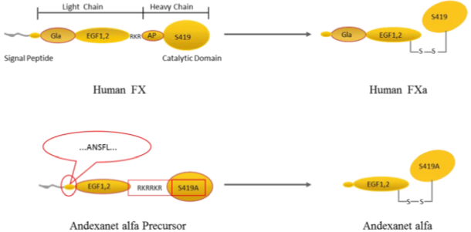

Abbreviations: FX = Factor X, FXa = Factor Xa.

The active ingredient is produced using recombinant DNA technology in CHO cells. The manufacturing process for recombinant andexanet alfa drug substance is divided into upstream manufacturing and downstream manufacturing. Upstream manufacturing consists of cell expansion, production, and harvest. Downstream manufacturing consists of viral inactivation, virus reduction filtration, polysorbate 80 addition, bulk filtration and filling. The overall quality of the active substance was demonstrated via adequate control of the starting material, control of critical steps and intermediates, process validation, extensive characterisation, control of impurities and contaminants, generation of robust reference materials and batch analyses that covered multiple manufacturing campaigns.

The finished product is a powder for injection presented at the concentration of 200 mg/vial with no included diluent. All excipients are well known pharmaceutical ingredients; compendial grade excipients are compliant with United States Pharmacopoeia, European Pharmacopoeia and, in most cases, Japanese Pharmacopoeia standards. The product is to be reconstituted with 20 mL of water for injection supplied by the user. The container closure is considered suitable for its intended use as demonstrated by compatibility and stability studies. The product labels are acceptable. The proposed tradename is considered acceptable.

Unopened vials should be stored refrigerated at 2 to 8 °C. The shelf life of the drug product is 48 months when stored at 2 to 8 °C, protected from light. The recommended shelf life and storage conditions for the reconstituted product are 24 hours or less when stored at 2 to 8 °C or 8 hours or less when stored at 25 °C or lower. To reduce microbiological hazard, use as soon as practicable after reconstitution/preparation.

There are no outstanding issues with the infectious disease/viral safety, container safety, microbiology (sterility), and endotoxin evaluations. The Product Information is acceptable from a quality perspective. There are no objections on quality grounds to the approval of Andexxa.

#### Quality related proposed conditions of registration

1. Laboratory testing & compliance with Certified Product Details (CPD)
2. All batches of Andexxa supplied in Australia must comply with the product details and specifications approved during evaluation and detailed in the Certified Product Details (CPD).
3. When requested by the TGA, the Sponsor should be prepared to provide product samples, specified reference materials and documentary evidence to enable the TGA to conduct laboratory testing on the Product. Outcomes of laboratory testing are published biannually in the TGA Database of Laboratory Testing Results <http://www.tga.gov.au/ws-labs-index> and periodically in testing reports on the TGA website.
4. Certified Product Details

The Certified Product Details (CPD), as described in Guidance 7: Certified Product Details of the Australian Regulatory Guidelines for Prescription Medicines (ARGPM), in PDF format, for the above products should be provided upon registration of these therapeutic goods. In addition, an updated CPD should be provided when changes to finished product specifications and test methods are approved in a Category 3 application or notified through a self-assessable change.  
A template for preparation of CPD for biological prescription medicines can be obtained from the TGA website   
[for the form] <https://www.tga.gov.au/form/certified-product-details-cpd-biological-prescription-medicines>   
[for the CPD guidance] <https://www.tga.gov.au/guidance-7-certified-product-details>

The CPD should be emailed to [Biochemistry.Testing@tga.gov.au](mailto:Biochemistry.Testing@tga.gov.au) as a single PDF document.

### Nonclinical

The submitted nonclinical data was in accordance with the relevant TGA guideline for the nonclinical assessment of biological medicines (ICH S6 [R1]).[5] All pivotal safety related studies were Good Laboratory Practice compliant.

*In vitro*, andexanet alfa bound to FXa direct inhibitors (betrixaban, rivaroxaban, apixaban and edoxaban) with nanomolar affinity, and also bound to antithrombin III complexed with indirect FXa inhibitors (enoxaparin,[6] fondaparinux), as well as tissue factor pathway inhibitor (TFPI). Andexanet alfa reversed the anti-FXa activity of direct FXa inhibitors and of ATIII-dependent (indirect) FXa inhibitors and inhibited thrombin generation. *In vivo*, andexanet alfa reversed anticoagulation of direct (rivaroxaban, edoxaban, apixaban) and indirect (enoxaparin, fondaparinux) FXa inhibitors. Reversal of anticoagulation required a molar excess of andexanet alfa to direct FXa inhibitors of approximately 2:1 for rivaroxaban, approximately 1.2:1 for apixaban, 2:1 for betrixaban, and 1.6:1 for edoxaban. Andexanet alfa showed no pro- or anti‑coagulant activity on its own. Overall, the pharmacology studies support the efficacy of andexanet alfa for the proposed indication.

No adverse effects were observed with andexanet alfa in Good Laboratory Practice studies on the cardiovascular, respiratory and central nervous systems and clinically relevant effects on these organ systems are not predicted.

The pharmacokinetic profile of andexanet alfa was similar in monkeys and humans. This was characterised by an overall long elimination half-life and a low volume of distribution, indicative of confinement largely to the vascular compartment.

Andexanet alfa displayed a low order of acute toxicity by the intravenous route in cynomolgus monkeys.

Two week repeat dose toxicity studies by the intravenous route were conducted in rats (daily administration) and cynomolgus monkeys (administration every 3 days). Maximum exposure to andexanet alfa was subclinical in rats and low in monkeys; however, this was at the maximum feasible dose. No target systems of toxicity were identified. Coadministration of andexanet alfa with FXa inhibitors (enoxaparin, rivaroxaban, apixaban, betrixaban) did not result in any adverse findings.

Genotoxicity and carcinogenicity studies were not conducted, in line with TGA guidelines.

Reproductive and developmental studies were not conducted. This is acceptable for the proposed indication and short dosing regimen. Pregnancy Category B2 is considered appropriate.[7]

There are no nonclinical objections to the registration of Andexxa (andexanet alfa) for the proposed indication. The Product Information is acceptable from a nonclinical perspective.

### Clinical

#### Summary of clinical studies

The clinical dossier presented 10 completed studies, including 7 clinical pharmacology studies (Phase I or II) in healthy subjects, two Phase III studies in healthy subjects, and one Phase III study in patients with major bleeding (Table 3). The two Phase III studies in healthy subjects, Study 14-503 & Study 14-504, assessed efficacy of andexanet alfa based on pharmacodynamic (PD) endpoints, primarily anti-FXa activity. Study 14-505 was a Phase IIIb/IV, single arm, open label study in patients with major bleeding events which assessed efficacy of andexanet alfa based on two coprimary endpoints (anti-FXa activity and haemostatic effectiveness). Data from the ongoing confirmatory efficacy and safety study (Study 18-513) comparing andexanet alfa to usual care in patients with acute intracranial haemorrhage (ICH) were not available for evaluation in this application.

Table 3: Studies in andexanet alfa clinical program

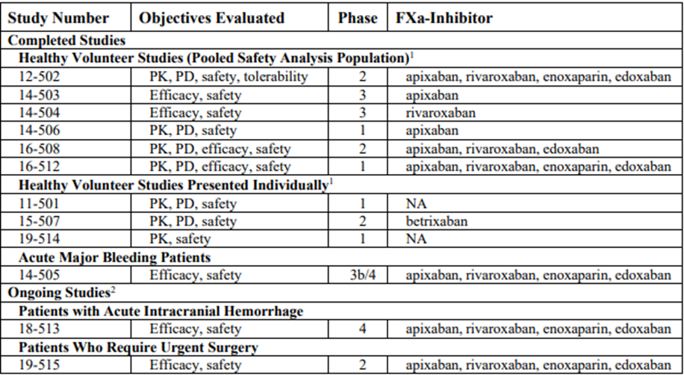

Abbreviations: FXa = Factor Xa, PD = pharmacodynamics, PK = pharmacokinetics, NA = not applicable.

Studies 12-502, 14-503, 14-504, 14-506, 16-508, 16-512 are included in pooled safety analyses. Studies 11-501 and 19-514 are presented separately, as the safety data are from subjects who did not receive an FXa inhibitor with andexanet. Study 15-507 is presented separately as this study used the FXa inhibitor betrixaban. However, pooling or integration of efficacy data was not considered appropriate due to differences in anticoagulant therapy, andexanet alfa doses, study designs, and time points of efficacy evaluation. Two data from ongoing studies are not available.

#### Pharmacology

The Phase I and II clinical pharmacology studies with relevant pharmacokinetic (PK)/PD data for this application are summarised in Table 4.

Table 4: Summary of Phase I and II studies with relevant clinical pharmacology data

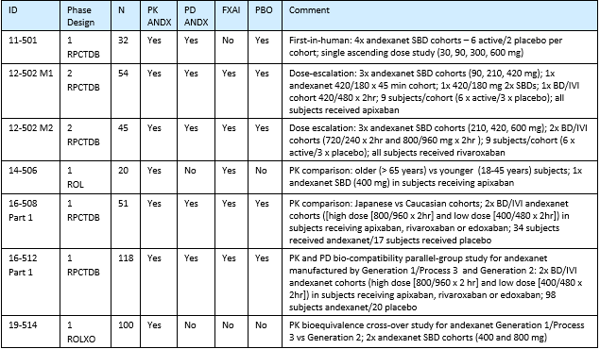Abbreviations: PK = studies with pharmacokinetic data, PD = studies with pharmacodynamic data, PBO = studies with placebo data, RPCTDB = randomised, placebo controlled trial, double blind, ROL = randomised, open label, ROLXO = randomised, open label, crossover; ANDX = andexanet, FXAI = studies with FXA inhibitor, SBD = single bolus dose.

##### Pharmacokinetics

The pharmacokinetics (PK) of andexanet alfa was characterised in single dose (single regimen) studies in healthy subjects, including a Phase I first-in-human single ascending dose study (Study 11-501), a Phase I elderly PK study (Study 14-506), Phase I studies of manufacturing process effect (Study 16-512 and Study 19-514), a Phase II dose range finding study (Study 12-502), and a Phase II Japanese study (Study 16-508). Multiple (repeat) dose studies were not required as the drug is proposed for single regimen administration. These studies confirmed that the PK of andexanet alfa is dose proportional over the proposed dose range, and the presence of FXa inhibitors did not affect the PK of andexanet. Pharmacokinetic findings from Study 16-512 and Study 19-514 are summarised in Table 5 and Table 6, respectively. Study 19-514 also confirmed equivalence of andexanet alfa from the generation 2 manufacturing process (proposed for marketing) and the generation 1 process 3 manufacturing process for PK and PD endpoints. In Study 14-506, there was no clinically significant difference in the PK of andexanet alfa in subjects aged 18 to 45 years and subjects aged 65 years or older, so no dose adjustment based on age is proposed. In Study 16-508, the PK of andexanet alfa was comparable in healthy Japanese and Caucasian subjects.

Andexanet alfa is a protein which will be metabolised by endogenous proteases, similar to endogenous proteins. Clearance of therapeutic proteins proceeds via degradation to small peptides and individual amino acids. There was no PK study in subjects with hepatic impairment or renal impairment. The PK studies did not detect andexanet alfa in urine samples indicating little to no renal clearance, and hepatic impairment is not expected to affect the clearance of andexanet alfa.

Table 5: Study 16-512 Andexanet alfa generation 2 pharmacokinetic parameters for Cohort 4 (low dose: 400 mg bolus and 480 mg infusion) and Cohort 5 (high dose: 800 mg bolus and 960 mg infusion), pharmacokinetic analysis population

|  |  |  |  |  |  |  |  |  |
| --- | --- | --- | --- | --- | --- | --- | --- | --- |
| PK | Cohort 4: Apixaban 5 mg bid, then Andexanet alfa Generation 2 (400 mg bolus + 480 mg infusion) | | | | Cohort 5: Rivaroxaban 20 mg QD, then Andexanet alfa Generation 2 (800 mg bolus + 960 mg infusion) | | | |
| Parameter | n | GeoMean | GeoCv% | Range | n | GeoMean | GeoCv% | Range |
| AUC0-∞  (h*ng/mL) | 11 | 200,487 | 16.3 | 153,411 to 255,569 | 10 | 572942 | 16.0 | 467,058 to 783,933 |
| Cmax  (ng/mL) | 11 | 76,620 | 17.5 | 61,128 to 100,083 | 10 | 206,571 | 18.8 | 158,935 to 280,516 |
| t½ (h) | 11 | 3.33 | 15.0 | 2.3 to 4.0 | 10 | 2.74 | 20.0 | 1.9 to 3.4 |
| CL (L/h) | 11 | 4.39 | 16.3 | 3.4 to 5.7 | 10 | 3.07 | 16.0 | 2.3 to 3.8 |
| Vss (L) | 11 | 4.41 | 17.6 | 3.3 to 5.7 | 10 | 2.96 | 23.3 | 2.2 to 5.0 |

Abbreviations: PK = pharmacokinetic(s), GeoMean = geometric mean, GeoCy% = geometric coefficient of variation, bid = twice a day, QD = once a day, Auc0-∞ = area under the concentration time curve from 0 to infinity, Cmax = maximum concentration, t½ = half life, CL = clearance, Vss = volume of distribution at steady state.

Table 6: Study 19-514 Andexanet alfa generation 2 pharmacokinetic parameters for Cohort 1 (400 mg bolus) and Cohort 2 (800 mg bolus), pharmacokinetic analysis population

|  |  |  |  |  |  |  |  |  |
| --- | --- | --- | --- | --- | --- | --- | --- | --- |
| PK | Cohort 1 (400 mg bolus) – Generation 2 (Period 1 or 2) | | | | Cohort 2 (800 mg bolus) – Generation 2 (Period 1 or 2) | | | |
| Parameter | n | GeoMean | GeoCv% | Range | n | GeoMean | GeoCv% | Range |
| AUC0-∞  (h*ng/mL) | 42 | 61,300 | 21.5 | 43,800 to 94,900 | 46 | 127,000 | 25.4 | 57,500 to 209,000 |
| Cmax  (ng/mL) | 49 | 61,000 | 21.3 | 40,300 to 98,500 | 50 | 118,000 | 24.9 | 50,200 to 191,000 |
| t½ (h) | 42 | 3.78 | 24.5 | 2.59 to 6.39 | 46 | 4.24 | 19.1 | 2.47 to 6.52 |
| CL (L/h) | 42 | 6.52 | 21.5 | 4.21 to 9.13 | 46 | 6.29 | 25.4 | 3.83 to 13.9 |
| Vss (L) | 42 | 9.47 | 25.8 | 6.08 to 15.3 | 46 | 8.94 | 28.6 | 5.36 to 23.1 |

Abbreviations: PK = pharmacokinetic(s), GeoMean = geometric mean, GeoCy% = geometric coefficient of variation, bid = twice a day, QD = once a day, Auc0-∞ = area under the concentration time curve from 0 to infinity, Cmax = maximum concentration, t½ = half life, CL = clearance, Vss = volume of distribution at steady state.

##### Pharmacodynamics

The pharmacodynamics (PD) of andexanet alfa was assessed in Phase I, II, and III studies. A key focus of the clinical development program was to evaluate the dose response relationship of andexanet alfa with regard to the reversal of anticoagulation resulting from FXa inhibitors. The Phase II Study 12-502 assessed the capacity of andexanet alfa to reverse the anticoagulation of FXa inhibitors in healthy subjects dosed to steady state with a direct FXa inhibitor (apixaban,3 rivaroxaban,2 or edoxaban) or an indirect FXa inhibitor (enoxaparin)6 to inform dose selection, which was then evaluated in two larger Phase III studies in healthy subjects, Studies 14-503 and 14-504. Modules 1 (apixaban) and 2 (rivaroxaban) of Study 12-502 provided key PD data for this application. The two Phase III studies in healthy subjects used PD endpoints as the major endpoints but they were considered as efficacy endpoints.

Anti-FXa activity was used as the primary PD endpoint in the Phase I, II, and III studies in healthy subjects, as this endpoint was considered to be a biomarker reasonably likely to predict clinical benefit, though ultimately the Phase IIIb/IV Study 14-505 in patients with major bleeding events failed to demonstrate a clinically meaningful correlation between the coprimary PD endpoint of reduction in anti-FXa activity and the coprimary clinical endpoint of haemostatic efficacy. Other PD endpoints assessed in the clinical program included tissue factor-initiated thrombin generation, total and free tissue factor pathway inhibitor (TFPI) antigen levels, TFPI functional activity, clotting based assays (for example, prothrombin time, activated partial thromboplastin time, activated clotting time, diluted Russell’s viper venom time, and other coagulation markers.

###### Study 12-502

This was a Phase II randomised, double blind, placebo controlled dose ranging study in healthy subjects to assess the capacity of andexanet alfa to reverse the anticoagulation of FXa inhibitors. The study was conducted in separate modules for each FXa inhibitor: module 1 apixaban, module 2 rivaroxaban, module 3 enoxaparin, and module 4 edoxaban. The focus of the evaluation was on modules 1 and 2 to support dose selection for the proposed indication.

The FXa inhibitor was dosed to steady state and andexanet alfa was administered following the last dose of the FXa inhibitor, such that the andexanet alfa bolus dose would end at the approximate time of maximum concentration for the FXa inhibitor. In module 1, apixaban was administered 5 mg twice a day for five days and then an additional 5 mg dose was administered in the morning on Day 6. Six different intravenous andexanet alfa doses/dose regimens (bolus only, or bolus and infusion) were then evaluated in separate cohorts of nine healthy subjects randomised 2:1 to receive andexanet alfa or placebo. The key PD outcomes from module 1 are shown in Table 7. In module 2, rivaroxaban was administered 20 mg once a day for six days. Five different intravenous andexanet alfa doses/dose regimens (bolus only, or bolus and infusion) were evaluated in separate cohorts of nine healthy subjects randomised 2:1 to receive andexanet alfa or placebo. The key PD outcomes from module 2 are shown in Table 8.

Table 7: Study 12-502 module 1, key pharmacodynamic measurements at the end of andexanet alfa bolus dose administration in apixaban-anticoagulated subjects

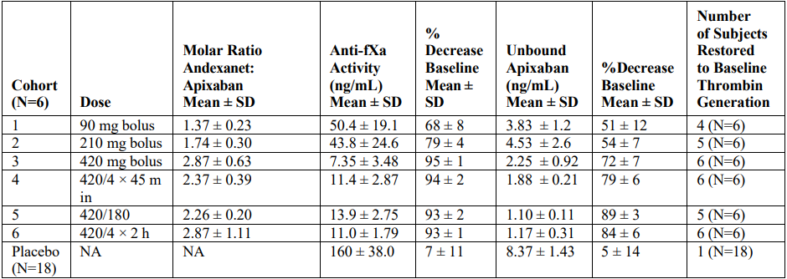  
Abbreviations: IV = intravenous, h = hour, min = minute, N = number of subjects, NA = not applicable, SD = standard deviation.

Notes: Andexanet alfa bolus dose administration was at 30 mg/min for all dose cohorts; 420/4 × 45 min is a 420 mg andexanet alfa IV bolus over 14 minutes (30 mg/min) followed immediately by a 180 mg continuous IV infusion (4 mg/min over 45 minutes); 420/180 is a 420 mg andexanet alfa IV bolus over 14 minutes (30 mg/min) followed after 45 minutes by a second bolus of 180 mg over 6 minutes (30 mg/min); 420/4 × 2 h is a 420 mg andexanet alfa IV bolus over 14 minutes (30 mg/min) followed immediately by a 480 mg continuous IV infusion (4 mg/min over 2 hours).

Table 8: Study 12-502 module 2, key pharmacodynamic measurements at the end of andexanet alfa bolus dose administration in rivaroxaban-anticoagulated subjects

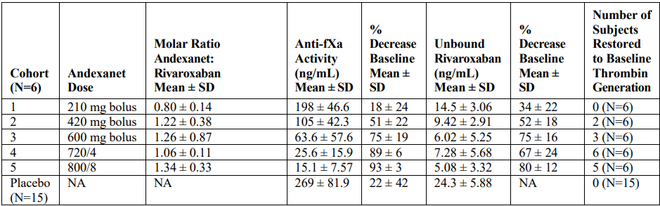  
Abbreviations: IV = intravenous, h = hour, min = minute, N = number of subjects, NA = not applicable, SD = standard deviation.

Notes: Andexanet alfa bolus dose administration was at 30 mg/min for all dose cohorts; 720/4 is a 720 mg bolus IV dose over 24 minutes followed immediately by a 240 mg continuous IV infusion (4 mg/min over 60 min); 800/8 is a 800 mg andexanet alfa IV bolus over 27 minutes (30 mg/min) followed immediately by a 960 mg continuous IV infusion (8 mg/min over 2 hours).

Administration of andexanet alfa resulted in a rapid (within two minutes after the end of bolus dose) decrease in anti-FXa activity relative to pre-dose values in patients treated with apixaban (Figure 2) and rivaroxaban (Figure 3). The magnitude and duration of decrease in anti-FXa activity following andexanet alfa administration were dose and dose-regimen dependent. The initial effect on mean anti-FXa activity was sustained (relative to placebo) when the andexanet alfa bolus dose was followed by a continuous infusion.

There was a direct correlation between unbound apixaban (Figure 4) and rivaroxaban (Figure 5) and anti-FXa activity, irrespective of the presence of andexanet alfa, indicating that the unbound fraction of the FXa inhibitor is responsible for anti-FXa activity.

Figure 2: Study 12-502 module 1, anti-FXa activity time profile after administration of andexanet alfa in subjects receiving apixaban

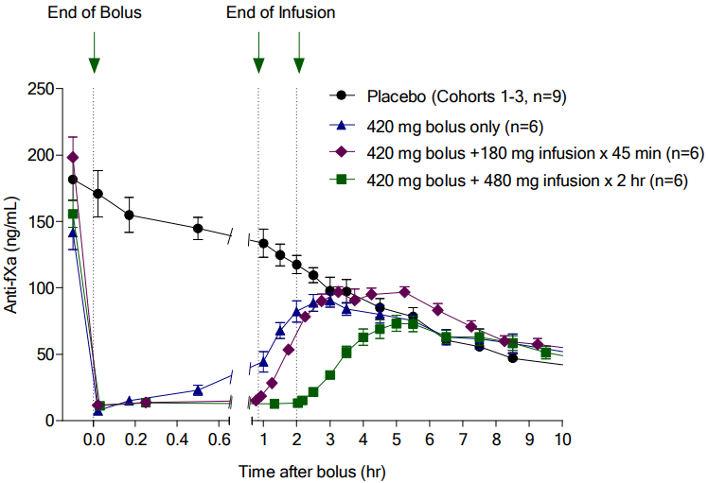

Abbreviations: fXa = factor Xa, hr = hour, min = minute, n = number of subjects.

Figure 3: Study 12-502 module 2, anti-FXa activity time profile after administration of andexanet alfa in subjects receiving rivaroxaban

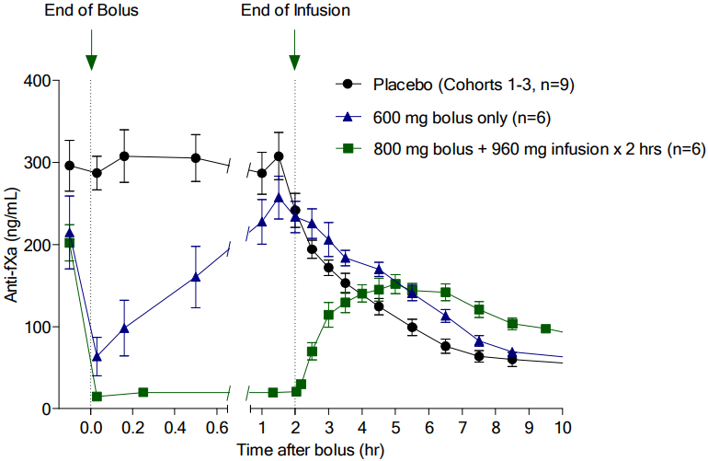

Abbreviations: fXa = factor Xa, hr = hour, n = number of subjects,.

Figure 4: Study 12-502 module 1, correlation between anti-FXa activity and unbound apixaban following andexanet alfa at various doses and placebo

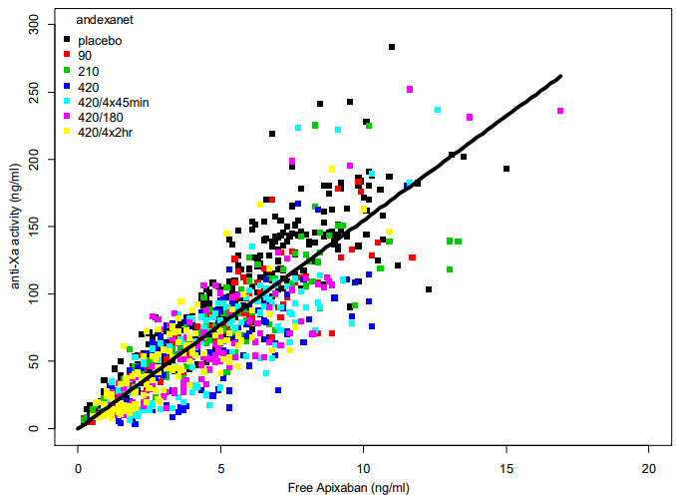

Abbreviations: fXa = factor Xa, hr = hour, min = minute.

Note: A plot of the anti-fXa activity versus the free (unbound) apixaban concentration demonstrates the direct linear correlation between the two independently generated values in the presence and absence of andexanet alfa.

Figure 5: Study 12-502 module 2, correlation between anti-FXa activity and unbound rivaroxaban following andexanet alfa at various doses and placebo

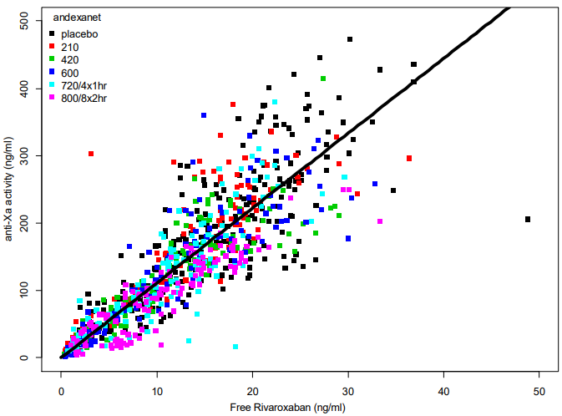

Abbreviations: fXa = factor Xa, hr = hour.

Note: A plot of the anti-fXa activity versus the free (unbound) rivaroxaban concentration demonstrates the direct linear correlation between the two independently generated values in the presence and absence of andexanet alfa.

Thrombin generation results from cleavage of prothrombin to thrombin by FXa in the prothrombinase complex and is the last protease in the coagulation cascade to convert fibrinogen to fibrin, so thrombin generation was used as a PD marker distal to FXa inhibition. In Study 12-502, andexanet alfa restored thrombin generation to Baseline levels observed prior to anticoagulation with apixaban (Figure 6) or rivaroxaban (Figure 7). The magnitude and duration of thrombin generation restoration were andexanet alfa dose and dose-regimen dependent and correlated with reversal of anti-FXa activity.

Figure 6: Study 12-502 module 1, thrombin generation with apixaban

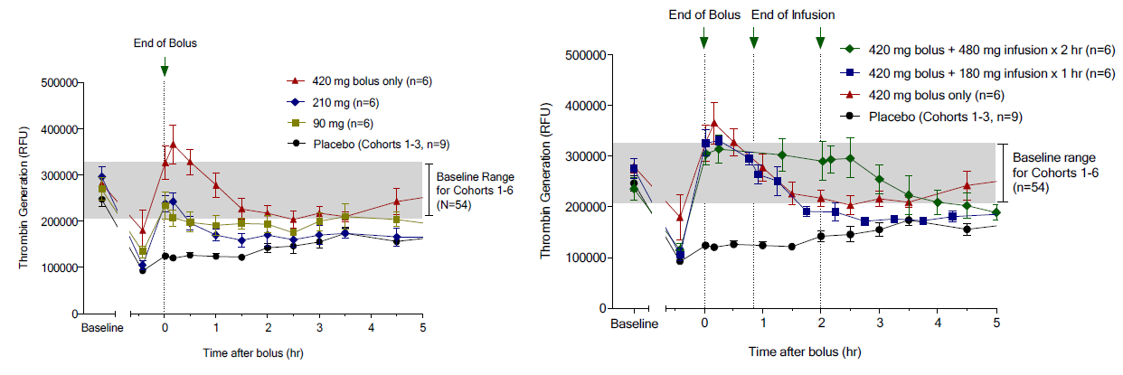

Abbreviations: hr = hour, N/n = number of subjects, RFU = relative fluorescence units.

Note: With apixaban, andexanet alfa was administered as a 90 mg, 210mg, 420 mg IV bolus; a 420 mg bolus and 180 mg continuous infusion (45 minutes at 4 mg/min); or a 420 mg bolus and 480 mg continuous infusion (120 minutes at 4 mg/min).

Figure 7: Study 12-502 module 2, thrombin generation with rivaroxaban

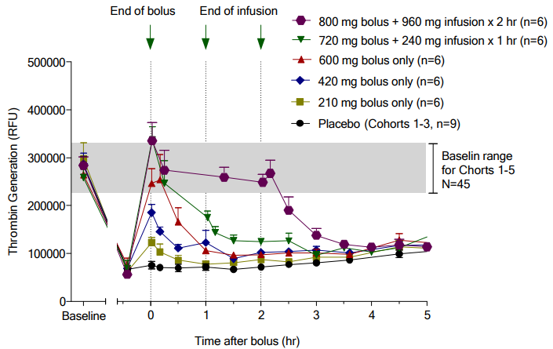

Abbreviations: hr = hour, N/n = number of subjects, RFU = relative fluorescence units.

Note: With rivaroxaban, andexanet alfa was administered as a 210 mg, 420 mg, 600 mg IV bolus; a 720 mg IV bolus and 240 mg continuous infusion (60 minutes at 4 mg/min); or a 800 mg IV bolus and 960 mg continuous infusion (120 minutes at 8 mg/min).

##### Population pharmacokinetics and pharmacokinetic/pharmacodynamic modelling

The submission presented population pharmacokinetic and PK/PD modelling reports to characterise the PK of andexanet alfa, to assess the impact of potential covariates on the PK of andexanet alfa, to characterise PK and PD relationships between andexanet alfa and FXa inhibitors, and to support dose selection of andexanet alfa for reversal of anticoagulant activity of apixaban and rivaroxaban. The objectives of the analyses were:

* to apply population modelling to characterise the PK of andexanet alfa in healthy subjects, assess the impact of potential covariates, and identify potential modifiers of exposure, including formulation effects.
* to apply population modelling to characterise the PK of FXa inhibitors (apixaban and rivaroxaban) in healthy subjects and bleeding patients, assess the impact of potential covariates, and identify potential modifiers of exposure, including patient level effects.
* To characterise the PK and PD interactions between andexanet alfa and the direct FXa inhibitors (apixaban and rivaroxaban) respectively, and the subsequent dynamics of anti-fXa activity following andexanet alfa administration in healthy subjects and bleeding patients.
* to characterise the effect of andexanet alfa on TFPI levels and endogenous thrombin potential (ETP) following andexanet alfa administration in healthy subjects and bleeding patients.
* to utilise the final population pharmacokinetic and PK/PD models to perform simulations to evaluate dose recommendations and treatment scenarios in populations of clinical interest.

Andexanet alfa PK data for healthy subjects from Studies 11-501, 12-502, 14-506, 16-512, 16‑508 (Parts I and II), and 19-514 were well characterised by a 2-compartment disposition model with a saturable binding site. No PK samples were taken from bleeding patients in Study 14-505 due to ethical reasons. Following model refinement, the covariates retained in the final andexanet alfa population pharmacokinetic model were body weight on both central volume of distribution of andexanet alfa and central clearance of andexanet alfa, baseline creatinine clearance effect on clearance of andexanet alfa, manufacturing process effect for generation 1 process 2 on clearance of andexanet alfa, and coadministration of andexanet alfa with an FXa inhibitor on clearance of andexanet alfa and central volume of andexanet alfa. The most influential covariates in the final PK model were body weight on both central volume of andexanet alfa and clearance of andexanet alfa, and the effect of coadministration of andexanet alfa with rivaroxaban or apixaban on clearance of andexanet alfa and central volume of andexanet alfa. The estimated effects of coadministration of a FXa inhibitor on andexanet alfa exposure were moderate, with 25% and 20% increases in andexanet alfa (4/400 mg dose) exposure (area under the concentration time curve from zero to 24 hours) for coadministration with apixaban and rivaroxaban, respectively. Body weight, baseline creatinine clearance, and manufacturing process had relatively small effects on exposure (area under the concentration time curve from zero to 24 hours) and these effects were considered to be not clinically significant (Figure 8).

Figure 8: Forest plot for andexanet alfa pharmacokinetic model

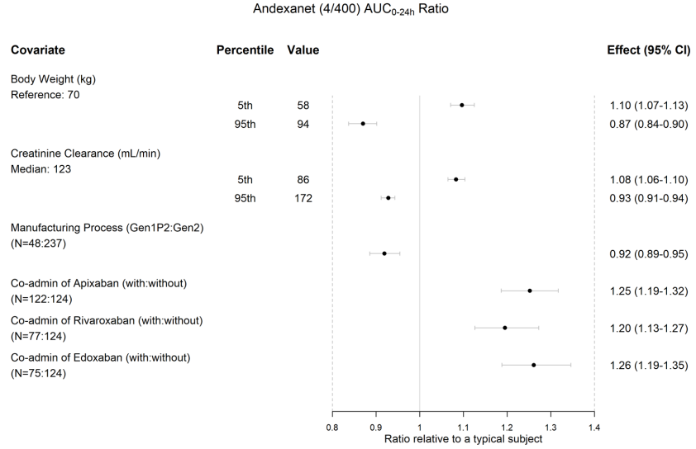  
Abbreviations: 4/400 = 400 mg at 30 mg/min followed by 4 mg/min for 2 hours, AUC0-24h = area under the concentration time curve from zero to 24 hours, CI = confidence interval, Gen = Generation, N = number of subjects, P = process, PK = pharmacokinetic(s).

Pharmacokinetic (PK) and PD data from Study 12-502 were used to develop a naïve-pooled PK/PD model which was used to predict andexanet alfa doses required to reverse anti-FXa activity of approved doses of apixaban and rivaroxaban, as well as andexanet alfa doses predicted to reverse anti-FXa activity at different times after the last administration of the FXa inhibitor. This model was used to select andexanet alfa doses for the two Phase III studies in healthy subjects (Study 14-503 (apixaban) and Study 14-504 (rivaroxaban)). As only a relatively small number of healthy subjects was available for each FXa inhibitor, covariates could not be evaluated in this model. A second set of PK/PD models were developed to determine if the andexanet alfa doses would need to be modified for patient populations taking FXa inhibitors. These models were then redeveloped to include all available data with healthy subjects as well as the data from patients with major bleeding from Study 14-505. This model informed the andexanet alfa dosing regimen in Study 14-505 from protocol amendment 4 onwards.

The final PK/PD modelling and simulations used data from Studies 11-501, 12-502, 14-503 (ANNEXA-A), 14-504 (ANNEXA-R),14-505 (ANNEXA-4), 14-506, 16-508 (Parts I and II), 16-512, and 19-514 to characterise the andexanet alfa bolus dose and infusion rates required to reverse and maintain the reversal of anti-FXa activity and confirm the appropriateness of the recommended posology for low and high andexanet alfa doses. The results showed that the proposed posology specified by the FXa inhibitor dose and time since the most recent FXa dose is expected to provide greater than 80% reversal of anti-FXa activity in more than 50% of healthy subjects and bleeding patients if intrinsic and extrinsic factors are similar. Within 12 hours after the start of andexanet alfa dosing, anti-FXa activity returned to levels similar to those expected in patients not treated with andexanet alfa, leaving only the anti-FXa activity from the last anticoagulant dose.

The final PK/PD modelling report included exploratory analyses of the effect of andexanet alfa on tissue factor pathway inhibitor (TFPI) and endogenous thrombin potential (ETP). Andexanet alfa binds to free TFPI and thus inhibits TFPI activity. The effect of andexanet alfa on TFPI activity was shown to be transient. Tissue factor pathway inhibitor returns to baseline levels within 3.5 to 5 days depending on the particular FXa inhibitor dose/time scenario but regardless of andexanet alfa high or low dose. Model predictions in bleeding patients showed that rivaroxaban and apixaban suppress ETP quickly after dosing. The andexanet alfa bolus promptly reverses this effect and increases ETP, which is maintained by the andexanet alfa infusion. Following completion of the andexanet alfa infusion, ETP decreases to within the normal range within 24 hours.

#### Efficacy

The efficacy studies presented in this submission included two Phase III randomised, double blind, placebo controlled studies in healthy subjects which evaluated efficacy based on PD endpoints (primarily anti-FXa activity), and a Phase IIIb/IV, single arm, open label study which assessed efficacy based on coprimary endpoints (anti-FXa activity and haemostatic effectiveness) in patients with major bleeding events.

##### Study 14-503 (ANNEXA-A)

Study 14-503 was a Phase III randomised, double blind, placebo controlled study designed to demonstrate the ability of andexanet alfa to reverse apixaban-induced anticoagulation and evaluate safety in healthy subjects aged 50 to 75 years who were dosed to steady state with apixaban. The study was conducted at one clinical site in the USA between March 2014 and December 2014.

The primary efficacy objective was to compare andexanet alfa and placebo with respect to reversal of apixaban anticoagulation as measured by anti-FXa activity, both after a bolus and after a bolus followed by a continuous infusion. The secondary efficacy objectives were to compare reversal of apixaban anticoagulation between andexanet alfa and placebo as measured by apixaban free-fraction and restoration of thrombin generation, after a bolus and after a bolus followed by a continuous infusion. The safety objective was to assess the safety of andexanet alfa in subjects anticoagulated with apixaban (that is, including bleeding events, thrombotic events, and immunogenicity), after a bolus and after a bolus followed by a continuous infusion.

The study consisted of two consecutive parts: Part 1 (n = 32 randomised subjects) evaluated bolus only and Part 2 (n = 32 randomised subjects) evaluated bolus followed by a continuous infusion. In Parts 1 and 2, randomisation was 3:1 andexanet alfa to placebo.

Dose selection was informed by the Phase II Study 12‑502 and nonclinical data. Study subjects were domiciled at the study site for 8 days, during which time apixaban 5 mg twice a day was administered for 3.5 days (to steady state) and then andexanet alfa (or matching placebo) was administered on Day 4. Andexanet alfa was administered intravenously as a bolus of 400 mg at a target rate of 30 mg/min (that is, approximately 13 minutes) in Parts 1 and 2, and in Part 2 the bolus was followed by a continuous infusion of 480 mg at 4 mg/min for 120 minutes. The bolus was started 3 hours after the last apixaban dose (approximate steady state maximum concentration for apixaban). Subjects were followed for safety through Day 43. The study design is outlined in Figure 9.

Figure 9: Study 14-503 schematic

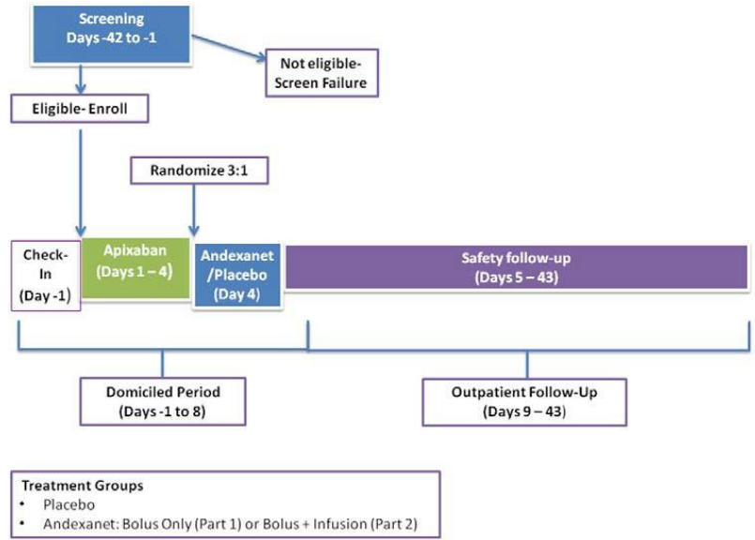

The study included subjects aged 50 to 75 years who were in reasonably good health, including those with well controlled, chronic, stable conditions, as determined by the investigator. Subjects with a history of abnormal bleeding, signs or symptoms of active bleeding, or risk factors for bleeding were excluded, as were subjects with a past or current medical history of thrombosis, any signs or symptoms that suggested an increased risk of a systemic thrombotic condition or thrombotic event, or recent events that may increase risk of thrombosis. In addition, subjects were excluded if they had taken one or more doses of aspirin, other antiplatelet drugs, nonsteroidal anti-inflammatory drugs, fibrinolytic, or any anticoagulant within 7 days prior to Day -1 or were anticipated to require such drugs during the study.

Part 1 and Part 2 were analysed separately. For both Part 1 and Part 2, the primary efficacy analysis compared the primary endpoint between the two treatment groups. The comparison was conducted using an exact Wilcoxon rank-sum test. All hypothesis tests were 2-sided and performed at the 0.05 significance level.

In Part 1, the primary endpoint was the percent change from Baseline in anti-FXa activity at the nadir, when nadir was defined as the smaller value for anti-FXa activity at the +2 minutes or +5 minutes time-point following the end of the bolus (Figure 10). The baseline measurement was obtained three hours following the Day 4 dose of apixaban, just prior to administration of andexanet alfa or placebo. The secondary efficacy endpoints in Part 1 were:

* The occurrence of 80% or greater reduction in anti-FXa activity from Baseline to nadir, when nadir was defined as the smaller value for anti-FXa activity at the +2 minute or +5 minute time-point after the completion of the andexanet alfa bolus.
* The change from Baseline in free apixaban concentration (ng/mL) at nadir, when nadir was defined as the smaller value for free apixaban concentration at the +2-minute or +5-minute time-point after the completion of the andexanet bolus.
* The change in thrombin generation (endogenous thrombin potential (ETP)) from Baseline to peak, where peak was defined as the largest value for thrombin generation (ETP) between the +2 minute time-point and the +10 minute time-point after the end of the andexanet alfa bolus (inclusive).
* The occurrence of thrombin generation (ETP) above the lower limit of the normal range at its peak, between the +2 minute time-point and the +10 minute time-point after the end of the andexanet alfa bolus (inclusive).

In Part 2, the primary endpoint was the percent change from Baseline in anti-FXa activity at the nadir, when nadir was defined as the smaller value for anti-FXa activity between the 110 minute time-point (10 minutes prior to the end of the continuous infusion) and the 5 minute time-point after the end of the continuous infusion (Figure 10). The secondary efficacy endpoints in Part 2 were:

* The percent change from Baseline in anti-FXa activity at the nadir, following the bolus, when nadir was defined as the smaller value for anti-FXa activity at the +2 minute or +5 minute time-point after the completion of the andexanet alfa bolus.
* The occurrence of 80% or greater reduction in anti-FXa activity from Baseline to nadir, when nadir was defined as the smaller value for anti-FXa activity between the 110 minute time‑point (10 minutes prior to the end of the continuous infusion) and the 5 minute time‑point after the end of the continuous infusion (inclusive).
* The change from Baseline in free apixaban concentration (ng/mL) at the nadir, when nadir was defined as the smaller value for free apixaban between the 110 minute time-point (10 minutes prior to the end of the continuous infusion) and the 5 minute time-point after the end of the continuous infusion (inclusive).
* The change in thrombin generation (ETP) from Baseline to peak, where peak was defined as the largest value for thrombin generation (ETP) between the 110 minute time-point (10 minutes prior to the end of the continuous infusion) and the 5 minute time-point after the end of the continuous infusion (inclusive).
* The occurrence of thrombin generation (ETP) above the lower limit of the normal range at peak, where peak was defined as the largest value for anti-FXa activity between the 110 minute time-point (10 minutes prior to the end of the continuous infusion) and the 5 minute time-point after the end of the continuous infusion (inclusive).

Figure 10: Study 14-503 timing of the primary endpoints for Part 1 and Part 2

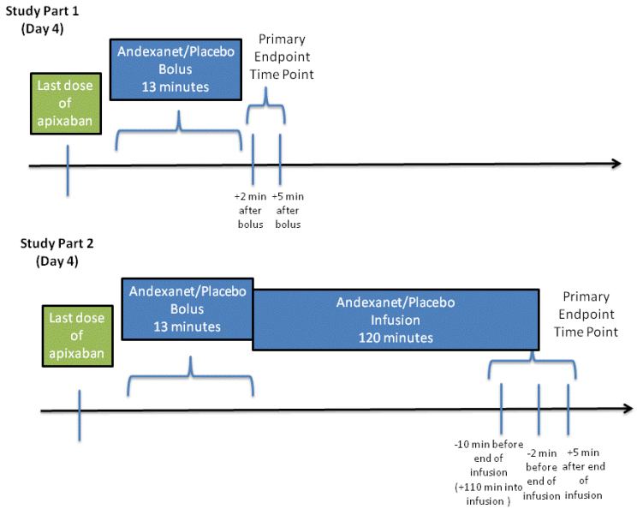

A total of 68 subjects (34 in Part 1 and 34 in Part 2) received apixaban and were considered enrolled. Of these, 66 subjects were randomised (34 subjects in Part 1 (25 andexanet, nine placebo) and 32 in Part 2 (24 andexanet, eight placebo)). In Part 1, 24 (96%) subjects randomised to andexanet alfa and nine (100%) subjects randomised to placebo completed the study. In Part 2, 24 (100%) subjects randomised to andexanet alfa and eight (100%) subjects randomised to placebo completed the study. In Part 1, one subject randomised to andexanet alfa did not receive study drug and was excluded from the safety, modified intent to treat (mITT), and per‑protocol populations, and one subject randomised to andexanet alfa was not included in the efficacy analysis mITT or per-protocol populations because the study drug was discontinued partway through the infusion and the site did not collect follow-up blood tests on that day as required for inclusion in the mITT population.

Demographic and baseline characteristics were similar in the andexanet alfa and placebo groups in both Part 1 and Part 2 of the study. The mean age was 60.4 years in Part 1 and 59.4 years in Part 2. In Part 1 57.6% of subjects and in Part 2 68.8% were male. The use of concomitant medications was low and similar in the andexanet alfa and the placebo groups.

The study met its primary efficacy endpoint in both Parts 1 and 2 (Table 9), demonstrating significant reduction in anti-FXa activity from Baseline to nadir in the andexanet alfa group compared to placebo. The time-course of anti-FXa activity in Part 1 and Part 2 is shown in Figure 11. The study also showed significant results for all secondary efficacy endpoints in Parts 1 and 2 (Table 10).

Table 9: Study 14-503 primary efficacy endpoint analysis in Parts 1 and 2, modified intent to treat population

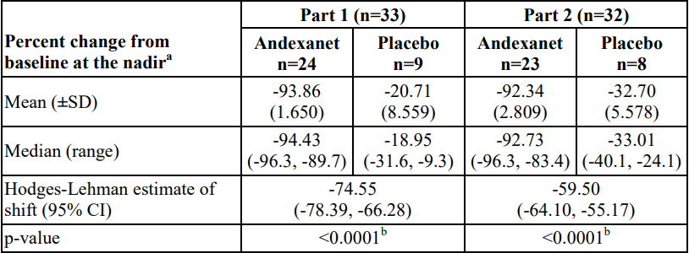  
a. Nadir for Part 1 is the smaller value for anti-FXa activity at the +2 minute or +5 minute time point after the completion of the andexanet alfa bolus for each subject; nadir for Part 2 is the smallest value for anti-FXa activity at the 110 minute (10 minutes prior to the end of the infusion) time point, 2 minute time point before completion of the infusion, or the 5 minute time point after the completion of the infusion for each subject.

b. P-value obtained from a 2-sided exact Wilcoxon rank-sum test.

Notes: Baseline is the last assessment obtained prior to the bolus of andexanet alfa or placebo. Only subjects with both a baseline and a postbaseline assessment are presented in the table.

Figure 11a: Study 14-503 time course of anti-FXa activity – andexanet alfa bolus or placebo (Part 1), modified intent to treat population

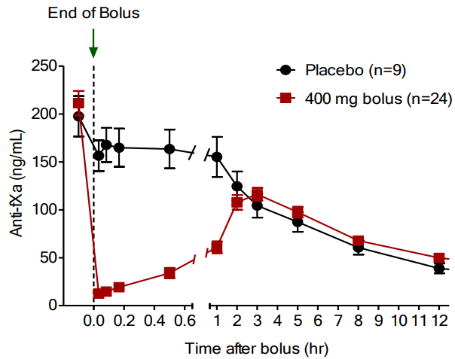

Abbreviations: hr = hour(s), n = number of subjects

Figure 11b: Study 14-503 time course of anti-FXa activity – andexanet alfa bolus plus infusion or placebo (Part 2), modified intent to treat population

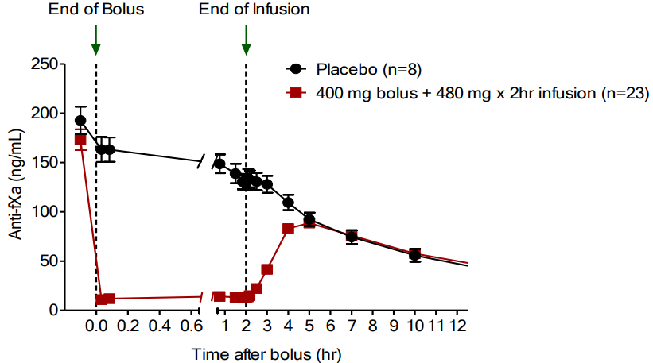

Abbreviations: hr = hour(s), n = number of subjects

Table 10: Study 14-503 secondary efficacy endpoint results in Parts 1 and 2, modified intent to treat population

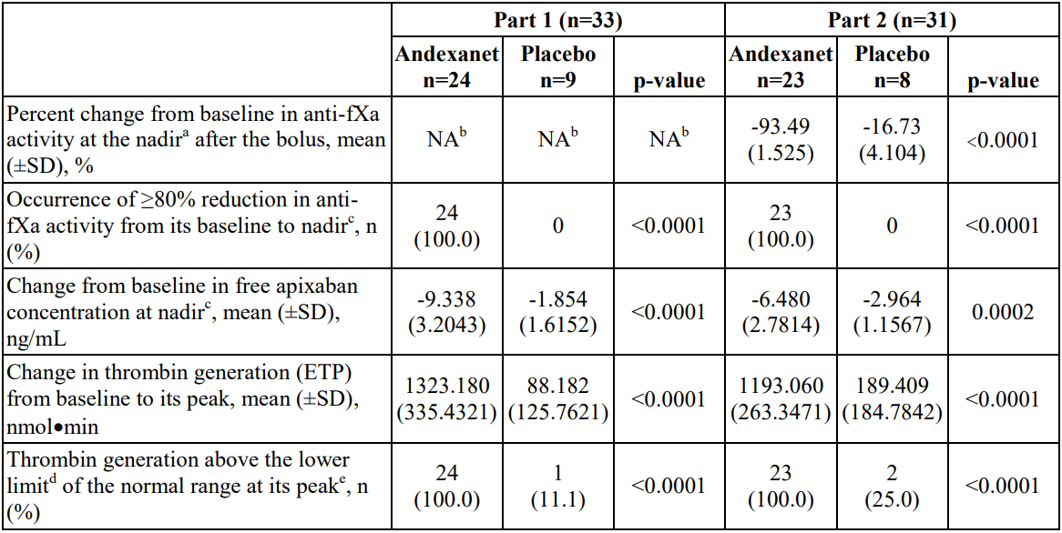  
Abbreviations: ETP = endogenous thrombin potential, fXa = Factor Xa, mITT = modified intent to treat, NA = not applicable, SD = standard deviation.

a. For Part 2, nadir is the smaller value for anti-fXa activity at the +2 minute or +5 minute time point after the completion of the andexanet alfa bolus.

b. This was the primary endpoint in Part 1 and is presented in the primary endpoint section.

c. For Part 1, nadir is the smaller value for anti-fXa activity at the +2 minute or +5 minute time point after the completion of the andexanet alfa bolus; for Part 2, nadir is the smaller value for anti-fXa activity between the 110 minute time point (10 minutes prior to the end of the continuous infusion) and the 5-minute time point after the end of the continuous infusion (inclusive).

d. The lower limit of normal range was derived as the mean minus 1 standard deviation from all thrombin generation assessments prior to the first dose of apixaban. For Part 1, the lower limit of the derived normal range for endogenous thrombin potential was 956.12 nmol/min. For Part 2, the lower limit of the derived normal range for endogenous thrombin potential was 1013.50 nmol/min.

e. For Part 1, peak is the largest value for thrombin generation at the +2 minute, +5 minute, or +10 minute time point after the completion of the andexanet alfa bolus for each subject; for Part 2, is the largest value for endogenous thrombin potential at the 110 minute (10 minutes prior to the end of the continuous infusion) time point, 2 minute time point before completion of the andexanet alfa infusion, or the 5 minute time point after the completion of the andexanet alfa infusion for each subject.

##### Study 14-504 (ANNEXA-R)

This was a Phase III randomised, double blind, placebo controlled study designed to demonstrate the ability of andexanet alfa to reverse rivaroxaban induced anticoagulation and evaluate safety in healthy subjects aged 50 to 75 years who were dosed to steady state with rivaroxaban. The study was conducted at one clinical site in the USA between May 2014 and June 2015. The study was of similar design to Study 14-503, except subjects were anticoagulated with rivaroxaban rather than apixaban.

The primary efficacy objective was to compare andexanet alfa and placebo with respect to reversal of rivaroxaban anticoagulation as measured by anti-FXa activity, both after a bolus and after a bolus followed by a continuous infusion. The secondary efficacy objectives were to compare reversal of rivaroxaban anticoagulation between andexanet alfa and placebo as measured by rivaroxaban free-fraction and restoration of thrombin generation, after a bolus and after a bolus followed by a continuous infusion. The safety objective was to assess the safety of andexanet alfa in subjects anticoagulated with rivaroxaban (that is, including bleeding events, thrombotic events, and immunogenicity), after a bolus and after a bolus followed by a continuous infusion.

The study consisted of two consecutive parts: Part 1 (n = 41 randomised subjects) evaluated bolus only and Part 2 (n = 39 randomised subjects) evaluated bolus followed by a continuous infusion. In Parts 1 and 2, randomisation was 2:1 andexanet alfa to placebo.

The study design is outlined in Figure 12. Dose selection was informed by the Phase II Study 12‑502 and non-clinical data. Study subjects were domiciled at the study site for 8 days, during which time rivaroxaban 20 mg once a day was administered for 4 days (to steady state) and then andexanet alfa (or matching placebo) was administered on Day 4. Andexanet alfa was administered intravenously as a bolus of 800 mg at a target rate of 30 mg/min (that is, approximately 27 minutes) in Parts 1 and 2, and in Part 2 the bolus was followed by a continuous infusion of 960 mg at 8 mg/min for 120 minutes. The bolus was started 4 hours after the last rivaroxaban dose (approximate steady state maximum concentration for rivaroxaban). Subjects were followed for safety through Day 43.

Figure 12: Study 14-504 schematic

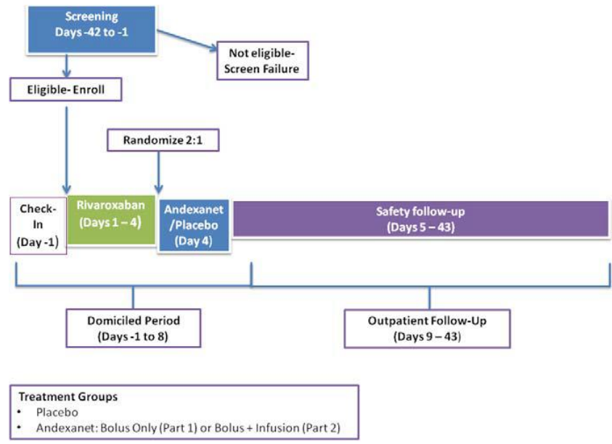

The study included subjects aged 50 to 75 years who were in reasonably good health, including those with well-controlled, chronic, stable conditions, as determined by the investigator. The inclusion and exclusion criteria were the same as those described for Study 14-503.

Part 1 and Part 2 were analysed separately. For both Part 1 and Part 2, the primary efficacy analysis compared the primary endpoint between the two treatment groups. The comparison was conducted using an exact Wilcoxon rank-sum test. All hypothesis tests were 2-sided and performed at the 0.05 significance level.

In Part 1, the primary efficacy endpoint was the percent change from Baseline in anti-FXa activity at the nadir, when nadir was defined as the smaller value for anti-FXa activity at the +2 minutes or +5 minutes time-point following the end of the bolus (Figure 13). The baseline measurement was obtained 4 hours following the Day 4 dose of rivaroxaban, just prior to administration of andexanet alfa or placebo. The secondary efficacy endpoints in Part 1 were:

* The change from Baseline in free rivaroxaban concentration (ng/mL) at nadir, when nadir was defined as the smaller value for free rivaroxaban concentration at the +2 minute or +5 minute time-point after the completion of the andexanet alfa bolus.
* The occurrence of 80% or greater reduction in anti-FXa activity from Baseline to nadir, when nadir was defined as the smaller value for anti-FXa activity at the +2 minute or +5 minute time-point after the completion of the andexanet alfa bolus.
* The change in thrombin generation (ETP) from Baseline to peak, where peak was defined as the largest value for thrombin generation (ETP) between the +2 minute time-point and the +10 minute time-point after the end of the andexanet alfa bolus (inclusive).
* The occurrence of thrombin generation (ETP) above the lower limit of the normal range at its peak, between the +2 minute time-point and the +10 minute time-point after the end of the andexanet alfa bolus (inclusive).

In Part 2, the primary endpoint was the percent change from Baseline in anti-FXa activity at the nadir, when nadir was defined as the smaller value for anti-FXa activity between the 110 minute time-point (10 minutes prior to the end of the continuous infusion) and the 5 minute time-point after the end of the continuous infusion (Figure 13). The secondary efficacy endpoints in Part 2 were:

* The percent change from Baseline in anti-FXa activity at the nadir, following the bolus, when nadir was defined as the smaller value for anti-FXa activity at the +2 minute or +5 minute time-point after the completion of the andexanet alfa bolus.
* The change from Baseline in free rivaroxaban concentration (ng/mL) at the nadir, when nadir was defined as the smaller value for free apixaban between the 110 minute time-point (10 minutes prior to the end of the continuous infusion) and the 5 minute time-point after the end of the continuous infusion (inclusive).
* The occurrence of 80% or greater reduction in anti-FXa activity from Baseline to nadir, when nadir was defined as the smaller value for anti-FXa activity between the 110 minute time‑point (10 minutes prior to the end of the continuous infusion) and the 5 minute time‑point after the end of the continuous infusion (inclusive).
* The change in thrombin generation (ETP) from Baseline to peak, where peak was defined as the largest value for thrombin generation (ETP) between the 110 minute time-point (10 minutes prior to the end of the continuous infusion) and the 5 minute time-point after the end of the continuous infusion (inclusive).
* The occurrence of thrombin generation (ETP) above the lower limit of the normal range at peak, when peak was defined as the largest value for anti-fXa activity between the 110 minute time-point (10 minutes prior to the end of the continuous infusion) and the 5 minute time-point after the end of the continuous infusion (inclusive).

Figure 13: Study 14-504 timing of the primary endpoints for Part 1 and Part 2

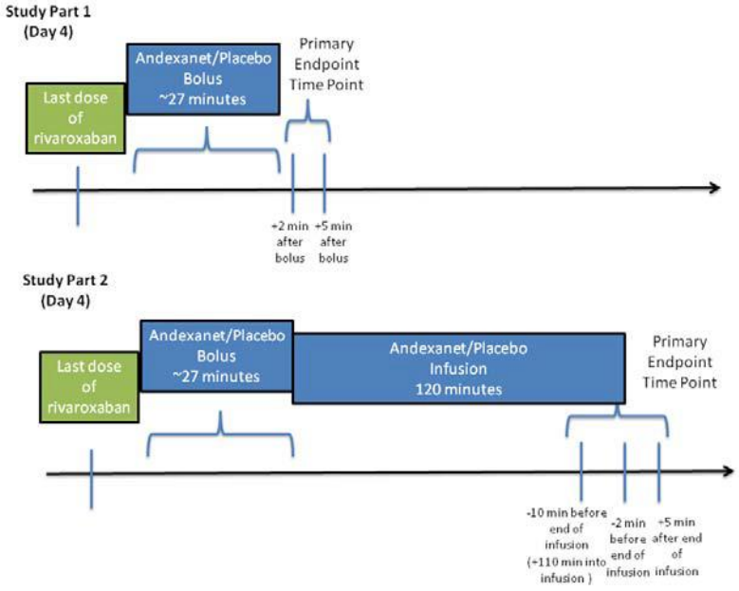

A total of 80 subjects (41 in Part 1 and 39 in Part 2) received rivaroxaban and were considered enrolled. All 80 subjects were randomised (41 subjects in Part 1 (27 andexanet alfa, 14 placebo) and 39 in Part 2 (26 andexanet alfa, 13 placebo)). In Part 1, all 41 randomised subjects completed the study and were included in the efficacy analysis (mITT) and safety analysis populations. In Part 2, two subjects in the andexanet alfa group did not complete the study, but all 39 randomised subjects were included in the efficacy analysis (mITT) and safety analysis populations.

Demographic and baseline characteristics were similar in the andexanet alfa and placebo groups in both Part 1 and Part 2 of the study. The mean age was 55.2 years in Part 1 and 57.3 years in Part 2. A total 63.4% of subjects in Part 1 and 56.4% in Part 2 were male. The use of concomitant medications was low and similar in the andexanet alfa and the placebo groups.

The study met its primary efficacy endpoint in both Parts 1 and 2 (Table 11), demonstrating significant reduction in anti-FXa activity from Baseline to nadir in the andexanet alfa group compared to placebo. The time-course of anti-FXa activity in Parts 1 and 2 is shown in Figure 14. The study also showed significant results for all secondary efficacy endpoints in Parts 1 and 2 (Table 12).

Table 11: Study 14-504 primary efficacy endpoint analysis in Parts 1 and 2, modified intent to teat population

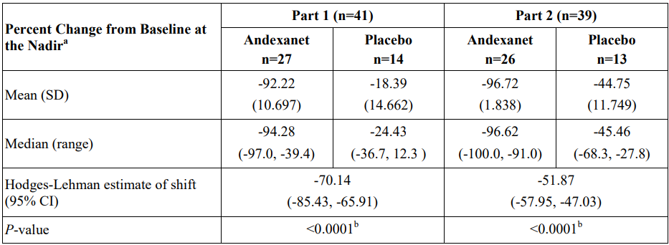  
Abbreviations: CI = confidence interval, mITT = modified intent to treat, SD = standard deviation.

a. For Part 1, nadir is the smaller value for anti-fXa activity at the +2 minute or +5 minute time point after the completion of the andexanet alfa bolus for each subject. For Part 2, nadir is the smallest value for anti-fXa activity at the 110 minute (10 minutes prior to the end of the infusion) time point, 2 minute time point before completion of the infusion, or the 5 minute time point after the completion of the infusion for each subject.

b. p-value obtained from a two-sided exact Wilcoxon rank-sum test.

Notes: Baseline is the last assessment obtained prior to the bolus dose of andexanet alfa or placebo. Only subjects with both a baseline and a post-baseline assessment are presented in the table.

Figure 14a: Study 14-504 time course of Anti-FXa activity andexanet alfa bolus or placebo (Part 1), modified intent to treat population

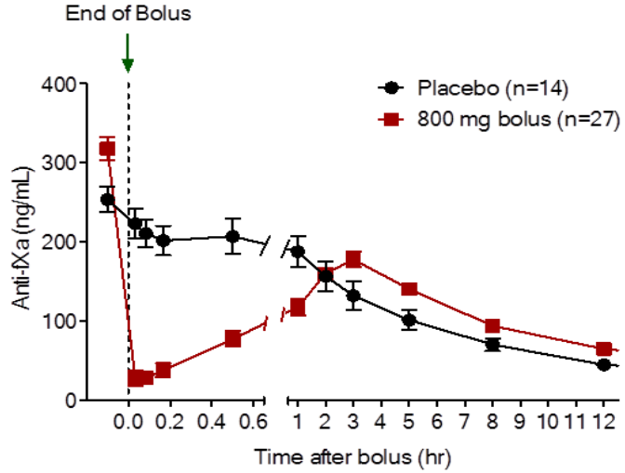

Abbreviations: hr = hour(s), n = number of subjects

Figure 14b: Study 14-504 time course of Anti-FXa activity or andexanet alfa bolus plus infusion or placebo (Part 2), modified intent to treat population

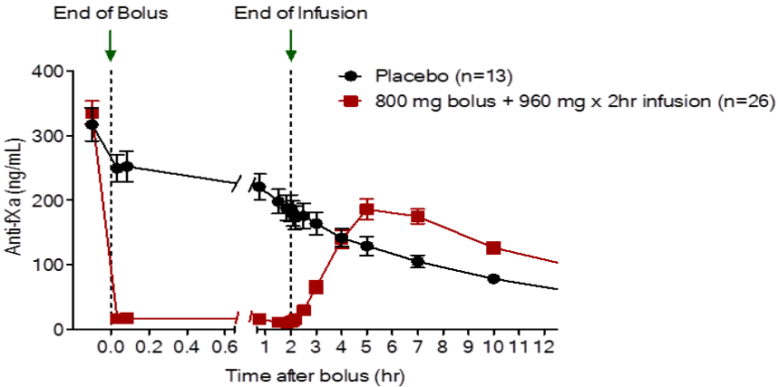

Abbreviations: hr = hour(s), n = number of subjects

Table 12: Study 14-504 secondary efficacy endpoint results in Parts 1 and 2, modified intent to treat population

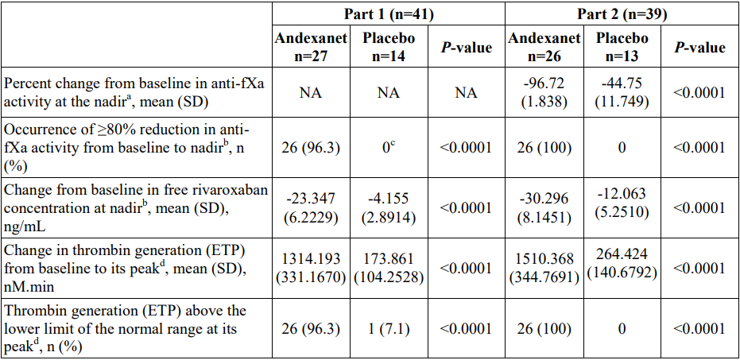  
Abbreviations: ETP = endogenous thrombin potential, mITT = modified intent to treat, NA = not applicable, SD = standard deviation.

a. In Part 2, nadir is the smaller value for anti-fXa activity at the +2 minute or +5 minute time point after the completion of the andexanet alfa bolus for each subject.

b. For Part 1, nadir is the smaller value at the +2 minute or +5 minute time point after the completion of the andexanet alfa bolus for each subject. For Part 2, nadir is the smallest value at the 110 minute (10 minutes prior to the end of the infusion) time point, 2 minute time point before completion of the infusion, or the 5 minute time point after the completion of the infusion for each subject.

c. 13 subjects in the placebo group had the requisite number of readings to be included.

d. In Part 1, the peak was defined as the largest value for thrombin generation (ETP) between the +2 minute time point and the +10 minute time point after the completion of the andexanet alfa bolus. In Part 2, the peak was defined as the largest value for thrombin generation (ETP) at the 110-minute (10 minutes prior to the end of the continuous infusion) time point, 2 minute time point before completion of the andexanet alfa infusion, or the 5 minute time point after the completion of the andexanet alfa infusion for each subject.

Notes: Baseline was the last assessment obtained prior to the bolus dose of andexanet alfa or placebo. Only subjects with both a baseline and a post-baseline assessment are presented in the table.

##### Study 14-505 (ANNEXA-4)

This was a Phase IIIb/IV prospective, open label, single arm study of andexanet alfa in patients receiving a FXa inhibitor who have acute major bleeding. It was a multicentre study conducted in North America, Europe and Japan. The definition of major bleeding was based on the International Society on Thrombosis and Hemostasis (Schulman and Kearon, 2005) criteria.[8] The study aimed to enrol patients on direct FXa inhibitors as well as those on indirect FXa inhibitors, and to limit the percentage of enrolled patients receiving indirect FXa inhibitors to 20% or less. The first patient was enrolled in April 2015 and the last patient in March 2020. The data cut-off for the submitted study report was 30 June 2020.

The co-primary objectives were to demonstrate the decrease in anti-FXa activity following andexanet alfa treatment, and to evaluate the haemostatic efficacy of andexanet alfa treatment. The secondary efficacy objective was to assess the relationship between decrease in anti-FXa activity and achievement of haemostatic efficacy in patients receiving a FXa inhibitor who have acute major bleeding and reduced FXa activity. Exploratory objectives included additional surrogate biomarkers and clinical outcomes, and consistency of efficacy across important subgroups. Safety objectives were to evaluate the overall safety of andexanet alfa, including treatment-emergent adverse events (TEAEs), adjudicated thromboembolic events and deaths, vital signs, clinical laboratory measurements, and antibodies to FX, FXa inhibitor, and andexanet alfa, and to evaluate 30 day all-cause mortality.

The study design is outlined in Figure 15. Screening and treatment were on Day 1. Redosing of andexanet alfa was permitted in the case of rebleeding within 24 hours after completion of the first andexanet alfa treatment. The safety evaluation period was 30 days.

Figure 15: Study 14-505 design

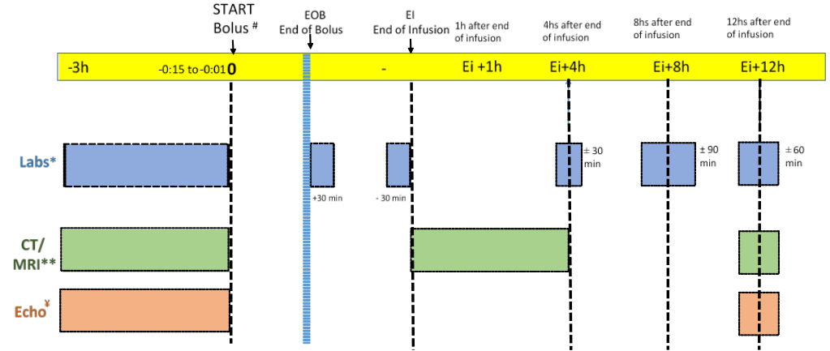  
Abbreviations: CT = computed tomography, Echo = Echocardiogram, fXa = Factor Xa, H/HS = hour/s, ICH = intracranial haemorrhage, min = minutes, MRI = magnetic resonance imaging.

# Redosing procedures began prior to the start of the second bolus for measurement of anti-fXa activity.

** CT/MRI was required for ICH and intra-spinal patients. The Ei+1 hour scan (window Ei + 4 hours) is required for ICH only.

¥ Pericardial bleeds only.

All of the following inclusion criteria were required to be fulfilled:

* Adequate informed consent (patient or medical proxy) prior to screening.
* Aged 18 years or older.
* Must have had an acute overt major bleeding episode requiring urgent reversal of anticoagulation; acute major bleeding requiring urgent reversal of anticoagulation was defined by at least one of the following:
  + Acute overt bleeding that is potentially life threatening, for example, with signs or symptoms of hemodynamic compromise, such as severe hypotension, poor skin perfusion, mental confusion, low urine output that could not be otherwise explained.
  + Acute overt bleeding associated with a fall in haemoglobin (Hb) level by 2 g/dL or greater, or a Hb 8 g/dL or lower if no baseline Hb was available.
  + Acute bleeding in a critical area or organ, such as pericardial, intracranial, or intraspinal.
* The patient, for whom the bleeding is intracranial or intraspinal, must have undergone a head computed tomography scan or magnetic resonance imaging scan demonstrating the intracranial or intraspinal bleeding.
* The patient received or was believed to have received one of the following anticoagulants within 18 hours prior to andexanet alfa administration: apixaban, rivaroxaban, edoxaban, or enoxaparin (dose of enoxaparin 1 mg/kg/day or greater).
* For patients with intracranial haemorrhage (ICH), there must have been a reasonable expectation that andexanet alfa treatment would commence within 2 hours of the baseline imaging evaluation.

The exclusion criteria included:

* Patient scheduled to undergo surgery less than 12 hours after the end of andexanet alfa infusion (with the exception of minimally invasive procedures).
* Patient with ICH and Glasgow Coma Scale less than 7.
* Patient with ICH and estimated intracerebral haematoma volume greater than 60 mL as assessed by the computed tomography scan or magnetic resonance imaging.
* Patient with visible, musculoskeletal, or intra-articular bleeding as the qualifying bleed.
* Patient with expected survival less than 1 month.
* Recent history (within 2 weeks) of a diagnosed thrombotic event (for example, venous thromboembolism, myocardial infarction, disseminated intravascular coagulation, cerebrovascular accident, transient ischemic attack, unstable angina hospitalisation, severe peripheral vascular disease).
* Received any of the following within 7 days of screening: vitamin K antagonist (for example, warfarin), dabigatran, prothrombin complex concentrate products, recombinant factor VIIa, whole blood, or plasma fractions.
* Planned administration of prothrombin complex concentrates, fresh frozen plasma, recombinant factor VIIa, plasma or whole blood from screening until within 12 hours after the end of the andexanet alfa infusion.

Study treatment was either a low dose or high dose regimen of andexanet alfa, based on the last dose of FXa inhibitor and timing of that dose before andexanet alfa administration (Table 13):

* low dose regimen: bolus dose of 400 mg at a target rate of 30 mg/min followed by a continuous 480 mg infusion administered at 4 mg/min for 120 minutes.
* high dose regimen: bolus dose of 800 mg at a target rate of 30 mg/min followed by a continuous 960 mg infusion administered at 8 mg/min for 120 minutes.

Prior to protocol amendment 4, the low dose andexanet alfa dosing regimen was used in all patients who had received apixaban and in patients who had received rivaroxaban more than 7 hours after the last dose. Changes to the dosing regimen in protocol amendment 4 were based on PK/PD modelling of data in healthy subjects and patients with major bleeding.

Table 13: Study 14-505 andexanet alfa dosing regimens

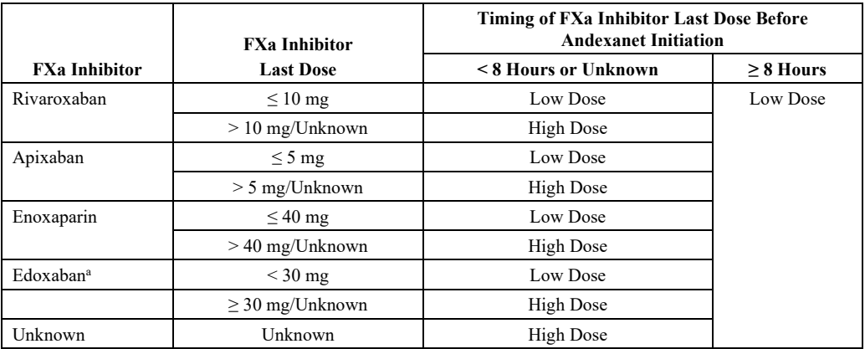  
Note: Low dose = 400 mg bolus plus 4 mg/min continuous infusion for 120 minutes; High dose = 800 mg bolus plus 8 mg/min continuous infusion for 120 minutes.

a Most patients on edoxaban were enrolled under pre-protocol amendment 6 conditions. The edoxaban criteria were changed in protocol amendment 6 to accommodate differences in Japanese PK of edoxaban.

The two co-primary efficacy endpoints were:

* percent change in anti-FXa activity from Baseline to the on-treatment nadir.
* achievement of haemostatic efficacy of stopping an ongoing major bleed at 12 hours from the end of the infusion rated by the independent endpoint adjudication committee (EAC) as excellent or good.

Haemostatic efficacy was determined by the EAC based on pre-defined criteria (Table 14). The EAC was blinded to anti-FXa activity levels. In addition, the central imaging laboratory that interpreted the brain computed tomography/magnetic resonance imaging images in patients with ICH was blinded to anti-FXa activity and clinical outcome for each patient.

Table 14: Study 14-505 rating system for effective haemostasis

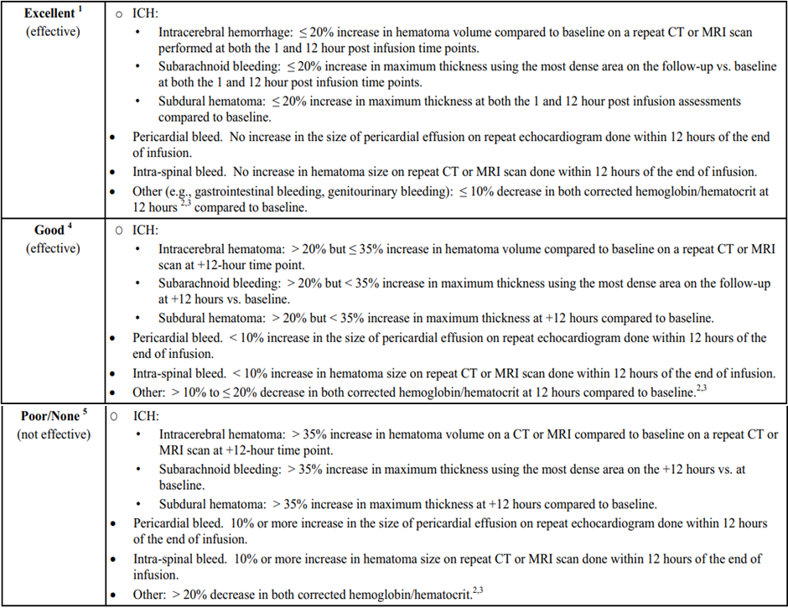

1 For all types of bleeding: no additional plasma, blood products (whole blood products not including packed red blood cells (PRBCs)) and/or coagulation factor products required after initial treatment with andexanet alfa.

2 The smallest percentage decrease in haemoglobin or haematocrit should be used to determine the efficacy rating of excellent, good, or poor/none. The net change is defined as the difference between the corrected haemoglobin or haematocrit value at Baseline and 12 hours after infusion.

3 For the adjusted haemoglobin and haematocrit calculation, it will be assumed that for each unit of PRBC transfusion there is an increase of 1 g/dL in haemoglobin and a 3% increase in haematocrit.

4 For all types of bleeding, no more than two additional units of plasma or blood products and/or coagulation factor products required after initial treatment with andexanet alfa. ‘Blood products’ include whole blood but not PRBCs.

5 For all types of bleeding, more than two additional units of plasma or blood products and/or coagulation factor products required after initial treatment with andexanet alfa. ‘Blood products’ include whole blood but not PRBCs.

The first co-primary efficacy endpoint, change in anti-FXa activity from Baseline to on-treatment nadir, was to be considered to be met if the 95% confidence interval (CI) for the median excluded zero. The second co-primary efficacy endpoint, haemostatic efficacy rated by the EAC as excellent or good, was to be considered to be met if the proportion of patients with excellent or good haemostasis was statistically significantly higher than 50% (p < 0.05).

The sample size of the study was based on the second co-primary efficacy variable, the rate of effective haemostasis. The study sample size was originally set to 250 patients but was expanded to 350 with the implementation of protocol amendment 4 requiring enrolment of at least 110 evaluable ICH patients to more comprehensively capture clinical outcomes in this high-risk patient population. The study sample size was subsequently increased to 500 patients with protocol amendment 6 to accommodate enrolment of more edoxaban and enoxaparin patients, as well as patients of Japanese descent.

A total 477 patients were enrolled and received andexanet alfa (safety population), 392 (82.2%) patients completed the study, 82 (17.2%) discontinued, and three were lost to follow up. The primary reason for discontinuation was death (78 patients). Of the 477 patients, 347 (73%) met the criteria[9] for inclusion in the efficacy population (Figure 16). A total 94 patients with baseline anti-FXa activity below pre-specified levels (derived from published literature) were excluded from the efficacy population.

Figure 16: Study 14-505 study populations

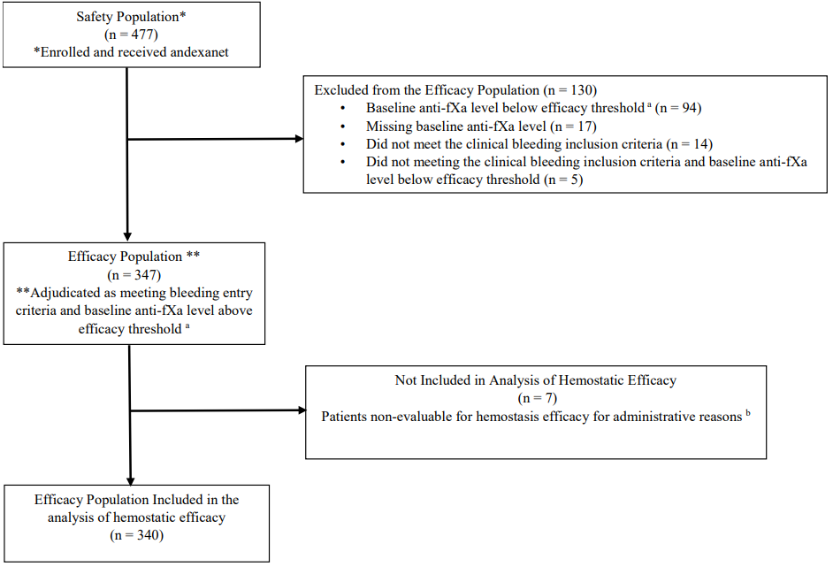  
a Efficacy threshold for baseline anti-fXa activity level less than 75 ng/mL for apixaban and rivaroxaban, less than 40 ng/mL for edoxaban, or less than 0.25 IU/mL for enoxaparin.

b Four patients had interventional procedures prior to the 12 hour assessment that affected the bleeding assessment but were not clinically driven. Two patients were missing the 12 hour assessment due to investigator oversight. One patient withdrew consent prior to the 12 hour assessment.

The high-risk ICH population included all ICH patients in the efficacy population with any of the following: for intracerebral/ intraparenchymal bleeding, volume of haematoma greater than 3 mL; for subdural bleeding, thickness of haematoma greater than 10 mm or midline shift greater than 5 mm; for subarachnoid bleeding, thickness of haematoma greater than 10 mm.

The study was conducted in patients who, because of their condition, were either hospitalised or in the emergency department (Table 15). As such, treatment with andexanet alfa and subsequent monitoring were performed in an in-patient setting. It was expected that patients with acute major bleeding would remain hospitalised for at least 12 hours, the timeframe for the primary efficacy evaluation.

Table 15: Study 14-505 details of hospitalisation, safety and efficacy population

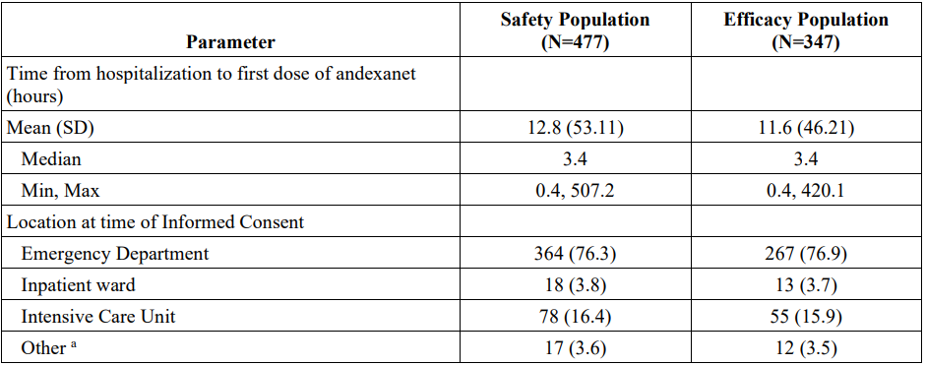

Abbreviations: CAT = computerised axial tomography, CCU = coronary care unit, EP = electrophysiology, FXa = factor Xa, Max = maximum, Min = minimum, PACU = paediatric acute care unit, SD = standard deviation.

Notes: The safety population included all patients who received any amount of andexanet alfa.

The efficacy population included all patients who received any amount of andexanet alfa, met clinical bleeding criteria, and had an anti-fXa level of 75 ng/mL or greater for patients receiving apixaban and rivaroxaban, 40 ng/mL or greater for edoxaban, or 0.25 IU/mL or greater for enoxaparin.

a Other included patients admitted in neurology service, outpatient procedure EP laboratory/PACU then to CCU, intensive coronary care unit, stroke unit, CT scan neuroradiology, and other hospital.

In the efficacy population, the median age was 79 years (range: 24 to 97 years), 10.1% of patients were aged under 65 years, 23.9% were aged 65 to 75 years and 66% were aged over 75 years. A total 53% of patients were male, 47% female. The majority of the population were White (86.5%), with Black or African American and other racial groups comprising 6.1% and 5.8% of the patient population, respectively. Prior medical history included atrial fibrillation (82.6%), hypertension (81.1%), stroke (22.6%), venous thrombosis (22.4%), congestive heart failure (19.7%), and myocardial infarction (12.4%). The baseline demographics and patient characteristics in the safety population were generally comparable with those in efficacy population. A summary of the safety population by FXa inhibitor and bleed type is shown in Table 16.

Table 16: Study 14-505 summary of patients enrolled by FXa inhibitor and bleed type, safety population

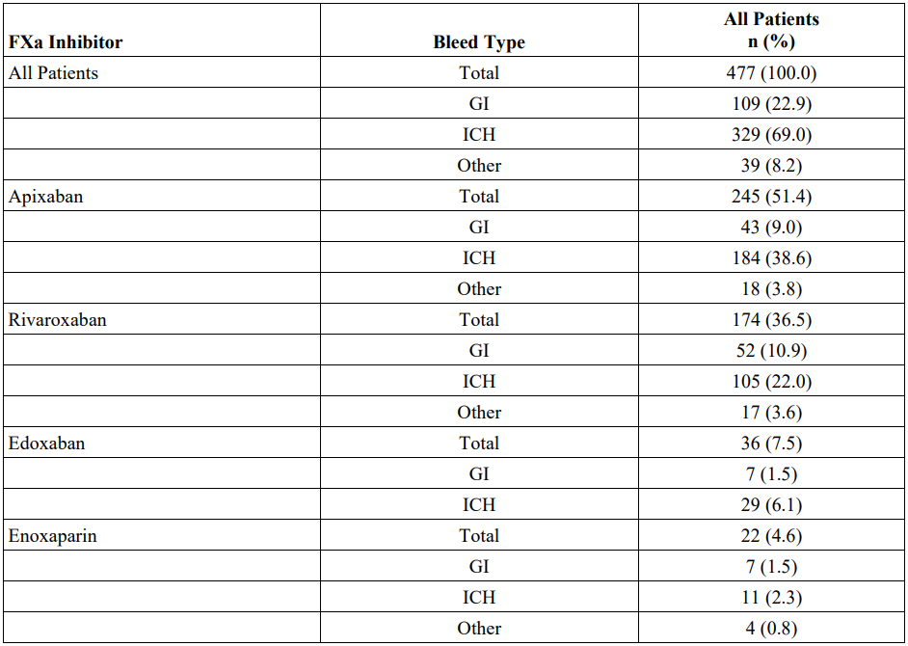  
Abbreviations: GI = gastrointestinal, ICH = intracranial haemorrhage (includes intracerebral, subdural and subarachnoid).

Notes: The safety population includes all patients who received any amount of andexanet alfa. Bleed type was adjudicated by the endpoint adjudication committee.

In the efficacy population, the majority of patients had received apixaban (49.6%) or rivaroxaban (37.5%), while 8.1% had received edoxaban and 4.9% had received enoxaparin. The majority of bleed types in the efficacy population were ICH (71.2%), followed by gastrointestinal (GI) (22.5%), and other (6.3%). Of the 329 patients in the safety population with ICH, the majority of patients (64.4%) were determined by central imaging to have had an intraparenchymal haemorrhage as the primary site of haemorrhage, 25.5% patients had a subdural haematoma, and 10% patients had a subarachnoid haemorrhage.

The median time from last dose of apixaban in 240 patients was 11.6 hours (range: 2.83 to 27.28 hours), and the median time from last dose of rivaroxaban in 166 patients was 11.54 hours (range: 2.62 to 33.42 hours). For patients with ICH, the time from scan to treatment was documented in 95.4% (314 out of 329) of patients in the safety population and 95.5% (236 out of 247) of patients in the efficacy population. The median time from scan to andexanet alfa treatment was 1.70 hours in both the safety population and efficacy population, and range was -0.10 to 9.70 hours in the safety population and 0.20 to 9.70 hours in the efficacy population.

The study met both of the co-primary efficacy endpoints:

* Treatment with andexanet alfa led to a median percent change in anti-FXa activity from Baseline to nadir of -93.3% (95% CI: -94.2, -92.5) in patients on apixaban and -94.1% (95% CI -95.1, -93.0) in patients on rivaroxaban (Table 17).
* For efficacy evaluable patients 80% (exact 95% CI: 75.3, 84.1) had excellent or good haemostasis as adjudicated by the EAC (Figure 17). The lower bound of the exact 95% CI was greater than 50%, supporting rejection of the null hypothesis.

Table 17: Study 14-505 summary for anti-FXa activity by FXa inhibitor, efficacy population

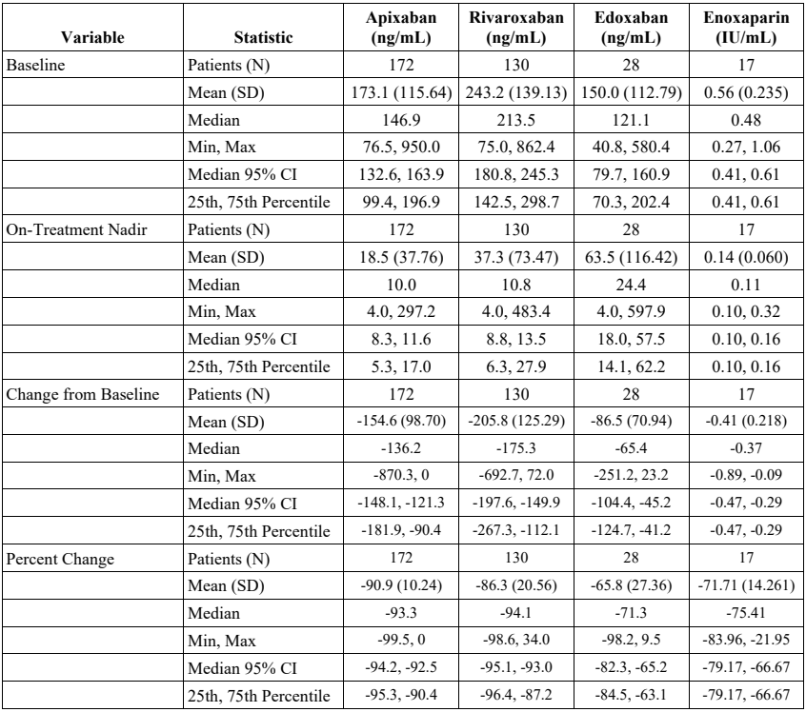

Figure 17: Study 14-505 haemostatic efficacy (excellent/good) at 12 hours post‑andexanet alfa, overall and by subgroup, efficacy population

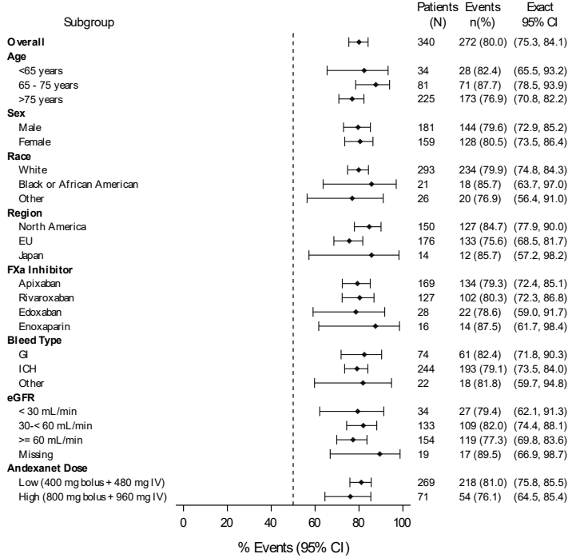  
Notes: The efficacy population includes all patients who received any amount of andexanet alfa, met clinical bleeding criteria, and had an anti-FXa level of 75 ng/mL or greater for apixaban and rivaroxaban, 40 ng/mL or greater for edoxaban, and 0.25 IU/mL or greater for enoxaparin. Bleed type was adjudicated by the EAC. Patients adjudicated as non-evaluable for clinical reasons were included in the efficacy population and were considered as having poor/none haemostatic efficacy. Patients adjudicated as non-evaluable for administrative reasons were excluded.

In the apixaban and rivaroxaban groups, the median percent decrease in anti-FXa activity from Baseline was similar across the three bleed types of GI, ICH, and other (91.5%, 93.7% and 93%, respectively for apixaban; 94.1%, 94.7%, and 89.1%, respectively for rivaroxaban). High baseline anti-FXa activity levels were defined as greater than 150 ng/mL for apixaban and greater than 300 ng/mL for patients on rivaroxaban. Of the 83 patients in the apixaban group with high baseline anti-FXa activity, the median percent decrease from Baseline was 92.3%. Of the 31 patients in the rivaroxaban group with high baseline anti-FXa activity, the median percent decrease from Baseline was 95.5%. In the 463 patients in the safety population with data from the time of the last dose to FXa inhibitor to start of andexanet alfa treatment, the median time was 11.42 hours and the range was 2.62 to 33.42 hours. There were 24 (5%) patients with time from the last dose of FXa inhibitor to start of andexanet alfa treatment greater than 18 hours, 10 of whom started andexanet alfa within 19 hours of the last dose of FXa inhibitor. Among the 13 patients included in the efficacy population, 10 (76.9%) had effective haemostasis and nine (69.2%) had a decrease in anti-FXa activity greater than 90% (median 92.8%).

Figure 18: Study 14-505 time-course of anti-FXa activity in patients taking apixaban (left panel) or rivaroxaban (right panel), efficacy population

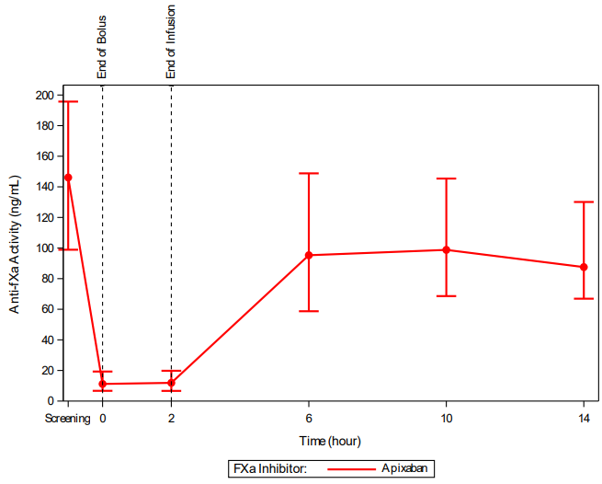 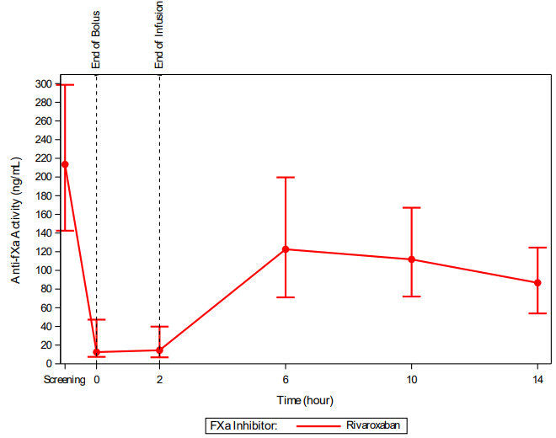

There was no secondary efficacy endpoint in this study. The secondary objective of the study was to assess the relationship between the change in anti-FXa activity and achievement of haemostatic efficacy. To analyse this relationship, several measures of anti-FXa activity (for example. baseline, nadir, absolute and percent change from Baseline) were evaluated in relationship to haemostatic efficacy. The relationship between anti-FXa level and haemostatic efficacy was then modelled using logistic regression. For apixaban and rivaroxaban, median anti‑FXa activity levels were numerically lower at Baseline and on-treatment nadir for patients who had excellent/good haemostatic efficacy compared to those with poor/none (Table 18).

Table 18: Study 14-505 anti-FXa activity by haemostatic efficacy, efficacy population

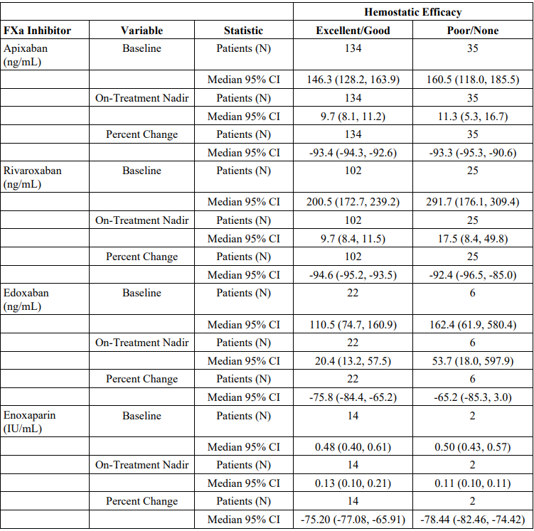

The odds of patients with excellent/good haemostatic efficacy to have achieved reduction of the anti-FXa level to below the clinical threshold were statistically significantly greater than the odds of patients with poor/none haemostatic efficacy (odds ratio = 1.85 (95% CI: 1.01, 3.39), p = 0.046); however, the predictive value of the anti-FXa level to determine haemostatic efficacy was only minimally greater than chance (area under the receiver operating characteristic = 0.56, p = 0.051, Table 19). Consequently, the modelling did not demonstrate a predictive relationship between anti-FXa activity and haemostatic efficacy. The sponsor commented that the design of the study decreased the likelihood that a relationship would be detected due to the low number of patients with both inadequate anti-FXa reversal and poor/none haemostatic efficacy. The sponsor also commented that it is possible that one or more confounding factors, such as wound anatomy/flow, anti-platelet agents, high baseline anti‑FXa activity, and the different methods of assessment of haemostatic efficacy across bleed types, introduced variability into the analysis.

Table 19: Study 14-505 summary of relationship results of haemostatic efficacy (poor/none haemostatic efficacy), efficacy population

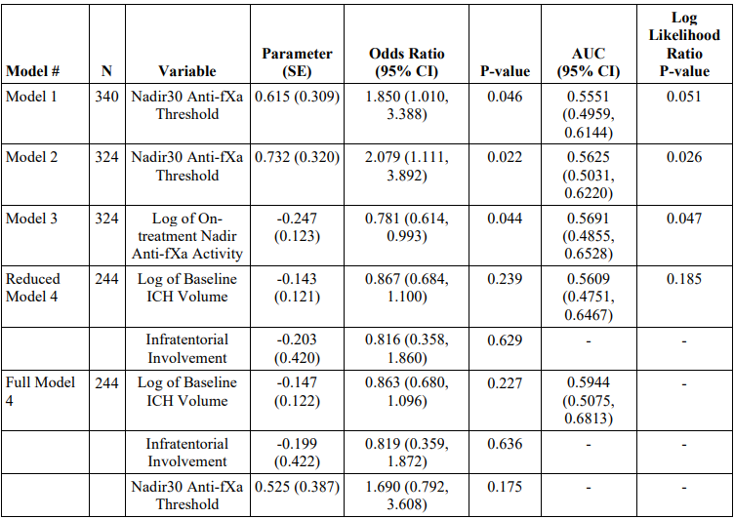  
Abbreviations: AUROC = area under the receiver operating characteristic curve, CI = confidence interval, FXa = factor Xa, GI = gastrointestinal, ICH = intracranial hemorrhage, SE = standard error.

Notes: The efficacy population includes all patients who received any amount of andexanet alfa, met clinical bleeding criteria, and had a Baseline anti-FXa level of 75 ng/mL or greater for apixaban and rivaroxaban, 40 ng/mL or greater for edoxaban, and 0.25 IU/mL or greater for enoxaparin. P-value and 95% confidence interval were computed for the primary endpoint (excellent/good verses poor/none haemostatic efficacy) using a logistic regression. Bleed type was adjudicated by the endpoint adjudication committee. Reference group of Nadir30 Anti-FXa Activity is on-treatment nadir anti-FXa activity greater than 30. Reference group of infratentorial involvement is no baseline infratentorial involvement.

Model 1: excludes patients with haemostatic efficacy not evaluable due to administrative reasons. Model 2: excludes patients with haemostatic efficacy not evaluable due to administrative reasons; excludes enoxaparin patients. Model 3: excludes patients with haemostatic efficacy not evaluable due to administrative reasons; excludes enoxaparin patients. Model 4: excludes patients with haemostatic efficacy not evaluable due to administrative reasons; excludes non-ICH patients (that is, GI and other bleeds).

Additional PD measures and clinical outcomes were assessed as exploratory efficacy outcomes. In patients with ICH in the efficacy population, there were no clinically meaningful changes in either the Glasgow Coma Scale or the National Institutes of Health Stroke Scale from Baseline to 1 hour or 12 hours after andexanet alfa treatment. The number and percentage of patients with ICH with modified Rankin Score 0 to 2 were 79 (32.2%) at Baseline, 33 (22.6%) at 1 hour after andexanet alfa, 34 (23.4) at 12 hours after andexanet alfa, and 78 (35.9) at Day 30. For patients with ICH 64.1% (139 out of 217) had modified Rankin Score 3 or greater at Day 30 evaluation, indicating a poor functional outcome.

Rebleeding within 24 hours of andexanet alfa treatment after achieving initial good/excellent haemostasis was included as an exploratory efficacy endpoint in protocol amendment 4. Of the 264 patients in the safety population enrolled after the implementation of protocol amendment 4, six patients with ICH were reported by the investigator to have experienced rebleeding. One patient was re-dosed for planned surgery. Per the protocol, all rebleeding events were subject to review by the EAC, and only one event in a patient receiving apixaban was confirmed as a true rebleeding episode.

#### Safety

Clinical studies contributing safety data include four Phase I studies in healthy subjects (Studies 11-501, 14-506, 16-512 and 19-514), three Phase II studies in healthy subject (Studies 12‑502, 15-507 and 16-508), two Phase III studies in healthy subjects (Studies 14-503 and 14‑504), and one Phase IIIb/IV study in patients with acute major bleeding (Study 14‑505). Overall, approximately 1,000 subjects were treated with andexanet alfa in the 10 studies (Table 20).

Table 20: Andexanet alfa clinical studies contributing safety data

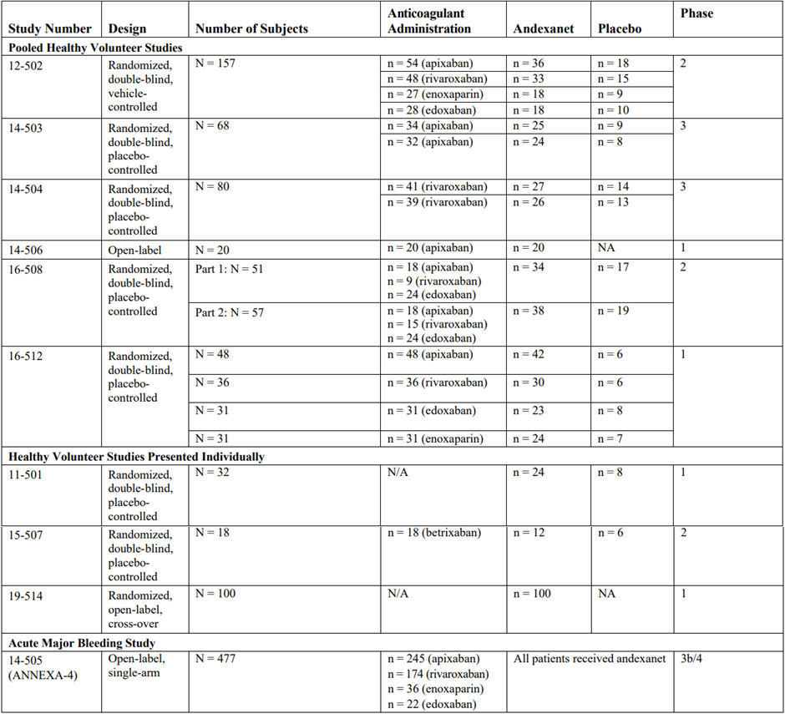

Safety data were presented for three different populations:

* Healthy volunteer studies (pooled safety analysis population): Pooled safety data from Studies 12-502, 14-503, 14-504, 14-506, 16-508 and 16-512 was presented as they were all conducted in healthy subjects who received a FXa inhibitor and the comparator was placebo. Of the 417 subjects treated with andexanet alfa, 143 subjects received bolus dose only (30 subjects 90 or 210 mg; 62 subjects 400 to 420 mg; 51 subjects 600 to 800 mg) and 274 subjects received bolus dose plus infusion (146 subjects 400 out of 420 mg bolus plus infusion; 128 subjects 720 out of 800 mg bolus plus infusion).
* Healthy volunteer studies presented individually: The Phase I Studies 11-501 and 19-514 involved subjects who did not receive a FXa inhibitor, and the Phase II Study 15-507 involved patients who received the FXa inhibitor betrixaban, so these studies were presented individually.
* Patients with acute major bleeding (Study 14-505): The safety population comprised 477 patients treated with andexanet alfa who had acute major bleeding while taking a FXa inhibitor (apixaban, rivaroxaban, edoxaban, or enoxaparin), of whom 381 (79.9%) received low-dose andexanet alfa (that is, 400 mg bolus plus 4 mg/min infusion for 120 minutes) and 96 (20.1%) received high-dose andexanet alfa (that is, 800 mg bolus plus 8 mg/min infusion for 120 minutes). The safety evaluation period for Study 14-505 was 30 days. Four patients (all with ICH) were re-dosed with andexanet alfa, three due to investigator reported ICH and one due to an unplanned surgery. A subset analysis of 419 patients anticoagulated with apixaban (n = 245) or rivaroxaban (n = 174) was also presented.

Compared to the pooled safety analysis population, the population in Study 14-505 was older, had more medical comorbidities, including a requirement for anticoagulation, and had acute major bleeding. In the safety population of Study 14-505, prior medical history included atrial fibrillation (82.6%), hypertension (81.1%), stroke (22.6%), venous thrombosis (22.4%), congestive heart failure (19.7%), and myocardial infarction (12.4%).

##### Study 14-505

Study 14-505 was a Phase IIIb/IV open label, single arm study in patients with major bleeding. An overview of treatment-emergent adverse events (TEAEs) in Study 14-505 is presented in Table 21. A total of 1,045 TEAEs were experienced by 346 (72.5%) of the 477 patients in the safety population. The most common TEAEs (10% or more of subjects) by preferred term (PT) are shown in Table 22. The majority of TEAEs were mild or moderate in severity. Overall, there were 468 mild TEAEs in 189 patients, 308 moderate TEAEs in 165 patients, 123 severe TEAEs in 79 patients, 65 life threatening TEAEs in 45 patients, and 81 fatal TEAEs. Severe TEAEs reported in four or more patients were pneumonia in six (1.3%) patients, pulmonary embolism in five (1%) patients, and cerebral infarction, ischaemic stroke, congestive cardiac failure, and hypotension each in four (0.8%) patients. Life threatening TEAEs reported in three or more patients were pneumonia in six (1.3%) patients, intracranial haemorrhage and acute respiratory failure each in four (0.8%) patients, and pulmonary embolism, respiratory failure, acute myocardial infarction, and subdural haematoma each in three (0.6%) patients.

Treatment related TEAEs were reported in 57 (11.9%) patients. Treatment related TEAEs reported in two or more patients were ischaemic stroke in seven (1.5%) patients, headache in five (1%) patients, cerebrovascular accident, myocardial infarction, pyrexia, and pulmonary embolism each in four (0.8%) patients, cerebral infarction, embolic stroke, atrial thrombosis, deep vein thrombosis and nausea each in three (0.6%) patients, and cerebral ischaemia, acute myocardial infarction, bradycardia, jugular vein thrombosis, hepatic function abnormal, and infusion-related reaction each in two (0.4%) patients.

Four patients (0.8%) experienced TEAEs leading to discontinuation of andexanet alfa:

* One received andexanet alfa for an apixaban related GI bleed and experienced a fatal adverse event of cardiac arrest following the completion of the andexanet alfa bolus.
* One received andexanet alfa for an apixaban related GI bleed and experienced a serious adverse event of cerebrovascular accident.
* One received andexanet alfa for an apixaban related ICH and experienced a serious adverse event of acute myocardial infarction.
* One received andexanet alfa for an apixaban related GI bleed and experienced an infusion related reaction consisting of rigors, severe chills, hypertension, oxygen desaturation, fever, agitation, and confusion beginning 75 minutes after starting treatment and resolving 80 minutes later.

Serious adverse events by preferred term reported in 1% or more of patients were: pneumonia (20 patients (4.2%)); respiratory failure (12 patients (2.5%)); ischaemic stroke (10 patients (2.1%)); cerebrovascular accident, pneumonia aspiration, pulmonary embolism and subdural haematoma (eight patients each (1.7%)); intracranial haemorrhage and sepsis (seven patients each (1.5%)); cardiac failure (six patients (1.3%)); cerebral haemorrhage, cerebral infarction, seizure, acute myocardial infarction, myocardial infarction, deep vein thrombosis and multi‑organ failure (five patients each (1%)). Fatal TEAEs are summarised in Table 23. In an analysis of haemostatic efficacy and 30 day mortality, patients who had poor/none haemostatic efficacy were twice as likely to die by Day 30 as patients who had excellent/good haemostatic efficacy.

Table 21: Study 14-505 overview of treatment-emergent adverse events

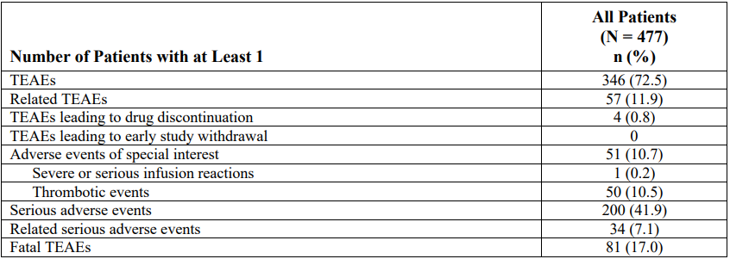  
Notes: Thrombotic event was adjudicated by the endpoint adjudication committee.

Table 22: Study 14-505 most common treatment-emergent adverse event (3% or more of subjects) by preferred term

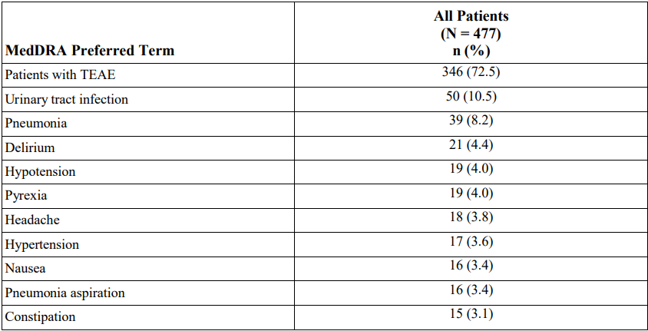

Table 23: Study 14-505 adjudicated reason of death, safety population

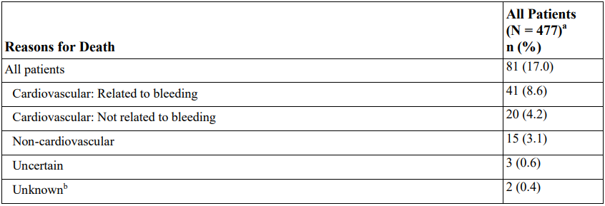  
a Survival status on six patients was not able to be determined (four patients were lost to follow-up, one early withdrawal before Day 30, and one withdrawal of consent at hour 12). These patients were included in the analysis and considered to be still alive.

b Patients were not adjudicated.

###### Adverse events of special interest

Adverse events of special interest (AESIs) in Study 14-505 were defined as either a thrombotic event or embolic event of any severity, or a severe or serious infusion reaction. Thromboembolic events were included as AESIs because it was expected that patients meeting the eligibility criteria for the study would have a high baseline thrombotic risk, due to their background medical conditions, discontinuation of anticoagulation therapy, and the presence of acute major bleeding. Potential thromboembolic events (for example, deep vein thrombosis, myocardial infarction, pulmonary embolism, cerebrovascular accident, transient ischemic attack, systemic atrial embolism) reported by investigators were reviewed by an independent EAC using pre‑specified definitions.

Two patients (0.4%) in the safety population had an infusion related reaction, with the event being considered an AESI in one of the two patients.

In the safety population 50 (10.5%) patients experienced confirmed thromboembolic events between the start of andexanet alfa treatment and the Day 30 visit (

Table 24). Overall, cerebrovascular accidents and deep vein thrombosis were the most commonly reported thromboembolic events, both in the overall safety population (4.6% (22 out of 477) and 2.5% (12 out of 477), respectively), and in the subgroup of patients with ICH (5.8% (19 out of 329) and 3% (10 out of 329), respectively). The thromboembolic event rate was broadly consistent across bleed types and FXa inhibitors, though the analysis was limited by small numbers of thromboembolic events in certain subgroups. A total three (12.5%) of 24 patients treated with andexanet alfa greater than 18 hours after the last dose of FXa inhibitor had adjudicated thrombotic events.

Anticoagulant and antiplatelet drugs were stopped from the signing of informed consent until after the 12 hour haemostatic efficacy evaluation. Subsequently, investigators were able to restart anticoagulation or antiplatelet agents with any agent at any time based on clinical judgment. Of the 477 patients who received andexanet alfa, 326 received at least one anticoagulation dose within 30 days of treatment. Of these 326 patients, 18 received anticoagulation in response to a thromboembolic event, and 308 received anticoagulation as a prophylactic prior to any thromboembolic event. Of the 308 patients receiving anticoagulation as a prophylactic, 15 (4.9%) had an adjudicated thromboembolic event after resumption of anticoagulation, and of the 169 patients not receiving anticoagulation as a prophylactic, 35 (20.7%) had an adjudicated thromboembolic event.

###### Sub-analysis in patients receiving apixaban or rivaroxaban

Of the 477 patients in the safety population, 419 (88%) subjects were included in the combined apixaban plus rivaroxaban population. Overall, the safety profile of patients with major bleeds associated with apixaban and rivaroxaban treated with andexanet alfa was similar to the safety profile in the overall safety population.

Table 24: Study 14-505 thromboembolic events stratified by type of event, safety population

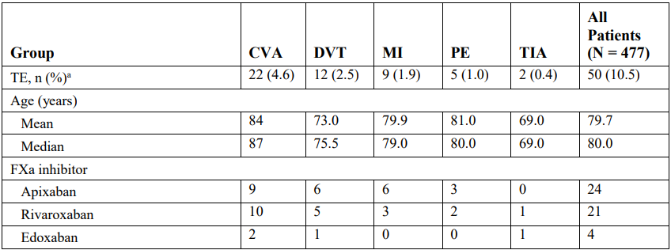  
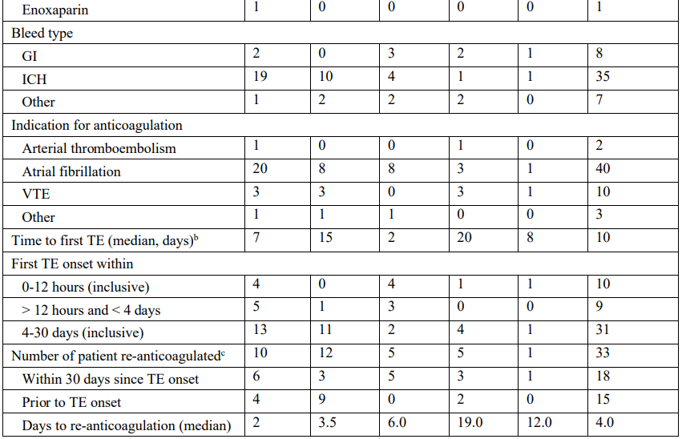 Abbreviations: CVA = stroke ischemic/uncertain classification, DVT = deep vein thromboembolism, FXa = factor Xa, GI = gastrointestinal, ICH = intracranial haemorrhage, MI = myocardial infarction, PE = pulmonary embolism, TE = thrombotic event, TIA = transient ischemic attack, VTE = venous thromboembolism.

Note: The safety population includes all patients who received any amount of andexanet alfa.

a The first occurring TE type is summarised if a patient had multiple TE types. Thrombotic event and bleed type were adjudicated by the endpoint adjudication committee.

b Time to first TE is inclusive of the dosing day.

c A patient could have multiple indications for the initial anti-coagulation.

Hepatobiliary disorders (system organ class (SOC)) were reported in eight (1.7%) patients (nine events) in Study 14-505. These events were predominantly mild or moderate in severity. There was one (0.2%) life threatening hepatobiliary disorder (TEAE of ischaemic hepatitis), which was also the only treatment-emergent serious adverse event disorder. No fatal hepatobiliary disorders were reported.

Renal and urinary disorders (SOC) were reported in 46 (9.6%) patients (48 events) in Study 14‑505. These events were predominantly mild or moderate in severity, with severe events being reported in four (0.8%) patients. Life threatening renal and urinary disorders were report in one (0.2%) patient (TEAE of acute kidney injury).

Blood and lymphatic disorders (SOC) were reported in 20 (4.2%) patients (26 events) in Study 14-505. These events were predominantly mild or moderate in severity, with severe events being reported in three (0.6%) patients. Life threatening blood and lymphatic disorders were reported in one (0.2%) patient (TEAE of heparin induced thrombocytopaenia). No fatal blood and lymphatic disorders were reported.

Cardiac disorders (SOC) were reported in 69 (14.5%) patients (85 events) in Study 14-505. Mild, moderate, or severe cardiac disorders were reported in 22 (4.6%), 20 (4.2%) and 14 (2.9%) patients, respectively. Life threatening cardiac disorders were reported in eight (1.7%) patients. Serious adverse events classified as cardiac disorders were reported in 36 (7.5%) patients: cardiac failure in six (1.3%) patients; acute myocardial infarction and myocardial infarction each in five (1%) patients; cardiogenic shock in four (0.8%) patients; atrial fibrillation, cardiac arrest, congestive cardiac failure, and right ventricular failure each in three (0.6%) patients; atrial thrombosis, bradycardia, and myocardial ischemia each in two (0.4%) patients; and atrial flutter, atrioventricular block, atrioventricular block complete, cardiac ventricular thrombosis, cardio-respiratory arrest, coronary artery disease, and sinus node dysfunction each in one (0.2%) patient. Fatal cardiac disorders were reported in 16 (3.4%) patients. Fatal TEAEs (PT) were: cardiac failure in six (1.3%) patients; cardiac arrest and cardiogenic shock each in three (0.6%) patients; and atrial fibrillation, congestive cardiac failure, myocardial infarction, and right ventricular failure each in one (0.2%) patient. The effect of andexanet alfa on electrocardiogram parameters was not evaluated in Study 14-505.

Vascular disorders (SOC) were reported in 77 (16.1%) patients (93 events) in Study 14-505. Mild, moderate, or severe vascular disorders were reported in 38 (8%), 27 (5.7%) and nine (1.9%) patients, respectively. Life threatening vascular disorders were reported in three (0.6%) patients. Treatment-emergent serious adverse events (PT) classified as vascular disorders were reported in 17 (3.6%) patients: deep vein thrombosis in five (1%) patients; hypotension in four (0.8) patients; arteriosclerosis and hypertension each in two (0.4%) patients; and aorto‑duodenal fistula, haematoma, haemorrhage, iliac artery occlusion, and haemorrhagic shock each in one (0.2%) patient. Fatal vascular disorders were reported in three (0.6) patients: arteriosclerosis in two (0.4) patients; and haemorrhagic shock in one (0.2) patient.

Nervous system disorders (SOC) were reported in 111 (23.3%) patients (144 events) in Study 14-505. Mild, moderate, or severe nervous system disorders were reported in 39 (8.2%), 33 (6.9%), and 23 (4.8%) patients, respectively. Life threatening nervous system disorders were reported in 14 (2.9%) patients. Serious adverse events classified as nervous system disorders were reported in 66 (13.8%) patients. Serious adverse events (PT) reported in 2 or more were patients: ischaemic stroke in 10 (2.1%) patients; cerebrovascular accident in eight (1.7%) patients; intracranial haemorrhage in seven (1.5%) patients; cerebral haemorrhage, cerebral infarction and seizure each in five (1%) patients; neurological decompensation in four (0.8%) patients; intraventricular haemorrhage in three (0.6) patients; and brain oedema, cerebral ischemia, depressed level of consciousness, intracranial venous sinus thrombosis, syncope and transient ischaemic attack each in two (0.4%) patients. There were a number of other serious adverse events (PT) classified as nervous system disorders each reported in one patient. Fatal nervous system were reported in 21 (4.4%) patients. Overall, nervous system disorders were the most commonly reported fatal disorders by SOC, followed by cardiac disorders. Fatal nervous system disorders by TEAEs (PT) were: ischaemic stroke in five (1%) patients; cerebrovascular accident in four (0.8%) patients; cerebral haemorrhage, intracranial haemorrhage and neurological decompensation each in two (0.4%) patients; and basilar artery thrombosis, brain compression, cerebral infarction, cerebral ischaemia, cerebral ventricle dilatation and haemorrhagic stroke each in one (0.2%) patient.

In Study 14-505, 66% of patients in the safety population were aged over 75 years, 24.3% were aged 65 to 75 years, and 9.6% were aged less than 65 years. The median age of age of the safety population was 79 years (range: 24 to 97 years). In general, the incidence of TEAEs tended to increase with age. The overall trend of increasing morbidity with age is consistent with the increased frailty, burden of disease, and background risk profile of elderly patients in Study 14‑505.

Immunogenicity findings in Study 14-505 are summarised in Table 25.

Table 25: Study 14-505 antibodies to andexanet alfa, factor X, factor Xa, and host-cell protein, safety population

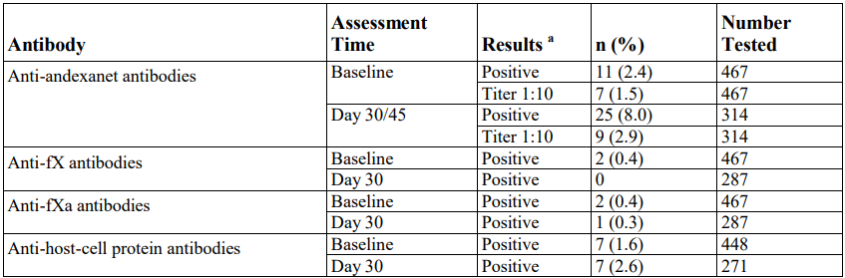  
Abbreviations: FX = factor X, FXa = factor Xa, HCP = host-cell protein, MRD = minimum required dilution.

a Positive results includes all confirmed patients. The MRD is as follows: andexanet alfa a value of 1:10; FX and FXa a value of 1:20; and HCP a value of 1:50. No neutralising activity was detected in any patient samples.

##### Pooled safety analysis population (healthy subjects)

An overview of TEAEs in the pooled safety analysis population is presented in Table 26. Treatment-emergent adverse events by SOC and PT are shown in Table 27. The frequencies of TEAEs were generally similar in the andexanet alfa and placebo groups (Table 27), except for infusion related hypersensitivity reactions which were reported more frequently with andexanet alfa (9.1%) than placebo (2.6%). Nearly all TEAEs in both pooled dose groups were mild or moderate in severity. One serious adverse event was reported (nephrolithiasis in one (0.2%) subject in the pooled andexanet alfa all doses group), which was classified as severe and unrelated to treatment with study drug or FXa inhibitor. No severe TEAEs were reported in the pooled placebo group. There were no deaths in any of the healthy volunteer studies.

###### Adverse events of special interest

The definition of adverse events of special interest (AESI) varied between studies in the pooled safety analysis population but generally included venous thromboembolic events of any severity, moderate or severe infusion reactions, and significant liver enzyme abnormalities. In the pooled andexanet alfa analysis, four subjects had eight AESIs and one subject in the pooled placebo analysis set had one AESI. All nine AESIs were non serious, moderate, infusion related reactions that occurred within the first hour of infusion and were considered by the investigator as possibly or probably related to study drug. No thrombotic events were reported in the pooled safety analysis population.

###### Investigations and laboratory parameters

There were no trends or clinical safety concerns related to electrocardiogram findings, haematology, clinical chemistry, urinalysis, in healthy subjects.

###### Immunogenicity

In the pooled safety analysis population, anti-andexanet alfa antibodies were detected in 1.7% of samples pre-dose, 3.4% of samples post-dose from Day 12 to 20, 4.5% of samples post-dose from Day 28 to 36, and 6.4% of samples post-dose from Day 43 to 48. Anti-FX antibodies were not detected. Anti-FXa antibodies were detected in 0.9% (5 out of 573) of samples pre-dose, 1.1% of samples post-dose from Day 12 to 20, 0.9% of samples post-dose from Day 28 to 36, and 0% (0 out of 329) of samples post-dose from Day 43 to 48. Neutralising antibodies were not detected using the modified Bethesda assay.

Table 26: Overview of treatment-emergent adverse events, pooled safety analysis

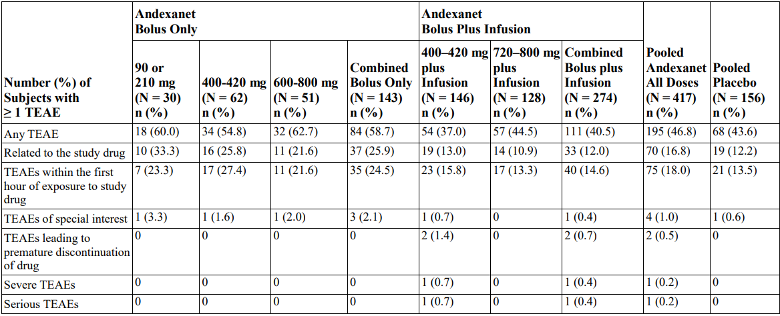  
Abbreviation: TEAE = treatment-emergent adverse event

Table 27: Most common treatment-emergent adverse events (5% of subjects or greater in any group) by system organ class and preferred term, pooled safety analysis

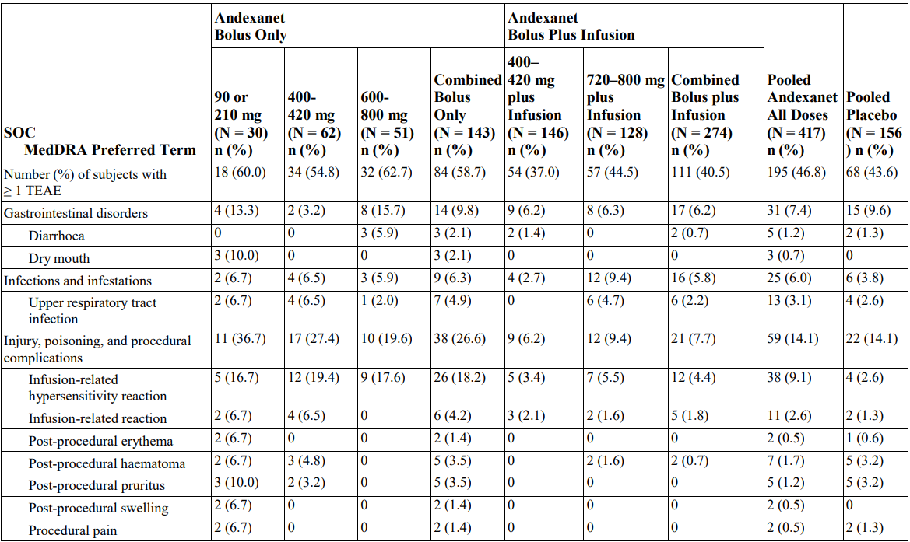  
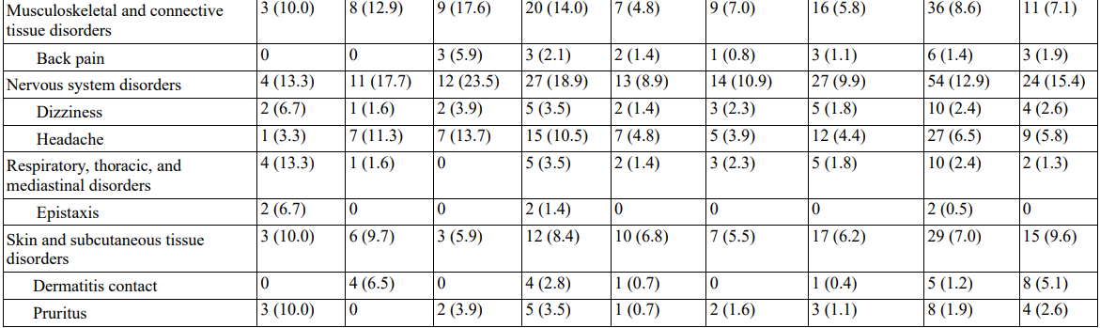  
Abbreviations: MedDRA = Medical Dictionary for Regulatory Activities, SOC = System Organ Class, TEAE = treatment-emergent adverse event.

###### Post-marketing experience

Andexanet alfa received marketing approval in the USA on 3 May 2018, and in the EU on 26 April 2019. The submission included a summary of cumulative post-marketing data as of 25 April 2021. Cumulatively, it was estimated that 12,513 patients had received marketed andexanet alfa, mostly in the USA (10,927 patients). The safety profile reported in post-market use has been similar to the safety profile in the clinical development program.

#### Other

Real world data presented in this submission includes post-marketing safety data.

### Risk management plan

The initial application included European Union (EU) risk management plan (RMP) version 2.5 (date 20 April 2022; data lock point (DLP) 19 April 2022) and Australia specific annex (ASA) version 1 succession 1 (date 16 May 2022) in support of this application. EU-RMP version 3.0 succession 2.0 (date 7 November 2022; DLP 30 June 2022) and ASA version 1.0 succession 2 (date 19 January 2023) were subsequently submitted with the sponsors response to TGA questions. The summary of safety concerns (Table 28) in the ASA aligns with the EU-RMP and is acceptable. Additional pharmacovigilance is proposed for the important identified risk of thrombotic events, the important potential risks of antibody formation and rebleeding, and the missing information use in children.

Table 28: Summary of safety concerns

|  |  |  |  |  |  |
| --- | --- | --- | --- | --- | --- |
| Summary of safety concerns | | Pharmacovigilance | | Risk Minimisation | |
| **Routine** | **Additional** | **Routine** | **Additional** |
| **Important identified risks** | Thrombotic events | ✓ | ✓* | ✓ | – |
| **Important potential risks** | Antibody formation | ✓ | ✓* | ✓† | – |
| Medication error | ✓ | – | ✓ | – |
| Off-label use in patients treated with anticoagulants other than as indicated | ✓ | – | ✓ | – |
| Re-bleeding | ✓ | ✓* | ✓ | – |
| **Missing information** | Use in patients who receive (pre-treatment) vitamin K antagonist, prothrombin complex concentrates products, recombinant FVIIa, whole blood or plasma fractions; or planned administration of these products within 12 hours of andexanet alfa treatment | ✓ | – | ✓ | – |
| Use in pregnant or lactating patients | ✓ | – | ✓ | – |
| Use in children | ✓ | ✓‡ | ✓ | – |

* ANNEXA-I 18-513

† EU only

‡ Paediatric study - Planned

The ASA details the clinical study plan for provisional registration (Table 29). The planned confirmatory study is Study 18-513, an ongoing, randomised, multicentre clinical trial designed to determine the efficacy and safety of andexanet alfa compared to usual care in patients presenting with acute intracranial haemorrhage within 12 hours of symptom onset (from the baseline scan) and within 15 hours (from randomisation) of taking an oral FXa inhibitor (apixaban, rivaroxaban, or edoxaban). The study will use a prospective, randomised, open label design, as it is unfeasible to blind the investigator to the treatment assignment given the many potential therapeutic options available under usual care treatment. Approximately 440 patients are planned to be enrolled in the study. The study includes three study periods:

* Screening and baseline period: less than 1 (Day 1)
* Treatment period: less than 1 (Day 1)
* Extended follow-up period (adverse events, survival, antibodies): approximately 30 days (Day 1 to the Day 30 study visit) and up to approximately 120 days (for patients with positive anti-andexanet alfa antibodies at Day 30 only).

Haemostatic efficacy is being evaluated as the primary efficacy outcome and change in anti-FXa activity is being investigated as a secondary outcome. The adjudication of haemostatic efficacy will be based on a combination of imaging and clinical findings and will be adjudicated by a blinded endpoint adjudication committee. To support the adjudication of haemostatic efficacy, a blinded imaging core laboratory will review all available scans. If a patient has an increase in haematoma volume or thickness (depending on subtype of ICH) greater than 35% from Baseline at any time between the end of initial randomised treatment and 12 hours post randomisation, they will be considered to have poor/none haemostatic efficacy. Additionally, if a worsening from Baseline in National Institutes of Health Stroke Scale score of seven or more is observed at 12 hours, a patient will be considered to have poor/none haemostatic efficacy. The study will be analysed on an intent to treat basis with no threshold Baseline anti-FXa activity criterion for efficacy analysis.

Table 29: Provisional registration clinical study plan

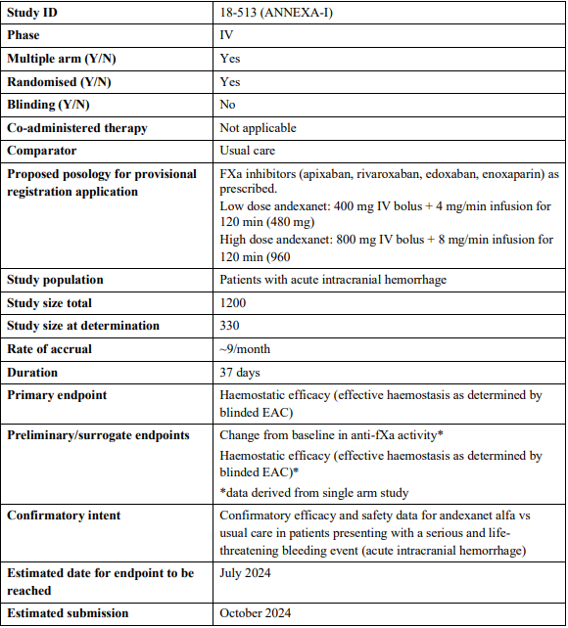

#### Risk management plan recommendations regarding conditions of registration

* The Andexxa EU risk management plan (RMP) (version 3.0 succession 2.0 (date 7 November 2022; DLP 30 June 2022), with Australia specific annex (version 1.0 succession 2 (date 19 January 2023), included with submission PM-2022-01981-1-3, and any subsequent revisions, as agreed with the TGA will be implemented in Australia.
* An obligatory component of risk management plans is routine pharmacovigilance. Routine pharmacovigilance includes the submission of periodic safety update reports (PSURs).

Unless agreed separately between the supplier who is the recipient of the approval and the TGA, the first report must be submitted to TGA no later than 15 calendar months after the date of the approval letter. The subsequent reports must be submitted no less frequently than annually from the date of the first submitted report until the period covered by such reports is not less than three years from the date of the approval letter, or the entire period of provisional registration, whichever is longer.

The reports are to at least meet the requirements for PSURs as described in the European Medicines Agency’s Guideline on good pharmacovigilance practices (GVP) Module VII-periodic safety update report (Rev 1), Part VII.B Structures and processes. Note that submission of a PSUR does not constitute an application to vary the registration. Each report must have been prepared within ninety calendar days of the data lock point for that report.

* Andexxa (andexanet alfa) is to be included in the Black Triangle Scheme. The PI and CMI [Consumer Medicines Information] for Andexxa must include the black triangle symbol and mandatory accompanying text for five years, or the product’s entire period of provisional registration, whichever is longer.
* The sponsor must conduct studies as described in the clinical study plan in version 1.0 succession 2 (date 19 January 2023) of the Australia specific annex.

### Risk-benefit analysis

#### Delegate’s considerations

##### Pharmacology

The pharmacokinetics (PK) of andexanet alfa was evaluated in seven Phase I or Phase II studies in healthy subjects. The PK of andexanet alfa was dose proportional over the proposed dose range, and the presence of FXa inhibitors did not affect the PK of andexanet alfa. There was no clinically significant difference in the PK of andexanet alfa based on age, and the PK was comparable in healthy Japanese and Caucasian subjects.

A key focus of the clinical development program was to evaluate the dose response relationship of andexanet alfa with regard to the reversal of anticoagulation resulting from FXa inhibitors. Key studies informing the proposed andexanet alfa dosage were the Phase II PK/pharmacodynamic (PD) study in healthy subjects (Study 12-502), the Phase III Studies in healthy subjects (Study 14-503 and Study 14-504), the Phase III study in patients with major bleeding (Study 14-505), and extensive PK/PD modelling of data from studies of healthy subjects as well as patients with major bleeding.

In the Phase II dose ranging Study 12-502, administration of andexanet alfa resulted in a rapid decrease in anti-FXa activity relative to pre-dose values in patients treated to steady state with apixaban 5 mg twice a day (module 1) or rivaroxaban 20 mg once a day (module 2). The magnitude and duration of decrease in anti-FXa activity following andexanet alfa administration were dose and dose regimen dependent. The initial effect on mean anti-FXa activity was sustained (relative to placebo) when the andexanet alfa bolus dose was followed by a continuous infusion. In module 1 (apixaban), the greatest effects of andexanet alfa on anti-FXa activity (greater than 90% decrease relative to baseline) and restoration of thrombin generation (greater than 83% increase) were observed following the initial 420 mg bolus dose. These effects were sustained when the 420 mg bolus dose was followed by a 480 mg continuous infusion (4 mg/min for 2 hours). Anti-FXa activity returned to placebo levels approximately 3 hours after completion of the infusion. In module 2 (rivaroxaban), the greatest effects of andexanet alfa on anti-FXa activity (93% decrease relative to baseline) and restoration of thrombin generation (83% increase) were observed following the 800 mg bolus dose. These effects were sustained when the 800 mg bolus dose was followed by a 960 mg continuous infusion (8 mg/min for 2 hours). Anti-FXa activity returned to placebo levels approximately 2 hours after completion of the infusion.

##### Efficacy

The two Phase III efficacy studies in healthy subjects, Study 14-503 and Study 14-504, were of similar design and evaluated the ability of andexanet alfa to reverse the anticoagulant effects of apixaban and rivaroxaban, respectively, compared to placebo. Efficacy of andexanet alfa in these two studies was assessed in terms of PD outcomes, primarily reduction in anti-FXa activity. The studies were conducted in two parts, evaluating bolus dose only and bolus plus infusion. Both studies met the primary endpoint in both Part 1 (bolus only) and Part 2 (bolus plus infusion), demonstrating significant reductions in anti-FXa activity from Baseline to nadir with andexanet alfa compared to placebo. All secondary efficacy (PD) endpoints were also met in Parts 1 and 2. The bolus doses of andexanet alfa led to greater than 90% mean reduction in anti-FXa activity from Baseline to nadir within minutes of the completion of the bolus. In Part 1 of the studies, anti-FXa activity then increased over time, returning to levels observed in the placebo group approximately 2 hours post-bolus. After approximately 3 hours post-bolus, anti-FXa activity decreased at a rate similar to that of placebo (consistent with loss of anticoagulant activity related to clearance of the FXa inhibitor). In Part 2 of the studies, the effect of the bolus dose on anti-FXa activity was sustained over the duration of the infusion. Following completion of the infusion, anti-FXa activity increased over time, returning to levels observed in the placebo group approximately 2-3 hours post-infusion. Anti-FXa activity subsequently decreased at a rate similar to that of placebo. In Study 14-504, anti-FXa activity was higher in the andexanet alfa group than placebo for all time points from 3 hours post-infusion to end of study.

Study 14-505 was the only study in the submission providing data on the efficacy of andexanet alfa in patients with acute major bleeding on apixaban or rivaroxaban. This was an open label, single arm study, so there was no comparator group. The definition of major bleeding in this study was based on International Society on Thrombosis and Haemostasis (ISTH) criteria, including acute overt bleeding that is potentially life threatening, acute overt bleeding associated with fall in haemoglobin (Hb) level by 2 g/dL or greater (or Hb 8 g/dL or lower if no baseline Hb was available), and acute bleeding in a critical area or organ.

Study 14-505 met both of the coprimary efficacy endpoints: decrease in anti-FXa activity from Baseline to on-treatment nadir, and achievement of haemostatic efficacy at 12 hours post‑infusion. Treatment with andexanet alfa led to a median percent change in anti-FXa activity from Baseline to nadir of -93.3% (95% CI: -94.2, -92.5) in patients receiving apixaban and ‑94.1% (95% CI -95.1, -93) in patients receiving rivaroxaban. In both the apixaban and rivaroxaban groups there was a rapid and substantial decline in anti-FXa activity following initiation of treatment with andexanet alfa, which was sustained through to the end of the infusion. In the efficacy population, 80% (95% CI: 75.3, 84.1) of patients achieved excellent or good haemostasis at 12 hours following treatment with andexanet alfa, as adjudicated by the EAC. Subgroup analyses of haemostatic efficacy based on age, sex, race, region, FXa inhibitor, bleed type, estimated glomerular filtration rate, and andexanet alfa dose were generally consistent with the overall findings.

Both of the primary efficacy endpoints met the pre-defined success criteria; however, the lack of a control arm raises uncertainty regarding the extent to which andexanet alfa contributed to the efficacy outcomes in this study. The secondary efficacy objective was to assess the relationship between decrease in anti-FXa activity and achievement of haemostatic efficacy, but this objective was not met as the modelling analyses did not demonstrate that change in anti-FXa activity was predictive of haemostatic efficacy.

##### Safety

The evaluation of safety of andexanet alfa was based on the safety population from Study 14-505 (477 patients with acute major bleeding on a FXa inhibitor), the pooled safety analysis population from six placebo controlled studies of healthy subjects treated with a FXa inhibitor (andexanet alfa n = 417, placebo n = 156), and three healthy volunteer studies presented individually (andexanet alfa n = 136, placebo n = 14).

The safety of andexanet alfa was similar to placebo in the placebo controlled studies, other than a higher incidence of infusion related reactions with andexanet alfa compared to placebo. The placebo controlled studies were conducted in healthy subjects who did not require anticoagulation and did not have active bleeding, a population which would be expected to have a more favourable safety profile than the proposed treatment population of patients requiring reversal of anticoagulation due to life threatening or uncontrolled bleeding. The safety population in Study 14-505 more closely reflects the proposed treatment population; however, this was an open label study with no control group. No controlled safety data in the proposed treatment population were presented in this submission.

Of the 477 patients in the safety population of Study 14-505, 346 (72.5%) patients experienced a total of 1,045 TEAEs and 57 (11.9%) patients experienced a total of 75 treatment related TEAEs. Treatment-emergent adverse events leading to discontinuation of the study drug were reported in four (0.8%) patients. Serious adverse events were reported in 200 (41.9%) patients and 34 (7.1%) patients had a treatment-related serious adverse events. Adverse events of special interest (AESIs) were reported in 51 (10.7%) patients, comprising 50 (10.5%) patients with adjudicated thromboembolic events and one (0.2%) patient with a serious infusion related reaction of moderate severity. Fatal TEAEs were reported in 81 (17%) patients, mostly due to cardiovascular reasons. Deaths occurred more frequently in patients aged over 75 years (21.9%) than in patients aged 75 years or younger (7.4%), and more frequently in patients with ICH (18.2%) than in patients with GI bleeds (13.8%) or other bleeds (15.4%).

The rate of thromboembolic events was a notable safety concern in Study 14-505. The patients in this study were at high risk of cardiovascular events given their age, medical comorbidities, withdrawal of medically indicated anticoagulation, and major bleeding episode. In the absence of a control arm, there remains uncertainty regarding the extent to which treatment with andexanet alfa may have contributed to thromboembolic events, versus the extent to which the observed safety profile reflects the background risk of thromboembolic events in this high-risk population. The sponsor presented published literature describing rates of thromboembolic events and cardiovascular mortality in patients treated with FXa inhibitors who experienced major bleeding. The majority of the published studies identified by the sponsor reported thromboembolic rates of approximately 10% over follow-up periods ranging from length of initial hospitalisation to 90 days, although rates as high as 25% to 28% have been reported. The presented literature varied substantially with regard to the design of the studies, study populations, and type of bleeding events, so there are limitations in drawing conclusions regarding background thromboembolic risk and the safety of andexanet alfa from the published studies. It is anticipated that residual uncertainty regarding the risk of thromboembolic events with andexanet alfa in patients with acute major bleeding will be informed by the ongoing confirmatory Study 18-513.

##### Proposed Indication

The proposed indication has been aligned with TGA guidance for provisional registration.[10] Only one confirmatory trial is included in the clinical study plan for provisional registration, so the indication should be amended to ‘… verification and description of benefit in a confirmatory trial’.

##### Proposed Dose

The proposed dosing regimen is summarised in Table 30, Table 31, and Table 32. This dosing regimen was evaluated in Study 14-505 from protocol amendment 4 onwards.

Table 30: Dosing regimens

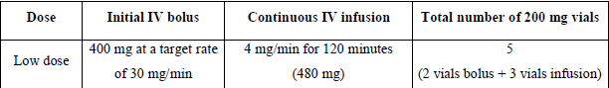  


Table 31: Summary of dosing for reversal of apixaban

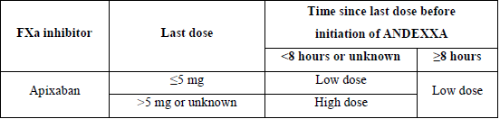

Table 32: Summary of dosing for reversal of rivaroxaban

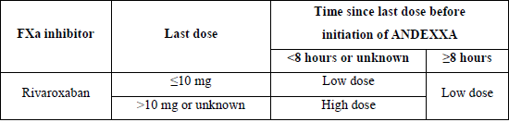

##### Uncertainties and limitations of the data

The study in patients with major bleeding, Study 14-505, was an open label, single arm study. In the absence of a control arm, there remains uncertainty regarding the extent to which andexanet alfa contributed to efficacy and safety outcomes in patients with major bleeding. The sponsor presented published literature describing rates of thromboembolic events and mortality rates in patients treated with a FXa inhibitor who experienced major bleeding, but there are limitations in comparing outcomes from other study populations. The ongoing confirmatory Study 18-513 is expected to provide controlled data informing efficacy and safety outcomes in patients with acute intracranial haemorrhage who were receiving an oral FXa inhibitor (apixaban, rivaroxaban, or edoxaban).

Evidence of efficacy of andexanet alfa is also derived from PD surrogate endpoints, primarily change in anti-FXa activity. However, Study 14-505 did not demonstrate a predictive relationship between change in anti-FXa activity and haemostatic efficacy (secondary objective). Consequently, there remains some uncertainty regarding the use of change in anti-FXa activity as a surrogate marker of haemostatic efficacy in patients with major bleeding.

In the safety population of Study 14-505, 130 (27.3%) patients were excluded from the efficacy population based on pre-specified criteria, the majority due to baseline anti-FXa activity below pre-specified thresholds (less than 75 ng/mL for apixaban and rivaroxaban). Consequently, efficacy in clinical practice may be lower than that observed in the efficacy population of Study 14-505 because the proposed treatment population would be expected to include patients with baseline anti-FXa activity less than 75 ng/mL. Testing of anti-FXa activity prior to treatment with andexanet alfa is not proposed because anti-FXa activity testing is not readily available at all hospitals and it may not be feasible to wait for the result in the setting of life threatening or uncontrolled bleeding. The ongoing confirmatory Study 18-513 will be analysed on an ITT basis with no threshold baseline anti-FXa activity criterion for efficacy analysis, so the findings from this study will inform efficacy regardless of baseline anti-FXa activity.

Study 14-505 required that patients had received, or were believed to have received, a FXa inhibitor within 18 hours prior to andexanet alfa administration. In the 463 patients in the safety population with data from the time of the last dose to FXa inhibitor to start of andexanet alfa treatment, the median time was 11.42 hours, and the range was 2.62 to 33.42 hours. Analyses of 24 patients who received andexanet alfa more than 18 hours after the last dose of FXa inhibitor did not identify efficacy or safety concerns, but the sample size is limited. Consequently, there remains uncertainty regarding efficacy and safety of andexanet alfa administration beyond 18 hours from the last dose of FXa inhibitor. The sponsor has accepted the clinical evaluations recommendation that the dosing guidance in the Product Information should advise that treatment with andexanet alfa should not be administered if more than 18 hours has elapsed since the last dose of apixaban or rivaroxaban.

Neurological outcomes data in patients with ICH are limited. In Study 14-505, 64.1% (139 out of 217) of the ICH patients in Study 14-505 had modified Rankin Score 3 or greater at Day 30, indicating a poor functional outcome. In the absence of a control group, it remains uncertain whether treatment with andexanet alfa in patients with ICH will have a beneficial effect on neurological outcomes. There are no longer term neurological outcomes data for patients with ICH treated with andexanet alfa. The ongoing confirmatory Study 18-513 will not resolve this uncertainty as the study protocol indicates that neurological status will be evaluated using modified Rankin Score obtained at Baseline and at 30 days post-randomisation, and the National Institutes of Health Stroke Scale will be evaluated at Baseline and at 12 hours post-randomisation.

The sponsor is not seeking approval of andexanet alfa for patients treated with edoxaban or enoxaparin. The clinical datasets for patients on edoxaban and enoxaparin are limited. Of the total safety and efficacy populations, edoxaban contributed 36 (7.5%) and 28 (8.1%) patients, respectively, and enoxaparin contributed 22 (4.6%) and 17 (4.9%) patients, respectively. These datasets are insufficient to make meaningful benefit-risk assessments for andexanet alfa for the treatment of acute major bleeding associated with these anticoagulants. The draft Product Information should be revised to remove all efficacy claims for patients on edoxaban or enoxaparin.

##### Proposed conditions of registration

* Laboratory testing & compliance with Certified Product Details (CPD)  
  (i) All batches of Andexxa supplied in Australia must comply with the product details and specifications approved during evaluation and detailed in the Certified Product Details (CPD).  
  (ii) When requested by the TGA, the sponsor should be prepared to provide product samples, specified reference materials and documentary evidence to enable the TGA to conduct laboratory testing on the product. Outcomes of laboratory testing are published biannually in the TGA Database of Laboratory Testing Results <http://www.tga.gov.au/ws-labs-index> and periodically in testing reports on the TGA website.
* Certified Product Details  
  The Certified Product Details (CPD), as described in Guidance 7: Certified Product Details of the Australian Regulatory Guidelines for Prescription Medicines (ARGPM), in PDF format, for the above products should be provided upon registration of these therapeutic goods. In addition, an updated CPD should be provided when changes to finished product specifications and test methods are approved in a Category 3 application or notified through a self-assessable change.  
  A template for preparation of CPD for biological prescription medicines can be obtained from the TGA website   
  [for the form] <https://www.tga.gov.au/form/certified-product-details-cpd-biological-prescription-medicines>   
  [for the CPD guidance] <https://www.tga.gov.au/guidance-7-certified-product-details>   
  It should be emailed to [Biochemistry.Testing@tga.gov.au](mailto:Biochemistry.Testing@tga.gov.au) as a single PDF document.
* The Andexxa EU-risk management plan (RMP) (version 3.0 succession 2.0 (date 7 November 2022; DLP 30 June 2022), with Australia specific annex (version 1.0 succession 2 (date 19 January 2023), included with submission PM-2022-01981-1-3, and any subsequent revisions, as agreed with the TGA will be implemented in Australia.
* An obligatory component of risk management plans is routine pharmacovigilance. Routine pharmacovigilance includes the submission of periodic safety update reports (PSURs).  
  Unless agreed separately between the supplier who is the recipient of the approval and the TGA, the first report must be submitted to TGA no later than 15 calendar months after the date of the approval letter. The subsequent reports must be submitted no less frequently than annually from the date of the first submitted report until the period covered by such reports is not less than three years from the date of the approval letter, or the entire period of provisional registration, whichever is longer.   
  The reports are to at least meet the requirements for PSURs as described in the European Medicines Agency’s Guideline on good pharmacovigilance practices (GVP) Module VII-periodic safety update report (Rev 1), Part VII.B Structures and processes. Note that submission of a PSUR does not constitute an application to vary the registration. Each report must have been prepared within ninety calendar days of the data lock point for that report.
* Andexxa (andexanet alfa) is to be included in the Black Triangle Scheme. The PI and CMI for Andexxa must include the black triangle symbol and mandatory accompanying text for five years, or the product’s entire period of provisional registration, whichever is longer.
* The sponsor must conduct Study 18-513 (ANNEXA-I) and submit the study report to TGA, as described in the clinical study plan in version 1.0 succession 2 (date 19 January 2023) of the Australia specific annex.

#### Proposed action

Life threatening or uncontrolled bleeding in a patient taking a FXa inhibitor is a serious clinical problem and there is currently no approved treatment in Australia for reversal of anticoagulation related to FXa inhibition. The provisional registration pathway provides a mechanism for registration of promising new medicines on the basis of preliminary clinical data, with a requirement for confirmatory efficacy and safety data to be submitted prior to the time-limited provisional registration lapsing.

There are limitations in the clinical evidence presented in this application for provisional registration. The submitted clinical studies demonstrate the efficacy of andexanet alfa with regard to reversal of anti-FXa activity; however, data demonstrating clinical benefit in patients with major bleeding are limited and there remains uncertainty regarding the reliability of anti‑FXa activity as a surrogate marker of haemostatic efficacy and clinical benefit. The only study evaluating haemostatic efficacy in patients with acute major bleeding was the open label, single arm Study 14-505. In the absence of a control arm, there remains uncertainty regarding the extent to which treatment with andexanet alfa contributed to the efficacy and safety outcomes in that study. In addition, Study 14-505 failed to demonstrate that reversal of anti-FXa activity was predictive of haemostatic efficacy. Neurological outcomes data in patients with ICH are very limited, adding to the uncertainty regarding clinical benefit in patients with ICH. Thromboembolic events were notable safety concerns in Study 14-505 and, in the absence of a control arm, it remains uncertain whether treatment with andexanet alfa may have contributed to these events, or whether the observed rate of events reflected the background risk in this population after ceasing a FXa inhibitor. The ongoing confirmatory Study 18-513, is expected to inform the efficacy and safety of andexanet alfa compared to usual care in patients presenting with acute intracranial haemorrhage whilst on treatment with an oral FXa inhibitor.

Whilst there are limitations in the efficacy and safety data presented in this application, particularly with regard to haemostatic efficacy, clinical benefit, and safety in the proposed treatment population, The Delegate was of the view that the submitted efficacy and safety data are sufficient to support provisional registration. The sponsor will be required to submit the confirmatory Study 18-513, as a condition of registration. There are no outstanding concerns from a quality perspective.

#### Advisory Committee considerations

The [Advisory Committee on Medicines (ACM)](https://www.tga.gov.au/committee/advisory-committee-medicines-acm), having considered the evaluations and the Delegate’s overview, as well as the sponsor’s response to these documents, advised the following.

##### Specific advice to the Delegate

1. ***What is ACM’s view regarding the adequacy of the efficacy and safety dataset to support provisional registration?***

The ACM was of the view that the efficacy and safety dataset is adequate to support provisional registration. The ACM noted that efficacy has been demonstrated, with Andexxa directly reversing/reducing anticoagulation. Additionally, reasonable pharmacokinetic and pharmacodynamic data has been provided and demonstrated clinical efficacy in the majority of patients.

The ACM commented on the limited data on patients with intracranial haemorrhage (ICH) and noted that the planned confirmatory efficacy and safety study (Study 18-513) will provide further evidence within the acute ICH population.

1. ***What is ACM’s perspective regarding anti-FXa activity as a surrogate endpoint for haemostatic efficacy?***

The ACM noted that it can be very difficult to determine when bleeding ends and agreed that the use of anti-FXa activity as a surrogate endpoint within the clinical trials is appropriate given the correlation of a reduction of anti-FXa activity with thrombin generation.

The ACM advised that anti-FXa activity is used clinically as a surrogate marker for haemostatic efficacy in patients with major bleeding and can help guide management, with increased anti‑FXa levels correlating with an increased bleeding rate. The ACM however noted that when managing major bleeds timely access to treatment is important and testing anti-FXa levels should not preclude treatment in appropriate patient groups.

1. ***What is ACM’s perspective regarding the evidence of clinical benefit of andexanet alfa in patients with acute major bleeding?***

Based on current provisional data the ACM was of the view that there is evidence of clinical benefit of andexanet alfa in patients with acute major bleeding. This is supported by the ANNEXA-4 trial with 80% (95% CI: 75.3, 84.1) of patients achieving excellent or good haemostasis at 12 hours following treatment with andexanet alfa. However, the lack of a control arm within this study was noted.

The ACM reiterated the importance of the planned confirmatory efficacy and safety study (Study 18-513) to provide additional evidence.

The ACM advised that while there are limitations within the data, there is a clear clinical need as there are currently no therapies approved in Australia specifically for the direct reversal of anticoagulation for life threatening or uncontrolled bleeding associated with FXa inhibitors.

The ACM also discussed restarting of direct-acting oral anticoagulants (DOACs) and noted that this would depend on the stability of the patient and their individual situation.

1. ***What is ACM’s interpretation of the observed rate of thromboembolic events in Study 14‑505?***

The ACM noted that 50 (10.5%) patients experienced confirmed thromboembolic events between the start of andexanet alfa treatment and the Day 30 visit. There was some concern that this thromboembolic rate could be higher than that expected from the background conditions. The ACM noted that the patient population within Study 14-505 were at high risk of thromboembolic events given their age, comorbidities and the withdrawal of required anticoagulation due to major bleeding. It is therefore extremely challenging/ not possible to determine whether andexanet alfa contributed to these events.

Given the limitations and uncertainty within the data the ACM advised that it is important that haematologists managing these patients understand the uncertainty and consider when to use this drug and when the benefits are no longer likely to be realised.

##### Conclusion

The ACM considered this product to have an overall positive benefit-risk profile for the indication:

*ANDEXXA (andexanet alfa) has provisional approval in Australia for adult patients treated with a direct factor Xa (FXa) inhibitor (apixaban or rivaroxaban) when reversal of anticoagulation is needed due to life-threatening or uncontrolled bleeding.*

*The decision to approve this indication has been made on the basis of haemostatic efficacy and reduction in anti-FXa activity. Continued approval of this indication depends on verification and description of benefit in a confirmatory trial.*

## Outcome

Based on a review of quality, safety, and efficacy, the TGA approved the provisional registration of Andexxa (andexanet alfa) 200 mg, powder for injection, vial for the following proposed indication:

*ANDEXXA (andexanet alfa) has provisional approval in Australia for adult patients treated with a direct factor Xa (FXa) inhibitor (apixaban or rivaroxaban) when reversal of anticoagulation is needed due to life-threatening or uncontrolled bleeding.*

*The decision to approve this indication has been made on the basis of haemostatic efficacy and reduction in anti-FXa activity. Continued approval of this indication depends on verification and description of benefit in a confirmatory trial.*

### Specific conditions of registration applying to these goods

* Andexxa (andexanet alfa) is to be included in the Black Triangle Scheme. The PI and CMI for Andexxa must include the black triangle symbol and mandatory accompanying text for five years, or the product’s entire period of provisional registration, whichever is longer.
* The Andexxa EU-risk management plan (RMP) (version 3.0 succession 2.0 (date 7 November 2022; DLP 30 June 2022), with Australia specific annex (version 1.0 succession 3, date 10 May 2023), included with submission PM-2022-01981-1-3, and any subsequent revisions, as agreed with the TGA will be implemented in Australia. An obligatory component of risk management plans is routine pharmacovigilance. Routine pharmacovigilance includes the submission of periodic safety update reports (PSURs).

Unless agreed separately between the supplier who is the recipient of the approval and the TGA, the first report must be submitted to TGA no later than 15 calendar months after the date of the approval letter. The subsequent reports must be submitted no less frequently than annually from the date of the first submitted report until the period covered by such reports is not less than three years from the date of the approval letter, or the entire period of provisional registration, whichever is longer.

The reports are to at least meet the requirements for PSURs as described in the European Medicines Agency’s Guideline on good pharmacovigilance practices (GVP) Module VII-periodic safety update report (Rev 1), Part VII.B Structures and processes. Note that submission of a PSUR does not constitute an application to vary the registration. Each report must have been prepared within ninety calendar days of the data lock point for that report.

* The sponsor must conduct Study 18-513 (ANNEXA-I) and submit the study report to the TGA, as described in the clinical study plan in version 1.0 succession 3 (date 10 May 2023) of the Australia specific annex.
* **Laboratory testing & compliance with Certified Product Details (CPD)**

(i) All batches of Andexxa supplied in Australia must comply with the product details and specifications approved during evaluation and detailed in the Certified Product Details (CPD).

(ii) When requested by the TGA, the sponsor should be prepared to provide product samples, specified reference materials and documentary evidence to enable the TGA to conduct laboratory testing on the Product. Outcomes of laboratory testing are published biannually in the TGA Database of Laboratory Testing Results <http://www.tga.gov.au/ws-labs-index> and periodically in testing reports on the TGA website.

* **Certified Product Details**

The Certified Product Details (CPD), as described in Guidance 7: Certified Product Details of the Australian Regulatory Guidelines for Prescription Medicines (ARGPM), in PDF format, for the above products should be provided upon registration of these therapeutic goods. In addition, an updated CPD should be provided when changes to finished product specifications and test methods are approved in a Category 3 application or notified through a self-assessable change.

A template for preparation of CPD for biological prescription medicines can be obtained from the TGA website [for the form] <https://www.tga.gov.au/form/certified-product-details-cpd-biologicalprescription-medicines> [for the CPD guidance] <https://www.tga.gov.au/guidance-7-certified-product-details>

It should be emailed to [Biochemistry.Testing@tga.gov.au](mailto:Biochemistry.Testing@tga.gov.au) as a single PDF document**.**

## Attachment 1. Product Information

The PI for Andexxa approved with the submission which is described in this AusPAR is at Attachment 1. For the most recent PI, please refer to the TGA [PI/CMI search facility.](https://www.tga.gov.au/picmi-search-facility)

|  |
| --- |
| Therapeutic Goods Administration |
| PO Box 100 Woden ACT 2606 Australia  Email: [info@tga.gov.au](mailto:info@tga.gov.au) Phone: 1800 020 653 Fax: 02 6203 1605  [**https://www.tga.gov.au**](https://www.tga.gov.au) |
| Reference/Publication # |

1. This is the original indication proposed by the sponsor when the TGA commenced the evaluation of this submission. It may differ to the final indication approved by the TGA and registered on the Australian Register of Therapeutic Goods.
2. Rivaroxaban was first registered in Australia on 24 November 2008. ARTG number: 147400.
3. Apixaban was fist registered in Australia on 21 July 2011. ARTG number: 172244.
4. <https://www.tga.gov.au/provisional-approval-pathway-prescription-medicines>
5. EMA: ICH guideline S6 (R1) - [Preclinical safety evaluation of biotechnology-derived pharmaceuticals](https://www.ema.europa.eu/en/documents/scientific-guideline/ich-s6r1-preclinical-safety-evaluation-biotechnology-derived-pharmaceuticals-step-5_en.pdf) (EMA/CHMP/ICH/731268/1998). TGA adopted, effective date: 1 June 2014
6. Enoxaparin was fist approved in Australia on 12 February 1993. ARTG number: 42962.
7. Pregnancy category B2: Drugs which have been taken by only a limited number of pregnant women and women of childbearing age, without an increase in the frequency of malformation or other direct or indirect harmful effects on the human fetus having been observed. Studies in animals are inadequate or may be lacking, but available data show no evidence of an increased occurrence of fetal damage.
8. Schulman, S. et al Definition of major bleeding in clinical investigations of antihemostatic medicinal products in non-surgical patients, *Journal of Thrombosis and Haemostasis*, 2005; 3: 692-694.
9. (i) had an evaluable baseline anti-FXa level; (ii) met bleeding inclusion criteria as adjudicated by the EAC; and (iii) had baseline anti-FXa levels 75 ng/mL or greater for apixaban or rivaroxaban, 40 ng/mL or greater for edoxaban, or 0.25 IU/mL or greater for enoxaparin.
10. <https://www.tga.gov.au/resources/resource/guidance/provisional-registration-extension-and-transition-full-registration>