This medicinal product is subject to additional monitoring in Australia due to **provisional approval** of an extension of indication. This will allow quick identification of new safety information. Healthcare professionals are asked to report any suspected adverse events at www.tga.gov.au/reporting-problems.

▼

Australian PRODUCT INFORMATION

IMFINZI®   
(durvalumab)

# Name of the medicine

Durvalumab

# Qualitative and quantitative composition

Each vial of IMFINZI concentrated solution for infusion contains either 120 mg or 500 mg of durvalumab.

For the full list of excipients, see Section 6.1 List of excipients.

# Pharmaceutical form

Sterile, preservative free, clear to opalescent and free from visible particles, colourless to slightly yellow, concentrated solution for infusion.

# Clinical particulars

## Therapeutic indications

Locally advanced non-small cell lung cancer (NSCLC)

IMFINZI is indicated for the treatment of patients with locally advanced, unresectable NSCLC whose disease has not progressed following platinum-based chemoradiation therapy.

Small cell lung cancer (SCLC)

IMFINZI in combination with etoposide and either carboplatin or cisplatin is indicated for the first-line treatment of patients with extensive-stage small cell lung cancer (ES-SCLC).

Malignant pleural mesothelioma (MPM)

IMFINZI in combination with pemetrexed and either cisplatin or carboplatin has **provisional approval** for the first-line treatment of patients with unresectable MPM with epithelioid histology. The decision to approve this indication has been made on the basis of two phase 2 single arm studies. Continued approval of this indication depends on verification and description of clinical benefit in a confirmatory trial.

Biliary tract cancer (BTC)

IMFINZI in combination with gemcitabine and cisplatin is indicated for the treatment of patients with locally advanced or metastatic biliary tract cancer (BTC).

Hepatocellular carcinoma (HCC)

IMFINZI in combination with tremelimumab is indicated for the treatment of adult patients with unresectable hepatocellular carcinoma (uHCC) who have not received prior treatment with a PD-1/PD-L1 inhibitor.

## Dose and method of administration

IMFINZI is for single use in one patient only. Discard any residue.

The recommended dose of IMFINZI depends on the indication as presented in Table 1. IMFINZI is administered as an intravenous infusion over 1 hour.

The proposed combination should be administered and monitored under the supervision of physicians experienced with the use of immunotherapy.

Table 1 Recommended dosage of IMFINZI

| Indication | Recommended IMFINZI dosage | Duration of therapy |
| --- | --- | --- |
| **Monotherapy** | | |
| Locally advanced NSCLC | 10 mg/kg every 2 weeks or 1500 mg every 4 weeksa | For one year or until disease progression or unacceptable toxicity |
| **Combination therapy** | | |
| ES-SCLC | 1500 mg b in combination with chemotherapy d, e every 3 weeks (21 days) for 4 cycles, followed by 1500 mg every 4 weeks as monotherapy | Until disease progression or unacceptable toxicity |
| MPM | 1120 mg f in combination with chemotherapy d, g every 3 weeks (21 days) for 6 cycles, followed by 1120 mg every 3 weeks as monotherapy | Until disease progression or unacceptable toxicity |
| BTC | 1500 mg c in combination with gemcitabine and cisplatin d, h every 3 weeks (21 days) for up to 8 cycles, followed by 1500 mg every 4 weeks as monotherapy | Until disease progression or until unacceptable toxicity |
| uHCC | *Single Tremelimumab Regular Interval Durvalumab (STRIDE):* 300 mgi tremelimumab as a single priming dose in combination with IMFINZI 1500 mg  i, ,j at Cycle 1/Day 1, followed by IMFINZI as monotherapy every 4 weeks | Until disease progression or unacceptable toxicity |

1. Patients with a body weight of 30 kg or less must receive weight-based dosing, equivalent to IMFINZI 10 mg/kg every 2 weeks as monotherapy until weight increases to greater than 30 kg [locally advanced NSCLC].
2. Patients with a body weight of 30 kg or less must receive weight-based dosing, equivalent to IMFINZI 20 mg/kg in combination with chemotherapy every 3 weeks (21 days) for 4 cycles, followed by 10 mg/kg every 2 weeks as monotherapy until weight increases to greater than 30 kg. [ES-SCLC]
3. Patients with a body weight of 30 kg or less must receive weight-based dosing of IMFINZI at 20 mg/kg in combination with gemcitabine and cisplatin doses every 3 weeks (21 days), followed by monotherapy at 20 mg/kg every 4 weeks until weight increases to greater than 30 kg [BTC]
4. Administer IMFINZI prior to chemotherapy when given on the same day [ES-SCLC, MPM, BTC]
5. When IMFINZI is administered in combination with chemotherapy, refer also to the Product Information for etoposide, and carboplatin or cisplatin, and to Section 5.1 Pharmacodynamic properties for dosing information in the CASPIAN study. [ES-SCLC]
6. Patients with a body weight of 30 kg or less must receive weight-based dosing, equivalent to IMFINZI 15 mg/kg in combination with chemotherapy every 3 weeks (21 days) for 6 cycles, followed by 15 mg/kg every 3 weeks as monotherapy until weight increases to greater than 30 kg. [MPM]
7. When IMFINZI is administered in combination with chemotherapy, refer also to the Product Information for pemetrexed, and cisplatin or carboplatin, and to Section 5.1 Pharmacodynamic properties – Clinical trials for dosing information in the PrE0505 study. [MPM]
8. When IMFINZI is administered in combination with gemcitabine and cisplatin, refer also to the Product Information for gemcitabine and cisplatin for dosing information [BTC]
9. Patients with a body weight of 30 kg or less must receive weight-based dosing, equivalent to IMFINZI 20 mg/kg and tremelimumab 4 mg/kg until weight is greater than 30 kg. [uHCC]
10. Administer tremelimumab prior to IMFINZI on the same day. When IMFINZI is administered in combination with tremelimumab, refer to the Product Information for tremelimumab dosing information. [uHCC]

It is recommended to continue treatment for clinically stable patients with initial evidence of disease progression until disease progression is confirmed.

No dose reduction or escalation for IMFINZI is recommended. In general, withhold IMFINZI for severe (Grade 3) immune-mediated adverse reactions. Permanently discontinue IMFINZI for life-threatening (Grade 4) immune-mediated adverse reactions, recurrent severe (Grade 3) immune-mediated reactions that require systemic immunosuppressive treatment, or an inability to reduce corticosteroid dose to 10 mg or less of prednisone or equivalent per day within 12 weeks of initiating corticosteroids.

Immune-mediated adverse reactions requiring specific management are summarized in Table 2.

Refer to Section 4.4 Special warnings and precautions for use for further monitoring and evaluation information.

Table 2 Treatment modifications and management recommendations for IMFINZI or IMFINZI in combination with tremelimumab

| Adverse reactions | Severitya | Treatment modification | Additional management advice |
| --- | --- | --- | --- |
| Pneumonitis / interstitial lung disease | Grade 2 | Withhold dose | Initiate 1 to 2 mg/kg/day prednisone or equivalent followed by a taper |
| Grade 3 or 4 | Permanently discontinue |
| Hepatitis | ALT or AST >3‑≤5 x ULN or total bilirubin >1.5-3 x ULN | Withhold dose | Initiate 1 to 2 mg/kg/day prednisone or equivalent followed by a taper |
| ALT or AST >5 - ≤10 x ULN |
| Concurrent ALT or AST >3 x ULN and total bilirubin >2 x ULN e | Permanently discontinue |
| ALT or AST >10 x ULN or total bilirubin >3 x ULN |
| Hepatitis in HCC (or secondary tumour involvement of the liver with abnormal baseline values) f | ALT or AST >2.5-≤5 x BLV and ≤20 x ULN | Withhold dose | Initiate 1 to 2 mg/kg/day prednisone or equivalent followed by a taper |
| ALT or AST >5-7 x BLV and ≤20 x ULN OR concurrent ALT or AST 2.5-5 x BLV and ≤20 x ULN AND total bilirubin >1.5 - <2 x ULNe | Withhold durvalumab and permanently discontinue tremelimumab |
| ALT or AST >7 x BLV OR >20 x ULN whichever occurs first OR bilirubin >3 x ULN | Permanently discontinue |
| Colitis or diarrhoea | Grade 2 | Withhold dose | Initiate 1 to 2 mg/kg/day prednisone or equivalent followed by a taper |
| Grade 3 for IMFINZI monotherapy | Withhold dose |
| Grade 3 for IMFINZI + tremelimumab | Permanently discontinue |
| Grade 4 | Permanently discontinue |
| Intestinal perforation ANY grade | Permanently discontinue | Consult a surgeon immediately if an intestinal perforation is suspected |
| *Endocrinopathies*: Hyperthyroidism, Thyroiditis | Grade 2-4 | Withhold dose until clinically stable | Symptomatic management |
| *Endocrinopathies*: Hypothyroidism | Grade 2-4 | No changes | Initiate thyroid hormone replacement as clinically indicated |
| *Endocrinopathies*:  Adrenal insufficiency, Hypophysitis / hypopituitarism | Grade 2-4 | Withhold dose until clinically stable | Initiate 1 to 2 mg/kg/day prednisone or equivalent followed by a taper and hormone replacement as clinically indicated |
| *Endocrinopathies*:  Type 1 diabetes mellitus | Grade 2-4 | No changes | Initiate treatment with insulin as clinically indicated |
| Nephritis | Grade 2 with serum creatinine >1.5-3 x (ULN or baseline) | Withhold dose | Initiate 1 to 2 mg/kg/day prednisone or equivalent followed by a taper |
| Grade 3 with serum creatinine >3 x baseline or >3-6 x ULN  Grade 4 with serum creatinine >6 x ULN | Permanently discontinue |
| Rash or dermatitis (including pemphigoid) | Grade 2 for >1 week or Grade 3 | Withhold dose | Initiate 1 to 2 mg/kg/day prednisone or equivalent followed by a taper |
| Grade 4 | Permanently discontinue |
| Myocarditis | Grade 2-4 | Permanently discontinue | Initiate 2 to 4 mg/kg/day prednisone or equivalent followed by a taperb |
| Myositis /polymyositis | Grade 2 or 3 | Withhold dosec | Initiate 1 to 2 mg/kg/day prednisone or equivalent followed by a taper |
| Grade 4 | Permanently discontinue |
| Infusion-related reactions | Grade 1 or 2 | Interrupt or slow the rate of infusion | May consider pre-medications for prophylaxis of subsequent infusion reactions |
| Grade 3 or 4 | Permanently discontinue | Manage severe infusion-related reactions per institutional standard, appropriate clinical practice guidelines and/or society guidelines |
| Infection | Grade 3 or 4 | Withhold dose until clinically stable |  |
| Myasthenia Gravis | Grade 2-4 | Permanently discontinue | Initiate 1 to 2 mg/kg/day prednisone or equivalent followed by a taper |
| Encephalitis | Grade 2-4 | Permanently discontinue | Initiate 1 to 2 mg/kg/day prednisone or equivalent followed by a taper |
| Guillain-Barré syndrome | Grade 2-4 | Permanently discontinue | Initiate 1 to 2 mg/kg/day prednisone or equivalent followed by a taper |
| Other immune-mediated adverse reactions d | Grade 2 or 3 | Withhold dose | Initiate 1 mg/kg/day to 2 mg/kg/day prednisone or equivalent followed by a taper |
| Grade 4 | Permanently discontinue |

1. Common Terminology Criteria for Adverse Events, version 4.03. ALT: alanine aminotransferase; AST: aspartate aminotransferase; ULN: upper limit of normal.
2. If no improvement within 2 to 3 days despite corticosteroids, promptly start additional immunosuppressive therapy. Upon resolution (Grade 0), corticosteroid taper should be initiated and continued over at least 1 month.
3. Permanently discontinue IMFINZI if adverse reaction does not resolve to ≤ Grade 1 within 30 days or if there are signs of respiratory insufficiency.
4. Includes immune thrombocytopenia, pancreatitis.
5. For patients with alternative cause follow the recommendations for AST or ALT increases without concurrent bilirubin elevations.
6. If AST and ALT are less than or equal to ULN at baseline in patients with liver involvement, withhold or permanently discontinue durvalumab based on recommendations for hepatitis with no liver involvement.

For suspected immune-mediated adverse reactions, adequate evaluation should be performed to confirm aetiology or exclude alternate aetiologies. Upon improvement to ≤ Grade 1, corticosteroid taper should be initiated and continued over at least 1 month. Consider increasing dose of corticosteroids and/or using additional systemic immunosuppressants if there is worsening or no improvement. After withhold, IMFINZI can be resumed within 12 weeks if the adverse reactions improved to ≤ Grade 1 and the corticosteroid dose has been reduced to ≤10 mg prednisone or equivalent per day. IMFINZI should be permanently discontinued for recurrent Grade 3 adverse reactions, as applicable.

For non-immune-mediated adverse reactions, withhold IMFINZI for Grade 2 and 3 adverse reactions until ≤ Grade 1 or baseline. IMFINZI should be discontinued for Grade 4 adverse reactions (with the exception of Grade 4 laboratory abnormalities, about which the decision to discontinue should be based on accompanying clinical signs/symptoms and clinical judgment).

Special patient populations

Renal impairment

No dose adjustment is recommended for patients with mild or moderate renal impairment (see Section 5.2 Pharmacokinetic properties). Durvalumab has not been studied in subjects with severe renal impairment.

Hepatic impairment

Based on a population pharmacokinetic analysis, no dose adjustment is recommended for patients with mild or moderate hepatic impairment. IMFINZI has not been studied in patients with severe hepatic impairment. However, due to minor involvement of hepatic processes in the clearance of durvalumab, no difference in exposure is expected for these patients (see Section 5.2 Pharmacokinetic properties).

Use in paediatric patients

The safety and efficacy of durvalumab have not been established in patients younger than 18 years of age.

Use in the elderly

No dose adjustment is required for elderly patients (≥65 years of age) (see Section 5.1 Pharmacodynamic properties - Clinical trials and Section 5.2 Pharmacokinetic properties).

Method of administration

Preparation of solution

IMFINZI is supplied as single-dose vials and does not contain any preservatives. Aseptic technique must be observed.

* Visually inspect drug product for particulate matter and discolouration. IMFINZI is a clear to opalescent, colourless to slightly yellow solution. Discard the vial if the solution is cloudy, discoloured or visible particles are observed. Do not shake the vial.
* Withdraw the required volume from the vial(s) of IMFINZI and transfer into an intravenous (IV) bag containing 0.9% Sodium Chloride Injection, or 5% Dextrose Injection. Mix diluted solution by gentle inversion. The final concentration of the diluted solution should be between 1 mg/mL and 15 mg/mL. Do not freeze or shake the solution.
* Care must be taken to ensure the sterility of prepared solutions.
* Do not re-enter the vial after withdrawal of drug; only withdraw one dose per vial.
* Discard any unused portion left in the vial.
* No incompatibilities between IMFINZI and 9 g/L (0.9%) sodium chloride or 50 g/L (5%) dextrose in polyvinylchloride or polyolefin IV bags have been observed.

After preparation of infusion solution

IMFINZI does not contain a preservative. Administer infusion solution immediately once prepared. If infusion solution is not administered immediately and needs to be stored, the time from preparation should not exceed:

* 30 days at 2°C to 8°C and for up to
* 12 hours at room temperature (up to 25°C) from the time of preparation.

Administration

Administer infusion solution intravenously over 1 hour through an intravenous line containing a sterile, low-protein binding 0.2 or 0.22 micron in-line filter.

Do not co-administer other drugs through the same infusion line.

## Contraindications

Hypersensitivity to the active substance or to any of the excipients listed in Section 6.1 List of excipients.

## Special warnings and precautions for use

Refer to Section 4.2 Dose and method of administration Table 2 for recommended treatment modifications and management of adverse reactions.

Immune-mediated adverse reactions

Immune checkpoint inhibitors, including durvalumab, can cause severe and fatal immune-mediated adverse reactions, which may involve any organ system. While immune-mediated reactions usually manifest during treatment, they can also manifest after discontinuation. Early identification of such reactions and timely intervention are an important part of the safe use of durvalumab. In clinical trials, most immune-mediated adverse reactions were reversible and managed with interruptions of durvalumab, administration of corticosteroids and/or supportive care. Patients should be monitored for signs and symptoms and managed as recommended in Table 2 (see Section 4.2 Dose and method of administration).

Note: Use of * in the below sections indicates that the relevant term is defined as requiring use of systemic corticosteroids with no clear alternate aetiology.

Immune-mediated pneumonitis

Immune-mediated pneumonitis/interstitial lung disease*, including fatal cases, occurred in patients receiving durvalumab in clinical trials (see Section 4.8 Adverse effects (undesirable effects)). Patients should be monitored for signs and symptoms of pneumonitis. Suspected pneumonitis should be confirmed with radiographic imaging and other infectious and disease-related aetiologies excluded, and managed as recommended in Table 2 (see Section 4.2 Dose and method of administration).

Pneumonitis and radiation pneumonitis

Radiation pneumonitis is frequently observed in patients receiving radiation therapy to the lung and the clinical presentation of pneumonitis and radiation pneumonitis is very similar. In the PACIFIC Study, in patients who had completed treatment with at least 2 cycles of concurrent chemoradiation within 1 to 42 days prior to initiation of the trial, pneumonitis or radiation pneumonitis occurred in 161 (33.9%) patients in the IMFINZI-treated group and 58 (24.8%) in the placebo group, including Grade 3 in 16 (3.4%) patients on IMFINZI vs 7 (3.0%) patients on placebo and Grade 5 in 5 (1.1%) patients on IMFINZI vs 4 (1.7%) patients on placebo. The median time to onset in the IMFINZI-treated group was 55 days (range: 1-406 days) vs. 55 days (range: 1-255 days) in the placebo group. See also Section 4.8 Adverse effects (undesirable effects).

Immune-mediated hepatitis

Immune-mediated hepatitis*,including a fatal case, occurred in patients receiving durvalumab in clinical trials (see Section 4.8 Adverse effects (undesirable effects)). Patients should be monitored for abnormal liver tests prior to each infusion, and as indicated based on clinical evaluation during and after discontinuation of treatment with durvalumab. Immune-mediated hepatitis should be managed as recommended in Table 2 (see Section 4.2 Dose and method of administration).

Immune-mediated colitis

Immune-mediated colitis* occurred in patients receiving durvalumab in clinical trials (see Section 4.8 Adverse effects (undesirable effects)). Patients should be monitored for signs and symptoms of colitis (including diarrhoea) and managed as recommended in Table 2 (see Section 4.2 Dose and method of administration).

Immune-mediated endocrinopathies

Immune-mediated hypothyroidism/hyperthyroidism/thyroiditis

Immune-mediated hypothyroidism, hyperthyroidism or thyroiditis have occurred in patients receiving durvalumab in clinical trials (see Section 4.8 Adverse effects (undesirable effects)). Patients should be monitored for abnormal thyroid function tests prior to and periodically during treatment and managed as recommendedin Table 2 (see Section 4.2 Dose and method of administration

Immune-mediated adrenal insufficiency

Immune-mediated adrenal insufficiency occurred in patients receiving durvalumab in clinical trials (see Section 4.8 Adverse effects (undesirable effects)). Patients should be monitored for clinical signs and symptoms of adrenal insufficiency. For symptomatic adrenal insufficiency, patients should be managed as recommended in Table 2 (see Section 4.2 Dose and method of administration).

Immune-mediated type 1 diabetes mellitus

Immune-mediated type 1 diabetes mellitus, which can present with diabetic ketoacidosis, occurred in patients receiving durvalumab in clinical trials (see Section 4.8 Adverse effects (undesirable effects)). Patients should be monitored for clinical signs and symptoms of type 1 diabetes mellitus. For symptomatic type 1 diabetes mellitus, patients should be managed as recommended in Table 2 (see Section 4.2 Dose and method of administration).

Immune-mediated hypophysitis/hypopituitarism

Immune-mediated hypophysitis/hypopituitarism occurred in patients receiving durvalumab in clinical trials (see Section 4.8 Adverse effects (undesirable effects)). Patients should be monitored for clinical signs and symptoms of hypophysitis or hypopituitarism. For symptomatic hypophysitis or hypopituitarism, patients should be managed as recommended in Table 2 (see Section 4.2 Dose and method of administration).

Immune-mediated nephritis

Immune-mediated nephritis* occurred in patients receiving durvalumab in clinical trials (see Section 4.8 Adverse effects (undesirable effects)). Patients should be monitored for abnormal renal function tests prior to and periodically during treatment with durvalumab and managed as recommended in Table 2 (see Section 4.2 Dose and method of administration).

Immune-mediated dermatological adverse reactions

Immune-mediated dermatitis (including pemphigoid)* occurred in patients receiving durvalumab in clinical trials (see Section 4.8 Adverse effects (undesirable effects)). Bullous dermatitis and Stevens-Johnson Syndrome (SJS)/toxic epidermal necrolysis (TEN) have occurred with other products in this class. Patients should be monitored for signs and symptoms dermatitis (including rash) and managed as recommended inTable 2 (see Section 4.2 Dose and method of administration).

Immune-mediated myocarditis

Immune-mediated myocarditis, which can be fatal, occurred in patients receiving IMFINZI or IMFINZI in combination with tremelimumab (see Section 4.8 Adverse effects (undesirable effects)). Patients should be monitored for signs and symptoms of immune-mediated myocarditis and managed as recommended in section 4.2.

Other immune mediated adverse reactions

Given the mechanism of action of durvalumab, other immune-mediated adverse reactions may occur. Other immune mediated adverse reactions are: aseptic meningitis, haemolytic anaemia, immune thrombocytopenia, pancreatitis, encephalitis, myasthenia gravis, myositis, polymyositis, Guillain-Barré syndrome and ocular inflammatory toxicity, including uveitis and keratitis. Patients should be monitored for signs and symptoms of immune-mediated adverse reactions and managed as recommended in Table 2 (see Section 4.2 Dose and method of administration).

Also see Section 4.8 Adverse effects (undesirable effects), immune-mediated neurological adverse events in ongoing and completed trials.

Infusion-related reactions

Patients should be monitored for signs and symptoms of infusion-related reactions and managed as recommended inTable 2 (see Section 4.2 Dose and method of administration). Severe infusion related reactions have been reported in patients receiving durvalumab (see Section 4.8 Adverse effects (undesirable effects)).

Efficacy in patients with PD-L1 expression <1%

Post-hoc analyses for locally advanced NSCLC suggest efficacy may be different for patients with PD-L1 <1%. Before initiating treatment, physicians are advised to carefully evaluate the individual patient and tumour characteristics, taking into consideration the observed benefits and the side effects of durvalumab (see Section 5.1 Pharmacodynamic properties - PACIFIC study).

Use in the elderly

No overall differences in safety were observed between patients treated with IMFINZI who were ≥ 65 years of age compared to younger patients in the PACIFIC study (NSCLC). Data from NSCLC patients 75 years of age or older are limited.

Of the 265 patients with ES-SCLC treated with IMFINZI in combination with chemotherapy, 101 (38%) patients were 65 years or older. There were no overall clinically meaningful differences in safety or effectiveness between patients ≥ 65 years of age and younger patients.

The median age in the intention to treat (ITT) population of PrE0505 and DREAM studies (MPM) was 70 and 68 years, respectively.

Of the 338 patients with BTC treated with IMFINZI in combination with chemotherapy, 158 (46.7%) patients were 65 years or older. No overall differences in safety or effectiveness were observed between patients ≥65 years of age and younger patients.

Of the 462 patients with uHCC treated with STRIDE, 173 (37.4%) patients were 65 years or older and 63 (13.6%) patients were 75 years or older. There were no clinically meaningful differences in safety or efficacy between patients 65 years or older and younger patients.

Paediatric use

The safety and efficacy of durvalumab have not been established in patients younger than 18 years of age.

## Interactions with other medicines and other forms of interactions

Durvalumab is an immunoglobulin. The primary elimination pathways of durvalumab are protein catabolism via reticuloendothelial system or target mediated disposition, therefore no formal pharmacokinetic (PK) drug-drug interaction studies have been conducted since no metabolic drug-drug interactions are expected. PK drug-drug interaction between durvalumab and etoposide, and carboplatin or cisplatin was assessed in the CASPIAN study and no clinically meaningful PK drug-drug interaction between durvalumab and the chemotherapy was identified.

## Fertility, pregnancy and lactation

Effects on fertility

There are no data on the effects of durvalumab on fertility in humans. In repeat-dose toxicology studies of durvalumab up to 3 months duration in sexually mature cynomolgus monkeys, there were no notable effects on the male and female reproductive organs.These animals received weekly doses of durvalumab yielding 11 times the clinical exposure (based on AUC) at the clinical dose of 1500 mg every 3 weeks and 23 times at the clinical dose of 10 mg/kg every 2 weeks.

Use in pregnancy – Category D

There are no data on the use of durvalumab in pregnant women. Based on its mechanism of action, durvalumab has the potential to impact maintenance of pregnancy and may cause foetal harm when administered to a pregnant woman. Human IgG1 is known to cross the placental barrier; therefore, durvalumab has the potential to be transmitted from the mother to the developing foetus. Durvalumab use is not recommended during pregnancy. Women of childbearing potential should use effective contraception during treatment and for at least 3 months after the last dose.

Animal data

As reported in the literature, the PD-1/PD-L1 pathway plays a central role in preserving pregnancy by maintaining maternal immune tolerance to the foetus. In mouse allogeneic pregnancy models, disruption of PD-L1 signalling was shown to result in an increase in foetal loss. The effects of durvalumab on prenatal and postnatal development were evaluated in reproduction studies in cynomolgus monkeys. Durvalumab was administered from the confirmation of pregnancy through delivery at exposure levels approximately 3 to 11 times the clinical exposure (based on AUC) at the clinical dose of 1500 mg every 3 weeks and 6 to 20 times at the clinical dose of 10 mg/kg every 2 weeks. Administration of durvalumab resulted in premature delivery, foetal loss (abortion and stillbirth) and increase in neonatal deaths compared to concurrent controls. Durvalumab was detected in infant serum on postpartum Day 1, indicating the presence of placental transfer of durvalumab. Based on its mechanism of action, foetal exposure to durvalumab may increase the risk of developing immune-mediated disorders or altering the normal immune response and immune-mediated disorders have been reported in PD-1 knockout mice.

Use in lactation

There is no information regarding the presence of durvalumab in human milk, the absorption and effects on the breast-fed infant, or the effects on milk production. Human IgG is excreted in human milk. In animal reproduction studies, administration of durvalumab to pregnant cynomolgus monkeys was associated with dose-related low-level excretion of durvalumab in breast milk and was associated with premature neonatal death compared to concurrent controls. Because of the potential for adverse reactions in breastfed infants from durvalumab, lactating women should be advised not to breast-feed during treatment and for at least 3 months after the last dose.

## Effects on ability to drive and use machines

Based on its pharmacodynamic properties, durvalumab is unlikely to affect the ability to drive and use machines. However, if patients experience adverse reactions affecting their ability to concentrate and react, they should be advised to use caution when driving or operating machinery.

## Adverse effects (undesirable effects)

Overall summary of adverse drug reactions

The safety of IMFINZI as monotherapy is based on pooled data in 3006 patients from 9 studies across multiple tumour types. IMFINZI was administered at a dose of 10 mg/kg every 2 weeks or 20 mg/kg every 4 weeks. The most frequent (>10%) adverse reactions were cough/productive cough (21.5%), diarrhoea (16.3%), rash (16.0%), pyrexia (13.8%), upper respiratory tract infections (13.5%), abdominal pain (12.7%), pruritus (10.8%) and hypothyroidism (10.1%).

Tabulated list of adverse drug reactions

Table 3 lists the incidence of adverse reactions in the monotherapy safety dataset. Adverse drug reactions (ADR) are listed according to system organ class in MedDRA. Within each system organ class, the ADR are presented in decreasing frequency. Within each frequency grouping, ADR are presented in order of decreasing seriousness. In addition, the corresponding frequency category for each ADR is based on the CIOMS III convention and is defined as: very common (≥ 1/10); common (≥ 1/100 to < 1/10); uncommon (≥ 1/1,000 to < 1/100); rare (≥ 1/10,000 to < 1/1000); very rare (< 1/10,000); not determined (cannot be estimated from available data).

Table 3 Adverse drug reactions in patients treated with IMFINZI monotherapy

|  | IMFINZI monotherapy | | | |
| --- | --- | --- | --- | --- |
| Any Grade (%) | | Grade 3‑4 (%) | |
| **Infections and infestations** | | | | |
| Upper respiratory tract infectionsa | Very common | 13.5 | Uncommon | 0.2 |
| Pneumonia b,c | Common | 8.9 | Common | 3.5 |
| Oral candidiasis | Common | 2.1 |  | 0 |
| Dental and oral soft tissue infectionsd | Common | 1.7 | Rare | <0.1 |
| Influenza | Common | 1.6 | Rare | <0.1 |
| **Blood and lymphatic system disorders** | | | | |
| Immune thrombocytopenia | Rare | <0.1 | Rare | <0.1 |
| **Endocrine disorders** | | | | |
| Hypothyroidisme | Very common | 10.1 | Uncommon | 0.2 |
| Hyperthyroidismf | Common | 4.6 |  | 0 |
| Thyroiditisg | Uncommon | 0.8 | Rare | <0.1 |
| Adrenal insufficiency | Uncommon | 0.6 | Rare | <0.1 |
| Type 1 diabetes mellitus | Rare | <0.1 | Rare | <0.1 |
| Hypophysitis/hypopituitarism | Rare | <0.1 | Rare | <0.1 |
| Diabetes insipidus | Rare | <0.1 | Rare | <0.1 |
| **Nervous system disorders** | | | | |
| Myasthenia gravis | Not determinedh |  | Not determinedh |  |
| Encephalitis | Not determinedu |  | Not determinedu |  |
| Guillain-Barré syndrome c | Not determined h |  | Not determined h |  |
| **Cardiac disorders** | | | | |
| Myocarditis | Rare | <0.1 | Rare | <0.1 |
| **Respiratory, thoracic and mediastinal disorders** | | | | |
| Cough/productive Cough | Very common | 21.5 | Uncommon | 0.4 |
| Pneumonitisc | Common | 3.8 | Uncommon | 0.9 |
| Dysphonia | Common | 3.1 | Rare | <0.1 |
| Interstitial lung disease | Uncommon | 0.6 | Uncommon | 0.1 |
| **Gastrointestinal disorders** | | | | |
| Diarrhoea | Very common | 16.3 | Uncommon | 0.6 |
| Abdominal paini | Very common | 12.7 | Common | 1.8 |
| Colitisj | Uncommon | 0.9 | Uncommon | 0.3 |
| Pancreatitist | Uncommon | 0.23 | Uncommon | 0.17 |
| **Hepatobiliary disorders** | | | | |
| Aspartate aminotransferase increased or alanine aminotransferase increased c,k | Common | 8.1 | Common | 2.3 |
| Hepatitis c,l | Uncommon | 0.8 | Uncommon | 0.4 |
| **Skin and subcutaneous tissue disorders** | | | | |
| Rashm | Very common | 16.0 | Uncommon | 0.6 |
| Pruritusn | Very common | 10.8 | Rare | <0.1 |
| Night sweats | Common | 1.6 | Rare | <0.1 |
| Dermatitis | Uncommon | 0.7 | Rare | <0.1 |
| Pemphigoido | Rare | <0.1 |  | 0 |
| **Musculoskeletal and connective tissue disorders** | | | |  |
| Myalgia | Common | 5.9 | Rare | <0.1 |
| Myositis | Uncommon | 0.2 | Rare | <0.1 |
| Polymyositis | Not determinedp |  | Not determinedp |  |
| **Renal and urinary disorders** | | | | |
| Blood creatinine increased | Common | 3.5 | Rare | <0.1 |
| Dysuria | Common | 1.3 |  | 0 |
| Nephritisq | Uncommon | 0.3 | Rare | <0.1 |
| **General disorders and administration site conditions** | | | | |
| Pyrexia | Very common | 13.8 | Uncommon | 0.3 |
| Peripheral oedemar | Common | 9.7 | Uncommon | 0.3 |
| **Injury, poisoning and procedural complications** | | | | |
| Infusion related reactions | Common | 1.6 | Uncommon | 0.2 |

1. includes laryngitis, nasopharyngitis, peritonsillar abscess, pharyngitis, rhinitis, sinusitis, tonsillitis, tracheobronchitis and upper respiratory tract infection.
2. includes lung infection, pneumocystis jirovecii pneumonia, pneumonia, pneumonia adenoviral, pneumonia bacterial, pneumonia cytomegaloviral, pneumonia haemophilus, pneumonia pneumococcal, pneumonia streptococcal, candida pneumonia and pneumonia legionella.
3. including fatal outcome.
4. includes gingivitis, oral infection, periodontitis, pulpitis dental, tooth abscess and tooth infection.
5. includes autoimmune hypothyroidism, hypothyroidism.
6. includes hyperthyroidism and Basedow's disease.
7. includes autoimmune thyroiditis, thyroiditis, and thyroiditis subacute.
8. Reported frequency from AstraZeneca-sponsored clinical studies outside of the pooled dataset is rare.
9. includes abdominal pain, abdominal pain lower, abdominal pain upper and flank pain.
10. includes colitis, enteritis, enterocolitis, and proctitis.
11. includes alanine aminotransferase increased, aspartate aminotransferase increased, hepatic enzyme increased and transaminases increased.
12. includes hepatitis, autoimmune hepatitis, hepatitis toxic, hepatocellular injury, hepatitis acute, hepatotoxicity and immune-mediated hepatitis.
13. includes rash erythematous, rash generalised, rash macular, rash maculopapular, rash papular, rash pruritic, rash pustular, erythema, eczema and rash.
14. includes pruritus generalised and pruritus.
15. includes pemphigoid, dermatitis bullous and pemphigus. Reported frequency from completed and ongoing trials is uncommon.
16. Polymyositis (fatal) was observed in a patient treated with IMFINZI from an ongoing sponsored clinical study outside of the pooled dataset: rare in any grade, rare in Grade 3 or 4 or 5.
17. includes autoimmune nephritis, tubulointerstitial nephritis, nephritis, glomerulonephritis and glomerulonephritis membranous.
18. includes oedema peripheral and peripheral swelling.
19. includes infusion related reaction and urticaria with onset on the day of dosing or 1 day after dosing.
20. includes pancreatitis and pancreatitis acute.
21. Reported frequency from ongoing AstraZeneca-sponsored clinical studies outside of the pooled dataset is rare and includes two events of encephalitis, one was Grade 5 (fatal) and one was Grade 2.

Laboratory abnormalities

In patients treated with durvalumab monotherapy, the proportion of patients who experienced a shift from baseline to a Grade 3 or 4 laboratory abnormality was as follows: 2.4% for alanine aminotransferase increased, 3.6% for aspartate aminotransferase increased and 0.5% for blood creatinine increased. The proportion of patients who experienced a TSH shift from baseline that was ≤ ULN to any grade > ULN was 18.8% and a TSH shift from baseline that was ≥ LLN to any grade < LLN was 18.1%.

Tabulated list of adverse events in individual studies

The data described below reflect exposure to IMFINZI as a single agent, in patients with locally advanced, unresectable NSCLC in the PACIFIC study, in combination with chemotherapy in patients with ES-SCLC in the CASPIAN study, in combination with chemotherapy in patients with unresectable MPM in the PrE0505 and DREAM studies and in combination with tremelimumab (STRIDE) in patients with uHCC in the HIMALAYA study and Study 22.

Adverse events are listed according to MedDRA system organ class. Within each system organ class, the adverse events are presented in decreasing frequency.

Non-small cell lung cancer (NSCLC)

PACIFIC study

The safety of IMFINZI in patients with locally advanced NSCLC who completed concurrent platinum-based chemoradiotherapy within 42 days prior to initiation of study drug was evaluated in the PACIFIC study, a multicentre, randomised, double-blind, placebo-controlled study. A total of 475 patients received IMFINZI 10 mg/kg intravenously every 2 weeks. The study excluded patients who had disease progression following chemoradiation, with active or prior autoimmune disease within 2 years of initiation of the study or with medical conditions that required systemic immunosuppression (see Section 5.1 Pharmacodynamic properties – Clinical trials).

The study population characteristics were: median age of 64 years (range: 23 to 90), 45% age 65 years or older, 70% male, 69% White, 27% Asian, 75% former smoker, 16% current smoker, and 51% had WHO performance status of 1. All patients received definitive radiotherapy as per protocol, of which 92% received a total radiation dose of 54 Gy to 66 Gy. The median duration of exposure to IMFINZI was 10 months (range: 0.2 to 12.6).

IMFINZI was discontinued due to adverse events in 15% of patients. The most common adverse events leading to IMFINZI discontinuation were pneumonitis or radiation pneumonitis in 6% of patients. Serious adverse events occurred in 29% of patients receiving IMFINZI. The most frequent serious adverse events reported in at least 2% of patients were pneumonitis or radiation pneumonitis (7%) and pneumonia (6%). Fatal pneumonitis or radiation pneumonitis and fatal pneumonia occurred in < 2% of patients and were similar across arms. The most common adverse events (occurring in ≥ 20% of patients) were cough, fatigue, pneumonitis or radiation pneumonitis, upper respiratory tract infections, dyspnoea and rash.

Table 4 summarises the adverse events that occurred in at least 10% of patients treated with IMFINZI.

Table 4 Treatment-emergent adverse events occurring in at least 10% of patients in the PACIFIC study

| Adverse reaction | IMFINZI  N=475 | | Placeboa  N=234 | |
| --- | --- | --- | --- | --- |
| All grades (%) | Grades 3-4 (%) | All grades (%) | Grades 3-4 (%) |
| **Respiratory, thoracic and mediastinal disorders** | | | | |
| Cough/productive cough | 40 | 0.6 | 30 | 0.4 |
| Pneumonitisb/radiation pneumonitis | 34 | 3.4 | 25 | 3.0 |
| Dyspnoeac | 25 | 1.5 | 25 | 2.6 |
| **Gastrointestinal disorders** | | | | |
| Diarrhoea | 18 | 0.6 | 19 | 1.3 |
| Abdominal pain d | 10 | 0.4 | 6 | 0.4 |
| **Endocrine disorders** | | | | |
| Hypothyroidism e | 12 | 0.2 | 1.7 | 0 |
| **Skin and subcutaneous tissue disorders** | | | | |
| Rashf | 23 | 0.6 | 12 | 0 |
| Pruritusg | 12 | 0 | 6 | 0 |
| **General disorders and administration site conditions** | | | | |
| Fatigueh | 34 | 0.8 | 32 | 1.3 |
| Pyrexia | 15 | 0.2 | 9 | 0 |
| **Infections** | | | | |
| Upper respiratory tract infectionsi | 26 | 0.4 | 19 | 0 |
| Pneumoniaj | 17 | 7 | 12 | 6 |

1. The PACIFIC study was not designed to demonstrate statistically significant difference in adverse event rates for IMFINZI, as compared to placebo, for any specific adverse event listed in Table 4
2. includes acute interstitial pneumonitis, interstitial lung disease, pneumonitis, pulmonary fibrosis
3. includes dyspnoea and exertional dyspnoea
4. includes abdominal pain, abdominal pain lower, abdominal pain upper, and flank pain
5. includes autoimmune hypothyroidism and hypothyroidism
6. includes rash erythematous, rash generalized, rash macular, rash maculopapular, rash papular, rash pruritic, rash pustular, erythema, eczema, rash and dermatitis
7. includes pruritus generalized and pruritus
8. includes asthenia and fatigue
9. includes laryngitis, nasopharyngitis, peritonsillar abscess, pharyngitis, rhinitis, sinusitis, tonsillitis, tracheobronchitis, and upper respiratory tract infection
10. includes lung infection, pneumocystis jirovecii pneumonia, pneumonia, pneumonia adenoviral, pneumonia bacterial, pneumonia cytomegaloviral, *pneumonia haemophilus*, *pneumonia klebsiella*, pneumonia necrotising, pneumonia pneumococcal, and pneumonia streptococcal

Other adverse events occurring in less than 10% of patients treated with IMFINZI were dysphonia, dysuria, night sweats, peripheral oedema, and increased susceptibility to infections.

Small cell lung cancer (SCLC)

CASPIAN study

The safety of IMFINZI in combination with etoposide and either carboplatin or cisplatin in previously untreated ES-SCLC was evaluated in CASPIAN, a randomised, open-label, multicentre, active-controlled trial. A total of 265 patients received IMFINZI 1500 mg in combination with chemotherapy every 3 weeks for 4 cycles followed by IMFINZI 1500 mg every 4 weeks until disease progression or unacceptable toxicity. The trial excluded patients with active or prior autoimmune disease or with medical conditions that required systemic corticosteroids or immunosuppressants (see Section 5.1 Pharmacodynamic properties – Clinical trials).

Among 266 patients receiving chemotherapy alone, 57% of the patients received 6 cycles of chemotherapy and 8% of the patients received PCI after chemotherapy.

IMFINZI was discontinued due to adverse reactions in 7% of the patients receiving IMFINZI plus chemotherapy. These include pneumonitis, hepatotoxicity, neurotoxicity, sepsis, diabetic ketoacidosis and pancytopenia (1 patient each). Serious adverse reactions occurred in 31% of patients receiving IMFINZI plus chemotherapy. The most frequent serious adverse reactions reported in at least 1% of patients were febrile neutropenia (4.5%), pneumonia (2.3%), anaemia (1.9%), pancytopenia (1.5%), pneumonitis (1.1%) and COPD (1.1%). Fatal adverse reactions occurred in 4.9% of patients receiving IMFINZI plus chemotherapy. These include pancytopenia, sepsis, septic shock, pulmonary artery thrombosis, pulmonary embolism, and hepatitis (1 patient each) and sudden death (2 patients). The most common adverse reactions (occurring in ≥ 20% of patients) were nausea, fatigue/asthenia and alopecia.

Table 5 summarises the adverse reactions that occurred in patients treated with IMFINZI plus chemotherapy.

Table 5 Adverse reactions occurring in ≥10% of patients in the CASPIAN study

| Adverse Reaction | IMFINZI with etoposide and either carboplatin or cisplatin  N = 265 | | Etoposide and either carboplatin  or cisplatin  N = 266 | |
| --- | --- | --- | --- | --- |
| All Grades (%) | Grade 3-4 (%) | All Grades (%) | Grade 3-4 (%) |
| **Respiratory, thoracic and mediastinal disorders** | | | | |
| Cough/productive cough | 15 | 0.8 | 9 | 0 |
| **Gastrointestinal disorders** | | | | |
| Nausea | 34 | 0.4 | 34 | 1.9 |
| Constipation | 17 | 0.8 | 19 | 0 |
| Vomiting | 15 | 0 | 17 | 1.1 |
| Diarrhoea | 10 | 1.1 | 11 | 1.1 |
| **Endocrine disorders** | | | | |
| Hyperthyroidisma | 10 | 0 | 0.4 | 0 |
| **Skin and subcutaneous tissue disorders** | | | | |
| Alopecia | 31 | 1.1 | 34 | 0.8 |
| Rashb | 11 | 0 | 6 | 0 |
| **General disorders and administration site conditions** | | | | |
| Fatigue/asthenia | 32 | 3.4 | 32 | 2.3 |
| **Metabolism and nutrition disorders** | | | | |
| Decreased appetite | 18 | 0.8 | 17 | 0.8 |

1. Includes hyperthyroidism and Basedow's disease
2. Includes rash erythematous, rash generalised, rash macular, rash maculopapular, rash papular, rash pruritic, rash pustular, erythema, eczema, rash and dermatitis

Table 6 summarises the laboratory abnormalities that occurred in at least 20% of patients treated with IMFINZI plus chemotherapy.

Table 6 Laboratory abnormalities worsening from baseline occurring in ≥20%a of patients in the CASPIAN study

| Laboratory Abnormality | IMFINZI with Etoposide and either Carboplatin or Cisplatin | Etoposide and either Carboplatin or Cisplatin |
| --- | --- | --- |
| Gradeb 3 or 4 (%)c | Gradeb 3 or 4 (%)c |
| **Chemistry** | | |
| Hyponatraemia | 11 | 13 |
| Hypomagnesemia | 11 | 6 |
| Hyperglycaemia | 5 | 5 |
| Increased alkaline phosphatase | 4.9 | 3.5 |
| Increased ALT | 4.9 | 2.7 |
| Increased AST | 4.6 | 1.2 |
| Hypocalcaemia | 3.5 | 2.4 |
| Blood creatinine increased | 3.4 | 1.1 |
| Hyperkalaemia | 1.5 | 3.1 |
| TSH decreased < LLNd and ≥ LLN at baseline | NA | NA |
| **Haematology** | | |
| Neutropenia | 41 | 48 |
| Lymphopenia | 14 | 13 |
| Anaemia | 13 | 22 |
| Thrombocytopenia | 12 | 15 |

1. The frequency cut off is based on any grade change from baseline
2. Graded according to NCI CTCAE version 4.03
3. Each test incidence is based on the number of patients who had both baseline and at least one on-study laboratory measurement available: IMFINZI (range: 258 to 263) and chemotherapy (range: 253 to 262) except magnesium IMFINZI + chemotherapy (18) and chemotherapy (16)
4. LLN = lower limit of normal

The proportion of patients who experienced a TSH shift from baseline that was ≤ ULN to any grade > ULN was 17.7% and a TSH shift from baseline that was ≥ LLN to any grade < LLN was 31.3%.

Malignant pleural mesothelioma (MPM)

PrE0505 study

The safety of IMFINZI in combination with pemetrexed and cisplatin or carboplatin in unresectable MPM was evaluated in PrE0505, an open-label, single arm, multicentre phase II study. A total of 55 patients received IMFINZI 1120 mg in combination with chemotherapy every 3 weeks for 6 cycles followed by IMFINZI 1120 mg every 3 weeks until disease progression, unacceptable toxicity or up to 12 months total therapy (see Section 5.1 Pharmacodynamic properties – Clinical trials). The median number of treatment cycles of durvalumab and chemotherapy was 9 cycles and 6 cycles, respectively.

Serious adverse events regardless of causality were reported in 15 (27.3%) patients. There was one serious adverse event reported for more than 1 patient: atrial fibrillation (2 [3.6%] patients).

Three (5.5%) patients had durvalumab related serious adverse events. One patient had platelet count decreased and white blood cell count decreased. One patient had pericardial effusion and one patient had hyponatraemia. The adverse events of platelet count decrease, white blood cell count decrease and hyponatraemia were considered by the investigator to be related to both durvalumab and chemotherapy.

Adverse events leading to treatment discontinuation occurred in 7 (12.7%) patients. One patient had 2 events of ALT increase and 2 events of AST increase that were considered related to durvalumab. One patient had hyponatraemia and encephalopathy that were considered to be related to both durvalumab and chemotherapy. Other events were not considered by the investigator to be related to durvalumab.

Table 7 presents the most common (≥15% frequency) adverse events regardless of causality that occurred in PrE0505. Table 8 summarises the laboratory abnormalities that worsened from baseline to CTCAE grade 3 or 4 in at least 1% of patients in PrE0505.

Table 7 Adverse events reported in at least 15% of patients in PrE0505

| Adverse Event | N=55 | |
| --- | --- | --- |
| All grade (%) | Grade 3 or 4 (%) |
| **Gastrointestinal disorders** | | |
| Nausea | 56.4 | 0.0 |
| Constipation | 54.5 | 0.0 |
| Diarrhoea | 23.6 | 0.0 |
| Vomiting | 23.6 | 0.0 |
| **General disorders and administration site conditions** | | |
| Fatigue | 67.3 | 7.3 |
| Oedema peripheral | 16.4 | 0.0 |
| **Respiratory, thoracic and mediastinal disorders** | | |
| Dyspnoea | 34.5 | 0.0 |
| Cough | 32.7 | 0.0 |
| Rhinorrhoea | 18.2 | 0.0 |
| **Metabolism and nutrition disorders** | | |
| Decreased appetite | 29.1 | 1.8 |
| Hyponatraemia | 23.6 | 9.1 |
| Hypomagnesaemia | 20.0 | 1.8 |
| **Blood and lymphatic system disorders** | | |
| Anaemia | 56.4 | 20.0 |
| **Investigations** | | |
| Weight decreased | 16.4 | 0.0 |
| **Nervous system disorders** | | |
| Dysgeusia | 16.4 | 0.0 |
| **Skin and subcutaneous tissue disorders** | | |
| Rash | 20.0 | 0.0 |
| Pruritus | 18.2 | 0.0 |

Table 8 Laboratory abnormalities worsening from baseline to CTCAE grade 3 or 4 in ≥1% of patients in PrE0505

| Parameter | All subjects (N=55) |
| --- | --- |
| n (%) |
| **Chemistry** | |
| Glucose increased (mmol/L) | 10 (18.2) |
| Sodium decreased (mmol/L) | 5 (9.1) |
| Lipase increased (U/L) | 3 (5.5) |
| Alanine aminotransferase increased (U/L) | 1 (1.8) |
| Alkaline phosphatase increased (U/L) | 1 (1.8) |
| Amylase increased (U/L) | 1 (1.8) |
| Aspartate aminotransferase increased (U/L) | 1 (1.8) |
| Calcium increased (mmol/L) | 1 (1.8) |
| Magnesium decreased (mmol/L) | 1 (1.8) |
| Potassium decreased (mmol/L) | 1 (1.8) |
| Uric acid increased (µmol/L) | 1 (1.8) |
| **Haematology** | |
| Lymphocytes (abs) decreased (109/L) | 18 (32.7) |
| Haemoglobin decreased (g/L) | 9 (16.4) |
| Neutrophils (abs) decreased (109/L) | 4 (7.3) |
| Leukocytes decreased (109/L) | 2 (3.6) |

abs, absolute

The proportion of patients who experienced a TSH shift from baseline that was *≤* ULN to any grade >ULN was 23.6%, and a TSH shift from baseline that was ≥LLN to any grade < LLN was 16.4%.

DREAM study

The safety of IMFINZI in combination with pemetrexed and cisplatin or carboplatin in unresectable MPM was evaluated in DREAM, an open-label, single arm, multicentre phase II study. A total of 54 patients received IMFINZI 1125 mg in combination with chemotherapy every 3 weeks for 6 cycles followed by IMFINZI 1125 mg every 3 weeks until disease progression, unacceptable toxicity or up to 12 months total therapy (see Section 5.1 Pharmacodynamic properties – Clinical trials). The median number of treatment cycles of durvalumab and chemotherapy was 12 cycles and 6 cycles, respectively.

Serious adverse events were reported in 29 (53.7%) patients. The most commonly reported (occurring in ≥ 5% of patients) serious adverse events were atrial fibrillation, nausea, and musculoskeletal chest pain (3 patients [5.6%] each).

Five (9.3%) patients had durvalumab only related serious adverse events. Abdominal pain, acute kidney injury, adrenal insufficiency, infusion related reaction and synovitis were reported as related to durvalumab for 1 (1.9%) patient each.

Five (9.3%) patients had serious adverse events leading to death. One of these patients died due to a Grade 5 event of multiple organ dysfunction syndrome associated with Grade 3 events of gastrointestinal (GI) haemorrhage, anaemia, fatigue and peripheral sensory neuropathy. The remaining 4 patients had the following adverse events that led to death: 1 patient with Grade 5 pneumonia aspiration, 1 patient with Grade 5 dyspnoea, 1 patient with Grade 5 embolism and 1 patient died due to myocardial infarction caused by mesothelioma. Fatigue was considered by the investigator to be related to durvalumab and chemotherapy; anaemia and embolism were considered by the investigator to be related to chemotherapy only. The remaining serious adverse events leading to death were not considered by the investigator to be related to durvalumab or chemotherapy.

Serious adverse events leading to treatment discontinuation occurred in 4 (7.4%) patients. These events were blood creatinine increased, fluid overload, synovitis, and embolism (1 patient [1.9%] each).

Table 9 presents the most common (≥15% frequency) adverse events regardless of causality that occurred in DREAM. Laboratory data were not available for analysis.

Table 9 Adverse events reported in at least 15% of patients in the DREAM study

| Adverse Event | N=54 | |
| --- | --- | --- |
| All grade (%) | Grade 3 or 4 (%) |
| **Ear and labyrinth disorders** | | |
| Tinnitus | 35.2 | 0.0 |
| Hypoacusis | 20.4 | 1.9 |
| **Eye disorders** | | |
| Lacrimation increased | 22.2 | 0.0 |
| **Gastrointestinal disorders** | | |
| Nausea | 77.8 | 11.1 |
| Constipation | 55.6 | 1.9 |
| Gastro-oesophageal reflux disease | 27.8 | 0.0 |
| Vomiting | 27.8 | 1.9 |
| Diarrhoea | 25.9 | 1.9 |
| **General disorders and administration site conditions** | | |
| Fatigue | 75.9 | 5.6 |
| Oedema peripheral | 29.6 | 0.0 |
| Pain | 29.6 | 1.9 |
| **Investigations** | | |
| Neutrophil count decreased | 33.3 | 13.0 |
| **Metabolism and nutrition disorders** | | |
| Decreased appetite | 20.4 | 0.0 |
| **Musculoskeletal and connective tissue disorders** | | |
| Musculoskeletal chest pain | 22.2 | 5.6 |
| **Nervous system disorders** | | |
| Peripheral sensory neuropathy | 38.9 | 1.9 |
| Dysgeusia | 24.1 | 0.0 |
| Dizziness | 18.5 | 0.0 |
| Headache | 18.5 | 0.0 |
| Lethargy | 16.7 | 0.0 |
| **Respiratory, thoracic and mediastinal disorders** | | |
| Dyspnoea | 35.2 | 1.9 |
| Cough | 24.1 | 0.0 |
| **Skin and subcutaneous tissue disorders** | | |
| Rash maculo-papular | 31.5 | 0.0 |
| Pruritus | 16.7 | 0.0 |

Biliary tract cancer (BTC)

TOPAZ-1 study

The safety of IMFINZI in combination with gemcitabine and cisplatin in locally advanced or metastatic BTC was evaluated in TOPAZ-1, a randomised, double-blind, placebo-controlled, multicentre trial. Safety data are available for the 680 patients, of which 338 patients received IMFINZI 1500 mg in combination with chemotherapy every 3 weeks up to 8 cycles followed by IMFINZI 1500 mg every 4 weeks until disease progression or unacceptable toxicity.

The trial excluded patients with active or prior documented autoimmune or inflammatory disorders, HIV infection or active infections, including tuberculosis or hepatitis C (see Section 5.1 Pharmacodynamic properties - Clinical trials).

IMFINZI was discontinued due to adverse events in 6.2% of the patients receiving IMFINZI plus chemotherapy. The most frequently reported adverse events resulting in discontinuation were sepsis (3 patients) and ischaemic stroke (2 patients). The remaining adverse events were dispersed across system organ classes and reported in 1 patient each. Serious adverse events occurred in 47.3% of patients receiving IMFINZI plus chemotherapy. The most frequent serious adverse events reported in at least 2% of patients were cholangitis (7.4%), pyrexia (3.8%), anaemia (3.6%), sepsis (3.3%) and acute kidney injury (2.4%). Fatal adverse events occurred in 3.6% of patients receiving IMFINZI plus chemotherapy. These include sepsis, ischaemic stroke, upper gastrointestinal haemorrhage (reported in 2 patients each). The most common adverse events (occurring in ≥20% of patients) were nausea, constipation, abdominal pain, fatigue, pyrexia, decreased appetite, anaemia, neutropenia, neutrophil count decreased and platelet count decreased. Table 10 summarizes the adverse events that occurred in ≥10% of patients treated with IMFINZI plus chemotherapy.

Table 10 Adverse events occurring in ≥10% of patients on IMFINZI in the TOPAZ-1 study

| Adverse event | IMFINZI with gemcitabine and cisplatin  N = 338 | | Placebo with gemcitabine and cisplatin  N = 342 | |
| --- | --- | --- | --- | --- |
| All Gradesa (%) | Gradea 3-4 (%) | All Gradesa (%) | Gradea 3-4 (%) |
| **Gastrointestinal disorders** | | | | |
| Nausea | 40 | 1.5 | 34 | 1.8 |
| Constipation | 32 | 0.6 | 29 | 0.3 |
| Abdominal painb | 24 | 0.6 | 23 | 2.9 |
| Vomiting | 18 | 1.5 | 18 | 2.0 |
| Diarrhoea | 17 | 1.2 | 15 | 1.8 |
| **General disorders and administration site conditions** | | | | |
| Fatiguec | 39 | 6.2 | 39 | 5.6 |
| Pyrexia | 20 | 1.5 | 16 | 0.6 |
| **Metabolism and nutrition disorders** | | | | |
| Decreased appetite | 26 | 2.1 | 23 | 0.9 |
| **Skin and subcutaneous tissue disorders** | | | | |
| Rashd | 18 | 0.9 | 12 | 0 |
| Pruritus | 11 | 0 | 8 | 0 |

1. Graded according to NCI CTCAE version 5.0
2. Includes abdominal pain, abdominal pain lower, abdominal pain upper and flank pain.
3. Includes fatigue and asthenia.
4. Includes rash macular, rash maculopapular, rash papular, rash pruritic, rash pustular, rash erythematous, eczema, erythema and rash.

Table 11 summarises the laboratory abnormalities that occurred in at least 20% of patients treated with IMFINZI plus chemotherapy.

Table 11 Laboratory abnormalities worsening from baseline occurring in ≥ 20%a of patients in the TOPAZ-1 study

| **Laboratory Abnormality** | IMFINZI with gemcitabine & cisplatin | Placebo with gemcitabine & cisplatin |
| --- | --- | --- |
| **Gradeb 3 or 4 (%)** | **Grade b 3 or 4 (%)** |
| **Chemistry** | | |
| Hyponatraemia | 18 | 13 |
| Gamma-glutamyltransferase increased | 12 | 13 |
| Hyperbilirubinemia | 9.6 | 13.5 |
| Hypokalaemia | 7.8 | 4.4 |
| Increased AST | 7.5 | 7.9 |
| Increased ALT | 6.6 | 6.2 |
| Blood creatinine increased | 5.1 | 2.1 |
| Hypomagnesemia | 4.5 | 2.2 |
| Hypoalbuminemia | 3.6 | 2.9 |
| Hyperkalaemia | 2.1 | 2.1 |
| Increased Alkaline Phosphatase | 1.8 | 3.8 |
| Hypocalcaemia | 1.8 | 2.4 |
| **Haematology** | | |
| Neutropenia | 48 | 49 |
| Anaemia | 31 | 28 |
| Leukopenia | 28 | 28 |
| Lymphopenia | 23 | 15 |
| Thrombocytopenia | 18 | 18 |

1. The frequency cut off is based on any grade change from baseline
2. Graded according to NCI CTCAE version 5.0. Each test incidence is based on the number of patients who had both baseline and at least one on-study laboratory measurement available: IMFINZI + Gem/Cis (range: 312 to 335) and Placebo + Gem/Cis (range: 319 to 341).

Hepatocellular carcinoma (HCC)

HIMALAYA study and Study 22

A total of 462 patients with uHCC received STRIDE in two studies; HIMALAYA (N=388), a randomised, open-label, multicentre study and Study 22 (N=74), an open-label, multi-part, multicentre study. The patients were treated as long as clinical benefit was observed or until unacceptable toxicity.

The studies excluded patients with co-infection of viral hepatitis B and hepatitis C; active or prior documented GI bleeding within 12 months; ascites requiring non-pharmacologic intervention within 6 months; hepatic encephalopathy within 12 months before the start of treatment; active or prior documented autoimmune or inflammatory disorders (see Section 5.1 Pharmacodynamic properties - Clinical trials).

In the two studies combined (HCC pool), the median duration of exposure to STRIDE was 20 weeks (range: 2 to 185). STRIDE was discontinued due to adverse events in 63 (13.6%) patients. The most common adverse events leading to treatment discontinuation were pneumonitis, colitis, diarrhoea and AST increased. Serious adverse events occurred in 40.9% of patients. The most frequent serious adverse events reported in at least ≥2% of patients were pneumonitis, colitis and diarrhoea. The most common adverse events (occurring in ≥20% of patients) were rash, pruritus and diarrhoea.

Table 12 summarises the adverse events that occurred in patients treated with STRIDE in the HIMALAYA study.

Table 12 Adverse events occurring in ≥10% of patients in the STRIDE treatment arm (regardless of causality) in the HIMALAYA study

| Adverse events | STRIDE  (N=388) | | Sorafenib  (N=374) | |
| --- | --- | --- | --- | --- |
| All Grades (%) | Grade 3-4 (%) | All Grades (%) | Grade 3-4 (%) |
| **Gastrointestinal disorders** | | | | |
| Diarrhoea | 26.5 | 4.4 | 44.7 | 4.3 |
| Abdominal pain | 11.9 | 1.3 | 16.8 | 3.2 |
| Nausea | 12.1 | 0 | 14.2 | 0 |
| **Skin and subcutaneous tissue disorders** | | | | |
| Pruritus | 22.9 | 0 | 6.4 | 0.3 |
| Rash | 22.4 | 1.5 | 13.6 | 1.1 |
| **Metabolism and nutrition disorders** | | | | |
| Decreased appetite | 17.0 | 1.3 | 17.9 | 0.8 |
| **General disorders and administration site conditions** | | | | |
| Asthenia | 10.1 | 1.8 | 11.8 | 2.7 |
| Fatigue | 17.0 | 2.1 | 19.0 | 2.9 |
| Pyrexia | 12.9 | 0.3 | 8.8 | 0 |
| **Psychiatric disorders** | | |  |  |
| Insomnia | 10.3 | 0.3 | 4.3 | 0 |
| **Endocrine disorders** | | | | |
| Hypothyroidism | 12.1 | 0 | 4.3 | 0 |

Table 13 summarises the laboratory abnormalities that occurred patients treated with STRIDE in the HIMALAYA study.

Table 13 Laboratory abnormalities worsening from baseline occurring in ≥ 20%a of patients treated with STRIDE in the HIMALAYA study

| Laboratory abnormality | STRIDE | | Sorafenib | |
| --- | --- | --- | --- | --- |
| Any gradeb (%)c | Grade 3b or 4 (%)c | Any gradeb (%)c | Grade 3b or 4 (%)c |
| **Chemistry** | | | | |
| Aspartate aminotransferase increased | 63.1 | 26.8 | 54.6 | 21.1 |
| Alanine aminotransferase increased | 56.2 | 17.8 | 52.6 | 12.2 |
| Sodium decreased | 46.0 | 15.3 | 39.8 | 11.1 |
| Bilirubin increased | 41.4 | 8.2 | 47.4 | 10.5 |
| Alkaline phosphatase increased | 41.2 | 8.3 | 44.4 | 5.4 |
| Glucose increased | 38.9 | 13.5 | 29.1 | 3.7 |
| Calcium decreased | 33.5 | 0 | 43.0 | 0.3 |
| Albumin decreased | 31.3 | 0.5 | 37.1 | 1.7 |
| Potassium increased | 28.4 | 3.8 | 21.3 | 2.6 |
| Creatinine increased | 20.9 | 1.3 | 14.8 | 0.9 |
| **Haematology** | | | | |
| Haemoglobin decreased | 51.6 | 4.8 | 40.3 | 6.0 |
| Lymphocytes decreased | 41.4 | 11.1 | 39.3 | 10.0 |
| Platelets decreased | 28.8 | 1.6 | 34.7 | 3.1 |
| Leukocytes decreased | 20.2 | 0.8 | 30.1 | 1.1 |

1. The frequency cut-off is based on any grade change from baseline for STRIDE.
2. Graded according to NCI CTCAE version 4.03.
3. Each test incidence is based on the number of patients who had both baseline and at least one on-study laboratory measurement available: IMFINZI with tremelimumab (range: 367-378) and sorafenib (range: 344-352).

Table 14 summarises the adverse events that occurred in patients treated with STRIDE in Study 22.

Table 14 Adverse events occurring in ≥10% of patients in the STRIDE treatment arm (regardless of causality) in Study 22

| Adverse events | STRIDE  (N=74) | |
| --- | --- | --- |
| All Grades (%) | Grade 3-4 (%) |
| **Skin and subcutaneous tissue disorders** | | |
| Pruritus | 39.2 | 0 |
| Rash | 37.8 | 4.1 |
| **Hepatobiliary disorders** | | |
| Ascites | 13.5 | 5.4 |
| **General disorders and administration site conditions** | | |
| Fatigue | 23.0 | 4.1 |
| Pyrexia | 18.9 | 0 |
| Oedema peripheral | 16.2 | 0 |
| **Respiratory, thoracic, and mediastinal disorders** | | |
| Cough | 20.3 | 1.4 |
| **Gastrointestinal disorders** | | |
| Diarrhoea | 18.9 | 1.4 |
| Amylase increased | 16.2 | 8.1 |
| Lipase increased | 16.2 | 12.2 |
| Abdominal pain | 16.2 | 4.1 |
| Nausea | 13.5 | 0 |
| Constipation | 12.2 | 0 |
| Abdominal distension | 10.8 | 1.4 |
| Vomiting | 10.8 | 0 |
| **Metabolism and nutrition disorders** | | |
| Decreased appetite | 13.5 | 0 |
| **Endocrine disorders** | | |
| Hypothyroidism | 10.8 | 0 |
| **Musculoskeletal and connective tissue disorders** | | |
| Arthralgia | 10.8 | 0 |

Table 15 summarises the laboratory abnormalities that occurred patients treated with STRIDE in Study 22.

Table 15 Laboratory abnormalities worsening from baseline occurring in ≥ 20%a of patients treated with STRIDE in Study 22

| Laboratory abnormality | STRIDE | |
| --- | --- | --- |
| Any gradeb (%)c | Grade 3b or 4 (%)c |
| **Chemistry** | | |
| Creatinine increased | 91.5 | 4.2 |
| Aspartate aminotransferase increased | 63.4 | 26.8 |
| Alanine aminotransferase increased | 60.6 | 18.3 |
| Glucose increased | 56.3 | 19.7 |
| Albumin decreased | 53.5 | 0 |
| Sodium decreased | 50.7 | 9.9 |
| Alkaline phosphatase increased | 36.6 | 5.6 |
| Bilirubin increased | 33.8 | 5.6 |
| Calcium decreased | 29.6 | 1.4 |
| **Haematology** | | |
| Lymphocytes decreased | 48.1 | 19.2 |
| Haemoglobin decreased | 42.3 | 8.5 |
| Platelets decreased | 32.4 | 0 |
| Leukocytes decreased | 23.9 | 1.4 |

1. The frequency cut-off is based on any grade change from baseline for STRIDE.
2. Graded according to NCI CTCAE version 4.03.
3. Each test incidence is based on the number of patients who had both baseline and at least one on-study laboratory measurement available: IMFINZI with tremelimumab (range: 52-71).

Description of selected adverse reactions

The data below reflect information for significant adverse reactions for IMFINZI as monotherapy in the pooled safety dataset across tumour types (n=3006) and IMFINZI in combination with tremelimumab (75 mg every 4 weeks) in the pooled safety dataset across tumour types (n=2280; pan-tumour pool) and STRIDE in the HCC pool (n=462). Significant adverse reactions for IMFINZI when given in combination with etoposide and carboplatin or cisplatin in the CASPIAN study were consistent with IMFINZI monotherapy and did not present clinically relevant differences. No new adverse reactions were identified for IMFINZI when given in combination with pemetrexed and cisplatin or carboplatin in the PrE0505 and DREAM studies, or IMFINZI when given in combination with gemcitabine and cisplatin in the TOPAZ-1 study.

The management guidelines for these adverse reactions are described in Sections 4.2 Dose and method of administration and 4.4 Special warnings and precautions for use.

Immune-mediated pneumonitis

In patients receiving IMFINZI monotherapy, immune-mediated pneumonitis occurred in 92 (3.1%) patients, including Grade 3 in 25 (0.8%) patients, Grade 4 in 2 (< 0.1%) patients, and Grade 5 in 6 (0.2%) patients. The median time to onset was 55 days (range: 2-785 days). Sixty-nine of the 92 patients received high-dose corticosteroid treatment (at least 40 mg prednisone or equivalent per day), 2 patients also received infliximab and 1 patient also received cyclosporine. IMFINZI was discontinued in 38 patients. Resolution occurred in 53 patients.

Immune-mediated pneumonitis occurred more frequently in patients in the PACIFIC Study who had completed treatment with concurrent chemoradiation within 1 to 42 days prior to initiation of the study (9.9%), compared to the other patients in the combined safety database (1.8%). In the PACIFIC Study, (n= 475 in the IMFINZI arm, and n= 234 in the placebo arm) immune-mediated pneumonitis occurred in 47 (9.9%) patients in the IMFINZI treated group and 14 (6.0%) patients in the placebo group, including Grade 3 in 9 (1.9%) patients on IMFINZI vs. 6 (2.6%) patients on placebo and Grade 5 (fatal) in 4 (0.8%) patients on IMFINZI vs. 3 (1.3%) patients on placebo. The median time to onset in the IMFINZI treated group was 46 days (range: 2- 342 days) vs. 57 days (range: 26 - 253 days) in the placebo group. In the IMFINZI treated group, 30 patients received high dose corticosteroid treatment (at least 40 mg prednisone or equivalent per day), and 2 patients also received infliximab. In the placebo group, 12 patients received high dose corticosteroid treatment (at least 40 mg prednisone or equivalent per day) and 1 patient also received cyclophosphamide and tacrolimus. Resolution occurred for 29 patients in the IMFINZI treated group vs 6 in placebo.

IMFINZI + tremelimumab pan-tumour pool

In patients receiving IMFINZI in combination with tremelimumab, immune-mediated pneumonitis occurred in in 86 (3.8%) patients, including Grade 3 in 30 (1.3%) patients, Grade 4 in 1 (<0.1%) patient, and Grade 5 in 7 (0.3%) patients. The median time to onset was 57 days (range: 8‑912 days). All patients received systemic corticosteroids, and 79 of the 86 patients received high-dose corticosteroid treatment (at least 40 mg prednisone or equivalent per day). Seven patients also received other immunosuppressants. Treatment was discontinued in 39 patients. Resolution occurred in 51 patients.

HCC pool

In patients receiving STRIDE, immune-‑mediated pneumonitis occurred in 6 (1.3%) patients, including Grade 3 in 1 (0.2%) patient and Grade 5 (fatal) in 1 (0.2%) patient. The median time to onset was 29 days (range: 5-774 days). Six patients received systemic corticosteroids, and 5 of the 6 patients received high‑dose corticosteroid treatment (at least 40 mg prednisone or equivalent per day). One patient also received other immunosuppressants. Treatment was discontinued in 2 patients. Resolution occurred in 3 patients.

Immune-mediated hepatitis

In patients receiving IMFINZI monotherapy, immune-mediated hepatitis occurred in 67 (2.2%) patients, including Grade 3 in 35 (1.2%) patients, Grade 4 in 6 (0.2%) and Grade 5 in 4 (0.1%) patient. The median time to onset was 36 days (range: 3-333 days). Forty-four of the 67 patients received high-dose corticosteroid treatment (at least 40 mg prednisone or equivalent per day). Three patients also received mycophenolate treatment. IMFINZI was discontinued in 9 patients. Resolution occurred in 29 patients.

IMFINZI + tremelimumab pan-tumour pool

In patients receiving IMFINZI in combination with tremelimumab, immune-mediated hepatitis occurred in 80 (3.5%) patients, including Grade 3 in 48 (2.1%) patients, Grade 4 in 8 (0.4%) patients, and Grade 5 in 2 (<0.1%) patients. The median time to onset was 36 days (range: 1‑533 days). All patients received systemic corticosteroids, and 68 of the 80 patients received high-dose corticosteroid treatment (at least 40 mg prednisone or equivalent per day). Eight patients also received other immunosuppressants. Treatment was discontinued in 27 patients. Resolution occurred in 47 patients.

HCC pool

In patients receiving STRIDE, immune‑mediated hepatitis occurred in 34 (7.4%) patients, including Grade 3 in 20 (4.3%) patients, Grade 4 in 1 (0.2%) patient and Grade 5 (fatal) in 3 (0.6%) patients. The median time to onset was 29 days (range: 13-313 days). All patients received systemic corticosteroids, and 32 of the 34 patients received high‑dose corticosteroid treatment (at least 40 mg prednisone or equivalent per day). Nine patients also received other immunosuppressants. Treatment was discontinued in 10 patients. Resolution occurred in 13 patients.

Immune-mediated colitis

In patients receiving IMFINZI monotherapy, immune-mediated colitis or diarrhoea occurred in 58 (1.9%) patients, including Grade 3 in 9 (0.3%) patients and Grade 4 in 2 (<0.1%) patients. The median time to onset was 70 days (range: 1-394 days). Thirty-eight of the 58 patients received high-dose corticosteroid treatment (at least 40 mg prednisone or equivalent per day). One patient also received infliximab treatment and one patient also received mycophenolate treatment. IMFINZI was discontinued in 9 patients. Resolution occurred in 43 patients.

IMFINZI + tremelimumab pan-tumour pool

In patients receiving IMFINZI in combination with tremelimumab, immune-mediated colitis or diarrhoea occurred in 167 (7.3%) patients, including Grade 3 in 76 (3.3%) patients and Grade 4 in 3 (0.1%) patients. The median time to onset was 57 days (range: 3-906 days). All patients received systemic corticosteroids, and 151 of the 167 patients received high-dose corticosteroid treatment (at least 40 mg prednisone or equivalent per day). Twenty-two patients also received other immunosuppressants. Treatment was discontinued in 54 patients. Resolution occurred in 141 patients.

Intestinal perforation was observed in patients receiving IMFINZI in combination with tremelimumab.

HCC pool

In patients receiving STRIDE, immune‑mediated colitis or diarrhoea occurred in 31 (6.7%) patients, including Grade 3 in 17 (3.7%) patients. The median time to onset was 23 days (range: 2-479 days). All patients received systemic corticosteroids, and 28 of the 31 patients received high‑dose corticosteroid treatment (at least 40 mg prednisone or equivalent per day). Four patients also received other immunosuppressants. Treatment was discontinued in 5 patients. Resolution occurred in 29 patients.

Intestinal perforation was not observed in patients receiving STRIDE.

Immune-mediated endocrinopathies

Immune-mediated hypothyroidism

In patients receiving IMFINZI monotherapy, immune-mediated hypothyroidism occurred in 245 (8.2%) patients, including Grade 3 in 4 (0.1%) patients. The median time to onset was 85 days (range: 1-562 days). Of the 245 patients, 240 patients received hormone replacement therapy, 6 patients received high-dose corticosteroids (at least 40 mg prednisone or equivalent per day) for immune-mediated hypothyroidism followed by hormone replacement. No patients discontinued IMFINZI due to immune-mediated hypothyroidism. Immune-mediated hypothyroidism was preceded by immune-mediated hyperthyroidism in 20 patients or immune-mediated thyroiditis in 3 patients.

IMFINZI + tremelimumab pan-tumour pool

In patients receiving IMFINZI in combination with tremelimumab, immune-mediated hypothyroidism occurred in 209 (9.2%) patients, including Grade 3 in 6 (0.3%) patients. The median time to onset was 85 days (range: 1-624 days). Thirteen patients received systemic corticosteroids, and 8 of the 13 patients received high-dose corticosteroid treatment (at least 40 mg prednisone or equivalent per day). Two-hundred and five patients required endocrine therapy. Treatment was discontinued in 3 patients. Resolution occurred in 52 patients. Immune-mediated hypothyroidism was preceded by immune-mediated hyperthyroidism in 25 patients or immune-mediated thyroiditis in 2 patients.

HCC pool

In patients receiving STRIDE, immune-mediated hypothyroidism occurred in 46 (10.0%) patients. The median time to onset was 85 days (range: 26-763 days). One patient received high-dose corticosteroid treatment (at least 40 mg prednisone or equivalent per day). All patients required other therapy (thiamazole, carbimazole, propylthiouracil, perchlorate, calcium channel blocker, or beta-blocker). Resolution occurred in 6 patients. Immune-mediated hypothyroidism was preceded by immune-mediated hyperthyroidism in 4 patients.

Immune-mediated hyperthyroidism

In patients receiving IMFINZI monotherapy, immune-mediated hyperthyroidism occurred in 50 (1.7%) patients, there were no Grade 3 or 4 cases. The median time to onset was 43 days (range: 1‑253 days). Forty six of the 50 patients received medical therapy (thiamazole, carbimazole, propylthiouracil, perchlorate, calcium channel blocker, or beta-blocker), 11 patients received systemic corticosteroids and 4 of the 11 patients received high-dose systemic corticosteroid treatment (at least 40 mg prednisone or equivalent per day). One patient discontinued IMFINZI due to immune-mediated hyperthyroidism. Resolution occurred in 39 patients.

IMFINZI + tremelimumab pan-tumour pool

In patients receiving IMFINZI in combination with tremelimumab, immune-mediated hyperthyroidism occurred in 62 (2.7%) patients, including Grade 3 in 5 (0.2%) patients. The median time to onset was 33 days (range: 4-176 days). Eighteen patients received systemic corticosteroids, and 11 of the 18 patients received high-dose corticosteroid treatment (at least 40 mg prednisone or equivalent per day). Fifty-three patients required other therapy (thiamazole, carbimazole, propylthiouracil, perchlorate, calcium channel blocker, or beta-blocker). Treatment was discontinued in 1 patient. Resolution occurred in 47 patients.

HCC pool

In patients receiving STRIDE, immune-mediated hyperthyroidism occurred in 21 (4.5%) patients, including Grade 3 in 1 (0.2%) patient. The median time to onset was 30 days (range: 13-60 days). Four patients received systemic corticosteroids, and all of the four patients received high-dose corticosteroid treatment (at least 40 mg prednisone or equivalent per day). Twenty patients required other therapy (thiamazole, carbimazole, propylthiouracil, perchlorate, calcium channel blocker, or beta-blocker). One patient discontinued treatment due to hyperthyroidism. Resolution occurred in 17 patients.

Immune-mediated thyroiditis

In patients receiving IMFINZI monotherapy, immune-mediated thyroiditis occurred in 12 (0.4%) patients, including Grade 3 in 2 (<0.1%) patients. The median time to onset was 49 days (range: 14-106 days). Of the 12 patients, 10 patients received hormone replacement therapy, 1 patient received high-dose corticosteroids (at least 40 mg prednisone or equivalent per day). One patient discontinued IMFINZI due to immune-mediated thyroiditis.

IMFINZI + tremelimumab pan-tumour pool

In patients receiving IMFINZI in combination with tremelimumab, immune-mediated thyroiditis occurred in 15 (0.7%) patients, including Grade 3 in 1 (<0.1%) patient. The median time to onset was 57 days (range: 22-141 days). Thirteen patients received systemic corticosteroids, and 2 of the 5 patients received high-dose corticosteroid treatment (at least 40 mg prednisone or equivalent per day). Thirteen patients required other therapy, including hormone replacement therapy, thiamazole, carbimazole, propylthiouracil, perchlorate, calcium channel blocker, or beta-blocker. No patients discontinued treatment due to immune-mediated thyroiditis. Resolution occurred in 5 patients.

HCC pool

In patients receiving STRIDE, immune-mediated thyroiditis occurred in 6 (1.3%) patients. The median time to onset was 56 days (range: 7-84 days). Two patients received systemic corticosteroids, and 1 of the 2 patients received high-dose corticosteroid treatment (at least 40 mg prednisone or equivalent per day). All patients required other therapy including hormone replacement therapy, thiamazole, carbimazole, propylthiouracil, perchlorate, calcium channel blocker, or beta-blocker. Resolution occurred in 2 patients.

Immune-mediated adrenal insufficiency

In patients receiving IMFINZI monotherapy, immune-mediated adrenal insufficiency occurred in 14 (0.5%) patients, including Grade 3 in 3 (<0.1%) patients. The median time to onset was 146 days (range: 20-547 days). All 14 patients received systemic corticosteroids; 4 of the 14 patients received high-dose corticosteroid treatment (at least 40 mg prednisone or equivalent per day). No patients discontinued IMFINZI due to immune-mediated adrenal insufficiency. Resolution occurred in 3 patients.

IMFINZI + tremelimumab pan-tumour pool

In patients receiving IMFINZI in combination with tremelimumab, immune-mediated adrenal insufficiency occurred in 33 (1.4%) patients, including Grade 3 in 16 (0.7%) patients and Grade 4 in 1 (<0.1%) patient. The median time to onset was 105 days (range: 20-428 days). Thirty-two patients received systemic corticosteroids, and 10 of the 32 patients received high-dose corticosteroid treatment (at least 40 mg prednisone or equivalent per day). Seven patients required endocrine therapy. Treatment was discontinued in 1 patient. Resolution occurred in 11 patients.

HCC pool

In patients receiving STRIDE, immune-mediated adrenal insufficiency occurred in 6 (1.3%) patients, including Grade 3 in 1 (0.2%) patient. The median time to onset was 64 days (range: 43‑504 days). All patients received systemic corticosteroids, and 1 of the 6 patients received high-dose corticosteroid treatment (at least 40 mg prednisone or equivalent per day). Resolution occurred in 2 patients.

Immune-mediated type 1 diabetes mellitus

In patients receiving IMFINZI monotherapy, Grade 3 immune-mediate type 1 diabetes mellitus occurred in 1 (<0.1%) patient. The time to onset was 43 days. This patient required long-term insulin therapy and IMFINZI was permanently discontinued due to immune-mediated type 1 diabetes mellitus.

IMFINZI + tremelimumab pan-tumour pool

In patients receiving IMFINZI in combination with tremelimumab, immune-mediated type 1 diabetes occurred in 6 (0.3%) patients, including Grade 3 in 1 (<0.1%) patient and Grade 4 in 2 (<0.1%) patients. The median time to onset was 58 days (range: 7-220 days). All patients required insulin. Treatment was discontinued in 1 patient. Resolution occurred in 1 patient.

HCC pool

In patients receiving STRIDE, immune-mediated type 1 diabetes mellitus was not observed.

Immune-mediated hypophysitis/hypopituitarism

In patients receiving IMFINZI monotherapy, immune-mediated hypophysitis/hypopituitarism occurred in 2 (<0.1%) patients both Grade 3. The time to onset for the events was 44 days and 50 days. Both patients received high-dose corticosteroid treatment (at least 40 mg prednisone or equivalent per day) and one patient discontinued IMFINZI due to immune-mediated hypophysitis/hypopituitarism.

IMFINZI + tremelimumab pan-tumour pool

In patients receiving IMFINZI in combination with tremelimumab, immune-mediated hypophysitis/hypopituitarism occurred in 16 (0.7%) patients, including Grade 3 in 8 (0.4%) patients. The median time to onset was 123 days (range: 63-388 days). All patients received systemic corticosteroids, and 8 of the 16 patients received high-dose corticosteroid treatment (at least 40 mg prednisone or equivalent per day). Four patients also required endocrine therapy. Treatment was discontinued in 2 patients. Resolution occurred in 7 patients.

HCC pool

In patients receiving STRIDE, immune-mediated hypophysitis/hypopituitarism occurred in 5 (1.1%) patients. The median time to onset for the events was 149 days (range: 27-242 days). Four patients received systemic corticosteroids, and 1 of the 4 patients received high-dose corticosteroid treatment (at least 40 mg prednisone or equivalent per day). Three patients also required endocrine therapy. Resolution occurred in 2 patients.

Immune-mediated nephritis

In patients receiving IMFINZI monotherapy, immune-mediated nephritis occurred in 14 (0.5%) patients, including Grade 3 in 2 (<0.1%) patients. The median time to onset was 71 days (range: 4‑393 days). Nine patients received high-dose corticosteroid treatment (at least 40 mg prednisone or equivalent per day) and 1 patient also received mycophenolate. IMFINZI was discontinued in 5 patients. Resolution occurred in 8 patients.

IMFINZI + tremelimumab pan-tumour pool

In patients receiving IMFINZI in combination with tremelimumab, immune-mediated nephritis occurred in 9 (0.4%) patients, including Grade 3 in 1 (<0.1%) patient. The median time to onset was 79 days (range: 39-183 days). All patients received systemic corticosteroids, and 7 patients received high-dose corticosteroid treatment (at least 40 mg prednisone or equivalent per day). Treatment was discontinued in 3 patients. Resolution occurred in 5 patients.

HCC pool

In patients receiving STRIDE, immune-mediated nephritis occurred in 4 (0.9%) patients, including Grade 3 in 2 (0.4%) patients. The median time to onset was 53 days (range: 26-242 days). All patients received systemic corticosteroids, and 3 of the 4 received high-dose corticosteroid treatment (at least 40 mg prednisone or equivalent per day). Treatment was discontinued in 2 patients. Resolution occurred in 3 patients.

Immune-mediated rash

In patients receiving IMFINZI monotherapy, immune-mediated rash or dermatitis (including pemphigoid) occurred in 50 (1.7%) patients, including Grade 3 in 12 (0.4%) patients. The median time to onset was 43 days (range: 4-333 days). Twenty-four of the 50 patients received high-dose corticosteroid treatment (at least 40 mg prednisone or equivalent per day). IMFINZI was discontinued in 3 patients. Resolution occurred in 31 patients.

IMFINZI + tremelimumab pan-tumour pool

In patients receiving IMFINZI in combination with tremelimumab, immune-mediated rash or dermatitis (including pemphigoid), occurred in 112 (4.9%) patients, including Grade 3 in 17 (0.7%) patients. The median time to onset was 35 days (range: 1-778 days). All patients received systemic corticosteroids, and 57 of the 112 patients received high-dose corticosteroid treatment (at least 40 mg prednisone or equivalent per day). Treatment was discontinued in 10 patients. Resolution occurred in 65 patients.

HCC pool

In patients receiving STRIDE, immune-mediated rash or dermatitis (including pemphigoid) occurred in 26 (5.6%) patients, including Grade 3 in 9 (1.9%) patients and Grade 4 in 1 (0.2%) patient. The median time to onset was 25 days (range: 2-933 days). All patients received systemic corticosteroids and 14 of the 26 patients received high-dose corticosteroid treatment (at least 40 mg prednisone or equivalent per day). One patient received other immunosuppressants. Treatment was discontinued in 3 patients. Resolution occurred in 19 patients.

Immune-mediated neurological adverse events in ongoing and completed trials

Meningitis

Infusion-related reactions

In patients receiving IMFINZI monotherapy, infusion related reactions occurred in 49 (1.6%) patients,including Grade 3 in 5 (0.2%) patients. There were no Grade 4 or 5 events.

IMFINZI + tremelimumab pan-tumour pool

In patients receiving IMFINZI in combination with tremelimumab, infusion-related reactions occurred in 45 patients (2.0%), including Grade 3 in 2 (<0.1%) patients. There were no Grade 4 or 5 events.

HCC pool

In patients receiving STRIDE, infusion-related reactions occurred in 13 (2.8%) patients.

Reporting of suspected adverse reactions

Reporting suspected adverse reactions after registration of the medicinal product is important. It allows continued monitoring of the benefit-risk balance of the medicinal product. Healthcare professionals are asked to report any suspected adverse reactions at www.tga.gov.au/reporting-problems.

## Overdose

There is no specific treatment in the event of durvalumab overdose, and symptoms of overdose are not established. In the event of an overdose, physicians should follow general supportive measures and should treat symptomatically.

For information on the management of overdose, contact the Poison Information Centre on 131126 (Australia).

# Pharmacological properties

## Pharmacodynamic properties

Mechanism of action

Expression of programmed cell death ligand-1 (PD-L1) protein is an adaptive immune response that helps tumours evade detection and elimination by the immune system. PD-L1 expression can be induced by inflammatory signals (e.g. IFN-gamma) and can be expressed on both tumour cells and tumour-associated immune cells in tumour microenvironment. PD-L1 blocks T-cell function and activation through interaction with PD-1 and CD80 (B7.1). By binding to its receptors, PD-L1 reduces cytotoxic T-cell activity, proliferation, and cytokine production.

Durvalumab is a fully human, high affinity, immunoglobulin G1 kappa (IgG1κ) monoclonal antibody that blocks the interaction of PD-L1 with PD-1 and CD80 (B7.1). Durvalumab does not induce antibody dependent cell-mediated cytotoxicity (ADCC). Blockade of PD-L1/PD-1 and PD-L1/CD80 interactions enhances antitumour immune responses. These antitumour responses may result in tumour elimination.

In preclinical studies, PD-L1 blockade by durvalumab led to increased T-cell activation and decreased tumour size in xenograft mouse models of human melanoma and/or pancreatic cancer cells as well as mouse syngeneic colorectal cancer.

The combination of durvalumab, a PD-L1 inhibitor, and tremelimumab, a CTLA-4 inhibitor functions to enhance anti-tumour T-cell activation and function at multiple stages of the immune response, maximizing anti-tumour immunity.

Clinical trials

Durvalumab doses of 10 mg/kg every 2 weeks or 1500 mg every 4 weeks were evaluated in NSCLC and ES-SCLC clinical studies. Based on the modelling and simulation of exposure, exposure-safety relationships and exposure-efficacy data comparisons, there are no anticipated clinically significant differences in efficacy and safety between durvalumab doses of 10 mg/kg every 2 weeks or 1500 mg every 4 weeks.

Non-small cell lung cancer (NSCLC)

Randomised, placebo-controlled phase 3 study in patients with locally advanced, unresectable NSCLC after chemoradiation (PACIFIC study)

The efficacy of IMFINZI was evaluated in the PACIFIC study, a randomised, double-blind, placebo-controlled, multicentre study in 713 patients with histologically or cytologically confirmed locally advanced, unresectable NSCLC. Patients had completed at least 2 cycles of definitive platinum-based chemotherapy with radiation therapy within 1 to 42 days prior to initiation of the study and had an ECOG performance status of 0 or 1. Ninety-two percent of patients had received a total dose of 54 to 66 Gy of radiation. The study excluded patients who had progressed following chemoradiation therapy, patients with prior exposure to any anti-PD-1 or anti-PD-L1 antibody, patients with active or prior documented autoimmune disease within 2 years of initiation of the study; a history of immunodeficiency; a history of severe immune-mediated adverse reactions; medical conditions that required systemic immunosuppression(except physiological dose of systemic corticosteroids); active tuberculosis or hepatitis B or C or HIV infection or patients receiving live attenuated vaccine within 30 days before or after the start of IMFINZI. Patients were randomised 2:1 to receive 10 mg/kg IMFINZI (n=476) or 10 mg/kg placebo (n=237) via intravenous infusion every 2 weeks for up to 12 months or until unacceptable toxicity or confirmed disease progression. Randomisation was stratified by gender, age (<65 years vs. ≥ 65 years) and smoking status (smoker vs. non- smoker). Patients with disease control at 12 months were given the option to be re-treated upon disease progression. Tumour assessments were conducted every 8 weeks for the first 12 months and then every 12 weeks thereafter.

Patients were enrolled regardless of their tumour PD-L1 expression level. Where available, archival tumour tissue specimens taken prior to chemoradiation therapy were retrospectively tested for PD-L1 expression on tumour cells (TC) using the VENTANA PD-L1 (SP263) IHC assay. Of the 713 patients randomised, 63% of patients provided a tissue sample of sufficient quality and quantity to determine PD-L1 expression and 37% were unknown.

The demographics and baseline disease characteristics were well balanced between study arms. Baseline demographics of the overall study population were as follows: male (70%), age ≥ 65 years (45%), white (69%), Asian (27%), other (4%), current smoker (16%), past-smoker (75%), and never smoker (9%), WHO/ECOG PS 0 (49%), WHO/ECOG PS 1 (51%). Disease characteristics were as follows: Stage IIIA (53%), Stage IIIB (45%), histological sub-groups of squamous (46%), non-squamous (54%). Of 451 patients with PD L1 expression available, 67% were TC ≥ 1% [PD-L1 TC 1-24% (32%), PD L1 TC ≥ 25% (35%)] and 33% were TC < 1%.

The two primary endpoints of the study were progression-free survival (PFS) and overall survival (OS) of IMFINZI vs. placebo. Secondary efficacy endpoints included PFS at 12 months (PFS 12) and 18 months (PFS 18) from randomisation and Time from Randomisation to Second Progression (PFS2). PFS was assessed by Blinded Independent Central Review (BICR) according to RECIST 1.1.

The study demonstrated a statistically significant improvement in PFS and OS in the IMFINZI-treated group compared with the placebo group (see Table 16 and Figure 1 and Figure 2).

Table 16 Efficacy results for the PACIFIC study a

|  | IMFINZI  (n= 476) | Placebo  (n= 237) |
| --- | --- | --- |
| **OS** | | |
| Number of deaths (%) | 183 (38.4%) | 116 (48.9%) |
| **Median (months) (95% CI)** | NR (34.7, NR) | 28.7 (22.9, NR) |
| HR (95% CI) | 0.68 (0.53, 0.87) | |
| 2- sided p-value | 0.00251 | |
| **OS at 24 months (%) (95% CI)** | 66.3% (61.7%, 70.4%) | 55.6% (48.9%, 61.8%) |
| p-value | 0.005 | |
| **PFS** | | |
| Number of events (%) | 214 (45.0%) | 157 (66.2%) |
| **Median PFS (months) (95% CI)** | 16.8 (13.0, 18.1) | 5.6 (4.6, 7.8) |
| HR (95% CI) | 0.52 (0.42, 0.65) | |
| p‑value | p < 0.0001 | |
| **PFS at 12 months (%) (95% CI)** | 55.9% (51.0%, 60.4%) | 35.3% (29.0%, 41.7%) |
| **PFS at 18 months (%) (95% CI)** | 44.2% (37.7%, 50.5%) | 27.0% (19.9%, 34.5%) |
| PFS2 | | |
| **Median PFS2b (months) (95% CI)** | 28.3 (25.1, 34.7) | 17.1 (14.5, 20.7) |
| HR (95% CI) | 0.58 (0.46, 0.73) | |
| p-value | p < 0.0001 | |

1. The analysis of OS was performed approximately 13 months after the primary analysis of PFS.
2. PFS2 is defined as the time from the date of randomisation until the date of second progression (defined by local standard clinical practice) or death.

NR: Not Reached

Figure 1 Kaplan-Meier curve of OS (PACIFIC study)

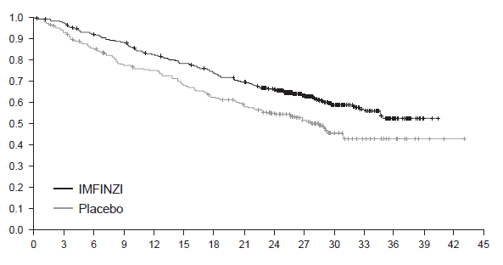

Median OS (95% CI)

IMFINZI NR (34.7, NR)

Placebo 28.7 (22.9, NR)

Hazard ratio (95% CI): 0.68 (0.53, 0.87)

Probability of OS

Time from randomisation (months)

|  |  |  |  |  |  |  |  |  |  |  |  |  |  |  |  |  |  |
| --- | --- | --- | --- | --- | --- | --- | --- | --- | --- | --- | --- | --- | --- | --- | --- | --- | --- |
| Number of patients at risk | | | | | | | | | | | | | | | | | |
| Month | 0 | 3 | 6 | 9 | 12 | 15 | 18 | 21 | 24 | 27 | 30 | 33 | 36 | 39 | 42 | 45 |
| IMFINZI | 476 | 464 | 431 | 415 | 385 | 364 | 343 | 319 | 274 | 210 | 115 | 57 | 23 | 2 | 0 | 0 |
| Placebo | 237 | 220 | 198 | 178 | 170 | 155 | 141 | 130 | 117 | 78 | 42 | 21 | 9 | 3 | 1 | 0 |

Figure 2 Kaplan-Meier curve of PFS (PACIFIC study)

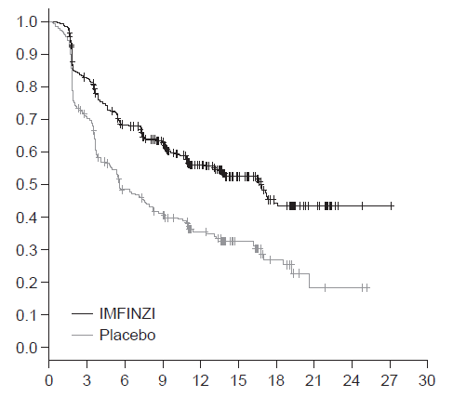

Time from randomisation (months)

Median PFS (95% CI)

IMFINZI 16.8 (13.0, 18.1)

Placebo 5.6 (4.6, 7.8)

Hazard ratio (95% CI): 0.52 (0.42, 0.65)

Probability of PFS

|  |  |  |  |  |  |  |  |  |  |  |  |
| --- | --- | --- | --- | --- | --- | --- | --- | --- | --- | --- | --- |
| Number of patients at risk | | | | | | | | | | | |
| Month | 0 | 3 | 6 | 9 | 12 | 15 | 18 | 21 | 24 | 27 | 30 | |
| IMFINZI | 476 | 377 | 301 | 264 | 159 | 86 | 44 | 21 | 4 | 1 | 0 | |
| Placebo | 237 | 163 | 106 | 87 | 52 | 28 | 15 | 4 | 3 | 0 | 0 | |

The improvements in PFS and OS in favour of patients receiving IMFINZI compared to those receiving placebo were consistently observed in all predefined subgroups analysed, including ethnicity, age, gender, smoking history, EGFR mutation status and histology. ALK mutation status was not analysed in this study.

Post-hoc subgroup analysis by PD-L1 expression

Additional subgroup analyses were conducted to evaluate the efficacy by tumour PD-L1 expression (≥ 25%, 1-24%, ≥ 1%, < 1%) and for patients whose PD-L1 status could not be established (PD-L1 unknown). PFS and OS results are summarised in Figure 3 and Figure 4. Overall the safety profile of durvalumab in PD-L1 TC ≥1% subgroup was consistent with the intent to treat population, as was the PD‑L1 TC <1% subgroup.

Figure 3 Forest plot of OS by PD-L1 expression (PACIFIC study)

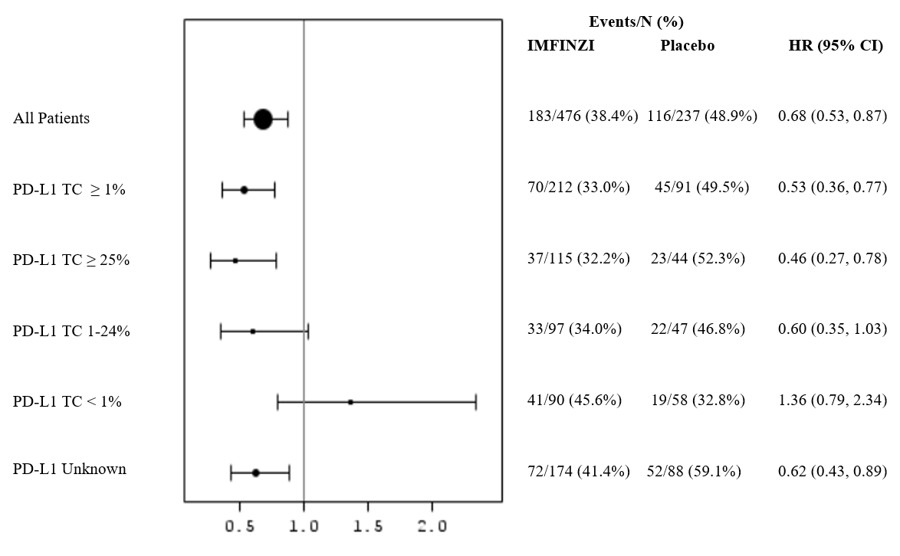

Figure 4 Forest plot of PFS by PD-L1 expression (PACIFIC study)

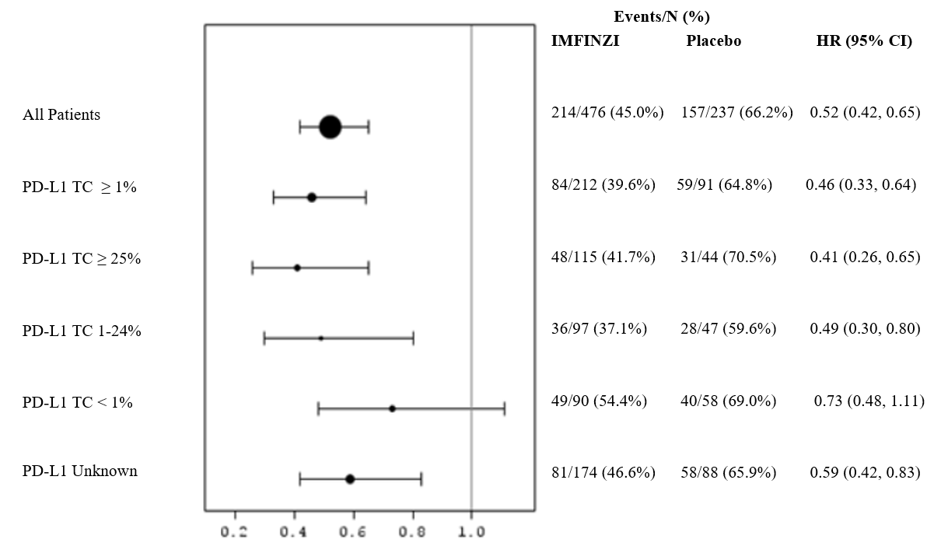

Patient reported outcomes

Patient-reported symptoms, function and health-related quality of life (HRQoL) were collected using the EORTC QLQ-C30 and its lung cancer module (EORTC QLQ-LC13). The LC13 and C30 were assessed at baseline and every 4 weeks for the first 8 weeks, then every 8 weeks until completion of the treatment period or discontinuation of study drug due to toxicity or disease progression. Compliance was similar between the IMFINZI and placebo treatment groups (83% vs 85.1% overall of evaluable forms completed).

At baseline, no differences in patient reported symptoms, function or HRQoL were observed between IMFINZI and placebo groups. Throughout the duration of the study to week 48, there was no clinically meaningful difference between IMFINZI and placebo groups in symptoms, functioning and HRQoL (as assessed by a difference of greater than or equal to 10 points).

Small cell lung cancer (SCLC)

CASPIAN study

The efficacy of IMFINZI in combination with etoposide and either carboplatin or cisplatin in previously untreated ES-SCLC patients was investigated in CASPIAN, a randomised, open-label, multicentre study in treatment naïve ES-SCLC patients with WHO/ECOG performance status of 0 or 1. Patients in the trial were eligible to receive a platinum-based chemotherapy regimen as first-line treatment for SCLC, with life expectancy ≥12 weeks, at least one target lesion by RECIST 1.1 and adequate organ and bone marrow function. Patients with asymptomatic or treated brain metastases were permitted. The study excluded patients with a history of chest radiation therapy; a history of active primary immunodeficiency; autoimmune disorders including paraneoplastic syndrome (PNS); active or prior documented autoimmune or inflammatory disorders; use of systemic immunosuppressants within 14 days before the first dose of the treatment except physiological dose of systemic corticosteroids; active tuberculosis or hepatitis B or C or HIV infection; or patients receiving live attenuated vaccine within 30 days before or after the start of IMFINZI.

Randomisation was stratified by the planned platinum-based therapy in cycle 1 (carboplatin or cisplatin).

* The evaluation of efficacy for ES-SCLC relied on comparison between: Arm 1: IMFINZI 1500 mg + etoposide (80-100 mg/m2) and either carboplatin (AUC 5 or 6 mg/mL/min) or cisplatin (75-80 mg/m2)
* Arm 2: Either carboplatin (AUC 5 or 6 mg/mL/min) or cisplatin (75-80 mg/m2) on Day 1 and etoposide (80-100 mg/m2) intravenously on Days 1, 2, and 3 of each 21-day cycle for between 4 and 6 cycles.

For patients randomised to Arm 1, etoposide and either carboplatin or cisplatin was limited to 4 cycles every 3 weeks subsequent to randomisation. IMFINZI monotherapy continued until disease progression or unacceptable toxicity. Administration of IMFINZI monotherapy was permitted beyond disease progression if the patient was clinically stable and deriving clinical benefit as determined by the investigator.

Patients randomised to Arm 2, were permitted to receive a total of up to 6 cycles of etoposide and either carboplatin or cisplatin. After completion of chemotherapy, prophylactic cranial irradiation (PCI) was permitted only in Arm 2 per investigator discretion.

Tumour assessments were conducted at Week 6 and Week 12 from the date of randomisation, and then every 8 weeks until confirmed objective disease progression. Survival assessments were conducted every 2 months following treatment discontinuation.

The primary endpoints of the study were OS of IMFINZI + chemotherapy (Arm 1) vs. chemotherapy alone (Arm 2). The key secondary endpoint was PFS. Other secondary endpoints were ORR, OS and PFS landmarks and Patient Reported Outcomes (PRO). PFS and ORR were assessed using Investigator assessments according to RECIST v1.1.

At a planned interim analysis, IMFINZI + chemotherapy (Arm 1) vs chemotherapy (Arm 2) met the efficacy boundary of the primary endpoint of OS and at a planned follow-up OS analysis IMFINZI + chemotherapy (Arm 1) vs chemotherapy (Arm 2) continued to demonstrate improved OS. The results are summarised below.

The demographics and baseline disease characteristics were well balanced between the study arms (268 patients in Arm 1 and 269 patients in Arm 2). Baseline demographics of the overall study population were as follows: male (69.6%), age ≥ 65 years (39.6%), median age 63 years (range: 28 to 82 years), white (83.8%), Asian (14.5%), black or African American (0.9%), other (0.6 %), non‑Hispanic or Latino (96.1%), current or past-smoker (93.1%), never smoker (6.9%), WHO/ECOG PS 0 (35.2%), WHO/ECOG PS 1 (64.8%), Stage IV 90.3%, 24.6% of the patients received cisplatin and 74.1% of the patients received carboplatin. In Arm 1, 1.1% of the patients received ≥5 cycles of chemotherapy and 0.4% of the patients received ≥6 cycles of chemotherapy based on etoposide exposure. In Arm 2, 62.8% of the patients received ≥5 treatment cycles, 56.8% of the patients received the maximum of 6 treatment cycles based on etoposide exposure and 7.8% of the patients received PCI after chemotherapy.

The study demonstrated a statistically significant and clinically meaningful improvement in OS at the planned interim analysis with IMFINZI + chemotherapy (Arm 1) vs. chemotherapy alone (Arm 2) [HR=0.73 (95% CI: 0.591, 0.909), p=0.0047]. IMFINZI + chemotherapy demonstrated an improvement in PFS vs. chemotherapy alone [HR=0.78 (95% CI: 0.645, 0.936)].

In the planned follow-up OS analysis (median: 25.1 months), the median OS for Arm 1 and Arm 2 was consistent with the OS interim analysis. The PFS, ORR and Duration of response (DoR) results from the planned interim analysis as well as the planned follow-up OS analysis results are summarised in Table 17. Kaplan-Meier curves for the planned follow-up OS and the interim analysis PFS are presented in Figure 5 and Figure 6.

Table 17 Efficacy results for the CASPIAN study

|  | Arm 1: IMFINZI + etoposide and either carboplatin or cisplatin  (n=268) | Arm 2: etoposide and either carboplatin or cisplatin  (n=269) |
| --- | --- | --- |
| **OSa** |  | |
| Number of deaths (%) | 210 (78.4) | 231 (85.9) |
| **Median OS (months) (95% CI)** | 12.9 (11.3, 14.7) | 10.5 (9.3, 11.2) |
| HR (95% CI)b | 0.75 (0.625, 0.910) | |
| p-valuec | 0.0032 | |
| **OS at 12 months (%) (95% CI)** | 52.8 (46.6, 58.5) | 39.3 (33.4, 45.1) |
| **OS at 18 months (%) (95% CI)** | 32.0 (26.5, 37.7) | 24.8 (19.7, 30.1) |
| **PFSd** |  | |
| Number of events (%) | 226 (84.3) | 233 (86.6) |
| **Median PFS (months) (95% CI)** | 5.1 (4.7, 6.2) | 5.4 (4.8, 6.2) |
| HR (95% CI)b | 0.78 (0.645, 0.936) | |
| **PFS at 6 months (%) (95% CI)** | 45.4 (39.3, 51.3) | 45.6 (39.3, 51.7) |
| **PFS at 12 months (%) (95% CI)** | 17.5 (13.1, 22.5) | 4.7 (2.4, 8.0) |
| **ORR n (%)d,e** | 182 (67.9) | 155 (57.6) |
| Complete Response n (%) | 6 (2.2) | 2 (0.7) |
| Partial Response n (%) | 176 (65.7) | 153 (56.9) |
| Odds ratio (95% CI)f | 1.56 (1.095, 2.218) | |
| **Median DoR (months) (95% CI) d,f** | 5.1 (4.9, 5.3) | 5.1 (4.8, 5.3) |
| **DoR at 12 months (%)d,f** | 22.7 | 6.3 |

1. Follow-up OS analysis at clinical cut-off 27 January 2020.
2. The analysis was performed using the stratified log-rank test, adjusting for planned platinum therapy in Cycle 1 (carboplatin or cisplatin), and using the rank tests of association approach.
3. At the interim analysis (data cut-off 11 March 2019) the OS p-value was 0.0047, which met the boundary for declaring statistical significance of 0.0178 for a 4% overall 2-sided alpha, based on a Lan-DeMets alpha spending function with O'Brien Fleming type boundary with the actual number of events observed.
4. PFS, ORR and DoR analyses at clinical cut-off 11 March 2019.
5. Confirmed Objective Response.
6. The analysis was performed using a logistic regression model adjusting for planned platinum therapy in Cycle 1 (carboplatin or cisplatin) with 95% CI calculated by profile likelihood.

Figure 5 Kaplan-Meier curve of OS (CASPIAN study)

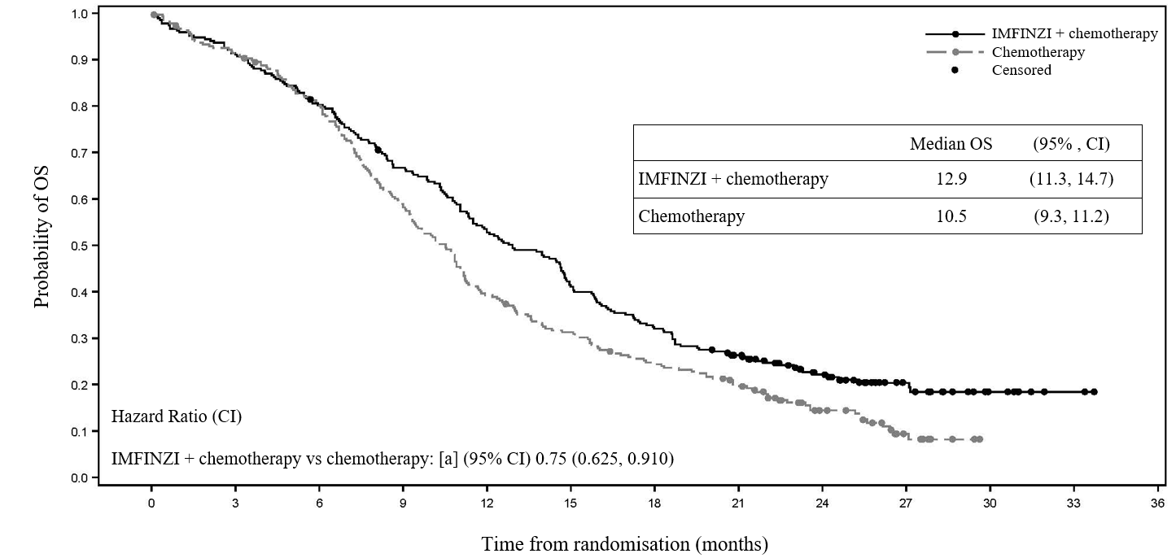

| Number of patients at risk | 0 | 3 | 6 | 9 | 12 | 15 | 18 | 21 | 24 |
| --- | --- | --- | --- | --- | --- | --- | --- | --- | --- |
| IMFINZI + chemotherapy | 268 | 244 | 214 | 177 | 140 | 109 | 85 | 66 | 41 |
| chemotherapy | 269 | 243 | 212 | 156 | 104 | 82 | 64 | 48 | 24 |

Figure 6 Kaplan-Meier curve of PFS (CASPIAN study)

| Number of patients at risk | 0 | 3 | 6 | 9 | 12 | 15 | 18 | 21 | 24 |
| --- | --- | --- | --- | --- | --- | --- | --- | --- | --- |
| IMFINZI + chemotherapy | 268 | 220 | 119 | 54 | 34 | 22 | 10 | 0 | 0 |
| chemotherapy | 269 | 194 | 109 | 30 | 9 | 7 | 0 | 0 | 0 |

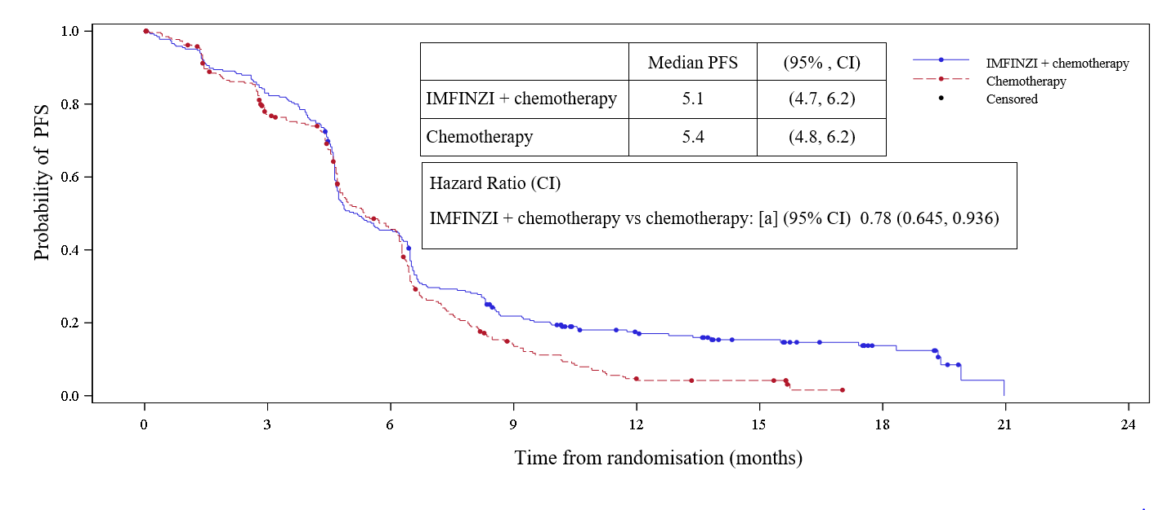

Subgroup analysis

The improvements in OS in favour of patients receiving IMFINZI + chemotherapy compared to those receiving chemotherapy alone, were consistently observed across the prespecified subgroups based on demographics, geographical region, carboplatin or cisplatin use and disease characteristics.

Change from baseline in lung cancer symptoms over 12 months (mixed model for repeated measures)

IMFINZI + chemotherapy improved appetite loss by demonstrating a statistically significant difference in mean change from baseline versus chemotherapy alone during the overall time period from randomisation until 12 months (Estimated mean difference -4.5; 99% CI -9.04, -0.04; p=0.009). Both treatment arms demonstrated numerical symptom reduction in cough, chest pain, dyspnoea and fatigue over the same time period.

Patient-reported outcome results should be interpreted in the context of the open-label study design.

In the exploratory subgroup analyses of OS based on the planned platinum chemotherapy received at cycle 1, the HR was 0.70 (95% CI 0.55, 0.89) in patients who received carboplatin, and the HR was 0.88 (95% CI 0.55, 1.41) in patients who received cisplatin.

Malignant pleural mesothelioma (MPM)

PrE0505 study

The efficacy of IMFINZI in combination with pemetrexed and cisplatin or carboplatin was evaluated in the PrE0505 study; an open-label, single arm, multicentre Phase II study in 55 treatment naïve patients with surgically unresectable MPM.

Patients with measurable disease, ECOG performance status of 0 or 1, adequate organ function and baseline tumour specimen were included. All histological subtypes were eligible.

The study excluded patients with prior chemotherapy or other systemic anti-cancer or immunotherapy for MPM; active, known or suspected autoimmune disease; any condition requiring systemic treatment with either corticosteroids (>10 mg daily prednisone or equivalent dose of an alternative corticosteroid) or other immunosuppressive medications within 28 days of durvalumab administration; symptomatic or uncontrolled brain metastases or leptomeningeal disease.

Patients received durvalumab (1120 mg), cisplatin (75 mg/m2) and pemetrexed (500 mg/m2) 3-weekly for a maximum of 6 cycles, followed by durvalumab alone (1120 mg 3-weekly) until progression, unacceptable toxicity or up to 12 months total therapy. Use of carboplatin (AUC 5) in place of cisplatin was permitted for patients with baseline hearing or renal impairment or, for patients experiencing cisplatin related toxicity. The initial 6 patients were monitored for dose-limiting toxicities and an interim safety analysis on the first 15 patients who completed 2 cycles of therapy was also completed.

Tumour assessments were conducted every 6 weeks when IMFINZI + chemotherapy was administered and then every 9 weeks until confirmed objective disease progression. Survival assessments were conducted every 3 months following treatment discontinuation.

The primary endpoint of the study was OS. The secondary endpoints included (PFS, ORR and DoR. PFS and ORR were assessed using Investigator assessments according to modified RECIST for mesothelioma.

The baseline demographics of the overall study population were as follows: male (81.8%), median age 70 years (range: 35 to 83 years), ECOG PS 0 (40%), ECOG PS 1 (60%), epithelioid histology (74.5%), sarcomatoid histology (12.7%), biphasic histology (10.9%) and other histology (1.8%).

Although patients with non-epithelioid histology were enrolled in the trial, IMFINZI is not indicated in non-epithelioid patients.

The study met its primary endpoint in the ITT population with a median OS of 20.4 months (95% CI: 13.0, 28.5) and a p-value of 0.0014 when compared to the historical control (12.1 months, Vogelzang et al, 2003). In the epithelioid histology subgroup, a median OS of 24.3 months (95% CI: 18.4, NR) was observed. Efficacy results for the epithelioid subgroup are summarised in Table 18. The Kaplan-Meier curve for OS and PFS for the epithelioid subgroup are presented in Figure 7 and Figure 8.

Table 18 Efficacy results for PrE0505 for the epithelioid subgroup

|  | N=41 |
| --- | --- |
| **OS** | |
| Number of deaths (%) | 21 (51.2) |
| Median OS (months) (95% CI)a | 24.3 (18.4, NR) |
| OS at 6 months (%) (95% CI)a | 92.7 (79.0, 97.6) |
| OS at 12 months (%) (95% CI)a | 85.3 (70.2, 93.1) |
| OS at 24 months (%) (95% CI)a | 53.5 (36.4, 67.9) |
| **PFS** | |
| Number of events (%) | 38 (92.7) |
| Median PFS (months) (95% CI)a | 8.3 (6.4, 9.7) |
| PFS at 6 months (%) (95% CI)a | 82.9 (67.5, 91.5) |
| ORR n (%)a,b (95% CI), all partial responses | 20 (48.8) (32.9, 64.9) |
| Median duration of response a,c,d, months (95% CI) | 6.6 (4.9-8.3) |

1. Calculated using the Kaplan-Meier method.
2. Confirmed objective response rate
3. Post-hoc analysis
4. Duration of response based on confirmed objective response rate

CI, confidence interval

NR: not reached

Figure 7 Kaplan-Meier curve of OS for the epithelioid subgroup (PrE0505 study)

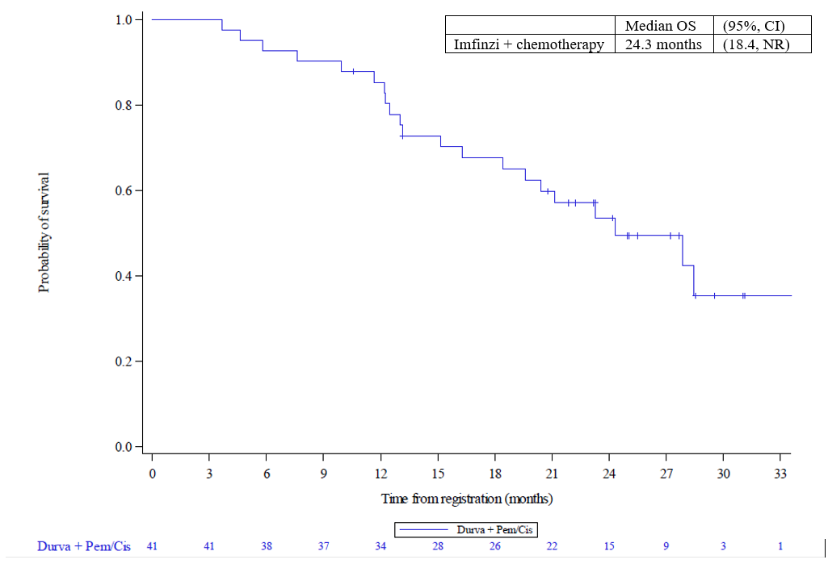

Figure 8 Kaplan-Meier curve of PFS for the epithelioid subgroup (PrE0505 study)

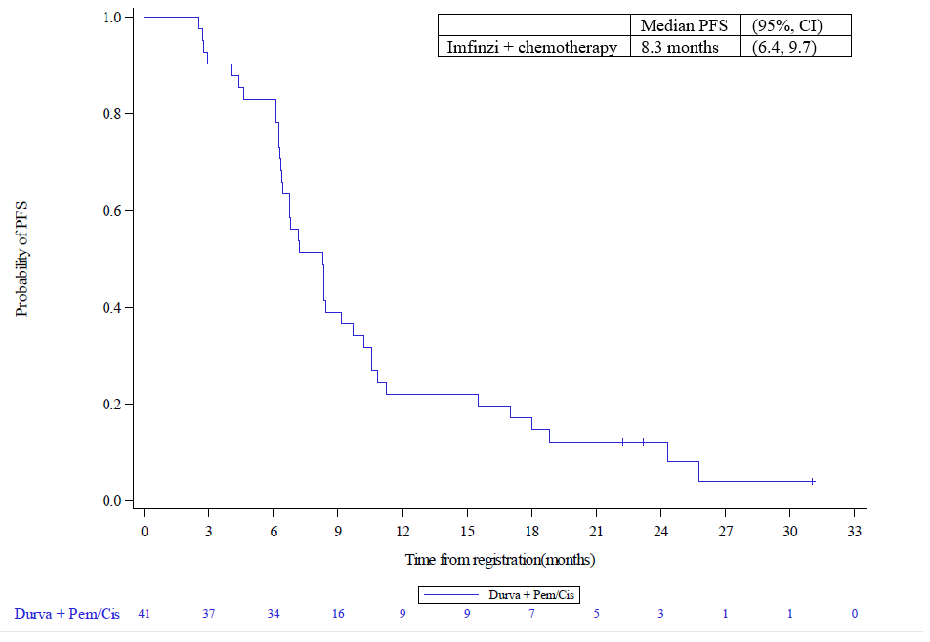

DREAM study

The efficacy of IMFINZI in combination with pemetrexed and cisplatin or carboplatin was evaluated in the DREAM study; an open-label, single-arm multicentre Phase II study in 54 treatment naïve patients with surgically unresectable MPM.

Patients were included if considered unsuitable for cancer-directed surgery, had ECOG performance status of 0 or 1 and measurable disease. All histological subtypes were eligible.

The study excluded patients with prior chemotherapy or other systemic anti-cancer or immunotherapy for MPM; active, known or suspected autoimmune disease; any condition requiring systemic treatment with either corticosteroids (>10 mg daily prednisone or equivalent dose of an alternative corticosteroid) or other immunosuppressive medications within 28 days of durvalumab administration; symptomatic or uncontrolled brain metastases or leptomeningeal disease.

Patients received durvalumab (1125 mg), cisplatin (75 mg/m2) and pemetrexed (500 mg/m2) 3‑weekly for a maximum of 6 cycles, followed by durvalumab alone (1125 mg 3‑weekly) until progression, unacceptable toxicity or for up to 12 months total therapy. Use of carboplatin (AUC 5) in place of cisplatin was permitted for patients developing cisplatin-induced hearing loss, Grade 3 nausea or vomiting, renal impairment, peripheral neuropathy or hypersensitivity. The first 6 patients were monitored for dose-limiting toxicities.

Tumour assessments were conducted every 6 weeks until Week 30 from date of registration, then at week 39 and 48 and then every 12 weeks (± 1 week) until confirmed objective disease progression. Survival assessments were conducted every 12 weeks (± 14 days) after progression.

The primary endpoint of the study was PFS at 6 months. The secondary endpoints included OS, ORR and DoR. PFS and ORR were assessed according to modified RECIST for mesothelioma.

The baseline demographics of the overall study population were as follows: male (83.3%), median age 68 years (range: 42 to 82 years), ECOG PS 0 (59.3%), ECOG PS 1 (40.7%), epithelioid (83.3%), biphasic (11.1%), desmoplastic (3.7%) and sarcomatoid histology (1.9%).

Although patients with non-epithelioid histology were enrolled in the trial, IMFINZI is not indicated in non-epithelioid patients.

The study met its primary endpoint in the ITT population with a PFS6 of 57.4% (95% CI 43.2, 69.3). In the epithelioid histology subgroup, a PFS6 of 62.2% (46.5, 74.6) was observed. Efficacy results for the epithelioid subgroup are summarised in Table 19. The Kaplan-Meier curve for PFS and OS for the epithelioid subgroup are presented in Figure 9 and Figure 10.

Table 19 Efficacy results for DREAM for the epithelioid subgroup

|  |  |
| --- | --- |
|  | N=45 |
| **PFS** | |
| Number of events (%) | 43 (95.6) |
| Median PFS (months) (95% CI) a | 7.5 (5.7, 9.0) |
| PFS at 6 months (%) (95% CI)a | 62.2 (46.5, 74.6) |
| PFS at 12 months (%) (95% CI)a | 26.7 (14.9, 40.0) |
| PFS at 24 months (%) (95% CI)a | 6.7 (1.7, 16.4) |
| **OS** | |
| Number of deaths (%) | 31 (68.9) |
| Median OS (months) (95% CI)a | 22.3 (14.7, 27.0) |
| **ORR n (%)b (95% CI), all partial responses** | 22 (48.9) (33.7, 64.2) |
| **Median duration of responsea,c, months (95% CI)** | 7.7 (4.9, 11.1) |

1. Calculated using the Kaplan-Meier method
2. Confirmed objective response rate
3. Duration of response based on confirmed objective response rate

CI, confidence interval

Figure 9 Kaplan-Meier curve of PFS for the epithelioid subgroup (DREAM study)

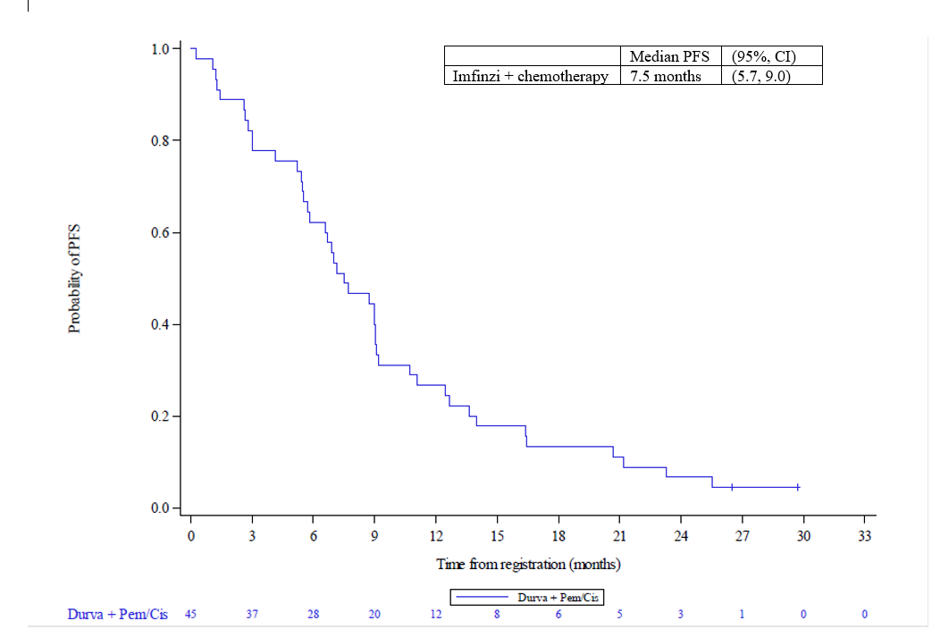

Figure 10 Kaplan-Meier curve of OS for the epithelioid subgroup (DREAM study)

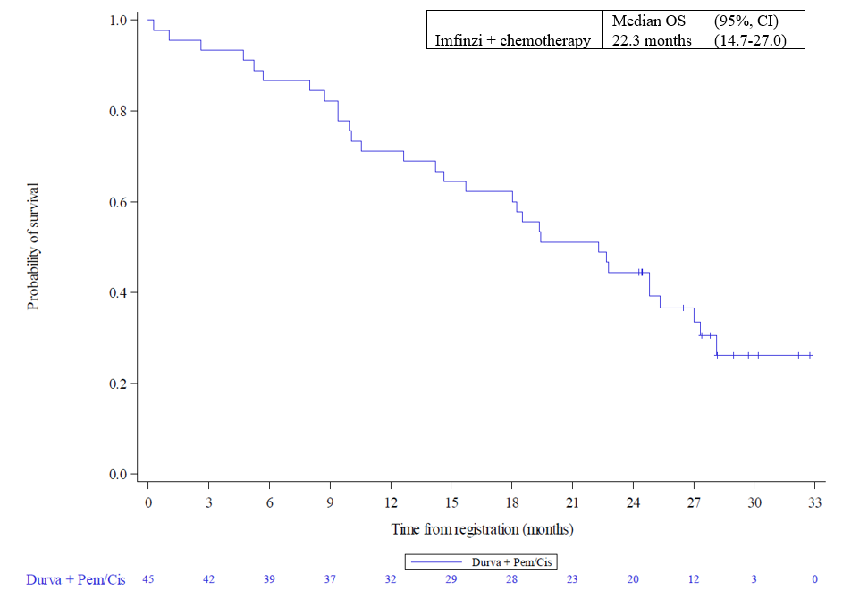

Biliary tract carcinoma (BTC)

TOPAZ-1 Study

TOPAZ-1 was a study designed to evaluate the efficacy of IMFINZI in combination with gemcitabine and cisplatin. TOPAZ-1 was a randomised, double-blind, placebo-controlled, multicentre study in 685 patients with histologically confirmed locally advanced or metastatic BTC and ECOG performance status of 0 or 1. Patients who developed recurrent disease more than 6 months after surgery and/or completion of adjuvant therapy were included. Patients must have had at least one target lesion by RECIST v1.1 and adequate organ and bone marrow function.

The study excluded patients with ampullary carcinoma, active or prior documented autoimmune or inflammatory disorders, HIV infection or active infections, including tuberculosis or hepatitis C or patients with current or prior use of immunosuppressive medication within 14 days before the first dose of IMFINZI.

Randomisation was stratified by disease status and primary tumour location.

Patients were randomised 1:1 to receive:

* Arm 1: IMFINZI 1500 mg administered intravenously on Day 1+ gemcitabine 1000 mg/m2 and cisplatin 25 mg/m2 (each administered on Days 1 and 8) every 3 weeks (21 days) for up to 8 cycles, followed by IMFINZI 1500 mg every 4 weeks as long as clinical benefit is observed or until unacceptable toxicity, or
* Arm 2: Placebo administered intravenously on Day 1+ gemcitabine 1000 mg/m2 and cisplatin 25 mg/m2 (each administered on Days 1 and 8) every 3 weeks (21 days) for up to 8 cycles, followed by placebo every 4 weeks as long as clinical benefit is observed or until unacceptable toxicity.

Tumour assessments were conducted every 6 weeks for the first 24 weeks after the date of randomisation, and then every 8 weeks until confirmed objective disease progression.

The primary endpoint of the study was OS and the key secondary endpoint was PFS. Other secondary endpoints were ORR, DoR and PRO. PFS, ORR and DoR were Investigator assessed according to RECIST v1.1.

The demographics and baseline disease characteristics were well balanced between the two study arms (341 patients in Arm 1 and 344 patients in Arm 2). Baseline demographics of the overall study population were as follows: male (50.4%), age <65 years (53.3%), white (37.2%), Asian (56.4%), black or African American (2.0%), other (4.2%), non‑Hispanic or Latino (93.1%), ECOG PS 0 (49.1%), vs. PS 1 (50.9%), primary tumour location (intrahepatic cholangiocarcinoma (55.9%), extrahepatic cholangiocarcinoma (19.1%) and gallbladder cancer (25.0%), disease status recurrent (19.1%) vs. initially unresectable (80.7%), metastatic (86.0%) vs. locally advanced (13.9%).

The study demonstrated a statistically significant and clinically meaningful improvement in OS and PFS at a pre‑planned interim (primary) analysis. The results in OS were [HR=0.80, (95% CI: 0.66, 0.97), p=0.021] and in PFS [HR=0.75, (95% CI: 0.63, 0.89), p=0.001]. The maturity for OS was 61.9% and the maturity for PFS was 83.64%. Results from this analysis are presented in Table 20 and Figure 12.

An additional OS analysis was performed 6.5 months after the interim analysis with an OS maturity of 76.9%. The observed treatment effect was consistent with the interim analysis. The OS HR was 0.76 (95% CI: 0.64, 0.91) and median survival was 12.9 months (95% CI: 11.6, 14.1) for the IMFINZI + gemcitabine and cisplatin arm. Results from this analysis are presented in the Table 20 and Figure 11.

Table 20 Efficacy results for the TOPAZ-1 study primary analysis and follow-up analysis

|  | Primary analysis a | | Follow-up analysis b | |
| --- | --- | --- | --- | --- |
| IMFINZI + gemcitabine & cisplatin  (n=341) | Placebo + gemcitabine & cisplatin  (n=344) | IMFINZI + gemcitabine & cisplatin  (n=341) | Placebo + gemcitabine & cisplatin  (n=344) |
| **OS** | | | | |
| Number of deaths (%) | 198 (58.1) | 226 (65.7) | 248 (72.7) | 279(81.1) |
| Median OS (months) (95% CI)c | 12.8 (11.1, 14) | 11.5 (10.1, 12.5) | 12.9 (11.6,14.1) | 11.3 (10.1,12.5) |
| HR (95% CI)d | 0.80 (0.66, 0.97) | | 0.76 (0.64, 0.91) | |
| p-value d, e | 0.021 | | - | |
| OS at 12 months (%) (95% CI)c | 54.1 (48.4, 59.4) | 48 (42.4, 53.4) | 54.3 (48.8, 59.4) | 47.1 (41.7, 52.3) |
| OS at 18 months (%) (95% CI)c | 35.1 (29.1, 41.2) | 25.6 (19.9, 31.7) | 34.8 (29.6, 40.0) | 24.1 (19.6, 28.9) |
| OS at 24 months (%) (95% CI)c | 24.9 (17.9, 32.5) | 10.4 (4.7, 18.8) | 23.6 (18.7, 28.9) | 11.5 (7.6, 16.2) |
| **PFS** | | | | |
| Number of events (%) | 276 (80.9) | 297 (86.3) | N/A | N/A |
| Median PFS (months) (95% CI)c | 7.2 (6.7, 7.4) | 5.7 (5.6, 6.7) | N/A | N/A |
| HR (95% CI)d | 0.75 (0.63, 0.89) | | N/A | |
| p-valued, f | 0.001 | | N/A | |
| PFS at 9 months (%) (95% CI)c | 34.8 (29.6, 40.0) | 24.6 (20.0, 29.5) | N/A | N/A |
| PFS at 12 months (%) (95% CI)c | 16.0 (12.0, 20.6) | 6.6 (4.1, 9.9) | N/A | N/A |
| **ORR n (%)g** | 91 (26.7) | 64 (18.7) | N/A | N/A |
| Complete Response n (%) | 7 (2.1) | 2 (0.6) | N/A | N/A |
| Partial Response n (%) | 84 (24.6) | 62 (18.1) | N/A | N/A |
| Odds ratio (95% CI)h | 1.60 (1.11, 2.31) | | N/A | |
| p-valueh | 0.011 | | N/A | |
| **DoR** | | | | |
| Median DoR (months) (95% CI)c | 6.4 (5.9, 8.1) | 6.2 (4.4, 7.3) | N/A | N/A |
| DoR at 9 months (%)c | 32.6 | 25.3 | N/A | N/A |
| DoR at 12 months (%)c | 26.1 | 15.0 | N/A | N/A |

1. Final OS, PFS, ORR and DoR analysis at data cut-off 11 Aug 2021.
2. Follow-up OS analysis at data cut-off 25 Feb 2022
3. Calculated using the Kaplan‑Meier technique. CI for median derived based on Brookmeyer‑Crowley method.
4. The analysis for HR was performed using a stratified Cox proportional hazards model and 2‑sided p‑value is based on a stratified log-rank test, both are adjusted for disease status and primary tumour location.
5. p-value based on the results from the pre-planned interim (primary) analysis. Based on a Lan-DeMets alpha spending function with O'Brien Fleming type boundary for OS and the actual number of events observed, the boundary for declaring statistical significance was 0.03 for an 4.9% overall alpha (Lan◦and◦DeMets 1983).
6. p-value based on the results from the pre-planned interim (primary) analysis. Based on a Lan-DeMets alpha spending function with Pocock type boundary and the actual number of events observed, the boundary for declaring statistical significance was 0.0481 for an 4.9% overall alpha (Lan and DeMets 1983).
7. Confirmed objective response by Investigator per RECIST 1.1. Based on patients with measurable disease at baseline IMFINZI + gemcitabine and cisplatin (n = 341), Placebo + gemcitabine and cisplatin (n = 343).
8. The analysis was performed using a stratified CMH test with factors for disease status and tumour location. Nominal 2‑sided p‑value

Figure 11 Kaplan-Meier curve of OS (TOPAZ-1 DCO: 25 Feb 2022)

Probability of OS

Time from randomisation (months)

IMFINZI + chemotherapy (N=341)

chemotherapy (N-344)

|  | Median OS | (95% CI) |
| --- | --- | --- |
| IMFINZI + chemotherapy | 12.9 | (11.6, 14.1) |
| chemotherapy | 11.3 | (10.1, 12.5) |
| Hazard Ratio (95% CI) | | | |
| IMFINZI + chemotherapy vs chemotherapy: 0.76 (0.64, 0.91) | | | |

Number of Patients at risk

IMFINZI + chemotherapy

chemotherapy

Figure 12 Kaplan-Meier curve of PFS (TOPAZ-1 DCO: 11 Aug 2021)

Number of Patients at risk

IMFINZI + chemotherapy

chemotherapy

Time from randomisation (months)

Probability of PFS

|  | Median PFS | (95% CI) |
| --- | --- | --- |
| IMFINZI + chemotherapy | 7.2 | (6.7, 7.4) |
| chemotherapy | 5.7 | (5.6, 6.7) |
| Hazard Ratio (95% CI) | | | |
| IMFINZI + chemotherapy vs chemotherapy: 0.75, (0.63, 0.89) | | | |

IMFINZI + chemotherapy (N=341)

chemotherapy (N-344)

Hepatocellular carcinoma (HCC)

HIMALAYA study

The efficacy of STRIDE was evaluated in the HIMALAYA study, a randomised, open-label, multicentre study in patients with confirmed uHCC who did not receive prior systemic treatment for HCC. The study included patients with BCLC Stage C or B (not eligible for locoregional therapy) and Child-Pugh Score Class A.

The study excluded patients with co-infection of viral hepatitis B and hepatitis C; active or prior documented GI bleeding within 12 months; ascites requiring non-pharmacologic intervention within 6 months; hepatic encephalopathy within 12 months before the start of treatment; active or prior documented autoimmune or inflammatory disorders.

Patients with oesophageal varices were included except those with active or prior documented GI bleeding within 12 months prior to study entry.

Randomisation was stratified by macrovascular invasion (MVI) (yes vs. no), aetiology of liver disease (confirmed hepatitis B virus vs. confirmed hepatitis C virus vs. others) and ECOG performance status (0 vs.1).

The HIMALAYA study randomised 1171 patients 1:1:1 to receive:

* IMFINZI: durvalumab 1500 mg every 4 weeks
* STRIDE: tremelimumab 300 mg as a single priming dose + IMFINZI 1500 mg; followed by IMFINZI 1500 mg every 4 weeks
* Sorafenib (S) 400 mg twice daily

Treatment continued as long as clinical benefit was observed or until unacceptable toxicity. Patients in all arms could continue to receive treatment after evidence of disease progression if, in the Investigator’s opinion, they were benefiting from study drug and met all inclusion and exclusion criteria for treatment beyond progression. In addition, patients in the STRIDE arm who continued treatment beyond progression were allowed to be rechallenged once with an additional single dose of tremelimumab 300 mg after cycle five of IMFINZI. Of the 182 patients enrolled to the STRIDE arm who received IMFINZI beyond progression, the median OS was 19.5 months (95% CI: 15.4, 23.4). Of the 30 patients who were enrolled to the STRIDE arm who were rechallenged with tremelimumab, the median OS was 30.4 months (95% CI: 23.4, NR).

Tumour assessments were conducted every 8 weeks for the first 12 months and then every 12 weeks thereafter. Survival assessments were conducted every month for the first 3 months following treatment discontinuation and then every 2 months.

The primary endpoint was OS for STRIDE vs. sorafenib. The key secondary objective was OS for non-inferiority based on the comparison of IMFINZI vs. sorafenib. Key secondary endpoints were Investigator assessed PFS, ORR and DoR according to RECIST v1.1. PROs were also assessed.

The demographics and baseline disease characteristics were generally representative for patients with uHCC. The baseline demographics of the overall study population were as follows: male (83.7%), age <65 years (50.4%), white (44.6%), Asian (50.7%), black or African American (1.7%), other (2.3%), ECOG PS 0 (62.6%); Child-Pugh Class score A (99.5%), macrovascular invasion (25.2%), extrahepatic spread (53.4%), viral aetiology; hepatitis B (30.6%), hepatitis C (27.2%), uninfected (42.2%).

The study demonstrated a statistically significant and clinically meaningful improvement in OS with STRIDE vs. sorafenib [HR=0.78 [95% CI 0.66, 0.92]; p=0.0035]. The study also met the key secondary objective of OS non-inferiority of IMFINZI to sorafenib with the upper limit of the 95.67% CI being below the pre-specified non-inferiority margin of 1.08. See Table 21 and Figure 13.

Table 21 Results for primary and key secondary efficacy endpoints for the HIMALAYA Study for STRIDE vs. sorafenib and IMFINZI vs. sorafenib

|  | STRIDE  (n=393) | sorafenib  (n=389) | IMFINZI  (n=389) |
| --- | --- | --- | --- |
| **Follow up duration (months)** | | | |
| Median follow up | 33.2 | 32.2 | 32.6 |
| Range | (31.7–34.5) | (30.4–33.7) | (31.6–33.7) |
| **OS** | | | |
| Number of deaths (%) | 262 (66.7) | 293 (75.3) | 280 (72.0) |
| Median OS (months) (95% CI) | 16.4 (14.2-19.6) | 13.8 (12.3-16.1) | 16.6 (14.1-19.1) |
| HR (95% CI) | 0.78 (0.66, 0.92) | | - |
| p-valuea | 0.0035 | | - |
| HR (95% CI) | - | 0.86 (0.73, 1.02) | |
| p-valueb | - | 0.0674 | |
| **OS at 12 months (%) (95% CI)** | 60.2 (55.2 - 64.9) | 56.2 (51.0 - 61.0) | 59.3 (54.2-64.0) |
| **OS at 18 months (%) (95% CI)** | 48.7 (43.6-53.5) | 41.5 (36.5-46.4) | 47.4 (42.4-52.3) |
| **OS at 24 months (%) (95% CI)** | 40.5 (35.6-45.3) | 32.6 (27.9-37.4) | 39.6 (34.8-44.5) |
| **OS at 36 months (%) (95% CI)** | 30.7 (25.8-35.7) | 20.2 (15.8-25.1) | 24.7 (20.0-29.8) |
| p-value | 0.0029 | | 0.1926 |
| Number of patients treated beyond progression | 182 | 192 | 188 |
| **PFS** | | | |
| Number of events (%) | 335 (85.2) | 327 (84.1) | 345 (88.7) |
| **Median PFS (months) (95% CI)** | 3.78 (3.68-5.32) | 4.07 (3.75-5.49) | 3.65 (3.19-3.75) |
| HR (95% CI) | 0.90 (0.77 - 1.05) | | - |
| p-valuec | 0.1625 | | - |
| HR (95% CI) | - | 1.02 (0.88 - 1.19) | |
| p-valuec | - | 0.7736 | |
| **ORR** | | | |
| **ORR n (%)c,d** | 79 (20.1) | 20 (5.1) | 66 (17.0) |
| Complete Response n (%) | 12 (3.1) | 0 | 6 (1.5) |
| Partial Response n (%) | 67 (17.0) | 20 (5.1) | 60 (15.4) |
| Odds ratio 95% CI | 4.69 (2.85, 8.04) | | 3.8 (2.3, 6.6) |
| p-value | <0.0001c | | <0.0001c |
| **DoR** | | | |
| **Median DoR (months)** | 22.3 | 18.4 | 16.8 |
| Sample size (n) | 79 | 20 | 66 |
| % with duration ≥6 months | 82.3 | 78.9 | 81.8 |
| % with duration ≥12 months | 65.8 | 63.2 | 57.8 |

1. Based on a Lan-DeMets alpha spending function with O'Brien Fleming type boundary and the actual number of events observed, the boundary for declaring statistical significance for STRIDE vs. sorafenib was 0.0398 (Lan◦and◦DeMets 1983).
2. p-value is for the superiority test of IMFINZI vs. S. Based on a Lan-DeMets alpha spending function with O'Brien Fleming type boundary and the actual number of events observed, the boundary for declaring statistical significance for IMFINZI vs. S was 0.0433 (Lan◦and◦DeMets 1983).
3. Nominal p-value. PFS and ORR were not included in the Multiple Testing Procedure (MTP).
4. Confirmed complete response.

NR=Not Reached, CI=Confidence Interval

Figure 13 Kaplan-Meier curve of OS (HIMALAYA study)

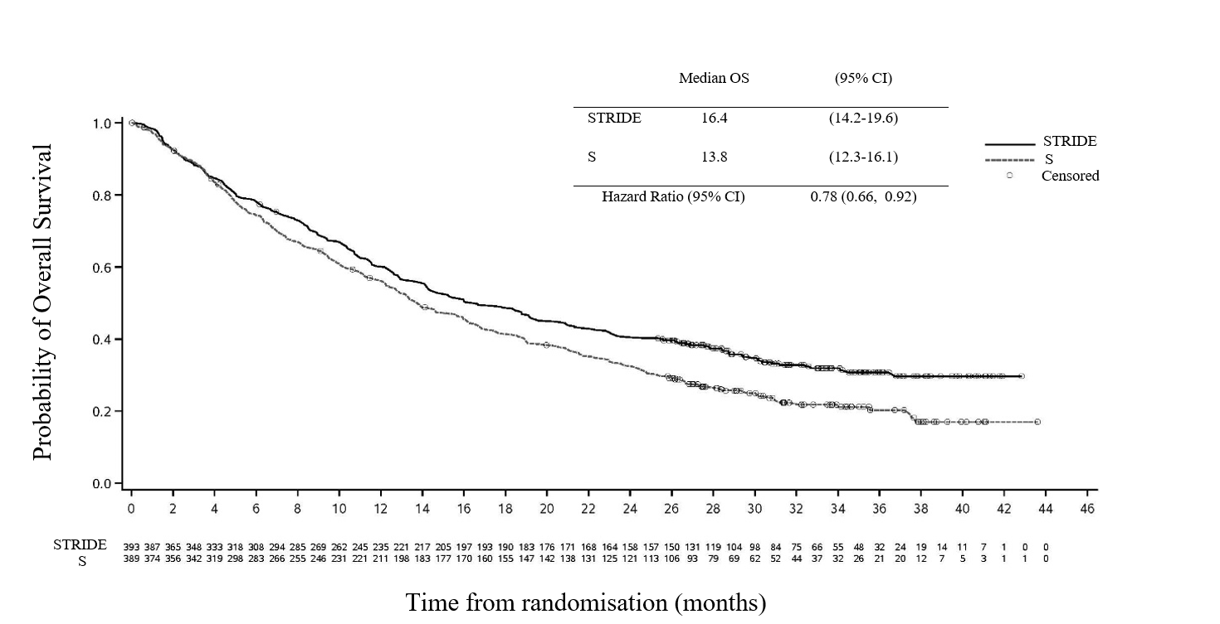

Patient reported outcomes

Patient-reported symptoms, function and HRQoL were collected using the EORTC QLQ-C30 and its HCC module (EORTC QLQ-HCC18). At baseline, patient-reported symptoms, functioning or HRQoL scores were comparable between the study arms.

Delay in time to deterioration of symptoms, functioning and global health status/QoL:

STRIDE vs. sorafenib demonstrated a clinically meaningful improvement by delaying time to deterioration in a broad range of patient-reported symptoms, function, and global health status/QoL compared to sorafenib. Longer time to deterioration (median in months) was observed in the STRIDE arm compared to S for the following symptoms: Global Health Status (7.5 vs. 5.7 months, HR 0.76, p = 0.0306); physical functioning (12.9 vs. 7.4 months, HR 0.68; p = 0.0020), fatigue (7.4 vs. 5.4 months, HR 0.71; p = 0.0026), nausea (25.0 vs. 11.0 months, HR 0.65; p = 0.0033), appetite loss (12.6 vs. 6.9 months, HR 0.59; p <0.0001), abdominal pain (16.8 vs. 8.9 months, HR 0.61; p = 0.0008) and abdominal swelling (20.9 vs. 11.1 months, HR 0.74; p = 0.0431.

Change from baseline in patient-reported symptoms (mixed model for repeated measures):

STRIDE improved patient-reported HRQoL functioning and diarrhoea by demonstrating a nominal difference and clinically meaningful mean change from baseline vs. sorafenib from randomisation until 8 months (Estimated mean difference at 8 months: -18.5 95% CI: -23.24, -13.84 and p‑value: <0.0001).

Patient-reported outcome results should be interpreted in the context of the open-label study design.

Study 22

The safety and efficacy of STRIDE was evaluated in Study 22, an open-label, uncontrolled, multi-part Phase I/II study involving 433 immunotherapy-naïve patients with uHCC. Of the 75 patients who received the STRIDE treatment regimen (tremelimumab 300 mg as a single priming dose + IMFINZI 1500 mg; followed by IMFINZI 1500 mg every 4 weeks), more than a quarter received STRIDE as first line of systemic therapy (73.3% had received prior systemic therapy with sorafenib/other VEGFR TKI). The higher percentage of patients alive and in survival follow-up (including those still receiving study treatment) in the STRIDE treatment arm (30.7%) compared to the other treatment arms (IMFINZI monotherapy and two additional tremelimumab arms; ranging from 17.4% to 19.2%) at DCO was more likely indicative of the data in the STRIDE treatment arm being less mature than that in the other 3 treatment arms as enrolment in the STRIDE safety run-in treatment arm (Part 2B) began approximately 8 months after the start of the other 3 treatment arms (in Part 2A).

The study included patients with BCLC Stage C or B (not eligible for locoregional therapy), ECOG performance status of 0 or 1 and Child-Pugh Score Class A.

The study excluded patients with co-infection of viral hepatitis B and hepatitis C; active or prior documented GI bleeding within 12 months; ascites requiring non-pharmacologic intervention within 6 months; hepatic encephalopathy within 12 months before the start of treatment; active or prior documented autoimmune or inflammatory disorders.

Treatment continued as long as clinical benefit was observed or until unacceptable toxicity. Patients who completed the assigned dosing cycles and were benefiting from study drug in the Investigator’s opinion and subsequently had evidence of disease progression during the IMFINZI monotherapy phase could be rechallenged with tremelimumab 300 mg.

Tumour assessments were conducted every 8 weeks.

The primary objective was safety and tolerability. Key secondary endpoints included OS, ORR and DoR. ORR, DoR and PFS were based on Investigator assessments and BICR according to RECIST 1.1.

The baseline demographics of the study population (STRIDE) were as follows: male (86.7%); age <65 years (45.3%), white (36.0%); Asian (58.7%); black or African American (5.3%); other (0%), ECOG PS 0 (61.3%), Child-Pugh Class/Score A/5 (68.0%), Child-Pugh Class/Score A/6 (30.7%), macrovascular invasion (21.3%); extrahepatic spread (70.7%), viral aetiology; hepatitis B (36.0%), hepatitis C (28.0%), uninfected (36.0%); prior systemic therapy (73.3%).

Efficacy results for the STRIDE and IMFINZI monotherapy treatment arms only are shown in Table 22. Results from the other two tremelimumab arms have not been provided.

Table 22 Efficacy results for STRIDE and IMFINZI monotherapy treatment arms from Study 22a

|  | STRIDE  (n=75) | IMFINZI monotherapy d  (n=104) |
| --- | --- | --- |
| **ORR** | | |
| **ORR n (%)b,c** | 18 (24.0) | 12 (11.5) |
| 95% CI | 14.9, 35.3 | 6.1, 19.3 |
| **DoRb** |  |  |
| **Median DoR (months) (95% CI)** | 18.4 (5.6, 24.0) | 15.0 (8.5, NR) |
| % with duration ≥6 months | 71.8 | 83.3 |
| % with duration ≥12 months | 64.6 | 56.3 |
| **OS** | |  |
| Number of deaths (%) | 49 (65.3) | 78 (75.0) |
| **Median OS (months) (95% CI)** | 17.05 (10.6-22.8) | 12.9 (8.7-16.8) |
| **OS at 12 months** **(%) (95% CI)** | 57.6 (45.5-68.0) | 50.4 (40.3-59.7) |
| **OS at 18 months (%) (95% CI)** | 47.8 (35.9-58.7) | 34.0 (24.9-43.3) |
| **OS at 24 months (%) (95% CI)** | 38.3 (26.9-49.6) | 26.2 (17.9-35.3) |

1. DCO of Final analysis: 6 Nov 2020.
2. Confirmed by BICR per RECIST v1.1.
3. Confirmed complete response.
4. durvalumab 1500 mg every 4 weeks

NR=Not Reached, CI=Confidence Interval

## Pharmacokinetic properties

The PK of durvalumab was assessed for both IMFINZI as a single agent and in combination with chemotherapy (etoposide and carboplatin or cisplatin) and in combination with tremelimumab and platinum-based chemotherapy. There was no clinically meaningful difference between the PK of durvalumab as a single agent, in combination with chemotherapy, and in combination with tremelimumab and platinum-based chemotherapy. There was no clinically meaningful difference between the PK of tremelimumab as monotherapy or in combination with durvalumab.

The pharmacokinetics of IMFINZI was studied in patients with solid tumours with doses ranging from 0.1 to 20 mg/kg administered once every two, three or four weeks.

Distribution

PK exposure increased more than dose-proportionally (non-linear PK) at doses <3 mg/kg and dose proportionally (linear PK) at doses ≥ 3 mg/kg. Steady state was achieved at approximately 16 weeks. Based on population PK analysis that included patients in the dose range of 10 mg/kg every 2 weeks (Q2W), 15 mg/kg every 3 weeks (Q3W) and 20 mg/kg every 4 weeks (Q4W), the steady state volume of distribution (Vss) was 5.64 L.

Excretion

Durvalumab clearance (CL) decreased over time resulting in a geometric mean steady state clearance (CLss) of 8.16 mL/h at Day 365; the decrease in CLss was not considered clinically relevant. The terminal half-life (t½), based on baseline CL, was approximately 18 days.

Special populations

Age (19–96 years), body weight (34-149 kg), gender, positive anti-drug antibody (ADA) status, albumin levels, LDH levels, creatinine levels, soluble PD-L1, tumour type, race, mild renal impairment (creatinine clearance (CRCL) 60 to 89 mL/min), moderate renal impairment (creatinine clearance (CRCL) 30 to 59 mL/min), mild hepatic impairment (bilirubin ≤ ULN and AST > ULN or bilirubin >1.0 to 1.5 × ULN and any AST) moderate hepatic impairment (bilirubin >1.5 to 3 x ULN and any AST) or ECOG/WHO status had no clinically significant effect on the pharmacokinetics of durvalumab.

The effect of severe renal impairment (CRCL 15 to 29 mL/min) or severe hepatic impairment (bilirubin >3.0 x ULN and any AST) on the pharmacokinetics of durvalumab is unknown; however, as IgG monoclonal antibodies are not primarily cleared via hepatic pathways, a change in hepatic function is not expected to influence durvalumab exposure.

Immunogenicity

As with all therapeutic proteins, there is a potential for immunogenicity. Immunogenicity of IMFINZI as monotherapy is based on pooled data in 2280 patients who were treated with IMFINZI 10 mg/kg every 2 weeks or 20 mg/kg every 4 weeks as a single-agent and evaluable for the presence of anti-drug antibodies (ADAs). Sixty-nine patients (3.0%) tested positive for treatment-emergent ADAs. Neutralising antibodies against durvalumab were detected in 0.5% (12/2280) patients. The presence of ADAs did not have a clinically relevant effect on pharmacokinetics, pharmacodynamics or safety.

In the CASPIAN study, of the 201 patients who were treated with IMFINZI 1500 mg every 3 weeks in combination with etoposide, and carboplatin or cisplatin and evaluable for the presence of ADAs, 0 (0%) patients tested positive for treatment-emergent ADAs.

In the TOPAZ-1 study, of the 240 patients who were treated with IMFINZI 1500 mg every 3 weeks in combination with chemotherapy, followed by IMFINZI 1500 mg every 4 weeks and evaluable for the presence of ADAs, 2 (0.8%) patients tested positive for treatment-emergent ADAs. There were insufficient numbers of patients with treatment emergent ADAs or neutralizing antibodies (2 patients each) to determine whether ADAs have an impact on pharmacokinetics and clinical safety of durvalumab.

In the HIMALAYA study, of the 294 patients who were treated with STRIDE and evaluable for the presence of ADAs, 9 (3.1%) patients tested positive for treatment-emergent ADAs. Neutralizing antibodies against durvalumab were detected in 1.7% (5/294) patients. The presence of ADAs did not have an apparent effect on pharmacokinetics or safety.

Immunogenicity assay results are highly dependent on several factors, including assay sensitivity and specificity, assay methodology, sample handling, timing of sample collection, concomitant medications and underlying disease.

For these reasons, comparison of incidence of antibodies to IMFINZI with the incidence of antibodies to other products may be misleading.

## Preclinical safety data

Genotoxicity

The genotoxic potential of durvalumab has not been evaluated. As a large protein molecule, durvalumab is not expected to interact directly with DNA or other chromosomal material.

Carcinogenicity

The carcinogenic potential of durvalumab has not been evaluated.

# Pharmaceutical particulars

## List of excipients

IMFINZI concentrated solution for infusion contains the following excipients: histidine, histidine hydrochloride monohydrate, trehalose dihydrate, polysorbate 80 and water for injections.

## Incompatibilities

Incompatibilities were either not assessed or not identified as part of the registration of this medicine.

## Shelf life

In Australia, information on the shelf life can be found on the public summary of the Australian Register of Therapeutic Goods (ARTG). The expiry date can be found on the packaging.

## Special precautions for storage

Store unopened vials under refrigeration at 2°C to 8°C in the original carton to protect from light. Do not freeze. Do not shake.

## Nature and contents of container

10 mL of concentrated solution for infusion in a 10 mL Type 1 glass vial with an elastomeric stopper and a white flip-off aluminium seal containing 500 mg durvalumab. Pack size of 1 vial.

2.4 mL of concentrated solution for infusion in a 10 mL Type 1 glass vial with an elastomeric stopper and a grey flip-off aluminium seal containing 120 mg durvalumab. Pack size of 1 vial.

## Special precautions for disposal

In Australia, any unused medicine or waste material should be disposed of by taking to your local pharmacy.

## Physicochemical properties

Durvalumab is a human immunoglobulin (IgG1κ) monoclonal antibody.

CAS number: 1428935-60-7

# Medicine schedule (Poisons Standard)

Prescription only medicine (Schedule 4).

# Sponsor

AstraZeneca Pty Ltd  
ABN 54 009 682 311  
66 Talavera Road  
MACQUARIE PARK NSW 2113

Telephone: 1800 805 342

# Date of first approval

2 October 2018

# Date of revision

<<draft 8 June 2023>>

Summary table of changes

| Section changed | Summary of new information |
| --- | --- |
| 4.1, 4.2 | New HCC indication and dosing recommendations (Table 1) and revised treatment modifications and management recommendations (Table 2) |
| 4.4, 4.8, 5.1 and 5.2 | Updated to include details from the HCC pooled data sets, HIMALAYA and Study 22 clinical study outcomes |
| 4.2, 4.4 and 4.8 | Safety update for Guillain-Barré syndrome |

© AstraZeneca 2023

Doc ID-004854588 v5 (clean copy of annotated Doc ID-004848898 v6)