GMP Clearance: Application and Submission User Guide

Version 1.0, November 2023

**Copyright**

© Commonwealth of Australia 11/12/2023  
This work is copyright. You may reproduce the whole or part of this work in unaltered form for your own personal use or, if you are part of an organisation, for internal use within your organisation, but only if you or your organisation do not use the reproduction for any commercial purpose and retain this copyright notice and all disclaimer notices as part of that reproduction. Apart from rights to use as permitted by the *Copyright Act 1968* or allowed by this copyright notice, all other rights are reserved and you are not allowed to reproduce the whole or any part of this work in any way (electronic or otherwise) without first being given specific written permission from the Commonwealth to do so. Requests and inquiries concerning reproduction and rights are to be sent to the TGA Copyright Officer, Therapeutic Goods Administration, PO Box 100, Woden ACT 2606 or emailed to <[**tga.copyright@tga.gov.au**](mailto:tga.copyright@tga.gov.au)>.

Contents

Introduction 5

Accessing TGA Business Services 5

Creating a new application 5

Completing Application Details 7

Completing Client Details tab 8

Sponsor 8

Agent acting on behalf of a sponsor 8

Selecting the manufacturer name and manufacturing site address 9

Selecting your scope 12

Completing API/Product Details tab 12

API scope 12

Finished Product Scope 15

Providing your evidence 16

Choosing your evidence and delivery method 17

Mandatory certificates or letters 17

Delivery methods 18

Mandatory evidence 22

Optional evidence 23

Submitting your complete application and paying fees 23

Fees and Payments tab 23

Declaration tab 23

Validating your application 24

Submitting your application 24

Paying your application fee 25

Maintaining your active GMP Clearance 26

Creating a variation application 26

Change clearance details - Scope, applicant or manufacturer changes 27

Change to manufacturer details - Administrative 27

Change to manufacturer details – Physical 29

Change of sponsor or applicant details 31

Change of scope 31

Change clearance status – Cancel or extend 32

Cancel your GMP Clearance 32

Extensions 33

Renewals 35

Withdrawing GMP Clearance applications no longer required 36

Evidence naming conventions 37

How to create a zip file 39

Submitting large files via GovTeams 40

Troubleshooting 41

Glossary 41

## Introduction

Applications for Good Manufacturing Practice (GMP) Clearance need to be submitted through the TGA Business services (TBS) portal.

Before applying, you should understand your [Sponsor responsibilities](https://www.tga.gov.au/resources/resource/guidance/sponsor-responsibilities-related-gmp-clearance-and-certification) and familiarise yourself with the GMP requirements for the particular category of medicine you intend to supply to Australia. The following guidance is available to assist you:

* [GMP Clearance guidance](https://www.tga.gov.au/resources/resource/guidance/gmp-clearance-guidance)
* [TGA Code Tables – Guidance to manufacturing steps and validation](https://www.tga.gov.au/resources/resource/guidance/gmp-clearance-code-tables-guidance)
* [Australian Regulatory Guidelines for Prescription Medicines (ARGPM)](https://www.tga.gov.au/resources/resource/guidance/guidelines-prescription-medicines)
  + Additional guidance is available on which steps of manufacture require [evidence of GMP compliance for prescription medicines](https://www.tga.gov.au/resources/resource/guidance/evidence-gmp-prescription-medicines)
* [Australian Regulatory Guidelines for Over the counter (OTC) Medicines (ARGOM)](https://www.tga.gov.au/resources/resource/guidance/australian-regulatory-guidelines-otc-medicines-argom)
* [Australian Regulatory Guidelines for Listed Medicines and Registered Complementary Medicines (ARGCM)](https://www.tga.gov.au/resources/resource/guidance/australian-regulatory-guidelines-listed-medicines-and-registered-complementary-medicines)

## Accessing TGA Business Services

You need to be a TGA client to access TGA Business Services in order to submit an application. Only Australian sponsors or agents acting on behalf of an Australian sponsor can submit GMP Clearance applications.

Direct any queries related to TGA Business Services to [ebs@health.gov.au](mailto:ebs@health.gov.au).

For more information see [getting started with the TGA](https://www.tga.gov.au/resources/resource/guidance/tga-business-services-getting-started-tga).

## Creating a new application

1. Go to [TGA Business Services](https://www.ebs.tga.gov.au/).
2. To limit issues with functionality, distortion or performance, check that the internet browser you are using is compatible with the TGA Business Services system by selecting ‘**Browser Support**’ and following the provided guidance.

In the footer of the TGA Business Services page the sixth option is 'Browser Support'.

|  |  |
| --- | --- |
| Information | Make sure that your browser allows pop-up windows, or you will be unable to see the dialog boxes and complete the form. |

1. Select ‘Log in to Business Services’.

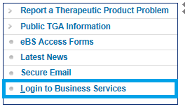

|  |  |
| --- | --- |
| Information | Before you create your GMP Clearance application, ensure you have read the required information contained in this guidance and have used the [GMP Clearance Application Assistance Tool (CAAT)](https://www.tga.gov.au/clearance-application-assistance-tool). |

1. On the homepage, select ‘Applications’ and from the dropdown menu under the ‘Manufacturers’ heading, select ‘Clearance Application’.

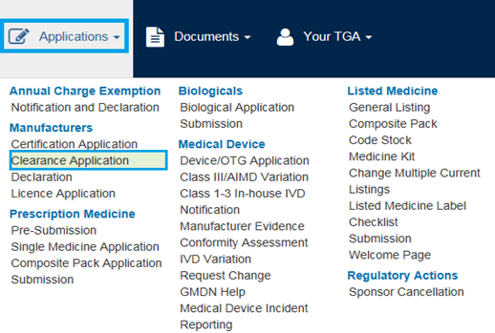

You will be taken to the ‘Clearance Application’ page which contains the application details section with the following tabs:

* Client Details
* API/Product Details
* Evidence
* Fees and payments
* Declaration

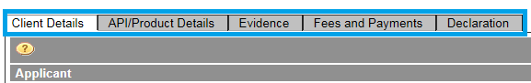

|  |  |
| --- | --- |
| Information | Throughout the e-form tabs, there are **mandatory fields** notated by a red asterisk * that need to be completed to progress your application.  There are also **help icons** notated by a yellow question mark picture of question mark icon available to assist you in preparing and submitting the application.  You will be requested to save your progress at various stages prior to continuing. |

## Completing Application Details

1. Under ‘Application Details’, you may wish to include your own reference description in the ‘**Applicant’s Own Ref**’ text box to assist you in identifying your GMP Clearance applications. This is a free text field.

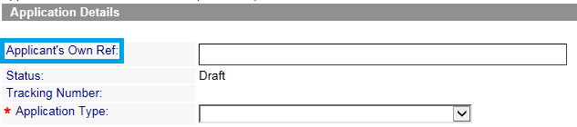

1. Select the ‘**Application Type**’ from the drop down list:
   * MRA
   * TGA GMP Certificate
   * CV – Non-Sterile API
   * CV – Non-Sterile Finished Product
   * CV – Sterile / Biotech API
   * CV – Sterile / Biotech Finished Product
   * CV – Contract Testing Laboratory
   * CV – Contract Steriliser

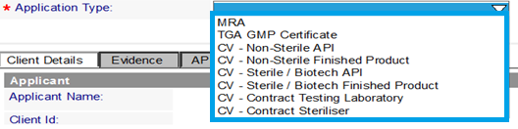

This selection will determine the subsequent information required for the application.

|  |  |
| --- | --- |
| Information | **Important** – It is crucial you select the correct application type to avoid unnecessary delays with your application. We use the information you enter to assist us in processing your applications and an incorrect will delay your application.  Additionally, once the application is submitted, the application type **cannot be changed**. A new application may be required if an incorrect selection is made.  We urge all applicants to refer to [GMP Clearance guidance](https://www.tga.gov.au/resources/resource/guidance/gmp-clearance-guidance) and use the [GMP Clearance Application Assistance Tool (CAAT)](https://www.tga.gov.au/clearance-application-assistance-tool) for assistance in identifying your application type **prior to submitting** a GMP Clearance application. |

1. Once you have selected the application type from the drop down list, you will be asked to confirm your selection. Select ‘**OK**’ to proceed or select ‘**Cancel**’ to go back and change the application type.

Are you sure you have selected the correct Application Type?
Select the 'OK' button.

## Completing Client Details tab

In the client details tab, whether you are a sponsor or an agent acting on behalf of a sponsor will determine the required information to be entered.

Some applicant and sponsor information will be pre-populated based on the Client ID you have logged in with. This information is based on the registered client details held by TGA.

|  |  |
| --- | --- |
| Information | If you wish to amend (add or remove) contacts, ask your organisation’s nominated TGA Business Services administrator to update these details.  Refer to [TGA Business Services – Questions and answers for administrators](https://www.tga.gov.au/resources/resource/guidance/tga-business-services-questions-and-answers-administrators) or contact [ebs@health.gov.au](mailto:ebs@health.gov.au) for assistance. |

### Sponsor

1. If you are the sponsor, you will need to select the address from the drop down menu in both the applicant and sponsor sections and proceed to instruction 12.

### Agent acting on behalf of a sponsor

1. If you are an agent lodging an application on behalf of a sponsor, you will need to choose who will be invoiced using the radio buttons.
   * Select ‘**Applicant**’ if you (the agent) is to be invoiced for the GMP Clearance
   * Select ‘**Sponsor**’ if the sponsor is to be invoiced for the GMP Clearance

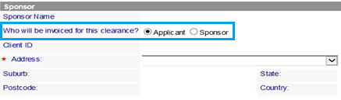

1. You will then need to choose who should be contacted if we need further information in relation to this GMP Clearance using the radio buttons.
   * Select ‘**Applicant**’ if you (the agent) is to be contacted about the GMP Clearance
   * Select ‘**Sponsor**’ if the sponsor is to be contacted about the GMP Clearance

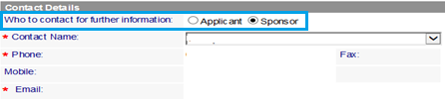

1. Select the ‘**Contact Name**’ from the drop down list. The subsequent mandatory information will automatically populate based on the selection made.

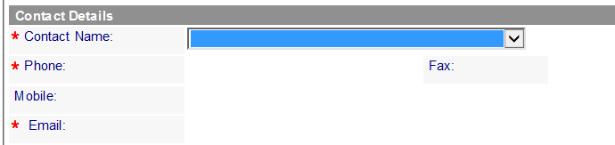

**Note:** If the contact is not displayed on the drop down list, your company’s TGA Business Services administrator can update these details. Refer to [TGA Business Services – Questions and answers for administrators](https://www.tga.gov.au/resources/resource/guidance/tga-business-services-questions-and-answers-administrators) or contact [ebs@health.gov.au](mailto:ebs@health.gov.au) for assistance.

### Selecting the manufacturer name and manufacturing site address

1. Select ‘**Search**’ to open the manufacturer information system’s search dialog box.

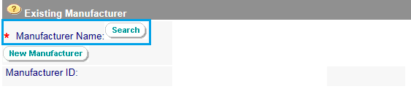

|  |  |
| --- | --- |
| Information | **Important** – Ensure you have thoroughly searched the TGA database for the manufacturer’s name and address **before** you select New Manufacturer. Duplicate entries created can result in extended delays to application processing times and may require significant updates to your ARTG entry.  If you are unsure whether the manufacturer you intend to use is available in the TGA database, please [contact us](https://www.tga.gov.au/manufacturing-therapeutic-goods#contacts) **prior** to proceeding with your application. |

1. In the search box, enter a search string by typing the name of the manufacturer you wish to obtain GMP Clearance for and select ‘**Search**’.

You can enter a search string to find a manufacturer in our database.
Select the Search button to the right of the dialog box.

1. If the manufacturer’s name is already registered with the TGA, it will appear in the list for selection. Click on the manufacturer and select ‘**OK**’.

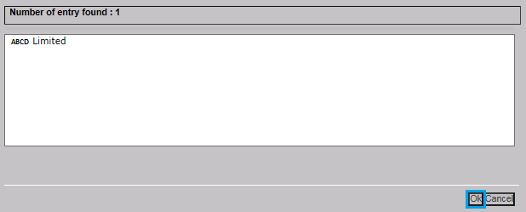

1. If the manufacturer selected has only one manufacturing site registered with the TGA, the existing manufacturing site information will automatically populate. Alternatively select the ‘**Manufacturing Site**’ from the drop down menu.

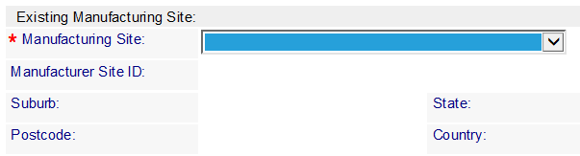

1. If your manufacturer and manufacturing site are already registered with the TGA, proceed to  Selecting your scope.

|  |  |
| --- | --- |
| Information | If the manufacturer name or the manufacturing site required is **not** already registered with the TGA you will have to register the manufacturing site **prior** to proceeding with the application. |

1. If you need to request a new manufacturer and/or manufacturing site, save your application, then select ‘**New Manufacturer**’.

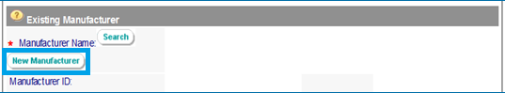

|  |  |
| --- | --- |
| Information | **Important** – Ensure you have thoroughly searched the TGA database for the manufacturer’s name and address **before** you select New Manufacturer. Duplicate entries created can result in extended delays to application processing times and may require significant updates to your ARTG entry.  If you are unsure whether the manufacturer you intend to use is available in the TGA database, please [contact us](https://www.tga.gov.au/manufacturing-therapeutic-goods#contacts) **prior** to proceeding with your application. |

1. Enter all the required information about the manufacturer or site address and upload at least one piece of evidence to support the request, then select ‘**Send**’.

You will need to enter details of the new manufacturer.
You can Browse your files to attach supporting documentation.
Select the Send buttom at the bottom when you have finished.

Once TGA Business Services have registered the manufacturer or site address, you will be notified and may proceed with the application.

Typically, a new registration is complete within 1-2 business days from the date of request. If you have questions regarding the status of the registration of the manufacturer or site address, please contact [ebs@health.gov.au](mailto:ebs@health.gov.au) for assistance.

## Selecting your scope

Selecting the correct scope of your application is one of the key steps in submitting GMP Clearance applications. When preparing GMP Clearance applications, it is the responsibility of the sponsor to select the scope that accurately reflects the dosage forms and/or manufacturing steps performed by the overseas manufacturer. You should take specific care to ensure that your selected scope is fully supported by the evidence provided. Incorrect selections here may lead to issues with your product registration or listing activities.

Information on dosage forms and manufacturing steps is available in the TGA code tables ([TGA Business Services](https://www.ebs.tga.gov.au/) > Public TGA Information > [Code Tables](http://www.ebs.tga.gov.au/ebs/home.nsf/GHPR?OpenAgent&amp;pt=DCT&amp;ptv=|CT)).

|  |  |
| --- | --- |
| Information | If you are unsure whether the manufacturing step(s) require GMP Clearance or align with the registration or listing requirements, please [contact the relevant product regulatory area](https://www.tga.gov.au/about-tga/contact-us) **prior** to submitting the application.  You may **not be contacted** prior to finalising the application and GMP Clearances will be issued for the scope that is supported by the evidence provided.  If the selections you made result in validation issues with the regulatory submission system, you may be required to submit a variation application and pay the relevant [fees](https://www.tga.gov.au/how-we-regulate/fees-and-payments/summary-fees-and-charges/summary-fees-and-charges-applications-submitted-tga). |

### Completing API/Product Details tab

In the API/Product Details tab, whether you select ‘API’ (Active Pharmaceutical Ingredient) or ‘Product’ will determine the required information to be entered. Once chosen, you will then need to enter the name of the specific substance or dosage forms along with the required steps of manufacture performed at the manufacturing site.

|  |  |
| --- | --- |
| Information | You will need to submit **separate applications** for API and finished product, even if the same evidence is applicable to both. |

1. Select if the application scope is for ‘API’ or ‘Product’ by selecting the radio button.

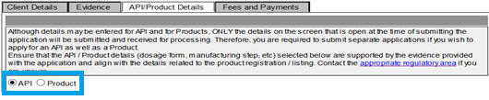

#### API scope

1. If the application is for API, select ‘API’ and then select the type of APIs you intend to obtain GMP Clearance for.
   * Select ‘**Sterile/Biotech**’ if all the APIs in your application are sterile or biotech substances
   * Select ‘**Non-Sterile**’ if all the APIs in your application are non-sterile substances
   * Select ‘**Sterile/Biotech & Non-Sterile**’ if the APIs in your application are a combination of both types of substances

If you select API then you need to choose from three radio buttons to the right: Sterile/Biotech, Non-Sterile, or Sterile/Biotech & Non-Sterile

1. Select ‘**Add**’.

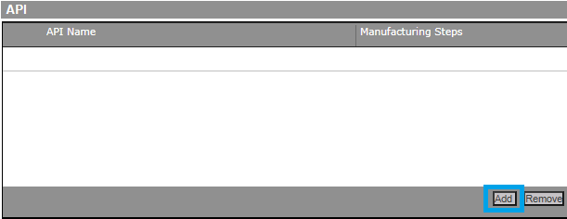

1. You cannot enter the ingredient name directly. Instead, select ‘**Search**’ to open a search box of the ingredients database.

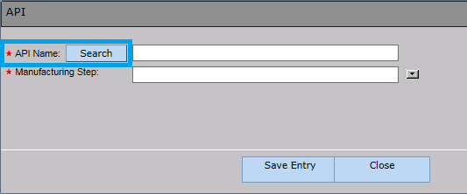

1. Enter the name or partial name of the substance in the Ingredient Search Dialog box and select ‘**Search**’.

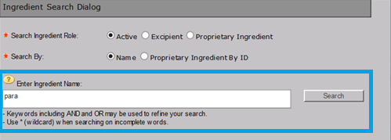

1. If the ingredient name is already registered with the TGA, it will appear in the list for selection. Click on the required ingredient and select ‘OK’.

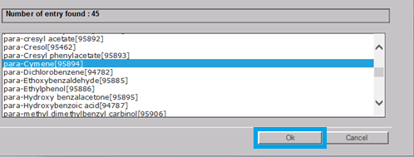

|  |  |
| --- | --- |
| Information | If the required APIs are already registered with the TGA, proceed to instruction 26.  If any of the API names are **not** already registered with the TGA and your search returns zero results, information about how to register an ingredient name will be displayed and you will have to manually enter the name of the API to proceed with the GMP Clearance application (instruction 25).  For cell bank manufacturing activities, the name of specific cell lines are not required to be entered in your application and the API name may be entered manually as ‘cell bank’. |

1. Enter the name of the API in the field labelled ‘Enter New Ingredient Name’ and select ‘**OK**’.

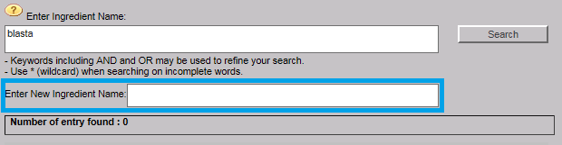

1. Select the appropriate ‘**Manufacturing Step**’ from the drop down menu and click save entry.

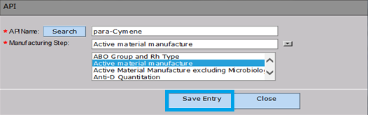

To see the entire list of possible manufacturing steps, go to the ‘Manufacturing Steps’ code table ([TGA Business Services](https://www.ebs.tga.gov.au/) > Public TGA Information > [Code Tables](http://www.ebs.tga.gov.au/ebs/home.nsf/GHPR?OpenAgent&amp;pt=DCT&amp;ptv=|CT)). Also, you may refer to [GMP Clearance Code tables guidance](https://www.tga.gov.au/resource/gmp-clearance-code-tables-guidance) for information regarding the specific manufacturing steps, definitions and which systems they validate.

1. Repeat instructions 20-26 as required to continue adding APIs and/or manufacturing steps to your application.

#### Finished Product Scope

1. If the application is for finished product, select ‘Product’ and then select ‘Add’.

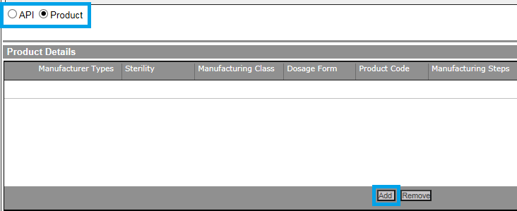

1. In the dialog box, make the required selections from the drop down menu for the following manufacturing items:
   * **Manufacturing Type** – Generally the selection here would be Medicine Manufacturer or Testing Laboratory
   * **Sterility** – Select the sterility of the product
   * **Manufacturing Class** – Select either multiple or single manufacturing steps or products
   * **Dosage Form** – Ensure when selecting group terms, all the dosage forms contained within the group are supported by the evidence you submit. To see the entire list of possible dosage forms, go to the ‘Dosage Form Group’ [Code Tables](http://www.ebs.tga.gov.au/ebs/home.nsf/GHPR?OpenAgent&amp;pt=DCT&amp;ptv=|CT).
   * **Product Code** – Generally the selection here would be Listed or Registered Therapeutic Good
   * **Manufacturing step** - Ensure when selecting group terms, all steps of manufacture contained within the group are supported by the evidence you submit. To see the entire list of possible manufacturing steps, go to the ‘Manufacturing Steps’ [Code Tables](http://www.ebs.tga.gov.au/ebs/home.nsf/GHPR?OpenAgent&amp;pt=DCT&amp;ptv=|CT) and [GMP Clearance code tables guidance](https://www.tga.gov.au/resources/resource/guidance/gmp-clearance-code-tables-guidance).
2. Once you have chosen from every drop down menu, select ‘**Save Item**’.

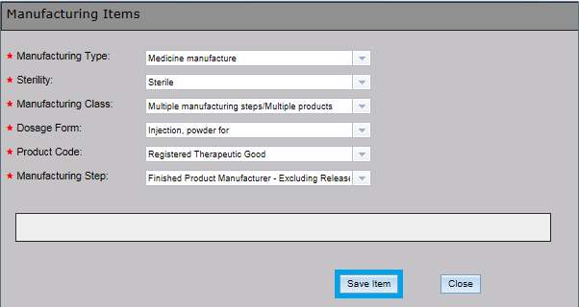

1. Repeat instructions 27 - 30 to continue adding dosage forms or manufacturing steps to your application.

## Providing your evidence

In the Evidence tab, you need to answer some questions about the GMP Clearance prior to providing the required evidence. The information you provide will allow us to process your applications efficiently.

1. **Inform us if the GMP Clearance application is related to a submission to list or register a product or vary an existing ARTG entry.**
   * Selecting ‘**Yes**’ will require you to choose the submission type from the drop down menu (mandatory) and submission number (if known)

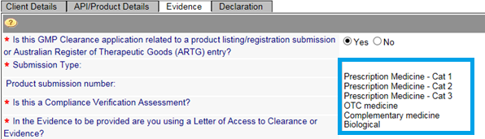

1. Choose whether the application is for the [Compliance Verification pathway](#_Compliance_Verification_(CV)).
   * Selecting ‘**Yes**’ will raise the **Compliance Verification fee**
   * Selecting ‘**No**’ will not raise the fee

There are Yes and No radio buttons.

|  |  |
| --- | --- |
| Information | If you are unsure whether the CV fee should apply, refer to the fee table in [How much GMP Clearance costs in the GMP Clearance guidance](https://www.tga.gov.au/resources/resource/guidance/gmp-clearance-guidance).  Ensure your selection aligns with the application type selected in instruction 5 - Completing Application Details.  If you have selected ‘No’ and during application receipt your application is determined to be a CV, we will raise the fee and your application will not progress until payment is received. |

1. Choose whether you intend to use a Letter of Access (LoA) to Clearance or Evidence as part of your evidence. If you select yes then you will need to provide the GMP Clearance number in instruction 44 or instruction 45.

There are Yes and No radio buttons for the question 'In the Evidence to be provided are you using a Letter of Access to Clearance or Evidence?'

### Choosing your evidence and delivery method

1. Save your application before proceeding.

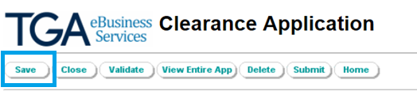

You will be required to select a delivery method for each piece of evidence you provide.

Based on the Application Type selected, this section will display:

* For MRA – Mandatory Certificate or Letters and Optional Evidence
* For CV – Mandatory Certificate or Letters, Mandatory Evidence and Optional Evidence

|  |  |
| --- | --- |
| Information | Ensure you have read the [GMP Clearance guidance](https://www.tga.gov.au/resources/resource/guidance/gmp-clearance-guidance) regarding **identifying the appropriate GMP Clearance pathway** and **identifying what documentation** is required **prior** to proceeding. |

### Mandatory certificates or letters

1. In the mandatory certificates or letters section, select whether you intend to provide a current GMP certificate or a Letter of Access (to clearance or evidence).

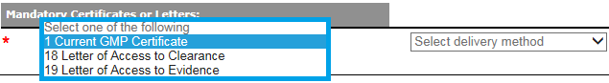

|  |  |
| --- | --- |
| Information | **Letters of Access** - If you choose to use a letter of access, you must upload the letter here **and** select the equivalent delivery method in the mandatory evidence section for the evidence to be covered by the LoA.  **US FDA evidence** - If you are using US FDA evidence, you **must** select TGA to obtain GMP certificate as your delivery method. **Do not** provide the cover letter from the US FDA EIR.  **Health Canada evidence** – If you are using Health Canada Exit Notice as evidence, you **must** select TGA to obtain GMP certificate as your delivery method and **provide** the exit notice as the inspection report.  When TGA to obtain GMP certificate is selected, a liaison fee will be automatically added to GMP Clearance application fee. This will avoid additional fees needing to be raised during application receipt. |

1. Select the required delivery method from the drop down menu.

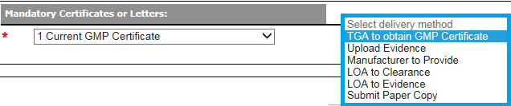

#### Delivery methods

There are multiple delivery methods available depending on each type of evidence. Additional information specific to the delivery method chosen will be required once selected. These are:

* TGA to obtain GMP certificate
* Manufacturer to provide
* Submit paper copy
* Upload evidence
* LoA to clearance
* LoA to evidence

##### TGA to obtain GMP certificate

1. If you have selected this delivery method, in the resulting dialog box select:
   * the regulatory authority the TGA are to liaise with from the drop down menu
   * the inspection date of the GMP Certificate required

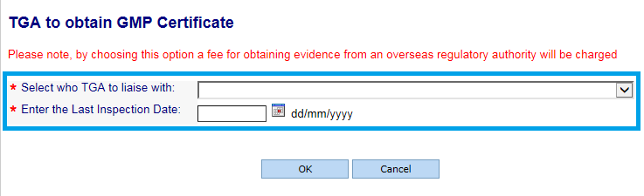

|  |  |
| --- | --- |
| Information | For MRA applications, we can only liaise for GMP certificates with regulatory authorities with whom we have a [MRA](https://www.tga.gov.au/how-we-regulate/manufacturing/manufacture-medicine/good-manufacturing-practice-gmp/international-agreements-and-arrangements-gmp-clearance) or equivalent agreement with.  For CV applications, if you are submitting evidence from a US FDA inspection you **must** select TGA to obtain GMP certificate to ask TGA to confirm the current GMP compliance status from the US FDA COMSTAT database. If you are using **Health Canada Exit Notice** as evidence, you **must** select TGA to obtain GMP certificate as your delivery method and **provide** the exit notice as the inspection report.  You may receive alerts if the inspection date is ≥3 years old identifying that the GMP Clearance may:   * result in a short expiry date (if issued)   OR   * not be issued if the evidence is > 3years from date of inspection. |

##### Manufacturer to provide

1. If you have selected this delivery method, in the resulting dialog box select the expected date the evidence will be provided to us. The delivery date cannot be earlier than the GMP application submission date and should not be later than one month past the date you submit the application.

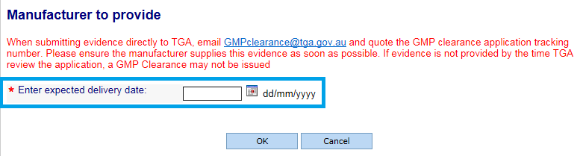

|  |  |
| --- | --- |
| Information | Please note the maximum file size we can receive via email is 20MB. For large files, please consider submitting via GovTeams.  You should liaise with your manufacturer to **ensure the date selected is achievable prior to submitting your GMP Clearance application**.  **Evidence should be provided no later than 1 month from the submission of the GMP Clearance application.**  If we have not received the evidence by the time we perform application receipt, your application will progress to assessment as **incomplete**. This will result in extended processing times and your GMP Clearance **may** **not be issued**. Sponsor should check status of the application around the expected delivery date of evidence and contact their manufacturers in the first instance to ensure the required evidence has been provided. |

##### Submit paper copy

1. If you have selected this delivery method, in the resulting dialog box select the expected date the evidence will be delivered to TGA.

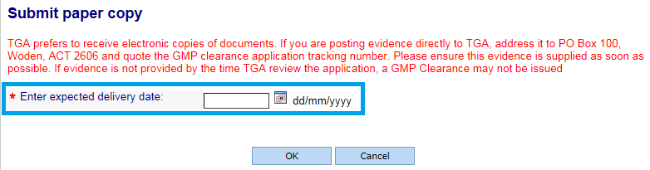

|  |  |
| --- | --- |
| Information | We prefer to receive electronic copies of documents. A file size of **100MB** is available and files may be zipped. Paper copies are accepted if they cannot be submitted electronically.  You should liaise with your manufacturer to ensure that the date selected is achievable **prior** to submitting your GMP Clearance application.  **Evidence should be provided no later than 1 month from the submission of the GMP Clearance application.**  If we have not received the evidence by the time we perform application receipt, your application will progress to assessment as incomplete. This will result in extended processing times and your GMP Clearance may not be issued. |

##### Upload evidence

1. If you have selected this delivery method, in the resulting dialog box select ‘Browse’ and select the file to upload.

|  |  |
| --- | --- |
| Information | **Important:** Ensure the document has the [correct naming convention](bookmark://_Evidence_naming_conventions). |

1. When uploading GMP certificates or inspection reports, you will also need to enter the inspection date relevant to the evidence provided.

|  |  |
| --- | --- |
| Information | You may receive alerts if the inspection date is ≥3 years old identifying that the GMP Clearance may:   * result in a short expiry date (if issued)   OR   * not be issued if the evidence is > 3years from date of inspection. |

You can Browse your files to select a file to upload. 
Enter the Last Inspection Date.
Select the OK button.

|  |  |
| --- | --- |
| Information | The maximum file size is **100MB** per piece of evidence. If supplying multiple documents in response to a single item of evidence (for example a SMF and separate appendices) please provide a single zip file. |

1. If the document does not have the correct naming convention, an error message will be displayed. Update the document name as per the naming convention and upload it again.

Message: Upload file name does not conform to agreed format. Please refer Help for instructions.
Select the 'OK' button.

##### Letter of access to clearance

1. If you have selected this delivery method, in the resulting dialog box enter a valid GMP Clearance tracking number.

Enter a valid GMP tracking number.
Select 'OK' button.

|  |  |
| --- | --- |
| Information | To avoid unnecessary delays and unforeseen outcomes that may impact your regulatory submissions, we strongly recommend you to only use LoA to clearance to access **already issued** GMP Clearances. Prior to submission, check with the owner of the parent clearance for the outcome of assessment. |

##### Letter of access to evidence

1. If you have selected this delivery method, in the resulting dialog box enter a valid GMP Clearance tracking number that contains this piece of evidence you wish to access.

Enter a vaild GMP tracking number.
Select the 'OK' button.

|  |  |
| --- | --- |
| Information | If choosing either letter of access delivery methods, the letter must be uploaded in the Mandatory certificates or letters section.  A **valid** GMP Clearance tracking number is a GMP Clearance that is currently under review or has been issued.  Ensure you have read the relevant information the [GMP Clearance guidance](https://www.tga.gov.au/resources/resource/guidance/gmp-clearance-guidance) regarding Letters of Access. |

#### Mandatory evidence

1. If you are submitting a Compliance Verification application, there is a Mandatory Evidence section.

Identify the evidence that is required for your application type:

* + Select N/A for the evidence that is not required **and**
  + Check the box next to the evidence that is required

|  |  |
| --- | --- |
| Information | If you or your manufacturer do not provide all required evidence, you will experience **significant delays in processing times** and your GMP Clearance **may** **not be issued****.** |

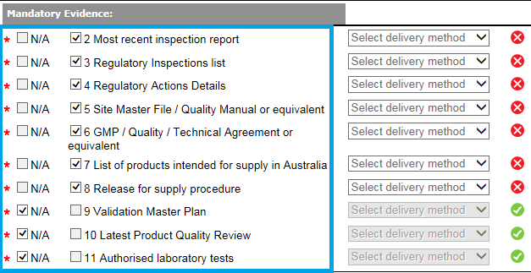

1. For each piece of evidence, choose the delivery method and complete the dialog box that appears.



1. To **update the information** that you previously entered into a dialog box (for example the delivery date of evidence), **click once** on the dropdown list and the dialog box will be displayed again to update.

Click the delivery method once to update details that you have already entered.

1. To **change the type of delivery method selected** (for example to change from Post paper version to Upload Evidence), **click and hold** the drop down menu and select the new delivery method and complete the required information in the resulting dialog box.

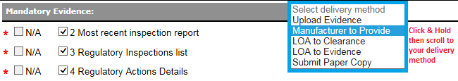

#### Optional evidence

1. If you wish to supply additional evidence, select the relevant check box in the Optional Evidence section and select the delivery methods as per instructions 37-45.

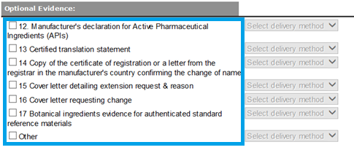

## Submitting your complete application and paying fees

### Fees and Payments tab

1. You will be able to view the itemised fee in addition the total amount before you submit your application.

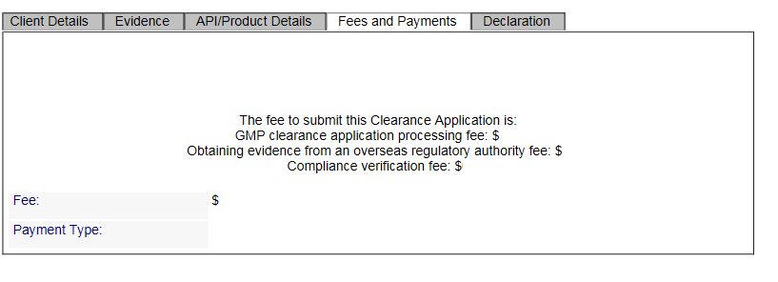

|  |  |
| --- | --- |
| Information | Please note any applicable fees not selected during the submission of your application will be raised during application receipt and will result in delays to processing times. |

### Declaration tab

1. You will need to complete the Declaration tab before you can submit your application by ticking the ‘**Agree**’ box. You can then proceed to validating and submitting your application.

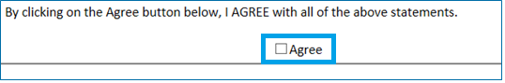

### Validating your application

1. Once you have entered all the required information, you will need to validate your application before submission. Select ‘**Validate**’.



1. If there are areas of the form that have incomplete or incorrect information, an error message will show you what needs to be rectified (example errors below). You will need to address the validation issue before you can proceed.

An example list of reasons why a validation fails.
The close button is at the bottom.

1. Once your application has validated, you will receive the message below.

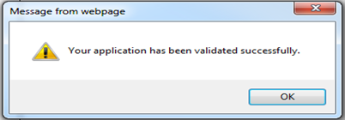

### Submitting your application

1. Once all validation issues are resolved, you are ready to submit the application. Select ‘Submit’.



### Paying your application fee

1. After submitting your application, the following screen will appear, notifying you of the fees to be charged. Select ‘**continue**’ to proceed. 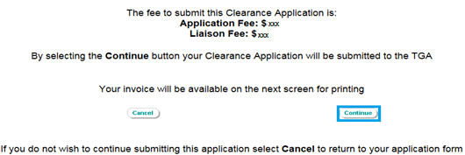
2. You will receive the following notification of a successful submission:

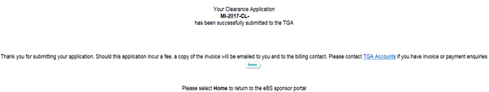

1. The invoice (along with payment instructions) will be emailed to the billing contact. Please direct any queries in relation to invoicing of GMP Clearances to [accountsrec@health.gov.au](mailto:accountsrec@health.gov.au).

## Maintaining your active GMP Clearance

### Creating a variation application

1. Log in to [TGA Business Services](https://business.tga.gov.au/).
2. On the homepage select ‘**Your TGA**’ and from the dropdown select ‘**Manufacturer Information**’

'Your TGA' is the third option at the top of the homepage.
'Manufacturer Information' is the fourth item in the dropdown list.

1. You will be redirected to a list of all your GMP Clearances and licences. Enter ‘**CL**’ as a filter on ‘**identifier**’ and select ‘**Go**’. This will display a list of your active GMP Clearances.

The 'Filter on' field select 'identifier' and in the adjacent field enter CL.
The 'Go' button is to the right of these two fields.

1. Select the existing GMP Clearance you wish to vary.

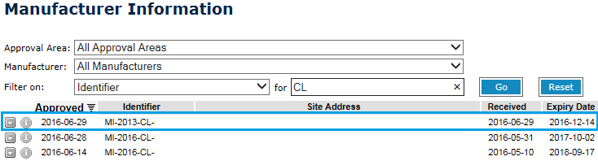

1. Select ‘**Vary Application’** from the menu bar at the top of your GMP Clearance.



1. Select one of the three variation types:
   * Change Clearance Details
   * Change Clearance Status
   * Renewals

|  |  |
| --- | --- |
| Information | We recommend that for any variation application where multiple changes are required, you provide a cover letter outlining these changes.  For example, where you wish to renew your GMP Clearance application in addition to updating the contact details and manufacturers name or address. |

### Change clearance details - Scope, applicant or manufacturer changes

1. Select ‘**Change Clearance Details’**



1. In the client details tab, for Variation Requests select the change(s) you wish to make to your GMP Clearance from the following options:
   * Change to Manufacturer details – Administrative: A change to manufacturer name or a minor change to the manufacturer's address with no physical change to the manufacturing site (rezoning, amending a postcode etc.)
     + If part of the site is being divested, please contact [GMPclearance@health.gov.au](mailto:GMPclearance@health.gov.au) **prior to** submitting your application.
   * Change to Manufacturer details – Physical: A change to the manufacturer’s address (adding a building, plot or unit or the relocation of a site to a different address)
   * Change of Sponsor or Applicant details: A change to the applicant or sponsor contact details (e.g. the nominated contact has left the organisation)
   * Change of scope: An increase / change or a reduction to the scope (dosage forms, manufacturing steps, etc.).

Please refer to [GMP Clearance guidance](https://www.tga.gov.au/resources/resource/guidance/gmp-clearance-guidance) for more information about evidence requirements for these types of changes.

#### Change to manufacturer details - Administrative

1. In client details tab select ‘**Change to manufacturer details – administrative’.**

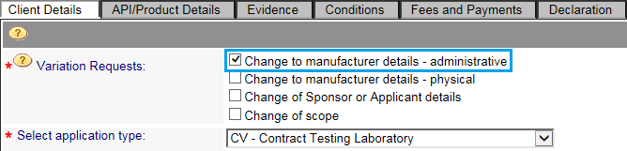

The manufacturer’s information from your existing clearance will be pre-populated in the Manufacturer Details section.

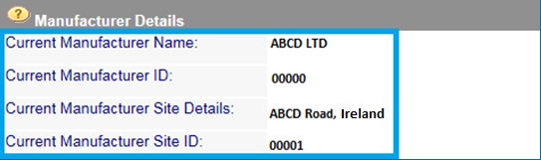

The manufacturing site selected in your existing application will be pre-populated. If the minor update to the site address has already been registered with TGA, it will automatically be updated in your application.

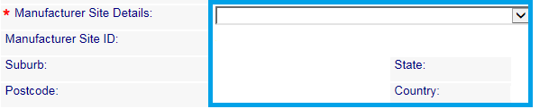

1. If you are updating the manufacturer name or address, select ‘**Search**’ to perform a search of the TGA database to discover whether the required update has already been registered by another sponsor.

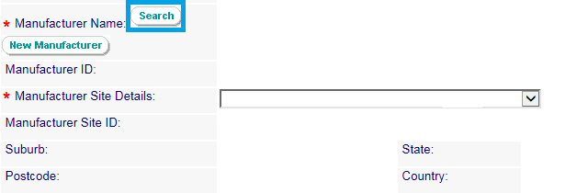

In the search box, enter a search string by typing the updated name of the manufacturer and select ‘**Search**’.

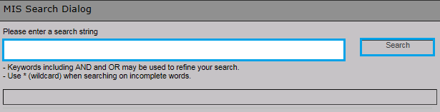

If the manufacturer’s updated name is already registered with the TGA, it will appear in the list for selection. Click on the manufacturer and select ‘**OK**’.



1. If the manufacturer name or address has not been updated by another sponsor, select the existing site address and request the update to be applied by providing a cover letter in the optional evidence section.
2. Proceed to the Evidence tab where the optional evidence is displayed. Select the evidence you will provide to support the update being applied to your GMP Clearance:
3. Select the delivery method for the evidence.
4. Complete the declaration tab.
5. Validate then Submit your variation application.

The Manufacturing Quality Branch will update the client database (manufacturer name/address) if the evidence supports the change.

#### Change to manufacturer details – Physical

1. In client details tab, select **‘Change to manufacturer details – physical’.**

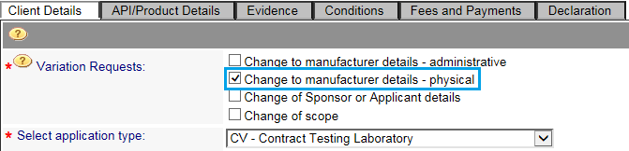

|  |  |
| --- | --- |
| Information | If your change is to **add a building, plot or unit to an existing site**, you can request the update to be applied by selecting the existing site address and provide the evidence to support this change when completing the evidence tab.  A physical change to manufacturer details will require the same documentary evidence to be submitted and incur the same **fees** as submitting a new application. |

1. Under manufacturer site details, open the drop down menu to your manufacturer to check whether the new site has been registered with TGA previously. If the new address is in the drop down menu, select it.

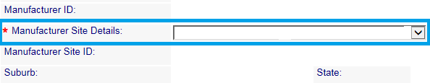

1. Otherwise, for the relocation of a site to a different address select ‘**New Manufacturer**’.



|  |  |
| --- | --- |
| Information | **Important** – Ensure you have thoroughly searched the TGA database for the manufacturer’s name and address **before** you select New Manufacturer. Duplicate entries created can result in extended delays to application processing times and may require significant updates to your ARTG entry.  If you are unsure whether the manufacturer you intend to use is available in the TGA database, please [contact us](https://www.tga.gov.au/manufacturing-therapeutic-goods#contacts) **prior** to proceeding with your application. |

1. Enter all the required updated information about the manufacturing site address, upload a cover letter that explains the request and select ‘**Send**’.

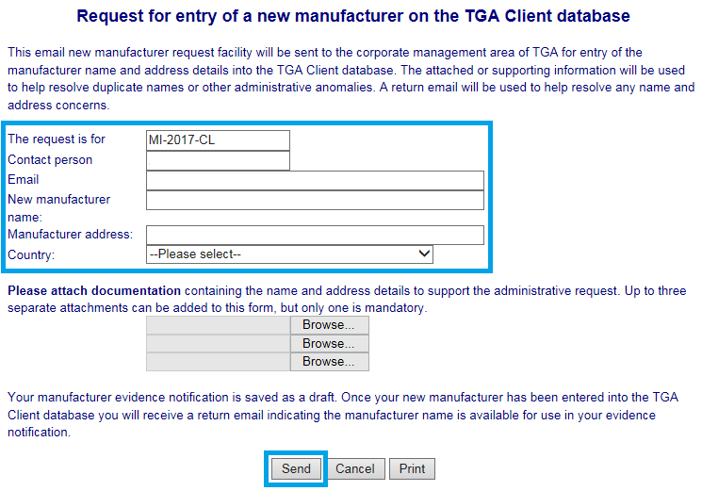

Once TGA Business Services have made the update to the manufacturer site address, you will be notified and be able to select the details and proceed with the application.

The time required to make changes to an existing manufacturer can vary depending on the impact of the change.

Proceed to complete the remainder of the application from this point as if you were creating a new GMP Clearance application.

#### Change of sponsor or applicant details

1. In client details tab select **‘Change of sponsor or applicant details’.**

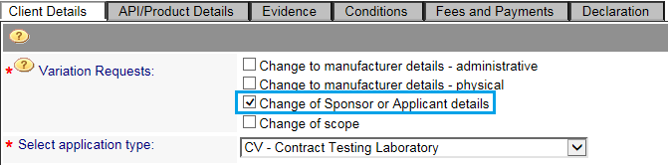

1. Update the relevant sponsor or applicant information in the client details tab by selecting from the available drop down menus.

|  |  |
| --- | --- |
| Information | If you wish to amend (add or remove) contacts, your company’s TGA Business Services administrator can update these details.  Refer to [TGA Business Services – Questions and answers for administrators](https://www.tga.gov.au/resources/resource/guidance/tga-business-services-questions-and-answers-administrators) or contact [ebs@health.gov.au](mailto:ebs@health.gov.au) for assistance. |

1. Complete the declaration tab.
2. Validate then submit your variation application.

#### Change of scope

1. In client details tab select ‘**Change of scope**’.
2. Select if this is:
   * an ‘increase/change in scope’ (for example, addition of dosage form or manufacturing steps) or
   * a ‘decrease in scope’ (for example, when a site has decommissioned a dosage form manufacturing line).

Change in Scope is the fourth and last tick box in the list of Variation Requests.
There are radio buttons for 'Increase/Change in scope' and 'Decrease in scope'

##### Increase/Change in scope

1. Your existing scope will be pre-populated. Proceed to complete the remainder of the application as if you were creating a new application by selecting your scope.

##### Decrease in scope

1. Proceed to the API/Product Details tab. Select the substance, dosage forms or manufacturing steps no longer required and select ‘**Remove**’.

There are tick boxes next to each of the manufcturings teps listed. 
Tick the step(s) you want to remove. Then go the the bottom of the Product Details box to find the Remove button.

1. Proceed to the Evidence tab where the optional evidence is displayed. Select the evidence you will provide to support the update being applied to your GMP Clearance.
2. Select the delivery method for the evidence.
3. Complete the declaration tab.
4. Validate then submit your variation application.

### Change clearance status – Cancel or extend

1. Select **‘Change Clearance Status’.**

The 'Change Clearance Status' radio button is the second Variation Type

1. Proceed to the Status tab and select whether you want to request to ‘**Cancel**’ or ‘**Extend**’ your existing GMP Clearance.

#### Cancel your GMP Clearance

1. Select ‘**Cancel**’ and provide details in the description text box as to the reason for the cancellation request.

The Cancel radio button is the first option for 'Select new status'.
The description box follows.

1. Complete the declaration tab.
2. Validate then submit your variation application.

#### Extensions

1. Select ‘**Extend**’ and from the resulting drop down menu select the reason for the extension request from the following options:
   * **Awaiting TGA inspection**

Select this option when the TGA is to perform an inspection

* + **Awaiting GMP Clearance application assessment by TGA**

Select this option when a renewal GMP Clearance application has been submitted

* + **Awaiting inspection by regulatory authority**

Select this option when the inspecting authority has scheduled an inspection

* + **Awaiting evidence from regulatory authority**

Select this option when there has been a recent inspection performed and awaiting on evidence

* + **Other** (Note: Selecting ‘Other’ will generate a heading text box to allow you to enter your reason for extension).

Select this option if your reason for the extension is not listed in the drop down menu. Please enter a brief reason in the heading text box. Please enter any additional details about this reason in the Description text box.

The 'Extend' radio button is the second option for 'Select enw status'
There is a drop down list for the reason for extension.

1. Select whether this request is the first extension request you have made. If ‘**No**’, provide the previous extension request expiry date.

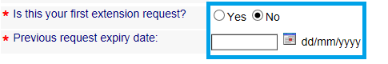

1. Depending on the reason for extension chosen, provide further information in the description text box. For example:
   * **Awaiting TGA inspection**

In the description text box, please enter the TGA certification (CE) number

* + **Awaiting GMP Clearance application assessment by TGA**

In the description text box, please enter the GMP Clearance (CL) renewal application number

* + **Awaiting inspection by regulatory authority**

In the description text box, please enter the inspecting regulatory authority and proposed inspection dates

Please also send an email to [GMP Clearance](mailto:GMPclearance@health.gov.au) referencing the extension clearance number and provide supporting information from the inspection authority regarding inspection dates

* + **Awaiting evidence from regulatory authority**

In the description text box, please enter the inspecting regulatory authority and inspection dates

Please also send an email to [GMP Clearance](mailto:GMPclearance@health.gov.au) referencing the extension clearance number and provide supporting information when the evidence will be available

* + **Other**

In the description text box, please enter further information. If waiting on evidence, please provide the type of evidence and when this will be available.



1. Complete the declaration tab.
2. Validate then submit your variation application.

|  |  |
| --- | --- |
| Information | * We may **not** grant an extension without valid reasons and/or evidence (for example, if you submit late renewal applications). * If you have submitted an extension and the extension is not yet processed, please do not submit another extension request as it may cause delays in our extension processing time. |

### 

### Renewals

You are expected to submit an application to renew your existing active GMP Clearance once new evidence becomes available and preferably **no later than six months** before your clearance is due to expire.

1. Select ‘**Renewals**’.

You may also request to include other changes as part of your renewal application (for example, change of sponsor contact details) by selecting the variation requests below.

|  |  |
| --- | --- |
| Information | * If no other changes are required, do not select a variation request. |

The Renewals radio button is the third Variation Type.
There are four tick boxes for Variation Requests.

|  |  |
| --- | --- |
| Information | **Important** – Please take processing times into account when submitting your renewal applications. |

1. Proceed to complete the remainder of the application from this point as if you were creating a new GMP Clearance application.

## Withdrawing GMP Clearance applications no longer required

Once your application has been submitted and the current status of your GMP Clearance application is ‘**under review**’, you can still withdraw your application if you have identified the GMP Clearance application is no longer required. Any **fees** previously paid may not be refunded.

Please withdraw via TBS by following these instructions:

1. Please login to your TBS portal
2. Under “View Lodged Submission”, locate the application that is no longer required
3. Click on the drop down next to the application you wish to withdraw. This will bring up an option box

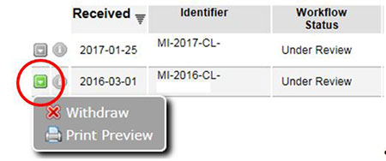

1. Select ‘Withdraw’ from this box
2. Select ‘Print Preview’ to preview your application, then select ‘Withdraw’.

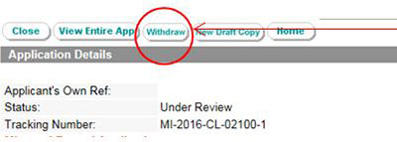

## Evidence naming conventions

The table below outlines the naming conventions for evidence being uploaded with your GMP Clearance application. Validation errors will occur if naming conventions are not followed.

Each piece of evidence should be provided as a separate file. If supplying multiple documents in response to a single item of evidence (for example a SMF and separate appendices), please provide a single zip file.

|  |  |
| --- | --- |
| Information | You will need to name each file with the document number prefix and the required file name to validate your application, for example:   * 8 Release SOP   You cannot add additional text **before the required** naming convention as this will fail validation. For example, the following will fail the validation rule:   * 8 Company Name Release SOP * Company Name 8 Release SOP   You can add additional text **after the required** naming convention. For example:   * 8 Release SOP Company Name Effective Date |

File naming convention table

|  |  |  |
| --- | --- | --- |
| Prefix # | Evidence name | The beginning of the file name (including the prefix number) |
| 1 | Current GMP or GLP or ISO Certificate | 1 Certificate |
| 2 | Most recent inspection report | 2 Inspection Report |
| 3 | Regulatory Inspections list | 3 Regulatory Inspection List |
| 4 | Regulatory Actions Details | 4 Regulatory Action Details |
| 5 | Site Master File or equivalent | 5 Site Master File **or** SMF |
| 6 | GMP **or** Quality **or** Technical Agreement **or** equivalent | 6 GMP **or** Quality **or** Technical **or** Agreement **or** TA **or** QA |
| 7 | List of Products intended for supply in Australia | 7 Product List |
| 8 | Release for supply procedure | 8 Release for Supply procedure **or** Release SOP |
| 9 | Validation Master Plan | 9 Validation Master Plan **or** VMP |
| 10 | Latest Product Quality Review | 10 Product Quality Review **or** PQR |
| 11 | Authorised laboratory tests | 11 Lab test |
| 12 | Manufacturer's declaration for Active Pharmaceutical Ingredients (APIs) | 12 Declaration |
| 13 | Certified translation statement | 13 Translation |
| 14 | Copy of the certificate of registration or a letter from the registrar in the manufacturer's country confirming the change of name | 14 Name **or** Address Change |
| 15 | Cover letter detailing extension request and reason | 15 Letter |
| 16 | Cover letter requesting change | 16 Letter |
| 17 | Botanical ingredients evidence for authenticated standard reference materials | 17 Botanical authenticated standard reference materials |
| 18 | LoA to Clearance | 18 LoA Clearance |
| 19 | LoA to Evidence | 19 LoA Evidence |

## 

## How to create a zip file

1. Locate the file or folder that you want to zip.
2. Press and hold (or right-click) the file or folder, select (or point to) **Send to**, and then select **Compressed (zipped) folder**.

'Send to' is the  ninth item in the first list
 'Compressed (zipped) folder' is the first item in the second list

1. A new zipped folder with the same name is created in the same location. To rename it, press and hold (or right-click) the folder, select **Rename**, and type the new name.

screenshot showing selected zip file

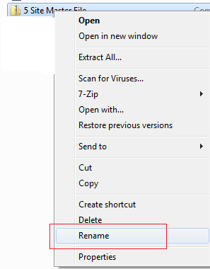

## Submitting large files via GovTeams

1. Access your company folder
   1. Log into GovTEAMS via <https://www.govteams.gov.au/>
   2. Access the TGA electronic submissions site
   3. Open the TGA electronic submissions SharePoint page
   4. Locate your company folder within the Documents section of the SharePoint page
2. Upload the sequence
   1. Upload your documents by dragging and dropping it into your folder or using the Upload button
3. Notify eSubmissions
   1. Email [eSubmissions@health.gov.au](mailto:eSubmissions@health.gov.au)

Title the email - [Sponsor] has submitted documents via the GovTEAMS [GMP Clearance tracking number]

Within the email body please include:

* + - type of application, including whether it is initial supporting evidence or a response to a request for information
    - GMP Clearance application number

## Troubleshooting

Please see below for common issues raised. If you come across any issues, please use the troubleshooting guide below. However, if you are still unable to rectify the issue, please [contact GMP Clearance](mailto:GMPclearance@health.gov.au) and include the following:

* GMP Clearance tracking number
* Screenshot of the issue (if IT issue related)
* Your username (if IT issue related)

|  |  |
| --- | --- |
| Issue | Suggestion |
| I am experiencing TBS related issues, such as:   * I don’t have administrator access to submit an application. * I’m not listed as a contact in the application. * I need to reset my password for the TGA Business Services account. | If the contact is not displayed in the drop down list, your company’s TGA Business Services administrator can update these details. Refer to [TGA Business Services – Questions and answers for administrators](https://www.tga.gov.au/resources/resource/guidance/tga-business-services-questions-and-answers-administrators).  For TBS related issues, please contact [ebs@health.gov.au](mailto:ebs@health.gov.au) for assistance. |
| I can’t select a radio button or checkbox in the GMP Clearance application form. | Please save your GMP Clearance application, refresh your internet browser and try saving again.  If you are still experiencing issues, please **contact GMP Clearance** **prior** to submitting the application. |
| I am experiencing problems when uploading evidence to the application. | Please save your GMP Clearance application, close your internet browser before trying to upload the evidence again.  If you are still experiencing issues, please [contact GMP Clearance](mailto:GMPclearance@health.gov.au) **prior** to submitting the application. |
| I received notification an invoice has been raised, however I cannot see it. | Please wait for 24 hours from the date GMP Clearance sends you an email.  If you have not received an invoice by then, please [contact GMP Clearance](mailto:GMPclearance@health.gov.au). |
| I am experiencing validation errors when entering GMP Clearance details for my product submission. | Please [contact the relevant product regulatory area](https://www.tga.gov.au/about-tga/contact-us) regarding the validation message shown in the respective lodgement systems.  If the selections you made result in validation issues with the regulatory submission system, you may be required to submit a variation application and pay the relevant fees. |

## Glossary

You can find terms, definitions and acronyms are used in Australian therapeutic goods regulation at <https://www.tga.gov.au/resources/acronyms-and-glossary-terms>

Version history

|  |  |  |  |
| --- | --- | --- | --- |
| Version | Description of change | Author | Effective date |
| V1.0 | Original publication following user guide separation from the GMP Clearance Guidance | Manufacturing Quality Branch | November 2023 |