|  |
| --- |
| Australian Public Assessment Report for Comirnaty  Original/Omicron BA.4-5 |
| Active ingredients: Tozinameran and famtozinameran |
| Sponsor: Pfizer Australia Pty Ltd |
| February 2024 |

About the Therapeutic Goods Administration (TGA)

* The Therapeutic Goods Administration (TGA) is part of the Australian Government Department of Health and Aged Care and is responsible for regulating therapeutic goods, including medicines, medical devices, and biologicals.
* The TGA administers the *Therapeutic Goods Act 1989* (the Act), applying a risk management approach designed to ensure therapeutic goods supplied in Australia meet acceptable standards of quality, safety, and efficacy.
* The work of the TGA is based on applying scientific and clinical expertise to decision-making, to ensure that the benefits to the Australian public outweigh any risks associated with the use of therapeutic goods.
* The TGA relies on the public, healthcare professionals and industry to report problems with therapeutic goods. The TGA investigates reports received to determine any necessary regulatory action.
* To report a problem with a therapeutic good, please see the information on the [TGA website](https://www.tga.gov.au/).

About AusPARs

* The Australian Public Assessment Report (AusPAR) provides information about the evaluation of a prescription medicine and the considerations that led the TGA to approve or not approve a prescription medicine submission. Further information can be found in [Australian Public Assessment Report (AusPAR) guidance](https://www.tga.gov.au/australian-public-assessment-report-auspar-guidance).
* AusPARs are prepared and published by the TGA.
* AusPARs are static documents that provide information that relates to a submission at a particular point in time. The publication of an AusPAR is an important part of the transparency of the TGA’s decision-making process.
* A new AusPAR may be provided to reflect changes to indications or major variations to a prescription medicine subject to evaluation by the TGA.

Copyright

© Commonwealth of Australia 2024  
This work is copyright. You may reproduce the whole or part of this work in unaltered form for your own personal use or, if you are part of an organisation, for internal use within your organisation, but only if you or your organisation do not use the reproduction for any commercial purpose and retain this copyright notice and all disclaimer notices as part of that reproduction. Apart from rights to use as permitted by the *Copyright Act 1968* or allowed by this copyright notice, all other rights are reserved and you are not allowed to reproduce the whole or any part of this work in any way (electronic or otherwise) without first being given specific written permission from the Commonwealth to do so. Requests and inquiries concerning reproduction and rights are to be sent to the TGA Copyright Officer, Therapeutic Goods Administration, PO Box 100, Woden ACT 2606 or emailed to <[tga.copyright@tga.gov.au](mailto:tga.copyright@tga.gov.au)>.

Contents

List of abbreviations 4

Product submission 5

Submission details 5

Product background 6

The disease/condition 7

Current treatment options 7

Clinical rationale 7

Regulatory status 10

Australian regulatory status 10

Foreign regulatory status 10

Registration timeline 11

Submission overview and risk/benefit assessment 12

Quality 12

Nonclinical 13

Clinical 13

Summary of clinical studies 13

Efficacy 13

Safety 19

Study plan 20

Risk management plan 21

Risk-benefit analysis 22

Delegate’s considerations 22

Proposed action 23

Advisory committee considerations 24

Outcome 25

Specific conditions of registration applying to these goods 25

Attachment 1. Product Information 28

## List of abbreviations

|  |  |
| --- | --- |
| Abbreviation | Meaning |
| ACV | Advisory Committee on Vaccines |
| ASA | Australia-specific annex |
| ATAGI | Australian Technical Advisory Group on Immunisation |
| CI | Confidence interval |
| CMI | Consumer Medicines Information |
| COVID-19 | Coronavirus disease 2019 |
| EU | European Union |
| GMR | Geometric mean ratio |
| GMT | Geometric mean titre |
| PI | Product Information |
| RMP | Risk Management Plan |
| SARS-CoV-2 | Severe acute respiratory syndrome coronavirus 2 |
| TGA | Therapeutic Goods Administration |

## Product submission

### Submission details

|  |  |
| --- | --- |
| *Types of submission:* | Extension of indication and new strength |
| *Product name:* | Comirnaty Original/Omicron BA.4-5 |
| *Active ingredients:* | Tozinameran and famtozinameran |
| *Decision:* | Approved for provisional registration |
| *Date of decision:* | 20 December 2023 |
| *Date of entry onto ARTG:* | 21 December 2023 |
| *ARTG number(s):* | 400874 and 412350 |
| [*Black Triangle Scheme*](https://www.tga.gov.au/black-triangle-scheme)  *for the current submission:* | Yes |
| *Sponsor’s name and address:* | Pfizer Australia Pty Ltd  Level 17, 151 Clarence Street  Sydney NSW 2000 |
| *Dose form:* | Suspension for injection |
| *Strengths:* | 15 mg of tozinameran and 15 mg of famtozinameran/0.3 mL and 5 mg of tozinameran and 5 mg of famtozinameran/0.2 mL |
| *Container:* | Vial |
| *Pack sizes:* | 10 and 195 |
| *Approved therapeutic use for the current submission:* | *Comirnaty Original/Omicron BA.4-5 Vaccine has provisional approval for the indication below:*  *Active immunisation to prevent coronavirus disease 2019 (COVID-19) caused by SARSCoV-2, in individuals 5 years of age and older.*  *The use of this vaccine should be in accordance with official recommendations.*  *The decision has been made on the basis of short term immunogenicity and safety data. Continued approval depends on the evidence of longer term efficacy and safety from ongoing clinical trials and post-market assessment.* |
| *Route of administration:* | Intramuscular |
| *Dosage:* | For individuals 12 years of age or older, one dose (0.3 mL) contains 15 mg of tozinameran and 15 mg of famtozinameran. For individuals aged 5 years to less than 12 years of age, one dose (0.2 mL) contains 5 mg of tozinameran and 5 mg of famtozinameran.  For primary series dosing two doses are administered at least 21 days (preferably 3 weeks) apart. Additional doses are administered at least 3 months after the previous dose.  **Severely immunocompromised aged 12 years and older**  In accordance with official recommendations, a third dose may be given, as part of the primary series, at least 28 days after the second dose to individuals who are severely immunocompromised (see Section 4.4 Special warnings and precautions for use).  For further information regarding dosage, such as dosage modifications to manage adverse reactions, refer to the Product Information. |
| *Pregnancy category:* | B1  Drugs which have been taken by only a limited number of pregnant women and women of childbearing age, without an increase in the frequency of malformation or other direct or indirect harmful effects on the human fetus having been observed.  Studies in animals have not shown evidence of an increased occurrence of fetal damage.  The use of any medicine during pregnancy requires careful consideration of both risks and benefits by the treating health professional. The [pregnancy database](https://www.tga.gov.au/products/medicines/find-information-about-medicine/prescribing-medicines-pregnancy-database) must not be used as the sole basis of decision making in the use of medicines during pregnancy. The TGA does not provide advice on the use of medicines in pregnancy for specific cases. More information is available from [obstetric drug information services](https://www.tga.gov.au/obstetric-drug-information-services) in your state or territory. |

### Product background

This AusPAR describes the submission by Pfizer Australia Pty Ltd (the sponsor) to register Comirnaty Original/Omicron BA.4-5 (tozinameran/famtozinameran) 15/15 mg/0.3 mL and 5/5 mg/0.2 mL, suspension for injection, vial for the following proposed extension of indication and new strength:[1]

***Proposed indication***

*Comirnaty Original/Omicron BA.4-5 Vaccine has provisional approval for the indication below:*

*As a booster dose for active immunisation to prevent coronavirus disease 2019 (COVID-19) caused by SARS-CoV-2, in individuals 5 years of age and older.*

*The use of this vaccine should be in accordance with official recommendations.*

*The decision has been made on the basis of short term immunogenicity and safety data. Continued approval depends on the evidence of longer term efficacy and safety from ongoing clinical trials and post-market assessment.*

***Proposed new strength***

*Comirnaty Original/Omicron BA.4-5 for age 5 to <12 years: (Multidose vial, Orange cap).*

*For administration of 5/5 micrograms/0.2 mL dose, a new strength of Comirnaty Original/Omicron BA.4-5 is proposed to be registered. One vial (1.3 mL fill of 0.05 mg/mL tozinameran + 0.05 mg/mL famtozinameran) is designed to provide 10 doses of 0.2 mL after dilution with 1.3 mL sodium chloride 9 mg/mL (0.9%) solution.*

#### The disease/condition

Coronavirus disease 2019 (COVID-19) is a disease caused by infection with the pandemic virus severe acute respiratory syndrome coronavirus 2 (SARS-CoV-2), which was first recognised internationally in late 2019 and in Australia by early 2020. It is manifest by respiratory, systemic and other organ-related manifestations.

Disease severity is mainly related to respiratory manifestations and increases with age. Mortality in unvaccinated individuals with untreated disease is rare in childhood but increases steeply beyond 60 years of age.

In the absence of highly effective prophylactic or therapeutic medicines, active immunisation through vaccination represents the best means of preventing hospitalisation and deaths at an individual level and controlling the pandemic at a societal level.

Emerging mutated SARS-CoV-2 variants of concern pose challenges for current vaccination strategies, which until somewhat recently had been based on inducing immunity to the non‑mutated spike protein that was sequenced in the original wild-type virus.

#### Current treatment options

At the time of the submission, all COVID-19 treatments available in Australia were provisionally approved by the TGA. These products are summarised on the TGA website ([COVID-19 treatments: Provisional registrations](https://www.tga.gov.au/products/covid-19/covid-19-treatments/covid-19-treatments-provisional-registrations)).

The list of COVID-19 vaccines approved by the TGA (provisional or full), along with those that are not currently approved but under evaluation are summarised on the TGA website ([COVID-19 vaccines regulatory status](https://www.tga.gov.au/products/covid-19/covid-19-vaccines/covid-19-vaccines-regulatory-status)). At the time of the submission, only SPIKEVAX Original (Moderna) had gained a full registration. Comirnaty Original was under evaluation for a full registration. Comirnaty Original/Omicron BA.1 was provisionally approved for individuals 18 years of age or older.

#### Clinical rationale

The sponsor has provided a justification in the cover letter for immunisation of children 5 to 12 years of age using Comirnaty Original/Omicron BA.4-5.

COVID-19 continues to be a significant public health issue in Australia, particularly since the emergence of the Omicron variants. During 15 December 2021 to 9 April 2023, there had been 5,066,975 polymerase chain reaction (PCR) confirmed and 5,889,502 rapid antigen test (RAT) probable COVID-19 cases in Australia, along with significant rises in severe diseases resulting in intensive care unit admissions and deaths over the period (Figure 1). In early July 2022, BA.5 (including sub-lineages) became the predominant subvariant detected in Australia, driving a third wave of transmission. The reported incidence of COVID-19 in individuals 0 to 9 and 10 to 19 remains significant (Figure 2).

Figure 1: COVID-19 cases, deaths and intensive care unit admissions in Australia, by date of onset, 27 June 2022 to 9 April 2023

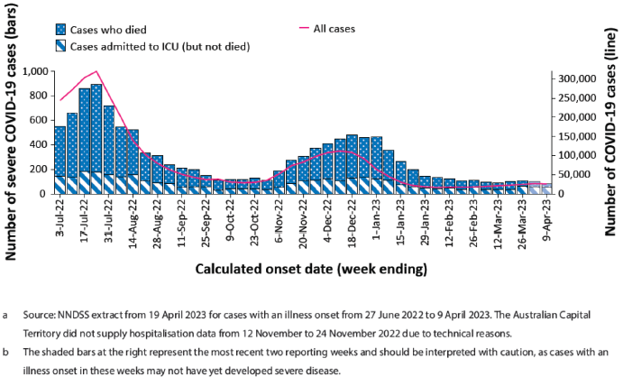

a. Source: NNDSS extract from 19 April 2023 for cases with an illness onset from 27 June 2022 to 9 April 2023. The Australian Capital Territory did not supply hospitalisation data from 12 November to 24 November 2022 due to technical reasons.

b. The shaded bars at the right represent the most recent two reporting weeks and should be interpreted with caution, as cases with an illness onset in these weeks may not have yet developed severe disease.

Figure 2: Polymerase chain reaction confirmed and rapid antigen testing probable COVID‑19 case rates for all ages in Australia, 3 July 2022 to 9 April 2022

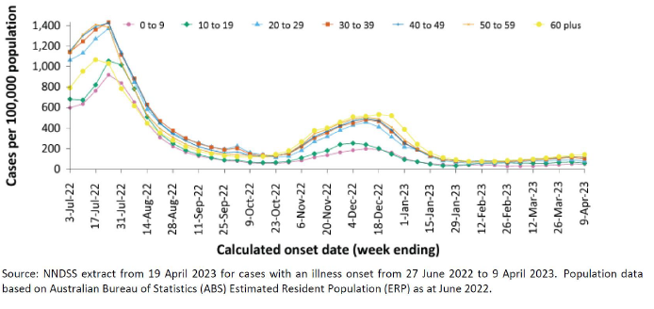

Source: NNDSS extract from 19 April 2023 for cases with an illness onset from 17 June 2022 to 9 April 2023. Population data based on Australian Bureau of Statistics (ABS) Estimated Resident Population (ERP) as at June 2022.

Furthermore, the sponsor has provided the following statement to highlight the disease burden in children and young adults:

*Nationally, since early March 2023, there has been a gradual increasing trend in case notifications. COVID-19 case rate per 100,000 population between 13 March – 9 April 2023 for the age groups 0-9 and 10-19 years were 186.3 and 255.5, respectively.*

*Per Communicable Diseases Intelligence COVID-19 Australia: Epidemiology Report 73 (reporting period ending 9 April 2023), since the start of the pandemic to 9 April 2023, there have been 175 cases of paediatric inflammatory multisystem syndrome - temporally associated with SARS-CoV-2 (PIMS-TS), reported to the Paediatric Active Enhanced Disease Surveillance network (PAEDS). The majority of PIMS-TS cases to date have occurred in those aged 5 to < 12 years (52%; 91/175), followed by those aged 6 months to < 5 years (28%; 49/175).*

Figure 3 shows paediatric inflammatory multisystem syndrome-temporally associated with SARS-CoV-2 cases reported to the Paediatric Active Enhanced Disease Surveillance network, by sample month and level of care required, Australia, 1 June 2021 to 9 April 2023.

Figure 3: Paediatric inflammatory multisystem syndrome-temporally associated with SARS-CoV-2 cases reported to the Paediatric Active Enhanced Disease Surveillance network, by sample month and level of care required, Australia, 1 June 2021 to 9 April 2023

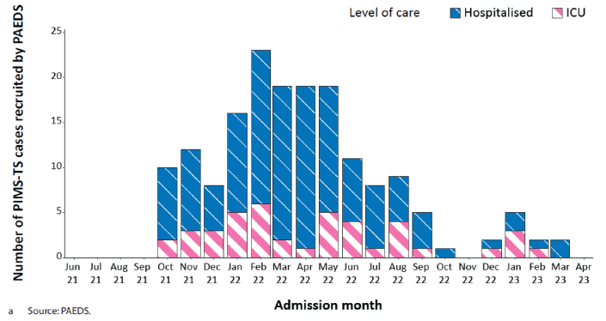

The sponsor has supplied the following justification for using Comirnaty Original/Omicron BA.4‑5 in children less than 12 years of age:

*COVID-19 burden persists among individuals of all ages and a variant-adapted vaccine that improves immune responses to currently circulating variants may help restore higher levels of protection against infection, and thus transmission, similar to that observed at earlier stages in the pandemic. Currently, a variant-adapted COVID-19 vaccine is not available for children <12 YOA.*

*Given the genetic and resulting antigenic differences in currently circulating Omicron sublineages of SARS-CoV-2 (e.g., BQ.1, BQ.1.1, BA.5, XBB.1, XBB.1.5) compared to the original WT strain, the addition of the bivalent variant-adapted vaccine is needed to ensure adequate protection. Implementation of the proposed additional booster dose with bivalent variant-adapted vaccine would expand vaccine protection and add another important layer of community protection against symptomatic SARS-CoV-2 infection and severe COVID-19, particularly in the current setting of Omicron sublineages dominance and with evidence that wild-type based vaccines likely offer significantly reduced protection against BA.4 and BA.5-related disease, including severe illness, compared to prior variants.*

### Regulatory status

#### Australian regulatory status

The product received initial registration in the [Australian Register of Therapeutic Goods](https://www.tga.gov.au/products/australian-register-therapeutic-goods-artg) ([ARTG](https://www.tga.gov.au/products/australian-register-therapeutic-goods-artg)) on 23 January 2023. It was approved for the following indication:[2]

*Comirnaty Original/Omicron BA.4-5 vaccine has provisional approval for the indication below:*

*As a booster dose for active immunisation to prevent coronavirus disease 2019 (COVID-19) caused by SARS-CoV-2, in individuals 12 years of age and older.*

*The use of this vaccine should be in accordance with official recommendations.*

*The decision has been made on the basis of short term immunogenicity and safety data. Continued approval depends on the evidence of longer term efficacy and safety from ongoing clinical trials and post-market assessment.*

#### Foreign regulatory status

At the time the TGA considered this submission, a similar submission had been considered by other regulatory agencies. The following table summarises these submissions and provides the indications where approved.

Table 1: International regulatory status

|  |  |  |  |
| --- | --- | --- | --- |
| Region | Submission date | Status | Approved indications |
| United States of America | 23 September 2023 | Approved on 12 October 2022 | ***Current:*** *(2023-2024 Formula)*  *BLA: Active immunization to prevent coronavirus disease 2019 (COVID-19) caused by severe acute respiratory syndrome coronavirus 2 (SARS-CoV-2) in individuals 12 years of age and older.*  *EUA: Active immunization to prevent coronavirus disease 2019 (COVID-19) caused by severe acute respiratory syndrome coronavirus 2 (SARS-CoV-2) in individuals 6 months through 11 years of age.*  ***At the time of approval:*** *Pfizer-BioNTech COVID-19 Vaccine, Bivalent (Original and Omicron BA.4/BA.5) is FDA-authorized under Emergency Use Authorization (EUA) for use in individuals 5 years of age and older as a single booster dose administered at least 2 months after either: completion of primary vaccination with any* *authorized or approved monovalent* COVID-19 vaccine; or receipt of the most recent booster dose with any authorized or approved monovalent COVID-19 vaccine.* |
| European Union | 14 September 2022 | Approved on 10 November 2022 | ***Current:***  *Active immunisation to prevent COVID-19 caused by SARS-CoV-2, in individuals aged 6 months and older. The use of this vaccine should be in accordance with official recommendations.*  ***At the time of approval:***  *Active immunisation to prevent COVID-19 caused by SARS-CoV-2, in children aged 5 to 11 years who have previously received at least a primary vaccination course against COVID-19. The use of this vaccine should be in accordance with official recommendations.* |
| Canada | 18 October 2022 | Approved on 9 December 2022 | *Active immunization against*  *coronavirus disease 2019 (COVID-19) caused by the severe acute respiratory syndrome coronavirus 2 (SARS-CoV-2) virus in individuals 6 months of age and older.* |

## Registration timeline

The following table captures the key steps and dates for this submission.

This submission was evaluated under the [registration process for COVID-19 vaccines](https://www.tga.gov.au/products/covid-19/covid-19-vaccines/covid-19-vaccine-approval-process).

Table 2: Timeline for Submission PM-2023-02389-1-2

Data were provided as a rolling submission. Under normal circumstances, TGA's assessment (for both provisional and general registration) begins once all information to support registration is available. As part of the Department of Health and Aged Care's response to the pandemic, the TGA has agreed to accept rolling data for COVID-19 vaccines and treatments, to enable early evaluation of data as it becomes available.

|  |  |
| --- | --- |
| Description | Date |
| Determination (provisional) | 28 March 2023 |
| Submission dossier accepted and first round evaluation commenced | 6 July 2023 |
| Evaluation completed | 19 December 2023 |
| Delegate’s Overall benefit-risk assessment and request for Advisory Committee advice[3] | 31 October 2023 |
| Sponsor’s pre-Advisory Committee response | 15 November 2023 |
| Advisory Committee meeting | 29 November 2023 |
| Registration decision (Outcome) | 20 December 2023 |
| Administrative activities and registration in the ARTG completed | 21 December 2023 |
| Number of working days from submission dossier acceptance to registration decision* | 119 |

*Statutory timeframe for standard submissions is 255 working days

## Submission overview and risk/benefit assessment

A summary of the TGA’s assessment for this submission is provided below.

### Quality

The BNT162b2 Bivalent BA.4-5 drug product has two drug substances, Original and Omicron BA.4-5, combined in a 1:1 ratio by mixing prior to lipid nanoparticle formulation. No changes have been made to the drug substance manufacturing process, testing procedures, and release criteria.

The Bivalent BA.4-5 drug product, is a preservative-free, sterile dispersion of RNA-containing lipid nanoparticles in aqueous cryoprotectant buffer for intramuscular administration.

There are no significant issues identified from the quality evaluation of the submitted data that would indicate the products should not be provisionally registered on the basis of quality, or safety related issues arising from the quality of the product. The manufacturing quality information submitted by the sponsor support the provisional registration of:[4]

* Comirnaty Original/Omicron BA.4-5 (tozinameran/famtozinameran) COVID-19 Vaccine 15/15 micrograms/0.3 mL suspension for injection single dose vial [AUST R 413718]
* Comirnaty Original/Omicron BA.4-5 (tozinameran/famtozinameran) COVID-19 Vaccine 5/5 micrograms/0.2 mL concentrated suspension for injection vial [AUST R 412350]
* Comirnaty Original/Omicron BA.4-5 (tozinameran/famtozinameran) COVID-19 Vaccine 5/5 micrograms/0.3 mL suspension for injection vial [AUST R 413719]
* Comirnaty Original/Omicron BA.4-5 (tozinameran/famtozinameran) COVID-19 Vaccine 5/5 micrograms/0.3 mL suspension for injection single dose vial [AUST R 413720]

### Nonclinical

No new nonclinical data or further nonclinical evaluation were required for this submission. The TGA considers that previously submitted and evaluated data satisfactorily address nonclinical aspects of safety/efficacy relating to this submission.[5]

### Clinical

#### Summary of clinical studies

Two studies were submitted with provided efficacy data, Study C4591048 and Study C4591044.

The clinical evaluation has noted that the dossier did not include clinical summaries.

#### Efficacy

##### Study C4591048

Study C4591048 was provided as an interim analysis of one sub-study, D, in a four-group study. This sub-study was designed to evaluate the safety and immunogenicity of a third or fourth dose of bivalent vaccine in participants 5 to less than 12 years of age who had received two or three prior doses of Comirnaty.

The interim analysis presented for evaluation was from subjects enrolled who had received three previous doses of monovalent Comirnaty and received a fourth dose of bivalent vaccine.

Comparator immunogenicity data for subjects who received three doses of monovalent Comirnaty was provided from subjects enrolled in Study C4591007. This was a study previously submitted to TGA to support the use of monovalent Comirnaty as a booster in children 5 to 11 years of age.

It is noted the 115 subjects enrolled in the bivalent vaccine arm had received three prior doses of Comirnaty. The comparator arm comprised 113 subjects matched for age from Study C4591007.

The primary endpoints of the trial were immunological:

* COVID-19 BA.4-5 neutralising titres.
* The geometric mean ratio (GMR), estimated as the ratio of COVID-19 BA.4-5 neutralising titres one month after receiving a third dose of Comirnaty Original/Omicron BA.4-5 vaccine to the same neutralising titre measured after receiving a third dose of monovalent Comirnaty.
* The difference in percentage of patients seropositive to BA.4-5 one month after receiving a third dose of Comirnaty Original/Omicron BA.4-5 vaccine compared to the percentage of patients seropositive to COVID-19 BA.4-5 after receiving a third dose of monovalent Comirnaty.

The full list of endpoints is summarised in Table 3.

Table 3: Study C4591048 primary and secondary efficacy endpoints

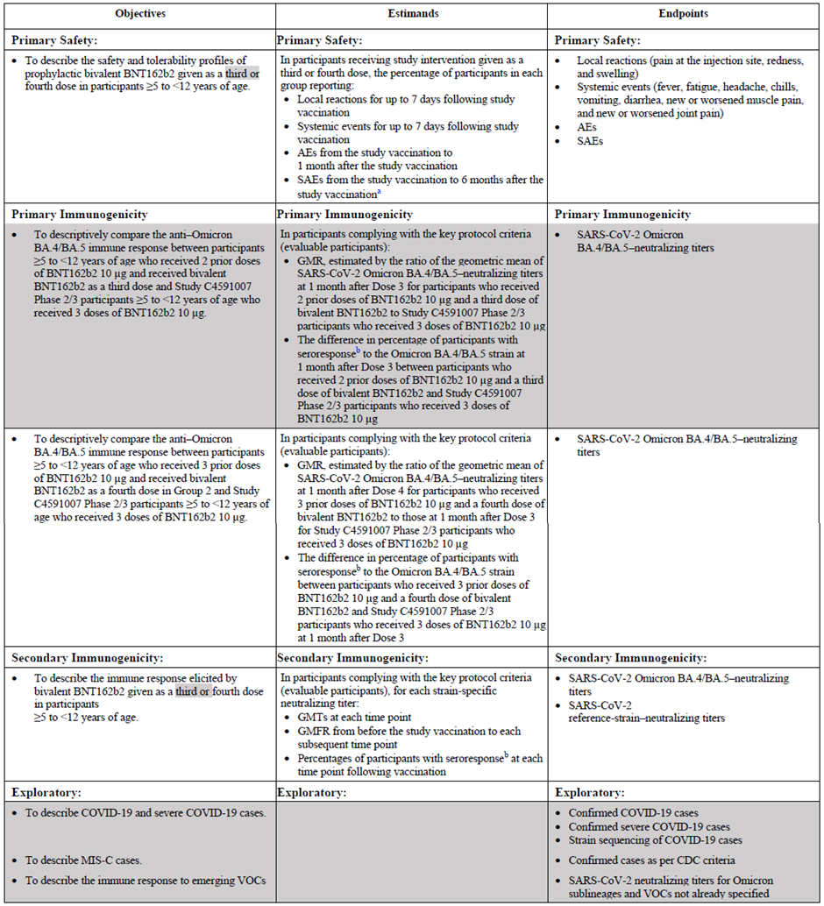

a. Serious adverse events (SAEs) are presented from vaccination through one month after vaccination in this interim CSR.

b. Seroresponse is defined as achieving a 4-fold or greater rise from Baseline (before the study vaccination) for participants in this sub-study. If the Baseline

measurement is below the lower limit of quantitation (LLOQ), the postvaccination measure of equal to or greater than 4 × LLOQ is considered seroresponse. For the comparator group of participants from Study C4591007 Phase II/III, seroresponse is defined as achieving a 4-fold or greater rise from before Dose 3. If the pre–Dose 3 measurement is below the LLOQ, the postvaccination measure of greater than or equal to 4 × LLOQ is considered seroresponse.

Collection of blood for immunogenicity occurred at Day 1 (vaccination) and one month (Day 28 to 35 post vaccination).

The GMR ratio for COVID-19 BA.4-5 neutralising antibodies observed at one month after the fourth dose of vaccine in the bivalent arm was 1.12 (95% confidence interval (CI) 0.92-1.37).

Table 4: Study C4591048 geometric mean titre ratio of bivalent to monovalent vaccine

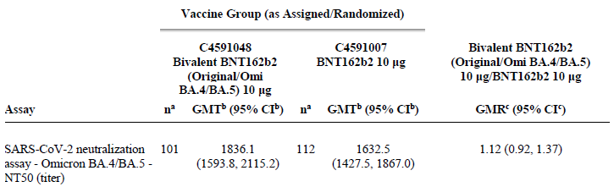

Abbreviations: CI = confidence interval, GMR = geometric mean ratio, GMT = geometric mean titre, LLOQ = lower limit of quantitation, NAAT = nucleic acid amplification test, N-binding = SARS-CoV-2 nucleoprotein–binding, NT50 = 50% neutralising titre, SARS-CoV-2 = severe acute respiratory syndrome coronavirus 2.

Note: Sub-study D Group 2 includes participants 5 to 11 years of age who received three prior doses of BNT162b2 10 mg 90 to 240 days prior to enrolment.

a. n = Number of participants with valid and determinate assay results for the specified assay at both the given dose and the given sampling time point.

b. GMTs and 2-sided CIs were calculated by exponentiating the LSMeans and the corresponding CIs based on analysis of log-transformed assay results using a linear regression model with baseline log-transformed neutralising titres, postbaseline infection status, and vaccine group as covariates.

c. GMRs and 2-sided CIs were calculated by exponentiating the difference of LSMeans for the assay and the corresponding CIs based on the same regression model as stated above.

The difference in seropositivity was 0.79% (95% CI -12.57-14.10) when the population was analysed regardless of evidence of prior infection. The Delegate notes that the majority of subjects were seropositive at Baseline; 57.3% in the bivalent vaccine arm and 58.4% in the monovalent vaccine arm (Table 6).

Table 5: Study C4591048 difference in seropositivity between recipients of bivalent and monovalent vaccine

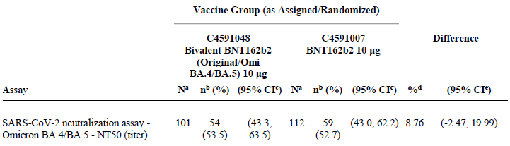

Abbreviations: CI = confidence interval, LLOQ = lower limit of quantitation, NAAT = nucleic acid amplification test, N‑binding = SARS-CoV-2 nucleoprotein–binding, NT50 = 50% neutralising titre, SARS-CoV-2 = severe acute respiratory syndrome coronavirus 2.

Note: Sub-study D Group 2 includes participants 5 to 11 years of age who received three prior doses of BNT162b2 10 mg 90 to 240 days prior to enrolment.

Note: Seroresponse is defined as achieving a 4-fold or greater rise from Baseline (before Dose 4 for C4591048 Sub-study D Group 2 and before Dose 3 for C4591007). If the baseline measurement is below the LLOQ, a postvaccination assay result equal to or greater than 4 × LLOQ is considered a seroresponse.

a. N = number of participants with valid and determinate assay results for the specified assay both before Dose 4 (C4591048)/Dose 3 (C4591007) and at the given dose/sampling time point. These values are the denominators for the percentage calculations.

b. n = Number of participants with seroresponse for the given assay at the given dose/sampling time point.

c. Exact 2-sided CI based on the Clopper and Pearson method.

d. Adjusted difference in proportions based on the Miettinen and Nurminen method stratified by baseline neutralising titre category (less than median, greater than or equal to median), expressed as a percentage (bivalent BNT162b2 [original/Omi BA.4/BA.5] 10 mg - BNT162b2 10 mg). The median of baseline neutralising titres was calculated based on the pooled data in two comparator groups.

e. 2-Sided CI, based on the Miettinen and Nurminen method for the difference in proportions stratified by baseline neutralising titre category (less than median, greater than or equal to median), expressed as a percentage.

Table 6: Demographic characteristics, participants with or without evidence of infection Study C4591048 Sub-study D Group 2 and Study C4591007 Phase II/III participants, evaluable immunogenicity population

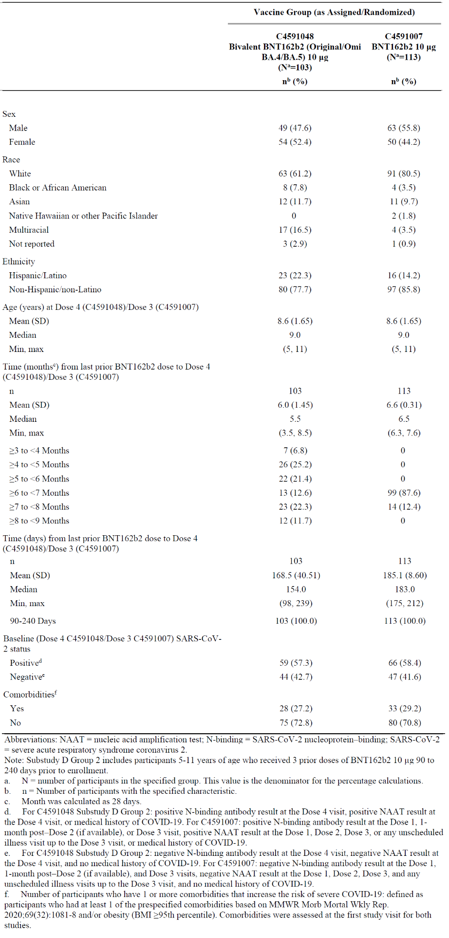

Abbreviations: NAAT = nucleic acid amplification test, N-binding = SARS-CoV-2 nucleoprotein–binding, SARS-CoV-2 = severe acute respiratory syndrome coronavirus 2.

Note: Sub-study D Group 2 includes participants 5 to 11 years of age who received three prior doses of BNT162b2 10 mg 90 to 240 days prior to enrolment.

a. N = number of participants in the specified group. This value is the denominator for the percentage calculations.

b. n = Number of participants with the specified characteristic.

c. Month was calculated as 28 days.

d. For C4591048 Sub-study D Group 2: positive N-binding antibody result at the Dose 4 visit, positive NAAT result at the Dose 4 visit, or medical history of COVID-19. For C4591007: positive N-binding antibody result at the Dose 1, 1-month post–Dose 2 (if available), or Dose 3 visit, positive NAAT result at the Dose 1, Dose 2, Dose 3, or any unscheduled illness visit up to the Dose 3 visit, or medical history of COVID-19.

e. For C4591048 Substudy D Group 2: negative N-binding antibody result at the Dose 4 visit, negative NAAT result at the Dose 4 visit, and no medical history of COVID-19. For C4591007: negative N-binding antibody result at the Dose 1, 1-month post–Dose 2 (if available), and Dose 3 visits, negative NAAT result at the Dose 1, Dose 2, Dose 3, and any unscheduled illness visits up to the Dose 3 visit, and no medical history of COVID-19.

f. Number of participants who have one or more comorbidities that increase the risk of severe COVID-19: defined as participants who had at least 1 of the prespecified comorbidities based on MMWR Morb Mortal Wkly Rep.2020;69(32):1081-8 and/or obesity (BMI ≥95th percentile). Comorbidities were assessed at the first study visit for both studies.

Figure 4: Study C4591048 geometric mean titres for neutralising antibodies against COVID-19 BA.4-5 in patients receiving monovalent (green) or bivalent (purple) vaccine

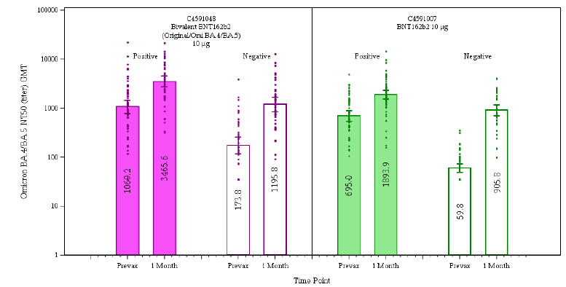

Abbreviations: GMT = geometric mean titre, NT50 = neutralising titre, SARS-CoV-2 = severe acute respiratory syndrome coronavirus 2.

Note: Sub-study D Group 2 includes participants 5 to 11 years of age who received three prior doses of BNT162b2 10 mg 90 to 240 days prior to enrolment.

Note: dots represent individual antibody levels.

Note: number with each bar denotes geometric mean.

Note: positive = for C4591048 Sub-study D Group 2: positive N-binding antibody result at the Dose 4 visit, positive NAAT result at Dose 1, Dose 2, Dose 3, or any unscheduled illness visit up to the Dose 3 visit, or medical history of COVID-19. Negative = for C4591048 Sub-study D Group 2: negative N-binding antibody result at the Dose 4 visit, negative NAAT result at the Dose 4 visit, and no medical history of COVID-19. For C4591007: negative N-binding antibody result at the Dose 1, one month post Dose 2 (if available), and Dose 3 visits, negative NAAT result at the Dose 1, Dose 2, Dose 3 and any unscheduled illness visits up to the Dose 3 visit and no medical history of COVID-19.

The geometric mean titre (GMT) for COVID-19 BA.4-5 neutralising antibodies was comparable for subjects who received Comirnaty Original/Omicron BA.4-5 vaccine and those who received monovalent vaccine. This pattern was consistent whether the subjects were, or were not, seropositive prior to vaccination with their last dose.

The Delegate notes that the bivalent vaccine group had higher pre-vaccination neutralising antibody titres than the bivalent vaccine group. While an increase in GMT was observed for both vaccines, the increase in GMT was much higher for the monovalent vaccine than the bivalent vaccine in patients who were seronegative pre-vaccination. There was a 15.1 fold increase in COVID-19 BA.4-5 neutralising antibodies in baseline seronegative subjects who received a third dose of monovalent Comirnaty, compared to a 6.9 fold increase in baseline seronegative subjects who received a bivalent vaccine.

The increase in antibody titre in baseline seropositive subjects was more comparable between the bivalent and monovalent vaccine, being 3.3 and 2.7 fold respectively from pre-dose to one month post vaccine.

The clinical evaluation concluded that this study has not conclusively demonstrated superiority of the Comirnaty Original/Omicron BA.4-5 vaccine over the monovalent vaccine. The Delegate agrees with this conclusion.

##### Study C4591044

Study C4591044 was an ongoing study, part of which was submitted to TGA as part of application PM-2022-0536-1-2 to register the Comirnaty Original/Omicron BA.4-5 vaccine as a booster dose in children 12 years of age or older.

This data provides updated immunogenicity data based on cross-trial comparisons in adults and adolescents 12 to 18 years of age. The clinical evaluation noted that the data broadly indicates a higher immune response to bivalent vaccine (fourth dose) than Comirnaty (third dose).

The Delegate notes that the immunogenicity of the vaccine in these age groups is not directly relevant to the current application for booster treatment in 5 to 11 year olds, other than providing supportive evidence of the immunogenicity of the vaccine in older patients.

#### Safety

The main evaluable safety data in this submission was provided by Study C4591048.

At 7 days post-vaccination local adverse events (electronic diary by parents/guardians) were all of mild or moderate severity. The clinical evaluation noted that the pattern of local adverse events in Comirnaty Original/Omicron BA.4-5 vaccine recipients was similar to that previously reported for third doses of monovalent vaccine.

Figure 5: System adverse events by severity reported in pivotal study

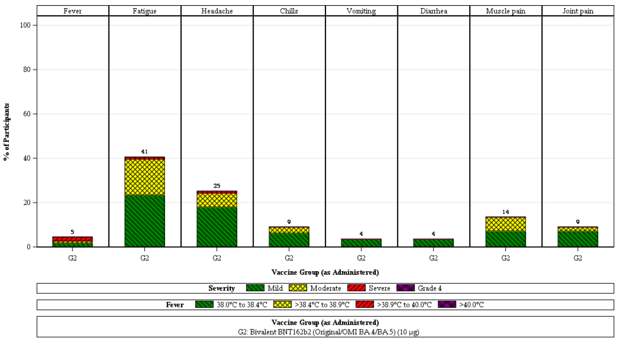

Note: Sub-study D Group 2 includes participants 5 to 11 years of age who received three prior doses of BNT162b2 10 mg 90 to 240 days prior to enrolment.

Note: Severity was not collected for use of antipyretic or pain medication.

Note: The number above each bar donates the percentage of participants reporting the event with any severity.

Among systemic reactions reported at 7 days post fourth dose of Comirnaty Original/Omicron BA.4-5 vaccine the most common was fatigue, followed by headache and muscle pain. The median onset of these reactions was at 2 to 4 days, with a median duration of 1 to 2 days after onset. All events resolved.

In the period from vaccination to one month, four adverse events were reported, comprising one case each of: influenza, otitis media, axillary lymphadenopathy and oropharyngeal pain. Of these, the lymphadenopathy was considered treatment related.

No serious or life-threatening adverse events were reported.

There were no cases of hypersensitivity or myocarditis reported through to one month post vaccination.

The clinical evaluation noted that Study C4591048 only provides short term safety data. However, when compared to three doses of Comirnaty, the bivalent vaccine appears to have comparable or more favourable rates of adverse events associated with its use.

#### Study plan

The sponsor submitted a clinical study plan.

The final report for Study C4591048, which is most relevant to this indication, is intended to be submitted in quarter two 2025, although the study will be completed in quarter four 2023.

The Delegate notes that submission of the final clinical study report for this study will be a condition of provisional registration.

### Risk management plan

The most recently evaluated European Union (EU) risk management plan (RMP) was version 9.0 (4 November 2022) and Australia-specific annex (ASA) version 0.7 (December 2022). In support of the extended indications, the sponsor has submitted EU-RMP version 10.0 (22 June 2023) and ASA version 0.8 (July 2023).

The summary of safety concerns and their associated risk monitoring and mitigation strategies are summarised in Table 7. The TGA may request an updated RMP at any stage of a product's life cycle, during both the pre-approval and post-approval phases.

Table 7: Summary of safety concerns

|  |  |  |  |  |  |
| --- | --- | --- | --- | --- | --- |
| Summary of safety concerns | | Pharmacovigilance | | Risk Minimisation | |
| Routine | Additional | Routine | Additional |
| **Important identified risks** | Myocarditis and pericarditis | ü | ü* | ü | – |
| **Important potential risks** | None | – | – | – | – |
| **Missing information** | Use in pregnancy and while breast feeding | ü | ü*≠ | ü | – |
| Use in immunocompromised patients | ü | ü* | ü | – |
| Use in frail patients with co-morbidities (e.g. chronic obstructive pulmonary disease (COPD), diabetes, chronic neurological disease, cardiovascular disorders) | ü | ü* | ü | – |
| Use in patients with autoimmune or inflammatory disorders | ü | ü* | – | – |
| Interaction with other vaccines | ü | ü* | ü | – |
| Long term safety data | ü | ü* | – | – |

≠Post-authorisation safety study

*Clinical trial

The important potential risk of ‘vaccine associated enhanced disease (VAED) including vaccine associated enhanced respiratory disease (VAERD)’ has been removed since the last evaluation of the summary of safety concerns. This change was made because the cumulative data did not show safety information that substantiates retaining VAED/VAERD as an important potential risk. This is acceptable.

The pharmacovigilance plan is acceptable from an RMP perspective.

Only routine risk minimisation measures are proposed by the sponsor. There are risk minimisation measures implemented for COVID-19 vaccines by the Department of Health and Aged Care and State Governments for the COVID-19 vaccines supplied in Australia, including the Comirnaty vaccines. The changes proposed by this application does not warrant additional risk minimisation measures as part of the RMP.

The RMP evaluation recommended conditions of registration relating to the versions of the risk management plan, requirement for periodic safety update reports, and inclusion of the medicine in the Black Triangle Scheme.

### Risk-benefit analysis

#### Delegate’s considerations

The data submitted in support of extending the use of Comirnaty Original/Omicron BA.4-5 vaccine to 5 to 11 year olds does not conclusively demonstrate superiority to the existing Comirnaty monovalent formulation, despite the latter being based on the original variant of COVID-19 rather than the Omicron variant.

The ratio of neutralising antibody geometric mean titre (GMT) after a fourth booster dose with Comirnaty Original/Omicron BA.4-5 vaccine to that obtained after a third dose of Comirnaty shows an essential equivalence in effect (ratio of 1.12). This is despite the pre-dose GMT being higher in the Comirnaty Original/Omicron BA.4-5 arm, and the fact that the Comirnaty Original/Omicron BA.4-5 booster was a fourth dose, while the Comirnaty monovalent was a third dose of vaccine.

The clinical evaluation has noted that these findings may be partly due to methodological flaws in the analysis provided in the pivotal Study C4591048. The Comirnaty comparator was drawn from matched controls in another study at a different time, and this population may have had different natural exposures to COVID-19. The intervals since the last pre-booster vaccine dose also differed between the two arms of the study. In Study C4591048 most patients had received their third dose of vaccine 4 to 6 months before the bivalent vaccine. In the comparator Study C4591007 the majority of patients (70%) received their third dose 8 to 9 months after the second dose of vaccine. The Delegate feels this makes a direct comparison between the monovalent and bivalent vaccines difficult, but the likely biases (fourth dose, shorter time since last vaccination) would tend to overestimate the effect of the bivalent vaccine.

Current Australian Technical Advisory Group on Immunisation (ATAGI) advice on the use of COVID-19 vaccines in the 5 to 11 age group notes:

*Primary course vaccination is recommended for all children aged 5–11 years. The recommended schedule is 2 doses, 8 weeks apart. An additional (3rd) primary dose is recommended for*[*severely immunocompromised children- external site*](https://www.health.gov.au/resources/publications/atagi-recommendations-on-the-use-of-a-third-primary-dose-of-covid-19-vaccine-in-individuals-who-are-severely-immunocompromised)*, which should be given 8 weeks after the second dose.*

*A booster dose can be considered for children aged 5–11 years who have medical comorbidities that increase their risk of severe COVID-19 or disability with significant or complex health needs, and whose last COVID-19 vaccine dose was 6 months ago or longer.*

*Comirnaty Original is the only formulation currently registered for this age group for both primary course and booster doses.*

While for patients older than 12 years of age:

*Primary course vaccination is recommended for all adolescents aged 12–17 years. The recommended schedule for the primary course is 2 doses, 8 weeks apart. An additional (3rd) primary course dose is recommended for*[*severely immunocompromised adolescents- external site*](https://www.health.gov.au/resources/publications/atagi-recommendations-on-the-use-of-a-third-primary-dose-of-covid-19-vaccine-in-individuals-who-are-severely-immunocompromised)*, which should be given 8 weeks after the second dose.*

*Booster doses can be considered for adolescents who have medical comorbidities that increase their risk of severe COVID-19 or disability with significant or complex health needs, and whose last COVID-19 vaccine dose was 6 months ago or longer.*

*Omicron-based vaccines are preferred for the primary course and for booster doses in this age group. People aged ≥12 years can receive Comirnaty bivalent Original/Omicron BA.4/5 or Spikevax bivalent Original/Omicron BA.4/5. Nuvaxovid (Original strain only) can also be used for primary or booster doses but is not preferred.*

There is little rationale in the data for maintaining different primary and booster recommendation in children younger than 12 years of age than in adolescents even though the data does not provide positive justification for recommending bivalent vaccine over Comirnaty. The Delegate accepts that strain-matched vaccines should be the best option overall, and the results of Study C4591048 probably reflect the generally poor response to Omicron from existing vaccines.

The Product Information for several fully registered COVID-19 vaccines have been simplified from the originally approved form by, for example, removing reference to the specific strain. Reference to boosters in the Dosage and Administration section has been simplified to refer to an additional dose without the number (third, fourth, etcetera) being specified. The general advice is that the vaccine should be used in accordance with official advice, which in the Australian context means the Australian Immunisation Handbook.

The potential to simplify the dosage and administration of vaccines that are currently only approved as boosters has not been relevant prior to the current application. Official advice in patients 12 years and older has moved towards recommending use of the bivalent vaccine in the primary series off-label. The Delegate accepts that this is reasonable since the rationale for using a variant specific booster (that is, a better immunological match with circulating strains of COVID-19) applies equally to primary vaccination.

The Delegate usually does not rely on expert opinion solely in place of evaluable data, and the Immunisation Handbook is not a regulatory document. However, the Delegate acknowledges there is a very low probability that clinical trial data using boosters as primary vaccination will be conducted to regulatory standards. This is because there are very few vaccine naïve populations in which a booster-as-primary trial could be conducted, and there is little motivation to conduct such a trial while most of the use of late-variant based vaccines is for boosters.

This situation leaves unresolved the question of how regulatory advice for primary vaccination series (for example, in vaccine naïve patients) can be updated to incorporate new vaccine strains. The Delegate has concluded that it is appropriate in this setting to broaden the approval for the booster product to include primary vaccination based on acceptable immunogenicity being demonstrated in a booster trial. The Delegate notes that this could be done either while the booster vaccine is provisionally registered or when it transitions to full registration. However, since additional data in primary vaccination is not going to be generated during the provisional period then a delay to until full registration is unlikely to change the regulatory outcome.

#### Proposed action

The Delegate currently proposes to:

1. Extend the indications of Comirnaty Original/Omicron BA.4-5 vaccine to be:

*Comirnaty Original/Omicron BA.4-5 vaccine has provisional approval for the indication below:*

*Active immunisation to prevent coronavirus disease 2019 (COVID-19) caused by SARS-CoV-2, in individuals 5 years of age or older.*

*The use of this vaccine should be in accordance with official recommendations.*

*The decision has been made on the basis of short term immunogenicity and safety data. Continued approval depends on the evidence of longer term efficacy and safety from ongoing clinical trials and post-market assessment.*

1. Extend the indications of Comirnaty Original/Omicron BA.4-5 vaccine to include primary vaccination by amending the Dosage and Administration section of the Product Information:
   1. A single table providing advice for primary vaccination and additional doses (that is, not boosters) in each approved age cohort.
   2. The primary dosing instructions should be based on the relevant dosing interval for Comirnaty monovalent vaccine for example, two doses at Day 0 and 21.
   3. Under the table the statement ‘The use of this vaccine should be in accordance with clinical recommendations in Australia, made by ATAGI in the Australian Immunisation Handbook’ should be included.

The Delegate would appreciate a draft PI in accordance with this proposed approval being made available in a pre-Advisory Committee on Vaccines (ACV) response.

#### Advisory committee considerations

The [Advisory Committee on Vaccines (ACV)](https://www.tga.gov.au/committee/advisory-committee-vaccines-acv), having considered the evaluations and the Delegate’s overview, as well as the sponsor’s response to these documents, advised the following.

##### Specific advice to the Delegate

1. ***The ACV is requested to provide advice on whether the indications (via amendment of the dosing instructions) for the Comirnaty Original/Omicron BA.4-5 vaccine should be extended to include primary vaccination as well as ‘booster’ use.***

The ACV did not object to the use of Comirnaty Original/Omicron BA.4-5 vaccine as a booster dose in children 5 years and older at least 3 months after the most recent COVID-19 vaccine. There was no evidence of superiority of Comirnaty Original/Omicron BA.4-5 over the original monovalent vaccine in limited immunogenicity data from an interim analysis in 115 participants; however, no new safety signal had emerged with the use of Comirnaty Original/Omicron BA.4-5 in the trial or from the current approved use in older individuals.

The ACV noted that no data on the use of Comirnaty Original/Omicron BA.4-5 vaccine as a two dose primary course at least 21 days apart in any age group had been presented by the sponsor. Notwithstanding this absence of evidence, the ACV did not object to the approval of use of Comirnaty Original/Omicron BA.4-5 as both a primary series and booster doses from age 5 years. This reflected:

* priming with a bivalent vaccine aims to maximise breadth of immunity.
* public health advantage of simplified and aligned indications and dosage regimens, unless contradicted by available data.
* data for another mRNA COVID-19 vaccine showed superior neutralising antibody response from a primary series of bivalent vaccine compared to monovalent vaccine in infants and young children.[6]
* some limited unmet need and likely short-term use given the recent approval of the monovalent Comirnaty XBB.1.5 vaccine for use as primary series and as a booster in persons 5 years and older.

The ACV emphasised the importance of ongoing safety surveillance, including of use as a primary series following approvals by northern hemisphere regulators, as there were no data provided on adverse events following Comirnaty Original/Omicron BA.4-5 as a primary series.

The ACV noted the potential for confusion with multiple ‘Comirnaty’/ ‘Pfizer’ COVID-19 vaccine presentations.[7]

##### Conclusion

The ACV considered this product to have an overall positive benefit-risk profile for the indication:

*Active immunisation to prevent coronavirus disease 2019 (COVID-19) caused by SARS-CoV-2, in individuals 5 years of age and older.*

*The use of this vaccine should be in accordance with official recommendations.*

*The decision has been made on the basis of short term immunogenicity and safety data. Continued approval depends on the evidence of longer term efficacy and safety from ongoing clinical trials and post-market assessment.*

## Outcome

Based on a review of quality, safety, and efficacy, the TGA decided to register Comirnaty Original/Omicron BA.4-5 (tozinameran/famtozinameran) 15/15 mg/0.3 mL and 5/5 mg/0.2 mL, suspension for injection, vial for the following proposed extension of indication and new strength:

*Comirnaty Original/Omicron BA.4-5 Vaccine has provisional approval for the indication below:*

*Active immunisation to prevent coronavirus disease 2019 (COVID-19) caused by SARSCoV-2, in individuals 5 years of age and older.*

*The use of this vaccine should be in accordance with official recommendations.*

*The decision has been made on the basis of short term immunogenicity and safety data. Continued approval depends on the evidence of longer term efficacy and safety from ongoing clinical trials and post-market assessment.*

### Specific conditions of registration applying to these goods

**RMP conditions**

* The Comirnaty Original/Omicron BA.4-5 COVID-19 Vaccine EU-risk management plan (RMP) (version 10.0; date 22 June 2023), with Australia-specific annex (version 0.8; date July 2023), included with Submission PM-2023-02389-1-2, and any subsequent revisions, as agreed with the TGA will be implemented in Australia.
* An obligatory component of risk management plans is routine pharmacovigilance. Routine pharmacovigilance includes the submission of periodic safety update reports (PSURs).

Unless agreed separately between the supplier who is the recipient of the approval and the TGA, the first report must be submitted to TGA no later than 15 calendar months after the date of the approval letter. The subsequent reports must be submitted no less frequently than annually from the date of the first submitted report until the period covered by such reports is not less than three years from the date of the approval letter, or the entire period of provisional registration, whichever is longer.

The reports are to at least meet the requirements for PSURs as described in the European Medicines Agency’s Guideline on Good Pharmacovigilance Practices (GVP) Module VII-periodic safety update report (Rev 1), Part VII.B Structures and processes. Note that submission of a PSUR does not constitute an application to vary the registration. Each report must have been prepared within ninety calendar days of the data lock point for that report.

* Tozinameran/famtozinameran (Comirnaty Original/Omicron BA.4-5 COVID-19 Vaccine) is to be included in the Black Triangle Scheme. The PI and CMI for Comirnaty Original/Omicron BA.4-5 COVID-19 Vaccine must include the black triangle symbol and mandatory accompanying text for the products entire period of provisional registration.

**Quality conditions**

* GMP [Good Manufacturing Practice] clearance for listed manufacturers: All relevant manufacturing sites require approved and current GMP Clearances prior to Australian supply. A commitment is required from the sponsor that they maintain the validity of all manufacturer GMP Clearances for the duration of product supply to Australia. Additionally, that adherence to the conditions of GMP Clearance approval is upheld.
* Post-approval stability protocol and stability commitment: Commitment to continue the ongoing stability studies presented in the stability studies protocol. Additionally, 1 batch of DP [Drug Product] per year for all relevant products will be placed on long-term stability program and on accelerated stability testing where significant changes are made to the manufacturing process. Commitment to communicate any out of specifications stability test results to the TGA.
* Multidose vials: Two (2) of the proposed Bivalent BA.4-5 DP presentations are multidose vials. At this stage in the pandemic, a move to single dose presentations is preferable. A period of 18 months is recommended to phase out the use of multidose vials.
* Batch Release Testing and Compliance

It is a condition of registration that all independent batches of:

* + Comirnaty Original/Omicron BA.4-5 (tozinameran/famtozinameran) COVID-19 Vaccine 15/15 micrograms/0.3 mL suspension for injection single dose vial [AUST R 413718]
  + Comirnaty Original/Omicron BA.4-5 (tozinameran/famtozinameran) COVID-19 Vaccine 5/5 micrograms/0.2 mL concentrated suspension for injection vial [AUST R 412350]
  + Comirnaty Original/Omicron BA.4-5 (tozinameran/famtozinameran) COVID-19 Vaccine 5/5 micrograms/0.3 mL suspension for injection vial [AUST R 413719] and
  + Comirnaty Original/Omicron BA.4-5 (tozinameran/famtozinameran) COVID-19 Vaccine 5/5 micrograms/0.3 mL suspension for injection single dose vial [AUST R 413720]

Vaccines imported into Australia are not released for sale until samples and the manufacturer’s release data have been assessed and you have received notification acknowledging release from the Laboratories Branch, TGA.

For each independent batch of the product imported into Australia, the sponsor must supply the following:

* + A completed Request for Release Form, available from [vaccines@health.gov.au](mailto:vaccines@health.gov.au).
  + Complete summary protocols for manufacture and QC, including all steps in production in the agreed format.
  + At least ten (10) vials (samples) of each manufacturing batch of the above listed vaccines with the Australian approved labels, PI and packaging (unless an exemption to supply these has been granted) representative of all batches of product seeking distribution in Australia.
  + At least five (5) vials (samples) of any further consignments of a manufacturing batch of the above listed vaccines with the Australian approved labels, PI and packaging (unless an exemption to supply these has been granted). Further consignments cover batches previously supplied to TGA for the purposes of batch release testing but are seeking to be supplied again.
  + If the manufacturing batch has been released in Europe or United Kingdom a copy of the EU Official Control Authority Batch Release (OCABR) certificate (or equivalent from the UK) must be provided.
  + Any reagents, reference material and standards required to undertake testing, as requested by Laboratories Branch, TGA.

Sponsors must provide all requested samples and data in sufficient time (at least 5 business days) prior to any distribution date to allow the TGA to perform testing and review. Distribution of each batch of vaccine is conditional upon fulfilment of these conditions and receipt of a letter from the Laboratories Branch acknowledging release.

Samples and data should be forwarded to the Biotherapeutics Section, Laboratories Branch before release of each batch and with sufficient lead time to allow for Laboratories Branch testing. The address for courier delivery is:

**ATTN: Batch Release Coordinator**

Batch Release Unit

TGA Laboratories Branch

1 Tindal Lane

Canberra Airport

ACT 2609

The shipments (including reagents) to TGA are the responsibility of the Australian sponsor/agent who will be required to facilitate the import and customs clearance process.

* Certified Product Details

An electronic copy of the Certified Product Details (CPD) as described in Guidance 7: Certified Product Details of the Australian Regulatory Guidelines for Prescription Medicines (ARGPM) <https://www.tga.gov.au/guidance-7-certified-product-details> should be provided upon registration of the therapeutic good. In addition, an updated CPD, for the above products incorporating the approved changes is to be provided within one month of the date of approval letter. A template for preparation of CPD for biological prescription medicines and Vaccines can be obtained from the TGA website <https://www.tga.gov.au/form/certifiedproduct-details-cpd-biological-prescription-medicines>]. The CPD should be sent as a single bookmarked PDF document to [Vaccines@health.gov.au](mailto:Vaccines@health.gov.au) as soon as possible after registration/approval of the product or any subsequent changes as indicated above.

## Attachment 1. Product Information

The [Product Information](https://www.tga.gov.au/products/australian-register-therapeutic-goods-artg/product-information-one) ([PI](https://www.tga.gov.au/products/australian-register-therapeutic-goods-artg/product-information-one)) approved with the submission for Comirnaty Original/Omicron BA.4-5 which is described in this AusPAR can be found as Attachment 1. It may have been superseded. For the most recent PI and [Consumer Medicines Information](https://www.tga.gov.au/products/australian-register-therapeutic-goods-artg/consumer-medicines-information-cmi) (CMI), please refer to the TGA [PI/CMI search facility.](https://www.tga.gov.au/picmi-search-facility)

|  |
| --- |
| Therapeutic Goods Administration |
| PO Box 100 Woden ACT 2606 Australia  Email: [info@tga.gov.au](mailto:info@tga.gov.au) Phone: 1800 020 653 Fax: 02 6203 1605  [**https://www.tga.gov.au**](https://www.tga.gov.au) |
| Reference/Publication # |

1. This is the original indication proposed by the sponsor when the TGA commenced the evaluation of this submission. It may differ to the final indication approved by the TGA and registered in the Australian Register of Therapeutic Goods.
2. [AusPAR: Comirnaty Original / Omicron BA.4 5 COVID-19 vaccine](https://www.tga.gov.au/resources/auspar/auspar-comirnaty-original-omicron-ba4-5-covid-19-vaccine)
3. In this report the ‘Delegate’ is the Delegate of the Secretary of the Department of Health and Aged Care who decided the submission under section 25 of the Act.
4. The quality evaluation for this submission (PM-2023-02389-1-2) was bundled with submission PM-2023-02753-1-2. Presentations from submission PM-2023-02753-1-2 have been included in the quality evaluation but are not otherwise included in this AusPAR.
5. AusPAR for [Comirnaty Original / Omicron BA.4 5 COVID-19 vaccine](https://www.tga.gov.au/resources/auspar/auspar-comirnaty-original-omicron-ba4-5-covid-19-vaccine)
6. <https://www.canada.ca/en/public-health/services/publications/vaccines-immunization/national-advisory-committee-immunization-interim-guidance-use-bivalent-omicron-containing-covid-19-vaccines-primary-series.html#t1>
7. See Question 6 to ACV in Australian public assessment report for Comirnaty Original/Omicron BA.4-5 COVID-19 vaccine (tga.gov.au)