|  |
| --- |
| Australian Public Assessment Report for Doptelet |
| Active ingredient: Avatrombopag |
| Sponsor: Swedish Orphan Biovitrum Pty Ltd |
| February 2024 |

About the Therapeutic Goods Administration (TGA)

* The Therapeutic Goods Administration (TGA) is part of the Australian Government Department of Health and Aged Care and is responsible for regulating therapeutic goods, including medicines, medical devices, and biologicals.
* The TGA administers the *Therapeutic Goods Act 1989* (the Act), applying a risk management approach designed to ensure therapeutic goods supplied in Australia meet acceptable standards of quality, safety, and efficacy.
* The work of the TGA is based on applying scientific and clinical expertise to decision-making, to ensure that the benefits to the Australian public outweigh any risks associated with the use of therapeutic goods.
* The TGA relies on the public, healthcare professionals and industry to report problems with therapeutic goods. The TGA investigates reports received to determine any necessary regulatory action.
* To report a problem with a therapeutic good, please see the information on the [TGA website](https://www.tga.gov.au).

About AusPARs

* The Australian Public Assessment Report (AusPAR) provides information about the evaluation of a prescription medicine and the considerations that led the TGA to approve or not approve a prescription medicine submission. Further information can be found in [Australian Public Assessment Report (AusPAR) guidance](https://www.tga.gov.au/australian-public-assessment-report-auspar-guidance).
* AusPARs are prepared and published by the TGA.
* AusPARs are static documents that provide information that relates to a submission at a particular point in time. The publication of an AusPAR is an important part of the transparency of the TGA’s decision-making process.
* A new AusPAR may be provided to reflect changes to indications or major variations to a prescription medicine subject to evaluation by the TGA.

Copyright

© Commonwealth of Australia 2024  
This work is copyright. You may reproduce the whole or part of this work in unaltered form for your own personal use or, if you are part of an organisation, for internal use within your organisation, but only if you or your organisation do not use the reproduction for any commercial purpose and retain this copyright notice and all disclaimer notices as part of that reproduction. Apart from rights to use as permitted by the *Copyright Act 1968* or allowed by this copyright notice, all other rights are reserved and you are not allowed to reproduce the whole or any part of this work in any way (electronic or otherwise) without first being given specific written permission from the Commonwealth to do so. Requests and inquiries concerning reproduction and rights are to be sent to the TGA Copyright Officer, Therapeutic Goods Administration, PO Box 100, Woden ACT 2606 or emailed to <[tga.copyright@tga.gov.au](mailto:tga.copyright@tga.gov.au)>.

Contents

List of abbreviations 4

Product submission 5

Submission details 5

Product background 6

Condition 7

Current treatment options 9

Regulatory status 11

Australian regulatory status 11

Foreign regulatory status 11

Registration timeline 12

Submission overview and risk/benefit assessment 13

Quality 13

Nonclinical 14

Clinical 15

Summary of clinical studies 15

Pharmacology 16

Efficacy by Indication 18

Safety 43

Risk management plan 51

Risk-benefit analysis 52

Delegate’s considerations 52

Proposed action 56

Independent expert advice 56

Advisory Committee considerations 58

Outcome 58

Specific conditions of registration applying to these goods 58

Attachment 1. Product Information 59

## List of abbreviations

|  |  |
| --- | --- |
| Abbreviation | Meaning |
| AESI | Adverse events of special interest |
| ASA | Australia specific annex |
| AUC | Area under the concentration time curve |
| AUC0-inf | Area under the concentration time curve from time zero to infinity |
| AUEC0-28d | Area under the effect curve for platelet count from time 0 to Day 28 |
| CLD | Chronic liver disease |
| CL/F | Apparent clearance |
| Cmax | Maximum concentration |
| CMI | Consumer Medicines Information |
| DLP | Data lock point |
| Emax | Maximum platelet counts after dosing |
| EU | European Union |
| ITP | Immune thrombocytopenia |
| LLN | Lower limit of normal |
| MELD | Model for End-Stage Liver Disease |
| PI | Product Information |
| PopPK | Population pharmacokinetic(s) |
| RMP | Risk management plan |
| SAE | Serious adverse event(s) |
| TEAE | Treatment-emergent adverse events |
| TGA | Therapeutic Goods Administration |
| Tmax | Time to reach maximum concentration |
| TPO | Thrombopoietin |
| TPO-RA | Thrombopoietin receptor agonists |
| ULN | Upper limit of normal |
| V/F | Apparent volume of distrubution |
| ΔEmax | Maximum change from Baseline in platelet count |

## Product submission

### Submission details

|  |  |
| --- | --- |
| *Type of submission:* | New chemical entity |
| *Product name:* | Doptelet |
| *Active ingredient:* | Avatrombopag |
| *Decision:* | Approved |
| *Date of decision:* | 13 January 2023 |
| *Date of entry onto ARTG:* | 16 January 2023 |
| *ARTG number:* | 375471 |
| [*Black Triangle Scheme*](https://www.tga.gov.au/black-triangle-scheme)  *for the current submission:* | Yes  This product will remain in the scheme for 5 years, starting on the date the product is first supplied in Australia |
| *Sponsor’s name and address:* | Swedish Orphan Biovitrum Pty Ltd  Level 22, 44 Market Street  Sydney NSW 2000 |
| *Dose form:* | Tablet |
| *Strength:* | 20 mg |
| *Container:* | Blister pack |
| *Pack sizes:* | 10, 15 and 30 |
| *Approved therapeutic use for the current submission:* | *Doptelet is indicated for the treatment of thrombocytopenia in adult patients with chronic liver disease who are scheduled to undergo a procedure.*  *Doptelet is indicated for the treatment of thrombocytopenia in adult patients with chronic immune thrombocytopenia (ITP) who have had an insufficient response to a previous treatment.* |
| *Route of administration:* | Oral |
| *Dosage:* | The recommended daily dose of Doptelet for patients with chronic liver disease is based on the patient’s platelet count prior to the scheduled procedure. Doptelet should be taken orally once daily for 5 consecutive days.  The recommended starting daily dose of Doptelet for patients with chronic immune thrombocytopenia is 20 mg once daily. Dose adjustments are based on the patient’s platelet count.  For further information regarding dosage, refer to the Product Information. |
| *Pregnancy category:* | B3  Drugs which have been taken by only a limited number of pregnant women and women of childbearing age, without an increase in the frequency of malformation or other direct or indirect harmful effects on the human fetus having been observed.  Studies in animals have shown evidence of an increased occurrence of fetal damage, the significance of which is considered uncertain in humans.  The use of any medicine during pregnancy requires careful consideration of both risks and benefits by the treating health professional. The [pregnancy database](https://www.tga.gov.au/products/medicines/find-information-about-medicine/prescribing-medicines-pregnancy-database) must not be used as the sole basis of decision making in the use of medicines during pregnancy. The TGA does not provide advice on the use of medicines in pregnancy for specific cases. More information is available from [obstetric drug information services](https://www.tga.gov.au/obstetric-drug-information-services) in your state or territory. |

### Product background

This AusPAR describes the submission by Swedish Orphan Biovitrum Pty Ltd (the sponsor) to register Doptelet (avatrombopag) 20 mg, tablet, blister pack for the following proposed indication:[1]

*Doptelet is indicated for the treatment of thrombocytopenia in adult patients with chronic liver disease who are scheduled to undergo a procedure.*

*Doptelet is indicated for the treatment of thrombocytopenia in adult patients with chronic immune thrombocytopenia (ITP) who have had an insufficient response to a previous treatment.*

Platelets are a formed element of blood and play an important role in haemostasis. Thrombopoietin plays an important role in megakaryopoiesis and thrombopoiesis, as summarised in Figure 1 below.

Figure 1: Platelet production

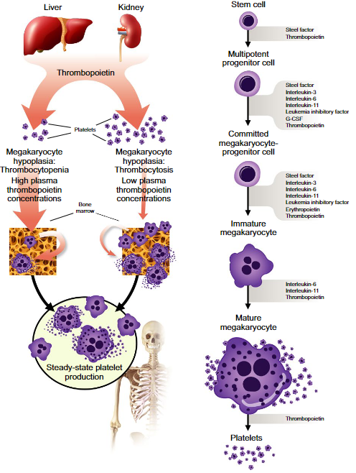

Figure as presented in Peck-Radosavljevic M.[2]

#### Condition

The lower limit of a normal platelet count is 150 x 109/L. Patients with a platelet count of less than 50 x 109/L can be symptomatic and significant spontaneous bleeding does not usually occur until the platelet count is less than 10 to 20 x 109/L.

##### Thrombocytopenia in chronic liver disease

There are several mechanisms which can contribute to thrombocytopenia in chronic liver disease (CLD):

* Reduced thrombopoietin expression and production.
* Splenic platelet sequestration.
* Bone marrow suppression (for example, in hepatitis C virus (HCV) or heavy alcohol use).
* Presence of antiplatelet antibodies, although there is uncertainty about their importance.

These mechanisms are schematically depicted in Figure 2, below.

Figure 2: Mechanisms contributing to thrombocytopenia in chronic liver disease

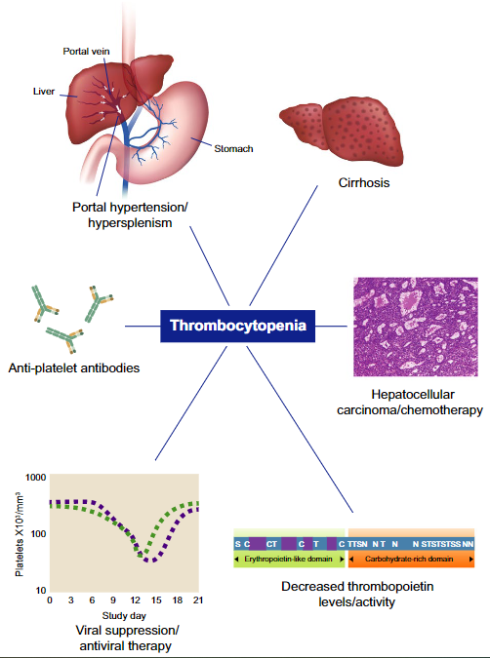

Figure as presented in Peck-Radosavljevic M.2

Patients with CLD are at risk of bleeding if the thrombocytopenia is severe or they undergo major surgery.

##### Immune thrombocytopenia

Immune thrombocytopenia (ITP) is characterised by antibody mediated platelet destruction and decreased platelet production (inhibited megakaryocyte function).[3] It is a diagnosis of exclusion. In children it can be self-limiting but in adults it tends to persist.

#### Current treatment options

Corrected platelet count is often used as a surrogate for platelet efficacy.[4] There are no specific guidelines regarding the use of platelet transfusion in patients with chronic liver disease or with immune thrombocytopenic purpura.[5] The Australian Patient Blood Management Guidelines include general guidance for the prevention of bleeding:[6] a platelet count of greater than 50 x 109/L is considered adequate for procedures such as placement of central venous catheters, endoscopy, biopsy and laparotomy. A platelet count of greater than 100 x 109/L is suggested for intracranial, intraocular and neuraxial surgery and in circumstances of head injury.

##### Immune thrombocytopenia

In ITP, the Consensus guidelines for the management of adult immune thrombocytopenia in Australia and New Zealand recommend steroid (prednisone;[7] or dexamethasone;[8]) as standard first line treatment.[9] The guidelines also recommend intravenous immunoglobulin (IVIg) as on demand or as first line therapy in combination with steroids. Eligibility for IVIg would usually include a platelet count of less than 30 x 109/L, present or perceived risk of bleeding, poor response to other therapies, and special clinical circumstances (for example, pregnancy, or periprocedural). First line therapy is considered to have failed if there is inadequate haemostatic response to greater than 5 mg prednisone, three or four cycles of high dose dexamethasone, or with one or more courses of IVIg.9

In the second line setting there is no single standard of care. Options include thrombopoietin receptor agonists (TPO-RAs), rituximab or splenectomy, and are based on patient preferences, lifestyle, comorbidities and available drugs. In general, TPO-RAs and rituximab are considered for second line treatment patients with a diagnosis of ITP of less than 12 months. Splenectomy is associated with a long-term response rate of 60 to 70%. Infection, including the increased risk of infection by encapsulated bacteria, and thromboembolism are the main risks. Patients considered for splenectomy would generally be less than 65 years, and with a disease duration greater than 12 months.9 Rituximab is an anti-CD20 antibody. A 50 to 70% response rate has been reported initially but the response is not durable, and at least half of responders are likely to relapse.

In Australia the currently registered TPO-RAs are romiplostim (injectable)[10] and eltrombopag (oral).[11]

Romiplostim is a thrombopoietin agonist that binds directly to the thrombopoietin (TPO) receptor to initiate signalling pathways. It is given by subcutaneous injection. Romiplostim is indicated in Australia for:[12]

*Adults*

*Nplate is indicated for treatment of thrombocytopenia in adult patients with primary immune thrombocytopenia (ITP) who are:*

* *non-splenectomised and have had an inadequate response, or are intolerant, to corticosteroids and immunoglobulins.*
* *splenectomised and have had an inadequate response to splenectomy.*

*Paediatrics*

*Nplate is indicated for treatment of thrombocytopenia in paediatric patients aged 1 year and older with primary immune thrombocytopenia ITP for at least 6 months who are:*

* *non-splenectomised and have had an insufficient response, or are intolerant, to corticosteroids and immunoglobulins.*
* *splenectomised and have had an inadequate response to splenectomy.*

Eltrombopag is an orally available small molecule TPO receptor agonist that also binds to the TPO receptor and via intracellular signalling induces proliferation and differentiation of megakaryocyte precursors and megakaryocytes that lead to an increase in platelet count. In Australia eltrombopag is Revolade:[13]

*Revolade is indicated for the treatment of:*

* *paediatric patients with chronic immune thrombocytopaenia (ITP) who have failed other treatments and either (a) need an increased platelet concentration for a planned procedure or (b) are at a high risk of bleeding.*
* *adult patients with chronic ITP who have had an inadequate response or are intolerant to corticosteroids and immunoglobulins.*
* *thrombocytopenia in adult patients with chronic hepatitis C to allow the initiation and maintenance of interferon-based therapy.*
* *severe aplastic anaemia (SAA) in combination with standard immunosuppressive therapy for the first-line treatment of adult and paediatric patients 2 years and older.*
* *adult patients with SAA who have had an insufficient response to immunosuppressive therapy.*

Eltrombopag must be taken 2 hours before or 4 hours after products with antacids, dairy products, or mineral supplements containing polyvalent cations (for example, aluminium, calcium, iron, magnesium, selenium and/or zinc).

##### Periprocedural management of thrombocytopenia

Platelet transfusion can be considered prior to procedures. One unit of apheresis or pooled leucocyte depleted platelets would be expected to produce an increase by 20 to 40 x109/L.[14] Platelet transfusion carries a small risk of febrile non haemolytic transfusion reaction, transfusion-related acute lung injury (mitigated to a certain extent by use of male only donors), and transfusion transmissible infections. Alloimmunisation with its associated platelet refractoriness, particularly in patients who require long-term platelet support, can be problematic. The risks are reduced due to the high level of leucodepletion in platelets for transfusion, nevertheless the theoretical risk remains.4

In CLD other strategies aimed at reducing the impact of hypersplenism or portal hypertension such as transjugular intrahepatic portosystemic shunt;[15] or partial splenic artery embolism may also result in an increased platelet count.

### Regulatory status

#### Australian regulatory status

This product is considered a new chemical entity for Australian regulatory purposes.

Avatrombopag is an orally administered second generation thrombopoietin receptor agonist. It is not currently registered in Australia.

#### Foreign regulatory status

At the time the TGA considered this submission, a similar submission had been considered by other regulatory agencies. The following table summarises these submissions and provides the indications where approved.

Table 1: International regulatory status

|  |  |  |  |
| --- | --- | --- | --- |
| Region | Submission date | Status | Approved indications |
| European Union (EU) | 27 April 2018 | 20 June 2019 | *Doptelet is indicated for the treatment of severe thrombocytopenia in adult patients with chronic liver disease who are scheduled to undergo an invasive procedure.* |
| 11 February 2020 | 18 January 2021 | *Doptelet is indicated for the treatment of primary chronic immune thrombocytopenia (ITP) in adult patients who are refractory to other treatments (e.g. corticosteroids, immunoglobulins).* |
| United States of America (USA) | 21 September 2017 | 21 May 2018 | *Doptelet is indicated for the treatment of thrombocytopenia in adult patients with chronic liver disease who are scheduled to undergo a procedure.* |
| 30 August 2018 | 26 June 2019 | *Doptelet is indicated for the treatment of thrombocytopenia in adult patients with chronic immune thrombocytopenia who have had an insufficient response to a previous treatment.* |
| Switzerland | 15 May 2020 | 23 November 2021 | *Doptelet is indicated for the treatment of severe thrombocytopenia in adult patients with chronic liver disease who are scheduled to undergo an invasive procedure.*  *Doptelet is indicated for the treatment of chronic immune thrombocytopenia (ITP) in adult patients who have shown insufficient response to at least one prior treatment.* |
| Canada | 14 April 2021 | Under consideration | Under consideration |

## Registration timeline

The following table captures the key steps and dates for this submission.

This submission was evaluated under the [standard prescription medicines registration process](https://www.tga.gov.au/how-we-regulate/supply-therapeutic-good-0/supply-prescription-medicine/application-process/prescription-medicines-registration-process).

Table 2: Timeline for Submission PM-2021-04302-1-6

|  |  |
| --- | --- |
| Description | Date |
| Submission dossier accepted and first round evaluation commenced | 1 November 2021 |
| First round evaluation completed | 31 March 2022 |
| Sponsor provides responses on questions raised in first round evaluation | 30 May 2022 |
| Second round evaluation completed | 11 July 2022 |
| Delegate’s Overall benefit-risk assessment | 24 October 2022 |
| Registration decision (Outcome) | 13 January 2023 |
| Administrative activities and registration on the ARTG completed | 16 January 2023 |
| Number of working days from submission dossier acceptance to registration decision* | 247 |

*Statutory timeframe for standard submissions is 255 working days

## Submission overview and risk/benefit assessment

A summary of the TGA’s assessment for this submission is provided below.

### Quality

The quality evaluation recommended approval of avatrombopag based on the quality aspects.

Figure 3: Chemical structure of avatrombopag

Chemical structure of avatrombopag

The quality evaluation was satisfied with the quality controls on starting materials. The drug substance is a white to off-white non-hygroscopic powder, practically insoluble in water at all pH values. The sponsor considered the compound was BCS Class IV.

Assay limits for the drug substance were acceptable. Specified related substances and impurity limits were justified, in line with relevant ICH standards, and were considered acceptable. Particle size limits were acceptable as were the residual solvent limits. Excipients were conventional for the dose form and acceptable, with appropriate controls.

The drug product was a pale yellow, round biconvex, film coated tablet, debossed, ‘AVA’ on one side and ‘20’ on the other.

Nitrite impurities and the possibility of nitrosamine formation was addressed sufficiently for the evaluation to recommend approval. The sponsor has undertaken to conduct a nitrosamines impurity reassessment and provide the results to the TGA. The evaluation found this was sufficient.

The control of mutagenic impurities was below the limit of 0.2% set by international regulators, all batches tested were well within this threshold (0.01%). The evaluation accepted the sponsor’s commitment to provide the results of an Ames test post-approval to the TGA for evaluation and that, if necessary, a variation to the limits of the impurities will be sought.

Three formulations were used in clinical studies: powder for oral suspension and two film‑coated tablet formulations A and B. Formulation A was used in the Phase I and II studies and the second generation formulation B used in the late Phase II and pivotal Phase III studies is proposed for commercialisation.

The primary container closure for the 20 mg tablet was a blister pack in a carton. The stability data provided supported the proposed shelf life of 60 months when stored below 25 °C.

All manufacturing sites had current clearance certificates valid until after the expected decision date.

### Nonclinical

The nonclinical evaluation had no objections to the registration of Doptelet for the proposed indications. The evaluation concluded the toxicity of avatrombopag may not have been fully characterised by animal studies, and the safety relies on clinical data. Careful monitoring of patients for unexpected adverse effects is therefore recommended.

Nonclinical studies were conducted in species in which avatrombopag is not pharmacologically active. This is a major deficiency in the submitted package. Nevertheless, toxicity studies in the only known responsive animal species (chimpanzees) could not be conducted for ethical reasons. Due to high species specificity, adequate *in vivo* systems were lacking to investigate efficacy.

Avatrombopag induces cell proliferation via the thrombopoietin receptor (TPO-R). Avatrombopag is expected to have an additive effect with TPO when administered together given TPO binds to an extracytoplasmic domain of the TPO receptor and avatrombopag binds to a transmembrane site on the TPO receptor. The nonclinical data findings of thrombopoietic and megakaryopoietic activity without affecting platelet function, support the proposed indication at the proposed clinical dose.

*In vitro* screening assays did not identify any clinically relevant secondary pharmacological activity by avatrombopag.

Safety pharmacology studies assessed effects on the cardiovascular, respiratory, renal and central nervous systems. *In vitro* studies did not identify significant inhibition of human ether-a-go-go-related gene channel tail current at clinically relevant concentrations of avatrombopag and no effects on action potentials were noted in isolated guinea pig papillary muscles. No adverse effects were seen on central nervous system function in rats and cardiovascular or respiratory function in dogs. The reversible renal toxicity only seen in dogs has unknown clinical relevance. The nonclinical evaluation recommended post market monitoring.

The pharmacokinetic profile in animals was qualitatively similar to that of humans. Avatrombopag was rapidly absorbed with a similar time to reach maximum concentration (Tmax) in all species; however, half-life values were highly variable in all species indicating high variability in absorption. Oral bioavailability was very high in mice (91%), high in rats (89 to 94%) and moderate in dogs (52%) and monkeys (49 to 67%) (compared with, 44% estimated in CLD patients). Plasma protein binding of avatrombopag was high in humans, monkeys and dogs, and medium to high in rodents and rabbits. Tissue distribution of avatrombopag was wide but brain penetration was very limited. Affinity to and retention in melanin containing tissues was evident. *In vitro* studies indicated CYP3A4 and CYP2C9 are involved in the metabolism of avatrombopag.[16] There was no circulating major metabolite in animals and humans. Faeces was the predominant route of excretion.

From *in vitro* studies, CYP3A4 and CYP2C9 inhibitors/inducers could alter the systemic exposure to avatrombopag. Avatrombopag inhibited P-glycoprotein (intestinal), breast cancer resistance protein, multi‑drug resistance protein 2, organic anion transporter (OAT)-P1B3, OAT1, OAT3 and organic cation transporter 1.

Avatrombopag had a low order of acute oral toxicity in rats and monkeys. Repeat-dose toxicity studies by the clinical route were conducted in mice (3 months), rats (up to 6 months), dogs (4 weeks) and Cynomolgus monkeys (up to 13 months). Maximum exposures (area under the concentration time curve (AUC)) were moderate to very high in mice and low to very high in rats, dogs and monkeys. Target organs for toxicity were the stomach in mice, rats and monkeys, the kidneys in mice, rats and dogs and skeletal muscle in monkeys. These findings were not considered clinically relevant.

Avatrombopag was not mutagenic in the bacterial mutation assay or clastogenic *in vitro* (in human lymphocytes) or i*n vivo* (in the rat micronucleus test).

Malignant neuroendocrine cell tumours were seen in both mice and rats and hypergastrinemia related gastric carcinoids in rodents are generally considered to be of low relevance to humans because avatrombopag is not pharmacologically active in rodents.

Fertility was unaffected in male and female rats treated with avatrombopag at exposure levels greater than or equal to 22 and 114 times the clinical AUC in males and females, respectively. Decreased fetal weight and incidences of skeletal variations including incidences of 14th rib (rats), and increased abortion (rabbits) were seen in embryofetal development studies at exposures much higher than clinical exposure. Transfer of avatrombopag was shown in lactating rats. Therefore, breastfed infants are likely to be exposed to avatrombopag following maternal exposure. Lower birth weight, increased mortality, and delay in sexual maturation were evident in pups of rats treated with avatrombopag during pregnancy and lactation at maternal exposures 30 times and pup exposures approximately three times the clinical AUC.

Avatrombopag is not proposed for paediatric use. Studies in juvenile rats revealed findings that were similar to those seen in treated adults.

Avatrombopag had no eye irritation, skin irritation or phototoxicity potential in nonclinical studies, suggesting no concerns for local tolerance or phototoxic potential in humans.

### Clinical

#### Summary of clinical studies

The clinical dossier consisted of:

* Fifteen Phase I studies
* Five Phase II studies
* Four Phase III studies

#### Pharmacology

##### Pharmacokinetics

The clinical evaluation found the conduct of the studies that were provided in support of the current submission was satisfactory, the data analyses undertaken were appropriate and the analytical methods used to measure avatrombopag exposure levels were validated.

The absolute oral bioavailability in humans is unknown. After a single oral 20 mg dose the median time to reach maximum concentration (Tmax) was 8 hours.

Avatrombopag should be administered with food. Under fasted conditions pharmacokinetics was highly variable (up to 4-fold differences for area under the concentration time curve from time zero to infinity (AUC0-inf)). Food (low or high fat meal) reduced intra individual variability from 50 to 70% and inter individual variability from 40 to 90%.

Dose proportionality for maximum concentration (Cmax) and area under the concentration time curve (AUC) was shown for doses up to a 75 mg single dose. With dose increases to a single 100 mg dose the parameters appeared to plateau. Dose proportionality was demonstrated with 14 days repeated 3 mg or 10 mg once daily of the proposed formulation, and for single doses in Japanese and White patients (fed conditions).

Half-life was independent of dose in single dose and repeated dose studies. With dosing of 3 mg or 10 mg once daily for 14 days it was around 18 to 21 hours, and accumulation rates were 1.8- and 2.0-fold, respectively. The half-life was considered supportive of once daily dosing.

Apparent volume of distribution (V/F) was 180 L (25% coefficient of variation) after a single oral 20 mg dose (fed conditions). *In vitro* plasma protein binding was independent of concentration over the range of 0.05 to 50 μg/mL and ranged from 96.3% to 96.6% in humans. The concentration in erythrocytes was 50% of that in plasma.

CYP2C9 is the primary enzyme involved in the metabolic clearance and CYP3A4 played a minor role.16 Avatrombopag has a weak inhibitory effect on uridine 5'-diphospho-glucuronosyltransferase, but there was no relationship between CYP3A5 genotype or P‑glycoprotein sequence variant. No specific studies were conducted in CYP2D9 poor metabolisers.

Around 88% of a 20 mg dose of carbon 14 [14C] avatrombopag was recovered in faeces while 6% was recovered in urine. No circulating metabolites were identified in human plasma. Population pharmacokinetics (popPK) analyses indicated that mild and moderate renal impairment had no effect on the oral clearance. No studies were undertaken in patients with severe renal impairment, with or without dialysis.

Age and gender had no effect in the popPK analyses.

Population pharmacokinetic analysis of CLD patients estimated the mean Cmax and AUC and median Tmax values after a 40 mg dose were 214 ng/mL, 3717 ng.h/mL and 7 hours, respectively. Estimated AUC and Cmax increased approximately proportionally with dose between 40 mg and 60 mg doses, but apparent clearance (CL/F) and V/F values were similar. Apparent volume of distribution (V/F) was 65% higher in patients with CLD than in healthy participants, but no relationship between CL/F and degree of liver impairment was shown.

Population pharmacokinetic analysis of an ITP population estimated steady-state mean Cmax and AUC and median Tmax after a 20 mg once daily dose were 190 ng/mL, 3824 ng.h/mL and 5 hours, respectively, and CL/F and V/F were 8.23 L/h and 351 L, respectively.

No clinically relevant exposure differences were identified between Japanese and White participants administered either 40 mg or 60 mg under fed conditions.

The interaction studies with fluconazole, itraconazole and rifampicin were conducted in the fed state. The findings were:

* Coadministration of a single 20 mg tablet with steady-state fluconazole 400 mg once daily, Cmax and AUC0-inf increased approximately 1.17-fold and 2.2-fold, respectively. Coadministration of fluconazole extended the mean half-life by approximately 20 hours, but Tmax values were similar.
* Coadministration of a single 20 mg avatrombopag tablet with steady-state itraconazole 200 mg once daily, avatrombopag mean Cmax and AUC0-inf increased 1.07-fold and 1.4-fold, respectively. Coadministration of itraconazole extended the mean half-life by approximately 8.5 hours.
* Coadministration of a single 20 mg tablet with steady-state rifampin 600 mg once daily decreased AUC0-inf 2-fold but had no significant on Cmax and Tmax values. Coadministration of rifampin shortened avatrombopag half-lifeby 10 hours.
* Studies conducted in fasted conditions with highly variable pharmacokinetics precluded conclusion about the effects of verapamil and cyclosporine A on avatrombopag exposure.

##### Pharmacodynamics

Avatrombopag stimulates proliferation and differentiation of megakaryocytes from bone marrow progenitor cells, resulting in an increased production of platelets.

Food status did not appear to have a clinically meaningful impact on the pharmacodynamics of a 40 mg dose of avatrombopag, with mean changes from Baseline up to 60.1 × 109/L at Day 9 (192 hours) in the fasted state and to 58.2 × 109/L at Day 9 (192 hours) post-dose in fed conditions.

No effect on QT interval or other electrocardiogram (ECG) parameters was demonstrated after a 100 mg dose.[17] This was confirmed by popPK/ pharmacodynamics analysis using the CLD dataset.

Following single doses, changes in platelet counts were evident 3 to 5 days after dosing, and the highest observed changes in platelet counts were observed by approximately 6 to 16 days.

Linear increases in platelet count from Baseline were seen after single doses of 1 mg, 3 mg, 10 mg, 20 mg, 50 mg, 75 mg or 100 mg or multiple doses of 3 mg, 10 mg or 20 mg given to healthy subjects.

Thrombopoietin, albumin and baseline body weight were identified as covariates of avatrombopag pharmacodynamics. While subjects of East Asian race (that is, Japanese, Chinese or Korean) had comparatively reduced platelet levels but the magnitude of the effects of these parameters were not likely to be clinically relevant.

When administered with 400 mg once daily fluconazole, avatrombopag induced maximum platelet counts after dosing (Emax), maximum change from Baseline in platelet count (ΔEmax) and area under the effect curve for platelet count from time 0 to Day 28 (AUEC0-28d) were increased 1.1-fold, 1.30-fold and 1.5-fold, respectively. The effects of itraconazole 200 mg once daily on avatrombopag pharmacodynamics for avatrombopag induced were similar for Emax, ΔEmax and was increased 1.4‑fold for AUEC0-28d.

Coadministration with rifampin resulted in essentially no change in Emax, a 1.1-fold decrease in ΔEmax and a 4.6-fold decrease in AUEC0-28d compared to avatrombopag administered alone.

Avatrombopag related platelet activation was assessed in a sub-study of 30 patients (20 avatrombopag, 10 placebo) from the pivotal Phase III studies. Platelet function was assessed using specified flow cytometric markers or platelet aggregometry. The findings were:

* Almost 2-fold increase in platelet counts at Day 10 after administration of 60 mg and 40 mg avatrombopag, but not with placebo.
* Similar magnitude increases in surface P-selectin and surface activated glycoprotein IIb/IIIa in response to both low and high concentrations of adenosine diphosphate and thrombin receptor activating peptide in both avatrombopag treated and placebo treated patients.
* No increase in circulating activated platelets in avatrombopag treated versus placebo treated patients, measured by platelet surface activated glycoprotein IIb-IIIa and platelet surface P‑selectin.
* No increase in platelet reactivity in avatrombopag treated versus placebo treated patients, assessed by the response to low and high concentrations of adenosine diphosphate and low and high thrombin receptor activating peptide.

#### Efficacy by Indication

This submission sought two indications. For clarity this AusPAR has been divided into separate sections based on requested indication. The clinical efficacy evidence is presented separately for each indication.

##### Chronic liver disease

###### Pivotal studies

Two similarly designed Phase III studies were submitted in support of this indication.

Both studies were conducted according to the schematic, below (see Figure 4). The procedure day occurred 5 to 8 days after the last dose of study drug (study Day 10 to 13) and all assessments were to be completed prior to the procedure.

Figure 4: Pivotal study design

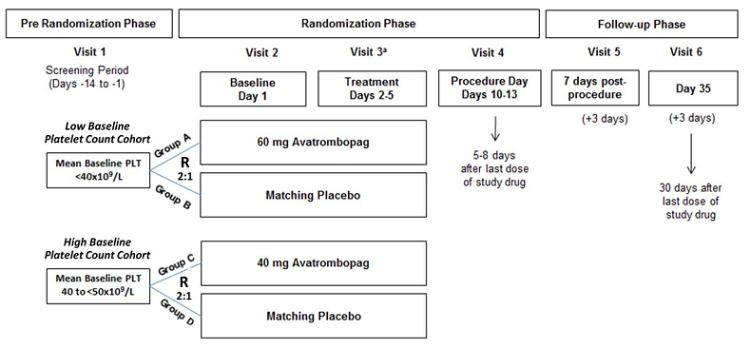

Abbreviations: PLT = platelet count, R = randomisation.

Low baseline platelet count cohort: Group A = 60 mg avatrombopag treatment group, Group B= placebo treatment group. High baseline platelet count cohort: Group C = 40 mg avatrombopag treatment group, Group D = placebo treatment group.

Platelet counts were measured on two separate occasions, during the screening period and at Baseline, at least 1 day apart with neither platelet count greater than 60×109/L. The mean of these two platelet counts (mean baseline platelet count less than 50×109/L) were used for entry criteria and determination of baseline platelet count.

a: Visit 3 occurred on Day 4 (±1 day) during the treatment period.

The main inclusion criteria were: male or female subjects 18 years of age or older with CLD; a mean Baseline platelet count less than 50 x 109/L;[18] Model for End-Stage Liver Disease (MELD)[19] scores less than 24; scheduled to undergo a permitted scheduled procedure that would require a platelet transfusion to address a risk of bleeding associated with the procedure unless there was a clinically significant increase in platelet count from Baseline. Patients undergoing neurosurgical interventions, thoracotomy, laparotomy, or organ resection were not eligible.

The main exclusion criteria were: history of arterial or venous thrombosis including partial or complete thrombosis in main portal vein,[20] portal vein branches or any part of the splenic mesenteric system; hepatic encephalopathy that could not be effectively treated; subjects with hepatocellular carcinoma and Barcelona-Clinic Liver Cancer staging classification C or D;[21] platelet transfusion or receipt of blood products containing platelets within 7 days of screening (packed red blood cells were permitted); erythropoietin stimulating agents, Heparin, warfarin, nonsteroidal anti-inflammatory drugs, aspirin, verapamil, and antiplatelet therapy with ticlopidine or glycoprotein IIb/IIIa antagonists (for example, tirofiban) within 7 days of screening; interferon use within 14 days of screening; estrogen containing hormonal contraceptive or hormone replacement therapy use within 30 days of screening; active infection requiring systemic antibiotic therapy within 7 days of screening (but prophylactic use of antibiotics was permitted), known human immunodeficiency virus (HIV) infection, primary haematological disorder (idiopathic thrombocytopenic purpura, myelodysplastic syndromes).

Eligible subjects were enrolled into two cohorts according to mean Baseline platelet count, and within each Baseline platelet count cohort, and were further stratified by hepatocellular carcinoma status (yes or no) and the risk of bleeding associated with the scheduled procedure (low, moderate, or high).

Within each Baseline platelet count cohort and each further stratum, subjects were randomised in a 2:1 ratio to receive either avatrombopag or placebo once a day for 5 days.

Dosing was based on dose ranging Study 202. Dosing was based on platelet cohort. Avatrombopag was administered with food.

Low Baseline platelet count cohort (less than 40 × 109/L): 60 mg avatrombopag (3 × 20 mg tablets) once daily on Days 1 through 5, or matching placebo.

High baseline platelet count cohort (40 to 50 × 109/L): 40 mg avatrombopag (2 × 20 mg tablets) once daily on Days 1 through 5, or matching placebo.

Permitted procedures and estimated bleeding risk associated with each procedure are included below.

Table 3: Permitted procedure and bleeding risk attributed to each procedure

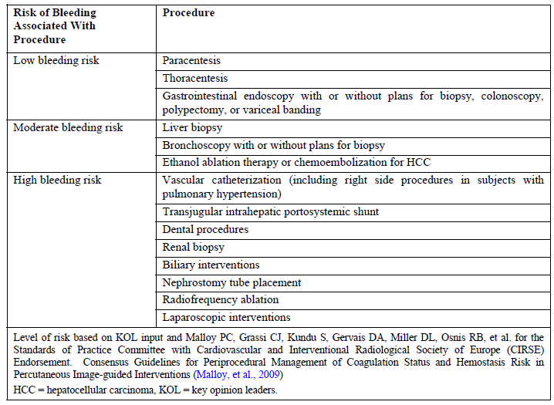

Abbreviations: HCC = hepatocellular carcinoma, KOL = key opinion leaders.

Level of risk based on KOL input and Malloy PC, Grassi CJ, Kundu S, Gervais DA, Miller DL, Osnis RB, et al. for the Standards of Practice Committee with Cardiovascular and Interventional Radiological Society of Europe (CIRSE) Endorsement. Consensus Guidelines for Periprocedural Management of Coagulation Status and Hemostasis Risk in Percutaneous Image-guided Interventions (Malloy, et al., 2009)

The primary efficacy endpoint was the proportion of patients (responders) who did not require a platelet transfusion or any rescue procedure for bleeding after randomisation and up to 7 days following a scheduled procedure.

The key secondary endpoints were:

* The proportion of patients who achieved the target platelet count 50 x 109/L or greater by Baseline platelet cohort, adjusted for the risk of bleeding in the scheduled procedure.
* The change in platelet count from Baseline to procedure day by Baseline platelet cohort.

Each study included several exploratory endpoints. Adjustments for multiple comparisons were made for the primary and first secondary endpoints. No alfa adjustments were made for other secondary or exploratory endpoints, therefore all p values for these comparisons are considered nominal.

Study 310 (E5501-G000-310)

A randomised, global, double blind, placebo controlled, parallel group study to evaluate the efficacy and safety of once daily oral avatrombopag for the treatment of adults with thrombocytopenia associated with liver disease prior to an elective procedure.

The study was conducted from February 2014 to January 2017 at 75 sites in the following countries: Argentina, Australia, Austria, Belgium, Brazil, Canada, Chile, China, France, Germany, Hungary, Italy, Republic of Korea, Poland, Portugal, Spain, Taiwan, Thailand, United Kingdom, and the United States of America.

Figure 5: Study 310 participant flow

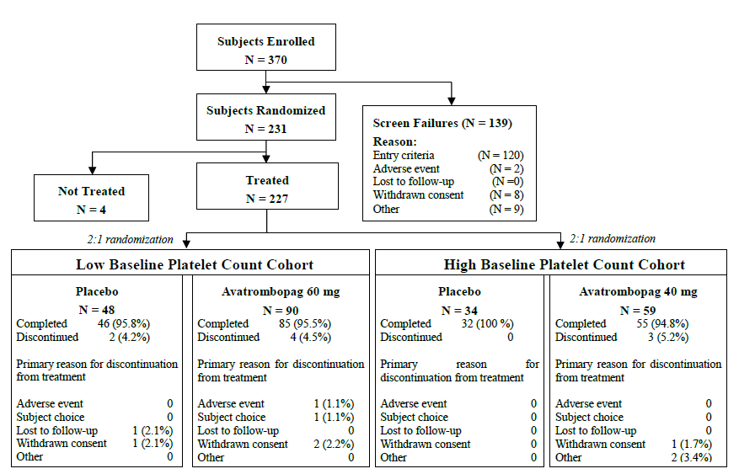

Baseline data

The mean age of randomised patients was 56.3 years, and 80.5% were aged less than 65 years. Most were male (68.4%) and White (56.4%) followed by Korean (19.1%), Chinese (10.7%), and other Asian (9.8%). The median Baseline count was 38 x 109/L (min, max 10, 50.5 x 109/L).

Baseline demographic and disease characteristics were similar across treatment groups and between subjects in the low and high Baseline platelet count cohorts.

The etiologies of CLD were most commonly chronic viral hepatitis (62.7%, of which 2 out of 3 had chronic hepatitis C), ‘other’ CLD (16.7%), and alcoholic liver disease (14.5%). By Child‑Turcotte-Pugh Grade,[22] 57% were Grade A, and 39% were Grade B. Of the 24.5% of participants with hepatocellular carcinoma, around half had Barcelona-Clinic Liver Cancer Grade of A (13.1% of study).

Most participants had scheduled procedures of low bleeding risk (64.6%). By Baseline platelet cohort (for the avatrombopag groups versus the placebo groups, respectively):

* Low risk procedures
  + low Baseline platelet cohort 66.7% versus 67.5%
  + high Baseline platelet cohorts 58.9% versus 65.6%
* Moderate risk procedures
  + low Baseline platelet cohort 11.9% versus 20%
  + high Baseline platelet cohorts 19.6% versus 9.4%
* High risk procedures
  + low Baseline platelet cohort 21.4% versus 12.5%
  + high Baseline platelet cohorts 21.4% versus 25%

Treatment compliance rates were high for the avatrombopag and placebo groups (96% versus 97.6%). Three patients who were less than 80% compliant were excluded from the per-protocol analysis set.

The initial planned enrolment of 300 patients was adjusted to 200 at protocol amendment 04, but the stratification and randomisation strategy was unchanged. The rationale was provided and was accepted by the clinical evaluation. The final study size gave greater than 90% power to detect an absolute difference of 35% between the avatrombopag response rate and the projected 18% placebo response rate, using the Fisher’s Exact tests with a 2-sided α = 0.05.

Around 19% of the avatrombopag groups and around 34% of the placebo groups had a major protocol deviation. Around 11% and 24% of the avatrombopag and placebo treatment groups, respectively, were excluded from the per-protocol analysis set, including for reasons of no scheduled procedure (6.1%), no platelet transfusion even though they did not have a significant increase of platelet count from Baseline to procedure day (3.9%), or platelet transfusion after a significant on-treatment increase in platelet count (3.5%).

Primary endpoint

The primary efficacy endpoint was the proportion of patients (responders) who did not require a platelet transfusion or any rescue procedure for bleeding after randomisation and up to 7 days following a scheduled procedure. The full analysis set was used as the primary efficacy analysis population.

Table 4: Study 310 summary of proportion of patient not requiring a platelet transfusion or any rescue procedure for bleeding, full analysis set

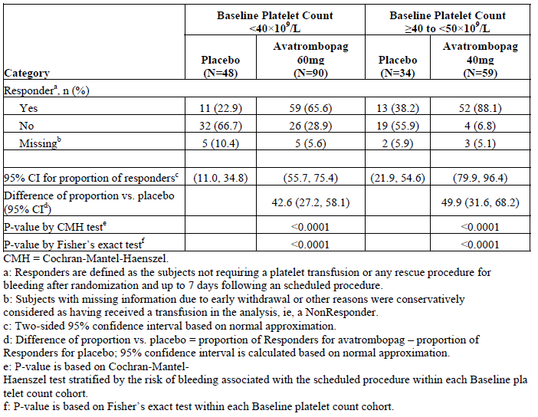

Abbreviations: CMH = Cochran-Mantel-Haenszel.

a: Responders are defined as the subjects not requiring a platelet transfusion or any rescue procedure for bleeding after randomisation and up to 7 days following a scheduled procedure.

b: Subjects with missing information due to early withdrawal or other reasons were conservatively considered as having received a transfusion in the analysis, that is, a non-responder.

c: Two-sided 95% confidence interval based on normal approximation.

d: Difference of proportion versus placebo = proportion of responders for avatrombopag – proportion of responders for placebo; 95% confidence interval is calculated based on normal approximation.

e: P-value is based on Cochran-Mantel-Haenszel test stratified by the risk of bleeding associated with the scheduled procedure within each Baseline platelet count cohort.

f: P-value is based on Fisher’s exact test within each Baseline platelet count cohort.

Sensitivity analyses confirmed the benefit for avatrombopag over placebo in the primary analysis.

Figure 6: Study 310 mean platelet counts by treatment group and visit day, full analysis set

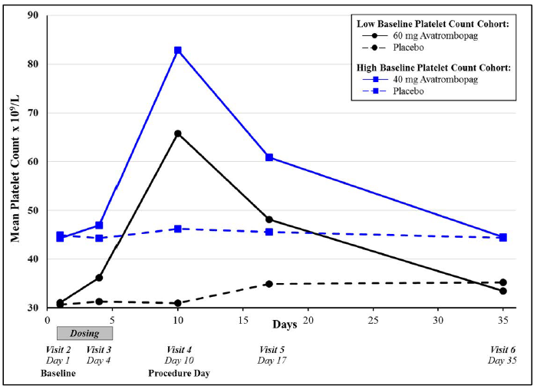

Secondary efficacy results

The proportion of responders achieving the targeted platelet count (greater than 50 x 109/L on procedure Day 10 to 13), are summarised below.

Table 5: Study 310 proportions of patients who achieved a platelet count 50 x 109/L or great on procedure day, full analysis set

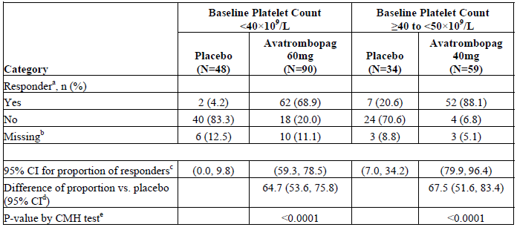

Abbreviations: CI = confidence interval, CMH = Cochran-Mantel-Haenszel, N = total number of subjects in sample group, n = number of subjects in specified group.

a: Responders were defined as the subjects who achieved platelet count greater than or equal to 50 × 109/L on the procedure day.

b: Subjects with missing platelet count on the procedure day were conservatively considered as not achieving platelet count 50 × 109/L in the analysis, that is, non-responders.

c: Two-sided 95% CI based on normal approximation.

d: Difference of proportion versus placebo = proportion of responders for avatrombopag – proportion of responders for placebo; 95% CI is calculated on normal approximation.

e: P-value is based on CMH test stratified by the risk of bleeding associated with the scheduled procedure within each Baseline platelet count cohort.

For each Baseline platelet cohort, the results for the Baseline and procedure day platelet counts, together with comparisons of the Baseline-adjusted platelet counts, are included in the table below.

Table 6: Study 310 change from Baseline of platelet count on procedure day, full analysis set

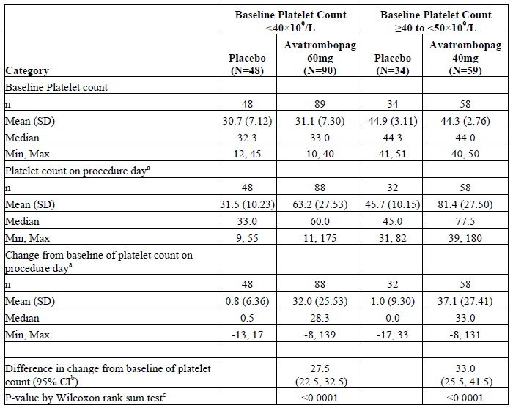

Abbreviations: CI = confidence interval, N = total number of subjects in sample group, n = number of subjects in specified group.

a: Last observation carried forward was used for subjects with missing platelet count on procedure day. Platelet count was measured pre-procedure and before any platelet transfusion.

b: Difference in change from Baseline of platelet count for avatrombopag versus placebo within each Baseline platelet count cohort was based on Hodges Lehmann estimation; 95% CI was the asymptotic (Moses) CI.

c: P value was based on Wilcoxon rank sum test for each avatrombopag treatment group versus placebo within each Baseline platelet count cohort.

Exploratory endpoints are described in more detail in the clinical evaluation report.

* The target platelet count of greater than 50 × 109/L on procedure day by Baseline cohort:
  + Low Baseline platelet count cohort - avatrombopag versus placebo: 77.5% versus 4.8%
  + High Baseline platelet count cohort- avatrombopag versus placebo: 92.9% versus 22.6%.
* No patients reached platelet count greater than 200 × 109/L during the study.
* Platelet transfusions needed:
  + Low Baseline platelet count cohort: avatrombopag versus placebo 28.9% versus 66.7%; mean transfusion requirements 3.2 (avatrombopag group) versus 4.3 units (placebo group)
  + High Baseline platelet count cohort: avatrombopag versus placebo 6.8% versus 55.9%; mean platelet transfusion requirement 6.2 units (avatrombopag group) versus 5.6 units (placebo group)
* World Health Organisation (WHO) bleeding score 2 or greater:[23] 3.4% combined avatrombopag versus 4.9% combined placebo groups, five patients (three in the avatrombopag group) had bleeding and platelet transfusion and one in each group had Grade 3 bleeding events.

Study 311 (E5501-G000-311)

A randomised, global, double blind, placebo controlled, parallel group study to evaluate the efficacy and safety of once daily oral avatrombopag for the treatment of adults with thrombocytopenia associated with liver disease prior to an elective procedure.

It was conducted from December 2013 to January 2017 at 74 sites in Argentina, Australia, Belgium, Brazil, China, Czech Republic, France, Germany, Israel, Italy, Japan, Mexico, Romania, Russia, Spain, and the United States of America.

Patient flow through the study is summarised, below (see Figure 7).

Figure 7: Study 311 patient flow

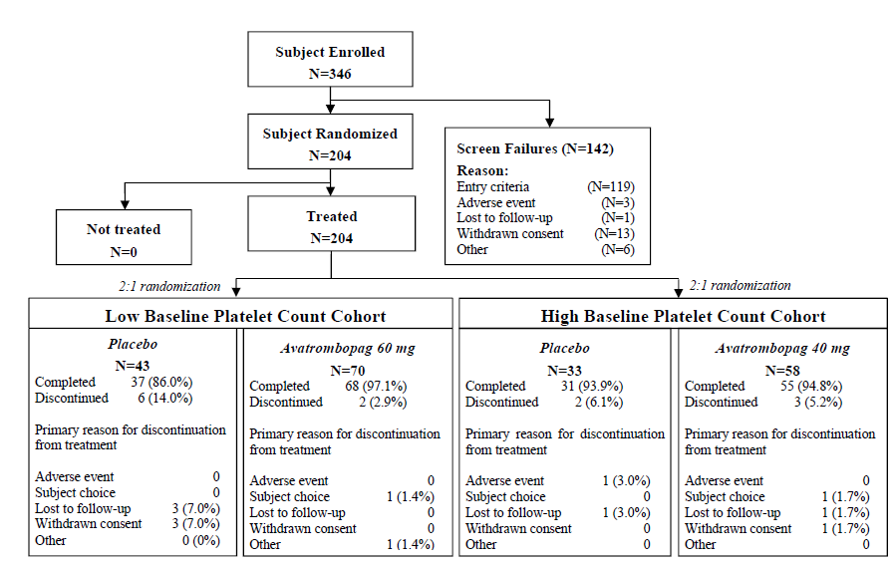

Baseline data

The mean age of randomised patients was 58.2 years, and 69.1% were aged less than 65 years. Most were male (62.3%) and White (64.5%) with 24.6% being Japanese. The median Baseline count was 39 x 109/L (min, max 12, 50 x 109/L).

Baseline demographic and disease characteristics were similar across all treatment groups and the low and high Baseline platelet cohorts.

The etiologies of CLD were most commonly chronic viral hepatitis (52.5%, of which 85% (43.6% of the study population) had chronic hepatitis C), ‘other’ CLD (20.1%), and alcoholic liver disease (14.7%). By Child-Turcotte-Pugh Grade,22 55.7% were Grade A, and 36.9% were Grade B. Of the 24.5% of participants with hepatocellular carcinoma, around half had Barcelona-Clinic Liver Cancer Grade of A (13.1% of study).21

Of the 29.9% of participants with hepatocellular carcinoma, around half had Barcelona‑Clinic Liver Cancer Grade of A or B (13.2% of study for each Grade).

Most participants had scheduled procedures of low bleeding risk (64.6%). By Baseline platelet cohort (for the avatrombopag groups versus the placebo groups, respectively):

* Low risk procedures
  + low Baseline platelet cohort 59.7% versus 52.5%
  + high Baseline platelet cohorts 57.9% versus 53.1%
* Moderate risk procedures
  + low Baseline platelet cohort 16.4% versus 22.5%
  + high Baseline platelet cohorts 15.8% versus 28.1%
* High risk procedures
  + low Baseline platelet cohort 23.9% versus 25%
  + high Baseline platelet cohorts 26.3% versus 18.8%

Compliance rates were high in the combined avatrombopag and placebo treatment groups (96.1% versus 98.7%). Two patients who were less than 80% compliant were excluded from the per-protocol analysis set.

Major protocol deviations were reported for around 15% of the combined avatrombopag treatment group and around 24% of the combined placebo treatment group. The most frequent deviation occurred in 1.6% and 6.6% of the avatrombopag placebo treatment group: patients who underwent their scheduled procedure without i) a platelet count response reaching the 50 × 109/L or greater threshold on procedure day or ii) a preprocedural platelet transfusion. An additional 2.3% and 2.6% of the avatrombopag and placebo groups received a platelet transfusion prior to a scheduled procedure, despite having a significant increase in platelet count. These patients were included in the full analysis set but not the per-protocol analysis set analysis.

Primary endpoint

The primary efficacy endpoint was the proportion of patients (responders) who did not require a platelet transfusion or any rescue procedure for bleeding after randomisation and up to 7 days following a scheduled procedure. The full analysis set was the primary efficacy analysis population.

Table 7: Study 311 primary endpoint

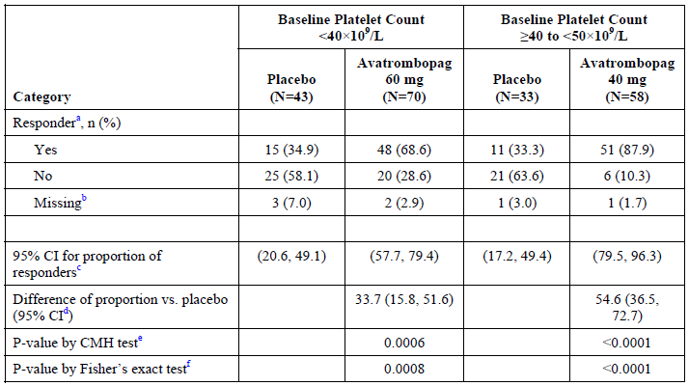

Abbreviations: CMH = Cochran-Mantel-Haenszel, N = total number of subjects in sample group, n = number of subjects in individual group.  
a: Responders were defined as the subjects not requiring a platelet transfusion or any rescue procedure for bleeding after randomisation and up to 7 days following a scheduled procedure.

b: Subjects with missing information due to early withdrawal or other reasons were conservatively considered as having received a transfusion in the analysis, that is, a non‑responder.

c: Two-sided 95% CI based on normal approximation.

d: Difference of proportion versus placebo = proportion of responders for avatrombopag – proportion of responders for placebo; 95% CI is calculated on normal approximation.

e: P-value was based on CMH test stratified by the risk of bleeding associated with the scheduled procedure within each Baseline platelet count cohort.

f: P-value was based on Fisher’s exact test within each Baseline platelet count cohort.

The per-protocol analysis set and observed case sensitivity analyses confirmed results of the primary full analysis set analysis.

Subgroup results (age, sex, race, region, MELD score category, Child-Turcotte-Pugh grade, and disease etiology, procedure bleeding risk category) were also numerically in favour of avatrombopag.

The evaluator noted in the ‘low bleeding risk’ subgroup more placebo patients (10 out of 13) than avatrombopag (4 out of 28) patients were counted as responders because they received no transfusion or rescue procedure, although they did not have platelet counts 50 × 109/L or greater on procedure day.

Secondary endpoint

The key secondary endpoint of the achievement of a platelet count 50 x 109/L or greater on procedure Day 10 to 13, was reported in a statistically significantly greater proportion of the avatrombopag versus placebo treatment group in both Baseline platelet count cohorts.

Table 8: Study 311 summary of the proportion of patients who achieved a platelet count 50 x 109/L or greater on procedure day, full analysis set

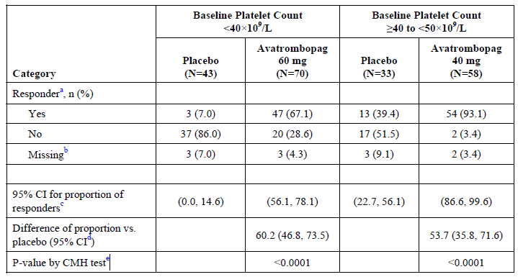

CMH = Cochran-Mantel-Haenszel, N = total number of subjects in sample group, n = number of subjects in individual group.

a: Responders were defined as the subjects who achieved platelet count greater than or equal to 50 × 109/L on the Procedure Day.

b: Subjects with missing platelet count on the procedure day were conservatively considered as not achieving platelet count greater than or equal to 50 × 109/L in the analysis, that is, non‑responders.

c: Two-sided 95% CI based on normal approximation.

d: Difference of proportion vs placebo = proportion of responders for avatrombopag – proportion of responders for placebo; 95% CI is calculated on normal approximation.

e: P-value is based on CMH test stratified by the risk of bleeding associated with the scheduled procedure within each Baseline platelet count cohort.

The other secondary endpoint of the mean change in platelet count (from Baseline on procedure day) was also statistically significantly greater in the avatrombopag versus placebo treatment group in both Baseline platelet count cohorts.

Table 9: Study 311 summary of change in platelet count from Baseline to procedure day, full analysis set

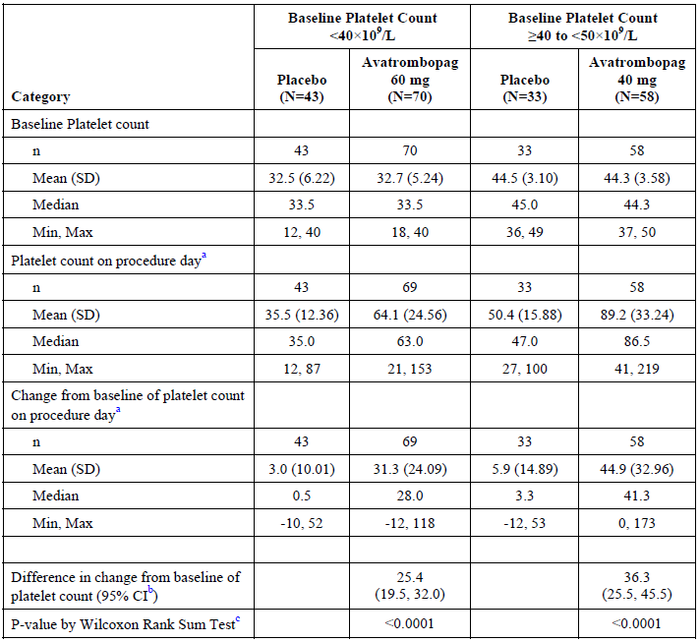

Abbreviations: N = total number of subjects in sample group, n = number of subjects in individual group.

a: Last observation carried forward was used for subjects with missing platelet count on the procedure day. Platelet count was measured pre-procedure and before any platelet transfusion.

b: Difference in change from Baseline of platelet count for avatrombopag versus placebo within each Baseline platelet count cohort was based on Hodges-Lehmann estimation; 95% CI was the asymptotic (Moses) CI.

c: P-value was based on Wilcoxon Rank Sum Test for each avatrombopag treatment group versus placebo within each Baseline platelet count cohort.

The pre-and post-procedure time platelet count by treatment and Baseline platelet cohort are summarised, below (see Figure 8).

Figure 8: Study 311 mean platelet counts by treatment group and visit day, full analysis set

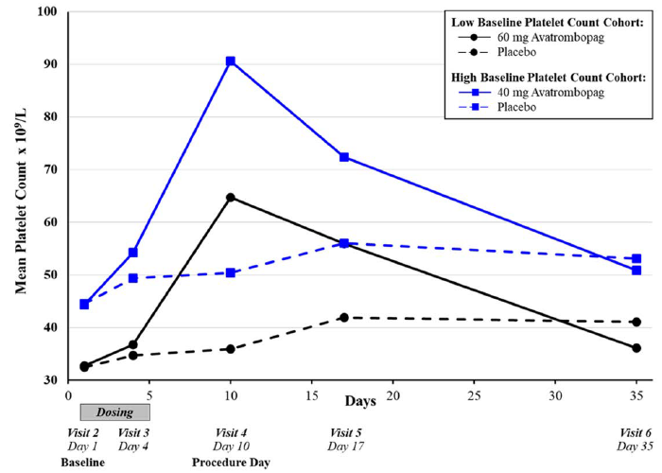

Exploratory endpoints

Exploratory endpoints were generally consistent with primary and secondary endpoints. Results of note were:

* The target platelet count of greater than 50 × 109/L on procedure day by Baseline cohort:
  + Low Baseline platelet count cohort - avatrombopag versus placebo: 77.5% versus 4.8%
  + High Baseline platelet count cohort- avatrombopag versus placebo: 92.9% versus 22.6%.
* Three avatrombopag treated patients (0 placebo patients) reached platelet count greater than 200 × 109/L during the study.
* Platelet transfusions needed:
  + Low Baseline Platelet Count Cohort: avatrombopag versus placebo 27.1% versus 58.1%; mean transfusion requirements 7.1 units in both groups
  + High Baseline Platelet Count Cohort: avatrombopag versus placebo 8.6% versus 63.6%; mean platelet transfusion requirement 2.0 units in the avatrombopag group versus 5.0 units in the placebo group
* World health organisation (WHO) bleeding score 2 or greater:23 1.6% combined avatrombopag versus 2.6% combined placebo groups.

###### Supportive studies

Controlled studies

Study E5501-G000-202

A Phase II, randomised, multicentre, placebo controlled, double blind, parallel group study to evaluate the efficacy, safety, and population pharmacokinetics of once daily oral avatrombopag tablets used up to 7 days in 130 subjects with chronic liver diseases and thrombocytopenia prior to elective surgical or diagnostic procedures. This study compared the dose response of different formulations of avatrombopag. The outcomes contributed data to the popPK analysis and supported. It did not demonstrate there was an advantage in a dosing regimen with a loading dose.

Study E5501-J081-204

A Phase II, randomised, double blind, placebo controlled, parallel group study to evaluate the efficacy, safety, and pharmacokinetics of once daily oral avatrombopag in 39 Japanese patients with chronic liver disease and thrombocytopenia. Patients were from two patient groups (low (n = 19) and high (n = 20) Baseline platelet groups). The evaluation found the groups too small to draw specific conclusions.

Study E5501-G000-203

A Phase II, randomised, multicentre, placebo controlled, double blind, parallel group study, with an open label extension to evaluate the efficacy, safety, and pharmacokinetics of avatrombopag in 65 patients with chronic hepatitis C virus related thrombocytopenia who were potential candidates for antiviral treatment. The study tested placebo, avatrombopag 10 mg, 20 mg and 30 mg prior to antiviral treatment (period A1) then during antiviral treatment (period A2). The primary efficacy endpoint was the achievement of a platelet count 100 × 109/L or greater by Day 21 of period A1, and was 5.88%, 37.5%, 66.67% and 64.29% for placebo, avatrombopag 10 mg, 20 mg and 30 mg, respectively. The proportion of patients with a platelet count greater than 30 × 109/L above Baseline by Day 21 during period A1 was statistically significantly (p < 0.002) higher in all avatrombopag groups compared with placebo (5.88%, 56.25%, 88.89% and 78.57% for placebo, avatrombopag 10 mg, 20 mg and 30 mg, respectively). The proportion of patients who initiated antiviral treatment at end of period A1 was statistically significantly (p < 0.03) higher in all avatrombopag groups compared with placebo (5.88%, 37.5%, 72.22% and 64.29% for placebo, avatrombopag 10 mg, 20 mg and 30 mg, respectively).

Uncontrolled studies

Study AVA-PST-320

An open label study to evaluate the efficacy and safety of avatrombopag for the treatment of subjects with thrombocytopenia scheduled for a surgical procedure. This study was terminated early due to low enrolment (three patients) and did not contribute to the conclusions for this indication.

Study AVA-CLD-401

An observational cohort study of the use of avatrombopag in patients with thrombocytopenia associated with chronic liver disease undergoing a procedure. This was a real-world cohort study that included data from 48 unique patients (50 enrolments) with a median age of 61.2 years, mostly male (5%), White (82%) and with a range of conditions underlying their chronic liver disease. The mean Baseline platelet count was 47 x 109/L and five patients had prior Doptelet exposure. The median increase in platelet count from Baseline was 41.1 x 109/L. Procedures included upper gastrointestinal endoscopy (56% primary procedure, 4% secondary procedure) or colonoscopy (10% primary procedure, 6% secondary procedure). From the main analysis, only one patient, with a Baseline platelet count of 34 x 109/L required a platelet transfusion. From exploratory analyses 50% of patients with a Baseline platelet count of 40 x 109/L and 82.4% with a Baseline platelet count 40 x 109/L to 50 x 109/L achieved a platelet count 50 x 109/L or greater on the day of procedure.

Pooled efficacy analysis

Pooled analyses of the primary, secondary, and other efficacy endpoints in the pooled full analysis set from Studies 310 and 311 were conducted. The clinical evaluation noted the results should be interpreted considering the definition of response was based on intervention rather than platelet count per se.

For the primary endpoint the following comparison demonstrates similar results between Studies 310 and 311.

Figure 9: Comparison of avatrombopag induced treatment difference in the proportion of patients not requiring a platelet transfusion or any rescue procedure for bleeding across Phase III studies, full analysis set

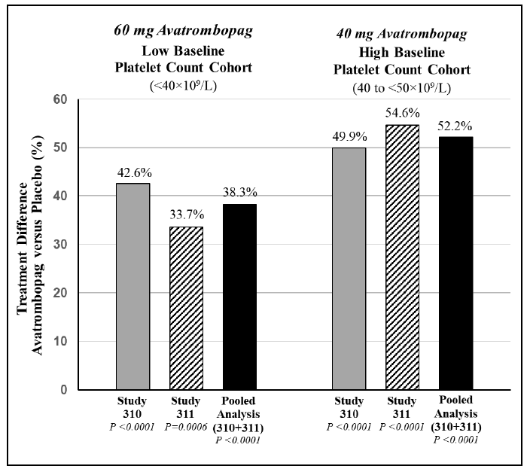

Responders were defined as the subjects not requiring a platelet transfusion or any rescue procedure for bleeding after randomisation and up to 7 days following a scheduled procedure.

Values represent the difference in proportion versus placebo = proportion of responders for avatrombopag – proportion of responders for placebo.

*P* value is based on Cochran-Mantel-Haenszel test stratified by the risk of bleeding associated with the scheduled procedure within each Baseline platelet count cohort.

The similarity of the pooled and individual study analyses was demonstrated for the secondary endpoints also.

##### Immune thrombocytopenia

###### Study 302

A Phase III, multicentre, multinational, randomised, double blind, placebo controlled, parallel group trial with an open label extension phase to evaluate the efficacy and safety of avatrombopag plus standard of care for the treatment of thrombocytopenia in 49 adults with chronic immune thrombocytopenia (ITP) conducted from February 2012 to April 2015.

The study was conducted at 27 sites in Australia, Belgium, Bulgaria, Czech Republic, Netherlands, New Zealand, Poland, Singapore, Slovakia, South Africa, and Ukraine.

The study had three main phases: a pre-randomisation phase, a double blind, randomised study (the core part of the study) and an open label extension phase. This is summarised in Figure 10 and Figure 12 below. Dose tapering and follow-up at the end of the core study was only needed for patients not continuing into the extension phase.

Figure 10: Study 302 design schematic

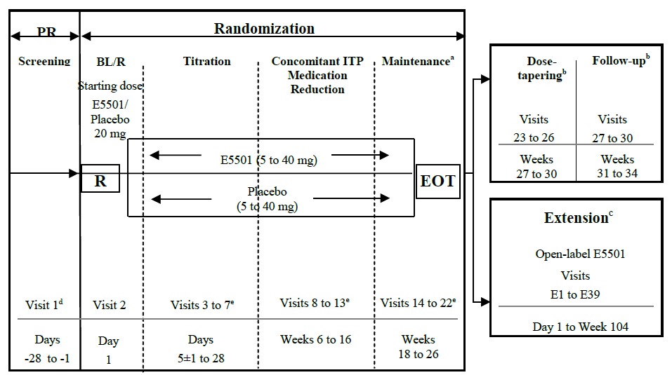

Abbreviations: BL = baseline, EOT = end-of-treatment, ITP = immune thrombocytopenia (idiopathic thrombocytopenic purpura), PR = pre-randomisation, R = randomisation

Note: E5501 is the code for avatrombopag.

a: At the EOT Visit (Visit 22), subjects had the choice to enter the extension phase and to receive open label avatrombopag therapy. Subjects who did not continue into the extension phase entered the dose-tapering and follow-up periods.

b: Only for subjects who did not enter the extension phase.

c: See Figure 11 for detailed design of extension phase. The extension phase consisted of 4 periods: conversion (6 weeks), maintenance period/concomitant ITP medication reduction period (90 weeks), dose-tapering (up to 4 weeks), and follow-up (30 days).

d: The screening visit and Day 1 Baseline/randomisation visit platelet counts averaged to obtain the Baseline platelet count value. The two samples were obtained 48 hours or more and 2 weeks or less apart and the results were available prior to randomisation. Therefore, an additional screening platelet count may have been required due to issues with scheduling.

e: Subjects who discontinued early who met the criteria for a lack of treatment effect may have moved directly into the open label extension.

Figure 11: Study 302 extension phase design

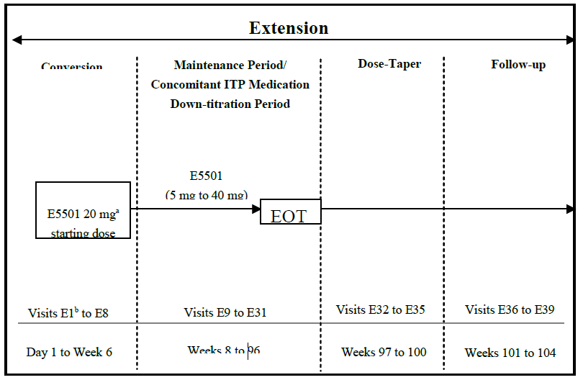

a: All subjects who entered the extension phase had a starting dose of 20 mg avatrombopag.

b: For those subjects who completed the entire core study, Visit E1 was the same day as core study Visit 22. For those subjects who demonstrated a lack of treatment effect, Visit E1 was the same day as the core study end of treater visit.

Inclusion criteria for Study 302

* Age 18 years or older and:
  + Diagnosed with chronic ITP (12 months or greater duration) according to the American Society for Hematology/British Committee for Standards in Hematology guidelines.
  + Average of two platelet counts less than 30 × 109/L (no single count should have been greater than 35 × 109/L).
  + Peripheral blood smear should have supported the diagnosis of ITP with no evidence of other causes of thrombocytopenia (for example, pseudothrombocytopenia, myelofibrosis).
  + Physical examination did not suggest any disease that might have caused thrombocytopenia other than ITP.
* Previously 1 or more ITP therapies (including, but not limited to corticosteroids, immunoglobulins, azathioprine, danazol, cyclophosphamide and/or rituximab).
* Must have had either initially responded (platelet count greater than 50 × 109/L) to a previous ITP therapy or have had a bone marrow examination consistent with ITP within 3 years to rule out myelodysplastic syndrome or other causes of thrombocytopenia.
* Prothrombin time/International Normalised Ratio and activated partial thromboplastin time must have been within 80% to 120% of the normal range with no history of hypercoagulable state.
* Had a complete blood count (excluding platelet count), within the reference range (with white blood cell differential not indicative of any significant haematological disorder), with the following exceptions:
  + Haemoglobin: patients with haemoglobin levels between 10 g/dL (100 g/L) and the lower limit of normal (LLN) were eligible for inclusion, if anaemia was clearly attributable to ITP (excessive blood loss).
  + Absolute neutrophil count (ANC) 1500/μL (1.5 x 109/L) or greater.
  + Elevated white blood cell or absolute neutrophil count (for example, due to corticosteroid treatment).

Exclusion criteria for Study 302

* Known secondary immune thrombocytopenia (for example, with known Helicobacter pylori‑induced ITP, known HIV or HCV or known systemic lupus erythematosus).
* Significant medical conditions that may have impact on safety or interpretation of study results (for example, acute hepatitis, active chronic hepatitis, lymphoproliferative disease. myeloproliferative disorders, leukemia).
* History of myelodysplastic syndrome.
* History of gastric atrophy.
* History of pernicious anaemia or patients with vitamin B12 deficiency (defined as less than LLN) who had not had pernicious anaemia excluded as a cause.
* Any prior history of arterial or venous thrombosis (stroke, transient ischemic attack, myocardial infarction, deep vein thrombosis or pulmonary embolism), and more than two of the following risk factors: estrogen containing hormone replacement or contraceptive therapies, smoking, diabetes, hypercholesterolemia, medication for hypertension, cancer, hereditary thrombophilic disorders (for example, Factor V Leiden, antithrombin III deficiency), or any other family history of arterial or venous thrombosis.
* History of significant cardiovascular disease (for example, congestive heart failure New York Heart Association Grade III/IV,[24] arrhythmia known to increase the risk of thromboembolic events (for example, atrial fibrillation), patients with a QT interval corrected for heart rate of greater than 450 msec,17 angina, coronary artery stent placement, angioplasty, coronary artery bypass grafting).
* History of cirrhosis, portal hypertension, and chronic active hepatitis.
* Concurrent malignant disease.
* Use of immunoglobulins (intravenous immunoglobulin and anti-D) within 1 week of randomisation.
* Splenectomy or use of rituximab within 12 weeks of randomisation.
* Use of romiplostim or eltrombopag within 4 weeks of randomisation.
* Treated with corticosteroids or azathioprine but had not on stable dose for 4 weeks or more prior to randomisation or had not completed these therapies more than 4 weeks prior to randomisation.
* Currently being treated with mycophenolate mofetil, Cyclosporine A, or danazol but not on a stable dose for 12 weeks or more prior to randomisation or have not completed these therapies more than 4 weeks prior to randomisation.
* Use of cyclophosphamide or vinca alkaloid regimens within 4 weeks of randomisation.
* Currently being treated with proton pump inhibitor or histamine antagonist therapy but not on a stable dose for 6 weeks or more prior to randomisation or had not completed these therapies more than 2 weeks prior to randomisation.
* Fasting gastrin-17 blood levels greater than the upper limit of normal (ULN) at screening if not on proton pump inhibitor or histamine antagonists.
* Fasting gastrin-17 blood levels greater than 1.5 x ULN at screening if on proton pump inhibitor or histamine antagonists.
* Blood creatinine greater than ULN by more than 20% or total albumin less than LLN by 10%.
* Alanine aminotransferase or aspartate aminotransferase levels greater than 3 x ULN or total bilirubin greater than 2 x ULN.
* History of cancer treatment with cytotoxic chemotherapy ± radiotherapy. Eligible if ITP and treatment with cytotoxic chemotherapy.
* Females who were pregnant (positive beta-human chorionic gonadotropin) or breastfeeding.
* Known allergy to avatrombopag and any of its excipients.

Inclusion criteria for extension study

* Completed 6 months of study treatment in the randomisation phase provided the open label extension phase was still ongoing.
* Discontinued from the core study early due to lack of treatment effects provided the open label extension phase was still ongoing.
* No significant safety or tolerability concerns with the patient’s participation of randomisation phase as determined by the investigator.
* Did not require rituximab, splenectomy or other thrombopoietin (TPO) agonists at the time of enrolment in the extension phase.

Patients were randomised to avatrombopag or placebo in a 2:1 ratio, stratified by splenectomy status, Baseline platelet count (15 x 109/L or less or 15 x 109/L to 30 x 109/L), and Baseline use of concomitant ITP medication (yes or no).

Treatments

The starting dose was 20 mg avatrombopag or placebo once daily.

The treatment goal was to maintain the peripheral platelet count 50 × 109/L or greater and 150 × 109/L or less, and to decrease the need for concomitant ITP medications, if possible. Study drug dose titration was permitted to a maximum dose of 40 mg for avatrombopag (or matching placebo) or minimum dose of 5 mg (or matching placebo) according to Table 10 below.

Table 10: Avatrombopag dose adjustment guidelines, core study and extension phase

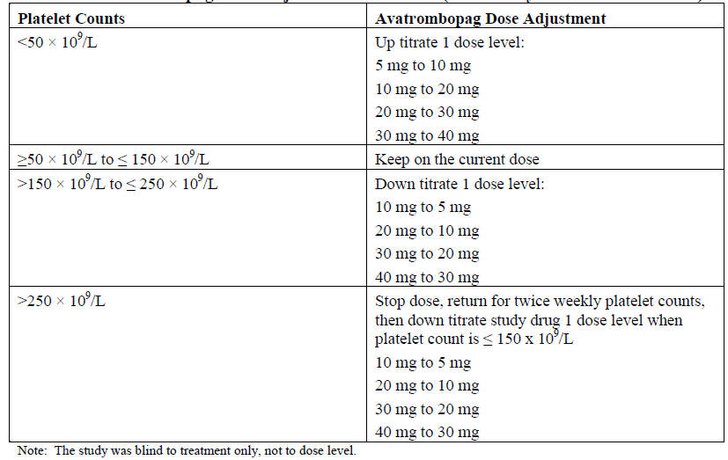

Treatment duration was 26 weeks in the randomised phase and up to 76 weeks in extension phase.

Rescue therapy could be considered at the discretion of the investigator or sub-investigator based on clinical assessment. It was to be considered in the event of potentially life threatening thrombocytopenia, such as a platelet count less than 10 × 109/L, major bleed or clinical signs suggesting a major bleed. Rescue therapy could include corticosteroids, intravenous immunoglobulin therapy, anti-D therapy, mycophenolate mofetil, azathioprine, danazol, dapsone, platelet transfusion, cyclosporin A (only if deemed medically necessary and/or no other suitable alternative treatment options are available as it is a P-glycoprotein inhibitor), or an increase in a Baseline dose of a concomitant ITP medication. Thrombopoietin agonists were not allowed as rescue therapy.

Patients requiring the following prohibited concomitant therapies during the treatment phase of the study were discontinued:

* Platelet transfusion was prohibited within 7 days before the first dose of study drug. Antifibrinolytic agents (aprotinin, tranexamic acid, and aminocaproic acid) and recombinant activated factor VII.
* Heparin, warfarin, factor Xa inhibitors, direct thrombin inhibitors, fresh frozen plasma and cryoprecipitate, chronic antiplatelet therapy (more than 4 weeks) with aspirin, clopidogrel, prasugrel, ticlopidine, or glycoprotein Ib/IIIa antagonists (for example, tirofiban).
* The use of nonsteroidal anti-inflammatory drugs other than aspirin for more than 7 days per month was prohibited. Short-term use of aspirin, other salicylates, or adenosine diphosphate receptor antagonists was permitted only if the platelet count had increased, and the investigator judged that the patient was at risk for thromboembolism.
* Some ITP therapies/procedures: vinca alkaloids, cyclophosphamide, rituximab, splenectomy, and other TPO receptor agonists (eltrombopag, romiplostim).

The primary efficacy endpoint was the cumulative number of weeks of platelet response as defined by:

* Cumulative number of weeks in which the platelet count is 50 x 109/L or greater (per local laboratory results) during the 6 months of treatment, in the absence of rescue therapy.

The key secondary efficacy endpoints were:

* Proportion of patients with a Day 8 platelet response 50 x 109/L or greater. Missing Day 8 platelet counts or use of a rescue therapy before or on Day 8 were considered platelet non‑responses.
* Proportion of patients with a reduction in use of concomitant ITP medications from Baseline (if used concomitant ITP medication at Baseline, had no use of rescue therapy during the 6 month treatment period, and had at least one concomitant ITP medication dose reduced from Baseline level during the whole maintenance period).

Patients had a median age of 44 years (range 18 to 69), with 4 out of 49 patients aged 65 years or older. The avatrombopag group was approximately 72% female, and the placebo group was approximately 53% male, and almost all (93.9%) were White. The median Baseline platelet count was 12.5 x 109/L (range 1.0 x 109/L, 31.5 x 109/L) in the avatrombopag group and 9.5 x 109/L (range 4.0 x 109/L, 27.0 x 109/L) in the placebo group, but the distribution into categories 15 x 109/L or less, and 15 x 109/L to 30 x 109/L were similar.

Around 2 out of 3 of patients did not have a previous splenectomy. Prior use of immunoglobulins (15.6% versus 5.9%), antihemorrhagics (25% versus 17.6%) and analgesics (15.6% versus 0%) were greater in the avatrombopag versus placebo groups. Prior of use of immunosuppressants was higher in the placebo group (0% versus 11.8%) and prior corticosteroid use was similar in both treatment groups. Previous use of TPO receptor agonist therapy (37.5% versus 35.3%), rituximab (18.8% versus 17.6%) and previous platelet transfusions (18.8% versus 17.6%) was similar in the avatrombopag and placebo groups.

Concomitant use of corticosteroids was higher in the avatrombopag group (9 (28.1%) versus 0%), and in 30.8% of the patients in the extension phase were on systemic corticosteroids.

All randomised patients were treated in the core study and 39 patients continued into the extension phase. The reasons for discontinuations are shown in Table 11 and Table 12 below.

Table 11: Study 302 patient flow through the core study

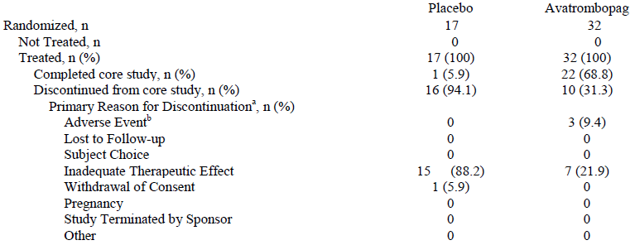

Abbreviations: FAS = full analysis set  
Percentages are based on the number of subjects randomised and treated in the relevant treatment group.  
a: As reported on the subject disposition (core study) case report form.  
b: Corresponding adverse event(s) leading to withdrawal from the study were reported on the adverse event case report form.

Table 12: Study 302 patient flow through the extension phases

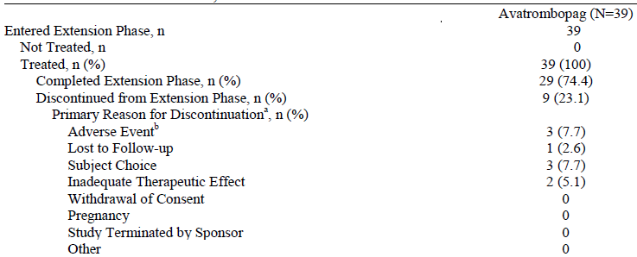

Abbreviations: mFAS = modified full analysis set

Percentages are based on the number of subjects entered the extension phase and treated in the relevant treatment group.

a: As reported on the subject disposition (extension phase) case report form.

b: Corresponding adverse event(s) leading to withdrawal from the study were reported on the adverse event case report form.

The sample size of 45 patients (15 placebo, 30 avatrombopag), was calculated by the sponsor to have greater than 95% power to detect a treatment difference between avatrombopag and placebo in the cumulative number of weeks of platelet response during the 4 week treatment period using Wilcoxon rank sum test at a 2-sided α = 0.05 significant level. This assumed a platelet response for placebo versus avatrombopag of 0% versus 80% at 4 weeks based on results observed in the Phase II Study 501-CL-003.

The full analysis set was used as the primary population for all efficacy analyses. Patients who discontinued the study or who were lost to follow-up before 6 months had all subsequent unobserved scheduled platelet assessments at the scheduled time points reported as ‘missing’ platelet.

The comparisons of the primary and two key secondary efficacy endpoints occurred in a sequential manner. For the two key secondary endpoints, the comparison of platelet response at Day 8 between avatrombopag and placebo was performed first at 2-sided α = 0.05. If this testing was significant, then the comparison of proportion of patients with a reduction in use of concomitant ITP medications from Baseline were performed at 2-sided α = 0.05. The null hypothesis was to be tested using Cochran-Mantel-Haenszel test adjusting for splenectomy status (yes and no) and Baseline platelet count (15 x 109/L or less and 15 to 30 x 109/L) at the 2-sided α = 0.05 significance level as long as none of the marginal cells equalled to 0. Since at least one of the marginal cell count was equal to 0, the Fisher’s exact test was used at the 2-sided α = 0.05 significance level.

All other endpoints were analysed without adjustment for multiple comparisons.

All patients who had a protocol deviations reported in the study had at least one considered a major deviation.

Table 13: Study 302 major protocol deviations full analysis set of core study

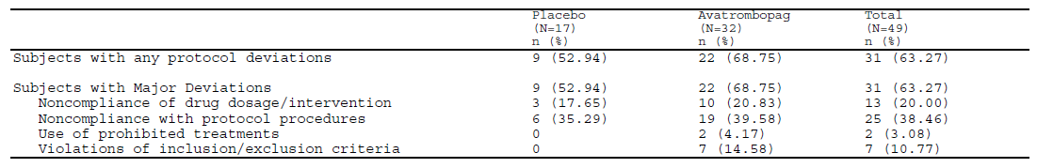

Percentages are based on the number of randomised subjects in the relevant treatment group. Subjects may have multiple major deviations.

Table 14: Study 302 major protocol deviations modified full analysis set of extension phase

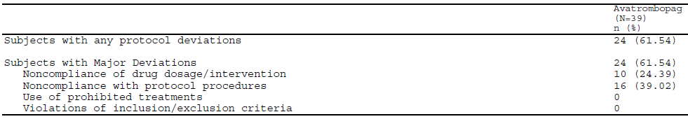

Percentages are based on the number of randomised subjects in the relevant treatment group. Subjects may have multiple major deviations.

Primary endpoint

The median cumulative number of weeks with platelet count 50 x 109/L or greater during the 6 month treatment period was 12.4 weeks in the avatrombopag group and 0 weeks in the placebo group.

Table 15: Summary of cumulative number of weeks with platelet count 50 x 109/L or greater, full analysis set of core study

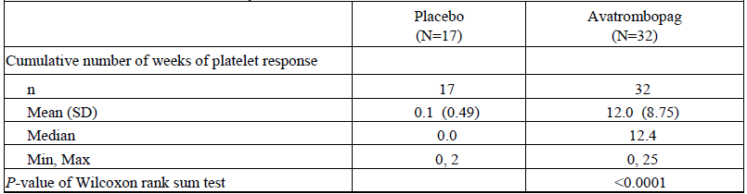

Abbreviations: FAS = full analysis set.

Cumulative number of weeks of platelet response is defined as the total numbers of weeks in which the platelet count is 50 x 109/L or greater during 6 months of treatment of core study in the absence of rescue therapy.

From the subgroup analyses, cumulative platelet response was lower in splenectomised patients compared to non-splenectomised patients (4.9 versus 15.9 weeks), patients with Baseline platelet count 15 x 109/L or less compared with a baseline count 15 to 30 x 109/L (5.3 versus 19.2 weeks), and in those patients who used concomitant ITP medication at Baseline compared to those who did not use concomitant ITP medication (4.9 versus 15.9 weeks).

Secondary endpoints

The proportion of patients with a Day 8 platelet count 50 x 109/L or greater was greater for avatrombopag versus placebo (65.63% versus 0%; treatment difference = 65.63%, 95% CI: 49.17%, 82.08%; p < 0.0001).

Only 22 patients were using ITP medication at Baseline. The proportion of patients with a reduction in use of concomitant ITP medication from Baseline was greater in avatrombopag group (33.33% versus 0%), but the difference was not statistically significant (treatment difference = 33.3%, 95% CI: 9.48%, 57.19%, p = 0.12348). Around half the patients on Baseline steroid were able to reduce their dose or discontinue treatment.

The small patient numbers and high dropout rate in the placebo group limit the interpretation of the results, as is demonstrated by the numbers of patients contributing to the figure (see Figure 12 .

Figure 12: Median (Q1, Q3) platelet count over time for core study treatment period, full analysis set

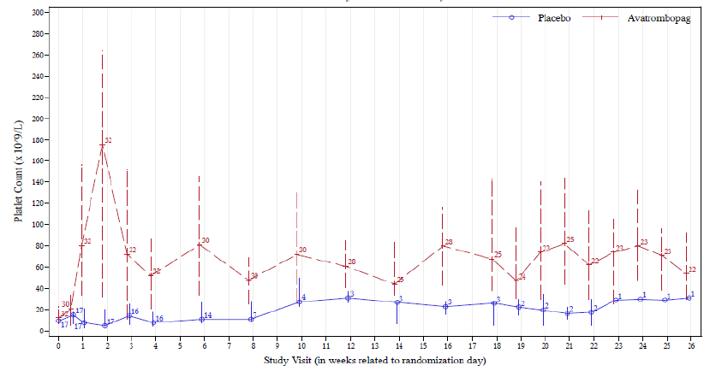

###### Study 305

A Phase III, multicentre, randomised, double blind, active controlled, parallel group trial with an open label extension phase to evaluate the efficacy and safety of oral avatrombopag versus eltrombopag, in adults with chronic immune thrombocytopenia. Only 24 were randomised and 23 treated. This study did not progress because of enrolment challenges.

###### Supportive studies

Study 501-CL-003

This was a Phase II prospective, multicentre, randomised, double blind, placebo controlled, parallel group dose ranging study (2.5 mg, 5 mg, 10 mg and 20 mg once daily for 28 days) conducted in 64 adults with ITP. The primary endpoint (responder rate) was determined by calculating the proportion of patients with a Day 1 platelet count of less than 30 x 109/L who achieved platelet count of 50 x 109/L or greater on Day 28 plus the proportion of patients using steroids who had a Day 1 platelet count greater than 30 x 109/L but less than 50 x 109/L who achieved a platelet count of 20 x 109/L or greater above their Day 1 platelet count on Day 28. The study allocated five, 15, 15, 14, and 15 patients to the placebo, 2.5 mg, 5 mg, 10 mg and 20 mg treatment groups, respectively. The primary efficacy endpoint responder rate was reported in 0%, 13.3%, 53.35%, 50% and 80% in the placebo, 2.5 mg, 5 mg, 10 mg, and 20 mg doses, respectively. A comparative safety analysis was conducted in this study for the avatrombopag versus placebo groups.

Study 501-CL-004

This was a Phase II, double blind, placebo controlled, parallel group, rollover study in 53 patients with chronic ITP who completed 28 days of study treatment in Study 003. The 25 patients from Study 003 who had responded to treatment continued on their same (blinded) treatment in Study 004. An additional 28 non-responders from Study 003 received unblinded 10 mg doses. These patients could have their dose titrated. Patients were treated for 6 months to investigate the efficacy of chronic treatment with avatrombopag.

Safety was the primary endpoint. Efficacy endpoints were secondary endpoints. In this maintenance period all patients had an increase in platelet count from Baseline to Week 24 (in the Study 003 responder and non-responder groups). All patients with platelets in the target range at commencement maintained this level of response. A durable response was defined as subjects who have three or more measurements in the last 14 weeks of the 24 week treatment period, and with platelet counts at a response level (50 x 109/L or greater for Baseline 30 x 109/L or greater, or an increase of 20 x 109/L or greater for Baseline less than 30 x 109/L) 75% or more of that time, without rescue medication. The durable response rate was 72% among the Study 003 responders and 35.7% among the Study 003 non-responders.

#### Safety

Data with 1100 individuals (587 patients and 520 healthy volunteers) who had received at least one dose of avatrombopag in 24 studies. The patient exposure is summarised below.

Table 16: Avatrombopag exposure

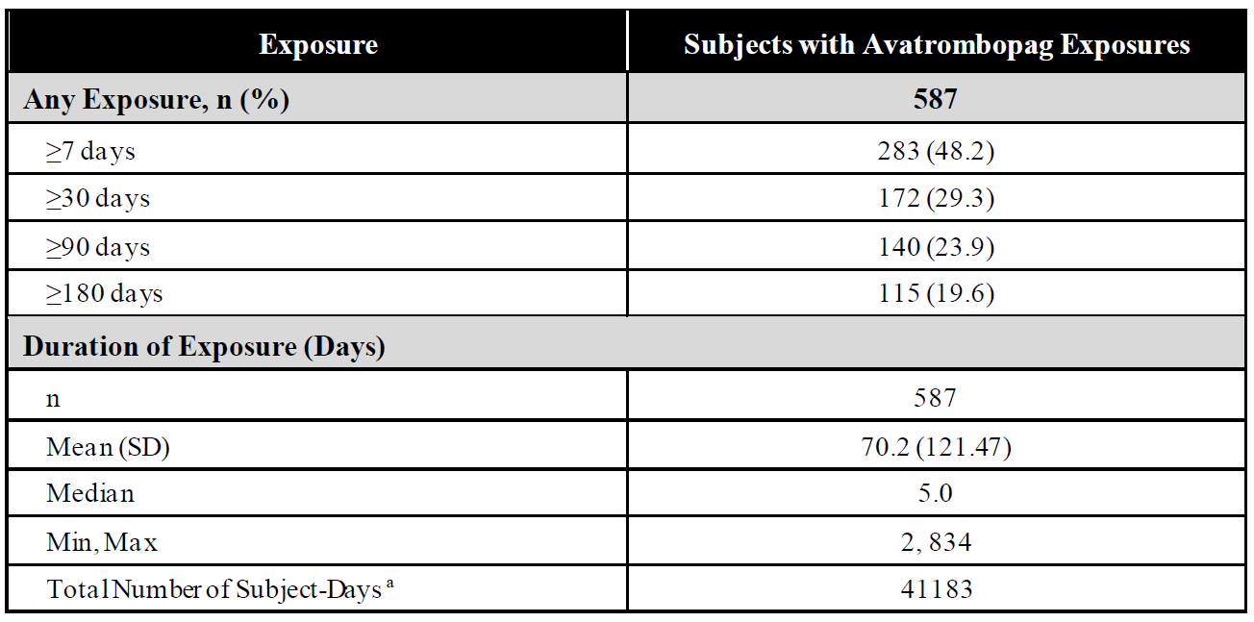

a: Total number of subject-days = summation over all subjects’ exposure durations.

The sponsor pooled safety data into six groups:

* Group 1: Primary safety data supporting the proposed indication in CLD (Studies 310 and 311 involving 435 patients).
* Group 2: Thrombocytopenia in all CLD Studies 310, 311, 202, 204 involving 599 patients (395 avatrombopag and 204 placebo).
* Group 3: Thrombocytopenia in all CLD studies including hepatitis C study: Studies 310, 311, 202, 204, 203 involving 644 patients. Study 203 not included in Group 2 because of different study population.
* Group 4: Thrombocytopenia in all chronic ITP Studies 302, 305, 003, 004 involving 161 patients.
* Group 5: Overall thrombocytopenia in all indication’s studies (n = 841).
* Group 6: Phase I studies in healthy volunteers: clinical pharmacology studies including bioavailability, drug-drug interaction and thorough QTc studies (single dose n = 517; multiple dose n = 64).17

##### Chronic liver disease indication: Group 1 safety cohort

The Group 1 cohort provides comparative safety against placebo and is considered the main safety cohort in the consideration of benefits and harms.

Table 17: Group 1 treatment-emergent adverse events (Studies 310 and 311)

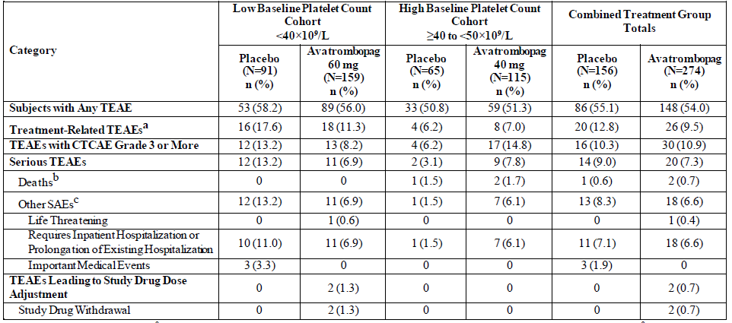

Abbreviations: AE = adverse event, CTCAE = common terminology criteria for adverse events, MedDRA = Medical Dictionary for Regulatory Activities, N = total number of subjects in sample group, n = number of subjects in individual group, SAE = serious adverse event, TEAE = treatment-emergent adverse event.

One subject in the 40 to 50 × 109/L high Baseline platelet count cohort received 60 mg avatrombopag and hence was included in the less than 40 × 109/L low Baseline platelet count cohort in all safety analyses.

A TEAE was defined as an AE that started on or after the date of first dose of study drug, up to 30 days after the last dose of study drug. For each row category, a subject with two or more AEs in that category is counted only once. In all safety analyses, subjects were reported in the Baseline platelet count cohort based on the actual study drug received.

MedDRA Version 19.1 was used.

a: Includes TEAEs considered by the investigator to be related to study drug or TEAEs with missing causality.

b: Includes all subjects with SAE resulting in death.

c: Includes subjects with nonfatal SAEs only. If a subject had both fatal and nonfatal SAEs, the subject was counted in the previous row and was not counted in this row.

Table 18: Group 1 treatment-emergent adverse events in greater than 3% of patients in the avatrombopag groups

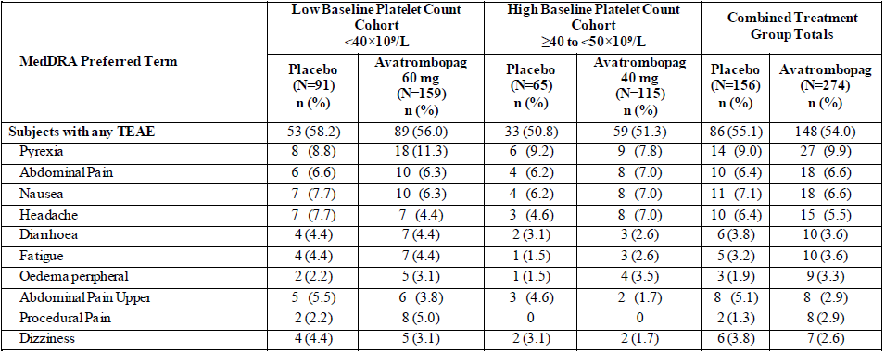

Abbreviations: AE = adverse event, MedDRA = Medical Dictionary for Regulatory Activities, N = total number of subjects in sample group, n = number of subjects in individual group, PT = preferred term, TEAE = treatment-emergent adverse event.

One subject in the 40 to 50 × 109/L high Baseline platelet count cohort received 60 mg avatrombopag and hence was included in the less than 40 × 109/L low Baseline platelet count cohort in all safety analyses.

A TEAE was defined as an AE that started on or after the date of first dose of study drug, up to 30 days after the last dose of study drug.

Subjects with two or more AEs with the same PT were counted only once for that PT.

In all safety analyses, subjects were reported in the Baseline platelet count cohort based on the actual study drug received.

MedDRA Version 19.1.

The common terminology criteria for adverse events Grade 3 or 4 treatment-emergent adverse events (TEAEs) reported in two or more patients in the combined avatrombopag group included neutrophil count decrease (1.5%), abdominal pain upper (0.7%), aspartate aminotransferase increased (0.7%), hepatic encephalopathy (0.7%), hyponatraemia (0.7%), and depression (0.7%).

The most frequently reported treatment-related adverse events in the combined avatrombopag versus placebo treated patients included the following: headache (1.8% versus 4.5%), nausea (1.8% versus 1.9%), fatigue (1.5% versus 1.3%), and dizziness (1.1% versus 1.3%). Other treatment-related adverse events reported in more than one avatrombopag treated patient were bone pain (0.7% versus 0%), diarrhoea (0.7% versus 1.9%), and pyrexia (0.7% versus 0.6%).

The three deaths reported were all in the high Baseline platelet count cohort. Two avatrombopag patients had multiple organ dysfunction and hepatic coma, and a patient from the placebo group died of a myocardial infarction. One additional patient in the low Baseline platelet count cohort 60 mg avatrombopag group died after completing the study and undergoing additional invasive procedures.

Serious adverse events (SAEs) occurred in 7.3% of the combined avatrombopag group and 9% of the placebo group. Gastrointestinal haemorrhage and hyponatraemia occurred in more than one patient in the combined avatrombopag treatment group. Transfusion reaction, hepatic encephalopathy, and pyrexia each occurred in more than one patient in the placebo group.

In the low Baseline platelet count cohort, SAEs were reported in 6.9% of the 60 mg avatrombopag group and 13.2% of the placebo groups. All SAEs in the avatrombopag 60 mg group were reported in only one patient. In the placebo group, transfusion reaction and hepatic encephalopathy were reported in more than one patient. In the high Baseline platelet count cohort, SAEs were reported in 7.8% of the 40 mg avatrombopag groups and 3.1% of the placebo group. All SAEs in the 40 mg group were only reported in single patients. Treatment-related SAEs in avatrombopag treated patients occurred in the low Baseline platelet count cohort 60 mg avatrombopag group in single patients and were anaemia and myalgia. There were no treatment-related SAEs in the 40 mg avatrombopag treated patients in the high Baseline platelet count cohort.

There were no reports of drug-induced hepatotoxicity or renal failure.

Platelet counts greater than 200 × 109/L are associated with the development of portal vein thrombosis.[25] Three avatrombopag treated patients had a platelet count greater than 200 × 109/L at any visit in the two pivotal Phase III studies. All occurred within the first 17 days of treatment. All had decreased platelet counts starting at the next visit and all were asymptomatic. There were no reports of severe thrombocytopenia, agranulocytosis or aplastic anaemia in the clinical studies.

There were no clinically important effects of avatrombopag on any other laboratory parameters, vital signs, or electrocardiograms. Subgroup analyses identified no meaningful trends in the incidence, type, or severity of TEAEs by race, region, Baseline platelet count, MELD score,19 Child-Turcotte-Pugh grade,22 or Baseline CLD aetiology.

There are no data to suggest rebound thrombocytopenia following discontinuation of avatrombopag.

Group 3 and Group 3 safety cohort results were overall similar to the primary CLD safety group.

##### Immune thrombocytopenia indication: Group 4 safety cohort

The main safety cohort included data from 128 patients from chronic ITP Studies 302, 305, 003 and 004. Also in the cohort were 22 patients who received placebo and 11 patients who received eltrombopag. The avatrombopag dosing ranged from 2.5 to 40 mg.

The mean duration of treatment in the ITP studies was 206.4 (135.57) days. Comparative safety for avatrombopag, placebo and eltrombopag was presented using exposure-adjusted incidence rates per patient-year.

Table 19: Group 4 safety cohort treatment-emergent adverse events

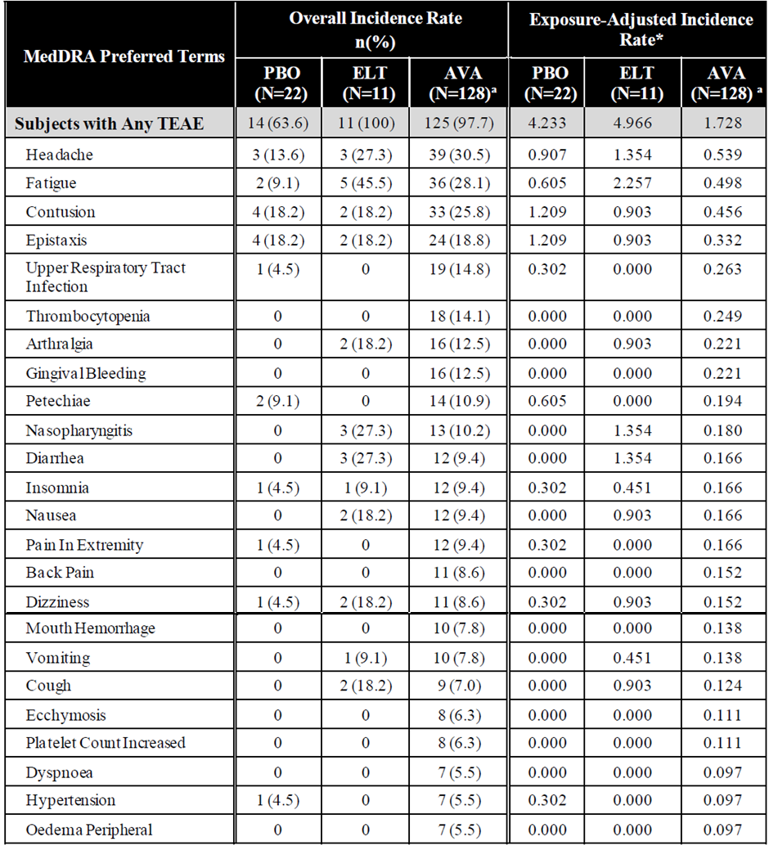

Abbreviations: AE = adverse event, AVA = avatrombopag, ELT = eltrombopag, MedDRA = Medical Dictionary for Regulatory Activities, N = total number of subjects in the sample group, n = number of subjects in individual group, PBO = placebo, PT = preferred term, TEAE = treatment-emergent adverse event.

* Exposure-adjusted incidence rate per subject-year.

A TEAE was defined as an AE that started on or after the date of first dose of study drug, up to 30 days after the last dose of study drug.

Subjects with two or more AEs with the same PT were counted only once for that PT.

MedDRA Version 19.1.

a: N denotes all subjects in the core study and open label extension phases who received avatrombopag.

Grade 3 or 4 TEAEs occurred in 35.2% of the avatrombopag group, 27.3% of the eltrombopag group, and none of the placebo group. Over half (55.6%) of the Grade 3 or 4 TEAEs in avatrombopag patients were increases or decreases in platelet counts. Most individual Grade 3 or 4 TEAEs in Group 4 were reported in only one patient each.

###### Treatment-emergent adverse events

Table 20: Group 4 treatment-emergent adverse event summary

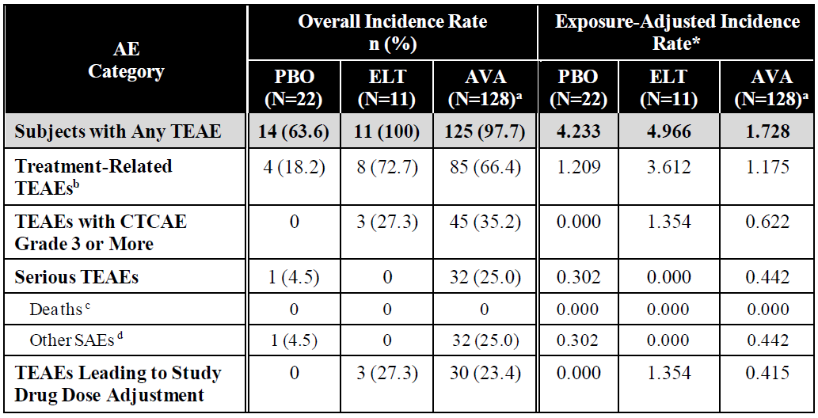

Abbreviations: AE = adverse event, AVA = avatrombopag, CTCAE = common terminology criteria for adverse events, ELT = eltrombopag, ITP = immune thrombocytopenia, N = total number of subjects in the sample group, n = number of subjects in individual group, PBO = placebo, SAE = serious adverse event, TEAE = treatment-emergent adverse event.

* Exposure-adjusted incidence rate per subject-year.

A TEAE was defined as an AE that started on or after the date of first dose of study drug, up to 30 days after the last dose of study drug. For each row category, a subject with two or more AEs in that category was counted only once.

a: N denotes all subjects in the core study and open label extension phase who received avatrombopag.

b: Includes TEAEs considered by the investigator to be related to study drug or TEAEs with missing causality.

c: Includes all subjects with SAE resulting in death.

d: Includes subjects with nonfatal SAEs only. If a subject had both fatal and nonfatal SAEs, the subject was counted in the previous row and was not counted in this row.

Table 21: Group 4 treatment-emergent adverse events, by preferred term

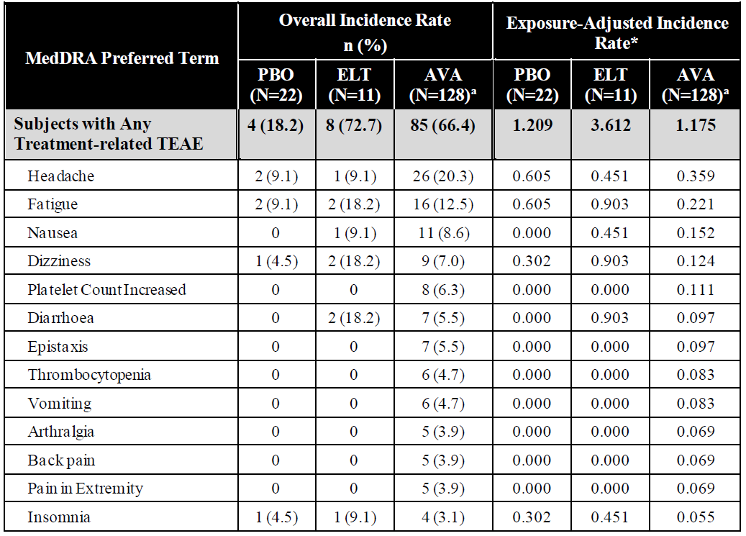

Abbreviations: AE = adverse event, AVA = avatrombopag, ELT = eltrombopag, MedDRA = Medical Dictionary for Regulatory Activities, N = total number of subjects in the sample group, n = number of subjects in individual group, PBO = placebo, PT = preferred term, TEAE = treatment-emergent adverse event.

* Exposure-adjusted incidence rate per subject-year.

A TEAE was defined as an AE that started on or after the date of first dose of study drug, up to 30 days after the last dose of study drug.

Subjects with two or more AEs with the same PT were counted only once for that PT.

MedDRA Version 19.1.

a: N denotes all subjects in the core study and open label extension phases who received avatrombopag.

Liver function abnormalities were reported in 3.9% patients in the avatrombopag group (exposure-adjusted incidence rate 0.069). The most common adverse events of special interest (AESI) were alanine transaminase increased (3.1%) and aspartate aminotransferase increased (2.3%). There was no clear signal for liver toxicity. No renal safety signals were identified.

Hypersensitivity events occurred in 6.3% of avatrombopag patients. Most were rash, with a mean time to onset of 70 days (range 1 to 191 days).

Safety in terms of baseline demographics (age, sex, race) or disease characteristics was not evaluated in the chronic ITP studies.

###### Deaths and serious adverse events

No deaths were reported in the chronic ITP studies. The SAEs exposure-adjusted incidence rates were 0.442 versus 0.302 versus 0 for avatrombopag versus placebo versus eltrombopag groups. SAEs occurring in more than two patients in the avatrombopag group included thrombocytopenia, vomiting, nausea, headache, gastric haemorrhage and ITP.

Table 22: Group 4 safety cohort serious adverse events in more than two patients in any treatment group (decreasing frequency)

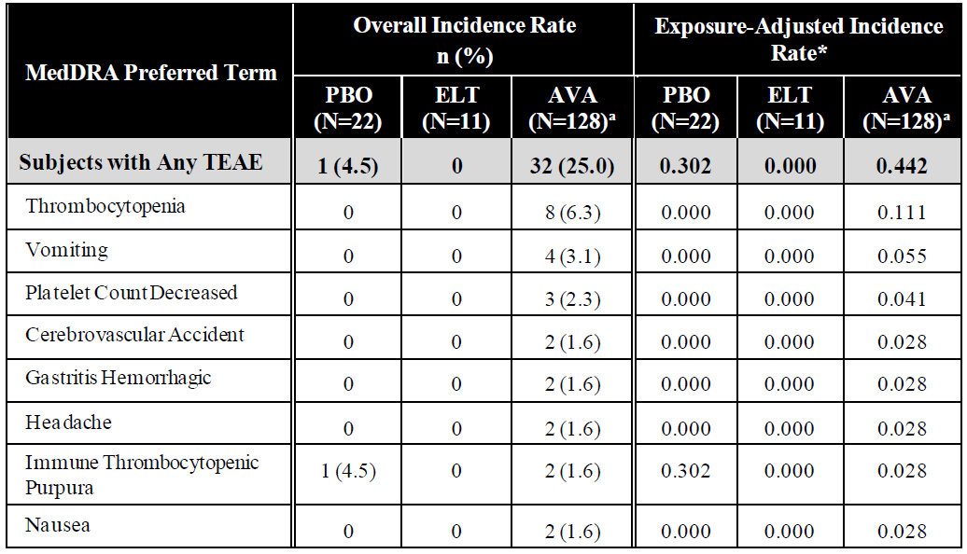

Abbreviations: AE = adverse events, AVA = avatrombopag, ELT = eltrombopag, MedDRA = Medical Dictionary for Regulatory Activities, N = total number of subjects in the sample group, n = number of subjects in individual group, PBO = placebo, PT = preferred term, TEAE = treatment-emergent adverse event.

* Exposure-adjusted incidence rate per subject-year.

A TEAE was defined as an AE that started on or after the date of first dose of study drug, up to 30 days after the last dose of study drug.

Subjects with two or more AEs with the same PT is counted only once for that PT.

MedDRA Version 19.1.

a: N denotes all subjects in the core study and open label extension phases who received avatrombopag.

###### Adverse events of special interest

The Group 4 treatment-emergent adverse events of special interest (AESI) included recurrence of thrombocytopenia, thromboembolic events, bleeding events, neoplastic events, and clinically significant liver test; no treatment-emergent AESI were reported in the gastric atrophy event or bone marrow pathology categories.

All AESIs, with the exception of one case of petechiae in the placebo group, occurred in the avatrombopag group. Those reported in more than two patients included thrombocytopenia (8.6%), contusion (3.9%), alanine transaminase increased and epistaxis (3.1% each), gingival bleeding, menorrhagia, petechiae, and aspartate aminotransferase increased (2.3% each). There was one case of myelofibrosis possibly related to study treatment in Study 302. The most common bleeding events were contusion 3.9% and epistaxis 3.1%; all other events were reported by three patients or less. The time of onset of bleeding events was greater than 26 weeks for one patient, 12 to less than 26 weeks for four patients, 4 to less than 12 weeks for eight patients, 1 to less than 4 weeks for four patients, and less than one week for one patient.

Recurrent or rebound thrombocytopenia was defined as a platelet count less than 10 × 109/L and 10 × 109/L below Baseline that occurred after the stopping of study drug and up to 30 days after the last dose of study drug. Recurrence of thrombocytopenia was reported in 8.6% of the avatrombopag group (exposure-adjusted incidence rate was 0.152). Among those events the time of onset of was greater than 26 weeks for 10 patients and 12 to less than 26 weeks for one patient.

Thromboembolic events were reported in 7% of the avatrombopag treatment group (exposure‑adjusted incidence rate 0.124). Cerebrovascular accident was reported by two (1.6%) patients; but no safety signal was identified. Myocardial infarction and transient ischaemic attack were reported as single events. The time of onset of these events was greater than 26 weeks for two patients, 12 to less than 26 weeks for four patients, 4 to less than 12 weeks for one patient, and one to less than 4 weeks for two patients.

##### Post marketing safety

The submission included 11 periodic safety update reports. The evaluation reviewed the events and found cerebral haemorrhage, portal vein thrombosis, pneumonia, febrile neutropenia and deaths.

##### Other

No companion diagnostics or drug delivery systems formed part of the submission. Platelet counts were based on local laboratory results.

### Risk management plan

Swedish Orphan Biovitrum Pty Ltd has submitted European Union (EU)-risk management plan (RMP) version 2.7 (dated 10 December 2020; data lock point (DLP) 20 November 2020) and Australia-specific annex (ASA) version 1.2 (dated September 2021) in support of this application. In response to TGA questions, the sponsor has submitted ASA version 1.3 (dated May 2022) to support its application.

The summary of safety concerns and their associated risk monitoring and mitigation strategies are summarised in Table 23. The TGA may request an updated RMP at any stage of a product's life cycle, during both the pre-approval and post-approval phases.

Table 23: Summary of safety concerns

|  |  |  |  |  |  |
| --- | --- | --- | --- | --- | --- |
| **Summary of safety concerns** | | **Pharmacovigilance** | | **Risk Minimisation** | |
| Routine | Additional | Routine | Additional |
| **Important identified risks** | Thrombotic/thromboembolic events | ✓* | ✓‡ | ✓ | – |
| Bone marrow fibrosis related to long-term and repeat use | ✓ | ✓‡ | ✓ | – |
| **Important potential risks** | Hepatic worsening function in patients with Child-Pugh class C | ✓* | ✓† | ✓ | – |
| Haematological malignancies | ✓ | ✓‡ | ✓ | – |
| **Missing information** | Use in splenectomy patients with chronic liver disease | ✓ | – | – | – |
| Use in patients receiving interferon products | ✓ | – | ✓ | – |
| Safety in patients undergoing highly invasive procedures | ✓ | – | ✓ | – |
| Use in patients with MELD scores > 24 | ✓* | ✓† | ✓ | – |

*Follow-up questionnaires  
†PASS to assess hepatic safety  
‡ PASS to further characterise the long-term safety profile

The summary of safety concerns in the ASA are consistent with the EU-RMP. No new safety concerns have been identified by the clinical and nonclinical evaluations. Therefore, the summary of safety concerns is satisfactory.

Routine and additional pharmacovigilance activities are proposed. Routine risk minimisation activities include follow up questionnaires for thrombotic/thromboembolic events and hepatic related events (in particular in patients with Child-Pugh class C liver disease or patients with MELD scores greater than 24). Additional pharmacovigilance activities include two planned post authorisation studies to further characterise the safety profile of avatrombopag. The studies are predicated on a positive outcome from feasibility studies which are to be submitted to the European Medicines Agency.

Routine risk minimisation activities only are proposed. This is acceptable as avatrombopag is an oral medicine and will be prescribed by specialists.

### Risk-benefit analysis

#### Delegate’s considerations

Avatrombopag stimulates the proliferation and differentiation of megakaryocytes from bone marrow progenitor cells, resulting in an increased production of platelets.

Platelet function, assessed by flow cytometry and platelet aggregometry in a small subset of the Phase III patients showed similar platelet function, providing some reassurance that avatrombopag induced platelet count elevations should result in functioning platelets. The assumption that platelet numbers equate to platelet function is proposed for mention in Section 4.4 of the PI.

Avatrombopag should be taken with food, but dietary restriction required for eltrombopag has not been shown to be needed with avatrombopag making it a potentially attractive alternative. CYP2C9 is the enzyme primarily responsible for metabolism, and the proposed PI includes advice to manage demonstrated drug-drug interactions. The proposed PI also includes information about potential interactions that have not been evaluated clinically.

##### Chronic liver disease

###### Efficacy

The sponsor’s requested indication for the treatment of thrombocytopenia in adult patients with chronic liver disease who are scheduled to undergo a procedure was mainly supported by data from two Phase III studies (Studies 310 and 311).

Both studies were placebo controlled. The use of a placebo comparator is acceptable in the Australian context given the lack of a registered therapy with a specific indication for this use. Platelet transfusion is an option, but this therapy was available to the avatrombopag and placebo arms of each of the pivotal studies as rescue therapy. The enrolment threshold of a platelet count of less than 50 x 109/L is reasonable and consistent with clinical guidelines.

In both studies platelet counts increased from Baseline in both the avatrombopag and placebo groups. The response in the avatrombopag compared with placebo reached statistical significance and clinical meaningfulness in both studies. Responses were seen in patients with a Baseline platelet count of less than 40 x 109/L and 40 to 50 x 109/L. Secondary endpoints of increase in platelet count were consistent with the primary endpoint, showing a benefit of avatrombopag over placebo.

The functional corollary of a low platelet count is bleeding. Bleeding events were exploratory endpoints in the pivotal studies. Bleeding events were low in each group and were numerically greater in the placebo group. Although platelet count is increased with avatrombopag, other aspects of the central function of the liver in the synthesis of clotting factors and clearance of activated factors are improved with avatrombopag, therefore it is reasonable to include bleeding events as an exploratory endpoint.

###### Safety

Adequate numbers of patients were exposed to avatrombopag for at least 5 days, allowing an assessment of the safety.

The most common adverse events were pyrexia, abdominal pain, nausea, headache, fatigue and abdominal pain.

The risk of thrombotic or thromboembolic adverse effects with thrombopoietin receptor agonists (TPO-RA) is well recognised. In Studies 310 and 311, only three patients in the avatrombopag groups and no patients in the placebo groups had a platelet count greater than 200 x 109/L. Portal vein thrombosis is of particular concern in patients with CLD and a platelet count greater than 200 x 109/L.

Thrombopoietin is expressed on the surface of myeloid cells, and there is a concern TPO-RAs may stimulate disease progression in patients with pre-existing haematological malignancies, including myelodysplastic syndromes. Use in patients with myelodysplastic syndromes was specifically excluded in clinical trials, and safety in this patient population is unknown. This uncertainty is captured in the important potential risks in the risk management plan and in section 4.4 of the proposed PI. This risk may be greater with longer exposure.

###### Limitations

Patients undergoing minor procedures such as venepuncture were not included but are potentially indicated in the proposed indication. There is a risk of overshoot of the platelet count and potential sequelae of this for patients with CLD, therefore a restriction to higher risk procedures may be more in keeping with the permitted procedures in the studies.

Patients undergoing highly invasive procedures such as thoracotomy, laparotomy or craniotomy were excluded from the studies. While this may be a limitation, support for platelet numbers from a TPO is only part of the mitigation strategies for higher risk procedures, which may also include blood products and coagulation factor replacement. Care of these patients is individualised and based on clinical expertise and judgement. The sponsor proposes to disclose this limitation as a Special Warning and Precaution for Use in the PI.

The efficacy and safety of avatrombopag in CLD patients who have undergone splenectomy has not been characterised in this submission. Although they were not specifically excluded from the studies, no post-splenectomy patients were enrolled.

In this preliminary consideration, the Delegate considers the evidence of an increase in platelets replicated in two main studies and supported by others in the submission, together with the platelet function study support the efficacy of avatrombopag. The exposure per the proposed dosing is short, and the most common adverse effects appear manageable. The major risk of thromboembolic events is highlighted in the PI.

The outstanding question is whether the indication should be limited to an invasive procedure per the EU wording of the indication. Specialist advice was sought on this aspect.

##### Immune thrombocytopenia

The following deliberations take into account the submission, the evaluation report and responses to the Delegate’s additional questions.

The efficacy of avatrombopag in ITP is supported primarily by Study 302, a Phase III randomised study of 49 adults with ITP (platelet count less than or equal to 30 x 109/L who had received at least one prior ITP therapy). Patients were stratified by Baseline platelet count and use of concomitant ITP therapy at Baseline. To be eligible patients either had an initial response to a previous ITP therapy or a bone marrow examination consistent with ITP in the previous three years. Avatrombopag dosing commenced at 20 mg once daily, orally and was titrated in a treat‑to‑target approach aiming for a platelet count of 50 to 150 x 109/L.

The primary endpoint was the cumulative number of weeks in which a platelet count of greater than or equal to 50 x 109/L was achieved in the 6 months of the treatment period for the primary analysis. Avatrombopag patients had a median 12.4 weeks in the target range compared with 0 weeks for the placebo group. This was statistically significant and clinically meaningful. Secondary endpoints were consistent with the primary endpoint in favour of avatrombopag over placebo.

Patients could receive a stable dose of corticosteroid. The use of corticosteroids did not confer an advantage in terms of cumulative weeks of response (median 4.86 weeks (range, 2, 22.43) with corticosteroid use and 13.71 weeks (range 0, 24.86) with no corticosteroids). However, around half the patients on baseline corticosteroids could reduce or stop that treatment, a clinically relevant finding.

In the extension phase of Study 302 67% (n = 26) of patients received 40 mg daily. Two patients discontinued because of lack of efficacy, but overall the mean daily doses were similar in the core phase and the extension phase of the studies. The sponsor has not identified any resistance mechanisms for avatrombopag, or demonstrated an exhaustion of response, but there is limited long term avatrombopag efficacy data. The EXTEND study data in eltrombopag does demonstrate a gradual decline in the proportion of patients with responses over time with data from 104 or more weeks treatment.

A second Phase III study comparing eltrombopag and avatrombopag would have been helpful to understand relative efficacy and safety of the two products, however due to poor accrual in the study it was discontinued after the randomisation of only 23 patients. Interpretation of the results is limited, and the study was not considered contributory in the efficacy considerations.

Further support for avatrombopag in the ITP population was derived from Studies 003 and 004. Study 003 was a dose ranging study conducted in 64 adults with ITP. Exposures ranged from 2.5 mg to 20 mg, and 15 patients commenced in the proposed starting dose of 20 mg. The primary response in that group was 80%. Study 004 was a roll-over study of Study 003 patients who had completed 28 days of treatment. An early response was predictive of a greater likelihood of a durable response with an additional 6 months of therapy; however the durable response rate was 35.7% for non-responders in Study 003.

Avatrombopag does not reverse the underlying cause of ITP and platelet counts returned towards baseline after discontinuation, but it dipped below baseline in around 9% of ITP patients, mostly 6 months after stopping the drug. It is difficult to assess whether this is a consequence of the use of avatrombopag or disease progression.

The safety profile was similar to that seen in the CLD cohort. No deaths were reported in the ITP studies and SAEs occurring in more than two patients included vomiting and headache, with gastric haemorrhage, thrombocytopenia and ITP. As uncommon events, portal vein thrombosis, cerebrovascular accident and transient ischemic attack, and retinal artery occlusion have been reported in the ITP population.

Study 302, and Studies CL-003 and CL-004 conducted in patients with ITP allowed patients who were post splenectomy to be enrolled. There did not appear to be an increased risk of thromboembolic events in these patients in the studies.

###### Limitations

In Study 302 63.3% of patients had what were described as major protocol deviations. The sponsor provided an adequate explanation that this was a stringent definition and that most were missed visits or bloods reflecting the frequent visits over a long period required of the study participants.

With regard to patient exposure in total 128 patients have received at least one dose of avatrombopag, although much smaller numbers contributed efficacy and safety data from the main studies. It is recognised that avatrombopag is not intended for initial therapy, and therefore the eligible population is limited. The sponsor points to a similar mechanism of action to that of eltrombopag which is already registered and has an established place in the treatment algorithm for refractory ITP in Australia.

Across the ITP studies the median duration of exposure was 6.8 months, thus there are limitations to the safety data with the number of patients exposed and the duration of response. The sponsor is collecting additional data in two Phase IV studies in adults with ITP in the United States of America and EU, and an open label extension of studies in Japanese patients and children and adolescents with ITP. The sponsor also notes discussions are underway with the European Medicines Agency around post-authorisation safety studies (for the CLD and ITP indications) with plans expected to be formalised in 2023. The sponsor would be expected to provide study reports from these studies for evaluation if avatrombopag were approved. The sponsor also provided top line results from a yet to be published analysis of pharmacy supply data that suggest most patients take avatrombopag for a median of 7 to 10 months, to support its position that adequate safety data had been provided to support registration. Avatrombopag has been available internationally for some years, so the safety information has benefitted from post-marketing surveillance.

The restriction of the population to adult patients is supported by the available data. It is noted the sponsor was required to conduct studies in patients aged 2 to 17 years as post-marketing requirements in the initial United States Food and Drug Administration application. Additional clinical studies to demonstrate the pharmacology, safety and efficacy of avatrombopag would be needed if the sponsor proposed an extension of the indications to paediatric patients in the future.

The proposed dosing regimen is supported by the pivotal data, which in turn was supported by the responses in the Phase II studies.

Subject to specialist advice, in this preliminary view the Delegate considers there are features of the evidence that are supportive of registration of avatrombopag for both proposed indications. Further consideration will be provided once the specialist advice has been received.

#### Proposed action

Taking into account the specialist advice and while acknowledging there are limitations to the data in the submission the Delegate concludes the following:

##### Proposed indication for patients with chronic liver disease who are scheduled to undergo a procedure

The expert advice provides a clinical rationale that balances the efficacy safety and limitations of the data, including the limited types of procedures studied against the potential practical applications of avatrombopag in this setting.

The Delegate, on balance, considers avatrombopag is approvable for:

*Doptelet is indicated for the treatment of thrombocytopenia in adult patients with chronic liver disease who are scheduled to undergo a procedure.*

##### Proposed indication for second line immune thrombocytopenia

The expert advice concluded it is reasonable that avatrombopag is available for this indication, nevertheless highlighting the limited duration of exposure in the clinical evidence presented, and the uncertainties this raises. While the Delegate agrees there is evidence of efficacy and safety to support the availability of avatrombopag for patients who have not responded to other therapies the sponsor will be required to provide additional data as part of the conditions of registration to further characterise the long term safety.

On balance, sufficient evidence has been presented to support the indication:

*Doptelet is indicated for the treatment of thrombocytopenia in adult patients with chronic immune thrombocytopenia (ITP) who have had an insufficient response to a previous treatment.*

#### Independent expert advice

The Delegate received the following independent expert advice.

##### Avatrombopag for chronic liver disease

1. ***Based on the same clinical trial evidence, internationally the chronic liver disease indication has a limitation on the type of procedures for which avatrombopag is indicated. For a clinical perspective, do you have any concerns about the benefits and risks if avatrombopag is used prior to any procedure?***

Interventions currently used to reduce the risk of bleeding in liver disease include platelet transfusions in thrombocytopenic patients. The use of platelet transfusion remains unproven as a mechanism to reduce bleeding. While it’s been assumed, two randomised studies in very different circumstances have suggested that transfusing at higher platelet thresholds may actually increase the risk of bleeding.[26], [27] In addition, the coagulopathy in liver disease is complex, with evidence based guidelines now questioning the use of blood products to prevent bleeding based on commonly used assays.[28] In liver disease there is a reduction in both procoagulant and anticoagulant proteins and commonly used assays do not assess the latter or the balance between the two. Whole blood assays have been proposed. Current practice is largely based around opinion and the outcomes presented in support of avatrombopag show that it is effective at achieving a pre-transfusion platelet threshold regarded as acceptable to perform most procedures. Since platelet transfusion is target driven, this effectively reduced transfusion, however it did not reduce bleeding (and assuming platelet transfusions are effective, the studies were not well designed to find this outcome).

The presented studies included large numbers of procedures that have a proven low risk of bleeding, including paracentesis, which is a procedure that may be repeatedly performed in advanced liver disease to control symptoms, thoracocentesis and endoscopies without planned biopsies.28 These procedures are usually performed without platelet transfusion and it is hard to justify adding a novel therapy when the standard of care is to not to increase the platelet count and the risk is known to be low. It would also be paradoxical to exclude avatrombopag use specifically prior to the procedures that made up the majority of the procedures in the studies.

The studies also did not include major surgical procedures. This is unfortunate, since these also carry a risk of thrombosis and understanding this risk with avatrombopag would be useful. However, standard of care currently is the transfusion of platelets, which, carry additional risks, including increasing portal hypertension due to the additional plasma volume. The independent expert would not like to see use in this circumstance prohibited, despite the limited data. As much of the current practice is opinion based, clinicians may feel the individual risk-benefit ratio is in favour of avatrombopag treatment. Current American Gastroenterology Association Guidelines do not limit use to specific procedures, although they do note that no specific therapies are required for low risk procedures, in particular thoracocentesis and paracentesis.28 It could be reasonable to consider use cirrhosis prior to procedures when platelet transfusion would otherwise be indicated.

##### Avatrombopag for immune thrombocytopenia

1. ***Please comment on whether the patients in the ITP studies are representative of Australian patients who may be considered for avatrombopag for the ITP indication.***

The pivotal study recruited from multiple countries, including Australia, with inclusion criteria that are consistent with typical ITP patients requiring treatment in Australia. An important consideration is the ethnicity of participants in the clinical development program, since it is known that there are pharmacokinetic differences between East Asians and Caucasians with eltrombopag, which needs to be considered in Australian clinical practice. These differences are not seen with avatrombopag.[29]

1. ***The median duration of exposure was 6.8 months across the avatrombopag clinical trial program. The sponsor states the mean length of time patients are treated with the available thrombopoietin receptor agonists is less than one year. Is this consistent with the clinical experience for patients in Australia?***

The independent expert is not aware of the median or mean duration of TPO mimetic therapy in Australia, although these data are likely obtainable from Medicare Australia. However, the independent expert does not believe that either of these measures is a clinically appropriate time frame for safety data for the ITP indication. ITP is a chronic condition. TPO mimetics are commenced usually in relapsed and refractory chronic ITP adults as long term therapy. Responding patients may remain on treatment for many years. Data about average duration of therapy will reflect responders and non-responders and is therefore not representative of the intended therapy duration for which safety data should be available. The extension arm of Study 302 is reflective of the need for long term therapy. In clinical practice, responding patients remain on therapy indefinitely and the Phase IV data will provide additional safety data to meet that need.

1. ***Only 76 patients with ITP received the proposed dose. The sponsor proposes to provide data from two Phase IV studies that are currently enrolling once they are complete. From a clinical perspective is this sufficient efficacy and safety data to support the availability of avatrombopag for Australian patients with ITP in the second-line setting?***

The efficacy data shows clear responses and are adequate to establish efficacy despite the low numbers. Comparative data with other TPO mimetics would be of value, however the study comparing avatrombopag with eltrombopag was ceased due to poor recruitment. The comparative safety data from Studies 302, 305, 003 and 004 are very limited due to the very short duration of placebo and very limited number of eltrombopag treated patients with which to compare. Effectively, the incidence of adverse events from avatrombopag in ITP is single arm data for this reason. For safety assessment, it is appropriate to examine the entire clinical development program, as has been done, and also to consider other TPO mimetics. In this regard, there is insufficient data on the effect on stem cells and thrombotic risk. It is noted that myelodysplastic syndrome and higher thrombotic risks were exclusion criteria from Study 302. It is also noted that while no rebound thrombocytopenia was noted, Study 302 design incorporated a dose taper at the end of treatment, a strategy specifically designed to prevent rebound thrombocytopenia. Therefore, while the availability is reasonable, longer term safety data are highly desirable.

#### Advisory Committee considerations

The Delegate did not refer this submission to the Advisory Committee on Medicines (ACM) for advice.

## Outcome

Based on a review of quality, safety, and efficacy, the TGA approved the registration of Doptelet (avatrombopag) 20 mg, tablet, blister pack, indicated for:

*Doptelet is indicated for the treatment of thrombocytopenia in adult patients with chronic liver disease who are scheduled to undergo a procedure.*

*Doptelet is indicated for the treatment of thrombocytopenia in adult patients with chronic immune thrombocytopenia (ITP) who have had an insufficient response to a previous treatment.*

### Specific conditions of registration applying to these goods

* Doptelet (avatrombopag maleate) is to be included in the Black Triangle Scheme. The product information (PI) and Consumer Medicines Information (CMI) for Doptelet must include the black triangle symbol and mandatory accompanying text for five years, which starts from the date that the sponsor notifies the TGA of supply of the product.
* The Doptelet EU-RMP (version 2.7, dated 10 December 2020; DLP 20 November 2020), with Australia-specific annex (version 1.3, dated May 2022), included with Submission PM‑2021‑04302-1-6, and any subsequent revisions, as agreed with the TGA will be implemented in Australia.

An obligatory component of risk management plans is routine pharmacovigilance. Routine pharmacovigilance includes the submission of periodic safety update reports (PSURs). Reports are to be provided in line with the current published list of EU reference dates and frequency of submission of PSURs until the period covered by such reports is not less than three years from the date of the approval letter. The reports are to at least meet the requirements for PSURs as described in the European Medicines Agency’s Guideline on Good Pharmacovigilance Practices (GVP) Module VII- periodic safety update report (Rev 1), Part VII.B Structures and processes. Note that submission of a PSUR does not constitute an application to vary the registration.

* Submit the final clinical study report for study AVA-ITP-401 (NCT04638829) for evaluation once completed.
* Submit the final clinical study report for study Sobi.Doptelet-001(NCT04943042) for evaluation once completed.

## Attachment 1. Product Information

The [Product Information](https://www.tga.gov.au/products/australian-register-therapeutic-goods-artg/product-information-one) ([PI](https://www.tga.gov.au/products/australian-register-therapeutic-goods-artg/product-information-one)) approved with the submission for Doptelet which is described in this AusPAR can be found as Attachment 1. It may have been superseded. For the most recent PI and [Consumer Medicines Information](https://www.tga.gov.au/products/australian-register-therapeutic-goods-artg/consumer-medicines-information-cmi) (CMI), please refer to the TGA [PI/CMI search facility.](https://www.tga.gov.au/picmi-search-facility)

|  |
| --- |
| Therapeutic Goods Administration |
| PO Box 100 Woden ACT 2606 Australia  Email: [info@tga.gov.au](mailto:info@tga.gov.au) Phone: 1800 020 653 Fax: 02 6203 1605  [**https://www.tga.gov.au**](https://www.tga.gov.au) |
| Reference/Publication # |

1. This is the original indication proposed by the sponsor when the TGA commenced the evaluation of this submission. It may differ to the final indication approved by the TGA and registered on the Australian Register of Therapeutic Goods.
2. Peck-Radodaljevic, M. Thrombocytopenia in chronic liver disease *Liver International* 2016; available from <https://onlinelibrary.wiley.com/doi/epdf/10.1111/liv.13317>
3. Khan M. et al. A review of immune thrombocytopenic purpura: focus on the novel thrombopoietin agonists, *Blood Med*, 2010; 1: 21-31.
4. National Blood Authority Clinical Indications for Apheresis and Whole Blood Pooled Platelets A National Statement, November 2015; [Microsoft Word - Clinical indications for Apheresis and Whole Blood Platelets.docx](https://www.blood.gov.au/system/files/Clinical-indications-for-Apheresis-and-Whole-Blood-Platelets.pdf) [Platelets | National Blood Authority](https://www.blood.gov.au/platelets).
5. Mitchell, Oscar, et al. The pathophysiology of thrombocytopenia in chronic liver disease, *Hepatic medicine: evidence and research 8*, 2016: 39.
6. National Blood Authority Patient Blood Management Guidelines: Companions Clinical Indications for Platelets; [companion-25-pbm-guidelines.pdf (blood.gov.au)](https://www.blood.gov.au/system/files/documents/companion-25-pbm-guidelines.pdf).
7. Prednisone was first registered in Australia on 30 August 1991. ARTG number: 13470.
8. Dexamethasone was first registered in Australia on 30 August 1991. ARTG number: 13539.
9. Choi, PY. et al. Consensus guidelines for the management of adult immune thrombocytopenia in Australia and New Zealand, *Med J Aust*, 2022; 216 (1): 43-52.
10. Romiplostim was first registered in Australia on 8 August 2008. ARTG number: 147187.
11. Eltrombopag was first registered in Australia on 16 July 2010. ARTG number: 158356.
12. Nplate (romiplostim) Product Information [pdf (tga.gov.au)](https://www.ebs.tga.gov.au/ebs/picmi/picmirepository.nsf/pdf?OpenAgent&id=CP-2010-PI-06336-3&d=20221025172310101)
13. Revolade (eltrombopag) Product Information [Revolade (tga.gov.au)](https://www.ebs.tga.gov.au/ebs/picmi/picmirepository.nsf/pdf?OpenAgent&id=CP-2011-PI-01377-3&d=20221025172310101)
14. Lifeblood use of platelets [Use of platelets | Lifeblood](https://www.lifeblood.com.au/health-professionals/clinical-practice/use-of-blood-components/use-of-platelets#:~:text=The%20usual%20dose%20for%20an%20adult%20patient%20is,transfusion%20in%20neonates%20and%20infants%20is%2010%20mL%2Fkg.)
15. Massoud OI, et al, The effect of transjugular intrahepatic portosystemic shunt on platelet counts in patients with liver cirrhosis *Gastroenterol Hepatol* 2017; 13: 286-291
16. **Cytochrome P450 (CYP) enzymes** are the major enzymes involved in drug metabolism, accounting for large part of the total metabolism. Most drugs undergo deactivation by CYPs, either directly or by facilitated excretion from the body. Also, many substances are bioactivated by CYPs to form their active compounds.

    Many drugs may increase or decrease the activity of various CYP isozymes either by inducing the biosynthesis of an isozyme (enzyme induction) or by directly inhibiting the activity of the CYP (enzyme inhibition). This is a major source of adverse drug interactions, since changes in CYP enzyme activity may affect the metabolism and clearance of various drugs. Such drug interactions are especially important to take into account when using drugs of vital importance to the patient, drugs with important side-effects and drugs with small therapeutic windows, but any drug may be subject to an altered plasma concentration due to altered drug metabolism.
17. The **QT interval** is the time from the start of the QRS wave complex to the end of the corresponding T wave. It approximates to the time taken for ventricular depolarisation and repolarisation, that is to say, the period of ventricular systole from ventricular isovolumetric contraction to isovolumetric relaxation.
18. Measured on two separate occasions, in screening period and at Baseline, and performed 1 day or more apart and platelet count 60×109/L or less. Mean of these two platelet counts (mean Baseline platelet count) used for entry criteria and assignment to low baseline platelet count cohort (less than 40×109/L) or high baseline platelet count cohort (40×109/L to 50×109/L)
19. Patients’ MELD scores calculated based on their serum bilirubin, serum creatinine, and international normalised ratio (INR) for prothrombin time at screening.
20. Patients screened for evidence of portal vein thrombosis (PVT), including portal vein flow rate, with doppler sonography before study entry. If platelets greater than 200×109/L to have doppler assessment at Visit 5. Mean of 3 main portal vein blood flow velocity measurements, lasting 4 seconds or more.
21. The **Barcelona Clinic Liver Cancer (BCLC) Staging System** is widely used to stage primary liver cancer. The system is used to predict the patient’s chance of recovery and to plan treatment, based on whether the cancer has spread within the liver or to other parts of the body, how well the liver is working, the general health and wellness of the patient, the symptoms caused by the cancer. The BCLC staging system has five stages. Stage 0: very early, stage A: early, stage B: immediate, stage C: advanced, stage D: end-stage.
22. The **Child-Pugh score** is used to assess the prognosis of chronic liver disease. The score employs five clinical measures of liver disease. Each measure is scored 1 to 3, with 3 indicating most severe derangement. Class A: 5 to 6 points, least severe liver disease, one to five year survival rate of 95%. Class B: 7 to 9 points, moderately severe liver disease, one to five year survival of 75%. Class C: 10 to 15 points, most severe liver disease, 1 to 5 year survival rate 50%.
23. WHO bleeding scores: Grade 0-nobleeding, Grade 1-petechial bleeding, Grade 2-mild blood loss (clinically significant), Grade 3-Gross blood loss, requires transfusion (severe), Grade 4-debilitating blood loss, retinal or cerebral associated with fatality.
24. The **New York Heart Association (NYHA) Classification** is a way of classifying the extent of heart failure. It classifies patients in one of four categories based on their limitations during physical activity; the limitations/symptoms are in regards to normal breathing and varying degrees in shortness of breath and or angina pain. Class I - No symptoms and no limitation in ordinary physical activity, for example, shortness of breath when walking, climbing stairs etc. Class II - Mild symptoms (mild shortness of breath and/or angina) and slight limitation during ordinary activity. Class III - Marked limitation in activity due to symptoms, even during less-than-ordinary activity, for example walking short distances (20 to 100 m). Comfortable only at rest. Class IV - Severe limitations. Experiences symptoms even while at rest. Mostly bedbound patients.
25. Afdhal, N.H. et al. Eltrombopag before procedures in patients with cirrhosis and thrombocytopenia, *New England Journal of Medicine*, 2012; 367 (8): 716-724.
26. Curley, A. et al. Randomized Trial of Platelet-Transfusion Thresholds in Neonates, *New England Journal of Medicine*, 2019; 380 (3): 242-251.
27. Baharoglu, M.I. et al. Platelet transfusion versus standard care after acute stroke due to spontaneous cerebral haemorrhage associated with antiplatelet therapy (PATCH): a randomised, open-label, phase 3 trial, *Lancet*, 2016; 387 (10038): 2606-2613.
28. O’Leary, J.G. et al. AGA Clinical Practice Update: Coagulation in Cirrhosis. *Gastroenterology*, 2019; 157 (1): 34-43.
29. Lu, J. et al. Avatrombopag ethnic sensitivity analysis in chronic liver disease and thrombocytopenia patients: individual-level pooled analysis, *Therap Adv Gastroenterol*, 2022; 15.