|  |
| --- |
| Australian Public Assessment Report for Minjuvi |
| Active ingredient: Tafasitamab |
| Sponsor: Specialised Therapeutics Alim Pty Ltd |
| January 2024 |

About the Therapeutic Goods Administration (TGA)

* The Therapeutic Goods Administration (TGA) is part of the Australian Government Department of Health and Aged Care and is responsible for regulating therapeutic goods, including medicines, medical devices, and biologicals.
* The TGA administers the *Therapeutic Goods Act 1989* (the Act), applying a risk management approach designed to ensure therapeutic goods supplied in Australia meet acceptable standards of quality, safety, and efficacy.
* The work of the TGA is based on applying scientific and clinical expertise to decision-making, to ensure that the benefits to the Australian public outweigh any risks associated with the use of therapeutic goods.
* The TGA relies on the public, healthcare professionals and industry to report problems with therapeutic goods. The TGA investigates reports received to determine any necessary regulatory action.
* To report a problem with a therapeutic good, please see the information on the [TGA website](https://www.tga.gov.au/).

About AusPARs

* The Australian Public Assessment Report (AusPAR) provides information about the evaluation of a prescription medicine and the considerations that led the TGA to approve or not approve a prescription medicine submission. Further information can be found in [Australian Public Assessment Report (AusPAR) guidance](https://www.tga.gov.au/australian-public-assessment-report-auspar-guidance).
* AusPARs are prepared and published by the TGA.
* AusPARs are static documents that provide information that relates to a submission at a particular point in time. The publication of an AusPAR is an important part of the transparency of the TGA’s decision-making process.
* A new AusPAR may be provided to reflect changes to indications or major variations to a prescription medicine subject to evaluation by the TGA.

Copyright

© Commonwealth of Australia 2024  
This work is copyright. You may reproduce the whole or part of this work in unaltered form for your own personal use or, if you are part of an organisation, for internal use within your organisation, but only if you or your organisation do not use the reproduction for any commercial purpose and retain this copyright notice and all disclaimer notices as part of that reproduction. Apart from rights to use as permitted by the *Copyright Act 1968* or allowed by this copyright notice, all other rights are reserved and you are not allowed to reproduce the whole or any part of this work in any way (electronic or otherwise) without first being given specific written permission from the Commonwealth to do so. Requests and inquiries concerning reproduction and rights are to be sent to the TGA Copyright Officer, Therapeutic Goods Administration, PO Box 100, Woden ACT 2606 or emailed to <[tga.copyright@tga.gov.au](mailto:tga.copyright@tga.gov.au)>.

Contents

List of abbreviations 4

Product submission 5

Submission details 5

Product background 6

The disease 6

Current treatment options 7

Clinical rationale 7

Regulatory status 8

Australian regulatory status 8

Foreign regulatory status 8

Registration timeline 10

Submission overview and risk/benefit assessment 11

Quality 11

Nonclinical 12

Clinical 13

Summary of clinical studies 13

Pharmacology 14

Efficacy 15

Safety 23

Risk management plan 27

Risk-benefit analysis 28

Delegate’s considerations 28

Proposed action 28

Advisory Committee considerations 28

Outcome 29

Specific conditions of registration applying to these goods 29

Attachment 1. Product Information 30

## List of abbreviations

|  |  |
| --- | --- |
| Abbreviation | Meaning |
| ACM | Advisory Committee on Medicines |
| AE | Adverse event |
| ARTG | Australian Register of Therapeutic Goods |
| ASCT | Autologous stem cell transplantation |
| AUC | Area under the concentration-time curve |
| CD | Cluster of differentiation |
| CI | Confidence interval |
| CMI | Consumer Medicines Information |
| CNS | Central nervous system |
| DLBCL | Diffuse large B-cell lymphoma |
| PI | Product Information |
| PSUR | Periodic safety update report |
| RMP | Risk management plan |
| TGA | Therapeutic Goods Administration |

## Product submission

### Submission details

|  |  |
| --- | --- |
| *Type of submission:* | New biological entity |
| *Product name:* | Minjuvi |
| *Active ingredient:* | Tafasitamab |
| *Decision:* | Approved for provisional registration |
| *Date of decision:* | 19 June 2023 |
| *Date of entry onto ARTG:* | 20 June 2023 |
| *ARTG number:* | 387298 |
| [*Black Triangle Scheme*](https://www.tga.gov.au/black-triangle-scheme)  *for the current submission:* | Yes |
| *Sponsor’s name and address:* | Specialised Therapeutics Alim Pty Ltd  Level 2, 17 Cotham Road, Kew, VIC 3101 |
| *Dose form:* | Powder for solution for infusion |
| *Strength:* | 200 mg |
| *Container:* | Vial |
| *Pack size:* | One vial per carton |
| *Approved therapeutic use for the current submission:* | *Minjuvi is indicated in combination with lenalidomide followed by Minjuvi monotherapy for the treatment of adult patients with relapsed or refractory diffuse large B-cell lymphoma (DLBCL) who are not eligible for autologous stem cell transplant (ASCT).*  *This indication was approved via the provisional approval pathway, based on objective response rate and duration of response in a single arm trial. Continued approval for this indication depends on verification and description of clinical benefit in a confirmatory trial.* |
| *Route of administration:* | Intravenous infusion |
| *Dosage:* | Minjuvi must be administered by a healthcare professional experienced in treatment of cancer patients.  **Recommended pre-medication**  A pre-medication to reduce the risk of infusion-related reactions should be administered 30 minutes to 2 hours prior to tafasitamab infusion. For patients not experiencing infusion related reactions during the first 3 infusions, pre-medication is optional for subsequent infusions.  The recommended dose of Minjuvi is 12 mg per kg body weight administered as an intravenous infusion according to the following schedule:   * Cycle 1: infusion on Days 1, 4, 8, 15 and 22 of the cycle. * Cycles 2 and 3: infusion on Days 1, 8, 15 and 22 of each cycle. * Cycle 4 until disease progression: infusion on Days 1 and 15 of each cycle.   Each cycle has 28 days.  For further information regarding dosage, such as dosage modifications to manage adverse reactions, refer to the Product Information. |
| *Pregnancy category:* | C  Drugs which, owing to their pharmacological effects, have caused or may be suspected of causing, harmful effects on the human fetus or neonate without causing malformations. These effects may be reversible. Accompanying texts should be consulted for further details.  The use of any medicine during pregnancy requires careful consideration of both risks and benefits by the treating health professional. The [pregnancy database](https://www.tga.gov.au/products/medicines/find-information-about-medicine/prescribing-medicines-pregnancy-database) must not be used as the sole basis of decision making in the use of medicines during pregnancy. The TGA does not provide advice on the use of medicines in pregnancy for specific cases. More information is available from [obstetric drug information services](https://www.tga.gov.au/obstetric-drug-information-services) in your state or territory. |

### Product background

This AusPAR describes the submission by Specialised Therapeutics Alim Pty Ltd (the sponsor) to register Minjuvi (tafasitamab) 200 mg, powder for solution for infusion, vial for the following proposed indication:[1]

*Minjuvi is indicated in combination with lenalidomide followed by Minjuvi monotherapy for the treatment of adult patients with relapsed or refractory diffuse large B-cell lymphoma (DLBCL) who are not eligible for autologous stem cell transplant (ASCT).*

#### The disease

Diffuse large B-cell lymphoma (DLBCL) is a form of lymphoma arising from B-cells that occurs most commonly between 65 to 74 years of age. Initial treatment of DLBCL produces sustained remission (years) in 50% to 60% of cases. About 10% to 15% of cases will not respond to initial therapy, a situation termed ‘refractory DLBCL’. A further 30% to 40% of patients will relapse within 2 years of initially successful treatment, a situation termed ‘relapsed DLBCL’.

The decision as to which secondary and further treatment is appropriate for a particular patient is complex and often influenced by age, fitness, extent of malignant disease and other co-morbid conditions present. In particular, these influence the patient’s ability to tolerate or survive the toxicity associated with these options of relapsed or refractory DLBCL treatment.

The median survival of all patients diagnosed with relapsed or refractory DBCL is approximately 7 months.

#### Current treatment options

Currently there is no standard therapy for the treatment of relapsed or refractory DLBCL in subjects who are not eligible for high dose chemotherapy / ASCT. Current consensus clinical practice guidelines[2],[3] recommend enrolment in a clinical trial or the following regimens as second-line therapy:

* combination of gemcitabine and oxaliplatin, with or without rituximab
* polatuzumab vedotin with or without bendamustine, with or without rituximab
* combination of tafasitamab and lenalidomide (the subject of this application).

Other recommended regimens2 include the following:

* combination of cyclophosphamide, etoposide, vincristine and prednisone, with or without rituximab
* dose-adjusted combination of rituximab, etoposide, prednisolone, vincristine, cyclophosphamide and doxorubicin, with or without rituximab
* combination of gemcitabine, dexamethasone and carboplatin, with or without rituximab
* combination of Gemcitabine and vinorelbine, with or without rituximab
* rituximab monotherapy
* brentuximab vedotin (for cluster of differentiation (CD)30+ disease)
* bendamustine with or without rituximab
* ibrutinib (for non-germinal centre B-cell like DLBCL)
* Lenalidomide with or without rituximab (for non-germinal centre B-cell like DLBCL).

Chimeric antigen receptor T-cell therapy is also a recommended form of therapy for relapsed or refractory DLBCL. Two such therapies Yescarta (axicabtagene ciloleucel) and Kymriah (isagenlecleucel) have been registered in Australia for the treatment of relapsed or refractory DLBCL. Both these therapies target CD19. Their approved indications restrict use to third-line or later therapy (that is, after two or more lines of systemic therapy).

#### Clinical rationale

Tafasitamab is a monoclonal antibody directed against CD19, which is an antigen expression on normal B-cells and most B-cell lymphomas. The choice of CD19 as a target may confer activity in patients who have been treated with rituximab first-line, as this targets CD-20. The actions of tafasitamab and lenalidomide are different and potentially complementary.

The clinical rationale for the development of tafasitamab in combination with lenalidomide, for the treatment of relapsed or refractory DLBCL can be summarised by the following:

* Patient outcomes with available treatments for relapsed or refractory DLBCL remain largely unsatisfactory and a substantial proportion of patients do not achieve sustained remission and ultimately die of DLBCL. Patients who are not eligible for high dose chemotherapy / ASCT in particular, have limited therapeutic options for a serious and life-threatening condition and are in urgent need of more tolerable and effective therapies.
* Cluster of differentiation (CD)19 is broadly and homogeneously expressed in DLBCL and is therefore a rational target for therapy.
* Rituximab (a monoclonal antibody targeting CD20) is a commonly used agent in DLBCL. After rituximab treatment, CD20 expression in DLBCL cells may be reduced or lost, whereas CD19 expression is preserved.
* Tafasitamab and lenalidomide have complementary modes of action. The mechanism of action of tafasitamab entails enhanced antibody-dependent cellular cytotoxicity, antibody-dependent cellular phagocytosis and direct cytotoxicity (apoptosis/inhibition of proliferation). Lenalidomide possesses both direct cytotoxic and immunomodulatory activity. The two drugs therefore act cooperatively against DLBCL cells.
* Tafasitamab in combination with lenalidomide shows increased anti-lymphoma activity in preclinical *in vitro* and *in vivo* models, compared to monotherapy.

### Regulatory status

#### Australian regulatory status

This product is considered a new biological entity for Australian regulatory purposes.

#### Foreign regulatory status

This evaluation was facilitated through [Project Orbis](https://www.tga.gov.au/project-orbis), an initiative of the United States Food and Drug Administration (FDA) Oncology Center of Excellence. Under this project, the FDA, and the TGA collaboratively reviewed the submission. This evaluation process provided a framework for process alignment and management of evaluation issues in real-time across jurisdictions. Each regulator made independent decisions regarding approval (market authorisation) of the new medicine.

At the time the TGA considered this submission, a similar submission had been considered by other regulatory agencies. The following table summarises these submissions and provides the indications where approved.

Table 1: International regulatory status

|  |  |  |  |
| --- | --- | --- | --- |
| Region | Submission date | Status | Approved indications |
| Brazil | 5 October 2022 | Under consideration | Under consideration |
| Canada | 4 December 2020 | 19 August 2021 | *Minjuvi (tafasitamab for injection) is indicated in combination with lenalidomide for the treatment of adult patients with relapsed or refractory diffuse large B-cell lymphoma (DLBCL) not otherwise specified, including DLBCL arising from low grade lymphoma, who are not eligible for autologous stem cell transplant (ASCT).* |
| European Union | 30 April 2020 | 26 August 2021 | *Minjuvi is indicated in combination with lenalidomide followed by Minjuvi monotherapy for the treatment of adult patients with relapsed or refractory diffuse large B-cell lymphoma (DLBCL) who are not eligible for autologous stem cell transplant (ASCT).* |
| Great Britain | 1 July 2021 | 8 October 2021 | *Minjuvi is indicated in combination with lenalidomide followed by Minjuvi monotherapy for the treatment of adult patients with relapsed or refractory diffuse large B-cell lymphoma (DLBCL) who are not eligible for autologous stem cell transplant (ASCT).* |
| Israel | 4 July 2021 | 29 June 2022 | *Minjuvi is indicated in combination with lenalidomide followed by Minjuvi monotherapy for the treatment of adult patients with relapsed or refractory diffuse large B-cell lymphoma (DLBCL) who are not eligible for autologous stem cell transplant (ASCT).* |
| Switzerland | 30 November 2020 | 22 March 2022 | *Minjuvi is indicated in combination with lenalidomide followed by Minjuvi monotherapy for the treatment of adult patients with relapsed or refractory diffuse large B-cell lymphoma (DLBCL) after at least one prior line of systemic therapy including an anti-CD20 antibody, who are not eligible for autologous stem cell transplant (ASCT).* |
| USA | 30 December 2019 | 31 July 2020 | *Monjuvi (tafasitamab-cxix) is a CD19-directed cytolytic antibody indicated in combination with lenalidomide for the treatment of adult patients with relapsed or refractory diffuse large B-cell lymphoma (DLBCL) not otherwise specified, including DLBCL arising from low grade lymphoma, and who are not eligible for autologous stem cell transplant (ASCT)* |

## Registration timeline

The following table captures the key steps and dates for this submission.

This submission was evaluated under the [provisional registration process](https://www.tga.gov.au/provisional-approval-pathway-prescription-medicines).

The active ingredient with its proposed indication was given [orphan drug designation](https://www.tga.gov.au/resources/resource/guidance/orphan-drug-designation).

Table 2: Timeline for Submission PM-2022-01544-1-6

|  |  |
| --- | --- |
| Description | Date |
| Designation (Orphan) Designation (Orphan) extension | 15 October 2021 7 March 2022 |
| Determination (Provisional) | 21 February 2022 |
| Submission dossier accepted and first round evaluation commenced | 3 June 2022 |
| First round evaluation completed | 9 November 2022 |
| Sponsor provides responses on questions raised in first round evaluation | 23 December 2022 |
| Second round evaluation completed | 6 March 2023 |
| Delegate’s[4] Overall benefit-risk assessment and request for Advisory Committee advice | 28 April 2023 |
| Sponsor’s pre-Advisory Committee response | 12 May 2023 |
| Advisory Committee meeting | 1 and 2 June 2023 |
| Registration decision (Outcome) | 19 June 2023 |
| Administrative activities and registration in the ARTG completed | 20 June 2023 |
| Number of working days from submission dossier acceptance to registration decision* | 183 |

*Statutory timeframe for standard submissions is 255 working days

## Submission overview and risk/benefit assessment

A summary of the TGA’s assessment for this submission is provided below.

This section is a TGA summary of wording used in TGA’s evaluation report, which discussed numerous aspects of overseas evaluation reports and included some information that was commercial-in-confidence.

Relevant guidelines or guidance documents referred to by the Delegate are listed below:

* European Medicines Agency (EMA), Committee for Medicinal Products for Human Use (CHMP), ICH Guideline S6 (R1) – Preclinical Safety Evaluation of Biotechnology-Derived Pharmaceuticals, EMA/CHMP/ICH/731268/1998, June 2011.
* European Medicines Agency (EMA), Committee for Medicinal Products for Human Use (CHMP), ICH Guideline S9 on Nonclinical Evaluation for Anticancer Pharmaceuticals, EMA/CHMP/ICH/646107/2008, May 2010.
* National Comprehensive Cancer Network (NCCN), [NCCN Clinical Practice Guidelines in Oncology, B-Cell Lymphomas](https://www.nccn.org/professionals/physician_gls/pdf/b-cell.pdf), Version 4.2022. 2022.
* Tilly H et al. Diffuse large B-cell lymphoma (DLBCL): ESMO Clinical Practice Guidelines for diagnosis, treatment and follow-up, *Ann Oncol*, 2015; 26 Suppl 5: v116-25.

### Quality

There are no objections on quality grounds to the registration of tafasitimab.

Tafasitamab is a humanised mAb of the immunoglobulin G1/2 hybrid, which binds to the CD19 antigen on the surface of B-lymphocytes and causes B-cell depletion. CD19 is a B-lymphocyte-specific surface antigen, which is broadly and homogeneously expressed across different B-cell malignancies including diffuse large B-cell lymphoma (DLBCL). CD19 expression is generally preserved during treatment of B-cell malignancies, including rituximab treatment.

Based upon stability data submitted by the sponsor, the recommended shelf life and storage conditions for the drug product of 48 months at 5 ± 3°C. The recommended shelf life and storage conditions for the reconstituted product are for not more than 24 hours when stored at 2 to 25°C. The diluted solution should be used immediately. If not used immediately, in-use storage times have been demonstrated for a maximum of 36 hours at 2 to 8°C, followed by up to 24 hours up to 25°C. Do not freeze or shake.

The finished product is presented as powder for solution for intravenous administration via infusion containing 200 mg/vial of tafasitamab as active substance.

The product is available in a Type I borosilicate 20 mL glass vial, closed with a coated rubber stopper and secured with an aluminium flip-off cap.

The quality of this product is considered to be acceptable when used in accordance with the conditions defined in the Product Information (PI), labels, Consumer Medicines Information (CMI) and the Australian Register of Therapeutic Goods (ARTG). Physicochemical and biological aspects relevant to the uniform clinical performance of the product have been investigated and are controlled in a satisfactory way. Information on development, manufacture and control of the active substance and finished product has been presented in a satisfactory manner. The results of tests carried out indicate consistency and uniformity of important product quality characteristics, and these in turn lead to the conclusion that the product should have a satisfactory and uniform performance in clinical use. From quality perspective, compliance with Therapeutic Goods Legislations and relevant Therapeutic Goods Orders as well as consistency with relevant guidelines and the Australian Regulatory Guidelines for Prescription Medicines has been demonstrated.

### Nonclinical

The nonclinical evaluation has not raised any objection to registration.

The main findings of the nonclinical evaluation are summarised below:

* The submitted nonclinical dossier was in accordance with the relevant ICH guidelines for the nonclinical assessment of a biopharmaceutical and anti-cancer therapeutic.[5],[6] The overall quality of the nonclinical dossier was high. All pivotal safety-related studies were Good Laboratory Practice[7] compliant.
* *In vitro*, tafasitamab bound human CD19 with nanomolar affinity. Tafasitamab comparably bound CD19-expressing lymphocytes from humans and cynomolgus monkeys (but not dogs, rabbits, rats or mice). Binding affinity of tafasitamab to human and cynomolgus monkey Fcγ receptors were overall similar. Tafasitamab demonstrated antibody-dependent cell‑mediated cytotoxicity and/or antibody-dependent cell-mediated phagocytosis in several tumour *in vitro*, with the effect enhanced in the presence of lenalidomide. Tafasitamab did not induced complement-dependent cytotoxicity in B-cell lymphoma cell lines. *In vivo*, tafasitamab demonstrated significant reduction in tumour growth, tumour volume and survival times in mice bearing B-cell lymphoma xenografts. Tafasitamab in combination with lenalidomide significantly increased anti-tumour activity in comparison with tafasitamab or lenalidomide alone in mice bearing non-Hodgkin lymphoma xenografts. These studies offer support for efficacy for the proposed indication.
* Tafasitamab (intravenous) resulted in decreases in B-lymphocyte (CD20+) and natural killer cells (CD20-) in cynomolgus monkeys.
* Immunohistochemistry assays examining cross-reactivity showed staining of B-cells in normal human and cynomolgus monkey tissues. Safety pharmacology parameters (effects on cardiovascular, respiratory and central nervous system (CNS) function) were examined in the repeat dose toxicity studies and were found unremarkable. No adverse effects on cardiovascular, respiratory or CNS function are predicted during clinical use.
* Overall, the pharmacokinetic profile in monkeys by the intravenous route was qualitatively similar to that of humans with dose-proportionality observed in maximum plasma concentration (Cmax)and area under the concentration-time curve (AUC) values across multiple doses, comparable half-lives and limited distribution. The *in vivo* deamidation of tafasitamab in the light chain was shown to abrogate binding of tafasitamab to its CD19 target, which could influence the pharmacokinetics of tafasitamab. This has been investigated in clinical Study MOR208C205.
* Repeat-dose toxicity studies by the intravenous route were conducted in monkeys (up to 13-weeks). Maximum exposures (AUC) were moderate. No major effects/target organs were identified that were not anticipated based on primary pharmacology of tafasitamab. Tafasitamab administration resulted in reversible decreases in peripheral total B‑lymphocytes, decreases in absolute lymphocyte/white blood cell counts, decreases in spleen weights and decreases in the cellularity of the splenic germinal centres.
* No genotoxicity and carcinogenicity studies were conducted in line with ICH guidelines for biotechnology-derived pharmaceuticals and/or anti-cancer pharmaceuticals.5,6
* No dedicated reproductive and developmental toxicity studies were conducted. This is considered acceptable since tafasitamab is proposed to be administered in combination with lenalidomide (known to be teratogenic or to cause embryofetal lethality) and based on age of the patient population (median age of 71 to 72 years in the supportive clinical studies). Additionally, no histopathological changes to male or female reproductive system and no effect on female menstrual cycle length were noted in the 13-week repeat-dose study in cynomolgus monkeys.
* Tafasitamab was well tolerated locally in cynomolgus monkeys by the intravenous route.
* In addition to effects on the spleen and lymphocyte populations, impairment of T-cell dependent antibody responses was seen in monkeys. Tafasitamab therefore may perturb immunological responses in patients, as expected based on its mode of action.

##### Conclusions and recommendation

* Primary pharmacology studies support the proposed clinical dose and indication.
* The only notable findings from studies in monkeys were B-cell depletion correlated with histopathological evidence of reduced cellularity in the germinal centres, which were generally resolved by the end of the treatment-free period.
* Pregnancy Category C[8] is considered appropriate.
* There are no nonclinical objections to registration of Minjuvi (tafasitamab) for the proposed indication.

### Clinical

#### Summary of clinical studies

The clinical dossier consisted of:

* one pivotal Phase II, single-arm trial (Study MOR208C203 also known as the L-MIND study) in which tafasitamab was combined with lenalidomide
* one Phase I dose-ranging study (Study XmAb5574-01) of tafasitamab monotherapy
* two supportive Phase II studies in which tafasitamab was administered as monotherapy (Studies MOR208C201 and MOR208C202)
* One retrospective study of lenalidomide monotherapy (MOR208C206, also known as the RE‑MIND trial).
* one supportive Phase II, single-arm trial (Study MOR208C205, also known as the COSMOS trial) in which tafasitamab was combined with idelalisib or venetoclax
* two reports of a population pharmacokinetic analyses
* one report of exposure-response analyses

#### Pharmacology

##### Pharmacokinetics

Studies providing PK data are listed in Table 3 below.

Table 3: Summary of pharmacokinetic studies submitted

|  |  |  |  |
| --- | --- | --- | --- |
| PK topic | Subtopic | Study identification | * |
| PK in subjects with haematological malignancies | General PK  - Single dose | XmAb5574-01  MOR208C201  MOR208C202 | * |
| - Multi-dose | XmAb5574-01  MOR208C203 (L-MIND)  MOR208C201  MOR208C202  MOR208C205 (COSMOS) |  |
| Population PK analyses | First analysis  Second analysis | Report MOR208L026  Report MOR208L032 | *  * |

Abbreviation: PK = pharmacokinetic(s).

* Indicates the primary PK aim of the study.

In brief, tafasitamab is administered intravenously and so has 100% bioavailability. The volume of distribution is small (9.32 L). Plasma concentrations of tafasitamab increased dose‑proportionally from 3 to 12 mg/kg and then slightly less than proportionally at higher levels. There were no specific studies on metabolism or excretion, and the clinical evaluation has noted it is likely to undergo protein catabolism by non-specific pathways.

There were no studies in the PK of tafasitamab in patients with hepatic impairment or renal impairment, but this was examined in population PK analyses of the clinical studies.

No drug interaction studies were performed except that no significant effect of tafasitamab on lenalidomide PK was observed in the population PK analysis.

Two population PK analyses were submitted (Reports MOR208L026 and MOR208l032). These analyses found that bodyweight, serum albumin and blood-volume were significant co-variates for observed concentrations of tafasitamab.

##### Pharmacodynamics

Studies providing pharmacodynamic data are listed in Table 4 below.

Table 4: Summary of Pharmacodynamic studies submitted

|  |  |  |  |
| --- | --- | --- | --- |
| PD Topic | Subtopic | Study identification | * |
| Primary Pharmacology | Effect on peripheral B-cell count | XmAb5574-01  MOR208C203 (L-MIND trial)  MOR208C201  MOR208C202  MOR208C205 (COSMOS trial) | * |
| Secondary Pharmacology | Effect on peripheral T‑cell and natural killer -cell counts | MOR208C203 (L-MIND trial)  MOR208C201  MOR208C202  MOR208C205 (COSMOS trial) |  |
| Effect on serum immunoglobulin G concentrations | IgG Report | * |
| Population PD and PK-PD analyses | Exposure-response analysis for efficacy | Report MOR208L035 | * |
| Exposure-response analysis for safety | - | * |

Abbreviations: IgG = immunoglobulin G; PD = pharmacodynamic(s); PK = pharmacokinetic(s).

* Indicates the primary PD aim of the study.

In summary, administration of tafasitamab either as a monotherapy or in combination with lenalidomide produced a significant reduction in the number of B-cells circulating in peripheral blood. This occurred rapidly, with a reduction from Baseline of 96.91% at Day 8 of Cycle 1. There was a concomitant reduction in immunoglobulin G levels.

No trend was observed for a reduction in peripheral T-cell numbers on treatment.

In the pivotal study (Study MOR208C203, also known as the L-MIND trial), in which tafasitamab was combined with lenalidomide, an increase in circulating natural killer cells was observed with longer term treatment. At Cycle 8, Day 15, the median percentage increase from Baseline was 67.50%. Lenalidomide has previously been associated with an increase in natural killer cell count.

In studies involving tafasitamab monotherapy there were no consistent significant changes observed across studies.

#### Efficacy

##### Pivotal study

Study MOR208C03 (L-MIND trial) was an open-label, phase II, single arm study that provided pivotal efficacy data.

Included patients were adults with relapsed or refractory DLBCL, defined as either:

* progression on first-line treatment
* less than a partial response on first-line treatment, or
* recurrence or progression within six months of the completion of first-line therapy.

Patients with CNS lymphoma were excluded from the trial. Patients with severe hepatic impairment or liver involvement by lymphoma were also excluded from the trial.

Figure 1: Study MOR208C03 (L-MIND trial) Study design

Figure 1: Study MOR208C03 (L-MIND trial) Study design 

Study MOR208C203 was designed to evaluate the efficacy and safety of lenalidomide combined with tafasitamab in adult patients with relapsed or refractory diffuse large B-cell lymphoma. The study included patients who had relapsed after or were refractory to at least one, but no more than 3 previous systemic regimens.

For the first 3 cycles, tafasitamab was administered on Day 1, Day 8, Day 15, and Day 22 of each 28 day cycle. On Day 4 of Cycle 1, an additional loading dose of tafasitamab was administered. Thereafter, tafasitamab was administered via intravenous infusion on a bi-weekly (every 14 days) basis on Day 1 and Day 15 of each 28 day cycle. 

The study period consisted of a screening period followed by a maximum of 12 cycles for lenalidomide plus tafasitamab followed by tafasitamab monotherapy thereafter, until disease progression, unacceptable toxicity, or discontinuation for any other reason, whichever came first. 

The survival follow-up phase began with the end of treatment Visit. A safety follow-up took place 30 days after last administration of study drug, followed by survival follow-up every 3 months.

Abbreviations: EOT = end of treatment; FU = follow-up; LEN = lenalidomide; R/R = relapsed or refractory; DLBCL = diffuse large B-cell lymphoma; SD = stable disease.

* An additional loading dose of tafasitamab is to be administered on Day 4 of Cycle 1.

After a 28-day screening period, patients received 12 cycles of treatment with combination tafasitamab and lenalidomide. After this period of combination treatment, tafasitamab monotherapy was continued until disease progression or unacceptable toxicity.

The primary endpoint of the trial was the objective response rate to treatment, defined as the sum of the complete response and partial response rates.

Duration of response, overall survival and time to progression were among several secondary endpoints that were explored in the trial.

Figure 2: Study MOR208C03 (L-MIND trial) Patient disposition (all enrolled patients)

Figure 2: Study MOR208C03 (L-MIND trial) Patient disposition (all enrolled patients)

A total of 156 patients were screened and 81 patients were enrolled, of which 80 (98.8%) patients received both tafasitamab and lenalidomide. One patient received tafasitamab only and was excluded from the full analysis set.

Overall, 30 of the 81 patients enrolled (37.0%) successfully completed the combination treatment phase on both study drugs (12 cycles). 51 out of the 81 patients enrolled (63.0%) did not complete the combination treatment phase, primarily due to progressive disease (32 patients, 39.5%).

In total, 34 (42.0%) patients reached Cycle 13 Day 1. Out of these, 6 (7.4%) patients discontinued tafasitamab treatment in the monotherapy period. 

In total, 28 (34.6%) patients were still on treatment with tafasitamab monotherapy at the primary data cut-off of 30 November 2018. All patients had completed combination treatment at this data cut-off.

Abbreviations: DLBC = diffuse large B-cell lymphoma; LEN = lenalidomide; n = number of patients; REAL = Revised European American Lymphoma; WHO = World Health Organization.

The enrolled patient population consisted of all patients who received at least 1 dose of any study drug (tafasitamab or Lenalidomide).

These summaries include discontinuations of tafasitamab and Lenalidomide at the same time as well as sequential discontinuations. If study drugs were discontinued sequentially for different reasons, only the reason for the later discontinuation was summarised.

These summaries include patients who discontinued the other study drug before completing 12 cycles (discontinuations at the same time as well as sequential discontinuations).

More than one reason for screen failure could be given.

Percentage is based on the number of enrolled patients and for screen failures was based on the number of screened patients.

Data cut-off: 30 November 2018.

A total of 156 patients were screened for the trial, of whom 81 were included for treatment. The mean age of patients in the study was 69.3 years with approximately equal male and female numbers. With regard to the baseline characteristics of the population, the Delegate notes:

* 50%, 42.5% and 6.4% of the patients had received 1,2 and 3 previous lines of therapy respectively
* 75% of patients had experienced relapse or progression >12 months from diagnosis, and 23.8% <12 months from diagnosis (one patient data not available)
* 18.8% of patients had ‘primary refractoriness’
* 75% of patient had Ann-Arbor Stage III or intravenous disease, and 25% had stage I or II disease
* 41.3% of patients were refractory to prior rituximab therapy.

Of the 81 treated patients, 30 completed 12 weeks of treatment. The most common reasons for discontinuation were disease progression (n = 32) and adverse events (n = 15).

Table 5: Study MOR208C03 (L-MIND trial) Summary of best objective response rate -Independent Radiology/Clinical Review Committee evaluation (full analysis set)

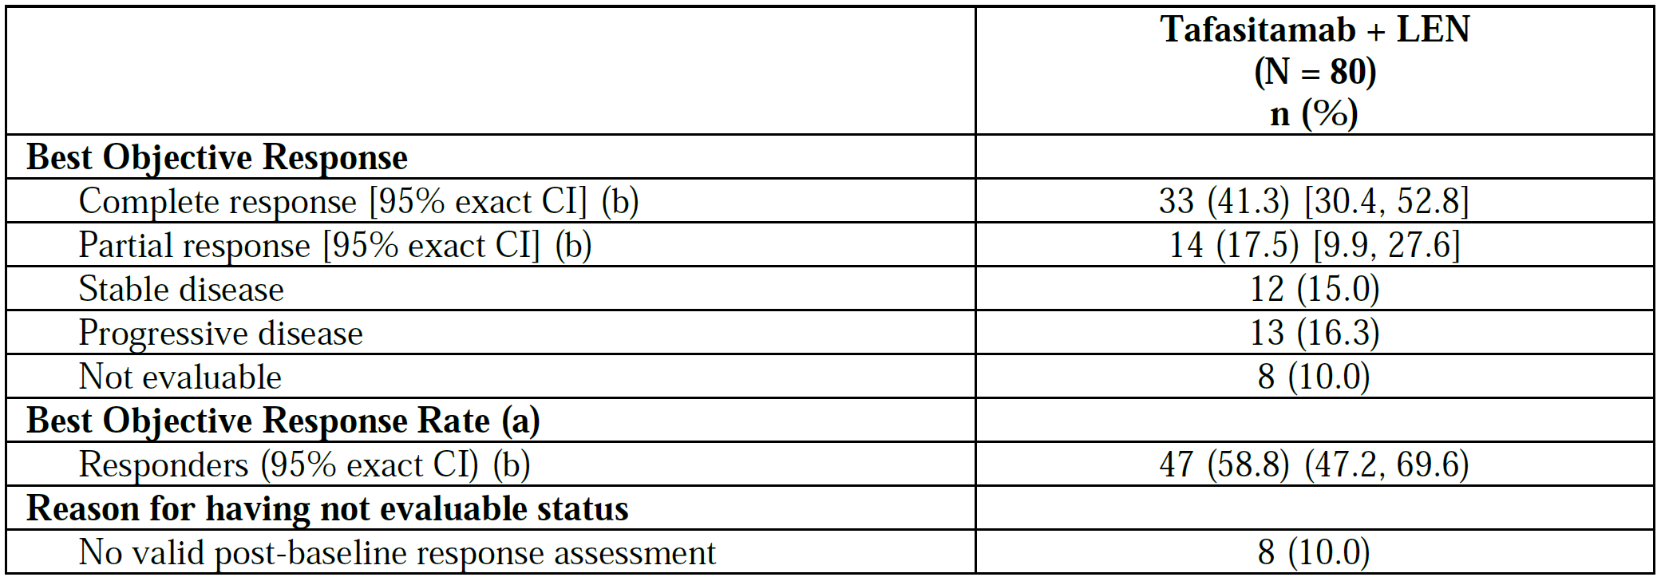

Abbreviations: CI = confidence interval; LEN = lenalidomide; N = number of patients in full analysis set; n = number of patients in each category.

Percentages are based on N.

a. The best objective response rate was defined as the proportion of patients with complete response or partial response as best response achieved at any time during the study.

b. Using 2-sided 95% Clopper-Pearson exact method based on binomial distribution.

Data cut-off: 30 November 2018

One patient was excluded from the final analysis set reported as they did not receive lenalidomide.

The objective response rate observed was 58.8%, comprised of 41.3% complete response and 17.5% partial response.

Table 6: Study MOR208C03 (L-MIND trial) Summary of duration of response - Independent Radiology/Clinical Review Committee evaluation (full analysis set)

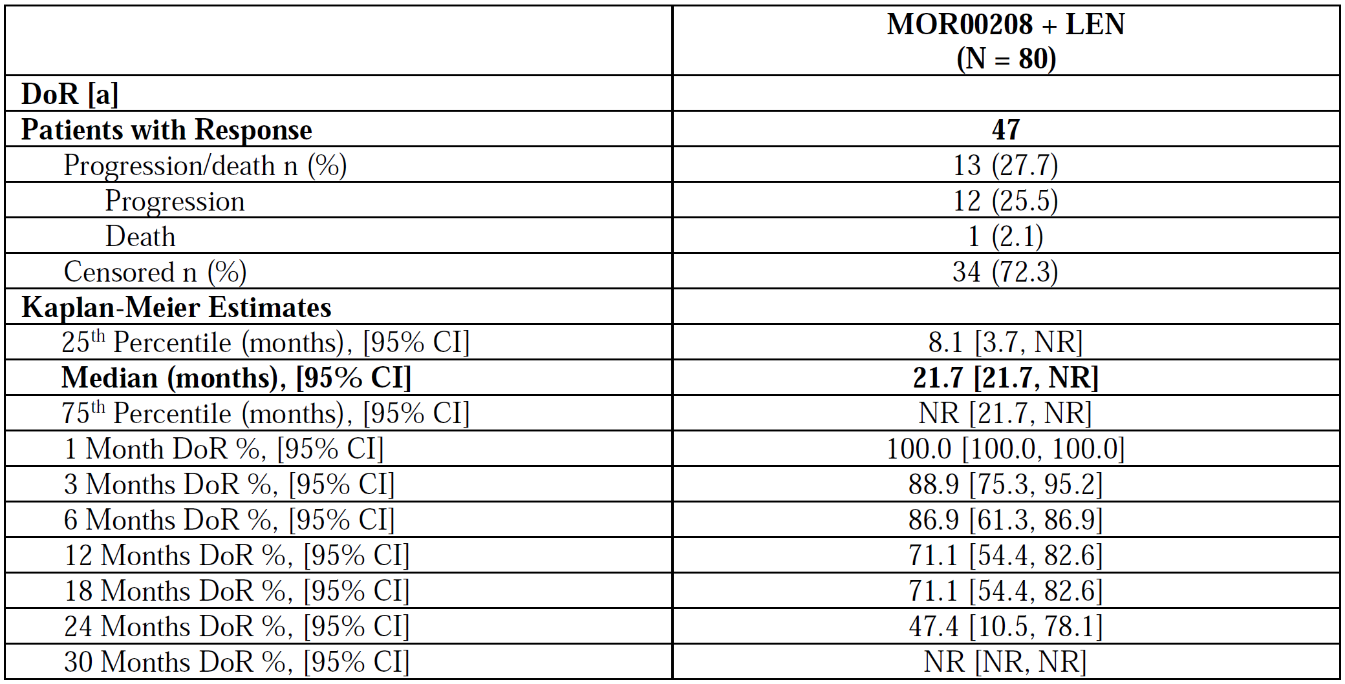

Abbreviations: CI = confidence interval; DoR = duration of response; FAS = full analysis set; IRC = Independent Radiology/Clinical Review Committee; LEN = lenalidomide; N = number of patients in FAS; n = number of patients in each category; NR = not reached.

95% CIs for the median and the 25th and 75th percentiles were calculated using the method of Brookmeyer and Crowley (1982).[9]

Percentages were based on the number of patients with response.

a. DoR (months) = (date of assessment of tumour progression or death – date of assessment of first documented response of (complete response or partial response) +1)/30.4375.

Data cut-off: 30 November 2018.

A total of 34 patients were censored from this analysis due to not achieving an objective response rate (either partial response or complete response) as per the primary endpoint. This indicates a median duration of response of 21.7 months, although a 95% confidence interval (CI) could not be fully estimated. There was no significant baseline variable that influenced this including age, rituximab refractoriness, primary or secondary refractory disease or number of prior treatments. The Delegate notes that the numbers in these stratifications were small given the overall limited number of patients in the analysis.

Table 7: Study MOR208C03 (L-MIND trial) Summary of progression free survival - Independent Radiology/Clinical Review Committee evaluation (full analysis set)

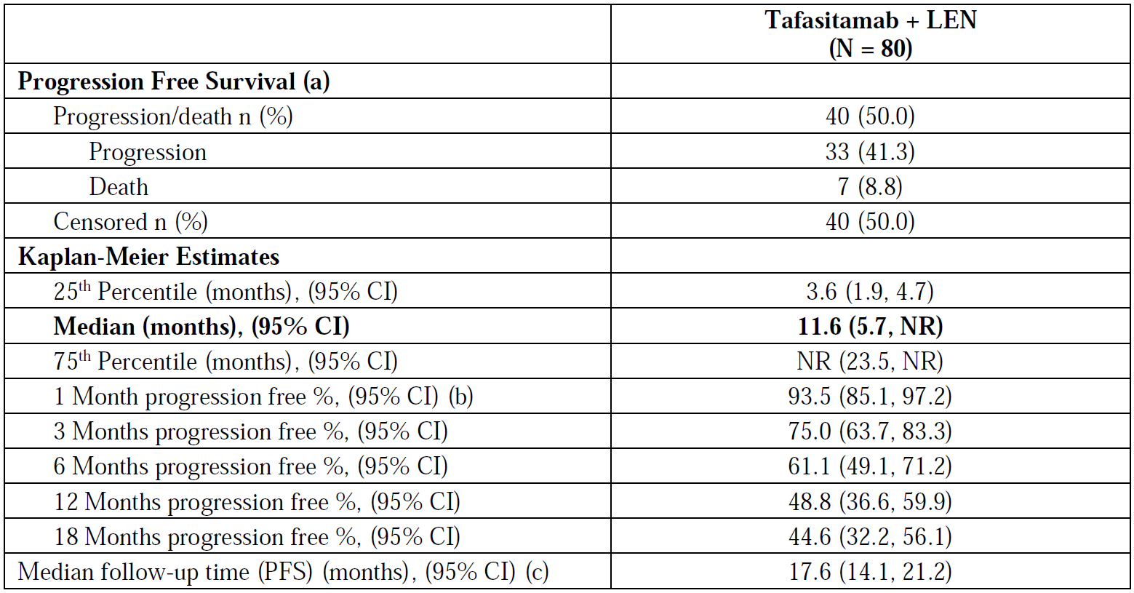

Abbreviations: CI = confidence interval; FAS = full analysis set; IRC = Independent Radiology/Clinical Review Committee; LEN = lenalidomide; N = number of patients in FAS; n = number of patients in each category; NR = not reached; PFS = progression free survival.

Percentages are based on N.

95% CIs for the median and the 25th and 75th percentiles were calculated using the method of Brookmeyer and Crowley (1982).9

a. Progression free survival time was defined as the time (in months) from the date of the first administration of any study drug to the date of tumour progression or death from any cause.

b. Progression free survival % estimate was the estimated probability that a patient would remain progression free up to the specified point in time.

c. The median follow-up time for progression free survival was calculated using the reverse Kaplan-Meier method, considering the censored patients as events and patients with events as censored.

Data cut-off: 30 November 2018.

The median progression free survival was 11.6 months, although a 95% CI could not be fully estimated.

Table 8: Study MOR208C03 (L-MIND trial) Kaplan-Meier analysis of overall survival (full analysis set)

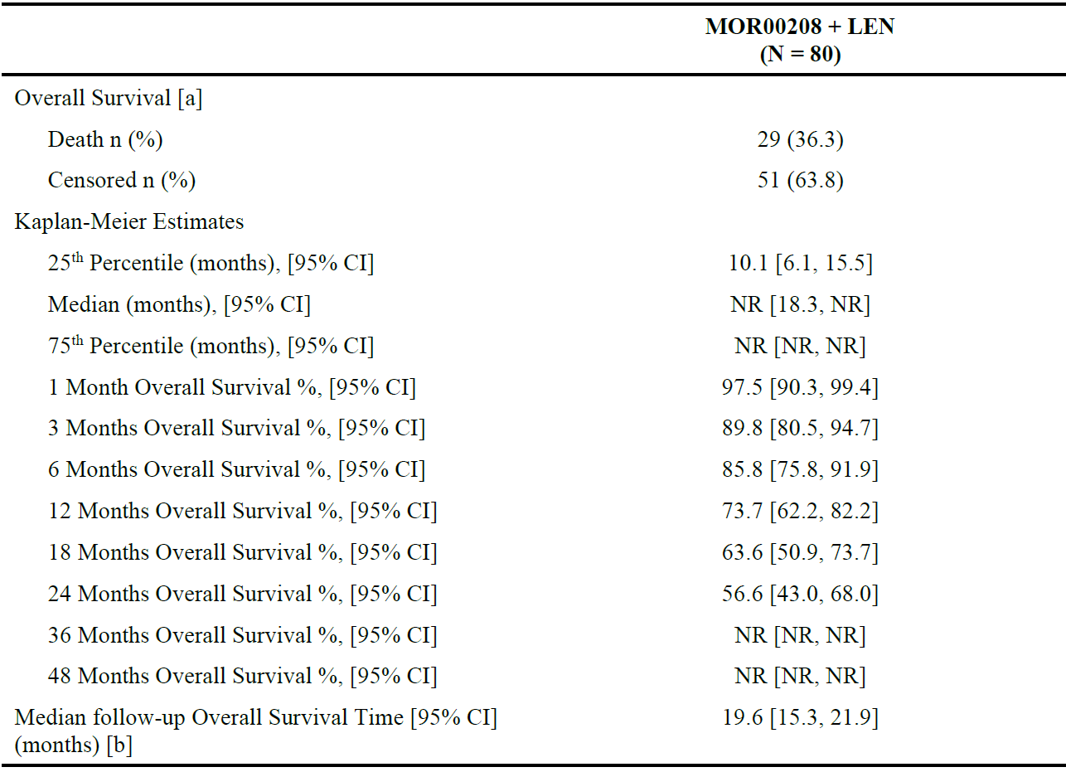

Abbreviations: CI = confidence interval; N = number of patients in FAS; n = number of patients in each category; NR = not reached.

Percentages were based on the number of patients in full analysis set, N.

95% CIs for the median and the 25th and 75th percentiles were calculated using the method of Brookmeyer and Crowley (1982).9

a. Overall survival was defined as the time from the date of the first administration of any study drug until death from any cause (documented by the date of death).

b. The median follow-up time for overall survival was calculated using the reverse Kaplan-Meier method, considering the censored patients as events and patients with events as censored.

At 24 months follow-up, 56.6% of patients were alive and the estimated medial overall survival was approximately 33.5 months.

##### Other efficacy studies

##### Study MOR208C201

Study MOR208C201 was a Phase IIa single arm, open label study. It examined the efficacy of tafasitamab monotherapy in 92 patients with relapsed or refractory DLBCL. The objective response rate reported was 25.7% (95%CI: 12.5, 43.4).

##### Study MOR208C206 (RE-MIND trial)

Study MOR208C206 (RE-MIND trial) was an observational retrospective cohort study for lenalidomide monotherapy or relapsed or refractory DLBCL. The objective was to provide an analysis of the efficacy of lenalidomide for comparison with the results of combination of tafasitamab and lenalidomide therapy. The best objective response rate was reported as 34.2% with lenalidomide monotherapy, with progression free survival of 4 months (95% CI: 3.1, 7.4) and overall survival of 9.4 months (95% CI: 5.1, 20.0).

#### Safety

There were no dedicated safety studies for tafasitamab, and the safety data is obtained from the submitted clinical studies.

Table 9: Summary of patient exposure in submitted studies

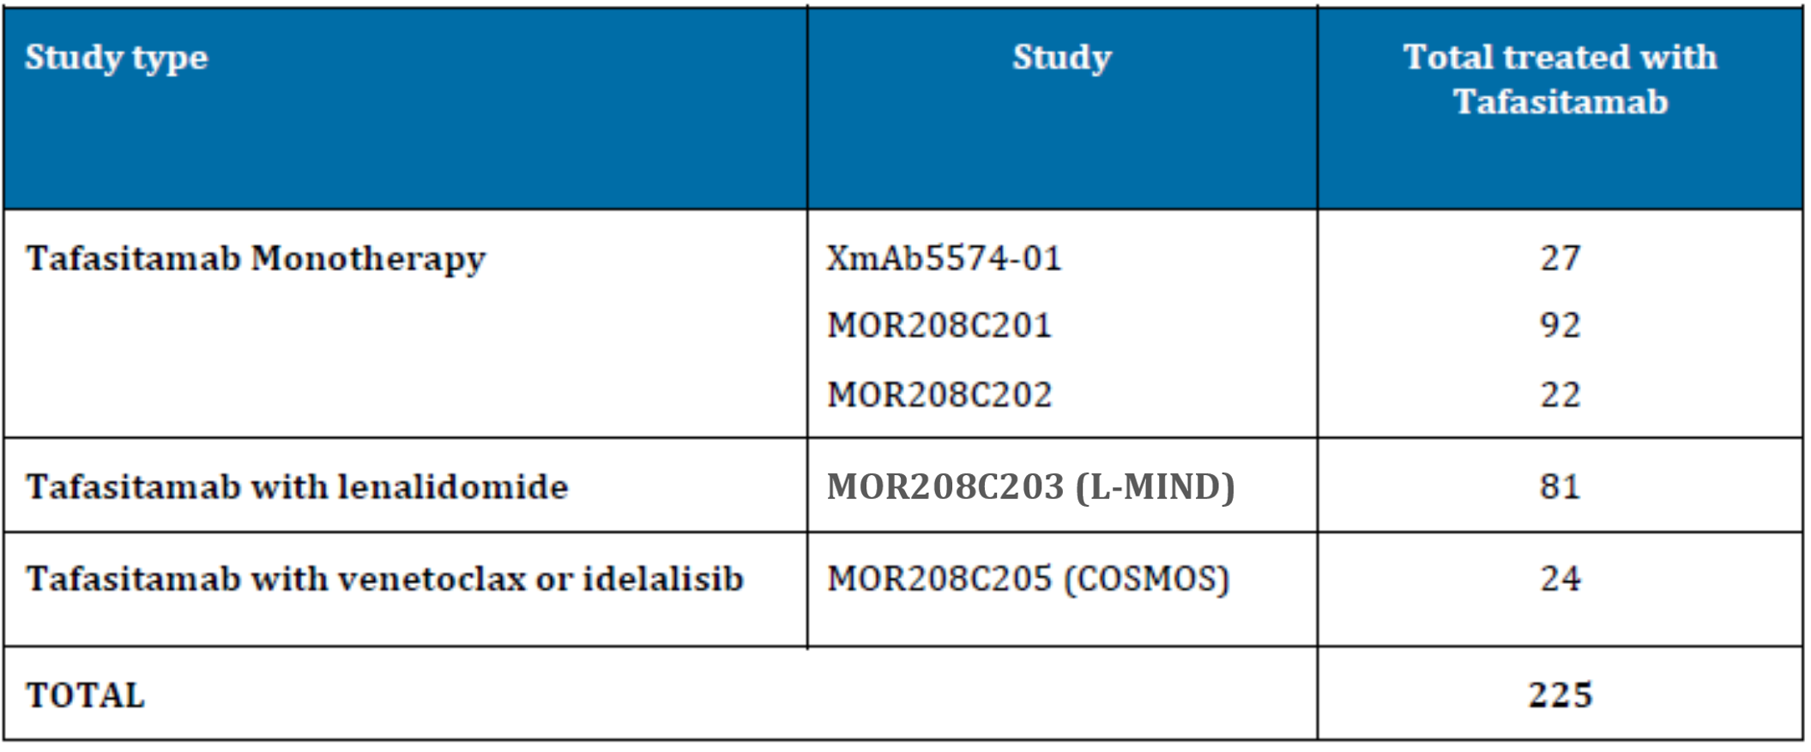The median days of treatment in this population was 232 days (mean of 532.5 days).

##### Pivotal Study

###### MOR208C03 (L-MIND trial)

The overall incidence of adverse events (AEs) was 100%. Incidence was 98.8% during combination treatment and 85.0% during tafasitamab monotherapy. Common AEs (those occurring with an incidence of at least 5% as of the 20 October 2020 data cut-off) are shown in Table 10 below.

Table 10: Study MOR208C03 (L-MIND trial) Treatment-emergent adverse events in at least 5% (Preferred Term) of patients (safety analysis set)

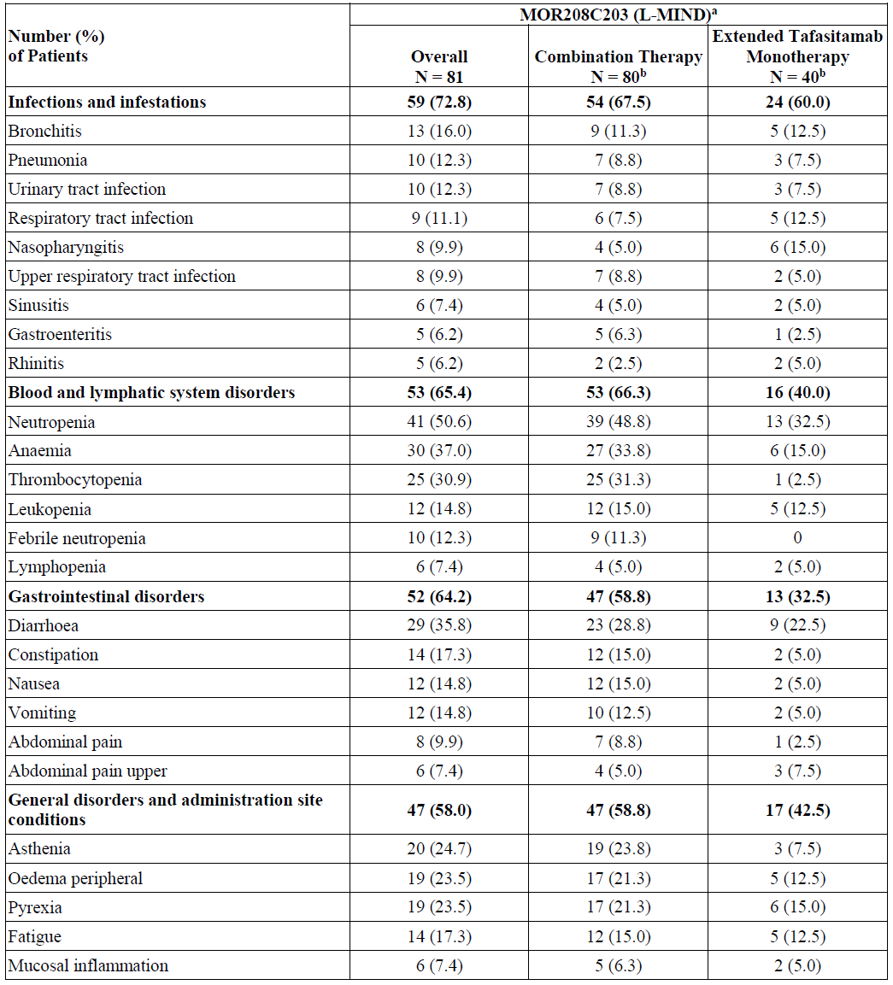

Table 10 continued: Study MOR208C03 (L-MIND trial) Treatment-emergent adverse events in at least 5% (Preferred Term) of patients (safety analysis set)

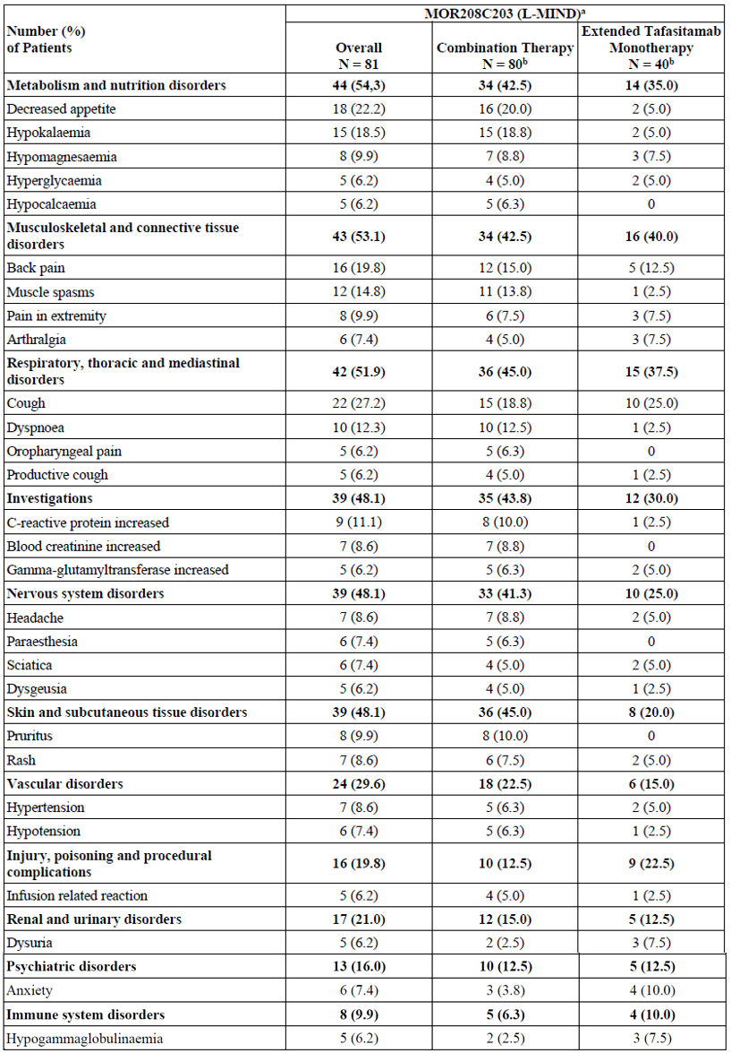

Abbreviation: N = total number of patients.

Patients were counted once per System Organ Class and Preferred Term.

Medical Dictionary for Regulatory Activities Version 21.0.

Sorted in descending order of frequency in by System Organ Class, Preferred Term within System Organ Class, then alphabetically.

a. Overall includes adverse events (AEs) starting during the entire on-treatment phase; the combination Therapy phase includes AEs starting between the start of the on-treatment phase and the last date of treatment with lenalidomide + 30 days; and the

Extended Tafasitamab Monotherapy phase includes AEs starting after the last date of treatment with lenalidomide + 30 days through the end of the on-treatment phase. Planned treatment is twelve 28-day cycles of combination therapy followed by extended tafasitamab monotherapy until progressive disease or unacceptable toxicity or study discontinuation for any reason.

b. One patient received infusions of tafasitamab on Days 1 and 4 of Cycle 1, but lenalidomide was not administered due to acute kidney injury at the time of treatment, and the patient discontinued the study treatment after Cycle 1 Day 4.

Data cut-off: 30 October2020.

The most common AEs were:

* haematological: neutropenia (50.6%), anaemia (37.0%), thrombocytopaenia (30.9%)
* gastrointestinal: diarrhoea (35.8%), decreased appetite (22.2%)
* general disorders: asthenia (24.7%), peripheral oedema (23.5%) and pyrexia (23.5%)
* respiratory: cough (27.2%)
* infections: all types combined (72.8%).

The incidence of most AE terms was lower during extended monotherapy treatment phase than during the initial combination therapy phase.

Haematological AEs were the most commonly observed Grade ≥ 3 events, with neutropenia (49.4%), febrile neutropenia (12.3%) and thrombocytopaenia (17.3%) being the most common. Grade ≥ 3 infections were reported in 29.6% of subjects with pneumonia being the most commonly reported AE (9.9%)

The overall incidence of serious AEs (including fatal AEs) was 26.2%. Serious AEs that were reported in more than one subject were:

* pneumonia (2.8%)
* sepsis (2.1%)
* herpes zoster (1.4%)
* febrile neutropenia (4.3%)
* anaemia (1.4%)
* pyrexia (2.8%)
* acute kidney injury (1.4%)
* tumour lysis syndrome (2.1%).

The clinical evaluation has noted that combination therapy is associated with a high rate of toxicity, these include

* Grade ≥ 3 AEs: 77.8%
* Grade ≥ 3 treatment-related AEs: 56.8%
* serious AEs: 53.1%
* serious treatment-related AEs: 21.0%.

Adverse events leading to discontinuation of tafasitamab or lenalidomide occurred in 24.7% of subjects.

However, the clinical evaluation has advised that in the context of relapsed or refractory DLBCL for which high dose chemotherapy/ASCT is not a possibility, toxicity is not so severe to warrant not approving the application.

### Risk management plan

The summary of safety concerns and their associated risk monitoring and mitigation strategies are summarised in Table 11. The TGA may request an updated risk management plan (RMP) at any stage of a product's life-cycle, during both the pre-approval and post-approval phases.

Table 11: Summary of safety concerns

|  |  |  |  |  |  |
| --- | --- | --- | --- | --- | --- |
| Summary of safety concerns | | Pharmacovigilance | | Risk minimisation | |
| **Routine** | **Additional** | **Routine** | **Additional** |
| **Important identified risks** | None | – | – | – | – |
| **Important potential risks** | Progressive multifocal leukoencephalopathy | ü | – | – | – |
| **Missing information** | Use in pregnancy and lactation | ü | – | ü | – |
| Use in patients with recent use of B-cell depleting drugs or chemotherapy | ü | – | ü | – |
| Long-term safety | ü | ü† | – | – |

† Phase II/III study

The summary of safety concerns is acceptable from an RMP perspective.

The sponsor has provided the clinical study plan for provisional registration with the Australia specific annex. The Delegate will assess the acceptability of the clinical study plan.[10] The pharmacovigilance plan is acceptable from an RMP perspective.

Only routine risk minimisation measures have been proposed. The risk minimisation plan is acceptable.

The RMP evaluation recommended conditions of registration relating to the versions of the risk management plan, requirement for periodic safety update reports, and inclusion of the medicine in the Black Triangle Scheme.

The Delegate noted that there are no outstanding RMP issues following the third round of evaluation.

### Risk-benefit analysis

#### Delegate’s considerations

Relapsed or refractory DLBCL is a condition with an overall poor prognosis, with overall survival of <6 months in primary refractory or rapidly relapsing disease. The population in MOR208C03 (L-MIND trial) was one with relatively rapidly progressing DLBCL, but both the progression free survival and overall survival suggest a benefit from tafastimab and lenalidomide combination therapy. The progression free survival of 11.8 months and 56.6% survival at 2 years is considerably longer than expected for lenalidomide alone, and comparable to other immunotherapies such as combination of polutuzumab and bendamustine. The Delegate notes that it is unfortunate than a comparator arm was not included in the pivotal trial.[11]

There is a considerable risk of toxicity with the use of combination of tafasitamab and lenalidomide, but the Delegate agrees with the clinical evaluation that in the context of relapsed or refractory DLBCL this is acceptable.

#### Proposed action

The Delegate is currently minded to approve tafasitamab for the indication:

*Minjuvi is indicated in combination with lenalidomide followed by Minjuvi monotherapy for the treatment of adult patients with relapsed or refractory diffuse large B-cell lymphoma (DLBCL) who are not eligible for autologous stem cell transplant (ASCT).*

#### Advisory Committee considerations

The [Advisory Committee on Medicines (ACM)](https://www.tga.gov.au/committee/advisory-committee-medicines-acm), having considered the evaluations and the Delegate’s overview, as well as the sponsor’s response to these documents, advised the following.

##### Specific advice to the Delegate

Is the safety and efficacy of this product sufficient to warrant provisional registration given the limited nature of the pivotal data supporting this application?

The ACM agreed the safety and efficacy data is sufficient to warrant provisional registration given the effectiveness of the drug and is supportive of the proposed indication for tafasitamab used in combination with lenalidomide.

Relapsed or refractory DLBCL is a serious, life-threatening disease, with a high clinical unmet need. This combination represents a significantly positive benefit risk ratio compared to single agents and other available therapy. The ACM noted that the L-MIND study demonstrated an overall response rate of 58.8% and complete remission rate of 41.3% and agreed that this is a clinically significant response within a difficult to treat population with limited treatment options.

The ACM acknowledged this data is based on a small number of patients from a single arm study, however, the ACM noted that the relapsed or refractory DLBCL population is small.

The ACM also noted this would be the first non-chemotherapy option and agreed the approval of this combination is significant for the standard of care and improving the mortality rates in patients with relapsed or refractory DLBCL who are ineligible for ASCT.

##### Conclusion

The ACM considered this product to have a provisional positive benefit-risk profile for the indication:

*Minjuvi is indicated in combination with lenalidomide followed by Minjuvi monotherapy for the treatment of adult patients with relapsed or refractory diffuse large B-cell lymphoma (DLBCL) who are not eligible for autologous stem cell transplant (ASCT).*

*This indication was approved via the provisional approval pathway, based on objective response rate and duration of response in a single arm trial. Continued approval for this indication depends on verification and description of clinical benefit in a confirmatory trial.*

## Outcome

Based on a review of quality, safety, and efficacy, the TGA decided to register Minjuvi (tafasitamab) 200 mg, powder for solution for infusion, vial, indicated for:

*Minjuvi is indicated in combination with lenalidomide followed by Minjuvi monotherapy for the treatment of adult patients with relapsed or refractory diffuse large B-cell lymphoma (DLBCL) who are not eligible for autologous stem cell transplant (ASCT).*

*This indication was approved via the provisional approval pathway, based on objective response rate and duration of response in a single arm trial. Continued approval for this indication depends on verification and description of clinical benefit in a confirmatory trial.*

### Specific conditions of registration applying to these goods

* Minjuvi (tafasitamab) is to be included in the Black Triangle Scheme. The PI and CMI for Minjuvi must include the black triangle symbol and mandatory accompanying text for five years, which starts from the date that the sponsor notifies the TGA of supply of the product.
* The Minjuvi EU-risk management plan (RMP) (version 0.7, date 24 June 2021; DLP 30 November 2019), with Australian specific annex (version 0.1, dated July 2021), included with Submission PM-2022-01544-1-6, and any subsequent revisions, as agreed with the TGA will be implemented in Australia.

An obligatory component of risk management plans is routine pharmacovigilance. Routine pharmacovigilance includes the submission of periodic safety update reports (PSURs).

Unless agreed separately between the supplier who is the recipient of the approval and the TGA, the first report must be submitted to TGA no later than 15 calendar months after the date of the approval letter. The subsequent reports must be submitted no less frequently than annually from the date of the first submitted report until the period covered by such reports is not less than three years from the date of the approval letter, or the entire period of provisional registration, whichever is longer.

The reports are to at least meet the requirements for PSURs as described in the European Medicines Agency’s Guideline on Good Pharmacovigilance Practices (GVP) Module VII-periodic safety update report (Rev 1), Part VII.B Structures and processes. Note that submission of a PSUR does not constitute an application to vary the registration. Each report must have been prepared within ninety calendar days of the data lock point for that report.

* A final clinical study report for [Study] MOR208C310 will be submitted for evaluation by the TGA as per the clinical study plan included in the Australian specific annex.
* Laboratory testing and compliance with Certified Product Details (CPD)
  + All batches of Minjuvi-tafasitamab supplied in Australia must comply with the product details and specifications approved during evaluation and detailed in the Certified Product Details (CPD).
  + When requested by the TGA, the sponsor should be prepared to provide product samples, specified reference materials and documentary evidence to enable the TGA to conduct laboratory testing on the product. Outcomes of laboratory testing are published biannually in the TGA Database of Laboratory Testing Results [http://www.tga.gov.au/ws-labs-index and periodically in testing reports on the TGA website](http://www.tga.gov.au/ws-labs-index%20and%20periodically%20in%20testing%20reports%20on%20the%20TGA%20website).
* The Certified Product Details (CPD), as described in Guidance 7: Certified Product Details of the Australian Regulatory Guidelines for Prescription Medicines (ARGPM), in PDF format, for the above products should be provided upon registration of these therapeutic goods. In addition, an updated CPD should be provided when changes to finished product specifications and test methods are approved in a Category 3 application or notified through a self-assessable change.

A template for preparation of CPD for biological prescription medicines can be obtained from the TGA website:

[for the form] <https://www.tga.gov.au/form/certified-product-details-cpd-biologicalprescription-medicines>

[for the CPD guidance] <https://www.tga.gov.au/guidance-7-certified-product-details>

## Attachment 1. Product Information

The [Product Information](https://www.tga.gov.au/products/australian-register-therapeutic-goods-artg/product-information-one) ([PI](https://www.tga.gov.au/products/australian-register-therapeutic-goods-artg/product-information-one)) approved with the submission for Minjuvi which is described in this AusPAR can be found as Attachment 1. It may have been superseded. For the most recent PI and [Consumer Medicines Information](https://www.tga.gov.au/products/australian-register-therapeutic-goods-artg/consumer-medicines-information-cmi) (CMI), please refer to the TGA [PI/CMI search facility.](https://www.tga.gov.au/picmi-search-facility)

|  |
| --- |
| Therapeutic Goods Administration |
| PO Box 100 Woden ACT 2606 Australia  Email: [info@tga.gov.au](mailto:info@tga.gov.au) Phone: 1800 020 653 Fax: 02 6203 1605  [**https://www.tga.gov.au**](https://www.tga.gov.au) |
| Reference/Publication # |

1. This is the original indication proposed by the sponsor when the TGA commenced the evaluation of this submission. It may differ to the final indication approved by the TGA and registered in the Australian Register of Therapeutic Goods.
2. National Comprehensive Cancer Network (NCCN), NCCN Clinical Practice Guidelines in Oncology, B-Cell Lymphomas, Version 4.2022, 2022. Available from: <https://www.nccn.org/professionals/physician_gls/pdf/b-cell.pdf>.
3. Tilly H et al. Diffuse Large B-Cell Lymphoma (DLBCL): ESMO Clinical Practice Guidelines for Diagnosis, Treatment and Follow-up, *Ann Oncol*, 2015; 26 Suppl 5: v116-25.
4. In this report the ‘Delegate’ is the Delegate of the Secretary of the Department of Health and Aged Care who decided the submission under section 25 of the Act.
5. European Medicines Agency (EMA), Committee for Medicinal Products for Human Use (CHMP), ICH Guideline S6 (R1) – Preclinical Safety Evaluation of Biotechnology-Derived Pharmaceuticals, EMA/CHMP/ICH/731268/1998, June 2011.
6. European Medicines Agency (EMA), Committee for Medicinal Products for Human Use (CHMP), ICH Guideline S9 on Nonclinical Evaluation for Anticancer Pharmaceuticals, EMA/CHMP/ICH/646107/2008, May 2010.
7. **Good Laboratory Practice (GLP)** is a code of standards following the International Council on Harmonisation (ICH) relevant to testing of medicines in laboratories during drug development.
8. **Pregnancy Category C**: Drugs which, owing to their pharmacological effects, have caused or may be suspected of causing, harmful effects on the human fetus or neonate without causing malformations. These effects may be reversible. Accompanying texts should be consulted for further details.
9. Brookmeyer R and Crowley J. A Confidence Interval for the Median Survival Time, *Biometrics*, 1982; 38 (1): 29-41.
10. The delegate has assessed the plan.
11. The absence of a comparator arm is not unusual within the scope of a provisional registration.