|  |
| --- |
| Australian Public Assessment Report for Vegzelma |
| Active ingredient: Bevacizumab |
| Sponsor: Celltrion Healthcare Australia Pty Ltd |
| February 2024 |

About the Therapeutic Goods Administration (TGA)

* The Therapeutic Goods Administration (TGA) is part of the Australian Government Department of Health and Aged Care and is responsible for regulating therapeutic goods, including medicines, medical devices, and biologicals.
* The TGA administers the *Therapeutic Goods Act 1989* (the Act), applying a risk management approach designed to ensure therapeutic goods supplied in Australia meet acceptable standards of quality, safety, and efficacy.
* The work of the TGA is based on applying scientific and clinical expertise to decision-making, to ensure that the benefits to the Australian public outweigh any risks associated with the use of therapeutic goods.
* The TGA relies on the public, healthcare professionals and industry to report problems with therapeutic goods. The TGA investigates reports received to determine any necessary regulatory action.
* To report a problem with a therapeutic good, please see the information on the [TGA website](https://www.tga.gov.au/).

About AusPARs

* The Australian Public Assessment Report (AusPAR) provides information about the evaluation of a prescription medicine and the considerations that led the TGA to approve or not approve a prescription medicine submission. Further information can be found in [Australian Public Assessment Report (AusPAR) guidance](https://www.tga.gov.au/australian-public-assessment-report-auspar-guidance).
* AusPARs are prepared and published by the TGA.
* AusPARs are static documents that provide information that relates to a submission at a particular point in time. The publication of an AusPAR is an important part of the transparency of the TGA’s decision-making process.
* A new AusPAR may be provided to reflect changes to indications or major variations to a prescription medicine subject to evaluation by the TGA.

Copyright

© Commonwealth of Australia 2024  
This work is copyright. You may reproduce the whole or part of this work in unaltered form for your own personal use or, if you are part of an organisation, for internal use within your organisation, but only if you or your organisation do not use the reproduction for any commercial purpose and retain this copyright notice and all disclaimer notices as part of that reproduction. Apart from rights to use as permitted by the *Copyright Act 1968* or allowed by this copyright notice, all other rights are reserved and you are not allowed to reproduce the whole or any part of this work in any way (electronic or otherwise) without first being given specific written permission from the Commonwealth to do so. Requests and inquiries concerning reproduction and rights are to be sent to the TGA Copyright Officer, Therapeutic Goods Administration, PO Box 100, Woden ACT 2606 or emailed to <[tga.copyright@tga.gov.au](mailto:tga.copyright@tga.gov.au)>.

Contents

List of abbreviations 4

Product submission 5

Submission details 5

Product background 7

Regulatory status 8

Australian regulatory status 8

Foreign regulatory status 9

Registration timeline 10

Submission overview and risk/benefit assessment 11

Quality 11

Nonclinical 12

Clinical 12

Summary of clinical studies 12

Bioequivalence to innovator product 13

Clinical comparison with innovator product 13

Safety 16

Risk management plan 18

Risk-benefit analysis 18

Delegate’s considerations 18

Proposed action 18

Advisory Committee considerations 18

Outcome 19

Specific conditions of registration applying to these goods 20

Attachment 1. Product Information 20

## List of abbreviations

|  |  |
| --- | --- |
| Abbreviation | Meaning |
| ACM | Advisory Committee on Medicines |
| ACV | Advisory Committee on Vaccines |
| ARTG | Australian Register of Therapeutic Goods |
| CI | Confidence interval |
| CMI | Consumer Medicines Information |
| DLP | Data lock point |
| EMA | European Medicines Agency |
| NSCLC | Non-small cell lung cancer |
| nsNSCLC | Non-squamous non-small cell lung cancer |
| ORR | Objective response rate |
| OS | Overall survival |
| PFS | Progression‑free survival |
| PI | Product Information |
| PK | Pharmacokinetic(s) |
| PSUR | Periodic safety update report |
| RMP | Risk management plan |
| TEAE | Treatment-emergent adverse event |
| TGA | Therapeutic Goods Administration |

## Product submission

### Submission details

|  |  |
| --- | --- |
| *Type of submission:* | New biosimilar medicine |
| *Product name:* | Vegzelma |
| *Active ingredient:* | bevacizumab  sponsor’s code: CT-P16 |
| *Decision:* | Approved |
| *Date of decision:* | 30 August 2023 |
| *Date of entry onto ARTG:* | 5 September 2023 |
| *ARTG numbers:* | 398631 and 398632 |
| [*Black Triangle Scheme*](https://www.tga.gov.au/black-triangle-scheme) | No |
| *Sponsor’s name and address:* | Celltrion Healthcare Australia Pty Ltd  Suite 13-03, 31 Market Street  Sydney NSW 2000 |
| *Dose form:* | Solution for intravenous infusion |
| *Strengths:* | 400 mg/16 mL and 100 mg/4 mL |
| *Container:* | Vials |
| *Pack size:* | One vial |
| *Approved therapeutic uses:* | ***Metastatic Colorectal Cancer***  *Vegzelma (bevacizumab) in combination with fluoropyrimidine-based chemotherapy is indicated for the treatment of patients with metastatic colorectal cancer.*  ***Locally recurrent or metastatic Breast Cancer***  *Vegzelma (bevacizumab) in combination with paclitaxel is indicated for the first-line treatment of metastatic breast cancer in patients in whom an anthracycline-based therapy is contraindicated. (see Section 5.1 Clinical Trials).*  ***Advanced, metastatic or recurrent non-squamous Non-Small Cell Lung Cancer (NSCLC)***  *Vegzelma (bevacizumab), in combination with carboplatin and paclitaxel, is indicated for first-line treatment of patients with unresectable advanced, metastatic or recurrent, non-squamous, non- small cell lung cancer.*  ***Advanced and/or metastatic Renal Cell Cancer***  *Vegzelma (bevacizumab) in combination with interferon alfa-2a is indicated for treatment of patients with advanced and/or metastatic renal cell cancer.*  ***Grade IV Glioma***  *Vegzelma (bevacizumab) as a single agent, is indicated for the treatment of patients with Grade IV glioma after relapse or disease progression after standard therapy, including chemotherapy.*  ***Epithelial Ovarian, Fallopian Tube or Primary Peritoneal Cancer***  *Vegzelma (bevacizumab) in combination with carboplatin and paclitaxel, is indicated for first-line treatment of patients with advanced (FIGO stages IIIB, IIIC and IV) epithelial ovarian, fallopian tube, or primary peritoneal cancer.*  ***Recurrent Epithelial Ovarian, Fallopian Tube or Primary Peritoneal Cancer***  *Vegzelma (bevacizumab), in combination with carboplatin and paclitaxel or in combination with carboplatin and gemcitabine, is indicated for the treatment of patients with first recurrence of* ***platinum-sensitive****, epithelial ovarian, fallopian tube, or primary peritoneal cancer who have not received prior bevacizumab or other VEGF targeted angiogenesis inhibitors.*  *Vegzelma (bevacizumab) in combination with paclitaxel, topotecan or pegylated liposomal doxorubicin is indicated for the treatment of patients with recurrent, platinum-resistant epithelial ovarian, fallopian tube, or primary peritoneal cancer who have received no more than two prior chemotherapy regimens, and have not received any prior anti-angiogenic therapy including bevacizumab.*  ***Cervical Cancer***  *Vegzelma (bevacizumab) in combination with paclitaxel and cisplatin is indicated for the treatment of persistent, recurrent or metastatic carcinoma of the cervix. Vegzelma (bevacizumab) in combination with paclitaxel and topotecan is an acceptable alternative where cisplatin is not tolerated or not indicated.* |
| *Route of administration:* | Intravenous infusion |
| *Dosage:* | The recommended dosage is based on multiple factors, including the condition being treated, patient’s body weight, line of treatment, and cycle of treatment.  Vegzelma should be administered under the supervision of a physician experienced in the use of anti-neoplastic medicinal products.  For information regarding dosage, including dose reduction, special populations, and preparation of infusion, refer to the Product Information. |
| *Pregnancy category:* | D  Drugs which have caused, are suspected to have caused or may be expected to cause, an increased incidence of human fetal malformations or irreversible damage. These drugs may also have adverse pharmacological effects. Accompanying texts should be consulted for further details.  The use of any medicine during pregnancy requires careful consideration of both risks and benefits by the treating health professional. The [pregnancy database](https://www.tga.gov.au/products/medicines/find-information-about-medicine/prescribing-medicines-pregnancy-database) must not be used as the sole basis of decision making in the use of medicines during pregnancy. The TGA does not provide advice on the use of medicines in pregnancy for specific cases. More information is available from [obstetric drug information services](https://www.tga.gov.au/obstetric-drug-information-services) in your state or territory. |

### Product background

This AusPAR describes the submission by Celltrion Healthcare Australia Pty Ltd (the sponsor) to register Vegzelma (bevacizumab) 100 mg/4 mL and 400 mg/16 mL solution for intravenous infusion in vials for the following proposed indications:[1]

***Metastatic Colorectal Cancer***

*Vegzelma (bevacizumab) in combination with fluoropyrimidine-based chemotherapy is indicated for the treatment of patients with metastatic colorectal cancer.*

***Locally recurrent or metastatic Breast Cancer***

*Vegzelma (bevacizumab) in combination with paclitaxel is indicated for the first-line treatment of metastatic breast cancer in patients in whom an anthracycline-based therapy is contraindicated. (see Section 5.1 Clinical Trials).*

***Advanced, metastatic or recurrent non-squamous Non-Small Cell Lung Cancer (NSCLC)***

*Vegzelma (bevacizumab), in combination with carboplatin and paclitaxel, is indicated for first-line treatment of patients with unresectable advanced, metastatic or recurrent, non-squamous, non- small cell lung cancer.*

***Advanced and/or metastatic Renal Cell Cancer***

*Vegzelma (bevacizumab) in combination with interferon alfa-2a is indicated for treatment of patients with advanced and/or metastatic renal cell cancer.*

***Grade IV Glioma***

*Vegzelma (bevacizumab) as a single agent, is indicated for the treatment of patients with Grade IV glioma after relapse or disease progression after standard therapy, including chemotherapy.*

***Epithelial Ovarian, Fallopian Tube or Primary Peritoneal Cancer***

*Vegzelma (bevacizumab) in combination with carboplatin and paclitaxel, is indicated for first-line treatment of patients with advanced (FIGO stages IIIB, IIIC and IV) epithelial ovarian, fallopian tube, or primary peritoneal cancer.*

***Recurrent Epithelial Ovarian, Fallopian Tube or Primary Peritoneal Cancer***

*Vegzelma (bevacizumab), in combination with carboplatin and paclitaxel or in combination with carboplatin and gemcitabine, is indicated for the treatment of patients with first recurrence of* ***platinum-sensitive****, epithelial ovarian, fallopian tube, or primary peritoneal cancer who have not received prior bevacizumab or other VEGF targeted angiogenesis inhibitors.*

*Vegzelma (bevacizumab) in combination with paclitaxel, topotecan or pegylated liposomal doxorubicin is indicated for the treatment of patients with recurrent, platinum-resistant epithelial ovarian, fallopian tube, or primary peritoneal cancer who have received no more than two prior chemotherapy regimens, and have not received any prior anti-angiogenic therapy including bevacizumab.*

***Cervical Cancer***

*Vegzelma (bevacizumab) in combination with paclitaxel and cisplatin is indicated for the treatment of persistent, recurrent or metastatic carcinoma of the cervix. Vegzelma (bevacizumab) in combination with paclitaxel and topotecan is an acceptable alternative where cisplatin is not tolerated or not indicated.*

Vegzelma (bevacizumab) is a recombinant humanised monoclonal antibody that binds specifically to all soluble forms of human vascular endothelial growth factor (VEGF), neutralising its biological activity and acting as an anti-neoplastic agent. Neutralising the biological activity of VEGF, the key driver of vasculogenesis and angiogenesis, regresses the vascularisation of tumours, normalises remaining tumour vasculature, and inhibits the formation of new tumour vasculature, thereby inhibiting tumour growth.

The proposed indications are the same as those approved for the innovator product, Avastin.[2]

With the expiry of the patent for bevacizumab there are now several [biosimilar medicines](https://www.tga.gov.au/resources/resource/guidance/biosimilar-medicines-regulation) of bevacizumab registered in the ARTG.

### Regulatory status

#### Australian regulatory status

This product is considered a new biosimilar medicine for Australian regulatory purposes.

This submission was submitted through the TGA’s [Comparable Overseas Regulator](https://www.tga.gov.au/comparable-overseas-regulators-cors-timeframes-and-milestones) B (COR-B) process, using evaluation reports from the European Medicines Agency (EMA).

For COR report-based applications indications must be equivalent, but not necessarily identical. Acceptable differences between the approved and proposed indication are limited to minor changes in the wording or minor differences in expression, as long as the text describes the same dosing range, patient population, and outcome. For a biosimilar product such as Vegzelma, the proposed indication must be identical to the indication approved for the originator in Australia.

In this case Vegzelma is not approved for use in Grade IV Glioma in the European Union but the innovator product Avastin is approved for this indication in Australia. Grade IV Glioma was proposed to be indicated for Vegzelma in Australia. The sponsor was asked to justify the omission in Europe. Additionally, there are minor dosing differences for the advanced, metastatic or recurrent non-squamous non-small cell lung cancer (nsNSCLC) indication: the recommended dose of Vegzelma is 7.5 mg/kg or 15 mg/kg every 3 weeks in the EU compared with 15 mg/kg every 3 weeks in Australia. Given these differences, the submission did not fully adhere to the administrative requirements of a COR submission, though it was evaluated according to those requirements.

#### Foreign regulatory status

At the time the TGA considered this submission, a similar submission had been considered by other regulatory agencies. The following table summarises these submissions and provides the indications where approved.

Table 1: International regulatory status at the time of TGA approval

|  |  |  |  |  |
| --- | --- | --- | --- | --- |
| Region | Submission date | Status | | Approved indications |
| European Union | 20 January 2022 | Approved on 18 August 2022 | | *Metastatic carcinoma of the colon or rectum*  *Metastatic breast cancer*  *Non-small cell lung cancer (NSCLC)*  *Advanced and/or metastatic renal cell cancer*  *Epithelial ovarian, fallopian tube and primary peritoneal cancer*  *Cervical cancer* |
| United Kingdom | 28 June 2022 | Approved on 16 September 2022 | *Metastatic carcinoma of the colon or rectum*  *Metastatic breast cancer*  *Non-small cell lung cancer (NSCLC)*  *Advanced and/or metastatic renal cell cancer*  *Epithelial ovarian, fallopian tube and primary peritoneal cancer*  *Cervical cancer* | |
| United States of America | 30 September 2021 | Approved on 27 September 2022 | | *Metastatic colorectal cancer*  *First-line non-squamous non‑small cell lung cancer*  *Recurrent glioblastoma*  *Metastatic renal cell carcinoma*  *Persistent, recurrent, or metastatic cervical cancer*  *Epithelial ovarian, fallopian tube and primary peritoneal cancer* |
| Korea | 29 September 2021 | Approved on 28 September 2022 | | *Metastatic carcinoma of the colon or rectum*  *Metastatic breast cancer*  *Non-small cell lung cancer (NSCLC)*  *Advanced and/or metastatic renal cell cancer*  *Epithelial ovarian, fallopian tube and primary peritoneal cancer*  *Grade IV Glioma*  *Cervical cancer* |
| Canada | 27 December 2021 | Approved on 3 January 2023 | | *Metastatic colorectal cancer*  *Locally advanced, metastatic or recurrent non-small cell lung cancer (NSCLC)*  *Platinum-sensitive recurrent epithelial ovarian, fallopian tube and primary peritoneal cancer*  *Platinum-resistant recurrent epithelial ovarian, fallopian tube and primary peritoneal cancer*  *Malignant glioma (WHO Grade IV) - glioblastoma* |
| Brazil | 20 January 2022 | Under consideration | |  |

## Registration timeline

The following table captures the key steps and dates for this submission.

This submission was evaluated under the [standard prescription medicines registration process](https://www.tga.gov.au/how-we-regulate/supply-therapeutic-good-0/supply-prescription-medicine/application-process/prescription-medicines-registration-process).

Table 2: Timeline for Submission PM-2022-04193-1-4

|  |  |
| --- | --- |
| Description | Date |
| Submission dossier accepted and first round evaluation commenced | 30 November 2022 |
| First round evaluation completed | 15 June 2023 |
| Sponsor provides responses on questions raised in first round evaluation | 14 July 2023 |
| Second round evaluation completed | 2 August 2023 |
| Sponsor’s notification to the TGA of errors/omissions in evaluation reports | 9 August 2023 |
| Delegate’s[3] Overall benefit-risk assessment | 15 August 2023 |
| Advisory Committee meeting | Not applicable |
| Registration decision (Outcome) | 30 August 2023 |
| Administrative activities and registration in the ARTG completed | 5 September 2023 |
| Number of working days from submission dossier acceptance to registration decision* | 138 |

* The COR-B process has a 175 working day evaluation and decision timeframe.

## Submission overview and risk/benefit assessment

A summary of the TGA’s assessment for this submission is provided below.

This section is a TGA summary of wording used in TGA’s evaluation report, which discussed numerous aspects of overseas evaluation reports and included some information that was commercial-in-confidence.

### Quality

There are no objections on quality grounds to the approval of Vegzelma.

The sponsor’s code for the active ingredient is CT-P16. CT-P16 is a recombinant humanised monoclonal immunoglobulin G1 antibody. Like other immunoglobulins of the G1 subclass, CT-P16 is a glycoprotein with one N-linked glycosylation site in the CH2 domain of each heavy chain. The molecular weight is approximately 149 kDa.

Vegzelma and Avastin are identical with respect to pharmaceutical form, concentration and composition, and route of administration.

Comprehensive characterisation studies support biosimilarity between Vegzelma and EU-approved Avastin with respect to the structural, physicochemical, and biological properties. Proposed Vegzelma lots were shown to be highly comparable to EU-approved Avastin lots.

A bridging study demonstrated comparability between the reference medicinal product registered in Australia using EU-approved and Australia-registered Avastin. Two primary areas of comparability study for EU-approved and Australia-registered Avastin were estimated in the report: physicochemical characterisation including primary, higher order structure, heterogeneity, contents and purity/impurity studies; biological functionality of cell-based potency and binding affinity. Overall, the results demonstrated comparability between EU-approved and Australia-registered Avastin both in physicochemical attributes and biological activities. The characterisation studies supporting biosimilarity between Vegzelma and EU-approved Avastin can be viewed as biosimilarity between Vegzelma and Australia-approved Avastin.

The drug product is a sterile colourless solution containing 400 mg or 100 mg of bevacizumab presented in 20 mL and 4 mL Type I borosilicate glass vials. The nominal concentration of the solution is 25.0 mg/mL. At the proposed storage condition of 2 to 8°C the shelf life is 48 months for the 400 mg drug product and 24 months for the 100 mg drug product.

The Quality evaluation recommended conditions of registration relating to laboratory testing, Certified Product Details, and compliance with Certified Product Details.

### Nonclinical

The nonclinical dossier contained comparative analytical method validation studies and a repeat-dose toxicity study. The scope of the nonclinical program is adequate under the relevant EU guideline.[4] These studies were conducted using the EU-sourced Avastin as the reference product. No nonclinical data were provided to the TGA to verify the comparability of the EU-sourced and Australian-sourced Avastin. Comparative in vitro pharmacology studies were submitted as quality data and evaluated as part of the quality evaluation.

A comparative Good Laboratory Practice-compliant 4-week repeat-dose toxicity study was conducted in young cynomolgus monkeys. The toxicity profile of Vegzelma was compared with that of EU-Avastin (10 and 50 mg/kg/day twice weekly). The choice of species and duration of the study were acceptable as they allowed for a sufficient period of time for the development of treatment-related changes seen with the innovator. The intravenous route of administration was used for both test items. No unexpected toxicity findings were observed. No meaningful differences between Vegzelma and EU-Avastin were observed in the comparative toxicity study including toxicokinetics.

### Clinical

#### Summary of clinical studies

The clinical dossier consisted of:

* two Phase I studies:
  + CT-P16 1.1, a randomised, double-blind, 3-arm, parallel group, single-dose study to compare the pharmacokinetics (PK) and safety of 3 formulations of bevacizumab (CT-P16, EU-Avastin and US-Avastin) in healthy male subjects. This study provided the pivotal PK outcomes to demonstrate bioequivalence between CT-P16, EU-Avastin, and US-Avastin.
  + CT-P16 1.2, a randomised, double-blind, parallel group, single-dose study to compare the PK and safety of CT-P16 and EU-Avastin in healthy Japanese male subjects.
* one Phase III study, CR-P16 3.1, the therapeutic similarity study. This was a double-blind, randomised, active-controlled, parallel group study to compare efficacy and safety of CT-P16 and EU-Avastin as first-line treatment for metastatic or recurrent nsNSCLC. This study provides comparative PK data (trough serum concentrations following repeated intravenous infusion) and long-term immunogenicity.

There were no paediatric data. The clinical studies were stated to have been conducted in accordance with Good Clinical Practice Guidelines.

#### Bioequivalence to innovator product

Study CT-P16 1.1 was the pivotal PK study. Comparative PK results are shown below.

Figure 1: Study CT-P16 1.1 Statistical analysis of serum pharmacokinetic parameters for bevacizumab (ANCOVA) (pharmacokinetic population)

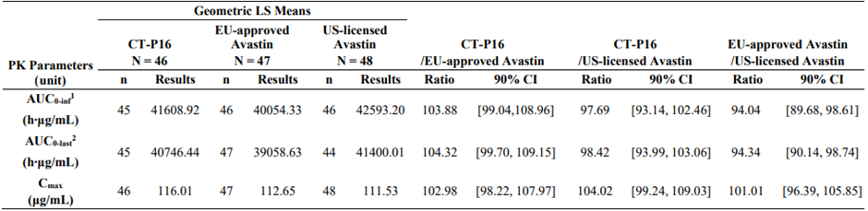

Abbreviations: ANCOVA = analysis of covariance; AUC0-inf = area under the concentration-time curve from time zero to infinity; AUC0-last = area under the concentration-time curve from time zero to the last quantifiable concentration; CI = confidence interval; Cmax = maximum serum concentration; EMA = European Medicines Agency; EU = European Union; λz = Terminal elimination rate constant; LS = least squares; PK = pharmacokinetic; US = United States.

Note: Ratio of geometric means was calculated by backed transforming difference of LS means calculated using an ANCOVA model with treatment as a fixed effect and body weight (less than 70 kg versus 70 kg and over) assessed on Day −1 and study site as covariates.

1 For 4 subjects (one in the CT-P16 treatment group; one in the EU-approved Avastin treatment group; 2 in the US licensed Avastin treatment group), AUC0-inf values were excluded from statistical analysis since the interval used to determine λz interval was less than 1.5-fold the estimated half-life.

2 For 5 subjects (one in the CT-P16 treatment group; 4 in the US-licensed Avastin treatment group), AUC0-last values were excluded from statistical summary since they withdrew, and the last PK samples of these subjects were collected earlier than the planned time (Day 99) according to EMA guidance.

The primary PK parameters were comparable across the 3 treatment groups, with small inter-subject variability. The 90% confidence intervals (CI) for the geometric mean ratios of AUC0-inf, AUC0‑last, and Cmax were contained within the predefined bioequivalence margin of 80.00 to 125.00% (including 100.00%) for CT-P16/EU-Avastin and CT-P16/US-Avastin comparisons. For the comparison of AUCs of EU-Avastin and US-Avastin, the 90% CIs were within 80.00 to 125.00% however did not include 100.00%.

Study CT-P16 1.2 was a supportive PK study enrolling 46 Japanese men. Similarity of CT-P16 and EU-Avastin was demonstrated, with the 90% CIs for the geometric mean ratios of AUC0-inf, AUC0‑last, and Cmax within 80.00 to 125.00%.

#### Clinical comparison with innovator product

Study CT-P16 3.1 is an ongoing Phase III, randomised, double-blind, active-controlled, parallel-group, multinational, multicentre study comparing the efficacy, PK, and safety of CT-P16 and EU-Avastin when co-administered with paclitaxel and carboplatin as first-line treatment in subjects with metastatic or recurrent nsNSCLC. The study was conducted at 164 sites in 21 countries commencing 1 February 2019.

There were 689 subjects randomised in 1:1 ratio to receive CT-P16 or EU-Avastin 15 mg/kg intravenous every 3 weeks, with randomisation stratified by country, sex, disease status and ECOG Performance Status.[5] Study drug was administered concomitantly with intravenous paclitaxel and intravenous carboplatin during the Induction Study Period (at least 4 and up to 6 cycles, that is, up to 18 weeks).[6] Subjects with controlled disease then entered the Maintenance Study Period and received CT-P16 or EU-Avastin as monotherapy until disease progression or unacceptable toxicity. The study design is shown below.

Figure 2: Study CT-P16 3.1 Schematic of study design

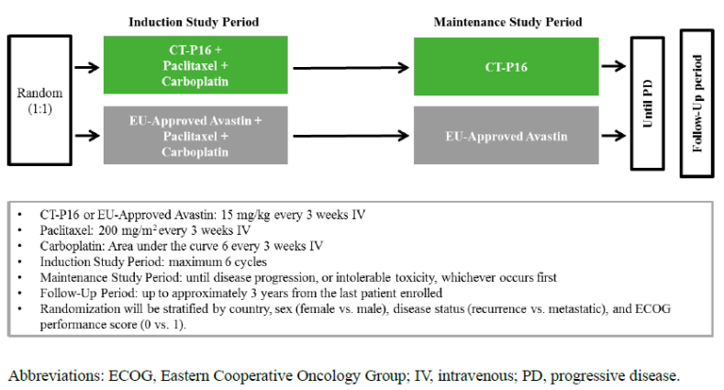

The primary objective was to demonstrate that CT-P16 was similar to EU-Avastin in terms of efficacy as determined by objective response rate (ORR) during the Induction Study Period. The primary efficacy endpoint was ORR based on the best overall response during the Induction Study Period by Response Evaluation Criteria in Solid Tumours (RECIST) version 1.1.[7] Secondary endpoints included response duration, progression‑free survival (PFS) and overall survival (OS). A blinded independent tumour review committee was used to review the images for tumour responses. Images were also reviewed locally in a blinded manner for eligibility and treatment practice.

The equivalence margin for ORR of −12.5% to 12.5% is similar to the margin previously applied for other bevacizumab biosimilars for demonstrating similar efficacy in first-line NSCLC indication. The margin was constructed using a meta-analysis of historical studies with the reference product and was agreed with EMA via Committee for Medicinal Products for Human Use (CHMP) Scientific Advice. According to the meta-analysis across 4 trials, randomised bevacizumab, added to chemotherapy, increases the probability of objective response by at least 12.89 percentage points (based on lower limit of 95% CIs). Thereby, the proposed margin is believed to preserve at least some positive fraction of the originator’s efficacy.

The primary endpoint of the study was met. The risk difference (CT-P16 − EU-Avastin) for ORR at the end of the Induction Study Period was 0.40 (95% CI: −7.02, 7.83) for the intent‑to‑treat population and −1.90 (95% CI: −9.80, 6.00) for the per-protocol population, with the 95% CIs contained within the pre-specified equivalence margin (−12.5 to 12.5) for both analyses. Efficacy results are shown below.

Figure 3: Study CT-P16 3.1 Objective response rate and Best overall response during the Induction Study Period (central review) (Intent-To-Treat and Per-Protocol populations)

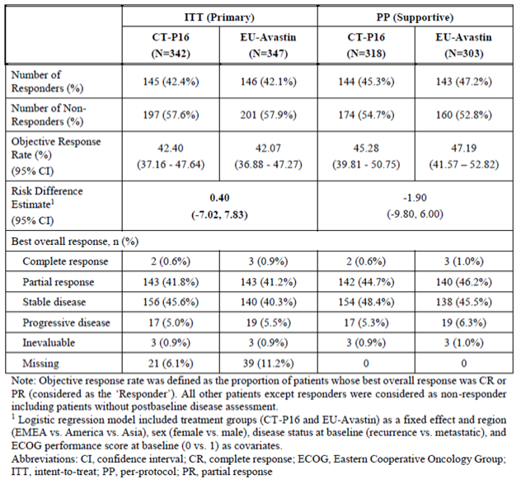

Comparisons of the secondary efficacy measures of PFS and OS were consistent with the ORR results.

#### Safety

The Safety Population comprised 876 subjects: 689 nsNSCLC patients in Study CT-P16 3.1; 141 healthy male subjects in Study CT-P16 1.1; and 46 healthy male subjects in Study CT-P16 1.2. Comparative safety data, from Study CT-P16 3.1, was available from 345 nsNSCLC patients randomised to CT-P16 and 344 to Avastin. Of these, 246 patients received at least 6 months exposure (induction plus at least 3 maintenance cycles). A follow-up safety assessment included 148 (21.5%) patients who completed one year of treatment (at least 12 Maintenance Cycles).

Exposure to study drug was not balanced between the 2 treatment groups. After Cycle 1, a higher proportion of subjects were exposed to CT-P16 than EU-Avastin during the Induction Study Period (76.2% CT-P16 versus 69.8% Avastin), and during the Maintenance Study Period up to Cycle 9 when the difference was 34.2% CT-P16 versus 30.5% Avastin. The dose intensities of study drug and chemotherapy were comparable for CT-P16 and EU-Avastin groups.

Figure 4: Study CT-P16 3.1 Overview of adverse events (safety population)

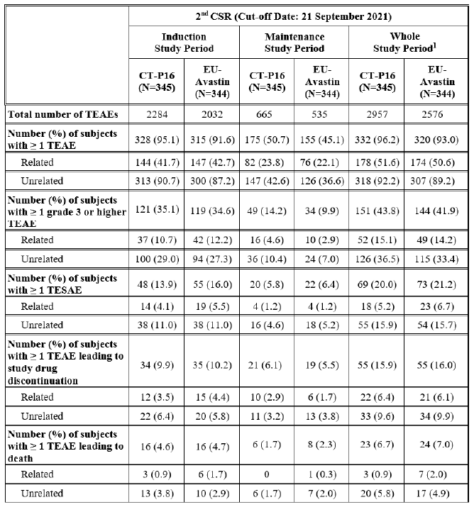

Abbreviations: CSR = clinical study report

1 Whole Study Period includes data from Follow-up Period in addition to Induction Study Period and Maintenance Study Period.

At least one treatment-emergent adverse event (TEAE) was reported for a higher proportion of CT-P16 patients (96.2% versus 93.0%), both during the Induction (95.1% versus 91.6%) and Maintenance (50.7% versus 45.1%) Study Periods. The most commonly reported preferred terms (PT)[8] were alopecia (63.8% versus 63.4%), anaemia (31.6% versus 27.0%), neutropenia (21.7% versus 16.0%) and nausea (21.4% versus 18.9%).

There was a 5% or more higher incidence of TEAEs for the CT-P16 group versus EU-Avastin group for the following SOCs:[9] Blood and lymphatic disorders (50.4% versus 42.2%), General disorders and administration site conditions (41.2% versus 34.9%) and Nervous system disorders (52.5% versus 47.4%).

Treatment-emergent adverse events considered related to study drug were reported for a comparable proportion of patients in each group (51.6% versus 50.6%), with proteinuria the most frequent treatment-related PT (10.4% versus 9.3%). There were 43.8% CT-P16 and 41.9% EU-Avastin patients with Grade 3 or higher TEAEs,[10] most commonly neutropenia (10.4% versus 7.3%). The Grade 3 or higher events of dyspnoea (2.0% [n = 7] versus 0.0%) and pulmonary embolism (1.7% [n = 6] versus 0.9% [n = 3]) were higher in the CT-P16 group. There was no clear explanation for the imbalance of pulmonary embolism between the groups, though the incidences in both groups were within the range of other bevacizumab biosimilar studies in nsNSCLC patients and were not considered sufficient to preclude biosimilarity in terms of safety.

As noted in the PIs for other registered bevacizumab medicines, ‘Grade 3-5 venous thromboembolic events have been reported in up to 10.6% of patients treated with chemotherapy plus bevacizumab compared with up to 5.4% in patients with chemotherapy alone’.

There were no between-group differences in the proportion of subjects with treatment-emergent serious AEs (20.0% versus 21.2%), treatment-related serious AEs (5.2% versus 6.7%) and deaths (6.7% versus 7.0%). Pneumonia was the most common treatment-emergent serious AE in both groups (2.3% versus 2.9%). Deaths considered related to study treatment by the investigator were lower in the CT-P16 group (0.9% versus 2.0%).

Immunogenicity assessment was considered insufficient by the EMA Assessor, and the adequacy of the assay in Study CT-P16 3.1 questionable, with the EMA Assessor noting the inability of the neutralising antibody assay to detect neutralising antibody at levels lower than 2000 ng/mL in any patients. As the prevalence of anti-drug antibody was low, neither of these issues were pursued further.

### Risk management plan

The sponsor is required to comply with product vigilance and risk minimisation requirements.

The TGA decided a risk management plan (RMP) was not required to be evaluated, as no additional pharmacovigilance activity or additional risk minimisation activity is currently conducted for the innovator, and the biosimilar will have the same indications, dosage form, strengths, and route of administration as the innovator product. See [TGA’s guidance](https://www.tga.gov.au/resources/resource/guidance/risk-management-plans-medicines-and-biologicals/when-rmp-required) on ‘when an RMP is required’.

### Risk-benefit analysis

#### Delegate’s considerations

The sponsor submitted a comparability study between the reference medicinal product registered in Australia using EU-approved and Australia-registered Avastin. Physicochemical and biological comparability between Avastin registered in the EU and Australia has been satisfactorily demonstrated.

The primary objective of a comparative clinical study in a biosimilar development program is not to establish efficacy but to assess for clinically meaningful differences. The primary endpoint selected should be sufficiently sensitive to assess for clinically meaningful differences between the products. As such, it is not scientifically necessary for the primary endpoint in a comparative clinical study to be the same as the endpoint used to demonstrate efficacy of the reference product.[11] Of note the primary efficacy endpoint in the pivotal study to demonstrate efficacy of Avastin in NSCLC was OS with PFS and ORR as secondary endpoints. Additionally, the population selected was suitable for comparisons and the nsNSCLC population was chosen to demonstrate comparability in other biosimilar bevacizumab products. The ORR demonstrated similarity according to protocol‑specified bounds, satisfying the requirement for efficacy comparable to that of the originator product.

There were no safety signals to suggest that the safety of Vegzelma would be clinically significantly different from that of the originator bevacizumab product.

The Delegate noted that the clinical evaluator considered that only those indications accepted by the EMA should be eligible for inclusion in the Product Information (PI) for Vegzelma. The Delegate disagreed and accepted the justification provided by the sponsor, which was based on extrapolation of clinical efficacy and safety based on the overall evidence of comparability. It was also noted that the TGA has previously accepted all Australian indications of bevacizumab (Avastin) for other biosimilar bevacizumab products. There is no evidence that bevacizumab has a unique mechanism of action in glioma.

#### Proposed action

The Delegate proposed to approve Vegzelma.

#### Advisory Committee considerations

The Delegate did not refer this submission to the [Advisory Committee on Medicines (ACM)](https://www.tga.gov.au/committee/advisory-committee-medicines-acm) for advice.

## Outcome

Based on a review of quality, safety, and efficacy, the TGA decided to register Vegzelma (bevacizumab) 100 mg/4 mL and 400 mg/16 mL solution for intravenous infusion in vials, indicated for:

***Metastatic Colorectal Cancer***

*Vegzelma (bevacizumab) in combination with fluoropyrimidine-based chemotherapy is indicated for the treatment of patients with metastatic colorectal cancer.*

***Locally recurrent or metastatic Breast Cancer***

*Vegzelma (bevacizumab) in combination with paclitaxel is indicated for the first-line treatment of metastatic breast cancer in patients in whom an anthracycline-based therapy is contraindicated. (see Section 5.1 Clinical Trials).*

***Advanced, metastatic or recurrent non-squamous Non-Small Cell Lung Cancer (NSCLC)***

*Vegzelma (bevacizumab), in combination with carboplatin and paclitaxel, is indicated for first-line treatment of patients with unresectable advanced, metastatic or recurrent, non-squamous, non- small cell lung cancer.*

***Advanced and/or metastatic Renal Cell Cancer***

*Vegzelma (bevacizumab) in combination with interferon alfa-2a is indicated for treatment of patients with advanced and/or metastatic renal cell cancer.*

***Grade IV Glioma***

*Vegzelma (bevacizumab) as a single agent, is indicated for the treatment of patients with Grade IV glioma after relapse or disease progression after standard therapy, including chemotherapy.*

***Epithelial Ovarian, Fallopian Tube or Primary Peritoneal Cancer***

*Vegzelma (bevacizumab) in combination with carboplatin and paclitaxel, is indicated for first-line treatment of patients with advanced (FIGO stages IIIB, IIIC and IV) epithelial ovarian, fallopian tube, or primary peritoneal cancer.*

***Recurrent Epithelial Ovarian, Fallopian Tube or Primary Peritoneal Cancer***

*Vegzelma (bevacizumab), in combination with carboplatin and paclitaxel or in combination with carboplatin and gemcitabine, is indicated for the treatment of patients with first recurrence of* ***platinum-sensitive****, epithelial ovarian, fallopian tube, or primary peritoneal cancer who have not received prior bevacizumab or other VEGF targeted angiogenesis inhibitors.*

*Vegzelma (bevacizumab) in combination with paclitaxel, topotecan or pegylated liposomal doxorubicin is indicated for the treatment of patients with recurrent, platinum-resistant epithelial ovarian, fallopian tube, or primary peritoneal cancer who have received no more than two prior chemotherapy regimens, and have not received any prior anti-angiogenic therapy including bevacizumab.*

***Cervical Cancer***

*Vegzelma (bevacizumab) in combination with paclitaxel and cisplatin is indicated for the treatment of persistent, recurrent or metastatic carcinoma of the cervix. Vegzelma (bevacizumab) in combination with paclitaxel and topotecan is an acceptable alternative where cisplatin is not tolerated or not indicated.*

### Specific conditions of registration applying to these goods

* Laboratory testing and compliance with Certified Product Details (CPD):
  + All batches of Vegzelmabevacizumab 100 mg/4 mL and 400 mg/16 mL concentrate solution for intravenous infusion, vial supplied in Australia must comply with the product details and specifications approved during evaluation and detailed in the CPD.
  + When requested by the TGA, the sponsor should be prepared to provide product samples, specified reference materials and documentary evidence to enable the TGA to conduct laboratory testing on the Product. Outcomes of laboratory testing are published biannually in the TGA Database of Laboratory Testing Results http://www.tga.gov.au/ws-labs-index and periodically in testing reports on the TGA website.
* The Certified Product Details (CPD), as described in Guidance 7: Certified Product Details of the Australian Regulatory Guidelines for Prescription Medicines (ARGPM) http://www.tga.gov.au/industry/pm-argpmguidance-7.htm, in PDF format, for the above products should be provided upon registration of these therapeutic goods. In addition, an updated CPD should be provided when changes to finished product specifications and test methods are approved in a Category 3 application or notified through a self-assessable change.

## Attachment 1. Product Information

The [Product Information](https://www.tga.gov.au/products/australian-register-therapeutic-goods-artg/product-information-one) ([PI](https://www.tga.gov.au/products/australian-register-therapeutic-goods-artg/product-information-one)) approved with the submission for Vegzelma which is described in this AusPAR can be found as Attachment 1. It may have been superseded. For the most recent PI and [Consumer Medicines Information](https://www.tga.gov.au/products/australian-register-therapeutic-goods-artg/consumer-medicines-information-cmi) (CMI), please refer to the TGA [PI/CMI search facility.](https://www.tga.gov.au/picmi-search-facility)

|  |
| --- |
| Therapeutic Goods Administration |
| PO Box 100 Woden ACT 2606 Australia  Email: [info@tga.gov.au](mailto:info@tga.gov.au) Phone: 1800 020 653 Fax: 02 6203 1605  [**https://www.tga.gov.au**](https://www.tga.gov.au) |
| Reference/Publication # |

1. This is the original indication proposed by the sponsor when the TGA commenced the evaluation of this submission. It may differ to the final indication approved by the TGA and registered in the Australian Register of Therapeutic Goods.
2. Bevacizumab, under the tradename Avastin, was first registered in the ARTG in February 2005 for the sponsor Roche Product Pty Ltd. In early 2021 Roche announced that Avastin was to be discontinued. Avastin was registered in the ARTG at the time that the Vegzelma application was submitted to the TGA. However, Avastin was cancelled from the ARTG by Roche on 3 August 2023. The 7 AusPARs published for Avastin for various extensions of indications continue to be available on the TGA website.
3. In this report the ‘Delegate’ is the Delegate of the Secretary of the Department of Health and Aged Care who decided the submission under section 25 of the Act.
4. Committee for Medicinal Products for Human Use (CHMP). Guideline on similar biological medicinal products containing monoclonal antibodies – non-clinical and clinical issues. Effective in Australia from 17 August 2015. EMA/CHMP/BMWP/403543/2010.
5. Eastern Cooperative Oncology Group Performance Status: The ECOG has developed criteria used by doctors and researchers to assess how a patient's disease is progressing, assess how the disease affects the patient’s daily living, and to determine appropriate treatment and prognosis. The ECOG Performance Status Scale is as follows: Grade 0 = Fully active, able to carry on all pre-disease performance without restriction; Grade 1 = Restricted in physically strenuous activity but ambulatory and able to carry out work of a light or sedentary nature, for example, light house work, office work; Grade 2 = Ambulatory and capable of all selfcare but unable to carry out any work activities. Up and about more than 50% of waking hours; Grade 3 = Capable of only limited selfcare, confined to bed or chair more than 50% of waking hours; Grade 4 = Completely disabled. Cannot carry on any selfcare. Totally confined to bed or chair; Grade 5 = Dead.
6. Paclitaxel is registered in the ARTG under multiple brand names and for multiple indications. Carboplatin is registered in the ARTG under multiple brand names and for multiple indications.
7. The Response Evaluation Criteria In Solid Tumours (RECIST) is a voluntary international standard with unified and easily applicable criteria to define when a patient's tumour has improved ('respond'), stayed the same ('stabilise'), or worsened ('progress') during treatment. The criteria were published in 2000 (and updated in 2009) by an international collaboration including the European Organisation for Research and Treatment of Cancer (EORTC), US National Cancer Institute (NCI) and the National Cancer Institute of Canada Clinical Trials Group. Today, the majority of clinical trials evaluating cancer treatments for objective response in solid tumours use RECIST.
8. The Medical Dictionary for Regulatory Activities (MedDRA) is an internationally used set of terms relating to medical conditions, medicines and medical devices. It was created to assist regulators with sharing information. It is also used by industry, academics, health professionals and other organisations that communicate medical information. In MedDRA, preferred terms (PT) are single concepts for symptoms, signs, disease diagnosis, therapeutic indications, investigations, procedures, and characteristics. There are over 20,000 preferred terms.
9. In MedDRA, System Organ Class (SOC) is the highest level of the MedDRA terminology for classification of adverse events. There are 27 classes.
10. The adverse event severity grading used US National Cancer Institute Common Terminology Criteria for Adverse Events (NCI CTCAE) v5 scale for assessing adverse event severity. In general: Grade 1 = Mild; Grade 2 = Moderate; Grade 3 = Severe or medically significant but not immediately life-threatening; Grade 4 = Life-threatening consequences; Grade 5 = Death related to AE.
11. He K, Chen H, Gwise T, Casak S, Lemery S, Keegan P, et al. Statistical Considerations in Evaluating a Biosimilar Product in an Oncology Clinical Study*. Clin Cancer Res.* 2016;22(21):5167-5170. doi: 10.1158/1078-0432.CCR-16-1010.