|  |
| --- |
| Australian Public Assessment Report for Alhemo |
| Active ingredient: Concizumab |
| Sponsor: Novo Nordisk Pharmaceuticals Pty Ltd |
| March 2024 |

About the Therapeutic Goods Administration (TGA)

* The Therapeutic Goods Administration (TGA) is part of the Australian Government Department of Health and Aged Care and is responsible for regulating therapeutic goods, including medicines, medical devices, and biologicals.
* The TGA administers the *Therapeutic Goods Act 1989* (the Act), applying a risk management approach designed to ensure therapeutic goods supplied in Australia meet acceptable standards of quality, safety, and efficacy.
* The work of the TGA is based on applying scientific and clinical expertise to decision-making, to ensure that the benefits to the Australian public outweigh any risks associated with the use of therapeutic goods.
* The TGA relies on the public, healthcare professionals and industry to report problems with therapeutic goods. The TGA investigates reports received to determine any necessary regulatory action.
* To report a problem with a therapeutic good, please see the information on the [TGA website](https://www.tga.gov.au).

About AusPARs

* The Australian Public Assessment Report (AusPAR) provides information about the evaluation of a prescription medicine and the considerations that led the TGA to approve or not approve a prescription medicine submission. Further information can be found in [Australian Public Assessment Report (AusPAR) guidance](https://www.tga.gov.au/australian-public-assessment-report-auspar-guidance).
* AusPARs are prepared and published by the TGA.
* AusPARs are static documents that provide information that relates to a submission at a particular point in time. The publication of an AusPAR is an important part of the transparency of the TGA’s decision-making process.
* A new AusPAR may be provided to reflect changes to indications or major variations to a prescription medicine subject to evaluation by the TGA.

Copyright

© Commonwealth of Australia 2024  
This work is copyright. You may reproduce the whole or part of this work in unaltered form for your own personal use or, if you are part of an organisation, for internal use within your organisation, but only if you or your organisation do not use the reproduction for any commercial purpose and retain this copyright notice and all disclaimer notices as part of that reproduction. Apart from rights to use as permitted by the *Copyright Act 1968* or allowed by this copyright notice, all other rights are reserved and you are not allowed to reproduce the whole or any part of this work in any way (electronic or otherwise) without first being given specific written permission from the Commonwealth to do so. Requests and inquiries concerning reproduction and rights are to be sent to the TGA Copyright Officer, Therapeutic Goods Administration, PO Box 100, Woden ACT 2606 or emailed to <[tga.copyright@tga.gov.au](mailto:tga.copyright@tga.gov.au)>.

Contents

List of abbreviations 4

Product submission 6

Submission details 6

Product background 7

Condition 7

Current treatment options 9

Clinical need 10

Mechanism of action of concizumab 11

Australian regulatory status 13

Foreign regulatory status 13

Registration timeline 14

Submission overview and risk/benefit assessment 15

Quality 15

Nonclinical 15

Clinical 17

Summary of clinical studies 17

Pharmacology 18

Efficacy 25

Safety 41

Paediatric patients 48

Drug delivery device 49

Companion diagnostic considerations 49

Real world evidence 49

Risk management plan 49

Risk-benefit analysis 51

Delegate’s considerations 51

Proposed action 58

Advisory Committee considerations 58

Outcome 60

Specific conditions of registration applying to these goods 60

Attachment 1. Product Information 61

## List of abbreviations

|  |  |
| --- | --- |
| Abbreviation | Meaning |
| ABR | Annualised bleeding rate |
| ACM | Advisory Committee on Medicines |
| aPCC | Activated prothrombin complex concentrate |
| ASA | Australia specific annex |
| BU | Bethesda units |
| CI | Confidence interval |
| Cmax | Maximum concentration |
| CMI | Consumer Medicines Information |
| CSR | Case study report |
| Ctrough | Trough concentration |
| DLP | Data lock point |
| FAS | Full analysis set |
| fIX | Factor IX |
| fVIII | Factor VIII |
| HA | Haemophilia A |
| HAwI | Haemophilia A with inhibitors |
| HB | Haemophilia B |
| HBwI | Haemophilia B with inhibitors |
| IgG | Immunoglobulin G |
| ITI | Immune tolerance induction |
| IU | International units |
| OTexIR | On treatment without data on initial regimen |
| PD | Pharmacodynamic(s) |
| PI | Product Information |
| PK | Pharmacokinetic(s) |
| PPX | Prophylaxis |
| PSUR | Periodic safety update report |
| rfVIIa | Recombinant activated factor VII |
| RMP | Risk management plan |
| SAS | Safety analysis set |
| SC | Subcutaneous |
| SD | Standard deviation |
| SF-36v2 | 36-item short form health survey version 2 questionnaire |
| TF | Tissue factor |
| TFPI | Tissue factor pathway inhibitor |
| TGA | Therapeutic Goods Administration |

## Product submission

### Submission details

|  |  |
| --- | --- |
| *Type of submission:* | New biological entity |
| *Product name:* | Alhemo |
| *Active ingredient:* | Concizumab |
| *Decision:* | Approved |
| *Date of decision:* | 3 July 2023 |
| *Date of entry onto ARTG:* | 5 July 2023 |
| *ARTG numbers:* | 394065, 394067, 394068 and 394066 |
| [*Black Triangle Scheme*](https://www.tga.gov.au/black-triangle-scheme)  *for the current submission:* | Yes |
| *Sponsor’s name and address:* | Novo Nordisk Pharmaceuticals Pty Ltd  Level 10/ 118 Mount Street North Sydney, NSW 2060 |
| *Dose form:* | Solution for injection |
| *Strengths:* | 10 mg/mL, 40 mg/mL and 100 mg/mL |
| *Container:* | Pre-filled pen |
| *Pack size:* | One |
| *Approved therapeutic use for the current submission:* | *Alhemo is indicated where prophylaxis is required to prevent or reduce the frequency of bleeding in patients at least 12 years of age who have haemophilia B (congenital factor IX deficiency) with FIX inhibitors.* |
| *Route of administration:* | Subcutaneous |
| *Dosage:* | Treatment should be initiated under the supervision of a physician experienced in treatment of haemophilia and/or bleeding disorders. Initiate concizumab in a non-bleeding state, and after discontinuing treatment with bypassing agents. Discontinue recombinant factor VIIa (rFVIIa) at least 12 hours before starting concizumab therapy. Discontinue activated prothrombin complex concentrates (aPCC) at least 48 hours before starting concizumab therapy.  The recommended dosing regimen is a loading dose of 1 mg/kg concizumab given once on treatment day one. From day two until determination of individual maintenance dose an initial maintenance dose of 0.20 mg/kg concizumab is administered daily.  From determination of individual maintenance dose onwards concizumab is administered daily.  For further information regarding dosage, refer to the Product Information. |
| *Pregnancy category:* | D  Drugs which have caused, are suspected to have caused or may be expected to cause, an increased incidence of human fetal malformations or irreversible damage. These drugs may also have adverse pharmacological effects. Accompanying texts should be consulted for further details.  The use of any medicine during pregnancy requires careful consideration of both risks and benefits by the treating health professional. This must not be used as the sole basis of decision making in the use of medicines during pregnancy. The TGA does not provide advice on the use of medicines in pregnancy for specific cases. More information is available from obstetric drug information services in your State or Territory. |

### Product background

This AusPAR describes the submission by Novo Nordisk Pharmaceuticals Pty Ltd (the sponsor) to register Alhemo (concizumab) 60 mg/1.5 mL, 300 mg/ 3 mL, 150 mg/1.5 mL, 15 mg/1.5 mL, solution for injection, prefilled pen for the following proposed indication:[1]

*Alhemo is indicated for the routine prophylaxis to prevent or reduce the frequency of bleeding in patients ≥ 12 years of age with haemophilia B (congenital factor IX deficiency) with FIX inhibitors.*

#### Condition

Blood clotting is a critical process through which mammals achieve haemostasis despite injury to blood vessels.[2],[3] The process is classically described as the coagulation cascade, with two major mechanisms of activation (Figure 1).2,3 Initiation can occur through the extrinsic (tissue factor) pathway, and/or the intrinsic (contact) pathway, both of which converge on a common pathway.3 The extrinsic pathway was named after its trigger: contact between plasma and something extrinsic (that is tissue factor).3 The intrinsic (or contact) pathway is activated through contact between blood and an artificial surface, and was so named as it appeared to be an intrinsic property of plasma.[4] Intrinsic coagulation does not contribute to normal haemostasis, but is thought to contribute to pathological thrombosis.[5]

Haemophilia is a congenital bleeding disorder characterised by deficiency of key proteins, referred to as clotting factors, involved in these pathways. Haemophilia A (HA) is caused by factor VIII (fVIII) deficiency (due to pathogenic mutations of the F8 gene). Haemophilia B (HB) is caused by factor IX (fIX) deficiency (due to pathogenic mutations of the F9 gene). As both F8 and F9 are located on the X chromosome, HA and HB are X-linked disorders: clinical disease rarely affects females. Whilst most cases are inherited, a significant proportion are attributable to spontaneous germ cell mutations (30%): around half of newly diagnosed cases occur with no known family history of haemophilia.2

Haemophilia A and HB have a similar clinical presentation, with easy bruising, mucous membrane bleeding, spontaneous haemorrhages into joints, muscles and soft tissues, or excessive bleeding following trauma or surgery. Repeated haemorrhages into joints may result in chronic arthropathy.2

Severity of haemophilia can be classified according to clotting factor levels relative to normal (0.5 to 1.5 international units (IU)/mL): mild (5 to less than 40% of normal), moderate (1 to 5% of normal fVIII (0.02-0.05 IU/mL) or 6 to 40% of normal fIX (0.06-0.40 IU/mL)) or severe (less than 1% of normal; less than 0.01 IU/mL).[6] Severity and frequency of bleeding episodes broadly correlates with the severity of clotting factor deficiency.[7]

Haemophilia is a rare disorder. There were 3127 people with haemophilia A or B in Australia according to the 2019-20 Annual Report of the Australian Bleeding Disorders Registry.[8] Haemophilia A accounts for 80 to 85% of cases of haemophilia and HB for 15 to 20%.

Figure 1: The classical schematic blood coagulation cascade pathways

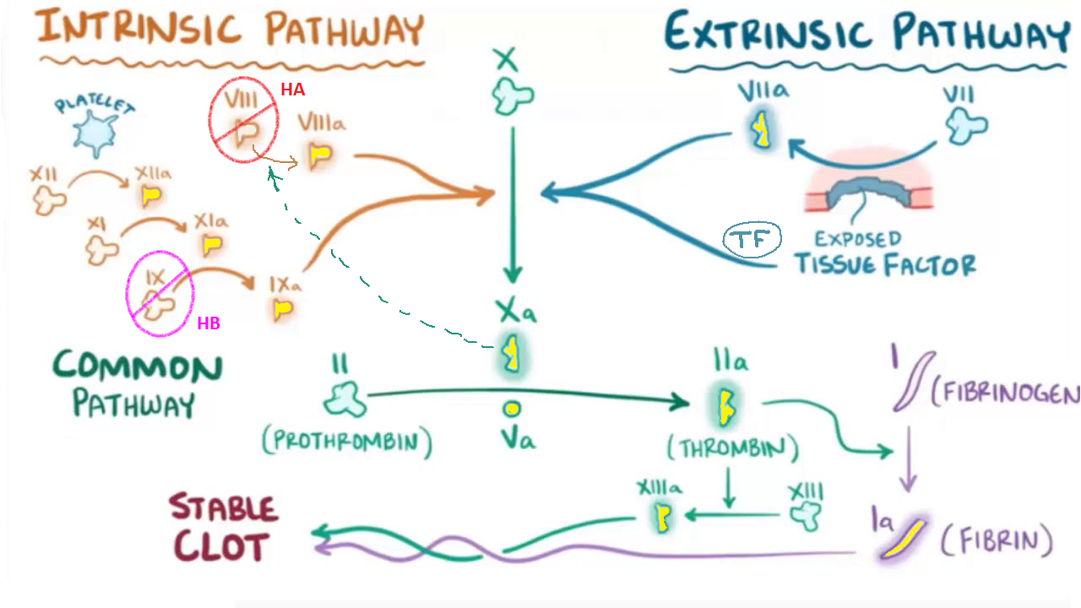

Yellow fill = activated. Red = fVIII is deficient in haemophilia A. Pink = fIX is deficient in haemophilia B.  
Dotted line = in a positive feedback loop, thrombin (Xa) cleaves circulating, inactive fVIII yielding active co-factor VIIIa. Factor VIIIa markedly increases the catalytic efficiency of factor IXa in making more thrombin.

Source: Quizlet image accessed 17 FEB 2023;[9] and Fay PJ, et al (2006);[10]

#### Current treatment options

##### Clotting factor replacement and inhibitors

Treatment of haemophilia involves clotting factor replacement with recombinant fVIII or fIX products. Factors can be administered ‘on demand’, that is for the treatment of bleeding episodes, or in a prophylaxis regimen to prevent haemorrhages. Clotting factor replacement is the treatment of choice for people with haemophilia as it is very safe and effective for treating and preventing bleeds. Prophylaxis regimens are considered standard of care for patients with severe (and some patients with moderate) haemophilia.

Inhibitors are immunoglobulin G (IgG) antibodies to exogenous fVIII or fIX that neutralise their clotting function. Inhibitors to fVIII develop in approximately 30% of HA subjects and inhibitors to fIX occur in approximately 5% of HB subjects. They occur more commonly in subjects with severe factor deficiency.

Inhibitors are measured by the Bethesda assay or the Nijmegen-modified Bethesda assay. The definition of a positive inhibitor is a Bethesda titre of greater than 0.6 Bethesda units (BU) for fVIII and 0.3 BU or greater for fIX. A low responding inhibitor is an inhibitor less than 5.0 BU. A high responding inhibitor is an inhibitor 5.0 BU or greater.

A transient inhibitor is defined as a positive inhibitor that drops below the definition threshold within 6 months of initial documentation without any change in treatment regimen, and despite antigenic challenge with clotting factor. Low responding inhibitors tend to be transient whereas high responding inhibitors tend to be persistent. High responding inhibitors may become undetectable after a prolonged period without clotting factor exposure but reoccur after a rechallenge (an anamnestic response).

##### Treatment of haemophilia A with inhibitors

Immune tolerance induction (ITI) aims to eradicate inhibitors by regular administration (for example, daily or several times a week) of high doses of fVIII, for a period of months to years. Immune tolerance induction is effective in 60 to 80% of HA patients and is considered standard of care in subjects with severe HA who develop high-titre inhibitors.[11] Immune tolerance induction is less successful in subjects with mild or moderate HA.

Prophylaxis for bleeding episodes can be achieved through the administration of bypassing agents. These include:

* Recombinant activated factor VII (rfVIIa), which makes use of the extrinsic pathway and negates the need for fVIII (see Figure 1), and;
* Activated prothrombin complex concentrate (aPCC), also known as factor VIII inhibitor bypassing fraction), which contains a mix of activated and inactivated factors VII, II, IX and X.[12]

In HA, emicizumab is another option for prophylaxis. Emicizumab is a bispecific monoclonal antibody that bridges activated fIX and FX to mimic the function of missing activated fVIII. Emicizumab is more effective as prophylaxis than bypassing agents, and simpler to administer, as it is given subcutaneously (SC).11

In Australia both emicizumab (Hemlibra) and aPCC (Feiba nf) are registered for the routine prophylaxis of bleeding episodes in haemophilia A with inhibitors (HAwI) subjects.[13],[14] The approved Australian Product Information (PI) for rfVIIa/eptacog alfa (NovoSeven RT) also allows for prophylactic use, but for a limited period (up to 3 months).[15]

Treatment of acute bleeding episodes is dependent upon the level of inhibitor present. In subjects with a low responding inhibitor, acute bleeds can be managed with continuing use of a fVIII product, although higher doses may be required. In subjects with a high responding inhibitor, fVIII replacement is ineffective, and treatment requires use of a bypassing agent (rfVIIa or aPCC). In subjects receiving emicizumab prophylaxis who require treatment of an acute bleeding episode, use of aPCC has been associated with cases of thrombotic microangiopathy and thrombotic events, so rfVIIa is preferred.

##### Treatment of haemophilia B with inhibitors

Inhibitor development in HB subjects is associated with anaphylaxis or severe allergic reactions to exogenous fIX in 50% of subjects. Inhibitors may also be associated with the development of nephrotic syndrome.

Eradication of inhibitors through ITI can be attempted using regular administration of high doses of fIX. However, ITI in HB subjects has a low success rate (30 to 35%)[16] and is complicated by the additional risks of anaphylaxis and nephrotic syndrome. In its current guideline document the World Federation of Haemophilia (WFH) states that it is unable to make a recommendation on the use of ITI in HB, as experience is limited.

Prophylaxis for bleeding episodes is possible using the same bypassing agents described above, which are registered in Australia for HB as for HA. Recombinant activated factor VII (rfVIIa) is preferred, due to the fact that aPCC contains fIX which may precipitate anaphylaxis.

Emicizumab cannot be used for prophylaxis in HB as its mechanism of action is specific to HA.

On-demand treatment of acute bleeding episodes uses a similar approach to that used in HAwI. For haemophilia B with inhibitors (HBwI) subjects with a low-responding inhibitor, acute bleeds can be managed with continuing use of a fIX product, provided there is no allergic response. In subjects with a high-responding inhibitor, or those with a low-responding inhibitor and evidence of allergy to fIX, a bypassing agent is used. Recombinant fVIIa is preferred due to the presence of fIX in aPCC.

#### Clinical need

Bypassing agents (rfVIIa and aPCC) must be administered intravenously. Prophylaxis regimens may therefore require an implanted central venous access device. Subcutaneous prophylaxis with emicizumab obviates the need for such a procedure but can only be used in haemophilia A with inhibitors (HAwI) subjects. The availability of a subcutaneously administered product for prophylaxis in haemophilia B with inhibitors (HBwI) would therefore improve treatment options for HBwI subjects.

#### Mechanism of action of concizumab

Concizumab is a monoclonal antibody with specificity against the K2 domain of tissue factor pathway inhibitor 1 (TFPI-1, hereafter referred to as TFPI). Tissue factor pathway inhibitor is an alternatively spliced anticoagulant protein that down-regulates initiation of the coagulation cascade.[17]

There are two major isoforms of TFPI in humans, TFPIα (full length) and TFPIβ (splice variant).[18] Both contain K (Kunitz) protease inhibitor domains K1 and K2. K2 directly binds the active site of fXa and facilitates binding of K1 to the active site of the TF-fVIIa complex, leading to inhibition of the TF‐fVIIa‐fXa ternary complex (Figure 2).[19]

TFPIα includes an additional domain (K3) that binds Protein S. Protein S provides a mechanism of cell surface localisation for TFPIα and synergistically enhances its inhibition of fXa.[20] Next to the K3 domain, TFPIα has a basic C‐terminus that can bind to fV and inhibit early forms of the fVa‐fXa catalytic complex (prothrombinase), providing downregulation of the common coagulation pathway through this second mechanism.17

TFPIβ, whilst unable to inhibit prothrombinase, has a C-terminal glycophosphatidylinositol anchor that localises it to the cell surface. This localisation increases its ability to inhibit TF‑mediated procoagulant activity at the endothelial surface.[21]

In keeping with their differing C-termini, TFPIβ is only found on endothelial cells, whilst TFPIα (with its ability to circulate as a soluble protein) is also found in platelets and plasma.[22] The ratio of total body TFPI across endothelial cells, platelets and plasma is approximately 85:10:5.[23]

Haemophilia A and B patients have normal initiation of the coagulation system but suffer from an inadequate propagation of the coagulation process due to deficiency in fVIII or fIX, leading to impaired fXa generation and, consequently, impaired fibrin clot formation. By binding to TFPI, concizumab is intended to reduce TFPI inhibitory activity so that the fXa produced by the fVIIa/TF complex will result in sufficient generation of thrombin to achieve haemostasis (Figure 3).

The mechanism of action of concizumab is independent of the presence of fVIII or fIX, and the drug is therefore being developed for the treatment of both HA and HB, regardless of inhibitor status.

Figure 2: Physiological functions of tissue factor pathway inhibitor

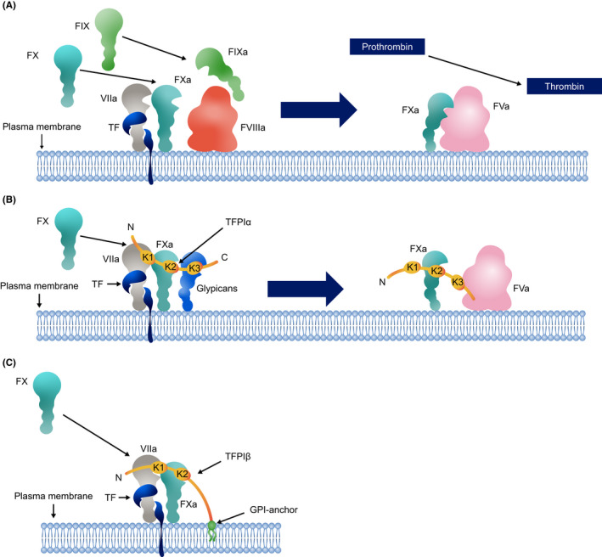

a, active; C, carboxy; F, factor; GPI, glycophosphatidylinositol; K, Kunitz; N, amino; TF, tissue factor; TFPI, tissue factor pathway inhibitor

(A) The TF‐fVIIa complex promotes coagulation (through the common pathway) by activating fX, and also (through the intrinsic pathway) by activating fIX which also catalyses activation of fX (enhanced by fVIIIa). fXa activates fV, and associates with fVa in the plasma membrane, becoming the prothrombinase complex, and proceeds to cleave prothrombin to thrombin.

(B) The K2 domain of TFPIα binds to fXa, which supports inhibition of the TF‐fVIIa complex. The binding of the K3 domain to PS supports membrane association of TFPIα and thus further promotes inhibition of the TF‐fVIIa complex. The basic C‐terminus of TFPIα can also interact with fVa, resulting in inhibition of the early prothrombinase complex.

(C) TFPIβ localizes to the cell surface via its GPI anchor, increasing its ability to inhibit fXa.

Source: Mast AE, and Ruf W (2022);17

Figure 3: The physiological function of tissue factor pathway inhibitor in clotting, and the proposed mechanism of action of tissue factor pathway inhibition in haemophilia A or haemophilia B

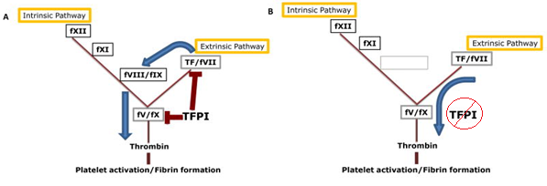

(A) Physiologically, TFPI downregulates the extrinsic pathway as a fXa-dependent inhibitor of TF-fVIIa, and downregulates the common pathway as an inhibitor of prothrombinase. Haemostasis is still achieved where there is significant enough tissue damage – the excess TF-fVIIa can amplify fXa generation through the intrinsic pathway, such that adequate thrombin is generated to form a clot.

(B) In HA or HB, the intrinsic pathway is not functional due to missing fVIII or fIX. By removing the inhibitory activity of TFPI, the extrinsic pathway alone may be able to generate sufficient thrombin for haemostasis.

Source: Mast AE (2016);22

#### Australian regulatory status

There have been no previous applications to register concizumab in Australia: this is a new biological entity, and first in its pharmacological class.

Concizumab was designated an orphan drug on 4 August 2022. The indication for which orphan designation was granted was: ‘for the treatment of haemophilia B’.

The current new active substance submission (for HBwI) was determined to be eligible for priority review on 7 July 2022. It was reviewed under a pilot arrangement between Health Canada, Swissmedic and TGA (new active substance priority submissions are not currently eligible for the work-sharing framework).[24]

A separate submission (for HAwI) has also been lodged with the TGA. The latter submission was not eligible for priority review. Both submissions seek to register the product for use as routine prophylaxis for bleeding in the respective groups of haemophilia patients.

### Foreign regulatory status

This submission was evaluated as part of the [Australia-Canada-Singapore-Switzerland-United Kingdom (ACCESS) Consortium](https://www.tga.gov.au/australia-canada-singapore-switzerland-united-kingdom-access-consortium) with work-sharing between the TGA, Health Canada, and Swissmedic. Each regulator made independent decisions regarding approval (market authorisation) of the new medicine.

At the time the current submission was lodged with the TGA (August 2022), concurrent submissions were also planned in the United States, Switzerland, Canada and Japan. In these jurisdictions the proposed indications were for both HA with fVIII inhibitors and HB with fIX inhibitors.

A submission in Europe was planned for the first quarter of 2023. This submission was to be for subjects with HA and HB with inhibitors.

Health Canada approved concizumab for HBwI in April 2023. On 24 April 2023, The United States Food and Drug Administration issued a complete response letter, and did not approve concizumab. Their complete response letter was shared with TGA by the sponsor, and the reasons for the complete response reviewed by the respective evaluation areas. All issues were resolved prior to TGA approval, with the exception of the companion diagnostic plan. This is not considered a barrier to completing the medicine registration, as the sponsor has agreed to a condition of registration to not supply the medicine until evaluation of the companion testing plan has been completed.

## Registration timeline

The following table captures the key steps and dates for this submission.

This submission was evaluated under the [priority registration process](https://www.tga.gov.au/resources/publication/publications/priority-registration-process#process).

Table 1: Timeline for Submission PM-2022-03458-1-6

|  |  |
| --- | --- |
| Description | Date |
| Priority determination | 7 July 2022 |
| Submission dossier accepted and first round evaluation commenced | 23 September 2022 |
| First round evaluation completed | 10 January 2023 |
| Sponsor provides responses on questions raised in first round evaluation | 18 November 2022 |
| Second round evaluation completed | 6 March 2023 |
| Delegate’s Overall benefit-risk assessment and request for Advisory Committee advice | 7 March 2023 |
| Sponsor’s pre-Advisory Committee response | 16 March 2023 |
| Advisory Committee meeting | 30 and 31 March 2023 |
| Registration decision (Outcome) | 3 July 2023 |
| Administrative activities and registration on the ARTG completed | 5 July 2023 |
| Number of working days from submission dossier acceptance to registration decision* | 141 |

*Target timeframe for priority submissions is 150 working days from acceptance for evaluation to the decision.

## Submission overview and risk/benefit assessment

This section is a TGA summary of wording used in TGA’s evaluation report, which discussed numerous aspects of overseas evaluation reports and included some information that was commercial-in-confidence.

### Quality

Concizumab is a humanised, recombinant immunoglobulin G4 (IgG4) monoclonal antibody of the IgG4 isotype. It is a glycosylated polypeptide with a molecular mass of approximately 149 kDa and contains two heavy chains (each with 448 amino acid residues), and two light chains (each with 219 amino acid residues), connected by 16 disulphide bridges. The molecule is produced by recombinant DNA technology in Chinese hamster ovary cells.

A point mutation (serine to proline) at position 241 of the native human IgG4 protein (S241P) was engineered into the molecule to prevent the formation of half antibodies during manufacture. This point mutation is present in other marketed IgG4 antibodies.

The drug product is presented as a solution for subcutaneous injection in a pre-filled pen injector device. It is planned for manufacture at four strengths: 15 mg in 1.5 mL, 60 mg in 1.5 mL, 150 mg in 1.5 mL, or 300 mg in 3 mL.

The concizumab drug product is a sterile solution containing phenol as a preservative and is intended for multi-use daily subcutaneous injections. It contains 10 mg/mL, 40 mg/mL or 100 mg/mL concizumab in L-Histidine, L-Arginine hydrochloride, sodium chloride, sucrose, polysorbate 80, and phenol.

The proposed products contain the following excipients: arginine hydrochloride, histidine, sodium chloride, sucrose, polysorbate 80, phenol, hydrochloric acid, sodium hydroxide and water for injections. No novel excipients are proposed.

The container closure system consists of either a 1.5 mL or a 3 mL type I glass cartridge with a cap consisting of a laminated bromobutyl rubber disc and aluminium seal at one end of the cartridge and a chlorobutyl rubber plunger at the other end.

The submitted data support a drug substance shelf life of 60 months at -80 °C storage conditions, and a drug product shelf life of 36 months when stored at 2 to 8 °C, including an in-use period of 4 weeks below 30 °C.

There are no outstanding Good Manufacturing Practice (GMP) clearances, and the tradename is considered acceptable.

From a quality perspective, it was concluded that there is sufficient data to support Australian registration.

### Nonclinical

The nonclinical dossier was of adequate quality and scope, consistent with the ICH S6 (R1) guideline for biotechnology-derived pharmaceuticals.[25] All pivotal safety-related studies, as well as the tissue cross-reactivity study, were Good Laboratory Practice compliant.

The submitted primary pharmacology studies support the utility of concizumab as prophylaxis in HA and HB.

The key concerns for patients identified from non-clinical data were:

* Thromboembolic events at very high doses:
  + In repeat-dose toxicity studies, cynomolgus monkeys received once daily subcutaneously concizumab for up to 52 weeks or once weekly intravenous administration for up to 26 weeks. The highest dose administered in the pivotal 52 week study - 9 mg/kg/day subcutaneous yielded systemic exposure to concizumab (plasma area under the concentration time curve from time 0 to 24 hours), over 4400 times greater than in patients at steady state.
  + Thrombi were observed in various organs (including the heart, lung, liver, spleen and lymph nodes), consistent with an exaggerated pharmacological response to concizumab in monkeys with a normal coagulation system (that is, non-haemophilic animals), at doses above 0.5 mg/kg/day subcutaneously the no observed adverse effect limit corresponds to an exposure approximately 70 times the plasma maximum concentration (Cmax) and area under the concentration-time curve in patients at steady state.
* Embryofetal lethality if used during pregnancy:
  + No specialised reproductive and developmental toxicity studies were conducted due to the lack of pharmacological activity in rodents, significant loss of exposure after repeated dosing in rabbits (secondary to the development of anti-drug antibodies), and because the intended patient population is almost exclusively male.
  + Monitoring of endpoints relevant to fertility was included in the 26 week general repeat-dose toxicity study in monkeys, with no effects on menstrual cycle duration, testicular volume, sperm count, sperm motility or sperm morphology observed (less than or equal to 9 mg/kg/day SC; relative exposure based on area under the concentration-time curve, greater than 3400). Histopathological examination did not identify male and female reproductive tissues as targets for toxicity in this or other studies (conducted in juvenile and sexually mature monkeys).
  + Published knockout studies have demonstrated that TFPI is critical for fetal development, with inactivation of the TFPI-gene in mice shown to result in embryofetal lethality.[26], [27]
  + As an IgG antibody, placental transfer of concizumab is expected, increasing in a linear fashion as pregnancy progresses.
  + The sponsor has proposed Pregnancy Category B3,[28] but based on the mechanism of action and embyrolethality seen in TFPI knockout studies, TGA considers Pregnancy Category D;[29] is warranted.

There were no nonclinical objections to registration of concizumab for the proposed indications.

### Clinical

#### Summary of clinical studies

Clinical study reports (CSRs) for seven clinical trials and one observational study were submitted to TGA and are listed in Table 2. The submission also included limited safety data from an ongoing Phase III trial in subjects with haemophilia A or B without inhibitors (Study 4307), and a report of safety and efficacy within a compassionate access program.

Table 2: Concizumab clinical studies from which data were submitted

|  |  |  |  |
| --- | --- | --- | --- |
| Phase | Study # | Description | Submitted data |
| I | 3813  (explorer1) | single IV and SC doses in healthy volunteers and subjects with haemophilia A or B | CSR |
| I | 3981 | single SC doses in healthy Japanese subjects | CSR |
| I | 3986  (explorer2) | repeated SC doses (every 2nd day) in healthy volunteers. This study was terminated early and only enrolled 4 subjects | CSR |
| I | 4159 (explorer3) | repeated SC doses (every 4th day) in subjects with severe haemophilia A | CSR |
| II | 4310 (explorer4) | efficacy and safety in subjects with HAwI or HBwI | CSR |
| II | 4255 (explorer5) | efficacy and safety in subjects with haemophilia A *without* inhibitors | CSR |
| NA | 4322 (explorer6) | observational study of bleeding rates in HAwI, HBwI, HA or HB | CSR |
| **III** | **4311 (explorer7)** | **efficacy and safety in subjects with HAwI or HBwI** | **CSR - pivotal** |
| III | 4307 (explorer8) | efficacy and safety in subjects with HA or HB | Limited safety data |
| NA | - | Compassionate use - whether under a compassionate use protocol or physician-driven | Efficacy and safety data |

CSR = clinical study report; NA = not applicable

Note: pivotal study highlighted with bold font.

##### Clinical development pause

The clinical development program for concizumab was paused between 16 March 2020 and 30 September 2020 (approximately 6.5 months) while a safety issue relating to thromboembolic events was investigated (see Thromboembolic events). This pause affected pivotal Study 4311 (also known as explorer7) and resulted in changes to dosing (see Study pause and changes to Phase III dosing) and protocol advice regarding the use of bypass agents (see Study pause and changes to protocol) when development was recommenced.

Throughout this document, the terms pre-pause and post-pause will be used to differentiate between the periods of time before and after the study pause period, respectively.

#### Pharmacology

##### Formulation

Various formulations of concizumab were used during the clinical development. The one proposed for marketing is ‘Concizumab C’, which was used in the explorer7 trial.

##### Pharmacokinetics

The pharmacokinetics (PK) of concizumab have been adequately defined and were similar in healthy volunteers compared to patients with haemophilia. The dominant clearance mechanism is through binding to endothelial cell-anchored TFPI with subsequent endocytosis and degradation (that is target-mediated drug disposition). As the amount of TFPI is saturable, the drug displays non-linear PK with increasing systemic exposure with increasing dose.

###### Absorption

Absolute bioavailability could not be reliably estimated due to the non-linear PK.

Concizumab is proposed for subcutaneous (SC) administration: into the thigh or abdomen. Following SC administration of 0.05 to 3 mg/kg concizumab in a Phase I study (Study 3813) in healthy and haemophilia subjects, median time to maximum concentration varied with dose: as low as 12 hours at a dose of 0.05 mg/kg, and as high as 70 hours at a dose of 3 mg/kg. The range of individual values for time to maximum concentrationwas 8 hours to 502 hours.

Concizumab Cmax and area under the concentration time curve from time zero to infinity increase in a greater than dose proportional manner. In explorer7 (pivotal Phase III), concizumab was given SC to patients aged 12 years or older with HAwI or HBwI, according to the regimen summarised in Table 3. Steady state was reached at 24 weeks, and the geometric mean (coefficient of variation) Cmax and trough concentration (Ctrough) at Week 24 were 1167.1 (1.3) ng/mL and 665.4 (2.2) ng/mL, respectively.

Due to the non-linear PK, for a typical subject, more than 95% of the steady state average concentration was reached already on Day 4 following once-daily dosing of 0.20 mg/kg with a loading dose of 1 mg/kg on Day 1.

###### Distribution

In common with other monoclonal antibodies, concizumab has a low volume of distribution. Following intravenous administration in haemophilia subjects in Study 3813, the geometric mean volume of distribution at steady state was between 32 and 59 mL/kg (approximately 2.3 to 4.2 L for a 70 kg individual).

###### Metabolism

As a large protein, concizumab would be expected to undergo catabolism to peptides and amino acids in various tissues, and be recycled for de novo synthesis of proteins, or excreted by the kidney.

###### Excretion

Non-linearity of elimination rates was seen both between doses levels, and over time for a particular dose level, consistent with target-mediated drug disposition (Figure 4). Following intravenous administration in haemophilia subjects in Study 3813, geometric mean total clearance decreased from 6.53 mL/hr/kg at the 250 μg/kg dose to 0.27 ml/hr/kg at the 9000 μg/kg dose.

The non-linear elimination process appeared to be saturated above 10,000 ng/mL. The typical terminal half-life value for the linear clearance pathway was approximately 22 days for a 75 kg patient. Considering the non-linear elimination, the effective half-life of concizumab was much shorter than the linear half-life and varied with plasma concentration due to the saturable elimination. Following intravenous administration in haemophilia subjects (Study 3813) geometric mean terminal half-life ranged from 31 hours at the 250 μg/kg dose to 73 hours at the 3000 μg/kg dose.

Figure 4: Simulated pharmacokinetic profiles of single intravenous (A) and subcutaneous (B) doses of concizumab for a typical subject with a body weight of 75 kg based on the final population pharmacokinetic model

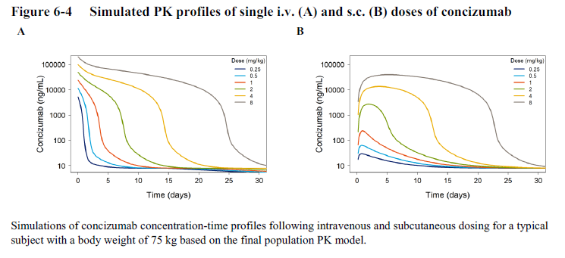

Source: Figure 6-4 from PopPK report VV-CLIN-141447, dated 14 June 2022.

##### Population pharmacokinetics data

The PK of concizumab were adequately described by a 2-compartment PK model with combined linear clearance and nonlinear target-mediated drug disposition, with a transit compartment for delayed absorption.

Body weight was included as a covariate in the model, with effects on linear clearance, intercompartmental clearance and the total amount of TFPI available for concizumab binding. Age, race, and haemophilia subtype were explored as covariates and no significant effects on concizumab PK were detected. However, there were insufficient subjects with impaired hepatic or renal function to allow meaningful analysis.

The pivotal study (explorer7 trial) enrolled both adult and adolescent subjects (See Study 4311 (explorer7) – pivotal Phase III RCT). Systemic exposure at 24 weeks was numerically higher in adult subjects compared to adolescents. However, there was no significant effect of age on concizumab PK in the population PK model. The differences in systemic exposure between the two age groups are likely due to differences in body weight, as body weight was the most important covariate in the model for predicting concizumab exposure.

Based on final population PK model estimates, absolute bioavailability was 77.7%, the mean central volume was 2.96 L, mean linear clearance was 0.00814 L/h (approximately 0.12 mLs/hr/kg), and simulated, instantaneous steady state half-life of concizumab at 24 hours after last dose was approximately 38 hours for a subject weighing 75 kg and with Ctrough of approximately 665 ng/mL (corresponding to the geometric mean Ctrough observed at Week 24 in Study 4311).

##### Pharmacodynamics

Concizumab treatment is associated with:

* Dose-dependent reduced concentration of free TFPI and residual functionality of TFPI in plasma, apparent from 6 to 12 hours post-dose.
* Dose-related increased capacity for thrombin generation in plasma, as measured by peak thrombin concentration (endogenous thrombin potential velocity index), apparent from 6 hours post-dose.

In explorer7, the geometric mean (coefficient of variation) of free TFPI decreased from 88.3 (0.2) ng/mL at Baseline to 10.7 (1.0) ng/mL at Week 24. The mean thrombin peak increased to normal plasma range.

Plasma concizumab level also appeared to be correlated with:

* Increased concentrations of prothrombin fragment 1+2;[30] compared to baseline or on‑demand treatment.
* Increased concentration of d-dimer compared to baseline or on-demand treatment.

The data were inconsistent regarding the effect of concizumab on total TFPI in plasma.

The submitted data did not demonstrate an effect of concizumab on:

* Mean concentration of thrombin-antithrombin complexes;[31] (except at a dose of 0.80 mg/kg; 4 times higher than the recommended dose).
* Fibrinogen concentrations in plasma.
* Soluble (non-cross linked) fibrin (except at a dose of 0.80 mg/kg; 4 times higher than the recommended dose).
* Prothrombin time/international normalised ratio and activated partial thromboplastin time.
* Antithrombin activity.
* Protein C or Protein S levels.
* Fibrinolysis (plasminogen, alfa-2 antiplasmin, plasmin-alfa 2 antiplasmin complex, plasminogen activator-1 and tissue plasminogen activator).
* Von Willebrand factor levels.

Pharmacodynamics effects in explorer7 trial (pre-dose free TFPI concentrations and pre-dose peak thrombin concentrations) were similar between HA and HB, and between adults and adolescents.

Annualised bleeding rate (ABR) was the outcome used for the primary efficacy analysis (explorere7 trial, see Study 4311 (explorer7) – pivotal Phase III RCT). An exploratory exposure‑response analysis of ABR indicated it decreased with increasing plasma concentration, with a plateau beginning at concizumab concentrations around 200 ng/mL (see Figure 5). The concentration which results in half the maximal drug effect was 45 ng/mL. No covariates were identified in the ER model.

Figure 5: Exposure-response model of the relationship between concizumab serum concentration and annualised bleeding rate based on data from explorer7 trial

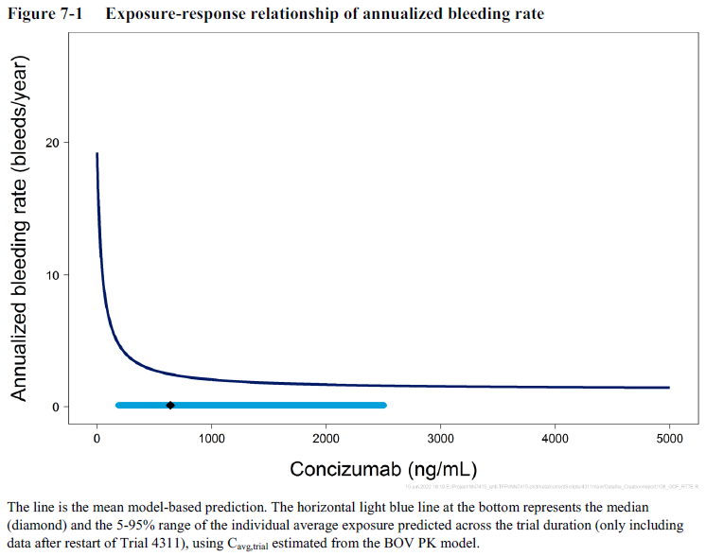

Source: Figure 7-1 from PopPK report VV-CLIN-141447, dated 14 June 2022.

Dark blue line = mean model-based prediction; light blue line = median (diamond) and range (5-95%) individual average exposure predicted across the trial duration (post-pause only).

Exposure-response model based on data from 117 subjects with 440 bleeding episodes (including data from the on-demand treatment period for 19 patients who started the study randomised to on-demand treatment, then commenced concizumab PPX in the extension period)

##### Dose selection

The proposed dose regimen for registration is summarised in Table 3, and aligns with the dose regimen used in the explorer7 trial. The basis for the proposed dose regimen is described below.

Table 3: Proposed dose regimen for registration

|  |  |  |
| --- | --- | --- |
| Treatment day | Dose phase | Dose |
| Day 1 | Loading dose | 1 mg/kg SC once |
| Day 2 until ~Day 28* | Initial maintenance dose | 0.20 mg/kg SC daily |
| ~Day 29* onwards | Selected maintenance dose | |  |  | | --- | --- | | *Measured concizumab plasma concentration:* | *Once-daily dose of concizumab SC:* | | <200 ng/ml | 0.25 mg/kg | | 200−4000 ng/ml | 0.20 mg/kg | | >4000 ng/ml | 0.15 mg/kg | |

* Measure serum concizumab concentration 4 weeks after initiation of treatment using concizumab ELISA (enzyme-linked immunosorbent assay) and use this to determine a selected maintenance dose. Determination of the selected maintenance dose should take place as soon as possible (after the concizumab plasma concentration result is available) and is recommended no later than 8 weeks after initiation of therapy. If resuming concizumab therapy after a discontinuation, a patient can resume at their previous selected maintenance dose.

Daily administration was chosen over less frequent dosing following analysis of Phase I data, in which high PK variability was seen with longer dosing intervals and high doses in Study 4159.

A PK/pharmacodynamic (PD) analysis (published;[32] but not submitted) of Phase I data indicated serum concizumab levels over 100 ng/mL were associated with normalisation of thrombin generation and decrease of bleeding episodes. For a typical subject, Ctrough values of 140, 250 and 440 ng/mL were expected with concizumab 0.15, 0.20 and 0.25 mg/kg subcutaneous daily, respectively. Therefore, 0.15 mg/kg subcutaneous daily was chosen as an initial Phase II maintenance dose, with the potential to increase to 0.25 mg/kg subcutaneous daily in the event of inefficacy.

Maintenance doses of 0.15, 0.20 or 0.25 mg/kg SC daily were studied in Phase II. In addition, a loading dose of 0.50 mg/kg subcutaneous on Day 1 was included in Study 4310 (the Phase II study in subjects with HAwI or HBwI) to reach steady state more quickly.

A population PK and ER analysis of the Phase II data suggested that bleeding rates would be reduced at plasma concizumab concentrations greater than 200 ng/mL, and that a maintenance dose of 0.25 mg/kg daily would provide exposures above this concentration in the majority of patients.

The highest Phase II maintenance dose (0.25 mg/kg subcutaneous daily) was selected for further study in Phase III, based on the following published rationale:[33]

*‘… a maintenance dose of 0.15 mg/kg is suboptimal for some patients, as few (13%) experienced zero bleeds. When the ABR for each patient in the phase 2 trials was calculated based on their final dose levels, the 0.25 mg/kg dose appeared to provide the most optimal efficacy while maintaining safety’*

A loading dose of 1.0 mg/kg subcutaneous on Day 1 was included for both of the Phase III studies. The increased loading dose was based on population PK modelling which indicated that its use would reduce the time to steady state exposure compared with a loading dose of 0.5 mg/kg.

The two Phase III studies commenced using a maintenance dose of 0.25 mg/kg subcutaneous daily. The initial protocol for explorer7 trial also included a provision to increase the maintenance dose to 0.35 mg/kg subcutaneous daily (in the extension part of the study only) in the event of inefficacy.

##### Study pause and changes to Phase III dosing

The clinical development program, including explorer7 trial, was paused between 16 March 2020 and 30 September 2020 (approximately 6.5 months) while a safety issue relating to thromboembolic events was investigated (see Thromboembolic events).

As a result of the investigations, changes were made to protocol recommendations regarding use of bypassing agents to treat bleeds (see Study pause and changes to protocol) as well as to the concizumab dose regimen. The maintenance dose of concizumab was reduced from 0.25 mg/kg (pre-pause) to 0.2 mg/kg (post-pause), based on the following:

* Two of three patients in whom thromboembolic events occurred had PK measurements indicating exposure at the higher end of the range of exposures observed in Phase II and III (see Figure 6).
* The early Phase III data indicated the pre-pause concizumab dose regimen (0.25 mg/kg/day) was resulting in exposure levels that were higher than had been expected based on previous PK results and modelling. When the model was amended to incorporate the early Phase III observed data, it predicted that a reduced dose of 0.20 mg/kg should achieve exposures within the range previously seen in Phase II studies (in which no thromboembolic adverse events and no deaths were seen).
* In Study 4310, efficacy appeared to be suggested at the 0.20 mg/kg dose, for nine subjects who had this as their last dose level, in whom the mean ABR was 3.2.

Figure 6: Concizumab concentrations in subjects with thromboembolic adverse events

A dose-setting step was also incorporated into the post-pause regimen, to minimise the risk of inefficacy or toxicity for patients with exposures at the extremes of the distribution. Post-pause, patients to be treated with concizumab would all commence with a loading dose, followed by an initial maintenance dose of 0.2 mg/kg SC daily, followed by a selected maintenance dose (with the potential for it to be adjusted up or down one step from initial) based on a measurement of trough serum concizumab concentration (Ctrough) at Week 4 (see Table 3).

The explorer7 protocol was therefore amended to include a dose-setting period of at least 4 weeks for concizumab treated patients. The protocol specified a maximum of 4 weeks between measuring trough concizumab and changing to the selected maintenance dose. The primary efficacy analysis was conducted in a population that only included patients who received concizumab at the post-pause dose regimen (see Analysis populations). Sensitivity analyses of the primary efficacy endpoint indicate this approach did not meaningfully bias study results (see also Primary efficacy endpoint).

The Ctrough cut-offs for changing the maintenance dose level were chosen based on population analyses of Phase II and early Phase III data.

The lower cut-off of 200 ng/mL was chosen based on exposure-response modelling showing this to be the approximate concentration at which an effect plateau began (Table 4 and Figure 5). In subjects with Ctrough less than 200 ng/mL at Week 4 the sponsor proposes that the selected maintenance dose should be 0.25 mg/kg.

Table 4: Predicted annualised bleeding rate for different concizumab exposure intervals based on main part results from trials 4255 (explorer5) and 4310 (explorer4)

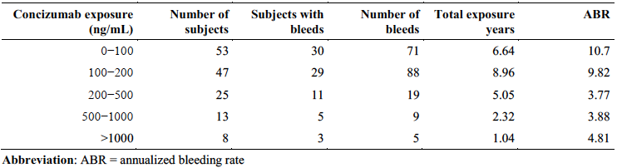

ABR = annualised bleeding rate

As exposure had been at the higher end of the range of exposures for two of the three cases in which thromboembolic events occurred, the upper cut-off of 4000 ng/mL was chosen as a precaution to avoid exposures which were consistently much higher than 4000 ng/mL. The measurement is taken at 4 weeks and steady state is not reached until around Week 24, so the levels would be expected to continue to rise past 4000 ng/mL if the dose wasn’t adjusted. In presenting their rationale, the sponsor stated that they do not consider it necessary for an individual patient to be within the range of 200 to 4000 ng/mL at all time points, that is, the range of 200 to 4000 ng/mL is not considered a target range per se, and they do not consider concizumab exposure outside this range to be risky. In subjects with concentrations greater than 4000 ng/mL at Week 4 the sponsor proposes that the selected maintenance dose should be 0.15 mg/kg.

Other parameters (free TFPI, bleeds, d-dimers and prothrombin fragment 1+2) were also considered for biomarkers for adjustment of the concizumab maintenance dose but were found to add complexity while not substantially contributing to increasing patient safety.

Modelling of dosing using the pre-pause versus post-pause approaches to maintenance dosing illustrates the expected effect on the population PK (Figure 7).

Figure 7: Simulated exposure with pre-pause (A) and post-pause (B) approaches to maintenance dosing

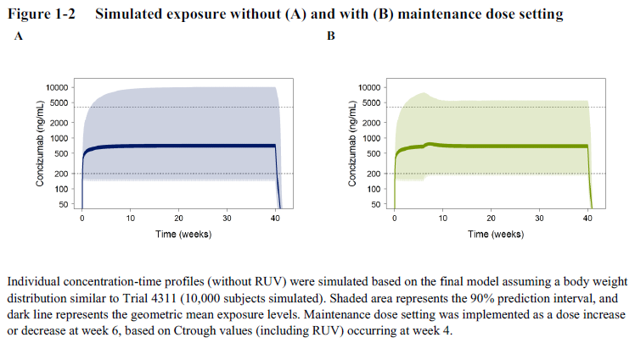 Individual concentration-time profiles (without residual unexplained variability [RUV]) were simulated based on the final model assuming a body weight distribution similar to Trial 4311 (10,000 subjects simulated). Shaded area represents the 90% prediction interval, and dark line represents the geometric mean exposure levels. Maintenance dose selection was implemented as a dose increase or decrease at week 6, based on Ctrough values (including RUV) at Week 4.

Source: Figure 1-2 from population PK report VV-CLIN-141447, dated 14 June 2022.

The pivotal trial did not include study of additional ‘catch-up’ doses of concizumab in case of missed doses, or dose interruption (for example, for major surgery these patients were excluded from the study).

#### Efficacy

##### Study 4311 (explorer7) – pivotal Phase III RCT

###### Explorer7 study design

Demonstration of the efficacy of concizumab for the proposed indication relies on data from Study 4311, also known as ‘explorer7 trial’. Study 4311/explorer7 trial is an ongoing, Phase III, partly randomised, open label trial that enrolled patients with HAwI or HBwI into one of four arms.

For the purposes of the regulatory decision, the main efficacy data come from the randomised comparison (Arms 1 and 2), whilst Arms 3 and 4 mainly contributed to safety considerations. The study design is summarised in Figure 8 and eligibility criteria are summarised in Table 5.

* Arms 1 and 2 included subjects who were currently receiving on-demand treatment for bleeds. Subjects were randomised (1:2) to receive either ongoing on-demand treatment (Arm 1) or prophylaxis (PPX) with concizumab (Arm 2).
* Arm 3 included subjects who had been treated with concizumab PPX in an earlier Phase II trial (Study 4310/explorer4). All these subjects continued treatment with concizumab PPX.
* Arm 4 included subjects who were either:
  + currently receiving prophylaxis with by-passing agents; or
  + currently receiving on-demand treatment for bleeds but were screened for enrolment at a timepoint where the required number of patients in Arms 1 and 2 had already been randomised.

Figure 8: Study 4311 schematic of trial design

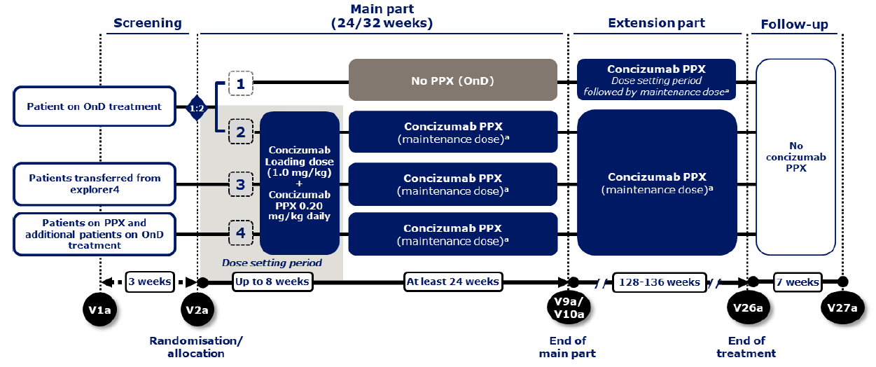

Abbreviations: OnD = on demand, PPX = prophylaxis, V = visit.

Note: a The individual maintenance dose will be either 0.15, 0.20 or 0.25 mg/kg concizumab. Explorer4 = trial 4310.

Subjects were enrolled from a total of 70 centres in 26 countries. The study commenced on 21 October 2019. The submitted CSR is dated 23 June 2022 and has a data cut-off date of 27 December 2021.

Patients eligible for Arms 1 or 2 were randomised 1:2 to either continue on their existing on‑demand treatment (Arm 1), or to instead received concizumab PPX in Arm 2. Randomisation was stratified by haemophilia subtype (HAwI versus HBwI) and by bleeding frequency during the 24 weeks prior to screening (less than 9 bleeding episodes versus 9 or more bleeding episodes).

The total study duration for each patient was 160 weeks and consisted of two parts: the main part (24 weeks) and an extension part (the remainder, during which all patients received concizumab PPX). The submitted CSR only provided efficacy analyses for the main part of the study, but descriptive data for the control arm was included in efficacy data tables for the extension part (see Explorer7 results).

Table 5: Summary of design of explorer7

|  |  |  |  |  |
| --- | --- | --- | --- | --- |
|  | Arm 1 | Arm 2 | Arm 3 | Arm 4 |
| **Eligibility** | Currently receiving on-demand treatment for bleeds i | | Received concizumab PPX in Phase II study 4310 (explorer4) | Either currently receiving PPX with bypassing agents; or eligible for arms 1&2 but they were full. |
| **Key common inclusion/ exclusion criteria** | Included:   * Consenting, compliant males at least 12 years old * Body weight >25 kg at screening * Congenital haemophilia A or B of any severity, with documented history of inhibitor (≥ 0.6 BU). * Patient has been prescribed, or in need of, treatment with bypassing agents in the last 24 weeks prior to screening (for patients not previously enrolled in study 4310).   Excluded:   * Renal or hepatic impairment, platelets ≤100 x109 * Thromboembolic disease ii * Risk of thromboembolic disease iii * Prior emicizumab within 180 days * Ongoing or planned Immune Tolerance Induction treatment | | | |
| **Randomisation ratio** | 1 | 2 | N/A | N/A |
| **Treatment** | Continue on-demand treatment iv | Concizumab PPX | Concizumab PPX | Concizumab PPX |
| **Prohibited treatment** | The following medicines were prohibited during the trial:   * Heparin (except for sealing of central venous access ports according to local practice) * Vitamin-K antagonists * Direct oral anti-coagulants (DOACs) * Emicizumab * Anti-fibrinolytics, except for local/topical use. Use of single systemic doses was allowed after careful benefit-risk evaluation. | | | |

PPX = prophylaxis.

1. Either transferred from study 4322 (explorer6 – see page 39) or a patient who has ≥6 documented treated bleeds in the last 24 weeks or ≥12 treated bleeds during the 52 weeks before screening.
2. History, or current clinical signs of (or treatment for) arterial or venous thrombosis including myocardial infarction, pulmonary embolism, cerebral infarction/thrombosis, deep vein thrombosis, other clinically significant thromboembolic events and peripheral artery occlusion.
3. Patients who in the judgement of the investigator are considered at high risk of thromboembolic events. Thromboembolic risk factors could include, but are not limited to, hypercholesterolemia, diabetes mellitus, hypertension, obesity, smoking, family history of thromboembolic events, arteriosclerosis, other conditions associated with increased risk of thromboembolic events.
4. Subjects who were randomised to Arm 1 continued their existing on-demand treatment with their usual bypassing agent product – that is. this was not supplied by the sponsor.

Study pause and changes to protocol

The clinical development program, including explorer7, was paused between 16 March 2020 and 30 September 2020 (approximately 6.5 months) while a safety issue relating to thromboembolic events was investigated (see Thromboembolic events).

As a result of the investigations, changes were made to protocol recommendations regarding use of bypassing agents to treat bleeds, as well as to the concizumab dose regimen (see Study pause and changes to Phase III dosing), as summarised in Table 6. The sponsor also provided additional training to study site staff and developed new patient material. These included guidance on the need to involve investigators in decisions regarding prolonged treatment of bleeding episodes, to eliminate unnecessary prolonged dosing.

Table 6: Changes to concizumab prophylaxis dose regimen, and protocol guidance on bypassing agents before and after the treatment pause

|  |  |  |
| --- | --- | --- |
|  | Concizumab PPX dose regimen | Protocol guidance on bypassing agents |
| **Prior to the treatment pause (‘pre-pause’)** | Loading dose (Day 1):*  1.0 mg/kg SC  Maintenance dose (Day 2 onwards): **0.25 mg/kg** SC daily | Treatment of bleeding episodes was at the discretion of the investigator, in accordance with local standards, and local prescribing information for bypassing agents, with the following limits:   * For aPCC, should not exceed 50 U/kg for a single dose, or 100 U/kg within 24 hours. * For ByClot® (a plasma-derived bypassing agent containing fVIIa and FX), should not exceed 60 μg/kg for a single dose, or 90 μg/kg within 24 hours |
| **After the treatment pause (‘post-pause’)** | Loading dose (Day 1):*  1.0 mg/kg SC   * Maintenance dose (Day 2 - ~Day 28): **0.20 mg/kg** SC daily * Selected maintenance dose (Day ~29 onwards): * See Table 3.** | Protocol contains specific guidance for the treatment of mild to moderate breakthrough bleeds. Treatment of severe and life-threatening bleeds remains at the discretion of the investigator. For patients coming from a prophylaxis regimen using a bypassing agent, a wash-out period of 48 hours was required for aPCC and ByClot®.  For other factor-containing products, a wash-out period of 2 half-lives was required. |

PPX = prophylaxis  
* Subjects in arm 3 who were already on concizumab PPX did not receive a loading dose.  
**Increase to 0.25 mg/kg for patients with levels <200 ng/mL was only undertaken if there were no safety concerns as judged by the Investigator, considering laboratory parameters, clinical assessment and medical history of the patient.

Endpoints

The primary endpoint was the number of treated bleeding episodes (whether spontaneous or traumatic) during randomised treatment. These were defined in general as any bleed where a factor-containing product was administered between start and stop of the bleed, and new episodes in the same anatomical location were only counted separately if they occurred more than 72 hours after stopping treatment for the previous episode.

Treated bleeding episodes were counted, expressed as an ABR, and analysed using the statistical methods described below (See Statistical methods).

For Arm 1 – the randomised treatment duration was from randomisation (Week 0) to commencement of concizumab PPX (at least 24 weeks).

For Arm 2 – the randomised treatment duration was from the start of the post-pause concizumab dosing regimen (Week 0) to the primary analysis cut-off (at least 32 weeks).

The primary analysis cut-off was defined to be when all patients in Arm 1 had completed visit 9/9a (after which they were commenced on concizumab PPX or withdrawn) and all patients in Arm 2 had completed visit 10a (or withdrawn).

There were two key secondary endpoints: both were patient reported outcome measures, obtained from the 36-item short form health survey version 2 (SF-36v2) questionnaire. These were Arm 1 versus Arm 2 for:

* Change in SF-36v2 bodily pain score from Week 0 to Week 24; and
* Change in SF-36v2 physical functioning score from Week 0 to Week 24.

A number of other supportive secondary and exploratory outcomes (efficacy, safety, PK and PD endpoints) were explored in the study but were not alpha-controlled. These included separate estimates for HAwI and HBwI, incidence of thromboembolic events, hypersensitivity type reactions, injection site reactions and antibodies to concizumab.

Analysis populations

Two analysis populations were defined. The full analysis set (FAS) consisted of all patients as randomised (Arms 1 and 2) or allocated (Arms 3 and 4). The safety analysis set (SAS) was a subset of the FAS that excluded patients who were randomised/allocated to concizumab PPX but did not receive any doses. In the end, no patients from the FAS were excluded, so the FAS and SAS were identical. A further two exploratory populations are mentioned below (see Exploratory analyses).

Five analysis data sets were defined. In short, these were:

* In trial excluding data on initial regimen for subjects exposed to both regimens
  + post-pause data only
* On treatment
  + pre-pause and post-pause data
  + excluding time after permanent discontinuation of treatment
* On treatment without data on initial regimen (OTexIR)
  + post-pause data only
  + excluding time after permanent discontinuation of treatment
* On treatment without ancillary therapy
  + pre-pause and post-pause data
  + excluding time after permanent discontinuation of treatment
  + excluding time during which patients received factor-containing products not related to a bleed
* On treatment without ancillary therapy excluding data on initial regimen for subjects exposed to both regimens (OTwoATexIR)
  + post-pause data only
  + excluding time after permanent discontinuation of treatment
  + excluding time during which patients received factor-containing products not related to a bleed.

Sample size

Predicted ABR was 18 for Arm 1 (on-demand treatment) and 3 to 5 for Arm 2 (concizumab prophylaxis), based on earlier studies. A high level of variability in ABR is noted between studies for patients being treated on-demand (between 8 and 30). This was also seen in the observational study explorer6 (See [Study 4322 (explorer6)](#_Study_4322_(explorer6))) from which 64 patients with inhibitors transferred to pivotal trial Study 4311. A sample size of 51 was chosen, assuming withdrawal of 9, to achieve 88% power to conclude superiority with a 2-sided significance level of 5%.

Table 7: Annualised bleeding rate assumptions for inhibitor patients treated on‑demand;[34],[35],[36]

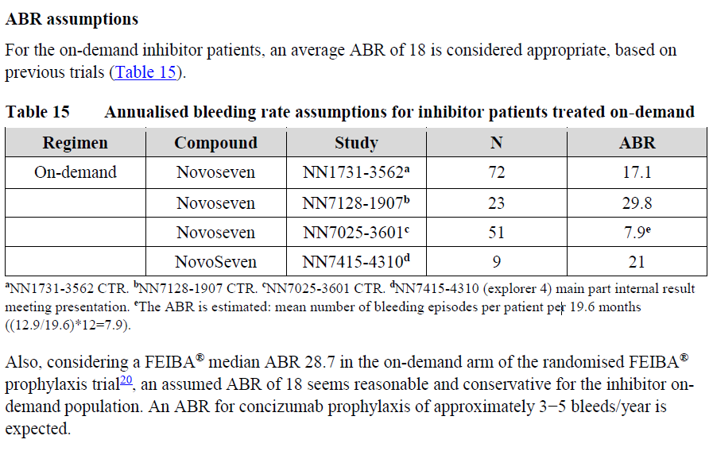

The protocol states:

‘For the on-demand inhibitor patients, an average ABR of 18 is considered appropriate, based on previous trials.

[See Table 7]

Also, considering a FEIBA median ABR 28.7 in the on-demand arm of the randomised FEIBA prophylaxis trial, an assumed ABR of 18 seems reasonable and conservative for the inhibitor on-demand population. An ABR for concizumab prophylaxis of approximately 3−5 bleeds/year is expected.’

The FEIBA prophylaxis trial is published.[37]

Statistical methods

The primary endpoint was analysed using a negative binomial regression model, offset by the logarithm of the length of the observation period (in years), and including randomised treatment regimen, type of haemophilia (HAwI or HBwI) and bleeding frequency (less than 9 or 9 or more bleeding episodes during the past 24 weeks prior to screening) as factors comparing Arms 1 and 2.

The ratio of the ABR (concizumab prophylaxis versus on-demand treatment) was estimated, with 95% confidence interval (CI). Superiority of concizumab prophylaxis over on-demand treatment would be concluded if the upper limit of the CI was below 1.

Bleeding episodes were analysed in the on treatment without ancillary therapy excluding data on initial regimen for subjects exposed to both regimens (OTwoATexIR) data set, that is, only including results obtained with the post-pause concizumab PPX regimen (that intended for registration), and excluding data collected during periods of ancillary therapy use (to exclude any efficacy benefit associated with other haemostatic medicines).

Descriptive statistics on ABR were presented for Arms 3 and 4.

The two key secondary efficacy patient reported outcome endpoints were analysed as continuous variables using a mixed model for repeated measurements with treatment, type of haemophilia (HAwI or HBwI) and bleeding frequency (less than 9 or 9 or more bleeding episodes during the past 24 weeks prior to screening) as factors, and baseline SF-36 v2 as covariates. The treatment difference at Week 24 was estimated, with the 95% CI. Superiority of concizumab prophylaxis over on‑demand treatment would be concluded if the upper limit of the CI was below 0.

Patient reported outcomes were analysed using the on treatment without data on initial regimen (OTexIR) analysis data set. The OTexIR dataset was chosen because data collected during use of the post-pause concizumab PPX regimen were considered the most appropriate, and because no patient had a 24 week measurement under the pre-pause PPX regimen.

Hierarchical testing of endpoints (ABR 🡪 SF-36v2 bodily pain 🡪 SF-36v2 physical functioning) was used to control type I error at the 5% significance level. No adjustments for multiplicity of testing were implemented for other endpoints. No interim analyses were planned or conducted.

###### Explorer7 population characteristics

In total, there were 19 patients randomised to Arm 1 and 33 patients randomised to Arm 2. Baseline demographic data for the FAS OTexIR dataset (that is excluding subjects who only received concizumab pre-pause) (see Table 8).

Table 8: Study 4311 baseline demographics (full analysis set, on treatment without data on initial regimen dataset)

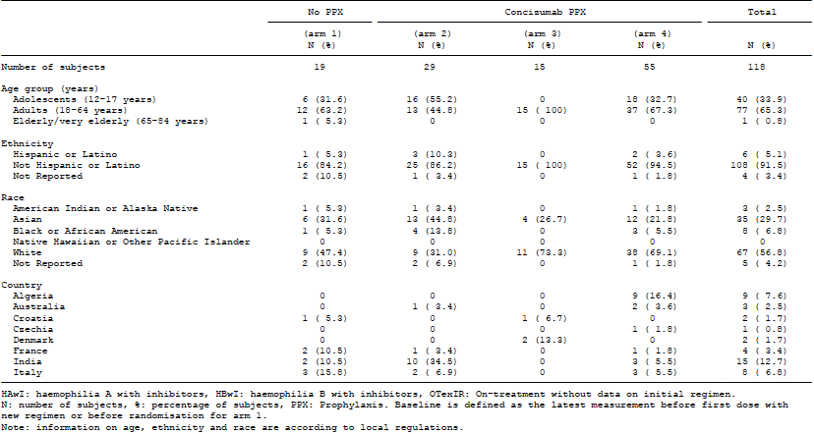

All subjects were male. Across all four arms of the study, a third of patients were adolescents, 57% were Caucasian and 30% were Asian. In keeping with the small study size, baseline demographics were not perfectly balanced by randomisation: the proportion of adolescent patients was 23% higher and the proportion of Asian patients was 13% higher in Arm 2 than Arm 1.

Baseline haemophilia details are shown in Table 9. Approximately 60% had HA and 40% had HB. The proportion of patients with HB was 12% higher in Arm 1 than Arm 2.

Table 9: Study 4311 baseline haemophilia details (full analysis set, on treatment without data on initial regimen dataset)

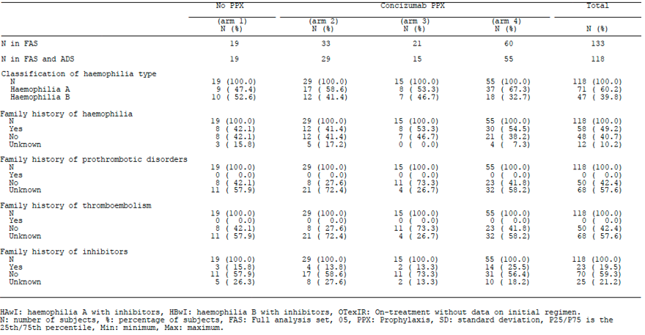

The enrolment criteria required a historical (rather than a baseline) inhibitor test with a result of at least 0.6 Bethesda units (BU), which is appropriate because it avoids excluding patients with inhibitors that have become undetectable due to lack of antigenic challenge (see Clotting factor replacement and inhibitors). The inclusion criteria also required a recent need for treatment with a bypassing agent. Historical inhibitor status and prescription of bypassing agents were confirmed through monitor review of individual medical records.

There were numerical imbalances at Baseline in inhibitor level. Inhibitor levels were to be measured at the screening visit, and results are summarised in (see Table 10). At screening, a higher proportion of subjects in Arm 1 had high-responding inhibitors (59% versus 21%). Median inhibitor concentration was 6.30 BU in Arm 1 and 1.85 BU in Arm 2.

Table 10: Study 4311 baseline inhibitor test results

|  |  |  |
| --- | --- | --- |
|  | Arm 1 (n = 17) | Arm 2 (n = 28) |
| < 0.6 BU | 4 (24%) | 9 (32%) |
| ≥ 0.6 and < 5.0 BU | 3 (18%) | 13 (46%) |
| ≥ 5.0 BU | 10 (59%) | 6 (21%) |

Information on previous inhibitor concentrations was also collected at screening. Results for the most recent inhibitor concentration prior to study entry are summarised in Table 11. The discrepancy between the two randomised arms with respect to high-responding inhibitors was less marked (62.5% versus 50%). Median values were 11.30 BU in Arm 1 and 4.85 BU in Arm 2.

Table 11: Study 4311 most recent inhibitor test result prior to study entry

|  |  |  |
| --- | --- | --- |
|  | Arm 1 (n = 16) | Arm 2 (n = 30) |
| < 0.6 BU | 3 (19%) | 2 (7%) |
| ≥ 0.6 and < 5.0 BU | 3 (19%) | 13 (43%) |
| ≥ 5.0 BU | 10 (63%) | 15 (50%) |

The Delegate commented that the numerical baseline inhibitor level imbalances are not considered of concern, as:

* The mechanism of action of concizumab is not related to inhibitor level.
* Given that this is already a selected population in whom a prior inhibitor level of at least 0.6 BU is documented, the baseline point-in-time inhibitor level is not a reliable predictor of severity of haemophilia or ABR, so is not a clear confounder.
* The study is small, the size of each arm is small, and the numerical imbalances are in keeping with chance distribution.
* There is less numerical imbalance in most recent inhibitor concentration.

Randomisation was stratified according to the categorical number of treated bleeding events during the 24 weeks prior to screening (less than 9 versus 9 or more). Baseline bleeding history is shown in Table 12. The two arms were well balanced with respect to this measure of bleeding history, in keeping with stratification at this cut-off. More detailed data on bleeding history (for example, the actual number of bleeds experienced by each subject) was not collected. As a result, it is not possible to assess whether Arm 1 and Arm 2 were comparable at Baseline with respect to recent bleeding rate as a continuous variable.

Table 12: Study 4311 bleeding history

|  |  |  |
| --- | --- | --- |
|  | Arm 1 (n = 19) | Arm 2 (n = 33) |
| < 9 bleeding episodes* | 7 (37%) | 10 (30%) |
| ≥ 9 bleeding episodes* | 12 (63%) | 23 (70%) |

* Treated bleeding episodes in the 24 weeks prior to study entry

Prior PPX had only been used by 1 patient (6%) in Arm 1 and 3 patients (11%) in Arm 2, preventing meaningful comparison of ABR in those arms during prior periods of PPX. On‑demand treatment at any time in the past had been used by all patients in Arm 1 and most (96% of) patients in Arm 2: most commonly Feiba or recombinant fVIIa. The mean (standard deviation (SD)) [range] ABR while using on-demand treatment was 12 (14) [-10, 38][38] in Arm 1 and 24 (27) [0.3, 124] in Arm 2. This suggests that, if anything, patients in Arm 2 had more frequent bleeds during historical on-demand treatment.

The Delegate commented that without being able to review the actual (rather than categorical) number of bleeds during the 24 weeks prior to screening for the randomised study, it is impossible to verify that the arms were reasonably balanced at baseline for this measure, which is clearly a potential confounder. This is a major limitation to the validity of the primary analysis. The historical data on bleeding frequency provides some reassurance that the results of the randomised comparison are unlikely to be explained by vastly different baseline disease severity/bleed frequency.

###### Explorer7 results

Primary efficacy endpoint

Results for the primary endpoint in the full analysis set (FAS) and in subgroups based on type of haemophilia (based on the on treatment without ancillary therapy excluding data on initial regimen for subjects exposed to both regimens (OTwoATexIR) dataset) are summarised in Table 13. Superiority of concizumab prophylaxis over on-demand treatment was concluded on this basis.

A bleed that required treatment occurred in 89.5% of Arm 1 (167 bleeds across 17 patients) and 45.5% of Arm 2 (59 bleeds across 15 patients). Recombinant fVIIa was the most common treatment agent, and mean rfVIIa consumption per bleed was comparable in the two arms (336.5 versus 305.3 μg/kg per bleed respectively).

Table 13: Key results of Study 4311 (explorer7)

|  |  |  |  |  |  |  |
| --- | --- | --- | --- | --- | --- | --- |
|  | FAS | | HAwI | | HBwI | |
| **Arm** | 1 | 2 | 1 | 2 | 1 | 2 |
| **Treatment** | OND | C-PPX | OND | C-PPX | OND | C-PPX |
| **n** | (n=19) | (n=33) | (n=9) | (n=18) | (n=10) | (n=15) |
| **ABR** | 11.8 | 1.7 | 18.3 | 1.6 | 7.2 | 2.2 |
| **95% CI for ABR** | 7.0, 19.9 | 1.0, 2.9 | 10.2, 32.9 | 0.9, 2.8 | 2.6, 20.1 | 0.8, 6.5 |
| **ABR ratio** | 0.14 | | 0.09 | | 0.31 | |
| **95% CI for ratio** | 0.07, 0.29 | | 0.04, 0.18 | | 0.07, 1.36 | |
| **p value\*** | <0.001 | | <0.001* | | 0.12* | |

ABR = annualised bleeding rate estimate based on negative binomial regression analysis (see Statistical methods); CI = confidence interval; C-PPX = concizumab prophylaxis; FAS = full analysis set; HAwI = haemophilia A with inhibitors; HBwI = haemophilia B with inhibitors; n = number of patients; OND = on-demand treatment; OTwoATexIR = on-treatment without ancillary therapy excluding data on pre-pause regimen for subjects exposed to both the pre‑pause and the post-pause regimen.

Sensitivity analyses

Sensitivity analyses were conducted of the primary analysis as follows:

1. Including patients who received only pre-pause treatment (using multiple imputation to predict their bleeding rate on post-pause treatment), with a resulting ABR ratio (95% CI) of 0.14 (0.07, 0.29)
2. Including bleeding data from the pre-pause period for all patients, with a resulting ABR ratio (95% CI) of 0.14 (0.07, 0.29)
3. Including in the model an interaction term between treatment and a factor differentiating between subjects randomised before and after the pause:
   1. For subjects randomised before the treatment pause, the estimated ABR ratio (95% CI) was 0.16 (0.08, 0.35)
   2. For subjects randomised after the pause, the estimated ABR ratio (95% CI) was 0.06 (0.01 to 0.42)
4. A tipping point analysis, modelling an increasing bleeding rate in subjects who only received the pre-pause regimen, until the loss of a conclusion of superiority. A further 25 bleeds would be required for this to have occurred.

These analyses support the robustness of the primary result, in light of the study interruption and the high discontinuation rate (25 patients withdrew or discontinued from arms 1 to 4 before the analysis cut-off).

Exploratory analyses

Data from the extension period for Arm 1 was included in the study report. For patients in Arm 1, who were randomised to continue their existing on-demand treatment, the mean (SD) [range] ABR was 18.4 (24.7) [0.0, 94.7] (n = 19) during their randomised treatment (n = 19). For 13 of the 19 patients in Arm 1, who had continued into the extension part of the study and received concizumab PPX at the time of data cut-off, the mean (SD) [range] ABR was 2.1 (1.9) [0.0, 4.7].

Additional descriptive, non-randomised, analyses comparing intra-patient data between periods of on-demand treatment and periods during which the same patients received concizumab PPX were provided at the regulator’s request for:

* 21 patients who were subjects in Study 4322 (and thus observed during their existing on‑demand therapy), and who were subsequently transferred into explorer7 and randomised to Arm 2 (the intra-patient analysis set 2 population in Table 14)
* 24 patients who were randomised to Arm 2 in explorer7 and received the pre-pause regimen, then ceased concizumab treatment (and returned to their prior on-demand treatment) during the treatment pause and then restarted concizumab treatment after the treatment pause, at the post-pause dose (the analysis data set population in Table 15)

Results of the exploratory intra-patient analyses are summarised in Table 14 and Table 15. Whilst exploratory, these analyses are consistent with the primary finding that a treatment effect exists.

Table 14: Exploratory intra-patient analyses of annualised bleeding rate before versus after initiation of concizumab prophylaxis (intra-patient analysis set population)

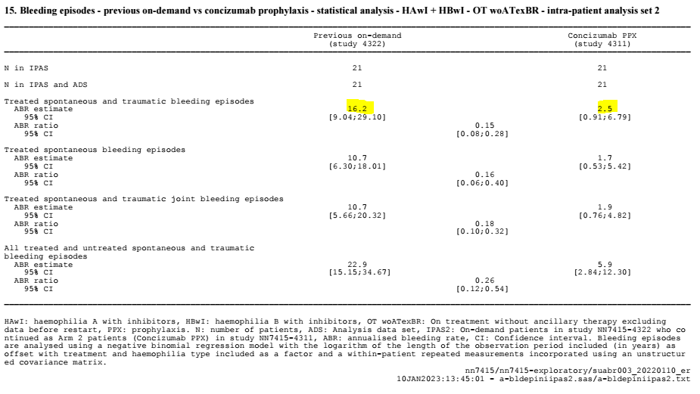

Table 15: Exploratory intra-patient analyses of annualised bleeding rate before versus after initiation of concizumab prophylaxis (analysis data set population)

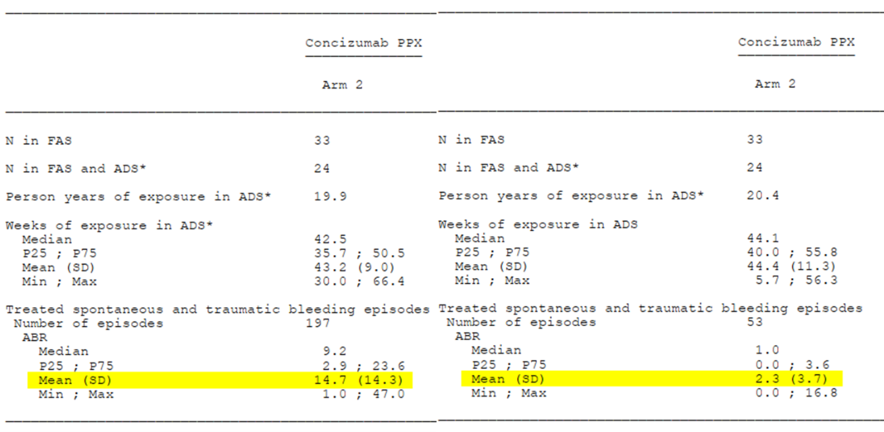

Key secondary endpoints

Patient reported outcome survey completion rates were low, leading to substantial missing data, particularly in Arm 1. No statistically significant difference was demonstrated between Arm 1 and Arm 2 for either of the key secondary endpoints. There was inconsistency between the Phase III study (Study 4311) and the Phase II study (Study 4310) in terms of the results obtained for the 36-item short form health survey. These endpoints are not considered to meaningfully contribute to the regulatory decision.

##### Other efficacy studies

###### Study 4310 (explorer4)

This was an international, multi-centre, Phase II, randomised, open label study in HAwI and HBwI which was completed in January 2020, and has been published.33, [39]

This study had similar eligibility to Arms 1 and 2 of explorer7 (see Table 5), but only included adults, and required a history of high-titre inhibitors (5 BU or greater; whilst eligibility for explorer7 accepted 0.6 BU or greater).

A study schema is shown in Figure 9. For the main part of the study, subjects were randomised 1:2 to receive either on-demand treatment with rFVIIa (supplied by the sponsor) (n = 9), or concizumab PPX (n = 17). In the extension part, all subjects received concizumab PPX.

Concizumab was given at:

* A loading dose of 0.5 mg/kg SC on Day 1.
* A maintenance dose of 0.15 mg/kg SC daily commencing on Day 2. This dose could be increased to 0.20 mg/kg and then to 0.25 mg/kg in the event of frequent bleeds (3 or more spontaneous bleeds in the preceding 12 weeks).

Figure 9: Study design of explorer4

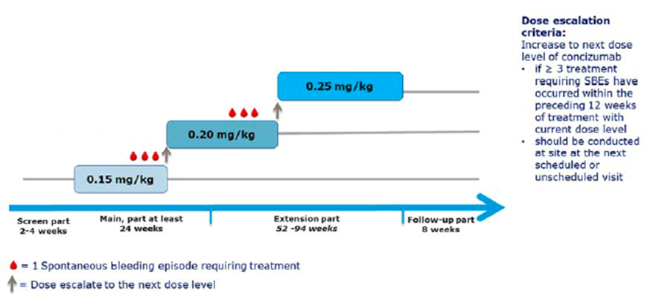

Dosing was not escalated beyond 0.25 mg/kg. Those who continued to have frequent bleeds at this dose level were to be discontinued from the study. There was no provision for dose reduction.

Breakthrough bleeding episodes occurring after Day 1 were treated with rFVIIa in both arms. Guidance was provided in the protocol for the treatment of breakthrough bleeds.

The following medicines were prohibited during the trial:

* Heparin (except for sealing of central venous access ports according to local practice).
* Vitamin-K antagonists.
* Direct oral anti-coagulants.
* Anti-fibrinolytics, except for local/topical use. Use of single systemic doses was allowed after careful benefit-risk evaluation.
* Home treatment with activated prothrombin complex concentrates (between Week 0 and Week 24).

A total of 26 subjects with a mean age of 37 years were randomised, 17 to concizumab and 9 to on-demand treatment with rfVIIa. Sixteen subjects had HAwI, and 10 subjects had HBwI. All had severe haemophilia. All subjects were receiving an on-demand treatment regimen at enrolment, with a mean ABR of 23. Four subjects had received prophylaxis in the preceding 12 months.

One subject (in the on-demand arm) withdrew during the main part of the study.

In the main part, patients randomised to concizumab mostly (88%) remained on 0.15 mg/kg; two patients (12%) escalated to receive 0.20 mg/kg.

The estimated ABR during the main part of the study (not including a 2 week run-in period after starting concizumab) was 5.4 in the concizumab arm and 20.6 in the on-demand arm. The estimated ABR ratio was 0.26 (95% CI: 0.15 to 0.44). The difference between treatment arms was statistically significant (p < 0.001).

The Delegate commented that the explorer4 trial provides supportive evidence for the efficacy of concizumab in HAwI and HBwI. The study also provides data on longer-term efficacy, with bleeding rates after at least 76 weeks of treatment remaining similar to those observed after 24 weeks of treatment. Randomisation was not stratified according to haemophilia type (HAwI versus HBwI) and no analyses for haemophilia subgroups were presented. Bleeding rates in this study were higher than those observed in the pivotal study, both for on-demand subjects and subjects treated with concizumab (see Table 16). This may reflect differences in entry criteria and dosage regimens.

Table 16: Annualised bleeding rates across studies, groups in which patients with haemophilia A with inhibitors or haemophilia B with inhibitors received concizumab prophylaxis are highlighted yellow, bold text indicates randomised groups

|  |  |  |  |
| --- | --- | --- | --- |
| Population | # patients | ABR | 95% CI |
| **explorer7 Arm 1 (on-demand bypassing agents)** | **19 (HAwI & HBwI)** | **11.8** | **7.0, 19.9** |
| **explorer7 Arm 2 (concizumab PPX)** | **33 (HAwI & HBwI)** | **1.7** | **1.0, 2.9** |
| explorer6 HAwI (on-demand)* | 35 (HAwI) | 14.3 | 10.6, 19.3 |
| explorer6 HBwI (on-demand)* | 14 (HBwI) | 9.8 | 5.2, 18.3 |
| explorer6 HAwI (bypassing agent prophylaxis)* | 18 (HAwI) | 10.0 | 6.6, 15.1 |
| explorer6 HBwI (bypassing agent prophylaxis)* | 17 (HBwI) | 12.7 | 7.5, 21.8 |
| explorer5 (concizumab PPX, highest dose time only) | 36 (HA) | 7.0 | 4.6, 10.7 |
| explorer5 (concizumab PPX, all doses) | 36 (HA) | 13.9 | 9.5, 20.3 |
| **explorer4 (on-demand rfVIIa)** | **9 (HAwI & HBwI)** | **20.6** | **13.7, 30.8** |
| **explorer4 (concizumab PPX)** | **17 (HAwI & HBwI)** | **5.4** | **3.8, 7.6** |
| Novo Nordisk internal study NN1731-3562 (on-demand rfVIIa or vatreptocog alfa) | 72 (HAwI & HBwI) | 17.1 |  |
| Novo Nordisk internal study NN7128-1907 (on-demand rfVIIa) | 23 (HAwI & HBwI) | 29.8 |  |
| Novo Nordisk internal study NN7025-3601 (on-demand rfVIIa) | 51 (HAwI & HBwI) | 7.9 |  |
| FEIBA NF prophylaxis trial (on-demand FEIBA NF)37 | 19 (HAwI & HBwI) | Median 28.7 | IQR 32.3 |

*The explorer6 population was not mutually exclusive with that of explorer7.

###### Study 4255 (explorer5)

This was an open label, single arm, Phase II study of concizumab PPX in subjects with HA without inhibitors. The design of the study was essentially the same as that used for the concizumab arm in explorer4.

Inclusion and exclusion criteria were similar to those employed for explorer4 with the following exceptions:

* Explorer5 only enrolled subjects with severe haemophilia A (fVIII activity less than 1%) without inhibitors. Subjects with haemophilia B were not eligible.
* Subjects could be receiving either a prophylaxis regimen or an on-demand regimen at Baseline. Patients being treated with on-demand FVIII replacement therapy were required to have a minimum of six documented and treated bleeding episodes during the 24 weeks (or twelve bleeds during the 52 weeks) prior to screening.
* Subjects with inhibitors to fVIII (0.6 BU or greater) at Baseline, or a history of such were excluded.
* Subjects receiving ITI therapy were eligible.
* Decreased antithrombin activity at Baseline was not an exclusion criterion.

The concizumab dosing regimen was the same as that used for explorer4 except that a loading dose was not administered. The criteria for dose escalation were the same as those used in explorer4.

Breakthrough bleeding episodes were treated with recombinant fVIII (turoctocog alfa), with dosage at the discretion of the investigator. Prohibited medicines were essentially the same as those specified for explorer4. Modified fVIII products with an extended half-life were also prohibited.

A total of 36 subjects with a mean age of 37 years were enrolled and treated. Four subjects withdrew while in the main part of the study. Thirty-one subjects had received a prophylactic regimen in the previous 12 months and 10 had received on-demand therapy (some subjects had received both). Mean ABR while on prophylaxis had been 5.2. Mean ABR while on on-demand therapy had been 17.5.

Of the 36 patients treated with concizumab in the main part, 58% stayed on 0.15 mg/kg, 19% escalated to receive 0.20 mg/kg and 22% escalated to receive 0.25 mg/kg.

The estimated ABR during concizumab treatment (not including a 2 week run-in period after starting concizumab) was 13.9 (95% CI: 9.5, 20.3). However, the estimated ABR during the period of highest dose level of concizumab treatment (not including the 2 week run-in period) was 7.0 (95% CI: 4.6, 10.7). According to the report, a value of 12 bleeds per year had been selected as the upper confidence bound for a clinically meaningful difference, based on a conservative estimate of bleeding rate during on-demand therapy, which in previous trials typically had been reported to be above 30 bleeds per year.

The Delegate commented that the ABR on concizumab treatment in this study are the same as ABRs seen in patients using on-demand treatment in studies used for sample size calculation for the pivotal trial. This emphasises the poor utility of ABR as an endpoint for conducted any non‑randomised comparison. It is clear that cross-study comparisons are fraught. Whether intra-patient comparisons (over differing time periods) are similarly unreliable is less clear. This would presumably depend on how likely it is that a patient’s individual ABR should vary over time in general.

###### Study 4322 (explorer6)

This study was an international, Phase II, prospective observational study of the natural history of haemophilia in current routine clinical practice, conducted between December 2018 and October 2021 (CSR dated 1 March 2022). The objective was to observe the number of bleeding episodes over time (up to a maximum of 115 weeks) in patients with severe HA (fVIII activity less than 1%), severe or moderate HB (fIX activity 2% or less), HAwI and HBwI, receiving standard treatment.

The inclusion criteria were similar to those used for the pivotal Phase III studies (explorer7 in subjects with inhibitors and the ongoing Study 4307/explorer8 in subjects without inhibitors), including allowing enrolment of paediatric patients aged 12 to 18 years.

Inclusion criteria with specific regard to HAwI and HBwI were:

* Congenital haemophilia A or B of any severity, with a presence or history of inhibitor (0.6 BU or greater), based on medical records.
* For patients being treated with Feiba prophylaxis:
  + Two or more treated bleeding episodes within 24 weeks before screening (Visit 1). For subjects on a prophylaxis regimens with agents other than Feiba there was no requirement for a specific number of bleeding episodes prior to screening.
* For patients being treated on-demand:
  + Six or more treated (with bypassing agent) bleeding episodes within 24 weeks (or 12 or more during the 52 weeks) before screening (Visit 1).

Patients received commercially available products according to local routine clinical practice at the discretion of the treating physician. Bleeding episodes, details of coagulation factor treatment and analgesia usage were recorded. The primary endpoint was ABR.

Sample size calculations described in the report used an assumption that was considered conservative that the expected ABR for subjects with HAwI and HBwI receiving on-demand treatment would be 24 and 18, respectively. These estimates were based on previous studies of rfVIIa conducted by the sponsor, and a published study of Feiba therapy.[40]

Most (94%) of the 231 patients who enrolled completed the study. Of 84 patients with inhibitors enrolled (53 with HAwI and 31 with HBwI), 64 patients transferred to pivotal trial Study 4311. The mean age was around 28 years (range 12 to 78), 54% were Caucasian and 24% were Asian. Of 53 patients with HAwI, 18 were receiving PPX. Of 31 patients with HBwI, 17 were receiving PPX.

Annualised bleeding rate (ABR) estimates were:

* 14.3 for HAwI receiving on-demand treatment (n = 35)
* 9.8 for HBwI receiving on-demand treatment (n = 14)
* 10.0 for HAwI receiving prophylaxis (n = 18)
* 12.7 for HBwI receiving prophylaxis (n = 17)

For HAwI and HBwI combined, the estimated ABR was 13.2 in patients treated on-demand.

The Delegate commented that as 64 of the patients in this group transferred to the pivotal study and could be eligible for randomisation, this does not represent a discrete comparator population.

The study report noted that the observed ABR for HBwI subjects receiving on-demand treatment was lower than expected. Based on disease history for these patients, their mean (SD) ABR during prior on-demand treatment (not during the period of the observational study) was 18 (8) in the HBwI on-demand group, 24 (32) in the HAwI on-demand group, 79 (91) in the HAwI PPX group, and 30 (25) in the HBwI PPX group.

The Delegate commented that the rate of bleeding was paradoxically much higher for one group of 18 patients on prophylaxis (ABR 79) than when they were treated on-demand (ABR 10). This raises questions about the reliability of the data, or possibly emphasises the variability that can be seen between time periods for a single group of patients and how easily such data might be confounded.

###### Compassionate use programs

The submission included a report on subjects who received concizumab on a compassionate use basis. Efficacy data from this report does not contribute significantly to the regulatory decision.

#### Safety

##### Exposure

All seven submitted clinical trials (four Phase I, two Phase II and one Phase III) provided evaluable safety data. A total of 243 subjects received concizumab across the seven studies.

Across the Phase II (explorer4 and explorer5) and Phase III (explorer7) studies, a total of 167 unique patients with haemophilia received approximately 225 patient years of exposure: 148 subjects were exposed to concizumab for at least 6 months, 90 subjects were exposed for more than 12 months, and 45 subjects were exposed for more than 24 months.

In the pivotal Phase III study, 127 subjects (76 with HAwI and 51 with HBwI) were exposed to concizumab for a total of 111.8 patient years of exposure. One patient received the 0.15 mg/kg maintenance dose, 72 patients received the 0.20 mg/kg maintenance dose, and 24 patients received the 0.25 mg/kg maintenance dose.

In the main part of explorer7, exposure was around ten times longer in patients receiving concizumab (Arms 2 to 4 combined: 102.5 patient years) compared to those who did not (Arm 1: 12 patient years). As a result, direct comparison of adverse event incidences between arms may be confounded by observation time bias. The tables presented by the sponsor therefore provided both raw incidences and event rates (number of events per patient year of exposure).

Safety evaluations were conducted using the on treatment and OTexIR datasets, as this was considered by the sponsor to be the ‘on-treatment’ time period during which patients were considered to be exposed to concizumab. This included safety data for the first 7 weeks after the treatment pause but did not include data from the date of cessation of treatment if a patient discontinued treatment during the study. Adverse events occurring outside the on-treatment period were reviewed and not found to add meaningfully to the safety data for concizumab.

The OT dataset is considered the most comprehensive dataset, as it includes data from both the pre-pause and post-pause period, and analyses from explorer7 discussed below are related to this dataset unless otherwise stated.

##### Adverse events

In explorer7, an adverse event of any grade was reported in 66% of 114 subjects treated with concizumab (Arms 2 to 4 combined) and 42% of 19 subjects in Arm 1 (n = 19). The event rate for adverse events was 3.3 adverse events per patient years of exposure with concizumab and 2.1 adverse events per patient years of exposure with on-demand treatment.

The most common adverse events reported with concizumab (Arms 2 to 4 combined), and which occurred with a higher event rate than Arm 1, were:

* Arthralgia
* Injection site erythema
  + There were 41 various injection site adverse events in 21 separate subjects.
* Prothrombin fragment 1+2 increased (also in explorer5)
* D-dimer increased (also in explorer5)
* Headache (also in explorer5)
  + The 12 events of migraine were all reported by the same subject.

Adverse events that occurred with an incidence of at least 5% in other studies, and with a higher event rate that a comparator arm, if present, were:

* Injection site haematoma (explorer4)
* Injection site haemorrhage (explorer4)
* Injection site bruising (explorer5)
* Nasopharyngitis (explorer4 and explorer5)

###### Laboratory abnormalities

There was no convincing evidence of hepatotoxicity or renal toxicity. Decreases in platelet count below the lower limit of normal were reported commonly across explorer4, explorer5 and explorer7. However, these were generally assessed as not clinically significant (one case of thrombocytopaenia in explorer5 was assessed as being clinically significant and was reported as an adverse event). Consistent with the pharmacodynamic parameter findings, increased d‑dimer, increased prothrombin fragment 1+2 and decreased fibrinogen were more common in the concizumab treatment arms of explorer7. Increased d-dimer was also seen in explorer5, and increased prothrombin fragment 1+2 was seen in all three studies.

##### Deaths, serious adverse events and discontinuation-related adverse events

###### Deaths

A total of four deaths were reported in patients receiving concizumab in explorer7, three of which occurred while ‘on treatment’. Briefly, these were:

* A patient with HBwI in Arm 2 presented with a cough after approximately 18 months on concizumab. They tested positive to COVID-19 and died approximately 3 weeks later due to respiratory complications of COVID-19 infection.
* A patient with HBwI in Arm 2 was involved in a road traffic accident and sustained a fractured femur and humerus. They were treated with four ‘injections’ of rFVIIa (NovoSeven). The subject’s condition was described as stable on the following day. Nineteen days after the accident the subject suddenly deteriorated. They were ventilated in the intensive care unit and were noted to have low blood pressure. They died the same day. An autopsy was performed but the results were not available.

The Delegate commented that very few clinical details were provided in the case narrative for this death. The road traffic accident occurred at a long distance from the study site, and the patient was therefore not admitted to the study site hospital but to a hospital closer to where the accident had occurred. The trial investigator had not been able to retrieve more details on the cause of death (including the autopsy report) from the other hospital. The sponsor had attempted on multiple occasions to retrieve further information on the course of the event.

The subject had been treated with concizumab prior to the study pause (approximately 2 months). Treatment was recommenced after the study pause. The subject narrative supplied stated that treatment was ‘ongoing’, which implies that the subject had been on treatment for approximately 6 weeks at the time of death. The sponsor subsequently stated that it was unknown whether treatment with concizumab was continued until the patient died.

The subject was hospitalised for a fractured femur and was therefore at risk of deep venous thrombosis/pulmonary embolus. The sudden deterioration and death, at approximately 2 to 3 weeks after the event, suggest that the event may have been related to a thromboembolic event (for example, pulmonary embolus).

The sponsor considered that the event was unlikely to be related to concizumab. However, based on the limited details available, and the other serious thromboembolic adverse events reported with concizumab the Delegate acknowledges the road trauma is a likely contributing factor, but considers that this death was possibly related to concizumab.

The two other deaths occurred during the treatment pause in subjects who had previously been treated with concizumab.

* A patient with HBwI developed a series of adverse events commencing approximately 3.5 months after ceasing concizumab. These were: haematuria with clots resulting in obstructive renal dysfunction, a haematoma involving the neck and floor of the mouth requiring tracheostomy due to respiratory compromise (at which point eptacog alfa was given), retinal vascular occlusion, an iatrogenic thrombosis of the inferior vena cava and a retroperitoneal haematoma and haemoperitoneum. These events all occurred within a one month period. The subject died on the day of the retroperitoneal haematoma/haemoperitoneum.
* A patient with HBwI died from gastrointestinal bleeding approximately 6 months after ceasing concizumab. The subject had a previous history of gastrointestinal bleeding prior to entry into the study.

The Delegate commented that the duration between cessation of concizumab and these deaths make a causal relationship less likely.

There were no reported deaths in explorer4 or explorer5.

###### Serious adverse events

In explorer7, in subjects treated with concizumab (Arms 2 to 4 combined) serious adverse events were reported in 12.3% of subjects compared with 15.8% of subjects in Arm 1. The event rate for adverse events was lower with concizumab (0.2 versus 0.4 serious adverse events per patient years of exposure).

There were two cases of COVID-19 infection among concizumab treated subjects. All other serious adverse events occurred in single subjects only and included a case of renal infarction in a patient with Prader-Willi syndrome (one of three cases of thrombosis that led to study pause) and a case of hypersensitivity, both of which led to treatment discontinuation.

There were no notable serious adverse events in explorer4 or explorer5.

###### Permanent discontinuations

In explorer7, the following cases occurred in which concizumab was permanently discontinued due to an adverse event:

* COVID-19 (fatal) in a patient with HBwI on study Day 553 during the extension period (Arm 2).
* Renal infarct in a patient with HBwI on study Day 21, prior to treatment pause (Arm 2).
* Hypersensitivity in a patient with HBwI on Day 18 during the post-pause treatment period (Arm 4).
* Congestive cardiomyopathy in a patient with HAwI on study Day 4, prior to treatment pause (Arm 3).

The case of congestive cardiomyopathy leading to discontinuation occurred in a patient with HAwI and complex medical history, including diffuse large B-cell lymphoma, hepatitis B and C, splenectomy and congestive cardiomyopathy requiring furosemide, carvedilol, ramipril and eplerenone. Decompensation of his cardiomyopathy first occurred on-study whilst enrolled in explorer4 (Study 4310), receiving on-demand treatment (that is, not receiving concizumab). They were first exposed to concizumab 5 months later with a loading dose of 0.5 mg/kg followed by 0.15 mg/kg daily, which was then escalated to 0.20 mg/kg daily around 10 months later. Another adverse event of decompensated dilated cardiomyopathy occurred after 477 days of concizumab PPX and 191 days after the daily dose was increased to 0.20 mg/kg. This event was non-serious, managed with higher doses of furosemide, and recovered without changes in concizumab treatment. Later that month, the patient was screened for participation in trial Study 4311 and the dose of concizumab was increased to 0.25 mg/kg daily as per the protocol. Four days later, another non-serious moderate adverse event of suspected worsening of decompensated dilated cardiomyopathy occurred. The patient continued concizumab PPX for a further 20 days until the drug was permanently discontinued due to the adverse event. They didn’t receive new treatment for the cardiomyopathy until a couple of weeks later, when they were commenced on sacubitril, valsartan, bisoprolol and higher doses of furosemide. The adverse event was reported as ‘recovering’/’resolving’ and the patient continued participating in trial follow-up for about another year. The reason for trial withdrawal is stated in the ‘end of trial’ form as ‘patient not willing to participate in trial.’

There were no discontinuations due to adverse events in explorer4 or explorer5.

##### Adverse events of special interest

###### Thromboembolic events

The clinical trials program for concizumab was paused between 16 March 2020 and 30 September 2020 (approximately 6.5 months) following reports of thromboembolic events (5 events) in three subjects in Phase III trials.

At the time of the pause, 130 patients had received concizumab in the Phase III studies, in which the 0.25 mg/kg maintenance dose was being given to all patients randomised to concizumab. There were no thromboembolic adverse events in the two Phase II studies in which all subjects commenced on a maintenance dose of 0.15 mg/kg SC daily, and increases in dose up to 0.25 mg/kg daily were only undertaken in subjects demonstrating lack of efficacy.

Three cases leading to treatment pause

* Case 1: Concizumab treatment for 58 days. Approximately 30 minutes before the symptoms of myocardial infarction, the patient treated a knee joint bleed with 67 IU/kg FVIII (Advate). Assuming an incremental recovery of close to 2%, as for most regular rFVIII products, a dose of 67 IU/kg would expectedly increase FVIII plasma activity to approximately 134%, which is just below normal upper range (50 to 150%).
* Case 2: Concizumab treatment for 21 days. The patient experienced a renal infarction and had treated a wrist bleed with NovoSeven using one dose of 89 μg/kg , three doses of 89 μg/kg (every 8 hours) and three doses of 130 μg/kg (every 8 hours).
* Case 3: Concizumab treatment for 86 days. The patient received the first concizumab dose and used Advate almost every day during the trial (except on three days), since they felt joint bleeds. The first thrombotic event was deep vein thrombosis, and the subsequent two events were pulmonary embolism and median vein thrombosis.

All three subjects had some risk factors for thromboembolic disease at Baseline and had been treated for breakthrough bleeds just before onset of the thromboembolic adverse event. In Case 2 and Case 3, high doses or prolonged treatment had been administered.

Concizumab plasma concentrations were high in two subjects (Case 1 and Case 3) around the time of the adverse event. In these two subjects, free TFPI concentrations were below the limit of quantification.

D-dimer levels were elevated in all three cases, and concentrations of prothrombin fragment 1+2 were similarly so. There were no abnormalities in fibrinogen concentrations or antithrombin activity.

The following additional investigations were performed:

1. As no thromboembolic adverse events were observed in the Phase II studies, an analysis was conducted on the prevalence of risk factors at Baseline across the Phase II and Phase III studies. Two categories of risk factors were analysed, cardiovascular risk factors and inflammatory risk factors. According to the analysis, risk factors at Baseline were not notably more common in the Phase III studies (Table 17).

Table 17: Cardiovascular and inflammatory risk factors at Baseline amongst patients who had been randomised to concizumab at time of treatment pause in the Phase II studies versus the Phase III studies

Cardiovascular and inflammatory risk factors at Baseline amongst patients who had been randomised to concizumab at time of treatment pause in the Phase II studies versus the Phase III studies

1. Using pooled safety data from all four trials, the presence of risk factors at Baseline was not associated with an increased prevalence of adverse events, or increased severity of adverse events, compared to subjects without such risk factors.
2. A series of preclinical studies were conducted examining the effects on thrombin generation of coadministration of concizumab with FVIII, FIX, rFVIIa or aPCC. These studies demonstrated that the presence in plasma of concizumab together with any of these coagulation factors resulted in additive effects on thrombin generation. The investigators concluded that in a subject receiving concizumab, a 2-fold reduction in dose of FIX, FVIII or aPCC could be implemented to treat bleeding episodes without reducing efficacy.

The Delegate commented that dose reductions of this magnitude have not been tested clinically and are not being proposed by the sponsor.

1. Data from the two Phase II studies also indicated an additive effect on thrombin generation when concizumab was administered concurrently with rFVIIa (Study 4310) or FVIII (Study 4255).

Coadministration of a bypassing agent in explorer4

In explorer4, a sub-study was incorporated of the safety of treatment with rFVIIa in patients exposed to concizumab treatment. One week after commencing concizumab, all subjects were administered a single 90 μg/kg dose of rFVIIa. The dose was administered in a non-bleeding state, at the trial site and under medical supervision.

The report stated that no adverse events were reported within 24 hours of administering eptacog alfa (rFVIIa) to concizumab treated patients at the one week visit.

The clinical relevance of this is unclear, given that testing of concizumab levels for the purpose of dose adjustment isn’t performed until 4 weeks after commencing dosing, and steady state is not reached for at least 16 weeks.

Other cardiac and vascular adverse events

In explorer7:

* A fatal adverse event occurred in a patient who was treated with anti-coagulant therapy after suffering a major road trauma. This death was possibly the result of a thromboembolic event.
* A partial thrombosis of an arteriovenous shunt (forearm) occurred 15 days after discontinuing concizumab (due to the treatment pause). The subject had commenced treatment with rFVIIa two days before the event and had started emicizumab on the day of the event. Six days later the shunt became completely thrombosed. The event was assessed as non-serious and unlikely to be related to concizumab.
* In Study 3813 (pharmacology study), a healthy volunteer who received a single dose of concizumab (1000 μg/kg SC) developed a moderate superficial thrombophlebitis in a vein on the medial aspect of the knee, 5 days after dosing. The diagnosis was confirmed on ultrasound scan.

Other events reported across explorer7, explorer5 and explorer4 were unremarkable, with hypertension the most common, occurring in four patients in explorer7 (3%).

###### Hypersensitivity

In explorer7, hypersensitivity was reported as an adverse event in three concizumab treated subjects (with a total of five events), compared with 0 subjects in Arm 1. In two subjects (two events) the hypersensitivity adverse events were assessed as being related to concizumab.

* A subject developed an injection site rash with burning and itching on Day 14 of treatment, which resolved after interruption of concizumab treatment. After recommencement of concizumab on Day 17 the subject complained of feeling unwell, fatigue and headache and was diagnosed with hypersensitivity. Concizumab was permanently discontinued. The adverse event was assessed as moderate in severity, but not serious. The subject tested negative for anti-drug antibodies.
* A subject experienced several injection site reactions in days leading up to the hypersensitivity event. Two days prior to the hypersensitivity event the subject experienced generalised itching (without a rash) 12 hours after concizumab. On the day of the adverse event the subject experienced a skin rash with generalised erythema and pruritus, a dry cough and abdominal pain. The subject was hospitalised and treated with antihistamines, intravenous steroids and intravenous fluids. The event was assessed as a serious adverse event and concizumab was temporarily discontinued. It was unclear from the adverse event report whether concizumab treatment was ever resumed. The subject tested negative for anti-drug antibodies.
* One further patient reported hypersensitivity (three events) to concizumab in explorer5. The patient reported a generalised prickling sensation, upper airway swelling and tingling of the cheeks on Days 2, 3 and 4 of concizumab treatment. The events were assessed as non‑serious and mild, and they resolved without treatment. Although the events were assessed as being related to concizumab, treatment was continued.

There were no reports of photosensitivity, erythema multiforme, Stevens Johnson syndrome, drug reaction with eosinophilia and systemic symptoms or toxic epidermal necrolysis.

###### Injection site reactions

Injection site reactions occurred in around 20% of patients in explorer7, most commonly erythema, bruising, urticaria, haematoma or haemorrhage. There were 45 mild events, three moderate events and no events that were severe or serious.

Similarly, 24% of patients who received concizumab in explorer4 and 44% of patients who received concizumab in explorer5 reported a mild injection site reaction.

##### Immunogenicity

No anti-drug antibodies were detected in healthy volunteers in the first three Phase I clinical pharmacology studies (Studies 3813, 3981 and 3986).

Immunogenicity was analysed across the four submitted interventional clinical studies in patients with haemophilia: Study 4159 (Phase I; explorer3), Study 4310 (Phase II; explorer4), Study 4255 (Phase II; explorer5) and Study 4311 (Phase III; explorer7).

Blood samples were tested for anti-drug antibodies and neutralising antibodies, as well as for whether antibodies had specificity against the complementarity determining region of concizumab or the S241P mutation.

The kinetics of anti-drug antibodies were categorised as follows:

* Transient anti-drug antibodies for 24 weeks or less: last sample was anti-drug antibody negative, and first and last anti-drug antibody positive samples (irrespective of any negative samples in between) were 24 weeks or less apart.
* Transient anti-drug antibodies for greater than 24 weeks: last sample was anti-drug antibody negative, and first and last anti-drug antibody positive samples (irrespective of any negative samples in between) were greater than 24 weeks apart.
* Persistent anti-drug antibodies for greater than 24 weeks: last sample was anti-drug antibody positive, and first and last anti-drug antibody positive samples (irrespective of any negative samples in between) were greater than 24 weeks apart.
* Kinetics unknown category: last sample was anti-drug antibody positive, and first and last anti-drug antibody positive samples (irrespective of any negative samples in between) were less than 24 weeks apart (seroconversion too proximal to data cut to conclude whether anti-drug antibody response was persistent and whether it was more or less than 24 weeks duration).

Out of the 185 patients in this integrated analysis, 47 (25%) were anti-drug antibody positive and 12 (7%) had neutralising antibodies. All anti-drug antibodies were treatment induced, with seroconversion occurring from around 12 weeks after first dose.

Most were low level titres (96%) but one patient had a medium and one had a high level titre.

Half of the anti-drug antibodies were transient (36% lasting less than 24 weeks and 17% lasting longer) whilst 11% of anti-drug antibody cases were persistent. The remaining approximate third (36%) were persistent at final cut-off but hadn’t been observed for longer than 24 weeks so were considered ‘unknown’.

Most subjects with anti-drug antibodies tested positive for antibodies against the complementarity determining region of concizumab. No subjects tested positive for antibodies against the S241P mutation.

Rates were similar between HAwI and HBwI, and between adolescent and adult subjects (anti‑drug antibodies 36% versus 22%, and neutralising antibodies 12% versus 5%, respectively).

In general, the presence of anti-drug antibodies did not appear to affect concizumab PK, free TFPI, or the occurrence of bleeding events. However, one patient with HBwI in explorer4 (Study 4310) developed high titre binding antibodies and neutralising antibodies. In this patient, inhibition of free TFPI appeared to be lost, as levels normalised. This was not accompanied by a notable spike of bleeding episodes requiring treatment or immunogenicity related adverse events, but the patient discontinued permanently in Week 72 as no therapeutic effect was suspected due to restoration of free TFPI back to Baseline. Pharmacokinetic data in this subject were not available due to anti-drug antibody interference with the PK assay.

The incidence of injection site adverse events was higher among anti-drug antibody positive patients with exposure time-adjusted rates of 0.6 per patient years of exposure compared to 0.4 per patient years of exposure for patients without anti-drug antibodies, however there was not a clear temporal association between increased rates of injection site adverse events and periods of anti-drug antibody positivity. There was no clear increase in other hypersensitivity events.

In accordance with the explorer7 study protocol, three patients were tested for anti-drug antibodies following a hypersensitivity adverse event. All three were negative.

Amongst 10 patients who received concizumab under the individual patient use (physician managed compassionate access) program, there was a second patient who developed anti-drug antibodies with neutralising antibodies in whom loss of effectiveness was reported. The development of anti-drug antibodies in this patient coincided with increased bleeding episodes.

The two cases that appear to indicate loss of efficacy with the development of anti-drug antibodies must be reflected in the Product Information. The approximate rate is considered to be 1% based on the total number of patients with haemophilia treated with concizumab across explorer4, explorer5, explorer7 and under compassionate access (n = 177).

##### Surgery

Under the revised protocol following the treatment pause, major elective surgery was not permitted during the trial. If the need for non-elective major surgery arose, it was recommended that concizumab therapy should be interrupted.

Minor surgical procedures were permitted. Concizumab therapy was to be continued during minor surgery.

* In Arm 1, there were two minor surgeries performed in one subject.
* In Arms 2 to 4, there were there were eight minor surgeries performed in seven subjects.

According to the study report the number of surgery related bleeding episodes was low and all were classified as mild or moderate.

In the draft PI, the sponsor recommends that concizumab treatment should be paused prior to major surgery and that no dosage adjustment is required in the event of minor surgery.

#### Paediatric patients

The pivotal efficacy and safety study (explorer7) included adolescent subjects (age 12 years or older). There were no data submitted from paediatric subjects aged less than 12 years.

The sponsor is conducting an ongoing open label study investigating efficacy, safety and pharmacokinetics of concizumab prophylaxis in children aged below 12 years with haemophilia A or B with or without inhibitors (Study NN7415-4616 (explorer10)). The estimated primary completion date is December 2024.[41]

#### Drug delivery device

In the pivotal study, explorer7, a prefilled pen injector (PDS290) was used. The same type of device is proposed for the products to be registered. Concizumab was to be administered into the abdomen or the thigh. Subjects were trained how to use the device. For the PK/PD visits, visits 2a and 9a, doses were administered in the clinic. All other doses were administered at home by the patient or the caregiver.

#### Companion diagnostic considerations

The current TGA guidance on companion diagnostics indicates that *in vitro* diagnostics that are intended to be used to monitor treatment with a therapeutic drug are generally not considered companion diagnostics. However, the legislated definition of companion diagnostic rests on whether the PI of the medicine indicates that the test is essential for the safe and effective use of that medicine. Guidance on the application of the legislation remains under development.

The use of a concizumab serum level test is essential for its safe and effective use, to identify the most appropriate ongoing maintenance dose, as done in the pivotal trial. Many serum level tests (such as gentamicin levels) may be considered likely to be ‘low risk’ and not needing regulation by TGA within the companion diagnostic framework due to the existing extent of usage and standardisation across Australia (being a ‘mainstream’ or ‘core’ laboratory test with standardised reference panels and extensive experience of usage demonstrating clinically acceptable interchangeability).

In this instance, however, the test proposed for usage in testing related to the proposed medicine indication is novel and not established. It is therefore considered of adequate risk level to be considered within the TGA’s companion diagnostic framework.

Review of companion testing will be conducted as a component evaluation and will consist of

1. an assessment of the analytical validity of the clinical trial assay.
2. an assessment of the analytical validity of a Randox brand CE-marked assay that the sponsor intends will allow Australian patients to use concizumab at the appropriate dose.
3. an assessment of the comparability of the Randox CE-marked assay with the clinical trial assay.

#### Real world evidence

Real world evidence was not included.

### Risk management plan

In support of this application, Novo Nordisk Pharmaceuticals Pty Ltd has submitted global risk management plan (RMP) version 1.0 (date 14 June 2022; data lock point (DLP) 10 Mar 2022) and Australia-specific annex (ASA) version 0.1 (9 August 2022). In response to the rolling questions sent to the sponsor on 19 January 2023, the sponsor provided the European Union (EU) RMP version 0.1 (date 8 December 2022; DLP 30 August 2022). In response to the rolling questions sent to the sponsor on 1 March 2023, the sponsor has provided the ASA version 0.2 (date 23 March 2023).

The sponsor has submitted another Type A application through the standard pathway for concizumab (PM-2022-03459-1-6) for the indication of haemophilia A with FVIII inhibitors (HAwI), which is currently under evaluation. The sponsor has provided identical data to support both indications.

The summary of safety concerns and their associated risk monitoring and mitigation strategies are summarised in Table 18. The TGA may request an updated RMP at any stage of a product's life cycle, during both the pre-approval and post-approval phases.

Table 18: Summary of safety concerns

|  |  |  |  |  |  |
| --- | --- | --- | --- | --- | --- |
| Summary of safety concerns | | Pharmacovigilance | | Risk Minimisation | |
| Routine | Additional | Routine | Additional |
| **Important identified risks** | Hypersensitivity reactions | ✓ | ✓* | ✓ | ✓‡ |
|  | Thromboembolic events† | ✓ | ✓* | ✓ | ✓‡§ |
| **Important potential risks** | None | ~~-~~ | ~~-~~ | ~~-~~ | - |
| **Missing information** | Use in female patients, pregnancy and lactation | ✓ | - | ✓ | - |
| Management of patients on concizumab in connection with major surgery | ✓ | - | ✓ | - |
| The safety of concizumab in patients receiving ITI | ✓ | - | - | - |
| Use in elderly patientsǁ | ✓ | - | ✓ | - |

(ITI - immune tolerance induction)  
*Registry-based cohort study

† The sponsor has agreed to reclassify ‘thromboembolic events’ as an important identified risk.

ǁ The sponsor has agreed to include ‘Use in elderly patients’ as a missing information.

‡ Patient/Carer guide and Patient Alert Card

§Health Care Professional (HCP) guide

Please note - Yellow highlighted safety concerns are Australia specific safety concerns.

The summary of safety concerns in the ASA aligns with the global-RMP and EU-RMP. The requested amendments to the summary of safety concern (that is, to reclassify ‘thromboembolic events’ as an important identified risk and include ‘use in elderly patients’ under missing information) have been addressed by the sponsor. The summary of safety concern is satisfactory.

The sponsor has proposed routine pharmacovigilance for all safety concerns. The sponsor has also proposed the additional pharmacovigilance in the form of a post-authorisation safety study for hypersensitivity reactions and thromboembolic events. The sponsor has confirmed no Australian patients are planned to be included in the study. The sponsor has provided the milestones of the studies. This is appropriate.

Only routine risk minimisation activities have been proposed for all safety concerns. The sponsor has implemented a Patient/Carer guide and a Patient Alert Card to address the risks ‘hypersensitivity reactions’ and ‘thromboembolic events’; and a Health Care Professional guide to address the risk ‘thromboembolic events’ as additional risk minimisation activities, as recommended by the RMP evaluation. The sponsor has also revised the Consumer Medicines Information (CMI) as recommended by the RMP evaluation. The sponsor has stated that the additional risk minimisation materials will be provided to the TGA for review prior to product launch. The risk minimisation plan is satisfactory. However, the sponsor should note that any additional risk minimisation activities should be provided 6 weeks prior to launch.

The RMP evaluation recommended conditions of registration relating to the versions of the risk management plan, requirement for periodic safety update reports, and inclusion of the medicine in the Black Triangle Scheme.

### Risk-benefit analysis

#### Delegate’s considerations

##### Efficacy data

###### Appropriateness of the pivotal study design (explorer7)

There are currently no specific regulatory guidelines on clinical trial design for non-clotting factor products intended for the prophylaxis of bleeding in subjects with haemophilia (with or without inhibitors).

Study 4311 is the only pivotal study and the only study of the proposed dose regimen. In addition to the treatment pause and change in dose regimen, interpretation of the efficacy data is complicated by other factors discussed below.

Justification for a pooled study in patients with HA and HB, with the primary endpoint analysed in this merged population, was justified on the basis of rarity (in particular of HBwI), the concizumab mechanism of action (in context of the commonalities between these two types of haemophilia), and the comparability of Phase II findings in HA versus HB (including PK/PD).

Evidence for efficacy comes principally from the randomised comparison of concizumab prophylaxis (Arm 2) against on-demand treatment with bypassing agents (Arm 1). The sponsor justified this approach on the grounds that ‘regulatory authorities have traditionally required a comparison of prophylaxis versus no prophylaxis for registration of haemophilia products for prophylaxis’. Comparison with another prophylaxis regimen (for example, using rfVIIa) would be impractical as all prophylactic regimens result in low bleeding rates and an adequately powered randomised comparison would require a large sample size.[42]

The entry criteria for the study are considered appropriate and focussed on a history of inhibitors (historical result of at least 0.6 BU) and a history of use of bypassing agents, thus identifying a population in keeping with the proposed population for registration that is, haemophilia patients with inhibitors (noting that this application is specific to registration for HBwI).

Overall, the randomised portion of the study claims to have demonstrated a statistically significant and clinically meaningful reduction in annualised bleeding rate (ABR [95% CI]) with concizumab prophylaxis (1.7 [1.0, 2.9]), compared to on-demand treatment with bypassing agents (11.8 [7.0, 19.9]). The ABR ratio (95% CI) was 0.14 (0.07, 0.29; p < 0.001).

The study was not powered to demonstrate a statistically significant reduction in ABR in the two haemophilia subgroups (HAwI and HBwI). The ABR ratio (95% CI) for HAwI was 0.09 (0.04 to 0.18; nominal p < 0.001]) and for HBwI subjects was 0.31 (0.07, 1.36; nominal p = 0.12).

The sponsor had anticipated an ABR of approximately 18 for the total population of subjects in Arm 1. The results in HAwI subgroup were consistent with this estimate. However, the result in the HBwI subgroup was notably lower than anticipated. The reason for this finding is unclear. Of the 10 HBwI subjects in Arm 1 of the OTexIR dataset, six subjects (60%) had 9 or more bleeds during the 24 weeks prior to screening (that is, an approximate ABR of 18 or greater).

The two key secondary efficacy endpoints did not demonstrate a quality of life benefit for concizumab prophylaxis over on-demand treatment.

Study 4307 (explorer8) is a study in patients with HA or HB without inhibitors. This study includes within patient comparison of ABR (Study 4322 versus Study 4307) as a secondary endpoint. Provision of this data to TGA when available should be made a condition of registration.

###### Annualised bleeding rate as a reliable measure of efficacy

The primary endpoint for the study was ABR. Annualised bleeding rate (ABR) has some limitations as an endpoint, as the decision by a patient to treat a possible bleeding episode is usually somewhat subjective.42, [43] Nevertheless, the ABR has commonly been used as the primary endpoint in haemophilia studies and was accepted as such by the TGA in the approval of emicizumab.[44]

The ABR was lower than estimated in the control arm (Arm 1) both overall (ABR 11.8) and particularly in HBwI (ABR 7.2). The expected on-demand ABR, on which sample size calculation was based, was 18. In response to regulator questions, the sponsor noted that the observed ABR of 11.8 was within the range of those seen in the studies used for sample size calculations (7.9 to 29.8). They also noted that the ABR in the HBwI subgroup (7.2) was similar to that seen in a mixed HAwI and HBwI group (n = 51, ABR 7.9) in one of the internal sponsor studies used for sample size calculation. There does not appear to be a peer reviewed publication of this study, and it is the only study used in sample size calculations in which the ABR was so low (the remainder were 18 to 30). The sponsor made further statements about similarity of ABRs in explorer6. These are not considered relevant, as there was a large group of patients with inhibitors from explorer6 (n = 64), who made up around two thirds of Arm 2, based on Table 14. The ABRs in explorer6 therefore do not provide an independent point of external control, they are not mutually exclusive populations.

The Delegate concluded that ABR is a measure of spurious utility outside the setting of randomisation. Its value for intra-patient comparisons during juxtaposed time periods is unclear and adds uncertainty to the exploratory intra-patient analyses of explorer7.

###### Baseline disease severity

In explorer7, randomisation of patients to Arm 1 or Arm 2 was stratified by a baseline severity criterion: less than 9, versus 9 or more bleeding episodes during the 24 weeks prior to trial start. This was in line with the approach used in stratifying randomisation for the pivotal study that supported emicizumab registration. For each patient, whether they were in the less than 9 or 9 or more category was stated to have been verified by the monitor based on review of patient medical records. However, the actual number of bleeds in the past 24 weeks was not provided to the sponsor. Additionally, in the full analysis set, among patients with HAwI and HBwI there was one patient in Arm 1 and one patient in Arm 2 with no prior bleeding event information reported for the prior 24 weeks. Nominally, the number of patients with missing prior bleeding event information is balanced between the treatment arms. However, the impact of the missing prior bleeding event information is unclear.

The Delegate commented that the study should have recorded the number of bleeds in the 24 weeks prior to study entry as baseline information on disease severity, noting that bleed frequency is the primary endpoint. Despite this, exploratory intra-patient analyses are reassuring that differences in disease severity are unlikely to explain the difference between bleeding rates seen in Arm 1 compared to Arm 2 of the study (see Exploratory analyses).

Based on multiple reassuring exploratory analyses, the Delegate was of the view it is unlikely that the effect of concizumab in reducing the frequency of bleeding episodes can be explained by a chance baseline difference in propensity to bleed between the arms. Advisory Committee on Medicines (ACM) advice was received indicating that whilst ABR may not be as ideally objective, data quality may be higher (due to better adherence) than for a more objective measure such as clinically or radiologically confirmed bleeds. The ACM was of the view that the submitted efficacy data is adequate to support the use of concizumab for prophylaxis against bleeding for patients with HBwI. The ACM noted that patient randomisation was stratified by number of bleeds in the previous 6 months and agreed that the lack of granularity in the baseline data on bleeding frequency is not ideal, however does not pose an absolute barrier to accepting the study as supportive of a treatment effect. The ACM also agreed that the consistency of effect across subgroups is reassuring that the difference between arms was not attributable to outliers.

###### Severity of haemophilia based on factor levels

There appear to be very few patients with non-severe haemophilia who actually enrolled in Arms 1 and 2, based on factor levels at Baseline.

Subjects were eligible for inclusion regardless of their initial severity of haemophilia (mild, moderate, or severe), and disease severity was assessed based on patient medical records by the study monitors, rather than baseline fIX or fVIII activity levels. A factor activity test was planned at the screening visit to ensure that a baseline value was available in case information was not available in medical records. For all but five patients, this result showed a factor level of less than 0.005 IU/mL consistent with severe haemophilia. One (Australian) patient with HAwI had a level of 0.043 IU/mL, consistent with mild disease, and was randomised to Arm 2 (in the less than 9 episodes stratum). One Ukrainian patient with HAwI had a fVIII level of 0.287 IU/mL, not consistent with a diagnosis of haemophilia, and was randomised to Arm 1. They had 9 or more bleeds in the 24 weeks prior to randomisation and severity recorded as ‘severe’, so likely this represents a test error of some kind. Three further patients (HBwI/9 or more/Arm 1, HBwI/less than 9/Arm 1, and HBwI/9 or more/Arm1) were missing a baseline test for fIX level.

In terms of severity related inclusion criteria, all subjects were required to have needed treatment with bypassing agents in the 24 weeks prior to study entry. The study therefore excluded subjects with low responding inhibitors being managed with increased doses of fVIII or fIX, who would have no need for bypassing agents. In addition, subjects randomised to Arm 1 and Arm 2 were required to have had at least 6 bleeds in the 24 weeks prior to study entry (or at least 12 bleeds in the 52 weeks prior).

Amongst responses to the regulators, the sponsor stated the following:

*Disease severity was not collected in Trial 4311.*

*Trial 4311 includes patients with congenital haemophilia A or B with inhibitors of any severity. It was therefore not considered relevant to measure fVIII or fIX activity on an ongoing basis during the trial, hence only values from the screening visit measurements are available.*

The explorer7 study report further states:

*The eligibility criteria were defined to ensure that the resulting population would be homogeneous in terms of unmet medical needs. Patients with HAwI and HBwI who were treated with bypassing agents comprised the population for this phase 3 study. Although the initial severity of a patient’s haemophilia may be directly related to endogenous FVIII or FIX activity, the treatment of patients of any severity (mild, moderate, or severe) with clinically relevant inhibitors is similar (i.e., with bypassing agents). In such cases, the initial severity of haemophilia is no longer prognostic for the risk of bleeding. Therefore, this was not to be used to determine eligibility. Instead, the eligibility was defined based on the need for bypassing treatment.*

The ACMʼs advice was sought as to:

* Whether the above statement is in line with their clinical experience.
* Whether there is a need for the indication to be limited to patients with a particular disease severity (either based on endogenous factor level or on frequency of requirement for bypassing agents).

The ACM recommended an indication stating ‘where prophylaxis is required’ would be ideal. They advised that limitation of the indication based on endogenous factor level or inhibitor level was not warranted, as endogenous factor levels are irrelevant once inhibitor is present (it neutralises them) and inhibitor titre may change over time, particularly in the absence of challenge with exogenous factor.

##### Safety issues

###### Thromboembolism

Based on its mechanism of action, concizumab is pro-thrombotic. Elevated d-dimer levels were associated with concizumab treatment in a dose-dependent manner and are known to be associated with an increased risk of venous thromboembolism.[45], [46] Concizumab treatment is also associated with dose-dependent increases in endogenous thrombin potential velocity index (a measure of capacity for thrombin generation in plasma) and increased concentrations of prothrombin fragment 1+2 (see Pharmacodynamics).

As with any such medicine, thromboembolism is a safety concern. High drug exposure and concurrent presence of other pro-thrombotic substances such as bypassing agents might be expected to increase the risk. It is noted that a Phase II study of another anti-TFPI antibody, befovacimab, was terminated due to the occurrence of three thromboses.[47] These occurred in the absence of bleeding episodes or concomitant use of bypass treatment and did not appear to be correlated with levels of circulating befovacimab or free TFPI. However, befovacimab targets both the K1 and K2 domains of TFPI. A third anti-TFPI antibody, with binding specificity against only K2, like concizumab, is called marstacimab, and began Phase III studies in November 2020.

Phase II data amongst 20 patients treated for up to a year has reported no thrombotic events as at October 2022.[48] The differences in binding specificity between concizumab (K2 only), marstacimab (K2 only) and befovacimab (K1 and K2) provide a potential rationale for differing propensity for causing thromboembolic events, however this remains hypothetical.

The thromboembolic adverse events observed in the concizumab clinical trial program were serious, life-threatening events (for example, myocardial infarction, pulmonary embolus). As such, they would appear to meet the criteria set out in the TGA’s Boxed Warning Guidance.[49]

It is noted that a boxed warning is in place for emicizumab, with which thromboembolic events were seen in the setting of concurrent administration of bypassing agents, analogous to the events seen in explorer7 pre-pause. Whilst there were no events post-pause, the dosing was not the only thing adjusted: advice on administration of bypassing agents in the protocol was also changed.

A similar black box warning was proposed for concizumab, noting that this treatment is proposed for a non-fatal disease, to be administered on an ongoing, life-long basis, including to paediatric patients. However, the ACM advised that a black box warning was not warranted.

###### Hypersensitivity

Hypersensitivity occurred in three concizumab treated patients, and although no severe events were seen, the potential severity of hypersensitivity events warrants inclusion of warning text in the PI. None of the observed hypersensitivity events were associated with development of anti‑drug antibodies.

###### Immunogenicity

Reduced efficacy appears to have occurred in two patients after development of anti-drug antibodies.

###### Injection site reactions

Mild injection site reactions were very common with concizumab. The remaining common adverse events seen with concizumab appear to be similar to those reported in the no prophylaxis group.

##### Dosing issues

###### Minimum body weight in study

The protocol for explorer7 restricted enrolment to patients with body weight of at least 25 kg at screening, for reasons related to assurance of protocol compliance. As the maximum blood volume that can be safely sampled from a patient is dependent on body weight, for an adolescent patient weighing 25 kg, the blood sampling volume at any time (each visit) should not exceed 20 mL, and the blood volume sampled over 4 weeks should not exceed 60 mL. Even with prioritising of only the most important blood samples at each visit, it would not be possible to safely sample enough blood from a patient weighing below 25 kg to satisfy the testing requirements of the study.

The Delegate commented that body weight was the most important covariate influencing concizumab PK in the population PK model. However, the proposed dosing is body weight based. Further, exposure decreases with decreasing body weight (see Pharmacokinetics). Additionally, there is at least one dose adjustment step incorporated into the proposed dosing, such that even for very small patients if there were concerns about over or under exposure, these would be expected to be identified and corrected. The submitted data do not support dose selection for children aged less than 12 years, and the proposed indication is limited to 12 years and older. The majority of patients over the age of 12 years would weigh more than 25 kg.

Based on the above, it is not necessary to restrict the use of concizumab based on body weight, despite this exclusion criterion in the pivotal trial.

###### Adequacy of dose adjustment approach

Due to the target-mediated drug disposition of concizumab, the exposure in each individual patient will fluctuate around an average value.

The proposed dose regimen involves an adjustment step, based on serum drug level at 4 weeks. This was introduced as a precautionary measure to avoid under or over exposure, in light of high exposures in two of three patients with thrombotic adverse events that led to a to study pause and a decrease to the default maintenance dose. Testing for underexposure at the same time is reasonable, as the clinical data indicate dose-dependent effects and inadequacy of the 0.15 mg/kg dose for a portion of patients (see Pharmacodynamics, and Dose selection).

The lower limit of exposure beyond which it is proposed to adjust the dose upwards was selected based on exposure-response analyses and is reasonable (see Figure 5).

The upper limit of exposure beyond which it is proposed to adjust the dose downwards is less evidence based, as there is inadequate data to develop a robust exposure-safety curve for thrombosis in humans. The available data points are as follows:

* The exposure levels in patients who experienced thromboses pre-pause were approximately 4800 ng/mL, 100 ng/mL and 4500 ng/mL.
* The no observed adverse effect limit in animals corresponds to an exposure around 82,600 ng/mL in humans.
* The geometric mean human exposure (Cmax) with the post-pause dosing regimen in humans was 1167 ng/mL.
* In the Phase I studies:
  + Three patients with severe haemophilia received 9 mg/kg (intravenous) and had concizumab exposure above 100,000 ng/mL for approximately 48 hours, with a mean Cmax of 239,053 ng/mL.
  + Three patients with severe haemophilia received 3 mg/kg SC and had concizumab exposure above 10,000 ng/mL for approximately 48 hours with a mean Cmax of 15,437 ng/mL.
  + No serious adverse events were reported, and the safety profile was considered acceptable to continue clinical development of concizumab.
* In explorer7, in which the proposed dosing regimen was used, one patient (who had HBwI) had a concizumab plasma concentration greater than 4000 ng/mL at the 4 week timepoint, and had their dose decreased to a maintenance dose of 0.15 mg/kg.
* There were few patients with exposures above 4000 ng/mL but this did occur and for one patient reached around 10,000 ng/mL.
* No further thrombotic events occurred in the clinical studies after the post-pause dosing was commenced.

The 4 week timepoint for initial testing appears to be reasonable, as a balance must be struck between reducing potential risk early and testing late enough for levels to be reasonably predictive of future exposure. During evaluation, it was suggested to the sponsor that a second test could be performed at a time by which most patients would be expected to have reached steady state exposure, in order to further reduce risk.

The sponsor response included the following:

*The upper cut-off of 4000 ng/mL is as an extremely cautious approach to avoid patients reaching constant very high concizumab exposure levels (i.e., nearing NOAEL, corresponding to 82,600 ng/mL). Novo Nordisk does not consider it to be a safety concern that individual patients are above 4000 ng/mL for a period of time. Due to the intra‑individual variability in concizumab exposure, Novo Nordisk expects that a number of patients will occasionally have concizumab exposure above 4000 ng/mL, also after maintenance dose setting.*

*…*

*There are no data to support or justify additional concizumab exposure measurements. However, Novo Nordisk acknowledges the need to further reassure physicians and patients after the maintenance dose setting and proposes the introduction of an additional, optional concizumab exposure measurement after maintenance dose setting at the physician’s discretion, despite the fact that this has not been studied in any concizumab clinical trials. This optional measurement may be conducted after 16 weeks following maintenance dose setting. The proposed timing is to ensure that majority of the patients who decrease their dose to a maintenance dose of 0.15 mg/kg will have reached steady state. Although the exposure decreases following the decrease in dose, modelling predictions show that 95% of patients have reached steady state after 16 weeks.*

The proposed timing of a second test appears reasonable. It is unclear whether, if the testing was to be made optional, what criteria the physician would use to determine the need for the second test. It is also noted that a number of patients in explorer7 had trough exposures above 4000 ng/mL despite the dose adjustment protocol, and only one patient had their dose adjusted down, so the proposed second test in just the patients whose dose had been adjusted down would not be expected to change this, unless the retest was performed for all patients, not just those who had an initial dose adjustment.

The ACM’s advice was that as a second serum level for potential dose readjustment had not been studied it was difficult to support, but that if further data became available to support such an approach it should be reconsidered. They also noted that freely available testing for serum levels for patients taking concizumab would support data collection on this topic and on the assessment of possible association between thromboembolism and serum levels.

###### Time limit within which dose adjustment should occur

In the draft PI, the sponsor has proposed an arbitrary 8 week limit between sampling for trough concizumab level at 4 weeks and implementing a dose change based on the result, to allow for time required for sending samples overseas for testing and receiving the result. In real terms, the sample should be sent as soon as possible, and the dose adjusted as soon as possible, but the specification of a time limit may be helpful for ensuring that access to testing and results are optimised. The timeframe proposed by the sponsor is based on what was undertaken in the study and is considered acceptable.

#### Proposed action

Haemophilia is a rare condition.

For haemophilia without inhibitors, the treatment of choice is clotting factor replacement both on-demand (for acute bleeds) and as prophylaxis, as this is very safe and effective.2 Some patients with haemophilia develop inhibitors against exogenous clotting factors, and for these patients, treatment options are limited. Bypassing agents can be used but are administered intravenously and can be associated with risk of thrombosis. For patients with HAwI, emicizumab can be used for prophylaxis, and is given subcutaneously. For HBwI, the only options are bypassing agents rfVIIa or aPCC: rfVIIa is preferred due to the fact that aPCC contains fIX which may precipitate anaphylaxis.

For patients with HBwI, for whom treatment options are very limited, the data from explorer7 are adequately robust and represent a clinically meaningful reduction in frequency of bleeding episodes requiring treatment with haemostatic agents. Care must be taken to communicate the potential for life-threatening thrombosis as described in the proposed Product Information.

Follow up data from the post-market registry study is important, given the rarity of the condition. Issues that should be considered are whether thromboembolism is a risk of treatment in the absence of other drugs that cause it, whether serum levels are associated if so, and whether serum levels are stable with longer term use (including the possible value of further serum monitoring). These data are required as a condition of registration.

The sponsor’s plan for companion testing will need to be evaluated prior to concizumab supply in Australia.

#### Advisory Committee considerations

The [Advisory Committee on Medicines (ACM)](https://www.tga.gov.au/committee/advisory-committee-medicines-acm), having considered the evaluations and the Delegate’s overview, as well as the sponsor’s response to these documents, advised the following.

##### Specific advice to the Delegate

1. ***Does the committee believe the presented efficacy data is adequate to support the use of concizumab for prophylaxis against bleeding for patients with HBwI, despite the lack of granularity in baseline data on bleeding frequency during the 24 weeks prior to study entry?***

The ACM was of the view that the efficacy data is adequate to support the use of concizumab for prophylaxis against bleeding for patients with HBwI.

The ACM noted while there can be difficulties with annualised bleed rate (ABR) as an end point due to the subjective perception of bleeds by patients, it is a common measure. The ACM also noted that a more objective measure such as clinically or radiologically confirmed bleeds would be difficult to manage and maintain compliance.

The ACM noted that patient randomisation was stratified by number of bleeds in the previous 6 months and agreed that the lack of granularity in the baseline data on bleeding frequency is not ideal, however does not pose an absolute barrier to accepting the study as supportive of a treatment effect.

The ACM found the consistency of effect across subgroups reassuring that the difference between arms was not entirely attributable to outliers.

1. ***Does the committee agree that a black box warning regarding thromboembolism is warranted? If so, what key pieces of information should the warning contain?***

The ACM did not consider it necessary to have a black box warning for thromboembolism, however agreed that continued monitoring for thromboembolic events is important.

The ACM noted that three patients on treatment were impacted by thromboembolism however in all three instances bypassing agent therapy in excess of the standard treatment dosage was administered.

1. ***Does the committee believe a second dose adjustment step based on a repeat serum trough level should be recommended? If so:***
   1. ***Should it be recommended for all patients, or only those whose dose was changed at the first adjustment step, or only the subset of those whose dose was adjusted downwards?***
   2. ***Should it be mandatory or optional? If the latter, how should a physician decide whether or not to test?***

The ACM noted that a second dose adjustment step was not part of the clinical trials and hesitated to recommend this noting it is a novel and untested monitoring approach. The ACM advised that data to support the use of this approach would be useful in the PI should it become available.

The ACM noted that free availability of post-market testing of concizumab levels would be valuable, to allow data collection in case post-market cases of thromboembolism occurred.

1. ***Regarding endogenous factor levels and severity of disease:***
   1. ***Does the committee agree with the statement in the pivotal study report to the effect that for patients requiring treatment with bypassing agents, disease severity according to endogenous factor levels is not prognostic for the risk of bleeding?***

The ACM agreed with the statement and noted that this is because once the inhibitor is formed it may mop up any existing endogenous fIX. They further noted that for determining eligibility for treatment, the titre of the inhibitor is also not important.

* 1. ***Does the committee believe that the indication wording should specify a particular severity of disease, or a requirement for a particular frequency of bypassing treatment?***

The ACM was of the view that the indication wording should include ‘where prophylaxis is required’ as this appropriately identifies the study population whilst allowing clinical determination of requirement.

The ACM noted that concizumab will be prescribed and monitored by designated haemophilia centres within Australia and as such advised that additional information on disease severity or frequency of bypassing treatment was not required within the indication.

1. ***Other advice:***

The ACM noted that the wording in the PI for use in patients with low responding inhibitors could be further clarified within the inclusion:

*The safety of high doses of factor IX, such as those used in immune tolerance induction or for treatment of bleeds in patients with low-responding inhibitors receiving concizumab has not been established.*

##### Conclusion

The ACM considered this product to have an overall positive benefit-risk profile for the indication:

*Indicated where prophylaxis is required to prevent or reduce the frequency of bleeding in patients at least ≥ 12 years of age with who have haemophilia B (congenital factor IX [fIX] deficiency) with fIX inhibitors*.

## Outcome

Based on a review of quality, safety, and efficacy, the TGA approved the registration of Alhemo (concizumab) 60 mg/1.5 mL, 300 mg/ 3 mL, 150 mg/1.5 mL, 15 mg/1.5 mL, solution for injection, prefilled pen for the following proposed indication:

*Alhemo is indicated where prophylaxis is required to prevent or reduce the frequency of bleeding in patients at least 12 years of age who have haemophilia B (congenital factor IX [FIX] deficiency) with FIX inhibitors.*

### Specific conditions of registration applying to these goods

* Alhemo (concizumab) is to be included in the Black Triangle Scheme. The PI [Product Information] and CMI [Consumer Medicines Information] for Alhemo must include the black triangle symbol and mandatory accompanying text for five years, which starts from the date that the sponsor notifies the TGA of supply of the product.
* The Alhemo EU [European Union]-risk management plan (RMP) (version 0.1, dated 8 December 2022, data lock point 30 August 2022), with Australia-specific annex (version 0.2, dated 23 March 2023), included with Submission PM-2022-03458-1-6, and any subsequent revisions, as agreed with the TGA will be implemented in Australia.
* An obligatory component of risk management plans is routine pharmacovigilance. Routine pharmacovigilance includes the submission of periodic safety update reports (PSURs).

Unless agreed separately between the supplier who is the recipient of the approval and the TGA, the first report must be submitted to TGA no later than 15 calendar months after the date of the approval letter. The subsequent reports must be submitted no less frequently than annually from the date of the first submitted report until the period covered by such reports is not less than three years from the date of the approval letter. The annual submission may be made up of two PSURs each covering six months. If the sponsor wishes, the six monthly reports may be submitted separately as they become available.

If the product is approved in the EU during the three years period, reports can be provided in line with the published list of EU reference dates no less frequently than annually from the date of the first submitted report until the period covered by such reports is not less than three years from the date of the approval letter.

The reports are to at least meet the requirements for PSURs as described in the European Medicines Agency’s Guideline on Good Pharmacovigilance Practices (GVP) Module VII-periodic safety update report (Rev 1), Part VII.B Structures and processes. Note that submission of a PSUR does not constitute an application to vary the registration. Each report must have been prepared within ninety calendar days of the data lock point for that report.

* The results from Study 4307 (explorer8) should be submitted for evaluation when available, including any endpoints that involve within-patient comparison of annualised bleeding rates with versus without concizumab prophylaxis. Expected date of availability: fourth quarter of 2023.
* The results of the planned registry-based cohort study should be submitted when available, including an analysis of any thrombosis events and relationship to serum concizumab levels, an analysis of the stability of serum levels with longer term usage, and an analysis of clinical data (if available) regarding catch-up or re-loading doses where treatment is missed or interrupted. Expected date of availability: Interim reports third quarter of 2025, third quarter of 2026, third quarter of 2027, Final report third quarter of 2028.
* Laboratory testing & compliance with Certified Product Details (CPD)

1. All batches of Alhemo supplied in Australia must comply with the product details and specifications approved during evaluation and detailed in the Certified Product Details (CPD).
2. When requested by the TGA, the sponsor should be prepared to provide product samples, specified reference materials and documentary evidence to enable the TGA to conduct laboratory testing on the Product. Outcomes of laboratory testing are published biannually in the TGA Database of Laboratory Testing Results <http://www.tga.gov.au/ws-labs-index> and periodically in testing reports on the TGA website.

* Certified Product Details

The Certified Product Details (CPD), as described in Guidance 7: Certified Product Details of the Australian Regulatory Guidelines for Prescription Medicines (ARGPM) <http://www.tga.gov.au/industry/pm-argpm-guidance-7.htm>, in PDF format, for the above products should be provided upon registration of these therapeutic goods. In addition, an updated CPD should be provided when changes to finished product specifications and test methods are approved in a Category 3 application or notified through a self-assessable change.

* For all injectable products the Product Information must be included with the product as a package insert.

## Attachment 1. Product Information

The [Product Information](https://www.tga.gov.au/products/australian-register-therapeutic-goods-artg/product-information-one) ([PI](https://www.tga.gov.au/products/australian-register-therapeutic-goods-artg/product-information-one)) approved with the submission for Alhemo which is described in this AusPAR can be found as Attachment 1. It may have been superseded. For the most recent PI and [Consumer Medicines Information](https://www.tga.gov.au/products/australian-register-therapeutic-goods-artg/consumer-medicines-information-cmi) (CMI), please refer to the TGA [PI/CMI search facility.](https://www.tga.gov.au/picmi-search-facility)

|  |
| --- |
| Therapeutic Goods Administration |
| PO Box 100 Woden ACT 2606 Australia  Email: [info@tga.gov.au](mailto:info@tga.gov.au) Phone:1800 020 653 Fax: 02 6203 1605  [**https://www.tga.gov.au**](https://www.tga.gov.au) |
| Reference/Publication # |

1. This is the original indication proposed by the sponsor when the TGA commenced the evaluation of this submission. It may differ to the final indication approved by the TGA and registered on the Australian Register of Therapeutic Goods.
2. Srivastava A, Santagostino E, Dougall A, et al. World Federation of Hemophilia (WFH). WFH Guidelines for the Management of Hemophilia, 3rd edition. Haemophilia. 2020: 26 (Suppl 6): 1-158.
3. Smith SA, Travers RJ, Morrissey JH. How it all starts: Initiation of the clotting cascade. Crit Rev Biochem Mol Biol. 2015;50(4):326-36.
4. George, J. N. (2006). Hemostasis and Thrombosis: Basic Principles and Clinical Practice. United Kingdom: Lippincott Williams & Wilkins.
5. Renné T. The factor XII-driven plasma contact system. In: Marder VJ, Aird WC, Bennett JS, Schulman S, White GC 2nd, editors. Hemostasis and Thrombosis: Basic Principles and Clinical Practice. 6th. Philadelphia: Lippincott Williams & Wilkins; 2013
6. Fijnvandraat K, Cnossen MH, Leebeek FW, Peters M. Diagnosis and management of haemophilia. BMJ. 2012 May 2;344:e2707.
7. Pavlova A, Oldenburg J. Defining severity of hemophilia: more than factor levels. Semin Thromb Hemost. 2013 Oct;39(7):702-10
8. National Blood Authority (NBA). Australian Bleeding Disorders Registry (ABDR) Annual Report 2019-20. Available from: https://www.blood.gov.au/sites/default/files/ABDR-Annual-Report-2019-20-FINAL.pdf
9. Quizlet image accessed 17 FEB 2023 at: https://o.quizlet.com/932YPpik4DkiG4yoDKDJog.png;
10. Fay PJ. Factor VIII structure and function. Int J Hematol. 2006 Feb;83(2):103-8. doi: 10.1532/IJH97.05113. PMID: 16513527.
11. Caracao M and Goudemand J. World Federation of Hemophilia – Inhibitors in Hemophilia: A Primer (5th edition). 2018.
12. Awad NI, Cocchio C. Activated prothrombin complex concentrates for the reversal of anticoagulant-associated coagulopathy. P T. 2013 Nov;38(11):696-701
13. Australian Product Information for emicizumab (HEMLIBRA). Dated 31 OCT 2022. Accessed 15 FEB 2023 at: https://www.ebs.tga.gov.au/ebs/picmi/picmirepository.nsf/pdf?OpenAgent&id=CP-2018-PI-01414-1&d=20230215172310101
14. Australian Product Information for factor VIII inhibitor bypassing fraction (FEIBA NF). Dated 11 DEC 2020. Accessed 15 FEB 2023 at: https://www.ebs.tga.gov.au/ebs/picmi/picmirepository.nsf/pdf?OpenAgent&id=CP-2019-PI-01510-1
15. Australian Product Information for eptacog alfa (activated) (bhk) (NOVOSEVEN RT). Dated 24 SEP 2018. Accessed 15 FEB 2023 at: <https://www.ebs.tga.gov.au/ebs/picmi/picmirepository.nsf/pdf?OpenAgent&id=CP-2013-PI-01744-1>
16. Hart DP, Matino D, Astermark J et al. International consensus recommendations on the management of people with haemophilia B. Ther Adv Hematol. 2022; 13: 1–22
17. Mast AE, Ruf W. Regulation of coagulation by tissue factor pathway inhibitor: Implications for hemophilia therapy. J Thromb Haemost. 2022 Jun;20(6):1290-1300
18. Wood JP, Ellery PE, Maroney SA, Mast AE. Biology of tissue factor pathway inhibitor. Blood. 2014; 123 (19): 2934-43.
19. Girard TJ, Warren LA, Novotny WF, et al. Functional significance of the Kunitz‐type inhibitory domains of lipoprotein‐associated coagulation inhibitor. Nature. 1989;338:518‐520.
20. Dahlbäck B, Tran S. A hydrophobic patch (PLVIVG; 1481-1486) in the B-domain of factor V-short is crucial for its synergistic TFPIα-cofactor activity with protein S and for the formation of the FXa-inhibitory complex comprising FV-short, TFPIα, and protein S. J Thromb Haemost. 2022 May;20(5):1146-1157.
21. Maroney SA, Ellery PE, Wood JP, Ferrel JP, Martinez ND, Mast AE. Comparison of the inhibitory activities of human tissue factor pathway inhibitor (TFPI)alpha and TFPIbeta. J Thromb Haemost. 2013;11:911‐918.
22. Mast AE. Tissue Factor Pathway Inhibitor: Multiple Anticoagulant Activities for a Single Protein. Arterioscler Thromb Vasc Biol. 2016; 36 (1): 9-14
23. Yuan D, Rode F, Cao Y. A systems pharmacokinetic/pharmacodynamic model for concizumab to explore the potential of anti-TFPI recycling antibodies. Eur J Pharm Sci. 2019; 138: 105032.
24. TGA worksharing information page. Accessed 15 FEB 2023 at: https://www.tga.gov.au/access-consortium-new-active-substance-nas-work-sharing-initiative
25. EMA: ICH guideline S6 (R1) - Preclinical safety evaluation of biotechnology-derived pharmaceuticals (EMA/CHMP/ICH/731268/1998) TGA adopted, effective date: 1 June 2014
26. Ellery PE, Maroney SA, Cooley BC, et al. (2015). A balance between TFPI and thrombin-mediated platelet activation is required for murine embryonic development. Blood 125(26):4078-84.
27. Huang ZF, Higuchi D, Lasky N, Broze GJ. (1997). Tissue factor pathway inhibitor gene disruption produces intrauterine lethality in mice. Blood 90(3):944-51.
28. Drugs which have been taken by only a limited number of pregnant women and women of childbearing age, without an increase in the frequency of malformation or other direct or indirect harmful effects on the human fetus having been observed. Studies in animals have shown evidence of an increased occurrence of fetal damage, the significance of which is considered uncertain in humans.
29. Drugs which have caused, are suspected to have caused or may be expected to cause, an increased incidence of human fetal malformations or irreversible damage. These drugs may also have adverse pharmacological effects. Accompanying texts should be consulted for further details.
30. Prothrombin fragment 1+2 is a polypeptide fragment of prothrombin (FII) produced by the cleavage of prothrombin into thrombin (FIIa) by the prothrombinase complex. It is a marker of thrombin generation and therefore of coagulation activation.
31. Thrombin-antithrombin complexes form following thrombin generation, and indicate ongoing thrombin formation and the consumption of antithrombin.
32. Eichler H, Angchaisuksiri P, Kavakli K et al. Concizumab restores thrombin generation potential in patients with haemophilia: Pharmacokinetic/pharmacodynamic modelling results of concizumab phase 1/1b data. Haemophilia. 2019; 25 (1): 60-66.
33. Shapiro AD, Angchaisuksiri P, Astermark J et al. Subcutaneous concizumab prophylaxis in hemophilia A and hemophilia A/B with inhibitors: phase 2 trial results. Blood. 2019; 134 (22): 1973-1982
34. NN1731-3562- https://clinicaltrials.gov/ct2/show/NCT01392547
35. NN7128-1907 - https://clinicaltrials.gov/ct2/show/NCT00951405
36. NN-7415-4310 - https://clinicaltrials.gov/ct2/show/NCT01220141
37. Antunes SV, Tangada S, Stasyshyn O, Mamonov V, Phillips J, Guzman-Becerra N, et al. Randomized comparison of prophylaxis and on-demand regimens with FEIBA NF in the treatment of haemophilia A and B with inhibitors. Haemophilia. 2014;20(1):65-72.
38. The negative duration of on-demand treatment was caused by a reported end date that was prior to a start date for a regimen for a patient in arm 1. As the treatment duration is used in the calculation of the annualised bleeding rate (ABR) in the table, the respective lower range of the ABR is also negative. The sponsor did not raise a query to the site regarding this data entry error, as they made an assessment that there was no impact on overall results.
39. Shapiro AD, Angchaisuksiri P, Astermark J et al. Long-term efficacy and safety of subcutaneous concizumab prophylaxis in hemophilia A and hemophilia A/B with inhibitors. Blood Adv. 2022; 6 (11): 3422-3432
40. Antunes SV, Tangada S, Stasyshyn O, Mamonov V, Phillips J, Guzman-Becerra N, et al. Randomized comparison of prophylaxis and on-demand regimens with FEIBA NF in the treatment of haemophilia A and B with inhibitors. Haemophilia. 2014;20(1):65-72.
41. ClinicalTrials.gov website. Available from: https://clinicaltrials.gov/ct2/show/NCT05135559. Accessed 21 November 2022.
42. Recht M, Konkle BA, Jackson S et al. Recognizing the need for personalization of haemophilia patient-reported outcomes in the prophylaxis era. Haemophilia. 2016; 22 (6): 825-832.
43. Food and Drug Administration. Human Gene Therapy for Hemophilia - Guidance for Industry. 2020. Available from: <https://www.fda.gov/regulatory-information/search-fda-guidance-documents/human-gene-therapy-hemophilia>
44. Keipert C, Müller-Olling M, Gauly F et al. Annual Bleeding Rates: Pitfalls of Clinical Trial Outcomes in Hemophilia Patients. Clin Transl Sci. 2020; 13 (6): 1127-1136.
45. Hansen ES, Rinde FB, Edvardsen MS et al. Elevated plasma D-dimer levels are associated with risk of future incident venous thromboembolism. Thromb Res. 2021; 208: 121-126.
46. Halaby R, Popma CJ, Cohen A et al. D-Dimer elevation and adverse outcomes. J Thromb Thrombolysis. 2015; 39 (1): 55-9.
47. Mancuso ME, Ingham SJM, Kunze M. Befovacimab, an anti-tissue factor pathway inhibitor antibody: Early termination of the multiple-dose, dose-escalating Phase 2 study due to thrombosis. Haemophilia. 2022 Sep;28(5):702-712. doi: 10.1111/hae.14595. Epub 2022 Jun 6. PMID: 35667016; PMCID: PMC9545794.
48. Mahlangu J, Luis Lamas J, Cristobal Morales J, Malan DR, Teeter J, Charnigo RJ, Hwang E, Arkin S. Long-term safety and efficacy of the anti-tissue factor pathway inhibitor marstacimab in participants with severe haemophilia: Phase II study results. Br J Haematol. 2023 Jan;200(2):240-248. doi: 10.1111/bjh.18495. Epub 2022 Oct 11. PMID: 36220152.
49. Therapeutic Goods Administration (TGA). Boxed Warning guidance. 2018; Available from: https://www.tga.gov.au/resources/resource/guidance/boxed-warning-guidance.