|  |
| --- |
| Australian Public Assessment Report for Exarane/Exarane Forte |
| Active ingredient: Enoxaparin sodium |
| Sponsor: Juno Pharmaceuticals Pty Ltd |
| March 2024 |

About the Therapeutic Goods Administration (TGA)

* The Therapeutic Goods Administration (TGA) is part of the Australian Government Department of Health and Aged Care and is responsible for regulating therapeutic goods, including medicines, medical devices, and biologicals.
* The TGA administers the *Therapeutic Goods Act 1989* (the Act), applying a risk management approach designed to ensure therapeutic goods supplied in Australia meet acceptable standards of quality, safety, and efficacy.
* The work of the TGA is based on applying scientific and clinical expertise to decision-making, to ensure that the benefits to the Australian public outweigh any risks associated with the use of therapeutic goods.
* The TGA relies on the public, healthcare professionals and industry to report problems with therapeutic goods. The TGA investigates reports received to determine any necessary regulatory action.
* To report a problem with a therapeutic good, please see the information on the [TGA website](https://www.tga.gov.au/).

About AusPARs

* The Australian Public Assessment Report (AusPAR) provides information about the evaluation of a prescription medicine and the considerations that led the TGA to approve or not approve a prescription medicine submission. Further information can be found in [Australian Public Assessment Report (AusPAR) guidance](https://www.tga.gov.au/australian-public-assessment-report-auspar-guidance).
* AusPARs are prepared and published by the TGA.
* AusPARs are static documents that provide information that relates to a submission at a particular point in time. The publication of an AusPAR is an important part of the transparency of the TGA’s decision-making process.
* A new AusPAR may be provided to reflect changes to indications or major variations to a prescription medicine subject to evaluation by the TGA.

Copyright

© Commonwealth of Australia 2024  
This work is copyright. You may reproduce the whole or part of this work in unaltered form for your own personal use or, if you are part of an organisation, for internal use within your organisation, but only if you or your organisation do not use the reproduction for any commercial purpose and retain this copyright notice and all disclaimer notices as part of that reproduction. Apart from rights to use as permitted by the *Copyright Act 1968* or allowed by this copyright notice, all other rights are reserved and you are not allowed to reproduce the whole or any part of this work in any way (electronic or otherwise) without first being given specific written permission from the Commonwealth to do so. Requests and inquiries concerning reproduction and rights are to be sent to the TGA Copyright Officer, Therapeutic Goods Administration, PO Box 100, Woden ACT 2606 or emailed to <[tga.copyright@tga.gov.au](mailto:tga.copyright@tga.gov.au)>.

Contents

List of abbreviations 4

Product submission 5

Submission details 5

Product background 6

Regulatory status 7

Australian regulatory status 7

Foreign regulatory status 7

Registration timeline 7

Submission overview and risk/benefit assessment 8

Quality 8

Nonclinical 9

Clinical 10

Summary of clinical studies 10

Pharmacology 11

Efficacy 15

Safety 15

Clinical evaluation’s conclusion 16

Risk management plan 16

Risk-benefit analysis 17

Delegate’s considerations 17

Limitations of the data 19

Proposed Indications 19

Proposed action 19

Advisory Committee considerations 19

Outcome 20

Specific conditions of registration applying to these goods 21

Attachment 1. Product Information 21

## List of abbreviations

|  |  |
| --- | --- |
| Abbreviation | Meaning |
| ACM | Advisory Committee on Medicines |
| ADR | Adverse drug reaction |
| Amax | Maximum activity |
| ARTG | Australian Register of Therapeutic Goods |
| ASA | Australia‑specific annex |
| AUC0-t | Area under the concentration-time curve from time zero to the last quantifiable concentration |
| CI | Confidence interval |
| CV | Coefficient of variation |
| LSM | Least-squares means |
| PCI | Percutaneous coronary intervention |
| PD | Pharmacodynamic(s) |
| PF4 | Platelet factor 4 |
| PI | Product Information |
| PK | Pharmacokinetic(s) |
| PSUR | Periodic Safety Update Report |
| Rmax | Maximum observed response (anti-factor Xa/anti-factor IIa) |
| Rmin | Minimum observed response (anti-factor Xa/anti-factor IIa) |
| RMP | Risk management plan |
| STEMI | ST-segment elevation myocardial infarction |
| TFPI | Tissue factor pathway inhibitor |
| TGA | Therapeutic Goods Administration |

## Product submission

### Submission details

|  |  |
| --- | --- |
| *Type of submission:* | New biological entity |
| *Product names:* | Exarane/Exarane Forte |
| *Active ingredient:* | Enoxaparin sodium |
| *Decision:* | Approved |
| *Date of decision:* | 27 June 2023 |
| *Date of entry onto ARTG:* | 28 July 2023 |
| *ARTG numbers:* | 375490, 375491, 375492, 375493, 375494, 375495 and 375496 |
| [*Black Triangle Scheme*](https://www.tga.gov.au/black-triangle-scheme)  *for the current submission:* | No |
| *Sponsor’s name and address:* | Juno Pharmaceuticals Pty Ltd  42 Kelso Street, Cremorne VIC 3121 |
| *Dose form:* | Solution for injection |
| *Strengths:* | Exarane 100 mg/mL (20 mg/0.2 mL, 40 mg/0.4 mL, 60 mg/0.6 mL, 80 mg/0.8 mL, 100 mg/1 mL)  Exarane Forte 150 mg/mL (120 mg/0.8 mL, 150 mg/1 mL) |
| *Container:* | Prefilled syringe |
| *Pack size:* | 10 |
| *Approved therapeutic use for the current submission:* | * *Prevention of thrombo-embolic disorders of venous origin in patients undergoing orthopaedic and general surgery.* * *Prophylaxis of venous thromboembolism in medical patients bedridden due to acute illness.* * *Prevention of thrombosis in extra-corporeal circulation during haemodialysis.* * *Treatment of established deep vein thrombosis.* * *Treatment of unstable angina and non-Q-wave myocardial infarction, administered concurrently with aspirin.* * *Treatment of acute ST-segment Elevation Myocardial Infarction (STEMI) as an adjunctive to thrombolytic treatment, including patients to be managed medically or with subsequent percutaneous coronary intervention (PCI).* |
| *Routes of administration:* | Subcutaneous, intravenous and extracorporeal circulation (haemodialysis) |
| *Dosage:* | Dosage is based on multiple factors, including the treatment type, condition being treated, pre-existing condition, risk level, severity level and age of the patient.  For further information regarding dosage, such as dosage modifications to manage adverse reactions, refer to the Product Information. |
| *Pregnancy category:* | C  Drugs which, owing to their pharmacological effects, have caused or may be suspected of causing, harmful effects on the human fetus or neonate without causing malformations. These effects may be reversible. Accompanying texts should be consulted for further details.  The use of any medicine during pregnancy requires careful consideration of both risks and benefits by the treating health professional. The [pregnancy database](https://www.tga.gov.au/products/medicines/find-information-about-medicine/prescribing-medicines-pregnancy-database) must not be used as the sole basis of decision making in the use of medicines during pregnancy. The TGA does not provide advice on the use of medicines in pregnancy for specific cases. More information is available from [obstetric drug information services](https://www.tga.gov.au/obstetric-drug-information-services) in your state or territory. |

### Product background

This AusPAR describes the submission by Juno Pharmaceuticals Pty Ltd (the sponsor) to register Exarane (enoxaparin sodium) 20 mg/0.2 mL, 40 mg/0.4 mL, 60 mg/0.6 mL, 80 mg/0.8 mL, 100 mg/1 mL and Exarane Forte (enoxaparin sodium) 120 mg/0.8 mL, 150 mg/1 mL, solution for injection, prefilled syringe for the following proposed indication:[1]

* *Prevention of thrombo-embolic disorders of venous origin in patients undergoing orthopaedic and general surgery.*
* *Prophylaxis of venous thromboembolism in medical patients bedridden due to acute illness.*
* *Prevention of thrombosis in extra-corporeal circulation during haemodialysis.*
* *Treatment of established deep vein thrombosis. Treatment of unstable angina and non-Q-wave myocardial infarction, administered concurrently with aspirin.*
* *Treatment of acute ST-segment elevation myocardial infarction (STEMI) as an adjunctive to thrombolytic treatment, including patients to be managed medically or with subsequent percutaneous coronary intervention (PCI).*

The sponsor proposes to register Exarane as a biosimilar to the registered product Clexane. If approved, Exarane will be an alternative to Clexane and the other enoxaparin sodium biosimilar product (Enoxapo). If the supply of one or more enoxaparin sodium products is disrupted, the availability of a number of biosimilar enoxaparin sodium products on the ARTG will enable ongoing access to treatment.

Enoxaparin sodium is a low molecular weight heparin, obtained by alkaline depolymerisation of heparin benzyl ester derived from porcine intestinal mucosa. Enoxaparin sodium has several actions on the coagulation pathway through binding to anti-thrombin III. The anti-thrombotic activity is related to inhibition of thrombin generation and inhibition of two main coagulation factors: Factor Xa and Thrombin. Enoxaparin sodium also induces a sustained release of the Tissue Factor Pathway Inhibitor *in vivo*.[2]

### Regulatory status

#### Australian regulatory status

This product is considered a new biological entity for Australian regulatory purposes.

#### Foreign regulatory status

At the time the TGA considered this submission, similar submissions had been approved in the European Union (EU) on 15 September 2016 and Canada on 11 December 2020. Similar submissions were under consideration in in the United States of America (Submitted on 20 May 2013), Singapore (Submitted on 15 June 2020) and Switzerland (submitted on 22 February 2019).

## Registration timeline

The following table captures the key steps and dates for this submission.

This submission was evaluated under the [standard prescription medicines registration process](https://www.tga.gov.au/how-we-regulate/supply-therapeutic-good-0/supply-prescription-medicine/application-process/prescription-medicines-registration-process).

Table : Timeline for Submission PM-2021-04339-1-3

|  |  |
| --- | --- |
| Description | Date |
| Submission dossier accepted and first round evaluation commenced | 6 December 2021 |
| First round evaluation completed | 1 June 2022 |
| Sponsor provides responses on questions raised in first round evaluation | 28 July 2022 |
| Second round evaluation completed | 6 October 2022 |
| Sponsor’s notification to the TGA of errors/omissions in evaluation reports | Not applicable |
| Delegate’s[3] Overall benefit-risk assessment and request for Advisory Committee advice | 28 October 2022 |
| Sponsor’s pre-Advisory Committee response | 21 November 2022 |
| Advisory Committee meeting | 1 and 2 December 2022 |
| Registration decision (Outcome) | 27 June 2023 |
| Administrative activities and registration in the ARTG completed | 28 June 2023 |
| Number of working days from submission dossier acceptance to registration decision* | 228 |

*Statutory timeframe for standard submissions is 255 working days

## Submission overview and risk/benefit assessment

A summary of the TGA’s assessment for this submission is provided below.

This section is a TGA summary of wording used in the TGA’s evaluation report, which discussed numerous aspects of overseas evaluation reports and included some information that was commercial-in-confidence.

Relevant guidelines or guidance documents referred to by the Delegate are listed below:

* European Medicines Agency (EMEA), Committee for Medicinal Products for Human Use (CHMP), Guideline on Non-clinical and Clinical Development of Similar Biological Medicinal Products Containing Low Molecular-Weight-Heparins, EMEA/CHMP/BMWP/118264/2007 Rev. 1, 10 November 2016.
* European Medicines Agency (EMEA), Committee for Medicinal Products for Human Use (CHMP), Guideline on Similar Biological Medicinal Products, CHMP/437/04 Rev 1, 23 October 2014.
* European Medicines Agency (EMEA), Committee for Medicinal Products for Human Use (CHMP), Guideline on Similar Biological Medicinal Products Containing Biotechnology-Derived Proteins as Active Substance: Non-clinical and Clinical Issues, EMEA/CHMP/BMWP/42832/2005 Rev.1, 1 July 2015.

### Quality

Exarane (enoxaparin sodium) is a derivative of porcine-sourced heparin sodium manufactured by depolymerisation of heparin sodium using b-eliminative cleavage of a benzyl ester of heparin by alkaline treatment. The manufacturing processes are consistent with those for an enoxaparin sodium product. The chemical structure enoxaparin sodium is shown in Figure 1 below.

Figure : Chemical structure of enoxaparin sodium

Figure 1: Chemical structure of enoxaparin sodium

During the development of Exarane, Clexane sourced from the EU was used as the main reference product for the quality and nonclinical comparability exercise. An additional comparability study was conducted to demonstrate similarity of EU- and Australian-sourced Clexane to support bridging to the Australian reference product.

Extensive characterisation studies of physicochemical properties and biological activities show that Exarane and Clexane are similar overall. Exarane has a higher level of linkage regions compared to Clexane. These are remnants of the structures found on the reducing end of enoxaparin which anchor the parent saccharide component to the proteoglycan and are mostly removed in the depolymerisation process of the heparin. The sponsor satisfactorily explained that the difference in link regions arises from the Juno depolymerisation process, but did not specifically address the clinical significance. This was addressed in a justification to the EMA that the link region is a structural feature of enoxaparin which has no known pharmacological role that directly or indirectly affects heparin or enoxaparin, and that assessments of link region levels in marketed enoxaparin products suggest no impact on safety. Overall, the comparisons of physicochemical properties and biological activity support the conclusion that Exarane is similar to Clexane in terms of structure, species, function, and degradation profile.

The overall quality of the active substance was demonstrated via adequate control of the starting material, control of critical steps and intermediates, process validation, extensive characterisation using orthogonal and state-of-the-art analytical methods, control of impurities and contaminants, generation of robust reference materials, and batch analyses that covered multiple manufacturing campaigns.

The finished product is presented as a solution for injection in pre-filled syringes containing enoxaparin sodium 20 mg/0.2 mL, 40 mg/0.4 mL, 60 mg/0.6 mL, 80 mg/0.8 mL, or 100 mg/1mL for Exarane, and 120 mg/0.8 mL, or 150 mg/1 mL for Exarane Forte. The only excipient is water for injections. The finished product manufacturing process is acceptable.

There are no outstanding issues with regard to infectious disease/viral safety, container safety, microbiology (sterility), and endotoxin evaluations.

The Product Information and labels are acceptable from a quality perspective. The proposed trade names, Exarane and Exarane Forte, are acceptable.

There are no objections on quality grounds to the approval of Exarane and Exarane Forte.

### Nonclinical

The submitted nonclinical dossier consisted of a comparative PD *in vitro* study, comparative immunogenicity *in vitro* studies, and a repeat dose toxicity study in rats. EU-sourced Clexane was used for comparison with Exarane. This is acceptable as EU-Clexane and Australian-Clexane have been demonstrated to be highly similar (refer to quality evaluation). The submitted nonclinical dossier fully complies with the current TGA-adopted guideline.

In the *in vitro* PD study, no meaningful differences were observed in anti-factor Xa or anti‑factor IIa activities. Bioequivalence between the reference product, Clexane, and Exarane was demonstrated with respect to anti-factor Xa and anti-Factor IIa activities.

An animal safety study was submitted to compare the safety and pharmacological activity of Exarane and Clexane in rats. No systemic toxicity or effects on organ weights, clinical chemistry, haematology or coagulation parameters were observed with either of the formulations. No differences were observed in local toxicity or anti-factor IIa and anti-factor Xa levels.

The immunogenic potential of Exarane compared to Clexane was assessed in Good Laboratory Practice (GLP)[4]-compliant *in vitro* immunogenicity studies, including:

* binding of enoxaparin to platelet factor 4 (PF4) by surface plasmon resonance
* formation of PF4-enoxaparin ultra large complexes by liquid chromatography
* structural characterisation of PF4/enoxaparin complexes by circular dichroism spectroscopy
* determination of PF4-enoxaparin complexes particle size by photon correlation spectroscopy
* *in vitro* immunogenic activity of PF4-enoxaparin complexes by stimulation of peripheral blood mononuclear cells
* evaluation of tissue factor pathway inhibitor (TFPI) release from cultured human umbilical vein endothelial cells treated with the biosimilar and reference.

The submitted immunogenicity studies demonstrated there were no *in vitro* differences in immunogenicity between Exarane and Clexane in terms of binding PF4, effect on PF4 structure, formation of PF4-enoxaparin ultra large complexes and size of the complexes, as well as the *in vitro* immunogenic activity of PF4-enoxaparin complexes on peripheral blood mononuclear cells and on cultured human umbilical vein endothelial cells.

The proposed Product Information is acceptable from a nonclinical perspective. There are no objections on nonclinical grounds to the registration of Exarane and Exarane Forte.

### Clinical

#### Summary of clinical studies

The clinical dossier consisted of:

* one Phase I study: Study 411/13
* post-marketing safety data from five Periodic Safety Update Reports (PSURs).

#### Pharmacology

##### Pharmacokinetics

The pharmacological assessment of comparability was based on pharmacodynamic (PD) parameters as conventional pharmacokinetic (PK) studies are not feasible for low molecular weight heparin.

##### Pharmacodynamics

###### Study 411/13

Study 411/13 was a Phase I, randomised, open-label, laboratory-blinded, single dose, 2-way cross-over, PD endpoint study with the objective to assess the PK/PD parameters and the bioequivalence of Exarane and Clexane administered as 40 mg/0.4 mL enoxaparin sodium by subcutaneous injection in healthy volunteers. The study was undertaken in 20 healthy subjects in the Czech Republic.

The reference Clexane product used in this study was sourced from the EU. A justification for use of an overseas reference product was provided, as well as a Quality Similarity Comparison Report comparing European and Australian-sourced Clexane (evaluated by the quality evaluator). The application also included a justification for assessing only the 40 mg/0.4 mL strength in this study, based on the qualitative and quantitative composition of the proposed strengths, and linear PK (based on PD endpoints) across the proposed dosage range.

Twenty subjects were dosed according to the protocol and all 20 subjects completed the study. The mean age (± standard deviation) was 28.2 (±7.9) years and mean body mass index was 23.7 (±3.0). There were 14 male (70%) and 6 female (30%) subjects.

The primary parameters for bioequivalence assessment were area under the concentration-time curve from time zero to the last quantifiable concentration (AUC0-t) and maximum activity (Amax) of anti-factor Xa and anti-factor IIa activity. Secondary parameters included AUC0-t and Amax of TFPI activity and minimal and maximal response (minimum observed response (anti-factor Xa/anti-factor IIa (Rmin), maximum observed response (anti-factor Xa/anti-factor IIa (Rmax)) of anti-factor Xa / anti‑factor IIa activity ratio.

An analysis of variance evaluation was performed, and 90% confidence intervals (CIs) were calculated for all parameters using least-squares means (LSM) values. Additional *post-hoc* analyses of 95% CIs for the anti-factor Xa and anti-factor IIa endpoints were also performed. Standard bioequivalence acceptance range (80.00% to 125.00%) was used.

For the primary parameters, the geometric LSM values for ln-transformed AUC0-t, and Amax of anti-factor Xa and anti-factor IIa activity were slightly higher for the test product (Exarane) compared with the reference product (EU-Clexane) but the 90% CIs were within the pre-defined bioequivalence acceptance range for both anti-factor Xa and anti-factor IIa activity (see Table 2 below). The 95% CIs for AUC0-t and Amax were also within the pre-defined bioequivalence acceptance range for both anti-factor Xa and anti-factor IIa activity.

Table : Study 411/13 Summary of the comparative bioequivalence data for the primary parameters, anti-factor Xa and anti-factor IIa activity

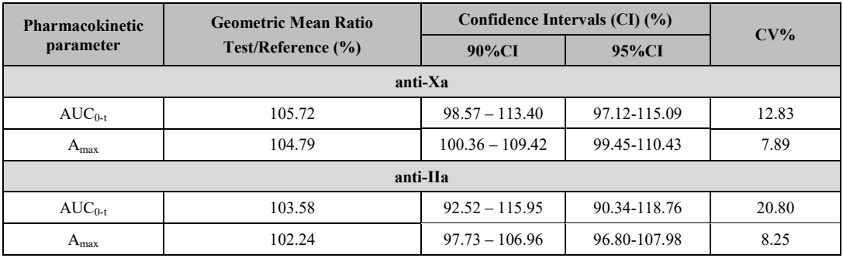

Abbreviations: AUC0-t = area under the concentration-time curve from time zero to the last quantifiable concentration; Amax = maximum activity; CI = confidence interval; CV = coefficient of variation.

Figure : Study 411/13 Profile of mean anti-factor Xa activity

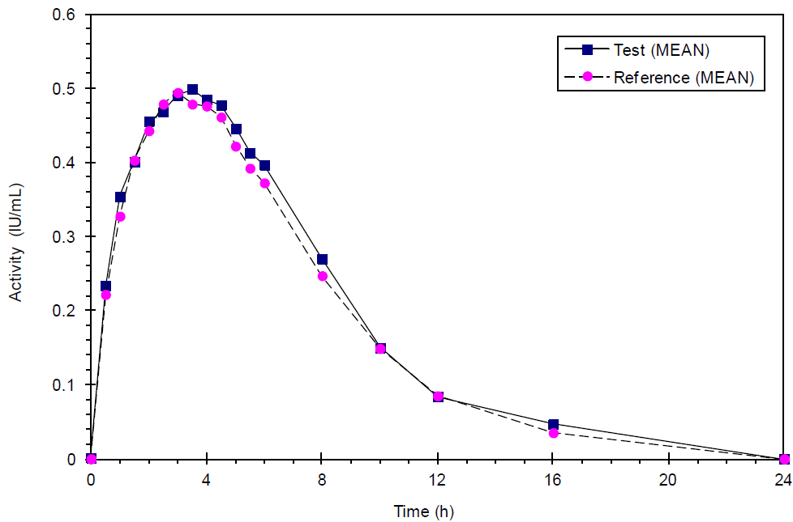

Abbreviations: IU =- international unit; h = hour.

Figure : Study 411/13 Profile of mean anti-factor IIa activity

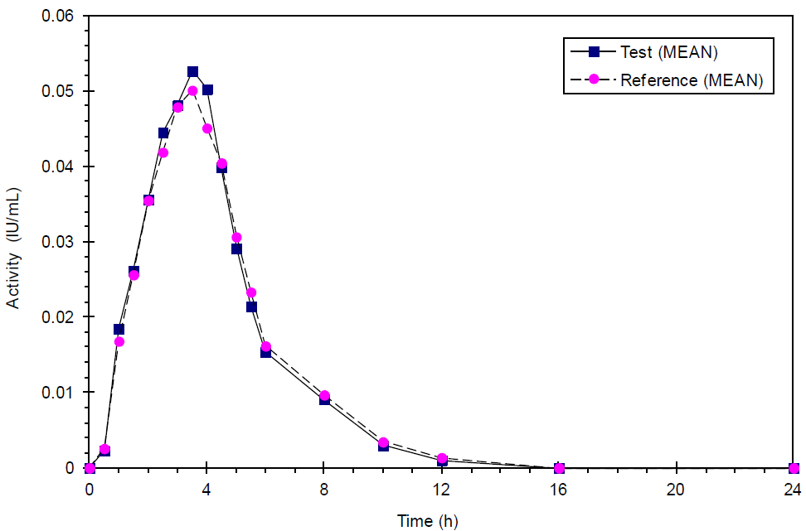

Abbreviations: IU =- international unit; h = hour.

For anti-factor Xa/anti-factor IIa ratio, the 90% CIs were within the bioequivalence acceptance range for both Rmin and Rmax (see Table 3 below). For TFPI activity, the geometric mean values of AUC0-t and Amax were lower for the test product compared with the reference product and the lower limits of the pre-specified 90% CI of the ratio of the geometric LSM for AUC0-t and Amax were below 80%. In response to the findings for TFPI activity, the sponsor commented as below:

* There was extremely high intra-subject variability for TFPI activity, resulting in wide confidence intervals. The coefficient of variation (CV)% for AUC0-t was 64.89% for the test product and 80.70% for the reference product, and the CV% for Amax was 57.39% for the test product and 48.89% for the reference product.
* The sample size calculation was based on the primary PD parameters.
* Increase in TFPI activity is only one of several components responsible for enoxaparin anticoagulant and antithrombotic action, and the main mechanisms (via factor Xa and IIa inhibition) were shown to be similar.
* The quality assessment did not provide a basis to state that there are any marked structural differences between the test and reference products which could affect biological activity.

Table : Study 411/13 Summary of the comparative bioequivalence data for the secondary parameters, tissue factor pathway inhibitor and anti-factor Xa/anti-factor IIa ratio

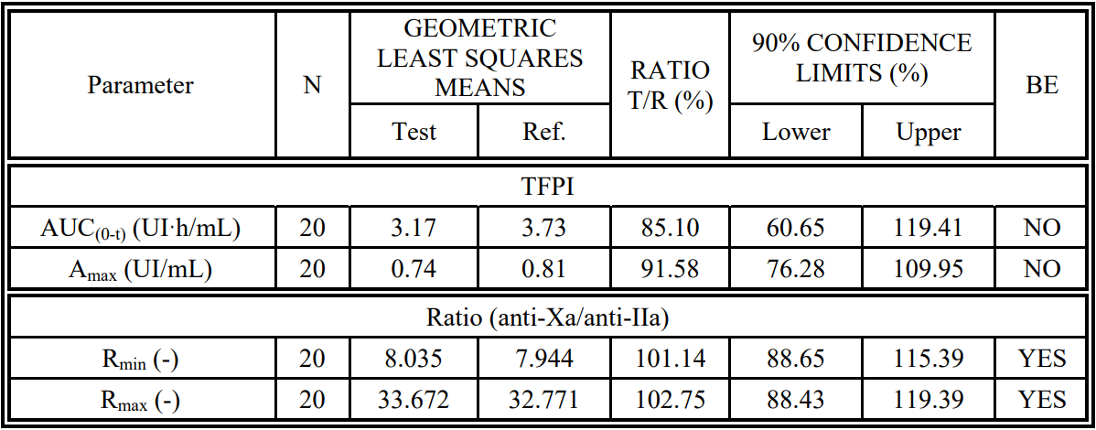

Abbreviations: AUC0-t = area under the concentration-time curve from time zero to the last quantifiable concentration; Amax = maximum activity, Rmax = maximum observed response (anti-factor Xa/anti-factor IIa); Rmin = minimum observed response (anti-factor Xa/anti-factor IIa).

Figure : Study 411/13 Profile of mean tissue factor pathway inhibitor activity

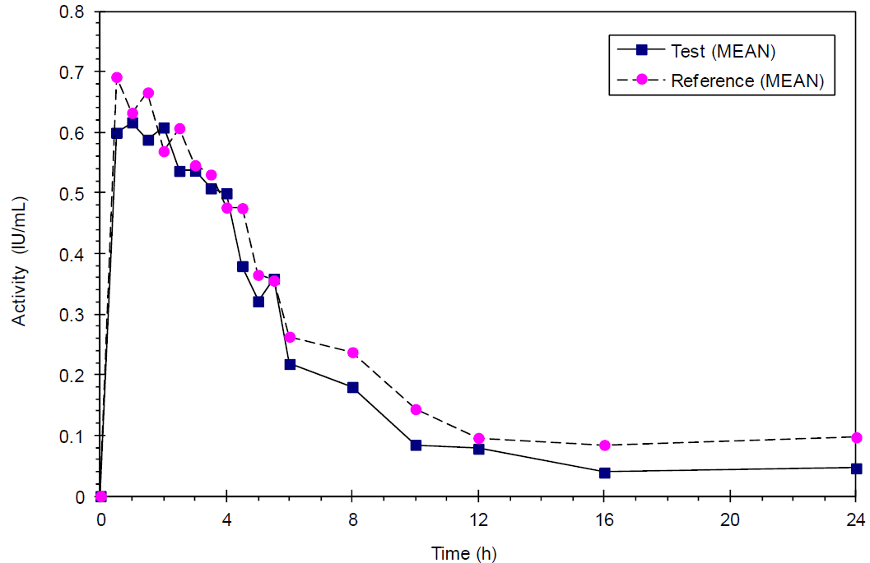

Abbreviations: IU =- international unit; h = hour

Figure : Study 411/13 Profile of mean anti-factor Xa/anti-factor IIa activity ratio

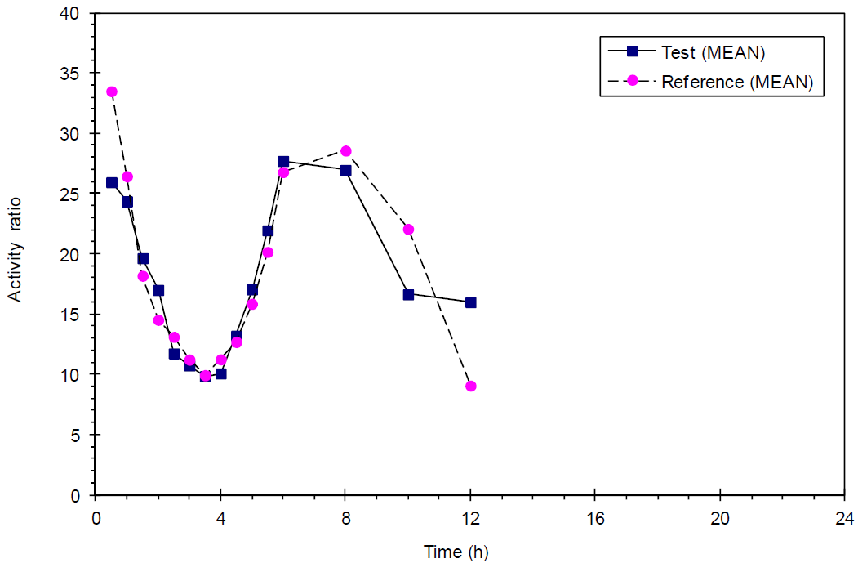

Abbreviation: h = hour.

#### Efficacy

No clinical efficacy study was submitted. The sponsor’s justification for not conducting a clinical efficacy study was primarily based on the Guideline on Non-clinical and Clinical Development of Similar Biological Medicinal Products Containing Low Molecular-Weight-Heparins (EMEA/CHMP/BMWP/118264/2007 Rev. 1) that was adopted by the CHMP on 10 November 2016 and came into effect on 01 June 2017.[5] This guideline states that: *‘Pivotal evidence for similar efficacy will be derived from the similarity demonstrated in physicochemical, functional and pharmacodynamic comparisons. A dedicated comparative efficacy trial is therefore not considered necessary.’* This guideline has not yet been formally adopted by the TGA but was considered by the Delegate of the Minister in the decision to register the enoxaparin biosimilar Enoxapo in Australia.[6]

#### Safety

The only clinical study providing safety data was Study 411/13, the open-label, single-dose, 2‑way crossover study comparing the PD of Exarane and Clexane 40 mg/0.4 mL subcutaneous in 20 healthy subjects. No adverse event or serious adverse event was reported in this study. There were no clinically significant changes in clinical laboratory measurements which could reasonably be associated with the study treatment.

No clinical immunogenicity data were presented. As part of the submission to the EMA, the sponsor addressed the lack of clinical immunogenicity data by presenting an enhanced assay strategy (assessed by the nonclinical evaluator), including a comprehensive range of *in vitro* studies, with particular focus on enoxaparin-PF4 complexes and the risk of heparin-induced thrombocytopaenia, to support a conclusion of similar immunogenicity.

Safety data from post-marketing use were presented in PSURs covering the period 15 September 2016 to 3 April 2020. The sponsor estimated the cumulative patient exposure to marketed Inhixa to be approximately 293,842,665 patient-days. During this period, a total of 538 case reports reporting 869 adverse drug reactions (ADRs) were received from spontaneous notifications, including from the literature and regulatory authorities. Of these, 503 were classified as serious reactions and 366 were non-serious reactions.

The most common serious reactions (5 or more ADRs) were: anaemia (40 ADRs), thrombocytopenia (22 ADRs), pulmonary embolism (18 ADRs), rectal haemorrhage (17 ADRs), deep vein thrombosis, haematoma (14 ADRs each), abdominal wall haematoma, intra-abdominal haematoma, drug ineffective (12 ADRs each), melaena (11 ADRs), heparin-induced thrombocytopenia (9 ADRs), gastrointestinal haemorrhage, haematuria, haemorrhage (8 ADRs each), haematoma muscle (6 ADRs), haematemesis, intestinal haemorrhage, retroperitoneal haematoma, drug interaction, erythema, rash, thrombosis (5 ADRs each).

#### Clinical evaluation’s conclusion

The application did not include a dedicated efficacy and safety study comparing Exarane to Clexane. In the absence of a comparative efficacy and safety study, a conclusion of similar efficacy and safety to Clexane is dependent on demonstration of similarity in physicochemical, functional, and PD comparisons. The findings from the comparative PK/PD study support the similarity of Exarane to Clexane. Consequently, the clinical evaluator supports the approval of Exarane as a biosimilar of Clexane provided that the quality and nonclinical evaluations confirm similarity in physicochemical and functional characteristics, and the evaluator’s comments regarding the Product Information are satisfactorily addressed.

### Risk management plan

The sponsor is required to comply with product vigilance and risk minimisation requirements.

The TGA decided a risk management plan (RMP) was not required due to the following reasons:

* Assuming that the generic product is substantially identical to the innovator product (for example, in efficacy, safety, indication, presentation, strength and dosing) then an RMP will not be required with this generic for enoxaparin sodium solution for injection submission.
* However, if there are any significant differences to the innovator product, then the sponsor should consider if the introduction of the generic product may lead to a new safety concern (for example, medication error related to different preparation instructions) and under those circumstances submit an RMP for evaluation.
* If the TGA identifies any additional safety concerns or changes in the safety profile during the course of the evaluation, the TGA may contact the sponsor to request an RMP.

See [TGA’s guidance](https://www.tga.gov.au/resources/resource/guidance/risk-management-plans-medicines-and-biologicals/when-rmp-required) on ‘when an RMP is required’.

The TGA may request an updated RMP at any stage of a product's life-cycle, during both the pre-approval and post-approval phases. Further information regarding the TGA’s risk management approach can be found in [risk management plans for medicines and biologicals](https://www.tga.gov.au/publication/risk-management-plans-medicines-and-biologicals) and [the TGA's risk management approach](https://www.tga.gov.au/tgas-risk-management-approach). Information on the [Australia-specific annex](https://www.tga.gov.au/resources/resource/guidance/risk-management-plans-medicines-and-biologicals/australia-specific-annex-eu-rmp) ([ASA](https://www.tga.gov.au/resources/resource/guidance/risk-management-plans-medicines-and-biologicals/australia-specific-annex-eu-rmp)) can be found on the TGA website.

### Risk-benefit analysis

#### Delegate’s considerations

A comprehensive comparison of physicochemical and functional characteristics was undertaken to demonstrate the similarity of Exarane to Clexane. The main comparability studies compared Exarane to EU-sourced Clexane. Additional comparisons of EU- and Australian-sourced Clexane support bridging to the Australian reference product. Overall, Exarane is similar to Clexane with respect to physicochemical properties and biological activity. Exarane has a higher level of linkage regions compared to Clexane as a consequence of the depolymerisation process, but this is not expected to impact on efficacy or safety.

The application included one clinical study, Study 411/13, a PK/PD study assessing the bioequivalence of 40 mg/0.4 mL Exarane and 40 mg/0.4 mL Clexane administered by subcutaneous injection in 20 healthy subjects. The Clexane used in this study was sourced from the EU. Bioequivalence was demonstrated for the primary parameters AUC0-t and Amax of anti‑factor Xa and anti-factor IIa activity, with both the 90% CI (pre-specified) and 95% CI (*post‑hoc*) being within the bioequivalence acceptance range. Bioequivalence was also shown for the secondary parameters Rmin and Rmax of anti-factor Xa/anti-factor IIa activity ratio, but not for AUC0-t and Amax of TFPI. The TFPI findings were impacted by high intra-subject variability, limiting conclusions regarding difference between the test and reference products.

The use of EU-sourced Clexane as the reference product in this study is acceptable based on the TGA regulatory guidance[7] and the quality similarity study comparing EU- and Australian-sourced Clexane. Bioequivalence was assessed only in the subcutaneous setting. The absence of an intravenous study is acceptable because the subcutaneous study informs both absorption and elimination.[8] This approach is consistent with Scientific Advice provided by CHMP and the revised Guideline on Non-clinical and Clinical Development of Similar Biological Medicinal Products Containing Low Molecular-Weight-Heparins adopted by CHMP in 2016.5 The sponsor’s justification for extrapolating the PK/PD findings from Study 411/13 for the 40 mg/0.4 mL strength to the other proposed strengths and the 150 mg/mL formulation is acceptable.

No clinical efficacy and safety study comparing Exarane to Clexane has been conducted. Comparative safety data are limited to the randomised, open-label, single-dose, 2-way cross‑over PK/PD study in 20 healthy subjects. *In vitro* immunogenicity studies showed no differences in *in vitro* immunogenicity between Exarane and Clexane in terms of binding PF4, effect on PF4 structure, formation of PF4-enoxaparin ultra large complexes and size of the complexes, as well as the *in vitro* immunogenic activity of PF4-enoxaparin complexes on peripheral blood mononuclear cells and on cultured human umbilical vein endothelial cells.

A conclusion of similar efficacy and safety is based on similarity to Clexane with regard to physicochemical properties, biological function, and PD equivalence, supported by the *in vitro* immunogenicity findings. This approach is consistent with the revised ), Guideline on Non-clinical and Clinical Development of Similar Biological Medicinal Products Containing Low Molecular-Weight-Heparins adopted by the CHMP/EMA in 2016,6,[9] as well as the 2014 Guideline on similar biological medicinal products.[10] In contrast, the original guideline for the development of low molecular weight heparin biosimilars adopted in 2009[11] required a comparative efficacy and safety study.

The regulatory history of enoxaparin in Australia, including the registration of Enoxapo as the first enoxaparin biosimilar in Australia, is relevant to this application. Following a long and complicated process, Enoxapo was approved without a comparative efficacy and safety study. The regulatory history for Enoxapo is outlined and described in further detail in the Enoxapo AusPAR.6 It is noted that the decision of the Delegate to set aside the original decision and make a substitute decision to register Enoxapo included the following reasons which are pertinent to the assessment of efficacy and safety in the current application:

*‘Subsequent to the adoption by the TGA of the EMA guideline document, EMEA/CHMP/BMWP/118264/2007 Guideline on non-clinical and clinical development of similar biological medicinal products containing low-molecular-weight-heparins there have been advances in the field of physicochemical characterisation such that convincing analytical data can substitute for clinical data, at least for clinical efficacy in some cases.*

*In keeping with those advances, the EMA guidance document was revised. As part of that revision clinical data requirements were amended such that clinical trial data is no longer considered essential, providing similarity of physicochemical characteristics of the biosimilar and the reference LMWH has been convincingly shown and similar efficacy and safety can be ensured by other means.*

*Consistent with the TGA’s approach to revisions to EMA guidelines that the TGA has previously adopted, the Delegate considers that the revised guideline should also be adopted by the TGA, and that its recommendations should apply to this application to register Apotex’s enoxaparin sodium. The Delegate notes that the TGA has taken no view to date on the revised EMA guideline, and that no objections to the guideline revisions have been expressed by the TGA.*

*Having regard to the recommendations in the revised EMA guideline, the Delegate does not consider that a clinical trial to demonstrate efficacy and safety of the revised formulation is required to conclude biosimilarity of Apotex’s enoxaparin sodium with Clexane.*

*The requirements of the revised EMEA/CHMP/BMWP/118264/2007 Rev 1 Guideline on non-clinical and clinical development of similar biological medicinal products containing low-molecular-weight-heparins are consistent with those of the TGA adopted guideline CHMP/437/04 Rev 1 Guideline on similar biological medicinal products in that in neither document is there an absolute requirement for a comparative clinical safety and efficacy assessment for a biosimilar product. This is dependent whether similar efficacy and safety can clearly be deduced from the similarity of physicochemical characteristics, biological activity/potency, and pharmacokinetic and/or pharmacodynamic profiles of the biosimilar and the reference product. In addition, it requires that the impurity profile and the nature of excipients of the biosimilar itself do not give rise to concern.’*

Overall, the submitted data support a conclusion of biosimilarity of Exarane to Clexane based on similarity of physicochemical and functional properties, and equivalence of PD parameters.

#### Limitations of the data

A comparative clinical efficacy and safety study was not conducted. The CHMP Guideline on Non‑clinical and Clinical Development of Similar Biological Medicinal Products containing Low Molecular Weight Heparins adopted in 200911 required a comparative efficacy and safety study to support a conclusion of biosimilarity, but the revised guideline adopted by CHMP in 20165 has removed the requirement for a comparative efficacy and safety study provided that biosimilarity is demonstrated in physicochemical, functional and PD comparisons, and the impurity profile and the nature of the excipients do not create uncertainties with regard to their impact on safety and immunogenicity.

The lack of clinical immunogenicity data was addressed by submitting an enhanced assay strategy evaluating the immunogenic potential of Exarane compared to Clexane across a comprehensive range of *in vitro* studies.

#### Proposed Indications

The proposed indications are the same as the reference product, Clexane. The demonstration of biosimilarity supports the use of Exarane in all of the indications approved for Clexane, including indications involving alternative routes of administration (intravenous or into the arterial line of the dialysis circuit).

#### Proposed action

The submitted data support a conclusion of biosimilarity of Exarane to Clexane based on similarity of physicochemical and functional characteristics, and equivalence of PD parameters. There is no clinical study comparing the efficacy and safety of Exarane to Clexane, but the Delegate is satisfied that the efficacy and safety of Exarane are expected to be similar to Clexane based on the submitted dataset demonstrating biosimilarity. The revised CHMP guideline has not yet been formally adopted in Australia, but it was taken into consideration in the registration of Enoxapo as the first enoxaparin biosimilar in Australia, and the Delegate is satisfied that it is a relevant consideration in the assessment of the biosimilarity of Exarane to Clexane.

The outstanding GMP issues were resolved before this application was approved.

#### Advisory Committee considerations

The [Advisory Committee on Medicines (ACM)](https://www.tga.gov.au/committee/advisory-committee-medicines-acm), having considered the evaluations and the Delegate’s overview, as well as the sponsor’s response to these documents, advised the following.

##### Specific advice to the Delegate

1. ***What is ACM’s advice regarding the adequacy of the submitted dataset to support a conclusion of similar efficacy and safety of Exarane to Clexane?***

The ACM considered the revised 2016 EMA guidance on nonclinical and clinical development of similar biological medicinal products containing low molecular weight heparins (EMEA/CHMP/BMWP/118264/2007 Rev. 1)5 for Exarane. The guideline states pivotal evidence for similar efficacy will be derived from the similarity demonstrated in the physicochemical, functional and pharmacodynamic comparisons, and that a dedicated comparative clinical efficacy trial is not required. The 2016 guideline has not yet been formally adopted by the TGA. The ACM noted that the 2016 guideline was taken into consideration in the approval of the first enoxaparin biosimilar in Australia in 2020.

The ACM agreed the data sets and approach submitted by the sponsor support the conclusion of similar efficacy and safety between Exarane and Clexane despite no head-to-head comparison via a clinical efficacy trial.

##### Conclusion

The ACM considered this product to have an overall positive benefit-risk profile for the indication:

* *Prevention of thrombo-embolic disorders of venous origin in patients undergoing orthopaedic and general surgery.*
* *Prophylaxis of venous thromboembolism in medical patients bedridden due to acute illness.*
* *Prevention of thrombosis in extra-corporeal circulation during haemodialysis.*
* *Treatment of established deep vein thrombosis.*
* *Treatment of unstable angina and non-Q-wave myocardial infarction, administered concurrently with aspirin.*
* *Treatment of acute ST-segment elevation myocardial infarction (STEMI) as an adjunctive to thrombolytic treatment, including patients to be managed medically or with subsequent percutaneous coronary intervention (PCI).*

## Outcome

Based on a review of quality, safety, and efficacy, the TGA decided to register Exarane (enoxaparin sodium) 20 mg/0.2 mL, 40 mg/0.4 mL, 60 mg/0.6 mL, 80 mg/0.8 mL, 100 mg/1 mL and Exarane Forte (enoxaparin sodium) 120mg/0.8mL, 150mg/1mL, solution for injection, prefilled syringe:

* *Prevention of thrombo-embolic disorders of venous origin in patients undergoing orthopaedic and general surgery.*
* *Prophylaxis of venous thromboembolism in medical patients bedridden due to acute illness.*
* *Prevention of thrombosis in extra-corporeal circulation during haemodialysis.*
* *Treatment of established deep vein thrombosis.*
* *Treatment of unstable angina and non-Q-wave myocardial infarction, administered concurrently with aspirin.*
* *Treatment of acute ST-segment elevation myocardial infarction (STEMI) as an adjunctive to thrombolytic treatment, including patients to be managed medically or with subsequent percutaneous coronary intervention (PCI).*

### Specific conditions of registration applying to these goods

* Laboratory testing and compliance with Certified Product Details (CPD)
  + All batches of Exarane and Exarane Forte supplied in Australia must comply with the product details and specifications approved during evaluation and detailed in the Certified Product Details (CPD).
  + When requested by the TGA, the sponsor should be prepared to provide product samples, specified reference materials and documentary evidence to enable the TGA to conduct laboratory testing on the Product. Outcomes of laboratory testing are published biannually in the TGA Database of Laboratory Testing Results <http://www.tga.gov.au/ws-labs-index> and periodically in testing reports on the TGA website.
* Certified Product Details

The Certified Product Details (CPD), as described in Guidance 7: Certified Product Details of the Australian Regulatory Guidelines for Prescription Medicines (ARGPM) [<http://www.tga.gov.au/industry/pm-argpm-guidance-7.htm>], in PDF format, for the above products should be provided upon registration of these therapeutic goods. In addition, an updated CPD should be provided when changes to finished product specifications and test methods are approved in a Category 3 application or notified through a self-assessable change.

## Attachment 1. Product Information

The [Product Information](https://www.tga.gov.au/products/australian-register-therapeutic-goods-artg/product-information-one) ([PI](https://www.tga.gov.au/products/australian-register-therapeutic-goods-artg/product-information-one)) approved with the submission for Exarane which is described in this AusPAR can be found as Attachment 1. It may have been superseded. For the most recent PI and [Consumer Medicines Information](https://www.tga.gov.au/products/australian-register-therapeutic-goods-artg/consumer-medicines-information-cmi) (CMI), please refer to the TGA [PI/CMI search facility.](https://www.tga.gov.au/picmi-search-facility)

The PI for Exarane Forte is identical except for the product name.

|  |
| --- |
| Therapeutic Goods Administration |
| PO Box 100 Woden ACT 2606 Australia  Email: [info@tga.gov.au](mailto:info@tga.gov.au) Phone: 1800 020 653 Fax: 02 6203 1605  [**https://www.tga.gov.au**](https://www.tga.gov.au) |
| Reference/Publication # |

1. This is the original indication proposed by the sponsor when the TGA commenced the evaluation of this submission. It may differ to the final indication approved by the TGA and registered in the Australian Register of Therapeutic Goods.
2. Therapeutic Goods Administration (TGA) Australian Product Information – Clexane and Clexane Forte (Enoxaparin Sodium). Available at: <https://www.ebs.tga.gov.au/ebs/picmi/picmirepository.nsf/pdf?OpenAgent=&id=CP-2010-PI-06891-3&d=20231218172310101>.
3. In this report the ‘Delegate’ is the Delegate of the Secretary of the Department of Health and Aged Care who decided the submission under section 25 of the Act.
4. **Good Laboratory Practice (GLP)** is a code of standards following the International Council on Harmonisation (ICH) relevant to testing of medicines in laboratories during drug development.
5. European Medicines Agency (EMEA), Committee for Medicinal Products for Human Use (CHMP), Guideline on Non-clinical and Clinical Development of Similar Biological Medicinal Products Containing Low Molecular-Weight-Heparins, EMEA/CHMP/BMWP/118264/2007 Rev. 1, 10 November 2016.
6. Therapeutic Goods Administration (TGA) Australian Public Assessment Report for Enoxapo (Enoxaparin sodium). Available at: <https://www.tga.gov.au/resources/auspar/auspar-enoxaparin-sodium-0>.
7. Therapeutic Goods Administration (TGA) Biopharmaceutic studies, 16 December 2019. Available at: <https://www.tga.gov.au/resources/resource/guidance/biopharmaceutic-studies.>
8. European Medicines Agency (EMEA), Committee for Medicinal Products for Human Use (CHMP), Guideline on Similar Biological Medicinal Products Containing Biotechnology-Derived Proteins as Active Substance: Non-clinical and Clinical Issues, EMEA/CHMP/BMWP/42832/2005 Rev.1, 1 July 2015.
9. Quoted from European Medicines Agency (EMEA), Committee for Medicinal Products for Human Use (CHMP), Guideline on Non-clinical and Clinical Development of Similar Biological Medicinal Products Containing Low Molecular-Weight-Heparins, EMEA/CHMP/BMWP/118264/2007 Rev. 1, 10 November 2016.

   *‘Pivotal evidence for similar efficacy will be derived from the similarity demonstrated in physicochemical, functional and pharmacodynamic comparisons. A dedicated comparative efficacy trial is therefore not considered necessary.’ ‘Biosimilar and reference LMWH [low molecular weight heparin] should exhibit convincingly similar physicochemical and functional characteristics and pharmacodynamic profiles. Under this premise, adverse effects that are related to exaggerated pharmacological effects (for example, bleeding) can be expected at similar frequencies. If, in addition, the impurity profile and the nature of excipients of the biosimilar do not create uncertainties with regard to their impact on safety/ immunogenicity, a safety/immunogenicity study may not be needed. In this case, further exploration of the immunogenic potential as suggested in section 4 (Non-clinical studies) should be performed.’*
10. Quoted from European Medicines Agency (EMEA), Committee for Medicinal Products for Human Use (CHMP), Guideline on similar biological medicinal products, CHMP/437/04 Rev 1, 23 October 2014.

    *‘In specific circumstances, a confirmatory clinical trial may not be necessary. This requires that similar efficacy and safety can clearly be deduced from the similarity of physicochemical characteristics, biological activity/potency, and PK and/or PD profiles of the biosimilar and the reference product. In addition, it requires that the impurity profile and the nature of excipients of the biosimilar itself do not give rise to concern.’*
11. European Medicines Agency (EMEA), Committee for Medicinal Products for Human Use (CHMP), Guideline on Non-clinical and Clinical Development Of Similar Biological Medicinal Products Containing Low-Molecular-Weight-Heparins, EMEA/CHMP/BMWP/118264/2007, 19 March 2009.