|  |
| --- |
| Australian Public Assessment Report for MELATONIN-LINK, IMMELA, MELAKSO, VOQUILY |
| Active ingredient: Melatonin |
| Sponsor: Link Medical Products Pty Ltd |
| March 2024 |

About the Therapeutic Goods Administration (TGA)

* The Therapeutic Goods Administration (TGA) is part of the Australian Government Department of Health and Aged Care and is responsible for regulating therapeutic goods, including medicines, medical devices, and biologicals.
* The TGA administers the *Therapeutic Goods Act 1989* (the Act), applying a risk management approach designed to ensure therapeutic goods supplied in Australia meet acceptable standards of quality, safety, and efficacy.
* The work of the TGA is based on applying scientific and clinical expertise to decision-making, to ensure that the benefits to the Australian public outweigh any risks associated with the use of therapeutic goods.
* The TGA relies on the public, healthcare professionals and industry to report problems with therapeutic goods. The TGA investigates reports received to determine any necessary regulatory action.
* To report a problem with a therapeutic good, please see the information on the [TGA website](https://www.tga.gov.au/).

About AusPARs

* The Australian Public Assessment Report (AusPAR) provides information about the evaluation of a prescription medicine and the considerations that led the TGA to approve or not approve a prescription medicine submission. Further information can be found in [Australian Public Assessment Report (AusPAR) guidance](https://www.tga.gov.au/australian-public-assessment-report-auspar-guidance).
* AusPARs are prepared and published by the TGA.
* AusPARs are static documents that provide information that relates to a submission at a particular point in time. The publication of an AusPAR is an important part of the transparency of the TGA’s decision-making process.
* A new AusPAR may be provided to reflect changes to indications or major variations to a prescription medicine subject to evaluation by the TGA.

Copyright

© Commonwealth of Australia 2024  
This work is copyright. You may reproduce the whole or part of this work in unaltered form for your own personal use or, if you are part of an organisation, for internal use within your organisation, but only if you or your organisation do not use the reproduction for any commercial purpose and retain this copyright notice and all disclaimer notices as part of that reproduction. Apart from rights to use as permitted by the *Copyright Act 1968* or allowed by this copyright notice, all other rights are reserved and you are not allowed to reproduce the whole or any part of this work in any way (electronic or otherwise) without first being given specific written permission from the Commonwealth to do so. Requests and inquiries concerning reproduction and rights are to be sent to the TGA Copyright Officer, Therapeutic Goods Administration, PO Box 100, Woden ACT 2606 or emailed to <[tga.copyright@tga.gov.au](mailto:tga.copyright@tga.gov.au)>.

Contents

List of abbreviations 5

Product submission 6

Submission details 6

Product background 7

The disease/condition 7

Current treatment options 8

Clinical rationale 8

Regulatory status 9

Australian regulatory status 9

Foreign regulatory status 9

Registration timeline 10

Submission overview and risk/benefit assessment 10

Quality 10

Nonclinical 11

Clinical 11

Pharmacology 11

Efficacy 13

Primary insomnia 13

Jet lag 15

Delayed sleep wake disorder (DSPD) in adults 18

Treatment of sleep disorders in children and adolescents with neurodevelopmental disorders 21

Sleep onset insomnia in children and adolescents 24

Safety 25

Risk management plan 26

Risk-benefit analysis 26

Advisory Committee considerations 26

Discussion 27

Conclusion 29

Outcome 29

Attachment 1. Product Information 29

**List of abbreviations**

|  |  |
| --- | --- |
| Abbreviation | Meaning |
| ACM | Advisory Committee on Medicines |
| ACV | Advisory Committee on Vaccines |
| ADHD | Attention deficit hyperactivity disorder |
| ARTG | Australian Register of Therapeutic Goods |
| ASA | Australia‑specific annex |
| AUC | Area under the curve |
| ASD | Autism spectrum disorder |
| Cmax | Maximum drug serum concentration post-administration |
| CMI | Consumer Medicines Information |
| CR | Controlled release |
| DLMO | Dim light melatonin onset |
| DLP | Data lock point |
| DSM-V | Diagnostic and Statistical Manual of Mental Disorders |
| DSPS | Delayed sleep phase syndrome |
| DSWD | Delayed sleep wake disorder |
| DSWPD | Delayed sleep-wake phase disorder |
| IR | Immediate release |
| ND | Neurodevelopmental disorders |
| PD | Pharmacodynamics |
| PI | Product Information |
| PK | Pharmacokinetics |
| PSUR | Periodic safety update report |
| RCT | Randomised controlled trial |
| REM | Rapid eye movement |
| RMP | Risk management plan |
| SE | Sleep efficacy |
| SOL | Sleep onset latency |
| TGA | Therapeutic Goods Administration |
| TST | Total sleep time |
| VAS | Visual analogue scales |
| WUT | Wake-up time |

## Product submission

### Submission details

|  |  |
| --- | --- |
| *Type of submission:* | Extension of indications (Type C), new dosage form and new strength [type F] |
| *Product name(s):* | MELATONIN-LINK, IMMELA, MELAKSO and VOQUILY |
| *Active ingredient(s):* | Melatonin |
| *Decision:* | Approved |
| *Date of decision:* | 3 October 2023 |
| *Date of entry onto ARTG:* | 27 October 2023 |
| *ARTG numbers:* | 388301, 388302, 388303, 388304, 388305, 388306, 388307, 388308, 388309, 388310, 388311, 388312, 388174, 388292, 388296, 388297 |
| [*Black Triangle Scheme*](https://www.tga.gov.au/black-triangle-scheme) | No |
| *Sponsor’s name and address:* | Link Medical Products Pty Ltd |
| *Dose form(s):* | Capsules, Oral liquid solution |
| *Strength(s):* | 2mg, 3mg, 5mg (capsules); 1 mg/mL (oral liquid) |
| *Container(s):* | Blister pack (capsules); bottle (oral liquid) |
| *Pack size(s):* | 10 capsules (starter pack), 30 capsules, 150mL (oral solution) |
| *Approved therapeutic use for the current submission:* | Adult: Short-term treatment of jet lag in adults aged 18 and over.  Paediatric: Sleep disorders in children and adolescents aged 6 to 18 with neurodevelopmental disorders including autism spectrum disorder (ASD) and attention deficit hyperactivity disorder (ADHD), where sleep hygiene measures have been insufficient |
| *Route(s) of administration:* | Oral |
| *Dosage:* | 2 mg, once daily (maximum 5 mg once daily).  For further information regarding dosage, such as dosage modifications to manage adverse reactions, refer to the Product Information (PI). |
| *Pregnancy category:* | Category B3: drugs which have been taken by only a limited number of pregnant women and women of childbearing age, without an increase in the frequency of malformation or other direct or indirect harmful effects on the human fetus having been observed.  Studies in animals have shown evidence of an increased occurrence of fetal damage, the significance of which is considered uncertain in humans.  The use of any medicine during pregnancy requires careful consideration of both risks and benefits by the treating health professional. The [pregnancy database](https://www.tga.gov.au/products/medicines/find-information-about-medicine/prescribing-medicines-pregnancy-database) must not be used as the sole basis of decision making in the use of medicines during pregnancy. The TGA does not provide advice on the use of medicines in pregnancy for specific cases. More information is available from [obstetric drug information services](https://www.tga.gov.au/obstetric-drug-information-services) in your state or territory. |

### Product background

This AusPAR describes the submission by Link Medical Products Pty Ltd (the sponsor) to register MELATONIN-LINK, IMMELA, MELAKSO and VOQUILY (melatonin), 2mg, 3mg, 5mg (capsules); 1 mg/mL (oral liquid) for the following proposed extension of indications:[1]

**Adult**

Short-term treatment of jet lag in adults aged 18 and over.

**Paediatric**

Sleep disorders in children and adolescents aged 6 to 18 with neurodevelopmental disorders including autism spectrum disorder (ASD) and attention deficit hyperactivity disorder (ADHD), where sleep hygiene measures have been insufficient.

#### The disease/condition

**Adults**

Primary insomnia is defined as sleep disturbance not associated with a medical condition, substance use or concurrent psychological disorder. Difficulty with initiating or maintaining sleep are characteristic features. Irritability or fatigue during wakefulness are key symptoms. Approximately 11.3% of the Australian population have been diagnosed with primary insomnia and approximately of patients may have chronic insomnia.

Delayed sleep wake disorder (DSWD) is also termed delayed sleep phase syndrome (DSPS). DSWD is a circadian rhythm sleep disorder characterised by abnormally late sleep and wake times. The American Thoracic Society has defined DSPS as a disorder in which a person’s bedtime is delayed by 2 or more hours beyond the socially acceptable or usual bedtime for people of the same age[2]*.* This results in an inability to fall asleep or wake up at conventional times. DSWD is the most common circadian rhythm sleep-wake phase disorder. DSPS is commonly seen in teenagers, although it can start at any age. DSPS eventually results in a shortened sleep time.

Jet lag is a short-term temporary condition characterised by daytime sleep and sleep disturbance caused by the inability of the body clock to adjust to rapid travel across multiple time zones[3]. It is a consequence of circadian misalignment that occurs after crossing time zones too rapidly for the circadian system to keep pace with. These circadian disturbances are not pathological and are self-limiting.

**Children**

Neurodevelopmental (ND) disorders include ASD, intellectual disability, motor disabilities (such as cerebral palsy), seizures, learning disabilities (such as dyslexia) and ADHD. There is an increased prevalence of sleep disturbances in children with ASD and ADHD, which adversely affect learning and behaviour. Low endogenous melatonin secretion and abnormal circadian rhythmicity leading to lengthened sleep onset latency (SOL), reduced total sleep time (TST) and frequent night-time awakenings are considered the responsible pathogenic mechanisms.

The Diagnostic and Statistical Manual of Mental Disorders (DSM-V) criteria for insomnia disorders in children are based on the adult criteria with primary complaints of poor sleep duration or quality. Additional criteria for children include the need for caregiver interventions. Sleep disorders in children include difficulty initiating sleep without caregiver intervention, difficulty maintaining sleep and early morning awakening with inability to return to sleep.

#### Current treatment options

**Primary insomnia**

Pharmacological treatments include benzodiazepine receptor agonists, benzodiazepines, sedating antidepressants, anxiolytics, antipsychotics, and antihistamines.

Melatonin is a schedule 3 (over-the-counter) product in Australia. It is available as modified release tablets containing up to 2 mg of melatonin for the treatment of primary insomnia for adults aged 55 or over, in packs containing not more than 30 tablets.

In Australia, Circadin 2 mg prolonged-release tablets are approved for the indication:

*Monotherapy for the short-term treatment of primary insomnia characterized by poor quality of sleep in patients who are aged 55 or over.*

Circadin is available as 2 mg in the pack sizes of 21, 30, 42, 60, 90 or 7 (sample pack) tablets.

**Delayed Sleep Wake Disorder**

Currently, there are no TGA approved treatment options for this condition.

Prolonged hypnotic treatment to promote sleep onset, or the use of stimulant drugs to increase morning alertness, are the current treatment options.

**Jet lag**

Pharmacological and non-pharmacological approaches to the treatment of jet lag are employed to address sleep loss, and desynchronisation of the body clock in the new environment.

Currently, there are no TGA approved treatment options for this condition.

**Sleep disorders in children with neurodevelopmental disorders**

The first line treatment for sleep disturbances experienced by children with ND disorders are based on behavioural and sleep hygiene interventions. These include increasing social cues, self-soothing before bedtime and increasing positive bedtime routines that promote effective sleep.

Slenyto was approved by TGA for the treatment of sleep disorders in children with ASD.

Currently, there are no TGA approved treatment options for primary insomnia in children.

#### Clinical rationale

Melatonin (N-acetyl-5 methoxytryptamine) is a naturally occurring hormone produced by the pineal gland and is structurally related to serotonin. Melatonin is associated with the control of circadian rhythms and entrainment to the light-dark cycle. It is also associated with a hypnotic effect and increased propensity for sleep. The activity of melatonin at the MT1, MT2 and MT3 receptors is believed to contribute to its sleep-promoting properties, as these receptors (mainly MT1 and MT2) are involved in the regulation of circadian rhythms and sleep regulation.

### Regulatory status

#### Australian regulatory status

Twenty orally administered melatonin products are currently listed in the ARTG.

The scheduling of melatonin-based medicines is dependent on dosing and pack size.

Schedule 4 (Prescription only) MELATONIN for human use, except when included in Schedule 3.

Schedule 3 (Pharmacist only) MELATONIN in modified release tablets containing 2 mg or less of melatonin for monotherapy for the short-term treatment of primary insomnia characterised by poor quality of sleep for adults aged 55 or over, in packs containing not more than 30 tablets.

Prolonged release-melatonin tablets are approved for use in Australia for the following indications:

CIRCADIN® 2mg prolonged release tablets are indicated as *monotherapy for the short-term treatment of primary insomnia characterized by poor quality of sleep in subjects who are aged 55 or over.*

SLENYTO® 1mg and 5mg prolonged release tablets are indicated for *the treatment of insomnia in children and adolescents aged 2-18 with autism spectrum disorder (ASD) and/or Smith-Magenis syndrome, where sleep hygiene measures have been insufficient.*

#### Foreign regulatory status

Table : International regulatory status at the time of product registration.

|  |  |  |  |
| --- | --- | --- | --- |
| Region | Submission date | Status | Approved indications |
| United Kingdom | 23/08/2017 | Approved on 10/6/2019 | Oral solution: short-term treatment of jetlag in adults (oral solution). |
| 26/10/2018 | Approved on 20/7/2022 | Hard Capsules: short-term treatment of jet lag in adults. |
| 15/7/2020 | Approved on 16/8/2022 | Oral solution: Insomnia in children and adolescents aged 6-17 years with ADHD where sleep hygiene measures have been inadequate. |
| Sweden | 01/04/2019 | Approved on 22/04/2020 | Oral solution:  Short-term treatment of jetlag in adults.  Insomnia in children and adolescents aged 6-17 years with ADHD where sleep hygiene measures have been inadequate. |
| UAE | 13/04/2020 | Approved on 25/08/2020 | Oral solution: For short-term treatment of jetlag in adults. |
| EU | 25/2/2021 | Approved:  Austria 24/11/2022  Belgium 5/8/2022  France 21/9/2022  Germany 10/11/2022  Hungary 18/7/2022  Italy 28/10/2022  Netherlands: 21/9/2022  Spain 8/8/2022  Sweden: 25/5/2022 | Oral solution: For short-term treatment of jetlag in adults.  Insomnia in children and adolescents aged 6-17 years with ADHD where sleep hygiene measures have been inadequate. |

## Registration timeline

The following table captures the key steps and dates for this submission.

This submission was evaluated under the [standard prescription medicines registration process](https://www.tga.gov.au/how-we-regulate/supply-therapeutic-good-0/supply-prescription-medicine/application-process/prescription-medicines-registration-process).

Table : Timeline for Submission PM-2022-01551-1-1

|  |  |
| --- | --- |
| Description | Date |
| Submission dossier accepted and first round evaluation commenced | 31 May 2022 |
| First round evaluation completed | 22 Nov 2022 |
| Second round evaluation completed | 18 Jul 2023 |
| Delegate’s[4] Overall benefit-risk assessment and request for Advisory Committee advice | 18 May 2030 |
| Advisory Committee meeting | August 2023 |
| Registration decision (Outcome) | 3 October 2023 |
| Number of working days from submission dossier acceptance to registration decision* | 210 |

*Statutory timeframe for standard submissions is 255 working days

## Submission overview and risk/benefit assessment

### Quality

There are no objections on quality grounds to the approval of MELATONIN-LINK, IMMELA, MELAKSO and VOQUILY. The sponsor submitted evidence demonstrating that the composition of the drug substance and the drug product complied with all applicable regulations with respect to batch consistency, stability, sterility and impurity content.All test parameters and limits proposed for the drug product specification were considered acceptable.

An s14 exemption for 18 months has been consented to for non-compliance with the British Pharmacopoeial (BP) monograph limit for ‘any unknown impurities’. This will allow the sponsor to engage with the BP to consider widening the limit for ‘any unknown impurities, to optimise their drug substance and/or drug product manufacturing processes to reduce impurity levels and allow time to characterise any impurities observed above the BP monograph control limit and set an appropriate limit.

The shelf life for the 2 mg and 5 mg capsules has been limited to 9 months when stored at or below 25°C in the proposed blister packs.

The shelf life for the 3 mg capsules is supported for 12 months when stored at or below 25°C in the proposed blister packs.

For the oral solution, a shelf life of 24 months when stored at or below 25°C in the proposed container closure system is supported.

Good Manufacturing Practice (GMP) clearances for the drug substance and drug product manufacturing sites are satisfactory.

### Nonclinical

No new nonclinical data or further nonclinical evaluation were required for this submission. The TGA considers that previously submitted and evaluated data satisfactorily address nonclinical aspects of safety/efficacy relating to this submission. The non-clinical safety profile is considered comparable to other registered melatonin products on the ARTG.

### Clinical

#### Pharmacology

##### Pharmacokinetics (PK)

**Study ARL/18/106 -** Open-label, single dose bioavailability study of melatonin 1 mg/mL oral solution (3 mL solution). 16 healthy adult subjects were recruited. Standard PK parameters were measured under fasting conditions.

PK parameters were estimated from the time of administration and for up to 6 hours.

Table : PK parameters

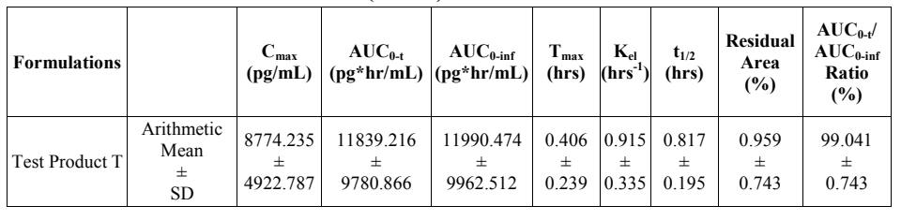

**Study 0916-16 -** Open-label, cross-over, single dose study to assess comparative bioavailability. The Sponsor’s melatonin 3 mg capsules were compared to the reference product: Bio-Melatonin® 3 mg film tabletta, manufactured by Pharma Nord Aps, Denmark.

The study was conducted in 100 healthy adult subjects. The age range was 18-45 years. PK parameters were estimated from the time of administration to up to 6 hours, under fasting conditions.

The bioavailability of the test capsule product was comparable to the reference tablet product with respect to Cmax and AUC0-t under fasted conditions.

Table : Intra-subject CV and Within-Subject Standard Deviation of Reference Product for Melatonin

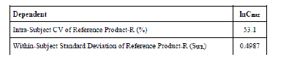

Table : Comparison of PK parameters across test and reference melatonin capsules.

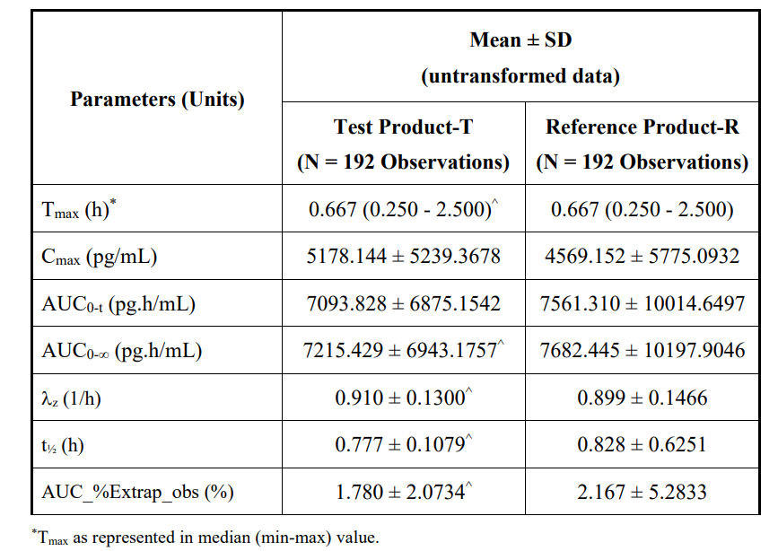

Table : Relative bioavailability for melatonin compared with the reference product.

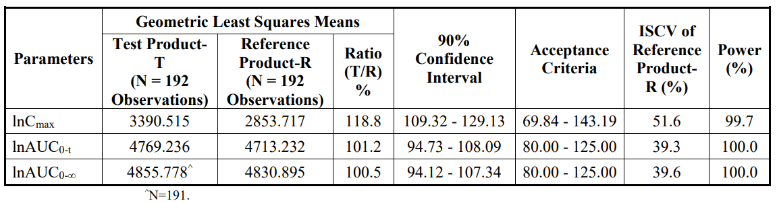

**Study 0531-17 -** Open label, crossover, single dose randomised control trial (RCT) to assess the comparative bioavailability of melatonin 3 mg tablets of Lamda laboratories SA, Greece with Bio-Melatonin® 3 mg filmtabletta of Pharma Nord Aps, Denmark in healthy adults. A total of 60 subjects were dosed under fasting condition. The age range was 18-45 years.

Table and Table : Comparison of PK parameters across test and reference melatonin products.

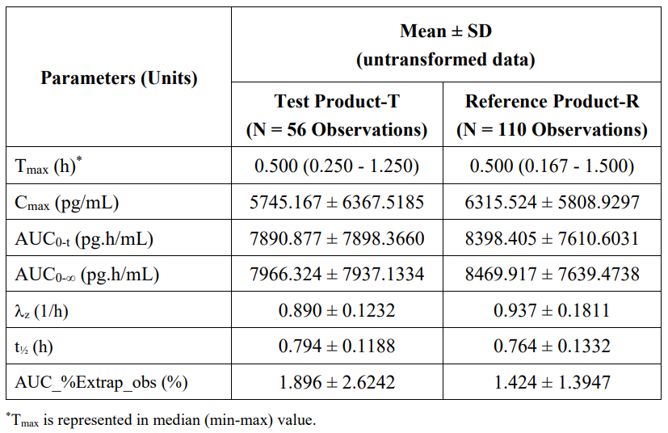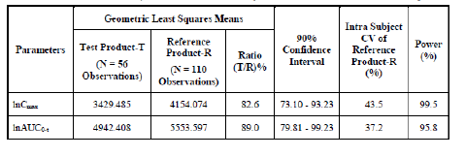

The bioavailability of the melatonin 3 mg tablet test product was comparable with respect to Cmax, but not comparable with respect to AUC0-t for baseline corrected data of melatonin under fasting conditions.

##### Pharmacodynamics (PD)

**Mechanism of action**

Melatonin acts on the MT1 and MT2 receptors.

Melatonin exerts its sleep promoting properties via their distinct actions on the circadian clock. The MT1 receptors are thought to inhibit neuronal firing, while the MT2 receptors have been implicated in the phase-shifting response.

Studies that examined the PK-PD relationship of melatonin that is relevant to the proposed indications were not included in the submission.

### Efficacy

#### Primary insomnia

The Sponsor indicated the following studies as “pivotal”.

**Ferracioli-Oda, 2013[5]**

Meta-analysis of melatonin for the treatment of primary sleep disorders. The primary outcomes were sleep latency (SOL), sleep quality (sleep efficacy (SE)) and total sleep time (TST).

The inclusion criteria were primary sleep disorders meeting DSM-IV criteria, RCTs and had at least 10 participants for parallel designs or five participants for cross-over designs.

A total of 19 studies involving 1683 subjects were included. Fourteen studies assessed the efficacy of melatonin for the treatment of primary insomnia, four studies assessed delayed sleep phase syndrome (DSPS) and one study assessed REM sleep behaviour disorder.

Studies conducted in adults and children were eligible and included melatonin given at a wide dose range and duration, irrespective of the drug formulation.

The dose range was 0.1 mg to 5mg daily. Treatment duration was between 7-182 days. Studies with melatonin in both IR and CR formulations were included.

SOL: On average, subjects in melatonin arm fell asleep seven minutes earlier than subjects receiving placebo (treatment difference = 7.06 minutes [95% CI: 4.37 to 9.75, p<0.001]).

TST: Melatonin increased total sleep time compared to placebo. On average, subjects randomly assigned to melatonin had a TST eight minutes longer than subjects taking placebo (treatment difference = 8.25 minutes [95% CI: 1.74 to 14.75, p = 0.013])

Sleep quality: subjects assigned to melatonin had greater improvements in sleep quality compared to placebo (SMD = 0.22 [95% CI: 0.12 to 0.32, p<0.001]).

Treatment difference for all the above endpoints achieved statistical significance.

**Brzezinski, 2005[6]**

A meta-analysis to assess the effect of melatonin on sleep. The outcome measures of SOL, total sleep duration, and sleep efficiency were selected.

Adults with no severe disabling systemic disease were included in the studies. RCTs with objective measures of sleep evaluation were included. A total of 17 studies including 284 subjects met the inclusion criteria.

The melatonin doses ranged from 0.1mg to 80mg given from one day to two months.

Most of the studies included healthy adults without primary insomnia. Some studies included subjects with schizophrenia and Alzheimer’s disease with insomnia. Most of the studies were conducted in young adults. The inclusion criteria of the meta-analysis required objective measures of sleep. Subjective measures such as restorative sleep and subsequent daytime functioning were not assessed.

SOL: There was an estimated mean reduction in SOL of 4.0 minutes (95% CI: 2.5, 5.4).

Total sleep duration: Treatment with melatonin increased total sleep duration by 12.8 minutes (95% CI: 2.9, 22.8).

Sleep efficiency:The sleep efficiency increased by 2.2% (95% CI: 0.2, 4.2) in the melatonin arm.

**Haimov, 1995[7]**

This study was conducted in elderly subjects with and without sleep disorders.

The study population comprised three groups: (a) independently living insomniacs (eight subjects with a mean age of 73.1 years); (b) institutionalized insomniacs (18 subjects with a mean age of 81.1) living for a minimum of six months in a nursing home; and (c) elderly subjects without sleep disorders (25 subjects with a mean age of 71.4 years) living independently in the community. The Sponsor has highlighted that the purpose of recording the elderly group without sleep disorders was to validate the subjective complaints of insomnia, and this group was not included in the treatment part of the study.

*Melatonin tablets* were given for seven consecutive days two hours before the desired bedtime. Melatonin 2 mg tablets were given as CR or IR formulations, or a matching placebo. Treatment period was for 1 week with either of the CR or IR formulations.

A greater sleep efficiency and activity levels were reported in IR melatonin group vs and placebo (80.4 vs. 77.4 and 23.0 vs. 26.9, respectively). In the independent elderly insomniacs, SOL was shorter in the IR melatonin group than in the placebo group (32 minutes vs. 54 minutes). There were no differences in sleep latency between the IR and CR groups, or between the CR and placebo groups.

**Jean-Louis, 1998[8]**

A RCT, crossover study. Effects of IR melatonin on circadian rest-activity profiles, cognition, and mood were investigated in ten elderly subjects living at home with self-reported sleep-wake disturbances. Mean age was 68.8 years. Two subjects had confirmed Alzheimer’s disease and seven others had lesser cognitive impairment.

Melatonin (6 mg) or matched placebo was administered for 10 days, two hours before their normal bedtime.

Melatonin enhanced the rest-activity rhythm and improved sleep quality. Compared with placebo, SOL was reduced by approximately 11 minutes (p<0.05) and the number of transitions from sleep to wakefulness were reduced. TST was not significantly increased.

Table : Melatonin effects on sleep in the elderly

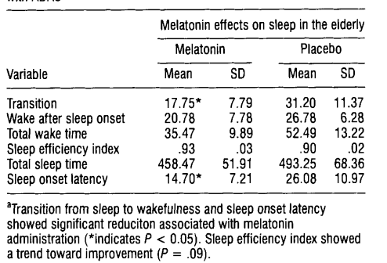

#### Jet lag

Seven studies were considered by the Sponsor to be pivotal.

**Herxheimer, 2002[9]**

The primary endpoint was visual analogue scales (VAS) (subjective rating of jet lag).

Secondary endpoints included fatigue, daytime tiredness, onset of sleep at destination, onset and quality of sleep, psychological functioning, duration of return to normal, and measures indicating the phase of circadian rhythms.

Ten randomised studies were included. One study was described as double-blind. The number of participants ranged from 17-320 subjects and included airline passengers, airline staff, or military personnel.

The meta-analysis compared the global jet lag ratings using a visual analogue scale (0 - insignificant to 100 - very bad) for four trials.

All trials compared melatonin with placebo.

The most common melatonin dose was 5 mg and other strengths included 0.5 mg IR, 2 mg CR, and 8 mg IR. Melatonin was taken at the same clock time each day after arrival at the destination. The duration of treatment ranged from 3-5 days.

Multiple comparisons were made across these studies, such as melatonin vs placebo; treatment with melatonin only after arrival at destination (’post’ regimen) vs treatment given before, during and after travel (’pre+post’ regimen); low doses (≤5 mg) vs high doses (≥8mg); low doses vs very low doses (0.5mg); rapid-release melatonin vs slow-release melatonin; short treatment duration (≤48 hr) vs long treatment duration (>48 hr) treatment; eastward flights vs westward flights (with placebo or melatonin).

A meta-analysis of VAS of jet lag symptoms was performed on four trials that were sufficiently similar in design.

Eight of the ten trials reported that melatonin taken close to the target bedtime at the destination (10pm to midnight), decreased jet-lag from flights crossing five or more time zones.

The mean difference in the global jet lag score for 142 subjects making eastward flights was 19.52 [95% CI:-28.13, - 10.92]) in subjects given melatonin compared with placebo.

The mean difference in the global jet lag score for 90 subjects making westward flights was 17.27 (95% CI: -27.28, -7.26)] for subjects given melatonin, compared with placebo.

Daytime sleepiness was reported less frequently in subjects taking melatonin compared with placebo in three studies. Sleep latency, sleep quality, fatigue, and mood states were also improved in subjects taking melatonin. ‘Pre+Post’ treatment was not reported to be more effective than ‘post’ regimens. A dose response was reported for sleep onset and quality of sleep with doses ranging from 0.5 mg to 5 mg melatonin. Doses above 5mg appeared to be no more effective. Melatonin 2 mg CR was relatively less effective than melatonin IR formulations. The benefit in favour of melatonin tended to be greater when more time zones were crossed and was less for westward compared to eastward flights.

**Tortorolo, 2015[10]**

Four systematic reviews and 11 RCTs were included.

The studies evaluated the efficacy of oral melatonin in reducing symptoms associated with jet lag after eastward and westward flights.

The primary endpoint was a global jet lag symptom score (0 to 100 scale).

Ten studies assessed the use of melatonin in eastward flights while four assessed westward flights.

Most of the studies used melatonin IR 5 mg and one study assessed 10 mg melatonin IR. Three studies assessed CR melatonin at doses of 0.5 mg followed by 2 mg, and then 0.5 mg. In all studies, melatonin was administered before the desired time of sleep at the destination.

Table . Melatonin for jet lag syndrome

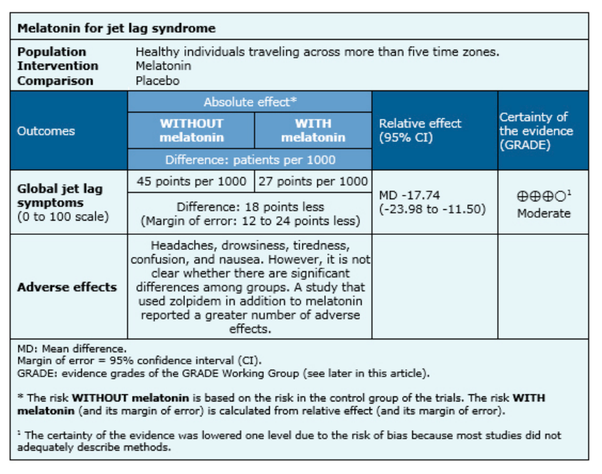

The mean difference in global jet lag symptoms was -17.74 (95% CI: -23.98, -11.50) for subjects in melatonin arm, compared to placebo. The treatment difference was statistically significant.

**Petrie, 1989[11]**

This was a RCT crossover study that compared the effect of melatonin on jet lag after flights from Auckland to London (eastward) and back (westward).

The objective of the study was to monitor the feelings of jet lag and mood for 10 days following the flight. The trial recruited 20 subjects aged 28-68 years, with previous experience of transcontinental flights across at least five time zones.

VAS scoring was utilised. Subjects also recorded the amount of sleep in the last 24 hours. The assessments were completed on the day of departure, on arrival, and at 4 pm local time. On Day 10 after arrival, subjects retrospectively self-rated their jet lag on a six-point scale. Sleep pattern and return to normal energy levels were also assessed.

On Day 10, subjects taking melatonin reported significantly less overall jet lag than those taking placebo (mean score 2.15 vs 3.40, p<0.01). Scores were higher in subjects flying westwards than in those flying eastwards. Based on the VAS scores, subjects in the melatonin arm required fewer days compared with those in placebo arm to establish a normal sleep pattern, to not feel tired during the day, and to reach normal energy levels. The treatment difference was statistically significant.

Table : Retrospective ratings on Day 10 after flights through 12 time zones in passengers given melatonin or placebo.

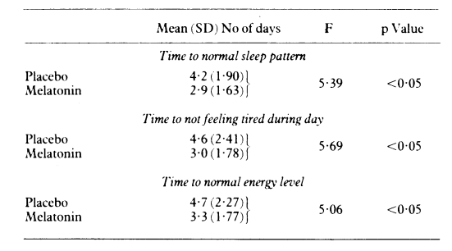

#### Delayed sleep wake disorder (DSPD) in adults

This condition is also called Delayed Sleep Wake Phase Disorder (DSWPD).

**Pivotal studies**

**Van Geijlswijk, 2010[12]**

A meta-analysis conducted in the Netherlands.

Studies included subjects (adults and children) with DSPD. The objective was to assess the efficacy of melatonin in advancing sleep-wake rhythm in subjects with DSPD.

ADHD was an associated co-morbidity. Dim light melatonin onset (DLMO), sleep onset (SOT), wake-up time (WUT), SOL, and TST were the outcomes. Studies using subjective outcomes such as the quality of sleep or life were excluded.

Five studies were conducted in 91 adults, and four studies were conducted in 226 children, aged (6 years to adolescence). Melatonin 5 mg was administered in seven studies. One study in adults compared the efficacy of 0.3 mg of melatonin with the efficacy of 3 mg of melatonin and with placebo. One study in children differentiated the dose according to bodyweight (3 mg or 6 mg).

Adult subjects in the melatonin arm experienced reduced DLMO [-1.69 hours (95% CI: -2.31, -1.07; p<0.0001)]. SOT measured by actigraphy or sleep diaries was shortened in adults [-0.70 hours (95% CI: -1.04, -0.36; p<0.0001)]. The treatment difference for these endpoints were statistically significant.

Mean WUT was reduced in adults. The difference was not statistically significant [-0.95 hours (95% CI: -3.25, 1.36)]. SOL in adults was reduced by 30.28 minutes. The treatment difference was not statistically significant. TST was measured by PSG, diary data or actigraphy. In adults, mean TST was increased by 0.77 minutes and the difference was not statistically significant.

Table : Study outcomes, differentiated between studies with adults17,42–45 and those with children46–49 with delayed sleep phase disorder.

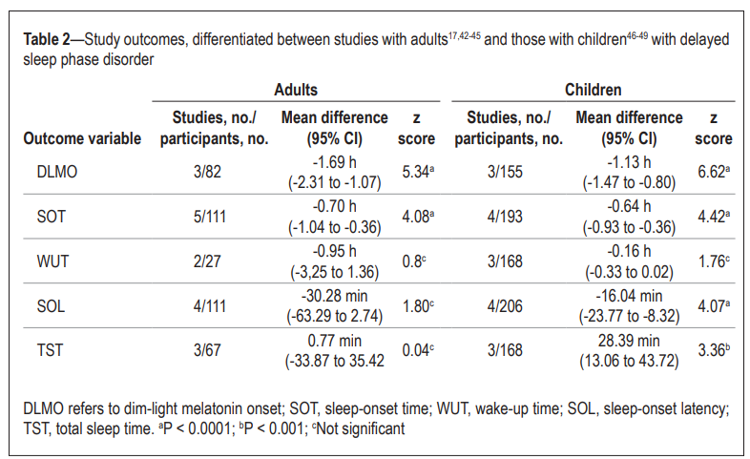

**Buscemi, 2004[13]**

This meta-analysis included studies in subjects with primary sleep disorders. 139 studies with melatonin were included. There were no significant differences in sleep quality, wakefulness after sleep onset, TST or percentage time spent in rapid eye movement (REM) sleep between subjects with a primary sleep disorder taking either melatonin or placebo. In two trials of subjects with DSPS, SOL was decreased with a treatment difference in favour of melatonin of -38.8 minutes (95% CI: -50.3, -27.3). In one trial, melatonin had no significant impact on sleep efficiency in subjects with DSPS. There was no breakdown of sleep quality, wakefulness after sleep onset, or TST for subjects with DSPS. The dosage regimen of melatonin administered in these studies were not described. Hence no conclusions can be made in terms of treatment benefit.

**Sletten, 2018[14]**

RCT conducted at multiple centres in Australia.

Delayed sleep-wake phase disorder (DSWPD) was defined as sleep initiation insomnia when attempting sleep at conventional times and difficulty waking at the required time for daytime commitments.

Treatment agents were 0.5 mg melatonin or placebo, combined with behavioural sleep-wake scheduling. The subjects were males and females aged between 16 and 65 years.

A total of 116 subjects with a mean age of 29.0 years were randomised. The baseline demographic and clinical characteristics were balanced between the melatonin and placebo groups.

On average, subjects took capsules (melatonin or placebo) on 21.1 nights during the four week treatment protocol, with an average of 5.30 nights per seven day period.

Table : Baseline demographic and clinical characteristics and relationship between DLMO and sleep timing among patients randomised to treatment with placebo or melatonin.

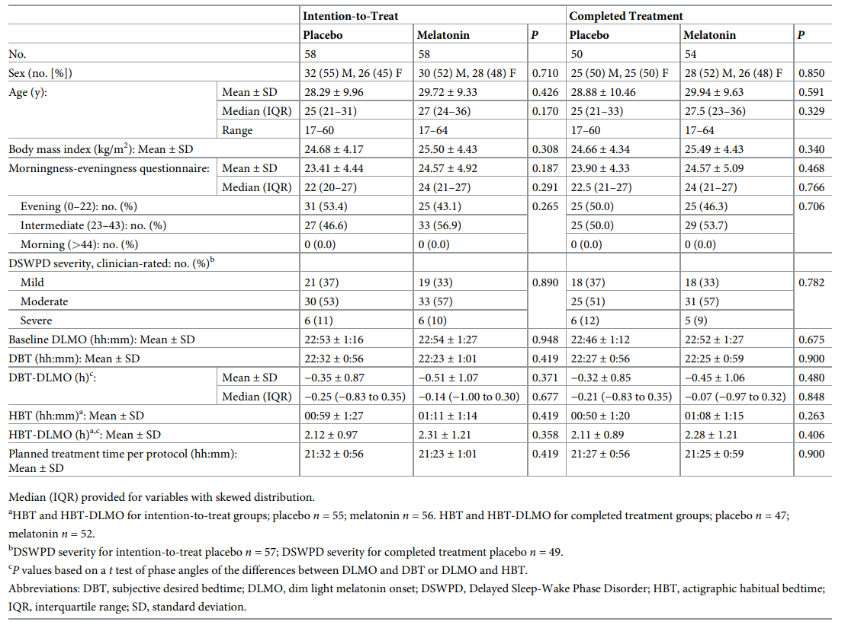

Compared to placebo, SOL was shorter in the melatonin group by 18.2 minutes based on subjective assessment (95% CI: −30.78, −5.59; p = 0.005) and by 11.9 minutes based on actigraphy (95% CI:−19.54, −4.39; p = 0.002).

SOT was 44 minutes earlier based on subjective assessment (95% CI: −66,−21; p < 0.001) and 34 minutes earlier by actigraphy (95% CI:−60, −8; p = 0.011). Subjective sleep offset time was 38 minutes earlier (95% CI: −63, −13; p = 0.003). Sleep efficiency was 3.0% higher for the entire sleep episode (95% CI: 1.02, 4.99; p = 0.003).

**Dahlitz, 1991[15]**

8 male subjects (age range 14-61 years) were administered with oral melatonin 5 mg or matched placebo at 10 pm in this cross-over RCT. The treatments were taken for four weeks with a one week washout period between the treatments.

**Kayumov, 2001[16]**

The treatment duration of this cross-over RCT was for four weeks. Treatment agents were melatonin 5 mg daily or placebo.22 subjects (15 men aged 35.6 ± 14.0 years, 7 women aged 30.8 ± 12.4 years) with an established diagnosis of DSPS were enrolled into the study.

Subjects in the melatonin arm had a lower mean SOL than those given placebo. The treatment difference was statistically significant (p<0.05). Treatment difference for TST between melatonin and placebo arm was statistically significant.

#### Treatment of sleep disorders in children and adolescents with neurodevelopmental disorders

**McDonagh, 2019[17]**

A systematic review of pharmacologic treatments for sleep disorders in children with neurodevelopmental (ND) disorders.

RCTs involving children (aged ≤18 years) lasting ≥1 week were included. Comparators included placebo and other drugs.

Efficacy outcomes included sleep outcomes (e.g., latency, duration), summary assessments of sleep (e.g., sleep behaviour questionnaires), and measures of overall functioning or quality of life.

Overall, the trials enrolled 1758 children with a mean age of 8.2 years. 34% of the subjects were females. Except for one study, the authors considered all of the studies as moderate to high quality. Almost all of the studies included children with sleep disorders and co-morbid neurodevelopmental disorders.

A total of 1021 children were studied across 18 studies. Sample sizes were generally small (range 8-160). Melatonin doses ranged from 1.0 mg per day to 12 mg per day (median 4.8 mg) and studies ranged in duration from one to 13 weeks (median four weeks). Actigraphy was used as the primary method of assessing sleep outcomes in most studies. Five studies used diary reports from parents, and one study used both methods.

The treatment difference for sleep latency was statistically significant for melatonin arm compared with placebo (median difference 28 minutes; range 11-51 minutes) in most of the studies.

A dose-ranging study found a dose-response trend for sleep latency: 31 minutes with 0.05 mg/kg (mean 1.6 mg), 36 minutes with 0.10 mg/kg (mean 2.9 mg), and 42 minutes with 0.15 mg/kg (mean 4.4 mg).

In 16 studies, sleep duration was improved with melatonin by a median of 33 minutes (range 14-68 minutes), with the difference to be statistically significant in majority of the studies.

The difference in mean number of awakenings (adjusted for number of hours slept) ranged from 0 to 2.7. The treatment difference was statistically significant in one study.

Table : Effect of medications on sleep outcomes in children with sleep disorders

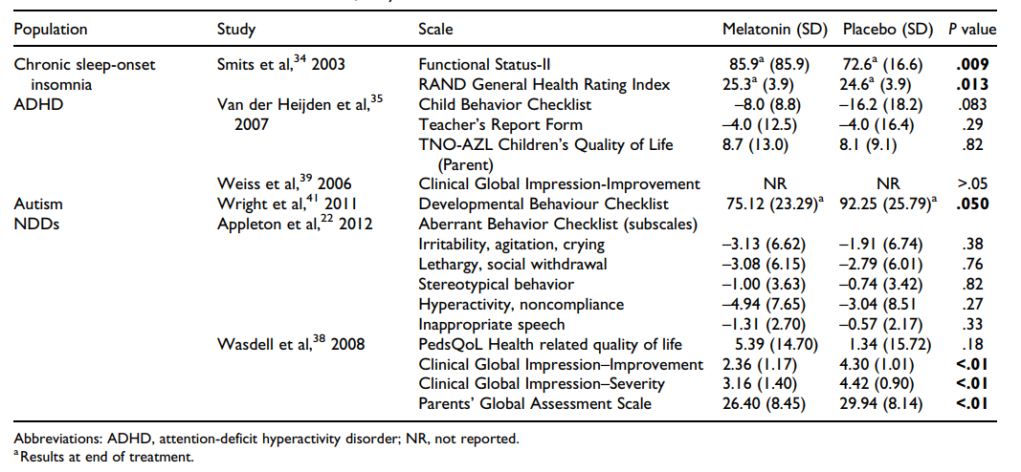

**Abdelgadir, 2018[18]**

A systematic review and meta-analysis of melatonin for the management of sleep problems in children with ND disorders. The main outcomes included total sleep time, sleep onset latency, and frequency of nocturnal awakenings.

RCTs that compared melatonin with placebo or other intervention for the management of sleep disorders in children and adolescents with ND disorders, including ADHD or ASD were included. The primary outcome measure was total sleep time. The secondary outcome measures included sleep onset latency, frequency of nocturnal awakening and early-morning awakening time, parental perception of the effect of melatonin treatment on their child’s behaviour, and quality of life for both children and families.

Children with ND disorder, autistic spectrum disorders, ADHD, fragile X syndrome, Rett syndrome and mental retardation were included.

IR melatonin was used in 10 studies. Two studies used a combination of IR and CR melatonin formulations. One further study used CR melatonin. The dosages used ranged from 0.1 to 12 mg. Escalating dose of melatonin according to response was used in three of the included studies. The duration of melatonin treatment ranged from 1 to 13 weeks.

682 subjects across 13 studies met the inclusion criteria. There was a statistically significant longer TST in the melatonin group compared with the placebo group [48.26 minutes (95%CI: 36.79, 59.73). There was mild heterogeneity among the studies (I2 =31%). The pooled data across 11 studies suggested that SOL was significantly shortened using melatonin [−28.97 (95%CI: −39.78, −18.17). High degree of heterogeneity was reported among the included individual studies (I2 =82%). In terms of nocturnal awakenings, there was no significant difference between participants receiving melatonin and those receiving placebo [−0.49 (95%CI: −1.71, 0.73). There was severe heterogeneity among the included individual studies (I2 =95%)

In children with ADHD, no greater improvement in behaviour was reported for children who received melatonin, compared to placebo.

Table : Mean difference in TST for melatonin versus placebo

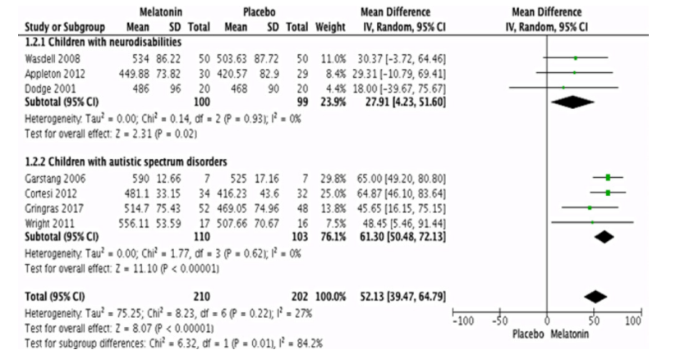

**Beresford, 2018[19]**

A systematic review of pharmacological and non-pharmacological interventions for sleep disorders in children with ND conditions.

Eleven trials in 589 randomised subjects compared melatonin with placebo. The melatonin dose ranged from 0.5- 12 mg. The duration of melatonin treatment across studies was from 10 days to 12 weeks. The age of subjects ranged from 1 to 18 years. The mean age across studies was from 5.5 to 10.3 years.

Subjects in melatonin arm reported a significant increase in TST, compared with placebo ( 29.6 minutes (95% CI: 6.9, 52.4; p = 0.01) The evaluator has highlighted the high statistical heterogeneity (I2 = 97%).

A statistically significant reduction in SOL for melatonin, compared with placebo [pooled MD –35.6 minutes (95% CI:–50.9, –20.3; p < 0.001) was reported.

Higher sleep efficiency was reported in melatonin arm, compared with placebo [4.76% (95% CI –0.95%, 10.47%; p = 0.10). The treatment difference was not statistically significant.

Table : Sleep-diary measured SOL

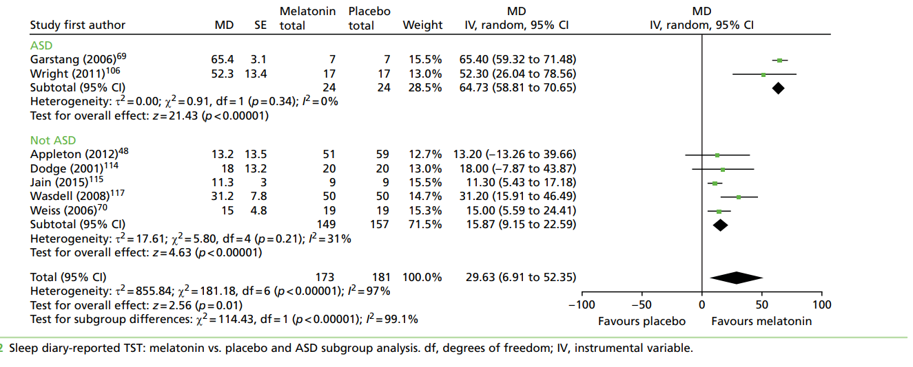

**Cuomo, 2017[20]**

A meta-synthesis to assess the effectiveness of sleep-based interventions for children with ASD. It was conducted at centres in Australia and Sweden.

The inclusion criteria included children with autism, ASD, autism spectrum disorder, and Asperger’s syndrome. The primary outcomes were parameters of night-time sleep such as sleep latency and duration.

The dosage regimen of melatonin was not described. Due to the heterogeneity of the study designs, a meta-analysis was not feasible. The authors used a weighted rating algorithm which, the Sponsor has highlighted to be interpreted with caution*.*

**Rossignol, 2011[21]**

A systematic review and meta-analysis to assess the effectiveness of melatonin in autism spectrum disorders.

Five of the included studies were RCTs. Two of the studies included children with ASD and other developmental disorders but only data for children with ASD were used in the meta-analysis. Information on the dosage regimens used were missing, which limits any conclusions regarding treatment benefit with melatonin.

#### Sleep onset insomnia in children and adolescents

**Wei, 2020[22]**

The objective was to evaluate the efficacy and safety of melatonin in the treatment of sleep onset insomnia in children and adolescents (aged 6-12 years and adolescents aged 13-18 years).

The primary efficacy outcome was SOT. Secondary outcomes included DLMO, SOL, TST, light-off time, and WUT.

All the studies used IR melatonin at doses of 1 mg to 6 mg per day. The treatment duration ranged from 1-4 weeks.

Seven trials with 387 participants were included in the analysis. The mean age was 9 years. One study was conducted in adolescents aged 14-19 years (treated for one week).

A greater reduction in SOT was reported in subjects receiving melatonin, compared to placebo (mean difference -0.62 hours , 95% CI:-0.80, -0.45; p<0.00001). A greater reduction in DLMO was reported in melatonin arm, compared to placebo (mean difference -0.82 h (95% CI -1.23, -0.41; P < 0.0001, and SOL was reduced with a mean difference of -0.36 h (95% CI -0.49, -0.24; P < 0.00001). The treatment difference was statistically significant for these endpoints. There was no difference in the outcomes of light-off time or wake-up time.

**McDonagh, 2019[23]**

The meta-analysis included five trials of melatonin included children diagnosed with chronic sleep-onset insomnia, many of whom had comorbid ND disorders.

This study was already considered with regards to the proposed indication for use in children with ND. The evaluator did not consider this study as relevant to the proposed indication for use in children and adolescents without ND.

### Safety

Across studies, the duration of exposure ranged from less than one week to 12 months in subjects aged 14-65 years and from 10 days to four weeks in adults over 65 years of age.

The melatonin dose ranged from 0.3 mg/day to 100 mg/day.

The ages of the children in the studies ranged from 1-17 years of age. The duration of melatonin exposure ranged from one week to 11 months and the dose ranged from 0.5 to 12 mg/day.

**Adverse events**

Overall, adverse events (AE) were not reported in detail in most of the submitted studies and systematic reviews. The most reported adverse events for melatonin in adults were headaches, dizziness, nausea, and daytime drowsiness but the frequency of reports were comparable to placebo and in line with the accepted safety profile. In children, bedwetting and irritability were also reported. Nearly all AEs were mild in severity and no drug-related severe or serious events were reported. Overall, melatonin was well tolerated irrespective of dose or formulation with no evidence of a relationship with age or gender.

Nil events of death were reported across clinical studies.

### Risk management plan

The summary of safety concerns and their associated risk monitoring and mitigation strategies are presented in Table 3. The TGA may request an updated RMP at any stage of a product's life-cycle, during both the pre-approval and post-approval phases.

Table : Summary of safety concerns

|  |  |  |  |  |  |
| --- | --- | --- | --- | --- | --- |
| Summary of safety concerns | | Pharmacovigilance | | Risk minimisation | |
| Routine | Additional | Routine | Additional |
| Important identified risks | Drug interactions | ✓ | – | ✓ | – |
| Important potential risks | Infections | ✓ | – | ✓ | – |
| Drug withdrawal | ✓ | – | – | – |
| Visual disturbances | ✓ | – | ✓ | – |
| Delay of sexual maturation and development § | ✓ | – | – | – |
| Missing information | Use in individuals with autoimmune diseases | ✓ | – | ✓ | – |
| Use in patients with renal or hepatic impairment | ✓ | – | ✓ | – |
| Fertility, pregnancy, and lactation | ✓ | – | ✓ | – |

### Risk-benefit analysis

#### Advisory Committee considerations

The [Advisory Committee on Medicines (ACM)](https://www.tga.gov.au/committee/advisory-committee-medicines-acm), having considered the evaluations and the Delegate’s overview, as well as the sponsor’s response to these documents, advised the following.

The ACM considered this product to have an overall positive benefit-risk profile for the indications:

* Short-term treatment of jet lag in adults greater than 18 years
* Treatment of sleep disorders in children and adolescents aged 6 to 18 with neurodevelopmental disorders, where sleep hygiene measures have been insufficient.

The following proposed indications were also considered by the ACM:

* Adult
* Monotherapy for the short-term treatment of primary insomnia characterised by sleep latency in adults aged 55 and over.
* Short-term treatment of delayed sleep wake disorder (DSWD) in adults aged 18 and over.
* Paediatric
* Treatment of sleep onset insomnia in children and adolescents aged 2 to 18 where sleep hygiene measures have been insufficient.

The ACM agreed that there was an overall negative benefit-risk profile for these proposed indications as the evidence submitted did not satisfactorily establish efficacy within these indications. In providing this recommendation the ACM noted the heterogenicity of the presented literature, which impacted on the ability to determine effective dosage, duration and population. Challenges in assessing the efficacy of the submitted formulation were also noted.

#### Discussion

The sponsor has proposed to register a range of indications and dosages for melatonin. The evaluator noted that a wide range of daily doses of melatonin (from 0.11 mg to 240 mg) were used in the studies included in this submission, which are more than 40 times higher than the maximum proposed daily dosage. This aspect had implications on the ability to translate the study findings to support the registration of the proposed dosage. Moreover, the evaluator highlighted the lack of studies that followed the proposed dosage regimen, thus lacking the evidence to support the proposed dosage regimen. The sponsor’s proposed dosage recommendations were based on the TGA approved controlled release (CR) formulations (Circardin and Slenyto), rather than supported by the literature provided in this submission. The evaluator considered the immediate release (IR) and CR formulations to not be bioequivalent, and no specific justification was provided in the submitted literature to support the proposed melatonin daily dose or dosage regimen. The evaluator concluded that optimal IR melatonin doses for the proposed indications were not defined.

##### Primary insomnia

The evaluator concluded that the sponsor was unable to provide an accepted definition of primary insomnia characterised by sleep latency*,* as stated in the proposed indication. In response to the evaluator’s request, the sponsor elected to change the indication by removing ‘primary’ to align it with DSM-V. The new proposed indication is:

*TRADENAME (melatonin) as monotherapy for the short-term treatment of insomnia characterised by sleep latency in adults aged 55 and over.*

The evaluator noted that the studies by Haimov, 1995 and Jean-Louis 1998 were the only studies that included subjects greater than 55 years of age. These studies did not follow the proposed dosage regimen.

The study by Haimov *et. al.* was conducted in elderly subjects with and without sleep disorders. Approximately 50% of the subjects did not have a sleep disorder. The treatment period was for one week with either of the CR or IR formulations and the dosage was 2 mg. The Study by Jean-Louis *et. al* was conducted in 10 elderly subjects with insomnia associated with cognitive decline. The dose of melatonin was 6 mg/day, which is higher than the proposed daily dose (2 mg).

None of the submitted studies were of 13 weeks duration (the sponsor’s proposed treatment period). The treatment dose ranged from 0.1 mg to 80 mg and treatment duration ranged from 1-182 days.

##### Jetlag

Across the pivotal studies, treatment with melatonin resulted in a greater subjective improvement measured by visual analogue scale (VAS), compared to placebo. The magnitude of treatment benefit was statistically significant. The evaluator has highlighted that, overall, the studies showed that melatonin restores the natural circadian rhythm approximately one day sooner than would otherwise have occurred naturally over a five-day period. It should be noted that the symptoms associated with jet lag are self-limiting.

An IR melatonin dose of 2 mg as starting dose is acceptable. A dose-response relationship was not evident. There was no evidence to support the proposed dose escalation recommendations in the PI.

Melatonin was scheduled to S3 while this submission was under evaluation in TGA. At that stage, the sponsor chose to continue their application to register melatonin as a S4 product. Melatonin is scheduled as a S3 product for the below usage:

*Immediate release preparations containing 5 mg or less of melatonin for the treatment of jet lag in adults aged 18 or over, in a primary pack containing no more than 10 dosage units.*

##### Delayed Sleep Wake Disorder

The evaluator has highlighted that the studies were heterogeneous with respect to diagnostic definitions of DSWD, inclusion and exclusion criteria, measures to evaluate insomnia, treatment dosage and treatment duration. The duration of the treatment period across the studies were 2-4 weeks, which is shorter than the proposed duration of 13 weeks.

The evaluator has highlighted that sleep guidelines generally recommend sleep hygiene measures as first line treatment for DSWD but this has not been adequately referenced in the submitted studies or in the indication.

Studies by Sletten *et. al*. and Kayumov *et. al.* were well designed and conducted in individuals with clinically diagnosed DSWD. These studies also showed a positive trend for treatment benefit with melatonin. However, the dosage regimen of 0.5 mg (Sletten) and 5mg (Kayumov) did not conform to the proposed dosage regimen. The study by Kayumov *et. al.* also included adolescents, which is not a target population in the proposed indication.

Similarly, the meta-analysis by Van geijlswijk *et. al.* showed a trend towards greater treatment benefit with melatonin, compared to placebo. However, the proposed dosage was not used in these studies.

Most of the studies used 5 mg, which is the maximum dose that is proposed to be registered and not the 2mg, the proposed starting dose and the titration for dose escalation. Also, the duration of treatment was much lower (around 4-5 weeks) than the proposed 13 weeks.

##### Sleep disorder in children and adolescents with neurodevelopmental disorders

Melatonin treatment following failed intervention of sleep hygiene (the current algorithm of treatment) was adopted in studies by Weiss *et. al.* and not evident in other studies. Across studies, it was not clear whether the diagnosis of a sleep disorder was made by a paediatrician. The majority of the studies were conducted in children with ADHD and/or ASD.

Systematic reviews by McDonagh *et. al.* and Abdelgadir *et. al.* showed positive results for melatonin compared to placebo. In n both studies, melatonin doses ranged from 1.0 mg per day to 12 mg per day (median 4.8 mg) and studies ranged in duration from one to 13 weeks (median four weeks). The majority of the studies involved children 7-10 years of age. Of note, the UK Summary of Product Characteristics has restricted the indication for the use of melatonin in children with ADHD to a range of 6-17 years.

##### Sleep onset insomnia in children and adolescents

The meta-analysis by Wei *et. al.* showed a positive treatment benefit with melatonin, compared to placebo. However, the majority of studies (5 out of 7) included children with ADHD. A similar trend was also noted with other (supportive) studies including children with ADHD, ASD and other neurological disorders, thus limiting the ability to translate the findings to children without this condition.

The majority of the studies were in children 6-10 years of age. Across studies, it was not stated whether the diagnosis of insomnia was made by a paediatrician. There was high variability in the dosage reported in these studies (1 mg to 6 mg/day).

## Conclusion

The evaluator considered the fact that melatonin is an endogenous substance and that it has been used for decades as both S4 and S3 products in Australia for the treatment of primary insomnia. The sponsor has proposed to register melatonin for multiple indications. However, from a regulatory perspective, I consider that there is sufficient evidence for the proposed treatment of sleep onset insomnia in children (>7 years of age) with ADHD and ASD and for the treatment of jetlag. The rationale for not approving the Sponsor’s proposed indications for other conditions are described in the discussion section under relevant headings.

The rationale for the evaluator’s decision for approval is that most of the studies involved children with ASD and ADHD and in the age group of 7-10 years. The evaluator also noted the sponsor’s modified maximum daily dose of 5 mg, instead of 10 mg, which is comparable to the median dose of 4.8 mg that was used in the submitted studies. The melatonin that will be supplied as a liquid formulation will provide a greater choice for prescription, better ease of administration and increased patient compliance, if approved for use in children (the currently TGA approved Slenyto is available as a tablet only, that needs to swallowed whole and cannot be crushed for administration to children).

The availability of melatonin as a prescription product (30 capsules) will be beneficial for frequent travellers and for airline crew.

## Outcome

Based on a review of quality, safety, and efficacy, the TGA decided to register MELATONIN-LINK, IMMELA, MELAKSO and VOQUILY (melatonin), 2mg, 3mg, 5mg (capsules); 1 mg/mL (oral liquid) for the following proposed extension of indications:

**Adult**

Short-term treatment of jet lag in adults aged 18 and over.

**Paediatric**

Sleep disorders in children and adolescents aged 6 to 18 with neurodevelopmental disorders including autism spectrum disorder (ASD) and attention deficit hyperactivity disorder (ADHD), where sleep hygiene measures have been insufficient.

## Attachment 1. Product Information

The [Product Information](https://www.tga.gov.au/products/australian-register-therapeutic-goods-artg/product-information-one) ([PI](https://www.tga.gov.au/products/australian-register-therapeutic-goods-artg/product-information-one)) approved with the submission for [Tradename] which is described in this AusPAR can be found as Attachment 1. It may have been superseded. For the most recent PI and [Consumer Medicines Information](https://www.tga.gov.au/products/australian-register-therapeutic-goods-artg/consumer-medicines-information-cmi) (CMI), please refer to the TGA [PI/CMI search facility.](https://www.tga.gov.au/picmi-search-facility)

|  |
| --- |
| Therapeutic Goods Administration |
| PO Box 100 Woden ACT 2606 Australia  Email: [info@tga.gov.au](mailto:info@tga.gov.au) Phone: 1800 020 653 Fax: 02 6203 1605  [**https://www.tga.gov.au**](https://www.tga.gov.au) |
| Reference/Publication # |

1. This is the original indication proposed by the sponsor when the TGA commenced the evaluation of this submission. It may differ to the final indication approved by the TGA and registered in the Australian Register of Therapeutic Goods.
2. https://www.thoracic.org/patients/patient-resources/resources/delayed-sleep-phase-syndrome.pdf
3. https://www.thoracic.org/patients/patient-resources/resources/travel-and-sleep.pdf
4. In this report the ‘Delegate’ is the Delegate of the Secretary of the Department of Health and Aged Care who decided the submission under section 25 of the Act.
5. Ferracioli-Oda E, Qawasmi A, Bloch MH. Meta-analysis: melatonin for the treatment of primary sleep disorders. PLoS One. 2013 May 17;8(5):e63773. doi: 10.1371/journal.pone.0063773.
6. Brzezinski A, Vangel MG, Wurtman RJ, Norrie G, Zhdanova I, Ben-Shushan A, Ford I. Effects of exogenous melatonin on sleep: a meta-analysis. Sleep Med Rev. 2005 Feb;9(1):41-50. doi: 10.1016/j.smrv.2004.06.004
7. Haimov I, Lavie P. Potential of melatonin replacement therapy in older patients with sleep disorders. Drugs Aging. 1995 Aug;7(2):75-8. doi: 10.2165/00002512-199507020-00001
8. Jean-Louis G, von Gizycki H, Zizi F. Melatonin effects on sleep, mood, and cognition in elderly with mild cognitive impairment. J Pineal Res. 1998 Oct;25(3):177-83. doi: 10.1111/j.1600-079x.1998.tb00557.x.
9. Herxheimer A, Petrie KJ. Melatonin for the prevention and treatment of jet lag. Cochrane Database Syst Rev. 2002;(2):CD001520. doi: 10.1002/14651858.CD001520.
10. Tortorolo F, Farren F, Rada G. Is melatonin useful for jet lag? Medwave. 2015 Dec 21;15 Suppl 3:e6343. English, Spanish. doi: 10.5867/medwave.2015.6343
11. Petrie K, Conaglen JV, Thompson L, Chamberlain K. Effect of melatonin on jet lag after long haul flights. BMJ. 1989 Mar 18;298(6675):705-7. doi: 10.1136/bmj.298.6675.705
12. van Geijlswijk IM, Korzilius HP, Smits MG. The use of exogenous melatonin in delayed sleep phase disorder: a meta-analysis. Sleep. 2010 Dec;33(12):1605-14. doi: 10.1093/sleep/33.12.1605
13. Buscemi N, Vandermeer B, Pandya R, Hooton N, Tjosvold L, Hartling L, Baker G, Vohra S, Klassen T. Melatonin for treatment of sleep disorders. Evid Rep Technol Assess (Summ). 2004 Nov;(108):1-7. doi: 10.1037/e439412005-001
14. Sletten TL, Magee M, Murray JM, Gordon CJ, Lovato N, Kennaway DJ, Gwini SM, Bartlett DJ, Lockley SW, Lack LC, Grunstein RR, Rajaratnam SMW; Delayed Sleep on Melatonin (DelSoM) Study Group. Efficacy of melatonin with behavioural sleep-wake scheduling for delayed sleep-wake phase disorder: A double-blind, randomised clinical trial. PLoS Med. 2018 Jun 18;15(6):e1002587. doi: 10.1371/journal.pmed.1002587
15. Dahlitz M, Alvarez B, Vignau J, English J, Arendt J, Parkes JD. Delayed sleep phase syndrome response to melatonin. Lancet. 1991 May 11;337(8750):1121-4. doi: 10.1016/0140-6736(91)92787-3
16. Kayumov L, Brown G, Jindal R, Buttoo K, Shapiro CM. A randomized, double-blind, placebo-controlled crossover study of the effect of exogenous melatonin on delayed sleep phase syndrome. Psychosom Med. 2001 Jan-Feb;63(1):40-8. doi: 10.1097/00006842-200101000-00005
17. McDonagh MS, Holmes R, Hsu F. Pharmacologic Treatments for Sleep Disorders in Children: A Systematic Review. J Child Neurol. 2019 Apr;34(5):237-247. doi: 10.1177/0883073818821030.
18. Abdelgadir IS, Gordon MA, Akobeng AK. Melatonin for the management of sleep problems in children with neurodevelopmental disorders: a systematic review and meta-analysis. Arch Dis Child. 2018 Dec;103(12):1155-1162. doi: 10.1136/archdischild-2017-314181
19. Beresford B, McDaid C, Parker A, Scantlebury A, Spiers G, Fairhurst C, Hewitt C, Wright K, Dawson V, Elphick H, Thomas M. Pharmacological and non-pharmacological interventions for non-respiratory sleep disturbance in children with neurodisabilities: a systematic review. Health Technol Assess. 2018 Oct;22(60):1-296. doi: 10.3310/hta22600. PMID: 30382936
20. Cuomo BM, Vaz S, Lee EAL, Thompson C, Rogerson JM, Falkmer T. Effectiveness of Sleep-Based Interventions for Children with Autism Spectrum Disorder: A Meta-Synthesis. Pharmacotherapy. 2017 May;37(5):555-578. doi: 10.1002/phar.1920
21. Rossignol DA, Frye RE. Melatonin in autism spectrum disorders: a systematic review and meta-analysis. Dev Med Child Neurol. 2011 Sep;53(9):783-792. doi: 10.1111/j.1469-8749.2011.03980.x
22. Wei S, Smits MG, Tang X, Kuang L, Meng H, Ni S, Xiao M, Zhou X. Efficacy and safety of melatonin for sleep onset insomnia in children and adolescents: a meta-analysis of randomized controlled trials. Sleep Med. 2020 Apr;68:1-8. doi: 10.1016/j.sleep.2019.02.017.
23. McDonagh MS, Holmes R, Hsu F. Pharmacologic Treatments for Sleep Disorders in Children: A Systematic Review. J Child Neurol. 2019 Apr;34(5):237-247. doi: 10.1177/0883073818821030.