|  |
| --- |
| Australian Public Assessment Report for Nurtec ODT |
| Active ingredient: Rimegepant (as sulfate) |
| Sponsor: Pfizer Australia Pty Ltd |
| March 2024 |

About the Therapeutic Goods Administration (TGA)

* The Therapeutic Goods Administration (TGA) is part of the Australian Government Department of Health and Aged Care and is responsible for regulating therapeutic goods, including medicines, medical devices, and biologicals.
* The TGA administers the *Therapeutic Goods Act 1989* (the Act), applying a risk management approach designed to ensure therapeutic goods supplied in Australia meet acceptable standards of quality, safety, and efficacy.
* The work of the TGA is based on applying scientific and clinical expertise to decision-making, to ensure that the benefits to the Australian public outweigh any risks associated with the use of therapeutic goods.
* The TGA relies on the public, healthcare professionals and industry to report problems with therapeutic goods. The TGA investigates reports received to determine any necessary regulatory action.
* To report a problem with a therapeutic good, please see the information on the [TGA website](https://www.tga.gov.au/).

About AusPARs

* The Australian Public Assessment Report (AusPAR) provides information about the evaluation of a prescription medicine and the considerations that led the TGA to approve or not approve a prescription medicine submission. Further information can be found in [Australian Public Assessment Report (AusPAR) guidance](https://www.tga.gov.au/australian-public-assessment-report-auspar-guidance).
* AusPARs are prepared and published by the TGA.
* AusPARs are static documents that provide information that relates to a submission at a particular point in time. The publication of an AusPAR is an important part of the transparency of the TGA’s decision-making process.
* A new AusPAR may be provided to reflect changes to indications or major variations to a prescription medicine subject to evaluation by the TGA.

Copyright

© Commonwealth of Australia 2024  
This work is copyright. You may reproduce the whole or part of this work in unaltered form for your own personal use or, if you are part of an organisation, for internal use within your organisation, but only if you or your organisation do not use the reproduction for any commercial purpose and retain this copyright notice and all disclaimer notices as part of that reproduction. Apart from rights to use as permitted by the *Copyright Act 1968* or allowed by this copyright notice, all other rights are reserved and you are not allowed to reproduce the whole or any part of this work in any way (electronic or otherwise) without first being given specific written permission from the Commonwealth to do so. Requests and inquiries concerning reproduction and rights are to be sent to the TGA Copyright Officer, Therapeutic Goods Administration, PO Box 100, Woden ACT 2606 or emailed to <[tga.copyright@tga.gov.au](mailto:tga.copyright@tga.gov.au)>.

Contents

List of abbreviations 4

Product submission 5

Submission details 5

Product background 6

The disease/condition 6

Current treatment options 7

Clinical rationale 7

Regulatory status 8

Australian regulatory status 8

Foreign regulatory status 8

Registration timeline 9

Submission overview and risk/benefit assessment 10

Quality 10

Nonclinical 11

Clinical 12

Summary of clinical studies 12

Pharmacology 12

Efficacy 17

Safety 26

Risk management plan 29

Risk-benefit analysis 30

Delegate’s considerations 30

Proposed action 33

Advisory Committee considerations 33

Outcome 35

Specific conditions of registration applying to these goods 35

Attachment 1. Product Information 35

## List of abbreviations

|  |  |
| --- | --- |
| Abbreviation | Meaning |
| ACM | Advisory Committee on Medicines |
| ALP | Alkaline phosphatase |
| ALT | Alanine aminotransferase |
| ASA | Australia specific annex |
| AST | Aspartate aminotransferase |
| AUC | Area under the concentration-time curve |
| CGRP | Calcitonin gene‑related peptide |
| CHMP | Committee for Medicinal Products for Human Use |
| CI | Confidence interval |
| Cmax | Maximum concentration |
| CMI | Consumer Medicines Information |
| CYP | Cytochrome P450 |
| eGFR | Estimated glomerular filtration rate |
| EMA | European Medicines Agency |
| mITT | Modified intention to treat |
| NSAID | Non-steroidal anti-inflammatory drug |
| ODT | Oral dispersible tablet |
| PI | Product Information |
| PK | Pharmacokinetic(s) |
| PSUR | Periodic safety update report |
| RMP | Risk management plan |
| TGA | Therapeutic Goods Administration |

## Product submission

### Submission details

|  |  |
| --- | --- |
| *Type of submission:* | New chemical entity |
| *Product name:* | Nurtec ODT |
| *Active ingredient:* | Rimegepant (as sulfate) |
| *Decision:* | Approved |
| *Date of decision:* | 17 July 2023 |
| *Date of entry onto ARTG:* | 27 July 2023 |
| *ARTG number:* | 392434 |
| [*Black Triangle Scheme*](https://www.tga.gov.au/black-triangle-scheme)  *for the current submission:* | Yes |
| *Sponsor’s name and address:* | Pfizer Australia Pty Ltd  Level 17, 151 Clarence Street, Sydney, NSW 2000 |
| *Dose form:* | Orally disintegrating tablet |
| *Strength:* | 75 mg |
| *Container:* | Blister pack |
| *Pack sizes:* | 2, 4, 8 and 16 tablets |
| *Approved therapeutic use for the current submission:* | *Nurtec ODT is indicated for:*  *• acute treatment of migraine with or without aura in adults;*  *• prophylactic treatment of episodic migraine in adults who have at least 4 migraine attacks per month.* |
| *Route of administration:* | Sublingual |
| *Dosage:* | *Acute treatment of migraine*  The recommended dose is 75 mg rimegepant orally disintegrating tablet, as needed. The maximum dose in a 24 hour period is 75 mg.  *Prophylaxis of migraine*  The recommended dose is 75 mg rimegepant every other day. If also requiring rimegepant for the acute treatment of migraine, do not exceed a total dose of 75 mg rimegepant in a 24 hour period.  Nurtec ODT can be taken with or without meals.  For further information regarding dosage, such as dosage modifications to manage adverse reactions, refer to the Product Information. |
| *Pregnancy category:* | B1  Drugs which have been taken by only a limited number of pregnant women and women of childbearing age, without an increase in the frequency of malformation or other direct or indirect harmful effects on the human fetus having been observed.  Studies in animals have not shown evidence of an increased occurrence of fetal damage.  The use of any medicine during pregnancy requires careful consideration of both risks and benefits by the treating health professional. The [pregnancy database](https://www.tga.gov.au/products/medicines/find-information-about-medicine/prescribing-medicines-pregnancy-database) must not be used as the sole basis of decision making in the use of medicines during pregnancy. The TGA does not provide advice on the use of medicines in pregnancy for specific cases. More information is available from [obstetric drug information services](https://www.tga.gov.au/obstetric-drug-information-services) in your state or territory. |

### Product background

This AusPAR describes the submission by Pfizer Australia Pty Ltd (the sponsor) to register Nurtec ODT (rimegepant) 75 mg, orally disintegrating tablet, blister packs for the following proposed indication:[1]

*• Acute treatment of migraine with or without aura in adults;*

*• Preventive treatment of episodic migraine in adults who have at least 4 migraine attacks per month.*

Rimegepant is a selective, high affinity, orally administered, small molecule calcitonin gene‑related peptide (CGRP) antagonist. Several lines of evidence suggest that CGRP plays an important role in migraine pathogenesis. Monoclonal antibodies targeting CGRP are effective prophylactic drugs and approved for such use in Australia and around the world.

#### The disease/condition

Migraine is a chronic episodic disorder characterised by headache and associated symptoms such as nausea, dizziness, photophobia and phonophobia. Around 25% of migraine sufferers experience aura prior to the onset of headache. Auras consist of focal neurologic symptoms that are typically of short duration, positive and negative in nature and are reversible. Examples include lines or objects in field of vision, tinnitus, paraesthesia, jerking and limb weakness. Previously thought to be due to abnormal cerebral vaso-activity, migraine is now considered a disorder of primary intra- and extracranial neuronal dysfunction.[2] Pathophysiological events associated with migraine include cortical spreading depression (especially in relation to the aura), trigeminovascular activation and neuronal sensitisation. Important neurotransmitters involved include calcitonin gene-related peptide (CGRP) and serotonin.

Migraine is one of the most prevalent and disabling illnesses. Lifetime prevalence in women is 33% and in men is 13%.[3] It is most prevalent between the ages of 25 and 55. Chronic migraine represents a small subset of the general migraine population and is defined as the presence of headache on 15 or more days per month, with criteria for migraine being met on at least eight of those days. It represents the more severe end of the disease spectrum, being associated with reduced quality of life, functional impairments and increased healthcare resource utilisation. Episodic migraine involves less than 15 headache days per month.

#### Current treatment options

The initial treatment of acute migraine is aspirin, a non-steroidal anti-inflammatory drug (NSAID) or paracetamol, with or without an antiemetic, such as metoclopramide or ondansetron. The subsequent line of acute treatment is with an oral triptan. If oral therapy is not feasible, sumatriptan is available in nasal and subcutaneous formulations. For severe symptoms and under appropriate medical supervision, parenteral sumatriptan, ketorolac, chlorpromazine or dexamethasone may be effective.

The proportion of patients pain free at 2 hours is established as the most meaningful measure for efficacy of the current therapies. Simple analgesics (aspirin, NSAIDs, paracetamol) lead to 2 hour pain free proportions of around 20 to 25%. Triptans perform better with proportions of 20 to 40%. Of note, triptans are contraindicated in patients with established cardiovascular disease or uncontrolled hypertension. As some patients do not respond adequately (or have contraindications) to the available treatments for acute migraine, there is significant unmet need.

A range of drugs are in use for migraine prophylaxis. Only a proportion have an Australian Register of Therapeutic Goods entry specifying migraine prophylaxis. The appropriate drug for a particular patient generally depends on the co-morbidities present and tolerability. Commonly used oral drugs for migraine prophylaxis include amitriptyline, pizotifen, propranolol, verapamil and topiramate. Botox is another treatment option for more refractory disease.

Four monoclonal antibodies targeting calcitonin gene-related peptide have become available since 2018 (erenumab, galcanezumab, fremanezumab, eptinezumab). Galcanezumab and fremanezumab are pharmaceutical benefits scheme subsidised therapies. These drugs are indicated for the preventative treatment of migraine in adults and are given by intravenous infusion or subcutaneously, depending on the agent.

#### Clinical rationale

Rimegepant binds with high affinity to the human calcitonin gene-related peptide (CGRP) receptor and antagonises CGRP receptor function.

Multiple lines of clinical evidence point to a role for CGRP in migraine pathophysiology: 1) serum levels of CGRP are elevated during migraine; 2) treatment with anti-migraine drugs returns CGRP levels to normal coincident with pain relief and 3) intravenous CGRP infusion produces lasting pain in non-migraineurs and migraineurs.

### Regulatory status

#### Australian regulatory status

This product is considered a new chemical entity for Australian regulatory purposes.

#### Foreign regulatory status

This submission was submitted through the TGA’s [Comparable Overseas Regulator](https://www.tga.gov.au/comparable-overseas-regulators-cors-timeframes-and-milestones) (COR-B) process, using evaluation reports from European Medicines Agency (EMA). The full dossier was submitted to the TGA.

At the time the TGA considered this submission, a similar submission had been considered by other regulatory agencies. The following table summarises these submissions and provides the indications where approved.

Table 1: International regulatory status

|  |  |  |  |
| --- | --- | --- | --- |
| Region | Submission date | Status | Approved indications |
| United States of America | 27 June 2019 28 July 2020 | Approved on 27 February 2020 (acute)  27 May 2021 (prevention) | *Nurtec ODT is a calcitonin gene-related peptide receptor antagonist indicated for the:*  *• acute treatment of migraine with or without aura in adults*  *• preventive treatment of episodic migraine in adults* |
| European Union | 2 February 2021 | 25 April 2022 | *Vydura is indicated for the*  *• Acute treatment of migraine with or without aura in adults;*  *• Preventive treatment of episodic migraine in adults who have at least 4 migraine attacks per month* |
| United Kingdom | 28 February 2022 | 10 June 2022 | *Vydura is indicated for the*  *• Acute treatment of migraine with or without aura in adults;*  *• Preventive treatment of episodic migraine in adults who have at least 4 migraine attacks per month* |
| Singapore | 25 July 2022 | 21 February 2023 | *Nurtec ODT is indicated for the*  *• Acute treatment of migraine with or without aura in adults;*  *• Preventive treatment of episodic migraine in adults who have at least 4 migraine attacks per month* |
| Switzerland | 8 July 2022 | Under consideration | Under consideration |
| Canada | 3 October 2022 | Under consideration | Under consideration |

Biohaven Pharmaceutical Ireland in February 2021 submitted an application for marketing authorisation for Vydura (that is, rimegepant), through the EMA’s centralised procedure. The requested indication was the ‘comprehensive management of migraine’ (acute treatment and prophylaxis). Biohaven had previously received scientific advice related to their pivotal Phase III studies. Following a positive Committee for Medicinal Products for Human Use (European Medicines Agency, European Union, CHMP) recommendation, rimegepant was granted marketing authorisation on 25 April 2022.

## Registration timeline

The following table captures the key steps and dates for this submission.

This submission was evaluated under the [standard prescription medicines registration process](https://www.tga.gov.au/how-we-regulate/supply-therapeutic-good-0/supply-prescription-medicine/application-process/prescription-medicines-registration-process).

Table 2: Timeline for Submission PM-2022-02939-1-1

|  |  |
| --- | --- |
| Description | Date |
| Submission dossier accepted and first round evaluation commenced | 7 September 2022 |
| First round evaluation completed | 9 January 2023 |
| Sponsor provides responses on questions raised in first round evaluation | 23 February 2023 |
| Second round evaluation completed | 17 April 2023 |
| Sponsor’s notification to the TGA of errors/omissions in evaluation reports | 27 February 2023 |
| Delegate’s Overall benefit-risk assessment and request for Advisory Committee advice[4] | 28 February 2023 |
| Sponsor’s pre-Advisory Committee response | 13 March 2023 |
| Advisory Committee meeting | 30 and 31 March 2023 |
| Registration decision (Outcome) | 17 July 2023 |
| Administrative activities and registration in the ARTG completed | 27 July 2023 |
| Number of working days from submission dossier acceptance to registration decision* | 159 |

* The COR-B process has a 175 working day evaluation and decision timeframe.

## Submission overview and risk/benefit assessment

A summary of the TGA’s assessment for this submission is provided below.

This section is a TGA summary of wording used in TGA’s evaluation report, which discussed numerous aspects of overseas evaluation reports and included some information that was commercial-in-confidence.

Relevant guidelines or guidance documents referred to by the Delegate are listed below:

* EMA: [Guideline on Clinical Investigation of Medicinal Products for the Treatment of Migraine](https://www.ema.europa.eu/en/documents/scientific-guideline/guideline-clinical-investigation-medicinal-products-treatment-migraine_en.pdf) (CPMP/EWP/788/01 Rev. 1)

TGA-adopted, effective date: 10 February 2009

* EMA: ICH Topic E1 – [Population Exposure – The Extent of Population Exposure to Assess Clinical Safety](https://www.ema.europa.eu/en/documents/scientific-guideline/ich-e-1-population-exposure-extent-population-exposure-assess-clinical-safety-step-5_en.pdf) (CPMP/ICH/375/95)

TGA-adopted, effective date: 12 February 2002

### Quality

Rimegepant is produced by chemical synthesis. The freebase molecular weight is 534.57 Daltons. The structure of rimegepant hemisulfate sesquihydrate is shown in Figure 1.

Figure 1: Structure of rimegepant

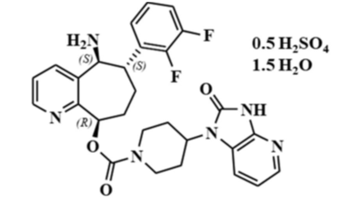

The drug substance is rimegepant hemisulfate sesquihydrate also known as BHV-3000 (during the drug development program). The drug substance content of the finished product is labelled according to the free base. Rimegepant has three chiral centres and is a single enantiomer.

The finished product is an oral lyophilisate (as oral dispersible tablet (ODT)) presented as a white to off-white, circular, 14 mm in diameter, unscored tablet, containing 75 mg of rimegepant as sulfate. The formulation rapidly disintegrates in the mouth. It is stable for 48 months when stored in the intended closure system at 20 to 25 °C.

Rimegepant is basic and soluble in acid. The oral dispersible tablet is intended to rapidly disintegrate and disperse micronised drug substance in the mouth.

The excipients are gelatin (obtained from fish), mannitol, sucralose and mint flavour. Other registered products, in particular certain sublingual wafers, are also formulated with mannitol and gelatin. There is routine batch control of disintegration and dissolution.

The sponsor has specified that the residual content of fish allergen (parvalbumin) in the gelatin is low and is considered to have a low allergenic risk.

The proposed specifications, which control identity, potency, purity and other properties of the drug substance relevant to the dose form are acceptable. Appropriate validation data have been submitted in support of the test procedures.

### Nonclinical

The evaluation report was based on the assessments and considerations detailed in reviews conducted by the EMA. In addition two *in vivo* studies and one *in vitro* study were evaluated.

The submitted nonclinical data was in accordance with relevant ICH guidelines and was overall of high quality.

*In vitro* rimegepant inhibited human CGRP-R with picomolar affinity. Affinity at non-human CGRP-R ranged from two (monkey) to 6000 (rat) times lower than human. Rimegepant also inhibited amylin 1 (AMY1) receptor at clinically relevant concentrations, but no relevant toxicities were observed in animal studies. Standard secondary pharmacology screening did not suggest off‑target effects.

In monkeys, no adverse central nervous system, cardiovascular or respiratory effects were seen. No clinically relevant cardiovascular or haemodynamic effects were seen in studies of human ether-a-go-go-related gene (hERG) and L-type calcium channels and rabbit Purkinje fibres.

Animal pharmacokinetics were similar across species, with rapid absorption, a moderate half‑life and moderate to high protein binding. In rats, penetration into the brain was limited. There was retention of drug-related material to melanin, particularly in the uveal tract, though this was not associated with any ocular toxicity findings in pigmented animals and rimegepant was negative for phototoxicity risk in vitro.

*In vitro* studies suggested rimegepant could be sensitive to cytochrome P450 isoenzyme 3A4 (CYP3A4) inhibition or induction and that it is a time dependant CYP3A4 inhibitor itself. It also has the potential to inhibit intestinal breast cancer resistance protein (BCRP), organic anion transporter P1B3 (OATP1B3), organic cation transporter 2 (OCT2) and multidrug and toxin extrusion protein 1 (MATE1).

Rimegepant had a low order of acute oral toxicity in rats and low to moderate in monkeys.

Rimegepant was not mutagenic (bacterial mutation assay) or clastogenic (*in vitro* human lymphocytes and *in vivo* rat micronucleus). No treatment related increase in tumour incidence was seen in transgenic mice (6 months) or rats (lifespan).

No effects were observed on fertility, embryo-fetal development or development (following maternal exposure).

The nonclinical evaluation found that the nonclinical data was acceptable. It was recommended that the pregnancy category be amended from category B2 to category B1.[5] There are no nonclinical objections to registration of Nurtec ODT.

### Clinical

#### Summary of clinical studies

The clinical dossier consisted of:

* 24 Phase I studies
* 1 Phase II study
* 2 Phase II/III studies
* 4 Phase III studies

#### Pharmacology

##### Pharmacokinetics

Rimegepant is eliminated unchanged in faeces and urine, as well as undergoing metabolism. Rimegepant is the predominant circulating species. Metabolism is via CYP3A4 and to a lesser extent cytochrome P450 isoenzyme 2C9 (CYP2C9). Significant drug interactions with strong inhibitors and inducers of CYP3A4 have been demonstrated in clinical studies.

Three formulations of rimegepant were used during the development process: a free-base capsule, a rimegepant sulfate tablet and a rimegepant sulfate oral dispersible tablet (ODT) using the Zydis formulation. Both the tablet and ODT were utilised in the pivotal clinical studies. The ODT is the final commercialised formulation.

Study CN170001 investigated the effect of pH lowering with famotidine on a capsule formulation of rimegepant. Famotidine reduced the maximum concentration (Cmax) by 75% and the area under the concentration-time curve (AUC) by 57%. This reduction in exposure was mitigated by the development of the tablet hemisulfate sesquihydrate formulation. Note that retrospective analyses of the clinical efficacy data did not find a change in efficacy with concomitant proton pump inhibitor use.

Study CN170006 investigated the absolute bioavailability, mass balance recovery, metabolism and pharmacokinetics following radiolabelled and unlabelled oral rimegepant and radiolabelled intravenous rimegepant. The study included eight healthy, male subjects. The geometric mean absolute bioavailability was 64%. Rimegepant was the primary circulating component. Following an oral radiolabelled dose, 78% of the radioactivity was detected in the faeces and 24% in the urine. Unchanged rimegepant was the major component in faeces (42%) and urine (51%).

Study BHV3000-110, Part 1, investigated the relative bioavailability of the 75 mg tablet and the 75 mg ODT formulation. Bioequivalence in terms of both AUC and Cmax was shown. Part 2 investigated the relative bioavailability of the ODT administered on top the tongue or sublingually. Bioequivalence of the administration sites was found in terms of the AUC. The Cmax was 10% higher when administered sublingually. Median time to maximum concentration was 30 minutes earlier with sublingual administration.

Study BHV3000-111 compared the pharmacokinetics and safety of rimegepant in healthy Japanese (n = 24) and healthy Caucasian (n = 26) subjects. Three doses (75 mg, 150 mg, 25 mg) were investigated, dosed daily for 14 consecutive days. There was an increase in exposure in Japanese subjects, which was more pronounced on Day 1 compared with Day 14. The increase was about 30% for Cmax and AUC on Day 1 (less on Day 14).

Study BHV3000-113, Part 1, investigated the relative bioavailability of 75 mg ODT formulation and the 75 mg tablet on top of the tongue. Bioequivalence of the ODT and the tablet was shown. Part 2 investigated the effect of a high-fat meal on the bioavailability of the ODT formulation administered on top of the tongue. The geometric mean ratios (fed/fasted) of the AUC and Cmax were 62.3% and 46.6% respectively, indicating reduced exposure in the presence of a high fat meal.

Study BHV3000-112 investigated the effect of a high fat meal on the pharmacokinetics (PK) of the 75 mg tablet and the 75 mg ODT formulation administered sublingually. The geometric mean ratios (fed/fasted) for AUC and Cmax were 68.3% and 58.8% respectively with the ODT, indicating reduced exposure in the presence of a high fat meal.

Study BHV3000-120 investigated the effect of a low-fat, low-calorie meal on the PK of 75 mg rimegepant ODT administered sublingually. The geometric mean ratios (fed/fasted) for AUC and Cmax were 71.8% and 63.9% respectively, indicating reduced exposure in the presence of a low‑fat, low-calorie meal.

Study BHV3000-117 investigated the dose proportionality of three doses of the ODT formulation (10 mg, 25 mg, 75 mg). Time to maximum concentration and half-life were increased for the 75 mg dose. There was a slightly greater than dose-proportional increase in exposure with increasing dose.

Study BMS-927711, part A, was a first-in-human Phase I study looking at single ascending doses of rimegepant (25 mg to 1500 mg), including the effect of gastric pH lowering with famotidine and the effect of food. Famotidine reduced the AUC to 43% and the Cmax to 26%. Food modestly increased the exposure. Part B looked at multiple ascending doses (75 mg to 600 mg; 300 mg twice a day with doses 2 hours apart) given once daily for 14 days. The accumulation index ranged from 1.4 (doses between 75 mg to 300 mg daily) to 1.6 (400 mg) to 2.3 (600 mg).

Study CN170004 investigated the PK profile of two dose levels (300 mg and 600 mg) in migraine subjects both during an attack and in the absence of an attack. The exposure to both doses was higher during a migraine attack.

Study BHV3000-106 investigated the PK of rimegepant 75 mg tablet in subjects with normal renal function and mild (estimated glomerular filtration rate (eGFR) 60 to 89), moderate (eGFR 30 to 59) and severe (eGFR less than 30) renal impairment. Whilst the AUCs were similar in the mild and severe renal impairment group, the AUC was increased in moderate renal impairment (140% compared with control). The Cmax was increased in the mild renal impairment group and decreased in the moderate and severe groups. The unbound AUC was found to be higher in subjects with severe renal impairment.

Study BHV3000-107 investigated the PK of rimegepant 75 mg tablet in subjects with normal hepatic function and mild (Child-Pugh A), moderate (Child-Pugh B) and severe (Child-Pugh C) hepatic impairment.[6] Subjects with mild and moderate hepatic impairment had no significant difference in AUC or Cmax compared with controls. Subjects with severe hepatic impairment had increased AUC and Cmax compared with controls (ratios 202% and 190%, respectively).

Study BHV3000-108 investigated the PK of rimegepant in elderly (65 years and older) and non‑elderly patients (18 to 45 years). The AUC and Cmax were similar in the two groups, although the half-life was significantly increased (by 4.9 hours) in elderly subjects.

The effect of co-administered drugs on the PK of rimegepant has been investigated (Figure 2). The largest effect was seen for itraconazole (strong CYP3A4 inhibitor) which increased the AUC approximately 4-fold. CYP3A4 induction with rifampicin led to a significant decrease in both the Cmax and AUC of rimegepant.

Figure 2: Effect of co-administered drugs on the exposure of rimegepant

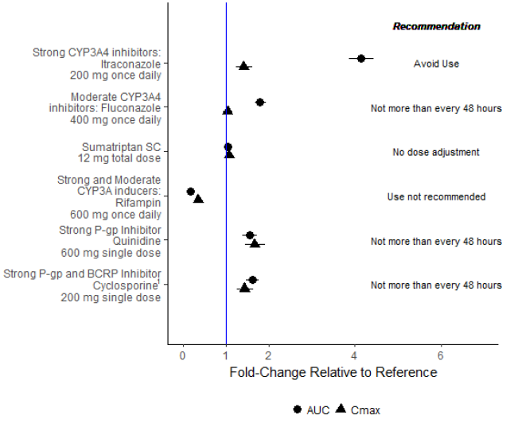

1 Observed inhibition is ascribed to P-gp only. Strong BCRP inhibitors do not require dose frequency adjustment. Source: BHV3000-103 CSR, BHV3000-104 CSR, BHV3000-105 CSR, BHV3000-112 CSR, and BHV3000-122 preliminary PK analysis memo

The effects of rimegepant on co-administered drugs have been investigated and the results are shown in Figure 3.

Figure 3: Effect of rimegepant on the exposure of co-administered drugs

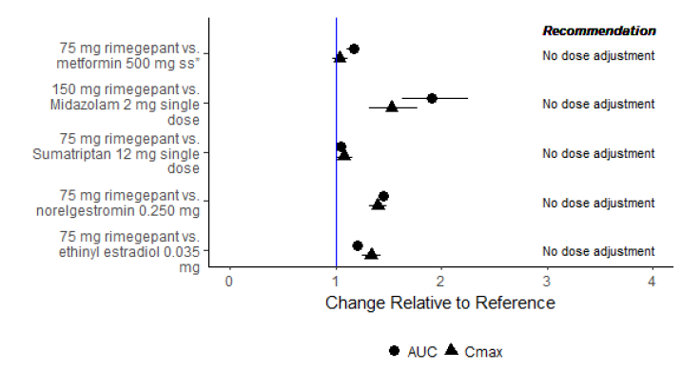

Source: CN170007 CSR, BHV3000-114 CSR, BHV3000-101 CSR, BHV3000-119 CSR

##### Population pharmacokinetic data

A population pharmacokinetic model was developed based on studies in healthy volunteers, subjects with renal impairment, subjects with hepatic impairment and elderly subjects (Studies BHV3000-102, BHV3000-103, BHV3000-105, BHV3000-106, BHV3000-107, BHV3000-108, BHV3000-110 and BHV3000-112). A total of 8781 concentration observations from 257 subjects were considered (1284 excluded due to being below the limit of quantitation). The final base structural model comprised of two-compartment disposition model. The following statistically significant covariates were identified in the final model:

* Allometric weight scaling on clearance and volume parameters.
* Fluconazole and itraconazole use, severe/moderate hepatic impairment on elimination clearance.
* Fed status, itraconazole use, capsule formulation, and ODT on transit absorption rate constant.
* Fed status on bioavailability.

Itraconazole (strong CYP3A4 inhibitor) was considered the only clinically significant covariate.

The model performed well using goodness of fit plots, visual predictive checks and an external data set.

Population pharmacokinetic modelling found a terminal half-life of 11 hours following a single 75 mg dose.

##### Pharmacodynamics

Study CN170003 investigated six different doses of rimegepant (10 mg, 25 mg, 75 mg, 150 mg, 300 mg, 600 mg) for their effect on a single acute migraine (that is, dose finding study). The study also included placebo and active (sumatriptan 100 mg) controls. Subjects were included if they had at least a one year migraine history, average attack duration 4 to 72 hours and not more than eight moderate to severe attacks per month in the previous 3 months. In this study, 885 subjects were randomised and 812 completed. The 75 mg rimegepant dose was found to have nearly the same efficacy (as measured by pain freedom at 2 hours post-dose) as the 150 mg dose and the sumatriptan (Figure 4).

Figure 4: Phase 2b primary endpoint, rimegepant pain freedom at 2 hours post dose

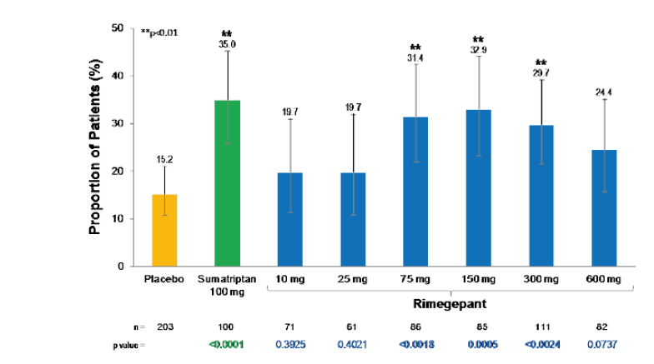

Study BHV3000-114 investigated the effect of rimegepant on resting blood pressure when co‑administered with sumatriptan in healthy adults. Sumatriptan was given as two subcutaneous injections (12 mg total) on Day 1 and Day 5. Rimegepant tablet 75 mg daily or placebo was given on Day 2 to Day 5. No significant effect on blood pressure was detected.

Study 180099 was a thorough QTc study using a 4-way crossover design. The treatments were rimegepant 75 mg, rimegepant 300 mg, moxifloxacin (positive control) and placebo. The two doses of rimegepant and placebo had the same QTcF pattern, whereas moxifloxacin was associated with a QTcF maximum increase of 14 milliseconds.[7]

The reason for the dosing regimen for migraine prevention being 75 mg every other day is based on the following:

* Studies CN170003, BHV3000-301, BHV3000-302 and BHV3000-303 have demonstrated a durable effect of a single 75 mg dose on pain and function in acute migraine, lasting up to 48 hours.
* It has not been shown that constant high (greater than 90%) CGRP blockade is required for adequate migraine prophylaxis. Constant blockade may theoretically be associated with adverse effects such as constipation.
* The sponsor believes that prophylaxis can be achieved with a period of high CGRP blockade, a longer period of partial blockade and a short period of minimal blockade. This is achieved through every other day dosing (during which the PK at each dose resembles the PK of a single dose).

#### Efficacy

Four pivotal efficacy studies were evaluated by the EMA:

* BHV3000-301 with tablet for acute migraine
* BHV3000-302 with tablet for acute migraine
* BHV3000-303 with ODT for acute migraine
* BHV-3000-305 with tablet for migraine prophylaxis

##### Studies BHV3000-301, BHV3000-302 and BHV3000-303

Studies BHV3000-301, BHV3000-302 and BHV3000-303 had similar study designs and requirements. They were Phase III, double blind, randomised, placebo controlled, multicentre, outpatient studies of the safety and efficacy of a single dose of rimegepant 75 mg (tablet or ODT) compared to placebo in the treatment of migraine with moderate to severe pain. The total duration of the study was up to 11 weeks. Following the screening period there was an acute treatment phase that could last up to 45 days during which the subject could treat one migraine that reached moderate to severe pain intensity. Participants were randomised 1:1 and dispensed one dose of study medication. Evaluation occurred from onset of migraine to 48 hours post dose. End of treatment occurred within 7 days of dosing.

Men and women aged 18 years of age and older with at least a one year history of migraines and the following features:

* Migraine onset before 50 years of age.
* Average duration of untreated attacks 4 to 72 hours.
* Eight or less moderate to severe attacks per month in previous 3 months.
* Ability to distinguish between migraine attacks and tension/cluster headaches.
* Consistent attacks numbering at least two of moderate to severe intensity per month for the 3 months prior to screening and during the screening period.
* Less than 15 days with any type of headache per month for the 3 months prior to screening and during the screening period.
* If on prophylactic migraine treatment, that the dose has been stable for at least 3 months.

Major exclusion criteria were:

* History of basilar or hemiplegic migraine.
* Uncontrolled, unstable or recently diagnosed cardiovascular disease.
* Uncontrolled hypertension and/or diabetes.
* Significant neurological, psychiatric or pain syndromes.
* Estimated glomerular filtration rate (eGFR) modification of diet in renal disease less than or equal to 40 mL/min/1.73m2.

Rescue medication use during the acute studies was allowed from 2 hours post study drug. Triptans were only permitted from 48 hours post study drug. Assessments conducted after any rescue medication use were classified as failures.

The study had two co-primary endpoints:

* Freedom from pain at 2 hours post-dose (using 4 point Likert scale, 0 = none, 1 = mild, 2 = moderate, 3 = severe).
* Freedom from most bothersome symptom at 2 hours post-dose (using binary scale, 0 = absent, 1 = present).

Hierarchically arranged secondary endpoints were (there were differences between Study BHV3000-303 and Studies BHV3000-301 and BHV3000-302 in terms of the number of endpoints and the order):

* Pain relief at 2 hours post-dose.
* Sustained pain relief from 2 to 24 hours.
* Sustained pain freedom from 2 to 24 hours.
* Response from 2 to 48 hours post-dose.
* Freedom from photophobia/phonophobia/nausea.

The modified intention to treat (mITT) efficacy population were randomised subjects who took study medication, had baseline migraine of moderate to severe pain intensity and provided at least 2 post-baseline efficacy data points. Rimegepant was tested for superiority using a 2-sided alpha of 0.05 using Cochran-Mantel-Haenszel tests stratified by use of prophylactic medication (yes or no). Type 1 error was controlled in the secondary endpoint analysis by using a hierarchical gate-keeping procedure. Sensitivity analyses assessed the influence of missing data.

In Study BHV3000-301, 546 subjects were randomised to and treated with rimegepant and 549 to placebo. Out of these 99.1% completed in the rimegepant group and reasons for discontinuation were loss to follow up and withdrawal by subject. In the placebo group 98.4% completed and reasons for discontinuation were loss to follow up, no occurrence of a moderate to severe migraine and withdrawal by subject.

In Study BHV3000-302, 543 subjects were randomised to and treated with rimegepant and 540 to placebo. Out of these 99.1% completed in the rimegepant group and reasons for discontinuation were loss to follow up, never experienced a moderate to severe migraine, other and technical problems. In the placebo group 99.8% completed and the only reason for discontinuation was loss to follow up.

In Study BHV3000-303, 682 subjects were randomised to and treated with rimegepant and 693 to placebo. Out of these 99.6% completed in the rimegepant group and the reason for discontinuation was loss to follow up. In the placebo group 99.4% completed and reasons for discontinuation were loss to follow up, protocol deviation and withdrawal by subject.

Baseline characteristics were similar across the three single dose acute migraine studies. The mean age was 40 to 42 and most patients were White (73 to 82%) and female (85 to 89%). The mean body max index was around 31 kg/m2. Around a third of the subjects experienced aura with their migraines and most (65 to 75%) had at least four attacks per month. The majority (93 to 96%) were not ‘triptan non-responders’ (that is, they responded to triptans). Only a very small proportion (around 1%) had cardiovascular risk that would contraindicate triptans. Around 83 to 86% were not using prophylactic migraine medication.

The primary efficacy results for the three single dose trials are shown in Table 3.

Table 3: Co-primary efficacy endpoints - modified intention to treat in Phase III single dose migraine studies

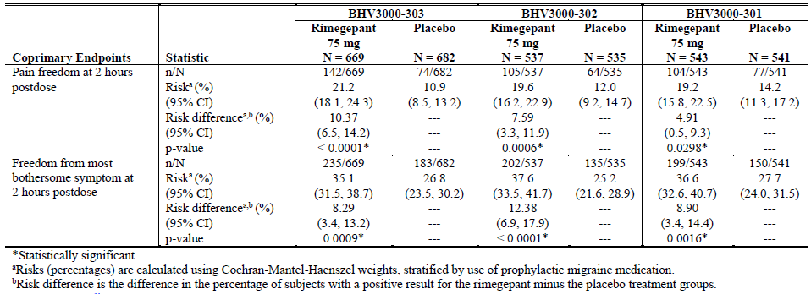

There was a statistically significant risk difference between rimegepant and placebo for pain freedom at 2 hours. The risk differences were 10.37% in Study BHV3000-303, 7.59% in Study BHV3000-302 and 4.91% in Study BHV3000-301. Note that the highest absolute risk of being pain free across all three studies was only 21.2%, with rimegepant in Study BHV3000-303. There was a statistically significant risk difference between rimegepant and placebo for being free from most bothersome symptom at 2 hours. The risk differences were 8.29% in Study BHV3000-303, 12.38% in Study BHV3000-302 and 8.9% in Study BHV3000-301.

The secondary endpoint results were:

* Consistent statistically significant superiority over placebo was shown for freedom of photophobia and phonophobia at 2 hours post-dose across all three studies.
* A trend towards superiority over placebo was shown for freedom of nausea across the studies. As nausea was less frequent (approximately 60%) than other symptoms present at onset of migraine, this endpoint was possibly underpowered to show a benefit.
* As the freedom from nausea at 2 hours was not significant, further secondary endpoints were not considered statistically significant.

##### Study BHV3000-305

Study BHV3000-305 was a multicentre, randomised, placebo controlled study of the safety and efficacy of rimegepant 75 mg every other day in migraine prophylaxis. It consisted of four phases: screening, 12 week double blind treatment phase, 52 week open label extension phase and an 8 week follow up safety phase. During the 28 day screening phase, subjects documented migraine occurrence, intensity and characteristics using an e-Diary. After this and if they were eligible, subjects were randomised to either rimegepant 75 mg or placebo every other day. If migraine occurred during the double blind phase, subjects could take standard of care medication.

Following the double blind period, subjects could enter the open label phase during which they took rimegepant 75 mg every other day. Migraines during this period subjects were able to treat with a 75 mg dose of rimegepant (on days they were not scheduled to take it, that is, a maximum of 75 mg per day could be taken). Subjects who completed the open label phase, as well as those discontinuing earlier, had a 2 week and 8 week safety follow-up visit.

The migraine and headache history criteria were:

* Onset of migraine less than 50 years of age.
* Untreated migraine attacks last 4 to 72 hours.
* Four to 18 moderate to severe migraine attacks per month over previous 3 months.
* Six or more migraine days during the observation period.
* Ability to distinguish migraine from tension/cluster headaches.
* Other prophylactic migraine therapy permitted, as long as dose stable over previous 3 months.
* Only one prophylactic migraine therapy permissible during the double blind period, excluding any CGRP antagonists.
* Other CGRP antagonist use not permitted throughout study.

During the double blind phase rescue medication, including triptans, was permitted. During the open label phase, additional rimegepant could be used as rescue therapy, as explained above. Triptans were not allowed during the open label phase.

The primary efficacy endpoint was the change from the observation period in the mean number of migraine days per month during the Week 9 to 12 period of the double blind phase.

There were six hierarchically arranged secondary efficacy endpoints:

* Percentage of subjects with 50% or greater reduction in number of moderate to severe migraine days in last 4 weeks of double blind phase (compared with observation period).
* Change from Baseline in mean number of migraine days per month over the whole double blind phase.
* Rescue medication days per month in the last month of the double blind phase.
* Change from Baseline in mean number of migraine days during Weeks 1 to 4 of double blind phase.
* Change from Baseline in migraine specific quality of life questionnaire restrictive role function domain score at Week 12 in double blind phase.
* Change from Baseline in the migraine disability assessment total score at Week 12 in double blind phase.

The primary efficacy mITT population consisted of subjects with 14 days or greater of e-Diary efficacy data in both the observation period and at least a 4 week interval of the double blind phase. The primary endpoint was analysed using a generalised linear mixed effect model. Sensitivity analyses were conducted to investigate the effect of missing data.

Overall, 747 subjects were randomised and 370 received rimegepant and 371 received placebo in the double blind phase. Out of these, 84.5% completed the double blind phase. In the rimegepant arm, discontinuation was due to adverse event (1.4%), baseline laboratory values (2.2%), lack of efficacy (0.3%), loss to follow up (5.1%), non-compliance (1.6%), protocol deviation (1.1%) and withdrawal by subject (3%). In the placebo arm, discontinuation was due to adverse event (0.5%), baseline laboratory values (3.5%), lack of efficacy (0.3%), loss to follow up (3.2%), non-compliance (1.3%), protocol deviation (1.3%) and withdrawal by subject (5.9%). The majority of subjects in both arms (81.5%) continued in the open label extension phase.

The median age was 40 and most were White (81.2%) and female (83%). In terms of migraine history, the median number of moderate to severe migraine attacks per month was eight. The most common most bothersome symptom was photophobia (57%) and most did not have aura (60%). Chronic migraine was reported in 20 to 25% of subjects.

In the double blind phase, the mITT included 695 (the main reason for exclusion was less than 14 days of efficacy data available). Rimegepant 75 mg taken every other day was superior to placebo in terms of the change from Baseline (observation period) to the final month of the double blind period in mean number of migraine days per month. The difference was -0.8 days per month (that is, a reduction of 0.8 days with rimegepant) (p = 0.0099). A sensitivity analysis utilising jump-to-reference to impute missing data, the absolute difference between rimegepant and placebo was -0.7 migraine days per month (p = 0.0099).

Secondary endpoints:

* Over the entire 12 week double blind phase, there were less migraine days compared with Baseline in the rimegepant arm compared with the placebo arm (-3.6 versus -2.7 respectively, p = 0.0017).
* There was no statistically significant difference in rescue medication use between the two arms, during any particular 4 week period or during the entire 12 week double blind phase. There was a trend to reduced use with rimegepant however the absolute differences were small.
* Overall, 7.6% more subjects in the rimegepant arm compared with the placebo arm were able to achieve a 50% reduction in migraine days during the last 4 week period of the 12 week double blind phase (49.1% versus 41.5%; p = 0.0438).
* There was no difference in change in migraine disability assessment score between the two groups.

During the open label phase subjects originally assigned to either rimegepant or placebo maintained a reduction of around five migraine days per month compared to the baseline observation period (Figure 5). Whilst this is consistent with maintenance of efficacy up to 10 months, it is not possible to definitively attribute this to rimegepant in the absence of a comparator group.

Figure 5: Longitudinal plot of total migraine days per month mean change from the observational period over time on open label rimegepant – modified intention to treat subjects

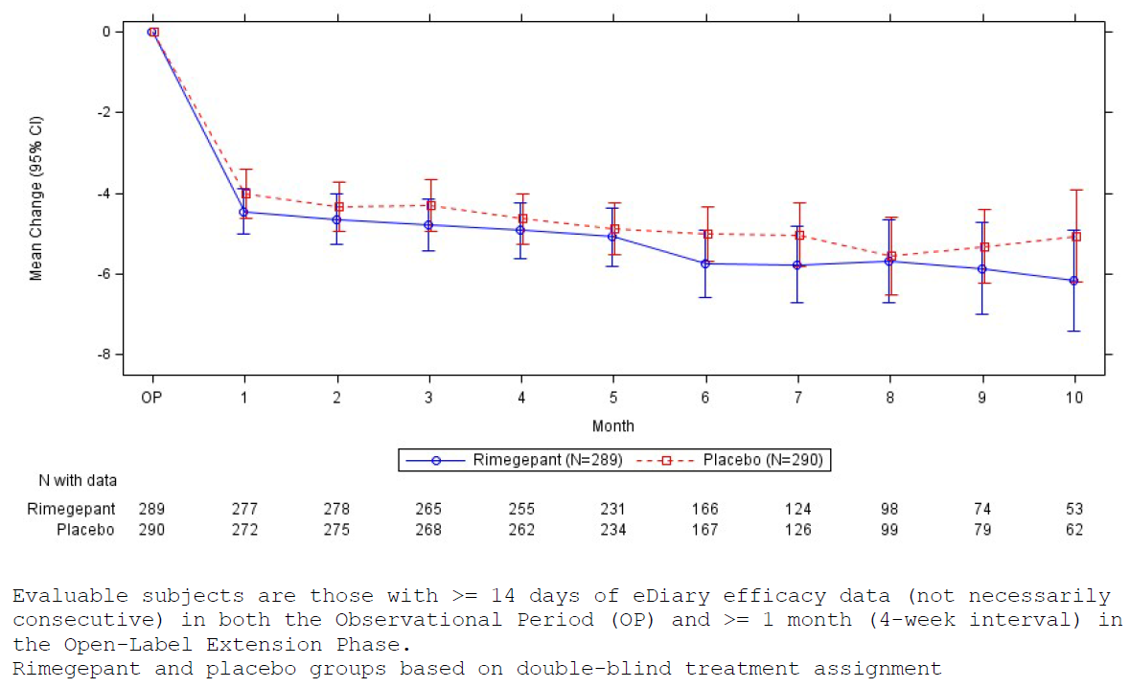

The EMA evaluation of the data included only partial data for those subjects treated in the open label extension. As part of the current application to the TGA for registration, the sponsor has submitted a clinical study report addendum which presents complete data for the 52 week open label extension, as well as additional data for the entire 64 week period.

Most patients who completed the double blind phase entered the open label extension (302 out of 370 in rimegepant arm and 301 out of 371 in placebo arm). Of these 603 subjects, 71% completed the open label extension. The most common reasons for not completing were withdrawal by subject (57 subjects), lost to follow-up (32 subjects), non-compliance (29 subjects), adverse event (19 subjects) and physician decision (18 subjects).

The open label results suggest that subjects initially randomised to placebo could achieve a similar reduction in migraine days per month once commenced on rimegepant. Over the subsequent 13 months there appeared to be sustained reduction in migraine days per month (Figure 6). These data are limited due to the absence of a comparator arm and the likelihood of non-responders to withdraw from the trial.

Figure 6: Longitudinal plot of total migraine days per month mean change from observational period over time on open label rimegepant

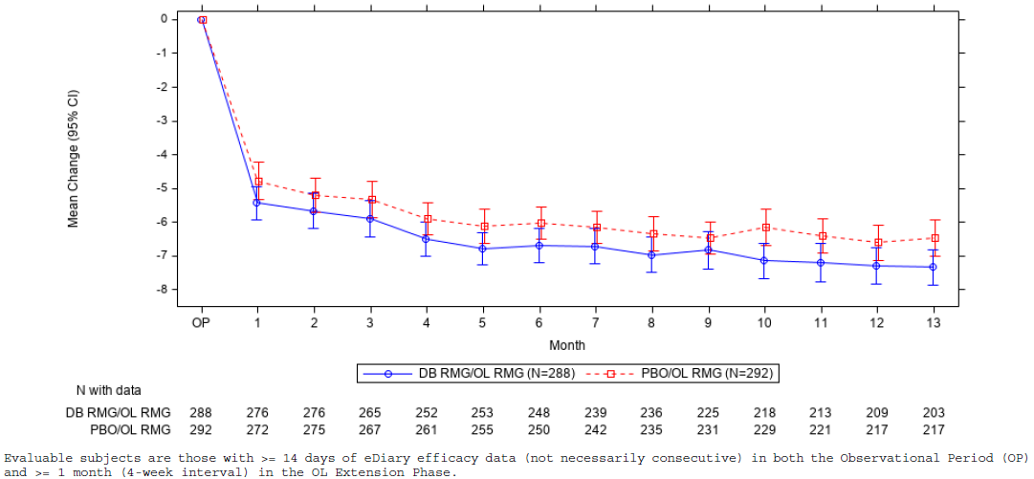

##### Study BHV3000-201

Supportive Study BHV3000-201 was a multicentre, open label safety and tolerability study of long term rimegepant (mainly dosed on an as required basis, although there was a small every other day dosing group). As this was a safety study, there were no primary or secondary endpoints for efficacy. Exploratory endpoints included the number of migraine headache days and severity of migraine attacks during the period that subjects were treated with rimegepant compared with during the observation period. The study included 52 week enrolment groups (one with migraines occurring 2 to 8 days per month and the other with migraine occurring 9 to 14 days per month) who used rimegepant as required (up to 75 mg daily). The study also included a 12 week enrolment group. One subgroup used rimegepant 75 mg every other daily and as required (that is, 75 mg on non-scheduled dosing days) and the other group used rimegepant as required, as well as a United States Food and Drug Administration (FDA) approved CGRP antagonist biologic (only 13 subjects were treated in this latter group). Triptans were not allowed during the long term treatment phase, but were allowed during the one month preceding observation period. The numbers of patients in each enrolment group and the exposure over their respective study periods is shown in Figure 7.

Figure 7: Time in long term treatment period, cumulative and average rimegepant exposure for treated subjects

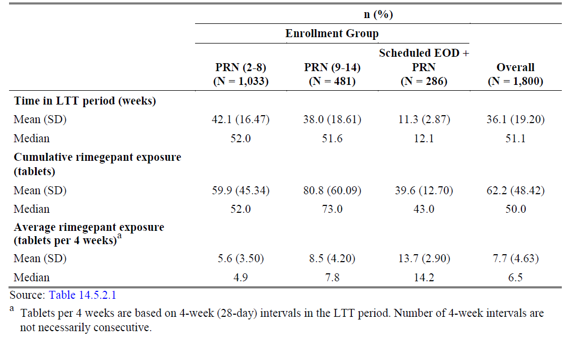

The largest difference between treatment period and observation period was for the rimegepant every other day and as required group (Table 4). The difference in mean number of migraine days was -2.2 (confidence interval (CI): -2.55 to -1.83). For the more severe migraine sufferers who were taking as required rimegepant (that is, group as needed 9 to 14) the difference was ‑0.9 (CI: -1.28 to -0.52) and for the less severe sufferers (that is, group as needed 2 to 8) the difference was 0.1 (CI: -0.10 to 0.28).

Table 4: Number of migraine days per four weeks on long term treatment - values, changes and percent changes from observation period

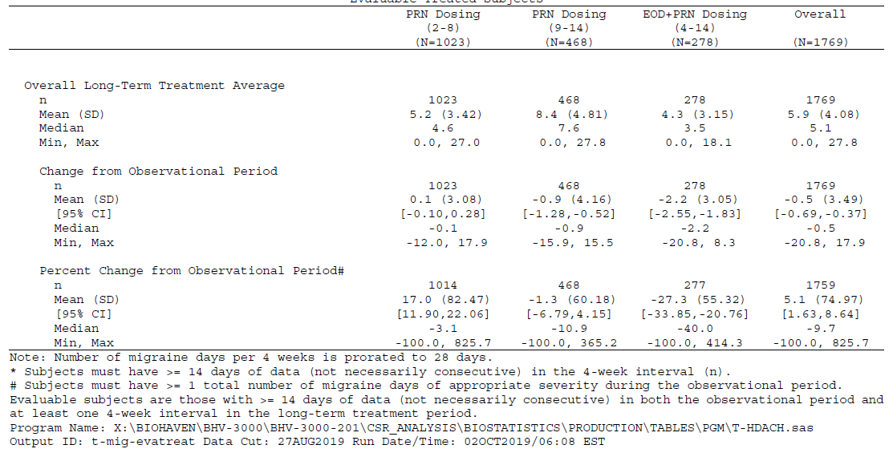

##### Study BHV3000-310

Study BHV3000-310 was not included in the dossier submitted to the EMA and has been submitted to the TGA in its entirety for evaluation. It was a multicentre, Phase III, randomised, double blind, placebo controlled study of rimegepant 75 mg ODT in the treatment of moderate or severe migraine. The study was conducted in China and Korea. The study included a screen period of up to 28 days, an acute phase up to 45 days, followed by end of treatment 7 days after rimegepant administration.

The co-primary endpoints were pain freedom at 2 hours post-dose and freedom from the most bothersome symptom at 2 hours post-dose.

The key secondary endpoints were:

* Pain relief at 2 hours post-dose (assessed using the number of subjects that reported a moderate or severe pain level at Baseline and then reported a pain level of none or mild at 2 hours post-dose).
* Functional disability scale at 2 hours post-dose (assessed using the number of subjects that self-reported as ‘normal’ on the functional disability scale in the subset of subjects that reported any level of disability just prior to taking study medication).
* Use of rescue medications through 24 hours post-dose.
* Sustained pain freedom from 2 to 24 hours post-dose.
* Sustained pain freedom from 2 to 48 hours post-dose.

The major inclusion criteria were:

* Male and female 18 years or older.
* A diagnosis of migraine with or without aura.
* No clinically significant medical or laboratory abnormality.

The major exclusion criteria were:

* History of migraine with brainstem aura.
* Hemiplegic migraine.
* Uncontrolled/unstable/recent onset cardiovascular disease.
* Uncontrolled hypertension or diabetes.
* Major psychiatric diagnoses which may interfere with study assessments.

Subjects were instructed to take study medication under the tongue when the headache reached moderate to severe intensity. Permissible rescue medications included aspirin, ibuprofen, paracetamol, NSAID, antiemetics or baclofen. Prophylactic migraine medications were permitted as long as the dose had been stable for at least 3 months.

For a sample size of 715 it was estimated that 85% would experience a migraine during the study. A sample size of 600 would allow detection of a difference in both co-primary endpoints at 90% power. The modified intention to treat (mITT) population was the primary efficacy population and consisted of those subjects who both experienced a migraine at the time of treatment and provided at least one post-treatment efficacy data point. Endpoints were stratified by use of prophylactic migraine medication and country.

Overall, 1431 subjects were randomised to rimegepant (n = 716) or placebo (n = 715), with 1413 completing the acute phase of the study. Of those who discontinued during the acute phase, six self-withdrew, two had adverse events (one in each arm), one had COVID-19 and nine withdrew for other reasons. The mITT population included 1340 subjects. The reasons for not being in the mITT was not having a qualifying migraine (50 subjects), not being treated due to other reasons (30 subjects), and not being treated for an unknown reason (nine subjects).

The median age of subjects was 36.5 (range 18 to 71) and most were female (81%) and from China (80.1%). Migraine characteristics were balanced between arms with median number of moderate to severe episodes per month 3.3, symptoms lasting between 4 to 72 hours (100%) and most bothersome symptoms of nausea (54.4%), phonophobia (26.4%) and photophobia (89.7%). Migraine without aura was most common (89.7%). Prophylactic medication use was relatively uncommon (73 subjects).

For the primary efficacy outcome, pain freedom at 2 hours occurred in 19.8% of subjects who took rimegepant and 10.7% who took placebo. The common risk difference was 9.2% (CI: 5.4 to 13%; p < 0.0001). Freedom from most bothersome symptom occurred in 50.5% of rimegepant subjects and 35.8% in placebo subjects, with a common risk difference of 14.8% (CI: 9.6 to 20%; p < 0.0001). Stratified results and sensitivity analyses were consistent with the main efficacy analysis.

All five secondary endpoints mentioned above had statistically significant findings favouring rimegepant over placebo.

#### Safety

The safety data set includes healthy subjects and subjects with migraine in single dose and multiple dose studies. Overall, 4,136 subjects have been exposed to rimegepant, including 1,857 in single dose migraine trials and 2,471 in multiple dose migraine trials. The multiple dose subjects included 456 who were previously exposed to rimegepant in single dose trials.

Amongst 1,800 subjects in Study BHV3000-201 (multiple dose studies with different dosing strategies as described in efficacy section above), the average rimegepant exposure was two or more tablets per 4 weeks and 954 subjects were treated for one year or longer. A total of 112,014 doses of rimegepant 75 mg were administered in the study.

In the pivotal prophylaxis Study BHV3000-305, taking into account both the double blind portion and the reported open label extension (n = 671), the median time on study drug was 48.7 weeks and the median cumulative exposure was 172 tablets. This represents the bulk of safety data relating to long term second daily use of rimegepant (Table 5).

Table 5: Summary of e-Diary exposure in Study BHV3000-305 and Study BHV3000-201, 12 week group

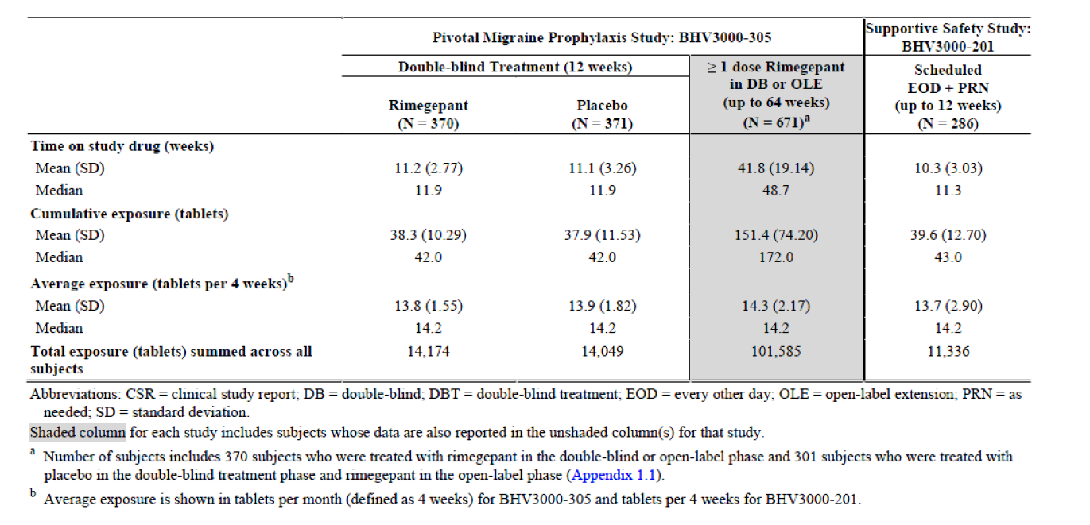

##### Single dose studies

The sponsor reported on treatment adverse events (as distinct from treatment-emergent adverse events) as those which occurred from drug administration until 7 days. For the pooled single dose Phase III studies, 10.8% of subjects experienced on treatment adverse events in the rimegepant arm compared with 8.6% in the placebo arm. The most frequent reported were nausea (1.5%) and urinary tract infection (0.8%). The only severe adverse event considered related to study drug was diarrhoea in two subjects (0.1%).

In the Phase III single dose studies there was one on treatment serious adverse event in the rimegepant group (back pain) and two on treatment serious adverse events in the placebo group (chest pain and urinary tract infection). There were no deaths.

There were no significant laboratory findings.

##### Multiple dose studies

In Study BHV3000-305 (rimegepant second daily prophylaxis study), the adverse events during the double blind period were generally comparable with placebo and consistent with the single dose studies. The on treatment adverse events reported in this study that occurred in 2% or less of subjects were nasopharyngitis, urinary tract infection, upper respiratory tract infection, sinusitis, influenza, nausea and back pain. There was a severe adverse event considered related in each arm during the double blind period. Serious adverse events were reported in three subjects in the rimegepant group (gastroenteritis, malignant melanoma, suicide attempt) and four subjects in the placebo group (appendicitis, pneumonia, pyelonephritis, overdose) during the double blind period.

Twenty (3%) of subjects had treatment-emergent adverse events leading to discontinuation of rimegepant in Study BHV3000-305 during the double blind (n = 6) and open label (n = 14) phases. The adverse events reported in more than one subjects were anxiety, depression, nausea and alanine aminotransferase (ALT) increased. One myocardial infarction was reported during the open label phase but was not considered as related.

There were two deaths during Study BHV3000-305 that occurred during the open label extension and were considered not related by the investigators. One subject died from septic shock following hospitalisation for diverticulitis. Another subject died from aortic aneurysm occurring on a background of Marfan’s syndrome.

In Study BHV3000-201 60.4% of subjects experienced on-treatment adverse events. Those occurring in at least 2% were upper respiratory tract infection, nasopharyngitis, sinusitis, urinary tract infection, influenza, bronchitis, nausea, back pain, arthralgia and dizziness. In this study 47 subjects (2.6%) experienced serious adverse events, with the following reported in more than one subject: accidental overdose (n = 3), appendicitis (n = 3), osteoarthritis (n = 3), pulmonary embolism (n = 3), constipation (n = 2), pneumonia (n = 2) and sepsis (n = 2). In this study 48 (2.7%) of subjects had on-treatment adverse events that lead to discontinuation. Adverse events leading to discontinuation occurring in more than one subject were dizziness, ALT increased, aspartate aminotransferase (AST) increased, anxiety, arthralgia, blood creatine phosphokinase increased, constipation, depression, hot flush, suicidal ideation and vertigo.

There were no significant laboratory findings.

##### Adverse events of special interest

Gastrointestinal: during double blind treatment every other day (Study BHV3000-305) the following gastrointestinal adverse events occurred at frequency 1% or greater: nausea (2.7% versus 0.8% with placebo), diarrhoea (1.6% versus 1.1% with placebo) and constipation (1.1% versus 0.5% with placebo).

Sleep disturbance: infrequent event in multiple dose studies in both rimegepant and placebo arms.

Raynaud’s phenomenon: only one event of Raynaud’s was reported across the clinical studies (one subject in Study BHV3000-201 had a moderate adverse event ‘worsening of Raynaud’s’ which was not reported in the subject’s past history).

Liver function abnormalities: these were infrequent during the single dose studies and occurred with similar frequency in both arms. During the open label safety study (Study BHV3000-201) frequencies above the upper limit of normal were 9.0% for ALT, 6.8% for AST, 1.7% for bilirubin and 3.6% for alkaline phosphatase (ALP). An external panel of liver experts determined that there were no Hy’s law cases (the two ‘possible’ Hy’s law cases had gallstone and mercaptopurine as alternative explanations) and there was no signal for drug induced liver injury due to rimegepant up to 64 weeks of at least every other day treatment.

During the double blind period of the pivotal migraine prophylaxis study (Study BHV3000-305) liver function test elevations were comparable between rimegepant and placebo. There was one severe hepatic related adverse event during the open label study. Overall, in Study BHV3000‑305 six subjects receiving rimegepant had liver related concerns (raised transaminases, raised ALP, raised bilirubin, cirrhosis, hepatitis, liver failure or jaundice) that were considered as ‘possibly’ representing drug-induced liver injury.

Systolic blood pressures over 160 were infrequent (1.3%) in the long term open label safety study.

One subject in the single dose study (Study BHV3000-303) experienced ‘severe anaphylactic reaction’ 4 days after taking study medication. The subject did not receive epinephrine, was not hospitalised and recovered.

There was no signal for rimegepant being a drug of abuse, causing withdrawal and rebound or medication overuse headache. Adverse events related to dizziness and somnolence were reported, often in subjects taking concomitant medication. These adverse events were of low frequency, similar to placebo, mostly mild and infrequently led to study drug discontinuation. No dedicated driving study was conducted and the sponsor does not believe specific instruction regarding ability to drive or operate machinery are required.

##### Additional studies

In Study BHV3000-310 1342 subjects took a single dose of study medication. One of these took only a half an oral dispersible tablet and another subject did not provide any post treatment data and was not included in the analysis. The incidence of treatment-emergent adverse events was 13.8% with rimegepant and 14.2% with placebo. Overall adverse events occurring in 1% or greater of subjects were protein urine present, nausea and urinary tract infection. Treatment‑emergent adverse events of at least grade 3 common terminology criteria for adverse events (CTCAE) intensity in the rimegepant group were ALT increased, blood creatine phosphokinase increased and infection (one subject each).

The number of subjects with treatment-emergent adverse events considered related were comparable in the rimegepant and the placebo arms. The most frequently reported preferred terms were nausea, protein urine present and photophobia. The grade 3 event of ALT increased and grade 4 event of blood creatine phosphokinase increased in the rimegepant group were both considered as related. The ALT increased was not considered a potential drug-induced liver injury event. There was one serious adverse event of infection reported in the rimegepant group.

##### Post market data

Rimegepant has been marketed since 2020 in the United States of America for acute migraine treatment. As of August 2020, approximately 70,900 patients have been treated. The most commonly reported adverse drug reactions were ‘drug ineffective’ and ‘therapeutic effect incomplete’. Other reported adverse drug reactions were nausea (30 patients), vomiting (10 patients), somnolence (16 patients), hypersensitivity (six patients; three of these were serious) and skin reactions (16 patients).

Data available since the EMA submission and comparable overseas report is from the fifth periodic safety update report (PSUR; February to August 2022). It is estimated that since first marketing authorisation 591,954 patients have received rimegepant. During the period of the most recent PSUR 350,632 patients have received rimegepant. There were no new safety signals. Use in pregnant women and patients with cardiovascular disease remain as missing information. The safety concern of hypertension has been removed, although will continue to be monitored.

There is a theoretical risk of an increase in Reynaud’s phenomenon in patients receiving CGRP antagonist drugs.

### Risk management plan

Pfizer Australia Pty Ltd has submitted European Union risk management plan (RMP) version 1.0 (dated 17 May 2022, data lock point 03 September 2021) and Australia‑specific annex version 1.0 (dated 15 July 2022) in support of this application.

With the response to TGA questions, the sponsor notified that, as a consequence of a request raised in the quality evaluation report, the proposed tradename for this product has been changed to Nurtec ODT and should be used in future evaluation reports, instead of Vydura or Nurtec.

The sponsor provided a further updated Australia-specific annex version 1.1 (dated 28 June 2023) after receiving advice from the Advisory Committee on Medicines (ACM).

The summary of safety concerns and their associated risk monitoring and mitigation strategies are summarised in Table 6. The TGA may request an updated RMP at any stage of a product's life cycle, during both the pre-approval and post-approval phases.

Table 6: Summary of safety concerns

|  |  |  |  |  |  |
| --- | --- | --- | --- | --- | --- |
| Summary of safety concerns | | Pharmacovigilance | | Risk Minimisation | |
| Routine | Additional | Routine | Additional |
| **Important identified risks** | None | – | – | – | – |
| **Important potential risks** | None | – | – | – | – |
| **Missing information** | Use in pregnant women | ü | ü# | ü | – |
| Use in patients with cardiovascular diseases | ü | ü* | ü | – |
| Use in breastfeeding womenµ | ü | – | ü | – |

#Pregnancy registry and retrospective cohort study on pregnancy outcomes   
*PASS   
µ Australia-specific safety concern

The sponsor included ‘use in breastfeeding women’ as an Australia-specific safety concern as recommended by the RMP and the clinical evaluation.

The sponsor has proposed routine pharmacovigilance for all safety concerns. In response to a recommendation made by the ACM, the sponsor has provided a commitment to report the serious adverse events in patients with uncontrolled hypertension and patients with uncontrolled diabetes in the PSURs. The pharmacovigilance plan is acceptable from an RMP perspective.

The sponsor proposed routine risk minimisation activities for all safety concerns. There are no differences in risk minimisation activities between the European Union and Australia. Routine risk minimisation measures are considered acceptable to minimise the risks associated with this product.

The RMP evaluation recommended conditions of registration relating to the versions of the risk management plan, requirement for periodic safety update reports, and inclusion of the medicine in the Black Triangle Scheme.

### Risk-benefit analysis

#### Delegate’s considerations

##### Proposed indication

Comparable overseas report view:

The amendment of the initial requested indication for ‘comprehensive management of migraine in adults’ to the indications as requested in this submission were considered acceptable to the EMA. There was adequate safety and efficacy data to support both acute treatment and prophylaxis.

Delegate view:

The Delegate agrees that the indications are generally appropriate. The Delegate notes that the pivotal trials focussed on patients experiencing moderate to severe migraine symptoms. It is a consideration about whether this needs to be reflected in the indication. This should also be considered in the context of triptans and CGRP antagonist monoclonal antibodies which do not specify moderate or severe attacks. The Delegate will seek the Advisory Committee on Medicines (ACM) view on this.

##### Efficacy

Comparable overseas report view:

The EMA found the primary efficacy endpoints and secondary endpoints in the single attack studies to be adequate and in line with guidelines. The statistical methods were generally appropriate. Even though a modified intention to treat analysis population was used, there were very few patients who did not provide post-dose data.

The population was felt to be representative of migraine sufferers (aged 40, more female than male, approximately 30% with aura and 15% on prophylaxis). The population experienced four attacks of moderate to severe intensity per month which is on the more severe spectrum of disease. Superiority over placebo was consistently shown with the magnitude of effect described as ‘modest’.

The EMA noted that the pivotal prophylaxis Study BHV3000-305 recruited both episodic migraine and chronic migraine patients (that is, 15 or more headache days per month). The definition of ‘migraine day’ used in the study related only to episodic migraine, leaving some doubt about the efficacy in chronic migraine. The chronic migraine subgroup was considered too small to draw independent conclusions from these further analyses.

The study was appropriately designed, including the use of a prospective observation period to document frequency of attacks and placebo control (essential). The use of usual (non rimegepant) medications for acute attacks during the placebo controlled period and the use of rimegepant for acute attacks during the open label period meant that there was no placebo controlled data of rimegepant every other day plus rimegepant for acute attacks (that is, no placebo controlled data to confirm taking additional rimegepant works when using it for prophylaxis). The EMA considered this a deficiency. Another deficiency was the lack of a study of within patient consistency (that is, that rimegepant is efficacious for subsequent acute attacks).

In Study BHV3000-305 the use of a modified intention to treat analysis population (that is, excluding patients providing less than 14 days of e-Diary data) is considered problematic as there is a risk of selection bias. Sensitivity analysis applying placebo outcome data for the missing data points found a similar result. Superiority over placebo was demonstrated, with the net difference of 0.8 migraine days per month described as ‘modest’. The open label portion was consistent with maintenance of effect.

Delegate view:

The Delegate agrees with the deficiencies in the efficacy data raised by the EMA. They do not preclude assessment of the risk: benefit balance. The modest magnitude of effect in both acute migraine and prophylaxis is noteworthy. Active comparator studies would help clarify how this treatment compares with other established treatments to put the demonstrated effect size into context (although no essential from a purely regulatory point of view). The small effect size should not necessarily preclude registration as rimegepant represents an efficacious therapeutic option for patients suffering from migraine.

There does not seem to be efficacy data (from the acute migraine studies) for additional doses of rimegepant on subsequent days if there are significant residual symptoms (that is, all part of the same acute attack) or a new attack. The product information implies that further doses are applicable in either scenario. The efficacy of prophylaxis plus as needed dosing has not been studies in a placebo controlled study yet appears to be recommended in the Product Information.

##### Safety

Comparable overseas report view:

In presenting safety data for single dose studies, the sponsor distinguished between on treatment adverse events (occurring within 7 days of dosing) and standard treatment-emergent adverse events (occurring post dose over the course of the study). This was considered by the EMA as an impediment to an easy overview of the summarised safety data. The EMA acknowledged that these data sets overlapped.

Exposure was sufficient to characterise the adverse events in both single dose and every other day dosing studies and was consistent with the ICH E1 Guidance. Most adverse events were mild and not related to study treatment. The single dose on treatment adverse events of note occurring more frequently with rimegepant were nausea. In the long term safety study (Study BHV3000-201), nausea, constipation, diarrhoea, dizziness and somnolence were seen.

No pattern of serious adverse events was observed that would suggest a specific safety concern. There were two deaths in the prophylaxis study (Study BHV3000-305) which were considered by the investigators as not related to rimegepant.

Of particular concern was the potential for liver toxicity, as was seen with other ‘gepant’ small molecule CGRP antagonists. Whilst a definite signal has been identified to date for rimegepant, subjects in both healthy volunteer and patient studies experience relevant increases in alanine aminotransferase (ALT) or aspartate aminotransferase (AST), bilirubin and alkaline phosphatase (ALP).

The EMA noted the exclusion of subjects with unstable or uncontrolled or recent onset cardiovascular disease and with uncontrolled hypertension. There is some uncertainty about the potential role of rimegepant in such patients for whom triptans are contraindicated. This may be clarified with the post authorisation safety study.

The fact that rimegepant does not readily cross the blood brain barrier and the low frequency or absence of abuse related adverse events seen in the studies do not suggest abuse liability.

The EMA recommended monitoring for ischaemic colitis (one case seen in rimegepant treated subject in Study BHV3000-305) as there is theoretical connection between CGRP antagonism and ischaemia.

Delegate view:

The Delegate considers the safety data as adequate to characterise the safety profile of rimegepant for acute and prophylactic migraine management. There does not appear to be a signal currently for serious safety concerns.

The sponsor is asked about the progress of the above referenced safety study. There does appear to be a lack of safety data in patients with established cardiovascular disease or high risk (including uncontrolled hypertension and uncontrolled diabetes).

##### Deficiencies in data

Comparable overseas report view:

The EMA evaluation identified the following areas of deficiency:

* Potential for rimegepant to cause or contribute to medication overuse headache.
* The efficacy of rimegepant for chronic migraine.
* Data on within patient consistency.
* Efficacy for acute treatment of breakthrough migraines when rimegepant is being taken every other day for prophylaxis.

Delegate view:

The Delegate agrees that the submitted data set does leave the above issues unresolved. Further clinical trial data may help to resolve them.

##### Risk-benefit-uncertainty assessment

Comparable overseas report view:

The EMA considered that rimegepant had overall good tolerability and modest efficacy for both acute and prophylactic migraine treatment.

Delegate view:

Given the favourable safety profile in the general migraine population together with modest efficacy, the risk-benefit remains positive. There is uncertainty about the safety of rimegepant in patients with active cardiovascular disease and this question will be answered with acquisition of more data.

The two additional studies submitted to the TGA as part of the COR-B application are largely consistent with the data evaluated by the EMA and does not alter the risk-benefit assessment.

#### Proposed action

The Delegate is of the view that rimegepant can be approved for the requested indications, pending resolution of the issues raised to the Advisory Committee on Medicines (ACM) in this overview.

#### Advisory Committee considerations

The [Advisory Committee on Medicines (ACM)](https://www.tga.gov.au/committee/advisory-committee-medicines-acm), having considered the evaluations and the Delegate’s overview, as well as the sponsor’s response to these documents, advised the following.

##### Specific advice to the Delegate

1. ***What is ACM’s view about the relevance of inserting into the indication that rimegepant is for ‘moderate and severe migraines’? Please consider this in the context of other registered migraine treatments (acute and prophylaxis).***

The ACM was of the view that the indication does not need to include for ‘moderate and severe migraines’. The ACM noted that this approach is consistent with other registered agents on the market for acute and prophylactic treatments of migraine.

1. ***Does the committee accept the recommendation for further doses of rimegepant in the same acute attack (for example, on Day 2)? Should there be a limit on how many consecutive days rimegepant may be taken under the ‘acute treatment’ format?***

The ACM was of the view that a second dose of rimegepant if there is incomplete relief or a return of more severe migraine symptoms is reasonable within the same acute attack. The ACM also highlighted that CYP3A4 and P-glycoprotein inhibitors need to be avoided 48 hours post‑rimegepant.

The ACM recommended to take rimegepant for acute treatment for no longer than three consecutive days, otherwise it exceeds the typical duration limits of migraine.

The ACM also considered that a limit of 18 doses in a 30 day period sufficient to avoid medication overuse headache.

1. ***Does the committee have other concerns about the identified deficiencies in the data and is any modification to the PI due to these required?***

The ACM recommended the inclusion of medication overuse headache in the Product Information (PI). The ACM considered that medication overuse headache remains plausible despite efficacy as a preventive agent. The ACM considered this extra precaution warranted as rimegepant is the first non-monoclonal agent that targets calcitonin gene-related peptide (CGRP).

The ACM noted that within patient consistency data was not provided as suggested in the EMA migraine guideline.

The ACM highlighted the lack of data for use of rimegepant in acute-on-preventive treatment and advised that the lack of data should be mentioned in the PI.

The ACM also advised the PI should include a statement that there is no data for use of rimegepant in brainstem and retinal migraine.

1. ***What is ACM’s view regarding information in the PI on use in patients with stable cardiovascular disease, unstable/recent onset cardiovascular disease, uncontrolled hypertension and uncontrolled diabetes?***

The ACM noted that patients with cardiovascular disease have been excluded from the trials. However, the ACM noted that there is no safety signal for cardiovascular conditions from the nonclinical and clinical data. The ACM noted that the risk management plan (RMP) addresses the cardiovascular disease but not for uncontrolled diabetes and hypertension. Overall, the ACM considered the safety profile of rimegepant reasonable and advised that the RMP should also monitor for diabetes and hypertension.

1. ***Other advice***

The ACM strongly recommended that the Consumer Medicines Information (CMI) and Product Information (PI) include somnolence as a possible after effect with the use of rimegepant and a statement regarding caution against driving and/or operating heavy machinery. The ACM noted that somnolence is a feature of treatment response and not a direct effect of the medication however agreed it is important to include in the PI and CMI.

##### Conclusion

The ACM considered this product to have an overall positive benefit-risk profile for the indication:

*Acute treatment of migraine with or without aura in adults.*

*Preventative treatment of episodic migraine in adults who have at least 4 migraine attacks per month.*

## Outcome

Based on a review of quality, safety, and efficacy, the TGA decided to register Nurtec ODT (rimegepant) 75 mg, orally disintegrating tablet, blister packs, indicated for:

*Nurtec ODT is indicated for:*

*• acute treatment of migraine with or without aura in adults;*

*• prophylactic treatment of episodic migraine in adults who have at least 4 migraine attacks per month.*

### Specific conditions of registration applying to these goods

* Nurtec ODT (rimegepant) is to be included in the Black Triangle Scheme. The PI and CMI for Nurtec ODT must include the black triangle symbol and mandatory accompanying text for five years, which starts from the date that the sponsor notifies the TGA of supply of the product.
* The Nurtec ODT European Union risk management plan (RMP) (version 1.0 dated 17 May 2022, data lock point 03 September 2021), with Australia-specific annex (version 1.1, dated 28 June 2023), included with Submission PM-2022-02939-1-1, and any subsequent revisions, as agreed with the TGA will be implemented in Australia.

An obligatory component of risk management plans is routine pharmacovigilance. Routine pharmacovigilance includes the submission of periodic safety update reports (PSURs).

Reports are to be provided in line with the current published list of European Union reference dates and frequency of submission of PSURs until the period covered by such reports is not less than three years from the date of the approval letter.

The reports are to at least meet the requirements for PSURs as described in the European Medicines Agency’s Guideline on Good Pharmacovigilance Practices (GVP) Module VII-periodic safety update report (Rev 1), Part VII.B Structures and processes. Note that submission of a PSUR does not constitute an application to vary the registration. Each report must have been prepared within ninety calendar days of the data lock point for that report.

## Attachment 1. Product Information

The [Product Information](https://www.tga.gov.au/products/australian-register-therapeutic-goods-artg/product-information-one) ([PI](https://www.tga.gov.au/products/australian-register-therapeutic-goods-artg/product-information-one)) approved with the submission for Nurtec ODT which is described in this AusPAR can be found as Attachment 1. It may have been superseded. For the most recent PI and [Consumer Medicines Information](https://www.tga.gov.au/products/australian-register-therapeutic-goods-artg/consumer-medicines-information-cmi) (CMI), please refer to the TGA [PI/CMI search facility.](https://www.tga.gov.au/picmi-search-facility)

|  |
| --- |
| Therapeutic Goods Administration |
| PO Box 100 Woden ACT 2606 Australia  Email: [info@tga.gov.au](mailto:info@tga.gov.au) Phone: 1800 020 653 Fax: 02 6203 1605  [**https://www.tga.gov.au**](https://www.tga.gov.au) |
| Reference/Publication # |

1. This is the original indication proposed by the sponsor when the TGA commenced the evaluation of this submission. It may differ to the final indication approved by the TGA and registered in the Australian Register of Therapeutic Goods.
2. Cutrer, F. Pathophysiology, clinical manifestations, and diagnosis of migraine in adults, in: UpToDate (accessed on 5 December 2022).
3. Dodick, D. Migraine. *Lancet, 2018; 391*: 1315-30.
4. In this report the ‘Delegate’ is the Delegate of the Secretary of the Department of Health and Aged Care who decided the submission under section 25 of the Act.
5. **Pregnancy Category B1:** Drugs which have been taken by only a limited number of pregnant women and women of childbearing age, without an increase in the frequency of malformation or other direct or indirect harmful effects on the human fetus having been observed. Studies in animals have not shown evidence of an increased occurrence of fetal damage.

   **Pregnancy Category B2**: Drugs which have been taken by only a limited number of pregnant women and women of childbearing age, without an increase in the frequency of malformation or other direct or indirect harmful effects on the human fetus having been observed. Studies in animals are inadequate or may be lacking, but available data show no evidence of an increased occurrence of fetal damage.
6. The **Child-Pugh score** is used to assess the prognosis of chronic liver disease. The score employs five clinical measures of liver disease. Each measure is scored 1 to 3, with 3 indicating most severe derangement. Class A: 5 to 6 points, least severe liver disease, one to five year survival rate of 95%. Class B: 7 to 9 points, moderately severe liver disease, one to five year survival of 75%. Class C: 10 to 15 points, most severe liver disease, 1 to 5 year survival rate 50%.
7. The **QT interval** is the time from the start of the QRS wave complex to the end of the corresponding T wave. It approximates to the time taken for ventricular depolarisation and repolarisation, that is to say, the period of ventricular systole from ventricular isovolumetric contraction to isovolumetric relaxation.

   The **corrected QT interval** (QTc) estimates the QT interval at a standard heart rate. This allows comparison of QT values over time at different heart rates and improves detection of patients at increased risk of arrhythmias.

   The **QTcF** is the QT interval corrected for heart rate according to Fridericia’s formula.