|  |
| --- |
| Australian Public Assessment Report for Tibsovo |
| Active ingredient: Ivosidenib |
| Sponsor: Servier Laboratories (Aust.) Pty Ltd |
| April 2024 |

About the Therapeutic Goods Administration (TGA)

* The Therapeutic Goods Administration (TGA) is part of the Australian Government Department of Health and Aged Care and is responsible for regulating therapeutic goods, including medicines, medical devices, and biologicals.
* The TGA administers the *Therapeutic Goods Act 1989* (the Act), applying a risk management approach designed to ensure therapeutic goods supplied in Australia meet acceptable standards of quality, safety, and efficacy.
* The work of the TGA is based on applying scientific and clinical expertise to decision-making, to ensure that the benefits to the Australian public outweigh any risks associated with the use of therapeutic goods.
* The TGA relies on the public, healthcare professionals and industry to report problems with therapeutic goods. The TGA investigates reports received to determine any necessary regulatory action.
* To report a problem with a therapeutic good, please see the information on the [TGA website](https://www.tga.gov.au).

About AusPARs

* The Australian Public Assessment Report (AusPAR) provides information about the evaluation of a prescription medicine and the considerations that led the TGA to approve or not approve a prescription medicine submission. Further information can be found in [Australian Public Assessment Report (AusPAR) guidance](https://www.tga.gov.au/australian-public-assessment-report-auspar-guidance).
* AusPARs are prepared and published by the TGA.
* AusPARs are static documents that provide information that relates to a submission at a particular point in time. The publication of an AusPAR is an important part of the transparency of the TGA’s decision-making process.
* A new AusPAR may be provided to reflect changes to indications or major variations to a prescription medicine subject to evaluation by the TGA.

Copyright

© Commonwealth of Australia 2024  
This work is copyright. You may reproduce the whole or part of this work in unaltered form for your own personal use or, if you are part of an organisation, for internal use within your organisation, but only if you or your organisation do not use the reproduction for any commercial purpose and retain this copyright notice and all disclaimer notices as part of that reproduction. Apart from rights to use as permitted by the *Copyright Act 1968* or allowed by this copyright notice, all other rights are reserved and you are not allowed to reproduce the whole or any part of this work in any way (electronic or otherwise) without first being given specific written permission from the Commonwealth to do so. Requests and inquiries concerning reproduction and rights are to be sent to the TGA Copyright Officer, Therapeutic Goods Administration, PO Box 100, Woden ACT 2606 or emailed to <[tga.copyright@tga.gov.au](mailto:tga.copyright@tga.gov.au)>.

Contents

List of abbreviations 4

Product submission 6

Submission details 6

Product background 7

Condition – acute myeloid leukaemia (AML) 7

Current treatment options 9

Isocitrate dehydrogenase 1 (IDH1) in cancer 12

Isocitrate dehydrogenase 1 (IDH1) in AML 14

Regulatory status 15

Registration timeline 17

Submission overview and risk/benefit assessment 18

Quality 18

Nonclinical 18

Clinical 19

Summary of clinical studies 19

Pharmacology 19

Efficacy 22

Safety 30

Adverse events of special interest in the relapsed/refractory AML population 36

Diagnostic testing considerations 39

Risk management plan 40

Advisory Committee considerations 41

Independent expert advice 41

Proposed action following independent expert advice 42

Delegate’s considerations 43

Does the submitted data adequately establish efficacy and safety for the intended use? 43

Indication wording regarding unsuitability of intensive induction chemotherapy and mutation type 45

Boxed warning 45

Outcome 46

Specific conditions of registration applying to these goods 46

## List of abbreviations

|  |  |
| --- | --- |
| Abbreviation | Meaning |
| α-KG | α-ketoglutarate |
| 2‑HG | 2-hydroxyglutarate |
| ACM | Advisory Committee on Medicines |
| AML | Acute myeloid leukemia |
| ARTG | Australian Register of Therapeutic Goods |
| ASA | Australia-specific annex |
| AUC | Area under the plasma concentration-time curve |
| AUC0-4 | Area under the plasma concentration-time curve from time zero to 4 hours |
| AUC0-24 | Area under the plasma concentration-time curve from time zero to 24 hours |
| CCA | Cholangiocarcinoma |
| CMI | Consumer Medicines Information |
| CR | Complete remission |
| DLP | Data lock point |
| ECG | Electrocardiogram |
| ECOG | Eastern Cooperative Oncology Group |
| EMA | European Medicines Agency |
| HMA | Hypomethylating agent |
| HSCT | Haematopoietic (stem) cell transplantation |
| IDH | Isocitrate dehydrogenase |
| ITD | Internal tandem duplications |
| LoDAC | Low-dose cytarabine |
| MSAC | Medical Services Advisory Committee (Australia) |
| NADPH | Nicotinamide adenine dinucleotide phosphate |
| NCCN | National Comprehensive Cancer Network (USA) |
| NGS | Next Generation Sequencing |
| PCR | Polymerase chain reaction |
| PD | Pharmacodynamics |
| PI | Product Information |
| PK | Pharmacokinetic |
| PSUR | Periodic safety update report |
| RMP | Risk management plan |
| TGA | Therapeutic Goods Administration |
| WHO | World Health Organization |

## Product submission

### Submission details

|  |  |
| --- | --- |
| *Type of submission:* | New chemical entity |
| *Product name:* | Tibsovo |
| *Active ingredient:* | Ivosidenib |
| *Decision:* | Approved |
| *Date of decision:* | 15 September 2023 |
| *Date of entry into ARTG:* | 20 September 2023 |
| *ARTG number:* | 391874 |
| [*Black Triangle Scheme*](https://www.tga.gov.au/black-triangle-scheme)  *for the current submission:* | Yes  This product will remain in the scheme for 5 years, which starts from the date that the sponsor notifies the TGA of supply of the product. |
| *Sponsor’s name and address:* | Servier Laboratories (Aust.) Pty. Ltd.  Level 4 Building 9, 588A Swan Street  Burnley VIC 3121 |
| *Dose form:* | Film-coated tablet |
| *Strength:* | 250 mg |
| *Container:* | Bottle |
| *Pack size:* | 60 |
| *Approved therapeutic use for the current submission:* | *Tibsovo is indicated for the treatment of acute myeloid leukaemia (AML) that carries an IDH1 R132 mutation:*  *• as monotherapy, or in combination with azacitidine, in newly diagnosed patients who are not eligible to receive intensive induction chemotherapy; or*  *• as monotherapy in patients whose AML is relapsed and/or refractory to prior therapy.* |
| *Route of administration:* | Oral |
| *Dosage:* | Treatment should be initiated by a physician experienced in the use of anti-cancer therapies. Before taking Tibsovo, patients must have confirmation of an *IDH1* mutation using an appropriate diagnostic test, and an electrocardiogram (ECG) to assess heart rate-corrected QT (QTc) interval. Patients with AML without *IDH1* mutations at diagnosis should be retested at relapse because a mutation in *IDH1* may emerge during treatment or at relapse.  The recommended dose of ivosidenib is 500 mg orally once daily until disease progression or unacceptable toxicity.  When Tibsovo is used in combination with azacitidine to treat patients with newly diagnosed AML, the recommended dose of azacitidine is 75 mg/m2 of body surface area, intravenously or subcutaneously, once daily on Days 1-7 (or on Days 1-5, then on Days 8 and 9) of each 28-day cycle.  Refer to the full Product Information for azacitidine for additional dosing information.[1]  Refer to the full Product Information for Tibsovo for further information regarding dosage, including method of administration, monitoring, dose modifications for concomitant administration of strong CYP3A4 inhibitors, and dose modifications for adverse reactions. |
| *Pregnancy category:* | D  Drugs which have caused, are suspected to have caused or may be expected to cause, an increased incidence of human fetal malformations or irreversible damage. These drugs may also have adverse pharmacological effects. Accompanying texts should be consulted for further details.  The use of any medicine during pregnancy requires careful consideration of both risks and benefits by the treating health professional. This must not be used as the sole basis of decision making in the use of medicines during pregnancy. The TGA does not provide advice on the use of medicines in pregnancy for specific cases. More information is available from obstetric drug information services in your state or territory. |

### Product background

This AusPAR describes the submission by Servier Laboratories (Aust) Pty Ltd to register Tibsovo (ivosidenib) 250 mg film-coated tablets supplied in bottles as a New Chemical Entity for the following proposed indication:[2],[3]

*Tibsovo in combination with azacitidine is indicated for the treatment of adult patients with newly diagnosed acute myeloid leukaemia (AML) with an isocitrate dehydrogenase-1 (IDH1) mutation who are not eligible to receive intensive induction chemotherapy.*

#### Condition – acute myeloid leukaemia (AML)

Acute myeloid leukaemia (AML) is a heterogeneous category of aggressive haematological malignancies characterised by myeloid differentiation block with clonal expansion of immature blasts in bone marrow, peripheral blood and occasionally extramedullary tissues.[4], [5],[6] The resulting deficiency of normal haematopoiesis results in life-threatening cytopenias and transfusion dependency, and death generally occurs within a year in the absence of treatment.3, 4

AML displays considerable heterogeneity at both the clinicopathological and genetic level. There are multiple systems of classification, including the World Health Organization (WHO) classification, which integrates clinical, molecular/genetic, and pathologic parameters and was updated in 2022.[7] The presence of at least 20% blasts in bone marrow or peripheral blood was previously considered necessary for a diagnosis of AML,5 but this is not a blanket requirement under the new WHO classification.

Whilst the actual cause of somatic abnormalities detected in a case of AML are usually unknown, risk factors for its development include exposure to certain environmental factors (chemicals, radiation, tobacco, chemotherapy, retroviruses) and predisposing inherited genetic conditions such as Li-Fraumeni syndrome.[8] AML may also be preceded by earlier evidence of a clonal myeloid disorder such as myelodysplastic neoplasm.7

AML is a rare disease, but incidence and mortality increase with age.[9] There were 1,082 new cases reported in Australia in 2018, translating to an age-standardised incidence of 3.8 per 100,000.8 Both the proportion of cases (57%) and mean age at diagnosis (70 versus 68 years) are higher in males than females.8 The overall mean and median age of diagnosis are 65 and 69 years, respectively.8 Australian data indicate 5-year survival is around 18% for the overall AML population.[10]

Older age and poor performance status are independent adverse prognostic factors, while response to therapy varies by cytogenetic risk and prior treatment.[11]

Older patients tend to have a lower percentage of favourable cytogenetics, a higher percentage of unfavourable cytogenetics, a higher incidence of multi-drug resistance, a higher incidence of treatment-resistant disease, lower complete response rates, shorter remission durations and shorter median overall survival.[12] [13] In addition, older adults are more likely to have co-morbidities that impact treatments that may be offered.10 Australian data demonstrates 5-year survival rates of 15%, 7% and 4% for patients aged 60 to 69 years, 70 to 79 years, and 80 years or older, respectively.9

#### Current treatment options

Being a haematological malignancy, curative surgical management is not possible.

Response to treatment is assessed according to standardised criteria, such as those published in the European LeukemiaNet (ELN) recommendations for diagnosis and management of AML in adults.[14] Complete remission (CR; less than 5% blast cells in bone marrow and complete clearance of blasts in blood) is required for cure, which is possible for a small percentage (noting the 5-year survival rates reported above), but requires intensive cytotoxic chemotherapy for induction of remission.[15]

##### Treatment-naive Acute Myeloid Leukemia

Standard intensive induction therapy for newly-diagnosed AML consists of cytarabine plus anthracycline (‘7+3’ regimen), with anti-CD33 or anti-*FLT3* targeted agents if applicable.[16] Induction is followed by reinduction if necessary, then consolidation with cytarabine or haematopoietic (stem) cell transplantation (HSCT).15

However, AML is expected be a life-ending disease for most patients, and the aim of treatment depends on the medical fitness of the patient (a metric incorporating performance status and physiological fitness).14 Patients with impaired performance status (either a modified Charlson comorbidity index score of 3,[17] or Eastern Cooperative Oncology Group (ECOG) Performance Status of 3,[18] could be used) or comorbid conditions that otherwise lead them to be considered ‘medically unfit’ are unlikely to tolerate the intensive anticancer treatment described above.14 Intensive induction in such patients has been associated with increased mortality and morbidity, including prolonged hospitalisation.[19] For these patients, there are no known treatments that achieve cure or long-term survival, and the aim of therapy is symptomatic relief and increased duration and quality of life.14 Treatment choices must therefore incorporate carefully the potential toxicities of treatment.

For patients who are medically unfit, the National Comprehensive Cancer Network (NCCN) guidelines recommend treatment with a hypomethylating agent (HMA; such as azacitidine) plus venetoclax,15 based on the VIALE-A trial, which demonstrated superior efficacy over HMA alone.[20] HMA monotherapy has previously shown to increase survival relative to best supportive care.[21]

The increased duration of survival comes at the cost of meaningful toxicities: HMA monotherapy is associated with a higher incidence than best supportive care of cytopenias, pneumonia and hypokalaemia, with 70% of patients requiring hospitalisation (for an average duration of 29 days per patient-year of drug exposure) for treatment-emergent adverse events.20 The addition of venetoclax entails possible tumour lysis syndrome and adds further toxicity:

The primary [adverse events] AEs of venetoclax plus an HMA are prolonged cytopenias, febrile neutropenia, and mild or moderate gastrointestinal effects (eg, nausea, vomiting, diarrhea), fatigue, and edema. Venetoclax plus an HMA should be used with caution in patients who have liver disease, renal dysfunction, or are receiving CYP3A inhibitors.14

Low-dose cytarabine (LoDAC) is an alternative to HMAs, which can be useful for patients ineligible due to past HMA exposure or poor renal or hepatic function.14,15 While head-to-head studies have been unable to demonstrate a significant difference between LoDAC and HMA in terms of survival outcomes,20, [22] HMA treatment appears to achieve higher rates of conversion to transfusion independence,21 and indirect comparisons suggest a HMA gives superior efficacy.[23]

Other options considered appropriate for medically unfit patients with AML by uniform NCCN consensus include:15

* LoDAC plus venetoclax, based on more limited evidence than for HMA22
* HMA monotherapy
* LoDAC plus glasdegib (a hedgehog pathway inhibitor).

Glasdegib has not been demonstrated to be useful as a single agent for treatment-naive AML, but has been approved by the FDA for use in combination with LoDAC, noting risks of prolongation of the QT interval,[24] CYP3A4-based interactions,[25] musculoskeletal adverse reactions, and possible teratogenicity.[26]

The NCCN guidelines include targeted options for patients with isocitrate dehydrogenase (IDH) or *FLT3* mutations.15 For patients with AML with an *IDH1* mutation, ivosidenib (with or without azacitidine) is included as an alternative preferred first-line option for patients ineligible for intensive induction therapy.

For frail patients (those with a performance status of at least 3 on both Charlson comorbidity index and ECOG indices), clinical guideline UpToDate recommends a focus on supportive care, where treatment aiming at modifying the disease course may be unlikely to improve quality of life.14

##### Relapsed/refractory Acute Myeloid Leukemia

For patients who receive intensive induction treatment but do not achieve complete remission (CR) or complete remissions with incomplete haematologic recovery disease may be defined as refractory or resistant. For such patients, HSCT is the only chance of cure, and may be attempted with or without first attempting re-induction of remission.[27] While patients who are in CR prior to undertaking HSCT appear to have better outcomes, decision-making is complex in this clinical setting, and is best guided by physicians with expertise in HSCT.26

There is no standard optimal regimen for attempting re-induction of remission in patients with relapsed or refractory AML, and options are similar to those used in the treatment-naive setting.26 Factors that may contribute to choice of regimen include presence of targetable mutations (*IDH* or *FLT3*), medical fitness, prior treatments, patient preference, and possibly the urgency of achieving disease control (as targeted agents may achieve remission more slowly than intensive chemotherapy).26

Complete remission rates with attempted reinduction for patients with relapsed/refractory AML have been reported at 12% to 15% for intensive chemotherapy options,[28] 21% with gilteritinib for patients with *FLT3* mutation,[29] and 26% with gemtuzumab ozogamicin for CD33+ disease.[30]

#### Isocitrate dehydrogenase 1 (IDH1) in cancer

Ivosidenib is an inhibitor of certain mutant alleles of the *IDH1* gene. The gene product of *IDH1* is a cytosolic and peroxisomal enzyme with a central role in cellular metabolism (including glucose sensing), epigenetic regulation, cellular redox homeostasis, and DNA repair.[31] IDH1 catalyses the oxidative decarboxylation of isocitrate to α-ketoglutarate (α-KG) as part of the Krebs cycle in glucose metabolism, generating carbon dioxide and reduced nicotinamide adenine dinucleotide phosphate (NADPH) in the process.[32] IDH1 is a key source of cellular NADPH generation in most tissues, and NADPH and α-KG both function in cellular responses to oxidative stress.[33] It is rational, therefore, that loss of function of IDH1 could impair cellular detoxification and be associated with DNA damage and genome instability.

Mutations of the *IDH1* gene were first described in 2006 among 189 genes that were mutated with significant frequency across a set of human breast and colorectal carcinomas.[34] Subsequent studies have revealed the presence of mutations in either *IDH1* or its mitochondrial counterpart, *IDH2*, in a notable proportion of certain other tumour types, including 20% of AML.[35] Cancer-associated mutation of *IDH1* is almost always a missense mutation in the arginine 132 codon leading to a single amino acid substitution in the active site.[36]

Across cancers, mutations of *IDH1* and *IDH2* share the following biochemical features: [37]

* They are predominantly somatic/rarely germline.
* They rarely co-occur.
* They are almost always missense mutations of one of three residues in the catalytic site (R132 in *IDH1*, the corresponding R172 in *IDH2*, or R140X in *IDH2*), consistent with a direct impact on enzyme function.
* They are always heterozygous, consistent with gain of function and with dominance over the remaining wild-type allele.

The presence of *IDH* mutations in a very specific set of cancers (for example, seen frequently in Grade 2 and 3 gliomas and secondary glioblastomas, but not in primary glioblastoma multiforme, and frequently in cytogenetically normal AML, but not in other sub-types of AML), and the fact that they occur at an early stage of tumorigenesis led to the hypothesis that *IDH* mutations may impair cell fate determination and differentiation.36

*In vitro*, tumour-derived mutant IDH was found to exhibit a loss of normal catalytic function.[38] Subsequently, it was demonstrated that *IDH* mutations also lead to simultaneous gain of a new, pathological function.[39] The neomorphic activity of the mutant IDH enzymes reduces α-KG to a structurally similar compound, the D enantiomer of 2-hydroxyglutarate (2-HG), consuming NADPH in the process.31

2-HG is widely referred to as an ‘oncometabolite’, and has been found to be elevated in patients with several tumour types, including solid and haematological malignancies.31,[40] It has no known physiological function in mammals, but occurs at low levels (less than 300 µM) as a product of metabolic error, and is rapidly converted by 2-hydroxyglutarate-dehydrogenase back to α-KG.31 In the presence of *IDH* mutation, this clearance mechanism is overwhelmed by the supraphysiological levels of 2-HG generated by neomorphic IDH activity.35 2-HG thereby accumulates to millimolar concentrations, becoming one of the most abundant metabolites in affected cells.31

As 2-HG competitively inhibits α-KG-dependent enzymes, including histone and DNA demethylases, its accumulation produces widespread epigenetic dysregulation, including of genes involved in cell differentiation and survival.30, 31, [41], [42] Impedance of cellular differentiation is believed to be the major tumorigenic mechanism of *IDH* mutation, and is thought to occur early in the process of malignant transformation.31 However, elevation of 2-HG and the attendant genetic instability has also been implicated in dysregulation of epithelial-mesenchymal transition and thus propensity to development of metastasis in colorectal cancer specimens.39

Though it is clear that accumulated intracellular 2-HG has the potential to lead to neoplastic development, a specific mechanism by which reduction of 2-HG levels are expected to cause tumour regression once cancer has developed has not been proposed.

Of note, 2-HG elevation has been reported to occur in other cancers such as breast and colon cancer in the absence of *IDH* mutation, through glutamine anaplerosis.39,[43] Elevated 2-HG levels leading to widespread genetic dysregulation and neoplastic transformation may therefore not be unique to cancers harbouring an *IDH1* mutation, confounding the usefulness of 2-HG as a general biomarker. However, its utility could be context-dependent as AML-specific studies (noting these were reported by the same authors as those who reported the pivotal study) showed strong association between 2-HG elevation and IDH mutation.[44]

#### Isocitrate dehydrogenase 1 (IDH1) in AML

The incidence of *IDH1* mutation in AML appears to be between 6% and 16%, and the most common R132- substitutions are for cysteine (R132C) or histidine (R132H). [45] [46] [47] [48] [49]

*IDH* mutations in AML are associated with older age and intermediate-risk cytogenetics, often co-occur with *FLT3*-internal tandem duplications (ITD) and *NPM1* mutations, and rarely co-occur with *TET2* and *WT1* mutations.[50] [51]

The prognostic value of *IDH1* mutation has been somewhat controversial and could be context-dependent. Early on it was reported that *IDH1* was associated with poor prognostic outcomes and an intermediate risk karyotype in adults younger than 60 years of age with wild-type *NPM1* status:

… trend for shorter overall survival (P = .110), a shorter event-free survival (P < .003) and a higher cumulative risk for relapse (P = .001). IDH1 mutations were of independent prognostic relevance for event-free survival (P = .039) especially in the age group < 60 years (P = .028).44

Some studies have since reported a much *higher* probability of overall survival with co-presence of *IDH1/2* and *NPM1* mutations and absence of *FLT3-*ITD mutation in otherwise intermediate-risk AML than when *IDH* mutation was absent.46, [52], [53] Other studies have described *worse* overall survival with *IDH* mutations including in the subset of patients with co-occurrence of *NPM1* and *IDH*.[54], [55], [56], [57], [58] One such recent study reported inferior outcomes specifically for patients with *IDH1* mutation in the context of an *NPM1* mutation lacking an *FLT3*-ITD.[59] A third set of studies have reported no prognostic significance.[60], [61], [62], [63], [64]

### Regulatory status

This submission PM-2022-02178-1-6 to register Tibsovo as a New Chemical Entity for an indication in AML was made in parallel to a separate but related submission by Servier Laboratories (Aust.) Pty. Ltd. under the Priority pathway to register Tibsovo as a New Chemical Entity for an indication in cholangiocarcinoma (Submission No. PM-2022-02134-1-4), While this submission PM-2022-02178-1-6 was under consideration, the product received initial registration in the [Australian Register of Therapeutic Goods](https://www.tga.gov.au/products/australian-register-therapeutic-goods-artg) ([ARTG](https://www.tga.gov.au/products/australian-register-therapeutic-goods-artg)) on 5 April 2023 for the following indication:

*Tibsovo is indicated for the treatment of adult patients with locally advanced or metastatic cholangiocarcinoma with an isocitrate dehydrogenase-1 (IDH1) R132 mutation after at least one prior line of systemic therapy.*

At the time the TGA considered this submission, ivosidenib had been approved by the Food and Drug Administration (FDA) of the United States of America (USA) in a series of approvals for AML: monotherapy for treatment of relapsed/refractory AML with a susceptible *IDH1* (July 2018), and monotherapy (May 2019) or in combination with azacitidine (May 2022) for treatment of newly diagnosed *IDH1*-mutant AML for patients unable to have chemotherapy.

Prior to the time the TGA considered this submission an earlier application to the European Medicines Agency (EMA) for treatment of AML in a relapsed/refractory setting was withdrawn.[65] A subsequent submission for ivosidenib for *IDH1*-mutated, newly diagnosed AML (in combination with azacitidine) where patients are not candidates for standard chemotherapy was approved.

The following table summarises these submissions and provides the approved indications regarding AML.

Table 1: International regulatory status

|  |  |  |  |
| --- | --- | --- | --- |
| Region | Submission date | Status | Approved indication in relation to AML |
| USA | 21 December 2017 | Approved on 20 July 2018 | *RRAML*  *TIBSOVO is indicated for the treatment of adult patients with relapsed or refractory acute myeloid leukemia (AML) with a susceptible isocitrate dehydrogenase-1 (IDH1) mutation as detected by an FDA-approved test* |
| 21 December 2018 | Approved on 2 May 2019 | *ND AML Mono*  *TIBSOVO is indicated for the treatment of newly-diagnosed acute myeloid leukemia (AML) with a susceptible isocitrate dehydrogenase-1 (IDH1) mutation as detected by an FDA-approved test in adult patients who are ≥ 75 years old or who have comorbidities that preclude use of intensive induction chemotherapy* |
|  | 5 January 2022 | Approved on 5 May 2022 | *ND AML combo*  *TIBSOVO is indicated in combination with azacitidine or as monotherapy for the treatment of newly diagnosed acute myeloid leukemia (AML) with a susceptible isocitrate dehydrogenase-1 (IDH1) mutation as detected by an FDA-approved test in adults 75 years or older, or who have comorbidities that preclude use of intensive induction chemotherapy* |
| Europe | 3 March 2022 | Approved on 4 May 2023 | *Tibsovo in combination with azacitidine is indicated for the treatment of adult patients with newly diagnosed acute myeloid leukaemia (AML) with an isocitrate dehydrogenase-1 (IDH1) R132 mutation who are not eligible to receive standard induction chemotherapy.* |

## Registration timeline

The following table captures the key steps and dates for this submission.

This submission was evaluated as a New Chemical Entity under the [standard prescription medicines registration process](https://www.tga.gov.au/how-we-regulate/supply-therapeutic-good-0/supply-prescription-medicine/application-process/prescription-medicines-registration-process).

Table 2: Timeline for Submission PM-2022-02178-1-6

|  |  |
| --- | --- |
| Description | Date |
| Submission dossier accepted and first round evaluation commenced | 31 August 2022 |
| First round evaluation completed | 20 March 2023 |
| *ARTG registration of ivosidenib as a new chemical entity for the cholangiocarcinoma indication* | *5 April 2023* |
| Sponsor provides responses on questions raised in first round evaluation | 11 May 2023 |
| Second round evaluation completed | 26 May 2023 |
| Sponsor completes notification to the TGA of errors or omissions in evaluation reports | 9 June 2023 |
| Delegate’s Overall preliminary benefit-risk assessment[66] | 5 July 2023 |
| Delegate’s Overall revised benefit-risk assessment following advice from Independent expert | 14 August 2023 |
| Sponsor’s pre-Advisory Committee response | Not applicable |
| Advisory Committee meeting | Not applicable |
| Registration decision (Outcome) | 15 September 2023 |
| Administrative activities and registration in the ARTG completed | 20 September 2023 |
| Number of working days from submission dossier acceptance to registration decision* | 215 |

*Statutory timeframe for standard submissions is 255 working days

## Submission overview and risk/benefit assessment

A summary of the TGA’s assessment for this submission is provided below.

### Quality

Quality evaluation was not required for this submission as there were no proposed changes to the quality of the currently approved product. The quality of the currently approved product is suitable for the changes proposed in the current submission. A full quality evaluation was conducted at the time this product received initial registration.[67]

### Nonclinical

No new nonclinical data or further nonclinical evaluation were required for this submission, other than changes to some wording in the Product Information. The TGA considers that previously submitted and evaluated data satisfactorily address nonclinical aspects of safety and efficacy relating to this submission.[68]

### Clinical

#### Summary of clinical studies

The clinical dossier consisted of 2 pivotal studies:

* an ongoing Phase I study, AG120-C-001, which is a multicentre, open‑label, dose escalation and expansion study of safety, pharmacokinetics (PK), pharmacodynamics (PD), and clinical activity evaluation of orally administered ivosidenib in subjects with advanced hematologic malignancies with an *IDH1* mutation
* a pivotal Phase III study, AGC120-C-009, which was a multicentre, double-blind, randomised, placebo-controlled study of ivosidenib in combination with azacitidine in subjects 18 years of age and older with previously untreated AML with an *IDH1* mutation (the AGILE study).

Supportive studies were:

* 2 ongoing Phase I studies:
  + AG120-C-002, which is a multicentre, open-label, dose escalation and expansion study of safety, PK, PD, and clinical activity study of orally administered ivosidenib in subjects with advanced solid tumors, including glioma, with an *IDH1* mutation66
  + AG120-221-C-001, which is an open-label, multicenter, clinical study to evaluate the safety of ivosidenib in combination with AML induction and consolidation therapy
* a Phase 1b/II study, AG-221-AML-005, which was an open-label, randomised, multicenter study to evaluate the safety and efficacy of oral ivosidenib with subcutaneous azacitidine in subjects with newly diagnosed AML with an *IDH1* mutation
* an expanded access program, AG120-C-010, designed to provide access to ivosidenib to patients in the USA with relapsed or refractory AML and an *IDH1* mutation
* a modelling study, AG120-C-META-CQT, which examines the relationship between IVOS plasma concentration and QT prolongation in patients enrolled in AG120-C-001.66

#### Pharmacology

##### Formulation

The commercial product intended for marketing only differs from the clinical product used in the pivotal clinical studies (AG120-C-001 and AG120-C-009 [AGILE]) by the addition of a debossed product identifier (‘IVO’ on one side of the tablet and ‘250’ on the opposite side). Comparative dissolution studies between non-debossed clinical lots and debossed proposed commercial lots demonstrated the debossing does not impact product performance.

##### Pharmacokinetics (PK)

The pharmacokinetics (PK) of ivosidenib with regard to usage in the treatment of cholangiocarcinoma (CCA) have previously been reviewed by TGA and are described in the approved Australian Product Information (PI). The pharmacokinetics of ivosidenib across indications, including in AML, are further summarised in the approved FDA label.[69]

In addition to the PK described in the context of CCA, the following PK findings relate specifically to ivosidenib in AML:

* In Study AG120‐C‐001 (in patients with advanced haematological malignancies with an *IDH1* mutation):
  + Following a single oral dose of ivosidenib 500 mg, less than 4% of the dose was excreted in urine over 10 hours post-dose. The apparent clearance at steady state (CLss/F) following once daily dosing was 4.06 L/h.
  + Following single and multiple oral doses of ivosidenib as monotherapy (ranging from 300 mg to 1200 mg daily), ivosidenib exposure increased less than proportionally with dose. Steady-state appeared to be reached following 14 days of once daily dosing.
  + Population PK analysis showed modest covariate effects with body weight and weak CYP3A4 inhibitors but no meaningful effect of the following intrinsic factors on ivosidenib PK: mild or moderate renal impairment, mild hepatic impairment, age, body weight, body mass index, markers of hepatic function, albumin, gender, ethnicity, race and ECOG Performance Status.
* In Study AG120-C-009 (in adults with previously untreated AML with an *IDH1* mutation):
  + Following a single oral dose of 500 mg ivosidenib in combination with azacitidine:
    - The geometric mean Cmax and AUC0-4 values for ivosidenib were 4,820 ng/mL and 12,683 ng.h/mL, respectively.
    - The Tmax ranged from 2.57 hours to 3.0 hours.
  + With ongoing co-administration of ivosidenib 500 mg once daily with azacitidine:
    - The values for the accumulation ratios for Cmax and AUC values at Cycle 2 Day 1 ranged from 1.00 to 1.58 indicating minor to moderate accumulation of ivosidenib exposure at steady-state.
    - Intraindividual variability for ivosidenib AUC0-4 and Cmax were moderate, with coefficient of variation (CV) ranging from 33.8% to 54.9%.
    - Population PK analysis based on 943 evaluable samples from 64 patients (for whom post-hoc exposure estimates could be obtained for ivosidenib), provided estimates for ivosidenib of apparent clearance (CL/F) of 4.56 L/h, apparent central volume of distribution (Vc/F) of 232 L, and absorption rate (Ka) of 1.95 h-1.
* Comparison of the population PK results in Study AG120-C-001 and in Study AG120-C-009 indicated that ivosidenib exposure was similar between the 2 study populations.

As noted during review of the CCA indication, PK of ivosidenib in patients with CCA and those with AML were similar, except that apparent peripheral volume of distribution was 3-fold higher, apparent clearance at steady state was about 60% higher, and AUC0-24 and Cmax were about 30% lower in CCA than in AML. Relevantly, there was a higher incidence of concurrent CYP3A4 inhibitor use in AML: 10% in CCA versus 65% in AML. Additionally, concurrent inhibitors taken by patients with AML tended to be moderate or strong inhibitors, while those taken by patients with CCA were most likely to be mild. Covariate effects in the 2 models were also similar.

##### Pharmacodynamics (PD)

In addition to the findings previously summarised for the CCA application, the following PD findings relate to ivosidenib in AML.

###### Primary pharmacodynamics - 2-HG inhibition

In Study AG120-C-001:

* Ivosidenib monotherapy (single and multiple doses of 100 mg twice a day to 1,200 mg daily) decreased plasma and bone marrow 2-HG concentrations from baseline.
* Following multiple doses of 500 mg daily, mean plasma 2-HG concentrations decreased on average by 95.2% (n = 160) to levels similar to those in healthy subjects and no additional inhibition was observed at doses of 800 mg or 1,200 mg daily.
* Mean bone marrow 2-HG concentrations were also decreased on average by over 90%. Concentrations of 2-HG in plasma and bone marrow appeared to be highly correlated.
* Decreased mean serum 2-HG persisted on longitudinal assessment throughout the study period.
* Similar reduction of 2-HG levels was seen regardless of mutation type (R132C [n = 108], R132G [n = 9], R132H [n = 34], R132L [n = 5] or R132S [n = 8]).

In Study AG120-C-009:

* When co-administered with azacitidine, ivosidenib was associated with similar decreases in plasma 2-HG concentrations, with an average of 84%.
* In the placebo arm of Study AG120-C-009, 2-HG levels were on average 11% higher at Cycle 1 Day15 than at baseline.

For a small proportion of patients, there was little or no reduction of serum or tumour 2-HG from their baseline. The reasons for this are unclear, but could include tumour genetic heterogeneity, primary resistance, a less responsive variant, or reduced exposure due to drug-drug or food interactions.

###### Secondary pharmacodynamics - QT prolongation

Ivosidenib plasma concentration is known to be positively correlated with Fridericia-corrected QT interval (QTcF)[70] prolongation, as described in the approved Australian PI. Co-administration of azacitidine is not expected to result in additional risk of QT prolongation, as it does not affect ivosidenib exposure, and is not known to prolong the QT interval itself.

In the pivotal study AGILE, 20% of patients (compared to 7% of the placebo arm) had QT prolongation reported as an adverse event, but none were higher than Grade 3, and it led to discontinuation of drug in 1 patient (1.4%). Electrocardiogram data were collected routinely in the pivotal study in both arms. Among patients with available data, a higher proportion of those receiving ivosidenib (n = 61) than placebo (n = 66) had a QTcF above 450 msec (57% versus 27%), QTcF above 480 msec (21% versus 8%) or a QTcF above 500 msec (8% versus 3%). No subjects in either arm had a QT interval increase from baseline of more than 30 msec or 60 msec.

##### Dose selection for the pivotal phase 3 study

###### Justification for selection of 500 mg daily as the dose for study

The dose used in the pivotal randomised study (500 mg daily) was previously studied in early phase studies Study AG120‐C‐001 (dose-escalation and expansion in patients with advanced *IDH1*-positive haematological malignancies) and Study AG120‐C‐002 (dose-escalation and expansion in patients with advanced *IDH1*-positive solid tumours).

Dose selection is discussed in detail in the AusPAR for ivosidenib as a new chemical entity.66 In short, the following findings supported selection of a 500 mg daily dose for randomised studies:

* the PK profile supporting daily dosing and indicating plateauing of exposure above 500 mg
* the PD data suggesting no additional reduction in plasma 2‐HG levels at doses above 500 mg daily
* no dose-limiting toxicities at the 500 mg daily dose
* efficacy findings in study AG120‐C‐001 for patients receiving the 500 mg daily dose.

###### Justification for use of ivosidenib in combination with azacitidine

As noted under Current treatment options, HMA such as azacitidine in combination with venetoclax are considered the most effective standard-of-care for biomarker-unselected patients with AML who are considered ‘medically unfit’ and therefore for whom allogenic stem cell transplantation is not indicated. As single agent, and in combination with venetoclax, azacitidine has shown survival and clinical benefit with good tolerability in subjects with AML at a dosing schedule of 75 mg/m2/day subcutaneous for 7 days of each 28-day cycle. Based on the lack of anticipated clinically significant overlapping toxicities and low drug-drug interaction risk for azacitidine and ivosidenib, azacitidine dosing for the combination in the pivotal study was 75 mg/m2 subcutaneous or intravenous for 7 days per cycle.

Azacitidine is approved in Australia for patients with AML for whom HSCT is not indicated, who have 20% to 30% blasts and multi-lineage dysplasia, according to the WHO Classification.

As azacitidine monotherapy is considered a reasonable treatment option for this population, the add-on design of the pivotal study is reasonable.

#### Efficacy

The pivotal study supporting the proposed indication for ivosidenib in combination with azacitidine in AML is Study AG120-C-009 (also known as AGILE). This study is described on clinicaltrials.gov and its findings have been published.[71] [72]

The pivotal study supporting the proposed indications for ivosidenib as monotherapy in AML (treatment-naïve where intensive induction therapy is not indicated, or relapsed/refractory) is Study AG120-C-001. This study is also described on clinical trials.gov and published in the literature.[73] [74]

The pivotal efficacy data supporting the proposed indications and submitted to the FDA were the same data also submitted to the TGA. The data following adjudication by the FDA during the New Drug Application (sNDA) review are summarised in the approved FDA label.[75] The FDA Prescribing Information summaries on clinical studies are provided below on newly diagnosed AML in combination with azacitidine (Figure 1), monotherapy in newly diagnosed AML (Figure 2) and relapsed or refractory AML (Figure 3).

Figure 1: Extract from FDA Prescribing Information for Tibsovo on Clinical studies on Newly diagnosed AML in combination with azacitidine

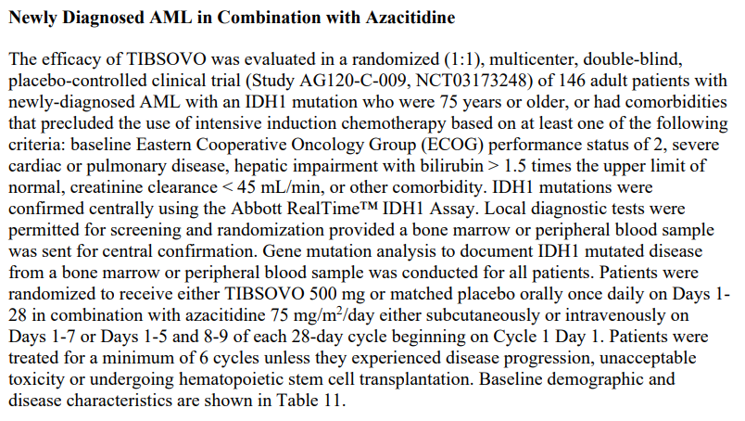

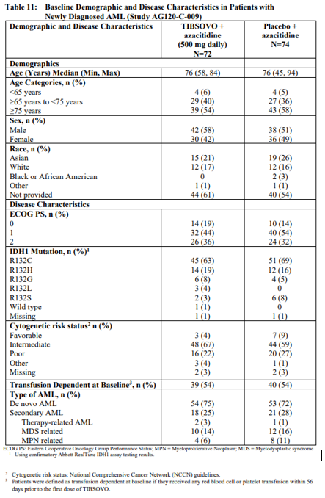

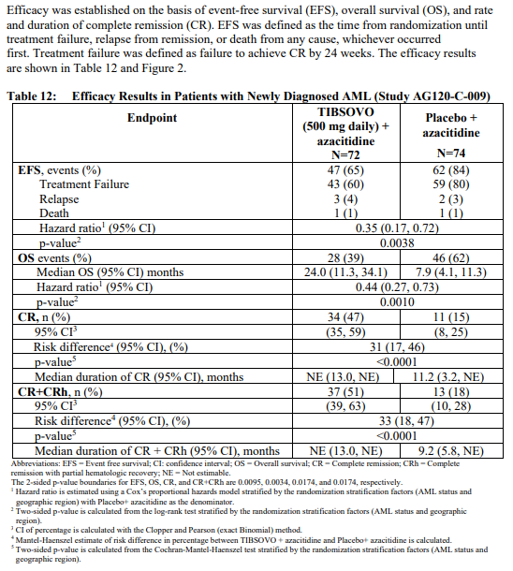

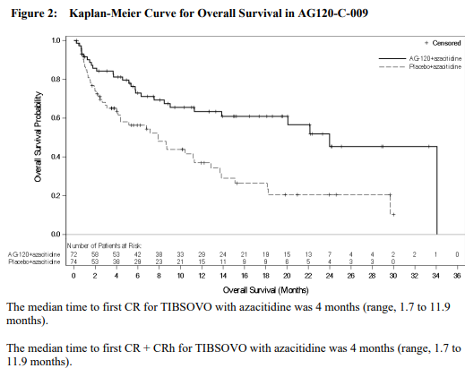

Figure 2: Extract from FDA Prescribing Information for Tibsovo on Clinical studies for Monotherapy in Newly Diagnosed AML

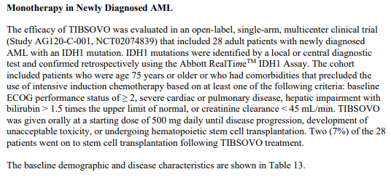

This panel is Table 13 from the FDA Prescribing Information and shows baseline demographic and disease characteristics in patients with newly diagnosed AML in study AG120-C-001.


This panel included Table 14 from the FDA Prescribing Information and shows efficacy results in patients with newly diagnosed AML in Study AG120-C-001.


Figure 3: Extract from FDA Prescribing Information for Tibsovo for Relapsed or refractory AML

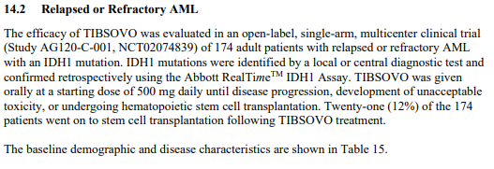

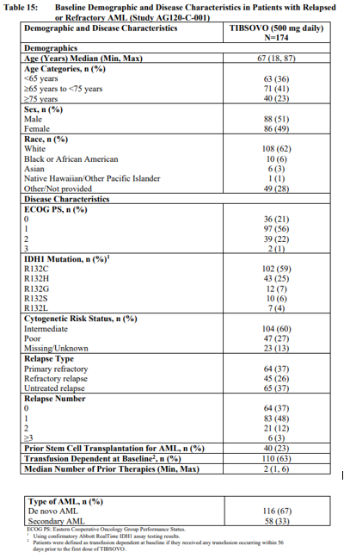

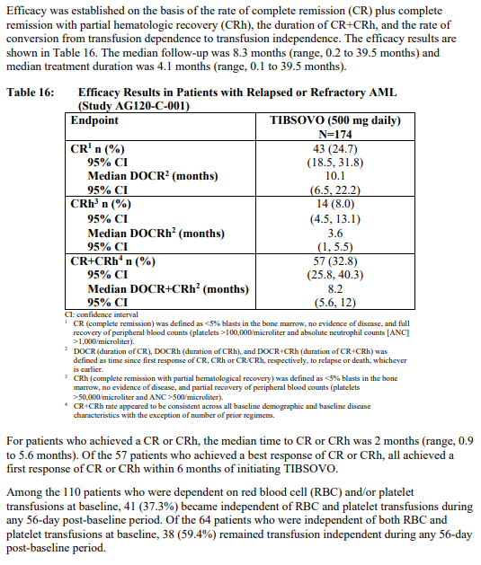

In addition to the data described by FDA, the clinical study report for Study AG120-C-001 reports that 10% of patients with relapsed/refractory disease went on to receive a HSCT after ivosidenib treatment.

##### Delegate’s conclusions regarding efficacy

In a well conducted, randomised, placebo-controlled study (AGILE) in patients with AML harbouring a *IDH1* R132 mutation for whom intensive therapy was not indicated, the addition of ivosidenib 500 mg orally daily to standard doses of azacitidine (a treatment that has previously demonstrated efficacy in this population) produced statistically significant and clinically meaningful increases in event-free (primary) and overall survival. The hazard ratio (95% confidence interval) for event-free survival was 0.35 (0.17, 0.72) with a p-value of 0.0038, and for overall survival was 0.44 (0.27, 0.73) with a p-value of 0.0010. These were corroborated by increased response rates (47% versus 15% CR). Durability of the treatment effect was demonstrated with higher event-free survival rates in the ivosidenib plus azacitidine arm at 12 months (37.4% versus 12.2%) and 24 months (22.2% versus not estimable).

The AGILE study population was adequately representative of the proposed Australian indication population and baseline disease and demographic characteristics were balanced across treatment arms. Most patients (56%) were aged older than 75 years, 73% had de novo AML at diagnosis, 34% had an ECOG Performance Status of 2, and baseline cytogenetic risk status for most patients was intermediate (63%) or poor (25%). The median baseline bone marrow blast count was 53%, and median baseline peripheral blood blast count was 20%. *IDH1* mutation status was determined by central laboratory testing using an investigational polymerase chain reaction (PCR) assay (Abbott RealTime IDH1) on bone marrow aspirates (or if unavailable, on peripheral blood); the most common mutation was R132C (66%).

Single arm, earlier phase data indicate that as monotherapy, treatment with ivosidenib at the same oral dosage is also associated with CR rates that are clearly inconsistent with the natural history of the disease – and 95% confidence intervals excluding zero – among 174 patients with AML harbouring a *IDH1* R132 mutation that was relapsed or refractory after initial intensive induction therapy (25%), and among 28 such patients for whom initial intensive therapy was not indicated (29%). Among these populations, it was also associated with reversion of transfusion dependence in around 40% of patients and maintenance of transfusion independence in around 55% to 60% for a period of at least 8 weeks sometime after baseline. This magnitude and duration of transfusion independence is considered inconsistent with the natural history of AML in the absence of treatment and therefore demonstrative of clinically meaningful efficacy in these single arm populations. The single arm evidence is further supported by the demonstrated benefits in time-to-event endpoints (event-free survival and overall survival) in a closely‑related clinical setting (in the AGILE study).

#### Safety

The pivotal safety data supporting the proposed indications have been published in the literature.70, 72 Selected safety outcomes are summarised in Figure 4. The FDA Prescribing Information summaries on adverse reactions in clinical studies are provided below in newly diagnosed AML in combination with azacitidine (Figure 5), monotherapy in newly diagnosed AML (Figure 6) and relapsed or refractory AML (Figure 7). These data correspond to a data cut-off date of 18 March 2021.

During the evaluation of this submission, the sponsor provided updated safety outcomes corresponding to a more recent data cut-off date of 21 October 2021 and these data were included in the approved PI.

Figure 4: Studies AG120-C-001 and AG120-C-009 (AGILE) Selected safety parameters among patients with *IDH1*-positive AML

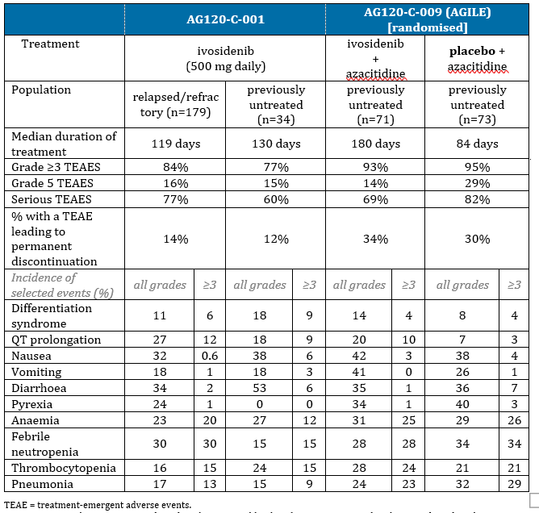

Figure 5: Extract from FDA Prescribing Information for Tibsovo on adverse reactions in combination with azacitidine

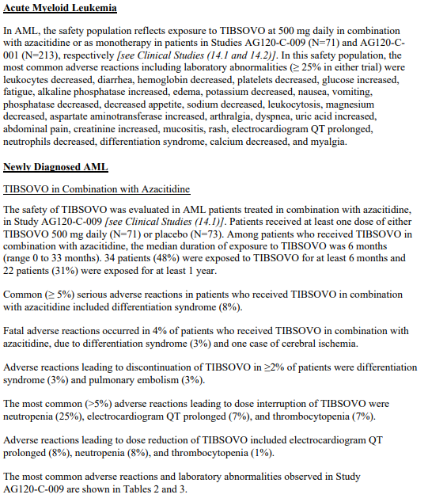

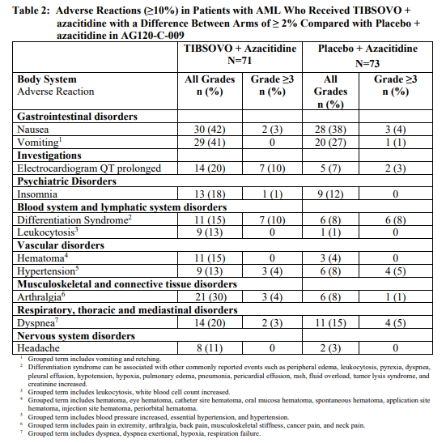

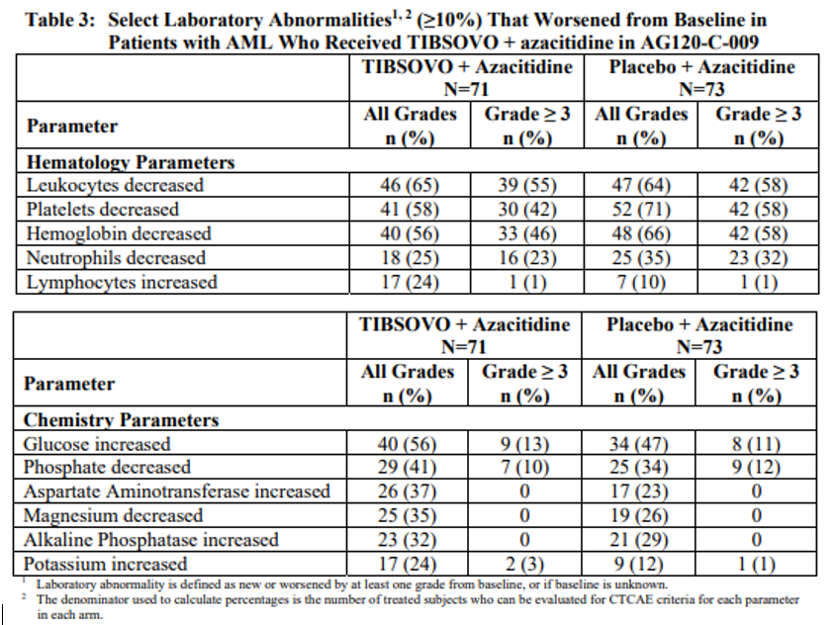

Figure 6: Extract from FDA Prescribing Information for Tibsovo on adverse reactions for monotherapy

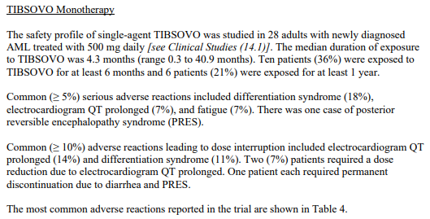

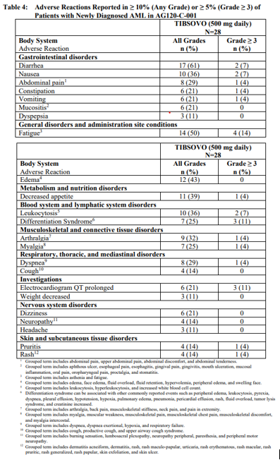

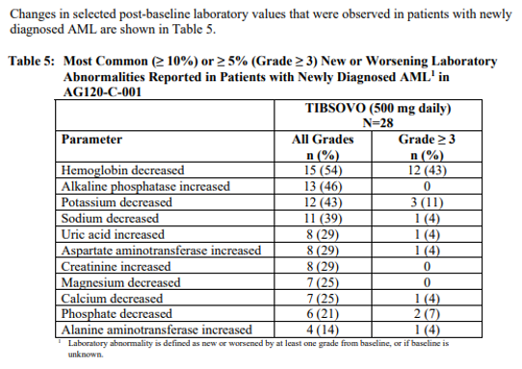

Figure 7: Extract from FDA Prescribing Information for Tibsovo on adverse reactions for relapsed or refractory AML

This figure has 3 panels, each from the FDA Prescribing Information. This panel has text on relapsed or refractory AML.


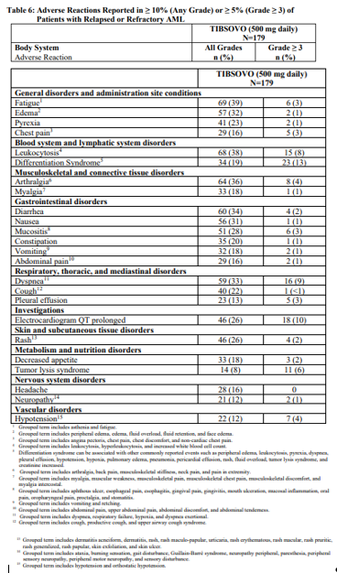

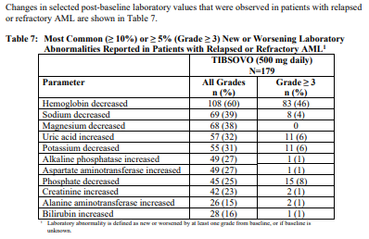

#### Adverse events of special interest in the relapsed/refractory AML population

The FDA multidisciplinary review provides an integrated assessment of safety in relapsed/refractory AML,[76] as below in Figure 8.

Figure 8: Extract from FDA Multidisciplinary review

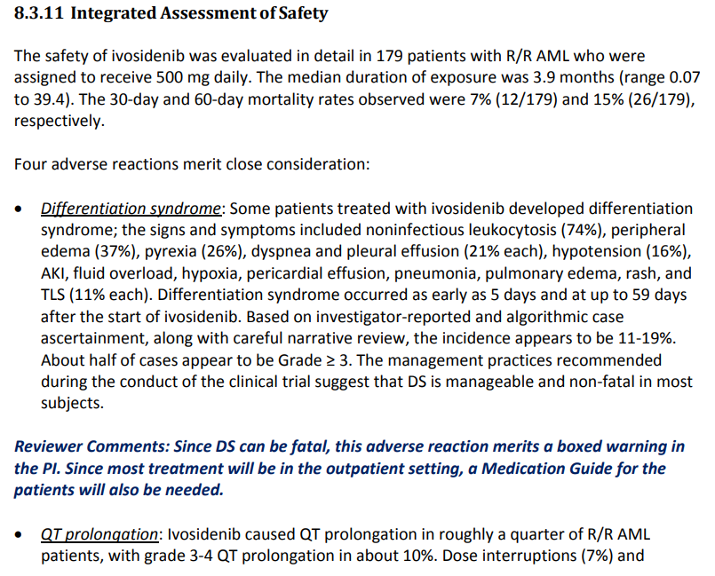

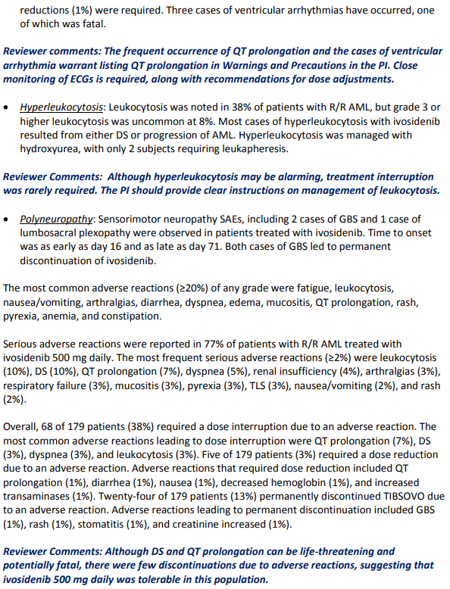

##### Description of selected adverse events

###### QT prolongation

As ivosidenib prolongs the QT interval, the randomised study in patients with AML (AGILE) excluded enrolment of patients with baseline QTc of 470 msec and higher, or taking medications known to prolong the QT interval, or who had other risk factors (such as heart failure, hypokalaemia and family history of long QT interval syndrome).

An analysis of QT prolongation in the haematology study population based on earlier phase data is contained in the FDA multidisciplinary review.74 Events in the AML population in early phase studies included multiple cases of ventricular arrhythmia and possible Torsades de pointes, though confounding factors were present. No such events were seen in the subsequent randomised AGILE study.

The rates of QTc above 500 msec, or increase from baseline QTc of more than 60 msec, respectively, were 10% and 13% among patients with relapsed/refractory AML (n = 178) treated in Study AG120-C-001, 8% and nil among patients receiving both ivosidenib and azacitidine in Study AG120-C-009, and 2% and 5% among patients with CCA treated in Study AG120-C-005. The observed higher incidence of QT prolongation in patients with AML is in keeping with an exposure-response relationship and the higher exposure in AML patients at the same ivosidenib dose, likely attributable to higher rates of co-administration of stronger CYP3A4 inhibitors. It is unclear whether increased exposure is the only contributing factor, but this is very likely to at least explain part of the relationship.

Two cases of cardiac arrest have been reported in the post-market monitoring, however, neither fit with a clinical picture consistent with ventricular arrhythmia secondary to QT prolongation based on Council for International Organizations of Medical Sciences (CIOMS) criteria. Both deaths occurred after a major surgery: one after a hip fracture and the other after mitral valve and attempted aortic valve replacement (aborted due to major complications).

Overall, QT prolongation is a significant safety concern, but is adequately described in the existing warning/precautionary text in the PI.

###### Polyneuropathy

Sensorimotor neuropathy, including the rare autoimmune severe acute paralytic neuropathy Guillain-Barré syndrome, was investigated as a potential risk in the ivosidenib clinical development program for haematological malignancies, as 2 cases of Guillain-Barré syndrome and one serious adverse event of lumbosacral plexopathy were reported within the haematology study population. All 3 events were assessed as treatment-related, but no clear mechanism of action has emerged.

The FDA label includes a precaution regarding Guillain-Barré syndrome as follows:67

Guillain-Barré syndrome can develop in patients treated with Tibsovo. Guillain-Barré syndrome occurred in <1% (2/258) of patients treated with Tibsovo in Study AG120-C-001.

Monitor patients taking Tibsovo for onset of new signs or symptoms of motor and/or sensory neuropathy such as unilateral or bilateral weakness, sensory alterations, paresthesias, or difficulty breathing. Permanently discontinue Tibsovo in patients who are diagnosed with Guillain-Barré syndrome.

It is plausible that ivosidenib rarely causes Guillain-Barré syndrome, however, there is no proposed mechanism of action to explain a relationship between ivosidenib and polyneuropathy. Nonclinical data did not identify the central nervous system as a target organ for ivosidenib toxicity, and the sponsor has confirmed there have been no cases of Guillain-Barré syndrome reported in patients with solid tumours, as at 5 July 2023.

The existing PI text adequately describes this possible risk.

##### Delegate’s conclusions regarding safety

The safety profile of ivosidenib in CCA is described in the current approved Australian PI.

In AGILE, compared to patients receiving placebo, ivosidenib (in combination with azacitidine) was associated with a higher incidence of adverse events of QT prolongation (20% versus 7%), differentiation syndrome (15% versus 8%) and leukocytosis (13% versus 1%), however only one patient had to discontinue due to one of these events (Grade 3 ECG prolongation). Leukocytosis was reported alone and in the context of differentiation syndrome, but none were reported as serious. There were no events of ventricular tachycardia or ventricular arrhythmia, and none of these events were Grade 4 or 5. Review of the narratives for fatal AEs recorded in AGILE suggested the events were likely attributable to the underlying condition.

The rate of discontinuation due to adverse events was 13% with ivosidenib alone in AG120-C-001. The rate of discontinuations (of one or both drugs) due to AEs in AGILE was 30% in the placebo arm and 34% in the ivosidenib arm.

Despite a duration of exposure in the ivosidenib arm that was more than double that of the placebo arm (6 months versus 2.8 months), infection events in the AGILE study occurred in a higher proportion of subjects in the placebo arm. Bleeding events occurred in 41% of subjects in the ivosidenib arm and 29% of subjects in the placebo arm, but rates of higher grade or serious events were similar. Treatment with ivosidenib appears to be tolerable.

### Diagnostic testing considerations

In AGILE, central determination of *IDH1* mutation status (presence or absence of any of the following variants: R132C, R132CL, R132G, R132H or R132S) was performed using the Abbott RealTime IDH1 Assay. This is an in vitro PCR test for the qualitative detection of single nucleotide variants (SNVs) coding 5 *IDH1* R132 mutations (R132C, R132H, R132G, R132S, and R132L) in DNA extracted from human blood or bone marrow, and intended for use with the Abbott *m*2000rt System.[77] It has been approved by FDA as a companion diagnostic for the analogous indication.[78]

Regarding testing for the proposed indications, the sponsor has indicated they anticipate testing for *IDH1* mutations in Australia would primarily be via Next Generation Sequencing (NGS), noting that in November 2022, Australia’s Medical Services Advisory Committee (MSAC) recommended MBS funding of an NGS panel of at least 25 genes for haematological malignancies, including *IDH1*.[79] MSAC’s public summary document for that application (1684) discusses the standard-of-care nature of genetic testing for haematological malignancies, and recognises the clinical validity of NGS panel testing for providing treatment decision-making information.77

The sponsor states that local practice in Australia is to identify *IDH1* mutation via NGS, although for some centres the turn-around time to provide results can limit the applicability for first line treatment decisions. Although these timeframes are improving with increased volume and funding, some centres utilise Droplet Digital PCR ( ddPCR) or High-Resolution Melting Curve Analysis (HRMCA) for rapid identification of the mutations. The Royal College of Pathologists of Australasia (RCPA) has a quality assurance program dedicated to IDH mutation detection in AML (catalogue number 23180102), and their listing page for *IDH1* indicates this testing is available from 16 laboratories across Australia, using a variety of tests, including smaller IDH-only tests and larger gene panels.[80]

While direct comparative data between the clinical trial assay and any other single (or double *IDH1/IDH2*)-gene IDH testing or panel-based or NGS testing have not been reviewed, this is not considered a requirement for this application, for the following reasons:

* The test is qualitative, and therefore at lower risk of intra-observer variability than a test for a continuous variable. Being PCR, the methodology is highly specific.
* The spectrum of *IDH1* mutation tests that are performed across the nation, and the MSAC approval of NGS testing with *IDH1* as a standard panel inclusion, reflects its status as a standard-of-care molecular test for AML samples. This is a test routinely performed at the expert centres with haematological malignancy sample pathology capabilities.
* *IDH1* is included in international guidelines as a test that is ‘necessary to establish the diagnosis, risk classification, and the other procedures recommended to be performed at diagnosis’ and ‘required for establishing the diagnosis and to identify actionable therapeutic targets.’[81] The same publication notes that ‘screening for gene mutations is an evolving field of research; screening for single genes is increasingly replaced by gene panel diagnostics.’

The findings of AGILE provide evidence of the clinical validity and utility of the Abbott RealTime IDH1 Assay for identifying patients suitable for treatment with ivosidenib. Any device seeking registration as a diagnostic from the TGA needs to demonstrate clinical validity and utility, as well as analytical validity and utility.

### Risk management plan

The summary of safety concerns and their associated risk monitoring and mitigation strategies are summarised in Table 3. The TGA may request an updated RMP at any stage of a product's life-cycle, during both the pre-approval and post-approval phases.

Table 3: Summary of safety concerns

|  |  |  |  |  |  |
| --- | --- | --- | --- | --- | --- |
| Summary of safety concerns | | Pharmacovigilance | | Risk minimisation | |
| **Routine** | **Additional** | **Routine** | **Additional** |
| **Important identified risks** | Differentiation Syndrome in patients with AML | ü1 | - | ü | - |
| Electrocardiogram QT prolonged | ü | - | ü | - |
| **Important potential risks** | Embryo-foetal toxicity | ü | - | ü | - |
| Guillain-Barré syndrome3 | ü | - | ü | - |
| **Missing information** | Use in patients with severe hepatic impairment | ü | ü2 | ü | - |
| Use in patients with severe renal impairment 3 | ü | ü2 | ü | - |

1 Differentiation syndrome follow-up questionnaire

2 Organ impairment substudy of study AG120-C-001

3 Australia-specific safety concern

The RMP evaluation recommended conditions of registration relating to the version of the risk management plan, requirement for periodic safety update reports, and inclusion of the medicine in the Black Triangle Scheme.

### Advisory Committee considerations

The Delegate did not refer this submission to the Advisory Committee on Medicines (ACM) for advice.

### Independent expert advice

The Delegate received the following independent expert advice.

1. ***Would ivosidenib monotherapy be a reasonable treatment choice to offer patients with newly-diagnosed, IDH1-positive AML for whom intensive induction therapy is not indicated, despite the lack of randomised data to inform a comparison to other available treatments?***

The inclusion criteria were equivalent to those used in the venetoclax plus azacitidine VIALE-A studies and although there are flaws with extrapolating these data, the magnitude of benefit, high complete remission rate and similarity to the VIALE-A study control group are all strongly supportive of a survival benefit from ivosidenib/azacitidine in this group of patients.

Ivosidenib monotherapy may be preferred in some cases. For example, azacitidine has to be administered parenterally, requiring proximity to large chemotherapy centres. Azacitidine causes local irritation and skin reactions that may be dose limiting. The expert would anticipate that ivosidenib monotherapy would be highly desirable for rural and regional patients, frail patients, and patients who do not wish to have concurrent chemotherapy with azacitidine.

1. ***Would ivosidenib monotherapy be a reasonable treatment choice to offer patients with relapsed/refractory IDH1-positive AML, despite the lack of randomised data to inform a comparison to other available treatments?***

In the relapsed/refractory setting, there is no standard-of-care. This is true, although patients who have *FLT3* mutations can access gilteritinib as standard-of-care, however patients with both mutations are relatively rare and appear to benefit from either approach. Complete responses are vanishingly rare with low dose palliative approaches (low‑dose cytarabine or hydroxyurea) in this setting, and therefore 43% combined CR rate is very impressive and again, highly supportive of the efficacy of drug in the absence of a defined control group.

1. ***Do you agree with the proposed black box warning text?***

On study, differentiation syndrome was as high as 18% in the monotherapy up front cohort and therefore the boxed warning should be included. The expert noted note that the rate of Grade 3 or above QTc prolongation (over 500 ms) is up to 12% in these studies, and the risk of this complication is that it predisposes the patient to ventricular arrhythmia and sudden cardiac death. Additionally, the studies included tight restrictions about co-administered medications, but this will not be monitored in real world use. Medications that inhibit CYP3A4 may cause potentiation of this QTc prolongation and physicians who are less familiar with the use of these drugs may not know to monitor closely. As such, I would recommend that the boxed warning also contains advice about the risk of QTc prolongation and the need to avoid concomitant drugs that have a strong inhibitory effect on CYP3A4.

1. ***Do you have any other concerns regarding the registration of this indication or the proposed product information?***

The expert had no other concerns and was highly supportive of the registration of ivosidenib for this therapeutic indication.

#### Proposed action following independent expert advice

The expert was supportive of the Delegate’s proposed approach regarding the proposed monotherapy usages. The Delegate is confident that this is an appropriate approach to take clinically, and considers the clinical benefit indicated by the relevant single arm data to be confirmed by the randomised data from pivotal study AG120-C-009.

The Delegate noted also that the independent expert has reflected very similar concerns to those raised by the evaluator for the initial CCA application around QT prolongation and concomitant CYP3A4 inhibitors. The incidence was somewhat lower in the CCA population (likely attributable to the lower rate of use or strength of concomitant CYP3A4 inhibitors), but both pivotal studies excluded patients with risk factors. The Delegate for the current submission believes that QT prolongation should also be included in the boxed warning for ivosidenib, on the basis that this is a new class of drug, and there is clinical concern from the field that management of this potential risk requires specific highlighting, at least for now.

The sponsor has indicated that the boxed warning will be included in the CMI, along with a link to a downloadable and printable electronic patient alert card. While the Delegate noted that patients with AML may be elderly and not necessarily comfortable with online access, the sponsor has also included the relevant information in the CMI along with a warning to carry the CMI or the alert card with them at all times. Prescribers and families or carers would be likely to be able to assist with this where needed.

Regarding tumour lysis syndrome, for which there is a warning in the FDA label, the Delegate noted the following in the original FDA multidisciplinary review:74

Tumor lysis syndrome

The FDA identified 15 events of tumor lysis syndrome (TLS) in 14 subjects (8%) in the [relapsed or refractory] R/R AML [safety analysis set] SAS. Grade 3 or higher events of TLS occurred in 11 (6%) of patients and none led to permanent discontinuation. Only one subject temporarily interrupted ivosidenib for TLS. Findings were similar in the SAS. To further understand the relationship between ivosidenib and TLS, the FDA reviewed the events of TLS, including narratives (where available) and compared the date of TLS onset to dates of reported [white blood cell] WBC counts. In all but three subjects, TLS occurred in the setting of leukocytosis, some in the setting of [progressive disease] PD (n=4) and/or [differentiation syndrome] DS (n=4).

Reviewer comment: The frequency and severity of tumor lysis syndrome is similar to what would be expected in the underlying population. In the case of ivosidenib, it appears to be occurring either as a consequence of leukocytosis/DS or disease progression. TLS does not appear to be a serious or life-threatening event related to treatment with ivosidenib that warrants a warning in the US PI.

Subsequently to this, there were no events of TLS in patients receiving ivosidenib in Study AG120-C-009, whilst there was one such event in the placebo arm.

The Delegate considers that there is not a clear signal for tumour lysis syndrome as an event associated with ivosidenib (based on mechanism or clinical data), and that this warning should not be added to the Australian PI at this time.

### Delegate’s considerations

#### Does the submitted data adequately establish efficacy and safety for the intended use?

##### Ivosidenib plus azacitidine for treatment-naive IDH1-positive AML

The pivotal data supporting this indication come from an adequately designed and conducted randomised, controlled clinical study. It demonstrated that for patients with AML harbouring a *IDH1* R132 mutation for whom intensive therapy was not indicated, treatment with ivosidenib 500 mg orally in combination with azacitidine was associated with durable remissions, delayed disease relapse/progression and increased duration of survival. The safety data demonstrated an acceptable toxicity profile commensurate with the additive profiles of both agents and consistent with their mechanisms of action.

The AGILE study commenced 26 June 2017 and had a primary completion date of 18 March 2021.69 The comparator (placebo plus azacitidine) was the preferred standard-of-care treatment at the time of the study and was an appropriate comparator.

Since that time, azacitidine in combination with venetoclax has been established as a more effective standard-of-care option for patients with newly-diagnosed AML, where intensive induction therapy is not indicated, based on data reported in 2020 (the VIALE-A study).19 Australia’s Pharmaceutical Benefits Scheme has included venetoclax for AML from December 2021.[82] Given the additional toxicity conferred by addition of venetoclax by comparison to HMA alone, the use of a HMA as monotherapy remains a reasonable treatment choice for some patients.

There are no direct data regarding the comparative efficacy of ivosidenib+azacitidine and venetoclax+azacitidine in this setting, however, this is not of concern due to:

* 1. the timing of the studies, and
  2. cross-trial comparison to VIALE-A, which does not raise concerns that the efficacy and safety seen with ivosidenib+azacitidine are unacceptable for this setting.

Indeed (noting that this was an unselected population rather than the *IDH1*-positive subset) exploratory cross-trial comparison suggests ivosidenib plus azacitidine has at least similar efficacy in this setting, and likely has less toxicity than venetoclax+HMA, for appropriately selected patients.

The submitted data clearly establish efficacy and safety for the intended use.

##### Ivosidenib monotherapy for treatment-naive IDH1-positive AML

In an open-label, single‑arm, multicentre study (Study AG120-C-001) ivosidenib as monotherapy demonstrated evidence of clinically meaningful efficacy for patients with *IDH1*-mutated AML for whom intensive induction chemotherapy is not indicated (n=28).

Treatment with ivosidenib at the same oral dosage (as was studied in AGILE) in this population was associated with a complete response rate of 29%, and conversion to transfusion independence or maintenance of transfusion independence for periods of at least 8 weeks in a notable proportion of patients (41% and 55%, respectively). Despite the lack of an internal comparator, the evidence represents clinically meaningful benefit in this population, because the magnitude and duration of these effects is inconsistent with the natural history of AML in the absence of treatment.

The single arm evidence demonstrating that ivosidenib has clinically meaningful efficacy as a monotherapy is supported by the demonstrated contribution of effect of ivosidenib to increased efficacy measured by time-to-event outcomes (event-free survival and overall survival) in essentially the same patient population (in the AGILE study). The randomised data from AGILE demonstrate the contribution of ivosidenib to the efficacy of the combination and confirm its clinical benefit.

This is a vulnerable patient group, for whom the aims of treatment are to temporarily increase duration and quality of life. Importantly, duration may come at the cost of some quality of life where there are significant toxicities to treatment. The AGILE population were medically ‘unfit’ (in keeping with the intended usage); most (56%) were older than 75 years and 34% had an ECOG Performance Status of 2. Whilst this population was able to tolerate azacitidine plus ivosidenib for the most part, around a third of patients in both arms of AGILE permanently discontinued due to AEs.

Based on the established efficacy and safety of azacitidine monotherapy,1 the mechanisms of action of each drug, and cross-trial comparison, it is highly likely that ivosidenib plus azacitidine is more efficacious but also more toxic than ivosidenib monotherapy.

Ivosidenib monotherapy represents a treatment option that may be useful for patients within this population who would prefer a more tolerable option and are willing to accept the chance of less efficacy, as well as the uncertainty regarding the magnitude of difference (both efficacy and safety) between ivosidenib monotherapy and ivosidenib plus azacitidine. Patient preferences are likely to be highly relevant.

Provided the usage could be clinically appropriate, the Delegate is satisfied that the efficacy and safety of ivosidenib monotherapy in this setting are adequately established.

##### Ivosidenib monotherapy for relapsed/refractory IDH1-positive AML

In another cohort of the same single-arm study (Study AG120-C-001), ivosidenib as monotherapy also demonstrated evidence of clinically meaningful efficacy for patients with refractory or relapsed *IDH1*-mutated AML after initial intensive induction treatment (n = 174).

Among this group, ivosidenib treatment demonstrated a CR rate of 25%, and conversion to transfusion independence or maintenance of transfusion independence for periods of at least 8 weeks in a notable proportion of patients (37% and 59%, respectively). The magnitude and duration of these effects is inconsistent with the natural history of AML in the absence of treatment, and represent clinically meaningful benefit in this populations despite the lack of an internal comparator.

As is the case for the newly-diagnosed setting, the single arm evidence of clinically meaningful efficacy for ivosidenib as monotherapy (from Study AG120-C-001) is supported by the demonstrated contribution of ivosidenib to improved time-to-event outcomes (event-free survival and overall survival) in a very similar patient population (in the AGILE study). These patients have essentially the same disease as the patients enrolled in AGILE, but their medical fitness was adequate to permit initial intensive induction chemotherapy.

The aim of treatment for patients with relapsed/refractory disease can be to induce response and aim for curative HSCT, however, this will not be the case for all patients. A patient who was medically fit at the time of their initial diagnosis may no longer be so by the time relapsed or refractory disease is diagnosed. There is also no standard approach in this setting to re-induction of response and whether to attempt HSCT (with or without prior re-induction). Choice of approach is highly nuanced based on multiple factors, including patient fitness and disease aggression.

For some patients with particular biomarkers, a targeted agent such as gilteritinib (for *FLT3* mutated AML) or gemtuzumab ozogamicin (CD33+ AML) may be an option with less toxicity and higher response rates (21% and 26%, respectively),28, 29 though onset of action may be slower, than for cytotoxic chemotherapy.26 Re-attempted induction with chemotherapy requires intact medical fitness, is highly toxic, and is associated with CR rates of 12%-15%.27

Based on the durable responses and rates of conversion to transfusion independence, with low rates of discontinuation due to adverse events, ivosidenib monotherapy represents a treatment option with clinically meaningful effects that may be useful for patients within the relapsed/refractory AML population who have an *IDH1* mutation who wish to prioritise lower treatment toxicity over treatment with curative intent.

#### Indication wording regarding unsuitability of intensive induction chemotherapy and mutation type

Previous Pharmaceutical Benefits Advisory Committee deliberations for similar indications have noted that in this clinical setting there is no consensus definition available for ‘ineligibility’ for standard intensive remission induction chemotherapy. In line with advice from other committees, it was agreed that it is appropriate for eligibility to be determined by clinician judgement incorporating patient preference.18

The European indication is limited to R132 mutations, whilst the US indication stipulates ‘susceptible’ mutations are eligible for treatment, with a definition contained later in the label regarding what susceptibility entails.[83]

The Australian indication for CCA specifies ‘R132’, similar to the European indication. The AML wording is similarly proposed, and this is considered reasonable.

#### Boxed warning

The FDA label contains a black box regarding the risk of differentiation syndrome, with wording as follows:67

WARNING: DIFFERENTIATION SYNDROME IN AML

Patients treated with TIBSOVO have experienced symptoms of differentiation syndrome, which can be fatal if not treated. Symptoms may include fever, dyspnea, hypoxia, pulmonary infiltrates, pleural or pericardial effusions, rapid weight gain or peripheral edema, hypotension, and hepatic, renal, or multi-organ dysfunction. If differentiation syndrome is suspected, initiate corticosteroid therapy and hemodynamic monitoring until symptom resolution [see Warnings and Precautions (5.1) and Adverse Reactions (6.1)].

The use of boxed warnings in the Australian PI may differ from that in the USA. The TGA [Boxed Warning guidance](https://www.tga.gov.au/resources/resource/guidance/boxed-warning-guidance) includes the following:

The rationale for the use of the boxed warning at the beginning of the PI is as a further risk mitigation measure, where the risk associated with taking the medicine cannot be adequately managed or mitigated through inclusion in the special warnings and precautions for use or contraindication sections of the PI.

The Sponsor proposes the following boxed warning for the Australian PI:

WARNING: DIFFERENTIATION SYNDROME IN AML

Patients treated with TIBSOVO have experienced symptoms of differentiation syndrome, which can be life-threatening or fatal if not treated. Symptoms may include: non-infectious leukocytosis, peripheral oedema, pyrexia, dyspnoea, pleural effusion, hypotension, hypoxia, pulmonary oedema, pneumonitis, pericardial effusion, rash, fluid overload, tumour lysis syndrome and creatinine increased. If differentiation syndrome is suspected, initiate corticosteroid therapy and hemodynamic monitoring until symptom resolution and for a minimum of 3 days (see “Special warnings and precautions for use (4.4) Adverse effects”(4.8).

## Outcome

Based on a review of quality, safety, and efficacy, the TGA approved the registration of Tibsovo (ivosidenib) 250 mg film-coated tablets supplied in bottles to extend the indications to include:

*Tibsovo is indicated for the treatment of acute myeloid leukaemia (AML) that carries an IDH1 R132 mutation:*

* + - *as monotherapy, or in combination with azacitidine, in newly diagnosed patients who are not eligible to receive intensive induction chemotherapy; or*
    - *as monotherapy in patients whose AML is relapsed and/or refractory to prior therapy.*

As such, the full indications at this time were:

*Cholangiocarcinoma*

*TIBSOVO is indicated for the treatment of adult patients with locally advanced or metastatic cholangiocarcinoma with an isocitrate dehydrogenase-1 (IDH1) R132 mutation after at least one prior line of systemic therapy.*

*Acute myeloid leukaemia*

*TIBSOVO is indicated for the treatment of acute myeloid leukaemia (AML) that carries an IDH1 R132 mutation:*

* *as monotherapy, or in combination with azacitidine, in newly diagnosed patients who are not eligible to receive intensive induction chemotherapy; or*
* *as monotherapy in patients whose AML is relapsed and/or refractory to prior therapy.*

### Specific conditions of registration applying to these goods

* Tibsovo (ivosidenib) is to be included in the Black Triangle Scheme. The PI and CMI for Tibsovo must include the black triangle symbol and mandatory accompanying text for 5 years, which starts from the date that the sponsor notifies the TGA of supply of the product.
* The Tibsovo EU-Risk Management Plan (RMP) (version 1.0, dated 17 February 2023;data lock point 31 October 2021), with Australian specific annex (version 1.3, dated August 2023), included with submission PM-2022-02178-1-6, and any subsequent revisions, as agreed with the TGA will be implemented in Australia.

An obligatory component of risk management plans is routine pharmacovigilance. Routine pharmacovigilance includes the submission of periodic safety update reports (PSURs).

Reports are to be provided in line with the current published list of EU reference dates and frequency of submission of PSURs until the period covered by such reports is not less than 3 years from the date of the approval letter.

The reports are to at least meet the requirements for PSURs as described in the European Medicines Agency’s Guideline on Good Pharmacovigilance Practices (GVP) Module VII-periodic safety update report (Revision 1), Part VII.B Structures and processes. Note that submission of a PSUR does not constitute an application to vary the registration. Each report must have been prepared within 90 calendar days of the data lock point for that report.

## Attachment 1. Product Information

The PI for Tibsovo approved with the submission which is described in this AusPAR is at Attachment 1. It may have been superseded. For the most recent PI, please refer to the TGA [PI/CMI search facility.](https://www.tga.gov.au/picmi-search-facility)

|  |
| --- |
| Therapeutic Goods Administration |
| PO Box 100 Woden ACT 2606 Australia  Email: [info@tga.gov.au](mailto:info@tga.gov.au) Phone: 1800 020 653 Fax: 02 6203 1605  [**https://www.tga.gov.au**](https://www.tga.gov.au) |
| Reference/Publication # |

1. Azacitidine was first registered in the ARTG in 2009 under the tradename VIDAZA and is now available under multiple tradenames. Product Information documents are available from the [Therapeutic Goods Administration (TGA) website.](https://www.tga.gov.au/)
2. This is the original indication proposed by the sponsor when the TGA commenced the evaluation of this submission. It may differ to the final indication approved by the TGA and registered in the Australian Register of Therapeutic Goods.
3. This submission was made in *parallel* to another submission by Servier Laboratories (Aust.) Pty. Ltd. under the Priority registration pathway to register Tibsovo as a New Chemical Entity for an indication in cholangiocarcinoma (Submission No. PM-2022-02134-1-4),
4. Estey E, Döhner H. Acute myeloid leukaemia. Lancet. 2006;368(9550):1894-1907. doi: [/10.1016/S0140-6736(06)69780-8](https://doi.org/10.1016/S0140-6736(06)69780-8).
5. Shipley JL, Butera JN. Acute myelogenous leukemia. Exp Hematol. 2009;37(6):649-658. doi: 10.1016/j.exphem.2009.04.002.
6. Schiffer AC, Gurbuxani S. Classification of acute myeloid leukemia (AML) (UpToDate). Literature review current through May 2023. Last updated 18 March 2022 at <https://www.uptodate.com/contents/classification-of-acute-myeloid-leukemia-aml>.
7. Khoury JD, Solary E, Abla O, Akkari Y, Alaggio R, Apperley JF, et al. The 5th edition of the World Health Organization Classification of Haematolymphoid Tumours: Myeloid and Histiocytic/Dendritic Neoplasms. Leukemia. 2022; 36(7):1703-1719. doi: 10.1038/s41375-022-01613-1.
8. Kolitz JE (ed. Larson RA and Rosmarin AG). Overview of acute myeloid leukemia in adults (UpToDate topic). Last updated 28 January 2022, literature review current through May 2023 at: <https://www.uptodate.com/contents/overview-of-acute-myeloid-leukemia-in-adults>.
9. Australian Institute of Health and Welfare (2022) [*Cancer data in Australia*](https://www.aihw.gov.au/reports/cancer/cancer-data-in-australia), AIHW, Australian Government, accessed 22 June 2023 at: <https://www.aihw.gov.au/reports/cancer/cancer-data-in-australia/contents/cancer-incidence-by-age-visualisation> and <https://www.aihw.gov.au/reports/cancer/cancer-data-in-australia/contents/cancer-mortality-by-age-visualisation>.
10. Beckmann K, Kearney BJ, Yeung D, Hiwase D, Li M, Roder DM. Changes in five-year survival for people with acute leukaemia in South Australia, 1980-2016. Med J Aust. 2022; 216(6):296-302. doi: 10.5694/mja2.51423.
11. Schiffer CA (ed. Larson RA and Rosmarin AG) Prognosis of acute myeloid leukemia (UpToDate topic). Last updated 13 February 2023, literature review current through May 2023 at: <https://www.uptodate.com/contents/prognosis-of-acute-myeloid-leukemia>.
12. Appelbaum FR, Gundacker H, Head DR, Slovak ML, Willman CL, Godwin JE, et al. Age and acute myeloid leukemia. Blood. 2006;107(9):3481-3485. doi: 10.1182/blood-2005-09-3724.
13. Stone RM. The difficult problem of acute myeloid leukemia in the older adult. CA Cancer J Clin. 2002;52(6):363-371. doi: 10.3322/canjclin.52.6.363.
14. Döhner H, Estey E, Grimwade D, Amadori S, Appelbaum FR, Büchner T, et al. Diagnosis and management of AML in adults: 2017 ELN recommendations from an international expert panel. Blood. 2017;129(4):424-447. doi: 10.1182/blood-2016-08-733196.
15. Larson RA ((ed. Lowenberg B and Rosmarin AG). Acute myeloid leukemia: Management of medically-unfit adults (UpToDate topic). Last updated 5 April 2023, literature review current through May 2023 at: [https://www.uptodate.com/contents/acute-myeloid-leukemia-management-of-medically-unfit-adults](https://www.uptodate.com/contents/acute-myeloid-leukemia-management-of-medically-unfit-adults?sectionName=GOALS,%20BENEFITS,%20AND%20TIMING%20OF%20TREATMENT&search=aml&topicRef=94786&anchor=H4255067232&source=see_link#H4255067232).
16. National Comprehensive Cancer Network (NCCN) guidelines for Acute Myeloid Leukaemia (Age ≥18 years). Version 3.2023, dated 4 May 2023 at <https://www.nccn.org/professionals/physician_gls/pdf/aml.pdf>.
17. Original paper is Charlson ME, Pompei P, Ales KL, MacKenzie CR. A new method of classifying prognostic comorbidity in longitudinal studies: development and validation. J Chronic Dis. 1987;40(5):373-83. doi: 10.1016/0021-9681(87)90171-8.
18. ECOG Performance Status: The Eastern Cooperative Oncology Group (ECOG) has developed criteria used by doctors and researchers to assess how a patient's disease is progressing, assess how the disease affects the daily living abilities of the patient, and determine appropriate treatment and prognosis. The following definitions are used: Status 0 = Fully active, able to carry on all pre-disease performance without restriction; Status 1 = Restricted in physically strenuous activity but ambulatory and able to carry out work of a light or sedentary nature, for example, light house work, office work; Status 2 = Ambulatory and capable of all selfcare but unable to carry out any work activities. Up and about more than 50% of waking hours; Status 3 = Capable of only limited selfcare, confined to bed or chair more than 50% of waking hours; Status 4 = Completely disabled. Cannot carry on any selfcare. Totally confined to bed or chair; Status 5 = Death.
19. Public Summary Document – March 2021 PBAC Meeting. Item 6.14: Venetoclax for newly diagnosed acute myeloid leukaemia (AML), ineligible for standard intensive remission induction chemotherapy, given in combination with azacitidine. <https://www.pbs.gov.au/industry/listing/elements/pbac-meetings/psd/2021-03/files/venetoclax-psd-mar-2021.pdf>.
20. DiNardo CD, Jonas BA, Pullarkat V, Thirman MJ, Garcia JS, Wei AH, et al. Azacitidine and Venetoclax in Previously Untreated Acute Myeloid Leukemia. N Engl J Med. 2020;383(7):617-629. doi: 10.1056/NEJMoa2012971. PMID: 32786187.
21. Dombret H, Seymour JF, Butrym A, Wierzbowska A, Selleslag D, Jang JH, et al. International phase 3 study of azacitidine vs conventional care regimens in older patients with newly diagnosed AML with >30% blasts. Blood. 2015;126(3):291-299. doi: 10.1182/blood-2015-01-621664.
22. Fenaux P, Mufti GJ, Hellström-Lindberg E, Santini V, Gattermann N, Germing U, et al. Azacitidine prolongs overall survival compared with conventional care regimens in elderly patients with low bone marrow blast count acute myeloid leukemia. J Clin Oncol. 2010;28(4):562-569. doi: 10.1200/JCO.2009.23.8329.
23. Wei AH, Montesinos P, Ivanov V, DiNardo CD, Novak J, Laribi K, et al. Venetoclax plus LDAC for newly diagnosed AML ineligible for intensive chemotherapy: a phase 3 randomized placebo-controlled trial. Blood. 2020;135(24):2137-2145. doi: 10.1182/blood.2020004856.
24. The QT interval is the time from the start of the QRS wave complex to the end of the corresponding T wave. It approximates to the time taken for ventricular depolarisation and repolarisation, that is to say, the period of ventricular systole from ventricular isovolumetric contraction to isovolumetric relaxation.
25. Cytochrome P450 (CYP) enzymes: CYPs are the major enzymes involved in drug metabolism, accounting for a large part of the total metabolism. Most drugs undergo deactivation by CYPs, either directly or by facilitated excretion from the body. Also, many substances are bioactivated by CYPs to form their active compounds. Many drugs may increase or decrease the activity of various CYP isozymes either by inducing the biosynthesis of an isozyme (enzyme induction) or by directly inhibiting the activity of the CYP (enzyme inhibition). This is a major source of adverse drug interactions, since changes in CYP enzyme activity may affect the metabolism and clearance of various drugs. Such drug interactions are especially important to take into account when using drugs of vital importance to the patient, drugs with important side-effects and drugs with small therapeutic windows, but any drug may be subject to an altered plasma concentration due to altered drug metabolism.
26. Approved FDA label for glasdegib (DAURISMO). Last updated March 2023 at: <https://www.accessdata.fda.gov/drugsatfda_docs/label/2023/210656s005lbl.pdf>
27. Larson RA ((ed. Lowenberg B and Rosmarin AG). Treatment of relapsed or refractory acute myeloid leukemia (UpToDate topic). Last updated 31 March 2023, literature review current through May 2023 at: <https://www.uptodate.com/contents/treatment-of-relapsed-or-refractory-acute-myeloid-leukemia>.
28. Roboz GJ, Rosenblat T, Arellano M, Gobbi M, Altman JK, Montesinos P, et al. International randomized phase III study of elacytarabine versus investigator choice in patients with relapsed/refractory acute myeloid leukemia. J Clin Oncol. 2014;32(18):1919-1926. doi: 10.1200/JCO.2013.52.8562.
29. Perl AE, Martinelli G, Cortes JE, Neubauer A, Berman E, Paolini S, et al. Gilteritinib or Chemotherapy for Relapsed or Refractory *FLT3*-Mutated AML. N Engl J Med. 2019;381(18):1728-1740. doi: 10.1056/NEJMoa1902688. Erratum in: N Engl J Med. 2022;386(19):1868.
30. Taksin AL, Legrand O, Raffoux E, de Revel T, Thomas X, Contentin N, et al. High efficacy and safety profile of fractionated doses of Mylotarg as induction therapy in patients with relapsed acute myeloblastic leukemia: a prospective study of the alfa group. Leukemia. 2007;21(1):66-71. doi: 10.1038/sj.leu.2404434.
31. Crispo F, Pietrafesa M, Condelli V, Maddalena F, Bruno G, Piscazzi A, et al. IDH1 Targeting as a New Potential Option for Intrahepatic Cholangiocarcinoma Treatment-Current State and Future Perspectives. Molecules. 2020;25(16):3754. doi: 10.3390/molecules25163754.
32. Dang L, Yen K, Attar EC. IDH mutations in cancer and progress toward development of targeted therapeutics. Ann Oncol. 2016;27(4):599-608. doi: 10.1093/annonc/mdw013.
33. Reitman ZJ, Yan H. Isocitrate dehydrogenase 1 and 2 mutations in cancer: alterations at a crossroads of cellular metabolism. J Natl Cancer Inst. 2010;102(13):932-941. doi: 10.1093/jnci/djq187.
34. Sjoblom T, Jones S, Wood LD, Parsons DW, Lin J, Barber TD, et al. The consensus coding sequences of human breast and colorectal cancers. Science. 2006;314(5797):268-74. doi: 10.1126/science.1133427.
35. Pusch S, Schweizer L, Beck AC, Lehmler JM, Weissert S, Balss J, et al. D-2-Hydroxyglutarate producing neo-enzymatic activity inversely correlates with frequency of the type of isocitrate dehydrogenase 1 mutations found in glioma. Acta Neuropathol Commun. 2014;2:19. doi: 10.1186/2051-5960-2-19.
36. Waitkus MS, Diplas BH, Yan H. Biological Role and Therapeutic Potential of IDH Mutations in Cancer. Cancer Cell. 2018;34(2):186-195. doi: 10.1016/j.ccell.2018.04.011.
37. Yang H, Ye D, Guan KL, Xiong Y. IDH1 and IDH2 mutations in tumorigenesis: mechanistic insights and clinical perspectives. Clin Cancer Res. 2012;18(20):5562-5571. doi: 10.1158/1078-0432.CCR-12-1773.
38. Zhao S, Lin Y, Xu W, Jiang W, Zha Z, Wang P, et al. Glioma-Derived Mutations in IDH1 Dominantly Inhibit IDH1 Catalytic Activity and Induce HIF-1 {alpha} Science. 2009;324:261-265. doi: 10.1126/science.117094.
39. Dang L, White DW, Gross S, Bennett BD, Bittinger MA, Driggers EM, et al. Cancer-associated IDH1 mutations produce 2-hydroxyglutarate. Nature. 2009;462:739–744. doi: 10.1038/nature08617.
40. Colvin H, Nishida N, Konno M, Haraguchi N, Takahashi H, Nishimura J, et al. Oncometabolite D-2-Hydroxyglurate Directly Induces Epithelial-Mesenchymal Transition and is Associated with Distant Metastasis in Colorectal Cancer. Sci Rep. 2016;6:36289. doi: 10.1038/srep36289.
41. Xu W, Yang H, Liu Y, Yang Y, Wang P, Kim SH, et al. Oncometabolite 2-hydroxyglutarate is a competitive inhibitor of α-ketoglutarate-dependent dioxygenases. Cancer Cell. 2011;19(1):17-30. doi: 10.1016/j.ccr.2010.12.014.
42. Turcan S, Rohle D, Goenka A, Walsh LA, Fang F, Yilmaz E, et al. IDH1 mutation is sufficient to establish the glioma hypermethylator phenotype. Nature. 2012;483(7390):479-483. doi: 10.1038/nature10866.
43. Terunuma A, Putluri N, Mishra P, Mathé EA, Dorsey TH, Yi M, et al. MYC-driven accumulation of 2-hydroxyglutarate is associated with breast cancer prognosis. J Clin Invest. 2014;124(1):398-412. doi: 10.1172/JCI71180.
44. DiNardo CD, Propert KJ, Loren AW, Paietta E, Sun Z, Levine RL, et al. Serum 2-hydroxyglutarate levels predict isocitrate dehydrogenase mutations and clinical outcome in acute myeloid leukemia. Blood. 2013;121(24):4917-4924. doi: 10.1182/blood-2013-03-493197.
45. Schnittger S, Haferlach C, Ulke M, Alpermann T, Kern W, Haferlach T. IDH1 mutations are detected in 6.6% of 1414 AML patients and are associated with intermediate risk karyotype and unfavorable prognosis in adults younger than 60 years and unmutated NPM1 status. Blood. 2010 Dec 16;116(25):5486-5496. doi: 10.1182/blood-2010-02-267955.
46. Patel KP, Ravandi F, Ma D, Paladugu A, Barkoh BA, Medeiros LJ, et al. Acute myeloid leukemia with IDH1 or IDH2 mutation: frequency and clinicopathologic features. Am J Clin Pathol. 2011;135(1):35-45. doi: 10.1309/AJCPD7NR2RMNQDVF.
47. Patel JP, Gönen M, Figueroa ME, Fernandez H, Sun Z, Racevskis J, et al. Prognostic relevance of integrated genetic profiling in acute myeloid leukemia. N Engl J Med. 2012;366(12):1079-1089. doi: 10.1056/NEJMoa1112304.
48. Kunadt D, Stasik S, Metzeler KH, Röllig C, Schliemann C, Greif PA, et al. Impact of IDH1 and IDH2 mutational subgroups in AML patients after allogeneic stem cell transplantation. J Hematol Oncol. 2022;15(1):126. doi: 10.1186/s13045-022-01339-8.
49. Im AP, Sehgal AR, Carroll MP, Smith BD, Tefferi A, Johnson DE, et al. DNMT3A and IDH mutations in acute myeloid leukemia and other myeloid malignancies: associations with prognosis and potential treatment strategies. Leukemia. 2014;28(9):1774-1783. doi: 10.1038/leu.2014.124. Erratum in: Leukemia. 2015;29(2):516.
50. DiNardo CD, Ravandi F, Agresta S, Konopleva M, Takahashi K, Kadia T, et al. Characteristics, clinical outcome, and prognostic significance of IDH mutations in AML. Am J Hematol. 2015;90(8):732-736. doi: 10.1002/ajh.24072.
51. Issa GC, DiNardo CD. Acute myeloid leukemia with IDH1 and IDH2 mutations: 2021 treatment algorithm. Blood Cancer J. 2021;11(6):107. doi: 10.1038/s41408-021-00497-1.
52. Green CL, Evans CM, Zhao L, Hills RK, Burnett AK, Linch DC, et al. The prognostic significance of IDH2 mutations in AML depends on the location of the mutation. Blood. 2011;118(2):409–412. doi: 10.1182/blood-2010-12-322479.
53. Rockova V, Abbas S, Wouters BJ, Erpelinck CA, Beverloo HB, Delwel R, et al. Risk stratification of intermediate-risk acute myeloid leukemia: integrative analysis of a multitude of gene mutation and gene expression markers. Blood. 2011;118(4):1069-1076. doi: 10.1182/blood-2011-02-334748.
54. Paschka P, Schlenk RF, Gaidzik VI, Habdank M, Krönke J, Bullinger L, et al. IDH1 and IDH2 mutations are frequent genetic alterations in acute myeloid leukemia and confer adverse prognosis in cytogenetically normal acute myeloid leukemia with NPM1 mutation without FLT3 internal tandem duplication. J Clin Oncol. 2010;28(22):3636-3643. doi: 10.1200/JCO.2010.28.3762.
55. Mardis ER, Ding L, Dooling DJ, Larson DE, McLellan MD, Chen K, et al. Recurring mutations found by sequencing an acute myeloid leukemia genome. N Engl J Med. 2009;361(11):1058-1066. doi: 10.1056/NEJMoa0903840.
56. Ravandi F, Patel K, Luthra R, Faderl S, Konopleva M, Kadia T, et al. Prognostic significance of alterations in IDH enzyme isoforms in patients with AML treated with high-dose cytarabine and idarubicin. Cancer. 2012;118(10):2665-2673. doi: 10.1002/cncr.26580.
57. Abbas S, Lugthart S, Kavelaars FG, Schelen A, Koenders JE, Zeilemaker A, et al. Acquired mutations in the genes encoding IDH1 and IDH2 both are recurrent aberrations in acute myeloid leukemia: Prevalence and prognostic value. Blood. 2010;116:2122–2126. doi: 10.1182/blood-2009-11-250878.
58. Nomdedeu J, Hoyos M, Carricondo M, Esteve J, Bussaglia E, EstivillC, et al. Adverse impact of IDH1 and IDH2 mutations in primary AML: Experience of the Spanish CETLAM group. Leuk Res. 2012;36(8):990–997. doi: 10.1016/j.leukres.2012.03.019.
59. Bill M, Jentzsch M, Bischof L, Kohlschmidt J, Grimm J, Schmalbrock LK, et al. Impact of IDH1 and IDH2 mutation detection at diagnosis and in remission in patients with AML receiving allogeneic transplantation. Blood Adv. 2023 Feb 14;7(3):436-444. doi: 10.1182/bloodadvances.2021005789.
60. Chotirat S, Thongnoppakhun W, Promsuwicha O, Boonthimat C, Auewarakul CU. Molecular alterations of isocitrate dehydrogenase 1 and 2 (IDH1 and IDH2) metabolic genes and additional genetic mutations in newly diagnosed acute myeloid leukemia patients. J Hematol Oncol. 2012;5:5. doi: 10.1186/1756-8722-5-5.
61. Shen Y, Zhu YM, Fan X, Shi JY, Wang QR, Yan XJ, et al. Gene mutation patterns and their prognostic impact in a cohort of 1185 patients with acute myeloid leukemia. Blood. 2011;118(20):5593-5603. doi: 10.1182/blood-2011-03-343988.
62. Kosmider O, Gelsi-Boyer V, Slama L, Dreyfus F, Beyne‑Rauzy O, Quesnel B, et al. Mutations of IDH1 and IDH2 genes in early and accelerated phases of myelodysplastic syndromes and MDS/myeloproliferative neoplasms. Leukemia. 2010;24:1094–1096. doi: 10.1038/leu.2010.52.
63. Wagner K, Damm F, Göhring G, Görlich K, Heuser M, Schäfer I, et al. Impact of IDH1 R132 mutations and an IDH1 single nucleotide polymorphism in cytogenetically normal acute myeloid leukemia: SNP rs11554137 is an adverse prognostic factor. J Clin Oncol. 2010;28(14):2356-2364. doi: 10.1200/JCO.2009.27.6899.
64. Thol F, Damm F, Wagner K, Göhring G, Schlegelberger B, Hoelzer D, et al. Prognostic impact of IDH2 mutations in cytogenetically normal acute myeloid leukemia. *Blood.*2010;116:614–616. doi: 10.1182/blood-2010-03-272146.
65. EMA withdrawal assessment report for relapsed/refractory AML (report EMA/CHMP/602725/2020). Dated 13 October 2020 at <https://www.ema.europa.eu/en/documents/withdrawal-report/withdrawal-assessment-report-tibsovo_en.pdf>.
66. In this report, ‘Delegate’ is the Delegate of the Secretary of the Department of Health and Aged Care who decided the submission under section 25 of the Act.
67. See AusPAR for ivosidenib as a New Chemical Entity for the Cholangiocarcinoma indication at [AusPAR: Tibsovo | Therapeutic Goods Administration (TGA)](https://www.tga.gov.au/resources/auspar/auspar-tibsovo), published October 2023.
68. See AusPAR for ivosidenib as a New Chemical Entity for the Cholangiocarcinoma indication at [AusPAR: Tibsovo | Therapeutic Goods Administration (TGA)](https://www.tga.gov.au/resources/auspar/auspar-tibsovo), published October 2023.
69. FDA label for ivosidenib (TIBSOVO), revised May 2022. <https://www.accessdata.fda.gov/drugsatfda_docs/label/2022/211192s009lbl.pdf>.
70. The corrected QT interval (QTc) estimates the QT interval at a standard heart rate. This allows comparison of QT values over time at different heart rates and improves detection of patients at increased risk of arrhythmias.
71. <https://classic.clinicaltrials.gov/ct2/show/NCT03173248>.
72. Montesinos P, Recher C, Vives S, Zarzycka E, Wang J, Bertani G, et a. Ivosidenib and Azacitidine in *IDH1*-Mutated Acute Myeloid Leukemia. N Engl J Med. 2022;386(16):1519-1531. doi: 10.1056/NEJMoa2117344. PMID: 35443108.
73. <https://www.clinicaltrials.gov/study/NCT02074839>.
74. DiNardo CD, Stein EM, de Botton S, Roboz GJ, Altman JK, Mims AS, et al. Durable Remissions with Ivosidenib in IDH1-Mutated Relapsed or Refractory AML. N Engl J Med. 2018;378(25):2386-2398. doi: 10.1056/NEJMoa1716984.
75. FDA label for ivosidenib (TIBSOVO), revised May 2022 at: <https://www.accessdata.fda.gov/drugsatfda_docs/label/2022/211192s009lbl.pdf>.
76. FDA CDER NDA Multidisciplinary Review and Evaluation, dated 19 July 2018 at <https://www.accessdata.fda.gov/drugsatfda_docs/nda/2018/211192Orig1s000MultidisciplineR.pdf>.
77. Manufacturer webpage for Realtime IDH1. Accessed 5 July 2023 at: <https://www.molecular.abbott/us/en/products/oncology/realtime-idh1>
78. FDA approval for Abbott RealTime IDH1. P170041. Accessed 5 July 2023 at: <https://www.accessdata.fda.gov/scripts/cdrh/cfdocs/cfpma/pma.cfm?id=P170041>.
79. MSAC - 1684 – Genetic testing for variants associated with haematological malignancies at: http://www.msac.gov.au/internet/msac/publishing.nsf/Content/1684-public.
80. RCPA page for IDH1. Accessed 5 July 2023 at: <https://www.rcpa.edu.au/Manuals/RGTL/Genes/Gene-Details?Symbol=IDH1>
81. Döhner H, Wei AH, Appelbaum FR, Craddock C, DiNardo CD, Dombret H, et al. Diagnosis and management of AML in adults: 2022 recommendations from an international expert panel on behalf of the ELN. Blood. 2022 Sep 22;140(12):1345-1377. doi: 10.1182/blood.2022016867.
82. Medicine Status Website page for venetoclax for the treatment of AML at <https://www.pbs.gov.au/medicinestatus/document/536.html>.
83. FDA label for ivosidenib (TIBSOVO), revised May 2022, states ‘In patients with AML, susceptible IDH1 mutations are defined as those leading to increased levels of 2-hydroxyglutarate (2-HG) in the leukemia cells and where efficacy is predicted by 1) clinically meaningful remissions with the recommended dose of ivosidenib and/or 2) inhibition of mutant IDH1 enzymatic activity at concentrations of ivosidenib sustainable at the recommended dosage according to validated methods. The most common of such mutations in patients with AML are R132H and R132C substitutions. <https://www.accessdata.fda.gov/drugsatfda_docs/label/2022/211192s009lbl.pdf>.