|  |
| --- |
| Australian Public Assessment Report for AREXVY |
| AREXVY Recombinant Respiratory Syncytial Virus pre-fusion F protein vaccine (AS01Eadjuvanted vaccine) |
| Sponsor: GlaxoSmithKline Australia Pty Ltd |
| March 2024 |

About the Therapeutic Goods Administration (TGA)

* The Therapeutic Goods Administration (TGA) is part of the Australian Government Department of Health and Aged Care and is responsible for regulating therapeutic goods, including medicines, medical devices, and biologicals.
* The TGA administers the *Therapeutic Goods Act 1989* (the Act), applying a risk management approach designed to ensure therapeutic goods supplied in Australia meet acceptable standards of quality, safety, and efficacy.
* The work of the TGA is based on applying scientific and clinical expertise to decision-making, to ensure that the benefits to the Australian public outweigh any risks associated with the use of therapeutic goods.
* The TGA relies on the public, healthcare professionals and industry to report problems with therapeutic goods. The TGA investigates reports received to determine any necessary regulatory action.
* To report a problem with a therapeutic good, please see the information on the [TGA website](https://www.tga.gov.au/).

About AusPARs

* The Australian Public Assessment Report (AusPAR) provides information about the evaluation of a prescription medicine and the considerations that led the TGA to approve or not approve a prescription medicine submission. Further information can be found in [Australian Public Assessment Report (AusPAR) guidance](https://www.tga.gov.au/australian-public-assessment-report-auspar-guidance).
* AusPARs are prepared and published by the TGA.
* AusPARs are static documents that provide information that relates to a submission at a particular point in time. The publication of an AusPAR is an important part of the transparency of the TGA’s decision-making process.
* A new AusPAR may be provided to reflect changes to indications or major variations to a prescription medicine subject to evaluation by the TGA.

Copyright

© Commonwealth of Australia 2024  
This work is copyright. You may reproduce the whole or part of this work in unaltered form for your own personal use or, if you are part of an organisation, for internal use within your organisation, but only if you or your organisation do not use the reproduction for any commercial purpose and retain this copyright notice and all disclaimer notices as part of that reproduction. Apart from rights to use as permitted by the *Copyright Act 1968* or allowed by this copyright notice, all other rights are reserved and you are not allowed to reproduce the whole or any part of this work in any way (electronic or otherwise) without first being given specific written permission from the Commonwealth to do so. Requests and inquiries concerning reproduction and rights are to be sent to the TGA Copyright Officer, Therapeutic Goods Administration, PO Box 100, Woden ACT 2606 or emailed to <[tga.copyright@tga.gov.au](mailto:tga.copyright@tga.gov.au)>.

Contents

Submission details 7

Product background 8

The disease/condition 8

Current treatment options 10

Clinical rationale 10

Regulatory status 10

Registration timeline 10

Submission overview and risk/benefit assessment 11

Quality 11

Nonclinical 12

Clinical 12

Summary of clinical studies 12

Vaccine Efficacy 14

Clinical Safety 24

Adverse Events 25

Delegate’s conclusion 29

Risk management plan 30

Advisory Committee considerations 31

Outcome 34

Specific conditions of registration applying to these goods 34

Attachment 1. Product Information 36

## List of abbreviations

|  |  |
| --- | --- |
| Abbreviation | Meaning |
| ACV | Advisory Committee on Vaccines |
| ADEM | Acute disseminated encephalomyelitis |
| ADRs | Adverse drug reactions |
| AEFI | Adverse events following immunisation |
| AF | Atrial fibrillation |
| ARI | Acute respiratory illness |
| ARTG | Australian Register of Therapeutic Goods |
| ASA | Australia specific annex |
| CHO | Chinese hamster ovary |
| CMI | Consumer medicines information |
| CMI | Cell mediated immunity |
| Co-Ad | Co-administration |
| DLP | Data lock point |
| ED60 | Estimated dilution 60 (the inverse of the interpolated serum dilution that yields a 60% reduction in the number of plaques as compared to the virus control wells) |
| FLU-QIV | Quadrivalent influenza vaccine. |
| GBS | Guillain Barré syndrome |
| GMT | Geometric mean titer |
| LRTD | Lower respiratory tract disease |
| HI | Haemagglutinin antibody |
| mES | Modified exposed set |
| MGI | Mean geometric increase |
| NAbs | Neutralising antibodies |
| NH | Northern Hemisphere |
| PI | Product Information |
| pIMD | Potential immune-mediated disease |
| PSUR | Periodic safety update report |
| RMP | Risk management plan |
| RNA | Ribonucleic acid |
| RSV | Respiratory syncytial virus |
| RT-PCR | Reverse transcriptase polymerase chain reaction |
| SAEs | Serious adverse events |
| SCRI | Self-controlled risk interval |
| SH | Southern hemisphere |
| SSS | Solicited safety set |
| TGA | Therapeutic Goods Administration |
| UL | Upper limit |
| VE | Vaccine efficacy |

## Product submission

### Submission details

|  |  |
| --- | --- |
| *Type of submission:* | New Biological Entity (New Vaccine) |
| *Product name:* | AREXVY |
| *Active ingredient:* | Recombinant Respiratory Syncytial Virus (RSV) pre-fusion F protein |
| *Decision:* | Approved |
| *Date of decision:* | 8 January 2024 |
| *Date of entry onto ARTG:* | 15 January 2024 |
| *ARTG number(s):* | 400657 |
| [*Black Triangle Scheme*](https://www.tga.gov.au/black-triangle-scheme) | Yes |
| *Sponsor’s name and address:* | GlaxoSmithKline Australia Pty Ltd  Level 4, 436 Johnston Street,  Abbotsford, Victoria, 3067 |
| *Dose form:* | Powder and suspension for suspension for injection.  After reconstitution, 1 dose (0.5 mL) contains 120 micrograms of RSVPreF3 antigen (RSV glycoprotein F stabilised in the pre-fusion conformation (RSVPreF3) produced by recombinant DNA technology in Chinese Hamster Ovary (CHO) cells) adjuvanted with AS01E (the GlaxoSmithKline proprietary AS01E Adjuvant System is composed of the plant extract *Quillaja saponaria* saponin (QS-21) (25 micrograms) and 3-O-desacyl-4’-monophosphoryl lipid A (MPL) from *Salmonella minnesota* (25 micrograms)). |
| *Container(s):* | Vial |
| *Approved therapeutic use for the current submission:* | AREXVY is indicated for active immunisation of individuals 60 years and older for the prevention of lower respiratory tract disease caused by RSV. |
| *Route(s) of administration:* | AREXVY is for intramuscular injection only, preferably in the deltoid muscle. |
| *Pregnancy category:* | Pregnancy Category B2  The use of any medicine during pregnancy requires careful consideration of both risks and benefits by the treating health professional. The [pregnancy database](https://www.tga.gov.au/products/medicines/find-information-about-medicine/prescribing-medicines-pregnancy-database) must not be used as the sole basis of decision making in the use of medicines during pregnancy. The TGA does not provide advice on the use of medicines in pregnancy for specific cases. More information is available from [obstetric drug information services](https://www.tga.gov.au/obstetric-drug-information-services) in your state or territory. |

### Product background

This AusPAR describes the submission by GlaxoSmithKline Australia Pty Ltd (the sponsor) to register AREXVY (Recombinant Respiratory Syncytial Virus (RSV) pre-fusion F protein) for the following proposed indication:[1]

“AREXVY is indicated for active immunisation for the prevention of lower respiratory tract disease (LRTD) caused by respiratory syncytial virus RSV-A and RSV-B subtypes in adults 60 years of age and older.

Consideration should be given to official vaccine recommendations on the appropriate use”.

#### The disease/condition

Respiratory syncytial virus (RSV) is an enveloped, single stranded ribonucleic acid (RNA) virus with antigenically distinct subtypes A and B. It has worldwide distribution and seasonal activity during winter in temperate climates and throughout the year in warmer climates. Both subtypes are usually present although one subtypes may predominate in a particular season.

RSV is well known for its burden of disease in infants (particularly under 8 months of age). Most children are exposed in the first year of life and all are exposed by 3 years of age. The infection does not cause lasting immunity, so repeat infections can occur. RSV is now increasingly recognised as an important cause of morbidity in older adults particularly those with comorbidities.

A shift in RSV epidemiology[2] and unseasonal outbreak was reported during the COVID19 summer of 2020–21 in Australia. RSV was designated a nationally notifiable disease in July 2021. The most recent data[3] shows a return to seasonal pattern overlapping with influenza. Total notifications (all ages) across Australia over the period 2/10/22 to 1/10/23 was 126,967[4] (Table 1)

Table 1. Total RSV notifications (all ages) across Australia over the period 2/10/22 to 1/10/23

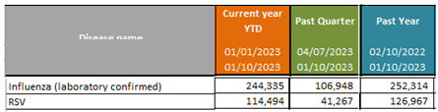

Previously published information on RSV-associated hospitalisations in Australia for the period covering 2006-2015[5] indicate that the reported rate of hospitalisations with an RSV code in at least one diagnostic field was 21/100,000 population (Table2*)*:

Table 2. Respiratory syncytial virus-coded hospitalisations, Australia, 2006–2015

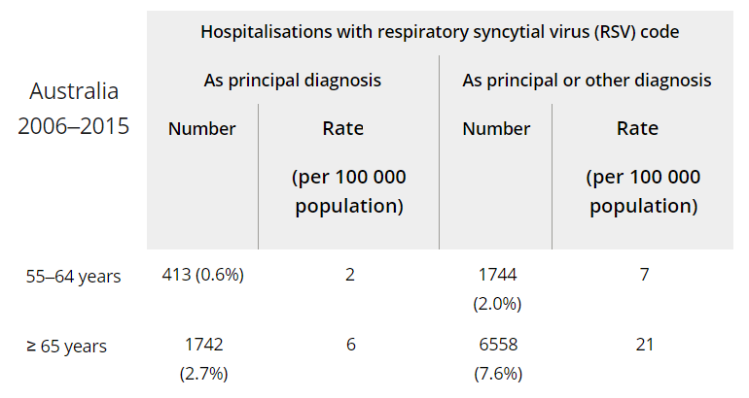

The reported burden of RSV in indigenous population was reported at least 3 times that in the general Australian population.

Although estimates of hospitalisations attributable to RSV based on modelling are uncertain[6], there is clear indication that risk increases with age and is particularly pronounced in elderly ≥75 years of age (Table 3):

Table 3. Estimated average annual RSV- and seasonal influenza-attributable hospitalisation rates per 100,000 population and counts (95% confidence intervals), by principal diagnosis and age group, from 2009 to 2017 for RSV and 2010 to 2017 for seasonal influenza.

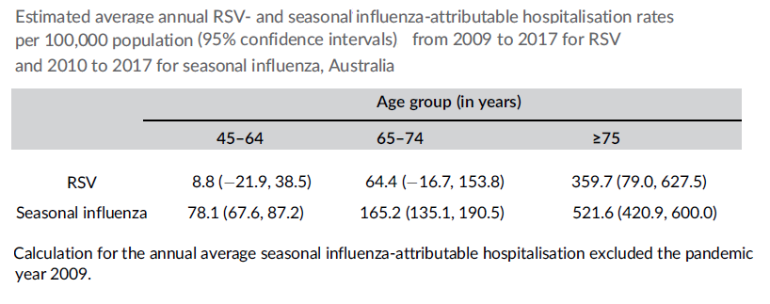

RSV causes acute lower respiratory tract infection and disease in all ages but significant morbidity at both extremes of age such as bronchiolitis and respiratory distress in infants and contribution to hospitalisations and mortality at advanced age. The spread is by direct contact, but droplet aerosols are also implicated. The virus can survive for several hours on hands and fomites. The incubation period is 2-6 days.

#### Current treatment options

At present, the treatment for RSV disease in adults is supportive plus treatment of complications such as pneumonia. The monoclonal antibody palivizumab is approved for prophylactic use in high-risk children.

#### Clinical rationale

The RSVPreF3 antigen is an engineered version of the RSV F surface glycoprotein. The F protein has been selected as vaccine antigen as it is a major surface antigen of the RSV virus that is necessary for viral entry/cell fusion process and is also well conserved among the RSV-A and RSV-B subtypes and hence is the main target of RSV neutralising antibodies (NAbs) in human sera.

### Regulatory status

At the time of initial submission, there were no approved RSV vaccines globally. Subsequently, earlier in 2023, AREXVY became the first vaccine to be registered in the USA for prevention of RSV and has since gained approval in EU, UK, Canada and Japan and 11 additional countries for use in the 60 year-old and above population. The indication approved overseas for AREXVY is the same as requested in Australia:

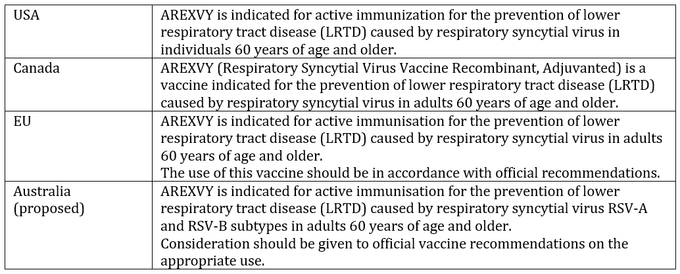

Another recombinant F protein antigen vaccine from Pfizer has since been approved in the US and EU for maternal use and in ≥60 years old population.

## Registration timeline

This submission was evaluated under the [standard prescription medicines registration process](https://www.tga.gov.au/how-we-regulate/supply-therapeutic-good-0/supply-prescription-medicine/application-process/prescription-medicines-registration-process).

Table 4: Timeline for Submission PM-2022-05281-1-2

|  |  |
| --- | --- |
| Description | Date |
| Submission dossier accepted and first round evaluation commenced | 31 Jan 2023 |
| First round evaluation completed | 18 July 2023 |
| Second round evaluation completed | 3 Nov 2023 |
| Advisory Committee meeting | 29 Nov 2023 |
| Registration decision (Outcome) | 8 Jan 2024 |
| Number of working days from submission dossier acceptance to registration decision* | 166 |

*Statutory timeframe for standard submissions is 255 working days

## Submission overview and risk/benefit assessment

### Quality

The proposed vaccine consists of 2 components, both provided as preservative free mono-dose presentations:

1. A lyophilised, freeze-dried powder in 3mL glass vial for one dose containing RSV glycoprotein F stabilised in the pre-fusion conformation (RSVPreF3) produced by recombinant DNA technology in Chinese hamster ovary (CHO) cells.
2. A liquid suspension in 3mL glass vial consisting of AS01E liposome-based adjuvant system. One dose contains 25µg of the plant extract *Quillaja saponaria* saponin (QS-21) and 25µg of the 3-O-desacyl-4’-monophosphoryl lipid A (MPL) from *Salmonella Minnesota*. The AS01B adjuvant is currently approved in the sponsor’s varicella zoster vaccine SHINGRIX (ARTG 289257). AS01B adjuvant contains a double amount of MPL, QS-21, DOPC and cholesterol compared to AS01E.

After reconstitution, one 0.5mL dose contains 120µg of RSVPreF3 antigen adjuvanted with AS01E. The commercial formulation is the same formulation that was used during the Phase 3 clinical trials.

The proposed vaccine has been variously referred to as RSVPreF3 vaccine, RSVPreF3 OA (Older Adults) vaccine or RSVPreF3/AS01E RV (Reconstituted Vaccine).

There are no significant issues identified from the quality evaluation of the submitted data that would indicate the product should not be registered on the basis of quality, or safety-related issues arising from the quality of the product. The manufacturing quality information submitted by the Sponsor support the registration of AREXVY.

It is a condition of registration that all independent batches of AREXVY vaccine imported into Australia are not released for sale until samples and the manufacturer’s release data have been assessed and have received notification acknowledging release from the Laboratories Branch, TGA.

The RSVPreF3 antigen consists of an engineered version of the RSV fusion (F) surface glycoprotein, stabilised in the trimeric pre-fusion conformation of the naturally occurring F protein and is produced by recombinant DNA technology in Chinese Hamster Ovary cells (CHO cells). Triggering and rearrangement into the post-F conformation is eliminated by the introduction of Cysteine residues leading to the formation of a disulfide bond; filling the cavities by hydrophobic substitutions, resulting in the pre-fusion molecule and a C terminal “foldon” domain.

### Nonclinical

Five *in vivo* primary pharmacology studies, two repeat-dose toxicity studies and literature-based data were submitted in the support of this vaccine. There were no efficacy models in animals.

The RSVPreF3/AS01E-induced immune response leads to generation of RSV A/B and contemporary RSV strain neutralising antibodies, F-specific CD4+ and CD8+ T cells and elicits specific binding antibodies directed at the neutralising sensitive epitope. Persistence of RSV neutralisation antibody response was observed for up to 2 months after the last dose for all adjuvanted formulations.

The 2-week (3 administrations) repeat toxicity studies were conducted in rabbits with RSVPreF3/AS01B. The concentration of ingredients in ASO1B was twice that in AS01E and was thus used as a worst-case scenario. The vaccine was well tolerated. The rabbits were administered up to 33 times the human dose (µg per kg) of RSVPreF3 antigen via the intramuscular route. The pharmacodynamic response was related to the inflammatory process. No significant safety issues were identified. Assessment of local tolerability was incorporated into the repeat-dose toxicity. Local inflammatory changes at the injection site were as expected.

No reproductive and developmental studies were included in the dossier based on the requested use in elderly population. There were no genotoxicity data for the final vaccine formulation (RSVPreF3/AS01E) which is considered acceptable as per guidelines. Similarly, carcinogenicity studies were not performed as per guidelines. Australian Pregnancy Category B2 is recommended.

The nonclinical dossier met the regulatory guidelines for vaccines/adjuvants and the pivotal studies were GLP compliant. There are no objections to the registration of AREXVY on nonclinical grounds.

### Clinical

#### Summary of clinical studies

The clinical Module 5 comprised of the following studies:

* RSV OA=ADJ-002 (Phase 1-2 dose selection and its extension RSV OA=ADJ-011).
* RSV OA=ADJ-006 (ongoing Phase 3 pivotal study of Vaccine Efficacy (VE) and safety).
* RSV OA=ADJ-004 (ongoing Phase 3 pivotal immunogenicity study ).
* RSV OA=ADJ-009 (immunogenicity study of lot-to-lot consistency).
* RSV OA=ADJ-007 (immunogenicity study of coadministration with influenza vaccine).

##### Study 002 (RSV OA=ADJ-002)

This Phase 1-2 randomised, placebo-controlled trial was aimed at assessment of safety, reactogenicity and immunogenicity of several formulations of the experimental RSVPreF3 vaccine in in young adults (n=48) aged 18-40 years (Part A) and older adults (n=1005) aged 60-80 years (Part B) (Figure 1) .

In Part A, safety and reactogenicity of two doses of non-adjuvanted vaccine were assessed. This was first in human part of the study. There were 4 groups with 12 participants in each group who received RSVPreF3 (non-adjuvanted) at 30, 60 or 120 µg or placebo dose. In Part B, nine formulations (RSVPreF3 antigen at 30, 60 or 120 µg either non-adjuvanted or adjuvanted with AS01E or AS01B) were tested against placebo.

Figure 1. Overall study design for study RSV OA=ADJ-002

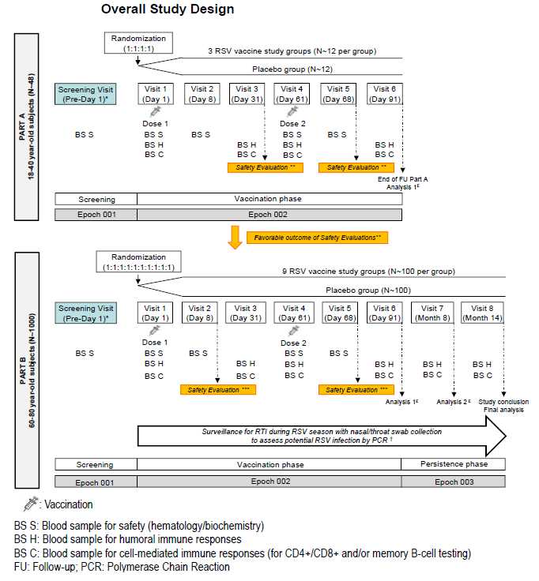

All subjects had evidence of exposure to RSV at baseline. The RSV-A neutralisation activity was assessed for all subjects in Part B at baseline (Day 1), Day 31, Day 61 and Day 91 and for a subset of subjects at month 8 and month 14. The RSV-B neutralisation activity was assessed for all subjects in Part B at baseline (Day 1) and post-Dose 2 at Day 91 and for a subset of subjects at Day 31 and for a subset at Month 8 and Month 14.

The findings in Part B, mainly described for RSV-A neutralising antibodies (RSA-A Nabs), were as follows:

Vaccine effect: In Part B, the vaccine demonstrated a positive immune response compared to placebo. All groups were superior to placebo (p<0.0001) in terms of RSV-A NAbs at one month post Dose 1. At Day 31 following one dose of vaccine there was a 5.6- to 9.9-fold increase in the NAb titres in the active groups. All vaccine groups also had as statistically significant difference (p<0.025) compared to placebo on the RSVPreF3-specific CD4+ T cells at Day 31 and Day 91.

There was no improvement in the humoral immune response following the 2nd vaccine dose.

The GMT ratios of the RSV-A NAb titres at Day 91 (post Dose 2) versus Day 31 (post-Dose 1) were all less than 1 (pooled for the adjuvant – none, AS01E or AS01B). Likewise, there was no meaningful improvement in CMI response post Dose 2.

Dose effect: A linear dose response was seen with increasing antigen dose and increased RSV-A NAb titre and the between group comparisons were statistically significant. This effect was maintained at Day 91. The antigen dose response was generally not reflected in the CMI response.

Adjuvant effect: Data were pooled for the adjuvant AS01B, AS01E or no adjuvant. The GMT ratio for RSV-A NAb titre of the pooled groups were compared at Day 31 and 91 and no significant difference was found. In terms of CMI response, both adjuvanted formulations AS01B and AS01E had 33-65% higher frequency of specific CD4+ T cells than the unadjuvanted group (pooled data). There was a trend for higher local injection site reactions with the AS01B than the AS01E formulation.

The sponsor has argued that high observed humoral response at one month post-Dose 1 was consistent with a booster response in a highly primed population.

During the 7 day follow up period, the rate of solicited AEs was higher in the adjuvanted than non-adjuvanted formation and the highest rate was in the 120-AS01B group (78.2%). Pain at injection site was higher in the 120-AS01B than 120-AS01E group (75.2% vs 56.0% respectively). The rate of solicited systemic AEs was also higher in the 120-AS01B adjuvanted group at 59.4% vs 34.0% of the 120 AS01E group and the rate of fatigue was 48.5% vs 21.0% respectively.

The 120µg antigen dose and the AS01E adjuvant were considered as representing the optimal balance in terms of immunogenicity and reactogenicity and chosen for Phase 3 development.

#### Vaccine efficacy

##### Pivotal study 006 (RSV OA=ADJ-006)

This was the pivotal Phase 3 randomised, placebo-controlled, observer-blind, multinational (including Australia & NZ) trial of vaccine efficacy (VE) of a single dose of AREXVY (3 different lots) in adults ≥60 years of age (Figure 2).

The participants were randomised initially in 1:1 ratio to placebo or the study vaccine. The VE is being assessed over three seasons in the northern hemisphere (NH) and two seasons in the southern hemisphere (SH). Pre-Season 2, participants who received RSV vaccine were re-randomised in a 1:1 ratio into 2 subgroups (RSV annual and RSV_1dose group) to receive repeat vaccinations (Dose 2 and Dose 3 in NH and Dose 2 SH).

The participants in NH will be on the study for about 3 years (3 consecutive RSV seasons) and in SH for 2.5-3 years (at least 2 consecutive seasons). This was an ongoing trial at the time of submission and these later data are not reported in this dossier.

Figure 2. Overall study design and plan for study RSV OA=ADJ-006

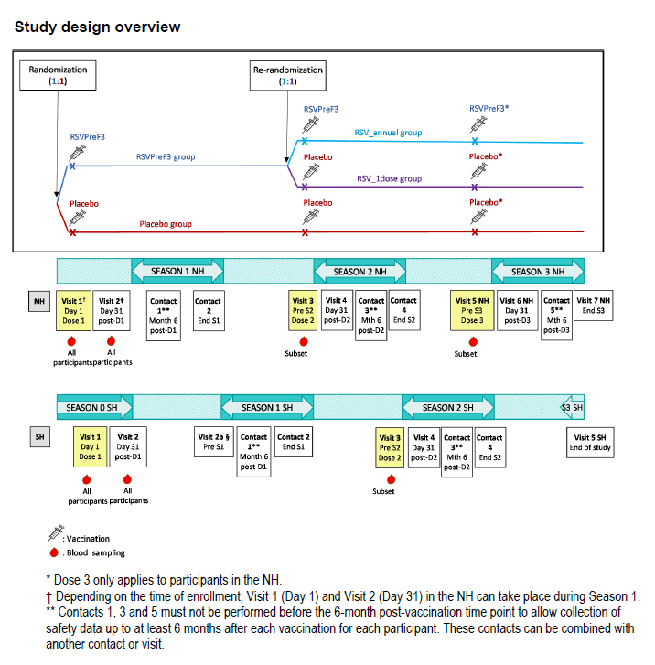

Interim results of VE with a median follow up of 6.7 months are presented in this registration dossier for the initially randomised population (vaccine group n=12,467; placebo group n=12,499) (Figure 3).

Figure 3. Disposition of participants for VE Analysis 1

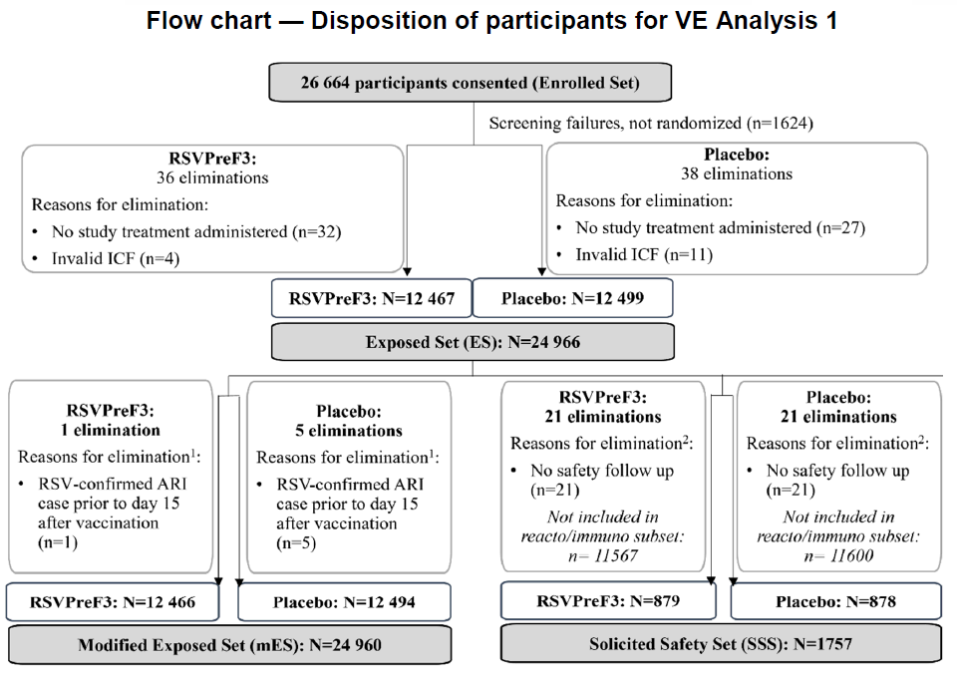

The enrolled participants who were healthy male and female participants aged 60 years of age could be community dwelling or in long-term care facilities. Participants with chronic stable medical conditions, with or without specific treatment, were allowed if considered by the investigator to be medically stable.

The confirmatory primary objective was to demonstrate VE (at least 20%) for prevention of RSV-confirmed LRTD (according to the case definition) during first season in adults ≥60 years of age following vaccination. A number of secondary efficacy outcomes were designated.

A single 0.5mL dose of the study vaccine or 0.7mL placebo (saline solution) was given by intramuscular injection in deltoid of the non-dominant arm.

The primary endpoint was first occurrence of quantitative reverse transcriptase polymerase chain reaction RT-PCR confirmed RSV-A and/or B-associated LRTD, according to the case definition. This assessment was based on cases occurring on or after day 15 of the study vaccinations.

An LRTD case was defined as concomitant presence of only lower respiratory symptoms and signs; either at least 2 lower respiratory symptoms/signs with at least 1 lower respiratory sign or at least 3 lower respiratory symptoms for at least a day. LRTD cases adjudicated by the Adjudication Committee were included in the primary analysis for the primary objective.

ARI (acute respiratory illness) case was defined as the concomitant presence of at least 2 respiratory symptoms/signs or at least 1 respiratory and 1 systemic symptom/sign for 24 hours.

RT-PCR tests were validated and performed by the sponsor. For the reactogenicity and immunogenicity subset (approximately 1800), selected sites allocated the first participants in each age category until the allocated target was reached. The unblinded staff administering the vaccine did not participate in data collection.

Table 5. The analysis populations for study RSV OA=ADJ-006

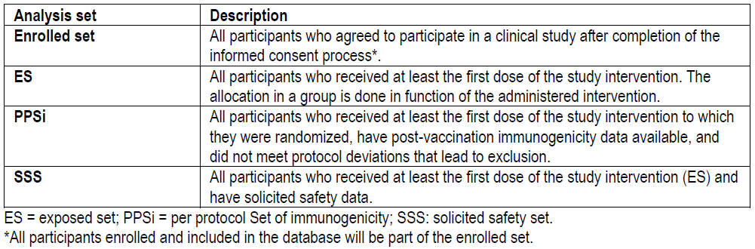

The primary efficacy analysis was performed on the modified exposed set (mES). The sample size was determined based on appropriate power calculations.

The final analysis of the primary objective was to be undertaken when at least 56 cases of RSV-confirmed and externally adjudicated LRTDs had been accrued in mES. If this number was not achieved by the end of Northern Hemisphere Season 1, there could be an interim analysis when at least 35 cases had been accrued noting that the trial took place during COVID19 pandemic.

The interim analysis of the primary objective was performed with 47 cases of RSV-confirmed LRTDs in the mES by the data lock point (DLP) of 11 April 2022 and included available data from participants enrolled in the SH.

At baseline, the two groups were well balanced on demographic and baseline characteristics. Some selected features are shown in Table 6.

Table 6. Study RSV OA=ADJ-006): Summary of demographic and baseline characteristics

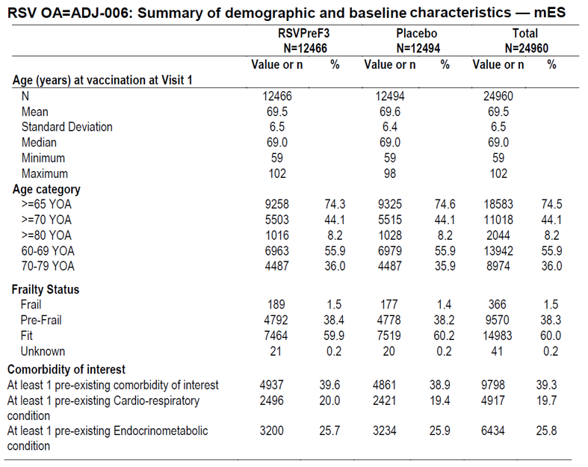

Some main results were as follows:

###### LRTD (primary efficacy outcome).

There were 47 externally adjudicated cases of RSV-confirmed LRTD (RSV-A and/or RSV-B associated LRTD) in the mES analysis set after a median follow up of 6.7 months comprising 40 cases in placebo group vs 7 cases in the vaccine group using mES set (Figure 4).

Figure 4. Study RSV OA=ADJ-006: Cumulative incidence curves for RT-PCR confirmed RSV LRTD reported up to VE analysis 1.

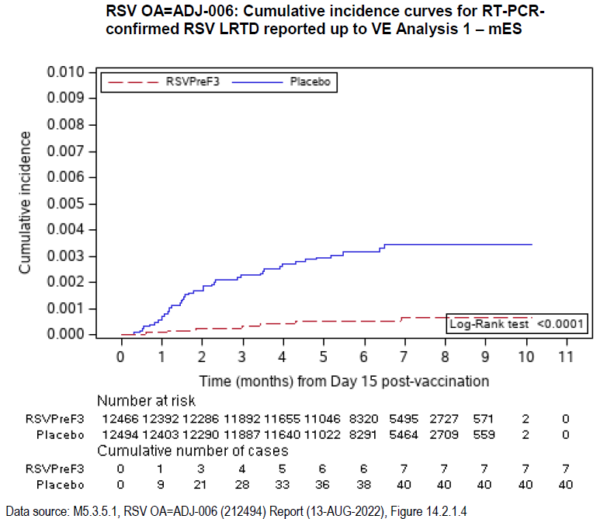

The VE (%) of a single dose of RSVPreF3 vaccine against first occurrence of RT-PCR-confirmed RSV-associated LRTD was 82.58% (96.95% CI: 57.89%, 94.08%) (Table 7).

Table 7. Study RSV OA=ADJ-006: Confirmatory comparison: VE against first occurrence of RT-PCR-confirmed RSV LRTD up to VE analysis 1, using Poisson method.

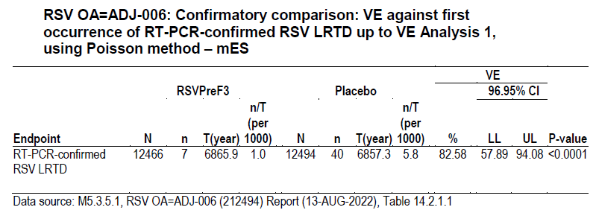

VE against LRTD using ES set (VE =83.79%, 96.95%CI: 61.09%, 94.47%) was consistent with the mES analysis.

Analysis of RT-PCR-confirmed RSV LRTD cases irrespective of the external Adjudication Committee decision (61 cases) showed a VE of 78.07% (96.95%CI: 54.74%, 90.51%).

VE for severe RSV-confirmed LRTD (as defined by symptoms or use of supportive therapy) was 94.10% (95%CI: 62.37, 99.86). There were 17 severe LRTD cases in the placebo group vs one in the RSVPreF3 group.

VE against LRTD was also consistent for subjects aged 60-69 years: 80.96% (95%CI: 43.56%, 95.25) and 70-79 years: 93.81% (95%CI: 60.15%, 99.85%). There were too few cases in ≥80 years of age group to draw meaningful conclusions.

VE against LRTD by RSV subtype was 84.62% for RSV-A (95%CI: 32.08%, 98.32%) and 80.88% for RSV-B (95%CI: 49.40%, 94.27%) (Table 8).

Table 8. Study RSV OA=ADJ-006: VE against first occurrence of RT-PCR-confirmed RSV LRTD up to VE analysis 1 by RSV subtype.

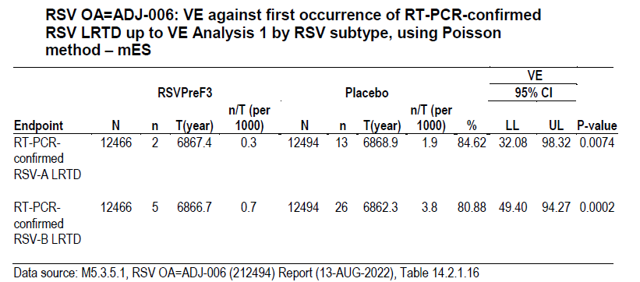

VE against LRTD by baseline comorbidities was consistent with the overall VE (Table 9).

Table 9. Study RSV OA=ADJ-006: VE against first occurrence of RT-PCR-confirmed RSV LRTD up to VE analysis 1 by comorbidities of interest.

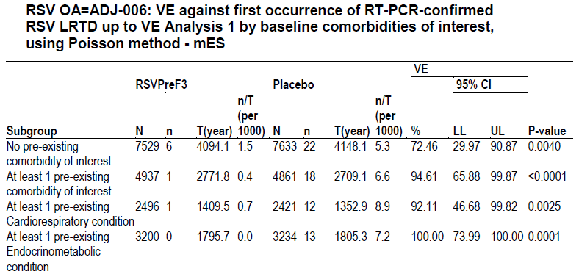

VE against LRTD by baseline frailty status was as also consistent with the overall VE, noting very small numbers in baseline Frail subgroup which do not permit reliable analysis (Table 10).

Table 10. Study RSV OA=ADJ-006: VE against first occurrence of RT-PCR-confirmed RSV LRTD up to VE analysis 1 by baseline frailty status.

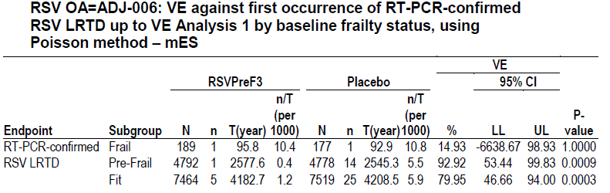

###### ARI (RT-PCR-confirmed acute respiratory illness)

There were 95 cases of ARI in placebo group vs 27 cases in vaccine group at the time of analysis. The VE of a single dose of RSVPreF3 vaccine against RT-PCR confirmed RSV ARI was 71.71% (95%CI: 56.23%, 82.27%).

The complications of ARI included pneumonia, exacerbation of COPD and bacterial bronchitis and occurred in 1 of the RSVPreF3 and 9 of the placebo group. VE against complications related to RSV-confirmed ARI was 88.86% (95%CI: 19.58%, 99.75%).

###### Other outcomes

There was only one hospitalisation (placebo group) due to RSV-confirmed respiratory disease.

**Immunogenicity (PPSi analysis set)**

At baseline, all participants in both groups had RSVPreF3-specific IgG Ab concentrations at or above the assay cut-off indicating previous exposure to RSV. At Day 31 post Dose 1, the mean geometric increase (MGI) was 13.1 in RSVPreF3 group vs 1.0 in placebo group compared to baseline levels.

At baseline, all participants had RSV-A NAb titres above the assay cut off. At Day 31 post Dose 1, MGI was 10.2 and 0.9 in RSVPreF3 and placebo groups respectively compared to baseline levels. The results for RSV-B NAb titres were similar with a MGI at Day 31 post Dose of 8.6 vs 1.0 respectively compared to baseline levels.

###### Other studies

Study 007 (RSV OA=ADJ-007)

This was a Phase 3, open-label, randomised, controlled, study of co-administration of RSVPreF3 vaccine with the sponsor’s inactivated seasonal quadrivalent (15µg haemagglutinin per strain) influenza vaccine (FLU-QIV) in adults aged ≥60 years (N=885) as follows:

Co-Ad group (n=442) - received a single dose of RSVPreF3 vaccine concomitantly with a single dose of FLU-QIV.

Control group (n=443) - received a single dose of FLU vaccine at Visit 1 (Day 1), followed by a single dose of the RSVPreF3 vaccine at Visit 2 (Day 31).

For the study to meet the non-inferiority criteria, the upper limit (UL) of the 2-sided 95%CI of GMT ratio (Control/Co-Ad) for RSV-A NAb titres needed to be ≤1.5 and the UL of the 2-sided 95%CI of haemagglutinin antibody (HI) GMT ratio (Control/Co-Ad) for each of the four FLU-QID vaccine strains needed to be ≤1.5.

RSV-A NAb responses (sourced from CHMP report provided by the sponsor) are shown in Table 11.

Table 11. Ratio of RSV-A NAb titres (ED60) GMTs between the Control group and (over) the Co-Ad group, 1 month after the RSVPreF3 OA - PPSi (Final analysis).

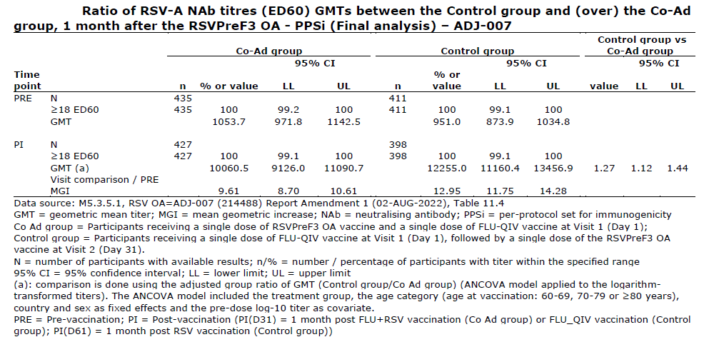

RSV-A NAb response was somewhat lower in the Co-Ad group compared to the Control group. However, the 95%CI for the GMT ratio of RSV-A NAb (Control/Co-Ad) was 1.44 which met the predefined non-inferiority margin of ≤1.5.

RSV-B NAb titres were measured in a subset of participants (n=425) and the GMT ratio of RSV-B NAb titres (Control/Co-Ad) at 1 month post dose was 1.27 (95%CI 1.08, 1.49).

The anti-HI antibody response to the 4 influenza vaccine antigens is shown in Table 12 (sourced from CHMP report provided by the sponsor)

Table 12. ratio of HI GMTs for each of the FLU-QIV vaccine strains between the Control group and (over) the Co-Ad group, 1 month after the FLU-QIV vaccine dose - PPSi (Final analysis)

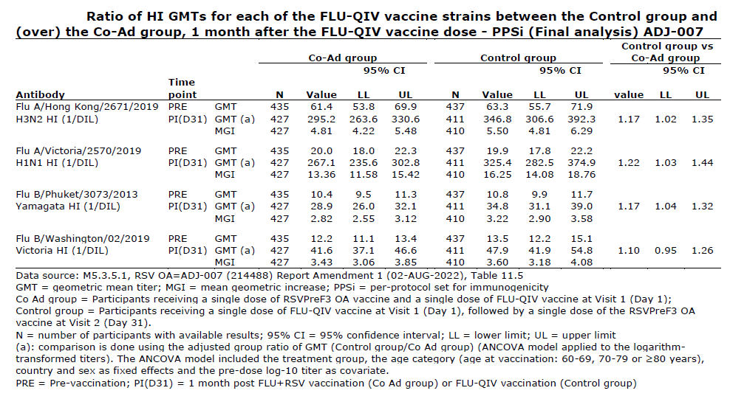

The results met the predefined inferiority margin for the UL of 95%CI for the Control/Co-Ad ratio to be no greater than 1.5 for each of the 4 HI antigens.

Study 009 (RSV OA=ADJ-009)

This was a lot-to-lot consistency study of 3 manufacturing lots of RSVPreF3 vaccine (single dose in adults aged ≥60 years of age) to assess humoral response up to 6 months post dose. Data to one month post-dose have been provided and indicated no issue.

Study 004 (RSV OA=ADJ-004)

This study aimed to evaluate immunogenicity, reactogenicity and persistence of a single dose and different revaccination schedules of RSVPreF3 vaccine in adults aged ≥60 years of age. There are 3 groups in the study. All received the vaccine on Day 1.

RSV annual group: revaccination at 12 and 24 months after dose 1.

RSV flexible group: revaccination at 24 months after dose 1.

RSV 1-dose group: no revaccination.

Data up to 6 months post-Dose 1 were included in the dossier and are shown below for RSV-A (Table 13) and RSV-B neutralising antibodies (GMT response in PPSi set of the pivotal study 006 at Day 31 are also shown).

Table 13. RSV OA=ADJ-004 and 006: Number and percentage of participants with RSV-A Nab titers equal to or above 18 ED60, GMT and MGI - Humoural PPSi.

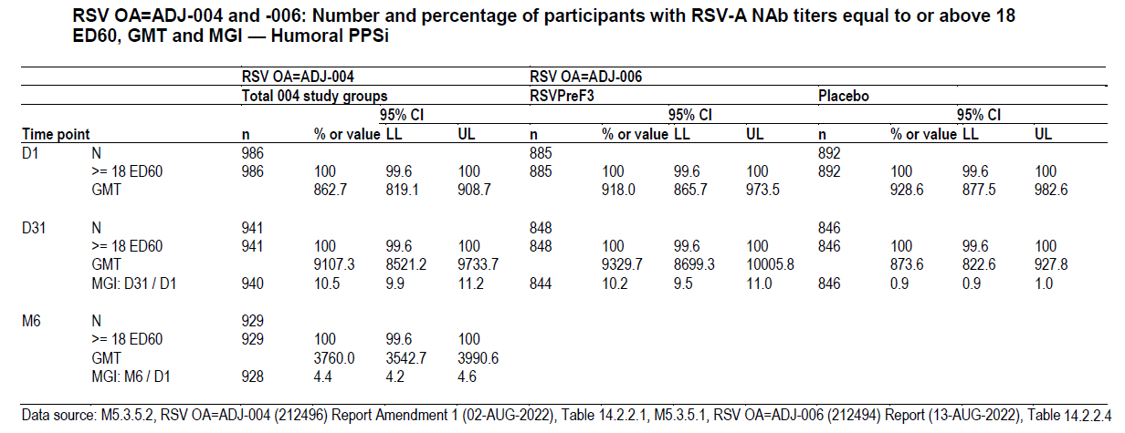

Table 14. RSV OA=ADJ-004 and 006: Number and percentage of participants with RSV-A Nab titers equal to or above 30 ED60, GMT and MGI - Humoural PPSi.

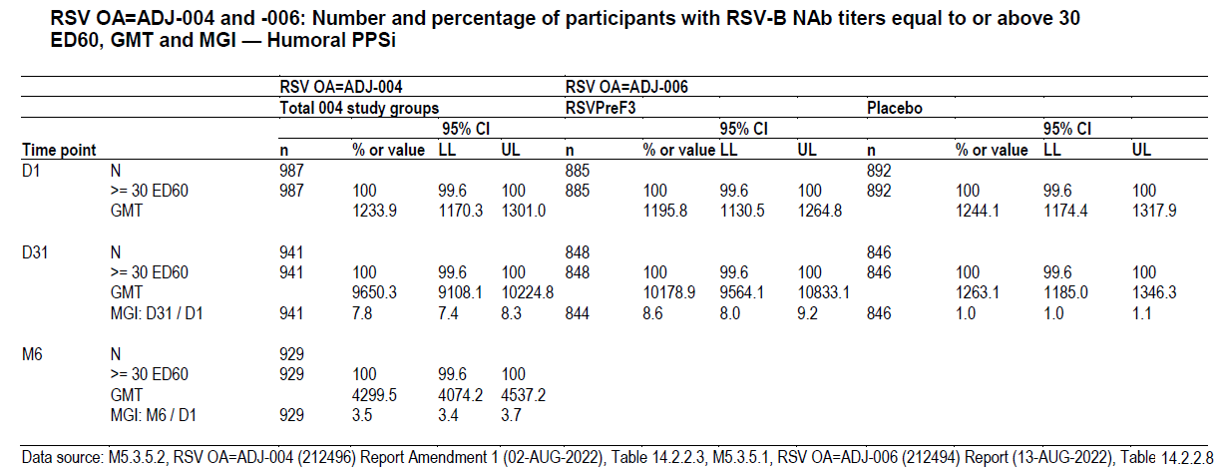

In the CMI (cell mediated immunity) subset in study 004, the frequency of RSVPreF3 specific CD4+ T cells expressing at least two activation markers (including at least 1 cytokine among CD40L, 41BB, IL-2, TNF-alpha, IFN-gamma, IL-13, IL-17) showed an increase at Day 31 and then a decline at Month 6, although the frequency was still greater than baseline. No change was noted in the CD8+ T cells expressing these markers.

Study 004 is ongoing with follow up to 3 years post-vaccination.

Study 011 (RSV OA=ADJ-011)

This was an extension of the Phase 2 study 002. The inclusion criteria were subjects who had received 2 doses of either the 120µg, 30µg or 60µg RSVPreF3/AS01E vaccine in Part B of the feeder study. The study aimed to evaluate a 3rd dose of RSVPreF3/AS01E at 18 months post-Dose 2. A total of 122 participants received a 3rd dose of RSVPreF3 with 121 completing the study follow up to 6 months (n=38 in 120-AS01E_B group of the feeder study).

Prior to Dose 3 (18 months post Dose 2), RSV-A and RSV-B NAb titres were lower than at the end of study 002 but higher than pre-Dose 1 with a geometric mean fold increase of 2.2 and 2.5, respectively.

Compared to pre-Dose 3, following vaccination at Day 31 after dose 3, the GMT for RSV-A and RSV-B NAb increased 2.3- and 1.8-fold, respectively. The GM fold increase at Day 31 post Dose 3, compared to pre-Dose 1 (of study 002) was 4.8 and 4.1 for RSV-A and RSV-B NAb respectively.

RSVPreF3 specific IgG GMC time profile showed a similar profile to the neutralising antibodies. Prior to Dose 3, the IgG levels were 3.1-fold higher than pre-Dose 1 in study 002. The 3rd dose of study vaccine resulted in an increase in antibody levels. There was a 2.3-fold increase in the IgG from pre-Dose 3 to one month post-Dose 3.

At 18 months post Dose 2 (pre-Dose 3) the level of CD4+ T cells expressing at least 2 markers was still higher than pre-Dose 1. Dose 3 resulted in a 2-fold increase (at Day 31 post dose 3) compared to pre-Dose 3.

The study showed that at 18 months, the immune response had waned (after 2 doses) although remained above pre-vaccination levels. The 3rd vaccine dose induced a humoral and cellular immune response although antibody levels were not quite as high as those seen post Dose 1.

#### Clinical safety

The reporting periods for the collection of safety data are shown in Table 15.

Table 15. Reporting periods for the collection of safety data across all studies

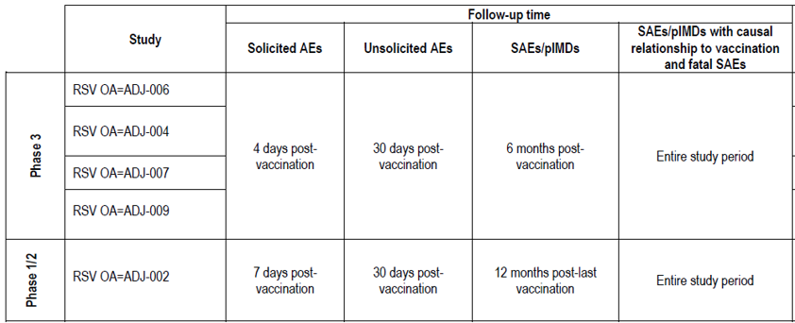

Over 15,000 participants have received a dose of RSVPreF3 as follows:

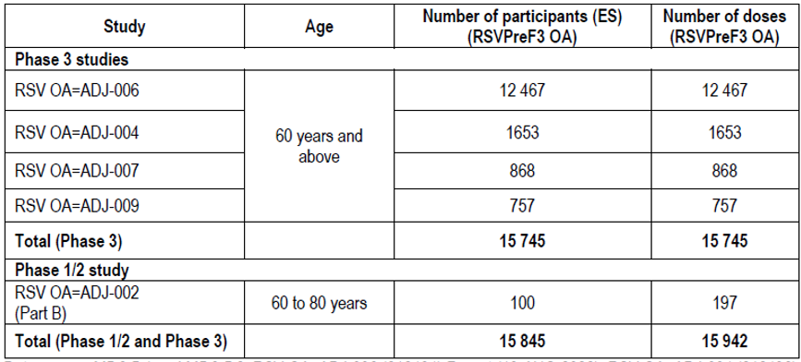

Pivotal Study 006

The pivotal efficacy study 006 is the only placebo-controlled study in the safety dataset. A total of 24,966 participants ≥60 years of age were assessed for safety (12,467 RSVPreF3 vs 12,499 placebo) with a median follow up time of 7.8 months post-vaccination. The rate of withdrawal was 3.0% and 3.1 % in the 2 groups respectively. The rate of withdrawal due to an adverse event was 0.5% vs 0.6% respectively.

#### Adverse events

##### Solicited adverse events

For solicited adverse events (AEs)(within 4 days of vaccination) in the solicited safety set (SSS), there were 1757 subjects (n=879 and n=878 in RSVPreF3 and placebo groups respectively). The rate of solicited AEs was 71.9% vs 27.9% in RSVPreF3 vs placebo respectively. The rate of grade 3 (severe) solicited AEs was 4.1% vs 0.9% respectively. Two events in RSVPreF3 group required medical visit vs none in the placebo group. The rate of solicited administration site events was 62.2% vs 10.0% and the rate of solicited systemic events was 49.4% vs 23.2% in the 2 groups respectively.

The most frequent solicited administration site events were pain (60.9% vs 9.3%, RR=6.57), erythema (7.5% vs 0.8%, RR=9.37) and swelling (5.5% vs 0.6%, RR=9.55). The rate of grade 3 solicited local events was 1.5% vs 0% in the 2 groups respectively.

The most frequent solicited systemic events were fatigue (33.6% vs 16.1%, RR=2.09), myalgia (28.9% vs 8.2%, RR=3.52), headache (27.2% vs 12.6%, RR=2.16) and arthralgia (18.1% vs 6.4%, RR=2.83). Fever (≥38°C) was reported at 2.0% vs 0.3% in the 2 groups respectively. The rate of grade 3 solicited systemic events was 3.3% vs 0.9% respectively and fatigue (1.7% vs 0.5%) and myalgia (1.4% vs 0.3%) were the most common.

##### Unsolicited adverse events

For unsolicited AEs (within 30 days post vaccination), in the Exposed Set (ES), the rate of at least one unsolicited AE was 33.0% vs 17.8% (RR=1.85) in RSVPreF3 vs placebo groups respectively. Note that for the ES, unsolicited AEs included events that in the SSS would be classified as solicited AEs.

Unsolicited events with a higher rate in RSVPreF3 group (based on RR) were injection site reactions, fatigue, pyrexia, headache, myalgia, arthralgia, pain, malaise, pain in extremity, muscle spasms, chills, rhinorrhoea, nausea, abdominal pain, rash, anxiety and lymphadenopathy. The rate of grade 3 unsolicited events was 2.0% vs 1.3% in the 2 groups respectively. The rate of unsolicited AEs requiring medical attention was 5.5% in both groups.

No hypersensitivity or anaphylaxis type reactions were reported within 30 minutes after vaccination. A search of hypersensitivity reactions and anaphylaxis within 30 days of vaccination found rates of 0.7% vs 0.4% in the RSVPreF3 and placebo groups respectively. Most cases were rashes.

###### Adverse drug reactions (ADRs)

In the ES population of study 006 within 30 days of vaccination, the rate of at least one ADR was 24.9% in RSVPreF3 vs 5.8% placebo group. The following ADRs were more frequent in the RSVPreF3 group: fatigue, malaise, asthenia, pyrexia, pain, discomfort, axillary pain, chills, feeling hot, feeling cold, headache, somnolence, myalgia, pain in extremity, arthralgia, nausea, rash, body temperature increased and lymphadenopathy. At least one grade 3 ADR occurred in 0.9% and 0.2% of the RSVPreF3 and placebo groups respectively. The most frequent grade 3 ADRs, based on RR, in the RSVPreF3 group were injection site pain, injection site erythema, injection site swelling, pyrexia and headache.

##### Serious adverse events (SAEs)

In study 006, the rate of SAEs within 30 days of vaccination was 0.7% in both groups. Serious atrial fibrillation (AF) was more frequent in the RSVPreF3 group than placebo group (n=7 vs n=1, RR=7.02). The investigator did not consider that treatment related. The sponsor assessed this signal further reporting that there were more subjects in the RSVPreF3 than placebo group (n=12 vs n=5, RR=2.41) with the higher term supraventricular arrhythmia AEs within 30 days of vaccination and most of these were AF (10 vs 4 respectively). There were 18 events of supraventricular tachyarrhythmias in 17 subjects with 6 cases of new onset atrial fibrillation. Of the new onset cases: 3 were serious [2 in RSVPreF3 group (including 1 case related to excess dose of losartan) and 1 in placebo group], and 3 were non-serious and occurred in the context of other medical conditions and/or in participants with risk factors for atrial fibrillation.

In the 6 months post vaccination, the rate of SAEs was 4.2% vs 4.0% (RR=1.03) in RSVPreF3 and placebo groups respectively. The rate of related SAEs was 0.1% vs 0% (n=9 vs n=6, RR=1.5). The related SAEs in the RSVPreF3 group were seizure 11 days post vaccination (1), transient ischaemic attack 3 days post vaccination (1), syncope one day post vaccination (1), Bell’s palsy with concurrent herpes zoster ophthalmic infection 41 days post vaccination (1), cardiopulmonary failure leading to death 30 days post vaccination (1), acute myocardial infarction 4 days post vaccination (1), acute myeloid leukaemia diagnosed on day 17 after vaccination (1), non-small cell lung cancer hospitalised 101 days post vaccination (1) with lung cancer and retinal vein occlusion 31 days post vaccination with a TIA on day 173 post vaccination (1).

Up to the data lock point, there were a further 86 and 101 subjects with a SAE in RSVPreF3 and placebo groups respectively. There was one related SAE in the vaccine group (fatal myxoid liposarcoma), however the investigator changed the causality to unrelated after data lock.

###### Deaths

In the ES population in study 006 there were 39 (0.3%) and 46 (0.4%) deaths in the RSVPreF3 and placebo groups, respectively (up to 6 months post vaccination). To the data lock point, the death rate was 0.4% vs 0.5% (n=49 vs 58 deaths respectively). The most frequent causes of death were cardiac disorders (n=14 vs 18, 0.1% both groups), infections and infestations (11 vs 12, 0.1% both groups), general disorders and administration site conditions (9 vs 13, 0.1% both groups).

Three deaths were considered study treatment related: 2 were within 6 months of vaccination and one more up to the data lock point. The single related death (RSVPreF3 group) was of a 63 year-old male with type 2 diabetes, hypertension, COPD and obesity with cause of death as cardiopulmonary failure 30 days after vaccination. The other 2 related deaths were in placebo group.

###### Potential immune-mediated disease (pIMD)

The rate of at least one potential immune mediated disease (pIMD) within 6 months of vaccination in Study 006 was 0.3% in both groups (RR=1.18). There were 40 subjects with 41 events in the RSVPreF3 group and 34 subjects with 35 events in the placebo group. The pIMD deemed related to study treatment by the investigator occurred in 4 (RSVPreF3 ) and 5 (placebo) subjects.

The four pIMDs deemed treatment related in the RSVPreF3 group were rheumatoid arthritis reported 99 days post vaccination (1), gout acute flare in foot one day after vaccination (1), polyarthritis 15 days post vaccination (1) was later updated to not a pIMD, and Bell’s palsy at 41 days post vaccination with herpes zoster (1).

Up to the DLP, there were additional 6 vs 10 pIMD cases reported in RSVPreF3 and placebo groups respectively. Of these, 3 cases (all non-serious) in the RSVPreF3 group considered treatment related were pancytopaenia (subsequently diagnosed as chronic lymphocytic leukaemia) (1), Graves’ disease (1) and Bell’s palsy which resolved (1).

###### AEs - Other studies

The solicited and unsolicited AE profile in these studies was generally consistent with that reported in the pivotal study 006.

In study 004, the rate of at least one SAE in the 6 months post vaccination was 3.9%. The most frequent SAE was atrial fibrillation (0.3%, n=5). There was one treatment related SAE of Guillain Barré syndrome (0.1%). The onset was 9 days post vaccination and the subject was hospitalised for 179 days. In study 007, the SAE rate was 3.4% and 4.5% in the Co-Ad and Control groups respectively.

In study 004 up to the data lock point, there were 6 deaths (0.4%) of which 4 occurred within 6 months of vaccination. None were considered study treatment related. In study 009, there were 3 deaths. None were considered study treatment related. In study 002, there were four deaths in the entire study period with none deemed treatment related. There were no deaths in study 011. In study 007, there were 4 (0.9%) deaths in the Co-Ad group and 8 (1.8%) in the Control group. Two deaths in Co-Ad group and 3 in Control group were due to COVID19 or suspected COVID19.

###### pIMDs - other studies

In the integrated dataset, the rate of at least one pIMD was 0.4% (95%CI: 0.3, 0.5). Gout was the most common event (n=13). Of the 55 subjects with a pIMD, 9 had events were considered treatment related.

In study 004, the rate of at least 1 pIMD within 6 months of vaccination was 0.4% (n=7). There were no additional cases up the data lock. One case of Guillain-Barré syndrome at 9 days post vaccination was considered treatment related (noted earlier) and led to hospitalisation for 179 days and was classified as Brighton Collaboration Working Group Level 3. It has subsequently been reported as resolved.

In study 009, two subjects with a pIMD of psoriasis – of these one was considered treatment related (worsening of pre-existing psoriasis 14 days post vaccination).

In study 002, there were four pIMDs reported with none classified as treatment related. The events were: autoimmune encephalitis in 30-Plain_B group; gout in the Placebo_B group (both post dose between day 91 and 6 months) and Bell’s palsy in 60-AS01E_B group; and rheumatoid arthritis in 120-AS01E_B group (both between 6 months post-Dose 2 and end of the study Month 14). The case of autoimmune encephalitis in 30-Plain_B group was an occurred in a 63 year old subject at 47 days post dose 2 of the vaccine. The diagnosis was confirmed with MRI and lumber puncture. The subject was discharged 13 days post onset and the event was reported resolved after 99 days.

No pIMDs were reported in study 011.

In study 007, there was a higher rate of pIMDs in the Co-Ad group vs Control group (1.1% vs 0.2%) based on n=5 vs n=1 subjects respectively. The pIMD events deemed treatment related in the Co-Ad group were 2 cases of ADEM and one case of gout flare (noted earlier).

The 2 cases of the pIMD of acute disseminated encephalomyelitis (ADEM) in the Co-Ad group were as follows:

* ADEM in a 71 year old female reported at 22 days post vaccination. The investigator classified the event (Grade 2, SAE) as related to RSVPreF3/FLU QIV. The symptoms improved gradually over 4 months but not resolved.
* ADEM in a 70 year old male reported at 7 days post vaccination and death at 22 days post vaccination. The investigator classified the event as related to RSVPreF3/FLU QIV coadministration.

The sponsor has stated that these 2 cases were reported as ADEM by the same Investigator from the same study site (249398) in South Africa 2 weeks apart.

On further review in June 2023, the investigator reconsidered the ADEM diagnosis of the case with the fatal outcome (Case Report 000109) based on brain imaging which showed chronic demyelination indicative of a pre-existing condition and has updated the diagnosis from ADEM to hypoglycaemia and dementia, not related to the study vaccine.

In the 2nd case (Case report 000082), it is stated that the diagnosis of ADEM was made by the investigator based only on symptoms and clinical findings. The sponsor considers that this case contains insufficient information to meet the ADEM case definition as alternative diagnoses were not evaluated, and no additional information on this case is available. In response to the TGA Round 2 CER, the sponsor has included updated comment on this case stating that the investigator has reconsidered the ADEM diagnosis, noted the medical history of the participant and evidence of vascular atherosclerosis and has updated the diagnosis to cerebrovascular accident, not related to the study vaccine. The sponsor’s safety database is being updated and given this assessment, no cases of ADEM are considered reported with AREXVY.

Drug/vaccine interactions

In study 007, the Co-Ad group had a higher rate of solicited administration site events within 4 days of vaccination (53.4%) than the Control group after FLU QIV (20.8%) or after RSVPreF3 alone at 4 weeks (39.9%). The most frequent event was injection site pain. Solicited systemic events were also more frequent in the Co-Ad group (40.2% vs 24.7% post FLU QIV and 34.1% post RSVPreF3 vaccination). Fatigue was the most common systemic event in both groups. The rate of grade 3 solicited systemic events was 2.5% in Co-Ad group vs 0.5% vs Control group post FLU QIV and 3.1% post RSVPreF3. The rate of unsolicited AEs within 30 days of vaccination was 18.8% vs 23.7% in Co-Ad and Control groups respectively and the rate of these events considered treatment related by the investigator was 5.9% and 3.4% in the respective groups.

Safety in special populations

In February 2022, the data monitoring committee of a Phase 3, randomised, double-blind, placebo-controlled trial (RSV MAT-009) of experimental unadjuvanted RSVPreF3 (120µg) formulation in pregnant women observed an imbalance in the proportion of preterm births (<37 weeks) in the vaccinated group vs placebo group. The study was paused and the signal investigated. Following unblinded review, all maternal trials with the unadjuvanted RSV vaccine were discontinued. The preterm birth rates were 6.81% (238/3496) vs 4.95% (86/1739) in the vaccine and the placebo groups respectively.

At the data lock point of 04 October 2022, based on data from 5328 maternal participants (3557 in vaccine group) and 5235 infant participants (3496 in vaccine active group), the imbalance in preterm birth was statistically significant (RR 1.38, 95%CI 1.08, 1.75). The imbalance in preterm births was noted across a range of risk factors. There was also a higher proportion of neonatal deaths in the RSVPreF3 maternal vaccine group. The rate of neonatal death was 0.37% (13/3496) vs 0.17% (3/1739) in the RSVPreF3 maternal vaccine group and placebo groups respectively (RR 2.16, 95%CI 0.62, 7.55). Of the 16 neonatal deaths, 7 were born preterm in RSVPreF3 maternal vaccine group and none in placebo group. There was no imbalance in neonatal deaths for infants born full term.

The sponsor stated that no underlying cause has been identified yet for the increased risk of preterm births in women who received RSVPreF3 maternal vaccine compared to the placebo recipients.

Any such risk with accidental or off-label use of AREXVY (RSVPreF3 120µg adjuvanted to AS01E) is unknown. However, the vaccine is being proposed for use in population ≥60 years of age and is not recommended for use in pregnancy.

#### Delegate’s conclusion

The vaccine efficacy (VE) of AREXVY was evaluated in one pivotal Phase 3 study (Study 006). This was a large, randomised, placebo-controlled, observer-blinded study in adults 60 years of age and older. All study participants had exposure to RSV at baseline prior to vaccination.

The results indicated a highly efficacious prophylactic vaccine. After a median follow up time of 6.7 months, the VE (%) against RT-PCR-confirmed RSV-associated LRTD was 82.58% (96.95%CI 57.89%, 94.08%). The primary efficacy analysis was supported by various sensitivity analyses.

VE, consistent with the overall VE, was demonstrated to both RSV-A and RSV-B subtypes as well as in subgroups stratified by baseline morbidity and by baseline frailty.

VE was also demonstrated for severe RSV LRTD (94.1%, 95%CI 62.4%, 99.9%) and RSV ARI (71.7%, 95%CI 56.2%, 82.3%).

There was only one hospitalisation (placebo group) due to RSV-confirmed respiratory disease, so meaningful statistical analysis was not feasible.

Data evaluated as part of the initial application is limited to one season.

The pivotal study 006 included approximately 1800 subjects in the immunogenicity subset where data were available for one month post vaccination. Longer term data is expected to become available soon. There are currently no recognised immune correlates of protection.

The immunogenicity study 004 demonstrated that 6 months after a single vaccine dose, RSV-A and B NAb titres had declined but remained above the pre vaccination levels. A cellular immune response in terms of RSVPreF3-specific poly-positive CD4+ T cells was also documented up to 6 months post vaccination in study 004, while there was no impact on specific CD8+ T cells.

The coadministration of AREXVY with seasonal inactivated unadjuvanted quadrivalent influenza vaccine (FLU-QID) in Study 007 showed non-inferior immunogenicity of the RSVPreF3 vaccine and the FLU QIV vaccine on coadministration (on the same day) vs separate administration (4 weeks apart).

The most common side effects with Arexvy (which may affect more than 1 in 10 people) include injection site pain, tiredness, muscle pain, headache and joint pain. These side effects are usually mild or moderate in intensity and resolve within a few days after vaccination. The safety data are limited by the duration of follow up. Data are lacking on the persistence of vaccine efficacy over time and the need for revaccination. There are currently no data on the use of AREXVY in immunocompromised adults 60 years or older.

Two cases of potential ADEM in the setting of coadministration of AREXVY with the inactivated, unadjuvanted quadrivalent influenza vaccine were initially reported in the Study 007. Other adverse event of concern was a case of Guillain Barré syndrome at 9 days post vaccination in Study 004 and a case of autoimmune encephalitis at 47 days post vaccination in Study 002 (with a different formulation). The 2 cases of pIMD in Study 007, on further consideration by the investigator, are now regarded as not ADEM.

Potential immune interaction (pIMD in particular ADEM and GBS) on RSVPreF3-AS01E/FLU QIV coadministration remains a safety concern of interest requiring more data to confirm or rule out this signal. The post-market surveillance study in the USA, and additional targeted surveillance in Australia, are considered appropriate.

A lack of coadministration studies with other vaccines, in particular COVID19 vaccines, is noted. Although not evaluated in this application, coadministration studies with other vaccines are ongoing.

### Risk management plan

This submission is supported by EU-RMP version 1.0 (dated 3 May 2023; DLP 30 April 2022) and ASA version 2.0 (dated 5 July 2023) from the sponsor.

The summary of safety concerns in the approved EU-RMP version 1.0 does not include pIMDs as an Important Potential Risk. This has been included in ASA version 2.0.

The proposed summary of safety concerns and the associated risk monitoring and risk mitigation strategies for the proposed use in ≥60 years of age population are summarised below:

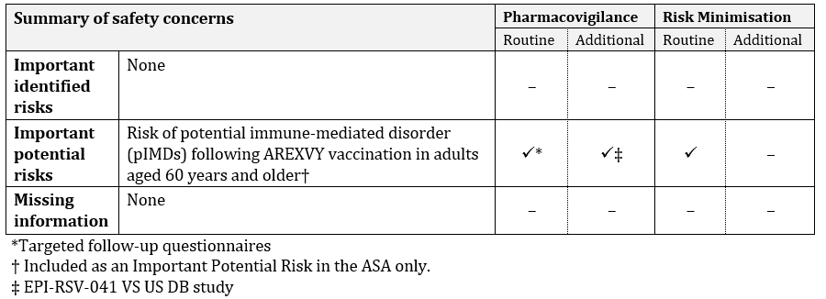

Routine pharmacovigilance includes targeted follow-up questionnaires for the Important Potential Risk “Risk of potential immune-mediated disorder (pIMDs) following AREXVY vaccination in adults aged 60 years and older.” In addition, cases of Guillain-Barré syndrome (GBS), acute disseminated encephalomyelitis (ADEM) and atrial fibrillation (AF) post-vaccination with AREXVY arising from multiple sources (such as spontaneous reports, clinical trials and literature) will be assessed and summarised in periodic safety update reports for review by the TGA.

Additional pharmacovigilance includes a post-marketing surveillance Study EPI-RSV-041 VS DB to be conducted in the US. The sponsor has committed to providing the results when available.

The TGA Pharmacovigilance area has provided post market conditions of registration.

The TGA may request an updated RMP at any stage of a product's life-cycle, during both the pre-approval and post-approval phases. Further information regarding the TGA’s risk management approach can be found in [risk management plans for medicines and biologicals](https://www.tga.gov.au/publication/risk-management-plans-medicines-and-biologicals) and [the TGA's risk management approach](https://www.tga.gov.au/tgas-risk-management-approach). Information on the [Australia-specific annex](https://www.tga.gov.au/resources/resource/guidance/risk-management-plans-medicines-and-biologicals/australia-specific-annex-eu-rmp) ([ASA](https://www.tga.gov.au/resources/resource/guidance/risk-management-plans-medicines-and-biologicals/australia-specific-annex-eu-rmp)) can be found on the TGA website.

### Advisory Committee considerations

The [Advisory Committee on Vaccines (ACV)](https://www.tga.gov.au/committee/advisory-committee-vaccines-acv), having considered the evaluations and the Delegate’s overview, as well as the sponsor’s response to these documents, advised the following.

##### Specific advice to the Delegate

Two cases of potential acute disseminated encephalomyelitis (ADEM) were initially reported in the AREXVY/seasonal inactivated unadjuvanted quadrivalent influenza vaccine (FLU-QIV) coadministration study. One was a fatal case and based on further findings is now considered to be due to a pre-existing chronic demyelinating condition. In the other case the initial diagnosis was based solely on signs and symptoms and no further investigations or information are available to confirm the diagnosis and the diagnosis has been revised. Both cases are now considered to have been not ADEM. Does the ACV agree with the current assessment of the 2 cases of ADEM in the RSVPreF3/FLU-QIV coadministration study?

The ACV advised that, based on updated information, the 2 cases of ADEM appear likely to have been incorrectly diagnosed. The ACV noted both cases had originated from the same trial site submitted by the same trial investigator. The ACV accepted that the cases had been satisfactorily dismissed.

A post-market study to assess association of potential Immune Mediated Disease (pIMD) has been agreed to by the sponsor with the FDA to be conducted in the USA. This study (EPI-RSV-041 VS US DB 220149) will be an active surveillance study to evaluate Guillain-Barré syndrome (GBS) and ADEM in adults 60 years of age and older who receive AREXVY in the United States and will use a self-controlled risk interval (SCRI) design. The study will be conducted in the Sentinel System and is aiming to evaluate 1.9 million individuals vaccinated with AREXVY. Pending availability of data from this study at a future date, does the ACV support the inclusion of ADEM and GBS as a potential IMDs in the Australian Product Information (PI) for AREXVY at the time of initial approval?

The ACV discussed in detail the adverse event of GBS, a potential immune mediated disorder, based on current available data of a single case of serious GBS occurring 9 days after vaccination. The event occurred in the risk window and meets Level 3 Brighton Collaboration criteria (if not Level 2) for GBS. The ACV noted that this event was appropriately included in the draft PI provided by the sponsor.

Results from the surveillance study required by the US FDA should further quantify any potential risk of GBS following AREXVY.

As for the 2 cases of ADEM, the ACV was of the opinion that the inclusion of ADEM in the PI is not sufficiently supported at present and more information from the planned post-market study in the USA and post-market surveillance is needed to confirm this signal and clarify any such risk.

While expressing support for the EPI-RSV-041 VS US DB 220149 active surveillance study as an exclusive US study, for which data are expected to be made available to the TGA when available, the ACV expressed the view that it was important that serious events reported locally are actively followed and that the sponsor should consider active surveillance/study for an initial defined period following the launch of this vaccine in Australia.

The ACV noted that SHINGRIX has recently become included in the National Immunisation Program for people 65 years and over and both SHINGRIX and AREXVY will be able to be administered to the same individuals at the same time. Both of these vaccines from GlaxoSmithKline utilise the same adjuvant[7], and thus there is potential for heightened occurrence of reactogenicity and also possibly for serious adverse effects. Concomitant vaccination using any new vaccine in a vulnerable (older) population can make post-market monitoring and attribution of adverse effects to AREXVY more difficult to confirm. Hence suitable proposals for active surveillance, that compare adverse events following immunisation (AEFI) with concomitant and non-concomitant vaccination are highly recommended.

Does the ACV agree that AREXVY can be administered concomitantly with the inactivated, unadjuvanted seasonal influenza vaccine or an interval between the 2 administrations is more desirable?

Study RSV OA=ADJ-007 had compared participants (n = 442) given AREXVY concomitantly with a quadrivalent, inactivated, unadjuvanted seasonal influenza to participants (n = 443) given a standard dose, non-adjuvanted influenza vaccine first followed by AREXVY at Day 31. RSV-A neutralising antibody response was numerically lower in the group with co-administered vaccines, however the GMT ratio of RSV-A neutralising antibody met the non-inferiority margin of ≤1.5.

The wording used in the US prescribing information was suitable, stating that ‘there was no evidence for interference in the immune response to any of the antigens contained in both concomitantly administered vaccines’[8].

The ACV expressed the view that the PI could permit concomitant administration as a practical and pragmatic way to support vaccination of older Australians, but attention should be drawn to the high reactogenicity of the vaccine and consideration of administration on separate occasions can be considered.

The ACV noted that the influenza vaccine used in Study RSV OA=ADJ-007 was not the preferred (adjuvanted or high dose) influenza vaccine for adults over 65 years in Australia in 2023.5 The ACV noted that the sponsor intends to submit newly available data to the TGA on coadministration of AREXVY with high-dose influenza vaccine or adjuvanted influenza vaccine[9].

The ACV is also requested to provide further comment or advice on any matter it considers relevant to this submission.

The ACV noted that the interval for revaccination is unclear pending availability of further data.

The ACV advised that mention of ‘RSV-A and RSV-B subtypes’ in the indication is unnecessary.

##### Conclusion

The ACV considered this vaccine to have an overall positive benefit-risk profile for the indication:

*Active immunisation of individuals 60 years and older for the prevention of lower respiratory tract disease caused by respiratory syncytial virus (RSV).*

*The use of this vaccine should be in accordance with official recommendations.*

## Outcome

The vaccine efficacy and clinical safety of AREXVY based on data from one RSV season are considered satisfactory. The vaccine is of public health importance. Pending ACV advice, registration is supported for the requested use as follows:

“*Active immunisation for the prevention of lower respiratory tract disease (LRTD) caused by respiratory syncytial virus RSV-A and RSV-B subtypes in adults 60 years of age and older. Consideration should be given to official vaccine recommendations on the appropriate use*.”

AREXVY is to be given as single 0.5mL dose of the reconstituted vaccine (RSVPreF3/AS01E) by intramuscular injection.

### Specific conditions of registration applying to these goods

* The Product Information applying to this therapeutic good must meet the TGA's approval at all times. Any proposed changes to the approved text of the PI, including safety related changes, must be submitted to, and be approved by, the TGA prior to distribution.
* Abridged Product Information must accurately reflect the approved Product Information, including safety-related statements, but may be a paraphrase or précis of the approved Product Information.
* Appropriate quantities of the reference material for the active ingredient, as well as of precursors, degradation products and other impurities for which limits are set in the finished product specifications are to be provided free of charge to the TGA, if required for testing purposes.
* Promotional material (other than Product Information) relating to the registered good must comply with the requirements of the Code of Conduct of Medicines Australia.
* You must supply a copy of any or all current labels for this product within two working days of a request from the TGA. Please note that this condition replaces Condition No.10 of the Standard Conditions Applying to Registered or Listed Therapeutic Goods under Section 28 of the Therapeutic Goods Act 1989 (Effective 1 July 1995).
* The actual date of commencement of supply is to be notified to the Branch Head, Prescription Medicines Authorisation Branch, TGA. Should it be decided not to proceed to supply, notification to this effect should be provided.
* Arexvy (Recombinant respiratory syncytial virus pre-fusion F protein) is to be included in the Black Triangle Scheme. The PI and CMI for Arexvy must include the black triangle symbol and mandatory accompanying text for five years, which starts from the date that the sponsor notifies the TGA of supply of the product.
* The Arexvy EU-Risk Management Plan (RMP) (version 1.0, dated 3 May 2023, data lockpoint 30 April 2022), with Australian Specific Annex (version 3.0, dated 5 October2023), included with submission PM-2022-05281-1-2, and any subsequent revisions, as agreed with the TGA will be implemented in Australia.
* An obligatory component of risk management plans is routine pharmacovigilance. Routine pharmacovigilance includes the submission of periodic safety update reports (PSURs).
* Reports are to be provided in line with the current published list of EU reference dates and frequency of submission of PSURs until the period covered by such reports is not less than three years from the date of this approval letter.
* The reports are to at least meet the requirements for PSURs as described in the European Medicines Agency’s Guideline on good pharmacovigilance practices (GVP) Module VII-periodic safety update report (Rev 1), Part VII.B Structures and processes. Note that submission of a PSUR does not constitute an application to vary the registration. Each report must have been prepared within ninety calendar days of the data lock point for that report.

###### Quality

GMP clearance for listed manufacturers

All relevant manufacturing sites require approved and current GMP Clearances prior to Australian supply. A commitment is required from the Sponsor that they maintain the validity of all manufacturer GMP Clearances for the duration of product supply to Australia. Additionally, that adherence to the conditions of GMP Clearance approval is upheld.

Batch release testing and compliance

It is a condition of registration that all independent batches of AREXVY Recombinant Respiratory Syncytial Virus pre-fusion F protein vaccine 120 micrograms powder vial and suspension vial for suspension for injection vaccine imported into Australia are not released for sale until samples and the manufacturer’s release data have been assessed and you have received notification acknowledging release from the Laboratories Branch, TGA.

For each independent batch of the product imported into Australia, the Sponsor must supply the following:

* A completed Request for Release Form, available from vaccines@health.gov.au.
* Complete summary protocols for manufacture and QC, including all steps in production in the agreed format.
* At least 10 (ten) vials (Samples) of each manufacturing batch of AREXVY Recombinant Respiratory Syncytial Virus pre-fusion F protein vaccine 120 micrograms powder vial and suspension vial for suspension for injection vaccine with the Australian approved labels, PI and packaging (unless an exemption to supply these has been granted) representative of all batches of product seeking distribution in Australia.
* If the manufacturing batch has been released in Europe or United Kingdom a copy of the EU Official Control Authority Batch Release (OCABR) certificate (or equivalent from the UK) must be provided.
* Any reagents, reference material and standards required to undertake testing, as requested by Laboratories Branch, TGA.

Sponsors must provide all requested Samples and data in sufficient time (at least 5 business days) prior to any distribution date to allow the TGA to perform testing and review. Distribution of each batch of vaccine is conditional upon fulfilment of these conditions and receipt of a letter from the Laboratories Branch acknowledging release.

Samples and data should be forwarded to the Biotherapeutics Section, Laboratories Branch before release of each batch and with sufficient lead time to allow for Laboratories Branch testing. The address for courier delivery is:

ATTN: Batch Release Coordinator

Batch Release Unit,

TGA Laboratories Branch

1 Tindal Lane

Canberra Airport, ACT 2609

The shipments (including reagents) to TGA are the responsibility of the Australian Sponsor/Agent who will be required to facilitate the import and customs clearance process.

**Certified product details**

An electronic copy of the Certified Product Details (CPD) as described in Guidance 7: Certified Product Details of the Australian Regulatory Guidelines for Prescription Medicines (ARGPM) https://www.tga.gov.au/guidance-7-certified-product-details should be provided upon registration of the therapeutic good. In addition, an updated CPD, for the above product incorporating the approved changes is to be provided within one month of the date of approval letter. A template for preparation of CPD for biological prescription medicines and Vaccines can be obtained from the TGA website https://www.tga.gov.au/form/certified-product-details-cpd-biological-prescription-medicines]. The CPD should be sent as a **single bookmarked PDF** document to Vaccines@health.gov.au as soon as possible after registration/approval of the product or any subsequent changes as indicated above.

## Attachment 1. Product Information

The [Product Information](https://www.tga.gov.au/products/australian-register-therapeutic-goods-artg/product-information-one) ([PI](https://www.tga.gov.au/products/australian-register-therapeutic-goods-artg/product-information-one)) approved with the submission for AREXVY which is described in this AusPAR can be found as Attachment 1. It may have been superseded. For the most recent PI and [Consumer Medicines Information](https://www.tga.gov.au/products/australian-register-therapeutic-goods-artg/consumer-medicines-information-cmi) (CMI), please refer to the TGA [PI/CMI search facility.](https://www.tga.gov.au/picmi-search-facility)

|  |
| --- |
| Therapeutic Goods Administration |
| PO Box 100 Woden ACT 2606 Australia  Email: [info@tga.gov.au](mailto:info@tga.gov.au) Phone: 1800 020 653 Fax: 02 6203 1605  [**https://www.tga.gov.au**](https://www.tga.gov.au) |
| Reference/Publication # |

1. This is the original indication proposed by the sponsor when the TGA commenced the evaluation of this submission. It may differ to the final indication approved by the TGA and registered in the Australian Register of Therapeutic Goods.
2. Eden JS, Sikazwe C, Xie R, Deng YM, Sullivan SG, Michie A, Levy A, Cutmore E, Blyth CC, Britton PN, Crawford N, Dong X, Dwyer DE, Edwards KM, Horsburgh BA, Foley D, Kennedy K, Minney-Smith C, Speers D, Tulloch RL, Holmes EC, Dhanasekaran V, Smith DW, Kok J, Barr IG; Australian RSV study group. Off-season RSV epidemics in Australia after easing of COVID-19 restrictions. Nat Commun. 2022 May 24;13(1):2884. doi: 10.1038/s41467-022-30485-3.
3. https://www.immunisationcoalition.org.au/wp-content/uploads/2023/10/Aust-RSV-Stats-worksheet-2023.xlsx-PDF-4.pdf
4. https://nindss.health.gov.au/pbi-dashboard/
5. Saravanos GL, Sheel M, Homaira N, Dey A, Brown E, Wang H, Macartney K, Wood NJ. Respiratory syncytial virus-associated hospitalisations in Australia, 2006-2015. Med J Aust. 2019 Jun;210(10):447-453. doi: 10.5694/mja2.50159. Epub 2019 May 7.
6. Allen L Nazareno, David J Muscatello, Robin M Turner, James G Wood, Hannah C Moore, Anthony T Newall. Modelled estimates of hospitalisations attributable to respiratory syncytial virus and influenza in Australia, 2009-2017. Influenza Other Respir Viruses. . 2022 Nov;16(6):1082-1090. doi: 10.1111/irv.13003. Epub 2022 Jun 30.
7. AS01E is the adjuvant system used in AREXVY. AS01B is the adjuvant system used in SHINGRIX. These systems contain the same ingredients in different quantities.
8. [Package Insert - AREXVY (fda.gov)](https://www.fda.gov/media/167805/download?attachment)
9. [GSK’s RSVPreF3 OA Vaccine (AREXVY) - Advisory Committee on Immunization Practices (ACIP) presentation (cdc.gov)](https://www.cdc.gov/vaccines/acip/meetings/downloads/slides-2023-06-21-23/03-RSV-Adults-Friedland-508.pdf)