This medicinal product is subject to additional monitoring in Australia. This will allow quick identification of new safety information. Healthcare professionals are asked to report any suspected adverse events at <https://www.tga.gov.au/reporting-problems>.

▼

Australian Product Information - VEOZA™ (Fezolinetant)

# Name of the medicine

Fezolinetant

# Qualitative and quantitative composition

Each film-coated tablet contains 45 mg of fezolinetant and is formulated for oral administration.

For the full list of excipients, see Section 6.1 List of excipients.

# Pharmaceutical form

Film-coated tablets

Fezolinetant 45 mg tablets are round, light red, film-coated tablets debossed with the Astellas logo and ‘645’ on the same side.

# Clinical particulars

## Therapeutic indications

VEOZA is indicated for the treatment of moderate to severe vasomotor symptoms (VMS) associated with menopause (see section 5.1 Pharmacodynamic Properties – Clinical Trials).

## Dose and method of administration

**Dosage**

The recommended dose of VEOZA is 45 mg once daily.

The benefit and duration of treatment with VEOZA should be periodically assessed based on the natural history and course of the vasomotor symptoms (VMS) associated with menopause. No clinical data beyond a treatment period of 12 months are available (see section 5.1 Pharmacodynamic Properties – Clinical Trials).

A baseline and subsequent periodic evaluation of liver function is recommended (see section 4.4 Special warnings and precautions for use).

**Special populations**

Elderly

Clinical studies have not been conducted for safety and efficacy in women initiating VEOZA treatment over 65 years of age.

Paediatric

VEOZA is not indicated for paediatric patients. No data are available.

Renal impairment

No dose adjustment is required in patients with mild or moderate renal impairment (eGFR ≥30 mL/min/1.73 m2) (see section 5.2 Pharmacokinetic properties – Pharmacokinetic characteristics in special populations). There are no data for patients with end-stage renal disease. VEOZA should not be used in patients with severe renal impairment or end-stage renal disease (eGFR <30 mL/min/1.73 m2) (see section 4.3 Contraindications).

Hepatic impairment

No dose modification is recommended for individuals with Child-Pugh Class A (mild) chronic hepatic impairment (see section 5.2 Pharmacokinetic properties – Pharmacokinetic characteristics in special populations).

VEOZA should not be used in individuals with Child-Pugh Class B (moderate) or C (severe) chronic hepatic impairment (see section 4.3 Contraindications).

Fezolinetant has not been studied in individuals with Child-Pugh Class C (severe) chronic hepatic impairment.

**Method of administration**

VEOZA should be administered orally once daily at about the same time each day with or without food, taken with liquids, and should be swallowed whole. Do not cut, crush, or chew tablets.

If a dose of VEOZA is missed or not taken at the usual time, administer the missed dose as soon as possible, unless there is less than 12 hours before the next scheduled dose. Return to the regular schedule the following day.

## Contraindications

VEOZA is contraindicated in:

* Patients with known hypersensitivity to fezolinetant or to any of the excipients in the formulation (see section 6.1 List of excipients).
* Concomitant use of moderate or strong CYP1A2 inhibitors (see section 4.5 Interactions with other medicines and other forms of interactions).
* Patients with pre-existing Child-Pugh Class B (moderate) or Class C (severe) chronic hepatic impairment (see section 4.4 Special warnings and precautions for use).
* Patients with severe or end stage renal impairment (eGFR < 30 mL/min/1.73 m2) (see section 4.4 Special warnings and precautions for use).

## Special warnings and precautions for use

Transaminase elevation and liver function monitoring

A baseline and subsequent periodic evaluation of liver function (at least once within the first 3 months of treatment) is recommended to inform the individual benefit-risk assessment of treatment with VEOZA.

Elevations in serum alanine aminotransferase (ALT) levels at least 3 times the upper limit of normal (ULN) occurred in 2.1% of women receiving fezolinetant compared to 0.8% of women receiving placebo. Elevations in serum aspartate aminotransferase (AST) levels at least 3 times the ULN occurred in 1.0% of women receiving fezolinetant compared to 0.4% of women receiving placebo (see section 4.8 Adverse effects (Undesirable effects)). ALT and/or AST elevations were not accompanied by an increase in bilirubin greater than two times the ULN. In the clinical studies, there were no cases of Hy’s law. Women with ALT or AST elevations were generally asymptomatic. Transaminase levels generally returned to pre-treatment levels (or close to these) without sequelae with dose continuation, and upon dose interruption or discontinuation.

In case of acute liver function test abnormalities, the cause should be investigated. A temporary or permanent discontinuation of VEOZA may be required.

Patients with existing liver disease

Patients with active liver disease, or Child-Pugh Class B (moderate) or C (severe) chronic hepatic impairment have not been included in the clinical efficacy and safety studies with fezolinetant.

The pharmacokinetics of fezolinetant have been studied in women with Child-Pugh Class A (mild) and B (moderate) chronic hepatic impairment (see section 5.2 Pharmacokinetic properties). Monitoring of liver function in women with known or suspected hepatic disorder is advised during treatment.

Patients with oestrogen-dependent tumours

Fezolinetant has not been studied in patients with current or previous breast cancer or with other oestrogen-dependent tumours. A decision to treat these patients with VEOZA should be based on an individual benefit-risk assessment.

Patients treated with anti-oestrogen therapy

Fezolinetant has not been studied in patients undergoing treatment with anti-oestrogen therapy. Anti-oestrogen therapy can be associated with severe VMS and/or other symptoms of oestrogen deficiency. A decision to treat these patients with VEOZA should be based on an individual benefit‑risk assessment.

Concomitant use with hormone replacement therapy (local vaginal preparations excluded)

Concomitant use of fezolinetant with hormonal replacement therapy was not investigated and is not recommended.

Medicinally induced menopause

Fezolinetant has been studied only in patients after natural or surgical menopause. No efficacy or safety data are available regarding the treatment of vasomotor symptoms in pharmacologically induced menopause (e.g., using GnRH analogues). A decision to treat these patients with VEOZA should be based on an individual benefit-risk assessment.

Use in the elderly

No data are available for commencing treatment in patients aged over 65 years.

Paediatric use

VEOZA is not indicated for paediatric patients. No data are available.

Effects on laboratory tests

Elevated transaminases have been observed in patients receiving fezolinetant (see section 4.4 Special warnings and precautions for use – Transaminase elevation and liver function monitoring).

## Interactions with other medicines and other forms of interactions

**Effect of other medicinal products on fezolinetant**

CYP1A2 inhibitors

The concomitant use of moderate or strong CYP1A2 inhibitors with VEOZA is contraindicated.

Fezolinetant is a substrate of CYP1A2. The concomitant use with drugs that are moderate or strong inhibitors of CYP1A2 (e.g., ethinyl oestradiol containing contraceptives, mexiletine, fluvoxamine) increase the plasma Cmax and AUC of fezolinetant.

In clinical studies, co-administration with fluvoxamine, a strong CYP1A2 inhibitor, resulted in an overall 1.8-fold increase in fezolinetant Cmax and a 9.4-fold increase in AUC; no change in tmax was observed.

Based on physiologically-based pharmacokinetic modelling, a typical weak CYP1A2 inhibitor (cimetidine) is predicted to increase the Cmax and AUC of fezolinetant by 42% and 75%, respectively. A typical moderate CYP1A2 inhibitor (mexiletine) is predicted to increase the Cmax of fezolinetant by 20% and the AUC 3.95-fold.

The predicted increase in fezolinetant exposure with concomitant use of weak CYP1A2 inhibitors is not considered to be clinically relevant.

CYP1A2 inducers

In clinical studies, smoking (moderate inducer of CYP1A2) decreased fezolinetant Cmax to a geometric LS mean ratio of 71.74%, while AUC decreased to a geometric LS mean ratio of 48.29%.

**Effect of fezolinetant on other medicinal products**

*In vitro*, fezolinetant is primarily catalysed by CYP1A2 and to a lesser extent by CYP2C9 and CYP2C19. Fezolinetant and its major metabolite, ES259564, are not inhibitors of CYP1A2, CYP2B6, CYP2C8, CYP2C9, CYP2C19, CYP2D6, and CYP3A4. Fezolinetant and ES259564 are not inducers of CYP1A2, CYP2B6, and CYP3A4 at clinically relevant concentrations.

*In vitro*, fezolinetant, and its major metabolite, ES259564, are not inhibitors of P-gp, BCRP, OATP1B1, OATP1B3, OCT2, OAT1, OAT3, MATE1 or MATE2-K. ES259564, but not fezolinetant, is a substrate of P-glycoprotein (P-gp).

## Fertility, pregnancy and lactation

### Effects on fertility

There are no human data on the effect of VEOZA on fertility.

Fezolinetant did not affect fertility in female rats at oral doses up to 100 mg/kg/day (estimated to yield exposure to fezolinetant [plasma AUC] approximately 140-times higher than in patients at the maximum recommended human dose [MRHD] of 45 mg/day).

### Use in pregnancy - Pregnancy Category B3

The use of VEOZA in pregnant women is not indicated. There are no data on the use of VEOZA in pregnant women. It is recommended that perimenopausal women of childbearing potential use an effective non-hormonal contraceptive method.

Placental transfer of fezolinetant was demonstrated in rats. Embryofetal lethality was observed in pregnant rats and rabbits at oral doses of 100 and 125 mg/kg/day in the respective species (yielding exposure to fezolinetant [plasma AUC] more than 128-times higher than in patients at the MRHD). Fezolinetant did not produce malformations in either species. Decreased fetal weight, impaired ossification and an increased incidence of fetal skeletal variations were observed in rabbits at ≥75 mg/kg/day, occurring in the context of maternotoxicity. No adverse effects on embryofetal development were observed in rats at doses up to 50 mg/kg/day and in rabbits at 45 mg/kg/day (yielding exposure to fezolinetant 62- and 16-times higher than in patients).

### Use in lactation

The use of VEOZA in breast-feeding women is not recommended. There are no data to assess the effects of fezolinetant on the breastfed child or the effects on milk production. It is not known if fezolinetant is present in human milk.

Excretion of fezolinetant in milk was evident in rats following administration of radiolabelled drug, as well as subsequent absorption by infants via milk consumption. The concentration of radioactivity in milk was higher than in maternal plasma at all time points.

## Effects on ability to drive and use machines

No formal studies on the effects of the ability to drive and use machines have been performed; however, fezolinetant is considered to have a negligible influence on the ability to drive and use machines.

## Adverse effects (Undesirable effects)

The safety of VEOZA was evaluated in three phase 3 studies (SKYLIGHT 1, 2, and 4). SKYLIGHT 1 and 2 were 12-week, randomised, placebo-controlled, double-blind studies, followed by a 40-week extension treatment period in women with moderate to severe VMS associated with menopause. SKYLIGHT 4 was a 52-week, randomised, placebo-controlled, double-blind long-term safety study in women with VMS associated with menopause. A total of 2203 women were administered VEOZA once daily.

Adverse events

**Table 1. SKYLIGHT 1, 2 and 4: Treatment-emergent adverse events reported** **in at least 1% in VEOZA 45 mg after 12 weeks of treatment**

|  |  |  |
| --- | --- | --- |
| **Preferred Term** | **Placebo**  **(n=952)**  **N (%)** | **Fezolinetant 45 mg**  **(n=949)**  **N (%)** |
| Headache | 59 (6.2%) | 43 (4.5%) |
| Nasopharyngitis | 15 (1.6%) | 11 (1.2%) |
| Nausea | 15 (1.6%) | 17 (1.8%) |
| Diarrhoea | 17 (1.8%) | 16 (1.7%) |
| Upper respiratory tract infection | 25 (2.6%) | 16 (1.7%) |
| Fatigue | 13 (1.4%) | 17 (1.8%) |
| Arthralgia | 13 (1.4%) | 12 (1.3%) |
| Insomnia | 8 (0.8%) | 16 (1.7%) |
| Back pain | 5 (0.5%) | 12 (1.3%) |
| Urinary tract infection | 9 (0.9%) | 10 (1.1%) |
| Uterine haemorrhage | 6 (0.6%) | 10 (1.1%) |

Preferred term in MedDRA (v.23.0).

The above-mentioned listed treatment-emergent adverse events have been observed during clinical studies (2693‑CL‑0301, 2693-CL-0302, and 2693-CL-0304).

n= number of participants in treatment group.

Across the phase 3 studies, the most common adverse reactions (≥3%) with VEOZA 45 mg were diarrhoea and insomnia.

There were no serious adverse reactions reported at an incidence greater than 1% across the total study population.

The most frequent adverse reactions leading to discontinuation with VEOZA 45 mg were alanine aminotransferase (ALT) increased (0.3%) and insomnia (0.2%).

Tabulated summary of adverse reactions

Adverse reactions observed during clinical studies are listed below by frequency category in each system organ class. Frequency categories are defined as follows: very common (≥ 1/10); common (≥ 1/100 to < 1/10); uncommon (≥ 1/1,000 to < 1/100); rare (≥ 1/10,000 to < 1/1,000); very rare (< 1/10,000); and not known (cannot be estimated from the available data).

**Table 2. SKYLIGHT 1, 2, and 4: Adverse reactions for VEOZA 45 mg**

| **MedDRA system organ class (SOC)** | **Adverse reaction**  **(preferred term)** | **Frequency category** |
| --- | --- | --- |
| **Gastrointestinal disorders** | Diarrhoea | Common |
| Abdominal pain | Common |
| **Psychiatric disorders** | Insomnia | Common |
| **Investigations** | Alanine aminotransferase (ALT) increased | Common |

Preferred term in MedDRA (v.23.0).

The above-mentioned listed adverse reactions have been observed during clinical studies (2693-CL-0301,   
2693-CL-0302, and 2693-CL-0304).

Reporting suspected adverse effects

Reporting suspected adverse reactions after registration of the medicinal product is important. It allows continued monitoring of the benefit-risk balance of the medicinal product. Healthcare professionals are asked to report any suspected adverse reactions at [www.tga.gov.au/reporting-problems](http://www.tga.gov.au/reporting-problems).

## Overdose

There is no experience with inadvertent fezolinetant overdose. Doses of fezolinetant up to 900 mg as a single-dose and 720 mg as once daily for 7 days have been tested in clinical studies in healthy women. The maximum tolerated dose was determined to be 900 mg. At 900 mg, headache, nausea, and paraesthesia were observed.

In the case of overdose, the individual should be closely monitored, and supportive treatment should be considered based on signs and symptoms. The terminal half-life (t1/2) of fezolinetant is less than 15 hours.

For information on the management of overdose, contact the Poisons Information Centre on 13 11 26 (Australia).

# Pharmacological properties

## Pharmacodynamic properties

### Mechanism of action

Fezolinetant is a nonhormonal selective NK3 receptor antagonist that blocks neurokinin B (NKB) binding on kisspeptin/neurokinin B/dynorphin (KNDy) neurons to modulate neuronal activity in the thermoregulatory centre.

The thermoregulatory centre in the hypothalamus is innervated by KNDy neurons, which are inhibited by oestrogen and stimulated by the neuropeptide NKB. Through the menopausal transition, declining oestrogen disrupts the balance with NKB. Unopposed, NKB signalling increases KNDy neuronal activity leading to hypertrophy of KNDy neurons and altered activity on the thermoregulatory centre, resulting in VMS, also known as hot flashes and night sweats.

Pharmacodynamic effects

Fezolinetant treatment provided relief from VMS over 24 hours. Fezolinetant is not a hormone and treatment with fezolinetant did not show any clear trends or clinically relevant changes in sex hormones measured (follicle-stimulating hormone, testosterone, oestrogen, and dehydroepiandrosterone sulfate) in menopausal women. Transient decrease of luteinising hormone (LH) levels was observed at peak concentrations of fezolinetant.

Cardiac electrophysiology

A model-based approach was conducted to assess the QT prolongation risk of fezolinetant. No clinically relevant prolongation of QTc interval was predicted by the model at the therapeutic or supratherapeutic concentrations.

### Clinical trials

*Efficacy: Effects on VMS*

SKYLIGHT 1 (2693-CL-0301) and SKYLIGHT 2 (2693-CL-0302) studies

The efficacy of fezolinetant was evaluated in 1022 postmenopausal women with moderate to severe VMS in two 12-week, randomised, placebo-controlled, double-blind phase 3 studies of identical design, followed by a 40-week extension treatment period. In the initial 12-week period, 341 women received fezolinetant 45 mg daily, and 342 women received placebo.

In the study population, the mean age was 54 years (range: 40 to 65 years). The women self‑identified as Caucasian (81%), Black (17%), and Asian (1%). The mean BMI was 28 kg/m2.

The study population included postmenopausal women with one or more of the following: prior hormone replacement therapy (HRT) use (19.9%), prior oophorectomy (21.6%), or prior hysterectomy (32.1%). The median time interval since amenorrhoea/menopause was between 57.2 and 69.2 months with a high variability (range: 2 to 442 months). The median time interval since onset of VMS was 54.8 months (range: 1 to 422 months). Women with a minimum average of 7 moderate to severe VMS per day were eligible to enroll. At baseline, the study participants had a mean 11 VMS episodes per day with a mean severity score of 2.4 points.

The co-primary efficacy endpoints for both studies were the change from baseline in moderate to severe VMS frequency and severity to weeks 4 and 12. Data from the studies showed a statistically significant and clinically meaningful (≥2 hot flashes per 24 hours) reduction from baseline in the frequency of moderate to severe VMS to weeks 4 and 12 for fezolinetant 45 mg compared to placebo. Data from the studies showed a statistically significant reduction from baseline in the severity of moderate to severe VMS to weeks 4 and 12 for fezolinetant 45 mg compared to placebo.

Results of the co-primary endpoint for change from baseline to weeks 4 and 12 in mean frequency of moderate to severe VMS per 24 hours from SKYLIGHT 1 and 2 and from pooled studies are shown in Table 3.

**Table 3. SKYLIGHT 1 and 2: Mean baseline and change from baseline in mean frequency of moderate to severe VMS per 24 hours to weeks 4 and 12**

|  |  |  |  |  |  |  |
| --- | --- | --- | --- | --- | --- | --- |
| **Parameter** | **SKYLIGHT 1** | | **SKYLIGHT 2** | | **Pooled studies**  **(SKYLIGHT 1 and 2)** | |
| **Fezolinetant**  **45 mg**  **(n=174)** | **Placebo**  **(n=175)** | **Fezolinetant**  **45 mg**  **(n=167)** | **Placebo**  **(n=167)** | **Fezolinetant**  **45 mg**  **(n=341)** | **Placebo**  **(n=342)** |
| **Baseline** | | | | | | |
| Mean (SD) | 10.44 (3.92) | 10.51 (3.79) | 11.79 (8.26) | 11.59 (5.02) | 11.10 (6.45) | 11.04 (4.46) |
| **Change from baseline to week 4** | | | | | | |
| LS Mean (SE)  Mean % Reduction*2*  Difference vs Placebo (SE)  P-value | -5.39 (0.30)  50.63%  -2.07 (0.42)  <0.001*1* | -3.32 (0.29)  30.46%  --  -- | -6.26 (0.33)  55.16%  -2.55 (0.46)  <0.001*1* | -3.72 (0.33)  33.60%  --  -- | -5.79 (0.23)  52.84%  -2.28 (0.32)  <0.001 | -3.51 (0.22)  31.96%  --  -- |
| **Change from baseline to week 12** | | | | | | |
| LS Mean (SE)  Mean % Reduction*2*  Difference vs Placebo (SE)  P-value | -6.44 (0.31)  61.35%  -2.55 (0.43)  <0.001*1* | -3.90 (0.31)  34.97%  --  -- | -7.50 (0.39)  64.27%  -2.53 (0.55)  <0.001*1* | -4.97 (0.39)  45.35%  --  -- | -6.94 (0.25)  62.80%  -2.51 (0.35)  <0.001 | -4.43 (0.25)  40.18%  --  -- |

*1* Statistically significantly superior compared to placebo at the 0.05 level with multiplicity adjustment.

LS Mean: Least Squares Mean estimated from a mixed model for repeated measures analysis of covariance;   
SD: Standard Deviation; SE: Standard Error.

*2* Mean % Reduction is a descriptive statistic and not from the mixed model.

Figures 1 and 2 show the mean frequency of moderate to severe VMS per 24 hours in SKYLIGHT 1 and 2.

**Figure 1. SKYLIGHT 1: Mean (SE) frequency of moderate to severe VMS per 24 hours   
by week**

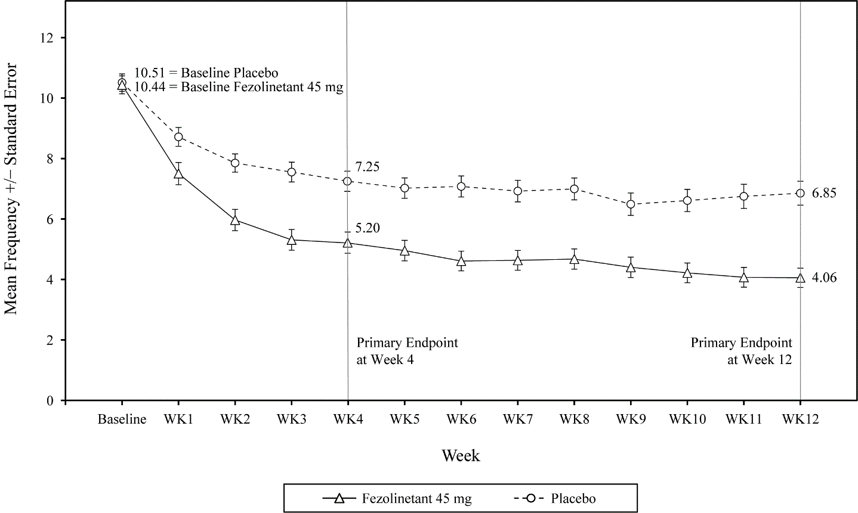

**Figure 2. SKYLIGHT 2: Mean (SE) frequency of moderate to severe VMS per 24 hours   
by week**

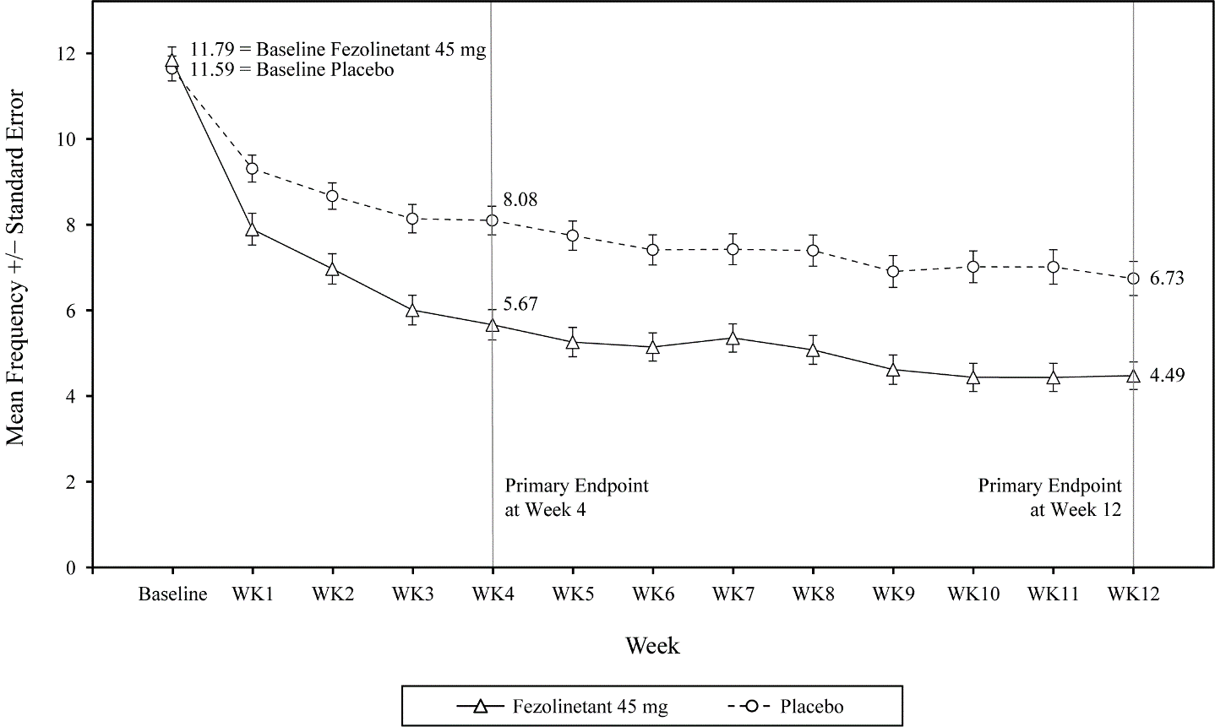

Results of the co-primary endpoint for change from baseline to weeks 4 and 12 in mean severity of moderate to severe VMS per 24 hours from SKYLIGHT 1 and 2 and from pooled studies are shown in Table 4.

**Table 4. SKYLIGHT 1 and 2: Mean baseline and change from baseline in mean severity of moderate to severe VMS per 24 hours to weeks 4 and 12**

|  |  |  |  |  |  |  |
| --- | --- | --- | --- | --- | --- | --- |
| **Parameter** | **SKYLIGHT 1** | | **SKYLIGHT 2** | | **Pooled studies**  **(SKYLIGHT 1 and 2)** | |
| **Fezolinetant**  **45 mg**  **(n=174)** | **Placebo**  **(n=175)** | **Fezolinetant**  **45 mg**  **(n=167)** | **Placebo**  **(n=167)** | **Fezolinetant**  **45 mg**  **(n=341)** | **Placebo**  **(n=342)** |
| **Baseline** | | | | | | |
| Mean (SD) | 2.40 (0.35) | 2.43 (0.35) | 2.41 (0.34) | 2.41 (0.32) | 2.40 (0.35) | 2.42 (0.34) |
| **Change from baseline to week 4** | | | | | | |
| LS Mean (SE)  Difference vs Placebo (SE)  P-value | -0.46 (0.04)  -0.19 (0.06)  0.002*1* | -0.27 (0.04)  --  -- | -0.61 (0.05)  -0.29 (0.06)  <0.001*1* | -0.32 (0.05)  --  -- | -0.53 (0.03)  -0.24 (0.04)  <0.001 | -0.30 (0.03)  --  -- |
| **Change from baseline to week 12** | | | | | | |
| LS Mean (SE)  Difference vs Placebo (SE)  P-value | -0.57 (0.05)  -0.20 (0.08)  0.007*1* | -0.37 (0.05)  --  -- | -0.77 (0.06)  -0.29 (0.08)  <0.001*1* | -0.48 (0.06)  --  -- | -0.67 (0.04)  -0.24 (0.06)  <0.001 | -0.42 (0.04)  --  -- |

*1* Statistically significantly superior compared to placebo at the 0.05 level with multiplicity adjustment.

LS Mean: Least Squares Mean estimated from a mixed model for repeated measures analysis of covariance;   
SD: Standard Deviation; SE: Standard Error.

The key secondary endpoint was the mean change from baseline to week 12 in Patient-Reported Outcomes Measurement Information System Sleep Disturbance – Short Form 8b (PROMIS SD SF). In the pooled analysis (SKYLIGHT 1 and 2), a statistically significant difference was shown for fezolinetant 45 mg compared to placebo (LS mean difference (95% CI): -1.5 (-2.5, -0.5)).

*Safety: Endometrial safety*

The pivotal trials SKYLIGHT 1 and 2, and the long-term safety study SKYLIGHT 4 assessed the endometrial safety of fezolinetant 45 mg by transvaginal ultrasound and endometrial biopsies. 304 women had baseline and post-baseline endometrial biopsies during 52 weeks of treatment.

The endometrial biopsy assessments did not identify an increased risk of endometrial hyperplasia or malignancy according to pre-specified criteria for endometrial safety. The transvaginal ultrasound assessments did not identify a clinically relevant effect on endometrial thickness.

## Pharmacokinetic properties

In healthy women, fezolinetant Cmax and AUC increased proportionally with doses between 20 and 60 mg once daily.

After once-a-day dosing, steady-state plasma concentrations of fezolinetant were generally reached by day 2, with minimal fezolinetant accumulation. The pharmacokinetics of fezolinetant do not change over time.

### Absorption

Fezolinetant Cmax is usually achieved at 1 to 4 hours post-dose.

Effect of food

VEOZA may be administered with or without food. No clinically significant differences in fezolinetant pharmacokinetics were observed following administration with a high-calorie, high-fat meal.

### Distribution

The mean apparent volume of distribution (Vz/F) of fezolinetant is 189 L. The plasma protein binding of fezolinetant is low (51%). The distribution of fezolinetant into red blood cells is almost equal to plasma.

### Metabolism

Fezolinetant is primarily metabolised by CYP1A2 in humans to yield oxidised major metabolite ES259564. ES259564 is approximately 20-fold less potent against the human NK3 receptor with no significant off-target activities. The metabolite-to-parent ratio ranges from 0.7 to 1.8.

### Excretion

The apparent clearance at steady-state of fezolinetant is 10.8 L/h. Following oral administration, fezolinetant is mainly eliminated in urine (76.9%) and to a lesser extent in feces (14.7%). In urine, a mean of 1.1% of the administered fezolinetant dose was excreted unchanged and 61.7% of the administered dose was excreted as ES259564. The terminal elimination half-life (t1/2) of fezolinetant is less than 15 hours in healthy women.

### Pharmacokinetic Characteristics in Special Populations

Effects of age, race, and body weight

There are no clinically relevant effects of age (18 to 65 years), race (Black, Asian, Other), body weight (42 to 126 kg), or menopause status on the pharmacokinetics of fezolinetant.

Renal impairment

Following single-dose administration of 30 mg fezolinetant, there was no clinically relevant effect on fezolinetant exposure (Cmax and AUC) in women with mild (eGFR 60 to less than 90 mL/min/1.73 m2) to severe (eGFR less than 30 mL/min/1.73 m2) renal impairment. The AUC of ES259564 was not changed in women with mild renal impairment but increased approximately 1.7- to 4.8-fold in moderate (eGFR 30 to less than 60 mL/min/1.73 m2) and severe renal impairment. Fezolinetant has not been studied in individuals with end-stage renal disease (eGFR less than 15 mL/min/1.73 m2).

Hepatic impairment

Following single-dose administration of 30 mg fezolinetant in women with Child-Pugh Class A (mild) chronic hepatic impairment, mean fezolinetant Cmax increased by 23% and AUCinf increased by 56%, relative to women with normal hepatic function. In women with Child-Pugh Class B (moderate) chronic hepatic impairment, mean fezolinetant Cmax decreased by 15% and AUCinf increased by 96%. The Cmax of ES259564 decreased in both mild and moderate chronic hepatic impairment groups while AUCinf and AUClast slightly increased less than 15%. Fezolinetant has not been studied in individuals with Child-Pugh Class C (severe) chronic hepatic impairment.

Pharmacologically induced menopause

Fezolinetant has not been studied in individuals with VMS induced by pharmacologic treatment of malignancy (e.g., breast cancer).

## Preclinical safety data

### Genotoxicity

Fezolinetant showed no genotoxic potential in assays for bacterial reverse mutation (Ames test), chromosomal aberration *in vitro* (in human lymphocytes), or in the *in vivo* rat peripheral blood micronucleus test. ES259564, the major metabolite of fezolinetant, was also shown not to be mutagenic or clastogenic *in vitro*.

### Carcinogenicity

The carcinogenic potential of fezolinetant was investigated in a 6-month study in transgenic (Tg.rasH2) mice and in a 2-year study in female rats, both conducted by the oral route. Fezolinetant was not carcinogenic in transgenic mice up to the highest dose level tested (450 mg/kg/day, yielding exposure to fezolinetant [plasma AUC] in female animals 47-times higher than in patients at the MRHD of 45 mg/day). An increase in the incidence of thyroid follicular cell adenoma was noted in rats at 100 mg/kg/day (186-fold the plasma AUC in patients at the MRHD). The increase is considered to be a rat specific effect secondary to the induction of hepatic enzymes and, therefore, does not constitute a clinical carcinogenic risk. Furthermore, no treatment-related increase in tumour incidence was observed in rats at 30 mg/kg/day (yielding 75-times the clinical AUC).

# Pharmaceutical particulars

## List of excipients

Mannitol, hyprolose, microcrystalline cellulose, magnesium stearate, hypromellose, purified talc, macrogol 8000, titanium dioxide, and ferric oxide (iron oxide red).

## Incompatibilities

None.

## Shelf life

36 months.

## Special precautions for storage

Store below 30°C.

## Nature and contents of container

PA/aluminium/PVC/aluminium unit dose blisters in cartons containing 10, 30 or 100 film-coated tablets.

*(Note: Not all pack sizes may be marketed).*

## Special precautions for disposal

In Australia, any unused medicine or waste material should be disposed of by taking to your local pharmacy.

## Physicochemical properties

Fezolinetant is a white powder. It is very slightly soluble in water (0.29 mg/mL).

### Chemical structure

The chemical name of fezolinetant is (4-Fluorophenyl)[(8*R*)-8-methyl-3-(3-methyl-1,2,4-thiadiazol-5-yl)-5,6-dihydro[1,2,4]triazolo[4,3-*a*]pyrazin-7(8*H*)-yl]methanone having a molecular formula of C16H15FN6OS and a molecular weight of 358.39. The structural formula of fezolinetant is:

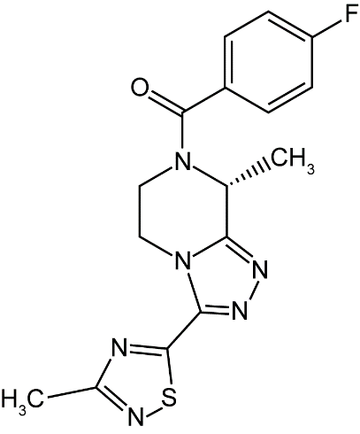

### CAS number

1629229-37-3

# Medicine schedule (Poisons Standard)

Schedule 4 – Prescription Only Medicine

# Sponsor

Astellas Pharma Australia Pty Ltd

Suite 2.01, 2 Banfield Road Macquarie Park NSW 2113

Tel: 1800 751 755 (Medical Information)

Email: aaumedinfo@astellas.com (Medical Information)

Website: www.astellas.com/au

# Date of first approval

26 February 2024

# Date of revision

Not applicable

Summary table of changes

|  |  |
| --- | --- |
| Section Changed | Summary of new information |
| all | New Product Information |

VEOZA™ is a trademark of Astellas US LLC