|  |
| --- |
| Australian Public Assessment Report for AQUIPTA |
| Active ingredient: Atogepant |
| Sponsor: Abbvie Pty Ltd |
| June 2024 |

About the Therapeutic Goods Administration (TGA)

* The Therapeutic Goods Administration (TGA) is part of the Australian Government Department of Health and Aged Care and is responsible for regulating therapeutic goods, including medicines, medical devices, and biologicals.
* The TGA administers the *Therapeutic Goods Act 1989* (the Act), applying a risk management approach designed to ensure therapeutic goods supplied in Australia meet acceptable standards of quality, safety, and efficacy.
* The work of the TGA is based on applying scientific and clinical expertise to decision-making, to ensure that the benefits to the Australian public outweigh any risks associated with the use of therapeutic goods.
* The TGA relies on the public, healthcare professionals and industry to report problems with therapeutic goods. The TGA investigates reports received to determine any necessary regulatory action.
* To report a problem with a therapeutic good, please see the information on the [TGA website](https://www.tga.gov.au/).

About AusPARs

* The Australian Public Assessment Report (AusPAR) provides information about the evaluation of a prescription medicine and the considerations that led the TGA to approve or not approve a prescription medicine submission. Further information can be found in [Australian Public Assessment Report (AusPAR) guidance](https://www.tga.gov.au/australian-public-assessment-report-auspar-guidance).
* AusPARs are prepared and published by the TGA.
* AusPARs are static documents that provide information that relates to a submission at a particular point in time. The publication of an AusPAR is an important part of the transparency of the TGA’s decision-making process.
* A new AusPAR may be provided to reflect changes to indications or major variations to a prescription medicine subject to evaluation by the TGA.

Copyright

© Commonwealth of Australia 2024  
This work is copyright. You may reproduce the whole or part of this work in unaltered form for your own personal use or, if you are part of an organisation, for internal use within your organisation, but only if you or your organisation do not use the reproduction for any commercial purpose and retain this copyright notice and all disclaimer notices as part of that reproduction. Apart from rights to use as permitted by the *Copyright Act 1968* or allowed by this copyright notice, all other rights are reserved and you are not allowed to reproduce the whole or any part of this work in any way (electronic or otherwise) without first being given specific written permission from the Commonwealth to do so. Requests and inquiries concerning reproduction and rights are to be sent to the TGA Copyright Officer, Therapeutic Goods Administration, PO Box 100, Woden ACT 2606 or emailed to <[tga.copyright@tga.gov.au](mailto:tga.copyright@tga.gov.au)>.

Contents

List of abbreviations 4

Product submission 5

Submission details 5

Product background 6

The disease/condition 6

Current treatment options 7

Clinical rationale 8

Regulatory status 9

Australian regulatory status 9

Foreign regulatory status 9

Registration timeline 10

Submission overview and risk/benefit assessment 11

Quality 11

Nonclinical 11

Clinical 12

Summary of clinical studies 12

Pharmacology 12

Pharmacodynamics 14

Efficacy 15

Safety 22

Risk management plan 26

Risk-benefit analysis 27

Delegate’s considerations 27

Proposed action 28

Questions for the sponsor 29

Advisory Committee considerations 35

ACM Conclusion 37

Outcome 37

Attachment 1. Product Information 37

## List of abbreviations

|  |  |
| --- | --- |
| Abbreviation | Meaning |
| ACM | Advisory Committee on Medicines |
| ADRs | Adverse drug reactions |
| AEs | Adverse events |
| ARTG | Australian Register of Therapeutic Goods |
| ASA | Australia‑specific annex |
| B.D. | Twice daily dosing |
| CGRP | Calcitonin-gene-related peptide |
| CI | Confidence interval |
| CIDV | Capsaicin-induced dermal vasodilation |
| CM | Chronic migraine |
| CMI | Consumer Medicines Information |
| EM | Episodic migraine |
| FDA | U.S. Food and Drug Administration |
| mITT | Modified intent-to-treat population |
| OTHE | Off-treatment hypothetical estimand population |
| PI | Product Information |
| PSUR | Periodic safety update report |
| Q.D. | Once daily dosing |
| RMP | Risk management plan |
| TGA | Therapeutic Goods Administration |
| ULN | Upper limit of normal |

## Product submission

### Submission details

|  |  |
| --- | --- |
| *Type of submission:* | New chemical entity |
| *Product name:* | AQUIPTA |
| *Active ingredient:* | Atogepant |
| *Decision:* | Approved |
| *Date of decision:* | 14 November 2023 |
| *Date of entry onto ARTG:* | 12 December 2023 |
| *ARTG numbers:* | 291361, 421965, 391362 |
| [*Black Triangle Scheme*](https://www.tga.gov.au/black-triangle-scheme) | Yes |
| *Sponsor’s name and address:* | Abbvie Pty Ltd, Locked Bag 5029, Botany, NSW, 1455 |
| *Dose form:* | Tablet |
| *Strengths:* | 10 mg, 30 mg, 60 mg |
| *Container:* | Blister pack |
| *Pack sizes:* | 7 (starter pack for 60 mg), 28 |
| *Approved therapeutic use for the current submission:* | AQUIPTA is indicated for prophylaxis of migraine in adults who have at least four migraine days per month. |
| *Route of administration:* | Oral |
| *Dosage:* | The recommended dose for AQUIPTA is 60 mg taken orally once daily with or without food.  30mg taken once daily for episodic migraine prophylaxis or 30 mg taken twice daily for chronic migraine prophylaxis may also be considered for some patients.  Tablets should be swallowed whole and should not be split, crushed, or chewed.  For further information regarding dosage, such as dosage modifications to manage adverse reactions, refer to the Product Information. |
| *Pregnancy category:* | B3  Drugs which have been taken by only a limited number of pregnant women and women of childbearing age, without an increase in the frequency of malformation or other direct or indirect harmful effects on the human fetus having been observed.  Studies in animals have shown evidence of an increased occurrence of fetal damage, the significance of which is considered uncertain in humans. |

### Product background

This AusPAR describes the submission by AbbVie Pty Ltd (the sponsor) to register AQUIPTA (atogepant) for the following proposed indication:

*“AQUIPTA is indicated for prophylaxis of migraine in adults who have at least 4 migraine days per month”.*

#### The disease/condition

Migraine is a common, chronic disorder that is typically characterised by recurrent disabling attacks of headache and accompanying symptoms, including aura. The aetiology is multifactorial[1].

Migraine usually manifests as a severe headache of up to several hours in duration, but some attacks may last for days. Typically, migraines cause asymmetrical or unilateral throbbing headaches, but the pain is variable and may be absent. Migraine is often accompanied by visual changes, photophobia, phonophobia, nausea, and lethargy. It is sometimes associated with focal neurological deficits such as weakness or numbness, speech disturbance, or vertigo. Many patients can identify food or environmental triggers for their migraines, including changes in stress levels and the hormonal changes associated with menstrual cycles. In many cases, the triggers for individual migraines are obscure.

When migraine occurs without headache, the condition is recognised from an otherwise typical constellation of associated symptoms, including nausea, visual changes and focal neurological deficits.

Many people suffer infrequent migraines, with only a few attacks per year, but some subjects experience multiple attacks per month. By convention, using definitions formalised by the International Headache Society, a burden of ≥ 15 migraine days per month is used to identify subjects with “chronic” migraine, in contrast to those with “episodic” migraine who suffer <15 migraine days per month. These terms are somewhat misleading, as subjects with episodic migraine clearly have a chronic condition, and subjects with chronic migraine usually have identifiable migraine episodes. There is potentially some ambiguity in counting migraine days per month, as some headache days might lack the classic features of migraine, but nonetheless be due to migraine. The number of migraine days per month can also vary, so there is no definite dividing line between episodic and chronic migraine.

Migraine is considered as the most prevalent neurological disorder globally and is estimated to affect approximately 1 billion people worldwide, predominantly females[2]. Migraine is more prevalent prior to 50 years of age. A targeted systematic review reported that the elderly and disabled population have a relatively high burden of migraine (16.4%), which is almost as high (17.9%) as that found in the 18–44-year-old age group. According to the Global Burden of Disease Study 2016, migraine is the second leading cause of disability. Migraines can have major impacts on a subject’s quality of life and mood, especially if the migraines occur frequently, and migraines are a leading cause of morbidity and absenteeism in young and middle-aged adults.

The diagnosis of migraine is based on clinical criteria provided by the International Classification of Headache Disorders, 3rd edition (ICHD-3). Common accompanying symptoms are nausea, vomiting, photophobia, and phonophobia. There are reports that indicate that migraine may also be preceded by an aura, which is characterised by reversible focal neurologic symptoms, typically comprising visual or hemisensory disturbances.

Calcitonin-gene-related peptide (CGRP) is released during migraine attacks and may play a causative role in induction of migraine attacks[3],[4]. Gepants are a class of small molecule drugs that bind to the CGRP receptor on the trigeminal nerve and block this effect. Atogepant is a potent, selective, orally-active CGRP receptor antagonist from this class of drugs developed for migraine prophylaxis.

#### Current treatment options

When migraines are infrequent or mild, the usual approach is to treat individual attacks with non-pharmacological measures (lying in a darkened room) and over-the-counter analgesics (such as paracetamol or aspirin). More severe attacks may be treated with specific anti-migraine drugs from the triptan family (sumatriptan, zolmitriptan and others). These drugs are often effective if taken early in the attack, but many patients respond only partially to triptans, and they usually still require bed rest and analgesics. Some subjects may need antiemetic medication, as well. Resistant cases may require treatment with stronger analgesics, including narcotics, intravenous lignocaine or ketamine.

When migraines are more frequent (4 or more attacks per month), or when the effects of individual migraines are very severe, prophylactic anti-migraine agents are indicated. These prophylactic agents include beta-blockers (propanolol), calcium channel blockers (verapamil), some anticonvulsants (topiramate, valproate), and pisotifen.

None of these drugs is highly effective, and all of them are associated with significant tolerability issues. Propanolol may cause lethargy, hypotension, bradycardia, vivid dreams or insomnia, impotence, an exacerbation of asthma, blunting of the haemodynamic response to exercise, and other side effects. Calcium channel blockers may cause hypotension, bradycardia and constipation. Anticonvulsants commonly cause sedation and cognitive side effects, and valproate causes a large number of additional side effects including weight gain, abnormal liver function, tremor, and teratogenesis. Topiramate may cause anorexia, cognitive dysfunction, mood changes, and renal calculi. Pisotifen causes lethargy and weight gain. Higher doses of these agents tend to be more effective at reducing migraine frequency and severity, but most tolerability issues are dose-dependent. Many patients are unable to tolerate the doses necessary to reduce their migraine frequency and must settle for a compromise between ongoing migraines and side effects.

Typically, even when prophylactic agents are used, patients experience breakthrough migraines and still require acute medication to treat individual attacks. Because existing prophylactic agents are often only partially effective, and cause significant side effects, there is a clear unmet need for additional prophylactic anti-migraine agents.

More recently, TGA has approved monoclonal antibody (mAb) antagonists to the CGRP receptor for migraine prophylaxis. They require parenteral (subcutaneous or intravenous) administration and have a very long duration of action (months). Erenumab, galcanezumab, fremanezumab and eptinezumab are approved by TGA. Like the older agents, these drugs only show modest efficacy, reducing the mean number of migraine days per month by about 2 days over an entire cohort of treated patients; individual patients may show a better response.

The mechanism of action and usage of the existing anti-CGRP antagonists (mAbs and oral agents) was summarised in a recent review article[5] as follows:

Erenumab is a human immunoglobulin G2 (IgG2) mAb produced from Chinese hamster ovary cells. Erenumab acts by potently and competitively inhibiting the binding of CGRP to its receptor.

Eptinezumab is a humanized immunoglobulin G1 produced in Pichia pastoris yeast cells by recombinant DNA technology. Eptinezumab potently and selectively binds to the α and β-forms of the human CGRP ligand and prevents the activation of the CGRP receptor. It has a rapid onset of action and prolonged clinical activity. This action may be due to the rapid binding and inactivation of CGRP and slow dissociation and from the peptide.

Galcanezumab is a humanized IgG4 mAb produced in Chinese hamster ovary (CHO) cells by recombinant DNA technology. Galcanezumab binds to human CGRP with high affinity and prevents CGRP-induced receptor activation. Galcanezumab also inhibits capsaicin-induced vasodilation, which is a CGRP induced, concentration-dependent, long-lasting relaxation of human coronary arteries.

Fremanezumab is a fully-humanized IgG2 produced by recombinant DNA technology in Chinese hamster ovary (CHO) cells. Fremanezumab selectively targets and binds to both the α and β isoforms of CGRP and prevents CGRP-induced receptor activation.

Rimegepant: is given for the acute treatment of migraine with or without aura. Rimegepant is administered as an orally disintegrating tablet containing 75mg of rimegepant free base orally/sublingually. Dosage should not exceed 75 mg in a 24-hr period. The safety of treating more than 15 migraines in 30 days has not been established. The current commercially available tablet disintegrates in saliva so that patients can swallow it without additional liquid.

Ubrogepant: is given orally at a dosage of 50 mg or 100 mg. 2 hours after the initial dose, a second dose may be taken if necessary. The dose should not exceed 200 mg in 24 hours. Treating any more than eight migraine episodes in 30 days is not recommended, as its safety has not yet been established. Like rimegepant, ubrogepant is for the acute treatment of migraine with or without aura.

If similar efficacy could be achieved with an oral CGRP antagonist as has already been achieved with the mAbs currently approved in Australia, the oral agent could fill an important unmet clinical need, allowing more convenient and flexible dosing, as well as possible cost benefits.

Two orally administered CGRP antagonists are approved by the FDA for the acute treatment of migraine (ubrogepant and rimegepant). Rimegepant was also approved by the FDA for the preventive treatment of episodic migraine. Rimegepant was also approved by the EMA for the above indications. Rimegepant was approved by the TGA on 27 July 2023 for acute treatment of migraine in adults, and for prophylactic treatment of episodic migraine in adults who have at least 4 migraine attacks per month.

#### Clinical rationale

Atogepant (also previously known as AGN-241689, MK-8031 and L-004880174) is a potent, selective, orally active CGRP receptor antagonist developed for migraine prophylaxis.

Before the development of mAb CGRP antagonists, there was already a large body of evidence suggesting that CGRP plays a central role in the pathogenesis of migraine. For instance, CGRP levels in the cranial circulation are increased during a migraine attack, and CGRP administration has been shown to trigger migraine-like headache with concomitant dilation of the middle cerebral artery. It has been hypothesized that the clinical activity of the triptans may be partly attributable to inhibition of CGRP release via an action on prejunctional serotonin receptors in trigeminal nerve fibres, because 5-hydroxytryptamine receptor 1D receptors are co-localised with CGRP in human trigeminal ganglia. Furthermore, immunoreactive CGRP receptor components have been observed in human meningeal and cerebral blood vessels.

With the development of other CGRP antagonists, principally mAbs, and a series of pivotal studies showing modest efficacy of those agents in preventing migraine, this basic rationale has achieved clinical vindication. Atogepant was developed as a small-molecule, orally available alternative to these parenteral treatments.

Atogepant is a potent antagonist of the human CGRP receptor. According to the sponsor, in the ligand-binding assays, atogepant exhibited very high affinity for human CGRP receptors (Ki = 15-26 pM) as well as monkey CGRP receptors (Ki = 9 pM). The potency of atogepant was evaluated by the inhibition of agonist-stimulated intracellular cAMP levels in cells stably expressing the human or rhesus CGRP receptor. Atogepant potently blocked human α-CGRP-stimulated cAMP response in human and rhesus CGRP receptor expressing HEK293 cells with an IC50 of 0.03 nM and 0.05 nM, respectively. The overall profile of atogepant supports the conclusion that atogepant is a highly selective and potent CGRP receptor antagonist.

### Regulatory status

#### Australian regulatory status

This product is considered a new chemical entity for Australian regulatory purposes.

#### Foreign regulatory status

At the time the TGA considered this submission, a similar submission had been considered by other regulatory agencies. The following table summarises these submissions and provides the indications where approved.

Table : International regulatory status at the time of product registration.

|  |  |  |  |
| --- | --- | --- | --- |
| Region | Submission date | Status | Approved indications |
| European Union via the centralised procedure | 24 June 2022 | Under consideration | Under consideration |
| United States of America | 28 Jan 2021 | Approved | For the preventative treatment of episodic migraine in adults |
| United States of America | 17 Jun 2022 | Under consideration (sNDA) | For preventative treatment of migraine in adults |
| Canada | 25 May 2021 | Review ongoing | For the prevention of episodic migraine (< 15 migraine days per month) in adults |

### Registration timeline

The following table captures the key steps and dates for this submission.

This submission was evaluated under the [standard prescription medicines registration process](https://www.tga.gov.au/how-we-regulate/supply-therapeutic-good-0/supply-prescription-medicine/application-process/prescription-medicines-registration-process).

Table : Timeline for Submission PM-2022-02486-1-1

|  |  |
| --- | --- |
| Description | Date |
| Submission dossier accepted and first round evaluation commenced | 1 August 2022 |
| First round evaluation completed | 24 January 2023 |
| Second round evaluation completed | 17 April 2023 |
| Delegate’s[6] Overall benefit-risk assessment and request for Advisory Committee advice | 4 May 2023 |
| Sponsor’s pre-Advisory Committee response | 18 May 2023 |
| Advisory Committee meeting | 1-2 June 2023 |
| Registration decision (Outcome) | 14 November 2023 |
| Administrative activities and registration in the ARTG completed | 12 December 2023 |
| Number of working days from submission dossier acceptance to registration decision* | 211 |

*Statutory timeframe for standard submissions is 255 working days

*Target timeframe for priority submissions is 150 working days from acceptance for evaluation to the decision.

## Submission overview and risk/benefit assessment

A summary of the TGA’s assessment for this submission is provided below.

### Quality

Atogepant has the following chemical structure:

Figure 1. Chemical structure of atogepant:

Chemical structure of atogepant monohydrate


Atogepantmonohydrate C29H23F6N5O3.H2O

The drug substance is the monohydrate of atogepant free base. Atogepant has four chiral centres and is a single enantiomer as shown above.

The aqueous solubility of atogepant is low (0.0045 µg/mL = approx. 13 L to dissolve 60 mg), albeit higher in acid (0.43 mg/mL in pH 1.0 HCl).

The crystalline atogepant monohydrate drug substance melts and converts to the amorphous physical form during an extrusion process in tablet manufacture, therefore, the particle size was not considered critical.

The drug substance was assessed as stable.

The proposed shelf life is 36 months when stored below 25°C. No significant adverse changes in the drug substance were reported in the stability studies.

The evaluator concluded that registration is recommended with respect to chemistry and quality control aspects.

### Nonclinical

The evaluator has recommended approval of this submission.

*In vitro*, atogepant inhibited CGRP binding to its receptor and antagonised CGRP induced relaxation of isolated human vasculature at clinically-relevant concentrations.

Safety pharmacology studies assessed effects on the cardiovascular, respiratory and central nervous systems. Based on animal data, no adverse effects on CNS, cardiovascular or respiratory function are expected in patients. Atogepant is not expected to have direct peripheral haemodynamic effects.

Overall, the pharmacokinetic profile in animals was qualitatively similar to that of humans.

Primary pharmacodynamic studies *in vitro* established that atogepant is a competitive antagonist at CGRP receptors and a functional antagonist of the vascular actions of CGRP.

Atogepant is a substrate for CYP3A4, P-gp, BCRP, OATP1B1, OATP1B3, OAT1. The effect of inhibitors/inducers is not expected to be clinically meaningful. Atogepant is not expected to alter exposures to co-administered drugs that are CYP450 substrates. *In vitro*, atogepant inhibited OCT1 and BCRP. The clinical relevance of these findings, in particular intestinal BCRP, is unknown.

No acute toxicity was observed in any of the repeat-dose toxicity studies in any species.

Repeat-dose toxicity studies by the oral route were conducted in mice (up to 3 months), rats (up to 6 months) and rhesus monkeys (up to 9 months).

Atogepant did not produce any major adverse effects in any target organ in any species examined.

Atogepant was not mutagenic. No treatment related increase in tumour incidence was observed in mice or rats in 2-year oral carcinogenicity studies.

Fertility was unaffected in male and female rats treated with atogepant at doses up to 125 mg/kg/day (22 times the clinical AUC). There was no evidence of embryofetal development effects in rabbits; however, maximum exposures were low and atogepant has poor pharmacological activity in this species.

Atogepant was excreted into milk in lactating rats and delayed growth was seen in breast-fed pups.

### Clinical

#### Summary of clinical studies

The sponsor submitted two pivotal studies: study 3101-301-002 (episodic migraine (EM)) and study 3101-303-002 (chronic migraine (CM).

Supportive efficacy data was provided by the dose-finding study CGP-MD-01 which assessed atogepant for the preventive treatment of migraine in participants with EM, using a range of active doses: 10 mg QD, 30 mg QD, 60 mg QD, 30 mg BD (twice daily dosing), 60 mg BD.

The sponsor also submitted two open-label extension studies in EM (study 3101-302-002 and study 3101-309-002) that assessed long-term safety of atogepant in EM. It should be noted that similar studies in subjects with chronic migraine were not submitted.

### Pharmacology

##### Pharmacokinetics (PK)

**Absorption**

Atogepant is well-absorbed orally. The median Tmax was approximately 1.0 to 1.5 hours. Absorption was slightly delayed and the Cmax blunted in the presence of food. No major overall reduction in bioavailability was reported.

**Distribution**

Extensive plasma protein binding was reported. The unbound fraction of atogepant was around 4.7%. A 14% to 38% higher extent of atogepant systemic exposure (AUC) was reported in subjects with hepatic impairment. The evaluator did not consider the magnitude of increase to be clinically relevant.

**Metabolism**

The oxidative metabolism of atogepant in humans was predominantly CYP3A4-mediated, with a minor involvement of CYP2D6.

**Excretion**

The elimination half-life of atogepant was approximately 11 hours. The major route of elimination of atogepant was faecal.

##### Population PK data (popPK)

The overall pharmacokinetic (PK) profile was described by a three-compartment model. A sequential zero-order/first-order absorption model was utilised.

Physiologically-based pharmacokinetic modelling (PBPK) modelling studies revealed that no significant variation in exposure was to be expected with mild-to-moderate renal impairment. The evaluator has highlighted that the major clinical efficacy studies excluded subjects with severe renal impairment, so the PK (and safety and efficacy) of atogepant in patients with severe renal impairment have not been studied. The PBPK modelling suggested a 2.3-fold increase in atogepant exposure in severe renal impairment. The lower atogepant dose (10 mg daily) is therefore recommended in subjects with severe renal impairment and in end- stage renal disease. The evaluator considered that it is ‘unlikely to be of significant clinical importance, given the minor role played by renal clearance and the lack of major dose-related toxicity’.

Exposure to atogepant was dose-proportional in the dose range of 1 mg to 300 mg. No significant accumulation of atogepant was noted after repeated daily dosing.

Coadministration of atogepant with a standard high-fat meal led to a 22% reduction in Cmax and 18% reduction in AUC. These variations were not expected to be clinically relevant.

##### Drug interactions

In clinical studies that examined drug interactions, strong OATP inhibitors (rifampin) significantly increased atogepant exposure. The PI states that a dose reduction to 10 mg daily dose should be considered when co-administered with strong OATP inhibitors. A similar issue applies for CYP3A4 interactions as well.

Clinically relevant PK interactions were noted with strong CYP3A4 inhibitors and strong CYP3A4 inducers. Coadministration of atogepant with itraconazole, a strong CYP3A4 inhibitor, resulted in a 5.5-fold increase in atogepant AUC0-∞ and a 2.15-fold increase in atogepant Cmax. The PI states that atogepant be administered at a dose of 10 mg daily when co-administered with strong CYP3A4 inhibitors.

Coadministration of atogepant with multiple-dose rifampin, a strong CYP3A4 inducer, resulted in a 60% reduction in atogepant exposure, which could compromise atogepant efficacy. The evaluator has highlighted that the sponsor did not propose a dose adjustment. The drug interaction findings are described in the PI.

Table 2: Dose modifications in the FDA approved PI

|  |  |  |
| --- | --- | --- |
| Dosage Modifications | Recommended Once Daily Dosage for Episodic Migraine | Usage and Recommended Once Daily Dosage for Chronic Migraine |
| **Concomitant Drug** | | |
| Strong CYP3A4 Inhibitors | 10 mg | Avoid use |
| Strong. Moderate, or Weak CYP3A4 Inducers | 30 mg or 60 mg | Avoid use |
| OATP Inhibitors | 10 mg or 30 mg | 30 mg |
| **Renal impairment** | | |
| Severe Renal Impairment and End-Stage Renal Disease  (CLcr <30 mL/min) | 10mg | Avoid use |

The delegate has noted that the FDA approved PI for atogepant has recommended the above dose modifications, when used along with CYP3A4 inhibitors and inducers and also with OATP inhibitors. FDA has also recommended avoiding the use in patients with severe renal impairment. The delegate considers that the proposed dosage regimen does not reflect the interaction findings and also not in line with FDA’s approach. The ACM’s advice will be considered prior to making further recommendations on this matter.

#### Pharmacodynamics

Pharmacodynamic (PD) assessments were performed by measuring the inhibition of capsaicin-induced dermal vasodilation (CIDV). The magnitude of increase in forearm dermal microvascular blood flow was adopted as a surrogate marker for PD effect. The evaluator has commented that it was unclear how results in dermal blood vessels relate to pathogenic processes in the cerebral vasculature, and also unclear how systemic concentrations relate to concentrations at cerebral effector sites. The evaluator concluded that it was likely that the important effector sites are outside the blood brain barrier, so the CIDV results were probably relevant to migraine.

In healthy subjects, an inhibitory effect on CIDV was reported at 1 hour and at 5 hours post dosing for atogepant 30 mg and atogepant 2.5 mg, but not for atogepant 0.4 mg. Based on these observations and the PK of atogepant, the sponsor estimated that a 10 mg dose of atogepant would be expected to achieve 90% inhibition of the CGRP effects in dermal vasculature for up to 12 hours post-dose, and that doses of 30 mg and 60 mg (the doses assessed in the major efficacy studies) would be expected to achieve 90% inhibition for up to 16 hours and 24 hours post-dose, respectively.

The exposure-response modelling for episodic migraine did not suggest a major dose-dependent effect on the magnitude of treatment benefit.

The relevant TGA adopted EMA guideline highlights the lack of an established PD model for migraine. The guideline also states that studies should be performed in order to show both the action of the product on the serotonergic system and its vasoactivity on different vascular territories, and on other biological systems, as appropriate. In that regard, the sponsor’s approach to demonstrate atogepant’s PK-PD relationship is acceptable.

### Efficacy

**Dose finding for pivotal studies**

The evaluator has mentioned that ‘the relatively short half-life of atogepant (~11 hours) suggested that more continuous antagonism of CGRP could be achieved with twice-daily dosing, but it appears that the sponsor clearly favoured development of a daily dose. A numerical superiority in terms of the reduction in the number of monthly migraine days and headache days were reported for 30mg BD vs 60 OD dosage regimen. The sponsor’s rationale was the OD dosing will be highly likely to facilitate better treatment compliance’.

##### Study CGP-MD-01

This study was a phase 2/3 randomised control trial to evaluate multiple dosage regimens of atogepant in episodic migraine prevention and to characterise the dose-response relationship. This study was also designed to test superiority of the 10mg, 30mg, 60mg once daily and 30 and 60 mg twice daily versus placebo.

The treatment period was 12 weeks.

The primary efficacy endpoint was the change from baseline in mean monthly migraine days.

Secondary efficacy endpoints were change from baseline in mean monthly headache days, proportion of patients with at least a 50% reduction in mean monthly migraine days and the change from baseline in mean monthly acute medication use days after the 12-week treatment period.

Key inclusion criteria were adults with a diagnosis of episodic migraine (between 4 to14 migraine attacks in each of the 3 months before screening) and 4 to 14 migraine days during the 28-day baseline period.

Subjects with retinal migraine were excluded.

4-week screening period was followed by a double-blind treatment period for 12 weeks, and a safety follow-up period of 4 weeks.

834 subjects were randomised, with 186 to placebo and 648 to atogepant groups. Mean age was 40.1 years. Most patients were female (86.5%). The mean duration of migraine was 19.37 years.

Overall, 82% of patients completed the 12-week treatment period, and completion rates were similar across the 6 treatment groups (range 78.5% to 87.7%). The most common reason for premature discontinuation during the treatment phase was withdrawal of consent (6.7% overall). Adverse event withdrawals were slightly more common in the atogepant groups (range 3.2% to 7.5%) than in the placebo group (2.7%).

A greater reduction in mean monthly migraine days was observed for all the treatment arms of atogepant compared with placebo, across the 12-week treatment period. The treatment difference for all the dosage groups was statistically significant (p ≤ 0.0390 after multiplicity adjustment).

A consistent dose-response trend for efficacy was lacking. Treatment difference in terms of reduction in the mean (SD) number of monthly migraine days ranged from 0.7 days (60 mg OD) to 1.39 days (30 mg BD). Treatment with the lowest dose of 10mg OD resulted in an intermediate benefit of a reduction of 1.15 days. Similar trend was observed with other efficacy endpoints.

The outcomes for the key secondary endpoints were supportive of the primary endpoint and statistically significant.

Table : Primary and key secondary endpoints

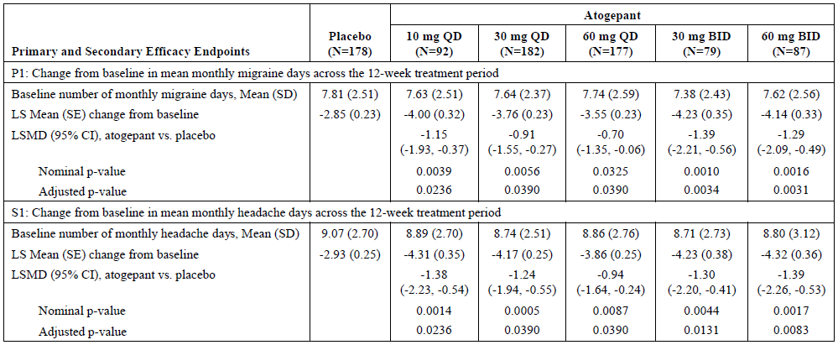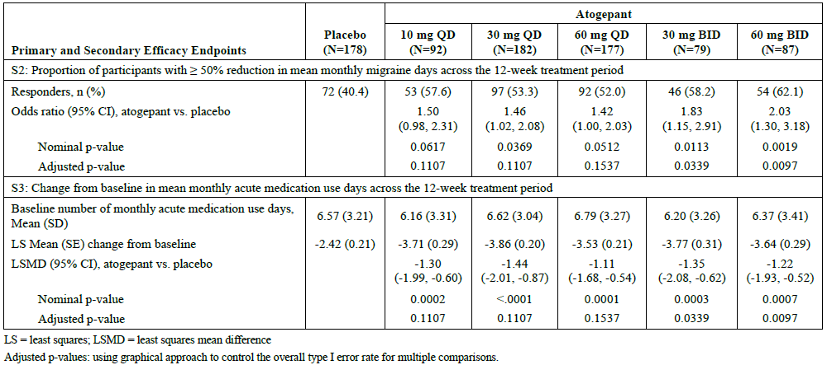

The evaluator highlighted that ‘no formal dose comparison was presented, but the 95%CIs suggest that there was substantial overlap in efficacy across active doses, and this indicates that it would be unlikely that any statistical analysis would show any active dose to be superior’*.*

**Study 301EM (pivotal episodic migraine study)**

A double-blind RCT to assess the efficacy and safety of atogepant at three different once-daily doses (10 mg, 30 mg or 60 mg) in comparison with placebo.

A lead-in period of 4 weeks to establish baseline migraine and headache frequency was followed by a double-blind treatment period of 12 weeks, and a 4-week safety follow-up period.

The primary efficacy endpoint was the change from baseline in migraine frequency (migraine days per month).

Key Secondary efficacy endpoints were the change from baseline in mean monthly headache days, monthly acute medication use across the 12-week treatment period and the proportion of responders (defined as those with ≥ 50% reduction in 3-month average of monthly migraine days).

**Key inclusion criteria:**

* History of 4 to 14 migraine days per month on average in the 3 months prior to enrolment and during the 28-day baseline period
* Age of the participant at the time of migraine onset < 50 years.

**Key exclusion criteria:**

* History of migraine accompanied by diplopia or decreased level of consciousness or retinal migraine.
* Trigeminal autonomic cephalgia (e.g., cluster headache), or painful cranial neuropathy.
* Usage of opioids or barbiturates > 2 days/month, triptans or ergots ≥ 10 days/month, or simple analgesics (e.g., aspirin, non-steroidal anti-inflammatory drugs, acetaminophen) ≥15 days/month in the 3 months prior to randomisation.
* Clinically “significant” history of cardiovascular and/or cerebrovascular disease

The power estimation was based on the phase 2 study findings. It was estimated that 218 participants per treatment group would provide at least 98% power to detect the treatment difference between each of the 3 atogepant doses and placebo for the primary efficacy endpoint, with an overall Type 1 error rate of 5%. The assumed treatment difference from placebo in change from baseline in mean monthly migraine days across the 12-week treatment period was anticipated to be around -1.5 days, with a standard deviation of 3.5 days.

The sponsor defined two main analysis populations for efficacy, a modified intent-to-treat (mITT) population, and off-treatment hypothetical estimand (OTHE) population.

All efficacy analyses were performed using the mITT population, which consists of all randomized participants who received at least 1 dose of study intervention, had an evaluable baseline period of eDiary data and at least 1 evaluable postbaseline 4-week period (Weeks 1 to 4, 5 to 8, and 9 to 12) of eDiary data during the double-blind treatment period.

The analysis population for off-treatment hypothetical estimand includes all randomized participants who received at least 1 dose of study treatment, had an evaluable baseline period of eDiary data, and had at least 1 evaluable postbaseline 4-week period (Weeks 1 to 4, 5 to 8, and 9 to 12) of eDiary data during the double-blind treatment period and follow-up period, regardless of whether on study treatment or off study treatment.

Analysis involving the mITT population was used for submission to FDA and OTHE population was used for submission to EMA. The sponsor included both analyses in the submission to TGA.

The evaluator commented that these populations differed by only 9 subjects. The reasons for excluding these 9 subjects from the mITT population were not clearly reported. The key difference between the mITT and OTHE populations appears to be that the mITT population excluded subjects who discontinued randomised treatment during the double-blind treatment period, but these patients remained in the OTHE population.

Subjects (n=910) were randomised in a 1:1:1:1 ratio to the atogepant 10 mg, 30 mg, 60mg OD and placebo groups.

Rescue treatment was allowed with triptan/opioid/NSAID/ergot derivative agents.

88.5% of all randomised subjects completed the study. A total of 142 subjects (15.6%) reported a significant protocol deviation. The most common significant protocol deviations were use of a prohibited concomitant medication (7.5%).

**Baseline characteristics**

The mean age was 41.6 years and most of the participants were female (88.8%). The baseline mean number of migraine days was 7.7 (SD 2.38) and mean number of headache days was 8.7 (SD 2.63) per month.

The mean duration of migraine was 21.2 years. 99.3% of participants reported use of medications for the acute treatment of migraine: 63.1% of these participants reported use of an NSAID, 48.8% used a triptan, and 63.2% reported use of acetaminophen or combination analgesics.

Overall, 70.3% of the participants reported having used a migraine prevention medication in the past.

**Results**

Subjects with episodic migraine and treated with atogepant doses of 10 mg, 30 mg, and 60 mg once daily experienced a greater reduction in the mean number of migraine and headache days from baseline, compared to placebo. Treatment difference (reduction in number of migraine days) ranged from 1.2 days (10 mg once daily) to 1.7 days (60mg once daily). The treatment difference was statistically significant (after adjusted for multiplicity).

Secondary outcomes were supportive and statistically significant for all atogepant doses, compared to placebo.

Table 4: Primary and key secondary endpoints

Primary and Secondary efficacy endpoints

P1: change from baseline in mean monthly migraine days across the 12 week treatment period

S1: Change from baseline in mean monthly headache days across the 12-week treatment period

S2: Change from baseline in mean monthly acute medication use days across the 12-week treatment period

Primary and secondary efficacy endpoints:

S3 - 50 percent or greater reduction in 3 month average of monthly migraine days

S4 - Change from baseline in MSQ v. 2.1 role function restrictive domain score at Week 12

S5 - change from baseline in mean monthly performance of daily activities domain score of the AIM-D across the 12 week treatment periodPrimary and secondary efficacy endpoints:

S3 - 50 percent or greater reduction in 3 month average of monthly migraine 

**Study 303 CM (pivotal study)**

Phase 3 RCT parallel-group study, comparing atogepant (30 mg BD or 60 mg OD) with placebo for the preventive treatment of migraine in participants with *chronic migraine (CM).*

The study design was identical to the study 301, except for:

* the requirement that subjects with ≥15 headache days per month were eligible to be recruited.

The sponsor estimated that a total sample size of 250 randomised subjects per treatment group and would provide at least 96% power to detect the treatment difference between each of the 2 atogepant doses (which were assumed to be equally effective) and placebo for the primary efficacy endpoint.

Based on published literature, the sponsor assumed that the treatment difference from placebo in change from baseline in mean monthly migraine days across the 12-week treatment period would be –2 days, with a standard deviation of 5.5 days.

The primary efficacy endpoint was the change from baseline in mean monthly migraine days after 12 weeks of treatment.

Key secondary endpoints were the change from baseline in mean monthly headache days, mean monthly acute medication days and proportion of subjects with a 50% reduction in 3-month average of monthly migraine days.

Completion rates were broadly similar across the 3 treatment groups (range 88.8% to 89.9%).

Significant protocol deviations occurred in 22% of subjects overall, but many of these deviations were in the category of *“Study Procedure – not performed per protocol”,* which includes events such as *mistimed visits*. Overall, the evaluator considered that the number of protocol deviations was acceptable for a study of this nature.

The mean age was 42.1 years, and the majority of the subjects were women (87.6%). The baseline mean number of migraine days was 18.9 (SD 5.06) and mean number of headache days was 21.4 (SD 4.19).

The mean migraine disorder duration was 21.4 years. Almost all of the participants (98.3%) were on treatment with agent for acute relief from migraine: around 72% of subjects were on triptans and around 70% of subjects on NSAIDs.

**Results**

Atogepant 30 mg BD and atogepant 60 mg OD were superior to placebo and provided statistically significant greater reduction from baseline compared with placebo in mean monthly migraine days across the 12-week treatment period. The reduction in the number of migraine days, relative to baseline and to the placebo reduction, was 2.24 days in the 30 mg BD group and 1.66 days in the 60 mg daily group.

The subjects in atogepant arm achieved greater treatment benefits for key secondary endpoints and were statistically significant.

Table : Key primary and secondary endpoints

Primary and secondary efficacy endpoints

P1: change from baseline in mean monthly migraine days across the 12 week treatment period

S1: change from baseline in mean monthly headache days across the 12 week treatment period

S2: change from baseline in mean monthly acute medication use days across the 12 week treatment period

Primary and secondary efficacy end points

S3: 50 percent or greater reduction in 3-month average of monthly migraines

S4: Change from baseline in HIT-6 total score at week 12

S5: Change from baseline in MSQ v2.1 Role Function-Restrictive domain score at Week 12

#### Safety

##### Treatment exposure

Studies 302 and 309 were open label studies designed to assess long term safety of atogepant in subjects with episodic migraine.

Study 309 was 40 weeks of duration and enrolled the subjects who completed the pivotal study in episodic migraine, Study 301. All subjects in the extension study received atogepant 60 mg daily. A total of 685 participants constituted the safety population.

Study 302 was 52 weeks of duration and enrolled subjects with episodic migraine who completed study MD-01 and also those who did not participate in that study but have *1-year history of migraine with or without aura and who experience 4 to 14 migraine days per month.* Study treatment included both standard of care preventive medicine and 60mg OD dosages.

Safety data from these studies are incorporated under relevant headings in the following discussion on safety findings.

1,911 subjects received the proposed dose of atogepant 60 mg once daily (QD), with 678 subjects in a placebo-controlled setting and 343 subjects received 30 mg BD in a placebo-controlled setting.

The safety cohort consisted of 604 healthy volunteers, 656 subjects with chronic migraine, and 1,970 subjects with episodic migraine.

966 subjects with episodic migraine were exposed for ≥ 6 months and 362 were exposed for ≥ 12 months.

165 subjects with chronic migraine were exposed for ≥ 6 months and 62 were exposed for ≥ 12 months.

The number of subjects with chronic migraine exposed for ≥ 12 months (n=62) does not meet the relevant TGA adopted EMA’s guideline stipulated minimum number of 100 subjects to establish long term safety. The delegate has noted that Study 312 is ongoing to assess long term safety of atogepant in chronic migraine.

A limited exposure of atogepant in the >65-year age groups was noted. The proportion of subjects in this age group was <5% of the total number of subjects.

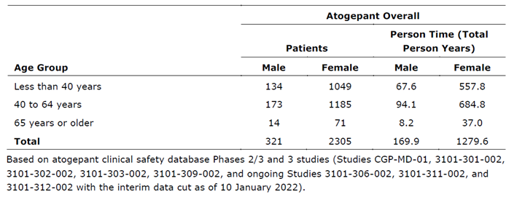

##### Adverse events (AEs)

The incidence of AEs was largely comparable across the dosages of atogepant.

Table : Comparison of incidence of AEs across dosages

Comparison of incidence of AEs across dosages


In the placebo-controlled analysis set of studies 301 and 303, the incidence of AE was comparable (around 50%) across the atogepant dose groups and placebo.

The most common AEs across the atogepant groups were nausea, constipation, fatigue, and upper respiratory tract infection.

Table : Table of AEs

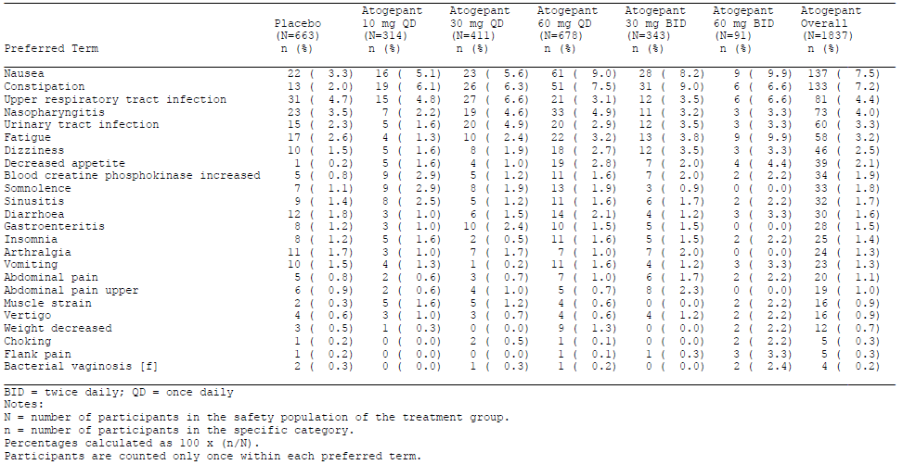

The majority of AEs were mild or moderate in severity. AEs that were considered by the investigator to be related to study drug were reported for 36.2% of participants in the standard-of-care group and 13.3% of participants in the atogepant 60 mg daily group (proposed dose for registration) in the long-term safety analysis set.

Hypersensitivity, constipation, nausea, decreased appetite, fatigue/somnolence were reported as Adverse Drug Reactions (ADRs). The evaluator has commented that these events were common to other TGA approved anti-migraine medicines (both anti-CGRP and other agents). The severity of these ADRs was generally low, with few ADRs leading to discontinuation.

Table : Table of ADRs (placebo-controlled analysis set)

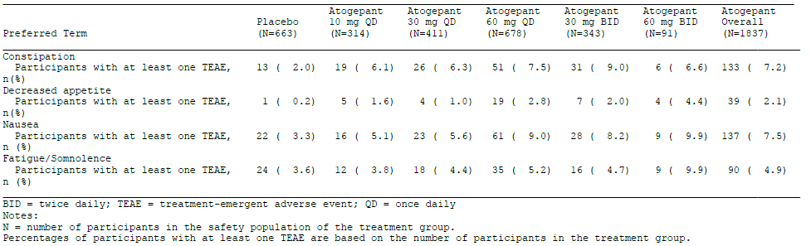

##### Serious adverse events (SAE)

In the placebo-controlled safety analysis set, incidence of SAEs was low and largely comparable across atogepant 60 mg OD (1.3%), atogepant 30 mg BD (1.2%) and the placebo (1.1%) groups (Table 9).

In the long-term safety analysis set, 3.6% of subjects in the standard-of-care group and 3.4% of participants in the atogepant 60 mg daily group experienced SAEs.

With the exception of one SAE labelled “optic neuritis” in the placebo-controlled analysis set (occurring in a subject receiving atogepant 10 mg QD), none of the SAEs was considered by the investigator to be related to study drug. For this case, the evaluator has highlighted that the sponsor did not agree with the diagnosis of optic neuritis and also disagreed with the potential for a causal relation with atogepant.

SAEs in the category “injury, poisoning and procedural complications” had the maximum number of events reported (4/0.2%) in the placebo-controlled analysis set.

Table : SAEs in placebo-controlled analysis set

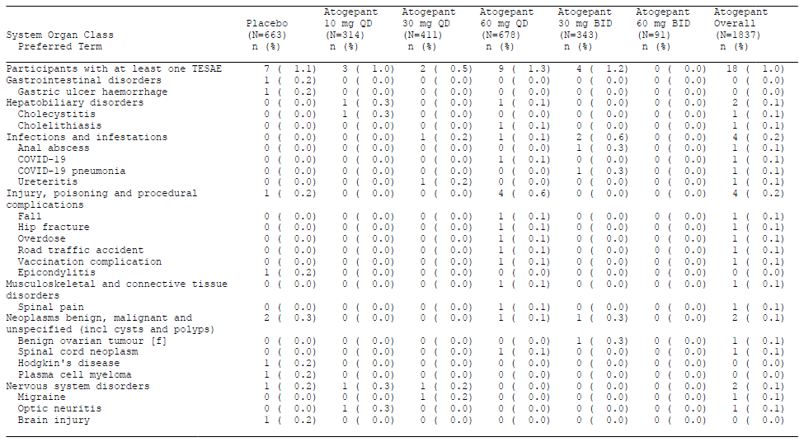

##### Immunological events

The incidence of immunological events was low (1.0%). Immune-related AEs were reported in 28 subjects. Of these, 5 events were related to drug hypersensitivity. In the placebo-controlled analysis set, there were no cases of drug hypersensitivity in the placebo group, and 2 cases with atogepant.

In response to the evaluator’s questions, the sponsor included post-market data on hypersensitivity and commented: *AbbVie conducted a signal evaluation for hypersensitivity with atogepant in December 2022.* Three serious cases and 221 non-serious cases of hypersensitivity were reported. The sponsor has updated the CCDS accordingly.

The three post-marketing serious cases were:

* A 20-25-year-old female with medical history of unspecified allergies and concomitant medication of levocetirizine, who was hospitalized due to drug hypersensitivity, eosinophilic oesophagitis, and gastritis after taking atogepant for 7 weeks.’
* A 55-60-year-old female with unknown medical history and concomitant medications who experienced serious events of anaphylactic shock, rash pruritus, and dyspnoea on the sixth day of atogepant treatment. The patient went to the emergency room and was given unknown steroids. The events resolved on unknown date and atogepant was withdrawn.’
* The third report described an event of ‘serious rash’ but did not meet any regulatory criteria for seriousness. This is a case of a >70-year-old male with history of dermatitis who experienced ‘serious rash’ and pruritus 3 weeks after the atogepant initiation. The events resolved one day after atogepant discontinuation. The event was treated with hydroxyzine. Despite potentially confounders of patient's history of dermatitis and multiple concomitant medications labelled either for rash and/or pruritus (with unknown dates), this case demonstrated a temporal association with atogepant and a potential positive dechallenge. Therefore, a possible causal association with atogepant and the events of rash and pruritus cannot be excluded.”

The sponsor has included “hypersensitivity” as an ADR in the proposed PI.

Discontinuations due to adverse events was comparable across atogepant and placebo groups (3.9% vs 3.2%).

The incidence of treatment-emergent AES (TEAEs) suggestive of liver toxicity was low, and it was comparable across the placebo and atogepant groups (placebo 1.8% vs atogepant 1.5%)

The incidence of elevations of ALT and/or AST ≥ 3 × the upper limit of normal (ULN) were comparable across atogepant and placebo groups. One participant in the long-term safety analysis set had concurrent ALT or AST elevations ≥ 3 × ULN and total bilirubin ≥ 1.5 × ULN, in the context of symptomatic cholelithiasis and considered by the investigator to be not related to study drug. No subjects in the placebo-controlled analysis set or long-term safety analysis set satisfied Hy's Law.

A single post-marketing report has raised the possibility that atogepant led to liver injury in a subject who subsequently required a liver transplant, but several other drugs were implicated, and an expert concluded that there were insufficient data to assign causality.

Nil significant ECG, haematological or other laboratory events were reported across studies with atogepant.

###### Deaths

Three events of deaths were reported in the atogepant 60 mg group during the long-term safety follow period. None of the deaths was considered by the investigator to be related to atogepant.

The causes of death were:

* beta-haemolytic streptococcal infection (toxic shock syndrome)
* homicide
* asphyxia (by house fire)

Other (e.g. companion diagnostic considerations, drug delivery device)

RWE/RWD1 were not included in this submission.

### Risk management plan

The summary of safety concerns and their associated risk monitoring and mitigation strategies are presented in 10. The TGA may request an updated RMP at any stage of a product's life-cycle, during both the pre-approval and post-approval phases.

Table : Summary of safety concerns

|  |  |  |  |  |  |
| --- | --- | --- | --- | --- | --- |
| Summary of safety concerns | | Pharmacovigilance | | Risk minimisation | |
| **Routine** | **Additional** | **Routine** | **Additional** |
| **Important identified risks** | None | - | - | - | - |
| **Important potential risks** | None | - | - | - | - |
| **Missing information** | Use in patients with significant cardiovascular and cerebrovasculardisease | ✓ | ✓ | – | – |
| Use in pregnant women | ✓ | ✓ | ✓ | – |
| Long-term safety beyond 1 year | ✓ | ✓ | – | – |

The RMP evaluation recommended conditions of registration relating to the versions of the risk management plan, requirement for periodic safety update reports, and inclusion of the medicine in the Black Triangle Scheme.

The AQUIPTA Core -Risk Management Plan (RMP) (version 1.1, dated January 2023, data lock point 11 October 2022), with Australian Specific Annex (version 2.0, dated February 2023), included with submission PM-2022-02486-1-1, and any subsequent revisions, as agreed with the TGA will be implemented in Australia.

AQUIPTA is to be included in the Black Triangle Scheme. The PI and CMI for AQUIPTA must include the black triangle symbol and mandatory accompanying text for five years, which starts from the date that the sponsor notifies the TGA of supply of the product.

The TGA may request an updated RMP at any stage of a product's life-cycle, during both the pre-approval and post-approval phases. Further information regarding the TGA’s risk management approach can be found in [risk management plans for medicines and biologicals](https://www.tga.gov.au/publication/risk-management-plans-medicines-and-biologicals) and [the TGA's risk management approach](https://www.tga.gov.au/tgas-risk-management-approach). Information on the [Australia-specific annex](https://www.tga.gov.au/resources/resource/guidance/risk-management-plans-medicines-and-biologicals/australia-specific-annex-eu-rmp) ([ASA](https://www.tga.gov.au/resources/resource/guidance/risk-management-plans-medicines-and-biologicals/australia-specific-annex-eu-rmp)) can be found on the TGA website.

### Risk-benefit analysis

#### Delegate’s considerations

Atogepant is the first oral CGRP antagonist proposed to register for the prophylaxis of episodic and chronic migraine.

In study MD-01 conducted in subjects with episodic migraine, the primary endpoint was met for all dosage groups (10, 30, 60mg once daily and 30 and 60 mg twice daily) of atogepant. The magnitude of treatment benefit was largely comparable between these dosage regimens. Similarly, in another study in subjects with episodic migraine, the magnitude of treatment benefit was comparable across 10, 30 and 60 mg once daily dosage and it was statistically significant for all treatment groups, compared to placebo. It should be noted that the 30mg BD dosage that achieved the most reduction in the number of migraine days in study MD-01was not included in Study 301 and no clear rationale was provided by the sponsor for this approach. To conclude, a clear dose response relationship is lacking for atogepant in subjects with episodic migraine.

In study 303 in subjects with chronic migraine, treatment with both 30mg BD and 60mg OD dosages resulted in greater treatment benefit, compared to placebo. The treatment difference for both dosage regimens were statistically significant. The magnitude of treatment benefit for the primary (-2.24 vs -1.66 migraine days) and all the secondary endpoints were numerically higher for 30mg BD vs 60 mg OD dosage regimen, compared to placebo. It should also be noted that it was the 30mg BD dose that met the sponsor’s estimated target for (-2 days) power calculation. The evaluator has attributed this finding to the elimination half-life of 11 hours for atogepant. It is reasonable to consider this fact as a mechanistically plausible reason.

The sponsor has proposed a dosage regimen of 60mg once daily for both episodic and chronic migraine. I have also noted that the sponsor has only proposed to register 10 and 60mg tablets. (FDA has approved 10, 30 and 60 mg of atogepant). The 10 mg strength is currently proposed to address some of the drug interaction issues described in the PK section of this overview. Based on the evidence from the data included in this dossier, I consider that the patients with episodic migraine should be commenced on the lowest efficacious dose (10mg OD) and titrated upwards (30-60mg OD) as clinically indicated. I also consider that the patients with chronic migraine and their prescribers should be provided with a choice of both 30mg BD and 60mg OD dosage. I have considered the sponsor’s argument regarding once daily dosage to facilitate better treatment compliance. In that regard, I consider that the treatment dosage should be personalised, based on benefit-risk (non-compliance) assessment. ACM’s advice on this matter will be considered prior to making further recommendations on this matter. It should also be noted that the 60mg tablet is not scored.

The safety events were largely in line with the known safety profile of previously approved ‘anti-CGRP’ agents. I have noted that subjects with cardiovascular risk factors were excluded from pivotal studies. Mechanistically, it is plausible for anti-CGRP (gepants) to have an anti-dilating effect on the blood vessels. I have considered that cardiovascular safety events have not been reported as class effects for ‘gepants’ and nil ECG or cardiovascular events reported across clinical studies with atogepant and nil safety-related signals from non-clinical studies. I have also considered that cardiovascular and cerebrovascular events are classified as “missing information” in the proposed RMP and PI statements are included as risk-mitigation strategies. Taken together, I consider that, mechanistically, there is a low level of risk for cardiovascular events with the use of atogepant and the risk-mitigation strategies are considered as adequate at this stage.

Limited long term safety data for the use of atogepant in subjects with chronic migraine is a critical limitation. Efficacy and safety data in subjects >65 years are also limited. Subjects with onset of migraine at the age of >50 years were not included in the pivotal studies. Across studies, the proportion of subjects >65 years of age was ≤ 5% of the total study population. This is particularly important, when considering the cardiovascular risk factors described above. Statements to reflect this limitation will be recommended to be inserted in the proposed PI.

#### Proposed action

Treatment with all the doses of atogepant resulted in a significant improvement in clinical and quality of life measures in subjects with episodic and chronic migraine, compared to placebo. Dosage regimen of atogepant is recommended to be modified based on the data that supports the lowest effective dose.

Adverse events across studies with atogepant were in line with the known safety profile of’ ‘anti-CGRP’ agents.

Long term efficacy of atogepant for the use in both episodic and chronic migraine has not been assessed.

Long term safety for the use of atogepant in subjects with chronic migraine has not been assessed.

Limited efficacy and safety data in subjects >65 years of age.

#### Questions for the sponsor

The sponsor provided the following response to questions from the delegate.

Dosage regimen for atogepant is not well characterised. The proposed dosage regimen does not reflect the evidence from the efficacy data from the pivotal studies in both episodic and chronic migraine.

Based upon the results of the clinical development program for atogepant, the benefit-risk profile is positive for all doses. Specifically, all doses were well tolerated and demonstrated efficacy in the prevention of migraine in EM or CM patients. Results from Study 3101-301-002 (EM study) demonstrated that atogepant 10 mg QD, 30 mg QD, and 60 mg QD were superior to placebo in the prophylaxis of migraine. Furthermore, results from Study 3101-301-002 demonstrated atogepant 60 mg QD provided numerically greater improvement across all primary and secondary efficacy endpoints compared with the 10 and 30 mg QD doses.

With respect to CM patients, Study 3101-303-002 evaluated the total daily dose of 60 mg of atogepant administered as two dosing regimens, 60 mg QD or 30 mg BID. Results from Study 3101-303-002 demonstrated that both 60 mg QD and 30 mg BID doses provide a statistically significant improvement in migraine compared to placebo. The study was not powered to compare the dose regimens.

With respect to safety, atogepant has been consistently demonstrated to be safe and well tolerated in migraine patients across all intended therapeutic doses. While small numerical differences in the incidence rates of some ADRs (e.g., nausea, constipation, and fatigue) were observed in the 60 mg QD group compared with 10 or 30 mg QD groups, there were no significant differences in the nature of these events. Most of these ADRs in the placebo-controlled analysis set were mild in severity and did not result in discontinuation, and none were serious.

Recognizing that EM and CM represent a continuum of migraine disease, a single dosing regimen (i.e., 60 mg QD) that has demonstrated efficacy and tolerability across the full spectrum of migraine provides a simple and consistent posology for both EM and CM patients, including for patients whose monthly headache days transition between these disease states over time.

Furthermore, the long-term efficacy and tolerability of 60 mg QD in EM patients over 12 months has been demonstrated in the open-label Study 3101-302-002, providing additional support that 60 mg QD is the most appropriate dose for patients across the migraine spectrum. As such, the 60 mg QD dose represents the most optimal risk-benefit profile, demonstrating efficacy across both the pivotal Studies 3101-301-002 (EM patients) and 3101-303-002 (CM patients). Considering the simplicity of a single dose and potential patient compliance advantage compared to BID dosing, the recommended dose for prophylaxis of migraine is 60 mg QD.

The proposed dosage regimen does not reflect the drug interaction findings.

The recommended dose of atogepant is 60 mg QD. Atogepant is primarily metabolized via cytochrome P450 (CYP) 3A4 and is a substrate of transporters including OATP 1B1, P-gp and BCRP. With respect to drug interactions, coadministration of atogepant with itraconazole, a strong CYP3A4 inhibitor, resulted in a significant (5.5-fold) increase in exposure of atogepant in healthy subjects. A dose of 10 mg atogepant once daily upon coadministration with strong CYP3A4 inhibitors should result in systemic exposure similar (within the expected PK variability) to 60 mg atogepant once daily administered alone. Thus, 10 mg once daily is recommended when co-administered with strong CYP3A4 inhibitors (e.g., ketoconazole, itraconazole, clarithromycin) with an expectation that efficacy and safety will be similar to 60 mg atogepant once daily administered alone. PBPK modelling results suggested that moderate and weak CYP3A4 inhibitors increase atogepant exposure (AUC) by 1.68- and 1.08-fold, respectively. Given the wide safety margin for atogepant, such increases are not considered clinically relevant and thus no atogepant dose adjustment is recommended when co-administered with moderate and weak CYP3A4 inhibitors.

Co-administration of atogepant with multiple dose (steady-state) rifampicin, a strong CYP3A4 inducer, decreased atogepant AUC by 60% and Cmax by 30% in healthy subjects. Although, no dedicated drug interaction studies were conducted to assess concomitant use with moderate CYP3A4 inducers, moderate inducers of CYP3A4 are expected to significantly decrease atogepant exposure. Clinically significant interaction was not observed with concomitant administration of atogepant with topiramate, a weak inducer of CYP3A4. Based on these, AbbVie recommends 60 mg atogepant dose when co-administered with all CYP3A4 inducers because: i) lower doses were proven effective in EM and patients tend to switch back and forth from CM to EM, ii) reduced exposure does not lead to any safety concern, and iii) concomitant use with a strong CYP3A inducer is usually a short-term course of therapy and CM patients may benefit from continuous atogepant treatment event if a strong CYP3A4 inducer is added. As such, AbbVie considers that the benefit risk profile of using 60 mg atogepant dose remains favourable in difficult to treat migraine population.

Co-administration of atogepant with single dose rifampicin, an OATP inhibitor, resulted in a significant increase (AUC by 2.85-fold and Cmax by 2.23-fold) in exposure of atogepant in healthy subjects. 10 mg atogepant dose with a 2.85-fold increase in exposure when co-administered with a OATP inhibitor results in exposure of ~30 mg atogepant alone. Although the efficacy of 30 mg QD atogepant was not established in CM patients, AbbVie recommends 10 mg atogepant dose when co-administered with a OATP inhibitors because i) lower doses were proven effective in EM and patients tend to switch back and forth from CM to EM, ii) reduced exposure does not lead to any safety concern. As such, AbbVie considers that the benefit risk profile of using a lower dose remains favourable in difficult to treat migraine population. Co-administration of atogepant with multiple dose quinidine, a P-gp inhibitor, resulted in increased atogepant AUC by 26% in healthy subjects. The changes in atogepant exposure when co-administered with P-gp inhibitors are not expected to be clinically significant.

PBPK modelling suggests that co-administration of atogepant with BCRP inhibitors increases atogepant exposure by 1.2-fold. This increase is not expected to be clinically significant.

**Combination with other gepants**

A two-way DDI study of atogepant and ubrogepant in healthy subjects (3101-106-002) revealed no significant effect of single dose ubrogepant on the steady state PK of atogepant. Steady state atogepant increased single dose ubrogepant AUC and Cmax by 19% and 26%, respectively. This increase in ubrogepant exposure is not considered clinically significant.

Limited efficacy and safety in subjects >65 years of age. Long term safety data in subjects with chronic migraine is lacking in this submission.

**Limited efficacy and safety in subjects >65 years of age**

The sponsor acknowledges the limited data on efficacy and safety in subjects >65 years of age due to limited number of subjects >65 years of age enrolled in the phase 2/3 and phase 3 clinical trials. However, regarding efficacy in elderly subjects, the sponsor conducted subgroup analyses according to age in each of the pivotal and supportive studies. Subgroup analysis results for the primary endpoint change from baseline (CFB) in mean monthly migraine days (MMD) across the 12-week treatment period. Similar subgroup analyses were conducted for the secondary endpoints CFB in mean monthly headache days; CFB in mean monthly acute medication use days across the 12-week treatment period, and the number (%) of participants with at least 50% reduction in 3-month average of MMDs. The number of subjects in the > 65-year subgroup is small and therefore the 95% confidence intervals are wide; however, data do not suggest reduced efficacy in this age group.

The sponsor also conducted an in-depth analysis of clinical trial safety data and post marketing safety reports of atogepant in subjects ≥ 65 years old. Overall, despite the limited number of subjects ≥ 65 years old in the clinical development program, no clinically significant differences in the safety profile of atogepant-treated subjects were observed between subjects ≥ 65 years old and the overall treatment population. In addition, no major differences in the safety data were observed between the elderly population and the overall population in the post marketing setting. As such, the overall safety profile of atogepant in the elderly population was similar to the overall population. Therefore, the sponsor will continue to closely monitor the safety of atogepant in subjects > 65 years of age through standardized surveillance activities.

**Long term safety data in subjects with chronic migraine is lacking in this submission**

The sponsor is conducting 2 open-label long-term safety studies in patients with chronic migraine (CM; up to 52 weeks conducted in Japan and up to 156 weeks conducted in the United States, Canada, Europe, Taiwan, and Korea). Both studies are still ongoing, and the clinical study reports will be submitted to the Agency when available. In the meantime, the sponsor performed an overview of efficacy and safety data for each study with a clinical cut-off date as of 11 October 2022. Overall, the safety profile of atogepant during these 2 long-term safety studies in CM was consistent with the safety profile of atogepant observed in previously completed clinical trials in episodic migraine and CM, and no new safety signals were identified. The main safety findings for each study are summarized below.

**Study 3101-306-002**

Study 3101-306-002 is an ongoing, 52-week, open-label, multicenter, long-term, safety study of atogepant 60 mg QD for the prevention of migraine that is being conducted in Japan. As of the data cut-off date of 11 October 2022, 155 subjects with CM entered the study and received ≥ 1 dose of atogepant 60 mg QD (safety population).

The most common AEs reported (≥ 10% of subjects) were pyrexia, nasopharyngitis, and constipation. Most of the AEs of pyrexia were associated with COVID-19 vaccination. The AE of constipation was reported for 11% of subjects, all of which were mild in severity, and none was serious or led to discontinuation. No deaths were reported. Serious adverse events (SAEs) were reported for 4.5% of subjects. No SAE preferred term (PT) was reported for more than 1 subject and no SAE was considered by the investigator to be related to atogepant.

Nine subjects had postbaseline alanine aminotransferase (ALT) and/or aspartate aminotransferase (AST) elevations ≥ 3 × upper limit of normal (ULN) and the cases were adjudicated by an external hepatic adjudication committee. Of these, 4 were adjudicated as unlikely related to atogepant. Among the remaining 5 which were adjudicated as either possibly or probably related to atogepant, all were nonserious, mild, or moderate in severity, without concurrent bilirubin elevation, and resolved with or without atogepant discontinuation. No potential Hy's law cases or cases with severe liver injury and/or life-threatening outcomes (liver transplantation or death) occurred.

No clinically significant trend of changes in other laboratory test results, blood pressure, or ECG was noted. The mean change from baseline in body weight at the end of treatment was -1.91 kg; 32.9% of subjects had potentially clinically significant weight decrease (≥ 7% of baseline weight) during the treatment period. AEs of weight decreased were reported for 2.6% of subjects, all of which were mild in severity and nonserious, and none resulted in discontinuation.

No subject reported Columbia-Suicide Severity Rating Scale suicidal ideation with the intent to act or suicidal behaviour during the study.

**Study 3101-312-002**

Study 3101-312-002 is an ongoing, 156-week, open-label, multicenter, long-term, safety extension study of atogepant 60 mg QD for the prevention of migraine that is being conducted in Europe, North America, and East Asia. As of the data cut-off date of 11 October 2022, 594 subjects were treated with ≥ 1 dose of atogepant 60 mg QD (safety population); this total included 324 treated subjects with CM who rolled over from Study 3101-303-002 and 270 treated subjects with EM who rolled over from Study 3101-304-002.

The most frequently reported AEs (≥ 5% of subjects) were COVID-19, constipation, and nasopharyngitis. The AE of constipation was reported for 7.4% of subjects (no event was serious). Constipation led to discontinuation of treatment for 5 subjects (0.8%). One subject died due to an SAE of asphyxia caused by a house fire. SAEs were reported for 2.5% of subjects. No SAE was considered by the investigator to be related to treatment with atogepant.

One subject had postbaseline ALT and AST elevations ≥ 3 × ULN, which led to discontinuation of treatment per protocol. This case was adjudicated by an external hepatic adjudication committee as possibly related to atogepant, and a confounding factor of large quantities of dried pineapple consumption was identified. No potential Hy's law cases or cases with severe liver injury and/or life-threatening outcomes (liver transplantation or death) occurred.

No clinically significant trend of changes in other laboratory test results, blood pressure, or electrocardiogram was noted. The mean change from baseline in body weight at the end of treatment was -2.14 kg; 22.9% of subjects had potentially clinically significant weight decrease (≥ 7% decrease from baseline weight) during the treatment period. AEs of weight decreased were reported for 4 (0.7%) subjects, all of which were either mild or moderate in severity and nonserious, and none resulted in discontinuation.

During the study, 1 subject (0.2%) reported suicidal ideation (wish to be dead), and 1 subject (0.2%) with medical history of depression reported suicidal behaviour (interrupted attempt) on Day 453.

Long term efficacy in subjects with chronic migraine and in subjects with episodic migraine has not been assessed.

The long-term efficacy of atogepant for the preventive treatment of migraine in participants with EM was evaluated in Study 3101-302-002. Participants were randomized in a 5:2 ratio to receive atogepant 60 mg QD or oral standard of care migraine preventive medication for 52 weeks. Efficacy measures were only collected for participants in the atogepant group.

At baseline, the mean number of monthly migraine days (MMD) in the atogepant 60 mg QD group was 7.3 days. Figure 2 below demonstrates the reduction in mean MMDs over the 52-week treatment period with atogepant. Atogepant treatment led to a 3.84-day reduction in the LS mean number of monthly migraine days in the first month (Weeks 1 to 4) and continued to improve during the remainder of the 52-week treatment period to a final value of 5.19 days at Weeks 49 to 52. The proportion of participants who responded with ≥ 50%, ≥ 75%, and 100% reduction in monthly migraine days at Weeks 1 to 4 was 60.4%, 37.2%, and 20.7%, respectively and the proportion of participants at Weeks 49 to 52 was 84.2%, 69.9%, and 48.4%, respectively. The results demonstrate the persistence of efficacy of atogepant up to 52 weeks in participants with EM.

Figure 2: Least Squares Mean (±SE) of Change from Baseline in the Number of Monthly Migraine Days (MMRM) During the Treatment Period: Study

3101-302-002 (mITT Population)

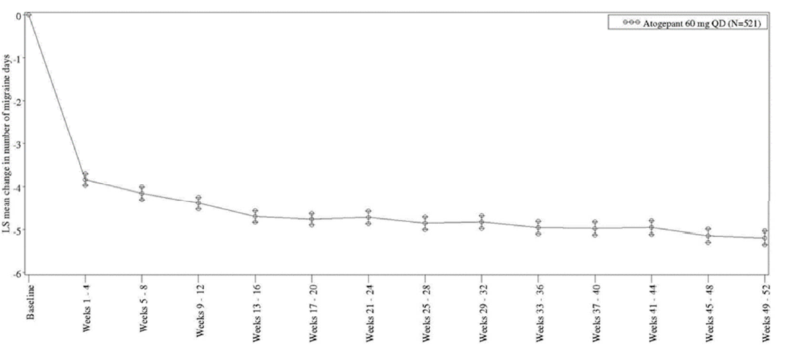

LS = least squares; mITT = modified intent-to-treat; MMRM = mixed-effects model for repeated measures; QD = once daily; SE = standard error.

**Chronic migraine**

Studies 3101-306-002 and 3101-312-002 are ongoing open-label, long-term extension studies of atogepant for the preventive treatment of migraine. To provide additional data and to characterize the long-term efficacy in subjects with CM, the sponsor evaluated the time course of efficacy in CM subjects in lead-in Study 3101-303-002 and the above-mentioned extension studies with a cutoff date of 11 October 2022. An overall summary of the main efficacy findings of each study is provided below.

**Long-Term Efficacy Evaluation for Study 3101-306-002**

Study 3101-306-002 is a 52-week, open-label, safety extension to Study 3101-303-002 in subjects with CM in Japan. Study 3101-303-002 completers, if eligible, rolled over to Study 3101-306-002 at Visit 7 (Week 12) of Study 3101-303-002, which also served as Visit 1 for Study 3101-306-002, and started taking open-label atogepant 60 mg QD the day after enrolment. Throughout Study 3101-306-002, subjects were completing a daily electronic diary (eDiary) about headache duration, severity, and symptoms that had a similar structure as the eDiary in Study 3101-303-002, that enabled the sponsor to analyse the maintenance of efficacy after the initial 12-week treatment up to an additional 52 weeks.

Study 3101-312-002 in many countries and at many sites, 214 subjects who completed Study 3101-303-002 entered Study 3101-312-002 with a significant gap, and only 71 subjects rolled over at Visit 7 and 39 subjects at Visit 8 of the lead-in study. Subjects in Study 3101-312-002 started taking open-label atogepant 60 mg QD the day after enrolment. In contrast to Study 3101-306-002, the protocol of Study 3101-312-002 does not request continuous but only intermittent collection of daily eDiary data: subjects are requested to complete the eDiary during 3 protocol-specified 4-week periods during the first 52 weeks of the study, specifically between Weeks 13 – 16, Weeks 29 – 32, and Weeks 45 – 48. Thus, the first eDiary efficacy assessment occurs after completing 12 weeks of open-label treatment with atogepant 60 mg QD.

Altogether, 325 completers of lead-in Study 3101-303-002 were screened for Study 3101-312- 002, 324 subjects took at least 1 dose of open-label atogepant 60 mg, and 282 subjects were included into the mITT population at the time of the data cut. Reduction in mean monthly migraine days relative to the lead-in study baseline was observed with atogepant 60 mg QD treatment during the first 4-week assessment period (weeks 13-16) which was maintained up to the last 4-week period (weeks 45-48). The mean change from baseline in monthly migraine days was -10.93 days at Weeks 13-16 and -11.26 days at Weeks 45-48. Similar results were observed in mean monthly headache days and mean monthly acute medication use days.

Figure 3 illustrates the mean (± SE) change from baseline in MMDs by treatment arm in the lead-in Study 3101-303-002 over time during the 52-week, open-label treatment period. Baseline is defined MMDs from the screening and baseline period of the lead-in Study 3101-303-002.

Figure 3. Mean (± SE) Change from Baseline in Monthly Migraine Days by Treatment Arm in the Lead-In Study 3101-303-002 Over Time during the 52 Week Open-Label Treatment Period in Study 3101-312-002

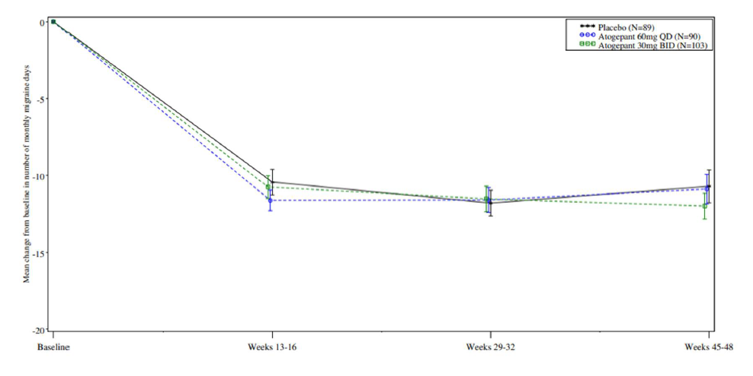

SE = standard error

Based on the analysis of the data of the ongoing long-term studies 3101-306-002 and 3101-312- 002, it can be concluded that the reductions in mean monthly migraine days, mean monthly headache days, and mean monthly acute medication use days relative to lead-in study baseline observed with treatment of atogepant 60 mg QD were sustained in both studies up to 48- or 52-weeks. This demonstrates the persistence of efficacy of atogepant 60 mg QD in participants with CM.

#### Advisory Committee considerations

The [Advisory Committee on Medicines (ACM)](https://www.tga.gov.au/committee/advisory-committee-medicines-acm), having considered the evaluations and the delegate’s overview, as well as the sponsor’s response to these documents, advised the following:

##### Specific advice to the delegate

1. ***Please comment on the sponsor’s proposed dosage regimen for episodic and chronic migraine, in consideration of the evidence from the efficacy data across pivotal studies.***

The ACM noted that the episodic migraine study including 10 mg, 30 mg and 60 mg once daily dosing while the chronic migraine study included 30 mg twice daily and 60 mg once daily dosing. However, only the 10 mg and 60 mg tablets are proposed for registration in Australia. The ACM expressed interest in having the 30 mg tablet made available in Australia as an option for Australian patients.

Within the chronic migraine study the ACM noted that the 30 mg BD dose appeared to demonstrate slightly better efficacy over the 60 mg od dose. The ACM noted that this finding is consistent with the half-life of atogepant however also noted that the study was not designed to compare doses and both doses demonstrated efficacy over placebo. The ACM also acknowledged that a single daily dose (60 mg) is likely to have improved treatment adherence (compared to twice daily dosing) which is important for prophylaxis.

The ACM noted that within the episodic migraine study there was no strong dose effect relationship, with the 10 mg, 30 mg and 60 mg once daily dosing each demonstrating efficacy over the placebo.

On balance, the ACM was satisfied with the proposed dosage regimen of 60 mg once daily for episodic and chronic migraine within the draft PI, however requested that the 30 mg dose be made available within Australia and appropriately incorporated in the dosage regimen within the PI. The ACM advised that the 10 mg dose does not need to be made available for chronic migraine that does not require a dose reduction, as dose related toxicity is not significant.

Dose reductions and modifications will be discussed within the response to question 4.

Please comment on any potential clinical implications from the limited efficacy and safety data in subjects > 65 years of age.

The ACM advised that the prevalence of migraine within adults aged over 65 years remains considerable. Migraine manifestations within this older age group are generally less typical and difficult to define and diagnose. The ACM also noted challenges with comorbidities and drug-drug interactions.

The ACM noted the pharmacokinetic studies show a small increase in exposure with age although this is unlikely to have significant clinical impact.

The ACM noted the lack of a safety signal for vascular events with atogepant and was reassured by this when considering use in this older population.

The ACM agreed there are minimal potential clinical implications for use in this age group given the overall acceptable safety profile, and that the limited efficacy and safety data should not preclude use in this population.

Are there any concerns regarding the lack of long-term safety data for the use of atogepant in subjects with chronic migraine?

The ACM noted the limited number of patients with chronic migraines who were exposed to atogepant for more than 12 months does not meet the EMA guideline to establish long term safety.

The ACM discussed the International Headache Society (HIS) definitions of chronic and episodic migraine and noted that patients with episodic migraine clearly have a chronic condition, and patients with chronic migraine usually have identifiable migraine episodes.

Noting the crossover between chronic and episodic migraine the ACM agreed that it would be appropriate to group the data when considering long term safety. The ACM advised that there are adequate numbers of patients with both episodic and chronic migraine exposed to atogepant for more than 12 months to demonstrate appropriate long-term safety.

The ACM also highlighted that the study is ongoing therefore more data is expected.

Please comment on the drug interaction findings with atogepant and whether further modifications are required for the proposed dosage recommendations, particularly for the use in chronic migraine.

The ACM was of the view that the dose reduction from 60 mg to10 mg is significant and recommended that the 30 mg dose is made available to provide more options for prescribing.

The ACM noted that the PI states the risks of renal impairment however there is some inconsistency with the data and reducing dosing to 10 mg is excessive particularly noting that atogepant is not renally excreted.

Overall, the ACM agreed that having a 30 mg option would be beneficial but given migraine is a chronic non-life-threatening condition, and adherence to prophylaxis is key, 10 or 60 mg daily dosing acceptable.

###### Other advice:

The ACM noted a typographical error in the PI Section 4.5 OATP inducers (2.85-fold and Cmax by 2.23-fold), and no advice was provided for PI CYP3A4 inducers.

Overall, the ACM recommended the approval of atogepant and to ensure the indication wording is consistent with other registered medications indicated for prophylaxis of migraine.

#### ACM Conclusion

The ACM considered this product to have an overall positive benefit-risk profile for the sponsor’s proposed indication.

## Outcome

Based on a review of quality, safety, and efficacy, the TGA decided to register AQUIPTA (atogepant):

AQUIPTA is indicated for prophylaxis of migraine in adults who have at least four

migraine days per month.

## Attachment 1. Product Information

The [Product Information](https://www.tga.gov.au/products/australian-register-therapeutic-goods-artg/product-information-one) ([PI](https://www.tga.gov.au/products/australian-register-therapeutic-goods-artg/product-information-one)) approved with the submission for AQUIPTA which is described in this AusPAR can be found as an additional link on the AQUIPTA AusPAR web page. It may have been superseded. For the most recent PI and [Consumer Medicines Information](https://www.tga.gov.au/products/australian-register-therapeutic-goods-artg/consumer-medicines-information-cmi) (CMI), please refer to the TGA [PI/CMI search facility.](https://www.tga.gov.au/picmi-search-facility)

|  |
| --- |
| Therapeutic Goods Administration |
| PO Box 100 Woden ACT 2606 Australia  Email: [info@tga.gov.au](mailto:info@tga.gov.au) Phone: 1800 020 653 Fax: 02 6203 1605  [**https://www.tga.gov.au**](https://www.tga.gov.au) |
| Reference/Publication # |

1. Ferrari, M.D., et al., Migraine. Nat Rev Dis Primers, 2022. 8(1)
2. Ashina, M., Migraine. N Engl J Med, 2020. 383(19): p. 1866-1876.
3. Iyengar, S., et al., CGRP and the Trigeminal System in Migraine. Headache, 2019. 59(5): p. 659-681.
4. Pellesi, L., S. Guerzoni, and L.A. Pini, Spotlight on Anti-CGRP Monoclonal Antibodies in Migraine: The Clinical Evidence to Date. Clin Pharmacol Drug Dev, 2017. 6(6): p. 534-547.
5. (Rashid A, Manghi A. Calcitonin Gene-Related Peptide Receptor. [Updated 2022 Jul 12]. In: StatPearls [Internet]. Treasure Island (FL): StatPearls Publishing; 2022 Jan
6. In this report the ‘delegate’ is the delegate of the Secretary of the Department of Health and Aged Care who decided the submission under section 25 of the Act.