|  |
| --- |
| Australian Public Assessment Report for NUVAXOVID |
| Active ingredient: SARS-CoV-2 rS (NVX‑CoV2373) |
| Sponsor: Biocelect Pty Ltd |
| February 2024 |

About the Therapeutic Goods Administration (TGA)

* The Therapeutic Goods Administration (TGA) is part of the Australian Government Department of Health and Aged Care and is responsible for regulating therapeutic goods, including medicines, medical devices, and biologicals.
* The TGA administers the *Therapeutic Goods Act 1989* (the Act), applying a risk management approach designed to ensure therapeutic goods supplied in Australia meet acceptable standards of quality, safety, and efficacy.
* The work of the TGA is based on applying scientific and clinical expertise to decision-making, to ensure that the benefits to the Australian public outweigh any risks associated with the use of therapeutic goods.
* The TGA relies on the public, healthcare professionals and industry to report problems with therapeutic goods. The TGA investigates reports received to determine any necessary regulatory action.
* To report a problem with a therapeutic good, please see the information on the [TGA website](https://www.tga.gov.au/).

About AusPARs

* The Australian Public Assessment Report (AusPAR) provides information about the evaluation of a prescription medicine and the considerations that led the TGA to approve or not approve a prescription medicine submission. Further information can be found in [Australian Public Assessment Report (AusPAR) guidance](https://www.tga.gov.au/australian-public-assessment-report-auspar-guidance).
* AusPARs are prepared and published by the TGA.
* AusPARs are static documents that provide information that relates to a submission at a particular point in time. The publication of an AusPAR is an important part of the transparency of the TGA’s decision-making process.
* A new AusPAR may be provided to reflect changes to indications or major variations to a prescription medicine subject to evaluation by the TGA.

Copyright

© Commonwealth of Australia 2024  
This work is copyright. You may reproduce the whole or part of this work in unaltered form for your own personal use or, if you are part of an organisation, for internal use within your organisation, but only if you or your organisation do not use the reproduction for any commercial purpose and retain this copyright notice and all disclaimer notices as part of that reproduction. Apart from rights to use as permitted by the *Copyright Act 1968* or allowed by this copyright notice, all other rights are reserved and you are not allowed to reproduce the whole or any part of this work in any way (electronic or otherwise) without first being given specific written permission from the Commonwealth to do so. Requests and inquiries concerning reproduction and rights are to be sent to the TGA Copyright Officer, Therapeutic Goods Administration, PO Box 100, Woden ACT 2606 or emailed to <[tga.copyright@tga.gov.au](mailto:tga.copyright@tga.gov.au)>.

Contents

List of abbreviations 4

Product submission 5

Submission details 5

Product background 6

The disease/condition 6

Current treatment options 7

Clinical rationale 7

Regulatory status 8

Australian regulatory status 8

Foreign regulatory status 8

Registration timeline 8

Submission overview and risk/benefit assessment 9

Quality 9

Nonclinical 9

Clinical 10

Summary of clinical studies 10

Immunogenicity 10

Clinical efficacy 16

Clinical safety 16

Risk management plan 19

Risk-benefit analysis 21

Delegate’s considerations 21

Proposed action 22

Advisory Committee considerations 22

Outcome 24

Specific conditions of registration applying to these goods 24

Attachment 1. Product Information 24

## List of abbreviations

|  |  |
| --- | --- |
| Abbreviation | Meaning |
| ACV | Advisory Committee on Vaccines |
| ASA | Australia-specific annex |
| ATAGI | Australian Technical Advisory Group on Immunisation |
| CI | Confidence interval |
| CMI | Consumer Medicines Information |
| COVID-19 | Coronavirus disease 2019 |
| DLP | Data lock point |
| EU | European Union |
| GMFR | Geometric mean fold rise |
| GMT | Geometric mean titre |
| IgG | Immunoglobulin G |
| MN50 | Microneutralisation at an inhibitory concentration of 50% |
| PI | Product Information |
| PP-IMM | Per-protocol immunogenicity |
| RMP | Risk Management Plan |
| SAE | Serious adverse event |
| SARS-CoV-2 | Severe acute respiratory syndrome coronavirus 2 |
| SCR(s) | Seroconversion rate(s) |
| TGA | Therapeutic Goods Administration |
| USA | United States of America |
| WHO | World Health Organisation |

## Product submission

### Submission details

|  |  |
| --- | --- |
| *Type of submission:* | Major variation (new dosage regimen) |
| *Product name:* | Nuvaxovid |
| *Active ingredient:* | SARS-CoV-2 rS (NVX CoV2373) |
| *Decision:* | Approved |
| *Date of decision:* | 31 January 2024 |
| *Date of entry onto ARTG:* | 7 February 2024 |
| *ARTG number:* | 355139 |
| [*Black Triangle Scheme*](https://www.tga.gov.au/black-triangle-scheme) *for the current submission:* | No |
| *Sponsor’s name and address:* | Biocelect Pty Ltd  Level 29, 66 Goulburn Street  Sydney NSW 2000 |
| *Dose form:* | Suspension for injection |
| *Strength:* | 5 mg/0.5 mL |
| *Container:* | Multidose vial |
| *Pack size:* | 2 and 10 vials |
| *Approved therapeutic use for the current submission:* | *Active immunisation to prevent coronavirus disease 2019 (COVID-19) caused by SARSCoV-2 in individuals 12 years of age and older.*  *The use of this vaccine should be in accordance with official recommendations.* |
| *Route(s) of administration:* | Intramuscular |
| *Dosage:* | **Primary series**  Nuvaxovid is administered intramuscularly as a course of 2 doses of 0.5 mL each. It is recommended that the second dose is to be administered 3 weeks after the first dose, see section  5.1 Pharmacodynamic Properties of the Product Information.  **Additional Dose**  An additional dose of Nuvaxovid (0.5 mL) may be administered intramuscularly at least 6 months after completion of the second dose of the primary series in adults 18 years of age and older and at least 5 months after completion of the second dose of the primary series with Nuvaxovid in adolescents 12 to 17 years of age (Nuvaxovid has provisional approval for this use in adolescents).  The decision when and for whom to implement an additional dose of Nuvaxovid should be made based on available vaccine safety and effectiveness data (see sections 4.8 Adverse Effects and 5.1 Pharmacodynamic Properties of the Product Information), in accordance with official recommendations.  The use of this vaccine should be in accordance with clinical recommendations in Australia, made by ATAGI in the Australian Immunisation Handbook.  For precautions for administering the vaccine, see section 4.4 Special Warnings and Precautions for Use of the Product Information.  For further information regarding dosage, such as dosage modifications to manage adverse reactions, refer to the Product Information. |
| *Pregnancy category:* | B1  Drugs which have been taken by only a limited number of pregnant women and women of childbearing age, without an increase in the frequency of malformation or other direct or indirect harmful effects on the human fetus having been observed.  Studies in animals have not shown evidence of an increased occurrence of fetal damage.  The use of any medicine during pregnancy requires careful consideration of both risks and benefits by the treating health professional. The [pregnancy database](https://www.tga.gov.au/products/medicines/find-information-about-medicine/prescribing-medicines-pregnancy-database) must not be used as the sole basis of decision making in the use of medicines during pregnancy. The TGA does not provide advice on the use of medicines in pregnancy for specific cases. More information is available from [obstetric drug information services](https://www.tga.gov.au/obstetric-drug-information-services) in your state or territory. |

### Product background

This AusPAR describes the submission by Biocelect Pty Ltd (the sponsor) to register Nuvaxovid (SARS-CoV-2 rS (NVX CoV2373)) 5 μg/0.5 mL suspension for injection, multidose vials for the following proposed change in dose regime:[1]

*to vary the Product information (PI) of Nuvaxovid (SARS-CoV-2 rS (NVX-CoV2373)) COVID‑19 vaccine to extend use of the currently approved booster dose to include adolescents 12 to <18 years of age.*

#### The disease/condition

Severe acute respiratory syndrome coronavirus 2 (SARS-CoV-2) has spread rapidly and globally since its emergence, causing coronavirus disease 2019 (COVID-19) disease.

The World Health Organisation (WHO) declared the outbreak to be a public health emergency of international concern on 30 January 2020 and declared the outbreak to be a pandemic on 11 March 2020. On 5 May 2023, the WHO Emergency Committee on COVID-19 advised that COVID-19 no longer fit the definition of a public health emergency of international concern because the disease had become well-established and ongoing. WHO clarifies that, whilst this marks an end to COVID‑19’s status as a global emergency, it does not mean the pandemic is over.[2]

As of 6 October 2023, approximately 769 million confirmed cases and almost 7 million deaths from COVID-19 worldwide had been reported to WHO. In Australia, in the same time period, there have been approximately 11.63 million confirmed cases, over 23,000 deaths.[3]

Long COVID is a multi-system illness characterised by symptoms lasting more than 12 weeks following COVID-19 infection. The Australian Institute of Health and Welfare (AIHW) estimates that long COVID occurs after 5% to 10% of COVID-19 cases and contributed to approximately 10% of the disease burden from COVID-19 in Australia in early 2022. The AIHW reports that receipt of two doses of COVID-19 vaccine is associated with a 13% to 47% lower risk of COVID‑19 symptoms lasting more than 4 weeks.[4]

#### Current treatment options

There are numerous options for treating or reducing the risk of contracting COVID-19 now available in Australia. All available pre-exposure prophylaxis and treatment medications currently have provisional approval.[5] Some COVID-19 vaccines have provisional approval, and some have transitioned to full registration.[6]

Currently approved COVID-19 vaccines in the proposed age group for booster dose include Comirnaty Omicron XBB1.5, Spikevax XBB1.5 and Vaxzevria (provisional).

#### Clinical rationale

Nuvaxovid (NVX-CoV2373) SARS-CoV-2 rS protein (COVID-19) nanoparticle vaccine suspension for injection, is a recombinant spike protein vaccine. It is based on the full length, wild-type SARS-CoV-2 spike glycoprotein (Wuhan-Hu-1 isolate). It is formulated in a sterile, preservative free, aqueous buffered suspension of the SARS-CoV-2 rS protein drug substance that is co‑formulated with Matrix-M1 adjuvant and formulation buffer and presented in a multidose vial containing ten doses. A single human dose of the drug product is 0.5 mL. Recommended storage conditions of the drug product are from 2 °C to 8 °C and the intended route of administration is intramuscular injection.

NVX-CoV2373 induces active immunity to the spike protein of SARS-CoV-2, which is the causative virus of COVID-19. It belongs to WHO anatomical therapeutic chemical (ATC) drug class J07 (vaccines), sub-class J07BX03 (COVID-19 vaccines).

### Regulatory status

#### Australian regulatory status

The product received initial registration in the [Australian Register of Therapeutic Goods](https://www.tga.gov.au/products/australian-register-therapeutic-goods-artg) ([ARTG](https://www.tga.gov.au/products/australian-register-therapeutic-goods-artg)) on 19 January 2022. after receiving provisional approval for active immunisation to prevent COVID‑19 for people aged 18 years and over (two dose primary series). Provisional approval for a booster dose for adults (18 years and over) was granted on 9 June 2022. Provisional approval for use as a primary vaccination series for people aged 12 to 17 years was granted on 22 July 2022.

#### Foreign regulatory status

At the time the TGA considered this submission, a similar submission had been considered by other regulatory agencies. The following table summarises these submissions and provides the indications where approved.

Table : International regulatory status at the time of product registration.

|  |  |  |  |
| --- | --- | --- | --- |
| Region | Submission date | Status | Approved indications |
| European Union | 24 February 2023 | Under consideration | Under consideration |
| United States of America | 7 February 2023 | Under consideration | Under consideration |
| United Kingdom | 27 March 2023 | Under consideration | Under consideration |
| Canada | 15 March 2023 | Under consideration | Under consideration |
| New Zealand | 27 March 2023 | Under consideration | Under consideration |
| Switzerland | 22 June 2023 | Under consideration | Under consideration |
| Singapore |  | Under consideration | Under consideration |

The sponsor has provided an assurance that the application has not been rejected or deferred by any overseas authorities.

## Registration timeline

The following table captures the key steps and dates for this submission.

This submission was evaluated under the [registration process for COVID-19 vaccines](https://www.tga.gov.au/products/covid-19/covid-19-vaccines/covid-19-vaccine-approval-process).

Table : Timeline for Submission PM-2023-00909-1-2

Data were provided as a rolling submission. Under normal circumstances, TGA's assessment (for both provisional and general registration) begins once all information to support registration is available. As part of the Department of Health and Aged Care's response to the pandemic, the TGA has agreed to accept rolling data for COVID-19 vaccines and treatments, to enable early evaluation of data as it becomes available.

|  |  |
| --- | --- |
| Description | Date |
| Determination (Provisional) | 19 January 2021 |
| Submission dossier accepted and first round evaluation commenced | 3 April 2023 |
| Evaluation completed | 14 November 2023 |
| Delegate’s[7] Overall benefit-risk assessment and request for Advisory Committee advice | 9 November 2023 |
| Sponsor’s pre-Advisory Committee response | 22 November 2023 |
| Advisory Committee meeting | 29 November 2023 |
| Registration decision (Outcome) | 31 January 2024 |
| Administrative activities and registration in the ARTG completed | 7 February 2024 |
| Number of working days from submission dossier acceptance to registration decision* | 205 |

*Statutory timeframe for standard submissions is 255 working days

## Submission overview and risk/benefit assessment

A summary of the TGA’s assessment for this submission is provided below.

### Quality

Quality evaluation is not required for this submission as there are no proposed changes to the quality of the currently approved product in Australia. The quality of the currently approved product is suitable for the proposed changes in this submission. A full quality evaluation was conducted at the time this product received initial registration.[8]

### Nonclinical

No new nonclinical data or further nonclinical evaluation were required for this submission. The TGA considers that previously submitted and evaluated data satisfactorily address nonclinical aspects of safety/efficacy relating to this submission.[9]

### Clinical

#### Summary of clinical studies

The clinical dossier consisted of:

* Study 2019nCoV-311 Part I – a Phase III, randomised, observer blinded study to evaluate the safety and immunogenicity of a single dose of Omicron BA.1 subvariant (NVXCoV2515) and bivalent SARS in adult subjects 18 to 65 years of age.
* Study 2019nCoV-311 Part II – a Phase III, randomised, observer blinded study to evaluate the safety and immunogenicity of two doses of Omicron BA.5 subvariant (NVX-CoV2540) vaccine and bivalent vaccine (NVX-CoV2540 and NVXCoV2373), given 90 days apart, in adults who were vaccinated with three or more doses of COVID-19 mRNA vaccines administered 90 days or more previously.

Clinical data to support the use of Nuvaxovid as a booster (homologous) was provided from Study 2019nCoV-301 (adolescent booster report). As clinical Study 2019nCoV-311 is ongoing the interim report was provided with the submission.

#### Immunogenicity

The sponsor submitted the immunogenicity data generated from Study 2019nCoV-301 adolescent booster study.

##### Dose finding

No dose finding study was conducted for the use of Nuvaxovid as an adolescent booster. A single dose of open label active vaccine (SARS-CoV-2 rS (5 μg) + Matrix-M1 adjuvant (50 μg) in 0.5 mL administered intramuscularly) no less than 5 months after completion of active vaccination.

##### Immunogenicity outcomes

###### Study 2019nCoV-301

Study 2019nCoV-301 (adolescent booster interim report) provides data to support the proposed booster indication.

Study 2019nCoV-301 is a Phase III, ongoing, randomised, observer blinded, placebo controlled study to evaluate the efficacy, safety, and immunogenicity of Nuvaxovid in adult participants 18 years or older with a paediatric expansion in adolescents (12 to less than 18 years).

The open label single dose booster vaccination period of the paediatric expansion was initiated on 04 April 2022 and completed enrolment on 12 May 2022, at 58 sites in the United States of America (USA).

**Objectives and endpoints**

Table 3: Study 2019nCoV-301 adolescent booster objectives and endpoints

| **Post Boost Objectives:** | **Post Boost Endpoints:** |
| --- | --- |
| **Immunogenicity** | |
| * To describe the humoral immune response at 28 days after the third (booster) vaccine dose in terms of neutralizing antibody to SARS-CoV-2 for all Immunogenicity Population participants, and for subsets with and without prior SARS-CoV-2 exposure determined by detectable pre-third (booster) vaccine dose anti-NP antibodies. * To assess the immune response at 28 days after the third (booster) vaccine dose by IgG antibody to SARS-CoV-2 S protein and hACE2 inhibition titers in all Immunogenicity Population participants, and for subsets with and without pre-dose SARS-CoV-2 exposure determined by detectable anti-NP antibodies * To assess the level of humoral immune response following the third (booster) vaccine dose in comparison to that after completion of the initial active Novavax vaccination series | * Neutralizing antibody titers, serum levels of IgG to SARS-CoV-2 S protein and hACE2 inhibition titers from Immunogenicity Population participants immediately prior to and at 28 days after administration of the third (booster) vaccine dose * Positive anti-NP antibody titers at any pre-specified time point following the third (booster) vaccine dose in participants with no intervening symptoms of COVID-19 * Immune response by neutralizing antibody titer and IgG antibody to SARS-CoV-2 rS protein and by hACE2 inhibition titers compared in the same participants at 28 days after a single booster dose and 14 days after the second dose of NVX-CoV2373. |
| **Safety** | |
| * To describe the safety experience for the vaccine in adolescent participants based on solicited short-term reactogenicity by toxicity grade for 7 days following the third (booster) vaccine dose. * To assess overall safety through 28 days after the third (booster) vaccine dose. * To assess the frequency and severity of MAAEs attributed to vaccine, AESIs or SAEs through Eos. * To assess all-cause mortality after a third (booster) vaccine dose. | * Reactogenicity incidence and severity (mild, moderate, or severe) recorded by all participants on their electronic patient-reported outcome diary application (eDiary)on the day of the third (booster) vaccination and subsequent 6 days. * Incidence and severity of unsolicited AEs through 28 days after the third (booster) vaccine dose. * Incidence and severity of MAAEs attributed to study vaccine SAEs and AESIs. * Death due to any cause. |

Abbreviations: AE = adverse event, AESI = adverse event of special interest, COVID-19 = coronavirus disease 2019, e‑Diary = electronic patient-reported outcome diary, hACE2 = human angiotensin-converting enzyme 2, IgG = immunoglobulin G, MAAE = medically attended adverse event, NIH = National Institutes of Health, NP = nucleoprotein, PCR = polymerase chain reaction, rS = recombinant spike (protein), SAE = serious adverse event, SARS-CoV-2 = severe acute respiratory syndrome coronavirus 2, SARS-CoV-2 rS = severe acute respiratory syndrome coronavirus 2 recombinant spike protein nanoparticle vaccine.

**Sample size**

The sample size is based on providing at least 90% power to conclude non-inferiority on microneutralisation at an inhibitory concentration of 50% (MN50) titres given the null hypothesis of geometric mean fold rise (GMFR) (geometric mean titre (GMT) booster (GMTbooster)/GMTD35) 1.0 or less.

Table : Summary of sample sizes required to provide at least 90% power to conclude non-inferiority

|  |  |
| --- | --- |
| GMFR | N |
| 1.1 | 2136 |
| 1.2 | 586 |
| 1.3 | 284 |
| 1.4 | 174 |
| 1.5 | 120 |

Abbreviations: GMFR = geometric mean fold rise for the ratio GMTbooster/GMTD35, GMT = geometric mean titre, N = number of participants.

Source: Table 1, Statistical Analysis Plan (SAP) Immune Response and Safety of Adolescents 28 Days Post Booster Dose Version: Final 2.1; Nov 3, 2022.

Participant flow

Figure : Study design of three periods of pre-crossover (initial), crossover, and booster vaccination periods

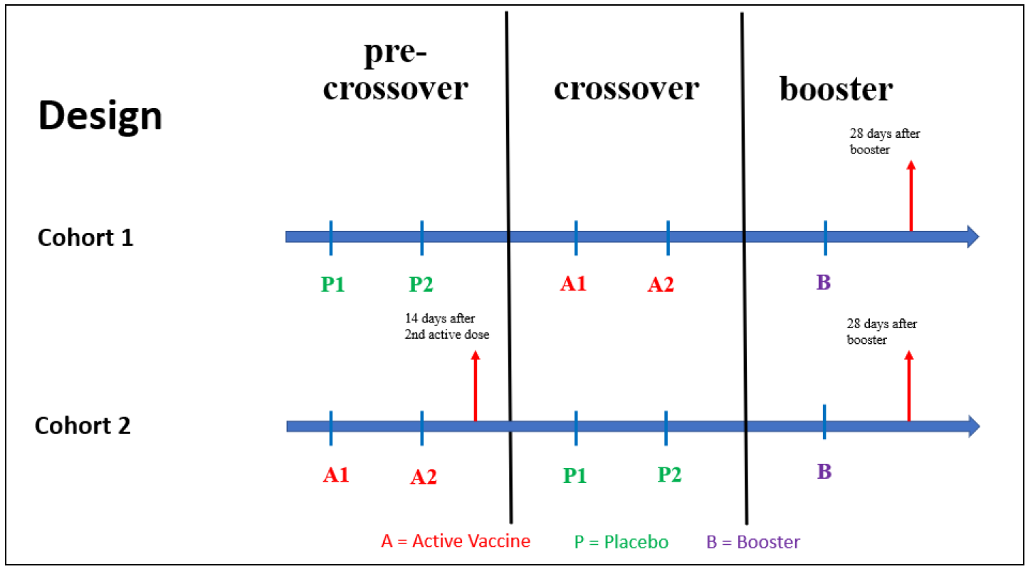

Abbreviations: A1 = first dose of NVX-CoV2373, A2 = second dose of NVX-CoV2373, B = booster dose, NVX‑CoV2373 = Nuvaxovid, P1 = first dose of placebo, P2 = second dose of placebo, SARS-CoV-2 rS = severe acute respiratory syndrome coronavirus 2 recombinant spike protein nanoparticle vaccine.

Note: Vertical arrow represents collection of a blood sample for immunogenicity

Source: Figure 1, Study 2019nCoV-301: Adolescent Booster Report

**Major protocol violations/deviations**

A total of 28 (25.5%) adolescent participants in Cohort 2 had at least one protocol deviation through 28 days after the third (booster) dose of NVX-CoV2373, with 16 (14.5%) having major deviations and 16 (14.5%) having minor deviations. Twelve of the 16 major protocol deviations were due to missing procedures/tests, four were issues with the informed consent form, and one adolescent participant had a protocol deviation (laboratory not done) leading to exclusion from the ad-hoc per-protocol immunogenicity (PP-IMM) analysis set.

**Baseline data**

Table : Ad-hoc booster analysis sets in the paediatric expansion

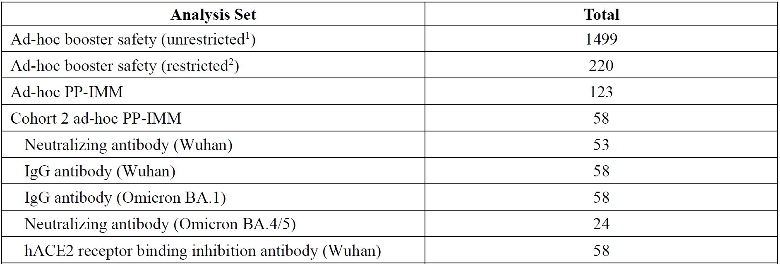

Abbreviations: hACE2 = human angiotensin-converting enzyme 2, IgG = immunoglobulin G, PP-IMM = per-protocol immunogenicity.

1. The unrestricted ad-hoc booster safety analysis set comprised safety data (MAAEs, SAEs, AESIs, and AEs resulting in study discontinuation) on all 1,499 participants who received booster vaccination in the paediatric expansion through the data extraction date of 07 September 2022.

2. The restricted ad-hoc booster safety analysis set comprised safety data (cleaned) on the 220 participants in the ad‑hoc PP-IMM analysis set through the data cut date of 16 June 2022.

Source: Table 6, Protocol 2019nCoV-301: Adolescent Booster Report

**Baseline Characteristics**

The mean age was 14 years and majority of participants were White. More than 98% were negative for anti-nucleo protein/polymerase chain reaction (PCR).

Table : Demographic and baseline characteristics of the Cohort 2 ad-hoc booster per‑protocol immunogenicity analysis set

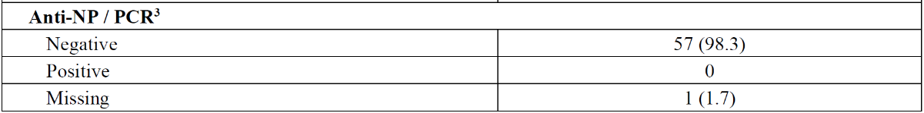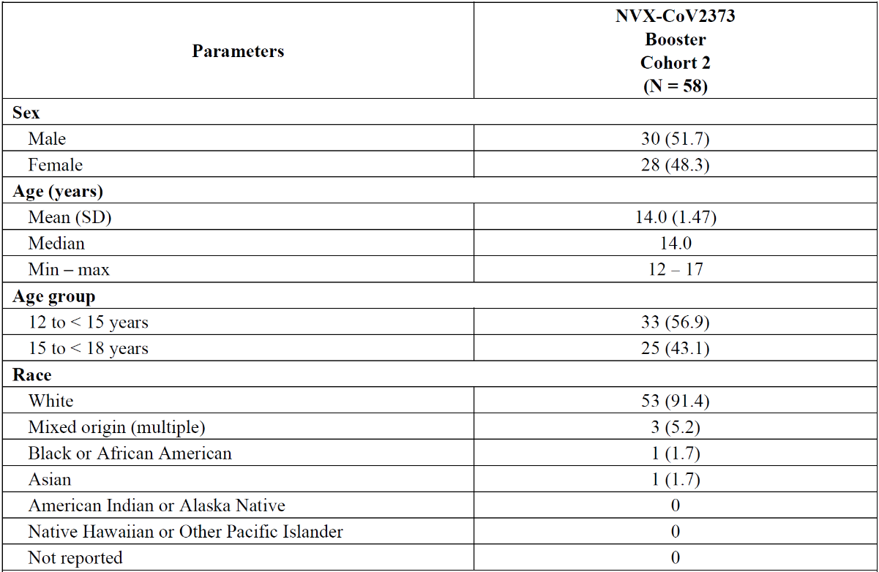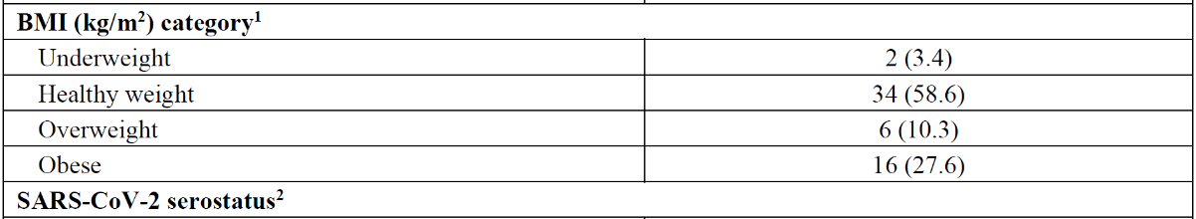

Abbreviations: BMI = body mass index, NP = nucleoprotein, PCR = polymerase chain reaction, NVX‑CoV2373 = Nuvaxovid, SARS-CoV-2 = severe acute respiratory syndrome coronavirus 2, SD = standard deviation.

1. BMI was classified as follows (using gender and age specific percentiles): Underweight = participants less than the 5th percentile; Healthy weight = participants within the 5th percentile and up to the 85th percentile; Overweight = participants within the 85th percentile to less than the 95th percentile; Obesity = participants equal to or greater than the 95th percentile. Percentiles are assigned via Centers for Disease Control and Prevention reference data and cdc‑source-code.sas.

2. SARS-CoV-2 serostatus is presented for baseline corresponding to booster dose.

3. Participants with either positive anti-NP or positive PCR are reported as positive. Participants with both negative anti-NP and negative PCR are reported as negative.

Note: Values are presented as n (%) unless otherwise specified.

Source: Adapted from Table 10, Protocol 2019nCoV-301: Adolescent Booster Report

**Results for the immunogenicity non-inferiority outcomes.**

In the Cohort 2 ad-hoc booster PP-IMM analysis set, non-inferiority was achieved for geometric mean fold rises (GMFRs) and for the differences in seroconversion rates (SCRs)using the baseline of the first dose of Nuvaxovid (See Table 7 and Table 8).

Table : Comparison of neutralising antibody titres (MN50) against SARS-CoV-2 wild-type virus (ancestral Wuhan strain) at 28 days after the third (booster) dose of Nuvaxovid versus at 14 days after the second dose of Nuvaxovid (primary series) in the Cohort 2 ad‑hoc booster per-protocol immunogenicity analysis set

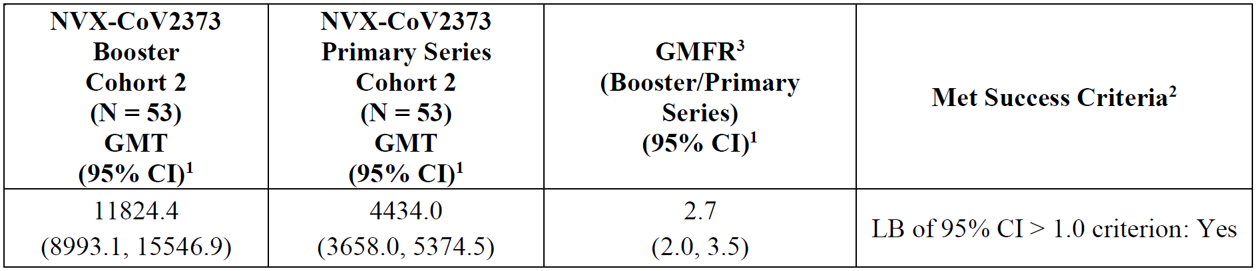

Abbreviations: CI = confidence interval, GMFR = geometric mean fold rise, GMT = geometric mean titre, LB = lower bound, MN50 = microneutralisation assay with an inhibitory concentration of 50%, NVX-CoV2373 = Nuvaxovid, PP‑IMM = per-protocol immunogenicity, SARS-CoV-2 = severe acute respiratory syndrome coronavirus 2.

1. The 95% CI for GMT and GMFR were calculated based on the t-distribution of the log-transformed values, then back transformed to the original scale for presentation.

2. Non-inferiority of the single booster dose of NVX-CoV2373 was achieved if the LB of the 95% CI for the ratio of MN50 GMT at 28 days after a single booster dose versus 14 days after the second dose of NVX-CoV2373 in Cohort 2 was greater than 1.0.

3. GMFR is defined as the GMT ratio of post-boost GMT/post-primary Day 35 GMT.

Note: The median duration between the time of the second dose of NVX-CoV2373 and the time of the third (booster) dose in Cohort 2 was 10.6 months

Table : Seroconversion rates for neutralising antibody titres (MN50) against SARS-CoV-2 wild-type virus (ancestral Wuhan strain) at 28 days after the third (booster) dose of Nuvaxovid relative to the time of the first dose of Nuvaxovid versus at 14 days after the second dose of Nuvaxovid (primary series) relative to the time of the first dose of Nuvaxovid in the Cohort 2 ad-hoc booster per-protocol immunogenicity analysis set

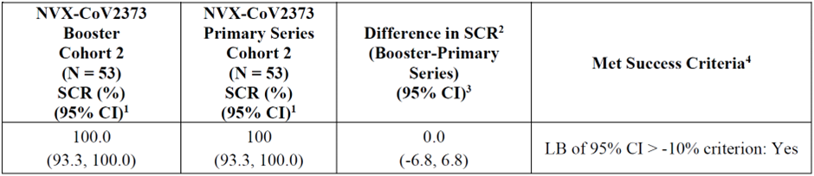Abbreviations: CI = confidence interval, LB = lower bound, MN50 = microneutralisation assay with an inhibitory concentration of 50%, N = number of participants in the assay-specific ad-hoc booster per-protocol immunogenicity analysis set, NVX-CoV2373 = Nuvaxovid, PP-IMM = per-protocol immunogenicity, SARS-CoV-2 = severe acute respiratory syndrome coronavirus, SCR = seroconversion rate.

1. Based on Clopper-Pearson.

2. Comparison between SCR of 28 days post-booster and SCR of 14 days after second dose of NVX-CoV2373.

3. Tango method.

4. Non-inferiority of the single booster dose of NVX-CoV2373 was achieved if the LB of the 95% CI for the difference of the proportion of participants with SCR in MN50 titres at 28 days after a single booster dose versus at 14 days after the second dose of NVX-CoV2373 was greater than -10%.

Note: SCR was defined as the proportion of participants with post-vaccination levels ≥ 4-fold higher than the baseline levels.

Note: The median duration between the time of the second dose of NVX-CoV2373 and the time of the third (booster) dose in Cohort 2 was 10.6 months

Source: Table 12, Protocol 2019nCoV-301: Adolescent Booster Report.

**Results for other immunogenicity outcomes**

Other immunogenicity results have not been formally tested for non-inferiority.

**Serum immunoglobulin G antibody to SARS-CoV-2 spike protein (n = 58)**

The comparison between the immunoglobulin G (IgG) antibody response against the SARS‑CoV‑2 spike protein (ancestral Wuhan strain) at 28 days after the third (booster) dose of NVX-CoV2373 and that reported at 14 days after the second dose of NVX-CoV2373 of the primary vaccination series yielded a GMFR of 2.5 (95% confidence interval (CI): 2.1 to 3.0).

The SCRs for serum IgG antibody against the SARS-CoV-2 spike protein (ancestral Wuhan strain) at 28 days after the third (booster) dose of NVX-CoV2373 and that reported at 14 days after the second dose of NVX-CoV2373 of the primary series, both relative to the first dose of NVX‑CoV2373, were 100% and 100%, respectively. The difference in SCRs was 0% (95% CI: ‑6.2 to 6.2).

**hACE2 receptor binding inhibition titres to SARS-CoV-2 rS (n = 58)**

The comparison between the hACE2 receptor binding inhibition to SARSCoV-2 rS (ancestral Wuhan strain) at 28 days after the third (booster) dose of NVX-CoV2373 and that reported at 14 days after the second dose of NVX-CoV2373 of the primary vaccination series yielded a GMFR of 2.0 (95% CI: 1.7 to 2.5).

The SCRs for hACE2 receptor binding inhibition to SARS-CoV-2 rS (ancestral Wuhan strain) at 28 days after the third (booster) dose of NVX-CoV2373 and that reported at 14 days after the second dose of NVX-CoV2373 of the primary vaccination series, both relative to the first dose of NVX-CoV2373, were 100% and 100%, respectively. The difference between SCRs was 0% (95% CI: -6.2 to 6.2).

**Immune response against emerging (at the time of trial) Omicron variants**

The study plan was modified to include immunogenicity analyses for the Omicron variants. In this paediatric study in adolescents 12 to less than 18 years of age, ad hoc booster analyses of the IgG antibody response to the SARS-CoV-2 spike protein (Omicron BA.1 variant) and of the pseudovirus-based neutralising antibody response to the SARS-CoV-2 spike protein (Omicron BA.4/5 variant) were conducted.

**Omicron BA.1 variant (n = 58)**

The comparison between the IgG antibody response against the SARS-CoV-2 spike protein (Omicron BA.1 variant) at 28 days after the third (booster) dose of NVX-CoV2373 and that reported at 14 days after the second dose of NVX-CoV2373 of the primary vaccination series yielded a GMFR of 8.0 (95% CI: 6.7 to 9.6).

The SCRs for serum IgG antibody against the SARS-CoV-2 spike protein (Omicron BA.1 variant) at 28 days after the third (booster) dose of NVX-CoV2373 and that reported at 14 days after the second dose of NVX-CoV2373 of the primary series, both relative to the first dose of NVX‑CoV2373, were 100% and 100%, respectively. The difference between SCRs was 0% (95% CI: -6.2 to 6.2).

**Omicron BA.4/5 variant (n = 24)**

The comparison between the pseudovirus-based neutralisation antibody titres (inhibitory dilution at a concentration of 50% (ID50)) to SARS-CoV-2 spike protein (Omicron BA.4/5 variant) at 28 days after the third (booster) dose of NVX-CoV2373 and that reported at 14 days after the second dose of NVX-CoV2373 of the primary vaccination series yielded a GMFR of 10.1 (95% CI: 6.7, 15.1).

The SCRs for pseudovirus-based neutralising antibody against SARS-CoV-2 spike protein (Omicron BA.4/5 variant) at 28 days after the third (booster) dose of NVX-CoV2373 relative to the first dose of NVX-CoV2373 and that reported at 14 days after the second dose of NVX‑CoV2373 relative to the first dose of NVX-CoV2373 in the primary vaccination series were 100% and 87.5%, respectively. The difference between SCRs was 12.5% (95% CI: -3.0, 31.0).

#### Clinical efficacy

Clinical efficacy was not assessed in the submitted study.

#### Clinical safety

An ad-hoc analysis was conducted with a subset of 220 participants from 58 sites in the USA who completed the Day 28 booster visit. These participants comprised a restricted data set with a data cut-off date of 16 June 2022; an unrestricted data set included all adolescent participants (N = 1499) who received a booster dose of NVX-CoV2373.[10]

##### Solicited adverse events

There were higher rates of systemic reactions after the booster compared to the data for the two dose primary series, although the differences are small (for example, headache: 63% after primary series versus 68% after booster), and even less prominent in the larger, unrestricted safety data set.

Table : Summary of solicited reactions by maximum toxicity grade 7 days following the third (booster) injection ad-hoc booster safety analysis set (restricted)

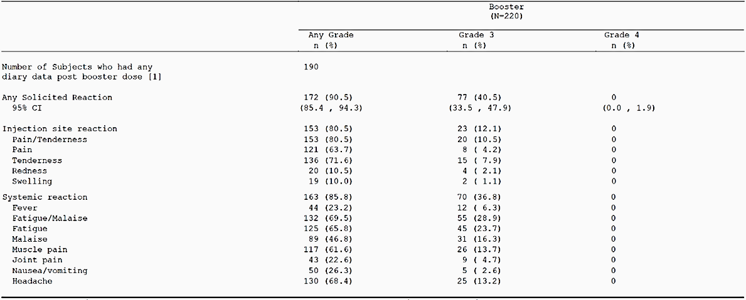n = number of subjects who reported at least one adverse event. [1] = Number of subjects who received the booster dose and completed at least one day of the post-booster dose reactogenicity diary. Percentages are based on n/[1]*100.  
At each level of subject summarisation, a subject is counted once for the most severe grade if the subject reported one or more events. The 95% confidence interval (CI) is based on the exact Clopper-Pearson method.  
Maximum toxicity grading is standardised according to the FDA toxicity grading scale: Grade 1 = mild, Grade 2 = moderate, Grade 3 = severe, Grade 4 = potential life threatening.  
Source: Table 14.3.2.1.1, 7.1 List of Tables, Protocol No.: 2019nCoV-301 paediatric expansion.

Table : Summary of solicited reactions by maximum toxicity grade 7 days following the third (booster) injection ad-hoc booster safety analysis set (unrestricted)

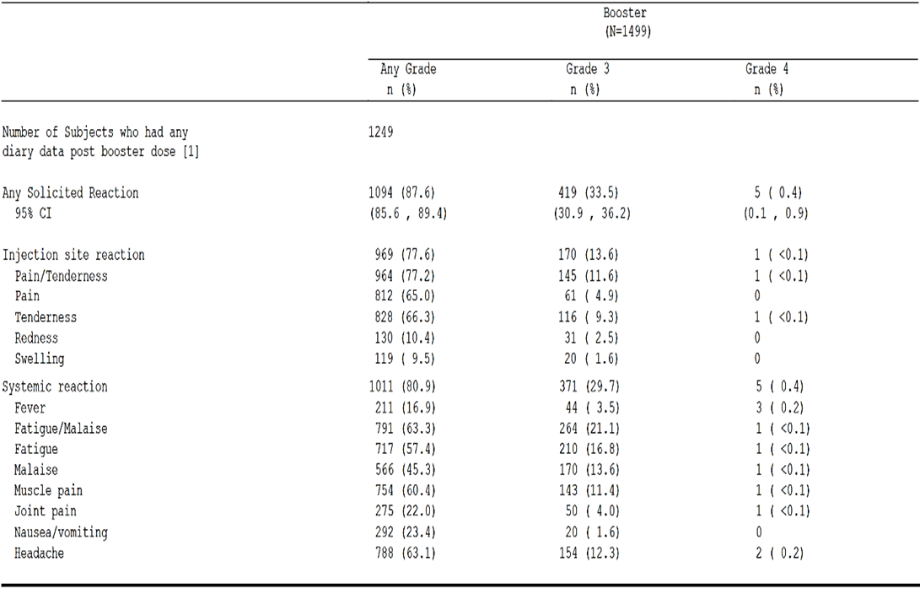

n = Number of subjects who reported at least one adverse event. [1] = Number of subjects who received the booster dose and completed at least one day of the post-booster dose reactogenicity diary.

Percentages are based on n/[1]*100.

At each level of subject summarisation, a subject is counted once for the most severe grade if the subject reported one or more events.

The 95% confidence interval (CI) is based on the exact Clopper-Pearson method. Maximum toxicity grading is standardised according to the FDA toxicity grading scale: Grade 1 = mild, Grade 2 = moderate, Grade 3 = severe, Grade 4 = potential life threatening.

Source: Table 14.3.2.1.1unr, 7.1 List of Tables, Protocol No.: 2019nCoV-301 paediatric expansion.

##### Unsolicited adverse events

Table : Unsolicited adverse events through 28 days after the booster dose of NVX‑CoV2373 in adolescent booster safety analysis set (restricted) by system organ class and preferred term

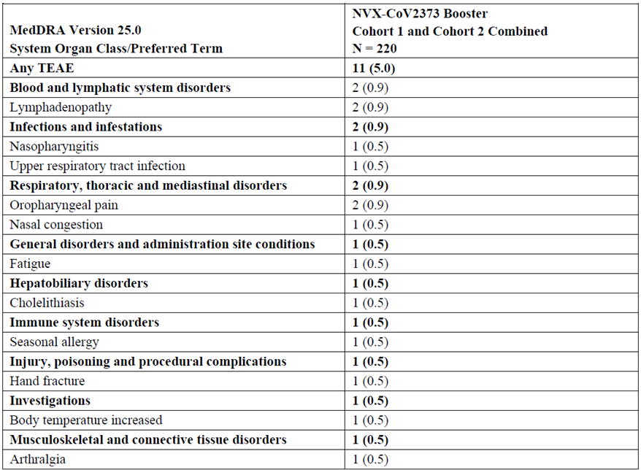

Abbreviations: MedDRA = Medical Dictionary for Regulatory activities, n = number of participants experiencing the TEAE, N = number of participants in the ad-hoc safety analysis set (restricted), NVX-CoV2373 = Nuvaxovid, PT = preferred term, SOC = system organ class, TEAE = treatment-emergent adverse event.

Note: If a participant had multiple TEAEs within the same SOC/PT, the participant was counted only once at the SOC/PT level. Totals for the number of participants at SOC level were not necessarily the sum of those at the PT levels since a participant may have reported 2 or more different TEAEs within the higher-level category.

Note: The median duration between the time of the second dose of NVX-CoV2373 and the time of the third (booster) dose was 7.7 months in Cohort 1 and 10.6 months in Cohort 2 and 9.0 months for Cohort 1 and Cohort 2 combined. Note: Values are presented as n (%); percentages are based on n/1 × 100.

Source: Table 32, Protocol 2019nCoV-301: Adolescent Booster Report

In the unrestricted safety group (n = 1499), there were 77 (5.1%) unsolicited adverse events. The most frequent events by preferred term were lymphadenopathy (n = 6; 0.4%), COVID-19 infection (n = 5; 0.3%), and viral infection (n = 4; 0.3%).

##### Treatment-related adverse events (adverse drug reactions)

In the unrestricted safety analysis set (n = 1499), there were 20 (1.3%) treatment-related unsolicited adverse events. The most frequent events by preferred term were lymphadenopathy (n = 5; 0.3%), headache (n = 3; 0.2%), and tachycardia (n = 2; 0.1%).

Table : Summary of treatment-related unsolicited adverse events by system organ class, preferred term through 28 days following the third (booster) injection, ad-hoc booster safety analysis set (restricted)

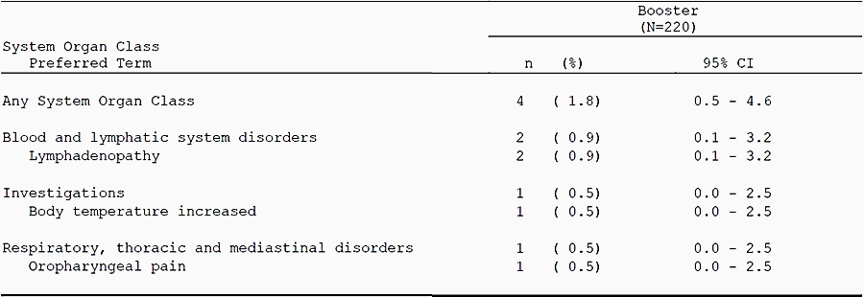

n = unique number of subjects experiencing the adverse event. N = number of subjects in ad-hoc booster safety analysis set.

The 95% CI = Exact Binomial Confidence Interval using the Clopper-Pearson method.

Percentages are based on n/N*100.

Adverse Events coded using MedDRA version 25.0.

If a subject has multiple adverse events within the same system organ class (SOC)/preferred term (PT), the subject is counted only once at the SOC/PT level.

Totals for the number of subjects at SOC level are not necessarily the sum of those at the PT levels since a subject may report two or more different adverse events within the higher level category.

Source: Table 14.3.4.5.1, 7.1 List of Tables, Protocol No.: 2019nCoV-301 paediatric expansion.

##### Deaths and other serious adverse events

No adolescent participant died through 28 days following the third (booster) dose of Nuvaxovid in either the restricted or unrestricted safety analysis sets.

There was one serious adverse event (SAE) in the restricted safety analysis set, which is a rate of 0.5%. The SAE was assessed by both the investigator and sponsor as not related to study vaccine.

Among the 1499 adolescent participants that comprised the unrestricted safety population, there were two reported SAEs (0.1%). Both of these SAEs were assessed by the investigator and sponsor as not related to study vaccine. Briefly, a participant reported a SAE of Type II diabetes on 22 April 2022 (Day 4). The event was downgraded to non-serious but remained ongoing as of 25 April 2022 (Day 7). Another participant reported a SAE of suicide attempt on 16 May 2022 (Day 10) that resolved on 26 May 2022 (Day 20).

##### Discontinuations due to adverse events

No adolescent participant in the restricted safety data set had a treatment emergent adverse event leading to study discontinuation through 28 days following the third (booster) dose of Nuvaxovid.

### Risk management plan

The most recently reviewed European Union (EU) risk management plan (RMP) was version 2.1 (dated 1 September 2022; data lock point (DLP) 31 July 2022) and Australia-specific annex (ASA) version 1.6 (dated 14 October 2022), through the updated RMP pathway. In support of the current application, the sponsor has submitted EU-RMP version 3.1 (dated 6 February 2023; DLP 22 December 2022) and ASA version 1.7 (dated 20 March 2023).

The summary of safety concerns and their associated risk monitoring and mitigation strategies are presented in Table 13. The TGA may request an updated RMP at any stage of a product's life cycle, during both the pre-approval and post-approval phases.

Table : Summary of safety concerns

|  |  |  |  |  |  |
| --- | --- | --- | --- | --- | --- |
| Summary of safety concerns | | Pharmacovigilance | | Risk Minimisation | |
| Routine | Additional | Routine | Additional |
| **Important identified risks** | Myocarditis and/ or pericarditis | ✓1 | ✓2,3 | ✓ | – |
| **Important potential risks** | Vaccine-associated enhanced disease (VAED), including vaccine associated enhanced  respiratory disease (VAERD) | ✓1 | ✓2,3 | – | – |
| **Missing information** | Use in pregnancy and while breastfeeding | ✓ | ✓2,3,4 | ✓ | – |
| Use in immunocompromised patients | ✓ | ✓2,3 | ✓ | – |
| Use in frail patients with comorbidities (e.g., chronic obstructive pulmonary disease (COPD), diabetes, chronic Neurological disease, cardiovascular disorders) | ✓ | ✓2,3 | – | – |
| Use in patients with autoimmune or inflammatory disorders | ✓ | ✓2,3 | ✓ | – |
| Interactions with other vaccines | ✓ | ✓2,3 | ✓ | – |
| Long term safety | ✓ | ✓2,3 | – | – |

1 Targeted follow-up questionnaires

2 Post authorisation safety study (PASS) in UK and US

3 Clinical trials

4 Global safety surveillance study (pregnancy and infant outcome) using pregnancy registry (GSSS)

The RMP evaluation recommended conditions of registration relating to the versions of the risk management plan.

The sponsor has not proposed any changes to the summary of safety concerns and states that no new risks have been identified in relation to the proposed changes to the Product Information (PI). The summary of safety concerns was previously accepted and continues to be acceptable from an RMP perspective.

The sponsor has not proposed changes to the overall, previously accepted, pharmacovigilance plan. There are minor changes to the clinical study report submission dates and addition of secondary objectives. The pharmacovigilance plan continues to be acceptable.

Only routine risk minimisation measures have been proposed by the sponsor. This is in line with the other COVID-19 vaccines approved by the TGA and continues to be acceptable.

### Risk-benefit analysis

#### Delegate’s considerations

##### Overview

This submission was to include the adolescent population (12 to 18 years) for the Nuvaxovid booster dose. Detailed data on immunogenicity and safety profiles by vaccine type are valuable to make informed decisions on booster regimens, alongside considerations of vaccine availability and population primary vaccine course regimens. Study 2019nCoV-301 (Part2) provides important insight regarding this.

##### Public health need

There is a need for homologous booster for the of Australian adolescent population, who have received (or going to receive) Nuvaxovid as the primary series vaccination.

##### Immunogenicity

Study 2019nCoV-301 (adolescent booster), an open label extension to an ongoing Phase III, multicentre, randomised, observer blinded, placebo-controlled study, provides the interim immunogenicity results for a booster dose of Nuvaxovid in adolescents aged 12 to 18 years old. The number of analysed participants was between 24 and 58 depending on the subset of the Cohort 2 ad-hoc booster per-protocol immunogenicity (PP-IMM) analysis set. Non-inferiority was measured by the lower bound of the 95% CI for the ratio of the geometric mean fold rise (GMFR) of the neutralising antibody geometric mean titre (GMT) 28 days after a single booster dose versus 14 days after the second active dose being greater than 1.0. Non-inferiority was also measured by the lower bound of the 95% CI for the difference of proportion of participants with seroconversion in microneutralisation assay with an inhibitory concentration of 50%, (MN50) titres 28 days after a single booster dose relative to the time of the first active dose versus 14 days after second active dose relative to the time of the first active dose being greater than ‑10%. Pre-specified non‑inferiority margins were demonstrated for GMFR (lower bound of 95% CI: 2.0) and difference in seroconversion proportions (lower bound of 95% CI: -6.8) (n = 53).

The immune responses to Omicron variants BA.1 and BA.4/5) also appeared reassuring. No immunogenicity is provided for currently circulating Omicron subvariants.

The study population was limited to participants deemed to be healthy, with no unstable chronic condition or the immunocompromised. This may limit external validity because the population of Australian adolescents receiving a booster dose of Nuvaxovid (if approved) is likely to include those with unstable chronic conditions or the immunocompromised.

No information about the durability of the immune response to booster vaccination has been provided.

##### Efficacy

Clinical efficacy was not assessed in the submitted study (Study 2019nCoV-301-part-2).

##### Safety

The safety profile of a third dose of Nuvaxovid among adolescents aged 12 to 18 years does not appear to meaningfully differ from the established safety profile of Nuvaxovid in this age group. However, the number of participants in the cleaned (‘restricted’) safety analysis set is relatively small and duration of safety follow-up is limited.

The study population was limited to participants deemed to be healthy, with no unstable chronic condition or the immunocompromised. This may limit external validity because the population of Australian adolescents receiving a booster dose of Nuvaxovid (if approved) is likely to include those with unstable chronic conditions or the immunocompromised.

Due to the small sample size of the safety group, it is not possible for it to be sufficiently powered to detect rare adverse outcomes.

As mentioned in the exclusion criteria, the study excluded those with certain conditions including significant medical comorbidities. As a result, no safety data is available for these individuals. The safety assessment was performed in relatively healthy individuals, which may underestimate the overall risk associated with the booster vaccines tested.

The sponsor provided a summary of 6 month booster safety data, which reported one related serious adverse event (myocarditis) during the post-crossover vaccination period (two days after the second dose). No related serious adverse events were reported during the pre‑crossover and booster vaccination periods.

##### Overall data limitations

* Immunogenicity data from booster dose against the Omicron sub-variants is only available for BA.1 and BA.4/5(not for XBB1.5 and after).
* Data related to persistence of immune response was not available in the submitted study.
* Safety sample size (restricted group) was small.
* Lack of safety and immunogenicity data in immunocompromised patients or patients with background autoimmune disease.
* Short-term safety data, which may not provide information on rare adverse events, risk of vaccine-associated enhanced disease or vaccine-associated enhanced respiratory disease as the antibodies wane over time, and there may be adverse events that have a long latency period including adverse events of special interest.
* Data on vaccine efficacy of the booster are lacking. Booster efficacy in the real world cannot be extrapolated with certainty, especially in view of currently circulating Omicron variant and its subvariants.

#### Proposed action

Based on the acceptable immunogenicity and safety demonstrated by the submitted data, and the existing public health need, the Delegate is of the view that provisional approval for Nuvaxovid to be used as homologous booster (primed with Nuvaxovid) in 12 to 18 year olds is appropriate. However, there are issues raised in this overview, which will be discussed with the Advisory Committee on Vaccines (ACV) and a final decision will be taken only after that.

#### Advisory Committee considerations

The [Advisory Committee on Vaccines (ACV)](https://www.tga.gov.au/committee/advisory-committee-vaccines-acv), having considered the evaluations and the Delegate’s overview, as well as the sponsor’s response to these documents, advised the following.

##### Specific advice to the Delegate

1. ***Based on the overall evidence from the Study 2019nCoV-301 (adolescent booster report), can the ACV advise if the benefits-risks balance of Nuvaxovid as a booster in individuals 12 to 17 years of age, is positive in the current COVID-19 situations?***

Study 2019nCoV-301 (adolescent booster report) showed that non-inferiority was achieved for geometric mean fold rises in neutralising antibody titres and for the differences in seroconversion rates against the baseline of the first dose of Nuvaxovid. No safety concerns emerged with homologous booster doses and adverse events were mostly mild or moderate reactogenicity reactions of short duration.

The ACV advised that the immunogenicity and safety data available indicate that the benefits outweigh the risks, specifically, the need to have this vaccine available to use as a booster dose in individuals aged 12 to 17 years outweighs the data limitations.

Limitations of the trial include:

* the small sample size and short duration of follow-up to Day 28 following the booster dose.
* only healthy individuals were in the trial. Current Australian Technical Advisory Group on Immunisation (ATAGI) advice is that a booster dose is not recommended for children and adolescents aged under the age of 18 who do not have risk factors (those with a medical condition that increases the risk of severe COVID-19 illness or those with disability with significant or complex health needs or multiple comorbidities which increase the risk of poor outcomes from COVID-19).[11]
* there are no data on immunogenicity against current SARS-CoV-2 circulating variants of concern (see Question 2).
* there are no data on co-administration with other vaccines administered to adolescents, including medically at-risk adolescents.

Nuvaxovid has been shown to induce a comparable immune response and effectiveness after the primary series in adolescents as in adults, and the ability to boost the vaccine-induced immune response was shown in adults.

1. ***Does the ACV agree with use of Nuvaxovid as booster dose for the proposed age group, notably in view of absence of immunogenicity data against currently circulating Omicron subvariants (XBB1.5 and later)?***

The ACV agreed with use of the vaccine as the sponsor has provided some immunogenicity data for Omicron variants BA.1 and BA.4/5. Immune responses in adolescents following booster dose showed cross reactivity against BA.1 and BA.4/5.

The ACV noted that the current ATAGI advice is that a monovalent Omicron XBB.1.5 vaccine is preferred as a booster vaccine. Given the USA and European approvals of an adapted vaccine (Nuvaxovid XBB.1.5), the ACV expected that original Nuvaxovid will also be superseded by a submission and potential approval for this variant vaccine in Australia in due course.

1. ***Can the ACV comment if overall safety is acceptable as the sample size was small (restricted group) and the follow-up was only 4 weeks?***

A subset of 220 participants who received the booster dose were evaluated for solicited adverse events within 7 days of vaccination. Most frequent were injection site tenderness (72%), headache (68%), fatigue (66%), injection site pain (64%), muscle pain (62%), malaise (47%), and nausea/vomiting (26%). The small number and short duration studied are insufficient to detect less common/ rare adverse events and for long-term safety. However, the ACV advised that the safety profile for booster among adolescents was acceptable based on extrapolation from the established safety profile of Nuvaxovid in this age group.

The ACV noted that Nuvaxovid has had a higher overall reporting rate of myocarditis than expected in the population in both males and females. The observed versus expected (O/E) analyses are supportive of an association between Nuvaxovid and myocarditis and pericarditis in both males and females. While there has been minimal use of Nuvaxovid in the 12 to 17 year age group (2653 persons recorded in the Australian Immunisation Register at as 31 October 2023), the TGA has received no report of myocarditis/ pericarditis in this age group.

1. ***Can the ACV comment on any specific risk mitigation strategies required for the booster dose?***

The ACV advised that no new safety concerns or risks had been identified for booster dose in adolescents and the current risk management plan continues to be acceptable.

##### Conclusion

The ACV considered this product to have an overall positive benefit-risk profile for the dose and administration information to include an additional dose of Nuvaxovid (0.5 mL) at least 5 months after completion of the second dose of the primary series with Nuvaxovid in adolescents 12 to 17 years of age.

## Outcome

Based on a review of quality, safety, and efficacy, the TGA decided to register Nuvaxovid (SARS‑CoV-2 rS (NVX CoV2373)) 5 μg/0.5 mL suspension for injection, multidose vials, for the following change in dose regime:

*for the use of the currently approved booster dose to include adolescents from 12 to less than 18 years of age*

As such, the full indications at this time were:

*Active immunisation to prevent coronavirus disease 2019 (COVID-19) caused by SARSCoV‑2 in individuals 12 years of age and older.*

The use of this vaccine should be in accordance with official recommendations.

### Specific conditions of registration applying to these goods

* The Nuvaxovid EU risk management plan (RMP) (version 3.1, dated 6 February 2023, data lock point 22 December 2022), with Australia-specific annex (version 1.7, dated 20 March 2023), included with Submission PM-2023-00909-1-2, and any subsequent revisions, as agreed with the TGA will be implemented in Australia.
* The final study report for the adolescent expansion (including adolescent booster) should be submitted to the TGA when it becomes available.

## Attachment 1. Product Information

The [Product Information](https://www.tga.gov.au/products/australian-register-therapeutic-goods-artg/product-information-one) ([PI](https://www.tga.gov.au/products/australian-register-therapeutic-goods-artg/product-information-one)) approved with the submission for Nuvaxovid which is described in this AusPAR can be found as Attachment 1. It may have been superseded. For the most recent PI and [Consumer Medicines Information](https://www.tga.gov.au/products/australian-register-therapeutic-goods-artg/consumer-medicines-information-cmi) (CMI), please refer to the TGA [PI/CMI search facility.](https://www.tga.gov.au/picmi-search-facility)

|  |
| --- |
| Therapeutic Goods Administration |
| PO Box 100 Woden ACT 2606 Australia  Email: [info@tga.gov.au](mailto:info@tga.gov.au) Phone: 1800 020 653 Fax: 02 6203 1605  [**https://www.tga.gov.au**](https://www.tga.gov.au) |
| Reference/Publication # |

1. This is the original indication proposed by the sponsor when the TGA commenced the evaluation of this submission. It may differ to the final indication approved by the TGA and registered in the Australian Register of Therapeutic Goods.
2. <https://www.who.int/europe/emergencies/situations/covid-19>
3. <https://covid19.who.int/region/wpro/country/au>
4. <https://www.aihw.gov.au/reports/covid-19/long-covid-in-australia-a-review-of-the-literature/summary>
5. <https://www.tga.gov.au/products/covid-19/covid-19-treatments/covid-19-treatments-provisional-registrations> Accessed 16 August 2023.
6. <https://www.tga.gov.au/products/covid-19/covid-19-vaccines/covid-19-vaccines-regulatory-status> Accessed 16 August 2023.
7. In this report the ‘Delegate’ is the Delegate of the Secretary of the Department of Health and Aged Care who decided the submission under section 25 of the Act.
8. [Australian Public Assessment Report for SARS-CoV-2 rS with Matrix-M adjuvant (tga.gov.au)](https://www.tga.gov.au/sites/default/files/auspar-sars-cov-2-rs-matrix-m-adjuvant.pdf)
9. [Australian public assessment report for Nuvaxovid (tga.gov.au)](https://www.tga.gov.au/sites/default/files/2023-11/auspar-nuvaxovid-231106.pdf)
10. The term ‘restricted’ refers to all the data cleaned through the data cut-off date, whereas ‘unrestricted’ refers to all data through the date of data extraction (not necessarily all cleaned).
11. [atagi-recommended-covid-19-vaccine-doses.pdf (health.gov.au)](https://www.health.gov.au/sites/default/files/2023-11/atagi-recommended-covid-19-vaccine-doses.pdf) current at 20 November 2023.