|  |
| --- |
| Australian Public Assessment Report for Givlaari |
| Active ingredient: Givosiran (as sodium) |
| Sponsor: Medison Pharma Australia Pty Ltd |
| June 2024 |
|  |

About the Therapeutic Goods Administration (TGA)

* The Therapeutic Goods Administration (TGA) is part of the Australian Government Department of Health and Aged Care and is responsible for regulating therapeutic goods, including medicines, medical devices, and biologicals.
* The TGA administers the *Therapeutic Goods Act 1989* (the Act), applying a risk management approach designed to ensure therapeutic goods supplied in Australia meet acceptable standards of quality, safety, and efficacy.
* The work of the TGA is based on applying scientific and clinical expertise to decision-making, to ensure that the benefits to the Australian public outweigh any risks associated with the use of therapeutic goods.
* The TGA relies on the public, healthcare professionals and industry to report problems with therapeutic goods. The TGA investigates reports received to determine any necessary regulatory action.
* To report a problem with a therapeutic good, please see the information on the [TGA website](https://www.tga.gov.au/).

About AusPARs

* The Australian Public Assessment Report (AusPAR) provides information about the evaluation of a prescription medicine and the considerations that led the TGA to approve or not approve a prescription medicine submission. Further information can be found in [Australian Public Assessment Report (AusPAR) guidance](https://www.tga.gov.au/australian-public-assessment-report-auspar-guidance).
* AusPARs are prepared and published by the TGA.
* AusPARs are static documents that provide information that relates to a submission at a particular point in time. The publication of an AusPAR is an important part of the transparency of the TGA’s decision-making process.
* A new AusPAR may be provided to reflect changes to indications or major variations to a prescription medicine subject to evaluation by the TGA.

Copyright

© Commonwealth of Australia 2024  
This work is copyright. You may reproduce the whole or part of this work in unaltered form for your own personal use or, if you are part of an organisation, for internal use within your organisation, but only if you or your organisation do not use the reproduction for any commercial purpose and retain this copyright notice and all disclaimer notices as part of that reproduction. Apart from rights to use as permitted by the *Copyright Act 1968* or allowed by this copyright notice, all other rights are reserved and you are not allowed to reproduce the whole or any part of this work in any way (electronic or otherwise) without first being given specific written permission from the Commonwealth to do so. Requests and inquiries concerning reproduction and rights are to be sent to the TGA Copyright Officer, Therapeutic Goods Administration, PO Box 100, Woden ACT 2606 or emailed to <[tga.copyright@tga.gov.au](mailto:tga.copyright@tga.gov.au)>.

Contents

List of abbreviations 4

Product submission 6

Submission details 6

Product background 7

The condition 7

Current treatment options 8

Clinical rationale 9

Regulatory status 9

Australian regulatory status 9

Foreign regulatory status 9

Registration timeline 10

Submission overview and risk/benefit assessment 11

Quality 11

Nonclinical 12

Clinical 13

Summary of clinical studies 13

Pharmacology 15

Efficacy 16

Safety 28

Risk management plan 33

Risk-benefit analysis 34

European assessment 34

TGA Delegate’s considerations 41

Proposed action 41

Advisory Committee considerations 41

Outcome 41

Specific conditions of registration applying to these goods 41

Attachment 1. Product Information 42

## List of abbreviations

|  |  |
| --- | --- |
| Abbreviation | Meaning |
| AAR | Annualised attack rate |
| ADA | Anti‑drug antibodies |
| ADP | ALA dehydratase-deficient porphyria |
| AE | Adverse event |
| AHP | Acute hepatic porphyria |
| AIP | Acute intermittent porphyria |
| ALA | Aminolevulinic acid |
| ALAS1 | 5′−aminolevulinate synthase 1 |
| ALT | Alanine aminotransferase |
| ARTG | Australian Register of Therapeutic Goods |
| ASA | Australia‑specific annex |
| AST | Aspartate aminotransferase |
| AUC | Area under the concentration-time curve (may include time period as subscript) |
| BMI | Body mass index |
| CHE | Chronic high excreters |
| CKD | Chronic kidney disease |
| CMI | Consumer Medicines Information |
| COR | Comparable overseas regulator |
| CUP | Compassionate use program (and equivalents in various countries) |
| CYP | Cytochrome P450 |
| DLP | Data lock point |
| eGFR | Estimated glomerular filtration rate |
| EMA | European Medicines Agency |
| EQ VAS | Euro Quality of Life Health State Profile Questionnaire visual analogue scale |
| EU | European Union |
| FAS | Full analysis set |
| FASAHP | Full analysis set – AHP patients |
| FASAIP | Full analysis set – AIP patients |
| GalNAc | *N*-acetylgalactosamine |
| HCP | Hereditary coproporphyria |
| IV | Intravenous |
| LFT | Liver function test |
| LS Mean | Least square mean |
| mRNA | Messenger RNA |
| OLE | Open‑label extension (of trial) |
| PBG | Porphobilinogen |
| PCS | Physical component score (of the SF‑12) |
| PD | Pharmacodynamics |
| PI | Product Information |
| PK | Pharmacokinetics |
| PSUR | Periodic safety update report |
| QM | Once monthly |
| RMP | Risk management plan |
| RNAi | Ribonucleic acid interference |
| SAE | Serious adverse events |
| SF‑12 | 12 item short form health survey |
| siRNA | Small interfering RNA |
| SmPC | Summary of Product Characteristics (for the European approved medicine) |
| TGA | Therapeutic Goods Administration |
| ULN | Upper limit of normal |
| US(A) | United States (of America) |
| UTI | Urinary tract infection |
| VAS | Visual analogue scale |
| VP | Variegate porphyria |

## Product submission

### Submission details

|  |  |
| --- | --- |
| *Type of submission:* | New chemical entity |
| *Product name:* | Givlaari |
| *Active ingredient:* | Givosiran (as sodium) |
| *Decision:* | Approved |
| *Date of decision:* | 16 November 2023 |
| *Date of entry onto ARTG:* | 28 November 2023 |
| *ARTG number:* | 401153 |
| [*Black Triangle Scheme*](https://www.tga.gov.au/black-triangle-scheme) | Yes  For 5 years, which starts from the date that the sponsor notifies the TGA of supply of the product. |
| *Sponsor’s name and address at time of publication of AusPAR:* | Medison Pharma Australia Pty Ltd  1 Bligh Street  Sydney NSW 2000 |
| *Dose form:* | Solution for injection |
| *Strength:* | 189 mg in 1 mL |
| *Container:* | Vial |
| *Pack size:* | One vial |
| *Approved therapeutic use for the current submission:* | Givlaari is indicated for the treatment of acute hepatic porphyria (AHP) in adults and adolescents aged 12 years and older. |
| *Route of administration:* | Subcutaneous injection |
| *Dosage:* | Therapy should be initiated under the supervision of a healthcare professional experienced in the management of porphyria.  The recommended dose of Givlaari is 2.5 mg/kg once monthly, administered via subcutaneous injection. Dosing is based on actual body weight.  For further information regarding dosage, including calculation of patient dose, missed doses, dose modifications for adverse reactions, special populations, and method of administration, refer to the Product Information. |
| *Pregnancy category:* | B3  Drugs which have been taken by only a limited number of pregnant women and women of childbearing age, without an increase in the frequency of malformation or other direct or indirect harmful effects on the human fetus having been observed. Studies in animals have shown evidence of an increased occurrence of fetal damage, the significance of which is considered uncertain in humans.  The use of any medicine during pregnancy requires careful consideration of both risks and benefits by the treating health professional. The [pregnancy database](https://www.tga.gov.au/products/medicines/find-information-about-medicine/prescribing-medicines-pregnancy-database) must not be used as the sole basis of decision making in the use of medicines during pregnancy. The TGA does not provide advice on the use of medicines in pregnancy for specific cases. More information is available from [obstetric drug information services](https://www.tga.gov.au/obstetric-drug-information-services) in your state or territory. |

### Product background

This AusPAR describes the submission by Alnylam Australia Pty Ltd (the sponsor at the time of evaluation and registration) to register Givlaari (givosiran sodium) 189 mg/mL solution for injection in vials for the following proposed indication:

*Treatment of acute hepatic porphyria (AHP) in adults and adolescents aged 12 years and older.*

#### The condition

Acute hepatic porphyria (AHP) is a family of rare, serious, and severely debilitating genetic disorders of liver heme synthesis. Induction of 5′−aminolevulinate synthase 1 (ALAS1) results in the overproduction of neurotoxic heme intermediates in the presence of a loss-of-function mutation in a heme synthesis pathway enzyme. The AHP family consists of 4 subtypes, each involving a defect in a distinct heme pathway enzyme (Figure 1):

* acute intermittent porphyria (AIP) is the most common AHP subtype, representing 80% of all cases. AIP is caused by mutations in the hydroxymethylbilane synthase gene, also known as porphobilinogen [PBG] deaminase gene
* hereditary coproporphyria (HCP) is caused by mutations in the coproporphyrinogen oxidase gene
* variegate porphyria (VP) is caused by mutations in the protoporphyrinogen oxidase gene
* Aminolevulinic acid (ALA) dehydratase-deficient porphyria (ADP) is caused by mutations in the ALA dehydratase gene.[1]

Figure : Effect of givosiran on liver heme synthetic pathway in acute hepatic porphyria

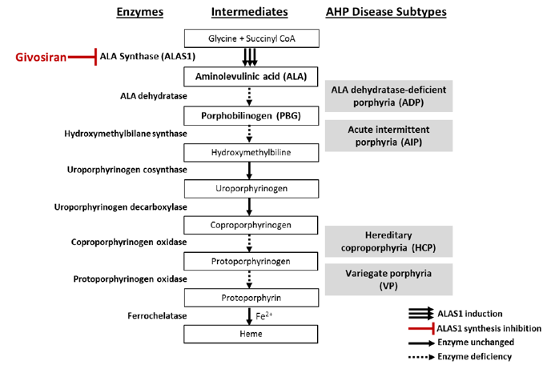

These porphyrias cause acute and chronic symptoms due to effects on the nervous system. The most common presenting symptom is neuropathic abdominal pain. The motor, sensory, and autonomic nervous systems are often affected, resulting in autonomic changes (for example, tachycardia, hypertension), muscle weakness, sensory loss, and pain in the back, chest, and extremities. Even severe symptoms may be discounted because they mimic other diseases, and physical findings are often minimal.

The prototype and most common of these porphyrias is AIP. Identical symptoms occur in the other AHPs (ADP, HCP, and VP). HCP and VP may also present with blistering skin lesions.

The conditions AIP, HCP, and VP are autosomal dominant inherited disorders with low penetrance and female predominance. Erythrocyte porphyrins are normal or only slightly elevated in these AHPs.

ADP is autosomal recessive and extremely rare, with only 8 documented cases worldwide, all of whom have been males (which is unexplained), usually with onset of attacks in their early teens. All cases of ADP have elevated erythrocyte zinc protoporphyrin, suggesting an erythropoietic component.

#### Current treatment options

Currently there is no Australian approved treatments for acute hepatic porphyria.

Intravenous hemin is recommended in clinical guidelines in countries and jurisdictions where it is approved (for example, the European Union (EU) and the USA) to treat acute attacks.[2] Hemin is not currently approved in Australia.

#### Clinical rationale

Givosiran is a double-stranded small interfering RNA (siRNA) directed against ALAS1 messenger RNA (mRNA). The molecule contains a triantennary *N*‑acetylgalactosamine (GalNAc) moiety to facilitate targeted delivery to the liver.

ALAS1 is the first and rate‑limiting enzyme of heme synthesis in the liver. In acute hepatic porphyria, loss‑of‑function gene mutation in a downstream heme synthesis enzyme induces expression of ALAS1, which leads to accumulation of the toxic heme intermediates, ALA and PBG.

### Regulatory status

#### Australian regulatory status

This product is considered a new chemical entity for Australian regulatory purposes.

#### Foreign regulatory status

This submission was submitted through the TGA’s [Comparable Overseas Regulator](https://www.tga.gov.au/comparable-overseas-regulators-cors-timeframes-and-milestones) B (COR-B) process, using evaluation reports from the European Medicines Agency (EMA). The full dossier was submitted to the TGA.

At the time the TGA considered this submission, a similar submission had been considered by other regulatory agencies. The following table summarises these submissions and provides the indications where approved.

Table : International regulatory status at the time of registration

|  |  |  |  |
| --- | --- | --- | --- |
| Region | Submission date | Status | Approved indications |
| United States of America | 4 June 2019 | Approved on 20 November 2019 | Givlaari is indicated for the treatment of acute hepatic porphyria (AHP) |
| European Union | 28 June 2019 | Approved on 2 March 2020 | Givlaari is indicated for the treatment of acute hepatic porphyria (AHP) in adults and adolescents aged 12 years and older |
| Brazil | 14 November 2019 | Approved on 20 July 2020 | Treatment of acute hepatic porphyria (AHP) in adults |
| Canada | 16 March 2020 | Approved on 9 October 2020 | Treatment of acute hepatic porphyria (AHP) in adults |
| Switzerland | 30 May 2020 | Approved on 29 March 2021 | Givlaari is indicated for the treatment of acute hepatic porphyria (AHP) in adults and adolescents aged 12 years and older |
| Great Britain | 25 May 2021 | Approved on 28 May 2021 | Givlaari is indicated for the treatment of acute hepatic porphyria (AHP) in adults and adolescents aged 12 years and older |
| Israel | 6 July 2020 | Approved on 17 June 2021 | Givlaari is indicated for the treatment of acute hepatic porphyria (AHP) in adults and adolescents aged 12 years and older |
| Japan | 29 September 2020 | Approved on 23 June 2021 | Givlaari is indicated for the treatment of acute hepatic porphyria (AHP) in adults |
| Argentina | 15 July 2021 | Approved on 16 November 2021 | Givlaari is indicated for the treatment of acute hepatic porphyria (AHP) in adults and adolescents aged 12 years and older |
| Taiwan | 28 September 2021 | 30 June 2023 | Givlaari is indicated for the treatment of acute hepatic porphyria (AHP) in adults |
| Columbia | 26 November 2021 | Under consideration |  |
| Mexico | 15 May 2023 | Under consideration |  |

## Registration timeline

The following table captures the key steps and dates for this submission.

This submission was evaluated under the Comparable Overseas Regulator B (COR-B) process [for prescription medicines registration](https://www.tga.gov.au/how-we-regulate/supply-therapeutic-good-0/supply-prescription-medicine/application-process/prescription-medicines-registration-process).

The active ingredient with its proposed indication was given [orphan drug designation](https://www.tga.gov.au/resources/resource/guidance/orphan-drug-designation).

Table : Timeline for Submission PM-2022-05371-1-6

|  |  |
| --- | --- |
| Description | Date |
| Designation (Orphan) | 13 October 2022 |
| Submission dossier accepted and first round evaluation commenced | 31 January 2023 |
| First round evaluation completed | 1 May 2023 |
| Sponsor provides responses on questions raised in first round evaluation | 30 June 2023 |
| Second round evaluation completed | 14 August 2023 |
| Sponsor’s notification to the TGA of errors/omissions in evaluation reports | Not submitted |
| Delegate’s Overall benefit-risk assessment[3] | 3 November 2023 |
| Advisory Committee meeting | Not required |
| Registration decision (Outcome) | 16 November 2023 |
| Administrative activities and registration in the ARTG completed | 28 November 2023 |
| Number of working days from submission dossier acceptance to registration decision* | 157 |

* The COR-B process has a 175 working day evaluation and decision timeframe.

## Submission overview and risk/benefit assessment

A summary of the TGA’s assessment for this submission is provided below.

This section is a TGA summary of wording used in TGA’s evaluation report, which discussed numerous aspects of overseas evaluation reports and included some information that was commercial-in-confidence.

### Quality

Givosiran (as givosiran sodium) is a synthetic double stranded RNA molecule. Its structure is shown in the Product Information.

The solution for injection contains 189 mg/mL givosiran, equivalent to 200 mg/mL givosiran sodium.

The evaluator reviewed the assessment reports prepared by the COR for the same submission and provided to the TGA by the applicant. The evaluator also assessed any Australia-specific data relating to the composition, development, manufacture, quality control, stability and bioavailability of the product and checked for compliance, as applicable, with Australian legislation and requirements for new medicines and in accordance with pharmacopoeial standards and the technical guidelines adopted by the TGA.

Approval was recommended for registration of the proposed product from a pharmaceutical chemistry perspective. No condition of registration was proposed.

### Nonclinical

The nonclinical dossier was of sound quality and adequate in scope, consistent with the relevant ICH guideline.[4] All pivotal safety-related studies were Good Laboratory Practice‑compliant.

Inhibition of ALAS1 mRNA expression by givosiran was demonstrated in a human hepatoma cell line in vitro (half maximal inhibitory concentration: 26 pM) and in the liver of rats and cynomolgus monkeys in vivo. Givosiran prevented increases in serum ALA and PBG in mouse and rat models of AIP. The submitted primary pharmacology studies offer support for the utility of givosiran for the proposed indication.

Givosiran has been designed to have at least 2 mismatches to every other known or predicted transcript in the human genome. Givosiran was screened for activity against the 6 most likely secondary targets (identified from in silico analysis), with no significant suppression of mRNA expression found.

No adverse effects on the central nervous system, cardiovascular function or respiratory function were identified in safety pharmacology or repeat‑dose toxicity studies.

Absorption of givosiran after subcutaneous administration was rapid in laboratory animal species and humans. Plasma half-life was short. Distribution to the liver was shown to be rapid, extensive and prolonged in rats and monkeys, with the liver AUC0–t thousands of times higher than that for plasma. The kidney showed the next highest exposure. No penetration of the blood‑brain barrier was evident in rats. Plasma protein binding was high up to clinically relevant concentrations, and similar in humans and laboratory animal species.

Metabolism of givosiran is via nucleases rather than cytochrome P450 (CYP). Loss of one nucleotide from the 3′ end of the antisense strand of givosiran gives rise to a single major circulating metabolite in humans and laboratory animal species, AS(N‑1)3′−givosiran; this metabolite retains full pharmacological activity and is expected to contribute to efficacy in patients. Excretion was shown to be predominantly via the urine in rats and monkeys.

Givosiran is not a substrate or inhibitor of major drug transporters at clinically relevant concentrations and does not directly inhibit CYPs. Givosiran has the potential to reduce CYP activity in the liver though, via its pharmacological effect to downregulate ALAS1 leading to a reduction in the availability of heme for use as a CYP cofactor.

Givosiran showed a low order of acute toxicity in laboratory animal species.

Pivotal repeat‑dose toxicity studies by the subcutaneous route were conducted in rats (6 months duration) and cynomolgus monkeys (9 months duration). The liver was identified as the key target organ for toxicity, with effects additionally observed in the kidney, pancreas, lymph nodes and injection site. Many of the microscopic changes observed represent drug accumulation rather than toxicity. Hepatocellular single cell necrosis was the most toxicologically significant finding. In monkeys, this was only of minimal severity at a dose yielding exposure at least 170 times higher than in patients, and not observed with dosing at 26 times the clinical exposure.

Givosiran was negative in the standard battery of tests for genotoxicity and was shown not to be carcinogenic in transgenic mice or in female rats. An increase in hepatocellular adenoma was observed in male rats with treatment at 100 mg/kg/month (yielding 40 times the plasma AUC in patients). Relative exposure at the no observed effect level (NOEL) for carcinogenicity in male rats, 50 mg/kg/month, is 17. Based on the exposure margins, and absence of similar tumour findings in transgenic mice or female rats, the clinical relevance of the observed increase in hepatocellular adenoma in male rats appears to be limited.

Givosiran did not impair male or female fertility in rats. No adverse effects on embryofetal development were observed with givosiran in rats. Embryolethality was encountered in rabbits, but this occurred only in conjunction with significant maternotoxicity; malformations were not observed. Postnatal development was unaffected in rats. Assignment to Pregnancy Category B3 is warranted.[5]

Supporting safety in paediatric patients, the pivotal 9-month study in monkeys used juvenile animals, and developing systems were not identified as targets for givosiran toxicity.

Acceptable local tolerance was demonstrated in animals.

There is no nonclinical objection to the registration of Givlaari for the proposed indication.

### Clinical

#### Summary of clinical studies

The clinical dossier consisted of the studies shown in Table 3.

The TGA evaluation was based on the EU Rapporteur and Co-Rapporteur day 60 critical assessment report, EU Rapporteurs day 150 joint Committee for Medicinal Products for Human Use (CHMP) and Pharmacovigilance Risk Assessment Committee (PRAC) assessment report, and a consolidated version of the CHMP positive opinion and European Public Assessment Report (EPAR).[6]

Table : Summary of clinical studies

| **Study, Status, Data Cut-off** | **Study Design, Objectives, Location** | **Dose(s)** | **N,**  **Patient Type** |
| --- | --- | --- | --- |
| **ALN-AS1-001**  **(Study 001)**  *Completed*  *Data lock:*  *23 Oct 2017* | Phase 1, randomized, single‑blind  SAD (Part A, 001A) and MAD (Part B, 001B) | Part A:  0.035 mg/kg to 2.5 mg/kg single SC dose  Part B:  0.35 mg/kg and 1 mg/kg, monthly (x 2) | Part A and B:  N=23; CHE subjects |
| double-blind multiple‑dose study (Part C, 001C) to evaluate safety, tolerability, PK, PD, and ADA of givosiran  6 clinical study centres  (4 in US, 1 in UK, 1 in Sweden) | Part C: 2.5 mg/kg and 5 mg/kg once monthly (x 4) and quarterly (x 2) | Part C:  N=17; AIP patients |
| **ALN-AS1-002**  **(Study 002)**  *Ongoing*  *Data cut-off:*  *19 April 2019*a | Phase 2, open-label, single-arm, long-term extension study to evaluate the long-term safety, and clinical activity of givosiran  5 clinical study centres  (3 in US, 1 in UK, 1 in Sweden) | 2.5 mg/kg SC  once monthlyb  Dosing up to 3 years | N=16; AIP patients who completed Study 001C |
| **ALN-AS1-003**  **(Study 003)**  *6-Month Double-Blind Period: completed*  *Data lock: 27 Feb 2019* | Phase 3, randomized (1:1), double‑blind, placebo-controlled study with an open-label extension to evaluate the efficacy and safety of givosiran  36 centres across North America, Europe, Asia, Australia, and Mexico | 2.5 mg/kg SC  once monthly  Dosing for 6 months in the double-blind treatment period | N=94, AHP patients  N=48 on givosiran  N=46 on placebo |
| *Ongoing;*  *Open-label extension*  *Data cut-off:*  *23 July 2019*c |  | 1.25 mg/kg or 2.5 mg/kg SC once monthly | N=93e, AHP patients  N=56 on 2.5 mg/kg once monthly  N=37 on 1.25 mg/kg once monthly |
| **ALN-AS1-004**  **(Study 004)**  *Completed;*  *Data lock:*  *25 Jan 2019* | Phase 1, open-label study to evaluate the drug-drug interaction of givosiran with midazolam, caffeine, losartan, omeprazole, and dextromethorphan  1 clinical study centre in Sweden | 2.5 mg/kg single SC dose of givosiran  Single oral dose of midazolam (5 mg), caffeine (200 mg), losartan (50 mg), omeprazole (40 mg), and dextromethorphan (30 mg) | N=10, CHE subjects |

Abbreviations: ADA = anti-drug antibodies; AHP = acute hepatic porphyria; AIP = acute intermittent porphyria; CHE = chronic high excreters; MAD = multiple ascending dose; mRNA = messenger ribonucleic acid; PD = pharmacodynamic; PK = pharmacokinetic; SAD = single ascending dose; SC = subcutaneous.

a Analysis for this submission was based on all available data from Study 002 as of the cut-off date of 19 April 2019

b Subjects received different starting doses in Study 002 before transitioning to the Phase 3 dose of 2.5 mg/kg once monthly

c All available data from the open label extension period as of the database lock date of 23 July 2019 was used in analysis. One patient discontinued treatment during the double‑blind period of 003 and did not participate in the open‑label extension.

#### Pharmacology[7]

##### Pharmacokinetics

Givosiran is designed to be selectively delivered to the liver via uptake by asialoglycoprotein receptors which are primarily expressed at high copy numbers on the cell surface of hepatocytes. Targeting is achieved by conjugation of the givosiran siRNA to a GalNAc moiety, which is a ligand for asialoglycoprotein receptors.

Pharmacokinetics and pharmacodynamics effects of givosiran have been evaluated in all 4 clinical studies [ Table 3]. The studies addressed single and multiple ascending doses, the metabolite profile and potential for drug-drug interactions with givosiran. Covariates affecting the pharmacokinetics of givosiran were evaluated by population pharmacokinetics. Pharmacokinetics of the primary active metabolite AS(N-1)3’ givosiran was also evaluated in most studies. Further, in vitro studies evaluating the drug-drug interaction potential of givosiran and exposure-response analyses have been performed.

No radiolabelled mass balance study, thorough QT prolongation study, and dedicated studies in subjects with dedicated hepatic and renal impairment have been conducted but patients with renal and hepatic impairment were allowed to be enrolled in study 003 as was agreed in 3 protocol assistance meetings with the European Medicines Agency (EMA) in July 2017 and March 2018 (EMEA/H/SA/3587/1/2017/PA/PR/III, EMEA/H/SA/3587/1/FU/1/2018/PA/PR/III, and EMEA/H/SA/3587/2/2018/PA/PR/I). Similarly, in agreement with the recommendations in the paediatric investigation plan, adolescents could be enrolled in study 003. Immunogenicity of givosiran treatment was evaluated in all studies.

The recommended dose of givosiran is 2.5 mg/kg once monthly, administered by subcutaneous (SC) injection in abdomen, thigh or upper arm.

##### Population PK data (popPK)

A population pharmacokinetic/pharmacodynamic (PD) model was developed to describe the time-course and estimate inter-individual variability of urinary ALA levels from pooled data following placebo and givosiran administration in CHE subjects and AHP patients.[8] The model was used to support the dose and dosing interval and to support dosing in patients.

###### Interactions

The potential of givosiran for drug‑drug interaction has been investigated by in vitro studies. In vitro studies indicated a low interaction profile for givosiran as givosiran was not a substrate, inhibitor or inducer of CYP enzymes and transporters in vitro.

Overall, these results indicate that givosiran moderately reduced the activity of CYP1A2 and CYP2D6, weakly reduced the activity of CYP3A4 and CYP2C19, and had no impact on activity of CYP2C9.

###### Overall conclusion

Pharmacokinetics of givosiran has been sufficiently well characterised. Givosiran is rapidly cleared from the plasma with a half-life of 6 hours and is not directly related to the pharmacodynamic effects which last for 2 to 3 months.

##### Pharmacodynamics (PD)

Givosiran is designed to be selectively delivered to the liver using the binding between the GalNAc ligand of givosiran and asialoglycoprotein receptor expressed on the liver. Upon delivery to the liver, givosiran uses the naturally occurring ribonucleic acid interference (RNAi) pathway to specifically target and silence ALAS1 mRNA in the liver. The RNAi-mediated lowering of induced liver ALAS1 mRNA levels and the consequent sustained decrease in the accumulation of toxic heme intermediates ALA and PBG is expected to prevent or reduce the occurrence of serious neurovisceral attacks and ongoing symptoms in patients with AHP.

The primary action of givosiran sodium is the reduction of the plasma levels of toxic metabolites ALA and PBG. Plasma ALA and PBG levels were shown to be highly correlated with corresponding urinary levels.

###### Secondary pharmacology

No dedicated QT study was performed. However, the data from the pre-clinical and clinical studies do not indicate any clinically relevant changes in QTc interval.

###### Immunogenicity

Across the 4 clinical studies, there was only 1 case of treatment-induced ADA in 131 subjects (AHP patients and CHE subjects) who received givosiran.

##### Conclusion on clinical pharmacology

Pharmacokinetics of givosiran in the target organ (liver) drives the long duration of PD effect. Givosiran causes a rapid dose-dependent decrease in urinary ALAS1 mRNA levels, ALA and PGB levels. The selected 2.5 mg/kg once monthly dosing regimen was chosen based on the exploratory studies with CHE and AHP patients and was further supported by the population PK/PD modelling and simulations.

#### Efficacy[9]

The proposed therapeutic dose of givosiran is 2.5 mg/kg once monthly in adults and adolescents, administered subcutaneously. The selection of the dose and dosing frequency was supported by a Phase 1 single, placebo-controlled multiple-dose Study 001 in CHE subjects (Study 001a and b) and AIP patients (Study 001c) and an open-label extension long-term dosing study in AIP patients (Study 002).

Adequacy of the selected 2.5 mg/kg once monthly dosing regimen was further supported by the population PK/PD modelling and simulations using data from Studies 001, 002, and 003. In general, the model supported that the 2.5 mg/kg dose once monthly seems to be near maximum PD/clinical effects for both dose-ALA and dose-AAR.

No clinically relevant effect of age, sex, race, or body weight on the PK and PD of givosiran was observed in the clinical studies or predicted in the pop PK/PD model. No dose adjustment for adolescents >12 years old or elderly are considered needed.

##### Study ALN-AS1-003 (ENVISION) – the main study

Study 003 is a randomised, double-blind, placebo-controlled, multicentre, Phase III study designed to evaluate the efficacy and safety of givosiran sodium in patients with AHP. Patient enrolment began on 16 November 2017, the 6-month DB period of the study was completed (last patient last visit) on 30 January 2019 with a data cut-off of 23 July 2019. The open-label extension (OLE) period of the study is ongoing (Figure 2).[10]

Figure : Study ALN-AS1-003 schema

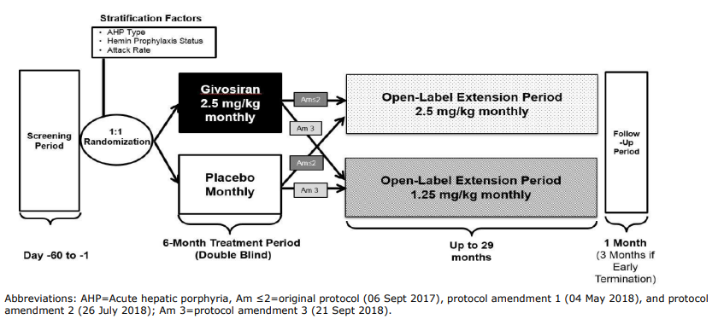

###### Methods

Study Participants

The study population is reflective of the population with AHP but was enriched for the attack rate: only patients with at least 2 attacks in the past 6 months were eligible to enrol in the study. Patients with all types of AHP were allowed to enrol. Adolescents >12 years of age were also allowed to enrol to the study, however, due to the rarity of these patients, none was eventually enrolled.

Subjects with moderate or severe liver impairment (ALT >2×upper limit of normal (ULN), Total bilirubin (TBL) >1.5×ULN, International normalised ratio (INR) >1.5) or severe renal impairment (eGFR <30 mL/min/1.73 m2) were excluded from the study. Hemin use was only allowed during the study (run-in, DB or OLE period) for treatment of acute porphyria attacks.

One patient who was included to the study [redacted] previously underwent a liver transplantation from a sibling donor that bore the same mutation in porphobilinogen [PBG] deaminase/hydroxymethylbilane synthase. The patient showed similar efficacy from givosiran treatment compared to the total study population.

Treatments

The study included a screening period, a 6‑month DB Treatment Period, and an OLE Treatment Period for up to 29 months. Eligible patients were randomised to receive either givosiran (2.5 mg/kg dose) or placebo (1:1) once monthly for up to 6 months. In light of liver transaminase elevations observed in some patients during this study, a lower givosiran dose of 1.25 mg/kg administered once monthly (QM) was introduced as a down‑titration dose in patients who had study drug withheld due to transaminase elevations per protocol-specified dosing rules with protocol Amendment 2.

After completion of the 6‑month DB Period, patients were given the option of continuing into the OLE period and receiving treatment with givosiran for up to 29 months. Patients who enrolled in the OLE before protocol amendment 3 was implemented received 2.5 mg/kg givosiran once monthly. Patients who enrolled in the OLE after implementation of protocol amendment 3 received 1.25 mg/kg givosiran once monthly. Patients who were assigned to 1.25 mg/kg were permitted to have givosiran increased after month 13 to 2.5 mg/kg if they had inadequate disease control, as pre-specified in the study protocol.

Use of hemin for the treatment of acute or ongoing porphyria attacks was allowed during the study and was recorded as a concomitant medication in the [electronic case report form] eCRF. Analgesic medications, including opioids (synthetic and non‑synthetic substances [narcotics]) or non‑opioids, such as non-steroid anti‑inflammatory drugs (NSAIDs), acetaminophen, or neuropathy medications (e.g., anti-depressants and anti-seizure medications), were permitted for the management of porphyria and for porphyria attacks, based on clinical judgment.

Objectives

The primary objective was to assess the effect of givosiran versus placebo on the rate of porphyria attacks requiring hospitalization, urgent healthcare visit, or IV hemin administration at home (composite attack) in AIP patients.

Outcomes/endpoints

Key primary efficacy endpoints

* + AAR in AIP patients over the double-blind period.

Key secondary efficacy endpoints

* + AAR in AHP patients
  + Levels of urinary ALA and PBG in AIP patients
  + Annualised days of hemin use in AIP patients
  + Patient reported outcomes in AIP patients (physical component score (PCS) of the short form 12 health survey (SF-12), pain, nausea, fatigue)

Randomisation and blinding (masking)

Patients were stratified based on their disease severity (use of hemin prophylaxis regimen at the time of screening and by each patient’s historical AAR) and AHP type. As very few non‑AIP patients were anticipated to be enrolled in the study, no additional stratification factors were considered for these patients. Allocations to the 2 doses (1.25 and 2.5 mg/kg) in the OLE period were not randomised … it can be concluded that the patients and investigators have remained blinded to the treatment that patients received during the DB period until all patients completed the month 12 visit in the OLE period.

Statistical methods

The TGA Delegate commented that appropriate methods appear to have been used.

###### Results

Participant flow

All patients (100%) completed the DB period of the study. Only one patient discontinued the treatment due to elevation in the liver enzymes (> 8 × ULN). This patient completed the 6‑month DB period and the 6‑month Visit; however, the patient then withdrew from the study after the 6‑month Visit and did not enter the OLE period. A total of 93 patients (98.9%) continued into the OLE period, where one more patient discontinued the treatment due to pregnancy and three patients discontinued because they no longer wanted to participate in the study.

Baseline data

Demographic characteristics for AIP and AHP patients were generally well-balanced between the givosiran and placebo treatment groups [see Table 4]. The study population was primarily female (84 [89.4%]); the mean age was 38.8 years (range: 19-65 years). The majority was white and coming from the different regions in North America, Europe or Asia. The mean years since diagnosis was longer in the givosiran group than the placebo group.

Table : Study ALN-AS1-003 Demographics for the 6 month double-blind period for AHP and AIP patients (safety analysis set)

| Parameter | AHP Patients | | | AIP Patients | | |
| --- | --- | --- | --- | --- | --- | --- |
| Placebo (N=46) | Givosiran (N=48) | Overall (N=94) | Placebo (N=43) | Givosiran (N=46) | Overall (N=89) |
| **Age at Screening (years)** | | | | | | |
| Mean (SD) | 37.4 (10.5) | 40.1 (12.1) | 38.8 (11.4) | 37.3 (10.5) | 40.7 (12.0) | 39.0 (11.4) |
| Min, Max | 20, 60 | 19, 65 | 19, 65 | 20, 60 | 19, 65 | 19, 65 |
| **Age category in years, n (%)** | | | | | | |
| 12 to <18 | 0 | 0 | 0 | 0 | 0 | 0 |
| 18 to 64 | 46 (100.0) | 47 (97.9) | 93 (98.9) | 43 (100.0) | 45 (97.8) | 88 (98.9) |
| ≥65 | 0 | 1 (2.1) | 1 (1.1) | 0 | 1 (2.2) | 1 (1.1) |
| **Gender, n (%)** | | | | | | |
| Male | 5 (10.9) | 5 (10.4) | 10 (10.6) | 4 (9.3) | 5 (10.9) | 9 (10.1) |
| Female | 41 (89.1) | 43 (89.6) | 84 (89.4) | 39 (90.7) | 41 (89.1) | 80 (89.9) |
| **Body Weight (kg)** | | | | | | |
| Mean (SD) | 67.88 (16.82) | 65.85 (15.63) | 66.84 (16.17) | 68.50 (16.69) | 65.71 (15.91) | 67.06 (16.26) |
| Min, Max | 41.5, 115.7 | 39.5, 131.3 | 39.5, 131.3 | 41.5, 115.7 | 39.5, 131.3 | 39.5, 131.3 |
| **BMI (kg/m2)** | | | | | | |
| Mean (SD) | 25.49 (6.38) | 24.31 (5.15) | 24.89 (5.78) | 25.66 (6.34) | 24.27 (5.24) | 24.94 (5.80) |
| Min, Max | 16.6, 49.7 | 16.4, 44.9 | 16.4, 49.7 | 17.8, 49.7 | 16.4, 44.9 | 16.4, 49.7 |
| **Race, n (%)** | | | | | | |
| White | 34 (73.9) | 39 (81.3) | 73 (77.7) | 33 (76.7) | 37 (80.4) | 70 (78.7) |
| Black or African American | 1 (2.2) | 0 | 1 (1.1) | 0 | 0 | 0 |
| Asian | 7 (15.2) | 8 (16.7) | 15 (16.0) | 6 (14.0) | 8 (17.4) | 14 (15.7) |
| **Ethnicity, n (%)** | | | | | | |
| Not Hispanic or Latino | 42 (91.3) | 42 (87.5) | 84 (89.4) | 40 (93.0) | 40 (87.0) | 80 (89.9) |
| Not reported | 1 (2.2) | 0 | 1 (1.1) | 1 (2.3) | 0 | 1 (1.1) |
| **Region, n (%)** | | | | | | |
| North Americaa | 18 (39.1) | 16 (33.3) | 34 (36.2) | 17 (39.5) | 16 (34.8) | 33 (37.1) |
| Europe | 19 (41.3) | 23 (47.9) | 42 (44.7) | 18 (41.9) | 22 (47.8) | 40 (44.9) |
| Other (Asia, Australia, Mexico) | 9 (19.6) | 9 (18.8) | 18 (19.1) | 8 (18.6) | 8 (17.4) | 16 (18.0) |
| Abbreviations: AHP=acute hepatic porphyria; AIP=acute intermittent porphyria; BMI=body mass index; Max=maximum; Min=minimum; SD=standard deviation.  a North America: United States, Canada | | | | | | |

The baseline disease characteristics were also well balanced between the groups with historical median AAR of 7 and 8 in the placebo and the givosiran group respectively. The number of patients with high (>7) and low (<7) AAR were around 1:1 within every treatment group.

Since allocation to the 2 doses (1.25 and 2.5 mg/kg) in the OLE period was not randomised, patient baseline characteristics in 2 groups in the OLE period were not balanced [Table 5].

Table : Study ALN-AS1-003 Demographics and baseline disease characteristics of AHP patients (all givosiran treated set)

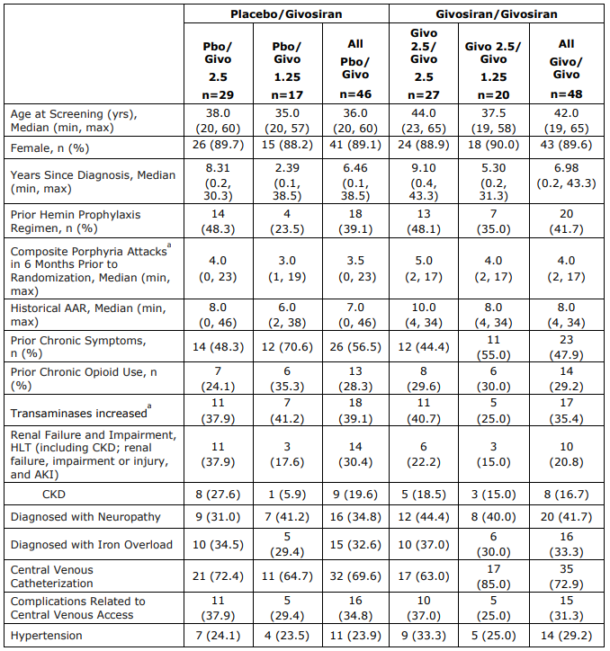

Abbreviations: AAR = annualised attack rate; AHP = acute hepatic porphyria; AKI = acute kidney injury; CKD = chronic kidney disease; givo = givosiran; HLT = high level term; max = maximum value; min = minimum value; Pbo = placebo.

a Composite porphyria attacks are all attacks that require hospitalisation, urgent healthcare visit, or IV hemin use at home.

Numbers analysed

Of the 94 AHP patients randomised and treated, all were included in the FAS, Safety, PK, PD, and ‘all givosiran’ treated analysis sets, and all 89 AIP patients randomised and treated were included in the FASAIP analysis set. One patient in the placebo group was excluded from the per protocol set (PPS) analysis because of the enrolment to the study despite not meeting the inclusion criteria (patient had 0 attacks in the 6 months prior to the study).

The primary endpoint was analysed for the Full Analysis Set, which was defined in the [statistical analysis plan] SAP: 43/43 in the placebo group and 46/46 in the givosiran group.

Outcomes and estimation

Primary endpoint

Annualised Rate of Porphyria Attack Composite Endpoint

Pivotal Study 003 met its primary endpoint, demonstrating that 2.5 mg/kg once monthly givosiran treatment led to statistically significant and clinically meaningful reduction of 74% in the AAR of composite attacks compared to placebo in AIP patients (rate ratio = 0.26, p < 0.0001). The results of all sensitivity analyses were consistent with the primary analysis. The proportion of attacks with median pain score >7 was lower for givosiran patients (21.1%) compared to placebo patients (32.0%).

Figure : Study ALN-AS1-003 Average number of attacks per patient per month during the double-blind and open label extension periods; porphyria attack composite endpoint in AHP patients (full analysis set)

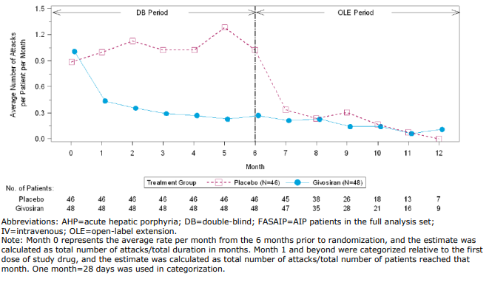

The effect of givosiran was sustained in the OLE study: the composite AAR remained reduced for patients continuing on givosiran treatment and got reduced for patients switching from placebo to givosiran. Specifically, placebo patients crossing to the 2.5 mg/kg QM givosiran dose during the OLE period demonstrated a trend towards a larger reduction in composite AAR: 88% reduction in AAR for placebo patients who crossed over to the 2.5 mg/kg QM givosiran dose in the OLE and 76% reduction for placebo patients crossing over to the 1.25 mg/kg QM dose group through Month 12 based on intrapatient comparisons. So a larger reduction in attack rate was seen in placebo patients crossing over to the 2.5 mg/kg QM dose group. This group had more than twice the total number of attacks while on placebo treatment (206 attacks) compared to the number of attacks during placebo treatment for patients who crossed over to the 1.25 mg/kg QM dose group (91 attacks).

Secondary endpoints

Urinary ALA and PBG Levels

Givosiran produced a substantial decrease in these toxic metabolites in both DB and OLE period: the median reduction for ALA was 86 and 84% in the DB and OLE period respectively and the median reduction for PBG was 91 and 78% in the DB and OLE period respectively. Similar results were seen in the overall AHP population. The 1.25 mg/kg givosiran dose was shown to produce somewhat lesser reduction in ALA and PBG compared to the 2.5 mg/kg dose.

Hemin Use

Givosiran treatment led to a similar decrease in hemin use: 77% decrease in annualised days of hemin use with around 50% of patients having no need to use hemin at all. In the placebo group, 23.3% of patients had 0 days of hemin use. Continued treatment with givosiran in the 6‑month DB and OLE period (givosiran/givosiran patients) led to a maintenance of the effect observed in the 6‑month DB period. Placebo group patients who crossed over to the 2.5 mg/kg QM givosiran dose in the OLE had a greater reduction in hemin use (>99% reduction), compared with the 1.25 mg/kg QM dose (54%) through Month 12, based on intra‑patient comparisons.

Pain Numerical Rating Score

The study was not enriched for the baseline levels of pain. Therefore, the patients enrolled had mostly mild to moderate pain levels (with patients in the givosiran group having a somewhat lower score at baseline). Givosiran was shown to significantly reduce the pain levels and the treatment separation was greater for the patients with a baseline pain score ≥ 2, with no difference between treatments for patients with a baseline pain level <2.

The treatment with givosiran led to a statistically significant difference in the AUC of change from baseline in weekly mean score of daily worst pain and average change from baseline in weekly mean score in AIP patients compared with placebo (p = 0.0455 and 0.0493 respectively as per post‑hoc Wilcoxon analysis). The absolute difference change in the median pain score between the groups was 0.45.

Patients in the placebo/givosiran group had a median weekly mean pain score of daily worst pain of 3.50 at baseline. Following 6 months of placebo treatment, the median score increased by 0.1 of a point. At Month 12 (after 6 months of givosiran treatment), the median score dropped by 0.54 points, similar to the decrease in pain seen in patients who received givosiran initially in the 6‑month DB period.

The decreases in pain with givosiran treatment were also reported in the context of lower analgesic use (opioid and non‑opioid) during and between attacks.

Fatigue and Nausea Numerical Rating Score

Givosiran treatment did not result in a significant change in the daily worst fatigue and daily worst nausea score.

PCS of SF‑12

PCS score of SF-12 was shown to be significantly improved in patients on givosiran treatment. Placebo crossover patients had similar improvements in PCS scores in the SF‑12 domain after 6 months of givosiran treatment in the OLE period as patients in the givosiran group had after 6 months in the DB period. Patients on givosiran 2.5 mg/kg QM treatment continuously through the Month 12 data‑cut, demonstrated maintenance of improvement in PCS score in the SF‑12 domain at Month 12.

###### Summary of main efficacy results

Table : Study ALN-AS1-003 Summary of efficacy

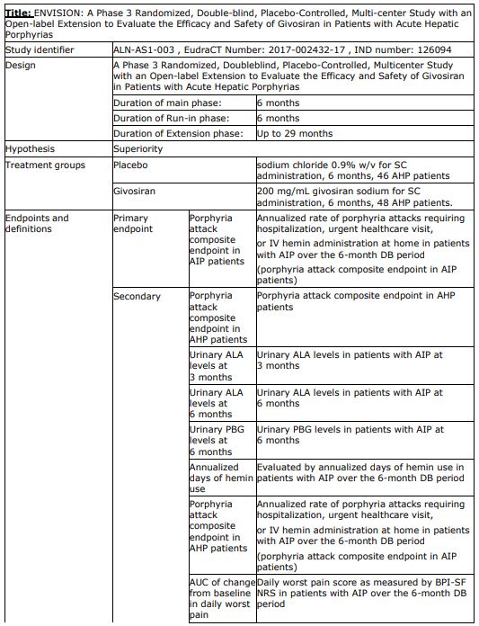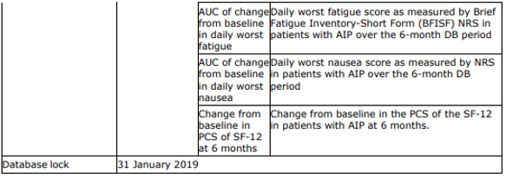

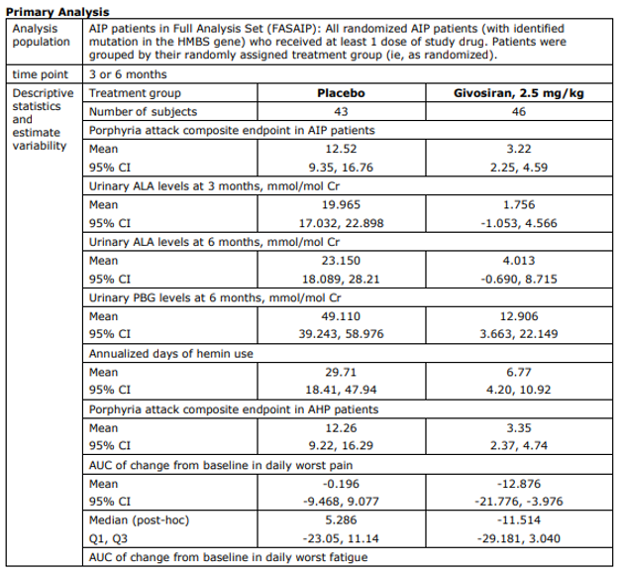

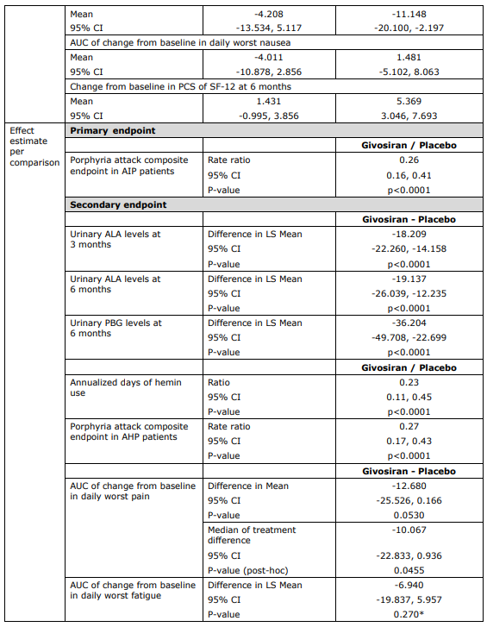

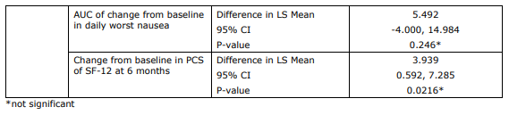

##### Analysis performed across trials (pooled analyses and meta-analysis)

Not applicable

##### Clinical studies in special populations

The maximum age of the patients included into the givosiran clinical program was 65 (one patient).

The influence of renal or hepatic impairment on givosiran PD was assessed across the studies. Only 5 patients with mild hepatic impairment and none with moderate or severe hepatic impairment were included in the study. Also, 25 patients with mild and 10 patients with moderate renal impairment were enrolled. Even though the results are variable due to the low number of patients in every group, the PD response of givosiran does not seem to be affected. The only 3 patients who were categorised to severe renal impairment had moderate renal impairment at baseline and progressed during the study.

##### Supportive studies

Study 001C was a randomised, placebo-controlled study conducted in AIP patients testing 4 dose regiments: 2.5 mg/kg givosiran once monthly, 2.5 mg/kg givosiran once quarterly, 5 mg/kg givosiran once monthly, and 5 mg/kg givosiran once quarterly.

Study 002 is an ongoing open‑label, long‑term extension study in AIP patients who have completed Study 001C. After completion of the evaluation period in Study 001, eligible patients from Part C transitioned into this study to receive givosiran treatment for an additional 3 years.[11]

Both studies are small (16 or 17 patients), but they confirm the beneficial effects of givosiran on various clinical parameters, including AAR, ALA and PBG levels, hemin use or quality of life.

##### Efficacy data and additional analyses

The treatment with givosiran resulted in a rapid, clinically meaningful and statistically significant decrease (approximately 75%) in the composite AAR in both AIP and AHP populations, as indicated by the analysis of FASAIP and FASAHP. Importantly, 50% of patients in the givosiran group had 0 attacks. The number of non‑AIP patients in the clinical development program is very low (5). Only 5 non‑AIP patients received givosiran in the Study 003 and one patient was treated with givosiran in the Compassionate Use Program. One of these patients discontinued the dosing after the third dose due to the ALT elevation 9.9 × ULN and another one discontinued the study after the second dose because the patient had no wish to participate in the study any longer. Givosiran seems to have a beneficial effect on the ALA/PBG levels, as well as AAR in this patient population as well, even though the data is considered very limited.

The results of certain secondary endpoints conclusively support the primary endpoint results: givosiran was shown to produce a substantial decrease in ALA/PBG levels and hemin use. Also, givosiran resulted in a modest reduction in pain levels and a clear decrease in the use of opioid and non‑opioid analgesics between and during the attacks. Also, the proportion of attacks with median pain scores > 7 was lower in the givosiran group compared to placebo. A significant effect on the daily worst fatigue and daily worst nausea levels was not observed. Even so, a PCS score of SF‑12 was shown to be significantly improved in patients on givosiran treatment. The data from the OLE study, including comparisons of patients who crossed from placebo to givosiran treatment, also support the favourable effects of givosiran on the pain and PCS of SF‑12 score.

No adolescent participated in the study. However, similar PD effect is expected between different body weight categories and therefore similar efficacy is expected in this population. Therefore, the indication for adolescents can be supported (see also section on safety for the discussion on the post-marketing measures).

The effects of the proposed 2.5 mg/kg dose are in general considered sufficiently described. The efficacy and safety data of the lower dose, 1.25 mg/kg, is, however, very limited. The study design, small number of patients in every group, the non‑randomised assignment of the patients to 2 doses in the OLE period and, as a result, imbalances in baseline characteristics between groups, do not allow for an adequate assessment of efficacy and safety of the 1.25 mg/kg dose, which is reflected in the SmPC.

The subgroup analysis performed for the primary endpoint of composite AAR showed consistency in the efficacy of givosiran between different groups. Age, race, region, gender, BMI or medical history of the disease did not have an influence on the givosiran efficacy. The mild hepatic impairment or mild to moderate renal impairment does not seem to influence PD of givosiran. The influence of moderate to severe hepatic impairment on givosiran effects was not assessed in the clinical program that brings some uncertainties to the safety of the product in this patient group. An appropriate warning is included in the SmPC indicating that the efficacy and safety of givosiran was not properly studied in the population with moderate or severe hepatic impairment. Since the data on patients with severe or end-stage renal disease is also extremely limited or absent. Additional efficacy and safety data in these patient populations should be collected post-marketing. Especially, the data on patients with more severe stages of hepatic and renal impairment, adolescent patients (≥12 to <18 years of age) and pregnant women should be obtained.

Even though the number of patients in the supportive studies 001 and 002 is small, they confirm the beneficial effects of givosiran on various clinical parameters, including AAR, ALA and PBG levels, hemin use or quality of life. These effects were also shown to be sustained in the OLE period of the Study 003.

In general, the treatment meets a high medical need in AHP patients by significantly reducing the frequency of severe porphyria attacks. Moreover, the quality of life and patient experience measures that cover various aspects of daily activities also showed a clinically meaningful improvement on givosiran treatment.

##### Conclusions on clinical efficacy

Givosiran is an effective treatment option for patients with AHP. The authorisation of the proposed indication requires that the remaining outstanding issues in the List of Questions are answered satisfactorily by the applicant.

The TGA Delegate commented that these issues were resolved as givosiran is now authorised in the EU.

#### Safety[12]

In total, the data for 111 unique patients with AHP are included in the overall pooled experience, including 17 patients from Studies 001C/002 as of the Study 002 cut-off date of 19 April 2019 and 94 patients from the double‑blind period of Study 003, of whom 93 (100% of eligible patients) entered the OLE period, as of the cut-off date of 23 July 2019.

##### Patient exposure

As the majority of the pooled data are in patients who received 2.5 mg/kg QM givosiran, patients who are receiving 1.25 mg/kg QM givosiran in the OLE period are pooled with patients who are receiving the 2.5 mg/kg regimen. The median duration of exposure for patients on the 1.25 mg/kg regimen was 7.1 months [range 5.7 to 8.9] for patients who crossed over from placebo in the double-blind period and 12.4 months [range 11.2 to 15.4] in patients who crossed over from 2.5 mg/kg givosiran during the double-blind period.

##### Adverse events

One case of anaphylactic reaction was reported following givosiran use. This patient had no ADA and had a history of various allergies and asthma. No other cases of anaphylactic reaction were reported over the course of the givosiran clinical development program. One fatal case of haemorrhagic pancreatitis was reported in the givosiran group.

In the Overall Pooled Experience, AEs were reported in 94.6% of patients. AEs reported in ≥15% of patients receiving givosiran included events coding to the PTs of nausea (32.4%),[13] ISR [injection site reaction] (24.3%), fatigue (22.5%), nasopharyngitis (22.5%), headache (19.8%), and abdominal pain (18.0%). AEs considered related to givosiran treatment by the Investigator were reported in 65.8% of patients. Related AEs occurring in ≥5% of patients were: ISR (24.3%), nausea (18.0%), fatigue (9.9%), injection site erythema (7.2%), asthenia (6.3%), ALT increased (6.3%), AST increase (6.3%), and headache and vomiting (5.4% each). AEs over time in patients treated with givosiran in the Overall Pooled Experience tended to remain stable over the course of exposure.

###### Serious adverse events and deaths

Death

The only fatal event during the givosiran treatment occurred in the Study 001 in a patient receiving a 5 mg/kg monthly dose. The patient had a complex medical history and a gallbladder sludge at the time of presentation.

Serious adverse events

Overall, more patients in the givosiran group reported serious adverse events (SAE) compared to placebo [Table 7]. Ten patients had SAEs that occurred during the Study 003 double‑blind period in the givosiran group. Most SAEs occurred in 1 patient each. Serious AEs occurring in more than 1 patient included pyrexia (2 [1.8%]), urinary tract infection (UTI) (2 [1.8%]), and CKD (2 [1.8%]).

Most SAEs were resolved as of the data cut-off date.

In the Overall Pooled Experience, SAEs were reported in 28 (25.2%) patients treated with givosiran. The SAEs reported in 2 or more patients were abdominal pain, pyrexia, influenza, UTI, and chronic kidney disease; these events occurred in 2 patients each (1.8%). There was a total of 4 SAEs related to study drug (1 event of anaphylaxis, 1 event of LFT abnormal, 1 event of CKD, and 1 event of transaminases increased) in the pooled analysis of 111 AHP patients through the Month 12 cutoff of Study 003 and the Month 18 cutoff of Study 002; all 4 occurred within the first 6 months of givosiran treatment.

Table : Study 003 Serious adverse events during the 6‑month double‑blind period by System Organ Class and Preferred Term in AHP patients (safety analysis set)

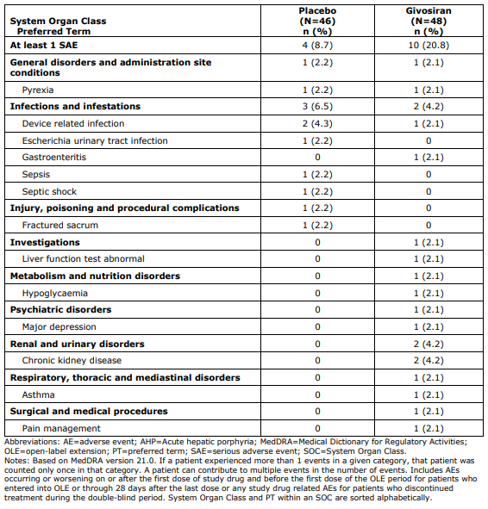

##### Laboratory findings

No significant changes in haematology or serum chemistry parameters were observed during the DB period of the Study 003. A higher proportion of patients in the placebo group reported lipase or amylase elevations compared to the givosiran group. On the other hand, more patients in the givosiran group experienced ALT/AST elevation, creatinine elevation and decrease in eGFR. Most of these elevations were transient and resolved during the study.

A trend in a transient decrease in the diastolic blood pressure was observed on givosiran treatment, with no apparent change in the systolic blood pressure. Electrocardiograms did not reveal any abnormalities on givosiran treatment.

##### Safety in special populations

Only one patient of 65 years old was included to the clinical development program. No patients above that age were studied.

No clear influence of gender, race, BMI or geographic region on the givosiran safety profile was observed. A somewhat higher frequency of AEs was reported in the older patient group (≥ 38 years of age) in both placebo and givosiran treatment groups. More patients with prior hemin prophylaxis reported AEs (84.8%) compared to the patients with no prior hemin prophylaxis (76.9%). However, more patients with no prior hemin prophylaxis reported SAE (20%) compared to the patients with prior hemin prophylaxis (15.2%).

The AEs associated with hepatic or renal events were usually reported in individuals with pre‑existing hepatic/renal condition. Three patients who had moderate renal function at baseline (eGFR ≥30 to <60 ml/min/1.73 m2) progressed to severe renal impairment during the study (eGFR <30 ml/min/1.73 m2).

No data is available on the use of givosiran in pregnant women and it is unknown whether givosiran is excreted in human milk.

##### Immunological events

Anti‑drug antibodies were assessed over the course of each study. Overall, the incidence of treatment emergent ADA in givosiran‑treated patients was low (one patient). The presence of ADA did not affect the safety profile of givosiran.

##### Safety related to drug‑drug interactions and other interactions

In the Study 004 drug‑drug interaction study with CHE patients, givosiran resulted in a moderate reduction (≤3.07‑fold) in activity of cytochrome P450 (CYP) 1A2 and CYP2D6, weak reduction (≤1.59‑fold) in activity of CYP3A4 and CYP2C19, and had no effect on CYP2C9 activity. No additional concerns were raised with respect to the safety of givosiran.

##### Discontinuation due to adverse events

Overall, 4 patients on givosiran discontinued the studies 001/002 or 003. Three of them discontinued due to the development of a SAE (ALT elevation, anaphylactic reaction or haemorrhagic pancreatitis) and one patient discontinued the OLE period of the Study 003 due to pregnancy.

In the overall pooled givosiran experience, AEs leading to treatment interruption occurred in 8.1% of patients; of the patients with dose interruptions, 7 were in Study 003 and 2 occurred in Study 001C/002. AEs leading to dose interruption in more than 1 patient are CKD (2 patients) and ALT/AST elevations (2 patients).

##### Discussion on clinical safety

The data from one pivotal study and two supportive studies compose the safety database. In general, the safety database is limited but can be acceptable, considering the rarity of the disease.

In general, the trial population represents the target population rather well. Data on adolescents (≥ 12 year of age and ≤18) or patients >65 years of age is, however, absent (due to their rarity) and the data on patients with various stages of renal or hepatic impairment is either absent or limited. Therefore, further data will need to be collected post‑approval as part of the RMP.

The frequency of total adverse events and SAE related to the study drug was higher in the givosiran treatment group compared to placebo (45.8% vs 26.1% and 6.3% vs 0%) in the pivotal study. In the overall pooled experience, 65.8% patients experienced treatment‑related AE and 3.6% experienced SAE. One death occurred in the givosiran treatment group (due to haemorrhagic pancreatitis). Three out of 4 patients who discontinued the studies did it because of SAE, and 9 patients had a dose interruption due to the AE.

Adverse events that were most frequently reported in the givosiran group are injection site reaction, nausea, fatigue, ALT elevation, rash, eGFR decrease and CKD. Most of the AEs were mild or moderate in severity and have resolved over the course of the study, with the exception of several events of CKD or fatigue. A recall phenomenon in the place of a previous injection brings some uncertainties to whether the drug might have an effect on the immune system systemically. Overall, the adverse events observed in the study are listed in the SmPC. One case of anaphylactic reaction was reported following givosiran use (in a patient with a history of various allergies and asthma).

The elevation in liver function test (LFT) is a known side effect of this type of compounds and is consistent with the non‑clinical data. Currently, the SmPC includes a warning and recommendations on the monitoring of serum transaminases (ALT and AST) and total bilirubin. Moreover, a recommendation on the dose resumption after the treatment interruption due to the significant transaminase elevations is provided. However, it is not known whether the lower dose of 1.25 mg/kg has a more favourable safety profile, as the data from the OLE period, where the efficacy and safety of this lower dose were evaluated, cannot be used to conclude on its better safety due to study design issues mentioned above (see discussion on efficacy). The transaminase elevations following givosiran treatment were more frequently reported in patients with a history of hepatic disorders or history of ALT elevations compared to patients with no history of hepatic disorders or ALT elevations. A similar situation was observed with AEs associated with renal events that were usually reported in individuals with preexisting CKD and reduced eGFR. Therefore, patients with the history of hepatic or renal disorders require additional safety warning in the SmPC to highlight an increased risk of givosiran side effects in these vulnerable patient populations.

Givosiran does not seem to result in changes in haematology or serum chemistry parameters. No clear influence of intrinsic or extrinsic factors on the givosiran safety profile was observed, aside the renal or hepatic impairment. Due to the lack of data, givosiran should only be considered in pregnant or lactating women if the benefits for the mother outweigh the risks for the foetus.

In general, the safety profile of givosiran is in accordance with that expected from non‑clinical studies and known class effects of siRNA molecules targeted to the liver.

##### Conclusions on clinical safety

The safety data presented for the moment indicates that most of the (S)AE seems to be reversible and of mild or moderate nature. The safety profile is in general in accordance with known class effects of similar siRNA molecules targeted to the liver. Adverse events that were most frequently reported in the givosiran group are injection site reaction, nausea, fatigue, ALT elevation, rash, eGFR decrease and CKD. The safety of givosiran in some target sub-populations (e.g. adolescents, patients with hepatic or renal disease) will need to be further addressed by the applicant as part of the RMP. For now, it cannot be concluded that the lower 1.25 mg/kg dose has a better safety profile as compared to the 2.5 mg/kg dose.

##### Post market experience

The TGA Delegate noted that there have been 6 periodic benefit‑risk evaluation reports (PBRER) covering the period 20 November 2018 to 19 November 2022 which have shown no new safety issues.

##### Other

The TGA Delegate noted that real‑world evidence/real‑world data were included in the submission and were considered supportive for approval. This evidence/data was within the PBRER reports.

### Risk management plan

The summary of safety concerns and their associated risk monitoring and mitigation strategies is presented in Table 8. The TGA may request an updated RMP at any stage of a product's life‑cycle, during both the pre-approval and post-approval phases.

Table : Summary of safety concerns

|  |  |  |  |  |  |
| --- | --- | --- | --- | --- | --- |
| Summary of safety concerns | | Pharmacovigilance | | Risk minimisation | |
| **Routine** | **Additional** | **Routine** | **Additional** |
| **Important identified risks** | Nil |  |  |  |  |
| **Important potential risks** | Hepatic effects | ✓∗ | ✓† | ✓ | − |
| Renal effects | ✓ | ✓† | ✓ | − |
| Pancreatitis | ✓∗ | ✓† | ✓ | − |
| Consequences of increased blood homocysteine levels ‡ | ✓ | ✓† | ✓ | − |
| **Missing information** | Longer-term safety (more than 3 years) | ✓ | ✓† | ✓ | − |
| Use in patients with moderate or severe hepatic impairment | ✓ | ✓† | ✓ | − |
| Use in patients with end stage renal disease or on dialysis | ✓ | ✓† | ✓ | − |
| Use in pregnant or lactating women and effects on pregnancy outcomes | ✓ | ✓† | ✓ | − |

∗Specific targeted follow-up questionnaires

†Post-authorization observational study

‡Includes reference to ‘thromboembolic events’, that is, *‘Clinical consequences of increased blood homocysteine levels, in particular thromboembolic events’* in EU RMP.

The RMP evaluation recommended conditions of registration relating to the versions of the risk management plan, requirement for periodic safety update reports, and inclusion of the medicine in the Black Triangle Scheme.

### Risk-benefit analysis

#### European assessment[14]

##### Therapeutic context

###### Disease or condition

Acute hepatic porphyria (AHP) is a family of rare, serious, and severely debilitating genetic disorders of liver heme synthesis. Symptoms arise due to accumulation of the toxic heme intermediates aminolevulinic acid (ALA) and porphobilinogen (PBG) due to induced expression of deltaaminolevulinate synthase 1 (ALAS1) in the presence of a pathogenic loss of function gene mutation in a downstream heme synthesis enzyme. There are 4 subtypes of AHP, each involving a defect in a distinct heme pathway enzyme, with AIP being the most common AHP subtype representing approximately 80% of all AHP cases. All AHP subtypes share a common pathophysiologic basis of disease, which is accumulation of ALA and PBG causing injury primarily to the nervous system and other organs, resulting in acute painful neurovisceral attacks as well as in chronic symptoms and disability.

Givosiran is a ribonucleic acid interference (RNAi) therapeutic that inhibits ALAS1 mRNA in the liver, decreasing the production of liver ALAS1 protein. The therapeutic hypothesis of givosiran is that this RNAi‑mediated reduction of induced liver ALAS1 mRNA levels leads to the sustained lowering of the elevated toxic heme intermediates ALA and PBG, thereby preventing or reducing neurovisceral attacks and ongoing symptoms in all AHP disease subtypes.

###### Available therapies and unmet medical need

Most severe AHP patients (5-10%) have recurrent attacks (≥ 4 per year). Each porphyria attack is serious, highly morbid, and carries potential for permanent disability, and where specific treatment is delayed or not available, attacks can be life-threatening.[15] Due to unpredictability and severity of porphyria disease manifestations, many patients are unable to work or attend school, have decreased socialization, and increased rates of depression and anxiety.

Current treatment options for AHP are limited. Patients are initially treated with supportive care during the attacks such as intravenous (IV) glucose, typically large doses of IV opioid analgesics, and antiemetics along with the removal of known precipitating triggers, such as certain medications or fasting.[16] Intravenous hemin is the only therapy currently approved for the treatment of acute attacks; hemin is not approved as a chronic treatment to prevent attacks,[17] however it is used off‑label. While hemin infusion temporarily reduces production of ALA and PBG through feedback inhibition of ALAS1 messenger ribonucleic acid (mRNA) expression, it has a short duration of action (elimination half-life of approximately 11 hours), which limits its effectiveness and permits residual attack activity when used prophylactically. Moreover, they are a big burden for AHP patients as they carry the risk of morbidity, such as iron overload or infections due to the catheter lines. The repeated use of hemin commonly causes venous access problems in AHP patients.

Additional treatments for AHP include chemically induced menopause with hormonal suppression therapy (for example, gonadotropin releasing hormone agonists)[18] and liver transplantation for patients with refractory disease or those who no longer have adequate venous access.[19]

Consequently, there is a clear unmet need for therapies that durably decrease the frequency of debilitating attacks, diminish chronic symptoms, and improve patients’ physical functioning and quality of life. In addition, therapeutics that reduce the need for opioid analgesics or drugs requiring chronic indwelling central venous catheters would reduce morbidity associated with these interventions.

###### Main clinical studies

The main evidence of efficacy submitted is a single, Phase III, randomised, double‑blind, placebo‑controlled, multicentre study with an open‑label extension to evaluate the efficacy and safety of givosiran in patients with AHP who experienced at least 2 attacks in the past 6 months (n = 94). The 6‑month double-blind (DB) period of this study, in which patients received 2.5 mg/kg givosiran or placebo SC once monthly, forms the primary demonstration of efficacy of givosiran. The primary endpoint was the reduction of the composite annualised attack rate (AAR) in AIP patients, with secondary endpoints for PD biomarkers and patient reported outcomes. The ongoing OLE period, in which patients receive 2.5 or 1.25 mg/kg givosiran SC once monthly, will provide additional information on efficacy and safety of givosiran and will continue for up to 29 months. Two supportive studies (double‑blind placebo‑controlled Study 001 and its open-label extension Study 002) were also presented.

##### Favourable effects

The treatment with givosiran 2.5 mg/kg dose monthly resulted in a rapid and statistically significant decrease (approximately 75%) in the AAR in the AIP population (primary endpoint): rate ratio 0.26 (95%CI: 0.16, 0.41; p<0.001) in favour of givosiran. In total, 50% of patients in the givosiran group and 17.4% of patients in placebo group had 0 attacks.

The results of certain secondary endpoints were in line with the primary endpoint: givosiran decreased ALA (86% from the baseline) and PBG (91% from the baseline) levels in AIP patients, while ALA and PBG levels in the placebo group remained relatively stable and elevated well above normal. The difference in LS Mean between givosiran and placebo was −18.2 mmol/mol Cr (95% CI: −17.97, −9.63; p<0.001) for ALA and −27.48 mmol/mol Cr (95% CI: −34.04, −20.99; p<0.001) for PBG. Also, the number of days of hemin use significantly decreased following givosiran treatment with [rate ratio] RR 0.23 (95% CI: 0.11 0.45; p<0.001).

Treatment with givosiran reduced the weekly mean score of daily worst pain compared with placebo in AIP patients (measured as mean change from baseline in the AUC) with median of treatment difference 0.5 (p=0.0455) on a 10‑point VAS. Moreover, givosiran treatment led to the decrease in opioid and non‑opioid analgesics use during and between attacks.

A quality-of-life measure (physical component score (PCS) of the SF‑12) was included as a secondary endpoint, and showed improvement on givosiran treatment with the mean change from baseline in [PCS of the SF‑ 12 at 6 months of] 3.939 (nominal p=0.0216). Consistently the EQ VAS score (exploratory endpoint: increase of 14.3 from baseline at Month 6 compared with placebo in AIP patients). Also, a larger proportion of givosiran AIP patients rated themselves as ‘very much improved’ or ‘much improved’ since the start of the study at Month 6 compared with placebo (61.1% and 20.0%, respectively) on the Patient global impression of change (PGIC) and more patients rates their experience as ‘much better’ on functional impacts, activities of daily living, and treatment satisfaction on the [porphyria patient experience questionnaire] PPEQ in AIP patients in givosiran group compared to placebo. Further, the number of missed work days was lower for givosiran compared to placebo.

Subgroup analyses were performed for the primary endpoint of the composite AAR based on age, race, region, gender, BMI and medical history of the disease. These factors did not have an influence on givosiran efficacy. Mild hepatic impairment and mild to moderate renal impairment also did not seem to influence PD or efficacy (AAR) of givosiran.

Consistent results were observed in 2 small supportive studies with givosiran, where beneficial effects of givosiran on various clinical parameters, including AAR, ALA and PBG levels, hemin use, or quality of life were observed. These effects were also shown to be sustained in the OLE period of the Study 003, where patients who received placebo in the DB period also switched to the givosiran treatment.

##### Uncertainties and limitations about favourable effects

Several uncertainties can be identified with respect to the results presented.

First of all, the applicant is seeking a general indication for the total AHP population. However, data on non‑AIP patients is very limited. In total, only 5 non‑AIP patients participated in the givosiran clinical trials and 1 patient participated in the Compassionate Use Program (CUP). Two of these patients discontinued the treatment: one discontinued the dosing after the third dose due to the ALT elevation 9.9 × ULN and the second patient, who received placebo in the DB period, discontinued the treatment after the second dose of givosiran in the OLE study because the patient no longer wished to participate in the study.

Data on patients with hepatic or renal impairment are limited. Patients with moderate/severe hepatic impairment or severe renal impairment were excluded from the study. Also, no adolescent or elderly patients >65 years of age were enrolled to the study. The efficacy in these groups is therefore largely extrapolated from the adult population.

Secondly, the data on the 1.25 mg/kg dose is limited, which does not allow to characterise and conclude on its efficacy. The totality of the data supports the 2.5 mg/kg monthly dose, but also gives an indication that the lower doses might be less efficient in controlling AAR.

Fourthly [sic], a re‑analysis of secondary endpoints ALA, PGB, pain and nausea was performed using a non‑parametric Wilcoxon test, after the observation of violating normality. Although the methods proposed are relatively standard, they were introduced post‑hoc. The non‑parametric analysis did not result in significant differences for the ALA/PBG as well as nausea analysis compared to the parametric analysis. The pain score results, however, switched from non‑significant (p-value slightly above 0.05) to significant (p-value slightly below 0.05).

Further, the number of patients in every subgroup (with respect to gender, race, hepatic or renal impairment) is small, which brings uncertainties to the conclusions drawn by the applicant that no particular differences are observed or to be expected in the efficacy of givosiran between the different sub-groups.

Finally, the study duration is rather short (median duration of treatment is 11.7 months), which does not allow for a reliable assessment of the long-term effects of givosiran.

##### Unfavourable effects

The frequency of total adverse events (AE) and serious adverse events (SAE) related to the study drug was higher in the givosiran treatment group compared to placebo (45.8% vs 26.1% and 6.3% vs 0%) in the pivotal study. One death occurred in the givosiran treatment group in the supportive OLE Study 002 (due to haemorrhagic pancreatitis). Three out of 4 patients who discontinued the studies did so because of an SAE (2.7%), and 9 patients had a dose interruption due to the AE (8.1%).

Adverse events that were most frequently reported in the givosiran group compared to placebo are injection site reaction (25% vs 0%), nausea (27.1% vs 10.9%), fatigue (10.4% vs 4.3%), ALT elevation (8.3% vs 2.2%), rash (6.3% vs 0%), eGFR decrease (6.3% vs 0%) and CKD (10.4% vs 0%). Most of the AEs were mild or moderate in severity and have resolved over the course of the study, with the exception of several events of CKD or fatigue. A recall phenomenon in the place of a previous injection was described in 3 patients during the study.

Several other single cases of SAE were reported during the studies: one case of anaphylactic reaction was reported following givosiran use (in a patient with a history of various allergies and asthma), one fatal case of haemorrhagic pancreatitis and one case of obstructive pancreatitis (in patients with a complex medical history).

The elevation in LFT is a known dose-dependent side effect of this type of siRNA compounds that targets the liver and is consistent with the non-clinical data. The data from the pivotal study suggest that LFT elevations following givosiran treatment were more frequently observed in patients with a history of hepatic disorders or history of ALT elevations compared to patients with no history of hepatic disorders or ALT elevations. A similar situation was observed with AEs associated with renal events that were usually reported in individuals with pre‑existing CKD and reduced eGFR. No clear influence of other intrinsic or extrinsic factors on the givosiran safety profile was observed. Further, givosiran does not seem to result in significant changes in haematology or serum chemistry parameters.

##### Uncertainties and limitations about unfavourable effects

The biggest limitation of the current safety database is the low number of patients in the clinical program due to the rarity of the disease and the short duration of exposure - the median exposure time across the studies is 11.7 months. This rather short follow-up and small sample size bring some uncertainties to whether all the potential side effects of the treatment are captured within the study and if any of the adverse effects might re‑occur or persist for a longer period of time.

Data on adolescents (12-18 years old) or patients >65 years of age is absent (due to the rarity of these patients) and the data on patients with various stages of renal or hepatic impairment is either absent or very limited. Therefore, this brings uncertainties to the safety of givosiran in these subpopulations and the data will need to be collected post‑approval as part of the RMP. Currently, the SmPC includes a warning and recommendations on the monitoring of serum transaminases (ALT and AST) and total bilirubin. Moreover, a recommendation on the dose resumption after the treatment interruption due to the significant transaminase elevations is provided. However, it is unclear if the lower dose of 1.25 mg/kg has a more favourable safety profile. The patient who experienced ALT elevation by 9.9 × ULN was a non‑AIP patient, which raises questions on whether the type of AHP can influence the safety of givosiran. This information will be (if feasible) collected post‑marketing. A role of givosiran in the worsening of renal function in some patients with severe to moderate renal impairment cannot be excluded. An appropriate warning should be added to the SmPC to address this uncertainty.

In addition, a recall phenomenon at the site of a previous injection observed in 3 patients brings some uncertainties to whether the drug might have an effect on the immune system systemically.

Carcinogenicity non‑clinical studies are currently ongoing and no data are available yet. However, the lack of these studies is acceptable based on unmet medical need and the nature of the product.

##### Effects table

Table : Effects Table for Givlaari for the treatment of acute hepatic porphyria (AHP) in adults and adolescents aged 12 years and older (data cut-off 31 January 2019)

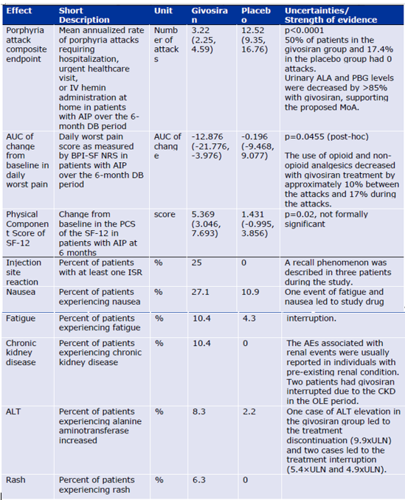

##### Benefit-risk assessment and discussion

###### Importance of favourable and unfavourable effects

Treatment with givosiran resulted in a rapid statistically significant decrease in the primary endpoint AAR of approximately 75%. Importantly, half of the patients receiving givosiran did not experience any attack during the 6 months period. The decrease in the AAR was accompanied by decreases in ALA and PBG levels which is consistent with the hypothesis of a crucial role of ALA and PBG in the attack development. The annualised days of hemin use was reduced by approximately 79%. The porphyria attacks are mostly very severe, with extreme pain and require hospitalisation or urgent health care visit. Hemin infusions used for treatment of attacks are a big burden for AHP patients as they carry the risk of morbidity, such as iron overload or infections due to the catheter lines. Therefore, the observed pronounced decrease in the attack rate and the reduction in need of hemin infusions following givosiran treatment are considered clinically meaningful and of high benefit not only for the patient, but also for the healthcare system in general. The results were consistent across statistical analyses, different subgroups and studies. Even though the number of male patients was low in the pivotal study, the pathophysiology of attacks (ALA/PBG accumulation) is similar in both genders and no apparent differences in response to givosiran were observed between males and females.

On the indication, while the subgroup of adolescents was allowed to be enrolled in the study, such patients have not been studied. However, as the pathophysiology of the disease is similar between adults and adolescents, the proposed posology is weight-based and no differences on PD and efficacy (AAR) were apparent between different body weight categories (40 to 131 kg), which includes the bodyweight range of adolescents, the inclusion of this subgroup in the indication is supported. Adolescent patients (together with other relevant subgroups) should be further studied post-marketing.

The majority of the AHP population comprises of patients with AIP. The data on the non‑AIP patients (with even rarer variants of this disease family) are very limited and therefore uncertain. However, a broad AHP indication can be supported considering: 1) the strong biological rationale behind the disease pathophysiology in all AHP types and givosiran mechanism of action; 2) the expected similar PK/PD and safety profile in different AHP subtypes; 3) the positive efficacy results from a few non‑AIP patients studied in the Study003 and the CUP program. Yet, the uncertainties on the efficacy and safety of givosiran in non‑AIP patients is reflected in the SmPC and this patient population should be further studied in the post-marketing setting.

The short study duration as well as the data collection approach does not allow for a full appreciation of the givosiran effects on all the studied chronic symptoms and patient reported outcomes. However, the data presented by the Applicant suggests that: 1) givosiran positively affects not only attack frequency, but also severity (based on pain scores and analgesics use during the attacks); 2) givosiran has a positive effect on pain and analgesics use also between the attacks; and 3) the quality of life as well as patient social engagement improves substantially on givosiran treatment. Therefore, the indication ‘treatment of AHP’ can be supported.

Adverse events were more frequently reported in the givosiran treatment group compared to placebo. However, most of the adverse events were mild or moderate in severity and most of them resolved within the study duration. Only few (S)AE led to the treatment discontinuation or dose interruption. Considering the severity of the disease, this can be acceptable. One case of anaphylactic reaction was reported in the clinical development program in a patient who had a complex history of allergies and asthma. No ADA were present in this patient and no other cases of anaphylaxis were reported. Considering the totality of the data and the specificity of the given case, the risks for anaphylaxis can be considered low.

Hepatic events are an important risk, and may be a class effect of liver-targeting siRNA products. A warning and dose recommendations are provided in the SmPC to cover these risks. The efficacy and safety of the proposed lower 1.25 mg/kg dose, however, cannot be currently determined due to the inconclusiveness of the data. This is reflected in the SmPC. This concern does not impact the benefit/risk assessment of the 2.5 mg/kg dose.

There are uncertainties on the efficacy and especially safety of givosiran in patients with renal or hepatic impairment due to the limited or absent data. These concerns, however, cannot be resolved within the current application and will need to be addressed post-marketing.”

#### TGA Delegate’s considerations

Treatment with givosiran resulted in a rapid, clinically meaningful, and statistically significant decrease (approximately 75%) in the primary endpoint composite AAR in both AIP and AHP populations, as indicated by the analysis of FASAIP and FASAHP. Half of patients in the givosiran group had nil attacks.

The effects of the proposed 2.5 mg/kg dose are in general considered sufficiently described. The efficacy and safety data of the lower dose, 1.25 mg/kg, is very limited.

The safety data presented for the moment indicates that most of the (S)AE seems to be reversible and of mild or moderate nature. The safety profile is in general in accordance with known class effects of similar siRNA molecules targeted to the liver. Adverse events that were most frequently reported in the givosiran group are injection site reaction, nausea, fatigue, ALT elevation, rash, eGFR decrease and CKD. The safety of givosiran in some target sub-populations (for example, adolescents, patients with hepatic or renal disease) will need to be further addressed by the applicant as part of the RMP. For now, it cannot be concluded that the lower 1.25 mg/kg dose has a better safety profile as compared to the 2.5 mg/kg dose.

There is no change to the benefit‑risk arising from the post‑market reports.

The overall benefit‑risk of givosiran is positive.

#### Proposed action

The Delegate proposed to approve the registration of the product Givlaariand to impose the conditions of registration as described in RMP Evaluation Report.

#### Advisory Committee considerations

The Delegate did not refer this submission to the Advisory Committee on Medicines for advice.

## Outcome

Based on a review of quality, safety, and efficacy, the TGA decided to register Givlaari (givosiran) 189 mg/mL solution for injection in vials. indicated for:

Givlaari is indicated for the treatment of acute hepatic porphyria (AHP) in adults and adolescents aged 12 years and older.

### Specific conditions of registration applying to these goods

* Givlaari (givosiran) is to be included in the Black Triangle Scheme. The PI and CMI for Givlaari must include the black triangle symbol and mandatory accompanying text for 5 years, which starts from the date that the sponsor notifies the TGA of supply of the product.
* The Givlaari EU-Risk Management Plan (version 2.0, dated 5 May 2022; DLP 19 November 2020), with Australia‑specific annex (version 0.2, dated 20 June 2023), included with submission PM-2022-05371-1-6, and any subsequent revisions, as agreed with the TGA will be implemented in Australia.

An obligatory component of risk management plans is routine pharmacovigilance. Routine pharmacovigilance includes the submission of periodic safety update reports (PSURs).

Reports are to be provided in line with the current published list of EU reference dates and frequency of submission of PSURs until the period covered by such reports is not less than 3 years from the date of the approval letter.

The reports are to at least meet the requirements for PSURs as described in the European Medicines Agency’s Guideline on good pharmacovigilance practices (GVP) Module VII-periodic safety update report (Rev 1), Part VII.B Structures and processes. Note that submission of a PSUR does not constitute an application to vary the registration. Each report must have been prepared within 90 calendar days of the data lock point for that report.

## Attachment 1. Product Information

The [Product Information](https://www.tga.gov.au/products/australian-register-therapeutic-goods-artg/product-information-one) ([PI](https://www.tga.gov.au/products/australian-register-therapeutic-goods-artg/product-information-one)) approved with the submission for Givlaari which is described in this AusPAR can be found as Attachment 1. It may have been superseded. For the most recent PI and [Consumer Medicines Information](https://www.tga.gov.au/products/australian-register-therapeutic-goods-artg/consumer-medicines-information-cmi) (CMI), please refer to the TGA [PI/CMI search facility.](https://www.tga.gov.au/picmi-search-facility)

|  |
| --- |
| Therapeutic Goods Administration |
| PO Box 100 Woden ACT 2606 Australia  Email: [info@tga.gov.au](mailto:info@tga.gov.au) Phone: 1800 020 653 Fax: 02 6203 1605  [**https://www.tga.gov.au**](https://www.tga.gov.au) |
| Reference/Publication # |

1. Anderson KE, Bloomer JR, Bonkovsky HL, Kushner JP, Pierach CA, Pimstone NR, et al. Recommendations for the Diagnosis and Treatment of the Acute Porphyrias. *Ann Intern Med*. 2005;142:439-450. doi: 10.7326/0003-4819-142-6-200503150-00010.

   Bissell DM, Wang B. Acute Hepatic Porphyria. *J Clin Transl Hepatol* 2015;3:17–26. doi: 10.14218/JCTH.2014.00039.
2. Bissell DM, Wang B. Acute Hepatic Porphyria. *J Clin Transl Hepatol* 2015;3:17–26. doi: 10.14218/JCTH.2014.00039.
3. In this report the ‘Delegate’ is the Delegate of the Secretary of the Department of Health and Aged Care who decided the submission under section 25 of the Act.
4. European Medicines Agency. ICH guideline M3(R2) on non-clinical safety studies for the conduct of human clinical trials and marketing authorisation for pharmaceuticals. EMA/CPMP/ICH/286/1995.
5. Australian category B3 for prescribing medicines in pregnancy: Drugs which have been taken by only a limited number of pregnant women and women of childbearing age, without an increase in the frequency of malformation or other direct or indirect harmful effects on the human fetus having been observed. Studies in animals have shown evidence of an increased occurrence of fetal damage, the significance of which is considered uncertain in humans.
6. The Clinical and Risk-benefit analysis sections of this AusPAR include lengthy quotes from documents of the European regulator. References to particular source documents are not provided. Table numbering within the quoted materials has been adjusted to Table or Figure numbering for this AusPAR. Definitions for abbreviated terms are included where appropriate.
7. All the material in this subsection is quoted from documents of the European regulator.
8. Sponsor’s explanation: CHE subjects carry a genetic mutation associated with AHP but do not have active neurovisceral attacks; these patients have elevated ALA and PBG levels, though generally lower than levels observed in patients with AHP. CHE subjects were studied in the initial clinical pharmacology studies instead of healthy volunteers because they had relevant genetic defects that resulted in stably elevated ALA and PBG levels, which better enabled evaluation of givosiran PD without the complex natural history associated with clinically active disease.
9. All the material in this subsection is quoted from documents of the European regulator, other than in 2 places commencing ‘The TGA Delegate …’.
10. Ongoing as at January 2020, when the final study report on the open‑label extension was planned for September 2021.
11. Ongoing as at January 2020, when the final study report on Study 002 was planned for February 2022.
12. All the material in this subsection is quoted from documents of the European regulator, other than in 2 places commencing ‘The TGA Delegate …’
13. The Medical Dictionary for Regulatory Activities (MedDRA) is an internationally used set of terms relating to medical conditions, medicines and medical devices. In MedDRA, preferred terms (PT) are single concepts for symptoms, signs, disease diagnosis, therapeutic indications, investigations, procedures, and characteristics. There are over 20,000 preferred terms.
14. All the material in this subsection is quoted from documents of the European regulator.
15. Bissell DM, Lai JC, Meister RK, Blanc PD. Role of Delta-aminolevulinic Acid in the Symptoms of Acute Porphyria. *Am J Med* 2015; 128:313-317. doi: 10.1016/j.amjmed.2014.10.026.

    Jaramillo-Calle DA, Aguirre Acevedo DC. Acute Hepatic Porphyrias in Colombia: An Analysis of 101 Patients. *JIMD Rep* 2019:44:65-72. doi: 10.1007/8904_2018_125.

    Jeans JB, Savik K, Gross CR, Weimer MK, Bossenmaier IC, Pierach CA, et al. Mortality in Patients With Acute Intermittent Porphyria Requiring Hospitalization: A United States Case Series. *Am J Med Genet* 1996; 65:269-273. doi: 10.1002/(SICI)1096-8628(19961111)65:4<269::AID-AJMG4>3.0.CO;2-K.

    Pischik E, Kauppinen R. An update of clinical management of acute intermittent porphyria. *Appl Clin Genet* 2015; 8:201–214. doi: 10.2147/TACG.S48605.
16. Bissell DM, Anderson KE, Bonkovsky HL. Porphyria. *N Engl J Med* 2017; 377:862-872. doi: 10.1056/NEJMra1608634.

    Bonkovsky HL, Guo J-T, Hou W, Li T, Narang T, Thapar M. Porphyrin and Heme Metabolism and the Porphyrias. *Compr Physiol* 2013; 3:365-401. doi: 10.1002/cphy.c120006.

    Stein P, Badminton M, Barth J, Rees D, Stewart MF. Best practice guidelines on clinical management of acute attacks of porphyria and their complications. *Ann Clin Biochem* 2013; 50:217-223. doi: 10.1177/0004563212474555.
17. Bissell DM, Lai JC, Meister RK, Blanc PD. Role of Delta-aminolevulinic Acid in the Symptoms of Acute Porphyria. *Am J Med* 2015; 128:313-317. doi: 10.1016/j.amjmed.2014.10.026.
18. Andersson C, Innala E, Backstrom T. Acute intermittent porphyria in women: clinical expression, use and experience of exogenous sex hormones. A population-based study in northern Sweden. *J Intern Med* 2003; 254:176–183. doi: 10.1046/j.1365-2796.2003.01172.x.

    Innala E, Backstrom T, Bixo M, Andersson C. Evaluation of gonadotropin-releasing hormone agonist treatment for prevention of menstrual-related attacks in acute porphyria. *Acta Obstet Gynecol Scand* 2010; 89: 95–100. doi: 10.3109/00016340903390729.
19. Soonawalla ZF, Orug T, Badminton MN, Elder GH, Rhodes JM, Bramhall SR, et al. Liver transplantation as a cure for acute intermittent porphyria*. Lancet* 2004; 363:705–706. doi: 10.1016/S0140-6736(04)15646-8.

    Stein P, Badminton M, Barth J, Rees D, Stewart MF. Best practice guidelines on clinical management of acute attacks of porphyria and their complications. *Ann Clin Biochem* 2013; 50:217-223. doi: 10.1177/0004563212474555.

    Yasuda M, Erwin AL, Liu LU, Balwani M, Chen B, Kadirvel S, et al. Liver Transplantation for Acute Intermittent Porphyria: Biochemical and Pathologic Studies of the Explanted Liver. *Mol Med* 2015; 21:487-495. doi: 10.2119/molmed.2015.00099.