|  |
| --- |
| Australian Public Assessment Report for SPEVIGO |
| Active ingredient: Spesolimab |
| Sponsor: Boehringer Ingelheim Pty Ltd |
| June 2024 |

About the Therapeutic Goods Administration (TGA)

* The Therapeutic Goods Administration (TGA) is part of the Australian Government Department of Health and Aged Care and is responsible for regulating therapeutic goods, including medicines, medical devices, and biologicals.
* The TGA administers the *Therapeutic Goods Act 1989* (the Act), applying a risk management approach designed to ensure therapeutic goods supplied in Australia meet acceptable standards of quality, safety, and efficacy.
* The work of the TGA is based on applying scientific and clinical expertise to decision-making, to ensure that the benefits to the Australian public outweigh any risks associated with the use of therapeutic goods.
* The TGA relies on the public, healthcare professionals and industry to report problems with therapeutic goods. The TGA investigates reports received to determine any necessary regulatory action.
* To report a problem with a therapeutic good, please see the information on the [TGA website](https://www.tga.gov.au/).

About AusPARs

* The Australian Public Assessment Report (AusPAR) provides information about the evaluation of a prescription medicine and the considerations that led the TGA to approve or not approve a prescription medicine submission. Further information can be found in [Australian Public Assessment Report (AusPAR) guidance](https://www.tga.gov.au/australian-public-assessment-report-auspar-guidance).
* AusPARs are prepared and published by the TGA.
* AusPARs are static documents that provide information that relates to a submission at a particular point in time. The publication of an AusPAR is an important part of the transparency of the TGA’s decision-making process.
* A new AusPAR may be provided to reflect changes to indications or major variations to a prescription medicine subject to evaluation by the TGA.

Copyright

© Commonwealth of Australia 2024  
This work is copyright. You may reproduce the whole or part of this work in unaltered form for your own personal use or, if you are part of an organisation, for internal use within your organisation, but only if you or your organisation do not use the reproduction for any commercial purpose and retain this copyright notice and all disclaimer notices as part of that reproduction. Apart from rights to use as permitted by the *Copyright Act 1968* or allowed by this copyright notice, all other rights are reserved and you are not allowed to reproduce the whole or any part of this work in any way (electronic or otherwise) without first being given specific written permission from the Commonwealth to do so. Requests and inquiries concerning reproduction and rights are to be sent to the TGA Copyright Officer, Therapeutic Goods Administration, PO Box 100, Woden ACT 2606 or emailed to <[tga.copyright@tga.gov.au](mailto:tga.copyright@tga.gov.au)>.

Contents

List of abbreviations 4

Product submission 5

Submission details 5

Product background 6

The disease/condition 6

Current treatment options 6

Clinical rationale 7

Regulatory status 7

Australian regulatory status 7

International regulatory status 7

Registration timeline 8

Submission overview and risk/benefit assessment 9

Quality 9

Nonclinical 10

Clinical 10

Summary of clinical studies 10

Pharmacology 12

Efficacy 14

Safety 40

Risk management plan 48

Risk-benefit analysis 49

Delegate’s considerations 49

Efficacy 49

Safety 50

Uncertainties and limitations of the data 51

Proposed action 51

Advisory Committee considerations 51

Outcome 53

Product Information 53

## List of abbreviations

|  |  |
| --- | --- |
| Abbreviation | Meaning |
| ACM | Advisory Committee on Medicines |
| AD | Atopic dermatitis |
| ADA | Anti-drug antibodies |
| AE | Adverse event |
| ARTG | Australian Register of Therapeutic Goods |
| ASA | Australia‑specific annex |
| AUC | Area under the curve |
| CMI | Consumer Medicines Information |
| ERASPEN | European Rare and Severe Psoriasis Expert Network |
| GPP | Generalised pustular psoriasis |
| GPPGA | Generalised pustular psoriasis physician global assessment |
| GPPASI | Generalised pustular psoriasis area and severity index |
| ICH | International Council for Harmonisation of Technical Requirements for Registration of Pharmaceuticals for Human Use |
| IL | Interleukin |
| IV | IV intravenous |
| OL | Open label |
| PI | Product Information |
| PK | Pharmacodynamics |
| PK | Pharmacokinetics |
| PPP | Palmoplantar pustulosis |
| PSS | Psoriasis Symptom Scale |
| PSUR | Periodic safety update report |
| PT | Preferred terms |
| REP | Residual effect period |
| RMP | Risk management plan |
| SC | Subcutaneous |
| TEAE | Treatment emergent adverse event |
| TGA | Therapeutic Goods Administration |
| UC | Ulcerative colitis |
| VAS | Pain Visual Analog Scale |

## Product submission

### Submission details

|  |  |
| --- | --- |
| *Type of submission:* | New biological entity |
| *Product name:* | SPEVIGO |
| *Active ingredient:* | spesolimab |
| *Decision:* | Approved |
| *Date of decision:* | 5 September 2023 |
| *Date of entry onto ARTG:* | 24 November 2023 |
| *ARTG number:* | 388597 |
| [*Black Triangle Scheme*](https://www.tga.gov.au/black-triangle-scheme) | Yes. The PI and CMI for SPEVIGO must include the black triangle symbol and mandatory accompanying text for five years, which starts from the date that the sponsor notifies the TGA of supply of the product. |
| *Sponsor’s name and address:* | Boehringer Ingelheim Pty Ltd, PO Box 1969, North Ryde, NSW 2113 |
| *Dose form:* | Concentrated solution for infusion |
| *Strength:* | 450 mg in 7.5 mL |
| *Container:* | Vial |
| *Pack size:* | 2 |
| *Approved therapeutic use for the current submission:* | *SPEVIGO is indicated for the treatment of flares in adult patients with generalised pustular psoriasis.* |
| *Route of administration:* | Injection |
| *Dosage:* | The recommended dose of SPEVIGO is a single dose of 900 mg (2 x 450 mg/7.5 mL vials) administered as an intravenous infusion. If flare symptoms persist, an additional 900 mg dose may be administered 1 week after the initial dose. |
| *Pregnancy category:* | B1  Drugs which have been taken by only a limited number of pregnant women and women of childbearing age, without an increase in the frequency of malformation or other direct or indirect harmful effects on the human fetus having been observed.  Studies in animals have not shown evidence of an increased occurrence of fetal damage.  The use of any medicine during pregnancy requires careful consideration of both risks and benefits by the treating health professional. The [pregnancy database](https://www.tga.gov.au/products/medicines/find-information-about-medicine/prescribing-medicines-pregnancy-database) must not be used as the sole basis of decision making in the use of medicines during pregnancy. The TGA does not provide advice on the use of medicines in pregnancy for specific cases. More information is available from [obstetric drug information services](https://www.tga.gov.au/obstetric-drug-information-services) in your state or territory. |

### Product background

This AusPAR describes the submission by Boehringer Ingelheim Pty Ltd (the sponsor) to register SPEVIGO (spesolimab) for the following proposed indication:[1]

SPEVIGO is indicated for the treatment of flares in adult patients with generalised pustular psoriasis.

#### The disease/condition

Generalised pustular psoriasis (GPP) is a rare, severe, clinically heterogeneous disease characterised by flares of widespread, non-infectious, macroscopically visible pustules that occur with or without systemic inflammation and are associated with significant morbidity and mortality.  GPP typically emerges during adulthood and is more common in women than men (reported female to male ratio 2:1). GPP can occur with or without plaque-type psoriasis. The incidence of GPP is linked to gene mutations, the majority of which impact the IL-36R signaling pathway and dysregulation of the innate immune system. The main cytokines implicated in pathophysiology of GPP include IL-1β, IL-36α and IL-36γ.

Flares are characteristic of the clinical course of GPP, with some patients having a relapsing disease with recurrent flares (and inter-flare periods of little to no activity) and others having a persistent disease with intermittent flares. GPP flares may be idiopathic or triggered by external stimuli, including infection, corticosteroid use or withdrawal, stress, or pregnancy[2]. Although severity of GPP flares vary, they have the potential to cause significant morbidity and mortality due to associated systemic symptoms (high fever, extreme fatigue, increased C-reactive protein) and extra-cutaneous organ manifestations (liver, kidney failure, cardiovascular shock). Studies have shown the GPP-specific mortality rate to range between 2% and 7.7% with deaths directly attributable to either the GPP flare or its associated treatment. Furthermore, GPP also has significant impacts on patient’s quality of life due to associated social isolation and negative impacts on professional/personal life and daily functioning[3].

#### Current treatment options

There are no GPP-specific therapies approved in Australia. Retinoids, cyclosporine, and methotrexate are the most used non-biologic therapies for GPP but the evidence that supports the currently available treatment options is based on case reports and small, open-label, single-arm studies. Several biologic agents that target key cytokines involved in the activation of inflammatory pathways, such as tumor necrosis factor-α blockers (adalimumab, infliximab, and certolizumab pegol), IL-17 inhibitors (secukinumab, brodalumab, and ixekizumab), and IL-23 inhibitors (risankizumab and guselkumab) have emerged as potential treatments for GPP[4]. However, the evidence supporting use of these treatments is mainly derived from small, uncontrolled studies based on subjective assessment of clinical improvement, or broad endpoints defined as any improvement in symptoms without requirement for pustular and/or skin clearance.

#### Clinical rationale

GPP is a severe skin and systemic condition, for whose pathogenesis the IL-36 pathway is central. GPP flares are unpredictable acute events that characterise the clinical course of GPP and can be life-threatening. Patients may experience several occurrences of GPP flares per year which are associated with a high clinical burden and a low quality of life. Despite the morbidity and mortality associated with GPP flares, no therapies for treatment of flares are approved to date. There is a high need for treatments that rapidly resolve the symptoms associated with GPP flares and prevent reoccurrences of flares with an acceptable safety profile.

Spesolimab (BI 655130) is a humanised antagonistic monoclonal IgG1 antibody that binds to the IL-36R. Spesolimab blocks human IL-36α-, IL-36β-, and IL-36γ-induced IL-36R activation, leading to suppressed pro-inflammatory and pro-fibrotic pathways in inflammatory skin diseases. IL-36R inhibition with spesolimab led to normalisation of inflammatory blood biomarkers (CRP, neutrophils, leukocytes) and of the gene expression profile of lesional skin in patients with GPP, and the downregulation of biomarkers correlated with decreases in clinical disease severity[5],[6]. Spesolimab has the potential to address the high unmet medical need for an effective/well-tolerated targeted therapy of potentially life-threatening GPP flares by blocking IL-36R signaling.

### Regulatory status

#### Australian regulatory status

This product is considered a new biological entity for Australian regulatory purposes.

#### International regulatory status

At the time the TGA considered this submission, a similar submission had been considered by other regulatory agencies. The following table summarises these submissions and provides the indications where approved.

Table 1: International regulatory status at the time of product registration.

|  |  |  |  |
| --- | --- | --- | --- |
| Region | Submission date | Status | Approved indications |
| European Union (Centralised procedure) | 6 October 2021 | Approved on 9 December 2022 | SPEVIGO is indicated for the treatment of flares in adult patients with generalised pustular psoriasis (GPP) as monotherapy. |
| United States of America | 1 October 2021 | Approved on 1 September 2022 | SPEVIGO is indicated for the treatment of generalised pustular psoriasis (GPP) flares in adults. |
| Canada | 26 August 2022 | Approved on 22 March 2023 | SPEVIGO (spesolimab for injection) is indicated for the treatment of flares in adult patients with generalised pustular psoriasis (GPP). |
| Singapore | 30 September 2022 | Under consideration | Under consideration |
| Switzerland | 7 December 2021 | Under consideration | Under consideration |

## Registration timeline

The active ingredient with its proposed indication was given orphan drug designation.  
Table 2 captures the key steps and dates for this submission.

Table 2: Timeline for SPEVIGO Submission (PM-2022-01272-1-1)

|  |  |
| --- | --- |
| Description | Date |
| Designation (Orphan) | 14 January 2022 |
| Submission dossier accepted and first round evaluation commenced | 30 June 2022 |
| First round evaluation completed | 15 December 2022 |
| Sponsor provides responses on questions raised in first round evaluation | 15 February 2023 |
| Second round evaluation completed | 23 March 2023 |
| Sponsor’s notification to the TGA of errors/omissions in evaluation reports | 6 April 2023 |
| Delegate’s[7] Overall benefit-risk assessment and request for Advisory Committee advice | 3 July 2023 |
| Sponsor’s pre-Advisory Committee response | 17 July 2023 |
| Advisory Committee meeting | 3-4 August 2023 |
| Registration decision (Outcome) | 5 September 2023 |
| Administrative activities and registration in the ARTG completed | 24 November 2023 |
| Number of working days from submission dossier acceptance to registration decision* | 226 |

*Statutory timeframe for standard submissions is 255 working days

## Submission overview and risk/benefit assessment

A summary of the TGA’s assessment for this submission is provided below.

Relevant guidelines or guidance documents referred to by the Delegate are listed below:

* European Medicines Agency (ICH S6 (R1), 25 July 2011) Preclinical safety evaluation of biotechnology-derived pharmaceuticals - Scientific guideline
* European Medicines Agency (EMA/816292/2011 Rev 1, 9 December 2013) Guideline on good pharmacovigilance practices (GVP) Module VII – Periodic safety update report (Rev 1)
* Therapeutic Goods Association (12 July 2013) Guidance 7: Certified product details

### Quality

Spesolimab is a monoclonal antibody that has been engineered to contain two mutations in the Fc region, Leu236Ala and Leu237Ala in the heavy chain of spesolimab Figure 1.

Figure 1: Amino acid sequence of the light chain (LC) and heavy chain (HC) of spesolimab

Amino acid sequence of the light chain (LC) and heavy chain (HC) of spesolimab


Each HC contains a single N-linked glycosylation site at Asn299 (according to EU numbering convention corresponds to asparagine 297). The consensus sequence for the N-linked glycosylation site of the HC is underlined. Intra-chain disulfide bonds are depicted as solid lines, the disulfide bond between LC and HC is depicted as a dashed line.

The container closure system of spesolimab concentrate for solution for infusion 450 mg/vial (60 mg/mL) consists of a clear Type I borosilicate glass vial, closed with a coated rubber stopper, and secured with an aluminum crimp cap.

The proposed shelf life of the spesolimab concentrate for solution for infusion 450 mg/vial (60 mg/mL) is 30 months at 2-8°C, when protected from light.

There are no objections to the registration of SPEVIGO from a manufacturing and quality perspective.

### Nonclinical

The submitted Module 4 dossier was largely in accordance with the relevant ICH guideline for the non-clinical assessment of biological medicines (ICH S6[R1]). The overall quality of the non-clinical dossier was satisfactory. All pivotal safety-related studies were GLP compliant.

*In vitro*, spesolimab bound the human IL36R with picomolar affinity and inhibited IL36R signalling in human cells. Spesolimab did not bind to IL36R from animal species typically used in toxicity studies. Therefore, a mouse surrogate (BI 674304) was developed to be used in *in vivo* pharmacology and toxicological studies. *In vivo*, the spesolimab surrogate antibody demonstrated efficacy in mouse models of skin inflammation and colitis.

Repeat-dose toxicity studies by the IV route were conducted in mice using the surrogate antibody (up to 6 months). The studies were adequately conducted, achieving moderate relative exposures based on a mg/kg basis. No target organs for toxicity were identified. The surrogate antibody was well tolerated. Examination of safety pharmacology (incorporated into general repeat-dose toxicity studies) revealed no overt effects of spesolimab on central nervous system (CNS) or respiratory function. ECG assessments were not included in the toxicity studies.

No off-target sites were identified in a panel of human tissues. Spesolimab is not expected to induce complement dependent cytotoxicity or antibody dependent cellular cytotoxicity.

No genotoxicity studies were conducted, which is considered acceptable given the nature of the drug. No carcinogenicity studies were conducted; however, a literature-based risk assessment revealed no carcinogenic potential. No proliferative lesions were seen in the repeat-dose toxicity studies.

Reproductive and development studies performed with the surrogate antibody revealed no effects on male or female fertility, and no obvious treatment-related adverse effects on embryofetal or pre/postnatal development in mice.

There are no non-clinical objections to the registration of SPEVIGO.

### Clinical

#### Summary of clinical studies

The clinical dossier included PK/PD studies in healthy volunteers, data from four efficacy/safety studies in patients with GPP, data from studies of spesolimab in other conditions (palmoplantar pustulosis [PPP], atopic dermatitis [AD], and ulcerative colitis [UC]), and a pooled popPK analysis which included data following IV and SC dosing from GPP and non-GPP studies (Table 3). The studies were all conducted in adults; GPP study 1368-0027 enrolled additionally adolescents ≥12 years. As the interim open-label data from study 1368-0027 did not include data from adolescents, no paediatric data were submitted.

The spesolimab GPP program was designed to evaluate the efficacy and safety of IV spesolimab for the treatment of flares in patients with GPP (studies 1368-0011 and 1368-0013) as well as SC spesolimab for the prevention of GPP flares (study 1368-0027). The SC study included the option of IV spesolimab for treatment of flares.

Table 3: Overview of spesolimab clinical trials

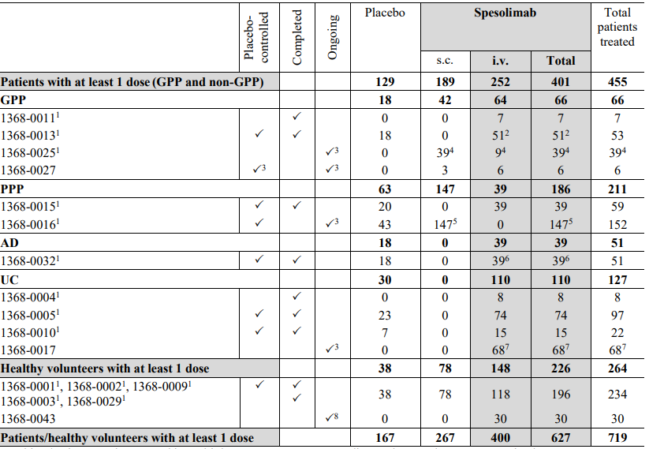

A subject/patient may be counted in multiple treatment groups according to the actual treatment received.

1 Included in the population PK model.

2 In trial 1368-0013, 35 patients received a randomized dose of spesolimab i.v. Of the 18 patients initially randomized to placebo, 15 patients received open-label spesolimab on Day 8 and 1 patient received rescue treatment with spesolimab after Day 8.

3 Up to the cut-off date of 08 Jan 2021 (for trial 1368-0027: only open-label data).

4 All patients rolled over from trial 1368-0013. Two patients who had been randomized to placebo and had not received any spesolimab in trial 1368-0013, received spesolimab s.c. in trial 1368-0025.

5 In trial 1368-0016, 109 patients received double-blind spesolimab during the 16-week trial period. Of the 43 patients initially randomised to placebo, 38 patients received spesolimab up to the cut-off date.

6 In trial 1368-0032, 33 patients received double-blind spesolimab during the first trial period. Of the 18 patients randomized to placebo, 6 patients received open-label spesolimab in the second trial period.

7 All patients rolled over from trials 1368-0004 and 1368-0005.

8 Trial 1368-0043: completed i.v. treatment period.

#### Pharmacology

The proposed dosing of spesolimab in this application is by IV infusion. Clinical studies are also evaluating SC spesolimab for the prevention of GPP flares, but that is not under consideration in this application.

Clinical data informing the PK and PD of spesolimab following IV dosing are derived from:

* 6 Phase 1 studies in healthy subjects (1368-0001, 1368-0002, 1368-0003, 1368-0009, 1368-0029, 1368-0043).
* 3 studies in patients with GPP (1368-0011, 1368-0013, 1368-0025).
* a pooled popPK analysis which included data following IV and SC dosing from patients in GPP and non-GPP studies.

These studies are described in detail in the clinical evaluation report and the key PK and PD findings are summarised below.

##### Pharmacokinetics (PK)

In the single ascending dose study in healthy subjects (Study 1368-0001), spesolimab Cmax and AUC0-tz increased in a greater than dose-proportional manner over the dose range of 0.010 to 0.300 mg/kg, and increased dose-proportionally over the 0.300 to 10 mg/kg dose range.

In the multiple ascending dose study in healthy subjects (Study 1368-0002), spesolimab Cmax and AUC were approximately dose-proportional across the tested dose range of 3 mg/kg to 20 mg/kg. Steady-state was not attained by any of the dose groups (3 mg/kg, 6 mg/kg, 10 mg/kg, and 20 mg/kg administered once weekly for 4 weeks).

Following a single 300 mg IV dose of spesolimab in healthy subjects (Study 1368-0003), the mean volume of distribution during the terminal phase after IV administration (Vz) was 5.15 L.

The metabolic pathway of spesolimab has not been characterised, but spesolimab is expected to be degraded into small peptides and amino acids via catabolic pathways in a manner similar to endogenous IgG.

Following a 900 mg IV dose of spesolimab to 32 patients with GPP in Study 1368-0013, spesolimab clearance (CL) and terminal half-life in plasma (t1/2) were 0.242 L/day and 16.8 days, respectively, and Vz ranged from 5.4 L to 6.8 L. CL and t1/2 were 0.203 L/day and 23.7 days, respectively, in ADA-negative patients (n=18) and 0.303 L/day and 10.8 days, respectively, in ADA-positive patients (n=14). AUC0-inf was lower in ADA-positive patients (2950 µg.day/mL, n=14) compared to ADA-negative patients (4380 µg.day/mL, n=18). For the entire cohort, spesolimab AUC0-inf was 3680 µg.day/mL.

Other than specific studies undertaken in healthy Chinese (Study 1368-0043) or Japanese (Study 1368-009) subjects, the PK of spesolimab in special populations was primarily addressed in the PopPK analyses. There were no PK studies in patients with hepatic or renal impairment; these conditions are not expected to have a clinically meaningful impact on spesolimab PK.

No drug-drug interaction (DDI) studies were conducted for this application as the potential of spesolimab to cause clinically significant DDI as a perpetrator is low for the treatment of GPP flares. The acute and transient increase in pro-inflammatory cytokines in patients with GPP flare, combined with the rapid anti-inflammatory effect of spesolimab makes the potential indirect DDI risk associated with normalisation of pro-inflammatory cytokine minimal.

##### Population PK data

A population pharmacokinetic (popPK) analysis was undertaken to characterise the PK of spesolimab in patients with GPP, healthy volunteers and other indications, to evaluate the effect of pre-specified covariates on the PK of spesolimab, and to derive exposure measures for patients in 1368-0013 for exposure-response analyses. Data were pooled for 557 subjects from 14 studies of IV or SC spesolimab in healthy volunteers and patients. The population comprised healthy volunteers (33.0%) and patients with PPP (32.9%), UC (17.2%), GPP (10.4%), and AD (6.5%). 59.6% of subjects received IV spesolimab.

The final model predicted that for a typical 70 kg ADA-negative patient with GPP who had been administered a single 900 mg IV dose, spesolimab Cmax and AUC0-inf were 238 mg/L and 4750 µg. day/L, respectively. The model-predicted steady state volume of distribution was 6.39 L, CL was 0.184 L/day and t1/2 was 25.5 days.

Covariates examined for potential effects on the PK of spesolimab included body weight, age, gender, race, disease state (HV, GPP, PPP, UC, AD), baseline disease severity, anti-drug antibodies (ADA), neutralising antibodies (NAb), renal function, liver function, concomitant medications (immunosuppressants, oral corticosteroids), and dose parameters. The modelling predicted that, for a 70 kg patient with GPP receiving a single IV dose, spesolimab AUC was approximately 2.3-fold lower in patients with a maximum ADA titre of 3.6x106 compared to a reference subject with no ADAs. By contrast, ADA titre had little to no effect on spesolimab Cmax.

Of the other covariates, extremes of bodyweight had the most impact on AUC and Cmax, but the effect of body weight on spesolimab AUC and Cmax is not expected to be clinically meaningful. Age, gender and race did not affect the PK of spesolimab. There was no meaningful correlation between spesolimab exposure and liver enzyme values.

##### Pharmacodynamics (PD)

Inhibition of macrophage inflammatory protein (MIP)-1β and tumour necrosis factor (TNF)α were assessed as indirect measures of target engagement of IL36R in Phase 1 studies in healthy subjects. In Study 1368-0001, MIP-1β and TNFα inhibition was detected following all spesolimab doses. Near maximal inhibition of TNFα and MIP-1β was generally maintained until 1008 h post-dose. In Study 1368-0002, median inhibition of MIP-1β of at least 90% compared to baseline (pre-dose) was observed during the entire time course until the end of study (week 25), whereas placebo groups showed negligible inhibition.

Study 1368-0013 investigated C-reactive protein (CRP) and neutrophil levels in serum following a 900 mg IV dose of spesolimab in patients with GPP presenting with an acute flare of moderate to severe intensity. Following treatment with spesolimab, the median decrease in the percent change from baseline in CRP was -8.9% on day 2, -76.4% on day 8, and -97.1% by week 4. This decrease was maintained through week 12. The median decrease in CRP at Day 8 was larger in spesolimab treated subjects (-76.4%) compared to placebo (-29.7%). Similar reductions from baseline were observed for neutrophil counts following spesolimab treatment.

Changes in RNA expression in skin biopsies were assessed in Studies 1386-0011 and 1386-0013. After spesolimab treatment, there were significant decreases in genes associated with pro-inflammatory cytokines, neutrophil recruitment,innate immune response**,** keratinocyte proliferation, and IL36 ligands.

##### Immunogenicity

Of 50 ADA-evaluable and spesolimab-treated patients in Study 1386-0013, 23 patients (46%) were ADA positive after treatment and 27 patients (54%) were ADA negative through the trial duration. The majority (87%) of the ADA-positive patients (40% of total treated) were also NAb positive and the NAb status appeared to be associated with the titre value. ADA appeared to decrease spesolimab exposure and increase clearance, particularly at titres greater than 4000. Twelve patients (24%) had a maximum titre of greater than 4000.

In ADA-positive patients, ADA developed early with a median onset time of 2.3 weeks and reached maximum titre at a median time of 11.7 weeks. In NAb-positive patients, NAb was detected at a median onset time of 6.7 weeks. At the end of the study (12-17 week after the first active dose), the ADA was resolved in 4 out of 23 ADA-positive patients. Nineteen (38% of total treated) patients remained ADA positive, 18 (36%) patients remained NAb positive and 12 (24%) patients had a titre greater than 4000**.**

##### Study 1368-0011

Study 1368-0011 was a Phase 1 proof-of-concept study evaluating the safety, tolerability, PK, pharmacogenomics, and efficacy of a single 10 mg/kg IV dose of spesolimab in 7 patients with active GPP. Patients were followed up for 140 days (20 weeks) after dosing. Decreases in biomarkers of inflammation, keratinocyte activation, and neutrophil activation were observed. Secondary efficacy endpoints, including total GPPASI, total GPPGA, FACIT-Fatigue scale, and Pain VAS scores, showed response to treatment at 2 weeks after dosing. Both investigator-assessed (GPPASI, GPPGA) and patient-rated (FACIT-Fatigue, Pain VAS) outcomes showed improvement in disease severity and symptoms. No severe AE, SAE, AESI, or discontinuation due to AE were observed.

Dose selection for the main efficacy study evaluating IV spesolimab for the treatment of acute flare of GPP (the Phase 2 Study 1368-0013) was informed by findings from Study 1368-0011, as well as findings from PK/PD studies in healthy volunteers and popPK modelling. A fixed dose of 900 mg IV was selected for Study 1368-0013 rather than a weight-based dose, as the popPK analysis indicated that the effects of body weight on the PK of spesolimab were unlikely to be clinically significant. The 900 mg dose was selected to maintain the PK exposures achieved in Study 1368-0011 and allow flexibility to recruit patients with body weight >70 kg.

#### Efficacy

Studies submitted to support efficacy in the proposed indication include:

* **1368-0011:** Phase I proof-of-concept study of IV spesolimab for treatment of GPP flares.
* **1368-0013** (pivotal study): Phase II randomised, placebo-controlled study evaluating the efficacy and safety of spesolimab 900 mg IV for treatment of an acute flare of GPP
* **1368-0027:** Ongoing Phase II randomised, placebo-controlled, double-blind study of SC spesolimab for prevention of GPP flares, with option for open-label spesolimab 900 mg IV for treatment of flares.
* **1368-0025**: Ongoing open-label extension (OLE) trial evaluating long-term safety and efficacy of spesolimab SC (with the option of spesolimab IV for recurring flare treatment) in eligible patients who completed trials 1368-0013 or 1368-0027.

Table 4: Summary of clinical trials with spesolimab in patients with GPP

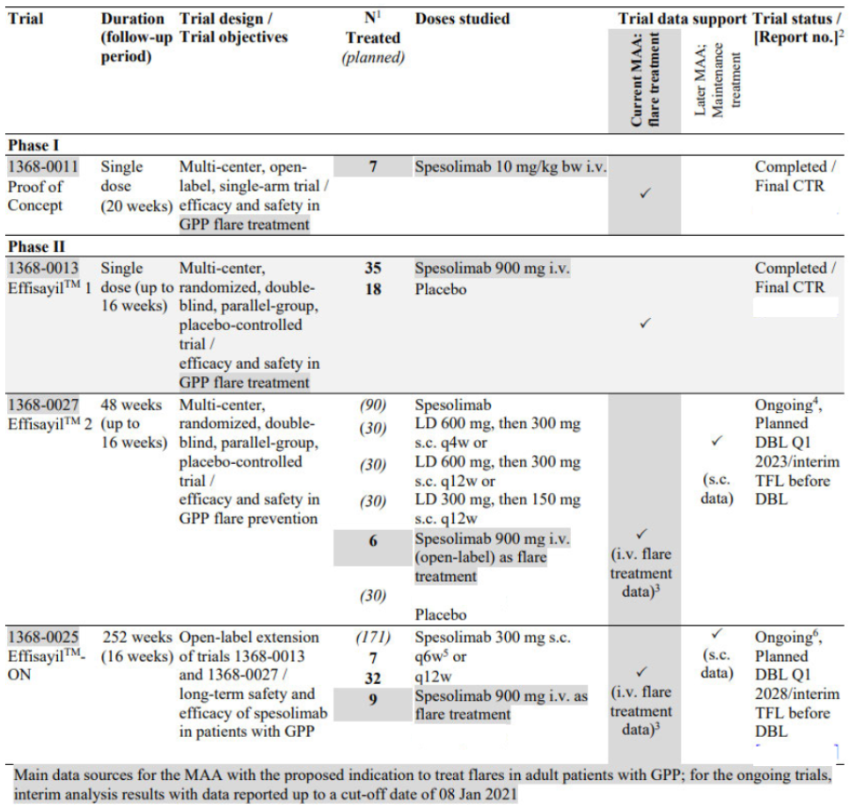

Bw = body weight, i.v. = intravenous, LD = loading dose, MAA = Marketing Authorisation Application, q4w = once every 4 weeks, q6w = once every 6 weeks, q12w = once every 12 weeks, s.c. = subcutaneous, TFL = tables, listings, and figures.

1 For completed trials, number of actually treated patients (for ongoing trials, number of patients planned to be treated).

2 For the completed trials, final clinical trial reports (CTR) are included in the MAA dossier. For the ongoing trials, results of the interim analyses conducted for the submission are included as tables, listings, or figures (TFL) and referenced in the clinical summary documents (SCE, SCS) in Module 2.7.

3 To support safety in patients with GPP, open-label s.c. data were also analyzed.

4 First patient screened in June 2020.

5 For the interim data collected up to the cut-off-date of 08 Jan 2021; changed to q4w with CTP amendment 2.

6 First patient screened in May 2019

**Study 1368-0013 (Effisayil-1)**

This is the pivotal efficacy study for this application. It was a Phase II multicentre, randomised, double-blind, placebo-controlled study with the primary objective to evaluate the efficacy, safety and tolerability of a single IV dose of spesolimab in patients with GPP presenting with an acute flare of moderate to severe intensity. Exploratory objectives included evaluation of efficacy and safety of an open-label dose of spesolimab IV on Day 8, and to investigate the PK, anti-drug antibodies (ADA), pharmacogenomics, and specific biomarkers. The study was conducted from 20 February 2019 to 5 January 2021 at 37 sites in 12 countries across Europe, North America, North Africa and Asia (China, France, Germany, Japan, Malaysia, Singapore, South Korea, Switzerland, Taiwan, Thailand, Tunisia, USA). The design of the study is shown in Figure 2.

Figure 2: Study design, 1368-0013

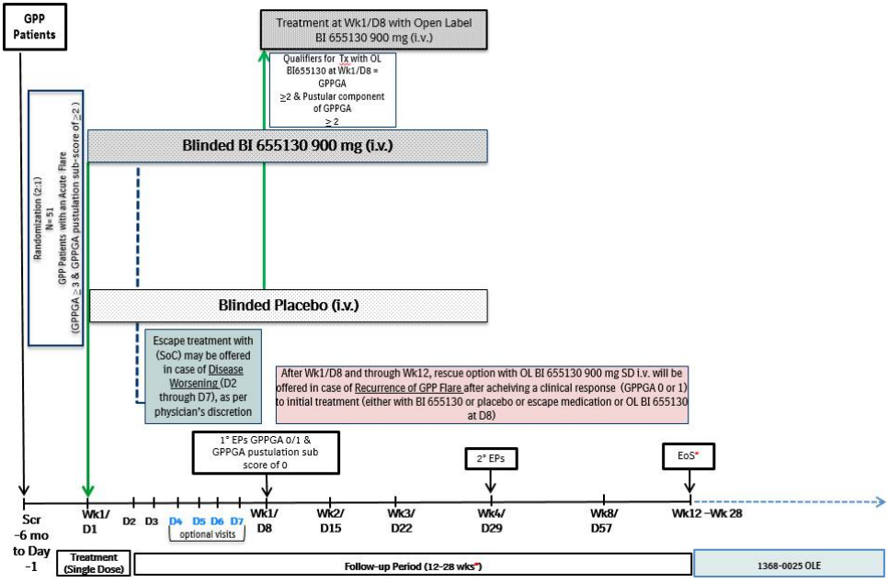

D = day, EoS = End of Study, EPs = Endpoints, Fup = Follow-up, GPP(GA) = generalised pustular psoriasis (physician global assessment), OL(E) = open-label (extension), R = randomisation, Scr = screening, SD = single dose, Wk = week.   
* Patients who did not require rescue treatment with OL spesolimab were to be followed until Wk12 (V14/EoS) prior to entering OLE trial 1368-0025.  
* Patients who received rescue treatment with OL spesolimab between Wk2 and Wk6 were to be followed until Wk12 (V14/EoS) prior to entering the OLE trial. If at V14 they qualified to enter OLE trial, then V14 was considered as EoS for these patients. If not, then patients were to have an additional 10 weeks follow-up and to have an EoS at V16 (Wk16-28).  
* Patients who received rescue treatment with OL spesolimab between Wk7 and Wk12 were to be followed for additional 6 weeks and were to have a response evaluation at V15 (Wk13-18). These patients did not have a V14. If at V15, they qualified to enter the OLE trial, then V15 was to be considered as EoS for these patients. If not, then the patients were to have an additional 10-week follow-up and had an EoS at V16 (Wk16-28).  
* Patients who did not qualify to enter into the OLE trial were to be followed for 16 weeks (EoS/V16/Wk16-28) after the last dose of trial medication, which was the latest time point of trial medication given during the study (i.e. the latest of D1, D8 if OL spesolimab/rescue with OL spesolimab was given).

The study enrolled male or female patients aged 18 to 75 at screening with:

* GPPGA total score of 0 or 1 and a known and documented history of GPP (per European Rare and Severe Psoriasis Expert Network (ERASPEN) criteria) regardless of IL-36RN mutation status, and previous evidence of fever and/or asthenia, and/or myalgia, and/or elevated CRP, and/or leukocytosis with peripheral blood neutrophilia; OR
* Acute flare of moderate to severe intensity with a known and documented history of GPP (per ERASPEN criteria) regardless of IL-36RN mutation status, and previous evidence of fever and/or asthenia, and/or myalgia, and/or elevated CRP, and/or leukocytosis with peripheral blood neutrophilia; OR
* First episode of an acute GPP flare of moderate to severe intensity with evidence of fever and/or asthenia, and/or myalgia, and/or elevated CRP, and/or leukocytosis with peripheral blood neutrophilia, with the GPP diagnosis to be confirmed retrospectively by a central external expert/committee.
* Patients who received any restricted medication (Table 5) were excluded, and patients had to discontinue retinoids/methotrexate/cyclosporine prior to receiving the first dose of study treatment.[8] Patients with an immediate life-threatening flare of GPP or requiring intensive care treatment were also excluded.

Table 5: Restricted medications, Study 1368-0013

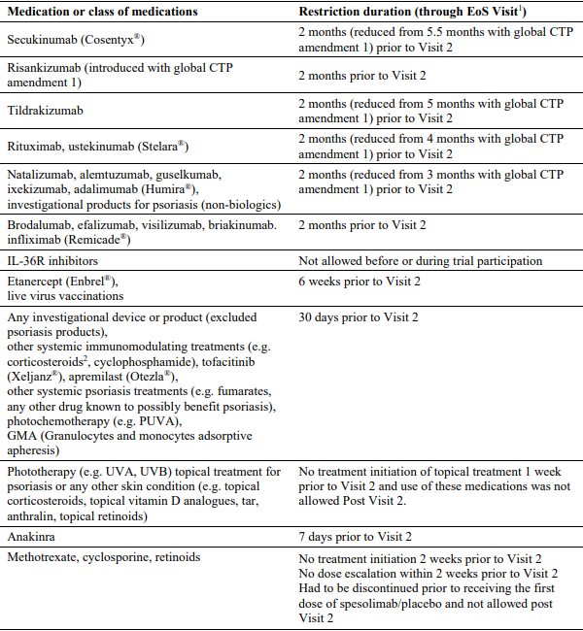

1 In the case of worsening of the flare (disease worsening), please refer to Section 9.4.2.1 of the clinical trial report for the details on the use of escape treatment.

2 No restriction on inhaled corticosteroids to treat asthma or corticosteroid drops administered in the eye or ear.

In the absence of a validated clinical outcome measure for GPP, the GPPGA[9] GPPASI[10] were developed based on the Physician Global Assessment PGA and Psoriasis Area and Severity Index measures used in psoriasis. The Sponsor performed validation exercises on data from Study 1368-013 to support the reliability and validity of these measures for use as key efficacy endpoints. Systemic aspects of the GPP flare were assessed using the JDA GPP Severity Score[11] and the Clinical Global Impression-Improvement (CGI-I) instrument[12]. Patient-reported outcomes were also assessed, including the Psoriasis Symptom Scale (PSS)[13], Pain Visual Analog Scale (VAS) score, Functional Assessment of Chronic Illness Therapy-Fatigue scale (FACIT-Fatigue), Dermatology Life Quality Index (DLQI), and EQ-5D-5L.

Following screening, study treatment was initiated immediately in patients who met the inclusion criteria, did not meet any of the exclusion criteria, and were presenting with an acute flare of moderate to severe intensity, defined by the emergence of:

* GPPGA total score ≥3, and
* presence of fresh pustules (new appearance or worsening of pustules), and
* GPPGA pustulation subscore ≥2, and
* ≥5% of Body Surface Area covered with erythema and the presence of pustules.

Eligible patients were randomised 2:1 to receive a single dose of spesolimab 900 mg IV or placebo on Day 1. If the severity and progression of the disease worsened within the first week, the investigator could treat the patient with Standard of Care (SoC) treatment of his/her choice (escape medication). At the Week 1/Day 8 Visit, the primary endpoint and key secondary endpoint were to be assessed. Patients who had not received escape treatment and who had a GPPGA ≥2 at Week 1 and a GPPGA pustulation subscore ≥2 at Week 1 were eligible to receive treatment with a single open-label IV dose of 900 mg spesolimab on Day 8. Patients with recurrence of GPP flare during the study (defined as a ≥2-point increase in the GPPGA score and the pustular component of GPPGA ≥2 after achieving clinical response (GPPGA 0 or 1) to either spesolimab or placebo on D1 or escape medication or OL spesolimab on D8) could receive 1 rescue dose of open-label spesolimab 900 mg IV after Day 8 through Week 12. Patients could also receive escape medication (SoC) after Day 8 for disease worsening.

The trial was designed to demonstrate superiority of spesolimab relative to placebo in the primary endpoint and the key secondary endpoint. The treatment effect was tested on the randomised set at a 1-sided α-level of 0.025. A hierarchical testing strategy was applied for the primary, key secondary, and other specified secondary endpoints. Analyses of endpoints that were not included in the hierarchical testing strategy were considered exploratory in nature. For the primary estimand concept applied to the primary and secondary endpoints, death or any use of escape medication, open-label spesolimab on Day 8, or rescue dose of open-label spesolimab before observing the endpoint was considered a non-response. For binary endpoints, the primary imputation strategy of missing values was Non-Response Imputation (NRI). For continuous endpoints, missing data were primarily imputed using the last observation carried forward method.

The primary efficacy endpoint was a GPPGA pustulation subscore of 0 (that is, no visible pustules) at Week 1. The key secondary efficacy endpoint was a GPPGA total score of 0 or 1 at Week 1.

Other secondary endpoints included in the hierarchical testing strategy were:

* GPPASI 75[14] at Week 4.
* Change from baseline in Pain VAS score at Week 4.
* Change from baseline in PSS score at Week 4
* Change from baseline in FACIT-Fatigue score at Week 4

Other secondary efficacy endpoints not included in the hierarchical testing strategy were:

* GPPGA pustulation subscore of 0 at Week 4.
* GPPGA total score of 0 or 1 at Week 4.
* GPPASI 50 at Week 1.
* GPPASI 50 at Week 4.
* Percent change from baseline in GPPASI total score at Week 1.
* Percent change from baseline in GPPASI total score at Week 4.

Exploratory efficacy endpoints were also assessed (detailed in the clinical study report).

Of 85 enrolled patients, 53 patients were randomised 2:1 to receive a single dose of spesolimab (35 patients) or placebo (18 patients). All randomised patients were treated. Most of the randomised patients completed the study (spesolimab: 32/35 [91.4%], placebo: 17/18 [94.4%]). There were no deaths or discontinuations due to AEs.

A total of 27 patients (spesolimab 12 patients [34%], placebo 15 patients [83%]) received open-label (OL) spesolimab on Day 8 (Table 6). Six patients (spesolimab 4, placebo 2) received rescue treatment with spesolimab after Day 8, of whom 3 (spesolimab 2, placebo 1) received open-label spesolimab both on Day 8 and as rescue treatment after Day 8.

Table 6: Use of escape medication, OL spesolimab on Day 8, or spesolimab rescue medication (after Day 8) in trial 1368-0013

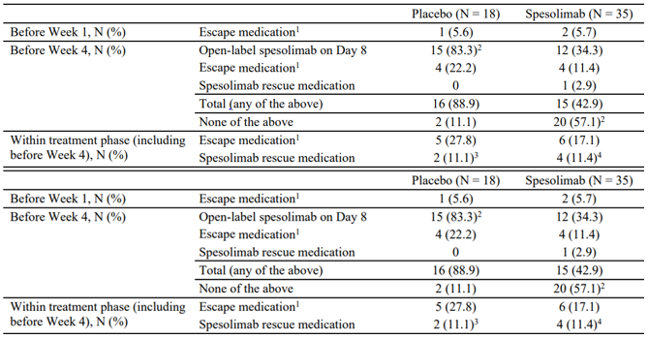

1 Standard of Care at the investigator’s discretion.

2 1 patient in the spesolimab group discontinued the trial before Week 1, and 1 patient in the placebo group discontinued the trial before Week 4.

3 1 patient not treated and 1 patient treated with OL spesolimab on Day 8.

4 2 patients not treated and 2 patients treated with OL spesolimab on Day 8 (i.e. 2 patients received 3 doses of spesolimab).

Demographic data and baseline disease scores are presented in Table 7 and Table 8. At baseline (initiation of randomised treatment), 81.1% of patients had a GPPGA total score of 3 (moderate) and 18.9% had a GPPGA total score of 4 (severe). The majority of patients had a GPPGA pustulation subscore of 3 (43.4%) or 4 (35.8%).

Table 7: Baseline Demographic data, Randomised Set, 1368-0013

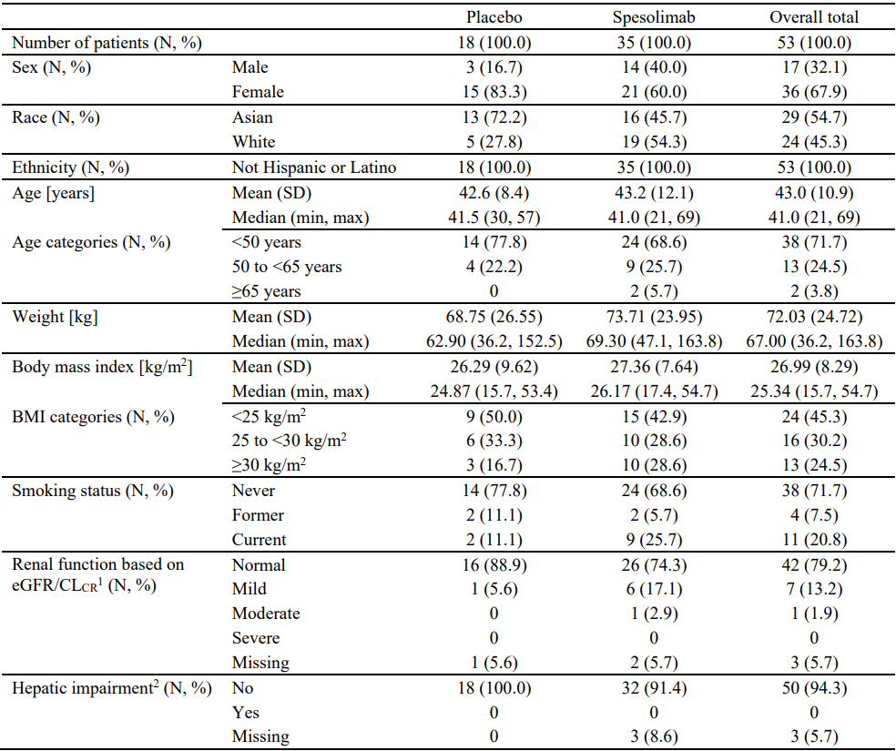

1 Classification of renal function based on estimated CLCR calculated according to the Cockcroft-Gault formula, with the following CLCR categories: normal (≥90 mL/min), mild decrease in GFR (60-89 mL/min), moderate decrease in GFR (30-59 mL/min), and severe decrease in GFR (15-29 mL/min).

2 Defined as INR ≥2.2 and total serum bilirubin >51.3 µmol/L.

Table 8: GPPGA and GPPASI scores and JDA GPP severity index at Baseline, Randomised Set, 1368-0013

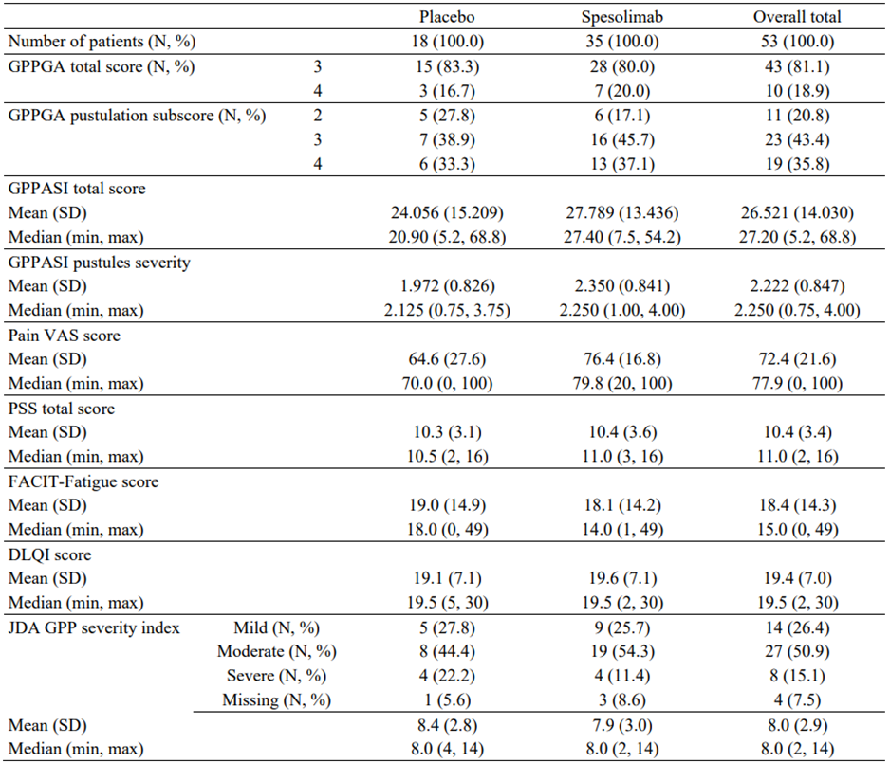

Study 1368-0013 met its primary endpoint (Table 9), with a significantly higher proportion of patients achieving a GPPGA pustulation subscore of 0 at Week 1 in the spesolimab group (54.3%) compared with the placebo group (5.6%).

Table 9: Primary endpoint: Proportion of patients with a GPPGA pustulation subscore of 0 at Week 1 – Randomised Set (EN-NRI).

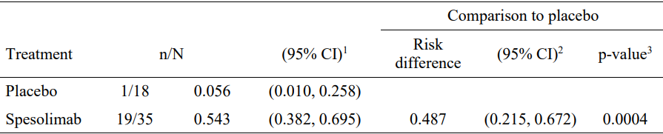

EN = any values after use of escape medication, open-label spesolimab at Day 8, or rescue medication with spesolimab represent non-response; NRI = non-response imputation for any missing data.

1 Calculated using the method of Wilson.

2 Calculated using the method of Chan and Zhang.

3 Calculated using Suissa-Shuster Z-pooled test (1-sided p-value).

Sensitivity analyses using different estimand strategies and imputations methods for missing data showed consistent results. 4 patients (11.4%) in the spesolimab group achieved a GPPGA pustulation subscore of 0 on Day 2, 1 day after treatment (Figure 3).

Figure 3: Proportion (95% CI) of patients with a GPPGA pustulation subscore of 0 over time up to Week 1 in trial 1368-0013 − RS (EN-NRI)

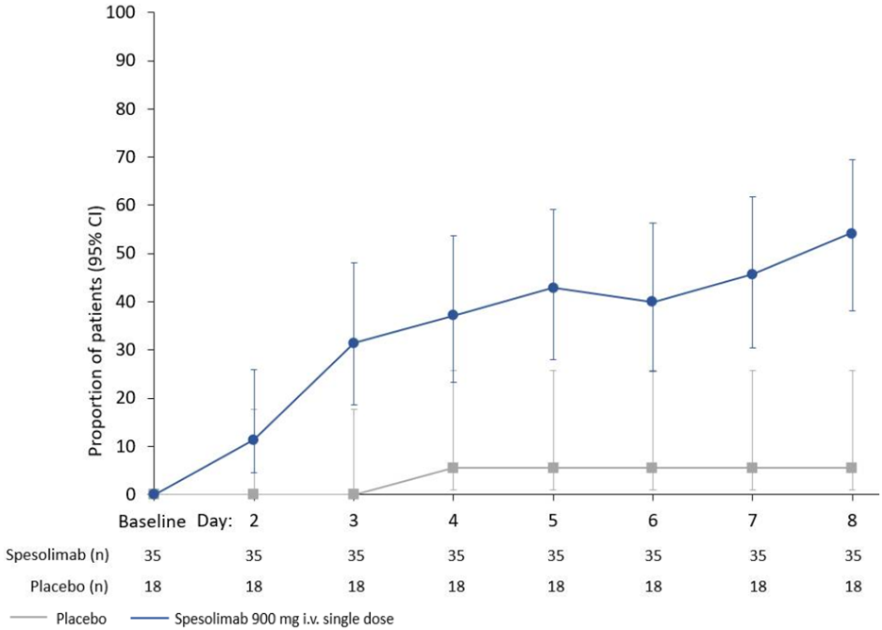

The study also met its key secondary endpoint (Table 10), with a significantly higher proportion of patients achieving a GPPGA total score of 0 or 1 at Week 1 in the spesolimab group (42.9%) compared with the placebo group (11.1%).

Table 10: Key secondary endpoint: proportion of patients with a GPPGA total score of 0 or 1 at Week 1 – Randomised Set (EN-NRI)

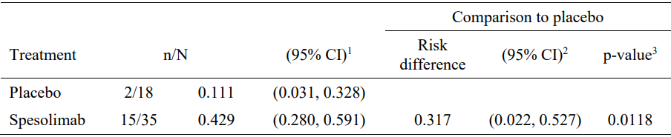

EN = any values after use of escape medication, open-label spesolimab at Day 8, or rescue medication with spesolimab represent non-response; NRI = non-response imputation for any missing data.

1 Calculated using the method of Wilson.

2 Calculated using the method of Chan and Zhang.

3 Calculated using Suissa-Shuster Z-pooled test (1-sided p-value).

Subgroup analyses for the primary (Figure 4) and key secondary (Figure 5) endpoints were limited by small sample sizes but were broadly consistent with the primary analysis.

Figure 4: Subgroup analyses for the primary endpoint: proportion of patients with a GPPGA pustulation subscore of 0 at Week 1 – Randomised Set (EN-NRI)

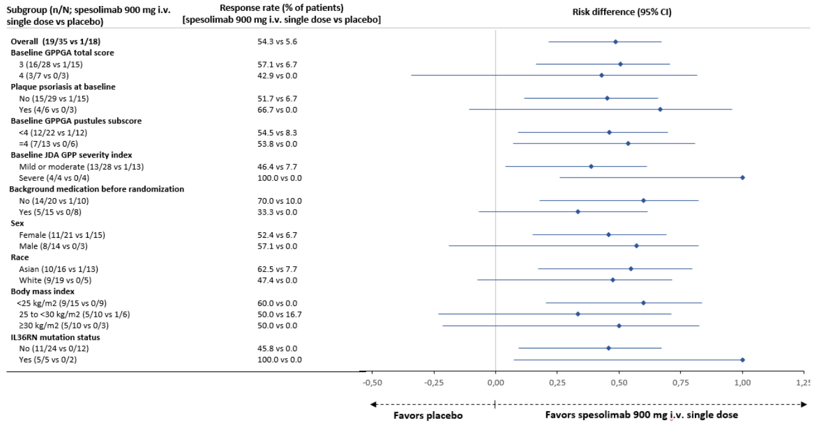

Figure 5: Subgroup analyses for the key secondary endpoint: proportion of patients with a GPPGA total score of 0 or 1 at Week 1 – Randomised Set (EN-NRI)

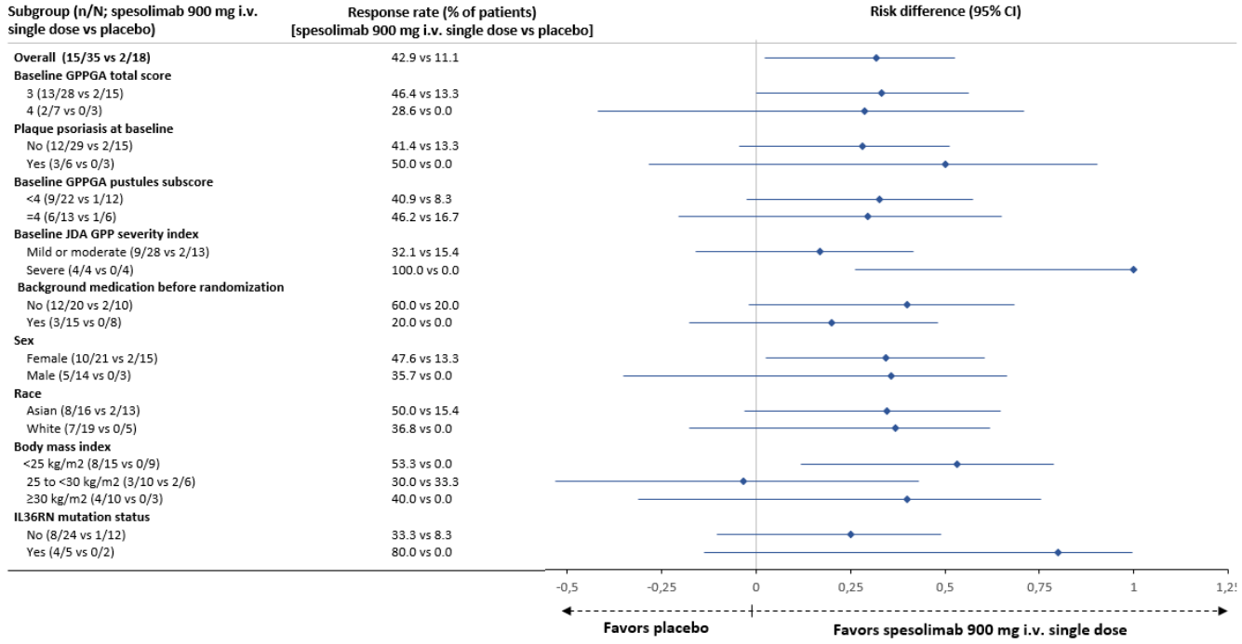

Other secondary efficacy endpoints included in the hierarchical testing strategy were GPPASI 75 at Week 4 and change from baseline in Pain VAS score, PSS score, and FACIT-Fatigue score at Week 4. The proportion of patients with a GPPASI 75 at Week 4 was significantly higher in the spesolimab group than in the placebo group (Table 11). Improvements in patient-reported outcome measures for pain (Pain VAS score), symptom severity (PSS score), and fatigue (FACIT-Fatigue score) from baseline to Week 4 were observed in the spesolimab group, but a treatment difference in the risk difference to placebo was not calculable as 88.9% of patients in the placebo group were classified as non-responders due to the use of escape medication, open-label spesolimab at Day 8, or rescue treatment with spesolimab before Week 4. In the Wilcoxon rank test, the worst ranks were assigned to the non-responders in both treatment arms and the resulting p-values were statistically significant in favour of spesolimab for each of these measures.

Table 11: Secondary endpoints included in the hierarchical testing procedure – Randomised Set, 1368-0013

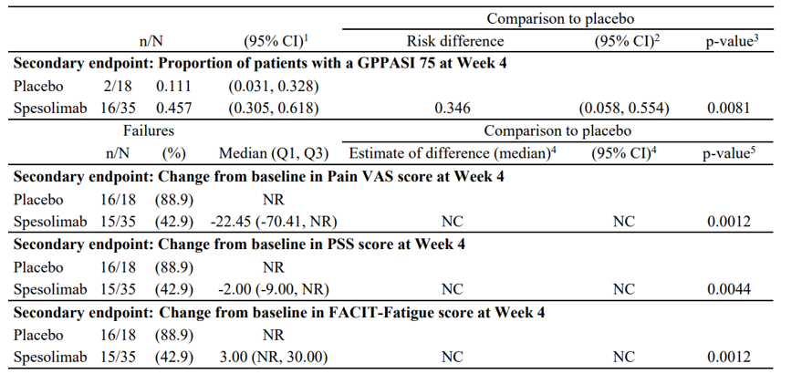

NC = not calculable, NR = non-response

Mean (SD) baseline values: Pain VAS: spesolimab: 76.4 (16.8), placebo: 64.6 (27.6); PSS score: spesolimab: 10.4 (3.6), placebo: 10.3 (3.1); FACIT-Fatigue score: spesolimab: 18.1 (14.2), placebo: 19.0 (14.9)

1 Calculated using the method of Wilson

2 Calculated using the method of Chan and Zhang

3 Calculated using Suissa-Shuster Z-pooled test (1-sided p-value)

4 By modified Hodges-Lehmann method

5 Based on Wilcoxon rank testing (1-sided p-value)

Other efficacy endpoints were not included in the hierarchical testing strategy. The proportions of patients achieving a GPPGA pustulation subscore of 0 at Week 4 (Table 12) and a GPPGA total score of 0 or 1 at Week 4 (Table 13) were higher in the spesolimab group than in the placebo group.

Table 12: Proportion of patients with a GPPGA pustulation subscore of 0 at Week 4 – RS (EN-NRI)

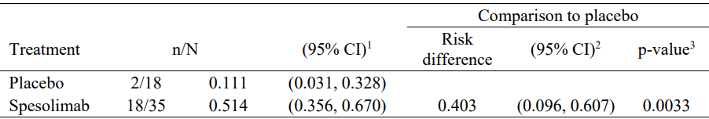

EN = any values after use of escape medication, open-label spesolimab at Day 8, or rescue medication with spesolimab represent non-response; NRI = non-response imputation for any missing data. 1 Calculated using the method of Wilson. 2 Calculated using the method of Chan and Zhang. 3 Calculated using Suissa-Shuster Z-pooled test (1-sided p-value).

Table 13: Proportion of patients with a GPPGA total score of 0 or 1 at Week 4 – RS (EN-NRI)

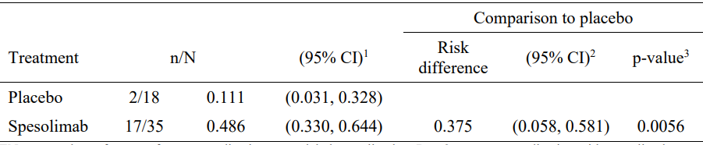  
EN = any values after use of escape medication, open-label spesolimab at Day 8, or rescue medication with spesolimab represent non-response; NRI = non-response imputation for any missing data. 1 Calculated using the method of Wilson. 2 Calculated using the method of Chan and Zhang. 3 Calculated using Suissa-Shuster Z-pooled test (1-sided p-value).

Interpretation of efficacy findings to Week 12 (end of study) was impacted by the use of escape medication (SoC), open-label spesolimab at Day 8, and rescue medication with open-label spesolimab after Day 8. 2 patients in the spesolimab arm and 1 patient in the placebo arm used escape medication before Day 8. 12 patients (34.3%) in the spesolimab arm and 15 patients (83.3%) in the placebo arm received open-label spesolimab on Day 8.

Treatment effects were generally sustained to Week 12. The proportion of patients with a GPPGA pustular subscore of 0 over time for patients randomised to spesolimab who received only 1 dose on Day 1 in shown in Figure 6, and for patients randomised to spesolimab who received up to 2 doses on Day 1 ± Day 8 is shown in Figure 7.

Figure 6: Proportion (95% CI) of patients with a GPPGA pustulation subscore of 0 over time for patients randomised to spesolimab who received a single dose on Day 1 only in trial 1368-0013 (EN-ID8-NRI)

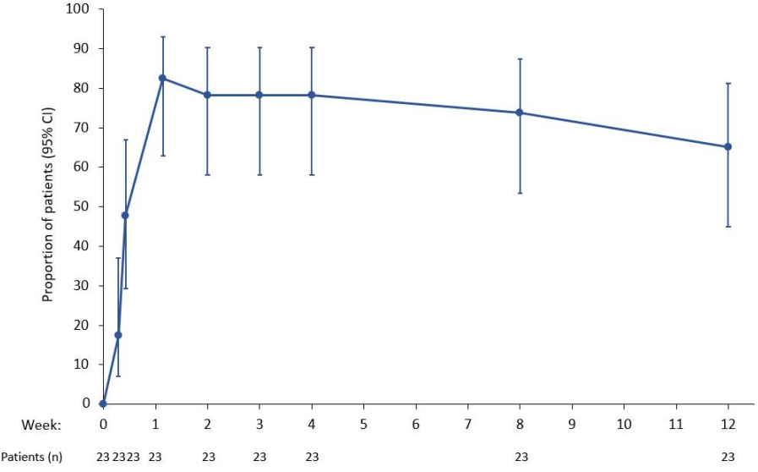

Figure 7: Proportion (95% CI) of patients with a GPPGA pustulation subscore of 0 over time for patients randomised to spesolimab who received up to 2 doses (Day 1 ± Day 8) in trial 1368-0013 (EN-ID8-NRI)

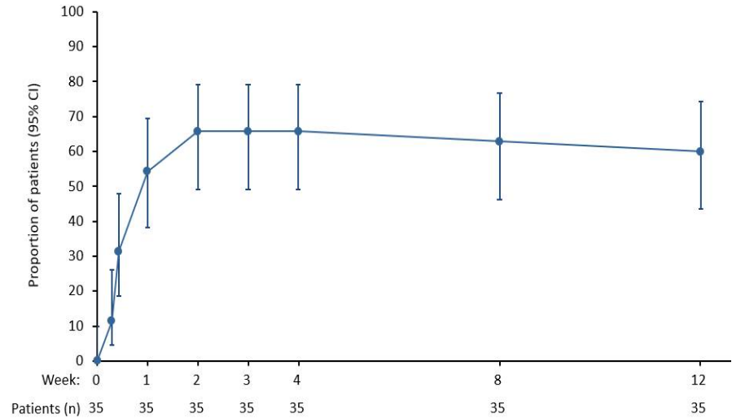

The proportion of patients with a GPPGA total score of 0 or 1 over time for patients randomised to spesolimab who received only 1 dose on Day 1 in shown in Figure 8, and for patients randomised to spesolimab who received up to 2 doses on Day 1 ± Day 8 is shown in Figure 9.

Figure 8: Proportion (95% CI) of patients with a GPPGA total score of 0 or 1 over time for patients randomised to spesolimab who received a single dose on Day 1 only in trial 1368-0013 (EN-ID8-NRI)

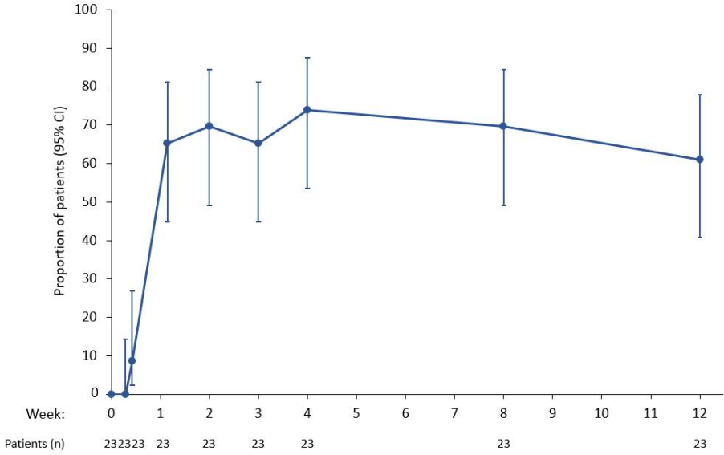

Figure 9: Proportion (95% CI) of patients with a GPPGA total score of 0 or 1 over time for patients randomized to spesolimab who received up to 2 doses (Day 1 ± Day 8) in trial 1368-0013 (EN-ID8-NRI)

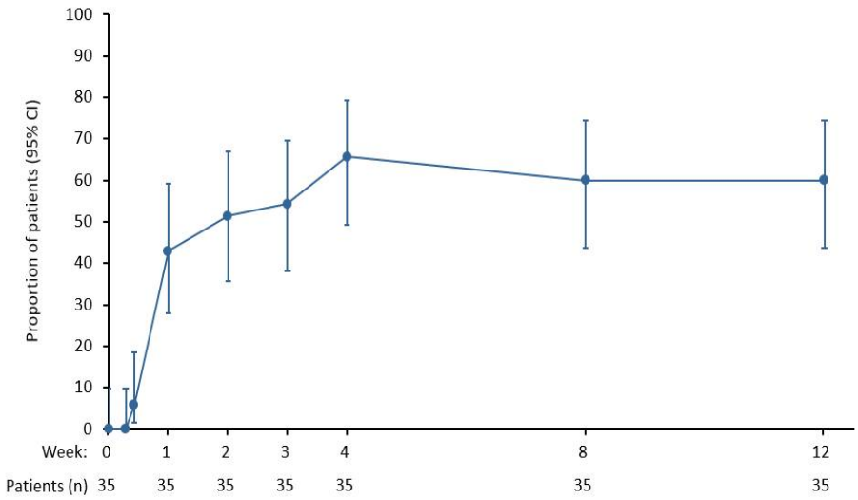

Descriptive analyses using the OC-IR approach[15] assessed the combined effect of any spesolimab treatment (up to 3 doses) and escape medication. The proportion of patients with a GPPGA pustulation subscore of 0 over time for all randomised patients, regardless of escape medication or open label spesolimab, is shown in Figure 10.

Figure 10: Proportion (95% CI) of patients with a GPPGA pustulation subscore of 0 over time for all randomised patients in trial 1368-0013 − RS (OC-IR)

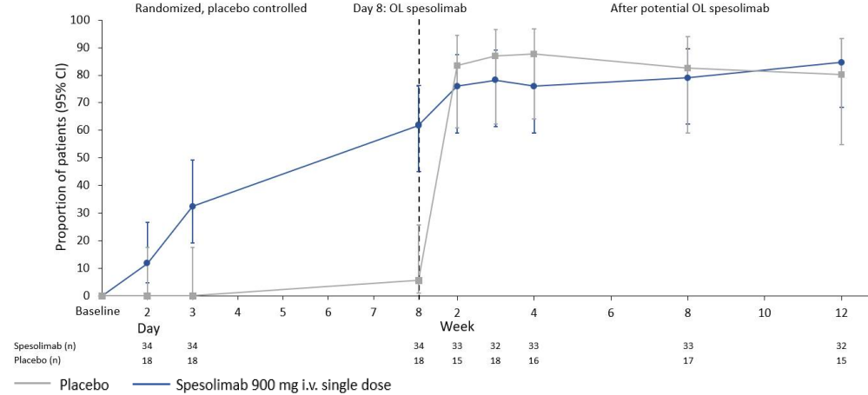

Note: the scale of the x-axis is not linear but the first week (i.e. the part until the vertical dotted line) is stretched. OC-IR = all values regardless of escape medication (SoC), open-label spesolimab on Day 8, or spesolimab rescue medication; the numbers of patients displayed are those with observed data at the corresponding time point; these are used as the denominator for the proportions.

Additional analyses were performed to assess the effect of open-label spesolimab on Day 8 for patients who had an inadequate response to randomised treatment (GPPGA ≥2 at Week 1 and GPPGA pustulation subscore of ≥2 at Week 1). The “Speso + OL D8” group included 12 of the 35 patients randomised to spesolimab who had persisting flare symptoms and received a second dose of spesolimab on Day 8. Of these 12 patients, 41.7% (5 patients) achieved pustular clearance and 16.7% (2 patients) achieved a GPPGA total score of 0 or 1 at Week 2. At Week 12, 50.0% (6 patients) had pustular clearance and 58.3% (7 patients) had a GPPGA total score of 0 or 1. The “Placebo + OL D8” group included 15 of the 18 patients randomised to placebo who received spesolimab on Day 8. Of the 15 patients, 73.3% (11 patients) achieved pustular clearance and 53.3% (8 patients) achieved a GPPGA total score of 0 or 1 at Week 2. The response rate for GPPGA pustulation subscore of 0 declined to 40.0% (6 patients) at Week 12. The response rate for GPPGA total score of 0 or 1 was sustained to Week 12.

Generally, the proportion of patients with a GPPGA score of 0 or 1 over time was similar for ADA negative and ADA positive patients across all groups based on ADA titre. At Week 12, the response rate appeared to decrease in the high ADA titre group, but interpretation was limited by large confidence intervals due to small sample size**.** A similar pattern was observed for NAb negative and positive patients, with no apparent evidence of difference in the proportion of patients with a GPPGA total score of 0 or 1 over time.

Study 1368-0027

This is an ongoing, Phase IIb, multicentre, randomised, double blind, placebo-controlled, dose-finding study investigating the efficacy and safety of multiple SC doses of spesolimab compared with placebo in preventing GPP flares in patients aged ≥12 years with a history of GPP (and currently presenting with GPPGA score of 0 or 1, i.e., clear or almost clear). The study protocol allowed the use of spesolimab 900 mg IV for the treatment of acute flares, so the study provides limited data relevant to the proposed indication.

The main objectives of this study relate to evaluation of multiple doses of SC spesolimab for the prevention of GPP flares. Evaluation of the safety and efficacy of spesolimab 900 mg IV for the treatment of acute GPP flare[16] was an additional objective of the study (Figure 11).

Figure 11: Study design in the event a patient experiences 1st GPP flare

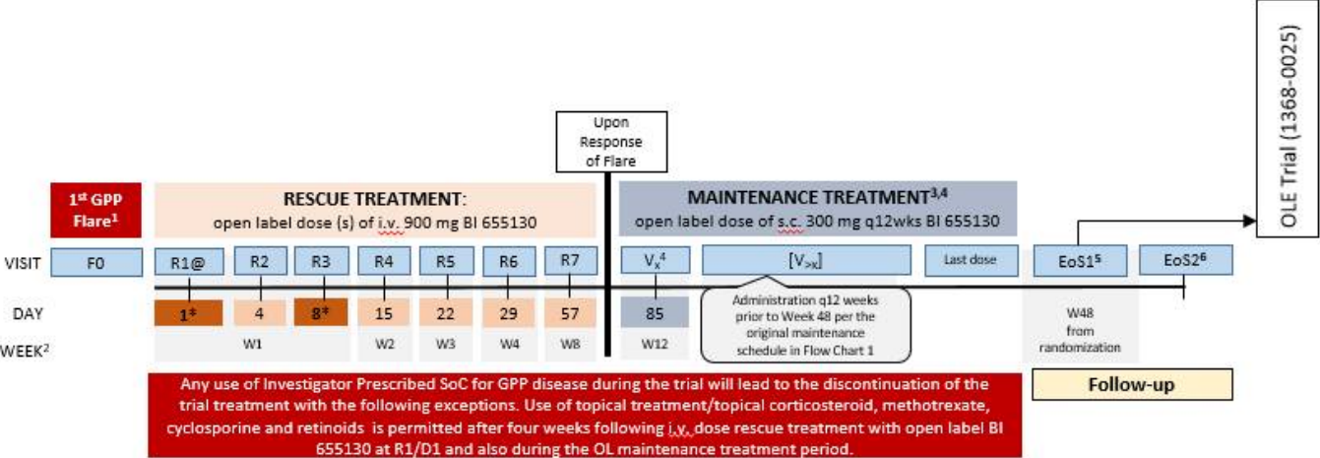

This submission presented interim open-label data up to data cut-off date of 8 January 2021 for 6 patients who received open-label flare treatment with spesolimab 900 mg IV during the randomised maintenance treatment period; no other data were provided to avoid risk of unblinding in this prevention study. Three of the 6 patients had completed 12 weeks of the IV treatment period, 1 patient had discontinued before Week 12, and 2 patients were still ongoing in the flare treatment period at the time of cut-off. All 6 patients had a GPPGA total score ≥3 and a GPPGA pustulation subscore of ≥2 just prior to receiving spesolimab IV flare treatment.

Of the 6 patients who received IV flare treatment, 5 patients (83.3%) achieved a GPPGA pustulation subscore of 0 on Day 4 and Day 8 (Table 14) and 3 patients (50%) achieved a GPPGA total score of 0 or 1 on Day 4 and Day 8 (Table 15).

Table 14: Proportion of patients with GPPGA pustulation subscore of 0 within rescue treatment period – SAF-FT (EN-ID8-NRI)

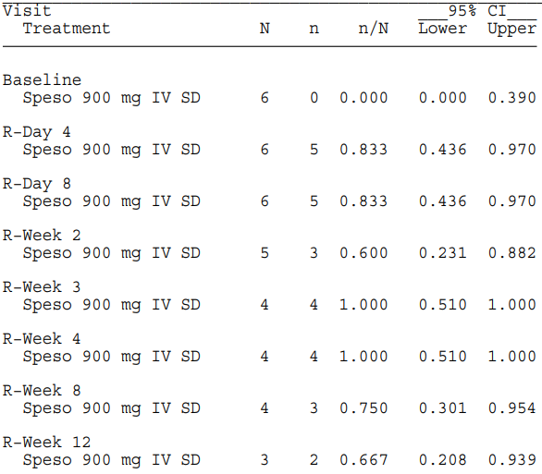

The denominator for percentages and proportions for a visit does not consider the patients who should not attend that visit per CTP. 95% confidence intervals (CI) are calculated using the method of Wilson. Estimand EN−ID8: Any values post death or investigator−prescribed SoC (except for topical treatments/topical corticosteroids after four weeks following rescue treatment at R1/D1) represent non−response. In interim analysis, if a patient has not completed a visit due to early cut−off, then the patient is not considered for that visit.

Table 15: Proportion of patients with GPPGA total score of 0 or 1 within rescue treatment period – SAF-FT (EN-ID8-NRI)

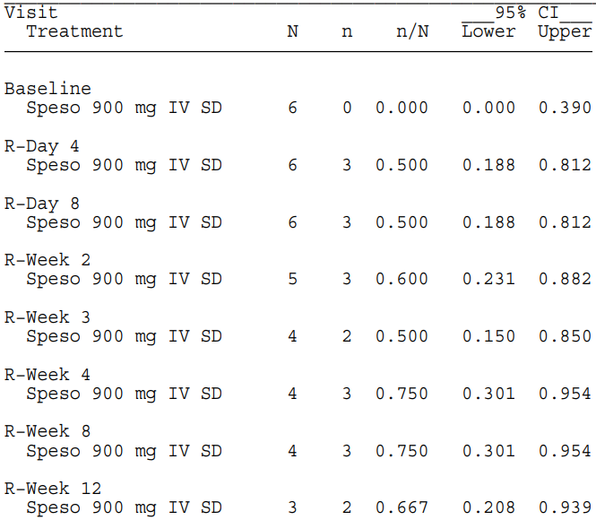

The denominator for percentages and proportions for a visit does not consider the patients who should not attend that visit per CTP. 95% confidence intervals (CI) are calculated using the method of Wilson. Estimand EN−ID8: Any values post death or investigator−prescribed SoC (except for topical treatments/topical corticosteroids after four weeks following rescue treatment at R1/D1) represent non−response. In interim analysis, if a patient has not completed a visit due to early cut−off, then the patient is not considered for that visit.

##### Study 1368-0025

This is an ongoing, 5-year, Phase II, multicentre, open-label, long term extension study to evaluate the safety and efficacy of spesolimab in patients with GPP who completed studies 1368-0013 or 1368-0027. Patients are excluded from the extension study if they have evidence of flare symptoms of moderate or severe intensity at screening. Patients who experience a reoccurrence of GPP flare[17] during SC maintenance treatment receive open-label spesolimab 900 mg IV as rescue treatment.

The primary endpoint is the occurrence of treatment emergent adverse events (TEAEs) up to week 252 of maintenance treatment. Secondary endpoints are:

* reoccurrence of a GPP flare, and

in patients who receive flare rescue treatment:

* time to first achievement of a GPPGA score of 0 or 1
* GPPGA pustulation sub-score of 0, by visit
* change from baseline in Psoriasis Symptom Scale (PSS) score, by visit

The interim analysis submitted with this application included all patients who flared and received open-label IV spesolimab up to the data cut-off (8 January 2021). The study population at the time of the interim analysis consisted entirely of patients who rolled over from Study 1368-0013. All patients in the extension study had a GPPGA total score of ≤2 at enrolment, and all patients who received flare rescue treatment had a GPPGA total score of 3 and a GPPGA pustulation subscore of ≥2 just before flare treatment.

As at the data cut-off date, 9 patients (23.1%) had received flare treatment with spesolimab 900 mg IV, of whom 3 patients had a second flare. Of the total 12 flare treatment periods, a GPPGA pustulation subscore of 0 was achieved in 50% (6 flare treatment periods) on Day 8 (Table 16) and a GPPGA total score of 0 or 1 was achieved in 33.3% (4 flare treatment periods) on Day 8 (Table 17). The median absolute PSS score at baseline (i.e. at Day 1 of flare treatment) was 12.0 and at Day 8 the absolute change from baseline was -3.0 after IV flare treatment.

Table 16: Proportion of flare treatment periods with GPPGA pustulation subscore of 0 by visit in each flare treatment period − SAF−FT (EN−ID8−NRI)

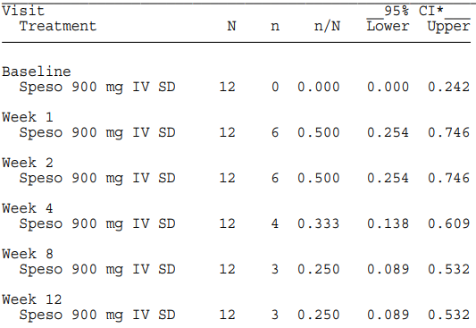  
The denominator for percentages and proportions at each visit is the number of flare treatment periods excluding flare treatment periods after the interim cut−off. * 95% confidence intervals (CI) are calculated using the method of Wilson. EN−ID8: Death or any use of escape medication, prior to observing the endpoint is considered to represent a non−response in the analysis of this binary endpoint outcome. Each flare treatment period: from start of 1st IV for each flare treatment period to the earliest day of treatment REP or before next maintenance treatment (SC), next flare treatment (IV) or cut−off for interim analysis if applicable.

Table 17: Proportion of flare treatment periods with GPPGA score of 0 or 1 by visit in each flare treatment period − SAF−FT (EN−ID8−NRI)

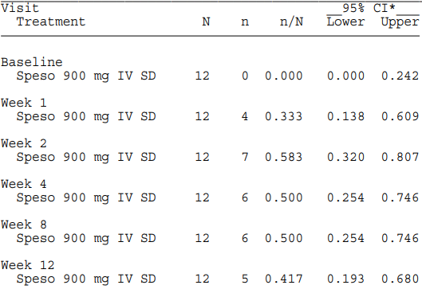

The denominator for percentages and proportions at each visit is the number of flare treatment periods excluding flare treatment periods after the interim cut−off. * 95% confidence intervals (CI) are calculated using the method of Wilson. EN−ID8: Death or any use of escape medication, prior to observing the endpoint is considered to represent a non−response in the analysis of this binary endpoint outcome. Each flare treatment period: from start of 1st IV for each flare treatment period to the earliest day of treatment REP or before next maintenance treatment (SC), next flare treatment (IV) or cut−off for interim analysis if applicable.

#### Safety

The main study informing the safety of spesolimab for the proposed indication and dosing regimen is the Phase 2 Study 1368-0013. Other safety data in patients with GPP are provided by the Phase 1 study 1368-0011 and interim analyses of open-label IV spesolimab in patients who experienced flares in the ongoing studies 1368-0027 and 1368-0025. The submission also presented safety data from the Phase 1 studies in healthy volunteers and spesolimab studies in other conditions (PPP, AD, and UC) to support the safety data in patients with GPP (Table 18). Pooling of safety data across trials was not considered appropriate due to heterogeneity in study populations and trial designs across trials, both within GPP and across other diseases.

In Study 1368-0013, 51 patients received at least 1 dose of spesolimab, including 35 patients who received spesolimab on Day 1 (of whom 12 received a second dose of spesolimab open-label on Day 8) and 15 patients randomised to placebo who received open-label spesolimab on Day 8. 6 patients (placebo: 2 patients, spesolimab: 4 patients) received rescue treatment with spesolimab after Day 8; of those, 3 patients (placebo: 1 patient, spesolimab: 2 patients) received open-label spesolimab both on Day 8 and as rescue therapy after Day 8. Of the 53 patients in Study 1368-0013, 49 (92.5%) completed the planned observation period and 39 patients (73.6%) rolled over into the open-label extension trial 1368-0025.

Table 18 Overview of patients treated in spesolimab clinical trials

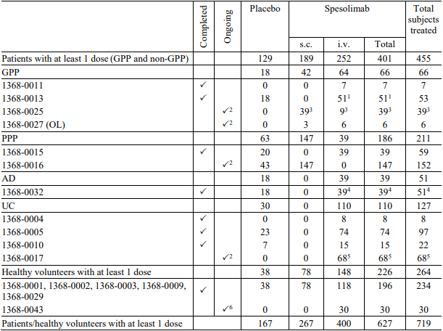

A subject/patient may be counted in multiple treatment groups according to the actual treatment received. 1 In trial 1368-0013, 35 patients received a randomised dose of spesolimab i.v. Of the 18 patients randomized to placebo, 15 patients received open-label spesolimab on Day 8 and 1 patient received rescue treatment with spesolimab after Day 8. 2 Up to the cut-off date of 08 Jan 2021. 3 All patients rolled over from trial 1368-0013. 4 In trial 1368-0032, 33 patients received double-blind spesolimab during the first trial period. Of the 18 patients randomised to placebo, 6 patients received open-label spesolimab in the second trial period. 5 All patients rolled over from trials 1368-0004 and 1368-0005. 6 Trial 1368-0043: completed i.v. treatment period.

##### Study 1368-0013

The safety analyses were performed on the safety analysis set (SAF), which included all randomised patients who were treated on Day 1 (53 patients overall, 35 randomised to spesolimab and 18 to placebo on Day 1). Statistical analysis and reporting of AEs focused on treatment-emergent AEs (TEAEs), which were all AEs occurring between start of treatment and end of the residual effect period (REP) defined as 16 weeks after the last dose of trial medication. For patients who continued into the extension trial, only TEAE up to the first dose in the extension trial were presented in this study report.

An overall summary of AEs up to Week 1 is presented in Table 19**.** Most AEs were mild or moderate (grade 1 or 2). Severe (grade 3) AEs were reported for 2 patients (11.1%) in the placebo group (PTs: pustular psoriasis and pyrexia) and 6 patients (17.1%) in the spesolimab group (PTs: anaemia, pustular psoriasis, and arthritis).

Table 19 Overall summary of AEs up to Week 1 – SAF, Study 1368-0013

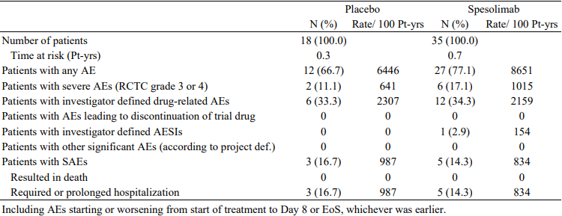

After Week 1, 16 of 18 (89%) patients randomised to placebo and 14 of 35 (40%) patients randomised to spesolimab received open-label spesolimab at Day 8 or as rescue medication after Day 8 and were censored for the subsequent Week 12 AE analysis. Consequently, there was little change in the proportion of patients reporting AEs in the placebo group from Week 1 up to Week 12 (Table 20). Exposure-adjusted AE incidence rates were lower at Week 12 than Week 1, particularly in the spesolimab group. There were no AEs leading to discontinuation of study drug. The proportion of patients reporting SAEs was balanced across the treatment groups and there were no deaths. One Grade 4 (life-threatening) AE was reported in 1 patient in the spesolimab group (DRESS, discussed below in SAE and AESI).

Table 20 Overall summary of AEs up to Week 12, including REP – SAF, Study 1368-0013

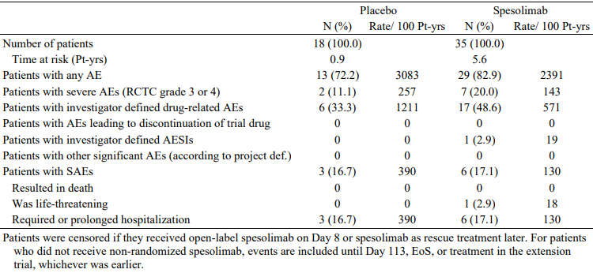

The most common TEAEs (>10% in either treatment group) up to Week 1 by system organ class (SOC) and preferred term (PT) are shown in Table 21, and up to Week 12 in Table 22. The most frequently reported AEs by PT up to Week 1 were pustular psoriasis (spesolimab vs placebo: 37.1% vs 38.9%), pyrexia (spesolimab vs placebo: 5.7% vs 22.1%), and headache (spesolimab vs placebo: 8.6% vs 5.6%). The frequencies of *skin and subcutaneous tissue disorders* were balanced between groups and were mainly driven by the PT pustular psoriasis. *Infections and infestations* were reported in 6 (17.1%) patients in the spesolimab group[18] compared to 1 (5.6%) patient in the placebo group. [19] Infections were generally of mild to moderate severity, with no distinct pattern regarding type of infection. Severe, serious, and opportunistic infections were reported as adverse events of special interest (AESIs).

Up to Week 12, the most frequently reported AEs by PT in the spesolimab group were pustular psoriasis (18 patients, 51.4%) and headache (4 patients, 11.4%). *Infections and infestations* were reported in 12 (34.3%) patients in the spesolimab group. The exposure-adjusted incidence rates of AEs up to Week 12 were markedly decreased from Week 1, but *infections and infestations* remained higher in the spesolimab groupthan placebo. Analyses of AEs based on any spesolimab use were also presented (Table 21).

Table 21. AEs reported for more than 10% of patients in either treatment group on the PT or SOC level up to Week 1 – SAF, Study 1368-0013

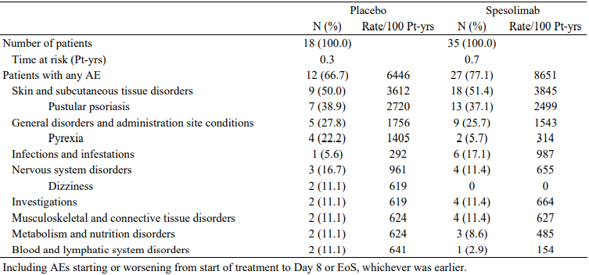

Table 22 AEs reported for more than 10% of patients in either treatment group on SOC or PT level up to Week 12, including REP – SAF, Study 1368-0013

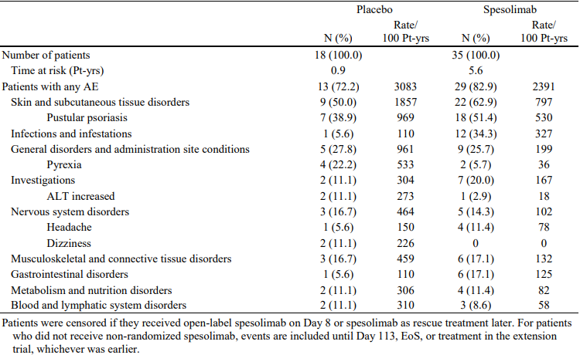

Table 23 Most common AEs (>10% in any group) by treatment period (spesolimab use) and initial randomisation up to Week 12, including REP – SAF, Study 1368-0013

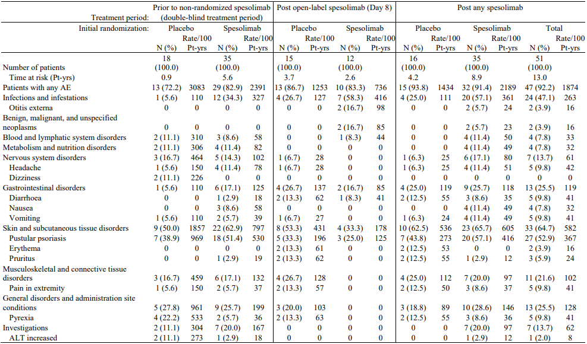  
Prior to non-randomised spesolimab: Patients were censored if they received open-label spesolimab on Day 8 or spesolimab as rescue treatment later. For patients who did not receive non-randomised spesolimab, events are included until Day 113, EoS, or treatment in the extension trial, whichever was earlier. Post open-label spesolimab: Including only patients who received open-label spesolimab on Day 8: events are included until rescue treatment with spesolimab, Day 120 (i.e. including a 16-week residual effect period after open-label spesolimab treatment on Day 8), EoS, or treatment in the extension trial, whichever was earlier. Post any spesolimab: Including only patients who received any spesolimab verum (double-blind or non-randomised): events are included until 16 weeks after last spesolimab administration, EoS, or treatment in the extension trial, whichever was earlier.

In total, 15 patients reported at least 1 SAE across the entire treatment period (Table 24). Excluding pustular psoriasis, most of the SAEs were also reported as AESIs.

Table 24 Listing of patients with SAEs

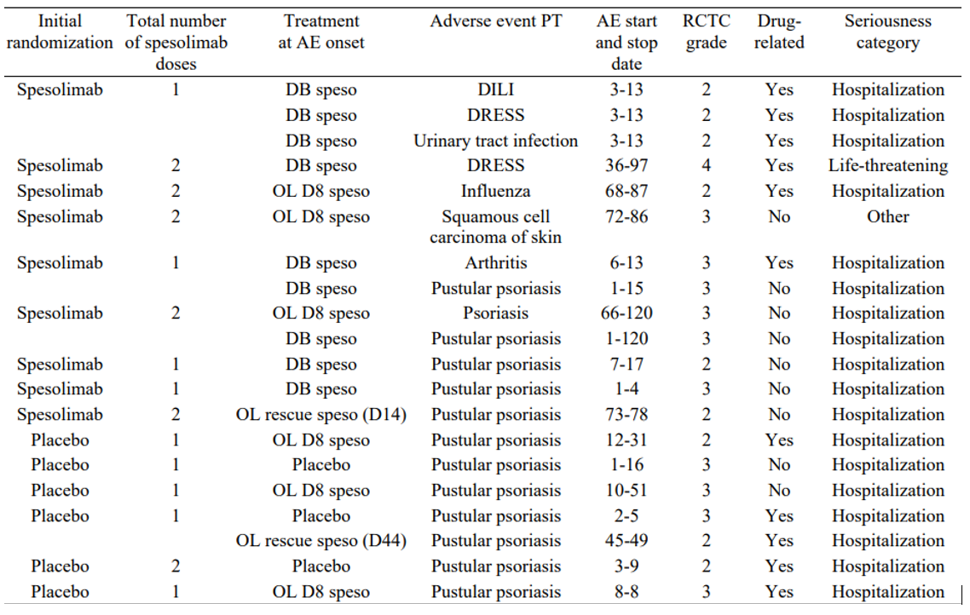

Protocol-specified AESIs included systemic hypersensitivity (including infusion reactions and anaphylactic reactions), severe infections (RCTC grade 3 or 4), opportunistic and tuberculosis infections, and hepatic injury. Analyses of user-defined adverse events categories (UDAECs) were also conducted for hypersensitivity reactions, infections (severe, serious, or opportunistic), malignancies, hepatic injury, and cardiac safety.

Hypersensitivity reactions were reported by one patient in the placebo group before any spesolimab (PTs urticaria and allergic dermatitis), and 5 patients in the spesolimab group after any spesolimab (PTs: drug reaction with eosinophilia and systemic symptoms (DRESS) and urticaria in 2 patients each, and eye oedema and dermatitis in 1 patient each). Of the 2 patients with SAEs reported as DRESS, one was classified as Grade 4 and one as Grade 2, and both required hospitalisation. Only 1 was classified as ‘possible DRESS’ on RegiSCAR scoring criteria, there were confounding factors, and both cases resolved without treatment. No infusion reactions or anaphylactic reactions were reported. No association between hypersensitivity events and ADA/NAb development was identified.

Infections reported as SAEs in the spesolimab group included 1 patient with a urinary tract infection prior to open-label spesolimab and 1 patient with influenza after open-label spesolimab. One patient in the placebo group reported latent TB (positive quantiferon test during screening for the OLE study) following open-label spesolimab.

One patient randomised to spesolimab was reported with a malignancy (PT squamous cell skin carcinoma) following open-label spesolimab administration (i.e. after 2 doses of spesolimab). Review of the narrative suggested that the SCC was a progression of pre-existing skin disease.

One patient in the spesolimab group was reported with AESI hepatic injury (PTs: DRESS and DILI) after 1 spesolimab dose, but concurrent cephalosporin use was a confounding factor. 6 patients, 3 in the spesolimab group and 3 in the placebo group, had markedly elevated ALT or AST but none met criteria for Hy’s law.

One case of syncope (non-serious) was reported during open-label rescue treatment infusion. No abnormal ECG findings were reported.

##### Other spesolimab studies

In studies in healthy volunteers, the frequency of AEs was generally similar across dose groups and no dose-dependency was observed. In-depth evaluation of ECGs in studies 1368-0001 and 1368-0002 showed no relevant effects of spesolimab on ECG parameters including QTc.

In the Phase 1 proof-of-concept study 1368-0011, all 7 patients with GPP treated with spesolimab reported at least 1 AE during the on-treatment period. No patient was reported with AEs of severe intensity, AESIs, SAEs, or AEs leading to trial medication discontinuation**.** On the PT level, arthralgia was reported in 3 patients (42.9%), and upper respiratory tract infection, chills, peripheral oedema, eosinophilia, and eczema were reported in 2 patients (28.6%) each.

In Study 1368-0027, the ongoing study evaluating SC spesolimab for flare prevention, all 6 patients treated with open-label IV spesolimab for acute flare treatment reported at least 1 AE during the flare treatment period. One patient was reported with AEs of severe intensity, and 1 patient was reported with AEs leading to treatment discontinuation. No AESIs or SAEs were reported. The most commonly reported AE within the rescue treatment period was pustular psoriasis (4 patients, 66.7%), which was the only PT reported for more than 1 patient. Fatigue and pyrexia were each reported for 1 patient each.

In the ongoing OLE study 1368-0025, 9 patients were treated with IV spesolimab for acute flare treatment, of whom 3 were also treated for a second flare. 8 patients (88.9%) reported an AE within the IV flare treatment period. 1 patient (11.1%) had an AE of severe intensity (grade 3, PT pustular psoriasis). The most commonly reported AEs by PT within the IV flare treatment period were pustular psoriasis (7 patients, 77.8%) and urinary tract infection (2 patients, 22.2%). No deaths were reported in any of the GPP studies.

Safety data were presented from studies of spesolimab in other dermatological conditions (palmoplantar pustulosis, atopic dermatitis) as well as ulcerative colitis. In the PPP studies, a total of 186 patients were treated with spesolimab, either via the SC route (147 patients, with doses of 300 mg qw to q8w or 600 mg qw to q4w) for up to 52 weeks or via the IV route (39 patients, with doses of 300 mg or 900 mg q4w) for up to 16 weeks. In the AD study, 39 patients were treated with spesolimab, all via the IV route (600 mg q4w) for up to 32 weeks. Safety findings from these studies are summarised in section 8.4.1.2.2 of the clinical evaluation report. Infections were reported more frequently with spesolimab compared to placebo, but most were mild to moderate and not serious. AEs grouped to malignancies or serious, severe, or opportunistic infections were rare in the non-GPP studies. There were 3 reports of Guillain-Barré syndrome in non-GPP studies (UC, PPP, and hidradenitis suppurativa), though an expert panel subsequently assessed that 2 of the cases did not meet Brighton criteria for Guillain-Barré syndrome. 1 death was reported in Study 1368-0017 (UC). This was the only death reported in the spesolimab clinical trial program. The patient was reported with SARS-CoV-2 pneumonia and Guillain-Barré syndrome (including tetraparesis) 20 days after the last administration of trial medication. The patient was hospitalised and died 12 days later.

Data on use of spesolimab during pregnancy or lactation are very limited. Two pregnancies were reported across all trials. One of the patients was treated with spesolimab in trial 1368-0032 (AD) and reported a miscarriage approximately 11 weeks after the last administration of trial medication, at a gestational age of approximately 12 weeks. The second patient was treated with spesolimab in trial 1368-0016 (PPP) and was reported with maternal exposure during pregnancy; however further dates and outcomes were not available. It is not known if spesolimab is excreted in human milk and there are no data on the effects on the breastfed infant, or the effects on milk production. Section 4.6 of the Product Information contains precautionary guidance regarding use of spesolimab in pregnancy and lactation.

### Risk management plan

The summary of safety concerns and their associated risk monitoring and mitigation strategies are presented in Table 25. The TGA may request an updated RMP at any stage of a product's life-cycle, during both the pre-approval and post-approval phases.

Table 25: Summary of safety concerns

|  |  |  |  |  |  |
| --- | --- | --- | --- | --- | --- |
| Summary of safety concerns | | Pharmacovigilance | | Risk minimisation | |
| **Routine** | **Additional** | **Routine** | **Additional** |
| **Important potential risks** | Serious or opportunistic infections | P | P | P | - |
| Systemic hypersensitivity reaction | P | P | P | - |
| Malignancy | P | P | P | - |
| Peripheral neuropathy | P | P | P | - |
| **Missing information** | Pregnant or breast-feeding women | P | - | P | - |

The RMP evaluation recommended conditions of registration relating to the versions of the risk management plan, requirement for periodic safety update reports, and inclusion of the medicine in the Black Triangle Scheme.

The SPEVIGO EU-Risk Management Plan (RMP) (version 1.0, dated 6 October 2022, data lock point 8 January 2021), with Australian Specific Annex (version 0.2, dated 31 January 2023), included with submission PM-2022-01272-1-1, and any subsequent revisions, as agreed with the TGA will be implemented in Australia.

An obligatory component of risk management plans is routine pharmacovigilance. Routine pharmacovigilance includes the submission of periodic safety update reports (PSURs).

Reports are to be provided in line with the current published list of EU reference dates and frequency of submission of PSURs until the period covered by such reports is not less than three years from the date of this approval letter.

The reports are to at least meet the requirements for PSURs as described in the European Medicines Agency’s Guideline on good pharmacovigilance practices (GVP) Module VII-periodic safety update report (Rev 1), Part VII.B Structures and processes. Note that submission of a PSUR does not constitute an application to vary the registration.

SPEVIGO (Spesolimab) is to be included in the Black Triangle Scheme. The PI and CMI for SPEVIGO must include the black triangle symbol and mandatory accompanying text for five years, which starts from the date that the sponsor notifies the TGA of supply of the product.

The TGA may request an updated RMP at any stage of a product's life-cycle, during both the pre-approval and post-approval phases. Further information regarding the TGA’s risk management approach can be found in [risk management plans for medicines and biologicals](https://www.tga.gov.au/publication/risk-management-plans-medicines-and-biologicals) and [the TGA's risk management approach](https://www.tga.gov.au/tgas-risk-management-approach). Information on the [Australia-specific annex](https://www.tga.gov.au/resources/resource/guidance/risk-management-plans-medicines-and-biologicals/australia-specific-annex-eu-rmp) ([ASA](https://www.tga.gov.au/resources/resource/guidance/risk-management-plans-medicines-and-biologicals/australia-specific-annex-eu-rmp)) can be found on the TGA website.

### Risk-benefit analysis

#### Delegate’s considerations

#### Efficacy

The main efficacy study for the proposed indication was the Phase 2 Study 1368-0013 which evaluated the efficacy of 900 mg IV spesolimab compared to placebo for the treatment of an acute flare of GPP of moderate to severe intensity. Supportive efficacy data were provided by the Phase 1 proof-of-concept study (1368-0011) as well as limited data for IV spesolimab for acute flare treatment in the ongoing study evaluating SC spesolimab for the prevention of flares of GPP (Study 1368-0027) and the ongoing open-label extension study (1368-0025) for patients who completed study 1368-0013 or 1368-0027.

In Study 1368-0013, 53 patients were randomised to treatment on Day 1 with spesolimab (n=35) or placebo (n=18). The primary endpoint (GPPGA pustulation subscore of 0, i.e. no visible pustules) and key secondary endpoint (GPPGA total score of 0 or 1, i.e. clear or almost clear) were assessed at Week 1 following a single IV dose of 900 mg spesolimab or placebo on Day 1.

The study met both the primary and key secondary endpoints. A significantly higher proportion of patients in the spesolimab group compared with the placebo group achieved a GPPGA pustulation subscore of 0 at Week 1 (primary endpoint, 54.3% vs 5.6%, p=0.0004) and GPPGA total score of 0 or 1 at Week 1 (key secondary endpoint, 42.9% vs 11.1%, p=0.0118). The primary endpoint represents complete clearance of pustules, which is a clinically meaningful benefit. The key secondary endpoint represents a meaningful improvement in the 3 components of erythema, pustules and scaling.

The use of additional treatment (escape medication [SoC], open-label spesolimab at Day 8, or rescue medication with open-label spesolimab after Day 8) impacted on the interpretation of efficacy findings beyond Day 8. For the secondary endpoints included in the testing hierarchy, a significant benefit was demonstrated for GPPASI 75 at Week 4, but a treatment difference in the risk difference for patient-reported outcomes (Pain VAS, PSS, and FACIT-Fatigue scores) at Week 4 could not be calculated because of the high rate of censoring in the placebo group. In the Wilcoxon rank test, the worst ranks were assigned to the non-responders in both treatment arms and the resulting p-values were statistically significant in favour of spesolimab for each of these patient-reported measures.

In patients who responded to spesolimab treatment, the benefit was generally maintained to the end of study (Week 12). Efficacy findings from 12 patients who received a second dose of IV spesolimab on Day 8 provide support for a second dose 1 week after the first dose in patients with an inadequate response.

The presence of ADA or NAb did not appear to have a meaningful impact on efficacy outcomes in Study 1368-0013 but the data are limited, particularly following repeat treatment.

Responses to open-label IV spesolimab for the treatment of acute flares in the ongoing SC preventive study (1368-0027) and the ongoing long-term extension study (1368-0025) are broadly consistent with the effects observed in the pivotal efficacy study 1368-0013, providing supportive evidence of the efficacy of IV spesolimab for the treatment of acute flares of GPP.

#### Safety

The safety of spesolimab in the proposed indication was primarily informed by the pivotal Phase II study 1368-0013, supported by safety findings from 3 other studies in patients with GPP, as well as Phase 1 studies in healthy volunteers and studies in patients with other conditions. Overall, 226 healthy volunteers and 401 patients (GPP or non-GPP) received at least one dose of spesolimab (IV or SC) in clinical studies, including 64 patients with GPP who received at least 1 dose of IV spesolimab for treatment of an acute flare. In Study 1368-0013, 51 patients received at least 1 dose of IV spesolimab, including 35 patients randomised to receive spesolimab on Day 1 and 16 patients randomised to placebo who received open-label spesolimab on Day 8 or as rescue treatment after Day 8.

In Study 1368-0013, placebo-controlled safety data up to Week 1 showed similar proportions of patients with any AE, as well as severe, serious and investigator-defined drug-related AEs in the spesolimab and placebo groups. The most frequently reported AEs by PT up to Week 1 were pustular psoriasis (spesolimab vs placebo: 37.1% vs 38.9%), pyrexia (spesolimab vs placebo: 5.7% vs 22.1%), and headache (spesolimab vs placebo: 8.6% vs 5.6%). Analyses of safety beyond Week 1 were impacted by high rates of censoring, particularly in the placebo group. 16 (89%) patients randomised to placebo and 14 (40%) patients randomised to spesolimab received open-label spesolimab on Day 8 and/or as rescue medication after Day 8 and were censored for subsequent safety analyses. Infections were reported more frequently in the spesolimab group compared to placebo. Most infections were mild or moderate severity, with no distinct pattern regarding pathogen or type of infection. Infections reported as SAEs in the spesolimab group included one patient with a urinary tract infection prior to open-label spesolimab and one patient with influenza after open-label spesolimab. One patient in the placebo group reported latent TB following open-label spesolimab, but there were no cases of active TB. No infusion reactions or anaphylactic reactions were reported in Study 1368-0013. DRESS was reported in 2 patients treated with spesolimab, one Grade 4 and one Grade 2. Only 1 was classified as ‘possible DRESS’ on RegiSCAR scoring criteria, there were confounding factors, and both cases resolved without treatment. There were no significant effects on laboratory parameters and ECG parameters in the GPP and the non-GPP studies.

Different dosing regimens were investigated across the clinical development program, but the safety of spesolimab in patients with non-GPP conditions and in healthy subjects was broadly consistent with the safety profile in GPP. Adverse reactions identified in a review of safety signals across GPP and non-GPP studies include urinary tract infection, upper respiratory tract infection, pruritus, injection site reactions, and fatigue. Three cases of Guillain-Barré syndrome were reported in non-GPP studies, although two were subsequently assessed by an expert panel as not fulfilling Brighton criteria for Guillain-Barré syndrome. Precautions have been included in section 4.4 of the Product Information addressing risks relating to infections (including TB), hypersensitivity reactions, and peripheral neuropathy (including Guillain-Barré syndrome). The important potential risks listed in the EU-RMP/ASA (serious or opportunistic infections, systemic hypersensitivity reactions, malignancies, and peripheral neuropathy) will be monitored with routine and additional pharmacovigilance.

#### Uncertainties and limitations of the data

The clinical dataset for spesolimab for the treatment of flares is limited. The main efficacy and safety study evaluated 53 patients (35 randomised to spesolimab, 18 to placebo).

The main efficacy study allowed the use of additional treatments, including escape medication (SoC) for disease worsening, open-label spesolimab on Day 8 for inadequate response, and open-label spesolimab after Day 8 for recurrent flare. The use of additional treatments impacted on the interpretation of efficacy and safety findings beyond Week 1. Placebo-controlled efficacy and safety data beyond Week 1 are limited by the high proportion of patients who received additional treatments.

Patients with a life-threatening flare of GPP or a flare requiring intensive care treatment were excluded from the main efficacy/safety study, so efficacy and safety have not been evaluated in these more severe clinical scenarios.

Efficacy and safety data for concomitant use of other immunomodulatory treatments with spesolimab are very limited. In the main study, patients were required to stop treatment with restricted medications prior to receiving study drug, but escape treatment based on standard-of-care was permitted for disease worsening.

Efficacy and safety data for subsequent treatment of recurrent flares are very limited.

High titres of ADA were associated with reduced spesolimab exposure in patients with GPP. The presence of ADA or NAb did not appear to have a meaningful impact on efficacy and safety outcomes in Study 1368-0013 but the data are limited, particularly following repeat treatment. The Sponsor is planning to conduct an open-label study to evaluate the effect of immunogenicity on PK, safety, and efficacy in patients re-treated with IV spesolimab for recurrent flares. The study is expected to be completed in 2028.

The use of spesolimab for the prevention of GPP flares is beyond the scope of this application. The clinical study evaluating SC spesolimab as maintenance treatment for the prevention of GPP flares is ongoing, so efficacy and safety in this setting have not been established.

#### Proposed action

GPP is a rare disease with severe clinical manifestations. There are no treatments approved in Australia specifically for the treatment of GPP and evidence supporting the efficacy and safety of other immunomodulatory therapies for the treatment of GPP flares is limited. The main study supporting this application demonstrated a clinically meaningful benefit with spesolimab compared to placebo, with an acceptable safety profile. Whilst there are limitations in the clinical dataset, I am of the view that the application provides sufficient evidence to conclude that the benefit-risk profile for spesolimab in the proposed indication is favourable. There are no objections to the registration of SPEVIGO from a manufacturing and quality perspective.

#### Advisory Committee considerations

The [Advisory Committee on Medicines (ACM)](https://www.tga.gov.au/committee/advisory-committee-medicines-acm), having considered the evaluations and the Delegate’s overview, as well as the sponsor’s response to these documents, advised the following.

##### Specific advice to the Delegate

What is ACM’s perspective on the clinical dataset for spesolimab for the treatment of flares of GPP?

The ACM was of the view that the clinical dataset for spesolimab for the treatment of flares of GPP is reasonable. The ACM noted that there were small numbers of participants within the clinical studies, however considering that GPP is a rare condition it was agreed that this is reasonable.

The ACM also noted that efficacy was demonstrated at Week 1 and appeared to be well maintained to Week 12. Further noting that there is evidence for a 2nd dose at day 8 (or after) for those with an inadequate response.

The ACM discussed the use of spesolimab at or after day 8 in the placebo group within the pivotal clinical study. The ACM agreed that given the severity of this condition and the current lack of satisfactory treatment options this was a reasonable approach, however noted that it did impact on the interpretation of some of the post-week 1 outcomes.

What is ACM’s perspective regarding concomitant use of other immunomodulatory therapies, and is this adequately addressed in the Product Information?

The ACM commented that escape treatment based on standard of care was permitted in the pivotal study however usage was quite low.

The ACM noted that overall safety data on use of concomitant immunosuppressants (including CS, TNFi, MTx) is available for 19 patients with GPP and more than 80 patients with ulcerative colitis (UC). Based on this, the ACM was of the view that the safety profile of spesolimab is comparable in patients with and without the use of concomitant medications.

Other advice

The ACM was of the view that it would be appropriate for the PI to include a statement regarding the two cases of DRESS that were reported in the pivotal study even when noting that the cases reported showed no and a low diagnostic certainty, respectively, and confounding factors were present.

The ACM discussed Table 1 – Adverse Events reported for more than 10% of patients included within the Adverse Effects section of the PI and noted that including events reported for more than 10% of patients is reasonable.

The ACM noted that the wording within the draft PI regarding peripheral neuropathy should be re-worded as the proposed wording could be interpreted as 750 cases of peripheral neuropathy.

##### Conclusion

The ACM considered this product to have an overall positive benefit-risk profile for the indication:

SPEVIGO is indicated for the treatment of flares in adult patients with generalised pustular psoriasis.

## Outcome

Based on a review of quality, safety, and efficacy, the TGA decided to register SPEVIGO:

SPEVIGO is indicated for the treatment of flares in adult patients with generalised pustular psoriasis.

#### Product Information

The [Product Information](https://www.tga.gov.au/products/australian-register-therapeutic-goods-artg/product-information-one) ([PI](https://www.tga.gov.au/products/australian-register-therapeutic-goods-artg/product-information-one)) approved with this submission for SPEVIGO which is referred to in this AusPAR (and can be accessed on this AusPAR’s webpage) may have been superseded. For the most recent PI and [Consumer Medicines Information](https://www.tga.gov.au/products/australian-register-therapeutic-goods-artg/consumer-medicines-information-cmi) (CMI), please refer to the TGA [PI/CMI search facility.](https://www.ebs.tga.gov.au/)

|  |
| --- |
| Therapeutic Goods Administration |
| PO Box 100 Woden ACT 2606 Australia  Email: [info@tga.gov.au](mailto:info@tga.gov.au) Phone: 1800 020 653 Fax: 02 6203 1605  [**https://www.tga.gov.au**](https://www.tga.gov.au) |
| Reference/Publication # |

1. This is the original indication proposed by the sponsor when the TGA commenced the evaluation of this submission. It may differ to the final indication approved by the TGA and registered in the Australian Register of Therapeutic Goods.
2. Choon SE, Lai NM, Mohammad N et al., Clinical profile, morbidity, and outcome of adult-onset generalized pustular psoriasis: analysis of 102 cases seen in a tertiary hospital in Johor, Malaysia. Int J Dermatol 2014; 53; 676-684.
3. Bachelez H, Choon SE, Marrakchi AD et al., Trial of spesolimab for Generalized Pustular Psoriasis. New Eng J Med 2021; 385: 2431-40
4. Krueger J, Puig L, Thaçi D. Treatment Options and Goals for Patients with Generalized Pustular Psoriasis. Am J Clin Dermatol. 2022 Jan;23 (Suppl 1):51-64. doi: 10.1007/s40257-021-00658-9.
5. Bachelez H. Pustular psoriasis: the dawn of a new era. Acta Derm Venereol 2020;100:adv00034
6. Baum P, Visvanathan S, Bossert S, et al. Treatment with BI 655130, an anti-interleukin-36 receptor antibody, in patients with generalized pustular psoriasis, is associated with the downregulation of biomarkers linked to innate, Th1/Th17, and neutrophilic pathways. 77th Ann Mtg of the Society for Investigative Dermatology (SID), Chicago, 8 - 11 May 2019. J Invest Dermatol 2019; 139(9):B25.
7. In this report the ‘Delegate’ is the Delegate of the Secretary of the Department of Health and Aged Care who decided the submission under section 25 of the Act.
8. Noting that standard-of-care treatment could be used as escape medication for disease worsening during the study.
9. The GPPGA relied on clinical assessment of the skin presentation of the patient with GPP. It is a modified PGA, adapted for the evaluation of GPP patients. The investigator (or qualified site personnel) scored the 3 components erythema, pustules, and scaling of all GPP lesions from 0 (clear) to 4 (severe). Each of the 3 components was graded separately, the average was calculated, and the final GPPGA was determined from this composite score. A lower score indicated a lesser severity, with 0 being clear and 1 being almost clear.
10. The GPPASI is an adaptation for GPP patients of the PASI, an established measure of severity and area of psoriatic lesions in patients with psoriasis. In the GPPASI, the induration component was substituted with the pustules’ component. It is a tool that provides a numeric scoring for a patient’s overall GPP disease state, ranging from 0 to 72. It was a linear combination of percent of surface area of skin that was affected by erythema, pustules, and scaling and the severity of erythema, pustules, and scaling (desquamation) over 4 body regions. A lower score indicated a better disease state.
11. The Japanese Dermatological Association (JDA) established the JDA GPP severity score that consists of the assessment of skin symptoms and systemic symptoms/laboratory test findings. For the skin symptoms, each of the 3 items (erythema area [total], erythema area with pustules, and edema area) was to be rated from 0 (none) to 3 (severe). For the systemic symptoms/laboratory test findings, each of the 4 items (fever, WBC count, serum CRP, and serum albumin) was to be rated from 0 to 2. The total score of JDA severity index for GPP was assigned a score between 0 (best) and 17 (worst).
12. The CGI-I is an observer-rated scale that measures the clinical global impression improvement (CGI-I), as per the JDA severity index guidelines, taking the change in the JDA total score and/or other criteria into account. Changes were categorised as “worsened”, “no change”, “minimally improved”, “much improved” or “very much improved”.
13. The PSS is a 4-item patient-reported outcome (PRO) instrument that was developed to assess the severity of psoriasis symptoms in patients with moderate to severe psoriasis. The symptoms included were pain, redness, itching, and burning. Current symptom severity was assessed using a 5-point scale ranging from 0 (none) to 4 (very severe). The symptom scores were added to an unweighted total score (range: 0 to 16).
14. ≥75% reduction from baseline in GPPASI.
15. Observed cases including also values after any use of escape medication, OL spesolimab on Day 8, or OL spesolimab as rescue medication after Day 8.
16. Increase in GPPGA score by ≥ 2 from baseline and the pustular component of GPPGA ≥ 2.
17. *A recurrent GPP flare in trial 1368-0025 is defined as:*

    *- Patients with GPPGA score 0 or 1 at screening* of OLE: ≥2 point increase in the GPPGA score and the pustular component of GPPGA ≥2.*

    *- Patients with GPPGA score 2 at screening* of OLE: ≥1 point increase in the GPPGA score and presence of fresh postulation.*

    *\*Note: the further re-occurrence of GPP flare in this OLE will be defined based on the individual patient’s best GPPGA score improvement achieved after each rescue treatment.*
18. PTs: urinary tract infection in 2 patients; bacteraemia, bacteriuria, cellulitis, herpes dermatitis, oral herpes, pustule, upper respiratory tract infection each in 1 patient.
19. Streptococcal infection in 1 patient.