|  |
| --- |
| Australian Public Assessment Report for ULTOMIRIS |
| Active ingredient: ravulizumab |
| Sponsor: Alexion Pharmaceuticals Australasia Pty Ltd |
| July 2024 |

About the Therapeutic Goods Administration (TGA)

* The Therapeutic Goods Administration (TGA) is part of the Australian Government Department of Health and Aged Care and is responsible for regulating therapeutic goods, including medicines, medical devices, and biologicals.
* The TGA administers the *Therapeutic Goods Act 1989* (the Act), applying a risk management approach designed to ensure therapeutic goods supplied in Australia meet acceptable standards of quality, safety, and efficacy.
* The work of the TGA is based on applying scientific and clinical expertise to decision-making, to ensure that the benefits to the Australian public outweigh any risks associated with the use of therapeutic goods.
* The TGA relies on the public, healthcare professionals and industry to report problems with therapeutic goods. The TGA investigates reports received to determine any necessary regulatory action.
* To report a problem with a therapeutic good, please see the information on the [TGA website](https://www.tga.gov.au/).

About AusPARs

* The Australian Public Assessment Report (AusPAR) provides information about the evaluation of a prescription medicine and the considerations that led the TGA to approve or not approve a prescription medicine submission. Further information can be found in [Australian Public Assessment Report (AusPAR) guidance](https://www.tga.gov.au/australian-public-assessment-report-auspar-guidance).
* AusPARs are prepared and published by the TGA.
* AusPARs are static documents that provide information that relates to a submission at a particular point in time. The publication of an AusPAR is an important part of the transparency of the TGA’s decision-making process.
* A new AusPAR may be provided to reflect changes to indications or major variations to a prescription medicine subject to evaluation by the TGA.

Copyright

© Commonwealth of Australia 2024  
This work is copyright. You may reproduce the whole or part of this work in unaltered form for your own personal use or, if you are part of an organisation, for internal use within your organisation, but only if you or your organisation do not use the reproduction for any commercial purpose and retain this copyright notice and all disclaimer notices as part of that reproduction. Apart from rights to use as permitted by the *Copyright Act 1968* or allowed by this copyright notice, all other rights are reserved and you are not allowed to reproduce the whole or any part of this work in any way (electronic or otherwise) without first being given specific written permission from the Commonwealth to do so. Requests and inquiries concerning reproduction and rights are to be sent to the TGA Copyright Officer, Therapeutic Goods Administration, PO Box 100, Woden ACT 2606 or emailed to <[tga.copyright@tga.gov.au](mailto:tga.copyright@tga.gov.au)>.

Contents

List of abbreviations 4

Product submission 5

Submission details 5

Product background 6

The disease/condition 6

Current treatment options 7

Clinical rationale 7

Regulatory status 7

Australian regulatory status 7

International regulatory status 8

Registration timeline 9

Submission overview and risk/benefit assessment 10

Quality evaluation summary 10

Nonclinical (toxicology) evaluation summary 10

Clinical evaluation summary 10

Pharmacology 10

Efficacy 14

Safety 22

Risk management plan 24

Risk-benefit analysis 25

Delegate’s considerations 25

Proposed action 27

Questions for the sponsor 27

Advisory committee on medicines considerations 35

Outcome 37

Product Information 38

### List of abbreviations

|  |  |
| --- | --- |
| Abbreviation | Meaning |
| ACM | Advisory Committee on Medicines |
| ADA | Anti-drug antibodies |
| AEs | Adverse events |
| aHUS | Atypical haemolytic uremic syndrome |
| AQP4 | aquaporin-4 |
| ARTG | Australian Register of Therapeutic Goods |
| ASA | Australia‑specific annex |
| CHMP | Committee for Medicinal Products for Human Use |
| CMI | Consumer Medicines Information |
| COR | Comparable Overseas Regulator |
| DLP | Data lock point |
| EDSS | Expanded disability status scale |
| FAS | Full analysis set |
| gMG | Generalized Myasthenia Gravis |
| HAI | Hauser Ambulation Index Score |
| IVIG | Intravenous immunoglobulin |
| NMOSD | Neuromyelitis optica spectrum disorder |
| PD | Pharmacodynamics |
| PK | Pharmacokinetics |
| PI | Product Information |
| PNH | Paroxysmal nocturnal haemoglobinuria |
| PPS | Per protocol set |
| PSUR | Periodic safety update report |
| RMP | Risk management plan |
| SAE | Serious adverse event |
| TEAE | Treatment emergent adverse event |
| TGA | Therapeutic Goods Administration |

## Product submission

### Submission details

|  |  |
| --- | --- |
| *Type of submission:* | Extension of indication |
| *Product name:* | ULTOMIRIS |
| *Active ingredient:* | Ravulizumab |
| *Decision:* | Approved |
| *Date of decision:* | 19 January 2024 |
| *Date of entry onto ARTG:* | 22 January 2024 |
| *ARTG numbers:* | [311926](https://www.tga.gov.au/resources/artg/311926), 330566, [336710](https://www.tga.gov.au/resources/artg/336710) |
| [*Black Triangle Scheme*](https://www.tga.gov.au/black-triangle-scheme) | Yes |
| *Sponsor’s name and address:* | Alexion Pharmaceuticals Australasia Pty Ltd, Level 4, 66 Talavera Road, Macquarie Park, NSW, 2113 Australia |
| *Dose forms:* | Solution for intravenous infusion |
| *Strengths:* | 10 mg / mL, 300 mg / 3 mL and 1100 mg / 11 mL |
| *Container:* | Vial |
| *Pack sizes:* | 1 |
| *Approved therapeutic use for the current submission:* | *ULTOMIRIS is indicated for the treatment of adult patients with Neuromyelitis Optica Spectrum Disorder (NMOSD) who are anti-aquaporin 4 (AQP4) antibody-positive.*  *ULTOMIRIS is not intended for the acute treatment of a NMOSD relapse.* |
| *Routes of administration:* | Intravenous infusion |
| *Dosage:* | The recommended dosing regimen consists of a loading dose followed by maintenance dosing, administered by intravenous infusion. The doses to be administered are based on the patient’s body weight, as shown in Table 1. Maintenance doses should be administered at a once every 8- week interval, starting 2 weeks after loading dose administration.  Table 1. ULTOMIRIS weight-based dosing regimen   |  |  |  |  | | --- | --- | --- | --- | | **Body Weight Range (kg)** | **Loading Dose (mg)** | **Maintenance Dose* (mg)** | **Dosing interval** | | ≥ 40 to < 60 | 2400 | 3000 | Every 8 weeks | | ≥ 60 to < 100 | 2700 | 3300 | Every 8 weeks | | ≥ 100 | 3000 | 3600 | Every 8 weeks |   * First maintenance dose is administered 2 weeks after loading dose  For further information regarding dosage, such as dosage modifications to manage adverse reactions, refer to the [Product Information](https://www.ebs.tga.gov.au/ebs/picmi/picmirepository.nsf/pdf?OpenAgent&id=CP-2021-PI-01352-1&d=20240705172310101) |
| *Pregnancy category:* | [B2](https://www.tga.gov.au/australian-categorisation-system-prescribing-medicines-pregnancy)  Drugs which have been taken by only a limited number of pregnant women and women of childbearing age, without an increase in the frequency of malformation or other direct or indirect harmful effects on the human fetus having been observed.  Studies in animals are inadequate or may be lacking, but available data show no evidence of an increased occurrence of fetal damage.  The use of any medicine during pregnancy requires careful consideration of both risks and benefits by the treating health professional. The [pregnancy database](https://www.tga.gov.au/products/medicines/find-information-about-medicine/prescribing-medicines-pregnancy-database) must not be used as the sole basis of decision making in the use of medicines during pregnancy. The TGA does not provide advice on the use of medicines in pregnancy for specific cases. More information is available from [obstetric drug information services](https://www.tga.gov.au/obstetric-drug-information-services) in your state or territory. |

### Product background

This application was submitted through the TGA’s [Comparable Overseas Regulator](https://www.tga.gov.au/resources/resource/guidance/comparable-overseas-regulators-cors-prescription-medicines) process, using evaluation reports from the European Medicines Agency (EMA) to assess quality, safety and efficacy. To complement the EMA’s evaluation reports, the full dossier, comprising all quality, toxicology and clinical data, was submitted to the TGA by the sponsor, Alexion Pharmaceuticals Pty Ltd.

This AusPAR describes the submission by Alexion Pharmaceuticals Pty Ltd and summarises the accompanying evaluation conducted by the TGA, which formed the basis of the TGA’s decision to register ULTOMIRIS (ravulizumab) for the following additional therapeutic uses proposed by the sponsor in this submission:[1]

ULTOMIRIS is indicated for:

* the treatment of patients with Paroxysmal Nocturnal Haemoglobinuria (PNH)
* the treatment of patients with Atypical Haemolytic Uraemic Syndrome (aHUS)
* an add-on to standard therapy for the treatment of adult patients with generalised myasthenia gravis (gMG) who are anti-acetylcholine receptor (AChR) antibody-positive.
* the treatment of adult patients with Neuromyelitis Optica Spectrum Disorder (NMOSD) who are anti-aquaporin 4 (AQP4) antibody-positive,

#### The disease/condition

Neuromyelitis optica spectrum disorder (NMOSD, previously known as Devic disease) is an inflammatory disorder of the CNS leading to demyelination and axonal damage. It is a rare disease, with a prevalence between 1/100 000 (Caucasian populations) to 10/100 000 (black populations). It mainly affects the optic nerves and spinal cord. Previously considered a phenotype of multiple sclerosis, the discovery of IgG antibodies targeting aquaporin-4 (AQP4) has led to the understanding of NMOSD as a distinct disease entity. Pathogenesis includes astrocyte death, axonal loss and grey and white matter necrosis and cavitation.

Complement activation plays a central role in anti-AQP4 positive NMOSD. Pathological antibodies bind to AQP4 on astrocytes and activate C1, initiating the complement cascade. Thus, interrupting the complement cascade on astrocytes is an attractive therapeutic target to prevent relapse.

The median age of onset is in the 4th decade and females are much more frequently affected. Attacks involving the optic nerves (leading to visual loss) and spinal cord (leading to limb weakness, sensory loss and bladder dysfunction) occur over days and the pattern is for relapses, with relative inter-episode stability. This pattern leads to stepwise progression of neurological deficits, disability and sometimes death. Brainstem and cerebral lesions also occur. Diagnostic testing includes MRI of the brain and spinal cord and anti-AQP4-IgG antibody assay.

#### Current treatment options

Treatment of acute attacks include pulsed corticosteroids and therapeutic plasma exchange. Treatment to prevent relapses includes two medicines that appear in the ARTG – satralizumab (anti-IL-6 monoclonal antibody) and eculizumab (monoclonal antibody terminal complement inhibitor). The antiproliferative conventional immunosuppressants azathioprine and mycophenolate are also used off-label, as are the biological medicines rituximab and tocilizumab.

#### Clinical rationale

Ravulizumab is a terminal complement inhibitor that specifically binds to the complement protein C5 with high affinity, thereby inhibiting its cleavage to C5a (the pro-inflammatory anaphylatoxin) and C5b (the initiating subunit of the terminal complement complex [C5b-9, also known as the membrane attack complex (MAC)]) and preventing the generation of the C5b-9 or MAC. By binding specifically to C5, ravulizumab antagonises terminal complement-mediated inflammation, cell activation, and cell lysis while preserving the early components of complement activation that are essential for opsonisation of microorganisms and clearance of immune complexes.

### Regulatory status

#### Australian regulatory status

ULTOMIRIS received initial registration in the [Australian Register of Therapeutic Goods](https://www.tga.gov.au/products/australian-register-therapeutic-goods-artg) ([ARTG](https://www.tga.gov.au/products/australian-register-therapeutic-goods-artg)) on 17 October 2019. It was approved for the following indications:

ULTOMIRIS (concentrated solution for intravenous infusion) is indicated for the treatment of adult patients with paroxysmal nocturnal haemoglobinuria (PNH).

Additional strengths (300 mg in 3 mL (100 mg/mL) and 1100 mg in 11 mL (100 mg/mL)) were registered on 23 March 2021.

On 16 August 2022, the product received registration for the following extension of indication[2]:

*ULTOMIRIS is indicated for the treatment of patients with Atypical Haemolytic Uraemic Syndrome (aHUS)*.

On 22 May 2023, the product received registration for the following extension of indication:

ULTOMIRIS is approved for the new indication as an add-on to standard therapy for the treatment of adult patients with generalised myasthenia gravis (gMG) who are anti-acetylcholine receptor (AChR) antibody-positive.

#### International regulatory status

At the time the TGA considered this submission, a similar submission had been considered by other regulatory agencies. Table 2 summarises these submissions and provides the indications where approved.

Table 2. International regulatory status for the proposed indication at the time of product registration.

|  |  |  |
| --- | --- | --- |
| Region | Status | Approved indications |
| United States of America | Approved on 22 March 2024 | Treatment of adult patients with neuromyelitis optica spectrum disorder (NMOSD) who are anti-aquaporin 4 (AQP4) antibody-positive |
| European Union | Approved on 5 May 2023 | ULTOMIRIS is indicated in the treatment of adult patients with NMOSD who are anti-aquaporin 4 (AQP4) antibody-positive |
| Japan | Approved on 25 May 2023 | Prevention of relapses in Neuromyelitis optica spectrum disorder (NMOSD) (including neuromyelitis optica) |
| Canada | Approved on 30 October 2023 | ULTOMIRIS (ravulizumab for injection) is indicated for the treatment of adult patients with anti-aquaporin 4 (AQP4) antibody-positive neuromyelitis optica spectrum disorder (NMOSD). |
| United Kingdom | Approved on 15 August 2023 | ULTOMIRIS is indicated in the treatment of adult patients with neuromyelitis optica spectrum disorder (NMOSD) who are anti-aquaporin 4 (AQP4) antibody-positive |
| Brazil | Approved on 10 April 2023 | ULTOMIRIS® is also used to treat adult patients with a central nervous system disease that primarily effects the optic nerves (eyes) and spinal cord, called neuromyelitis optica spectrum disease (NMOSD) |
| Switzerland | Approved on 29 August 2023 | ULTOMIRIS is used in the treatment of adult patients with NMOSD who are anti-aquaporin 4 (AQP4) antibody-positive |

Table 3. Summary of international regulatory status for paroxysmal nocturnal haemoglobinuria (PNH), atypical haemolytic uremic syndrome (aHUS) and generalized myasthenia gravis (gMG) indications.

|  |  |  |
| --- | --- | --- |
| **Indication** | **Date of first approval and country** | **Where approved** |
| Paroxysmal nocturnal haemoglobinuria (PNH) | 21 December 2018 (US) | Approved in US, EEA, UK, Japan, Canada, Brazil, Australia, Switzerland, Bosnia, Israel, North Macedonia, Serbia, Montenegro, Russia, Taiwan, Hong Kong, Korea, Ecuador, Peru, Chile, Argentina, Saudi Arabia, UAE, Kuwait, Oman, Qatar, Bahrain, Albania, Dominican Republic, Guatemala, Macao, |
| Atypical haemolytic uremic syndrome (aHUS) | 18 October 2019 (US) | Approved in US, EEA, UK, Japan, Canada, Brazil, Australia, Switzerland, Bosnia, Israel, North Macedonia, Serbia, Montenegro, Russia, Taiwan, Hong Kong, Korea, Ecuador, Peru, Chile, Argentina, Saudi Arabia, UAE, Kuwait, Oman, Qatar, Bahrain, Albania, Dominican Republic, Guatemala, Macao |
| Generalized Myasthenia Gravis (gMG) | 27 April 2022 (US) | Approved in US, EEA, UK, Japan, Canada, Brazil, Australia, Switzerland, Bosnia, North Macedonia, Israel, Montenegro, Russia, Hong Kong, Saudi Arabia, UAE, Kuwait, Oman, Qatar, Bahrain, Albania, Argentina, Dominican Republic, Guatemala, Korea, Macao, Peru, Taiwan, Serbia. |

#### Registration timeline

This submission was evaluated under the [Comparable Overseas Regulator](https://www.tga.gov.au/comparable-overseas-regulators-cors-timeframes-and-milestones) Comparable Overseas Regulator (COR) B approach.

Table 4 captures the key steps and dates for this submission.

Table 4. Timeline for ULTOMIRIS submission PM-2023-02695-1-1

|  |  |
| --- | --- |
| Description | Date |
| Submission dossier accepted and first round evaluation commenced | 31 July 2023 |
| First round evaluation completed | 15 December 2023 |
| Second round evaluation completed | 15 December 2023 |
| Delegate’s[3] Overall benefit-risk assessment and request for Advisory Committee advice | 1 November 2023 |
| Sponsor’s pre-Advisory Committee response | 8 November 2023 |
| Advisory Committee meeting | 15 December 2023 |
| Registration decision (Outcome) | 18 January 2024 |
| Administrative activities and registration in the ARTG completed | 22 January 2024 |
| Number of working days from submission dossier acceptance to registration decision* | 108 |

* The COR-B process has a 175 working day evaluation and decision timeframe.

## Submission overview and risk/benefit assessment

### Quality evaluation summary

As this is an extension of indication application, quality evaluation is not required for this submission. There are no proposed changes to the quality aspects of the currently approved and supplied drug substance or product (manufacturing processes, physicochemical properties, purity, stability, drug specifications, container closure system and stability). A full quality evaluation was conducted at the time this product received initial registration.[4]

### Nonclinical (toxicology) evaluation summary

No new nonclinical data or further nonclinical evaluation were required for this submission. The previously submitted and evaluated data satisfactorily address nonclinical aspects of safety/efficacy relating to this submission.[5]

### Clinical evaluation summary

#### Pharmacology

##### Pharmacokinetics

Pivotal study ALXN1210-NMO-307 incorporated pharmacokinetic (PK) assessments. The details of the study are presented below. The dosing in the study was as follows:

A loading dose was given on day 1 and maintenance doses on day 15 and then q8weeks. Each dose was weight-based as follows:

* 40 to <60kg: loading dose 2400mg, maintenance dose 3000mg
* 60 to <100kg: loading dose 2700mg, maintenance dose 3300mg
* 100kg or greater: loading dose 3000mg, maintenance dose 3600mg

PK sampling (pre- and post-infusion) was planned on days 1, 15, 71, 127, 183, 239, 351, 463, 573, 743, 911, 1135, 1359, 1583, end of treatment or early discontinuation and in event of relapse, plasma exchange, plasmapheresis or IVIG administration.

Absorption: bioavailability is 100% due to route of administration. The PK was dose proportional and time linear.

The mean volume (SD) of distribution was 4.77 L (0.819).

The mean t1/2 (SD) was 64.3 (11) days and the mean clearance (SD) was 0.00228 (0.000662) L/h.

Figure 1 shows the semi-log plot of ravulizumab concentration vs. time:

Figure 1. Mean serum concentration over time, semi-log scale

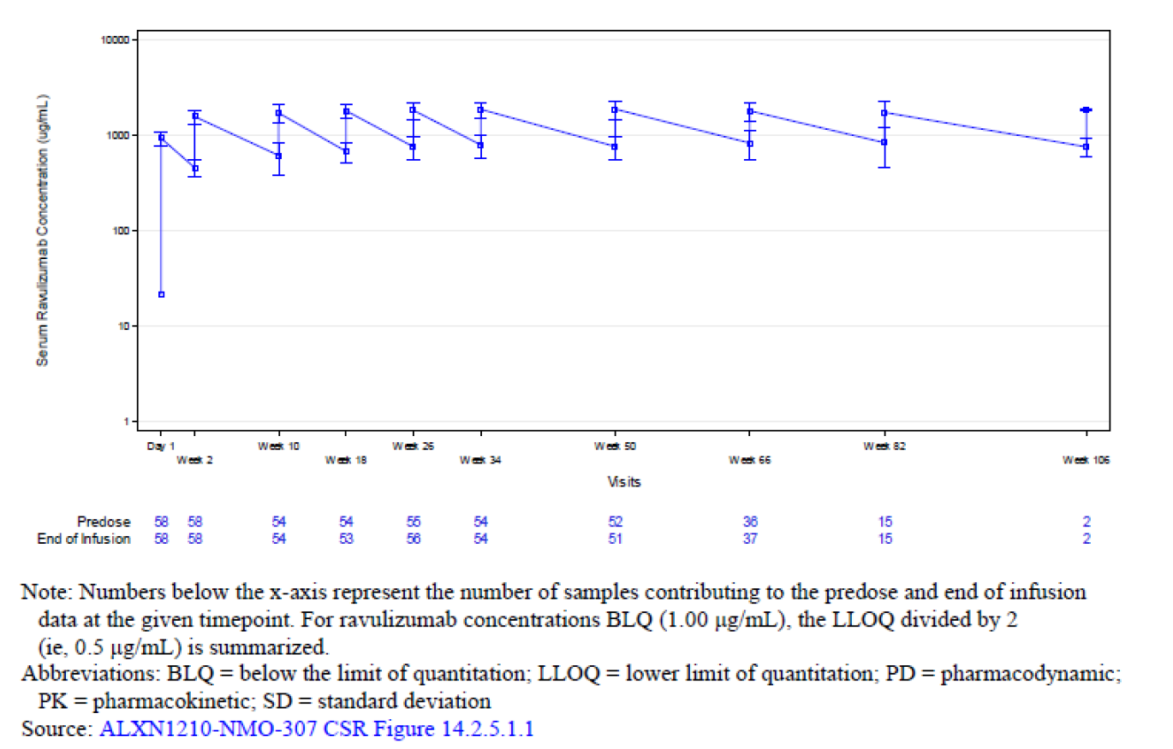

Table 5 shows the concentration range following the loading dose for all patients and accordingly to weight category. Note the slightly lower Cmax and Cmin for patients with weight ≥ 100kg.

Table 5. Cmax and Cmin following the loading dose.

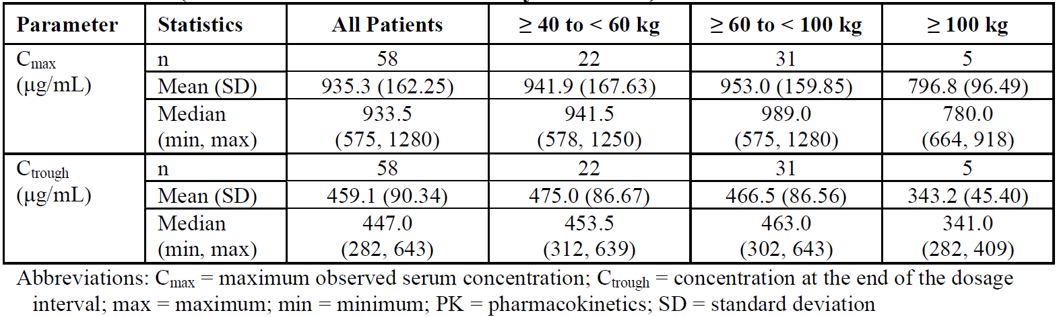

Table 6 shows the concentration range following maintenance dosing for all patients and then according to weight category. The influence of body weight was somewhat more pronounced with maintenance dosing, compared with following the loading dose, in patients ≥ 100kg.

Table 6. Cmax and Cmin during maintenance dosing

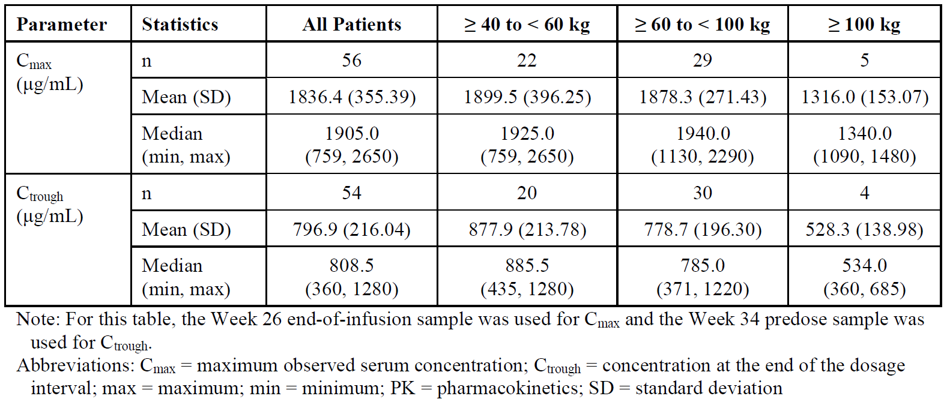

The exposures (Cmax, Cmin) in patients with NMOSD were slightly higher than in patients with gMG. In addition, exposure was slightly higher, by approximately 25%, in Japanese compared with non-Japanese patients in the trial.

##### Population pharmacokinetic modelling

Previous population pharmacokinetic (popPK) modelling utilised a 2-compartment model with first order elimination. An allometric exponent for body weight was incorporated and goodness of fit was demonstrated across patients with PNH and gMG.

The effects of plasmapheresis/exchange and IVIG were previously explored in the gMG popPK study. For plasmapheresis/exchange the clearance was significantly increased (0.793 L/h) and the terminal t1/2 was reduced to 3.6 days. IVIG had a more modest effect, with clearance of 0.0108 L/h and t1/2 of 14.7 days.

For the NMOSD study, concentration data from 58 patients, comprising 792 samples, were used for the popPK analysis. A 2-compartment model with first order elimination and an allometric exponent for body weight was the starting point. One subject had five plasmapheresis/exchange procedures and one subject had IVIG, and the resultant PK was also explored.

Potential covariates were tested, including BMI, age, sex, race, renal function, liver function, haemoglobin, ADA status and concomitant medications. BMI was the only covariates that reached the p-value threshold of 0.001 (alanine transferase was a significant covariate at the 0.005 level).

Population estimates of clearance and volume of distribution were 0.00226 L/h and 3.01 L in a typical 70kg patient with BMI 25.1 kg/m2. The mean terminal t1/2 was 64.3 days.

Checking of the model using goodness-of-fit, bootstrap resampling and visual predictive check confirmed its performance.

Body weight was a significant covariate affecting clearance, intercompartmental clearance and volume of distribution (both compartments). Plasmapheresis/exchange caused a large increase in clearance and a large reduction in half-life to 3.4 days.

##### Pharmacodynamics

Serum free C5 is expected to be significantly reduced following exposure to ravulizumab. Figure 2 shows C5 concentrations reduced between 3 to 4 orders of magnitude compared with baseline. This key pharmacodynamic (PD) effect was sustained out to week 50 with maintenance dosing.

Figure 2. Free C5 in relation to ravulizumab loading and maintenance dosing, semi-log.

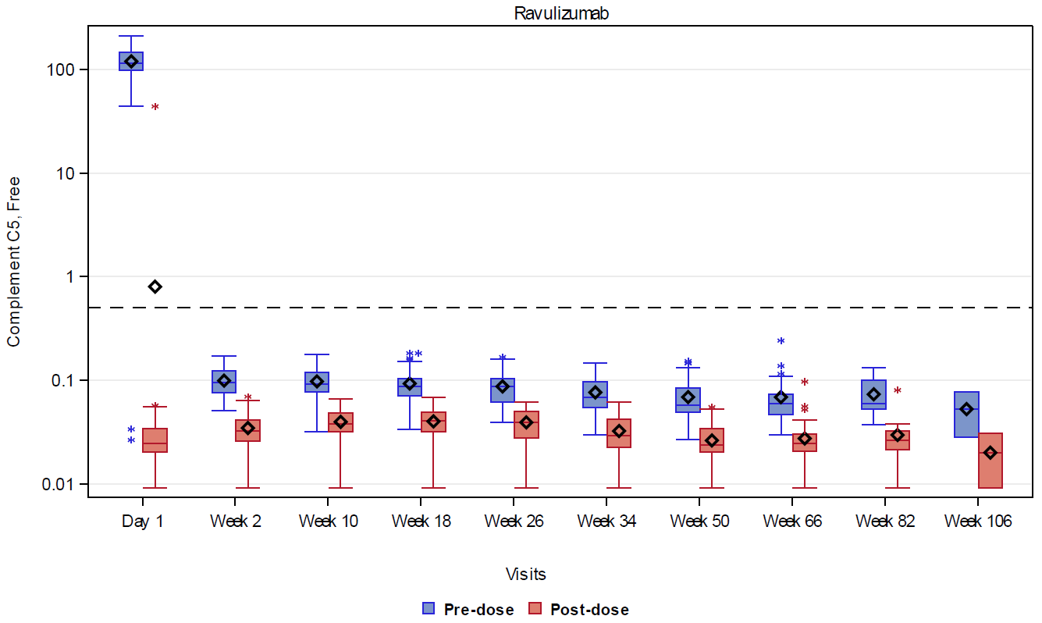

The ravulizumab concentration threshold for adequate reduction in C5 is considered to be 175 µg/mL. The PK/PD relationship between ravulizumab concentration and free C5 was explored. Of note, virtually all post-dose concentrations achieved a marked reduction in free C5 and the dose-response curve was relatively flat within this concentration range. These data are relevant to interpreting the differences in exposure noted between indications – gMG and NMOSD – and between weight categories.

Figure 3. Ravulizumab concentration vs. C5 during the primary treatment period

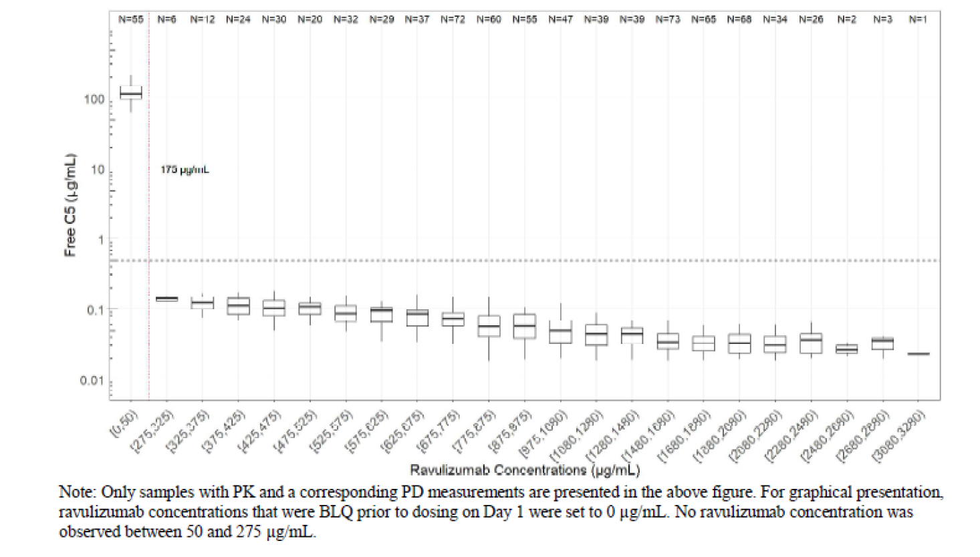

There did not appear to be a relationship between the occurrence of particular treatment emergent adverse effects (TEAEs) and ravulizumab exposure.

#### Efficacy

The pivotal study ALXN1210-NMO-307 is an ongoing, phase 3, randomised, external placebo-controlled, open-label, multicentre study to evaluate the efficacy and safety of ravulizumab in adult patients with NMOSD. The study was conducted at 36 sites in Europe, Japan, South Korea, the US and Australia. It consists of a primary treatment period, a long-term extension period, as well as screening and follow-up (Figure 4). The primary treatment period was to finish when all patients either completed 50 weeks on study or were discontinued. The primary treatment period could also be triggered in the event of 2 patients experiencing on-trial relapse and all patients completing 26 weeks or discontinuing prior.

Figure 4. Study schematic

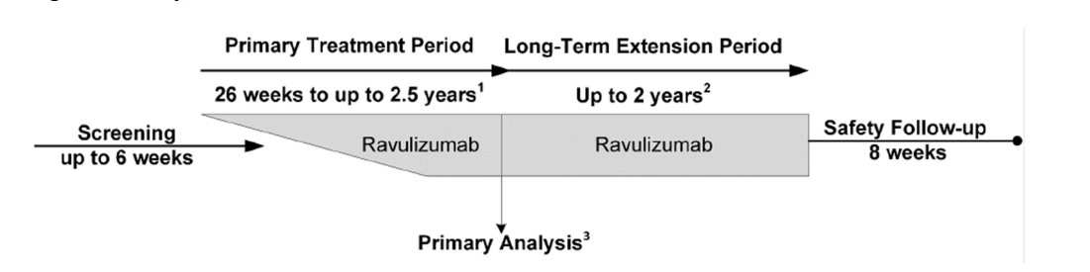

The key inclusion criteria were being ≥ 18 years of age, anti-AQP4 antibody positive and with a diagnosis of NMOSD per 2015 international consensus diagnostic criteria. Patients had to have had at least 1 relapse in the last 12 months prior to screening, expanded disability status scale (EDSS) ≤ 7 and vaccination against Neisseria meningitidis. Stable doses of background immunosuppression were permitted. The key exclusion criteria were previous participation in ECU-NMO-301 (see below), history of unexplained infection, active infection or certain previous treatments (rituximab or mitoxantrone within previous 3 months, IVIG within 3 weeks, any treatment with a complement inhibitor).

The historical control arm consisted of the placebo arm from study ECU-NMO-301. ECU-NMO-301 was a randomised, double-blind trial comparing eculizumab and placebo for the prevention of relapse in NMOSD. There were some discrepancies between the study criteria for the placebo arm and those from the ravulizumab study. In the placebo arm at least 2 relapses in the previous year or 3 relapses in the previous three years were required. This implies that the placebo arm patients may have had more severe disease (which could favour ravulizumab efficacy in the analysis). Overall, the similarities between the two studies resulted in a similar group of patients (e.g. with respect to inclusion/exclusion criteria and concomitant medications) within the ravulizumab and the control arms. Given the use of a historical control, the study was not randomised or blinded with regard to treatment (though other attempts at blinding, such as of assessments, were employed).

Dosing in ALXN1210-NMO-307 is shown in Table 7. A loading dose was given on day 1 and maintenance dosing commenced on day 15 and every 8 weeks thereafter.

Table 7. Weight-based dosing of ravulizumab.

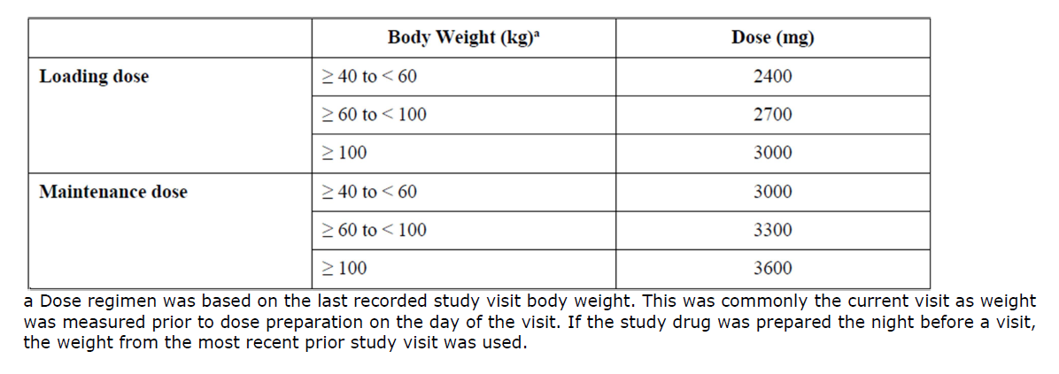

On-trial relapse could be managed with plasma exchange/plasmapheresis or IVIG. If such treatments were required, a supplemental ravulizumab dose (same as the recently administered maintenance dose) was given following completion of that treatment. This dosing regimen is the same as for other ravulizumab indications (i.e. paroxysmal nocturnal haemoglobinuria, atypical haemolytic-uraemic syndrome and generalised myasthenia gravis) and is expected to achieve terminal complement inhibition in > 90% of patients.

The primary efficacy outcome was the time to first adjudicated on-trial relapse and the relapse risk reduction. Relapse was defined as new onset neurologic symptoms, or worsening of existing symptoms, with objective clinical signs persisting for more than 24 hours. Relapses needed to be positively adjudicated by the Relapse Adjudication Committee. The study also included 8 secondary endpoints and 6 exploratory endpoints (Table 8).

Table 8. Secondary and exploratory endpoints.

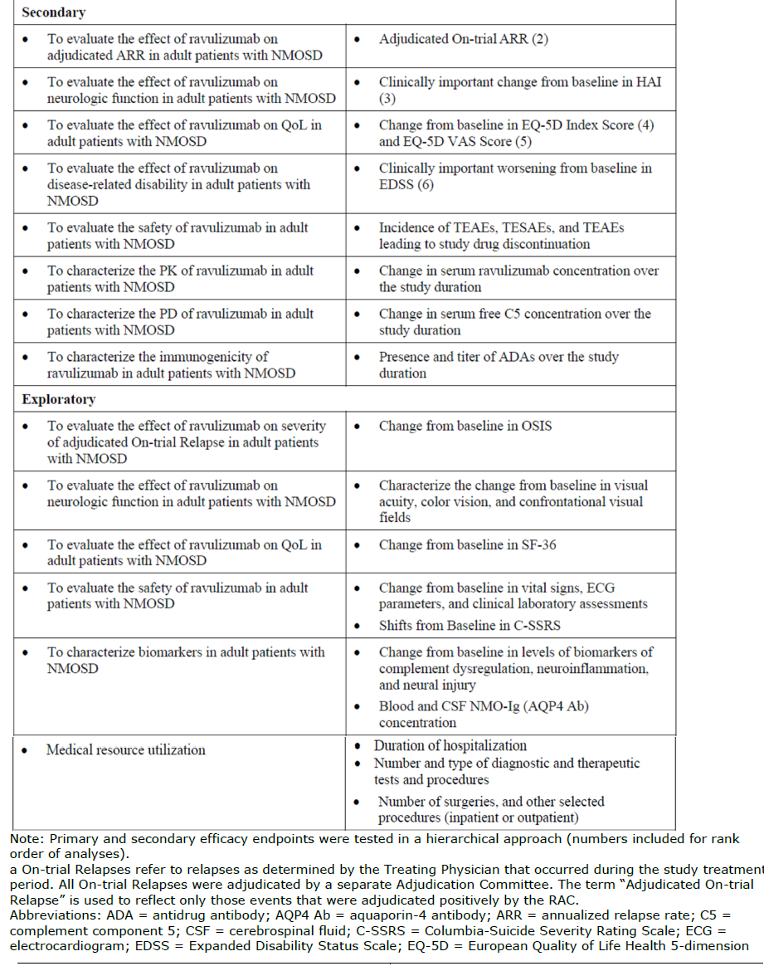

Note the following definitions for the secondary endpoints:

* HAI / Hauser Ambulation Index Score - a rating scale that assesses mobility over 25 feet and ranges from 0, fully active, to 9, restricted to wheelchair and dependant for transfers.
* EQ5D – quality of life scale based on mobility, self-care, usual activities, pain and discomfort, anxiety and depression.
* EDSS / expanded disability status scale – a scale of disability in multiple sclerosis that ranges from 0 (normal examination and no disability) to 9.5 (confined to bed and totally dependant unable to communicate effectively or eat/swallow) and 10 (death dye to MS).

A sample size of 55 patients receiving ravulizumab was calculated as adequate to detect a treatment difference in time to first positively adjudicate relapse. This assumed a 12-month relapse-free rate of 92% (ravulizumab) and 63% (placebo) with 90% power and a two-sided significance level of 5%. To ensure that the historical placebo arm was appropriate, sensitivity analyses using propensity scores and tipping point analyses (E-value) were conducted to detect any biases arising from this study design.

The populations for analysis were the full analysis set (FAS), the safety set and the per protocol set (PPS). The primarily analysis population was the FAS. The primary outcome was analysed using the log-rank test. Hazard ratio and risk reduction were summarised from a Cox proportional hazards model. Kaplan-Meier estimates were analysed at various time points.

A total of 58 patients were treated with ravulizumab. Of these, 56 continued in the long-term extension and 2 discontinued during the primary treatment phase due to adverse events. The primary treatment phase continued for 50 weeks due to no on-treatment relapse occurring (i.e. the other potential trigger for end of primary treatment phase). The study duration for individual patients ranges between 13.7 week and 117.7 weeks. Most of the patients were female (89.4-89.7%), and white (50-51.1%) or Asian (31.9%-36.2%). The median age was 47.4 years (ravulizumab arm).

In terms of baseline disease characteristics, patients in the ravulizumab arm had a median Hauser Ambulation Index Score of 1 and patients in the placebo arm had a median score of 2. Other disease characteristics were consistent with somewhat greater disease severity in the placebo group compared with the ravulizumab group (Table 9). As previously noted, this imbalance could overestimate any efficacy effect attributed to ravulizumab.

Table 9. Baseline disease characteristics.

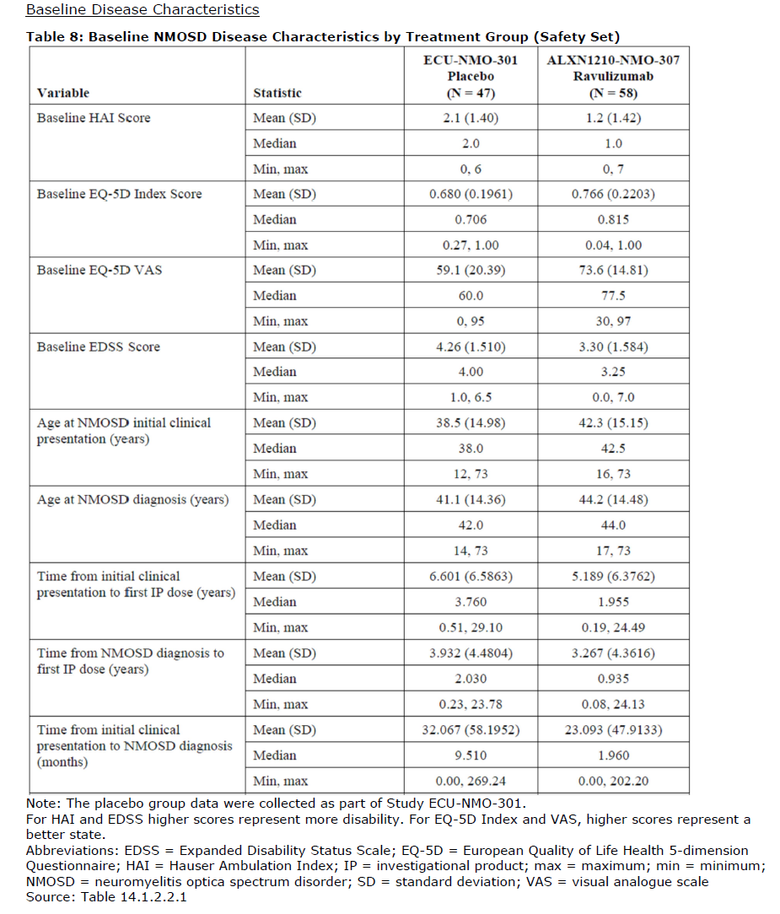

Similarly, patients in the placebo arm compared with the ravulizumab arm had a history of more relapses (median 4 vs. 2) and relapses within the previous 12 months (median 2 v. 1). The types of relapses in each arm are shown in Table 10.

Table 10. Historical relapse characteristics.

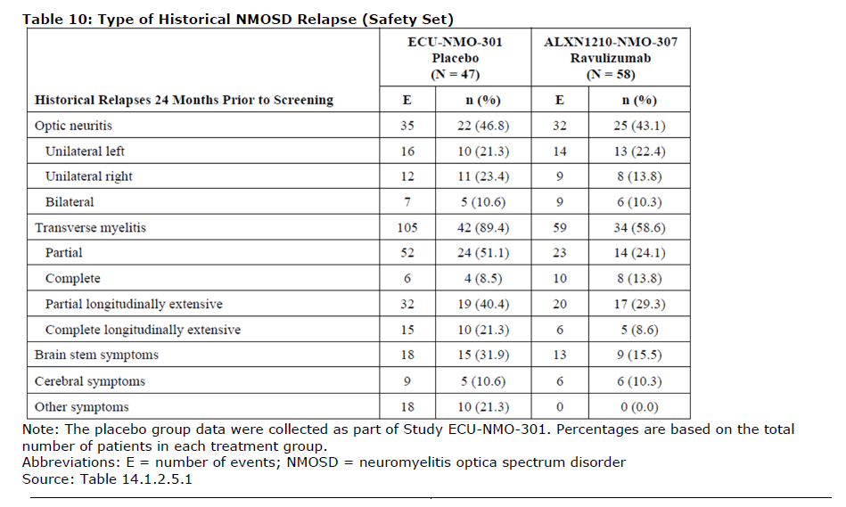

In terms of background therapy, more patients in the placebo group were on immunosuppressive medications compared with the ravulizumab group (72.3% vs. 48.3%). These medications included steroids, azathioprine and mycophenolate.

Propensity scoring was used to understand the baseline covariates in each group and their potential contribution to bias. The median propensity scores were 0.675 with ravulizumab and 0.425 with placebo. Following stratification of covariates, 70.7% in the ravulizumab group and 23.4% in the placebo group had a propensity score that was above the median (i.e. selected baseline characteristics were more likely to be present in the ravulizumab group, than the placebo group). Despite differences observed, the majority of covariates had standardised mean differences < ± 0.25, which was the limit set to define “balance” of a covariate. A derivation of propensity scores, standardised inverse probability treatment weights, were also used to match the groups. Using this method, all covariates had a standardised mean difference in propensity scores of < ± 0.25 indicating balancing of covariates.

The FAS and safety set included 58 patients in the ravulizumab arm and 47 patients in the placebo arm. Three ravulizumab patients were excluded from the per protocol set (PPS) due to major changes in their immunosuppression. Fifty-six of 58 patients remain in the ongoing, long-term study. Two patients discontinued due to adverse events (described below). A third patient had also ceased treatment during the study and was discontinued after the data cut-off date. The primary treatment period lasted for a different time for each patient (as it was only triggered when all patients had either completed 50 weeks or were discontinued).

In terms of the primary analysis, no patient in the ravulizumab group had an adjudicated on-trial relapse during the primary treatment period, compared to 20 (42.6%) in the placebo group, with a p-value of < 0.0001. The hazard ratio was 0.014 (0.000-0.103) and the percent reduction was 98.6% (89.7-100%). An E-value of 8.33 for the upper 95% confidence limit suggests that any unmeasured confounder would be unlikely to have a large enough impact on results to change the observed treatment effect.

Sensitivity analyses stratifying by propensity scores or using propensity scores in a weighted analysis were consistent with the main primary analysis.

Subgroup analyses found the same treatment effect for each of these (Figure 5).

Figure 5. Subgroup analyses, primary outcome.

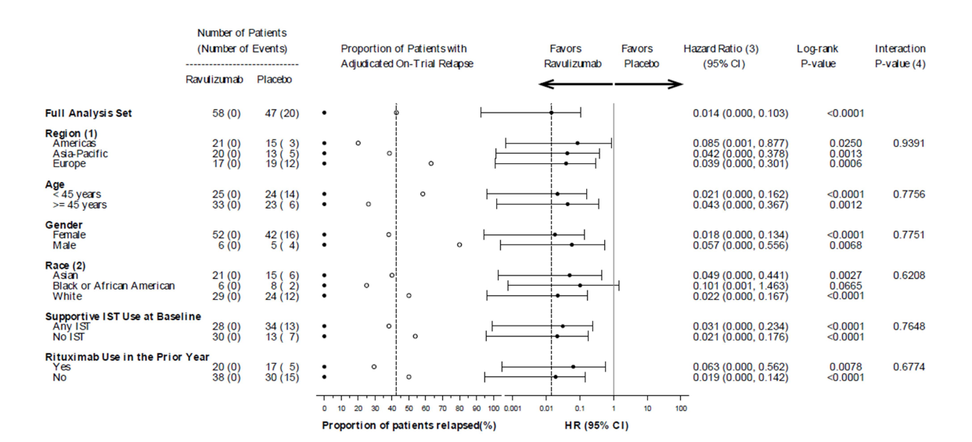

The time to first adjudicated on trial relapse was displayed as Kaplan-Meier Survival estimates (Figure 6). Note that patients who did not experience an on-trial relapse were censored at the end of the study period.

Figure 6. Kaplan-Meier Survival Estimates for Time to First Adjudicated On-trial Relapse (FAS)

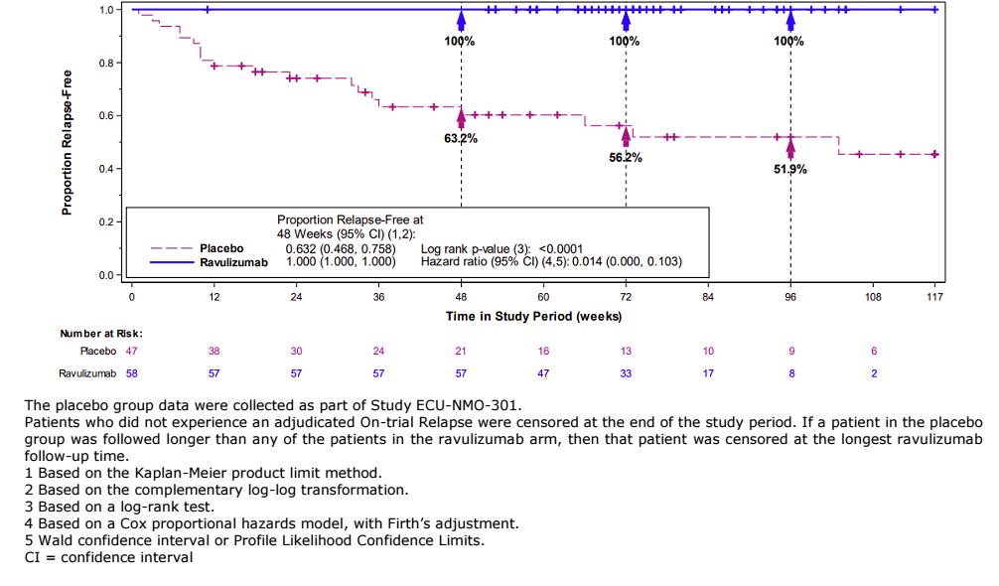

Two patients in the ravulizumab group had on trial relapses, as determined by the treating physician (i.e. but not the adjudication committee). A sensitivity analysis, counting these as relapses, still lead to a highly significant effect of ravulizumab (p<0.001) compared with placebo, with a hazard ratio of 0.039 (0.009, 0.164) and a 96.1% reduction in the risk of relapse.

In terms of secondary efficacy endpoints, 2 of 5 endpoints (per hierarchical testing) found significant effects favouring ravulizumab:

* The adjudicated on-trial annualised relapse rate was 0 (p<0.0001).
* Clinically important worsening of baseline HAI score (i.e. mobility related neurologic disability) occurred in 2 (3.4%) patients in the ravulizumab group and 11 (23.4%) in the placebo group (odd ratio 0.155, p=0.0228).
* The difference in EQ-5D was 11.15, favouring ravulizumab, but did not reach statistical significance (p=0.0567). Note, hierarchical testing of secondary endpoints ceased at this point.
* Nominally significant differences in EQ-5D VAS and EDSS were found.

#### Safety

The safety set is the same as the full analysis set (FAS) described in the efficacy section. As the primary treatment period continued until all patients either completed 50 weeks of treatment or were discontinued, the actual exposure period for each patient was different.

The median study duration was 73.5 weeks and ranged from 13.7 weeks to 117.7 weeks. Fifty-five (94.8%) of ravulizumab treated patients in ALXN1210-NMO-307 were followed for > 12 months and 21 (36.2%) for > 18 months. Treatment exposure comprised 84.1 patient-years.

Treatment emergent adverse events (TEAEs) were reported in 53 (91.4%) of patients in ALXN1210-NMO-307. Most of these were mild and considered unrelated to ravulizumab.

Severe AEs were reported in 9 (15.5%) patients. The most common severe TEAEs were infections with 1 patient each suffering from meningococcal encephalitis, intervertebral discitis, meningococcal sepsis, pneumonia and upper respiratory tract infection. Another 2 patients experienced severe musculoskeletal TEAEs (back pain and rheumatoid arthritis). Other severe TEAEs were alcohol poisoning, invasive lobular breast carcinoma, dizziness, suicidal ideation and acute kidney injury.

Serious adverse events (SAEs) were reported in 8 patients. Two of these were meningococcal infection and the patients recovered following treatment with no sequalae. Both patients had received vaccination against serogroups A, C, Y, W135 and B. One of the meningococcal events led to study drug withdrawal.

Two patients discontinued study drug due to meningococcal encephalitis and breast carcinoma. Of note, the patient with breast cancer continued ravulizumab for 6 months following diagnosis.

There was no mortality in the ravulizumab group.

Fifteen (25.9%) patients experienced COVID-19 infection whilst on the study, with no deaths or serious events considered related to ravulizumab.

The most common events were COVID19 (24.1%) and headache (24.1%). Events occurring in ≥5% of patients are shown in Table 11.

Table 11. TEAEs occurring in at least 5% of patients.

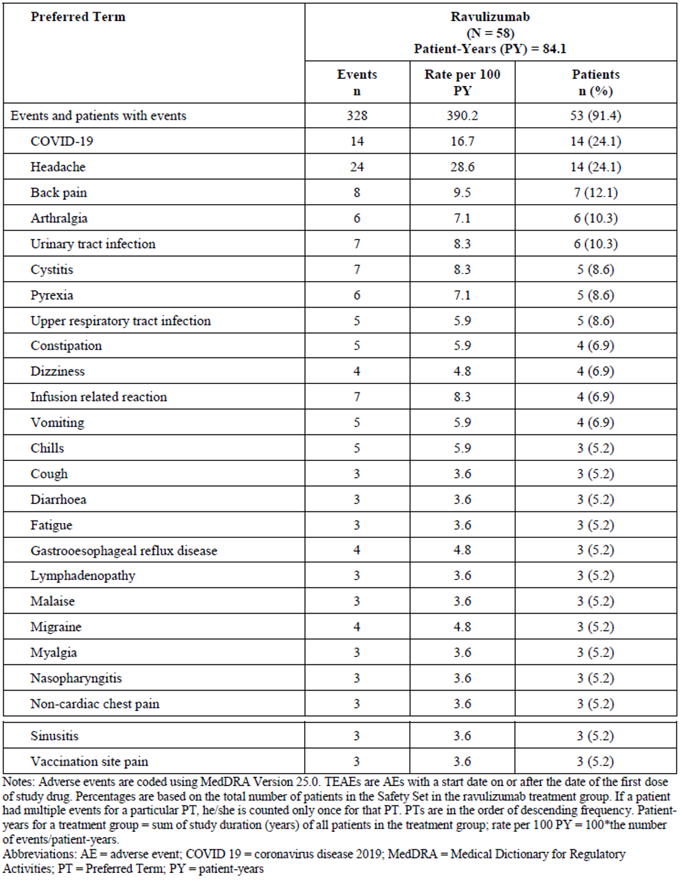

TEAEs that were also considered as related to ravulizumab were cystitis, urinary tract infection, upper respiratory tract infection, nasopharyngitis, sinusitis, encephalitis meningococcal, meningococcal sepsis, pneumonia and infusion related reactions.

Potential infusion reactions were noted in 20 (34.5%) of patients. None of these were serious or led to study drug withdrawal. Four patients (6.9%) had infusion reactions that led to study drug interruption during a total of 5 infusions. Events described in the cases of drug interruption included rigors, abdominal pain, muscle spasms, back pain and vomiting. Infusions were eventually completed in each case. No anaphylaxis was reported.

Laboratory related TEAEs were mostly mild and were considered as not related to ravulizumab. No trends were detected in terms of vital signs, physical findings or ECG results.

Intrinsic factors (age, gender, race, geographic region) were not found to influence the safety evaluation. Only 7 elderly patient were included in the study.

Post marketing exposure:

Ravulizumab has been marketed for a number of indications and there is substantial post-marketing safety data related to these. According to the EU evaluation, from Dec 2018 to Dec 2021, the cumulative post marketing exposure was 5733.9 patient-years. Therefore, the safety profile of ravulizumab is considered as well understood.

**Antidrug antibodies (ADA)**

53 (91.4%) of patients had a negative ADA at baseline and 5 (8.6%) had a positive ADA at baseline. Only 1 patient was ADA positive post dose with a low titre (1:3) at week 26 (also positive at baseline). There were no cases of treatment emergent ADAs. None of the ADAs were found to be neutralizing. ADA status at baseline did not seem to influence ravulizumab exposure.

#### Risk management plan

A summary of safety concerns are presented in Table 12.

Table 12. Safety concerns associated with ravulizumab.

The TGA decided a RMP was not required due to the following factors:

* The FDA has instructed the sponsor to implement additional risk minimisation measures that are very similar to what is already implemented in the approved EU-RMP and ASA.
* The ASA aligns with the EU-RMP in the list of summary concerns (that include meningococcal infections as an important identified risk) as well as the Pharmacovigilance and Risk minimisation plans that include:

Pharmacovigilance activities:

* + Specific adverse reaction follow-up questionnaires for ‘Meningococcal infection’: Global Pharmacovigilance Suspected/Confirmed Meningococcal Case Questionnaire
  + Additional pharmacovigilance activities: Five safety studies that include: PNH extension safety study ALXN1210-PNH-301, Study ALXN1210-PNH-302, PNH registry (M07-001), aHUS registry (M11-001) and Study ALXN1210-aHUS-311.

Additional risk minimisation activities:

* + Physicians guide
  + Patient/Parent/Legal Guardian guide
  + Patient Safety Card
  + Controlled Access
  + Annual vaccination reminder
* The PBS restrictions also include authority script required and S100 HSD requirements: [Pharmaceutical Benefits Scheme (PBS) |](https://www.pbs.gov.au/medicine/item/12841W-12884D-12895Q-12898W)
* The new extension of indication was recently approved by the EMA and the pharmacovigilance plan in the EU-RMP is similar, ([ULTOMIRIS | European Medicines Agency (europa.eu)](https://www.ema.europa.eu/en/medicines/human/EPAR/ultomiris).)

## Risk-benefit analysis

#### Delegate’s considerations

**Efficacy – EMA perspective:**

ALXN1210-NMO-307 was a single-arm study and the efficacy of a new treatment would normally be demonstrated in a double blind, randomised, controlled trial. Three previous monoclonal antibody treatments have shown efficacy in adults with NMOSD through randomised trials. The Sponsor considered it unethical to conduct placebo-controlled studies given the availability of efficacious treatments. A non-inferiority comparison with eculizumab was considered but deemed not feasible due to the large sample size required. The EMA agreed that it was acceptable in these exceptional circumstances to proceed with a single-arm study.

In terms of support for studying ravulizumab in NMOSD, ravulizumab and eculizumab (for which efficacy is established in NMOSD) are extremely similar structurally and pharmacologically. Furthermore, the drugs perform similarly in other indications. For example, randomised trials in PNH have shown ravulizumab to be non-inferior to eculizumab. ALXN1212-NMO-307 was designed to enrol similar patients to ECU-NMO-301 to ensure appropriateness of the historical control approach.

The primary and secondary efficacy endpoints were appropriate and had been used in prior studies of NMOSD. The use of an independent committee for adjudication of relapses provided robustness. However, given the unblinded nature of the study and the lack of objective measures to define relapse (e.g. MRI) there is still a risk of bias in the study.

The main concern with the validity of the data was the potential for intrinsic differences between the placebo arm and the ravulizumab arm. Relevant differences were noted in demographics, baseline disease severity / disability and use of immunosuppressive drugs. The EMA evaluation considered in detail the statistical methods for managing the risk of bias in this circumstance. In summary, the EMA assessed the variables used in the analysis (initially region, gender, age at first dose, background immunosuppressive use, baseline EDSS, annualised relapse rate in previous 24 months; the Sponsor also provided additional analysis of nearly all baseline characteristics), the use of median propensity score and standardised inverse probability treatment weights and the cut-off for median score acceptability (<0.25 vs. <0.10). Finally, the Sponsor provided an additional post hoc propensity score model using most of the baseline characteristics and found the risk reduction to still be 98.6% (89.5%, 100%). The EMA Committee for Medicinal Products for Human Use (CHMP) considered these analyses as sufficient to support the trial design and efficacy results.

**Efficacy – Delegate perspective:**

The study is convincing for establishing the significant and clinically relevant efficacy of ravulizumab to prevent relapses in NMOSD. There were no adjudicated relapses with ravulizumab over the treatment period. Worsening disability (as measured by clinically important worsening of HAI) only occurred in 3.4% of patients. This is different to what would be expected in an untreated patient and is different to what occurred in the historical placebo group (even acknowledging the inherent deficiencies of using a historical control).

The issues around use of a historical placebo group have been discussed in depth and dealt with, both statistically and in terms of the general narrative, as much possible. The Delegate considers favourably the fact that the historical placebo approach was discussed and agreed upon with the major regulators prior to undertaking the clinical trial. The efficacy is therefore considered as acceptably demonstrated.

**Proposed indication:**

The proposed indication is “for the treatment of adult patients with Neuromyelitis Optica Spectrum Disorder (NMOSD) who are anti-aquaporin 4 (AQP4) antibody-positive.” It would be preferable to specify in the indication that ravulizumab is for prevention of relapse, given that it has not been studied in acute NMOSD-related neurological episodes. The ACM will be asked about this.

**Safety – EMA perspective:**

The safety data set was relatively small, but this was not unexpected given the rarity of NMOSD. The safety was considered generally acceptable and consistent with previous experience with ravulizumab. The EMA noted the 2 cases of meningococcal infection that occurred during ALXN1210-NMO-307 but did not consider further actions necessary.

The study took place during the COVID-19 pandemic and 15 TEAEs consistent with infection were documented. There did not appear to be a signal for severe COVID-19 associated with ravulizumab. There were no deaths or serious AEs related to COVID19 and none of the AEs were considered drug related.

The EMA requested that “urinary tract infection” be added to the SmPC. They appeared satisfied that the AEs of cystitis, sinusitis and pneumonia, were not definitively causally related to ravulizumab.

**Safety – Delegate perspective:**

The meningococcal infections in two adequately vaccinated patients during the pivotal study are noteworthy. This seems higher than would be expected in patients treated with ravulizumab (the CHMP report notes a post-marketing rate of 0.05 cases per 100 PY), however the sample size is small. The Sponsor will be asked about this. Meningococcal infection is already extensively dealt with in the PI and other risk minimisation activities.

Only a single weight-based dosing regimen has been studied. This is not unexpected given the rarity of NMOSD. However, there is some uncertainty with regard to whether a different dosing regimen could be similarly efficacious, but safer. The dossier states that a ravulizumab concentration of 175mcg/mL is required for adequate complement inhibition (C5<0.5mcg/mL), which is the general target across indications. Mean trough concentrations were 3-5 fold and mean peak concentrations were up to 10 fold this threshold in ALXN1210-NMO-307. This raises questions about whether reducing peak exposure (e.g. smaller dose given more frequently) or reducing trough exposure (e.g. using a lower overall dose) could improve the safety profile, particularly with regard to serious infections. The Sponsor and ACM will be asked about this.

**Risk-benefit-uncertainty assessment**

Ravulizumab appears to be efficacious for preventing relapse in patients with NMOSD. This is the central treatment goal in these patients as it prevents the accumulation of neurological morbidity, as well as potentially mortality. The risks are reasonably well understood given the use of ravulizumab in other indications for several years. The ALXN1210-NMO-307 did not suggest new safety signals, although the occurrence of 2 cases of meningococcal infection in a small cohort is somewhat concerning. The risk of meningococcal infection is considered as appropriately managed currently. The risk: benefit is favourable, given the potential severity of the disease. Some uncertainty arises due to the open label, single treatment arm with historical placebo control, design of the pivotal study. The reasons for conducting the study in this way appear acceptable. Additional uncertainty arises from only a single dosing regimen being explored in clinical trials.

#### Proposed action

The Delegate considers ravulizumab as suitable for registration for treatment of patients with NMOSD.

#### Questions for the sponsor

The sponsor provided the following response to questions from the Delegate.

Update on the international regulatory status, including in the US and UK.

A comprehensive summary of the worldwide regulatory status applicable to ravulizumab (ULTOMIRIS) for NMOSD is provided in Module 1.11.1 for reference. As previously communicated to the TGA (19th September 2023), a Complete Response Letter has been issued by FDA for the review of the NMOSD indication, as an update to the REMS is pending for ULTOMIRIS (and SOLIRIS) for all indications. The resubmission of the NMOSD indication to the FDA with the updated REMS is planned to be completed in November 2023. Approval for the NMOSD application was received from the MHRA in the UK in August 2023 and from Health Canada in October 2023.

The incidence of meningococcal infection (2/58) in study ALXN1210-NMO-307 is higher than expected from previous experience with ravulizumab.

The safety implications of targeted complete blockade of terminal complement activity, through binding of ravulizumab to complement protein C5, are well understood. These implications are informed by patients with congenital C5 deficiency, who functionally mimic the inhibition of C5, and by experience in patients treated with eculizumab, which bears a high degree of pharmacological similarity and similar risk of meningococcal infections. As described in the SOLIRIS and ULTOMIRIS Product Information, C5 inhibition is associated with an increased incidence of meningococcal infections. Risk factors for common meningococcal infections include congenital immunodeficiency, including complement deficiency diseases, anatomic or functional asplenia, HIV infection, and high density population living. Other than those general risks, there are no identified differences in the incidence by indications, and no other risk factors related to meningococcal infection in patients treated with ravulizumab have been identified.

* 1. ***Is there an explanation for this? Did these patients have higher ravulizumab concentrations / more intense complement inhibition?***

In study ALXN1210-NMO-307, complete terminal complement inhibition (defined as serum free C5 concentrations < 0.5 μg/mL) was achieved by the end of the infusion of the first ravulizumab dose and sustained throughout the study period, as previously seen in the Phase 3 studies for PNH, aHUS and gMG with the same dosing regimen. For the 2 patients with meningococcal infection in the NMOSD study (patients 0014-101 and 0135-101), the most recent ravulizumab post dose concentrations (before meningococcal event) were 1500 and 1510 μg/mL respectively. Both patients achieved complete terminal complement inhibition and their post-dose are below typical mean Cmax during study (1836.4 μg/mL). Even in a scenario when Cmax would be higher, when complete terminal complement inhibition is achieved, it is considered that there is no residual complement activity and thus “no more intense inhibition” can be achieved. As highlighted in the product information, vaccination may not always be sufficient to mitigate risk of meningococcal infections and additional risk minimizations measures are in place to educate for identification of early signs of meningococcal infection, act immediately if infection is suspected, and treat with appropriate antibiotics, if necessary. In these cases, both patients were promptly treated and recovered with no sequelae, with one patient withdrawing from study and one patient continuing to receive ravulizumab with the addition of chronic antibiotic prophylaxis (amoxicillin). Notably, one of the two patients lived in a college dormitory which is considered an additional risk factor for meningococcal infection.

* 1. ***Are there any post market data yet for meningococcal infection in patients with NMOSD treated with ravulizumab?***

As the first regulatory approvals for the ULTOMIRIS NMOSD indication were received in Q2 2023, the launches for this indication are ongoing and there is limited post marketing experience of ravulizumab in this indication. As of 30 Jun 2023, 13 cases of meningococcal infections (9 in PNH and 4 in aHUS) were from post-marketing sources globally with ULTOMIRIS; there have been no cases in the NMOSD indication to date. The cumulative post-marketing reporting rate for meningococcal infections is approximately 0.12 cases per 100 patient-years (13 cases per 10974.3 patient-years).

Cumulatively as of 30 Jun 2023, there have been 6 cases of meningococcal infection (Preferred Terms: Meningococcal infection [n = 2], Meningococcal sepsis [ n = 3], and Encephalitis meningococcal [n = 1]) in the entire ravulizumab clinical development program (including ongoing clinical studies across all indications) with an overall rate of 0.19 per 100 patient-years (6 cases/3,161.07 patient-years). Overall cumulative patient exposure with frequencies of serious meningococcal infections is presented inTable 13, based upon actual exposure data from clinical trials in other approved indications. To date, no meningococcal infection event has been reported in clinical trials in other indications in development.

Table 13. Estimated Cumulative Subject Exposure, Meningococcal Infections Events in Ravulizumab Clinical Trials up to 30 Jun 2023.

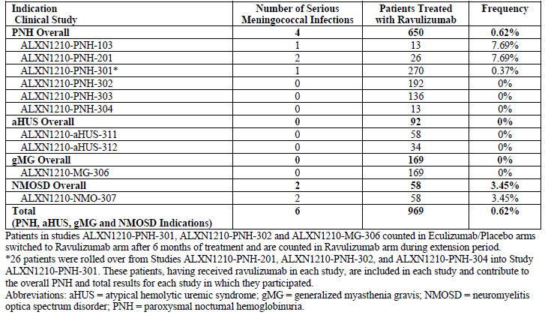

Eculizumab, which is approved globally for the treatment of NMOSD since 2019 under the tradename SOLIRIS, has generated extensive post marketing experience with the same mechanism of action.

Based on the latest data, overall rate of meningococcal infection with ravulizumab and eculizumab are consistent. When the incidence of meningococcal infection in clinical studies of both drugs was compared for each indication combined, there was no difference. SOLIRIS post marketing experience also confirmed that there is no difference in incidence of meningococcal infections in NMOSD indication as compared to previously approved indications (PNH, aHUS, gMG).

Therefore, the ravulizumab and eculizumab accumulated data do not suggest a higher incidence of meningococcal infections in the NMOSD indication for ravulizumab. As the number of patients treated with ravulizumab in NMOSD is still limited, information will continue to be collected via post-marketing surveillance to confirm that there is no risk of invasive meningococcal disease specific to NMOSD.

The dossier states that a ravulizumab concentration of 175mcg/mL is required for adequate complement inhibition (C5<0.5mcg/mL), which is the target across indications. Mean trough concentrations were 3-5 fold and mean peak concentrations were up to 10 fold this threshold in ALXN1210-NMO-307. Are there data to suggest that safety may be improved without significantly compromising efficacy by reducing peak exposure (e.g. smaller dose given more frequently) or reducing trough exposure (e.g. using a lower overall dose)?

The dose regimen has been designed to provide PK coverage to achieve complete and sustained terminal complement suppression to the majority of patients while taking into account intra and inter patient variability as well as clinical events that could impact complement components levels. The exposure threshold of 175 μg/mL was set up corresponding to the complete C5 inhibition based on multiple indications in different patient populations. With the dose regimen, no major safety issue was observed. The Sponsor has explored the relationship between PK exposure and safety in NMOSD patients. Across all approved indications, ravulizumab has been shown to have no exposure-safety relationship. The population pharmacokinetic (PopPK) model-based Exposure-Response analysis of safety with the Phase 3 NMOSD data suggested that no relationship between the probability of any Treatment Emergent Adverse Event (TEAE) and the maximum concentration at steady state (Cmax,ss) or the area under the curve at steady state (AUCss) of ravulizumab could be ascertained [NMOSD PopPK report, Section 6.6]. The probability of patients experiencing any TEAE did not increase with higher Cmax,ss and AUCss values [Table 14 and Table 15]. Likewise, the probability of patients experiencing other TEAEs occurring at more than 10% (i.e., headache, COVID-19 infection and backpain) did not increase in a consistent manner with higher Cmax,ss and AUCss values [Table 14, Table 15 and Table 16].

Therefore, a lower dose is unlikely to improve the safety of ravulizumab, but instead increases the risk of compromising efficacy considering the relatively large PK variability.

Table 14. Summary of Treatment-Emergent Adverse Events Occurring in Greater Than or Equal to 5% in the Ravulizumab Treatment Group During the Primary Treatment Period - Study ALXN1210-NMO-307.

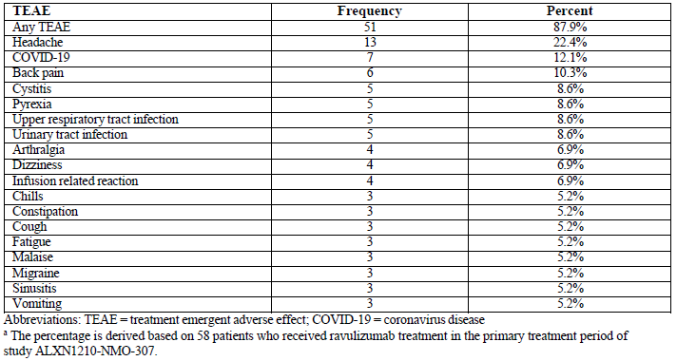

Table 15. Probability of TEAEs as a Function of Ravulizumab Cmax at Steady State in Study ALXN1210-NMO-307.

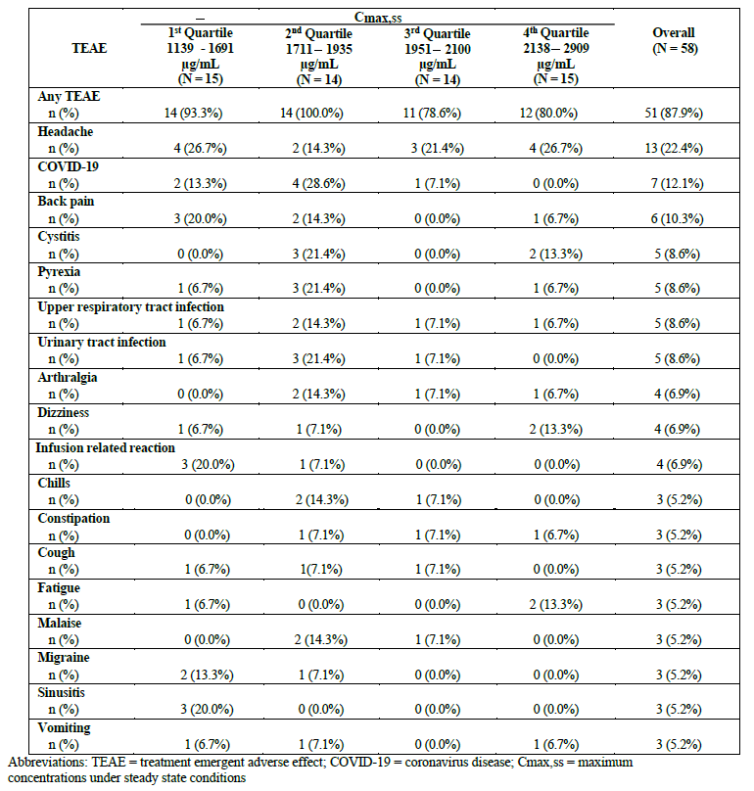

Table 16. Probability of TEAEs as a Function of Ravulizumab Area Under the Curve at Steady State in Study ALXN1210-NMO-307.

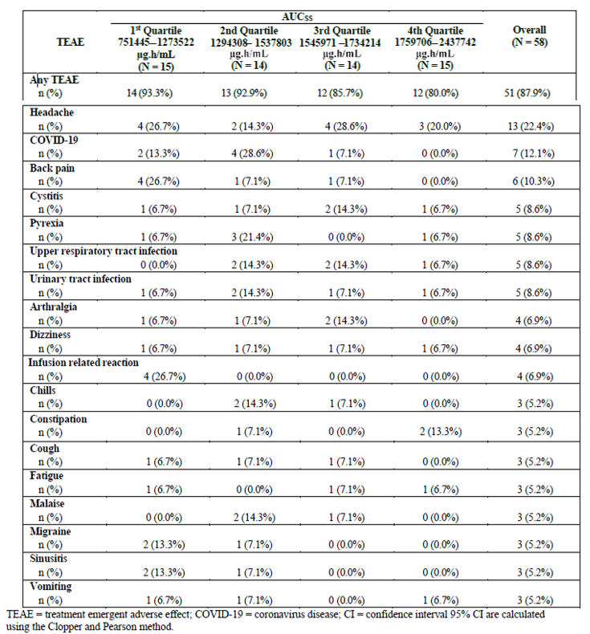

Only one weight-based dosing regimen for ravulizumab has been explored in NMOSD and this is the same regimen as for the approved indications. Please justify this dose, specifically in relation to NMOSD and comment on the residual uncertainty about alternative dosing regimens being safer and equally effective.

Findings from the clinical development program of eculizumab in patients with NMOSD supported the rationale for complete C5 inhibition as a therapeutic approach for reducing the risk of relapses in NMOSD. The dose of ravulizumab in the NMOSD study was based upon the extensive knowledge and experience related to C5 inhibition. Alexion’s cumulative experience with anti-C5 monoclonal antibodies (ravulizumab/eculizumab) provided evidence of maximal efficacy following achievement of complete and sustained complement inhibition.

To establish this optimal dosing regimen, a thorough modelling simulation approach was adopted. For the first indication, PNH, in addition to conducting dose ranging Phase 2 study, we conducted simulations using a validated Pop-PK model and the established C5 threshold to evaluate different dosing regimens and body weight cut-offs. The proposed weight-based dosing regimen is expected to achieve a population SS Ctrough of ≥ 175 μg /mL, a threshold corresponding to complete terminal complement inhibition, in nearly all patients, and is predicted not to exceed exposures that have been achieved in our current Phase 2 program. The optimal dosing regimen was agreed up on with the FDA and EMA and thereafter tested in Phase 3.

The Phase 3 data following ravulizumab intravenous (IV) dosing in patients with PNH, aHUS, or gMG showed that ravulizumab trough concentrations were optimally maintained above the target therapeutic PK threshold (175 μg/mL) ensuring immediate and complete terminal complement inhibition (defined as serum free C5 < 0.5 μg/mL), sustained throughout treatment at all timepoints in all patients. Across above indications, we confirmed that the PK/PD were not different across indications. This analysis helped us confirm one body weight-based dosing regimen for all indications. Furthermore, multiple ascending dose assessment in Phase 2 study in PNH patients performed early during the ravulizumab development process showed no noticeable differences for the type or incidence of adverse events across the different dosing cohorts, including at doses higher than that currently approved. There were no unexpected safety concerns across all dose cohorts, and ravulizumab was well tolerated in patients with PNH.

Therefore, the favourable risk-benefit profile of ravulizumab under the currently approved weight-based dosing regimen across multiple indications, for which the therapy was rooted in terminal complement inhibition, supported the dosing regimen for NMOSD patients.

Despite the inter-indication, intra-indication inter-study, and intra-study variabilities across patients in all of the aforementioned studies conducted in PNH, aHUS and gMG patients, the same weight-based dosing regimen was able to robustly achieve and maintain the therapeutic serum ravulizumab and Free C5 levels, with desirable efficacy and acceptable safety characteristics. Therefore, alternative dosing regimens were not explored, to avoid loss of efficacy due to low exposure in NMOSD patients considering the high debilitating impact of potential relapse with potential irreversible sequalae.

The study result obtained with NMOSD patients using this dose regimen also demonstrated an acceptable benefit/risk profile to the patients.

Are there any further immunogenicity data for the NMOSD indication (in particular, any events of treatment emergent ADA development)?

Cumulative ADA results from the first ravulizumab administration during the Primary Treatment Period in Study ALXN1210-NMO-307 through the Long-Term Extension Period as of up to the 15 Jun 2022 data cutoff were reported in the last CSR addendum generated for EMA and FDA. As of this data cutoff date, no treatment-emergent ADA response was observed following ravulizumab treatment in patients with NMOSD.

Regarding section 4.4 of the PI, under infusion reactions 1.6% is given in relation to “clinical trials infusion reactions”. It is not clear whether this means 1.6% of patients during the course of their treatment or 1.6% of infusions are associated with reactions. In any case, in ALXN1210-NMO-307 34.5% had potential infusion reactions and 6.9% had infusion reactions leading to drug interruption. Explain the discrepancy in these rates.

The wording in the product information states that 1.6 % of patients presented with infusion reactions, corresponding to the number of patients with events, not the number of infusions. The sponsor would like to clarify that the clinical study report section 5.2.1.8 capture TEAEs representing potential infusion reactions, using broad search criteria. These search criteria included both adverse events reported specifically as infusion reactions as well as those indicating local injection site reactions, potential hypersensitivity reactions, and nonspecific symptoms that may be associated with infusion reactions. Adverse events meeting these broad criteria were captured regardless of the investigator’s assessment of relationship to ravulizumab.

It is expected that these broad search criteria would identify adverse events that were not specifically infusion reactions associated with the use of ravulizumab. Although 20 (34.5%) patients experienced 1 or more TEAEs suggestive of potential infusion reactions, only 4 patients (6.9%) experienced a total of 7 adverse events that were described by the investigators as symptoms associated with infusion reactions and were coded to the preferred term infusion related reaction. None of these events were serious, and none resulted in withdrawal of ravulizumab. In 3 of these 4 patients the infusions were interrupted due to the events; the infusions were resumed, and the patients received the total infusion volume. The adverse events in these 4 patients are described below:

* + Patient 1152-103 experienced 2 adverse events during the Day 1 infusion (described as *“infusion reaction increased low back pain” and “infusion reaction spasm to mid thoracic area”*) and 2 adverse events during the Day 15 infusion (described as *“infusion reaction lower back pain 5/10 pain”* and *“infusion reaction muscle spasms in back 5/10 pain”*). On both days, the infusions were interrupted due to the events (25 minutes and 12 minutes on Days 1 and 15, respectively), the patient was treated with diphenhydramine, the events resolved, and the infusions were subsequently resumed and completed. The patient received treatment with ravulizumab during the Primary Treatment Period for a total of 691 days without further infusion reactions.
  + Patient 0207-103 experienced a single Grade 2 adverse event described as *“infusion related reaction. Rigors”* on Day 15; the infusion was interrupted (55 minutes), diphenhydramine was administered, the event resolved, and the infusion was completed. No other infusion reactions were reported during 519 days of treatment in the Primary Evaluation Period.
  + Patient 1152-102 experienced a single Grade 1 infusion related reaction on Day 354, described as *“Infusion reaction left upper abdominal pain.”* The event resolved without treatment; the infusion was interrupted for 10 minutes and subsequently completed. No other infusion reactions occurred during 688 days of treatment with ravulizumab during the Primary Evaluation Period.
  + Patient 1338-101 experienced a single Grade 1 infusion related reaction on Day 16, described as *“mild headache after infusion,”* treated with ibuprofen, and did not require infusion interruption. No other infusion reactions occurred during 465 days of treatment with ravulizumab during the Primary Evaluation Period.

Table 17 presents the frequencies of infusion related reactions for each of the completed clinical studies and by approved indication. In this table, infusion related reactions are defined as adverse events that are coded to the Preferred Term “*infusion related reaction*” for all included completed studies. Each protocol provided instructions to the investigators on the identification and management of infusion reactions, including a description of typical signs and symptoms of hypersensitivity reactions; however, specific definitions for purposes of recording these adverse events on the CRF were not provided.

The overall frequency of infusion related reactions for all completed studies, including Study ALXN1210-NMO-307, is 1.61%. The incidence rates in the PNH, aHUS, gMG, NMOSD completed clinical trials were 1.13%, 2.25%, 1.18%, and 6.9%, respectively. It should be noted that interpretation of these frequencies is limited by the small number of events, large differences in the numbers of patients, and possible inconsistent reporting of adverse events by the investigators in the various clinical trials. In order to evaluate apparent differences between the indications, incidences and 95% confidence intervals [CI] were calculated for each study, each indication, and for the overall population. For the studies, the Clopper-Pearson method is presented, and for indications and the combined results, both a fixed effects and random effects model are presented.

For the overall population, the infusion related reaction incidence rate was 1.71% (95% CI 0.76, 3.78) and the incidence rates (95% CI) for the PNH, aHUS, gMG, and NMOSD completed clinical trials were 1.15% (0.48, 2.71), 2.16% (0.50, 9.38), 1.18% (0.23, 5.79), and 6.90% (1.93, 21.83), respectively. These results suggest that there was sufficient homogeneity in the incidences of infusion related reactions across indications. Therefore, the frequency of infusion reactions in Study ALXN1210-NMO-307 is consistent with what is currently labelled in the ULTOMIRIS Australian Product Information.

Table 17. Summary of Infusion Related Reactions Reported during Ravulizumab Treatment Period across Indications (Safety Set).

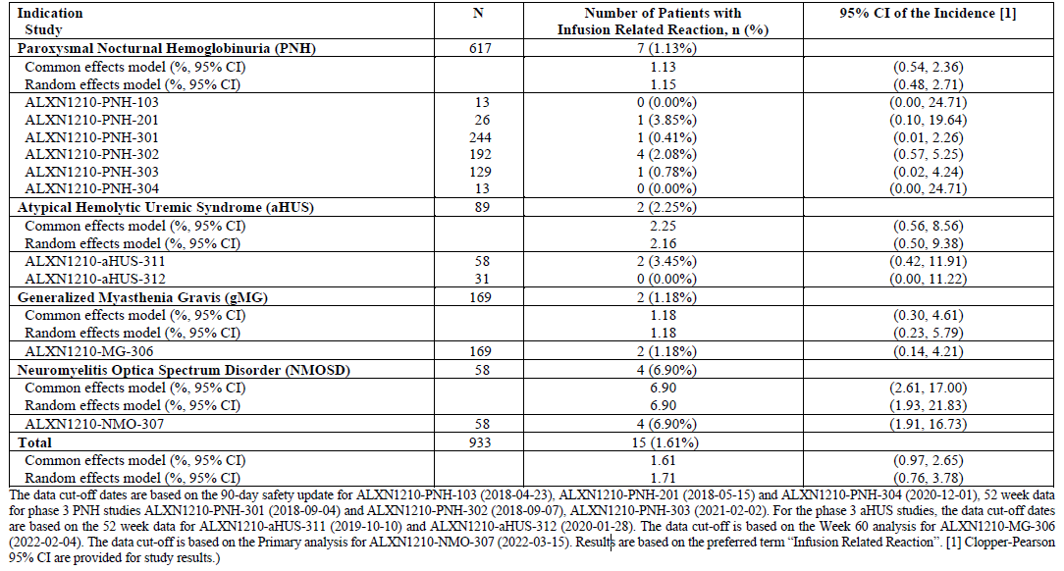

The PI for the 10mg/mL presentation has only recently been approved. Ensure that the next version of the PI submitted for PM02023-02695-1-1 is consistent with the recently approved version.

Alexion can confirm that the updated PI documents submitted in Module 1.3.1 of this response are consistent with those changes submitted to and approved by the TGA as part of the sequence 0055 (Safety Related Request). All changes to the previously submitted PI have been identified using the track change and comments functions.

#### Advisory committee on medicines considerations

The [Advisory Committee on Medicines (ACM)](https://www.tga.gov.au/committee/advisory-committee-medicines-acm), having considered the evaluations and the Delegate’s overview, as well as the sponsor’s response to these documents provided the following advice in response to the following questions posed by the Delegate:

##### Specific advice to the Delegate

1. ***Should the indication specify that treatment is “prevention of relapse” to distinguish it from treatment of acute NMOSD episodes (for which it has not been tested)? Should it specify that it is for “patients with a “relapsing course of disease”?***

The ACM favoured consistency with the wording of the approved indication for NMOSD for eculizumab and satralizumab, which have similar mechanisms of action.

Explicit restriction to a relapsing course of disease was not supported. Patient selection should include a clinical relapse whilst on adequate immunosuppressive therapy or contraindications to other immunosuppressive therapies.

The ACM highlighted that prescribing should be by a neurologist or immunologist.

There could be a theoretical beneficial effect of complement inhibition in acute relapses in addition to standard therapy (high dose steroids, plasma exchange). However, as there are no data available on use of ravulizumab in the treatment of acute episodes of NMOSD this should be stated in the indication.

Does the committee have any comments about the use of a single-arm study to establish efficacy in this situation?

The ACM advised that it is reasonable to use a non-historical placebo comparator given the prevalence of the disease and as the natural history of the disease is well-established. Further placebo-controlled studies for AQP4 antibody positive NMOSD are no longer justifiable ethically and would practically be difficult to conduct.

The clinical development program for this indication was discussed and agreed upon by the sponsor and both the EMA and the FDA prior to commencement of the trial.

The ACM did note the greater disease severity in the placebo group compared with the ravulizumab group at baseline, and that this imbalance could lead to an overestimate of efficacy attributed to ravulizumab. However, at 48 weeks, no adjudicated on-trial relapse had occurred in the ravulizumab group while in the external placebo group 43% of participants had relapsed. The ACM noted that it was unlikely that any NMOSD relapse would be undetected. The obvious efficacy outweighs concerns on variability in baseline characteristics.

What is the committee’s opinion on the proposed dosing regimen?

The ACM advised that the proposed dosing regimen reflected the pharmacokinetic, pharmacodynamic, efficacy and safety data.

The proposed dosing regimen is the same as that already approved for Paroxysmal Nocturnal Haemoglobinuria and Atypical Haemolytic Uraemic Syndrome, as below:

Table 18. Proposed dosing regimen

***Proposed dosing regimen***

In people with higher BMI (5 participants were over 100 kg in the pivotal study), clearance of ravulizumab was higher leading to lower Cmax and Ctrough values. Adequate complement inhibition is achieved with ravulizumab 175 microgram/mL and this serum level was exceeded at least 3-fold at Ctrough across all body weights.

Adverse effects were not more common at higher doses, that is, ravulizumab has a wide therapeutic index.

Two-monthly infusions seem appropriate, maintaining complete complement inhibition throughout all timepoints, and acceptable clinically.

The ACM noted the absence of guidance for use in adults weighing less than 40 kg.

Is there anything further (such as in the PI) that may help with managing the risk of meningococcal infection with ravulizumab?

The ACM noted that in Study ALXN1210-NMO-307 the participants were required to have been vaccinated against *N. meningitidis*, although 2 vaccinated patients did have meningococcal infections during the trial.

The ACM favoured consistency in the wording of boxed warnings for severe meningococcal infection. The boxed warning for eculizumab is straight-forward and preferred over the proposed boxed warning for ravulizumab, although the ACM acknowledged that it may not be possible to align the warnings for different medicines.

Prescribers and treated patients can discuss the potential role of long-term prophylactic antibiotic therapy, especially if meningococcal vaccination was performed in the context of prior immunosuppressive therapy.

The ACM confirmed that all patients should be well informed on symptoms of meningococcal infection and have rapid access to appropriate health care.

##### ACM conclusion

The ACM considered this product to have an overall positive benefit-risk profile for the proposed indication.

## Outcome

Based on a review of quality, safety, and efficacy, the TGA decided to register ULTOMIRIS (ravulizumab) for the following additional indications:

*ULTOMIRUS is indicated for the treatment of adult patients with Neuromyelitis Optica Spectrum Disorder (NMOSD) who are anti-aquaporin 4 (AQP4) antibody-positive.*

*ULTOMIRIS is not intended for the acute treatment of a NMOSD relapse.*

As such, the full indications at this time are:

ULTOMIRIS is indicated:

* for the treatment of patients with Paroxysmal Nocturnal Haemoglobinuria (PNH)
* for the treatment of patients with Atypical Haemolytic Uraemic Syndrome (aHUS)
* as an add-on to standard therapy for the treatment of adult patients with generalised myasthenia gravis (gMG) who are anti-acetylcholine receptor (AChR) antibody-positive.
* for the treatment of adult patients with Neuromyelitis Optica Spectrum Disorder (NMOSD) who are anti-aquaporin 4 (AQP4) antibody-positive.

ULTOMIRIS is not intended for the acute treatment of a NMOSD relapse.

#### Product Information

The [Product Information](https://www.tga.gov.au/products/australian-register-therapeutic-goods-artg/product-information-one) approved with this submission for ULTOMIRIS which is referred to in this AusPAR (and can be accessed on this AusPAR’s webpage) may have been superseded. For the most recent PI and [Consumer Medicines Information](https://www.tga.gov.au/products/australian-register-therapeutic-goods-artg/consumer-medicines-information-cmi) (CMI), please refer to the TGA [PI/CMI search facility.](https://www.ebs.tga.gov.au/)

|  |
| --- |
| Therapeutic Goods Administration |
| PO Box 100 Woden ACT 2606 Australia  Email: [info@tga.gov.au](mailto:info@tga.gov.au) Phone: 1800 020 653 Fax: 02 6203 1605  [**https://www.tga.gov.au**](https://www.tga.gov.au) |
| Reference/Publication # |

1. This is the original indication proposed by the sponsor when the TGA commenced the evaluation of this submission. It may differ to the final indication approved by the TGA and registered in the Australian Register of Therapeutic Goods.
2. AusPAR for submission PM-2021-01659-1-6 at https://www.tga.gov.au/sites/default/files/2023-06/auspar-ULTOMIRIS-230522.pdf
3. In this report the ‘Delegate’ is the Delegate of the Secretary of the Department of Health and Aged Care who decided the submission under section 25 of the Act.
4. Australian Public Assessment Report for Ravulizumab (ULTOMIRIS), November 2019: <https://www.tga.gov.au/sites/default/files/auspar-ravulizumab-191113.pdf>
5. ibid