|  |
| --- |
| Australian Public Assessment Report for XEOMIN |
| Active ingredient: incobotulinumtoxinA |
| Sponsor: Merz Australia Pty Ltd |
| June 2024 |

About the Therapeutic Goods Administration (TGA)

* The Therapeutic Goods Administration (TGA) is part of the Australian Government Department of Health and Aged Care and is responsible for regulating therapeutic goods, including medicines, medical devices, and biologicals.
* The TGA administers the *Therapeutic Goods Act 1989* (the Act), applying a risk management approach designed to ensure therapeutic goods supplied in Australia meet acceptable standards of quality, safety, and efficacy.
* The work of the TGA is based on applying scientific and clinical expertise to decision-making, to ensure that the benefits to the Australian public outweigh any risks associated with the use of therapeutic goods.
* The TGA relies on the public, healthcare professionals and industry to report problems with therapeutic goods. The TGA investigates reports received to determine any necessary regulatory action.
* To report a problem with a therapeutic good, please see the information on the [TGA website](https://www.tga.gov.au/).

About AusPARs

* The Australian Public Assessment Report (AusPAR) provides information about the evaluation of a prescription medicine and the considerations that led the TGA to approve or not approve a prescription medicine submission. Further information can be found in [Australian Public Assessment Report (AusPAR) guidance](https://www.tga.gov.au/australian-public-assessment-report-auspar-guidance).
* AusPARs are prepared and published by the TGA.
* AusPARs are static documents that provide information that relates to a submission at a particular point in time. The publication of an AusPAR is an important part of the transparency of the TGA’s decision-making process.
* A new AusPAR may be provided to reflect changes to indications or major variations to a prescription medicine subject to evaluation by the TGA.

Copyright

© Commonwealth of Australia 2024  
This work is copyright. You may reproduce the whole or part of this work in unaltered form for your own personal use or, if you are part of an organisation, for internal use within your organisation, but only if you or your organisation do not use the reproduction for any commercial purpose and retain this copyright notice and all disclaimer notices as part of that reproduction. Apart from rights to use as permitted by the *Copyright Act 1968* or allowed by this copyright notice, all other rights are reserved and you are not allowed to reproduce the whole or any part of this work in any way (electronic or otherwise) without first being given specific written permission from the Commonwealth to do so. Requests and inquiries concerning reproduction and rights are to be sent to the TGA Copyright Officer, Therapeutic Goods Administration, PO Box 100, Woden ACT 2606 or emailed to <[tga.copyright@tga.gov.au](mailto:tga.copyright@tga.gov.au)>.

Contents

List of abbreviations 4

Product submission 5

Submission details 5

Product background 6

The disease/condition 7

Current treatment options 7

Clinical rationale 8

Regulatory status 9

Australian regulatory status 9

International regulatory status 9

Registration timeline 11

Submission overview and risk/benefit assessment 12

Quality 12

Nonclinical 13

Clinical 13

Summary of clinical studies 13

Efficacy 14

Safety 24

Risk management plan 28

Risk-benefit analysis 28

Delegate’s considerations 28

Proposed action 30

Advisory Committee considerations 30

Outcome 32

Specific conditions of registration applying to these goods 32

Product Information 33

## List of abbreviations

|  |  |
| --- | --- |
| Abbreviation | Meaning |
| ACM | Advisory Committee on Medicines |
| ADRs | Adverse drug reactions |
| AE | Adverse event |
| ACh | Acetylcholine |
| ARTG | Australian Register of Therapeutic Goods |
| AS | Ashworth Scale |
| ASA | Australia‑specific annex |
| BoNT | Botulinum toxin |
| CMI | Consumer Medicines Information |
| DLP | Data lock point |
| GICS | Global Impression of Change Scale |
| GMFCS | Gross Motor Function Classification System |
| HFS | Hemifacial spasm |
| LDU | 1 LDU unit corresponds to the LD50 in the mouse (or about 20 g) by the intraperitoneal route. (LD50 is the dose required to kill half the group of experimental animals) |
| LL | Lower limb |
| PBO | Placebo |
| PD | Pharmacodynamics |
| PI | Product Information |
| PK | Pharmacokinetics |
| PSUR | Periodic safety update report |
| RMP | Risk management plan |
| SAE | Serious adverse event |
| SIA | Sialorrhea |
| SmPCs | Summaries of Product Characteristics |
| SP | Spasticity |
| TEAE | Treatment emergent adverse event |
| TGA | Therapeutic Goods Administration |
| UL | Upper limb |
| uSFR | Unstimulated salivary flow rate |

## Product submission

### Submission details

|  |  |
| --- | --- |
| *Type of submission:* | Extension of indication |
| *Product name:* | XEOMIN |
| *Active ingredient:* | Incobotulinumtoxin A |
| *Decision:* | Approved |
| *Date of decision:* | 21 November 2023 |
| *Date of entry onto ARTG:* | 21 March 2014 |
| *ARTG numbers:* | 205507, 205508 |
| [*Black Triangle Scheme*](https://www.tga.gov.au/black-triangle-scheme) | Yes |
| *Sponsor’s name and address:* | Merz Australia Pty Ltd, Suite 8 01A, 189 O’Riordan Street, Mascot, NSW 2020 |
| *Dose forms:* | Powder for injection |
| *Strengths:* | 50 Units, 100 Units |
| *Container:* | Vial |
| *Pack size:* | 1 |
| *Approved therapeutic use for the current submission:* | *XEOMIN is indicated in adults for the treatment of:*  *• Chronic sialorrhea due to neurological disorders*  *XEOMIN is indicated in children and adolescents aged 2 years to 17 years for the symptomatic treatment of:*  *• Chronic sialorrhea due to neurological/neurodevelopmental disorders*  *• Spasticity of the lower and/or upper limbs* |
| *Route of administration:* | Intramuscular, intraglandular |
| *Dosage:* | XEOMIN is reconstituted prior to use with sodium chloride 9 mg/mL (0.9%) solution for injection.  **Chronic sialorrhea (adults)**  A reconstituted solution at a concentration of 5 units/0.1 mL should be used. XEOMIN is injected into the parotid and submandibular glands on both sides (per treatment four injections in total). The dose is divided with a ratio of 3:2 between the parotid and submandibular glands. The recommended and total maximum dose per treatment session is 100 units. This maximum dose should not be exceeded.  **Spasticity of the lower and upper limb (children and adolescents aged 2 years to 17 years)**  Reconstituted XEOMIN at a concentration between 1.25 units/0.1 mL and 5 units/0.1 mL is recommended. The exact dosage, frequency and number of injection sites should be tailored to the individual patient based on size, number and localisation of involved muscles, the severity of spasticity, and the presence of local muscle weakness.  **Chronic sialorrhea (children and adolescents aged 2 years to 17 years)**  A reconstituted solution at a concentration of 2.5 units/0.1 mL should be used. XEOMIN is injected into the parotid and submandibular glands on both sides (per treatment four injections in total). The body weight adjusted dose is divided with a ratio of 3:2 between the parotid and submandibular glands. Treatment doses should be administered by body weight class and the total dose should not exceed 75 units per treatment session. For children weighing less than 12 kg no data are available and therefore no dosing recommendations can be made for children weighing less than 12 kg.  For further information regarding dosage, such as dosage modifications to manage adverse reactions, refer to the Product Information. |
| *Pregnancy category:* | B3  Drugs which have been taken by only a limited number of pregnant women and women of childbearing age, without an increase in the frequency of malformation or other direct or indirect harmful effects on the human fetus having been observed.  Studies in animals have shown evidence of an increased occurrence of fetal damage, the significance of which is considered uncertain in humans.  The use of any medicine during pregnancy requires careful consideration of both risks and benefits by the treating health professional. The [pregnancy database](https://www.tga.gov.au/products/medicines/find-information-about-medicine/prescribing-medicines-pregnancy-database) must not be used as the sole basis of decision making in the use of medicines during pregnancy. The TGA does not provide advice on the use of medicines in pregnancy for specific cases. More information is available from [obstetric drug information services](https://www.tga.gov.au/obstetric-drug-information-services) in your state or territory. |

### Product background

This AusPAR describes the submission by Merz Australia Pty Ltd (the Sponsor) to register XEOMIN (incobotulinumtoxin A) for the following proposed extension of indications:[1]

* The following indications in adults:
  + Treatment of chronic sialorrhea due to neurological disorders
  + Treatment of Hemifacial spasm (HFS)
* The following indications in children and adolescents (age 2-17 years):
  + Treatment of chronic sialorrhea due to neurological / neurodevelopmental disorders
  + Treatment of spasticity of the lower limb/s (LL) or of combined spasticity of the upper and the lower limb

#### The disease/condition

##### Sialorrhea

Sialorrhea (SIA) is the involuntary drooling of saliva and oral content that usually occurs in infants. At 24 months of age, children with typical development should have the ability to perform most activities without loss of saliva. After the age of 4 years, sialorrhea is abnormal and often persists in children with neurological disorders, including neuromuscular incoordination of swallowing and intellectual disabilities.

In adults, sialorrhea may be due to excessive saliva production or excessive pooling of saliva in the anterior oral cavity secondary to poor swallowing and is usually caused by neuromuscular dysfunction (e.g., Parkinson’s disease [PD], stroke, cerebral palsy (CP), hypersecretion (e.g., medication side-effects, gastroesophageal reflux disease), or anatomic abnormalities (e.g., macroglossia, oral incompetence, dental malocclusion).

Intraglandular injection of Botulinum toxin (BoNT) initiates a blockade in the neurogenic (parasympathetic) control of salivary secretion.

##### Spasticity

Cerebral palsy is the most common developmental disorder and cause of spasticity in the paediatric population and is associated with lifelong motor impairment and disability. The overall prevalence of cerebral palsy is estimated at 2 to 3.5 per 1,000 neonates in developed countries. Most (76%-87%) cerebral palsy patients suffer from spasticity. Spasticity is a chronic, non-fatal condition. In younger children with spasticity in the lower limbs the most prominent and most frequently observed presentation is equinus gait (pes equinus). Spasticity can greatly interfere with the functional use of the affected body parts, particularly when spastic antagonists counteract selective voluntary muscle activity.

##### Hemifacial spasm

Hemifacial spasm (HFS) is characterised by unilateral contractions of the facial muscles. Hemifacial spasm is defined as unilateral, involuntary, irregular clonic or tonic contraction of facial muscles innervated by the ipsilateral 7th cranial (facial) nerve. The clinical picture of hemifacial spasm is characterised by more or less prolonged contractions of the muscles of one face half (and in very rare cases of both facial halves). These involuntary muscle contractions can only occur for a short time, or they can also persist and mimic dystonic muscle contractions. The abnormal muscle activity is typically limited to the muscles from the area of innervation of the facial nerve. Unilateral eye closure constitutes the leading clinical pattern observed in this disorder.

#### Current treatment options

##### Sialorrhea in children and adolescents

There are no TGA approved medicines for this condition.

Currently, SIALANARSIALANAR (glycopyrrolate) is approved in the EU as an oral solution for the symptomatic treatment of severe SIA in children and adolescents aged 3 years and older. Glycopyrrolate oral solution, is also approved in the US to reduce chronic severe drooling in paediatric subjects aged 3 to 16 years with neurologic conditions.

XEOMIN is approved for the treatment of paediatric chronic SIA in the EU.

###### Sialorrhea in adults

There are no TGA approved medicines for this condition.

XEOMIN is approved for the treatment of chronic SIA in adults in the EU.

###### Spasticity in children and adolescents

Botox and DYSPORT are TGA approved for these conditions.

DYSPORTand Botox are licensed in the EU for the treatment of children with spasticity. Both products are approved for the treatment of dynamic equinus foot deformity due to SP in ambulatory paediatric CP patients.

In 2016, DYSPORT was also approved in the US for the treatment of LL SP in paediatric patients ≥ 2 years of age.

###### Hemifacial spasm in adults

In the EU, XEOMIN, Botox and DYSPORT are approved for the treatment of both blepharospasm and HFS in adults.

In Australia, Botox and DYSPORT are approved for treatment in both blepharospasm and HFS in adults.

#### Clinical rationale

*SIA in children and adolescents*: SIALANAR shows a high rate of adverse drug reactions (ADRs) and some significant drug interactions with a number of other medicinal products. Due to lack of long-term safety data, SIALANAR is recommended for short‐term intermittent use. Additionally, it should not be given to children with mild and moderate SIA and not to children below 3 years.

*SIA in adults (from study 3090):* Numerous studies have demonstrated that Botulinum Toxin A or B injections (BoNT/A and BoNT/B) are effective and safe for the reduction of SIA in adult subjects with PD or amyotrophic lateral sclerosis, with mean global doses injected into salivary glands that ranged from 55 to 200 units (U) (Botox) and 250 to 450 U (DYSPORT) for BoNT/A to 2500 to 4000 U for BoNT/B. Standard dopaminergic medications for parkinsonism have only limited effects on SIA.

*Spasticity (SP)*: Currently, there is significant limitation of the available SP treatment options with BoNT/A in the EU for paediatric patients resulting in an unmet clinical need. For example, non-ambulatory paediatric patients (Gross Motor Function Classification System (GMFCS) levels IV-V) who are most severely affected by SP are excluded from the defined target population in the DYSPORT and Botox Summaries of Product Characteristics (SmPCs). Furthermore, the currently approved BoNT/A preparations are restricted to the treatment of a single manifestation of SP in LL only, i.e., the pes equinus deformity involving gastrocnemius and soleus muscles. However, in a multi-focal condition such as paediatric SP, a number of muscle groups in the LL and UL must be targeted using a multi-pattern/multi-level treatment approach to achieve optimal therapeutic outcomes. Hence, in clinical practice, continuous BoNT/A treatment of multiple SP patterns in the LL (e.g., flexed knee, adducted thigh, pes equinus) and/or UL (e.g., flexed elbow, flexed wrist, pronated forearm, clenched fist and thumb-in-palm) is often required to address the paediatric patient’s need. Efficacy and safety of these BoNT/A treatments in the paediatric population is well-established in clinical practice from clinical studies and international guidance recommendations.

*Hemifacial spasm (HFS)*: Even though HFS and blepharospasm have a different origin, the neurotransmitter release mechanism involved in increased tonus and abnormal contractile activity of the muscles in both disorders is the same. Muscles involved and resulting symptoms of HFS bear close resemblance to unilateral blepharospasm. Consequently, the same muscles need to be treated in both conditions and the dosage and administration recommendations for HFS are identical to those approved for unilateral blepharospasm.

### Regulatory status

#### Australian regulatory status

The product received initial registration in the [Australian Register of Therapeutic Goods](https://www.tga.gov.au/products/australian-register-therapeutic-goods-artg) ([ARTG](https://www.tga.gov.au/products/australian-register-therapeutic-goods-artg)) on 21 March 2014. It was approved[2] for the following indications:

* Cervical dystonia in adults
* Blepharospasm in adults
* spasticity of the upper limb in adults
* Upper Facial lines
  + Glabellar frown lines
  + Lateral periorbital lines (crow’s feet)
  + Horizontal forehead lines

#### International regulatory status

At the time the TGA considered this submission, a similar submission had been considered by other regulatory agencies. The following table summarises these submissions and provides the indications where approved.

Table : International regulatory status at the time of product registration.

|  |  |  |  |
| --- | --- | --- | --- |
| Region | Submission date | Status | Approved indications |
| EU (decentralised procedure) Concerned member states:  AT, DK, ES, FI, FR, IT, LU, NO, PL, PT, SE, UK, BE, BG, CY, CZ, EE, EL, HR, HU, IE, IS, LI, LT, LV, MT, NL, RO, SI, SK |  | Sialorrhea 29 May 2019 Paediatric sialorrhea  31 August 2021  Hemifacial spasm  25 October 2019 | In adults:  Blepharospasm and hemifacial spasm  Cervical dystonia of a predominantly rotational form (spasmodic torticollis)  Spasticity of the upper limb  Chronic sialorrhea due to neurological disorders  In children and adolescents aged 2 to 17 years and weighing ≥12 kg:  Chronic sialorrhea due to neurological/neurodevelopmental disorders |
| United States of America |  | 30 July 2010 | In adults:  Blepharospasm  Cervical dystonia  Upper limb spasticity  Chronic sialorrhea due to neurological disorders  In adults below 65 years:  Temporary improvement in the appearance of moderate to severe glabella frown lines in adults below 65 years  In children and adolescents:  Treatment of upper limb spasticity in patients 2 to 17 years old, excluding spasticity caused by cerebral palsy.  Chronic sialorrhea in patients from 2 to 18 years old |
| Canada |  | 2 August 2011 | In adults:  Cervical dystonia of a predominantly rotational form (spasmodic torticollis)  Treatment of hypertonicity disorders of the 7th nerve such as blepharospasm including benign essential blepharospasm and hemifacial spasm  Upper limb spasticity  Chronic sialorrhea due to neurological disorders |
|  | 12 April 2012 | In adults:  Temporary improvement in the appearance of upper facial lines including forehead, crow’s feet and frown lines |
| New Zealand | 15 April 2014 | 18 December 2014 | In adults:  Cervical dystonia of a predominantly rotational form (spasmodic torticollis)  Blepharospasm  Upper limb spasticity  Upper facial lines: glabellar frown lines, lateral periorbital lines, horizontal forehead lines |
| Singapore | 25 April 2013 | 12 August 2014 | In adults:  Cervical dystonia of a predominantly rotational form (spasmodic torticollis)  Blepharospasm  Upper limb spasticity  Upper facial lines |
| Switzerland | 22 March 2012  (50U, Ax)  18 January 2018  (100U, AX)  15 January 2011  (50U, Tx)  25 January 2011  (100 U, Tx)  5 March 2019  (200U, Tx) | 4 February 2015  (50U, Ax)  11 February 2019  (100U, Ax)  12 April  2013  (50U, Tx)  4 April  2013  (100U, Tx)  31 August 2020  (200U, Tx) | In adults below 65 years:  Temporary improvement in the appearance of moderate to severe glabellar frown lines  Temporary improvement in the appearance of moderate to severe crow’s feet lines when the severity of these lines has an important psychological impact for the patient.  In adults:  Cervical dystonia of a predominantly rotational form (spasmodic torticollis)  Blepharospasm  Upper limb spasticity  Chronic sialorrhea  In children:  Chronic sialorrhea from the age of 2 to 17 years due to neurological / neurodevelopmental disorders |
| United Kingdom | 29 July 2022 | 2 June 2023 | Symptomatic treatment in adults of focal spasticity of the lower limb affecting the ankle joint |

## Registration timeline

This submission was evaluated under the standard [prescription medicines registration process.](https://www.tga.gov.au/how-we-regulate/supply-therapeutic-good/supply-prescription-medicine/application-process/prescription-medicines-registration-process)

Table 2 captures the key steps and dates for this submission.

Table : Timeline for Submission PM-2022-03519-1-1

|  |  |
| --- | --- |
| Description | Date |
| Submission dossier accepted and first round evaluation commenced | 30 November 2022 |
| First round evaluation completed | 24 April 2023 |
| Sponsor provides responses on questions raised in first round evaluation | 28 June 2023 |
| Second round evaluation completed | 31 July 2023 |
| Sponsor’s notification to the TGA of errors/omissions in evaluation reports | 3 August 2023 |
| Delegate’s[3] Overall benefit-risk assessment and request for Advisory Committee advice | 8 September 2023 |
| Sponsor’s pre-Advisory Committee response | 22 September 2023 |
| Advisory Committee meeting | 5-6 October 2023 |
| Registration decision (Outcome) | 21 November 2023 |
| Administrative activities and registration in the ARTG completed | 28 November 2023 |
| Number of working days from submission dossier acceptance to registration decision* | 199 |

*Statutory timeframe for standard submissions is 255 working days

## Submission overview and risk/benefit assessment

A summary of the TGA’s assessment for this submission is provided below.

Relevant guidelines or guidance documents referred to by the Delegate are listed below:

* *European Medicines Agency (CPMP/ICH/375/95; June 1995): The extent of population exposure to assess clinical safety.*
* *European Medicines Agency (CPMP/EWP/2330/99; 31 May 2001): Points to consider on application with one pivotal study.*
* *Therapeutic Goods Administration (27 May 2014): Literature-based submissions.*

### Quality

Quality evaluation is not required for this submission as there are no proposed changes to the quality of the currently approved product in Australia. The quality of the currently approved product is suitable for the proposed changes in this submission. A full quality evaluation was conducted at the time this product received initial registration.[4]

### Nonclinical

The Evaluator had no objections to the registration of incobotulinutoxin A for the proposed indications.

* Single and repeat-dose studies were conducted in rats via the intraglandular route and a juvenile toxicity study in rats via the intramuscular route.
* A single dose toxicity study conducted in rats using the intraglandular route of administration resulted in deaths at doses of 50 and 80 LDU/kg, associated with marked clinical signs, severe body weight loss and reduced food consumption. The maximum non-lethal dose was 20 LDU/kg.
* A repeat dose toxicity study by the intraglandular route was conducted in rats at doses up to 40 LDU/kg for 26 weeks (four injections at 8-week intervals). Treatment-related findings were restricted to the injected (treated) gland (i.e., reduced weight of the mandibular gland, decreased serum amylase and associated histopathological changes and body weight loss) at the high dose of 40 LDU/kg. Mortality and morbidity resulting in premature euthanasia was also observed at this dose. Death was due to acute bronchopneumonia with the presence of alveolar foreign materials due to muscular dysfunction in the region surrounding the pharynx/larynx resulting in inhalation of material from the oral cavity. This was considered to be due to an indirect effect of NT 201. The No-observed-adverse-effect level (NOAEL) was considered to be 10 LDU/kg (6-fold the clinical dose based on U/kg).
* Studies in juvenile rats following intramuscular administration revealed findings that were similar to those seen in treated adults and included effects on bodyweight and muscle atrophy. Associated secondary consequences on growth were likely due to the physical disability arising from muscle paralysis. Germinal atrophy in the testes and hypospermia in the epididymides were also observed at the high dose. A NOAEL was established in this study and considered to be 10 LDU/kg.

### Clinical

#### Summary of clinical studies

The Evaluator has recommended approval of XEOMIN for the proposed use for treatment of Sialorrhea in children, adolescents and adults, and spasticity in children and adolescents.

After first round of evaluation, the Evaluator did not recommend approval of XEOMIN for the treatment of Hemifacial spasm. The Sponsor withdrew their proposed indication for this condition. Hence, the Delegate has not considered HFS as part of the current submission and not discussed in this overview.

No new pharmacokinetic (PK) and pharmacodynamic (PD) data was included in this submission. This approach was acceptable.

Mechanism of action: IncobotulinumtoxinA blocks cholinergic transmission at the neuromuscular junction by inhibiting the release of acetylcholine (ACh) from peripheral cholinergic nerve terminals. This inhibition occurs in the following sequence:

* Heavy chain of toxin binding to cholinergic nerve terminals;
* Internalisation of the toxin within vesicles into the nerve terminal;
* Translocation of the light-chain of the toxin molecule into the cytosol of the nerve terminal; and
* Enzymatic cleavage of SNAP25, the presynaptic target protein essential for the release of ACh.

Complete recovery of endplate function/impulse transmission after intramuscular injection normally occurs within 3-4 months as nerve terminals sprout and reconnect with the muscle endplate and the presynaptic neurotransmitter release mechanism becomes functional again.

No PK or PD dose-finding studies were provided for any of the 4 proposed indications.

#### Efficacy

*The Sponsor’s approach to identify the dose for pivotal studies:* The Sponsor’s proposed dosing regimens for XEOMIN, for the treatment of sialorrhea and spasticity were based on published clinical trial data from Botox and consensus guideline recommendations from established US and European sources. Essentially, the proposed dose-regimens in the pivotal studies assumed a 1:1 therapeutic equivalence ratio between Botox and NT 201. This assumption was mainly based on approved indications for XEOMIN other than that proposed in this application. The Evaluator has also considered that therapeutic equivalence between Botox and XEOMIN has been described in both the approved XEOMIN PI (for glabellar frown lines) and in the approved EU SmPC for XEOMIN in its blepharospasm and cervical dystonia indications. The Evaluator considered this rationale as reasonable.

*Chronic sialorrhea in children and adolescents*: Published studies in children with CP used doses of Botox injected into the parotid and submandibular glands that ranged from 30 U to 100 U (on average ranging from 2 to 4 U/kg BW). These values are also within the dose-recommendations of a 2010 consensus paper and hence, the average dose-level of 2 U NT 201/kg BW was chosen on grounds of both efficacy and safety, with a placebo (PBO) comparator.

*Chronic sialorrhea in adults*: In clinical studies, the mean doses injected into salivary glands ranged from 55-200 U (Botox) and 250-450 U (DYSPORT). Doses ranging between 75 U and 100 U of BoNT/A have also been shown to be safe and efficacious in open-label trials with XEOMIN and onabotulinumtoxinA in PD. Based on these data, the Sponsor chose 75 U and 100 U dose-regimens for the pivotal study with a PBO comparator.

*Spasticity in children and adolescents aged 2-17 years, inclusive:* The 2010 international consensus guidelines stated that 400 U up to 600 U Botox is the upper total dose limit, while a 2009 European consensus paper recommended a total body dose for BoNT treatment using Botox of up to 20-25 U/kg BW in children with CP. The latter was based on results from 2 multi-level/multi-muscle trials that used doses of 20-30 U/kg BW. The Sponsor chose the proposed dosing for XEOMIN based on these findings from comparable botulinum products.

##### List of studies

* Sialorrhea in children and adolescents: 3091 (phase III, pivotal)
* Sialorrhea in adults: 3090 (phase III, pivotal)
* Spasticity in children and adolescents: 3070 (phase III, dose-response, pivotal), 3072 (phase III, dose-response, pivotal), 3071 (phase III, OL) and R-201212 (phase IV)

###### Sialorrhea in children and adolescents: Study 3091

Parallel group, phase III RCT with an open-label extension period.

Figure : Study 3091 design.

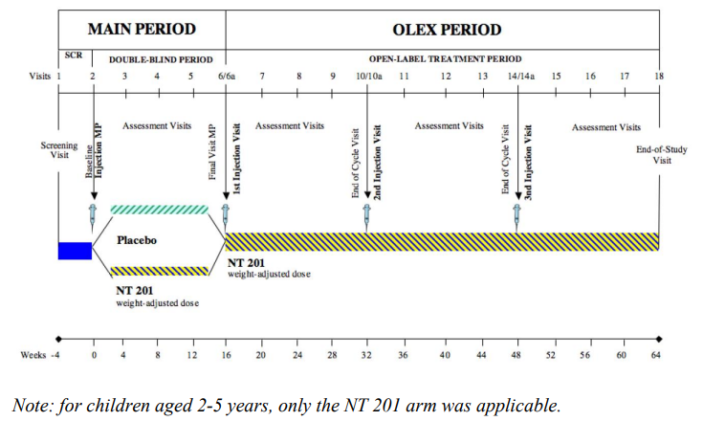

*Note*: NT 201 is the term used for XEOMIN.

**Inclusion criteria**

Children and adolescents aged 2-17 years of age.

* Any neurological disorder and/or Intellectual Disability (ID) associated with chronic troublesome sialorrhea for at least 3 months up to the screening
  + In subjects with ID without neurological disorders, a diagnosis of ID by a specialist, e.g., a paediatrician or by a centre for developmental medicine was required for inclusion.
* Severe drooling (modified Teacher´s Drooling Scale [mTDS] ≥ 6; clothing occasionally becomes damp)

**Study treatments**

A body weight-based dosage regimen was adopted.

Children and adolescents aged 6 to 17 years, inclusive, received a single DB treatment dose of XEOMIN or a matching volume of PBO (randomisation ratio 2:1). Total XEOMIN doses of 20, 30, 40, 50, 60 or 75 U were administered depending on subjects’ body weight.

Subjects aged 2 to 5 years, inclusive, received NT 201 according to BW (approx. 2 U/kg) in the MP and in the OLEX.

Study drug was administered via intraparenchymal/intraglandular injections (percutaneously) into the parotid and submandibular glands bilaterally with a single injection site per gland per side.

*Primary and co-primary efficacy variables:*

*Primary variable*: Change in mean uSFR from baseline to Week 4. Mean uSFR was calculated by averaging 2 absorbent swab assessments, using direct saliva collection, at each visit;

*Co-primary variable*: Global Impression of Change Scale (GICS) at Week 4. This represented the functional improvement in drooling since baseline, as assessed by the carer on a 7-point scale.

NB: uSFR was not determined in subjects aged 2 to 5 years, inclusive, because the Sponsor considered the swab method of direct saliva collection inappropriate for children of this age.

*Secondary efficacy variables:*

* Change in mean uSFR from baseline to Week 8 and Week 12, respectively; and
* GICS at Week 8 and Week 12, respectively.

Other efficacy variables

* GICS at Weeks 4, 8, 12 and 16, respectively, for subjects aged 2–5 years;

***Baseline***

Around 62% of subjects were males. Median age in the (6 to 17) years group was 10 years and median age in the (2 to 5 years) group was 4 years. Cerebral palsy was the major cause for sialorrhea across both age groups. Median time since first diagnosis of sialorrhea at screening was 28.1 months in the 2 to 5 years group and ranged from 80.9 to 94.9 months in the 6 to 17 years group. Local anaesthetics was reported as the most frequent previous medication.

**Results**

*Primary endpoint*: In the 6-17 years age group, a greater improvement in uSFR was observed in the XEOMIN arm (-0.14 [-0.16; -0.11] g/min), compared to PBO (-0.07 [-0.10; -0.04] g/min). The treatment difference was statistically significant.

*Co-primary endpoint*: In the 6-17 years of age group, a higher proportion of subjects in XEOMIN group were responders (the total proportion of subjects whose function was rated by the carer to have at least +1 ‘minimally improved’: (LS-Mean of 0.91 [95% CI: 0.76; 1.06]) than in the PBO group (LS-Mean of 0.63 [0.43; 0.84]. The treatment difference of 0.28 [95% CI: 0.02; 0.53]) was statistically significant (p = 0.0320).

**Secondary outcomes**

*uSFR at week 8 and 12*: At week 8 and 12, the mean change from baseline in uSFR was higher for XEOMIN group, compared to PBO (-0.09 [95% CI: -0.12; -0.05] g/min) and at week 8 and (-0.10 [95% CI: -0.14; -0.06] g/min) at week 12. The treatment difference was statistically significant at both time points.

*GICS at week 8 and 12*:A higher proportion of responders was reported in the XEOMIN group (69.2% [Week 8], 65.3% [Week 12]), compared to PBO group (47.9% [Week 8], 42.9% [Week 12]), respectively.

The mean treatment difference between the XEOMIN and PBO groups at Week 8 (0.40 [95% CI: 0.17; 0.63]; p = 0.0008) and at Week 12 (0.40 [95% CI: 0.14; 0.66]; p = 0.0026) were statistically significant.

“Other efficacy outcomes” were supportive of the primary and secondary outcomes.

###### Sialorrhea in adults: Study 3090

Phase III, double blind RCT with an open label extension phase.

Figure : Study 3090 design

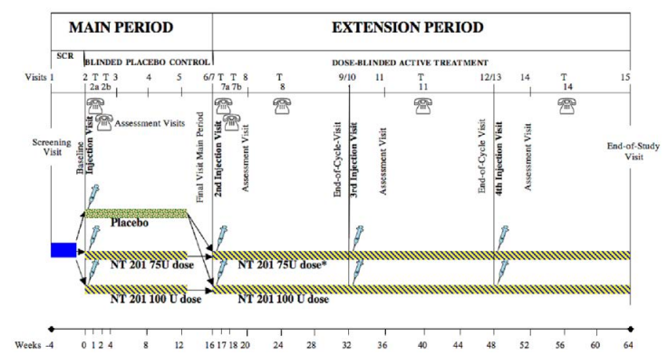

Adults with chronic (3 months duration) troublesome sialorrhea secondary to Parkinson’s Disease or atypical parkinsonism, stroke, or Traumatic Brain Injury (TBI) were recruited.

Chronic troublesome sialorrhea was defined as below:

* A Drooling Severity and Frequency Scale [DSFS] sum score of ≥ 6 points; and
* A score of ≥ 2 points for each item of the DSFS; and

A score of ≥ 3 points on the modified Radboud Oral Motor Inventory for Parkinson’s disease (mROMP), Section III ‘Drooling’.

XEOMIN 75U, 100U and PBO were the study treatments. The treatment interval was 16 weeks.

Study-site staff administered treatment by bilateral intraglandular injection, with or without ultrasound guidance, to the parotid and submandibular glands in a 3:2 ratio, as follows:

* 75 U Treatment group: Parotid 22.5 U (0.6 mL) on each side and submandibular: 15 U (0.4 mL) on each side;
* 100 U Treatment group: Parotid: 30 U (0.6 mL) on each side and submandibular: 20 U (0.4 mL) on each side; and
* PBO group: Parotid PBO solution (0.6 mL) on each side and submandibular PBO solution (0.4 mL) on each side.

184 subjects were randomised, with 74 subjects in XEOMIN group and 36 subjects in PBO group. Around 97% of subjects in the XEOMIN group completed the study period. 173 subjects entered the extension period.

At baseline, around 70% of subjects were males. Median age was around 66 years (range: 21 to 80 years). Most (58.2% overall) were in the 65 to 84 years age-category.

Around 70% of subjects had sialorrhea secondary to Parkinson’s Disease. Stroke was the reason for sialorrhea in around 17% subjects.

**Results**

*Co-primary endpoint 1*: At week 4, a greater improvement in uSFR was reported in both XEOMIN 100 U and 75 U groups, compared to PBO. The treatment difference was statistically significant (-0.09 (0.031), p = 0.004) for the 100U, but not for the 75U.

Table : Change in uSFR from baseline to Week 4

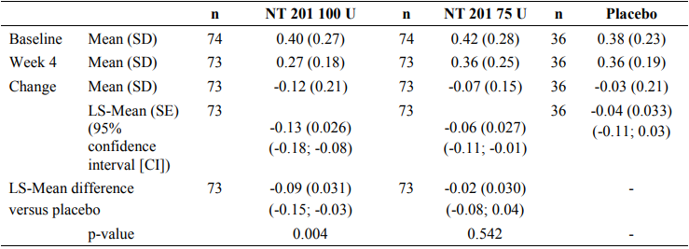

Co-primary endpoint 2: Greater improvement in GICS was achieved by subjects in both 100 and 75 U XEOMIN, compared to PBO. The treatment difference was statistically significant for the 100 U and not for the 75 U.

Table : GICS at week 4

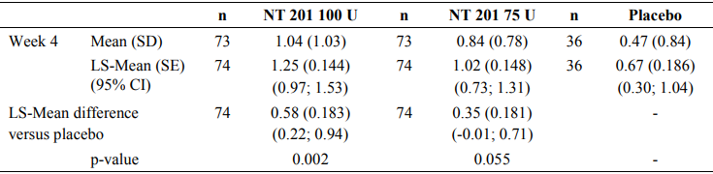

*Secondary endpoints:* Subjects in XEOMIN group continued to achieve a greater reduction in uSFR, compared to PBO at week 8 and 12. The treatment differences were statistically significant.

Table : Change in uSFR at week 8 and 12

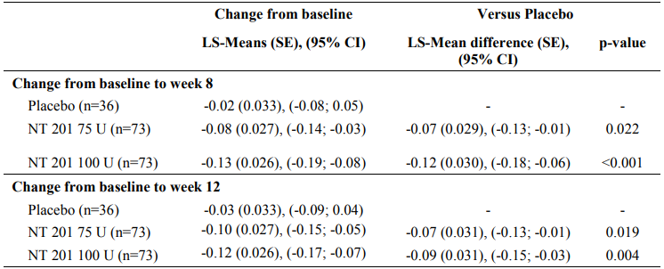

##### Spasticity Study 3070

Phase III, parallel group, RCT dose response study. Three doses of XEOMIN were administered as study treatment for lower limb spasticity in children and adolescents (age 2 - 17 years) with cerebral palsy.

Figure : Study 3070 design

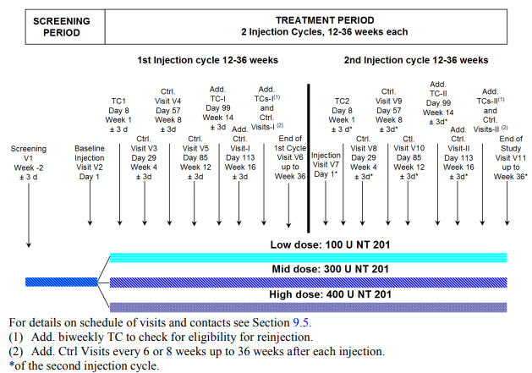

**Inclusion criteria**

Children and adolescents aged 2 to 17 years of age were recruited.

* Unilateral or bilateral CP with clinical need for unilateral or bilateral LL injections with Botulinum toxin (BoNT) for the treatment of spasticity;
* Ashworth Scale (AS) score ≥ 2 in plantar flexors (at least unilaterally); and
* Clinical need for a total dose of 16 U/kg BW NT 201 (maximum of 400 U). Of the total dose, subjects had to have a clinical need for:
  + 8 U/kg BW NT 201 (maximum dose of 200 U) for unilateral treatment of pes equinus; and 8 U/kg BW NT 201 (maximum dose of 200 U) into ipsilateral clinical pattern flexed knee or adducted thigh; or
  + 16 U/kg BW NT 201 (maximum dose of 400 U) for bilateral treatment of pes equinus (Ashworth Scale (AS) score ≥ 2 on both sides).

Both treatment-naive and subjects who had received previous treatment with BoNT were recruited.

Children with fixed contracture, those who had surgery for pes equinus, hip flexion that required BoNT treatment and those with a limitation of hip abduction to < 40° or pre-diagnosed migrational percentage > 30° were excluded.

Study treatments:

* High-dose group: 400 U XEOMIN for subjects of ≥ 25kg BW or 16 U/kg BW for subjects of < 25kg BW;
* Mid-dose group: 300 U XEOMIN for subjects of ≥ 25kg BW or 12 U/kg BW for subjects of < 25kg BW; and
* Low-dose group: 100 U XEOMIN for subjects of ≥ 25kg BW or 4 U/kg BW for subjects of < 25kg BW.

The primary efficacy variable was change from baseline in Ashworth Scale (AS)[5] score of plantar flexors (for subjects with bilateral pes equinus body at Week 4.

The co-primary efficacy variable was: The Investigator’s global impression of plantar flexor spasticity scale GICS-PF (Global impression of Change Scale – Plantar Flexors) [6] (for subjects with bilateral treatment on the same body side as chosen for the primary efficacy variable) at Week 4.

The secondary outcomes included changes from baseline in the AS score of plantar flexors and/or other treated patterns at week 4 of first and second injection cycle.

At baseline, 54.3% of subjects were males. Median age was 6 years (2-17 years). 48.9% of subjects were in the 2-5 years category and 16.1% of subjects were in the 12-17 years category.

The overall median time since first diagnosis of CP was 48.4 months and median time since first diagnosis of spasticity was 53.1 months. Perinatal asphyxia/hypoxia was the main cause for CP (40.8% overall), followed by prematurity (31.5% overall).

Most subjects were pre-treated with BoNT (62.4% overall), with the highest proportion in the mid-dose group (70.1%) and the lowest proportion in the low-dose group (51.3%). In all 3 dose-groups, the left and right LLs were pre-treated to a similar extent. The most frequent previous treatments were muscle relaxants (62.2%, 70.1%, 51.3% in the high-dose, mid-dose and low-dose group, respectively; mostly peripheral acting agents). No other major differences between the treatment groups were seen for previous medications.

Most subjects received concomitant medication: 75.0%, 72.7% and 70.5% of subjects in the NT 201 high-dose, mid-dose and low-dose group, respectively. The most common concomitant medications recorded were for anaesthetics (52.6%, 54.5% and 43.6%, respectively) and anti-epileptic agents (19.9%, 20.8% and 20.5%, respectively).

Almost 100% of subjects completed the study.

**Results**

Subjects in both high and low dose arms achieved improvement. However, the in-between group difference was not statistically significant.

Table : Study 3070 results across high and low dose arms

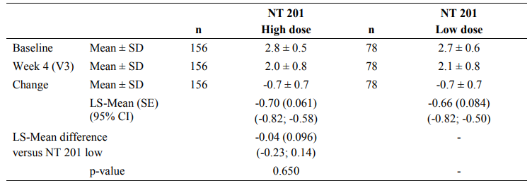

In terms of co-primary and secondary outcomes, overall, subjects in both treatment arms experienced an improvement in their spasticity. However, treatment difference between dose groups or injection cycles did not achieve statistical significance.

###### Study 3072 (upper and lower limbs)

Phase III RCT that also examined dose-response of three doses of XEOMIN for the treatment of upper limb spasticity alone or combined upper and mower limb spasticity in children and adolescents CP.

**Study design**

Study duration was 50 to 66 weeks. Four treatment cycles were of the duration of 12 to 16 weeks each.

Figure 4: Study 3072 design

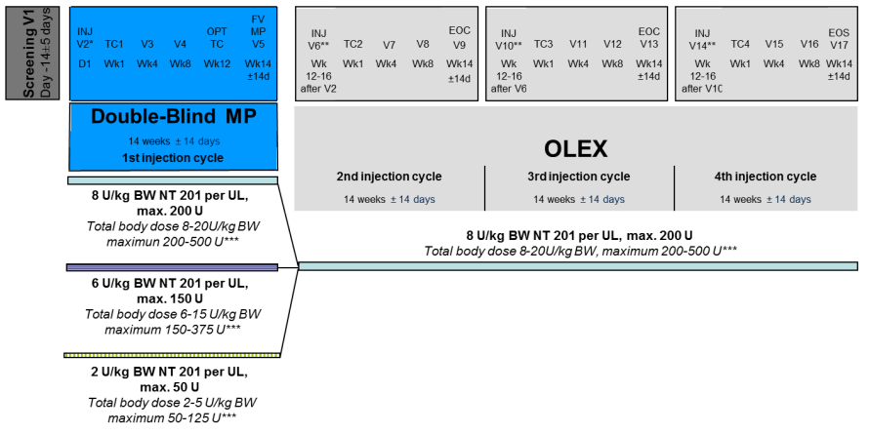

**Inclusion criteria**

Children aged 2 to 17 years with unilateral or bilateral CP with clinical need for injections with XEOMIN for the treatment of upper limb spasticity at least unilaterally.

* AS score ≥ 2 in in the main clinical target patterns in this study:
  + Flexed elbow: AS ≥ 2 in elbow flexors (at least unilaterally) at baseline; and/or
  + Flexed wrist: AS ≥ 2 in wrist flexors (at least unilaterally) at baseline.

Subjects were allocated 2:1:1 to receive NT 201 high-dose (8 U), NT 201 mid-dose (6 U) and NT 201 low-dose (2 U), respectively, for 1 injection cycle.

During the open label phase, all subjects received high dose (8U) of XEOMIN for up to three cycles.

Study outcomes were assessed at Week 4.

The *primary efficacy variable* was:

* Change from baseline in AS in the primary clinical target pattern (elbow flexors or wrist flexors). NB: For subjects with bilateral upper limb treatment, the body side for analysis was decided by the Investigator at screening or by IV/WRS if both sides qualified for the primary efficacy analysis.

The *co-primary efficacy variable* was:

* Investigator’s Global Impression of Change in Scale (GICS). NB: For upper limb only.

*Key secondary efficacy variables* were:

* Change from baseline in the AS score of the other treated main clinical target pattern (i.e., of elbow flexors or wrist flexors, if treated) and
* Second: change from baseline in AS score of the treated clinical target pattern clenched fist (in subjects treated in combination with flexed wrist).

Testing of the primary, co-primary and key-secondary efficacy variables of the MP was performed in a 4-step approach using a hierarchical test procedure, to ensure overall type I level of 5%, as described below:

* Step 1: Primary and co-primary efficacy variables for high-dose vs low-dose
* Step 2: First key-secondary efficacy variable and co-primary efficacy on sub-population variables for high-dose vs low-dose
* Step 3: Second key-secondary efficacy variable for high-dose vs low-dose and
* Step 4: Primary and co-primary efficacy variables for mid-dose vs low-dose

**Baseline demographics**

350 subjects were randomised in a 2:1:1 ratio. 176 subjects were in the NT 201 high-dose group, 88 were in the NT 201 mid-dose group and 87 were in the NT 201 low-dose group. The overall study completion rate was 94.3%, with similar frequency of discontinuations between dose-groups.

62.9% of subjects were males. Median age was 6.5 years (2 to 17 years). 43.7% of subjects were in the 2 to 5 years age category. 28.3% of subjects had level II and 22.3% of subjects had level III Gross Motor Function Classification System - Expanded & Revised (GMFCS-E&R). Mean AS score was 2.6 (0.53).

56.6% of subjects were treatment naïve, with regards to botulinum toxin.

**Results**

**Primary** **outcome**

The high dose XEOMIN group achieved greater mean change from baseline in AS score in upper limb spasticity, compared to low dose counterpart. The treatment difference was statistically significant.

Table 7: Study 3072 primary outcomes

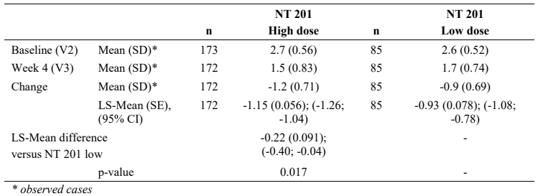

The step 4 analysis of the primary efficacy variable did not demonstrate statistical separation between mid-dose vs low-dose of XEOMIN. The Evaluator has highlighted that the magnitude of the treatment effect in both groups was clinically meaningful (LS-Mean changes were -1.02 and -0.96, respectively).

No major differences were found between the dose-groups. The median length of the injection cycle was slightly shorter in the low-dose group (14.43 weeks) than in the other 2 dose-groups (each 15.00 weeks).

**Co-primary outcome**

Investigator’s GICS was comparable across high and low dose groups of XEOMIN. The mean treatment difference did not achieve statistical significance.

Table 8: Study 3072 co-primary outcome

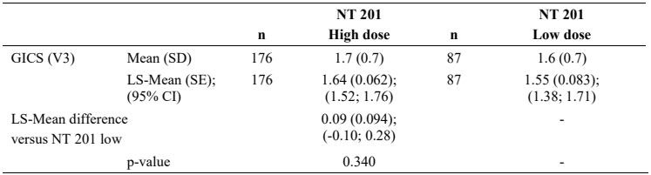

Since the co-primary outcome did not achieve statistical significance, secondary outcomes were considered as exploratory.

Subjects across all three dose groups achieved clinically meaningful improvement in spasticity of upper limb and lower limb (AS scores and GICS).

##### Upper and lower limb spasticity - Study 3071

Open label study to investigate the long-term efficacy and safety of XEOMIN for the treatment of upper limb and lower limb spasticity in children and adolescents.

370 subjects were eligible and treated. Of these, 124 subjects participated in the lead-in study and 246 subjects were newly recruited. A total of 266 subjects (124 subjects from lead-in and 142 newly recruited subjects) were treated for LL only, whereas 104 newly recruited subjects were treated for combined UL and LLs. Bilateral LL treatment was performed in 212 subjects and unilateral LL treatment in 54 subjects.

Change from baseline in AS score of plantar flexors showed numerically higher improvements from baseline in AS scores from cycle to cycle, in both left and right flexors.

**Blepharospasm**

Phase III, double blind RCT in adults with bilateral blepharospasm to investigate the efficacy and safety of two doses of XEOMIN, compared to PBO.

Treatment naïve subjects were recruited. XEOMIN 25 U (NT 201 12.5 U per eye) or 50 U (NT 201 25 U per eye) were administered IM. During the open label phase, all subjects received 1 injection with up to 70 U NT 201 (up to 35 U per eye) in the OLEX. After the treatment, subjects returned to the study site for assessment visits over a total period of 6 to 20 weeks. 61 were randomised and received treatment; 55 (90.2%) subjects completed the MP.

59% of subjects were females. Jankovic Rating Scale (JRS) severity subscore ≥ 2 (0 = no spasm to 4 = severe spasm) was used to rate the severity of spasm at baseline.

Primary efficacy variable was change from baseline in JRS severity subscore at Week 6.

At week 6, both 25 U and 50U of XEOMIN achieved greater reduction in JRS score. Statistical significance was achieved for the 50U arm.

Table 9: Study 3074 Efficacy outcome

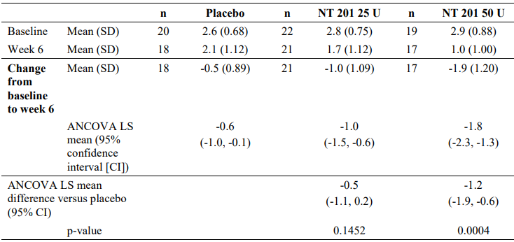

During the open label phase, 39 patients received an injection of XEOMIN at a mean dose of 25 U (Range: 15-30 U) per eye, with median duration of the treatment interval of 19.9 weeks. Over the course of the study, mean JRS severity sub-score decreased from baseline notably in all 3 treatment-groups (PBO/NT 201 70 U; NT 201 25 U/NT 201 70 U; NT 201 50 U/NT 201 70 U; Range: -1.1 to -1.3), with the best results obtained at the OLEX Week 6 visit.

#### Safety

Table 10: Treatment exposure

|  |  |  |  |  |
| --- | --- | --- | --- | --- |
| Study type/ Indication | Controlled studies | | Uncontrolledstudies | Total NT 201 |
| NT 201 | Placebo | NT 201 |
| Sialorrhea in children and adolescents |  |  |  |  |
| Pivotal/Main | 148 | 72 | 64 | 212 |
| Sialorrhea in adults |  |  |  |  |
| Pivotal/Main | 148 | 36 | 24 | 172 |
| Spasticity in children and adolescents |  |  |  |  |
| Pivotal/Dose-response | 661 | 0 | n/a | 661 |
| Other | n/a | n/a | 370 | 370 |
| Subtotal | 661 | 0 | 370 | 1031 |
| HFS in adults* |  |  |  |  |
| Main | 182 | 11 | 95 | 277 |
| TOTAL | 957 | 108 | 458 | 1,415 |

Treatment exposure for >12 months.

Sialorrhea: 226 children (including adolescents). 33 subjects were in the 2-5 years group.

Sialorrhea in adults: 79 adults.

Spasticity in children and adolescents: 613.

**Sialorrhea in children and adolescents**

**AE**

Across randomised and open label treatment phases, the most frequent AEs were upper respiratory tract infections.

**TEAE**

The rate of events was low (<3%). Most of the events were mild to moderate and the types of events were similar to AEs.

**SAE**

In the Main Period in the Placebo group (6-17 years) one patient experienced pneumonia and epilepsy. In the NT 201 (2-5 years age group) one patient experienced Staphylococcus aureus bacteraemia and Tonic clonic seizure. Overall in the OLEX, a total of 8 patients experienced 16 SAEs. Apart from Functional gastrointestinal disorder which occurred in 2 patients no other SAE was reported in more than 1 patient.

These events were not considered as treatment related.

Nil events of deaths were reported.

**Discontinuations**

Three TEAEs of dysphagia, saliva altered and choking, which led to discontinuation, were considered to be treatment-related.

**AE of special interest**

Dysphagia was reported in 5 (2.7%) subjects during the entire study period. Dysphagia was observed in 1 (0.7%) subject in the XEOMIN (6-17 years) group during the controlled phase. During the open label phase, dysphagia was reported in 3 (2.1%) subjects during the 2nd injection cycle and 1 (0.7%) subject during the 3rd injection cycle, all the events were in the XEOMIN group (MP = NT 201, 6-17 years) group. All instances of dysphagia occurred as single events, were not severe or serious, and apart from one patient, did not lead to study discontinuation and all resolved. All events were considered as treatment-related.

**Sialorrhea in adults**

**AE**

Infections and GI disorders were the most frequently reported events. Fall was reported in subjects with Parkinson’s disease or multiple system atrophy. Majority of them were ≥ 65 years of age.

In the Main Period, three subjects were reported to have dysphagia. These subjects had history of Parkinson’s Disease and 2 of the 3 subjects had pre-existing dysphagia.

During the open label extension phase, upper respiratory infections, dry mouth (11.2% in the 100 U dose group, dose-related trend) and fall (5.6% in the 100 U dose group) were reported.

**TEAE**

ADRs were reported in the GI disorders and Nervous system disorders SOC categories. Frequency of ADRs was evenly distributed across treatment groups. There were no clear dose-response trends. Dry mouth was reported in around 5% subjects.

**SAE**

One event of dysphagia was considered treatment-related. No dose-dependent trend was noted.

**Deaths**

5 deaths were reported during the open label phase of study 3090. None of these events were considered as related to the treatment with XEOMIN.

3 subjects received 75 U of XEOMIN and 2 subjects received 100 U of XEOMIN. All 5 subjects died in the 4th injection cycle.

Three subjects in the PBO arm died during study period.

Fatal TEAEs were UTI, Coagulopathy and volvulus, Cardio-respiratory arrest, Altered state of consciousness, Delusion, Dopamine dysregulation syndrome and Psychomotor hyperactivity and pulmonary embolism.

**Discontinuations**

A higher frequency of dry mouth in the XEOMIN (100 U) group compared to the NT 201 (75 U) group was reported 4.5% (n = 4) vs 0.0%, that led to discontinuations. Other events were pneumonia and GI obstruction. These events were not considered as treatment-related.

**AE of special interest**

During the controlled phase of study 3090, dysphagia was reported in 3 (4.1%) subjects in the XEOMIN (75 U) group; and dry mouth and dysphonia in 2 (2.7%) subjects each in the XEOMIN (100 U) group. None of the AESIs was serious. Two events of dysphagia, 1 event each of dry mouth, speech disorder and eyelid ptosis, were considered treatment-related. The 2 severe AESIs of dysphonia and dysarthria were not considered treatment-related.

During the open label phase, speech disorder was reported in 3.7% of subjects in the 75 U group and dry mouth in 6.7% of subjects in the 100 U group. The frequency of dysphagia was similar between the NT 201 dose-groups. Incidence of AESIs per cycle did not increase with increasing numbers of injections.

**Spasticity in children and adolescents**

**AE**

Upper respiratory infections were the most reported events.

**TEAE**

Approx. 50% of subjects experienced events possibly attributable to the injection procedure, such as injection site pain (n = 5), injection site erythema (n = 2), haematoma, injection site warmth, injection site inflammation or rash (each n = 1). Muscular weakness was reported for approx. 33% (n = 5) of subjects and only occurred in the high-dose and mid-dose groups. Related TEAEs occurred more frequently in the high-dose group than in the other 2 dose-groups in both injection cycles, but with no increase in incidence with repeated injection. No event was serious, severe or led to study discontinuation. All events resolved without sequelae.

**SAE**

Respiratory infections (pneumonia, bronchitis) were reported as SAEs. None of the SAEs were considered as treatment-related.

Nil events of death were reported.

**Discontinuations**

Pneumonia, respiratory tract infections and seizures were the common events that led to discontinuations.

**AE of special interest**

During study 3070, muscular weakness was the only AESI that occurred in more than 1 subject i.e., 4 subjects in the high-dose group and 1 subject in the mid-dose group. No event of muscular weakness was recorded in the low-dose group. AESIs, all of muscular weakness in the LL that was treated, were considered treatment-related. Four of these events occurred during the 1st injection cycle. No AESI was serious, severe or led to discontinuation. All events resolved.

During study 3072, dysphagia was the only AESI that occurred in more than 1 subject (0.6%; n = 2; both in the 2nd injection cycle). None of the reported AESIs were severe, 1 was considered serious (aspiration pneumonia; unrelated to treatment) and 2 AESIs led to study discontinuation. Three AESIs were considered treatment-related i.e., hypotonia, eyelid ptosis and dysphagia. None of the AESIs reported in the OLEX was located at a treated UL or a treated LL.

Nil major changes to ECG, haematology or vital signs were reported.

Modified Radboud oral motor inventory for Parkinson’s disease (mROMP) swallowing symptoms

Only minor changes in mROMP swallowing symptoms from study baseline to the post-baseline visits in both the MP and the EP were observed. Mean reduction (improvements), from study baseline were slightly higher in the XEOMIN (100 U) group than in the other treatment groups. It should be noted that this study did not include subjects with moderate or severe dysphagia based on the mROMP.

Overall, the Evaluator concluded that mROMP swallowing symptoms rating remained stable throughout the study and no increased risk of dysphagia was observed using this scale.

**Botulinum toxin antibodies**

In studies in children and adults with sialorrhea, positive results were reported for around 10% subjects. Around 3% of those subjects were detected to have neutralizing antibodies. These events were not associated with loss of treatment response.

**Suicidality assessment**

In study 3090 (sialorrhea in adults) two events of suicidal ideation was reported.

In other studies, nil suicidal behaviour or self-injurious behaviour without suicidal intent or committed suicide were reported.

Other

Real World Evidence/Real World Data were not included in the submission.

### Risk management plan

The summary of safety concerns and their associated risk monitoring and mitigation strategies are presented in Table 12. The TGA may request an updated RMP at any stage of a product's life-cycle, during both the pre-approval and post-approval phases.

Table 11: Summary of safety concerns

|  |  |  |  |  |  |  |  |
| --- | --- | --- | --- | --- | --- | --- | --- |
| Summary of safety concerns | | Pharmacovigilance | | | Risk minimisation | | |
| **Routine** | **Additional** | **Routine** | | **Additional** |
| **Important identified risks** | None | - | - | - | | - |
| **Important potential risks** | Atrophy of the salivary glands | ✓ | - | ✓ | | - |
| **Missing information** | None | - | - | - | | - |

The RMP evaluation recommended the inclusion of the medicine in the Black Triangle Scheme.

The Sponsor is required to comply with product vigilance and risk minimisation requirements.

The TGA may request an updated RMP at any stage of a product's life-cycle, during both the pre-approval and post-approval phases. Further information regarding the TGA’s risk management approach can be found in [risk management plans for medicines and biologicals](https://www.tga.gov.au/publication/risk-management-plans-medicines-and-biologicals) and [the TGA's risk management approach](https://www.tga.gov.au/tgas-risk-management-approach). Information on the [Australia-specific annex](https://www.tga.gov.au/resources/resource/guidance/risk-management-plans-medicines-and-biologicals/australia-specific-annex-eu-rmp) ([ASA](https://www.tga.gov.au/resources/resource/guidance/risk-management-plans-medicines-and-biologicals/australia-specific-annex-eu-rmp)) can be found on the TGA website.

### Risk-benefit analysis

#### Delegate’s considerations

**Sialorrhea in children and adolescents**

The Evaluator considered that the study design and conduct were generally acceptable and consistent with the TGA-adopted guidelines for clinical trials in small populations.

The Evaluator has highlighted that the co-primary endpoints (mTDS, DQ and DIS) were specific tests for drooling evaluation; however not yet validated for use in children. It was noted that the study utilised defined standardised conditions for assessment and measurement of the uSFR. The Sponsor has mentioned that the Paediatric Committee of the EMA had considered that the design and the endpoints as acceptable.

In children with sialorrhea, the magnitude of the treatment differences between NT 201 treatment and placebo treatment were clinically meaningful and achieved statistical significance.

Children in the 2 to 5 years age group were not randomised to receive placebo treatment. Furthermore, only 35 subjects in this age-group received XEOMIN in the controlled phase and 34 subjects received XEOMIN in the open-label phase. The Delegate has noted that the overall results in the 2 to 5 years group were generally consistent with those in the 6 to 17 years group. The ACM’s advice will be considered with regards to inclusion of this age group in the proposed indication.

**Sialorrhea in adults**

The 75 U strength of XEOMIN did not achieve statistical significance for each co-primary endpoint and also the secondary endpoints, when compared to placebo. The Evaluator concluded that the evidence to date does not support the XEOMIN 75 U dose-regimen for the proposed indication. In terms of the 100 U strength, 74 subjects were exposed to the NT 201 (100 U) regimen in the controlled phase and an additional 15 subjects in the open label phase.

This extent of exposure deviated from the specific TGA-adopted guidelines, in which at least 100 subjects at 1 year are recommended. The Evaluator has raised this issue with the Sponsor. The Sponsor had clarified that both US FDA and EMA had advised that 50 subjects with an exposure for a year would be sufficient to establish safety. The Evaluator also concluded that this is acceptable. The Sponsor’s proposed dose is 100U.

The injection cycle length data were generally consistent with the proposed dose-regimens. Data from the clinical dossier were generally supportive of intraglandular administration of 100 U of XEOMIN.

**Spasticity in children and adolescents**

Across the phase III studies, the (2-5 years) group were well represented, with between 40 to 60% of study participants in this age-group.

The study design and conduct of studies 3070, 3071 and 3072 were generally acceptable. The primary, co-primary and secondary variables used in this study used well-established, validated endpoints, which were considered as acceptable by the Evaluator.

Overall, the magnitude of benefit was comparable between the studies over the dose range of 4 to 16 U/kg for both upper limb, lower limb and combined upper limb and lower limb spasticity. The Sponsor’s proposed dosing regimen to commence treatment naïve patients on 2U/kg and the approach for upward titration based on treatment response is acceptable.

**Blepharospasm**

It appears that a greater treatment benefit was achieved the treatment with XEOMIN for efficacy outcomes even with the reduction of the maximum dose of XEOMIN from 100U to 50U per eye per treatment session. The treatment difference was statistically significant, compared to placebo.

**Safety**

Treatment exposure was considered as adequate, except for the 2 to 5 year age group with chronic sialorrhea. Only 35 subjects in this age group were treated for 6 weeks (controlled study period) and 34 subjects in the open label phase for 12 weeks. The Sponsor’s approach to extrapolate the efficacy and safety data from the 6 to 17 year age group was considered as acceptable by the Evaluator.

The AEs in the paediatric cohort were mostly upper respiratory tract infection, in contrast to the adult cohort experiencing mostly GI events (dry mouth) and nervous system disorders (fall). No clear dose dependent trend was observed across studies in adults and children. Frequency of dysphagia was low and did not lead to discontinuations.

In studies involving children with spasticity, the frequency of treatment-related AESIs (related to possible toxin spread) was low across the spasticity studies, with no clear pattern of treatment-related events with regards to the number of injection cycles.

In adults with sialorrhea, fall and dry mouth were the most commonly reported TEAEs.

In the adult population, 5 deaths were reported, which were all considered by the investigators as unrelated to study treatment. Confounding factors or other aetiologies that provided an alternative explanation were provided as rationale for this conclusion. Given the age distribution of the study population and co-morbidities, the explanations provided for each case by the investigator or Sponsor were acceptable to the Evaluator.

In adults with chronic sialorrhea, there was no obvious treatment related effects on the subject’s ability to swallow. However, the Evaluator has highlighted that the subjects were generally recruited into Study *3090* with no clinically relevant pre-existing dysphagia. Hence, the safety of treatment with XEOMIN in a target population with known dysphagia remains unclear. It was also noted that no comparative assessment of a subject’s ability to swallow was undertaken in *3091*. In children and adolescents with chronic sialorrhea. an excess number of instances of adverse events of dysphagia were not reported in this study. Based on these findings, the Evaluator considered that difficulty in swallowing was not a major concern.

‘Atrophy of the salivary gland’ was considered as risk, based on XEOMIN’s mechanism of action. The Evaluator has noted that it is listed as an Important Potential Risk in the proposed RMP.

Frequency of treatment related adverse events of special interest (related to possible toxin spread) was low across the spasticity studies.

Long term safety data for XEOMIN on the above aspects are lacking in this submission.

#### Proposed action

Intraglandular treatment with XEOMIN appears to benefit children, adolescents and adults with chronic sialorrhea.

The dosing regimen for the treatment of upper and lower limb spasticity is not well characterised. The Sponsor’s proposed starting low dose of 2U/kg and upward titration based on treatment response appears to be reasonable.

Most of the safety-related events were previously reported in studies with botulinum products. Nil serious events related to distant spread of toxin were reported. However, long term safety data for the use of XEOMIN in the targeted patient population is limited.

#### Advisory Committee considerations

The [Advisory Committee on Medicines (ACM)](https://www.tga.gov.au/committee/advisory-committee-medicines-acm) having considered the evaluations and the Delegate’s overview, as well as the Sponsor’s response to these documents, advised the following.

##### Specific advice to the Delegate

1. ***Considering the low number of subjects (n=35) in the 2-5 year age group of children with sialorrhea, please comment with regards to the adequacy of evidence for the inclusion of this age group in the proposed indication for this condition.***

The ACM considered the number of participants in the 2-5 year age group of children with sialorrhea included in the clinical study to be adequate, noting the challenges of accruing large cohorts for this age group. The ACM further noted that the study demonstrated favourable efficacy outcomes with most participants treated for more than twelve months.

The ACM also noted the requirement that selection, prescription and administration of XEOMIN is performed under the care of a specialist.

1. ***Based on the data provided in this submission, please comment on any potential concerns regarding safety for the use of XEOMIN in a population at risk of dysphagia.***

The ACM considered the risk of dysphagia to be a minor concern with the risk being lower than 1% within the clinical studies. The ACM noted there are possible confounders, and the dysphagia may be due to the underlying disease rather than the treatment itself as dysphagia was seen in two participants who were only administered the study treatment to their limbs.

The ACM was of the view that dysphagia should be mentioned in the PI specifically in relation to the treatment of sialorrhea.

1. ***Please comment on the adequacy of safety data, particularly for the use of XEOMIN in children and adolescents with sialorrhea and also in this age group with spasticity.***

The ACM noted there were 839 participants included in the safety study, 226 with sialorrhea (33 in the 2-5 year age group), and 613 with spasticity. Participants were treated for at least 12 months and received appropriate follow up. The ACM commented that this is a very reasonable the number of participants.

Considering the number of participants, duration of treatment and duration of follow up, the ACM was of the view that there is adequate safety data available for the proposed indications.

1. ***Atrophy of salivary glands is included as an important potential risk in the proposed RMP. Please advise whether any other measures are also needed to further mitigate this risk.***

The ACM advised that no additional measures were needed to further mitigate the risk of atrophy of salivary glands. The ACM noted that there will likely be some atrophy of salivary glands with long term treatment particularly noting the mechanism of action and administration sites. The ACM was of the view that if treatment is repeated and patients are treated for many years the risk of long term effects like atrophy in the 2-5 year age group would merge with older age groups with long term use.

1. ***Other advice***

The ACM indicated that the proposed indication could state ‘spasticity of the lower limb or upper limb’. The ACM was of the view that the inclusion of ‘or’ would distinguish that a patient could present with either upper or lower limb spasticity rather than both upper and lower limb spasticity.

The ACM noted that the chronic sialorrhea indication in children states ‘neurological/neurodevelopmental disorders’ and supported the same wording for the adult chronic sialorrhea indication.

The ACM discussed the potential for dental cavities due to reduced saliva/ dry mouth. The ACM advised that patients generally have ongoing dental care as part of their standard treatment and therefore dental cavities should not be a significant issue. However, the ACM supported the inclusion of information on dental health within the PI and CMI.

##### ACM conclusion

The ACM considered this product to have an overall positive benefit-risk profile for the indication:

In children and adolescents aged 2 years to 17 years, inclusive:

• Chronic sialorrhea due to neurological/neurodevelopmental disorders; and

• Spasticity of the lower limb (LL) or upper limb (UL).

In adults:

Chronic sialorrhea due to neurological/neurodevelopmental disorders.

## Outcome

Based on a review of quality, safety, and efficacy, the TGA decided to register XEOMIN for the following extension of indications:

XEOMIN is indicated in adults for the treatment of:

• Chronic sialorrhea due to neurological disorders

XEOMIN is indicated in children and adolescents aged 2 years to 17 years for the symptomatic treatment of:

• Chronic sialorrhea due to neurological/neurodevelopmental disorders

• Spasticity of the lower and/or upper limbs

As such, the full indications at this time are:

XEOMIN is indicated in adults for the treatment of:

• Cervical dystonia (spasmodic torticollis)

• Blepharospasm

• Spasticity of the upper limb

• Chronic sialorrhea due to neurological disorders

• Upper facial lines - Glabellar frown lines

- Lateral periorbital lines (crow’s feet)

- Horizontal forehead lines

XEOMIN is indicated in children and adolescents aged 2 years to 17 years for the symptomatic treatment of:

• Chronic sialorrhea due to neurological/neurodevelopmental disorders

• Spasticity of the lower and/or upper limbs

### Specific conditions of registration applying to these goods

Incobotulinum toxin A (XEOMIN) is to be included in the Black Triangle Scheme. The PI and CMI for XEOMIN must include the black triangle symbol and mandatory accompanying text for five years, which starts from the date the new indication is registered.

The XEOMIN EU-Risk Management Plan (RMP) (version 17.1, dated 26 April 2021; DLP15 July 2020), with Australian Specific Annex (version 3.0, dated June 2023), included with submission PM-2022-03519-1-1, and any subsequent revisions, as agreed with the TGA will be implemented in Australia.

#### Product Information

The [Product Information](https://www.tga.gov.au/products/australian-register-therapeutic-goods-artg/product-information-one) ([PI](https://www.tga.gov.au/products/australian-register-therapeutic-goods-artg/product-information-one)) approved with this submission for XEOMIN which is referred to in this AusPAR (and can be accessed on this AusPAR’s webpage) may have been superseded. For the most recent PI and [Consumer Medicines Information](https://www.tga.gov.au/products/australian-register-therapeutic-goods-artg/consumer-medicines-information-cmi) (CMI), please refer to the TGA [PI/CMI search facility.](https://www.ebs.tga.gov.au/)

|  |
| --- |
| Therapeutic Goods Administration |
| PO Box 100 Woden ACT 2606 Australia  Email: [info@tga.gov.au](mailto:info@tga.gov.au) Phone: 1800 020 653 Fax: 02 6203 1605  [**https://www.tga.gov.au**](https://www.tga.gov.au) |
| Reference/Publication # |

1. This is the original indication proposed by the Sponsor when the TGA commenced the evaluation of this submission. It may differ to the final indication approved by the TGA and registered in the Australian Register of Therapeutic Goods.
2. AusPAR for XEOMIN for previous indications (17 September 2015): https://www.tga.gov.au/resources/auspar/auspar-botulinum-toxin-type-2
3. In this report the ‘Delegate’ is the Delegate of the Secretary of the Department of Health and Aged Care who, under section 25 of the Act., decides whether an application is either approved or rejected. I
4. AusPAR for XEOMIN (17 September 2015): https://www.tga.gov.au/resources/auspar/auspar-botulinum-toxin-type-2
5. The AS is a validated scale to categorise the severity of spasticity by judging resistance to passive movement and widely used to assess treatment effects of BoNT in clinical studies on adult spasticity. Assessed on a 5-point Likert scale where 0 = no increase in tone to 4 = limb rigid in flexion or extension. Performed by the same Investigator in this study.
6. The GICS-PF is a 7-Point Likert Scale for the assessment of the functional change due to treatment of plantar flexor spasticity only undertaken by Investigators. For subjects with bilateral treatment of plantar flexor spasticity GICS-PF for both sides were assessed and recorded separately. Performed by the same Investigator in this study and undertaken before the AS and MTS assessments in order to minimise confounding and bias. The scale was scored from +3 = very much improved function to 0 = no change in function and -3 = very much worse function.