|  |
| --- |
| Medicine Shortages Report |
| 2024 |
| Version 1.0, July 2024 |

Copyright

© Commonwealth of Australia 2024  
This work is copyright. You may reproduce the whole or part of this work in unaltered form for your own personal use or, if you are part of an organisation, for internal use within your organisation, but only if you or your organisation do not use the reproduction for any commercial purpose and retain this copyright notice and all disclaimer notices as part of that reproduction. Apart from rights to use as permitted by the *Copyright Act 1968* or allowed by this copyright notice, all other rights are reserved and you are not allowed to reproduce the whole or any part of this work in any way (electronic or otherwise) without first being given specific written permission from the Commonwealth to do so. Requests and inquiries concerning reproduction and rights are to be sent to the TGA Copyright Officer, Therapeutic Goods Administration, PO Box 100, Woden ACT 2606 or emailed to <[tga.copyright@tga.gov.au](mailto:tga.copyright@tga.gov.au)>.

Contents

Purpose of this report 4

Key insights 4

When COVID-19 disrupted supply chains 6

How our shortages management evolved 6

Better coordination and collaboration 7

Increased communication activities 7

Improved regulation 8

More and better use of data 8

The impacts of medicine shortages on patients 9

The medicine supply landscape 9

Number of shortage reports 9

Shortages specific to Australia 10

Reasons for shortages 11

Shortage status from initial reports 13

Dealing with discontinuations 14

Case study: the tenecteplase shortage 14

Managing shortages: next steps 16

## Purpose of this report

Interruptions to the supply and availability of medicines in Australia can occur for various reasons and have a range of impacts on patients and health professionals. Medicine shortages are a global problem and unfortunately some medicine shortages are unavoidable and cause significant impact.

The Therapeutic Goods Administration (TGA) closely monitors for shortages of prescription and certain over-the-counter medicines and takes action to limit their effects.

After the introduction of mandatory shortage reporting in January 2019, we published a [report on the first 12 months of the mandatory reporting scheme](https://www.tga.gov.au/resources/publication/publications/medicine-shortages-report-first-12-months-mandatory-reporting-scheme). The 2020 report recommended various improvements to shortage reporting, communications, mitigation and arrangements for supply of alternative products.

Since that time, the way we manage shortages has evolved significantly. This 2024 Medicine Shortages report looks at what has changed and what our data show.

## Key insights

Since 2020, we have improved how we manage shortages in many ways, including:

* better use of data to identify supply chain issues and anticipate potential shortages
* better public access to information about shortages
* updated guidance information for sponsors (pharmaceutical companies) to help them report and mitigate shortages
* introduced [Serious Scarcity Substitution Instruments](https://www.tga.gov.au/safety/shortages/accessing-medicines-during-shortage/substituting-scarce-medicines)
* better coordination with other government departments
* more collaboration with clinical experts for recommendations to help conserve supply for patients with limited alternatives
* more communication with consumers
* strengthened collaboration with our stakeholders in the medicine supply chain.

While the overall number of shortages reported in Australia by medicine sponsors has remained consistent since mandatory reporting commenced, some of these shortages have had a much more significant impact on patients and health professionals than others. Examples of such high-impact shortages include the following:

* When an unexpected increase in off-label prescribing of Ozempic (semaglutide) for weight loss occurred, other GLP-1 agonists Trulicity (dulaglutide) and Mounjaro (tirzepatide) also went into shortage in a spill-over effect.
* Seven antibiotics were concurrently in shortage at one point in 2023, including all oral syrups and suspensions of cefalexin. This was particularly problematic for the paediatric and geriatric populations.

Complicating these situations, multi-country shortages appear to be increasing, which hampers the ability of sponsors to increase supply or access overseas alternatives.

The image says although the number of shortages reported to the TGA by medicine sponsors has remained fairly consistent, we appreciate the significant impact shortages have on patients and health professionals. We have made improvements to how we manage shortages including:
Number 1, using data. The way we use data has evolved including the way its gathered and how its used to determine management strategies. Number 2, communication activities. We have improved our communication on medicine shortages making information clearer and easier to understand. Number 3, collaboration. We actively collaborate with a broad range of stakeholders to help us coordinate shortage management activities.


## When COVID-19 disrupted supply chains

The COVID-19 pandemic highlighted the importance of having resilient medicine supply chains. The TGA adopted a coordination and leadership role in response to rapidly emerging issues as the pandemic progressed. We worked with local and global stakeholders in the supply chain to gather and share information as the pandemic unfolded.

* We chaired frequent meetings of the Medicine Shortages Working Party, which included representatives from the pharmaceutical industry, wholesalers and health professional groups. The supply chain intelligence this group shared allowed for quick identification of issues and enabled us to coordinate rapid responses.
* We made new connections with stakeholders across Australia, who helped us gather and share information so that we could monitor the supply of important medicines.
* We established the Medicines Availability Working Group with representatives from each state and territory health department.
* We developed a protocol to monitor availability of medicines used for the management of ventilated patients with COVID-19.
* Sponsor companies and pharmaceutical wholesalers provided data for use in the newly created ‘Dynamic Model of Medicine Availability’, the tool used by the Medicines Availability Working Group to forecast availability at national and jurisdictional levels and facilitate coordinated and equitable access.
* Key medicines industry representative groups, namely Medicines Australia, Generic and Biosimilar Medicines Australia and National Pharmaceutical Services Australia, applied for [Australian Competition and Consumer Commission authorisation](https://www.accc.gov.au/business/competition-and-exemptions/exemptions-from-competition-law/authorisation) that allowed coordinated discussion about supply of medicines in shortage. To further our monitoring of intensive care unit medicines, the TGA used these industry group authorisations to convene meetings with sponsors to discuss their supply.

At the beginning of the pandemic, increased purchasing by consumers and pharmacies caused more demand for medicines. In response, we encouraged sponsors to report any supply disruptions. We also worked with sponsors, wholesalers and pharmacy organisations to constrain supply and limit dispensing to one month’s supply. Additionally, we collaborated to develop advice for patients, prescribers and pharmacists to support equitable distribution.

With medicines for the prevention or treatment of COVID-19, increased off-label use had the potential to create a shortage in Australia. To help prevent this, we introduced prescribing restrictions.

In our meetings with the Medicine Shortages Working Party, we identified that patients needed access to substitute medicines quickly during a shortage, but without significant impacts on the workload of prescribers. To satisfy this need, we worked with the Medicine Shortages Working Party and state and territory representatives to implement informal Serious Shortage Substitution Notices that allowed community pharmacists to substitute specific medicines in certain situations without prior approval from the prescribing doctor.

With border closures and fewer flights available during the pandemic, transportation of medicines was also affected. We worked with sponsors and across government departments to support continued deliveries into Australia.

## How our shortages management evolved

As the pandemic progressed, we formalised and expanded many of the solutions we had been developing with our stakeholders. This was a great opportunity to leverage this collaboration and their goodwill. Below are key areas where our management of shortages evolved over this time.

### Better coordination and collaboration

The pandemic revealed that we needed a centralised coordination approach to manage shortages in Australia. Aiming to prevent, manage and communicate about serious shortages in a consistent way, the TGA expanded into this coordination role with relevant stakeholders. Examples of this expansion follow.

* We expanded how we worked with states and territories to give conservation advice. We increased the frequency of our Medicines Availability Working Group meetings and worked with the experts in the group to model the availability of several important medicines used in hospitals. In this way, we were able to provide conservation advice, including for medicines such as tocilizumab, tenecteplase and alteplase that were used outside of the COVID-19 intensive care unit setting.
* We significantly increased the number of Medicine Shortages Action Groups, which are collaborative, short-term working groups devoted to a particular shortage. Medicine Shortages Action Groups can include relevant medicine sponsors, health professional representatives and patient groups. Action group meetings are held as needed as a shortage evolves and may provide clinical and conservation advice, as well as produce consistent communication across stakeholders. For example, Medicine Shortages Action Groups were formed for the shortages of contrast media, antibiotics, and arthritis, diabetes, palliative care, heart, antidepressant and hormonal medicines.
* We improved coordination with other parts of the TGA to secure faster regulatory approvals to address medicine shortages.
* We regularly liaised with other government departments about medicine supply. For example, we communicated with Austrade regarding the International Freight Assistance Mechanism, a program that could be used by medicine sponsors who were experiencing freight issues early in the pandemic. We also worked with the Office of Supply Chain Resilience in the Department of Industry, Science and Resources to receive early signals of emerging issues within other industries that could flow on to affect medicine supply.
* In collaboration with stakeholders, we worked to amend clinical guidelines and clinical trials guidelines to help conserve medicines for specific shortages. The tenecteplase and tocilizumab shortages are examples of this.
* We worked collaboratively with wholesalers and sponsors to facilitate equitable distribution of medicines and to minimise stockpiling of limited supplies. For example, Community Service Obligation (CSO) wholesalers are required to supply medicines listed on the Pharmaceutical Benefits Scheme (PBS) to pharmacies as ordered (chronologically and filling orders in full, irrespective of size) to be eligible to receive payment through the CSO Funding Pool. For PBS medicines in short supply, the Department of Health and Aged Care can issue a notice to wholesalers that gives CSO wholesalers relief from these CSO supply requirements to pharmacies. This allows them to use their expertise in supply of medicines to independently manage fair and equitable distribution.

### Increased communication activities

The medicine shortages during and following the pandemic have strengthened our understanding of the need for clear and prompt communication. We have significantly increased our activity to better inform health professionals, consumers and sponsors during a medicine shortage.

* We conducted a consumer workshop in 2020 to identify what was most important about medicine shortages communication, how consumers seek information about shortages, and what would help in the future. Opportunities for improvement included more coordinated and consistent messaging to reduce confusion, and more tailored information and language for consumers.
* The increased number of Medicine Shortages Action Groups led to us publishing more web statements − we published 24 new medicine shortage web statements in 2023, compared with 2 in 2018. We have also increased the dissemination of shortages information via social media.
* We also formed a Medicine Shortages Communication Champions Group, comprising consumer and patient groups, health professional and sponsor peak bodies, and special interest groups. The members of that group help us develop and improve the sharing of information about medicine shortages through their networks.
* We created the [Medicine Shortages Hub](https://www.tga.gov.au/safety/shortages) on the TGA website to make information easier to find. This included creating new tailored pages for consumers, health professionals and sponsors.
* We expanded the use of our email subscriber list to actively promote shortage alerts, and shared key information via our social media channels.
* We updated our guidance on how to report shortages for medicine sponsors, as well as how to apply for approval to supply an overseas medicine during a shortage (under section 19A of the *Therapeutic Goods Act 1989*). In these updates we included changes to our online form and amendments to the legislation, and we clarified requirements for sponsors.
* We improved the [Medicine Shortage Reports Database](https://www.tga.gov.au/safety/shortages/medicine-shortage-reports-database), making information easier to find and more up to date. Sponsors are now legally required to update changes about the duration of the shortage, and we now publish all current shortages. This means the information on the database is now more accurate. We also introduced a comma-separated values (CSV) export function to allow users to download and search through current and past shortages.
* We responded to a high number of enquiries from media, health professionals, sponsors and the public. For example, in 2023 we responded to more than 230 enquiries.

### Improved regulation

Legislative changes were needed to allow for some of the improvements and flexibilities we introduced. The following are examples of changes to legislation that have occurred.

* A new pathway was legislated to help patients continue to access a medicine when it is cancelled or suspended from the Australian Register of Therapeutic Goods. The amendments under section 19A of the *Therapeutic Goods Act 1989* allow us to approve supply of overseas-registered medicines as a substitute when they remain clinically important but are no longer supplied in Australia.
* The Serious Scarcity Substitution Instruments were legislated. This enabled a national approach to pharmacy substitution, replacing the informal Serious Shortage Substitution Notices.
* Legislation was amended to make it clearer to sponsors that they must notify the TGA of changes about the duration of a shortage – changes to when it is expected to be resolved – and confirm once the shortage has been resolved.
* More flexibility was allowed so that regulatory applications could be prioritised to support continued supply during medicine shortages.
* New registrations of medicines were encouraged to bolster supply in Australia. To help the process, we published a [list of medicines](https://www.tga.gov.au/how-we-regulate/monitoring-safety-and-shortages/manage-medicine-shortage/supplying-alternative-medicines-during-shortage/identifying-medicines-long-term-shortage) that have been in shortage repeatedly or long-term and collated information to help sponsors with registration.

### More and better use of data

The way we use data has evolved. We now use information gathered from a range of sources, including global regulators, states and territories, wholesalers, sponsors and other stakeholders, to determine conservation and management strategies.

The new version of the Dynamic Model of Medicine Availability incorporates various data (including PBS data) to make conservation recommendations. We continue to refine and improve our modelling activities, and we are currently developing data-sharing principles to support this process and to define future use of the model.

These activities were among the key outcomes from an online workshop we hosted in August 2022, where we brought together a range of stakeholder organisations that hold or use medicines data. The workshop aimed to give stakeholders a common understanding of the information needed to predict and manage shortages, and how such information could be more readily accessed and shared.

## The impacts of medicine shortages on patients

We acknowledge that shortages can have significant impacts on patients’ health outcomes, as well as impacting them financially and emotionally. Medicine shortages with the following characteristics are more challenging to manage and are more likely to have greater patient impacts:

* there are only one or two products of the medicine on the market
* the medicine has few or no available alternatives locally and/or globally that could be used as a substitute
* an appropriate substitute product is unlikely to be available in sufficient quantities to meet demand
* the shortage is due to demand for a medicine increasing more quickly than supply can respond, such as a sudden increase in off-label use, when new research is published, high social media influence, scarcity is driving panic buying
* the medicine has low commercial viability and potential global discontinuations may limit overseas supply options.

We use the [Medicines Watch List](https://www.legislation.gov.au/F2018L01679/asmade/text) to simplify and streamline decision-making when determining the impact of a shortage. The list includes vital medicines that if unavailable would have the potential to result in significant morbidity or death. Any shortage of a medicine listed on the Medicines Watch List is automatically considered to have a critical patient impact.

## The medicine supply landscape

Since mandatory reporting of medicine shortages started in January 2019, we have been able to create a better picture of the medicine supply landscape – both at points in time and from a longer-term perspective.

To report a shortage or discontinuation, sponsors must notify us using a form that requests information such as:

* shortage dates
* reasons for the shortage
* expected impact
* stock situation
* proposed shortage management
* communication activities.

The following are insights we have gathered from the data reported by sponsors.

### Number of shortage reports

The number of shortage reports does not necessarily correlate to the impact of the shortage. The severity of a shortage depends on many factors, such as the number of patients affected, availability of suitable alternatives, complexity around switching patients to other treatments, the cost involved, and the timing around getting information and accessing alternatives.

In recent years, there have been some very high-profile shortages such as Ozempic (semaglutide), Vyvanse (lisdexamfetamine) and hormonal replacement patches, some of which are continuing. These shortages are global – they are not limited to Australia.

The number of shortages reported by sponsors has been fairly consistent since the introduction of mandatory reporting in 2019, apart from a spike in April 2020 due to the increase in demand for medicines at the beginning of the COVID-19 pandemic.

Figures 1 and 2 below show the number of new reports submitted by sponsors (from 2019 to 2023) for all reports and reports with critical impact rating compared to the 6-monthly rolling average (red line), respectively. The shortage of any medicine on the Medicines Watch List is given a critical impact rating and must be reported to the TGA within 2 working days.

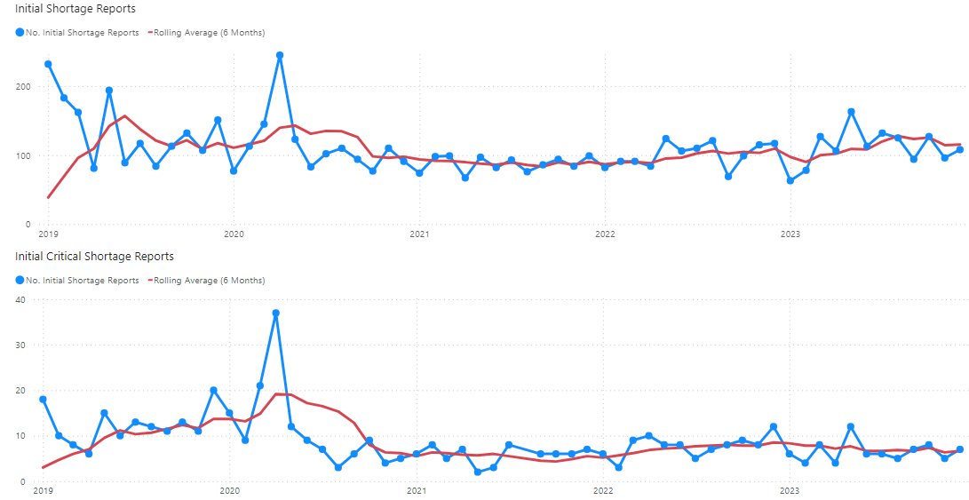

Figures 1 & 2: Number of new shortage reports over time overlayed on the 6-monthly rolling average

### Shortages specific to Australia

Sponsors are required to specify if a shortage or discontinuation of their product is specific to Australia. Shortages not specific to Australia (multi-country shortages), such as the shortages of Ozempic (semaglutide), some oral antibiotics in 2023 and Vyvanse (lisdexamfetamine), are more challenging to manage because the ability of sponsors to redirect stock from other markets to Australia may be limited.

Sponsors indicated that the shortages of their medicines are predominantly specific to Australia. However, the number of multi-country shortages was at its highest in 2022 after the COVID-19 pandemic.

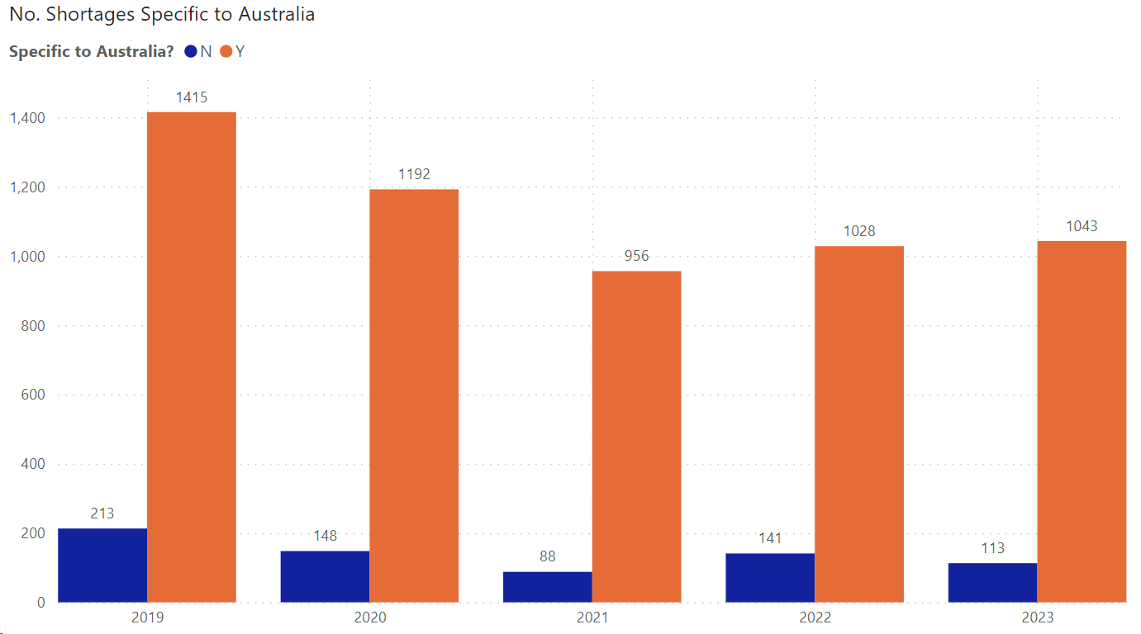

Figure 3: Data as reported by sponsors from new shortage reports

### Reasons for shortages

When reporting a shortage using the TGA form, sponsors select the reason for a shortage from a list. When they select ‘Manufacturing’, sponsors must select a specific reason from a subsequent list. Sponsors can provide more information about the reason for the shortage, so we have a better understanding of the context.

The most commonly reported reason for shortages is manufacturing issues. In 2023, it represented 63% of shortage reasons from the initial reports. Manufacturing issues vary in complexity and can take longer to resolve compared to shortages caused by transport/logistics issues or increases in consumer demand.

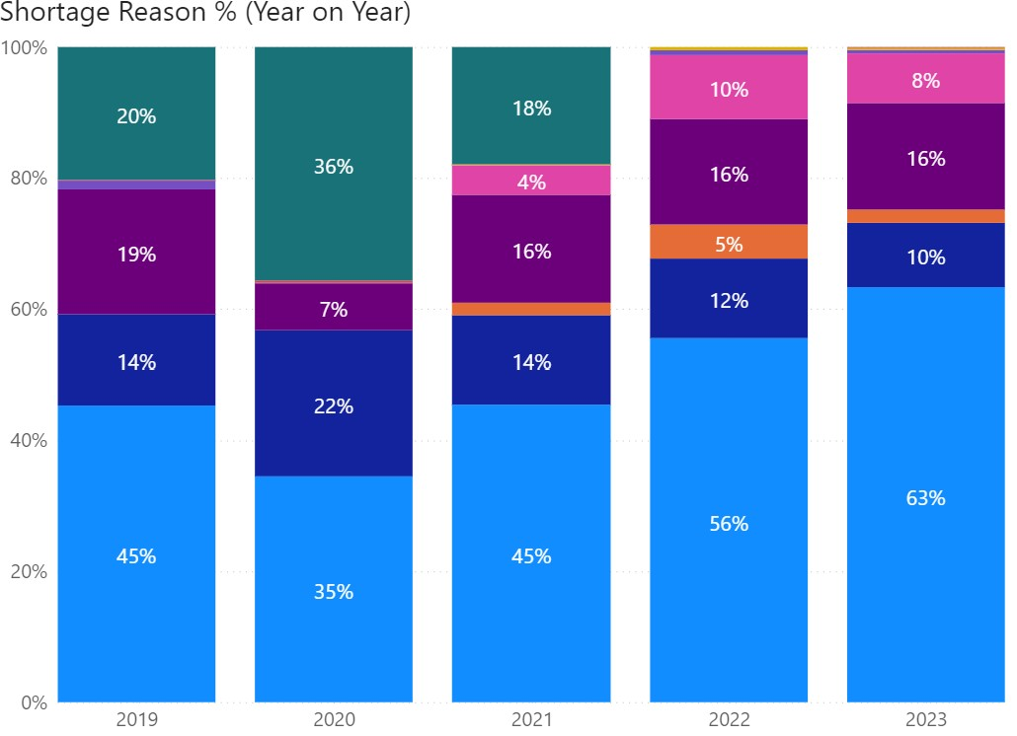shortage reason list
- manufacturing
- inc. consumer demand
- inc. demand (other sponsors)
- commercial changes / viability 
- transport / logistics
- product recall
- seasonal depletion
- not provided
- other

Figure 4: Shortage reasons over time as reported by sponsors from new shortage reports

Please note: ‘Other’ was removed as a shortage reason from 1 June 2021.

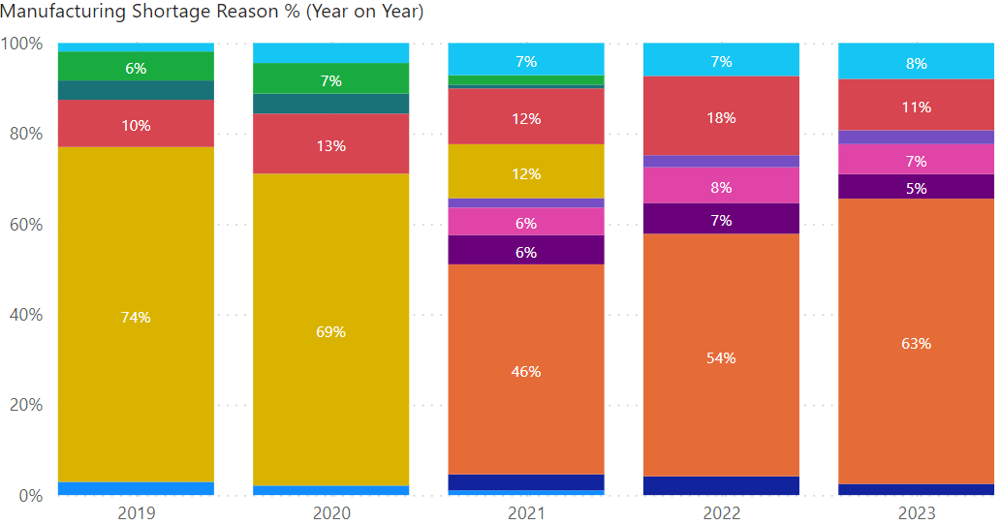

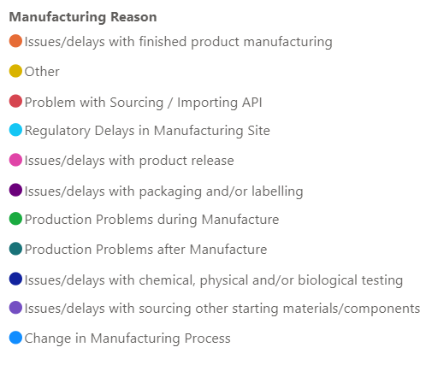

Figure 5: Manufacturing shortage reasons over time as reported by sponsors from new shortage reports

Please note: ‘Other’ was removed as a shortage reason from 1 June 2021.

### Shortage status from initial reports

Early reporting is crucial for timely management and communication of significant shortages. Early reporting enables the TGA to:

* investigate potential management strategies
* explore the need to coordinate a national management approach to help minimise supply gaps
* reduce patient impact.

Based on the data reported by sponsors, approximately half of initial reports were notified when the shortage was current rather than anticipated. Sponsors must report shortages within the legislated timeframes from their awareness of the disruption. Having robust supply monitoring mechanisms in place allows sponsors to detect issues that could potentially impact supply of medicines early and manage them in a timely manner.

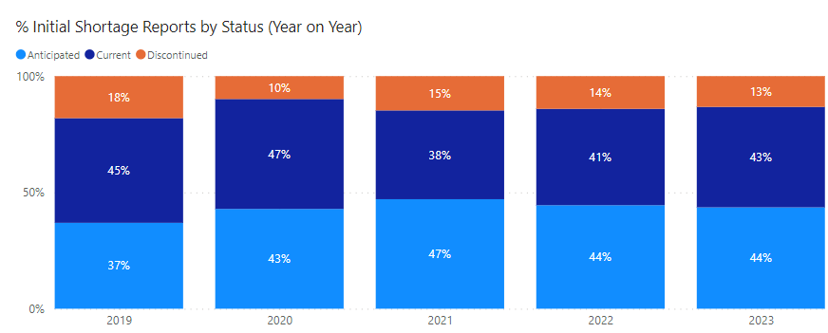

Figure 6: Shortage status as reported by sponsors from new shortage reports

### Dealing with discontinuations

Sponsors are required to report the discontinuation of medicines with critical impact 12 months, or with non-critical impact 6 months, ahead of market deletion. If a sponsor is unable to comply with this timeframe, they must report the discontinuation as soon as practicable after the decision to discontinue is made.

In 2023, the median number of days between reporting and market deletion was 169 days (roughly 5.6 months), up from 59 days (roughly 2 months) in 2020. The TGA receives about 5 critical discontinuations every year. For critical discontinuations, the median number of days between reporting and market deletion in 2023 was 383 days.

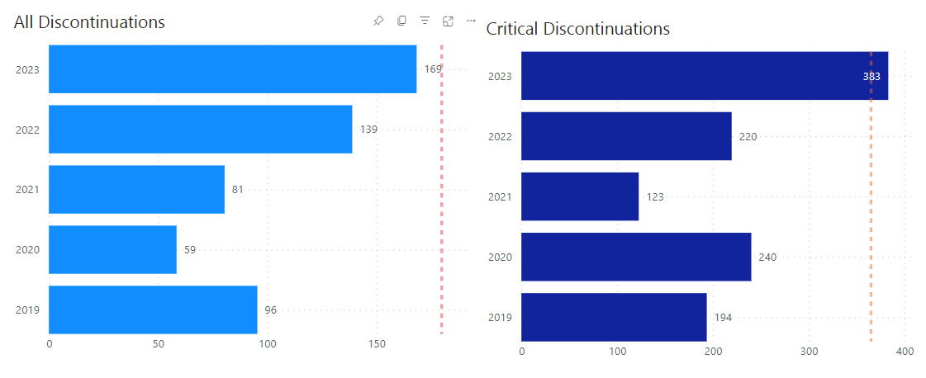

Figure 7: Median number of days between reporting and market deletion for initial discontinuation reports

## Case study: the tenecteplase shortage

Our response to the ongoing [Metalyse (tenecteplase) shortage](https://www.tga.gov.au/safety/shortages/medicine-shortage-alerts/shortage-tenecteplase-metalyse) illustrates many of the ways we can respond to a medicine shortage to reduce the impact on Australians.

Tenecteplase injection is used to dissolve blood clots (thrombolysis) in the immediate period following a heart attack. An alternative medicine, alteplase, is available, but this can only be administered in larger hospitals. Tenecteplase can be administered in ambulances and smaller health facilities, making it particularly important for regional and remote areas of Australia.

The pharmaceutical company that manufactures and supplies Metalyse (tenecteplase), Boehringer Ingelheim, advised us in July 2022 that they expected the product to be in shortage from October 2022. They advised that there would be limited supplies available over the following 18 months but not enough to meet usual demand.

The shortage was caused by manufacturing capacity constraints following unexpected increases in global demand.

The TGA immediately took several steps to address the issue. Firstly, we worked with the Medicines Availability Working Group and Boehringer-Ingelheim to model the availability of tenecteplase and the anticipated demand across Australia. The working group agreed that usage of tenecteplase must be reduced by at least 35% nationally or tenecteplase stock would be exhausted in Australia by the end of 2022.

We quickly approved the importation of overseas-registered tenecteplase under section 19A of the Act.

Boehringer Ingelheim asked us for approval to extend the acceptable shelf-life of Metalyse, as there were batches about to expire. We communicated with health facilities and other bodies, asking that they set aside any out-of-date Metalyse, rather than discarding it, while we evaluated product quality data to see if this was feasible.

We also set up a dedicated Medicine Shortages Action Group, bringing together key stakeholders and clinicians to advise on the way forward. This group had representatives from:

* Aboriginal Community Controlled Health Services
* Aboriginal Health Council of Western Australia
* Cardiac Society of Australia and New Zealand
* Council of Ambulance Authorities
* Royal Flying Doctors Service, Western Operations
* Society of Hospital Pharmacists of Australia
* Stroke Foundation
* Stroke Society
* The Australian College of Rural and Remote Medicine
* The National Aboriginal Community Controlled Health Organisation.

Among the issues the Medicine Shortages Action Group considered were:

* coordination of messaging about the extension of the shelf-life of Metalyse by 12 months, to inform clinicians and pharmacists and ensure stock was not destroyed
* development of clinical guidelines to assist health professionals with conservation strategies.

In consultation with the Medicine Shortages Action Group members, we advised that tenecteplase should be prioritised for:

* pre-hospital thrombolysis, such as for ambulance services
* small rural and remote facilities/hospitals, including Aboriginal health services.

We advised that alteplase should be used in metropolitan and larger regional hospitals to conserve tenecteplase for the above settings.

In addition, after our evaluation, we approved the shelf-life extension of Metalyse by 12 months.

The Clinical Trials Project Reference Group also published supplementary advice to provide guidance for researchers using tenecteplase.

In August 2023, Boehringer Ingelheim informed us that the shortage of tenecteplase would be extended until 31 December 2024 as there had been delays in ramping up production. They advised that the conservation strategies we had in place were working as intended and they were confident that the supply of stock throughout 2024 would meet the Australian demand established in 2023.

We updated our advice to extend the conservation strategies and thanked all clinicians and health services for their support in adopting them. These strategies had played a key role in minimising the impact of the shortage in Australia.

While the shortage of tenecteplase will continue until the end of 2024, the actions the TGA took in collaboration with many stakeholders have ensured continued availability of this important medicine in Australia.

## Managing shortages: next steps

In early 2024, we held a public consultation to better understand the nature, extent and urgency of current problems with the supply of medicines, including shortages and discontinuations of medicines in Australia.

We also asked to hear about possible opportunities to address these challenges, in continued collaboration with the broad range of stakeholders responsible for medicine supply in Australia.

The consultation document and published responses can be found at [Medicine shortages in Australia – Challenges and opportunities](https://consultations.tga.gov.au/tga/medicine-shortages-australia/).

We will draw on these responses to inform the way we prevent, manage and communicate about shortages.

Version history

|  |  |  |  |
| --- | --- | --- | --- |
| Version | Description of change | Author | Effective date |
| V1.0 | Original publication | Pharmacovigilance Branch/Medicine Shortages Section | July 2024 |

|  |
| --- |
| Therapeutic Goods Administration |
| PO Box 100 Woden ACT 2606 Australia  Email: [info@tga.gov.au](mailto:info@tga.gov.au) Phone: 1800 020 653 Fax: 02 6203 1605  [**https://www.tga.gov.au**](https://www.tga.gov.au) |
| Reference/Publication # |