**AUSTRALIAN PRODUCT INFORMATION - JARDIANCE® empagliflozin film-coated tablets**

# NAME OF THE MEDICINE

empagliflozin

# QUALITATIVE AND QUANTITATIVE COMPOSITION

JARDIANCE 10 mg film-coated tablets contains 10 mg empagliflozin. JARDIANCE 25 mg film-coated tablets contains 25 mg empagliflozin. Excipients with known effect:

The JARDIANCE 10 mg tablet contains 162.5 mg of lactose monohydrate and the JARDIANCE 25 mg tablet contains 113 mg of lactose monohydrate per maximum recommended daily dose.

For the full list of excipients, see Section 6.1 List of excipients.

# PHARMACEUTICAL FORM

JARDIANCE are film-coated tablets for oral administration.

JARDIANCE 10 mg film-coated tablets are pale yellow, round, biconvex and bevel-edged tablets. One side is debossed with the code ‘S10’, the other side is debossed with the Boehringer Ingelheim company symbol.

JARDIANCE 25 mg film-coated tablets are pale yellow, oval, biconvex tablets. One side is debossed with the code ‘S25’, the other side is debossed with the Boehringer Ingelheim company symbol.

# CLINICAL PARTICULARS

* 1. **THERAPEUTIC INDICATIONS**

## Type 2 diabetes mellitus

Glycaemic control

JARDIANCE is indicated in the treatment of type 2 diabetes mellitus to improve glycaemic control in adults as:

Monotherapy

When diet and exercise alone do not provide adequate glycaemic control in patients for whom use of metformin is considered inappropriate due to intolerance.

Add-on combination therapy

In combination with other glucose–lowering medicinal products including insulin, when these, together with diet and exercise, do not provide adequate glycaemic control (see Section 5.1 Pharmacodynamic properties - Clinical trials).

Prevention of cardiovascular death

JARDIANCE is indicated in patients with type 2 diabetes mellitus and established cardiovascular disease to reduce the risk of cardiovascular death (see Section 5.1 Pharmacodynamic properties - Clinical trials).

To prevent cardiovascular deaths, JARDIANCE should be used in conjunction with other measures to reduce cardiovascular risk in line with the current standard of care.

## Heart failure

JARDIANCE is indicated in adults for the treatment of symptomatic heart failure independent of left ventricular ejection fraction, as an adjunct to standard of care therapy (see Section 5.1 Pharmacodynamic properties - Clinical trials).

## Chronic kidney disease

JARDIANCE is indicated to reduce the risk of kidney disease progression in adults with chronic kidney disease (CKD Stages 2 and 3A with urine ACR ≥30 mg/g, or CKD Stages 3B, 4 and 5 irrespective of urine ACR).

# DOSE AND METHOD OF ADMINISTRATION

## Type 2 diabetes mellitus

The recommended starting dose of JARDIANCE is 10 mg once daily. In patients tolerating empagliflozin 10 mg once daily who have an eGFR ≥30 mL/min/1.73 m2 and requiring additional glycaemic control, the dose can be increased to 25 mg once daily.

Combination therapy

When JARDIANCE is used in combination with a sulfonylurea or with insulin, a lower dose of the sulfonylurea or insulin may be considered to reduce the risk of hypoglycaemia (see Sections 4.5 Interactions with other medicines and other forms of interactions and 4.8 Adverse effects (Undesirable effects)).

## Heart failure

The recommended dose of JARDIANCE is 10 mg once daily (see Section 5.1 Pharmacodynamic Properties - Clinical Trials).

## Chronic kidney disease

The recommended dose of JARDIANCE is 10 mg once daily (see Section 5.1 Pharmacodynamic Properties - Clinical Trials).

JARDIANCE can be taken with or without food.

## Patients with renal impairment

Assess renal function prior to initiation of empagliflozin and periodically thereafter.

Empagliflozin 10 mg can be used regardless of renal function. However, due to limited experience, it is not recommended to initiate treatment with JARDIANCE in patients with an eGFR <20mL/min/1.73m2.

Glycaemic efficacy of empagliflozin is dependent on renal function and likely absent in patients with severe renal impairment. If eGFR falls below 30 mL/min/1.73 m2 the recommended dose of empagliflozin is limited to 10 mg and additional glucose lowering treatment should be considered if needed (see Section 4.4 Special warnings and precautions for use).

## Patients with hepatic impairment

No dose adjustment is recommended for patients with hepatic impairment.

## Elderly Patients

Type 2 Diabetes Mellitus

No dosage adjustment is recommended based on age. Therapeutic experience in patients aged 85 years and older is limited. Initiation of empagliflozin therapy in this population is not recommended (see Section 4.4 Special warnings and precautions for use). Patients aged 75 years and older should be prescribed with caution (see Section 4.4 Special warnings and precautions for use).

Heart Failure

No dosage adjustment is recommended based on age. Patients aged 75 years and older should be prescribed with caution (see Section 4.4 Special warnings and precautions for use).

## Paediatric population

Safety and effectiveness of JARDIANCE in children under 18 years of age have not been established.

# CONTRAINDICATIONS

Hypersensitivity to empagliflozin or any of the excipients in JARDIANCE.

In case of rare hereditary conditions that may be incompatible with an excipient of the product, the use of the product is contraindicated. The JARDIANCE 10 mg tablet contains 162.5 mg of lactose monohydrate and the JARDIANCE 25 mg tablet contains 113 mg of lactose monohydrate per maximum recommended daily dose. Patients with the rare hereditary conditions of galactose intolerance e.g. galactosaemia should not take this medicine.

# SPECIAL WARNINGS AND PRECAUTIONS FOR USE

## General

JARDIANCE should not be used in patients with type 1 diabetes (see Section 4.1 Therapeutic indications).

## Ketoacidosis

Cases of ketoacidosis, a serious life-threatening condition requiring urgent hospitalisation, have been reported in postmarketing surveillance in patients with diabetes mellitus treated with SGLT2 inhibitors, including empagliflozin. Fatal cases of ketoacidosis have been reported in patients taking empagliflozin.

Cases of ketoacidosis have also been reported in patients without diabetes mellitus who were treated with JARDIANCE.

Patients treated with JARDIANCE who present with signs and symptoms consistent with severe metabolic acidosis should be assessed for ketoacidosis regardless of presenting blood glucose levels as ketoacidosis associated with JARDIANCE may be present even if blood glucose levels are less than 13.8 mmol/L.

Signs and symptoms of ketoacidosis may include excessive thirst, nausea, vomiting, abdominal pain, generalised malaise, and shortness of breath. If ketoacidosis is suspected, JARDIANCE should be discontinued, the patient should be evaluated and prompt treatment should be instituted. Treatment of ketoacidosis generally requires insulin, fluid, potassium and carbohydrate replacement.

Restarting SGLT2 inhibitor treatment in patients with previous ketoacidosis while on SGLT2 inhibitor treatment is not recommended, unless another clear precipitating factor is identified and resolved.

Before initiating JARDIANCE, consider factors in the patient history that may predispose to ketoacidosis.

Factors that predispose patients to ketoacidosis include a low carbohydrate diet, dehydration, acute illness, surgery (see below), a previous ketoacidosis, insulin deficiency from any cause (including insulin pump failure, history of pancreatitis, or pancreatic surgery), malnourishment/reduced caloric intake or increased insulin requirements due to infections, and alcohol abuse. JARDIANCE should be used with caution in these patients. When reducing the insulin dose in patients requiring insulin, caution should be taken (see Section 4.2 Dose and method of administration). Consider monitoring for ketoacidosis and temporarily discontinuing JARDIANCE in clinical situations known to predispose ketoacidosis. In these situations, consider monitoring of ketones, even if JARDIANCE treatment has been interrupted.

## Surgery

Treatment with JARDIANCE should be ceased prior to major surgery. An increase in other glucose lowering agents may be required during this time.

Patients scheduled for non-urgent surgery who have not ceased empagliflozin should be assessed and consideration should be given to postponing the procedure.

Treatment with JARDIANCE may be restarted once the patient's condition has stabilised and oral intake is normal.

## Complicated urinary tract infections

Cases of complicated urinary tract infections including urosepsis and pyelonephritis requiring hospitalisation have been reported in patients receiving SGLT2 inhibitors, including JARDIANCE (see Section 4.8 Adverse effects (Undesirable effects)). Treatment with SGLT2 inhibitors increases the risk for urinary tract infections. Evaluate patients for signs and symptoms of urinary tract infections and treat promptly, if indicated (see Section 4.8 Adverse effects (Undesirable effects)). Patients should be alerted to the symptoms of urinary tract infection, and advised to seek treatment promptly.

Discontinuation of empagliflozin may be considered in cases of recurrent urinary tract infections.

## Necrotising fasciitis of the perineum (Fournier’s gangrene)

Cases of necrotising fasciitis of the perineum (also known as Fournier’s gangrene), a rare, but serious and life-threatening necrotising infection, have been reported in female and male patients with diabetes mellitus treated with SGLT2 inhibitors, including empagliflozin. Serious outcomes have included hospitalisation, multiple surgeries, and death.

Patients treated with JARDIANCE who present with pain or tenderness, erythema, swelling in the genital or perineal area, fever, malaise should be evaluated for necrotising fasciitis. If suspected, JARDIANCE should be discontinued and prompt treatment should be instituted (including broad-spectrum antibiotics and surgical debridement if necessary).

## Use in patients at risk for volume depletion

Based on the mode of action of SGLT2 inhibitors, osmotic diuresis accompanying glucosuria may lead to a modest decrease in BP. Therefore, caution should be exercised in patients for whom an empagliflozin-induced drop in BP could pose a risk, such as patients with known cardiovascular disease, patients on diuretics, patients with a history of hypotension or patients aged 75 years and older.

In case of conditions that may lead to fluid loss (e.g. gastrointestinal illness), careful monitoring of volume status (e.g. physical examination, BP measurements, laboratory tests including

haematocrit) and electrolytes is recommended for patients receiving empagliflozin. Temporary interruption of treatment with JARDIANCE should be considered until the fluid loss is corrected.

## Lower limb amputations

An increase in cases of lower limb amputation (primarily of the toe) has been observed in a long-term clinical study with another SGLT2 inhibitor. The medicine in that study is not empagliflozin. However, it is unknown whether this constitutes a class effect. In a pooled safety analysis of 12,620 patients with T2DM the frequency of patients with lower limb amputations was similar between empagliflozin and placebo. In the largest placebo-controlled trial in 7020 patients (EMPA-REG OUTCOME trial), in which 88% of all the cases of amputations were reported, lower limb amputations occurred in 1.8% of patients treated with empagliflozin 10 mg, in 2.0% of patients treated with empagliflozin 25 mg, and in 1.8% of patients in the placebo arm. It is important to regularly examine the feet and counsel all diabetic patients on routine preventative footcare.

## Use in renal impairment

Empagliflozin increases serum creatinine and decreases eGFR (see Section 4.8 Adverse effects (Undesirable effects)). Renal function abnormalities can occur after initiating empagliflozin. Patients with hypovolaemia may be more susceptible to these changes.

There have been postmarketing reports of acute kidney injury, some requiring hospitalisation and dialysis, in patients receiving SGLT2 inhibitors, including empagliflozin; some reports involved patients younger than 65 years of age.

Due to limited experience, it is not recommended to initiate treatment with empagliflozin in patients with an eGFR <20 mL/min/1.73 m2.

Glycaemic efficacy of empagliflozin is dependent on renal function and likely absent in patients with an eGFR <30 mL/min/1.73 m2 (see Section 4.2 Dose and method of administration - Patients with renal impairment).

Monitoring of renal function

Assessment of renal function is recommended:

* prior to empagliflozin initiation and periodically during treatment, i.e. at least yearly;
* prior to initiation of concomitant medicines that may reduce renal function and periodically thereafter.

Patients treated with empagliflozin can experience an initial fall in eGFR. More intensive monitoring of renal function is recommended, particularly following treatment initiation, if empagliflozin is used in patients with an eGFR <60 mL/min/1.73m2, especially if the eGFR is

<45 mL/min/1.73m2.

## Cardiomyopathies and severe valvular heart disease

Patients with cardiomyopathies associated with infiltration diseases (e.g. amyloidosis), accumulation diseases (e.g. haemochromatosis), muscular dystrophies, pericardial constriction, hypertrophic obstructive cardiomyopathy or severe valvular disease with surgery expected were excluded from clinical trials of patients with symptomatic heart failure. Therefore, safety and efficacy in these patients has not been established.

## Patients with symptomatic heart failure of NYHA IV class

Limited data on patients with NYHA IV symptoms (i.e. symptoms with minimal activity or at rest) are available.

## Use in the elderly

Patients aged 75 years and older may be at increased risk of volume depletion, therefore, JARDIANCE should be prescribed with caution in these patients (see Section 4.8 Adverse effects (Undesirable effects)).

In patients aged 85 years and older, initiation of JARDIANCE for treatment of type 2 diabetes mellitus is not recommended due to limited therapeutic experience.

## Paediatric use

Safety and effectiveness of JARDIANCE in children under 18 years of age have not been established.

## Effect on laboratory tests

Urine will test positive for glucose while patients are taking JARDIANCE due to the nature of the mechanism of action of the SGLT2 inhibitors (see Section 5.1 Pharmacodynamic properties).

Interference with 1,5-anhydroglucitol (1,5-AG) assay

Monitoring glycaemic control with 1,5-AG assay is not recommended as measurements of 1,5- AG are unreliable in assessing glycaemic control in patients taking SGLT2 inhibitors. Use alternative methods to monitor glycaemic control.

# INTERACTIONS WITH OTHER MEDICINES AND OTHER FORMS OF INTERACTIONS

## Pharmacodynamic Interactions

Diuretics

Empagliflozin may add to the diuretic effect of thiazide and loop diuretics and may increase the risk of dehydration and hypotension.

Insulin and insulin secretagogues

Insulin and insulin secretagogues, such as sulfonylureas, may increase the risk of hypoglycaemia. Therefore, a lower dose of insulin or an insulin secretagogue may be required to reduce the risk of hypoglycaemia when used in combination with empagliflozin (see Sections 4.2 Dose and method of administration and 4.8 Adverse Effects (Undesirable effects)).

## Pharmacokinetic Interactions

Lithium

Empagliflozin may increase renal lithium excretion and the blood lithium levels may be decreased. Serum concentration of lithium should be monitored more frequently after empagliflozin initiation and dose changes. Please refer the patient to the lithium prescribing doctor in order to monitor serum concentration of lithium.

*In vitro* assessment of drug interactions

Empagliflozin does not inhibit, inactivate, or induce CYP450 isoforms. *In vitro* data suggest that the primary route of metabolism of empagliflozin in humans is glucuronidation by the uridine 5'-diphospho-glucuronosyltransferases UGT2B7, UGT1A3, UGT1A8, and UGT1A9. Empagliflozin does not notably inhibit UGT1A1, UGT1A3, UGT1A8, UGT1A9 or UGT2B7. At therapeutic doses, the potential for empagliflozin to reversibly inhibit or inactivate the major CYP450 and UGT isoforms is remote. Drug-drug interactions involving the major CYP450 and UGT isoforms with empagliflozin and concomitantly administered substrates of these enzymes are therefore considered unlikely.

Empagliflozin is a substrate for P-glycoprotein (P-gp) and breast cancer resistance protein, but it does not inhibit these efflux transporters at therapeutic doses. Based on *in vitro* studies, empagliflozin is considered unlikely to cause interactions with drugs that are P-gp substrates. Empagliflozin is a substrate of the human uptake transporters OAT3, OATP1B1, and OATP1B3, but not OAT1 and OCT2. Empagliflozin does not inhibit any of these human uptake transporters at clinically relevant plasma concentrations and, as such, drug-drug interactions with substrates of these uptake transporters are considered unlikely.

*In vivo* assessment of drug interactions

No clinically meaningful pharmacokinetic interactions were observed when empagliflozin was co-administered with other commonly used medicinal products. Based on results of pharmacokinetic studies no dose adjustment of JARDIANCE is recommended when co- administered with commonly prescribed medicinal products.

Empagliflozin pharmacokinetics were similar with and without co-administration of metformin, glimepiride, pioglitazone, sitagliptin, linagliptin, warfarin, verapamil, ramipril, simvastatin, in healthy volunteers and with or without co-administration of torasemide and hydrochlorothiazide in patients with T2DM. Increases in overall exposure (AUC) of empagliflozin were seen following co-administration with gemfibrozil (59%), rifampicin (35%), or probenecid (53%). These changes were not considered to be clinically meaningful.

Empagliflozin had no clinically relevant effect on the pharmacokinetics of metformin, glimepiride, pioglitazone, sitagliptin, linagliptin, warfarin, digoxin, ramipril, simvastatin, hydrochlorothiazide, and oral contraceptives when co-administered in healthy volunteers.

# FERTILITY, PREGNANCY AND LACTATION

## Effects on fertility

No studies on the effect on human fertility have been conducted for JARDIANCE. Studies in rats at doses up to 700 mg/kg/day, do not indicate direct or indirect harmful effects with respect to fertility. In female rats this dose was 90- and 155-fold the systemic AUC exposure anticipated with a human dose of 10 and 25 mg.

## Use in pregnancy (Category D)

There are limited data from the use of JARDIANCE in pregnant women. It is recommended to avoid the use of JARDIANCE during pregnancy unless clearly needed.

Empagliflozin administered during the period of organogenesis was not teratogenic at doses up to 300 mg/kg in the rat or rabbit, which corresponds to approximately 48- and 122-times or 128- and 325-times the clinical dose of empagliflozin based on AUC exposure associated with the 25 mg and 10 mg doses, respectively. Doses of empagliflozin causing maternal toxicity in the rat also caused the malformation of bent limb bones at exposures approximately 155- and 393-times the clinical dose associated with the 25 mg and 10 mg doses, respectively. Maternally toxic doses in the rabbit also caused increased embryofetal loss at doses approximately 139- and 353-times the clinical dose associated with the 25 mg and 10 mg doses, respectively.

Empagliflozin administered to female rats from gestation day 6 to lactation day 20 resulted in reduced weight gain in offspring at >30 mg/kg/day (maternal exposures approximately 4- and 11-times those seen with a clinical dose of 25 mg and 10 mg, respectively). No adverse effects on postnatal development were noted at 10 mg/kg/day (maternal exposures approximately equivalent to those seen with a clinical dose of 25 mg).

Specialised studies in rats with other members of the pharmacological class have shown toxicity to the developing kidney in the time period corresponding to the second and third trimesters of human pregnancy. Similar effects have been seen for empagliflozin at approximately 11 times the clinical AUC exposure associated with the 25 mg dose. These

findings were absent after a 13-week drug-free recovery period. JARDIANCE should be used in pregnancy only if the expected benefit to the patients justifies the potential risk to the fetus.

## Use in lactation

No data in humans are available on excretion of empagliflozin into milk. Available nonclinical data in animals have shown excretion of empagliflozin in milk. Reduced body weight was observed in rats exposed to empagliflozin *in utero* and through the consumption of maternal milk (see Use in pregnancy (Category D)). Adverse effects on renal development have been observed in juvenile rats treated with other members of this pharmacological class. Similar effects were seen with empagliflozin but the findings were absent after a 13 week drug-free recovery. A risk to human newborns/infants cannot be excluded. It is recommended to discontinue breast feeding during treatment with JARDIANCE.

# EFFECTS ON ABILITY TO DRIVE AND USE MACHINES

No studies on the effects on the ability to drive and use machines have been performed.

# ADVERSE EFFECTS (UNDESIRABLE EFFECTS)

## Reporting suspected adverse effects

Reporting suspected adverse reactions after registration of the medicinal product is important. It allows continued monitoring of the benefit-risk balance of the medicinal product. Healthcare professionals are asked to report any suspected adverse reactions at http://[www.tga.gov.au/reporting-problems](http://www.tga.gov.au/reporting-problems).

## Type 2 diabetes mellitus

A total of 15,582 patients with T2DM were treated in clinical studies to evaluate the safety of empagliflozin, of which 10,004 patients were treated with empagliflozin, either alone or in combination with metformin, a sulfonylurea, a PPAR agonist, DPP4 inhibitors, or insulin. This pool includes the EMPA-REG OUTCOME study involving 7020 patients at high cardiovascular risk (mean age 63.1 years, 9.3% patients at least 75 years old, 28.5% women) treated with JARDIANCE 10 mg/day (n=2345), JARDIANCE 25 mg/day (n=2342), or placebo (n=2333) up to 4.5 years. The overall safety profile of empagliflozin in this study was comparable to the previously known safety profile.

In the above described trials, the frequency of adverse effects leading to discontinuation was similar by treatment groups for placebo (5.6%), JARDIANCE 10 mg (5.0%) and JARDIANCE 25 mg (5.3%).

Placebo controlled double-blinded trials of 18 to 24 weeks of exposure included 3534 patients, of which 1183 were treated with placebo, 1185 were treated with JARDIANCE 10 mg and 1166 were treated with JARDIANCE 25 mg (Table 1).

The most frequent adverse drug reaction was hypoglycaemia, which depended on the type of background therapy used in the respective studies (Table 2).

## Table 1 Side effects reported in patients who received JARDIANCE in placebo controlled double-blind studies of 18 to 24 weeks, classified by MedDRA System organ class and MedDRA Preferred terms

|  |  |  |  |
| --- | --- | --- | --- |
|  | **Placebo n=1183**  **%** | **Empagliflozin 10 mg n=1185**  **%** | **Empagliflozin 25 mg n=1166**  **%** |
| **System Organ Class**  Adverse reaction |  |  |  |
| **Infection and infestations** |  |  |  |
| Vaginal moniliasis, vulvovaginitis, balanitis and other genital infections*, a | 1.0 | 4.0 | 3.9 |
| Urinary tract infections*, a | 7.2 | 8.8 | 7.0 |
| **Metabolism and nutrition disorders** |  |  |  |
| Hypoglycaemiaa |  | **Refer to Table 2** | |
| **Gastrointestinal disorders** |  |  |  |
| Constipation | 1.1 | 1.4 | 0.9 |
| **Skin and subcutaneous tissue disorders** |  |  |  |
| Pruritus | 0.7 | 0.9 | 0.7 |
| **Vascular disorders** |  |  |  |
| Volume depletiona | 0.3 | 0.6 | 0.4 |
| **Renal and urinary disorders** |  |  |  |
| Increased urinationa | 1.4 | 3.5 | 3.3 |
| Dysuria | 0.3 | 0.3 | 0.4 |
| **General disorders and administration site conditions** |  |  |  |
| Thirst | 0 | 1.4 | 1.5 |
| **Investigations** |  |  |  |
| Glomerular filtration rate decreaseda | 0.3 | 0.1 | 0 |
| Blood creatinine increaseda | 0.5 | 0.6 | 0.1 |
| Haematocrit increased#, a | 0 | <0.1 | 0.1 |
| Serum lipids increaseda | 4.9 | 5.7 | 5.1 |

* based on prespecified list of preferred terms;

# frequency of the preferred term in the broad safety data pool

a see subsections below

## Hypoglycaemia

The frequency of hypoglycaemia depended on the background therapy in the respective studies and was similar for JARDIANCE and placebo as monotherapy, as add-on to metformin, add-on to pioglitazone +/- metformin, and as add-on with linagliptin + metformin. The frequency of patients with hypoglycaemia was increased in patients treated with JARDIANCE compared to placebo when given as add-on to metformin plus sulfonylurea, and as add-on to insulin +/- metformin and +/- sulfonylurea (Table 2).

Major hypoglycaemia (events requiring assistance)

The frequency of patients with major hypoglycaemic events was low (<1%) and similar for JARDIANCE and placebo as monotherapy, as add-on to metformin +/- sulfonylurea, as add- on to pioglitazone +/- metformin, and as add-on with linagliptin + metformin.

The frequency of patients with major hypoglycaemic events was increased in patients treated with JARDIANCE compared to placebo when given as add-on to insulin +/- metformin and +/- sulfonylurea.

## Table 2 Frequency of patients with confirmed hypoglycaemic events per trial (1245.19, 1245.20, 1245.23(met), 1245.23(met+SU), 1245.33, 1245.49, 1275.9(lina+met) and

**1245.25 – Treated Set1)**

|  |  |  |  |
| --- | --- | --- | --- |
|  | **Placebo** | **Empagliflozin** | |
| **10 mg** | **25 mg** |
| **Monotherapy (1245.20) (24 weeks)** | n=229 | n=224 | n=223 |
| Overall confirmed (%) | 0.4% | 0.4% | 0.4% |
| Major (%) | 0% | 0% | 0% |
| **In combination with metformin**  **(1245.23*(met)*) (24 weeks)** | n=206 | n=217 | n=214 |
| Overall confirmed (%) | 0.5% | 1.8% | 1.4% |
| Major (%) | 0% | 0% | 0% |
| **In combination with metformin +**  **sulfonylurea (1245.23 *(met + SU)*) (24 weeks)** | n=225 | n=224 | n=217 |
| Overall confirmed (%) | 8.4% | 16.1% | 11.5% |
| Major (%) | 0% | 0% | 0% |
| **In combination with pioglitazone +/- metformin (1245.19) (24 weeks)** | n=165 | n=165 | n=168 |
| Overall confirmed (%) | 1.8% | 1.2% | 2.4% |
| Major (%) | 0% | 0% | 0% |
| **In combination with basal insulin (1245.33) (18 weeks2 / 78 weeks)** | n=170 | n=169 | n=155 |
| Overall confirmed (%) | 20.6%/35.3% | 19.5%/36.1% | 28.4%/36.1% |
| Major (%) | 0%/0% | 0%/0% | 1.3%/1.3% |
| **In combination with MDI insulin +/- metformin (1245.49) (18 weeks2 / 52 weeks)** | n=188 | n=186 | n=189 |
| Overall confirmed (%) | 37.2%/58.0% | 39.8%/51.1% | 41.3%/57.7% |
| Major (%) | 0.5%/1.6% | 0.5%/1.6% | 0.5%/0.5% |
| **In combination with metformin and linagliptin (1275.9) (24 weeks)3** | n=110 | n=112 | n=110 |
| Overall confirmed (%) | 0.9% | 0.0% | 2.7% |
| Major (%) | 0% | 0% | 0.9% |
| **EMPA-REG OUTCOME (1245.25)** | n=2333 | n=2345 | n=2342 |
| Overall confirmed (%) | 27.9% | 28% | 27.6% |
| Major (%) | 1.5% | 1.4% | 1.3% |

Confirmed: blood glucose ≤3.9 mmol/L or required assistance Major: required assistance

1 i.e. patients who had received at least one dose of study drug

2 The dose of insulin as background medication was to be stable for the first 18 weeks

3 This was a fixed-dose combination of empagliflozin with linagliptin 5 mg with a background treatment with metformin (see also Section 5.1 Pharmacodynamic properties – Clinical trials)

MDI = multiple daily injections

## Urinary tract infection

The overall frequency of urinary tract infection adverse events was similar in patients treated with JARDIANCE 25 mg and placebo (7.0% and 7.2%), and higher in patients treated with JARDIANCE 10 mg (8.8%). Similar to placebo, urinary tract infection was reported more frequently for JARDIANCE in patients with a history of chronic or recurrent urinary tract infections. The intensity of urinary tract infections was similar to placebo for mild, moderate, and severe intensity reports. Urinary tract infection events were reported more frequently for empagliflozin compared to placebo in female patients, but not in male patients.

## Vaginal moniliasis, vulvovaginitis, balanitis and other genital infection

Vaginal moniliasis, vulvovaginitis, balanitis and other genital infections were reported more frequently for JARDIANCE 10 mg (4.0%) and JARDIANCE 25 mg (3.9%) compared to placebo (1.0%). These adverse events were reported more frequently for empagliflozin compared to

placebo in female patients, and the difference in frequency was less pronounced in male patients. The genital tract infections were mild and moderate in intensity, none was severe in intensity.

## Increased urination

As expected via its mechanism of action, increased urination (as assessed by preferred term search including pollakiuria, polyuria, nocturia) was observed at higher frequencies in patients treated with JARDIANCE 10 mg (3.5%) and JARDIANCE 25 mg (3.3%) compared to placebo (1.4%). Increased urination was mostly mild or moderate in intensity. The frequency of reported nocturia was comparable between placebo and JARDIANCE (<1%).

## Volume depletion

The overall frequency of volume depletion (including the predefined terms BP (ambulatory) decreased, SBP decreased, dehydration, hypotension, hypovolaemia, orthostatic hypotension and syncope) was similar to placebo (0.6% for JARDIANCE 10 mg, 0.4% for JARDIANCE 25 mg and 0.3% for placebo). The effect of empagliflozin on urinary glucose excretion is associated with osmotic diuresis, which could affect hydration status of patients aged 75 years and older. In patients ≥75 years of age (pooling of all patients with diabetes, n=13,402) the frequency of volume depletion events was similar for JARDIANCE 10 mg (2.3%) compared to placebo (2.1%), but it increased with JARDIANCE 25 mg (4.3%).

## Blood creatinine increased and glomerular filtration rate decreased

Use of empagliflozin was associated with increases in serum creatinine and decreases in eGFR. These changes were observed to reverse after treatment discontinuation, suggesting acute haemodynamic changes play a role in the renal function abnormalities observed with empagliflozin.

Renal-related adverse reactions (e.g. acute kidney injury, renal impairment, acute prerenal failure) may occur in patients treated with empagliflozin.

The overall frequency of patients with increased blood creatinine and decreased glomerular filtration rate was similar between empagliflozin and placebo (blood creatinine increased: JARDIANCE 10 mg 0.6%, JARDIANCE 25 mg 0.1%, placebo 0.5%; glomerular filtration rate

decreased: empagliflozin 10 mg 0.1%, empagliflozin 25 mg 0%, placebo 0.3%).

In placebo-controlled, double-blind studies up to 76 weeks, initial transient increases in creatinine (mean change from baseline after 12 weeks: JARDIANCE 10 mg 0.0011 mmol/L, JARDIANCE 25 mg 0.0006 mmol/L) and initial transient decreases in estimated glomerular filtration rates (mean change from baseline after 12 weeks: JARDIANCE 10 mg

-1.34 mL/min/1.73m2, JARDIANCE 25 mg -1.37 mL/min/1.73m2) have been observed. These changes were generally reversible during continuous treatment or after drug discontinuation (see Section 5.1 Pharmacodynamic properties - Clinical trials - Cardiovascular outcome - Figure 4 for the eGFR course in the EMPA-REG OUTCOME study).

## Adverse effects based on trials in heart failure

The pooled EMPEROR studies included patients with heart failure and either reduced ejection fraction (N = 3726) or preserved ejection fraction (N = 5985) treated with 10 mg empagliflozin (N = 4859) or placebo (N = 4852). Approximately half of the patients had type 2 diabetes mellitus.

The most frequent adverse drug reaction was volume depletion (empagliflozin 10 mg: 11.4%; placebo: 9.7%).

The overall safety profile of JARDIANCE in heart failure patients was generally consistent with that observed in the type 2 diabetes mellitus population.

## Chronic kidney disease

The EMPA-KIDNEY study included patients with chronic kidney disease (N = 6609) treated with 10 mg empagliflozin or placebo. About 44% of the patients had type 2 diabetes mellitus.

The most frequent adverse events in the EMPA-KIDNEY study were gout (empagliflozin 7.0% vs placebo 8.0%), and acute kidney injury (empagliflozin 2.8% vs placebo 3.5%) which were more frequently reported in patients on placebo. No new adverse reactions were identified in the EMPA-KIDNEY study.

The overall safety profile of JARDIANCE was generally consistent across the studied indications.

## Laboratory parameters

Haematocrit increased

In a pooled safety analysis (pooling of all patients with diabetes, n=13,402), mean changes from baseline in haematocrit were 3.4% and 3.6% for empagliflozin 10 mg and 25 mg, respectively, compared to -0.1% for placebo. In the EMPA-REG OUTCOME study, haematocrit values returned towards baseline values after a follow-up period of 30 days after treatment stop.

Serum lipids increased

In a pooled safety analysis (pooling of all patients with diabetes, n=13,402), mean percent increases from baseline for empagliflozin 10 mg and 25 mg versus placebo, respectively, were total cholesterol 4.9% and 5.7% versus 3.5%; HDL-cholesterol 3.3% and 3.6% versus 0.4%;

LDL-cholesterol 9.5% and 10.0% versus 7.5%; triglycerides 9.2% and 9.9% versus 10.5%.

## Postmarketing experience

The following postmarketing case reports have been reported during post-approval use of JARDIANCE. Because these cases are reported voluntarily from a population of an unknown size, it is not always possible to reliably estimate their frequency.

Metabolism and nutrition disorders - Ketoacidosis

Infections and infestations - Pyelonephritis, urosepsis, necrotising fasciitis of the perineum (Fournier’s gangrene)a

Immune system disorders - Allergic skin reactions (e.g. rash, urticaria), angioedema Reproductive system and breast disorders – Phimosis.

a observed in patients with diabetes mellitus

# OVERDOSE

For information on the management of overdose, contact the Poisons Information Centre on 131126 (Australia).

During controlled clinical trials in healthy subjects, single doses of up to 800 mg empagliflozin, were well tolerated.

## Treatment

In the event of an overdose, supportive treatment should be initiated as appropriate to the patient’s clinical status. The removal of empagliflozin by haemodialysis has not been studied.

# PHARMACOLOGICAL PROPERTIES

Pharmacotherapeutic group: SGLT2 Inhibitor, ATC code: A10BK03.

# PHARMACODYNAMIC PROPERTIES

## Mechanism of action

Empagliflozin is a reversible competitive inhibitor of SGLT2 with an IC50 of 1.3 nM. It has a 5000-fold selectivity over human SGLT1 (IC50 of 6278 nM), responsible for glucose absorption in the gut.

SGLT2 is highly expressed in the kidney, whereas expression in other tissues is absent or very low. It is responsible as the predominant transporter for re-absorption of glucose from the glomerular filtrate back into the circulation. In patients with type 2 diabetes mellitus (T2DM) and hyperglycaemia a higher amount of glucose is filtered and reabsorbed.

Empagliflozin improves glycaemic control in patients with T2DM by reducing renal glucose re- absorption. The amount of glucose removed by the kidney through this glucuretic mechanism is dependent upon the blood glucose concentration and glomerular filtration rate (GFR). Through inhibition of SGLT2 in patients with T2DM and hyperglycaemia, excess glucose is excreted in the urine.

In patients with T2DM, urinary glucose excretion increased immediately following the first dose of empagliflozin and is continuous over the 24 hour dosing interval. Increased urinary glucose excretion was maintained at the end of 4-week treatment period, averaging approximately 78 g/day with empagliflozin 25 mg once daily. Increased urinary glucose excretion resulted in an immediate reduction in plasma glucose levels in patients with T2DM.

Empagliflozin (10 mg and 25 mg) improves both fasting and post-prandial plasma glucose levels.

There is no direct effect on changes in β cell function and insulin secretion / action, and this contributes to a low risk of hypoglycaemia. Improvement of surrogate markers of beta cell function including Homeostasis Model Assessment-β (HOMA-β) and proinsulin to insulin ratio were noted. In addition urinary glucose excretion triggers calorie loss, associated with body fat loss and body weight reduction.

The glucosuria observed with empagliflozin is accompanied by mild diuresis which may contribute to sustained and moderate reduction of blood pressure (BP).

Empagliflozin also reduces sodium reabsorption and increases the delivery of sodium to the distal tubule. This may influence several physiological functions including, but not restricted to: increasing tubuloglomerular feedback, reducing intraglomerular pressure, downregulating sympathetic activity, lowering both pre- and afterload of the heart and reducing left ventricular wall stress as evidenced by beneficial effects on filling pressures and diastolic function as well as preserving kidney structure and function. Other effects such as an increase in haematocrit, a reduction in body weight and blood pressure may underlie some of the cardiac and renal beneficial effects.

## Clinical Trials

**Type 2 diabetes mellitus**

A total of 17,331 patients with T2DM were evaluated in 15 double-blind, placebo- and active- controlled clinical studies, of which 4603 patients received empagliflozin 10 mg and 5567 received empagliflozin 25 mg. Six studies had a treatment duration of 24 weeks; in extensions of applicable studies, and other trials, patients were exposed to JARDIANCE for up to 102 weeks.

Treatment with empagliflozin (10 mg and 25 mg) as monotherapy and in combination with metformin, pioglitazone, sulfonylurea, dipeptidyl peptidase 4 (DPP-4) inhibitors, and insulin lead to clinically relevant improvements in glycated haemoglobin (HbA1c), fasting plasma glucose (FPG), body weight, systolic and diastolic BP (SBP and DBP, respectively). Administration of empagliflozin 25 mg resulted in a higher proportion of patients achieving an

HbA1c goal of ≤7% and fewer patients needing glycaemic rescue compared to empagliflozin 10 mg and placebo. There was a clinically meaningful improvement in HbA1c in all subgroups of gender, race, geographic region, time since diagnosis of T2DM, BMI, insulin resistance based on HOMA-IR, and beta cell function based on HOMA-β. Higher baseline HbA1c was associated with a greater reduction in HbA1c. Clinically meaningful HbA1c reduction was seen in patients with eGFR >30 mL/min/1.73m² (see Section 4.2 Dose and method of administration

- Patients with renal impairment). In patients aged 75 years and older, reduced efficacy of JARDIANCE was observed.

Empagliflozin as monotherapy

The efficacy and safety of empagliflozin (10 mg and 25 mg) as monotherapy was evaluated in a double-blind, placebo- and active-controlled study of 24 weeks duration in treatment-naïve patients. The primary endpoint was the change from baseline in HbA1c after 24 weeks of treatment. The key secondary endpoints were the change from baseline in body weight and blood pressure (systolic, SBP and diastolic, DBP) after 24 weeks of treatment.

Treatment with JARDIANCE resulted in statistically significant reductions in HbA1c, body weight and SBP compared to placebo (Table 3) and a clinically meaningful decrease in FPG. A numerical decrease in DBP was seen but did not reach statistical significance versus placebo (-1.0 mmHg for empagliflozin 10 mg, -1.9 mmHg for empagliflozin 25 mg, -0.5 mmHg for placebo, and +0.7 mmHg for sitagliptin).

In a prespecified analysis of patients (n=201) with a baseline HbA1c ≥8.5% to ≤10% empagliflozin resulted in a reduction in HbA1c from baseline of -1.44% for empagliflozin 10 mg, -1.43% for empagliflozin 25 mg, +0.01% for placebo, and -1.04% for sitagliptin.

In the double-blind placebo-controlled extension of this study, reductions of HbA1c (change from baseline of -0.65% for empagliflozin 10 mg, -0.76% for empagliflozin 25 mg, +0.13% for placebo, and -0.53% for sitagliptin), body weight (change from baseline of -2.24 kg for empagliflozin 10 mg, -2.45 kg for empagliflozin 25 mg, -0.43 kg for placebo, and +0.10 kg for sitagliptin) and BP (SBP: change from baseline of -4.1 mmHg for empagliflozin 10 mg,

-4.2 mmHg for empagliflozin 25 mg, -0.7 mmHg for placebo, and -0.3 mmHg for sitagliptin, DBP: change from baseline of -1.6 mmHg for empagliflozin 10 mg, -1.6 mmHg for empagliflozin 25 mg, -0.6 mmHg for placebo, and -0.1 mmHg for sitagliptin) were sustained up to 76 weeks of treatment.

Treatment with JARDIANCE daily significantly improved marker of beta cell function, including HOMA-β.

## Table 3 Results of a 24 week (LOCF)1 placebo-controlled study of JARDIANCE as monotherapy (Full Analysis Set)

|  |  |  |  |  |
| --- | --- | --- | --- | --- |
| **JARDIANCE as monotherapy** | **Placebo** | **Empagliflozin 10 mg** | **Empagliflozin 25 mg** | **Sitagliptin 100mg** |
| N | 228 | 224 | 224 | 223 |
| **HbA1c (%)** |  |  |  |  |
| Baseline (mean) | 7.91 | 7.87 | 7.86 | 7.85 |
| Change from baseline2 | 0.08 | -0.66 | -0.78 | -0.66 |
| Difference from placebo2 (97.5% CI) |  | -0.74*  (-0.90, -0.57) | -0.85*  (-1.01, -0.69) | -0.73  (-0.88, -0.59)3 |
| N | 208 | 204 | 202 | 200 |
| **Patients (%) achieving HbA1c**  **<7% with baseline HbA1c ≥7%4** | 12.0 | 35.3 | 43.6 | 37.5 |

|  |  |  |  |  |
| --- | --- | --- | --- | --- |
| **JARDIANCE as monotherapy** | **Placebo** | **Empagliflozin 10 mg** | **Empagliflozin 25 mg** | **Sitagliptin 100mg** |
| N | 226 | 223 | 233 | 223 |
| **Fasting plasma glucose (mmol/L)4** |  |  |  |  |
| Baseline (mean) | 8.59 | 8.48 | 8.47 | 8.17 |
| Change from baseline2 | 0.65 | -1.08 | -1.36 | -0.38 |
| Difference from placebo2 (95% CI) |  | -1.73*  (-2.03, -1.43) | -2.01*  (-2.31, -1.71) | -1.04*  (-1.34, -0.73) |
| N | 228 | 224 | 224 | 223 |
| **Body weight (kg)** |  |  |  |  |
| Baseline (mean) | 78.23 | 78.35 | 77.80 | 79.31 |
| Change from baseline2 | -0.33 | -2.26 | -2.48 | 0.18 |
| Difference from placebo1 (97.5% CI) |  | -1.93*  (-2.48, -1.38) | -2.15*  (-2.70, -1.60) | 0.52  (-0.04, 1.00)4 |
| N | 228 | 224 | 224 | 223 |
| **Patients(%) achieving weight loss of >5%5** | 4.4 | 22.8 | 29.0 | 6.3 |
| N | 228 | 224 | 224 | 223 |
| **Systolic blood pressure (mmHg)3** | | | | |
| Baseline (mean) | 130.4 | 133.0 | 129.9 | 132.5 |
| Change from baseline1 | -0.3 | -2.9 | -3.7 | 0.5 |
| Difference from placebo1 (97.5% CI) |  | -2.6*  (-5.2, 0.0) | -3.4*  (-6.0, -0.9) | 0.8  (-1.4, 3.1)4 |

1 last observation (prior to glycaemic rescue) carried forward (LOCF)

2 mean adjusted for baseline value and stratification

3 last observation (prior to glycaemic rescue or hypertensive rescue) carried forward (LOCF)

4 95% CI

5 not evaluated for statistical significance; not part of sequential testing procedure for the secondary endpoints

*p value <0.0001

Empagliflozin as add on to metformin therapy

A double-blind, placebo-controlled study of 24 weeks duration was conducted to evaluate the efficacy and safety of empagliflozin in patients with T2DM not controlled on metformin. The primary endpoint was the change from baseline in HbA1c after 24 weeks of treatment. The key secondary endpoints were the change from baseline in body weight and mean daily plasma glucose (MDG) after 24 weeks of treatment.

Treatment with JARDIANCE resulted in statistically significant improvements in HbA1c and body weight, and clinically meaningful reductions in FPG and BP compared to placebo (Table 4).

In the double-blind placebo-controlled extension of this study, reductions of HbA1c (change from baseline of -0.62% for empagliflozin 10 mg, -0.74% for empagliflozin 25 mg and -0.01% for placebo), body weight (change from baseline of -2.39 kg for empagliflozin 10 mg,

-2.65 kg for empagliflozin 25 mg and -0.46 kg for placebo) and BP (SBP: change from baseline of -5.2 mmHg for empagliflozin 10 mg, -4.5 mmHg for empagliflozin 25 mg and -0.8 mmHg for placebo, DBP: change from baseline of -2.5 mmHg for empagliflozin 10 mg, -1.9 mmHg for empagliflozin 25 mg and -0.5 mmHg for placebo) were sustained up to 76 weeks of treatment.

## Table 4 Results of a 24 week (LOCF)3 placebo-controlled study of JARDIANCE as add-on to metformin (Full Analysis Set)

|  |  |  |  |
| --- | --- | --- | --- |
| **JARDIANCE as add-on to metformin therapy** | **Placebo** | **Empagliflozin 10 mg** | **Empagliflozin 25 mg** |
| N | 207 | 217 | 213 |
| **HbA1c (%)** |  |  |  |
| Baseline (mean) | 7.90 | 7.94 | 7.86 |
| Change from baseline1 | -0.13 | -0.70 | -0.77 |
| Difference from placebo1 (97.5% CI) |  | -0.57* (-0.72, -0.42) | -0.64* (-0.79, -0.48) |
| N | 184 | 199 | 191 |
| **Patients (%) achieving HbA1c <7%**  **with baseline HbA1c ≥7%2** | 12.5 | 37.7 | 38.7 |
| N | 207 | 216 | 213 |
| **Fasting plasma glucose (mmol/L)2** |  |  |  |
| Baseline (mean) | 8.66 | 8.58 | 8.29 |
| Change from baseline1 | 0.35 | -1.11 | -1.24 |
| Difference from placebo1 (95% CI) |  | -1.47* (-1.74, -1.20) | -1.59* (-1.86, -1.32) |
| N | 207 | 217 | 213 |
| **Body weight (kg)** |  |  |  |
| Baseline (mean) | 79.73 | 81.59 | 82.21 |
| Change from baseline1 | -0.45 | -2.08 | -2.46 |
| Difference from placebo1 (97.5% CI) |  | -1.63* (-2.17, -1.08) | -2.01* (-2.56, -1.46) |
| N | 207 | 217 | 213 |
| **Patients (%) achieving weight loss of >5%2** | 4.8 | 21.2 | 23.0 |
| N | 207 | 217 | 213 |
| **Systolic blood pressure (mmHg)2** |  |  |  |
| Baseline (mean) | 128.6 | 129.6 | 130.0 |
| Change from baseline1 | -0.4 | -4.5 | -5.2 |
| Difference from placebo1 (95% CI) |  | -4.1* (-6.2, -2.1) | -4.8* (-6.9, -2.7) |

1 mean adjusted for baseline value and stratification

2 not evaluated for statistical significance; not part of sequential testing procedure for the secondary endpoints

3 last observation (prior to glycaemic rescue) carried forward (LOCF)

*p-value <0.0001

Empagliflozin and metformin combination therapy in drug-naïve patients

A factorial design study of 24 weeks duration was conducted to evaluate the efficacy and safety of empagliflozin in drug-naïve patients. The majority of patients had been diagnosed with diabetes for up to a year (55.8%) or for between one and five years (28.6%). Their mean age was 52.6 years and mean BMI was 30.37 kg/m². Treatment with empagliflozin in combination with metformin (5 mg and 500 mg; 5 mg and 1000 mg; 12.5 mg and 500 mg, and 12.5 mg and 1000 mg given twice daily) provided statistically significant improvements in HbA1c and led to significantly greater reductions in FPG and body weight compared to the individual components. A greater proportion of patients with a baseline HbA1c ≥7.0% and treated with empagliflozin in combination with metformin achieved a target HbA1c <7% compared to the individual components (Tables 5 and 6).

## Table 5 Results of a 24 week (OC)2 study comparing empagliflozin 10 mg in combination with metformin to the individual componentsa

|  |  |  |  |  |  |
| --- | --- | --- | --- | --- | --- |
| **Empagliflozin + metformin** | | | **Empagliflozin** | **Metformin** | |
|  | **10 mg +**  **1000 mga** | **10 mg +**  **2000 mga** | **10 mg (qd)** | **1000 mga** | **2000 mga** |
| N | 161 | 167 | 169 | 167 | 162 |
| **HbA1c (%)** |  |  |  |  |  |
| Baseline (mean) | 8.7 | 8.7 | 8.6 | 8.7 | 8.6 |
| Change from baseline1 | -2.0 | -2.1 | -1.4 | -1.2 | -1.8 |
| Comparison vs. empagliflozin (95% CI)1 | -0.6*  (-0.9, -0.4)b | -0.7*  (-1.0, -0.5)b |  |  |  |
| Comparison vs. metformin  (95% CI)1 | -0.8*  (-1.0, -0.6)b | -0.3*  (-0.6, -0.1)b |  |  |  |
| N | 153 | 161 | 159 | 166 | 159 |
| **Patients (%) achieving HbA1c <7% with baseline HbA1c ≥7%** | 96 (63%) | 112 (70%) | 69 (43%) | 63 (38%) | 92 (58%) |
| N | 161 | 166 | 168 | 165 | 164 |
| **Fasting Plasma Glucose (mmol/L)** |  |  |  |  |  |
| Baseline (mean) | 9.2 | 9.1 | 9.4 | 9.6 | 9.4 |
| Change from baseline1 | -2.5 | -2.7 | -1.8 | -1.0 | -1.8 |
| Comparison vs. empagliflozin (95% CI)1 | -0.7**  (-1.1, -0.3)b | -0.8**  (-1.2, -0.5)b |  |  |  |
| Comparison vs. metformin  (95% CI)1 | -1.6**  (-1.9, -1.2)b | -0.9**  (-1.2, -0.5)b |  |  |  |
| N | 161 | 165 | 168 | 166 | 162 |
| **Body Weight (kg)** |  |  |  |  |  |
| Baseline (mean) | 82.3 | 83.0 | 83.9 | 82.9 | 83.8 |
| % Change from baseline1  Comparison vs. metformin (95% CI)1 | -3.1  -2.7**  (-3.6, -1.8)b | -4.1  -2.8**  (-3.8, -1.9)b | -2.7 | -0.4 | -1.2 |

a Given in two equally divided doses per day (5 mg empagliflozin + 500 mg metformin bid or 5 mg empagliflozin + 1000 mg metformin bid, respectively).

b Full analysis population (observed case) using MMRM. MMRM model included treatment, renal function, region, visit, visit by treatment interaction, and baseline HbA1c; FPG included baseline FPG in addition; weight included baseline weight in addition.

1 mean adjusted for baseline value

2 Analyses were performed on the full analysis set (FAS) using an observed cases (OC) approach

*p≤0.0062 for HbA1c;

**Analysis in an exploratory manner: p≤0.0002 for FPG and p<0.0001 for body weight

qd=once daily; bid=twice daily

## Table 6 Results of a 24 week (OC)2 study comparing empagliflozin 25 mg in combination with metformin to the individual monotherapy components

|  |  |  |  |  |  |
| --- | --- | --- | --- | --- | --- |
| **Empagliflozin + metformin** | | | **Empagliflozin** | **Metformin** | |
|  | **25 mg +**  **1000 mga** | **25 mg +**  **2000 mga** | **25 mg (qd)** | **1000 mga** | **2000 mga** |
| N | 165 | 169 | 163 | 167 | 162 |
| **HbA1c (%)** |  |  |  |  |  |
| Baseline (mean) | 8.8 | 8.7 | 8.9 | 8.7 | 8.6 |
| Change from baseline1 | -1.9 | -2.1 | -1.4 | -1.2 | -1.8 |
| Comparison vs.  empagliflozin (95% CI)1 | -0.6*  (-0.8, -0.3)b | -0.7*  (-1.0, -0.5)b |  |  |  |
| Comparison vs. metformin (95% CI)1 | -0.8*  (-1.0, -0.5)b | -0.3*  (-0.6, -0.1)b |  |  |  |

|  |  |  |  |  |  |
| --- | --- | --- | --- | --- | --- |
| **Empagliflozin + metformin** | | | **Empagliflozin** | **Metformin** | |
|  | **25 mg +**  **1000 mga** | **25 mg +**  **2000 mga** | **25 mg (qd)** | **1000 mga** | **2000 mga** |
| N | 159 | 163 | 158 | 166 | 159 |
| **Patients (%) achieving HbA1c <7% with baseline HbA1c ≥7%** | 91 (57%) | 111 (68%) | 51 (32%) | 63 (38%) | 92 (58%) |
| N | 163 | 167 | 163 | 165 | 164 |
| **Fasting Plasma Glucose (mmol/L)** |  |  |  |  |  |
| Baseline (mean) | 9.5 | 9.3 | 9.8 | 9.6 | 9.4 |
| Change from baseline1 | -2.4 | -2.8 | -1.6 | -1.0 | -1.8 |
| Comparison vs. empagliflozin (95% CI)1 | -0.9**  (-1.3, -0.5)b | -1.3**  (-1.6, -0.9)b |  |  |  |
| Comparison vs. metformin (95% CI)1 | -1.5**  (-1.9, -1.1)b | -1.0**  (-1.4, -0.7)b |  |  |  |
| N | 165 | 167 | 162 | 166 | 162 |
| **Body Weight (kg)** |  |  |  |  |  |
| Baseline (mean) | 82.9 | 83.7 | 83.4 | 82.9 | 83.8 |
| % Change from baseline1 | -3.6 | -4.3 | -2.8 | -0.4 | -1.2 |
| Comparison vs. metformin (95% CI)1 | -3.1**  (-4.1, -2.2)b | -3.1**  (-4.1, -2.2)b |  |  |  |

a Given in two equally divided doses per day (12.5 mg empagliflozin + 500 mg metformin bid or 12.5 mg empagliflozin + 1000 mg metformin bid, respectively)

b Full analysis population (observed case) using MMRM. MMRM model included treatment, renal function, region, visit, visit by treatment interaction, and baseline HbA1c; FPG included baseline FPG in addition; weight included baseline weight in addition.

1 mean adjusted for baseline value

2 Analyses were performed on the full analysis set (FAS) using an observed cases (OC) approach

*p≤0.0056 for HbA1c

** Analysis in an exploratory manner: p<0.0001 for FPG and p<0.0001 for body weight

Empagliflozin as add on to a combination of metformin and sulfonylurea therapy

A double-blind, placebo-controlled study of 24 weeks duration was conducted to evaluate the efficacy and safety of empagliflozin in patients not sufficiently treated with a combination of metformin and a sulfonylurea. The primary endpoint was the change from baseline in HbA1c after 24 weeks of treatment. The key secondary endpoints were the change from baseline in body weight and mean daily plasma glucose (MDG) after 24 weeks of treatment.

Treatment with JARDIANCE resulted in statistically significant improvements in HbA1c and body weight and clinically meaningful reductions in FPG and BP compared to placebo (Table 7).

In the double-blind placebo-controlled extension of this study, reductions of HbA1c (change from baseline of -0.74% for empagliflozin 10 mg, -0.72% for empagliflozin 25 mg and -0.03% for placebo), body weight (change from baseline of -2.44 kg for empagliflozin 10 mg,

-2.28 kg for empagliflozin and -0.63 kg for placebo) and BP (SBP: change from baseline of

-3.8 mmHg for empagliflozin 10 mg, -3.7 mmHg for empagliflozin 25 mg and -1.6 mmHg for placebo, DBP: change from baseline of -2.6 mmHg for empagliflozin 10 mg, -2.3 mmHg for empagliflozin 25 mg and -1.4 mmHg for placebo) were sustained up to 76 weeks of treatment.

## Table 7 Results of a 24 week (LOCF)3 placebo-controlled study of JARDIANCE as add-on to metformin and a sulfonylurea (Full Analysis Set)

|  |  |  |  |
| --- | --- | --- | --- |
| **JARDIANCE as add-on to metformin and a sulfonylurea therapy** | **Placebo** | **Empagliflozin 10 mg** | **Empagliflozin 25 mg** |
| N | 225 | 225 | 216 |
| **HbA1c (%)** |  |  |  |
| Baseline (mean) | 8.15 | 8.07 | 8.10 |
| Change from baseline1 | -0.17 | -0.82 | -0.77 |
| Difference from placebo1 (97.5% CI) |  | -0.64* (-0.79, -0.49) | -0.59* (-0.74, -0.44) |
| N | 216 | 209 | 202 |
| **Patients (%) achieving HbA1c <7%**  **with baseline HbA1c ≥7%2** | 9.3 | 26.3 | 32.2 |
| N | 224 | 225 | 215 |
| **Fasting plasma glucose (mmol/L)2** |  |  |  |
| Baseline (mean) | 8.42 | 8.38 | 8.68 |
| Change from baseline1 | 0.31 | -1.29 | -1.29 |
| Difference from placebo1 (95% CI) |  | -1.60* (-1.90, -1.30) | -1.60* (-1.90, -1.29) |
| N | 225 | 225 | 216 |
| **Body weight (kg)** |  |  |  |
| Baseline (mean) | 76.23 | 77.08 | 77.50 |
| Change from baseline1 | -0.39 | -2.16 | -2.39 |
| Difference from placebo1 (97.5% CI) |  | -1.76* (-2.25, -1.28) | -1.99* (-2.48, -1.50) |
| N | 225 | 225 | 216 |
| **Patients (%) achieving weight loss of >5%2** | 5.8 | 27.6 | 23.6 |
| N | 225 | 225 | 216 |
| **Systolic blood pressure (mmHg)2** |  |  |  |
| Baseline (mean) | 128.8 | 128.7 | 129.3 |
| Change from baseline1 | -1.4 | -4.1 | -3.5 |
| Difference from placebo1 (95% CI) |  | -2.7# (-4.6, -0.8) | -2.1# (-4.0, -0.2) |

1 mean adjusted for baseline value and stratification

2 not evaluated for statistical significance; not part of sequential testing procedure for the secondary endpoints

3 last observation (prior to glycaemic rescue) carried forward (LOCF)

*p-value <0.0001; # p-value <0.05

*2 hour post-prandial glucose*

Treatment with empagliflozin as add-on to metformin or metformin plus sulfonylurea resulted in clinically meaningful improvement of 2-hour post-prandial glucose (meal tolerance test) at 24 weeks (add-on to metformin: -2.55 mmol/L for empagliflozin 10 mg (n=52), -2.47 mmol/L for empagliflozin 25 mg (n=58) and +0.33 mmol/L for placebo (n=57); add-on to metformin plus sulfonylurea: -1.98 mmol/L for empagliflozin 10 mg (n=44), -2.03 mmol/L for empagliflozin 25 mg (n=46) and -0.13 mmol/L for placebo (n=35)).

Empagliflozin as add on to a combination of pioglitazone therapy (+/- metformin)

The efficacy and safety of empagliflozin was evaluated in a double-blind, placebo-controlled study of 24 weeks duration in patients with T2DM not controlled on a combination of metformin and pioglitazone or pioglitazone alone. The primary endpoint was the change from baseline in HbA1c after 24 weeks of treatment. The key secondary endpoints were the change from baseline in FPG and body weight after 24 weeks of treatment.

Empagliflozin in combination with pioglitazone (dose ≥30 mg) with or without metformin resulted in statistically significant reductions in HbA1c, FPG, and body weight and clinically meaningful reductions in BP compared to placebo (Table 8).

In the double-blind placebo-controlled extension of this study, reductions of HbA1c (change from baseline of -0.61% for empagliflozin 10 mg, -0.70% for empagliflozin 25 mg and -0.01%

for placebo), body weight (change from baseline of -1.47 kg for empagliflozin 10 mg, -1.21 kg for empagliflozin 25 mg and +0.50 kg for placebo) and BP (SBP: change from baseline of

-1.7 mmHg for empagliflozin 10 mg, -3.4 mmHg for empagliflozin 25 mg and +0.3 mmHg for placebo, DBP: change from baseline of -1.3 mmHg for empagliflozin 10 mg, -2.0 mmHg for empagliflozin 25 mg and +0.2 mmHg for placebo) were sustained up to 76 weeks of treatment.

## Table 8 Results of a 24 week (LOCF)3 placebo-controlled study of JARDIANCE as add-on to pioglitazone with or without metformin (Full Analysis Set)

|  |  |  |  |
| --- | --- | --- | --- |
| **Pioglitazone +/- metformin add-on therapy** | **Placebo** | **Empagliflozin 10 mg** | **Empagliflozin 25 mg** |
| N | 165 | 165 | 168 |
| **HbA1c (%)** |  |  |  |
| Baseline (mean) | 8.16 | 8.07 | 8.06 |
| Change from baseline1 | -0.11 | -0.59 | -0.72 |
| Difference from placebo1 (97.5% CI) |  | -0.48* (-0.69, -0.27) | -0.61* (-0.82, -0.40) |
| N | 155 | 151 | 160 |
| **Patients (%) achieving HbA1c <7%**  **with baseline HbA1c ≥7%**2 | 7.7 | 23.8 | 30.0 |
| N | 165 | 163 | 168 |
| **Fasting plasma glucose (mmol/L)** |  |  |  |
| Baseline (mean) | 8.43 | 8.44 | 8.43 |
| Change from baseline1 | 0.37 | -0.94 | -1.23 |
| Difference from placebo1 (97.5% CI) |  | -1.30* (-1.72, -0.91) | -1.58* (-2.04, -1.12) |
| N | 165 | 165 | 168 |
| **Body weight (kg)** |  |  |  |
| Baseline (mean) | 78.1 | 77.97 | 78.93 |
| Change from baseline1 | 0.34 | -1.62 | -1.47 |
| Difference from placebo1 (97.5% CI) |  | -1.95* (-2.64, -1.27) | -1.81* (-2.49, -1.13) |
| N | 165 | 165 | 168 |
| **Patients (%) achieving weight loss of >5%**3 | 5.5 | 18.8 | 13.7 |
| N | 165 | 165 | 168 |
| **Systolic blood pressure (mmHg)2** |  |  |  |
| Baseline (mean) | 125.7 | 126.5 | 125.9 |
| Change from baseline1 | 0.7 | -3.1 | -4.0 |
| Difference from placebo1 (95% CI) |  | -3.9 (-6.2, -1.5) | -4.7 (-7.1, -2.4) |

1 mean adjusted for baseline value and stratification

2 not evaluated for statistical significance; not part of sequential testing procedure for the secondary endpoints

3 last observation (prior to glycaemic rescue) carried forward (LOCF)

*p-value <0.0001

Empagliflozin 2-year data, as add on to metformin in comparison to glimepiride

In a study comparing the efficacy and safety of empagliflozin 25 mg versus glimepiride (4 mg) in patients with inadequate glycaemic control on metformin alone, treatment with empagliflozin daily resulted in superior reduction in HbA1c, and a clinically meaningful reduction in FPG, compared to glimepiride (Table 9). Empagliflozin daily resulted in a statistically significant reduction in body weight, systolic and diastolic blood pressure.

Treatment with empagliflozin resulted in statistically significantly lower proportion of patients with hypoglycaemic events compared to glimepiride (2.5% for empagliflozin, 24.2% for glimepiride, p<0.0001).

## Table 9 Results at 104 week (LOCF)4 in an active controlled study comparing JARDIANCE to glimepiride as add on to metformin (Full Analysis Set)

|  |  |  |
| --- | --- | --- |
| **Empagliflozin as add-on to metformin therapy in comparison to glimepiride** | **Empagliflozin 25 mg** | **Glimepiride (up to 4 mg)** |
| N | 765 | 780 |
| **HbA1c (%)** |  |  |
| Baseline (mean) | 7.92 | 7.92 |
| Change from baseline1 | -0.66 | -0.55 |
| Difference from glimepiride1 (97.5% CI) | -0.11* (-0.20, -0.01) |  |
| N | 690 | 715 |
| **Patients (%) achieving HbA1c <7% with**  **baseline HbA1c ≥7%2** | 33.6 | 30.9 |
| N | 764 | 779 |
| **Fasting plasma glucose (mmol/L)**2 |  |  |
| Baseline (mean) | 8.33 | 8.32 |
| Change from baseline1 | -0.85 | -0.17 |
| Difference from glimepiride1 (95% CI) | -0.69 (-0.86, -0.51) |  |
| N | 765 | 780 |
| **Body weight (kg)** |  |  |
| Baseline (mean) | 82.52 | 83.03 |
| Change from baseline1 | -3.12 | -1.34 |
| Difference from glimepiride1 (97.5% CI) | -4.46** (-4.87, -4.05) |  |
| N | 765 | 780 |
| **Patients(%) achieving weight loss of >5%2** | 27.5 | 3.8 |
| N | 765 | 780 |
| **Systolic blood pressure (mmHg)3** |  |  |
| Baseline (mean) | 133.4 | 133.5 |
| Change from baseline1 | -3.1 | -2.5 |
| Difference from glimepiride1 (97.5% CI) | -5.6** (-7.0, -4.2) |  |
| N | 765 | 780 |
| **Diastolic blood pressure (mmHg)3** |  |  |
| Baseline (mean) | 79.5 | 79.4 |
| Change from baseline1 | -1.8 | 0.9 |
| Difference from glimepiride1 (97.5% CI) | -2.7** (-3.5, -1.8) |  |

1 mean adjusted for baseline value and stratification

2 not evaluated for statistical significance; not part of sequential testing procedure for the secondary endpoints

3 last observation (prior glycaemic rescue or to antihypertensive rescue) carried forward (LOCF)

4 last observation (prior to glycaemic rescue) carried forward (LOCF)

* p-value <0.0001 for non-inferiority, and p-value = 0.0153 for superiority

** p-value <0.0001

Empagliflozin as add on to basal insulin therapy

The efficacy and safety of empagliflozin (10 mg or 25 mg) as add on to basal insulin with or without concomitant metformin and/or sulfonylurea therapy was evaluated in a double-blind, placebo-controlled trial of 78 weeks duration. The primary endpoint was the change from baseline in HbA1c after 18 weeks of treatment. The key secondary endpoints were the change from baseline in dose of basal insulin dose after 78 weeks of treatment and change from baseline in HbA1c after 78 weeks of treatment.

During the initial 18 weeks the insulin dose was to be kept stable, but was adjusted to achieve a FPG <6.10 mmol/L in the following 60 weeks.

At week 18, empagliflozin (10 mg or 25 mg) provided statistically significant improvement in HbA1c compared to placebo. A greater proportion of patients with a baseline HbA1c ≥7.0% achieved a target HbA1c of <7% compared to placebo. At 78 weeks, empagliflozin resulted in a statistically significant decrease in HbA1c and insulin sparing compared to placebo (Table 10).

At week 78, empagliflozin resulted in a reduction in FPG (-0.58 mmol/L for empagliflozin 10 mg, -0.97 mmol/L for empagliflozin 25 mg and -0.30 mmol/L for placebo), body weight (-2.47 kg for empagliflozin 10 mg, -1.96 kg for empagliflozin 25 mg and +1.16 kg for placebo, p<0.0001), BP (SBP: -4.1 mmHg for empagliflozin 10 mg, -2.4 mmHg for empagliflozin 25 mg and +0.1 mmHg for placebo, DBP: -2.9 mmHg for empagliflozin 10 mg, -1.5 mmHg for empagliflozin 25 mg and -0.3 mmHg for placebo).

## Table 10 Results at 18 and 78 weeks (LOCF) in a placebo-controlled study of JARDIANCE as add on to basal insulin with or without metformin or sulfonylurea (Full Analysis Set - Completers)

|  |  |  |  |
| --- | --- | --- | --- |
| **Basal insulin +/- metformin or sulfonylurea add-on therapy** | **Placebo** | **Empagliflozin 10 mg** | **Empagliflozin 25 mg** |
| N | 125 | 132 | 117 |
| **HbA1c (%) at week 18** |  |  |  |
| Baseline (mean) | 8.10 | 8.26 | 8.34 |
| Change from baseline1 | -0.01 | -0.57 | -0.71 |
| Difference from placebo1 (97.5% CI) |  | -0.56*  (-0.78, -0.33) | -0.70*  (-0.93, -0.47) |
| N | 112 | 127 | 110 |
| **HbA1c (%) at week 78** |  |  |  |
| Baseline (mean) | 8.09 | 8.27 | 8.29 |
| Change from baseline1 | -0.02 | -0.48 | -0.64 |
| Difference from placebo1 (97.5% CI) |  | -0.46*  (-0.73, -0.19) | -0.62*  (-0.90, -0.34) |
| N | 112 | 127 | 110 |
| **Basal insulin dose (IU/day) at week 78** |  |  |  |
| Baseline (mean) | 47.84 | 45.13 | 48.43 |
| Change from baseline1 | 5.45 | -1.21 | -0.47 |
| Difference from placebo1 (97.5% CI) |  | -6.66**  (-11.56, -1.77) | -5.92**  (-11.00, -0.85) |

1 mean adjusted for baseline value and stratification

*p-value ≤0.0001; **p-value <0.025

Empagliflozin as add on to multiple daily injection (MDI) insulin therapy and metformin

The efficacy and safety of empagliflozin as add-on to multiple daily insulin with or without concomitant metformin therapy (71.0% of all patients were on metformin background) was evaluated in a double-blind, placebo-controlled trial of 52 weeks duration. During the initial 18 weeks and the last 12 weeks, the insulin dose was to be kept stable, but was adjusted to achieve pre-prandial glucose levels <5.5 mmol/L, and post-prandial glucose levels

<7.8 mmol/L between Weeks 19 and 40.

At Week 18, empagliflozin provided statistically significant improvement in HbA1c compared with placebo (Table 11). A greater proportion of patients with a baseline HbA1c ≥7.0% (19.5% empagliflozin 10 mg, 31.0% empagliflozin 25 mg) achieved a target HbA1c of <7% compared with placebo (15.1%).

At Week 52, treatment with empagliflozin resulted in a statistically significant decrease in HbA1c and insulin sparing compared with placebo and a reduction in FPG (change from baseline of -0.02 mmol/L for placebo, -1.09 mmol/L for empagliflozin 10 mg, and -1.31 mmol/L for empagliflozin 25 mg), body weight, and blood pressure (SBP: change from baseline of

-2.6 mmHg for placebo, -3.9 mmHg for empagliflozin 10 mg and -4.0 mmHg for empagliflozin 25 mg, DBP: change from baseline of -1.0 mmHg for placebo, -1.4 mmHg for empagliflozin 10 mg and -2.6 mmHg for empagliflozin 25 mg).

## Table 11 Results at 18 and 52 (LOCF)5 weeks in a placebo-controlled study of JARDIANCE as add on to MDI insulin with metformin2

|  |  |  |  |
| --- | --- | --- | --- |
| **Empagliflozin as add-on to MDI insulin + metformin therapy** | **Placebo** | **Empagliflozin 10 mg** | **Empagliflozin 25 mg** |
| N | 188 | 186 | 189 |
| **HbA1c (%) at week 18** |  |  |  |
| Baseline (mean) | 8.33 | 8.39 | 8.29 |
| Change from baseline1 | -0.50 | -0.94 | -1.02 |
| Difference from placebo1 (97.5% CI) |  | -0.44* (-0.61, -0.27) | -0.52* (-0.69, -0.35) |
| N | 115 | 119 | 118 |
| **HbA1c (%) at week 523** |  |  |  |
| Baseline (mean) | 8.25 | 8.40 | 8.37 |
| Change from baseline1 | -0.81 | -1.18 | -1.27 |
| Difference from placebo1 (97.5% CI) |  | -0.38** (-0.62, -0.13) | -0.46* (-0.70, -0.22) |
| N | 113 | 118 | 118 |
| **Patients (%) achieving HbA1c <7% with baseline HbA1c ≥7% at week 524** | 26.5 | 39.8 | 45.8 |
| N | 188 | 186 | 189 |
| **Fasting plasma glucose (mmol/L) at week 525** |  |  |  |
| Baseline (mean) | 8.41 | 8.83 | 8.34 |
| Change from baseline1 | -0.02 | -1.09 | -1.31 |
| Difference from placebo1 (95% CI) |  | -1.07 (-1.55, -0.6) | -1.30 (-1.77, -0.83) |
| N | 115 | 118 | 117 |
| **Insulin dose (IU/day) at week 523** |  |  |  |
| Baseline (mean) | 89.94 | 88.57 | 90.38 |
| Change from baseline1 | 10.16 | 1.33 | -1.06 |
| Difference from placebo1 (97.5% CI) |  | -8.83** (-15.69, -1.97) | -11.22** (-18.09, -4.36) |
| N | 115 | 119 | 118 |
| **Body weight (kg) at week 523** |  |  |  |
| Baseline (mean) | 96.34 | 96.47 | 95.37 |
| Change from baseline1 | 0.44 | -1.95 | -2.04 |
| Difference from placebo1 (97.5% CI) |  | -2.39* (-3.54, -1.24) | -2.48* (-3.63, -1.33) |
| N | 188 | 186 | 189 |
| **Systolic blood pressure (mmHg)6** |  |  |  |
| Baseline (mean) | 132.6 | 134.2 | 132.9 |
| Change from baseline1 | -2.6 | -3.9 | -4.0 |
| Difference from placebo1,4 (95% CI) |  | -1.4 (-3.6, 0.9) | -1.4 (-3.7, 0.8) |

1 mean adjusted for baseline value and stratification

2 week 18: Full Analysis Set; week 52: Per Protocol Set-Completers-52

3 week 19-40: treat-to-target regimen for insulin dose adjustment to achieve pre-defined glucose target levels (pre-prandial <5.5 mmol/L, post-prandial <7.8 mmol/L)

4 not evaluated for statistical significance; not part of sequential testing procedure for the secondary endpoints

5 last observation (prior to glycaemic rescue) carried forward (LOCF)

6 week 52: Full Analysis Set

* p-value <0.0001; ** p-value <0.005

Empagliflozin as add on to DPP-4 inhibitor therapy

The efficacy and safety of empagliflozin as add on to DPP-4 inhibitors plus metformin, with or without one additional oral anti-diabetic drug was evaluated in 160 patients with T2DM and high cardiovascular risk. Treatment with empagliflozin for 28 weeks reduced Hb1Ac compared to placebo (change from baseline -0.54% for empagliflozin 10 mg, -0.52% for empagliflozin 25 mg and -0.02% for placebo).

Empagliflozin vs. placebo in patients inadequately controlled on metformin and linagliptin

In patients inadequately controlled on metformin and linagliptin, 24-weeks treatment with both doses (10 mg and 25 mg) of empagliflozin provided statistically significant improvements in HbA1c, FPG and body weight compared to placebo (background linagliptin 5 mg). A

statistically significantly greater number of patients with a baseline HbA1c ≥7.0% and treated with empagliflozin achieved a target HbA1c of <7% compared to placebo (background linagliptin 5 mg) (Table 12). After 24 weeks’ treatment with empagliflozin, both SBPs and DBPs were reduced, -2.6/-1.1 mmHg (n.s. versus placebo for SBP and DBP) for empagliflozin 25 mg/linagliptin 5 mg and -1.3/-0.1 mmHg (n.s. versus placebo for SBP and DBP) for empagliflozin 10 mg/linagliptin 5 mg.

After 24 weeks, rescue therapy was used in 4 (3.6%) patients treated with empagliflozin 25 mg/linagliptin 5 mg and in 2 (1.8%) patients treated with empagliflozin 10 mg/linagliptin 5 mg, compared to 13 (12.0%) patients treated with placebo (background linagliptin 5 mg).

## Table 12 Efficacy Parameters Comparing Empagliflozin to placebo as Add-on Therapy in Patients Inadequately Controlled on Metformin and Linagliptin 5 mg

|  |  |  |  |
| --- | --- | --- | --- |
| **Metformin + Linagliptin 5 mg** | | | |
|  | **Empagliflozin**  **10 mg1** | **Empagliflozin**  **25 mg1** | **Placebo2** |
| **HbA1c (%) - 24 weeks3** |  |  |  |
| N | 109 | 110 | 106 |
| Baseline (mean) | 7.97 | 7.97 | 7.96 |
| Change from baseline (adjusted mean) | -0.65 | -0.56 | 0.14 |
| Comparison vs. placebo (adjusted mean) (95% CI)2 | -0.79 (-1.02, -0.55) p<0.0001 | -0.70 (-0.93, -0.46) p<0.0001 |  |
| **Fasting plasma glucose (mmol/L) - 24 weeks3** |  |  |  |
| N | 109 | 109 | 106 |
| Baseline (mean) | 9.3 | 9.5 | 9.1 |
| Change from baseline (adjusted mean) | -1.5 | -1.8 | 0.3 |
| Comparison vs. placebo (adjusted mean) (95% CI) | -1.8 (-2.3, -1.3) p<0.0001 | -2.1 (-2.6, -1.6) p<0.0001 |  |
| **Body Weight-24 weeks3** |  |  |  |
| N | 109 | 110 | 106 |
| Baseline (mean) in kg | 88.4 | 84.4 | 82.3 |
| Change from baseline (adjusted mean) | -3.1 | -2.5 | -0.3 |
| Comparison vs. placebo (adjusted mean) (95% CI)1 | -2.8 (-3.5, -2.1) p<0.0001 | -2.2 (-2.9, -1.5) p<0.0001 |  |
| **Patients (%) achieving HbA1c <7% with baseline HbA1c ≥7% - 24 weeks4** |  |  |  |
| N | 100 | 107 | 100 |
| Patients (%) achieving A1c <7% | 37.0 | 32.7 | 17.0 |
| Comparison vs. placebo (odds ratio) (95% CI)5 | 4.0  (1.9, 8.7) | 2.9  (1.4, 6.1) |  |

1 Patients randomised to the empagliflozin 10 mg group were receiving empagliflozin 10 mg/linagliptin 5 mg or empagliflozin 25 mg/linagliptin 5 mg with background metformin

2 Patients randomised to the placebo group were receiving the placebo plus linagliptin 5 mg with background metformin

3 MMRM model on FAS (OC) includes baseline HbA1c, baseline eGFR (MDRD), geographical region, visit, treatment, and visit by treatment interaction. For FPG, baseline FPG is also included. For weight, baseline weight is also included.

4 not evaluated for statistical significance; not part of sequential testing procedure for the secondary endpoints

5 Logistic regression on FAS (NCF) includes baseline HbA1c, baseline eGFR (MDRD), geographical region, and treatment; based on patients with HbA1c of 7% and above at baseline

In a prespecified subgroup of patients with baseline HbA1c greater or equal than 8.5% the reduction from baseline in HbA1c with empagliflozin 25 mg/ linagliptin 5 mg was -1.3% at 24 weeks (p<0.0001 versus placebo [background linagliptin 5 mg]) and with empagliflozin 10 mg/linagliptin 5 mg -1.3% at 24 weeks (p<0.0001 versus placebo [background linagliptin

5 mg]).

Patients with renal impairment, 52 weeks placebo controlled data

The efficacy and safety of empagliflozin as add on to anti-diabetic therapy was evaluated in patients with mild and moderate renal impairment in a double-blind, placebo-controlled study for 52 weeks.

Treatment with JARDIANCE led to statistically significant reduction of HbA1c and clinically meaningful improvement in FPG, body weight and BP compared to placebo at Week 24 (Table 13). The improvement in HbA1c, FPG, body weight, and BP was sustained up to 52 weeks.

## Table 13 Results at 24 weeks (LOCF) in a placebo-controlled study of JARDIANCE in renally impaired type 2 diabetes patients (Full Analysis Set)

|  |  |  |  |  |  |
| --- | --- | --- | --- | --- | --- |
| **eGFR ≥60 to <90 mL/min/1.73m²** | | | | **eGFR ≥30 to**  **<60 mL/min/1.73m2** | |
|  | **Placebo** | **Empagliflozin** | | **Placebo** | **Empagliflozin 25 mg** |
| **10 mg** | **25 mg** |
| N | 95 | 98 | 97 | 187 | 187 |
| **HbA1c (%)** |  |  |  |  |  |
| Baseline (mean) | 8.09 | 8.02 | 7.96 | 8.04 | 8.03 |
| Change from baseline1 | 0.06 | -0.46 | -0.63 | 0.05 | -0.37 |
| Difference from |  | -0.52* | -0.68* |  | -0.42* |
| placebo1 (95% CI) | (-0.72, -0.32) | (-0.88, -0.49) | (-0.56, -0.28) |
| N | 89 | 94 | 91 | 178 | 175 |
| **Patients (%) achieving HbA1c <7% with baseline HbA1c ≥7%**2 | 6.7 | 17.0 | 24.2 | 7.9 | 12.0 |
| N | 95 | 98 | 97 | 187 | 187 |
| **Fasting plasma glucose (mmol/L)** |  |  |  |  |  |
| Baseline (mean) | 8.04 | 8.10 | 8.24 | 7.98 | 7.92 |
| Change from baseline1 | 0.31 | -0.77 | -1.00 | 0.56 | -0.51 |
| Difference from |  | -1.09 | -1.32 |  | -11.08 |
| placebo1 (95% CI) | (-1.62, -0.55) | (-1.86, -0.78) | (-1.51, -0.64) |
| N | 95 | 98 | 97 | 187 | 187 |
| **Body Weight (kg)**2 |  |  |  |  |  |
| Baseline (mean) | 86.00 | 92.05 | 88.06 | 82.49 | 83.22 |
| Change from baseline1 | -0.33 | -1.76 | -2.33 | -0.08 | -0.98 |
| Difference from |  | -1.43 | -2.00 |  | -0.91 |
| placebo1 (95% CI) | (-2.09, -0.77) | (-2.66, -1.34) | (-1.41, -0.41) |
| N | 95 | 98 | 97 | 187 | 187 |
| **Systolic blood pressure (mmHg)**2 |  |  |  |  |  |
| Baseline (mean) | 134.69 | 137.37 | 133.68 | 136.38 | 136.64 |
| Change from baseline1 | 0.65 | -2.92 | -4.47 | 0.40 | -3.88 |
| Difference from |  | -3.57 | -5.12 |  | -4.28 |
| placebo1 (95% CI) | (-6.86, -0.29) | (-8.41, -1.82) | (-6.88, -1.68) |

1 mean adjusted for baseline value and stratification

2 not evaluated for statistical significance; not part of sequential testing procedure for the secondary endpoints

* p<0.0001

Patients with high baseline HbA1c >10%

In a pre-specified pooled analysis of three phase 3 studies, treatment with open-label empagliflozin 25 mg in patients with severe hyperglycaemia (n=184, mean baseline HbA1c 11.15%) resulted in a clinically meaningful reduction in HbA1c from baseline (-3.27%) at week 24.

Body weight

In a pre-specified pooled analysis of 4 placebo controlled studies, treatment with empagliflozin resulted in body weight reduction compared to placebo at week 24 (-2.04 kg for empagliflozin 10 mg, -2.26 kg for empagliflozin 25 mg and -0.24 kg for placebo) that was maintained up to week 52 (-1.96 kg for empagliflozin 10 mg, -2.25 kg for empagliflozin 25 mg and -0.16 kg for placebo).

Waist circumference

At 24 weeks, treatment with empagliflozin as monotherapy or as add-on to metformin, pioglitazone, or metformin plus sulfonylurea resulted in sustained reduction of waist circumference over the duration of studies in a range of -1.7 cm to -0.9 cm for empagliflozin and -0.5 cm to +0.2 cm for placebo.

Blood pressure

The efficacy and safety of empagliflozin (10 mg and 25 mg) was evaluated in a double-blind, placebo controlled study of 12 weeks duration in patients with T2DM and high BP on different oral anti-diabetic drugs and up to 2 antihypertensive agents (Table 14). Treatment with empagliflozin once daily resulted in statistically significant improvement in HbA1c and reduction in 24 hour mean SBP and DBP as determined by ambulatory BP monitoring. Treatment with empagliflozin also provided reductions in seated SBP (change from baseline of -0.67 mmHg for placebo, -4.60 mmHg for empagliflozin 10 mg and -5.47 mmHg for empagliflozin 25 mg) and seated DBP (change from baseline of -1.13 mmHg for placebo,

-3.06 mmHg for empagliflozin 10 mg and -3.02 mmHg for empagliflozin 25 mg).

## Table 14 Results at 12 weeks (LOCF)3 in a placebo-controlled study of JARDIANCE in patients with type 2 diabetes and uncontrolled blood pressure (Full Analysis Set)

|  |  |  |  |
| --- | --- | --- | --- |
|  | **Placebo** | **Empagliflozin 10 mg** | **Empagliflozin 25 mg** |
| N | 271 | 276 | 276 |
| **HbA1c (%)** |  |  |  |
| Baseline (mean) | 7.90 | 7.87 | 7.92 |
| Change from baseline1 | 0.03 | -0.59 | -0.62 |
| Difference from placebo1 (95% CI) |  | -0.62* (-0.72, -0.52) | -0.65* (-0.75, -0.55) |
| **24 hour systolic blood pressure (mmHg)2** |  |  |  |
| Baseline (mean) | 131.72 | 131.34 | 131.18 |
| Change from baseline1 | 0.48 | -2.95 | -3.68 |
| Difference from placebo1 (95% CI) |  | -3.44* (-4.78, -2.09) | -4.16* (-5.50, -2.83) |
| **24 hour diastolic blood pressure (mmHg)2** |  |  |  |
| Baseline (mean) | 75.16 | 75.13 | 74.64 |
| Change from baseline1 | 0.32 | -1.04 | -1.40 |
| Difference from placebo1 (95% CI) |  | -1.36** (-2.15, -0.56) | -1.72* (-2.51, -0.93) |

1 mean adjusted for baseline value and stratification

2 last observation (prior to antihypertensive rescue) carried forward (LOCF)

3 last observation (prior to glycaemic rescue) carried forward (LOCF)

*p-value <0.0001; ** p-value = 0.0008

In a pre-specified pooled analysis of 4 placebo-controlled studies, treatment with empagliflozin resulted in a reduction in SBP (-3.9 mmHg for empagliflozin 10 mg and -4.3 mmHg for empagliflozin 25 mg) compared with placebo (-0.5 mmHg), and in DBP (-1.8 mmHg for empagliflozin 10 mg and -2.0 mmHg for empagliflozin 25 mg) compared with placebo (-0.5 mmHg), at week 24, that were maintained up to week 52.

Cardiovascular outcome

The EMPA-REG OUTCOME study is a multi-centre, multi-national, randomised, double-blind, placebo-controlled trial investigating the effect of JARDIANCE as adjunct to standard care

therapy in reducing cardiovascular (CV) events in patients with type 2 diabetes and one or more CV risk factors, including coronary artery disease, peripheral artery disease, history of myocardial infarction (MI), or history of stroke. The primary endpoint was the time to first event in the composite of CV death, nonfatal MI, or non-fatal stroke (Major Adverse Cardiovascular Events (MACE-3)). Additional pre-specified endpoints addressing clinically relevant outcomes tested in an exploratory manner included CV death, the composite of heart failure requiring hospitalisation or CV death, all-cause mortality and the composite of new or worsening nephropathy.

A total of 7020 patients were treated with JARDIANCE (empagliflozin 10 mg: 2345, empagliflozin 25 mg: 2342, placebo: 2333) and followed for a median of 3.1 years.

The population was 72.4% Caucasian, 21.6% Asian, and 5.1% Black. The mean age was 63 years and 71.5% were male. At baseline, approximately 81% of patients were being treated with renin angiotensin system inhibitors, 65% with beta-blockers, 43% with diuretics, 89% with anticoagulants, and 81% with lipid lowering medication. Approximately 74% of patients were being treated with metformin at baseline, 48% with insulin and 43% with sulfonylurea. The baseline HbA1c was <7% in 6.0% of the patients, 7 to <8% in 43.7% of the patients, 8 to <9% in 33.2% of the patients, and ≥9% in 17.0% of the patients. The time since diagnosis of diabetes was ≤5 years for 18.0% of the patients, >5 to 10 years for 24.9% of the patients, and

>10 years for 57.1% of the patients.

About half of the patients (52.2%) had an eGFR of 60-90 mL/min/1.73m2, 17.8% of 45-60 mL/min/1.73m2 and 7.7% of 30-45 mL/min/1.73m2. Mean systolic BP was 136 mmHg, diastolic BP 76 mmHg, low density lipoprotein (LDL) 2.2 mmol/L, and high density lipoprotein (HDL) 1.1 mmol/L. The urinary albumin to creatinine ratio (UACR) was normal in 59.4% of the patients, 28.7% had microalbuminuria, and 11% had macroalbuminuria.

*Reductions in risk of CV death and all-cause mortality*

JARDIANCE was superior in reducing the primary composite endpoint of cardiovascular death, non-fatal MI, or non-fatal stroke compared to placebo. The incidence rate was 37.1 for JARDIANCE (10 and 25 mg, pooled) compared to 43.9 with placebo. The treatment effect reflected a significant reduction in cardiovascular death with no significant change in non-fatal MI, or non-fatal stroke (Table 15 and Figure 1).

JARDIANCE also improved all-cause mortality (Table 15), which was driven by a reduction in cardiovascular death with JARDIANCE. There was no statistically significant difference between empagliflozin and placebo in non-cardiovascular mortality.

## Table 15 Treatment effect for the primary composite endpoint, its components and mortality (Treated Set*)

|  |  |  |
| --- | --- | --- |
|  | **Placebo** | **Empagliflozin**  **(10 and 25 mg, pooled)** |
| N | 2333 | 4687 |
| **Time to first occurrence of CV death, non-fatal MI, or non-fatal stroke N (%)** | 282 (12.1) | 490 (10.5) |
| Hazard ratio vs. placebo (95.02% CI)** |  | 0.86 (0.74, 0.99) |
| p−value for superiority |  | 0.0382 |
| **CV Death N (%)** | 137 (5.9) | 172 (3.7) |
| Hazard ratio vs. placebo (95% CI) |  | 0.62 (0.49, 0.77) |
| p-value |  | <0.0001 |
| **Categories of CV death N (%)** |  |  |
| Sudden death | 38 (1.6) | 53 (1.1) |
| Death due to heart failure | 22 (0.9) | 14 (0.3) |
| Fatal stroke *** | 11 (0.5) | 16 (0.3) |
| Fatal MI | 11 (0.5) | 15 (0.3) |
| Other | 55 (2.4) | 74 (1.6) |

|  |  |  |
| --- | --- | --- |
|  | **Placebo** | **Empagliflozin**  **(10 and 25 mg, pooled)** |
| N | 2333 | 4687 |
| **Non-fatal MI N (%)** | 121 (5.2) | 213 (4.5) |
| Hazard ratio vs. placebo (95% CI) |  | 0.87 (0.70, 1.09) |
| p−value |  | 0.2189 |
| **Non-fatal stroke N (%)** *** | 60 (2.6) | 150 (3.2) |
| Hazard ratio vs. placebo (95% CI) |  | 1.24 (0.92, 1.67) |
| p−value |  | 0.1638 |
| **All-cause mortality N (%)** | 194 (8.3) | 269 (5.7) |
| Hazard ratio vs. placebo (95% CI) |  | 0.68 (0.57, 0.82) |
| p-value |  | <0.0001 |
| **Non-CV mortality N (%)** | 57 (2.4) | 97 (2.1) |
| Hazard ratio vs. placebo (95% CI) |  | 0.84 (0.60, 1.16) |

* i.e. patients who had received at least one dose of study drug

** Since data from the trial were included in an interim analysis, a two-sided 95.02% confidence interval applied which corresponds to a p-value of less than 0.0498 for significance.

*** A non-significant trend for fatal/non-fatal stroke compared to the placebo group: HR 1.18 (95% CI 0.89, 1.56) was observed. A causal relationship between JARDIANCE and stroke has not been established.

## Figure 1 Time to occurrence of CV death

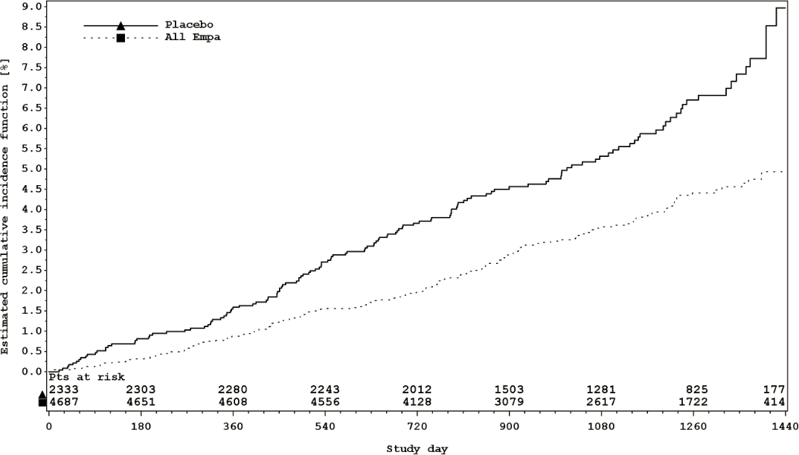

*Reductions in risk of heart failure requiring hospitalisation or CV death*

JARDIANCE significantly reduced the risk of hospitalisation for heart failure and cardiovascular death or hospitalisation for heart failure compared with placebo (Table 16 and Figure 2).

## Table 16 Treatment effect for hospitalisation for heart failure or cardiovascular death (excluding fatal stroke) (Treated Set*)

|  |  |  |
| --- | --- | --- |
|  | **Placebo** | **Empagliflozin\*\***  **(10 and 25 mg, pooled)** |
| N | 2333 | 4687 |
| **Heart failure requiring hospitalisation or CV death (excluding fatal stroke) N (%)\*\*\*** | 198 (8.5) | 265 (5.7) |
| HR (95% CI) |  | 0.66 (0.55, 0.79) |
| p−value |  | <0.0001 |
| **Heart failure requiring hospitalisation N (%)** | 95 (4.1) | 126 (2.7) |
| HR (95% CI) |  | 0.65 (0.50, 0.85) |
| p−value |  | 0.0017 |
| **CV death (excluding fatal stroke) N (%)** | 126 (5.4) | 156 (3.3) |
| HR (95% CI) |  | 0.61 (0.48, 0.77) |
| p−value |  | <0.0001 |

* i.e. patients who had received at least one dose of study drug

** empagliflozin 10 mg and 25 mg showed consistent results

*** time to first event

## Figure 2 Time to first occurrence of first heart failure hospitalisation or CV death*

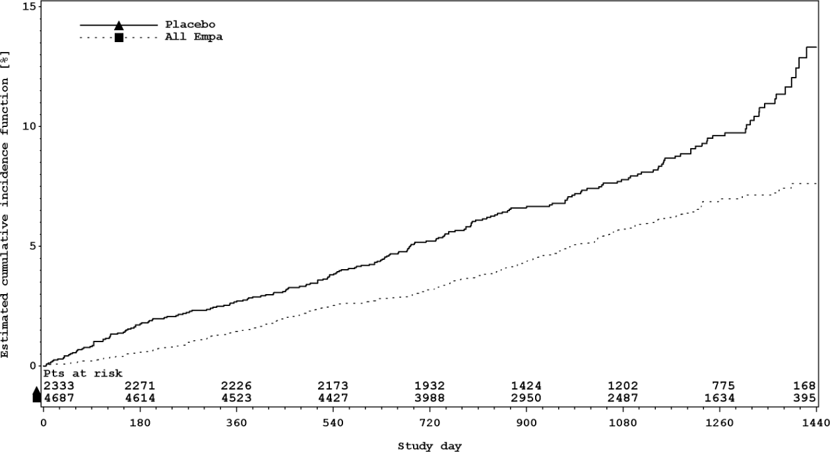

*Estimated cumulative incidence function for time to first occurrence of first heart failure hospitalisation or CV death, pooled empagliflozin vs placebo – treated set.

The cardiovascular benefits (CV death and hospitalisation for heart failure or CV death) of JARDIANCE observed were consistent across major demographic and disease subgroups.

*Diabetic kidney disease*

In the EMPA-REG OUTCOME study population, the risk of new or worsening nephropathy (defined as onset of macroalbuminuria, doubling of serum creatinine, and initiation of renal replacement therapy (i.e. haemodialysis)) was significantly reduced in empagliflozin group compared to placebo (Table 17 and Figure 3).

JARDIANCE compared with placebo showed a significantly higher occurrence of sustained normo- or microalbuminuria in patients with baseline macroalbuminuria (HR 1.82, 95% CI 1.40, 2.37).

## Table 17 Time to first new or worsening of nephropathy (Treated Set*)

|  |  |  |
| --- | --- | --- |
|  | **Placebo** | **Empagliflozin**  **(10 and 25 mg, pooled)** |
| N | 2061 | 4124 |
| **New or worsening nephropathy N (%)** | 388 (18.8) | 525 (12.7) |
| HR (95% CI) |  | 0.61 (0.53, 0.70) |
| p−value |  | <0.0001 |
| N | 2323 | 4645 |
| **Doubling of serum creatinine level** N (%)** | 60 (2.6) | 70 (1.5) |
| HR (95% CI) |  | 0.56 (0.39, 0.79) |
| p−value |  | 0.0009 |
| N | 2033 | 4091 |
| **New onset of macroalbuminuria*** N (%)** | 330 (16.2) | 459 (11.2) |
| HR (95% CI) |  | 0.62 (0.54, 0.72) |
| p−value |  | <0.0001 |
| N | 2333 | 4687 |
| **Initiation of continuous renal replacement therapy N (%)** | 14 (0.6) | 13 (0.3) |
| HR (95% CI) |  | 0.45 (0.21, 0.97) |
| p−value |  | 0.0409 |
| N | 2333 | 4687 |
| **Death due to renal disease N (%)\*\*\*\*** | 0 | 3 (0.1) |

* i.e. patients who had received at least one dose of study drug

** Accompanied by an eGFR ≤45 mL/min/1.73m2

*** Urine Albumin Creatinine Ratio >33.9 mg/mmol

**** Due to low event rate, HR not calculated

## Figure 3 Time to first new or worsening of nephropathy

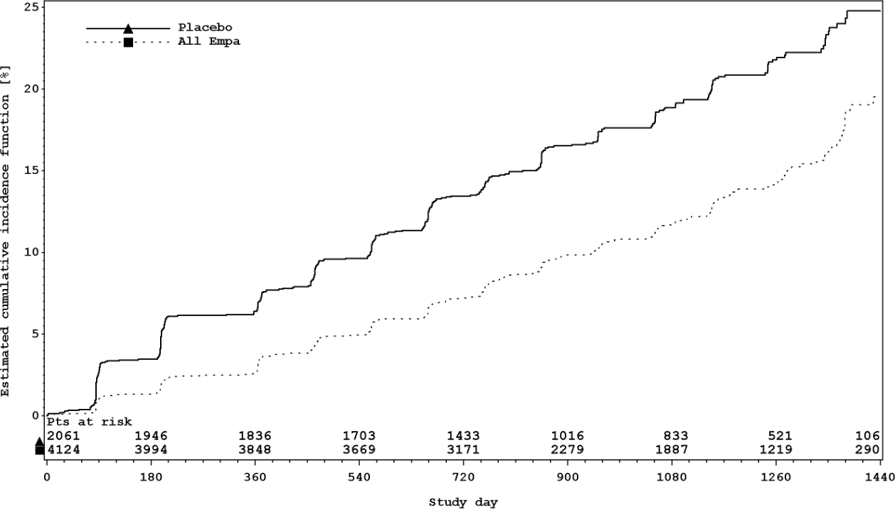

Treatment with empagliflozin preserved eGFR and eGFR increased during the post treatment 4-week follow up. However, the placebo group showed a gradual decline in GFR during the course of the study with no further change during 4-week follow up (see Figure 4).

## Figure 4 eGFR over time*

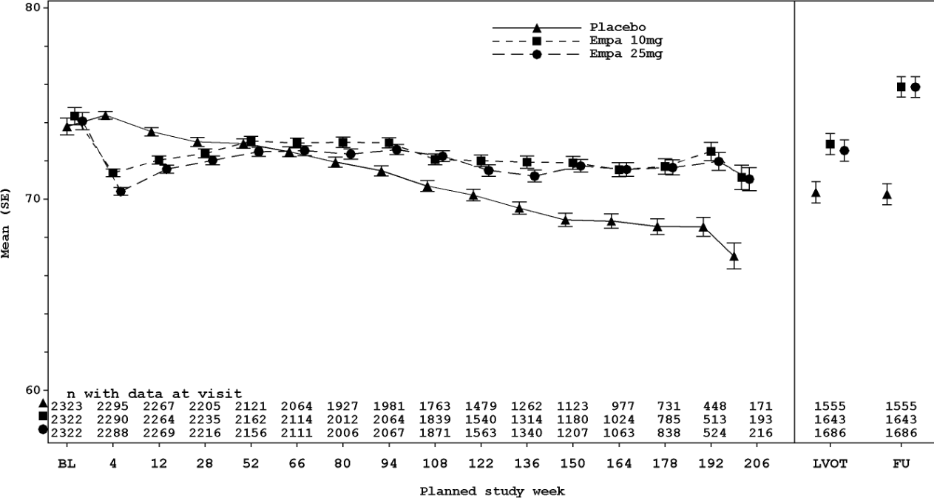

*eGFR (MDRD) (mL/min/1.73m2) MMRM results over time, unadjusted last value on treatment and follow-up value

- treated set – right side based on patients with available last value on treatment (LVOT) and follow-up (FU).

Thorough QTc study

In a randomised, placebo-controlled, active-comparator, crossover study of 30 healthy subjects no increase in QTc was observed with either 25 mg or 200 mg empagliflozin.

## Heart failure

Empagliflozin in patients with heart failure and reduced ejection fraction

A randomised, double-blind, placebo-controlled study (EMPEROR-Reduced) was conducted in 3730 patients with chronic heart failure (New York Heart Association [NYHA] II-IV) and reduced ejection fraction (LVEF ≤ 40 %) to evaluate the efficacy and safety of empagliflozin 10 mg once daily as adjunct to standard of care heart failure therapy. The primary endpoint was the time to adjudicated first event of either cardiovascular (CV) death or hospitalisation for heart failure (HHF). Occurrence of adjudicated HHF (first and recurrent), and eGFR (CKD- EPI)cr slope of change from baseline were included in the confirmatory testing. Heart Failure therapy at baseline included ACE inhibitors/angiotensin receptor blockers/angiotensin receptor-neprilysin inhibitor (88.3%), beta blockers (94.7%), mineralocorticoid receptor antagonists (71.3%) and diuretics (95.0%).

A total of 1863 patients were randomised to empagliflozin 10 mg (placebo: 1867) and followed for a median of 15.7 months. The study population consisted of 76.1% men and 23.9% women with a mean age of 66.8 years (range: 25-94 years), 26.8% were 75 years of age or older. 70.5% of the study population were White, 18.0% Asian and 6.9% Black/African American. At randomisation, 75.1% of patients were NYHA class II, 24.4% were class III and 0.5% were class IV. The mean LVEF was 27.5%. At baseline, the mean eGFR was 62.0 mL/min/1.73 m2 and the median urinary albumin to creatinine ratio (UACR) was 22 mg/g. About half of the patients (51.7%) had an eGFR of ≥60 mL/min/1.73 m2, 24.1% of 45 to <60 mL/min/1.73 m2, 18.6% of 30 to <45 mL/min/1.73 m2 and 5.3% 20 to <30 mL/min/1.73 m2.

Empagliflozin was superior in reducing the risk of the primary composite endpoint of cardiovascular death or hospitalisation for heart failure compared with placebo, primarily driven by hospitalisation for heart failure. Additionally, empagliflozin significantly reduced the

risk of occurrence of HHF (first and recurrent), and significantly reduced the rate of eGFR decline (see Table 18).

## Table 18 Treatment effect for the primary composite endpoint, its components and the two key secondary endpoints included in the pre-specified confirmatory testing

|  |  |  |
| --- | --- | --- |
|  | **Placebo** | **Empagliflozin 10 mg** |
| N | 1867 | 1863 |
| **Time to first event of CV death or HHF, N (%)** | 462 (24.7) | 361 (19.4) |
| Hazard ratio vs. placebo (95.04% CI)** |  | 0.75 (0.65, 0.86) |
| p−value for superiority |  | <0.0001 |
| **CV Death, N (%)\*** | 202 (10.8) | 187 (10.0) |
| Hazard ratio vs. placebo (95% CI) |  | 0.92 (0.75, 1.12) |
| p-value |  | 0.4113 |
| **HHF (first occurrence), N (%)\*** | 342 (18.3) | 246 (13.2) |
| Hazard ratio vs. placebo (95% CI) |  | 0.69 (0.59, 0.81) |
| p−value |  | <0.0001 |
| **HHF (first and recurrent), N of events** | 553 | 388 |
| Hazard ratio vs. placebo (95.04% CI)** |  | 0.70 (0.58, 0.85) |
| p−value |  | 0.0003 |
| **eGFR (CKD EPI)cr slope, Rate of decline (mL/min/1.73m2/year)** | -2.28 | -0.55 |
| Treatment difference vs. placebo (99.9% CI)*** |  | 1.73 (0.67, 2.80) |
| p-value |  | < 0.0001 |

CV = cardiovascular, HHF = hospitalisation for heart failure, eGFR = Estimated glomerular filtration rate, CKD EPI = Chronic kidney disease epidemiology collaboration equation

*not controlled for type 1 error

**Due to an interim analysis, a two-sided 95.04% confidence interval was applied which corresponds to a p-value less than 0.0496 for significance. CV death and HHF events were adjudicated by an independent clinical event committee and analysed based on the randomised set.

***As pre-specified in the statistical testing procedure, a two-sided 99.9% confidence interval was applied which corresponds to a p-value less than 0.001 for significance. eGFR slope was analysed based on the treated set.

## Figure 5 Time to first event of adjudicated CV death or HHF

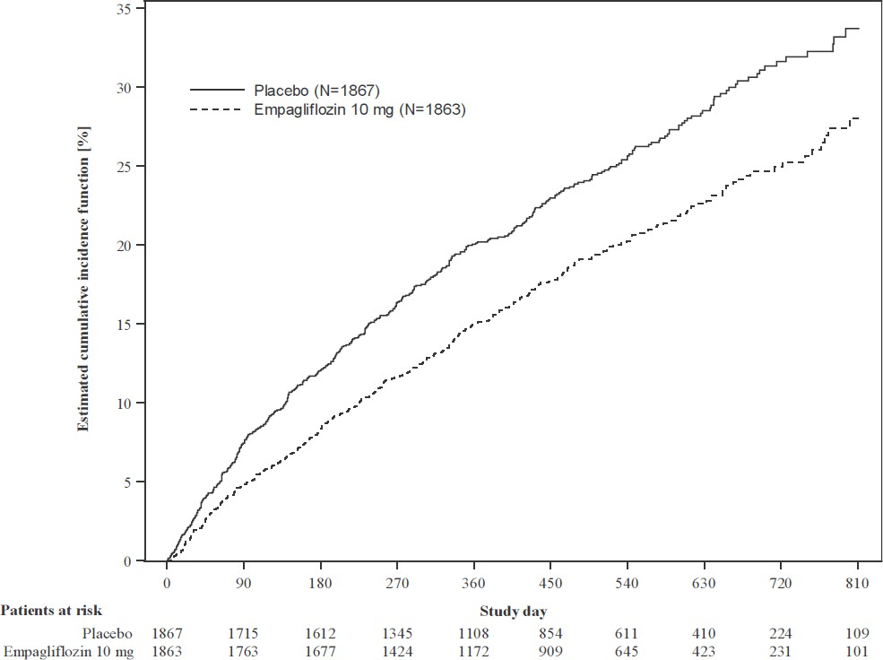

**Figure 6 Time to event of adjudicated HHF**

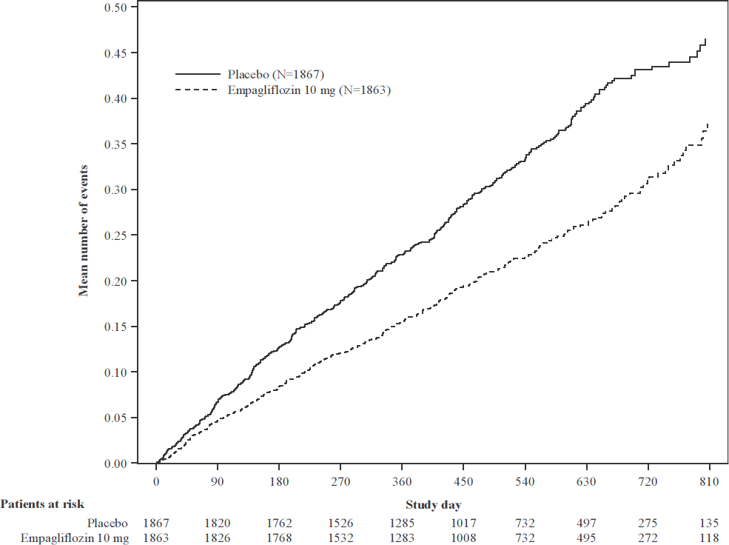

The results of the primary composite endpoint were generally consistent with a hazard ratio (HR) below 1 across the pre-specified subgroups, including heart failure patients with and without type 2 diabetes mellitus (see Figure 7).

## Figure 7 Subgroup analyses for the time to the first event of adjudicated of CV death or HHF

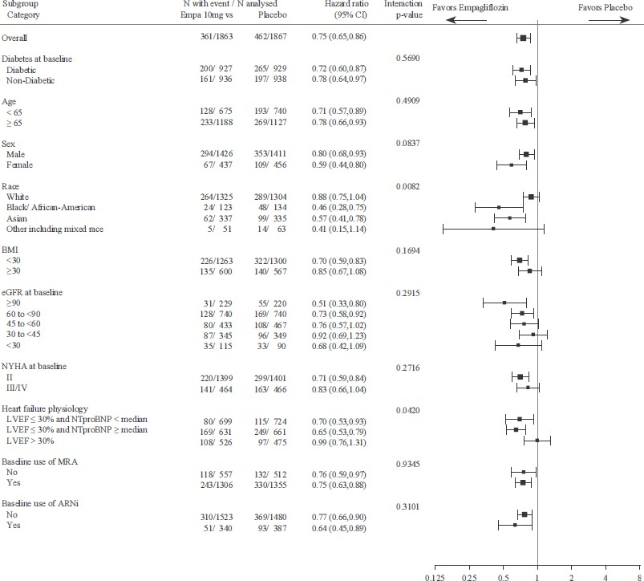

LVEF >30%: Includes both above and below the median NTproBNP. To be eligible for inclusion, patients with an LVEF >30% were required to meet a higher NTproBNP threshold than those with LVEF ≤30%, unless they additionally had a history of HHF within the past 12 months. Interaction p-values are nominal. The subgroup analyses were not adjusted for multiple testing.

*Renal Outcome*

During treatment, eGFR decline over time was slower in the empagliflozin group compared to the placebo group (see Figure 8). Treatment with empagliflozin 10 mg significantly reduced the rate of eGFR decline. Patients treated with empagliflozin experienced an initial drop in eGFR which returned towards baseline after treatment discontinuation.

## Figure 8 Change in eGFR over time*

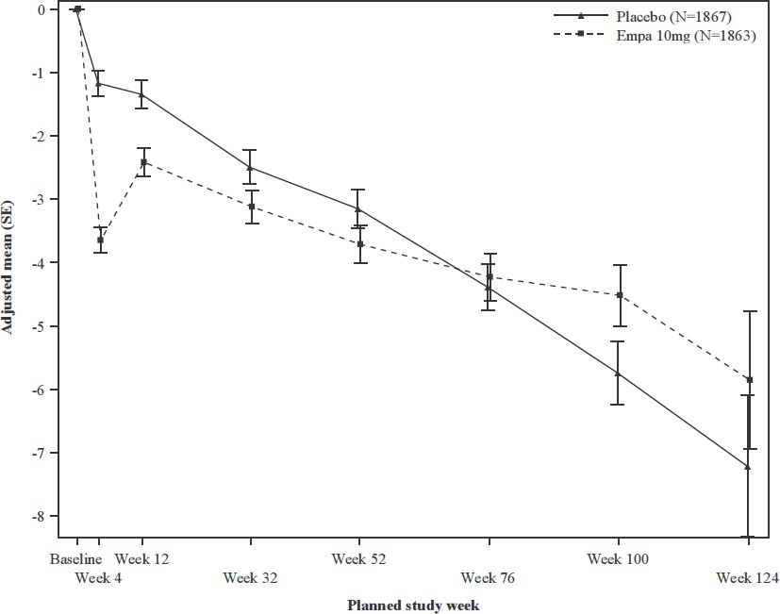

*eGFR (CKD-EPI) (mL/min/1.73m2) MMRM results over time - randomised set. The number of patients who provided data at various time points (placebo, empagliflozin): at week 4 (1788, 1802); at week 12 (1729, 1756); at week 32 (1563, 1614); at week

52 (1211, 1228); at week 76 (801, 805); at week 100 (359, 386); and at week 124 (86, 91).

Empagliflozin in patients with heart failure and an ejection fraction >40%

A randomised, double-blind, placebo-controlled study (EMPEROR-Preserved) was conducted in 5988 patients with chronic heart failure of at least 3 months duration (NYHA II-IV) who are currently stable and have an ejection fraction >40% to evaluate the efficacy and safety of empagliflozin 10 mg once daily as adjunct to standard of care therapy. The primary endpoint was the time to adjudicated first event of either cardiovascular (CV) death or hospitalisation for heart failure (HHF). The secondary endpoints occurrence of adjudicated HHF (first and recurrent), and eGFR(CKD-EPI)cr slope of change from baseline were included in the confirmatory testing. Overall, baseline therapy included ACE inhibitors/angiotensin receptor blockers/angiotensin receptor-neprilysin inhibitor (80.7%), beta blockers (86.3%), mineralocorticoid receptor antagonists (37.5%) and diuretics (86.2%).

A total of 2997 patients were randomised to empagliflozin 10 mg (placebo: 2991) and followed for a median of 26.2 months. The study population consisted of 55.3% men and 44.7% women with a mean age of 71.9 years (range: 22-100 years), 43.0% were 75 years of age or older. 75.9% of the study population were White, 13.8% Asian and 4.3% Black/African American. At randomisation, 81.5% of patients were NYHA class II, 18.1% were class III and 0.3% were class IV. The EMPEROR-Preserved study population included patients with a LVEF <50% (33.1%), with a LVEF 50 to <60% (34.4%) and a LVEF ≥60% (32.5%). At baseline, the mean eGFR was 60.6 mL/min/1.73 m2 and the median urinary albumin to creatinine ratio (UACR) was 21 mg/g. About half of the patients (50.1%) had an eGFR of ≥60 mL/min/1.73 m2, 26.1% of 45 to <60 mL/min/1.73 m2, 18.6% of 30 to <45 mL/min/1.73 m2 and 4.9% 20 to <30 mL/min/1.73 m2. About half of the patients (49.1%) had diabetes at baseline, of whom almost all had type 2 diabetes (10 patients had type 1 diabetes). 33.1% had pre-diabetes (HbA1c

≥5.7% and <6.5%). At baseline, 51.1% of the patients had a history of atrial fibrillation. The most common causes of HF were hypertension (36.5% of patients) and ischaemia (35.4%).

Patients with infiltration diseases (e.g. amyloidosis), accumulation diseases (e.g. haemochromatosis), muscular dystrophies, pericardial constriction, hypertrophic obstructive cardiomyopathy or severe valvular disease with surgery expected were excluded from the trial.

Empagliflozin was superior in reducing the risk of the primary composite endpoint of cardiovascular death or hospitalisation for heart failure (primarily driven by hospitalisation for heart failure) compared with placebo. Additionally, empagliflozin significantly reduced the risk of occurrence of HHF (first and recurrent), and significantly reduced the rate of eGFR decline (see Table 19).

## Table 19 Treatment effect for the primary composite endpoint, its components and the two key secondary endpoints included in the pre-specified confirmatory testing

|  |  |  |
| --- | --- | --- |
|  | **Placebo** | **Empagliflozin 10 mg** |
| N | 2991 | 2997 |
| **Time to first event of CV death or HHF, N (%)** | 511 (17.1) | 415 (13.8) |
| Hazard ratio vs placebo (95.03% CI)** |  | 0.79 (0.69, 0.90) |
| p-value for superiority |  | 0.0003 |
| **CV Death, N (%)\*** | 244 (8.2) | 219 (7.3) |
| Hazard ratio vs. placebo (95% CI) |  | 0.91 (0.76, 1.09) |
| p-value |  | 0.2951 |
| **HHF (first occurrence), N (%)\*** | 352 (11.8) | 259 (8.6) |
| Hazard ratio vs. placebo (95% CI) |  | 0.71 (0.60, 0.83) |
| p-value |  | <0.0001 |
| **HHF (first and recurrent), N of events** | 541 | 407 |
| Hazard ratio vs. placebo (95.03% CI)** |  | 0.73 (0.61, 0.88) |
| p-value |  | 0.0009 |
| **eGFR (CKD EPI)cr slope, Rate of decline (mL/min/1.73 m2/year)** | –2.62 | –1.25 |
| Treatment difference vs. placebo (99.9% CI)*** |  | 1.36 (0.86, 1.87) |
| p-value |  | <0.0001 |

CV = cardiovascular, HHF = hospitalisation for heart failure, eGFR = Estimated glomerular filtration rate, CKD EPI = Chronic kidney disease epidemiology collaboration equation

*not controlled for type 1 error

**Due to an interim analysis, a two-sided 95.03% confidence interval was applied which corresponds to a p-value less than 0.0497 for significance. CV death and HHF events were adjudicated by an independent clinical event committee and analysed based on the randomised set.

***As pre-specified in the statistical testing procedure, a two-sided 99.9% confidence interval was applied which corresponds to a p-value less than 0.001 for significance. eGFR slope was analysed based on the treated set.

## Figure 9 Time to first event of adjudicated CV death or HHF

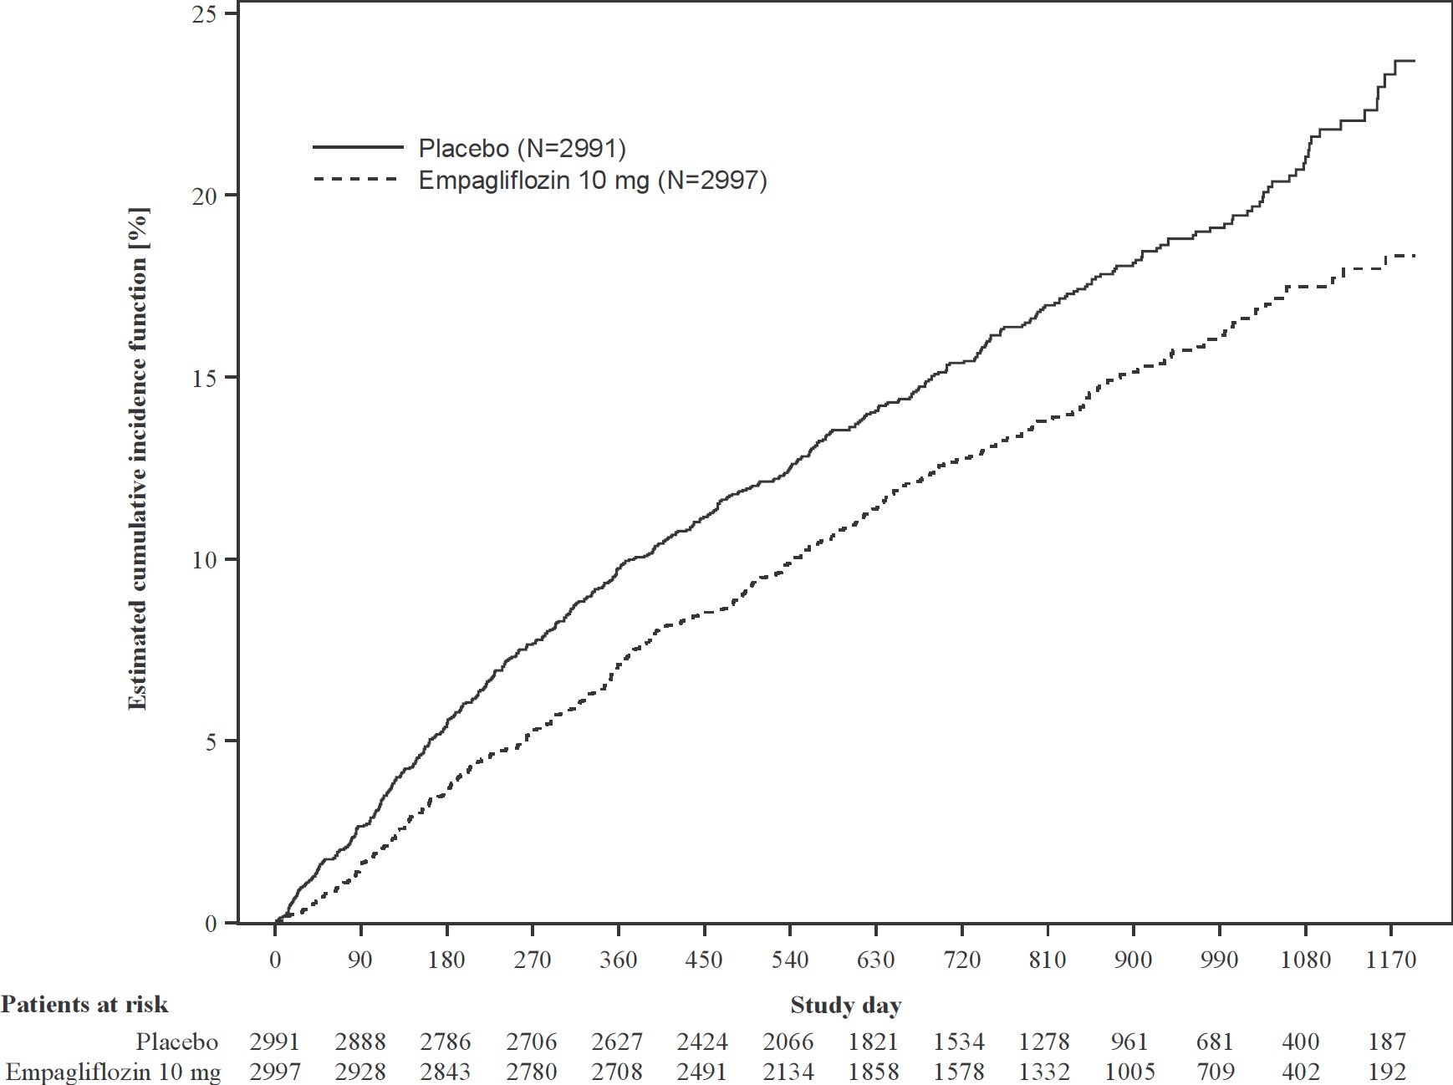

**Figure 10 Time to event of adjudicated HHF**

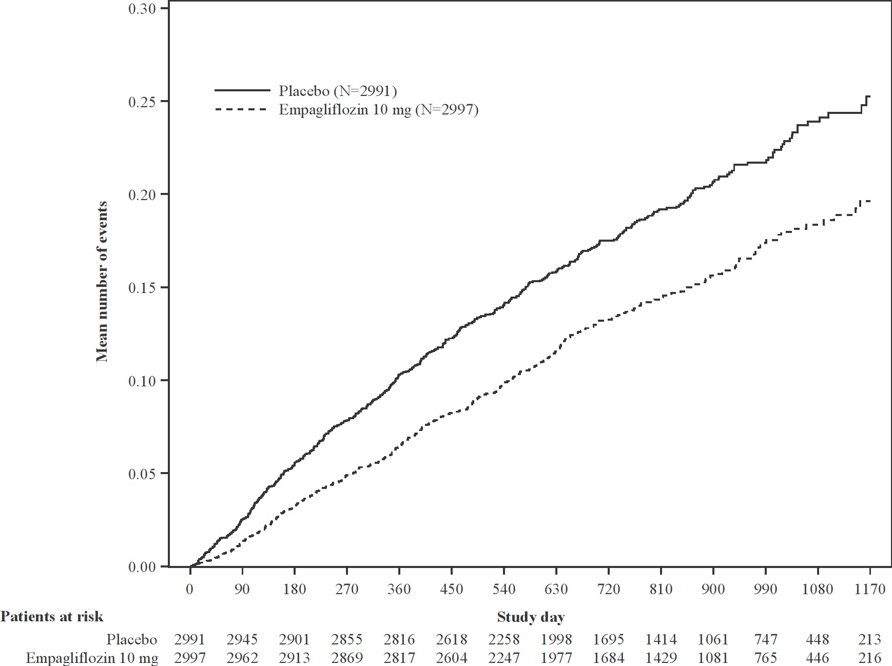

The results of the primary composite endpoint were consistent across each of the pre-specified subgroups categorised by e.g., LVEF, diabetes status or renal function down to an eGFR of 20 mL/min/1.73 m2 (see Figure 11).

## Figure 11 Subgroup analyses for the time to the first event of adjudicated CV death or HHF

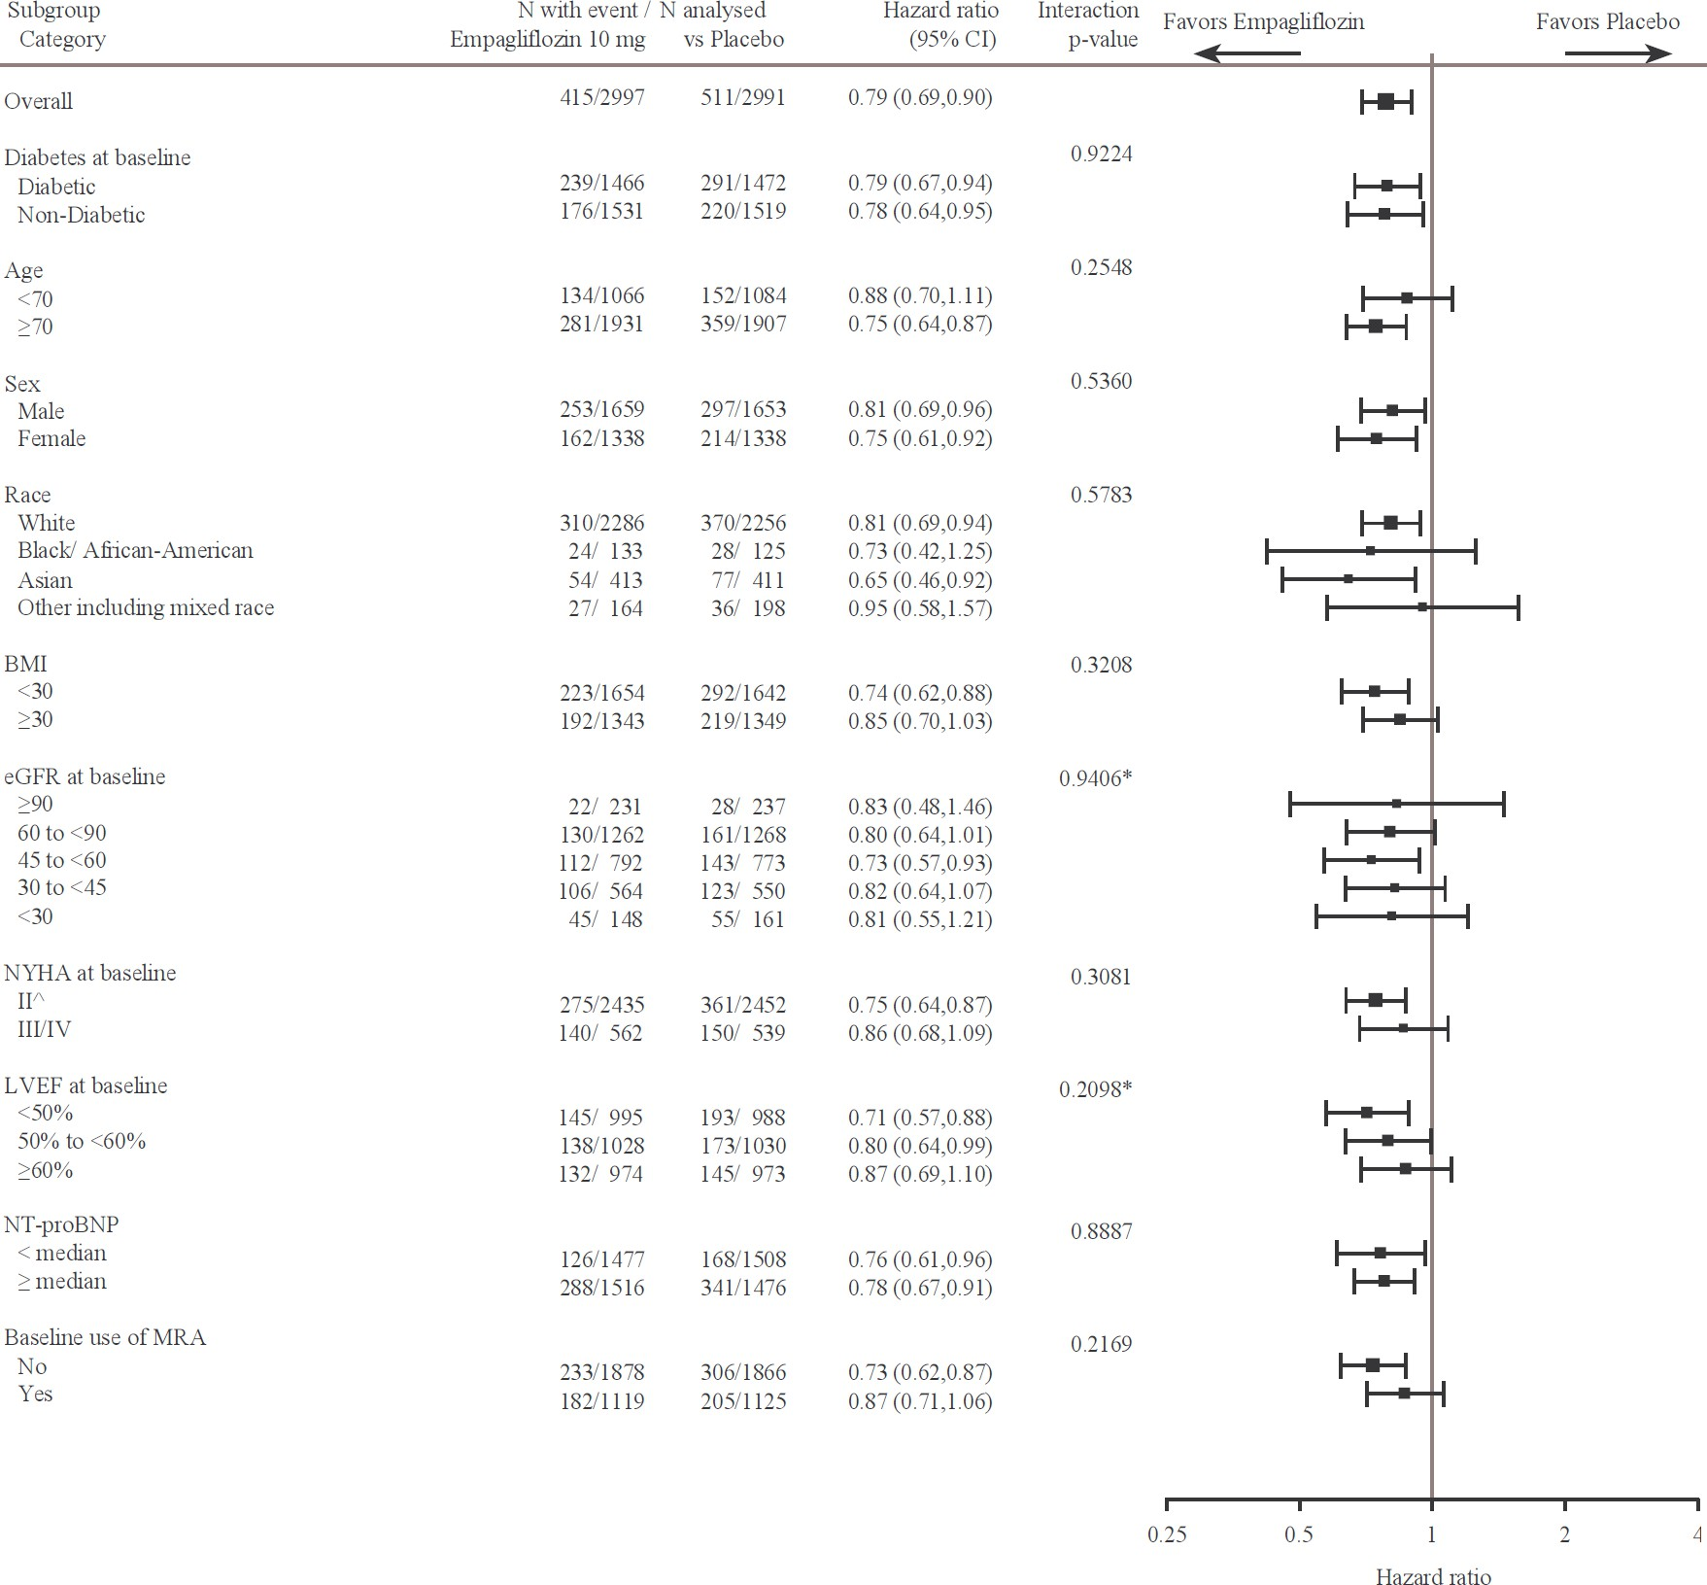

^4 patients with NYHA class I are counted in subgroup NYHA class II

*trend test

*Renal Outcome*

During treatment, eGFR decline over time was slower in the empagliflozin group compared to the placebo group (see Figure 12). Treatment with empagliflozin 10 mg significantly reduced the rate of eGFR decline. Patients treated with empagliflozin experienced an initial drop in eGFR which returned towards baseline after treatment discontinuation.

## Figure 12 Change in eGFR over time*

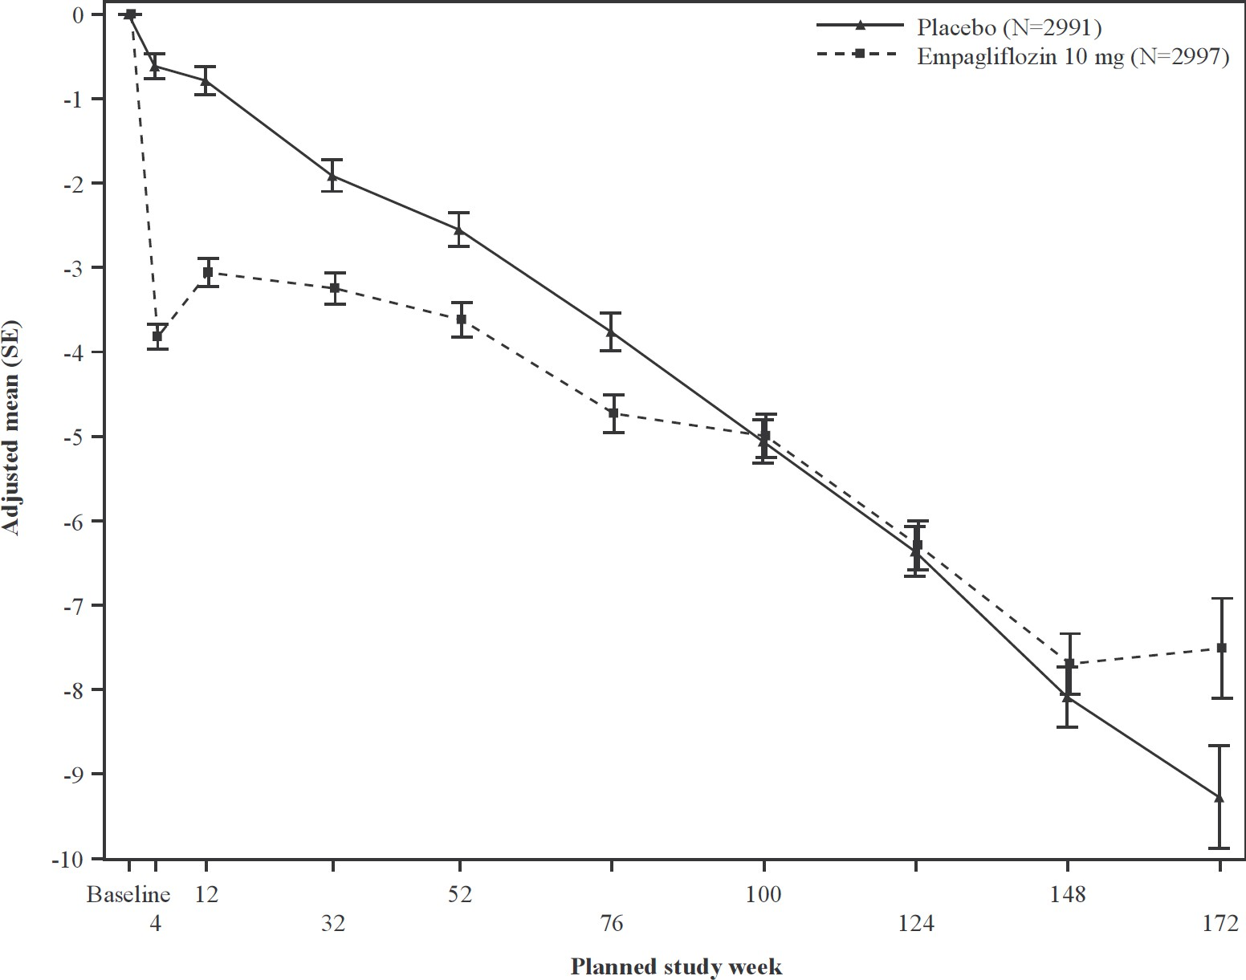

*eGFR (CKD-EPI) (mL/min/1.73 m2) MMRM results over time - randomised set. The number of patients who provided data at various time points (placebo, empagliflozin): at week 4 (2910, 2931); at week 12 (2820, 2854); at week 32 (2590, 2629); at week

52 (2457, 2474); at week 76 (2123, 2114); at week 100 (1548, 1550); at week 124 (1091, 1122), at week 148 (695, 686), at week

172 (231, 243) and at week 196 (16, 23).

## Chronic kidney disease

A randomised, double-blind, placebo-controlled study of empagliflozin 10 mg once daily (EMPA-KIDNEY) was conducted in 6609 patients with chronic kidney disease (eGFR ≥20 -

<45 mL/min/1.73 m2; or eGFR ≥45 - <90 mL/min/1.73 m2 with a urine albumin-to-creatinine ratio [UACR] ≥200 mg/g*)* to assess cardio-renal outcomes as adjunct to standard of care therapy. This trial excluded patients with polycystic kidney disease, or receiving maintenance dialysis, or patients who had received a kidney transplant.

The primary endpoint was the time to first occurrence of kidney disease progression (sustained

≥40% eGFR decline from randomisation, sustained eGFR <10 mL/min/1.73 m2, end-stage kidney disease, or renal death) or CV death. All-cause hospitalisation (first and recurrent), first occurrence of hospitalisation for heart failure or CV death, and all-cause mortality were included in the confirmatory testing. Baseline therapy included an appropriate use of a RAS- inhibitor (85.2% ACE inhibitor or angiotensin receptor blocker).

A total of 3304 patients were randomised to empagliflozin 10 mg (placebo: 3305) and followed for a median of 24.3 months. The study population consisted of 66.8% men and 33.2% women with a mean age of 63.3 years (range: 18-94 years), 23.0% were 75 years of age or older. 58.4% of the study population were White, 36.2% Asian and 4.0% Black/ African American.

At baseline, the mean eGFR was 37.3 mL/min/1.73 m2, 21.2% patients had an eGFR of

≥45 mL/min/1.73 m2, 44.3% of 30 to <45 mL/min/1.73 m2 and 34.5% <30 mL/min/1.73 m2

including 254 patients with an eGFR <20 mL/min/1.73 m2. The median UACR was 329 mg/g, 20.1% patients had an UACR <30 mg/g, 28.2% had an UACR 30 to ≤300 mg/g and 51.7% had an UACR >300 mg/g; 41.1% of patients had an UACR <200 mg/g. Primary causes of chronic kidney disease were diabetic nephropathy/diabetic kidney disease (31%), glomerular disease (25%), hypertensive/renovascular disease (22%) and other/unknown (22%).

Empagliflozin was superior in reducing the risk of the primary composite endpoint of kidney disease progression or CV death compared with placebo (see Table 20). Additionally, empagliflozin significantly reduced the risk of all-cause hospitalisation (first and recurrent).

## Table 20 Treatment effect for the primary composite and key secondary endpoints included in the pre-specified confirmatory testing and its components

|  |  |  |
| --- | --- | --- |
|  | **Placebo** | **Empagliflozin 10 mg** |
| N | 3305 | 3304 |
| **Time to first occurrence of kidney disease progression (sustained ≥40% eGFR decline from randomisation, sustained eGFR <10 mL/min/1.73 m2, end-stage kidney disease* (ESKD), or renal death) or CV death, N (%)** | 558 (16.9) | 432 (13.1) |
| Hazard ratio vs. placebo (99.83% CI) |  | 0.72 (0.59, 0.89) |
| p−value for superiority |  | <0.0001 |
| **Sustained ≥40% eGFR decline from randomisation, N**  **(%)** | 474 (14.3) | 359 (10.9) |
| Hazard ratio vs. placebo (95% CI) |  | 0.70 (0.61, 0.81) |
| p-value |  | <0.0001 |
| **ESKD*or sustained eGFR <10 mL/min/1.73 m2, N (%)** | 221 (6.7) | 157 (4.8) |
| Hazard ratio vs. placebo (95% CI) |  | 0.69 (0.56, 0.84) |
| p-value |  | 0.0003 |
| **Renal death, N (%)\*\*** | 4 (0.1) | 4 (0.1) |
| Hazard ratio vs. placebo (95% CI) |  |  |
| p-value |  |  |
| **CV Death, N (%)** | 69 (2.1) | 59 (1.8) |
| Hazard ratio vs. placebo (95% CI) |  | 0.84 (0.60, 1.19) |
| p-value |  | 0.3366 |
| **Occurrence of all-cause hospitalisation (first and recurrent), N of events** | 1895 | 1611 |
| Hazard ratio vs. placebo (99.03% CI) |  | 0.86 (0.75, 0.98) |
| p-value |  | 0.0025 |
| **Time to first occurrence of HHF or CV death, N (%)** | 152 (4.6) | 131 (4.0) |
| Hazard ratio vs. placebo (98.55% CI) |  | 0.84 (0.63, 1.13) |
| p−value |  | 0.1530 |
| **Time to all-cause mortality N (%)** | 167 (5.1) | 148 (4.5) |
| Hazard ratio vs. placebo (97.1% CI) |  | 0.87 (0.68, 1.11) |
| p-value |  | 0.2137 |

CV = cardiovascular, HHF = hospitalisation for heart failure, eGFR = estimated glomerular filtration rate

* End-stage kidney disease (ESKD) is defined as the initiation of maintenance dialysis or receipt of a kidney transplant.

** There were too few events of renal death to compute a reliable hazard ratio.

## Figure 13 Time to first event of kidney disease progression or adjudicated CV death, estimated cumulative incidence function

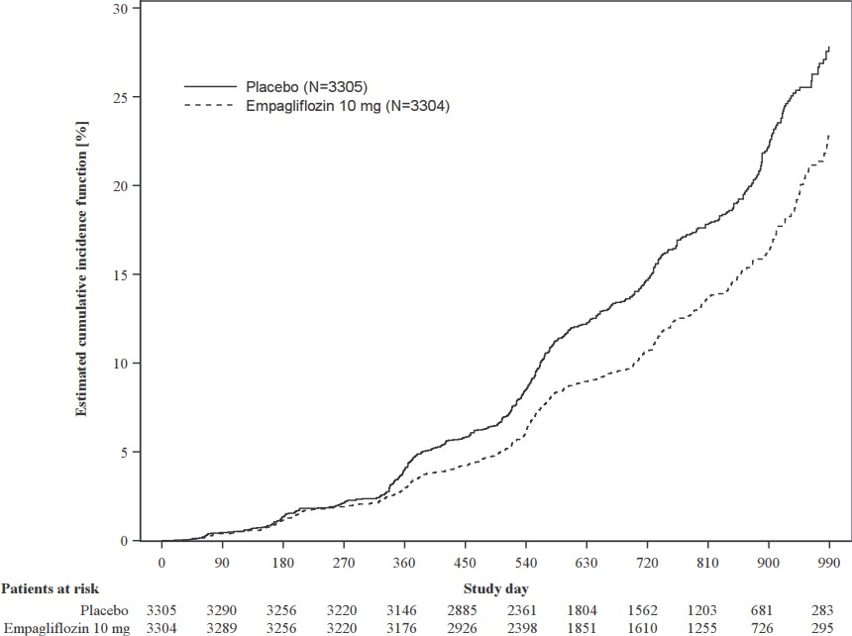

**Figure 14 Occurrence of all-cause hospitalisation (first and recurrent), mean cumulative function**

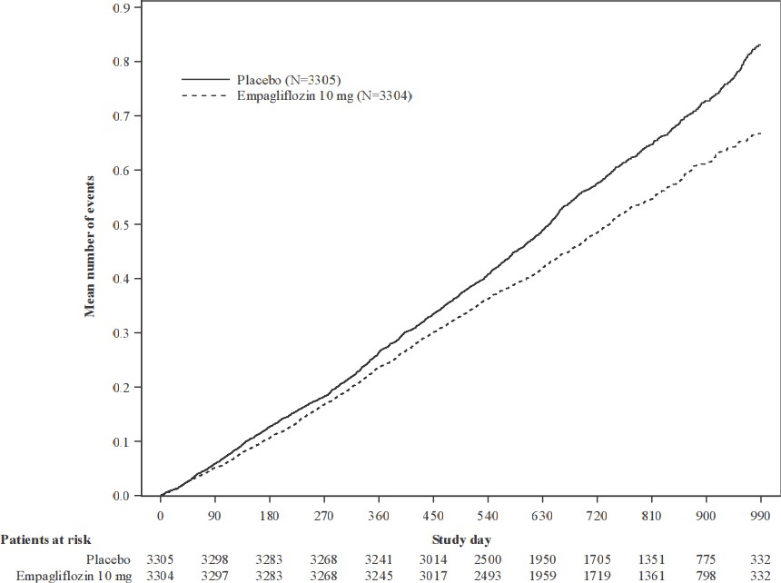

The results of the primary composite endpoint were generally consistent across the pre- specified subgroups, including eGFR categories, underlying cause of renal disease, diabetes status, or background use of RAS inhibitors. Treatment benefits were more clearly evident in patients with higher levels of albuminuria.

Empagliflozin slowed the annual rate of eGFR decline compared to placebo by

1.37 mL/min/1.73 m2/year (95% CI 1.16, 1.59), based on a pre-specified analysis of all eGFR measurements taken from the 2-month visit to the final follow-up visit. Patients treated with empagliflozin experienced an initial drop in eGFR which returned towards baseline after treatment discontinuation as demonstrated in several of the empagliflozin studies, supporting that haemodynamic changes play a role in the acute effects of empagliflozin on eGFR.

# PHARMACOKINETIC PROPERTIES

## Absorption

The pharmacokinetics of empagliflozin have been extensively characterised in healthy volunteers and patients with T2DM. After oral administration, empagliflozin was rapidly absorbed with peak plasma concentrations (Cmax) with a median time to reach Cmax (tmax) of

1.5 h post-dose. Thereafter, plasma concentrations declined in a biphasic manner with a rapid distribution phase and a relatively slow terminal phase. The steady state mean plasma area under the curve (AUC) was 4740 nmol·h/L and Cmax was 687 nmol/L with 25 mg empagliflozin once daily. Systemic exposure of empagliflozin increased in a dose-proportional manner. The single-dose and steady-state pharmacokinetics parameters of empagliflozin were similar suggesting linear pharmacokinetics with respect to time. There were no clinically relevant differences in empagliflozin pharmacokinetics between healthy volunteers and patients with T2DM.

Administration of 25 mg empagliflozin after intake of a high-fat and high calorie meal resulted in slightly lower exposure; AUC decreased by approximately 16% and Cmax decreased by approximately 37%, compared to fasted condition. The observed effect of food on empagliflozin pharmacokinetics was not considered clinically relevant and empagliflozin may be administered with or without food.

## Distribution

The apparent steady-state volume of distribution was estimated to be 73.8 L, based on a population pharmacokinetic analysis. Following administration of an oral [14C]-empagliflozin solution to healthy subjects, the red blood cell partitioning was approximately 36.8% and plasma protein binding was 86.2%.

## Metabolism

No major metabolites of empagliflozin were detected in human plasma and the most abundant metabolites were three glucuronide conjugates (2-O-, 3-O-, and 6-O-glucuronide). Systemic exposure of each metabolite was less than 10% of total drug-related material. *In vitro* studies suggested that the primary route of metabolism of empagliflozin in humans is glucuronidation by the uridine 5'-diphospho-glucuronosyltransferases UGT2B7, UGT1A3, UGT1A8, and UGT1A9.

## Excretion

The apparent terminal elimination half-life of empagliflozin was estimated to be 12.4 h and apparent oral clearance was 10.6 L/h based on the population pharmacokinetic analysis. The inter-subject and residual variabilities for empagliflozin oral clearance were 39.1% and 35.8%, respectively. With once-daily dosing, steady-state plasma concentrations of empagliflozin were reached by the fifth dose. Consistent with half-life, up to 22% accumulation, with respect to plasma AUC, was observed at steady-state. Following administration of an oral [14C]- empagliflozin solution to healthy subjects, approximately 95.6% of the drug related radioactivity was eliminated in faeces (41.2%) or urine (54.4%). The majority of drug related radioactivity recovered in faeces was unchanged parent drug and approximately half of drug related radioactivity excreted in urine was unchanged parent drug.

## Pharmacokinetics in special patient groups

Pharmacokinetics in children

Studies characterising the pharmacokinetics of empagliflozin in paediatric patients have not been performed.

Pharmacokinetics in the elderly

Age did not have a clinically meaningful impact on the pharmacokinetics of empagliflozin based on the population pharmacokinetic analysis.

Pharmacokinetics in patients with renal impairment

In patients with mild (eGFR: 60 - <90 mL/min/1.73m2), moderate (eGFR: 30 - <60 mL/min/1.73m2), severe (eGFR: <30 mL/min/1.73m2) renal impairment and patients with kidney failure/end stage kidney disease (ESKD) patients, AUC of empagliflozin increased by approximately 18%, 20%, 66%, and 48%, respectively, compared to subjects with normal renal function. Peak plasma levels of empagliflozin were similar in subjects with moderate renal impairment and kidney failure/ESKD compared to patients with normal renal function. Peak plasma levels of empagliflozin were roughly 20% higher in subjects with mild and severe renal impairment as compared to subjects with normal renal function. In line with the Phase I study, the population pharmacokinetic analysis showed that the apparent oral clearance of empagliflozin decreased with a decrease in eGFR leading to an increase in drug exposure.

Based on pharmacokinetics, no dosage adjustment is recommended in patients with renal insufficiency.

Pharmacokinetics in patients with hepatic impairment

In subjects with mild, moderate, and severe hepatic impairment according to the Child-Pugh classification, AUC of empagliflozin increased approximately by 23%, 47%, and 75% and Cmax by approximately 4%, 23%, and 48%, respectively, compared to subjects with normal hepatic function. Based on pharmacokinetics, no dosage adjustment is recommended in patients with hepatic impairment.

Body Mass Index (BMI)

No dosage adjustment is necessary based on BMI. Body mass index had no clinically relevant effect on the pharmacokinetics of empagliflozin based on the population pharmacokinetic analysis.

Gender

No dosage adjustment is necessary based on gender. Gender had no clinically relevant effect on the pharmacokinetics of empagliflozin based on the population pharmacokinetic analysis.

Race

No dosage adjustment is necessary based on race. Based on the population pharmacokinetic analysis, AUC was estimated to be 13.5% higher in Asian patients with a BMI of 25 kg/m2 compared to non-Asian patients with a BMI of 25 kg/m2.

# PRECLINICAL SAFETY DATA

## Genotoxicity

Empagliflozin was not mutagenic or clastogenic in a battery of genotoxicity studies, including the Ames bacterial mutagenicity assay (bacterial reverse mutation), *in vitro* mouse lymphoma tk assays and *in vivo* rat bone marrow micronucleus assays.

## Carcinogenicity

Two-year oral carcinogenicity studies were conducted in mice and rats. There was an increase in renal adenomas and carcinomas in male mice given empagliflozin at 1000 mg/kg/day. No renal tumours were seen at 300 mg/kg/day (11- and 28-times the exposure at the clinical dose of 25 mg and 10 mg, respectively). These tumours are likely associated with a metabolic pathway not present in humans, and are considered to be irrelevant to patients given 10 or 25 mg empagliflozin. No drug-related tumours were seen in female mice or female rates at doses up to 1000 and 700 mg/kg/day, respectively, resulting in exposures at least 60 times that expected at the clinical dose of 10 or 25 mg empagliflozin. In male rats, treatment-related benign vascular proliferative lesions (haemangiomas) of the mesenteric lymph node, were observed at 700 mg/kg/day, but not at 300 mg/kg/day (approximately 26- and 65-times the exposure at the clinical does of 25 mg and 10 mg, respectively). These tumours are common in rats and are unlikely to be relevant to humans.

# PHARMACEUTICAL PARTICULARS

* 1. **LIST OF EXCIPIENTS**

Tablet core:

lactose monohydrate microcrystalline cellulose hyprolose

croscarmellose sodium colloidal anhydrous silica magnesium stearate.

Tablet coating:

hypromellose titanium dioxide purified talc macrogol 400 iron oxide yellow.

# INCOMPATIBILITIES

Incompatibilities were either not assessed or not identified as part of the registration of this medicine.

# SHELF LIFE

In Australia, information on the shelf life can be found on the public summary of the Australian Register of Therapeutic Goods (ARTG). The expiry date can be found on the packaging.

# SPECIAL PRECAUTIONS FOR STORAGE

Store below 30°C.

# NATURE AND CONTENTS OF CONTAINER

JARDIANCE 10 mg is available in PVC / Aluminium blister packs containing 10 (sample) and 30 tablets.

JARDIANCE 25 mg is available in PVC / Aluminium blister packs containing 10 (sample) and 30 tablets.

# SPECIAL PRECAUTIONS FOR DISPOSAL

In Australia, any unused medicine or waste material should be disposed of by taking to your local pharmacy.

# PHYSICOCHEMICAL PROPERTIES

## Chemical Structure

Empagliflozin is a white to yellowish powder. It is very slightly soluble in water, slightly soluble in acetonitrile and ethanol, sparingly soluble in methanol and practically insoluble in toluene. Empagliflozin is not hygroscopic and no polymorphism has been observed. It is neither a hydrate nor a solvate. Partition coefficient: log P = log D (pH 7.4): 1.7.

Chemical name: (1S)-1,5-anhydro-1-(4-chloro-3-{4-[(3S)-tetrahydrofuran-3- yloxy]benzyl}phenyl)-D-glucitol

Molecular formula: C23H27ClO7 Molecular weight: 450.91

Structural formula:

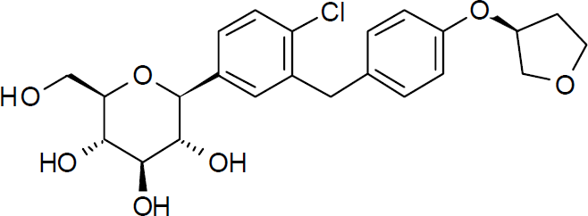

## CAS number

864070-44-0

# MEDICINE SCHEDULE (POISONS STANDARD)

S4 – Prescription Only Medicine

# SPONSOR

Boehringer Ingelheim Pty Limited ABN 52 000 452 308

78 Waterloo Road North Ryde NSW 2113

[www.boehringer-ingelheim.com.au](http://www.boehringer-ingelheim.com.au/)

# DATE OF FIRST APPROVAL

30 April 2014

# DATE OF REVISION

DRAFT

**SUMMARY TABLE OF CHANGES**

|  |  |
| --- | --- |
| **Section changed** | **Summary of new information** |
| 4.1 | Addition of new indication - chronic kidney disease (CKD) |
| 4.2 | Addition of dosing recommendation for CKD indication; Revision of  information concerning treatment of patients with renal impairment based on EMPA-KIDNEY trial |
| 4.3 | Removal of eGFR contraindication based on EMPA-KIDNEY trial |
| 4.4 | Revision of information concerning treatment of patients with renal impairment based on EMPA-KIDNEY trial |
| 4.8 | Addition of EMPA-KIDNEY trial safety data |
| 5.1 | Addition of EMPA-KIDNEY trial data; Update mode of action to include proposed mechanism for CKD |
| 5.2 | Removal of eGFR contraindication based on EMPA-KIDNEY trial |