|  |
| --- |
| Australian Public Assessment Report for Koselugo |
| Active ingredient/s: Selumetinib |
| Sponsor: Alexion Pharmaceuticals, Inc. |
| August 2024 |

About the Therapeutic Goods Administration (TGA)

* The Therapeutic Goods Administration (TGA) is part of the Australian Government Department of Health and Aged Care and is responsible for regulating therapeutic goods, including medicines, medical devices, and biologicals.
* The TGA administers the *Therapeutic Goods Act 1989* (the Act), applying a risk management approach designed to ensure therapeutic goods supplied in Australia meet acceptable standards of quality, safety, and efficacy.
* The work of the TGA is based on applying scientific and clinical expertise to decision-making, to ensure that the benefits to the Australian public outweigh any risks associated with the use of therapeutic goods.
* The TGA relies on the public, healthcare professionals and industry to report problems with therapeutic goods. The TGA investigates reports received to determine any necessary regulatory action.
* To report a problem with a therapeutic good, please see the information on the [TGA website](https://www.tga.gov.au/).

About AusPARs

* The Australian Public Assessment Report (AusPAR) provides information about the evaluation of a prescription medicine and the considerations that led the TGA to approve or not approve a prescription medicine submission. Further information can be found in [Australian Public Assessment Report (AusPAR) guidance](https://www.tga.gov.au/australian-public-assessment-report-auspar-guidance).
* AusPARs are prepared and published by the TGA.
* AusPARs are static documents that provide information that relates to a submission at a particular point in time. The publication of an AusPAR is an important part of the transparency of the TGA’s decision-making process.
* A new AusPAR may be provided to reflect changes to indications or major variations to a prescription medicine subject to evaluation by the TGA.

Copyright

© Commonwealth of Australia 2024  
This work is copyright. You may reproduce the whole or part of this work in unaltered form for your own personal use or, if you are part of an organisation, for internal use within your organisation, but only if you or your organisation do not use the reproduction for any commercial purpose and retain this copyright notice and all disclaimer notices as part of that reproduction. Apart from rights to use as permitted by the *Copyright Act 1968* or allowed by this copyright notice, all other rights are reserved and you are not allowed to reproduce the whole or any part of this work in any way (electronic or otherwise) without first being given specific written permission from the Commonwealth to do so. Requests and inquiries concerning reproduction and rights are to be sent to the TGA Copyright Officer, Therapeutic Goods Administration, PO Box 100, Woden ACT 2606 or emailed to <[tga.copyright@tga.gov.au](mailto:tga.copyright@tga.gov.au)>.

Contents

List of abbreviations 4

Background and proposed indications 7

Registration decision 7

Neurofibromatosis type 1 (NF1) 7

Current treatment options 8

Nonclinical (toxicology) evaluation summary 9

Clinical evaluation summary 10

Pharmacology 10

Efficacy 15

Safety 24

Risk management plan 35

Risk-benefit analysis 37

Delegate’s considerations 37

Proposed action 39

Advisory Committee on Medicines considerations 39

Registration decision 40

Product submission 40

Submission details 40

Specific conditions of registration 41

Product Information (PI) and Consumer Medicine Information (CMI) 42

Regulatory status 42

Australian regulatory status 42

International regulatory status 43

Assessment and registration timeline 44

Attachment 1. Product Information 44

## List of abbreviations

|  |  |
| --- | --- |
| Abbreviation | Meaning |
| ACM | Advisory Committee of Medicines |
| AE | Adverse event |
| ARTG | Australian Register of Therapeutic Goods |
| ASA | Australia specific annex |
| AUC | Area under the concentration time curve |
| AUC0-12h | Area under the plasma concentration time curve from time 0 to 12 hours |
| BA | Bioavailability |
| BSA | Body surface area |
| CI | Confidence interval |
| Cmax | Maximum concentration |
| COA | Clinical outcome assessment |
| CPK | Creatine phosphokinase |
| CR | Complete response |
| CTCAE | Common Terminology Criteria for Adverse Events |
| CTEP | Cancer Therapy Evaluation Program (National Cancer Institute; United States of America) |
| DLP | Data lock point |
| DOR | Duration of response |
| ECG | Electrocardiogram |
| ECHO | Echocardiogram |
| EMA | European Medicines Agency |
| ERK | Extracellular signal regulated kinase |
| ESRD | End stage renal disease |
| EU | European Union |
| FAS | Full analysis set |
| FDA | Food and Drug Administration (United States of America) |
| ICR | Independent central review |
| IOP | Intraocular pressure |
| IRB | Institutional review board |
| LVEF | Left ventricular ejection fraction |
| MPNST | Malignant peripheral nerve sheath tumour |
| MRI | Magnetic resonance imaging |
| mTOR | Mammalian target of rapamycin |
| NCI | National Cancer Institute (United States of America) |
| NCI POB | National Cancer Institute Pediatric Oncology Branch (United States of America) |
| NE | Not examined |
| NF1 | Neurofibromatosis type 1 |
| NIH | National Institutes of Health (United States of America) |
| NMT | Not more than |
| NRS | Numerical pain rating scale |
| OAT3 | Organic anion transporter 3 |
| OCE | Oncology Center of Excellence (United States of America) |
| ORR | Objective response rate |
| PBPK | Physiologically based pharmacokinetic(s) |
| PD | Pharmacodynamic(s) |
| PFS | Progression free survival |
| PI | Product Information |
| PK | Pharmacokinetic(s) |
| PN | Plexiform neurofibromas |
| PR | Partial response |
| PSUR | Periodic safety update report |
| RAF | Rapidly accelerated fibrosarcoma |
| RAS | Rat sarcoma virus |
| REiNS | Response Evaluation in Neurofibromatosis and Schwannomatosis |
| RMP | Risk management plan |
| SAE | Serious adverse event |
| TEAE | Treatment emergent adverse event |
| Tmax | Time of maximum plasma concentration |
| TTP | Time to progression |
| TTR | Time to response |
| UGT | UDP-glucuronosyltransferase |
| ULN | Upper limit of normal |
| US(A) | United States (of America) |
| Vss | Volume of distribution at steady state |

## Background and proposed indications

Selumetinib is a kinase inhibitor that preferentially targets and inhibits mitogen-activated protein kinase kinase 1 (MEK1, also MEL; CFC3; MEK1; MKK1; MAPKK1; PRKMK1) and mitogen-activated protein kinase kinase 2 (MEK2, also CFC4; MEK2; MKK2; MAPKK2; PRKMK2) enzymes, which are part of the MAPK/ERK pathway. This pathway plays a role in regulating cellular growth and division and its activity is often increased in many types of cancer. This AusPAR describes the application by Alexion Pharmaceuticals, Inc. (the Sponsor) to register Koselugo (selumetinib sulfate) for the proposed indication:

Koselugo is indicated for the treatment of paediatric patients 2 years of age and older with neurofibromatosis type 1 (NF1) who have symptomatic, inoperable plexiform neurofibromas (PN).[1].

## Registration decision

Following the evaluation of quality, safety, and efficacy data submitted by the Sponsor and summarised in this report, the TGA decided to **approve** the registration of **Koselugo (selumetinib)** on the ARTG for the indication above.

### Neurofibromatosis type 1 (NF1)

Neurofibromatosis type 1 (NF1) is a rare, autosomal dominant, multisystem disorder that primarily involves the skin and peripheral nervous system and affects approximately 1 in 3000 individuals[2]. The condition is usually recognised in early childhood, when pigmentary manifestations emerge, and the diagnosis is usually made on clinical grounds, requiring two or more clinical features to be present from the defined list of diagnostic criteria of the 1987 United States (US) National Institutes of Health (NIH) consensus development conference statement, for example, café-au-lait macules; neurofibromas, optic glioma, Lisch nodules2.

Plexiform neurofibromas (PN) develop in 20 to 50% of individuals with NF1 and can cause substantial complications including pain, disfigurement, visual and neurological dysfunction; life threatening complications can occur due to compression of vital structures (for example, great vessel compression, spinal cord compression and airway obstruction).2,[3],[4] Most plexiform neurofibromas grow most rapidly during early childhood, with complete surgical resection of these tumours often not feasible3. Although spontaneous shrinkage of PN has been observed in a small number of older adolescent and adult patients, this is a rare phenomenon, with shrinkage slow and occurring over many years. In the National Cancer Institute (NCI) Paediatric Oncology Branch (POB) natural history study of NF1, no patient was recorded to have spontaneous plexiform neurofibroma shrinkage of ≥ 20% within a year. Although PN are benign, there is potential for malignant transformation, with NF1 associated malignant peripheral nerve sheath tumours most commonly arising in preexisting plexiform neurofibromas.2

Neurofibromatosis type 1 is caused by germline mutations in the NF1 tumour suppressor gene (neurofibromin gene, NF1). This encodes the tumour suppressor protein neurofibromin 1, which functions as a negative regulator of rat sarcoma virus (RAS) activity.3,4,[5] Lack of functional neurofibromin protein in patients with neurofibromatosis type 1leads to dysregulated RAS and tumorigenesis.

### Current treatment options

In Australia, there are no approved systemic therapies for inoperable plexiform neurofibromas in patients with NF1. Management options are limited, including symptomatic treatment (for example analgesia or other pain management techniques), or off-label use of chemotherapy (though generally not recommended due to risk of secondary malignancies and other toxicities in a population with a benign tumour).2,5

Studies of various tyrosine kinase inhibitors, mammalian target of rapamycin (mTOR) inhibitors, a farnesyltransferase inhibitor, and anti-inflammatory and immune modulating agents have not demonstrated meaningful or durable objective responses in patients with progressive plexiform neurofibromas.5

Preclinical trials of targeted agents involving the RAS/rapidly accelerated fibrosarcoma (RAF)/MEK/extracellular signal regulated kinase (ERK) pathway have shown significant tumour shrinkage in mouse models of NF1 plexiform neurofibromas from MEK (mitogen-activated protein kinase kinase) inhibition.3 There are case reports of off label use of Food and Drug Administration (FDA) approved MEK inhibitors leading to objective responses in patients with plexiform neurofibromas.5 Multiple MEK inhibitors such as selumetinib, trametinib, binimetinib and mirdametinib are currently under investigation in ongoing clinical trials in paediatric and adult patients with NF1 plexiform neurofibromas and other NF1 related tumours.

## Evaluation overview

A summary of the TGA’s assessment for this submission is provided below.

This evaluation was facilitated through Project Orbis, an initiative of the USA FDA Oncology Center of Excellence (OCE). Under this project, the US FDA, Health Canada, Health Sciences Authority (Singapore), Swissmedic (Switzerland) and the TGA collaboratively reviewed the application. This evaluation process provided a framework for process alignment and management of evaluation issues in real-time across jurisdictions. Each regulator made independent decisions regarding approval (market authorisation) of the new medicine.:

Quality Selumetinib is a selective, uncompetitive inhibitor of mitogen-activated protein kinase kinase (MEK). It is chemically synthesised as the selumetinib hydrogen sulfate salt (1:1). The structure of selumetinib free base is shown in Figure 1.

Figure 1: Chemical structure of selumetinib

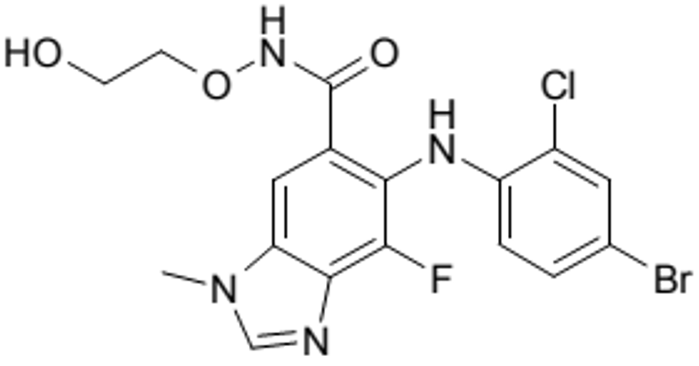

Koselugo (selumetinib) capsules are formulated with selumetinib hydrogen sulfate suspended in a solid matrix of tocofersolan (vitamin E polyethylene glycol succinate) which is sealed in a two piece, hard capsule shell.

The recommended dose is 25 mg/m2 orally twice daily (equivalent to a maximum of 50 mg twice daily). The capsules should be taken on an empty stomach with no food or drink other than water;[6] and should be swallowed whole with water and not chewed, dissolved or opened. It cannot be administered to patients who are unable to swallow a whole capsule.

Approval cannot be recommended from a pharmaceutical chemistry perspective for the following reason:

The drug substance specification remains outstanding.

Based on the advice received from the non-clinical evaluation section:

* Selumetinib des-bromo remains unqualified at the not more than 0.2% level.

Approval should be considered if there are any clinical reasons that outweigh the non-clinical advice.

### Nonclinical (toxicology) evaluation summary

The Delegate notes the following from the nonclinical evaluation report:

* The pharmacology studies support the use of selumetinib to treat paediatric patients with NF1 who have symptomatic, inoperable plexiform neurofibromas
* The combined in vitro studies and animal safety studies revealed the following findings of potential clinical relevance:
  + Plasma selumetinib and the active metabolite levels may be affected by CYP; 3A4 and CYP2C19 inhibitors or inducers
  + Selumetinib is an inhibitor of organic anion transporter 3 (OAT3) and may increase exposure of co-administered drugs that are substrates of OAT3
  + Targets for toxicity include the gastrointestinal tract (diarrhoea, mucosal inflammation, ulceration and epithelial hyperplasia), soft tissue (mineralisation associated with increases in plasma phosphate and/or calcium), skin (scabs, erosion/ulceration), and bone (physeal dysplasia)
  + Teratogenicity and embryofetal loss
* No juvenile toxicity studies were submitted which was considered acceptable.
* However, approval cannot be recommended from a pharmaceutical chemistry perspective. The nonclinical evaluator considers that the proposed limit of not more than 0.2% for selumetinib des-bromo is not toxicologically qualified as the exposure to the impurity in toxicity studies was below the maximum exposure in humans at the proposed limit. However, on balance, the overall risk benefit might allow the specification limit of not more than 0.2% weight per weight (w/w) for selumetinib des-bromo to be acceptable. This may require consideration by the Delegate and/or the advisory committee (see Advisory Committee considerations, below).

### Clinical evaluation summary

#### Pharmacology

The clinical pharmacology evaluation is supported by single and multiple dose pharmacokinetics (PK) characterisation, population pharmacokinetics and exposure‑response analyses, absolute and relative bioavailability (BA), mass balance, food effect, hepatic impairment, renal impairment, race/ethnicity, cardiac QT-interval, drug-drug interaction *in vivo* studies, *in vitro* studies and physiologically-based pharmacokinetic (PBPK) modelling.

These studies support the recommended dose of selumetinib 25 mg/m2 body surface area administered orally twice daily on a continuous schedule. Pharmacological activity is primarily due to selumetinib and although two metabolites of selumetinib were identified to have pharmacological activity, the N-desmethyl metabolite is approximately 3- to 5-fold more potent than parent (circulates at 7% of parent in healthy adult subjects) and may contribute to some activity, while the amide metabolite is approximately 50-fold less potent *in vitro* (circulates at less than 2% of parent in healthy adult subjects).

The PK of selumetinib appears to be similar in adult and paediatric patients.

##### Pharmacokinetics

In paediatric patients, selumetinib is rapidly absorbed after single and repeated oral twice daily 20 to 30 mg/m2 body surface area dosing with:

* Median time of maximum plasma concentration is reached (Tmax) of 1 hour
* Maximum concentration (Cmax) and area under the concentration time curve (AUC) increases proportionally over a dose range from 20 mg/m2 to 30 mg/m2 (0.8 to 1.2 times the recommended dose)
* Oral clearance of 8.8 to 15 L/hour
* Mean apparent volume of distribution of 78 to 171 L
* Terminal half-life ranging between 6.2 to 9.4 hours
* Minimum accumulation at steady state observed (accumulation ratio about 1.2).

###### Absorption

Absolute oral bioavailability of a single dose of selumetinib in healthy adult patients was 62%; absorption is rapid with Cmax achieved at a median Tmax of 1 to 1.5 hours after dosing following single oral doses of 25 to 75 mg of selumetinib. In paediatric patients, the median time to peak plasma concentrations (Tmax) following oral dosing was 1 hour across the 20 to 30 mg/m2 dose range.

Effect of food:

* Mean Cmax and AUC of selumetinib decreased by 50% and 16% respectively, following a high fat meal (800 to 1000 calories, 50% fat) in healthy adults following a single 75 mg dose; Tmax was delayed by 1.5 hours.
* Mean Cmax and AUC of selumetinib decreased by 60% and 38% respectively, following a low fat meal (400 calories, 20% fat) in healthy adults following a single 50 mg dose; Tmax was delayed by approximately 1 hour.

###### Distribution

The mean apparent volume of distribution at steady state (Vss) of selumetinib in the dose range of 20 to 30 mg/m2 ranged from 78 L to 171 L for paediatric patients, similar to that observed in adult patients and healthy adult subjects. Selumetinib is highly bound to human plasma proteins, with a mean percentage binding of 98.4% in male subjects.

###### Metabolism

Selumetinib is primarily metabolised by CYP3A4, and to a lesser extent, by CYP2C19, CYP1A2, CYP2C9, CYP2E1 and CYP3A5. It also undergoes glucuronidation by UDP-glucuronosyltransferases (UGT)1A1 and UGT1A3. It is estimated that 56% of the observed intrinsic clearance of selumetinib could be due to CYP metabolism and about 29% to direct glucuronidation by UGT enzymes *in vitro*. The N-desmethyl metabolite is approximately 3- to 5- fold more potent *in vitro* than selumetinib (AUC ratio metabolite to parent is approximately 7% across clinical studies), that is contributing to about 21% to 35% of the overall pharmacologic activity.

###### Excretion

After a single oral dose of radiolabelled selumetinib 75 mg to healthy adults, 59% of the dose was recovered in faeces (with mean value of 19% unchanged selumetinib) and 33% recovered in urine (< 1% as unchanged selumetinib).

###### Special populations

*Renal impairment*: minor changes in PK were observed in subjects with end stage renal disease (ESRD) compared to those with normal renal function (28% reduction in AUC and 16% reduction in Cmax); selumetinib can be dosed to patients with mild, moderate, severe renal impairment or ESRD without dose adjustment.

*Hepatic impairment*: Selumetinib exposure (AUC) was 14% lower in subjects with mild hepatic impairment, 59% higher in those with moderate hepatic impairment and 57% higher in those with severe hepatic impairment, compared to normal subjects. The increases in unbound AUC were 31% lower in those with mild hepatic impairment, 41% higher with moderate hepatic impairment and 217% higher with severe hepatic impairment compared to subjects with normal hepatic function.

###### Ethnicity

Observed PK ethnic differences of selumetinib are unlikely to be clinically relevant, particularly as paediatric patients will follow a body surface area (BSA) adjusted dosing regimen.

###### Drug-drug interaction studies

In clinical studies and physiologically based-PK modelling, selumetinib exposure increased by 49% (and Cmax by 19%) when co‑administered with itraconazole (strong CYP3A4 inhibitor), by 41% (and Cmax by 23%) with erythromycin (moderate CYP3A4 inhibitor), by 53% (and Cmax by 26%) with fluconazole (strong CYP2C19 inhibitor and moderate CYP3A4 inhibitor).

Selumetinib exposure decreased by 51% (and Cmax by 26%) when co-administered with rifampicin (strong CYP3A4 inducer), and by 38% (and Cmax by 22%) with efavirenz (moderate CYP3A4 inducer).

Based on *in vitro* studies, selumetinib does not inhibit CYP1A2, CYP2A6, CYP2B6, CYP2C8, CYP2C9, CYP2C19, CYP2D6, CYP3A4 or CYP2E1. Selumetinib does not induce CYP3A4, CYP1A2, or CYP2B6.

###### Corrected QT interval

Study D15320C00071 was a randomised, three period, three treatment (selumetinib 75 mg, placebo, and moxifloxacin 400 mg), single dose crossover QT;[7] study conducted in healthy male volunteers to evaluate the effect of selumetinib on cardiac repolarisation. The highest upper bound of two sided 90% confidence interval (CI) over the 24 hour post dose QTcF;[8] interval change from Baseline was 2.5 ms for selumetinib 75 mg. A single oral dose of selumetinib 75 mg was not associated with any incidents of QTcF intervals greater than 450 ms or increases greater than 30 ms from Baseline.

A pharmacokinetic (PK)-pharmacodynamic (PD) analysis of the relationship between selumetinib concentrations and change in QTcF interval was performed using the data from Study D1530C00071, with 468 pairs of time matched PK concentrations and electrocardiogram (ECG) values from 47 subjects treated with selumetinib 75 mg. The relationship between selumetinib concentrations and change in QTcF;10 interval was reasonably described by a linear mixed effect model.

This demonstrated a predicted upper bound of two sided 90% CI for change in QTc interval of 3.52 ms (mean of 2.38 ms) for selumetinib 75 mg, supporting the conclusion of the Study D15320C00071. The model also predicted the upper bound of two sided 90% CI was 6.95 ms (mean 4.7 ms) after 150 mg selumetinib single dose in patients, that is less than 10 ms for doubled Phase III dose.

There is therefore no significant effect of selumetinib on QTc prolongation in adults.

##### Clinical pharmacology assessment

###### General dosing

The recommended Phase II dose was determined to be 25 mg/m2 in the SPRINT trial, Phase I study based on the following:

* Objective response rate (ORR) was similar across 20 to 30 mg/m2 twice daily doses with best ORR (83.3%) observed at 25 mg/m2 twice daily
* tolerability was similar between 20 and 25 mg/m2 twice daily doses as per dose limiting toxicity rates: 2 out of 12 at 20 mg/m2, 1 out of 6 at 25 mg/m2 and 2 out of 6 at 30 mg/m2.

In the SPRINT trial, Phase II, at a dose of 25 mg/m2, exposure-response assessment of selumetinib demonstrated a minor positive trend for AUC at steady state efficacy (ORR determined by independent central review but not for ORR determined by NCI central analysis) association and no clear exposure-response relationship for safety in paediatric patients. In adult studies, a direct relationship is noted between inhibition of ERK phosphorylation (substrate of MEK) and selumetinib exposure, suggesting that higher exposure contributes to greater target engagement.

The proposed dosing regimen of 25 mg/m2 twice daily is therefore supported by safety and efficacy findings in the indicated patient population, and PK-PD relationships in paediatric and adult patients.

###### Therapeutic individualisation of dosing

The dosing schema by body surface area (BSA) is based on the availability of the capsule strengths (10 and 25 mg). In the Sponsor’s proposed dosing schema, the proposed dose for a BSA of 0.55 to 0.69 m2 is 10 mg twice daily, which is equivalent to a dose level of 14.5 to 18.2 mg/m2 twice daily, where the corresponding mean simulated area under the plasma concentration time curve from time 0 to 12 hours (AUC0-12h) is approximately 40% lower as compared to other BSA subgroups. An overseas regulator’s evaluation therefore recommended a daily dose of 30 mg for BSA 0.55 to 0.69 m2, that is 20 mg morning dose and 10 mg evening dose.

Figure 2: Sponsor’s stimulated steady state AUC0-12h across body surface area bands based on 25 mg/m2 of selumetinib twice daily

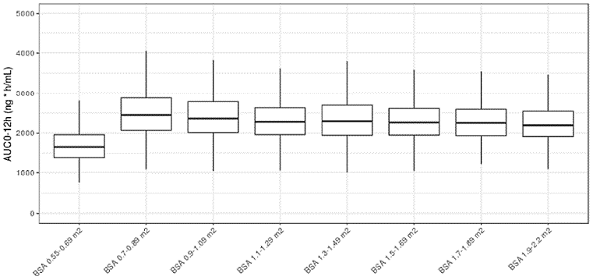

###### Summary of pharmacology assessment, issues and recommendations

The key issues raised in the clinical pharmacology evaluation relate to the proposed dosing regimen in patients with a BSA of 0.55 to 0.69 m2, dose recommendations for patients with moderate to severe hepatic impairment and those requiring co‑administration of strong and moderate CYP3A4 modulators, and administration with regards to food (to potentially alleviate gastrointestinal toxicities).

The clinical evaluator recommended the following:

* The recommended dosage of selumetinib is 25 mg/m2 orally twice daily without food (fasted 2 hours before and 1 hour after each dose); minimum BSA of 0.55 m2 and capped at 50 mg when the BSA is ≥ 1.9 m2. Doses should be rounded to nearest achievable dose with 10 and 25 mg capsules (see Table 1).

Table 1: Recommended dosage of selumetinib based on body surface area

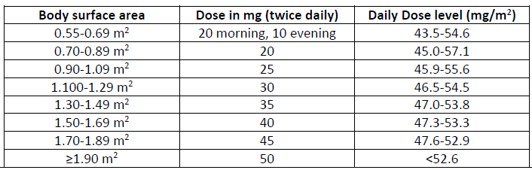

* Avoid co-administration of strong or moderate CYP3A4 inhibitors or fluconazole; if co‑administration is unavoidable, reduce starting dose:
  + If patient is currently taking 25 mg/m2 twice daily, dose reduce to 20 mg/m2 twice daily
  + If patient is currently taking 20 mg/m2 twice daily, dose reduce to 15 mg/m2 twice daily (see Table 2)

Table 2: Dosing schema for selumetinib 20 mg/m2 twice daily and 15 mg/m2 twice daily

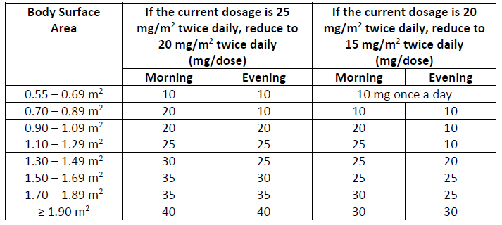

* Avoid concomitant use with strong or moderate CYP3A4 inducers.
* Reduce dose to 20 mg/m2 in patients with moderate hepatic impairment. No dose adjustment is recommended for patients with mild hepatic impairment. The recommended dose for patients with severe hepatic impairment has not been established.
* Submission of the final report from a PK trial in paediatric patients to confirm the effect of a low fat meal on selumetinib exposure, evaluate whether administration of selumetinib with food may alleviate gastrointestinal toxicities, and confirm appropriate dosing recommendation of selumetinib with a low fat meal that maintains efficacy with acceptable safety. This issue is particularly relevant as:
  + paediatric patients may have difficulty taking selumetinib twice daily on an empty stomach (six hour fasting time window) and may lead to compliance issues.
  + the food effect studies showed a greater magnitude of exposure change when selumetinib is administered with a low fat meal compared to high fat, which is unusual; although a high fat meal showed minimal effect on selumetinib AUC, it is not feasible to recommend taking selumetinib with a high fat meal.
  + the incidence of gastrointestinal toxicities and resultant dose interruptions were high in paediatric patients.
  + the gastrointestinal toxicity profile is not similar in adult patients and cannot be extrapolated to paediatric patients.

In addition, regarding the indication for selumetinib, the Delegate notes that an overseas evaluator recommends a lower age cut off (that is two years of age and older) than the original age range proposed in the new drug submission with the overseas regulator (‘*3 years and above*’) as reflected in the approved indication. The rationale was based on the metabolism of selumetinib by CYP enzymes (56%, mainly by CYP3A4) and UGT enzymes (29%, UGT1A1 and UGT1A3), all of which have greater than 80% adult enzyme activity by 2 years of age.

There is a discrepancy in the age cut off between that in the US-approved indication and in the indication as recommended by the European Medicines Agency (EMA), who have approved its use in those three years of age and older. The eligibility criteria for patients in the SPRINT trial, Phase I study was 3 to 18 years of age, and patients enrolled in the SPRINT trial, Phase II studies were 3.5 years to 17.4 years of age. Expansion of this indication to patients as young as two years of age, although reasonable given the similar expected PK of selumetinib at the age of two years compared to that at three years, was not evaluated in the SPRINT trial. The Delegate therefore recommends that the indication be aligned with the population as evaluated in the SPRINT trial, that is three years of age and older.

#### Efficacy

##### SPRINT trial (Phase II)

The study was Sponsored by cancer therapy evaluation programme and conducted by the National Cancer Institute Paediatric Oncology Branch (NCI POB (co-ordinating site)) at four sites in the USA.

###### Study design

The SPRINT trial, Phase II stratum 1 is an open label, single arm, multicentre study of selumetinib in children with neurofibromatosis type 1 (NF1) and inoperable plexiform neurofibromas (PN), with PN-related morbidity at enrolment; in SPRINT trial, Phase II study, patients who had no significant morbidity but the potential for significant PN-related morbidity were enrolled in stratum 2; data from stratum 2 was immature at data cut off for this submission). Fifty patients aged ≥ 2 and ≤ 18 years with NF1 and inoperable PN and PN-related morbidity present at enrolment were to receive selumetinib 25 mg/m2 twice daily. Patients were enrolled irrespective of their PN progression status at Baseline and had to have a BSA of ≥ 0.55 m2, and the ability to swallow whole capsules. Patients who had either progressive PN at Baseline, or if they did not have progressive PN at Baseline and did respond to selumetinib, continued on treatment providing they were deriving clinical benefit or until they met at least one of the off study criteria. Treatment was discontinued in patients who did not have progressive PN at Baseline and had not achieved a response at two years. Patients are to be followed up for five years after discontinuing selumetinib treatment, or for seven years from initiation of treatment, whichever was longer.

###### Inclusion and exclusion criteria

Key inclusion criteria were:

* children 2 to 18 years with NF1 and inoperable PN;
* BSA of ≥ 0.55 m2;
* ability to swallow whole capsules;
* measurable disease, that is, at least 1 PN of at least 3 cm measured in 1 dimension;
* performance status ≥ 70% on Karnofsky scale (if > 16 years old) or Lansky scale (if ≤ 16 years old);
* normal cardiac function (ejection fraction ≥ 53%, or normal as per institution); and
* previous investigational agents (for example, tipifarnib, pirfenidone, peg-intron, sorafenib, imatinib, or other targeted therapy) allowed; at least four weeks must have elapsed since receiving medical therapy directed at PN and must have recovered from acute toxicities from prior therapy.

Key exclusion criteria were:

* pregnant or breast-feeding females; and
* prior treatment with selumetinib or other specific MEK1/2 inhibitor, unless the patient met criteria for re-treatment;
* evidence of an optic glioma, malignant glioma, malignant peripheral nerve sheath tumour, or other cancer requiring treatment with chemotherapy or radiation therapy;
* ophthalmological conditions (including central serous retinopathy, retinal vein occlusion, intraocular pressure (IOP) >21 mmHg (or upper limit of normal (ULN) adjusted by aged) or uncontrolled glaucoma (irrespective of IOP), ophthalmological findings secondary to long-standing optic pathway glioma or long-standing orbito‑temporal PN were not considered a significant abnormality).

###### Study procedures and schedule

All patients to undergo scheduled clinical, laboratory safety evaluations, echocardiography, ophthalmology examinations, magnetic resonance imaging (MRI), patient reported and observer reported outcome assessments, and evaluations of functional response.

###### Drug administration and safety assessments

*Dose selection*: 25 mg/m2 twice daily orally in 28 day cycles on a continuous dosing schedule.

*Dose modification*: selumetinib was to be with-held if toxicity experienced requiring dose modification; if toxicity resolved to common terminology criteria for adverse events (CTCAE) version 4 ≤ grade 1 within 21 days of drug interruption, resumption of selumetinib at a dose reduced by 25% to 33% was allowed.

###### Efficacy endpoints

*Primary endpoint*: The pre-specified primary outcome was the objective response rate (ORR). Tumour response evaluation was performed centrally at the NCI by non-blinded volumetric MRI analysis of the PN by Response Evaluation in Neurofibromatosis and Schwannomatosis (REiNS) criteria. At Baseline, the target PN was selected by the assessing investigator as the most clinically relevant PN, amenable to volumetric MRI analysis. Retrospective independent central review (ICR) of the volumetric MRI assessments were also conducted following oversea regulator request. A partial response (PR) was defined as a target PN volume decrease from Baseline of at least 20%; a confirmed partial response designated when PR observed again within 3 to 6 months. Progressive disease was defined as a volume increase from Baseline (or time of best response after documenting a PR) of at least 20%.

Secondary endpoints:

* duration of response (DOR),
* tumour volume changes,
* progression free survival (PFS) - (including comparison with PFS in placebo arm of tipifarnib Study 01-C-0222)
* time to progression (TTP)
* time to response (TTR)
* clinical outcome assessments (COAs) including functional, patient reported, and observer reported outcome measures

The open label design of the SPRINT trial, Phase II study limits the interpretability of the COA endpoints as the patient’s (or parent/carer) knowledge of treatment assignment may lead to systematic over/underestimation of treatment effect. In addition, the lack of a comparator treatment arm, small sample size and choice of instruments for the measurement of secondary outcomes are notable limitations (for example apart from the pain interference index and measurements of visual acuity, the remaining outcome measures have yet to be validated in the population of patients with NF1). The Delegate agrees with the clinical evaluator that time-to-event endpoints such as PFS, TTP and TTR are uninterpretable in a single arm trial.

The analyses of these endpoints were considered exploratory by the oversea regulator and were therefore not verified by the clinical evaluator.

###### Statistical analysis plan

Efficacy analyses relating to ORR was conducted on the full analysis set (full analysis set (FAS); that is all patients who received at least one dose of selumetinib). COAs were conducted on either the FAS, or age subsets of the FAS (pain ≥ 8 years, physical functioning ≥ 5 years) or a subset of the FAS with PN-related morbidity. Safety analyses were also conducted on the FAS.

ORR was as determined by the NCI POB central analysis of volumetric MRI of target PN. ORR was defined as the percentage of patients with complete response (CR) or confirmed partial response (PR; defined as target PN decrease ≥ 20% compared with Baseline; confirmed when observed again within 3 to 6 months), per REiNS criteria, and was based on the FAS. ORR was presented with corresponding two sided exact 95% CIs based on the Clopper-Pearson method. A sensitivity analysis of the ORR based on the ICR of the MRI data was also performed; supplementary analyses were performed to derive ORR based on all available volumetric MRI scans.

For most patient-reported and observer-reported outcomes and functional measures obtained, no validated thresholds for clinically meaningful change exist in the paediatric population with NF1; therefore, results are descriptive in nature.

The statistical analysis method for the primary endpoint of study SPRINT trial, Phase II stratum 1 is considered acceptable.

###### Protocol amendments

Protocol amendments not considered to have any significant influence on results.

###### Patient disposition

50 patients were enrolled in stratum 1 and received at least one dose of selumetinib. In total, 16 patients (32%) discontinued selumetinib, due to adverse events (AE) (six patients), disease progression (three patients), investigator discretion (three patients), treatment period completed (two patients), patient not willing to continue treatment (one patient) and severe non-compliance to protocol (one patient). Four patients who discontinued treatment also terminated the study (voluntary discontinuation in two patients, one patient lost to follow up). There were no deaths during SPRINT trial, Phase II stratum 1.

###### Protocol violations and deviations

There were two important protocol deviations in SPIRNT trial, Phase II stratum 1. One patient was removed from study on Day 64 for non-compliance (that is missed evaluations). A second patient had a Grade 2 AE of decreased left ventricular ejection fraction (LVEF) pre-Cycle 9 who did not have a repeat echocardiogram (ECHO) 3 to 6 weeks later as per protocol, but rather was repeated 16 weeks later; the ECHO showed LVEF improvement at this later assessment.

Two additional important protocol deviations occurred during SPRINT trial, Phase I. In both cases, the patients had been dose reduced due to AEs with subsequent tumour evaluations demonstrating regrowth (not meeting threshold for PD). NCI recommended an alternative dose modification for both patients (full dose five days on, two days off), with modifications discussed with the Cancer Therapy Evaluation Program (CTEP) and the institutional review board (IRB), however, the required protocol amendments were not submitted.

These deviations are unlikely to have any significant impact on the primary endpoint result and overall efficacy conclusions.

###### Baseline characteristics

The majority of patients were White (84%) and male (60%), with a median age of 10.2 years (range, 3.5 to 17.4). The median total number of treatment cycles was 36 (range, 0 to 47).

The median target PN volume at Baseline was 488 ml (range, 5.6 to 3820). A total of 21 patients (42%) had progressive PNs at enrolment. Patients had a median of three target PN related morbidities (range, 1 to 4), the most common being disfigurement (44 patients, 88%), motor dysfunction (33 patients, 66%) and pain (26 patients, 52%).

Overall, 39 patients (78%) had received a prior treatment for PN and/or another NF1‑related tumour. The 2 most common PN-directed medical treatments were interferon and imatinib;18 patients had received a singled medical therapy.

###### Treatment adherence

Treatment adherence, as measured using diary reviews for Cycles 1 to 12, was high (mean of 94%) with few missed doses.

###### Efficacy results for the primary endpoints

The objective response rate (ORR) was 66% (33 of 50 patients) by NCI POB central analysis (95% CI: 51.2%, 78.8%) in the SPRINT trial, Phase II Stratum 1. The response rates for patients who had progressive PN at enrolment (that is ≥ 20% increase in preceding 18 months; n = 21) were similar to those with non-progressive PN (n = 15), with ORR of 61.9% (95% CI: 38.4%, 81.9%) and 66.7% (95% CI: 38.4%, 88.2%) respectively.

Sensitivity analysis, based on the ICR, reported an ORR of 44.0% (95% CI: 30.0, 58.7). These results are consistent with those of obtained by NCI POB central analysis, where no patients had a best objective response of progressive disease. Only 2 patients had an increased in target PN volume from Baseline.

The ORR in subgroups based on demographic/clinical characteristics as calculated by the oversea regulator are detailed in Table 3, below.

Table 3: SPRINT trial Phase II Stratum 1, Confirmed overall response rate by demographic and clinical subgroups (independent central review analysis)

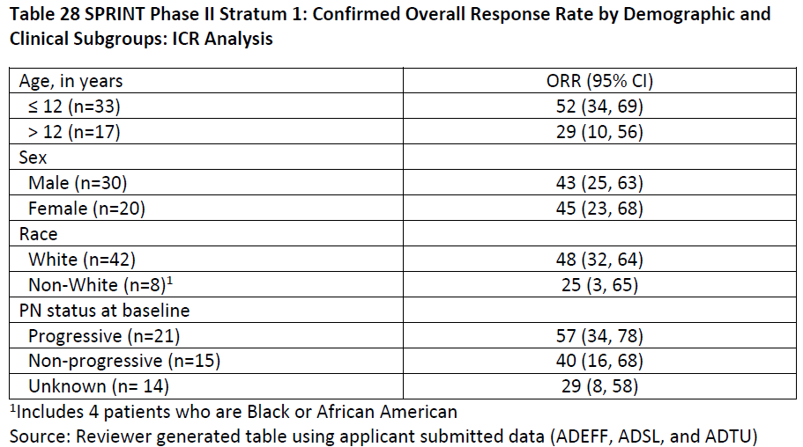

1 Includes 4 patients who are Black or African American

###### Secondary and other relevant endpoints

*Progression-free survival*: At data cut-off, 3 out of 50 patients had progressed; median PFS was not reached.

*Time to progression*: As per PFS, as no deaths reported in the SPRINT trial, Phase II Stratum 1.

*Time to response*: In the 33 responders, 14 (42.4%) had a response by 4 cycles from the first dose, and 24 (72.7%) had a response from 8 cycles from first dose.

*Duration of response*: At data cut-off, 32 out of 33 patients with a response had been followed for at least 12 months from onset of response. Median DOR as assessed by ICR and calculated by oversea regulator was 21.9 months (95% CI: 17.6, 30.3). Median DOR as assessed by NCI POB central analysis was not reached (95% CI: not examined (NE)). (The definition of disease progression in the NCI POB central analysis included non-target lesions and new lesions, whereas the ICR analysis was based only on target PN volumes. However, no patients progressed in the NCI POB central analysis based on non-target lesions or new lesions).

PFS, TTP, TTR and persistence of effect analyses are exploratory and were not verified by the oversea regulator’s evaluator.

*Clinical outcome assessments*: The study collected a number of patient related outcomes, observer related outcomes and performance observations. The clinical evaluation focussed on pain intensity (numeric pain rating scale (NRS)-11), pain interference (pain interference index), and health related quality of life (paediatric quality of life inventory), with high completion rates for these instruments. However, these analyses were all exploratory with notable challenges associated with interpretation including lack of a comparator arm, parent/caregiver’s knowledge of treatment assignment, a small sample size, potential instrument limitations, thresholds used for defining clinically meaningful change and assumptions of the mixed model repeated measures.

There was a decrease from Baseline in pain scores at each measurement cycle based on mixed model repeated measures analysis. For the 24 patients who completed both baseline and pre-cycle 13 assessments, the mean change from Baseline was -2.07 (95% CI: -2.84, -1.31); see Table 4 and Figure 3.

Table 4: SPRINT trial Phase II Stratum 1, Change from Baseline for numeric pain rating scale-11 pain intensity primary outcome, mixed model repeated measures (full set analysis)

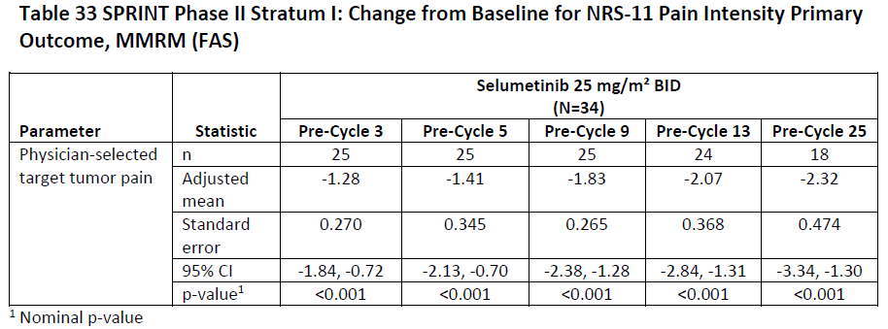

1 Nominal p-value

BID = twice daily; CI = confidence interval; N = total number of subjects; n = number of subjects in group.

Figure 3: SPRINT trial Phase II Stratum 1, Adjusted mean change from Baseline of numeric pain rating scale-11 physician selected target tumour pain score, mixed model repeated measures (full set analysis)

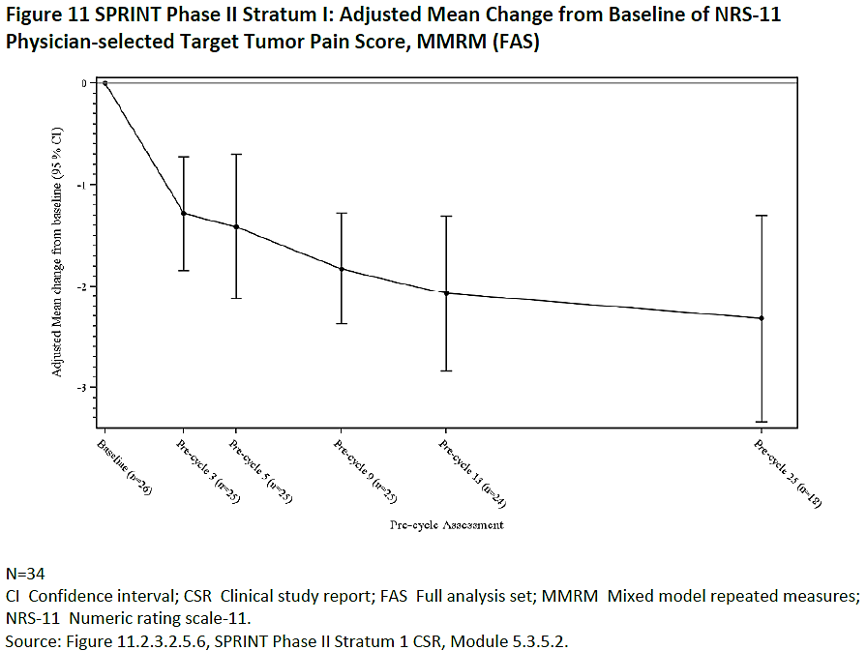

N = 34 (total number of subjects)

CI = confidence interval; CSR = clinical study report; FAS = full analysis set; MMRM = mixed model repeated measures; NRS-11 = numeric rating scale-11

There were challenges with regard to the analysis of the pain NRS, as the primary focus of the analysis was on the results of the NRS-11 physician selected tumour pain score. Only 24 of 34 patients who were eligible to respond (that is those > 8 years old) completed this pain item. No deteriorations were reported at the pre-cycle 13, and most patients classified as stable had either no pain or pain that could not reduce by ≥ 2 points at Baseline. Pain was measured infrequently, further limiting interpretability of results.

As per Phase II results, pain did not appear to be getting worse on treatment with only one patient reporting a deterioration with Phase II.

For paediatric quality of life inventory, all items exhibit some degree of floor effects (with > 20% patients responding to the lowest response option) which may limit detection of change in health-related quality of life and other domains; in addition, the total paediatric quality of life inventory score includes a number of items considered distal to the drug effect (for example *‘others teach me’*, or ‘*it’s hard to pay attention in class’*).

The analyses of other patient reported outcomes and performance endpoints are considered exploratory; the clinical evaluator did not verify these results.

Additional analyses conducted on SPRINT trial; Phase II Stratum 1 results included:

* Margin of error for target PN measurements estimated by inter-reader variability, and volumetric PN
* Volumetric PN Growth and the NCI POB NF1 natural history study (age matched)

These results are noted, with the analyses considered exploratory and not verified by the clinical evaluator.

Data from the NCI POB NF1 natural history study and the placebo arm of tipifarnib Study 01-C-0222 were not independently confirmed by the overseas regulator in their evaluation report. Given the heterogeneity in the patient population, the overseas regulator considered results from the external control studies to be supportive but inadequate for any comparative analyses.

###### Descriptive analyses of clinical outcomes data

The SPRINT trial protocol included multiple COA tools for supportive efficacy assessments due to diverse tumour sites (for example, respiratory function tests and sleep studies for tumours near the airway; vision testing for orbital tumours; range of motion and strength testing for extremity tumours). Due to the rarity of this condition and heterogeneity in associated morbidity, the sample size for each morbidity category were small. These were exploratory endpoints intended to better characterise the clinical benefit of selumetinib.

The SPRINT trial investigators assigned specific target PN related morbidities to each patient with the clinical outcome measure evaluated routinely with radiographic tumour volume assessments. The objective was to show that a reduction in tumour volume was accompanied by an effect on physical function or PN related symptoms indicating that quality of life was improved. Given the benign nature of the tumour, this correlation was considered important in the overall benefit risk assessment for selumetinib.

The reviewed clinical outcomes data showed that at the patient level, 33 patients had an objective response per NCI review using REiNS criteria. The following is noted from this evaluation:

* Patients had substantial baseline PN related morbidity, with many tumours being large, disfiguring and/or located in critical areas (for example, near the airway or orbit).
* After initial onset of response, further reduction in tumour volume was observed, with best overall response occurring later, often after Cycle 13.
* In most patients with a durable objective response, there was a trend of tumour volume reduction associated with at least one improved clinical outcome.
* In some patients, there was clear benefit noted (for example, removal of tracheostomy tube, forced expiratory volume in one second normalisation, increased bowel/bladder incontinence, decreased pain), whilst in other patients, objective measures were not consistent with patient/parent reports of improvement or with tumour volume reduction endpoints.
* Disfigurement due to PN was present in 88% of patients, with changes in disfigurement marginal for most patients as per evaluation of photos. However, patients and parents often reported improvement in appearance that were not obvious to the reviewer or evident on photos.
* 29 out of 33 (88%) patients who remained on selumetinib at data cutoff appeared to have good tolerability. One additional patient who discontinued selumetinib due to malignant peripheral nerve sheath tumour (MPNST) diagnosis resumed selumetinib under the expanded access program after completing MPNST treatment.
* 35 out of 50 (70%) patients were considered by the SPRINT trial investigators to have experienced clinical benefit; of the 15 patients who were considered to not have experienced clinical benefit, five patients had an objective response per REiNS criteria. Of the 17 patients who did not experience a radiographic objective response to selumetinib, two were considered to have had benefit based on improved pain symptoms and one based on improved bladder continence.

##### SPRINT trial (Phase I)

###### Study design

This was a Phase I, open label, multiple dose, dose escalation multi-centre study of selumetinib in paediatric patients with neurofibromatosis type-1 (NF1) and inoperable plexiform neurofibroma (PN), conducted by the US National Cancer Institute Paediatric Oncology Branch (NCI POB). At least 21 patients aged between 3 and 18 years were planned for enrolment. The primary objective of the study was to determine the recommended Phase II dose (RP2D) of selumetinib and to study the plasma pharmacokinetics (PK) of selumetinib at Baseline and at steady state, in children and adolescents with NF1 and inoperable PN. Three dose levels of selumetinib were evaluated; 20, 25 and 30 mg/m2 twice daily. 25 mg/m2 twice daily was declared the RP2D and consequently used in SPRINT trial Phase II. Selumetinib was administered orally twice daily on a continuous schedule; the dose was capped at 50 mg when BSA was ≥ 1.9 m2 and a cycle was 28 days. Volumetric MRI assessments were performed pre-study, prior to Cycles 6 and 11, and every six cycles thereafter. Efficacy endpoints evaluated in this study (all exploratory) include objective response rate (ORR), duration of response (DOR) and time to response (TTR).

###### Patient disposition

At the data cut-off on 29 June 2018, 13 (54.2%) patients remained on selumetinib; 3 patients (12.5%) had discontinued selumetinib but remained on study. In total, 11 patients discontinued selumetinib: three patients due to adverse events (AEs), two patients due to disease progression, two patients unwilling to continue, one patient completed treatment period, and three patients due to other reasons. Eight patients terminated the study; the reasons were voluntary discontinuation (four patients), disease progression (two patients), AEs (one patient) and other (one patient). There were no deaths during SPRINT trial, Phase I.

75% of patients were White, with the median age 10.9 years (range, 3.0 to 18.5). The median time from diagnosis of PN to start of selumetinib treatment was 8.28 years (range: 0.79, 17.00). The target PN volume at Baseline ranged from 29.4mL to 8744.0mL. Target PN were located in different body sites for different patients and one patient had a whole body PN.

###### Efficacy results

SPRINT trial, Phase I study had no primary efficacy endpoints.

Secondary and other relevant endpoints:

* Objective response rate (ORR): the observed ORR in SPRINT trial, Phase I study was 66.7% (16 out of 24 patients); 95% CI: 44.7%, 84.8%.
* Progression-free survival (PFS): only two patients progressed, therefore the median PFS was not reached.
* Time to progression (TTP): there were no deaths in SPRINT trial, Phase I, hence TTP results are as for PFS.
* Time to response (TTR): 81.3% of patients with a confirmed objective response had target PN shrinkage ≥ 20% from Baseline within 10 cycles.

The ORR data is considered descriptive only; time to event endpoints are considered uninterpretable in a single arm trial, with analyses considered exploratory and were not verified by the oversea regulator. The overseas regulator did however consider that the results demonstrate a key characteristic of NF1 PN is the uncommon occurrence of spontaneous regression such that the observed tumour responses in SPRINT trial are concluded to be the effect of the drug.

###### Assessment of efficacy across trials

Comparison of results between SPRINT trial, Phase II Stratum 1 and the natural history study are considered exploratory, due to the lack of information available to adjust any comparison for potential confounding or bias.

###### Additional efficacy considerations

In the overseas regulator’s report, they conducted additional analyses of ORR assessed by the ICR by age, PN status, and PN classification at enrolment:

* patients age > 12 years: ORR = 29% (95% CI: 10%, 56%)
* patients age ≤ 12 years: ORR = 52% (95% CI: 34%, 69%)
* patients with progressive disease at enrolment: ORR = 57% (95% CI: 34%, 78%)
* patients with non-progressive disease: ORR = 40% (95% CI: 16%, 68%)

The ORR and DOR were assessed for the 24 patients enrolled in SPRINT trial, Phase I and for the 25 patients in SPRINT trial, Phase II Stratum 2. The NCI central review of ORR were 67% (16 out of 24 patients, 95% CI: 45, 84) and 68% (17 out of 25, 95% CI: 47, 85) respectively. All 16 of 16 responders in SPRINT trial, Phase I had a DOR ≥ 12 months from the onset of response. In SPRINT Phase II Stratum 2 at data cutoff 1317 patients with a response had been followed for at least 12 months from onset of response, and of these, 12 patients had a DOR ≥12 months from the onset of response.”

##### Summary of efficacy

* The SPRINT trial, Phase II Stratum 1 enrolled 50 paediatric patients with NF1 and inoperable PN that resulted in significant clinical morbidity. The ORR per NCI central review via REiNS criteria was 66% (95% CI: 51, 79). All responses were confirmed PRs.
* Among the 33 responders, the median DOR was not reached, and the proportion of patients who experienced DOR ≥12 months was 82% (27 of 33 patients).
* The ORR per ICR was 44% (95% CI: 30, 59); and the proportion of patients who experienced DOR ≥ 12 months was 59% (13 out of 22 patients). This differed to the ORR per NCI central review partly due to tumour volume measurements for six patients that showed PN shrinkage between -19.2% and -19.9% as best objective response.
* Supportive response data for the 24 patients in SPRINT trial, Phase I and the 25 patients in SPRINT trial, Phase II Stratum 2, with an ORR of 67% (95% CI: 45, 84) and 68% (95% CI: 47, 85) respectively by NCI central review. In SPRINT trial, Phase I 100% experienced a DOR ≥ 12 months. In SPRINT trial, Phase II Stratum 2 of responders at data cutoff 13 out of 17 patients with a response had been followed for at least 12 months from onset of response, and of these, 12 patients had a DOR ≥ 12 months from the onset of response.
* The response rate for SPRINT trial, Phase II Stratum 1 were considered in the context of clinical outcomes for patients including the effects of PN related symptoms and functional impairments. Despite limitations of the study including the single arm design and small sample sizes of patients assessed for each PN related morbidity subset, there was a general trend of tumour volume reduction that was associated with at least one improved clinical outcome in most patients who experienced a durable response to selumetinib.

#### Safety

The pivotal paediatric safety data for this submission is based on the Phase II Stratum 1 study, part of the SPRINT trial.

Supportive paediatric safety data evaluated includes:

* SPRINT trial Phase I: 24 paediatric patients with NF1 and inoperable PN, receiving at least one dose of selumetinib (20 mg/m2 for 12 patients, 25 mg/m2 for six patients and 30 mg/m2 for six patients).
* Paediatric safety pool: 74 paediatric patients in the SPRINT trial, Phase II Stratum 1 and Phase I studies.

The overseas regulator conducted an independent review of exposure and safety data from the SPRINT trial, Phase II Stratum 1 (n = 50); and from the paediatric pool (n = 74). Most patients in the SPRINT trial, either Phase I or II, received the intended marketing dose of selumetinib 25 mg/m2 twice daily per initial dose assignment (n = 56). As the study populations and the adverse event (AE) profiles were similar between the SPRINT trial, Phase II Stratum 1 dataset (n = 50) and the paediatric pool (n = 74), the clinical evaluation focussed on the larger paediatric pool for key safety analyses.

Other supportive safety data provided:

* Pooled safety data from adult patients with cancer treated with selumetinib monotherapy in seven completed studies (studies Sponsored by the Sponsor): 347 adult patients in which 79 received selumetinib capsules (hyd-sulfate) and 268 received selumetinib free base.
* 12 Phase I clinical pharmacology studies (approximately 380 healthy adult volunteers).
* Ongoing early access program: 166 patients aged 3 years and above at enrolment.
* Paediatric externally Sponsored research studies (data cut-off date: 31 January 2019): serious adverse events (SAE) are reported for 291 paediatric patients, evaluating selumetinib in a range of indications.

The overseas regulator reviewed safety data from the ‘adult monotherapy pool’ (n = 347) given the limited sample size of the paediatric pool, with the clinical evaluator noting that the safety profiles of the two selumetinib formulations represented in this pool, hyd-sulfate capsule (n = 79) and free base oral suspension (n = 268), were different. Patients receiving the capsule had a greater incidence of SAEs (33% versus 24%), AEs ≥ Grade 3 (60% versus 43%) and discontinuations due to AEs (29% versus 11.6%). Review of PK parameters for the two formulations show a 2-fold AUC and 2.5 fold Cmax for the capsule compared to that of the free base. As these formulations are not bioequivalent, the oversea regulator has focussed on the cohort of 79 adults who received the hyd-sulfate capsule for supportive safety data. The larger safety database was used to identify rare adverse drug reactions that may not have been identified in the smaller dataset.

Data was provided by the Sponsor from the ongoing selumetinib ongoing early access program for NF1 PN and from paediatric externally Sponsored research studies. The evaluator notes that determining the true AE incidence rates from analysis of these datasets is not possible due to variable reporting requirements between countries in the expanded access program, data collection methods, continued accrual in ongoing studies, missing elements for a substantial number of the events (for example, AE duration, toxicity grade, action taken in response, outcomes). The SAE datasets were reviewed to further assess known, but less common, safety signals associated with MEK inhibition, and to identify any new safety signals not observed in the SPRINT trial paediatric pool.

##### Patient exposure

Exposure for the safety populations is presented for the safety analysis set (all patients who received at least one dose of selumetinib.

In the SPRINT trial, Phase II Stratum 1:

* median total exposure to selumetinib was 2.2. years (range, 28 to 1053 days);
* median actual exposure of 2 years (26 to 1022 days);
* 66.0% of patients received ≥ 24 to ≤36 months total treatment.

Median duration of exposure in the paediatric pool was higher than for the SPRINT trial, Phase II Stratum 1 (855.5 days, range 28 to 2169) as it was influenced by the longer exposure to selumetinib (median total treatment duration of approximately 4.4 years). Most patients (42.0%) in the SPRINT trial, Phase I had received ≥ 48 to ≤ 60 months treatment with selumetinib. Although the paediatric pool includes a relatively small sample size, the evaluator considered the exposure data sufficient to assess the general safety profile of selumetinib in the intended population.

For the adult monotherapy pool:

* median total exposure to selumetinib was 63 days (2.1 months, range 0 to 14 months);
* median actual exposure was 62 days (range 1 to 436 days);
* approximately 87.9% of patients were exposed for less than 3 months.

Exposure was shorter than for the paediatric pool as this predominantly included participants in adult oncology studies, most of whom progressed whilst on study and discontinued treatment. Due to the limited supportive adult safety data, the Sponsor submitted additional safety analyses of the selumetinib global database and expanded access program at the oversea regulator’s request.

##### Adequacy of clinical safety assessments

The primary safety data from the SPRINT trial, the supportive adult monotherapy pooled data, the supplemental data from the selumetinib expanded access program, externally Sponsored paediatric selumetinib studies and the additional safety analyses of the global selumetinib database allowed for an informed risk assessment of selumetinib in the intended population. The longer term safety profile will require further evaluation in the post-marketing setting.

##### Safety results

###### Adverse events summary

In the paediatric pool:

* 98.6% (73 out of 74) patients had at least one AE,
* 98.6% (73 out of 74) patients had at least one AE causally related to selumetinib as per investigator,
* 67.6% (50 out of 74) patients had an AE of Grade ≥ 3,
* 23.0% (17 out of 74) patients experienced an SAE,
* There were no deaths due to an AE,
* 12.2% (9 out of 74) permanently discontinued selumetinib due to AE,
* 78.4% (58 out of 74) patients had AEs leading to dose interruption,
* 32.4% (24out of 74) patients had AE leading to dose reduction.

The overall incidence of AEs in each category were similar for the SPRINT trial, Phase II Stratum 1, however, the incidence of AEs leading to dose reduction were higher in the paediatric pool (32.4% versus 24%), which is attributed to the inclusion of the Phase I dose escalation study in the paediatric pool.

In the adult monotherapy pool:

* 329 patients (94.8%) had at least one AE,
* 309 patients (89%) had at least one AE causally related to selumetinib as per investigator,
* 163 (47%) patients had an AE of Grade ≥ 3, including 98 (28.2%) causally related to selumetinib as per investigator,
* 91 patients (26.2%) experienced an SAE, including 32 (9.2%) causally related to selumetinib as per investigator,
* 11 patients (3.2%) died due to an AE, with 3 (0.9%) patients who died due to an AE causally related to selumetinib as per investigator,
* 54 patients (15.6%) permanently discontinued selumetinib due to AE,
* 94 patients (27.1%) had AEs leading to dose interruption,
* 19 patients (5.5%) had AEs leading to dose reduction.

###### Deaths

There were no deaths in the SPRINT trial, Phase II Stratum 1/ paediatric pool, and no paediatric deaths in the 90 day safety update report.

172 deaths (49.6% of patients) occurred in the adult monotherapy pool, including 152 (43.8%) deaths due to disease progression. 4% (14 out of 347) of patients died due to an AE or ‘other’ reason; 3% (11 out of 347) of patients had a fatal AE within 30 days of receiving selumetinib. 0.9% (3 out of 347) of patients experienced a fatal AE that was at least possibly related to selumetinib: cardiac arrest, acute kidney injury and respiratory failure. There were multiple confounding variables in the causality analysis (for example, underlying disease, medical history), although selumetinib exposure cannot be excluded as possibly contributing to these deaths.

One additional patient [Information redacted] was experienced two Grade 5 AEs (death and abdominal pain); there was insufficient information to determine selumetinib relatedness; the patient did not have evidence of progressive disease at the time of death, and although extensive disease including peripancreatic metastases was recorded, selumetinib cannot be ruled out as possibly contributing to this death.

In addition, another patient [Information redacted] died outside of the 30 day reporting window, with cause of death listed as myocarditis and congestive heart failure, with the investigator assessment of event as related to selumetinib. The evaluator determined that the presence of multiple confounding variables precludes reliable assessment of causality of death.

###### Serious adverse events

In the paediatric pool:

* 17 out of 74 patients (23%) had at least one SAE during the treatment period,
* 11 patients (14.9%) had AEs that led to hospitalisation,
* 8 patients (10.8%) had an SAE possibly related to selumetinib,
* Most commonly reported SAEs by Preferred Term were anaemia (2.7%), blood creatine phosphokinase (CPK) increase (2.7%), diarrhoea (2.7%), hypoxia (2.7%), pyrexia (2.7%).

In the adult safety cohort receiving the hyd-sulfate formulation:

* 26 out of 79 patients (32.9%) had at least one SAE during the treatment period,
* 7 patients (8.9%) had an SAE possibly related to selumetinib,
* SAEs that occurred in at least three patients included: vomiting (four patients), lower respiratory tract infection (three patients), anaemia (two patients), constipation (two patients), pyrexia (two patients).

The overseas regulator also reviewed the SAE datasets for the selumetinib expanded access program in NF1 PN and externally Sponsored paediatric studies of selumetinib. AEs that were considered serious and related to selumetinib occurring in at least two patients in the expanded access program include stomatitis, rash, paronychia, oedema, hypertension, decreased left ventricle ejection fraction (LVEF), diarrhoea, acneiform dermatitis, CPK elevation, aspartate aminotransferase elevation and abdominal pain. Of these, SAEs that led to discontinuation of selumetinib were LVEF decrease and rash.

In the externally Sponsored pediatric studies of selumetinib, SAEs that were assessed as related to selumetinib and occurred in at least two patients include: CPK increase, rash, paronychia, stomatitis, vision impairment, optic nerve disorder, vomiting, dehydration, headache, and alanine aminotransferase elevation. Of these, SAEs that led to discontinuation of selumetinib were optic nerve disorder in two patients, vision impairment with retinal detachment in one patient, stomatitis, alanine aminotransferase elevation and rash.

These SAEs are consistent with the known safety profile of selumetinib and the MEK inhibitor drug class.

###### Discontinuations due to adverse effects

In the paediatric pool, 9 out of 74 patients (12%) had at least one AE that resulted in permanent discontinuation of selumetinib. These included diarrhoea, paronychia, nausea, stomatitis, fatigue, acute kidney injury, skin ulcer, malignant peripheral nerve sheath tumour (MPNST), increased weight, myalgia and gastroesophageal reflux. All of these events, with the exception of MPNST and creatinine elevation, were assessed as at least possibly related to selumetinib exposure. Five events were considered SAEs: skin ulcer, MPNST, acute kidney injury, creatinine increase and diarrhoea.

In the adult safety pool, 23 out of 79 patients (29%) in the hyd-sulfate cohort had at least one AE that resulted in discontinuation of selumetinib. Events that occurred in at least two patients include fatigue, dyspnoea, aspartate aminotransferase elevation and left ventricle dysfunction. One patient experienced retinal vein occlusion event that led to discontinuation.

###### Dose interruption/reduction due to adverse effects

In the paediatric pool, 58 out of 74 patients (78.4%) had an AE leading to dose modification (interruption and/or reduction). The most common AEs leading to dose modification in more than 10% of paediatric patients were vomiting, diarrhoea, nausea, flu like illnesses and paronychia. Most patients were able to resume dosing upon resolution of the AE without dose reduction. 32.4% (24 out of 74 patients) in the paediatric pool required dose reduction due to an AE; AEs that required dose reduction in at least two patients were CPK elevation, increased weight, paronychia, rash and stomatitis. One patient required dose reduction for reduced LVEF.

In the adult safety pool, 19 out of 79 patients (24.1%) in the hyd-sulfate cohort had an AE leading to dose modification (interruption and/or reduction), with gastrointestinal and skin toxicities most commonly leading to dose interruptions.

###### Treatment emergent adverse events and adverse reactions

Safety databases for SPRINT trial, Phase II Stratum 1, the paediatric pool, and the adult monotherapy pool were analysed for treatment emergent adverse events (TEAEs), AEs that occurred from the time of first dose up to 30 days after the last dose of selumetinib or the data cut-off if that date was earlier. Almost all paediatric patients (99%) and adult patients (98%) exposed to selumetinib had at least one AE during treatment. The SPRINT trial data shows that AEs were frequent and varied in the NF1 PN population. SPRINT trial AEs according to System Organ Class are shown in Table 5, below.

Table 5: Adverse events by System Organ Class (≥ 20% incidence), (Sprint Phase II population and paediatric pool population)

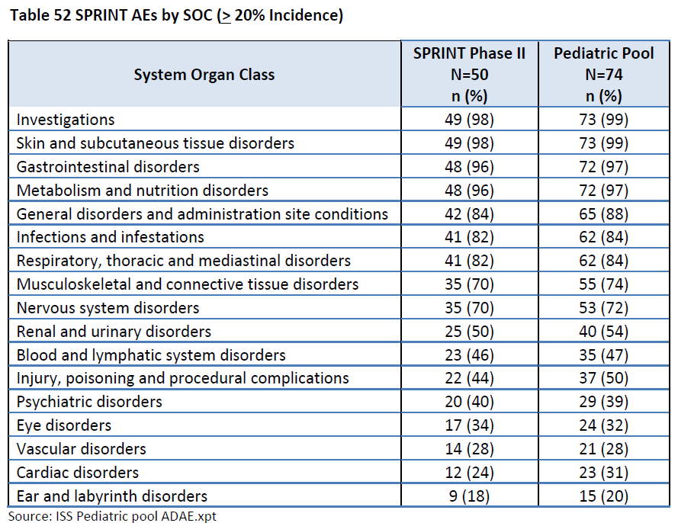

At the Preferred Term level, AEs that occurred in ≥ 30% of patients in SPRINT trial, Phase II Stratum 1 are shown in the following table, with the most common including vomiting, rash, abdominal pain, diarrhoea, nausea, dry skin, musculoskeletal pain, fatigue, pyrexia, dermatitis acneiform and stomatitis. Grade 3 to 4 AEs that occurred in at least 5% of patients included vomiting, rash, CPK elevation, diarrhoea, pyrexia and paronychia.

Table6: Common treatment emergence adverse events (≥ 20%) by Preferred Term of any grade, and Grade 3 or more (Sprint Phase II population and paediatric pool population)

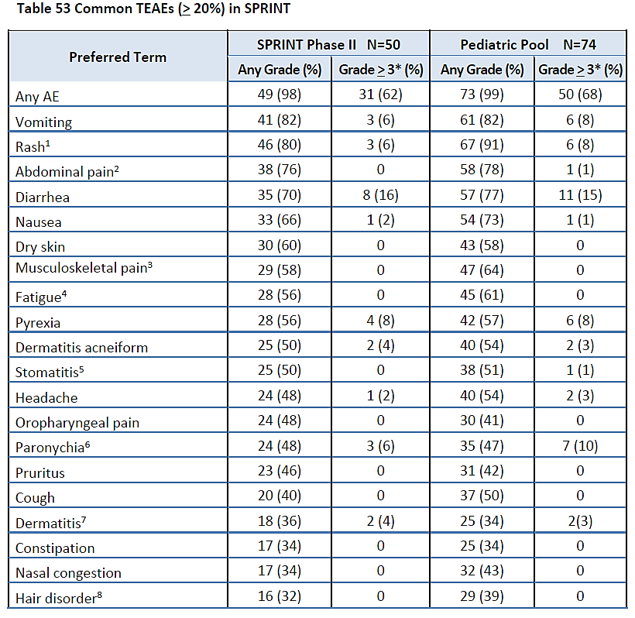

Adverse events were less frequent and less varied in the adult patient with cancer receiving selumetinib, compared to the paediatric patient NF1 PN population, mostly due to the relatively short selumetinib exposure time for adults. Analysis of the longer term safety data in the 90 day safety update did not detect any new safety signals.

###### Other safety findings

* *Laboratory findings*: Grade 3 or 4 laboratory abnormalities were uncommon; those that occurred in 2 or more patients in the SPRINT trial, Phase II population include anaemia, neutropenia, increased CPK, increased alanine transaminase (ALT), increased lipase and hyperkalaemia.
* *Vital signs*: Changes in vital signs were generally not a safety concern as indicated in the clinical study reports. In the paediatric pool, 16% (12 out of 74) of patients experienced Grade 1 to 2 hypertension during selumetinib exposure; these AEs did not result in dose modification. Tachycardia or bradycardia occurred in 30% of patients, all Grade 1 except for two Grade 2 tachycardia AEs.
* *ECGs*: No clinically relevant ECG patterns were observed in the paediatric pool.
* *Cardiac QT interval*: Selumetinib does not prolong the QTc interval in healthy adult subjects.
* *Immunogenicity*: There are no safety concerns relating to immunogenicity for selumetinib.

##### Analysis of submission-specific safety issues

###### Paronychia

Paronychia (nail fold infection and inflammation), a known toxicity associated with MEK inhibitors, was commonly seen in the SPRINT trial population, occurring in 45% (33 out of 74) of patients in the paediatric pool; 10% (7 out of 74) experienced Grade 3 paronychia. Seven patients (14%) had a dose interruption, 4 patients (8%) had a dose reduction, including one who had paronychia that led to permanent discontinuation of selumetinib. Most patients with paronychia recovered with symptomatic treatment and supportive care.

###### Alopecia

39% (29 out of 74) of patients in the paediatric pool and 6% (5 out of 79) of patients in the hyd-sulfate sub-group of the adult pool experienced a hair disorder adverse reaction (alopecia, hair colour change, and hair disorder) during selumetinib exposure, all Grade 1 or 2.

###### Decreased ejection fraction

In SPRINT trial, Phase II Stratum 1, 22% (11 out of 50) of patients experienced a decreased ejection fraction (all Grade 2); none of the events resulted in dose modification, and six recovered (five had unknown outcomes). In the paediatric pool, 17% (23 out of 74) of patients experienced a decrease in LVEF including one patient with a Grade 3 LVEF decrease (from 65% to 50%) resulting in dose reduction. All events of decreased EF were asymptomatic and detected on routine echocardiogram. During SPRINT trial, a reduction in LVEF of 10% or more from Baseline was counted as a decreased ejection fraction. 14 out of the 17 patients who experienced ejection fraction decrease maintained ejection fractions that met the study inclusion criteria (of ejection fraction ≥ 53%); the other three patients had an ejection fraction decrease to 50% (n = 2) or 52% (n = 1).

Ventricular dysfunction is a known MEK inhibitor related toxicity. As per SPRINT trial protocol, patients underwent baseline echocardiogram and routine echocardiograms every 4 cycles for the first year and every 6 cycles thereafter. Management of LVEF reduction depended on severity and symptoms, with paediatric cardiology consultation the usual course of action. This should be reflected in the PI.

###### Increased blood creatine phosphokinase

In the paediatric pool, 87.8% (65 out of 74 patients) had elevated CPK events:

* 74.3% were Grade 1 or 2;
* 6.8% were Grade 3;
* 4.1% were Grade 4.

Given the small paediatric safety pool and short median exposure time for the 79 adult patients who received the hyd-sulfate formulation, the oversea regulator requested additional analyses of CPK elevation and rhabdomyolysis using the global adult safety database, selumetinib expanded access program in PN and externally Sponsored selumetinib studies. The clinical evaluator concluded that there although CPK elevation was common in paediatric patients exposed to selumetinib, there were no events of rhabdomyolysis reported in the paediatric population. Patients who experienced concurrent CPK elevation and creatinine elevation and/or muscle symptoms generally had Grade 1 to 2 events that resolved without dose reduction. CPK evaluation rates were not reliable in the adult monotherapy pool as not all studies required routine assessments. There were rare cases of rhabdomyolysis with MEK inhibitors. The Delegate suggests that given the risk of CPK elevation and rhabdomyolysis with MEK inhibitors, this AE should be highlighted in the warnings/precautions section of the PI with specific dose modification guidelines.

###### Visual disturbance

Retinal events that were reported by two or more patients in SPRINT trial, Phase II Stratum 1 included vision blurred (4 out of 50 patients, 8%), and photophobia (2 out of 50 patients, 4%). The median time to onset of blurred vision was 455.5 days, with an event rate of 4.03 per 100 patient years.

Across the paediatric pool, 33% (24 out of 74) of patients experienced at least one eye disorder AE; none were SAEs or AEs ≥ Grade 3, and there were no discontinuation AEs or dose reductions for ocular toxicity. In the adult hyd-sulfate pool, 36% (27 out of 79) of patients had an eye disorder AE, including one Grade 3 visual impairment and one Grade 2 retinal vein occlusion resulting in discontinuation of selumetinib. 5% (4 out of 79) of adult patients experienced retinal pigment epithelial detachment or chorioretinopathy, which were not serious, severe or require dose modification.

Given the rarity of some ocular AEs, (such as retinal vein occlusion, and retinal pigment epithelial detachment), the relatively small paediatric safety pool, and the short median exposure time for the adult safety pool, the oversea regulator requested additional analyses of ocular toxicity across the global adult safety database, selumetinib expanded access program, and externally Sponsored selumetinib studies. In the expanded access program, three paediatric patients had ocular SAEs (visual field defect, eye disorder, abnormal ocular finding). The patient with the visual field defect discontinued selumetinib. In the paediatric external study dataset, two patients experienced optic nerve disorders resulting in discontinuation, and one patient experienced retinal pigment epithelial detachment. This dataset is confounded by patients having underlying low grade glioma, with existing baseline visual impairments due to underlying disease. The adult global database of 1860 patients who received selumetinib revealed 0.2% (4 out of 1860) patients with retinal vein occlusion and 0.1% (1 out of 1860) with retinal pigment epithelial detachment. The four patients with retinal vein occlusion events had Grade 2 (n = 3) or Grade 1 (n = 1) events; two of four patients are reported to not have recovered. Across the externally Sponsored adult studies, there was an additional retinal vein occlusion event and six retinal pigment epithelial detachment events.

The clinical evaluator concluded that selumetinib appears to have a similar ocular risk profile as other commercially available MEK inhibitors. While serious toxicities such as retinal vein occlusion and retinal pigment epithelial detachment were rare in the paediatric data, there is no evidence that paediatric patients have less risk than adults for MEK associated retinal AEs. The Delegate recommends that risk mitigating measures for serious ocular toxicity are highlighted in the PI.

###### Rash

Skin toxicities including dermatitis acneiform, non-acneiform rashes, pruritus and dry skin were common during selumetinib treatment. The majority of rashes were Grade 1 to 2 and did not require dose modification in paediatric patients. Rashes did not appear to lead to serious skin infections in patients with NF1 PN. Palmar-plantar erythrodysesthesia syndrome did not occur in the paediatric population, but is a known risk with MEK inhibitors, as observed in the adult safety data. Given the frequency of skin toxicity associated with selumetinib, this should be highlighted in the warnings/precautions section in the PI in addition to specific dose modification guidelines.

###### Physeal dysplasia

No AEs of physeal dysplasia were reported for the pediatric pool or for the adult monotherapy pool. In order to ascertain the risk of physeal dysplasia, height was used as a surrogate measure of effect of selumetinib on growth plates. From the comparison of data from the pediatric pool to that of the natural history study (which acted as a control population), selumetinib does not appear to have any adverse effects on skeletal growth in the SPRINT trial, population.

Growth and development parameters will continue to be monitored as part of the long term safety follow up for SPRINT trial and as part of the post-marketing requirements for selumetinib.

###### Serious gastrointestinal toxicity

Across the paediatric pool population, gastrointestinal tract toxicity was common:

* diarrhoea: 77%
  + 15% with Grade 3 events; one patient required dose reduction followed by permanent discontinuation),
  + In 65% (48 out of 74) of patients, diarrhoea was possibly or probably related to selumetinib.
* vomiting: 82%
  + 8% with Grade 3 events;
  + 25% of patients required drug interruptions for vomiting;
  + in 72% (53 out of 74) of patients, vomiting was possibly or probably related to selumetinib.
* Stomatitis: 50% (no ≥ Grade 3 events)

Gastrointestinal tract toxicity during the SPRINT trial was therefore frequent but usually tolerable and patients were managed with supportive care and/or selumetinib interruptions. Serious gastrointestinal tract toxicities (for example, perforation, obstruction, haemorrhagic events) were not observed across the paediatric pool which had relatively long exposure to selumetinib. However, more serious gastrointestinal tract toxicities were seen across the global selumetinib datasets, and although rare, were considered to be causally related to selumetinib in some patients.

The paediatric PN population is considered to be at risk for developing serious gastrointestinal tract toxicity associated with selumetinib and should be monitored carefully. The PI should attempt to mitigate risk by including specific precautions and dose modification guidelines. This risk will also be continually assessed during the long-term follow up of paediatric patients with PN in the post-marketing phase.

###### Haemorrhage

Haemorrhage is a labelled warning for other MEK inhibitors (that is, trametinib, cobimetinib and binimetinib), with events such as gastrointestinal tract bleeding, intracranial haemorrhage and haematuria described in association with these agents. The oversea regulator therefore conducted analyses to assess haemorrhagic events across the paediatric and adult safety pools.

In the paediatric pool, 53% (39 out of 74) of patients had some bleeding event, where 22% (16 out of 74) were considered to be at least possibly related to selumetinib exposure. All were Grade 1 to 2 in severity. Across the adult hyd-sulfate pool, 14% (11 out of 79) of patients experienced a bleeding event, where all were Grade 1 to 2 except for two Grade 3 events of gastrointestinal tract haemorrhage and serious haematemesis. One bleeding event was considered related to selumetinib (epistaxis). Across the larger adult monotherapy pool of 347 patients, there were three fatal bleeding events, with the investigators attributing these events to underlying disease and unrelated to selumetinib. Among paediatric patients in the externally Sponsored research studies, there were four patients, all with underlying low grade glioma, who experienced bleeding events including Grade 3 haematuria (n = 1), Grade 2 intracranial haemorrhage (n = 2) and Grade 2 haemorrhoid haemorrhage (n = 1). The Grade 2 haemorrhoid bleeding was assessed as related to selumetinib, with other events considered unrelated.

###### Weight gain

In the paediatric pool, 14% (10 out of 74) of patients experienced an AE of increased weight, including six patients (8%) with Grade 3 weight increase. One weight increase AE resulted in permanent discontinuation and two patients had dose reductions; confounders and unknowns (for example, diet changes) were present in all patients. The evaluator noted that reliable conclusions regarding the effect of selumetinib on weight in the paediatric study population cannot be made based on the available data. This potential safety signal could be addressed with longer term follow up of patients in the post‑marketing phase.

##### Other safety considerations

###### Additional safety explorations

* *Human carcinogenicity or tumour development*: No data are available. Based on pre‑clinical studies, selumetinib is not considered carcinogenic, and the number of patients on SPRINT trial who developed MPNST does not exceed the known background incidence of malignant transformation of PN to MPNST in the NF1 population.
* *Human reproduction and pregnancy*: Based on non-clinical data, it is recommended that pregnancy test be performed on female patients of childbearing potential prior to treatment with selumetinib, and that they must use adequate contraception during treatment and for at least 1 week after completion of treatment. Lactating mothers should be advised not to breast-feed during treatment with selumetinib. Male patients with sexual partners who are pregnant or who could become pregnant should use acceptable methods of contraception for at least one week after completing treatment with selumetinib.
* *Overdose*: Selumetinib overdose, defined as any dose received above 25 mg/m2, has no specific treatment. Due to low elimination of selumetinib related material in urine, dialysis is unlikely to influence elimination during overdose. Physicians should follow general supportive measures and treat with appropriate supportive care until recovery.
* *Drug abuse potential*: No findings during the clinical study program indicate that selumetinib induces drug abuse.
* *Withdrawal and rebound:* Based on available data, no evidence of withdrawal or rebound effects were noted following discontinuation of treatment with selumetinib therapy.

###### Expectations on safety in the post-market setting

As per the clinical evaluator, the long term follow up safety monitoring that is part of the SPRINT trial protocol is noted and aligns with the additional oversea regulator clinical safety post-marketing requirements, and, similarly, as required for the post-marketing requirements of this submission.

In addition to routine pharmacovigilance, the following post-authorisation measures are planned for selumetinib in the treatment of patients with NF1 and PNs:

* Long term safety follow-up from the SPRINT trial, Phase II Stratum 1 study

Per protocol, all patients in Phase II Stratum 1 will enter long-term follow up for a duration for seven years from the initiation of treatment or five years after completion of selumetinib, whichever takes longer. The follow up assessments will note whether there have been any significant medical issues with a focus on possible AEs related to selumetinib and safety follow up will specifically collect data on whether patients have seen a paediatric oncologist in the past year.

The following three oversea regulator post-marketing requirements are considered by the Delegate to also be conditions of registration for this submission

Figure 4: Selected post marketing requirements by United States Food and Drug Administration

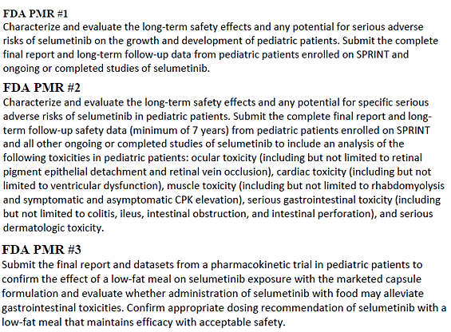

##### Safety summary

* The SPRINT trial, a multi-centre, single arm trial in 74 patients with NF1 PN, provided the primary safety data. Supportive safety data from the adult monotherapy pool, the selumetinib expanded access program, externally Sponsored paediatric selumetinib studies and additional safety analyses of the global selumetinib database allowed for an informed risk assessment of selumetinib in the intended population.
* Although the sample size of the SPRINT trial was relatively small, the median duration of treatment was approximately two years, which allows for a reasonable evaluation risk of cumulative toxicities with chronic dosing.
* There were no fatal AEs in the SPRINT trial. Serious adverse events (SAEs) occurred in 23% patients, including 11% who experienced selumetinib related SAEs. Adverse events (AEs) leading to permanent discontinuation occurred in 12%; approximately 32% of patients required dose reduction for an AE. Grade 3 to 4 AEs occurred in 68% of patients, including 43% which were considered at least possibly related to selumetinib. The commonest AEs in the paediatric pool included vomiting, rash, abdominal pain, diarrhoea, nausea, dry skin and musculoskeletal pain.
* Given the relatively low discontinuation rate of selumetinib over a relatively long treatment duration, it appears that toxicities were tolerable and manageable with dose modifications and supportive care in paediatric patients.
* Important risks of selumetinib are similar to those of other MEK inhibitors, including ocular, cardiac, musculoskeletal, gastrointestinal tract and dermatologic toxicities. Rare, serious AEs such as retinal vein occlusion, retinal pigment epithelial detachment and rhabdomyolysis were not observed in the SPRINT trial, however, review of supportive safety data suggests that selumetinib has a similar safety profile to commercially available MEK inhibitors. The intended paediatric population likely has a similar risk for developing these toxicities, and the PI should include relevant warnings, precautions, and dose modification guidelines to mitigate such risks.
* Patients in the SPRINT trial had substantial PN related morbidity, with long treatment durations and a low discontinuation rate observed, suggesting that selumetinib at the recommended dose was reasonably safe and generally tolerable. The long term safety profile of selumetinib for chronic dosing in this population will need to be further assessed through post-marketing requirements.

### Risk management plan

The Sponsor has submitted European Union (EU)-risk management plan (RMP) version 1.0 (dated 22 February 2020; data lock point (DLP) 3 September 2019) and Australia specific annex (ASA) version 1.0 (dated 30 September 2020) in support of this application. At Milestone 5, the Sponsor has submitted EU-RMP version 1.0 (succession 4) (dated 6 May 2021; DLP 3 September 2019) and ASA version 1.0 (succession 2) (dated 10 August 2021) in support of this application. On 26 August 2021, the Sponsor submitted EU-RMP version 1.0 (succession 4) (dated 6 May 2021; DLP 3 September 2019) and ASA version 1.0 (succession 3) (dated 25 August 2021).

The summary of safety concerns and their associated risk monitoring and mitigation strategies are summarised in Table 7.[9]

Table 7: Summary of safety concerns and their associated risk monitoring and mitigation strategies

|  |  |  |  |  |  |
| --- | --- | --- | --- | --- | --- |
| Summary of safety concerns | | Pharmacovigilance | | Risk Minimisation | |
| Routine | Additional | Routine | Additional |
| Important identified risks | Left ventricular ejection fraction reduction | ✓*† | ✓ ∆ | ✓ | – |
| Important potential risks | Physeal dysplasia | ✓*† | ✓ ∆ | – | – |
| Ocular toxicity | ✓*† | ✓ ∆ | ✓ |  |
| Myopathy | ✓*† | ✓ ∆ | ✓ | – |
| Hepatotoxicity | ✓*† | ✓ ∆ | ✓ | – |
| Choking on the capsule | ✓* | – | ✓ | – |
| Missing information | Long term exposure (including long term safety data on developmental toxicity in children) | ✓† | ✓ ∆ | – | – |

† Long term safety data will be collected by SPRINT trial.

∆ Post authorisation safety study (PASS)

*Follow-up questionnaires.

The summary of safety concerns in EU-RMP and ASA are the same. There are no Australia specific safety concerns. This was acceptable at second round of evaluation. At first round of evaluation, the RMP evaluator had recommended the inclusion of ‘Gastrointestinal toxicity’ and ‘Skin toxicity’ as important potentials risks in the summary of safety concerns as well as ‘Inappropriate use of capsules’ under missing information in the Australian RMP. The Sponsor has provided sufficient justification for not including the above in the summary of safety concerns (not in scope of this AusPAR). However, ‘Choking on the capsule’ has been added as an important potential risk in EU-RMP and ASA which addresses the concerns of the RMP evaluator regarding ‘inappropriate use of capsules’ as one of the concerns was the child might bite the capsule if they could not swallow it that is inability to swallow.

Routine pharmacovigilance has been proposed and includes specific targeted follow up questionnaires and the SPRINT trial which will study the long term safety of selumetinib. Additional pharmacovigilance activities include a post authorisation safety study.

Routine risk minimisation activities only have been proposed which is appropriate as selumetinib is administered orally and will be prescribed by specialists.

##### Proposed wording for conditions of registration

Any changes to which the Sponsor has agreed should be included in a revised RMP and ASA. However, irrespective of whether or not they are included in the currently available version of the RMP document, the agreed changes become part of the risk management system.

The suggested wording is:

*‘The Koselugo EU-Risk Management Plan (RMP) (version 1 (succession 4), dated 6 May 2021, data lock point 3 September 2019), with Australian specific annex (version 1 (succession 3) , dated 25 August 2021), included with submission PM-2020-05290-1-4 and any subsequent revisions, as agreed with the TGA will be implemented in Australia.’*

The following wording is recommended for the PSUR requirement:

*‘An obligatory component of risk management plans is routine pharmacovigilance. Routine pharmacovigilance includes the submission of periodic safety update reports (PSURs).*

*Reports are to be provided in line with the current published list of EU reference dates and frequency of submission of PSURs until the period covered by such reports is not less than three years from the date of this approval letter.*

*The reports are to at least meet the requirements for PSURs as described in the European Medicines Agency’s Guideline on good pharmacovigilance practices (GVP) Module VII-periodic safety update report (Rev 1), Part VII.B Structures and processes. Note that submission of a PSUR does not constitute an application to vary the registration.’*

As Koselugo is a new chemical entity it should be included in the Black Triangle Scheme as a condition of registration. The following wording is recommended for the condition of registration:

*‘Koselugo (selumetinib) is to be included in the Black Triangle Scheme. The PI and CMI for Koselugo must include the black triangle symbol and mandatory accompanying text for five years, which starts from the date that the Sponsor notifies the TGA of supply of the product.’*

## Risk-benefit analysis

#### Delegate’s considerations

Plexiform neurofibromas (PN) in paediatric patients with neurofibromatosis type-1 (NF1) are benign tumours that can cause substantial morbidity including disfigurement, pain and functional impairment. Complete surgical resection of these tumours are often not feasible; there are currently no approved systemic therapies for the treatment of PN in Australia. The lack of functional neurofibromin as a negative regulator of RAS activity in patients with NF1 provides the rationale for MEK inhibition as a treatment approach for PN.

##### Benefits

The clinical benefit of selumetinib in the intended population is based on the results of the US National Cancer Institute (NCI) SPRINT trial. The SPRINT trial, Phase II Stratum 1, an open label, single arm, multi‑centre study of selumetinib in children with NF1 and inoperable, symptomatic PN, enrolled 50 paediatric patients. The objective response rate (ORR) per REiNS criteria was 66% (95% CI: 51, 79) based on NCI central review, and 44% (95% CI: 30, 59) based on independent central review (ICR). In the 33 responders, median duration of response (DOR) was not reached; 82% of patients had a DOR of at least 12 months.

In supportive studies, the ORRs for the 24 patients in SPRINT trial, Phase I and the 25 patients in SPRINT trial, Phase II Stratum 2, were 67% (95% CI: 45, 84) and 68% (95% CI: 47, 85) respectively by NCI central review, consistent with the Phase II Stratum 1 results and similarly durable.

The response rate for the SPRINT trial was considered in the context of clinical outcomes data for patients, including the effects of selumetinib on PN related symptoms, functional impairment and disfigurement. Despite limitations of the single arm study design and small sample sizes of patients assessed for each PN related morbidity subset, there was a general trend of tumour volume reduction observed that was associated with at least one improved clinical outcome in most patients who experienced a durable response to selumetinib.

##### Uncertainties of benefit

Although the responses observed in the SPRINT trial are durable, the study follow up was not sufficiently mature to characterise the median duration of response.

Results for secondary and other endpoints in the study (patient related outcomes, observer related outcomes and performance observations) are considered descriptive only. These analyses were all exploratory with notable challenges associated with interpretation including, lack of a comparator arm, parent/caregiver’s knowledge of treatment assignment, a small sample size, potential instrument limitations, and thresholds used for defining clinically meaningful change.

It is noted that the NCI POB natural history study (submitted as part of application) showed spontaneous regression of PNs to be an uncommon occurrence, suggesting that the observed tumour responses in SPRINT trial are likely an effect of selumetinib. However, comparison of efficacy endpoints in SPRINT trial, Phase II Stratum 1 to either the natural history study or the placebo arm of Study 01-C-0222 are considered to be exploratory only, due to potential between study differences including patient eligibility criteria, endpoint definition and assessments frequencies of endpoints. In addition, the lack of covariate information for these external data limits the ability to compare data sources or adjust for potential confounders or bias; results of any comparisons are therefore not interpretable.

##### Risks

The primary safety analysis was based on the paediatric pool of 74 patients from the SPRINT trial, Phase II Stratum 1 and Phase I studies. Additional safety data from the adult monotherapy pool, the selumetinib expanded access program, externally Sponsored paediatric selumetinib studies and additional safety analyses of the global selumetinib database allowed for a more informed risk assessment of selumetinib in the intended population. Although the sample size of the SPRINT trial was relatively small, the median duration of treatment was approximately two years, which allows for a reasonable evaluation risk of cumulative toxicities with chronic dosing.

The primary safety risks of selumetinib are consistent with the profiles of other approved MEK inhibitors. The commonest adverse events (AEs) in the paediatric pool included vomiting, rash, abdominal pain, diarrhoea, nausea, dry skin and musculoskeletal pain. Although AEs in paediatric patients were frequent, most were low-grade and manageable with supportive care, dose interruptions and dose reductions.

##### Uncertainty of risks

Given the relatively low incidence of treatment related serious adverse events (SAEs; 11%) and low discontinuation rate (12%) of selumetinib over a relatively long treatment duration, it appears that toxicities were generally tolerable and manageable in paediatric patients. However, there is no evidence that paediatric patients are at less risk for uncommon but serious MEK inhibitor class toxicity effects that were not observed in the paediatric safety pool (for example, retinal vein occlusion, retinal pigment epithelial detachment, rhabdomyolysis). Therefore, relevant warnings and specific safety precautions, and dose modification guidelines should be included in the PI, and conditions of registration should include post-marketing requirements for long term safety evaluation in paediatric patients.

Paediatric patients may have difficulty taking selumetinib twice daily on an empty stomach (that is a total of 6 hour fasting time window per day) which may lead to subsequent issues with adherence to therapy. Food effect studies showed significant exposure change when selumetinib is administered with a low fat meal. Further data is therefore required to inform appropriate dosing recommendations with a low fat meal that maintains efficacy of selumetinib with acceptable safety. Submission of the final report from a PK trial in paediatric patients to confirm the effect of a low fat meal on selumetinib exposure is expected.

##### Benefit-risk balance

The benefit‑risk assessment for selumetinib is favourable. Selumetinib has demonstrated reasonable clinical benefit with a confirmed ORR that is durable (at least for the two year duration of follow up of the pivotal study), with a trend in improvements in some PN related morbidities and complications. The safety profile of selumetinib is consistent with other approved MEK inhibitors and is acceptable in view of the serious and debilitating nature of inoperable PN in paediatric patients with NF1.

#### Proposed action

While a decision is yet to be made, approval for selumetinib for the proposed indicationcannot be recommended whilst outstanding issues relating to manufacturing and quality control remain unresolved.

The Delegate will request further advice from ACM in relation to the following question (see Advisory Committee considerations):

* There is an outstanding toxicology issue regarding the selumetinib des-bromo impurity which remains unqualified at the not more than 0.2% level. Does the clinical benefit of selumetinib outweigh the risks of this toxicology concern regarding selumetinib des‑bromo?

#### Advisory Committee on Medicines considerations

The Advisory Committee on Medicines (ACM), having considered the evaluations and the Delegate’s overview, as well as the Sponsor’s response to these documents, advised the following.

##### Specific advice to the Delegate

Does an objective response rate of 66%, and a trend for improvement in patient reported outcomes, support the use of selumetinib in the intended population, despite the lack of long-term efficacy data?

The ACM advised that the available data support the use of selumetinib in the intended population. The ACM commented there is an unmet clinical need in Australia as there are no other treatments registered for a similar indication. Plexiform neurofibromas grow most rapidly in young children and symptomatology can be varied, extreme, and can have life threatening or life altering consequences (for example, requiring a tracheostomy for an airway tumour) with no other potential interventions. The ACM was of the view that waiting for additional longer-term safety data before approval could have a profound impact on the lives of many young children.

Should the indication, if approved, be restricted to paediatric patients 3 years of age and above?

The ACM was of the view that although the available data is in children ≥ 3 years old, there is little difference between the physiology of a 2-year-old and 3-year-old child in this particular context. The ACM commented that while recruitment of children under the age of 3 years old in the trial was likely impeded by their ability to swallow the capsule whole (further discussion of the capsule size in included under ‘4. Other advice’, below), they did not have any significant concerns that the systemic tolerability of this product in a 2-year-old child would be significantly different from that of a 3-year-old.

The ACM advised that there are likely to be patients that are only 2 to 3 years old with severe manifestations of this disease, as tumour growth is often most rapid in these patients. The ACM was of the view that not including 2-year-old patients in the indication may prevent access for some severely affected individuals who have no other treatment options available.

There is an outstanding toxicology issue regarding the selumetinib des-bromo impurity which remains unqualified at the not more than 0.2% level. Does the clinical benefit of selumetinib outweigh the risks of this toxicology concern regarding selumetinib des-bromo?

The ACM disagreed with the Sponsor’s conclusion that the impurity has been qualified. The relevant ICH Q3A guideline;[10] clearly states no more than 0.15% or 1 mg, whichever is the lower. However, the ACM was of the view that although the impurity is unqualified, the clinical benefits outweigh the risks and this finding should not preclude approval.

Other advice.

The ACM discussed the difficulties that young children (including those below the age of 3 years old) might have in swallowing the capsule whole. The Koselugo capsule is considered to be relatively large for paediatric use (14 mm) and presents a potential choking risk in young children. The ACM noted that it is not possible to open the hard gel capsule and add the contents to food, as is a common practice for dosing young children. The ACM commented that an alternative dose form would be a useful option for very young children.

The ACM commented that paediatric patients may have difficulty taking selumetinib twice daily on an empty stomach (6 hour fasting time window) and this may lead to compliance issues. The administration of selumetinib with food is more practical and it may also alleviate the reported gastrointestinal toxicities.

##### Conclusion

The ACM considered this product to have an overall positive benefit-risk profile for the indication:

*For the treatment of paediatric patients 2 years of age and older with neurofibromatosis type 1 (NF1) who have symptomatic, inoperable plexiform neurofibromas (PN).*

## Registration decision

Based on a review of quality, safety and efficacy, the TGA approved the registration of Koselugo (selumetinib sulfate) 10 mg and 25 mg, capsule, bottle, indicated for:

*Koselugo is indicated for the treatment of paediatric patients aged 2 years and above, with neurofibromatosis type 1 (NF1) who have symptomatic, inoperable plexiform neurofibromas (PN).*

## Product submission

### Submission details

|  |  |
| --- | --- |
| *Type(s) of submission:* | New chemical entity |
| *Product name(s):* | Koselugo |
| *Active ingredient(s):* | Selumetinib sulfate |
| *Decision:* | Approved |
| *Date of decision:* | 29 November 2021 |
| *Date of entry onto ARTG:* | 2 December 2021 |
| *ARTG number(s):* | 345972 and 345973 |
| [*Black Triangle Scheme*](https://www.tga.gov.au/black-triangle-scheme)  *for the current submission:* | Yes  This product will remain in the scheme for 5 years, starting on the date the product is first supplied in Australia |
| *Sponsor’s name and address:* | Alexion Pharmaceuticals, Inc. 66 Talavera Rd, Macquarie Park NSW 2113. |
| *Dose form(s):* | Capsule |
| *Strength(s):* | 10 mg and 25 mg |
| *Container(s):* | Bottle |
| *Pack size(s):* | 60 |
| *Approved therapeutic use for the current submission:* | Koselugo is indicated for the treatment of paediatric patients aged 2 years and above, with neurofibromatosis type 1 (NF1) who have symptomatic, inoperable plexiform neurofibromas (PN). |
| *Route(s) of administration:* | Oral |
| *Dosage:* | The recommended dosage of Koselugo is 25 mg/m2 orally twice daily (approximately every 12 hours) until disease progression or unacceptable toxicity. Dosage is based on body surface area of the patient.  Therapy should be initiated by a physician experienced in the diagnosis and the treatment of patients with neurofibromatosis type 1 (NF1) related tumours.  For further information regarding dosage, refer to the Product Information. |
| *Pregnancy category:* | D  Drugs which have caused, are suspected to have caused or may be expected to cause, an increased incidence of human fetal malformations or irreversible damage. These drugs may also have adverse pharmacological effects. Accompanying texts should be consulted for further details.  The use of any medicine during pregnancy requires careful consideration of both risks and benefits by the treating health professional. This must not be used as the sole basis of decision making in the use of medicines during pregnancy. The TGA does not provide advice on the use of medicines in pregnancy for specific cases. More information is available from obstetric drug information services in your State or Territory. |

### Specific conditions of registration

* Koselugo (selumetinib)is to be included in the Black Triangle Scheme. The PI and CMI for Koselugo must include the black triangle symbol and mandatory accompanying text for five years, which starts from the date that the Sponsor notifies the TGA of supply of the product.
* The Koselugo EU-RMP (version 1 (succession 4), dated 6 May 2021, data lock point 3 September 2019), with ASA (version 1 (succession 3), dated 25 August 2021), included with submission PM-2020-05290-1-4 and any subsequent revisions, as agreed with the TGA will be implemented in Australia.

An obligatory component of risk management plans is routine pharmacovigilance. Routine pharmacovigilance includes the submission of periodic safety update reports (PSURs).

Reports are to be provided in line with the current published list of EU reference dates and frequency of submission of PSURs until the period covered by such reports is not less than three years from the date of the approval letter.

The reports are to at least meet the requirements for PSURs as described in the European Medicines Agency’s Guideline on good pharmacovigilance practices (GVP) Module VII-periodic safety update report (Rev 1), Part VII.B Structures and processes. Note that submission of a PSUR does not constitute an application to vary the registration.

* Evaluation of long term safety effects and any potential for serious adverse risks of selumetinib on the growth and development of paediatric patients. Submission of complete final report and long term follow up data from paediatric patients enrolled on SPRINT trial and ongoing or completed studies of selumetinib.
* Evaluate the long term safety effects and any potential for specific serious adverse risks of selumetinib in paediatric patients. Submission of complete final report and long-term follow-up safety data (minimum of 7 years) from paediatric patients enrolled on SPRINT trial and all ongoing or completed studies of selumetinib to include an analysis of the following toxicities in paediatric patients: ocular toxicity, cardiac toxicity, muscle toxicity, serious gastrointestinal toxicity, and serious dermatologic toxicity.
* Submit the final report and datasets from a PK trial in paediatric patients to confirm the effect of a low fat meal on selumetinib exposure with the marketed capsule formulation. Evaluate whether administration of selumetinib with food may alleviate gastrointestinal toxicities. Confirm appropriate dosing recommendation of selumetinib with a low fat meal that maintains efficacy with acceptable safety.

### Product Information (PI) and Consumer Medicine Information (CMI)

The [Product Information](https://www.tga.gov.au/products/australian-register-therapeutic-goods-artg/product-information-one) ([PI](https://www.tga.gov.au/products/australian-register-therapeutic-goods-artg/product-information-one)) approved with this submission for Koselugo which is referred to in this AusPAR (and can be accessed on this AusPAR’s webpage) may have been superseded. For the most recent PI and [Consumer Medicines Information](https://www.tga.gov.au/products/australian-register-therapeutic-goods-artg/consumer-medicines-information-cmi) (CMI), please refer to the TGA [PI/CMI search facility.](https://www.ebs.tga.gov.au/)

### Regulatory status

#### Australian regulatory status

This product is considered a new chemical entity for Australian regulatory purposes.

Selumetinib was granted orphan drug determination by the TGA on 30 July 2020 with the orphan indication for the treatment of neurofibromatosis type 1.

#### International regulatory status

At the time the TGA considered this application, a similar application had been approved in European Union (EU) (approved 17 June 2021), United Kingdom (approved on 9 August 2021), United States of America (approved on 10 April 2020) and Singapore (approved on 9 July 2021). It was under consideration in Canada and Switzerland. There have been no deferrals, withdrawals or rejections in major countries in which a similar application has been submitted.

|  |  |  |  |
| --- | --- | --- | --- |
| Region | Submission date | Status | Approved indications |
| Canada | 9 September 2020 | Under consideration | Under consideration |
| European Union | 5 March 2020 | Granted conditional marketing authorisation on 17 June 2021 | *Koselugo as monotherapy is indicated for the treatment of symptomatic, inoperable plexiform neurofibromas (PN) in paediatric patients with neurofibromatosis type 1 (NF1) aged 3 years and above.* |
| United Kingdom | 27 April 2021 | Approved on 9 August 2021 | *Koselugo as monotherapy is indicated for the treatment of symptomatic, inoperable plexiform neurofibromas (PN) in paediatric patients with neurofibromatosis type 1 (NF1) aged 3 years and above*. |
| United States of America | 13 September 2020 | 10 April 2020 | *Koselugo is indicated for the treatment of paediatric patients 2 years of age and older with neurofibromatosis type 1 (NF1) who have symptomatic, inoperable plexiform neurofibromas (PN).* |
| Switzerland | 30 September 2020 | Under consideration | Under consideration |
| Singapore | 12 August 2020 | 9 July 2021 | *Koselugo is indicated for the treatment of paediatric patients aged 3 years and above with neurofibromatosis type 1 (NF1) who have symptomatic, inoperable plexiform neurofibromas (PN).* |

### Assessment and registration timeline

Table captures the key steps and dates of the assessment and registration process for this submission.

The active ingredient with its proposed indication was given [orphan drug designation](https://www.tga.gov.au/resources/resource/guidance/orphan-drug-designation).

Table: Registration timeline for Koselugo (submission no. PM-2020-05290-1-4) – Key Dates.

|  |  |
| --- | --- |
| Description | Date |
| Determination (Orphan);7 | 30 July 2020 |
| Submission dossier accepted and first round evaluation commenced | 30 November 2020 |
| First round evaluation completed | 30 April 2021 |
| Sponsor provides responses on questions raised in first round evaluation | 29 June 2021 |
| Second round evaluation completed | 30 July 2021 |
| Delegate’s Overall benefit-risk assessment and request for Advisory Committee advice | 23August 2021 |
| Sponsor’s pre-Advisory Committee response | 14 September 2021 |
| Advisory Committee meeting | 30 September and 1 October 2021 |
| Registration decision (Outcome) | 29 November 2021 |
| Completion of administrative activities and registration on the ARTG | 2 December 2021 |
| Number of working days from submission dossier acceptance to registration decision* | 205 |

*Statutory timeframe for standard submissions is 255 working days

## Attachment 1. Product Information

The [Product Information](https://www.tga.gov.au/products/australian-register-therapeutic-goods-artg/product-information-one) ([PI](https://www.tga.gov.au/products/australian-register-therapeutic-goods-artg/product-information-one)) approved with the submission for [Tradename] which is described in this AusPAR can be found as Attachment 1. It may have been superseded. For the most recent PI and [Consumer Medicines Information](https://www.tga.gov.au/products/australian-register-therapeutic-goods-artg/consumer-medicines-information-cmi) (CMI), please refer to the TGA [PI/CMI search facility.](https://www.tga.gov.au/picmi-search-facility)

|  |
| --- |
| Therapeutic Goods Administration |
| PO Box 100 Woden ACT 2606 Australia  Email: [info@tga.gov.au](mailto:info@tga.gov.au) Phone: 1800 020 653 Fax: 02 6203 1605  [**https://www.tga.gov.au**](https://www.tga.gov.au) |
| Reference/Publication # |

1. This is the original indication proposed by the Sponsor when the TGA commenced the evaluation of this submission. It may differ to the final indication approved by the TGA and registered in the Australian Register of Therapeutic Goods.
2. Miller DT, et al. Health Supervision for Children with Neurofibromatosis Type 1. Pediatrics. 2019 May;143(5).
3. Dombi E, et al. Activity of Selumetinib in Neurofibromatosis Type-1 Related Plexiform Neurofibromas. N Engl J Med 2016;375(26):2550-60.
4. Gross AM, et al. Selumetinib in Children with Inoperable Plexiform Neurofibromas. *N Engl J Med* 2020;382(15):1430-42.
5. Multi-disciplinary Review and Evaluation NDA 213756 Koselugo (selumetinib) Centre for drug evaluation and research.
6. Sponsor clarification: capsule taken on an empty stomach refers to fasting 2 hours before and 1 hour after each dose.
7. The **QT interval** is the time from the start of the QRS wave complex to the end of the corresponding T wave. It approximates to the time taken for ventricular depolarisation and repolarisation, that is to say, the period of ventricular systole from ventricular isovolumetric contraction to isovolumetric relaxation.
8. The **corrected QT interval** (**QTc**) estimates the QT interval at a standard heart rate. This allows comparison of QT values over time at different heart rates and improves detection of patients at increased risk of arrhythmias. The **QTcF** is the QT interval corrected for heart rate according to Fridericia’s formula.
9. *Routine risk minimisation* activities may be limited to ensuring that suitable warnings are included in the product information or by careful use of labelling and packaging.

   *Routine pharmacovigilance* practices involve the following activities:

   All suspected adverse reactions that are reported to the personnel of the company are collected and collated in an accessible manner;

   Reporting to regulatory authorities;

   Continuous monitoring of the safety profiles of approved products including signal detection and updating of labelling;

   Submission of PSURs;

   Meeting other local regulatory agency requirements.
10. ICH guidance Q3A (R2): Impurities in new drug substances, October 2006.