**AUSTRALIAN PRODUCT INFORMATION**

**LYNPARZA®**

**Olaparib Tablets**

1. **NAME OF THE MEDICINE**

Olaparib

# QUALITATIVE AND QUANTITATIVE COMPOSITION

LYNPARZA tablets consist of either 100 mg or 150 mg olaparib drug substance and the following inactive ingredients; copovidone, colloidal anhydrous silica, mannitol, sodium stearylfumarate hypromellose, macrogol 400, titanium dioxide and iron oxide yellow. LYNPARZA 150 mg tablets also contain iron oxide black.

# PHARMACEUTICAL FORM

LYNPARZA 150 mg tablets are a green to green/grey, oval, bi-convex tablet debossed with ‘OP150’ on one side and plain on the reverse.

LYNPARZA 100 mg tablets are a yellow to dark yellow, oval, bi-convex tablet debossed with ‘OP100’ on one side and plain on the reverse.

# CLINICAL PARTICULARS

## Therapeutic indications Ovarian cancer

LYNPARZA is indicated as monotherapy for the:

* + - maintenance treatment of adult patients who have advanced, high-grade, epithelial ovarian, fallopian tube or primary peritoneal cancer with a deleterious or suspected deleterious, breast cancer susceptibility gene (*BRCA*) mutation (germline or somatic), which is in response (complete or partial) to first-line platinum-based chemotherapy.
    - maintenance treatment of adult patients who have platinum-sensitive relapsed, high-grade epithelial ovarian, fallopian tube or primary peritoneal cancer which is in response (complete or partial) after platinum-based chemotherapy. Prior treatment must have included at least 2 courses of platinum-based regimens.

LYNPARZA in combination with bevacizumab is indicated for the:

* + - maintenance treatment of adult patients who have advanced, epithelial ovarian, fallopian tube or primary peritoneal cancer which is in response (complete or partial) to first-line platinum- based chemotherapy and whose cancer is associated with homologous recombination deficiency (HRD)-positive status defined by either:
      * a deleterious or suspected deleterious *BRCA* mutation (germline or somatic), and/or
      * genomic instability

## Breast cancer

LYNPARZA is indicated as monotherapy for the:

* adjuvant treatment of adult patients who have HER2-negative, high-risk early breast cancer with a deleterious or suspected deleterious germline *BRCA* mutation (*gBRCAm*), for which they have previously been treated with neoadjuvant or adjuvant chemotherapy.
* treatment of adult patients who have HER2-negative metastatic breast cancer with a deleterious or suspected deleterious *gBRCAm*, for which they have previously been treated with chemotherapy in the neoadjuvant, adjuvant or metastatic setting.

## Adenocarcinoma of the pancreas

LYNPARZA is indicated as monotherapy for the:

* + - maintenance treatment of adult patients who have metastatic pancreatic adenocarcinoma with a deleterious or suspected deleterious g*BRCA*m, which has not progressed on at least 16 weeks of a first-line platinum-based chemotherapy regimen.

## Prostate cancer

LYNPARZA is indicated as monotherapy for the:

* + - treatment of adult patients who have metastatic castration-resistant prostate cancer (mCRPC) with a deleterious or suspected deleterious *BRCA* mutation (germline or somatic), which has progressed following prior therapy that included a new hormonal agent.

LYNPARZA in combination with abiraterone and either prednisone or prednisolone is indicated for the:

* + - treatment of adult patients who have mCRPC with a deleterious or suspected deleterious *BRCA*

mutation (germline or somatic).

## Dose and method of administration

Treatment with LYNPARZA should be initiated and supervised by a physician experienced in the use of anticancer medicinal products.

## Patient selection

Companion diagnostic (CDx) testing using an *in vitro* diagnostic (IVD), including notified assays performed by a NATA accredited laboratory, is essential for the use of olaparib to be safe and effective in indications that are *BRCA* and/or HRD specific. Where specified in the indication, confirmation of the relevant *BRCA* mutation (*BRCAm*) or HRD status must be obtained prior to initiating treatment with LYNPARZA.

Testing used in clinical practice should be comparable to the testing used in the relevant pivotal studies (see Section 5.1 - Pharmacodynamic properties – Clinical trials).

In these studies, deleterious or suspected deleterious *BRCA*m were identified in tumour DNA from a tumour tissue sample, or in germline DNA obtained from a non-tumour (usually blood) sample. In the prostate cancer studies deleterious or suspected deleterious *BRCA*m were also identified in circulating tumour DNA [ctDNA] obtained from a plasma sample. If a ctDNA test is used and the result is negative, this does not rule out the presence of a *BRCA*m.

## Method of administration

LYNPARZA tablets should be swallowed whole (not chewed, crushed, dissolved or divided) at approximately the same time each day, and can be taken with or without food.

## Dosage in adults

The recommended dose of LYNPARZA (whether as monotherapy or in combination) is 300 mg twice a day, taken orally.

When olaparib is used in combination with other medicines, refer to the Product Information for the other medicines for their recommended dosing information. The studied doses are described in Section 5.1 - Pharmacodynamic properties – Clinical trials.

## Duration of treatment

The recommended duration of treatment for each indication is summarised in Table 1.

The efficacy and safety of maintenance retreatment with LYNPARZA following first or subsequent relapse in ovarian cancer patients has not been established. There are no efficacy or safety data on retreatment with LYNPARZA of breast cancer, prostate cancer and pancreatic cancer patients.

## Table 1 Duration of treatment for each indication

|  |  |
| --- | --- |
| **Indication** | **Duration of treatment** |
| First-line maintenance treatment of  *BRCAm* advanced ovarian cancer | Until disease progression, unacceptable toxicity or for a maximum of 2 years unless there is remaining evidence of disease and the treating physician believes continuing treatment would provide further benefit. |
| Maintenance treatment of relapsed ovarian cancer | Until disease progression or unacceptable toxicity. There are no data to support retreatment with olaparib. |
| First-line maintenance treatment of HRD-positive advanced ovarian cancer (in combination with bevacizumab) | Until disease progression, unacceptable toxicity or for a maximum of 2 years unless there is remaining evidence of disease and the treating physician believes continuing treatment would provide further benefit. |
| Adjuvant treatment of high-risk HER2-negative, *gBRCAm* early breast cancer | Until disease recurrence, unacceptable toxicity or for a maximum of 1 year, whichever occurs first. Patients with hormone receptor-positive breast cancer should continue concurrent treatment with endocrine therapy as per local guidelines. |
| Metastatic HER2-negative *gBRCAm*  breast cancer | Until disease progression or unacceptable toxicity. There are no data to support retreatment with olaparib. |
| First-line maintenance treatment of *gBRCAm* metastatic pancreatic adenocarcinoma | Until disease progression or unacceptable toxicity. |
| Treatment of BRCAm mCRPC after prior NHA therapy | Until disease progression or unacceptable toxicity. There are no data to support retreatment with olaparib. |
| First-line treatment of BRCAm mCRPC (in combination with abiraterone and steroid) | Until disease progression or unacceptable toxicity. |

**Missing dose**

If a patient misses a dose of LYNPARZA, they should take their next normal dose at its scheduled time.

## Dose adjustments

Treatment interruption can be used to manage adverse reactions such as nausea, vomiting, diarrhoea, and anaemia. Dose reduction can be considered.

Gastrointestinal toxicities are frequently reported with olaparib therapy (see Section 4.8 - Adverse effects) and are generally low grade (CTCAE grade 1 or 2) and intermittent. In addition to dose interruption or reduction, concomitant medicinal products (e.g. antiemetic therapy) may also be considered. Antiemetic prophylaxis is not required. Refer to Table 2 below for recommended dose adjustments to manage adverse reactions.

## Table 2 Recommended dose adjustments to manage adverse reactions

|  |  |
| --- | --- |
| **Dose level** | **Dose of olaparib** |
| Starting dose | 300 mg twice a day |
| First dose reduction | 250 mg twice a day |
| Second dose reduction | 200 mg twice a day |

**Co-administration with CYP3A inhibitors**

Concomitant use of strong or moderate CYP3A inhibitors is not recommended: consider alternative agents. If a strong CYP3A inhibitor must be co-administered, reduce the dose of LYNPARZA tablets to 100 mg twice a day. If a moderate CYP3A inhibitor must be co-administered, reduce the LYNPARZA dose to 150 mg twice a day. The patient should be carefully monitored for adverse events. (see Section 4.5 - Interactions with other medicines and other forms of interactions).

## Special patient populations

### Children or adolescents

LYNPARZA is not indicated for use in paediatric patients, as safety and efficacy of LYNPARZA in children and adolescents have not been established.

### Elderly (>65 years)

No adjustment in starting dose is required for elderly patients. There are limited clinical data in patients aged 75 years and over.

### Renal impairment

For patients with moderate renal impairment (creatinine clearance 31-50 mL/min) the recommended dose of LYNPARZA tablets is 200 mg twice a day. LYNPARZA is not recommended for patients with severe renal impairment or end-stage renal disease (creatinine clearance ≤30 mL/min) as safety and pharmacokinetics have not been studied in these patients. LYNPARZA can be administered to patients with mild renal impairment (creatinine clearance 51- 80 mL/min) with no dose adjustment. Patients should be monitored closely for renal function and adverse events.

### Hepatic impairment

LYNPARZA can be administered to patients with mild or moderate hepatic impairment (Child- Pugh classification A or B) with no dose adjustment however, patients should be monitored closely for hepatic function and adverse events (see Section 5.2- Pharmacokinetic properties). LYNPARZA is not recommended for use in patients with severe hepatic impairment (Child-Pugh classification C), as safety and pharmacokinetics have not been studied in these patients.

## Contraindications

Hypersensitivity to the active substance (olaparib) or to any of the excipients.

## Special warnings and precautions for use Haematological toxicity

Olaparib commonly causes haematological toxicity (see Section 4.8 – Adverse effects). While the majority were generally mild or moderate (CTCAE Grade 1 or 2), Grade 3 or higher events of anaemia (decrease in haemoglobin) occurred in 7.4% of patients in Study 19, and one patient died from a haemorrhagic stroke associated with thrombocytopenia.

Patients should not start treatment with LYNPARZA until they have recovered from haematological toxicity caused by previous anti-cancer therapy (haemoglobin, platelet, and neutrophil levels should be ≤CTCAE grade 1). Check full blood count at baseline, then monthly for the first year of treatment, and periodically after that. If a patient develops severe haematological toxicity or blood transfusion dependence, interrupt treatment with LYNPARZA and initiate haematological testing.

If blood parameters remain clinically abnormal after 4 weeks of LYNPARZA dose interruption, bone marrow analysis and/or blood cytogenetic analysis are recommended.

## Myelodysplastic syndrome (MDS) and acute myeloid leukaemia (AML)

LYNPARZA may cause MDS/AML, and the majority of events reported had a fatal outcome (see Section 4.8 – Adverse effects). The incidence of MDS/AML in patients treated in clinical trials with LYNPARZA monotherapy, including during long-term survival follow up, was 1.5%. In a Phase III placebo-controlled clinical trial (SOLO2), a higher incidence was reported in LYNPARZA treated patients with *BRCA*m platinum-sensitive relapsed ovarian cancer, who had received at least two prior lines of platinum chemotherapy and were followed up for 5 years, compared to the placebo arm in the SOLO2 study (and to patients receiving LYNPARZA in clinical trials in other indications). The reports were typical of secondary MDS/cancer therapy-related AML. The duration of therapy with LYNPARZA in patients who developed secondary MDS/AML varied from <6 months to >4 years. The majority of reports were in germline *BRCA* mutation (*gBRCAm*) carriers and some of the patients had a history of previous more than one primary malignancy or of bone marrow dysplasia.

If MDS and/or AML are confirmed while on treatment with LYNPARZA, permanently discontinue LYNPARZA.

## Pneumonitis

Pneumonitis has been reported in <1% of patients treated with LYNPARZA in clinical studies, including some fatal cases when used in combination with other therapies. Reports of pneumonitis had no consistent clinical pattern and occurred in patients with other risk factors (cancer and/or metastases in lungs, underlying pulmonary disease, smoking history, and/or previous chemotherapy and radiotherapy).

If patients present with new or worsening respiratory symptoms such as dyspnoea, cough and fever, or an abnormal chest radiological finding is observed, LYNPARZA treatment should be interrupted and prompt investigation initiated. If pneumonitis is confirmed, LYNPARZA treatment should be discontinued.

Venous thromboembolism

Venous thromboembolic events (VTE), including severe or fatal pulmonary embolism (PE), have occurred in patients treated with LYNPARZA. In the combined data from two randomised,

placebo-controlled clinical studies (PROfound and PROpel) in patients with mCRPC who were also receiving androgen deprivation therapy (N=1180), VTE occurred in 8% of patients who received LYNPARZA, including PE in 6%. In the control arms, VTE occurred in 2.5% including PE in 1.5%. The incidence of VTE/PE in these patients was higher than seen in other approved indications (see section 4.8 – Adverse effects). Monitor patients for clinical signs and symptoms of venous thrombosis and pulmonary embolism and treat as medically appropriate, which may include long-term anticoagulation as clinically indicated.

## Use in hepatic impairment

Exposure is increased in hepatic impairment (see Section 5.2- Pharmacokinetic properties and Section 4.2 - Dose and method of administration).

## Use in renal impairment

Exposure is increased in renal impairment (see Section 5.2- Pharmacokinetic properties and Section 4.2- Dose and method of administration).

## Use in the elderly

There are limited clinical data in patients aged 75 years and over (see Section 4.2- Dose and method of administration).

## Patients with worsened performance status

There are very limited clinical data available in patients with Eastern Cooperative Oncology Group performance status 2 to 4.

## Paediatric use

The safety and efficacy of LYNPARZA in children and adolescents have not been established.

## Effects on laboratory tests

No data available.

## Interactions with other medicinal products

Olaparib co-administration with strong or moderate CYP3A inhibitors is not recommended (see Section 4.5 - Interactions with other medicines and other forms of interactions). If a strong or moderate CYP3A inhibitor must be co-administered, the dose of olaparib should be reduced (see Section 4.2 - Dose and method of administration).

Olaparib co-administration with strong or moderate CYP3A inducers is not recommended (see Section 4.5 - Interactions with other medicines and other forms of interactions). In the event that a patient already receiving olaparib requires treatment with a strong or moderate CYP3A inducer, the efficacy of olaparib may be substantially reduced (see Section 4.2 - Dose and method of administration.).

## Interactions with other medicines and other forms of interactions

Clinical studies of olaparib in combination with other anticancer agents, including DNA damaging agents, indicate a potentiation and prolongation of myelosuppressive toxicity. The recommended LYNPARZA monotherapy dose is not suitable for combination with other myelosuppressive anticancer agents.

## Effect of other drugs on olaparib

### Strong and moderate CYP3A inhibitors

CYP3A4/5 are the isozymes predominantly responsible for the metabolic clearance of olaparib.

Co-administration of olaparib with a strong CYP3A inhibitor (itraconazole) increased olaparib Cmax by 42% (90% CI: 33% to 52%) and mean AUC by 170% (90% CI: 144% to 197%). It is therefore recommended that known strong inhibitors of these isozymes are not co-administered with LYNPARZA. These include but are not limited to inhibitors such as itraconazole, clarithromycin, boosted protease inhibitors with ritonavir or cobicistat, indinavir, saquinavir and boceprevir (see Section 4.4 - Special warnings and precautions for use).

Physiologically based pharmacokinetic modelling has suggested that moderate CYP3A inhibitors will alter the clearance of olaparib and therefore concomitant use of moderate CYP3A inhibitors such as, but not limited to ciprofloxacin, erythromycin, diltiazem, fluconazole and verapamil is not recommended with LYNPARZA (see Section 4.4 - Special warnings and precautions for use).

If a strong or moderate CYP3A inhibitor must be co-administered, the dose of LYNPARZA should be reduced (see Section 4.2 - Dose and method of administration.).

Patients should avoid star fruit, grapefruit and Seville oranges because these foods are known to inhibit CYP3A enzymes.

### Strong and moderate CYP3A inducers

A clinical study to evaluate the impact of rifampicin, a known CYP3A inducer has shown that co- administration with olaparib decreased olaparib Cmax by 71% (90% CI: 76% to 67%) and mean AUC by 87% (90% CI: 89% to 84%). It is therefore possible that CYP3A inducers could substantially diminish the clinical efficacy of LYNPARZA and as such, concomitant use of strong inducers such as, but not limited to phenytoin, rifabutin, rifampicin, carbamazepine, nevirapine, phenobarbital and St John's Wort (*Hypericum perforatum*) is not recommended with LYNPARZA.

Physiologically based pharmacokinetic modelling has suggested that moderate CYP3A inducers will decrease olaparib AUC by approximately 60% and therefore concomitant use of moderate CYP3A inducers such as, but not limited to, bosentan, efavirenz, etravirine and modafinil is not recommended with LYNPARZA. If a moderate CYP3A inducer must be co-administered, the prescriber should be aware of a potential for decreased efficacy of LYNPARZA (see Section 4.4 - Special warnings and precautions for use).

## Effect of olaparib on other drugs

### CYP and UGT interactions

Both induction and inhibition of CYP3A4 has been shown *in vitro,* however, physiologically based pharmacokinetic modelling simulations and clinical data suggest that the net effect of olaparib *in vivo* is weak inhibition of CYP3A. Therefore, caution should be exercised when sensitive CYP3A substrates or substrates with a narrow therapeutic margin (e.g. simvastatin, ciclosporin, midazolam ergot alkaloids, sirolimus, fentanyl, tacrolimus and quetiapine) are combined with LYNPARZA. Appropriate clinical monitoring is recommended for patients receiving CYP3A substrates with a narrow therapeutic margin concomitantly with LYNPARZA.

Induction of CYP1A2 and 2B6 has been shown *in vitro*. Therefore, LYNPARZA upon co- administration may reduce the exposure to substrates of these metabolic enzymes.

Olaparib produced little/no direct inhibition *in vitro* of UGT1A4, UGT1A9, UGT2B7 or CYPs 1A2, 2A6, 2B6, 2C8, 2C9, 2C19, 2D6 or 2E1. Olaparib was not a time dependent inhibitor of CYPs 1A2, 2A6, 2B6, 2C8, 2C9, 2D6 or 2E1. Olaparib inhibited UGT1A1 *in vitro*. Based on evaluation using enzyme activity, olaparib was not an inducer of CYP2C9 or 2C19.

### Drug transporter interactions

*In vitro,* olaparib inhibits the efflux transporter P-gp (IC50=76 μM). Therefore, it cannot be excluded that LYNPARZA may cause clinically relevant drug interactions with substrates of P-gp (e.g. simvastatin, pravastatin, dabigatran, digoxin, colchicine). Appropriate clinical monitoring is recommended for patients receiving this type of medication concomitantly. The potential for olaparib to induce P-gp has not been evaluated.

Olaparib has also been shown to be an *in vitro* inhibitor of OATP1B1, OCT1, OCT2, OAT3, MATE1 and MATE2K. The clinical relevance of these findings is unknown, however, it cannot be excluded that LYNPARZA may increase the exposure to substrates of OATP1B1 (e.g. bosentan, glibenclamide, repaglinide, statins, and valsartan), OCT1 (e.g. metformin), OCT2 (e.g. serum creatinine), OAT3 (e.g. furosemide and methotrexate), MATE1 (e.g. metformin and cisplatin) and MATE2K (e.g. metformin). In particular, caution should be exercised if LYNPARZA is administered in combination with any statin.

*In vitro* data also show that olaparib is not a substrate for OATP1B1, OATP1B3, OCT1, BCRP or MRP2, is a weak inhibitor of BCRP and not an inhibitor of OATP1B3, OAT1 or MRP2.

## Fertility, pregnancy and lactation Effects on fertility

The effects of LYNPARZA on human fertility are not known. Exposures achieved in animal fertility and embryofetal development studies were subclinical.

## Use in pregnancy – Category D

Based on its mechanism of action and findings in animal studies LYNPARZA has teratogenic and genotoxic potential and could cause fetal harm if administered to a pregnant person or their sexual partner. Advise patients of the risk of embryofetal harm and potential for embryofetal lethality.

Studies in rats have shown that olaparib causes embryofetal lethality and induces major fetal malformations (major eye and vertebral/rib malformations) at exposures below those expected at the recommended human dose.

LYNPARZA should not be used during pregnancy due to the teratogenic and genotoxic potential of olaparib. Female partners of male patients taking LYNPARZA should also avoid pregnancy. No studies have been conducted in pregnant women.

If a female patient or female partner of a male patient receiving LYNPARZA becomes pregnant, she should be informed of the potential hazard to the fetus or potential risk of loss of the pregnancy.

Patients who could become pregnant must use effective contraception during LYNPARZA treatment and for 1 month after receiving the last dose. Verify pregnancy status prior to treatment, at regular intervals during treatment and at one month after receiving the last dose.

It is not known whether olaparib or its metabolites are found in seminal fluid. Male patients whose sexual partners are pregnant, or who could become pregnant, must use condoms when having intercourse at any time during LYNPARZA treatment, and during the 3 months after receiving the last dose. Patients must not donate sperm during LYNPARZA treatment and for 3 months after receiving the last dose.

Use in lactation

There are no data on the use of LYNPARZA in breast-feeding. The excretion of olaparib in milk has not been studied in animals or humans. A risk to the breast-feeding child cannot be excluded. Patients must not breast-feed during treatment with LYNPARZA and for one month after receiving the last dose.

## Effects on ability to drive and use machines

No studies to establish the effects of olaparib on the ability to drive and use machinery have been conducted. However, during treatment with LYNPARZA, fatigue and dizziness have been reported and those patients who experience these symptoms should observe caution when driving or using machines.

## Adverse effects (undesirable effects)

**Summary of adverse drug reactions during clinical trials**

The safety profile summary table is based on pooled data from 4098 patients with solid tumours treated with LYNPARZA monotherapy, 535 patients treated with LYNPARZA in combination with bevacizumab and 469 patients treated with LYNPARZA in combination with abiraterone and prednisone or prednisolone in clinical trials at the recommended dose.

When LYNPARZA is used in combination with bevacizumab for ovarian cancer or in combination with abiraterone and prednisone or prednisolone for prostate cancer, the safety profile is generally consistent with that of the individual therapies.

Adverse events led to dose interruption and/ or reduction of olaparib in 57.4% of patients when used in combination with bevacizumab and led to permanent discontinuation of treatment with olaparib/bevacizumab and placebo/bevacizumab in 20.4% and 5.6% of patients, respectively. The adverse reactions that most commonly led to dose interruption and/or reduction were anaemia (20.6%) and nausea (7.5%). The adverse reactions that most commonly led to permanent discontinuation were anaemia (3.6%), nausea (3.4%) and fatigue/asthenia (1.5%).

The following adverse reactions have been identified in clinical studies with patients receiving LYNPARZA monotherapy where patient exposure is known. Adverse Drug Reactions are organised by MedDRA System Organ Class (SOC) and then by MedDRA preferred term in Table

3. Within each SOC, preferred terms are arranged by decreasing frequency and then by decreasing seriousness. Frequencies of occurrence of adverse reactions are defined as: very common (≥1/10); common (≥1/100 to <1/10); uncommon (≥1/1,000 to <1/100); rare (≥1/10,000 to <1/1000); very rare (<1/10,000) including isolated reports.

## Table 3 Adverse drug reactions reported in clinical trials with LYNPARZA monotherapy

**MedDRA SOC MedDRA term CIOMS descriptor/**

**overall frequency (All CTCAE grades)**

**Frequency of CTCAE grade 3 and above\**

Neoplasms benign, malignant and unspecified

(including cysts and polyps)

Myelodysplastic syndrome/Acute myeloid leukaemiaa

Uncommon Uncommon

|  |  |  |  |
| --- | --- | --- | --- |
| **MedDRA SOC** | **MedDRA term** | **CIOMS descriptor/ overall frequency (All CTCAE grades)** | **Frequency of CTCAE grade 3 and above** |
| Blood and lymphatic | Anaemiaa | Very common | Very common |
| system disorders | Neutropeniaa | Very common | Common |
|  | Leukopeniaa | Very common | Common |
|  | Thrombocytopeniaa | Common | Common |
|  | Lymphopeniaa | Common | Common |
| Immune system | Hypersensitivitya | Uncommon | Rare |
| disorders | Angioedema* | Rare | - |
| Metabolism and | Decreased appetite | Very common | Uncommon |
| nutrition disorders |  |  |  |
| Nervous system | Dizziness | Very common | Uncommon |
| disorders | Headache | Very common | Uncommon |
|  | Dysgeusiaa | Very common | - |
| Respiratory, thoracic | Cougha | Very common | Uncommon |
| and mediastinal disorders | Dyspnoeaa | Very common | Common |
| Gastrointestinal | Vomiting | Very common | Common |
| disorders | Diarrhoea | Very common | Uncommon |
|  | Nausea | Very common | Common |
|  | Dyspepsia | Very common | Rare |
|  | Stomatitisa | Common | Uncommon |
|  | Upper abdominal | Common | Rare |
|  | pain |  |  |
| Skin and | Rasha | Common | Uncommon |
| subcutaneous tissue | Dermatitisa | Uncommon | Rare |
| disorders | Erythema nodosum | Rare | - |
| General disorders | Fatigue (including | Very common | Common |
|  | asthenia) |  |  |
| Investigations | Blood creatinine | Common | Rare |
|  | increased |  |  |
|  | Mean cell volume | Uncommon | - |
|  | increased |  |  |
| Vascular disorders | Thromboembolism | Common | Common |
|  | (venous) a |  |  |

a MDS/AML includes preferred terms (PTs) of acute myeloid leukaemia, myelodysplastic syndrome and myeloid leukaemia.

Anaemia includes PTs of anaemia, anaemia macrocytic, erythropenia, haematocrit decreased, haemoglobin decreased, normocytic anaemia and red blood cell count decreased.

Neutropenia includes PTs of febrile neutropenia, neutropenia, neutropenic infection, neutropenic sepsis and neutrophil count decreased.

Leukopenia includes PTs of leukopenia and white blood cell count decreased. Thrombocytopenia includes PTs of platelet count decreased and thrombocytopenia. Lymphopenia includes PTs of lymphocyte count decreased and lymphopenia.

Cough includes PTs of cough and productive cough. Dyspnoea includes PTs of dyspnoea and dyspnoea exertional. Dysgeusia includes PTs of dysgeusia and taste disorder.

Stomatitis includes PTs of aphthous ulcer, mouth ulceration and stomatitis.

Rash includes PTs of erythema, rash, rash erythematous, rash macular, rash maculo-papular, rash papular, and rash pruritic.

Dermatitis includes PTs of dermatitis and dermatitis allergic.

Thromboembolism (venous) includes PTs of embolism, pulmonary embolism, deep vein thrombosis, vena cava thrombosis and venous thrombosis.

* As observed in the post-marketing setting

## Adverse events in individual clinical trials

### First-Line Maintenance Treatment of BRCA-mutated Advanced Ovarian Cancer

The safety of LYNPARZA for the maintenance treatment of patients with *BRCA*-mutated advanced ovarian cancer following first-line treatment with platinum-based chemotherapy was investigated in SOLO-1. Tables Table 4 and Table 5 summarise adverse reactions and laboratory abnormalities in SOLO-1.

## Table 4 Adverse Reactions* in SOLO-1 (≥10% of Patients Who Received LYNPARZA)

|  |  |  |  |  |
| --- | --- | --- | --- | --- |
| **Adverse Reaction** | **LYNPARZA tablets n=260** | | **Placebo n=130** | |
| **All Grades (%)** | **Grades 3 – 4 (%)** | **All Grades (%)** | **Grades 3 – 4 (%)** |
| **Gastrointestinal Disorders** | | |  |  |
| Nausea | 77 | 1 | 38 | 0 |
| Abdominal pain† | 45 | 2 | 35 | 1 |
| Vomiting | 40 | 0 | 15 | 1 |
| Diarrhoea‡ | 37 | 3 | 26 | 0 |
| Constipation | 28 | 0 | 19 | 0 |
| Dyspepsia | 17 | 0 | 12 | 0 |
| Stomatitis§ | 11 | 0 | 2 | 0 |
| **General Disorders and Administration Site Conditions** | | |  |  |
| Fatigue¶ | 67 | 4 | 42 | 2 |
| **Blood and Lymphatic System Disorders** | | | | |
| Anaemia | 38 | 21 | 9 | 2 |
| Neutropenia# | 17 | 6 | 7 | 3 |
| LeukopeniaÞ | 13 | 3 | 8 | 0 |
| Thrombocytopeniaẞ | 11 | 1 | 4 | 2 |
| **Infections and Infestations** | | |  |  |

|  |  |  |  |  |
| --- | --- | --- | --- | --- |
| **Adverse Reaction** | **LYNPARZA tablets n=260** | | **Placebo n=130** | |
| **All Grades (%)** | **Grades 3 – 4 (%)** | **All Grades (%)** | **Grades 3 – 4 (%)** |
| Upper respiratory tract infection/ influenza/nasopharyngitis/bronchitis | 28 | 0 | 23 | 0 |
| UTIà | 13 | 1 | 7 | 0 |
| **Nervous System Disorders** | | | | |
| Dysgeusia | 26 | 0 | 4 | 0 |
| Dizziness | 20 | 0 | 15 | 1 |
| **Metabolism and Nutrition Disorders** | | | | |
| Decreased appetite | 20 | 0 | 10 | 0 |
| **Respiratory, Thoracic and Mediastinal Disorders** | | |  |  |
| Dyspnoeaè | 15 | 0 | 6 | 0 |

* Graded according to the National Cancer Institute Common Terminology Criteria for Adverse Events (NCI CTCAE), version 4.0.

† Includes abdominal pain, abdominal pain lower, abdominal pain upper, abdominal distension, abdominal discomfort, and abdominal tenderness.

‡ Includes colitis, diarrhoea, and gastroenteritis.

§ Includes stomatitis, aphthous ulcer, and mouth ulceration.

¶ Includes asthenia, fatigue, lethargy, and malaise. # Includes neutropenia and febrile neutropenia.

Þ Includes leukopenia and white blood cell count decreased. ẞ Includes platelet count decreased and thrombocytopenia.

à Includes urosepsis, urinary tract infection, urinary tract pain, and pyuria. è Includes dyspnoea and dyspnoea exertional.

Clinically relevant adverse reactions that occurred in <10% of patients receiving LYNPARZA were increased blood creatinine (8%), lymphopenia (6%), VTE (3%), hypersensitivity (2%), MDS/AML

(1%), dermatitis (1%), and increased mean cell volume (0.4%).

## Table 5 Laboratory Abnormalities Reported in ≥25% of Patients in SOLO-1

|  |  |  |  |  |
| --- | --- | --- | --- | --- |
| **Laboratory Parameter\*** | **LYNPARZA tablets n†=260** | | **Placebo n†=130** | |
| **Grades 1-4 (%)** | **Grades 3-4 (%)** | **Grades 1-4 (%)** | **Grades 3-4 (%)** |
| Decrease in haemoglobin | 87 | 19 | 63 | 2 |
| Increase in mean corpuscular volume | 87 | - | 43 | - |
| Decrease in leukocytes | 70 | 7 | 52 | 1 |
| Decrease in lymphocytes | 67 | 14 | 29 | 5 |
| Decrease in absolute neutrophil count | 51 | 9 | 38 | 6 |
| Decrease in platelets | 35 | 1 | 20 | 2 |
| Increase in serum creatinine | 34 | 0 | 18 | 0 |

* Patients were allowed to enter clinical studies with laboratory values of CTCAE Grade 1.

† This number represents the safety population. The derived values in the table are based on the total number of evaluable patients for each laboratory parameter.

### First-line Maintenance Treatment of HRD-positive Advanced Ovarian Cancer in Combination with Bevacizumab

The safety of LYNPARZA in combination with bevacizumab for the maintenance treatment of patients with advanced ovarian cancer following first-line treatment containing platinum-based chemotherapy and bevacizumab was investigated in PAOLA-1. Tables Table 6 and Table 7 summarise adverse reactions and laboratory abnormalities in PAOLA-1, respectively*.*

## Table 6 Adverse Reactions* Occurring in ≥10% of Patients Treated with LYNPARZA/bevacizumab in PAOLA-1 and at ≥5% Frequency Compared to the Placebo/bevacizumab Arm

|  |  |  |  |  |
| --- | --- | --- | --- | --- |
| **Adverse Reactions** | **LYNPARZA/bevacizumab n=535** | | **Placebo/bevacizumab n=267** | |
| **Grades 1-4 (%)** | **Grades 3-4 (%)** | **Grades 1-4 (%)** | **Grades 3-4 (%)** |
| **General Disorders and Administration Site Conditions** | | | | |
| Fatigue (including asthenia)† | 53 | 5 | 32 | 1.5 |
| **Gastrointestinal Disorders** | | | | |
| Nausea | 53 | 2.4 | 22 | 0.7 |
| Vomiting | 22 | 1.7 | 11 | 1.9 |
| **Blood and Lymphatic Disorders** | | | | |
| Anaemia‡ | 41 | 17 | 10 | 0.4 |
| Lymphopenia§ | 24 | 7 | 9 | 1.1 |
| Leukopenia¶ | 18 | 1.9 | 10 | 1.5 |

* Graded according to the National Cancer Institute Common Terminology Criteria for Adverse Events (NCI CTCAE), version 4.0.

† Includes asthenia and fatigue.

‡ Includes anaemia, anaemia macrocytic, erythropenia, haematocrit decreased, haemoglobin decreased, normochromic anaemia, normochromic normocytic anaemia, normocytic anaemia, and red blood cell count decreased.

§ Includes B-lymphocyte count decreased, lymphocyte count decreased, lymphopenia, and T-lymphocyte count decreased.

¶ Includes leukopenia and white blood cell count decreased.

Clinically relevant adverse reactions that occurred in <10% of patients receiving LYNPARZA/bevacizumab were dysgeusia (8%), dyspnoea (8%), stomatitis (5%), dyspepsia

(4.3%), erythema (3%), dizziness (2.6%), hypersensitivity (1.7%), and MDS/AML (0.7%).

Venous thromboembolism occurred more commonly in patients receiving LYNPARZA/bevacizumab (5%) than in those receiving placebo/bevacizumab (1.9%).

## Table 7 Laboratory Abnormalities Reported in ≥25% of Patients in PAOLA-1*\**

|  |  |  |  |  |
| --- | --- | --- | --- | --- |
| **Laboratory Parameter†** | **LYNPARZA/bevacizumab n†=535** | | **Placebo/bevacizumab n‡=267** | |
| **Grades 1-4 (%)** | **Grades 3-4 (%)** | **Grades 1-4 (%)** | **Grades 3-4 (%)** |
| Decrease in haemoglobin | 79 | 13 | 55 | 0.4 |
| Decrease in lymphocytes | 63 | 10 | 42 | 3.0 |
| Increase in serum creatinine | 61 | 0.4 | 36 | 0.4 |
| Decrease in leukocytes | 59 | 3.4 | 45 | 2.2 |
| Decrease in absolute neutrophil count | 35 | 7 | 30 | 3.7 |
| Decrease in platelets | 35 | 2.4 | 28 | 0.4 |

* Reported within 30 days of the last dose.

† Patients were allowed to enter clinical studies with laboratory values of CTCAE Grade 1.

‡ This number represents the safety population. The derived values in the table are based on the total number of evaluable patients for each laboratory parameter.

### Maintenance Treatment of Recurrent Ovarian Cancer

*SOLO-2*

The safety of LYNPARZA for the maintenance treatment of patients with platinum sensitive *gBRCAm* ovarian cancer was investigated in SOLO-2. Tables Table 8 and Table 9 summarise adverse reactions and laboratory abnormalities in SOLO-2*.*

## Table 8 Adverse Reactions* in SOLO-2 (≥20% of Patients Who Received LYNPARZA)

|  |  |  |  |  |
| --- | --- | --- | --- | --- |
| **Adverse Reaction** | **LYNPARZA tablets n=195** | | **Placebo n=99** | |
| **Grades 1-4 (%)** | **Grades 3-4 (%)** | **Grades 1-4 (%)** | **Grades 3-4 (%)** |
| **Gastrointestinal Disorders** | | | | |
| Nausea | 76 | 3 | 33 | 0 |
| Vomiting | 37 | 3 | 19 | 1 |
| Diarrhoea | 33 | 2 | 22 | 0 |
| Stomatitis† | 20 | 1 | 16 | 0 |
| **General Disorders and Administration Site Conditions** | | | | |
| Fatigue including asthenia | 66 | 4 | 39 | 2 |
| **Blood and Lymphatic Disorders** | | | | |
| Anaemia‡ | 44 | 20 | 9 | 2 |
| **Infections and Infestations** | | | | |

|  |  |  |  |  |
| --- | --- | --- | --- | --- |
| **Adverse Reaction** | **LYNPARZA tablets n=195** | | **Placebo n=99** | |
| **Grades 1-4 (%)** | **Grades 3-4 (%)** | **Grades 1-4 (%)** | **Grades 3-4 (%)** |
| Nasopharyngitis/URI/sinusitis/ rhinitis/influenza | 36 | 0 | 29 | 0 |
| **Musculoskeletal and Connective Tissue Disorders** | | | | |
| Arthralgia/myalgia | 30 | 0 | 28 | 0 |
| **Nervous System Disorders** | | | | |
| Dysgeusia | 27 | 0 | 7 | 0 |
| Headache | 26 | 1 | 14 | 0 |
| **Metabolism and Nutrition Disorders** | | | | |
| Decreased appetite | 22 | 0 | 11 | 0 |

* Graded according to the National Cancer Institute Common Terminology Criteria for Adverse Events (NCI CTCAE), version 4.0.

† Represents grouped term consisting of abscess oral, aphthous ulcer, gingival abscess, gingival disorder, gingival pain, gingivitis, mouth ulceration, mucosal infection, mucosal inflammation, oral candidiasis, oral discomfort, oral herpes, oral infection, oral mucosal erythema, oral pain, oropharyngeal discomfort, and oropharyngeal pain.

‡ Represents grouped term consisting of anaemia, haematocrit decreased, haemoglobin decreased, iron deficiency, mean cell volume increased, and red blood cell count decreased.

Clinically relevant adverse reactions that occurred in <20% of patients receiving LYNPARZA were neutropenia (19%), cough (18%), leukopenia (16%), hypomagnesemia (14%), thrombocytopenia

(14%), dizziness (13%), dyspepsia (11%), increased creatinine (11%), MDS/AML (8%), oedema

(8%), rash (6%), VTE (5%), and lymphopenia (1%).

## Table 9 Laboratory Abnormalities Reported in ≥25% of Patients in SOLO-2

|  |  |  |  |  |
| --- | --- | --- | --- | --- |
| **Laboratory Parameter\*** | **LYNPARZA tablets n†=195** | | **Placebo n†=99** | |
| **Grades 1-4 (%)** | **Grades 3-4 (%)** | **Grades 1-4 (%)** | **Grades 3-4 (%)** |
| Increase in mean corpuscular volume‡ | 89 | - | 52 | - |
| Decrease in haemoglobin | 83 | 17 | 69 | 0 |
| Decrease in leukocytes | 69 | 5 | 48 | 1 |
| Decrease in lymphocytes | 67 | 11 | 37 | 1 |
| Decrease in absolute neutrophil count | 51 | 7 | 34 | 3 |
| Increase in serum creatinine | 44 | 0 | 29 | 0 |
| Decrease in platelets | 42 | 2 | 22 | 1 |

* Patients were allowed to enter clinical studies with laboratory values of CTCAE Grade 1.

† This number represents the safety population. The derived values in the table are based on the total number of evaluable patients for each laboratory parameter.

‡ Represents the proportion of subjects whose mean corpuscular volume was > upper limit of normal (ULN).

*Study 19*

The safety of LYNPARZA as maintenance monotherapy was evaluated in patients with platinum sensitive ovarian cancer who had received 2 or more previous platinum-containing regimens in Study 19. Tables Table 10 and Table 11 summarise adverse reactions and laboratory abnormalities in Study 19.

## Table 10 Adverse Reactions* in Study 19 (≥20% of Patients Who Received LYNPARZA)

|  |  |  |  |  |
| --- | --- | --- | --- | --- |
| **Adverse Reaction** | **LYNPARZA capsules n=136** | | **Placebo n=128** | |
| **Grades 1-4 (%)** | **Grades 3-4 (%)** | **Grades 1-4 (%)** | **Grades 3-4 (%)** |
| **Gastrointestinal Disorders** | | | | |
| Nausea | 71 | 2 | 36 | 0 |
| Vomiting | 35 | 2 | 14 | 1 |
| Diarrhoea | 28 | 2 | 25 | 2 |
| Constipation | 22 | 1 | 12 | 0 |
| Dyspepsia | 20 | 0 | 9 | 0 |
| **General Disorders and Administration Site Conditions** | | | | |
| Fatigue (including asthenia) | 63 | 9 | 46 | 3 |
| **Blood and Lymphatic Disorders** | | | | |
| Anaemia† | 23 | 7 | 7 | 1 |
| **Infections and Infestations** | | | | |
| Respiratory tract infection | 22 | 2 | 11 | 0 |
| **Metabolism and Nutrition Disorders** | | | | |
| Decreased appetite | 21 | 0 | 13 | 0 |
| **Nervous System Disorders** | | | | |
| Headache | 21 | 0 | 13 | 1 |

* Graded according to NCI CTCAE v4.0.

† Represents grouped terms of related terms that reflect the medical concept of the adverse reaction.

Clinically relevant adverse reactions that occurred in <20% of patients receiving LYNPARZA were dysgeusia (16%), dizziness (15%), dyspnoea (13%), pyrexia (10%), stomatitis (9%), oedema (9%),

increase in creatinine (7%), neutropenia (5%), thrombocytopenia (4%), leukopenia (2%),

MDS/AML (1%), VTE (1%), and lymphopenia (1%).

## Table 11 Laboratory Abnormalities Reported in ≥25% of Patients in Study 19

|  |  |  |  |  |
| --- | --- | --- | --- | --- |
| **Laboratory Parameter\*** | **LYNPARZA capsules n†=136** | | **Placebo n†=129** | |
| **Grades 1-4 (%)** | **Grades 3-4 (%)** | **Grades 1-4 (%)** | **Grades 3-4 (%)** |
| Decrease in haemoglobin | 82 | 8 | 58 | 1 |
| Increase in mean corpuscular volume‡ | 82 | - | 51 | - |

|  |  |  |  |  |
| --- | --- | --- | --- | --- |
| **Laboratory Parameter\*** | **LYNPARZA capsules n†=136** | | **Placebo n†=129** | |
| **Grades 1-4 (%)** | **Grades 3-4 (%)** | **Grades 1-4 (%)** | **Grades 3-4 (%)** |
| Decrease in leukocytes | 58 | 4 | 37 | 2 |
| Decrease in lymphocytes | 52 | 10 | 32 | 3 |
| Decrease in absolute neutrophil count | 47 | 7 | 40 | 2 |
| Increase in serum creatinine | 45 | 0 | 14 | 0 |
| Decrease in platelets | 36 | 4 | 18 | 0 |

* Patients were allowed to enter clinical studies with laboratory values of CTCAE Grade 1.

† This number represents the safety population. The derived values in the table are based on the total number of evaluable patients for each laboratory parameter.  
‡ Represents the proportion of subjects whose mean corpuscular volume was > ULN.

***Adjuvant Treatment of germline BRCA-mutated HER2-negative High Risk Early Breast Cancer*** The safety of LYNPARZA as monotherapy for the adjuvant treatment of patients with gBRCA- mutated HER2-negative high risk early breast cancer was investigated in OlympiA. Tables Table 12 and Table 13 summarise the adverse reactions and laboratory abnormalities, respectively, in patients in OlympiA.

## Table 12 Adverse Reactions* in OlympiA (≥ 10% of Patients Who Received LZLYNPARZA)

|  |  |  |  |  |
| --- | --- | --- | --- | --- |
| **Adverse Reactions** | **LYNPARZA tablets n=911** | | **Placebo n=904** | |
| **Grades 1-4 (%)** | **Grades 3-4 (%)** | **Grades 1-4 (%)** | **Grades 3-4 (%)** |
| **Gastrointestinal Disorders** | | | | |
| Nausea | 57 | 0.8 | 23 | 0 |
| Vomiting | 23 | 0.7 | 8 | 0 |
| Diarrhoea | 18 | 0.3 | 14 | 0.3 |
| Stomatitis† | 10 | 0.1 | 4.5 | 0 |
| **General Disorders and Administration Site Conditions** | | | | |
| Fatigue (including asthenia) | 42 | 1.8 | 28 | 0.7 |
| **Blood and Lymphatic Disorders** | | | | |
| Anaemia‡ | 24 | 9 | 3.9 | 0.3 |
| Leukopenia§ | 17 | 3 | 6 | 0.3 |
| Neutropenia¶ | 16 | 5 | 7 | 0.8 |
| **Nervous System Disorders** | | | | |
| Headache | 20 | 0.2 | 17 | 0.1 |
| Dysgeusia# | 12 | 0 | 4.8 | 0 |
| Dizziness | 11 | 0.1 | 7 | 0.1 |
| **Metabolism and Nutrition Disorders** | | | | |

|  |  |  |  |  |
| --- | --- | --- | --- | --- |
| Decreased appetite | 13 | 0.2 | 6 | 0 |

* Graded according to the National Cancer Institute Common Terminology Criteria for Adverse Events (NCI CTCAE), version 4.03

† Includes aphthous ulcer, mouth ulceration, and stomatitis.

‡ Includes anaemia, anaemia macrocytic, erythropenia, haematocrit decreased, haemoglobin decreased, normochromic anaemia, normochromic normocytic anaemia, normocytic anaemia, and red blood cell count decreased.

§ Includes leukopenia and white blood cell count decreased.

¶ Includes agranulocytosis, febrile neutropenia, granulocyte count decreased, granulocytopenia, idiopathic neutropenia, neutropenia, neutropenic infection, neutropenic sepsis, and neutrophil count decreased.

# Includes dysgeusia and taste disorder.

Clinically relevant adverse reactions that occurred in **<**10% of patients receiving LYNPARZA were cough (9.2%), lymphopenia (7%), dyspepsia (6%), upper abdominal pain (4.9%), rash (4.9%),

dyspnoea (4.2%), thrombocytopenia (4.2%), increase in creatinine (2%), hypersensitivity (0.9%), VTE (0.5%), dermatitis (0.5%), increase in mean corpuscular volume (0.2%), and MDS/AML (0.2%).

## Table 13 Laboratory Abnormalities Reported in ≥25% of Patients in OlympiA

|  |  |  |  |  |
| --- | --- | --- | --- | --- |
| **Laboratory Parameter\*** | **LYNPARZA tablets n†= 911** | | **Placebo n†=904** | |
| **Grades 1-4 (%)** | **Grades 3-4 (%)** | **Grades 1-4 (%)** | **Grades 3-4 (%)** |
| Decrease in lymphocytes | 77 | 13 | 59 | 3.7 |
| Increase in mean corpuscular volume‡ | 67 | 0 | 4.8 | 0 |
| Decrease in haemoglobin | 65 | 8 | 31 | 0.9 |
| Decrease in leukocytes | 64 | 5 | 42 | 0.7 |
| Decrease in absolute neutrophil count | 39 | 7 | 27 | 1.1 |

* Patients were allowed to enter clinical studies with laboratory values of CTCAE Grade 1.

† This number represents the safety population. The derived values in the table are based on the total number of evaluable patients for each laboratory parameter.

‡ Represents the proportion of subjects whose mean corpuscular volume was > ULN.

### Germline BRCA-mutated HER2-negative Metastatic Breast Cancer

The safety of LYNPARZA was evaluated in *gBRCAm* patients with HER2-negative metastatic breast cancer who had previously received up to two lines of chemotherapy for the treatment of metastatic disease in OlympiAD. Tables Table 14 and Table 15 summarise the adverse reactions and laboratory abnormalities in OlympiAD.

## Table 14 Adverse Reactions* in OlympiAD (≥20% of Patients Who Received LYNPARZA)

|  |  |  |  |  |
| --- | --- | --- | --- | --- |
| **Adverse Reaction** | **LYNPARZA tablets n=205** | | **Chemotherapy n=91** | |
| **Grades 1-4 (%)** | **Grades 3-4 (%)** | **Grades 1-4 (%)** | **Grades 3-4 (%)** |
| **Gastrointestinal Disorders** | | | | |
| Nausea | 58 | 0 | 35 | 1 |
| Vomiting | 30 | 0 | 15 | 1 |
| Diarrhoea | 21 | 1 | 22 | 0 |
| **Blood and Lymphatic Disorders** | | | | |
| Anaemia† | 40 | 16 | 26 | 4 |
| Neutropenia‡ | 27 | 9 | 50 | 26 |
| Leukopenia§ | 25 | 5 | 31 | 13 |
| **General Disorders and Administration Site Conditions** | | | | |
| Fatigue (including asthenia) | 37 | 4 | 36 | 1 |
| **Infections and Infestations** | | | | |
| Respiratory tract infection¶ | 27 | 1 | 22 | 0 |
| **Nervous System Disorders** | | | | |
| Headache | 20 | 1 | 15 | 2 |

* Graded according to NCI CTCAE v4.0.  
† Represents grouped terms consisting of anaemia (anaemia erythropenia, haematocrit decreased, haemoglobin decreased, and red blood cell count decreased).  
‡ Represents grouped terms consisting of neutropenia (febrile neutropenia, granulocyte count decreased, granulocytopenia, neutropenia, neutropenic infection, neutropenic sepsis, and neutrophil count decreased).  
§ Represents grouped terms consisting of leukopenia (leukopenia and white blood cell count decreased).  
Represents grouped terms consisting of bronchitis, influenza, lower respiratory tract infection, nasopharyngitis, pharyngitis, respiratory tract infection, rhinitis, sinusitis, upper respiratory tract infection, and upper respiratory tract infection bacterial.  
Clinically relevant adverse reactions that occurred in **<**20% of patients receiving LYNPARZA were cough (18%), decreased appetite (16%), thrombocytopenia (11%), dysgeusia (9%), lymphopenia

(8%), dyspepsia (8%), dizziness (7%), stomatitis (7%), upper abdominal pain (7%), rash (5%), increase in serum creatinine (3%), dermatitis (1%), and VTE (1%).

## Table 15 Laboratory Abnormalities Reported in ≥25% of Patients in OlympiAD

|  |  |  |  |  |
| --- | --- | --- | --- | --- |
| **Laboratory Parameter\*** | **LYNPARZA tablets n†= 205** | | **Chemotherapy n†= 91** | |
| **Grades 1-4 (%)** | **Grades 3-4 (%)** | **Grades 1-4 (%)** | **Grades 3-4 (%)** |
| Decrease in haemoglobin | 82 | 17 | 66 | 3 |
| Decrease in lymphocytes | 73 | 21 | 63 | 3 |
| Decrease in leukocytes | 71 | 8 | 70 | 23 |
| Increase in mean corpuscular volume‡ | 71 | - | 33 | - |
| Decrease in absolute neutrophil count | 46 | 11 | 65 | 38 |

|  |  |  |  |  |
| --- | --- | --- | --- | --- |
| **Laboratory Parameter\*** | **LYNPARZA tablets n†= 205** | | **Chemotherapy n†= 91** | |
| **Grades 1-4 (%)** | **Grades 3-4 (%)** | **Grades 1-4 (%)** | **Grades 3-4 (%)** |
| Decrease in platelets | 33 | 3 | 28 | 0 |

* Patients were allowed to enter clinical studies with laboratory values of CTCAE Grade 1.

† This number represents the safety population. The derived values in the table are based on the total number of evaluable patients for each laboratory parameter.

‡ Represents the proportion of subjects whose mean corpuscular volume was > ULN.

### First-line Maintenance Treatment of Germline BRCA-mutated Metastatic Pancreatic Adenocarcinoma

The safety of LYNPARZA as maintenance treatment of germline BRCA-mutated metastatic pancreatic adenocarcinoma following first-line treatment with platinum-based chemotherapy was evaluated in POLO. Tables Table 16 and Table 17 summarise the adverse reactions and laboratory abnormalities in patients in POLO.

## Table 16 Adverse Reactions* in POLO (Occurring in ≥10% of Patients who Received LYNPARZA)

|  |  |  |  |  |
| --- | --- | --- | --- | --- |
| **Adverse Reaction** | **LYNPARZA tablets (n=91)†** | | **Placebo (n=60)†** | |
| **All Grades (%)** | **Grades 3 – 4 (%)** | **All Grades (%)** | **Grades 3 – 4 (%)** |
| **General Disorders and Administration Site Conditions** | | |  |  |
| Fatigue‡ | 60 | 5 | 35 | 2 |
| **Gastrointestinal Disorders** | | |  |  |
| Nausea | 45 | 0 | 23 | 2 |
| Abdominal pain§ | 34 | 2 | 37 | 5 |
| Diarrhoea | 29 | 0 | 15 | 0 |
| Constipation | 23 | 0 | 10 | 0 |
| Vomiting | 20 | 1 | 15 | 2 |
| Stomatitis¶ | 10 | 0 | 5 | 0 |
| **Blood and Lymphatic System Disorders** | | | | |
| Anaemia | 27 | 11 | 17 | 3 |
| Thrombocytopenia# | 14 | 3 | 7 | 0 |
| NeutropeniaÞ | 12 | 4 | 8 | 3 |
| **Metabolism and Nutrition Disorders** | | | | |
| Decreased appetite | 25 | 3 | 7 | 0 |
| **Musculoskeletal and Connective Tissue Disorders** | | | | |
| Back pain | 19 | 0 | 17 | 2 |
| Arthralgia | 15 | 1 | 10 | 0 |
| **Skin and Subcutaneous Tissue Disorder** |  | | | |
| Rashẞ | 15 | 0 | 5 | 0 |
| **Respiratory, Thoracic and Mediastinal Disorders** | | |  |  |
| Dyspnoeaà | 13 | 0 | 5 | 2 |
| **Infections and Infestations** | | | | |
| Nasopharyngitis | 12 | 0 | 3 | 0 |
| **Nervous System Disorders** | | | | |

|  |  |  |  |  |
| --- | --- | --- | --- | --- |
| **Adverse Reaction** | **LYNPARZA tablets (n=91)†** | | **Placebo (n=60)†** | |
| **All Grades (%)** | **Grades 3 – 4 (%)** | **All Grades (%)** | **Grades 3 – 4 (%)** |
| Dysgeusia | 11 | 0 | 5 | 0 |

* Graded according to NCI CTCAE, version 4.0

† This number represents the safety population. The derived values in the table are based on the total number of evaluable patients for each laboratory parameter.

‡ Includes asthenia and fatigue.

§ Includes abdominal pain, abdominal pain upper, and abdominal pain lower.

¶ Includes stomatitis and mouth ulceration.

# Includes platelets count decreased and thrombocytopenia.

Þ Includes neutropenia, febrile neutropenia, and neutrophil count decreased. ẞ Includes rash erythematous, rash macular, and rash maculo-papular.

à Includes dyspnoea and dyspnoea exertional.

Clinically relevant adverse reactions that occurred in <10% of patients receiving LYNPARZA were cough (9%), abdominal pain upper (7%), blood creatinine increased (7%), dizziness (7%), headache

(7%), dyspepsia (5%), leukopenia (5%), VTE (3%), hypersensitivity (2%), and lymphopenia (2%).

## Table 17 Laboratory Abnormalities Reported in ≥25% of Patients in POLO

|  |  |  |  |  |
| --- | --- | --- | --- | --- |
| **Laboratory Parameter\*** | **LYNPARZA tablets n†=91** | | **Placebo n†=60** | |
| **Grades 1-4 (%)** | **Grades 3-4 (%)** | **Grades 1-4 (%)** | **Grades 3-4 (%)** |
| Increase in serum creatinine | 99 | 2 | 85 | 0 |
| Decrease in haemoglobin | 86 | 11 | 65 | 0 |
| Increase in mean corpuscular volume‡ | 71 | - | 30 | - |
| Decrease in lymphocytes | 61 | 9 | 27 | 0 |
| Decrease in platelets | 56 | 2 | 39 | 0 |
| Decrease in leukocytes | 50 | 3 | 23 | 0 |
| Decrease in absolute neutrophil count | 25 | 3 | 10 | 0 |

* Patients were allowed to enter POLO with haemoglobin ≥9 g/dL (CTCAE Grade 2) and other laboratory values of CTCAE Grade 1.

† This number represents the safety population. The derived values in the table are based on the total number of evaluable patients for each laboratory parameter.

‡ Represents the proportion of subjects whose mean corpuscular volume was > ULN.

### HRR Gene-mutated Metastatic Castration-Resistant Prostate Cancer

The safety of LYNPARZA as monotherapy was evaluated in patients with mCRPC and HRR gene mutations who have progressed following prior treatment with enzalutamide or abiraterone in PROfound. Tables Table 18 and Table 19 summarise the adverse reactions and laboratory abnormalities, respectively, in patients in PROfound.

## Table 18 Adverse Reactions* Reported in ≥10% of Patients in PROfound

|  |  |  |  |  |
| --- | --- | --- | --- | --- |
| **Adverse Reactions** | **LYNPARZA tablets n=256** | | **Enzalutamide or abiraterone n=130** | |
| **Grades 1-4 (%)** | **Grades 3-4 (%)** | **Grades 1-4 (%)** | **Grades 3-4 (%)** |
| **Blood and lymphatic disorders** | | | | |
| Anaemia† | 46 | 21 | 15 | 5 |
| Thrombocytopenia‡ | 12 | 4 | 3 | 0 |
| **Gastrointestinal disorders** | | | | |
| Nausea | 41 | 1 | 19 | 0 |
| Diarrhoea | 21 | 1 | 7 | 0 |
| Vomiting | 18 | 2 | 12 | 1 |
| **General disorders and administration site conditions** | | | | |
| Fatigue (including asthenia) | 41 | 3 | 32 | 5 |
| **Metabolism and nutrition disorders** | | | | |
| Decreased appetite | 30 | 1 | 18 | 1 |
| **Respiratory, thoracic, and mediastinal disorders** | | | | |
| Cough | 11 | 0 | 2 | 0 |
| Dyspnoea | 10 | 2 | 3 | 0 |

* Graded according to the National Cancer Institute Common Terminology Criteria for Adverse Events (NCI CTCAE), version 4.03.

† Includes anaemia and haemoglobin decreased.

‡ Includes platelet count decreased and thrombocytopenia.

Clinically relevant adverse reactions that occurred in **<**10% of patients receiving LYNPARZA were neutropenia (9%), VTE (7%), dizziness (7%), dysgeusia (7%), dyspepsia (7%), headache (6%),

pneumonia (5%), stomatitis (5%), rash (4%), blood creatinine increase (4%), pneumonitis (2%), upper abdominal pain (2%), and hypersensitivity (1%).

## Table 19 Laboratory Abnormalities Reported in ≥25% of Patients in PROfound

|  |  |  |  |  |
| --- | --- | --- | --- | --- |
| **Laboratory Parameter\*** | **LYNPARZA tablets n†= 256** | | **Enzalutamide or abiraterone n†=130** | |
| **Grades 1-4 (%)** | **Grades 3-4 (%)** | **Grades 1-4 (%)** | **Grades 3-4 (%)** |
| Decrease in haemoglobin | 98 | 13 | 73 | 4 |
| Decrease in lymphocytes | 62 | 23 | 34 | 13 |
| Decrease in leukocytes | 53 | 4 | 21 | 0 |
| Decrease in absolute neutrophil count | 34 | 3 | 9 | 0 |

* Patients were allowed to enter clinical studies with laboratory values of CTCAE Grade 1.

† This number represents the safety population. The derived values in the table are based on the total number of evaluable patients for each laboratory parameter.

### Treatment of BRCA-mutated Metastatic Castration-Resistant Prostate Cancer in Combination with Abiraterone and Prednisone or Prednisolone

The safety of LYNPARZA in combination with abiraterone and prednisone or prednisolone for the treatment of patients in the first-line mCRPC setting was investigated in PROpel Tables Table 20 and Table 21 summarise adverse reactions and laboratory abnormalities in PROpel, respectively.

## Table 20 Adverse Reactions (≥10%) in Patients Who Received LYNPARZA (with a Difference of ≥5% Compared to Placebo) in PROpel

|  |  |  |  |  |
| --- | --- | --- | --- | --- |
| **Adverse Reactions\*** | **LYNPARZA/abiraterone n=398** | | **Placebo/abiraterone n=396** | |
| **Grades 1-4 (%)** | **Grades 3-4 (%)** | **Grades 1-4 (%)** | **Grades 3-4 (%)** |
| **Blood and Lymphatic Disorders** | | | | |
| Anaemia† | 48 | 16 | 18 | 3.3 |
| Lymphopenia‡ | 14 | 5 | 6 | 1.8 |
| **General Disorders and Administration Site Conditions** | | | | |
| Fatigue (including asthenia) | 38 | 2.3 | 30 | 1.5 |
| **Gastrointestinal Disorders** | | | | |
| Nausea | 30 | 0.3 | 14 | 0.3 |
| Diarrhoea | 19 | 1 | 10 | 0.3 |
| Abdominal painα | 13 | 0 | 7 | 0.5 |
| **Metabolism and nutrition disorders** | | | | |
| Decreased appetite | 16 | 1 | 7 | 0 |
| **Nervous System Disorders** | | | | |
| Dizzinessβ | 14 | 0.3 | 7 | 0 |

* Graded according to the National Cancer Institute Common Terminology Criteria for Adverse Events (NCI CTCAE), version 4.03.

† Includes anaemia, anaemia macrocytic, and red blood cell count decreased

‡ Includes lymphocyte count decreased and lymphopenia

α Includes abdominal discomfort, abdominal pain, abdominal pain upper, and abdominal pain lower

β Includes dizziness and vertigo.

Clinically relevant adverse reactions that occurred in <10% for patients receiving LYNPARZA plus abiraterone were headache (9%), VTE (8%), rash (7%), dysgeusia (6%), acute kidney injury (3%),

and stomatitis (2.5%).

## Table 21 Selected Laboratory Abnormalities Reported in ≥20% of Patients in PROpel

|  |  |  |  |  |
| --- | --- | --- | --- | --- |
| **Laboratory Parameter** | **LYNPARZA/abiraterone n=398†** | | **Placebo/abiraterone n=396†** | |
| **Grades 1-4 (%)** | **Grades 3-4 (%)** | **Grades 1-4 (%)** | **Grades 3-4 (%)** |
| Decrease in haemoglobin | 97 | 12 | 81 | 1.3 |
| Decrease in lymphocytes | 70 | 23 | 49 | 11 |
| Decrease in platelets | 23 | 1.2 | 20 | 0.3 |
| Decrease in absolute neutrophil count | 23 | 5 | 6 | 0 |

† This number represents the safety population. The derived values in the table are based on the total number of evaluable patients for each laboratory parameter.

## Description of selected adverse reactions

### Myelodysplastic syndrome/Acute myeloid leukaemia

In clinical studies, across all indications, MDS/AML occurred uncommonly in patients on treatment and during the 30-day safety follow up, and <1.5% at any time after starting olaparib, including cases actively solicited during the long term follow up for overall survival. All patients had potential contributing factors for the development of MDS/AML, having received previous chemotherapy with platinum agents. Many had also received other DNA damaging treatments.

In patients with *BRCA*m platinum-sensitive relapsed ovarian cancer who had received at least two prior lines of platinum chemotherapy and received study treatment until disease progression (SOLO2 study, with olaparib treatment ≥ 2 years in 45% of patients), the incidence of MDS/AML was 8.2% in patients receiving olaparib and 4.0% in patients receiving placebo at a follow-up of 5 years. In the olaparib arm, 9 out of 16 MDS/AML cases occurred after discontinuation of olaparib during the survival follow-up. The incidence of MDS/AML was observed in the context of extended overall survival in the olaparib arm and late onset of MDS/AML. The median exposure to olaparib was 2.3 years among those patients who developed MDS/AML, which is slightly longer than the median olaparib exposure overall in the olaparib arm (19.5 months - 1.6 years). The risk of MDS/AML remains < 1.5% at 5 year follow up in the first-line setting when olaparib maintenance treatment is given after one line of platinum chemotherapy for a duration of 2 years.

### Haematological toxicity

Anaemia and other haematological toxicities are generally low grade (CTCAE grade 1 or 2), however, there are reports of CTCAE grade 3 and higher events. Anaemia was the most common CTCAE grade ≥3 adverse reaction reported in clinical studies with first onset generally reported in the first 3 months of treatment. An exposure-response relationship between olaparib and decreases in haemoglobin has been demonstrated. In clinical studies with LYNPARZA monotherapy the incidence of CTCAE grade ≥2 shifts (decreases) from baseline in haemoglobin was 21%, absolute neutrophils 17%, platelets 5%, lymphocytes 26% and leucocytes 19% (all % approximate).

The incidence of elevations in mean corpuscular volume from low or normal at baseline to above the upper limit of normal was approximately 51%. Levels appeared to return to normal after treatment discontinuation and did not appear to have any clinical consequences.

Baseline testing, followed by monthly monitoring, of complete blood counts is recommended for the first 12 months of treatment, and periodically after this time, to monitor for clinically significant changes in any parameter during treatment which may require dose interruption or reduction and/or further treatment (see Section 4.4 - Special warnings and precautions for use and Section 4.2 - Dose and method of administration.)

### Other laboratory findings

In clinical studies with LYNPARZA monotherapy the incidence of CTCAE grade ≥2 shifts (elevations) from baseline in blood creatinine was approximately 11%. Data from a double-blind placebo-controlled study showed median increase up to 23% from baseline remaining consistent over time and returning to baseline after treatment discontinuation, with no apparent clinical sequelae. 90% of patients had creatinine values of CTCAE grade 0 at baseline and 10% were CTCAE grade 1 at baseline.

### Nausea and vomiting

Nausea was generally reported very early, with first onset within the first month of LYNPARZA treatment in the majority of patients. Vomiting was reported early, with first onset within the first two months of LYNPARZA treatment in the majority of patients. Both nausea and vomiting were reported to be intermittent for the majority of patients.

## Reporting suspected adverse effects

Reporting suspected adverse reactions after registration of the medicinal product is important. It allows continued monitoring of the benefit-risk balance of the medicinal product. Healthcare professionals are asked to report any suspected adverse reactions at [www.tga.gov.au/reporting-](http://www.tga.gov.au/reporting-) problems.

## Overdose

Symptoms of overdose are not established and there is no specific treatment in the event of LYNPARZA overdose. In the event of an overdose, physicians should follow general supportive measures and should treat the patient symptomatically.

For information on the management of overdose, contact the Poison Information Centre on 131126 (Australia).

# PHARMACOLOGICAL PROPERTIES

## Pharmacodynamic properties Mechanism of action

Olaparib is an orally active inhibitor of human poly (ADP-ribose) polymerase enzymes, including PARP-1, PARP-2, and PARP-3. PARP enzymes are involved in normal cellular functions, such as DNA transcription and repair of DNA single strand breaks. An important aspect of PARP-induced DNA repair requires that after chromatin modification, PARP auto-modifies itself and dissociates from the DNA to facilitate access for base excision repair (BER) enzymes. When olaparib is bound to the active site of DNA-associated PARP it prevents the dissociation of PARP and traps it on the DNA, thus blocking repair. When replication forks meet the PARP-DNA adducts in replicating cells, this leads to DNA double strand breaks (DSBs), which are cytotoxic.

In normal cells, the homologous recombination repair (HRR) pathway is effective at repairing DNA double-strand breaks. Breast cancer susceptibility gene 1 (*BRCA1*) and *BRCA2* encode key components required for HRR, and cells with deleterious BRCA mutations are more susceptible to cytotoxicity caused by the accumulation of DNA damage. Absence of a fully functional HRR pathway is one of the key determinants of platinum sensitivity in ovarian and other cancers. In the absence of *BRCA1* or *BRCA2* mutations, the HRR pathway may be compromised by other mechanisms, although the causative aberrancy and penetrance are not fully elucidated.

Olaparib has been shown to inhibit the growth of certain tumour cell lines *in vitro,* and to decrease tumour growth in mouse xenograft models of human cancer, whether given as monotherapy or following platinum-based chemotherapy. Increased cytotoxicity and anti-tumour activity following treatment with olaparib were noted in cell lines and mouse tumour models with deficiencies in *BRCA1*, *BRCA2*, *ATM*, or other genes involved in the homologous recombination repair (HRR) of DNA damage and correlated with platinum response. In prostate cancer models, PARP1 has been shown to contribute to androgen receptor (AR) activity regulation. The combination of olaparib and AR inhibition resulted in cytotoxicity *in vitro,* and anti-tumour activity in mouse xenograft models.

## Clinical trials

**First-line maintenance treatment of *BRCA*-mutated advanced ovarian cancer**

### SOLO1 study in newly diagnosed advanced ovarian cancer with a BRCA mutation

SOLO1 was a Phase III randomised, double-blind, placebo-controlled, multicentre trial that compared the efficacy of maintenance treatment with LYNPARZA tablets (300 mg twice a day) against placebo in advanced (FIGO Stage III-IV) high-grade serous or endometrioid *BRCA*-mutated (*BRCAm)* ovarian cancer. The study randomised 391 patients (2:1 randomisation: 260 olaparib and 131 placebo) who were in response (CR [complete response] or PR [partial response]) following completion of first-line platinum-containing chemotherapy. Patients were stratified by response to first-line platinum chemotherapy (CR or PR). Treatment was continued for 2 years or until progression of the underlying disease. For patients who remained in complete clinical response (i.e. no radiological evidence of disease), the maximum duration of treatment was 2 years; however, patients who had evidence of disease that remained stable (i.e. no evidence of disease progression) could continue to receive LYNPARZA beyond 2 years.

Patients with deleterious or suspected deleterious *BRCA* mutations were identified either from germline testing in blood via a local test or central test (i.e. Myriad Integrated BRAC*Analysis*® test, Myriad BRAC*Analysis* CDx®, China BGI test) or from testing a tumour sample using a local test. The *BRCAm* status of all patients was confirmed where possible using the Myriad Integrated BRAC*Analysis*® test, the Myriad BRACAnalysis CDx® or the Foundation Medicine FoundationOne CDxTM Clinical Trial Assay.

There were 389 patients who were germline *BRCAm* and 2 who were somatic *BRCAm* in SOLO1.

Demographic and baseline characteristics were generally well balanced between the olaparib and placebo treatment arms. Median age was 53 years in both arms. Ovarian cancer was the primary tumour in 85% of the patients. The most common histological type was serous (96%), endometrioid histology was reported in 2% of the patients. Most patients were ECOG performance status 0 (78%). All patients had received first-line platinum-based therapy; response to prior platinum chemotherapy was complete in 82% and partial in 18% of the patients. Ninety three percent (93%) of patients were randomised within 8 weeks of their last dose of platinum-based chemotherapy.

The primary endpoint was progression-free survival (PFS), defined as time from randomisation to progression determined by investigator assessment using modified Response Evaluation Criteria in Solid Tumours (RECIST) 1.1, or death. Secondary efficacy endpoints included time from randomisation to second progression or death (PFS2) and overall survival (OS). Patients had tumour assessments at baseline and every 12 weeks for 3 years, and then every 24 weeks relative to the date of randomisation, until objective radiological disease progression.

The study demonstrated a clinically relevant and statistically significant improvement in investigator-assessed PFS for olaparib compared to placebo, with a hazard ratio (HR) of 0.30 (95% CI 0.23–0.41; p<0.0001; the median was not reached for olaparib versus 13.8 months for placebo). Based on Kaplan -Meier estimates, the proportion of patients that were progression free at 12, 24 and 36 months were 88%, 74%, and 60% for olaparib versus 51%, 35% and 27% for placebo; the median follow-up time was 41 months for both the olaparib and placebo treatment arms. The investigator assessment of PFS was supported with a blinded independent central

radiological (BICR) review of PFS (HR 0.28; 95% CI 0.20-0.39; p<0.0001; median not reached for olaparib vs. 14.1 months for placebo). A clinically meaningful and statistically significant improvement in PFS2 was also observed with a HR of 0.50 (95% CI 0.35-0.72; p=0.0002; median not reached for olaparib vs. 41.9 months for placebo) indicating that the benefit observed with olaparib continued to be evident even with the use of subsequent therapies (see Table 22). At the time of PFS analysis, interim OS data were immature with events in 82/391 (21%) patients (HR 0.95; 95% CI 0.60-1.53; p=0.8903; medians not reached).

## Table 22 Summary of key efficacy findings for newly diagnosed patients with *BRCA*- mutated advanced ovarian cancer in SOLO1

|  |  |  |
| --- | --- | --- |
|  | **LYNPARZA tablet 300 mg bd** | **Placebo** |
| **PFS (51% maturity)** |  |  |
| Number of events: Total number of patients (%) | 102:260 (39) | 96:131 (73) |
| Median time (months) | NR | 13.8 |
| Progression-free at 12 months (%)a | 88 | 51 |
| Progression-free at 24 months (%)a | 74 | 35 |
| Progression-free at 36 months (%)a | 60 | 27 |
| HR (95% CI) b | 0.30 (0.23-0.41) |  |
| P value (2-sided) | p<0.0001 |  |
| **PFS2 (31% maturity)** |  |  |
| Number of events: Total number of patients (%) | 69:260 (27) | 52:131 (40) |
| Median time (months)  HR (95% CI) b | NR  0.50 (0.35-0.72) | 41.9 |
| P value (2-sided) | p=0.0002 |  |
| **Interim OS (21% maturity)** |  |  |
| Number of events: Total number of patients (%) | 55:260 (21) | 27:131 (21) c |
| Median time (months)  HR (95% CI) b | NR  0.95 (0.60-1.53) | NR |
| P value (2-sided) | p=0.8903 |  |

1. Kaplan-Meier estimates.
2. Cox proportional hazards model with response to previous platinum chemotherapy (CR or PR) as a covariate
3. Of the 94 patients on the placebo arm who received subsequent therapy, 52% received a PARP inhibitor. bd Twice a day; NR not reached; CI Confidence interval

**Figure 1 SOLO1: Kaplan-Meier plot of PFS for newly diagnosed patients with**

***BRCAm* advanced ovarian cancer (51% maturity - investigator assessment)**

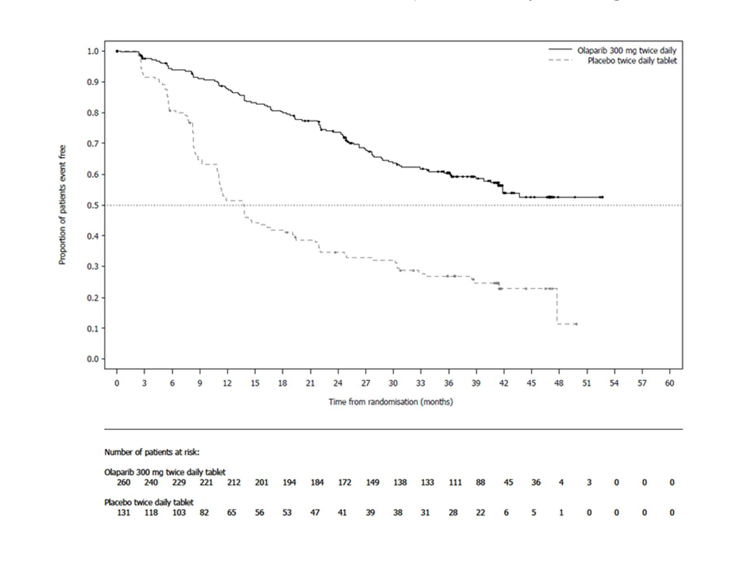

**Treatment of platinum-sensitive relapsed (PSR) ovarian cancer**

The efficacy of LYNPARZA in the maintenance treatment setting in platinum-sensitive relapsed (PSR) ovarian, fallopian tube or primary peritoneal cancer is supported by two randomised, double- blind, placebo-controlled trials in patients with PSR and *BRCA*-mutated disease (SOLO2) and in patients with PSR disease agnostic of *BRCA* status (Study 19). In both studies, PSR patients who were in response following completion of platinum-based chemotherapy and whose disease had recurred >6 months after completion of penultimate platinum-based chemotherapy were enrolled. Patients could not have received prior olaparib or other PARP inhibitor treatment. Patients could have received prior bevacizumab, except in the regimen immediately prior to randomisation.

Patients with *BRCA* mutations were identified either from germline testing in blood via a local test or the Myriad CLIA Integrated BRAC*Analysis*® test or from testing a tumour sample using a local test or a test performed by Foundation Medicine.

### SOLO2 study in patients with PSR ovarian cancer with a germline BRCA mutation

SOLO2 compared the efficacy of LYNPARZA tablets as maintenance treatment (300 mg twice a day, taken until disease progression or unacceptable toxicity) against placebo treatment in patients with high-grade serous or endometrioid PSR ovarian cancer who were in response (CR or PR) following completion of platinum-containing chemotherapy. All patients had a deleterious or suspected deleterious germline BRCA mutation as detected either by a local test (n=236) or central Myriad test (n=59), subsequently confirmed by a commercial assay (BRACAnalysis CDx) (n=286).

A total of 295 patients were randomised, 196 to LYNPARZA and 99 to placebo. The median age was 56 years (range: 28 to 83) among patients treated with LYNPARZA and 56 years (range: 39 to 78) among patients treated with placebo. The ECOG PS was 0 in 83% of patients receiving LYNPARZA and 78% of patients receiving placebo. Of all patients, 89% were Caucasian, 47% were in complete response to their most recent platinum-based regimen, and 40% had a progression-free interval of 6-12 months since their penultimate platinum regimen. Prior bevacizumab therapy was reported for 17% of those treated with LYNPARZA and 20% of those receiving placebo. Approximately 44% of patients on the LYNPARZA arm and 37% on placebo had received three or more lines of platinum-based treatment.

The primary endpoint was PFS determined by investigator assessment using RECIST 1.1. Secondary efficacy endpoints included time from randomisation to PFS2 and OS.

A summary of key efficacy findings for patients with *gBRCAm* PSR ovarian cancer in SOLO2 is presented in Table 23. PFS results from a blinded independent review were consistent. At the final analysis (61% maturity) a statistically significant difference in OS was not demonstrated.

## Table 23 Summary of key efficacy findings for patients with *gBRCAm* PSR ovarian cancer in SOLO2

|  |  |  |
| --- | --- | --- |
|  | **LYNPARZA tablet 300 mg bd** | **Placebo** |
| **PFS (63% maturity)** |  |  |
| Number of events: Total number of patients (%) | 107:196 (55) | 80:99 (81) |
| Median time (months) | 19.1 | 5.5 |
| HR (95% CI) a | 0.30 (0.22-0.41) |  |
| P value (2-sided) | p<0.0001 |  |
| **PFS2 (~40% maturity)** |  |  |
| Number of events: Total number of patients (%) | 70:196 (36) | 49:99 (50) |
| Median time (months)  HR (95% CI) a | NR  0.50 (0.34-0.72) | 18.4 |
| P value (2-sided) | p=0.0002 |  |
| **OS (61% maturity)** |  |  |
| Number of events: Total number of patients (%) | 116:196 (59) | 65:99 (66)b |
| Median time (95% CI) months | 51.7 (41.5, 59.1) | 38.8 (31.4, 48.6) |
| HR (95% CI) a | 0.74 (0.54-1.00) |  |
| P value (2-sided) | p=0.0537 |  |

a Cox proportional hazard model with response to previous platinum chemotherapy (CR or PR), and time to disease progression (>6-12 months and >12 months) in the penultimate platinum-based chemotherapy as covariates.

b Of 99 patients on the placebo arm, 28% received a subsequent PARP inhibitor.

HR Hazard Ratio; bd Twice a day; NR Not reached; OS Overall survival; PFS Progression-free survival; CI Confidence interval.

## Figure 2 SOLO2: Kaplan-Meier plot of PFS in patients with *gBRCAm* PSR ovarian cancer (63% maturity - investigator assessment)

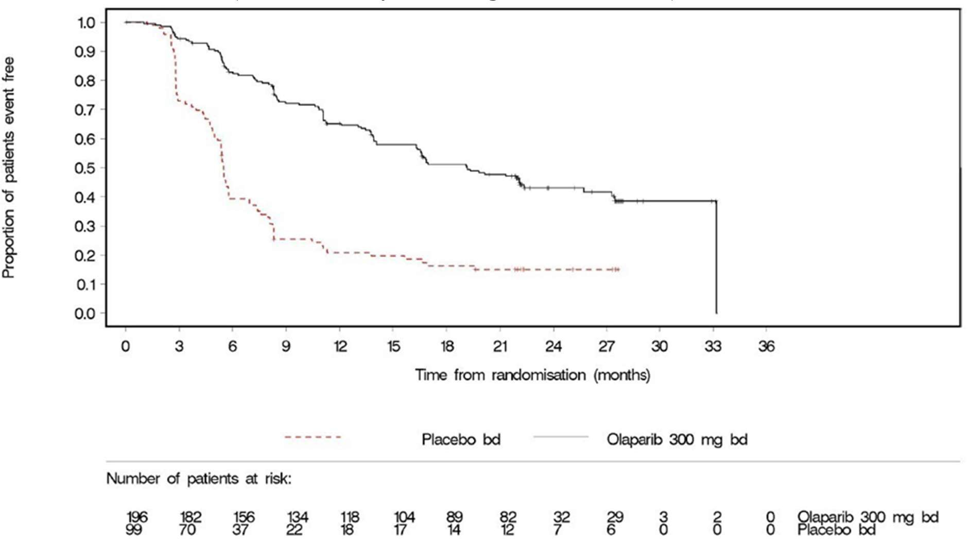

bd Twice a day; PFS Progression-free survival

## Figure 3 SOLO2: Kaplan-Meier plot of OS in patients with *gBRCAm* PSR ovarian cancer (61% maturity)

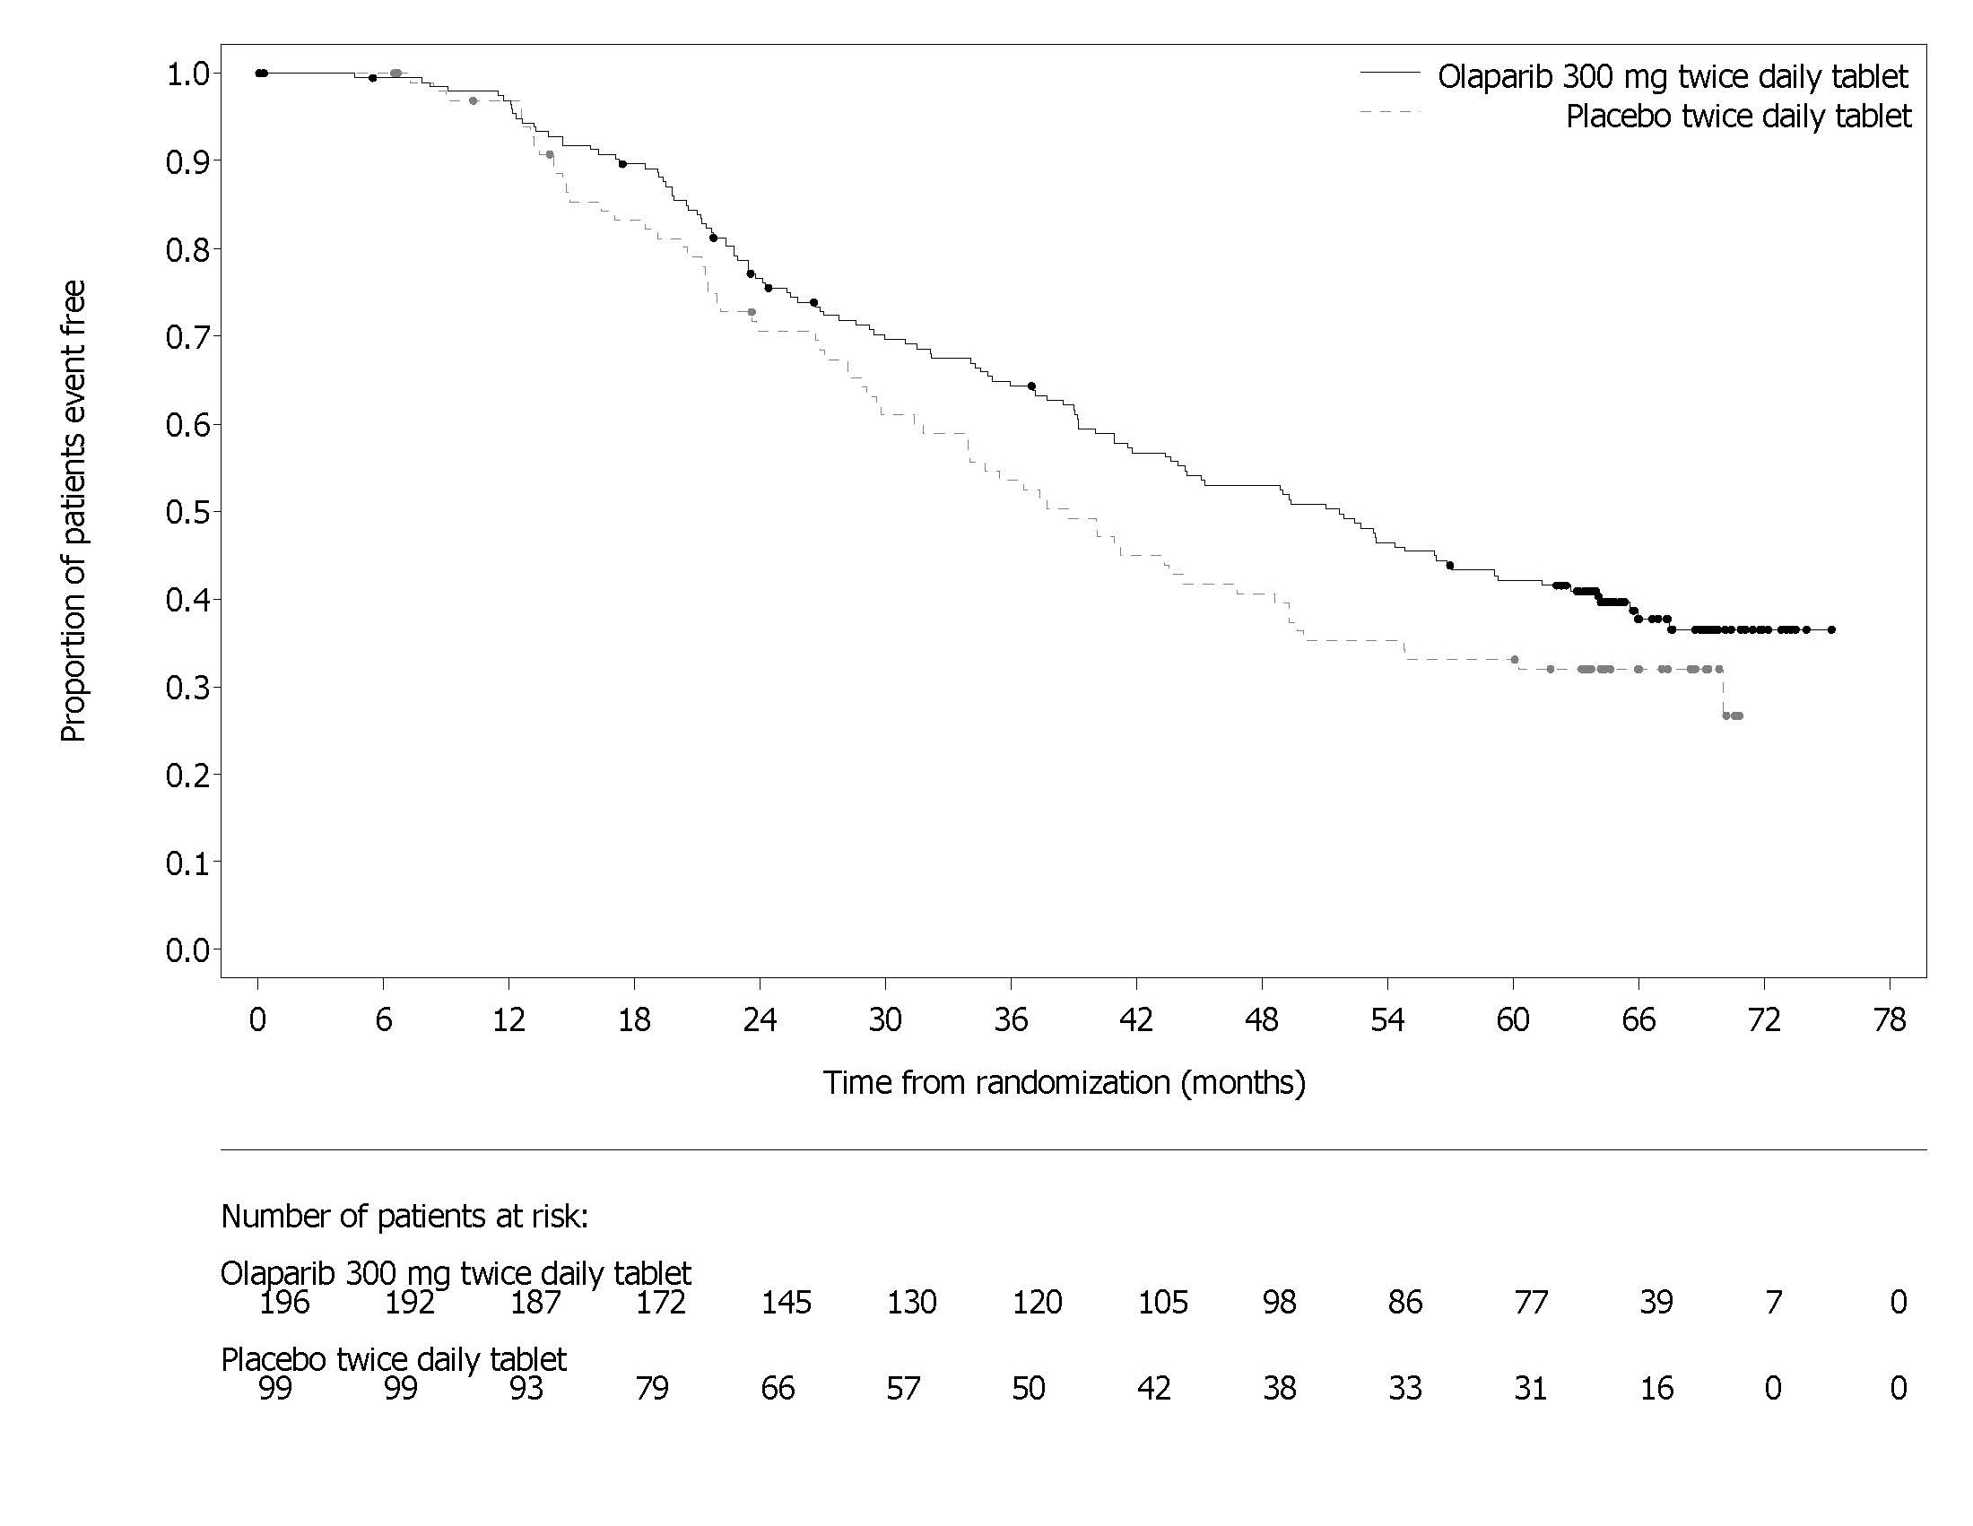

### Study 19 in patients with PSR ovarian cancer agnostic of BRCA status

Study 19 was a randomised, double-blind, placebo-controlled, phase 2 trial conducted (using the older capsule formulation of olaparib) in patients with PSR ovarian cancer who were in response (CR or PR) following completion of platinum-containing chemotherapy. Patients were randomised (1:1) to receive maintenance treatment with either LYNPARZA capsules 400 mg twice a day, or matching placebo, taken until disease progression or unacceptable toxicity. Randomisation was stratified by response to last platinum chemotherapy (CR versus PR), time to disease progression in the penultimate platinum-based chemotherapy (6-12 months versus longer than 12 months), and descent (Jewish versus non-Jewish). The primary endpoint was PFS based on investigator assessment using RECIST 1.0. Secondary efficacy endpoints included OS.

A total of 265 patients were randomised: 136 to LYNPARZA and 129 to placebo. The median age was 58 years (range: 21 to 89) among patients treated with LYNPARZA and 59 years (range: 33 to 84) among patients treated with placebo. ECOG PS was 0 in 81% of patients receiving LYNPARZA and 74% of patients receiving placebo. Of all patients, 97% were Caucasian, 45% were in complete response following their most recent platinum chemotherapy regimen, and 40% had a progression-free interval of 6-12 months since their penultimate platinum regimen. Prior bevacizumab therapy was reported for 13% of patients receiving LYNPARZA and 16% of patients receiving placebo.

A summary of efficacy findings for patients with PSR ovarian cancer (including patients with a *BRCAm*) in Study 19 is presented in Table 24. At the final analysis (data cut off [DCO] 9 May 2016; 79% maturity), the OS comparison did not meet the prespecified significance level (<0.0095).

*BRCA* mutation status was confirmed retrospectively. Whilst not controlled for multiplicity, a preplanned subgroup analysis suggested that patients with *BRCA*-mutated (germline and somatic) ovarian cancer (n=136, 51.3%) derived the greatest clinical benefit from LYNPARZA maintenance monotherapy. However, a PFS benefit of olaparib over placebo was also suggested in patients in whom a deleterious germline *BRCA* mutation was not identified [HR 0.54 (95% CI: 0.34, 0.85); nominal p<0.0075].

## Table 24 Summary of key efficacy findings for all patients with PSR ovarian cancer in Study 19, and for the subgroup of patients with a *BRCAm*

|  |  |  |
| --- | --- | --- |
|  | **All patients** | ***BRCA-mutated*** |
| **LYNPARZA Placebo 400 mg**  **capsule bid** | **LYNPARZA Placebo 400 mg**  **capsule bid** |
| **PFS – DCO 30 June 2010** |  |  |
| Number of events: Total number | 60:136 (44%) 94:129 (73%) | 26:74 (35%) 46:62 (74%) |
| of patients (%) |  |  |
| Median time (months) | 8.4 4.8 | 11.2 4.3 |
| HR (95% CI) a | 0.35 (0.25-0.49) | 0.18 (95% CI 0.10–0.31) |
| P value (2-sided) | p<0.00001* | p<0.00001* |
| **OS - DCO 09 May 2016** |  |  |
| Number of events: Total number | 98:136 (72%) 112:129 (87%)**b** | 112:129 (66%) 50:62 (81%)**b** |
| of patients (%) |  |  |
| Median time (months) | 29.8 27.8 | 34.9 30.2 |
| HR (95% CI) a | 0.73 (95% CI 0.55–95) | 0.62 (95% CI 0.42-0.93) |

**All patients *BRCA-mutated***

**LYNPARZA**

**400 mg capsule bid**

**Placebo LYNPARZA 400 mg**

**capsule bid**

**Placebo**

P value (2-sided) p=0.02138* p=0.02140*

* Not controlled for multiplicity

a HR=Hazard Ratio based on a Cox proportional hazards model with factors for treatment, ethnic descent, platinum sensitivity and response to final platinum therapy.

b Of 62 patients on the placebo arm who had a *BRCA*-mutation, 23% received a subsequent PARP inhibitor. OS Overall survival; PFS Progression-free survival; CI Confidence interval

## First-line maintenance treatment of HRD-positive advanced ovarian cancer

### PAOLA-1 study in newly diagnosed advanced ovarian cancer with a BRCA mutation and/or genomic instability

PAOLA-1 (NCT02477644) was a Phase III randomised, double-blind, placebo-controlled, multi- centre trial that compared the efficacy of LYNPARZA in combination with bevacizumab versus placebo/ bevacizumab for the maintenance treatment of advanced high-grade epithelial ovarian cancer, fallopian tube or primary peritoneal cancer following first-line platinum-based chemotherapy and bevacizumab. Randomisation was stratified by first-line treatment outcome (timing and outcome of cytoreductive surgery and response to platinum-based chemotherapy) and t*BRCAm* status, determined by prospective local testing. All available clinical samples were retrospectively tested with Myriad myChoice® CDx. Patients were required to have no evidence of disease (NED) due to complete surgical resection, or who were in complete response (CR), or partial response (PR) following completion of first-line platinum-containing chemotherapy and bevacizumab. Patients were randomized (2:1) to receive LYNPARZA tablets 300 mg orally twice a day in combination with bevacizumab (n=537) 15 mg/kg every three weeks or placebo/bevacizumab (n=269) Patients continued bevacizumab in the maintenance setting and started treatment with LYNPARZA after a minimum of 3 weeks and up to a maximum of 9 weeks following completion of their last dose of chemotherapy. LYNPARZA treatment was continued for up to 2 years or until progression of the underlying disease or unacceptable toxicity. Patients who in the opinion of the treating physician could derive further benefit from continuous treatment could be treated beyond 2 years. Treatment with bevacizumab was for a total of up to 15 months, including the period given with chemotherapy and given as maintenance.

The primary efficacy endpoint was investigator-assessed PFS evaluated according to RECIST, version 1.1. Additional efficacy endpoints included PFS2 and overall survival (OS).

The median age of patients in both arms was 61 years overall (range 26 to 87). Ovarian cancer was the primary tumour type in 86% of patients in both arms. Ninety six percent (96%) were serous histological type. The ECOG performance score was 0 in 70% of patients and 1 in 28% of patients, overall. All patients had received first-line platinum-based therapy and bevacizumab. First-line treatment outcomes at screening indicated that patients had no evidence of disease with complete macroscopic resection at initial debulking surgery (32%, both arms), no evidence of disease/ CR with complete macroscopic resection at interval debulking surgery (31%, both arms), no evidence of disease/ CR in patients who had either incomplete resection (at initial or interval debulking surgery) or no debulking surgery (15%, both arms) and patients with a partial response (22%, both arms). Thirty percent (30%) of patients in both arms had a deleterious BRCA mutation. Patients were not restricted by the surgical outcome with 65% having complete cytoreduction at initial or interval debulking surgery and 35% having residual macroscopic disease. Demographics and baseline disease characteristics were balanced and comparable between the study and placebo arms in the Intention to Treat (ITT) population and also in the HRD-positive subgroup.

The study demonstrated increased PFS and PFS2 in the ITT population with addition of olaparib to bevacizumab. However, efficacy was not demonstrated in patients with HRD-negative status.

Efficacy results from a biomarker subgroup analysis of 387 patients with HRD-positive tumours (including *BRCA* mutation), identified post-randomisation using the Myriad myChoice® HRD Plus tumour test, who received LYNPARZA/bevacizumab (n=255) or placebo/bevacizumab (n=132), are summarised in Table 25 and Figure 4. Results from a blinded independent review of PFS were consistent. At the time of final analysis of PFS2 (DCO 22 March 2020), overall survival data remained immature in the ITT population and in biomarker subgroups.

## Table 25 Efficacy results for patients with HRD-positive status in PAOLA-1 per investigator assessment

**Olaparib/bevacizumab (n=255)**

**Placebo/bevacizumab (n=132)**

|  |  |  |  |
| --- | --- | --- | --- |
| **PFS* (59% Maturity)** |  | | |
| Number of events (%) | 87 (34%) |  | 92 (70%) |
| Median, months  Hazard Ratioa (95% CI) | 37.2 | 0.33 (0.25, 0.45) | 17.7 |
| **PFS2**(53% Maturity)** |  |  |  |
| Number of events (%) | 85 (33%) |  | 70 (53%) |
| Median, months  Hazard Ratioa (95% CI) | 50.3 | 0.56 (0.41, 0.77) | 35.4 |

* Median follow-up of 27.4 months in LYNPARZA/bevacizumab arm and 27.5 months in placebo/bevacizumab arm.

** Median follow-up of 37.8 months in the LYNPARZA/bevacizumab arm and 36.8 months in the placebo/bevacizumab arm.

a The analysis was performed using an unstratified Cox proportional hazards model. CI Confidence interval NR Not reached

## Figure 4 Kaplan-Meier curves of investigator-assessed progression-free survival in patients with HRD-positive ovarian cancer (PAOLA-1)

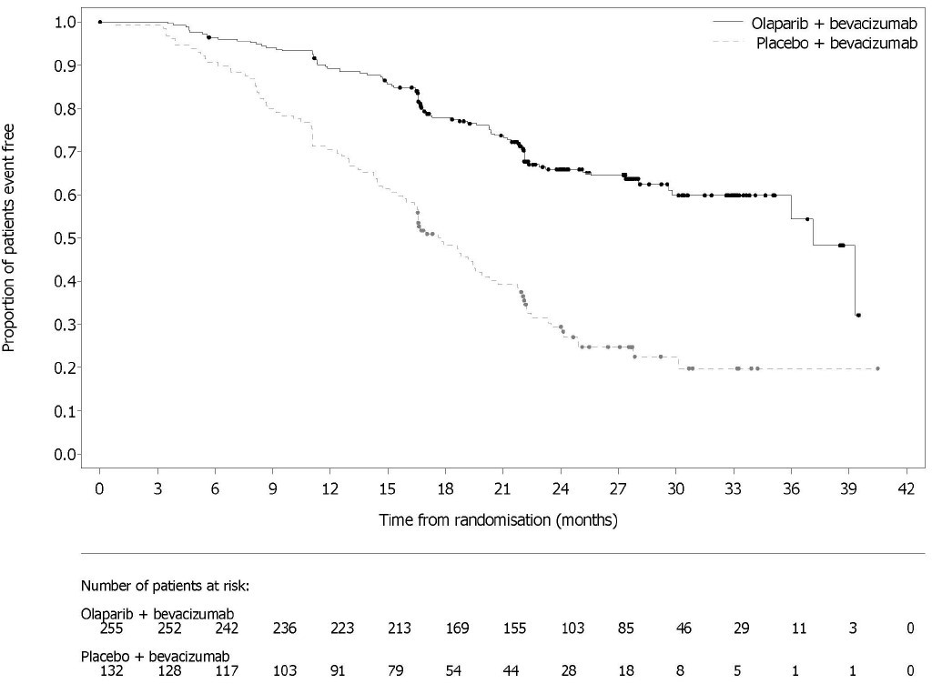

**Adjuvant treatment of *BRCA*-mutated, HER2-negative, high-risk early breast cancer**

### OlympiA study in patients with HER2-negative, high-risk early breast cancer and a germline BRCA mutation

OlympiA was a Phase III randomised, double-blind, placebo-controlled, international study in patients with a germline *BRCA* mutation and HER2-negative, high-risk early breast cancer, who had completed definitive local treatment and neoadjuvant or adjuvant chemotherapy (but not both).

Patients were randomised to receive either olaparib tablets (300 mg twice a day) or placebo as adjuvant treatment, continued for 1 year unless disease progression or unacceptable toxicity occurred first. Patients were required to have completed at least 6 cycles of neoadjuvant or adjuvant chemotherapy containing anthracyclines and/or taxanes. Prior platinum for previous cancer (e.g. ovarian) or as adjuvant or neoadjuvant treatment for breast cancer was allowed. For the purpose of determining study eligibility, “high-risk” (of recurrence) was defined differently depending on whether the tumour was hormone receptor (oestrogen receptor (ER) and/or progesterone receptor)-positive (HR-positive), and whether the patient had received their chemotherapy in the neoadjuvant or the adjuvant setting, as follows:

* *For patients who had received prior neoadjuvant chemotherapy*: patients must have had residual invasive cancer in the breast and/or the resected lymph nodes (non-pathological complete response) at the time of surgery. Additionally, patients with HR-positive tumours required a risk score of ≥3 based on pre-treatment clinical and post-treatment pathological stage (CPS), oestrogen receptor (ER) status and histological grade as shown in Table 26.

## Table 26 Risk scoring system (stage, receptor status and grade) for hormone receptor- positive early breast cancer (after prior neoadjuvant chemotherapy)

|  |  |  |
| --- | --- | --- |
| **Stage/Feature** | | **Points** |
| **Clinical stage (pre-treatment)** | I/IIA | 0 |
| IIB/IIIA | 1 |
| IIIB/IIIC | 2 |
| **Pathological stage (post-treatment)** | 0/I | 0 |
| IIA/IIB/IIIA/IIIB | 1 |
| IIIC | 2 |
| **Receptor status** | ER positive | 0 |
| ER negative | 1 |
| **Nuclear grade** | Nuclear grade 1-2 | 0 |
| Nuclear grade 3 | 1 |

* A score of ≥3 was deemed ‘high-risk’ for the purposes of study eligibility for OlympiA.

Alternatively,

* *for patients who had received prior adjuvant chemotherapy:* triple negative breast cancer (TNBC) must have had node-positive disease or node-negative disease with a ≥2 cm primary tumour. HR-positive breast cancer must have had ≥4 pathologically confirmed positive lymph nodes.

Patients were randomised in a 1:1 ratio to either olaparib (n=921) or placebo (n=915). Randomisation was stratified by hormone receptor status (HR-positive versus TNBC), by whether prior chemotherapy was neoadjuvant versus adjuvant, and by prior platinum use for breast cancer (yes versus no).

The primary endpoint was invasive disease-free survival (IDFS), defined as the time from randomisation to date of first recurrence, where recurrence was defined as loco-regional, distant recurrence, contralateral invasive breast cancer, new cancer or death from any cause. Secondary endpoints included OS and distant disease free survival [(DDFS, defined as the time from randomisation until evidence of first distant recurrence of breast cancer), the incidence of new primary contralateral breast cancers (invasive and non-invasive), new primary ovarian cancer, new primary fallopian tube cancer and new primary peritoneal cancer].

Patients who were enrolled based on local g*BRCA* test results provided a sample for retrospective confirmatory testing with BRACAnalysis®. Out of 1836 patients enrolled into OlympiA, 1623 were confirmed as g*BRCAm* by Myriad BRACAnalysis®, either prospectively or retrospectively.

Demographic and baseline characteristics were well balanced between the arms. The median age was 42 years. Most patients (67%) were Caucasian and 29% were Asian. Two patients (0.2%) in the olaparib arm and four patients (0.4%) in the placebo arm were male. Sixty-one percent (61%) of patients were pre-menopausal. Eighty-nine percent (89%) of patients were ECOG performance status 0 and 11% ECOG PS 1. Eighty-two percent (82%) of patients had TNBC and 18% had hormone receptor-positive disease (defined as ER positive and/or PgR positive). Fifty percent (50%) of patients had received prior neoadjuvant and 50% received prior adjuvant chemotherapy.

Ninety-four percent (94%) of patients received anthracycline and taxane. Twenty-six (26%) of patients overall had received prior platinum for breast cancer. In the olaparib and placebo arms,

87% and 92% of patients with HR positive disease were receiving concomitant endocrine therapy, respectively.

The main efficacy results from OlympiA are presented in Table 27, Figure 5, Figure 6 and Figure 7. Findings were consistent across subgroups based on the stratification factors.

## Table 27 Summary of key efficacy findings in HER2-negative high risk early breast cancer patients with a germline *BRCA* mutation in OlympiA

|  |  |  |
| --- | --- | --- |
|  | **Olaparib 300 mg bd** | **Placebo** |
| **(n=921)** | **(N=915)** |
| **IDFS (15% maturity) DCO 27 March 2020** |  |  |
| Number of events/Total number of patients (%) | 106/921 (12) | 178/915 (20) |

HR (95% CI) a 0.58 (0.46, 0.74)

p-value (2-sided) b <0.0001

Percentage (95% CI) of patients invasive disease free at 3 years c

86 (83, 88) 77 (74,80)

**DDFS (13% maturity) DCO 27 March 2020**

Number of events/Total number of patients (%) 89/921 (10) 152/915 (17) HR (95% CI) a 0.57 (0.44, 0.74)

p-value (2-sided) b 0.0001

Percentage (95% CI) of patients distant disease free at 3 years c

**OS (10% maturity) DCO 12 July 2021**

88 (85, 90) 80 (77, 83)

Number of events/total number of patients (%) 75/921 (8) 109/915 (12) HR (95% CI) a 0.68 (0.50,0.91)

p-value (2 sided) b 0.0091

|  |  |  |
| --- | --- | --- |
| Percentage (95%CI) of patients alive at 3 years c | 93 (91, 94) | 89 (87, 91) |
| Percentage (95% CI) of patients alive at 4 years c | 90 (87, 92) | 86 (84, 89) |
| 1. Based on a stratified Cox's Proportional Hazards Model. 2. p-value from a stratified log-rank test. 3. Percentages are calculated using Kaplan-Meier estimates. |  |  |

bd = twice a day; CI = confidence interval; DDFS = distant disease free survival; IDFS = invasive disease free survival; OS = overall survival.

## Figure 5 Kaplan-Meier plot of IDFS in patients with HER2-negative high risk early breast cancer patients with a BRCA mutation

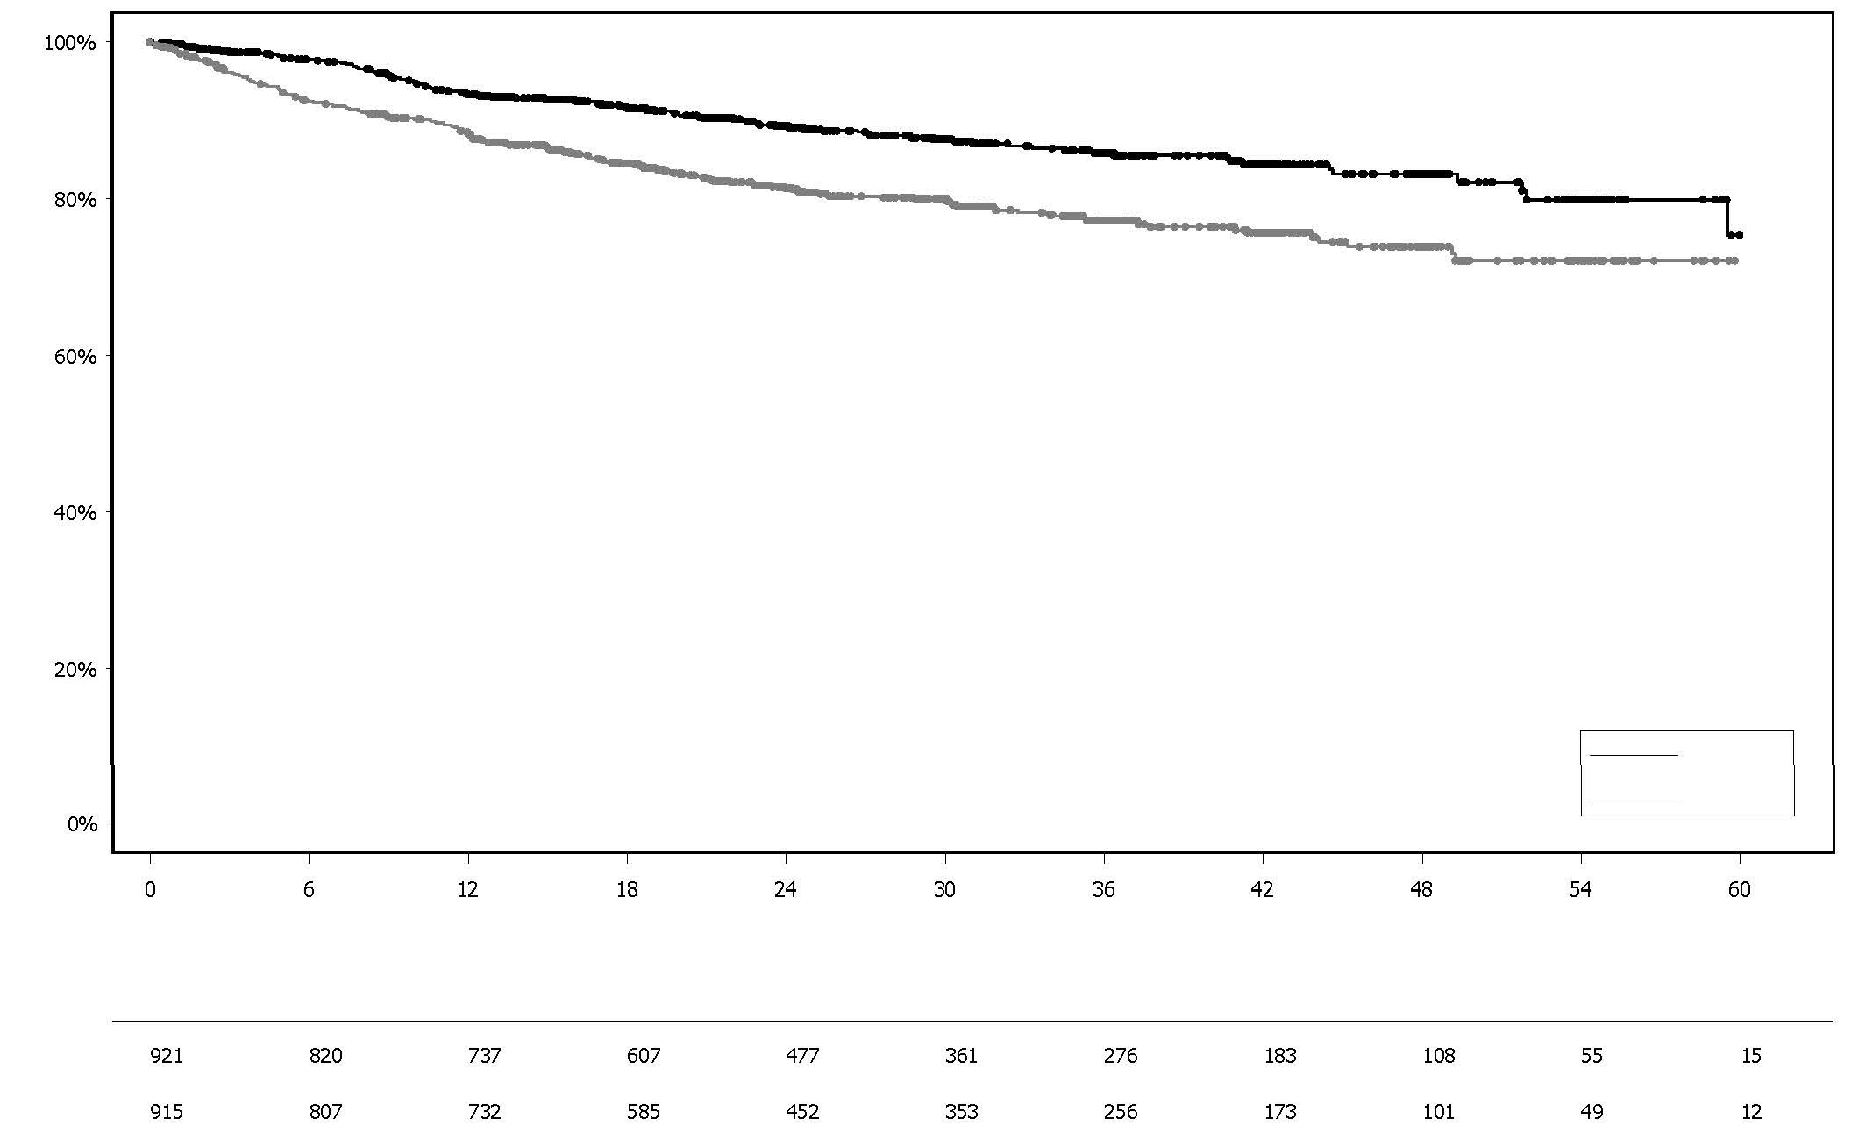

Olaparib

Placebo

Months since randomisation

Number of patients at risk:

Olaparib 300 mg bd Placebo

Percentage of patients alive and invasive disease free

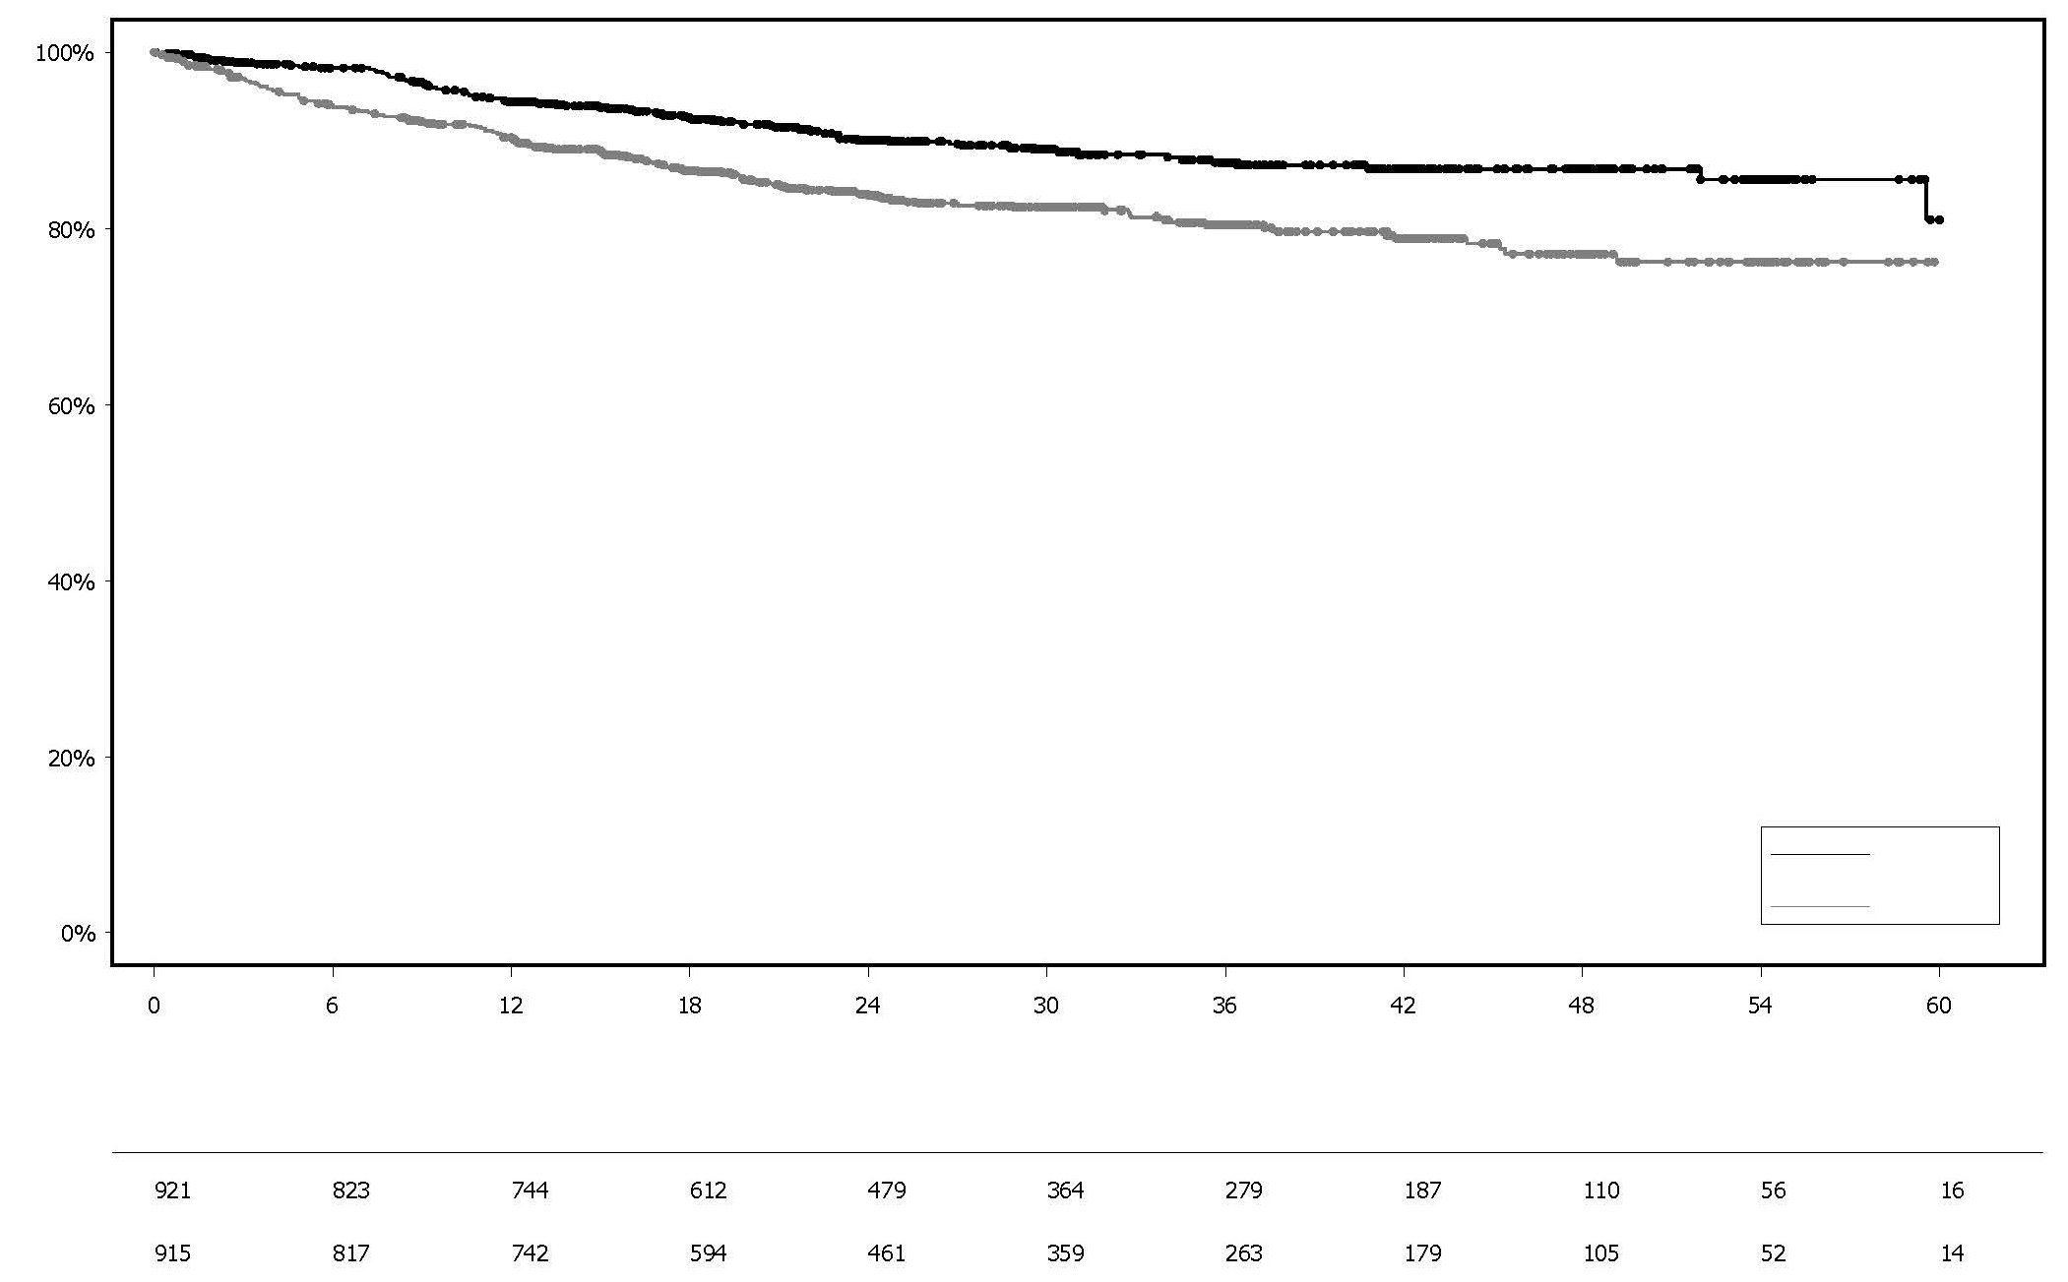**Figure 6 Kaplan-Meier plot of DDFS in patients with HER2-negative high risk early breast cancer patients with a *BRCA* mutation**

Olaparib Placebo

Percentage of patients alive and distant disease free

Months since randomisation

Number of patients at risk:

Olaparib 300 mg bd Placebo

## Figure 7 Kaplan-Meier plot of OS in patients with HER2-negative high risk early breast cancer patients with a *BRCA* mutation

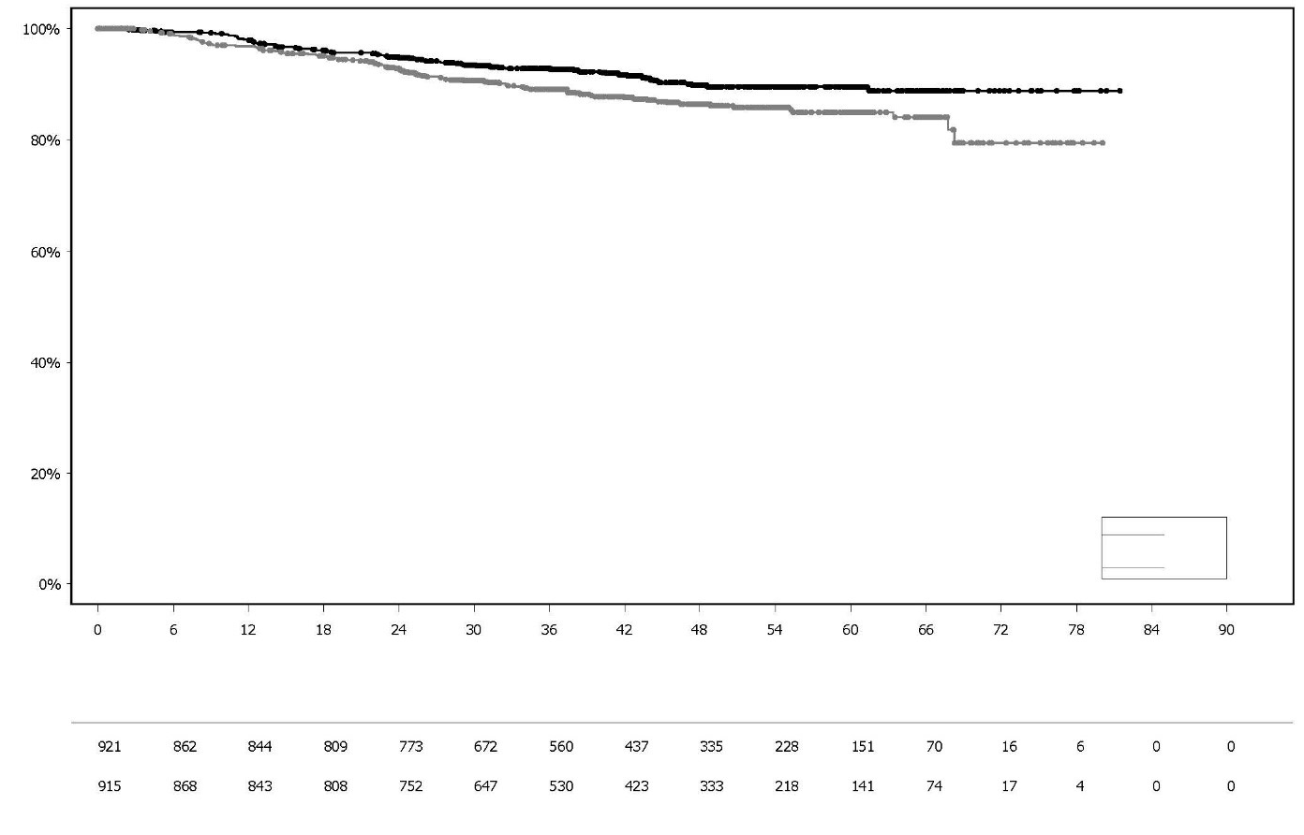

Olaparib

Placebo

Months since randomisation

Numbers of patients at risk:

Olaparib 300 mg bd Placebo

Percentage of patients alive

**Treatment of germline *BRCA*-mutated HER2-negative metastatic breast cancer**

### OlympiAD study in patients with a gBRCA mutation and HER2-negative metastatic breast cancer after prior chemotherapy

This study was a Phase 3 open-label, randomised trial that compared the efficacy of olaparib tablets (300 mg twice a day) taken to progression with a comparator arm of physician’s choice of chemotherapy (capecitabine, eribulin, or vinorelbine). In the study 302 patients with *gBRCAm* HER2-negative metastatic breast cancer who had previously received up to two lines of chemotherapy for the treatment of metastatic disease were randomised (2:1 randomisation: 205 olaparib and 97 comparator). Patients were stratified based on: receipt of prior chemotherapy regimens for metastatic breast cancer, oestrogen receptor (ER) and / or progesterone receptor (PgR) positive vs ER and PgR negative, prior platinum for breast cancer. The primary endpoint was PFS assessed by blinded independent central review (BICR) using RECIST 1.1. Secondary endpoints included PFS2, OS, objective response rate (ORR) and HRQoL.

All patients had received prior treatment with anthracycline (unless contraindicated) and a taxane in either the neoadjuvant, adjuvant or metastatic setting. Prior therapy with platinum for metastatic breast cancer was allowed provided there had been no evidence of disease progression during platinum treatment. Prior therapy with platinum in the (neo)adjuvant setting was allowed provided the last dose was received at least 12 months prior to randomisation. Patients could not have received prior olaparib or other PARP inhibitor treatment. Patients with ER and/or PgR-positive disease must have received and progressed on at least one endocrine therapy (adjuvant or metastatic) or had disease that the treating physician believed to be inappropriate for endocrine therapy. Patients had tumour assessments at baseline and every 6 weeks for the first 24 weeks, and then every 12 weeks relative to date of randomisation, until objective radiological disease progression.

The results of OlympiAD are presented in Table 28 and Figure 8. A statistically significant difference in OS between arms was not demonstrated, with a median follow-up time for censored

patients of 25.3 months in the olaparib arm and 26.3 months in the comparator arm. The median time to onset of response was 47 days for olaparib vs 45 days for comparator. The median duration of response was 6.4 months for olaparib vs 7.1 months for comparator.

Consistent results were observed across patient subgroups.

**Table 28 Summary of key efficacy findings for patients with *gBRCAm* HER2-negative metastatic breast cancer in OlympiAD**

**Olaparib 300 mg bd Physician’s choice**

**chemotherapya**

**PFS (77% maturity) – DCO 9 December 2016**

Number of events: Total number of patients

(%)

163:205

(80)

71:97

(73)

Median time (months) 7.0 4.2

HR (95% CI) 0.58 (0.43-0.80)

P value (2-sided) p=0.0009

**PFS2 (52% maturity) – DCO 9 December 2016**

Number of events: Total number of patients (%)

104:205

(51)

53:97

(55)

Median time (months) 13.2 9.3

HR (95% CI) 0.57 (0.40-0.83)

P value (2-sided) p=0.0033

**OS (64% maturity) – DCO 25 September 2017**

Number of events: Total number of patients (%)

130:205

(63)

62:97 (64)b

Median time (months) 19.3 17.1

HR (95% CI) 0.90 (0.66-1.23)

P value (2-sided) p=0.5131

**ORR – DCO 9 December 2016**

Number of objective responders: Total number of patients with measurable disease (%)

100:167

(60)

19:66

(29)

95% CI 52.0 to 67.4 18.3 to 41.3

Complete response (%) 15:67 (9) 1:66 (2)

Partial response (%) 85:167 (51) 18:66 (27)

1. Physician’s choice of chemotherapy consisting of either capecitabine, eribulin or vinorelbine.
2. Approximately a tenth of patients in the physician’s choice group (8/97; 8.2%) received a subsequent PARP inhibitor

bd Twice a day; CI Confidence interval; DCO Data cut off; HR Hazard ratio; ORR Objective response rate; OS Overall survival; PFS Progression-free survival; PFS2 Time to second progression or death.

## Figure 8 OlympiAD: Kaplan-Meier plot of PFS in patients with *gBRCAm* HER2- negative metastatic breast cancer (77% maturity)

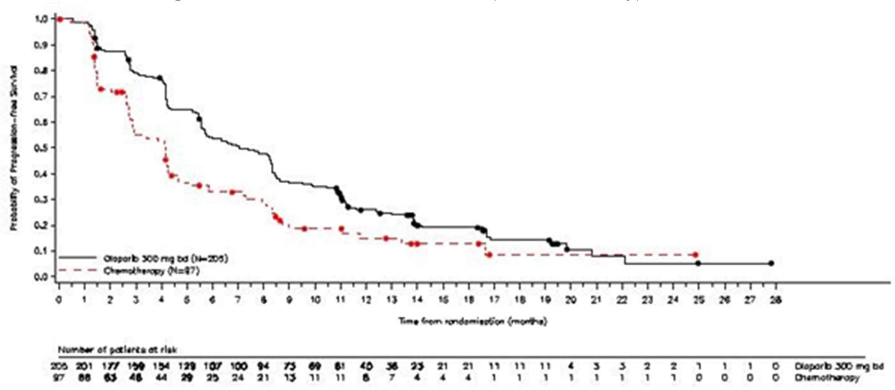

A significant difference in global health status/QoL (assessed using the EORTC QLQ-C30 questionnaire which uses a 0-100 point scale) in favour of olaparib was observed (adjusted mean difference in change from baseline score was 7.5 points [95% CI: 2.48-12.44; p=0.0035]). Time to deterioration (≥10 points decrease from baseline) in global health status/QoL score was statistically significantly longer on the olaparib arm (HR 0.44; 95% CI: 0.25-0.77; p=0.0043; median not reached for olaparib vs. 15.3 months for comparator arm).

## First-line maintenance treatment of germline *BRCA*-mutated metastatic adenocarcinoma of the pancreas

### POLO study in gBRCAm pancreatic adenocarcinoma after first-line chemotherapy

POLO was a Phase III, randomised, double-blind, placebo-controlled, multi-centre trial that compared the efficacy of LYNPARZA tablets as maintenance treatment (300 mg twice a day) against placebo in *gBRCA*-mutated metastatic adenocarcinoma of the pancreas. The study randomised 154 patients (3:2 randomisation: 92 olaparib and 62 placebo) whose disease had not progressed following at least 16 weeks of first-line platinum-based chemotherapy. There was no upper limit to the duration of chemotherapy received. After 16 weeks of continuous platinum-based chemotherapy, the platinum could be discontinued at any time for toxicity and the other agents continued; the patients were eligible for randomisation as long as there was no evidence of progression at any time during chemotherapy treatment. All toxicities from previous anti-cancer therapy must have been resolved to CTCAE grade 1, except for alopecia, grade 3 peripheral neuropathy and Hgb ≥ 9 g/dL. LYNPARZA treatment was continued until disease progression or unacceptable toxicity.

Patients with germline *BRCA* mutations were identified from prior local testing results or by central testing using the Myriad BRACAnalysis® or Myriad BRACAnalysis CDx® test. The *BRCAm* status of all patients identified using prior local testing results was confirmed, where sent, using the Myriad BRACAnalysis® or Myriad BRACAnalysis CDx® test.

Demographic and baseline characteristics were generally well balanced between the olaparib and placebo arms. Median age was 57 years in both arms; 30% of patients in the olaparib arm were ≥ 65 years compared to 21% in the placebo arm. Most patients had an ECOG performance status of 0 (67%) and 58% of patients were male. The majority of patients (96%) were randomised within 8 weeks of their last dose of platinum-based chemotherapy. The median time from initiation of first-

line platinum-based chemotherapy to randomisation was 5.8 months (range 3.4 to 33.4 months) and 49% of patients were in complete or partial response to their most recent platinum-based regimen.

The primary endpoint was progression-free survival (PFS), defined as time from randomisation to progression determined by BICR using modified Response Evaluation Criteria in Solid Tumours (RECIST) 1.1, or death. Secondary efficacy endpoints included overall survival (OS) objective response rate (ORR) and duration of response (DoR). Patients had tumour assessments at baseline and every 8 weeks for 40 weeks, and then every 12 weeks relative to the date of randomisation, until objective radiological disease progression. For the primary analysis (PFS), the median follow- up time for censored patients was 9.1 months in the olaparib arm and 3.8 months in the placebo arm. At the final analysis of OS, the median follow-up time for censored patients was 31.3 months in the olaparib arm and 23.9 months in the placebo arm.

The study results are presented in Table 29, Figure 9 and Figure 10. A sensitivity analysis of PFS by investigator assessment was consistent with that by BICR. Based on descriptive Kaplan–Meier estimates, the proportion of patients that were alive and progression-free at 12, 24 and 36 months were 34%, 28% and 22% for olaparib vs 15%, 10% and 10% for placebo.

At the final analysis (70% maturity), there was no difference in OS demonstrated between arms.

## Table 29 Summary of key efficacy findings for patients with *gBRCAm* metastatic adenocarcinoma of the pancreas in POLO

|  |  |  |
| --- | --- | --- |
|  | **Olaparib 300 mg bd** | **Placebo** |
| **PFS (68% maturity)** |  |  |
| Number of events: Total number of patients (%) | 60:92 (65) | 44:62 (71) |
| Median time (months) | 7.4 | 3.8 |
| HR (95% CI)b | 0.53 (0.35-0.82 | ) |
| P value (2-sided) | p=0.0038 |  |
| **OS (70% maturity)** |  |  |
| Number of events: Total number of patients (%) | 61:92 (66) | 47:62 (76)c |
| Median time (months) | 19.0 | 19.2 |

HR (95% CI)a,b 0.83 (0.56-1.22)

P value (2-sided) p=0.3487

**ORR**

Number of objective responders: total number of patients with measurable disease at baseline (%)

18:78 (23.1) 6:52 (11.5)

|  |  |  |
| --- | --- | --- |
| Complete response (%) | 2 (2.6) | 0 |
| Partial response (%) | 16 (20.5) | 6 (11.5) |
| Median time to onset in case of response | 5.4 months | 3.6 months |
| **DoR** |  |  |
| Median time (months) (95% CI) | 24.9 (14.75, NC) | 3.7 (2.10, NC) |

a Log-rank test

b Six (6.5%) patients in the olaparib arm received subsequent PARP inhibitor and 16 (26%) patients on the placebo arm received a PARP inhibitor in any subsequent line.

bd Twice a day; CI Confidence interval; DoR Duration of response; HR Hazard Ratio; ORR Objective Response Rate; OS Overall survival; PFS Progression-free survival.Figure 9 POLO: Kaplan-Meier plot of PFS for patients with *gBRCAm* metastatic adenocarcinoma of the pancreas (68% maturity – BICR)

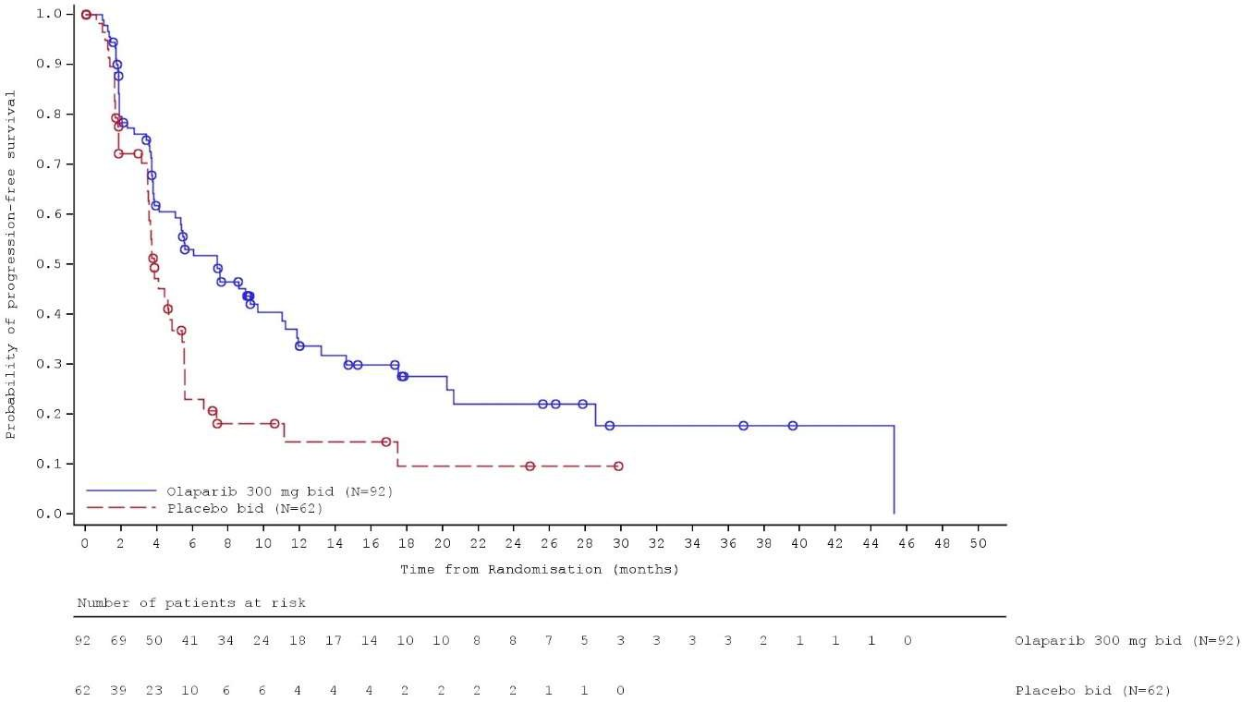

**Figure 10 POLO: Kaplan-Meier plot of OS for patients with g*BRCAm* metastatic adenocarcinoma of the pancreas (70% maturity)**

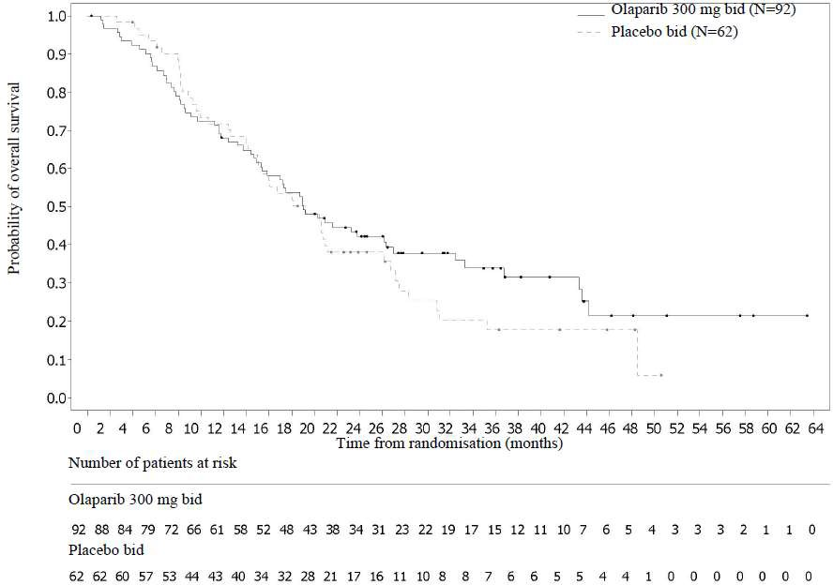

***Treatment of BRCA*-mutated metastatic castration-resistant prostate cancer (mCRPC)**

### PROfound study in patients with a homologous recombination repair gene mutation and mCRPC after progression on prior NHA treatment

PROfound was a Phase III randomised, open-label, multicentre trial that evaluated the efficacy of LYNPARZA tablets (300 mg twice a day) versus a comparator arm of investigator’s choice of NHA (new hormonal agent: enzalutamide or abiraterone acetate) in men with mCRPC.

To be eligible, patients had to have progressed on prior NHA for the treatment of metastatic prostate cancer and/or CRPC, and have a tumour mutation in one of 15 genes involved in the homologous recombination repair (HRR) pathway, as detected by prospective central testing using a clinical trial assay. Cohort A comprised patients with deleterious or suspected deleterious mutations in *BRCA1, BRCA2* or *ATM*. Although patients with gene mutations other than *BRCA1*/*2* were enrolled in the trial, LYNPARZA is not indicated for the treatment of patients with gene mutations other than *BRCA1*/*2* since favourable benefit-risk is not established beyond *BRCA1/2*.

All patients continued on a luteinising hormone releasing hormone (LHRH) analogue or had prior bilateral orchiectomy.

A total of 245 patients were randomised in Cohort A (162 olaparib and 83 comparator). Randomisation was stratified by prior taxane use and evidence of measurable disease. Treatment was continued until disease progression. Patients randomised to the NHA comparator were given the option to switch to olaparib upon confirmed radiological BICR progression.

Of the 160 patients with a *BRCA1* or *BRCA2* mutation enrolled in PROfound, 114 patients underwent retrospective testing to determine if the identified *BRCA1/2* mutation was germline or somatic in origin. Germline *BRCA1/2* mutations were identified in 63 patients, and for the remaining 51 patients, the *BRCA1/2* mutation was determined to be somatic in origin based on the absence of evidence of germline *BRCA1/2* mutation.

Demographics and baseline characteristics were generally well balanced between the olaparib and comparator arms in patients with *BRCA1/2* mutations. Median age was 68 years and 67 years in the olaparib and comparator arms, respectively. Prior therapy in the olaparib arm was 71% taxane, 41% enzalutamide, 37% abiraterone acetate and 20% both enzalutamide and abiraterone acetate.

Prior therapy in the comparator arm was 60% taxane, 50% enzalutamide, 36% abiraterone acetate and 14% both enzalutamide and abiraterone acetate. Fifty-eight percent (58%) of patients in the olaparib arm and 55% in the comparator arm had measurable disease at study entry. The proportion of patients with bone, lymph node, liver and respiratory metastases was 89%, 62%, 12% and 23%, respectively in the olaparib arm and 86%, 71% 17% and 16%, respectively in the comparator arm. Most patients in both treatment arms had an ECOG of 0 or 1 (93%). Baseline pain scores (BPI-SF worst pain) were 0-<2 (52%), 2-3 (10%) or >3 (34%) in the olaparib arm and 0-<2 (45%), 2-3 (7%) or >3 (45%) in the comparator arm. Median baseline PSA was 57.48 µg/L in the olaparib arm and

103.95 µg/L in the comparator arm.

The primary endpoint of the study was radiological progression free survival (rPFS) in Cohort A determined by BICR using RECIST 1.1 (soft tissue) and Prostate Cancer Working Group (PCWG3) (bone). Key secondary endpoints included confirmed objective response rate (ORR) by BICR, time to pain progression (TTPP) and overall survival (OS).

The study demonstrated a clinically meaningful and statistically significant improvement in BICR- assessed rPFS and final OS for olaparib vs comparator in Cohort A, attributable to patients with *BRCA1/2* gene mutations. Results for patients with *BRCA1/2* mutations are presented in Table 30.

Sensitivity analyses showed similar efficacy in patients for whom mutations could be identified using the Foundation Medicine F1CDx assay, the Foundation Medicine F1 Liquid CDx assay, or the Myriad BRACAnalysis CDx assay.

## Table 30 Summary of key efficacy findings in patients with *BRCA1/2*-mutated mCRPC in PROfound

|  |  |  |  |
| --- | --- | --- | --- |
|  | **Olaparib 300 mg bd (N=102)** | | **Investigators choice of NHA (N=58)** |
| **rPFS by BICR a,b,c DCO 4 June 2019** |  | |  |
| Number of events/total number of patients | 62/102 | | 51/58 |
| (%) | (61)c | | (88)c |
| Median rPFS (95% CI) [months] | 9.8 (7.6, 11.3) | | 3.0 (1.8, 3.6) |
| HR (95% CI)c 0.22 (0.15, 0.32) | | | |
| **Confirmed ORR by BICR a** | | | |
| Number of objective responders/total number | 25/57 (44) | 0/33 (0) | |
| of patients with measurable disease at |  |  | |
| baseline (%) |  |  | |
| Odds ratio (95% CI) |  | NC (NC, NC) | |
| **OSa DCO 20 March 2020c** |  |  | |
| Number of events/total number of patients | 53/102 | 41/58 | |
| (%) | (52) | (71) | |
| Median OS (95% CI) [months] | 20.1 (17.4, 26.8) | 14.4 (10.7, 18.9) | |
| HR (95% CI) |  | 0.63 (0.42, 0.95) | |
| **Time to pain progression a, d** |  |  | |
| Number of events/total number of patients | 9/102 | 10/58 | |
| (%) | (9) | (17) | |
| Median (95% CI) [months] |  | NC (NC, NC) | |
| HR (95% CI) |  | 0.27 (0.11, 0.69) | |

a Not controlled for multiplicity when tested in the *BRCA1/2* subgroup (but was controlled for multiplicity when tested in Cohort A, which showed statistically significant results)

b rPFS 71% maturity

c The HR and CI were calculated using a Cox proportional hazards model that contains terms for treatment, *BRCA* mutation (positive, negative) and interaction term of treatment and *BRCA* mutation.

d Time to pain progression was defined as the time from randomisation to the first date of a clinically meaningful worsening (≥2 points increase from baseline on a scale of 0-10) in average BPI-SF worst pain [Item 3] score and/or an increase in or initiation of opioid analgesic use.

bd Twice a day; BICR Blinded independent central review; CI Confidence interval; HR Hazard ratio; NC Not calculable; NHA New hormonal agent; ORR Objective response rate; OS Overall survival; rPFS Radiological progression-free survival

## Figure 11 *BRCA1/2m* patients: Kaplan-Meier plot of rPFS (by BICR)

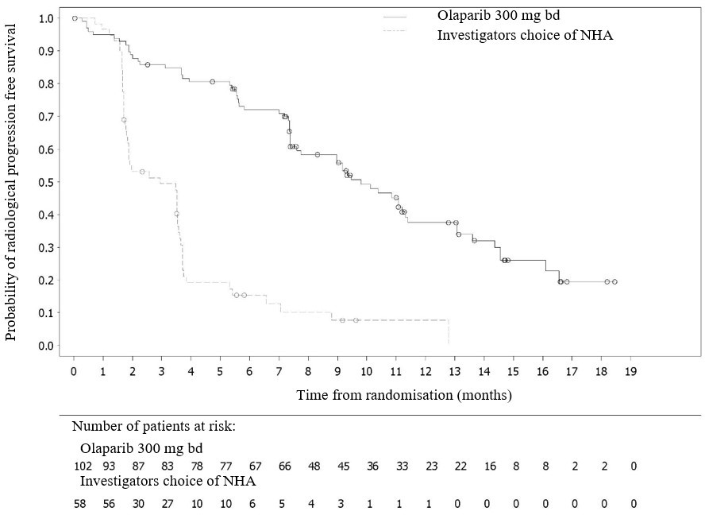

**Figure 12 *BRCA1/2m* patients: Kaplan-Meier plot of OS**

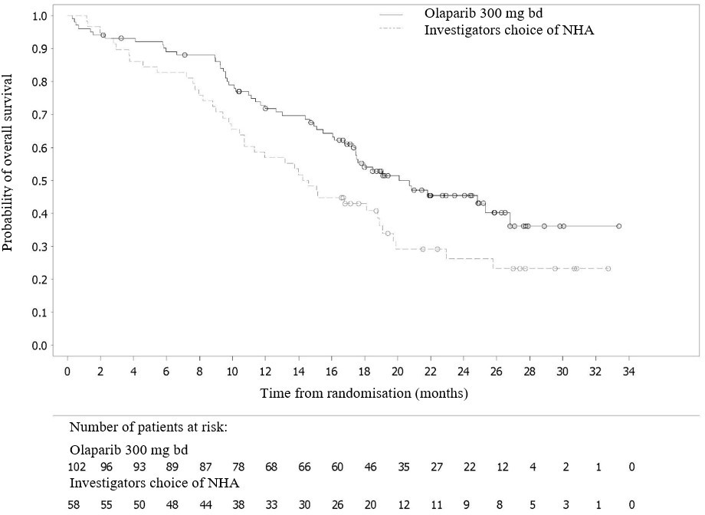

### PROpel study in the first-line setting for patients with mCRPC

PROpel was a Phase III randomised, double-blind, placebo-controlled, multicentre study conducted in patients with mCRPC. Patients (n=796) were randomised (1:1) to receive either LYNPARZA tablets 300 mg twice a day (n=399) or a matching placebo (n=397) as first-line treatment, in combination with abiraterone (1000 mg once daily) and either prednisone or prednisolone 5 mg twice a day, as well as a gonadotropin-releasing hormone (GnRH) analogue unless they had prior bilateral orchiectomy. Patients could not have received any prior abiraterone, other NHA within 12 months or first-generation antiandrogen agents within 4 weeks of randomisation. Docetaxel was allowed for prior hormone-sensitive prostate cancer (mHSPC), as long as no signs of disease progression occurred during or immediately after such treatment. Randomisation was stratified by metastases (bone only, visceral or other) and docetaxel treatment at mHSPC stage (yes or no).

Treatment was continued until objective radiological disease progression (determined by investigator) or unacceptable toxicity.

Assessment for somatic or germline deleterious or suspected deleterious *BRCA* gene mutations (*BRCAm*) was conducted after randomisation and before primary analysis by both NGS-based tumour tissue (FoundationOne® CDx [F1CDx]) and ctDNA (FoundationOne® Liquid CDx) tests.

The primary endpoint was rPFS, defined as time from randomisation to progression determined by investigator assessment based on RECIST v1.1 and Prostate Cancer Working Group (PCWG-3) criteria (bone). The key secondary efficacy endpoint was overall survival (OS).

Of the 796 patients, *BRCAm* status was unknown for a third of patients in each arm according to the tissue test, and for 8% of patients in each arm according to the ctDNA test. There were 85 patients in the total study (11%) who had a *BRCAm* according to either test.

Among the 85 *BRCAm* patients, the median age was 68 years (range 43 to 85), and 67% were 65 years or older; 72% were Caucasian and 22% were Asian; 66% had ECOG performance status (PS) 0 and 34% had ECOG PS 1; 25% had prior docetaxel treatment for mHSPC; 53% had bone-only metastases, 15% had visceral metastases, and 32% had other metastases.

A statistically significant improvement in rPFS for LYNPARZA/abiraterone compared to placebo/abiraterone was observed in the intention to treat (ITT) population. Exploratory analysis based on BRCAm status were conducted among 711 patients with no *BRCAm* – either according to either both tests, or according to one test where no valid result was obtained for the second test – the exploratory subgroup rPFS hazard ratio was 0.77 (95% CI: 0.63, 0.96) and the OS hazard ratio was

0.92 (95% CI: 0.74, 1.14)

These exploratory analyses indicated that the improvement in the ITT population was primarily attributable to the results seen in the subgroup of patients with *BRCAm*. Results of an exploratory analysis in the subgroup of 85 patients with *BRCAm* who participated in PROpel are summarised in Table 31 and Figure 13.

## Table 31 Exploratory efficacy findings in the *BRCAm* subgroup of PROpel (first-line mCRPC)

**Olaparib + abiraterone N=47**

**Placebo + abiraterone N=38**

**rPFS (by investigator assessment) (50% maturity) (DCO1: 30 July 2021)**

Number of events (%) 14(30) 28(74)

Median time (95% CI) (months) b NC (NC, NC) 8(6, 15) HR (95% CI) a 0.24 (0.12,0.45)

**Final OS (48% maturity) (DCO3: 12 October 2022)**

Number of events (%) 13 (28) 25 (66)

Median time (95% CI) (months) d NC (NC, NC) 22.97 (17.77, 34.17)

HR (95% CI) a 0.29 (0.14, 0.56)

a Cox proportional hazards model that contains a term for treatment, subgroup factor and a treatment by subgroup interaction. CIs were calculated using profile likelihood method.

b Calculated using the Kaplan-Meier technique.

CI Confidence interval; DCO Data cut-off; HR Hazard ratio; NC Not calculable; OS Overall survival; rPFS Radiological progression-free survival

**Figure 13 PROpel: Kaplan-Meier plot of rPFS (patients with *BRCAm* Investigator Assessment)**

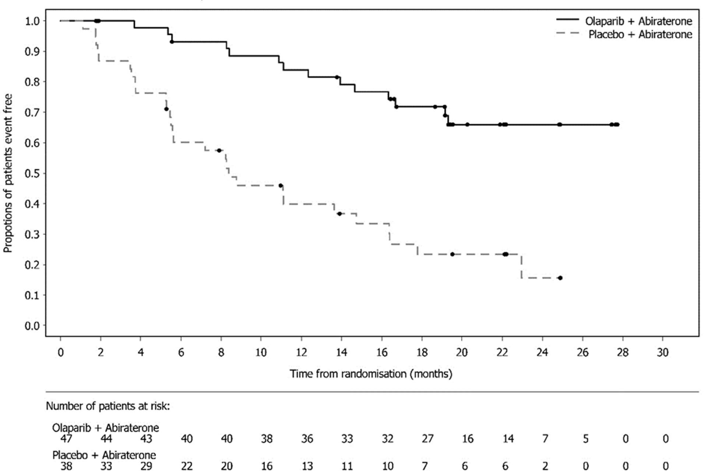

**Figure 14 PROpel: Kaplan-Meier plot of OS (patients with *BRCAm*)**

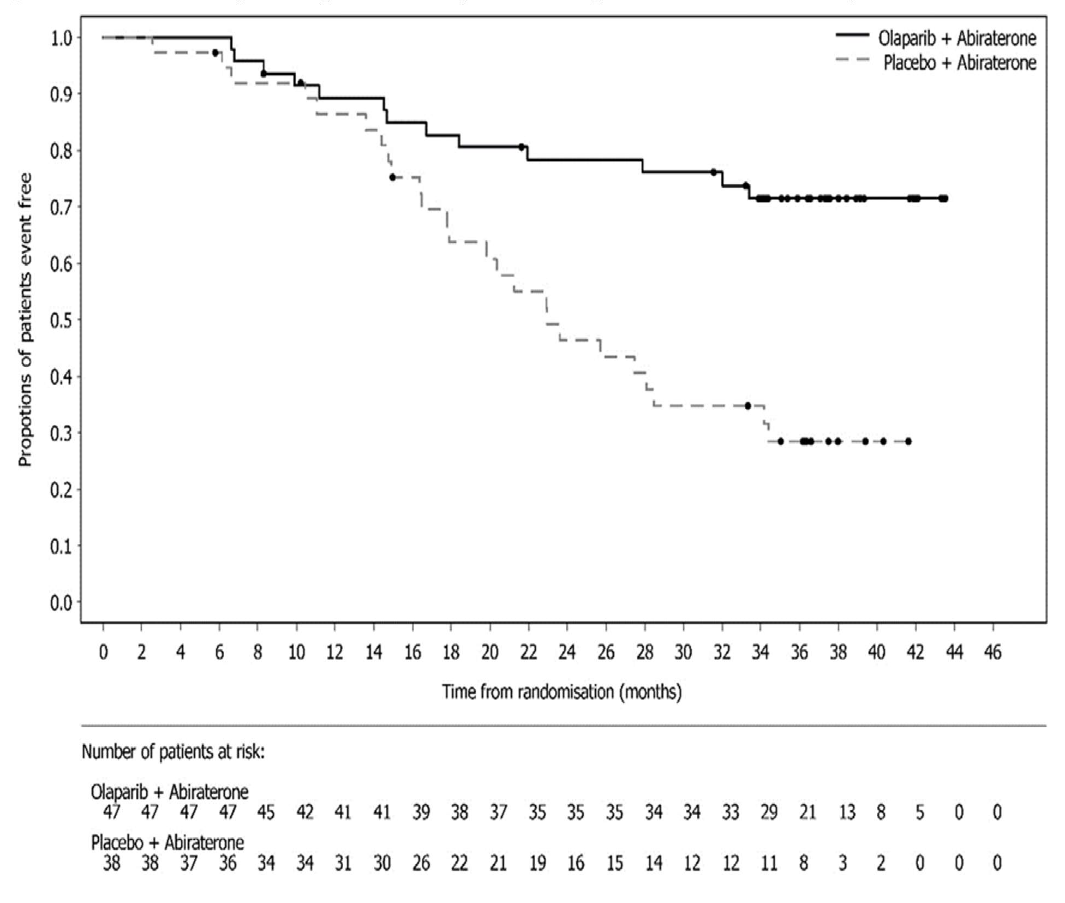

**Effect on the QT interval**

There is no clinically relevant effect of olaparib on cardiac repolarisation (as evaluated by an effect on the QT interval) following 300 mg twice a day multiple dosing of olaparib.

## Retreatment on relapse

There are no data to support rechallenge with olaparib after relapse or progression on olaparib treatment, in any setting.

## Pharmacokinetic properties

Olaparib displays high inter-patient variability in PK parameters, including Cmax, AUC, Vd and CL/F.

The pharmacokinetics of olaparib at the 300 mg tablet dose are characterised by an apparent plasma clearance of ~7 L/h, an apparent volume of distribution of ~158 L and a terminal half-life of

15 hours after dosing. On multiple dosing, an AUC accumulation ratio of 1.8 was observed and PK appeared to be time-dependent to a small extent.

## Absorption

Following oral administration of 300 mg olaparib (tablet formulation), absorption is rapid with peak plasma concentrations typically achieved between 1.5 hours after dosing.

Co-administration with food slowed the rate (tmax delayed by 2.5 hours and Cmax reduced by approximately 21%) but did not significantly affect the extent of absorption of olaparib (AUC treatment ratio: 1.08; 90% CI: 1.01, 1.16). Consequently, patients may take LYNPARZA without regard to food (see Section 4.2 - Dose and method of administration).

## Distribution

*In vitro*, human plasma protein binding of olaparib was dose-dependent; the fraction bound was approximately 91% at 1 μg/mL, reducing to 82% at 10 μg/mL and to 70% at 40 μg/mL. In solutions of purified proteins, the olaparib fraction bound to albumin was approximately 56%, which was independent of olaparib concentrations. Using the same assay, the fraction bound to alpha-1 acid glycoprotein was 29% at 10 μg/mL with a trend of decreased binding at higher concentrations.

## Metabolism

*In vitro*, CYP3A4/5 were shown to be the enzymes primarily responsible for the metabolism of olaparib.

Following oral dosing of 14C-olaparib to female patients, unchanged olaparib accounted for the majority of the circulating radioactivity in plasma (70%) and was the major component found in both urine and faeces (15% and 6% of the dose respectively). The metabolism of olaparib is extensive with the main site of metabolism being the piperazine and fluorobenzyl ring structures. The majority of the metabolism was attributable to oxidation reactions with a number of the components produced undergoing subsequent glucuronide or sulphate conjugation. Up to 20, 37 and 20 metabolites were detected in plasma, urine and faeces respectively, the majority of them representing <1% of the dosed material. A ring-open piperazin-3-ol moiety, and two mono- oxygenated metabolites (each ~10%) were the major circulating components, with one of the mono- oxygenated metabolites also being the major metabolite in the excreta (6% and 5% of the urinary and faecal radioactivity respectively).

## Excretion

Following a single dose of 14C-olaparib, ~86% of the dosed radioactivity was recovered within a 7 day collection period, ~44% via the urine and ~42% via the faeces. The majority of the material was excreted as metabolites.

## Special populations

### Renal impairment

Following a single oral 300 mg dose of olaparib to patients with mild renal impairment (creatinine clearance: 51 to 80 mL/min), AUC increased by 24% (90% CI: 6% to 47%) and Cmax by 15% (90% CI: 4% to 27%) compared with patients with normal renal function. No LYNPARZA dose adjustment is required for patients with mild renal impairment, however, patients should be monitored closely for renal function and adverse events (see Section 4.2 - Dose and method of administration).

Following a single oral 300 mg dose of olaparib to patients with moderate renal impairment (creatinine clearance: 31 to 50 mL/min), AUC increased by 44% (90% CI: 10% to 89%) and Cmax by 26% (90% CI: 6% to 48%) compared with patients with normal renal function. LYNPARZA dose adjustment is recommended for patients with moderate renal impairment and patients should be monitored closely for renal function and adverse events (see Section 4.2 - Dose and method of administration). Renal clearance of olaparib was lower in patients with mild and moderate renal impairment compared to patients with normal renal function (1.48 L/h). For patients with mild or moderate renal impairment, arithmetic mean CLR was 59% (0.614 L/h) and 80% (0.299 L/h) lower, respectively, than that observed in patients with normal renal function.

Olaparib has not been studied in patients with severe renal impairment or end-stage renal disease (creatinine clearance ≤30 mL/min).

### Hepatic impairment

Following a single oral 300 mg dose of olaparib to patients with mild hepatic impairment (Child- Pugh classification A) AUC increased by 15% (90% CI: -23% to 28%) and Cmax by 13%

(90% CI: -18% to 55%) and to patients with moderate hepatic impairment (Child-Pugh classification B) AUC increased by 8% (90% CI: 0.66, 1.74) and Cmax decreased by 13% (90% CI: 0.63, 1.22) compared with patients with normal hepatic function. No LYNPARZA dose adjustment is required in patients with mild or moderate hepatic impairment, however, patients should be monitored closely for hepatic function and adverse events (see Section 4.2 - Dose and method of administration.).

Olaparib has not been studied in patients with severe hepatic impairment (Child-Pugh classification C).

### Other

In population based PK analyses, patient age, gender, bodyweight, tumour location or race (including Caucasian [n = 516] and Asian [n = 126] patients) were not significant covariates.

## Preclinical safety data Genotoxicity

Olaparib showed no mutagenic potential in bacterial cells, but was clastogenic in mammalian cells *in vitro*. When dosed orally to rats, olaparib induced micronuclei in bone marrow. This clastogenicity is consistent with the primary pharmacology of olaparib and indicates potential for genotoxicity in man.

## Carcinogenicity

Carcinogenicity studies have not been conducted with olaparib.

# PHARMACEUTICAL PARTICULARS

## List of excipients

Refer to Section 2 - Qualitative and quantitative composition.

## Incompatibilities

Incompatibilities were either not assessed or not identified as part of the registration of this medicine.

## Shelf life

In Australia, information on the shelf life can be found on the public summary of the Australian Register of Therapeutic Goods (ARTG). The expiry date can be found on the packaging.

## Special precautions for storage

Store below 30°C. Store in original container to protect from moisture.

## Nature and contents of container

LYNPARZA is supplied in cartons containing 56 tablets in aluminium/aluminium blister platforms.

## Special precautions for disposal

In Australia, any unused medicine or waste material should be disposed of by taking to your local pharmacy.

## Physicochemical properties

Olaparib is a white to pale yellow crystalline powder, which is very slightly soluble in aqueous solutions (0.10 - 0.13 mg/mL at 37°C), slightly soluble in ethanol (5.5 mg/mL at 37°C) and has a pKa of 12.07.

## Chemical structure

The chemical name for olaparib is: 4-[[3-[[4-(cyclopropylcarbonyl)-1-piperazinyl]carbonyl]-4- fluorophenyl]methyl]-1(2H)-phthalazinone.

The chemical structure of olaparib is:

O

N

N

N H

N

O

F

O

Molecular formula: C24H23FN4O3 Molecular weight: 434.46

## CAS number

CAS number: 763113-22-0

# MEDICINE SCHEDULE (POISONS STANDARD)

Schedule 4 – Prescription Only Medicine

# SPONSOR

AstraZeneca Pty Ltd ABN 54 009 682 311

66 Talavera Road

MACQUARIE PARK NSW 2113

Telephone: 1800 805 342

# DATE OF FIRST APPROVAL

23 May 2018

# DATE OF REVISION

## To be confirmed Summary table of changes

|  |  |
| --- | --- |
| **Section changed** | **Summary of new information** |
| 4.1 | Extension of indications for use in breast cancer and prostate cancer |
| 4.2 | Updated consistent with extension of indications in breast cancer and prostate cancer |
| 4.4 | Revision of Venous thromboembolic events section |
| 4.8 | Adverse effect data updated with results from additional clinical trials |
| 5.1 | Update to mechanism of action information  Description of additional clinical trial data relevant to indication extensions for breast cancer and prostate cancer included. |

LYNPARZA is a trade mark of the AstraZeneca group of companies.

© AstraZeneca 2023 Doc ID-004821006 v6.0