|  |
| --- |
| Australian Public Assessment Report for Sidapvia |
| Active ingredients: Dapagliflozin 10 mg and sitagliptin 100 mg |
| Sponsor: AstraZeneca Pty Ltd |
| August 2024 |

About the Therapeutic Goods Administration (TGA)

* The Therapeutic Goods Administration (TGA) is part of the Australian Government Department of Health and Aged Care and is responsible for regulating therapeutic goods, including medicines, medical devices, and biologicals.
* The TGA administers the *Therapeutic Goods Act 1989* (the Act), applying a risk management approach designed to ensure therapeutic goods supplied in Australia meet acceptable standards of quality, safety, and efficacy.
* The work of the TGA is based on applying scientific and clinical expertise to decision-making, to ensure that the benefits to the Australian public outweigh any risks associated with the use of therapeutic goods.
* The TGA relies on the public, healthcare professionals and industry to report problems with therapeutic goods. The TGA investigates reports received to determine any necessary regulatory action.
* To report a problem with a therapeutic good, please see the information on the [TGA website](https://www.tga.gov.au/).

About AusPARs

* The Australian Public Assessment Report (AusPAR) provides information about the evaluation of a prescription medicine and the considerations that led the TGA to approve or not approve a prescription medicine submission. Further information can be found in [Australian Public Assessment Report (AusPAR) guidance](https://www.tga.gov.au/australian-public-assessment-report-auspar-guidance).
* AusPARs are prepared and published by the TGA.
* AusPARs are static documents that provide information that relates to a submission at a particular point in time. The publication of an AusPAR is an important part of the transparency of the TGA’s decision-making process.
* A new AusPAR may be provided to reflect changes to indications or major variations to a prescription medicine subject to evaluation by the TGA.

Copyright

© Commonwealth of Australia 2024  
This work is copyright. You may reproduce the whole or part of this work in unaltered form for your own personal use or, if you are part of an organisation, for internal use within your organisation, but only if you or your organisation do not use the reproduction for any commercial purpose and retain this copyright notice and all disclaimer notices as part of that reproduction. Apart from rights to use as permitted by the *Copyright Act 1968* or allowed by this copyright notice, all other rights are reserved and you are not allowed to reproduce the whole or any part of this work in any way (electronic or otherwise) without first being given specific written permission from the Commonwealth to do so. Requests and inquiries concerning reproduction and rights are to be sent to the TGA Copyright Officer, Therapeutic Goods Administration, PO Box 100, Woden ACT 2606 or emailed to <[tga.copyright@tga.gov.au](mailto:tga.copyright@tga.gov.au)>.

Contents

List of abbreviations 4

Product submission 5

Submission details 5

Sidapvia (dapagliflozin 10 mg and sitagliptin 100 mg) 6

Type 2 diabetes mellitus (T2DM) 6

Current treatment options for T2DM 6

Clinical rationale for Sidapvia use in T2DM 6

Regulatory status 7

Australian regulatory status 7

International regulatory status 8

Registration timeline 9

Submission overview and risk/benefit assessment 9

Quality 9

Nonclinical 10

Clinical 11

Summary of clinical studies 11

Pharmacology 12

Efficacy 16

Safety 20

Risk management plan 27

Risk-benefit analysis 29

Advisory committee on medicines considerations 35

Outcome 35

Attachment 1. Product Information 36

## List of abbreviations

|  |  |
| --- | --- |
| Abbreviation | Meaning |
| ACM | Advisory Committee on Medicines |
| ACR | Albumin to creatinine ratio |
| ADRs | Adverse drug reactions. |
| AE | Adverse events |
| ARTG | Australian Register of Therapeutic Goods |
| ASA | Australia‑specific annex |
| BE | Bioequivalence |
| CKD | Chronic kidney disease |
| CMI | Consumer Medicines Information |
| CV | Cardiovascular |
| DPP4i | Dipeptidyl peptidase 4 inhibitor |
| eGFR | Estimated glomerular filtration rate |
| FDC | Fixed dose combination |
| HbA1c | Glycated haemoglobin |
| PD | Pharmacodynamics |
| Ph. Eur | European Pharmacopoeia |
| PI | Product Information |
| PK | Pharmacokinetics |
| PSUR | Periodic safety update report |
| RMP | Risk management plan |
| SAE | Serious adverse event |
| SGLT2 | Sodium-Glucose Transport Protein 2 inhibitor |
| TGA | Therapeutic Goods Administration |
| T2DM | Type 2 diabetes mellitus |
| USP-NF | United States Pharmacopeia/National Formulary |

## Product submission

### Submission details

|  |  |
| --- | --- |
| *Type of submission:* | New fixed dose combination |
| *Product name:* | Sidapvia |
| *Active ingredient:* | Dapagliflozin 10 mg and sitagliptin 100 mg |
| *Decision:* | Approved |
| *Date of decision:* | 24 May 2024 |
| *Date of entry onto ARTG:* | 7 June 2024 |
| *ARTG number:* | 405540 |
| [*Black Triangle Scheme*](https://www.tga.gov.au/black-triangle-scheme) | No |
| *Sponsor’s name and address:* | AstraZeneca Pty Ltd ABN 54 009 682 311 66 Talavera Road MACQUARIE PARK NSW 2113 |
| *Dose form:* | Film coated tablet |
| *Strength:* | Each film-coated tablet contains 10 mg dapagliflozin as dapagliflozin propanediol monohydrate and 100 mg sitagliptin as sitagliptin phosphate monohydrate |
| *Container:* | The film coated tablets are packed into aluminium/aluminium blisters. |
| *Pack size:* | Pack sizes of 7 (sample pack) and 28 tablets. |
| *Approved therapeutic use for the current submission:* | Sidapvia is indicated as an adjunct to diet and exercise to improve glycaemic control in adults with type 2 diabetes mellitus when treatment with both dapagliflozin and sitagliptin is appropriate. (See sections 4.5 Interactions with other medicines and other forms of interactions and 5.1 Pharmacodynamic properties – Clinical trials.) Sidapvia should be used in combination with metformin unless contraindicated or not tolerated. |
| *Route of administration:* | Oral |
| *Dosage:* | The recommended dose of Sidapvia is one dapagliflozin 10 mg/sitagliptin 100 mg tablet taken orally once daily |
| *Pregnancy category:* | **Category D**: Drugs which have caused, are suspected to have caused or may be expected to cause, an increased incidence of human fetal malformations or irreversible damage. These drugs may also have adverse pharmacological effects. Dapagliflozin/sitagliptin combination Sidapvia should not be used during pregnancy. There are no adequate and well-controlled studies of Sidapvia or its mono-components in pregnant women. No animal embryofetal development studies have been performed with dapagliflozin and sitagliptin in combination. When pregnancy is detected, treatment with Sidapvia should be discontinued. |

### Sidapvia (dapagliflozin 10 mg and sitagliptin 100 mg)

Sidapvia is a new fixed dose combination (FDC) product composed of two active ingredients, dapagliflozin 10 mg (as propanediol monohydrate) and sitagliptin 100 mg (as phosphate monohydrate) currently registered and supplied separately in Australia as   
Forxiga 10mg (dapagliflozin; AUST R 180147) and Januvia 100mg (sitagliptin; AUST R 133182). Both are indicated as an adjunct to diet and exercise to improve glycaemic control in adults with type 2 diabetes mellitus.

This AusPAR summarises the assessment of Sidapvia 10/100 (dapagliflozin 10 mg and sitagliptin 100 mg) for the following proposed indication[1].

*Sidapvia is indicated as an adjunct to diet and exercise to improve glycaemic control in adults with type 2 diabetes mellitus when treatment with both dapagliflozin and sitagliptin is appropriate.*

### Type 2 diabetes mellitus (T2DM)

Type 2 diabetes mellitus (T2DM) is a metabolic disorder characterised by insulin resistance and relative insulin deficiency leading to hyperglycaemia. T2DM comprises the majority of people with diabetes and is largely the result of excess body weight and physical inactivity. The course of T2DM is marked by deteriorating β-cell function and increasing insulin resistance. T2DM is a progressive disease that may require intensification of therapy over time to achieve adequate glycaemic control to reduce and prevent long-term complications of heart failure (HF) and chronic kidney disease (CKD) caused by chronic hyperglycaemia.

### Current treatment options for T2DM

The primary goal of treatment is to maximise the control of blood sugar concentrations, whilst minimising the risk of hypoglycaemia. Secondary goals are to manage cardiovascular risk factors and microvascular complications of diabetes.

Treatments for T2DM include lifestyle modification (including dietary advice with regard to weight loss and increased physical activity); Metformin (as monotherapy or in combination); Dipeptidyl peptidase 4 inhibitors; Sodium-Glucose Transport Protein 2 (SGLT2) inhibitors; glucagon-like peptide-1 receptor agonists (GLP-1 Ras); Sulfonylureas (SU); Thiazolidinediones; Acarbose; Insulin therapy.

### Clinical rationale for Sidapvia use in T2DM

The first line pharmacological treatment of T2DM is often metformin monotherapy titrated to maximum tolerated dose. The UK Prospective Diabetes Study[2] has shown that more than half of people newly diagnosed with T2DM required a second diabetes medication within 3 years of the commencement of the initial monotherapy. The use of combination therapy for management of T2DM in patients who have inadequate control with monotherapy or dual therapy is recommended by several clinical practice guidelines[3],[4] . Earlier combination therapy is recommended when patients have more marked or persistent hyperglycaemia, as early glucose control was shown to associate with long-term cardiovascular (CV) benefits[5] .

The add-on combination therapy of dapagliflozin 10 mg once daily (QD) to sitagliptin 100 mg QD (with or without metformin) as an adjunct to diet and exercise in patients with T2DM who are inadequately controlled on sitagliptin 100 mg (with or without metformin) had demonstrated statistically significant improvement in glycaemic control of HbA1c over monotherapy sitagliptin (with or without metformin) in a Phase 3, randomised, double-blind, placebo-controlled study[6]. In addition, the drug interaction study MB102037 reviewed in the original submission to the TGA showed no significant effect on the pharmacokinetics (PK) of dapagliflozin or sitagliptin when both drug products were co-administered.

Suboptimal adherence to diabetes treatments affects almost half of people with diabetes, leading to inadequate control of glycaemic and CV risk factors and increase the risk of diabetes complications. A fixed dose combination (FDC) tablet for patients who are already stabilised on co-administered individual monotherapy may provide alternative treatment when a patient requires greater glycaemic control with multiple combination therapies, as lower pill burden improved compliance that may translate into better clinical outcomes[7]

### Regulatory status

This submission was evaluated as part of the Australia-Canada-Singapore-Switzerland-United Kingdom (ACCESS) Consortium with work-sharing between the TGA and the Health Sciences Authority Singapore. Both regulators made independent decisions regarding approval (market authorisation) of the new FDC medicine.

#### Australian regulatory status

Forxiga (dapagliflozin) received initial registration in the ARTG on 22 October 2012 and has since been approved for several extensions of indication. The full indications to date are:

*Forxiga is indicated in adults with type 2 diabetes mellitus:,· as monotherapy as an adjunct to diet and exercise in patients for whom metformin is otherwise indicated but was not tolerated.,· as initial combination therapy with metformin, as an adjunct to diet and exercise, to improve glycaemic control when diet and exercise have failed to provide adequate glycaemic control and there are poor prospects for response to metformin monotherapy (for example, high initial haemoglobin A1c [HbA1c] levels) in combination with other anti-hyperglycaemic agents to improve glycaemic control, when these together with diet and exercise, do not provide adequate glycaemic control*

*Forxiga is indicated in adults with type 2 diabetes mellitus and established cardiovascular disease or risk factors for cardiovascular disease to reduce the risk of hospitalization for heart failure.*

*Forxiga is indicated in adults for the treatment of symptomatic heart failure independent of left ventricular ejection fraction, as an adjunct to standard of care therapy.*

*Forxiga is indicated to reduce the risk of progressive decline in kidney function in adults with proteinuric chronic kidney disease (CKD Stage 2,3 or 4 and urine ACR ≥ 30 mg/g)*

JANUMET (sitagliptin) received initial registration in the ARTG on 14 January 2008. Sitagliptin has since been approved for additional indications and as a combination therapy either as innovator or generic:

* JANUMET/XELEVIA/BPA SITAGLIPTIN/SITAGLIPTIN SUN/ SITAGLIPTIN SANDOZ PHARMA/PHARMACOR SITAGLIPTIN/SITAGLIPTIN PCOR/ARX-SITAGLIPTIN/ SITAGLIPTIN-APX/JANORIX/JANTRA/SITAGLO/SITAGLIPTIN MAPLE/ SITAGLIPTIN MYLAN/SITAGLIN/SITAGLIPTIN B&B/SITAGLIPTIN MLabs/SITALAXIN/SITAPRIDIN/SITAZITIN/SITARIAN (sitagliptin) is indicated as an adjunct to diet and exercise to improve glycaemic control in adults with type 2 diabetes mellitus as:
  + monotherapy when metformin is considered inappropriate due to intolerance; or
  + in combination with other anti-hyperglycaemic agents, including insulin
* JANUMET XR (sitagliptin)/METFORMIN HCL is indicated as an adjunct to diet and exercise to improve glycaemic control in adults with type 2 diabetes mellitus when treatment with both sitagliptin and metformin is appropriate.
* VELMETIA XR (sitagliptin phosphate monohydrate and metformin hydrochloride) is indicated as an adjunct to diet and exercise to improve glycaemic control in adults with type 2 diabetes mellitus when treatment with both sitagliptin and metformin is appropriate.
* CHEMMART/GenRx/APOTEX/ TERRY WHITE CHEMISTS/ SITAGLIPTIN LAPL/ SITAGLIPTIN SANDOZ (sitagliptin) is indicated for the treatment of diabetes mellitus type 2 in persons 18 years of age and older who have failed dietary measures and exercise:
  + as monotherapy, as an adjunct to diet and exercise to improve glycaemic control in patients with type 2 diabetes mellitus, when metformin cannot be used.
  + as dual combination therapy, with metformin, or with a sulfonylurea, or with a thiazolidinedione where the use of a thiazolidinedione is considered appropriate.
  + as triple combination therapy with metformin and a sulfonylurea when combination therapy with both agents does not provide adequate glycaemic control.
  + -as add-on combination therapy with insulin (with or without metformin).
* Sitagliptin-Metformin Sandoz/ SITAGLIPTIN/METFORMIN SUN/ SITAGLIPTIN/METFORMIN SANDOZ XR/SITAMETIN is indicated as an adjunct to diet and exercise to improve glycaemic control in adults with type 2 diabetes mellitus when treatment with both sitagliptin and metformin is appropriate.

### International regulatory status

A similar marketing-authorisation application has been submitted in Singapore.

### Registration timeline

This submission was evaluated under the [standard prescription medicines registration process](https://www.tga.gov.au/how-we-regulate/supply-therapeutic-good-0/supply-prescription-medicine/application-process/prescription-medicines-registration-process).

Table 1 captures the key steps and dates for this submission.

Table 1: Registration timeline for Sidapvia (submission no. PM-2023-00672-1-5) - key dates.

|  |  |
| --- | --- |
| Description | Date |
| Submission dossier accepted and first round evaluation commenced | 5 April 2023 |
| Evaluation completed | 13 December 2023 |
| Delegate’s[8] Overall benefit-risk assessment and request for Advisory Committee advice | 6 March 2024 |
| Sponsor’s pre-Advisory Committee response | 14 March 2024 |
| Advisory Committee meeting | 22 April 2024 |
| Registration decision (Outcome) | 24 May 2024 |
| Administrative activities and registration in the ARTG completed | 7 June 2024 |
| Number of working days from submission dossier acceptance to registration decision* | 281 |

*Statutory timeframe for standard submissions is 255 working days

## Submission overview and risk/benefit assessment

### Quality

Sitagliptin is presented as the phosphate monohydrate (Figure 1). It has monograph entries in the United States Pharmacopeia/National Formulary (USP-NF) and European Pharmacopoeia (Ph. Eur). As the substance is covered by a Certificate of suitability to the Monographs of the European Pharmacopoeia (CEP), the Ph. Eur. monograph is applied.

Figure 1. Sitagliptin phosphate monohydrate

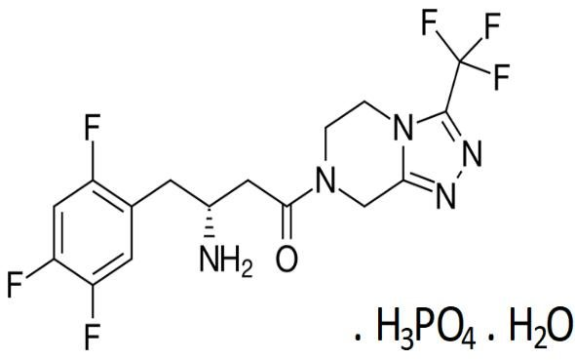

Dapagliflozin is presented as a propanediol monohydrate (Figure 2) and at the time of submission had no effective monograph in a default standard, but a specific monograph is effective in the USP-NF as of 1 December 2023 and is complied with.

Figure 2. Dapagliflozin propanediol monohydrate

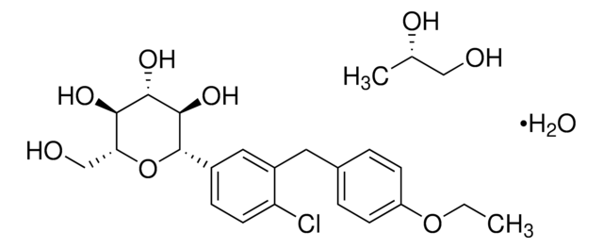

The proposed tablet product is immediate release, bilayer, film-coated, fixed dose combination containing sitagliptin 100 mg and dapagliflozin 10 mg. The tablets are yellow, oval shaped, biconvex, film-coated tablet, with ‘F M’ debossed on one side. They will be packed in aluminium blisters.

The active substances are formulated separately and fused to form the bi-layered product. The excipients are typical for the dosage form and acceptably controlled.

The Sponsor provided a full dataset for describing the manufacture of the drug product. The finished product specifications include tests for description, identification, assay, uniformity of dosage, control of impurity levels including nitrosamines, disintegration (in lieu of dissolution), and microbiological quality. The finished product specifications are sufficient to ensure the quality of the finished product at release and throughout the shelf-life. A shelf life of 24 months is supported by the stability data.

Chemistry and quality control aspects are acceptable. Approval is recommended from a chemistry and quality perspective.

### Nonclinical

The nonclinical data submitted was entirely literature-based, comprising 15 published papers, overseas reports, monographs and guidance documents dating from 2005 to 2020. None used the proposed commercial formulation. The Sponsor provided a satisfactory justification for the absence of new studies with the proposed new FDC (based on the extensive nonclinical and clinical experience for these drugs). Daily doses of the individual active ingredients in this product do not exceed those already approved for other SGLT2 and/or DPP4 inhibitors-containing products registered in Australia.

New data supporting the nonclinical efficacy of the proposed combination were not submitted. Nonclinical data for each active ingredient has been previously evaluated and the efficacy of dapagliflozin and sitagliptin are well established in type 2 diabetes adult patients.

No new data supporting the nonclinical safety of the proposed combination were submitted. This is considered acceptable in accordance with ICH M3(R2)[9] , given existing nonclinical data for the dual combination SGLT2/DPP4 inhibitors, as well as clinical experience with such products.

No genotoxicity or carcinogenicity studies for the proposed combination were submitted. The genotoxic potential and carcinogenicity of the individual components has been evaluated previously (EMA, 2012 – EPAR Forxiga[10] and EMEA, 2007 – EPAR Januvia [11]) and are summarised in the Product Information documents for Forxiga and Januvia.

Reproductive and developmental toxicity studies with the proposed combination were not submitted. The reproductive and developmental toxicity potential of the individual components has been previously evaluated (EMA, 2012 – EPAR Forxiga9 and EMEA, 2007 – EPAR   
Januvia10) and is summarised in the PI documents for Forxiga and Januvia. The Sponsor has proposed Pregnancy Category D. This is consistent with the category for existing combination products of SGLT2/DPP4 inhibitors and is considered appropriate.

There were no objections on nonclinical grounds to the registration of Sidapvia for the proposed indication.

### Clinical

#### Summary of clinical studies

The application is supported by 3 completed clinical studies (Table 2):

Table 2. Clinical studies supporting the use of dapagliflozin/sitagliptin fixed-dose combination for the treatment of type 2 diabetes mellitus.

#### Pharmacology

The pharmacology of dapagliflozin and sitagliptin have been evaluated for previous applications leading to their registration on the ARTG.

For this application, a bioequivalence (BE) study was conducted: Study D1683C00014

The study was an open-label, randomised, single-dose, 2-period, 2-sequence, two-way crossover, to compare the PK and bioequivalence between the dapagliflozin/sitagliptin 10mg/100 mg FDC tablet and the co-administration of dapagliflozin 10 mg tablet with sitagliptin 100 mg tablet in healthy adult male and female subjects under fasting conditions.

##### Phase 1 bioequivalence study D1683C00014

###### Design

Randomised (1:1), open-label, 2-period, 2-treatment, single-dose, crossover study (AB or BA) in 46 healthy male and female subjects aged 18-55y. The study was conducted in a single centre in Germany between 21 March 2022 and 31 May 2022.

**Primary objective**: to demonstrate the fasted-state BE between a dapagliflozin 10 mg/sitagliptin 100 mg FDC tablet relative to dapagliflozin 10 mg and sitagliptin 100 mg when co-administered as individual tablets in healthy subjects.

**Secondary objective**: to characterise the PK profiles of this FDC tablet and individual tablets co-administered in healthy subjects in fasted state.

The study also assessed the safety and tolerability of the FDC and the individual components in healthy subjects.

**Treatments**: Subjects received the following treatments after a 10 hour overnight fast, with a washout period of 7 to 14 days between each treatment:

* Treatment A: dapagliflozin 10 mg/sitagliptin 100 mg FDC tablet (test formulation).
* Treatment B: dapagliflozin 10 mg tablet and sitagliptin 100 mg tablet co-administered as individual tablets (reference formulation).

The sponsor states that:

* The test product (dapagliflozin/sitagliptin) FDC used in study D1983C00014 is identical to that proposed to be registered in Australia.
* The dapagliflozin reference product is identical to that registered and supplied in Australia.
* An *in vitro* analysis comparing the Australian innovator product, Januvia 100 mg tablet (sourced from a wholesaler in Australia) to the reference product used (i.e., Januvia 100 mg tablet manufactured by MSD, UK designated for supply to Germany), has been undertaken to establish the German tablets manufactured in the UK and Australian reference products are identical in accordance with the Australian Regulatory Guidelines for Biopharmaceutic Studies (Guidance 15), v1.2, Dec 2019 – section 15.6, scenario 2).

**Sampling**: Pre-dose and at 0.5, 1, 1.5, 2, 2.5, 3, 4, 5, 6, 8, 12, 16, 24, 36, 48, and 72 hours post-dose.

**Baseline characteristics**: 28 subjects (60.9%) were male, and 40 subjects (87.0%) were White. The mean age was 39.5 years (range 19 to 54 years). The subject demographics and characteristics were generally balanced between treatment sequences AB and BA.

**Disposition**: 46 subjects completed Treatment period 1 and 43 subjects completed treatment period 2 (i.e., completed the study), and 3 subjects withdrew before starting treatment period 2: one subject discontinued due to a COVID-19 infection and 1 subject discontinued due to an adverse event of rash. Two of the 3 subjects who withdrew from the study were replaced by 2 new subjects, both allocated to treatment sequence BA.

##### Results

The AUC0-last derived from the measurements covered 80% or more of the AUC0-inf for all the subjects included, i.e., the 72 hours sampling time was considered sufficient.

The calculated 90% CIs for ln-transformed AUC0-last, AUC0-inf and Cmax values of both dapagliflozin and sitagliptin were contained within the bioequivalence acceptance limit of 80.00-125.00% (Table 3, Table 4).

Table 3. Study D1683C00014. Analysis of dapagliflozin PK parameters.

Table 4. Study D1683C00014. Analysis of sitagliptin PK parameters.

|  |  |  |  |  |  |
| --- | --- | --- | --- | --- | --- |
| **Treatment** | **AUC0-last**  **ng/ml/h** | **AUC0-inf**  **ng/ml/h** | **Cmax**  **ng/ml** | **tmax**  **h** | **t1/2**  **h** |
| **Test** | 3328 ± 678.3 | 3371 ± 694.6 | 378.8 ± 120.7 | 3.00  (1.00 – 7.98) | 14.0 ± 2.3 |
| **Reference** | 3338 ± 676.7 | 3384 ± 685.6 | 375.4 ± 106.9 | 2.50  (1.00 – 6.03) | 14.4 ± 2.9 |
| **\*Ratio (90% CI)** | 99.85  (98.33, 101.40) | 99.74  (**98.25, 101.26**) | 100.12  (**94.51, 106.07**) | - | - |
| **Intra-subject CV (ANOVA) (%)** | 4.2 | 4.1 | 16.0 | - | - |
| **AUC0-inf** area under the plasma concentration-time curve from time zero to infinity  **AUC0-last**area under the plasma concentration-time curve from time zero to the last quantifiable concentration  **Cmax**  maximum plasma concentration  **Tmax**  time for maximum concentration  **t1/2**half-life  *Ln-transformed values | | | | | |

##### Phase 1 drug-drug interaction study (Study MB102037)

Study MB102037 was an open-label, randomised, 5-period, 5-treatment, unbalanced, crossover PK drug interaction study of dapagliflozin and glimepiride or sitagliptin in healthy subjects (N = 18). The objectives were: (1) to assess the effect of sitagliptin (or glimepiride) on the PK of dapagliflozin; and the effect of dapagliflozin on the PK of sitagliptin (or glimepiride), when co-administered in healthy subjects, and (2) to assess the safety and tolerability of these drugs administered alone, or in combination, in healthy subjects.

Subjects were randomised to receive the following five treatments in 1 of 12 treatment sequences: Treatment A, B, or C during the first 3 periods (Phase A), followed by Treatment D or E in Periods 4 and 5 (Phase B). The washout duration between each period was 96 hours.

|  |  |
| --- | --- |
| **Phase A** | **Phase B** |
| Treatment A: 20 mg dapagliflozin (single dose)  Treatment B: 4 mg glimepiride (single dose)  Treatment C: 20 mg dapagliflozin (single dose) + 4 mg glimepiride (single dose) | Treatment D: 100 mg sitagliptin (single dose)  Treatment E: 20 mg dapagliflozin (single dose) + 100 mg sitagliptin (single dose) |

All study treatments were administered following a fast of at least 10 hours. In each period, subjects were maintaining a fasted state (except for glucose solution administered per protocol) for 4 hours post-dose, and serial blood samples were collected for up to 72 hours post-dose for PK assessments. The single dose PK parameters Cmax, AUCinf, AUClast, tmax, and t1/2 of dapagliflozin and sitagliptin were derived from plasma concentration versus time data. T

##### Results

Dapagliflozin (Table 5): The 90% CIs for the ratios of population geometric means, with and without sitagliptin, were within the bioequivalence range of 0.8000 to 1.2500 for dapagliflozin Cmax, AUCinf, and AUClast.

Sitagliptin (Table 6): The 90% CIs for the ratios of population geometric means, with and without sitagliptin, were within the bioequivalence range of 0.8000 to 1.2500 for dapagliflozin Cmax, AUCinf, and AUClast.

**Conclusion with regard to the drug-drug interaction objective**: Overall, co-administration of a single-dose dapagliflozin 20 mg tablet and sitagliptin 100 mg tablet in healthy subjects did not affect the PK of either drug.

Table 5. Study MB102037. Analysis of dapagliflozin PK parameters.

Table 6. Study MB102037. Analysis of sitagliptin PK parameters.

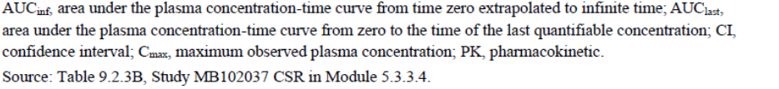

#### Efficacy

The sponsor has presented Study D1690C00010 as the only efficacy study to support their FDC application. This study was the pivotal study in the Type A (NCE) application for Forxiga (dapagliflozin).

##### Phase 3 study (Study D1690C00010)

###### Design

A pivotal, Phase 3, multicentre (102 centres in 6 countries), randomised, double-blind, 2-arm parallel-group (1:1), controlled study in 451 adult patients (≥18y) with T2DM with inadequate glycaemic control on sitagliptin alone or in combination with metformin for a 24-week short term period (ST) and a 24-week long term extension period (LT). The study was conducted between 10 October 2009 and 10 March 2011 (LPLV for the 24-week period).

Figure 3. Study D1690C00010. Study design schema.

**Study objectives**: To assess the safety and tolerability of dapagliflozin over 48 weeks of treatment; To assess the maintenance of efficacy of dapagliflozin versus placebo over 48 weeks of treatment (Table 7).

**Inclusion criteria**:

* ≥18 years of age with T2DM
* drug naïve or treated with sitagliptin 100 mg daily or vildagliptin 50 mg bd monotherapy, or a combination of sitagliptin 100 mg daily or vildagliptin 50 mg bd with metformin ≥1500 mg/day, or metformin ≥1500 mg/day monotherapy.
* Inadequate glycaemic control: HbA1c ≥7.2% and ≤10.0% for subjects who received sitagliptin or vildagliptin monotherapy or sitagliptin or vildagliptin in combination with metformin, and HbA1c ≥7.7% and ≤10.5% for subjects who received metformin monotherapy or who were drug naïve.

Patients were stratified according to metformin use:

* patients who were drug-naïve or on a DPP4 inhibitor at enrolment were in Stratum 1 (sitagliptin without metformin)
* patients who were on metformin monotherapy or on metformin plus a DPP4 inhibitor at enrolment were in Stratum 2 (sitagliptin with metformin).

Within each stratum, patients were randomised to dapagliflozin or placebo treatment in a 1:1 ratio to the:

* Dapagliflozin group (dapagliflozin + sitagliptin ± metformin); or
* Placebo group (sitagliptin ± metformin).

Table 7. Study D1690C00010. Outcome variables/endpoints.

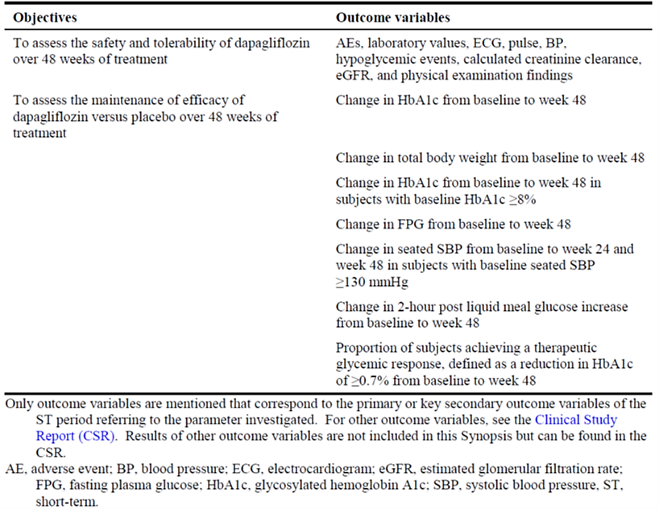

**Treatments:**

* **Stratum 1**: dapagliflozin 10 mg daily or matching placebo, according to their assignment to treatment groups, as add-on therapy to open-label sitagliptin 100 mg daily during the ST + LT period.
* **Stratum 2**: dapagliflozin 10 mg daily or matching placebo, according to their assignment to treatment groups, as add-on therapy to open-label sitagliptin 100 mg daily plus open-label metformin ≥1500 mg/day during the ST + LT period (the metformin dose was based on the dose during the last 10 weeks prior to enrolment and was kept stable).

**Randomisation**: via an Interactive Web Response System on Visit 5 in balanced blocks in order to ensure approximate balance among treatment arms and strata.

**Baseline characteristics**: The study population was representative of the target population, and baseline characteristics were balanced across the two treatment arms. In the FAS, 54.8% were male, the mean age was 54.9 years, the mean duration of T2DM was 5.7 years, and the mean baseline HbA1c was 7.9%. 95% of patients had baseline estimated glomerular filtration rate (eGFR) values ≥60 mL/min/1.73 m2.

###### Magnitude of the treatment effect and its clinical significance

**Primary efficacy endpoint (HbA1c at Week 24):**

The difference in adjusted mean change from baseline in HbA1c compared with placebo was (noting that the absolute reduction in HbA1c units is shown, not a relative percentage reduction) (Table 8):

* –0.48% (95% CI: -0.62, -0.34) in the overall study population
* –0.56 (95% CI: -0.79, -0.34) in Stratum 1 (no metformin)
* –0.40 (95% CI: -0.58, -0.23) in Stratum 2 (with metformin)

Table 8. Study D1690C00010. Main results (ST) excluding data after rescue (FAS).

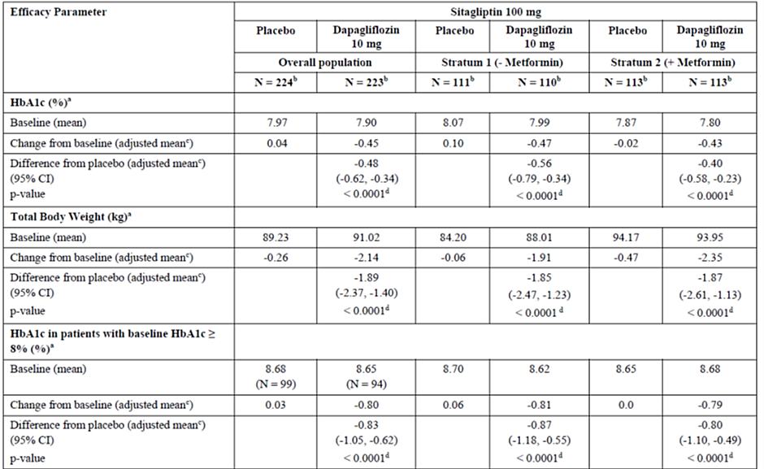

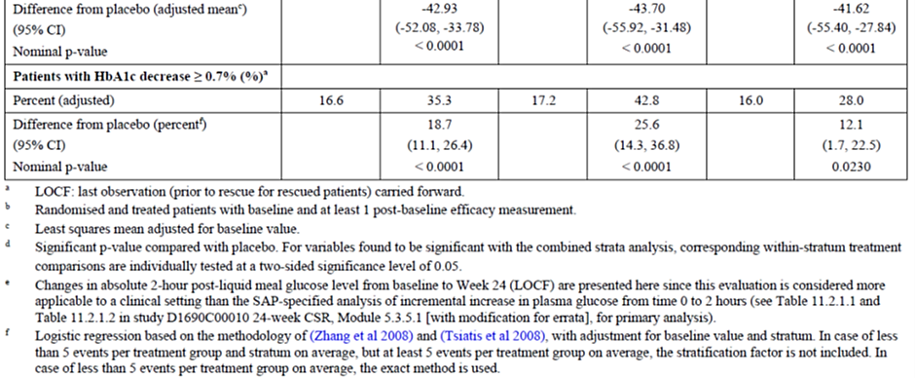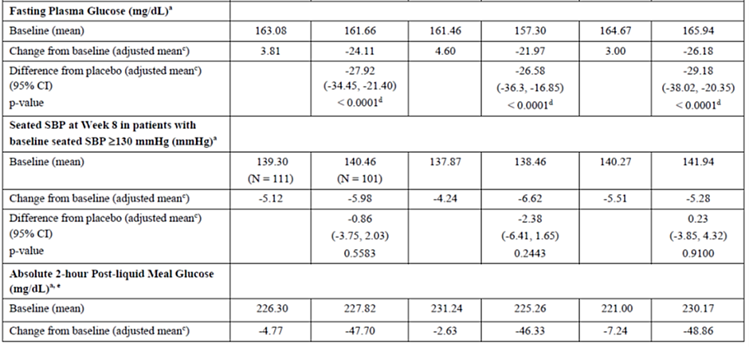

The placebo corrected HbA1c reductions observed with dapagliflozin in combination with sitagliptin (with or without metformin) at Week 24 were maintained through Week 48 (Figure 2).

Figure 4. Study D1690C00010. HbA1c (%) adjusted mean change from baseline over time to Week 48 (excluding data after rescue) (Full Analysis Set).

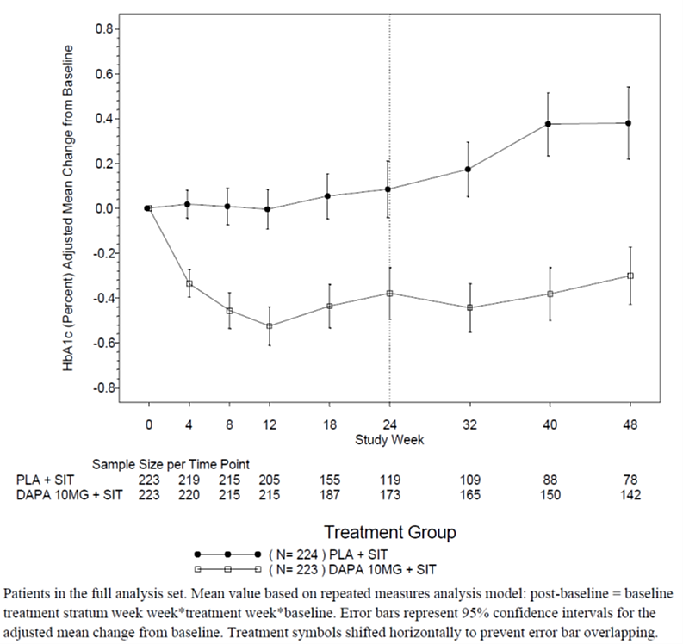

#### Safety

The safety evaluation was mainly based on the single pivotal trial D1690C00010 that compared the FDC to sitagliptin.

This pivotal phase 3 study compared dapagliflozin (SGLT2i) + sitagliptin (DPP4i) ± metformin to sitagliptin (DPP4i) ± metformin. A study with dapagliflozin as the comparator has not been provided. Clinical data regarding the standalone dapagliflozin or sitagliptin components were not included.

##### Exposure

**Study D1690C00010**: 451 patients (dapagliflozin group: 225; placebo group: 226) received the study medication during the 48-week treatment period (>80% for between 301-360 days) (Table 9).

Table 9. Study D1690C00010. Exposure.

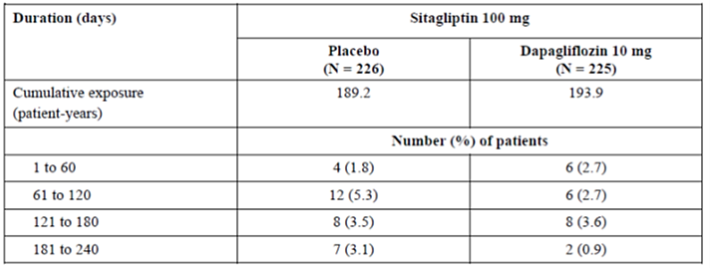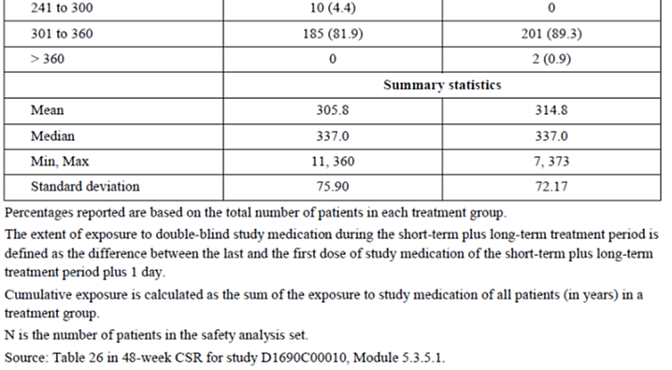

##### Adverse event overview

The overall incidence of AEs in patients treated with dapagliflozin 10 mg as add-on to sitagliptin was 66.2% vs. 61.1% in patients treated with placebo add-on to sitagliptin (Table 10).

Table 10. Study D1690C00010. AE summary (Short-term (ST) plus Long-term (LT) treatment period, including data after rescue) (Safety Analysis Set).

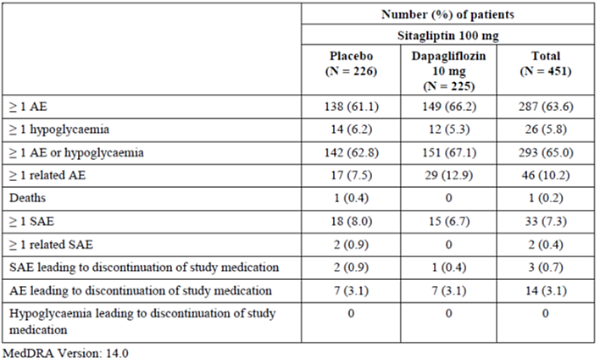

The most common AEs (Table 11) in the dapagliflozin/sitagliptin arm with at least 1% higher incidence than in the placebo/sitagliptin arm and in descending order of frequency, were urinary tract infection (UTI) (4.4% vs. 2.7%), pharyngitis (4.0% vs. 1.8%), constipation (2.7% vs 0.4%), vulvovaginal mycotic infection (2.7% vs. 0%), and microalbuminuria (2.2% vs. 0%).

Table 11. Study D1690C00010. Overview of AEs.

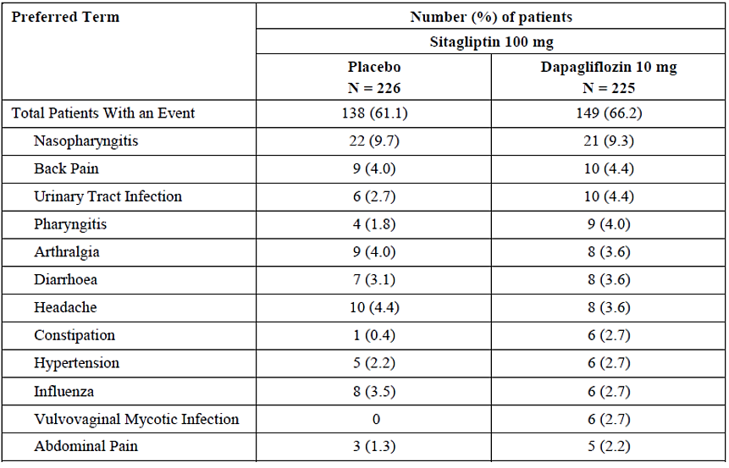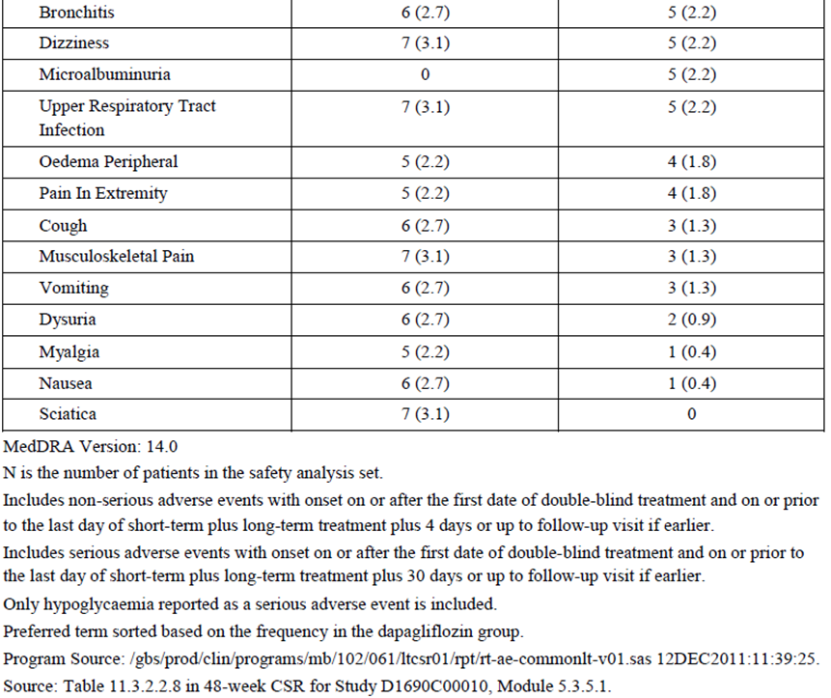

##### Treatment related adverse event (adverse drug reaction) overview

The proportion of patients with at least 1 AE assessed as related to the study medication was higher in the dapagliflozin (10.2%) than in the placebo group (5.8%) (Table 12). The difference in the proportion of patients with at least 1 treatment related AE can primarily be attributed to differences in the standard of care of infections and infestations (dapagliflozin: 5.8%, placebo: 2.2%) as well as reproductive system and breast disorders (dapagliflozin: 2.2%, placebo: 0.0%). UTI and vulvovaginal mycotic infection were assessed as treatment related in most patients. These preferred terms (PTs) were reported by more patients in the dapagliflozin than in the placebo group. The total proportion of patients with an AE assessed as treatment related was larger in stratum 2 than in stratum 1, and within both strata the proportion of patients with an AE assessed as treatment related was larger in the dapagliflozin than in the placebo group.

Table 12. Study D1690C00010. Overview of adverse drug reactions (ADRs).

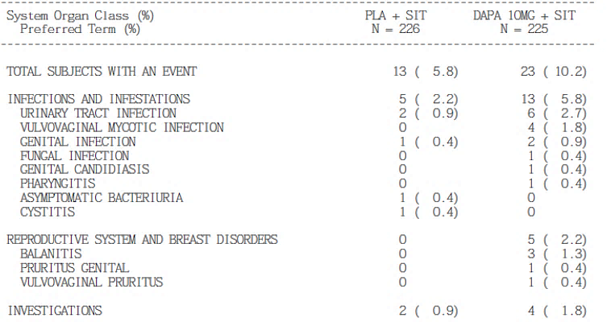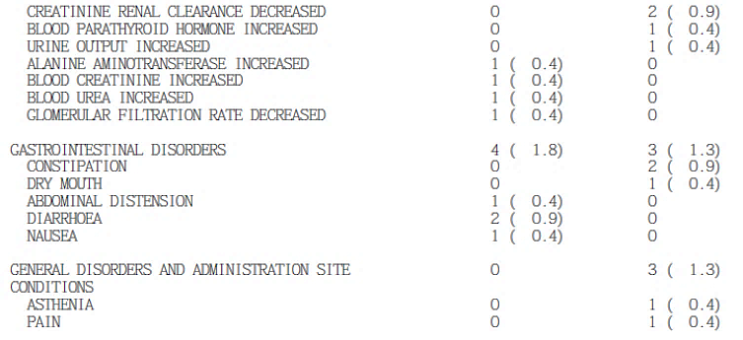

##### Deaths and SAEs

There were 2 deaths during the study; both were considered unrelated to study medication.

The proportion of patients who reported SAEs was 6.7% in the dapagliflozin/sitagliptin arm and 8.0% in the placebo/sitagliptin group.

##### Discontinuations

Discontinuations of study medication due to AEs were reported in small and similar proportions of patients in both treatment groups (3.1%). No specific pattern was evident.

##### Adverse events of special interest

For AEs of special interest suggestive of volume depletion (e.g., hypotension, dehydration, or hypovolemia), the number of patients affected did not indicate an increased risk associated with dapagliflozin as add-on to sitagliptin.

**Genital infections**: A higher proportion of patients treated with dapagliflozin/sitagliptin had events of genital infection compared with placebo/sitagliptin (9.3% vs. 0.4%). In both groups, the events were mild or moderate in intensity and more common in female than male patients.

No AEs of genital infection were assessed as serious. One patient in the dapagliflozin/sitagliptin arm experienced an event of vulvovaginal mycotic infection that resulted in discontinuation of study treatment. With one exception, all events treated with antimicrobial treatment (97% of events) responded to initial treatment.

**UTIs**: The overall proportion of patients with events of urinary tract infection (UTI) was higher in the dapagliflozin/sitagliptin arm than the placebo/sitagliptin arm (5.8% vs. 3.5%), and more common in females. Upper UTIs were not reported. No UTIs were assessed as serious or led to discontinuation of study medication. An adequate response to initial antimicrobial treatment was obtained in all cases but one.

**Hypoglycaemia**: Hypoglycaemic AEs were reported in 12 (5.3%) patients in the dapagliflozin/sitagliptin arm and 14 (6.2%) in the placebo/sitagliptin arm, and the majority were reported following initiation of rescue therapy (glimepiride). Prior to initiation of rescue therapy, hypoglycaemia was reported in 6 (2.7%) vs. 3 (1.3%). No patients discontinued study treatment due to a hypoglycaemic event.

**Renal impairment**: The proportion of patients reporting AEs of renal impairment or failure was higher in the dapagliflozin/sitagliptin arm (8 patients [3.6%]) than in the placebo/sitagliptin arm (4 patients [1.8%]). The difference was primarily due to the higher number of patients with an AE of creatinine renal clearance decreased in the dapagliflozin/sitagliptin arm (4 patients [1.8%]) compared with the placebo/sitagliptin arm (1 patient [0.4%]). No patient experienced an AE of renal impairment or failure assessed as serious.

**Volume depletion**: 3 patients in the dapagliflozin/sitagliptin arm and 2 patients in the placebo/sitagliptin arm experienced at least 1 AE of volume depletion. Most patients with at least 1 AE of volume depletion experienced an AE of hypotension (PT). An AE of syncope reported in 1 patient in the placebo/sitagliptin arm was assessed as serious. No patient was discontinued from study medication due to an AE of volume depletion.

**Neoplasms**: A smaller proportion of patients reported neoplasms (benign or malignant) in the dapagliflozin group (0.9%) compared to placebo group (2.7%). One case of prostate cancer was reported and no events of bladder cancer or breast cancer in the dapagliflozin group.

**CV**: A meta-analysis of cardiovascular events included all patients in the first 24 weeks of the double blind treatment period and 50% of patients who had completed the 48 weeks of double blind treatment showed that dapagliflozin was not associated with an unacceptable increase in CV risk (hazard ratio versus comparator for the primary composite endpoint of adjudicated CV death, MI, stroke and hospitalisation for unstable angina: 0.82 (95%CI 0.58 – 1.15).

##### Other studies (PK studies in healthy volunteers)

There were no inconsistencies regarding the known safety profile. Details are in the CER.

***Post-market experience***

No data submitted in the dossier.

#### Risk management plan

The sponsor has sought an exemption for submitting a risk management plan (RMP) waiver within this application, and provided the following justification:

In Australia, both dapagliflozin and sitagliptin active substances have been supplied (alone and in combination with other anti-diabetic medications, at the proposed dose) for use in T2DM, as summarised in Table 13 below:

Table 13. Medicines registered on the ARTG containing dapagliflozin or sitagliptin

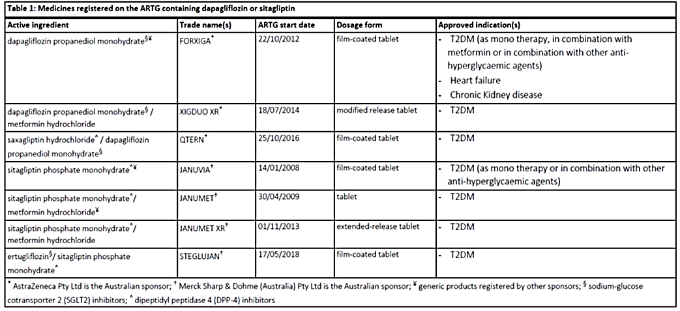

As shown in Table 13, the combination use of SGLT2 and DPP-4 for the treatment of T2DM is well established with various FDCs already registered and available. In addition, the PI of Forxiga includes safety and efficacy data on the combination treatment at the proposed dose with no new safety concerns having been identified in the clinical trial program (note: Steglujan was [cancelled](https://www.tga.gov.au/resources/cancellations-by-sponsors/steglujan-5100-ertugliflozinsitagliptin-phosphate-monohydrate-5-mg100-mg-film-coated-tablet-blister-pack-cancelled-under-section-301c-act) by the Sponsor, Merck, Sharp and Dohme, in June 2024).

Whilst the implementation of the RMP and Australian Specific Annex (ASA) are imposed as conditions of registration for the single drug products, Forxiga (dapagliflozin) and Januvia (sitagliptin), no additional risk minimisation activities are required. The risk minimisation measures employed are that of routine risk minimisation measures in the form of the information provided in the Product Information and Consumer Medicines Information documents.

According to the ‘Risk management plans for medicines and biologicals – Australian requirements and recommendations, version 3.3, March 2019’, submission of an RMP is required for a new fixed combination when:

* one of the active ingredients is a new chemical entity
* one or more of the active ingredients requires additional risk minimisation
* the indication of the combination differs from the indications of the individual active ingredients.

Considering the extensive use of both dapagliflozin and sitagliptin for the treatment of T2DM and the fact that there are no new safety concerns or additional risk minimisation measures required for the individual active ingredients, the proposed dapagliflozin/sitagliptin FDC product does not meet any of the three criteria listed above where the submission of an RMP is required. Therefore, a waiver for the requirement to submit an RMP for the registration of the proposed dapagliflozin (10 mg) and sitagliptin (100 mg) FDC is considered appropriate.

The RMP evaluation area has advised that No RMP was required for this Type B application.

See [TGA’s guidance](https://www.tga.gov.au/resources/resource/guidance/risk-management-plans-medicines-and-biologicals/when-rmp-required) on ‘when an RMP is required’.

The TGA may request an updated RMP at any stage of a product's life-cycle, during both the pre-approval and post-approval phases. Further information regarding the TGA’s risk management approach can be found in [risk management plans for medicines and biologicals](https://www.tga.gov.au/publication/risk-management-plans-medicines-and-biologicals) and [the TGA's risk management approach](https://www.tga.gov.au/tgas-risk-management-approach). Information on the [Australia-specific annex](https://www.tga.gov.au/resources/resource/guidance/risk-management-plans-medicines-and-biologicals/australia-specific-annex-eu-rmp) ([ASA](https://www.tga.gov.au/resources/resource/guidance/risk-management-plans-medicines-and-biologicals/australia-specific-annex-eu-rmp)) can be found on the TGA website.

## Risk-benefit analysis

##### Regulatory context

T2DM is a progressive disease typically associated with a stepwise intensification of treatments. Adding additional agents to an existing regimen that does not sufficiently control the disease is the usual clinical practice.

##### Dossier

Only the submitted bioequivalence studies have been conducted recently. The pivotal efficacy and safety trial (Study D1690C00010) was conducted over 10 years ago and has been submitted to and evaluated by the TGA previously.

The dossier could have benefitted from up-to-date post-market data for the individual agents. The sponsor’s dossier contains some additional information on dapagliflozin, but very little on sitagliptin (outside of the FDC context), presumably as AstraZeneca is not the sponsor Januvia. To that effect, sitagliptin may be regarded as a quasi-generic with the TGA holding existing clinical data on sitagliptin unavailable to the sponsor. The pivotal clinical trial, and hence this whole application, focussed on dapagliflozin as an add-on therapy rather than sitagliptin.

##### Pharmacology

The bioequivalence of dapagliflozin and sitagliptin between dapagliflozin/sitagliptin 10mg/100mg FDC tablet and co-administered dapagliflozin 10mg tablet and sitagliptin 100mg tablet has been demonstrated.

##### Efficacy and safety

The efficacy and safety of dapagliflozin and sitagliptin for the use in T2DM are undisputed. Both agents had an extensive clinical trial program evaluated by the TGA in previous submissions (Table 17). Both agents are commonly used together with a significant amount of experience of this in real-life clinical practice.

With regard to the dapagliflozin and sitagliptin FDC, Study D1690C00010 demonstrated a statistically significant reduction in HbA1c with dapagliflozin 10 mg as add-on to sitagliptin 100 mg with or without metformin. The safety profile in this study was consistent with current knowledge of those agents. Overall, the evidence is supportive.

The indications of individual FDC components and their currently approved indications (as separate products) are listed in Table 14.

##### Benefit-risk balance

Based on the available data, at this stage, the benefit-risk ratio is considered positive for a T2DM indication, subject to outstanding regulatory issues to be satisfactorily addressed. This includes an appropriate indication wording and a revision to the PI (to be requested separately).

Table 14. Current Australian indications of dapagliflozin and sitagliptin.

|  |  |
| --- | --- |
| Dapagliflozin (Forxiga) | Sitagliptin (Januvia) |
| **Glycaemic control**  Forxiga is indicated in adults with type 2 diabetes mellitus:  • as monotherapy as an adjunct to diet and exercise in patients for whom metformin is otherwise indicated but was not tolerated.  • as initial combination therapy with metformin, as an adjunct to diet and exercise, to improve glycaemic control when diet and exercise have failed to provide adequate glycaemic control and there are poor prospects for response to metformin monotherapy (for example, high initial haemoglobin A1c [HbA1c] levels).  • in combination with other anti-hyperglycaemic agents to improve glycaemic control, when these together with diet and exercise, do not provide adequate glycaemic control (see section 5.1 Pharmacodynamic properties – Clinical trials and section 4.4 Special warnings and precautions for use for available data on different add-on combination therapies).  **Prevention of hospitalisation for heart failure**  Forxiga is indicated in adults with type 2 diabetes mellitus and established cardiovascular disease or risk factors for cardiovascular disease to reduce the risk of hospitalization for heart failure (see section 5.1 Pharmacodynamic properties – Clinical trials).  **Heart failure**  Forxiga is indicated in adults for the treatment of symptomatic heart failure independent of left ventricular ejection fraction, as an adjunct to standard of care therapy (see section 5.1 Pharmacodynamic properties).  **Chronic kidney disease**  Forxiga is indicated to reduce the risk of progressive decline in kidney function in adults with proteinuric chronic kidney disease (CKD Stage 2,3 or 4 and urine ACR ≥ 30 mg/g) | Januvia (sitagliptin phosphate monohydrate) is indicated as an adjunct to diet and exercise to improve glycaemic control in adults with type 2 diabetes mellitus as:  - monotherapy when metformin is considered inappropriate due to intolerance; or  - in combination with other anti-hyperglycaemic agents, including insulin |

##### Regulatory considerations

###### Clinical practice considerations

FDCs typically have benefits associated with a more favourable patient compliance.

As per national and international guidelines, the concurrent use (typically with metformin, if tolerated, and unless contraindicated) of both DPP4 inhibitors and SGLT2 inhibitors is possible and even recommended for glycaemic and also non-glycaemic benefits based on individual patient circumstances.

However, the current Australian T2DM guidelines only provide a conditional recommendation for DPP4 inhibitors in favour of SGLT2 inhibitors or GLP-1 receptor agonists, and furthermore, additional agents should be added in a stepwise fashion.

The current non-availability issues of oral formulations of GLP-1 RAs (i.e., Rybelsus) may lead to compliance issues for some patients with a GLP-1 RA prescription, but who have an aversion to injections. Furthermore, some diabetic medicines have temporary supply issues.

In current clinical practice, typically, SGLT2 inhibitors are added to metformin before DPP4 inhibitors are considered.

###### Clinical trials

The clinical trial presented in the dossier compares SGLT2i + DPP4i ± metformin to DPP4i ± metformin, and essentially demonstrates superiority for a SGLT2i/DPP4i combination over DPP4i (± metformin in both instances).

The applicant has presented evidence with sitagliptin (DPP4i) as the comparator, but not with dapagliflozin (SGLT2i) as the comparator. Studies comparing SGLT2i + DPP4i ± metformin to SGLT2i ± metformin have not been presented in the dossier, neither as a sponsor-conducted study, nor from the literature, noting that the current application is not literature-based.

A search and analysis of the relevant literature on randomised controlled trials of SGLT2i + DPP4i combinations are out of scope of this overview, but the following points are made:

There are some randomised controlled trials published in the literature concerning this, and typically the SGLT2i drives the glycaemic benefits in a SGLT2i + DPP4i combination (rather than the DPP4i; as also seen to some extent in Study D1690C00010), and in most instances, but not all, comparing SGLT2i + DPP4i + metformin to ± metformin may not be able to demonstrate superiority. However, a synergistic mechanism of action has been postulated in the literature, but relevant analyses (e.g., using PD data) have not been presented in the dossier.

###### Usage scenarios

###### Scenario 1: Substitution of the combined use of the individual components

This scenario concerns patients stabilised on the regular 10 mg dose of dapagliflozin (the only dose available) and the 100 mg dose of sitagliptin (the highest dose of sitagliptin), for whom this dosing is appropriate (e.g., those with unaffected renal function). The proposed doses in the FDC are available for the individual component medicines.

Overall, the use in this scenario is supported by relevant clinical PK data (bioequivalence and DDI studies) and supported by clinical practice guidelines.

###### Scenario 2: Add-on use in patients insufficiently responding to current therapy or benefitting from an additional agent

This scenario concerns patients on either dapagliflozin or sitagliptin who have the other agent added to their regimen with similar caveats as in Scenario 1.

As for Scenario 1, the use is supported by relevant clinical PK data (bioequivalence and DDI studies) and supported by clinical practice guidelines.

However, as noted above, the pivotal phase 3 study presented by the sponsor (Study D1690C00010) compared dapagliflozin (SGLT2i) + sitagliptin (DPP4i) ± metformin to sitagliptin (DPP4i) ± metformin. A study with dapagliflozin as the comparator has not been provided but could have been included as an additional study arm in Study D1690C00010. Hence, there is definite support of the data for adding dapagliflozin to an existing regimen with sitagliptin, but not necessarily vice versa. However, in clinical practice, that distinction may not be significant.

In the relevant TGA-adopted guidance[12], the contribution of each active substance to efficacy is expected to be demonstrated.

The question that poses itself is whether an addition of sitagliptin to an existing regimen with dapagliflozin should be restricted in the PI.

###### Scenario 3: Initial combination treatment

This scenario concerns patients not treated with either dapagliflozin or sitagliptin who commence on the Sidapvia FDC ± metformin.

As for Scenario 2, the pivotal phase 3 study presented by the sponsor (Study D1690C00010) compared to sitagliptin (DPP4i) ± metformin, but not to dapagliflozin (SGLT2i) ± metformin.

The question for this scenario is whether the initial therapy (i.e., no stepwise addition) of dapagliflozin + sitagliptin ± metformin should be restricted in the PI.

The translation of the usage scenarios into the product information wording is discussed below.

###### Concurrent therapy with metformin

It is noted that the pivotal clinical trial did include patients not treated with metformin concurrently.

However, for Forxiga (dapagliflozin), the indication wording specifically prescribes the concurrent use with metformin unless not tolerated. Allowing therapy without metformin when tolerated would go beyond the existing indication for Forxiga.

In their request for a RMP waiver, the sponsor essentially states that the indication of the combination does not differ from the indications of the individual active ingredients. Consequently, it can be concluded that the sponsor is not seeking an indication without metformin when metformin is actually tolerated.

###### PI issues

A complete list of PI requests will be sent to the sponsor separately. A number of issues are outlined below.

###### Dosing

Dapagliflozin (Forxiga) is only available as a 10 mg tablet. Sitagliptin (Januvia) is available as 25, 50, and 100 mg tablets to accommodate potential dosage reductions (e.g., in renal impairment). The proposed Sidapvia PI contains a relevant statement regarding use in patients with an eGFR <45 mL/min/1.73 m2. A reference to other available products should be added.

###### Additional efficacy claims for dapagliflozin

Dapagliflozin (Forxiga) has additional heart failure hospitalisation prevention or CKD indications, but the sponsor has not sought to include them in the Sidapvia FDC, and no definite clinical trial data for the FDC are available for those indications. Efficacy claims unrelated to the proposed indication should be removed.

##### Proposed indication

###### Sidapvia sponsor-proposed indication

The sponsor-proposed indication is:

*Sidapvia is indicated as an adjunct to diet and exercise to improve glycaemic control in adults with type 2 diabetes mellitus when treatment with both dapagliflozin and sitagliptin is appropriate.*

QTERN indication as a comparison. This is similar to the approved indication for QTERN (dapagliflozin + saxagliptin):

*QTERN is indicated as an adjunct to diet and exercise, in combination with metformin, to improve glycaemic control in adults with type 2 diabetes mellitus when treatment with both saxagliptin and dapagliflozin is appropriate.*

But it is noted that the pivotal clinical trial for that QTERN application (Study CV181169) included an additional comparison with dapagliflozin as the comparator (unlike this application), and all groups were treated with metformin XR.

###### Sidapvia indication options

The following indication options can be considered:

* A less restricted (sponsor-proposed) indication
  + Sidapvia is indicated as an adjunct to diet and exercise to improve glycaemic control in adults with type 2 diabetes mellitus when treatment with both dapagliflozin and sitagliptin is appropriate.
* Issues to consider
  + Addition of sitagliptin to existing dapagliflozin therapy
  + Use of Sidapvia as initial therapy
  + Use of Sidapvia without metformin when metformin is tolerated and/or not contraindicated
* A more restricted and more precise indication, which may be too narrow
  + Sidapvia is indicated as an adjunct to diet and exercise to improve glycaemic control in adults with type 2 diabetes mellitus to substitute the existing sitagliptin and/or dapagliflozin therapy in patients being treated with:
* sitagliptin, and for whom the addition of dapagliflozin is appropriate.
* an equivalent free combination of both sitagliptin and dapagliflozin.
  + Sidapvia should be used in combination with metformin unless contraindicated or not tolerated.

Additional alternative wording options may include a reference to other parts of the PI (e.g., sections 4.4, 4.5, 5.1), e.g.:

*Sidapvia is indicated as an adjunct to diet and exercise to improve glycaemic control in adults with type 2 diabetes mellitus when treatment with both dapagliflozin and sitagliptin is appropriate (see sections 4.4 Interactions with other medicines and other forms of interactions and 5.1 Pharmacodynamic properties – Clinical trials).*

*Sidapvia should be used in combination with metformin unless contraindicated or not tolerated.*

#### Advisory committee on medicines considerations

The [Advisory Committee on Medicines (ACM)](https://www.tga.gov.au/committee/advisory-committee-medicines-acm), having considered the evaluations and the Delegate’s overview, as well as the sponsor’s response to these documents, advised the following.

Can the ACM comment on whether there are sufficient data for a T2DM indication and also comment on the proposed indication wording?

The ACM concluded that there were sufficient data included in the submission to justify a T2DM indication. The ACM did not identify any safety or efficacy issues of concern in the trial data. The safety and efficacy for the dapagliflozin/sitagliptin combination are in accord with that observed for the single agents, with no additional issues identified for the combination. It was noted that both dapagliflozin and sitagliptin are included in current guidelines and being used together in clinical practice in Australia.

The ACM considered the indication proposed below and verified that this modified indication is consistent with current guidelines and clinical practice, and reflects the clinical trial data:

Sidapvia is indicated as an adjunct to diet and exercise to improve glycaemic control in adults with type 2 diabetes mellitus when treatment with both dapagliflozin and sitagliptin is appropriate.

Sidapvia should be used in combination with metformin unless contraindicated or not tolerated.

At this stage, the indications for both individual component products (dapagliflozin and sitagliptin) restrict the use without metformin to scenarios in which metformin is not tolerated. The ACM noted that if the additional metformin wording were not included, the fixed combination product would have an indication that extends beyond the component drug indications with regard to concurrent metformin use.

Can the ACM comment on the inclusion of efficacy claims unrelated to the proposed indication in the product information document (section 5.1 Pharmacodynamic properties – Clinical trials)?

The ACM discussed the inclusion of efficacy claims within the PI that are unrelated to the proposed indication. On balance the ACM was of the view that statements on this combination therapy should be similar to those of the individual components and not include data unrelated to the indications proposed in the submission, and for which no clinical data were submitted. However, there were no definite objections to inclusion of some additional individual component data in order to inform prescribers. These data can be included in a summarised form and also in the context of safety rather than claimed efficacy outcomes.

###### ACM conclusion

The ACM considered this product to have an overall positive benefit-risk profile for the indication:

*Sidapvia is indicated as an adjunct to diet and exercise to improve glycaemic control in adults with type 2 diabetes mellitus when treatment with both dapagliflozin and sitagliptin is appropriate*

*Sidapvia should be used in combination with metformin unless contraindicated or not tolerated*

## Outcome

The TGA decided to register Sidapvia for the above indication.

## Attachment 1. Product Information

The [Product Information](https://www.tga.gov.au/products/australian-register-therapeutic-goods-artg/product-information-one) ([PI](https://www.tga.gov.au/products/australian-register-therapeutic-goods-artg/product-information-one)) approved with the submission for Sidapvia which is described in this AusPAR can be found as Attachment 1. It may have been superseded. For the most recent PI and [Consumer Medicines Information](https://www.tga.gov.au/products/australian-register-therapeutic-goods-artg/consumer-medicines-information-cmi) (CMI), please refer to the TGA [PI/CMI search facility.](https://www.tga.gov.au/picmi-search-facility)

|  |
| --- |
| Therapeutic Goods Administration |
| PO Box 100 Woden ACT 2606 Australia  Email: [info@tga.gov.au](mailto:info@tga.gov.au) Phone: 1800 020 653 Fax: 02 6203 1605  [**https://www.tga.gov.au**](https://www.tga.gov.au) |

1. This is the original indication proposed by the sponsor when the TGA commenced the evaluation of this submission. It may differ to the final indication approved by the TGA and registered in the Australian Register of Therapeutic Goods.
2. Turner RC, Cull CA, Frighi V, Holman RR. Glycemic control with diet, sulfonylurea, metformin, or insulin in patients with type 2 diabetes mellitus: progressive requirement for multiple therapies (UKPDS 49). UK Prospective Diabetes Study (UKPDS) Group. JAMA. 1999;281(21):2005-12
3. ADA. 9. Pharmacologic Approaches to Glycemic Treatment: Standards of Medical Care in Diabetes-2021. Diabetes Care. 2021;44(Suppl 1):S111-S24.
4. International Diabetes Federation. IDF Diabetes Atlas 2019.
5. Holman RR, Paul SK, Bethel MA, Matthews DR, Neil HA. 10-year follow-up of intensive glucose control in type 2 diabetes. N Engl J Med. 2008;359(15):1577-89.
6. Jabbour SA, Hardy E, Sugg J, Parikh S; Study 10 Group. Dapagliflozin is effective as add-on therapy to sitagliptin with or without metformin: a 24-week, multicenter, randomized, double-blind, placebo-controlled study. Diabetes Care. 2014;37(3):740-50. doi: 10.2337/dc13-0467. Epub 2013 Oct 21. PMID: 24144654.
7. Bangalore S, Kamalakkannan G, Parkar S, Messerli FH. Fixed-dose combinations improve medication compliance: a meta-analysis. Am J Med. 2007;120(8):713-9.
8. The ‘Delegate’ is the Delegate of the Secretary of the Department of Health and Aged Care who made the final decision to either include the new medicine/indication on the ARTG or reject the submission, under section 25 of the Therapeutic Goods Act..
9. ICH guideline M3(R2) on non-clinical safety studies for the conduct of human clinical trials and marketing authorisation for pharmaceuticals – Step 5
10. [https://www.ema.europa.eu/en/medicines/human/EPAR/Forxiga](https://www.ema.europa.eu/en/medicines/human/EPAR/forxiga)
11. [https://www.ema.europa.eu/en/medicines/human/EPAR/Januvia](https://www.ema.europa.eu/en/medicines/human/EPAR/januvia)
12. European Medicines Agency. Committee for Human Medicinal Products (CHMP). Guideline on clinical development of fixed combination. EMA/CHMP/158268/2017. 23 March 2017.