|  |
| --- |
| Australian Public Assessment Report for Spy Agent Green |
| Active ingredient: Indocyanine green |
| Sponsor: Stryker Australia Pty Ltd |
| August 2024 |

About the Therapeutic Goods Administration (TGA)

* The Therapeutic Goods Administration (TGA) is part of the Australian Government Department of Health and Aged Care and is responsible for regulating therapeutic goods, including medicines, medical devices, and biologicals.
* The TGA administers the *Therapeutic Goods Act 1989* (the Act), applying a risk management approach designed to ensure therapeutic goods supplied in Australia meet acceptable standards of quality, safety, and efficacy.
* The work of the TGA is based on applying scientific and clinical expertise to decision-making, to ensure that the benefits to the Australian public outweigh any risks associated with the use of therapeutic goods.
* The TGA relies on the public, healthcare professionals and industry to report problems with therapeutic goods. The TGA investigates reports received to determine any necessary regulatory action.
* To report a problem with a therapeutic good, please see the information on the [TGA website](https://www.tga.gov.au/).

About AusPARs

* The Australian Public Assessment Report (AusPAR) provides information about the evaluation of a prescription medicine and the considerations that led the TGA to approve or not approve a prescription medicine submission. Further information can be found in [Australian Public Assessment Report (AusPAR) guidance](https://www.tga.gov.au/australian-public-assessment-report-auspar-guidance).
* AusPARs are prepared and published by the TGA.
* AusPARs are static documents that provide information that relates to a submission at a particular point in time. The publication of an AusPAR is an important part of the transparency of the TGA’s decision-making process.
* A new AusPAR may be provided to reflect changes to indications or major variations to a prescription medicine subject to evaluation by the TGA.

Copyright

© Commonwealth of Australia 2024  
This work is copyright. You may reproduce the whole or part of this work in unaltered form for your own personal use or, if you are part of an organisation, for internal use within your organisation, but only if you or your organisation do not use the reproduction for any commercial purpose and retain this copyright notice and all disclaimer notices as part of that reproduction. Apart from rights to use as permitted by the *Copyright Act 1968* or allowed by this copyright notice, all other rights are reserved and you are not allowed to reproduce the whole or any part of this work in any way (electronic or otherwise) without first being given specific written permission from the Commonwealth to do so. Requests and inquiries concerning reproduction and rights are to be sent to the TGA Copyright Officer, Therapeutic Goods Administration, PO Box 100, Woden ACT 2606 or emailed to <[tga.copyright@tga.gov.au](mailto:tga.copyright@tga.gov.au)>.

Contents

List of abbreviations 4

Product submission 5

Submission details 5

Product background 6

Spy Agent Green – clinical uses 7

Current options for lymphatic mapping 7

Clinical rationale 8

Regulatory status 8

Australian regulatory status 8

International regulatory status 9

Registration timeline 9

Submission overview and risk/benefit assessment 10

Quality 10

Nonclinical 11

Clinical 12

Summary of clinical studies 12

Efficacy 12

Safety 34

Risk management plan 35

Risk-benefit analysis 35

Outcome 36

Specific conditions of registration applying to these goods 36

Attachment 1. Product Information 36

## List of abbreviations

|  |  |
| --- | --- |
| Abbreviation | Meaning |
| AE | Adverse events |
| ARTG | Australian Register of Therapeutic Goods |
| ASA | Australia‑specific annex |
| CI | Confidence Interval |
| CMI | Consumer Medicines Information |
| ICG | Indocyanine green |
| LN | Lymph node |
| PBRER | Periodic Benefit-Risk Evaluation Reports |
| PI | Product Information |
| PSUR | Periodic safety update report |
| RMP | Risk management plan |
| SAE | Serious adverse events |
| TGA | Therapeutic Goods Administration |

## Product submission

### Submission details

|  |  |
| --- | --- |
| *Type of submission:* | New chemical entity |
| *Product name:* | Spy Agent Green |
| *Active ingredient:* | Indocyanine green |
| *Decision:* | Approved |
| *Date of decision:* | 19 February 2024 |
| *Date of entry onto ARTG:* | 28 February 2024 |
| *ARTG number:* | 369670 |
| [*Black Triangle Scheme*](https://www.tga.gov.au/black-triangle-scheme) | Yes |
| *Sponsor’s name and address:* | Stryker Australia Pty Ltd, PO Box 970, Artarmon NSW 1570 |
| *Dose form:* | Powder for injection |
| *Strength:* | 25 mg |
| *Container:* | Vial |
| *Pack size:* | 1 |
| *Approved therapeutic use for the current submission:* | Spy Agent Green (indocyanine green) is an imaging agent (dye) intended for:   * Visualisation of vessels, blood flow and tissue perfusion in adults and paediatric patients from one month of age and above. * Visualisation of extrahepatic biliary ducts in adults and children from 12 years of age and above. * Visualisation of lymph nodes and lymphatic vessels in women with cervical or uterine solid tumours for which lymphatic mapping is a component of intraoperative management. |
| *Route of administration:* | Intravenous and interstitial administration according to the indication |
| *Dosage:* | ***Adults****:*  The recommended dose of Spy Agent Green for a single image sequence is 1.25 mg to 5 mg of a 2.5 mg/mL solution.  For visualisation of perfusion in extremities through the skin, the recommended dose is 3.75 mg to 10 mg of a 2.5 mg/mL solution.  Immediately flush with a 10 mL bolus of 0.9% Sodium Chloride.  ***Paediatric population:*** The recommended dose for a single image sequence is 1.25 mg to 5 mg Spy Agent Green of a 2.5 mg/mL solution. Lower doses may be administered in younger patients and in those with lower body weight. Immediately flush with bolus. Adjust the amount and type of flush to avoid volume and/or sodium overload. |
| *Pregnancy category:* | B2  Drugs which have been taken by only a limited number of pregnant women and women of childbearing age, without an increase in the frequency of malformation or other direct or indirect harmful effects on the human fetus having been observed.  Studies in animals are inadequate or may be lacking, but available data show no evidence of an increased occurrence of fetal damage.  The use of any medicine during pregnancy requires careful consideration of both risks and benefits by the treating health professional. The [pregnancy database](https://www.tga.gov.au/products/medicines/find-information-about-medicine/prescribing-medicines-pregnancy-database) must not be used as the sole basis of decision making in the use of medicines during pregnancy. The TGA does not provide advice on the use of medicines in pregnancy for specific cases. More information is available from [obstetric drug information services](https://www.tga.gov.au/obstetric-drug-information-services) in your state or territory. |

### Product background

Spy Agent Green (indocyanine green, ICG) is an imaging dye.

This AusPAR describes the submission by Stryker Australia Pty Ltd (the Sponsor) to register Spy Agent Green (indocyanine green) for the following proposed indications:[1]

* ***Visual assessment of blood flow and tissue perfusion***
* *Spy Agent Green is indicated in adults and paediatric patients one month of age and older for fluorescence imaging of micro- and macro-vasculature, blood flow and tissue perfusion before, during and after vascular, gastrointestinal, organ transplant, and plastic, micro- and reconstructive surgeries, including general minimally invasive surgical procedures.*
* ***Visualization of extrahepatic biliary ducts***
* *Spy Agent Green is indicated in adults and paediatric patients aged 12 to 17 years for fluorescence imaging of extrahepatic biliary ducts.*
* *Visualization of lymph nodes and lymphatic vessels during lymphatic mapping for cervical and uterine tumours:*
* *Spy Agent Green is indicated in women for fluorescence imaging of lymph nodes and delineation of lymphatic vessels in the cervix and uterus during lymphatic mapping in patients with solid tumours for which this procedure is a component of intraoperative management*

### Spy agent green – clinical uses

As an imaging agent, Spy Agent Green, when used with SPY Elite and a PINPOINT imaging system is used to locate and delineate structures, including arteries, veins, soft tissues and tissue perfusion, as well extrahepatic biliary anatomy and lymph nodes. ICG has been marketed in the United States for almost 60 years for use in determining cardiac output, hepatic function, liver blood flow, and in ophthalmic angiography. ICG is also FDA-approved for assessing blood flow, tissue perfusion and visualization of biliary anatomy (i.e., extrahepatic biliary ducts) in a variety of surgical interventions.

There are three proposed clinical uses of Spy Agent Green in this new drug application:

1. fluorescence angiography - entails visualization of blood flow and tissue perfusion using ICG fluorescence imaging in a variety of surgical interventions.
2. visualization of biliary anatomy entails visualization of the major extra-hepatic biliary ducts.
3. lymphatic mapping entails visualization of lymphatic vessels and lymph nodes (LNs) during lymphatic mapping of patients undergoing surgery for cervical or endometrial cancer.

Uterine cancer (or endometrial cancer) is the most common gynecological cancer with a high prevalence in western countries and it is the most common gynecological cancer in Australia (4% of all new female cancer cases diagnosed in 2016)[2]. Although cervical cancer affects fewer women, it is still a cause of considerable morbidity/mortality in women (1.3% of all new female cancer cases in 2021)[3]. Surgical staging, including pathological assessment of gynecologic cancer is commonly practiced to gather more information[4] about the primary tumor as well as lymph node status to guide prognosis and use of adjuvant therapies. Although the majority (almost 90%) of women present with early-stage disease with low rates of lymphatic metastasis, the use of lymphatic mapping may help provide a middle ground between the extreme treatment options of ‘complete lymphadenectomy’ and ‘no nodal evaluation’ for patients with uterine cancers4.

### Current options for lymphatic mapping

ICG fluorescence angiography has been utilized extensively for the visual assessment of blood flow and tissue perfusion in a variety of surgical procedures ("fluorescence angiography applications"). Hence, this section focuses on the proposed new indication for lymphatic mapping in women with undergoing surgery for cervical or endometrial cancer.

Lymphatic mapping is an image-guided procedure, using various dyes and / or tracers that are well established in the treatment of solid malignancies, including breast, vulva, melanoma and others and is based on concept that lymph drains in an orderly pattern away from the tumor through the lymphatic system to the first LN or LNs[5]. Lymphatic mapping is defined as injection of a dye / radiotracer and observing the lymphatic flow through the channels as it incorporates into a lymph node (LN). The surgeon uses the tracer / dye as a guide to the LN that would normally be very difficult to identify due to presence of adipose tissue, inflammatory tissue, adhesions, etc. LN detection is a critical step during the surgical staging of uterine and cervical cancer and involves the excision of the first primary node(s) that the dye / tracer has identified4. The use of imaging agents and radiotracers for LN identification during lymphatic mapping provides an opportunity for more selective LN removal, thereby minimizing the costs and morbidity associated with complete lymphadenectomy.

Currently, blue dyes (such as isosulfan blue, patent blue, methylene blue etc.), radiotracers (such as technetium 99m), or a combination of both are utilized for the identification of LNs during lymphatic mapping in gynecological cancers[6]. However, these have significant limitations: - Blue dyes are limited in that they are small molecule dyes that tend to leak from the lymphatic vessels and cannot easily be seen through any but the most superficial tissue layers; - Radiotracers are audibly detected (using a Geiger counter) and therefore unable to provide visual cues to the surgeon and give rise to radiation exposure concerns.

### Clinical rationale

ICG has a well-established safety profile, and it has been marketed for almost 60 years for use in determining cardiac output, hepatic function, liver blood flow, and in ophthalmic angiography. Over the last several years, ICG fluorescence angiography has gained utility and has become one of the most popular methods in medical science for the visualization of cells, tissues, and anatomical structures.

Lymphatic mapping and sentinel lymph node detection are two critical steps for effective staging of endometrial and cervical cancer. Fluorescence imaging using interstitially administered ICG has consequently emerged as an alternative technique for LN identification and delineation of lymphatic vessels during lymphatic mapping. This technique enables real-time intraoperative visualization of the lymphatic system with high LN detection rates. Once administered, ICG is taken up and rapidly drained from the interstitial space by the lymphatic system and as it binds to lymph proteins, it travels through the lymphatic vessels with minimal extravasation and enables detailed visualization of the lymphatic architecture and LNs[7]. The near-infrared (NIR) fluorescence spectrum of ICG is located at wavelengths at which tissues are maximally optically transparent and thereby enables visualization of deeper lymph structures than is possible with other dyes (e.g., blue dyes). Furthermore, ICG is injected intraoperatively compared to the intracervical injection of Tc99 on the day prior to surgery without anesthesia (followed by a lymphoscintigraphy). This makes the procedure simpler, less painful for the patient and is perceived by the patients as a higher quality of care[8].

### Regulatory status

#### Australian regulatory status

This product is considered a new chemical entity for Australian regulatory purposes.

#### International regulatory status

Table 1. International regulatory status at the time of product registration.

|  |  |  |  |
| --- | --- | --- | --- |
| Region | Submission date | Status | Approved indications |
| United States of America | 23 January 2018 | Approved 21 November 2018 | **Visualization of Vessels, Blood Flow and Tissue Perfusion**  Spy Agent Green is indicated in adults and paediatric patients one month of age and older for fluorescence imaging of micro- and macro-vasculature, blood flow and tissue perfusion before, during and after vascular, gastrointestinal, organ transplant, and plastic, micro- and reconstructive surgeries, including general minimally invasive surgical procedures.  **Visualization of Extrahepatic Biliary Ducts**  Spy Agent Green is indicated in adults and paediatric patients aged 12 to 17 years for fluorescence imaging of extrahepatic biliary ducts.  **Visualization of Lymph Nodes and Lymphatic Vessels**  During Lymphatic Mapping for Cervical and Uterine Tumours  Spy Agent Green is indicated in women for fluorescence imaging of lymph nodes and delineation of lymphatic vessels in the cervix and uterus during lymphatic mapping in patients with solid tumours for which this procedure is a component of intraoperative management. |

## Registration timeline

Table 2 captures the key steps and dates for this submission.

This submission was evaluated under the [standard prescription medicines registration process](https://www.tga.gov.au/how-we-regulate/supply-therapeutic-good-0/supply-prescription-medicine/application-process/prescription-medicines-registration-process).

Table 2 . Registration timeline for Spy Agent Green (submission no. PM-2021-02677-1-2) – Key Dates.

|  |  |
| --- | --- |
| Description | Date |
| Submission dossier accepted and first round evaluation commenced | 2 August 2021 |
| First round evaluation completed | 4 January 2022 |
| Sponsor provides responses on questions raised in first round evaluation | 22 March 2022 |
| Second round evaluation completed | 21 December 2023 |
| Sponsor’s notification to the TGA of errors/omissions in evaluation reports | 1 March 2023 |
| Delegate’s[9] Overall benefit-risk assessment | 10 March 2023 |
| Registration decision (Approved) | 19 February 2024 |
| Administrative activities and registration in the ARTG completed | 28 February 2024 |
| Number of working days from submission dossier acceptance to registration decision* | 128 |

*Statutory timeframe for standard submissions is 255 working days

## Submission overview and risk/benefit assessment

### Quality

ICG is a water soluble, tricarbocyanine dye that is commonly used as an intravascular imaging agent. It has been used as a standard dye in medical diagnostics for more than 50 years. The product has no therapeutic use or pharmacological effect (no chemical or metabolic action) on the patient and is not scheduled.

ICG has the chemical structure shown below in Figure 1.

Figure 1: Chemical structure of indocyanine green

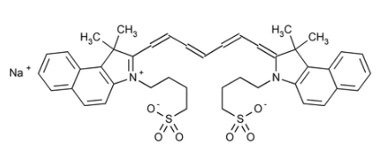

The drug product is to be packaged in 20 mL Type I clear glass vials with a rubber stopper and a tear off seal and marketed in cartons of 1 and 6 vials. The product is reconstituted with 10 mL or 20 mL of sterile Water for Injections prior to use to form a 2.5 mg/mL or 1.25 mg/mL solution of indocyanine green.

The proposed shelf life for the unopened product is 48 months “Store below 25°C”. The maximum in-use shelf life for the reconstituted solution is 6 hours at room temperature (below 25°C).

There were no significant issues identified from the quality evaluation of the submitted data that would indicate the product should not be registered on the basis of quality, or safety-related issues arising from the quality of the product. The Evaluator was satisfied that the Sponsor had satisfied all requirements with respect to:

* GMP compliance
* stability and release specifications (which dictate the medicine’s physicochemical properties, biological activity, immunochemical properties and purity)
* validation of analytical procedures,
* appropriate choice of reference standards and reference materials
* consistency of medicine manufacture as demonstrated by appropriate in-process acceptance criteria and action limits
* medicine sterility
* appropriate/compatible container closure systems.
* labelling that conformed to relevant Therapeutic Goods Orders.

These requirements, where applicable, were met for drug precursors/intermediates, the drug substance and the drug product.

The quality information submitted by the Sponsor supported the registration of Spy Agent Green.

### Nonclinical

The non-clinical evaluation comprised data of nonclinical studies performed by NOVADAQ focusing on the primary pharmacology, and nonclinical reports in published literature using commercially available ICG to support the overall efficacy and safety of Spy Agent Green. The submitted papers focussed on primary pharmacology, pharmacokinetics, single-dose toxicity and phototoxicity. ICG was evaluated (with limited data) and registered in Australia between 1996 and 2003. Therefore, the Sponsor’s nonclinical approach and justifications were considered acceptable. No safety pharmacology studies were conducted with ICG. The clinical safety profile for ICG is considered well established.

Based on published literature, ICG is highly bound to plasma proteins, especially lipoproteins, which confines it to the intravascular and lymphatic compartments. The binding to plasma proteins shifts the absorption peak towards the longer wavelengths. Following intravenous injection, ICG is not metabolised and taken up by hepatic parenchymal cells and excreted into the bile. It is not reabsorbed from the intestine and does not undergo enterohepatic circulation. Plasma clearance of ICG is biphasic, with a distribution half-life of around 6 minutes and a slightly slower elimination half-life of ~20 minutes in pigs, and a faster elimination in rats (t½ ~6 min). Overall, the pharmacokinetic profile in animals was qualitatively comparable to that of humans.

Indocyanine green has a medium order of acute intravenous toxicity with an intravenous LD50 of 60 mg/kg in mice (no observable effects at 35 mg/kg) and no observable effects at 20 mg/kg IV in rats. The maximum recommended dose of ICG in humans is 2 mg/kg, which is several folds lower than the tested doses in animal studies.

No repeat-dose toxicity studies were conducted with ICG. It has a well-established clinical safety profile and no known pharmacological effects on vital organ function. Indocyanine green is proposed to be used as an injectable diagnostic in all its applications, with very limited re-administration. ICG is not intended to be administered on a repeated dose schedule. Considering the short-term duration of treatment for the proposed indications and long history of clinical use, absence of repeat-dose toxicity study is acceptable.

No studies have been performed to evaluate the genotoxic or carcinogenic potential of ICG. The absence of carcinogenicity study was considered acceptable based on the proposed intended clinical use as an intraoperative imaging agent and history of clinical use.

No reproductive and developmental toxicity studies with ICG have been performed in animals. No data reported in the published literature was submitted. It is not known whether ICG is excreted in milk.

Phototoxicity studies were not conducted using ICG. This is acceptable as the peak absorption of >700 nm, which indicates that ICG is unlikely to be photoreactive. There was minimal decomposition of ICG from light irradiation in the presence plasma *in vitro*.

ICG is proposed for paediatric use. However, no specific preclinical studies in juvenile animals were submitted. Support for use in the paediatric patient group relies solely on clinical data.

The non-clinical evaluation report further advised that no notable toxicities or hazards were identified in animal studies pointing to potential safety issue about the proposed clinical use of Spy Agent Green. There were also no concerns to be raised with Risk Management Plan Evaluation area from the nonclinical perspective.

Overall, there were no nonclinical objections to the registration of Spy Agent Green for the proposed indications. Relevant recommendations for the PI have been provided including B2 Pregnancy Category instead of Category C proposed by the Sponsor.

### Clinical

#### Summary of clinical studies

***Pharmacodynamics***: ICG has no pharmacological effect. When bound to plasma proteins or in lymph fluid, ICG absorbs light in the near-infrared region at 805nm and emits fluorescence at a slightly longer wavelength with peak emission at 830nm. The fluorescence imaging devices provide external energy as near infrared light for the ICG to absorb, resulting in excitation of the ICG and the emitted light (fluorescence) is transferred to an image on a monitor.

***Pharmacokinetics***: Following intravenous administration, ICG is highly bound to plasma proteins (98%) and largely confined to the intravascular compartment. It is transported unchanged by glutathione S-transferase (plasma clearance). From plasma, ICG is almost exclusively taken up by the hepatic parenchymal cells and excreted into bile. It is not reabsorbed from the intestine and does not undergo enterohepatic circulation.

***Dose finding***: This was a hybrid literature-based submission focussing on the proposed diagnostic uses of ICG in relation to the proprietary imaging systems.

The literature search and the submitted dossier did not include any specific dose-ranging studies.

#### Efficacy

The diagnostic efficacy mainly relies on 4 meta-analyses included in this dossier relating to the 3 proposed indications (Table 1).

Table 1. Meta-analyses submitted to support proposed indications

|  |  |
| --- | --- |
| Proposed indication | Corresponding meta-analysis |
| Visualisation of vessels, blood flow and tissue perfusion | Micro-IAM-01  Macro-IAM-01 |
| Visualisation of extrahepatic biliary ducts. | Biliary -IAM-0 1 |
| Visualisation of lymph nodes and lymphatic vessels during lymphatic mapping for cervical and uterine tumours | LMN-UC0l |

The efficacy data on intravenous use in ‘angiography’ indications included:

* MACRO-IAM-01: meta-analysis based on 13 studies
* MICRO-IAM-01: meta-analysis based on 33 studies

The efficacy data on intravenous use in ‘cholangiography’ indication included:

* BILIARY-IAM-01: meta-analysis based on 4 studies
* Updated literature search further 19 published papers in the period 208-2020 both of above 3 indications. The 3 meta-analyse noted above were performed concurrently and were up to date to 2018 and formed the basis of approval in the USA and Canada. In submitting its submission to the TGA, the Sponsor was asked to update the literature search which resulted in identification of 19 studies of the use of ICG in angiography/cholangiography indications between 2018-2021.

The efficacy data on subcutaneous use in ‘lymph node mapping’ included:

* 1 RCT (FILM study)
* LNM-UC01: meta-analysis based on 11 studies
* Updated literature search (2018-2021) identified further 5 studies.

In addition, the clinical dossier included:

* paediatric use reports (2017 and 2022) providing summary of paediatric population in the above datasets.

A summary of key features of the component studies of these 3 meta-analyses is shown in Table 2.

Table 2. Summary of component studies

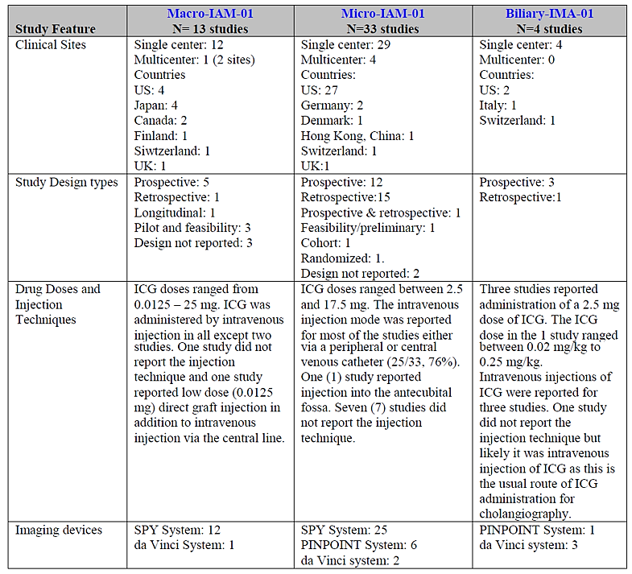

The objectives of the 3 meta-analyses (angiography and cholangiography indications) are described in Table 3.

Table 3. Primary and secondary objectives of meta-analyses

|  |  |
| --- | --- |
| Macro-IAM-01 | **Primary**: to demonstrate the effectiveness of ICG fluorescence imaging using Novadaq’s systems in the intraoperative visualisation of macrovascular blood flow in vessels  **Secondary:**   1. Decrease in blood flow related complication rates as a consequence of visualisation with ICG fluorescence imaging 2. Frequency of a change in patient management as a consequence of visualisation with IGC fluorescence imaging |
| Micro-IAM-01 | **Primary**: to demonstrate the effectiveness of ICG fluorescence imaging using Novadaq’s systems in the intraoperative visualisation of macrovascular blood flow in tissues  **Secondary:**   1. Decrease in blood flow related complication rates as a consequence of visualisation with ICG fluorescence imaging 2. Frequency of a change in patient management as a consequence of visualisation with IGC fluorescence imaging |
| Biliary-IAM-01 | **Primary**: to demonstrate the effectiveness of ICG fluorescence imaging using Novadaq’s systems in the intraoperative visualisation of extrahepatic biliary anatomy. |

The literature searches examined MEDLINE database for papers matching the search criteria (selected to capture efficacy data related to the use of NOVADAQ ICG fluorescence imaging systems) for papers published between January 1, 2001, and September 14, 2017. Publications were screened and sorted into 3 categories (macrovascular blood flow, microvascular tissue perfusion and extrahepatic biliary structure visualisation):

* The Macro-IAM-01 patient population included those undergoing coronary bypass surgery, organ transplant procedures, plastic reconstructive surgery utilising autologous flaps, renal cancer surgery and vascular surgery.
* The Micro-IAM-01 patient population included those undergoing plastic reconstructive surgery, vascular surgeries (such as wound, amputation and coronary vessels), surgery of the colon, stomach or oesophagus and endocrine surgery.
* The Biliary-IAM-01 patient population included those undergoing cholecystectomy for gall bladder disease.

##### MACRO-IAM-01

The objective of this meta-analysis was to demonstrate the effectiveness of ICG fluorescence imaging using NOVADAQ’S systems (including the da Vinci) in the intraoperative visualisation of macrovascular blood flow. A total of 13 unique published papers were identified that describe clinical experience in over 1000 patients.

The primary endpoint was success rate of intraoperative visualisation of macrovascular blood flow in vessels, assessed as the number of visualisation attempts successfully completed divided by the total number of visualisation attempts. No inferential statistics were planned for the primary or secondary endpoints. Only descriptive analysis (frequencies and percentages) and proportions with associated 95%CI for each study and overall were to be presented.

The 13 studies a broad range of surgical procedures including coronary bypass surgery, organ transplant procedures, plastic reconstructive surgery utilising autologous flaps, renal cancer surgery and vascular surgery. The study designs varied and included prospective (5), retrospective (1), longitudinal (1), pilot and feasibility studies (3) and not reported (3). The ICG doses ranged from 0.0125mg to 25mg. ICG was administered intravenously in all except 2 studies.

The overall success rate for the 13 studies was 97.0% (95%CI 96.3%, 97.6%). There were a total of 2854 visualisation attempted and 2768 succeeded (Figure 2).

Figure 2. Forest plot of primary endpoint results for visualisation success rate for intraoperative visualisation of macrovascular blood flow in vessels (point estimates and 95% CIs)

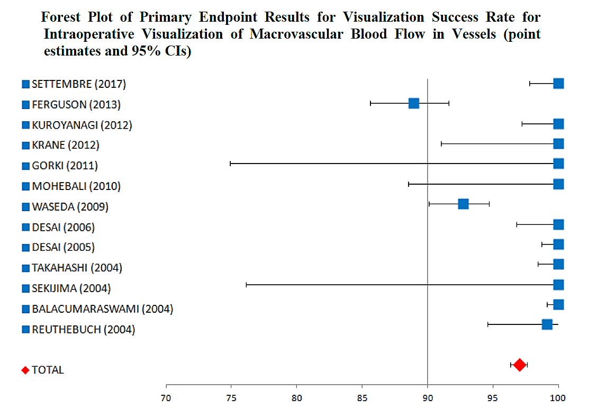

Adverse event data was available for 7 studies. No ICG related AEs or SAEs were reported in the published papers for these 7 studies.

##### MICRO-IAM-01

The objective of this meta-analysis was to demonstrate the effectiveness of ICG fluorescence imaging using NOVADAQ’S systems (including the da Vinci) in the intraoperative visualisation of microvascular blood flow in tissues. A total of 33 unique published papers were identified that describe a clinical experience in over 2000 patients.

The primary endpoint was success rate of intraoperative visualisation of microvascular blood flow in tissues, assessed as the number of visualisation attempts successfully completed divided by the total number of visualisation attempts.

No inferential statistics were planned for primary or secondary endpoints. Only descriptive statistics and associated 95% CI for each study and overall were presented.

The study designs varied and included prospective (12), retrospective (15), prospective and retrospective (1) feasibility/preliminary (1), 1 cohort and 1 randomised (Wormer 2016) studies and not reported (2). The ICG dose ranged between 2.5mg and 17.5 mg. Intravenous injection mode was reported for most of the studies either via a peripheral or central venous catheter (25/33, 76%).

The overall success rate for the 33 studies was 99.9% (95%CI 99.7%, 100.0%). There were a total of 2696 visualisation attempted and 2693 succeeded (Figure 3).

Figure 3. Forest plot of primary endpoint results for visualisation success rate for intraoperative visualisation of microvascular blood flow in tissues (point estimates and 95% CI)

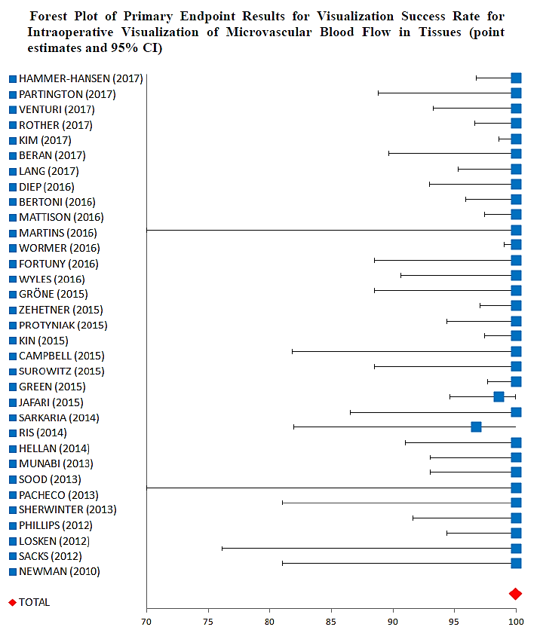

A secondary endpoint compared the complication rate of ICG to historical data. The data was available for 6 studies. This endpoint showed an overall complication rate of 5.47% for ICG compared to 9.06% for historical data (Odds ratio 0.5804; 95%CI 0.3778, 0.8915). A second secondary endpoint summarised the proportion of change in patient management as a consequence of ICG fluorescence imaging and showed that overall, 24.8% resulted in change in management (95%CI 22.0%, 27.8%).

The safety data, reported for 11/33 studies in the identified papers, did not identify anaphylaxis or other adverse events directly related to the ICG fluorescence imaging. No ICG related AEs or SAEs were reported in these 11 published papers.

##### BILIARY-IAM-01

This was a meta-analysis of published studies that evaluated the effectiveness of ICG fluorescence imaging using NOVADAQ PINPOINT and da Vinci systems in the intraoperative visualisation of at least one of the major extrahepatic bile ducts (cystic duct, common bile duct or common hepatic duct). A total of 4 unique papers were identified that described the clinical experience in 314 patients.

The primary endpoint was success rate of intraoperative visualisation of at least one of the major extrahepatic bile ducts, assessed as the number of visualisation attempts successfully completed divided by the total number of visualisation attempts.

No inferential statistics were planned. Only descriptive success rate and associated 95%CI for each study and overall were to be presented. Of the 4 studies, 3 were prospectively designed and one study was retrospective.

Three studies reported ICG dose of 2.5 mg. The ICG dose in one study ranged between 0.02mg/kg to 0.25mg/kg.

The overall success rate for the 4 studies was 99.3% (95%CI 97.3%, 100.0%). There were a total of 286 visualisations attempted and 284 succeeded (Figure 4).

Figure 4. Forest plot of primary endpoint results for visualisation success rate for extrahepatic biliary anatomy (point estimates and 95% CI)

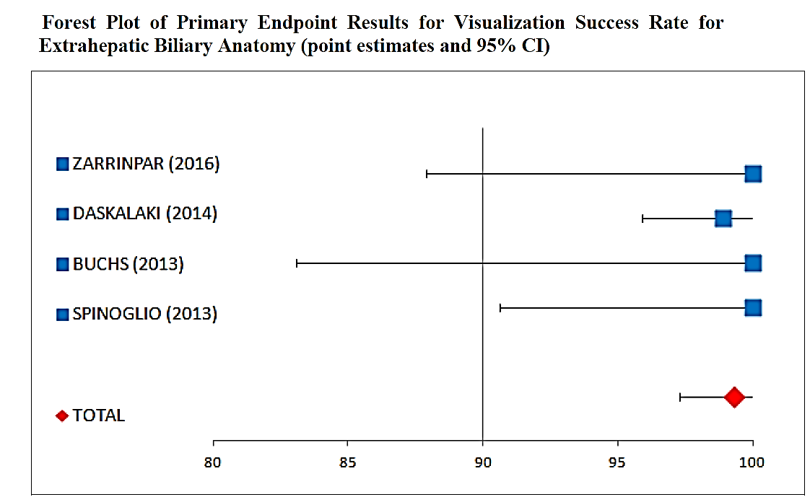

Safety data were reported in 2 publications. No reports identified anaphylaxis or any other adverse events related to the ICG fluorescence imaging.

A summary of overall visualisation success rates for the above 3 individual meta-analyses is shown in Table 4.

Table 4. Pooled study results for visualisation success rate for intraoperative visualisation of macrovascular blood flow in vessels, microvascular tissue perfusion and extrahepatic biliary anatomy

Pooled study results for visualisation success rate for intraoperative visualisation of macrovascular blood flow in vessels, microvascular tissue perfusion and extrahepatic biliary anatomy


##### Updated literature search

An updated literature search to cover the period 2018-2020 resulted in identification of a further 19 published papers (Table 5):

Table 5. Summary of patient age, by study

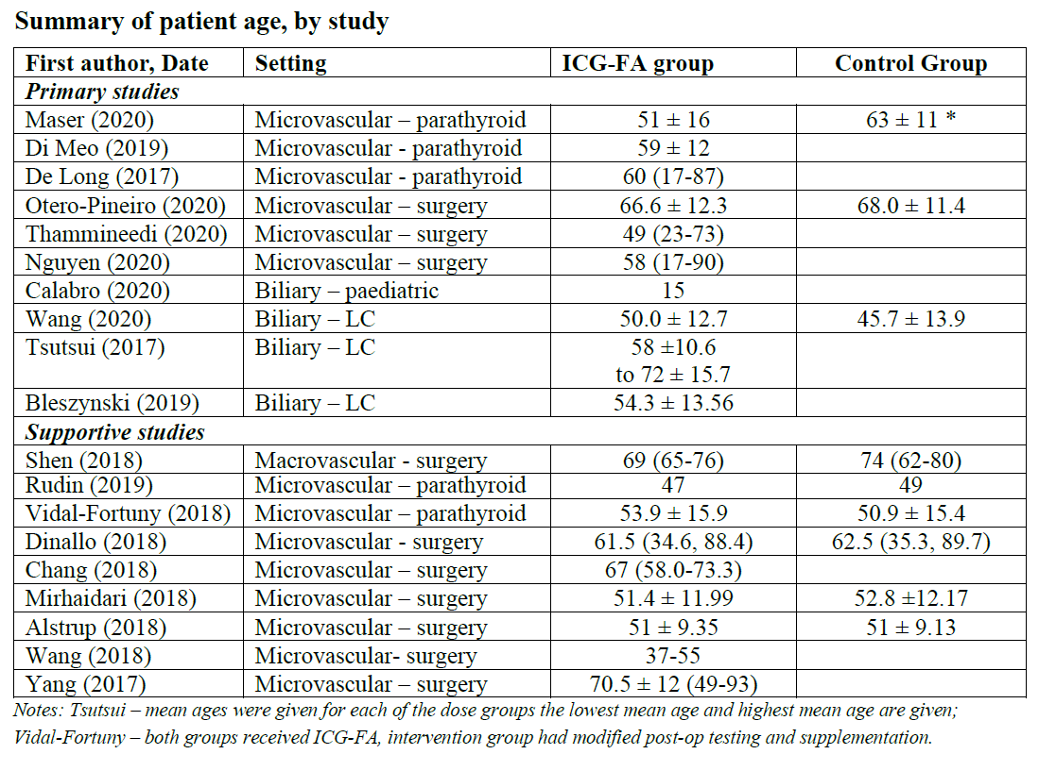

The doses used in these studies for the ‘angiography’ indication are outlined in Table 6.

Table 6. Summary of doses, by angiography study

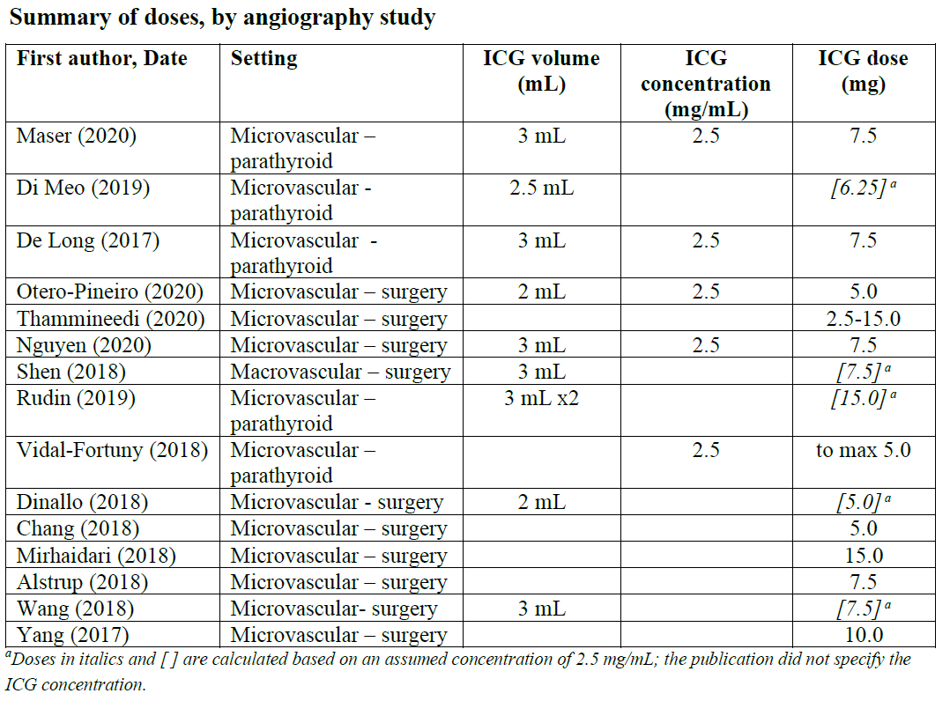

Table 7 shows the doses used in these studies for the ‘cholangiography’ indication.

Table 7. Summary of doses, by biliary study

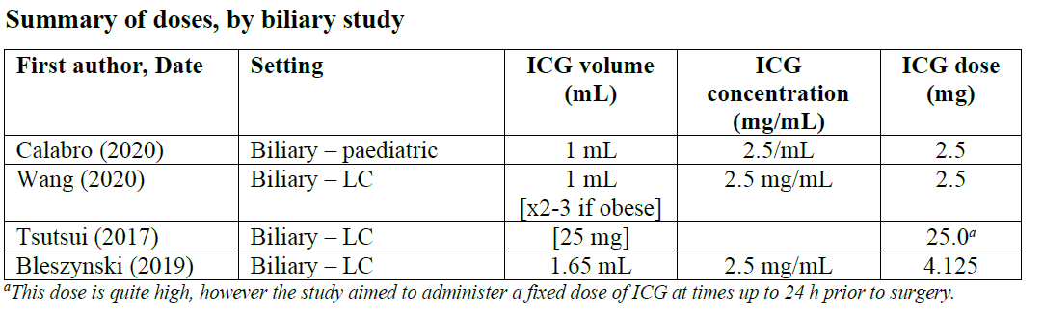

The findings in the studies were consistent with those reported in the three meta-analyses.

##### Lymph Node Mapping

The proposed interstitial use in this indication is based on one RCT (PP LNM 01 – also called FILM study) and one meta-analysis (LNM-UC01) (Table 8).

Table 8. Overview of studies conducted to evaluate the efficacy of Spy Agent Green in the identification of lymph nodes during lymphatic mapping in patients with uterine and cervical cancers

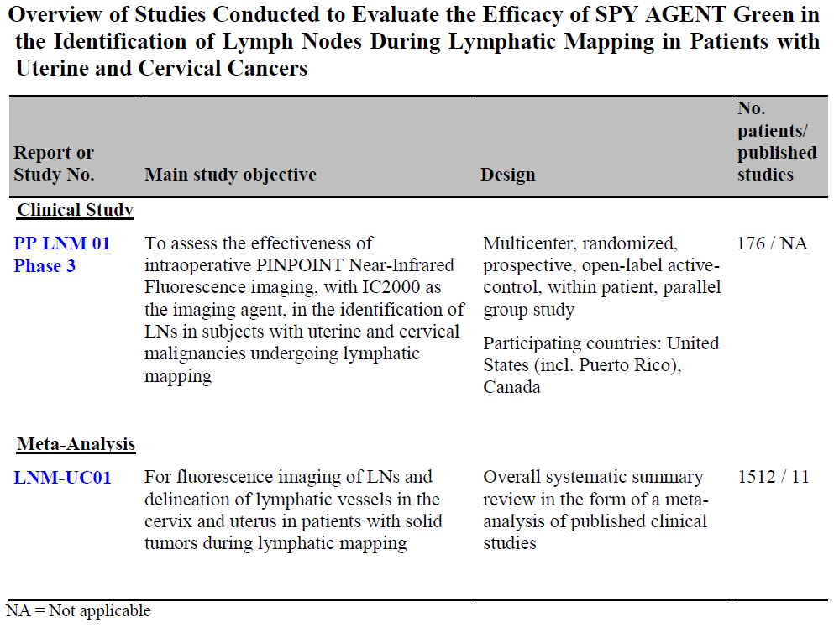

##### PP LNM 01 (film trial)

This was a multicentre (8 centres in North America), randomised, open-label, phase III study to assess effectiveness of ICG and PINPOINT near infrared fluorescence imaging in identification of lymph nodes in women with cervical and uterine malignancies undergoing lymphatic mapping following interstitial cervical injection of dye. The eligible patients were 18 years of age or older, diagnosed with clinical stage I cervical or uterine cancer, any histology, and were scheduled for curative surgery that included lymph node assessment. Other eligibility criteria included negative nodes and absence of metastatic disease by clinical evaluation and radiologic imaging.

The patients were randomised 1:1 to mapping with blue dye followed by mapping with ICG with PINPOINT platform (B-P arm) or mapping with ICG with PINPOINT followed by mapping with blue dye (P-B arm). The trial was a non-inferiority design with within-patient comparison. As this was a within-subject comparison study, the investigator could not be blinded to the use of Blue dye or PINPOINT device.

After general anaesthesia was achieved, blue dye was injected in the cervix deeply (1-3 cm) and superficially (1-3 mm) at 3:00 and deeply (1-3 cm) and superficially (1-3 mm) at 9:00, and ICG was injected in the cervix similarly deeply and superficially at 3:00 and deeply and superficially at 9:00 for a total of eight injections in each patient. The blue dye injection consisted of 1mL of a 10mg/mL blue dye (1% isosulfan blue), for a total dose of 40mg. The ICG injection consisted of 1mL of a 1.25mg/mL ICG solution for a total dose of 5mg. The surgeon identified lymph nodes and lymphatic vessels with white light for blue dye (“blue”) or near infrared imaging with the PINPOINT for ICG (“green”).

In both patient groups, mapping with the first dye was completed before mapping with the second dye was started, and mapping with both dyes was completed before any lymph nodes were excised. Bilateral lymphatic mapping was performed according to applicable published clinical guidelines. The resected tissues were evaluated by histopathology to confirm presence of lymph nodes.

The trial was conducted between 2015 and 2017. A total of 180 patients were randomised (90 in each arm) and 176 were evaluable. The two arms did not differ in terms of demographic factors, tumour factors, or number enrolled at each site. Majority patients (169/180, 96%) had uterine cancer. Most patients were aged 50-69 years (68%).

The results for resected and confirmed lymph nodes are shown in Table 9 (note IC2000 = ICG).

Table 9. Identification of resected confirmed LNs by IC2000 and IB in patients with uterine and cervical cancers – FILM study

The results by patient groups are shown in Table 10 (note IC2000 = ICG):

Table 10. Number of patients with uterine or cervical cancer with greater than 1 resected confirmed lymph node identified by of IC2000 and / or IB – FILM study

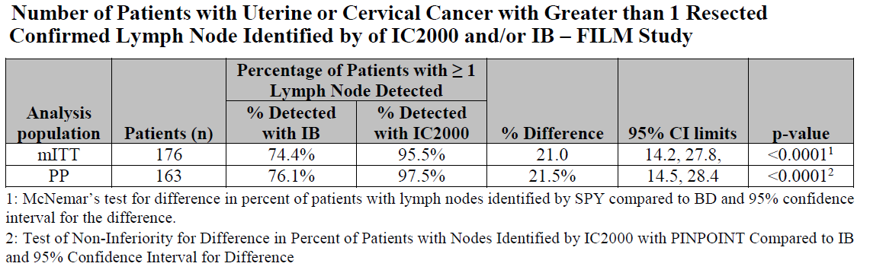

These results as reported in the published paper are shown in Table 11:[10]

Table 11. Results of PM LNM 01 (FILM) study

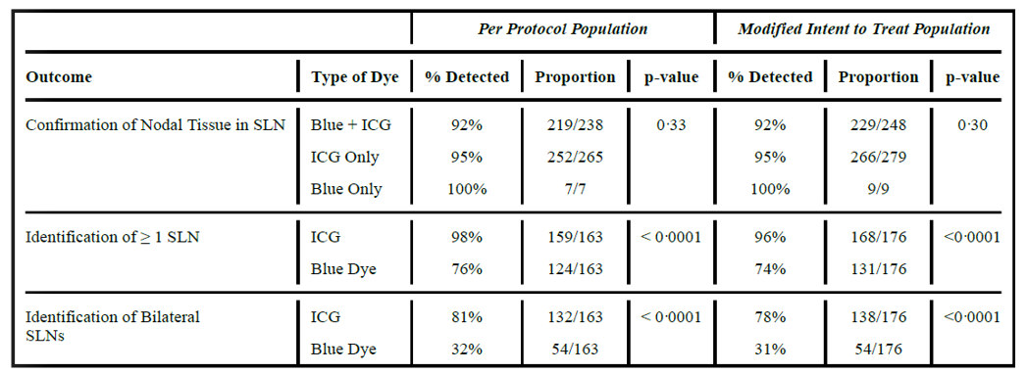

##### LNM-UC01

This meta-analysis identified a total of 11 publications relating to intra-cervical injection of ICG. The ICG dose and method same as in the FILM Study was reported in 2 of the 11 studies. Other ICG doses ranged from 1.0mg to 10.0mg. The vast majority of studies cited patients with uterine cancer with only 2 citing cervical cancer (Table 12).

Table 12. Main features of published studies (comparative studies are identified in bold)

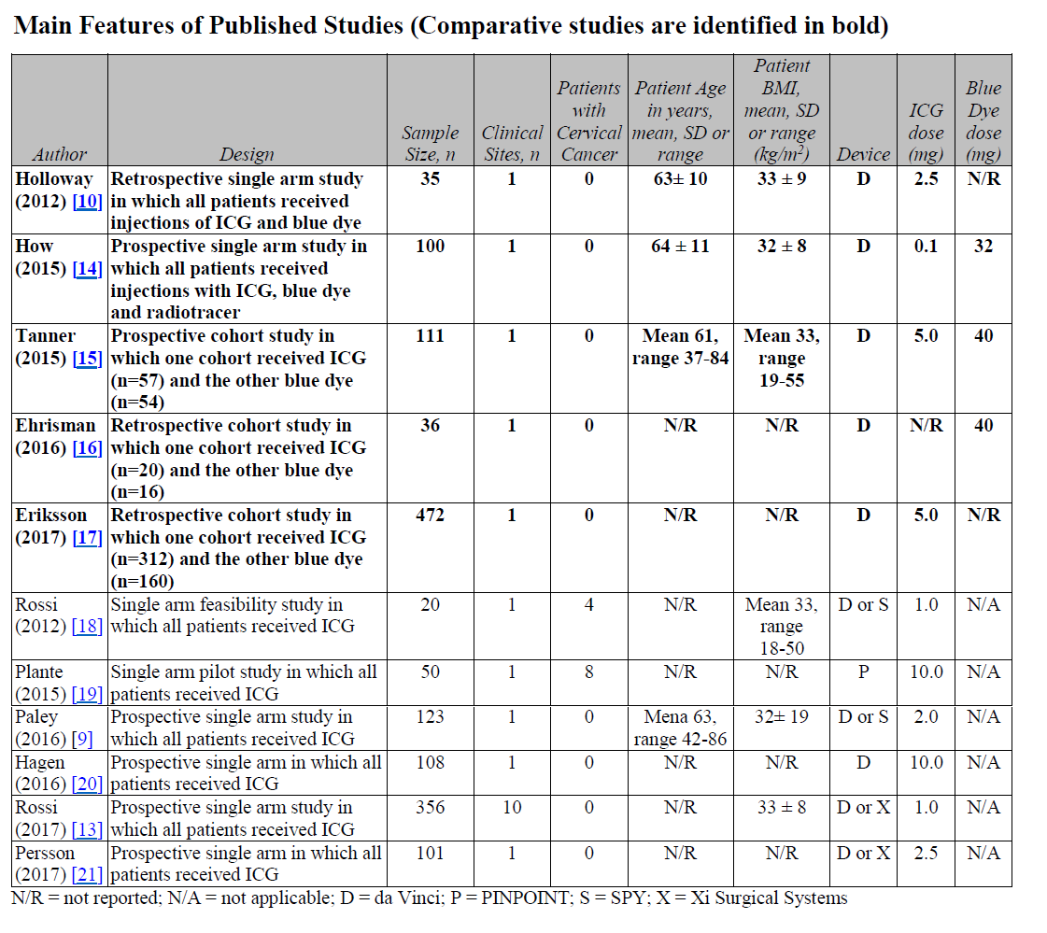

Five studies (2 were prospective) were comparative (vs blue dye or/and radiotracer) comprising a clinical experience in 754 patients. The individual results in comparative studies are shown in Table 13.

Table 13. Comparative study results: proportion of subjects with at least one lymph node (LN) detected bilaterally

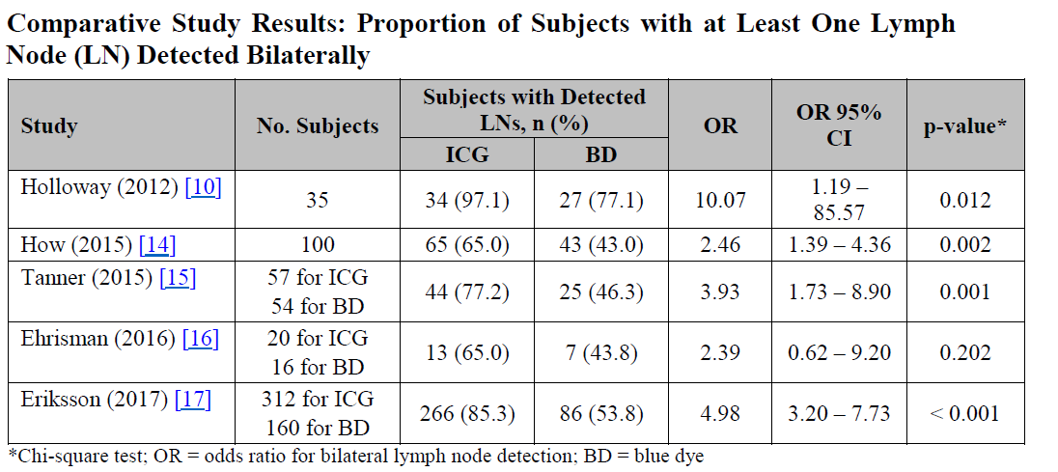

The results in for the non-comparative studies in LNM-UC01 are shown n Table 14.

Table 14. Non-comparative study results: proportion of subjects with at least one lymph node (LN) detected bilaterally

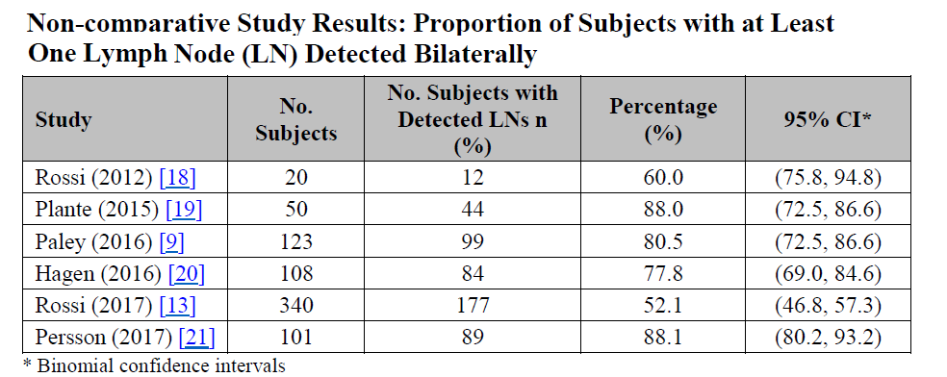

An updated literature search for the LNM indication resulted in identification of 5 more published studies (Table 15).

Table 15. Published studies in patients with uterine and cervical malignancies selected to support the meta-analyses

A summary of ICG doses by study in these 5 studies is presented in Table 16.

Table 16. Summary of doses, by study

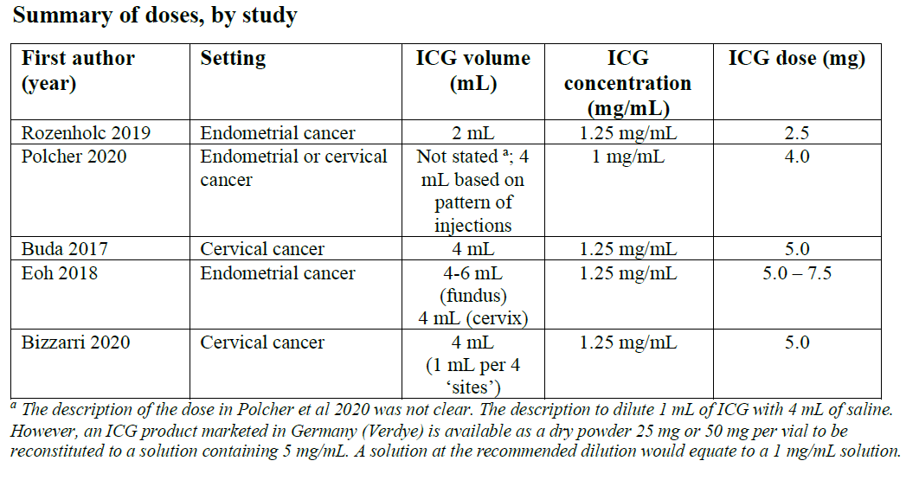

The results for at least 1 LN detected are shown in Table 17.

Table 17. Proportion of subjects with at least 1 LN detected

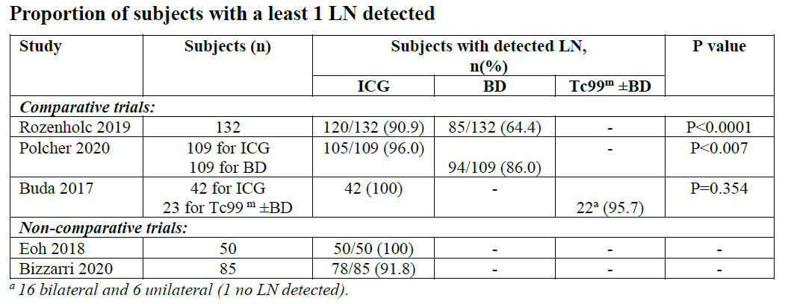

The results for bilateral LN detection are shown in Table 18.

Table 18. Proportion of subjects with bilateral LN mapping

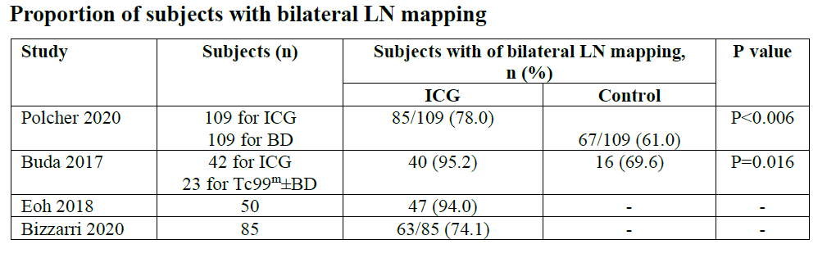

##### ICG imaging in paediatric patients (2017)

A literature search on the use of ICG in paediatric population (any indication and with or without use of any device) for published papers between January 1, 1959, and June 8, 2018, was conducted using the MEDLINE database. A total of 95 unique articles were identified that reported ICG use in the paediatric population based on the protocol-specified criteria.

Of these, 9 articles contained data relating to the use of ICG with NOVADAQ/STRYKER fluorescence imaging devices (NOVADAQ imaging articles; including the da Vinci). Thirty-eight (38) articles contained data relating to the use of ICG with other (NON-NOVADAQ) fluorescence imaging devices (NON-NOVADAQ imaging articles). An additional forty-eight (48) articles contained data examining non imaging uses of ICG such as measuring cardiac output, hepatic function and liver blood flow (non-imaging articles). There were a total of 1185 paediatric patients in 95 articles, including:

* 57 paediatric patients in 9 NOVADAQ imaging articles
* 133 paediatric patients in 38 NON-NOVADAQ imaging articles
* 995 paediatric patients in 48 non-imaging articles

The ICG doses ranged from 0.005mg to ~168mg in the 95 publications in 1185 paediatric patients. ICG was administered via intravenous route in 74 studies, intradermal in 4 studies, intra-arterial in 7 studies, subcutaneous in 3 studies and both intra-arterial and intravenous, inter-toe, intralesional in 1 study each. The injection route was not specified in 4 studies. Interstitial administration of ICG was not reported in any paper.

The intravenous ICG doses ranged from 0.2mg to 35mg except for one study in which ~168mg ICG intravenously (3 mg/kg) was given to a 15-year old male adolescent with asymptomatic primary sclerosing cholangitis (NON-NOVADAQ imaging article).

Table 19 shows ICG dosing stratified by age group (excluding the 168 mg dose):

Table 19. ICG dosing by age group (excluding the 168 mg dose)

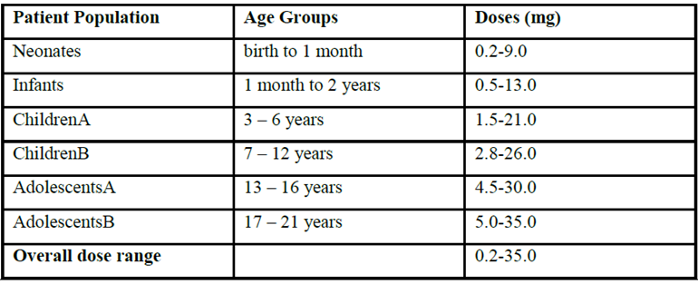

In NOVADAQ imaging studies, intravenous ICG doses ranged from 1.25mg to 10mg in 7 NOVADAQ imaging articles. Two studies did not report ICG doses. In 8 articles, ICG was administered intravenously. One article did not report the route of administration. ICG injection was repeated in three studies with one patient in each study. Two studies reported repeat ICG dosing as needed but it was not clearly stated if this was done.

Table 20 presents the intravenous ICG doses administered by age group in NOVADAQ imaging articles in angiographic indications:

Table 20. Intravenous ICG doses administered by age group in NOVIDAQ imaging articles in angiographic indications.

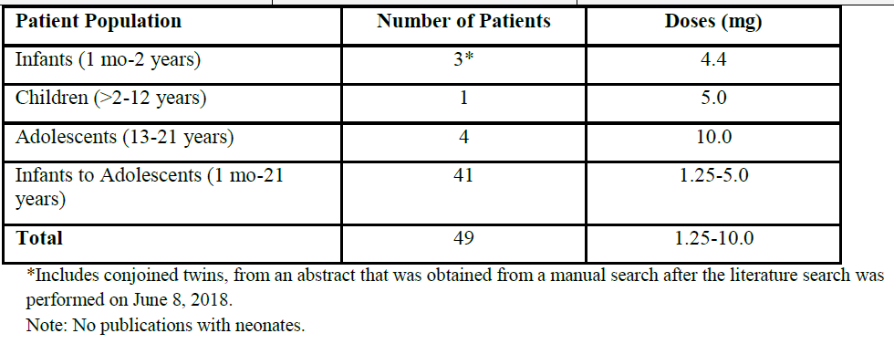

Table 21 presents intravenous ICG doses administered by age group in the studies with NOVADAQ imaging systems (including 2 with da Vinci) in anatomy delineation and tumour localisation indications:

Table 21. Intravenous ICG doses administered by age group in the studies with NOVADAQ imaging systems in anatomy delineation and tumour localisation indications.

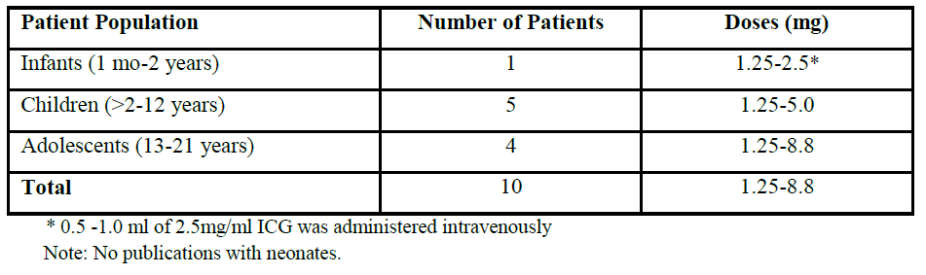

Of the 59 patients listed in the Tables above, 49 received intravenous ICG in angiographic indications of cardiovascular/vascular and plastic-micro and reconstructive applications. All studies with NOVADAQ devices were performed in the United States.

Efficacy data (57 patients) showed 100% success for visualisation in all publications except one study in which 60% visualisation success was reported (adequate images in 18 of 30 patients). The study reported procedural reasons for unsuccessful imaging including small incision with difficult exposure, overlying structures obscuring the view, nonuniform dye column, overdosing or underdosing of indocyanine green dye, bleeding with resultant extravasation of dye, and minimal penetrance through polytetrafluoroethylene.

In NON-NOVADAQ imaging articles, intravenous ICG dose ranges were different compared to the NOVADAQ imaging articles and ranged from 0.5mg to 30 mg. The upper range of doses used in NON-NOVADAQ imaging articles/devices was 3 times higher than the highest dose reported in NOVADAQ imaging articles/devices.

ICG was administered intravenously in 27 studies, subcutaneously in 3 studies, intradermal in 4 studies, intra-arterial, intralesional, and both intra-arterial and intravenous in 1 study each. One study did not report the route of administration. ICG injection was repeated in two studies with one patient in each study.

In non-imaging ICG published articles, intravenous ICG doses ranged from 0.2mg to 35mg. The upper range of doses used in non-imaging articles was more than 3 times higher than the highest dose reported in NOVADAQ imaging articles. In addition, repeated doses of intravenous ICG, as high as 5 mg/kg were administered to infants (n=89) in one study. ICG was administered intravenously in 39 studies, intra-arterial in 6 studies and both intra-arterial and intravenous in 1 study. Two studies did not report the route of administration.

Although the duration of treatment was not reported in all 95 articles, it is inferred from the methodology that most of the patients received a single dose of ICG. Repeat assessments with ICG were performed in 7 studies.

Analysis of doses administered to a number of paediatric subpopulations showed that the doses used in angiographic applications (1.25mg to 10.0mg with the majority of doses in the range from 1.25mg to 5.0mg) were similar to those used in adult patients in similar applications and were well below the maximum recommended dose of 2mg/kg body weight.

None of the studies identified anaphylaxis or any other adverse events related to ICG use in a total of 1185 paediatric patients.

**Updated paediatrics search (2022)**

An updated literature search examined the MEDLINE database for papers matching the search criteria and published between June 9, 2018, and July 23, 2020, to identify additional articles on the use of ICG in paediatric population during this time period. Following the protocol-specified criteria, 18 published unique articles were identified involving the use of ICG in the paediatric population.

Of these, 6 were NOVADAQ fluorescence imaging articles and 11 were with other (NON-NOVADAQ) fluorescence imaging devices and one article contained data examining non-fluorescence imaging use of ICG in patients with chronic liver disease to assess hepatic function (non-imaging article). There were a total of 328 paediatric patients in 18 articles, including:

* 72 paediatric patients in 6 NOVADAQ imaging articles
* 169 paediatric patients in 11 NON-NOVADAQ imaging articles
* 87 paediatric patients in 1 non-imaging article

ICG doses ranged from 0.03mg to ~89mg in the 18 publications in 328 paediatric patients. The ICG was administered via intravenous route in 11 studies, intracoronary in 1, sub-dermal in 1, and subcutaneous in 5 studies. The intravenous ICG doses ranged from 0.03mg to 28.60mg in except for one study in which ~89mg ICG intravenously (2.5 mg/kg) was administered in a 11-year old male with intracranial hypertension syndrome (NON-NOVADAQ imaging article).

Table 22 presents ICG doses administered by age group, excluding the 89 mg, from the 17 publications:

Table 22. Overall ICG doses per paediatric subgroups

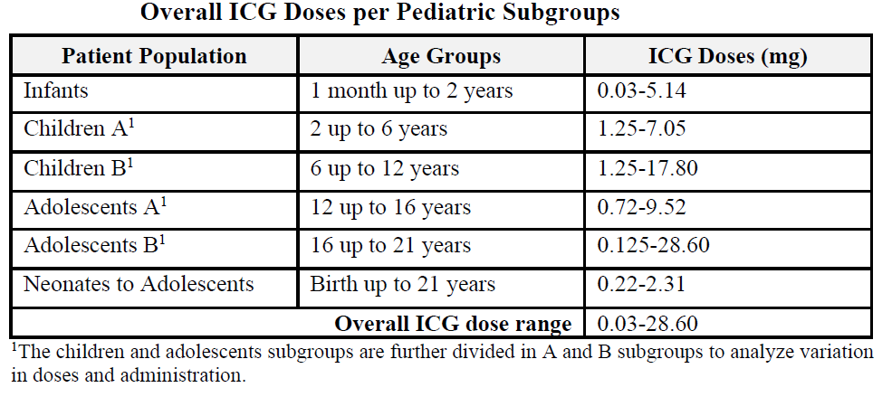

In NOVADAQ studies (6 articles) intravenous ICG doses ranged from 0.03mg to 28.60 mg. ICG was administered using intracoronary injection in 1 study, and subcutaneous in 1 study. ICG was injected immediately before the procedure in all studies except for one study with a non-approved indication where it was injected intravenously 72 hours before surgery.

In NON-NOVADAQ studies (11 articles), intravenous ICG dose ranges were generally higher compared with NOVADAQ studies and ranged from 0.22mg to 89mg. The upper range of doses used in NON-NOVADAQ studies was 3 times higher (mainly due to one study that used 2.5mg/kg dose) than the highest dose reported in articles with NOVADAQ studies. ICG was administered intravenously in 7 studies, subcutaneously in 3 studies, and subdermal in one study. ICG was injected 24 hours before laparotomy in one study with visualisation of hilar micro-bile ducts, and 19-138 hours before navigation surgery in two studies with liver resection and metastasectomy.

In non-imaging studies (1 article) intravenous ICG doses ranged from 0.83mg to 15.45mg where ICG was used to determine hepatic function. The highest dose used in the non-imaging study was two times less than the highest dose reported in articles using ICG with NOVADAQ studies.

Although the duration of treatment was not reported in all 18 publications, it is inferred from the methodology that majority of the patients received a single dose of ICG.

Table 23 below presents the intravenous and intracoronary ICG doses administered by age group in NOVADAQ (3 publications) and NON-NOVADAQ studies (1 publication) for visualisation of vessels, blood flow and tissue perfusion:

Table 23. Paediatric patients in visualisation of vessels, blood flow and tissue perfusion

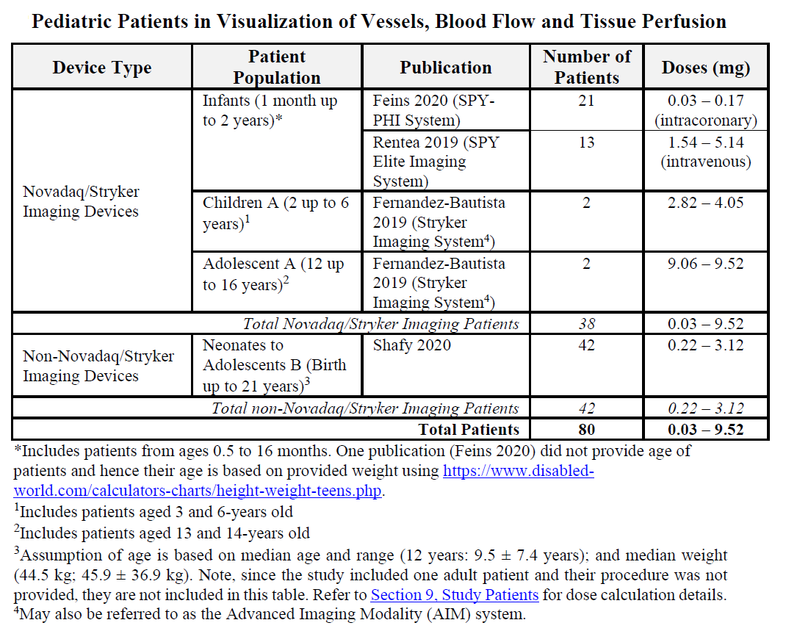

Table 24 presents intravenous ICG doses administered by age group in the studies with NOVADAQ studies (2 publications) and NON-NOVADAQ studies (4 publications) imaging systems in visualisation of extrahepatic biliary ducts:

Table 24. Paediatric patients in visualisation of extrahepatic biliary ducts

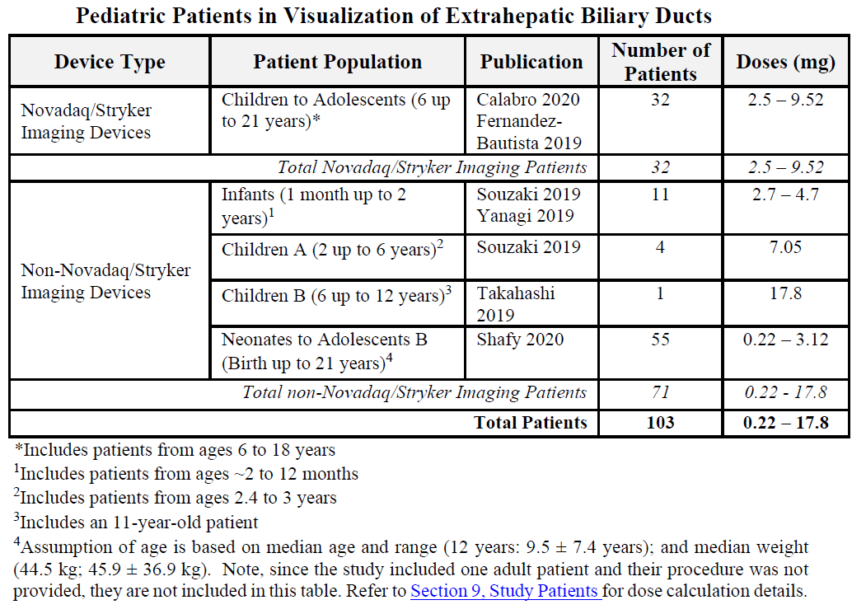

Table 25 presents the intravenous, subcutaneous and sub-dermal ICG doses administered by age group in the studies with NOVADAQ studies (2 publications) and NON-NOVADAQ studies (7 publications, excludes one study in which one patient received a very high dose of 89mg ICG) imaging systems using other applications such as lymphography, head and neck, and nephrectomy:

Table 25. Paediatric patients in other imaging indications

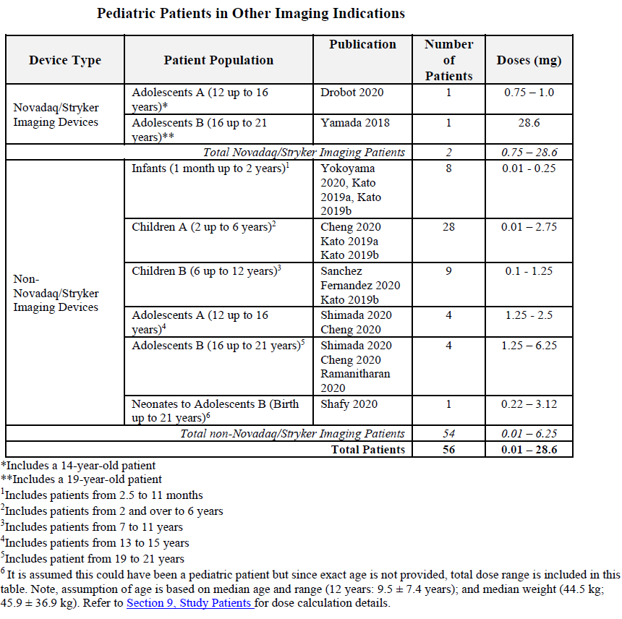

Of the 72 NOVADAQ imaging patients, 38 were administered with a 0.03 mg to 9.52 mg dose of ICG using intravenous (17 patients with 1.54 mg to 9.52 mg) and intracoronary (21 patients with 0.03 mg to 0.17 mg) injections, and 42 out of 169 NON-NOVADAQ imaging patients were administered a 0.22 mg to 3.12 mg dose intravenously for visualization of vessels, blood flow and tissue perfusion during various angiographic procedures.

Furthermore, 32 out of 72 NOVADAQ imaging patients were administered with 2.5mg to 9.52mg dose of ICG intravenously, and 55 out of 169 NON-NOVADAQ imaging patients were administered with 0.22mg to 17.8mg dose of ICG intravenously for visualisation of extrahepatic biliary ducts during various surgical procedures.

The lower range of the ICG doses in NOVADAQ imaging group is consistent with the 2.5mg dose approved in Spy Agent Green US Prescribing information for paediatric and adult patients. Almost all patients in the NOVADAQ imaging group received a dose of 2.5mg ICG. In the NON-NOVADAQ imaging group, one study reported a much lower dose (0.22mg), likely because it included neonates. The higher upper dose ranges such as 9.52mg (NOVADAQ imaging group) and 17.8mg (NON-NOVADAQ imaging group) are noted in literature due to use of older paediatric population (adolescents) and differences in time of ICG administration (72 hours before surgery).

Overall, data was collected from 328 paediatric patients who received at least one dose of ICG in this literature search, with 72 patients (21.9%) in the NOVADAQ imaging group (includes 1 non-systematic search publication), 169 patients (51.5%) in NON-NOVADAQ imaging group and 87 patients (26.5%) in the non-imaging group. Efficacy data was obtained from the NOVADAQ imaging group only (72 patients) and showed 100% success for visualisation in all publications.

Analysis of doses administered to a number of paediatric subpopulations, shows that the effective doses used in angiographic applications 0.03mg to 9.52mg (1.54mg to 9.52mg intravenously and 0.03mg to 0.17mg intracoronary) are similar to those recommended in the Spy Agent Green US Prescribing Information as well as those used in adult patients in similar applications and are well below the maximum recommended dose of 2mg/kg. It was noted that much lower doses were administered in infants and higher doses were administered in a few adolescents however, these doses are still consistent with the approved paediatric dosage and administration statements in the Spy Agent Green US Prescribing Information.

None of the studies identified anaphylaxis or any other adverse events related to ICG use in a total of 328 paediatric patients from 18 publications.

#### Safety

The total number of patients exposed to ICG in the 3 meta-analyses is shown in Table 26.

Table 26. Number of patients exposure in published studies

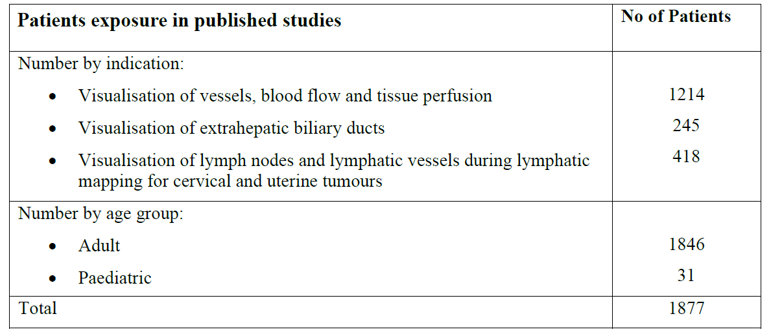

The exposure in majority of patients was a single dose in relation to a single procedure. There are some instances and surgical settings where administration require several injections (such as LNM; 4 injections of 1 mL), or when more than 1 dose may have been administered.

ICG has a well-established safety profile as demonstrated over many decades of diagnostic use for angiographic florescence imaging in a disparate range of clinical circumstances. Hypersensitivity reactions have been reported with use of ICG, however these are rare. However, anaphylactic deaths have been reported following ICG administration during cardiac catheterisation.

No deaths or serious adverse events related/attributed to ICG were reported in the published studies included in the dossier.

ICG contains sodium iodide and therefore, should be used with caution in subjects who have a history of allergy to iodides or iodinated imaging agents, although anaphylactic or urticarial reactions have been reported in subjects with and without history of allergy to iodides .

The safety data from the FILM Study and published literature on the use of ICG in fluorescence angiography involving interstitial administration of ICG into the cervix is also consistent with the safety/adverse effects profile observed in the other indications involving intravenous use.

Since the international approval of Spy Agent Green in 2018, Periodic Benefit-Risk Evaluation Reports (PBRER) over 2 reporting periods, 21 November 2018 to 20 November 2019 and 21 November 2019 to 20 November 2020 have become available with cumulative data as shown in Table 27.

Table 27. Overall distribution of Spy Agent Green vials (25 mg)

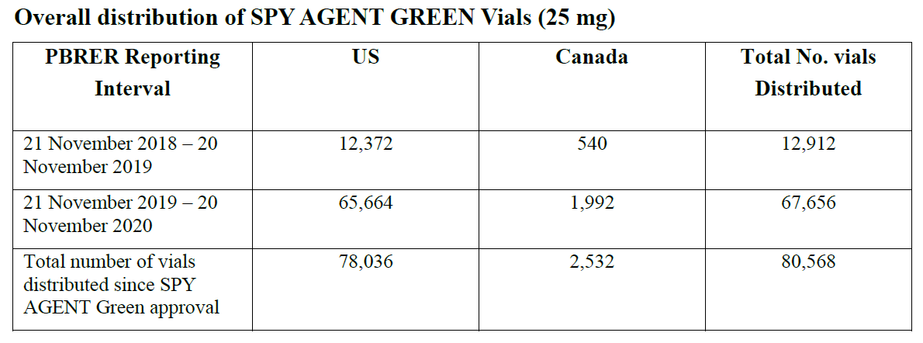

An overall safety evaluation, post marketing data and results from four separate meta-analysis and individual studies provide sufficient and broad characterisation of adverse events, adverse reactions or complications with intravenous or interstitial use of ICG.

### Risk management plan

The Sponsor is required to comply with product vigilance and risk minimisation requirements.

The TGA decided a risk management plan (RMP) was not required since the product is not scheduled and it is not a biosimilar (see [TGA’s guidance](https://www.tga.gov.au/resources/resource/guidance/risk-management-plans-medicines-and-biologicals/when-rmp-required) on ‘when an RMP is required’)

The TGA may request an updated RMP at any stage of a product's life-cycle, during both the pre-approval and post-approval phases. Further information regarding the TGA’s risk management approach can be found in [risk management plans for medicines and biologicals](https://www.tga.gov.au/publication/risk-management-plans-medicines-and-biologicals) and [the TGA's risk management approach](https://www.tga.gov.au/tgas-risk-management-approach). Information on the [Australia-specific annex](https://www.tga.gov.au/resources/resource/guidance/risk-management-plans-medicines-and-biologicals/australia-specific-annex-eu-rmp) ([ASA](https://www.tga.gov.au/resources/resource/guidance/risk-management-plans-medicines-and-biologicals/australia-specific-annex-eu-rmp)) can be found on the TGA website.

## Risk-benefit analysis

The literature searches were primarily directed towards establishing successful imaging/visualisation by the proprietary imaging system used with the ICG, but the overall weight of evidence is considered acceptable to allow approval of ICG as a diagnostic agent/medicine for the proposed uses.

There is sufficient exposure data in paediatric population based on published literature to support the proposed use, noting that the proposed use of ICG from one month of age and above, noting also that the use is expected to be in serious and significant clinical/surgical situations. Further clarification of the paediatric data is being sought from the Sponsor.

The overall risk benefit is considered favourable for the proposed indications, age groups and dosing recommendations.

## Outcome

Based on a review of quality, safety, and efficacy, the TGA decided to register Spy Agent Green (indocyanine green) for the following indications:

*For fluorescence imaging use only.*

*Spy Agent Green (indocyanine green) is an imaging agent (dye) intended for:*

1. Visualisation of vessels, blood flow and tissue perfusion in adults and paediatric patients from one month of age and above.
2. Visualisation of extrahepatic biliary ducts in adults and children from 12 years of age and above.
3. Visualisation of lymph nodes and lymphatic vessels in women with cervical or uterine solid tumours for which lymphatic mapping is a component of intraoperative management.

*Visualisation with Spy Agent Green requires an imaging system that has been validated for fluorescence imaging with indocyanine green.*

### Specific conditions of registration applying to these goods

Spy Agent Green is to be included in the [Black Triangle Scheme](https://www.tga.gov.au/how-we-regulate/monitoring-safety-and-shortages/report-adverse-event-or-incident/report-adverse-events-medicines-and-biologicals/black-triangle-scheme). The PI and CMI for Spy Agent Green must include the black triangle symbol and mandatory accompanying text for five years, or the product’s entire period of provisional registration, whichever is longer. The Black Triangle Scheme identifies new prescription medicines with a black triangle on the medicine information documents. The scheme also applies to [prescription medicines](https://www.tga.gov.au/products/medicines/prescription-medicines) being used in new ways, such as a medicine that is now being used for children. The black triangle is a visual reminder to encourage health practitioners and patients to [report a problem or side effect](https://www.tga.gov.au/safety/reporting-problems).

### Attachment 1. Product Information

The [Product Information](https://www.tga.gov.au/products/australian-register-therapeutic-goods-artg/product-information-one) ([PI](https://www.tga.gov.au/products/australian-register-therapeutic-goods-artg/product-information-one)) approved with the submission for Spy Agent Green which is described in this AusPAR can be found as Attachment 1. It may have been superseded. For the most recent PI and [Consumer Medicines Information](https://www.tga.gov.au/products/australian-register-therapeutic-goods-artg/consumer-medicines-information-cmi) (CMI), please refer to the TGA [PI/CMI search facility.](https://www.tga.gov.au/picmi-search-facility)

|  |
| --- |
| Therapeutic Goods Administration |
| PO Box 100 Woden ACT 2606 Australia  Email: [info@tga.gov.au](mailto:info@tga.gov.au) Phone: 1800 020 653 Fax: 02 6203 1605  [**https://www.tga.gov.au**](https://www.tga.gov.au) |
| Reference/Publication # |

1. This is the original indication proposed by the Sponsor when the TGA commenced the evaluation of this submission. It may differ to the final indication approved by the TGA and registered in the Australian Register of Therapeutic Goods.
2. Australian Government. Cancer Australia*.* Uterine cancer statistics. <https://www.canceraustralia.gov.au/cancer-types/uterine-cancer/statistics>
3. Ibid*.*
4. Abu-Rustum NR Sentinel lymph node mapping for endometrial cancer: a modern approach to surgical staging. J Natl Compr Canc Netw. 12, 288–97 (2014).
5. National Cancer Institute. Sentinel Lymph Node Biopsy. Available at: [https://www.cancer.gov/aboutcancer/diagnosis-staging/staging/sentinel-node-biopsy-fact-sheet.](https://www.cancer.gov/aboutcancer/diagnosis-staging/staging/sentinel-node-biopsy-fact-sheet.%20)  [Accessed 2021 Oct 24]
6. How J et al., Comparing indocyanine green, technetium, and blue dye for sentinel lymph node mapping in endometrial cancer. Gynecol. Oncol. (2015). doi:10.1016/j.ygyno.2015.04.004.
7. Kamisaka, K., Yatsuji, Y., Yamada, H. & Kameda, H. The binding of indocyanine green and other organic anions to serum proteins in liver diseases. Clin. Chim. Acta. 53, 255– 64 (1974).
8. Rossi, EC, Kowalski, LD. A comparison of sentinel lymph node biopsy to lymphadenectomy for endometrial cancer staging (FIRES trial): a multicentre, prospective, cohort study. Lancet Oncol. 2017 Mar;18(3):384-392. doi: 10.1016/S1470-2045(17)30068-2. Epub 2017 Feb 1.
9. The ‘Delegate’ is the Delegate of the Secretary of the Department of Health and Aged Care who made the final decision to either include the new medicine/indication on the ARTG or reject the submission, under section 25 of the Therapeutic Goods Act.
10. Lancet Oncol. 2018 October ; 19(10): 1394–1403. doi:10.1016/S1470-2045(18)30448-0.