|  |
| --- |
| Australian Public Assessment Report for Tukysa |
| Active ingredient: Tucatinib |
| Sponsor: Pfizer Australia Pty Ltd |
| July 2024 |

About the Therapeutic Goods Administration (TGA)

* The Therapeutic Goods Administration (TGA) is part of the Australian Government Department of Health and Aged Care and is responsible for regulating therapeutic goods, including medicines, medical devices, and biologicals.
* The TGA administers the *Therapeutic Goods Act 1989* (the Act), applying a risk management approach designed to ensure therapeutic goods supplied in Australia meet acceptable standards of quality, safety, and efficacy.
* The work of the TGA is based on applying scientific and clinical expertise to decision-making, to ensure that the benefits to the Australian public outweigh any risks associated with the use of therapeutic goods.
* The TGA relies on the public, healthcare professionals and industry to report problems with therapeutic goods. The TGA investigates reports received to determine any necessary regulatory action.
* To report a problem with a therapeutic good, please see the information on the [TGA website](https://www.tga.gov.au/).

About AusPARs

* The Australian Public Assessment Report (AusPAR) provides information about the evaluation of a prescription medicine and the considerations that led the TGA to approve or not approve a prescription medicine submission. Further information can be found in [Australian Public Assessment Report (AusPAR) guidance](https://www.tga.gov.au/australian-public-assessment-report-auspar-guidance).
* AusPARs are prepared and published by the TGA.
* AusPARs are static documents that provide information that relates to a submission at a particular point in time. The publication of an AusPAR is an important part of the transparency of the TGA’s decision-making process.
* A new AusPAR may be provided to reflect changes to indications or major variations to a prescription medicine subject to evaluation by the TGA.

Copyright

© Commonwealth of Australia 2024  
This work is copyright. You may reproduce the whole or part of this work in unaltered form for your own personal use or, if you are part of an organisation, for internal use within your organisation, but only if you or your organisation do not use the reproduction for any commercial purpose and retain this copyright notice and all disclaimer notices as part of that reproduction. Apart from rights to use as permitted by the *Copyright Act 1968* or allowed by this copyright notice, all other rights are reserved and you are not allowed to reproduce the whole or any part of this work in any way (electronic or otherwise) without first being given specific written permission from the Commonwealth to do so. Requests and inquiries concerning reproduction and rights are to be sent to the TGA Copyright Officer, Therapeutic Goods Administration, PO Box 100, Woden ACT 2606 or emailed to <[tga.copyright@tga.gov.au](mailto:tga.copyright@tga.gov.au)>.

Contents

Tukysa (tucatinib) – background and proposed indications 3

Registration decision 3

Colorectal cancer 3

Current treatment options 3

Clinical rationale 6

Evaluation overview 6

Quality Evaluation Summary 7

Nonclinical (Toxicology) Evaluation Summary 7

Clinical Evaluation Summary 7

Summary of clinical studies 7

Pharmacology 7

Efficacy 9

Safety 12

Risk Management Plan Evaluation 15

Risk-benefit analysis 17

Delegate’s considerations 17

Proposed action 20

Questions for the Sponsor 20

Advisory Committee on Medicines considerations 30

Risk/benefit assessment (post-Advisory Committee Meeting) 31

Registration decision 32

Tukysa (tucatinib) submission: administrative information 33

Submission details 33

Specific conditions of registration applying to these goods 35

Product Information 35

Regulatory status 36

Australian regulatory status 36

International regulatory status 36

Registration timeline 37

List of abbreviations 38

## Tukysa (tucatinib) – background and proposed indications

This AusPAR describes the submission by Pfizer Australia Pty Ltd (the Sponsor) to register Tukysa (tucatinib) for the following proposed extension of indications:[1]

Tukysa is indicated in combination with trastuzumab for the treatment of patients with HER2-positive colorectal cancer who have received at least one prior treatment regimen for unresectable or metastatic disease.

Tucatinib is an orally administered, reversible HER2-targeted small molecule tyrosine kinase inhibitor. Tucatinib is a potent inhibitor of HER2 *in vitro*, and in cellular signaling assays is >1000-fold more selective for HER2 compared to the closely related kinase epidermal growth factor receptor (EGFR).

### Registration decision

Based on a review of quality, safety, and efficacy data submitted by the Sponsor and summarised in this report, the TGA decided to **provisionally register** **Tukysa (tucatinib)** for the following extension of indications:

*Tukysa is indicated in combination with trastuzumab for the treatment of adult patients with RAS wild-type HER2 positive unresectable or metastatic colorectal cancer that has progressed following treatment with fluoropyrimidine, oxaliplatin, and irinotecan based chemotherapy. This indication was approved via the provisional approval pathway based on confirmed objective response rate (cORR) in a single arm trial. Continued approval of this indication depends on verification and description of benefit in confirmatory trials.*

### Colorectal cancer

Globally, colorectal cancer (CRC) is the third most common malignancy and the second leading cause of cancer death.

In Australia, AIHW data indicates around 18% of patients have metastatic disease at diagnosis, and the 5-year survival for metastatic disease is 13%. In addition to those presenting initially with metastatic disease, 20% to 25% of patients who do not have metastases at diagnosis will relapse and develop metastases after curative-intent treatment. Current treatment algorithms for patients with metastatic colorectal cancer (mCRC) are associated with survival times of approximately 2 to 3 years.

### Current treatment options

Current recommendations for standard of care treatment for patients with unresectable/mCRC follow a complex algorithm. First line options according to the National Comprehensive Cancer Network[2] and UpToDate[3] are:

* Pembrolizumab monotherapy for tumours that are microsatellite high (MSI-h) or mismatch repair deficient (dMMR)
* Chemotherapy:
  + Folfirinox/folfoxiri triplet regimen (5-fluorouracil [5-FU], used with leucovirin + oxaliplatin + irinotecan)
* Although it is more toxic than doublet therapy, FOLFIRINOX may be preferred for patients with a good PS who are able to tolerate it and who have biologically aggressive/poor-prognosis cancer (e.g., right-sided cancer, BRAF V600E mutation, large tumour volume, need for strong response to be eligible for metastasectomy).
  + Folofox doublet regimen (5-FU [with leucovirin] + oxaliplatin)
  + Folfiri doublet regimen (5-FU [with leucovirin] + irinotecan)
* This is preferred over an oxaliplatin-containing regimen for patients who received adjuvant oxaliplatin-based chemotherapy within the last 12 months or if there was any oxaliplatin-related neuropathy.
  + Capeoxor Xelox doublet regimen (oxaliplatin plus capecitabine)
  + Single-agent fluoropyrimidine may be considered (+/- bevacizumab) rather than supportive care alone, for patients unfit for intensive therapy; with poor performance status or extensive co-morbidities.
* An epidermal growth factor receptor (EGFR) inhibitor (cetuximab, panitumumab) can be added to FOLFOX or FOLFIRI.
  + EGFR inhibitors are contraindicated in patients with tumoral RAS mutations or BRAF V600E mutations.
  + Use of EGFR inhibitors is only appropriate if the primary tumour originated in the left side of the colon (splenic flexure to rectum)
  + Median overall survival (OS) with these regimens was 19 to 37 months
* Bevacizumab (which targets vascular endothelial growth factor [VEGF]) may be added to any of these chemotherapy regimens if not contraindicated, at a toxicity cost.
  + Contraindications might include major surgery within 28 days, active bleeding, untreated haemorrhagic brain metastases or an arterial thromboembolic event within the last 6 to 12 months.
  + Addition of an EGFR inhibitor is preferred over addition of bevacizumab, so bevacizumab is more likely to be added for patients with RAS or BRAF mutations.

Regarding subsequent therapy, UpToDate[4] states:

The approach to subsequent therapy is variable and might include maintenance chemotherapy (particularly for patients treated initially with an oxaliplatin-containing regimen) or a switch to a different regimen altogether because of disease progression or intolerance to the initial regimen.

For patients with mCRC, the model of distinct "lines" of chemotherapy (in which regimens containing non-cross-resistant drugs are each used in succession until disease progression) is being abandoned in favour of a "continuum of care" approach . This approach emphasizes an individualized treatment strategy that might include phases of maintenance chemotherapy interspersed with more aggressive treatment protocols, rechallenging patients who responded to first-line treatment with the same agents used first-line [3-6], treatment-free intervals, as well as reutilization of previously administered chemotherapy agents in combination with other active drugs.

An important principle is that exposure to all active drugs during the course of treatment for mCRC, as appropriate, is more important than the specific sequence of drug administration in order to maximize OS. The proportion of patients receiving all active agents correlates strongly with median survival in all large, published phase III trials over the last decade.

After completion of initial systemic therapy, options include the following. [5]

* Targeted therapies for tumours with particular molecular alterations:
  + Tumours that are RAS wild-type but harbour BRAF V600E mutations can receive encorafenib plus cetuximab (which is preferred by both UpToDate and NCCN over triplet therapy targeting BRAF, EGFR, and MEK for second-line treatment and beyond). This indication has full TGA registration for encorafenib.
  + Tumours with high mutational burden (TMB-h) that are not MSI-h/dMMR (so didn’t receive pembrolizumab first line) can receive pembrolizumab monotherapy after failure of acceptable standard-of-care options per an existing *provisional* TGA approval.
  + Tumours with neurotrophic tyrosine receptor kinase (NTRK) mutations can be treated with larotrectinib or entrectinib per existing *provisional* TGA approvals.
  + UpToDate and NCCN recommend anti-HER2- therapy as subsequent therapy for RAS and BRAF wildtype patients who have a HER2 amplification.
* Second-line backbone chemotherapy options for patients without targetable molecular alterations (or after progression on a targeted therapy):
  + After progression on FOLFOX: FOLFIRI or irinotecan monotherapy
  + After progression of FOLFIRI: FOLFOX
* If the tumour is RAS/BRAF wild-type, and anti-EGFR hasn’t yet been used, anti-EGFR can be considered as an add-on to backbone chemotherapy, or as monotherapy.
  + For patients in this category who progressed on first line FOLFIRINOX, irinotecan can be used as the chemotherapy backbone.
  + Use of an anti-EGFR agent for right sided tumours in the second-line setting is controversial.
  + There is limited data regarding rechallenge with anti-EGFR.
* Bevacizumab may be added and should be continued with the second-line chemotherapy backbone if it was used first line, unless not tolerated or being replaced by anti-EGFR.
* For patients with mCRC who have been previously treated with fluoropyrimidine-, oxaliplatin-, and irinotecan-based chemotherapy, an anti-vascular endothelial growth factor (VEGF) agent, anti-epidermal growth factor receptor (EGFR) therapy (if RAS wild-type), and molecularly targeted therapy, if appropriate, and if they desire and are eligible for additional cancer therapy, options are:
  + Regorafenib monotherapy
  + Trifluridine-tipiracil (+/- bevacizumab)
  + Raltitrexed monotherapy

As noted amongst the above, the guidelines incorporate a recommendation for anti-HER2 treatment after failure of first line therapy if HER2-amplification is identified. UpToDate summarises the findings of three phase 2 studies supporting this recommendation: the HERCALES study of trastuzumab plus lapatinib, MyPathway study (NCT02091141) of trastuzumab plus pertuzumab, and the DESTINY-CRC01 study of fam-trastuzumab deruxtecan.

#### HER2-positive colorectal cancer

As above, HER2 has recently emerged as a promising drug target in mCRC. Encoded by the ERBB2 gene, the HER2 tyrosine kinase is a well-established target in multiple solid tumours, and there are multiple anti-HER2 monoclonal antibodies, antibody-drug conjugates, and small-molecule drugs approved for patients with HER2+ breast and gastric cancers. ERBB2 amplification or HER2 overexpression are common in breast and gastric cancer, but only occur in 3% to 5% of CRC.

Testing for HER2 ‘positivity’ follows a different scoring algorithm in gastric versus breast cancer. Scoring in CRC is aligned to that of gastric. Whilst the scoring algorithm differs, the phenotypic relevance of a ‘positive’ result is the same, and there is no indication that the resultant biochemical pathways leading to tumour growth signalling should be significantly different between tumour histologies.

Whilst it does not have its own International Classification of Diseases (ICD) diagnostic code, HER2-positivity is associated with some clinicopathological features in CRC: predominantly left colonic origin, known to be associated with different genomics to right-sided tumours, predominantly KRAS/NRAS/BRAF (RAS) wild-type (WT) status, and a lack of response to anti-EGFR treatments. The prognosis for HER2-positive mCRC does not appear to differ from other mCRC.

The strong biological plausibility for HER2 involvement in the pathogenesis of cancer supports the investigation of drugs that target HER2 for colorectal cancers that express HER2.

Sponsor’s justification for dual inhibition approach (from orphan application document):

HER2-targeted therapies have been evaluated as monotherapy and in combination (dual HER2 inhibition) in HER2+ CRC and other cancers in preclinical models and clinical studies.

Based on compelling preclinical results, most clinical data in HER2+ mCRC have been generated utilizing a dual HER2 inhibition strategy. This approach is consistent with historical data from patients with other cancers that strongly suggest that dual HER2 inhibition is more effective compared with anti- HER2 monotherapy. No objective responses were noted in 9 subjects with HER2+ unresectable/recurrent advanced CRC identified by the National Cancer Center OncoPanel gene test who were treated with single-agent trastuzumab in the prospective basket/umbrella BELIEVE trial in Japan. Doublet therapy with HER2-directed agents, including trastuzumab administered in combination with either pertuzumab or lapatinib, has been studied more extensively, and small single-arm clinical studies have yielded encouraging results demonstrating the potential of dual HER2 inhibition in HER2+ CRC. Although single-agent HER2 inhibition was never recommended, the response rates seen in the HERACLES and MyPathway trials have led to a recommendation for dual HER2 inhibition in NCCN guidelines, which now recommend (Category 2A) dual HER2 inhibition for treatment of HER2 amplified, RAS WT, mCRC for 2L treatment or as initial therapy for patients who are not candidates for intensive therapy.

### Clinical rationale

Tucatinib is an orally administered, reversible, HER2-targeted, small molecule tyrosine kinase inhibitor (TKI). *In vitro*, tucatinib inhibits phosphorylation of HER2 and HER3, resulting in inhibition of downstream MAPK and AKT signalling and cell proliferation, and showed anti-tumour activity in HER2-expressing tumour cells. *In vivo*, tucatinib inhibited the growth of HER2-expressing tumours.

## Evaluation overview

Relevant guidelines or guidance documents referred to by the Delegate are listed below:

* European Medicines Agency (EMA/816292 2011 Rev 1*, 19 April 2013): Guideline on good pharmacovigilance practices (GVP) – Module VII – Periodic safety update report (Rev 1)
* National Comprehensive Cancer Network (2022): NCCN Guidelines Colon Cancer

This evaluation was facilitated through [Project Orbis](https://www.tga.gov.au/project-orbis), an initiative of the United States Food and Drug Administration (FDA) Oncology Center of Excellence. Under this project, the FDA and the TGA collaboratively reviewed the submission. This evaluation process provided a framework for process alignment and management of evaluation issues in real-time across jurisdictions. Each regulator made independent decisions regarding approval (market authorisation) of the new medicine.

### Quality evaluation summary

Quality evaluation is not required for this submission as there are no proposed changes to the quality aspects of the currently approved and supplied drug product (manufacturing processes, physicochemical properties, purity, stability, drug specifications, container closure system and stability). A full quality evaluation was conducted at the time this product received initial registration.[6]

### Nonclinical (toxicology) evaluation summary

No new nonclinical data or further nonclinical evaluation were required for this submission. The TGA considers that previously submitted and evaluated data satisfactorily address nonclinical aspects of safety/efficacy relating to this submission.[7]

### Clinical evaluation summary

#### Summary of clinical studies

The dossier contained the following clinical studies:

* MOUNTAINEER (SGNTUC-017) – This is the pivotal study supporting the mCRC indication.
* HER2CLIMB (ONT-380-206) – This was the pivotal study supporting the original breast cancer indication. The Sponsor states that this study provides supportive safety data for the mCRC indication. However, the use of tucatinib in this study was in combination with trastuzumab and capecitabine, which is different to the proposed combination for the mCRC indication. Thus, it is of limited value in the current application.
* ONT-380-005 – A safety/PK study of tucatinib in combination with trastuzumab alone, capecitabine alone, and in combination in breast cancer patients.
* Updated population pharmacokinetic (popPK) analysis including data from the MOUNTAINEER trial, and 4 previously submitted healthy volunteer studies (ARRAY-380-103, ONT-380-012, SGNTUC-015 and SGNTUC-020)

#### Pharmacology

For the mCRC indication, the proposed dose of tucatinib is 300mg orally twice a day (PO bd) with or without food. The proposed dose of trastuzumab is a loading dose of 8mg/kg IV; followed by 6mg/kg IV q3weekly. These doses are the same as for the breast cancer indications for both drugs.

##### Pharmacokinetics (PK)

The pharmacological parameters of tucatinib were established during initial registration of the breast cancer indication, and are documented in the currently approved PI:

**Absorption**

Following a single oral dose of 300 mg tucatinib, the median time to peak plasma concentration was approximately 2 hours (range 1 to 4 hours).

Following administration of a single dose of tucatinib in 11 subjects after a high-fat meal (approximately 58% fat, 26% carbohydrate, and 16% protein), the mean AUCinf increased by 1.5-fold, the Tmax shifted from 1.5 hours to 4 hours, and Cmax was unaltered. The effect of food on the PK of tucatinib was not clinically meaningful.

**Distribution**

The geometric mean (CV%) volume of distribution of tucatinib was 1670 L (66%). The plasma protein binding was 97.1% at clinically relevant concentrations.

**Metabolism**

Tucatinib is metabolised primarily by CYP2C8 and to a lesser extent via CYP3A.

**Excretion**

Following a single oral dose of 300 mg [14C]-tucatinib, 86% of the total radiolabelled dose was recovered in faeces (16% of the administered dose as unchanged tucatinib) and 4% in urine with an overall total recovery of 90% within 13 days post-dose. In plasma, 76% of the plasma radioactivity was unchanged, 19% was attributed to identified metabolites, and 5% was unassigned.

##### Population pharmacokinetics

The Sponsor provided an updated popPK analysis using data from 4 previously submitted healthy volunteer studies and the MOUNTAINEER trial.

The covariates of disease status, race, age, and albumin did not have a clinically meaningful effect on tucatinib exposure. There was no effect of mild renal or hepatic impairment on tucatinib PK. No other covariates, including combination with trastuzumab were identified as impacting tucatinib PK.

A PK analysis assessing cerebrospinal fluid (CSF) showed that tucatinib and its primary metabolite, ONT-993, are detectable in CSF within 2 hours after the first tucatinib dose and that total CSF concentrations are comparable to steady-state unbound plasma concentrations.

##### Pharmacodynamics

Exploratory exposure-response analysis of data from the MOUNTAINEER study was conducted. There was no apparent association between objective response rate (ORR) and increasing tucatinib trough concentrations, and no association between treatment emergent adverse events (TEAEs) of interest and tucatinib trough concentrations. These results must be interpreted cautiously due to the low number of patients in MOUNTAINEER.

#### Efficacy

##### MOUNTAINEER Study

The pivotal study supporting this extension of indication is the MOUNTAINEER (SGNTUC-017) study. MOUNTAINEER is a multi-centre, open-label, phase II trial in patients with RAS wild-type, HER2 positive unresectable or metastatic colorectal cancer with disease progression following fluoropyrimidine, oxaliplatin, and irinotecan based therapy. The trial began as a single arm study of tucatinib and trastuzumab (cohort A), but a later amendment allowed patients to be randomised to tucatinib in combination with trastuzumab (cohort B) or tucatinib alone (cohort C). Cohorts A and B provide the data supporting the proposed indication.

117 subjects were enrolled across 56 study sites. From 2017-2019, 45 patients were enrolled to Cohort A to be treated with tucatinib and trastuzumab. In November 2019, the protocol was amended to include randomisation of an additional 40 subjects to be treated with tucatinib and trastuzumab (cohort B), and 30 subjects to be treated with tucatinib monotherapy (cohort C). Subjects enrolled after the protocol amendment were randomised 4:3 to cohort B or C. The study design is outlined in Figure 1.

Figure 1: MOUNTAINEER Study Design

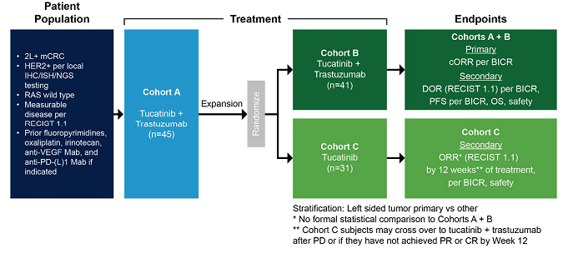

Subjects in cohorts A and B continued study treatment until radiologic or clinical progression, unacceptable toxicity, withdrawal of consent or study closure. Subjects were allowed to continue study treatment past radiologic progression if there were signs of clinical benefit, and this was determined by the subject, treating clinician and medical monitor to be in the patient’s best interests.

Subjects in cohort C were allowed to cross over to receive combination treatment after radiologic progression or if they did not achieve partial remission (PR) or complete remission (CR) by the week 12 assessment.

Data from cohorts A and B were pooled for efficacy and safety analyses, as subject demographics and baseline characteristics were comparable, the only difference being enrolment before (cohort A) or after (cohort B) the protocol amendment.

###### Population

Patients with HER2 positive, RAS wild type unresectable or metastatic CRC who had received prior treatment with fluoropyrimidine-, oxaliplatin-, and irinotecan-based therapy and an anti-VEGF monoclonal antibody were eligible for the study. Patients with MSI-H tumours also received prior anti-PD1 monoclonal antibody, if indicated. Prior use of anti-EGFR antibodies was not required. Patients were also required to have radiographically measurable disease assessable by RECIST 1.1, ECOG performance status of 0-2, and a life expectancy of > 3 months.

Exclusion criteria included previous anti-HER2 therapy, clinically significant cardiopulmonary disease, or ≥ Grade 2 QTc prolongation at screening ECG.

HER2 positive was defined as IHC 3+, IHC2+ with positive ISH test, or ERBB2 amplification on a next generation sequencing assay. RAS status was determined as standard of care prior to study entry based on expanded RAS testing including KRAS exons 2, 3, 4 and NRAS exons 2, 3, 4.

The trial was conducted in the US, Italy, Belgium, Spain and France.

###### Intervention

Patients received tucatinib 300mg bd either alone (cohort C), or in combination with trastuzumab 8mg/kg loading dose then 6mg/kg on day 1 of each subsequent 2-week cycle (cohorts A and B), until disease progression or unacceptable toxicity.

###### Control

There was no control group for this phase II study, which is acceptable for this provisional application.

###### Outcome

The primary endpoint was confirmed ORR by blinded independent central review (BICR) in Cohorts A + B. Confirmation of response was required ≥ 4 weeks from the first documentation of response.

Secondary endpoints included duration of response (DOR) per BICR, and ORR by 12 weeks of treatment per BICR in cohorts A+B, and C. Progression free survival (PFS) by BICR and overall survival (OS) in Cohorts A+B were also listed as secondary efficacy endpoints, however, due to the lack of a comparator arm, these time-to-event endpoints are of limited use.

###### Results

**Subject disposition**

140 patients were screened at 56 study sites. 45 subjects were enrolled in Cohort A; one of these subjects withdrew after receiving trastuzumab and before receiving tucatinib (included in efficacy analysis). 41 subjects were randomised to Cohort B, all of whom received tucatinib and trastuzumab. 2 subjects in Cohort B were found to have been enrolled despite not having HER2+ tumours and were excluded from the efficacy analysis. The 45 subjects from cohort A and 39 from cohort B constituted the efficacy analysis set.

31 subjects were randomised to cohort C, of which, 30 received at least one dose of tucatinib, and 28 crossed over at 12 weeks to receive combination treatment.

3 subjects in cohorts A+B (3.5%) discontinued study treatment due to adverse events (AEs), and I subject (3.2%) in cohort C discontinued due to AEs. Progressive disease (PD) was the most common reason for treatment discontinuation in cohorts A+B (n=59, 68.6%), and cohort C (n=18, 58.1%). Death was the most common reason for study discontinuation in cohorts A+B (n=39, 45.3%) and C (n=8, 25.8%). There were no deaths due to AEs.

At the data cut off (DCO) of 28 March 2022, 19 subjects (22.1%) in cohorts A+B, and 11 subjects in Cohort C (35.5%) were still receiving combination treatment. Median duration of follow-up was 16.3 months.

**Patient demographics and baseline characteristics**

The median age of patients was 55.0 years in Cohorts A+B and 59.5 years in cohort C. 60.7% of cohorts A+B and 50% of cohort C were male. The majority of patients (n=69, 82%) were enrolled at US sites, with an additional 15 patients (17%) enrolled in Europe. 77.4% of patients in cohorts A+B, and 76.7% in cohort C were Caucasian. The study population consisted of a lower proportion of racial and ethnic minorities compared to the US population with mCRC. The Sponsor has submitted a diversity plan to enrol a more representative selection of patients in the confirmatory trial. This will be important in determining the generalisability of the confirmatory trial to the Australian population.

The majority of patients enrolled in MOUNTAINEER had left-sided colorectal cancers (84.5% in cohorts A+B and 90.0% in cohort C), most likely because patients were required to have RAS wild-type tumours to be eligible for enrolment. Stage IV disease at initial diagnosis was most common (59.5% in cohorts A+B and 63.3% in cohort C). 56 (65%) patients in cohorts A+B had liver metastasis, as did 15 (50%) in cohort C. 22(26%) in cohort A+B and 6 (20%) in cohort C had undergone a liver directed procedure prior to study enrolment.

The median number of prior lines of systemic therapy was 3 (range 1-6) in cohorts A+B, and 2 (range 1-5) in cohort C. 99% of patients in all cohorts had received fluoropyrimidine-, oxaliplatin-, and irinotecan- prior therapy. 52.4% of cohorts A+B and 56.7% of cohort C had received prior EGFR-directed therapy, and 85.7% of cohorts A+B and 86.7% of cohort C had received prior anti-VEGF therapy.

**Results for the primary endpoint (ORR) and secondary endpoints**

At the DCO 28 March 2022, ORR by BICR was 38.1% (95% CI: 27.7-49.3) in the 84 patients in Cohorts A + B who received tucatinib and trastuzumab. Of these, 3 patients had a CR (3.6%) and 29 had PR (34.5%). For cohort A, ORR was 42.2% (95% CI: 27.7-57.8) and for cohort B, ORR was 33.3% (95% CI: 19.1-50.2). ORR was consistent across pre-specified subgroups of age <65 vs ≥65, ECOG performance status at baseline (0 vs 1-2), primary site of disease, and geographic region. A sensitivity analysis of ORR per investigator showed comparable results to the BICR results. There was a 90% concordance rate between BICR and investigator assessment.

Median time to response in cohorts A+B was 2.1 months (range 1.2-9.8 months). Median duration of response (DOR) was 12.4 months (95% CI: 8.5-20.5). 81% of the responders had a response lasting at least 6 months, and 34% had a response lasting at least 12 months.

Median DOR per BICR in Cohort A+B was 12.4 months (95% CI 8.5-20.5). Median DOR per investigator assessment was 15.4 months (95% CI 7.7-40.3).

ORR by BICR at 12 weeks was 28.6% (95% CI 19.2-39.5) in cohorts A+B. In cohort C, the ORR by BICR at 12 weeks was 3.3% (95% CI 0.1-17.2), which included a best overall response of PR for 1 subject (3.3%) and SD for 23 subjects (76.7%). 13 subjects (46.4%) achieved tumour reduction per BICR by 12 weeks.

28 subjects in cohort C crossed over at 12 weeks to receive combination treatment. ORR per BICR for these subjects was 17.9% (95% CI 6.1-36.9). Median DOR was not reached.

Any comparison between cohorts must be interpreted cautiously, as not all subjects were randomised due to the protocol change, and the majority of cohort C subjects crossed over by week 12.

#### Safety

##### Overview of safety data

The key safety data in support of the tucatinib + trastuzumab combination in the mCRC indication comes from the MOUNTAINEER trial. This includes 114 subjects who received at least one dose of study treatment.

Safety data are presented in the following analysis sets:

* Tucatinib + Trastuzumab Cohort (A+B): all MOUNTAINEER cohort A + B subjects who received at least one dose of either drug (n=86)
* Tucatinib Monotherapy Cohort (C): all subjects in MOUNTAINEER Cohort C who received any amount of tucatinib from randomisation to the day before cross-over (n=30)
* Pool 1 (Tucatinib + Trastuzumab): all subjects in MOUNTAINEER Cohort A + B, and Cohort C patients who received at least one dose of either drug on or after the date of cross-over (n=114)
* Pool 2 (Tucatinib + Trastuzumab + Capecitabine): All subjects who received this combination in the trials supporting the mBC indication (n=431)

The primary safety analysis was performed on Cohorts A and B of the MOUNTAINEER trial.

The median duration of exposure was 6.9 months, and median relative dose intensity was 97%.

##### TEAEs

The majority of subjects experienced at least 1 TEAE (95.3% in cohort A+B and 92.1% in pool 1). TEAEs occurring in ≥ 10% of subjects in pool 1 are shown in the Table 1:

Table 1: TEAEs by PT in ≥ 10% of subjects in Pool 1, tucatinib integrated safety analysis set

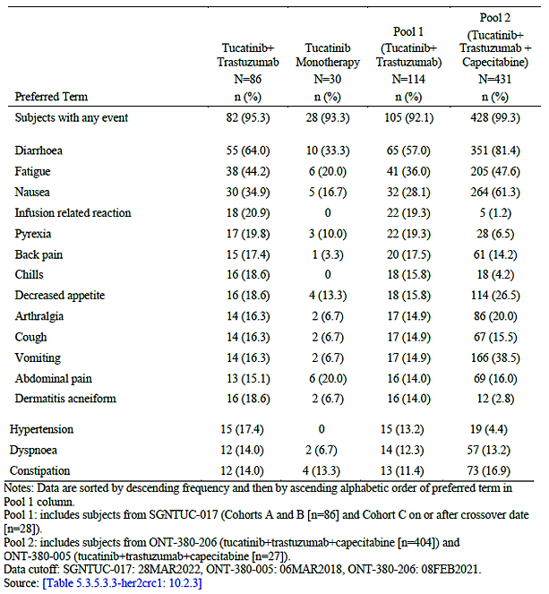

##### Deaths

There were no TEAEs leading to death in Pool 1. One patient in Cohort B died in the safety analysis period, after discontinuing study treatment for progressive disease and beginning another treatment; the cause of death was unknown.

##### Serious adverse events (SAEs)

SAEs were higher in the tucatinib + trastuzumab cohort (19 subjects, 22.1%) compared to the tucatinib monotherapy cohort (3 subjects, 10%), as would be expected with a combination treatment. 2 subjects in Pool 1 (7%) also reported SAEs. In cohorts A+B, the most common SAEs were large intestinal obstruction, small intestinal obstruction and urinary tract infection (UTI) (3 subjects each, 3.5%). Tucatinib related SAEs included acute kidney injury (AKI), colitis, and fatigue in 1 subject each (1.2%).

In cohort C, there were 5 SAEs in 3 subjects (10%) including UTI, flank pain, duodenal obstruction, overdose (misunderstanding of instructions by subject, no associated AEs), and pyelonephritis. Grade 4 events in cohorts A+B were rectal perforation, pneumonia attributed to covid, and cholangitis.

##### Discontinuations due to AEs

56 subjects (65.1%) in cohorts A+B and 18 (60.0%) in cohort C discontinued study treatment due to progressive disease. 5 subjects (5.8% in cohorts A+B and 7 (6.1%) in Pool 1) discontinued tucatinib treatment due to TEAEs (4 cases of increased liver function tests (LFTs), one each of COVID-19 pneumonia, cholangitis, and fatigue). 2 additional subjects in cohorts A+B discontinued treatment due to treatment related TEAEs (alanine aminotransferase (ALT) increased and fatigue), and 2 subjects in Pool 1 discontinued tucatinib due to treatment related TEAEs of raised LFTs. Discontinuations were comparable in cohorts A+B compared to the crossover cohort, suggesting that the combination was similarly tolerated compared to monotherapy.

##### Dose interruption/reduction due to AEs

The median dose intensity was 97%, suggesting that most patients were able to achieve adequate exposure, with toxicities largely manageable by dose interruption or reduction.

20 subjects (23.3%) in cohorts A+B had 28 tucatinib dose hold events due to TEAEs. In 71.4% of these events, dosing resumed at the same dose. The median length of dose interruptions was 18 days (range 2-58).

3 subjects (10%) in the tucatinib monotherapy cohort had a dose hold due to TEAEs. 2 of the 3 subjects (66.6%) did not receive further tucatinib dosing; the other subject resumed at the same dose.

Diarrhoea and raised LFTs were the most common reasons for tucatinib dose modifications. These are known AEs, and appropriate dose modifications for diarrhoea and hepatotoxicity are included in the PI.

##### AEs of special interest

##### Hepatotoxicity

9 subjects (10.5% in cohorts A+B had hepatotoxicity related AEs including aspartate aminotransferase (AST) increased, ALT increased. Two subjects 92.3%) had grade 4 hepatotoxicity events. There were 4 subjects (13.3%) in the tucatinib monotherapy cohort C who experienced a hepatotoxicity related AE. Two subjects (6.7%) had grade 3 hepatotoxicity events. There were no events higher than grade 3 in cohort C. 5 subjects in the MOUNTAINEER trial met the criteria for drug induced liver injury, however, all had alternative explanations such as progression of liver metastasis, and none were considered cases of Hy’s law.

##### Gastrointestinal AEs

Diarrhoea, nausea and vomiting are known to be associated with tucatinib. 64% of patients in cohorts A+B experienced diarrhoea, the majority of events were grade 1-2. 3 subjects (3.5%) experienced grade 3 diarrhoea and there were no grade 4-5 events. Diarrhoea occurred in 10 subjects in cohort C (33.3%), all being grade 1-2. Nausea and vomiting occurred in 34.9% and 16.3% of subjects in cohorts A+B, and 16.7% and 6.7% of subjects in Cohort C respectively. Stomatitis is also known to be associated with tucatinib, is listed in the PI, and occurred in 7.0% and 10% of subjects in cohorts A+B and C respectively.

##### Cardiovascular AEs

Asymptomatic left ventricular ejection fraction (LVEF) decreased was identified as an adverse event of special interest during initial registration of tucatinib. In cohorts A+B of MOUNTAINEER (combination therapy), 4 subjects (4.7%) had grade 2 events of ejection fraction decreased. 2 additional crossover subjects in Pool 1 experienced grade 3 cardiac AEs (cardiac failure and ejection fraction decreased). Among subjects with baseline and at least one post-baseline cardiac ejection fraction evaluations, 78.5% of patients in cohorts A+B had no decrease, as did 94.7% of cohort C.

##### Hypertension

Hypertension was one of the most frequently reported grade ≥ 3 AEs in cohorts A+B, occurring in 38.4% of subjects. This is a known adverse reaction associated with trastuzumab and is included in the trastuzumab PI. There were no cases of hypertension observed in the tucatinib monotherapy cohort (C). The Sponsor is requested to add the incidence of hypertension in the MOUNTAINEER trial to the tucatinib PI.

##### Rash

Rash is also a known AE of tucatinib and is listed in the PI. 36.0% of subjects in cohorts A+B, and 13.3% of cohort C experienced rash. All rash related preferred terms are grouped in the AE table in the PI, which is appropriate.

##### Companion Diagnostic

In Australia, RAS status is routinely tested in patients with mCRC. HER2 testing is performed widely for breast and gastric cancers, however there is no currently approved companion diagnostic for the mCRC indication in Australia. This is not necessarily a problem, as the testing can be performed using the breast or gastric algorithm. In the MOUNTAINEER trial, HER2 testing was conducted centrally using immunohistochemistry / fluorescence in situ hybridisation and breast and gastric scoring criteria, and there was high concordance between scoring algorithms. Nevertheless, the Sponsor has agreed to a post-market commitment to the FDA, to develop a companion diagnostic test for the selection of patients with HER2 positive colorectal cancer during the confirmatory MOUNTAINEER-03 trial. Registration of the companion diagnostic outside the US will be considered in the lead-up to submission of the confirmatory data.

#### Risk management plan evaluation

The EU RMP versions 0.3 and 1.1; and the ASA versions 0.4 and 0.5 were evaluated by the TGA. The summary of safety concerns and their associated risk monitoring and mitigation strategies are presented in Table 2. The TGA may request an updated RMP at any stage of a product's life-cycle, during both the pre-approval and post-approval phases.

Table 2: Summary of safety concerns

|  |  |  |  |  |  |
| --- | --- | --- | --- | --- | --- |
| Summary of safety concerns | | Pharmacovigilance | | Risk minimisation | |
| Routine | Additional | Routine | Additional |
| Important identified risks | Diarrhoea | ✓ | ✓ | ✓ | - |
| Hepatotoxicity | ✓ | ✓ | ✓ | - |
| Important potential risks | Embryo-foetal toxicity | ✓ | ✓ | ✓ | - |
| Missing information | Patients with prior cumulative anthracycline doses equivalent to >360 mg/m2 doxorubicin | ✓ | ✓ | - | - |
| Patients who are known carriers of hepatitis B and/or hepatitis C, or who have auto-immune hepatitis, sclerotizing cholangitis, or other known chronic liver disease | ✓ | - | ✓ | - |
| Long-term safety | ✓ | ✓ | - | - |

The RMP evaluation recommended conditions of registration relating to the versions of the risk management plan, requirement for periodic safety update reports (PSURs), and inclusion of the medicine in the Black Triangle Scheme.

* The Tukysa EU-Risk Management Plan (RMP) (version 1.1, dated 23 November 2022, data lock point 16 October 2022), with Australian Specific Annex (version 0.5, dated June 2023), included with submission PM-2022-04598-1-4, and any subsequent revisions, as agreed with the TGA will be implemented in Australia.
* An obligatory component of risk management plans is routine pharmacovigilance. Routine pharmacovigilance includes the submission of periodic safety update reports PSURs.
* Unless agreed separately between the supplier who is the recipient of the approval and the TGA, the first report must be submitted to TGA no later than 15 calendar months after the date of this approval letter. The subsequent reports must be submitted no less frequently than annually from the date of the first submitted report until the period covered by such reports is not less than three years from the date of this approval letter, or the entire period of provisional registration, whichever is longer.
* The reports are to at least meet the requirements for PSURs as described in the European Medicines Agency’s Guideline on good pharmacovigilance practices (GVP) Module VII-periodic safety update report (Rev 1), Part VII.B Structures and processes. Note that submission of a PSUR does not constitute an application to vary the registration. Each report must have been prepared within ninety calendar days of the data lock point for that report.
* Tukysa is to be included in the Black Triangle Scheme. The Product Information (PI) and Consumer Medicine Information (CMI) for Tukysa must include the black triangle symbol and mandatory accompanying text for five years, or the product’s entire period of provisional registration, whichever is longer.
* Specifically, the Sponsor must conduct studies as described in the clinical study plan in version 0.5 (date June 2023) of the Australia-Specific Annex. The following study report should be submitted to TGA:
  + MOUNTAINEER-03 by April 2028

The Delegate notes that the primary analysis from the MOUNTAINEER-03 study is expected in the second half of 2025. This will be incorporated into the conditions of registration.

The TGA may request an updated RMP at any stage of a product's life-cycle, during both the pre-approval and post-approval phases. Further information regarding the TGA’s risk management approach can be found in [risk management plans for medicines and biologicals](https://www.tga.gov.au/publication/risk-management-plans-medicines-and-biologicals) and [the TGA's risk management approach](https://www.tga.gov.au/tgas-risk-management-approach). Information on the [Australia-specific annex](https://www.tga.gov.au/resources/resource/guidance/risk-management-plans-medicines-and-biologicals/australia-specific-annex-eu-rmp) ([ASA](https://www.tga.gov.au/resources/resource/guidance/risk-management-plans-medicines-and-biologicals/australia-specific-annex-eu-rmp)) can be found on the TGA website.

## Risk-benefit analysis

#### Delegate’s considerations

##### Indication

The Sponsor initially applied for a broad indication that did not specify RAS wild-type or prior therapies. They have now agreed to the Delegate’s request to include RAS wild-type and specific prior chemotherapies in the indication. The new indication now more closely reflects the clinical study population. This is particularly important for a provisional application, where evidence of efficacy is limited. In addition, the proposed indication for Australia is now the same as the indication approved by the US FDA.

The proposed indication requires tucatinib to be used in combination with trastuzumab. Trastuzumab is registered on the ARTG, but not for the mCRC indication. This is not a barrier to the registration of tucatinib in combination with trastuzumab for mCRC. It means that the Sponsor for tucatinib will be responsible for the post-market monitoring of the tucatinib + trastuzumab combination.

##### Efficacy

The MOUNTAINEER trial provides evidence of clinical efficacy of the tucatinib + trastuzumab combination in patients with HER2 positive, RAS wild-type unresectable or metastatic CRC who have received prior treatment with fluoropyrimidine-, oxaliplatin-, and irinotecan-based therapy. MOUNTAINEER is a phase II study with a primary endpoint of ORR. As there is no true comparator group, PFS and OS endpoints are of limited use, therefore, the efficacy assessment is based on ORR. For the tucatinib + trastuzumab treated group, the ORR of 38.1% (95% CI: 27.7-49.3) demonstrates a clinically meaningful response for a substantial proportion of patients. Responses are durable, with median DOR being 12.4 months (95% CI 8.5-20.5). These results are clinically important for a patient population with short life expectancy and limited treatment options. The primary endpoint of ORR, while usually not sufficient for full registration, is suitable for a provisional application. Favourable ORR and DOR in single arm studies has led to provisional approvals for other oncology drugs. There is inherent uncertainty in provisional applications such as this, as it is not yet known whether this ORR benefit will translate into a survival benefit for patients. The Sponsor has added a statement to the PI to make clear that the approval is based on ORR, and confirmatory trials are needed for continual approval. This ensures patients and clinicians are aware of the limitations of the provisional approval.

##### Contribution of Tucatinib

The treatment of cohort C patients with tucatinib monotherapy in the MOUNTAINEER study was intended to investigate whether tucatinib alone had any efficacy in this patient population. The ORR of 3.3% (95% CI 0.1-17.2) in cohort C includes 1 PR and 23 stable diseases (SDs), and 46.4% of subjects had reductions in the sum of diameters of target lesions. An ORR of 3.3% seems to suggest that the contribution of tucatinib to the treatment effect is modest, at best. Furthermore, the ORR for the 28 patients in cohort C who crossed over to combination therapy was 17.9% (95% CI 6.1-36.9). This could be interpreted as suggestive of trastuzumab being the major contributor to the efficacy of the combination.

The Delegate asked the Sponsor to provide evidence that an ORR of 3.3% was better than placebo in mCRC. In their response, the Sponsor referenced two phase III randomised placebo controlled trials of regorafenib and TAS102 (trifluridine and tipiracil hydrochloride) in mCRC. Both are registered on the ARTG for mCRC indications similar to that proposed for tucatinib. The ORR in the placebo groups of both trials was 0.4%, and disease control rates (ORR + standard deviation (SD)) were 15% in the placebo group of the regorafenib trial, and 16% in the placebo group of the TAS102 trial. These results are summarised in the Table 3.

Table 3: Currently Available Therapies for Pre-treated biomarker-unselected mCRC

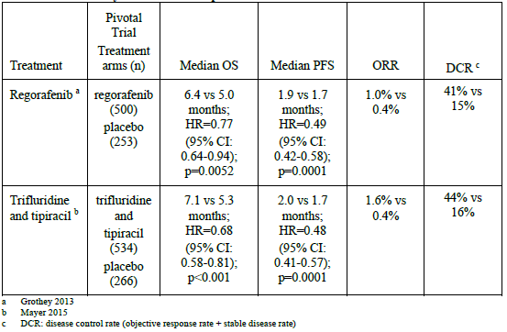

The disease control rate in cohort C of MOUNTAINEER at 12 weeks was 80%, and after cross-over, was 82.1%. This is much higher than the placebo groups of the two trials referenced by the Sponsor, although disease control rate was not an endpoint in the MOUNTAINEER trial. The Sponsor argues that the ORR of 3.3% and disease control rate of 80%, when considered in the context of preclinical data demonstrating that dual HER2-inhibition enhances anti-tumour activity, is sufficient to demonstrate the contribution of tucatinib to the treatment effect. This contribution of tucatinib must be balanced against the risks of increased toxicity associated with adding tucatinib to trastuzumab therapy. The ACM’s opinion on whether the contribution of tucatinib has been satisfactorily established as requested.

##### Confirmatory trial

The Sponsor has committed to conducting a confirmatory study, MOUNTAINEER-03. This is a multi-centre, open-label RCT, comparing tucatinib + trastuzumab + mFOLFOX6 with mFOLFOX6 plus either bevacizumab or cetuximab, in the first line treatment of patients with mCRC. The study design is outlined in Figure 2.

Figure 2: MOUNTAINEER-03 Study Design

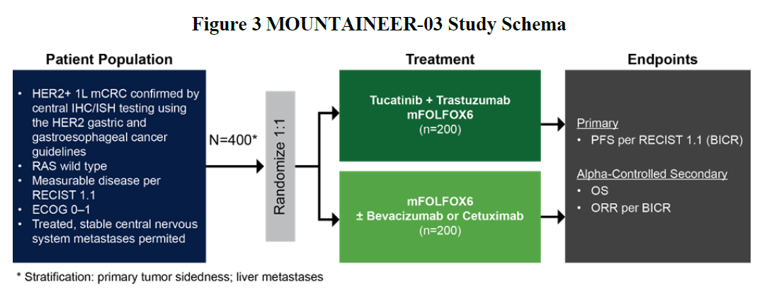

The primary endpoint is PFS per response evaluation criteria in solid tumours (RECIST) v1.1 per BICR. Secondary endpoints include OS and ORR per RECIST v1.1 and BICR.

As of 10 July 2023, clinical trial approvals had been granted in 25 countries and 84 sites activated, which is approximately 36% of the target. 18 subjects of a planned 400 were enrolled; 77 subjects had been screened, and 14 were currently undergoing screening. Enrolment is expected to be completed by the end of 2024, and the primary analysis is expected in the second half of 2025. This provides some reassurance that the confirmatory trial is progressing.

Notably, there will be no tucatinib monotherapy or trastuzumab monotherapy arm, thus the phase II MOUNTAINEER study is the extent of clinical evidence available to support the contribution of tucatinib to the treatment effect.

If the trial is successful, the Sponsor plans to submit data from MOUNTAINEER-03 to convert the provisional registration to full registration in a future Type S application.

##### Safety

The totality of the safety data for the tucatinib + trastuzumab combination in mCRC is limited to 114 patients in the MOUNTAINEER trial. Other safety data from studies in the breast cancer indication involved different combinations of treatment (e.g., with capecitabine) and therefore are not directly applicable to the proposed indication for mCRC. The planned confirmatory trial will provide additional safety data, which is important in detecting rare toxicities that may not have occurred in MOUNTAINEER.

In MOUNTAINEER, the addition of tucatinib to trastuzumab increased toxicity, which is not unexpected for a combination therapy compared to monotherapy. Diarrhoea, fatigue and nausea were the most common AEs in the combination therapy cohorts. Gastrointestinal (GI) AEs such as diarrhoea are known adverse events of tucatinib established during initial registration, and are not unexpected, particularly in a patient group with mCRC. Hepatotoxicity and rash are other known toxicities of tucatinib that occurred in the trial. The PI contains appropriate warnings about these risks, and recommendations for dose modifications. The Sponsor has also updated the incidence rates in the PI with data from the MOUNTAINEER trial.

Cardiac AEs also occurred during the trial. While cardiotoxicity is known to be associated with trastuzumab, an association with tucatinib cannot be ruled out with the small safety population for which data is currently available, and this should be added to the PI. Hypertension occurred commonly, and only with combination therapy. While hypertension is more likely to have been associated with trastuzumab, it should be listed in the tucatinib PI because the proposed indication requires trastuzumab combination treatment. The Sponsor is requested to make the required PI changes.

Overall, the safety profile of tucatinib in combination with trastuzumab for mCRC is consistent with the profile established during initial registration of the breast cancer indication. The AEs that occurred in the MOUNTAINEER trial were generally manageable, with dose modifications in some instances, as recommended in the PI. These events are routinely monitored for and managed in clinical practice by expert clinicians. No new safety signals emerged from the MOUNTAINEER study.

The AE profile and risks of the tucatinib and trastuzumab combination for mCRC are acceptable when balanced against the life-threatening and debilitating nature of the condition.

#### Proposed action

At that stage, the Delegate was inclined to approve the provisional registration of the product.

The Delegate proposed the following additional conditions of registration:

* The Tukysa EU-Risk Management Plan (RMP) (version 1.1, dated 23 November 2022, data lock point 16 October 2022), with Australian Specific Annex (version 0.5, dated June 2023), included with submission PM-2022-04598-1-4, and any subsequent revisions, as agreed with the TGA will be implemented in Australia.
* An obligatory component of risk management plans is routine pharmacovigilance. Routine pharmacovigilance includes the submission of periodic safety update reports (PSURs).
* Unless agreed separately between the supplier who is the recipient of the approval and the TGA, the first report must be submitted to TGA no later than 15 calendar months after the date of this approval letter. The subsequent reports must be submitted no less frequently than annually from the date of the first submitted report until the period covered by such reports is not less than three years from the date of this approval letter, or the entire period of provisional registration, whichever is longer.
* The reports are to at least meet the requirements for PSURs as described in the European Medicines Agency’s Guideline on good pharmacovigilance practices (GVP) Module VII-periodic safety update report (Rev 1), Part VII.B Structures and processes. Note that submission of a PSUR does not constitute an application to vary the registration. Each report must have been prepared within ninety calendar days of the data lock point for that report.
* Tukysa is to be included in the Black Triangle Scheme. The PI and CMI for Tukysa must include the black triangle symbol and mandatory accompanying text for five years, or the product’s entire period of provisional registration, whichever is longer.
* Specifically, the Sponsor must conduct studies as described in the clinical study plan in version 0.5 (date June 2023) of the Australia-Specific Annex. The primary analysis of the MOUNTAINEER-03 study should be submitted to the TGA by 31 December 2025. All subsequent study reports from this study should be submitted as soon as they become available.

#### Questions for the Sponsor

The Sponsor provided the following response to questions from the Delegate.

In the Tucatinib monotherapy arm of the MOUNTAINEER trial, the ORR at 12 weeks was 3.3% (95% CI 0.1-17.2); and after cross-over to combination therapy, the ORR improved to 17.9% (95% CI 6.1-36.9). This seems to suggest that the majority of the efficacy benefit comes from trastuzumab.

* 1. ***Can the Sponsor please provide clinical evidence such as a cross-trial comparison (noting the limitations of such comparisons) and/or a justification to show that an ORR of 3.3% is better than placebo for metastatic colorectal cancer?***

Data regarding the effects of trastuzumab monotherapy (without chemotherapy) in HER2+ mCRC are sparse and limited to case reports which documented a minor response (n=1), a partial response (n=1) and a complete response (n=1). Notably however, no objective responses were noted in 9 patients with HER2+ unresectable/recurrent advanced CRC who were treated with single agent trastuzumab in the prospective basket/umbrella BELIEVE trial in Japan (PMDA review 2022). Due to limited clinical benefit from trastuzumab monotherapy, investigations of trastuzumab in HER2+ mCRC have focused on combinations with a second HER2 directed agent (Table 4).

Table 4. Dual HER2‑Inhibition in Previously Treated mCRC

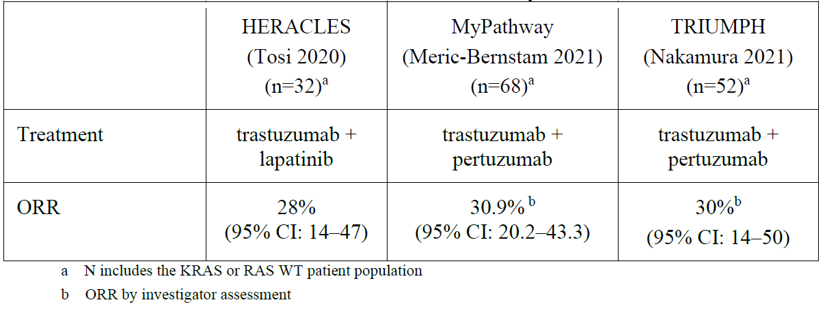

To date, regorafenib and TAS102 (trifluridine and tipiracil hydrochloride) are the only 2 approved biomarker unselected therapies for the treatment of unresectable or metastatic colorectal cancer that has progressed following treatment with fluoropyrimidine, oxaliplatin, and irinotecan-based chemotherapy (same requirement as in MOUNTAINEER trial). Both regorafenib and TAS102 were evaluated in phase 3 randomised trials with best supportive care/placebo (BSC) as control arm. The clinical efficacy of both regorafenib and TAS102 is limited with ORR of 1.0% and 1.6% vs 0.4% for placebo, respectively (Table 5).

Table 5. Currently Available Therapies for Pre-treated biomarker-unselected mCRC

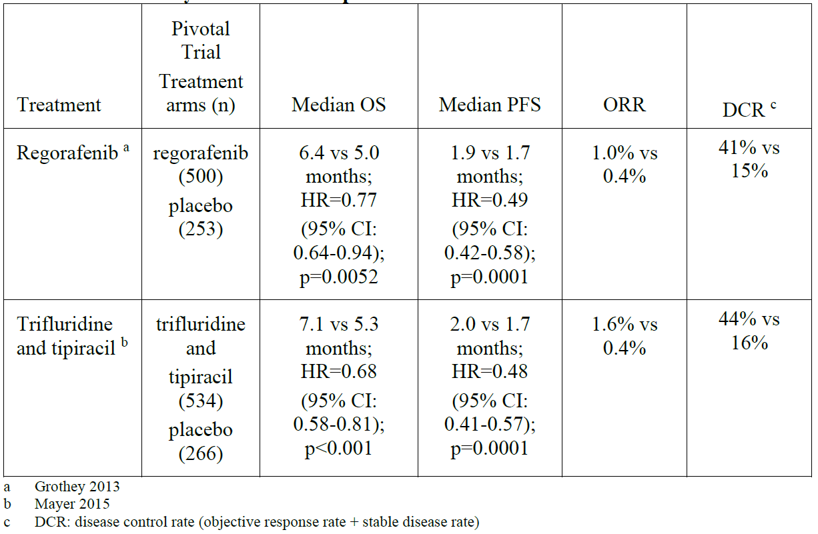

In MOUNTAINEER Cohort C, 30 patients were randomised to receive tucatinib monotherapy. Patients were allowed to cross over and receive tucatinib + trastuzumab therapy if they experienced radiographic progression at any time point or if they did not achieve a PR or CR by the Week 12 assessment. The ORR per BICR in the tucatinib monotherapy group was 3.3% (95% CI, 0.1-17.2), and the disease control rate (DCR = objective response + stable disease) was 80.0% by Week 12 (Table 6).

Table 6. Objective Response Rate by Week 12 per BICR (Tucatinib Monotherapy) (Cohort C Pre-crossover)

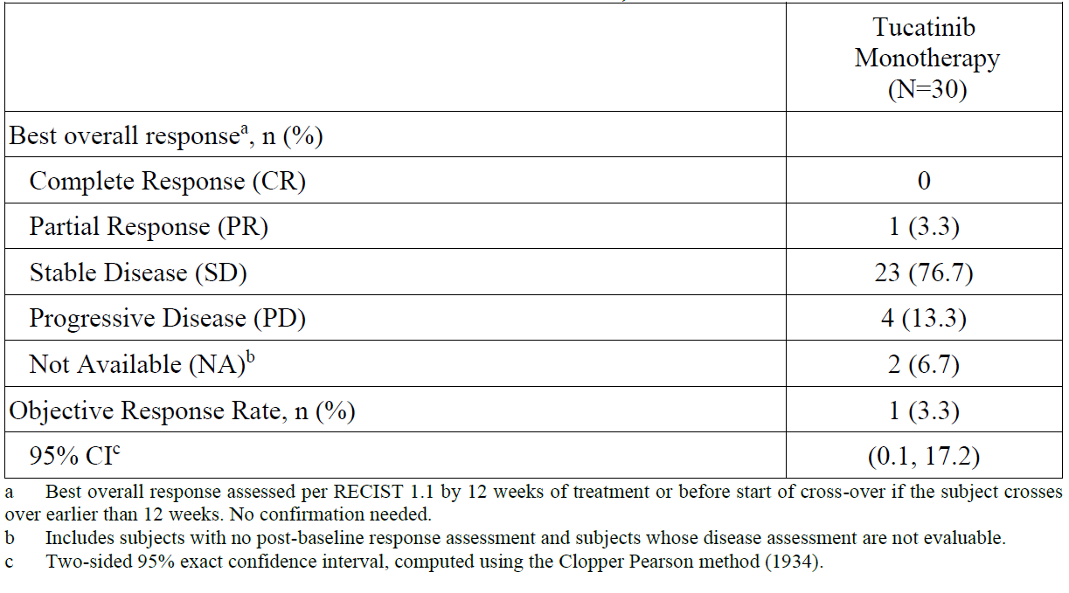

While the ORR of 3.3% for tucatinib monotherapy appears modest, it is numerically higher than the ORRs for the currently approved regorafenib and TAS102 (1.0% and 1.6%, respectively vs 0.4% for placebo). In addition, the DCR of 80.0% compares favourably with 41% and 44% for regorafenib and TAS102, respectively. After 28 of 30 patients (93.0%) crossed over to receive treatment with tucatinib + trastuzumab as specified by protocol, radiographic responses increased to 17.9% (95% CI: 6.1- 36.9) while the DCR remained high (82.1%) (Table 7), suggesting that the anti-tumour effect of tucatinib persisted and was likely necessary to enhance the anti-tumour activity of trastuzumab when administered in combination with tucatinib.

Table 7. Confirmed Objective Response Rate per BICR - Tucatinib +Trastuzumab (Cohort C Post‑crossover)

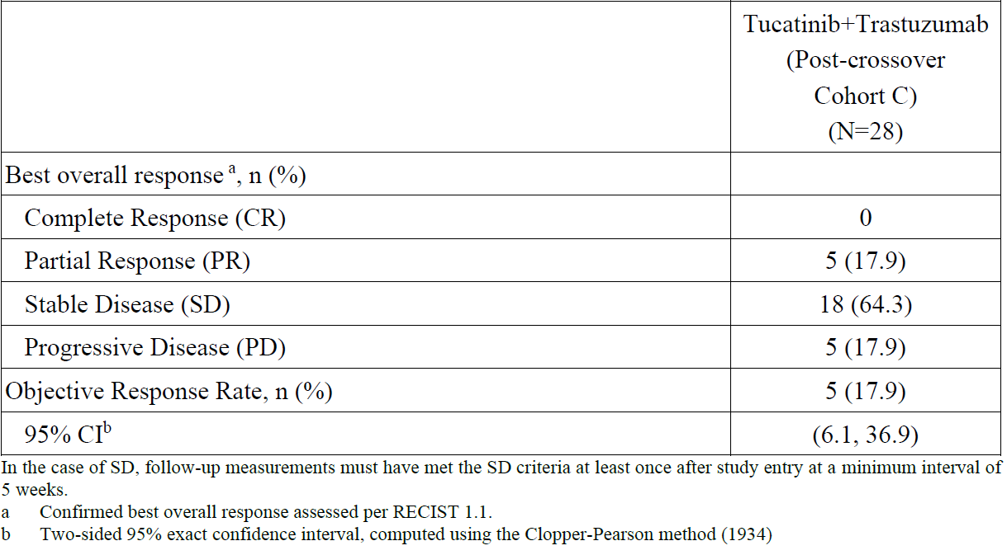

In cohorts A+B (n=84) where tucatinib and trastuzumab were co-administered at the initiation of study treatment, a more robust reduction in tumour burden was observed in comparison to that in the post-crossover cohort C where trastuzumab was administered after 12 weeks of tucatinib monotherapy. The confirmed ORR 38.1% (95% CI: 27.7, 49.3) was observed for dual-HER2 inhibition at the initiation of study treatment in cohorts A+B (Table 8). This suggests that concurrent initiation of dual-HER2 inhibition is likely necessary to maximize clinical benefit in HER2‑positive colorectal cancer. The high response rate to dual therapy and its durability mDOR 12.4 months (95% CI: 8.5, 20.5)) was the basis for the FDA Accelerated Approval for the combination of tucatinib and trastuzumab for the treatment of RAS wild-type HER2-positive unresectable or metastatic colorectal cancer that has progressed following chemotherapy.

Table 8. Confirmed Objective Response Rate per BICR (Tucatinib + Trastuzumab)

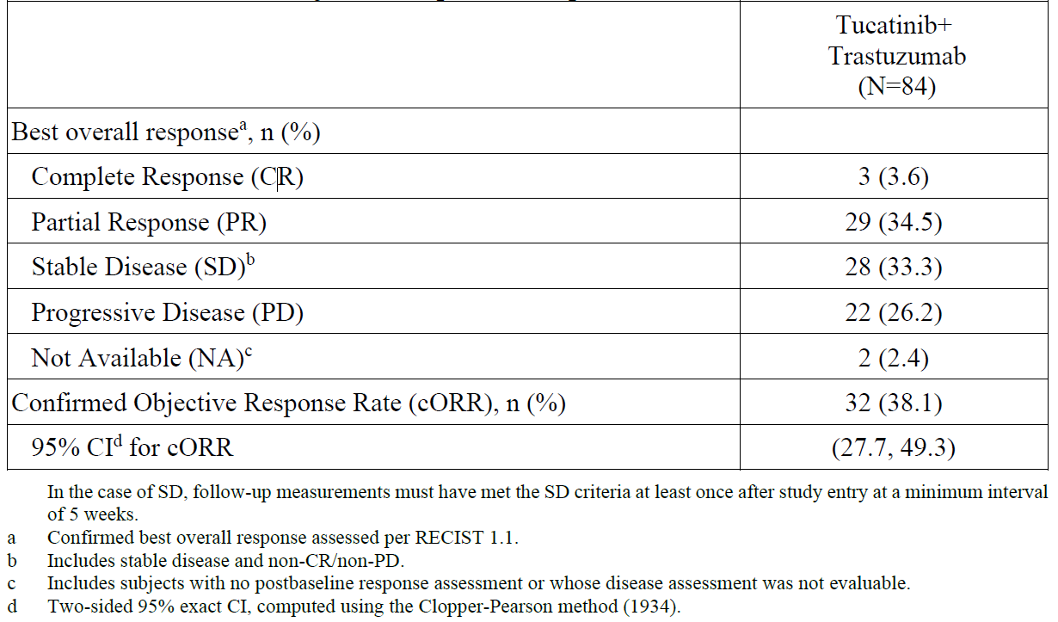

Further, clinical data for tucatinib in breast cancer reinforces the improved clinical benefit when tucatinib is added to a trastuzumab-based regimen at the initiation of therapy. HER2CLIMB was a global phase 3 clinical trial that randomised patients with HER2-positive, unresectable locally advanced or metastatic breast cancer, with or without brain metastases, and who received prior treatment with trastuzumab, pertuzumab, and ado-trastuzumab emtansine (T-DM1) to receive either tucatinib or placebo, in combination with trastuzumab and capecitabine (Murthy 2020). Among the 511 patients with measurable disease at baseline per BICR, the percentage who had a confirmed objective response was 40.6% (95% CI, 35.3 to 46.0) in the tucatinib-combination group and 22.8% (95% CI, 16.7 to 29.8) in the placebo-combination group. The mPFS for the first 480 patients (primary endpoint) was superior for tucatinib-combination group (7.8 months (95% CI: 7.5, 9.6) vs 5.6 months (95% CI: 4.2, 7.1)); HR 0.54 (95% CI: 0.42, 0.71), p <0.00001). The mOS for the overall population (n=612) was also statistically superior for the tucatinib combination group (21.9 months (95% CI: 18.3, 31.0) vs 17.4 months (95%CI: 13.6, 19.9), HR 0.66 (95% CI: 0.50, 0.87), p = 0.00480). As a result, tucatinib was approved for use in combination with trastuzumab and capecitabine for the treatment of advanced pre-treated HER2+ breast cancer.

In summary, due to limited anti-tumour activity for trastuzumab monotherapy known to date, clinical evaluation of trastuzumab in HER2+ mCRC has focused on combination approaches with a second HER2 targeted agent. While the objective response rate to tucatinib monotherapy appears modest, the results of MOUNTAINEER provided evidence for the contribution of both tucatinib and trastuzumab to the efficacy of the regimen. Importantly, the totality of clinical evidence to date suggests the clinical benefit is maximized when tucatinib and trastuzumab are administered concurrently as the magnitude of benefit observed would not be expected with either agent alone.

* 1. ***Does the seemingly small benefit of the addition of tucatinib to the combination outweigh the additional toxicity associated with tucatinib? Please provide a detailed justification for your answer.***

Based on the safety results observed in the MOUNTAINEER trial (Table 9), patients administered tucatinib monotherapy had a manageable and tolerable safety profile that did not impact participation on study and when added to trastuzumab following cross over enabled an extended time on treatment.

Table 9. Summary of Treatment-Emergent Adverse Events (Tucatinib Integrated Safety Analysis Set)

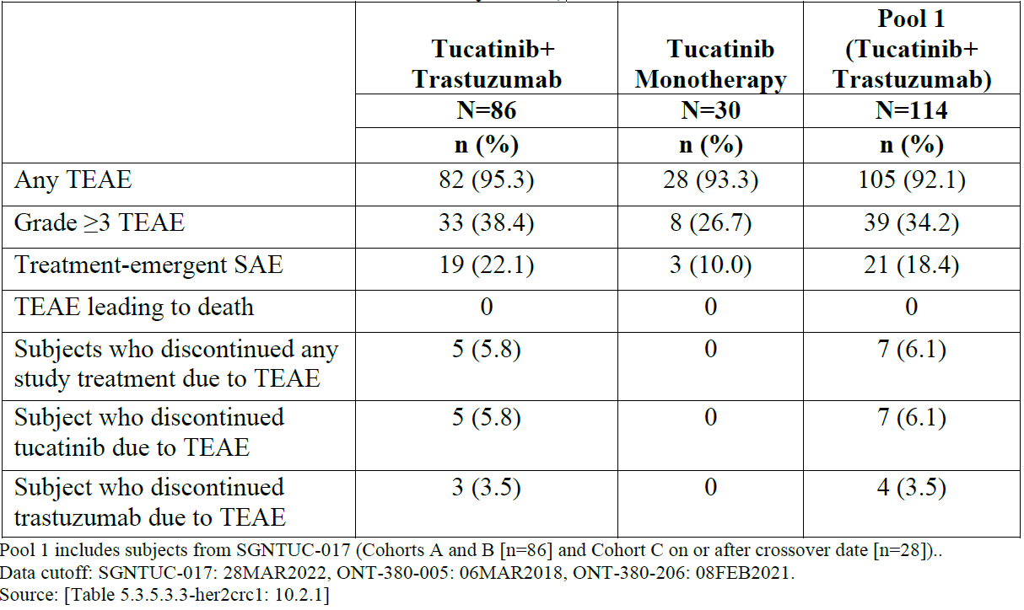

The total incidence of TEAEs in the tucatinib monotherapy cohort was similar to that observed in both the tucatinib+trastuzumab cohort and Pool 1. The total incidence rates of Grade ≥3 TEAEs and SAEs were lower in the tucatinib monotherapy cohort (26.7% [8 subjects] and 10.0% [3 subjects], respectively). No subjects in the tucatinib monotherapy cohort discontinued tucatinib treatment due to a TEAE. There were no TEAEs leading to death in the MOUNTAINEER trial (including Pool 1) (Table 9).

In the tucatinib monotherapy cohort, the most commonly reported TEAEs were diarrhoea (33.3%), fatigue (20.0%), abdominal pain (20.0%), and nausea (16.7%) (Table 10). Subjects in the tucatinib monotherapy cohort had lower incidence rates across TEAEs with the exception of abdominal pain (20.0% in the tucatinib monotherapy cohort compared with 15.1% and 14.0% in the tucatinib + trastuzumab cohort and Pool 1, respectively).

Table 10. Treatment-Emergent Adverse Events by Preferred Term Occurring in ≥10% of Subjects in Pool 1 (Tucatinib Integrated Safety Analysis Set)

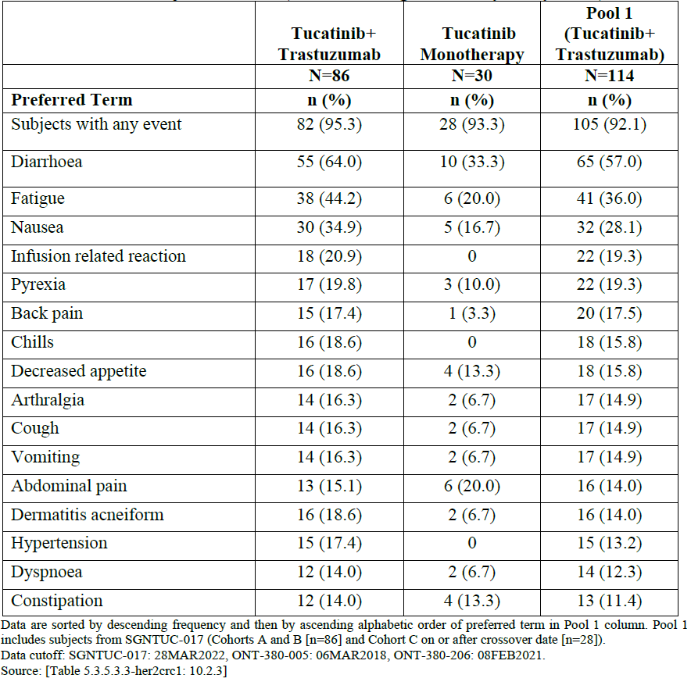

In the tucatinib monotherapy cohort, at least 1 Grade ≥3 TEAE was reported for 26.7% of subjects. The most commonly reported Grade ≥3 TEAEs were ALT increased and AST increased (2 subjects [6.7%], each). Other events were observed in <5% of subjects.

Grade ≥3 treatment-related TEAEs were reported in 2 subjects (6.7%) in the tucatinib monotherapy cohort. These included 2 subjects each (6.7%) with Grade ≥3 ALT increased and AST increased (Table 11).

Table 11. Treatment-Emergent Grade ≥3 Adverse Events by Preferred Term Occurring in ≥2 Subjects in Pool 1 (Tucatinib Integrated Safety Analysis Set)

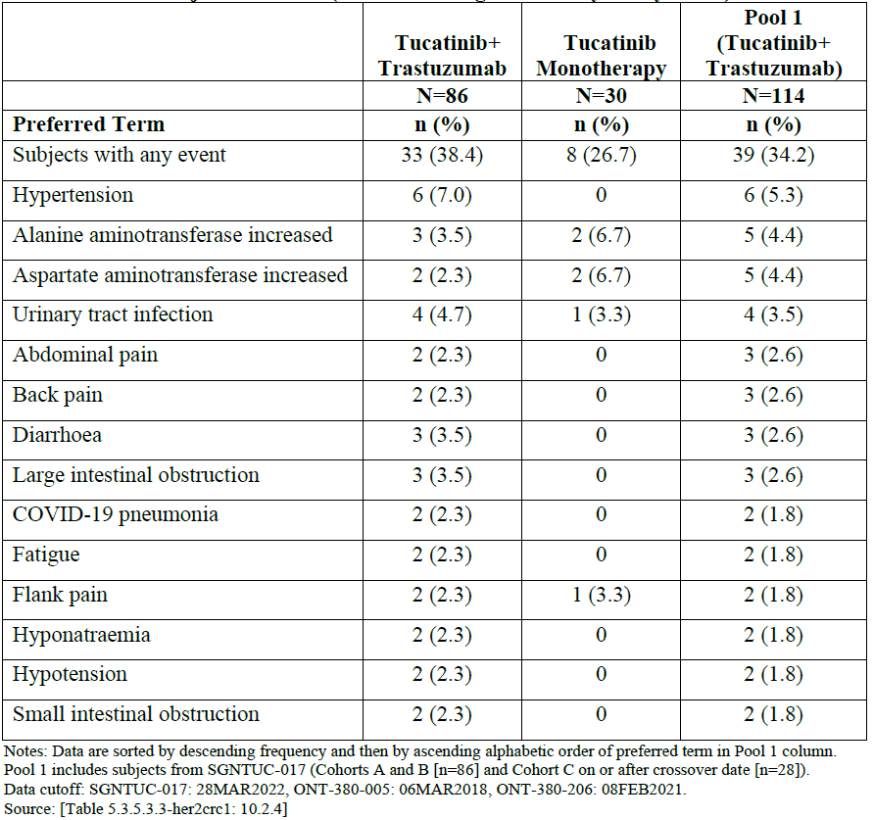

In the tucatinib monotherapy cohort, 5 SAEs were reported in 3 subjects (10.0%) and included SAEs of urinary tract infection, flank pain, duodenal obstruction, overdose, and pyelonephritis. The SAE of overdose was attributed to misunderstanding of instructions by the subject, and it was not associated with any AEs (Table 12).

Table 12. Treatment-Emergent Serious Adverse Events by Preferred Term Occurring in ≥1 Subject in the MOUNTAINEER Trial (Tucatinib Integrated Safety Analysis Set)

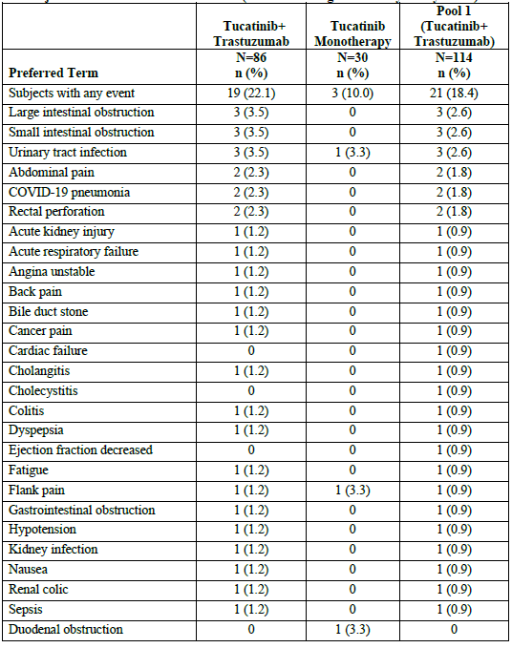

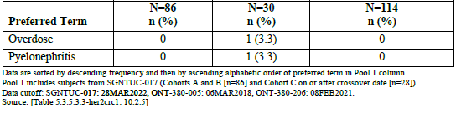

The MOUNTAINEER trial demonstrated that as with tucatinib monotherapy, in combination with trastuzumab had a tolerable and manageable safety profile in subjects with unresectable or metastatic HER2+ mCRC. The types of AEs observed with the tucatinib and trastuzumab combination regimen were generally consistent with the known safety profile of each individual agent. No new safety risks were identified.

The majority of the TEAEs reported were of low grade (Grades 1–2). When observed, Grade 3 and 4 events were manageable with standard of care and/or dose modifications. Low incidences of SAEs were observed, and there were no deaths due to TEAEs. Patients with HER2+ mCRC who have progressed after fluoropyrimidine, oxaliplatin and irinotecan-based therapies have a poor prognosis, and therapeutic options are limited to regorafenib and TAS102 which offer minimal clinical benefit. Therefore, these patients represent a group with a high unmet medical need. There is currently no approved HER2-targeted therapy for mCRC in Australia. While historical data for trastuzumab monotherapy is sparse, it suggested that trastuzumab monotherapy may have limited clinical efficacy in HER2+ mCRC. Data from MOUNTAINEER demonstrated the added clinical benefit from both tucatinib and trastuzumab, especially when co-administered at the initiation of therapy. Although the contribution of tucatinib in terms of objective response appeared modest (3.3%), the anti-tumour effect of tucatinib was evident in the substantially high degree of stable disease achieved by Week 12 in 23 of 30 subjects (76.7%), which compared favourably against the currently available therapies for these patients which include regorafenib (ORR 1.0%, SD 41%) and TAS102 (ORR 1.6%, SD 44%).

Further, in MOUNTAINEER, the majority of patients (28/30) in cohort C (tucatinib monotherapy) crossed over to also receive trastuzumab at Week 12; this crossover may have limited the full extent of anti-tumour effect that could have been recorded for tucatinib monotherapy. Notably however, the anti-tumour effect was maximized when tucatinib and trastuzumab were administered together at the initiation of treatment as observed in Cohorts A+B which achieved cORR 38.1% (95% CI: 27.7%, 49.3%) and DOR 12.4 months, and this was the basis for the recent FDA approval.

Overall, the combination of tucatinib and trastuzumab demonstrates a favourable benefit-risk profile for dual HER2 inhibition of patients with HER2+ CRC who have received at least one prior treatment regimen for unresectable or metastatic disease.

The indication should more closely reflect the patient population in the MOUNTAINEER study. This is particularly important for provisional applications, where evidence of efficacy is limited. Please change the indication to:

Tukysa is indicated in combination with trastuzumab for the treatment of adult patients with RAS wild-type HER2-positive unresectable or metastatic colorectal cancer that has progressed following treatment with fluoropyrimidine, oxaliplatin, and irinotecan based chemotherapy.

The Sponsor acknowledges and accepts.

Why is there no plan to register this indication in Canada, the EU, or Switzerland?

The Sponsor’s primary goal is to make innovative therapies available globally to as many patients as possible. The decision not to register this indication in the specified regions was informed by the unclear path to approval and patient access based on precedent in these regions considering the MOUNTAINEER study design. The Sponsor aims to achieve global access to tucatinib in combination with trastuzumab in mCRC patients based on the actively recruiting phase 3 study, MOUNTAINEER-03.

Please provide an update for the subjects in the MOUNTAINEER trial who remained on study at the 28 March 2022 data cut-off.

As of 06 July 2023, there are 6 subjects on treatment (3 subjects on Cohort A, 1 subject on Cohort B, and 2 subjects on Cohort C). 14 subjects remain in long term follow-up, and 97 subjects are off study. No new safety signals have been observed since the 28 March 2022 data cut-off.

Please provide an update on the progress of the MOUNTAINEER-03 trial.

SGNTUC-029 (MOUNTAINEER-03) is actively recruiting. As of 10 July 2023, MOUNTAINEER-03 has received clinical trial application approvals in 25 countries with 84 sites activated globally (approximately 36% of the target). The study has enrolled 18 subjects of the targeted 400 total planned, with 77 subjects screened and an additional 14 currently in screening.

Please provide details of HER2 and RAS testing available in Australia for colorectal cancer. Is there a plan to register a companion diagnostic in Australia?

RAS gene mutational status is routinely tested in Australia and listed on Medicare Benefits Schedule (Item 73338) for metastatic colorectal cancer (mCRC) patients. Since this testing is considered standard of care for patients newly diagnosed with mCRC and is widely available, there are no plans to register a companion diagnostic (CDx) test for RAS gene mutation testing.

HER2 tests are widely available in Australia and typically consist of immunohistochemistry (IHC) to assess protein expression levels of HER2 and/or *in situ* hybridization (ISH) to assess DNA copy number amplification of the *ERBB2* gene (encodes HER2 protein). These tests are routinely performed for patients with gastric and breast cancers. There is currently no approved HER2 CDx in the mCRC indication in Australia, and HER2 testing is infrequently performed in mCRC patients within Australian pathology labs as there are currently no HER2-directed therapies approved in Australia in any line of therapy. That said, in the global study, although no Australian sites were included, patients were enrolled based on local testing by IHC, ISH, and next-generation sequencing (NGS). The efficacy results from MOUNTAINEER indicate that local laboratory developed tests identified mCRC patients that may respond to tucatinib and trastuzumab in the absence of a CDx assay.

Seagen has engaged with Roche Tissue Diagnostics (Ventana) to co-develop an IHC and ISHbased HER2 CDx in the confirmatory MOUNTAINEER-03 (SGNTUC-029) trial. The submission of the CDx Premarket Approval (PMA) at the completion of the MOUNTAINEER-03 study in the United States will be used to fulfill FDA Post-Marketing Commitment (PMC) 4388-2 from the MOUNTAINEER Accelerated Approval. Registration of the CDx assays outside the United States will be explored during the time leading up to MOUNTAINEER-03 submissions.

#### Advisory committee on medicines considerations

The [Advisory Committee on Medicines (ACM)](https://www.tga.gov.au/committee/advisory-committee-medicines-acm), having considered the evaluations and the Delegate’s overview, as well as the Sponsor’s response to these documents, advised the following.

##### Specific advice to the Delegate

1. ***Please comment on the contribution of tucatinib to the overall treatment effect of the tucatinib + trastuzumab combination in mCRC. Has the contribution of both agents been satisfactorily established?***

The ACM advised that the present data is not sufficient to ascertain the individual contribution of either tucatinib or trastuzumab to the combination in mCRC. However, the ACM noted that tucatinib in combination with trastuzumab in mCRC appears to be effective in terms of ORR and duration of response.

The ACM noted that within the single arm phase II MOUNTAINEER study the single agent activity of tucatinib is negligible in comparison to the overall response rate of the combination.

The ACM noted that within the oncology setting there are examples of synergy of a drug combination, where this is limited data on the efficacy of the single agents. Examples include other combinations with trastuzumab.

The ACM noted the planned confirmatory study will not establish the contribution of each agent. The ACM supported further studies to establish the treatment effect of each agent in mCRC.

1. ***Are the data from the phase II MOUNTAINEER study, and the plan to provide confirmatory data from the phase III MOUNTAINEER-3 study sufficient to support provisional registration?***

The ACM was of the view that the provided data and the planned confirmatory data are sufficient to support provisional registration of the combination.

The ACM noted that the phase II MOUNTAINEER study demonstrated an overall response rate of 38.1% for patients receiving tucatinib in combination with trastuzumab, agreeing that these results are substantially better than for standard of care.

The ACM noted that the phase III MOUNTAINEER-3 study will provide confirmatory data on the combination of tucatinib and trastuzumab in the first line treatment of mCRC.

1. ***The committee is also requested to provide any additional comments or advice that it considers relevant to this submission, such as comments on the indication, PI and CMI.***

The ACM supported provisional registration, noting that metastatic colorectal cancer is an incurable disease with a poor prognosis and there are currently no HER2 targeted treatments available for HER2 positive mCRC.

The ACM requested that consideration be given to addressing use as second line therapy and the contributions of the single agents to the treatment effect within the MOUNTAINEER-3 confirmatory study.

##### ACM conclusion

The ACM supported provisional registration, noting that metastatic colorectal cancer is an incurable disease with a poor prognosis and there are currently no HER2 targeted treatments available for HER2 positive mCRC.

The ACM requested that consideration be given to addressing use as second line therapy and the contributions of the single agents to the treatment effect within the MOUNTAINEER-3 confirmatory study.

#### Risk/benefit assessment (post-advisory committee meeting)

Metastatic colorectal cancer is an incurable disease with a poor prognosis. At present, there are no HER2 targeted therapies available for patients with HER2 positive mCRC. The ORR demonstrated for tucatinib in combination with trastuzumab therapy in the MOUNTAINEER trial is promising. It could potentially translate to meaningful improvements in morbidity or mortality in the phase III trial MOUNTAINEER-03. Tucatinib in combination with trastuzumab appears to have an acceptable safety profile based on the evidence presented, although toxicities are higher compared to monotherapy, as is expected. Granting provisional approval based on a phase II study will benefit patients with an incurable disease by allowing earlier access to a promising therapy. While the safety profile appears acceptable, due to the limited evidence available at this point, it is possible that very rare adverse events may not have been detected. This risk is mitigated by the provisional status of this application, meaning further safety data from a phase III study will need to be provided before full registration can be granted. Overall, the risk benefit balance for the combination is positive.

## Registration decision

Based on a review of quality, safety, and efficacy, the TGA decided to register Tukysa (tucatinib) 50 mg and 150 mg, film-coated tablet, blister pack, for the following extension of indications:

Tukysa is indicated in combination with trastuzumab for the treatment of adult

patients with RAS wild-type HER2 positive unresectable or metastatic colorectal cancer

that has progressed following treatment with fluoropyrimidine, oxaliplatin, and

irinotecan based chemotherapy. This indication was approved via the provisional

approval pathway based on confirmed objective response rate (cORR) in a single arm

trial. Continued approval of this indication depends on verification and description of

benefit in confirmatory trials.

As such, the full indications at this time were:

Tukysa is indicated in combination with trastuzumab for the treatment of adult

patients with RAS wild-type HER2 positive unresectable or metastatic colorectal cancer

that has progressed following treatment with fluoropyrimidine, oxaliplatin, and

irinotecan based chemotherapy. This indication was approved via the provisional

approval pathway based on confirmed objective response rate (cORR) in a single arm

trial. Continued approval of this indication depends on verification and description of

benefit in confirmatory trials.

Tukysa is indicated in combination with trastuzumab and capecitabine for treatment

of patients with advanced unresectable or metastatic HER2-positive breast cancer,

including patients with brain metastases, who have received one or more prior anti-

HER2-based regimens in the metastatic setting.

## Tukysa (tucatinib) submission: administrative information

### Submission details

|  |  |
| --- | --- |
| *Type of submission:* | Extension of indications |
| *Product name:* | Tukysa |
| *Active ingredient:* | tucatinib |
| *Decision:* | Approved for provisional registration |
| *Date of decision:* | 17 November 2023 |
| *Date of entry onto ARTG:* | 24 November 2023 |
| *ARTG numbers:* | 328525, 328526 |
| [*Black Triangle Scheme*](https://www.tga.gov.au/black-triangle-scheme) | Yes |
| *Sponsor’s name and address:* | Pfizer Australia Pty Ltd Level 17, 151 Clarence Street Sydney NSW 2000 |
| *Dose form:* | Film coated tablet |
| *Strength:* | TUKYSA film-coated tablets contain either 50 mg or 150 mg of tucatinib.  TUKYSA 50 mg contains 9.2 mg sodium and 10 mg potassium per tablet and TUKYSA 150 mg contains 27.6 mg sodium and 30 mg potassium per tablet. |
| *Container:* | Blister presentation |
| *Pack size:* | 150 mg blister presentation: 4 tablets per blister pack and 21 packs per carton  50 mg blister presentation: 8 tablets per blister pack and 11 packs per carton |
| *Approved therapeutic use for the current submission:* | TUKYSA is indicated in combination with trastuzumab for the treatment of adult patients with RAS wild-type HER2 positive unresectable or metastatic colorectal cancer that has progressed following treatment with fluoropyrimidine, oxaliplatin, and irinotecan based chemotherapy. This indication was approved via the provisional approval pathway based on confirmed objective response rate in a single arm trial. Continued approval of this indication depends on verification and description of benefit in confirmatory trials. |
| *Route of administration:* | Oral |
| *Dosage:* | 300 mg taken orally twice daily in combination with trastuzumab and capecitabine until disease progression or unacceptable toxicity. |
| *Pregnancy category:* | D  *Drugs which have caused, are suspected to have caused or may be expected to cause, an increased incidence of human fetal malformations or irreversible damage. These drugs may also have adverse pharmacological effects*.  Based on findings in animal studies and its mechanism of action, Tukysa can cause fetal harm when administered to a pregnant woman. There are no available human data on Tukysa use in pregnant women. Advise pregnant patients and patients of reproductive potential of the potential risk to the fetus.  In pilot embryo-fetal development studies, pregnant rats and rabbits received oral doses of tucatinib up to 150 mg/kg/day during the period of organogenesis.  In rats, maternal toxicity (body weight loss, reduced body weight gain, low food consumption) was observed at doses ≥90 mg/kg/day (3.5 times the human exposure at the recommended dose based on AUC). Fetal effects also occurred at maternal doses ≥90 mg/kg/day, including reduced number of live fetuses, decreased fetal weights and fetal abnormalities (increase in skeletal variations, incomplete ossification).  In rabbits, increased resorptions, decreased percentages of live fetuses, and skeletal, visceral, and external malformations in fetuses were observed at maternal doses ≥90 mg/kg/day (1.3 times the human exposure at the recommended dose based on AUC). Fetal abnormalities included domed head, brain dilation, incomplete ossification of frontal and parietal bones, and a hole in the parietal bone. |

### Specific conditions of registration applying to these goods

Tukysa is to be included in the [Black Triangle Scheme](https://www.tga.gov.au/how-we-regulate/monitoring-safety-and-shortages/report-adverse-event-or-incident/report-adverse-events-medicines-and-biologicals/black-triangle-scheme). The PI and CMI for Tukysa must include the black triangle symbol and mandatory accompanying text for five years, or the product’s entire period of provisional registration, whichever is longer. The Black Triangle Scheme identifies new prescription medicines with a black triangle on the medicine information documents. The scheme also applies to [prescription medicines](https://www.tga.gov.au/products/medicines/prescription-medicines) being used in new ways, such as a medicine that is now being used for children.  The black triangle is a visual reminder to encourage health practitioners and patients to [report a problem or side effect](https://www.tga.gov.au/safety/reporting-problems).

The Tukysa EU- [Risk Management Plan](https://www.tga.gov.au/resources/resource/guidance/risk-management-plans-medicines-and-biologicals) (RMP) (version 1.1, dated 23 November 2022, data lock point 16 October 2022), with Australian Specific Annex (version 0.5, dated June 2023), included with submission PM-2022-04598-1-4, and any subsequent revisions, as agreed with the TGA will be implemented in Australia. An obligatory component of risk management plans is routine [pharmacovigilance](https://www.tga.gov.au/resources/resource/guidance/pharmacovigilance-responsibilities-medicine-sponsors). Routine pharmacovigilance includes the submission of [periodic safety update reports (PSURs)](https://www.tga.gov.au/resources/resource/guidance/risk-management-plans-medicines-and-biologicals/periodic-safety-update-reports).

Unless agreed separately between the supplier who is the recipient of the approval and the TGA, the first report must be submitted to TGA no later than 15 calendar months after the date of this approval letter. The subsequent reports must be submitted no less frequently than annually from the date of the first submitted report until the period covered by such reports is not less than three years from the date of this approval letter, or the entire period of provisional registration, whichever is longer.

The reports are to at least meet the requirements for PSURs as described in the European Medicines Agency’s Guideline on good pharmacovigilance practices (GVP) Module VII-periodic safety update report (Rev 1), Part VII.B Structures and processes. Note that submission of a PSUR does not constitute an application to vary the registration. Each report must have been prepared within ninety calendar days of the data lock point for that report.

Specifically, the sponsor must conduct studies as described in the clinical study plan in version 0.5 (date June 2023) of the Australia-Specific Annex. The primary analysis of the MOUNTAINEER-03 study should be submitted to the TGA by April 2026, and the full study report should be submitted by 31 October 2028.

### Product Information

The [Product Information](https://www.tga.gov.au/products/australian-register-therapeutic-goods-artg/product-information-one) ([PI](https://www.tga.gov.au/products/australian-register-therapeutic-goods-artg/product-information-one)) approved with this submission for Tukysa which is referred to in this AusPAR (and can be accessed on this AusPAR’s webpage) may have been superseded. For the most recent PI and [Consumer Medicines Information](https://www.tga.gov.au/products/australian-register-therapeutic-goods-artg/consumer-medicines-information-cmi) (CMI), please refer to the TGA [PI/CMI search facility.](https://www.ebs.tga.gov.au/)

### Regulatory status

#### Australian regulatory status

The product received initial registration in the [Australian Register of Therapeutic Goods](https://www.tga.gov.au/products/australian-register-therapeutic-goods-artg) ([ARTG](https://www.tga.gov.au/products/australian-register-therapeutic-goods-artg)) on 13 August 2020. It was approved for the following indications:

Tukysa is indicated in combination with trastuzumab and capecitabine for treatment

of patients with advanced unresectable or metastatic HER2-positive breast cancer,

including patients with brain metastases, who have received one or more prior anti-

HER2-based regimens in the metastatic setting[8].

#### International regulatory status

At the time the TGA considered this submission, a similar submission had been considered by other regulatory agencies. Table 13 summarises these submissions and provides the indications where approved.

Table 13: International regulatory status at the time of product registration.

|  |  |  |  |
| --- | --- | --- | --- |
| Region | Submission date | Status | Approved indications |
| United States of America | 19 July 2022 | Approved on 19 January 2023 | Tukysa is indicated in combination with trastuzumab for the treatment of adult patients with RAS wild-type, HER2-positive unresectable or metastatic colorectal cancer that has progressed following treatment with fluoropyrimidine-, oxaliplatin-, and irinotecan-based chemotherapy.  This indication is approved under accelerated approval based on tumour response rate and durability of response.  Continued approval for this indication may be contingent upon verification and description of clinical benefit in confirmatory trials. |
| Singapore | 27 September 2022 | Under consideration | Under consideration |
| Great Britain | 29 February 2023 | Under consideration | Under consideration |

### Registration timeline

This submission was evaluated under the [provisional registration process.](https://www.tga.gov.au/resources/resource/guidance/provisional-registration-process)

Table 14 captures the key steps and dates for this submission.

Table 14: Registration timeline for Tukysa (submission no. PM-2022-04598-1-4) – Key Dates.

|  |  |
| --- | --- |
| Description | Date |
| Determination (Provisional) | 20 October 2022 |
| Submission dossier accepted and first round evaluation commenced | 30 November 2022 |
| First round evaluation completed | 2 May 2023 |
| Sponsor provides responses on questions raised in first round evaluation | 8 June 2023 |
| Second round evaluation completed | 11 August 2023 |
| Sponsor’s notification to the TGA of errors/omissions in evaluation reports | 22 August 2023 |
| Delegate’s[9] Overall benefit-risk assessment and request for Advisory Committee advice | 4 September 2023 |
| Sponsor’s pre-Advisory Committee response | 14 September 2023 |
| Advisory Committee meeting | 5-6 October 2023 |
| Registration decision (Outcome) | 17 November 2023 |
| Administrative activities and registration in the ARTG completed | 24 November 2023 |
| Number of working days from submission dossier acceptance to registration decision* | 208 |

*Statutory timeframe for standard submissions is 255 working days

### List of abbreviations

|  |  |
| --- | --- |
| Abbreviation | Meaning |
| ACM | Advisory Committee on Medicines |
| AE | Adverse events |
| AKI | Acute kidney injury |
| ALT | Alanine aminotransferase |
| ARTG | Australian Register of Therapeutic Goods |
| ASA | Australia‑specific annex |
| AST | Aspartate aminotransferase |
| BICR | Blinded independent central review |
| CMI | Consumer Medicines Information |
| cORR | Confirmed objective response rate |
| CR | Complete remission |
| CSF | Cerebrospinal fluid |
| DCO | Data cut off |
| DLP | Data lock point |
| DOR | Duration of response |
| GI | Gastrointestinal |
| LVEF | Left ventricular ejection fraction |
| mCRC | Metastatic colorectal cancer |
| ORR | Objective response rate |
| OS | Overall survival |
| PI | Product Information |
| PD | Pharmacodynamics |
| PD | Progressive disease |
| PFS | Progression-free survival |
| PK | Pharmacokinetics |
| PR | Partial remission |
| PSUR | Periodic safety update report |
| RECIST | Response evaluation criteria in solid tumours |
| RMP | Risk management plan |
| SAE | Serious adverse event |
| SD | Stable disease |
| SD | Standard deviation |
| TEAE | Treatment emergent adverse event |
| TGA | Therapeutic Goods Administration |
| UTI | Urinary tract infection |

|  |
| --- |
| Therapeutic Goods Administration |
| PO Box 100 Woden ACT 2606 Australia  Email: [info@tga.gov.au](mailto:info@tga.gov.au) Phone: 1800 020 653 Fax: 02 6203 1605  [**https://www.tga.gov.au**](https://www.tga.gov.au) |
|  |

1. This is the original indication proposed by the Sponsor when the TGA commenced the evaluation of this submission. It may differ to the final indication approved by the TGA and registered in the Australian Register of Therapeutic Goods.
2. http://www.nccn.org/
3. https://www.uptodate.com/
4. https://pro.uptodatefree.ir/Show/129349
5. https://www.uptodate.com/contents/systemic-therapy-for-nonoperable-metastatic-colorectal-cancer-approach-to-later-lines-of-systemic-therapy
6. AusPAR for Tukysa: <https://www.tga.gov.au/resources/auspar/auspar-tucatinib>
7. Ibid
8. https://www.tga.gov.au/sites/default/files/auspar-tucatinib-210317.pdf
9. The ‘Delegate’ is the Delegate of the Secretary of the Department of Health and Aged Care who made the final decision to either include the new medicine/indication on the ARTG or reject the submission, under section 25 of the Therapeutic Goods Act.