|  |
| --- |
| Australian Public Assessment Report for Winlevi |
| Active ingredient: Clascoterone |
| Sponsor: Sun Pharma ANZ Pty Ltd |
| August 2024 |

About the Therapeutic Goods Administration (TGA)

* The Therapeutic Goods Administration (TGA) is part of the Australian Government Department of Health and Aged Care and is responsible for regulating therapeutic goods, including medicines, medical devices, and biologicals.
* The TGA administers the *Therapeutic Goods Act 1989* (the Act), applying a risk management approach designed to ensure therapeutic goods supplied in Australia meet acceptable standards of quality, safety, and efficacy.
* The work of the TGA is based on applying scientific and clinical expertise to decision-making, to ensure that the benefits to the Australian public outweigh any risks associated with the use of therapeutic goods.
* The TGA relies on the public, healthcare professionals and industry to report problems with therapeutic goods. The TGA investigates reports received to determine any necessary regulatory action.
* To report a problem with a therapeutic good, please see the information on the [TGA website](https://www.tga.gov.au/).

About AusPARs

* The Australian Public Assessment Report (AusPAR) provides information about the evaluation of a prescription medicine and the considerations that led the TGA to approve or not approve a prescription medicine submission. Further information can be found in [Australian Public Assessment Report (AusPAR) guidance](https://www.tga.gov.au/australian-public-assessment-report-auspar-guidance).
* AusPARs are prepared and published by the TGA.
* AusPARs are static documents that provide information that relates to a submission at a particular point in time. The publication of an AusPAR is an important part of the transparency of the TGA’s decision-making process.
* A new AusPAR may be provided to reflect changes to indications or major variations to a prescription medicine subject to evaluation by the TGA.

Copyright

© Commonwealth of Australia 2024  
This work is copyright. You may reproduce the whole or part of this work in unaltered form for your own personal use or, if you are part of an organisation, for internal use within your organisation, but only if you or your organisation do not use the reproduction for any commercial purpose and retain this copyright notice and all disclaimer notices as part of that reproduction. Apart from rights to use as permitted by the *Copyright Act 1968* or allowed by this copyright notice, all other rights are reserved and you are not allowed to reproduce the whole or any part of this work in any way (electronic or otherwise) without first being given specific written permission from the Commonwealth to do so. Requests and inquiries concerning reproduction and rights are to be sent to the TGA Copyright Officer, Therapeutic Goods Administration, PO Box 100, Woden ACT 2606 or emailed to <[tga.copyright@tga.gov.au](mailto:tga.copyright@tga.gov.au)>.

Contents

List of abbreviations 4

Product submission 6

Submission details 6

Winlevi (clascoterone) 7

Acne vulgaris 7

Current treatment options for acne vulgaris 7

Clinical rationale for Winlevi use in acne vulgaris 8

Regulatory status 8

Australian regulatory status 8

International regulatory status 8

Registration timeline 9

Submission overview and risk/benefit assessment 10

Quality evaluation summary 10

Nonclinical (toxicology) evaluation summary 11

Clinical evaluation summary 12

Summary of clinical studies 12

Pharmacology 13

Efficacy 14

Safety 30

Risk Management Plan evaluation summary 36

Discussion 37

Advisory Committee considerations 39

Outcome 40

Specific conditions of registration 40

Product Information 41

## List of abbreviations

|  |  |
| --- | --- |
| Abbreviation | Meaning |
| ACM | Advisory Committee on Medicines |
| ACTH | adrenocorticotropic hormone |
| AE | adverse event |
| ALT | alanine aminotransferase |
| AR | androgen receptor |
| ARTG | Australian Register of Therapeutic Goods |
| ASA | Australia‑specific annex |
| AST | aspartate aminotransferase |
| AUC | area under the curve |
| AUC0-12 | area under the curve from 0 hours to 12 hours |
| AUC0-24 | area under the curve from 0 hours to 24 hours |
| BID | *bis in die* (twice daily) |
| BSA | body surface area |
| CB-03-01 | clascoterone, cortexolone 17α-propionate |
| Cmax | maximum concentration |
| Cmin | minimum (trough) concentration |
| CMI | Consumer Medicines Information |
| CRF | case report form |
| CSR | clinical study report |
| CST | cosyntropin stimulation test |
| CYP | cytochrome P450 |
| DHT | dihydrotestosterone |
| DLP | Data lock point |
| ECG | electrocardiogram |
| EOP2 | End of Phase 2 |
| FDA | Food and Drug Administration |
| GCP | Good Clinical Practices |
| hERG | human Ether-à-go-go-Related Gene |
| HPA | hypothalamic-pituitary-adrenal |
| ICH | International Council for Harmonization of Technical Requirements for Pharmaceuticals for Human Use |
| IC50 | half-maximal inhibitory concentration |
| ID | identification |
| IGA | Investigator’s Global Assessment |
| ILC | inflammatory lesion count |
| ITT | intent-to-treat |
| LC/MS/MS | Liquid Chromatography with Mass Spectrometric Detection |
| LLOQ | lower limit of quantification |
| LSR | local skin reaction |
| LTF | long-term follow-up |
| MedDRA | Medical Dictionary for Regulatory Activities |
| NDS | New Drug Submission |
| NILC | non-inflammatory lesion count |
| PADER | Periodic Adverse Drug experience report |
| PI | Product Information |
| PK | pharmacokinetic(s) |
| PSUR | Periodic safety update report |
| QD | *quaque die* (once daily) |
| QTc | QT corrected for heart rate |
| RMP | Risk management plan |
| SAE | serious adverse event |
| SPIL | Sun Pharmaceutical Industries Ltd. |
| TEAE | treatment-emergent adverse event |
| TGA | Therapeutic Goods Administration |
| TLC | total lesion count |
| TQT | thorough QT |
| USAN | United States Adopted Name |
| VCA | vasoconstrictor assay |
| WBC | white blood cell |

## Product submission

### Submission details

|  |  |
| --- | --- |
| *Types of submission:* | New chemical entity |
| *Product name:* | Winlevi |
| *Active ingredient:* | Clascoterone |
| *Decision:* | Approved |
| *Date of decision:* | 8 March 2024 |
| *Date of entry onto ARTG:* | 12 March 2024 |
| *ARTG number(s):* | 403948 |
| [*Black Triangle Scheme*](https://www.tga.gov.au/black-triangle-scheme) | Yes |
| *Sponsor’s name and address:* | Sun Pharma ANZ Pty Ltd |
| *Dose form:* | White to almost white cream. |
| *Strength:* | 10 mg clascoterone / g |
| *Container:* | Epoxy-lined aluminum blind-end tube with a polypropylene cap closure. |
| *Pack sizes:* | Tubes of 2 g, 10 g, 30 g and 60 g. |
| *Approved therapeutic use for the current submission:* | Winlevi (clascoterone) cream is indicated for the topical treatment of acne vulgaris in patients 12 years of age and older |
| *Route of administration:* | Topical |
| *Pregnancy category:* | D  There are no available data on the use of Winlevi in pregnant women to evaluate for a drug-associated risk of major birth defects, miscarriage, or adverse maternal or fetal outcomes.  Winlevi should not be used during pregnancy.  The use of any medicine during pregnancy requires careful consideration of both risks and benefits by the treating health professional. The [pregnancy database](https://www.tga.gov.au/products/medicines/find-information-about-medicine/prescribing-medicines-pregnancy-database) must not be used as the sole basis of decision making in the use of medicines during pregnancy. The TGA does not provide advice on the use of medicines in pregnancy for specific cases. More information is available from [obstetric drug information services](https://www.tga.gov.au/obstetric-drug-information-services) in your state or territory. |

### Winlevi (clascoterone)

This AusPAR describes the submission by Sun Pharma ANZ Pty Ltd (the Sponsor) to register Winlevi (clascoterone) for the following proposed indication:[1]

*Winlevi (clascoterone) cream is indicated for the topical treatment of acne vulgaris in patients 12 years of age and older.*

Clascoterone is a new chemical entity with local anti-androgenic activity, acting as an androgen receptor (AR) inhibitor. The exact mechanism of action of clascoterone in the treatment of acne vulgaris is unknown.

### Acne vulgaris

Acne vulgaris is a common skin condition that is most frequently seen in adolescents and young adults but is not limited to these ages. The condition involves the pilosebaceous unit, comprising the hair follicle and associated sebaceous gland. Acne lesions include open and closed comedones (also referred to as blackheads and whiteheads), papules, pustules, nodules, and pseudocysts. The severity of skin involvement ranges from minimal involvement to disfiguring inflammatory presentations, with associated risks of scarring, hyperpigmentation, and negative psychosocial effects. Pathogenic factors in the development of acne include androgen-mediated stimulation of sebaceous glands, follicular hyperkeratinisation, microbial colonisation with *Cutibacterium acnes* (formerly *Propionibacterium acnes*), and complex inflammatory mechanisms. The condition may also be influenced by genetics, diet, and environmental factors.

Clinical measures used to assess acne severity include the Investigator’s Global Assessment (IGA) scale (Table 1) and acne lesion counts (non-inflammatory lesion count [open and closed comedones], inflammatory lesion count [papules, pustules, nodules], total lesion count).

Table 1. Investigator’s Global Assessment scale

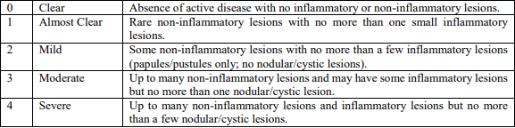

### Current treatment options for acne vulgaris

Acne treatments aim to reduce the number of comedones, reduce inflammation, reduce hyperpigmentation, prevent scarring, and improve psychological wellbeing. Various topical and oral treatments can be used, depending on the severity of the condition. Over-the-counter topical treatments include benzoyl peroxide, azelaic acid, salicylic acid, and glycolic acid. Prescription topical treatments include retinoids and antibiotics. Prescription oral treatments include antibiotics, oral contraceptive pill, anti-androgens, and isotretinoin[2].

### Clinical rationale for Winlevi use in acne vulgaris

Clascoterone cream, 1%, is a new chemical entity, that is purported to target ARs in the skin to block the local effects of circulating endogenous androgens.

Acne is characterized by epithelial hyperkeratinisation, excessive sebum production, with   
*C. acnes* colonisation of the pilosebaceous unit, and inflammation. Within the sebaceous gland, sebocytes convert precursor molecules into androgens including to dihydrotestosterone (DHT). Within sebocytes, DHT binds to ARs in the cytosol. On binding, the DHT-AR complex dimerizes and translocates to the nucleus where it influences transcription of genes involved in acne pathogenesis, including sebum and inflammatory cytokine production. Clascoterone, applied topically to the skin, binds to the AR with high affinity at the site of application, competing with DHT. Results from *in vitro* studies suggest that it thereby limits the effect of DHT on the transcription of genes that modulate sebum production and inflammation.

### Regulatory status

#### Australian regulatory status

This product is considered a new chemical entity for Australian regulatory purposes.

#### International regulatory status

USA: Submitted 19 August 2019. Approved 26 August 2020 for the following indication:

*Winlevi (clascoterone) cream is an androgen receptor inhibitor indicated for the topical treatment of acne vulgaris in patients 12 years of age and older.*

Canada: Submitted 28 June 2022. Approved 15 June 2023 for the following indication:

*Winlevi (clascoterone) is indicated for the topical treatment of acne vulgaris in patients 12 years of age and older.*

EU: Submission planned for October 2023.

##### Regulatory guidance

The clinical development program for Winlevi was informed by US FDA regulatory guidance[3], including Acne Vulgaris: Developing Drugs for Treatment (2005, draft) and Acne Vulgaris: Establishing Effectiveness of Drugs Intended for Treatment (2018)[4]. Key regulatory principles in these documents include:

* efficacy should be demonstrated in randomised, double-blind, well controlled trials that include a placebo arm.
* although acne occurs on the face and trunk, efficacy assessment should be limited to the face because it is the most frequent site of involvement.
* the assessment of treatment effect should be based on both changes in lesion counts and success on the Investigator’s Global Assessment (IGA) severity scale (i.e. quantitative and qualitative assessments).
* inflammatory and noninflammatory lesions should be counted and reported separately.
* absolute and percent change in lesion counts are both relevant, with absolute change recommended for the primary endpoint analysis and percent change for the secondary endpoint analysis.

The Sponsor received regulatory advice from the FDA, including agreement on a special protocol assessment for Study CB-03-01/25 on 30 July 2015 and paediatric study plan on 15 December 2015.

### Registration timeline

This submission was evaluated under the [standard prescription medicines registration process](https://www.tga.gov.au/how-we-regulate/supply-therapeutic-good-0/supply-prescription-medicine/application-process/prescription-medicines-registration-process).

Table 2: Timeline for Winlevi submission PM-2023-00180-1-1

|  |  |
| --- | --- |
| Description | Date |
| Submission dossier accepted and first round evaluation commenced | 28 February 2023 |
| First round evaluation completed | 11 July 2023 |
| Second round evaluation completed | 1 November 2023 |
| Delegate’s[5] Overall benefit-risk assessment and request for Advisory Committee advice | 18 December 2023 |
| Sponsor’s pre-Advisory Committee response | 11 January 2024 |
| Advisory Committee meeting | 23 February 2024 |
| Registration decision (Outcome) | 8 March 2024 |
| Administrative activities and registration in the ARTG completed | 12 March 2024 |
| Number of working days from submission dossier acceptance to registration decision* | 263 |

*Statutory timeframe for standard submissions is 255 working days

## Submission overview and risk/benefit assessment

### Quality evaluation summary

The drug substance, clascoterone (Figure 1), is manufactured by Curia Spain S.A.U. by chemical synthesis in three steps from cortexolone-21-acetate. There are no compendial monographs on clascoterone and the quality of the drug substance is controlled in the specifications to meet relevant ICH guidelines[6]. There are appropriate controls in place for the starting material, intermediates, and critical steps of the synthetic process that ensure the drug substance meets the specification limits. Final specifications are considered appropriate to ensure drug substance quality.

Figure 1. The chemical structure of clascoterone.

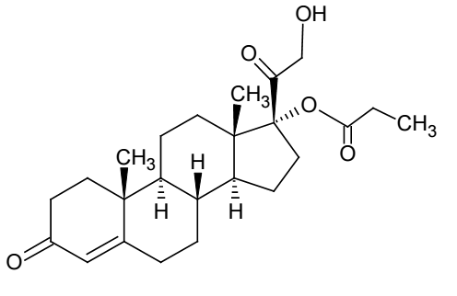

The drug product is a white to almost white homogenous cream packaged in an epoxy-lined blind-ended aluminium tube with a polypropylene screw cap. The proposed tube sizes are 2 g (starter pack), 10 g (starter pack), 30 g and 60 g. Each gram of the cream contains 10 mg of clascoterone. Main vehicles are propylene glycol, liquid paraffin, and water. Polysorbate 80, mono- and di- glycerides are used as emulsifying agents. Cetyl alcohol, dl-alpha-tocopherol and disodium edetate are used as stabilisers and antioxidants. The chosen excipients and their roles are common for this type of drug product. The drug product manufacturing process has been appropriately validated and relevant in-process controls are present. The imposed finished product specifications are sufficient to ensure the quality of the product at release and throughout the shelf-life. Packaging integrity has been demonstrated.

The unopened product should be stored at 2 °C to 8 °C prior to dispensing, with stability studies supporting a shelf-life of 36 months. After dispensing to the patient, the product should be stored at room temperature (below 25 °C). In-use stability studies support an in-use period of 6 months.

Risk assessment on nitrosamine impurities has been provided and is considered acceptable.

The commercial product formulation is the same as that used in Phase 3 clinical efficacy studies.

All GMP clearances are valid and should remain valid for the remainder of this submission.

Approval of the registration of Winlevi is recommended from a pharmaceutical chemistry perspective.

### Nonclinical (toxicology) evaluation summary

The submitted nonclinical (toxicology) dossier was in accordance with the relevant ICH guideline[7] for the non-clinical assessment of pharmaceuticals (ICH M3(R2)). The overall quality of the nonclinical dossier was high. All pivotal safety-related studies were good laboratory practice (GLP) compliant.

*In vitro*, clascoterone was found to bind the human AR with nanomolar affinity, inhibit AR-regulated transcription in a reporter cell line, antagonise androgen-regulated lipid production and inhibit inflammatory cytokine production in human primary sebocytes. Given acne arises from the fatty acid accumulation and inflammation in the sebaceous gland, these effects lend some support to the role of clascoterone in acne treatment. Clascoterone is structurally similar to non-androgen corticosteroids and may exerts its efficacy by means other than the AR. Local anti-inflammatory activity may contribute to efficacy. The set of secondary pharmacodynamic studies do not raise any systemic off-target concerns.

No adverse effects on the respiratory, cardiovascular and central nervous systems are expected in clinical scenarios based on non-clinical safety pharmacology studies.

Clascoterone was shown to penetrate human skin in a formulation-dependent manner. Low systemic exposure to clascoterone was apparent in all species (and humans) after dermal administration. Plasma protein binding of clascoterone was moderate in all animal species and humans. The main human metabolite (cortexolone) was also seen in animals. *In vitro* and *ex vivo* studies indicated that metabolism of clascoterone can occur in the skin, plasma and liver. Overall, the pharmacokinetic profile in animals was adequately similar to that of humans.

Based on the available data and considering the extent of systemic exposure, pharmacokinetic drug interactions mediated by clascoterone are not expected in patients.

Clascoterone had a higher order of acute toxicity in rats compared to mice when administered intravenously, whereas low order of acute toxicity was seen in both species when administered subcutaneously. Given low clascoterone exposure is expected in clinical scenarios, no acute safety concern is raised.

Pivotal repeat-dose toxicity studies were conducted in rats via the SC route to achieve high systemic exposures for a worst-case-scenario situation and in minipigs with the clinical formulation via the dermal route. The systemic effects seen at high relative exposures were expected glucocorticoid effects: adrenal suppression and immunosuppression. These effects are not expected in patients at typical clinical doses.

Dermal reactions (including erythema, epidermal or dermal atrophy and/or mucinous change in skin) were observed at the treatment site in vehicle- and, to a greater extent, clascoterone-treated groups following repeated dermal administration in minipigs. The no effect concentration was not established. While these changes were generally reversible the results still suggest a potential for local reactions at the application site due to clascoterone pharmacology.

A weight of evidence approach indicates clascoterone does not pose a genotoxic concern. There was no evidence of drug-related tumours at the application site in a dermal rat carcinogenicity study.

In a rat fertility study, adverse effects on male reproductive organs and testicular sperm count were seen. An increase in pre-implantation loss was also seen in females. However, given the margin at the NOAEL, adverse effects on fertility are not expected during clinical use. Drug-related teratogenicity and embryofetal death were seen in rat and rabbit embryofetal development studies, respectively. Given a NOAEL for teratogenicity could not be determined in rats, Pregnancy category D is recommended. No adverse effects on postnatal development were seen in rats following maternal exposure.

Clascoterone is not expected to be an ocular irritant or skin sensitiser in clinical scenarios.

Non-clinical conclusions

* The primary pharmacology studies lend some support for the drug’s use in the proposed indication.
* The only clinically-relevant findings in the general toxicity program were dermal reactions. However, concerns for systemic effects may exist in paediatric patients receiving high doses.
* Clascoterone should be avoided in pregnancy.
* There are no non-clinical objections to the registration of Winlevi cream.

### Clinical evaluation summary

#### Summary of clinical studies

The clinical dossier included:

* Six phase 1 studies in healthy subjects and subjects with acne vulgaris:
  + Study CB-03-01/02: single ascending dose PK study in healthy adult male subjects.
  + Study CB-03-01/04: repeat-dose PK study in healthy adult subjects.
  + Study CB-03-01/05: repeat-dose study in healthy adult subjects to evaluate potential cumulative skin irritation.
  + Study CB-03-01/32: repeat-dose study in healthy adult subjects to determine potential to induce sensitisation.
  + Study CB-03-01/33: repeat-dose QT/QTc study in healthy adult subjects.
  + Study 171-7151-203: repeat-dose safety/PK study in adults with acne vulgaris.
* Four phase 2 dose-range or maximal use studies in subjects with acne vulgaris:
  + Study 171-7151-202: maximal use HPA/PK study to evaluate adrenal suppression potential and PK in adults and adolescents with acne vulgaris.
  + Study CB-03-01/28: maximal use HPA/PK study to evaluate adrenal suppression potential and PK in children aged 9 to 11 years with acne vulgaris.
  + Study CB-03-01/03: comparative pilot study in adult with acne vulgaris.
  + Study 171-7151-201: dose-ranging study in patients aged ≥12 years.
* Three phase 3 efficacy and safety studies in subjects ≥9 years old with acne vulgaris:
  + Studies CB-03-01/25 and CB-03-01/26, pivotal 12-week efficacy/safety studies.
  + Study CB-03-01/27: open-label long-term follow-up study.

The proposed commercial formulation of clascoterone 1% cream was used in all clinical studies except the QT study which used a 7.5% solution formulation to achieve a supratherapeutic dose.

#### Pharmacology

##### Pharmacokinetics

Clascoterone 1% cream is for topical application to the skin. The phase 1 and 2 pharmacokinetic (PK) studies are summarised below. Across the PK studies in healthy subjects and patients with acne vulgaris, clascoterone systemic exposure was very low or non-quantifiable following topical administration. In the single ascending dose study, systemic exposure was not proportional to the dose applied.

The Phase 2 Study 171-7151-202 evaluated the PK of clascoterone 1% cream under maximal use conditions in adults and adolescents with acne vulgaris. cohort 1 included 20 patients aged ≥18 years and cohort 2 included 22 patients aged 12 to <18 years. Subjects were instructed to apply 6 g of clascoterone 1% cream (or 4 g for subjects <18 years old with BSA ≤1.6m2) twice daily for 14 days. PK steady-state was achieved by Day 5. At steady-state, plasma concentrations increased ~2-fold compared to the first dose. On Day 14, mean Cmax was 4.5 ng/mL and mean AUCt was 37.1 ng*h/mL. Clascoterone systemic exposure was similar for adults and adolescents. Plasma concentrations of the metabolite, cortexolone, were generally below the lower limit of quantitation in both adult and adolescent subjects.

The PK of clascoterone 1% cream in patients aged 9 to <12 years was evaluated in the Phase 2 Study CB-03-01/28. The objectives of this maximal use study were to determine the adrenal suppression potential and the trough plasma concentrations associated with topical application of clascoterone 1% cream. Subjects were instructed to apply 2 g of clascoterone 1% cream (1 g on face and 1 g on trunk) twice daily for 14 days. Morning trough plasma concentrations of clascoterone and cortexolone were generally near or below the lower limit of quantitation.

The excretion of clascoterone has not been fully characterised due to the low systemic exposure. In the PK studies, less than 1% of the applied dose of clascoterone was excreted in urine (in conjugated form).

Based on the low systemic exposure, the effects of renal or hepatic impairment of the PK of clascoterone were not evaluated in the clinical trial program. The risk for clinically relevant PK interactions with topically administered clascoterone is expected to be low based on the low systemic exposure and findings from *in vitro* studies.

##### Pharmacodynamics

The pharmacodynamic effect of clascoterone in patients with acne vulgaris has not been directly evaluated.

##### Hypothalamic-pituitary-adrenal axis suppression

The main metabolite of clascoterone is cortexolone, which is an intermediate in the synthesis of glucocorticoids and exhibits weak glucocorticoid properties. Two maximal use studies were conducted to evaluate the potential for suppression of the hypothalamic-pituitary-adrenal (HPA) axis. HPA axis suppression potential was evaluated in 20 adults (cohort 1) and 22 adolescents aged 12 to <18 years (cohort 2) in Study 171-7151-202 and 27 children aged 9 to <12 years in Study CB-03-01/28. Subjects were treated with clascoterone 1% cream twice daily for 14 days.

In Study 171-7151-202, 1 of 20 (5.0%) adult subjects in cohort 1 and 2 of 22 (9.1%) adolescent subjects in cohort 2 demonstrated laboratory evidence of abnormal HPA axis response on cosyntropin stimulation test (CST) at day 14/EOS as defined by a 30-minute post-stimulation serum cortisol level ≤18 µg/dL. All 3 subjects demonstrated only a small reduction below normal post-stimulation cortisol levels (Adult Subject 02-107: 17.7 µg/dL; Adolescent Subject 01-206: 17.0 µg/dL; Adolescent Subject 03-203: 14.9 µg/dL). All ‘suppressed’ subjects returned to normal HPA axis function (as assessed by CST) at their initial follow-up visit ∼4 weeks after Day 14/EOS.

In Study CB-03-01/28, 4 enrolled subjects were excluded from the Evaluable population for the following reasons: did not meet all inclusion/exclusion criteria (3), and Day 14 CST was not conducted within one hour of Screening CST between 7-9am (1). Two of 23 (8.7%) subjects in the Evaluable population demonstrated laboratory evidence of abnormal HPA axis response on CST at Day 14/EOS as defined by a 30-minute post-stimulation serum cortisol level ≤18 µg/dL. The 30-minute post-stimulation serum cortisol levels in these subjects were 16.1 μg/dL and 18.0 μg/dL. Both subjects returned to normal HPA axis level (as assessed by CST) at their initial follow-up visit ∼4 weeks after Day 14/EOS. In the total population, HPA axis suppression was observed in 4 of 27 (15%) subjects aged 9 to <12 years.

##### QT

Study CB-03-01/33 was a thorough QT study to evaluate the effect of systemically absorbed clascoterone (and its metabolites) on QT interval following repeat topical administration of a supratherapeutic dose. It was a double-blind vehicle control study in 32 healthy adult male and female subjects. Subjects were randomised 3:1 to receive 225 mg of clascoterone applied topically as a 7.5% solution (75 mg/1 mL) twice daily for 3 days and then a single morning dose on Day 4, or matching placebo.

After topical administration of a single dose, Tmax was at 5 hours, mean Cmax was 2.26 ng/mL and AUC0-12 19.96 ng*h/mL. After multiple dosing, the PK data suggested steady state was reached by ∼24 hours post-first dose. Mean Cmax on Day 1 was 4.81 ng/mL and on Day 4 was 7.65 ng/mL. Mean AUC0-24 on Day 1 was 57.28 ng*h/mL and on Day 4 was 113.94 ng*h/mL.

The predicted effect on QTcF of the topically applied clascoterone solution at the geometric mean Cmax was -0.45 ms (90% CI: -4.0, 3.1). The study met the criteria for a negative QT study, with the upper bound of the two-sided 90% confidence interval falling below 10 ms with respect to the dose tested.

#### Efficacy

##### Phase 2 studies

###### Study CB-03-01/03

This was a Phase 2, randomised, double-blind, vehicle-controlled study. The primary objective was to evaluate the efficacy of clascoterone 1% cream compared to 0.5% tretinoin (Retin-A) cream and vehicle for the treatment of acne vulgaris. Treatment was administered to the face at night for 8 weeks.

The study included adult male patients with facial acne vulgaris with Investigator Global Assessment (IGA) score of 2 (mild) or 3 (moderate), 20 to 100 Total Lesion Count (TLC), and 10 to 50 Inflammatory Lesion Count (ILC).

The primary efficacy endpoints (Table 3) were:

* Percent improvement of TLC and ILC at Week 8.
* Percent of subjects with success, defined as an IGA score of clear or almost clear (0 or 1; 0 if the baseline score was 2) at Week 8.

Table 3. Study CB-03-01/03 efficacy endpoints (intent-to-treat population)

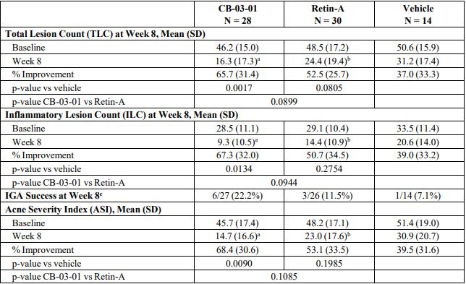

ITT = intent-to-treat; SD = standard deviation a N = 27 b N = 26 c Percent of success was calculated on the available data by treatment group; at Week 8 (Visit 4), 5 frequencies were missing.

###### Study 171-7151-201

This was a Phase 2, randomised, double-blind, vehicle-controlled, consecutive group dose escalation study conducted at 15 sites in the USA over 12 weeks. The primary objective was to compare the safety and efficacy of topical clascoterone creams containing 0.1% (BID), 0.5% (BID) or 1% (QD or BID) CB-03-01 and the vehicle cream (QD or BID) in subjects with facial acne vulgaris.

The study included male and female subjects aged 12 years or older with acne vulgaris Grade 2 to 4 on the face as measured on the Investigator’s Global Assessment (IGA) Scale. 363 subjects were enrolled and randomised to treatment with clascoterone 0.1% BID (n=72), clascoterone 0.5% BID (n=76), clascoterone 1% QD (n=70), clascoterone 1% BID (n=70), or vehicle QD or BID (n=75). The primary efficacy endpoints (Table 4) were:

* Proportion of subjects with treatment success, defined as an IGA score of clear or almost clear (0 or 1) AND at least a 2-point improvement from baseline at Week 12/EOS
* Absolute change from baseline in ILC and non-inflammatory lesion count (NILC) at Week 12/EOS.

Table 4. Study 171-7151-201 - Primary Efficacy Endpoints (ITT Population)

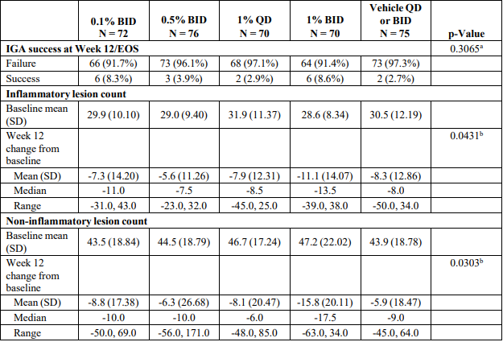

BID = twice daily; EOS = end of study; ITT = intent-to-treat; QD = once daily; SD = standard deviation. a Fisher’s exact test (2-tailed) b Rank analysis of covariance, ITT: 1% BID < 0.5%, 1% QD, and vehicle.

The submission included two pivotal 12-week, randomised, double-blind, vehicle-controlled studies (CB-03-01/25 and CB-03-01/26) plus a 9-month open-label long-term follow-up study (CB-03-01/27) for subjects who completed either of the pivotal studies. The pivotal studies shared the same study design, which was informed by regulatory guidance from the US FDA. Dose selection for the pivotal studies was informed by systemic safety data from the maximal use PK study (171-7151-202) and efficacy and safety data from the phase 2 comparative pilot study (CB-03-01/03) and dose-ranging study (171-7151-201).

###### Study CB-03-01/25

This was a Phase 3, randomised, multicentre, double-blind, vehicle-controlled study to evaluate the efficacy and safety of clascoterone 1% cream applied twice daily for 12 weeks in subjects with moderate to severe facial acne vulgaris. The study was conducted between January 2016 and April 2018 at 55 centres (45 in USA, 7 in Ukraine, 3 in Republic of Georgia).

The study plan consisted of a screening/baseline visit (visit 1), two follow-up visits after 4 and 8 weeks of treatment (visit 2 and visit 3), and a final visit (visit 4) at the end of the 12-week treatment period.

The study included subjects aged 9 years or older with acne vulgaris on the face with IGA score of 3 (moderate) or 4 (severe), 30 to 75 ILC, and 30 to 100 NILC. Subjects with >2 facial nodules or nodulocystic acne were excluded. Subjects were not permitted to use topical anti-acne treatments within 2 weeks of initiation of study treatment, retinoids within 4 weeks of initiation of study treatment, or light treatments, microdermabrasion or chemical peels within 8 weeks of initiation of study treatment.

Study treatment was clascoterone 1% cream or vehicle cream applied to the face twice daily for 12 weeks. Subjects were instructed to apply about 1 gram of the cream to the face by dabbing small amounts gently on multiple regions of the face. Using a fingertip, the cream was spread to provide a thin, uniform layer of the cream over the entire face.

708 subjects were enrolled and randomised 1:1 to treatment with clascoterone (N=353) or vehicle (N=355). Overall, 577 (81.5%) subjects completed the study. 66 subjects from the clascoterone arm and 65 subjects from the vehicle arm discontinued from the study, the most common reason in each group being Lost to follow up.

Patient demographics were generally balanced across treatment groups. Overall, 61.6% of subjects were female and median age was 18 years (range 9 to 58 years). There were only 16 subjects <12 years old, 11 in the clascoterone arm and 5 in the vehicle arm. 34.3% of subjects had Fitzpatrick skin type III, 31.4% type II, 17.9% type IV, 7.3% type VI, 7.1% type V, and 2.0% type I. All subjects had baseline IGA score of 3 or 4, with the majority (∼82%) having a baseline score of 3. Baseline acne lesion counts are summarised in Table 5.

Table 5. Baseline Acne Lesion Count (ITT Set), Study CB-03-01/25

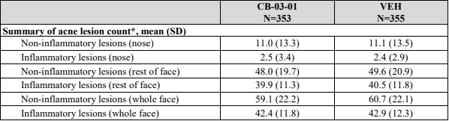

The primary efficacy endpoints (hierarchical) were:

* **P1**: Proportion of subjects in each treatment group achieving “success” at Week 12, with “success” defined as an IGA score of “clear (score=0)” or “almost clear (score=1)” AND at least a two-point reduction in IGA compared to Baseline.
* **P2**: Absolute change from Baseline in NILC in each treatment group at Week 12.
* **P3**: Absolute change from Baseline in ILC in each treatment group at Week 12.

The secondary efficacy endpoints (hierarchical) were:

* **S1**: Absolute change from Baseline in TLC in each treatment group at Week 12.
* **S2**: Percent change from Baseline in TLC in each treatment group at Week 12.
* **S3**: Percent change from Baseline in NILC in each treatment group at Week 12.
* **S4**: Percent change from Baseline in ILC in each treatment group at Week 12.

The hypothesis tests for the primary and secondary efficacy endpoints were performed in hierarchical order at the significance level α=0.05 two-sided. The ITT set (all randomised subjects) was used for the primary analysis.

All three of the primary endpoints were met (Table 6, Table 7, Table 8). Planned sensitivity analyses on the PP set, and on the ITT set using different methods of imputation for missing data, were generally supportive of the primary analysis. Findings for all four of the secondary efficacy endpoints were also statistically significant (Table 9, Table 10, Table 11, Table 12).

Table 6. P1: Proportion of subjects achieving IGA “Success” at Week 12 (ITT Set), Study CB-03-01/25

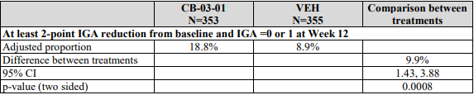

The 95% CI relates to the adjusted odds ratio (point estimate 2.36).

Table 7. P2: Absolute Change from Baseline in NILC at Week 12 (ITT Set), Study CB-03-01/25

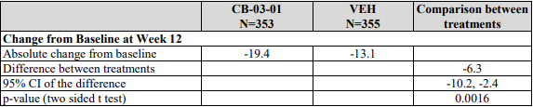

Table 8. P3: Absolute Change from Baseline in ILC at Week 12 (ITT Set), Study CB-03-01/25

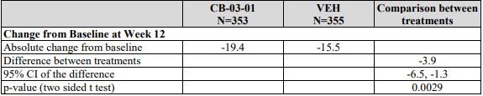

Table 9. S1: Absolute Change from Baseline in TLC at Week 12 (ITT Set), Study CB-03-01/25

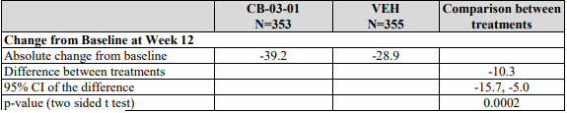

Table 10. S2: Percent Change from Baseline in TLC at Week 12 (ITT Set), Study CB-03-01/25

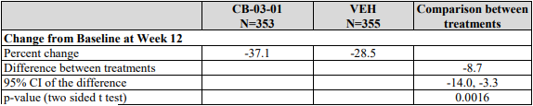

Table 11. S3: Percent Change from Baseline in NILC at Week 12 (ITT Set), Study CB-03-01/25

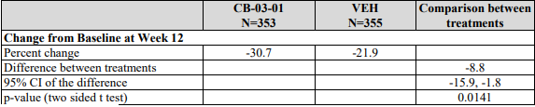

Table 12. S4: Percent Change from Baseline in ILC at Week 12 (ITT Set), Study CB-03-01/25

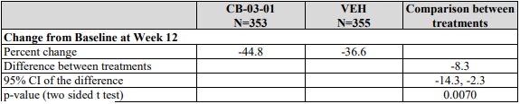

Subgroup analyses are presented in the pooled analysis. A *post-hoc* subgroup analysis of the primary endpoints of Study CB-03-01/25 based on age are presented below. The number of patients in the 9 to 11 year age group was small and no treatment effect was observed in this age group for any of the primary efficacy measures (Table 13, Table 14, Table 15). The study was not powered to demonstrate significant benefit in age subsets, but efficacy findings for subjects ≥12 years of age (Table 16) were generally similar to the adult population.

Table 13. Age Subgroup Analysis for proportion of subjects with at least a two-point reduction in IGA compared to baseline and an IGA score of 0 or 1 at Week 12 – Logistic Regression – MI under MAR, ITT (CB-03-01/25)

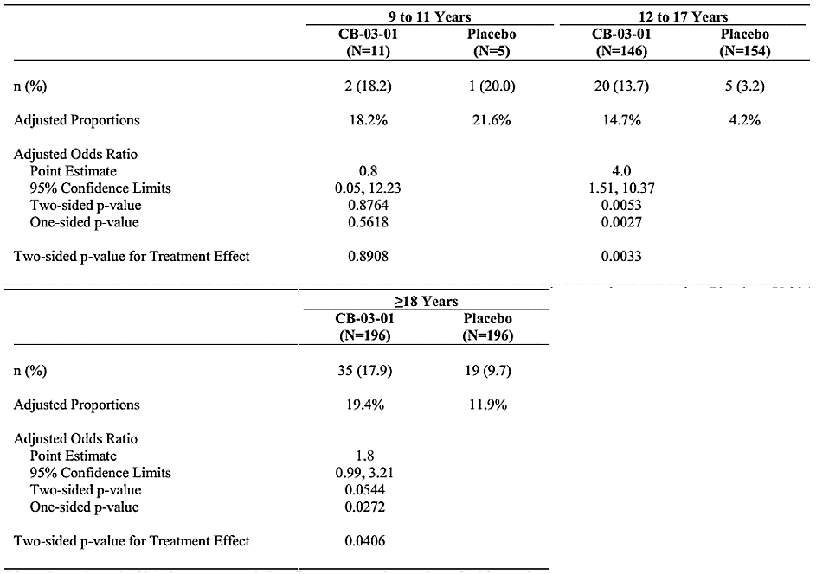

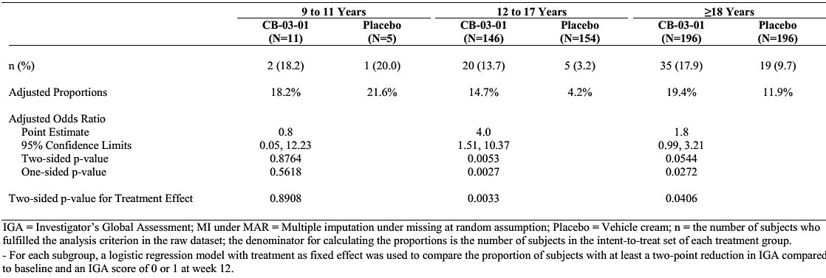

Table 14. Age Subgroup Analysis for absolute change from baseline in NILC at Week 12 – ANCOVA – MI under MAR, ITT (CB-03-01/25)

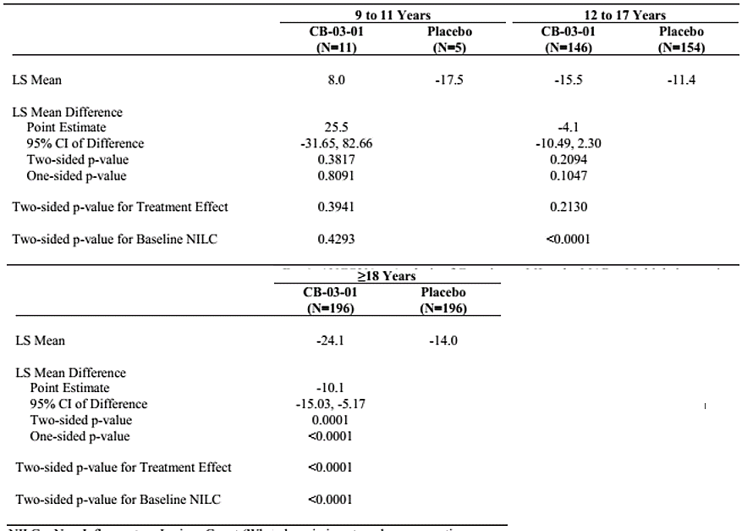

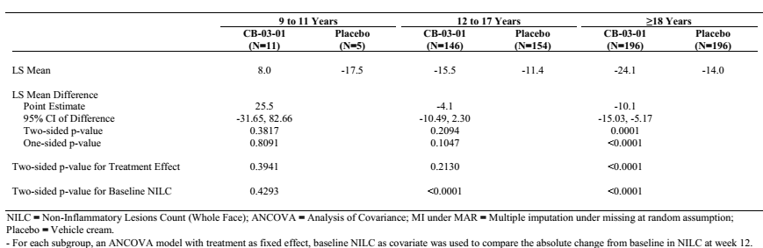

Table 15. Age Subgroup Analysis for absolute change from baseline in ILC at Week 12 – ANCOVA – MI under MAR, ITT (CB-03-01/25)

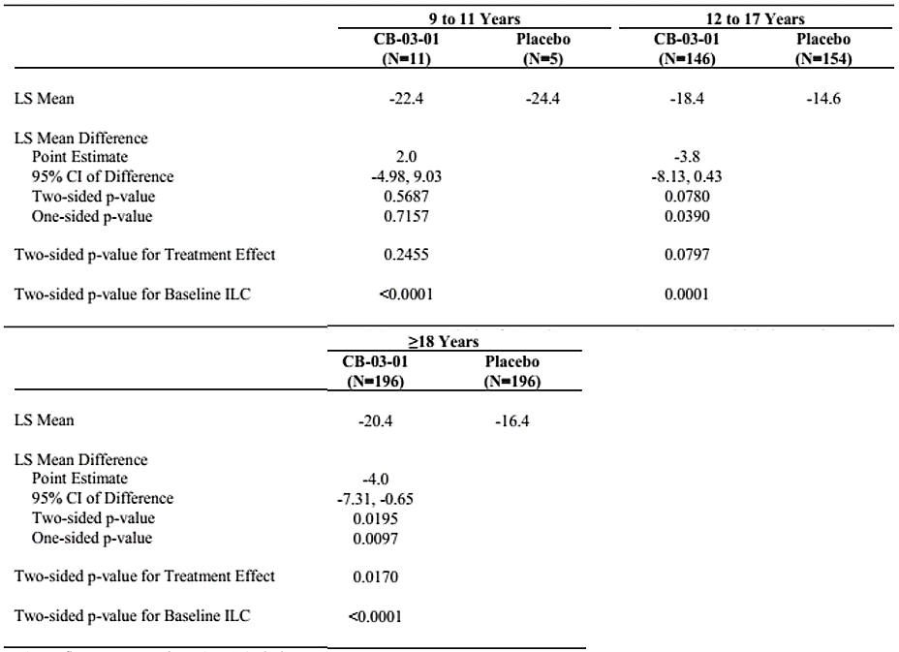

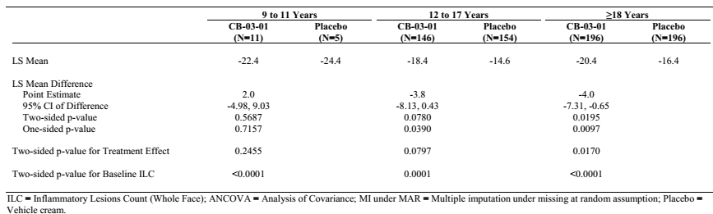

Table 16. Results of the primary endpoints at Week 12 in subjects ≥12 years of age, Study CB-03-01/25 (Trial 1) and CB-03-01/26 (Trial 2)

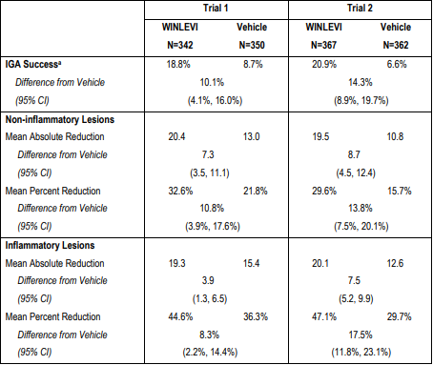

a IGA success was defined as at least a 2-point reduction in IGA compared to baseline and an IGA score of 0 (clear) or 1 (almost clear).

###### Study CB-03-01/26

This was a Phase 3, randomised, multicentre, double-blind, vehicle-controlled study to evaluate the efficacy and safety of clascoterone 1% cream applied twice daily for 12 weeks in subjects with facial acne vulgaris. The study was conducted at 48 sites in Bulgaria, Republic of Georgia, Poland, Romania, Serbia, and USA between November 2015 and February 2018.

The study design, objectives, population, endpoints, and statistical analysis were the same as CB-03-01/25.

732 subjects were enrolled and randomised 1:1 to treatment with clascoterone 1% cream (N=369) or vehicle cream (N=363) applied to the face twice daily for 12 weeks. Overall, 584 subjects (79.8%) completed the study. 67 subjects (18.2%) in the clascoterone arm and 81 subjects (22.3%) in the vehicle arm discontinued from the study, the most common reasons being *Withdrawal by subject* and *Lost to follow up*.

Patient demographics were generally balanced across the treatment groups. Overall, 63.4% of subjects were female and median age was 18 years (range 10 to 50 years). There were only 3 subjects aged <12 years, 2 in the clascoterone arm and 1 in the vehicle arm. 45.9% of subjects had Fitzpatrick skin type III, 31.3% type II, and 15.2% type IV, 3.8% type V, 12.6% type I, and 1.2% type VI. All subjects had baseline IGA score of 3 or 4, with the majority (∼84% overall) having a baseline score of 3. Baseline acne lesion counts are summarised in Table 17.

Table 17. Baseline Acne Lesion Count (ITT Set), Study CB-03-01/26

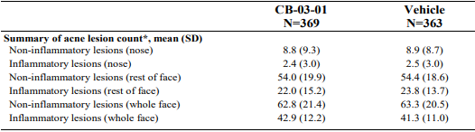

The primary efficacy endpoints (hierarchical) were:

* **P1**: Proportion of subjects in each treatment group achieving “success” at Week 12, with “success” defined as an IGA score of “clear (score=0)” or “almost clear (score=1)” AND at least a two-point reduction in IGA compared to Baseline.
* **P2**: Absolute change from Baseline in NILC in each treatment group at Week 12.
* **P3**: Absolute change from Baseline in ILC in each treatment group at Week 12.

The secondary efficacy endpoints (hierarchical) were:

* **S1**: Absolute change from Baseline in TLC in each treatment group at Week 12.
* **S2**: Percent change from Baseline in TLC in each treatment group at Week 12.
* **S3**: Percent change from Baseline in NILC in each treatment group at Week 12.
* **S4**: Percent change from Baseline in ILC in each treatment group at Week 12.

All three primary endpoints were met (Table 18, Table 19, Table 20). Planned sensitivity analyses on the PP set, and the ITT set using different methods of imputation for missing data, were generally supportive of the primary analysis. Statistically significant findings were seen for all four of the secondary efficacy endpoints (Table 21, Table 22, Table 23, Table 24).

Table 18. P1: Proportion of subjects achieving IGA “Success” at Week 12 (ITT Set), Study CB-03-01/26

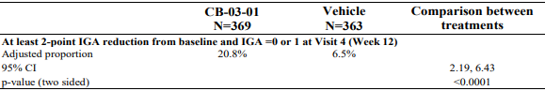

The 95% CI relates to the adjusted odds ratio (point estimate 3.76).

Table 19. P2: Absolute Change from Baseline in NILC at Week 12 (ITT Set), Study CB-03-01/26

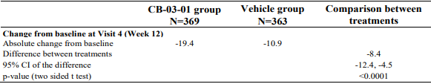

Table 20. P3: Absolute Change from Baseline in ILC at Week 12 (ITT Set), Study CB-03-01/26

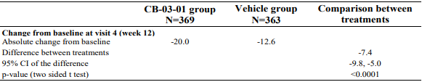

Table 21. S1: Absolute Change from Baseline in TLC at Week 12 (ITT Set), Study CB-03-01/26

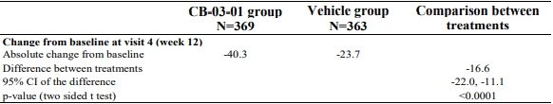

Table 22. S2: Percent Change from Baseline in TLC at Week 12 (ITT Set), Study CB-03-01/26

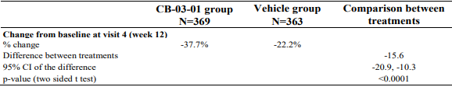

Table 23. S3: Percent Change from Baseline in NILC at Week 12 (ITT Set), Study CB-03-01/26

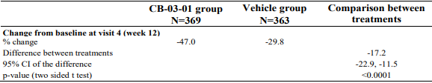

Table 24. S4: Percent Change from Baseline in ILC at Week 12 (ITT Set), Study CB-03-01/26



###### Pooled analyses

The two pivotal studies shared the same study design so were suitable for pooled analyses. Efficacy findings in the pooled population are presented in Table 25 (primary endpoints) and Table 26 (secondary endpoints).

Table 25. Analysis of Co-Primary Efficacy Endpoints by Study and Pooled (ITT Population)

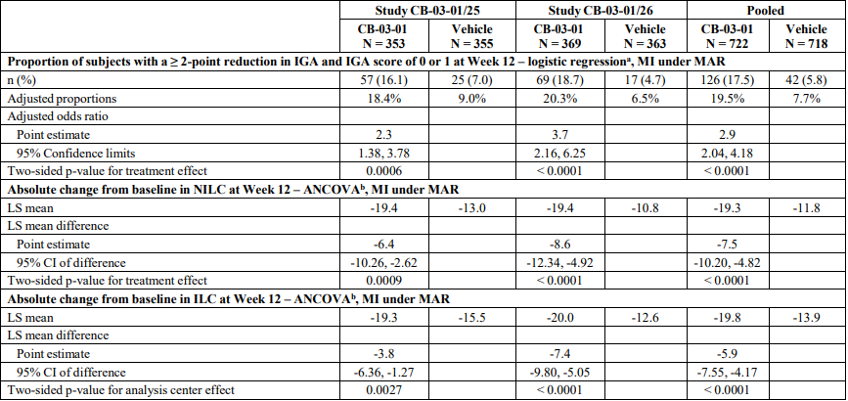

Table 26. Analysis of Secondary Efficacy Endpoints by Study and Pooled (ITT Population)

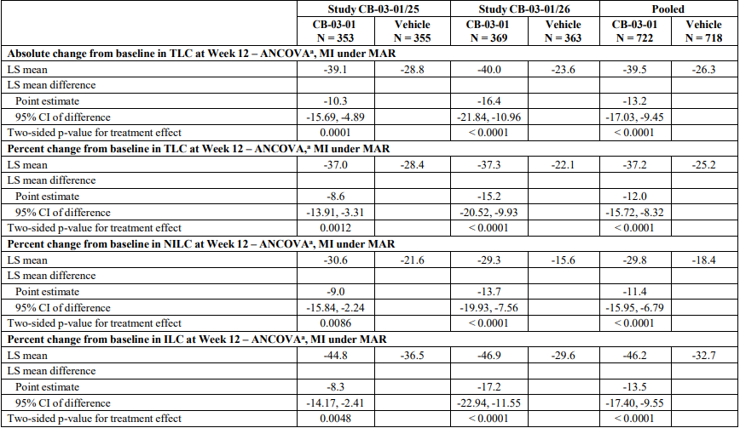

Subgroup analyses based on gender and age (9 to <18 years, 18 to <65 years) were consistent with the primary analysis. The number of patients in the 9 to <12 year age group was low and post-hoc subgroup analyses showed no treatment effect in this age group for any of the primary efficacy endpoints (Table 27, Table 28, Table 29).

Table 27. Age Subgroup Analyses for proportion of subjects with at least a 2-point reduction in IGA compared to baseline and an IGA score of 0 or 1 at Week 12 – Logistic Regression – MI under MAR – Pooled (ITT, N=1440)

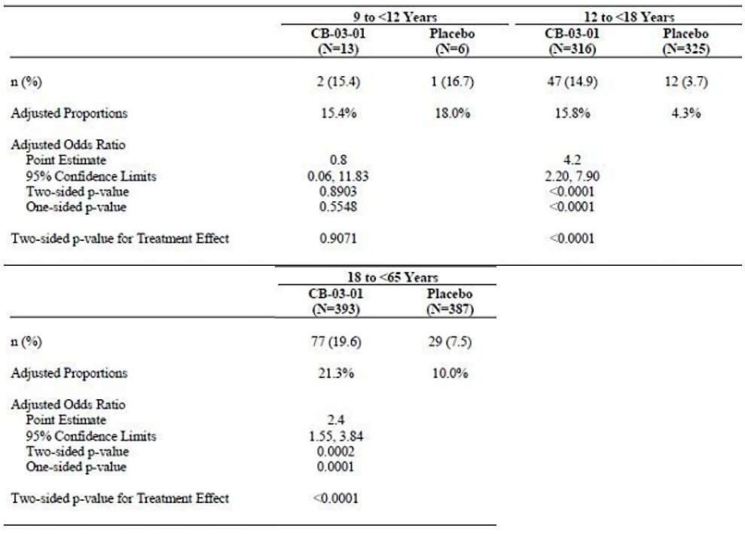

Table 28. Age Subgroup Analyses for absolute change from baseline in NILC at Week 12 – ANCOVA – MI under MAR – Pooled (ITT, N=1440)

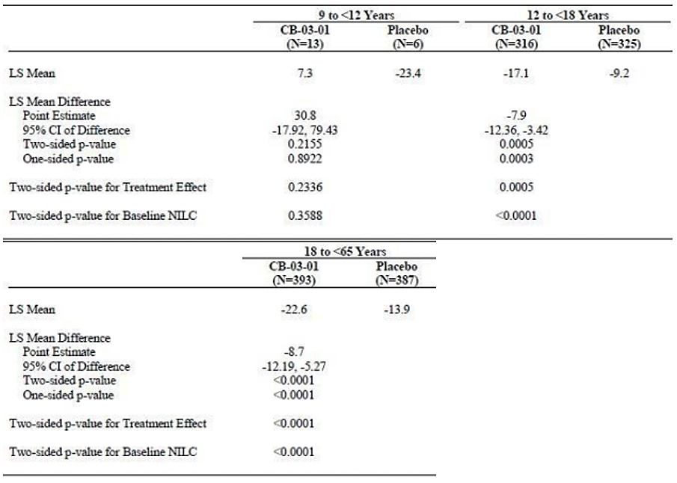

Table 29. Age Subgroup Analyses for absolute change from baseline in ILC at Week 12 – ANCOVA – MI under MAR – Pooled (ITT, N=1440)

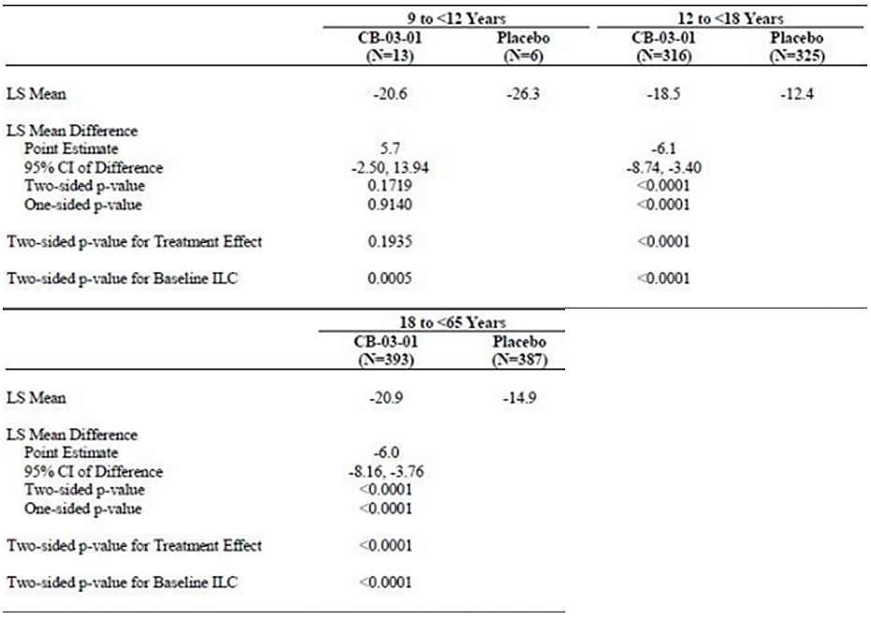

In the pooled population, 73.8% of subjects had Fitzpatrick skin type I, II, or III and 26.2% had type IV, V, or VI. In subgroup analyses based on skin type, the treatment effect in subjects with skin type IV, V, or VI was not statistically significant but numerically favoured clascoterone.

###### Study CB-03-01/27

This was an open-label, long-term extension study to evaluate the safety of clascoterone 1% cream BID over an additional 9 months in patients who completed either of the Phase 3 studies. Subjects rolled over into this study within 3 days of Visit 4 (Week 12) in the pivotal study. Evaluation of efficacy was not a stated objective of this open-label study, but IGA scores were assessed throughout the study. Subjects applied clascoterone 1% cream BID to the face and, if designated by the investigator and desired by the subject, to the trunk for an additional 9 months. Treatment on the face and/or trunk could be discontinued if acne cleared (IGA=0) or almost cleared (IGA=1), and restarted if acne worsened (IGA ≥2), according to the assessment of the investigator.

Of the 609 enrolled subjects (317 randomised to clacoterone and 292 randomised to vehicle in the pivotal studies), 57.2% completed the study. 2 subjects were not treated with study drug and were excluded from the safety population. The most common reasons for discontinuation were Withdrawal by subject or parent or guardian (18.6%) and Lost to follow up (14.8%).

Duration of exposure across the double-blind and extension studies is summarised in Table 30. The mean daily amount of study drug applied to the face and trunk (where applicable) in the safety population was 2.3 g of clascoterone (range 0.2 to 13.0 g). Efficacy findings in terms of IGA score clear (0) or almost clear (1) at the investigator’s last assessment and at 12 months (face) or 9 months (trunk) are presented in Table 31.

Table 30. Duration of Exposure to Clascoterone Across Controlled and Follow-up Studies (Safety Population)

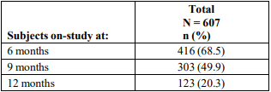

Table 31. Subjects with IGA Score 0 or 1 at Investigator’s Last Assessment and at 9 or 12 Months, CB-03-01/27

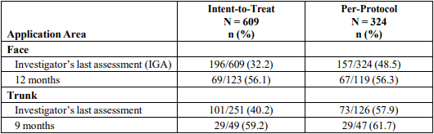

#### Safety

The safety of Winlevi was informed primarily by the two pivotal phase 3 studies and the 9-month open-label extension study. Safety data from the Phase 3 studies were supported by four Phase 2 studies and six Phase 1 studies, including repeat-dose studies evaluating potential cumulative skin irritation, potential to induce sensitisation, and effect on QT.

The safety evaluation presented two pooled safety datasets: Pool A (studies CB-03-01/25 and CB-03-01/26) and Pool B (Pool A plus the clascoterone 1% BID and vehicle BID groups from the 12-week Phase 2 Study 171-7151-201). In Pool A, 722 subjects were treated with clascoterone 1% cream (13 children aged 9 to <12 years, 316 adolescents aged 12 to <18 years, and 393 adults aged 18 to <65 years) and 718 were treated with vehicle (6 children aged 9 to <12 years, 325 adolescents aged 12 to <18 years, and 387 adults aged 18 to <65 years). In Pool B, 792 subjects were treated with clascoterone 1% cream and 773 were treated with vehicle.

Across all of the clinical studies, 1757 subjects have been exposed to at least 1 application of clascoterone at any concentration and regimen, including 352 healthy subjects and 1405 subjects with acne (Table 32). Duration of exposure to clascoterone 1% cream BID in the Pooled Analysis Studies (171-7151-201, CB-03-01/25, CB-03-01/26) and the Long-term Follow-up Study (CB-03-01/27) is summarised in Table 33. 416 subjects were treated with clascoterone 1% cream for at least 6 months and 123 for at least 12 months (Table 30).

Table 32. Total Number of Subjects in the Safety Population by Study

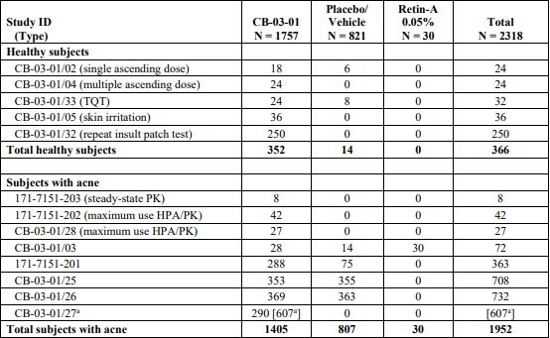

a Of the 607 subjects, all of whom were included in previous studies, 290 had received vehicle and 317 had received CB-03-01 in the previous controlled studies, CB-03-01/25 or CB-03-01/26.

Table 33. Duration of Exposure to clascoterone 1% cream BID in studies included in the Pooled Analysis and the Long-term Follow-up Study (CB-03-01/27)

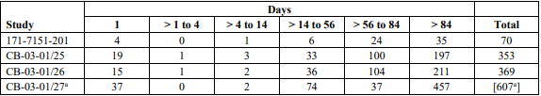

a Of the 607 subjects, all of whom were included in previous studies, 290 had received vehicle and 317 had received CB-03-01 in the previous controlled studies, CB-03-01/25 or CB-03-01/26.

##### Pool A (pivotal studies)

Safety endpoints in the pivotal studies were: local and systemic AEs at every visit (baseline, weeks 4, 8, and 12), local skin reactions at every visit, urinary pregnancy tests in all women of child-bearing potential at every visit, and changes from baseline in ECGs at week 12.

In the two pivotal studies, treatment-emergent adverse events (TEAEs) were reported in 11.4% of clascoterone-treated subjects and 12.7% of vehicle-treated subjects (Table 34). The only TEAE reported for ≥1% of subjects in either treatment group in pool A was nasopharyngitis (Table 35). The only TEAE assessed as treatment-related and reported for more than 1 subject treated with clascoterone was application site dryness (reported for 2 subjects (0.3%) in each treatment group). Most TEAEs were mild or moderate in severity, and no severe TEAEs were reported in the clascoterone group.

No serious TEAEs were reported with clascoterone in the pivotal studies, and TEAEs leading to dose modification or discontinuation of study drug were similar between clascoterone and vehicle (Table 36). In the clascoterone group, TEAEs that led to dose interruption were application site dryness, bronchitis, dry skin, furuncle, oropharyngeal pain, and pyrexia. TEAEs that led to discontinuation of study drug were contac dermatitis, hair colour changes, sebaceous hyperplasia, application site hypersensitivity, and oropharyngeal pain (each in 1 patient).

Local skin reactions were investigated as adverse events of special interest. There were no serious skin reactions across the clinical development program. The proportion of subjects experiencing local skin reactions was similar between the treatment groups (Table 36). Application site hypersensitivity was reported for one subject treated with clascoterone in Study CB-03-01/25 (the event was reported as mild, probably related to study drug, and resolved, and led to study drug discontinuation).

The incidence of psychiatric TEAEs was low and these were balanced between the active and the vehicle treatment groups. None of these events were judged to be related to clascoterone.

The incidence of TEAEs was similar with regard to gender, race, and baseline disease severity. A higher proportion of children aged 9 to <12 years experienced TEAEs (23.1%) compared to adolescents (10.8%) or adults (11.5%), but this was based on only 13 children (Table 37).

Table 34. Overall Summary of TEAEs in Phase 3 Pivotal Studies (Pool A, Safety Population)

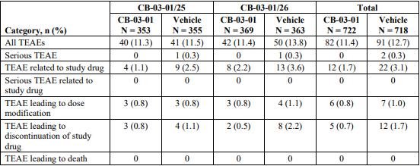

Table 35. TEAEs Reported for ≥1% of Subjects in Either Treatment Group in Phase 3 Pivotal Studies (Pool A, Safety Population)

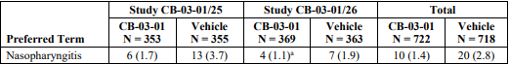

Table 36. Number (Percentage) of Subjects with Treatment-Emergent (New or Worsening) Local Skin Reactions After Day 1 by Severity in Pooled Phase 3 Pivotal Studies (Safety Population)

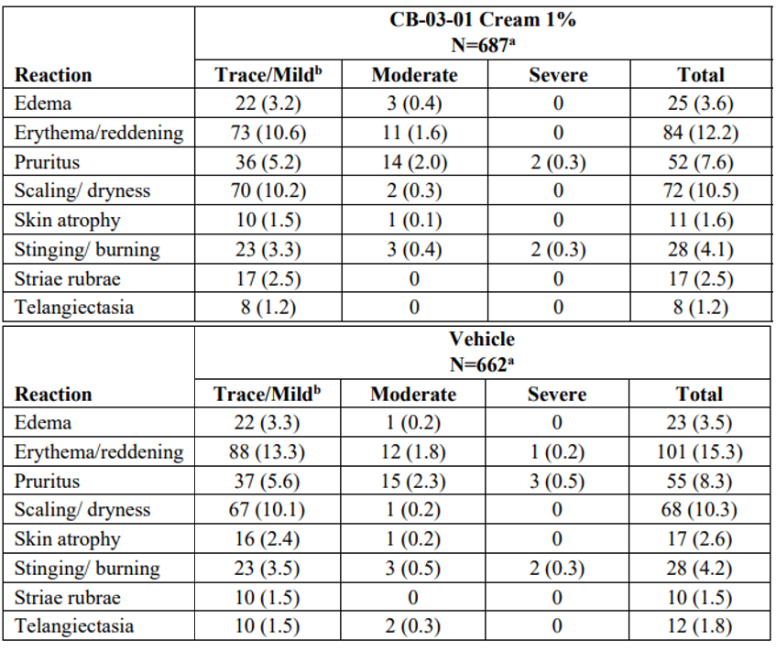

a The denominators for calculating the percentages were the 687 of 722 patients treated with Winlevi cream and 662 of 718 patients treated with vehicle in these studies who had local skin reaction results reported after Day 1. b Minimal or mild for oedema, erythema, and scaling/dryness; minimal for stinging/burning; and mild for pruritus.

Table 37. Overall Summary of TEAEs by Subgroups of Age, Gender, Race, and Baseline IGA for Clascoterone Cream 1% BID Group in Pooled Phase 3 Pivotal Studies (Safety Population)

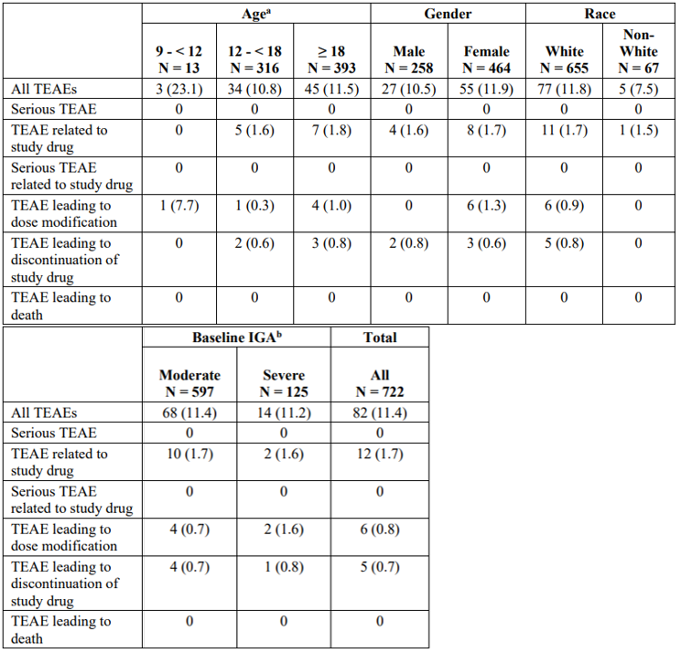

a No subjects were ≥ 65 years old. b All subjects had baseline IGA of 3 (moderate) or 4 (severe)

###### Laboratory parameters

Based on the safety and PK profiles of clascoterone in Phase 1 and 2 studies, the US FDA agreed in a special protocol assessment that clinical laboratory tests were not required to be evaluated as a safety parameter in the Phase 3 studies. In the studies in which clinical chemistry and haematology were investigated there were no events judged to be related to study medication. A review of potassium levels was undertaken as clascoterone is structurally similar to spironolactone, providing biological plausibility for an effect on potassium. Overall, the rate of potassium shift from low/normal to high was low and similar between vehicle and active groups, and no clinically significant events were observed. An exposure-response analysis by the FDA found a lack of correlation between systemic exposure under maximal use conditions and incidence of hyperkalaemia.

In the pivotal studies, there were no clinically significant ECG findings attributable to study treatment. A thorough QT study found no evidence of QT prolongation.

###### Long-term exposure

Treatment with clascoterone 1% cream BID for up to 12 months was generally well tolerated. Safety endpoints in the open-label, long-term extension Study CB-03-01/27 included local and systemic AEs, local skin reactions, and urine pregnancy test results. An overview of TEAEs in Study CB-03-01/27 is presented in Table 38. The only TEAEs reported for ≥1.0% of subjects were nasopharyngitis (2.6%) and upper respiratory tract infection (1.3%). Most TEAEs were mild in severity and most LSRs and treatment-emergent LSRs were trace/minimal or mild in severity. Seven subjects experienced events that were reported as severe: coronary artery dissection, dizziness, eosinophilic gastroenteritis, fatigue, suicide attempt, nephrolithiasis, pancreatitis, pruritus, sciatica, and toothache. Six subjects reported serious TEAEs (coronary artery dissection, depression, dizziness and suicide attempt, eosinophilic gastroenteritis, fatigue, and induced abortion) but none were considered related to study drug. Hypersensitivity events were reported in 2 subjects in Study CB-03-01/27, but both events were assessed as not related to study drug, there was no change in study treatment, both events resolved, and both subjects completed the study. Ten subjects experienced TEAEs leading to study drug and/or study discontinuation.[8] In seven of these subjects, TEAEs were assessed as at least possibly related to study drug: acne, acne conglobata, acne cystic, application site acne, application site dryness, application site swelling, and hair colour changes (1 subject each). TEAEs of suicide attempt and dizziness (1 subject) were assessed as not related, and TEAEs of amenorrhoea (1 subject) and polycystic ovaries (1 subject) were assessed as unlikely related.

Table 38. CB-03-01/27: Overall Summary of Subjects with TEAEs by Treatment Sequence from Parent Study

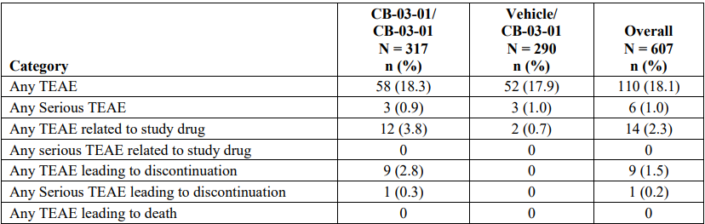

###### HPA axis suppression

The potential for HPA axis suppression was assessed in two maximal use studies.

###### Withdrawal and rebound

None of the studies specifically evaluated withdrawal and rebound, but Study CB-03-01/27 allowed clascoterone to be discontinued if/when acne cleared and restarted if/when acne worsened.

###### Use in pregnancy

Five subjects became pregnant during clinical studies. Two were treated with vehicle cream in the pivotal studies and three were treated with clascoterone in Study CB-03-01/27. The narratives are presented in the evaluation report. No adverse outcomes related to treatment were reported. Of the three women exposed to clascoterone in early pregnancy, two delivered healthy babies with no reported developmental abnormalities and 1 elected to terminate the pregnancy for personal reasons (not due to possibility of fetal abnormality from participating in the study).

###### Post-marketing data

Winlevi was first launched in the USA on 25 October 2021. Since then, four Periodic Adverse Drug Experience Reports (PADERs) cumulatively covering the period 26 August 2021 to 25 August 2022 have been submitted to the FDA, and were included in this submission. Adverse events reported in the post-market environment were similar in nature and intensity to those reported in the clinical studies. No new safety signals have been identified. No deaths or serious adverse events have been identified. There has been no change made to the US prescribing information and no other regulatory action undertaken as a result of these PADERs.

###### Other

Real world evidence (RWE) presented in this application includes post-marketing safety data. [9]

### Risk Management Plan evaluation summary

The Sponsor submitted AU-RMP version 0.1 (dated 17 January 2023, DLP 30 October 2022) in the initial application, and subsequently submitted AU-RMP version 0.2 (dated 22 September 2023; DLP 30 October 2022). The summary of safety concerns (Table 39) is acceptable.

Table 39. Summary of safety concerns

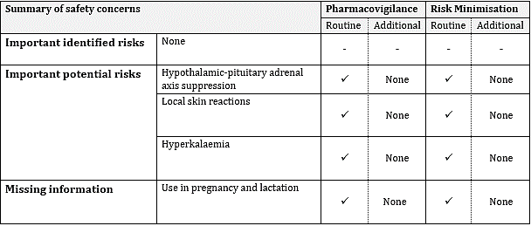

**RMP Evaluator recommendations regarding conditions of registration**

* The Winlevi AU-Risk Management Plan (RMP) (version 0.2, dated 22 September 2023, data lock point 30 October 2022), included with submission PM-2023-00180-1-1, and any subsequent revisions, as agreed with the TGA will be implemented in Australia.
* An obligatory component of risk management plans is routine pharmacovigilance. Routine pharmacovigilance includes the submission of periodic safety update reports (PSURs).

Unless agreed separately between the supplier who is the recipient of the approval and the TGA, the first report must be submitted to TGA no later than 15 calendar months after the date of approval. The subsequent reports must be submitted no less frequently than annually from the date of the first submitted report until the period covered by such reports is not less than three years from the date of this approval letter. The annual submission may be made up of two PSURs each covering six months. If the Sponsor wishes, the six-monthly reports may be submitted separately as they become available.

If the product is approved in the EU during the three years period, reports can be provided in line with the published list of EU reference dates no less frequently than annually from the date of the first submitted report until the period covered by such reports is not less than three years from the date of this approval letter.

The reports are to at least meet the requirements for PSURs as described in the European Medicines Agency’s Guideline on good pharmacovigilance practices (GVP) Module VII-periodic safety update report (Rev 1), Part VII.B Structures and processes. Note that submission of a PSUR does not constitute an application to vary the registration. Each report must have been prepared within ninety calendar days of the data lock point for that report.

* Winlevi (Clascoterone) is to be included in the Black Triangle Scheme. The PI and CMI for Winlevi must include the black triangle symbol and mandatory accompanying text for five years, which starts from the date that the Sponsor notifies the TGA of supply of the product.

#### Discussion

##### Efficacy

The efficacy of clascoterone 1% cream for the treatment of moderate to severe acne vulgaris was demonstrated in two pivotal 12-week, double-blind, vehicle-controlled studies of the same design. Studies CB-03-01/25 and CB-03-01/26 enrolled 708 and 732 subjects, respectively, aged 9 years or older with acne vulgaris on the face with IGA score of 3 (moderate) or 4 (severe), 30 to 75 ILC, and 30 to 100 NILC.

Consistent treatment effects were observed for the 3 primary endpoints and the 4 secondary endpoints in each of the pivotal studies. The treatment effects compared to vehicle cream were statistically significant and clinically meaningful. Treatment benefit was demonstrated for qualitative and quantitative measures of response, and for inflammatory and non-inflammatory lesions.

In the pooled analysis, the proportion of subjects achieving IGA ‘success’ at Week 12 was 19.5% in the clascoterone arm versus 7.7% in the placebo arm (p<0.0001), the absolute change in NILC from baseline to Week 12 was -19.3 in the clascoterone arm versus -11.8 in the placebo arm (p<0.0001), and the absolute change in ILC from baseline to Week 12 was -19.8 in the clascoterone arm versus -13.9 in the placebo arm (p<0.0001). Significant treatment effects were also observed for each of the secondary efficacy endpoints: absolute change in TLC from baseline to Week 12 (-39.5 vs -26.3; p<0.0001), percent change in TLC from baseline to Week 12 (-37.2 vs -25.2; p<0.0001), percent change in NILC from baseline to Week 12 (-29.8 vs -18.4; p<0.0001), and percent change in ILC from baseline to Week 12 (-46.2 vs -32.7; p<0.0001).

Both studies enrolled patients 9 years or older, but in the pooled population there were only 19 subjects aged 9 to <12 years and no treatment effect was seen in this age group in *post-hoc* subgroup analyses. In both studies, efficacy findings in patients aged 12 to <18 years were generally similar to the adult population. The Sponsor is seeking an indication in patients 12 years of age and older.

In the pooled population, 73.8% of subjects had Fitzpatrick skin type I, II, or III and 26.2% had type IV, V, or VI. The subgroup analysis did not show a statistically significant treatment effect on the primary endpoints for subjects with skin type IV, V, or VI, but there was a numerical trend in favour of clascoterone.

Longer term efficacy was explored in a 9-month open-label extension study following on from the 12-week pivotal studies. There are limitations in interpreting efficacy findings in an uncontrolled open-label study, but for treatment on the face, 196 of 609 (32.3%) subjects had an IGA score of 0 or 1 at the Investigator’s last assessment and 69 of 123 (56.1%) subjects had an IGA score of 0 or 1 at 12 months.

##### Safety

The safety of clascoterone 1% cream was evaluated in a comprehensive clinical development program including two 12-week randomised, double-blind, vehicle-controlled studies and a 9-month open-label extension study. The submission also included post-marketing safety data since the product launch in USA in 2021.

The proposed product is for topical administration to skin areas affected by acne vulgaris. PK studies under maximal use conditions in patients with acne vulgaris showed that clascoterone systemic exposure was very low or non-quantifiable following topical administration.

Clascoterone 1% cream was well tolerated in the clinical studies. The overall frequency of TEAEs was similar to placebo and no serious TEAEs were reported with clascoterone in the pooled analysis. The proportion of subjects experiencing local skin reactions was similar between the clascoterone and vehicle treatment groups. The only TEAE reported for ≥1% of subjects in either treatment group in the pooled analysis was nasopharyngitis (clascoterone 1.4% vs vehicle 2.8%). The only TEAE assessed as treatment-related and reported for more than 1 subject treated with clascoterone was application site dryness (2 subjects (0.3%) in each treatment group). Most TEAEs were mild or moderate in severity, and no severe TEAEs were reported in the clascoterone group.

The frequency of TEAEs was similar for adolescents and adults. A higher proportion of children aged 9 to <12 years reported TEAEs compared to adolescents and adults, but this was based on only 13 children aged 9 to <12 years exposed to clascoterone.

The main metabolite of clascoterone is cortexolone, which is an intermediate in the synthesis of glucocorticoids and exhibits weak glucocorticoid properties. The risk of HPA axis suppression was evaluated in two maximal use studies in adults and adolescents aged ≥12 years (Study 171-7151-202) and children aged 9 to <12 years (CB-03-01/28). In Study 171-7151-202, 1 of 20 (5.0%) adult subjects and 2 of 22 (9.1%) adolescent subjects demonstrated laboratory evidence of abnormal HPA axis response on Cosyntropin Stimulation Test at Day 14. In Study CB-03-01/28, 2 of 23 (8.7%) children in the Evaluable population (4 of 27 (14.8%) children in the Safety population) demonstrated laboratory evidence of abnormal HPA axis response on CST at Day 14. None of the subjects with HPA axis suppression were symptomatic and all had normal HPA axis response on repeat testing ∼4 weeks after stopping study treatment. The analyses of HPA axis response involved small numbers of subjects, but the limited data suggest that paediatric patients may be more susceptible to HPA axis suppression than adults.

##### Uncertainties and limitations of the data

The pivotal studies recruited patients 9 years of age and older, but there were only 19 patients aged 9 to <12 years across the two studies. Subgroup analyses of the pooled population did not show a treatment benefit in this age subset. Data informing safety and risk of HPA axis suppression in this age group are also very limited. The limitations in the efficacy and safety data for patients aged <12 years have been addressed by the proposed use of Winlevi in patients 12 years of age and older.

The clascoterone clinical development program has evaluated safety up to 12 months. Following registration, safety will be monitored through routine pharmacovigilance as per the AU-RMP.

##### Proposed conditions of registration

* The Winlevi AU-Risk Management Plan (RMP) (version 0.2, dated 22 September 2023, data lock point 30 October 2022), included with submission PM-2023-00180-1-1, and any subsequent revisions, as agreed with the TGA will be implemented in Australia.
* An obligatory component of risk management plans is routine pharmacovigilance. Routine pharmacovigilance includes the submission of periodic safety update reports (PSURs).

Unless agreed separately between the supplier who is the recipient of the approval and the TGA, the first report must be submitted to TGA no later than 15 calendar months after the date of this approval letter. The subsequent reports must be submitted no less frequently than annually from the date of the first submitted report until the period covered by such reports is not less than three years from the date of this approval letter. The annual submission may be made up of two PSURs each covering six months. If the Sponsor wishes, the six-monthly reports may be submitted separately as they become available.

If the product is approved in the EU during the three years period, reports can be provided in line with the published list of EU reference dates no less frequently than annually from the date of the first submitted report until the period covered by such reports is not less than three years from the date of this approval letter.

The reports are to at least meet the requirements for PSURs as described in the European Medicines Agency’s Guideline on good pharmacovigilance practices (GVP) Module VII-periodic safety update report (Rev 1), Part VII.B Structures and processes. Note that submission of a PSUR does not constitute an application to vary the registration. Each report must have been prepared within ninety calendar days of the data lock point for that report.

* Winlevi (Clascoterone) is to be included in the Black Triangle Scheme. The PI and CMI for Winlevi must include the black triangle symbol and mandatory accompanying text for five years, which starts from the date that the Sponsor notifies the TGA of supply of the product.

##### Conclusions

There are no outstanding quality or manufacturing concerns. The submitted data support a favourable benefit-risk profile for clascoterone 1% cream for the topical treatment of acne vulgaris in patients 12 years of age and older. Expert advice is requested from ACM regarding the risk of HPA axis suppression.

#### Advisory Committee considerations

The [Advisory Committee on Medicines (ACM)](https://www.tga.gov.au/committee/advisory-committee-medicines-acm) considered the evaluations and the Delegate’s overview and responded to the Delegate’s questions, listed below:

1. ***What is ACM’s perspective regarding the clinical relevance of the risk of hypothalamic-pituitary-adrenal axis suppression with longer term use of clascoterone 1% cream?***

The ACM advised that HPA axis suppression was unlikely to be clinically relevant given, across pharmacokinetic studies, systemic exposure was very low or non-quantifiable following topical administration. In addition, the ACM noted that the HPA suppression observed in the trials was minimal.

The ACM proposed that the Sponsor should be approached to consider conducting a long-term study (to monitor HPA axis suppression) that better corresponds to the treatment interval (several months) that is required when the drug will be used in clinical practice (in contrast to the 2 week length of the submitted studies).

1. ***From a clinical perspective, is the risk of hypothalamic-pituitary-adrenal axis suppression adequately addressed in the Product Information?***

The ACM noted that HPA axis suppression is not an adverse event that is normally considered in other antiandrogen therapies for acne and suggested that it may be useful to add an explainer to the PI. The ACM proposed the following wording in the PI:

Hypothalamic-pituitary-adrenal (HPA) axis suppression

Clascoterone is structurally similar to non-androgen corticosteroids and may exert its efficacy by means other than the AR.

The main metabolite of clascoterone is cortexolone, which is an intermediate in the synthesis of glucocorticoids and exhibits weak glucocorticoid properties.

Reversible physiologic HPA axis suppression was observed in two maximal use clinical studies with exposure conditions up to 3 times the recommended Winlevi daily dose for up to 2 weeks.

##### ACM conclusion

The ACM considered this product to have an overall positive benefit-risk profile for the indication:

*Winlevi (clascoterone) cream is indicated for the topical treatment of acne vulgaris in patients 12 years of age and older.*

## Outcome

Based on a review of quality, safety, and efficacy data, the TGA decided to register Winlevi (Clascoterone). The approved indication for this therapeutic good is:

*Winlevi (clascoterone) cream is indicated for the topical treatment of acne vulgaris in patients 12 years of age and older.*

#### Specific conditions of registration

Winlevi is to be included in the [Black Triangle Scheme](https://www.tga.gov.au/how-we-regulate/monitoring-safety-and-shortages/report-adverse-event-or-incident/report-adverse-events-medicines-and-biologicals/black-triangle-scheme). The PI and CMI for Winlevi must include the black triangle symbol and mandatory accompanying text for five years.

The Black Triangle Scheme identifies new prescription medicines with a black triangle on the medicine information documents and serves as a visual reminder to encourage health practitioners and patients to [report a problem or side effect](https://www.tga.gov.au/safety/reporting-problems) associated with the medicine.

The Winlevi EU- [Risk Management Plan](https://www.tga.gov.au/resources/resource/guidance/risk-management-plans-medicines-and-biologicals) (RMP) (version 0.2, dated 22 September 2023, data lock point 30 October 2022), included with submission PM-2023-00180-1-1, and any subsequent revisions, as agreed with the TGA will be implemented in Australia. An obligatory component of risk management plans is routine [pharmacovigilance](https://www.tga.gov.au/resources/resource/guidance/pharmacovigilance-responsibilities-medicine-sponsors), which includes the submission of [periodic safety update reports (PSURs)](https://www.tga.gov.au/resources/resource/guidance/risk-management-plans-medicines-and-biologicals/periodic-safety-update-reports).

##### Certified Product Details

The Certified Product Details (CPD), as described in Guidance 7: Certified Product Details of the Australian Regulatory Guidelines for Prescription Medicines (ARGPM) for the above products should be provided upon registration of these therapeutic goods. In addition, an updated CPD should be provided when changes to finished product specifications and test methods are approved in a Category 3 application or notified through a self-assessable change.

#### Product Information

The [Product Information](https://www.tga.gov.au/products/australian-register-therapeutic-goods-artg/product-information-one) ([PI](https://www.tga.gov.au/products/australian-register-therapeutic-goods-artg/product-information-one)) approved with this submission for Winlevi which is referred to in this AusPAR (and can be accessed on this AusPAR’s webpage) may have been superseded. For the most recent PI and [Consumer Medicines Information](https://www.tga.gov.au/products/australian-register-therapeutic-goods-artg/consumer-medicines-information-cmi) (CMI), please refer to the TGA [PI/CMI search facility.](https://www.ebs.tga.gov.au/)

|  |
| --- |
| Therapeutic Goods Administration |
| PO Box 100 Woden ACT 2606 Australia  Email: [info@tga.gov.au](mailto:info@tga.gov.au) Phone: 1800 020 653 Fax: 02 6203 1605  [**https://www.tga.gov.au**](https://www.tga.gov.au) |
|  |

1. This is the original indication proposed by the Sponsor when the TGA commenced the evaluation of this submission. It may differ to the final indication approved by the TGA and registered in the Australian Register of Therapeutic Goods.
2. <https://www.dermcoll.edu.au/atoz/acne-vulgaris/>
3. Guidance for Industry. Acne Vulgaris: Developing Drugs for Treatment (2005, draft) U.S. Department of Health and Human Services, Food and Drug Administration, Center for Drug Evaluation and Research (CDER) September 2005. <https://www.regulations.gov/document/FDA-2005-D-0461-0002>
4. Acne Vulgaris: Establishing Effectiveness of Drugs Intended for Treatment (2018). Center for Drug Evaluation and Research, Food and Drug Administration. <https://www.fda.gov/media/71152/download>
5. The ‘Delegate’ is the Delegate of the Secretary of the Department of Health and Aged Care who made the final decision to either include the new medicine/indication on the ARTG or reject the submission, under section 25 of the Therapeutic Goods Act
6. <https://www.ich.org/page/ich-guidelines>
7. Ibid.
8.
9. RWE is defined as d*ata regarding the usage, or the potential benefits or risks, of a therapeutic good derived from sources other than traditional clinical trials.*