|  |
| --- |
| Australian Public Assessment Report for Xenpozyme |
| Active ingredient: Olipudase alfa |
| Sponsor: Sanofi-Aventis Australia Pty Ltd |
| August 2024 |

About the Therapeutic Goods Administration (TGA)

* The Therapeutic Goods Administration (TGA) is part of the Australian Government Department of Health and Aged Care and is responsible for regulating therapeutic goods, including medicines, medical devices, and biologicals.
* The TGA administers the *Therapeutic Goods Act 1989* (the Act), applying a risk management approach designed to ensure therapeutic goods supplied in Australia meet acceptable standards of quality, safety, and efficacy.
* The work of the TGA is based on applying scientific and clinical expertise to decision-making, to ensure that the benefits to the Australian public outweigh any risks associated with the use of therapeutic goods.
* The TGA relies on the public, healthcare professionals and industry to report problems with therapeutic goods. The TGA investigates reports received to determine any necessary regulatory action.
* To report a problem with a therapeutic good, please see the information on the [TGA website](https://www.tga.gov.au/).

About AusPARs

* The Australian Public Assessment Report (AusPAR) provides information about the evaluation of a prescription medicine and the considerations that led the TGA to approve or not approve a prescription medicine submission. Further information can be found in [Australian Public Assessment Report (AusPAR) guidance](https://www.tga.gov.au/australian-public-assessment-report-auspar-guidance).
* AusPARs are prepared and published by the TGA.
* AusPARs are static documents that provide information that relates to a submission at a particular point in time. The publication of an AusPAR is an important part of the transparency of the TGA’s decision-making process.
* A new AusPAR may be provided to reflect changes to indications or major variations to a prescription medicine subject to evaluation by the TGA.

Copyright

© Commonwealth of Australia 2024  
This work is copyright. You may reproduce the whole or part of this work in unaltered form for your own personal use or, if you are part of an organisation, for internal use within your organisation, but only if you or your organisation do not use the reproduction for any commercial purpose and retain this copyright notice and all disclaimer notices as part of that reproduction. Apart from rights to use as permitted by the *Copyright Act 1968* or allowed by this copyright notice, all other rights are reserved and you are not allowed to reproduce the whole or any part of this work in any way (electronic or otherwise) without first being given specific written permission from the Commonwealth to do so. Requests and inquiries concerning reproduction and rights are to be sent to the TGA Copyright Officer, Therapeutic Goods Administration, PO Box 100, Woden ACT 2606 or emailed to <[tga.copyright@tga.gov.au](mailto:tga.copyright@tga.gov.au)>.

Contents

List of abbreviations 4

Product submission 6

Submission details 6

Xenpozyme (olipudase alfa) 7

Acid sphingomyelinase deficiency (ASMD) 7

Current treatment options for ASMD 8

Clinical rationale for Xenpozyme use in ASMD 8

Regulatory status 9

Registration timeline 9

Submission overview and risk/benefit assessment 10

Quality evaluation summary 10

Clinical evaluation summary 13

Pharmacology 17

Efficacy 21

Safety 30

Risk management plan evaluation summary 33

Discussion 34

Conclusions 37

Advisory Committee considerations 37

Outcome 39

Specific conditions of registration applying to these goods 39

Attachment 1. Product Information 40

## List of abbreviations

|  |  |
| --- | --- |
| Abbreviation | Meaning |
| ACM | Advisory Committee on Medicines |
| ADA | Anti-drug antibodies |
| ASMKO | Acid sphingomyelinase knock-out mouse |
| ARTG | Australian Register of Therapeutic Goods |
| ASA | Australia‑specific annex |
| ASM | Acid sphingomyelinase |
| ASMD | Acid sphingomyelinase deficiency |
| AUC | Area under the plasma drug concentration-time curve (drug exposure) |
| CHO | Chinese hamster ovary |
| Cmax | Maximum concentration of a drug in the blood, or other compartment, after a dose is administered. |
| CMI | Consumer Medicines Information |
| DLCO | Diffusing capacity for carbon monoxide |
| DLP | Data lock point |
| EMA/CHMP | European Medicines Agency/Committee for Medicinal Products for Human Use |
| FEV1 | Forced expiratory volume in 1 second |
| FVC | Forced vital capacity |
| LLQ | Lower limit of quantitation |
| mITT | Modified intention to treat |
| MMRM | Mixed model for repeated measures |
| PI | Product Information |
| PK | Pharmacokinetics |
| popPK | Population pharmacokinetics |
| PSUR | Periodic safety update report |
| QSP | Quantitative Systems Pharmacology |
| RMP | Risk management plan |
| SAE | Serious adverse event |
| SMPD1 | Sphingomyelin phosphodiesterase 1 |
| TEAEs | Treatment emergent adverse events |
| TGA | Therapeutic Goods Administration |
| TLC | Total lung capacity |

## Product submission

### Submission details

|  |  |
| --- | --- |
| *Type of submission:* | New chemical entity |
| *Product name:* | Xenpozyme |
| *Active ingredient:* | Olipudase alfa |
| *Decision:* | Approved |
| *Date of decision:* | 21 August 2023 |
| *Date of entry onto ARTG:* | 3 May 2024 |
| *ARTG number:* | 423370 |
| [*Black Triangle Scheme*](https://www.tga.gov.au/black-triangle-scheme) | Yes |
| *Sponsor’s name and address:* | Sanofi-Aventis Australia Pty Ltd |
| *Dose form:* | White to off-white lyophilised powder for injection. |
| *Strength:* | Each vial contains 20 mg of olipudase alfa. After reconstitution, each vial contains 4 mg of olipudase alfa per mL |
| *Container:* | Type 1 glass vials with a siliconised chlorobutyl-elastomer lyophilisation stopper and an aluminium seal with plastic flip-off cap. |
| *Pack sizes:* | 1, 5, 10 or 25 vials |
| *Approved therapeutic use for the current submission:* | Xenpozyme is indicated as an enzyme replacement therapy for the treatment of noncentral nervous system (CNS) manifestations of acid sphingomyelinase deficiency (ASMD) in paediatric and adult patients with type A/B (Niemann-Pick type A/B) or type B (Niemann-Pick type B). |
| *Route of administration:* | Intravenous Infusion |
| *Dosage:* | Treatment with Xenpozyme should always be initiated via a dose escalation regimen followed by a maintenance dose. The dose escalation regimens are different for adult and paediatric patients. For further information regarding dosage refer to the Product Information. |
| Pregnancy category: | Category D - Drugs which have caused, are suspected to have caused or may be expected to cause, an increased incidence of human fetal malformations or irreversible damage. These drugs may also have adverse pharmacological effects.  It is recommended to perform a pregnancy test prior to treatment initiation with Xenpozyme.  Women of childbearing potential are advised to use effective contraception during treatment and for 14 days after the last dose if Xenpozyme is discontinued.  There are no data on Xenpozyme use in pregnant women. Xenpozyme is not recommended during pregnancy and in women of childbearing potential not using effective contraception, unless the potential benefits to the mother outweigh the potential risks, including those to the fetus.  An increased incidence of exencephaly was observed when pregnant mice were treated daily with olipudase alfa at exposure levels less than the human exposure (based on AUC) at the recommended maintenance therapeutic dose and frequency. This incidence was slightly higher than historical control data. The relevance of this observation for humans is unknown. The daily intravenous administration of olipudase alfa to pregnant rabbits did not result in fetal malformations or variations at exposures 10 times the human exposure (based on AUC) at the recommended maintenance therapeutic dose and frequency. |

### Xenpozyme (olipudase alfa)

Xenpozyme (olipudase alfa; human acid sphingomyelinase) is an enzyme replacement therapy synthesised in Chinese hamster ovary (CHO) cells by recombinant DNA technology. Olipudase alfa is intended as a disease-modifying therapy for the long term treatment of non-central nervous system (CNS) manifestations of acid sphingomyelinase deficiency (ASMD) in paediatric and adult patients.

This AusPAR describes the submission by Sanofi-Aventis Australia Pty Ltd (the Sponsor) to register Xenpozyme (olipudase alfa) for the following proposed indication:[1]

*Xenpozyme is indicated as an enzyme replacement therapy for the treatment of noncentral nervous system (CNS) manifestations of acid sphingomyelinase deficiency (ASMD) in paediatric and adult patients with type A/B (Niemann-Pick type A/B) or type B (Niemann-Pick type B).*

### Acid sphingomyelinase deficiency (ASMD)

Acid sphingomyelinase deficiency is a rare (<1:100 000) inherited metabolic disorder and one of the lysosomal storage diseases. ASMD is also known as Niemann-Pick Disease (subtypes A, B or A/B, but not Niemann-Pick C which is a different disease). ASMD is caused by the presence of two pathogenic autosomal recessive alleles within the sphingomyelin phosphodiesterase 1 (SMPD1) gene. These alleles lead to a variable reduction in sphingomyelinase activity and the accumulation of sphingomyelin and other fatty substances within cell of the mononuclear-phagocyte lineage resident in various organs and in hepatocytes. Disease manifestations relate to the speed of accumulation of sphingomyelin and the particular organs affected.

Currently, three types of ASMD are recognised and distinguished by differences in the implicated alleles, age of onset, presence or absence of CNS manifestations and prognosis. The three types are ASMD A, B, A/B.

ASMD type A (also called Niemann-Pick A disease) results from complete loss of enzyme activity. This is associated with a severe phenotype, with onset of hepatosplenomegaly, lung and neurological disease and death usually before age 3. ASMD type A is also described as the neurovisceral infantile form.

ASMD type B (also called Niemann-Pick B disease) is typically diagnosed after the age of 2 with hepatosplenomegaly as the presenting feature. It follows a much slower trajectory and is characterised by the aforementioned hepatosplenomegaly, as well as thrombocytopaenia, hyperlipidaemia, interstitial lung disease, retinal stigmata and impaired growth. CNS manifestations are not prominent. Common symptoms include dyspnoea, bruising, fatigue, abdominal pain, diarrhoea, lung infections, joint pain and peripheral dysaesthesia. ASMD type B is also described as the chronic visceral form and patients frequently survive into adulthood (even later adulthood).

An overlap syndrome termed ASMD type A/B has non-CNS features consistent with type B. Patients also have CNS manifestations. ASMD type A/B is also described as the chronic neurovisceral form.

Whilst the prognosis for ASMD types B and A/B is better than for type A, they are still associated with significant premature death. One study of ASMD B from the USA found a median life expectancy of 15.5 years, with a range of 1 – 72[2]. Another study found a median life expectancy of 23.5 years for ASMD type B and 8.5 years for ASMD type A/B. This is consistent with the overlap syndrome representing a more severe phenotype.

Diagnosis of ASMD is made through demonstration of reduced acid sphingomyelinase activity (commonly in peripheral blood leucocytes) and identification of the pathogenic SMPD1 alleles.

It should be noted that whilst Niemann-Pick A, Niemann-Pick B and the overlap syndrome, are synonymous with the three ASMD types, Niemann-Pick C disease is a distinct entity with a different genetic basis (i.e. mutations in NPC1 or NPC2), phenotype and treatment. For example, the drug miglustat is registered in many countries (including Australia) for treatment of Niemann-Pick C, but not for the other types.

### Current treatment options for ASMD

Standard of care for all types of ASMD consists of supportive management. Previously, there has been no approved therapy that influences the level of enzyme activity or progression of organ dysfunction. Genetic counselling and prenatal diagnosis can be helpful to manage the risk of a couple having offspring that suffer from the disease.

### Clinical rationale for Xenpozyme use in ASMD

The progressive accumulation of sphingomyelin due to acid sphingomyelinase deficiency, and, to a lesser extent, cholesterol and other lipids, is responsible for the tissue damage and resultant organ dysfunction in patients with ASMD.

Olipudase alfa is an enzyme replacement therapy whereby it distributes throughout the body and is taken up by receptor-mediated endocytosis into various tissues and cell types, where it is transported to the lysosomes (due to its molecular size, olipudase alfa does not cross the blood-brain barrier and thus is not expected to modulate CNS disease manifestations). By restoring cellular acid sphingomyelinase levels, the non-CNS symptoms of ASMD may be alleviated.

### Regulatory status

##### Australian regulatory status

This product is considered a new biological medicine for Australian regulatory purposes.

Xenpozyme was designated as an orphan drug on 21 June 2022.

##### International regulatory status

This submission was submitted through the TGA’s [Comparable Overseas Regulator](https://www.tga.gov.au/comparable-overseas-regulators-cors-timeframes-and-milestones) A (COR-A) process, using evaluation reports from the European Medicines Agency. The full dossier was submitted to the TGA.

Table 1: International regulatory status at the time of product registration.

Xenpozyme received marketing approval in the USA in August 2022, for the following indication:

*Xenpozyme is a hydrolytic lysosomal sphingomyelin-specific enzyme indicated for treatment of non–central nervous system manifestations of acid sphingomyelinase deficiency (ASMD) in adult and pediatric patients.*

The approved indication in the EU is as follows:

*Xenpozyme is indicated as an enzyme replacement therapy for the treatment of non-Central Nervous System (CNS) manifestations of Acid Sphingomyelinase Deficiency (ASMD) in paediatric and adult patients with type A/B or type B.*

## Registration timeline

This submission was evaluated under the [standard prescription medicines registration process](https://www.tga.gov.au/how-we-regulate/supply-therapeutic-good-0/supply-prescription-medicine/application-process/prescription-medicines-registration-process)

Table 2 captures the key steps and dates for this submission.

Table 2: Timeline for Xenpozyme Submission PM-2022-03512-1-3

|  |  |
| --- | --- |
| Description | Date |
| Designation (Orphan) | 21 June 2022 |
| Submission dossier accepted and first round evaluation commenced | 31 October 2022 |
| First round evaluation completed | 31 January 2023 |
| Second round evaluation completed | 7 August 2023 |
| Delegate’s[3] Overall benefit-risk assessment and request for Advisory Committee advice | 28 February 2023 |
| Sponsor’s pre-Advisory Committee response | 15 March 2023 |
| Advisory Committee meeting | October 2023 |
| Registration decision (Outcome) | Approved 21 August 2023 |
| Administrative activities and registration in the ARTG completed | 24 August 2023 |
| Number of working days from submission dossier acceptance to registration decision* | 301 |

*Statutory timeframe for standard submissions is 255 working days

## Submission overview and risk/benefit assessment

A summary of the TGA’s assessment for this submission is provided below.

Relevant guidelines or guidance documents referred to by the Delegate are listed below:

* International scientific guideline: Reflection paper on the use of extrapolation in the development of medicines for paediatrics. EMA/189724.2018
* International scientific guideline: ICH topic E11 – Note for guidance on clinical investigation of medicinal products in the paediatric population. CPMP/ICH/2711/99
* International scientific guideline: Guideline on clinical trials in small populations

### Quality evaluation summary

The proposed formulation of Xenpozyme contains the active ingredient olipudase alfa   
(20.00 mg/vial) and the excipients dibasic sodium phosphate heptahydrate (8.45 mg/vial), methionine (74.60 mg/vial), monobasic sodium phosphate monohydrate (9.40 mg/vial) and sucrose (250.00 mg/vial). The product is filled in a 20 mL colourless clear glass vial closed with 20mm siliconized grey chlorobutyl elastomeric stopper. Stoppered vials are crimped with an aluminium seal with a Flip-Off button.

Olipudase alfa is a recombinant human acid sphingomyelinase (Figure 1). The protein structure includes an N-terminal saposin (Sap) domain (residues 84–167), a proline-rich (P) linker (residues 168–195), a catalytic metallophosphatase domain (residues 196–538), and a helical C-terminal domain (residues 539– 611). A schematic of the protein is shown in Figure 1. The molecule also contains a C-terminal cysteine. The MW of the glycosylated protein is approximately 76,000 Daltons. The protein is expressed in CHO cells and manufactured by standard mammalian cell culture processes followed by chromatographic purification to yield purified enzyme. The manufacturing process has been described in sufficient detail and the overall quality has been established.

Figure 1. Olipudase alfa schematic

DS manufacturing involves pooling of active substance, filtration through a 0.2 µm filter, aseptic filling, lyophilisation, capping and visual inspection. The vials are stored at 5±3oC.

The specifications for testing and release at both the drug substance stage and the final drug product stage are described in the dossier and acceptable. Batch release testing of the finished product includes identity, potency, purity, impurities, sterility, bacterial endotoxin and several other tests.

The shelf life of the drug product is 48 months at 5±3oC.

From a microbiological point of view, both the reconstituted product and the diluted product should be used immediately. Chemical, physical, microbiological in use stability has been demonstrated for up to 24 hours at 2oC to 8oC or 12 hours (which includes infusion time for the diluted product) at room temperature up to 25oC.

The quality Evaluator advised that there are no objections on quality grounds for the approval of Xenpozyme 20mg powder for injection. The Evaluator has noted that this COR application is based on EMA reports and that the product has been approved in the EU since June 2022.

**Nonclinical (toxicology) evaluation summary**

The submitted nonclinical dossier was largely in accordance with the relevant ICH guideline for nonclinical assessment of biotechnology-derived pharmaceuticals (ICH S6)[4]. The overall quality of the nonclinical dossier was satisfactory. All pivotal safety-related studies were GLP-compliant.

No *in vitro* pharmacology studies were submitted. *In vivo* pharmacology studies in the Acid Sphingomyelinase Knock Out (ASMKO) mouse model demonstrated dose-dependent decreases of sphingomyelin in the liver, spleen, kidney and lung after a single dose of ≥ 1mg/kg or repeated doses of ≥ 0.1 mg/kg every other week.

Studies in ASMKO mice identified increased ceramide, sphingosine and sphingosine-1-phosphate (catabolites of the accumulated sphingomyelin) and cytokines after a high dose of olipudase alfa (20 mg/kg), which was lethal to ASMKO mice. A gradual ascending dosing regimen eliminated the toxic response to olipudase alfa, and elevations of catabolites of the accumulated sphingomyelin and cytokines seen with high doses of olipudase alfa.

Fluoxetine, an inhibitor of ASM, is not expected to affect the activity of olipudase alfa in patients, but effects of another ASM inhibitor, citalopram on olipudase alfa could not be excluded.

Safety pharmacology studies assessed effects on the central nervous systems (CNS), cardiovascular and respiratory systems. No adverse effects were noted in CNS (monkey), cardiovascular (mouse, dog and monkey) or respiratory (monkey and dog) function studies. Bradycardia and hypotension were noted in ASKMO mice after a single dose at 3, 10 and 20 mg/kg, but only a slight decline in heart rate was noted following the second administration of 3 or 10 mg/kg olipudase alfa. The proposed ascending clinical dosing regimen would alleviate potential effects on heart rate (and QT) in patients.

Pharmacokinetic profiles in mice, rats, dogs and monkeys were comparable to humans. As expected of a human enzyme, olipudase alfa half-life values were shorter and clearance was higher in the nonclinical species compared to humans. Tissue distribution of drug-related material is expected to be limited, with no penetration into brain tissue.

No pharmacokinetic drug interaction studies were submitted for evaluation given that olipudase alfa is not expected to be affected by another drug, or likely to affect exposure of other drugs, which is acceptable for a product of this nature.

Acute administration of olipudase alfa at dose levels of ≥ 10 mg/kg was lethal in ASMKO mice (due to accumulation of the catabolites of sphingomyelin (ceramides, sphingosine andsphingosine-1 phosphate) in this model (in contrast to healthy animals (mice, rats and dogs), where no toxicity was seen at doses up to 30 mg/kg). The adverse histopathological findings in the deceased mice were observed primarily in the liver and adrenals and included hepatic ballooning degeneration and inflammation, hepatocellular apoptosis, adrenal cortical degeneration/necrosis and adrenocortical cell apoptosis.

Repeat-dose toxicity studies by IV administration were conducted in ASKMO mice (up to 13weeks), SD rats (26 weeks) and monkeys (26 weeks). The main findings were non adverse and mild, including liver and adrenal glands (consistent with findings reported in the acute toxicity studies), and decreases in the number and size of foamy macrophages and the incidence and/or severity of cytoplasmic vacuolization (consistent with the elimination of sphingomyelin in this disease model) in ASKMO mice.

No genotoxicity or carcinogenicity studies were submitted for evaluation, which is acceptable.

Fertility was unaffected in male and female mice treated intravenously with up to 30 mg/kg of olipudase alfa (~ exposure ratio of AUC1.5 based on AUC values in the embryofetal development study). An increased incidence of exencephaly was observed when pregnant mice were treated daily with olipudase alfa at exposure levels less than the human exposure at the recommended maintenance therapeutic dose and frequency. The relevance of this observation for humans is unknown and cannot be ruled out. Possible antibody-mediated hypersensitivity resulting in mortality and/or clinical signs at the low-dose (3-3.16 mg/kg) in animals across all reproductive and developmental toxicity were noted. Anti-drug antibody responses to human proteins administered to laboratory animals are not predictive of similar effects in humans.

No juvenile studies were submitted, and this is considered acceptable as the mode of action of olipudase alfa is well established and is based on the degradation of the accumulated sphingomyelin. It is thus not expected that this would be different in juvenile animals.

There were no adverse olipudase alfa related findings in the IV infusion sites.

The primary pharmacology studies support the proposed indication; however, dosing regimen is better assessed from clinical data.

The key concern for patients identified from nonclinical data was increased incidence of exencephaly.

Olipudase alfa should be assigned to Pregnancy Category D, rather than Category B1 as the Sponsor proposes.

There are no nonclinical objections to registration of Xenpozyme for the proposed indications.

### Clinical evaluation summary

##### Summary of clinical studies

The clinical data consists of:

* 5 clinical trials (Table 3)
* 5 modellings studies (popPK, popPK/PD, PK/PD, quantitative systemics pharmacology analysis) (Table 4)
* 5 ASMD natural history studies (Table 5)

Table 3. ASMD clinical trials of olipudase alfa

Table 4. Clinical modelling

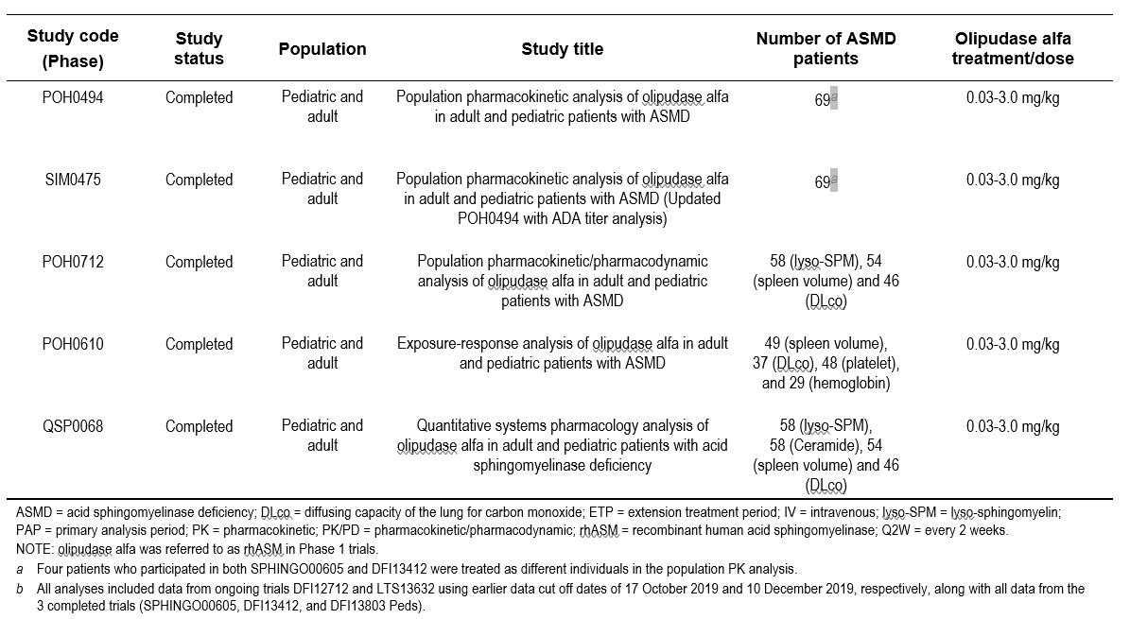

Table 5. Natural history studies

#### Pharmacology

##### Pharmacokinetics

Suitable and validated assays were developed to detect and measure olipudase alfa, the biomarkers described below, antidrug antibodies, neutralising potential of ADAs (both for enzyme activity and cellular uptake) and specific IgE ADAs.

Absolute bioavailability of olipudase alfa is 100% given the intravenous route of administration.

###### Adults:

Linear pharmacokinetics were observed for Cmax and AUC over the dose range 0.3mg/kg to 3 mg /kg. There was no accumulation following repeated dosing.

After the 3mg/kg dose, the mean steady state volume of distribution ranged from 0.148 L/kg to 0.181 L/kg or 10.4-12.7 L in a 70kg adult. This is consistent with distribution to the vascular compartment with limited tissue distribution.

Clearance mean values ranged from 4.5 to 5.2 mL/h/kg (doses 0.3 to 3 mg/kg). The terminal half-life at a dose of 3 mg/kg ranged from 32 to 38 hours.

Elimination is expected to occur via proteolytic catabolism and no metabolism or excretion studies were conducted.

The presence of ADAs did not affect olipudase alfa exposure.

Four manufacturing processes were used during clinical development: processes A, B, C1 and C2 (the latter being the commercialised process). The manufacturing process had a modest effect on exposure (B compared with C) or a minimal effect on exposure (C1 compared with C2). At 3 mg/kg the Cmax was 21% higher and the AUC was 14% higher with process C vs process B. At 3 mg/kg the Cmax was 8% higher and the AUC was 15% higher with process C1 vs process C2. These values are based on small numbers of patients, but the same result was found in the PopPK analysis, as described below.

Table 6. Mean (CV%) olipudase alfa PK parameters with 3 mg/kg in ASMD patients who switched from Process C1 to C2#.

###### Patients < 18 years old:

Paediatric patients were enrolled into 3 cohorts: adolescent (12 to < 18 years), child (6 to < 12 years) and infant/early child (<6 years). The PK analysis set included 4 in the adolescent group, 9 in the child group and 7 in the infant/early child group.

After the end of infusion, plasma concentrations declined with a mean t1/2 of 17.1h to 24.3h. Linear PK was observed for Cmax and AUC over the dose range 0.1mg/kg to 3mg/kg. As predose

# The numbers 1 and 2 in Process C1 and C2 have been altered so that Company Confidential Information is not disclosed.

concentrations were below the LLQ, there was no significant accumulation with multiple dosing. As with adults, no effect of ADA positivity on drug exposure was found.

##### Population PK data

PopPK and PopPK/PD studies were undertaken using available data from all 5 clinical trials. All patients who provided PK samples were included.

Studies POH0494, and its updated successor SIM0475 pooled data from all 5 clinical trials to characterise olipudase alfa PK. Intrinsic and extrinsic factors that may influence the PK were also investigated, including demographics, renal and hepatic function, baseline lipids, ADA status, ADA titres, baseline acid sphingomyelinase activity, sphingomyelin phosphodiesterase 1 (*SMPD1*) genotype and olipudase alfa manufacturing process.

The dataset included 69 patients (49 adults and 20 paediatric patients) with a total of 3079 olipudase alfa concentration-time data points. A number of covariates were tested and those that provided significant change were retained in the model. The final PopPK model was a three-compartment model with linear (first order) clearance from the central compartment. In the final model clearance from the central department varied by bodyweight-dependant allometric scaling and by the olipudase alfa manufacturing process. Table 7 shows the exposure (AUC and Cmax) according to both body weight category and manufacturing process. There was modestly increased exposure with higher bodyweight and with process C compared with process A or B. Of note, ADA status was not found to be a significant covariate.

Table 7. Descriptive statistics of individual exposure parameters by bodyweight

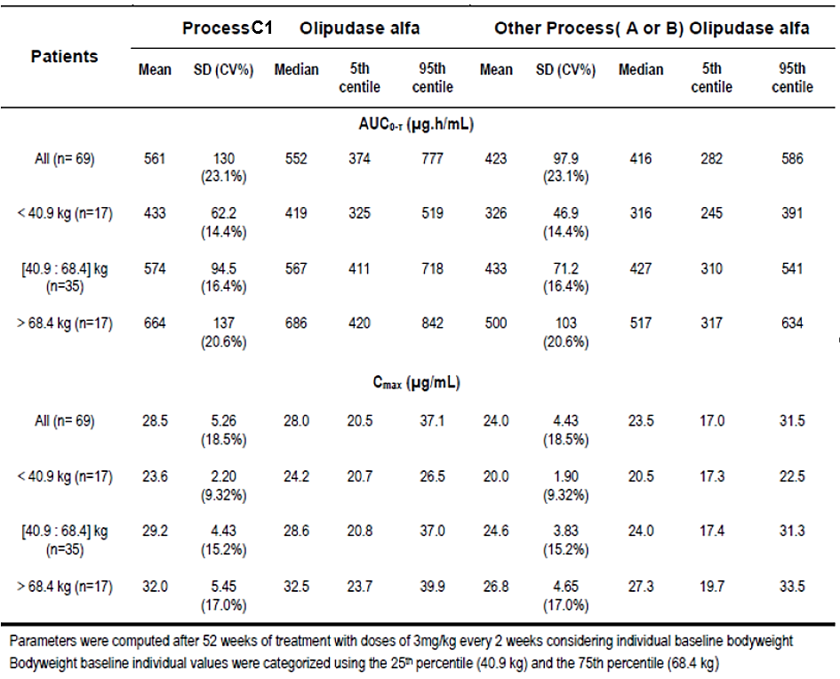

Interpatient variability in model parameters ranged between 14% and 24%. Residual (intra-individual) variability was moderate at 23% CV.

The PopPK model showed good agreement between model-predicted and observed plasma concentrations.

Study SIM0475 did not find a significant effect of ADA status at any timepoint on the pharmacokinetics of olipudase alfa (see safety section below where ADA status did seem to have clinical correlates).

The PopPK predicted exposures at steady state with 3mg/kg by age grouping are as follows:

* Adult – Cmax 30±5 µg/mL, AUC 607±120 µg.h/mL
* Adolescent – Cmax 28±2.2 µg /mL, 529±35 µg.h/mL
* Children aged 6 to < 12 – Cmax 24±2.4 µg /mL, AUC 450±68 µg.h/mL
* Young children/infants aged < 6 – Cmax 23±1.8 µg/mL, AUC 403±43 µg.h/mL

These differences in exposure between the various paediatric groups was not considered clinically significant and this was supported by the efficacy outcomes in the trial. The proposed weight based dosing (applicable to all age groups) is therefore appropriate.

Special populations:

Impaired renal or hepatic function is not expected to affect the exposure to olipudase alfa and no specific studies have been conducted. PopPK analysis using creatinine as a covariate did not find a difference. Four adult patients with cirrhosis had similar steady state AUC compared to patients without cirrhosis.

##### Pharmacodynamics

The following biomarkers were investigated in some of the clinical studies:

* Sphingomyelin is the major sphingolipid that accumulates in ASMD. No consistent changes were observed following olipudase alfa administration (SPHINGO00605, DFI13412, or DFI12712 ASCEND).
* Lysosphingomyelin (deacylated sphingomyelin) is elevated in plasma of ASMD patients and declined with treatment.
* Ceramide is a direct catabolite of sphingomyelin and acutely increases followed by a longer term decrease with olipudase alfa treatment.
* Chitotriosidase and CCL18 are secreted by tissue macrophages and angiotensin-converting enzyme is produced by endothelial cells – all are being explored as potential biomarkers in ASMD.

The single dose study in adults (SPHING0605) demonstrated a dose dependant increase in ceramide soon after olipudase alfa infusion (Figure 2).

Figure 2. Serum ceramide levels following olipudase alfa infusion.

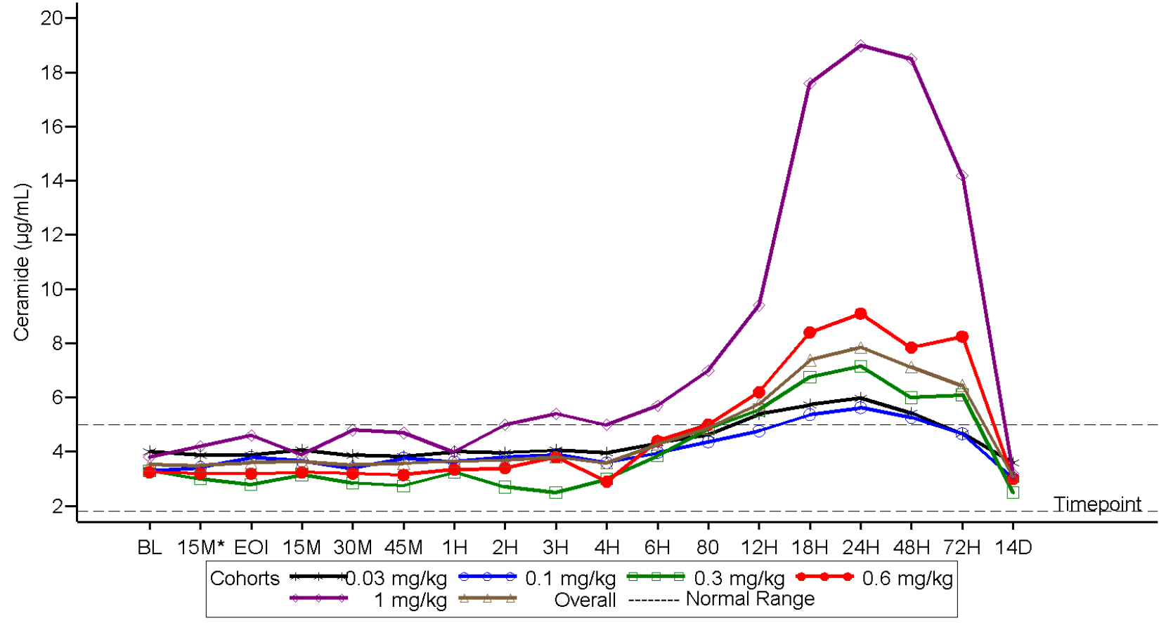

Decreases over the 52 week studies compared with baseline were seen in chitotriosidase, CCL18, ACE, lysosphingomyelin, ceramide and liver sphingomyelin (on biopsy). In the adult study which included a placebo arm, there were significant changes both from baseline and compared with placebo.

##### Immunogenicity / antidrug antibody (ADA) measurement:

ADA analysis was conducted in all multiple dose studies of adults and paediatric patients.

Overall, 48.3% (29 of 60 patients) of patients developed treatment-emergent ADAs (16/40 adults and 13/20 paediatric patients). The majority had a low titre (≤400) with a median titre of 75 (range 50-3200) for adults and 200 (range 50-1600) for paediatric patients. Paediatric patients developed ADAs sooner than adults.

Overall, 15% (9/60) develop neutralising ADAs that inhibited catalytic activity (similar number of adult and paediatric patients). Six of these patients were only neutralising-ADA positive at a single timepoint, whereas the other 3 were intermittently positive. No ADA that inhibited cellular uptake of olipudase alfa into cells was detected.

As mentioned above, ADAs did not significantly alter the exposure to olipudase alfa in either the PK or PopPK studies. In addition, they did not seem to have an effect on lysosphingomyelin concentrations. Based on very limited data, the neutralising ADA also did not affect the lysosphingomyelin concentration.

##### Population PK/PD data (PopPK/PD)

Study POH0610 was a PopPK/PD study evaluating the relationship between olipudase alfa exposure and spleen volume and DLCO (as well as platelets, haemoglobin, haematocrit). Cumulative exposure was determined using the PopPK model. None of the responses had a clear relationship with olipudase alfa cumulative AUC.

Study POH0712 developed models to characterise the relationship between olipudase alfa plasma concentration and lysosphingomyelin and between lysosphingomyelin and spleen volume reduction and DLCO increase. A relationship was found whereby olipudase alfa reduced lysosphingomyelin, with age and bodyweight as covariates. A near maximal reduction of lysosphingomyelin was achieved in the overall population. A relationship between lysosphingomeylin and reduced spleen volume and increased DLCO predicted was subsequently found.

##### Quantitative systems pharmacology (QSP) modelling

In study QSP0068 a QSP model was developed to provide supportive (extrapolative) evidence of efficacy in the paediatric population. The paediatric studies included only a limited number of patients across a range of developmental stages (n=20). In addition, there was no placebo arm in any of the paediatric efficacy studies. The QSP model incorporated data from the adult and paediatric clinical studies, the natural history studies, preclinical studies and studies on sphingomyelin biology and ASMD. The PD outcomes included sphingomyelin, ceramide, lysosphingomyelin and the cellular and organ level representations of disease. The QSP model supports mechanistic similarity between paediatric and adult patients. Though not directly related to the proposed indications in this submission, the QSP model also predicts olipudase alfa to be efficacious in debulking tissue sphingomyelin in patients with ASMD type A.

#### Efficacy

As mentioned, above manufacturing processes A, B, C1 and C2 were used during the clinical development program and subsequent commercialisation. Most patients during the primary analysis periods of the main adult and paediatric trials were exposed to B and C. During the subsequent extension studies, patients received either C or C. Post hoc analyses did not identify differences in efficacy due to the manufacturing processes, although this was not definitive. Similarity was demonstrated from a quality perspective, and the EMA considered this acceptable.

Study SPHING0605 was a phase 1, single-centre, single-dose, dose-escalation study of olipudase alfa in 11 adults with ASMD. Doses administered were 0.03 mg/kg (n=3), 0.1 mg/kg (n=3), 0.3 mg/kg (n=2), 0.6 mg/kg (n=2) and 1.0 mg/kg (n=1). The patients were all white and the mean age was 31. There were 6 were males and 5 females. Mean baseline peripheral leukocyte ASM activity was 16% of normal and ranged from 6% to 29%. All patients had a spleen volume ≥ 2 multiples of normal (MN). Liver volumes were increased by a mean of 1.6 MN, but no patients had cirrhosis and the mean ALT, AST and total bilirubin were within normal limits. Ten of 11 patients had a BMI < 30 and all had both *SMPD1* pathogenic alleles identified.

There was a dose-dependent increase in ceramide (sphingomyelin is converted by the exogenous sphingomyelinase to ceramide), with a high peak in the patient receiving 1mg/kg (Figure 1). It was difficult to assess the relationship between sphingomyelin levels and the safety biomarkers.

Study DFI13412 was an open-label ascending dose study of the tolerability, safety PK and PD of olipudase alfa in adults with ASMD. Patients had a spleen volume ≥ 6 MN, DLCO (diffusing capacity of carbon monoxide) between 20 and 81% predicted. Modestly elevated liver parameters were acceptable (ALT/AST ≤ 250 IU/L, total bilirubin ≤ 1.5mg/dL and INR ≤ 1.5). The study’s purpose was to look at a gradual dose escalation strategy to prevent rapid and excessive build-up of ceramide and allow tolerable dosing. Repeated IV infusions of olipudase alfa were administered every 2 week for 26 weeks. There were 5 patients aged between 18 and 65 years enrolled.

Following 26 weeks of olipudase alfa treatment the following was observed:

* Lung function parameters improved, including FVC (forced vital capacity), TLC (total lung capacity) and FEV1 (forced expiratory volume in 1 second). Diffusing capacity for carbon monoxide (DLCO) % predicted increased more than the other parameters, by 13.4%.
* Spleen volume and liver volume decreased (by means of -29.4% and -21.9% respectively)

Plasma ceramide levels increased in the days following each olipudase alfa infusion. However, pre-infusion levels gradually decreased over time. This is consistent with olipudase alfa mediated metabolism of sphingomyelin into ceramide.

Pivotal study DFI12712 (also known as ASCEND) was a phase 2/3, multicentre, randomised, double-blinded, placebo-controlled, repeat dose study to evaluate the efficacy, safety, pharmacodynamics and pharmacokinetics of olipudase alfa in adults. The study consisted of a 52 week on-treatment double-blind part, followed by a 52 week open-label extension (with placebo patients crossing over to olipudase alfa).

In this study patients were randomised 1:1 to placebo or 3.0mg/kg olipudase alfa (target dose, preceded by up-titration schedule). Treatments were given by IV infusion every 2 weeks. In case of infusion reaction, one rechallenge was allowed for each of the first 2 dose levels (0.1mg/kg and 0.3mg/kg). Patients were in hospital for at least 24 hours post-dose during the titration periods (either in the double-blind part or the extension study for those originally randomised to placebo). Home infusions, by trained nurses, were allowed during the extension study. A rescue strategy was applied during the double-blind period if patients experienced significant clinical decline.

Patients who could only tolerate a dose that was less than the target dose, could remain at that dose level for the remainder of the study (as long as it was at least 0.3mg/kg). Patients with BMI > 30 kg/m2 were dosed using a weight calculated from their height and a BMI assumption of 30 (i.e. weight used for dosing = 30 X h2). Otherwise, the administration schedule was as per Table 8. Criteria were applied to determine whether dose escalation was to proceed (if no or mild AE -> escalate per protocol; if moderate AE -> repeat same dose; severe AE -> decrease to prior dose).

Table 8. Olipudase alfa administration schedule

Major inclusion criteria included:

* Male and females aged ≥ 18 years
* ASMD with ASM deficiency documented in peripheral leukocytes, fibroblasts or lymphocytes
* A clinical diagnosis of Nieman Pick B (i.e. chronic visceral ASMD)
* DLCO ≤ 70% predicted
* Spleen volume ≥ 6 times normal measured by MRI
* Splenomegaly-related score ≥ 5

Major exclusion criteria included:

* Platelet count < 60
* INR > 1.5
* ALT or AST > 250 IU/L or total bilirubin > 1.5 mg/dL (unless Gilbert’s syndrome present)

The primary endpoints were:

1. Percentage change in % predicted DLCO from baseline to week 52
2. Percentage change in spleen volume from baseline to week 52

The secondary endpoints (in order of testing hierarchy) were:

1. Percentage change in liver volume from baseline to week 52
2. Percentage change in platelet count from baseline to week 52
3. Fatigue severity as measured by item 3 of Brief Fatigue Inventory (BFI) scale
4. Pain severity as measured by item 3 of the Brief Pain Inventory-Short Form (BPI SF) scale
5. Dyspnoea severity as measured by the Functional Assessment of Chronic Illness Therapy (FACIT)-dyspnoea tool
6. Patient perception related to spleen volume (5 items: abdominal pain, abdominal discomfort, early satiety, abdominal body image and ability to bend down)

Tertiary endpoints related to lung function testing, pulmonary imaging on CT and cardiopulmonary exercise testing (CPET)

Randomisation used blocks of 4 and was not stratified. Patients, investigators and the Sponsor were all blinded (except for the unblinded Sponsor team who managed certain activities).

The main efficacy population was the modified intention to treat (mITT) which included all patients who received at least 1 infusion (including partial infusions). Other populations analysed were the per protocol population and the mITT-C, which excluded patients who had exposure to the Process B olipudase alfa product.

The study would meet both primary endpoints if they were positive at the p < 0.05 level. If one of the endpoints had an associated p value > 0.05, the other endpoint could be considered significant if its p values was < 0.025.

DLCO % change from baseline was analysed using a mixed model for repeated measures (MMRM), having an unstructured variance-covariance matrix with other variance-covariance models used in case of failure to converge (Toeplitz, first order autoregressive and compound symmetry in order). In addition, a DLCO responder was defined as at least a 15% improvement from baseline, which is supported by the literature in other diseases (e.g. connective tissue disease-associated interstitial lung disease). Spleen volume change was also analysed using MMRM and a responder was defined by at least a 30% change in volume from baseline. If statistical significance was reached for the two primary endpoints, the secondary endpoints were tested sequentially (in the order given above), with testing proceeding as long as the p values was < 0.05.

Of 62 patients screened, 18 were randomised to each of placebo and olipudase alfa. All 36 with wither olipudase alfa or placebo randomised patients received treatment. The mean age overall was 34.8 (range 18.6-65.9) and 39% were male and 61% female. Most patients were white (89%). The mean age at ASMD diagnosis was 18 and the mean time since diagnosis was 16.8 years. Overall, 22.2% of patients had severe splenomegaly (>15 MN) and the mean DLCO predicted was 49%. Most patients (13/18) received olipudase alfa produced using process C and 4/18 were treated with drug using process B.

For percent predicted DLCO, the least squares mean percent change was 22% (i.e. an increase) with olipudase alfa and 3% with placebo at week 52. The between arm difference was 19% (CI: 9.4-28.7) with p < 0.004. As shown in Table 9 this improvement was evident at week 26 and continued until week 52, when the double blind period ended.

Table 9. Analysis of the percentage change in DLCO (%predicted) from baseline to week 52 in the mITT population

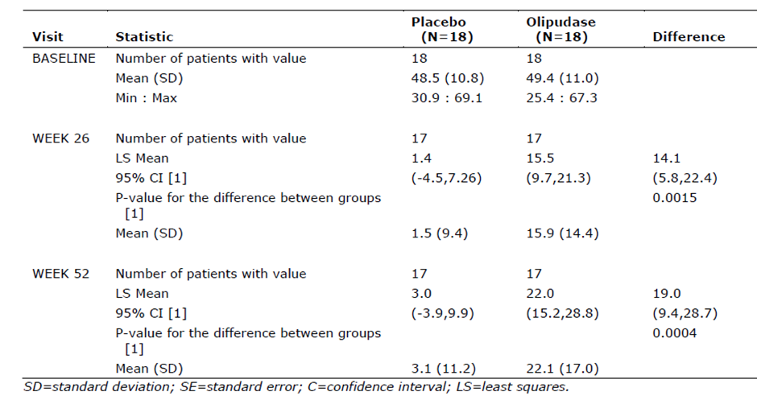

In the open-label period there appeared to be ongoing improvement (or at least stabilisation of effect) for those continuing with olipudase alfa. Those patients transitioning from placebo to olipudase alfa experienced a similar improvement in DLCO % predicted as those treated with olipudase alfa initially. The responder analysis for the double-blind period found that 27.8% of patients receiving olipudase alfa were responders compared with 0% receiving placebo.

For percentage change in spleen volume, there was a -39.5% change in LS mean volume with olipudase alfa and a 0.48% increase in LS mean volume with placebo over the 52 week placebo controlled period. The difference between the arms was -39.9% (CI: -47.1% to -32.8%) with p < 0.0001.

In the open-label period, the placebo/olipudase alfa group achieved 35.9% reduction in spleen size over the 52 weeks (i.e. essentially caught up to the olipudase alfa-treated patients). The olipudase alfa/olipudase alfa arm achieved further reductions in volume at week 104 (47%, n=14), week 132 (52%;n=13) and was stable at week 156 (49.9%;n=6). The responder analysis for the double blind period found 94.4% of patients in the olipudase alfa arm were responders, compared with 0% in the placebo arm.

The secondary endpoint outcomes were as follows:

* At week 52 the LS mean % reduction in liver volume was 28% with olipudase alfa and 1.5% with placebo (p<0.0001).
* At week 52, the LS mean % increase in platelet count was 16.8% with olipudase alfa and 2.5% with placebo (p=0.0185).
* No difference between olipudase alfa and placebo for fatigue severity was found and secondary outcome evaluation was stopped according to the testing procedure.

The analyses looking at the impact of olipudase alfa production process method did not reveal any effects. The sensitivity analyses supported the primary outcome.

Pivotal study DFI13803 (also known as ASCEND-peds) was a phase 1/2 , multi-centre, open-label, repeat-dose study to evaluate safety, tolerability, PK, PD and exploratory efficacy of olipudase alfa q2w for 64 weeks in patients < 18 years of age and with non-CNS manifestations of ASMD. The study planned to treat at least 20 patients to a target dose of 3.0mg/kg (or highest tolerated dose) following a minimum 16 week dose escalation. Patients who could not tolerate 2 consecutive doses of 0.3mg/kg olipudase alfa were replaced.

Similar to other olipudase alfa studies, the study drug was manufactured using different methods, as described above. During the 64 week study, 12 patients were treated with Process B drug and 8 were treated with process C drug.

Major inclusion criteria:

* Male or female < 18 years of age
* Documented ASM deficiency as measured in peripheral leukocytes, cultured fibroblasts and/or lymphocytes
* Spleen volume ≥ 5 MN as measured by MRI
* Patient height was -1 standard deviation or lower than Z score

Major exclusion criteria:

* Acute or rapidly progressive neurological abnormalities
* Homozygosity or compound heterozygosity with *SMPD1* mutations R496L, L302P, fs330

Dosing commenced at 0.03mg/kg olipudase alfa (i.e. 30% of the adult starting dose) and proceeded over 16 weeks to a target of 3.0mg/kg. Dose escalation could also end with identification of the highest tolerated dose. The minimum allowable maintenance dose was 0.3mg/kg. The typical dose escalation was 0.03mg/kg, 0.1mg/kg, 0.3mg/kg for 2 doses, 0.6mg/kg for 2 doses, 1mg/kg, 2mg/kg and 3mg/kg (i.e. minimum 16 weeks before reaching target dose). If required, additional doses at all dose levels were allowed with rechallenge only once at the 0.03mg/kg and 0.1mg/kg were d. The length of infusion time (20 minutes to 3.7 hours) depended on the dose and could be adjusted depending on patient tolerability. There were also rules governing resumption of dosing in case of missed doses.

The paediatric population were divided into infant/early child, child and adolescent groups, as shown in Table 10.

Table 10. Demographic and baseline characteristics.

The age at symptom onset, age at diagnosis, ASM activity and disease characteristics are shown in Table 11.

Table 11. Baseline disease characteristics

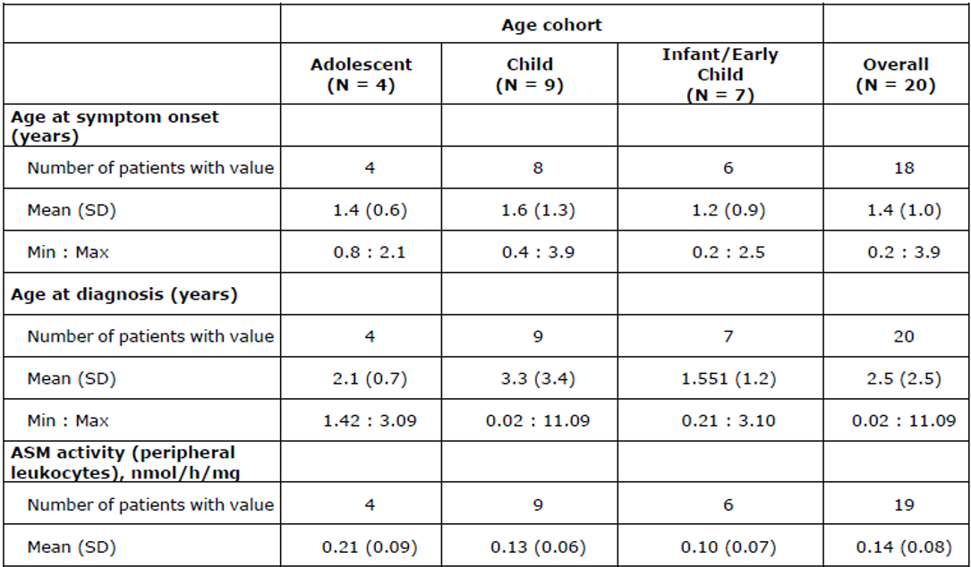

All 20 patients in the study had reductions in spleen and liver volume, which was evident at the 26 week assessment and continued to 52 weeks. For the group overall, there was a mean decrease of 49.2% of spleen size, with a range of 22.9% to 61.5% (Figure 3).

Figure 3. Individual patient spleen and liver volume over 52 weeks (mITT).

In terms of pulmonary function outcome, the % predicted DLCO adjusted for haemoglobin increased by 32.9%. This data was based on 9 patients who were able to perform the test at baseline (Figure 4). Individual patient changes ranged from 0.7% to 91.7%. Five patients (55.6%) had an improvement that reached the threshold (≥ 15%) for being a “responder”.

Figure 4. Individual percent changes in DLCO over 52 weeks (mITT)

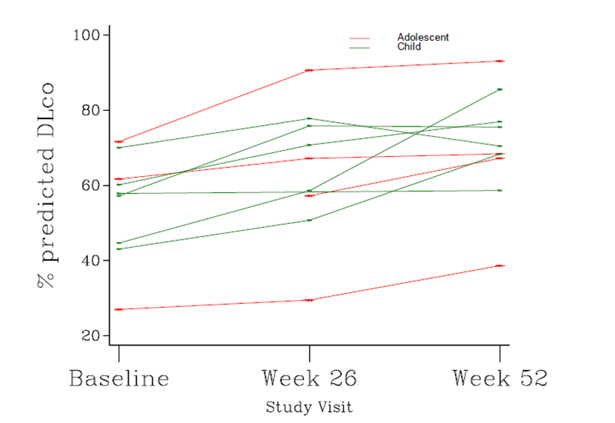

The results from the study were compared with those of the MSC12840 natural history study (described below). In the absence of a comparator group in the clinical trial, this allowed for some estimation of the likely treatment effect of olipudase alfa in the population. Significant improvements were found for spleen volume, liver volume, platelet count, height Z-score change and lung appearance change on high resolution CT scan (Table 12).

Table 12. Summary of efficacy parameters for comparative paediatric analysis of DFI13803 Peds versus natural history study (MSC12840) change over 1 year

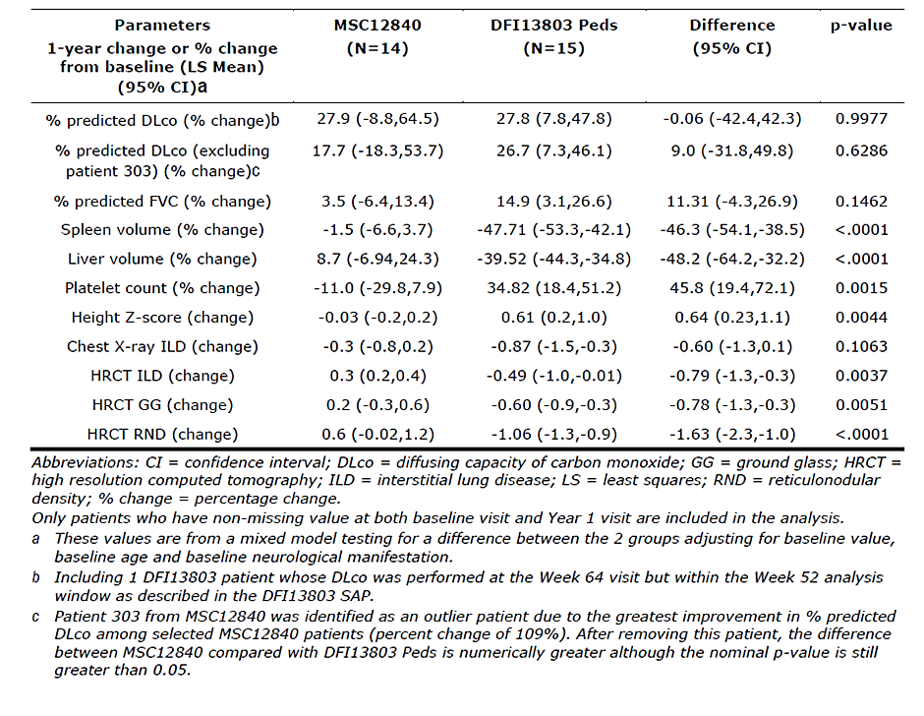

Three adolescents and 2 children underwent cycle ergometry testing (i.e. cardiopulmonary exercise testing) and there was a trend towards improvement in parameters including mean maximum workload, mean percent predicted maximum workload, mean working time, mean maximum O2 uptake and mean maximum CO2 output.

After 52 weeks of treatment, 15 (78.9%) of patients improved their height Z-score category and 4 (21.1%) remained in the same category.

There were significant improvements in some health outcome questionnaires including PedsQL Generic Core Scale (4/6 subtests positive for both patient and parent) and Multidimensional Fatigue Scale (3/4 subtests positive for both patient and parent).

Study LTS13632 is an ongoing long-term study for patients who completed DFI13412 (adult open-label, uncontrolled ascending dose study; n=5)) and DFI13803 (open-label, uncontrolled paediatric study; n=20). The study can continue for either 9 years or until marketing approval.

The primary objective of the study is to obtain additional safety data in long term use of olipudase alfa. Secondary objectives are to obtain data on efficacy, PK and PD with long term use. The inclusion and exclusion criteria mirrored those of the original trial. In this study patients continued with the same dose they were using at the end of the original trial. Home infusion was possible in certain circumstances.

Spleen volume appeared to continue to decrease beyond 12 months and then remain stale until the last time point studied (Figure 5).

Figure 5. Individual patient spleen volume (MN) - safety population

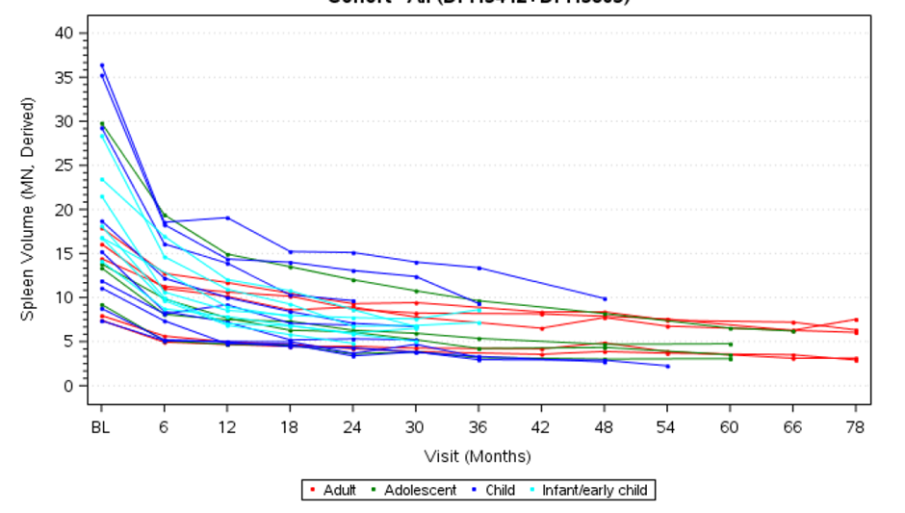

DLCO also appeared to continue to increase between the original 52 weeks studies (Figure 6).

Figure 6. Percentage predicted DLCO adjusted for Hb over time - safety population

Subgroup analyses were consistent with:

* Similar magnitude of effect size in patients with severe and non-severe splenomegaly
* Similar magnitude of effect size in patients who were ADA (antidrug antibody) positive and negative

#### Safety

The safety data was analysed together across the 5 studies. Some patients participated in more than 1 study. Seventy-two patients received olipudase alfa, of whom 11 received a single dose and 61 received multiple doses. Of 60 patients from the multiple dose studies, who comprised the pooled safety set, 40 were adults and 20 were children. Follow up ranged between 26 weeks and 9 years. The majority were still enrolled in ongoing studies (only 3 adults had discontinued treatment due to “wishes to withdraw” and “other”). The majority (35 adults and 20 children) achieved the target dose of 3.0mg/kg at the time of data cut-off.

The cumulative exposure was 80.29 patient-years for children and 135.78 patient-years for adults. The mean exposure time was 4.01 years for children and 3.39 years for adults (corresponding median exposure times were 4.15 and 2.95 years). The maximum exposure was 7.8 years, which occurred in the adult group.

There were no deaths. More paediatric patients than adults experienced serious adverse events (SAEs) (16.12 per 100 patient-years vs. 12.18 patient years), severe treatment emergent adverse events (TEAEs) (11.47 per 100 patient-years vs. 5.93 per 100 patient-years) and TEAEs leading to dose reduction (12.86 per 100 patient-years vs. 3.31 per 100 patient-years) (Table 13).

Table 13. Overview of treatment-emergent adverse events (safety set)

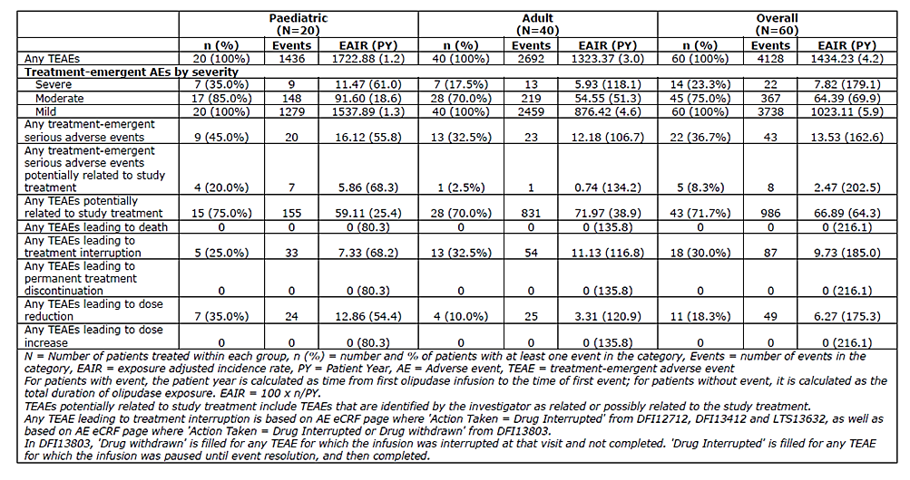

Overall, 22 patients experienced SAEs. These were most frequently infection related, including COVID, urinary tract infection, gastritis, pharyngitis and pneumonia. SAEs reported more than once were loss of consciousness (2 adults), gastroenteritis (2 children) and hypersensitivity (2 event in one child).

All 60 patients experienced at least 1 TEAE. A high percentage (71.7%) experienced TEAEs that were considered related, 23.3% had at least 1 severe TEAE and 18.3% had a TEAE leading to dose reduction. The related AEs were commonly headache, pyrexia, nausea, abdominal pain, vomiting, myalgia, pruritis, urticaria and increase CRP.

Transient biochemical aberrations in both adults and children included high creatinine (33.3% patients), hypoglycaemia (30%), elevated blood urea nitrogen (23.3%). For adults, the most frequent aberrations were hypoglycaemia (38.5%) and hyperglycaemia (17.5%, i.e. random glucose ≥ 11.1 mmol/L and fasting glucose > 7mmol/L). For children, the most frequent aberrations were elevated blood urea nitrogen (70%) and potassium ≤ 3.5mmol/L (15%).

Overall, liver parameters improved during treatment with olipudase alfa. The transaminase elevations there were seen were in patients with elevated baseline levels and during the dose escalation phase.

There was no QTc prolongation or AEs consistent with prolonged QTc sequalae.

Infusion associated reactions occurred in 53.8% of adult patients, more often during dose escalation, and included headache, nausea, urticaria, pyrexia and arthralgia. None of these reactions were severe. Infusion associated reactions occurred in 60% of paediatric patients and included pyrexia, urticaria, vomiting, headache, nausea, increased CRP, increase ferritin and rash. Three of the reactions were serious, with 1 patient experiencing each of anaphylactic reaction, urticaria and rash, and hypersensitivity reaction. A patient with anaphylaxis underwent a successful desensitisation procedure.

Hypersensitivity reactions occurred in 17.9% of adults and 40% of children.

The production processes (process B vs C) did not appear to influence occurrence of AEs.

Hypersensitivity infusion associated reactions occurred more frequently in ADA positive patients compared with ADA negative patients (38.5% vs. 7.7%). Treatment emergent SAEs were also more frequent in both adults and children with ADAs (30.8% and 50%, respectively) compared to those without ADAs (19.2% and 37.5%, respectively).

Pre-treatment (antihistamines, antipyretic, glucocorticoids) were not used systematically but could have been used at Investigator discretion.

In addition to the difference between adults and paediatric patients in terms of the occurrence of various types of AEs, younger children experienced more SAEs and infusion associated reactions.

In post-market use of olipudase alfa, one paediatric patient reported 2 anaphylactic reactions and treatment was discontinued. Another paediatric patient experienced emesis during and after the infusion, although the treating physician felt this was consistent with their underlying clinical state.

##### Natural history studies

Study SPHING00302was a retrospective natural history study of ASMD looking at morbidity, mortality rate and cause, predictors of morbidity and mortality and incidence and prevalence in the studied regions. As this study was not used by the Sponsor for any direct comparison with the clinical efficacy data, it is only considered briefly here.

There were 100 patients in the study (13 with ASMD A, 77 with ASMD B and 6 with ASMD other). Most patients were white (68%), female (62%) and diagnosed by enzyme assay (98%). Common (>50%) broad morbidity categories reported across the group were hepatobiliary disorders (91%), respiratory/thoracic/mediastinal disorders (83%), infection and infestations (77%), gastrointestinal disorders (76%), general disorders / admin site conditions (71%), blood and lymphatic system disorders (61%), musculoskeletal / connective tissue disorders (62%) and skin/subcutaneous tissue disorders (58%).

Out of 81 patients with ASMD B in the study, 2 died (1 from renal failure/hepatic failure at age 43 and 1 from respiratory at age 2). Progressive reduction in platelet counts was indicative of disease progression.

Study MSC12840 was a prospective, cross-sectional survey of natural history data in patients with ASMD B. The study, conducted over 11 years, included patients aged 6 years and above with ASMD B, and was used as a comparator for the open label paediatric study (DF13803). The data collected in this study was used to plan clinical studies. Detailed evaluation included assessment of spleen and liver volumes, pulmonary assessments, cardiac evaluation, neurological evaluation, quality of life and growth parameters. These evaluations were conducted at baseline, year 1 and again after 5-11 years.

Of 59 patients enrolled, 57 completed the baseline visit, 50 completed the year 1 visit and 32 completed the final visit. Some patients remained in the study despite not completing earlier assessments. Overall, 8 patients died during the course of the study. Eight patients were lost to follow-up and 4 were discontinued for unknown reasons. Most patients were Caucasian (91.5%), mean age was 22.2 and median age was 17 (range 7 to 64 years old). There were 30 patients aged 17 or under (20 male and 10 female).

Baseline and year 1 height for age Z scores were -0.9 and -1.1 (6-11 year olds) and -2.7 and -2.6 (12 to 17 year olds), respectively. There were too few patients at the final visit to provide meaningful data on this metric.

DLCO predicted at each visit was 66% - 75% and tended to decrease in those patients with baseline dyspnoea. On CT imaging, 66.1% had interstitial changes at baseline and 78.1% at final visit (n=59 at baseline and n=32 at final visit).

### Risk management plan evaluation summary

The Sponsor submitted EU-RMP version 1.0 (10 May 2022; DLP15 Mar 2021) and ASA version 1.0 (Aug 2022). The Summary of safety concerns is shown in Table 14.

Table 14. Summary of safety concerns

The Sponsor has proposed routine pharmacovigilance for all safety concerns as well as additional pharmacovigilance for immunogenicity, medication errors in the home infusion setting and safety beyond 2 years. In addition to routine risk minimisation activities, the Sponsor has proposed additional activities for immunogenicity, medication errors in home infusion setting and foetal toxicity. This RMP is considered acceptable, notwithstanding additional issues raised by module 4 and module 5.

The content of the Health Care Professional guide and the Patient Card have been reviewed by the RMP Evaluator.

##### RMP evaluator recommendations regarding condition/s of registration

The Evaluator has not formally documented the intended conditions of registration at this stage, but they are likely to include:

* Details of RMP and ASA to be implemented in Australia
* Provision of periodic safety update reports (PSURs) aligned with the reference dates in the EU
* Use of the black triangle system for enhanced reporting of new drugs and inclusion of the symbol and accompanying text in the Healthcare Professional guide and Patient Card.

### Discussion

##### Proposed indication

###### EMA/CHMP perspective

The original submission to the EMA did request inclusion of ASMD A patients in the indication. The EMA was concerned about the lack of direct data and also the applicability of the QSP model to ASMD A. The Sponsor explained the basis for the QSP model providing a meaningful perspective on olipudase alfa treatment in type A patients but agreed not to pursue their inclusion in the current submission, given the risk-benefit uncertainty.

###### Delegate perspective

The indication includes patients with ASMD B and A/B. The Sponsor has not requested the inclusion of ASMD A patients. This is appropriate as they were not studied in any of the clinical trials presented in the dossier. ASMD A is characterised by severe disease in infancy with prominent neurological features. Olipudase alfa, which does not cross the blood-brain barrier, is likely to be effective for reducing sphingomyelin burden outside the CNS and could reduce symptoms of hepatosplenomegaly. However, its overall effect on disease course (including mortality and other morbidity, symptom burden, quality of life) is currently unknown.

##### Efficacy

###### EMA/CHMP perspective:

The EMA considered it demonstrated that olipudase alfa treatment reduces the spleen and liver volume to a clinically meaningful extent. DLCO stabilises or improves with treatment and this is also clinically meaningful. Results appeared comparable in adults and paediatric patients and the modelling included in the dossier lends further support to this. The EMA also noted other results that support efficacy were pharmacodynamic parameters, additional lung function parameters and improvements in dyspnoea and quality of life.

Delegate perspective:

The pivotal clinical trials used hard primary outcome endpoints that are also highly clinically relevant (i.e. the direct cause of morbidity and mortality). The results in the adult placebo-controlled trial demonstrated significant effect sizes for spleen reduction and DLCO improvement. Whilst the paediatric data was open-label and not controlled, the effect sizes seen were comparable to the adult population and, together with other lines of evidence such as QSP modelling, imply the efficacy of olipudase alfa.

The Delegate notes the small number of patients in the clinical studies make it difficult to reach sufficient power to demonstrate efficacy across a wider range of outcomes (such as those secondary outcome measures in DFI12712). In addition, given the chronicity of ASMD B, a longer duration study may be needed to demonstrate an effect on mortality, if indeed there is one. These questions may be answered in the long term follow up studies. ASMD is extremely rare (estimated at 1:250 000) and the current dataset is acceptable.

##### Safety

###### EMA/CHMP perspective

The EMA considered that most adverse effects were either related to infusion reactions (pyrexia, rash) or treatment failure. The proportion of patients having at least 1 severe TEAE (23.3%) or TEAE leading to dose reduction (18.3%) was noted. No patient permanently stopped treatment. The EMA also noted that paediatric patients had a higher burden of concerning AEs as there were more SAEs, related SAEs and severe TEAEs in paediatric (45%, 20% and 35%) patients compared with adults (32.5%, 2.5% and 17.5%). The two events of loss of consciousness were noted.

Infusion associated reactions were common in adults and paediatric patients. They occurred more often during dose escalation than after, in adults. In paediatric patients they occurred during and after dose escalation. Three paediatric patients had serious infusion associated reactions (anaphylaxis, urticaria and hypersensitivity). Hypersensitivity infusion associated reactions were twice as common in children than adults. The EMA asked the Sponsor about whether any specific advice should be given regarding pre-treatment and was satisfied that routine symptom management and antipyretics should be applied if needed (in the trials, no adults received pre-treatment and only 10% of paediatric infusions were associated with pre-treatment).

There was an association between treatment emergent ADA positivity and infusion associated reactions (both hypersensitivity and non-hypersensitivity related).

###### Delegate perspective

This is a small dataset that has limitations in detecting safety signals, especially ones that are uncommon or rare or are only seen with long-term treatment. This should be addressed with the acquisition and dissemination of additional safety data.

There is a significant rate of infusion related reactions, most of which are non-severe and manageable at the clinical level. The risk of anaphylaxis, which can be life threatening, is of concern and needs to be considered when addressing risk-benefit in individual patients.

##### Deficiencies in the data

###### EMA/CHMP perspective

The EMA noted some aspects of the data that are deficient and may lead to clinical uncertainty. They include,

* Nine of out 60 patients developed neutralising ADAs that inhibit catalytic activity.
* There is limited data for longer term use – in the extended treatment period, 29/35 have week 104 data reported; between week 156 and week 208 11/35 were treated and only 4 patients received olipudase alfa for > 208 weeks.
* There is inconsistency with dyspnoea as a secondary outcome when considering the different tools (FACIT Dyspnoea score, QoL questionnaires, PGIC dyspnoea item).
* The paediatric study was primarily a safety. Some of the efficacy measures included in that study were not possible in infants (DLCO).
* The natural history study data (MSC12840) was not totally matched with the paediatric study, reducing its reliability as a comparator.
* In terms of the safety analysis, the low number of patients does not allow for firm conclusions. The full safety profile will emerge during clinical use.

###### Delegate perspective

The deficiencies identified by the EMA are reasonable, however the rarity of the disease and subsequent numbers enrolled in the trial renders them acceptable.

##### Risk-benefit analysis

###### EMA/CHMP perspective

Considering the morbidity (spleen, liver, lung), treatment related morbidity (e.g. splenectomy, liver transplant) and mortality with ASMD B and A/B, there is unmet need. Olipudase alfa is the first disease specific treatment for ASMD. Across the 67 patients included in the clinical development program, there is evidence for the following favourable effects:

* Changes in important PD biomarkers – chitotriosidase, plasma lyso-sphingomyelin and ceramide.
* Improvements in percentage predicted DLCO
* Reduction in spleen volume
* Reduction in liver volume
* Increase in platelet count
* Positive signals for other lung function parameters, quality of life, ergometry

The effects on the spleen, liver and lung appeared durable up to 5 years.

The important risks relate to infusion reactions, including anaphylaxis, and treatment failure. In addition, nearly half of patients develop ADAs, including some that were neutralising. No obvious detrimental effect on efficacy was noted. There appeared to be an associated with infusion associated reactions.

###### Delegate perspective

The efficacy is established across different age ranges and is also likely to be clinically meaningful. The currently known risks of treatment are acceptable but should be conveyed in the Product Information. There may be patients of older age with milder symptoms and/or co-morbidities who decide that the risk-benefit is not acceptable.

#### Conclusions

On the basis of limited but adequate safety and efficacy data, the Delegate intends to recommend approval of olipudase alfa for the indication *as an enzyme replacement therapy for the treatment of non-central nervous system (CNS) manifestations of acid sphingomyelinase deficiency (ASMD) in paediatric and adult patients with type A/B or type B.* This is pending the outcome of ACM, the module 3 and 4 evaluations and any negotiations over the content of the PI.

#### Advisory Committee considerations

The [Advisory Committee on Medicines (ACM)](https://www.tga.gov.au/committee/advisory-committee-medicines-acm) having considered the evaluations and the Delegate’s overview, as well as the Sponsor’s response to these documents, advised the following.

1. What is ACM’s view regarding changing wording of the indication to ‘Xenpozyme treatment should be initiated and supervised by a specialist physician experienced in the management of ASMD or other inherited metabolic disorders?

The ACM was of the view that it is important for the PI to state *‘Xenpozyme treatment should be initiated and supervised by a specialist physician experienced in the management of ASMD or other inherited metabolic disorders.*

The ACM noted ASMD is a rare inborn error of metabolism which requires the expertise of specialist physicians to diagnose and provide optimal management of affected patients.

The clinical oversight of Xenpozyme treatment should be similar to other lysosomal storage disorders that are managed by specialist physicians with relevant expertise in inherited metabolic disorders.

1. Considering the Australian context, including patient safety and health access equity what is the committee’s view regarding the suitability for administering olipudase alfa at home? Is the PI sufficient in this regard? Are there any parameters around the ‘healthcare professional,’ including their skills and equipment they have available, that should be considered?

The ACM was of the view that dose escalation should occur in a hospital setting with oversight from specialist physicians to ensure safety and appropriately establish the maximal tolerated maintenance dose. During the maintenance phase the ACM considered a cautious approach is warranted and advised that individual patient risks need to be considered in deciding as to whether home infusion is an appropriate option. A practical approach would be to expect achievement of maintenance dose and a minimum of 6 months of hospital administration before the potential for home-administration was considered (if it is to be considered).

In providing this advice, the ACM considered the hypersensitivity and infusion reaction safety data and noted that it was unclear as to when infusion reactions occurred in adults. The ACM further noted that infusion reactions appeared to occur in children during and after dose escalation and that post-market data show two instances of anaphylaxis.

The ACM noted that should the home or a non-hospital healthcare setting be used for the administration of maintenance doses, resuscitation equipment should be available and the healthcare professional administering treatment be qualified to use the equipment.

The ACM acknowledged the quality-of-life benefits for patients and families with home infusions however reiterated the importance of taking into consideration the individual patient risks prior to making this decision.

Should home administration be supported for this product during the maintenance phase the ACM strongly supported additional information on infusion reactions and when these occurred be included within the PI (similar to other enzyme replacement therapy PIs) to allow specialists and patients to make fully informed decisions.

1. Does information need to be included about the severity of disease required to be observed before commencing treatment?

The ACM was of the view that a diagnosis of ASMD type B or type A/B (alternatively referred to as ASMD intermediate form) must be established prior to commencing treatment. The ACM agreed that ASMD type A should be excluded from the indication as this aligns with the clinical studies.

The ACM noted there can be variability in the phenotype and severity of the disease however considered the progressive nature of the disease and agreed that treatment following diagnosis is appropriate.

1. Should the PI include information about monitoring the response to therapy (e.g. spleen imaging, DLCO, biomarkers)? If yes, what may be appropriate.

The ACM agreed that the PI should include information about monitoring the response to therapy. Appropriate monitoring includes:

* platelet count
* liver function
* liver/spleen volume
* lung function, including diffusing capacity (age appropriate)
* height, weight and pubertal status
* biomarkers analyses including lysosphingomyelin

The ACM also noted the recommended surveillance for individuals with ASMD outlined in the table within Wasserstein & Schuchman 2006.[5]

1. Other advice:

The ACM was supportive of the PI changes proposed by the Delegate further stating:

* Suggest including the word ‘maximum’ in front of recommended maintenance dose when referring to the 3 mg/kg dose
* Separate instructions for adults and paediatrics should be provided in regard to missed doses noting the differing starting doses

The ACM also noted that it is important to include the clinical trial inclusion and exclusion criteria in the PI.

##### ACM conclusion

The ACM considered this product to have an overall positive benefit-risk profile for the indication:

*Xenpozyme is indicated as an enzyme replacement therapy for the treatment of non-central nervous system (CNS) manifestations of acid sphingomyelinase deficiency (ASMD) (also known as Niemann-Pick Disease) in paediatric and adult patients with type A/B or type B Type B and intermediate form.*

## Outcome

Based on a review of quality, safety, and efficacy, the TGA decided to register Xenpozyme.

Indication:

*Xenpozyme is indicated as an enzyme replacement therapy for the treatment of noncentral nervous system (CNS) manifestations of acid sphingomyelinase deficiency (ASMD) in paediatric and adult patients with type A/B (Niemann-Pick type A/B) or type B (Niemann-Pick type B).*

### Specific conditions of registration applying to these goods

##### RMP conditions

Xenpozyme (Olipudase alfa) is to be included in the Black Triangle Scheme. The PI and CMI for Xenpozyme must include the black triangle symbol and mandatory accompanying text for five years, which starts from the date that the sponsor notifies the TGA of supply of the product.

The Xenpozyme EU-Risk Management Plan (RMP) (version 2.2, dated 2 March 2023, data lock point 31 October 2022), with Australian Specific Annex (version 2.1, dated May 2023), included with submission PM-2022-03512-1-3, and any subsequent revisions, as agreed with the TGA will be implemented in Australia.

An obligatory component of risk management plans is routine pharmacovigilance. Routine pharmacovigilance includes the submission of periodic safety update reports (PSURs).

Reports are to be provided in line with the current published list of EU reference dates and frequency of submission of PSURs until the period covered by such reports is not less than three years from the date of this approval letter. The reports are to at least meet the requirements for PSURs as described in the European Medicines Agency’s Guideline on good pharmacovigilance practices (GVP) Module VII-periodic safety update report (Rev 1), Part VII.B Structures and processes. Note that submission of a PSUR does not constitute an application to vary the registration. Each report must have been prepared within ninety calendar days of the data lock point for that report.

##### Clinical conditions

Provision of the final Clinical Study Report of the open-label extension study, using the appropriate application type.

##### Quality conditions

###### Laboratory testing & compliance with Certified Product Details (CPD)

All batches of Xenpozyme olipudase alfa supplied in Australia must comply with the product details and specifications approved during evaluation and detailed in the Certified Product Details (CPD).

When requested by the TGA, the Sponsor should be prepared to provide product samples, specified reference materials and documentary evidence to enable the TGA to conduct laboratory testing on the Product. Outcomes of laboratory testing are published biannually in the TGA Database of Laboratory Testing Results http://www.tga.gov.au/ws-labs-index and periodically in testing reports on the TGA website.

###### Certified product details

The Certified Product Details (CPD), as described in Guidance 7: Certified Product Details of the Australian Regulatory Guidelines for Prescription Medicines (ARGPM) for the above products should be provided upon registration of these therapeutic goods. In addition, an updated CPD should be provided when changes to finished product specifications and test methods are approved in a Category 3 application or notified through a self-assessable change.

#### Attachment 1. Product Information

The [Product Information](https://www.tga.gov.au/products/australian-register-therapeutic-goods-artg/product-information-one) ([PI](https://www.tga.gov.au/products/australian-register-therapeutic-goods-artg/product-information-one)) approved with the submission for Xenpozyme which is described in this AusPAR can be found as Attachment 1. It may have been superseded. For the most recent PI and [Consumer Medicines Information](https://www.tga.gov.au/products/australian-register-therapeutic-goods-artg/consumer-medicines-information-cmi) (CMI), please refer to the TGA [PI/CMI search facility.](https://www.tga.gov.au/picmi-search-facility)

|  |
| --- |
| Therapeutic Goods Administration |
| PO Box 100 Woden ACT 2606 Australia  Email: [info@tga.gov.au](mailto:info@tga.gov.au) Phone: 1800 020 653 Fax: 02 6203 1605  [**https://www.tga.gov.au**](https://www.tga.gov.au) |
|  |

1. This is the original indication proposed by the Sponsor when the TGA commenced the evaluation of this submission. It may differ to the final indication approved by the TGA and registered in the Australian Register of Therapeutic Goods.
2. M McGovern, N. L. (2013). Morbidity and mortality in type B Niemann-Pick disease. Genet Med, 618-623.
3. In this report the ‘Delegate’ is the Delegate of the Secretary of the Department of Health and Aged Care who decided the submission under section 25 of the Act.
4. International Conference on Harmonisation of Technical Requirements for Registration of Pharmaceuticals For Human Use Guideline S6 (R1) - preclinical safety evaluation of biotechnology-derived pharmaceuticals. <https://database.ich.org/sites/default/files/S6_R1_Guideline_0.pdf>
5. Wasserstein MP, Schuchman EH. Acid Sphingomyelinase Deficiency. 2006 Dec 7 [Updated 2021 Feb 25]. In: Adam MP, Mirzaa GM, Pagon RA, et al., editors. GeneReviews® [Internet]. Seattle (WA): University of Washington, Seattle; 1993-2023. Available from: https://www.ncbi.nlm.nih.gov/books/NBK1370/