## AUSTRALIAN PRODUCT INFORMATION – YONSA MPRED™ ABIRATERONE ACETATE 4 MG TABLET AND METHYLPREDNISOLONE 4 MG TABLET COMPOSITE PACK

## 1 NAME OF THE MEDICINE

Abiraterone acetate and methylprednisolone.

## 2 QUALITATIVE AND QUANTITATIVE COMPOSITION

YONSA MPRED contains 125 mg abiraterone acetate tablets (YONSA) and 4 mg methylprednisolone tablets.

**Excipients with known effects**

YONSA MPRED contains sugars as lactose.

Each abiraterone acetate tablet (YONSA) contains lactose monohydrate.

Each methylprednisolone tablet contains lactose monohydrate. Methylprednisolone tablets contain sulfites.

For the full list of excipients, see section 6.1 List of excipients.

## 3 PHARMACEUTICAL FORM

Abiraterone acetate 125 mg tablet (YONSA): White to off-white modified oval shaped tablet debossed with ‘125 FP’.

Methylprednisolone 4 mg tablet: White to almost white, round, flat, bevelled edge, scored tablets.

## 4 CLINICAL PARTICULARS

### 4.1 Therapeutic indications

YONSA MPRED is indicated for the treatment of patients with:

* newly diagnosed high-risk metastatic hormone sensitive prostate cancer (mHSPC) in combination with androgen deprivation therapy (ADT), or
* patients with metastatic advanced prostate cancer (castration resistant prostate cancer, mCRPC) who are asymptomatic or mildly symptomatic after failure of androgen deprivation therapy (ADT) or
* patients with mCRPC who have received prior chemotherapy containing a taxane.

### 4.2 Dose and method of administration

The recommended dose of YONSA abiraterone acetate tablets is 500 mg (four 125 mg tablets) administered orally once daily in combination with methylprednisolone.

The recommended dose of methylprednisolone for metastatic hormone sensitive prostate cancer is 4 mg administered once daily. The recommended dose of methylprednisolone for metastatic castration resistant prostate cancer is 4 mg administered twice daily. (See section 4.4 Special Warnings and Precautions for Use - Corticosteroid withdrawal and coverage of stress situations).

#### Important administration instructions

To avoid medication errors and overdose, be aware that YONSAtablets may have different dosing and food effects than other abiraterone acetate products.

YONSAtablets can be taken with or without food (see Section 5.2 Pharmacokinetic properties). The tablets should be swallowed whole with water. Do not crush or chew tablets.

Patients started on YONSAMPRED who were receiving a LHRH agonist should continue to receive a LHRH agonist.

#### Recommended monitoring

Serum transaminases and bilirubin should be measured prior to starting treatment with YONSA MPRED, every two weeks for the first three months of treatment and monthly thereafter. Blood pressure, serum potassium and fluid retention should be monitored monthly (see section 4.4 Special Warnings and Precautions for Use).

#### Special populations

##### Abiraterone acetate

*Renal insufficiency*

No dosage adjustment is necessary for patients with renal impairment.

*Hepatic insufficiency*

No dosage adjustment is necessary for patients with pre-existing mild hepatic impairment. There are no data on the clinical safety and efficacy of multiple doses of abiraterone acetate when administered to patients with moderate or severe hepatic impairment (Child-Pugh Class B or C). No dose adjustment can be predicted. Abiraterone acetate tablets should be used with caution in patients with moderate hepatic impairment, only if the benefit clearly outweighs the possible risk. Abiraterone acetate tablets should not be used in patients with pre-existing severe hepatic impairment (see sections 4.3 Contraindications, 4.4 Special Warnings and Precautions for Use and 5.2 Pharmacokinetic Properties).

For patients who develop hepatotoxicity during treatment with abiraterone acetate tablets (alanine aminotransferase (ALT) or aspartate aminotransferase (AST) increases above 5 times the upper limit of normal or bilirubin increases above 3 times the upper limit of normal) treatment should be withheld immediately until liver function tests normalise (see section 4.4 Special Warnings and Precautions for Use). Re- treatment following return of liver function tests to the patient’s baseline may be given at a reduced dose of 250 mg (two 125 mg tablets) once daily. For patients being re-treated, serum transaminases and bilirubin should be monitored at a minimum of every two weeks for three months and monthly thereafter. If hepatotoxicity recurs at the reduced dose of 250 mg daily, discontinue treatment with abiraterone acetate.

If patients develop severe hepatotoxicity (ALT or AST 20 times the upper limit of normal) anytime while on therapy, abiraterone acetate tablets should be discontinued and patients should not be re-treated with abiraterone acetate tablets.

### 4.3 Contraindications

#### Abiraterone acetate

Abiraterone acetate is contraindicated in women who are or may potentially be pregnant.

Abiraterone acetate is contraindicated in patients with severe hepatic impairment [Child Pugh Class C].

Abiraterone acetate is contraindicated in combination with XOFIGO (radium 223 dichloride; see section 4.4 Special warnings and precautions for use)

Known hypersensitivity to abiraterone acetate or any excipient in the formulation.

#### Methylprednisolone

Known hypersensitivity to methylprednisolone or any excipient in the formulation.

### 4.4 Special warnings and precautions for use

#### Abiraterone acetate

##### Hypertension, hypokalaemia and fluid retention due to mineralocorticoid excess

Abiraterone acetate should be used with caution in patients with a history of cardiovascular disease. The safety of abiraterone acetate in patients with left ventricular ejection fraction (LVEF) <50% or New York Heart Association (NYHA) Class III or IV heart failure (in study 301) or NYHA Class II to IV heart failure (in studies 3011 and 302) was not established. Before treatment with abiraterone acetate, hypertension must be controlled and hypokalaemia must be corrected.

Abiraterone acetate may cause hypertension, hypokalaemia and fluid retention (see section 4.8 Adverse Effects (Undesirable Effects)) as a consequence of increased mineralocorticoid levels resulting from CYP17 inhibition (see section 5.1 Pharmacodynamic Properties). Co-administration of a corticosteroid suppresses adrenocorticotropic hormone (ACTH) drive, resulting in a reduction in the incidence and severity of these adverse reactions. Caution is required in treating patients whose underlying medical conditions might be compromised by increases in blood pressure, hypokalaemia or fluid retention, e.g., those with heart failure, recent myocardial infarction or ventricular arrhythmia. In postmarketing experience, QT prolongation and Torsades de Pointes have been observed in patients who develop hypokalaemia or have underlying cardiovascular conditions while taking abiraterone acetate.

Blood pressure, serum potassium and fluid retention should be monitored at least monthly.

##### Hepatotoxicity

Marked increases in liver enzymes leading to drug discontinuation or dosage modification occurred in controlled clinical studies (see section 4.8 Adverse Effects (Undesirable Effects)). Very rarely, hepatitis fulminant and hepatic failure has been seen. Serum transaminase and bilirubin levels should be measured prior to starting treatment with abiraterone acetate, every two weeks for the first three months of treatment, and monthly thereafter. If clinical symptoms or signs suggestive of hepatotoxicity develop, serum transaminases, should be measured immediately. If at any time the ALT or AST rises above 5 times the upper limit of normal or the bilirubin rises above 3 times the upper limit of normal, treatment with abiraterone acetate should be interrupted immediately and liver function closely monitored.

Re-treatment with abiraterone acetate tablets may only take place after the return of liver function tests to the patient’s baseline and at a reduced dose level (see section 4.2 Dose and Method of Administration).

If patients develop severe hepatotoxicity (ALT or AST 20 times the upper limit of normal) anytime while on therapy, abiraterone acetate should be discontinued and patients should not be re-treated with abiraterone acetate.

Patients with active or symptomatic viral hepatitis were excluded from clinical trials; thus, there are no data to support the use of abiraterone acetate tablets in this population.

There are no data on the clinical safety and efficacy of multiple doses of abiraterone acetate when administered to patients with moderate or severe hepatic impairment (Child-Pugh Class B or C). The use of abiraterone acetate tablets should be cautiously assessed in patients with moderate hepatic impairment, in whom the benefit clearly should outweigh the possible risk. Abiraterone acetate tablets should not be used in patients with severe hepatic impairment (see sections 4.3 Contraindications, 4.2 Dose and Method of Administration, and 5.2 Pharmacokinetic Properties).

##### Use with chemotherapy

The safety and efficacy of concomitant use of abiraterone acetate with cytotoxic chemotherapy has not been established.

##### Use in combination with radium 223 dichloride

In a randomised clinical trial in patients with asymptomatic or mildly symptomatic bone-predominant metastatic castration resistant prostate cancer, at the time of unblinding, the addition of radium 223 dichloride to abiraterone acetate plus prednisone/prednisolone showed an increase in mortality and an increased rate of fracture. Radium 223 dichloride is not recommended for use in combination with YONSA MPRED. It is recommended that subsequent treatment with radium 223 dichloride is not initiated for at least 5 days after the last administration of YONSA MPRED.

##### Paediatric use

This medicine is not for use in children.

##### Effects on laboratory tests

No data available.

#### Methylprednisolone

##### Corticosteroid withdrawal and coverage of stress situations

Caution is advised and monitoring for adrenocortical insufficiency should occur if patients need to be withdrawn from methylprednisolone. If abiraterone acetate is continued after corticosteroids are withdrawn, patients should be monitored for symptoms of mineralocorticoid excess.

In patients on methylprednisolone who are subjected to unusual stress, increased dosage of a corticosteroid may be indicated before, during and after the stressful situation. 17α hydroxylase inhibition by abiraterone acetate decreases glucocorticoid production.

##### Hyperglycaemia

The use of glucocorticoids could increase hyperglycaemia, therefore blood sugar should be measured frequently in patients with diabetes.

##### Immune system effects

Allergic reactions may occur. Because rare instances of skin reactions and anaphylactic/anaphylactoid reactions have occurred in patients receiving corticosteroid therapy, appropriate precautionary measures should be taken prior to administration, especially when the patient has a history of allergy to any drug.

##### Cardiac Effects

Adverse effects of glucocorticoids on the cardiovascular system, such as dyslipidemia and hypertension, may predispose treated patients with existing cardiovascular risk factors to additional cardiovascular effects if high doses and/or prolonged courses are used. When using corticosteroids in these patients, attention should be paid to risk modification and additional cardiac monitoring should be considered.

Use of systemic corticosteroid is not recommended in patients with congestive heart failure.

Particular care is required when considering the use of systemic corticosteroids in patients with recent myocardial infarction (myocardial rupture has been reported) and frequent patient monitoring is necessary.

Care should be taken for patients receiving cardioactive drugs such as digoxin because of steroid induced electrolyte disturbance/potassium loss (see section 4.8 Adverse effects).

##### Vascular Effects

Thrombosis including venous thromboembolism has been reported to occur with corticosteroids. As a result corticosteroids should be used with caution in patients who have or may be predisposed to thromboembolic disorders.

Corticosteroids should be used with caution in patients with hypertension.

Endocrine effects

Because glucocorticoids can produce or aggravate Cushing’s syndrome, glucocorticoids should be avoided in patients with Cushing’s disease.

There is an enhanced effect of corticosteroids in patients with hypothyroidism.

Pheochromocytoma crisis, which can be fatal, has been reported after administration of systemic corticosteroids. Corticosteroids should only be administered to patients with suspected or identified pheochromocytoma after an appropriate risk/benefit evaluation.

##### Hepatobiliary effects

There is an enhanced effect of corticosteroids in patients with cirrhosis (see Section 4.2 Dose and method of administration - Recommended monitoring).

##### Ocular effects

Corticosteroids should be used cautiously in patients with ocular herpes simplex because of possible corneal perforation.

Prolonged use of corticosteroids may produce posterior subcapsular cataracts and nuclear cataracts, exophthalmos or increased intraocular pressure which may result in glaucoma with possible damage to the optic nerves and may enhance the establishment of secondary ocular infections due to fungi or viruses.

Corticosteroid therapy has been associated with central serous chorioretinopathy, which may lead to retinal detachment.

If a patient presents with symptoms such as blurred vision or other visual disturbances, the patient should be considered for referral to an ophthalmologist for evaluation of possible causes.

Psychiatric effects

Psychic derangements may appear when corticosteroids are used, ranging from euphoria, insomnia, mood swings, personality changes and severe depression to frank psychotic manifestations. Also, existing emotional instability or psychotic tendencies may be aggravated by corticosteroids.

Potentially severe psychiatric adverse reactions may occur with systemic steroids (see Section 4.8 Adverse effects (undesirable effects)). Symptoms typically emerge within a few days or weeks of starting treatment. Most reactions recover after either dose reduction or withdrawal, although specific treatment may be necessary.

Psychological effects have been reported upon withdrawal of corticosteroids; the frequency is unknown. Patients/caregivers should be encouraged to seek medical attention if psychological symptoms develop in the patient, especially if depressed mood or suicidal ideation is suspected. Patients/caregivers should be alert to possible psychiatric disturbances that may occur either during or immediately after dose tapering/withdrawal of systemic steroids.

##### Gastrointestinal Effects

Corticosteroid therapy may mask the symptoms of peptic ulcer so that perforation or haemorrhage may occur without significant pain. Glucocorticoid therapy may mask peritonitis or other signs or symptoms associated with gastrointestinal disorders such as perforation, obstruction or pancreatitis. In combination with NSAIDs, the risk of developing gastrointestinal ulcers is increased.

Corticosteroids should be used with caution in non-specific ulcerative colitis if there is a probability of impending perforation, abscess, or other pyogenic infection, diverticulitis, fresh intestinal anastomoses, or active or latent peptic ulcer.

##### Nervous system effects

Use of corticosteroids is not recommended in patients with seizure disorders.

Corticosteroids should be used with caution in patients with myasthenia gravis.

##### Use with NSAIDs

Non-steroidal anti-inflammatory agents should be used cautiously in conjunction with corticosteroids (see Section 4.5 Interactions with other medicines and other forms of interactions).

##### Use in renal impairment

Caution is required in patients with systemic sclerosis because an increased incidence of scleroderma renal crisis has been observed with corticosteroids, including methylprednisolone. Corticosteroids should be used with caution in patients with renal insufficiency.

##### Use in the elderly

Caution is recommended with prolonged corticosteroid treatment in the elderly due to a potential increased risk for osteoporosis, diabetes, susceptibility to infection and thinning of the skin, as well as increased risk for fluid retention with possible resultant hypertension.

##### Paediatric use

No data available for use in combination with abiraterone acetate.

##### Effects on laboratory tests

No data available.

### 4.5 Interaction with other medicines and other forms of interaction

#### Abiraterone acetate

##### In vitro studies

*In vitro* studies with human hepatic microsomes showed that abiraterone acetate is a strong inhibitor of CYP1A2, CYP2D6 and CYP2C8 and a moderate inhibitor of CYP2C9, CYP2C19 and CYP3A4/5. The major metabolites, abiraterone sulphate and N-oxide abiraterone sulphate are also strong inhibitors of CYP2C8 *in vitro*. *In vitro* abiraterone acetate, abiraterone sulphate and N-oxide abiraterone sulphate are inhibitors of OATP1B1. The clinical relevance of this inhibition is not clear.

##### Clinical studies

*CYP2D6*

In a study to determine the effects of abiraterone acetate (plus prednisone) on a single dose of the CYP2D6 substrate dextromethorphan, the systemic exposure (AUC) of dextromethorphan was increased approximately 200%. The AUC24 for dextrorphan, the active metabolite of dextromethorphan, increased approximately 33%.

Caution is advised when abiraterone acetate is administered with drugs activated by or metabolised by CYP2D6, particularly with drugs that have a narrow therapeutic index. Dose reduction of narrow therapeutic index drugs metabolised by CYP2D6 should be considered the same.

*CYP3A4*

Abiraterone acetate is a substrate of CYP3A4. In a clinical pharmacokinetic interaction study of 20 healthy subjects pre-treated with a strong CYP3A4 inducer (rifampicin, 600 mg daily for 6 days) followed by a single dose of 1000 mg of another abiraterone acetate product, the mean plasma Cmax and AUC∞ of abiraterone were decreased by 55%.

Strong inducers of CYP3A4 (e.g., phenytoin, carbamazepine, rifampicin, rifabutin, rifapentine, phenobarbital) during treatment with abiraterone acetate tablets are to be avoided, or used with careful evaluation of clinical efficacy, if there is no therapeutic alternative.

In a separate clinical pharmacokinetic interaction study of 19 healthy subjects, co-administration of ketoconazole, a strong inhibitor of CYP3A4 (ketoconazole 400mg for 6 days), had no clinically meaningful effect on the pharmacokinetics of abiraterone acetate.

*CYP2C8*

In a CYP2C8 drug-drug interaction trial in healthy subjects, the AUC of pioglitazone was increased by 46% and the AUCs for M-III and M-IV, the active metabolites of pioglitazone, each decreased by 10%, when pioglitazone was given together with a single dose of 1000 mg of another abiraterone acetate product.

Although these results indicate that no clinically meaningful increases in exposure are expected when abiraterone acetate tablets are combined with drugs that are predominantly eliminated by CYP2C8, patients should be monitored for signs of toxicity related to a CYP2C8 substrate with a narrow therapeutic index if used concomitantly with abiraterone acetate tablets.

*CYP1A2*

In a clinical study to determine the effects of abiraterone acetate (plus prednisone) on a single dose of the CYP1A2 substrate theophylline, no increase in systemic exposure of theophylline was observed.

##### Use with Spironolactone

Spironolactone binds to the androgen receptor and may increase prostate specific antigen (PSA) levels. Use with abiraterone acetate tablets is not recommended (see section 5.1 Pharmacodynamic Properties - Pharmacodynamic effects).

#### Methylprednisolone

Methylprednisolone has a wide spectrum of clinical use and is therefore used with numerous concurrent drugs. The interactions summarised in the following table are of known or likely clinical significance. The need for dosage adjustment of either medication will depend on the clinical situation, the dose regimen prescribed and the observed clinical response. The interactions listed have either pharmacokinetic or pharmacodynamic basis.

Methylprednisolone is a cytochrome P450 enzyme (CYP) substrate and is mainly metabolised by the CYP3A4 enzyme. CYP3A4 catalyses 6β-hydroxylation of steroids, the essential Phase I metabolic step for both endogenous and synthetic corticosteroids. Many other compounds are also substrates of CYP3A4, some of which (as well as other drugs) have been shown to alter glucocorticoid metabolism by induction (upregulation) or inhibition of the CYP3A4 enzyme.

##### CYP3A4 Inhibitors

Drugs that inhibit CYP3A4 activity generally decrease hepatic clearance, resulting in increased plasma concentrations of corticosteroids. Co-administration of these substances may require titration of corticosteroid dosage to reduce the risk of adverse effects and avoid steroid toxicity.

##### CYP3A4 Inducers

Drugs that induce CYP3A4 activity generally increase hepatic clearance, resulting in decreased plasma concentrations of corticosteroids. Coadministration of these substances may require an increase in corticosteroid dosage to achieve the desired result.

##### CYP3A4 Substrates

In the presence of another CYP3A4 substrate, the hepatic clearance of methylprednisolone may be affected, with corresponding dosage adjustments required. It is possible that adverse events associated with the use of either drug alone may be more likely to occur with coadministration.

The most common and/or clinically important drug interactions or effects resulting from co- administration of methylprednisolone and examples of CYP3A4 inhibitors, inducers and substrates are provided in Table 1 and 2. Table 1 and 2 should be used in conjunction with the detailed information provided above.

**Table 1 Examples of CYP3A4 inhibitors, inducers and substrates that interact with methylprednisolone**

|  |  |  |  |
| --- | --- | --- | --- |
|  | **CYP3A4**  **Inhibitors Inducers** | **CYP3A4**  **Inducers** | **CYP3A4**  **Substrates** |
| **Antibiotics/Antifungal Agents** | | | |
| Triacetyloleandomycin | ✓ |  | ✓ |
| Erythromycin | ✓ |  | ✓ |
| Ketoconazole | ✓ |  | ✓ |
| Itraconazole | ✓ |  | ✓ |
| **Antibiotics/Antitubular Agents** | | | |
| Rifampicin |  | ✓ |  |
| Rifabutin |  | ✓ |  |
| Isoniazid (also see Table 2) ✓ | ✓ |  |  |
| **Anticonvulsants** | | | |
| Carbamazepine |  | ✓ | ✓ |
| Phenobartital |  | ✓ |  |
| Phenytoin |  | ✓ |  |
| **Antiemetics** | | | |
| Aprepitant ✓ | ✓ |  | ✓ |
| Fosaprepitant ✓ | ✓ |  | ✓ |
| **Antivirals** | | | |
| HIV Protease Inhibitors e.g. indanivir and ritonavir | ✓ |  | ✓ |
| **Calcium channel blocker** | | | |
| Diltiazem ✓ | ✓ |  | ✓ |
| **Food** | | | |
| Grapefruit Juice ✓ | ✓ |  |  |
| **Immunosuppressants** | | | |
| Ciclosporin (also see Table 2) ✓ | ✓ |  | ✓ |
| Cyclophosphamide |  |  | ✓ |
| Tacrolimus |  |  | ✓ |
| **Macrolide antibacterial agents** | | | |
| Clarithromycin ✓ | ✓ |  | ✓ |
| Erythromycin | ✓ |  | ✓ |
| Troleandomycin | ✓ |  |  |

**Table 2 Important drug or substance interactions/effects with methylprednisolone**

| **Class of Drug/Drug(s) Involved** | **Drug(s) Affected/Mechanism/Clinical Implication** |
| --- | --- |
| **Antibiotic/Antifungal Therapy**  Triacetyloleandomycin  Erythromycin  Ketoconazole | CYP3A4 inhibitor  Coadministration may result in reduced corticosteroid clearance, enhanced clinical effects and an increased risk of adverse effects of methylprednisolone. |
| **Antibiotics/Antitubular therapy**  Rifampicin | CYP3A4 Inducer  Increased hepatic clearance which may reduce efficacy of corticosteroid. Dosage adjustment may be required |
| **Anticholinesterase**  Neostigmine  Pyridostigmine | Corticosteroids may reduce the effects of anticholinesterases in myasthenia gravis which may result in precipitation of myasthenic crisis. |
| **Anticoagulants**  Oral anticoagulants or heparin | Effect on anticoagulant is variable. Enhanced as well as diminished effects of anticoagulants with coadministration with corticosteroids have been reported. Coagulation indices should be monitored.  Adjust dose accordingly to maintain desired anticoagulant effects. |
| **Anticonvulsants**  Phenobarbitone  Phenytoin | CYP3A4 Inducers  Coadministration may increase clearance of methylprednisolone leading to reduced methylprednisolone efficacy. Monitor clinical response. Adjust dose if necessary. |
| **Antidiabetic drugs**  Insulin  Glibenclamide  Metformin | Diabetogenic effects of corticosteroid may impair glucose control of the antidiabetic agents. Monitor glucose levels and adjust dose of antidiabetic therapy if used concurrently with corticosteroids. |
| **All antihypertensive agents** | Antihypertensive agents are affected with coadministration due to mineralocorticoid effect of corticoid leading to raised blood pressure.  May result in partial loss of hypertensive control. |
| **Antitubular agents**  Isoniazid | CYP3A4 inhibitor. In addition, there is a potential effect of methylprednisolone to increase the acetylation rate and clearance of isoniazid. |
| **Aromatase inhibitors**  Aminoglutethimide | Aminoglutethimide induced adrenal suppression may exacerbate endocrine changes caused by prolonged glucocorticoid treatment. |
| **Cardioactive drugs**  Digoxin and related glycosides | Corticosteroid induced potassium loss (mineralocorticoid effect).  Potentiation of digoxin toxicity. |
| **Diuretic**  All potassium losing diuretics  e.g. frusemide, thiazide  Carbonic anhydrase inhibitors  e.g. acetazolamide. | Excessive potassium loss may be experienced with concurrent use of corticosteroids and potassium depleting diuretics or carbonic anhydrase inhibitors. There is enhanced toxicity with co-administration and an increased risk of hypokalaemia. Monitor K+ levels and supplement if necessary. |
| **HIV protease inhibitors**  e.g. indinavir, ritonavir | Coadministration may increase plasma concentrations of corticosteroids. Corticosteroids may reduce plasma concentrations of HIV-protease inhibitors, by inducing their metabolism. |
| **Immunising agents**  Live vaccine e.g. poliomyelitis, BCG, mumps, measles, rubella, smallpox. | Coadministration may result in corticosteroid induced immunosuppression.  There may be an increased toxicity from vaccine. |
| Killed virulent Vaccines | Co-administration may result in impaired immune response and/or reduced response to vaccine. |
| **Immunosuppressants**  Methotrexate  Ciclosporin | Synergistic effect on disease state. Since concurrent administration of these agents results in a mutual inhibition of metabolism, it is possible that convulsions and other adverse events associated with the individual use of either drug may be more likely to occur.  May allow reduced dose of corticosteroid. Increased activity of both ciclosporin and corticosteroids with coadministration.  Convulsions have been reported with concurrent use of methylprednisolone and cyclosporin. Monitor cyclosporin A levels. Adjust dose as necessary. |
| **Anticholinergics**  Neuromuscular Blocking Agent e.g. pancuronium, vecuronium | Partial reversal of neuromuscular block  Antagonism of the neuromuscular blocking effects of pancuronium and vecuronium has been reported in patients taking corticosteroids. This reaction may be expected with all competitive neuromuscular blockers. |
| **Potassium depleting agents**  Diuretics  Amphotericin B, xanthines or beta 2 agonists | When administered with potassium depleting agents, patients should be observed closely for development of hypokalaemia as there is an increased risk with concurrent use. |
| **Psychotherapeutic**  CNS active drugs such as Anxiolytics and Antipsychotics | Coadministration may potentiate CNS effects of corticosteroid. As the CNS active drug is affected with coadministration, recurrence or poor control of CNS symptoms may result. May require dose adjustment to obtain desired effect. |
| **NSAIDs**  Aspirin | There may be increased incidence of gastrointestinal bleeding and ulceration when corticosteroids are given with NSAIDs.  Methylprednisolone may increase the clearance of high- dose aspirin, which can lead to decreased salicylate serum levels. Discontinuation of methylprednisolone treatment can lead to raised salicylate serum levels, which could lead to an increased risk of salicylate toxicity. |
| **Sympathomimetic agents**  Salbutamol | Coadministration leading to increased response to sympathetic agents with resulting increased efficacy and potentially increased toxicity. |

### 4.6 Fertility, pregnancy and lactation

#### Effects on fertility

##### Abiraterone acetate

In fertility studies in both male and female rats (4-and 3-weeks), abiraterone acetate reduced fertility, which was completely reversible in 4 to 16 weeks after abiraterone acetate was stopped.

In studies in mice (4 weeks), rats (4 up to 26-weeks) and monkeys (up to 39-weeks), decreases in testosterone levels, atrophy, aspermia/hypospermia, and/or hyperplasia in the reproductive system were observed at >125 mg/kg/day in mice, ≥30 mg/kg/day in rats and ≥250 mg/kg/day in monkeys and were consistent with the antiandrogenic pharmacological activity of abiraterone acetate. These effects were observed at exposure levels similar to or lower than the human clinical exposure, based on abiraterone AUC.

##### Methylprednisolone

Animal studies on the effects of methylprednisolone did not show an adverse impact on fertility in male and female rats treated with methylprednisolone aceponate at subcutaneous doses up to 0.1 mg/kg/day, although there was an increase in the number of non-viable fetuses. Other corticosteroids have been shown to impair fertility and reduce embryonic viability in studies in mice and rats.

#### Use in pregnancy – Category D

YONSA MPRED is contraindicated in women who are or may potentially be pregnant (see section 4.3 Contraindications).

##### Abiraterone acetate

There are no human data on the use of abiraterone acetate in pregnancy and abiraterone acetate is not for use in women of child-bearing potential. Maternal use of a CYP17 inhibitor is expected to produce changes in hormone levels that could affect development of the fetus.

In an embryofetal developmental study in the rat, abiraterone acetate at ≥10 mg/kg/day affected pregnancy including reduced fetal weight and survival, delayed ossification, and increases in late resorptions and post implantation loss with a subsequent reduction in live fetuses. Effects on the external genitalia (decreased fetal ano-genital distance) were observed though abiraterone acetate was not teratogenic.

In these fertility and developmental toxicity studies performed in the rat, all effects were related to the pharmacological activity of abiraterone acetate.

It is not known if abiraterone acetate or its metabolites are present in semen. A condom is required if the patient is engaged in sexual activity with a pregnant woman. If the patient is engaged in sex with a woman of child-bearing potential, a condom is required along with another effective contraceptive method.

To avoid inadvertent exposure, women who are pregnant or women who may be pregnant should not handle abiraterone acetate tablets without protection, e.g., gloves.

##### Methylprednisolone

There are no data for use of methylprednisolone in combination with abiraterone acetate in women.

#### Use in lactation

##### Abiraterone acetate

Abiraterone acetate tablets are not for use in women. It is not known if either abiraterone acetate or its metabolites are excreted in human breast milk.

##### Methylprednisolone

There are no data for use of methylprednisolone in combination with abiraterone acetate in women.

### 4.7 Effects on ability to drive and use machines

#### Abiraterone acetate

No studies on the effects of abiraterone acetate on the ability to drive or use machines have been performed. It is not anticipated that abiraterone acetate will affect the ability to drive and use machines.

#### Methylprednisolone

The effect of corticosteroids on the ability to drive or use machinery has not been systematically evaluated. Undesirable effects, such as dizziness, vertigo, visual disturbances, and fatigue are possible after treatment with corticosteroids. If affected, patients should not drive or operate machinery.

### 4.8 Adverse effects (Undesirable effects)

#### Abiraterone acetate

##### Adverse Drug Reactions from Clinical Trials

In an analysis of adverse reactions of composite Phase 3 studies with abiraterone acetate, adverse reactions that were observed in ≥ 10% of patients were peripheral oedema, hypokalaemia, hypertension, urinary tract infection, and alanine aminotransferase increased, and/or aspartate aminotransferase increased.

Abiraterone acetate may cause hypertension, hypokalaemia and fluid retention as a pharmacodynamic consequence of its mechanism of action. In Phase 3 studies anticipated mineralocorticoid effects were seen more commonly in patients treated with abiraterone acetate versus patients treated with placebo; hypokalaemia 18% versus 8%, hypertension 22% versus 16% and fluid retention (peripheral oedema) 23% versus 17%, respectively. Grades 3/4 hypokalaemia were observed in 6% versus 1%, grades 3/4 hypertension were observed in 7% versus 5%, and grades 3/4 fluid retention oedema were observed in 1% versus 1% of patients treated with abiraterone acetate versus patients treated with placebo, respectively. Mineralocorticoid effects generally were able to be successfully managed medically. Concomitant use of a corticosteroid reduces the incidence and severity of these adverse drug reactions (see section 4.4 Special Warnings and Precautions for Use).

In a Phase 3 study of patients with newly diagnosed high-risk mHNPC or mHSPC (Study 3011) who were receiving and remained on ADT (a luteinising hormone-releasing hormone [LHRH] agonist or orchiectomy), abiraterone acetate was administered at a dose equivalent to 500 mg of YONSA(abiraterone acetate tablets contained in YONSA MPRED) once daily in combination with low dose prednisone (5 mg daily) and ADT in the active treatment arm; ADT and placebo were given to control patients. The median duration of treatment with abiraterone acetate was 24 months.

Adverse reactions that occurred at a rate of ≥ 1% (all grades) are shown in Table 3:

|  |  |  |  |  |  |  |
| --- | --- | --- | --- | --- | --- | --- |
| **Table 3: Adverse Reactions in ≥ 1% of Patients in Study 3011a** | | | | | | |
|  | abiraterone with prednisone and ADT  n=597b | | | Placebos and ADT n=602b | | |
| **System Organ Class** Adverse Reaction | All grades  % | Grade 3  % | Grade 4  % | All grades  % | Grade 3  % | Grade 4  % |
| **Metabolism and Nutrition Disorders** |  |  |  |  |  |  |
| Hypokalaemia | 20.4% | 9.5% | 0.8% | 3.7% | 1.2% | 0.2% |
| **Vascular Disorders** |  |  |  |  |  |  |
| Hypertension | 36.7% | 20.3% | 0% | 22.1% | 9.8% | 0.2% |

a All patients were receiving an LHRH agonist or had undergone orchiectomy.

b n=patients assessed for safety.

In a Phase 3 study of patients with metastatic castration resistant prostate cancer who had received prior chemotherapy (study 301) who were using a LHRH agonist, or were previously treated with orchiectomy, abiraterone acetate was administered at a dose equivalent to 500 mg of YONSA(abiraterone acetate tablets contained in YONSA MPRED) once daily in combination with low dose prednisone or prednisolone (10 mg daily) in the active treatment arm; placebo plus low dose prednisone or prednisolone (10 mg daily) was given to control patients. Patients were intolerant to or had failed up to two prior chemotherapy regimens, one of which contained a taxane. The average duration of treatment with abiraterone acetate was 8 months.

Adverse drug reactions that occurred at a rate of ≥1% (all grades) are shown in Table 4.

|  |  |  |  |  |  |  |
| --- | --- | --- | --- | --- | --- | --- |
| **Table 4: Adverse drug reactions due to abiraterone acetate in ≥ 1% of patients in a phase three study (Study 301)a** | | | | | | |
|  | Abiraterone with prednisone or prednisolone  n=791b | | | Placebo with prednisone or prednisolone  n=394b | | |
| **System Organ Class**  Adverse Drug Reaction | All grades% | Grade 3  % | Grade 4  % | All grades% | Grade 3% | Grade 4  % |
| **General Disorders and Administration Site Conditions** |  |  |  |  |  |  |
| Edema peripheral | 25 | 1 | <1 | 17 | 1 | 0 |
| **Metabolism and Nutrition Disorders** |  |  |  |  |  |  |
| Hypokalaemia | 17 | 3 | <1 | 8 | 1 | 0 |
| Hypertriglyceridemia | 1 | <1 | 0 | 0 | 0 | 0 |
| **Infections and Infestations** |  |  |  |  |  |  |
| Urinary tract infection | 12 | 2 | 0 | 7 | 1 | 0 |
| **Hepatobiliary Disorders** |  |  |  |  |  |  |
| Alanine aminotransferase increased | 3 | 1 | 0 | 1 | <1 | <1 |
| **Vascular Disorders** |  |  |  |  |  |  |
| Hypertension | 9 | 1 | 0 | 7 | <1 | 0 |
| **Injury, poisoning and procedural complications** |  |  |  |  |  |  |
| Fracturesd | 6 | 1 | <1 | 2 | 0 | 0 |
| **Cardiac Disorders** |  |  |  |  |  |  |
| Cardiac failurec | 2 | 2 | <1 | 1 | 0 | <1 |
| Angina pectoris | 1 | <1 | 0 | 1 | 0 | 0 |
| Arrhythmia | 1 | 0 | 0 | 0 | 0 | 0 |
| Atrial fibrillation | 2 | 1 | 0 | 1 | 1 | 0 |
| Tachycardia | 3 | 0 | 0 | 2 | 0 | 0 |
| a All patients were receiving an LHRH agonist or had undergone orchiectomy.  b n = patients assessed for safety  c Cardiac failure also includes congestive heart failure, left ventricular dysfunction and ejection fraction decreased  d Fractures includes all fractures with the exception of pathological fracture. | | | | | | |

In a second placebo-controlled, multicentre Phase 3 clinical study (study 302), in asymptomatic or mildly symptomatic, chemotherapy naïve patients with metastatic advanced prostate cancer who were using a LHRH agonist or were previously treated with orchiectomy, abiraterone acetate was also administered at a dose equivalent to 500 mg of YONSA(abiraterone acetate tablets contained in YONSA MPRED) once daily in combination with low dose prednisone or prednisolone 10 mg daily in the active treatment arm. Placebo plus low dose prednisone or prednisolone 10 mg daily was given to control patients. The average duration of treatment with abiraterone acetate in study 302 was 13.8 months.

Adverse drug reactions that occurred at a rate of ≥1% (all grades) are shown in Table 5.

|  |  |  |  |  |  |  |
| --- | --- | --- | --- | --- | --- | --- |
| **Table 5: Adverse drug reactions due to abiraterone acetate in ≥ 1% of patients in study (Study 302)a** | | | | | | |
|  | Abiraterone with prednisone or prednisolone  n=542b | | | Placebo with prednisone or prednisolone  n=540b | | |
| **System Organ Class**  Adverse Drug Reaction | All grades  % | Grade 3  % | Grade 4  % | All grades  % | Grade 3  % | Grade 4  % |
| **Gastrointestinal Disorders** |  |  |  |  |  |  |
| Dyspepsia | 11 | 0 | 0 | 5 | <1 | 0 |
| **Hepatobiliary Disorders** |  |  |  |  |  |  |
| Alanine aminotransferase increased | 12 | 5 | 1 | 5 | 1 | <1 |
| Aspartate aminotransferase increased | 11 | 3 | 0 | 5 | 1 | 0 |
| **Renal and Urinary Disorders** |  |  |  |  |  |  |
| Hematuria | 10 | 1 | 0 | 6 | 1 | 0 |
| a All patients were using an LHRH agonist or had undergone orchiectomy.  b n = patients assessed for safety | | | | | | |

The most common adverse drug reactions that resulted in drug discontinuation in combined data from phase 3 studies were alanine aminotransferase increased, aspartate aminotransferase increased, and hypokalaemia (each in < 1% of patients taking abiraterone acetate).

The adverse drug reaction, adrenal insufficiency, occurred in the Phase 3 clinical studies at a rate 0.3% in patients taking abiraterone acetate and at a rate of 0.1% inpatients taking placebo.

In the Phase 3 studies, 70% of patients were 65 years and over, and 27% were 75 years and over for patients taking abiraterone acetate. Adverse effects were more common in patients ≥ 75 years old in both the abiraterone acetate and placebo groups.

##### Cardiovascular effects

The three Phase 3 studies excluded patients with uncontrolled hypertension, clinically significant heart disease as evidenced by myocardial infarction, arterial thrombotic events in the past 6 months, severe or unstable angina, or NYHA Class III or IV heart failure (study 301) or Class II to IV heart failure (studies 3011 and 302) or cardiac ejection fraction measurement of < 50%. All patients enrolled (both active and placebo-treated patients) were concomitantly treated with androgen deprivation therapy, predominately with the use of LHRH agonists, which has been associated with diabetes, myocardial infarction, cerebrovascular accident and sudden cardiac death. The incidence of cardiovascular adverse reactions in the Phase 3 studies in patients taking abiraterone acetate versus patients taking placebo were as follows: atrial fibrillation 2.6% vs. 2.0%, tachycardia 1.9% vs. 1.0%, angina pectoris 1.7% vs. 0.8%, cardiac failure 0.7% vs. 0.2% and arrhythmia 0.7% vs. 0.5%.

##### Hepatotoxicity

Drug-associated hepatotoxicity with elevated ALT, AST and total bilirubin has been reported in patients treated with abiraterone acetate. Across Phase 3 clinical studies, hepatotoxicity grades 3 and 4 (e.g. ALT or AST increases of > 5 X ULN or bilirubin increases > 1.5 X ULN) were reported in approximately 4% of patients who received abiraterone acetate, typically during the first 3 months after starting treatment. In Study 3011, grade 3 or 4 hepatotoxicity was observed in 8.4% of patients treated with abiraterone acetate. Ten patients who received abiraterone acetate were discontinued because of hepatotoxicity; two had Grade 2 hepatotoxicity, six had Grade 3 hepatotoxicity, and two had Grade 4 hepatotoxicity. No patient died of hepatotoxicity in Study 3011. In the 301 clinical study, patients whose baseline ALT or AST were elevated were more likely to experience liver function test elevations than those beginning with normal values. When elevations of either ALT or AST > 5 X ULN, or elevations in bilirubin > 3 X ULN were observed, abiraterone acetate was withheld or discontinued. Hepatic metastases and baseline elevations in alkaline phosphatase associated with prostate cancer were present in a few of these patients. In two instances marked increases in liver function tests occurred (see section 4.4 Special Warnings and Precautions for Use). These two patients with normal baseline hepatic function, experienced ALT or AST elevations 15 to 40 X ULN and bilirubin elevations 2 to 6 X ULN. Upon discontinuation of abiraterone acetate, both patients had normalisation of their liver function tests and one patient was re-treated with abiraterone acetate without recurrence of the elevations. In study 302, grade 3 or 4 ALT or AST elevations were observed in 35 (6.5%) patients treated with abiraterone acetate. Aminotransferase elevations resolved in all but 3 patients (2 with new multiple liver metastases and 1 with AST elevation approximately 3 weeks after the last dose of abiraterone acetate). In Phase 3 clinical studies, treatment discontinuations due to ALT and AST increases or abnormal hepatic function were reported in 1.1% of patients treated with abiraterone acetate and 0.6% of patients treated with placebo. No deaths were reported due to hepatotoxicity events.

In clinical trials, the risk for hepatotoxicity was mitigated by exclusion of patients with baseline hepatitis or significant abnormalities of liver function tests. In the 3011 trial, patients with baseline ALT and AST > 2.5 X ULN, bilirubin > 1.5 X ULN or those with active or symptomatic viral hepatitis or chronic liver disease; ascites or bleeding disorders secondary to hepatic dysfunction were excluded. In the 301 trial, patients with baseline ALT and AST ≥ 2.5X ULN in the absence of liver metastases and > 5X ULN in the presence of liver metastases were excluded. In the 302 trial patients with liver metastases were not eligible and patients with baseline ALT and AST ≥ 2.5 X ULN were excluded. Abnormal liver function tests developing in patients participating in clinical trials were vigorously managed by requiring treatment interruption and permitting re-treatment only after return of liver function tests to the patient’s baseline (see section 4.2 Dose and Method of Administration). Patients with elevations of ALT or AST > 20X ULN were not re-treated. The safety of re-treatment in such patients is unknown. The mechanism for hepatotoxicity associated with abiraterone acetate is not understood.

##### Post-marketing Data

Adverse drug reactions identified during the post-marketing experience based on spontaneous reports with abiraterone acetate used with a different corticosteroid are described below. The frequencies are provided according to the following convention:

Very common ≥1/10

Common ≥1/100 and <1/10

Uncommon ≥1/1,000 and <1/100

Rare ≥1/10,000 and <1/1,000

Very rare <1/10,000

Isolated reports frequency unknown

System Organ Class: Respiratory, thoracic and mediastinal disorders

Rare: Allergic alveolitis

System Organ Class: Musculoskeletal and connective tissue disorders

Uncommon: Rhabdomyolysis, Myopathy

System Organ Class: Gastrointestinal Disorders

Very common: Diarrhoea

System Organ Class: Hepatobiliary Disorders

Very rare: Hepatitis fulminant, hepatic failure

System Organ Class: Cardiac disorders

Very rare: QT prolongation and Torsades de Pointes (observed in patients who developed hypokalaemia or had underlying cardiovascular conditions).

System Organ Class: Immune System Disorders – Hypersensitivity

Very rare: Anaphylactic reaction (severe allergic reactions that include, but are not limited to difficulty swallowing or breathing, swollen face, lips, tongue or throat, or an itchy rash (urticaria))

#### Methylprednisolone

The adverse effects listed in the table below are typical for all systemic corticosteroids. Their inclusion in this list does not necessarily indicate that the specific event has been observed with methylprednisolone in combination with abiraterone acetate tablets.

The adverse effects are listed below by system organ class and frequency. Common (≥1/100 to <1/10); Uncommon (≥1/1,000 to <1/100); Rare (≥1/10,000 to <1/1,000); Not known (frequency cannot be estimated from the available data).

|  |  |
| --- | --- |
| ***Infections and Infestations*** | |
| Common | Infection (including increased susceptibility and severity of infections with suppression of clinical symptoms and signs) |
| Not known: | Opportunistic infection, recurrence of dormant tuberculosis, peritonitis* |
| ***Blood and Lymphatic System Disorders*** | |
| Not known: | Leukocytosis |
| ***Immune System Disorders*** | |
| Not known: | Drug hypersensitivity, anaphylactic reaction, anaphylactoid reaction. |
| ***Endocrine Disorders*** | |
| Common: | Cushingoid |
| Not known: | Hypopituitarism |
| **Neoplasms benign, malignant and unspecified (including cysts and polyps)** | |
| Not known: | Kaposi’s sarcoma |
| ***Metabolism and Nutrition Disorders*** | |
| Common: | Sodium retention, fluid retention |
| Not known: | Metabolic acidosis, alkalosis hypokalaemic, dyslipidaemia; glucose tolerance impaired, increased requirements for insulin (or oral hypoglycemic agents in diabetics), lipomatosis, increased appetite (which may result in weight increased), epidural lipomatosis |
| ***Psychiatric Disorders*** | |
| Common | Affective disorder (including depressed mood and euphoric mood) |
| Not known: | Psychotic disorder (including mania, delusion, hallucination, and schizophrenia; psychotic behaviour; affective disorder (including affect lability, psychological dependence, suicidal ideation), mental disorder, personality change, confusional state, anxiety, mood swings, abnormal behavior, insomnia, irritability |
| ***Nervous System Disorders*** | |
| Not known | Intracranial pressure increased (with papilloedema [benign intracranial hypertension]), seizure, amnesia, cognitive disorder, dizziness, headache |
| ***Eye Disorders*** | |
| Common: | Cataract |
| Rare | Vision blurred |
| Not known | Glaucoma, exophthalmos, corneal thinning, scleral thinning, chlorioretinopathy |
| ***Ear and Labyrinth Disorders*** | |
| Not known | Vertigo |
| ***Cardiac Disorders*** | |
| Not known | Cardiac failure congestive (in susceptible patients), myocardial rupture following myocardial infarction |
| ***Vascular Disorders*** | |
| Common | Hypertension |
| Not known: | Hypotension, embolism arterial, thrombotic events |
| ***Respiratory, Thoracic and Mediastinal Disorders*** | |
| Not known | Pulmonary embolism, hiccups |
| ***Gastrointestinal Disorders*** | |
| Common | Peptic ulcer (with possible peptic ulcer perforation and peptic ulcer haemorrhage) |
| Not known | Intestinal perforation, gastric haemorrhage, pancreatitis, oesophagitis ulcerative, oesophagitis, abdominal distension, abdominal pain, diarrhoea, dyspepsia, nausea |
| ***Hepatobiliary disorders*** | |
| Not known | Increase of liver enzymes (e.g. alanine aminotransferase increased, aspartate aminotransferase increased) |
| ***Skin and Subcutaneous Tissue Disorders*** | |
| Common | Skin atrophy, acne |
| Not known | Angioedema, hirsutism, petechiae, ecchymosis, erythema, hyperhidrosis, skin striae, rash, pruritus, urticaria, telangiectasia |
| ***Musculoskeletal and Connective Tissue Disorders*** | |
| Common | Muscular weakness, growth retardation |
| Not known | Myalgia, myopathy, muscle atrophy, osteoporosis, osteonecrosis, pathological fracture, neuropathic arthropathy, arthralgia |
| ***Reproductive System and Breast Disorders*** | |
| Not known | Menstruation irregular |
| ***General Disorders and Administration Site Conditions*** | |
| Common | Impaired healing |
| Not known | Oedema peripheral, fatigue, malaise, withdrawal symptoms |
| ***Investigations*** | |
| Common | Blood potassium decreased |
| Not known | Intraocular pressure increased, carbohydrate tolerance decreased, calcium balance negative, urine calcium increased, blood alkaline phosphatase increased, blood urea increased, suppression of reactions to skin tests**. |
| ***Injury, Poisoning and Procedural Complications*** | |
| Not known | Spinal compression fracture, tendon rupture (particularly of the achilles tendon). |

* Peritonitis may be the primary presenting sign or symptom of a gastrointestinal disorder such as perforation, obstruction or pancreatitis (see section 4.4 Special warnings and precautions for use).

** Not a MedDRA preferred term.

### Reporting suspected adverse effects

Reporting suspected adverse reactions after registration of the medicinal product is important. It

allows continued monitoring of the benefit-risk balance of the medicinal product. Healthcare

professionals are asked to report any suspected adverse reactions at www.tga.gov.au/reportingproblems.

### 4.9 Overdose

#### Abiraterone acetate

Human experience of overdose with abiraterone acetate tabletsis limited.

There is no specific antidote. In the event of an overdose, stop abiraterone acetate tablets, undertake general supportive measures, including monitoring for arrhythmias and cardiac failure and assess liver function.

#### Methylprednisolone

Reports of acute toxicity and metabolic disturbances with glucocorticoids are rare but do occur. There is no clinical syndrome of acute overdosage with methylprednisolone. Acute overdose may possibly aggravate pre-existing disease states such as ulceration of the gastrointestinal tract, electrolyte disturbances, infections, diabetes and oedema. Repeated high doses of methylprednisolone have caused hepatic necrosis and an increase in amylase. Bradyarrhythmias, ventricular arrhythmias and cardiac arrest have been observed in cases of intravenous administration of high doses of methylprednisolone.

Repeated frequent doses (daily or several times per week) over a protracted period may result in a Cushingoid state. The possibility of adrenal suppression should be guarded against by gradual diminution of dose levels over a period of time.

In the event of an overdose, treatment is symptomatic and supportive, including respiratory and cardiovascular function. In chronic toxicity, fluids and electrolytes should be monitored closely. Serum levels are not clinically useful.

For information on the management of overdose, contact the Poisons Information Centre on

131126 (Australia).

## 5 PHARMACOLOGICAL PROPERTIES

### 5.1 Pharmacodynamic properties

#### Abiraterone acetate

##### Mechanism of action

Abiraterone acetate is converted *in vivo* to abiraterone, an androgen biosynthesis inhibitor. Specifically, abiraterone selectively inhibits the enzyme 17α hydroxylase/C17,20-lyase (CYP17). This enzyme is expressed in and is required for androgen biosynthesis in testicular, adrenal and in prostatic tumour tissues. It catalyses the conversion of pregnenolone and progesterone into testosterone precursors, DHEA and androstenedione, respectively, by 17α hydroxylation and cleavage of the C17,20 bond. CYP17 inhibition also results in increased mineralocorticoid production by the adrenals (see section 4.4 Special Warnings and Precautions for Use).

Androgen-sensitive prostatic carcinoma responds to treatment that decreases androgen levels. Androgen deprivation therapies, such as treatment with luteinising hormone-releasing hormone (LHRH) agonists or orchiectomy, decrease androgen production in the testes but do not affect androgen production by the adrenals or in the tumour. Treatment with abiraterone acetate decreases serum testosterone to undetectable levels (using commercial assays) when given with LHRH agonists (or orchiectomy).

##### Pharmacodynamic effects

Abiraterone acetate decreases serum testosterone and other androgens to levels lower than those achieved by the use of LHRH agonists alone or by orchiectomy. Prostate specific antigen (PSA) serves as a biomarker in patients with prostate cancer. In a Phase 3 clinical study of patients who failed prior chemotherapy with taxanes, 29% of patients treated with abiraterone acetate, versus 6% of patients treated with placebo, had at least a 50% decline from baseline in PSA levels.

*Use of Spironolactone*

Patients in pivotal clinical trials with abiraterone acetate were not allowed to use spironolactone as spironolactone binds to the androgen receptor and may increase PSA levels.

*Effects on the QT interval*

In a cardiovascular safety study in patients with metastatic advanced prostate cancer there were no significant effects of abiraterone acetate on the cardiac QT/QTc interval.

##### Clinical trials

The efficacy of abiraterone acetate was established in three randomised placebo controlled multicentre Phase 3 clinical studies (studies 3011, 301 and 302) of patients with hormone naïve metastatic prostate cancer and metastatic castration resistant prostate cancer.

Study 3011 enrolled patients who were newly diagnosed (within 3 months of randomisation) mHNPC who had high-risk prognostic factors. High-risk prognosis was defined as having at least 2 of the following 3 risk factors: (1) Gleason score of ≥8; (2) presence of 3 or more lesions on bone scan; (3) presence of measurable visceral (excluding lymph node disease) metastasis. In the active arm, abiraterone acetate was administered at a dose equivalent to 500 mg of YONSA(abiraterone acetate tablets contained in YONSA MPRED) once daily in combination with low dose prednisone 5 mg once daily in addition to ADT (LHRH agonist or orchiectomy), which was the standard of care treatment. Patients in the control arm received ADT and placebos for both abiraterone acetate and prednisone.

Study 302 enrolled patients who were asymptomatic or mildly symptomatic and had not received prior chemotherapy, whereas study 301 enrolled patients who received prior chemotherapy containing a taxane. In both studies patients were using a LHRH agonist or were previously treated with orchiectomy. In the active treatment arms, abiraterone acetate was administered at a dose equivalent to 500 mg of YONSA(abiraterone acetate tablets contained in YONSA MPRED) once daily in combination with low dose prednisone or prednisolone 5 mg twice daily. Control patients received placebo and low dose prednisone or prednisolone 5 mg twice daily.

Because changes in PSA serum concentration do not always predict clinical benefit, in all studies patients were maintained on abiraterone acetate until specific discontinuation criteria were met for each study below.

**Study 3011 (patients with newly diagnosed high-risk metastatic hormone naïve prostate cancer (mHNPC) or hormone sensitive prostate cancer (mHSPC)**

In Study 3011, (n=1199) the median age of enrolled patients was 67 years. The ECOG performance status was 0 or 1 for 97% of patients. Patients with uncontrolled hypertension, significant heart disease, or NYHA Class II or worse heart failure were excluded. Co-primary efficacy endpoints were overall survival (OS) and radiographic progression-free survival (rPFS). The median baseline pain score, as measured by the Brief Pain Inventory Short Form (BPI-SF) was 2.0 in both the treatment and placebo groups. In addition to the co primary endpoint measures, benefit was also assessed using time to skeletal-related event (SRE), time to subsequent therapy for prostate cancer, time to initiation of chemotherapy, time to pain progression and time to PSA progression.

In the 3011 study, treatment continued until disease progression, withdrawal of consent, the occurrence of unacceptable toxicity, or death.

Radiographic progression-free survival was defined as the time from randomisation to the occurrence of radiographic progression or death from any cause. Radiographic progression included progression by bone scan (according to modified PCWG2) or progression of soft tissue lesions by CT or MRI (according to RECIST 1.1).

At the planned rPFS analysis there were 593 events; 239 (40.0%) of patients treated with abiraterone acetate and 354 (58.8%) of patients treated with placebo had radiographic evidence of progression or had died. A significant difference in rPFS between treatment groups was observed (see Table 6 and Figure 1).

|  |  |  |
| --- | --- | --- |
| **Table 6: Radiographic Progression-Free Survival - Stratified Analysis; Intent-to-treat Population (Study PCR3011)** | | |
|  | AA-P | placebo |
| Subjects randomised | 597 | 602 |
| Event | 239 (40.0%) | 354 (58.8%) |
| Censored | 358 (60.0%) | 248 (41.2%) |
| **Time to Event (months)** | | |
| 25th percentile (95% CI) | 14.59 (11.47, 15.61) | 7.43 (7.29, 10.58) |
| Median (95% CI) | 33.02 (29.57, NE) | 14.78 (14.69, 18.27) |
| 75th percentile (95% CI) | NE (NE, NE) | 30.36 (29.24, 39.95) |
| Range | (0.0+, 41.0+) | (0.0+, 40.6+) |
| 6-month event-free rate (95% CI) | 0.941 (0.918, 0.957) | 0.867 (0.836, 0.892) |
| 12-month event-free rate (95% CI) | 0.779 (0.742, 0.812) | 0.611 (0.567, 0.652) |
| 18-month event-free rate (95% CI) | 0.702 (0.661, 0.739) | 0.476 (0.431, 0.520) |
| 24-month event-free rate (95% CI) | 0.611 (0.568, 0.652) | 0.347 (0.303, 0.391) |
| 30-month event-free rate (95% CI) | 0.532 (0.483, 0.579) | 0.250 (0.206, 0.296) |
| 36-month event-free rate (95% CI) | 0.471 (0.414, 0.526) | 0.209 (0.162, 0.260) |
| p valuea | < 0.0001 |  |
| Hazard ratio (95% CI)b | 0.466 (0.394, 0.550) |  |
| Note: += censored observation, NE=not estimable. The radiographic progression and death are considered in defining the rPFS event. AA-P= subjects who received abiraterone acetate and prednisone.  a p value is from a log-rank test stratified by ECOG PS score (0/1 or 2) and visceral (absent or present).  b Hazard ratio is from stratified proportional hazards model. Hazard ratio <1 favours AA-P. | | |

**Figure 1: Kaplan-Meier Plot of Radiographic Progression-free Survival; Intent-to-treat Population (Study PCR3011)**

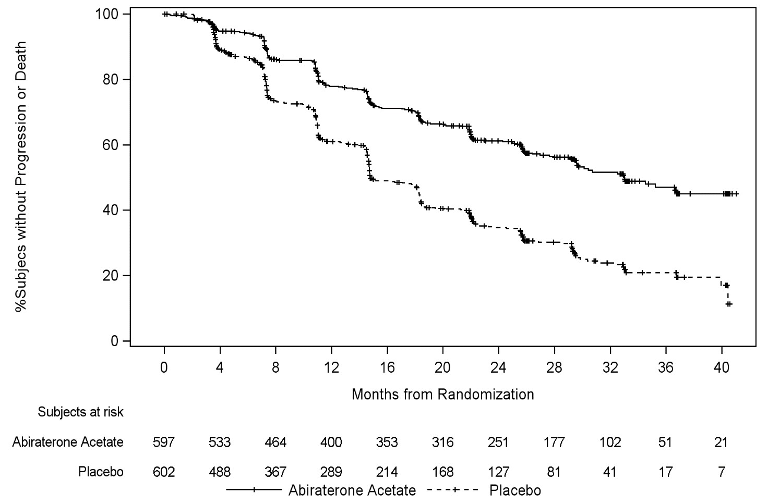

At the planned first interim analysis (IA-1) for overall survival, four hundred and six (406; 47.7% of the total number of deaths required at the final analysis) deaths had occurred (169 subjects in the AA-P group and 237 subjects in the placebo group). A statistically significant improvement in OS in favour of AA-P plus ADT was observed with a 38% reduction in the risk of death (HR=0.621; 95% CI: 0.509, 0.756) compared to placebo plus ADT. Median survival was not reached in the AA-P group versus 34.7 months in the placebo group (p<0.0001, crossing the pre-specified boundary for OS at Interim Analysis 1 of 0.010) (see Table 7 and Figure 2). The study was un-blinded based on the magnitude of clinical benefit observed and patients in the placebo group were offered treatment with abiraterone acetate. Survival continued to be followed after this IA.

|  |  |  |
| --- | --- | --- |
| **Table 7: Overall Survival, Stratified Analysis; Intent-to-treat Population (Study PCR3011)** | | |
|  | AA-P | placebo |
| Subjects randomised | 597 | 602 |
| Event | 169 (28.3%) | 237 (39.4%) |
| Censored | 428 (71.7%) | 365 (60.6%) |
| Overall Survival (months) | | |
| 25th percentile (95% CI) | 26.12 (22.74, 30.13) | 19.75 (17.91, 21.82) |
| Median (95% CI) | NE (NE, NE) | 34.73 (33.05, NE) |
| 75th percentile (95% CI) | NE (NE, NE) | NE (NE, NE) |
| Range | (0.1, 43.5+) | (1.4+, 43.5+) |
| 12-month event-free rate (95% CI) | 0.931 (0.908, 0.949) | 0.892 (0.863, 0.914) |
| 24-month event-free rate (95% CI) | 0.769 (0.732, 0.802) | 0.686 (0.646, 0.723) |
| 36-month event-free rate (95% CI) | 0.658 (0.608, 0.704) | 0.492 (0.436, 0.546) |
| p valuea | < 0.0001 |  |
| Hazard ratio (95% CI)b | 0.621 (0.509, 0.756) |  |
| Note: += censored observation, NE = not estimable. AA-P= subjects who received abiraterone acetate and prednisone.  a p value is from log-rank test stratified by ECOG PS score (0/1 or 2) and visceral (absent or present).  b Hazard ratio is from stratified proportional hazards model. Hazard ratio <1 favours AA-P. | | |

**Figure 2: Kaplan-Meier Plot of Overall Survival; Intent-to-treat Population (Study PCR3011)**

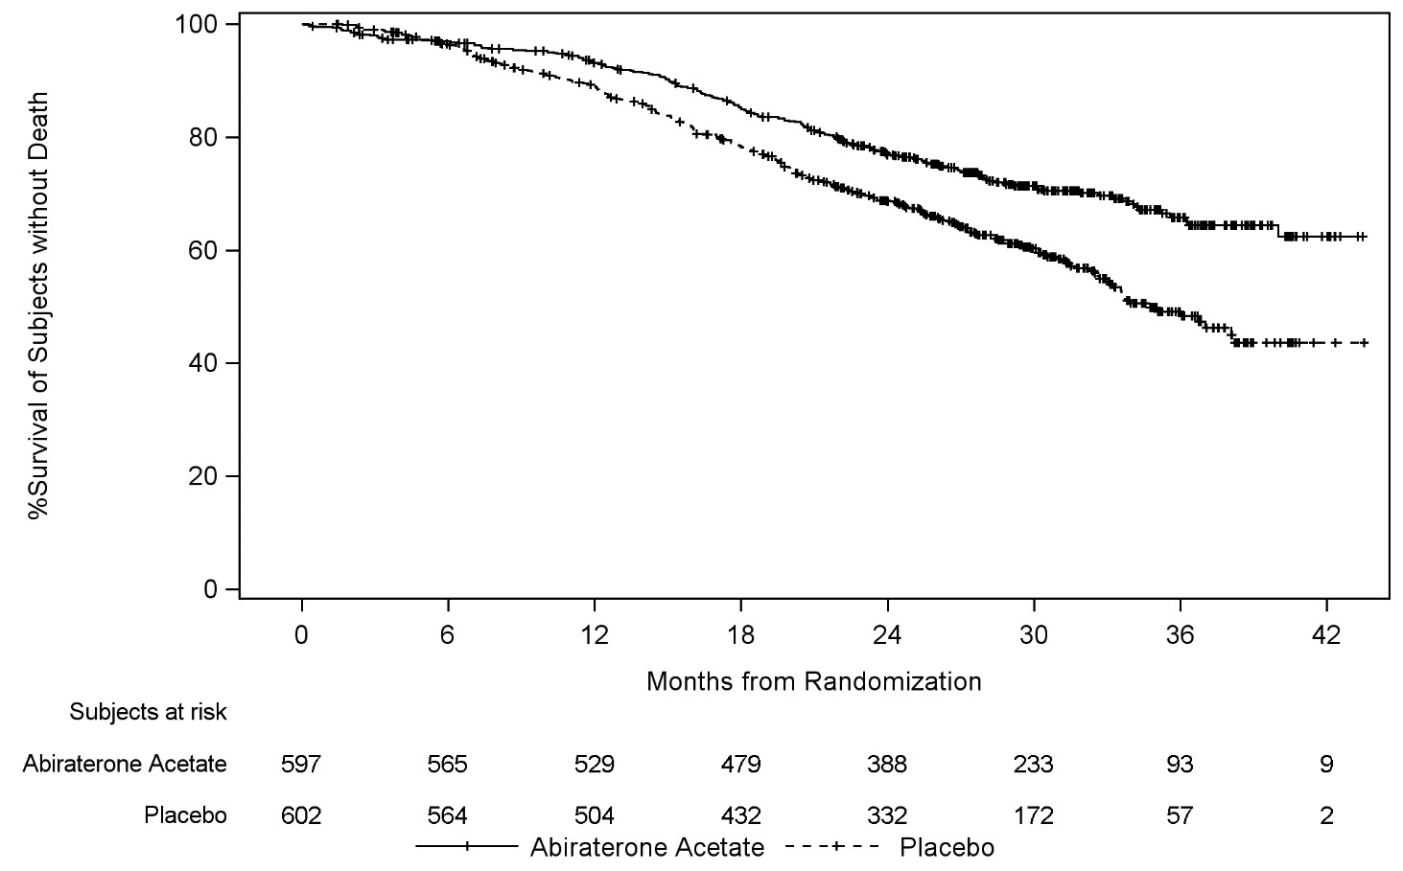

Subgroup analyses consistently favour treatment with abiraterone acetate (see Figure 3).

**Figure 3: Overall Survival by Subgroup; Intent-to-treat population (Study PCR3011)**

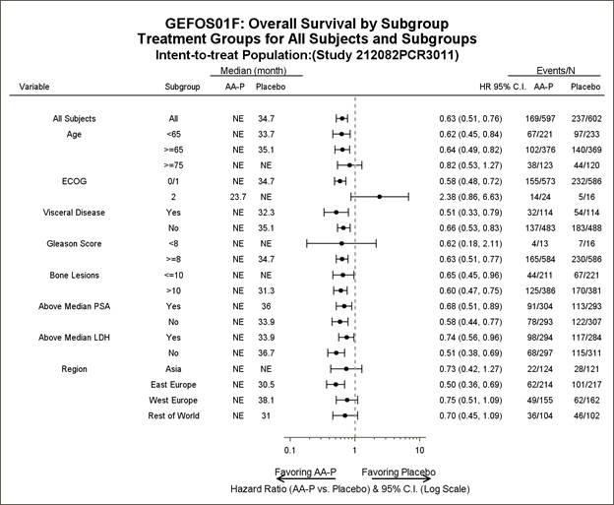

In addition to the observed improvements in overall survival and rPFS, benefit was demonstrated for abiraterone acetate vs placebo treatment in all prospectively defined secondary endpoint measures as follows:

*Time to skeletal-related event (SRE)*

There was a 30% reduction in the risk of skeletal-related events (HR = 0.703; 95% CI: [0.539, 0.916] p < 0.0086). The median time to SRE has not been reached for the abiraterone acetate or placebo study arm.

*Time to PSA progression based on PCWG2 criteria*

The median time to PSA progression was 33.2 months for patients receiving abiraterone acetate and 7.4 months for patients receiving placebo (HR = 0.299; 95% CI: [0.255, 0.352], p <0.0001).

*Time to subsequent therapy*

The median time to subsequent therapy at the time of interim analysis was not reached for patients receiving abiraterone acetate and was 21.6 months for patients receiving placebo (HR = 0.415; 95% CI: [0.346, 0.497], p <0.0001).

*Time to initiation of chemotherapy*

The median time to initiation of chemotherapy was not reached for patients receiving abiraterone acetate and was 38.9 months for patients receiving placebo (HR = 0.443; 95% CI: [0.349, 0.561], p < 0.0001).

*Time to pain progression*

The median time to pain progression was not reached for patients receiving abiraterone acetate and was 16.6 months for patients receiving placebo (HR = 0.695; 95% CI: [0.583, 0.829], p = <0.0001).

The majority of exploratory endpoints favored treatment with abiraterone acetate and prednisone (AA-P) over placebo. A statistically significant improvement in prostate cancer-specific OS was observed for AA-P treatment compared with placebo (HR=0.547, p<0.0001). A confirmed PSA response was observed in 91.0% of subjects in the AA-P group and 66.8% of subjects in the placebo group (relative risk=1.362; p<0.0001). The overall response rate (complete plus partial response) in subjects with measurable disease at baseline was significantly higher in the AA-P group compared with those in the placebo group (p=0.0002).

The time to degradation analyses of patient reported outcome (PRO) measures consistently demonstrated that treatment with AA-P delayed degradation and progression of pain, functional status, fatigue and health-related quality of life. Based on the change from baseline using repeated measures mixed-effect model statistically significant differences were observed between AA-P and placebo as early as Cycle 2 and maintained throughout the study.

**Study 302 (asymptomatic or mildly symptomatic patients who did not receive prior chemotherapy)**

In study 302, (n=1088) the median age of enrolled patients was 71 years for patients treated with abiraterone acetate plus prednisone or prednisolone and 70 years for patients treated with placebo plus prednisone or prednisolone. The ECOG performance status was 0 for 76% of patients, and 1 for 24% of patients in both arms. Co-primary efficacy endpoints were overall survival and radiographic progression-free survival (rPFS). In addition to the co-primary endpoint measures, benefit was also assessed using time to opiate use for cancer pain, time to initiation of cytotoxic chemotherapy, time to deterioration in ECOG performance score by ≥ 1 point and time to PSA progression based on Prostate Cancer Working Group-2 (PCWG2) criteria.

In study 302, treatments were discontinued at the time of unequivocal clinical progression. Treatments could also be discontinued at the time of confirmed radiographic progression at the discretion of the investigator. Patients should not be discontinued based on PSA progression alone and should remain on treatment until fully confirmed clinical progression utilising multiple assessment criteria.

Radiographic progression free survival was assessed with the use of sequential imaging studies as defined by PCWG2 criteria (for bone lesions) and modified Response Evaluation Criteria in Solid Tumours (RECIST) criteria (for soft tissue lesions). PCWG2 criteria require a confirmatory bone scan to document progression. Analysis of rPFS utilised centrally-reviewed radiographic assessment of progression.

At the planned rPFS analysis there were 401 radiographic progression events; 150 (28%) of patients treated with abiraterone acetate and 251 (46%) of patients treated with placebo had radiographic evidence of progression or had died. A significant difference in rPFS between treatment groups was observed (see Table 8 and Figure 4).

**Table 8: Study 302: Radiographic Progression-free Survival of patients treated with either abiraterone acetate or placebo in combination with prednisone or prednisolone plus LHRH agonists or prior orchiectomy**

|  |  |  |
| --- | --- | --- |
|  | **ABIRATERONE (N=546)** | **PLACEBO (N=542)** |
| **Radiographic Progression- free-Survival (rPFS)** |  |  |
| Progression or death | 150 (28%) | 251 (46%) |
| Median rPFS in months (95% CI) | Not reached (11.6, NE) | 8.3 (8.12, 8.54) |
| p value* | < 0.0001 |  |
| Hazard ratio** (95% CI) | 0.425 (0.347, 0.522) |  |
| NE = Not estimated  *P value is derived from a log-rank test stratified by baseline ECOG score (0 or 1)  **Hazard ratio <1 favours abiraterone | | |

**Figure 4: Kaplan Meier curves of radiographic Progression-free Survival in patients treated with either abiraterone acetate or placebo in combination with prednisone or prednisolone plus LHRH Agonists or prior orchiectomy**

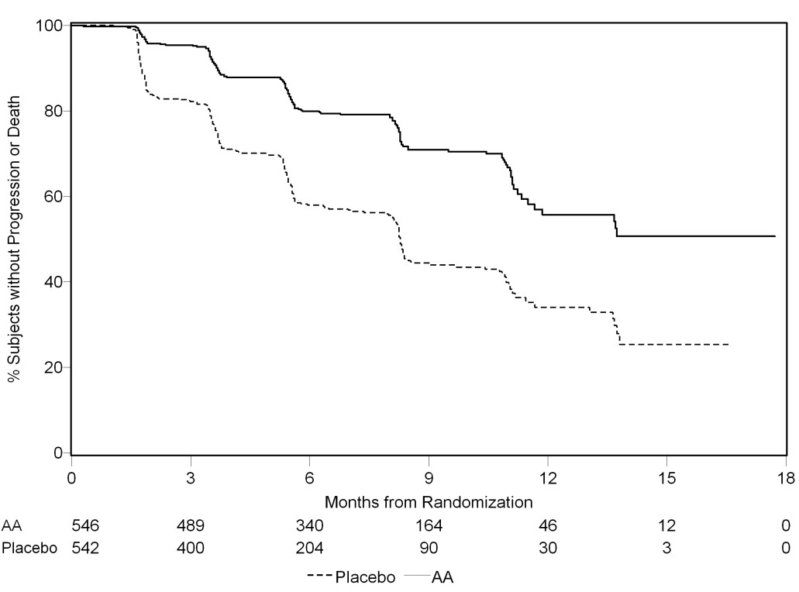

Subgroup analyses of rPFS are presented in Figure 5. The treatment effect of abiraterone acetate on the co- primary endpoint of the independent review of rPFS was consistently favourable and highly robust across all subgroups.

**Figure 5: Radiographic Progression-Free Survival by subgroup cut-off date of 20 December 2010**

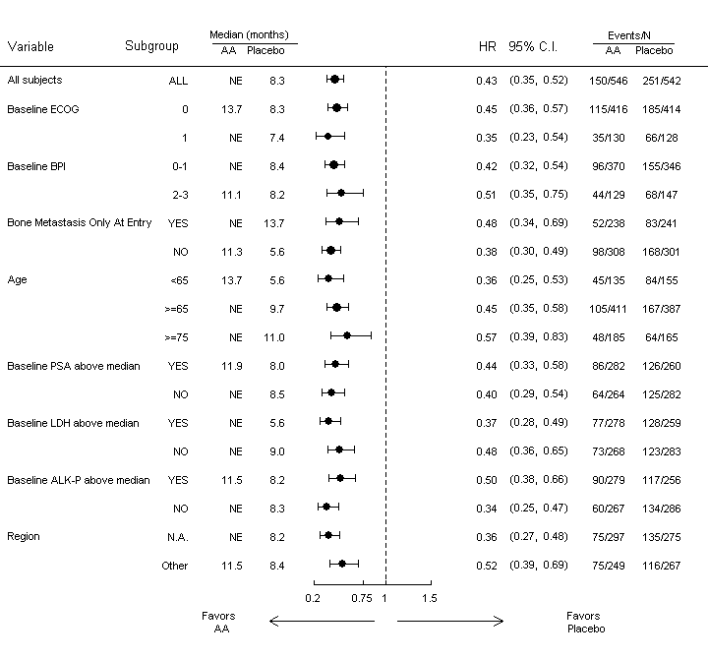The HR within each subgroup was estimated using a non-stratified Cox proportional hazard model.

AA=abiraterone acetate; ALK-P=alkaline phosphatase; BPI=Brief Pain Inventory; C.I.=confidence interval; ECOG=Eastern Cooperative Oncology Group; HR=hazard ratio; LDH=lactic dehydrogenase; N.A.=North America; NE=not estimable; No.=number; PSA=prostate-specific antigen

A planned interim analysis for overall survival was conducted after 333 deaths were observed. The study was unblinded, following the recommendation of the Independent Data Monitoring Committee (IDMC), based on the magnitude of clinical benefit observed. Twenty seven percent (147 of 546) of patients treated with abiraterone acetate, compared with 34% (186 of 542) of patients treated with placebo, had died. Overall survival was longer for abiraterone acetate than placebo with a 25% reduction in risk of death (Hazard Ratio = 0.752; 95% CI: 0.606-0.934). The p value was 0.0097 which did not meet the pre-specified level (0.0008) to claim statistical significance (see Table 9 and Figure 6).

**Table 9: Study 302: Overall Survival of patients treated with either abiraterone acetate or placebo in combination with prednisone or prednisolone plus LHRH agonists or prior orchiectomy**

|  |  |  |
| --- | --- | --- |
|  | **ABIRATERONE (N=546)** | **PLACEBO (N=542)** |
| **Overall Survival** |  |  |
| Deaths | 147 (27%) | 186 (34%) |
| Median overall survival in months (95% CI) | Not reached (NE, NE) | 27.2 (25.95, NE) |
| p value* | 0.0097 |  |
| Hazard ratio** (95% CI) | 0.752 (0.606, 0.934) |  |
| NE = Not estimated  *P value is derived from a log-rank test stratified by baseline ECOG score (0 or 1)  **Hazard ratio <1 favours abiraterone | | |

**Figure 6: Kaplan Meier Survival curves of patients treated with either abiraterone acetate or placebo in combination with prednisone or prednisolone plus LHRH agonists or prior orchiectomy**

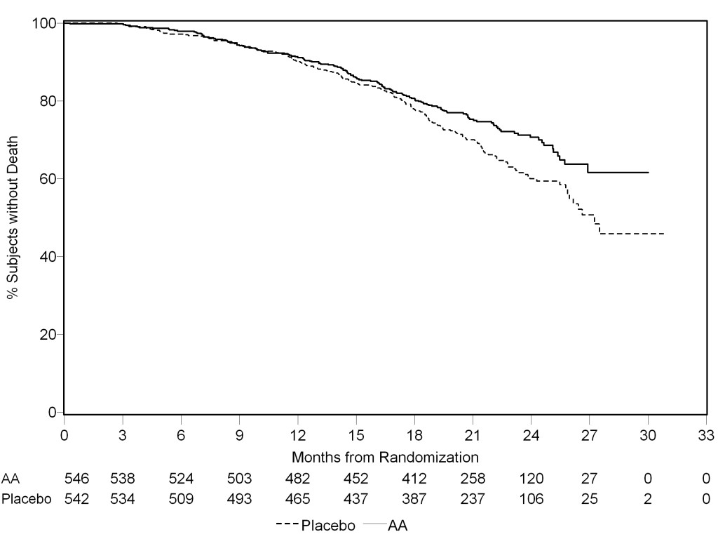

Subgroup analyses of overall survival are presented in Figure 7. The treatment effect of abiraterone acetate on overall survival was favorable across all subgroups (all HR<1.0).

**Figure 7: Overall Survival by subgroup (Study COU-AA-302: ITT Population)**

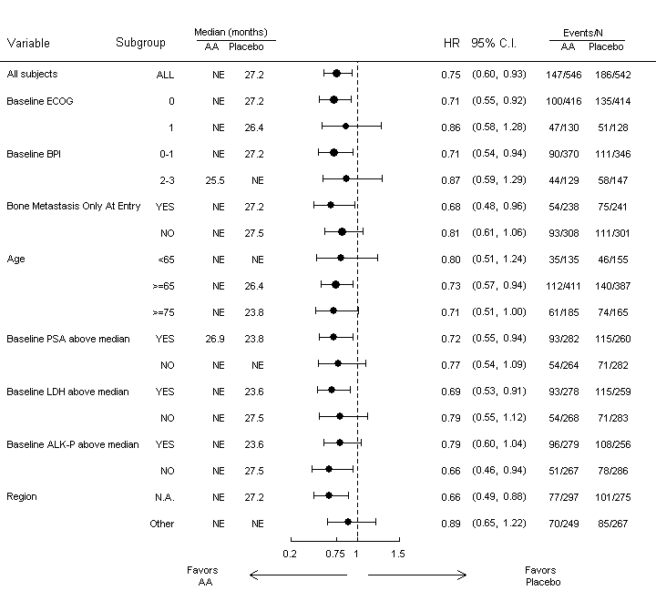

The HR within each subgroup was estimated using a non-stratified Cox proportional hazard model.

AA=abiraterone acetate; ALK-P=alkaline phosphatase; BPI=Brief Pain Inventory; C.I.=confidence interval; ECOG=Eastern Cooperative Oncology Group; HR=hazard ratio; LDH=lactic dehydrogenase; N.A.=North America; NE=not estimable; No.=number; PSA=prostate-specific antigen

In addition to the observed improvements in overall survival and rPFS, benefit was demonstrated for abiraterone acetate versus placebo treatment in all the secondary endpoint measures as follows.

*Time to PSA progression based on PCWG2 criteria*

Median time to PSA progression was 11.1 months for patients receiving abiraterone acetate and 5.6 months for patients receiving placebo (HR=0.488; 95%CI: [0.420, 0.568], p<0.0001). Time to PSA progression was approximately doubled with abiraterone acetate treatment. The proportion of subjects with a confirmed PSA response was greater in the abiraterone acetate group than in the placebo group (62% versus 24%; p<0.0001).

*Time to opiate use for cancer pain*

The median time to opiate use for prostate cancer pain was not reached for patients receiving abiraterone acetate and was 23.7 months for patients receiving placebo (HR=0.686; 95%CI: [0.566, 0.833], p=0.0001).

*Time to initiation of cytotoxic chemotherapy*

The median time to initiation of cytotoxic chemotherapy was 25.2 months for patients receiving abiraterone acetate and 16.8 months for patients receiving placebo (HR=0.580; 95% CI: [0.487, 0.691], p<0.0001).

*Time to deterioration in ECOG performance score by ≥ 1 point*

The median time to deterioration in ECOG performance score by ≥1 point was 12.3 months for patients receiving abiraterone acetate and 10.9 months for patients receiving placebo (HR=0.821; 95% CI: [0.714, 0.943], p=0.0053).

The following study endpoints demonstrated a statistically significant advantage in favour of abiraterone acetate treatment:

*Objective response*

Objective response was defined as the proportion of subjects with measurable disease achieving a complete or partial response according to RECIST criteria (baseline lymph node size was required to be ≥2 cm to be considered a target lesion). The proportion of subjects with measurable disease at baseline who had an objective response was 36% in the abiraterone acetate group and 16% in the placebo group (p<0.0001).

*Pain*

Treatment with abiraterone acetate significantly reduced the risk of average pain intensity progression by 18% compared with placebo (p=0.0490). The median time to progression was 26.7 months in the abiraterone acetate group and 18.4 months in the placebo group.

*Time to degradation in the FACT-P (Total Score)*

Treatment with abiraterone acetate decreased the risk of FACT-P (Total Score) degradation by 22% compared with placebo (p=0.0028). The median time to degradation in FACT-P (Total Score) was 12.7 months in the abiraterone acetate group and 8.3 months in the placebo group.

**Study 301 (patients who had received prior chemotherapy**)

Eleven percent of patients enrolled in study 301 had an ECOG performance score of 2; 70% had radiographic evidence of disease progression with or without PSA progression; 70% had received one prior cytotoxic chemotherapy and 30% received two. Liver metastasis was present in 11% of patients treated with abiraterone acetate.

It was recommended that patients be maintained on their study drugs until there was PSA progression (confirmed 25% increase over the patient’s baseline/nadir) together with protocol- defined radiographic progression and symptomatic or clinical progression. The primary efficacy endpoint was overall survival.

In a planned analysis conducted after 552 deaths were observed, 42% (333 of 797) of patients treated with abiraterone acetate compared with 55% (219 of 398) of patients treated with placebo had died. A statistically significant improvement in median overall survival was seen in patients treated with abiraterone acetate (see Table 10).

**Table 10: Study 301: Overall Survival of patients treated with either abiraterone acetate or placebo in combination with prednisone or prednisolone plus LHRH agonists or prior orchiectomy**

|  |  |  |
| --- | --- | --- |
|  | **ABIRATERONE (N=797)** | **PLACEBO (N=398)** |
| Deaths | 333 (42%) | 219 (55%) |
| Median overall survival in months (95% CI) | 14.8 (14.1, 15.4) | 10.9 (10.2, 12.0) |
| p value | < 0.0001 |  |
| Hazard ratio* (95% CI) | 0.646 (0.543, 0.768) |  |
| *Hazard ratio <1 favours abiraterone acetate | | |

At all evaluation time points after the initial few months of treatment, a higher proportion of patients treated with abiraterone acetate remained alive compared with the proportion of patients treated with placebo (see Figure 8).

**Figure 8: Kaplan Meier survival curves of patients treated with either abiraterone acetate or placebo in combination with prednisone or prednisolone plus LHRH agonists or prior orchiectomy**

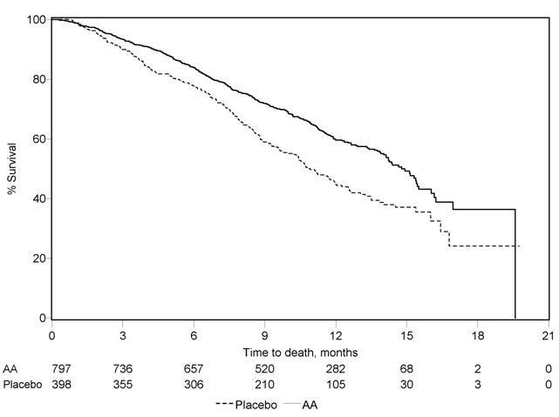

AA = abiraterone acetate

Subgroup survival analyses showed a consistent survival benefit for treatment with abiraterone acetate (see Figure 9).

**Figure 9: Overall Survival by Subgroup: Hazard Ratio and 95% Confidence Interval**

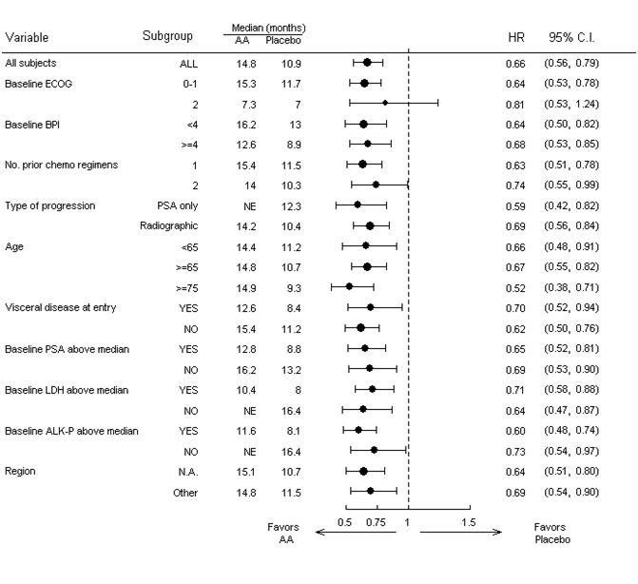

AA=abiraterone acetate; ALK-P=alkaline phosphatase; BPI=Brief Pain Inventory; C.I.=confidence interval; ECOG=Eastern Cooperative Oncology Group performance score; HR=hazard ratio; LDH=lactic dehydrogenase; N.A.=North America; NE=not evaluable; No.=number

In addition to the observed improvement in overall survival, all secondary study endpoints favoured abiraterone acetate and were statistically significant after adjusting for multiple testing as follows.

Patients receiving abiraterone acetate demonstrated a significantly higher total PSA response rate (defined as a ≥ 50% reduction from baseline), compared with patients receiving placebo: 29% versus 6%, p<0.0001.

The median time to PSA progression was 10.2 months for patients treated with abiraterone acetate and 6.6 months for patients treated with placebo (HR= 0.580; 95% CI: [0.462, 0.728], p< 0.0001).

The median radiographic progression free survival was 5.6 months for patients treated with abiraterone acetate and 3.6 months for patients who received placebo (HR= 0.673; 95% CI: [0.585, 0.776], p<0.0001).

*Pain*

The proportion of patients with pain palliation was statistically significantly higher in the abiraterone acetate group than in the placebo group (44% versus 27%, p=0.0002).

A lower proportion of patients treated with abiraterone acetate had pain progression compared to patients taking placebo at 6 (22% vs. 28%), 12 (30% vs. 38%) and 18 months (35% vs. 46%). The time to pain progression at the 25th percentile was 7.4 months in the abiraterone acetate group, versus 4.7 months in the placebo group.

*Skeletal-Related Events*

A lower proportion of patients in the abiraterone acetate group had skeletal-related events compared with the placebo group at 6 months (18% vs. 28%), 12 months (30% vs 40%), and 18 months (35% vs. 40%). The time to first skeletal-related event at the 25th percentile in the abiraterone acetate group was twice that of the control group at 9.9 months vs 4.9 months.

#### Methylprednisolone

##### Mechanism of action

Naturally occurring glucocorticoids (hydrocortisone), which also have salt-retaining properties, are used in replacement therapy in adrenocortical deficiency states. Their synthetic analogues are used primarily for their potent anti-inflammatory effects in disorders of many organ systems. Glucocorticoids cause profound and varied metabolic effects. In addition, they modify the body's immune response to diverse stimuli.

##### Clinical trials

No data available.

### 5.2 Pharmacokinetic properties

#### Abiraterone acetate

Following administration of abiraterone acetate, the pharmacokinetics of abiraterone and abiraterone acetate have been studied in healthy subjects, patients with metastatic advanced prostate cancer and subjects without cancer with hepatic or renal impairment. Abiraterone acetate is rapidly converted *in vivo* to abiraterone.

Geometric mean ±SD abiraterone Cmax was 73 ± 44 ng/mL and AUCINF was 373 ± 249 ng·hr/mL following a single dose of abiraterone 500 mg in overnight fasted healthy volunteers. Dose proportionality was observed in single doses of abiraterone in a range of 125 mg to 625 mg.

##### Absorption

Following oral administration of abiraterone to healthy volunteers and patients with metastatic CRPC, the mean time to reach maximum plasma abiraterone concentrations is approximately 2 hours.

*Effect of Food*

Abiraterone Cmax was approximately 6.5-fold higher and AUC0-∞ was 4.4-fold higher when a single dose of abiraterone tablets 500 mg was administered with a high-fat meal (56-60% fat, 900-1000 calories) compared to overnight fasting in healthy volunteers. These differences are not considered significant andabiraterone can be taken with or without food (see Section 4.2 Dosage and Method of Administration).

Other formulations of abiraterone acetate may differ in their food effects and dose. This may impact the ability to take other abiraterone acetate formulations with food.

##### Distribution

The plasma protein binding of 14C abiraterone in human plasma is 99.8%. The apparent volume of distribution is approximately 5630 L, suggesting that abiraterone extensively distributes to peripheral tissues.

##### Metabolism

Following oral administration of 14C-abiraterone acetate as capsules, abiraterone acetate is hydrolysed to abiraterone, which then undergoes metabolism including sulphation, hydroxylation and oxidation primarily in the liver. The majority of circulating radioactivity (approximately 92%) is found in the form of metabolites of abiraterone. Of 15 detectable metabolites, 2 main metabolites, abiraterone sulphate and N-oxide abiraterone sulphate, each represent approximately 43% of total radioactivity.

The major enzymes involved in the metabolism of abiraterone are CYP3A4 for phase I (oxidative) metabolites, the sulfotransferase (SULT) isozyme SULT2A1, and UDP-glucuronosyl transferase (UGT) UGT1A4. No studies have been conducted to determine if drugs that induce or inhibit these enzymes affect the metabolism of abiraterone.

##### Excretion

The mean half-life of abiraterone in plasma is approximately 15 hours based on data from healthy subjects. Following oral administration of 14C abiraterone acetate, approximately 88% of the radioactive dose is recovered in faeces and approximately 5% in urine. The major compounds present in faeces are unchanged abiraterone acetate and abiraterone (approximately 55% and 22 % of the administered dose, respectively).

##### Additional information on special populations

###### Hepatic impairment

The pharmacokinetics of abiraterone acetate was examined in subjects with pre-existing mild or moderate hepatic impairment (Child-Pugh class A and B, respectively) and in healthy control subjects. Systemic exposure to abiraterone after a single oral 1000 mg dose of another abiraterone acetate product increased by approximately 11% and 260% in subjects with mild and moderate pre-existing hepatic impairment, respectively. The mean half-life of abiraterone is prolonged to approximately 18 hours in subjects with mild hepatic impairment and to approximately 19 hours in subjects with moderate hepatic impairment. No dosage adjustment is necessary for patients with pre-existing mild hepatic impairment. There are no data on the clinical safety and efficacy of multiple doses of abiraterone acetate when administered to patients with moderate or severe hepatic impairment (Child-Pugh Class B or C). No dose adjustment can be predicted. Abiraterone acetate tablets should be used with caution in patients with moderate hepatic impairment, only if the benefit clearly outweighs the possible risk. Abiraterone acetate tablets should not be used in patients with pre- existing severe hepatic impairment (see sections 4.3 Contraindications, 4.4 Special Warnings and Precautions for Use, and 4.2 Dose and Method of Administration).

For patients who develop hepatotoxicity during treatment with abiraterone acetate, suspension of treatment and dosage adjustment may be required (see sections 4.4 Special Warnings and Precautions for Use and 4.2 Dose and Method of Administration).

###### Renal impairment

The pharmacokinetics of abiraterone acetate was compared in patients with end-stage renal disease on a stable haemodialysis schedule versus matched control subjects with normal renal function. Systemic exposure to abiraterone after a single oral 1000 mg dose of another abiraterone acetate product did not increase in patients with end-stage renal disease on dialysis.

Administration of abiraterone acetate in patients with renal impairment including severe renal impairment does not require dose reduction (see section 4.2 Dose and Method of Administration).

#### Methylprednisolone

Methylprednisolone pharmacokinetics are linear, independent of route of administration.

##### Absorption

Methylprednisolone is rapidly absorbed and the maximum plasma methylprednisolone concentration is achieved around 1.5 to 2.3 hours across doses following oral administration in normal healthy adults. The absolute bioavailability of methylprednisolone in normal healthy subjects is generally high (82% to 89%) following oral administration.

The mean oral time of peak concentration is 1.1 - 2.2 hours.

##### Distribution

Methylprednisolone is widely distributed into the tissues, crosses the blood-brain barrier, and is secreted in breast milk. Its apparent volume of distribution is approximately 1.4 L/kg.

The plasma protein binding of methylprednisolone in humans is approximately 77%.

##### Metabolism

Corticosteroids are metabolised mainly in the liver but also in the kidney and are excreted in the urine.

In humans, methylprednisolone is metabolized in the liver to inactive metabolites; the major ones are 20α-hydroxymethylprednisolone and 20β-hydroxymethylprednisolone. Metabolism in the liver occurs primarily via the CYP3A4 enzyme. Methylprednisolone, like many CYP3A4 substrates, may also be a substrate for the ATP-binding cassette (ABC) transport protein p-glycoprotein, influencing tissue distribution and interactions with other medicines.

##### Excretion

The mean elimination half-life for total methylprednisolone is in the range of 1.8 to 5.2 hours. Total clearance is approximately 5 to 6 mL/min/kg.

### 5.3 Preclinical safety data

#### Abiraterone acetate

##### Genotoxicity

Abiraterone acetate and abiraterone were devoid of genotoxic potential in the standard panel of genotoxicity tests including, an *in vitro* bacterial reverse mutation assay (the Ames test), an in vitro mammalian chromosome aberration test (using human lymphocytes) and an *in vivo* rat micronucleus assay. Genotoxicity studies have not been conducted with the main human metabolites of abiraterone.

##### Carcinogenicity

Carcinogenicity studies were not conducted with abiraterone acetate.

#### Methylprednisolone

##### Genotoxicity

Methylprednisolone acetate has not been formally evaluated for genotoxicity. However, methylprednisolone sulfonate, which is structurally similar to methylprednisolone, was not mutagenic in bacteria (Ames test), or in a mammalian cell gene mutation assay using Chinese hamster ovary cells. Methylprednisolone suleptanate did not induce unscheduled DNA synthesis in primary rat hepatocytes. Prednisolone farnesylate, which is also structurally similar to methylprednisolone, was not mutagenic in bacteria, but displayed weak clastogenic activity *in vitro* in Chinese hamster lung fibroblasts in the presence of metabolic activation.

##### Carcinogenicity

Methylprednisolone has not been formally evaluated in rodent carcinogenicity studies. Negative results for carcinogenicity have been obtained with various other glucocorticoids including budesonide, prednisolone and triamcinolone acetonide, in mice. However, all three of these compounds were shown to increase the incidence of hepatocellular adenomas and carcinomas after oral administration in a 2-year study in male rats. These tumorigenic effects occurred at doses that are less than the typical clinical doses on a mg/m2 basis. Hepatocarcinogenicity is likely to involve an interaction with the glucocorticoid receptor.

## 6 PHARMACEUTICAL PARTICULARS

### 6.1 List of excipients

#### YONSA abiraterone acetate 125 mg tablets

Lactose monohydrate

Sodium lauryl sulfate

Butylated hydroxyanisole

Butylated hydroxytoluene

Microcrystalline cellulose

Croscarmellose sodium

Sodium stearyl fumarate

#### Methylprednisolone 4 mg tablets

Lactose monohydrate

Maize starch

Gelatin

Magnesium stearate

Talc

### 6.2 Incompatibilities

Not applicable.

### 6.3 Shelf life

In Australia, information on the shelf life can be found on the public summary of the Australian Register of Therapeutic Goods (ARTG). The expiry date can be found on the packaging.

### 6.4 Special precautions for storage

Store at or below 25°C.

### 6.5 Nature and contents of container

YONSA abiraterone acetate 125 mg tablets are available in high-density polyethylene bottles with child resistant closure. Each bottle contains 120 tablets.

Methylprednisolone 4 mg tablets are available in high-density polyethylene bottles. Each bottle contains 60 tablets.

### 6.6 Special precautions for disposal and handling

In Australia, any unused medicine or waste material should be disposed of by taking to your local Pharmacy. Women who are pregnant or women who may be pregnant should not handle abiraterone acetate tablets without protection, e.g., gloves (see Section 4.6 Fertility, pregnancy and lactation).

### 6.7 Physicochemical properties

#### Abiraterone acetate

Abiraterone acetate is a white to off-white, non-hygroscopic, crystalline powder. It is a lipophilic compound with an octanol-water partition coefficient of 5.12 (Log P) and is practically insoluble in water. The pKa of the aromatic nitrogen is 5.19.

Chemical structure



CAS number

154229-18-2

#### Methylprednisolone

Methylprednisolone is a white to practically white, odourless, crystalline powder. It is sparingly soluble in alcohol, in dioxane, and in methanol, slightly soluble in acetone, and in chloroform, and very slightly soluble in ether. It is practically insoluble in water.

Chemical structure



CAS number

83-43-2

## 7 MEDICINE SCHEDULE (POISONS STANDARD)

Prescription Medicine – S4

## 8 SPONSOR

Sun Pharma ANZ Pty Ltd  
Macquarie Park, Sydney NSW 2113  
Australia

## 9 DATE OF FIRST APPROVAL

## 10 DATE OF REVISION

## SUMMARY TABLE OF CHANGES

|  |  |
| --- | --- |
| Section Changed | Summary of new information |
| N/A | New product. |
|  |  |
|  |  |