|  |
| --- |
| Australian Public Assessment Report for Yonsa Mpred |
| Active ingredients: Abiraterone acetate and methylprednisolone |
| Sponsor: Sun Pharma ANZ Pty Ltd |
| August 2024 |

About the Therapeutic Goods Administration (TGA)

* The Therapeutic Goods Administration (TGA) is part of the Australian Government Department of Health and Aged Care and is responsible for regulating therapeutic goods, including medicines, medical devices, and biologicals.
* The TGA administers the *Therapeutic Goods Act 1989* (the Act), applying a risk management approach designed to ensure therapeutic goods supplied in Australia meet acceptable standards of quality, safety, and efficacy.
* The work of the TGA is based on applying scientific and clinical expertise to decision-making, to ensure that the benefits to the Australian public outweigh any risks associated with the use of therapeutic goods.
* The TGA relies on the public, healthcare professionals and industry to report problems with therapeutic goods. The TGA investigates reports received to determine any necessary regulatory action.
* To report a problem with a therapeutic good, please see the information on the [TGA website](https://www.tga.gov.au).

About AusPARs

* The Australian Public Assessment Report (AusPAR) provides information about the evaluation of a prescription medicine and the considerations that led the TGA to approve or not approve a prescription medicine submission. Further information can be found in [Australian Public Assessment Report (AusPAR) guidance](https://www.tga.gov.au/australian-public-assessment-report-auspar-guidance).
* AusPARs are prepared and published by the TGA.
* AusPARs are static documents that provide information that relates to a submission at a particular point in time. The publication of an AusPAR is an important part of the transparency of the TGA’s decision-making process.
* A new AusPAR may be provided to reflect changes to indications or major variations to a prescription medicine subject to evaluation by the TGA.

Copyright

© Commonwealth of Australia 2024  
This work is copyright. You may reproduce the whole or part of this work in unaltered form for your own personal use or, if you are part of an organisation, for internal use within your organisation, but only if you or your organisation do not use the reproduction for any commercial purpose and retain this copyright notice and all disclaimer notices as part of that reproduction. Apart from rights to use as permitted by the *Copyright Act 1968* or allowed by this copyright notice, all other rights are reserved and you are not allowed to reproduce the whole or any part of this work in any way (electronic or otherwise) without first being given specific written permission from the Commonwealth to do so. Requests and inquiries concerning reproduction and rights are to be sent to the TGA Copyright Officer, Therapeutic Goods Administration, PO Box 100, Woden ACT 2606 or emailed to <[tga.copyright@tga.gov.au](mailto:tga.copyright@tga.gov.au)>.

Contents

List of abbreviations 4

Product submission 5

Submission details 5

Product background 7

Current treatment options 7

Regulatory status 8

Registration timeline 8

Submission overview and risk/benefit assessment 9

Quality 9

Abiraterone acetate 9

Methylprednisolone 9

Nonclinical 10

Clinical 10

Summary of clinical studies 10

Pharmacology 10

Efficacy 11

Safety 12

Risk management plan 15

Risk-benefit analysis 15

Delegate’s considerations 15

Proposed action 16

Outcome 16

Attachment 1. Product Information 17

## List of abbreviations

|  |  |
| --- | --- |
| Abbreviation | Meaning |
| ACM | Advisory Committee on Medicines |
| ADT | Androgen Depletion Therapy |
| ARTG | Australian Register of Therapeutic Goods |
| AUC | Area under the plasma concentration time graph |
| Cmax | Maximum plasma concentration |
| CMI | Consumer Medicines Information |
| mCRPC | Metastatic castration resistant prostate cancer |
| mCSPC | Metastatic castration sensitive prostate cancer |
| PI | Product Information |
| RMP | Risk management plan |
| TGA | Therapeutic Goods Administration |
| Tmax | Time to maximum plasma concentration |
| US FDA | United States (of America) Food and Drug Administration |

## Product submission

### Submission details

|  |  |
| --- | --- |
| *Type of submission:* | New combination of active ingredients (new composite pack) |
| *Product name:* | Yonsa Mpred |
| *Active ingredients:* | Abiraterone acetate and methylprednisolone |
| *Decision:* | Approved |
| *Date of decision:* | 24 March 2022 |
| *Date of entry onto ARTG:* | 29 March 2022 |
| *ARTG number:* | 346890 |
| [*Black Triangle Scheme*](https://www.tga.gov.au/black-triangle-scheme)  *for the current submission:* | No |
| *Sponsor’s name and address:* | Sun Pharma ANZ Pty Ltd |
| *Dose forms:* | Abiraterone acetate tablets and methylprednisolone tablets |
| *Strengths:* | Abiraterone acetate 125 mg Methylprednisolone 4 mg |
| *Containers:* | Abiraterone acetate tablets in bottles Methylprednisolone tablets in bottles |
| *Pack size:* | 120 abiraterone acetate tablets in each bottle 60 methylprednisolone tablets in each bottle |
| *Approved therapeutic use for the current submission:* | *Yonsa Mpred is indicated for the treatment of patients with:*   * *newly diagnosed high-risk metastatic hormone sensitive prostate cancer (mHSPC) in combination with androgen deprivation therapy (ADT), or* * *patients with metastatic advanced prostate cancer (castration resistant prostate cancer, mCRPC) who are asymptomatic or mildly symptomatic after failure of androgen deprivation therapy (ADT) or* * *patients with mCRPC who have received prior chemotherapy containing a taxane.* |
| *Routes of administration:* | Oral |
| *Dosage:* | The recommended dose of Yonsa abiraterone acetate tablets is 500 mg (four 125 mg tablets) administered orally once daily in combination with methylprednisolone.  The recommended dose of methylprednisolone for metastatic hormone sensitive prostate cancer is 4 mg administered once daily.  The recommended dose of methylprednisolone for metastatic castration resistant prostate cancer is 4 mg administered twice daily.  **Important administration instructions**  To avoid medication errors and overdose, be aware that Yonsa tablets may have different dosing and food effects than other abiraterone acetate products.  For further information regarding dosage, refer to the Product Information. |
| *Pregnancy category:* | D  Drugs which have caused, are suspected to have caused or may be expected to cause, an increased incidence of human fetal malformations or irreversible damage. These drugs may also have adverse pharmacological effects. Accompanying texts should be consulted for further details.  The use of any medicine during pregnancy requires careful consideration of both risks and benefits by the treating health professional. This must not be used as the sole basis of decision making in the use of medicines during pregnancy. The TGA does not provide advice on the use of medicines in pregnancy for specific cases. More information is available from obstetric drug information services in your State or Territory. |

### 

### Product background

This AusPAR describes the submission by Sun Pharma ANZ Pty Ltd (the Sponsor) to register Yonsa Mpred, a new composite pack containing an abiraterone acetate 125 mg tablet bottle and a methylprednisolone 4 mg tablet bottle, for the following indication:

*Yonsa Mpred is indicated for the treatment of patients with:*

* *newly diagnosed high-risk metastatic hormone sensitive prostate cancer (mHSPC) in combination with androgen deprivation therapy (ADT), or*
* *patients with metastatic advanced prostate cancer (castration resistant prostate cancer, mCRPC) who are asymptomatic or mildly symptomatic after failure of androgen deprivation therapy (ADT) or*
* *patients with mCRPC who have received prior chemotherapy containing a taxane*

Prostate cancer is a common malignancy, causing a high burden of morbidity and mortality. Metastatic disease is not curable but there are a range of therapies which aim to prolong life, as well as reduce the morbidity from metastatic foci that cause pain or osteolytic fractures.

### Current treatment options

Prostate cancer is usually androgen dependent at diagnosis. The standard initial therapy is androgen depletion therapy (ADT) using gonadotropin-release hormone antagonists which dramatically lower androgen synthesis.

Cancer that responds to androgen depletion therapy is referred to as ‘metastatic castration sensitive prostate cancer’ (mCSPC), but it inevitably ceases to respond and becomes metastatic castration resistant prostate cancer (mCRPC). At this stage, chemotherapy with taxanes can be commenced but many mCRPC tumours remain androgen driven albeit at very low androgen levels.

Several new hormonal agents have been developed which directly antagonise androgens at the tumour level or, in the case of abiraterone, prevent androgen synthesis at the tumour level. The use of new hormonal agents is still evolving, and they can be used before taxanes, in combination with androgen depletion therapy, or in combination with taxanes. Overall, there is a general trend to more aggressive therapy in early high-risk metastatic disease provided the patient is fit enough to tolerate this therapy.

The main adverse effects of abiraterone relate to mineralocorticoid excess, which can produce hypertension, hypokalaemia, and fluid retention. To combat this, prednisone or prednisolone is co-administered twice a day, and this can cause hyperglycaemia as well as steroid discontinuation syndromes when treatment is interrupted. Yonsa Mpred replaces prednisone or prednisolone with methylprednisolone at a dose equivalence of 4 mg (methylprednisolone) to 5 mg (prednisone).

Hepatotoxicity can occur with abiraterone, which is hepatically metabolised, leading to increases in bilirubin and hepatic enzymes. Hepatic failure is rarely observed but treatment interruption is recommended in patients with markedly elevated liver enzymes.

Yonsa Mpred contains a micronized formulation of abiraterone acetate. The micronized formulation is intended to provide a lower-dose option to currently registered products with a comparable safety and efficacy profile. The recommended dose of Yonza Mpred is 500 mg abiraterone acetate once a day, while the usual dose of currently registered abiraterone acetate formulations is 1000mg once a day. As the glucocorticoid dose is administered twice a day, Yonsa Mpred is presented in a composite pack of micronized abiraterone tablets and methylprednisolone tablets.

At this time of this submission, there were two abiraterone acetate products registered in Australia: Zytiga 250 mg and 500 mg tablets,[1] and Janssen Abiraterone 500 mg tablets. Both products were Sponsored by Janssen-Cilag Pty Ltd. There were no oral methylprednisolone products registered in Australia, only injectable presentations.

### Regulatory status

Yonsa Mpred is considered a new fixed combination product for Australian regulatory purposes. Yonsa Mpred contains a bottle of 125 mg abiraterone acetate tablets and a bottle of 4 mg methylprednisolone tablets that are packaged together for registration as a composite pack. The bottles are not available for individual supply. In other foreign regulatory regions, the tablets are registered as individual products.

At the time the TGA considered this submission, a similar submission for abiraterone acetate tablets (without methylprednisolone) had been approved by the US FDA on 22 May 2018. The approved indication was:

*Yonsa is a CYP17 inhibitor indicated in combination with methylprednisolone for the treatment of patients with metastatic castration-resistant prostate cancer (CRPC).*

The Delegate noted that the FDA indication was limited to mCRPC, which would preclude initially diagnosed patients included in the Australian indications for Abiraterone.

The abiraterone acetate tablets were still under consideration by Israel and New Zealand.

At the time the TGA considered this submission, the methylprednisolone tablets were approved in Finland, Sweden, Norway, Denmark, Poland, Czech Republic and Hungary.

## Registration timeline

The following table captures the key steps and dates for this submission.

This submission was evaluated under the [standard prescription medicines registration process](https://www.tga.gov.au/how-we-regulate/supply-therapeutic-good-0/supply-prescription-medicine/application-process/prescription-medicines-registration-process).

Table 1: Timeline for Submission PM-2020-04869-1-4

|  |  |
| --- | --- |
| Description | Date |
| Submission dossier accepted and first round evaluation commenced | 2 November 2020 |
| First round evaluation completed | 31 March 2021 |
| Sponsor provides responses on questions raised in first round evaluation | 2 June 2021 |
| Second round evaluation completed | 5 November 2021 |
| Delegate’s Overall benefit-risk assessment | 1 March 2022 |
| Registration decision (Outcome) | 24 March 2022 |
| Administrative activities and registration on the ARTG completed | 29 March 2022 |
| Number of working days from submission dossier acceptance to registration decision* | 206 |

*Statutory timeframe for standard submissions is 255 working days

## Submission overview and risk/benefit assessment

A summary of the TGA’s assessment for this submission is provided below.

### Quality

Yonsa Mpred is a composite pack containing abiraterone acetate tablets and methylprednisolone tablets.

#### Abiraterone acetate

The active ingredient, abiraterone acetate is a white to off-white, non-hygroscopic, crystalline powder, which is practically insoluble in water. It has the following structure (Figure 1).

Figure 1: Chemical structure of abiraterone acetate

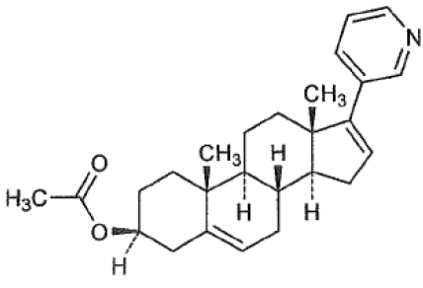

The proposed abiraterone acetate tablets are white to off-white modified oval shaped and debossed with ‘125 FP’. The tablets contain a micronized form of the active ingredient, resulting in a supra-bioavailable formulation of abiraterone compared to the currently registered Australian abiraterone tablets.

The tablets are packaged in HDPE bottles containing 120 tablets and are stable for 48 months when stored below 25°C.

The quality evaluation considered the chemistry, manufacture and quality of abiraterone acetate tablets acceptable.

#### Methylprednisolone

Methylprednisolone is a white to practically white, odourless, crystalline powder, which is practically insoluble in water. It has the following structure (Figure 2).

Figure 2: Chemical structure of methylprednisolone

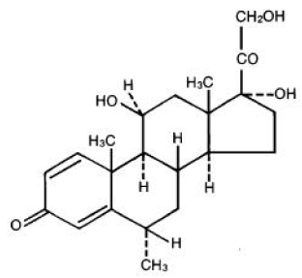

Methylprednisolone tablets are white to almost white, round, flat, bevelled edge and scored. The tablets are packaged in HDPE bottles containing 60 tablets and are stable for 36 months when stored below 25°C.

The quality evaluation considered the chemistry, manufacture and quality of the tablets acceptable.

### Nonclinical

No new nonclinical data or further nonclinical evaluation were required for this submission. The TGA considers that previously submitted and evaluated data satisfactorily address nonclinical aspects of safety/efficacy relating to this submission.

### Clinical

#### Summary of clinical studies

The clinical dossier for this submission mainly consisted of:

* Study CHL-AA-201: A pivotal efficacy and safety study to evaluate serum testosterone levels after treatment with the proposed abiraterone acetate tablets 500 mg (4 x 125 mg) with methylprednisolone (4 mg twice a day) compared to Zytiga 1000 mg (4 x 250 mg) with prednisolone (5 mg twice a day) at Day 9 and 10.
* Study CHL-AA-202: An efficacy and safety study to evaluate the safety of Yonsa 500 mg (4 × 125 mg) with methylprednisolone (4 mg twice a day) over approximately one year following an initial 84 day treatment with abiraterone acetate in a previous study.

#### Pharmacology

The Sponsor submitted several studies which evaluated bioavailability of Yonsa Mpred with the current Australian product, Zytiga. There were minor differences observed in the peak levels of abiraterone when the two produces were compared in fasted patients. However, overall bioequivalence between Yonsa Mpred 500 mg and Zytiga 1000 mg once a day was demonstrated.

Pharmacokinetic analysis was conducted in the pivotal efficacy study, Study CHL-AA-201. This did not find significant difference in the pharmacokinetic parameters between Yonza Mpred and Zytiga treated patients.

Drug exposure of a single dose of Yonsa Mpred 500 mg was increased under high-fat meal conditions by approximately 4.5-fold for area under the plasma concentration time curve and 6.5-fold for the maximum plasma concentration (Cmax) with time to maximum concentration (Tmax) being unchanged at 2 hours. This is lower than the reported food effect for Zytiga, which was not examined in this submission, which is a 10- and 17-fold increase in area under the plasma versus time curve (AUC) and Cmax respectively.

No new studies were conducted in patients with hepatic or renal impairment. Abiraterone is metabolised in the liver by sulphonation, oxidation and hydroxylation with metabolites being excreted almost entirely through the gut. Systemic exposure to Zytiga is increased in hepatic impairment and the half-life is prolonged. The current Zytiga Product Information recommends no dosage adjustment for mild hepatic impairment, and there is no data on patient with more severe impairment. Treatment should be interrupted if patients develop biochemical evidence of hepatic impairment on treatment.

No new studies were conducted in drug-drug interactions involving Yonsa Mpred.

#### Efficacy

One pivotal efficacy study was submitted, Study CHL-AA-201. This was a randomised, open label study conducted over approximately four months. It compared Yonsa Mpred 500 mg abiraterone acetate and methylprednisolone 4 mg against Zytiga 1000 mg with prednisolone 5 mg.

Included patients had metastatic prostate cancer and were receiving androgen depletion therapy with a serum testosterone level less than 50 ng/dL on enrolment.

The main efficacy outcome was the testosterone level in patients on Days 9 and 10. Serum testosterone and prostate specific antigen were measured as secondary endpoints at Weeks 4, 8 and 12 of therapy.

Figure 1: Study CHL-AA-201 patient disposition

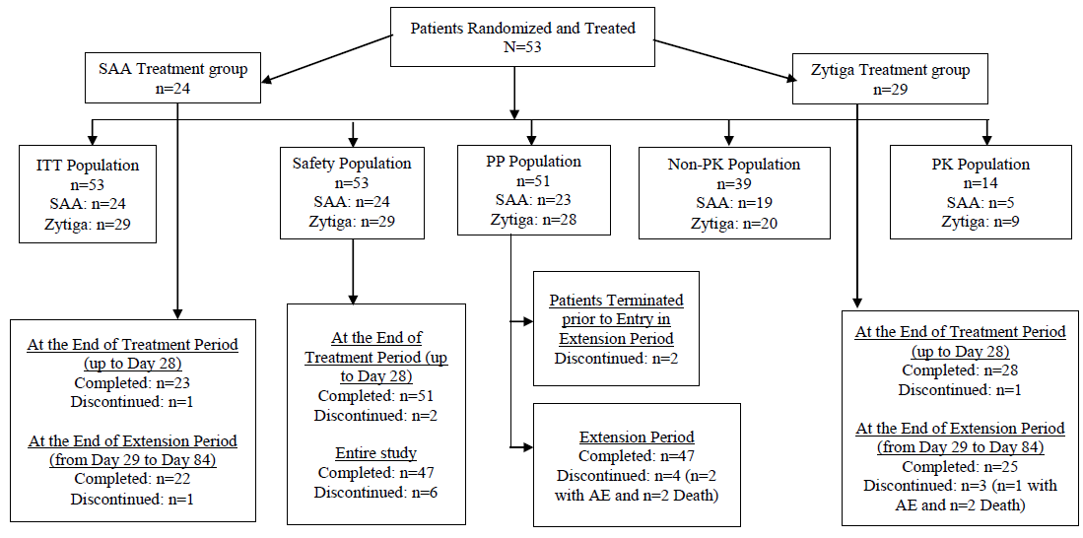

Abbreviations: SAA = Yonsa Mpred, ITT = intent to treat, PP = Per Protocol, PK = pharmacokinetic, AE = adverse event.

The study found mean testosterone levels on Days 9 and 10 of treatment were bioequivalent between Yonsa Mpred and Zytiga at 1.05 ng/dL and 1.02 ng/dL respectively.

Table 2: Study CHL-AA-201 prostate specific antigen measurements on treatment with Yonsa Mpred or Zytiga

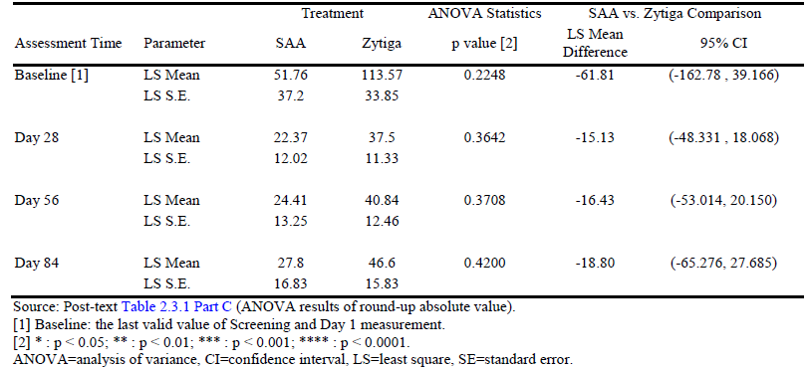

There were no significant differences in prostate specific antigen at days 28, 56 or 84 of therapy.

#### Safety

No safety specific studies were included.

**Table 3: Summary of patient exposure in submitted studies**

|  |  |  |  |  |
| --- | --- | --- | --- | --- |
| Study number | Design | Study population | Number of subjects enrolled/ evaluated | Study medication |
| CHL-AA-101 | Open-label, randomized, single-dose, 4-way crossover study under fasted conditions | Healthy male subjects | 20/20 | Yonsa  100 mg (1 x 100 mg)  200 mg (2 x 100 mg)  400 mg (4 x 100 mg)  Zytiga  1000 mg (4 x 250 mg) |
| CHL-AA-102 | Open-label, randomized, single-dose, 4-way crossover study under fasted conditions | Healthy male subjects | 36/36 | Yonsa  125 mg (1 x 125 mg)  500 mg (4 x 125 mg)  625 mg (5 x 125 mg)  Zytiga  1000 mg (4 x 125 mg) |
| CHL-AA-103 | Open-label, randomized, single-dose, crossover, study under fed and fasted conditions | Healthy male subjects | 25/25 | Yonsa  500 mg (4 x 125 mg) |
| CHL-AA-104 | Open-label, randomized, single-dose, crossover, study on background of steady-state steroid treatment under fasted conditions | Healthy male subjects | 37/37 | Yonsa Mpred Abiraterone acetate 500 mg (4 x 125 mg) with methylprednisolone (4 mg twice a day)  Zytiga 1000 mg (4 x 250 mg) plus prednisone (5 mg twice a day) |
| CHL-AA-201 | Open-label, randomised active-controlled, multiple-dose, multi-center, pharmacokinetic, efficacy and safety study | Patients with mCRPC | 53/53 | Yonsa Mpred Abiraterone acetate 500 mg (4 x 125 mg) plus methylprednisolone (4 mg twice a day)  Zytiga 1000 mg (4 x 250 mg) plus prednisone (5 mg twice a day) |

The mean exposure time to Yonza Mpred was 81.7 days. The main safety data comes from the pivotal trial.

Table 4: Study CHL-AA-201 comparative rates of adverse events observed in more than 5% of recipients of Yonsa Mpred or Zytiga

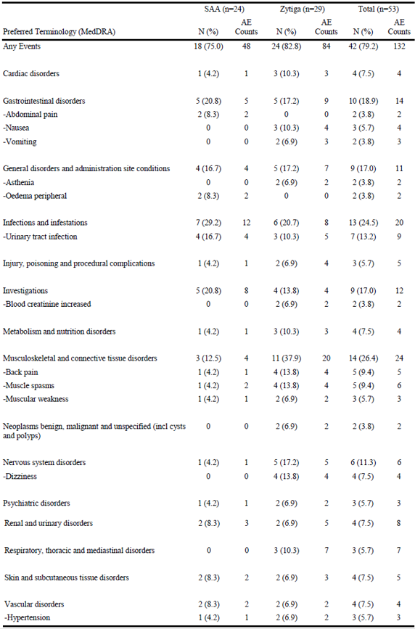

Rates of any adverse event were similar between Yonsa Mpred and Zytiga. There was no consistent trend favouring one therapy over the other in terms of specific adverse events.

There were five serious adverse events on treatment, three in the Yonsa Mpred group and two in the Zytiga group. Apart from one adverse event (vertigo) in the Yonza Mpred group, all were considered unrelated to treatment.

Table 5: Study CHL-AA-201 serious adverse events

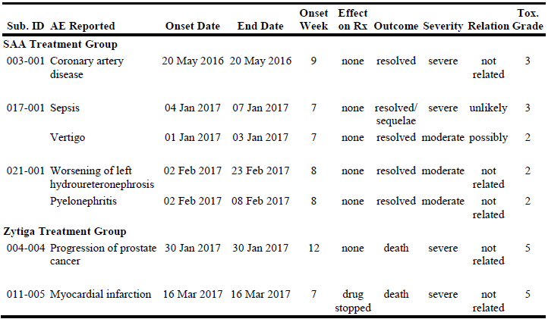

In the pivotal study, two patients on Yonsa Mpred and four on Zytiga developed elevated alkaline phosphatase from a normal Baseline. These were considered possibly related to study drug. No hepatic failure was reported.

No new safety concerns were raised regarding the new formulation of abiraterone. They have noted that the rates of adverse events related to mineralocorticoid excess were similar and low in both Yonsa Mpred and Zytiga, although there was a lower overall rate of adverse events seen in the Yonza arm (72.2%) compared to Zytiga (82.8%).

### Risk management plan

The TGA decided a RMP was not required as the combination of abiraterone acetate and corticosteroids is currently approved for the proposed indications and no additional risks are expected from a fixed dose combination (see [TGA’s guidance](https://www.tga.gov.au/resources/resource/guidance/risk-management-plans-medicines-and-biologicals/when-rmp-required) on ‘when an RMP is required’).

### Risk-benefit analysis

#### Delegate’s considerations

Yonsa Mpred offers a new micronized formulation of abiraterone which allows for a lower total dose to be taken (500 mg once a day) than when using the existing formulations (1000 mg once a day). A clinical benefit for this has not, however, been demonstrated since the existing and micronized formulations are bioequivalent. While, therefore, reformulating abiraterone clearly offers superior absorption of active drug it produces the same systemic abiraterone exposure as the standard formulation.

The use of methylprednisolone rather than prednisolone or prednisone is consistent with the US formulation of this product. Since methylprednisolone is not currently registered as an oral product in Australia it is somewhat irregular to include it as a new chemical entity in an Australian dossier that focuses almost exclusively on abiraterone. The Delegate notes that the Sponsor has provided no evidence of a therapeutic advantage for methylprednisolone over Australian registered oral glucocorticoids. However, the Delegate agrees that the equivalence of 5 mg prednisone to 4 mg methylprednisolone is well recognised and reported. This element of the product has no oncological activity that would require equivalent efficacy to be demonstrated.

There is essentially no difference in the safety profile of Yonsa Mpred and Zytiga within the limited amount of data available. This is based on a small study population exposed for a short period of time, and the safety analysis submitted is not powered to allow quantitative distinctions in rates of adverse events between the two products.

The sole efficacy study demonstrates a lack of inequivalence with Zytiga rather than equivalent efficacy, given that it is small (n = 53) and run for too short a period to be definitive in the setting of prostate cancer. Furthermore, the endpoints of prostate specific antigen and testosterone reduction are surrogates for clinical response and not anti-tumour endpoints. Therefore, evidence for the efficacy of Yonsa Mpred rests on its demonstrated bioequivalence with Zytiga, not the submitted study. The Delegate considers Study CHL-AA-201 to provide supportive evidence of efficacy only.

The *Dose and Method of Administration* section of the proposed Yonsa Mpred Product Information states that this product can be taken with or without food. This is compared to Zytiga, which must not be taken with food due to the observed food effects on pharmacokinetics. The Delegate notes that the proposed Yonsa Mpred label is consistent with the US FDA labelling for both Yonsa Mpred and Zytiga. There is, however, a less marked effect of food on Yonsa Mpred pharmacokinetics and this has not been examined head-to-head with Zytiga in data submitted in this application. The safety of Yonsa Mpred also not been examined specifically in a high-fat-fed population in data submitted in this application.

#### Proposed action

The Delegate concludes that Yonsa Mpred is a bioequivalent formulation to existing abiraterone formulations. As such it provides the same level of efficacy and safety as existing formulations, albeit at a lower dose level.

## Outcome

Based on a review of quality, safety, and efficacy, the TGA approved the registration of Yonsa Mpred, a composite pack of abiraterone acetate 125 mg tablet bottle and methylprednisolone 4 mg tablet bottle, indicated for:

*Yonsa Mpred is indicated for the treatment of patients with:*

* *newly diagnosed high-risk metastatic hormone sensitive prostate cancer (mHSPC) in combination with androgen deprivation therapy (ADT), or*
* *patients with metastatic advanced prostate cancer (castration resistant prostate cancer, mCRPC) who are asymptomatic or mildly symptomatic after failure of androgen deprivation therapy (ADT) or*
* *patients with mCRPC who have received prior chemotherapy containing a taxane.*

## Attachment 1. Product Information

The [Product Information](https://www.tga.gov.au/products/australian-register-therapeutic-goods-artg/product-information-one) ([PI](https://www.tga.gov.au/products/australian-register-therapeutic-goods-artg/product-information-one)) approved with this submission for Yonsa Mpred which is referred to in this AusPAR (and can be accessed on this AusPAR’s webpage) may have been superseded. For the most recent PI and [Consumer Medicines Information](https://www.tga.gov.au/products/australian-register-therapeutic-goods-artg/consumer-medicines-information-cmi) (CMI), please refer to the TGA [PI/CMI search facility.](https://www.ebs.tga.gov.au/)

|  |
| --- |
| Therapeutic Goods Administration |
| PO Box 100 Woden ACT 2606 Australia  Email: [info@tga.gov.au](mailto:info@tga.gov.au) Phone: 1800 020 653 Fax: 02 6203 1605  [**https://www.tga.gov.au**](https://www.tga.gov.au) |
|  |

1. An AusPAR for Zytiga original submission is available at <https://www.tga.gov.au/resources/auspar/auspar-abiraterone-acetate>. An AusPAR for Zytiga extension of indications is available at <https://www.tga.gov.au/resources/auspar/auspar-abiraterone-acetate-0>