|  |
| --- |
| Medicine shortages data-sharing framework |
| Dynamic Model of Medicine Availability (DMMA version 2.0) |
| Version 1.0, July 2024 |

Copyright

© Commonwealth of Australia 2024  
This work is copyright. You may reproduce the whole or part of this work in unaltered form for your own personal use or, if you are part of an organisation, for internal use within your organisation, but only if you or your organisation do not use the reproduction for any commercial purpose and retain this copyright notice and all disclaimer notices as part of that reproduction. Apart from rights to use as permitted by the *Copyright Act 1968* or allowed by this copyright notice, all other rights are reserved and you are not allowed to reproduce the whole or any part of this work in any way (electronic or otherwise) without first being given specific written permission from the Commonwealth to do so. Requests and inquiries concerning reproduction and rights are to be sent to the TGA Copyright Officer, Therapeutic Goods Administration, PO Box 100, Woden ACT 2606 or emailed to <[tga.copyright@tga.gov.au](mailto:tga.copyright@tga.gov.au)>.

Contents

Background 5

About data-sharing 5

Our data-sharing principles 6

Our data-sharing processes 7

Step by step process 7

Details about the data to be shared by providers 9

Period of endorsement 10

Data-sharing participants 10

Roles and responsibilities 13

Providers of information 13

Consent to use information 13

Receivers of information 14

State and territory entities 14

Provide information 14

Endorse the use of information 14

Sponsors 14

Provide information 14

Endorse the use of information 14

Wholesalers 14

Provide information 14

Endorse the use of information 15

Private hospital sector 15

Provide information 15

Endorse the use of information 15

Therapeutic Goods Administration 15

How the information is treated by the TGA 15

Release of information by the TGA 15

Information to be released under the legislative instrument 16

Release of related information under an existing framework 18

Confidentiality 18

Fictitious case study – our process applied 18

Attachment A 20

Example de-identified aggregated visual 20

Attachment B 21

Example of public information release 21

## Background

The purpose of this document is to create a framework that will allow us to share information to better manage the most serious national shortages. Modelling of up-to-date supply and demand data allows us to test shortage management scenarios to find the best approach for a specific shortage incident. The sharing of information under this framework is voluntary. In our experience supply chain participants have voluntarily shared data to assist with the management of serious national shortage incidents in the interest of achieving best outcomes for Australian patients. The Data-sharing framework applies alongside the TGA’s functions and powers under the *Therapeutic Goods Act 1989* (The Act).

The Therapeutic Goods Administration (TGA) launched the Dynamic Model of Medicine Availability (DMMA) version 1.0 (the Intensive Care Unit [ICU] Model) in December 2020. This was initially developed in response to the COVID-19 pandemic to provide a national approach to forecast the availability of medicines for COVID-19 patients in ICU.

We incorporated the lessons learned from the COVID-19 pandemic ICU modelling to create a second version of this model. DMMA version 2.0 has expanded scope and flexibility to identify, predict and quantify shortages of *any* medicine used in a hospital setting. This new version allows for multiple demand and supply inputs relating to stock. It also allows inclusion of extra parameters such as indication and hospital use area for when more granular information is available and necessary to inform shortage management strategies.

This document provides the framework for data-sharing under DMMA version 2.0. The Framework replaces the Protocol for National Use[1] which provided the framework for data-sharing under version 1.0 of the model.

Under this new framework, we will approach data providers to share medicine supply and demand data held by them about specific medicines or groups of medicines. This will allow the availability of these medicines to be monitored at a national level and help to forecast and manage medicine shortages in Australia. Availability of more granular and current information will increase resilience of the pharmaceutical supply chain by helping us manage serious shortages better and will ensure stakeholders have the information they need to help manage such shortages effectively, for example through effective conservation measures.

## About data-sharing

The objectives of this framework are to share data in response to serious current or emerging shortages and prevent and manage serious shortages. This will be achieved by the sharing of information:

* **From** individual Medicine Availability Working Group (MAWG) representatives for states and territories (data from public hospitals provided by the state), wholesalers (e.g. data provided by the National Pharmaceutical Services Association), private hospitals (data provided by the Australian Private Hospital sector), and medicine sponsors (data provided by specific sponsors of the medicine in or at risk of shortage, or sponsors of medicines approved for supply under section 19A of the Act to mitigate shortages).
* **To** the TGA, a part of the Department of Health and Aged Care, and groups convened by the TGA such as the MAWG and various Medicine Shortage Action Groups (MSAGs). Information will also be shared with other parts of government and the public as defined under Information to be released.

The Framework applies to specific requests for information made by TGA. The framework specifies which data will be shared and records what the TGA will do with the information consistent with a [legislative instrument](https://www.legislation.gov.au/F2024L00675/latest/text) made under s 61(5AB) and (5D) of the Act.

|  |  |
| --- | --- |
| Information | Section 61 of the Actprovides for the release, by the Secretary of the Department of Health and Aged Care, of information that is held by the department in relation to therapeutic goods. Certain kinds of therapeutic goods information that the Secretary may release may be set out in legislative instruments that are made by the Minister and published on the [Federal Register of Legislation](https://www.legislation.gov.au). |

The document intends to give clarity and certainty to all parties. The document should be seen as a framework around how the data can be accessed, shared, and reused as well as how the data is protected from accidental misuse.

### Our data-sharing principles

The policy principles underpin the data-sharing framework between the TGA, state and territory jurisdictions, wholesalers, sponsors, and the private hospital sector.

The data-sharing principles:

* Apply to medicines used in a hospital setting.
* Allow us to better work together to facilitate the safe sharing of medicine supply and demand data to effectively manage medicine shortages.
* Provide clarity on the value to those sharing the data:
  + The enhanced data-sharing under the Framework will be used to inform management strategies to reduce the impact of serious medicine shortages on patients and health professionals in Australia. Information sharing assists sponsors, wholesalers, states and territories and the TGA with the management of serious national shortages.
  + A data-sharing template standardises the information collected for each case, facilitating the modelling process.
  + The model will be used by the TGA to predict medicine availability on a national level. The model itself (without data) is available for states and territories to use with their own jurisdiction’s data.
* Provide clarity on the purpose of sharing.
  + Data providers will contribute medicine supply and demand data held by the state or territory, wholesalers and/or affected sponsors, as relevant, in relation to specific hospital medicines or groups of medicines.
  + The TGA will use this data to inform medicine shortages monitoring and management.
  + The TGA will share de-identified aggregated visuals with specified stakeholders for a specific shortage under a legislative instrument made under section 61 of the Act, as described in further detail in the section detailing the information release. An example of an aggregated visual is provided as Attachment A.
  + The TGA may also publish forecasts of medicine availability on the TGA website as set out under information release. An example of the type of information we will publish on our website is provided as Attachment B.
* Specify who the data will be shared with, what types of data could be requested and what the TGA will do with the data. The process of internal and external data-sharing is captured by our standard process.
* Protect the information you provide to us by restricting who will access the information.
* Provide an opportunity for reviewing arrangements if the requirements for data-sharing change.
* The TGA will not share individual data provided by one stakeholder with another stakeholder without permission, except as set out under information release.
* Sharing data under this Framework does not obligate any party to any specific management actions. For example, they cannot be used by the TGA to relocate purchased stock or facilitate negotiation of its relocation. However, states and territory jurisdictions may wish to discuss stock in the context of shortage.

### Our data-sharing processes

The standard data-sharing processes are outlined below.

Not all medicine shortages of interest will require national forecasting. An information request is only triggered if all eligibility criteria are met. This balances the burden of providing, collecting, and modelling data with the need for national coordination to ensure forecasting is delivered in the interest of public health.

|  |  |
| --- | --- |
| Information | **Criteria that trigger an information request:**   * the medicine is used in the hospital setting AND * the medicine is at risk of shortage or in shortage AND * the medicine has a significant clinical interest AND * unavailability of the medicine has a serious national impact AND * modelling of medicine shortage prevention or management is in the interest of public health. |

The model and Data-sharing framework may also be used for forecasting availability of community medicines if the medicine is also used in a hospital setting. Data**-**sharing to model availability of medicines only used in the community setting is not triggered by the above criteria.

Reportable and non-reportable medicines used in the hospital setting are in scope. Requests for non-reportable medicines are expected to be rare. The definition of a [reportable medicine](https://www.tga.gov.au/resources/resource/guidance/medicine-shortages-information-sponsors-suppliers) is available on our website.

#### Step by step process

We consider major medicine shortages of medicines used in the hospital setting that cannot be managed with standard approaches to be shortages of interest for potential forecasting of medicine availability. Once a shortage of interest is identified, the TGA’s process for triggering a request for information to inform modelling of medicine availability and communication of a management strategy is outlined below.

Figure 1: Data sharing process.

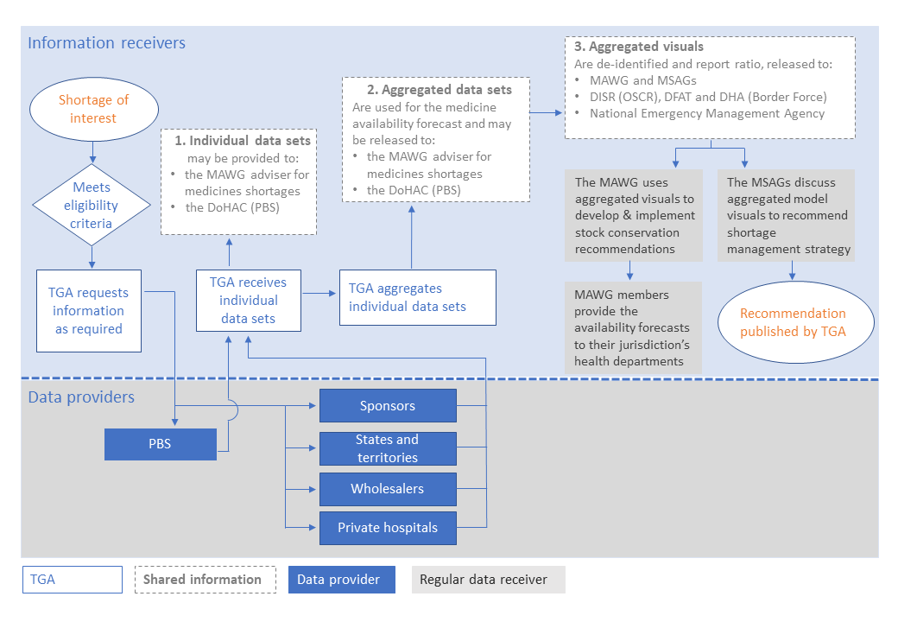

##### TGA Assessment and request

* The TGA identifies (or identifies risk of) a very serious national shortage that cannot be effectively managed with conventional means.
* The medicine shortage is assessed against specified criteria for a TGA information request.
* If the modelling threshold is met, The TGA sends a request for data input to sponsors, states and territories, wholesalers and the private hospital sector if required. We will provide you with an excel data-sharing template for the data.
* By providing data, the data sharer is consenting to this information being shared under this Data-sharing framework.

##### Individual and aggregated data-sharing

* Individual data is provided by relevant stakeholders to the TGA. Individual data may comprise aggregates of individual information where constituents are represented by a data provider (e.g. hospitals in a state or wholesalers represented by a peak body).
* Data are collated to form aggregated data (if required)
* Individual and aggregated data may be shared with very limited specified individuals or organisations if it is required as set out in the legislative instrument:
  + the Medicine Availability Working Group (MAWG) adviser who runs the model.
  + the Pharmaceutical Benefits Scheme (a part of the Department of Health and Aged Care).

##### Forecast modelling

* Forecast modelling is performed by the TGA and the MAWG adviser by running the model.

##### Aggregated visual sharing and response coordination

* Aggregated visuals are the de-identified model output with stock displayed as a percentage of demand (see below example). Individual stock data is not shown.
* If required, the aggregated visuals (the model outputs) may be shared with specified individuals or organisations set out in the [legislative instrument](https://www.legislation.gov.au/F2024L00675/latest/text). An example is provided in Attachment A.
* Aggregated visuals are shared with the MAWG and discussed from a hospital perspective. This is coordinated by the TGA and comprises representatives from state and territory health departments. The MAWG uses the model projections to develop and implement conservation recommendations.
* Aggregated visuals may also be shared with an MSAG to discuss clinical management. MSAGs are convened and coordinated by the TGA and include healthcare professional peak bodies and consumer representative groups relevant to a specific shortage. MSAGs use the aggregated visual forecasts to provide recommendations on shortage management strategies.

##### Communication: Sharing of conclusions and recommendations

* Management strategies, which may include estimates about medicine availability captured under data release, are published on the TGA website. The type of information that may be published is detailed in a [legislative instrument](https://www.legislation.gov.au/F2024L00675/latest/text). An example of this type of information is shown in Attachment B.
* The public information, including predictions for medicine availability and conservation recommendations (for the specific medicines) are disseminated to state and territory health departments by their representatives on the MAWG or may be shared by MSAG members through their own communication channels.

### Details about the data to be shared by providers

The TGA will request providers to share data on the supply and use of specific medicines or groups of medicines specified in the data-sharing template. The template will be customised to each scenario. For example, some requests may require specific usage data. It is acknowledged that the data provider may not be able to provide the granularity of data requested. If participants do not capture demand information by indication or use area, total demand may be provided instead and must be noted. The data-sharing request could ask for the types of data set out in Table 1.

Table 1: Types of data.

|  |  |
| --- | --- |
| Descriptor | Data type |
| supply | Sponsor:  Stock on hand plus approximate dates and quantities of future orders or stock not currently usable that could be used (e.g. expired stock), estimates of the stock at wholesalers |
| supply | Wholesaler:  Stock on hand |
| supply | Stock on hand (pharmacy level) Central store stockpile captured as part of ‘total pharmacy location stock’ |
| supply | Hospital pharmacy:  Stock on hand (pharmacy level) – estimates would be provided by states and territories if they are available. Stock may be captured by location (pharmacy 1-20) as the jurisdiction’s stock levels are collated.  Community pharmacies will not be approached (out of scope) but may be extrapolated from wholesaler data. |
| Supply | Public hospitals (including hospital pharmacies) |
| supply | Private hospitals |
| demand | Indication  In some cases, the TGA may request breakdown of usage for multiple indications, where relevant  In other cases, the TGA will request total stock numbers for each jurisdiction (captured as indication not known or considered) |
| demand | Specific usage within primary care e.g. outpatient, ambulance or remote (public, private) |
| demand | Specific usage within secondary care e.g. outpatient, Emergency Department (ED), Operating Theater (OT), Intensive Care Unit (ICU) , Non-ICU ward (public, private) |
| demand | Usage by presentation  Typically usage would be requested for each ARTG product or unregistered product (e.g.19A product). |
| Demand | Total demand may be requested or provided where specific demand is not relevant to modelling or not available. |

### Period of endorsement

The participants under this framework are set out in the table under Data-sharing participants. Entities listed in the table under ‘Data Providers’ who share information under this framework have endorsed that information will be shared and used as set out in this document and pursuant to the ‘[*Therapeutic Goods (Information Specification—Medicine Shortages and Availability Data) Instrument 2024*](https://www.legislation.gov.au/F2024L00675/latest/text)’.

The Data-sharing framework is endorsed for a period of 2 years. After this, it will be revisited and may be renewed with or without amendment.

Stakeholders may raise issues or requests for process amendment at any point in time, which could lead to earlier review of the Framework if concerns are significant and experienced across multiple stakeholders.

### Data-sharing participants

The table below shows the data providers and receivers participating in the data-sharing process. They are responsible for sharing data in line with this Data-sharing framework. Actual sharing of data may be delegated as necessary, except for the role of MAWG adviser. Specific persons, bodies, or authorities that data may be shared with are summarised below under legislative instrument.

The need to share information with each data receiver will be assessed on a case-by-case basis. Information will be provided to potential data receivers only if it is necessary for the effective management of a specific shortage. The type of information that can be shared is limited and set out in the legislative instrument summarised below. Data providers are approached with information requests tailored to the specific shortage.

New members may be added with agreement from their sector. Participation is voluntary and a member may leave by emailing the TGA at [medicine.shortages@health.gov.au](mailto:medicine.shortages@health.gov.au). When a member leaves, they should provide the TGA with details of a new representative for their sector. The TGA and current representatives may make recommendations for new members to participate in the data-sharing process.

Table 2: Data sharing participants.

|  |  |  |
| --- | --- | --- |
| Entity | Sector | Position |
| Information receiver | | |
| TGA | Commonwealth | Director, Medicine Shortages Section, TGA |
| Medicine Shortage Action Groups (MSAGs) *Short-term groups are created in response to case-by-case acute shortage events. Groups give advice on clinical shortage management strategies.* | Commonwealth  As required groups may include:  relevant health professional peak bodies and colleges  relevant consumer representative groups | Director, Medicine Shortages Section, TGA |
| Medicine Availability Working Groups (MAWG) *Assist with collation of national medicine availability data. The group uses the DMA model and the model outputs to develop conservation recommendations.* | Advisory Group for the TGA consisting of state and territory health department representatives | The MAWG adviser  Director, Medicine Shortages Section, TGA |
| The Department of Health and Aged Care, Technology Assessment and Access Division | Area that administers the Pharmaceutical Benefits Scheme | Directors, Office of Health Technology Assessment, Department of Health and Aged Care |
| The Department of Industry, Science and Resources (DISR), Office of Supply Chain Resilience | Commonwealth | Managers, Office of Supply Chain Resilience, DISR |
| The Department of Home Affairs | Commonwealth | Directors, Australian Border Force |
| The Department of Foreign Affairs and Trade (DFAT) | Commonwealth | Directors Supply Chain Resilience Section, DFAT |
| Data providers – States and territories | | |
| ACT | State/territory government | Director  Pharmaceutical Services Section Operations  (Deputy Chief Pharmacist)  Health Protection Service  ACT Health |
| NSW | State/territory government | Chief Health Officer and Deputy Secretary – Population and Public Health Office of the Chief Health Officer  NSW Health |
| NT | State/territory government | Executive Director  Medicines Management/Research  NT Health |
| QLD | State/territory government | Executive Director  Healthcare Regulation Branch  Queensland Public Health and Scientific Services  Queensland Health |
| SA | State/territory government | Director of Medicines and Technology Programs  Office of the Chief Pharmacist  SA Health |
| TAS | State/territory government | Director  Medication Strategy and Reform  Clinical Quality, Regulation and Accreditation  Department of Health, Tasmania |
| VIC | State/territory government | Director  Supply Chain Surety  HealthShare Victoria |
| WA | State/territory government | Chief Pharmacist  Public Health Regulation Directorate  Department of Health  Western Australia |
| Data providers – wholesalers | | |
| NPSA – Australia’s medicine distribution network (NPSA) | Pharmaceutical Benefits Scheme (PBS) Community Service Obligation Distributors (CSOD) Wholesalers | Executive Director |
| NPSA member– Australian Pharmaceutical Industries | PBS Wholesalers | General Manager Healthcare Services |
| NPSA member- Sigma | PBS Wholesalers | Supply Planning Manager Sigma Healthcare |
| NPSA member- Symbion | PBS Wholesalers | General Manager Supply Chain |
| NPSA member- NPD (National Pharmacies Distribution) | PBS Wholesalers | Chief Executive Officer National Pharmacies |
| Other wholesalers – Clifford Hallam Healthcare (CH2) | Wholesalers | Chief Executive Officer CH2 |
| Other wholesalers/distributors may be approached as required for individual cases | Wholesalers |  |
| Data providers – medicine sponsors | | |
| Sponsor affected by a specific, anticipated or current shortage. Any sponsor with a TGA client ID could be approached including sponsors of reportable or non-reportable medicines, and sponsors of overseas medicines approved under s19A of the Act. Sponsors of non-reportable medicines may opt in to use the framework if needed but is expected to be rare. | Pharmaceutical Industry | TGA client database contact for any sponsors represented or not represented by Medicines Australia /Generic and Biosimilar Medicines Australia  Chief Executive Officer  Medicines Australia (MA)  Chief Executive Officer, Generic and Biosimilar Medicines Australia (GBMA) |
| Data providers – Private hospital sector | | |
| Individual private hospitals subject to their election to participate in the framework. Some private hospitals may have a separate private pharmacy provider. | Private sector | To be determined on a case-by-case basis and subject to agreement  Director of Pharmacy or Chief Pharmacist |
| Private Hospital Pharmacy Service Providers:  ICON group (including Slade and Epic pharmacy  HPS Pharmacies  Ramsay Pharmacy  Main hospitals with inhouse pharmacy service:  Adventist Health  Chris O’Brien Lifehouse | Private sector |  |

## Roles and responsibilities

### Providers of information

It is the responsibility of data providers to ensure that all data under this Framework is provided in good faith and is accurate and correct. Data will change over time, sometimes quickly. To assist with forecasting, it is essential that the currency of information is identified in the date column of the data template. If exact data is unavailable, approximate data may be provided (e.g. data on usage for certain indications). This should be noted by data providers when the information is returned to the TGA.

Data providers acknowledge that information may be shared by the TGA as outlined in this Framework. The TGA assumes no legal liability or responsibility for the accuracy, currency or completeness of the information shared by data providers which is then shared under the Framework.

#### Consent to use information

When sending the request for data, the covering email will include the following statement:

“This request for data is being provided under the ‘Data-sharing framework’ document. By providing data in response to this request, you consent to this information being shared in line with the Data-sharing framework document and consistent with the ‘[*Therapeutic Goods (Information Specification—Medicine Shortages and Availability Data) Instrument 2024*](https://www.legislation.gov.au/F2024L00675/latest/text)’.

### Receivers of information

Receivers of information are set out in table 2. The release of information is covered in the section Release of information by TGA.

### State and territory entities

#### Provide information

State and territory data providers are requested to provide collated information specified in the MAWG data-sharing template. The information should be provided as soon as possible, following the receipt of a request for information from TGA.

The type of information to be provided consists of the available information from public hospitals (see Data to be shared).

#### Endorse the use of information

Data providers endorse the use and release of provided information as set out under the section Release of information by TGA.

### Sponsors

#### Provide information

Sponsors of any therapeutic goods (including those that are non-reportable) are requested to provide the information set out in the data template. The information should be provided as soon as possible, following the receipt of a request for information from the TGA.

The receipt of this medicine data from sponsors under this Framework will be used alongside data received under the Act.

#### Endorse the use of information

The sponsors of reportable and non-reportable medicines approached under this process elect to participate in this framework by providing information to the TGA. Participating sponsors consent to the use of information under this framework as set out under the section Release of information by TGA.

### Wholesalers

#### Provide information

Endorsement of the Data-sharing framework will be sought from NPSA. Wholesalers are requested to provide information covered by the TGA and NPSA Medicine Shortages Wholesaler Data Reporting Protocol for specific medicines that are either in shortage or at risk of shortage. The information should be provided as soon as possible, following the receipt of a request for information from TGA, unless otherwise agreed. Aggregated wholesaler data is provided to the TGA by the NPSA. Individual NPSA wholesaler data is not requested or received.

Other wholesalers will be approached individually on a case-by-case basis. Wholesalers approached under this process elect to participate in this framework by providing information to the TGA.

#### Endorse the use of information

Participating wholesalers consent to the use of information under this framework as set out under the section Release of information by TGA.

### Private hospital sector

#### Provide information

Individual private hospitals pharmacy service providers may be approached with a request to complete the data-sharing template on a case-by-case basis.

The information should be provided as soon as possible, following the receipt of a request for information from the TGA.

The type of information to be provided consists of the available information from private hospitals or pharmacies servicing the hospitals.

Private hospitals or peak bodies approached under this process elect to participate in this framework by providing information.

#### Endorse the use of information

Data providers consent to the use of information under this framework as set out under the section Release of information by TGA.

### Therapeutic Goods Administration

#### How the information is treated by the TGA

Information provided to the TGA such as personal, business or commercially confidential information is treated as official information. As part of the Department of Health and Aged Care, the TGA has obligations under the [Protective Security Policy Framework](https://www.protectivesecurity.gov.au/about/structure-protective-security-policy-framework) (PSPF) to ensure that we develop, document, implement and review appropriate security measures to protect information from unauthorised use or accidental modification, loss or release.

The department’s [Data Strategy](https://www.health.gov.au/resources/publications/department-of-health-and-aged-care-data-strategy-2022-25) sets out how we ensure that we use data for public good while maintaining individual privacy and confidentiality and upholding commercial-in-confidence obligations. Strategic objective number 4 of the data strategy embeds our commitment to safe sharing and release of data using trusted, transparent, consistent, and efficient protocols.

Data will be reviewed by the TGA and treated for official use. The TGA does not collect personal information of patients or healthcare professionals as part of this initiative.

The TGA will retain the information provided for the duration of 7 years as required by our record-keeping obligations.

### **Release of information by the TGA**

Individual data sets and their aggregates received by the TGA will only be shared with the MAWG adviser for medicine shortages for modelling purposes, and the relevant PBS area to facilitate shortage mitigation through flexibilities within the PBS. Individual data sets are provided by a stakeholder in response to a request for information. Aggregated data sets are used to run the DMMA and model outputs for these include estimates of quantity.

The majority of information released by the TGA to specific bodies or individuals occurs in the form of an aggregated visual and supports the management or prevention of specific medicine shortages (see data-sharing process and Attachment A). This is the model output and can be released as a narrative or as a live view while the model is run during forecasting meetings. The information that is shared as an aggregated visual is less sensitive than the aggregated data set and shared more broadly (see data-sharing process). The aggregated visual includes estimates of available quantity as a percentage of demand rather than specifying medicine quantity in units or milligrams.

The aggregated visual will be used to inform other Commonwealth departments, state and territory entities (the MAWG), sponsors, wholesalers, relevant MSAGs and private hospitals. They may be discussed to inform shortage management at MSAG or MAWG meetings. Representatives for consumers or relevant health professional peak bodies may be present at these meetings to advise on shortage management solutions. Aggregated visuals may also be shared with other Commonwealth entities that contribute to the national shortages management such as the Department of Industry, Science and Resources (DISR). All aggregated visuals will be de-identified to prevent identification of individual data sources.

Due to the time-critical nature of the shortage management process, it may be necessary for the TGA to undertake data model predictions based on incomplete information. In situations where some stakeholder’s data input is delayed, data receivers viewing the aggregate visuals may be able to estimate this data provider’s input through the comparison of modelling outcomes before and after the input was included.

Conclusions drawn from aggregated visuals may be shared with the public as a narrative of the supply situation and mitigation and management actions (example at Attachment B). Publication on the TGA website supports communication about medicine shortages and could include projected time periods of stock unavailability. Public information may also be presented at conferences or webinars.

The release of information by the TGA will be undertaken pursuant to a legislative instrument made under section 61 of the Act. The instrument specifies kinds of information that can be disclosed and the persons to whom, and the purposes for which, information can be disclosed.

To control further disclosure, all entities or individuals who receive individual data, aggregated data, or aggregated visuals released under the section 61 legislative instrument will be required to agree to confidentiality in advance if they are not already subject to a confidentiality deed. Although we have put these measures in place to protect the information, the TGA does not take responsibility for the information once it has been provided to recipients under the legislative instrument made under section 61 of the Act.

#### Information to be released under the legislative instrument

A legislative instrument provides a legal basis under the Act to release information concerning medicine availability and demand to specified data recipients and the public. The ‘[*Therapeutic Goods (Information Specification—Medicine Shortages and Availability Data) Instrument 2024*](https://www.legislation.gov.au/F2024L00675/latest/text) ‘came into effect on 13June 2024.

The instrument facilitates broader consideration and analysis of medicine availability data, to support the management of medicine shortages and discontinuations.

The instrument specifies:

* the kinds of information that the TGA may release to specified persons, bodies, or authorities; and
* the persons, bodies, or authorities to which that information may be released.
* the purpose for which the information may be released.

Table 3: Information to be released to persons, bodies, or authorities.

|  |  |
| --- | --- |
| Information to be released to persons, bodies, or authorities | |
| Individual data set means any data provided to the TGA by a data source for a medicine that is in shortage, is at risk of being in shortage, or has been permanently discontinued, and includes data about the following:  the supply of, or demand for, the medicine;  the current and expected availability of the medicine (including the quantity of the medicine);  when the medicine is expected to become available. | The following persons, bodies, or authorities:  an expert adviser in the Medicine Availability Working Group (MAWG) (if any)  the part of the department responsible for administering the Pharmaceutical Benefits Scheme (PBS). |
| Aggregated data set  means data that is an aggregate of the individual data sets for a medicine from all data sources that provided data to the TGA for the medicine. | The following persons, bodies, or authorities:  an expert adviser in the MAWG (if any)  the part of the department responsible for administering the PBS. |
| Aggregated visual  means the medicine availability modelling forecast (either in report form, live modelling form or any other form) for a medicine, that is created by the TGA or an expert adviser in the MAWG through the process of running the aggregated data set through a dynamic modelling process to obtain estimates of expected medicine availability. | an expert adviser in the MAWG (if any)  the part of the department responsible for administering the PBS.  The MAWG  The Medicine Shortage Action Groups (MSAG)  Industry Department (including the Office of Supply Chain Resilience)  Department of Home Affairs (including Border Force)  Department of Foreign Affairs and Trade  National Emergency Management Agency |

The instrument specifies the kinds of information that the TGA may release to the public, with a view to facilitating greater public awareness of medicine shortages and discontinuations across Australia and key information about how the shortage is being managed.

Table 4: Information to be released to the public.

|  |
| --- |
| Information to be released to the public |
| * information about a medicine, and the availability of the medicine, including:   1. the sponsor of the medicine;   2. the date when, or period within which, a shortage or discontinuation of the medicine is expected to commence, and the anticipated period of the shortage;   3. the estimated proportion of national demand for the medicine that is available (including if none is available);   4. the estimated proportion of the usual or expected supply of the medicine that is available (including if none is available);   5. the predicted future supply and availability of the medicine over time;   6. the estimated supply deficit of the medicine. * information about the predicted impact of a shortage or discontinuation of a medicine, and recommended measures to potentially limit the impact of the shortage or discontinuation. * information about an alternative treatment, and the availability of the alternative treatment, including:   1. the sponsor of the alternative treatment.   2. the predicted future supply and availability of the alternative treatment over time * information about the predicted impact of usage of alternative treatments, or implementation of recommended measures to potentially limit the impact of a shortage or discontinuation of a medicine, including:   1. the predicted impact (if any) on supply of the medicine that is in shortage or discontinued;   2. the predicted impact (if any) of usage of the alternative treatment on the availability of the alternative treatment |

#### Release of related information under an existing framework

In addition to information received under this data-sharing process, the TGA already holds and releases related information to the public. Under the Act, the Secretary of the Department of Health and Aged Care may release therapeutic goods information set out in the *Therapeutic Goods* [*(Information relating to Shortages and Discontinuations of Supply of Medicines*](https://www.legislation.gov.au/Details/F2018L01746)*) Specification 2018.*

The therapeutic goods information that is routinely published in the Medicine Shortage Reports Database on the TGA website, in relation to medicine shortages and discontinuations and their management, is included in this Specification.

#### Confidentiality

The data is classified for official use. The TGA recognises that information provided under this Framework may be commercial-in-confidence information and will be treated as such. This information will only be released when the data provider has consented and in accordance with the Framework.

### Fictitious case study – our process applied

* The TGA becomes aware of a national shortage for a medicine used in the hospital setting. We are concerned medicine availability may not be adequately managed with conventional measures. We apply the criteria to determine if the shortage triggers an information request to inform modelling availability. The medicine shortage in this scenario meets all criteria.
* TGA sends a request for information on supply and demand data to each data provider as shown below.

Table 5: Type of information requested from data providers.

|  |  |
| --- | --- |
| Entity | Type of information requested |
| State and territory jurisdictions | Hospital stock on hand (e.g. 500 units) |
| Normal daily demand (e.g.50 units) |
| Jurisdictional central stockpile (e.g. 500 units) |
| Wholesaler | Stock at wholesaler level (e.g. 500 units) |
| Sponsor | Stock at sponsor level (e.g. 1000 units) |
| Future orders Date A – (e.g. 50 units)  Date B (e.g. 500 units)  Date C (e.g. 500 Units) |

* Provision of information is voluntary and data providers will provide data if the seriousness of the national shortage incident compels them to contribute information to assist with shortage management in the interest of patients.
* Data providers are aware that providing data means to agree to the release of information under a section 61 instrument.
* Data providers that select to participate in the management of the national shortage return the populated data sharing template.

Under the Framework the TGA uses the information to inform the following activities. Events are listed in the order they would typically occur.

* The TGA reviews usage including usage other than registered indications such as off-label use in clinical practice and atypical uses (e.g. clinical trials) of the medicine in shortage.
* The TGA models national medicine availability and tests the effectiveness of various management strategies using the model prediction.
* The model shows usage must be reduced by 25% or stock will run out before supply returns.
* The TGA convenes an MSAG and works with health professionals to create recommendations for clinicians to implement conservation measures. TGA shares the aggregated visuals at the meeting. Recommendations are to prioritise the use in a patient group and in the primary care setting.
* The TGA seeks MAWG (state and territory jurisdictions) endorsement of the management strategies. TGA shares the aggregated visuals at the meeting.
* The TGA works with the MAWG to implement the shortage management strategies.
* The TGA publishes a web statement advising of the shortage and the developed clinical recommendations (example web statement at Attachment B) .
* The TGA approves the temporary supply of overseas-registered equivalent products under section 19A of the *Therapeutic Goods Act 1989.*
* TGA requests updated supply and demand data and re-runs the model. The model predicts that usage needs to be reduced by an additional 10%. The TGA reconvenes the MSAG and MAWG to review and update the recommendations. Health professionals are advised to reduce the medicine usage by 35% by prioritising usage in patient group A, in the primary care setting in certain geographical locations.
* TGA works with MAWG and the medicine sponsor to implement the updated clinical recommendations. TGA shares the aggregated visuals at the meeting.
* The medicine sponsor has data on the shelf life of individual batches and TGA reviews and approves their submission to extend the shelf-life for specific batches.
* The TGA updates the web statement with the new management actions (example web statement at Attachment B).

## Attachment A

### Example de-identified aggregated visual

The example aggregated visual below shows stock over time. The medicine name is part of the visual. In this example there are two registered brands (ThatMedicine and OtherMedicine, the active ingredient is activeMAB).

The dose equivalence tab shows the available products expressed as a 15mg strength.

Information in the visual is de-identified as follows:

* Stock is shown as % of demand (not units of stock)
* Days are shown consecutively, from start of modelling (not calendar days).

Figure 2: Example of an aggregated visual.

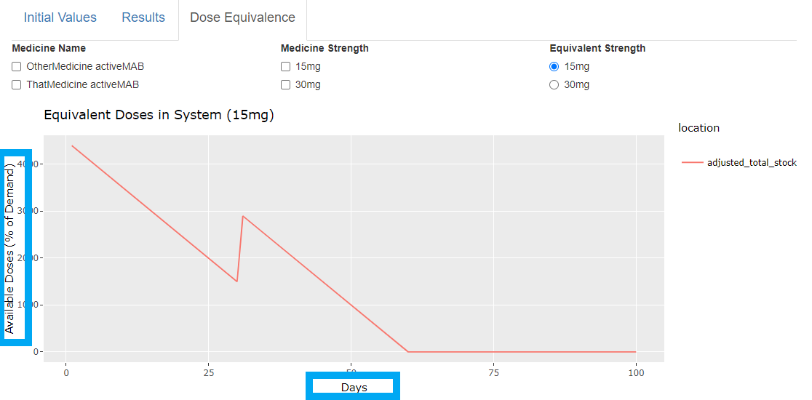

## Attachment B

### Example of public information release

Public release of information is intended to be similar to the information we currently release. A difference would be that availability predictions would be based on our model outputs.

A recent example of the type of information we provide to the public as part of our management strategy can be found at <https://www.tga.gov.au/safety/shortages/medicine-shortage-alerts/joint-statement-shortage-tenecteplase-metalyse>. It includes the model output in terms of:

* estimated reduction in usage that is required to maintain supply and
* implementation of conservation measures.

An excerpt from the statement is shown below.

Figure 3: Example of information published on our website.

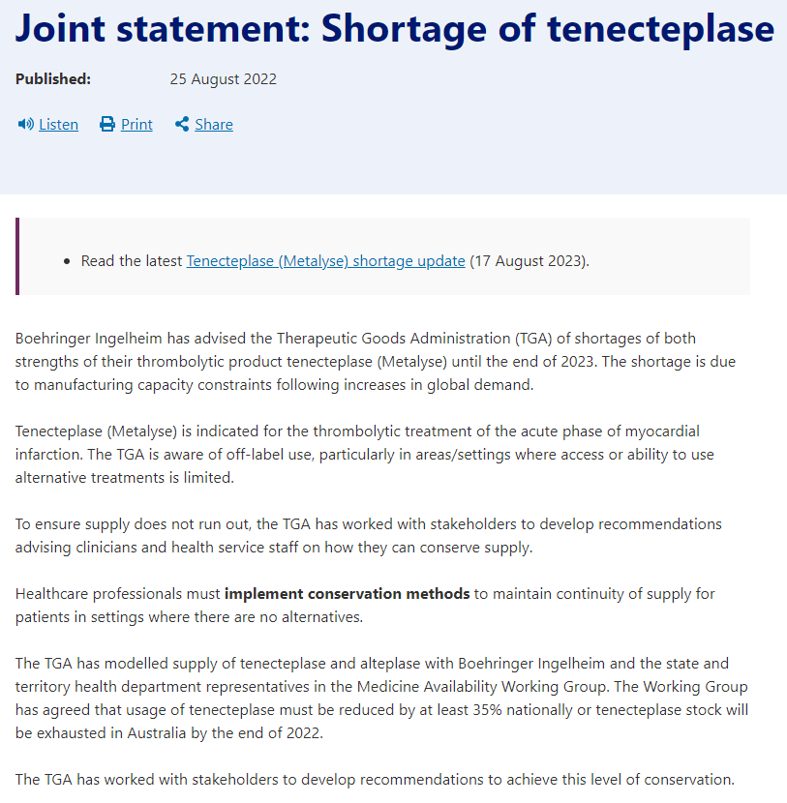

Version history

|  |  |  |  |
| --- | --- | --- | --- |
| Version | Description of change | Author | Effective date |
| V1.0 | Final | Pharmacovigilance Branch | 23/07/2024 |

|  |
| --- |
| Therapeutic Goods Administration |
| PO Box 100 Woden ACT 2606 Australia  Email: [info@tga.gov.au](mailto:info@tga.gov.au) Phone: 1800 020 653 Fax: 02 6203 1605  [**https://www.tga.gov.au**](https://www.tga.gov.au) |
| Reference/Publication # D24-2847716 |

1. Protocol for National Use [D20-3043288](el://D20-3043288?db=A7&open)