|  |
| --- |
| Australian Public Assessment Report for Comirnaty Original/Omicron BA.4-5 COVID-19 Vaccine |
| Active ingredient: tozinameran/famtozinameran |
| Sponsor: Pfizer Australia Pty Ltd |
| August 2024 |

About the Therapeutic Goods Administration (TGA)

* The Therapeutic Goods Administration (TGA) is part of the Australian Government Department of Health and Aged Care and is responsible for regulating therapeutic goods, including medicines, medical devices, and biologicals.
* The TGA administers the *Therapeutic Goods Act 1989* (the Act), applying a risk management approach designed to ensure therapeutic goods supplied in Australia meet acceptable standards of quality, safety, and efficacy.
* The work of the TGA is based on applying scientific and clinical expertise to decision-making, to ensure that the benefits to the Australian public outweigh any risks associated with the use of therapeutic goods.
* The TGA relies on the public, healthcare professionals and industry to report problems with therapeutic goods. The TGA investigates reports received to determine any necessary regulatory action.
* To report a problem with a therapeutic good, please see the information on the [TGA website](https://www.tga.gov.au/).

About AusPARs

* The Australian Public Assessment Report (AusPAR) provides information about the evaluation of a prescription medicine and the considerations that led the TGA to approve or not approve a prescription medicine submission. Further information can be found in [Australian Public Assessment Report (AusPAR) guidance](https://www.tga.gov.au/australian-public-assessment-report-auspar-guidance).
* AusPARs are prepared and published by the TGA.
* AusPARs are static documents that provide information that relates to a submission at a particular point in time. The publication of an AusPAR is an important part of the transparency of the TGA’s decision-making process.
* A new AusPAR may be provided to reflect changes to indications or major variations to a prescription medicine subject to evaluation by the TGA.

Copyright

© Commonwealth of Australia 2024  
This work is copyright. You may reproduce the whole or part of this work in unaltered form for your own personal use or, if you are part of an organisation, for internal use within your organisation, but only if you or your organisation do not use the reproduction for any commercial purpose and retain this copyright notice and all disclaimer notices as part of that reproduction. Apart from rights to use as permitted by the *Copyright Act 1968* or allowed by this copyright notice, all other rights are reserved and you are not allowed to reproduce the whole or any part of this work in any way (electronic or otherwise) without first being given specific written permission from the Commonwealth to do so. Requests and inquiries concerning reproduction and rights are to be sent to the TGA Copyright Officer, Therapeutic Goods Administration, PO Box 100, Woden ACT 2606 or emailed to <[tga.copyright@tga.gov.au](mailto:tga.copyright@tga.gov.au)>.

Contents

Comirnaty original/omicron BA.4-5 submission 4

Comirnaty Original/Omicron BA.4-5 – proposed indications 6

Coronavirus disease (COVID-19) 6

Clinical rationale for comirnaty original/omicron BA.4-5 use 7

Regulatory status 7

Australian regulatory status 7

International regulatory status 8

Registration timeline 9

Evaluation overview 9

Clinical evaluation summary 9

Efficacy 9

Safety 14

Risk/benefit assessment 20

Conclusion and recommended course of action 22

Outcome 22

Specific conditions of registration applying to these goods 22

Attachment 1. Product Information 24

## Comirnaty original/omicron BA.4-5 submission

|  |  |
| --- | --- |
| ***Type of submission:*** | Extension of indications/New strength |
| ***Product name:*** | Comirnaty original/omicron BA.4-5 |
| ***Active ingredient:*** | tozinameran/famtozinameran |
| ***Decision:*** | Approved |
| ***Approved therapeutic use for the current submission:*** | Comirnaty Original/Omicron BA.4-5 Vaccine has provisional approval for the indication below*:*  *Active immunisation to prevent coronavirus disease 2019 (COVID-19) caused by SARSCoV-2, in individuals 6 months of age and older.*  *The use of this vaccine should be in accordance with official recommendations.*  *The decision has been made on the basis of short term immunogenicity and safety data.*  *Continued approval depends on the evidence of longer term efficacy and safety from ongoing clinical trials and post-market assessment.* |
| ***Date of decision:*** | 9 May 2024 |
| ***Date of entry onto ARTG:*** | 14 May 2024 |
| ***ARTG number:*** | [417266](https://www.tga.gov.au/resources/artg/417266) |
| [***Black Triangle Scheme***](https://www.tga.gov.au/black-triangle-scheme) | Yes |
| ***Sponsor’s name and address:*** | Pfizer Australia Pty Ltd, Level 17, 151 Clarence Street, Sydney NSW 2000 |
| ***Dose form:*** | Comirnaty Original/Omicron BA.4-5 (grey, orange and maroon cap) is a white to off-white frozen suspension.  Comirnaty Original/Omicron BA.4-5 (blue cap) is a clear to slightly opalescent solution. |
| ***Strength:*** |  |
| ***Container:*** | Comirnaty Original/Omicron BA.4-5 – Suspension for injection (grey or blue cap): 2 mL clear vial (Type I glass) with a stopper (synthetic bromobutyl rubber) and a grey or blue flip-off plastic cap with aluminium seal. Each vial contains either 1 or 6 doses   * Light grey or light blue cap: single dose vial * Dark grey or dark blue cap: 6 dose multidose vial   Comirnaty Original/Omicron BA.4-5 – Concentrated Suspension for injection (orange or maroon cap): 2 mL clear vial (Type I glass) with a stopper (synthetic bromobutyl rubber) and an orange or maroon flip-off plastic cap with aluminium seal. Each vial contains 10 doses after dilution   * Orange or maroon cap: 10 dose multidose vial after dilution |
| ***Pack size:*** | 10 vials, 195 vials |
| ***Route of administration:*** | Intramuscularly (DO NOT inject the vaccine intravascularly, subcutaneously or intradermally) |
| ***Dosage:*** | For further information regarding dosage, such as dosage modifications to manage adverse reactions, refer to the [Comirnaty Product Information](https://www.ebs.tga.gov.au/ebs/picmi/picmirepository.nsf/pdf?OpenAgent=&id=CP-2023-PI-01101-1&d=20240826172310101). |
| ***Pregnancy category:*** | **Category B1:** Drugs which have been taken by only a limited number of pregnant women and women of childbearing age, without an increase in the frequency of malformation or other direct or indirect harmful effects on the human fetus having been observed. Studies in animals have not shown evidence of an increased occurrence of fetal damage.  No data are available yet regarding the use of Comirnaty Original/Omicron BA.4-5 during pregnancy. However, a large amount of information from pregnant women vaccinated with the initially approved COMIRNATY (tozinameran) vaccine during the second and third trimester have not shown negative effects on the pregnancy or the newborn baby. While information on effects on pregnancy or the newborn baby after vaccination during the first trimester is limited, no change to the risk for miscarriage has been seen. Animal studies do not indicate direct or indirect harmful effects with respect to pregnancy, embryo/fetal development, parturition or post-natal development. Administration of Comirnaty Original/Omicron BA.4-5 in pregnancy should only be considered when the potential benefits outweigh any potential risks for the mother and fetus.  The use of any medicine during pregnancy requires careful consideration of both risks and benefits by the treating health professional. The [pregnancy database](https://www.tga.gov.au/products/medicines/find-information-about-medicine/prescribing-medicines-pregnancy-database) must not be used as the sole basis of decision making in the use of medicines during pregnancy. The TGA does not provide advice on the use of medicines in pregnancy for specific cases. More information is available from [obstetric drug information services](https://www.tga.gov.au/obstetric-drug-information-services) in your state or territory. |

### Comirnaty original/omicron BA.4-5 – proposed indications

Tozinameran/Famtozinameran (Comirnaty Original/Omicron BA.4-5), also referred to as Bivalent BA.4-5, is currently provisionally approved for use in children 5 years of age and older and for use in primary series/additional doses from 5 years of age and above.

This AusPAR describes the submission by Pfizer Australia Pty Ltd (the Sponsor) to register Comirnaty Original/Omicron BA.4-5 COVID-19 Vaccine (tozinameran and famtozinameran) for the following proposed extension of indications and registration of a new strength:

**Proposed indication:**

As a booster dose for active immunisation to prevent coronavirus disease 2019 (COVID-19) caused by SARS-CoV-2, in individuals 6 months of age and older.

The use of this vaccine should be in accordance with official recommendations.

**Proposed dosage for Individuals 6 months to <5 years of age:**

COMIRNATY Original/Omicron BA.4-5 (For Age 6 months to <5 Years) is administered intramuscularly as a booster dose (1.5/1.5 micrograms/0.2 mL), at least 3 months after the completion of a COVID-19 vaccine primary series or a previous booster dose of any COVID-19 vaccine.

**New strength proposed**:

COMIRNATY Original/Omicron BA.4-5 for age 6 months to <5 years: (Multidose vial, Maroon cap) For administration of 1.5/1.5 micrograms/0.2 mL dose, a new strength of COMIRNATY Original/Omicron BA.4-5 is proposed to be registered. One vial (0.4 mL fill of 0.05 mg/mL tozinameran + 0.05 mg/mL famtozinameran) is designed to provide 10 doses of 0.2 mL after dilution with 2.2 mL sodium chloride 9 mg/mL (0.9%) solution.

The current submission is seeking the registration of the new strength 1.5/1.5 micrograms/0.2 mL and extension of primary series and additional dosing from 6 months of age and above as follows:

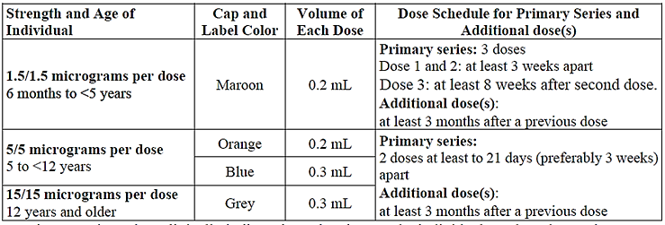

### Coronavirus disease (COVID-19)

Coronavirus disease (COVID-19) is caused by severe acute respiratory syndrome coronavirus 2 (SARS-CoV-2), a zoonotic virus that has rapidly spread around the world by human-to-human transmission. At the time of this submission, the ongoing pandemic remains a significant challenge to public health and economic stability worldwide, for which a licensed prophylactic vaccine, including booster dosing, is a necessary and critical mitigation for all age groups.

COVID-19 presentation is generally with cough and fever, with chest radiography showing ground-glass opacities or patchy shadowing.[1] However, many patients present without fever or radiographic changes, and infections may be asymptomatic which is relevant to controlling transmission. For symptomatic patients, disease progression may lead to acute respiratory distress syndrome requiring ventilation, subsequent multi-organ failure, and death.[2]

Since the pandemic began, children <5 years of age represent about 3 to 4% of total cases of COVID-19 in both the US and Europe.[3],[4] Although the severity of COVID-19 disease in children appears to be lower compared to adults, approximately 25% of children and adolescents may experience long-COVID, children with chronic health conditions may experience more severe disease, and SARS-CoV-2 infection and the ongoing pandemic in general may cause significant harm to children's long-term physical and mental/emotional health.[5],[6],[7]

### Clinical rationale for comirnaty original/omicron BA.4-5 use

COVID-19 burden persists among children <5 years of age and is underestimated due to many factors including at-home testing. Currently, Omicron sub-lineage BQ.1 (including BQ.1.1), which has shown increased growth advantage and immune escape compared to earlier Omicron sublineages, is the dominant sublineage based on sequenced samples from the EU and UK. Given the genetic and resulting antigenic differences in currently circulating Omicron sublineages of SARS-CoV-2 (e.g., BQ.1, BQ.1.1, BA.5, XBB.1, XBB.1.5) compared to the original WT strain, the addition of the bivalent variant-adapted vaccine is needed to ensure adequate protection in children <5 years of age, as is currently authorised for booster doses in individuals ≥5 years of age.

## Regulatory status

### Australian regulatory status

The product received provisional registration in the [Australian Register of Therapeutic Goods](https://www.tga.gov.au/products/australian-register-therapeutic-goods-artg) ([ARTG](https://www.tga.gov.au/products/australian-register-therapeutic-goods-artg)) on 25 January 2021. It was approved for the following indications:

“COMIRNATY (BNT162b2 [mRNA]) COVID-19 Vaccine has provisional approval for the

indication below:

Active immunisation to prevent coronavirus disease 2019 (COVID-19) caused by   
SARS-CoV-2, in individuals 16 years of age and older.

The use of this vaccine should be in accordance with official recommendations.

The decision has been made on the basis of short term efficacy and safety data. Continued

approval depends on the evidence of longer term efficacy and safety from ongoing clinical trials and post-market assessment.”

Several mRNA vaccines against COVID-19, Sponsored by Pfizer Australia are approved for use in Australia. At present, the Pfizer set of mRNA vaccines for active immunisation against COVID-19 are as follows:

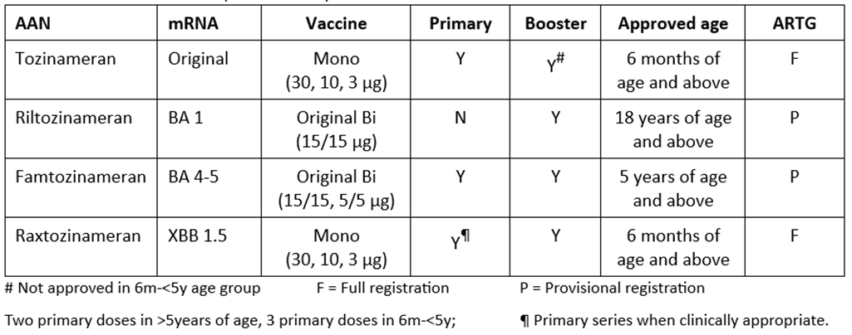

#### International regulatory status

Applications for extension of indication to include individuals 6 months to <5 years of age for Comirnaty Original/Omicron BA.4-5 have been filed in other jurisdictions. The table below provide dates of submission and the regulatory status of these applications.

Table 1: International regulatory status

|  |  |  |  |
| --- | --- | --- | --- |
| Region | Submission date | Status | Approved indications |
| United States of America | Submitted to FDA for EUA amendment | EUA amended: 14 Mar 2023 | Emergency Use Authorization (EUA) for the emergency use of Pfizer-BioNTech COVID-19 Vaccine, Bivalent (Original and Omicron BA.4/BA.5) for active immunization to prevent coronavirus disease 2019 (COVID-19) caused by severe acute respiratory syndrome coronavirus 2 (SARS-CoV-2) in individuals 6 months of age and older. |
| European Union (centralised procedure) | 3 Mar 2023 | Under evaluation (pre-approval received 22 Jun 2023) | Applied for use as a booster dose and in primary course. |
| Canada | 24 May 2023 | Under evaluation | Applied for use as a booster dose and in primary course. |
| New Zealand | In planning |  | - |
| Singapore | In planning |  | - |
| Switzerland | In planning |  | - |

### Registration timeline

The following table captures the key steps and dates for this submission.

This submission was evaluated under the [provisional registration process](https://www.tga.gov.au/provisional-approval-pathway-prescription-medicines).

Table 2: Timeline for Comirnaty original/omicron BA.4-(tozinameran /famtozinameran) COVID-19 Vaccine submission PM-2023-03314-1-2

|  |  |
| --- | --- |
| Step/Stage | Date |
| Submission dossier accepted and first round evaluation commenced | 16 August 2023 |
| Evaluation completed | 26 March 2024 |
| Delegate’s[8] Overall benefit-risk assessment | 8 April 2024 |
| Registration decision (Outcome) | 9 May 2024 |
| Registration in the ARTG | 14 May 2024 |
| Number of working days from submission dossier acceptance to registration decision* | 188 |

*Statutory timeframe for standard submissions is 255 working days

## Evaluation overview

### Clinical evaluation summary

The clinical dossier comprises an interim report of Study C4591048 (Substudy B - Group 2) i.e. immunogenicity results of 4th dose of the Bivalent BA.4-5 (1.5/1.5) vaccine in participants 6 months to 4 years of age (<5 years of age). Results of the first 3 doses of the Bivalent BA.4-5 (1.5/1.5) vaccine (‘primary series’) in these participants were not included in this interim report.

#### Efficacy

The Study C4591048 is an assessment of immunogenicity of the Bivalent BA.4-5 vaccine in healthy children. The study comprises 4 substudies (A, B, C and D). Substudy B was an open label design for assessment of immunogenicity of a 3rd (Group 1) or 4th (Group 2) dose of Bivalent BA.4-5 (1.5μg /1.5μg) vaccine. The overall structure of Substudy B/Group 2,with participants ≥6 months to 4 years of age (<5 years) who received a 4th dose of the Bivalent BA.4-5 (1.5/1.5) after having received 3 prior doses of the same vaccine is shown in Table 3.

Table 3. Substudy B, which included groups administered 3 (Group 1) or 4 (Group 2) doses of Bivalent BA.4-5 (1.5μg /1.5μg) vaccine.

In Group 2, ≈300 participants ≥6 months to <5 years of age, who had received 3 prior doses of BNT162b2 at 3μg with their last dose at 60 to 240 days prior to enrolment, were enrolled and received 1 dose (fourth) of the Bivalent BA.4-5 (1.5/1.5). The enrolment was stratified by age, such that approximately 30% participants were in ≥6 months to <2 years of age range and approximately 70% participants were in ≥2 years to <5 years of age range.

A subset of participants from a separate study C4591007 who had received 3 doses of BNT162b2 3μg (original monovalent tozinameran formulation) were used as non-concurrent controls.

The participants in Study C4591048/Substudy B/Group 2 received Dose 4 with Bivalent BA.4-5 (1.5/1.5) in September 2022 through February 2023 whereas the participants in the non-concurrent control group from Study C4591007 received Dose 3 of original monovalent BNT162b2 in February through July 2022.

The controls were matched for age, past infection status and time since the last dose of BNT162b2.

At Baseline, N=274 participants in the Study C4591048/Substudy B/Group 2 and N=309 participants in the historical Study C4591007 were matched as shown in Table 4.

Table 4. Demographic Characteristics – C4591048 Substudy B Group 2 and Study C4591007 Phase 2/3 Participants – Full Group – ≥6 Months to <5 Years of Age participants ith or Without Evidence of Infection – Evaluable Immunogenicity Population

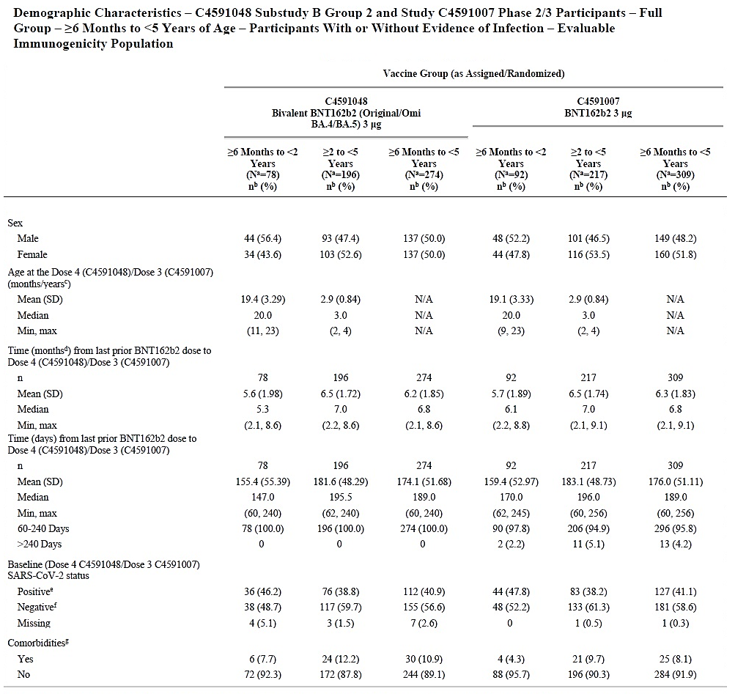

Blood samples from participants in Study C4591048 Substudy B/Group 2 and the selected controls from Study C4591007 were tested using a validated SARS-CoV-2 neutralisation assay for Omicron BA.4/BA.5 and reference strain-specific SARS-CoV-2 neutralising antibody titres.

##### Geometric mean titres and seroresponse rates

One month after a booster dose (4th dose) of Bivalent BA.4-5 (1.5/1.5) in Study C4591048 Substudy B/Group 2, geometric mean titres and seroresponse rates were compared to non-concurrent controls from Study C4591007 (at one month post 3rd dose of the monovalent original formulation) (Table 5).

Table 5. Model-Based Geometric Mean Ratio – C4591048 Substudy B Group 2 (1 Month After Dose 4) to C4591007 Phase 2/3 Participants (1 Month After Dose 3) – Per-protocol Subset – ≥6 Months to <5 Years of Age – Participants With or Without Evidence of Infection – Evaluable Immunogenicity Population

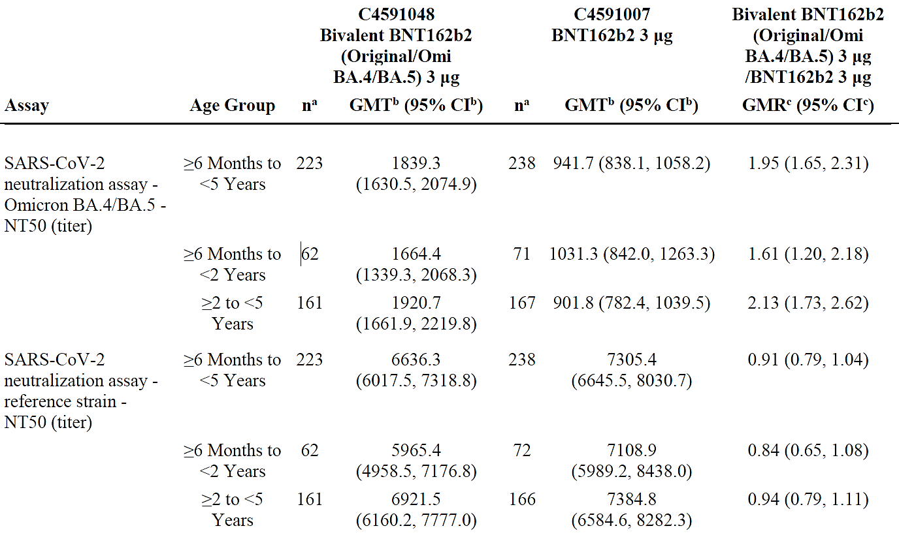

Abbreviations: GMR = geometric mean ratio; GMT = geometric mean titer; LLOQ = lower limit of quantitation; NT50 =50% neutralizing titer; SARS-CoV-2 = severe acute respiratory syndrome coronavirus 2. Note: Substudy B Group 2 includes participants ≥6 months to <5 years of age who received 3 doses of BNT162b2 3 μg 60 to 240 days prior to enrolment. Note: Per-protocol subset is a random sample of 240 participants selected from the full group and comprising the same percentages of participants in each age group and baseline SARS-CoV-2 infection status group as the full group. a. n = Number of participants with valid and determinate assay results for the specified assay at both before Dose 4 (C4591048)/Dose 3 (C4591007) and the given sampling time point. b. GMTs and 2-sided CIs were calculated by exponentiating the LSMeans and the corresponding CIs based on analysis of log-transformed assay results using a linear regression model with baseline log-transformed neutralizing titers, postbaseline infection status, age group (for ≥6 Months to <5 Years only) and vaccine group as covariates. Assay results below the LLOQ were set to 0.5 × LLOQ. c. GMRs and 2-sided CIs were calculated by exponentiating the difference of LSMeans for the assay and the corresponding CIs based on the same regression model as stated above.

The Omicron BA.4/BA.5 specific neutralising antibody titre was higher, and the reference strain specific neutralising antibody response was similar in Study C4591048 (Substudy B/Group 2) participants (1 month after Dose 4) compared to participants (1 month after Dose 3) from the Study C4591007.

At one month after a booster dose (4th dose) of Bivalent BA.4-5 (1.5/1.5) in the Study C4591048 Substudy B/Group 2 compared to non-concurrent controls from the Study C4591007 (at one month post 3rd dose of the monovalent original formulation), the seroresponse rates (regardless of Baseline serostatus) in the Per Protocol population are shown in Table 6.

Table 6. Adjusted Difference in Percentages of Participants With Seroresponse Between C4591048 Substudy B Group 2 (1 Month After Dose 4) and C4591007 Phase 2/3 Participants (1 Month After Dose 3) – Per-protocol Subset – ≥6 Months to <5 Years of Age – Participants With or Without Evidence of Infection – Evaluable Immunogenicity Population

Abbreviations: LLOQ = lower limit of quantitation; NT50 = 50% neutralizing titer; SARS-CoV-2 = severe acute respiratory syndrome coronavirus 2. Note: Substudy B Group 2 includes participants ≥6 months to <5 years of age who received 3 doses of BNT162b2 3 μg 60 to 240 days prior to enrolment. Note: Per-protocol subset is a random sample of 240 participants selected from the full group and comprising the same percentages of participants in each age group and baseline SARS-CoV-2 infection status group as the full group. Note: Seroresponse is defined as achieving a ≥4-fold rise from baseline (before Dose 4 for C4591048 Substudy B Group 2 and before Dose 3 for C4591007). If the baseline measurement is below the LLOQ, a postvaccination assay result ≥4 × LLOQ is considered a seroresponse. a. N = number of participants with valid and determinate assay results for the specified assay both before Dose 4 (C4591048)/Dose 3 (C4591007) and at the given sampling time point. These values are the denominators for the percentage calculations. b. n = Number of participants with seroresponse for the given assay at the given dose/sampling time point. c. Exact 2-sided CI based on the Clopper and Pearson method. d. Adjusted difference in proportions based on the Miettinen and Nurminen method stratified by baseline neutralizing titer category (<median, ≥median), expressed as a percentage (bivalent BNT162b2 [original/Omi BA.4/BA.5] 3 μg - BNT162b2 3 μg). The median of baseline neutralizing titers was calculated based on the pooled data in 2 comparator groups. e. 2-Sided CI, based on the Miettinen and Nurminen method for the difference in proportions stratified by baseline neutralizing titer category (<median, ≥median), expressed as a percentage.

The Omicron BA.4/BA.5 specific seroresponse rate was higher, and the reference strain specific seroresponse rate was similar in Study C4591048 (Substudy B/Group 2) participants (Dose 4) compared to participants (Dose 3) from the Study C4591007.

Overall, 22 cases of COVID-19 were reported in participants ≥6 months to <5 years (9 cases in ≥6 months to <2 years, 13 cases in ≥2 to <5 years) who received a 4th dose of Bivalent BA.4-5 (1.5/1.5) in Study C4591048. The variants of concern among the 22 cases are outlined in Table 7.

Table 7. SARS-CoV-2 Variants of Concern for the First COVID-19 Occurrence After the Study Vaccination – C4591048 Substudy B Group 2 – ≥6 Months to <5 Years of Age

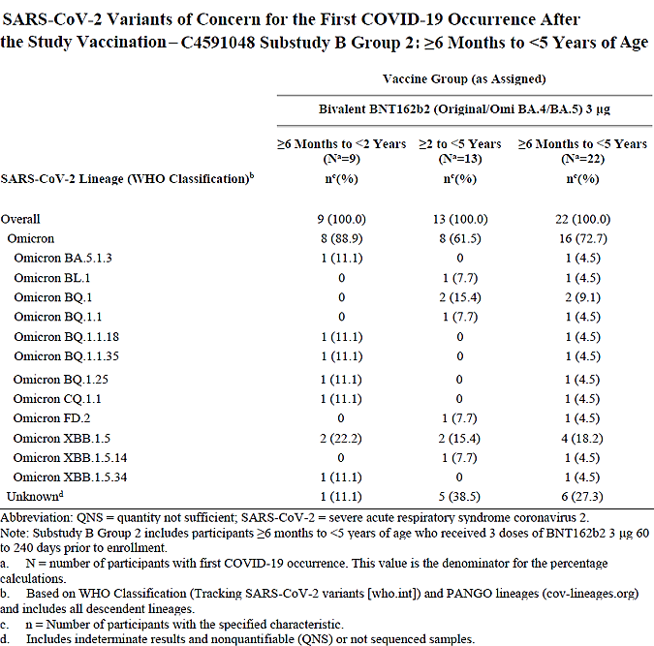

#### Safety

The safety data reported in this dossier were as of 03 March 2023 cutoff date for the full safety population of 310 participants (92 and 218 participants assigned in ≥6 months to <2 years age group and ≥2 years to <5 years age group respectively).

Adverse events (AEs) were collected from the study vaccination up to 1 month after the study vaccination, and serious adverse events (SAEs) were collected from study vaccination up to 6 months post Dose 4.

AEs of specific interest (AESIs) included anaphylaxis/hypersensitivity, Bell’s palsy and myocarditis/pericarditis.

No severe AEs, life-threatening AEs, SAEs, or AEs leading to withdrawal or death were reported from study vaccination to 1 month after study vaccination.

No AESI were reported at this timepoint in this dataset.

The overall incidence of any AEs within one month post vaccination was 20/310 (6.5%) (Table 8).

Table 8. Number (%) of Participants Reporting at Least 1 Adverse Event From the Study Vaccination to 1 Month After the Study Vaccination – Substudy B Group 2 – ≥6 Months to <5 Years of Age – Safety Population

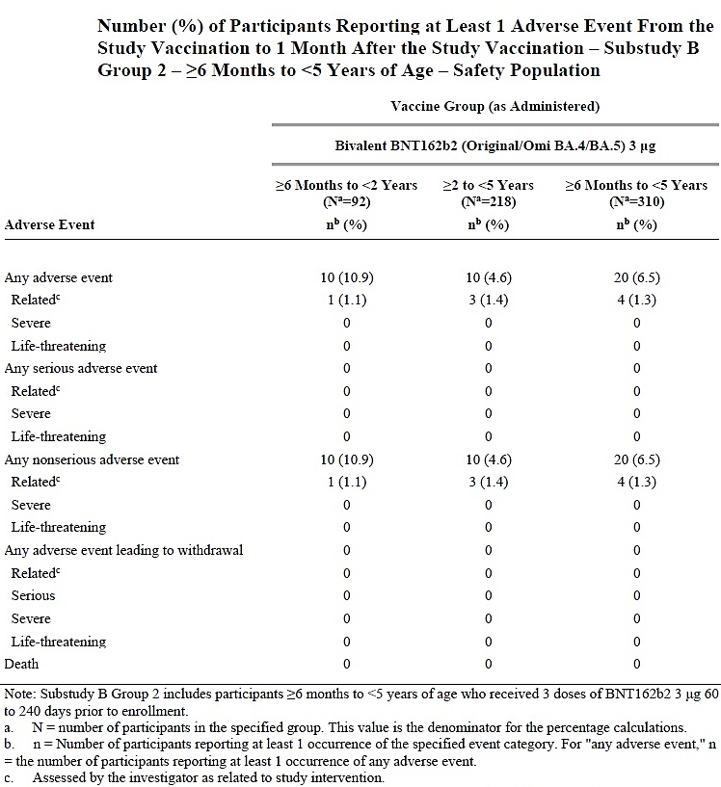

The percentage participants experiencing a local reaction reported within 7 days after Bivalent BA.4-5 (1.5/1.5) vaccine (Dose 4) in Study C4591048 in the ≥6 months to<2 years of age group is shown in Figure 1.

Figure 1. Local Reactions, by Maximum Severity, Within 7 Days After the Study Vaccination –Substudy B Group 2 - ≥6 Months to <2 Years of Age – Safety Population

The percentage of participants experiencing a systemic reaction reported within 7 days of vaccination (Dose 4) in the ≥6 months to<2 years of age is shown in Figure 2.

Figure 2. Systemic Events, by Maximum Severity, Within 7 Days After the Study Vaccination – Substudy B Group 2 - ≥6 Months to <2 Years of Age – Safety Population

The percentage of participants experiencing a local reaction reported within 7 days of vaccination in ≥2 years to <5 years of age is shown in Figure 3.

Figure 3. Local Reactions, by Maximum Severity, Within 7 Days After the Study Vaccination –Substudy B Group 2 - ≥2 Years to <5 Years of Age – Safety Population

The percentage of participants experiencing a systemic reaction reported within 7 days of vaccination in ≥2 years to <5 years of age is shown in Figure 4.

Figure 4. Systemic Events, by Maximum Severity, Within 7 Days After the Study Vaccination – Substudy B Group 2 - ≥2 to <5 Years of Age – Safety Population

No new adverse reactions were identified up to one month after vaccination in this dataset.

The overall adverse effects profile of the Bivalent BA.4-5 (1.5/1.5) vaccine (Dose 4) was similar to that seen after 3 doses of the original monovalent (tozinameran) formulation at 3µg dose.

## Risk/benefit assessment

Study C4591048/Substudy B/Group 2 was a single arm study of immunogenicity in which children aged 6 months to 4 years (<5 years of age) who had completed a 3 dose primary series with the Bivalent BA.4-5 (1.5/1.5) were administered a booster (Dose 4) after a median of 189 days (range 60, 240) after completion of the primary series:

The median age at the time of Dose 4 was 20 months (range 11, 23) in ≥6 months to <2 years age group and 3 years (range 2, 4) in ≥2 years to <5 years age group.

As noted earlier, the dossier was limited to the interim report of Dose 4, so that details of demographic features at the time of Dose 1, the primary vaccination series schedule and the results at the completion of Dose 3 were not available. Some of these aspects have been requested from the Sponsor and are awaited at the time of writing of this overview. The full details are expected when the full clinical study report of the completed Study C4591048 becomes available.

The comparison with non-concurrent controls after 3 doses in Study C4591007 was neither meaningful nor interpretable so that the comparative statistical analyses can be disregarded. This would have been useful if there was a Dose 4 in these controls (of whichever vaccine) or correlates of protection were known.

The descriptive GMTs within the Study C4591048 provide a good indication of the immune response post Dose 4.

For the Omicron BA 4-5 specific neutralising antibodies, the fold increase in GMTs from Pre- to Post- vaccination was 8-9 fold overall as well as within the two age substrata regardless of baseline serostatus. The increase was 3-4 fold overall as well as within the two age substrata in baseline seropositive participants. The increase was 12-14 fold overall as well as within the two age substrata in baseline seronegative participants.

For the reference (Original) strain specific neutralising antibodies, the GMT response was qualitatively similar but quantitatively much subdued despite the bivalent formulation containing equal amount of the original variant mRNA. The fold increase in GMTs from pre- to post-vaccination was ≈3.5 fold overall as well as within the two age substrata regardless of baseline serostatus. The increase was up to 2 fold overall as well as within the two age substrata in baseline seropositive participants. The increase was ≈4.5 fold overall as well as within the two age substrata in baseline seronegative participants.

However, the validity of these findings is much diminished as these were based on an Evaluable Immunogenicity subset of n=60. The Sponsor has been asked to account for the participant disposition from the start of study at Dose 1 to the reported results at Dose 4.

The adverse effects profile with Dose 4 at 1 month follow up (using safety population set N=310) in Study C4591048 (Substudy B/Group 2) was consistent with the known adverse effects profile with the original monovalent vaccine for this age group. No new or unexpected adverse findings were reported in the interim dossier.

A useful finding was the report of 22 cases of COVID-19 infection (noted earlier); please see further recommendations for the PI.

The Sponsor is seeking use of the Bivalent BA 4-5 vaccine for primary series and for additional (booster) dosing in this age group (6 months to 4 years of age). Pending the availability of results of the primary series in the Study C4591048, the tabular summary of results from the Study C4591048 (Substudy A) is a useful guide. The design of the Phase I Study C4591048 (subset of Substudy A) within the master protocol of Study C4591048 was as follows:

Further justification and basis of extrapolation for the Bivalent BA 4-5 bivalent extension of use to include all ages from 6 months and above for primary and additional doses include the previous Study C4591007 (6 Month to <5 Years of Age) wherein the interim CSR presented immunogenicity and efficacy data from participants in the 6 months to <2 years of age and 2 to <5 years of age groups and showed that vaccinating children 6 months to <5 years of age with 3 doses of BNT162b2 3μg affords measurable protection against symptomatic COVID-19 and the observed safety profile was indicative of a safe and tolerable vaccine. Original COMIRNATY monovalent vaccine has full registration status in Australia. This study, among others, formed the basis for transition of provisional to full registration of the original monovalent formulation ([AusPAR: Comirnaty COVID-19 Vaccine](https://www.tga.gov.au/resources/auspar/auspar-comirnaty-covid-19-vaccine)).

Furthermore, indirect support for use in this age group is afforded by COMIRNATY monovalent XBB 1.5 vaccine which currently has full registration in Australia for primary and additional doses from 6 months of age group and above ([AusPAR: Comirnaty Omicron XBB.1.5](https://www.tga.gov.au/resources/auspar/auspar-comirnaty-omicron-xbb15)).

In the US authorisation of Omicron BA.4/BA.5-adapted bivalent COVID-19 vaccine for all doses to individuals 6 months of age and older and has been superseded by the currently supplied “2023-2024 Formula”. The Bivalent BA.4-5 vaccine (from 6 months of age and above including primary and additional doses) remains fully authorised in Canada and the EU.

In Australia, the programmatic public implementation of vaccinations is informed by clinical advice from ATAGI ([ATAGI statement on the administration of covid-19 vaccines in 2024](https://www.health.gov.au/sites/default/files/2024-03/atagi-statement-on-the-administration-of-covid-19-vaccines-in-2024.pdf)).

#### Conclusion and recommended course of action

The Sponsor has acknowledged that “the current circulating strains and the epidemiology of COVID-19 has moved on from the Omicron BA.4-5 related strains since submission of the application. As the only bivalent COVID-19 vaccine formulation for the paediatric population (6 months to <5 years of age), the Sponsor wishes to proceed with the proposed registration in preparation for the potential future requirement to supply bivalent COVID-19 vaccine with updated strains.

At present, two monovalent BNT162b2 vaccines (original and XBB 1.5) are approved for all ages from 6 months and above for primary and booster dosing. Both have full registration although the original formulation is no longer in current use.

At present no bivalent BNT162b2 vaccine has approval for use from 6 months of age and above nor full registration in any population in Australia.

The interim results of the Study C4591048 (Substudy B/Group 2) and the overall totality of data support provisional approval of the Bivalent (original/BA 4-5) from 6 months of age and above including primary and additional doses.

The main purpose of this approval at this time would be to allow entry of Comirnaty Original/Omicron BA.4-5 Vaccine onto the ARTG as a bivalent vaccine ‘placeholder’ that has approval for a full age and dosing range and which can be updated to a relevant and current strain should such need arise. A few such ‘model’ vaccines are currently on the ARTG for non-circulating avian influenza strains serving this purpose (however, unlike these bird flu strains, the SARS-CoV-2 virus is well established and presently circulating in human populations).

The controls on availability and use of this vaccine should be consistent with the recommendation of ATAGI and the Australian Immunisation Handbook, which are considered sufficient to preclude any inappropriate use.

Provisional approval is proposed.

## Outcome

Based on a review of quality, safety, and efficacy, the TGA decided to register Comirnaty original/omicron BA.4 COVID-19 vaccine (tozinameran/famtozinameran) for the following indication:

COMIRNATY Original/Omicron BA.4-5 Vaccine has **provisional approval** for the

indication below:

Active immunisation to prevent coronavirus disease 2019 (COVID-19) caused by   
SARSCoV-2, in individuals 6 months of age and older.

The use of this vaccine should be in accordance with official recommendations.

The decision has been made on the basis of short term immunogenicity and safety data.

Continued approval depends on the evidence of longer term efficacy and safety from

ongoing clinical trials and post-market assessment.

#### Specific conditions of registration applying to these goods

##### RMP conditions

Comirnaty Original/Omicron BA.4-5 (tozinameran/famtozinameran) is to be included in the Black Triangle Scheme. The PI and CMI for Comirnaty Original/Omicron BA.4-5 must include the black triangle symbol and mandatory accompanying text for five years, or the product’s entire period of provisional registration, whichever is longer.

The Comirnaty Original/Omicron BA.4-5 EU-Risk Management Plan (RMP) (version 10.0, dated 22 June 2023, data lock points 15 November 2022 and 25 November 2022), with Australian Specific Annex (version 0.8, dated July 2023), included with submission PM-2023-03314-1-2, and any subsequent revisions, as agreed with the TGA will be implemented in Australia.

An obligatory component of risk management plans is routine pharmacovigilance. Routine pharmacovigilance includes the submission of periodic safety update reports (PSURs).

Unless agreed separately between the supplier who is the recipient of the approval and the TGA, the first report must be submitted to TGA no later than 15 calendar months after the date of this approval letter. The subsequent reports must be submitted no less frequently than annually from the date of the first submitted report until the period covered by such reports is not less than three years from the date of this approval letter, or the entire period of provisional registration, whichever is longer.

The reports are to at least meet the requirements for PSURs as described in the European Medicines Agency’s Guideline on good pharmacovigilance practices (GVP) Module VII-periodic safety update report (Rev 1), Part VII.B Structures and processes. Note that submission of a PSUR does not constitute an application to vary the registration. Each report must have been prepared within ninety calendar days of the data lock point for that report.

As Comirnaty Original/Omicron BA.4-5 is being considered for a provisional registration, confirmatory trial data is recommended for the condition of registration. Specifically, the Sponsor must conduct studies as described in the clinical study plan in version 0.8 (date July 2023) of the Australia-Specific Annex. The following study reports should be submitted to TGA:

* C4591048, Substudy B (Group 2), by Q2 2025
* C4591048, Substudy D (Group 2), by Q2 2025
* C4591044, Cohort 2, by Q1 2024
* C4591031, Substudy D (Cohort 2), by Q4 2023
* C4591031, Substudy E, by Q4 2023

##### Quality conditions

**GMP clearance for listed manufacturers**

All relevant manufacturing sites require approved and current GMP Clearances prior to Australian supply. A commitment is required from the Sponsor that they maintain the validity of all manufacturer GMP Clearances for the duration of product supply to Australia. Additionally, that adherence to the conditions of GMP Clearance approval is upheld.

**Post-approval stability protocol and stability commitment**

Commitment to continue the ongoing stability studies presented in the stability studies protocol. Additionally, 1 batch of DP per year for all relevant products will be placed on long-term stability program and on accelerated stability testing where significant changes are made to the manufacturing process. Commitment to communicate any out of specifications stability test results to the TGA.

**Batch Release Testing and Compliance with the Certified Product Details Conditions of registration for COMIRNATY ORIGINAL/OMICRON BA.4-5 (tozinameran/famtozinameran) covid-19 vaccine**

It is a condition of registration that all independent batches of COMIRNATY ORIGINAL/OMICRON BA.4-5 (tozinameran/famtozinameran) COVID-19 VACCINE 1.5/1.5 micrograms/0.2 mL suspension for injection vial imported into Australia are not released for sale until samples and the manufacturer’s release data have been assessed and you have received notification acknowledging release from the Laboratories Branch, TGA.

For each independent batch of the product imported into Australia, the Sponsor must supply the following:

* A completed Request for Release Form, available from vaccines@health.gov.au; and
* Complete summary protocols for manufacture and QC, including all steps in production in the agreed format.
* At least 10 (ten) vials (Samples) of each manufacturing batch of the above listed vaccine with the Australian approved labels, PI and packaging (unless an exemption to supply these has been granted) representative of all batches of product seeking distribution in Australia.
* At least 5 (five) vials (Samples) of any further consignments of a manufacturing batch of the above listed vaccine with the Australian approved labels, PI and packaging (unless an exemption to supply these has been granted). Further consignments cover batches previously supplied to TGA for the purposes of batch release testing but are seeking to be supplied again.
* If the manufacturing batch has been released in Europe or United Kingdom a copy of the EU Official Control Authority Batch Release (OCABR) certificate (or equivalent from the UK) must be provided.
* Any reagents, reference material and standards required to undertake testing, as requested by Laboratories Branch, TGA.

Sponsors must provide all requested Samples and data in sufficient time (at least 5 business days) prior to any distribution date to allow the TGA to perform testing and review. Distribution of each batch of vaccine is conditional upon fulfilment of these conditions and receipt of a letter from the Laboratories Branch acknowledging release. Samples and data should be forwarded to the Biotherapeutics Section, Laboratories Branch before release of each batch and with sufficient lead time to allow for Laboratories Branch testing.

## Attachment 1. Product Information

The [Product Information](https://www.tga.gov.au/products/australian-register-therapeutic-goods-artg/product-information-one) ([PI](https://www.tga.gov.au/products/australian-register-therapeutic-goods-artg/product-information-one)) approved with the submission for COMIRNATY ORIGINAL/OMICRON BA.4-5 Covid 19 vaccine which is described in this AusPAR can be found as Attachment 1. It may have been superseded. For the most recent PI and [Consumer Medicines Information](https://www.tga.gov.au/products/australian-register-therapeutic-goods-artg/consumer-medicines-information-cmi) (CMI), please refer to the TGA [PI/CMI search facility.](https://www.tga.gov.au/picmi-search-facility)

|  |
| --- |
| Therapeutic Goods Administration |
| PO Box 100 Woden ACT 2606 Australia  Email: [info@tga.gov.au](mailto:info@tga.gov.au) Phone: 1800 020 653 Fax: 02 6203 1605  [**https://www.tga.gov.au**](https://www.tga.gov.au) |
|  |

1. Wiersinga WJ, Rhodes A, Cheng AC, et al. Pathophysiology, Transmission, Diagnosis, and Treatment of Coronavirus Disease 2019 (COVID-19): A Review. JAMA. 2020;324(8):782-793. doi:10.1001/jama.2020.12839
2. Ibid.
3. Centers for Disease Control and Prevention (CDC). COVID Data Tracker. Demographic Trends of COVID-19 cases and deaths in the US reported to CDC. Available: https://covid.cdc.gov/covid-data-tracker/#demographics.
4. World Health Organization. Joint ECDC-WHO Regional Office for Europe Weekly COVID-19 Surveillance Bulletin. Week 03/2023 (16 January - 22 January 2023). Available: https://worldhealthorg.shinyapps.io/euro-covid19/
5. Lopez-Leon S, Wegman-Ostrosky T, Ayuzo Del Valle NC, et al. Long-COVID in children and adolescents: a systematic review and meta-analyses. Sci Rep. 2022 Jun 23;12(1):9950. doi: 10.1038/s41598-022-13495-5.
6. American Academy of Pediatrics. Children and COVID-19: State-Level Data Report. Available: https://www.aap.org/en/pages/2019-novel-coronavirus-covid-19-infections/children-and-covid-19-state-level-data-report/
7. Drouin O, Hepburn CM, Farrar DS, et al. Characteristics of children admitted to hospital with acute SARS-CoV-2 infection in Canada in 2020. CMAJ. 2021;193(38):E1483- E1493.
8. The ‘Delegate’ is the Delegate of the Secretary of the Department of Health and Aged Care who made the final decision to either include the new medicine/indication on the ARTG or reject the submission, under section 25 of the Therapeutic Goods Act