|  |
| --- |
| Australian Public Assessment Report for Kyprolis |
| Active ingredient: Carfilzomib |
| Sponsor: Amgen Australia Pty Ltd |
| September 2024 |

About the Therapeutic Goods Administration (TGA)

* The Therapeutic Goods Administration (TGA) is part of the Australian Government Department of Health and Aged Care and is responsible for regulating therapeutic goods, including medicines, medical devices, and biologicals.
* The TGA administers the *Therapeutic Goods Act 1989* (the Act), applying a risk management approach designed to ensure therapeutic goods supplied in Australia meet acceptable standards of quality, safety, and efficacy.
* The work of the TGA is based on applying scientific and clinical expertise to decision-making, to ensure that the benefits to the Australian public outweigh any risks associated with the use of therapeutic goods.
* The TGA relies on the public, healthcare professionals and industry to report problems with therapeutic goods. The TGA investigates reports received to determine any necessary regulatory action.
* To report a problem with a therapeutic good, please see the information on the [TGA website](https://www.tga.gov.au/).

About AusPARs

* The Australian Public Assessment Report (AusPAR) provides information about the evaluation of a prescription medicine and the considerations that led the TGA to approve or not approve a prescription medicine submission. Further information can be found in [Australian Public Assessment Report (AusPAR) guidance](https://www.tga.gov.au/australian-public-assessment-report-auspar-guidance).
* AusPARs are prepared and published by the TGA.
* AusPARs are static documents that provide information that relates to a submission at a particular point in time. The publication of an AusPAR is an important part of the transparency of the TGA’s decision-making process.
* A new AusPAR may be provided to reflect changes to indications or major variations to a prescription medicine subject to evaluation by the TGA.

Copyright

© Commonwealth of Australia 2024  
This work is copyright. You may reproduce the whole or part of this work in unaltered form for your own personal use or, if you are part of an organisation, for internal use within your organisation, but only if you or your organisation do not use the reproduction for any commercial purpose and retain this copyright notice and all disclaimer notices as part of that reproduction. Apart from rights to use as permitted by the *Copyright Act 1968* or allowed by this copyright notice, all other rights are reserved and you are not allowed to reproduce the whole or any part of this work in any way (electronic or otherwise) without first being given specific written permission from the Commonwealth to do so. Requests and inquiries concerning reproduction and rights are to be sent to the TGA Copyright Officer, Therapeutic Goods Administration, PO Box 100, Woden ACT 2606 or emailed to <[tga.copyright@tga.gov.au](mailto:tga.copyright@tga.gov.au)>.

Contents

List of abbreviations 4

Product submission 5

Submission details 5

Kyprolis (carfilzomib) – proposed indications 7

Multiple myeloma 7

Current treatment options for multiple myeloma 8

Clinical rationale for Kyprolis (carfilzomib) use in multiple myeloma 9

Regulatory status 9

Australian regulatory status 9

Foreign regulatory status 10

Registration timeline 12

Evaluation overview 12

Clinical evaluation summary 12

Pharmacology 12

Efficacy 13

Safety 17

Discussion 24

Conclusion 25

Advisory Committee considerations 25

ACM conclusion 26

Outcome 26

Attachment 1. Product Information 27

## List of abbreviations

|  |  |
| --- | --- |
| Abbreviation | Meaning |
| AE | Adverse event |
| CI | Confidence interval |
| CMI | Consumer Medicine Information |
| CR | Complete Response |
| D-Kd | Daratumumab-carfilzomib-dexamethasone |
| EMA | European Medicines Agency |
| FDA | United States Food and Drug Administration |
| IMiD | Immunomodulator drug |
| ITT | Intent-to-treat |
| IV | Intravenous |
| Kd | Carfilzomib and dexamethasone |
| KdD | Carfilzomib, dexamethasone, and daratumumab |
| MedDRA | Medical Dictionary for Regulatory Activities |
| MRD[-] | Minimal residual disease negative |
| MRD[-]CR | Minimal residual disease negative-complete response |
| NCCN | National Comprehensive Cancer Network |
| NGS | Next-generation sequencing |
| ORR | Overall response rate |
| OS | Overall survival |
| PFS | Progression free survival |
| PI | Product Information |
| PK | Pharmacokinetic |
| PR | Partial response |
| RRMM | Relapsed or refractory multiple myeloma |
| PT | Preferred term |
| SAE | Serious adverse event |
| sCR | Stringent complete response |
| SOC | System organ class |
| TEAE | Treatment-emergent adverse event |

## Product submission

### Submission details

|  |  |
| --- | --- |
| *Type of submission:* | Extension of indications |
| *Product name:* | Kyprolis |
| *Active ingredient:* | carfilzomib |
| *Decision:* | Approved |
| *Date of decision:* | 17 February 2023 |
| Approved therapeutic use for the current submission: | Kyprolis is indicated for the treatment of patients with relapsed or refractory multiple myeloma who have received at least one prior therapy as part of combination therapy with:   * dexamethasone, or * lenalidomide and dexamethasone, or * daratumumab and dexamethasone, or * isatuximab and dexamethasone |
| *Date of entry onto ARTG:* | 2 March 2023 |
| *ARTG number:* | 266773, 283228, 288527 |
| [*Black Triangle Scheme*](https://www.tga.gov.au/black-triangle-scheme) | No |
| *Sponsor’s name and address:* | Amgen Australia Pty Ltd Level 11, 10 Carrington Street Sydney, NSW 2000 |
| *Dose form:* | Sterile, white to off-white lyophilised powder |
| *Strength:* | A single-use vial contains 10 mg, 30 mg or 60 mg of carfilzomib. After reconstitution, 1 mL of solution contains 2 mg of carfilzomib |
| *Container:* | Clear glass vial, fluoropolymer laminated elastomeric stopper and aluminium seal with plastic flip off cap |
| *Pack size:* | 1 vial per pack |
| *Route of administration:* | Intravenous |
| *Dosage:* | Kyprolis is administered intravenously (IV) as a 10 minute or a 30 minute infusion either once or twice weekly based on the selected regimen (see Table 1). Treatment may be continued until disease progression or until unacceptable toxicity occurs.  a Infusion time remains consistent throughout each regimen  For further information regarding dosage, such as dosage modifications to manage adverse reactions, refer to the Product Information. |
| *Pregnancy category:* | Category C  Drugs which, owing to their pharmacological effects, have caused or may be suspected of causing, harmful effects on the human fetus or neonate without causing malformations. These effects may be reversible.  The use of any medicine during pregnancy requires careful consideration of both risks and benefits by the treating health professional. The [pregnancy database](https://www.tga.gov.au/products/medicines/find-information-about-medicine/prescribing-medicines-pregnancy-database) must not be used as the sole basis of decision making in the use of medicines during pregnancy. The TGA does not provide advice on the use of medicines in pregnancy for specific cases. More information is available from [obstetric drug information services](https://www.tga.gov.au/obstetric-drug-information-services) in your state or territory. |

### Kyprolis (carfilzomib) – proposed indications

Carfilzomib is a proteasome inhibitor. Inhibition of proteasome activity activates cell death pathways.

This AusPAR describes the submission by Amgen Australia Pty Ltd (the sponsor) to register Kyprolis (carfilzomib) for the following proposed extension of indications:[1]

*Kyprolis is indicated in patients who have received at least one prior therapy for the treatment of relapsed or refractory multiple myeloma. For use in combination*

* + - with dexamethasone, or
    - with lenalidomide and dexamethasone, or
    - with daratumumab and dexamethasone

### Multiple myeloma

Multiple myeloma (MM) is a haematological malignancy characterised by the neoplastic proliferation of plasma cells in the bone marrow producing a monoclonal immunoglobulin[2]. MM represents approximately 1-1.8% of all malignancies and is the second most common haematological malignancy worldwide[3],[4]. In Australia, MM accounted for an estimated 1.6% of all new cancer diagnoses in 2021[5].

MM is a disease of older adults, with a median age of 69 years at diagnosis[6], and is slightly more frequent in men than in women. In Australia in 2017, the age-standardised incidence rate was 8.4 and 5.6 cases per 100,000 for males and females respectively, and median age at diagnosis was 72.6 years[7].

Most patients with MM present with signs or symptoms related to the infiltration of plasma cells into the bone or other organs, including lytic bone lesions, hypercalcaemia, anaemia and renal impairment[8].

MM is characterised by a recurring pattern of remission and relapse, and eventually becomes refractory. Although survival rates have significantly improved for patients with MM with the development of new antimyeloma therapies in recent years, the disease remains incurable. In Australia, 5-year relative survival for MM improved from 28% to 54% between 1988-1992 and 2013-2017[9].

### Current treatment options for multiple myeloma

There are a number of treatments for relapsed or refractory MM (RRMM), including conventional agents such as alkylating agents, anthracyclines, and corticosteroids as well as novel agents including immunomodulatory drugs (IMiDs), proteasome inhibitors and monoclonal antibodies. Treatments for relapsed or refractory MM that are either NCCN preferred regimens or ESMO major regimens are shown below in Table 2.

Table 2: NCCN Preferred and ESMO Major Regimens for Relapsed or Refractory MM

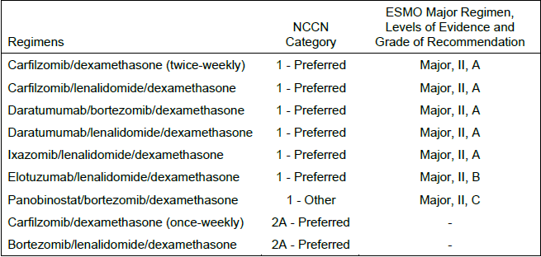

ESMO level of evidence II = small randomized trials or large randomized trials with a suspicion of bias (lower methodological quality) or meta-analyses of such trials or of trials demonstrated heterogeneity. ESMO grade of recommendation: A = strong evidence for efficacy with a substantial clinical benefit, strongly recommended; B = strong or moderate evidence for efficacy but with a limited clinical benefit, generally recommended; C = insufficient evidence for efficacy or benefit does not outweigh the risk or disadvantages (adverse events, costs, etc), optional

The current submission proposes to extend the indication for carfilzomib in combination with dexamethasone and daratumumab, and for carfilzomib in combination with dexamethasone and isatuximab.

Daratumumab (Darzalex, Janssen-Cilag Pty Ltd) is an IgG1k human monoclonal antibody that binds to CD38 protein expressed at a high level on the surface of cells in a variety of haematological malignancies, including MM tumour cells. Daratumumab is indicated as second line therapy in combination with bortezomib and dexamethasone, or lenalidomide and dexamethasone. Daratumumab is also approved for newly diagnosed MM in combination with various agents, or as monotherapy in patients refractory to a proteasome inhibitor and IMiD[10].

Isatuximab (Sarclisa, Sanofi Aventis Australia Pty Ltd) is an IgG1-derived monoclonal antibody that binds to a specific extracellular epitope of CD38. Isatuximab was recently approved as second line therapy for MM in combination with carfilzomib and dexamethasone, and is also indicated as third line therapy in combination with pomalidomide and dexamethasone[11].

### Clinical rationale for Kyprolis (carfilzomib) use in multiple myeloma

Current treatment guidelines by NCCN and ESMO recommend regimens containing an IMiD for frontline therapy as well as lenalidomide for maintenance therapy, which has become standard of care. Despite recent therapeutic advances, relapse is virtually inevitable and patients can become refractory to IMiDs. Median PFS for lenalidomide-free regimens have been reported as 7.8 to 11.2 months in subjects who were refractory to lenalidomide compared with 16.7 to 18.7 months for the general relapsed or refractory multiple myeloma population.

Due to the reduced efficacy of lenalidomide after relapse or after prolonged exposure to lenalidomide, clinical practice guidelines recommend treatment with an IMiD-free regimen for these patients. Thus, developing a highly efficacious, IMiD-free, particularly lenalidomide-free, option is expected to address a significant unmet need for the treatment of relapsed or refractory multiple myeloma.

## Regulatory status

### Australian regulatory status

Kyprolis was first approved on 16th December 2016 for the indication ‘Kyprolis, as part of combination therapy with dexamethasone or lenalidomide and dexamethasone, is indicated for the treatment of patients with relapsed or refractory multiple myeloma who have received at least one prior therapy’.

An additional strength product (10 mg powder for injection vial) was registered on 27th February 2018.

In 2019, an application to register an additional dosage regimen to administer carfilzomib 20/70 mg/m2 once weekly in combination with dexamethasone for the indicated patient population was approved.

On 17th September 2021, TGA approved the application by Sanofi-Aventis Australia Pty Ltd for Sarclisa (isatuximab) for the additional indication ‘Sarclisa is indicated in combination with carfilzomib and dexamethasone, for the treatment of patients with multiple myeloma who have received at least one prior therapy’.

#### Foreign regulatory status

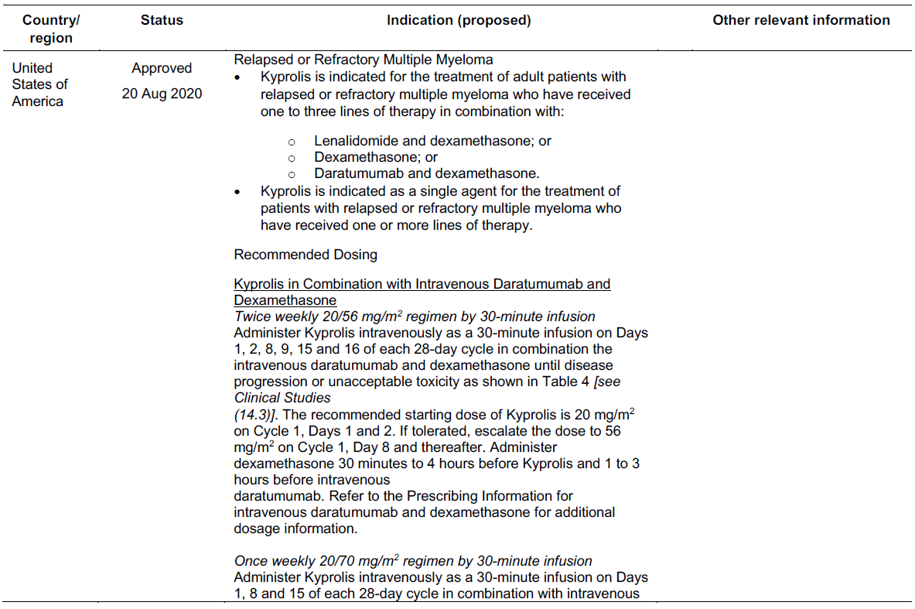

## Registration timeline

Table 3 captures the key steps and dates for this submission.

This submission was evaluated under the [standard prescription medicines registration process](https://www.tga.gov.au/how-we-regulate/supply-therapeutic-good-0/supply-prescription-medicine/application-process/prescription-medicines-registration-process).

Table 3: Timeline for Kyprolis submission PM-2021-02664-1-6

|  |  |
| --- | --- |
| Description | Date |
| Submission dossier accepted and first round evaluation commenced | 2 August 2021 |
| Evaluation completed | 5 September 2022 |
| Delegate’s[12] Overall benefit-risk assessment | 15 November 2022 |
| Registration decision (Outcome) | 17 February 2023 |
| Registration in the ARTG | 2 March 2023 |
| Number of working days from submission dossier acceptance to registration decision* | 280 |

*Statutory timeframe for standard submissions is 255 working days

## Evaluation overview

### Clinical evaluation summary

The two main studies submitted in this dossier were a phase III study, 20160275 (CANDOR) and a phase 1b study, MMY1001. CANDOR provides pivotal data of Kd vs KdD dosed twice- weekly, and MMY001 provides the data supporting once-weekly dosing of carfilzomib in of KdD.

A population PK report was included that drew on 5 studies to update the previous PK model for carfilzomib.

#### Pharmacology

The pharmacokinetics of carfilzomib were examined in the CANDOR study. This was a phase III study that compared patients treated with carfilzomib + dexamethasone with those treated with carfilzomib +dexamethasone + daratumumab.

Carfilzomib was administered twice weekly on days 1-2, 8-9 and 15-16 of each 28 day cycle at a dose of 20mg/m2 on days 1-2 of cycle 1 and 56 mg/m2 from day 8 of cycle one onwards.

Daratumumab was administered IV once weekly for cycles 1 and 2, then every 2 weeks for cycles 3 to 6, and then four weekly thereafter at a dose of 8 mg/kg on cycle 1 and 16 mg/kg for subsequent cycles. PK was evaluable from 457 subjects who had received at least 1 dose of carfilzomib, and 300 patients who had received daratumumab (Table 4).

Table 4. Descriptive statistics of plasma carfilzomib concentrations after intravenous infusion of 56 mg/m2 carfilzomib with dexamethasone and daratumumab or with dexamethasone alone

CV% = percent coefficient of variation; EOI = end of infusion; Geo. Mean = geometric mean; Kd = carfilzomib plus dexamethasone; KdD = carfilzomib, dexamethasone, plus daratumumab Concentrations are reported in units of ng/mL. Data presented to 3 significant figures for all summary statistics with the exception of %CV, which is presented as a whole number. The EOI sample was taken within 2 minutes before the EOI.

The Evaluator has noted that the PK data from CANDOR is limited but does not suggest the combination of carfilzomib and daratumumab affects the pharmacokinetics of carfilzomib when administered twice weekly with dexamethasone. Data available from MMY0001 was considered insufficient to draw conclusions.

No dose-finding studies were performed. The proposed twice-weekly carfilzomib + dexamethasone dose in CANDOR was based on the currently registered twice- weekly dose of 20mg/m2 initially followed by 56 kg/m2. The dose of daratumumab was as per the current labelling for that drug. The CE has noted that when carfilzomib and dexamethasone are used with lenolidamine as triple therapy, the carfilzomib dose is reduced to 20mg/m2 followed by 27mg/m2.

#### Efficacy

##### CANDOR study

Study 20160275 (CANDOR) was a phase III study that provided pivotal evidence to support the safety and efficacy of carfilzomib + dexamethasone + daratumumab therapy (KdD) in comparison to carfilzomib + dexamethasone (Kd) over 24 months. Included patients were relapsed or refractory to 1-3 previous therapies. The primary objectives were Overall Response Rate (ORR), the rate of achieving minimal residual disease negative or complete response(MRD-/CR) and overall survival (OS). The study enrolled a total of 466 patients randomised to receive Kd (n=154) or KdD (n=312).

The dosing schedule of medications in each arm is shown in Table 5 and subject disposition is outlined in Figure 1.

Table 5. CANDOR study dosing schedule

a Daratumumab only administered to subjects in the KdD treatment group b For subjects > 75 years of age, dexamethasone was administered at 20 mg weekly.

Figure 1: Subject Disposition (ITT Population)

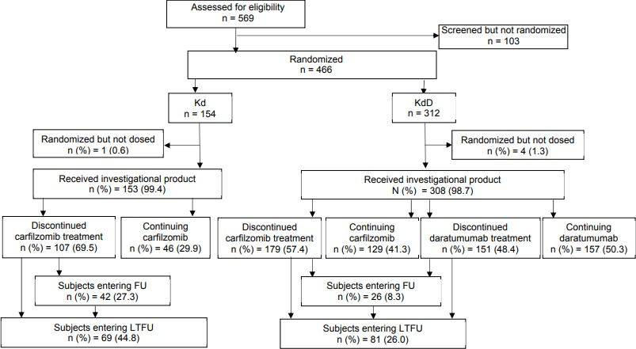

A significant difference was observed between Progression Free Survival (PFS), with progression occurring in 44.2% of the Kd treated and 35.3% of the KdD treated patients after 24 months (Figure 2).

Overall Response Rate (ORR) indicated a response in 84.3% of KdD patients and 74.7% of Kd patients, giving an odds ratio of 1.92 (95%CI 1.18-3.12) which was a significant difference in effect (Table 7).

Figure 2. Kaplan-Meier Plot – PFS as Assessed by the IRC (ITT Population)

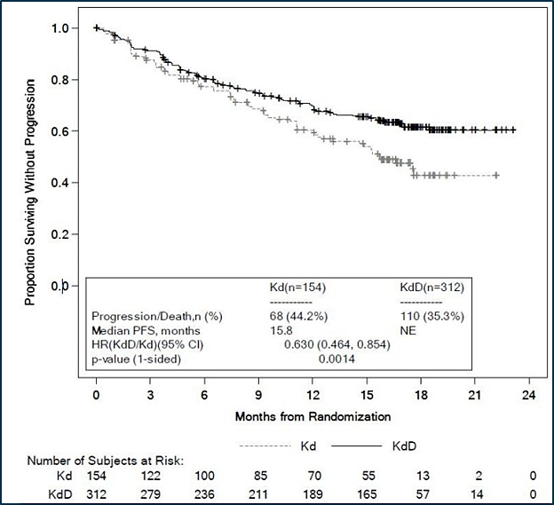

Table 7. Analysis of Best Overall Response as Assessed by the IRC (ITT Population)

CR = complete response; IMWG-URC = International Myeloma Working Group Uniform Response Criteria; Kd = carfilzomib and dexamethasone; KdD = carfilzomib, dexamethasone, and daratumumab; MRD[-] = mean residual disease negative; MRD[-]CR = mean residual disease negative – complete response; NGS = next generation sequencing; ORR = overall response rate; PR = partial response; sCR = stringent complete response; VGPR = very good partial response. Stratification factors (as assessed at randomization): International Staging System stage (Stage 1 or 2 vs Stage 3) at screening; prior proteasome inhibitor exposure (yes vs no); number of prior lines of therapy (1 vs ≥ 2). a Overall response rate is defined as the proportion of subjects in each treatment group who achieve PR or better per the IMWG-URC as their best response. b sCR could not be differentiated due to lack of kappa/lambda ratio by IHC c MRD[-]CR (at a 10-5 level) is defined as achievement of CR per IMWG-URC and MRD[-] status as assessed by NGS at any time during the study. d 95% CIs for proportions were estimated using the Clopper-Pearson method. e Odds ratios and corresponding 95% CIs were estimated using the stratified Mantel-Haenszel method. f P-values were calculated using the stratified Cochran-Mantel-Haenszel Chi-Square test

Assessment of Overall Survival (OS) was less mature at the time of reporting of CANDOR. There were 18.9% deaths in the KdD arm and 23.4% in the Kd arm with the difference in odds of death not being significantly different.

The OS did not favour KdD in patients over 75 years of age; 3/18 (16.7%) of Kd patients died and 6/25 (24.0%) of KdD patient did. Similarly in patients over 75 years of age, there were 27.8% progressions or deaths in the Kd arm and 44.0% in the KdD arm. These differences were not statistically significant, but were contrary to the trend of outcomes in younger patients (average age 64 years).

##### Study MMY001

Study MMY1001 was a phase 1b open-label non-randomised study in 85 subjects which examined KdD where the carfilzomib was administered as a once-weekly infusion of 20 mg/m2 on the first day of cycle 1 followed by 70 mg/m2 on days and cycles. ORR was a secondary endpoint of the study. Once commenced, treatment was continued until disease progression or discontinuation with a follow-up phase thereafter. Median time of follow-up was 24 months (Table 8).

Table 8. Overall Best Response Based on Computerised Algorithm (All Treated Analysis Set)

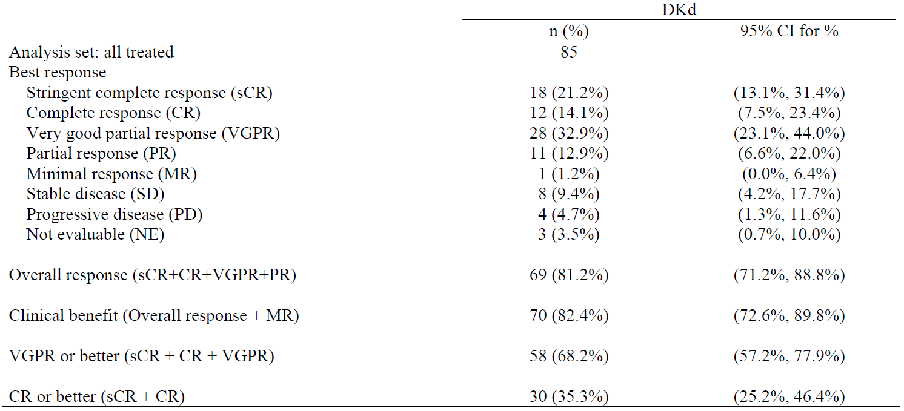

Keys: CI = exact confidence interval; DKd = daratumumab-carfilzomib-dexamethasone. Note: Response was assessed by computerized algorithm, based on International Uniform Response Criteria Consensus Recommendations. Note: Percentages are calculated with the number of subjects in the treatment group as denominator.

The ORR was 81.2% (95%CI 71.2-88.8) at the reporting cut-off with a median duration of response of 27.5 months (95%CI 20.5-not estimable)

The Evaluator has noted:

*This was a Phase 1b, open-label, non-randomised study primarily designed to assess the safety and tolerability of daratumumab in combination with once weekly carfilzomib and dexamethasone. Efficacy outcomes were secondary, with analyses of response and disease progression conducted by the Sponsor. The main limitations of the study were the lack of comparator arm and sample size. Overall, limited conclusions can be drawn regarding the efficacy of the proposed KdD 20/70 mg/m2 once-weekly dose regimen.*

#### Safety

Safety data was provided by the CANDOR and MMY1001 studies. However, only the CANDOR study provides comparative rates of adverse events between treatment arms. The Delegate considers the comparative data to be pivotal for safety as both Kd and KdD have potential serious adverse events and some overlap in their toxicities (Table 9).

Table 9. Summary of Exposure to Carfilzomib (Safety Analysis Set)

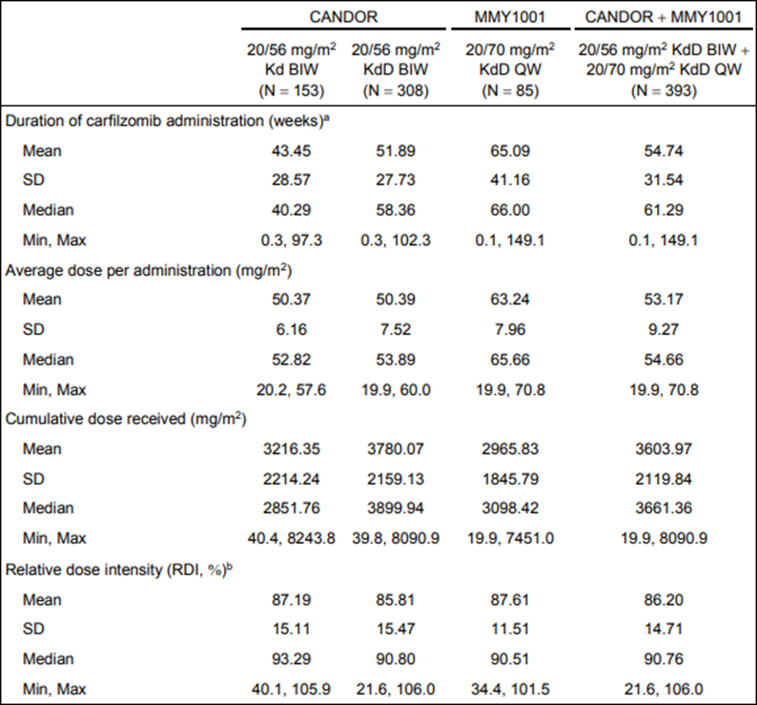

BIW = twice-weekly; Kd = carfilzomib and dexamethasone; KdD = carfilzomib, dexamethasone, and daratumumab; QW = once- weekly In CANDOR, the dose of carfilzomib for each subject was calculated based on baseline body surface area which was capped at 2.2 m2 unless the subject experienced a change in weight of ≥ 20% in which case the new body surface area was used in dose calculation. In Study MMY1001, the dose of carfilzomib for each subject was calculated based on body surface area at each visit. a Duration of administration is defined as the time from the first dose to the last dose of carfilzomib. b RDI (%) = actual dose intensity/planned dose intensity x 100, where actual (planned) dose intensity is the actual (planned) cumulative dose (mg/m2) divided by the actual (planned) duration of carfilzomib administration (weeks).

Table 10. Summary of Subject Incidence of TEAEs (Safety Population)

Kd = carfilzomib and dexamethasone; KdD = carfilzomib, dexamethasone, and daratumumab - = not applicable. Treatment-emergent adverse events are defined as any adverse event with an onset after the administration of the first dose of any study treatment and within the end of study or 30 days of the last dose of any study treatment, whichever occurs earlier. Adverse events were coded using MedDRA (version 22.0) and graded using NCI-CTCAE (version 4.03). a Treatment-related adverse events are adverse events considered related to at least one investigational product by the investigator, including those with unknown relationship.

The Evaluator has noted that exposure to carfilzomib differs in the arms of CANDOR, and exposure to KdD was longer in MMY001 than in CANDOR. The Delegate notes that discrepancies in exposure are typical of studies in which there is treatment to failure and have been appropriately managed by expressing exposure-adjusted rates of adverse events in the safety data.

Table 11. Adverse Events (CANDOR study) by System Organ Class and Preferred Term – With at Least 5% Difference Between Group (Safety Population)

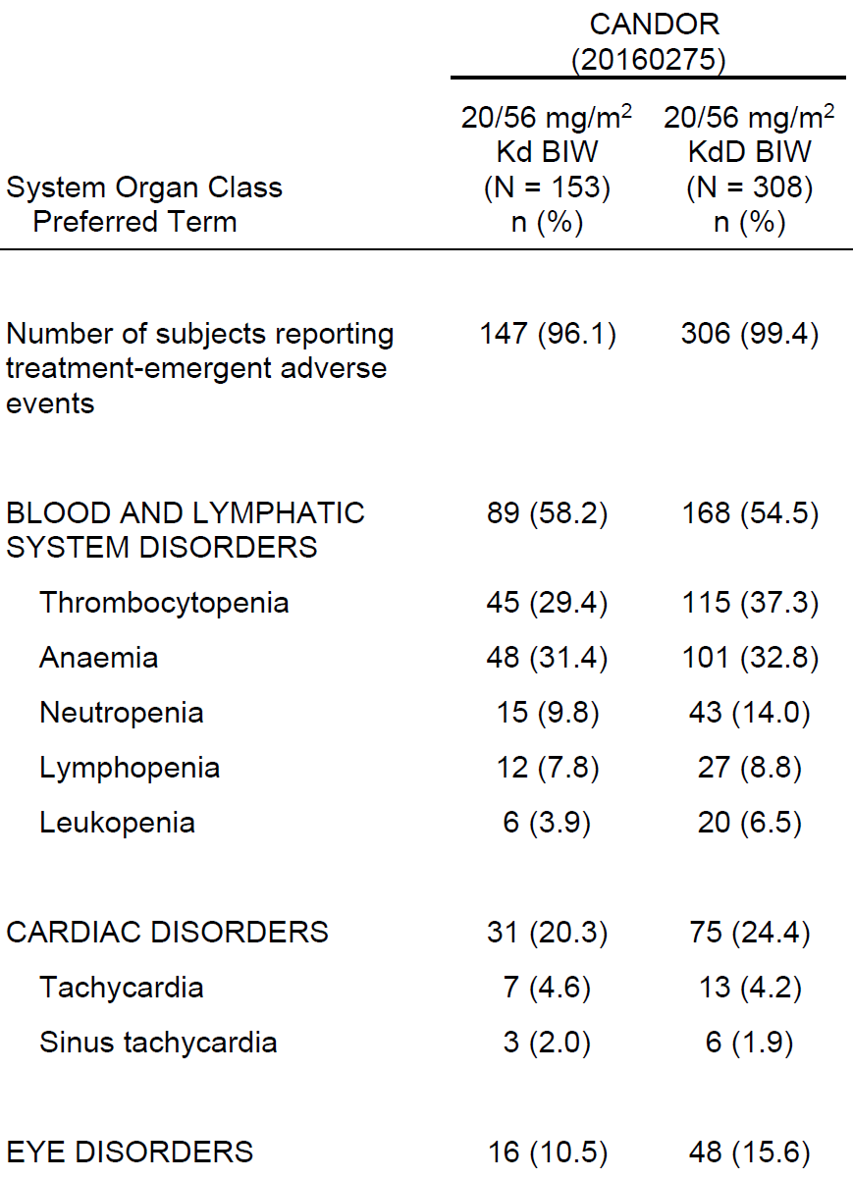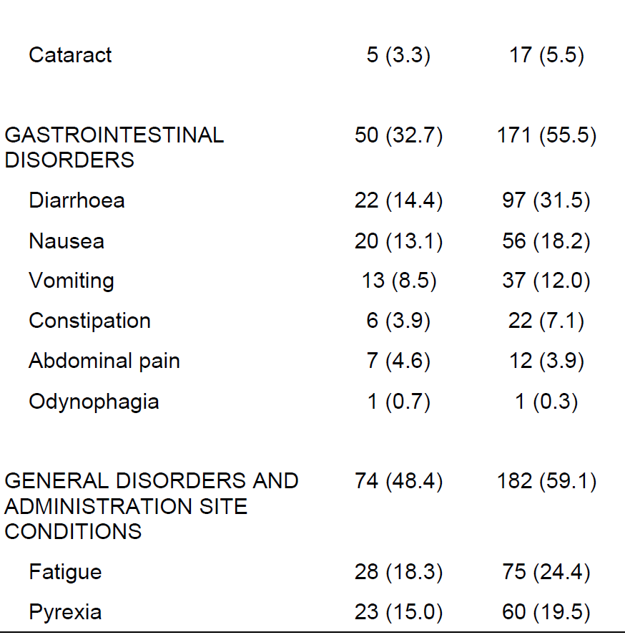

Kd = carfilzomib and dexamethasone; KdD = carfilzomib, dexamethasone, and daratumumab Treatment-emergent adverse events are defined as any adverse event with an onset after the administration of the first dose and within 30 days of the last dose of any investigational product. Adverse events were coded using MedDRA (version 22.0).

The Delegate notes that there was a higher rate of adverse events in the KdD group than in Kd exposed patients, which is not unexpected given it’s a comparison of triplet to duplet therapy with medications that have similar potential adverse effects. The Delegate notes the substantially increased rate of diarrhoea/nausea and increased rate of thrombocytopenia and infections in KdD-treated patients compared to those who received Kd (Table 12).

Table 12. Adverse Events of Interest for Carfilzomib by Search Strategy (Safety Population)

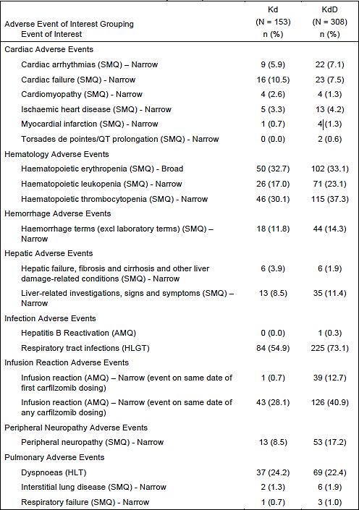

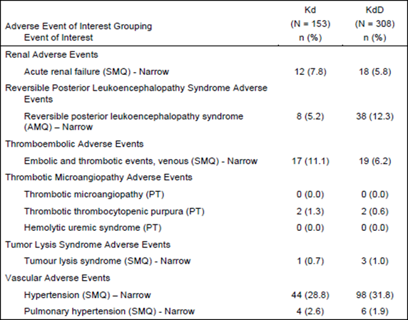

AMQ = Amgen MedDRA Query; Broad = broad scope; EOI = event of interest; HLGT = High Level Group Terms; HLT = High Level Terms; Kd = carfilzomib and dexamethasone; KdD = carfilzomib, dexamethasone, and daratumumab; Narrow = narrow scope; SMQ = Standardised MedDRA Query. Treatment-emergent adverse events are defined as any adverse event with an onset after the administration of the first dose and within 30 days of the last dose of any investigational product. Adverse events were coded using MedDRA (version 22.0).

A higher rate of infection AEs was reported in the KdD group compared to Kd (81.2% vs 66.7%), the majority being respiratory tract infections (73.1% vs 54.9% respectively). Fatal infection AEs occurred in 4.5% of KdD and 2.6% of Kd subjects (Table 13).

Cardiac AEs and SAEs were reported at a higher rate in the KdD group compared to the Kd group (7.1% vs 5.9% and 2.3% vs 1.3% respectively).

The rate of Pulmonary AEs was low and comparable between groups; 1.9% KdD, 1.3% Kd. Grade ≥ 3 events occurred in the KdD group only (1.6% vs. 0.0%). There were 1.6% KdD and 0.7% Kd subjects with SAEs.

Table 13. Fatal Adverse Events by System Organ Class and Preferred Term (Safety Population)

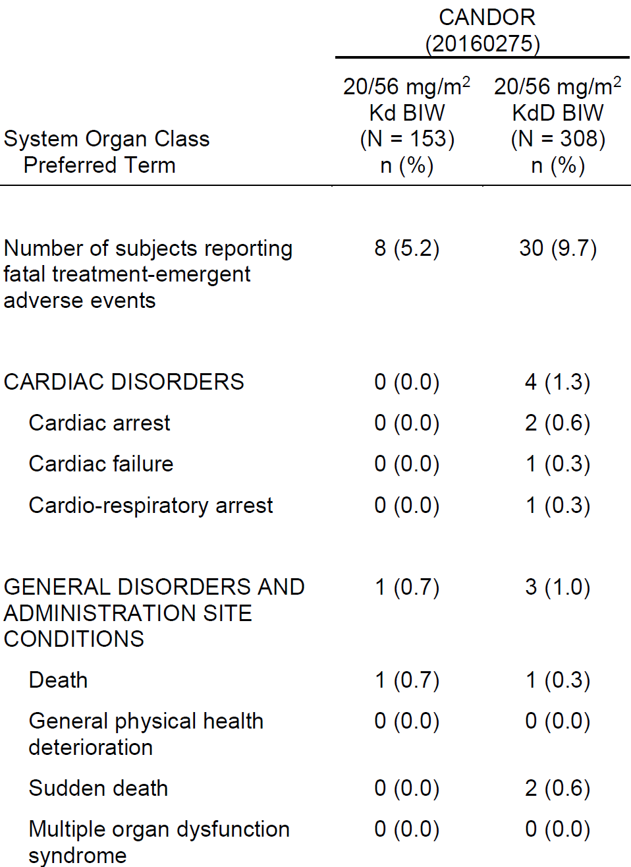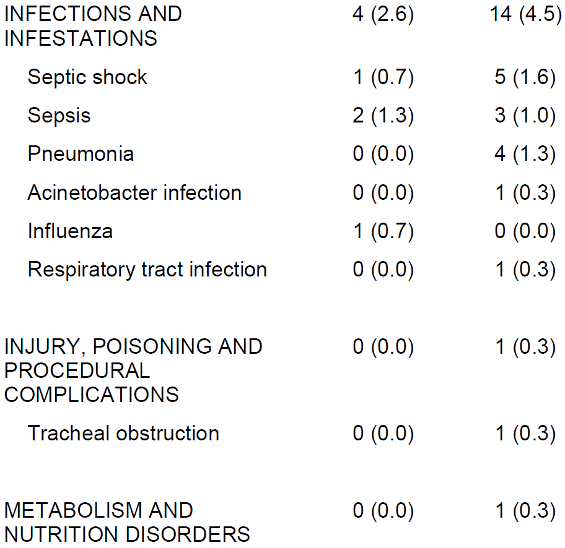

Kd = carfilzomib and dexamethasone; KdD = carfilzomib, dexamethasone, and daratumumab. Treatment-emergent adverse events are defined as any adverse event with an onset after the administration of the first dose and within 30 days of the last dose of any investigational product. Adverse events were coded using MedDRA (version 22.0).

The overall incidence of fatal AEs was higher in the KdD group (n = 30 [9.7%]) than the Kd group (n = 8 [5.2%]), with exposure-adjusted incidence rates also higher in the KdD group (9.08 vs. 6.22 per 100 subject-years).

Fatal AEs were reported most frequently in the Infections and infestations SOC for both groups (n = 14 [4.5%] KdD, n = 4 [2.6%] Kd), with fatal AEs by PT occurring in ≥ 1% subjects including septic shock (1.6% KdD, 0.7% Kd), plasma cell myeloma (1.3% each group), pneumonia (1.3% KdD, 0.0% Kd) and sepsis (1.0% KdD, 1.3% Kd).

The Evaluator has noted that there was a higher rate of fatal adverse events in patients >75 years of age compared to those under <75 years of age. In the discussion of risks the Evaluator has noted:

A key issue for consideration is use in elderly patients. Additional PFS analyses demonstrated a clinically meaningful PFS benefit in patients aged ≥ 65 years. The incidence of fatal AEs in the KdD group were higher in patients aged ≥ 65 years; 13.7% vs. 2.6% in the Kd group. The Sponsor has proposed additional warnings in the PI regarding fatal AEs in patients ≥ 65 years to mitigate this risk. The Evaluator considers the benefit- risk balance for the proposed KdD triplet in patients aged ≥ 65 years is favourable with these additional risk mitigation measures.

Of particular concern is use of the proposed KdD triplet in patients aged over 75 years. There was no improvement in PFS demonstrated in this subgroup at the primary PFS analysis (hazard ratio: 1.459 [95% CI: 0.504, 4.223]). The incidence of fatal AEs in patients aged ≥ 75 years was 14.3% in the KdD group vs. 0.0% in the Kd group. The Evaluator acknowledges the number of patients aged > 75 years in CANDOR was small (9.2%), which does limit any firm conclusions regarding use in this patient population. However, given the median age of diagnosis of multiple myeloma in Australia (~ 72 years), it is not unreasonable to consider the proposed triplet would be used in patients aged over 75 years in Australia. To mitigate the risk in patients aged > 75 years, the Evaluator recommends additional statements in the PI regarding fatal AEs and PFS data in this subgroup to inform prescribers of available data in this patient population.

The Evaluator has recommended approval of the proposed twice-weekly 20/56 mg/m2 dose of KdD but not of the proposed 20/70 mg/m2 dose of KdD.

### Discussion

The Delegate agrees with the Evaluator that CANDOR provides sufficient, albeit immature, evidence that KdD at a dose of 20/56 mg/m2 twice weekly for the carfilzomib component provides superior efficacy to Kd alone. The Delegate notes that this expected since adding additional therapies is likely to more aggressively suppress RRMM. However, this clearly comes at the cost of increased toxicity. Incremental toxicity for KdD is substantial in CANDOR, with a 4.2% higher rate of fatal adverse events reported in the KdD than the Kd arm of therapy (9.7 vs 5.2% respectively). This is a Number Needed to Harm of approximately 23, with the harm being fatal. These adverse events appear distributed between cardiac and infective adverse events.

The Evaluator has raised the issue that stratified analysis of the efficacy endpoints for CANDOR indicate no statistically robust benefit for patients >75 years of age. The trend for overall survival and PFS did not favour KdD in this group compared to Kd. This is problematic because this cohort represents an age in which MM is prevalent. The Delegate is not certain whether the negative effect of KdD treatment observed in this cohort reflects a difference in the sensitivity of disease to therapy in older patients or the patient’s susceptibility to toxicity. The Delegate acknowledges that the older cohort in CANDOR is small and so limited conclusions can be drawn from this data. However, the Delegate notes that the patients in CANDOR had ECOG status 0-1 (approx. 95%), did not have severe COPD or asthma or cardiac failure (EF<40% on echo).

These patients, therefore, did not represent particularly frail or compromised older patients at enrolment.

The Sponsor has agreed to include a statement (in bold below), regarding the older patients, in the Clinical Trials section of the PI and under precautions for ‘Use in the Elderly’:

**Use in the elderly**

Overall, the subject incidence of certain adverse events (including cardiac failure, see Section 4.4 Special warnings and precautions for use, Cardiac disorders) in clinical trials was higher for patients who were ≥ 75 years of age compared to patients who were < 75 years of age. In the CANDOR study (see Section 5.1 Pharmacological properties (clinical trials)), 146 (47%) of the 308 patients who received KDd 56 mg/m2 twice weekly were ≥ 65 years of age and 28 (9%) were ≥ 75 years of age. In the KDd arm of the study, fatal treatment-emergent adverse events (TEAEs) occurred in 6% of patients < 65 years of age and 14% of patients ≥ 65 years of age. In the Kd arm, fatal TEAEs occurred in 8% of patients < 65 years of age and 3% of patients ≥ 65 years of age (see Section 4.8 Adverse effects (undesirable effects)). Fatal TEAEs occurred in 14% and 0% of patients ≥ 75 years of age in the KDd and Kd arms respectively.

The Delegate agrees that this information is appropriate. The Delegate has considered whether it would be more appropriate to advise against the used of KdD in patients >65 or >75 years of age, depending on whether the stratification for adverse events or efficacy is used. The Delegate has concluded that this would be inappropriate since this is the age group in whom RRMM occurs and patient selection for therapy is a complex matter managed by clinical experts when using this medication.

The Evaluator has noted the paucity of data supporting the use of the once-weekly doing regimen, which relies on the phase 1b study MMY1001. The Delegate notes that the US FDA has approved this dosage for KdD while the EMA does not appear to have done so. The Delegate concurs with the view of the Evaluator that MMY1001 does not provide robust evidence of the equivalence of KdD once weekly to the twice-weekly schedule examined in CANDOR, either in terms of efficacy or safety outcomes. The study population in MMY1001 is small, and it is not a comparative study. The Delegate notes that while there would undoubtedly be gains in operational efficiency and patient convenience from once-weekly dosing, this cannot offset the need for robust efficacy and safety analysis.

However, the Delegate notes that there is unlikely to be significant pharmacokinetic interaction between carfilzomib and daratumumab. Furthermore, the increased toxicity of KdD therapy compared to Kd is likely to arise from the addition of daratumumab per se rather than an interaction between medications, and one weekly dosing for carfilzomib in Kd has been previously approved.

### Conclusion

The Delegate proposes to approve the application to extend carfilzomib for the indication, with the approved indication being worded as:

*Kyprolis is indicated for the treatment of patients with relapsed or refractory multiple myeloma who have received at least one prior therapy as part of combination therapy with:*

* dexamethasone or
* lenalidomide and dexamethasone or
* daratumumab and dexamethasone
* isatuximab and dexamethasone

The Delegate proposes that the approved Dose and Method of Administration section for carfilzomib in relation to therapy with daratumumab will advise a twice weekly schedule as per the CANDOR protocol. Reference to once weekly dosing and 20/70 mg/m2 will be removed from the Product Information.

### Advisory Committee considerations

The [Advisory Committee on Medicines (ACM)](https://www.tga.gov.au/committee/advisory-committee-medicines-acm), having considered the evaluations and the Delegate’s overview, as well as the sponsor’s response to these documents, advised the following.

1. ***Advice is sought on whether the submitted data is sufficient to justify a once weekly dosing interval for carfilzomib.***

The ACM advised that, based on a totality of evidence approach, there is sufficient information to justify having a once weekly dosing interval as an option for carfilzomib. In making this recommendation the ACM noted that the key efficacy study (CANDOR) only used the twice weekly dosing and there is no Phase III equivalence study directly comparing once weekly dosing with the standard twice weekly dosing. However, post market and real world usage in addition to indirect comparison for the two carfilzomib dosing regimens suggest equivalence for both Kd and KdD groups.[13],[14] The ACM also noted the supportive inclusion of extrapolation and bridging data and a small open label tolerability study within the dossier.

The ACM noted that there are a number of significant patient centred advantages for the once weekly carfilzomib within the indicated multiple myeloma regimens, including fewer infusions which frees up time for ill patients to spend with their family and reduces finance burden associated with travelling to hospital and/or infusion costs.

The ACM noted that there are examples of instances where once weekly (rather than twice weekly) dosing is utilised for safety and/or patient centred care reasons for other medicines in this space. The ACM noted that the Myeloma Australia’s Medicine Scientific Advisory Group recommends that in the bortezomib, lenalidomide and dexamethasone combination treatment for multiple myeloma a once weekly regimen of bortezomib can be considered to reduce the risk of peripheral neuropathy, noting that such regimens have not been subjected to Phase III comparison studies to the twice weekly regimen.

Based on the totality of evidence approach the ACM advised that the availability of both the once and twice weekly carfilzomib regimens would allow options for clinicians and patients. However, should the once weekly dosing be permitted the ACM indicated that the PI must clearly highlight that the once weekly regimen was not included in the Phase III clinical trial and direct equivalence to the twice weekly carfilzomib regimen has not been established.

#### ACM conclusion

The ACM considered this product to have an overall positive benefit-risk profile for both twice a week and once a week dosing of carfilzomib for the following indication:

Kyprolis is indicated for the treatment of patients with relapsed or refractory multiple myeloma who have received at least one prior therapy as part of combination therapy with:

* dexamethasone, or
* lenalidomide and dexamethasone, or
* daratumumab and dexamethasone, or isatuximab and dexamethasone.

## Outcome

Based on a review of quality, safety, and efficacy, the TGA decided to register Kyprolis (carfilzomib) for the above indications.

## Attachment 1. Product Information

The [Product Information](https://www.tga.gov.au/products/australian-register-therapeutic-goods-artg/product-information-one) ([PI](https://www.tga.gov.au/products/australian-register-therapeutic-goods-artg/product-information-one)) approved with the submission for Kyprolis which is described in this AusPAR can be found as Attachment 1. It may have been superseded. For the most recent PI and [Consumer Medicines Information](https://www.tga.gov.au/products/australian-register-therapeutic-goods-artg/consumer-medicines-information-cmi) (CMI), please refer to the TGA [PI/CMI search facility.](https://www.tga.gov.au/picmi-search-facility)

|  |
| --- |
| Therapeutic Goods Administration |
| PO Box 100 Woden ACT 2606 Australia  Email: [info@tga.gov.au](mailto:info@tga.gov.au) Phone: 1800 020 653 Fax: 02 6203 1605  [**https://www.tga.gov.au**](https://www.tga.gov.au) |

1. This is the original indication proposed by the sponsor when the TGA commenced the evaluation of this submission. It may differ to the final indication approved by the TGA and registered in the Australian Register of Therapeutic Goods.
2. Laubach JP. Multiple myeloma: clinical features, laboratory manifestations, and diagnosis. In: Connor RF (Ed), UpToDate, Waltham, MA. <https://www.uptodate.com/contents/multiple-myeloma-clinical-features-laboratory-manifestations-and-diagnosis?search=multiple%20myeloma&source=search_result&selectedTitle=1~150&usage_type=default&display_rank=1#H2>
3. Laubach, JP (n 2)
4. Dimopoulos MA, Moreau P, Terpos E, Mateos MV, Zweegman S, Cook G et al. Multiple myeloma: EHA-ESMO Clinical Practice Guidelines for diagnosis, treatment and follow-up. Ann Oncol. 2021;32(3):309-322.
5. Cancer Australia. Multiple myeloma in Australia statistics. Australia Government Cancer Australia. https://www.canceraustralia.gov.au/cancer-types/myeloma/statistics. Last updated 3rd January 2022.
6. Surveillance, Epidemiology, and End Results Program. Cancer Stat Facts: Myeloma. National Cancer Institute, Bethesda, MD; 2019. https://seer.cancer.gov/statfacts/html/mulmy.html
7. Australian Institute of Health and Welfare. Cancer data in Australia: cancer incidence by age groups for selected cancers, by sex and age, 1982-2021. https://www.aihw.gov.au/reports/cancer/cancer-data-in-australia/contents/cancer-incidence-by-age-visualisation. Last updated 8th June 2021.
8. Laubach, JP (n 2)
9. Cancer Australia (n 5)
10. Australian Darzalex PI. Available at TGA PI/CMI repository. <https://www.ebs.tga.gov.au/ebs/picmi/picmirepository.nsf/pdf?OpenAgent&id=CP-2017-PI-02146-1&d=2022051717231010>
11. Australian Sarclisa PI. Available at TGA PI/CMI repository. <https://www.ebs.tga.gov.au/ebs/picmi/picmirepository.nsf/pdf?OpenAgent&id=CP-2020-PI-01680-1&d=20220509172310101>
12. The ‘Delegate’ is the Delegate of the Secretary of the Department of Health and Aged Care who made the final decision to either include the new medicine/indication on the ARTG or reject the submission, under section 25 of the Therapeutic Goods Act
13. Leleu, X., et al. Efficacy and safety of weekly carfilzomib (70 mg/m2), dexamethasone, and daratumumab (KdD70) is comparable to twice-weekly KdD56 while being a more convenient dosing option: a cross-study comparison of the CANDOR and EQUULEUS studies. Leukemia & lymphoma, 2021, 62(2), 358–367.
14. Moreau, P., et al. Once-weekly (70 mg/m2 ) vs twice-weekly (56 mg/m2 ) dosing of carfilzomib in patients with relapsed or refractory multiple myeloma: A post hoc analysis of the ENDEAVOR, A.R.R.O.W., and CHAMPION-1 trials. Cancer medicine, 2020,9(9), 2989–2996.