|  |
| --- |
| Australian Public Assessment Report for Opdivo |
| Active ingredient: Nivolumab |
| Sponsor: Bristol-Myers Squibb Australia Pty Ltd |
| August 2024 |

About the Therapeutic Goods Administration (TGA)

* The Therapeutic Goods Administration (TGA) is part of the Australian Government Department of Health and Aged Care and is responsible for regulating therapeutic goods, including medicines, medical devices, and biologicals.
* The TGA administers the *Therapeutic Goods Act 1989* (the Act), applying a risk management approach designed to ensure therapeutic goods supplied in Australia meet acceptable standards of quality, safety, and efficacy.
* The work of the TGA is based on applying scientific and clinical expertise to decision-making, to ensure that the benefits to the Australian public outweigh any risks associated with the use of therapeutic goods.
* The TGA relies on the public, healthcare professionals and industry to report problems with therapeutic goods. The TGA investigates reports received to determine any necessary regulatory action.
* To report a problem with a therapeutic good, please see the information on the [TGA website](https://www.tga.gov.au/).

About AusPARs

* The Australian Public Assessment Report (AusPAR) provides information about the evaluation of a prescription medicine and the considerations that led the TGA to approve or not approve a prescription medicine submission. Further information can be found in [Australian Public Assessment Report (AusPAR) guidance](https://www.tga.gov.au/australian-public-assessment-report-auspar-guidance).
* AusPARs are prepared and published by the TGA.
* AusPARs are static documents that provide information that relates to a submission at a particular point in time. The publication of an AusPAR is an important part of the transparency of the TGA’s decision-making process.
* A new AusPAR may be provided to reflect changes to indications or major variations to a prescription medicine subject to evaluation by the TGA.

Copyright

© Commonwealth of Australia 2024  
This work is copyright. You may reproduce the whole or part of this work in unaltered form for your own personal use or, if you are part of an organisation, for internal use within your organisation, but only if you or your organisation do not use the reproduction for any commercial purpose and retain this copyright notice and all disclaimer notices as part of that reproduction. Apart from rights to use as permitted by the *Copyright Act 1968* or allowed by this copyright notice, all other rights are reserved and you are not allowed to reproduce the whole or any part of this work in any way (electronic or otherwise) without first being given specific written permission from the Commonwealth to do so. Requests and inquiries concerning reproduction and rights are to be sent to the TGA Copyright Officer, Therapeutic Goods Administration, PO Box 100, Woden ACT 2606 or emailed to <[tga.copyright@tga.gov.au](mailto:tga.copyright@tga.gov.au)>.

Contents

List of abbreviations 4

Opdivo (nivolumab) submission 5

Opdivo (nivolumab) – proposed indication 6

Opdivo and non-small cell lung cancer (NSCLC) 6

Regulatory status 7

Australian regulatory status 7

International regulatory status 9

Registration timeline 9

Submission overview and risk/benefit assessment 10

Clinical evaluation summary 10

Pharmacology 10

Efficacy 10

Safety 16

Discussion 19

Outcome 20

Attachment 1. Product Information 20

## List of abbreviations

|  |  |
| --- | --- |
| Abbreviation | Meaning |
| ACM | Advisory Committee on Medicines |
| ARTG | Australian Register of Therapeutic Goods |
| BICR | Blinded independent central review |
| CMI | Consumer Medicines Information |
| EFS | Event-free survival |
| NSCLC | Non-small cell lung cancer |
| OS | Overall survival |
| pCR | Pathological complete response |
| PI | Product Information |
| PK | Pharmacokinetic(s) |
| Q2W | Dosing every two weeks |
| Q3W | Dosing every three weeks |
| TGA | Therapeutic Goods Administration |

## Opdivo (nivolumab) submission

|  |  |
| --- | --- |
| *Type of submission:* | Extension of indications |
| *Product name:* | Opdivo |
| *Active ingredient:* | Nivolumab |
| *Decision:* | Approved |
| *Date of decision:* | 17 February 2023 |
| *Date of entry onto ARTG:* | 20 February 2023 |
| *ARTG numbers:* | 231867, 231868, 318057 |
| [*Black Triangle Scheme*](https://www.tga.gov.au/black-triangle-scheme) | No |
| *Sponsor’s name and address:* | Bristol-Myers Squibb Australia Pty Ltd, Level 2, 4 Nexus Court MULGRAVE VIC 3170. |
| *Dose form:* | Concentrate for solution for infusion. |
| *Strength:* | 10 mg/mL concentrate solution for infusion Each 1 mL of concentrate contains 10 mg of nivolumab. |
| *Container:* | 10 mL vial (Type I glass) with a stopper (coated butyl rubber) and an aluminium dark blue “flip off” seal |
| *Pack size:* | 1 vial per pack |
| *Approved therapeutic use for the current submission:* | **Non-Small Cell Lung Cancer (NSCLC)**  Opdivo, in combination with platinum-doublet chemotherapy, is indicated for the neoadjuvant treatment of patients with resectable non-small cell lung cancer (NSCLC). |
| *Route of administration:* | Infusion (NOT administered as an intravenous push or bolus injection) |
| *Dosage:* | For further information regarding dosage, such as dosage modifications to manage adverse reactions, refer to the Product Information. |
| *Pregnancy category:* | **Category D:** Drugs which have caused, are suspected to have caused or may be expected to cause, an increased incidence of human fetal malformations or irreversible damage. These drugs may also have adverse pharmacological effects.  Opdivo is not recommended during pregnancy or in women of childbearing potential not using effective contraception, unless the clinical benefit outweighs the potential risk. Advise females of reproductive potential to use effective contraception during treatment with Opdivo for at least 5 months following the last dose of Opdivo.  There are no data on the use of Opdivo in pregnant women. Human IgG4 is known to cross the placental barrier and Opdivo is an IgG4; therefore, Opdivo has the potential to be transmitted from the mother to the developing foetus. It is not known whether nivolumab can cause foetal harm when administered to a pregnant woman The use of any medicine during pregnancy requires careful consideration of both risks and benefits by the treating health professional. The [pregnancy database](https://www.tga.gov.au/products/medicines/find-information-about-medicine/prescribing-medicines-pregnancy-database) must not be used as the sole basis of decision making in the use of medicines during pregnancy. The TGA does not provide advice on the use of medicines in pregnancy for specific cases. More information is available from [obstetric drug information services](https://www.tga.gov.au/obstetric-drug-information-services) in your state or territory. |

### Opdivo (nivolumab) – proposed indication

This AusPAR describes the submission by Bristol-Myers Squibb Australia Pty Ltd (the sponsor) to register Opdivo (nivolumab) for the following proposed extension of indications:

*Opdivo, in combination with platinum-doublet chemotherapy, is indicated for the neoadjuvant treatment of patients with resectable non-small cell lung cancer (NSCLC).*

### Opdivo and non-small cell lung cancer (NSCLC)

Non-small cell lung cancer (NSCLC) represents about 85% of lung cancers. The main curative treatment for these tumours is surgical resection, although this is only possible in a minority of patients who are diagnosed early in the course of their disease[1].

Approximately 30-55% of patients will experience a recurrence after surgery. Neoadjuvant chemotherapy is often used after surgery to reduce this rate of recurrence, although the US FDA notes a lack of regulatory approval for specific regimens. Nivolumab represents a potential improvement to neoadjuvant regimens with an increased rate of response and can be used pre-operatively[2].

Nivolumab is a monoclonal antibody that binds to programmed death-1 receptors (PD-1) on T-cells and so blocks them from binding to cells which express programmed death ligand-1 and -2 (PD-L1, PD-L2). When T-cells bind to PD-L1 and PD-L2 this inhibits destruction of these cells and is usually a means for the immune system to recognise ‘self’ tissues. Tumour cells frequently express PD-L1 and PD-L2 to evade immune detection and blocking this receptor can enhance the immune mediated destruction of tumour cells[3].

### Regulatory status

#### Australian regulatory status

The product received initial registration in the Australian Register of Therapeutic Goods (ARTG) on 11 January 2016. It was approved for the following indication:

*Opdivo is indicated for the treatment of patients with unresectable or metastatic melanoma.*

It has since been approved to treat a range of cancers:

**Melanoma**

Opdivo, as monotherapy, is indicated for the adjuvant treatment of adults and adolescent patients 12 years and older with completely resected Stage IIB, IIC, III or IV melanoma.

Opdivo, as monotherapy, is indicated for the treatment of patients with unresectable or metastatic melanoma.

Opdivo, in combination with ipilimumab, is indicated for the treatment of patients with unresectable or metastatic melanoma. The approval of this indication is based on a pre-specified comparison to ipilimumab monotherapy. All analyses comparing nivolumab monotherapy with the nivolumab/ipilimumab combination are descriptive.

**Non-small cell lung cancer (NSCLC)**

Opdivo, in combination with ipilimumab and 2 cycles of platinum-doublet chemotherapy, is indicated for the first-line treatment of patients with metastatic or recurrent non-small cell lung cancer (NSCLC) with no EGFR or ALK genomic tumour aberrations.

Opdivo, as monotherapy, is indicated for the treatment of locally advanced or metastatic squamous non-small cell lung cancer (NSCLC) with progression on or after prior chemotherapy.

Opdivo, as monotherapy, is indicated for the treatment of locally advanced or metastatic non-squamous non-small cell lung cancer (NSCLC) with progression on or after prior chemotherapy. In patients with tumour EGFR or ALK genomic aberrations, Opdivo should be used after progression on or after targeted therapy.

**Malignant pleural mesothelioma (MPM)**

Opdivo, in combination with ipilimumab, is indicated for the first-line treatment of patients with unresectable malignant pleural mesothelioma.

**Renal cell carcinoma (RCC)**

Opdivo, in combination with ipilimumab, is indicated for the treatment of patients with intermediate/poor-risk, previously untreated advanced renal cell carcinoma.

Opdivo, in combination with cabozantinib, is indicated for the first-line treatment of patients with advanced renal cell carcinoma.

Opdivo, as monotherapy, is indicated for the treatment of patients with advanced clear cell renal cell carcinoma after prior anti-angiogenic therapy.

**Classical Hodgkin lymphoma (cHL)**

Opdivo, as monotherapy, is indicated for the treatment of patients with relapsed or refractory classical Hodgkin lymphoma (cHL) after autologous stem cell transplant and treatment with brentuximab vedotin. The approval of this indication is based on objective response rate in a single arm study.

**Squamous cell carcinoma of the head and neck (SCCHN)**

Opdivo, as monotherapy, is indicated for the treatment of recurrent or metastatic squamous cell cancer of the head and neck in patients progressing on or after platinum based therapy.

**Urothelial carcinoma (UC)**

Opdivo, as monotherapy, is indicated for the adjuvant treatment of patients with muscle invasive urothelial carcinoma (MIUC) who are at high risk of recurrence after undergoing radical resection of MIUC.

Opdivo, as monotherapy, is indicated for the treatment of patients with locally advanced unresectable or metastatic urothelial carcinoma after prior platinum-containing therapy. The approval of this indication is based on objective response rate and duration of response in a single arm study.

**Hepatocellular carcinoma (HCC)**

Opdivo, as monotherapy, is indicated for the treatment of patients with hepatocellular carcinoma after prior sorafenib therapy. This indication is approved based on objective response rate and duration of response in a single arm study. An improvement in survival or disease-related symptoms has not been established.

**Oesophageal squamous cell carcinoma (OSCC)**

Opdivo in combination with ipilimumab is indicated for the first-line treatment of patients with unresectable advanced, recurrent or metastatic oesophageal squamous cell carcinoma with tumour cell PD-L1 expression ≥ 1% as determined by a validated test.

Opdivo in combination with fluoropyrimidine- and platinum-based combination chemotherapy is indicated for the first-line treatment of patients with unresectable advanced, recurrent or metastatic oesophageal squamous cell carcinoma with tumour cell PD-L1 expression ≥ 1% as determined by a validated test.

Opdivo, as monotherapy, is indicated for the treatment of patients with unresectable advanced, recurrent or metastatic oesophageal squamous cell carcinoma after prior fluoropyrimidine and platinum based chemotherapy.

**Adjuvant oesophageal cancer (OC) or gastro-oesophageal junction cancer (GOJC)**

Opdivo, as monotherapy, is indicated for the adjuvant treatment of resected oesophageal or gastro-oesophageal junction cancer in patients who have received neoadjuvant chemoradiotherapy.

**Gastric cancer (GC), gastro-oesophageal junction cancer (GOJC), or oesophageal adenocarcinoma (OAC)**

Opdivo, in combination with fluoropyrimidine- and platinum-based combination chemotherapy, is indicated for the first-line treatment of patients with HER2 negative advanced or metastatic gastric or gastro-oesophageal junction or oesophageal adenocarcinoma.

Its current indication for the treatment of NSCLC is:

*Opdivo, in combination with ipilimumab and 2 cycles of platinum-doublet chemotherapy, is indicated for the first-line treatment of patients with metastatic or recurrent non-small cell lung cancer (NSCLC) with no EGFR or ALK genomic tumour aberrations.*

*Opdivo, as monotherapy, is indicated for the treatment of locally advanced or metastatic squamous non-small cell lung cancer (NSCLC) with progression on or after prior chemotherapy.*

*Opdivo, as monotherapy, is indicated for the treatment of locally advanced or metastatic nonsquamous non-small cell lung cancer (NSCLC) with progression on or after prior chemotherapy. In patients with tumour EGFR or ALK genomic aberrations, Opdivo should be used after progression on or after targeted therapy.*

#### International regulatory status

This evaluation was facilitated through [Project Orbis](https://www.tga.gov.au/project-orbis), an initiative of the United States Food and Drug Administration (FDA) Oncology Center of Excellence. The Delegate has referred to a US FDA evaluation report on which to base their decision. This evaluation was performed with participation from TGA, Health Canada, the MHRA and ANVISA, but is a US FDA authored document.

The FDA approved the proposed neoadjuvant indication on 4 March 2022.

Health Canada approved the proposed neoadjuvant indication on 23 August 2022.

The EMA has validated an application for the neoadjuvant indication but has not yet made a decision.

### Registration timeline

Table 2 captures the key steps and dates for this submission.

This submission was evaluated under the [standard prescription medicines registration process](https://www.tga.gov.au/how-we-regulate/supply-therapeutic-good-0/supply-prescription-medicine/application-process/prescription-medicines-registration-process).

Table 2: Timeline for Opdivo Submission PM-2022-00374-1-4

|  |  |
| --- | --- |
| Description | Date |
| Submission dossier accepted and first round evaluation commenced | 31 March 2022 |
| Evaluation completed | 29 July 2022 |
| Delegate’s[4] Overall benefit-risk assessment | 12 January 2023 |
| Registration decision (Outcome) | 17 February 2023 |
| Registration in the ARTG | 20 February 2023 |
| Number of working days from submission dossier acceptance to registration decision* | 226 |

*Statutory timeframe for standard submissions is 255 working days

## Submission overview and risk/benefit assessment

### Clinical evaluation summary

The pivotal data supporting this application was study CA209816 (CHECKMATE-816).

Pharmacokinetic (PK) modelling was performed to support the proposed dosing regimen for the neoadjuvant indication.

There were no new module 3 or 4 data submitted for evaluation.

#### Pharmacology

The pharmacology of nivolumab has been investigated in previous applications and a 2-compartment population PK model validated[5].

The proposed 360mg Q3W flat dosing for this indication resulted in similar drug exposure to previously registered 3mg/kg Q2W dosing. No clinically meaningful impact of patient demographics or disease characteristics on nivolumab exposure was observed in patients for this indication.

#### Efficacy

CA209816 was an open-label, randomised, phase III trial comparing the effect of nivolumab + chemotherapy or chemotherapy as neoadjuvant therapy in patients with resectable NSCLC. The study originally contained a nivolumab + ipilimumab arm but this was discontinued as a protocol amendment and patient randomised into the two remaining arms.

The primary endpoints of the study were event-free survival (EFS) and pathological complete response (pCR).

* EFS was defined as the time from randomisation to progression precluding surgery, recurrence after surgery or death from any cause. Patients who did not undergo surgery for any reason other than progression were considered to have had an ‘event.’
* pCR was defined was defined as the rate of patients having an absence of residual tumour in lung resected tissue and lymph nodes.

The evaluator has noted that there is limited experience with pCR as a primary efficacy outcome in supporting regulatory approval of treatment of early-stage NSCLC. It is not yet determined what difference in pCR would be required to predict an improvement in EFS or OS in early NSCLC.

Included patients had histologically confirmed stages IB, II or IIIA NSCLC.

Table 1: Key baseline characteristics of patients enrolled in Study CA209816

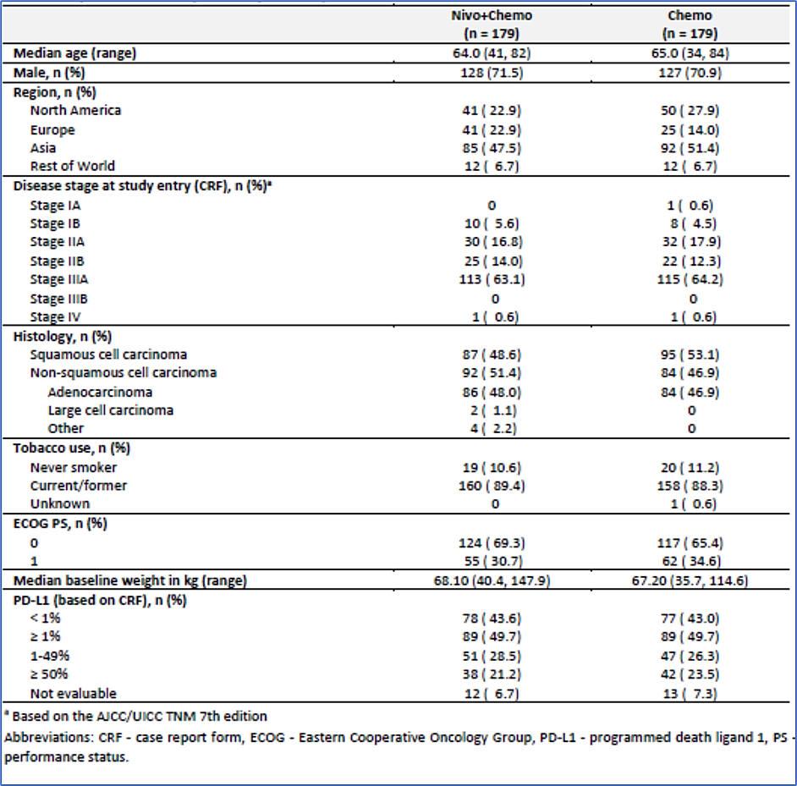

The treatment arms were well balanced for baseline measures of response to treatment. Only about 50% of patients in either arm had evidence of PD-L1 expression>1% in their tumour.

Patients were randomised 1:1 to received one of two neoadjuvant regimens:

**Nivo+Chemo Arm (Arm C)**

Nivolumab: nivolumab 360 mg IV every 3 weeks for up to 3 cycles

Chemotherapy: investigator choice of platinum-based doublet chemotherapy (IV):

* -cisplatin (75 mg/m2 on Day 1 of a 3-week cycle for up to 3 cycles) and one of the following:
  + -gemcitabine (1000 mg/m2 or 1250 mg/m2 [per local prescribing information] on Days 1 and 8 of a 3-week cycle for up to 3 cycles) (squamous histology)
  + -pemetrexed (500 mg/m2 on Day 1 of a 3-week cycle for up to 3 cycles) (non-squamous histology)
  + -carboplatin (area under the plasma drug concentration-time curve [AUC] 5 or 6 on Day 1 of a 3-week cycle for up to 3 cycles) and the following:
* -paclitaxel (175 or 200 mg/m2 on Day 1 of a 3-week cycle for up to 3 cycles) (any histology)

**Chemo Arm (Arm B)**

Investigator choice of platinum-based doublet chemotherapy (IV):

Cisplatin (75 mg/m2 on Day 1 of a 3 week cycle for up to 3 cycles) and one of the following:

* -gemcitabine (1000 mg/m2 or 1250 mg/m2 [per local prescribing information] on Days 1 and 8 of a 3-week cycle for up to 3 cycles) (squamous histology)
* -pemetrexed (500 mg/m2 on Day 1 of a 3-week cycle for up to 3 cycles) (non-squamous histology)
* -vinorelbine (25 mg/m2 or 30 mg/m2 [per local prescribing information] on Days 1 and 8 of a 3-week cycle for up to 3 cycles)
* -docetaxel (60 mg/m2 or 75 mg/m2 [per local prescribing information] on Day 1 of a 3-week cycle for up to 3 cycles)

Carboplatin (AUC 5 or 6 on Day 1 of a 3-week cycle for up to 3 cycles) and the following:

* -paclitaxel (175 or 200 mg/m2 on Day 1 of a 3 week cycle for up to 3 cycles)

Following resection of their tumour, patients were allowed to receive up to 4 cycles of optional adjuvant chemotherapy and/or radiotherapy at the discretion of the investigator. This was classified as on-study adjuvant chemotherapy.

Patient disposition in the study is shown in Table 2.

Table 2: Disposition of patients enrolled in study CA209816

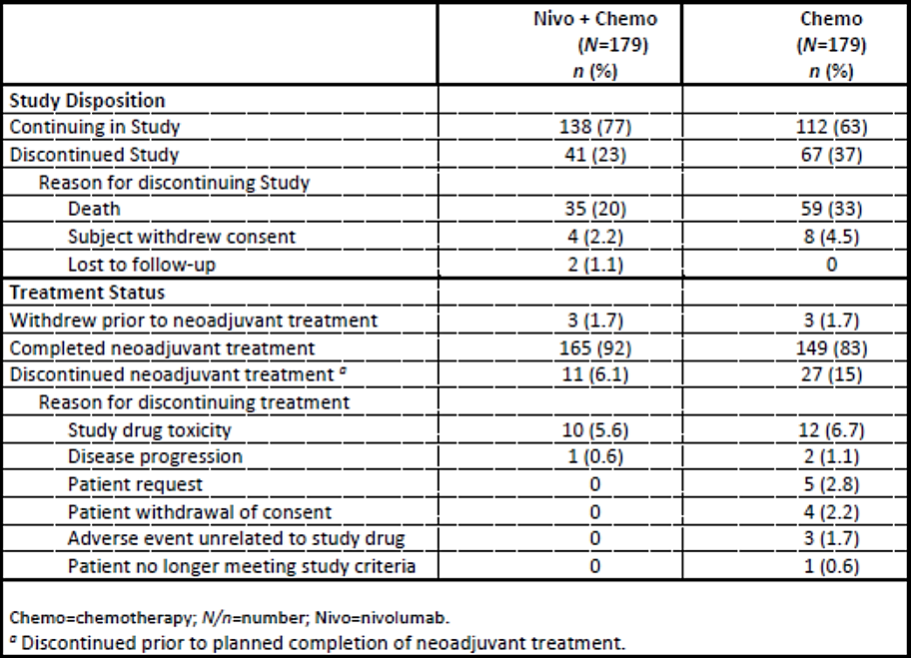

The majority of patients had undergone resection at the time of the study reporting; 83.2% in the nivolumab + chemotherapy and 75.4% in the chemotherapy-only arm respectively.

Of those patients who had not undergone surgery in each arm, the majority of remaining patients (15.6% and 20.7% respectively) had had surgery cancelled. In about half of the cases in each arm the reason for surgery being cancelled was disease progression, with a higher rate of cancellation due to adverse events in the nivolumab + chemotherapy arm (7.1% of cancellations) than the chemotherapy arm (2.7% of cancellations). Types of surgery, time to surgery, and completeness of resection margins were similar between the two treatment arms.

Figure 1: Kaplan-Meier plot of event free survival (EFS) for all randomised patients receiving nivolumab + chemotherapy (upper line) and chemotherapy (lower line) in study CA209816

Overall, in study CA209816 the median EFS in the nivolumab + chemotherapy arm was 31.57 months and in the chemotherapy arm it was 20.80 months. This equated to a hazard ratio (HR) of 0.63 (95%CI 0.43-0.91) in favour of nivolumab + chemotherapy.

The 12-month EFS was 76.1% and 63.4% in the nivolumab + chemotherapy and chemotherapy arms respective, and the 24-month EFS was 63.8% in the nivolumab + chemotherapy arm and 45.3% in the chemotherapy arm respectively.

The pCR rate was 24% in the nivolumab + chemotherapy arm compared to 2.2% in the chemotherapy arm.

The HR for overall survival was 0.57 (95%CI 0.30-1.07) in favour of the nivolumab + chemotherapy arm compared to the chemotherapy arm.

Table 3: Treatment effect on event free survival per blinded independent central review (BICR), primary definition in pre-defined subsets – all concurrently randomized subjects in Arm C (Nivo+Chemo) and Arm B (Chemo) Study CA209816

Table 4. Treatment Effect on Event Free Survival per BICR, Primary Definition in Pre-Defined Subsets – All Concurrently Randomized Subjects in Arm C (Nivo+Chemo) and Arm B (Chemo); Study CA209816.

The evaluator noted that the EFS was better in Asian than white patients, with an HR of 1.05 and 0.44, respectively. The reason for this difference is not certain but may reflect racial differences in PD-L1 expression. However, a marked difference in response was also observed when comparing Asian and white patients with PD-L1 expression rates <1%. The evaluator has noted some differences in the type of chemotherapy used in addition to nivolumab with 34% of Asian patients receiving carboplatin compared to 10% of white patients in the nivolumab + chemotherapy arm.

Patients with PD-L1 expression >50% appear to benefit most from nivolumab, with a HR for EFS of 0.24 (95% 0.10-0.61) compared to chemotherapy alone. Patients with PD-L1 expression <1% derive a marginal benefit from nivolumab, with a HR of 0.85 (95%CI 0.54-1.32) compared to chemotherapy alone.

#### Safety

The safety profile of nivolumab has been extensively investigated in other trials, as well as in clinical usage for NSCLC and other solid tumours. Overall, no new safety signals were detected in CA219816 (Table 5 and Table 6).

Table 5. Summary of safety - all treated Subjects in Randomized Arms C (Nivo+Chemo) and B (Chemo)

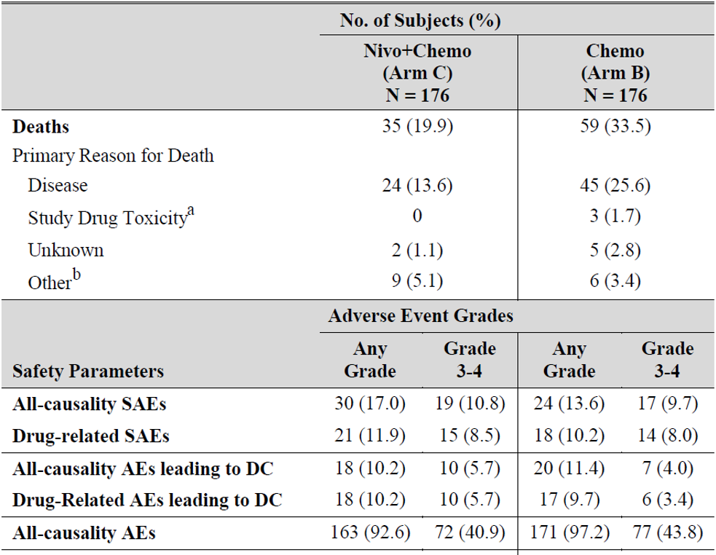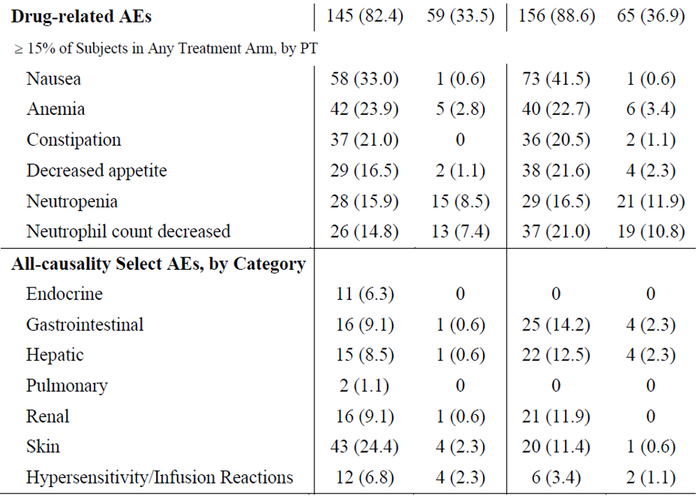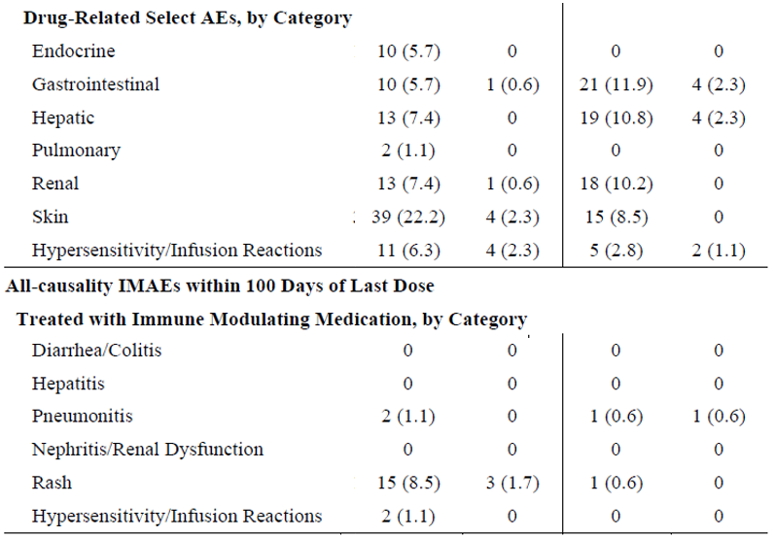

The majority of deaths in either arm resulted from disease progression, with 3 (1.7%) of patients in the chemotherapy arm dying of drug toxicity.

Rates of adverse events (serious adverse events and severe treatment-emergent adverse events) were similar between the two treatment arms. There was an increased in low-grade hypothyroidism in the nivolumab + chemotherapy arm (2.3%) compared to the chemotherapy arm (0%), and this is consistent with one of the known adverse events of nivolumab.

The frequency of adverse events leading to delayed or cancelled surgery was low; 3.4% in the nivolumab + chemotherapy and 5.1% in the chemotherapy arm respectively.

Table 6: Causality of deaths 30 and 90 days post-surgery in Study CA209816

Of the deaths that occurred within 30 or 90 days of surgery that were not due to disease progression, all in the nivolumab + chemotherapy arm were assessed as being due to known surgical complications of resection and not pharmaceutical treatment.

### Discussion

CA209816 provides evidence of a generally significant therapeutic benefit when nivolumab is added to chemotherapy as neoadjuvant therapy compared to chemotherapy alone. An increase in overall survival of patients has not been established but there is a significant increase in median EFS of approximately 11 months. This correlates with an approximate number needed to treat of 5 to achieve one patient having EFS at 24 months.

The additional toxicity from adding nivolumab to the adjuvant regimen is not severe in the clinical context of NSCLC and medication-related adverse events did not generally interfere with the performance or outcome of surgery. The Delegate notes that the toxicity of nivolumab is likely to be partly mitigated by patient’s having an exposure of only 3 cycles compared to the long-term administration that may occur in advanced disease.

The Delegate notes that, as might be expected from the mechanism of action of nivolumab, there is substantially greater benefit from nivolumab + chemotherapy observed in patients with high PD-L1 expression. While this is a sub-analysis, the observed difference between an HR of 0.24 and HR of 0.85 is very large. The Delegate therefore is of the view that this information should be included in the prescribing information for the indication.

## Outcome

Based on a review of safety and efficacy, the TGA decided to register Opdivo (nivolumab) for the indication:

*Opdivo, in combination with platinum-doublet chemotherapy, is indicated for the neoadjuvant treatment of patients with resectable non-small cell lung cancer (NSCLC).*

## Attachment 1. Product Information

The [Product Information](https://www.tga.gov.au/products/australian-register-therapeutic-goods-artg/product-information-one) ([PI](https://www.tga.gov.au/products/australian-register-therapeutic-goods-artg/product-information-one)) approved with the submission for Opdivo which is described in this AusPAR can be found as Attachment 1. It may have been superseded. For the most recent PI and [Consumer Medicines Information](https://www.tga.gov.au/products/australian-register-therapeutic-goods-artg/consumer-medicines-information-cmi) (CMI), please refer to the TGA [PI/CMI search facility.](https://www.tga.gov.au/picmi-search-facility)

|  |
| --- |
| Therapeutic Goods Administration |
| PO Box 100 Woden ACT 2606 Australia  Email: [info@tga.gov.au](mailto:info@tga.gov.au) Phone: 1800 020 653 Fax: 02 6203 1605  [**https://www.tga.gov.au**](https://www.tga.gov.au) |
|  |

1. Thai AA, Solomon BJ, Sequist LV, Gainor JF, Heist RS. Lung cancer. Lancet. 2021 Aug 7;398(10299):535-554. doi: 10.1016/S0140-6736(21)00312-3. Epub 2021 Jul 21. PMID: 34273294.
2. West HJ, Kim JY. Rapid Advances in Resectable Non-Small Cell Lung Cancer: A Narrative Review. JAMA Oncol. 2024 Feb 1;10(2):249-255. doi: 10.1001/jamaoncol.2023.5276. Erratum in: JAMA Oncol. 2024 Mar 1;10(3):412. doi: 10.1001/jamaoncol.2024.0049. PMID: 38153722.
3. Ibid.
4. The ‘Delegate’ is the Delegate of the Secretary of the Department of Health and Aged Care who made the final decision to either include the new medicine/indication on the ARTG or reject the submission, under section 25 of the Therapeutic Goods Act
5. AusPAR for New Biological Entity, Opdivo, 2016. <https://www.tga.gov.au/sites/default/files/auspar-nivolumab-160823.pdf>