|  |
| --- |
| Australian Public Assessment Report for Velsipity |
| Active ingredient: Etrasimod |
| Sponsor: Pfizer Australia Pty Ltd |
| August 2024 |

About the Therapeutic Goods Administration (TGA)

* The Therapeutic Goods Administration (TGA) is part of the Australian Government Department of Health and Aged Care and is responsible for regulating therapeutic goods, including medicines, medical devices, and biologicals.
* The TGA administers the *Therapeutic Goods Act 1989* (the Act), applying a risk management approach designed to ensure therapeutic goods supplied in Australia meet acceptable standards of quality, safety, and efficacy.
* The work of the TGA is based on applying scientific and clinical expertise to decision-making, to ensure that the benefits to the Australian public outweigh any risks associated with the use of therapeutic goods.
* The TGA relies on the public, healthcare professionals and industry to report problems with therapeutic goods. The TGA investigates reports received to determine any necessary regulatory action.
* To report a problem with a therapeutic good, please see the information on the [TGA website](https://www.tga.gov.au/).

About AusPARs

* The Australian Public Assessment Report (AusPAR) provides information about the evaluation of a prescription medicine and the considerations that led the TGA to approve or not approve a prescription medicine submission. Further information can be found in [Australian Public Assessment Report (AusPAR) guidance](https://www.tga.gov.au/australian-public-assessment-report-auspar-guidance).
* AusPARs are prepared and published by the TGA.
* AusPARs are static documents that provide information that relates to a submission at a particular point in time. The publication of an AusPAR is an important part of the transparency of the TGA’s decision-making process.
* A new AusPAR may be provided to reflect changes to indications or major variations to a prescription medicine subject to evaluation by the TGA.

Copyright

© Commonwealth of Australia 2024  
This work is copyright. You may reproduce the whole or part of this work in unaltered form for your own personal use or, if you are part of an organisation, for internal use within your organisation, but only if you or your organisation do not use the reproduction for any commercial purpose and retain this copyright notice and all disclaimer notices as part of that reproduction. Apart from rights to use as permitted by the *Copyright Act 1968* or allowed by this copyright notice, all other rights are reserved and you are not allowed to reproduce the whole or any part of this work in any way (electronic or otherwise) without first being given specific written permission from the Commonwealth to do so. Requests and inquiries concerning reproduction and rights are to be sent to the TGA Copyright Officer, Therapeutic Goods Administration, PO Box 100, Woden ACT 2606 or emailed to <[tga.copyright@tga.gov.au](mailto:tga.copyright@tga.gov.au)>.

Contents

List of abbreviations 4

Velsipity (etrasimod) submission 6

Velsipity (etrasimod) – proposed indications 7

Ulcerative colitis 7

Current treatment options for ulcerative colitis 7

Clinical rationale for Velsipity use in ulcerative colitis 8

Regulatory status 8

Australian regulatory status 8

International regulatory status 8

Registration timeline 9

Evaluation overview 10

Quality evaluation summary 10

Nonclinical (toxicology) evaluation summary 10

Clinical evaluation summary 11

Pharmacology 12

Efficacy 13

Clinical studies in subjects with ulcerative colitis 14

Safety 20

Risk management plan evaluation summary 23

Risk/benefit assessment 24

Advisory Committee considerations 25

ACM conclusion 27

Outcome 27

Specific conditions of registration applying to these goods 27

Attachment 1. Product Information 28

#### List of abbreviations

|  |  |
| --- | --- |
| Abbreviation | Meaning |
| 5-ASA | 5-aminosalicylic acid |
| ACM | Advisory Committee on Medicines |
| APD334 | Etrasimod/ETR |
| ARTG | Australian Register of Therapeutic Goods |
| AUC | Area under the concentration-time curve |
| AUC0-24 | Area under the concentration-time curve from time 0 to 24 hours |
| CFB | Change from baseline |
| CI | Confidence interval |
| Cmax | Maximum plasma concentration |
| CMI | Consumer medicines information |
| CYP | Cytochrome P450 |
| EAIR | Exposure-adjusted incidence rate |
| ECG | Electrocardiogram |
| ETR | Etrasimod |
| FAS | Full analysis set |
| FDA | (US) Food and Drug Administration |
| FEV1 | Forced expiratory volume in one second |
| GI | Gastrointestinal |
| HR | Heart rate |
| ICH | International Council for Harmonisation of Technical Requirements for Pharmaceuticals for Human Use |
| IL | Interleukin |
| JAK | Janus kinase |
| PD | Pharmacodynamic(s) |
| PI | Product information |
| PK | Pharmacokinetic (s) |
| PopPK | Population PK |
| QTcF | QT interval corrected using Fridericia’s formula |
| RB | Rectal bleeding |
| RMP | Risk management plan |
| S1P | Sphingosine 1-phosphate |
| S1P1-5 | Sphingosine 1-phosphate receptors 1, 2, 3, 4 and 5 |
| SAE | Serious adverse event |
| SOC | System organ class |
| TEAE | Treatment-emergent adverse event |
| TGA | Therapeutic goods administration |
| TNFα | Tumour necrosis factor alpha |
| tmax | Time to maximum plasma concentration |
| UC | Ulcerative colitis |

## Velsipity (etrasimod) submission

|  |  |
| --- | --- |
| *Type of submission:* | New chemical entity |
| *Product name:* | Velsipity |
| *Active ingredient:* | Etrasimod |
| *Decision:* | Approved |
| *Date of decision:* | 17 May 2024 |
| *Date of entry onto ARTG:* | 22 May 2024 |
| *ARTG number:* | 405528, 405529 |
| [*Black Triangle Scheme*](https://www.tga.gov.au/black-triangle-scheme) | Yes |
| *sponsor’s name and address:* | Pfizer Australia Pty Ltd, Level 17, 151 Clarence Street, SYDNEY NSW 2000 |
| *Dose form:* | Film-coated tablets |
| *Strength:* | Each film-coated tablet contains 2.762 mg of etrasimod arginine, equivalent to 2 mg etrasimod. |
| *Container:* | High-density polyethylene (HDPE) bottles closed with a child-resistant polypropylene cap and packaged inside an outer carton.  Aluminum strip laminated to an oriented polyamine (oPA) film and integrated desiccant layer (HDPE/LDPE) with a paper/aluminum/LDPE backing. |
| *Pack size:* | Bottle: 30 tablets  Strips: 7, 28 or 98 tablets |
| *Approved therapeutic use for the current submission:* | Velsipity is indicated for the treatment of adults with moderately to severely active ulcerative colitis (UC) who have had inadequate response, loss of response or intolerance to conventional, biologic or Janus kinase (JAK) inhibitor therapies. |
| *Route of administration:* | Oral |
| *Dosage:* | 2 mg taken orally once daily  For further information regarding dosage, such as dosage modifications to manage adverse reactions, refer to the Product Information. |
| *Pregnancy category:* | Category D: Drugs which have caused, are suspected to have caused or may be expected to cause, an increased incidence of human fetal malformations or irreversible damage. These drugs may also have adverse pharmacological effects.  The use of any medicine during pregnancy requires careful consideration of both risks and benefits by the treating health professional. The [pregnancy database](https://www.tga.gov.au/products/medicines/find-information-about-medicine/prescribing-medicines-pregnancy-database) must not be used as the sole basis of decision making in the use of medicines during pregnancy. The TGA does not provide advice on the use of medicines in pregnancy for specific cases. More information is available from [obstetric drug information services](https://www.tga.gov.au/obstetric-drug-information-services) in your state or territory. |

#### Velsipity (etrasimod) – proposed indications

This AusPAR describes the submission by Pfizer Australia Pty Ltd (the sponsor) to register Velsipity (etrasimod) for the following proposed indication:

*Velsipity is indicated for the treatment of patients 16 years of age and older with moderately to severely active ulcerative colitis (UC).*

#### Ulcerative colitis

Ulcerative colitis is a type of inflammatory bowel disease (IBD). UptoDate provides the following summary information regarding ulcerative colitis and current treatment options:[1].

“Ulcerative colitis (UC) is a chronic inflammatory condition of the large intestine that is limited to the mucosal layer of the colon. It almost always involves the rectum and may extend in a proximal and continuous fashion to involve other portions of the colon. The pattern of disease activity is characterised by periods of active inflammation alternating with periods of remission.

Most patients with UC are treated with pharmacologic therapy, and multiple drugs are available. Therapies can be grouped as induction therapies (i.e., relatively rapid onset of action) and maintenance therapies (i.e., appropriate for long-term use). Some therapies (e.g., biologic agents) are used for both induction and maintenance of remission. While glucocorticoids may be used for inducing remission, they are not effective or suitable for maintaining remission. As a result, the term "maintenance of remission" refers to glucocorticoid-free remission.

The severity of UC is classified as mild, moderate, or severe disease; however, the definition of moderate to severe disease activity may vary in the literature depending on the specific index or score being used.”

#### Current treatment options for ulcerative colitis

Current Australian Gastroenterological Society of Australia clinical practice guidelines outline the initial therapies of 5-aminosalicylic acid (5-ASAs) and corticosteroids in the medical management of UC, and biologic therapy can be prescribed by a specialist gastroenterologist for patients with insufficient response to standard medical therapy.

Medicines currently included in the ARTG with specific indications in moderate to severe ulcerative colitis include four monoclonal antibodies, described as “biological medicines” (biologics in international jurisdictions), as well as Janus kinase (JAK) inhibitors and sphingosine 1-phosphate receptor modulators:

* Two TNF antagonists infliximab (indicated in “*moderately severe to severe active ulcerative colitis in adults and children and adolescents (6-17 years) who have had an inadequate response to conventional therapy*”) and adalimumab (indicated “*for the treatment of moderate to severe ulcerative colitis in adult patients who have had an inadequate response to conventional therapy or who are intolerant to or have medical contraindications for such therapies*”)
* The anti-integrin vedolizumab (for “*treatment of adult patients with moderate to severe ulcerative colitis who have had an inadequate response with, lost response to, or are intolerant to either conventional therapy or a tumour necrosis factor-alpha (TNFα) antagonist*”),
* The anti-IL12/IL23 antibody ustekinumab (for “*the treatment of adult patients with moderately to severely active ulcerative colitis*”)
* The humanised immunoglobulin G4 monoclonal antibody mirikizumab that binds with high affinity and specificity to the p19 subunit of IL23 (for “*the treatment of moderately to severely active ulcerative colitis (UC) in adult patients who have had an inadequate response with, lost response to, or were intolerant to conventional therapy or a biological medicine or have medical contraindications to such therapies*.”).
* The JAK inhibitor tofacitinib (for “*the treatment of adult patients with moderately to severely active ulcerative colitis (UC) who have had an inadequate response, lost response, or were intolerant to either conventional therapy or a biological therapy*”)
* The JAK inhibitor upadacitnib (for “*the treatment of adult patients with moderately to severely active ulcerative colitis, who have had an inadequate response, lost response or were intolerant to either conventional therapy or a biological medicine*”)
* The sphingosine 1-phosphate receptor modulator ozanimod (for “*the treatment of adult patients with moderately to severely active ulcerative colitis who have had an inadequate response, lost response, or were intolerant to either conventional therapy or a biological therapy*.”)

#### Clinical rationale for Velsipity use in ulcerative colitis

Etrasimod is a sphingosine 1-phosphate (S1P) receptor modulator that binds with high affinity to S1P receptors 1, 4 and 5 (S1P1,4,5). Etrasimod has no activity on S1P2 or S1P3. Etrasimod partially and reversibly blocks the capacity of lymphocytes to egress fromlymphoid organs, reducing the number of lymphocytes in peripheral blood thereby lowering thenumber of activated lymphocytes in the tissue.The mechanism by which etrasimod exerts its therapeutic effects in UCis unknown but it may be due to fewer peripheral immune cells trafficking to sites of inflammation, such as the gastrointestinal tract, in patients with ulcerative colitis.

## Regulatory status

### Australian regulatory status

This product is considered a new chemical entity for Australian regulatory purposes.

### International regulatory status

At the time the TGA considered this submission, a similar submission had been considered by other regulatory agencies. Table 1 summarises these submissions and provides the proposed indications.

Table 1: International regulatory status

|  |  |  |  |
| --- | --- | --- | --- |
| Region | Submission date | Status | Indications |
| USA | 14 October 2022 | Submitted | Proposed: Etrasimod is indicated for the treatment of patients 16 years of age and older with moderately to severely active ulcerative colitis (UC). |
| EU | 11 November 2022 | Submitted | Proposed: Etrasimod is indicated for the treatment of patients 16 years of age and older with moderately to severely active ulcerative colitis (UC) who have had an inadequate response, lost response, or were intolerant to either conventional therapy or an advanced treatment. |
| Canada | 28 December 2022 | Submitted | Proposed: TRADENAME is indicated for the treatment of patients 16 years of age and older with moderately to severely active ulcerative colitis who have had an inadequate response, lost response, or were intolerant to either conventional therapy or an advanced treatment. |
| UK | 15 December 2023 | Planned | Proposed: Etrasimod is indicated for the treatment of patients 16 years of age and older with moderately to severely active ulcerative colitis (UC) who have had an inadequate response, lost response, or were intolerant to either conventional therapy or an advanced treatment |
| Singapore | 31 May 2023 | Planned | Proposed: Etrasimod is indicated for the treatment of patients 16 years of age and older with moderately to severely active ulcerative colitis (UC). |
| Switzerland | 31 May 2023 | Planned | Etrasimod is indicated for the treatment of patients 16 years of age and older with moderately to severely active ulcerative colitis (UC). |

### Registration timeline

The following table captures the key steps and dates for this submission.

This submission was evaluated under the [standard prescription medicines registration process](https://www.tga.gov.au/how-we-regulate/supply-therapeutic-good-0/supply-prescription-medicine/application-process/prescription-medicines-registration-process).

Table 2: Timeline for Velsipity submission PM-2023-00714-1-1

|  |  |
| --- | --- |
| Description | Date |
| Submission dossier accepted and first round evaluation commenced | 31 March 2023 |
| Evaluation completed | 22 December 2023 |
| Delegate’s[2] Overall benefit-risk assessment and request for Advisory Committee advice | 29 February 2024 |
| Advisory Committee meeting | 23 April 2024 |
| Registration decision (Outcome) | 17 May 2024 |
| Registration in the ARTG | 22 May 2024 |
| Number of working days from submission dossier acceptance to registration decision* | 250 |

*Statutory timeframe for standard submissions is 255 working days

## Evaluation overview

### Quality evaluation summary

The evaluator was satisfied that the sponsor had satisfied all requirements with respect to GMP compliance, stability and release specifications, stability studies that support the proposed shelf life/storage conditions, validation of analytical procedures, appropriate choice/synthesis and validation of reference standards, appropriate in-process controls, process validation, control of impurities, characterisation of excipients, medicine sterility/appropriate control of infectious disease & adventitious agents, appropriate/compatible container closure systems and labelling that conformed to Therapeutic Goods Order 91.

Approval was recommended for registration of Velsipity from a pharmaceutical chemistry perspective.

### Nonclinical (toxicology) evaluation summary

The submitted nonclinical dossier was in accordance with the relevant ICH guideline. The overall quality of the nonclinical dossier was high and all safety studies were Good Laboratory Practice compliant. There were no nonclinical objections to the registration of Velsipity. Amendments to the initially submitted Product Information were requested.

*In vitro*, ETR activated S1P1 as a full agonist, but had only partial agonist activity of S1P4,5 and no activity of S1P2,3. In support of the proposed clinical indication, prophylactic ETR treatment suppressed disease progression and attenuated inflammation in a mouse model of colitis. There were no potential off-target effects identified in an adequate *in* *vitro* screening assay.

Safety pharmacology studies assessed effects on the cardiovascular, respiratory and central nervous systems. No clinically relevant inhibition of hERG K+ channel tail current was observed and no ECG effects seen in dogs. ETR appears to have a less prominent effect on heart rate and atrioventricular conduction than other S1P receptor modulators. No acute functional effects on the CNS or respiratory systems were seen in rats.

Overall, the pharmacokinetic profile in animals was qualitatively similar to that of humans. ETR was readily absorbed with a similar Tmax (6–8 h) in mice, rats, dogs and humans. Half-life values were similar in humans and dogs but shorter in monkeys and rats. Plasma protein binding of ETR was high to very high in all animal species and humans. Tissue distribution of drug-related material in rats following oral dosing was moderate with noticeable penetration into brain and reproductive organs. Melanin-binding was seen in pigmented tissues with retention and accumulation seen in the thyroid gland following repeat-dosing. ETR was extensively metabolised in animals and humans. No human-specific metabolites were identified. Metabolically, mice and rabbits were less relevant species than rats and dogs. Drug-related material was excreted predominantly via the faeces in humans and animal species.

Based on *in vitro* studies, inhibitors/inducers of CYP2C8, 2C9 or 3A4 could alter the systemic exposure to ETR. This has been assessed by clinical data. ETR is not expected to alter the exposure of co-administered drugs that are CYP450 or uridine 5-diphospho-glucuronosyltransferase substrates. ETR is unlikely to alter the exposure of co-administered drugs that are substrates of prominent membrane transporters.

Repeat-dose toxicity studies by the oral route were conducted in mice (up to 3 months), rats (up to 6 months) and dogs (up to 9 months). Exposures (AUC) achieved were very high. The overall toxicity profile of ETR was similar to the other members of the S1P receptor modulator class. No novel toxicities were seen. Notable target organs were the lymphoid tissues, as expected for the drug’s mode of action, lungs (alveolar histiocytosis with pleural fibrosis seen with prolonged exposure), heart (hypertrophy and hyperplasia in tunica media with myofiber degeneration seen in one treated dog) and brain (mineralisation).

A treatment related increase in haemangiosarcomas/haemangiomas incidences was observed in a mouse 2-year oral carcinogenicity study at high relative exposures (46 times the clinical AUC). Haemangiosarcomas/haemangiomas were considered class- and species-specific. No clinically-relevant tumours were seen in a 2-year oral carcinogenicity study in rats. However, ETR is an immunosuppressive agent and a risk of tumours secondary to this cannot be dismissed. An increased incidence of skin tumours have been reported in patients receiving S1P receptor modulators.

The sponsor has proposed Pregnancy Category D. The sponsor’s proposed category is in line with other approved drugs of same pharmacological class. ETR is considered a teratogenic drug and should not be used during pregnancy.

### Clinical evaluation summary

The clinical evaluator recommended authorisation of ETR for a modified indication, subject to negotiation of the product information. The indication proposed by the evaluator is

*“for the treatment of adult patients with moderately to severely active ulcerative colitis (UC) who have had inadequate response, loss of response or intolerance to conventional, biologic or janus kinase (JAK) inhibitor therapies.”*

The main studies submitted for clinical evaluation were the pivotal efficacy/safety study APD334-301 (induction period and maintenance period) and APD334-302 (induction period only). As these pivotal efficacy studies have the same enrolment criteria, comparators, clinical endpoints and other similar design features, the evaluator evaluated the two studies together whilst highlighting differences. These two pivotal studies were supported by two completed phase II studies: APD334-003 (induction period; dose-finding; proof-of-concept); and APD334-005 (maintenance period only).

#### Pharmacology

The submitted phase 1 studies included both healthy volunteers and subjects with UC. Clinical pharmacology studies provided in the submission reported the following pharmacokinetics (PK) outcomes:

* ETR was rapidly absorbed following a single oral dose administration. The median time (tmax) to reach peak plasma concentrations (Cmax) after immediate release oral administration of ETR was approx. 4.0 h (Range: 2 h to 8 h post-dose for doses up to 5 mg in the fasted state and 4 h to 6 h post-dose in the fed state) in healthy volunteers.
* No absolute bioavailability (BA) studies were included in the clinical dossier. The evaluator considered this approach as reasonable. Since steady state plasma concentrations were achieved within 7 days following ETR 2 mg once-daily administrations, any effect on BA during multiple dosing is not expected to be clinically meaningful.
* ETR was primarily eliminated by the hepatic route
* No dedicated PK studies were undertaken in patients with UC. From the population PK Report ARE0301H, PK of ETR is expected to be similar in healthy subjects and subjects with UC.
* PK of ETR in children and adolescents below 16 years of age have not been established. A PopPK simulation that compared model-predicted PK metrics in adults (≥ 18-years-old) and older adolescents (16 to < 18-years-old) with UC showed negligible differences (Report ARE0301H-ADO). However, data were only available for 3 older adolescents in the phase III pivotal studies. The evaluator concluded that the PK of ETR in children and adolescents below 16 years of age have not been adequately established.

***Comment:***

*The delegate has considered the PopPK comment provided by the TGA PopPK expert (not available to the evaluator for review at the time of evaluation), which considered the sponsor’s population PK/PK-PD modelling and simulation analysis in the ETR population within the report ARE0301H-ADO. The expert noted that the adult patient population used for the model had a median (range) body weight of 71 kg (35 – 140 kg). This was used to simulate steady-state ETR PK metrics for ETR 2mg once daily in adults and adolescents aged 16-<18 years with ulcerative colitis.*

*The PopPK expert commented that exposure matching involves simulating exposures based on a population PK model developed in adults and predicting exposures across age-weight bands for the paediatric population of interest, utilising growth charts such as by the CDC. Based on this approach and referenced CDC growth charts where the median body weight for older adolescents aged 16 – 18 years is 54 – 56 kg in females and 61 – 67 kg in males, the popPK expert concluded that these median body weights for the older adolescent groups are contained within the studied body weight range for the adult population (35-140kgs).*

*Based on this information and making the reasonable assumption that disease and response to therapy for these two populations are similar, the PopPK expert stated similar exposures may be expected following the same dosing regimen for adults and adolescents. The simulations provided by the sponsor’s report ARE0301H-ADO showed similar exposures between adults and adolescents. The popPK expert further commented that Population pharmacokinetic modelling and simulation has been used to extrapolate from adults to adolescents for dosing of oral sphingosine 1-phosphate (S1P) receptor modulators such as fingolimod.*

*However, the delegate considers that standard growth charts for adolescents may not be representative of adolescents with UC. UC is a chronic condition that is known to cause growth impairment in children and adolescents, with a history of weight loss or failure to thrive common at age of diagnosis. Therefore, the standard CDC growth charts may not reflect the weight ranges for adolescents with UC, and thus the exposure matching simulations based on this assumption of reasonable weight for adolescents may be incorrect.*

*Additionally, the very small number of adolescent subjects in the pivotal studies (1 randomised to etrasimod 2mg, 2 randomised to placebo) does not provide enough clinical trial data to support the PopPK simulations.*

Pharmacodynamic (PD) outcomes reported from clinical pharmacology studies are as follows:

* Results from the QT study did not reveal clinically meaningful effects of ETR treatment on cardiac repolarisation or prolongation of the QT interval.
* As consistent with known S1P receptor modulation effects, a transient negative chronotropic effect was demonstrated with ETR over the dose-range 2 mg to 4 mg, on Day 1 of treatment. This effect was independent of the dose administered (APD334-008).
* Use of a 6-day dose-escalation regimen, from ETR 0.25 mg once daily to ETR 2 mg once daily, did not meaningfully mitigate the first dose effect on heart rate reduction.
* As consistent with known S1P receptor modulation effects, time-dependent, reversible, partial reductions in absolute lymphocyte count were observed across the studies in the clinical program. Recovery of approx. 80% of baseline absolute lymphocyte count values was achieved in the pivotal studies, within 1-2 weeks of discontinuation of ETR treatment. The time-course and magnitude of the absolute lymphocyte count reductions were consistent with other marketed S1P receptor agonists.
* ETR induced a rapid, dose-dependent, partial reduction in peripheral total T cells, CD4 T cells, CD8 T cells, naïve T cells, central memory T cells and B cells. There was no meaningful reduction in NK cells observed, and minimal impact on monocytes. Immune subsets recovered following cessation of ETR.
* The evaluator concluded that it is unclear whether the PD data were sufficient to support registration of ETR in older adolescents (16 to < 18 years of age), using extrapolated adult data, since data from only three older adolescents were available.

#### Efficacy

##### Dosage selection for the pivotal studies

**Induction dose selection**: The phase III doses were selected based on the dose-response from the placebo-controlled efficacy and safety phase II study, *APD334-003*. Subjects with moderately to severely active UC received ETR 1 mg, ETR 2 mg or placebo for 12 weeks. The rationale for selecting ETR 2mg daily was due to the statistically significant improvement in the primary endpoint i.e., the mean difference from placebo at Week 12 in the adapted Mayo score in the ETR 2mg group. This group also had significant improvements in all secondary endpoints, including improvement in the total Mayo score and endoscopic improvement. In contrast, the ETR 1mg regimen did not achieve statistical separation versus placebo.

**Maintenance dose selection:** ETR 2 mg once daily was compared to placebo to Week 52 in *APD334-301*, using a treat-through design, in which participants continued to receive the initially assigned treatment. The evaluator had noted that it is unclear whether higher ETR doses e.g., 3 mg would provide additional benefit particularly since there were apparent dose-proportional increases observed for mean AUC0-24,ss and mean Cmax,ss over the ETR dose-range 2 mg to 4 mg once daily in healthy volunteers (*APD334-008*), but was of the opinion that the absence of this information does not adversely impact the benefit-risk assessment *per se*, except to say that the maximum and optimal doses for efficacy of ETR have not clearly been described.

#### Clinical studies in subjects with ulcerative colitis

##### Induction

Both *APD334-301* and *APD334-302* were phase III, multicentre, randomised, double-blind, placebo-controlled studies, with study design summarised in Figure 1.

Figure 1. Study design of studies APD334-301 and APD334-302

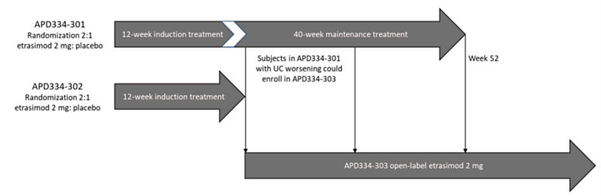

##### Key inclusion criteria

* Subjects were aged 16 to 80 years (inclusive)
* Subjects had a history of inadequate response[3] to, loss of response[4] to, or intolerance3 to ≥ 1 of:
  + Conventional therapy i.e., oral 5-ASA, corticosteroids and thiopurines; or
  + Biologic therapy, including TNFα antibodies, anti-integrin antibodies or anti-interleukin 12/23 antibodies; or
  + JAK inhibitor therapy.
* Diagnosed with UC ≥ 3 months prior to screening, confirmed by endoscopy & histology;
* Confirmation of moderately to severely active UC defined by a MMS of 4 to 9[5], which included endoscopic score (ES) ≥ 2 and rectal bleeding (RB) score ≥ 1; and
* Active UC confirmed by endoscopy with ≥ 10 cm rectal involvement.

##### Key exclusion criteria

* Diagnosis of severe extensive colitis, Crohn’s disease, or indeterminate colitis
* Hospitalisation for exacerbation of UC requiring multiple doses of IV steroids within 12 weeks of screening. NB: A single IV dose of steroids was permitted;
* Subjects had a condition or received treatment that may affect cardiovascular function;
* Forced expiratory volume in 1 second (FEV1) or forced vital capacity (FVC) < 70% predicted values and FEV1/FVC ratio < 0.70 at screening; and
* Treatment with ≥ 3 biologic agents or ≥ 2 biologics plus a JAK inhibitor for UC treatment.

###### Primary endpoints

* The proportion of subjects (with baseline MMS of 5 to 9) who achieved clinical remission at Week 12

###### Key secondary endpoints

* The proportion of subjects achieving endoscopic improvement at Week 12
* The proportion of subjects achieving symptomatic remission at Week 12
* The proportion of subjects with mucosal healing (MH) at Week 12

###### Endpoint definitions

* Clinical remission: Stool frequency (SF) subscore = 0 [or = 1 with a ≥ 1-point decrease from baseline], rectal bleeding (RB) subscore = 0, and endoscopy subscore (ES) ≤ 1 [excluding friability – only applicable to ES = 2 i.e., mild]
* Endoscopic improvement: Defined as: ES ≤ 1; excluding friability
* Symptomatic remission: Defined as: SF subscore = 0 [or = 1 with a ≥ 1 point decrease from baseline]; and RB subscore = 0
* Mucosal healing: defined as ES of ≤ 1 with histologic remission measured by a Geboes Index score < 2.0

***Comment:*** *Neither of the pivotal (a) induction and (b) maintenance studies (APD334-301 and APD334-302) used co-primary efficacy endpoints (to assess patient reported and endoscopic subscores), as recommended by the guidance (CHMP/EWP/18463/2006 Rev.1) adopted by the TGA. Of note the FDA recommends clinical remission as defined by the modified Mayo score as the primary endpoint for trials in UC. The sponsor has justified their use of one primary endpoint (clinical remission) as based on a hypothesis testing hierarchy to address differences in regional guidelines, considering the two co-primary endpoints recommended by the TGA guidance can only be achieved after passing the clinical remission endpoint. Their statistical approach which considers the endpoints in the type-1 error rate-controlled family showed consistent statistically significant superiority in favour of etrasimod when evaluating the short -term and long-term efficacy data. This justification is considered acceptable by the evaluator and the delegate.*

###### Statistical analyses

The primary efficacy analysis was performed for the full analysis set (FAS), with baseline Modified Mayo Score (MMS) 5 to 9, using the Cochran-Mantel-Haenszel method, at the 2-sided α level of 0.05. Patients were stratified according to disease activity and by the subject’s previous treatment and/or background treatment. The evaluator considered the sample size calculations and statistic methods acceptable.

###### Study population

Overall, the study population used in the induction studies were well characterised in regard to duration, disease activity, localisation and prior treatment. Adolescent subjects aged 16 years of age and 17 years of age were analysed within the adult population, with only three subjects were aged < 18 years (2 randomised to placebo, 1 randomised to ETR).

*APD334-301*: 821 persons were screened and 433 (52.7%) subjects were randomised (ETR 289, placebo 144). Of the 433 subjects randomised, 389 (89.8%) subjects completed Week 12 study treatment i.e., 124 (86.1%) subjects in the placebo group and 265 (91.7%) subjects in the ETR group, respectively. The discontinuation rates and reasons between the two groups were similar.

*APD334-302*: 606 persons were screened and 354 (58.4%) subjects were randomised (ETR 238, placebo 116). Of the 354 subjects randomised (ETR 238, placebo 116), 319 (90.1%) subjects completed 12-weeks of treatment, similarly distributed between treatment groups i.e., 89.9% ETR vs 90.5% placebo. There were small differences between the groups for study discontinuation rates and reasons (see ‘participant flow’ under ‘maintenance’).

##### Baseline demographics

Across both studies, most subjects were male (55.4% to 58.8%). Overall mean age on consent was 40.4 years (range 16 years to 78 years). One (0.2%) subject was < 18 years of age (in the placebo group) in *APD334-301* and 2 (0.6%) subjects were < 18 years of age (1 in each group) in *APD334-302*. Most subjects had left-sided colitis/proctosigmoiditis (59.0% to 65.5% overall), followed by pancolitis (32.3% to 33.3% overall). Overall median duration of UC was 4.6 to 4.7 years (range 0.0 to 37.9 years), and the overall median baseline total Mayo Clinic score was 9.0 (range 4.0 to 12.0).

Consistent with the inclusion criteria, all subjects (except for one subject in the ETR group in *APD334-*302) demonstrated an inadequate response to, loss of response to, or intolerance to at least 1 therapy for UC prior to study entry. About 62% of subjects in both studies were naïve to biologic or JAK inhibitor therapy. Across both studies, 40.2% to 45.7% of subjects had prior use of biologics (plus JAK inhibitors). Overall percentage of subjects with prior failure of 5-ASA only was 11.3% to 17.1%, and prior thiopurines was 36.3% and 39.0%. Overall percentage of subjects with prior corticosteroid use was 75.1% to 77.7%. Use of UC concomitant medications were well balanced between randomised treatment groups across both trials (88.8% in placebo and 92.9% in ETR in *ADP334-302*, 87.5% in placebo and 88.9% in ETR in *ADP334-301*).

Overall, the baseline demographic characteristics were balanced between treatment groups which reflected an adult population with moderate disease severity.

###### Primary efficacy outcomes

The proportion of subjects who achieved clinical remission at Week 12 was similar in the ETR groups across both studies (Table 3) with 27.0% (74/274) achieving clinical remission in *APD334-301*, and 24.8% (55/222) in *APD334-302*. These results were statistically significant. However, a higher placebo responder rate was observed in *APD334-302* (15.2%) compared to *APD334-301* (7.4%). The sponsor stated that differences in the proportion of subjects who achieved clinical remission at Week 12 in *APD334-302* were not attributable to any identified differences in baseline characteristics or demographics.

Table 3. Primary endpoints for APD334-301 and APD334-302

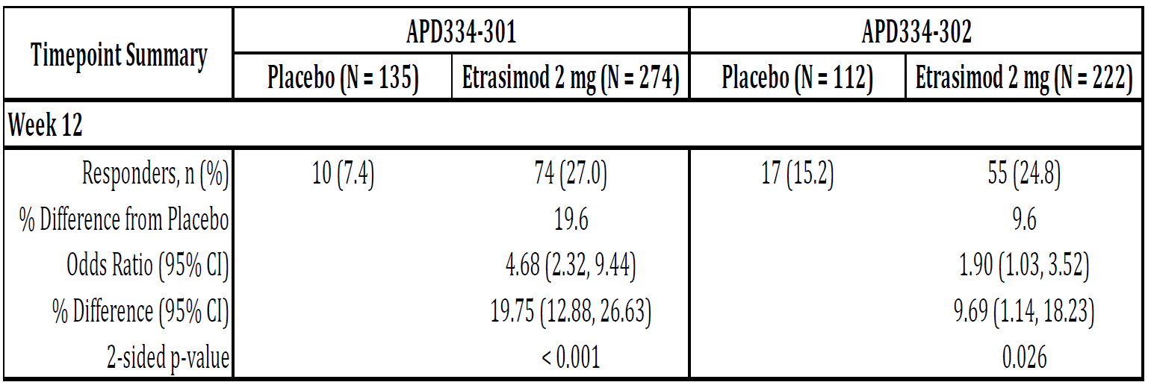

###### Secondary endpoints

All key secondary endpoints were met at week 12 across both pivotal phase III studies (Table 4). The proportion of subjects who achieved endoscopic improvement, symptomatic remission and MH were all significantly higher in subjects who received ETR 2 mg treatment compared to placebo treatment. The magnitude of the treatment differences between the ETR 2 mg once daily group and the placebo group were clinically meaningful.

Table 4. Key Secondary Endpoints at Week 12 (FAS with baseline MMS 5-9) for the pivotal induction studies

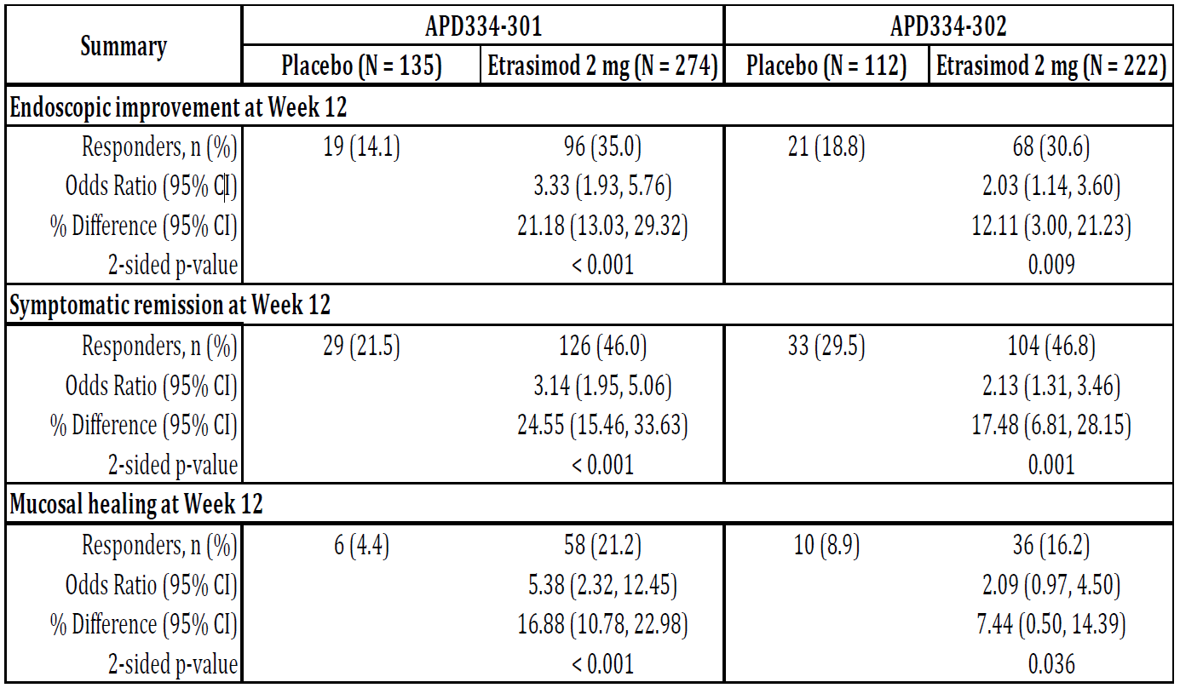

The results for other secondary endpoints across the two pivotal trials were all statistically significant and favoured the ETR 2mg group. These endpoints were: proportion of subjects achieving clinical response at week 12; proportion of subjects achieving endoscopic normalization at Week 12; proportion of subjects achieving symptomatic remission at Weeks 2, 4 and 8; proportion of subjects achieving complete symptomatic remission at each study visit; proportion of subjects achieving non-invasive clinical response at each study visit; and proportion of subjects achieving symptomatic response at each study visit.

###### Maintenance

A 52-week phase III RCT to assess efficacy and safety of ETR as maintenance therapy in patients with moderately to severely active UC was conducted (ADP334-301). Subjects were randomised in a 2:1 ratio to receive ETR 2 mg once daily or matching placebo once daily, for a 52-week treatment period in total. The main difference between the entry criteria in the induction and maintenance phases of treatment in APD334-301 was that for subjects on existing oral corticosteroid therapy the corticosteroid was tapered during the 40-week maintenance period but was continued during the 12-week induction period.

The primary endpoint was the proportion of subjects with (induction) baseline MMS of 5 to 9 who achieved clinical remission (as per induction definition) at Week 52. The key secondary endpoints were: endoscopic improvement (as per induction definition) at Week 52; symptomatic remission (as per induction definition) at Week 52; mucosal healing (as per induction definition) at Week 52; corticosteroid-free clinical remission (defined as clinical remission at Week 52 and who had not been receiving corticosteroids for ≥ 12 weeks immediately prior to Week 52); and sustained clinical remission (defined as clinical remission at both Weeks 12 and 52).

###### Sample size

Based on a 2-group Fisher’s exact test, a 1-sided significance level of 0.025, and a 2:1 randomisation ratio, 420 total subjects (280 ETR, 140 placebo) were required to provide 93.4% power to detect a difference of 13.5% in clinical remission at Week 52 between the ETR treatment group (23.5%) and the placebo treatment group (10.0%).

###### Participant flow

49.0% (n = 212) of subjects completed the study, with 57.4% (n = 166) of ETR subjects compared to 31.9% (n = 46) of placebo subjects. The main reasons for study discontinuation in the placebo group were disease worsening in 73 (50.7%) subjects, followed by ‘withdrawal by subject or parent/guardian’ in 10 (6.9%) subjects. The most common reasons for study discontinuation in the ETR group were ‘disease worsening’ in 79 (27.3%) subjects followed by ‘withdrawal by subject or parent/guardian’ in 17 (5.9%) subjects. Less than 4% subjects in any treatment group withdrew due to AEs.

###### Baseline demographics

The baseline demographics are as previously described in the induction phase.

###### Results

The primary endpoint was met (Table 5). The proportion of subjects treated with ETR who achieved clinical remission at Week 52 was greater than the corresponding group who achieved clinical remission at Week 12.

Table 5. Primary Endpoint at Week 52 (APD334-301; FAS with actual baseline MMS 5-9)

The Week 52 sub-group analyses of the primary endpoint were consistent with the corresponding Week 12 results except there was no meaningful difference between subjects who were naïve to prior biologic or JAK inhibitor therapies at study entry compared with those subjects who had prior exposure to biologic or JAK inhibitor therapies. The evaluator noted that sub-group analyses were not powered to detect meaningful differences between treatments. Furthermore, the results may be skewed from the high drop-out rates in both treatment arms.

All key secondary endpoints were met at Week 52 (Table 6). The proportion of subjects who achieved endoscopic improvement, symptomatic remission, mucosal healing and corticosteroid-free clinical remission at Week 52 was significantly greater in subjects who received ETR 2 mg compared to placebo (all p < 0.001).

Table 6. Key Secondary Endpoints at Week 52 (APD334-301; FAS with actual baseline MMS 5-9)

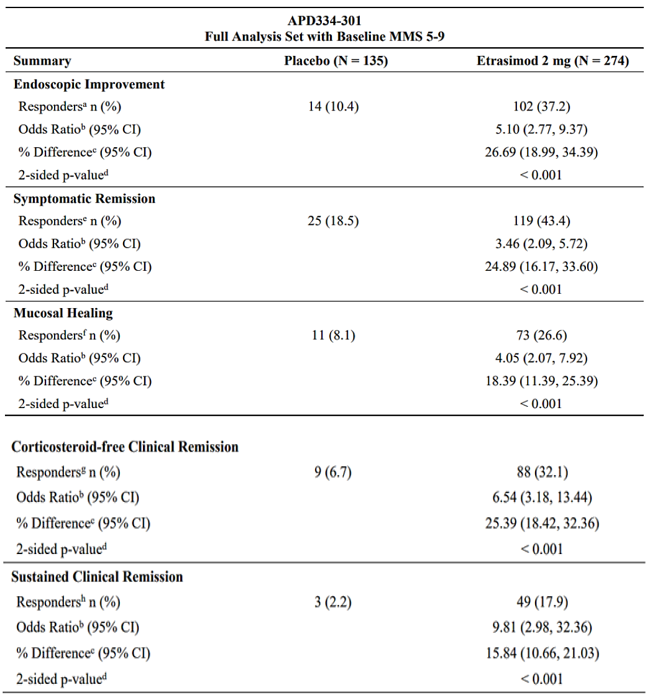

###### Other efficacy studies

###### Induction

*APD334-003* was a phase II, randomised, double-blind, placebo-controlled, parallel-group, multicentre, proof-of-concept and dose-finding study. The key inclusion criteria were male or female subjects aged between 18 and 80 years of age, inclusive, with moderately to severely active UC (formal diagnosis of ≥ 6 months prior to screening, defined as an MMS equivalent of 4 to 9, that included an ES of ≥ 2 and an RB score of ≥ 1), and who were in a stable health condition. Eligible subjects were randomly assigned in a 1:1: ratio to 1 of 3 treatment groups i.e., ETR 1 mg, ETR 2 mg or matching placebo, once daily for 12 weeks in a fasted state. Randomisation was stratified by presence or absence of current oral corticosteroid usage and prior exposure to TNFα antagonists. After study completion, eligible subjects could enrol in the 34-week OL extension study (*APD334-005*).

156 subjects were enrolled/randomised; 141 (90.4%) subjects completed the study. Patient demographic characteristics were comparable across the treatment groups: Mean age ranged from 40.4 years to 44.8 years and male (57.1% overall).

The primary efficacy population was the Modified ITT population, with multiple imputation. The primary endpoint of the change from baseline in the adapted Mayo Clinic score at week 12 was greatest for ETR 2mg group (-1.50, -1.94 and -2.49 for the placebo, ETR 1 mg and ETR 2 mg groups, respectively), with a statistically significant difference from placebo with ETR 2mg dose (P = 0.0091), whereas there was no difference between placebo and ETR 1mg dose (P = 0.1457). The secondary endpoint of endoscopic improvement was achieved in the ETR 2mg group compared to placebo (treatment difference was 24.4% (P = 0.0030)) but not for the ETR 1mg dose (treatment difference vs placebo of 4.1% (P = 0.3059)).

###### Maintenance

*ADP334-005* was a completed phase II, OLE study with the objective to evaluate the effect of ETR on achieving and maintaining clinical response and/or remission in subjects with UC after 46 weeks of treatment (12 weeks induction + 34 weeks OLE). The entry criteria consisted of male or female adult participants (18 to 80 years of age) with moderately to severely active UC who had completed *APD334-003*, the 12-week induction study. The treatment was OL ETR 2 mg once daily IR tablet for 34 weeks. 118 subjects were analysed (112 ETR; 6 placebo). The median age ranged from 45.0 to 53.0 years (Range: 20 years to 72 years). For the ETR group, enrolment was higher for males (60.7%).

The primary efficacy populations were the Modified ITT population and the completers population. The proportion of subjects who achieved a clinical response improved from 42.9% at Week 12 (*APD334-005* baseline) to 78.6% at end-of-trial (secondary endpoint), irrespective of treatment received in the parent study. The proportion of subjects who achieved a clinical remission improved from 21.4% at Week 12 (*APD334-005* baseline) to 39.3% at end-of-trial (secondary endpoint), irrespective of prior treatment received.

#### Safety

The overall exposure of ETR, irrespective of dose administered and indication, occurred in 1,107 individual subjects with 879.1 total subject-years of exposure. The 942 individual subjects with UC who were dosed with ETR 2 mg/day had a total exposure at the time of the data cut-off of 757.9 total subject-years of exposure.

The *Safety Analysis Set* included all randomised subjects who received at least 1 dose of study treatment. In the pivotal phase III studies, the Safety Analysis Sets were identical to the FAS populations. Other safety data sets included and evaluated were: *All UC Pool* (controlled and uncontrolled UC studies i.e., as above plus *APD334-005*; the OLE period of *APD334-003* and *APD334-303(an OLE of* *APD334-301 and APD334-302)*; and the OL period of *ES101002*), *Non-UC Pool (*2 phase II studies (atopic dermatitis [*APD334-201*] and alopecia areata [*APD334-205*]); the *All Indications Pool* (*All UC Pool* plus *Non-UC Pool*) and *Clinical pharmacology pool.*

###### Treatment emergent adverse events (TEAEs)

During the induction periods of controlled studies, the TEAEs considered related to ETR treatment in study *APD334-301* were dizziness (2.8% vs 0.0% for placebo, respectively); headache (1.7% vs 0.0% for placebo); and bradycardia (1.0% vs 0.0% for placebo). The TEAEs considered related to ETR in *APD334-302* were nausea and sinus bradycardia (each 1.7%; n = 4); abdominal distension (1.3%; n = 3); dizziness, liver disorder, somnolence and vomiting (each 0.8%; n = 2). The only TEAE related to ETR 2 mg/day that occurred with ≥ 1% frequency compared to placebo treatment for the maintenance period was for ALT increased (1.1%; EAIR 0.02 vs 0.0% for placebo treatment, respectively). Most ETR-related AEs appeared to occur in the first 12 weeks. No new safety concern was identified.

###### Serious adverse events (SAEs)

During induction for study *APD334-301*, there were 7 SAEs in the ETR 2 mg group and 3 SAEs in the placebo group. Most SAEs occurred in the ‘GI disorders’ and ‘Infections and infestations’ SOC categories. Most SAEs occurred as single events except for 2 events of ‘anaemia’ and ‘colitis ulcerative’ in the ETR 2 mg group (each 0.7%; EAIR 0.03) compared to zero events for ‘anaemia’ and 1 event for ‘colitis ulcerative’ (0.7%; EAIR 0.03) in the placebo group, respectively. During induction for study *APD334-302* SAEs were reported in 6 (2.5%) subjects in the ETR group compared to 2 (1.7%) subjects in the placebo group. Most SAEs (n = 3; 1.3%) were ‘colitis ulcerative’. All were severe and occurred in the ETR group, 2 of which led to study withdrawal. None were considered treatment-related*.*

There were 15 SAEs in the ETR 2 mg group and 7 SAEs in the placebo group during the 40-week maintenance interval. Most SAEs occurred in the GI disorders and Infections and infestations SOC categories. All SAEs occurred as single events except for ‘colitis ulcerative,’ which occurred in 4 (1.5%; EAIR 0.03) subjects in the ETR 2 mg group and 2 (1.5%; EAIR 0.04) subjects in the placebo group, respectively.

###### Adverse events of special interest

###### Hepatic events

In the *All UC Pool* within the Hepatobiliary disorder SOC category, 1.0% (n = 9) subjects in the ETR 2mg/day group experienced treatment-related hepatic AEs compared with 0.0% in placebo-treated subjects. Of these, 3 (0.3%) subjects experienced hepatic function abnormal and 2 (0.2%) subjects each experienced cholestasis, liver disorder and liver injury. No liver enzyme test abnormalities met Hy’s Law criteria, in any treatment group across the pivotal studies.

###### Haematological toxicity

Reductions in peripheral lymphocyte counts, including total lymphocytes, T and B cells, following treatment with ETR is considered an on-target PD effect and may be related to the mechanism by which ETR exerts its therapeutic effects in UC.

###### Electrocardiograph findings and cardiovascular safety

S1P receptor modulators have known dose-dependent cardiovascular effects, which include slowing of the HR and slowing of AV nodal conduction.

During induction in study *ADP334-301* the only cardiac-related AE that occurred in more than 1 subject across the entire treatment period was bradycardia (1.0% (n = 3) in the ETR group vs 0.0% in the placebo group). There was a reduction (−8.6 bpm) of mean ECG HR from 71.6 bpm at baseline to 63.1 bpm at 4 h post-dose after the first dose of ETR on Day 1, compared with no change in HR in the placebo group, at the same time-point. There was an average of 4.7 msec PR prolongation (at 4 h post-dose) after the first dose of ETR on Day 1 compared with placebo (-0.5 msec CFB), and there was a mild increase in the proportion of subjects with QTcF ≥ 450 msec (male) or ≥ 470 msec (female) in the ETR group (2.6%) compared to the placebo (0.0%) group at Day 1, at any post-dose. At Week 12, the mean ECG HRs, proportion of subjects with 1st degree AV block, and proportions of subjects with >30msec increase in baseline in QTcF were similar between the two treatment groups.

In study *ADP334-302*, there was a reduction (−7.9 bpm) of mean ECG HR from 71 bpm at baseline to 63 bpm at 4 h post-dose after the first dose of ETR on Day 1, compared with a 1.2 bpm increase in the placebo group, at the same time-point. There was an average of 5.6 msec PR prolongation (at 4 h post-dose) after the first dose of ETR on Day 1 compared with placebo. The proportion of subjects with 1st-degree AV blocks was greater in the ETR group at Day 1 any post-dose (9.9%) compared with 2.6% in the placebo group. However, there were more 1st degree AV blocks pre-dose in the ETR group (6.1%) compared with 3.5% in the placebo group. Mean QRS intervals were similar in both treatment groups. There were no meaningful CFB values observed on either Day 1 or Week 12. Additionally at Week 12, the mean ECG heart rates (HRs) and proportion of subjects in the ETR group with 1st degree AV block were similar to baseline values at week 12.

In the maintenance study, ECG findings at worst post-baseline were similar between the ETR and placebo groups. The mean ECG HRs were similar to baseline values between week 12 and week 52 for both treatment groups. The proportion of 1st-degree atrioventricular block was similar between the ETR group (6.8%) and the placebo group (7.7%) at Week 52 group.

###### Vital signs and clinical examination findings

During the induction studies, in *APD334-301* the by-time-point largest mean reduction CFB HR during the required 4-hour in-clinic monitoring period was −7.3 bpm at 3 h post-dose and −0.4 bpm at 4 h post-dose for the ETR and placebo groups, respectively, on Day 1. On Day 1, the mean HR at nadir was 63.5 bpm in the ETR group compared to 71.6 bpm in the placebo group, with corresponding mean CFB HR at nadir of −10.3 bpm in the ETR group and −4.2 bpm in the placebo group, respectively. The mean time to the minimum HR (i.e., nadir) on Day 1 in the ETR group was 2.51 h. There were 8 (2.8%) subjects in the ETR group whose minimum HR measurement was < 50 bpm at any post-dose time-point on Day 1 compared to no subjects in the placebo group. Of these 8 subjects, 1 had a decrease of HR > 10 bpm from baseline at Hour 4, but no subjects had a Day 1 minimum HR < 40 bpm. No subject required medication and none experienced TEAEs related to the first-dose effect.

In *APD334-302* the by-time-point largest mean reduction CFB HR was −7.3 bpm at 2 h post-dose and ˗0.1 bpm at 1 h post-dose for the ETR and placebo groups, respectively, on Day 1. The mean nadir HR was 63.9 bpm for the ETR group compared to 71.4 bpm for the placebo group. The mean time to the nadir HR on Day 1 in the ETR group was 2.46 h. The highest proportion of ETR-treated subjects with a HR < 55 occurred on Day 1 at Hour 2 post-dose (16.9%) and then decreased by Hours 3 and 4. No subjects had a Day 1 minimum HR < 40 bpm. Two subjects in the ETR group with HR < 50 bpm underwent Day 2 vital sign monitoring, both had a HR of < 50 bpm at any post-dose and were withdrawn from the study (HR returned to baseline in the Early Termination visit, a few of days after stopping the ETR treatment)

During induction, the mean changes in blood pressure measurements were minimal and similar between the ETR and placebo groups. There were no clinically relevant mean changes in respiratory rate and body temperature from baseline through to Week 12 for respiratory rate and body temperature measurements.

###### Malignancy

In the *All Indications Pool*, malignancies were reported for 3 (0.3% EAIR < 0.01) subjects in the ETR 2mg/day group (1 neuroendocrine tumour, 1 squamous cell carcinoma and 1 malignant melanoma, which was reported as a “melanocytic mole manifestation,” but was not confirmed as a malignancy) compared with 1 (0.3% EAIR < 0.01) subject in the placebo group (1 SCC). The neuroendocrine tumour was reported in *APD334-303* as an unrelated SAE, which led to the death of the subject as previously described. No malignancy events reported at the time of the data cut-off were considered treatment related or led to study discontinuation.

###### Serious or opportunistic infection

No events of progressive multifocal leukoencephalopathy or tuberculosis (TB) (or TB reactivation in latent subjects) were reported in the entire clinical program for ETR at the time of the data cut-off.

###### Death

One death was reported in the ETR clinical development program (from the *OLE period* of *APD334-303* in UC). A male subject in his 30s who initially received placebo before receiving ETR was diagnosed with neuroendocrine tumour of unknown primary origin. The SAE of neuroendocrine tumour was assessed as unlikely related to study treatment by the investigator and the evaluator agreed with this.

### Risk management plan evaluation summary

Table 5. Summary of Safety Concerns

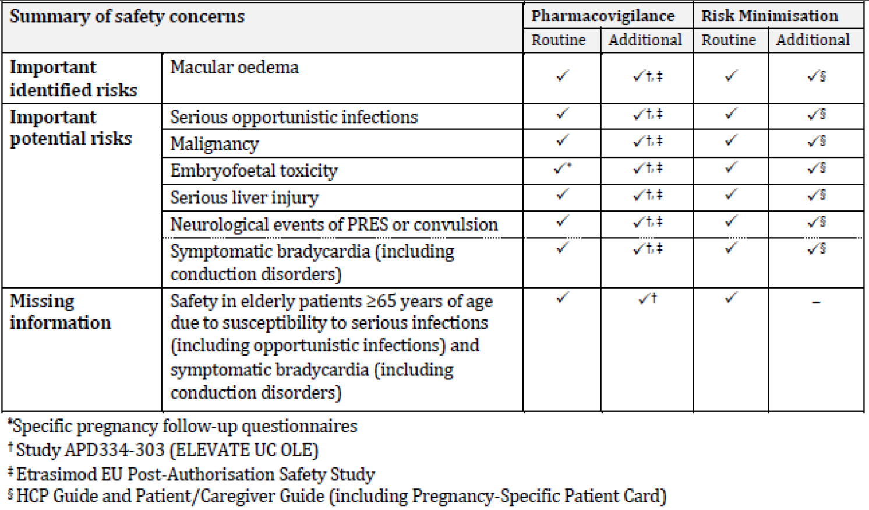

##### RMP evaluator recommendations regarding condition/s of registration

Any changes to which the sponsor has agreed should be included in a revised RMP and ASA. However, irrespective of whether or not they are included in the currently available version of the RMP document, the agreed changes become part of the risk management system.

The suggested wording is:

*The Velsipity EU-Risk Management Plan (RMP) (version 0.2, dated 02 August 2023; DLP 31 January 2022), with Australian Specific Annex (version 1.1, dated*

*20 October 2023), included with submission PM-2023-00714-1-1, and any subsequent revisions, as agreed with the TGA will be implemented in Australia.*

The following wording is recommended for the PSUR requirement:

*An obligatory component of risk management plans is routine pharmacovigilance. Routine pharmacovigilance includes the submission of periodic safety update reports (PSURs).*

*Unless agreed separately between the supplier who is the recipient of the approval and the TGA, the first report must be submitted to TGA no later than 15 calendar months after the date of this approval letter. The subsequent reports must be submitted no less frequently than annually from the date of the first submitted report until the period covered by such reports is not less than three years from the date of this approval letter. The annual submission may be made up of two PSURs each covering six months. If the sponsor wishes, the six monthly reports may be submitted separately as they become available.*

*If the product is approved in the EU during the three years period, reports can be provided in line with the published list of EU reference dates no less frequently than annually from the date of the first submitted report until the period covered by such reports is not less than three years from the date of this approval letter.*

*The reports are to at least meet the requirements for PSURs as described in the European Medicines Agency’s Guideline on good pharmacovigilance practices (GVP) Module VII-periodic safety update report (Rev 1), Part VII.B Structures and processes. Note that submission of a PSUR does not constitute an application to vary the registration. Each report must have been prepared within ninety calendar days of the data lock point for that report.*

As Velsipity is a new chemical entity it should be included in the Black Triangle Scheme as a condition of registration. The following wording is recommended for the condition of registration:

*Velsipity (etrasimod) is to be included in the Black Triangle Scheme. The PI and CMI for Velsipity must include the black triangle symbol and mandatory accompanying text for five years, which starts from the date of first supply of the product.*

## Risk/benefit assessment

##### Indication

The sponsor’s proposed indication for ETR is “the treatment of patients 16 years of age and older with moderately to severely active ulcerative colitis (UC) who have had inadequate response, loss of response or intolerance to conventional, biologic or janus kinase (JAK) inhibitor therapies”. Across both pivotal studies *ADP334-301* and *ADP334-302*, a total of only 3 subjects were aged <18 years old (2 randomised to placebo, 1 randomised to ETR).

It is noted that the sponsor had provided further information in the supplementary recommendation responses regarding the EMA and FDA applications to support the inclusion of the adolescent population. The sponsor highlighted that the CHMP did not provide a guidance on the minimum number of adolescent subjects required to be included in the pivotal studies in the responses to the evaluation. However, the delegate is of the view that having only one adolescent subject who received the treatment drug in the pivotal trials causes uncertainty regarding the efficacy and safety of ETR for the adolescent population. The sponsor’s response also detailed that the FDA advised the sponsor that since there was only one adolescent patient who received etrasimod in the pivotal studies, the FDA review would focus on the results of analyses in adults only in the “FDA Preferred Analysis Population.”

##### Efficacy

The two pivotal trials reached the primary and secondary endpoints. The primary endpoint of clinical remission at week 12 was met in a similar proportion of subjects in both studies. Efficacy was satisfactorily demonstrated (27.0% (74/274) for ETR vs 7.4% (10/135) for placebo in *ADP334-301*, P<0.001; 24.8% (55/222) for ETR vs 15.2% (17/112) for placebo in *ADP334-302,* P=0.026). All key secondary efficacy endpoints were met across both studies at week 12. In the maintenance study, the primary endpoint of the proportion of subjects treated with ETR who achieved clinical remission at Week 52 was greater than the corresponding group who achieved clinical remission at Week 12 and favourable compared to placebo (32.1% vs 6.7%, P<0.001). All secondary endpoints were met in the maintenance study and efficacy was satisfactorily demonstrated.

##### Safety

Overall ETR displayed a similar safety profile of known S1P modulators. ETR, like other S1P modulators, can cause a negative chronotropic effect that is greatest at drug initiation. This effect for ETR needs to be considered in comparison to other S1P modulators including ozanimod that is already used in UC. The product information recommends a baseline electrocardiogram for patients prior to ETR initiation, as well as certain criteria where advice from a cardiologist should be sought. However, there is no advice for any further cardiac monitoring, which needs to be considered in the context of potentially asymptomatic presentations of clinically significant arrhythmias and the magnitude of the negative chronotropic effect of ETR.

##### Conclusions

Pending advice from the Advisory Committee for Medicines, I propose to approve the registration of ETR for the following indication, subject to conditions as recommended by the clinical and risk management plan evaluators and agreement on an appropriate PI:

“*For the treatment of adult patients with moderately to severely active ulcerative colitis who have had an inadequate response, lost response, or were intolerant to either conventional therapy or a biological therapy*.”

#### Advisory Committee considerations

The [Advisory Committee on Medicines (ACM)](https://www.tga.gov.au/committee/advisory-committee-medicines-acm), having considered the evaluations and the delegate’s overview, as well as the sponsor’s response to these documents, advised the following.

What is the viewpoint of the Committee regarding the inclusion of the adolescent population in the proposed indication for the treatment of UC based on the efficacy and safety data presented?

The ACM noted that the safety of etrasimod in an older adolescent population (aged between 16 years to 18 years) was not well characterised in the pivotal studies due to the small number of subjects in this age group (only 3 participants across the 2 pivotal studies, with 2 randomised to placebo and 1 randomised to etrasimod). However, a PopPK simulation that compared model-predicted PK metrics in adults (≥ 18-years-old) and older adolescents (16 to < 18-years-old) with UC showed negligible differences. The ACM also acknowledged the significant burden of this condition in this age group and a high unmet clinical need. On balance from a clinical perspective the ACM was supportive of including the adolescent population in the indication however acknowledged the significant clinical trial limitations for this age range.

What is the opinion of the Committee regarding the risk of bradyarrhythmia in the use of etrasimod, particularly with the lack of a dose titration regimen for the initiation of etrasimod? Dose titration is typically done for initiating certain S1P agonists (i.e. ozanimod), or cardiac monitoring (i.e. fingolimod).

The ACM did not express concern regarding the lack of a dose-titration regimen for the initiation of etrasimod. The ACM noted that in Study APD334-110 a 6-day dose escalation was performed (etrasimod 0.25 mg once daily to etrasimod 2 mg once daily) which did not meaningfully mitigate the first dose effect on heart rate reduction (an effect that is likely independent of the does administered) but merely delayed its onset. The ACM was therefore of the opinion that it was more favourable for the bradycardia to manifest in its entirety within day 1 post-treatment rather than over a period of several days, obviating the need for dose titration.

The ACM acknowledged that the bradyarrhythmia risk in the use of etrasimod is a real phenomenon and related to the mechanism of action of the drug (despite only one such temporary adverse event observed in the trials).

What is the opinion of the Committee regarding the resting heart rate of less than 50 beats per minute (bpm) as the threshold to seek advice from a cardiologist before starting etrasimod (as stated in the product information)? Is a threshold of less than 60 bpm more appropriate?

The ACM was of the view that a resting heart rate of less than 50 bpm is an appropriate threshold to seek advice from a cardiologist before starting etrasimod. In providing this advice the ACM noted that jurisdictions where etrasimod is already approved, employ a threshold of 50 bpm. This is consistent with the trial data presented. In addition, the American College of Cardiology practice guidelines defines sinus node dysfunction as a sinus rate of less than 50 bpm.

The ACM made the following recommendations/comments regarding the PI:

* The ACM agreed that, as stated in the PI, an ECG should be performed on all patients prior to treatment with etrasimod and that etrasimod is contraindicated for patients with a 2nd or 3rd degree heart block.
* The ACM agreed with the following list of conditions outlined in the PI that stipulate when advice from a cardiologist should be sought prior to etrasimod treatment:
  + With significant QT prolongation (QTcF ≥ 450 msec in males, ≥ 470 msec in females)
  + With arrhythmias requiring treatment with Class Ia or Class III anti-arrhythmic drugs
  + With ischemic heart disease, heart failure, history of cardiac arrest, cerebrovascular disease, or uncontrolled hypertension
  + With resting heart rate of less than 50 bpm
  + With history of symptomatic bradycardia, recurrent cardiogenic syncope, or severe untreated sleep apnoea
  + With history of Mobitz type I second-degree AV block, unless the patient has a functioning pacemaker.
* The ACM expressed concern with the PI statement ‘temporary interruption may be needed of beta-blockers or other antiarrhythmic,’ given that cessation of beta-blockers can lead to complications, such as in a patient with angina which may lead to rebound angina. The ACM noted that there was no evidence of patients ceasing beta blockers prior to etrasimod treatment presented in the trial data with no information presented on whether any recruited patients had indeed been on an antiarrhythmic.
* The ACM suggested this alternative statement ‘monitoring of heart rate (HR), blood pressure (BP) and ECG for first 4 hours after first dose is reasonable/ advisable in an individual on HR lowering medications such as beta blockers or calcium channel blockers. In addition, the EU and Canadian PIs advise monitoring for the first 4 hours post-etrasimod administration in patients who have had a past myocardial infarction, heart failure, a second-degree atrioventricular block Type I or a heart rate less than 50 bpm. The ACM recommend that this statement also be included in the Australian PI.

#### ACM conclusion

The ACM opinion was mixed regarding the inclusion of the adolescent age group 16 to 18 years old, however, on balance, the ACM considered Velsipity to have an overall positive benefit-risk profile for the indication:

Velsipity is indicated for the treatment of patients 16 years and older with moderately to severely active ulcerative colitis who have had inadequate response, loss of response or intolerance to conventional, biologic or Janus kinase (JAK) inhibitor therapies.

## Outcome

Based on a review of quality, safety, and efficacy, the TGA decided to register Velsipity (etrasimod) for the following indication:

Velsipity is indicated for the treatment of adults with moderately to severely active ulcerative colitis (UC) who have had inadequate response, loss of response or intolerance to conventional, biologic or Janus kinase (JAK) inhibitor therapies.

#### Specific conditions of registration applying to these goods

Velsipity (etrasimod) is to be included in the Black Triangle Scheme. The PI and CMI for Velsipity must include the black triangle symbol and mandatory accompanying text for five years, which starts from the date of first supply of the product.

The Velsipity EU-Risk Management Plan (RMP) (version 0.2, dated 02 August 2023;DLP 31 January 2022), with Australian Specific Annex (version 1.1, dated 20 October2023), included with submission PM-2023-00714-1-1, and any subsequent revisions, as agreed with the TGA will be implemented in Australia.

An obligatory component of risk management plans is routine pharmacovigilance. Routine pharmacovigilance includes the submission of periodic safety update reports (PSURs).

Unless agreed separately between the supplier who is the recipient of the approval and the TGA, the first report must be submitted to TGA no later than 15 calendar months after the date of this approval letter. The subsequent reports must be submitted no less frequently than annually from the date of the first submitted report until the period covered by such reports is not less than three years from the date of this approval letter. The annual submission may be made up of two PSURs each covering six months. If the sponsor wishes, the six monthly reports may be submitted separately as they become available.

If the product is approved in the EU during the three years period, reports can be provided in line with the published list of EU reference dates no less frequently than annually from the date of the first submitted report until the period covered by such reports is not less than three years from the date of this approval letter.

The reports are to at least meet the requirements for PSURs as described in the European Medicines Agency’s Guideline on good pharmacovigilance practices (GVP) Module VII-periodic safety update report (Rev 1), Part VII.B Structures and processes. Note that submission of a PSUR does not constitute an application to vary the registration. Each report must have been prepared within ninety calendar days of the data lock point for that report.

## Attachment 1. Product Information

The [Product Information](https://www.tga.gov.au/products/australian-register-therapeutic-goods-artg/product-information-one) ([PI](https://www.tga.gov.au/products/australian-register-therapeutic-goods-artg/product-information-one)) approved with the submission for Velsipity which is described in this AusPAR can be found as Attachment 1. It may have been superseded. For the most recent PI and [Consumer Medicines Information](https://www.tga.gov.au/products/australian-register-therapeutic-goods-artg/consumer-medicines-information-cmi) (CMI), please refer to the TGA [PI/CMI search facility.](https://www.tga.gov.au/picmi-search-facility)

|  |
| --- |
| Therapeutic Goods Administration |
| PO Box 100 Woden ACT 2606 Australia  Email: [info@tga.gov.au](mailto:info@tga.gov.au) Phone: 1800 020 653 Fax: 02 6203 1605  [**https://www.tga.gov.au**](https://www.tga.gov.au) |
|  |

1. Cohen, R.F., Stein, A.C. Management of moderate to severe ulcerative colitis in adults. Management of moderate to severe ulcerative colitis in adults. 2021. <https://www.uptodate.com/contents/management-of-moderate-to-severe-ulcerative-colitis-in-adults>.
2. The ‘delegate’ is the delegate of the Secretary of the Department of Health and Aged Care who made the final decision to either include the new medicine/indication on the ARTG or reject the submission, under section 25 of the Therapeutic Goods Act
3. Signs and symptoms of persistently active disease despite a history of completing a dosing regimen
4. Recurrence of symptoms of active disease during treatment following prior clinical benefit.
5. *Both the US Food and Drug Administration (FDA) and the European Medicines Agency (EMA) defined patients with moderately to severely active UC typically with an MMS of 5 to 9 i.e., MMS 5 to 7 = moderate UC and MMS > 7 = severe UC. This became the primary analysis in the pivotal studies, with supplementary analyses evaluated in all subjects with an MMS from 4 to 9.