|  |
| --- |
| Australian Public Assessment Report for Wegovy |
| Active ingredient: Semaglutide |
| Sponsor: Novo Nordisk Pharmaceuticals Pty Ltd |
| July 2024 |

About the Therapeutic Goods Administration (TGA)

* The Therapeutic Goods Administration (TGA) is part of the Australian Government Department of Health and Aged Care and is responsible for regulating therapeutic goods, including medicines, medical devices, and biologicals.
* The TGA administers the *Therapeutic Goods Act 1989* (the Act), applying a risk management approach designed to ensure therapeutic goods supplied in Australia meet acceptable standards of quality, safety, and efficacy.
* The work of the TGA is based on applying scientific and clinical expertise to decision-making, to ensure that the benefits to the Australian public outweigh any risks associated with the use of therapeutic goods.
* The TGA relies on the public, healthcare professionals and industry to report problems with therapeutic goods. The TGA investigates reports received to determine any necessary regulatory action.
* To report a problem with a therapeutic good, please see the information on the [TGA website](https://www.tga.gov.au/).

About AusPARs

* The Australian Public Assessment Report (AusPAR) provides information about the evaluation of a prescription medicine and the considerations that led the TGA to approve or not approve a prescription medicine submission. Further information can be found in [Australian Public Assessment Report (AusPAR) guidance](https://www.tga.gov.au/australian-public-assessment-report-auspar-guidance).
* AusPARs are prepared and published by the TGA.
* AusPARs are static documents that provide information that relates to a submission at a particular point in time. The publication of an AusPAR is an important part of the transparency of the TGA’s decision-making process.
* A new AusPAR may be provided to reflect changes to indications or major variations to a prescription medicine subject to evaluation by the TGA.

Copyright

© Commonwealth of Australia 2024  
This work is copyright. You may reproduce the whole or part of this work in unaltered form for your own personal use or, if you are part of an organisation, for internal use within your organisation, but only if you or your organisation do not use the reproduction for any commercial purpose and retain this copyright notice and all disclaimer notices as part of that reproduction. Apart from rights to use as permitted by the *Copyright Act 1968* or allowed by this copyright notice, all other rights are reserved and you are not allowed to reproduce the whole or any part of this work in any way (electronic or otherwise) without first being given specific written permission from the Commonwealth to do so. Requests and inquiries concerning reproduction and rights are to be sent to the TGA Copyright Officer, Therapeutic Goods Administration, PO Box 100, Woden ACT 2606 or emailed to <[tga.copyright@tga.gov.au](mailto:tga.copyright@tga.gov.au)>.

Contents

List of abbreviations 4

Wegovy (Semaglutide) submission 5

Wegovy (semaglutide) – proposed indication 7

Obesity 7

Current treatment options for obesity 8

Clinical rationale for Wegovy use in obesity 9

Regulatory status 9

Australian regulatory status 9

International regulatory status 9

Registration timeline 10

Evaluation overview 10

Quality evaluation summary 10

Nonclinical (toxicology) evaluation summary 11

Clinical evaluation summary 11

Summary of clinical studies 11

Pharmacology 12

Efficacy 15

Safety 18

Risk management plan evaluation summary 25

Risk-benefit analysis 26

Pharmacology and formulations 26

Efficacy 27

Safety 29

Conclusion and remaining issues 30

Advisory Committee on Medicines considerations 30

Outcome 31

Specific conditions of registration applying to these goods 31

Attachment 1. Product Information 31

Appendix 32

### List of abbreviations

|  |  |
| --- | --- |
| Abbreviation | Meaning |
| AE | Adverse event |
| ARTG | Australian Register of Therapeutic Goods |
| AUC | Area under the curve |
| BMI | Body mass index |
| CI | Confidence interval |
| CL/F | Apparent clearance |
| Cmax | Maximum concentration |
| DEXA | Dual-energy X-ray absorptiometry |
| DXA | DEXA analysis set |
| GLP-1 | Glucagon-like peptide-1 |
| GLP-1 RA | Glucagon-like peptide-1 receptor antagonist |
| HDL | High-density lipoprotein |
| LDL | Low-density lipoprotein |
| PK | Pharmacokinetics |
| RMP | Risk management plan |
| SAE | Serious adverse event |
| SBP | Systolic blood pressure |
| STEP | Semaglutide Treatment Effect in People with obesity |
| T2DM | Type 2 diabetes mellitus |
| t½ | Terminal half-life |
| TEAE | Treatment-emergent adverse event |
| Tmax | Time to maximum concentration |
| Vss/F | Apparent volume of distribution at steady state |

## Wegovy (Semaglutide) submission

|  |  |
| --- | --- |
| *Type of submission:* | Extension of indications |
| *Product name:* | Wegovy |
| *Active ingredient:* | Semaglutide |
| *Decision:* | Approved |
| *Approved therapeutic use for the current submission:* | *Wegovy is indicated as an adjunct to a reduced-energy diet and increased physical activity for chronic weight management (including weight loss and weight maintenance) in adults with an initial Body Mass Index (BMI) of:*  *• ≥30 kg/m2 (obesity), or*  *• ≥27 kg/m2 to <30 kg/m2 (overweight) in the presence of at least one weight-related comorbidity (see Section 5.1 of the Product Information document: Pharmacodynamic Properties – Clinical trials).’* |
| *Date of entry onto ARTG:* | 1 September 2022 |
| *ARTG numbers:* | [356286](https://www.tga.gov.au/resources/artg/356286) , [356285](https://www.tga.gov.au/resources/artg/356285), [356288](https://www.tga.gov.au/resources/artg/356288), , [356270](https://www.tga.gov.au/resources/artg/356270), [356287](https://www.tga.gov.au/resources/artg/356287) |
| [*Black Triangle Scheme*](https://www.tga.gov.au/black-triangle-scheme) | Yes |
| *Sponsor’s details:* | Novo Nordisk Pharmaceuticals Pty Limited Level 10, 118 Mount Street, North Sydney, NSW 2060, Australia. |
| *Dose form:* | Clear and colourless isotonic solution (pH=7.4) for injection in pre-filled pen. |
| *Strength:* | 0.25 mg dose pen: One mL of solution contains 0.5 mg of semaglutide. One pre-filled pen contains 0.25 mg semaglutide in 0.5 mL  0.5 mg dose pen: One mL of solution contains 1 mg of semaglutide. One pre-filled pen contains 0.5 mg semaglutide in 0.5 mL  1 mg dose pen: One mL of solution contains 2 mg of semaglutide. One pre-filled pen contains 1.0 mg semaglutide in 0.5 mL  1.7 mg dose pen: One mL of solution contains 2.27 mg of semaglutide. One pre-filled pen contains 1.7 mg semaglutide in 0.75 mL  2.4 mg dose pen: One mL of solution contains 3.2 mg of semaglutide. One pre-filled pen contains 2.4 mg of semaglutide in 0.75 mL |
| *Container:* | The primary packaging contains a 1 ml glass syringe (Type I glass) with attached stainless-steel needle, rigid needle shield (Type II/polyisoprene) and a rubber plunger (Type I/chlorobutyl). |
| *Pack size:* | For all strengths, 2 or 4 pre-filled pens per pack. |
| *Route of administration:* | Wegovy is to be injected subcutaneously in the abdomen, in the thigh or in the upper arm. |
| *Dosage:* | The maintenance dose of 2.4 mg once-weekly is reached by starting with a dose of 0.25 mg (Table 1):  Table 1. Wegovy dose escalation schedule    For further information regarding dosage, such as dosage modifications to manage adverse reactions, refer to the [Product Information](https://www.ebs.tga.gov.au/). |
| *Pregnancy category:* | **D**  Semaglutide should not be used during pregnancy. Women of childbearing potential are recommended to use contraception when treated with semaglutide. If a patient wishes to become pregnant, or pregnancy occurs, semaglutide should be discontinued. Semaglutide should be discontinued at least 2 months before a planned pregnancy due to the long half-life.  The use of any medicine during pregnancy requires careful consideration of both risks and benefits by the treating health professional. The [pregnancy database](https://www.tga.gov.au/products/medicines/find-information-about-medicine/prescribing-medicines-pregnancy-database) must not be used as the sole basis of decision making in the use of medicines during pregnancy. The TGA does not provide advice on the use of medicines in pregnancy for specific cases. More information is available from [obstetric drug information services](https://www.tga.gov.au/obstetric-drug-information-services) in your state or territory. |

### Wegovy (semaglutide) – proposed indication

This AusPAR describes the submission by Novo Nordisk Pharmaceuticals Pty Limited (the Sponsor) to register Wegovy (semaglutide) for the following proposed extension of indications:[1]

*Wegovy is indicated as an adjunct to a reduced-energy diet and increased physical activity for chronic weight management (including weight loss and weight maintenance) in adults with an initial Body Mass Index (BMI) of:*

*• ≥30 kg/m2 (obesity), or*

*• ≥27 kg/m2 to <30 kg/m2 (overweight) in the presence of at least one weight-related comorbidity (see Section 5.1 of the Product Information document: Pharmacodynamic Properties – Clinical trials).*

This is a Category 1, Type C (extension of indication) application for Wegovy (semaglutide) 0.25 mg (0.5 mg/mL), 0.5 mg (1.0 mg/mL), 1.0 mg (2.0 mg/mL), 1.7 mg (2.27 mg/mL) and 2.4 mg (3.2 mg/mL), solution for injection, single use prefilled pen with pre-assembled needle.

The application is to extend the indications for semaglutide to include management of obesity. The new indication is intended to be registered with a new trade name (Wegovy), new strengths and a new dosage delivery system (a single use prefilled pen with pre-assembled needle).

### Obesity

Obesity is a common condition with high associated morbidity and mortality. Body mass index (BMI) is used as a surrogate measure of being overweight and obese:

* 25.0 to 29.9 kg/m2 is classified as overweight but not obese
* ≥30.0 kg/m2 is classified as obese.
* >35.0 kg/m2 is classified as severely obese.

These definitions of obesity and overweight align with the World Health Organisation definitions.

BMI is a composite measure of weight and height:

$$BMI=\frac{body weight (kg)}{{(height \left[cm\right])}^{2}}$$

Hence, this measure is not a direct measure of adiposity, but is a surrogate measure. Hence, these definitions may not apply to a highly muscled individual or to children and adolescents. Interpretation of BMI may vary between ethnic groups. Waist circumference in adults may be a better measure of adiposity and a better measure of obesity-related morbidity.

The Australian Institute of Health and Welfare[2] reports that in 2017–18, an estimated 2 in 3 (67%) Australians aged 18 and over were overweight or obese, 36% were overweight but not obese, and 31% were obese. This equates to approximately 12.5 million adults in Australia. The prevalence of overweight and obesity was higher in males (75% compared to 60% in females) and also the prevalence of obesity was higher in males (33% compared to 30% in females). Obesity is more prevalent in older age groups: 16% of adults aged 18–24 compared with 41% of adults aged 65 to 74 years.

Obesity is associated with increased prevalence of cardiovascular disease, hypertension, type 2 diabetes mellitus (T2DM) and metabolic syndrome, non-alcoholic fatty liver disease, cholelithiasis, cancer, sleep apnoea, osteoarthritis and reduced psychosocial function. Overall, obesity is associated with increased mortality, increased morbidity and decreased quality of life.[3]

It has been estimated that in 2015 high BMI accounted for 4.0 million deaths globally, representing 7.1% of deaths from any cause, and 120 million disability-adjusted life-years, representing 4.9% of disability adjusted life-years. More than two thirds of deaths related to high BMI were due to cardiovascular disease.[4]

### Current treatment options for obesity

* **Lifestyle modification:** diet and exercise with or without psychological support
* **Pharmacological treatments:**
  + Orlistat: a selective inhibitor of pancreatic lipase, resulting in decreased absorption of fat. Orlistat is a Schedule 3 drug in Australia and is available over the counter.
  + Liraglutide: a GLP-1 agonist
  + Phentermine: sympathomimetic agent with anorectic actions.
  + Naltrexone/bupropion is approved for the following indication in Australia:

“”Contrave (naltrexone/bupropion) is indicated, as an adjunct to a reduced-calorie diet and increased physical activity, for the management of weight in adult patients (≥18 years) with an initial BMI of:

≥ 30 kg/m2 (obese) or

≥ 27 kg/m2 to < 30 kg/m2 (overweight) in the presence of one or more weight-related comorbidities (e.g., type 2 diabetes, dyslipidaemia, or controlled hypertension).

Treatment with Contrave should be discontinued after 16 weeks if patients have not lost at least 5% of their initial body weight.”

* Pharmacological treatments not approved in Australia:
  + Phentermine/topiramate: is approved in the US for weight control. Topiramate is associated with weight loss due to an unknown mechanism (approved in the US).
  + Lorcaserin: an appetite suppressant through activation of hypothalamic 5-HT2C receptors (approved in the US).
* **Bariatric surgery:** usually reserved for patients with severe obesity with considerable peri-operative and post-operative morbidity.

### Clinical rationale for Wegovy use in obesity

Semaglutide is a glucagon-like peptide-1 receptor agonist (GLP-1 RA) with a 94% homology to human GLP-1. Both native GLP-1 and GLP-1 RAs reduce body weight by lowering energy intake via inducing feelings of satiety and fullness, and lowering feelings of hunger.

### Regulatory status

#### Australian regulatory status

Ozempic (semaglutide) solution for injection (intended for subcutaneous administration) was approved in Australia on 28 August 2019 for the identical indication of:

*Ozempic is indicated for the treatment of adults with insufficiently controlled type 2 diabetes mellitus as an adjunct to diet and exercise:*

* *as monotherapy when metformin is not tolerated or contraindicated.*
* *in addition to other medicinal products for the treatment of type 2 diabetes.*

Rybelsus (in its semaglutide (rys) tablet form for oral administration) was approved in Australia on 22 October 2022 for the management of Type 2 diabetes.

A comparison of Wegovy with the currently registered Ozempic solution is shown in **Error! Reference source not found.**. The differences in the composition of the new formulation *cf.* the old formulation includes the use of sodium chloride as a tonicity agent instead of propylene glycol, and the removal of phenol (preservative).

#### International regulatory status

##### EMA (Europe)

***Adults***

Wegovy is indicated as an adjunct to a reduced-calorie diet and increased physical activity for weight management, including weight loss and weight maintenance, in adults with an initial BMI of:

≥30 kg/m2 (obesity), or

≥27 kg/m2 to <30 kg/m2 (overweight) in the presence of at least one weight-related comorbidity e.g. dysglycaemia (prediabetes or type 2 diabetes mellitus), hypertension, dyslipidaemia, obstructive sleep apnoea or cardiovascular disease.

***Adolescents (>12 years)***

Wegovy is indicated as an adjunct to a reduced-calorie diet and increased physical activity for weight management in adolescents ages 12 years and above with obesity (BMI ~5th percentile) as defined on sex- and age-specific BMI growth charts) body weight above 60 kg.

Treatment with Wegovy should be discontinued and re-evaluated if adolescent patients have not reduced their BMI by at least 5% after 12 weeks on the 2.4 mg or maximum tolerated dose.

##### FDA (USA)

Wegovy is indicated as an adjunct to a reduced calorie diet and increased physical activity for chronic weight management in

adults with an initial BMI of:

* 30 kg/m2 or greater (obesity) or
* 27 kg/m2 or greater ( overweight) in the presence of at least one weight-related comorbid condition ( e.g., hypertension, type 2 diabetes mellitus, or dyslipidaemia)

paediatric patients aged 12 years and older with an initial BMI at the 95th percentile or greater standardized for age and sex (obesity)

### Registration timeline

This submission was evaluated under the [standard prescription medicines registration process](https://www.tga.gov.au/how-we-regulate/supply-therapeutic-good-0/supply-prescription-medicine/application-process/prescription-medicines-registration-process).

Table 2 captures the key steps and dates for this submission.

Table 1: Registration timeline for Wegovy (submission no. PM-2021-00612-1-5) – Key Dates.

|  |  |
| --- | --- |
| Description | Date |
| Submission dossier accepted and first round evaluation commenced | 31 March 2021 |
| First round evaluation completed | 31 August 2021 |
| Second round evaluation completed | 27 October 2021 |
| Delegate’s[5] Overall benefit-risk assessment and request for Advisory Committee advice | 4 January 2022 |
| Sponsor’s pre-Advisory Committee response | 17 January 2022 |
| Advisory Committee meeting | 18 February 2022 |
| Registration decision (Outcome) | 25 March 2022 |
| Administrative activities and registration in the ARTG completed | 1 September 2022 |
| Number of working days from submission dossier acceptance to registration decision* | 365 |

*Statutory timeframe for standard submissions is 255 working days

## Evaluation overview

### Quality evaluation summary

The active ingredient in Wegovy (semaglutide) was approved by the TGA[6] and is the active ingredient in Ozempic, which is manufactured by the same Sponsor. The drug substance (DS) manufacturing process remains unchanged for Wegovy. The Sponsor did not provide a DS package and instead referred to Ozempic for the details regarding DS manufacture. This quality evaluation focused only on the drug product (DP).

The Wegovy DP manufacturing process is divided into formulation, filling and inspection. All manufacturing steps were validated.

For all DP strengths, the specifications (covering physicochemical properties, potency and purity) were acceptable and all analytical procedures related to specification assessment were validated.

Stability data were generated under stressed and real-time conditions to characterise the stability profile of the product. Photostability data indicate the DP is not photostable. The real time stability data support a shelf life of 2 years when stored at 2-8°C. In-use stability data support the in-use stability of 28 days when stored below 30°C.

There were no objections to the registration of the DP with respect to sterility, endotoxin contamination, container safety/compatibility and viral safety-related aspects.

The Product Information (PI) document is finalised from quality perspective.

The Product Labelling has been finalised and complies with the applicable requirements of Therapeutic Goods Order 91.

The quality information submitted by the Sponsor supported the registration of Wegovy.

### Nonclinical (toxicology) evaluation summary

The submitted nonclinical dossier was generally acceptable. No major deficiencies were identified.

Two primary pharmacology studies were submitted. Semaglutide is a GLP-1 receptor agonist, which is a physiological regulator of appetite and caloric intake. The GLP-1 receptor is present in several areas of the brain involved in appetite regulation. Animal studies showed that semaglutide distributed to and activated neurons in brain regions involved in regulation of food intake, and therefore support the new indication.

There are no new safety concerns associated with the higher systemic exposures expected with the higher strength formulation of semaglutide (as Wegovy), and overall, no nonclinical objections to registration.

### Clinical evaluation summary

#### Summary of clinical studies

The Sponsor submitted the following studies (that had not previously been submitted to the TGA as part of other semaglutide submissions) for evaluation:

* 3 clinical pharmacology trials (2 of which were bioequivalence trials): Studies NN9536-4590, NN9535-4588, and NN9536-4455
* 1 Phase 2 dose-finding trial: Study NN9536-4153
* 2 PKPD modelling reports (based on Phase 2 data, and STEP 1 and 2 studies)
* 4 Phase 3a therapeutic confirmatory trials (STEP trials): Studies NN9536-4373 (STEP 1), NN9536-4374 (STEP 2), NN9536-4375 (STEP 3), and NN9536-4376 (STEP 4)

#### Pharmacology

##### Pharmacokinetics

Wegovy (semaglutide) is intended for subcutaneous administration. Semaglutide formulation D with the single-dose pen-injector (DV3396) appears to be the formulation intended for marketing. The pharmacokinetic studies were performed in populations typical of those intended for marketing in Australia.

###### Absorption

Absolute bioavailability was 89% (NN9535-3687).

Mean Tmax (SD) was 21.3 (14.90) h for formulation D and 64.5 (16.84) h for Formulation B (NN9535-4588). In NN9536-4590, median (range) Tmax was 24 (3 to 48) h for Formulation D.

###### Distribution

A volume of distribution of 9.8 L indicates limited tissue distribution for semaglutide. The unbound fraction assessed with *in vitro* assay was less than 0.5% for all subjects (NN9535-3651). The geometric mean (CV%) Vss/F was 9.8 (23.4) L (Formulation D in NN9536-4590).

###### Metabolism

Prior to elimination, semaglutide is extensively metabolised to multiple metabolites that appear to be inactive. Semaglutide is a peptide and would be expected to have similar metabolism to other endogenous and exogenous peptides.

In plasma, semaglutide was the primary component circulating at all timepoints. 6 metabolites were detected in plasma, each accounting for 0.4−7.7% of the semaglutide-related material based on AUC. In urine, 22 components were detected in urine and 7 minor metabolites in faeces.

###### Excretion

The CV% for CL/F was 20.7, indicating inter-individual variability to be typical for a peptide drug.

3.1% of semaglutide was excreted unchanged in urine. The total recovery (measured as the total excretion) of [3H]-semaglutide related material was 75.1% of the administered dose: 53.0% in urine, 18.6% in faeces and 3.2% in expired air (NN9535-3789).

CL, t½, Tmax and Vss were similar for both B and D formulations at the 2.4 mg dose level (NN9536-4590). For Formulation D, geometric mean (CV%) CL/F was 0.040 (22.6) L/h, t½ was 155 (9.8) h, and Vss/F was 9.8 (23.4) L. Median (range) Tmax was 24 (3 to 48) h.

The geometric mean terminal t½ of s.c. semaglutide (range 143−152 hours) and i.v. semaglutide were comparable (137 hours) (NN9535-3687).

###### Bioequivalence

At a dose of 0.8 mg semaglutide, equivalence between semaglutide 1 mg/mL, 3 mg/mL and 10 mg/mL was demonstrated for AUC0−∞. but not for Cmax.

**Synthetic vs. recombinant**: Bioequivalence has been demonstrated between synthetic semaglutide and recombinant semaglutide at a concentration of 1.34 mg/mL and dose of 0.5 mg (NN9535-4010).

**Formulation B and D**: Study NN9536-4590 compared the semaglutide Formulation D with the DV3396 pen-injector with Formulation B with the PDS290 pen-injector. The two formulations were:

* bioequivalent at the 2.4 mg dose level for AUC but not for Cmax. The ratio (90% CI) Formulation D/B for AUC0-168h was 1.0539 (1.0003 to 1.1104). The ratio (90% CI) Formulation D/B for Cmax was 1.1556 (1.0800 to 1.2365). The Formulation D resulted in slightly higher exposure.
* bioequivalent at the 1 mg dose level for AUC and Cmax, but Formulation D also resulted in slightly higher exposure.

Similar results were found in Study NN9535-4588.

###### Dose proportionality

There was dose proportionality between the 1 mg and 2.4 mg dose levels: ratio (95% CI) (2.4 mg/1 mg) was 2.57 (2.49 to 2.65) for AUC and 2.57 (2.42 to 2.73) for Cmax (NN9536-4590).

The Sponsor has examined dose-proportionality for the intended dose range in the titration phase. This indicates dose-proportionality for overall exposure (AUC) but not for peak exposure (Cmax). However, this would not be expected to result in any differences in effect during the titration phase.

###### Pharmacokinetics in special populations

Pharmacokinetic properties and exposure of semaglutide was not affected by hepatic impairment (NN9535-3651).

For subjects with impaired renal function, the ‘no-effect’ criterion was met for all renal impairment groups, except for the severe renal impairment group (AUC0-∞ approx. 22% higher) (NN9535-3616). Based on these results, a dose adjustment of semaglutide may not be warranted in subjects with renal impairment.

There were no differences in PK properties between Caucasian and Japanese subjects with comparable steady state exposure and maximum concentration (NN9535-3633).

###### Drug-drug interactions (DDIs)

Semaglutide did not have a clinically significant effect on exposure to ethinylestradiol (11% increase) and levonorgestrel (20% increase) (NN9535-3819).

Semaglutide had no significant effect on exposure to digoxin, metformin, warfarin, or atorvastatin (NN9535-3817 and NN9535-3818).

##### Population PK data (popPK)

*Modelling Report for Data from Phase 2 Study NN9536-4153*

The covariate analysis indicated body weight was the most important covariate influencing exposure (Figure 7 Appendix). The concentration response relationship was described by the model (Figure 8, Appendix).

###### Modelling report for data from Phase 3a STEP 1 and STEP 2 studies

For a typical participant, CL/F was estimated as 0.0475 L/h and V/F as 12.4 L. Dose proportionality was demonstrated in the dose range 0.25 to 2.4 mg. Interindividual variability in CL/F in the final model was 18.7%. Body weight had a significant effect on exposure (Table 3). The presence of antibodies did not affect the PK of semaglutide.

Table 3. PopPK modelling based on Phase 3a STEP 1 and STEP 2 studies. Forest plot of covariate effects for semaglutide exposure.

Data are steady-state dose-normalised average semaglutide exposures relative to a reference subject profile (non- Hispanic or Latino, normoglycaemic (STEP 1) white female aged 18-<65 years, with a body weight of 110 kg and normal renal function, who injected in the abdomen). The forest plot and the column to the right show means and 90% CI for the relative exposures. Body weight test categories (74 and 143 kg) represent the 5% and 95% percentiles, respectively in the data set. There were 1 subject with severe renal impairment included in the moderate group. Vertical dotted lines indicate the acceptance interval for bioequivalence (0.80;1.25).

##### Pharmacodynamics

The pharmacodynamics of Wegovy (semaglutide) have been adequately characterised. Semaglutide has a dose-dependent effect on weight loss. Semaglutide decreases appetite, decrease food intake and decreased food cravings. An Emax relationship between concentration and the proportion of responders has been demonstrated.

Semaglutide has a beneficial effect on pancreatic β-cell function. The improvement in glycaemic and weight control has been previously documents in patients with T2DM.

Semaglutide did not have adverse effects on gastric emptying or cardiac repolarisation.

#### Efficacy

There were 4 pivotal Phase 3a efficacy studies: NN9536-4373 (STEP 1), NN9536-4374 (STEP 2), NN9536-4375 (STEP 3), and NN9536-4376 (STEP 4). Figure 1 provides an overview of the STEP efficacy trials.

Figure 1. Trial design overview – phase 3a trials

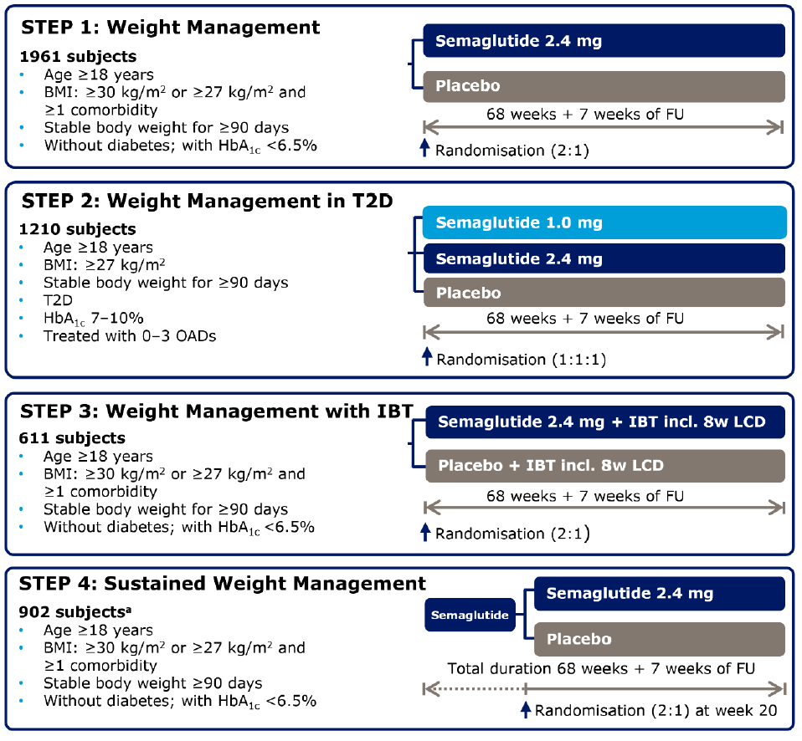

The primary objective of STEP 1–4 was to compare the effect of semaglutide s.c. 2.4 mg once weekly versus placebo in overweight or obese subjects (with T2D in STEP 2 only) on body weight, either as an adjunct to a reduced-calorie diet and increased physical activity (STEP 1, 2 and 4) or to IBT (STEP 3).

The main secondary objectives of STEP 1–4 were to compare the effect of semaglutide s.c. 2.4 mg once weekly on other factors related to body weight, cardiovascular risk factors, glucose metabolism, and clinical outcome assessments including patient-reported outcomes.

##### Pivotal STEP trials (Pivotal STEP 1, 2, 3, and 4)

###### Design

The pivotal STEP trials (STEP 1, 2, 3, and 4) were Phase 3a, randomised, double-blind, multi-centre, parallel-group, controlled studies to assess the efficacy and safety of semaglutide. 4585 adult subjects were randomised in STEP 1–4: 2652 to semaglutide 2.4 mg, 1530 to placebo, and 403 to semaglutide 1.0 mg.

STEP 1, 3, and 4 were two-armed trials with 2:1 randomisation (semaglutide 2.4 mg : placebo) and STEP 2 was a 3-arm, double-blind, double-dummy trial with 1:1:1 randomisation (semaglutide 1.0 mg : semaglutide 2.4 mg : placebo). Dose escalation occurred in STEP 1‒3, but not in STEP 4.

The primary endpoint was the identical in all 4 phase 3a trials: change from baseline to week 68 in body weight (%). Furthermore, STEP 1–3 included a co-primary endpoint: subjects achieving (y/n) ≥5% body weight reduction at week 68. An overview of endpoints is shown in Table10 (Appendix).

Trial population and study design are summarised in **Error! Reference source not found.** 1. Inclusion criteria and key exclusion criteria are summarised in Table 11 (Appendix), and Table 12 (Appendix), respectively.

Subject disposition, baseline demographic characteristics, and co-morbidities at screening are summarised in Table 13 (Appendix),

**Table**4 (Appendix), and Table 15 (Appendix), respectively.

Treatment effects were estimated using a treatment policy estimand method (primary estimand; disregarding product adherence or use of other anti-obesity therapies), and a hypothetical estimand method (without the potentially confounding effects of discontinuation or use of other anti-obesity therapies). The analyses of the confirmatory endpoints were controlled for multiplicity only for the treatment policy estimand, and all superiority claims were based on conclusions from the treatment policy estimand.

##### Magnitude of the treatment effect and its clinical significance

An overview of primary endpoint results is shown in

Table . The treatment effect was well in excess of a clinically significant 5% weight loss. The effect size was consistent across the four studies. The effect persisted in a patient group undergoing IBT.

**STEP 1 (NN9536-4373) (patients without diabetes) main findings (Table 16, Appendix):**

The mean (SD) change in body weight (%) from baseline to Week 68 was -15.1 (10.1) % for semaglutide and -2.8 (6.5) % for placebo; treatment difference (95% CI), semaglutide – placebo, -12.44 (-13.37 to -11.51) %, p <0.0001.

Semaglutide at a dose of 2.4 mg weekly resulted in a sustained and clinically significant loss of weight over a one-year period. This was matched by clinically significant decreases in waist circumference and BMI. There were improvements in cardiovascular endpoints: lipid profile, surrogate markers (hsCRP and PAI-I) and in blood pressure. There were improvements in glycaemic control. There were significant improvements in quality of life and physical functioning. There were improvements in fatty liver index.

The DEXA sub-study demonstrated that the losses in weight, waist circumference and BMI were due to a decrease in adipose, and not to loss of another body component (such as water or muscle).

**STEP 2 (NN9536-4374) (patients with T2DM) main findings (Table7, Appendix):**

In patients with T2DM, the mean (SD) change in body weight (%) from baseline to Week 68 was -7.2 (6.6) % for semaglutide 1.0 mg, -9.9 (8.0) % for semaglutide 2.4 mg and -3.3 (5.5) % for placebo; estimated treatment difference (95% CI), semaglutide 2.4 mg – placebo, -6.21 (-7.28 to -5.15) %, p <0.0001; and semaglutide 2.4 mg – semaglutide 1.0 mg, -2.65 (-3.66 to -1.64) %, p <0.0001.

Semaglutide at a dose of 2.4 mg weekly resulted in a sustained and clinically significant loss of weight over a one-year period compared with both placebo and semaglutide 1.0 mg groups. This was matched by clinically significant decreases in waist circumference and BMI. There were improvements in cardiovascular endpoints: lipid profile, surrogate markers (hsCRP and PAI-I) and in blood pressure in both semaglutide groups. There were improvements in glycaemic control in both semaglutide groups, with no significant differences between the dose levels. There were significant improvements in quality of life and physical functioning, that were greater in the semaglutide 2.4 mg group compared with both semaglutide 1.0 mg and placebo.

**STEP 3 (NN9536-4375) (patients without diabetes with IBT background treatment) main findings (Table 18, Appendix):**

With background treatment with IBT, the mean (SD) change in body weight from baseline to Week 68 was -16.5 (10.1) % for semaglutide and -5.8 (7.7) % for placebo; treatment difference (95% CI), semaglutide – placebo, -10.27 (-11.97 to -8.57) %, p <0.0001.

The background treatments included those in the proposed indication: diet and exercise. However, an additional background treatment was IBT.

Semaglutide at a dose of 2.4 mg weekly resulted in a sustained and clinically significant loss of weight over a one-year period in patients who were also having IBT. This was matched by clinically significant decreases in waist circumference and BMI. There were improvements in cardiovascular endpoints: lipid profile, surrogate markers (hsCRP and PAI-I) and in blood pressure. There were improvements in glycaemic control.

However, there were improvements in quality of life and physical functioning in both treatment groups, with no significant differences between the treatment groups.

**STEP 4 (NN9536-4376) main findings (Table19, Appendix):**

The mean (SD) change in body weight from Week 20 to Week 68 was -8.8 (7.8) % for semaglutide and 6.1 (7.7) % for placebo; treatment difference (95% CI), semaglutide – placebo, -14.75 (-16.00 to -13.50) %, p <0.0001.

Semaglutide at a dose of 2.4 mg weekly resulted in a sustained and clinically significant loss of weight over a one-year period. This was matched by clinically significant decreases in waist circumference and BMI. There were improvements in cardiovascular endpoints: lipid profile, surrogate markers (hsCRP and PAI-I) and in blood pressure. There were improvements in glycaemic control. There were significant improvements in quality of life and physical functioning.

There were significant improvements in the semaglutide group both for the randomisation phase, and the treatment period. However, the placebo group had loss of benefit following the titration phase. The initial gains in this group were lost over the remainder of the study. This indicates that the benefits that occur during treatment may be lost after treatment is ceased. Semaglutide is likely to be a long-term treatment for obesity.

Table 4. Pivotal STEP trials. Inclusion criteria. Primary endpoint results.

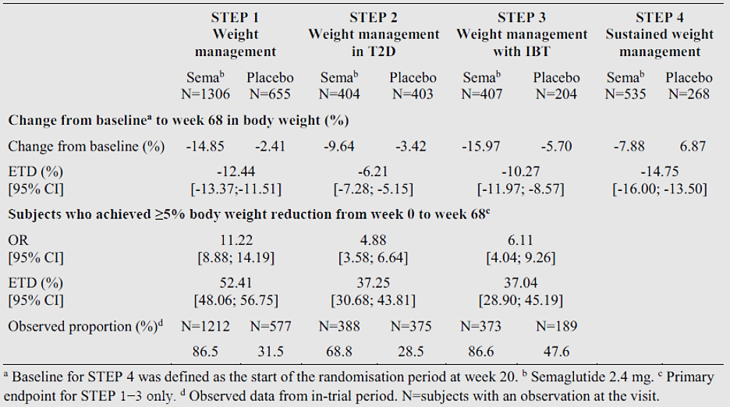

#### Safety

##### Summary of safety

###### Exposure

14,520 patients (7,432 males and 6,721 females) in 21 trials were exposed in all Phase 3 clinical trials (oral and s.c. semaglutide for T2D; and semaglutide s.c. 2.4 mg for weight management) 9.925 patients were exposed for ≥12 months and 1,266 for ≥24 months.

In completed Phase 3a trials for weight management (STEP 1–4), 402 patients have been exposed to semaglutide 1.0 mg and 3,018 to 2.4 mg. Exposure to semaglutide 1.0 mg was 361 patients for 12 months and semaglutide 2.4 mg was 2.389 patients for 12 months (**Error! Not a valid bookmark self-reference.**). There were 930 males and 2,123 females. There were 311 patients aged 65 to 74 years, 27 aged 75 to 84 years and one aged ≥85 years. There were 2,234 White patients, 410 Asian and 283 Black/African American.

Additionally, the Sponsor referred to 7 supportive trials from the Ozempic program (including the SUSTAIN 6 CVOT) and the clinical pharmacology trials investigating drug-drug interactions, populations with renal or hepatic impairment, and potential impact on cardiac electrophysiology (QTc).

Table 5. Pivotal STEP trials. Summary of exposure to semaglutide s.c. 2.4 mg for weight management.

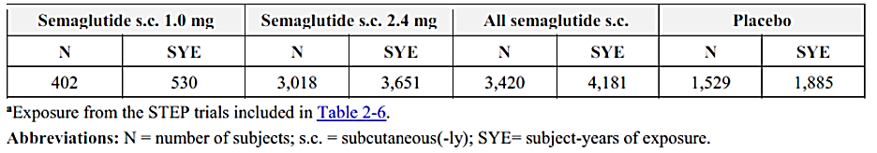

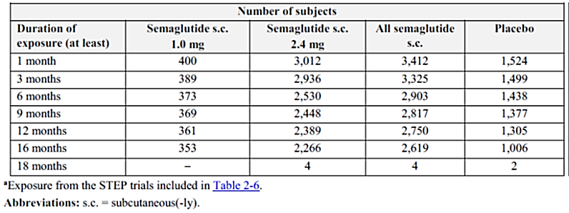

Abbr: N=number of subjects; s.c. = subcutaneous(-ly); SYE=subject-years of exposure.

###### Adverse event overview

Adverse events presented early in treatment (Figure 2). There were increased rates of gastrointestinal disorders and neurological disorders with semaglutide in comparison with placebo (Figure 3). The gastrointestinal adverse events that occurred more frequently with semaglutide compared to placebo were nausea, diarrhoea, vomiting, constipation, abdominal pain, decreased appetite, dyspepsia, eructation and abdominal distension. The neurological disorders that occurred more commonly with semaglutide were headache, fatigue and dizziness. Other AEs that were reported more frequently with semaglutide were alopecia (3.3% patients compared to 1.4% with placebo) and migraine (2.1% patients compared to 1.3% with placebo). In Study NN9536-4153, the Phase II dose-finding study, gastrointestinal adverse effects (vomiting, diarrhoea and constipation) were dose-related.

Injection site reactions occurred at a similar frequency with semaglutide 2.4 mg in comparison with placebo.

Figure 2. Pivotal STEP 1-3 trials (pooled data). Time to onset of first or to onset of any event.

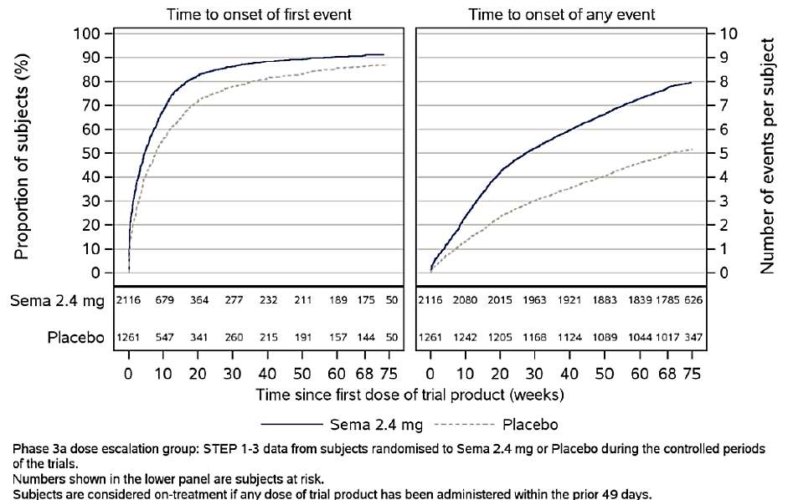

Figure 3. Pivotal STEP trials (pooled data). On-treatment AEs in ≥5% of subjects.

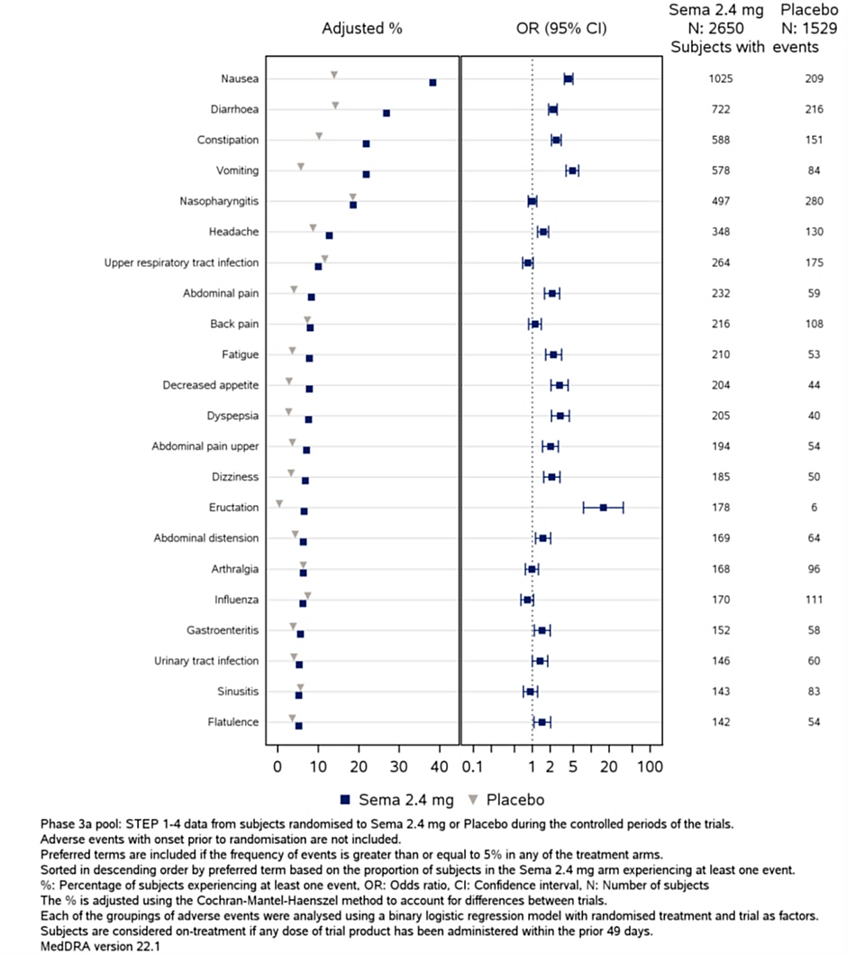

###### Deaths

8 deaths were reported in the completed clinical trials: 7 deaths in the STEP trials and 1 death in the phase 2 trial 4153. There were no deaths in the clinical pharmacology trials.

In the phase 3a pool, there was no difference between semaglutide 2.4 mg and placebo in proportion of subjects who died (3 subjects [0.1%] in the semaglutide 2.4 mg group and 3 subjects [0.2%] in the placebo group). There was one death at the semaglutide 1.0 mg dose level (undetermined cause of death). There was one death in the 0.4 mg fast escalation group in Study NN9536-4153 (malignancy). There were three deaths under placebo treatment, all due to malignancy.

###### Serious adverse events

The rate of SAEs was increased relative to placebo. SAEs were reported in 9.3% with semaglutide and in 6.4% with placebo. The rate of SAEs was 10.5/100 person-year with semaglutide and 6.8/100 person-year with placebo. Hepatobiliary SAEs were reported at a rate of 1.2/100 person-year with semaglutide and 0.2/100 person-year with placebo. Gastrointestinal SAEs were reported at a rate of 1.1/100 person-year with semaglutide and 0.6/100 person-year with placebo.

###### Discontinuations

In the Phase 3a pool, more patients discontinued due to AEs in the semaglutide groups compared to placebo: 149 (5.7%) patients in the semaglutide group and 47 (3.0%) for placebo. This was primarily due to gastrointestinal disorders: nausea, vomiting, diarrhoea, upper abdominal pain, and constipation.

###### Adverse events of special interest

GI AEs: In the dose escalation group (STEP 1–3: dose-escalation regimen with 4-week increments to reach the 2.4 mg maintenance dose to improve tolerability), GI AEs were reported for 72.9% of subjects on semaglutide 2.4 mg compared to 47.1% of subjects on placebo. The GI AE incidence was highest during the initial 20 weeks of treatment (covering the dose-escalation period) and tapered off subsequently (Figure 4).

Figure 4. Pivotal STEP 1-3 trials (pooled data). Time to onset of first or to onset of any GI event.

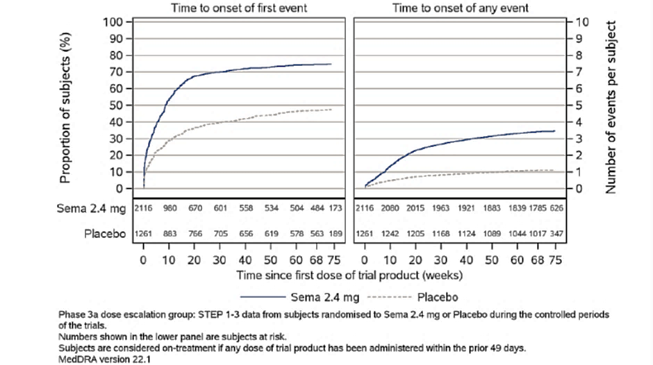

**Hepatobiliary AEs**: Hepatobiliary disorders were more frequent with semaglutide 2.4 mg, but elevation of transaminases was not more frequent, and no patients fulfilled the criteria of Hy’s law. There were few reports of pancreatitis: four in the semaglutide groups and one for placebo.

In the phase 3a pool, there were more events of gallbladder-related disorders with semaglutide 2.4 mg than with placebo (2.5% vs 1.6%). Most of the events were cholelithiasis (1.6% vs 1.1% for semaglutide 2.4 mg vs placebo) or related complications. The increased risk may be at least partly explained by the larger weight loss.

**Renal AEs**: The rate of renal dysfunction was not increased with semaglutide 2.4 mg. Plasma calcitonin concentrations were not increased by semaglutide 2.4 mg.

**Haematological AEs**: Haematology AEs occurred at similar rates to placebo.

**CV AEs**: Cardiovascular AEs were less frequent with semaglutide than placebo. This supports the improvement in surrogate measures of cardiovascular risk in the pivotal studies. In the pivotal studies, mean pulse rate increased by 2 to 5 bpm, but there was a significant decrease in SBP relative to placebo in the semaglutide groups.

**Immunogenicity**: In the clinical studies semaglutide 2.4 mg had low immunogenicity. In the two Phase 3 studies that tested for anti-semaglutide antibodies, there were 50 (2.9%) patients with treatment induced anti-semaglutide antibodies; none were neutralising and 28 (1.6%) had antibodies that cross-reacted with GLP-1. The rate of allergic AEs was similar to the placebo group.

**Neoplasia**: The rates of neoplasia were similar for semaglutide 2.4 mg and placebo.

**Hypoglycaemia**: Hypoglycaemia was infrequent and was not identified as a safety concern in this population.

**Mental** **health**: Mental health scores and suicidality did not differ significantly between semaglutide 2.4 mg and placebo.

**Misuse**: Misuse of semaglutide was addressed in the clinical studies, but only in the group of patients included in the indication. The potential for misuse in other patient groups, such as eating disorders and athletes, has not been addressed in the data.

**Diabetic** **retinopathy**: In Study NN9536-4374, diabetic retinopathy was reported in 25 (6.2%) patients in the semaglutide 1 mg group, 28 (6.9%) in the semaglutide 2.4 mg and 17 (4.2%) in the placebo.

In the phase 3a without T2D group, there were no PT diabetic retinopathy events reported.

**Subgroups**: The safety of semaglutide 2.4 mg was evaluated in subgroups of subjects defined based on: intrinsic factors (sex, baseline age, race, ethnic origin, baseline body weight, baseline BMI, baseline renal function [phase 3a pool], and baseline glycaemic status [phase 3a without T2D group]), extrinsic factors (region [phase 3a pool]; anti-diabetic background medication [phase 3a with T2D trial]), and weight loss category (≥20% vs <20%).The evaluation did not reveal any new safety concerns or markedly different AE profiles for any subgroups.

**Pregnancy and lactation**: 37 pregnancies were reported in the weight management trials: 29 with semaglutide (24 in the phase 3a pool) and 8 with placebo. In all cases, the subject was exposed to trial product for a short time (or not exposed at all) until the pregnancy was discovered and trial product discontinued. One child of a female subject exposed to semaglutide was born with a congenital anomaly of the external ear. Spontaneous abortions were reported in 6 of 29 (21%) pregnancies in the semaglutide 2.4 mg group. In the placebo group, 2 of 8 (25%) pregnancies resulted in a spontaneous abortion or a stillbirth. None of the elective abortions were due to congenital anomalies. There were few AEs related to fertility without significant differences between groups. No AEs related to lactation were reported.

OZEMPIC currently has pregnancy category D. This is also proposed for Wegovy.

###### Post-market experience

No data available.

### Risk management plan evaluation summary

A Risk Management Plan was not requested for this submission. The rationale given by the RMP Evaluation section included:

* No significantly different target population from an RMP perspective.
* Semaglutide is currently approved for use in Type 2 diabetes (Ozempic) as a once weekly SC injection.
* There are currently no additional risk minimisation activities in place for Ozempic.
* Although there is a change in presentation and the inclusion of new strengths, this product is intended to be approved under a new name, with its own PI and CMI so the risk of medication error in relation to other strengths of semaglutide on the market could be expected to be minimal.

However, in the dossier for Wegovy, the Sponsor submitted EU-RMP version 5.0 (26 November 2020; DLP 31 May 2018 (semaglutide s.c.), 2 November 2018 (oral semaglutide), and 28 Oct 2020 (semaglutide s.c. 2.4 mg for weight management)) and ASA version 0.1 (28 August 2020) in support of this application.

It is noted that the ASA version 0.1 appears to be only an annex to semaglutide s.c. 2.4 mg for weight management (WYGOVY, but not for OZEMPIC or RYBELSUS).

The Sponsor proposes Pregnancy Category D.

The Sponsor proposes inclusion in the Black Triangle Scheme (as per PI).

The proposed summary of safety concerns and their associated risk monitoring and mitigation strategies are summarised in Table 6:

Table 6. Summary of safety concerns and missing information

|  |  |  |  |  |  |
| --- | --- | --- | --- | --- | --- |
| **Summary of safety concerns** | | **Pharmacovigilance** | | **Risk Minimisation** | |
| **Routine** | **Additional** | **Routine** | **Additional** |
| **Important identified risks** | Diabetic retinopathy complications | ✓ | ✓ | ✓ | – |
| **Important potential risks** | Neoplasms (malignant and non-malignant) | ✓ | ✓ | – | – |
| Pancreatic cancer | ✓ | ✓ | ✓ | – |
| Medullary thyroid cancer | ✓ | ✓ | ✓ | – |
| **Missing information** | Pregnancy and lactation | ✓ | – | ✓ | – |
| Patients with severe hepatic impairment | ✓ | – | ✓ | – |

The clinical Evaluator commented that misuse of semaglutide was addressed in the clinical studies, but only in the group of patients included in the indication. The potential for misuse in other patient groups, such as eating disorders and athletes, has not been addressed in the data. This may be addressed in the risk management plan under off-label use.

See [TGA’s guidance](https://www.tga.gov.au/resources/resource/guidance/risk-management-plans-medicines-and-biologicals/when-rmp-required) on ‘when an RMP is required’.

The TGA may request an updated RMP at any stage of a product's life-cycle, during both the pre-approval and post-approval phases. Further information regarding the TGA’s risk management approach can be found in [risk management plans for medicines and biologicals](https://www.tga.gov.au/publication/risk-management-plans-medicines-and-biologicals) and [the TGA's risk management approach](https://www.tga.gov.au/tgas-risk-management-approach). Information on the [Australia-specific annex](https://www.tga.gov.au/resources/resource/guidance/risk-management-plans-medicines-and-biologicals/australia-specific-annex-eu-rmp) ([ASA](https://www.tga.gov.au/resources/resource/guidance/risk-management-plans-medicines-and-biologicals/australia-specific-annex-eu-rmp)) can be found on the TGA website.

## Risk-benefit analysis

#### Pharmacology and formulations

The pharmacokinetics and pharmacodynamics of Wegovy (semaglutide) have been adequately characterised. This includes bioequivalence studies for the new formulation. Semaglutide has a dose-dependent effect on weight loss. Semaglutide decreases appetite, decrease food intake and decreased food cravings. An Emax relationship between concentration and the proportion of responders has been demonstrated. Semaglutide has a beneficial effect on β-cell function. The improvement in glycaemic and weight control has been previously documents in patients with T2DM. Semaglutide did not have adverse effects on gastric emptying or cardiac repolarisation.

The Sponsor has obtained adequate data to inform the dosage selection. The optimal dosing was defined using Emax models, and by balancing efficacy against tolerability. The proposed dose-titration, with initiation of treatment, is also supported by these data.

##### Deficiencies of data

The Sponsor has not examined the PK for all the formulations intended for marketing, and that would be used in the titration phase. These are: 0.25 mg/dose (0.5 mg/mL); 0.5 mg/dose (1.0 mg/mL); 1 mg/dose (2.0 mg/mL); 1.7 mg/dose (2.27 mg/mL); and 2.4 mg/dose (3.2 mg/mL).

However, in Modelling Report 3, dose proportionality was demonstrated for the doses used in the Phase 3a clinical trials. In the opinion of the Clinical Evaluator, dose-proportionality can be extrapolated to the new formulations.

The primary differences between the clinical trial formulations and the to-be-marketed formulations are:

* Composition: the to-be-marketed formulations do not contain phenol or propylene glycol
* Concentration (Table 7): the titration formulations and the maintenance dose formulations used in the clinical trials are different concentrations to the to-be-marketed formulations.

The different formulation is unlikely to have an effect on efficacy, especially as bioequivalence has been demonstrated for the maintenance formulations. The different concentrations in the titration formulations are unlikely to have any effect on efficacy because efficacy is primarily from the maintenance formulations, which have been demonstrated to be bioequivalent.

Table 7. Phase 3a formulation vs. To-be-marketed formulation: Concentration differences.

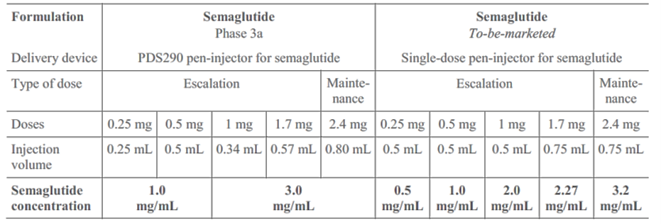

#### Efficacy

The design and conduct of the Phase 3a studies was appropriate and complied with the Guideline on Clinical Evaluation of Medicinal Products Used in Weight Management (EMA/CHMP/311805/2014) 23 June 2016. The primary outcome measure was weight loss, and this was analysed both as % body weight and by mass (kg). The studies were placebo controlled. The predictive value of short-term versus long-term treatment can be determined from the data. Waist circumference and BMI were used as secondary endpoints. DEXA was used to validate that the weight loss was due to loss of adipose and not due to loss of other body constituents. Cardiovascular risk and co-morbidities were also measured as outcomes. A relevant proportion of the study population had coexisting cardiovascular and other co-morbidities.

The patient populations were representative of the target population in Australia.

The background treatments were the same as those in the proposed indication: diet and exercise. The background treatments were applied consistently and were clearly defined in the study protocols.

Bias was controlled through randomisation and blinding. Multiplicity was addressed. The statistical analysis was appropriate. The outcome measures were appropriate and measured different aspects of treatment effect.

The Phase 3a studies demonstrated a statistically and clinically significant weight loss with semaglutide 2.4 mg weekly dosing. The treatment effect was well in excess of a clinically significant 5% weight loss. The effect size was consistent across the four studies. The effect persisted in a patient group undergoing IBT.

The decrease in body weight was matched by decreases in waist circumference and in BMI.

There were improvements in cardiovascular endpoints: lipid profile, surrogate markers (hsCRP and PAI-I) and in blood pressure. The improvements in plasma lipids were primarily in total cholesterol, LDL-cholesterol and VLDL-cholesterol, with lesser effect on HDL-cholesterol. These improvements are associated with a lessening of cardiovascular risk.

##### Deficiencies of data

Deficiencies include:

* In STEP 2, there was lack of blinding between the 1.0 mg / placebo groups and the 2.4 mg / placebo groups. However, the outcome measures were objective and the primary comparison was between semaglutide 2.4 mg and placebo.
* In STEP 2, in patients with T2DM the decrease in body weight was not as great as in STEP 1, where T2DM was excluded. However, there was still significant benefit in this patient group.

Clinical issues that have not been addressed by the submitted data are:

**Persistence of treatment effect beyond one year of treatment (continuing on treatment)**: The data indicate that treatment with semaglutide is likely to be required long-term. There was a return to baseline in the placebo group (who received Wegovy initially) in Study STEP 4.

The Sponsor presented data that appears to demonstrate a persistence of the treatment effect beyond one year: STEP 5 (NN9536-4378, data publicly available in 2022), a phase 3b trial, showed that weight loss obtained after approximately one year of semaglutide 2.4 mg treatment, persisted up until end of treatment of semaglutide 2.4 mg (week 104) (Figure 5). However, no data beyond 2 years is available.

Figure 5. STEP 5 (not provided in the dossier). Body weight change (%) from baseline.

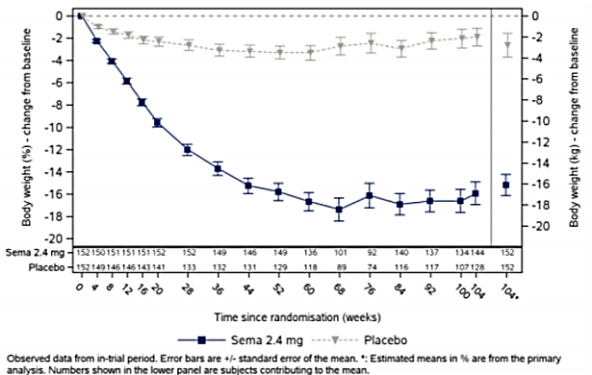

Potential for rebound in weight once treatment is stopped (not continuing on treatment): While the results of Study STEP 4 suggest this is unlikely, a rebound in weight might occur over the long term in patients who cease semaglutide treatment.

The Sponsor presented data from the STEP 1 extension study regarding the effect after semaglutide cessation at Week 68: The trajectory of weight gain after treatment cessation indicates a return towards baseline, but not rebound (i.e. weight gain in excess of baseline weight) with the extension study period (Figure 6).

Figure 6. STEP 1 Extension (not in dossier). Body weight change (%) from baseline.

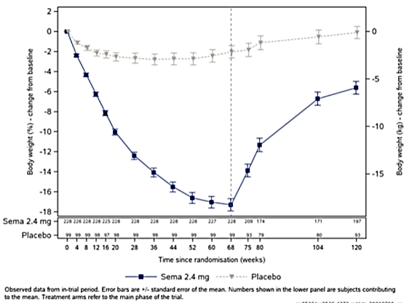

#### Safety

There were increased rates of gastrointestinal disorders and neurological disorders with semaglutide in comparison with placebo. These events were predominantly non-serious and were of limited duration and without long-term sequelae.

The gastrointestinal adverse events that occurred more frequently with semaglutide compared to placebo were nausea, diarrhoea, vomiting, constipation, abdominal pain, decreased appetite, dyspepsia, eructation and abdominal distension. The neurological disorders that occurred more commonly with semaglutide were headache, fatigue and dizziness.

In the pivotal studies the rate of SAEs was 10.5 /100 person-year with semaglutide and 6.8 /100 person-year with placebo. Hepatobiliary SAEs were reported at a rate of 1.2 /100 person-year with semaglutide and 0.2 /100 person-year with placebo. Gastrointestinal SAEs were reported at a rate of 1.1 /100 person-year with semaglutide and 0.6 /100 person-year with placebo.

Discontinuation due to AE occurred at a higher rate in the semaglutide groups compared to placebo. In the Phase IIIa pool there were 149 (5.7%) patients in the semaglutide group and 47 (3.0%) in the placebo discontinuing because of AEs. This was primarily due to gastrointestinal disorders: nausea, vomiting, diarrhoea, upper abdominal pain and constipation

Cardiovascular AEs were less frequent with semaglutide than placebo.

Misuse of semaglutide was addressed in the clinical studies, but only in the group of patients included in the indication. The potential for misuse in other patient groups, such as eating disorders and athletes, has not been addressed in the data.

#### Conclusion and remaining issues

The Clinical Evaluator has no objection to the approval of Wegovy (semaglutide) 0.25 mg (0.5 mg/mL), 0.5 mg (1.0 mg/mL), 1.0 mg (2.0 mg/mL), 1.7 mg (2.27 mg/mL) and 2.4 mg (3.2 mg/mL), solution for injection, single use prefilled pen with pre-assembled needle, for the proposed indication:

*Wegovy is indicated as an adjunct to a reduced-calorie diet and increased physical activity for chronic weight management, including weight loss and weight maintenance, in adults with an initial Body Mass Index (BMI) of:*

* *≥30 kg/m2 (obesity); or*
* *≥27 kg/m2 to <30 kg/m2 (overweight) in the presence of at least one weight related comorbidity.*

#### Advisory Committee on Medicines considerations

The [Advisory Committee on Medicines (ACM)](https://www.tga.gov.au/committee/advisory-committee-medicines-acm) having considered the evaluations and the Delegate’s overview, as well as the Sponsor’s response to these documents, advised the following:

The Phase 3a studies provided a large amount of data supporting the proposed indication. Long-term data beyond 2 years and data regarding potential rebound are limited.

***Can the ACM comment on whether the provided data are sufficient to support registration for the proposed indication?***

The ACM was of the view that the provided data confirms robust efficacy and a clinically meaningful effect for the target population. Furthermore, a predictable and reasonable safety profile was noted within this context of use.

The ACM noted that maintenance of effect was demonstrated within 104 weeks (two years) with continued use and agreed that there is no evidence of diminished effect with continued treatment.

The ACM discussed treatment cessation and agreed that this would lead to an expected loss of effect over time, however no rebound phenomenon was observed or expected.

The ACM was very supportive of the management modalities being included within the indication and considered Wegovy to have a favourable benefit risk profile for the following indication [amendments underlined]:

*Wegovy, when used as an adjunct to a reduced-energy diet and increased physical exercise, is indicated for induction and maintenance of weight loss in adults with an initial Body Mass Index (BMI) of:*

*≥ 30 kg/m2 (obesity); or*

*≥ 27 kg/m2 to < 30 kg/m2 (overweight) in the presence of at least one weight related comorbidity.*

The committee is also requested to provide advice on any other issues that it thinks may be relevant to a decision on whether or not to approve this application.

The ACM advised that drug names rather than drug classes (such as sulphonylurea) should be used within the Consumer Medicines Information (CMI), so consumers can readily identify relevant medications.

The ACM discussed the pregnancy classification and agreed that Category D is appropriate. The ACM was supportive of further emphasis within the PI of the importance of contraception / not attempting conception or pregnancy while on treatment, particularly as weight-loss may be used as an aid for fertility.

##### ACM conclusion

The ACM considered this product to have an overall positive benefit-risk profile for the proposed indication.

## Outcome

Based on a review of quality, safety, and efficacy, the TGA decided to register Wegovy (semaglutide), for the following extension of indications:

Wegovy, when used as an adjunct to a reduced-energy diet and increased physical exercise, is indicated for induction and maintenance of weight loss in adults with an initial Body Mass Index (BMI) of:

≥ 30 kg/m2 (obesity); or

≥ 27 kg/m2 to < 30 kg/m2 (overweight) in the presence of at least one weight related comorbidity.

#### Specific conditions of registration applying to these goods

Wegovy (semaglutide) is to be included in the Black Triangle Scheme. The PI and CMI for Wegovy must include the black triangle symbol and mandatory accompanying text for five years, which starts from the date that the sponsor notifies the TGA of supply of the product.

As a post-registration commitment, a Risk Management Plan (RMP) prepared to the satisfaction of the TGA will be implemented in Australia.

An obligatory component of risk management plans is routine pharmacovigilance. Routine pharmacovigilance includes the submission of periodic safety update reports (PSURs).

Reports are to be provided in line with the current published list of EU reference dates and frequency of submission of PSURs until the period covered by such reports is not less than three years from the date of this approval letter.

The reports are to at least meet the requirements for PSURs as described in the European Medicines Agency’s Guideline on good pharmacovigilance practices (GVP) Module VII-periodic safety update report (Rev 1), Part VII.B Structures and processes. Note that submission of a PSUR does not constitute an application to vary the registration.

The final clinical study report (CSR) for Study EX9536-4388 (SELECT) should be submitted to the TGA, once available (planned reporting of results in 2024).

## Attachment 1. Product Information

The [Product Information](https://www.tga.gov.au/products/australian-register-therapeutic-goods-artg/product-information-one) ([PI](https://www.tga.gov.au/products/australian-register-therapeutic-goods-artg/product-information-one)) approved with this submission for Wegovy which is referred to in this AusPAR (and can be accessed on this AusPAR’s webpage) may have been superseded. For the most recent PI and [Consumer Medicines Information](https://www.tga.gov.au/products/australian-register-therapeutic-goods-artg/consumer-medicines-information-cmi) (CMI), please refer to the TGA [PI/CMI search facility.](https://www.ebs.tga.gov.au/)

### Appendix

Figure 7. PopPK modelling based on NN9536-4153. Forest plot of covariate analysis for semaglutide exposure expressed as steady-state dose-normalised average semaglutide concentrations relative to a reference subject.

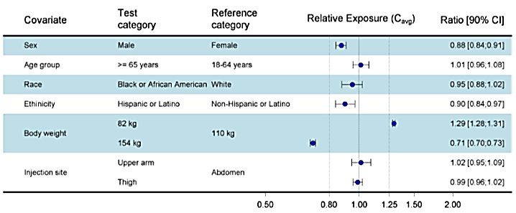

Figure 8. PopPK modelling based on NN9536-4153. Body weight change from baseline versus exposure of semaglutide for all subjects (A) and shown by sex (B) and body weight quantile (C).

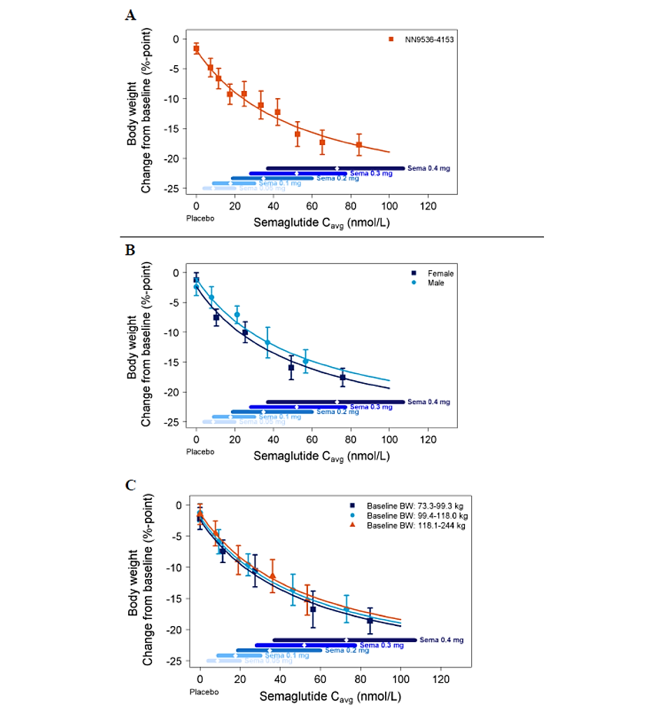



Table 8. Overview of STEP trial endpoints.

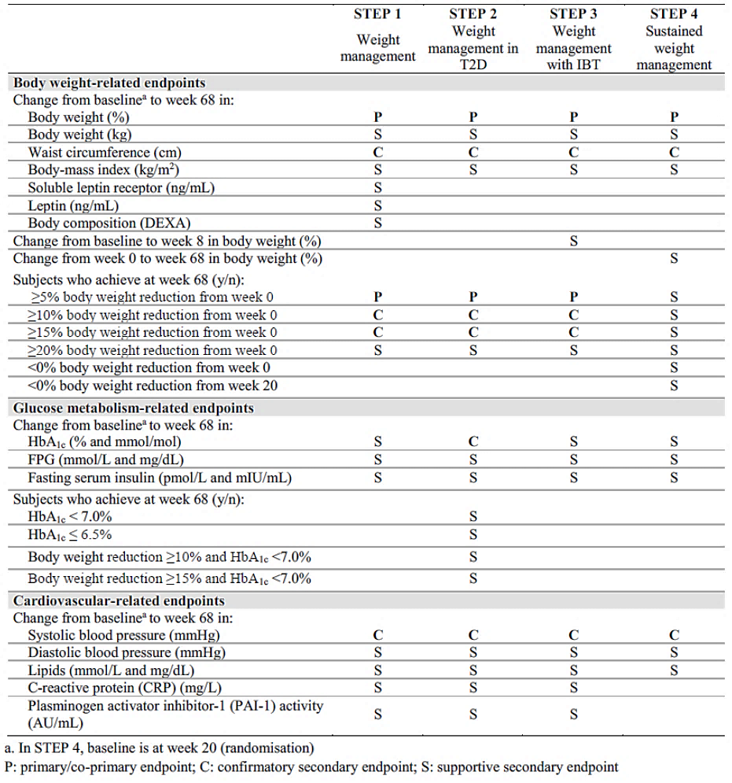

**Table 9. Pivotal STEP trials. Inclusion criteria.**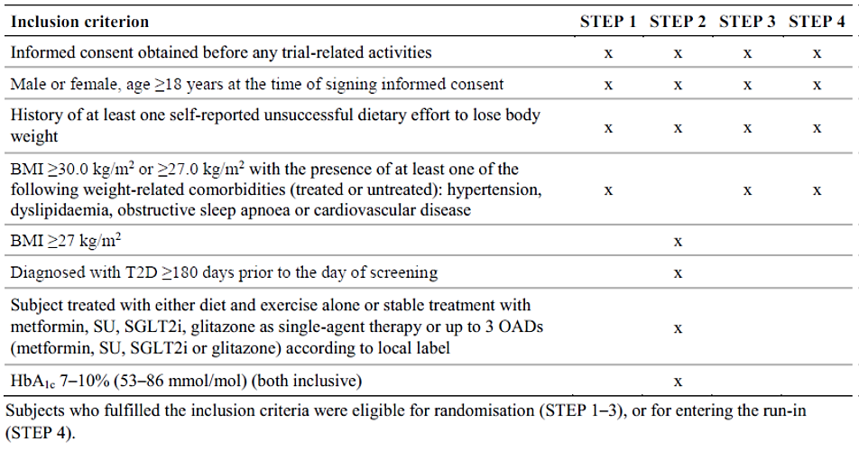

**Table 10. Pivotal STEP trials. Key exclusion criteria.**

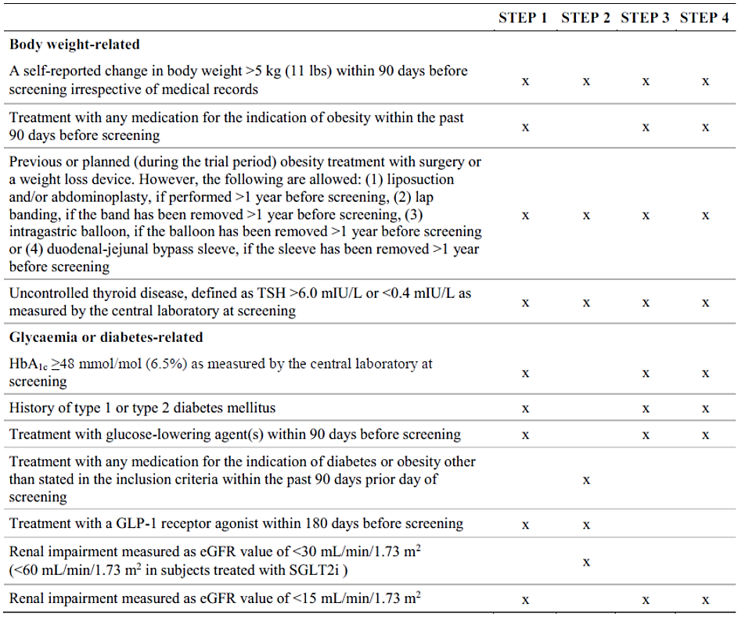

**Table 11. Pivotal STEP trials. Study disposition.**

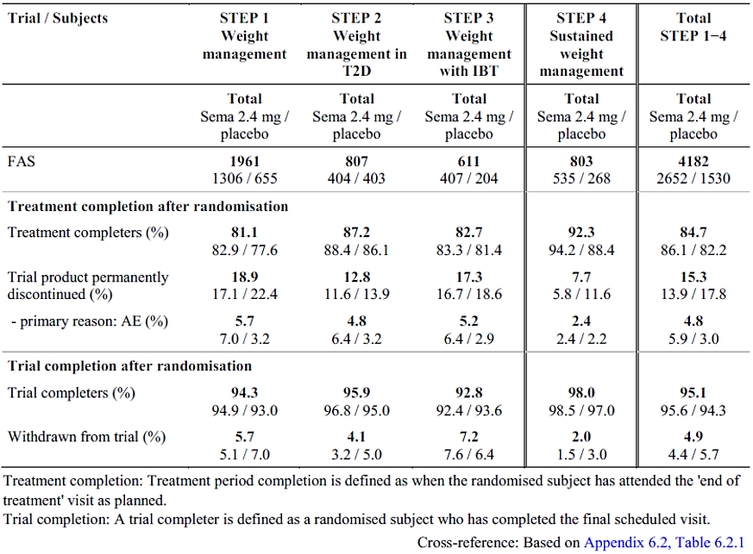

**Table 12. Pivotal STEP trials. Baseline demographics - categorical values.**

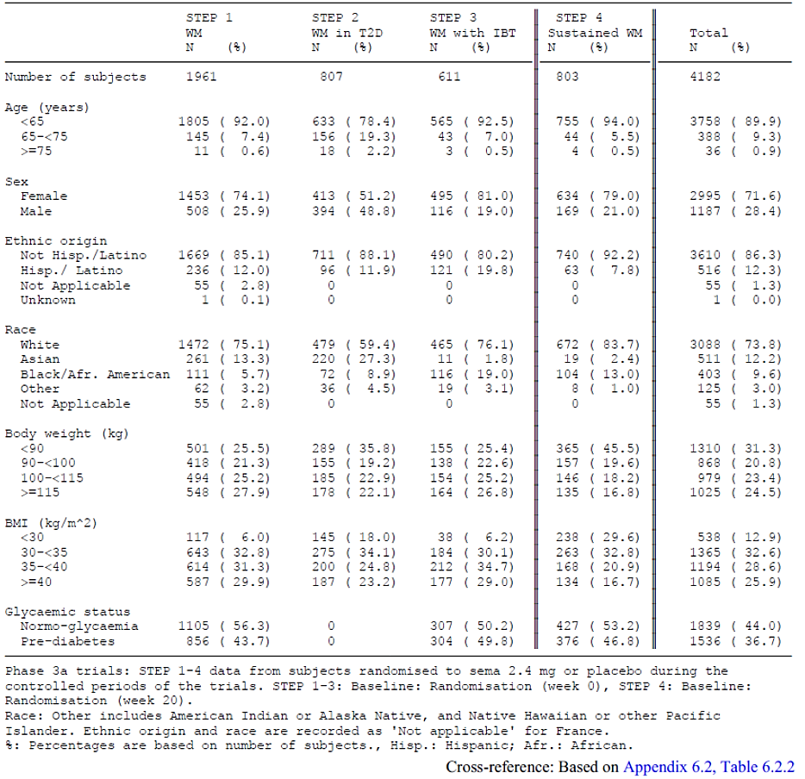

**Table 13. Pivotal STEP trials. Comorbidities at screening.**

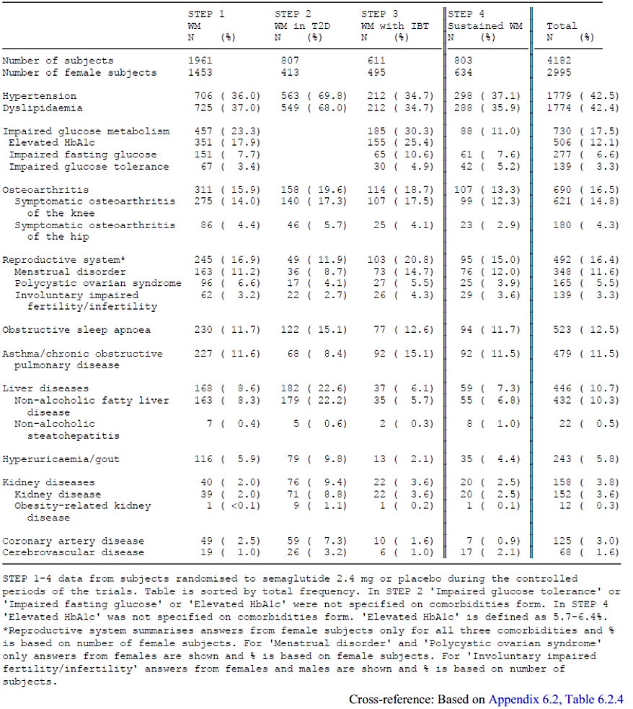

**Table 14. STEP 1 study. Primary and confirmatory secondary endpoint results.**

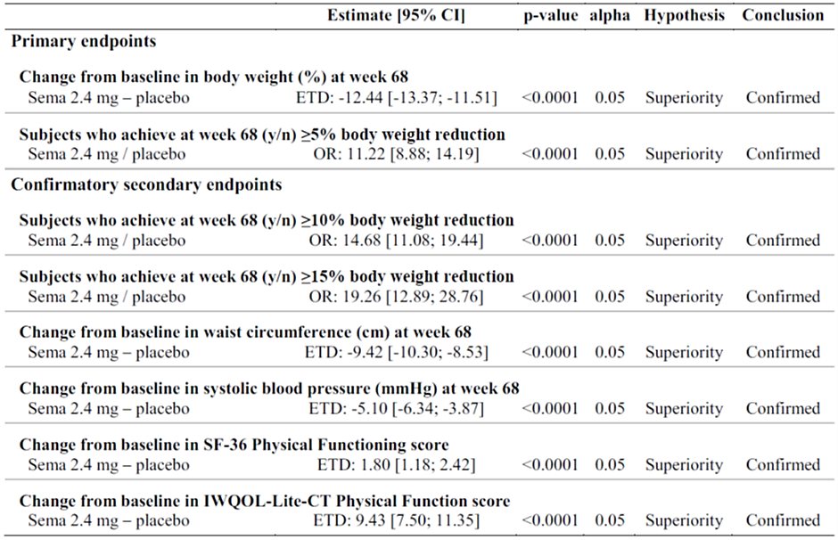

**Table 15. STEP 2 study. Primary and confirmatory secondary endpoint results.**

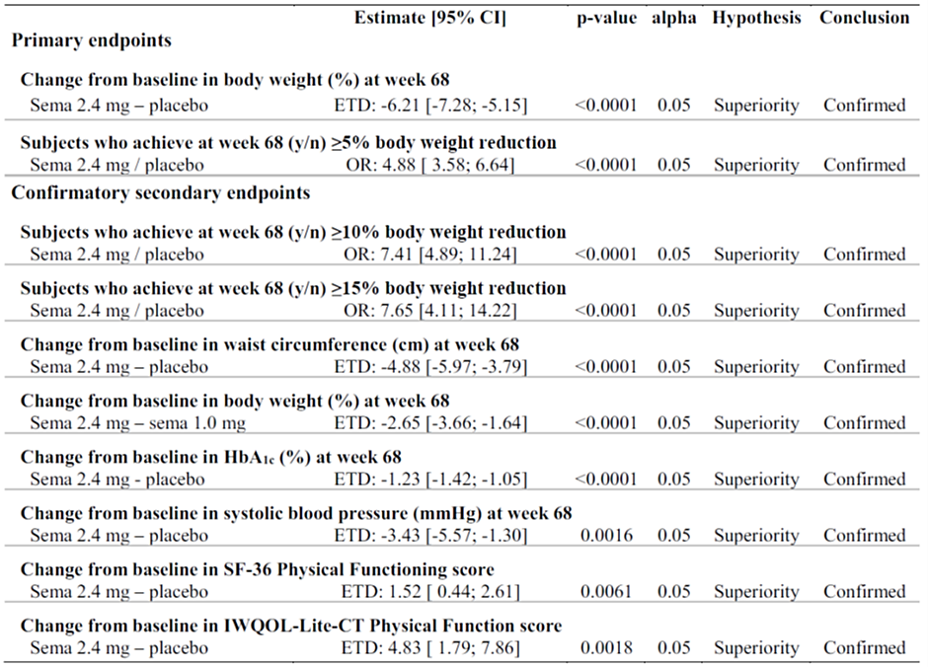

**Table 16. STEP 3 study. Primary and confirmatory secondary endpoint results.**

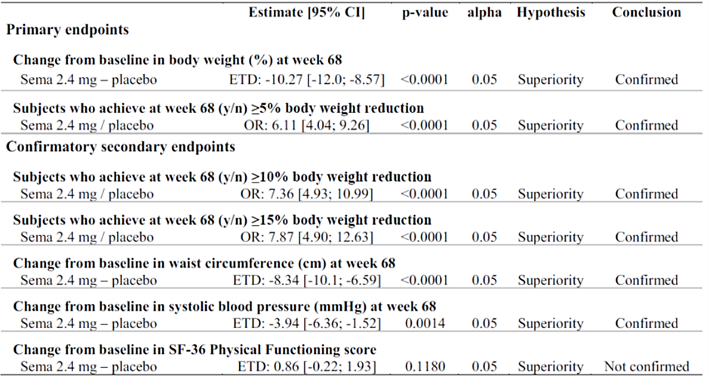

**Table 17. STEP 4 study. Primary and confirmatory secondary endpoint results.**

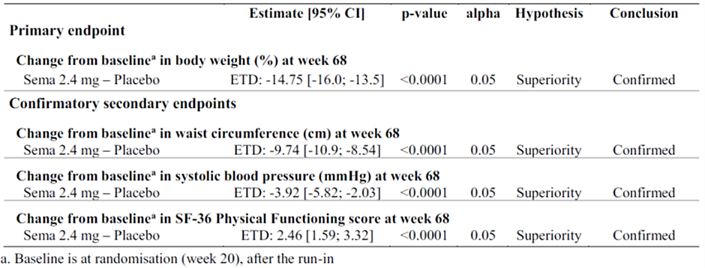

|  |
| --- |
| Therapeutic Goods Administration |
| PO Box 100 Woden ACT 2606 Australia  Email: [info@tga.gov.au](mailto:info@tga.gov.au) Phone: 1800 020 653 Fax: 02 6203 1605  [**https://www.tga.gov.au**](https://www.tga.gov.au) |

1. This is the original indication proposed by the Sponsor when the TGA commenced the evaluation of this submission. It may differ to the final indication approved by the TGA and registered in the Australian Register of Therapeutic Goods.
2. Australian Institute of Health and Welfare. Overweight and obesity. 23rd July 2020: <https://www.aihw.gov.au/reports/australias-health/overweight-and-obesity>
3. Bray GA. Medical consequences of obesity. J Clin Endocrinol Metab. 2004;89(6):2583-9.
4. Afshin A, Forouzanfar MH, Reitsma MB, et al. Health effects of overweight and obesity in 195 countries over 25 years. N Engl J Med. 2017;377(1): 13–27.
5. In this report the ‘Delegate’ is the Delegate of the Secretary of the Department of Health and Aged Care who decided the submission under section 25 of the Act.
6. AusPAR for initial Ozempic approval: <https://www.tga.gov.au/resources/auspar/auspar-ozempic>