▼This medicinal product is subject to additional monitoring in Australia. This will allow quick identification of new safety information. Healthcare professionals are asked to report any

suspected adverse events at [www.tga.gov.au/reporting-problems](http://www.tga.gov.au/reporting-problems).

# AUSTRALIAN PRODUCT INFORMATION – EBGLYSS® (LEBRIKIZUMAB) SOLUTION FOR INJECTION – AUTOINJECTOR [PRE-FILLED PEN]

1. **NAME OF THE MEDICINE**

Lebrikizumab

# QUALITATIVE AND QUANTITATIVE COMPOSITION

Each EBGLYSS autoinjector (pre-filled pen) contains 250 mg/2 mL of lebrikizumab.

Lebrikizumab is a recombinant Immunoglobulin G4 (IgG4) monoclonal antibody. Lebrikizumab is produced in Chinese Hamster Ovary (CHO) cells by recombinant DNA technology and is composed of 2 identical gamma heavy chains (445 amino acid residues each) and 2 identical kappa light chains (218 amino acid residues each) with inter- and intra-chain disulfide bonds. The antibody undergoes posttranslational modifications such as glycosylation of heavy chain Asn295.

For the full list of excipients, see Section 6.1 List of excipients.

# PHARMACEUTICAL FORM

Solution for subcutaneous injection.

EBGLYSS is a sterile, preservative-free, non-pyrogenic, clear to opalescent, colourless to slightly yellow to slightly brown solution, free of visible particles.

# CLINICAL PARTICULARS

## Therapeutic indications

EBGLYSS is indicated for the treatment of adult and adolescent patients (12 years of age and older) with moderate to severe atopic dermatitis (AD) who are candidates for systemic therapy.

## Dose and method of administration

Prior to Administration of EBGLYSS

Consider completion of all age-appropriate immunisations according to current immunisation guidelines (see Section 4.4 Special warnings and precautions for use, Immunisations).

Adults and Adolescents (12 years of age and older who weigh at least 40 kg)

Treatment with EBGLYSS should be initiated and supervised by a dermatologist or physician with expertise in management of atopic dermatitis.

The recommended dose of lebrikizumab is an initial dose of 500 mg (two 250 mg injections) injected subcutaneously at Week 0 and Week 2, followed by 250 mg every two weeks until Week 16. For patients who achieve an adequate clinical response at Week 16, the maintenance dose is 250 mg every four weeks.

Consideration should be given to discontinuing treatment in patients who have shown no clinical response after 16 weeks of treatment.

For patients who have had a less than adequate clinical response at Week 16, consideration may be given to continuing lebrikizumab 250 mg every two weeks until an adequate clinical response is achieved. Patients achieving an adequate clinical response can then continue maintenance treatment with lebrikizumab 250 mg every four weeks. Consideration should be given to discontinuing treatment in patients who have shown inadequate clinical response after a total of 24 weeks of dosing every two weeks.

Lebrikizumab can be used with or without topical corticosteroids (TCSs) or topical calcineurin inhibitors (TCIs).

General considerations for administration for subcutaneous injection by autoinjector (pre-filled pen)

* EBGLYSS is single use only. Use in one patient on one occasion only. Discard any residue. It contains no antimicrobial preservative.
* EBGLYSS is for subcutaneous administration.
* EBGLYSS is intended for use under the guidance of a healthcare professional. Provide proper training to patients and/or caregivers on the subcutaneous injection technique of EBGLYSS according to the “Instructions for Use”, included with the packaged product.
* Adult patients may self-inject or caregivers may give injections of EBGLYSS after training in subcutaneous injection technique. For adolescent patients, caregivers may give injections after training in subcutaneous technique.
* Sites for injection include the abdomen, thigh, and back of the upper arm. Administration of EBGLYSS in the back of the upper arm may be performed by a caregiver or healthcare provider (*see Instructions for Use)*.
* Instruct patients not to inject in the exact same spot every time. Do not inject into areas where the skin is tender, bruised, red, hard, or in an area of skin that is affected by atopic dermatitis or skin lesions.
* Parenteral drug products should be inspected visually for particulate matter and discoloration prior to administration, whenever solution and container permit. Do not use EBGLYSS if it is cloudy, or there are visible particles.

Missed dose

Instruct patients to inject a missed dose as soon as possible. Thereafter, dosing should be resumed at the regular scheduled time.

## Contraindications

Hypersensitivity to the active substance or to any of the excipients listed in Section 6.1 List of excipients.

## Special warnings and precautions for use

### Immunisations

Prior to initiating therapy with EBGLYSS, consider completion of all age-appropriate immunisations according to current immunisation guidelines. Avoid use of live vaccines in patients treated with EBGLYSS.

### Hypersensitivity

Hypersensitivity reactions, including angioedema and urticaria, have been reported with use of EBGLYSS. If a serious hypersensitivity reaction occurs, discontinue EBGLYSS and initiate appropriate therapy.

### Parasitic (Helminth) Infections

Patients with known helminth infections were excluded from participation in clinical studies. It is unknown if lebrikizumab will influence the immune response against helminth infections by inhibiting IL-13 signalling. Treat patients with pre-existing helminth infections before initiating treatment with lebrikizumab. If patients become infected while receiving lebrikizumab and do not respond to antihelminth treatment, discontinue treatment with lebrikizumab until the infection resolves.

**Conjunctivitis and Keratitis**

Conjunctivitis and keratitis adverse reactions have been reported in clinical trials.

Advise patients to report new onset or worsening eye symptoms to their healthcare professional.

Patients treated with lebrikizumab who develop conjunctivitis that does not resolve following standard treatment should undergo ophthalmological examination (see section 4.8 Adverse Effects (Undesirable Effects)).

### Reduction of Corticosteroid Dosage

Upon initiation of therapy with EBGLYSS, do not discontinue corticosteroid abruptly. Reductions in corticosteroid dose, if appropriate, should be gradual and performed under the direct supervision of a physician. Reduction in corticosteroid dose may be associated with systemic withdrawal symptoms and/or unmask conditions previously suppressed by systemic corticosteroid therapy.

### Use in the elderly

Of the 1348 adult subjects with moderate-to-severe atopic dermatitis exposed to EBGLYSS, a total of 123 were 65 years or older, and 29 subjects were 75 years or older. Although no differences in safety or efficacy were observed between older and younger subjects, the number of subjects aged 65 and over is not sufficient to determine whether they respond differently from younger subjects (see Section 5.2 Pharmacokinetic properties, Special Populations).

### Paediatric use

The safety and effectiveness of EBGLYSS have been established in paediatric subjects aged 12 to less than 18 years who weigh at least 40 kg with moderate-to-severe atopic dermatitis. A total of 372 paediatric subjects were exposed to EBGLYSS with 270 subjects exposed to EBGLYSS for at least one year. The safety and effectiveness of EBGLYSS in paediatric subjects aged 12 years to less than 18 years who weigh less than 40 kg and paediatric subjects less than 12 years of age with moderate to severe atopic dermatitis have not been established.

### Effects on laboratory tests

No information on the effect of lebrikizumab on laboratory tests is available.

## Interactions with other medicines and other forms of interactions

No drug interactions studies were conducted. In AD studies, safety of lebrikizumab in combination with other systemic immunomodulatory agents or phototherapy has not been evaluated.

### Live Vaccines

No data are available on the response to live vaccines. Avoid use of live vaccines in patients treated with lebrikizumab.

## Fertility, pregnancy and lactation

### Effects on fertility

No effects on reproductive organs, reproductive hormones or menstrual cycle length were observed in sexually mature female cynomolgus monkeys that were administered lebrikizumab for 37 weeks at an intravenous dose of 25 mg/kg/week, up to 16 times the human exposure (Cavg,ss) at the recommended human dose.

No effects on reproductive organs or sperm analysis were observed in sexually mature male cynomolgus monkeys that were administered lebrikizumab for 13 weeks at a subcutaneous dose of 25 mg/kg/week, up to 13 times the human exposure (Cavg,ss) at the recommended dose.

### Use in pregnancy – Pregnancy Category B1

There are limited data on lebrikizumab use in pregnant women. Human IgG is known to cross the placental barrier, therefore, lebrikizumab may be transmitted from the mother to the developing fetus. The background risk of major birth defects and miscarriage for the indicated population is unknown.

No embryofetal toxicity or malformations, or effects on morphological, functional, or immunological development in infants were seen in developmental toxicity studies in pregnant monkeys at maintenance subcutaneous doses up to 50 mg/kg per week during gestation, resulting in exposures up to 18 times the human exposure (Cavg,ss) at the recommended dose.

Lebrikizumab crossed the placenta in monkeys and was quantifiable in infant serum up to the last assessment point (6 months of age). No effects on morphological, functional, or immunological development were observed in infants. A higher risk of infections in infants exposed to lebrikizumab during the gestational period cannot be excluded. As a precautionary measure, it is preferable to avoid the use of lebrikizumab during pregnancy.

### Use in lactation

There are no data on the presence of lebrikizumab in human milk, the effects on the breastfed infant, or the effects on milk production. Human immunoglobulin G (IgG) is known to be excreted in breast milk. A decision must be made whether to discontinue breastfeeding or to discontinue from lebrikizumab therapy taking into account the benefit of breastfeeding for the child and the benefit of therapy for the woman.

## Effects on ability to drive and use machines

There are no known effects on the ability to drive or use machines associated with the use of lebrikizumab.

## Adverse effects (Undesirable effects)

### Atopic dermatitis

***Clinical trial experience***

Tabulated list of adverse reactions

The safety of EBGLYSS was evaluated in subjects with moderate-to-severe atopic dermatitis across three randomised, double-blind, placebo-controlled, multicenter phase 3 studies (ADvocate 1, ADvocate 2 and ADopt-VA), two topical corticosteroid (TCS) combination, placebo- controlled phase 3 studies (ADhere and ADhere-J) and one phase 2 dose ranging trial (KGAF). A total of 1184 subjects were treated with EBGLYSS for at least 1 year in the atopic dermatitis clinical development trials. ADvocate 1, ADvocate 2, ADopt-VA and KGAF compared the safety of EBGLYSS monotherapy to placebo. ADhere and ADhere-J compared the safety of EBGLYSS + TCS to placebo + TCS through 16 weeks. Eligible subjects from the Phase 3 studies were allowed to enrol in the long-term extension study.

**Table 1** summarizes the adverse reactions that were reported more frequently in the EBGLYSS groups than in the placebo group during the 16-week placebo-controlled period of the clinical trials.

### Table 1: Adverse Drug Reactions Reported More Frequently in the EBGLYSS group in the Placebo-Controlled Trials Up to 16 Weeks

|  |  |  |
| --- | --- | --- |
| **System Organ Class Adverse Drug reaction** | **Lebrikizumab 250 mg**  **Monotherapy or in Combination with TCSa** | |
| **Lebrikizumab 250 mg Q2Wb (with and without TCS)**  **N=1031**  **n(%)** | **Placebo**  **(with and without TCS)**  **N=608 n(%)** |
| **Eye Disorders** | | |
| Conjunctivitis allergic | 37 (3.7) | 7 (1.2) |
| Keratitisc | 5 (0.5) | 1 (0.2) |
| **General Disorders and Administration Site Conditions** | | |
| Injection Site Reactionsd | 30 (3.0) | 12 (1.9) |
| **Infections and Infestations** | | |
| Conjunctivitis | 66 (6.3) | 9 (1.6) |
| Conjunctivitis bacterial | 3 (0.3) | 0 |
| Herpes zoster | 5 (0.5) | 1 (0.2) |

Abbreviations: n = number of patients in the specified category; N = number of patients in the safety analysis set; Q2W = every 2 weeks; TCS = topical corticosteroids.

a Integrated analysis of ADvocate 1, ADvocate 2, ADhere, Adopt-VA, ADhere-J and the phase 2 dose finding trial (KGAF)

b EBGLYSS 500 mg at Week 0 and Week 2, followed by 250 mg every two weeks (Q2W)

c Keratitis cluster contains the preferred terms keratitis, atopic keratoconjunctivitis, allergic keratitis, ulcerative keratitis, vernal keratoconjunctivitis

d Injection Site Reactions were identified by MedDRA High-Level Term (HLT)

Description of selected adverse reactions

*Eosinophilia*

Eosinophilia (>5000 cells/mm3) was uncommonly observed in patients treated with lebrikizumab. In general, the eosinophilia was transient and did not result in discontinuation.

*Conjunctivitis and Keratitis*

Most cases of conjunctivitis and keratitis were mild or moderate in severity, recovered or resolved without treatment interruption or discontinuation. Conjunctivitis was the most frequently reported eye disorder.

Treatment-Emergent Adverse Events (TEAE)

During the placebo-controlled induction period (week 0 to 16), the overall frequency of participants with at least 1 TEAE was similar in the lebrikizumab and placebo groups (**Table 2**). Conjunctivitis was the most frequently reported event for lebrikizumab-treated participants.

### Table 2: TEAEs occurring in at least 1% of lebrikizumab-treated participants from the induction period (week 0 to 16) placebo-controlled analysis seta

|  |  |  |
| --- | --- | --- |
| **Event** | **All lebrikizumab treated Placebo Controlled Analysis Seta** | |
| **Placebo (N=404)**  **n (adj %)** | **Lebrikizumab 250 mg Q2W (N=783)**  **n (adj %)** |
| Participants with at least 1 TEAE | 215 (53.1) | 384 (49.2) |
| Conjunctivitis | 7 (1.8) | 51 (6.5) |
| Dermatitis atopic | 74 (18.4) | 47 (6.0) |
| Nasopharyngitis | 13 (3.2) | 34 (4.4) |
| Headache | 12 (2.9) | 34 (4.4) |
| Oral herpes | 9 (2.3) | 15 (1.9) |
| Conjunctivitis allergic | 3 (0.7) | 14 (1.8) |
| Dry eye | 4 (0.9) | 11 (1.4) |
| Pruritis | 7 (1.8) | 9 (1.2) |
| COVID-19 | 5 (1.3) | 9 (1.1) |
| Hypertension | 4 (1.0) | 9 (1.1) |
| Rhinitis allergic | 1 (0.2) | 8 (1.0) |
| Injection site pain | 4 (1.0) | 7 (1.0) |

Abbreviations: adj % = study size adjusted percentage; COVID-19 = coronavirus disease 2019; n = number of patients in the specified category; N = number of patients in the safety analysis set; Q2W = every 2 weeks

a Studies ADvocate 1, ADvocate 2, Adhere and KGAF

During the placebo-controlled induction period, the frequency of reported TEAEs were lower in the EBGLYSS group compared to the Placebo group for the adolescent population. The safety profile in adolescents is considered consistent with the safety profile in adults.

### Reporting suspected adverse effects

Reporting suspected adverse reactions after registration of the medicinal product is important. It allows continued monitoring of the benefit-risk balance of the medicinal product. Healthcare professionals are asked to report any suspected adverse reactions at [www.tga.gov.au/reporting-problems](http://www.tga.gov.au/reporting-problems).

## Overdose

For information on the management of overdose, contact the Poisons Information Centre on 13 11 26 (Australia).

There is no specific treatment for EBGLYSS overdose. Single intravenous doses up to 10 mg/kg and multiple subcutaneous doses up to 500 mg have been administered to humans in clinical trials without dose-limiting toxicity. In the event of overdosage, monitor the patient for any signs or symptoms of adverse reactions and institute appropriate symptomatic treatment immediately.

# PHARMACOLOGICAL PROPERTIES

## Pharmacodynamic properties

In lebrikizumab clinical studies, lebrikizumab reduced the levels of serum periostin, total immunoglobulin E (IgE), CC chemokine ligand (CCL)17 (thymus and activation-regulated chemokine [TARC]), CCL18 (pulmonary and activation-regulated chemokine [PARC]), and CCL13 (monocyte chemotactic protein-4 [MCP-4]). These decreases in type 2 inflammatory biomarkers provide indirect evidence of inhibition of the IL-13 pathway by lebrikizumab.

### Mechanism of action

Lebrikizumab is an immunoglobulin G4 (IgG4) monoclonal antibody (MAb) that binds with high affinity to interleukin (IL)-13 and inhibits IL-13 signalling through the IL-4 receptor alpha (IL- 4Rα)/IL-13 receptor alpha 1 (IL-13Rα1) pathway, thereby blocking the downstream effects of IL-13 with high selectivity.

Blockade of IL-13 signalling is expected to be of benefit in diseases in which IL-13 is a key contributor to the disease pathogenesis.

### Clinical trials

Atopic Dermatitis (AD)

Three multicenter, randomized, double-blind, placebo-controlled trials, ADvocate 1, ADvocate 2 and ADhere enrolled a total of 1062 subjects 12 years of age and older with moderate-to-severe atopic dermatitis not adequately controlled by topical medication(s) and who were candidates for systemic therapy. A total of 148 subjects (14%) were adolescent subjects (12 to <18 years who weigh at least 40 kg) and 914 subjects (86%) were adult subjects. Disease severity was

defined by an Investigator’s Global Assessment (IGA) score ≥3 in the overall assessment of AD lesions on a severity scale of 0 to 4, an Eczema Area and Severity Index (EASI) score ≥16 on a scale of 0 to 72, and a minimum body surface area involvement of ≥10%.

In all three trials, subjects in the EBGLYSS group received subcutaneous injections of EBGLYSS 500 mg at Week 0 and at Week 2, followed by 250 mg every other week (Q2W) through Week 16.

In the monotherapy trials (ADvocate 1 and ADvocate 2), subjects received EBGLYSS or placebo. Subjects who received EBGLYSS and achieved an IGA score of 0 or 1 (with a 2-point or greater reduction from Baseline), or at least a 75% reduction in EASI from baseline [EASI-75] at Week 16 and did not require rescue therapy were re-randomised to maintenance and durability study for an additional 36 weeks of either a maintenance dose of EBGLYSS 250 mg Q2W, EBGLYSS 250 mg Q4W (every 4 weeks) or lebrikizumab withdrawal (placebo).

In the concomitant therapy trial (ADhere), subjects received EBGLYSS + topical corticosteroids (TCS) or placebo + TCS. Subjects in the EBGLYSS + TCS group who achieved IGA 0 or 1 (with a 2- point or greater reduction from Baseline) or EASI-75 at Week 16 and did not require rescue therapy, were re-randomised to EBGLYSS 250 mg Q2W + TCS or EBGLYSS 250 mg Q4W + TCS in the long-term extension study.

All three trials assessed the primary endpoint, the proportion of subjects who achieved an IGA score of 0 (clear) or 1 (almost clear) and at least a 2-point improvement from baseline at Week 16. Other evaluated outcomes at Week 16 included the proportion of subjects with EASI- 75 and EASI-90, and improvement in itch severity as defined by a reduction of at least 4 points on an 11-point Pruritus Numeric Rating Scale (Pruritus NRS). ADvocate 1 and ADvocate 2 also evaluated the maintenance and durability of response through to Week 52.

*Baseline characteristics*

At baseline, 50% of subjects were male, 63% of subjects had a baseline IGA score of 3 (moderate AD) and 37% of subjects had a baseline IGA of 4 (severe AD). The baseline mean EASI was 29, and the baseline Pruritus NRS was 7 on a scale of 0-10. Of all subjects, 99% had received prior treatment for AD.

Clinical Response at Week 16 (ADvocate 1, ADvocate 2, and ADhere)

The results of the EBGLYSS monotherapy trials (ADvocate 1 and ADvocate 2) and the EBGLYSS

+ TCS trial (ADhere) are presented in **Table 3**.

### Table 3: Efficacy Results of EBGLYSS With or Without Concomitant TCS at Week 16a

**ADvocate 1 ADvocate 2 ADhere**

|  |  |  |  |  |  |  |
| --- | --- | --- | --- | --- | --- | --- |
|  | **EBGLYSS**  **250 mg Q2Wb** | **Placebo** | **EBGLYSS**  **250 mg Q2Wb** | **Placebo** | **EBGLYSS**  **250 mgb Q2W +**  **TCS** | **Placebo**  **+ TCS** |
| Number of subjects | 283 | 141 | 281 | 146 | 145 | 66 |
| IGA 0 or 1c | 43.1%  (p<0.001) | 12.7% | 33.2%  (p<0.001) | 10.8% | 41.2%  (p=0.011) | 22.1% |
| EASI-75 | 58.8%  (p<0.001) | 16.2% | 52.1%  (p<0.001) | 18.1% | 69.5%  (p<0.001) | 42.2% |
| EASI-90 | 38.3%  (p<0.001) | 9.0% | 30.7%  (p<0.001) | 9.5% | 41.2% (p=0.008) | 21.7% |
| Number of subjects with baseline Pruritus  NRS score ≥4 | 263 | 130 | 253 | 134 | 130 | 57 |
| Pruritus NRS ≥4 point  improvement | 45.9%  (p<0.001) | 13.0% | 39.8%  (p<0.001) | 11.5% | 50.6% (p=0.017) | 31.9% |

p-values for difference from placebo.

Abbreviations: EASI= eczema area and severity index, IGA = Investigator’s Global Assessment; NRS =

numeric rating scale; Q2W = every 2 weeks; TCS = topical corticosteroids.

a Subjects who received rescue therapy or discontinued treatment due to lack of efficacy were analyzed as non-responders. Data after treatment discontinuation due to any other reason were considered missing. Any missing data was imputed using MCMC-MI.

b Subjects received 500 mg of EBGLYSS at Week 0 and Week 2, and 250 mg Q2W up to Week 16

c Primary endpoint. Responder was defined as a subject with an IGA 0 or 1 (“clear” or “almost clear”) and a reduction of ≥2 points on a 0-4 IGA scale

A higher proportion of EBGLYSS-treated subjects achieved IGA 0 or 1 (with ≥2 point

improvement from baseline) by Week 4 in ADvocate 1 and ADvocate 2 (**Figure 1**).

### Figure 1: Proportion of Subjects achieving IGA 0 or 1, with a ≥2 point improvement from

**baseline through Week 16 in ADvocate 1 and ADvocate 2**

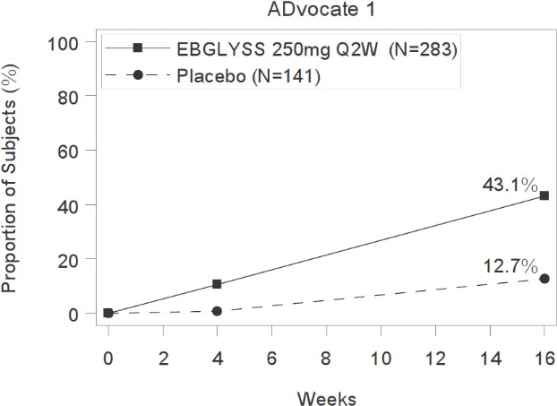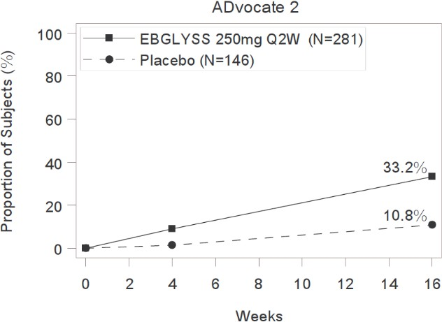

A higher proportion of EBGLYSS-treated subjects achieved at least a 4 point improvement from baseline in pruritus NRS by Week 2 in ADvocate 1 and Week 4 in ADvocate 2 (**Figure 2**).

### Figure 2: Proportion of Subjects with ≥4-point improvement in Pruritus NRS through Week 16 in ADvocate 1 or ADvocate 2

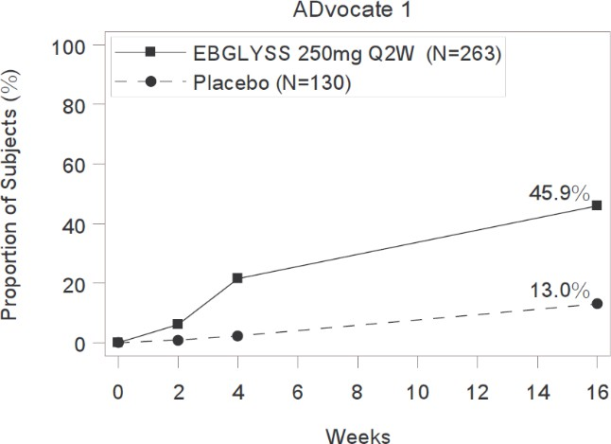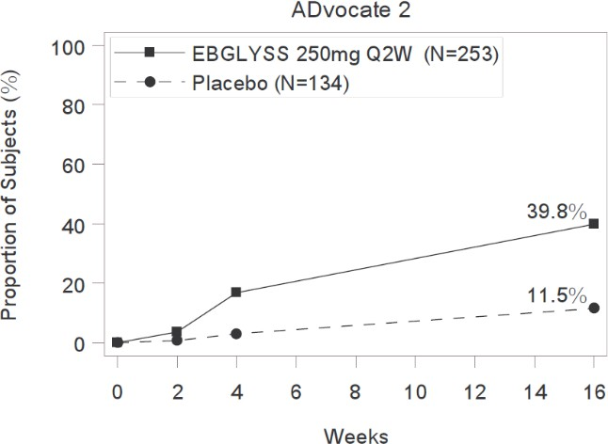

Examination of age, gender, race, body weight, and prior treatment did not identify meaningful differences in response to EBGLYSS among these subgroups at Week 16.

*Adolescent sub-population*

A subgroup analyses of adolescent efficacy data from ADvocate1, ADvocate2 and ADhere for the induction period are provided in the **Table 4** below.

**Table 4: Comparison of Adolescent Results at Week 16 across Studies (MCMC-MI)**

**Pooled ADvocate 1 and ADvocate 2 studies**

**ADhere study**

n (%)

|  |  |  |  |  |
| --- | --- | --- | --- | --- |
|  | **Placebo** | **EBGLYSS 250**  **mg Q2W** | **Placebo + TCS** | **EBGLYSS 250 mg Q2W + TCS** |
| Adolescents in Induction Period treatment group  (N) | 35 | 67 | 14 | 32 |
| IGA 0,1 at W16, n (%) | 5 (14.3) | 31 (46.6) | 4 (28.6) | 18 (57.3) |
| EASI 75 at W16, | 6 (17.3) | 42 (62.0) | 8 (57.1) | 28 (88.0) |

Abbreviations: MCMC-MI = Markov Chain Monte Carlo multiple imputation; EASI = Eczema Area and

Severity Index; IGA = Investigator’s Global Assessment; N = number of participants in the analysis population; n = number of participants in the specified category; Q2W = every 2 weeks; W16 = Week 16; TCS = topical corticosteroids.

Results in adolescents were generally consistent with the results observed in the adult population for the induction period.

Maintenance and Durability of Response (Week 16 to Week 52)

*Monotherapy Trials*

To evaluate the maintenance and durability of response, subjects from the monotherapy trials originally randomised to EBGLYSS who achieved an IGA score of 0 or 1, or at least a 75% reduction in EASI from baseline [EASI-75] at Week 16 and did not require rescue therapy were re-randomised to an additional 36 weeks of either a maintenance dose of EBGLYSS 250 mg Q2W, EBGLYSS 250 mg Q4W (every 4 weeks) or lebrikizumab withdrawal (placebo). For details on lebrikizumab half-life, refer to Section 5.2 Pharmacokinetic properties, Excretion.

Subjects maintained durable response through to Week 52 with dosing of either EBGLYSS Q4W or Q2W. Response durability was comparable for Q4W and Q2W dose frequencies.

There was a higher maintenance of IGA 0,1 response at Week 52, among those who had achieved this endpoint at baseline, for subjects re-randomised to EBGLYSS treatment arms compared to placebo (lebrikizumab withdrawal) arm, for individual study and pooled populations.

### Figure3: Proportions of participants maintaining IGA 0 or 1, with a ≥2 point improvement from Baseline; Week 16 through Week 52 of ADvocate 1 and ADvocate 2 pooled population (MCMC-MI).

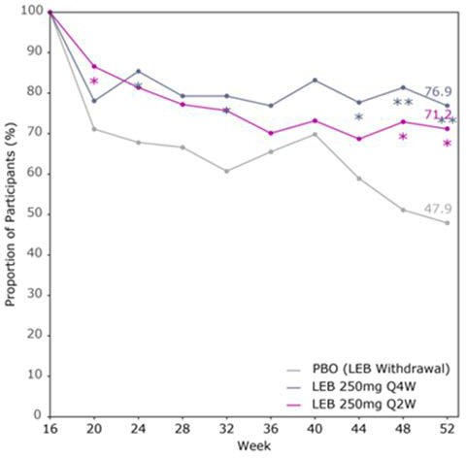

Abbreviations: MCMC-MI = Markov Chain Monte Carlo multiple imputation; LEB = lebrikizumab; PBO = placebo; Q2W = every 2 weeks; Q4W = every 4 weeks. vs. PBO: *p <.05, **p <.01, ***p <.001 (all p-values were nominal).

At Week 52, maintenance of IGA 0,1 response was significantly higher (p<0.05) for EBGLYSS 250 mg Q4W (76.9%) arm compared to placebo (lebrikizumab withdrawal) arm (47.9%) in the pooled population (**Figure 3**).

There was a higher maintenance of EASI 75 response at Week 52, among those who achieved this endpoint at Week 16, for subjects re-randomised to EBGLYSS treatment arms compared to placebo (lebrikizumab withdrawal) arm, for individual study and pooled populations.

### Figure 4: Proportion of participants maintaining EASI 75; Week 16 through Week 52 of ADvocate 1 and ADvocate 2 pooled population (MCMC-MI)

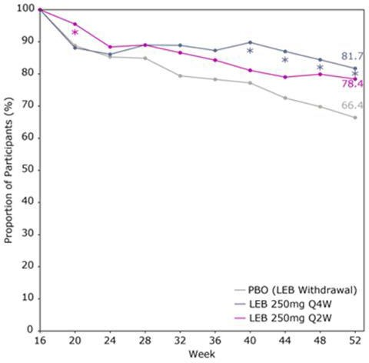

Abbreviations: EASI = Eczema Area and Severity Index; MCMC-MI = Markov Chain Monte Carlo multiple imputation; LEB = lebrikizumab; PBO = placebo; Q2W = every 2 weeks; Q4W = every 4 weeks. vs. PBO:

*p<.05, **p<.01, ***p<.001 (all p-values were nominal).

At Week 52, maintenance of EASI 75 response was significantly higher (p<0.05) for the EBGLYSS 250 mg Q4W (81.7%) arm compared to lebrikizumab placebo (withdrawal) arm (66.4%) in the pooled population (**Figure 4**).

There was a higher maintenance of Pruritus NRS 4-point improvement at Week 52, among those who achieved this endpoint at Week 16, for subjects re-randomised to EBGLYSS treatment arms compared to placebo (lebrikizumab withdrawal) arm, for individual study and pooled populations.

### Figure 5: Proportion of participants maintaining a 4-point or greater improvement in Pruritus NRS; Week 16 through Week 52 of ADvocate 1 and ADvocate 2 pooled population (MCMC-MI).

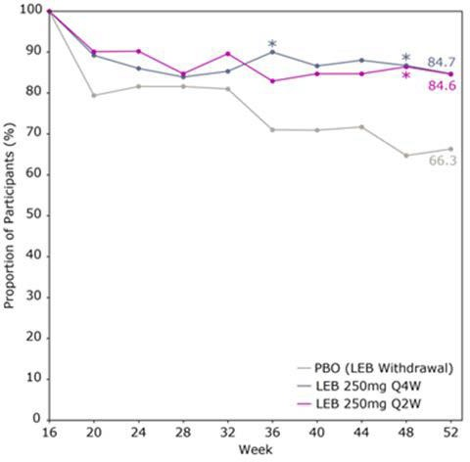

Abbreviations: MCMC-MI = Markov Chain Monte Carlo multiple imputation; LEB = lebrikizumab; PBO = placebo; Q2W = every 2 weeks; Q4W = every 4 weeks. vs. PBO: *p<.05, **p<.01, ***p<.001 (all p-values were nominal).

At Week 52, pruritus NRS 4-point improvement was numerically higher for EBGLYSS 250 mg Q4W (84.7%) compared to placebo (lebrikizumab withdrawal) arm (66.3%) (**Figure 5**).

*Adolescent sub-population*

A subgroup analyses of adolescent efficacy data from the pooled ADvocate 1 and ADvocate 2 results for the maintenance period (Week 16 to 52) is provided in **Table 5** below.

### Table 5: Adolescent results for pooled ADvocate 1 and ADvocate 2 studies at Week 52 (MCMC-MI)

**Pooled ADvocate 1 and ADvocate 2 studies**

responders) at W16

|  |  |  |
| --- | --- | --- |
| **lebrikizumab**  **withdrawal (Placebo)** | **EBGLYSS 250 mg QW4** | **EBGLYSS 250 mg Q2W** |
| Adolescents  (lebrikizumab 8  (N) | 17 | 13 |
| EBGLYSS-responders  with IGA 0,1 at W16 6  (N) | 15 | 7 |
| Maintained IGA  0,1 at W52, 2 (40.7) n (%) | 10 (63.7) | 3 (49.1) |
| EBGLYSS-responders  with EASI 75 at W16 8  (N) | 16 | 13 |
| Maintained  EASI 75 at 4 (53.0) | 15 (92.8) | 11 (82.2) |

W52, n (%)

Abbreviations: MCMC-MI = Markov Chain Monte Carlo multiple imputation; EASI = Eczema Area and Severity Index; IGA = Investigator’s Global Assessment; N = number of participants in the analysis population; n = number of participants in the specified category; Q2W = every 2 weeks; Q4W = every 4 weeks; W16 = Week 16; W52 = Week 52.

Results in adolescents were generally consistent with the results observed in the adult population for the induction period.

*Concomitant TCS Trial*

Subjects treated with EBGLYSS 250 mg Q2W + TCS in the TCS combination study (ADhere) who achieved IGA 0 or 1 (with a 2-point or greater reduction from Baseline) or EASI-75 at Week 16 and did not receive rescue therapy were re-randomised to receive EBGLYSS 250 mg Q2W +TCS or EBGLYSS 250 mg Q4W +TCS in a long term extension study.

The maintenance of IGA 0 or 1 response at Week 56 was 75.4% for subjects who continued on EBGLYSS 250 mg Q2W and 86.8% for subjects who received EBGLYSS 250 mg Q4W. The maintenance of EASI-75 response at Week 56 was 85.6% for subjects who continued on EBGLYSS 250 mg Q2W and 81.2% for subjects who received EBGLYSS 250 mg Q4W.

### Immunogenicity

With 12 months of treatment of lebrikizumab (250 mg Q2W induction dosing followed by 250 mg Q4W maintenance dosing), up to 2.8% of patients developed anti-drug antibodies (ADAs), most of which were neutralizing and of low titre. The presence of anti-drug antibodies was not associated with changes to pharmacokinetics, efficacy, or safety of lebrikizumab.

## Pharmacokinetic properties

Following the 500 mg loading doses at Week 0 and Week 2, steady-state serum concentrations were achieved with the first 250 mg every 2 weeks (Q2W) dose at Week 4.

Based on a population PK analysis, the steady-state maximum concentration (Cmax,ss), the steady- state average concentration (Cavg,ss), and the steady-state trough concentration (Ctrough,ss) following the 250 mg Q2W subcutaneous dose in patients with AD were 108 μg/mL, 100 μg/mL, and 87 μg/mL, respectively. The Cmax,ss, the Cavg,ss, and the Ctrough,ss following the 250 mg every 4 weeks (Q4W) subcutaneous dose in patients with AD were 63 μg/mL, 51 μg/mL, and 36 μg/mL, respectively.

### Absorption

Following a single subcutaneous 250 mg dose of lebrikizumab, peak serum concentrations were achieved approximately 7 to 8 days post dose. The absolute bioavailability for a subcutaneous dose was estimated as 86%.

Injection site location did not significantly influence the absorption of lebrikizumab.

### Distribution

Based on a population PK analysis, the total volume of distribution at steady-state was 5.14 L.

### Metabolism

Lebrikizumab is expected to be degraded into small peptides and amino acids via catabolic pathways in the same manner as endogenous IgG.

### Excretion

In the population PK analysis, clearance was 0.154 L/day and was independent of dose. The mean elimination half-life was 24.5 days.

### Dose Proportionality

Lebrikizumab exhibited linear pharmacokinetics with dose-proportional increase in exposure over a dose range of 37.5 to 500 mg given as a subcutaneous injection in patients with AD or in healthy volunteers.

### Special Populations

*Age, Sex, Weight, Race*

Age, sex, or race did not have a significant effect on the pharmacokinetics of lebrikizumab. Lebrikizumab trough concentrations were lower in subjects with higher body weight.

*Renal and hepatic impairment*

Specific clinical pharmacology studies to evaluate the effects of renal impairment and hepatic impairment on the pharmacokinetics of lebrikizumab have not been conducted. Lebrikizumab, as a monoclonal antibody, is not expected to undergo significant hepatic or renal elimination. Population pharmacokinetic analysis showed that markers of renal and hepatic function did not affect the pharmacokinetics of lebrikizumab.

## Preclinical safety data

### Genotoxicity

Genotoxicity studies have not been conducted with lebrikizumab. Lebrikizumab is a monoclonal antibody and as such, it is not expected to interact directly with DNA.

### Carcinogenicity

Studies have not been conducted to evaluate the carcinogenic potential of lebrikizumab.

# PHARMACEUTICAL PARTICULARS

## List of excipients

Histidine

Glacial acetic acid Sucrose Polysorbate 20 Water for injections

## Incompatibilities

Incompatibilities were either not assessed or not identified as part of the registration of this medicine.

## Shelf life

In Australia, information on the shelf life can be found on the public summary of the Australian Register of Therapeutic Goods (ARTG). The expiry date can be found on the packaging.

## Special precautions for storage

* + - Store refrigerated at 2°C to 8°C in the original carton to protect from light until use.
    - May be stored outside of refrigeration in the original carton at not more than 30°C for up to 7 days. Once stored out of refrigeration, do not place back in the refrigerator. If these conditions are exceeded, EBGLYSS must be discarded.
    - Do not freeze. Do not use if frozen.
    - Do not shake.
    - Discard autoinjector (pre-filled pen) in a sharps container.

## Nature and contents of container

EBGLYSS is supplied in a 2 mL autoinjector (pre-filled pen) that delivers 250 mg/2 mL of lebrikizumab. The solution is contained in a clear glass syringe barrel with plunger. The plunger is not made with natural rubber latex.

EBGLYSS is available in a pack size of 1 single dose autoinjector (pre-filled pen) as a trade pack and as a starter pack. Not all pack types may be marketed.

## Special precautions for disposal

In Australia, any unused medicine or waste material should be disposed of by taking to your local pharmacy.

## Physicochemical properties

### Chemical structure

**CAS number**

953400-68-5

# MEDICINE SCHEDULE (POISONS STANDARD)

Schedule 4

# SPONSOR

Eli Lilly Australia Pty Ltd

Level 9, 60 Margaret Street, Sydney, NSW 2000 AUSTRALIA

Phone: 1800 454 559

# DATE OF FIRST APPROVAL

DAY MONTH YEAR

# DATE OF REVISION

Not applicable.

## Summary table of changes

|  |  |
| --- | --- |
| **Section Changed** | **Summary of new information** |
| **All** | New biological entity |
|  |  |
|  |  |

EBGLYSS® is a registered trademark of Eli Lilly and Company