|  |
| --- |
| Australian Public Assessment Report for Nubeqa |
| Active ingredient: Darolutamide |
| Sponsor: Bayer Australia Ltd |
| September 2024 |

About the Therapeutic Goods Administration (TGA)

* The Therapeutic Goods Administration (TGA) is part of the Australian Government Department of Health and Aged Care and is responsible for regulating therapeutic goods, including medicines, medical devices, and biologicals.
* The TGA administers the *Therapeutic Goods Act 1989* (the Act), applying a risk management approach designed to ensure therapeutic goods supplied in Australia meet acceptable standards of quality, safety, and efficacy.
* The work of the TGA is based on applying scientific and clinical expertise to decision-making, to ensure that the benefits to the Australian public outweigh any risks associated with the use of therapeutic goods.
* The TGA relies on the public, healthcare professionals and industry to report problems with therapeutic goods. The TGA investigates reports received to determine any necessary regulatory action.
* To report a problem with a therapeutic good, please see the information on the [TGA website](https://www.tga.gov.au/).

About AusPARs

* The Australian Public Assessment Report (AusPAR) provides information about the evaluation of a prescription medicine and the considerations that led the TGA to approve or not approve a prescription medicine submission. Further information can be found in [Australian Public Assessment Report (AusPAR) guidance](https://www.tga.gov.au/australian-public-assessment-report-auspar-guidance).
* AusPARs are prepared and published by the TGA.
* AusPARs are static documents that provide information that relates to a submission at a particular point in time. The publication of an AusPAR is an important part of the transparency of the TGA’s decision-making process.
* A new AusPAR may be provided to reflect changes to indications or major variations to a prescription medicine subject to evaluation by the TGA.

Copyright

© Commonwealth of Australia 2024  
This work is copyright. You may reproduce the whole or part of this work in unaltered form for your own personal use or, if you are part of an organisation, for internal use within your organisation, but only if you or your organisation do not use the reproduction for any commercial purpose and retain this copyright notice and all disclaimer notices as part of that reproduction. Apart from rights to use as permitted by the *Copyright Act 1968* or allowed by this copyright notice, all other rights are reserved and you are not allowed to reproduce the whole or any part of this work in any way (electronic or otherwise) without first being given specific written permission from the Commonwealth to do so. Requests and inquiries concerning reproduction and rights are to be sent to the TGA Copyright Officer, Therapeutic Goods Administration, PO Box 100, Woden ACT 2606 or emailed to <[tga.copyright@tga.gov.au](mailto:tga.copyright@tga.gov.au)>.

Contents

List of abbreviations 4

Nubeqa (darolutamide) submission 6

Nubeqa (darolutamide) – proposed indications 7

Metastatic hormone sensitive prostate cancer (mHSPC) 7

Current treatment options for mHSPC 8

Clinical rationale for Nubeqa use in mHSPC 8

Regulatory status 9

Australian regulatory status 9

International regulatory status 9

Registration timeline 12

Evaluation overview 12

Clinical evaluation summary 12

Efficacy 26

Safety 39

Risk/benefit analysis 51

Conclusions 53

Outcome 53

Attachment 1. Product Information 53

#### List of abbreviations

|  |  |
| --- | --- |
| Abbreviation | Meaning |
| ACM | Advisory Committee on Medicines |
| ADT | Androgen deprivation therapy |
| AE | Adverse events |
| ALP | Alkaline phosphatase |
| ALT | Alanine Transaminase |
| AR | Androgen receptor |
| ARI | Androgen receptor inhibitor |
| ARTG | Australian Register of Therapeutic Goods |
| ASA | Australia‑specific annex |
| AST | Aspartate Transferase |
| CI | Confidence interval |
| CMI | Consumer Medicines Information |
| DDI | Drug-drug interactions |
| DLP | Data lock point |
| ECOG | Eastern Cooperative Oncology Group |
| FAS | Full analysis set |
| HR | Hazard ratio |
| IxRS | Interactive Voice/Web Response System |
| KM | Kaplan-Meier survival analysis |
| LHRH | luteinizing hormone-releasing hormone |
| mCRPR | metastatic castration resistant prostate cancer |
| mHSPC/mCSPC | Metastatic hormone sensitive prostate cancer/metastatic castration-sensitive prostate cancer |
| mPC | metastatic prostate cancer |
| nmCRPC | Non-metastatic castration resistant prostate cancer |
| OS | Overall survival |
| PI | Product Information |
| PK | Pharmacokinetics |
| PKS | Pharmacokinetic Analysis Set |
| PSA | Prostate specific antigen |
| PSUR | Periodic safety update report |
| PT | Preferred terms |
| QoL | Quality of life |
| RMP | Risk management plan |
| SAEs | serious adverse events |
| SAF | Safety analysis set |
| SSE | symptomatic skeletal event |
| SSE-FS | Symptomatic skeletal event-free survival |
| TEAE | Treatment-emergent adverse events |
| TGA | Therapeutic Goods Administration |
| ULN | Upper limit of normal |

## Nubeqa (darolutamide) submission

|  |  |
| --- | --- |
| ***Type of submission:*** | Extension of indications |
| ***Product name:*** | Nubeqa |
| ***Active ingredient:*** | Darolutamide |
| ***Decision:*** | Approved |
| ***Approved therapeutic use for the current submission:*** | NUBEQA is indicated for the treatment of patients with metastatic hormone-sensitive prostate cancer (mHSPC) in combination with docetaxel |
| ***Date of decision:*** | 17 March 2023 |
| ***Date of entry onto ARTG:*** | 21 March 2023 |
| ***ARTG number:*** | 316417, 317242 |
| [***Black Triangle Scheme***](https://www.tga.gov.au/black-triangle-scheme) | No |
| ***Sponsor’s details:*** | Bayer Australia Ltd, 875 Pacific Highway, Pymble, NSW 2073 |
| ***Dose form:*** | Film-coated tablet |
| ***Strength:*** | Each film-coated tablet contains 300 mg of darolutamide |
| ***Container:*** | Blister: Each package contains 112 film coated tablets in PVC/Aluminium foil blisters (7 x 16).  Bottle: Each 120 mL PE white opaque bottle contains 120 tablets and closed with PP/PP white opaque seal PE child-resistant screw cap |
| ***Route of administration:*** | Oral |
| ***Dosage:*** | The recommended dose is 600 mg (two film-coated tablets of 300 mg) darolutamide taken twice daily,  For further information regarding dosage, such as dosage modifications to manage adverse reactions, refer to the Nubeqa [Product Information](https://www.ebs.tga.gov.au/ebs/picmi/picmirepository.nsf/pdf?OpenAgent&id=CP-2020-PI-01276-1&d=20240825172310101). |
| ***Pregnancy category:*** | **Category D**: Drugs which have caused, are suspected to have caused or may be expected to cause, an increased incidence of human fetal malformations or irreversible damage. These drugs may also have adverse pharmacological effects  The use of any medicine during pregnancy requires careful consideration of both risks and benefits by the treating health professional. The [pregnancy database](https://www.tga.gov.au/products/medicines/find-information-about-medicine/prescribing-medicines-pregnancy-database) must not be used as the sole basis of decision making in the use of medicines during pregnancy. The TGA does not provide advice on the use of medicines in pregnancy for specific cases. More information is available from [obstetric drug information services](https://www.tga.gov.au/obstetric-drug-information-services) in your state or territory. |

### Nubeqa (darolutamide) – proposed indications

Darolutamide is a non-steroidal androgen receptor inhibitor (ARI) for the treatment of patients with prostate cancer.

This AusPAR describes the submission by Bayer Australia Ltd (the Sponsor) to register Nubeqa (darolutamide) for the following proposed indication:

Nubeqa is indicated for the treatment of patients with metastatic hormone-sensitive prostate cancer (mHSPC) in combination with docetaxel.

### Metastatic hormone sensitive prostate cancer (mHSPC)

Prostate cancer is the second most frequent cancer diagnosed in men, and the fifth leading cause of death in the world. Based on Global Cancer Observatory (GLOBOCAN) 2020 estimates[1], 1,414,259 new cases of prostate cancer were reported worldwide, with higher prevalence in developed countries. In Australia, the estimated number of new cases of prostate cancer diagnosed in 2022 is 24,217 and this is 27% of all new male cancers. Prostate cancer is estimated to account for 13% of all male deaths from cancer in 2022[2]. For patients with localised prostate cancer, the survival rate at 5 years is almost 100%. However, for patients with metastatic prostate cancer (mPC) in which the prostate cancer has spread to distant parts of the body (lymph nodes, bones, other organs), the survival rate at 5 years is only about 30% (NCI 2021)[3]. There is a need to improve the overall survival (OS) in patients with mPC.

Metastatic hormone sensitive prostate cancer (mHSPC), also known as metastatic castration-sensitive prostate cancer (mCSPC), is defined as metastatic prostate cancer in patients who have not yet received or are continuing to respond to anti-hormonal therapy. Depriving prostate cancer cells of androgen is the primary form of therapy since prostate cancer depends on androgen for growth and survival.

Androgen deprivation therapy (ADT) can be achieved with surgical castration by bilateral orchiectomy or medical castration with luteinizing hormone-releasing hormone (LHRH) agonist/antagonists. Metastatic HSPC can occur due to recurrence after initial local treatment with surgery and/or radiotherapy, or as *de novo* disease in patients whose first diagnosis of prostate cancer is metastatic disease. Based on European country-specific registries, approximately 6% to 30% of newly diagnosed prostate cancers are metastatic hormone sensitive prostate cancer (mHSPC). Although almost all men with mHSPC initially respond to ADT, most will progress to mCRPC (metastatic castration resistant prostate cancer) within 1 to 3 years of their initial diagnosis[4].

mCRPC is associated with high morbidity and high mortality.

### Current treatment options for mHSPC

ADT is an integral component in the therapeutic pathways for castration sensitive metastatic prostate cancer. ADT can be achieved by surgical castration or medical castration using gonadotropin-releasing hormone agonists or antagonists.

Current treatment options in Australia for mHSPC include the following[5]: apalutamide, enzalutamide, degarelix, abiraterone + prednisolone, docetaxel, cyproterone, goserlin, leuprorelin and triptorelin.

Additional effective systemic therapies can be used in combination with ADT for initial therapy in patients with more advanced disease[6]:

* Abiraterone/prednisone plus ADT: abiraterone blocks the intracellular conversion of androgen precursors in the testes, adrenal glands, and prostate tumour tissue. This combination in high risk patients prolongs OS compared to ADT alone.
* Enzalutamide (or apalutamide) plus ADT: These drugs bind to the androgen binding site in the androgen receptor and function as androgen receptor inhibitors.
* Docetaxel plus ADT: This combination has been shown to improve survival in patients with high volume disease.

### Clinical rationale for Nubeqa use in mHSPC

Darolutamide binds with a high affinity and selectivity to the androgen receptor (AR), thus inhibiting androgen binding, AR nuclear translocation and AR mediated transcription, thus preventing transcription of oncologic genes necessary for cancer growth and survival[7]. The addition of darolutamide to docetaxel chemotherapy and ADT was expected to provide greater benefit than docetaxel and ADT alone. The goal of this combination treatment for mHSPC was to extend OS and delay progression to mCRPC, compared with the current standard of care. A more efficacious treatment was expected with the combination of darolutamide, docetaxel, and ADT due to the complementary mechanisms of action of the component drugs. Docetaxel is said to target the androgen-insensitive compartment of the tumour, thus potentially addressing tumour heterogeneity. The AR axis is targeted centrally with ADT, and by adding darolutamide, blockade of the AR axis is further enhanced.

In contrast to other ARIs, darolutamide showed low blood-brain barrier penetration in preclinical and human studies, which may be associated with a low potential for central nervous system adverse effects[8],[9],[10]. In addition, darolutamide is not a potent enzyme e inducer and has a low potential for drug-drug interactions (DDIs) with medications commonly used to treat comorbidities in an elderly patient population, such as calcium channel blockers, and anticoagulants[11]. Therefore, darolutamide may offer a new treatment strategy that expands upon currently approved therapies without adding to the burden of adverse events (AEs).

### Regulatory status

#### Australian regulatory status

The product received initial registration in the [Australian Register of Therapeutic Goods](https://www.tga.gov.au/products/australian-register-therapeutic-goods-artg) ([ARTG](https://www.tga.gov.au/products/australian-register-therapeutic-goods-artg)) on 26 February 2020. It was approved for the following indications:

*NUBEQA is indicated for the treatment of patients with non-metastatic castration resistant prostate cancer (nmCRPC)[12].*

#### International regulatory status

This evaluation was facilitated through [Project Orbis](https://www.tga.gov.au/project-orbis), an initiative of the United States Food and Drug Administration (FDA) Oncology Center of Excellence. Under this project, the FDA and the TGA collaboratively reviewed the submission. This evaluation process provided a framework for process alignment and management of evaluation issues in real-time across jurisdictions. Each regulator made independent decisions regarding approval (market authorisation) of the new medicine.

Table 1: Nubeqa (darolutamide) international regulatory status: Metastatic hormone-sensitive prostate cancer

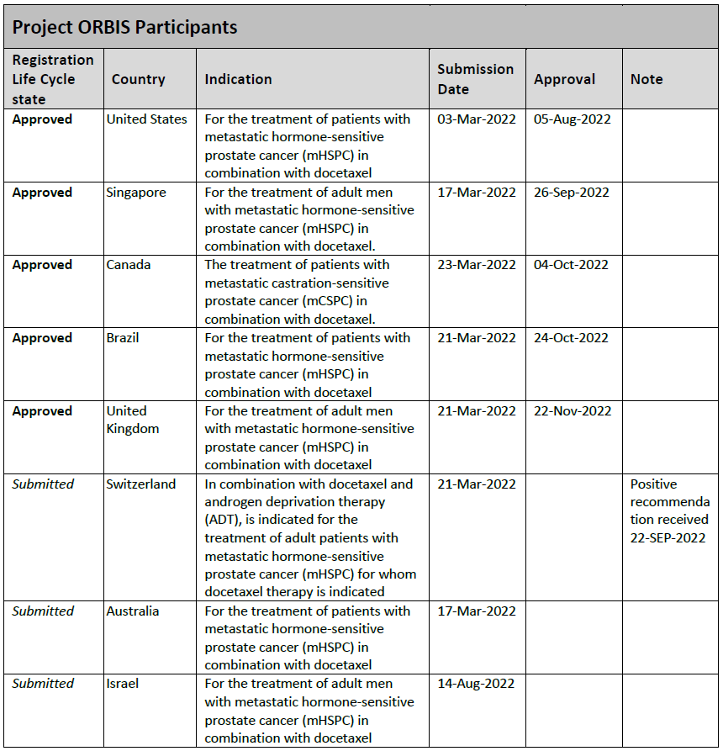

Table 2. Overseas regulatory status: indicated for metastatic hormone-sensitive prostate cancer.

Table 3. Overseas regulatory status indicated for the treatment of patients with non-metastatic castration-resistant prostate cancer (nmCRPC)

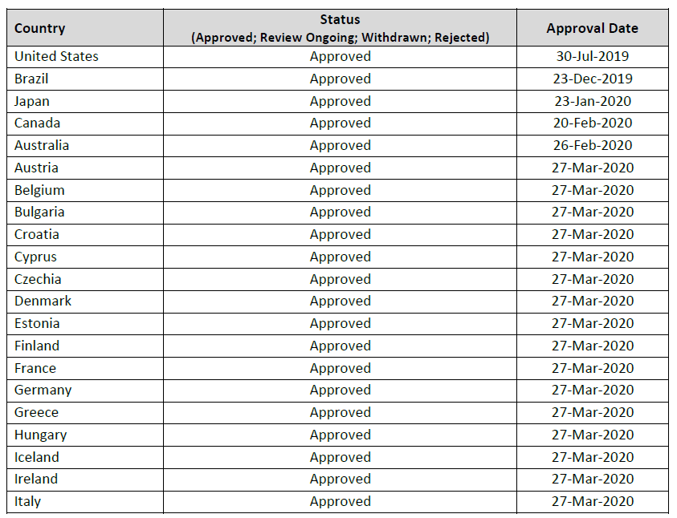

## Registration timeline

This submission was evaluated under the standard prescription medicines registration process.

Table 4 captures the key steps and dates for this submission.

Table 4: Timeline for Nubeqa submission PM-2022-00878-1-4

|  |  |
| --- | --- |
| Description | Date |
| Submission dossier accepted and first round evaluation commenced | 2 May 2022 |
| Evaluation completed | 30 November 2022 |
| Delegate’s[13] Overall benefit-risk assessment | 23 February 2023 |
| Registration decision (Outcome) | 17 March 2023 |
| Registration in the ARTG | 21 March 2023 |
| Number of working days from submission dossier acceptance to registration decision* | 228 |

*Statutory timeframe for standard submissions is 255 working days

## Evaluation overview

### Clinical evaluation summary

The Sponsor is seeking approval to extend the indications for darolutamide, for the treatment of patients with metastatic hormone sensitive prostate cancer in combination with docetaxel.

Data to support the submission is from a randomised, double-blind, placebo–controlled, multicenter phase III study (ARASENS).

##### ARASENS Study

ARASENS is a randomised, double–blind, placebo–controlled Phase III study of darolutamide versus placebo in addition to standard androgen deprivation therapy and docetaxel in patients with metastatic hormone–sensitive prostate cancer.

The submission is based on data from study 17777 (ARASENS). All patients received ADT - an LHRH agonist/antagonist concurrently or had a bilateral orchiectomy (Figure 1). Table 5 provides an overview of the study.

Figure 1. Study design of Study 17777 (ARASENS)

Patients were randomised in a 1:1 ratio to receive either of the study drugs:

* Darolutamide at 600 mg (2 tablets of 300 mg) BID with food, equal to a daily dose of 1200 mg
* Placebo matching darolutamide tablets in appearance, BID with food.

Table 5: Overview of study 17777 (ARASENS).

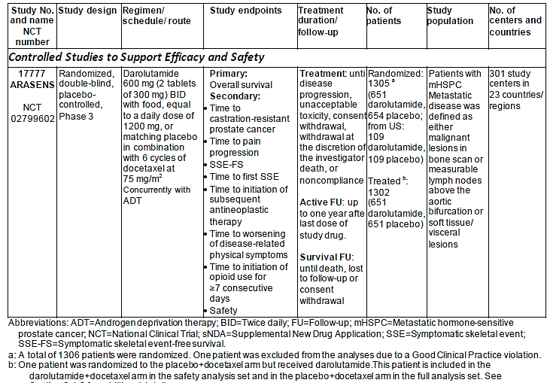

The primary objective of this study was to demonstrate superiority of darolutamide in combination with docetaxel over placebo in combination with docetaxel in OS.

The secondary objectives were to evaluate the time to castration-resistant prostate cancer (CRPC), the time to pain progression, symptomatic skeletal event-free survival (SSE-FS), the time to first symptomatic skeletal event (SSE), the time to initiation of subsequent systemic antineoplastic therapy, the time to worsening of disease-related physical symptoms, the time to initiation of opioid use for ≥7 consecutive days, and to characterize the safety of darolutamide in combination with docetaxel in mHSPC patients.

The exploratory objectives of the study included the evaluation of health-related quality of life (QoL), medical resource use, prostate specific antigen (PSA) assessments, pharmacokinetics (PK) and exposure and response analysis, as well as the evaluation of biomarkers.

**Key inclusion criteria were:**

* Males ≥18 years of age.
* Histologically or cytologically confirmed adenocarcinoma of prostate.
* Metastatic disease documented either by a positive bone scan, or for soft tissue or visceral metastases, either by contrast–enhanced abdominal/pelvic/chest computed
* tomography (CT) or magnetic resonance imaging (MRI) scan assessed by investigator and confirmed by central radiology review. Metastatic disease is defined as either malignant lesions in bone scan or measurable lymph nodes above the aortic bifurcation or soft tissue/visceral lesions according to Response Evaluation Criteria In Solid Tumors (RECIST) 1.1[14]. Lymph nodes are measurable if the short axis diameter is ≥15 mm, soft tissue/visceral lesions are measurable if the long axis diameter is ≥10 mm.
* Patients with regional lymph node metastases only (N1, below the aortic bifurcation) ≤will not be eligible for the study. Only patients with non–regional lymph node metastases (M1a) and/or bone metastases (M1b) and/or other sites of metastases with or without bone disease (M1c) will be eligible.
* Patients must be candidates for ADT and docetaxel therapy per investigator’s judgment.
* Started ADT (LHRH agonist/antagonist or orchiectomy) with or without first generation anti–androgen, but no longer than 12 weeks before randomisation. For patients receiving LHRH agonists, treatment in combination with a first generation anti–androgen for at least 4 weeks, prior to randomisation is recommended. First generation anti– androgen has to be stopped prior to randomisation.
* An Eastern Cooperative Oncology Group performance status of 0 or 1.
* Blood counts at screening: haemoglobin ≥ 9.0 g/dL, absolute neutrophil count ≥ 1.5x109/L, platelet count ≥ 100x109/L.
* Screening values of serum alanine aminotransferase and/or aspartate transaminase ≤1.5 x upper limit of normal (ULN), total bilirubin ≤ULN, total bilirubin ≤ULN, creatinine ≤2.0 x ULN.

**Key exclusion criteria were:**

* Prior treatment with: LHRH agonist/antagonists started more than 12 weeks before randomisation, second–generation AR inhibitors such as enzalutamide, ARN–509, darolutamide, other investigational AR inhibitors, cytochrome P 17 enzyme inhibitor such as abiraterone acetate or oral ketoconazole as antineoplastic treatment for prostate cancer, chemotherapy or immunotherapy for prostate cancer prior to randomisation.
* Treatment with radiotherapy (external beam radiation therapy, brachytherapy, or radiopharmaceuticals) within 2 weeks before randomisation.
* Had any of the following within 6 months before randomisation: stroke, myocardial infarction, severe/unstable angina pectoris, coronary/peripheral artery bypass graft, congestive heart failure (New York Heart Association Class III or IV).
* Uncontrolled hypertension as indicated by a resting systolic blood pressure (BP) ≥160 mmHg or diastolic BP ≥100 mmHg despite medical management.
* Had a prior malignancy. Adequately treated basal cell or squamous cell carcinoma of skin or superficial bladder cancer that has not spread behind the connective tissue layer (i.e., pTis, pTa, and pT1) is allowed, as well as any other cancer for which treatment has been completed ≥5 years before randomisation and from which the patient has been disease–free.
* A gastrointestinal disorder or procedure which is expected to interfere significantly with absorption of study drug 17777.
* An active viral hepatitis, known human immunodeficiency virus infection with detectable viral load, or chronic liver disease with a need for treatment.

The study comprised 4 consecutive periods: screening, treatment, active follow-up, and survival follow-up.

**Enrolment**: the study started enrolling patients on 30 November 2016 and was conducted in 23 countries/regions. Patients were randomised in a 1:1 ratio to receive darolutamide or placebo (i.e., study drug) at 600 mg (2 tablets of 300 mg) BID with food, equal to a daily dose of 1200 mg.

**Randomisation:** was stratified by extent of disease and alkaline phosphatase (ALP) levels. Docetaxel was to be administered after randomisation at a dose of 75 mg/m2 as an IV

infusion every 21 days for 6 cycles, starting within 6 weeks after the start of study drug.

Docetaxel could be administered in combination with prednisone/prednisolone at the discretion of the investigator. All patients were required to receive ADT of the investigator’s

choice (LHRH agonist/antagonists or orchiectomy) as standard therapy starting ≤12 weeks

before randomisation. Patients were to remain on treatment with either darolutamide or

placebo until symptomatic progressive disease, change of antineoplastic therapy, unacceptable

toxicity, death, or until any other withdrawal criterion was met.

**Periodic review**: an independent Data Monitoring Committee (DMC) was instituted to ensure ongoing safety of patients with respect to a risk/benefit assessment during periodic data review meetings. The DMC reviewed results from a planned interim analysis for futility, provided a formal recommendation for continuation/termination of the study, and monitored study conduct to ensure the overall integrity of trial was maintained.

**Interim analysis:** an analysis for futility was performed after 177 deaths were observed. Primary completion was to be reached when approximately 509 deaths (as per SAP) had occurred. At the data cut-off 25 October 2021 (primary completion data analysis), 533 deaths had occurred.

**Treatment period**: study treatment was provided for all patients twice daily, until disease progression (symptomatic progressive disease, change of systemic antineoplastic therapy), unacceptable toxicity, consent withdrawal, withdrawal at the discretion of the investigator, death, or non-compliance.

**Patient evaluation**: patients were evaluated every 12 weeks for progression to CRPC, initiation of subsequent antineoplastic therapy, SSEs, opioid use for ≥7 consecutive days, pain progression, worsening of physical symptoms of disease based on The Functional Assessment of Cancer Therapy-Prostate (FACT-P) and the National Comprehensive Cancer Network/Functional Assessment of Cancer Therapy-Prostate Symptom Index-17 (NFPSI-17), AEs and SAEs, QoL and PSA assessment.

**Active follow–up period (approximately 1 year)**: the active follow-up period was the interval from the end-of study drug intake to the end of all protocol-specified post-treatment

interventions.

**Long–term (survival) follow–up period**: after active follow-up, patients continued to be contacted approximately every 12 weeks by phone to capture all antineoplastic treatments for prostate cancer with start and stop date and reasons for change (PSA progression, clinical

progression, radiological progression, toxicity, other), study drug–related SAEs and survival status. The end of long–term (survival) follow–up period was death, lost to follow–up, consent withdrawal, or end–of–study.

**Dose modification**: doses of study treatment could be delayed or reduced in case of clinically significant toxicities. If a patient experienced a Grade 3 or 4 adverse event (AE), treatment with blinded study drug was interrupted until the AE improved to Grade 2 or lower, then resumed at a lower dose of 300 mg BID. Any patient who required a study drug interruption >28 consecutive days or who experienced a Grade 3 or higher treatment-related toxicity on 300 mg BID was to permanently discontinue study treatment. Dosing of study drug below 300 mg BID was not allowed. Dose modifications of docetaxel were to be made based on specific types of toxicities.

**Screening:** screening tests were performed within 28 days prior to randomisation. During the study treatment period, patients were evaluated every 12 weeks (±7 days) for progression to

CRPC, initiation of subsequent antineoplastic therapy, SSEs, opioid use for ≥7 consecutive days, pain progression, worsening of physical symptoms of disease based on NCCN-FACT-FPSI-17 questionnaire, quality of life (QoL), PSA, and safety. Serum PSA and testosterone were assessed by central laboratory.

Chest, abdomen, and pelvic CT or MRI and bone scans were performed at the end of docetaxel

treatment (within 30 days from last cycle of docetaxel) and yearly thereafter. Chest, abdomen,

and pelvic CT or MRI and bone scans could also be performed at any time in case of PSA

progression, symptomatic progressive disease, change of antineoplastic therapy, or if

considered as appropriate in the investigator’s judgment. Radiographic progression by soft

tissue/visceral lesions was determined according to RECIST criteria, version 1.1, and by bone

lesions according to Prostate Cancer Clinical Trials Working Group 3 criteria based on whole body 99mTechnetium-methylene diphosphonate bone scans.

**End of treatment:** after treatment discontinuation, patients had an End-of-Treatment visit 30 days (+7 days) after the last dose and entered the Active follow-up period for up to 1 year. During active follow-up, the following evaluations were performed approximately every 12 weeks at standard of care clinic visits: QoL, pain assessment, analgesic consumption, subsequent antineoplastic treatments for prostate cancer, SSEs, survival status, and study drug-related SAEs.

After active follow up, patients continued to be contacted about every 12 weeks in long term (survival) follow up to capture survival status, subsequent anti-neoplastic treatments for PC and study drug related SAEs.

Efficacy endpoints are as detailed below in Table 6. The order of secondary endpoints reflects the hierarchical test procedure as indicated in the following information.

Table 6. Efficacy endpoints in study 1777

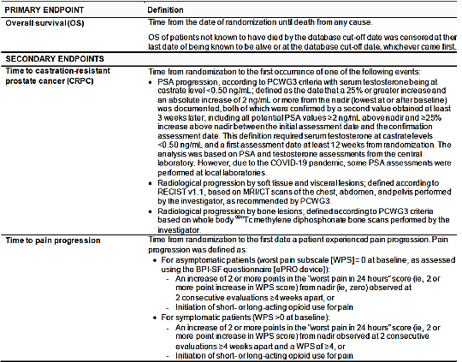

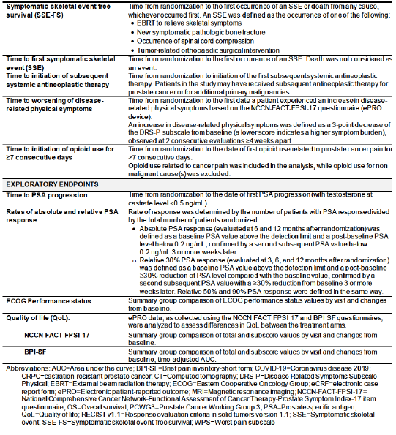

The sample size of the study was based on the primary endpoint of OS. The study was designed

to have 90% power to detect a 25% decrease in the risk of death with darolutamide compared

with placebo with a 1-sided test with a type I error of 0.025 (equivalent to a 2-sided test with a

type I error of 0.05). The OS data were considered mature when approximately 509 deaths

were observed.

The analyses sets were as follows:

* **Full analysis set (FAS)**: All patients who were randomised were included in the FAS, except for cases with critical Good Clinical Practices (GCP) violations. Following the intent to treat principle, the patients in this set were grouped according to the planned treatment they were allocated to receive at randomisation, irrespective of actual treatment.
* **Safety analysis set (SAF)**: All randomised patients who received at least 1 dose of study drug (darolutamide/placebo) were included in the SAF, except for cases with critical GCP violations. Patients were included in the analyses according to the treatment they actually received. Patients were included in the darolutamide + docetaxel arm if they had received any dose of darolutamide.
* **Pharmacokinetic Analysis Set (PKS)**: At least the first 20 randomised patients who received at least 1 cycle of docetaxel and for whom mandatory dense PK sampling was performed were included in the PKS, except for cases with critical GCP violations. These patients should have received at least 3 days of uninterrupted study drug treatment, as well as one cycle of docetaxel and had at least one post-dose PK measurement.

All safety analyses were performed in the SAF. The PK data was analysed in the PKS. The FAS was used for efficacy analyses and all other data analyses.

###### Primary efficacy endpoint

The primary efficacy endpoint was OS, defined as the time from randomisation until death from any cause. Overall survival of patients not known to have died at or before the database cut-off were censored in the analysis at their last date of being known to be alive, or at the database cut-off date, whichever came first.

The primary analysis of OS was a stratified log-rank test using the information collected from the IxRS and the same stratification factors used for randomisation.

The hazard ratio (HR) (darolutamide + docetaxel over placebo + docetaxel) for OS and its 95% confidence interval (CI) were calculated using the Cox model, stratified by the same factors as were used for randomisation. An overall one-sided stratified log-rank test with a type I error of 0.025 (equivalent to two-sided test with a type I error of 0.05) was used.

Sensitivity analyses of OS were performed to assess the robustness of the results of the primary analysis of OS and included 1) an unstratified analysis, 2) a stratified analysis using information collected from the eCRF and 3) a stratified analysis according to central imaging review of extent of disease. The latter analysis was performed to address a discrepancy observed between IxRS stratification and central review stratification.

Pre-specified sensitivity analyses were also conducted, including an unstratified analysis using information collected from the IxRS, a stratified analysis according to central imaging review, and a stratified analysis using information collected from the CRF. A post-hoc sensitivity analysis by number of cycles of docetaxel received was also performed.

Subgroup analyses of OS were also conducted to determine whether randomisation stratification factors (extent of disease, ALP), selected demographics (age, race, geographical region), and baseline cancer characteristics (PSA, ECOG PS, Gleason score, metastasis at initial diagnosis) were consistent with the primary analysis of OS.

###### Secondary efficacy endpoints

The same overall one-sided test with a type I error of 0.025 used for the primary endpoint was used for the secondary endpoints. The endpoints were tested in a pre-specified sequential order.

If the primary endpoint OS or a secondary endpoint was not statistically significant, the hierarchical procedure was stopped and all subsequent analyses of the secondary endpoints were considered exploratory.

The primary endpoint, OS, was first in order.

The order of secondary endpoints was as follows:

* Time to CRPC
* Time to pain progression
* Symptomatic SSE-FS
* Time to first SSE
* Time to initiation of subsequent systemic antineoplastic therapy
* Time to worsening of disease-related physical symptoms
* Time to initiation of opioid use for ≥7 consecutive days

The definitions are as follows;

* Time to castration-resistant prostate cancer, defined as the time from randomisation to the first occurrence of one of the following events, according to the Prostate Cancer Working Group 3 criteria: (1) PSA progression (≥25% increase above the nadir value, confirmed by a second value ≥3 weeks later, and an increase in absolute value of ≥2 ng/mL above nadir, at least 12 weeks from baseline, with serum testosterone being at castrate level <0.50 ng/mL), (2) Radiological progression by soft tissue and visceral lesions, (3) Radiological progression by bone lesions.
* Time to pain progression, defined as the time from randomisation to the first date a patient experienced pain progression assessed using the BPI-SF questionnaire.
* For asymptomatic patients, pain progression was defined as an increase of ≥2 points in the “worst pain in 24 hours” score from nadir (i.e., zero) observed at 2 consecutive evaluations ≥4 weeks apart, or initiation of short- or long-acting opioid use for pain.
* For symptomatic patients (score >0 at baseline), pain progression was defined as an increase of ≥2 points in the “worst pain in 24 hours” score from nadir observed at 2 consecutive evaluations ≥4 weeks apart and a WPS of ≥4, or initiation of short- or long-acting opioid use for pain.
* Symptomatic skeletal event-free survival (SSE-FS), defined as the time from randomisation to the first occurrence of an SSE or death from any cause, whichever occurred first.
* An SSE was defined as the first occurrence of one of the following: administration of external beam radiation therapy (EBRT) to relieve skeletal symptoms, new symptomatic pathologic bone fracture, spinal cord compression, or tumour-related orthopaedic surgical intervention.
* Time to first SSE was defined as the time from randomisation to the first occurrence of an SSE. Death was not considered as an event in this endpoint.
* Time to initiation of subsequent systemic antineoplastic therapy, defined as the time from randomisation to the initiation of first subsequent systemic antineoplastic therapy. Patients in the study may have received subsequent antineoplastic therapy for prostate cancer or for additional primary malignancies.
* Time to worsening of disease-related physical symptoms was defined as the time from randomisation to the first date a patient experienced an increase in disease-related physical symptoms based on the NCCN-FACT-FPSI-17 questionnaire.
* An increase in disease-related physical symptoms was defined as a 3-point decrease in FPSIDRS-P subscale from baseline in the disease-related physical symptoms subscale observed at 2 consecutive evaluations ≥4 weeks apart. A lower score indicates a higher symptom burden.
* Time to the initiation of opioid use for ≥7 consecutive days, defined as the time from randomisation to the date of the first opioid use for ≥7 consecutive days. Data of opioid use related to cancer pain was included in the analysis, and opioid use for non-malignant causes was excluded.
* Two of the endpoints were QoL endpoints:
* Time to pain progression was assessed as Patient Reported Outcome (PRO) as evaluated by Brief Pain Inventory-Short Form (BPI-SF) questionnaire and initiation of short- or long- acting opioid use for pain.
* Time to worsening of disease-related physical symptoms was assessed as PRO as evaluated by National Comprehensive Cancer Network/Functional Assessment of Cancer Therapy-Prostate Symptom Index 17 (NCCN–FACT-FPSI-17) questionnaire.

For all secondary efficacy endpoints, a log-rank test stratified by stratification factors of extent of disease and ALP at baseline was used to compare the darolutamide + docetaxel and placebo + docetaxel arms. The hazard ratio as well as its 95% CI were presented based on fitting a Cox regression model stratified by the same randomisation stratification factors.

###### Exploratory endpoints

* **Time to PSA progression**: the time to PSA progression was defined as the time from the date of randomisation to the date of first PSA progression with testosterone at castrate <0.5 ng/mL.
* **Rate of absolute and relative PSA response**: for PSA response assessments, the baseline PSA value was to be above the detection limit.
* Comparisons between the 2 treatment arms for the PSA response assessments were performed using the Cochran–Mantel–Haenszel test stratified by the IxRS stratification factors:
  + Rate of absolute PSA response at 6 and 12 months. Absolute PSA response was defined as blood PSA level <0.2 ng/mL, which was confirmed 3 or more weeks later by a subsequent PSA value <0.2 ng/mL.
  + Rate of relative PSA response at 3, 6, and 12 months. Relative 30% PSA response was defined as a ≥30% reduction of the blood PSA level compared with the baseline value, confirmed 3 or more weeks later by a subsequent PSA value with a ≥30% reduction from baseline. Relative 50% and 90% PSA response were defined in the same way.
* **ECOG performance status**: summary group comparison of ECOG PS values by visit and changes from baseline.
* **Quality of Life (QOL)**: ePRO data, as collected using the NCCN-FACT-FPSI-17 and BPI-SF questionnaires were analysed to assess differences in QoL between the treatment arms.

The study was conducted at 301 centres in 23 countries/regions, including North America (Canada and US), Asia Pacific (mainland China, Japan, South Korea and Taiwan), and the ROW (Australia, Belgium, Brazil, Bulgaria, Czech Republic, Finland, France, Germany, Israel, Italy, Mexico, Netherlands, Poland, Russian Federation, Spain, Sweden, and UK). A total of 1686 patients were enrolled in the study between 30 November 2016 (first patient first visit) and 5 June 2018 (last patient first visit). The database cut-off date for the primary completion analyses was 25 October 2021.

A total of 1306 patients were randomly assigned in a 1:1 ratio to study treatment. Of the randomised patients, 100% of the patients in the darolutamide + docetaxel arm and 99.5% of the patients in the placebo + docetaxel arm received at least 1 dose of study drug. At the time of the data cut-off date for the primary completion analysis (25 October 2021), 45.9% of the patients in the darolutamide + docetaxel arm and 19.1% of the patients in the placebo + docetaxel arm were ongoing with study treatment.

Discontinuation of treatment was 54.1% in the darolutamide + docetaxel arm versus 80.4% in placebo + docetaxel arm. The most common reason for treatment discontinuation in both arms was progressive disease, reported in a lower percentage of patients in the darolutamide + docetaxel arm compared with the placebo + docetaxel arm (clinical progression, 19.5% vs. 41.6%, respectively; radiological progression, 12.9% vs. 20.2%, respectively).

Demographic and baseline characteristics appeared to be balanced. There was a higher baseline PSA in the experimental arm, as shown in Table 7.

Table 7: Demographic and baseline characteristics

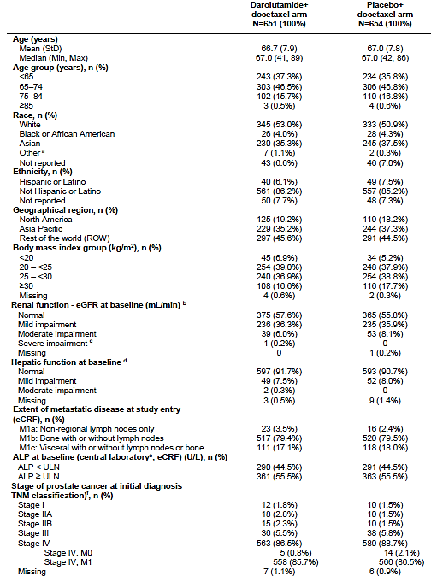

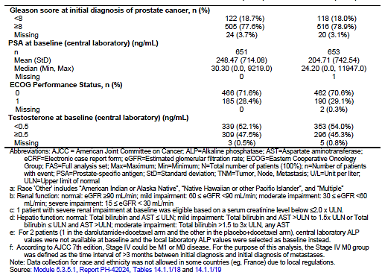

Baseline cancer characteristics appeared balanced between the two groups (Table 8).

Table 8: Baseline Cancer Characteristics

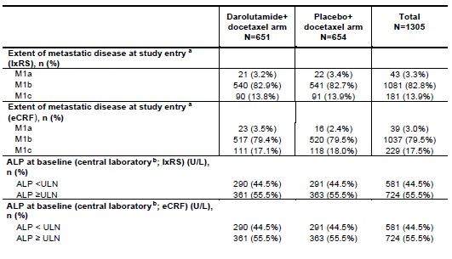

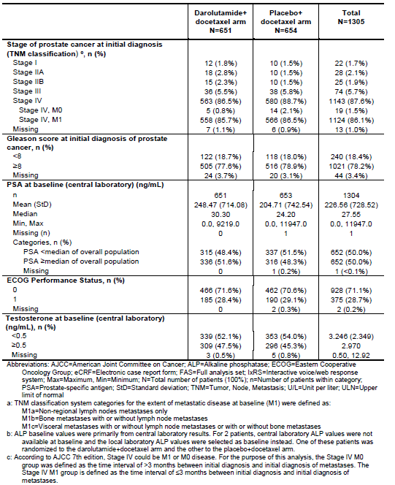

The majority of patients had de novo metastatic disease (stage IV: 87.6% of total study population) and most had M1b (bone metastases, with or without lymph node metastases) at study entry. Only a small percentage of patients (3.3% per the IxRS; 3.0% by eCRF) had M1a (non-regional lymph node metastases only) disease.

Table 9 shows the patient disposition for the study period and follow up periods as of the database cut off.

Table 9: Patient disposition at the time of study completion

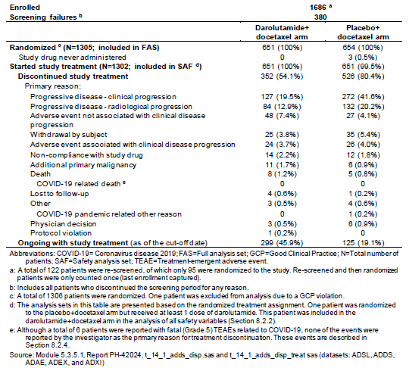

Treatment compliance was high in both treatment arms. The mean percentage of the planned dose of study drug (darolutamide or placebo) taken was above 97% and the median was 100% in both treatment arms. Most patients (87.6% in the darolutamide + docetaxel arm and 85.5% in the placebo + docetaxel arm) had completed 6 cycles of docetaxel.

During the study, nearly all (≥99%) patients in both treatment arms were administered at least 1 concomitant medication in the FAS. Overall, the most common concomitant medications (≥90% of patients in either treatment arm) by ATC subclass were (percentage of patients in the darolutamide +docetaxel vs. placebo + docetaxel arm):

* Ophthalmological (96.6% vs. 95.9%)
* Corticosteroids, dermatological preparations (93.4% vs. 92.7%)
* Stomatological preparations (92.9% vs. 93.1%)
* Corticosteroids for systemic use (92.9% vs. 92.7%)
* Otologicals (91.2% vs. 92.4%)
* Vasoprotectives (90.9% vs. 90.5%)
* Ophthalmological and ontological preparations (89.6% and 90.2% of patients, respectively)
* Nasal preparations (88.5% and 90.4% of patients, respectively)

In total, 27.6% of patients in the darolutamide + docetaxel arm and 23.2% in the placebo + docetaxel arm received drugs for the treatment of bone diseases during the treatment period. Post study entry, 23.3% of patients in the darolutamide + docetaxel arm 21.5% in the placebo +docetaxel arm received bone health agents (bisphosphonates and denosumab).

Treatment compliance and concomitant medication usage appeared comparable between the arms. The mean percentage of the planned dose of study drug (darolutamide or placebo) taken was above 97% and the median was 100% in both treatment arms. The median time under study drug treatment (including dose interruptions/delays) for patients in the darolutamide + docetaxel arm was 41.0 months (range: 0.1 to 56.5 months), and 16.7 months (range: 0.3 to 55.8 months) for patients in the placebo + docetaxel arm. The majority of patients (87.6% in the darolutamide + docetaxel arm and 85.5% in the placebo + docetaxel arm) completed the full 6 cycles of docetaxel.

###### Pharmacokinetics

There were small differences observed in the darolutamide pharmacokinetics (PK) profiles between mHSPC patients treated with darolutamide in combination with docetaxel in Study 17777 (ARASENS) and nmCRPC patients treated with darolutamide in Study 17712 (ARAMIS).

These were not considered clinically relevant with respect to efficacy and safety. Given that there appeared to be a flat exposure-response (E-R) relationship between darolutamide AUC0-12ss and overall survival in the context of the 600 mg twice-daily dose, a 10% reduction in exposure was not considered to have a meaningful impact on efficacy.

Based on a popPK meta-analysis with consideration of covariate influence, darolutamide exposure in Study 17777 was 10% lower compared with Study 17712. There were no clinically relevant effects (with respect to efficacy or safety) on darolutamide PK in mHSPC patients by age, race, geographical region (e.g., Japan and mainland China), body weight, mild or moderate renal impairment, or mild hepatic impairment.

The administration of darolutamide in combination with docetaxel in Study 17777 resulted in no clinically relevant changes in the PK of either drug, considering the variability associated with exposure, and the E-R relationship of the corresponding drug.

The E-R analyses of efficacy and safety for Study 17777 showed that both efficacy (OS and prostate-specific antigen [PSA] response) and safety laboratory value (increase in bilirubin) in mHSPC patients were consistent across the darolutamide exposure range at 600 mg BID dose.

#### Efficacy

##### Primary endpoint

The primary efficacy endpoint OS was defined as the time from the date of randomisation until death from any cause. The primary OS analysis used stratification factors from IxRS. The significance threshold was a one-sided alpha of 0.025. The study met its primary objective, showing a statistically significant improvement of OS of darolutamide in combination with docetaxel and ADT over placebo in addition to docetaxel and ADT. The median follow-up time from randomisation to the last contact or death was 43.7 months in the darolutamide + docetaxel arm and 42.4 months in the placebo + docetaxel arm.

At the time of the database cut-off date for the primary completion analysis (25 October 2021), 533 OS events had occurred, with 229 deaths (35.2% of patients) in the darolutamide + docetaxel arm and 304 deaths (46.5% of patients) in the placebo + docetaxel arm.

The risk of death was lower in the darolutamide + docetaxel arm than in the placebo + docetaxel arm (HR: 0.675; 95% CI: [0.568; 0.801]), and the log-rank test was statistically significant with a one-sided p<0.0001. Median OS was not reached in the darolutamide + docetaxel arm (95% CI: [A; A]) and was 48.9 months in the placebo + docetaxel arm (95% CI: [44.4; A]).

64.8% of patients in the darolutamide arm and 53.5% of patients in the control arm were censored. 393 patients in the darolutamide arm (60%) and 320 patients in the control arm (49%) were ongoing with study treatment, active follow-up, or survival follow-up. Treatment arms were comparable with respect to numbers of patients who withdrew or were lost to follow up.-

The results of the primary efficacy analysis in the FAS are shown below in Table 10. Figure 3 illustrates the Kaplan-Meier curves for OS.

Table 10: Overall Survival in study 17777

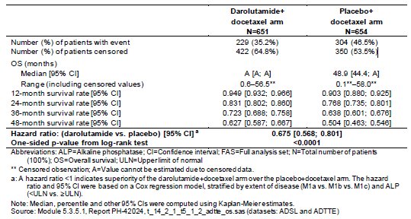

Figure 3: Kaplan-Meier curves of OS in study 1777

OS was longer for patients in the darolutamide + docetaxel arm than in the placebo + docetaxel arm despite a higher proportion of patients receiving subsequent therapy after discontinuation of study treatment in the placebo + docetaxel arm (75.6%) compared with the darolutamide + docetaxel arm (56.8%). Subsequent systemic therapies are shown in Table 11.

Table 11: Summary of subsequent life-prolonging systemic antineoplastic medication by preferred drug name based on WHO-DD drug record number in Study 17777 (FAS).

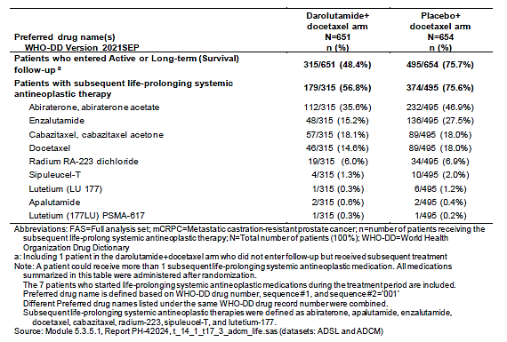

Sensitivity analyses of the OS were in line with the primary findings:

* An analysis without including stratification factors in the model: HR: 0.689; 95% CI: [0.580; 0.818]; p<0.0001
* An analysis using stratification data from the eCRF: HR: 0.678; 95% CI: [0.571; 0.806]; p<0.0001
* An analysis using extent of disease stratification data according to central imaging review;
* HR: 0.678; 95% CI: [0.571; 0.805]; p<0.0001

The post-hoc analyses of OS by number of docetaxel cycles (6 vs ≤5, and 5-6 vs ≤4) were also consistent with the primary analysis. In patients with 4 or less cycles of docetaxel, the confidence interval included 1 (0.713 [95%CI 0.44, 1.14], p 0.0790). There was however a low number of patients in this subgroup (70 in each arm).

An OS subgroup analysis is shown in Figure 4 and is consistent in a number of subgroups. There are some subgroups that appeared to have less benefit e.g. 65-74 years, Asians, visceral metastases, Asia-Pacific but the reasons are unclear and likely to be multifactorial.

An analysis was conducted applying the CHAARTED volume criteria at the request of an Orbis partner. The Sponsor notes that this was not a pre-specified analysis in ARASENS and that the study did not prospectively define and collect high and low volume strata in the same way as the CHAARTED study. This information was derived based on the data as it was collected in ARASENS and high and low-volume groups were defined as follows:

* Patients with non-regional lymph nodes metastases only (M1a) were assigned to the low volume group
* Patients with metastases with or without lymph node metastases (M1b) were assigned to groups according to CHAARTED criteria. Patients with ≤ 4 bone metastases were assigned to the low-volume group and patients > 4 bone metastases or superscan were assigned to the high-volume group.
* Patients with visceral metastases with or without lymph node metastases or with or
* without bone metastases (M1c) were assigned to the high-volume group.

The Sponsor’s analysis showed the following in subgroups of high- and low-volume with the addition of darolutamide to ADT + docetaxel over ADT + docetaxel:

* high-volume HR= 0.685 (95%CI:[0.571; 0.822])
* low-volume HR = 0.682 (95%CI:[0.412; 1.130]).

The OS benefit in the high volume subgroup appears to be in keeping with the overall study population results of HR = 0.675 (95%CI:[0.568, 0.801]). The benefit in the low volume disease did not appear to be as certain.

Figure 4. Forest plot of subgroup analyses; OS and 95% CIs in study 1777



##### Secondary endpoints

An overview of the secondary efficacy results is shown in Table 12.

The following endpoints had a HR< 1 and were statistically significant:

* - time to castration-resistant prostate cancer,
* - time to pain progression,
* - SSE-free survival,
* - time to first SSE
* - time to initiation of subsequent systemic antineoplastic therapy.

As per the hierarchical testing procedure, since time to worsening of disease-related physical symptoms was not statistically significant, the secondary endpoint time to initiation of

opioid use was not tested for significance and was considered exploratory.

Table 12. Results of the secondary efficacy endpoints in Study 17777

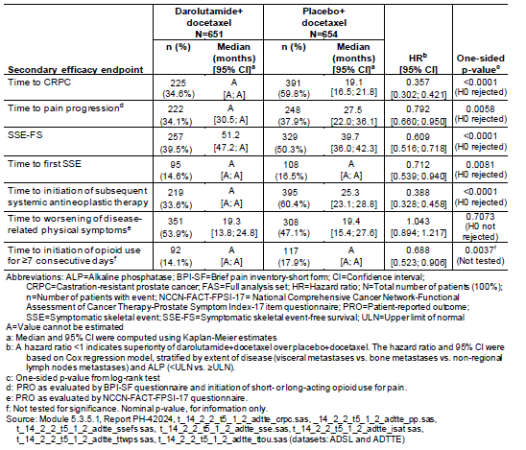

###### Time to CRPC

Overall, 34.6% of patients in the darolutamide + docetaxel arm and 59.8% of patients in the

Placebo + docetaxel arm progressed to CRPC. The analysis was based on central laboratory PSA and testosterone assessments.

Figure 5 shows the KM curves for the main analysis based on central PSA and testosterone.

Figure 5: KM curves for the main analysis based on central PSA and testosterone

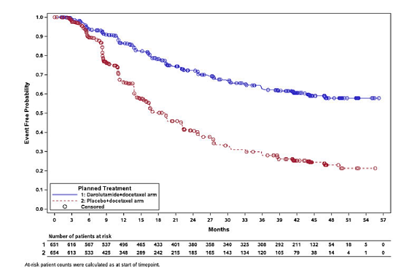

The median time to CRPC was not reached (95% CI: [A; A]) in the darolutamide + docetaxel arm and was 19.1 months (95% CI: [16.5; 21.8]) in the placebo + docetaxel arm.

Of the patients who progressed to CRPC, the first progression event observed was (see Table 13 below):

* PSA progression for 121/225 patients (53.8%) in the darolutamide + docetaxel arm compared with 289/391 patients (73.9%) in the placebo + docetaxel arm.
* Radiological progression by bone lesions for 53/225 patients (23.6%) compared with 53/391 patients (13.6%), respectively.
* Radiological progression by soft tissue/visceral lesions for 51/225 patients (22.7%) compared with 49/391 patients (12.5%), respectively.

Table 13. Time to CRPC (FAS)

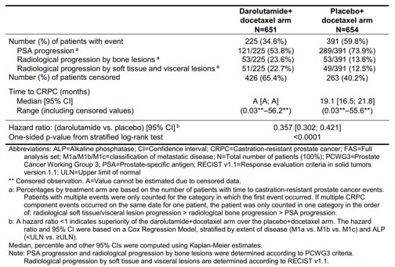

The Sponsor conducted a sensitivity analysis based on central and local PSA. This sensitivity analysis showed: HR=0.361; 95% CI: 0.306, 0.426.

###### Time to pain progression

Time to pain progression was evaluated by BPI-SF and initiation of short or long-acting opioid use for pain and time to worsening of disease related physical symptoms was evaluated by NCCN-FACT-FPSI-17.

There were 34.1% of patients in the darolutamide + docetaxel arm and 37.9% in the placebo +docetaxel arm with pain progression.

There was a delay in this parameter HR 0.792 (95% CI [0.660; 0.950], p=0.0058) with the experimental arm.

The sensitivity analysis showed HR 0.805 (95% CI [0.671; 0.965], p=0.0094 based of electronic patient reported outcome and paper questionnaires.

KM curves are shown below in Figure 6.

Figure 6: Kaplan-Meier curve of time to pain progression

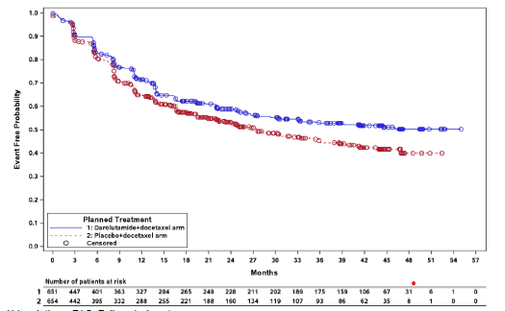

###### Symptomatic skeletal event free survival (SSE-FS).

There were 39.5% of patients in the darolutamide + docetaxel arm and 50.3% in the placebo + docetaxel arm with an SSE-FS event.

SSE-FS was longer in the darolutamide + docetaxel arm, with an HR of 0.609 (95% CI: [0.516; 0.718]); p<0.0001.

The KM curves are shown below in Figure 7.

Figure 7: Kaplan-Meier curves of SSE-FS I study 17777

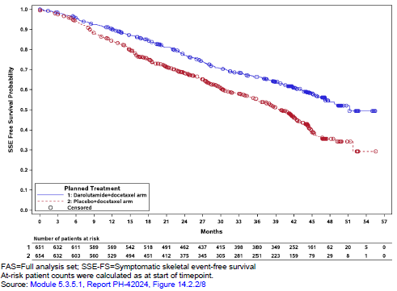

###### Time to first SSE

Overall, SSEs were reported in 14.6% of patients in the darolutamide + docetaxel arm compared with 16.5% in the placebo + docetaxel arm. A delay in time to first SSE was observed for patients in the darolutamide + docetaxel arm, with a HR of 0.712 (95% CI: [0.539; 0.940]); p=0.0081. The median time to first SSE was not reached (95% CI: [A; A]) in either treatment arm. See Figure 8.

The majority of the first SSEs were EBRT to relieve skeletal symptoms, reported for 63.2% of patients with an SSE in the darolutamide + docetaxel arm and 82.4% of patients with an SSE in the placebo + docetaxel arm.

Figure 8. Kaplan-Meier curves of time to first SSE in study 17777.

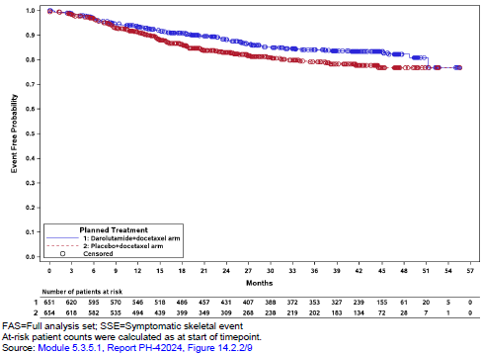

###### Time to initiation of subsequent systemic antineoplastic therapy.

There were 33.6% of patients in the darolutamide + docetaxel arm who started a new systemicantineoplastic therapy, compared with 60.4% in the placebo + docetaxel arm. Subsequent antineoplastic therapies were for prostate cancer, however 8 patients in the Darolutamide + docetaxel arm and 2 patients in the placebo + docetaxel arm received a first antineoplastic therapy for an additional primary malignancy.

A delay was seen in the time to initiation of subsequent systemic antineoplastic therapy for patients in the darolutamide + docetaxel arm compared with the placebo + docetaxel arm (HR=0.388, 95% CI: [0.328; 0.458]; p<0.0001). The median time to initiation of subsequent systemic antineoplastic therapy was not reached (95% CI: [A; A]) in the darolutamide + docetaxel arm and was 25.3 months (95% CI: [23.1; 28.8]) in the placebo + docetaxel arm. The KM curve is shown in Figure 9.

Figure 9. Kaplan-Meier curves of time to initiation of subsequent systemic antineoplastic therapy in study 1777.

###### Time to worsening of disease related symptoms.

The analysis of worsening of disease-related physical symptoms was based on the FPSIDRS-P subscale of the NCCN-FACT-FPSI-17 questionnaire. Worsening of disease-related physical symptoms was observed for 53.9% of patients in the darolutamide + docetaxel arm and 47.1% of patients in the placebo + docetaxel arm.

There was no significant difference in time to worsening of disease-related physical symptoms between the treatment arms (HR=1.043; 95% CI: [0.894, 1.217]; p=0.7073).

The median time to worsening of disease-related physical symptoms was 19.3 months (95% CI:

[13.8, 24.8]) in the darolutamide + docetaxel arm and 19.4 months (95% CI: [15.4, 27.6]) in the placebo + docetaxel arm. See KM curve below in Figure 10.

Figure 10. Kaplan-Meier curves of time to worsening of disease related physical symptoms in study 17777.

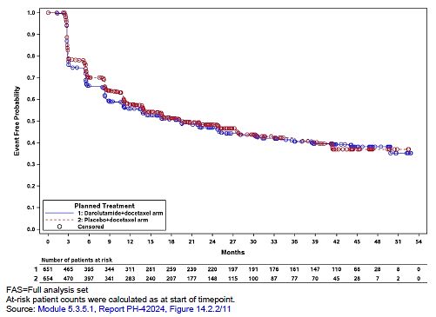

###### Time to initiation of opioid use for ≥ 7 consecutive days.

The secondary endpoints of the study were pre-specified in a hierarchical testing scheme to be

tested for significance if the results of all previous endpoints were significant. As the preceding endpoint “Time to worsening of disease-related physical symptoms” did not reach the pre-specified significance level for this analysis was not tested for significance and was considered exploratory**.**

Overall, 14.1% of patients in the darolutamide + docetaxel arm and 17.9% in the placebo + docetaxel arm had initiated opioid treatment for cancer pain for ≥7 consecutive days as of the database cut-off date for the primary completion analysis.

##### Exploratory endpoints

###### Time to PSA progression

Treatment with darolutamide in combination with docetaxel resulted in a longer time to PSA progression than placebo in combination with docetaxel (HR=0.255; 95% CI: [0.208; 0.313]; p<0.0001). The median time to PSA progression was not reached in the darolutamide + docetaxel arm and was 22.4 months (95% CI: [22.1; 27.6]) in the placebo + docetaxel arm. The proportion of patients with PSA progression was lower in the darolutamide + docetaxel arm compared with the placebo + docetaxel arm: 20.9% vs. 47.4%, respectively.

###### PSA response rates

Patients receiving darolutamide in combination with docetaxel demonstrated a higher PSA response rate (defined as a ≥50% reduction from baseline) at 12 months after randomisation, compared with patients receiving placebo in combination with docetaxel: 89.6% versus 80.4% (difference=9.03%, 95% CI: [5.20; 12.86], p<0.0001). Overall, both absolute PSA response rates (PSA level <0.2 ng/mL) and relative PSA response rates (≥90% reduction in PSA from baseline) were higher in the darolutamide + docetaxel arm than in the placebo + docetaxel arm at all evaluated time points.

###### Eastern cooperative oncology group (ECOG) performance status

Most patients in both treatment arms maintained ECOG PS of 0 or 1 at all visits throughout the study.

###### QOL

NCCN-FACT-FPSI-17 questionnaire - there were no clinically meaningful nor statistically significant differences between the treatment arms.

BPI-SF questionnaire – pain assessment - there were no clinically meaningful differences (MID=2 points) between the treatment arms. The pain interference score and pain severity score results favoured the darolutamide + docetaxel arm (lower scores represent less pain) but were not statistically significant nor clinically meaningful, as the difference in least squares (LS) mean between the treatment arms did not meet the MID threshold (MID=2 points).

Health related QOL appeared to be maintained on the experimental arm.

###### Comments on sPC.

There was an imbalance of the type of progression between the treatment arms as follows: proportion of patients with PSA progression event was higher in the placebo arm (73.9% vs. 53.8%) and the rate of bone progression and soft tissue progression was higher in the darolutamide arm compared to placebo (23.6% vs. 13.6% and 22.7% vs. 12.5%, respectively).

As per the response to an Orbis partner’s data request, the number of patients with simultaneous PSA and radiological progression (within +/- 7 days), appeared small in both treatment arms (darolutamide n=6, placebo n=8).

A sensitivity analysis (SA) excluding the component of PSA progression was provided by the Sponsor at the request of an Orbis partner. This sensitivity analysis showed a HR of 0.463 (95% CI: 0.375; 0.572; p<0.0001). With regard to imaging, apart from a yearly scan after docetaxel treatment, there was no standardised radiological assessment in the study.

SA results suggest that the magnitude of treatment benefit in time to CRPC was affected when PSA progression was excluded. This suggests that time to CRPC was driven by PSA progression. Individual patient management decisions based on PSA results are variable as they are based on physician/patient choice.

###### Time to pain progression.

In ARASENS, pain progression was defined as change from nadir. However, in the study ARAMIS, it was defined as change from baseline.

A high number of patients were censored at randomisation as they were on opioids. At the request of an Orbis partner, a SA was undertaken by the Sponsor wherein these patients were not censored but were permitted to have an increase of 2 or more points in WPS from nadir. The SA showed results consistent with the primary analysis with HR 0.81, 95% CI: 0.69.0.95).

###### SSE – free survival

These results were mainly driven by death and thus do not provide further clinically relevant information beyond OS.

###### Time to first SSE

Although the time to first SSE endpoint demonstrated a statistically significant benefit in the darolutamide arm over the control arm and the numbers of events were low in both arms. The median time to first SSE could not be estimated for either treatment arm due to the low number of events in both arms at the time of data cut-off.

###### Time to Initiation of subsequent antineoplastic therapy

This endpoint is subjective (dependant on the physician/patient decision) and as imaging was not routine following PSA progression in the study, it is unclear as to the clinical benefit of this.

#### Safety

The safety analyses were done on the SAF which included all patients who were randomised and received at least one dose of study drug (darolutamide or placebo). One patient was randomised to the planned placebo + docetaxel arm but received at least one dose of darolutamide by mistake. This patient was included in the actual darolutamide + docetaxel arm in the analysis of all safety variables presented in this section. Therefore, the SAF comprised of 652 patients in the actual darolutamide + docetaxel arm and 650 patients in the actual placebo +docetaxel arm.

The median duration of treatment with study drug (darolutamide or placebo) was longer in the darolutamide + docetaxel arm than in the placebo + docetaxel arm (41.0 vs. 16.7 months, respectively). The exposure to docetaxel was similar between the treatment arms, and a majority of the patients in both treatment arms (87.6% vs. 85.5%) received full 6 cycles of docetaxel.

The full dose of study drug was tolerated by the majority of patients in both treatment arms without any dose modifications (interruption/delay or reduction) during the treatment period. At least 1 study drug dose modification was reported for 29.1% of patients in the Darolutamide +docetaxel arm and 24.5% in the placebo + docetaxel arm. At least 1 study drug dose modification was reported for 29.1% vs. 24.5% of patients, respectively. The median total number of cycles was 6 in both treatment arms.

A treatment emergent adverse event (TEAE) was defined as any event arising or worsening after the first dose of study drug until 30 days after the last dose of study drug. TEAEs assessed as study drug-related by the investigator were reported with a higher incidence in the darolutamide + docetaxel arm (52.1%) than in the placebo + docetaxel arm (47.4%). The incidences of docetaxel-related TEAEs were comparable between the treatment arms (87.9% vs. 88.5%, respectively).

Study drug exposure is shown below in Table 14.

Table 14: Study drug exposure in Study 17777

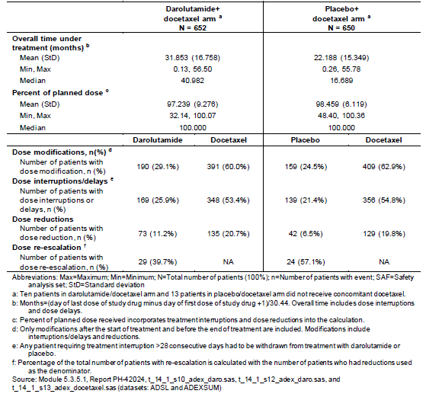

Special topic AEs were identified as events/disorders representing potential or known risks associated with ADT or with anti-androgens.

Special topics associated with ADT include: fatigue/asthenic conditions, bone fractures, fall, vasodilatation and flushing, breast disorders/gynecomastia, hypertension, cardiac disorders, diabetes mellitus and hyperglycaemia, mental impairment disorders, depressed mood disorders, cerebrovascular disorders, and weight decreased (Michaelson et al. 2008, Rhee et al. 2015, Sharifi et al. 2005) while special topics rash and seizure are associated with anti-androgens (Hussain et al. 2018, Smith et al. 2018). Special topic AEs are presented as grouped terms.

An overview of the TEAEs is shown in Table 15 below.

Table 15. An overview of TEAEs (SAF)

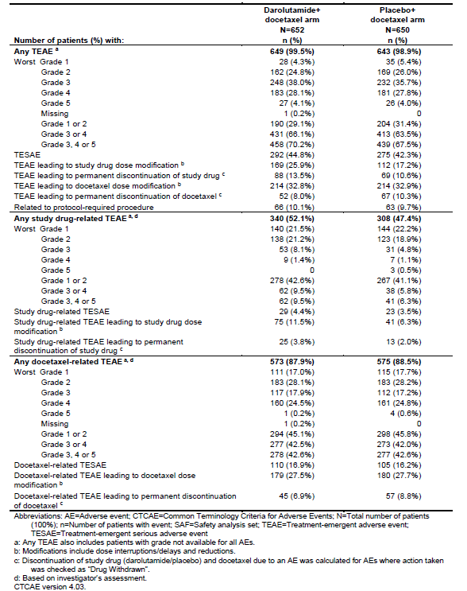

The overall incidence of TEAEs was comparable between the treatment arms. There were more study drug-related TEAEs leading to study dose modification in the experimental arm (11.5% versus 6.3%). Similar incidences were observed for TEAEs with a worst grade of 1 or 2 (29.1% vs. 31.4% in the darolutamide + docetaxel and placebo + docetaxel arm, respectively) and TEAEs with a worst grade of 3 or 4 (66.1% vs. 63.5%, respectively) in both treatment arms. The incidences of TEAEs with fatal outcome (Grade 5) were similar in both treatment arms (4.1% vs. 4.0%).

Overall, drug discontinuation and modification of the study drug due to TEAES were higher in the combination arm. These were comparable for docetaxel. The added toxicity with darolutamide (added to docetaxel) appears acceptable.

TEAEs that resulted in permanent discontinuation of study drug occurred in 13.5% vs. 10.6% of patients in the darolutamide + docetaxel vs. placebo + docetaxel arms, respectively. The most common TEAEs leading to study drug discontinuation in ≥5 patients in either treatment arm were bone pain (0.3% vs. 1.4%), AST increased (0.9% vs. 0.3%), and ALT increased (0.8% vs. 0.2%), darolutamide + docetaxel vs. placebo + docetaxel arms, respectively.

TEAEs that resulted in permanent discontinuation of docetaxel were observed in 8.0% of patients in the darolutamide + docetaxel arm and 10.3% of patients in the placebo + docetaxel arm. The most common TEAEs leading to docetaxel discontinuation in ≥5 patients in either treatment arm were neutrophil count decreased (0.8% vs. 0.5%), febrile neutropenia (0.5% vs. 0.8%), neutropenia (0.5% vs. 0.8%), and WBC count decreased (0.2% vs. 0.9%), Darolutamide + docetaxel vs. placebo + docetaxel arms, respectively.

TEAEs that resulted in interruption of study drug occurred at a greater incidence in the Darolutamide + docetaxel arm (22.9%) than in the placebo + docetaxel arm (15.7%). The most common TEAEs leading to interruption of study drug (in ≥2% of patients in either treatment arm) were ALT increased (3.2% vs. 1.5%), AST increased (3.1% vs. 1.1%), and febrile neutropenia (2.1% vs. 1.4%) in the darolutamide + docetaxel arm and placebo + docetaxel arm, respectively. When adjusted for the difference in study drug treatment duration, the incidences of all TEAEs were comparable between the treatment arms, except for ALT increased, for which the exposure adjusted incidence rate (EAIRs) were 1.2 vs. 0.8 per 100 PYs in the darolutamide + docetaxel and placebo + docetaxel arms, respectively, and AST increased (EAIRs 1.2 vs. 0.6 per 100 PYs, respectively).

TEAEs that resulted in interruption of docetaxel occurred at a similar incidence between the treatment arms, in 21.9% of patients in the darolutamide + docetaxel arm and 20.6% of patients in the placebo + docetaxel arm. The most common TEAEs leading to interruption of docetaxel (in ≥2% of patients in either treatment arm) were ALT increased (4.0% vs. 3.4%), neutrophil count decreased (2.8% vs. 2.3%), and AST increased (2.8% vs. 1.7%) in the darolutamide + docetaxel arm and placebo + docetaxel arm, respectively.

TEAEs that resulted in dose reduction of study drug occurred at a greater incidence in the Darolutamide + docetaxel arm (8.7%) than in the placebo + docetaxel arm (4.3%). The most common TEAEs leading to dose reduction of study drug (in ≥2% of patients in either treatment arm) were ALT increased (2.8% vs. 1.2%) and AST increased (2.5% vs. 0.8%) in the darolutamide + docetaxel arm and placebo + docetaxel arm, respectively.

TEAEs that resulted in dose reduction of docetaxel occurred at a similar incidence between the treatment arms, in 19.9% of patients in the darolutamide + docetaxel arm and 19.5% of patients in the placebo + docetaxel arm. The most common TEAEs leading to reduction of docetaxel (in ≥2% of patients in either treatment arm) were neutrophil count decreased (5.4% vs. 6.0%), febrile neutropenia (3.7% vs. 3.8%), WBC count decreased (3.2% vs. 3.4%), and neutropenia (1.8% vs. 2.2%) in the darolutamide + docetaxel arm and placebo + docetaxel arm, respectively.

A general trend of decreasing incidence and severity of TEAEs after the first 6 months of study treatment was observed in both treatment arms, with the exception of hypertension.

The incidences of TEAEs in ≥10% of patients in either treatment arm are presented below (Table 16). To adjust for differences in study drug treatment duration between the treatment arms, exposure-adjusted incidence rates (EAIRs) per 100 PYs are also summarised.

Table 16. Incidences and exposure-adjusted incidence rates of the most common TEAEs by MedDRA PT (preferred terms) occurring in ≥10% of patients in either treatment arm (SAF)

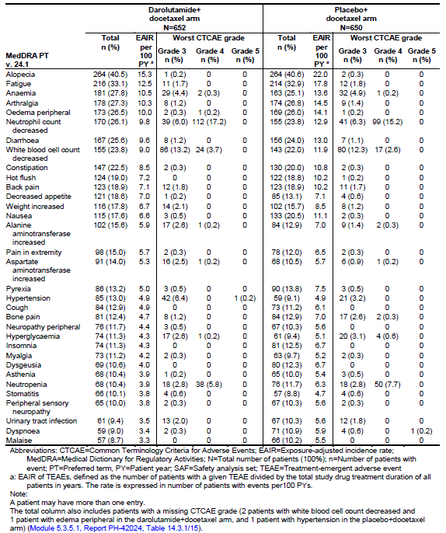

The most commonly reported TEAEs were generally similar between the treatment arms. The most common events (≥25% of patients in either treatment arm) included alopecia, fatigue, anaemia, arthralgia, oedema peripheral, neutrophil count decreased, and diarrhea. The most common TEAEs reported with ≥3 percentage points higher incidence in the darolutamide + docetaxel arm than in the placebo + docetaxel arm were decreased appetite, hypertension, AST increased, and pain in extremity.

The TEAE hypertension (PT) was reported in mHSPC patients at an incidence of 13.0% in the darolutamide + docetaxel arm vs. 9.1% in the placebo + docetaxel arm.

Alanine aminotransferase (ALT) increased and aspartate aminotransferase (AST) increased were reported as a TEAE at a higher incidence in the darolutamide + docetaxel arm vs. placebo + docetaxel arm (15.6% vs. 12.9%) and (14.0% vs. 10.5%), respectively. Hypertension incidence (Grade 3: 6.4% vs. 3.2%) was greater in the darolutamide + docetaxel arm, and neutropenia incidence (Grade 4: 5.8% vs. 7.7%) was greater in the placebo + docetaxel arm.

Grade 3 or 4 TEAEs – see Table 17 below - occurring in 66.3% of patients in the darolutamide plus docetaxel arm and 63.5% of patients in the placebo plus docetaxel arm.

The most common TEAEs with a worst grade of 3 or 4 (≥5% of patients in either treatment arm) were neutrophil count decreased, WBC count decreased, neutropenia, febrile neutropenia, hypertension, and anaemia.

Hypertension was reported with ≥3 percentage point higher incidence in the darolutamide + docetaxel arm (6.4%) than in the placebo + docetaxel arm (3.2%).

Table 17. Incidence of worst Grade 3 or 4 TEAEs by MedDRA PT occurring in ≥1.5% of patients in either arm in Study 17777 (SAF).

The Sponsor provided a safety update dated 13th October 2022 with a cutoff date of 1st August 2022. Overall, 335 late entered AEs with an onset date prior to 25 October 2021 were identified (Table 18).

The following was seen with the safety update:

* Minor changes were observed in the incidences of TEAEs with Grade 1, 2 or 3 as the
* worst severity grade.
* Incidences of Grade 4 and 5 TEAEs were slightly increased in the study arm.
* TEAEs leading to permanent discontinuation of darolutamide reported 1 additional patient in the darolutamide + docetaxel arm.

Table 18: Overview of TEAEs in Study 17777 (SAF).

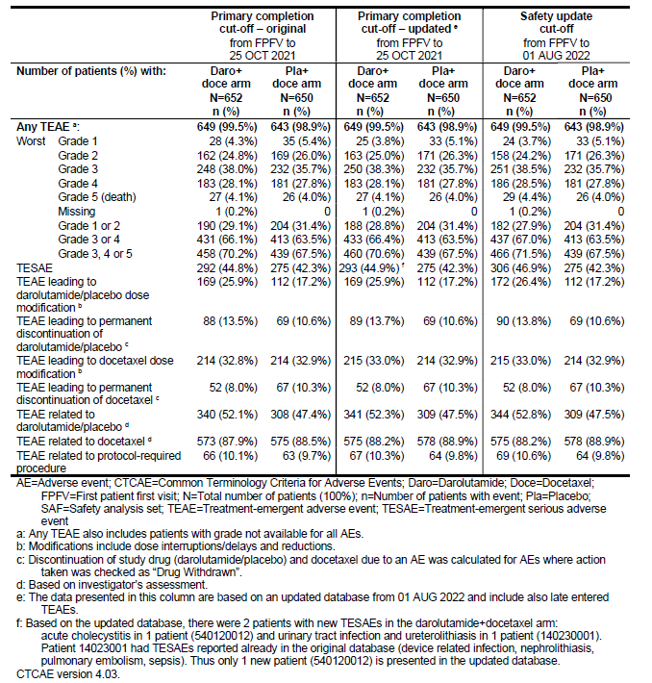

###### Lab findings

Blood bilirubin increased was observed as a laboratory abnormality (as previously seen in nmCRPC) more commonly in the darolutamide + docetaxel arm than in the placebo + docetaxel arm (19.6% vs 10.0% of patients, respectively). The bilirubin elevations were mainly Grade 1 or 2 and of no clear clinical significance, consistent with the low percentage of patients with a TEAE of blood bilirubin increased (4.9% of patients in the darolutamide + docetaxel arm and in 2.9% of patients in the placebo + docetaxel arm).

There was 1 patient (0.2%) in the darolutamide + docetaxel arm with an event with a worst grade of 3 (no patients in the placebo + docetaxel arm). Hyperbilirubinemia was reported as a TEAE in 2 patients (0.3%) (1 patient had an event with a worst grade of 1 and 1 patient with a worst grade of 3) in the placebo + docetaxel arm (no patients in the darolutamide + docetaxel arm).

ALT increased (PT) and AST increased (PT) were reported as a TEAE more commonly in the Darolutamide + docetaxel arm vs. placebo + docetaxel arm: ALT, 15.6% vs. 12.9%, respectively; and AST, 14.0% vs. 10.5%, respectively.

An evaluation of liver injury based on analyses of laboratory data and TEAEs was performed, including review for potential Hy’s Law cases and drug-induced liver injury (DILI) cases. Overall, 2 patients with hepatocellular DILI were identified in the darolutamide + docetaxel arm. The overall incidence of TEAEs of DILI (MedDRA PT) was balanced between the treatment arms: 3 patients (0.5%) in the darolutamide + docetaxel arm and 4 patients (0.6%) in the placebo + docetaxel arm. A total of 3 patients met potential Hy’s Law criteria, including 2 patients in the darolutamide + docetaxel arm and 1 patient in the placebo +docetaxel arm.

###### Safety analyses by subgroups.

Subgroup analyses for TEAEs were performed for age, geographical region , renal function at baseline, hepatic function at baseline and concomitant statin use. No clinically meaningful differences in the incidence of TEAEs between the respective subgroups in either treatment arm were observed for age, renal function, hepatic function, or concomitant use of statins. It is noted that there were very few patients in the age group $≥$ 85 years in each arm to draw any clear conclusions about safety in this age group.

For geographical region subgroups, a difference was seen in both treatment arms between the Asia Pacific region and other regions: There were higher incidences of TEAEs with a worst grade of 4 and TESAEs reported in patients from the Asia Pacific region compared with patients from North America and ROW.

These differences were primarily driven by higher incidences of haematological toxicities, mainly neutrophil count decreased and WBC count decreased. The Sponsor considered these results to be in line with the literature showing higher incidences of severe haematological toxicities (e.g., neutropenia) in Asian patients treated with docetaxel compared with non-Asian patients treated with docetaxel[15],[16],[17],[18],[19].

###### Analysis of special topics

Special topics were defined as events/disorders representing potential or known risks associated with ADT or with anti-androgens.

Special topics associated with ADT included fatigue/asthenic conditions, bone fractures, fall, vasodilatation and flushing, breast disorders/gynecomastia, hypertension, cardiac disorders, diabetes mellitus and hyperglycaemia, mental impairment disorders, depressed mood disorders, cerebrovascular disorders, and weight decreased[20],[21],[22] while special topics rash and seizure are associated with anti-androgens[23],[24].

For the analysis of special topics, TEAEs representing the same or pathophysiologically related clinical concepts were grouped. The grouped terms were selected and pre-defined based on the data from the Phase 3 Study 17712 in nmCRPC (Table 19).

Specific predefined safety topics included: fatigue, fractures, falls, vasodilatation and flushing, breast disorders/gynecomastia, cardiac disorders, diabetes mellitus and hyperglycaemia, mental impairment disorders, depressed mood disorders, cerebrovascular disorders, seizure and weight decrease, which are known to be associated with the currently existing therapeutic options for mHSPC.

Table 19. Incidences and exposure-adjusted incidence rates of TEAEs of special topics associated with ADT or anti-androgens (SAF)

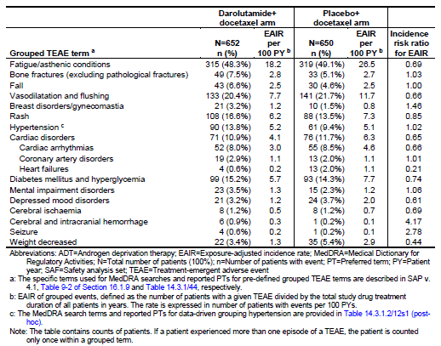

In study 17777, the grouped term of coronary artery disorders occurred at a higher incidence in patients on the darolutamide + docetaxel arm (2.9%) compared to placebo + docetaxel (2.0%). The most common PTs within this HLGT were myocardial infarction (0.9% vs. 0.3%), acute myocardial infarction (0.5% vs. 0.5%), angina pectoris (0.5% vs 0.3%) and myocardial ischaemia (0.5% vs 0.3%) in the darolutamide + docetaxel arm and the placebo + docetaxel arm, respectively. In the pivotal trial of patients with nmCRPC, ischemic heart disease (IHD) occurred in 3.2% of patients treated with darolutamide and in 2.5% of those treated with placebo.

There was an increased incidence of fall in the study arm (6.6%) compared to the control arm (4.6%), although the EAIR was similar. A pooled analysis did not show any evidence for an increased risk of fall for patients treated with darolutamide compared with placebo. Seizure occurred in 0.6% of patients receiving darolutamide + docetaxel compared to 0.2% receiving placebo + docetaxel.

Fractures occurred at a higher incidence in patients on the darolutamide + docetaxel arm compared to placebo plus docetaxel (7.5% vs 5.1%). Despite the similar exposure adjusted incidence rates, the unadjusted incidence of fractures is higher in ARASENS and fractures are of concern in prostate cancer given its predilection for bone metastases. Although ADT is associated with BMD loss and increased risk of bone fracture, in the ARAMIS study[25] in nmCRPC, bone fractures occurred in 5.5% of patients receiving darolutamide compared with 3.6% of patients receiving placebo.

Breast disorders/gynecomastia were more commonly reported in the darolutamide + docetaxel arm than in the placebo + docetaxel arm (3.2% vs. 1.5%, respectively). As these were G1 or 2 events and there were no changes to the dosing or treatment regimens, it is not considered to have a meaningful impact on the safety profile.

There was an increased incidence of mental impairment disorders in the darolutamide arm compared with the control arm, although the EAIR was similar. At the PT level, the most commonly reported TEAE within this group was memory impairment (1.2% vs. 0.9%), followed by cognitive disorder (0.9% vs. 0.5%) and disturbance in attention (0.8% vs. 0.5%) in both the darolutamide + docetaxel arm and the placebo + docetaxel arm, respectively.

There also appeared to be a higher incidence of cerebral and intracranial haemorrhage (0.9%) in the darolutamide + docetaxel arm compared to the placebo + docetaxel arm (0.2%). All 6 reports of cerebrovascular accident in the study arm had potentially confounding preceding surgery, trauma, and underlying comorbidities.

During the study, seizure was reported in 4 patients (0.6%) in the darolutamide + docetaxel arm and in 1 patient (0.2%) in the placebo + docetaxel arm. At the PT level, the events were seizure (3 patients) and focal dyscognitive seizures (1 patient) in the darolutamide + docetaxel arm, and epilepsy (1 patient) in the placebo + docetaxel arm All seizure events were of Grade 1 (0.2% vs. 0%) or Grade 2 (0.5% vs. 0.2%) in the darolutamide + docetaxel arm and the placebo + docetaxel arm, respectively.

Darolutamide in combination with docetaxel and ADT contributed to an increased incidence of rash and hypertension.

Treatment-emergent events of rash were reported with a higher incidence in the darolutamide + docetaxel arm compared with the placebo + docetaxel arm (16.6% vs. 13.5%, respectively). The majority of events were grade 1 and 2 but there was a higher incidence of grade 3 events in the darolutamide arm (1.2%) than in the control arm (0.2%), a higher incidence of permanent discontinuation and dose reduction in the darolutamide arm, and a report of a grade 4 event (drug eruption) in the darolutamide arm but not in the control arm.

Hypertension was more commonly reported in the darolutamide + docetaxel arm than in the placebo + docetaxel arm 13.8% vs. 9.4%, respectively. The incidence of Grade 3 events was higher in the darolutamide + docetaxel arm as illustrated below in Table 20.

Table 20. Incidence of TEAEs hypertension (MLG) by present history of hypertension (MLG) and worst CTCAE grade (SAF)

##### Deaths

A total of 229 patients (35.1%) in the darolutamide + docetaxel arm and 304 patients (46.8%) in the placebo + docetaxel arm had died as of the database cut-off date. The most common cause of death was progressive disease in both the darolutamide + docetaxel arm (26.1% of patients) and the placebo + docetaxel arm (36.0% of patients). An overview of the deaths is sown in Table 21.

Table 21: overview of deaths in study 17777.

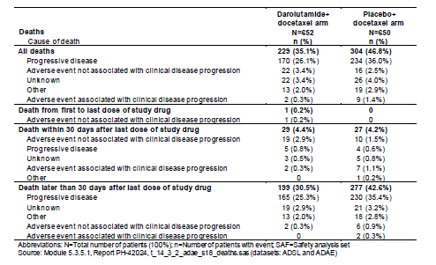

As shown in Table 22 below, the incidences of reported Grade 5 TEAES events appeared similar in both arms: 27 patients (4.1%) in the darolutamide + docetaxel arm and 26 patients (4.0%) in the placebo + docetaxel arm.

Five patients (0.8%) in the darolutamide + docetaxel treatment arm had fatal cardiac events, which included myocardial infarction, acute myocardial infarction, cardiac disorder, cardiac arrest, and cardiac failure acute (reported in 1 patient each). None of these events were assessed as related to study drug, and the Sponsor reports that these patients had underlying confounders such as advanced age, hypertension, ischemic heart disease, chronic heart failure, and arterial hypertension. One patient was reported as having a fatal heart attack due to anaesthesia. Fatal cardiac events were reported in 3 patients (0.5%) in the placebo + docetaxel arm, which included cardiac arrest in 2 patients and cardiac failure in 1 patient.

No Grade 5 TEAEs were considered to be study drug-related by the investigator in the darolutamide + docetaxel arm. Study drug-related Grade 5 TEAEs were reported in 3 patients (0.5%) in the placebo + docetaxel arm (cardiac arrest, general physical health deterioration, and interstitial lung disease).

The most common (in ≥2 patients) fatal TEAEs in the darolutamide plus docetaxel arm included COVID-19/COVID-19 pneumonia (0.8%), myocardial infarction (0.4%), and sudden death (0.3%).

The Sponsor reports that most deaths occurred more than 30 days after the last dose of study drug in both treatment arms, with progressive disease being the most commonly reported primary cause of death.

Overall, the incidence of deaths due to a TEAE appeared similar between the arms.

Table 22. Incidence of all Grade 5 TEAEs by MedDRA PT in Study 17777 (SAF)

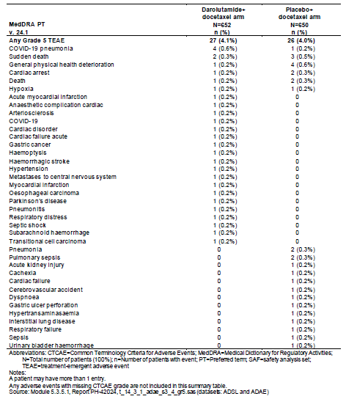

## Risk/benefit analysis

The study met its primary objective, with an improvement in OS with HR 0.675 [0.568; 0.801] which was statistically significant with p <0.0001, in patients treated with darolutamide in combination with docetaxel compared with placebo in combination with docetaxel. Of note, a higher percentage of patients received subsequent life prolonging antineoplastic therapy after discontinuation of study treatment in the placebo + docetaxel arm.

The median OS was not reached in the darolutamide + docetaxel arm (95% CI: [A; A]) and was 48.9 months in the placebo + docetaxel arm (95% CI: [44.4; A]).

Death events were reported in 35.2% of patients in the darolutamide arm and 46.5% of patients in the control arm at the primary efficacy analysis. The survival curves separated at approximately 6 months, and survival rates at 12, 24, 36, and 48 months were consistently higher in the darolutamide arm than in the control arm.

Subgroup analysis of the OS showed generally consistent results among the pre-specified subgroups. The number of patients in the non-regional LN metastases group was small and the confidence interval was wide (HR=0.651; 95% CI: 0.188, 2.249) with a resultant uncertainty as to the result in this group. There are some subgroups that appeared to have less benefit e.g. 65-74 years, Asians, visceral metastases, Asia-Pacific but the reasons are unclear and likely to be multifactorial.

With respect to the seven secondary endpoints which were formally tested: the first five tested were statistically significant but the 6th (time to worsening of disease related symptoms) was not and the 7th endpoint (time to initiation of opioid use for ≥7 consecutive days) was not tested. These were tested with a hierarchical approach (if the prior endpoint in the hierarchy was significant, then the next endpoint in the order was tested for significance). Planned sensitivity analyses were consistent with the primary analyses for these secondary endpoints.

The secondary endpoints of time to castration-resistant prostate cancer, time to pain progression, SSE-free survival, time to first SSE, and time to initiation of subsequent systemic antineoplastic therapy showed a statistically significant benefit for the study arm compared with the placebo arm. However, there were limitations with some these endpoints in relation to the timing of radiographic assessments, potential confounding by subsequent therapies and/or investigator subjectivity.

Regarding the secondary endpoint of time to CRPC, 34.6% of patients in the darolutamide +docetaxel arm and 59.8% of patients in the placebo + docetaxel arm progressed to CRPC. Treatment with darolutamide delayed the time to CRPC (HR: 0.357; 95% CI: 0.302, 0.421; p<0.0001) compared to the control arm.

At the request of an Orbis partner, the Sponsor undertook a SA to exclude the component PSA progression from time to CRPC. By excluding the component of PSA progression in this analysis, patients could still have radiological progression later in the trial. This sensitivity analysis showed an HR of 0.463 (95% CI: [0.375; 0.572]; p<0.0001.

It is noted that the FDA did not include the following in the label: time to castration-resistant prostate cancer, SSE-free survival, time to first SSE and time to initiation of subsequent systemic antineoplastic therapy. Only OS and time to pain progression were included.

The clinical meaningfulness of PSA progression is unclear and it has not been unequivocally correlated with long-term outcomes in patients with mHSPC.

Given that radiographic imaging was not consistently performed at regular, frequent intervals in the study, there is uncertainty regarding the accuracy of the estimates. In addition, radiological imaging was assessed by investigator only and not by blinded independent review. Thus, treatment benefit by radiological progression could not be reliably estimated.

The results of SSE-FS appear to be largely driven by death and thus does not add further clinically relevant information beyond OS.

Time to initiation of subsequent antineoplastic therapy appears to be subjective endpoint as it is governed by a physician-patient decision. As radiological imaging was at the discretion of the investigator and not routine following PSA progression, the utility of this endpoint regarding this is unclear.

In general, the incidence, severity, and nature of the most commonly reported TEAEs in patients treated with darolutamide in combination with docetaxel were consistent with those expected of the individual compounds in the target population (patients with advanced age and underlying disease). However, the study drug combination did lead to the following TEAEs in addition to hypertension and rash, occurring in ≥ 10% of patients with a ≥2% absolute increase in frequency: anaemia, neutrophil count decreased, constipation, decreased appetite, weight increased, hemorrhage (GT), ALT increased, AST increased, and hyperglycaemia. Blood bilirubin increase was also noted to be higher in the darolutamide plus docetaxel arm. Other clinically relevant adverse events that occurred in <10% of patients in the study arm included fractures, IHD, seizures, and drug induced liver injury.

The incidences of permanent discontinuation, interruption, and dose reduction appeared comparable between the arms. Overall, the combination of darolutamide plus docetaxel appears to have an acceptable safety profile for the indicated patient population.

Overall, the addition of darolutamide to docetaxel showed a manageable toxicity profile in the above study and the safety profile is characterised in the product information to incorporate the above.

### Conclusions

There is a positive benefit/risk for darolutamide (Nubeqa) in combination with androgen deprivation therapy and docetaxel in the treatment of patients with metastatic hormone sensitive prostate cancer. The primary endpoint was met with a statistically significant improvement in OS compared to the darolutamide + placebo arm: HR 0.675 (95% CI: 0.568, 0.801; p<0.0001). The median OS in the darolutamide + docetaxel arm was not reached (NR, [NR, NR]) and was 48.9 months (44.4, NR) in the placebo + docetaxel arm.

## Outcome

Based on a review of quality, safety, and efficacy, the TGA decided to register Nubeqa (darolutamide) for the following indications:

NUBEQA is indicated for the treatment of patients with:

* metastatic hormone-sensitive prostate cancer (mHSPC) in combination with docetaxel

The **full indications** are now:

NUBEQA is indicated for the treatment of patients with:

* non-metastatic castration resistant prostate cancer (nmCRPC)
* metastatic hormone-sensitive prostate cancer (mHSPC) in combination with docetaxel Specific conditions of registration applying to these goods

## Attachment 1. Product Information

The [Product Information](https://www.tga.gov.au/products/australian-register-therapeutic-goods-artg/product-information-one) ([PI](https://www.tga.gov.au/products/australian-register-therapeutic-goods-artg/product-information-one)) approved with the submission for Nubeqa which is described in this AusPAR can be found as Attachment 1. It may have been superseded. For the most recent PI and [Consumer Medicines Information](https://www.tga.gov.au/products/australian-register-therapeutic-goods-artg/consumer-medicines-information-cmi) (CMI), please refer to the TGA [PI/CMI search facility.](https://www.tga.gov.au/picmi-search-facility)

|  |
| --- |
| Therapeutic Goods Administration |
| PO Box 100 Woden ACT 2606 Australia  Email: [info@tga.gov.au](mailto:info@tga.gov.au) Phone: 1800 020 653 Fax: 02 6203 1605  [**https://www.tga.gov.au**](https://www.tga.gov.au) |
|  |

1. Sung H, Ferlay J, Siegel RL, Laversanne M, Soerjomataram I, Jemal A, Bray F. Global Cancer Statistics 2020: GLOBOCAN Estimates of Incidence and Mortality Worldwide for 36 Cancers in 185 Countries. CA Cancer J Clin. 2021 May;71(3):209-249. doi: 10.3322/caac.21660. Epub 2021 Feb 4. PMID: 33538338.
2. Cancer Australia. Prostate cancer in Australia statistics. <https://www.canceraustralia.gov.au/cancer-types/prostate-cancer/statistics>
3. NCI. National Cancer Institute (NCI) Surveillance, Epidemiology, and End Results Program; Cancer Stat Facts: Prostate Cancer. <https://seer.cancer.gov/statfacts/html/prost.html> 2021
4. Wenzel M, Preisser F, Hoeh B, Schroeder M, Würnschimmel C, Steuber T, et al. Impact of Time to Castration Resistance on Survival in Metastatic Hormone Sensitive Prostate Cancer Patients in the Era of Combination Therapies. Front Oncol. 2021;11:659135.
5. <https://www.eviq.org.au/medical-oncology/urogenital/prostate>
6. Dawson, NA. Patient education: Treatment for advanced prostate cancer (Beyond the Basics). In UpToDate: <https://www.uptodate.com/contents/treatment-for-advanced-prostate-cancer-beyond-the-basics>
7. Baumgart SJ, Nevedomskaya E, Lesche R, Newman R, Mumberg D, Haendler B. Darolutamide antagonizes androgen signaling by blocking enhancer and superenhancer activation. Molecular Oncology. 2020 2020/09/01;14(9):2022-39.
8. Moilanen AM, Riikonen R, Oksala R, Ravanti L, Aho E, Wohlfahrt G, et al. Discovery of ODM-201, a new-generation androgen receptor inhibitor targeting resistance mechanisms to androgen signaling-directed prostate cancer therapies. Sci Rep. 2015

   Jul 3;5:12007.
9. Palmieri VE, Roviello G, D'Angelo A, Casadei C, De Giorgi U, Giorgione R. Darolutamide in hormone-sensitive and castration-resistant prostate cancer. Expert Rev Clin Pharmacol. 2021 May;14(5):535-44.
10. Williams S, Mazibuko N, O’Daly O, Zurth C, Patrick F, Wooldridge C, et al. Significant localized reduction in cerebral blood flow (CBF) in regions relevant to cognitive function with enzalutamide (ENZA) compared to darolutamide (DARO) and placebo (PBO) in healthy volunteers. J Clin Oncol. 2020;38(6_suppl):326.
11. Shore N, Zurth C, Fricke R, Gieschen H, Graudenz K, Koskinen M, et al. Evaluation of Clinically Relevant Drug-Drug Interactions and Population Pharmacokinetics of Darolutamide in Patients with Nonmetastatic Castration-Resistant Prostate Cancer: Results of Pre-Specified and Post Hoc Analyses of the Phase III ARAMIS Trial. Target Oncol. 2019 Oct;14(5):527-39
12. Nubeqa AusPAR, 2 July 2020: <https://www.tga.gov.au/resources/auspar/auspar-darolutamide>
13. The ‘Delegate’ is the Delegate of the Secretary of the Department of Health and Aged Care who made the final decision to either include the new medicine/indication on the ARTG or reject the submission, under section 25 of the Therapeutic Goods Act
14. <https://recist.eortc.org/recist-1-1-2/>
15. Hor SY, Lee SC, Wong CI, Lim YW, Lim RC, Wang LZ, et al. PXR, CAR and HNF4α genotypes and their association with pharmacokinetics and pharmacodynamics of docetaxel and doxorubicin in Asian patients. Pharmacogenomics J. 2008

    04/01;8(2):139-46.
16. Kenmotsu H, Tanigawara Y. Pharmacokinetics, dynamics and toxicity of docetaxel: Why the Japanese dose differs from the Western dose. Cancer Sci. 2015 May;106(5):497-504.
17. Poon DM, Ng J, Chan K. Importance of cycles of chemotherapy and postdocetaxel novel therapies in metastatic castration-resistant prostate cancer. Prostate Int. 2015 Jun;3(2):51-5.
18. Poon DMC, Chan T, Chan K, Chan M, Lee EKC, Law K, et al. Preliminary efficacy and tolerability of chemohormonal therapy in metastatic hormone-naïve prostate cancer:The first real-life experience in Asia. Asia Pac J Clin Oncol. 2018 Aug;14(4):347-52.
19. Poon DMC, Chan K, Chan TW, Ng B, Siu S, Ng J, et al. Prevention of docetaxel-associated febrile neutropenia with primary granulocyte colony-stimulating factor in Chinese metastatic hormone-sensitive and castration-resistant prostate cancer patients. Asia Pac J Clin Oncol. 2021 Apr;17 Suppl 3:39-47..
20. Michaelson MD, Cotter SE, Gargollo PC, Zietman AL, Dahl DM, Smith MR. Management of complications of prostate cancer treatment. CA Cancer J Clin. 2008 Jul- Aug;58(4):196-213.
21. Rhee H, Gunter JH, Heathcote P, Ho K, Stricker P, Corcoran NM, et al. Adverse effects of androgen-deprivation therapy in prostate cancer and their management. BJU Int. 2015 Apr;115 Suppl 5:3-13
22. Sharifi N, Gulley JL, Dahut WL. Androgen deprivation therapy for prostate cancer. JAMA. 2005 Jul 13;294(2):238-44.
23. Hussain M, Fizazi K, Saad F, Rathenborg P, Shore N, Ferreira U, et al. Enzalutamide in Men with Nonmetastatic, Castration-Resistant Prostate Cancer. N Engl J Med. 2018 Jun 28;378(26):2465-74
24. Smith MR, Saad F, Chowdhury S, Oudard S, Hadaschik BA, Graff JN, et al. Apalutamide Treatment and Metastasis-free Survival in Prostate Cancer. N Engl J Med. 2018 Apr 12;378(15):1408-18
25. Shore ND, Luz M, Ulys A, Ortiz J, Srinivasan S, Kurland E, et al. MP11-14 TREATMENT DURATION AND LONG-TERM SAFETY AND TOLERABILITY WITH DAROLUTAMIDE IN NONMETASTATIC CASTRATION-RESISTANT PROSTATE CANCER (nmCRPC): ARAMIS ROLLOVER STUDY. Journal of Urology [Internet]. 2023 Apr 1 [cited 2024 Aug 25];209(Supplement 4):e129. Available from: https://doi.org/10.1097/JU.0000000000003226.14