|  |
| --- |
| Australian Public Assessment Report for Vaxchora |
| Active ingredients: Cholera vaccine, recombinant, live, oral |
| Sponsor: Biocelect Australia Pty Ltd |
| October 2024 |

About the Therapeutic Goods Administration (TGA)

* The Therapeutic Goods Administration (TGA) is part of the Australian Government Department of Health and Aged Care and is responsible for regulating therapeutic goods, including medicines, medical devices, and biologicals.
* The TGA administers the *Therapeutic Goods Act 1989* (the Act), applying a risk management approach designed to ensure therapeutic goods supplied in Australia meet acceptable standards of quality, safety, and efficacy.
* The work of the TGA is based on applying scientific and clinical expertise to decision-making, to ensure that the benefits to the Australian public outweigh any risks associated with the use of therapeutic goods.
* The TGA relies on the public, healthcare professionals and industry to report problems with therapeutic goods. The TGA investigates reports received to determine any necessary regulatory action.
* To report a problem with a therapeutic good, please see the information on the [TGA website](https://www.tga.gov.au).

About AusPARs

* The Australian Public Assessment Report (AusPAR) provides information about the evaluation of a prescription medicine and the considerations that led the TGA to approve or not approve a prescription medicine submission. Further information can be found in [Australian Public Assessment Report (AusPAR) guidance](https://www.tga.gov.au/australian-public-assessment-report-auspar-guidance).
* AusPARs are prepared and published by the TGA.
* AusPARs are static documents that provide information that relates to a submission at a particular point in time. The publication of an AusPAR is an important part of the transparency of the TGA’s decision-making process.
* A new AusPAR may be provided to reflect changes to indications or major variations to a prescription medicine subject to evaluation by the TGA.

Copyright

© Commonwealth of Australia 2024  
This work is copyright. You may reproduce the whole or part of this work in unaltered form for your own personal use or, if you are part of an organisation, for internal use within your organisation, but only if you or your organisation do not use the reproduction for any commercial purpose and retain this copyright notice and all disclaimer notices as part of that reproduction. Apart from rights to use as permitted by the *Copyright Act 1968* or allowed by this copyright notice, all other rights are reserved and you are not allowed to reproduce the whole or any part of this work in any way (electronic or otherwise) without first being given specific written permission from the Commonwealth to do so. Requests and inquiries concerning reproduction and rights are to be sent to the TGA Copyright Officer, Therapeutic Goods Administration, PO Box 100, Woden ACT 2606 or emailed to <[tga.copyright@tga.gov.au](mailto:tga.copyright@tga.gov.au)>.

Contents

List of abbreviations 4

Product submission 5

Submission details 5

Product background 6

Condition 6

Current treatment options 7

Clinical rationale 7

Regulatory status 8

Australian regulatory status 8

Foreign regulatory status 8

Registration timeline 10

Submission overview and risk/benefit assessment 10

Quality 10

Nonclinical 11

Clinical 11

Summary of clinical studies 11

Correlates of protection 12

Efficacy 12

Safety 23

Risk management plan 25

Risk-benefit analysis 26

Delegate’s considerations 26

Proposed action 26

Advisory Committee considerations 27

Outcome 28

Specific conditions of registration applying to these goods 29

Attachment 1. Product Information 30

## List of abbreviations

|  |  |
| --- | --- |
| Abbreviation | Meaning |
| ACV | Advisory Committee on Vaccines |
| AE | Adverse event |
| ARTG | Australian Register of Therapeutic Goods |
| ASA | Australia‑specific annex |
| CFU | Colony forming units |
| CI | Confidence interval |
| CMI | Consumer Medicines Information |
| CPD | Certified product details |
| CVD | Center for Vaccine Development of the University of Maryland School of Medicine, USA |
| DLP | Data lock point |
| EMA | European Medicines Agency |
| EU | European Union |
| FDA | Food and Drug Administration, United States of America |
| GMT | Geometric mean titre |
| PI | Product Information |
| PSUR | Periodic safety update report |
| RMP | Risk management plan |
| TGA | Therapeutic Goods Administration |

## Product submission

### Submission details

|  |  |
| --- | --- |
| *Type of submission:* | New biological entity |
| *Product name:* | Vaxchora  Company code: PXVX0200 |
| *Active ingredient:* | *Vibrio cholerae* bacteria cells (CVD 103-HgR strain) |
| *Decision:* | Approved |
| *Date of decision:* | 4 September 2023 |
| *Date of entry onto ARTG:* | 6 September 2023 |
| *ARTG number:* | 389746 |
| [*Black Triangle Scheme*](https://www.tga.gov.au/black-triangle-scheme) | Yes  This product will remain in the scheme for 5 years, starting on the date the product is first supplied in Australia. |
| *Sponsor’s name and address:* | Biocelect Pty Ltd  Level 29  66 Goulburn Street  Sydney NSW 2000 |
| *Dose form:* | Powder for suspension |
| *Strength:* | 4 × 108 to 2 × 109 colony forming units (CFU) |
| *Container:* | Sachet |
| *Pack sizes:* | Each carton contains one active ingredient sachet (2 g of powder for suspension) and one buffer sachet (4.5 g of effervescent powder). |
| *Approved therapeutic use for the current submission:* | *Vaxchora vaccine is indicated for active immunisation against disease caused by Vibrio cholerae serogroup O1 in adults and children aged 2 years and older travelling to cholera-affected countries. Vaxchora vaccine should be used in accordance with official recommendations. The vaccine should not replace standard preventive hygiene measures.* |
| *Route of administration:* | Oral |
| *Dosage:* | Adults and children aged 2 years and older: A single oral dose should be administered at least 10 days prior to potential exposure to cholera.  The safety and effectiveness of revaccination with VAXCHORA vaccine have not been established.  For further information regarding preparation for use, refer to the Product Information. |
| *Pregnancy category:* | B2  Drugs which have been taken by only a limited number of pregnant women and women of childbearing age, without an increase in the frequency of malformation or other direct or indirect harmful effects on the human fetus having been observed.  Studies in animals are inadequate or may be lacking, but available data show no evidence of an increased occurrence of fetal damage.  The use of any medicine during pregnancy requires careful consideration of both risks and benefits by the treating health professional. The [pregnancy database](https://www.tga.gov.au/products/medicines/find-information-about-medicine/prescribing-medicines-pregnancy-database) must not be used as the sole basis of decision making in the use of medicines during pregnancy. The TGA does not provide advice on the use of medicines in pregnancy for specific cases. More information is available from [obstetric drug information services](https://www.tga.gov.au/obstetric-drug-information-services) in your state or territory. |

### Product background

This AusPAR describes the submission by Biocelect Pty Ltd to register Vaxchora (*Vibrio cholerae* bacteria cells (CVD 103-HgR strain)) 4 × 108 to 2 × 109 CFU powder for suspension in sachets, for the following proposed indication:[1]

*Active immunisation against disease caused by Vibrio cholerae serogroup O1 in adults and children aged 2 years and older.*

#### Condition

*Vibrio cholerae* O1 and 0139 strains are found in the faeces of infected people and are spread by drinking contaminated water, eating food washed with contaminated water or prepared with soiled hands, or eating fish or shellfish caught in contaminated water. Person-to-person spread is reported but is much less common. The clinical manifestation of the infection is cholera, a potentially life-threatening, diarrhoeal disease, the result of the potent oligomeric cholera toxin that the bacteria produce in the small intestine.

Death rates in untreated patients with severe cholera can exceed 70%.[2] Children under 5 years of age have the highest incidence of cholera and contribute to almost half of the mortality.[3]

*V. cholerae* O1 is classified by biotype (classical or El Tor) and is further divided into 2 main serotypes, Inaba or Ogawa. Worldwide, *V. cholerae* El Tor is currently the predominant biotype and the serotype varies over time and geography. ‘Hybrid’ *V. cholerae* O1 have emerged globally that are classified as El Tor biotype but express classical biotype cholera enterotoxin. Cholera due to these hybrid El Tor organisms is more severe than due to the El Tor strain that express El Tor cholera toxin. Infections with O139 are currently rare and are found in only a few areas of Asia.

##### Epidemiology

Cholera occurs in both endemic and epidemic patterns. It is endemic in many areas of Asia and Africa.

In Australia, approximately 2 to 6 cases of cholera occur each year,[4] and these are typically imported by Australians returning from cholera endemic areas. A total of 19 cases of cholera were notified in Australia between 2011-2016.[5] Australians of all ages, sex and race can contract the disease when travelling to parts of Africa, Asia, South America, the Middle East and the Pacific Islands.

#### Current treatment options

There is currently one cholera vaccine registered in Australia, Dukoral, first registered in the ARTG in 2003. Dukoral is an oral vaccine containing inactivated whole-cell *V. cholerae* O1 Inaba, Ogawa, classic and El Tor strains (31.25 × 109 vibrios of each) and 1.0 mg recombinant cholera toxin B subunit. It is indicated for the prevention of cholera caused by serogroup O1 *V. cholerae*, for adults and children from 2 years of age who will be visiting areas with epidemic or endemic cholera and who are at high risk of infection.[6] The dosage regimen is 2 doses for adults and children over the age of 6 years, and 3 doses for children from 2 to 6 years of age. Satisfactory protection against cholera can be expected about 2 weeks after completing the primary immunisation course. No clinical efficacy data have been generated on repeat booster dosing.

#### Clinical rationale

Vaxchora is a live attenuated bacterial vaccine. The formulation was largely adopted from the previously marketed live, attenuated cholera vaccine of the same CVD 103-HgR *V. cholerae* strain. The original commercial formulation of CVD 103-HgR, launched in 1993, was licensed under the trade name Orochol vaccine in Australia, for the active immunisation against disease caused by *V. cholerae* O1 in travellers to cholera endemic area. For commercial reasons, production and supply of the vaccine globally ceased in 2001. The current owner of the licence has reformulated CVD 103-HgR into the Vaxchora vaccine.[7]

Further information on immunisation in Australia is available in the Australian Immunisation Handbook.

### Regulatory status

#### Australian regulatory status

This product is considered a new biological entity for Australian regulatory purposes.

#### Foreign regulatory status

This submission was evaluated as part of the [Australia-Canada-Singapore-Switzerland-United Kingdom (ACCESS) Consortium](https://www.tga.gov.au/australia-canada-singapore-switzerland-united-kingdom-access-consortium) with work-sharing between the TGA and Health Canada. Each regulator made independent decisions regarding market authorisation of the new medicine.

At the time the TGA considered this submission, a similar submission had been approved in other jurisdictions, as detailed in Table 1.

Table 1: International regulatory status

|  |  |  |  |
| --- | --- | --- | --- |
| Region | Submission date | Status | Approved indications |
| United States of America | 16 October 2015 | Approved on 10 June 2016 | *VAXCHORA is a vaccine indicated for active immunization against disease caused by Vibrio cholerae serogroup O1. VAXCHORA is approved for use in persons 2 through 64 years of age traveling to cholera-affected areas.*  *1.1 Limitations of Use*  *The effectiveness of VAXCHORA has not been established in persons living in cholera-affected areas. The effectiveness of VAXCHORA has not been established in persons who have pre-existing immunity due to previous exposure to V. cholerae or receipt of a cholera vaccine. VAXCHORA has not been shown to protect against disease caused by V. cholerae serogroup O139 or other non-O1 serogroups.* |
| Great Britain | 10 January 2019 | Approved on 1 April 2020  Approved on 8 September 2021 | *VAXCHORA is indicated for active immunisation against disease caused by Vibrio cholerae serogroup O1 in adults and children aged 6 years and older.*  Extended to:  *VAXCHORA is indicated for active immunisation against disease caused by Vibrio cholerae serogroup O1 in adults and children aged 2 years and older.* |
| European Union | 10 January 2019 | Approved on 1 April 2020  Approved on 26 February 2021 | *VAXCHORA is indicated for active immunisation against disease caused by Vibrio cholerae serogroup O1 in adults and children aged 6 years and older.*  Extended to:  *VAXCHORA is indicated for active immunisation against disease caused by Vibrio cholerae serogroup O1 in adults and children aged 2 years and older.* |
| Canada | 8 June 2022 | Approved on 19 June 2023 | *VAXCHORA (Cholera Vaccine, Live Attenuated, Oral) is indicated for the active immunization against diarrheal disease caused by Vibrio cholerae serogroup O1 in persons 2 to 64 years of age travelling to cholera-affected countries.*  *The efficacy of VAXCHORA vaccine has not been evaluated in cholera endemic areas. However, it provides protection to vaccine recipients from areas not endemic for cholera, such as Canada, travelling to areas posing a threat of diarrheal disease caused by cholera. Onset of protection against cholera diarrhea can be expected one week after administration.*  *VAXCHORA vaccine should be used in accordance with official recommendations, taking into account the epidemiological variability and the risk of contracting diarrheal illness in different geographical areas and in different conditions of travel. VAXCHORA vaccine has not been shown to protect against V. cholerae serogroup O139 or other non-O1 serogroups, which are uncommon causes of disease.*  *The vaccine should not replace standard preventive hygiene measures. Travellers should take all necessary precautions to avoid contact with or ingestion of potentially contaminated food or water. Rehydration measures must be taken in the event of diarrhea.* |

## Registration timeline

The following table captures the key steps and dates for this submission.

This submission was evaluated under the [standard prescription medicines registration process](https://www.tga.gov.au/how-we-regulate/supply-therapeutic-good-0/supply-prescription-medicine/application-process/prescription-medicines-registration-process).

Table 2: Timeline for Submission PM-2021-04064-1-2

|  |  |
| --- | --- |
| Description | Date |
| Submission dossier accepted and first round evaluation commenced | 11 July 2022 |
| First round evaluation completed | 2 December 2022 |
| Sponsor provides responses on questions raised in first round evaluation | 30 January 2023 |
| Second round evaluation completed | 10 March 2023 |
| Sponsor’s notification to the TGA of errors/omissions in evaluation reports | 24 March 2023 |
| Delegate’s Overall benefit-risk assessment and request for Advisory Committee advice[8] | 24 June 2023 |
| Sponsor’s pre-Advisory Committee response | 11 July 2023 |
| Advisory Committee meeting | 2 August 2023 |
| Registration decision (Outcome) | 4 September 2023 |
| Administrative activities and registration on the ARTG completed | 6 September 2023 |
| Number of working days from submission dossier acceptance to registration decision* | 209 |

*Statutory timeframe for standard submissions is 255 working days

## Submission overview and risk/benefit assessment

This section is a TGA summary of wording used in TGA’s evaluation report, which discussed numerous aspects of overseas evaluation reports and included some information that was commercial-in-confidence.

### Quality

Vaxchora is a lyophilised, live attenuated bacterial vaccine suspension for oral administration containing the *V. cholerae* strain CVD 103-HgR.

A typical *V. cholerae* strain is a comma-shaped Gram-negative rod. The CVD 103-HgR strain of *V. cholerae* is comma shaped and stained in red or pink with Gram stain, indicative of a Gram-negative rod. In addition, the typical morphology for *V. cholerae* colonies on Trypticase Soy Agar plates are large in size, round, and flat in shape, with a shiny texture and tan colour.

The vaccine consists of a co-package of a single dose sachet containing vaccine powder for reconstitution, and a separate single dose sachet containing buffer powder for reconstitution. The buffer and vaccine are reconstituted in 100 mL of cold or room temperature (5‑22°C) bottled water (purified, spring, or sparkling/carbonated), by mixing and dissolving the buffer powder first followed by the active component. The reconstituted vaccine is a non-sterile orally administered product that contains 4 × 108 to 2 × 109 colony-forming units (CFU) of live attenuated *V. cholerae* VCD 103-HgR.

The excipients present in the active ingredient sachet are compatible with *V. cholerae* and were selected to be protective of live bacteria during and after lyophilisation.

The buffer contains sodium bicarbonate and sodium carbonate as the major ingredient and functions to neutralise stomach acid.

The data provided support the 18-month shelf-life of the active ingredient sachet when stored at 2°C to 8°C (Refrigerate). The stability data also support that the buffer sachet is stable to 36 months when stored at 2°C to 8°C (Refrigerate).

The Quality evaluation was undertaken by Health Canada as per the Access Workshare arrangement. Based on Health Canada’s report and communication with the Health Canada evaluator, the TGA Quality reviewer concluded that the sponsor has provided adequate information to ensure the product’s quality under full registration.

The quality evaluator recommended conditions of registration relating to batch release and provision of Certified Product Details.

### Nonclinical

No nonclinical data were provided in this application. The sponsor provided the following justifications:

* *V. cholerae* is a human pathogen and there is no valid animal model available to assess safety or predict the mucosal immune response to vaccine.
* The pathogen is unable to multiply in the healthy adult animal; therefore, animal studies would not identify potential toxicity or any immune response.
* The only animal models available to study cholera disease are infant rabbits, infant mice, ileal loops modified rabbits, and adult mice with Removable Intestinal Tie-Adult Rabbit (RITARD). Therefore, single or repeat dose, carcinogenicity or reproductive studies would not serve relevant purposes in these models.

Given the history of clinical use of cholera vaccines containing the CVD 103-HgR strain, the nonclinical evaluation concluded that the sponsor’s justifications for not providing nonclinical data were acceptable.

### Clinical

#### Summary of clinical studies

The clinical dossier consisted of 5 clinical studies:

* one phase I study
* 3 phase III studies
* one phase IV study

Each clinical trial used a single oral dose of Vaxchora vaccine, and all studies were randomised, double-blind, and placebo controlled.

Safety and immunogenicity were assessed in each trial. Safety follow-up was for 6 months post-vaccination in each trial, and vaccine reactogenicity was solicited using a memory aid for 7 days post-vaccination.

#### Correlates of protection

The vibriocidal antibody remains the best accepted correlate of protection for cholera, however it is not an absolute correlate of protection: ‘There is no threshold vibriocidal titre at which 100% protection against cholera is observed’.[9]

For this submission, the vibriocidal antibody assays used for the primary immunogenicity analyses used a vaccine-homologous classical Inaba strain (89 from the Centre for Vaccine Development (CVD) collection) as the reagent. Vibriocidal antibody assays were also conducted in a subset of subjects using vaccine-heterologous classical Ogawa (79 from CVD), El Tor Inaba (N16961), and El Tor Ogawa (E7946 from CVD) strains as the reagents, in order to assess the immune response against these other members of the *V. cholerae* O1 serogroup.

The 1998 Vaccines and Related Biological Products Advisory Committee confirmed that human challenge trials could be an adequate source of efficacy data for a vaccine indicated for travellers from countries in which cholera is not endemic.[10]

#### Efficacy

##### Study PXVX-VC-200-002

The publication for this study is Chen et al (2014).[11]

###### Design

Phase I randomised, double-blind, placebo-controlled trial of single dose of oral vaccine (4.43 × 108 CFU/dose) in healthy adults.

###### Primary Objectives

1. To evaluate the initial safety and clinical acceptability of PXVX0200 compared to placebo.
2. To estimate the rate of seroconversion (4-fold rise) of serum Inaba vibriocidal antibody after one oral dose of PXVX0200.
3. To obtain initial estimates of between-subject variability of vibriocidal antibody response.

###### Secondary objectives

1. To evaluate the kinetics of serum Inaba vibriocidal antibody after one oral dose of PXVX0200
2. To estimate serum anti-cholera toxin immunoglobulin G antibody seroconversion rates after one oral dose of PXVX0200
3. To assess the faecal shedding of PXVX0200 by vaccine recipients
4. To evaluate household contacts for vibriocidal seroconversion and shedding of PXVX0200.

###### Study treatments

Subjects were randomised (5:1) to receive a single oral dose of either 4.43 × 108CFU of vaccine (Lot No. PR-1002B) or placebo (approximately 2 g lactose).

Rationale for dose chosen: The vaccine dose of 4.43 × 108 CFU of vaccine organisms was chosen to be within the range 2 × 108 to 1 × 109 CFU, as used in the previously licensed Orochol vaccine. As the historic placebo was capable of inducing reactogenicity symptoms, the United States Food and Drug Administration (FDA) requested that an inert placebo (that is, lactose) be used in this Phase I trial.

###### Efficacy variables and outcomes

Safety was assessed with solicited reactogenicity through 7 days post-vaccination, unsolicited adverse events (AEs), medically attended events, and new onset of chronic medical conditions assessed through 180 days post-vaccination. Safety laboratory tests were assessed one week post-vaccination. Immunogenicity was assessed with serum vibriocidal and anti-cholera toxin antibody responses measured before and 10 days, 14 days, and 28 days post-vaccination.

To assess vaccine shedding and transmission, subjects were allocated to providing a fresh stool sample or having a rectal swab performed before vaccination and either on Days 1, 3, and 7 or on Days 2, 4, and 7 following vaccination. The possibility of transmission to household contacts residing with the study subject was also evaluated: household contacts were evaluated for shedding of PXVX0200 on Day 7 and for vibriocidal seroconversion on Day 28.

###### Results

Efficacy

Cumulative vibriocidal and anti-cholera toxin conversion rates were 88.9% (95% CI: 77.4, 95.8) and 59.3% (95% CI: 45.0, 72.4) respectively, in vaccine recipients. As expected, no placebo recipient seroconverted.

Safety results

Reactogenicity was reported by 40.0% (95% CI: 27.0, 54.1) of vaccine recipients and 45.5% (95% CI: 16.7, 76.6) of placebo recipients.

Shedding of vaccine was detected in specimens from 11.1% (95% CI: 4.2, 22.6) of vaccine recipients through to Day 7. Stool cultures and serology did not detect any instance of transmission of the vaccine strain to household contacts, or any instance of vibriocidal seroconversion.

###### Delegate’s comments

Results of this Phase I randomised, double-blind placebo-controlled study to evaluate the safety and immunogenicity of PXVX0200 were very similar to previously tested and commercialised formulations of CVD 103-HgR that were well tolerated and elicited vibriocidal antibody seroconversion in vaccine recipients. It is noteworthy that only about 30% of vaccine recipients in the Phase I trial demonstrated a 4-fold or greater rise in anti-cholera toxin antibody by Day 11 post-vaccination, while 83% of vaccine recipients exhibited a 4-fold or greater increase in vibriocidal antibody by Day 11.

##### Study PXVX-VC-200-003

The publications for this study are Chen et al (2016), Haney et al (2017) and Haney et al (2018).[12] [13] [14]

###### Design

Phase III randomised, double-blind, placebo-controlled trial of single dose of oral vaccine (5 × 108 CFU/dose) in healthy adults, with a subsequent live oral cholera challenge.

###### Primary objectives

10-Day Challenge Co-Primary *objective*

To demonstrate that the lower 95% confidence bound on the protective efficacy of a single dose of PXVX0200 is at least 30% following a challenge with virulent *V. cholerae* O1 El Tor Inaba 10 days post-vaccination.

* Associated Primary Endpoint: the occurrence of moderate or severe diarrhoea (minimum 3.0 L purge)

3-Month Challenge Co-Primary *objective*

to demonstrate that the lower 95% confidence bound on the protective efficacy of a single dose of PXVX0200 is at least 30% following a challenge with virulent *V. cholerae* O1 El Tor Inaba 3 months post-vaccination.

* Associated Primary Endpoint: the occurrence of moderate or severe diarrhoea (minimum 3.0 L purge)

###### Secondary objectives

* Evaluate the impact of vaccination on disease severity.
  + Associated post-challenge endpoints: total weight (as volume) of diarrhoeal stools; diarrhoea of any severity; fever; faecal shedding of wild type *V. cholera*; peak concentration of wild type *V. cholerae* in stool.
* Evaluate the tolerability of vaccine.
  + Associated pre-challenge endpoints: incidence and severity of signs and symptoms of reactogenicity such as diarrhoea and fever; incidence and severity of unsolicited AEs.

###### Study treatments

A target dose of 5 × 108CFU (Lot No. P701.550-8WA02) of vaccine organisms was chosen to be towards the lower end but within the dose range of 2 × 108 to 1 × 109 CFU that was used in the previously licensed Orochol vaccine. This ‘low dose’ was chosen in order to obtain evidence of efficacy of a ‘low’ dose of vaccine for the purposes of setting shelf-life specifications.

Placebo vaccine was 100 mL of physiological saline (sourced at site) administered orally. The challenge inoculum of 1 × 105 CFU of wild type *V. cholerae* O1 El Tor Inaba strain N16961, was chosen based on historical experience.

###### Efficacy variables and outcomes

The 2 primary analyses, one for the vaccine recipients challenged at 10 days post-vaccination (10-Day Challenge) and the second for the vaccine recipients challenged at 3 months post-vaccination (3-Month Challenge), were based on the attack rates of moderate/severe diarrhoea in the corresponding vaccine group compared with the rate measured from the set of placebo recipients pooled across the 10-Day and 3-Month Challenges. The attack rate was defined as the percentage of subjects within each treatment arm who experienced a cumulative diarrhoeal purge of at least 3.0 L following challenge up through 10 days post-challenge.

###### Results

Participant flow

The 197 recipients were randomised to vaccine (95) or placebo (102). One subject in each group did not complete a Day 8 visit but remained in the study. Subjects were eligible for challenge based on blood group,[15] and continued availability and eligibility. For the 10‑Day Challenge, 35 PXVX0200 recipients and 33 placebo recipients were challenged on Day 11. For the 3-Month Challenge, a separate set of 33 vaccine recipients and 33 placebo recipients received the same dose of wild type *V. cholerae* O1 El Tor Inaba strain N16961on Day 91. There were 63 subjects who were randomised but not challenged: 27 vaccine recipients and 36 placebo recipients.

Primary efficacy outcome

One oral dose of PXVX0200 demonstrated protective efficacy of 90.3% (95% CI: 62.7%, 100.0%) at 10 days and of 79.5% (95% CI: 49.9%, 100.0%) at 3 months against moderate or severe diarrhoea following challenge. Both co-primary objectives were met since the lower 95% confidence bound on protective efficacy exceeded 30% in both challenge groups. Subgroup analyses by blood type, sex, and race did not reveal differences in efficacy results between subgroups.

Table 3: Study PXVX-VC-200-003 Primary efficacy: Protective efficacy for 10 Day and 3 Months challenge groups (Intention To Treat population)

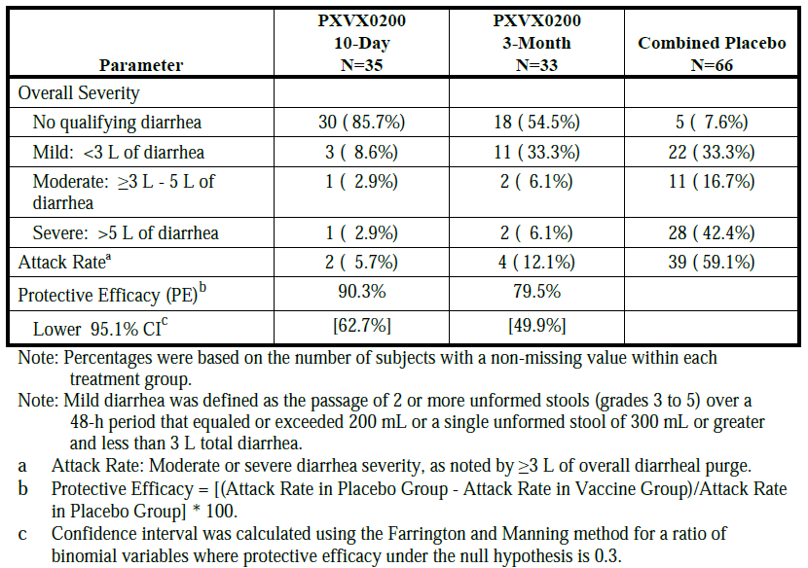

###### Delegate’s comments

The FDA had significant input into the design of this human challenge study in developing a closely monitored human infection model involving the ingestion of virulent *V. cholerae* O1 El Tor Inaba strain N16961, 10 days or 3 months after vaccination.12 It was concluded that the study provided evidence that in immunologically naive adults, ‘serum vibriocidal antibody seroconversion is a reliable correlate of protection and may constitute a surrogate for an as yet uncharacterised mechanistic intestinal protective response’.12 Serum vibriocidal antibody seroconversion was later used as an immunologic bridge for trials in more vulnerable populations in which cholera challenge studies are not feasible.

##### Study PXVX-VC-200-004

The publication for this study is McCarty et al (2018).[16]

###### Design

Phase III randomised, double-blind, placebo-controlled trial of single dose of oral vaccine (1 × 109 CFU/dose) in healthy adults.

###### Primary immunogenicity objective

Demonstrate immunologic equivalence of 3 different production lots of PXVX0200.

* Primary endpoint: serum vibriocidal antibody measured at Day 11 (Immunogenicity Evaluable Population).
* Equivalence criteria: geometric mean titre (GMT) of each lot must be within ±50% of each other lot with 95% confidence. Specifically, the 95% CI around each pairwise ratio of GMTs must be within 0.67 and 1.5.

###### Study treatments

A target concentration of 1 × 109 CFU was selected to correspond to the upper end of the concentration range of 2× 108 to 1 × 109 CFU/dose that was used in the previously marketed Orochol vaccine.

###### Results

Participant flow

The 3146 subjects were randomised to one of three PXVX0200 lots (2795) or placebo (351). Overall, 92.7% of vaccine recipients and 94.3% of placebo recipients completed the study. The most frequent reason for early termination was subjects being lost to follow-up (6.0% for vaccine recipients and 4.6% for placebo recipients), followed by withdrawal by subject (0.9% for both vaccine and placebo recipients); 2 subjects discontinued early due to AEs.

Primary objective

The primary objective was met with geometric mean ratio of vibriocidal titres equal to 0.92 (95% CI: 0.78, 1.08), 1.02 (95% CI: 0.87, 1.20), and 0.94 (95%CI: 0.80, 1.10) for the comparison of Lots A:B, B:C, and A:C, respectively. The Day 11 GMTs of serum vibriocidal antibodies homologous classical Inaba were 9220, 10034, and 9827 for Lots A, B, and C, respectively.

Reactogenicity signs and symptoms after vaccine administration were reported by 51.90% (95% CI: 50.01%, 53.79%) of vaccine recipients and 43.15% (95% CI: 37.84%, 48.58%) of placebo recipients (p=0.0024). Reactogenicity signs and symptoms of at least moderate severity were reported by 23.81% (95% CI 22.23%, 25.45%) of vaccine recipients and 18.37% (95% CI 14.41%, 22.88%) of placebo recipients (p=0.0250). The 3 individual lots of vaccine did not show meaningful differences in reactogenicity.

###### Delegate’s comments

The evaluator concluded that this was the largest of the studies included in this application, conducted in healthy young adults. Aside from demonstrating lot-to-lot consistency, the vaccine was shown to be well tolerated and immunogenic, hence providing a large proportion of the safety database for Vaxchora.

##### Study PXVX-VC-200-005

The publication for this study is McCarty et al (2019).[17]

###### Design

Phase III randomised, double-blind, placebo-controlled trial of single dose of oral vaccine (1 × 109 CFU/dose) in healthy older adults.

The study aimed to compare the immunogenicity established in study PXVX-VC-200-004 (lot consistency) in younger adults, and demonstrate the immune responses were non-inferior in older adults.

###### Primary bridging objectives

* Demonstrate that seroconversion by classical Inaba vibriocidal antibody at Day 11 in older adults aged 46 to 64 years was non‑inferior to seroconversion at Day 11 in younger adults aged 18 to 45 years following vaccination with PXVX0200.
  + Non-inferiority margin: the lower bound of the 2-sided 95% CI on the difference in seroconversion between older and younger adults must be greater than -10 percentage points.
* Demonstrate that the lower bound of the 2-sided 95% CI on seroconversion by classical Inaba vibriocidal antibody at Day 11 is greater than 70% in older adults aged 46 to 64 years following vaccination with PXVX0200.

###### Study treatment

A target concentration of 1 × 109 CFU was selected to correspond to the upper end of the concentration range of 2 × 108 to 1 × 109 CFU/dose that was used in the previously marketed Orochol vaccine. This vaccine lot was one of the 3 used in the lot consistency trial (PXVX-VC-002-004).

###### Results

*Participant flow*

Subjects were randomised to vaccine (299) or placebo (99). For randomised subjects, the percentage with study visit completion at Days 1, 11, 29, and 91 was between 98.0% and 100% at all time points for both vaccine and placebo groups. The study completion rate for vaccine recipients was 97.7% and for placebo recipients was 96.0%.

Primary objectives

Both primary objectives were met. By Day 11 following vaccination, 90.4% (95% CI: 86.4%, 93.5%) of older subjects and 93.5% (95% CI: 92.5%, 94.4%) of younger subjects had seroconverted by classical Inaba vibriocidal antibody. The lower bound of the 2-sided 95% CI on the difference in seroconversion rate between older and younger adults was −6.7%, and the lower bound of the 2-sided 95% CI on seroconversion by classical Inaba vibriocidal antibody in older subjects was 86.4%. Similar results were derived from a sensitivity analysis that used logistic regression to estimate the difference between older and younger adults adjusting for the effects of sex, blood type, and baseline titre.

Table 4: Study PXVX-VC-200-005 Primary Bridging Analysis: Vibriocidal antibody seroconversion against Classical Inaba *V. cholera* at Day 11 (Bridging analysis population)

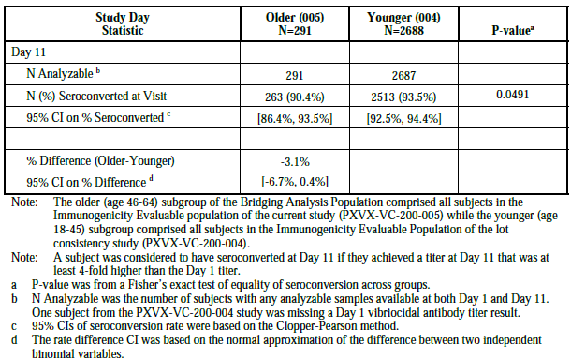

###### Delegate’s comments

This was an immunologic bridging study with serum vibriocidal antibody seroconversion as a surrogate marker of protection. The Delegate notes that the age range of included adults in this study was 46 to 64 years and defined as ‘older adults’, acknowledging the immunosenescence associated with ageing,16 however adults aged 65 years and older were not included.

The clinical evaluation noted the significantly lower geometric means in the older compared to the younger populations.

Table 5: Study PXVX-VC-200-005 Additional Bridging Analysis: Cumulative Vibriocidal Antibody Seroconversion against Classical Inaba V. cholerae (Bridging Analysis Population)

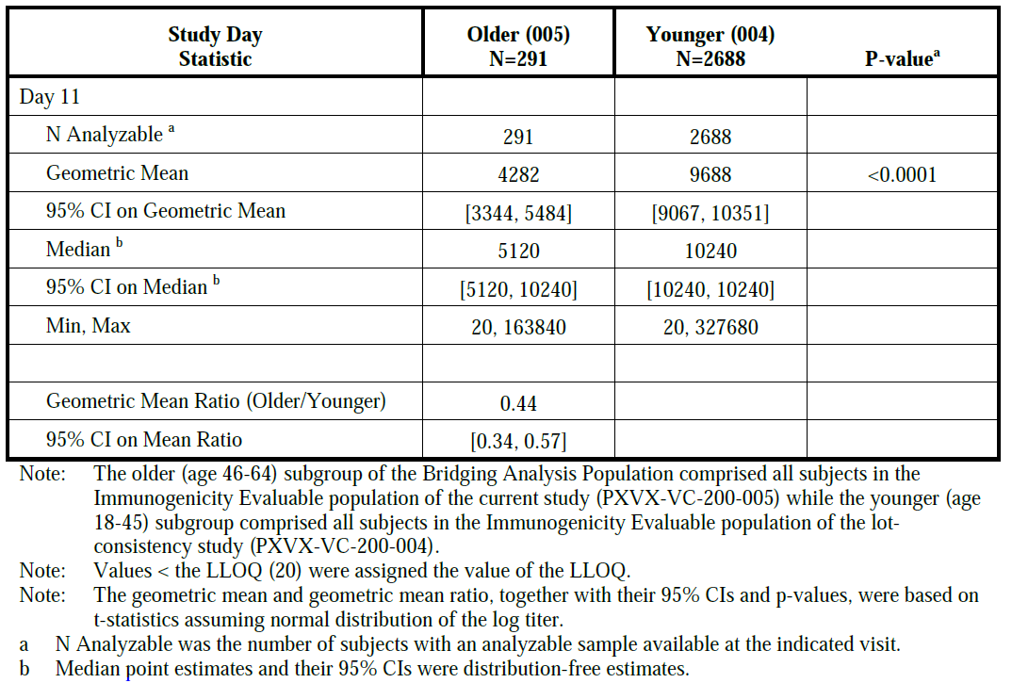

##### Study PXVX-VC-200-006

The publications for this study are McCarty et al (2020), McCarty et al (2020a) and McCarty et al (2021).[18]

###### Design

Phase IV randomised, double-blind, placebo-controlled trial of single dose of oral vaccine (1 × 109 CFU/dose) in healthy children; objectives to demonstrate safety and immunogenicity.

###### Primary objectives

* Demonstrate that the seroconversion rate at Day 11 in paediatric subjects is noninferior to the seroconversion rate at Day 11 in adults between the ages of 18 and 45 years.
* Demonstrate that the seroconversion rate in paediatric subjects is at least 70% with 98.3% confidence.

###### Secondary objectives

* Safety: to evaluate the safety and tolerability of Vaxchora, as well as to evaluate the palatability of Vaxchora, and the acceptability of Vaxchora.
* Immunogenicity: to evaluate the immunogenicity of Vaxchora in each cohort.

###### Study treatments

Lot P700.610-7000005 was used for dosing in the Vaxchora group from July to November 2017. Lot P700.610-7000008 was used afterwards for the duration of the study. Over that time period, the potency range was approximately 8.9 × 108 CFU to 7.7 × 108 CFU. By comparison, the Vaxchora product used in the 004 (lot consistency) adult study maintained a potency range of approximately 1.4 × 109 CFU to 9.0 × 108 CFU. Similar to the earlier studies, the vaccine was reconstituted in 100 mL of bicarbonate buffer solution prior to oral administration, except for the youngest cohort, where 50 mL of the buffer solution was discarded prior to adding the vaccine. The placebo was 100 mL of physiological saline (sourced by the sites) administered orally for subjects aged 6 up to 18 years and 50 mL for subjects aged 2 up to 6 years.

Table 6: Study PXVX-VC-200-006 Study treatments by cohort and treatment group

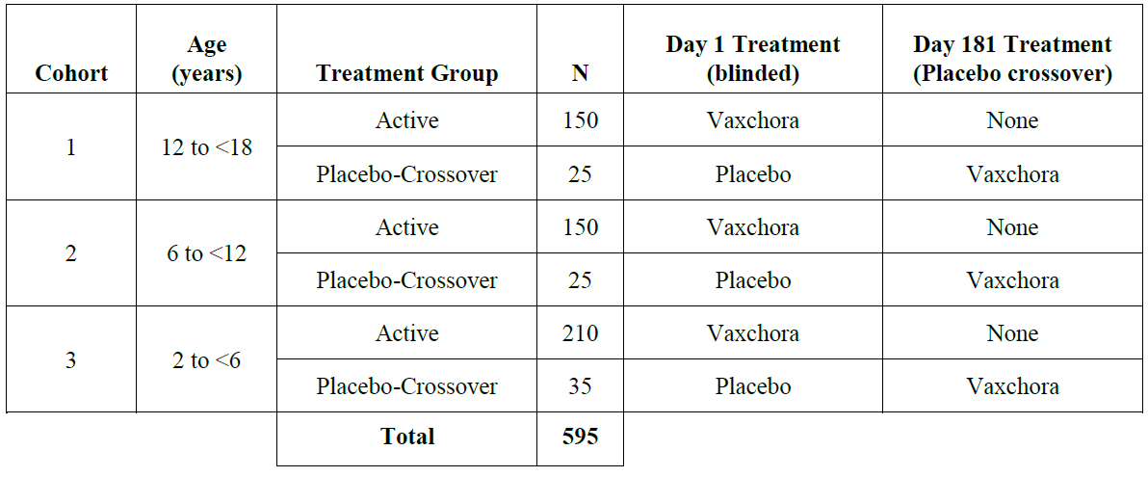

###### Results

The Day 11 seroconversion rates of subjects in the immunogenicity evaluable population dataset who received Vaxchora were compared to those of the PXVX-VC-200-004 adult Bridging Population (i.e. adult Bridging Population), as shown in Table 7.

Both co-primary objectives were met for Cohort 1, Cohort 2 and Cohort 3.

In a post-study analysis, subjects who consumed less than 50% of the dose experienced a lower rate of seroconversion (69.2%) than those who drank at least 50% of the expected dose. Of note, all subjects who drank at least half the dose seroconverted.

Table 7: Study PXVX-VC-200-006 Comparison of seroconversion rates at Day 11 visit by age group compared to the adult bridging population

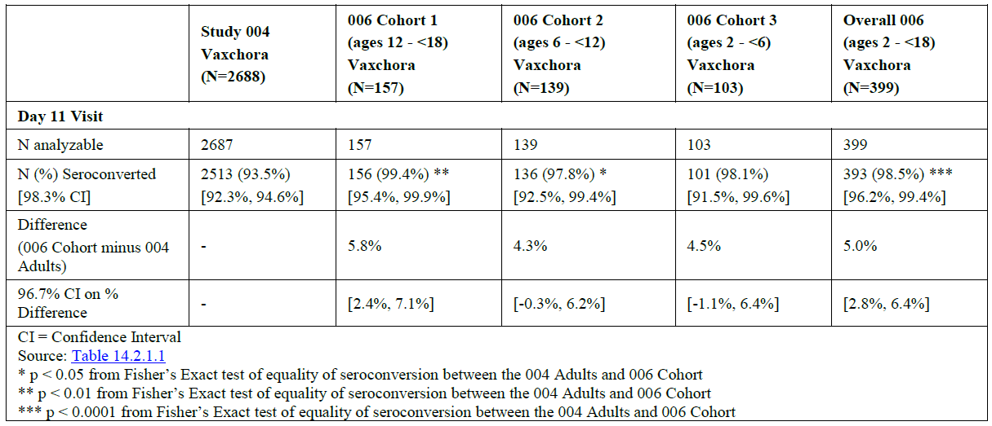

###### Delegate’s comments

The clinical evaluation concluded that administration of a single reconstituted oral dose of Vaxchora led to vibriocidal antibody seroconversion in 99.4%, 97.8% and 98.1% of Vaxchora recipients in Cohorts 1, 2, and 3 respectively, by Day 11. Based on the primary immunogenicity objectives to show noninferiority of seroconversion in children aged 2 to 17 years compared to adults aged 18 to 45 years at Day 11 and to have at least 70% seroconversion, both of the primary endpoints were achieved. The seroconversion rates observed were non-inferior to those of adults and were greater than 70% with 98.3% confidence.

For the Cohort 1 sub-study population, 64.5% of subjects maintained seroconversion for 2 years following vaccination. Safety data demonstrate that one oral dose of Vaxchora was well tolerated. It is likely that palatability impacted the acceptability of Vaxchora, with 21% of the children in the youngest cohort unable to consume at least 80% (40 mL) of the dose, and although seroconversion rates were very high, they were lower in those consuming less than 50% of the dose.

The clinical evaluation also noted that one of the unintended consequences of an efficacious vaccine is that the usual precautions to avoid exposure to diarrhoea-causing pathogens might be lessened, in the false belief that the protection the vaccine provided is ‘absolute’.

###### European Medicines Agency assessment report (paediatric variation)

The European Medicines Agency (EMA) assessment report (paediatric variation)[19] included an update to include long-term immunogenicity data supporting Vaxchora effectiveness at generating a protective immune response that persists for 2 years following vaccination (adolescent substudy) and an extension of indication to the 2 year age group.

The following issues are highlighted:

The safety profile of Vaxchora in children 2-<6 years appears to be similar to the safety profile in older children (6-< 18 years). Solicited AEs were reported by a higher proportion of subjects in Cohort 1 (Vaxchora 68.5%; Placebo 66.7%) than in Cohort 2 (Vaxchora 54.8%; Placebo 52.0%) and Cohort 3 (Vaxchora 40.4%; Placebo 34.6%) … The most frequently reported solicited AEs in Vaxchora-recipients (Cohort 3) were tiredness (Vaxchora 30.8%, placebo 23.1%), lack of appetite (Vaxchora 19.2%, placebo 11.5%) and abdominal pain (Vaxchora 17.1%, placebo 15.4%)

There is an increased risk of medication errors when the vaccine is prepared and administered to the youngest children (2 -< 6 years). Preparation requires that half of the buffer solution is discarded before the active substance is added. Spilling or inaccuracies in this context may impact the potency of the vaccine-solution. It may also be a challenge to get the child to consume sufficient of the dose to achieve protection.

#### Safety

##### TGA clinical evaluation report

In the integrated safety analysis, a total of 3797 subjects were included in the Safety Population, 3235 in the vaccine group and 562 in the placebo group. Overall, 93.7% of vaccine recipients and 95.0% of placebo recipients completed the study. Table 8 shows the most common AEs irrespective of relatedness to treatment.

The TGA clinical evaluation highlighted that it was not possible to assess whether dose concentration had an effect on reactogenicity or AEs since only 150 subjects received vaccine (in the Phase I and challenge trials) with a concentration of less than 5 × 108 CFU compared to 3075 subjects vaccinated (in the lot consistency and older adult trials) with a concentration of 1 × 109 CFU. Also, since the different concentrations were used in different trials, it is not possible to isolate the effect of concentration from other factors that differed between trials and study populations.

Table 8: Summary of most common adverse events (safety population)

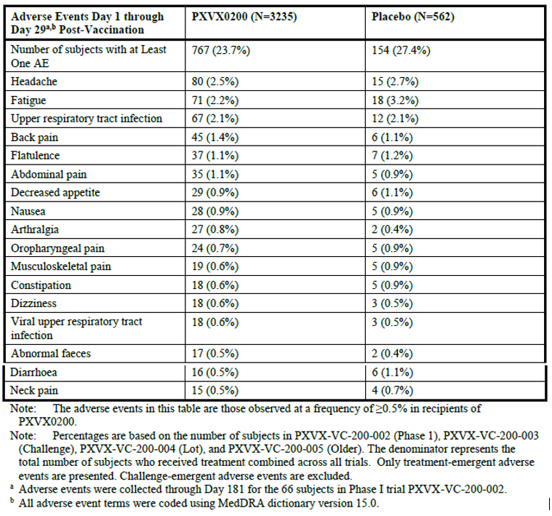

##### Health Canada clinical evaluation

Health Canada’s clinical evaluation report highlighted the following.

The safety profile of PXVX0200 was favourable and only significantly different from placebo in one respect: the incidence of diarrhea recorded as solicited reactogenicity was 3.62% (115/3177) in adult vaccine recipients compared to 1.63% (9/553) in placebo recipients (p=0.0140). For the paediatric study the incidence of diarrhea was 1.5% (7/468) in vaccine recipients compared to 1.3% (1/75) in placebo recipients. This vaccine-associated diarrhea is typically mild and resolves spontaneously within 2 days in the majority of cases (ISS Table 20.1.2.8). There were no serious adverse events judged to be related to the administration of vaccine.

Faecal shedding of vaccine organisms by vaccine recipients and potential transmission to household contacts was examined in the Phase 1 trial (ISS Section 7.2). Shedding of vaccine occurred in a total of 11.1 % (95% CI: 4.2, 22.6) of vaccine recipients. Shedding increased in frequency over the week following vaccination, reaching a peak at Day 7 when it was detected in 7.3% (95% CI: 2.0, 17.6) of vaccine recipients. There was no microbiological or serological evidence of transmission of PXVX0200 from vaccine recipients to household contacts.

Reactogenicity was characterized by prospectively defining a set of solicited signs and symptoms that were considered to be at least possibly related to vaccine or placebo and occurring on the day of vaccination or during the 7-day period following vaccination (Days 1-8). Reactogenicity signs and symptoms after vaccine administration were reported by 50.08% of vaccine and 45.75% of placebo recipients (p=0.0652; ISS Table 20.1.2.1).[20]

##### Delegate’s comments

The Delegate concurs with the TGA clinical evaluator in the overall assessment of safety for Vaxchora:

The portfolio of trials in this Type 1 Application have demonstrated that single dose oral PXVX0200 for active immunisation against cholera, is safe and effective across the age spectrum tested i.e. healthy non-immunocompromised 2 year to 64 year olds. All trials were carried out in cholera non-endemic countries (predominantly the USA), and this vaccine is for those living in non-endemic countries planning to visit countries where there is a risk of *V. cholerae* acquisition which could lead to cholera disease. Just under 4000 subjects have received PXVX0200 (VAXCHORA) in clinical trials since the developmental birth date of 15 March 2012, but post-marketing use indicates far higher numbers, with just under 70,000 doses used according to the most recent PBRER [periodic benefit-risk evaluation report], and without any emergent AEs that would merit a change to the existing label.

The poor palatability for the younger children is a potential issue and there is a paucity of data in people who are immunocompromised, acknowledging some information in adults living with HIV from a small study conducted in Mali (38 HIV-seropositive adults, 387 HIV-seronegative adults).[21]

### Risk management plan

The summary of safety concerns and their associated risk monitoring and mitigation strategies are presented in Table 9. The TGA may request an updated risk management plan (RMP) at any stage of a product's life-cycle, during both the pre-approval and post-approval phases.

Table 9: Summary of safety concerns

|  |  |  |  |  |  |
| --- | --- | --- | --- | --- | --- |
| Summary of safety concerns | | Pharmacovigilance | | Risk minimisation | |
| **Routine** | **Additional** | **Routine** | **Additional** |
| **Important identified risks** | None |  |  |  |  |
| **Important potential risks** | Medication errors | ✓ | _ | ✓ | _ |
| **Missing information** | Use during pregnancy | ✓ | _ | ✓ | _ |

The RMP evaluation recommended conditions of registration relating to the versions of the risk management plan, requirement for periodic safety update reports, and inclusion of the medicine in the Black Triangle Scheme.

### Risk-benefit analysis

#### Delegate’s considerations

This submission was an Access Workshare application with Health Canada. The TGA completed the Clinical evaluation and Health Canada completed the Quality evaluation. The TGA Quality evaluator provided a detailed summary for the Delegate and the ACV which included quality conditions relevant to use of this vaccine in Australia.

Both agencies worked collaboratively and were satisfied with the quality of the respective evaluations. The TGA acknowledges the detailed review of the Product Information (PI) and Consumer Medicine Information (CMI) undertaken by Health Canada, also noting that some PI and CMI content may differ from that relevant to the intended use of this vaccine to Australia.

The submitted data are sufficient to recommend approval. In recommending approval, the Delegate acknowledges the previous history of use of the original marketed formulation of Orochol, in addition to the more recent data for the reformulated vaccine,7 and the positive recommendations of the FDA, the EMA and Health Canada.

While it is acknowledged that Vaxchora is given as a single dose and is potentially more convenient than currently available vaccines which require multiple doses, there are significant limitations to the data. These include absence of efficacy data in people living in cholera endemic areas and lack of protection against *V. cholerae* serogroup O139 or other non-O1 serogroups. The duration of protection with Vaxchora is unknown. The persistence of serum vibriocidal antibody response was assessed in a subset of adolescents 12 to 17 years of age in the Phase IV study where seroconversion was observed in 64.5% of participants 2 years post-vaccination. There is a paucity of data in people who are immunosuppressed.

No comparative study with any currently approved cholera vaccine has been conducted. There are no data available regarding the need for revaccination. Only single dose administration was studied and the strength of an anamnestic response with a subsequent dose after the first priming dose has not been quantified.

#### Proposed action

The submitted data are sufficient to recommend registration of Vaxchora in Australia. Registration is subject to satisfactory implementation of the RMP and Quality conditions of registration, and resolution of the product information.

The wording of the indication for use of Vaxchora in Australia will be finalised following ACV advice.

#### Advisory Committee considerations

The [Advisory Committee on Vaccines (ACV)](https://www.tga.gov.au/about-tga/advisory-bodies-and-committees/advisory-committee-vaccines-acv), having considered the evaluations and the Delegate’s overview, as well as the sponsor’s response to these documents, advised the following.

##### Specific advice to the Delegate

1. ***Please comment on the wording of the indication appropriate to the intended use of this vaccine in Australia, taking into consideration the wording of overseas product information. What is the view of the ACV in relation to a proposed lack of upper age limit, given the submitted data?***

The ACV advised that the indication is appropriate for a vaccine administered in Australia for travellers to cholera-affected countries, including the lower age of 2 years and no maximum age.

The ACV noted that in Europe the approved vaccine is indicated for ‘adults and children aged 2 years and older’ while in the USA there is an upper age limit of 64 years.

The ACV noted that Study PXVX-VC-200-005 demonstrated that seroconversion at Day 11 post vaccination in adults aged 46 to 64 years at 90.4% (95% CI: 86.4%, 93.5%) was non-inferior to adults aged 18 to 45 years at 93.5% (95% CI: 92.5%, 94.4%). As reported by McCarty,17 ‘[t]here appeared to be a continuous age-related decline in [serum vibriocidal antibody] [SVA] seroconversion and geometric mean titers, but not memory B cell responses, across the 18–64 year age range’. The ACV noted that there are very limited data for Dukoral on protective efficacy of the vaccine in subjects aged 65 years and over.

However, the 65 years and over age group can be expected to have a higher risk of severe complications if infected by cholera. Higher cholera case fatality rates have been observed in older adults at ages beginning as early as the forties. In post-market monitoring, few adverse events following Vaxchora have been reported in people over 65 years of age; all 9 cases were assessed as non-serious events following immunisation.

The ACV advised that overall, the benefit risk profile was positive for people aged over 2 years.

1. ***Please comment on the dosing and administration section, in light of the submitted data and intended use of Vaxchora in Australia.***

The ACV noted that the choice of single dose schedule did not appear to arise from a systematic investigation of various vaccine schedules, although dose finding studies were conducted previously, which informed doses used in the trials presented in the dossier.

Nonetheless, immunisation with 2 doses has not been shown to increase seroconversion rates.

The duration of protection provided by Vaxchora is unknown and no studies have been carried out to determine when a booster immunisation may be needed. Data on this issue are likely to arise from vaccine effectiveness studies in endemic or outbreak settings, as well as longer term immunogenicity data.

The ACV noted that the completion of a vaccination schedule by a single dose vaccine is an advantage for travellers.

1. ***The committee is requested to provide advice on the content of the final PI and CMI approved by Health Canada and the Delegate’s proposed amendments for Australia.***

The ACV suggested improvements to the Product Information to be clearer and accurate in the areas of missing information (for example, use during pregnancy; immunocompromise) and contraindications (for example, concomitant use of immunosuppressive drugs). For example, ‘immunisation with Vaxchora vaccine may not provide 100% protection’ should be corrected to ‘immunisation with Vaxchora will not provide 100% protection’, noting that Vaxchora does not protect against *V. cholerae* serogroup O139 or other non-O1 serogroups.

The ACV supported use of positive advice (for example, ‘Safe water sources and hygienic food preparation is the recommended protection against cholera’ or similar) rather than that the vaccine is secondary to ‘standard preventive hygiene measures’. The ACV indicated that this may be a useful approach for other vaccines used exclusively for international travellers.

The ACV commented that addition of carbonated water to the effervescent buffer may result in excess frothing, causing the reconstituted product to overflow out of the container.

1. ***Please comment on the use of this vaccine in young children, given the potential for medication errors and under-dosing, due to palatability issues.***

The ACV noted that in Study PXVX-VC-200-006 about 21% of children in the youngest cohort (2 to less than 6 years of age) were unable to consume at least 80% (40 mL) of the vaccine dose. Although seroconversion rates were very high overall, seroconversion was lower in children consuming less than 50% of the dose.

The ACV noted the 3 measures in the PI to improve the acceptance of the oral vaccine by young children: reducing the volume to be administered (by discarding 50 mL of buffer prior to adding the active ingredient), adding sweetener (sugar or stevia), and allowing a longer period to finish the dose if sweetened (30 minutes instead of 15 minutes). It may be more useful for the Product Information and Consumer Medicine Information to consolidate information on preparation of the suspension for children.

1. ***Other advice***

It would be useful to generate data on the timing of administration of Vaxchora and other vaccines (especially oral typhoid vaccines) and medicines (especially antimalarials) taken by travellers.

##### ACV conclusion

The ACV considered this product to have an overall positive benefit-risk profile for the indication:

*Vaxchora vaccine is indicated for active immunisation against disease caused by Vibrio cholerae serogroup O1 in adults and children aged 2 years and older travelling to cholera affected countries.*

*Vaxchora vaccine should be used in accordance with official recommendations.*

*The vaccine should not replace standard preventive hygiene measures.*

## Outcome

Based on a review of quality, safety, and efficacy, the TGA approved the registration of Vaxchora (*Vibrio cholerae* bacteria cells (CVD 103-HgR strain)) 4 × 108 to 2 × 109 CFU powder for suspension in sachets, indicated for:

*VAXCHORA vaccine is indicated for active immunisation against disease caused by Vibrio cholerae serogroup O1 in adults and children aged 2 years and older travelling to cholera-affected countries.*

*VAXCHORA vaccine should be used in accordance with official recommendations.*

*The vaccine should not replace standard preventive hygiene measures.*

### Specific conditions of registration applying to these goods

* Vaxchora (*Vibrio cholerae*) is to be included in the Black Triangle Scheme. The PI and CMI for Vaxchora must include the black triangle symbol and mandatory accompanying text for 5 years, which starts from the date that the sponsor notifies the TGA of supply of the product.
* The Vaxchora EU Risk Management Plan (version 3.1 dated 14 April 2022, data lock point 10 December 2021), with Australia‑specific annex (version 1.1, dated10 January 2023), included with submission PM-2021-04064-1-2, and any subsequent revisions, as agreed with the TGA will be implemented in Australia.

An obligatory component of risk management plans is routine pharmacovigilance. Routine pharmacovigilance includes the submission of periodic safety update reports (PSURs).

Reports are to be provided in line with the current published list of EU reference dates and frequency of submission of PSURs until the period covered by such reports is not less than 3 years from the date of the approval letter.

The reports are to at least meet the requirements for PSURs as described in the European Medicines Agency’s Guideline on good pharmacovigilance practices (GVP) Module VII-periodic safety update report (Rev 1), Part VII.B Structures and processes. Note that submission of a PSUR does not constitute an application to vary the registration. Each report must have been prepared within 90 calendar days of the data lock point for that report.

* **Batch Release Testing and Compliance**

It is a condition of registration that all independent batches of Vaxchora vaccine imported into Australia are not released for sale until samples and the manufacturer’s release data have been assessed and the sponsor has received notification acknowledging release from the Laboratories Branch, TGA. For each independent batch of the product imported into Australia, the sponsor must supply the following:

* + A completed Request for Release Form. The template is available from <vaccines@health.gov.au>.
  + Complete summary protocols for manufacture and QC [quality control], including all steps in production in the agreed format.
  + At least 5 samples of each manufacturing batch of Vaxchora with the Australian approved labels, PI and packaging representative of all batches of product seeking distribution in Australia.
  + At least one sample of any further consignments of a manufacturing batch of Vaxchora vaccine with the Australian approved labels, PI and packaging. Further consignments cover batches previously supplied to TGA for the purposes of batch release testing but are seeking to be supplied again.
  + If the manufacturing batch has been released in Europe or United Kingdom (UK) a copy of the EU Official Control Authority Batch Release certificate (or equivalent from the UK) must be provided.
  + Any reagents, reference material and standards required to undertake testing, as requested by Laboratories Branch, TGA.

Sponsors must provide all requested samples and data in sufficient time (at least 5 business days) prior to any distribution date to allow the TGA to perform testing and review. Distribution of each batch of vaccine is conditional upon fulfilment of these conditions and receipt of a letter from the Laboratories Branch acknowledging release.

Samples and data should be forwarded to the Biotherapeutics Section, Laboratories Branch before release of each batch and with sufficient lead time to allow for Laboratories Branch testing. The address for courier delivery is:

* + **ATTN:** Batch Release Coordinator
  + Biotherapeutics Section
  + TGA Laboratories Branch
  + 1 Tindal Lane
  + Canberra Airport ACT 2609

The shipments (including reagents) to the TGA are the responsibility of the Australian sponsor/agent who will be required to facilitate the import and customs clearance process.

* **Certified Product Details**

An electronic copy of the Certified Product Details (CPD) as described in Guidance 7: Certified Product Details of the Australian Regulatory Guidelines for Prescription Medicines (ARGPM) <https://www.tga.gov.au/resources/guidance/submitting-certified-product-details-cpd-prescription-medicines> should be provided upon registration of the therapeutic good. In addition, an updated CPD, for the above products incorporating the approved changes is to be provided within one month of the date of approval letter. A template for preparation of CPD for biological prescription medicines and Vaccines can be obtained from the TGA website https://www.tga.gov.au/resources/resource/forms/certified-product-details-cpd-biological-prescription-medicines. The CPD should be sent as a single bookmarked PDF document to [Vaccines@health.gov.au](mailto:Vaccines@health.gov.au) as soon as possible after registration/approval of the product or any subsequent changes as indicated above.

## Attachment 1. Product Information

The PI for Vaxchora approved with the submission described in this AusPAR is at Attachment 1. For the most recent PI, please refer to the TGA [PI/CMI search facility.](https://www.tga.gov.au/picmi-search-facility)

|  |
| --- |
| Therapeutic Goods Administration |
| PO Box 100 Woden ACT 2606 Australia  Email: [info@tga.gov.au](mailto:info@tga.gov.au) Phone: 1800 020 653 Fax: 02 6203 1605  [**https://www.tga.gov.au**](https://www.tga.gov.au) |
| Reference/Publication # |

1. This is the original indication proposed by the sponsor when the TGA commenced the evaluation of this submission. It may differ to the final indication approved by the TGA and registered on the Australian Register of Therapeutic Goods.
2. Harris JB, LaRocque RC, Qadri F, Ryan ET, Calderwood SB. Cholera. *Lancet,* 2012 Jun 30;379(9835):2466-2476. doi: 10.1016/S0140-6736(12)60436-X.
3. Columbara DV, Cowgill KD, Faruque ASG. Risk Factors for Severe Cholera among Children under Five in Rural and Urban Bangladesh, 2000–2008: A Hospital-Based Surveillance Study. *PLoS ONE*, 2013; 8(1):e54395. doi: 10.1371/journal.pone.0054395.
4. [Cholera | The Australian Immunisation Handbook (health.gov.au)](https://immunisationhandbook.health.gov.au/contents/vaccine-preventable-diseases/cholera).
5. NNDSS Annual Report Working Group. Australia's notifiable disease status, 2016: Annual report of the National Notifiable Diseases Surveillance System. *Commun Dis Intell (2018).* 2021 May 27;45. doi: 10.33321/cdi.2021.45.28.
6. Product information for Dukoral, available from the TGA website.
7. McCarty J, Bedell L, De Lame P-A, Cassie D, Lock M, Bennett S, et al. Update on CVD 103-HgR single-dose, live oral cholera vaccine. *Expert Review of Vaccines.* 2022; 21(1): 9-23. doi: 10.1080/14760584.2022.2003709.
8. In this report the ‘Delegate’ is the Delegate of the Secretary of the Department of Health and Aged Care who decided the submission under section 25 of the Act.
9. Iyer AS, Harris JB. Correlate of Protection for Cholera. *The Journal of Infectious Diseases.* 2021; 224(Supp 7): S732–S737. doi: 10.1093/infdis/jiab497.
10. US FDA CBER Vaccines And Related Biological Products Advisory Committee, Meeting of 27 May 1998.
11. Chen WH, Greenberg RN, Pasetti MF, Livio S, Lock M, Gurwith M, et al. Safety and immunogenicity of single-dose live oral cholera vaccine strain CVD 103-HgR, prepared from new master and working cell banks. *Clin Vaccine Immunol*. 2014 Jan;21(1):66-73. doi: 10.1128/CVI.00601-13.
12. Chen WH, Cohen MB, Kirkpatrick BD, Brady RC, Galloway D, Gurwith M, et al. Single-dose Live Oral Cholera Vaccine CVD 103-HgR Protects Against Human Experimental Infection With Vibrio cholerae O1 El Tor. *Clin Infect Dis*. 2016 Jun 1; 62(11):1329-1335. doi: 10.1093/cid/ciw145.
13. Haney DJ, Lock MD, Simon JK, Harris J, Gurwith M. Antibody-Based Correlates of Protection Against Cholera Analysis of a Challenge Study in a Cholera-Naïve Population. *Clin Vaccine Immunol*. 2017 May 31;24(8):e00098-17. doi: 10.1128/CVI.00098-17.
14. Haney DJ, Lock MD, Gurwith M, Simon JK, Ishioka G, Cohen MB, et al. Lipopolysaccharide-specific memory B cell responses to an attenuated live cholera vaccine are associated with protection against *Vibrio cholerae* infection*. Vaccine*. 2018 May 11;36(20):2768-2773. doi: 10.1016/j.vaccine.2018.04.011.
15. Blood group O individuals are at higher risk for severe cholera; see Chen et al (2016).
16. McCarty JM, Lock MD, Hunt KM, Simon JK, Gurwith M. Safety and immunogenicity of single-dose live oral cholera vaccine strain CVD 103-HgR in healthy adults age 18-45. *Vaccine.* 2018 Feb 1; 36(6): 833-840. doi: 10.1016/j.vaccine.2017.12.062.
17. McCarty JM, Lock MD, Bennett S, Hunt KM, Simon JK, Gurwith M. Age-related immunogenicity and reactogenicity of live oral cholera vaccine CVD 103-HgR in a randomized, controlled clinical trial. *Vaccine.* 2019 Mar 7;37(11):1389-1397. doi: 10.1016/j.vaccine.2019.01.077.
18. McCarty JM, Gierman EC, Bedell L, Lock MD, Bennett S. Safety and Immunogenicity of Live Oral Cholera Vaccine CVD 103-HgR in Children and Adolescents Aged 6-17 Years. *Am J Trop Med Hyg.* 2020 Jan;102(1):48-57. doi: 10.4269/ajtmh.19-0241.

    McCarty JM, Cassie D, Bedell L, Lock MD, Bennett S. Safety and Immunogenicity of Live Oral Cholera Vaccine CVD 103-HgR in Children Aged 2-5 Years in the United States. *Am J Trop Med Hyg*. 2020 Dec 14;104(3):861-865. doi: 10.4269/ajtmh.20-0917.

    McCarty JM, Cassie D, Bedell L, Lock MD, Bennett S. Long-Term Immunogenicity of Live Oral Cholera Vaccine CVD 103-HgR in Adolescents Aged 12-17 Years in the United States*. Am J Trop Med Hyg*. 2021 Apr 5;104(5):1758-1760. doi: 10.4269/ajtmh.20-1576.
19. Committee for Medicinal Products for Human Use (CHMP) Assessment report EMA/CHMP/444278/2020, dated 28 January 2021, available at [Vaxchora, INN-cholera vaccine (recombinant, live, oral) (europa.eu)](https://www.ema.europa.eu/en/documents/variation-report/vaxchora-h-c-003876-ii-0003-g-epar-assessment-report-variation_en.pdf)
20. Study document 2.5 - Clinical Overview, available at [Available information for VAXCHORA - Submission control number 264995 - Canada.ca](https://clinical-information.canada.ca/ci-rc/item/264995) (Government of Canada)
21. Perry RT, Plowe CV, Koumaré B, Bougoudogo F, Kotloff KL, Losonsky GA, et al. A single dose of live oral cholera vaccine CVD 103-HgR is safe and immunogenic in HIV-infected and HIV-noninfected adults in Mali. *Bull World Health Organ*. 1998;76(1):63-71.