This method describes the analysis of samples derived from Cannabis species, specifically the assay of the primary compounds of regulatory interest [Tetrahydrocannabinolic Acid (THCA), Tetrahydrocannabinol (THC), Cannabidiolic Acid (CBDA) and Cannabidiol (CBD)] by UPLC coupled with UV or PDA.
Note: This method is adapted from the Cannabis Flos Monograph, produced by the Netherlands Cannabis Bureau.
Test: | Assay of Cannabinoids by UPLC
Column: | Waters Acquity BEH C18, 1.7µm, 2.1 x 150mm, with an Acquity VanGuard BEH C18, 1.7 µm, 2.1 x 5mm guard column
Mobile phase: | A: 0.1% formic acid in water (0.055 µScm-1), prepared daily  B: 0.1% formic acid in acetonitrile
Gradient table: | Time (min) | A (%) | B (%)
Gradient table: | 0.0 | 30 | 70
Gradient table: | 6.0 | 30 | 70
Gradient table: | 10.5 | 0 | 100
Gradient table: | 10.7 | 0 | 100
Gradient table: | 1.0 | 30 | 70
Gradient table: | 14 | 30 | 70
Wash solvents: | 80% acetonitrile (needle wash and purge solvent)  10% acetonitrile (seal wash)
Flow rate: | 0.4 mL/min
Injection volume: | 1 µL
Column Temp: | 30°C
Sample Temp: | 8°C
Detection: | UV at 228 nm, PDA range 190-400nm with monitoring at 228 nm.  Mass Detection may be used if further verification of peak identity is required.
Sample diluent: | 30:70 Mobile phase A:Mobile Phase B

Resolution Solution
Prepare a solution containing 0.04mg/mL delta-9-THC and 0.005mg/mL delta-8-THC in Diluent. The resolution between the peaks attributed to these compounds in the chromatogram obtained from analysis of this solution must be not less than 1.2.

Standard Preparation (in duplicate)
Prepare the standards in sample diluent for plant material samples.
Prepare the standards in 2-propanol (IPA) for cannabis oil finished product samples.
Weigh accurately an amount of cannabidiol (CBD) and accurately dilute to a volume in the appropriate diluent to achieve a final concentration of 100 µg/mL CBD (this target concentration may need to be adjusted depending on your validated linear range).

Sample Preparation

Plant material:
Perform a loss on drying test on the sample as follows:
Samples should be dried to anhydrous at 40 °C, under vacuum of 1.5 - 2.5kPa (15 -25 mbar), over phosphorus pentoxide. Typically constant weight is achieved within 24 hours. Refer to BP Appendix IX D.
The anhydrous plant material can be homogenised by milling or chopping. Care should be taken to avoid loss of resin through adhesion to surfaces and ensure the sample is not subjected to heat or light.
Immediately following performing the loss on drying, weigh accurately, in triplicate, approximately 1.0 g of anhydrous homogenised sample material into a new plastic 50 mL centrifuge tube. Add a single stainless steel ball (approximately 12 mm diameter), 40mL of ethanol and cap securely. Place on a mechanical shaker at 70% maximum speed for 15 minutes. Centrifuge at 3000rpm for 5 minutes, and transfer the clear upper layer to a 100mL volumetric flask. Repeat this extraction a further two times using 25mL aliquots of ethanol. Make the sample solution to the mark with ethanol.
Filter the solution using a glass fibre / 0.2µm PTFE syringe filter. Dilute the filtrate appropriately with sample diluent to achieve target concentrations within the validated linear range for the target cannabinoids.

Cannabis Oil/ Oral solution:

Density Measurements:
Measure the density of any oral solution and/or cannabis oil sample using a densitometer. Use the density result to calculate the weight equivalent to 1 mL of sample for assay testing.

Cannabis oil capsules:
Prepare a composite of 20 capsules. Measure the average fill weight of the capsules following the procedure in BP Appendix XII C. Use the average fill weight for assay preparation.
Weigh accurately, in triplicate, approximately 1 mL of oral solution/cannabis oil, or the average fill weight for capsules into a 50 mL volumetric flask. Add 40 mL of 2-propanol (IPA) to each volumetric flask and cap securely. Place on a mechanical shaker at 70% maximum speed for 15 minutes. Sonicate for 5 minutes, and make the sample solution to the mark with IPA.
Filter the solution using a glass fibre / 0.2µm PTFE syringe filter. Dilute appropriately with IPA to achieve target concentrations within the validated linear range for the target cannabinoids.

Blank Preparation
Prepare a blank preparation by following the sample preparation steps, omitting the sample.

Calculations:

Plants:
$$\left(\begin{aligned}\% w/w cannabinoid \\ (anhydrous basis)\end{aligned}\right)= \frac{{Area}_{cannabinoid}}{{Area}_{standard}} × \frac{{wt}_{standard}}{{wt}_{sample}} ×DF ×P(\%) ×RRF$$
$$\left(\begin{aligned}\% w/w cannabinoid \\ (as is)\end{aligned}\right)= \left(\begin{aligned}\% w/w cannabinoid \\ (anhydrous basis)\end{aligned}\right) × LOD factor$$
$$\left(\begin{aligned}Total CBD \\ (\% w/w)\end{aligned}\right)=\% w/w CBDA ×0.877+\% w/w CBD$$
$$\left(\begin{aligned}Total THC \\ (\% w/w)\end{aligned}\right)=\% w/w THCA ×0.877+\% w/w THC$$

Cannabis Oil Finished Products:
$$\left(\begin{aligned}amount cannabinoid \\ (mg/mL)\end{aligned}\right)= \frac{{Area}_{cannabinoid}}{{Area}_{standard}} × \frac{{wt}_{standard}}{{wt}_{sample}} ×DF ×P ×RRF ×Den$$
$$\left(\begin{aligned}Total CBD \\ (mg/mL)\end{aligned}\right)=amount CBDA ×0.877+amount CBD$$
$$\left(\begin{aligned}Total THC \\ (mg/mL)\end{aligned}\right)=amount THCA ×0.877+amount THC$$

% Stated content:
$$\left(\begin{aligned}\% stated content \\ (CBD)\end{aligned}\right)=\frac{total CBD amount or \%w/w}{stated content CBD} ×100 \%$$
$$\left(\begin{aligned}\% stated content \\ (THC)\end{aligned}\right)=\frac{total THC amount or \%w/w}{stated content THC} ×100 \%$$
Where:
Area_{Cannabinoid} | is the peak area response of the individual cannabinoid in the sample solution
Area_{Standard} | is the average peak area response of CBD in the standard solution
Wt_{Standard} | is the weight of CBD reference material, in mg
Wt_{Sample} | is the weight of sample, in mg
DF | is the combined standard and sample dilution factor
P(%) | is the ‘as is’ potency in percentage of the CBD reference material
P | is the ‘as is’ potency in fraction form of the CBD reference material
RRF | is the relative response factor of the individual cannabinoid to CBD – Refer to Table 1.
LOD factor | is the loss on drying expressed in fraction form ((100 – loss on drying (%))/100)
Den | is the density measurement in mg/mL
Similar calculations for other cannabinoids can be performed, using the values listed in Table 1.

Table 1: RRTs and RRFs for UPLC
Component | Structure | Relative Retention Time | Relative Response Factor (RRF) | MS mode & parent ion mass
Cannabidivarinic Acid  (CBDVA) | 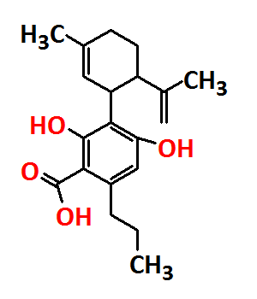 | 0.57 | 0.496 | -ve mode  329.2
Cannabidivarin  (CBDV) | 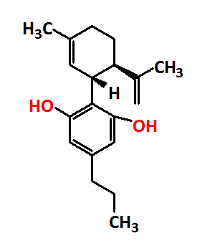 | 0.62 | 0.923 | +ve mode  287.2
Cannabidiolic Acid  (CBDA) | 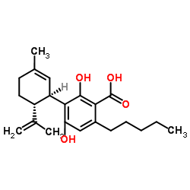 | 0.86 | 0.538 | -ve mode  357.3
Cannabigerolic Acid  (CBGA) | 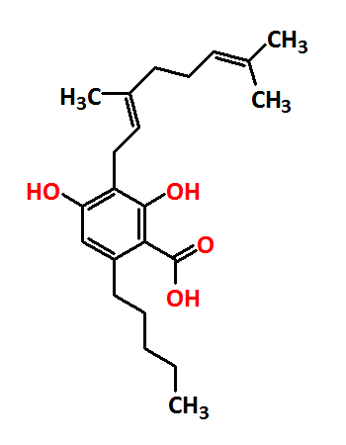 | 0.93 | 0.534 | -ve mode  359.3
Cannabigerol  (CBG) | 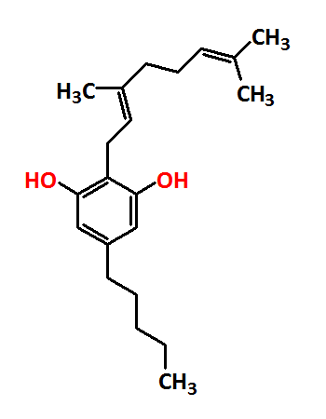 | 0.97 | 1.069 | +ve mode  317.2
Cannabidiol  (CBD) | 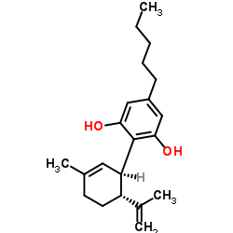 | 1.00 | 1.000 | +ve mode  315.2
Tetrahydrocannabivarin  (THCV) | 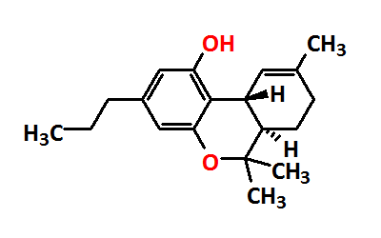 | 1.10 | 1.064 | +ve mode  287.2
Cannabinol  (CBN) | 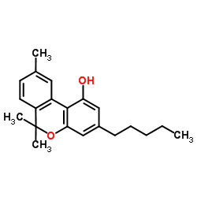 | 1.63 | 0.421 | +ve mode  311.2
Δ⁹-Tetrahydrocannabinol  (THC) | 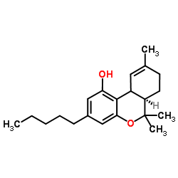 | 2.02 | 1.124 | +ve mode  315.2
Δ⁸-Tetrahydrocannabinol  (Δ⁸-THC) | 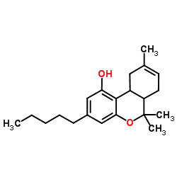 | 2.07 |  | +ve mode  315.2
(+/-) Cannabicyclol  (CBL) | 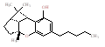 | 2.23 | 1.039 | +ve mode  315.2
Cannabichromeme  (CBC) | 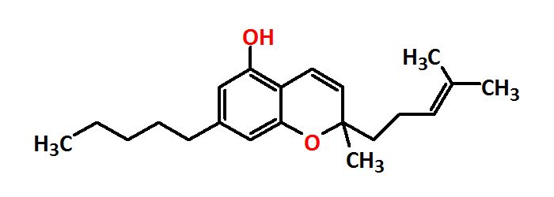 | 2.35 | 0.453 | +ve mode  315.2
Tetrahydrocannabinolic Acid  (THCA) | 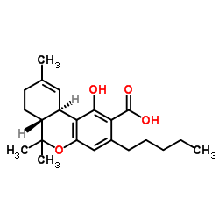 | 2.39 | 0.588 | -ve mode  357.3
This table provides information on the standards currently validated for linearity. If further investigation is required for a peak in the assay both positive and negative ionisation modes should be considered. The intensity of [M+H]+ ions for acid-type cannabinoids in positive ion mode tends to be low as in-source fragmentation can occur. [M-H]- ions have been observed in negative ion mode for the acid-type cannabinoids.

UV Spectra:

Example Chromatogram
Mixed Cannabinoids Standard Solution ~ 70 µg/mL, chromatogram extracted at 228 nm.

