|  |
| --- |
| Australian Public Assessment Report for Paxlovid |
| Active ingredient: Nirmatrelvir and ritonavir |
| Sponsor: Pfizer Australia Pty Ltd |
| November 2024 |

About the Therapeutic Goods Administration (TGA)

* The Therapeutic Goods Administration (TGA) is part of the Australian Government Department of Health and Aged Care and is responsible for regulating therapeutic goods, including medicines, medical devices, and biologicals.
* The TGA administers the *Therapeutic Goods Act 1989* (the Act), applying a risk management approach designed to ensure therapeutic goods supplied in Australia meet acceptable standards of quality, safety, and efficacy.
* The work of the TGA is based on applying scientific and clinical expertise to decision-making, to ensure that the benefits to the Australian public outweigh any risks associated with the use of therapeutic goods.
* The TGA relies on the public, healthcare professionals and industry to report problems with therapeutic goods. The TGA investigates reports received to determine any necessary regulatory action.
* To report a problem with a therapeutic good, please see the information on the [TGA website](https://www.tga.gov.au/).

About AusPARs

* The Australian Public Assessment Report (AusPAR) provides information about the evaluation of a prescription medicine and the considerations that led the TGA to approve or not approve a prescription medicine submission. Further information can be found in [Australian Public Assessment Report (AusPAR) guidance](https://www.tga.gov.au/australian-public-assessment-report-auspar-guidance).
* AusPARs are prepared and published by the TGA.
* AusPARs are static documents that provide information that relates to a submission at a particular point in time. The publication of an AusPAR is an important part of the transparency of the TGA’s decision-making process.
* A new AusPAR may be provided to reflect changes to indications or major variations to a prescription medicine subject to evaluation by the TGA.

Copyright

© Commonwealth of Australia 2024  
This work is copyright. You may reproduce the whole or part of this work in unaltered form for your own personal use or, if you are part of an organisation, for internal use within your organisation, but only if you or your organisation do not use the reproduction for any commercial purpose and retain this copyright notice and all disclaimer notices as part of that reproduction. Apart from rights to use as permitted by the *Copyright Act 1968* or allowed by this copyright notice, all other rights are reserved and you are not allowed to reproduce the whole or any part of this work in any way (electronic or otherwise) without first being given specific written permission from the Commonwealth to do so. Requests and inquiries concerning reproduction and rights are to be sent to the TGA Copyright Officer, Therapeutic Goods Administration, PO Box 100, Woden ACT 2606 or emailed to <[tga.copyright@tga.gov.au](mailto:tga.copyright@tga.gov.au)>.

Contents

List of abbreviations 4

Paxlovid (nirmatrelvir and ritonavir) submission 5

Paxlovid (nirmatrelvir and ritonavir) – proposed indication 6

Coronavirus disease 2019 (COVID-19) 6

Current treatment options for COVID-19 7

Regulatory status 7

Australian regulatory status 7

International regulatory status 7

Registration timeline 8

Evaluation overview 9

Clinical evaluation summary 9

Summary of clinical studies 9

Efficacy 11

Safety 16

Risk Management Plan (RMP) evaluation summary 18

Discussion 19

Efficacy 19

Safety 19

Conclusions 20

Outcome 20

Specific conditions of registration applying to these goods 20

Attachment 1. Product Information 20

## List of abbreviations

|  |  |
| --- | --- |
| Abbreviation | Meaning |
| ACM | Advisory Committee on Medicines |
| ARTG | Australian Register of Therapeutic Goods |
| ASA | Australia‑specific annex |
| CMI | Consumer Medicines Information |
| CSR | Clinical study report |
| mITT | Modified intention to treat |
| PCD | Primary completion date |
| PI | Product Information |
| RMP | Risk management plan |
| SAEs | Serious adverse events |
| SARS-CoV-2 | Severe acute respiratory syndrome coronavirus 2 |
| TEAEs | Treatment-emergent adverse events |
| TGA | Therapeutic Goods Administration |

## Paxlovid (nirmatrelvir and ritonavir) submission

|  |  |
| --- | --- |
| *Type of submission:* | Provisional to full registration. |
| *Product name:* | Paxlovid |
| *Active ingredients:* | nirmatrelvir and ritonavir |
| *Decision:* | Approved |
| *Approved therapeutic use for the current submission:* | *Paxlovid is indicated for the treatment of coronavirus disease 2019 (COVID-19) in adults 18 years of age and older, who do not require initiation of supplemental oxygen due to COVID-19 and are at increased risk of progression to hospitalisation or death.* |
| *Date of decision:* | 26 August 2024 |
| *Date of entry onto ARTG:* | 30 August 2024 |
| *ARTG numbers:* | [377572](https://www.tga.gov.au/resources/artg/377572), [389801](https://www.tga.gov.au/resources/artg/389801) |
| [*Black Triangle Scheme*](https://www.tga.gov.au/black-triangle-scheme) | Yes |
| *Sponsor’s details:* | Pfizer Australia, 151 Clarence Street, Sydney NSW 2000 |
| *Dose form:* | Tablet |
| *Strength:* | 150 mg of nirmatrelvir per tablet  100 mg of ritonavir per tablet |
| *Container:* | Paxlovid is supplied in a carton containing five blister cards marked as “Morning Dose” and “Evening Dose” for tablets to be taken each morning and each evening. |
| *Pack size:* | This image shows dosing information for two patient groups receiving nirmatrelvir and ritonavir |
| *Route of administration:* | Oral |
| *Dosage:* | 300 mg nirmatrelvir (two 150 mg tablets) with 100 mg ritonavir (one 100 mg tablet) taken together orally every 12 hours for 5 days.  For further information regarding dosage, such as dosage modifications to manage adverse reactions, refer to the Product Information. |
| *Pregnancy category:* | Category B3  The use of any medicine during pregnancy requires careful consideration of both risks and benefits by the treating health professional. The [pregnancy database](https://www.tga.gov.au/products/medicines/find-information-about-medicine/prescribing-medicines-pregnancy-database) must not be used as the sole basis of decision making in the use of medicines during pregnancy. The TGA does not provide advice on the use of medicines in pregnancy for specific cases. More information is available from [obstetric drug information services](https://www.tga.gov.au/obstetric-drug-information-services) in your state or territory. |

### Paxlovid (nirmatrelvir and ritonavir) – proposed indication

Nirmatrelvir is a peptidomimetic inhibitor of the severe acute respiratory syndrome coronavirus 2 (SARS-CoV-2) main protease (Mpro), rendering the protein incapable of processing polyprotein precursors. This prevents viral replication. Ritonavir is an HIV-1 protease inhibitor but is not active against SARS-CoV-2 Mpro; Ritonavir inhibits the CYP3A-mediated metabolism of nirmatrelvir, resulting in increased plasma concentrations of nirmatrelvir.

This AusPAR describes the submission by Pfizer Australia Pty Ltd (the Sponsor) to transition Paxlovid (nirmatrelvir and ritonavir) from provisional to full registration for the indication:[1]

*Paxlovid is indicated for the treatment of coronavirus disease 2019 (COVID-19) in adults 18 years of age and older, who do not require initiation of supplemental oxygen due to COVID-19 and are at increased risk of progression to hospitalisation or death.*

### Coronavirus disease 2019 (COVID-19)

COVID-19 (coronavirus disease 2019) is caused by an infection with SARS-CoV-2, a positive-stranded RNA β-coronavirus with a crown-like appearance.

Clinical features of COVID-19 include fever, cough, dyspnoea, upper respiratory tract symptoms, myalgia, diarrhoea, and loss of senses of smell or taste. Complications may include pneumonia, acute respiratory distress syndrome, thromboembolic events, acute cardiac injury, kidney injury, and inflammatory complications. As of 25 February 2024, almost 775 million confirmed cases[2] and approximately 7 million deaths[3] from COVID-19 worldwide had been reported to WHO. In Australia, in the same time period, there have been approximately 11.8 million confirmed cases[4], and almost 25,000 deaths[5].

Long COVID is a multi-system illness characterised by symptoms lasting more than 12 weeks following COVID-19 infection. The Australian Institute of Health and Welfare estimates that long COVID occurs after 5-10% of COVID-19 cases and contributed to approximately 10% of the disease burden from COVID-19 in Australia in early 2022[6].

### Current treatment options for COVID-19

There are numerous options for treating or reducing the risk of contracting COVID-19 available in Australia. All available pre-exposure prophylaxis and treatment medications currently have provisional approval[7].

Some COVID-19 vaccines have provisional approval, and some have transitioned to full registration[8].

### Regulatory status

#### Australian regulatory status

Paxlovid has been provisionally registered and on the ARTG since 20 January 2022 (with an extension of provisional registration granted on 20 Sept 2023).

#### International regulatory status

Applications for conversion of conditional registration to standard registration for Paxlovid have been filed in other jurisdictions. Table 1 provides the dates of submission and the regulatory status of these applications.

Table 1: International regulatory status

|  |  |  |  |
| --- | --- | --- | --- |
| Region | Submission date | Status | Approved indications |
| European Union  (Centralised Procedure) | 10 December 2021 | Approved  24 February 2023 | Paxlovid is indicated for the treatment of coronavirus disease 2019 (COVID-19) in adults who do not require supplemental oxygen and who are at increased risk for progressing to severe COVID-19. |
| United States of America | 29 June 2022 | Approved  25 May 2023 | Paxlovid is indicated for the treatment of mild-to-moderate coronavirus disease 2019 (COVID-19) in adults who are at high risk for progression to severe COVID-19, including hospitalisation or death. Paxlovid is not approved for use as preexposure or post-exposure prophylaxis for prevention of COVID-19. |
| Canada | 1 December 2021 | Approved  17 January 2022 | Paxlovid (nirmatrelvir tablets; ritonavir tablets) is indicated for the treatment of mild to- moderate coronavirus disease 2019 (COVID-19) in adults with positive results of direct severe acute respiratory syndrome coronavirus 2 (SARS-CoV-2) viral testing, and who are at high risk for progression to severe COVID-19, including hospitalization or death. |
| New Zealand | 30 August 2023 |  | Treatment of coronavirus disease 2019 (COVID-19) in adults 18 years of age and older, who do not require initiation of supplemental oxygen due to COVID-19 and are at increased risk of progression to hospitalisation or death. |
| Singapore | 29 December 2022 | Approved 2 October 2023 | PAXLOVID is indicated for the treatment of mild-to-moderate Coronavirus Disease 2019 (COVID-19) in adults who are at high risk for progression to severe COVID-19, including hospitalization or death. |
| Switzerland | 14 March 2024 | Approved 05 April 2024 | Paxlovid is indicated for the treatment of Coronavirus Disease 2019 (COVID-19) in adults who do not require oxygen therapy or hospitalization due to COVID-19, and who are at increased risk for progressing to severe COVID-19. Paxlovid is not intended as a replacement for vaccination against COVID-19. Paxlovid should be used in accordance with official recommendations and in consideration of local epidemiological data about circulating SARS-CoV-2 variants. |

### Registration timeline

This submission was evaluated under the [standard prescription medicines registration process](https://www.tga.gov.au/how-we-regulate/supply-therapeutic-good-0/supply-prescription-medicine/application-process/prescription-medicines-registration-process).

Table 2 captures the key steps and dates for this submission.

Table 2. Timeline for Submission PM-2023-03740-1-2

|  |  |
| --- | --- |
| Description | Date |
| Submission dossier accepted and first round evaluation commenced | 9 November 2023 |
| Evaluation completed | 21 May 2024 |
| Delegate’s[9] Overall benefit-risk assessment and request for Advisory Committee advice. | 2 July 2024 |
| Advisory Committee meeting | 2 August 2024 |
| Registration decision (Outcome) | 26 August 2024 |
| Registration in the ARTG | 30 August 2024 |
| Number of working days from submission dossier acceptance to registration decision* | 200 days |

*Statutory timeframe for standard submissions is 255 working days

## Evaluation overview

### Clinical evaluation summary

#### Summary of clinical studies

The following guideline was referred to by the Delegate as being relevant to this submission:

* [Provisional registration extension and transition to full registration](https://www.tga.gov.au/resources/resource/guidance/provisional-registration-extension-and-transition-full-registration) (Guidance on obligations during provisional registration period, process for applying for extension of provisional registration and transition to full registration).

The clinical conditions of provisional registration for nirmatrelvir and ritonavir (Paxlovid) are listed in Table 1 below, along with information on availability of data to transition to full registration.

Table 1. Clinical studies provided to support this application for transition from provisional registration to full registration

|  |  |  |  |
| --- | --- | --- | --- |
| Description of condition of registration in decision letter | Due date | Type of condition | Status |
| Please provide updates to the TGA regarding the clinical activity, efficacy, and effectiveness of Paxlovid against the current and future Variants of Concern and Variants of Interest identified by the World Health Organization (WHO). | N/A | Clinical | Ongoing |
| Please also provide updates to the TGA on timelines of the comparable overseas regulators for conditional and full marketing authorisation applications. | N/A | Clinical | To be included with full submission on 30 August 2023 (Complete). |
| When available, further data relating to efficacy in immunocompromised subjects, pregnant women, lactating mother, paediatric subjects, pharmacology, long term safety, drug-drug interaction, and the information relating to post-market safety and effectiveness studies should be provided to the TGA to update the Product information. | N/A | Clinical and RMP | Ongoing.  Status of data for specific patient  groups as listed in this Condition as  per the current approved ASA v2.1:  Study C4671037: A post-authorisation safety study of PF-  07321332/ritonavir use in pregnant  and breastfeeding women. Protocol  was submitted on 23-Jun-22, within 6 months from provisional registration. Final report: 28-Nov-25  Study C4671039: A multiple dose,  pharmacokinetic and safety study in  healthy lactating adult women. Final  report: 15-Sep-23.  PASS in moderate and severe renal impairment: A post-authorisation safety study of PF-  07321332/ritonavir use in moderate and severe renal impairment. Final report: 30-Nov-25.  PASS in moderate and severe hepatic impairment: A post-authorisation safety study of PF-  07321332/ritonavir use in moderate and severe hepatic impairment. Final report: 30-Nov-25. |
| Confirmatory trial data (as identified in the Sponsor’s plan to submit comprehensive clinical data on the safety and efficacy of the medicine before the end of the 6 years that would start on the day that registration would commence) must be provided. Specifically, the  Sponsor must conduct studies as described in  the clinical study plan in version 0.2 (dated 23  December 2021) of the Australia-Specific Annex.  • Any further data/analysis from the Pivotal Study C4671005 should be submitted to TGA. | N/A | Clinical | Study C4671005 (LPLV, amendment 08 March 2023) submitted on 30-Mar-23 |

#### Efficacy

##### Pivotal Study C4671005

This pivotal study was initially evaluated as part of the provisional registration of Paxlovid, based on the primary completion date (PCD) full analysis report dated 13 Dec 2021, and the final PCD clinical study report (CSR), dated 11 Jan 2022.

For the provisional registration of Paxlovid, the efficacy of PF-07321332/ritonavir was demonstrated with a formal interim analysis of 1361 participants and supported/confirmed by the PCD-full analysis of 2246 participants. Both the primary and the first key secondary analyses showed significant treatment benefit (p<0.0001). The results showed an 89.1%, 85.2%, and 83.6% relative reduction in primary endpoints events for the modified intention to treat (mITT) (i.e.when treatment was initiated within 3 days of symptom onset), mITT1 (i.e. when treatment was initiated within 5 days of symptom onset)and mITT2 analysis sets, respectively. The relative risk reduction was similar for the PCD- full analysis being 88.9%, 87.8% and 86.7%, respectively.

The provisional registration submission was supported by the ACM on 13 January 2022.

The final result for the primary efficacy endpoint, as per the final CSR dated 08 March 2023, confirmed that treatment with nirmatrelvir/ritonavir started within 3 days of symptom onset significantly reduced the proportion of participants with COVID-19-related hospitalisation or death from any cause through Day 28 in non-hospitalised symptomatic adult participants with COVID-19 who were at increased risk of progression to severe illness at baseline (p<0.0001) (Table 2; Figure 1). Analysis of the first key secondary efficacy endpoints (in participants who were treated within 5 days of symptom onset) supports the findings for the primary endpoint (Table 3; Figure 2). Results of the second key secondary efficacy endpoint demonstrate that treatment with nirmatrelvir/ritonavir significantly reduced the median time to sustained alleviation of all targeted signs and symptoms through Day 28 in the mITT analysis set who received treatment within 3 days of symptom onset (Table 4).

Table 2: Primary Analysis of Proportion of Participants With COVID-19-Related-Hospitalization or Death From Any Cause Through Day 28 - mITT, Kaplan-Meier Method (Study C4671005)

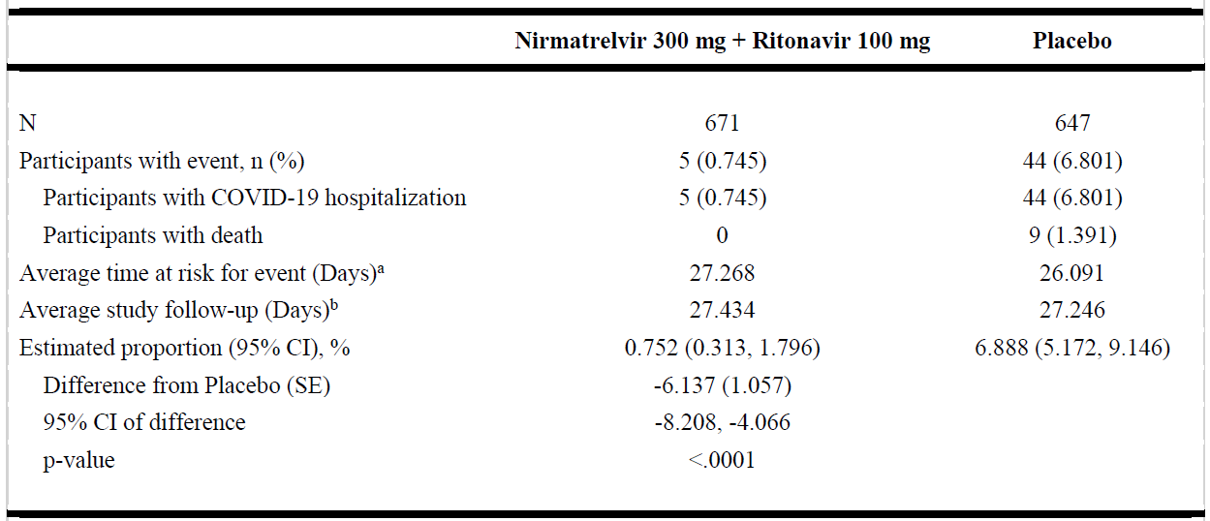

N = number of participants in the analysis set.

The cumulative proportion of participants hospitalized for the treatment of COVID-19 or death during the first 28 days of the study was estimated for each treatment group using the Kaplan-Meier method. The difference of the proportions in the 2 treatment groups and its 95% confidence interval, and p-value based on Normal approximation of the data are presented.

a. Average time at risk for event is computed as time to first event, or time to last day of participation, or Day 28, whichever is earlier.

b. Average study follow-up is computed as time to last day of participation, or Day 28, whichever is earlier.

Participants enrolled at sites 1274 and 1470 (including those switched to 1276) are excluded.

Figure 1. Time to COVID-19-Related Hospitalization or Death From Any Cause Through Day 28 – mITT Analysis Set

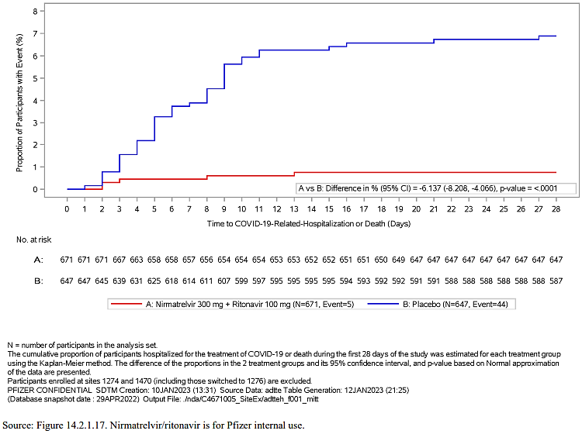

Table 3: Secondary Analysis of Proportion of Participants With COVID-19-Related-Hospitalization or Death From Any Cause Through Day 28 - mITT1, Kaplan-Meier Method (Study C4671005)

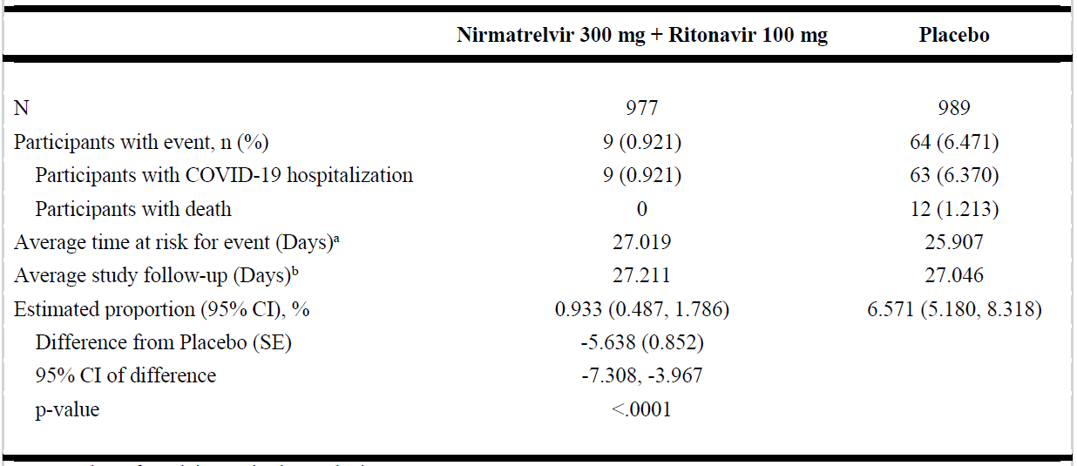

N = number of participants in the analysis set.

The cumulative proportion of participants hospitalized for the treatment of COVID-19 or death during the first 28 days of the study was estimated for each treatment group using the Kaplan-Meier method. The difference of the proportions in the 2 treatment groups and its 95% confidence interval, and p-value based on Normal approximation of the data are presented.

a. Average time at risk for event is computed as time to first event, or time to last day of participation, or Day 28, whichever is earlier.

b. Average study follow-up is computed as time to last day of participation, or Day 28, whichever is earlier.

Participants enrolled at sites 1274 and 1470 (including those switched to 1276) are excluded.

Source: Table 16, Study C4671005 Final CSR dated 08 March 2023 (seq 0058)

Figure 3. Time to COVID-19-Related Hospitalization or Death From Any Cause Through Day 28 – mITT1 Analysis set

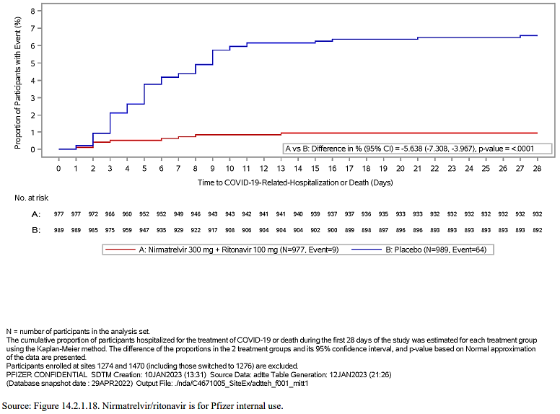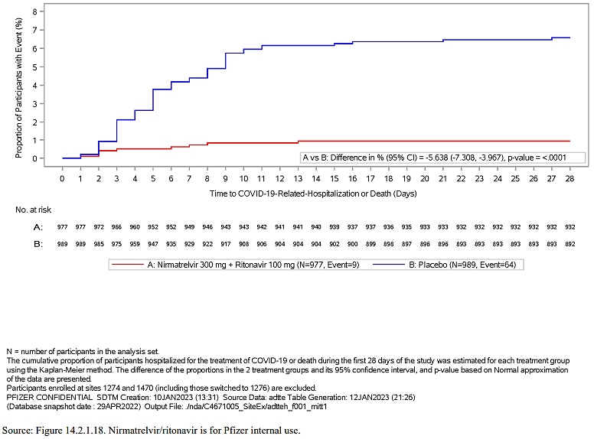

Table 4: Analysis of Time to Sustained Alleviation of All Targeted Signs and Symptoms Through Day 28 - mITT Analysis Set (Study C4671005)

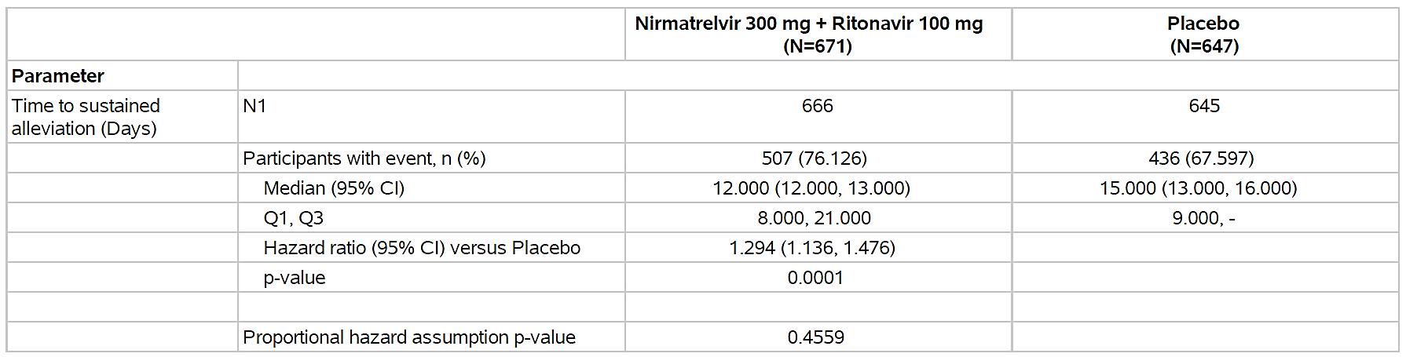

N = number of participants in the analysis set.

N1 = number of participants with non-missing data in the analysis set.

Q1, Median and Q3 are obtained from Kaplan Meier (KM) method.

Analysis of treatment effect on time to sustained alleviation is based on Cox proportional hazard (PH) model with treatment and geographic region effects as independent variables, and baseline SARS-CoV-2 serology status and baseline viral load (<4 log10 copies/mL, >=4 log10 copies/mL) as covariates.

The proportional hazard assumption was assessed in separate model that included treatment and treatment interaction term with time to sustained alleviation.

Participants enrolled at sites 1274 and 1470 (including those switched to 1276) are excluded.

###### Other specific conditions of registration related to clinical efficacy

* Please provide updates to the TGA regarding the clinical activity, efficacy, and effectiveness of Paxlovid against the current and future Variants of Concern and Variants of Interest identified by the World Health Organization (WHO).

The nonclinical commitment of testing new variants that are continuously emerging to confirm effective antiviral activity by nirmatrelvir as a condition of the provisional registration has been addressed on an ongoing basis, and the relevant information (e.g., Omicron variants) is included in the PI under the subheading Antiviral activity. No clinical data have been submitted.

* When available, further data relating to efficacy in immunocompromised subjects, pregnant women, lactating mother, paediatric subjects, pharmacology, long term safety, drug-drug interaction, and the information relating to post-market safety and effectiveness studies should be provided to the TGA to update the Product information.

These specific patient groups (C4671039-PK and safety study, PASS in in pregnant and breastfeeding women, moderate and severe renal impairment, PASS in moderate and severe hepatic impairment) are ongoing, in the pharmacovigilance plan of the RMP and a summary of the applications made to the TGA to update the Product Information with relevant data as it has become available was provided by the Sponsor.

#### Safety

##### Pivotal Study C4671005

The proportion of participants with all-causality treatment-emergent adverse events (TEAEs) that started on or prior to the Day 34 visit was comparable between treatment groups (22.0% and 24.3% for nirmatrelvir/ritonavir and placebo, respectively).

Table 5: Treatment-Emergent Adverse Events (All Causalities) - DAIDS Grade - Safety Analysis Set (Study C4671005)

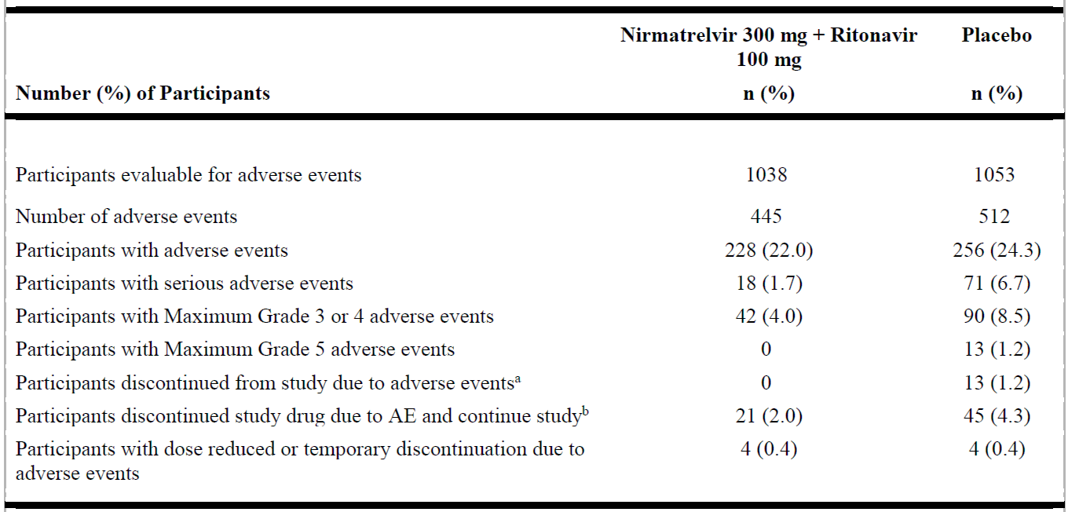

Includes AEs that started on or prior to Day 34 visit.

Except for the Number of Adverse Events participants are counted only once per treatment in each row.

Serious Adverse Events - according to the investigator's assessment.

a. Participants who have an AE record that indicates that the AE caused the participant to be discontinued from the study.

b. Participants who have an AE record that indicates that action taken with study treatment was drug withdrawn but AE did not cause the participants to be discontinued from study.

MedDRA v24.1 coding dictionary applied.

Participants enrolled at sites 1274 and 1470 (including those switched to 1276) are excluded.

The most frequently reported treatment related TEAEs in the nirmatrelvir/ritonavir group were dysgeusia and diarrhoea. Both of these treatment-related TEAEs were reported with a higher incidence in the nirmatrelvir/ritonavir group (3.5% and 1.1%, respectively) compared with the placebo group (0% and 0.2%, respectively).

There were 15 deaths among participants in this study, all of which occurred in the placebo group. Of the 15 deaths, 14 were related to COVID-19 disease (COVID-19 pneumonia [8 participants], COVID-19 [3 participants], pneumonitis [2 participants], and acute respiratory failure [1 participant]). The remaining death occurred during the long-term follow-up period outside of the active safety collection period (cause of death: sepsis with underlying relapsed acute myeloid leukemia).

The incidence of all-causality treatment-emergent serious adverse events (SAEs) that started on or prior to the Day 34 visit was lower in the nirmatrelvir/ritonavir treatment group (1.7%) compared with placebo (6.7%). The most frequently reported SAEs were COVID-19 pneumonia, COVID-19, and acute respiratory failure, all of which had a lower incidence in the nirmatrelvir/ritonavir group (0.7%, 0.2%, and 0%, respectively) compared with the placebo group (3.4%, 0.7%, and 0.5%, respectively). One participant in the nirmatrelvir/ritonavir group had treatment-related SAEs of chest discomfort, dyspnoea, and palpitations. The participant discontinued study intervention due to these SAEs but continued in the study; all of these events resolved.

###### Other specific conditions of registration related to clinical safety

* When available, further data relating to efficacy in immunocompromised subjects, pregnant women, lactating mother, paediatric subjects, pharmacology, long term safety, drug-drug interaction, and the information relating to post-market safety and effectiveness studies should be provided to the TGA to update the Product information.

In the time since provisional registration, the Sponsor has made a submission to update drug-drug interactions in the PI and has provided periodic safety update reports (PSURs). The most recently supplied Summary of Clinical Safety states that the reported post-marketing AEs are consistent with safety data from the Phase 2/3 clinical studies and in the approved Australian PI, and no new safety issues have been identified.

The Sponsor has also confirmed that ongoing applications have been made to the TGA to update the PI with data relating to immunocompromised subjects, pregnant women, lactating mothers, paediatric subjects, pharmacology, long term safety, drug-drug interaction, and/or information relating to post-market safety studies where relevant.

Details of subgroup studies which are underway have been provided by the Sponsor in their overview of the progress of clinical specific conditions of registration and are recorded in the RMP. The pharmacovigilance plan is acceptable from an RMP perspective as also confirmed by the RMP team.

### Risk Management Plan (RMP) evaluation summary

Pfizer Australia Pty Ltd has submitted an updated ASA version 3.1 (date 22 April 2024) in association to EU-RMP version 3.0 (date 19 April 2023; DLP 31 December 2022).

The proposed summary of safety concerns and their associated risk monitoring and mitigation strategies are summarised in Table 6.

Table 6. Summary of safety concerns.

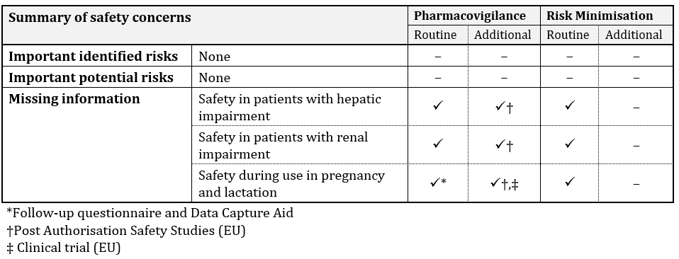

This summary of safety concerns was previously reviewed and accepted. The summary of safety concerns continues to be acceptable from an RMP perspective.

Routine and additional pharmacovigilance activities are conducted for all safety concerns. Routine pharmacovigilance includes pregnancy follow-up questionnaires and Data Capture Aid for lactation. Additional pharmacovigilance includes an ongoing pharmacokinetic and safety study (Study C4671039) in lactating women and planned post authorisation safety studies in pregnant and breastfeeding women, in moderate and severe renal impairment and in moderate and severe hepatic impairment. The pharmacovigilance plan is acceptable from an RMP perspective.

Only routine risk minimisation activities are proposed for this product. This plan was approved during the provisional registration of this product. The changes proposed in this application do not warrant changes to the currently approved risk minimisation plan. The risk minimisation plan is acceptable from an RMP perspective.

##### RMP evaluator recommendations regarding condition/s of registration

###### Wording for conditions of registration

Any changes to which the Sponsor has agreed should be included in a revised RMP and ASA. However, irrespective of whether or not they are included in the currently available version of the RMP document, the agreed changes become part of the risk management system.

The suggested wording is:

*The Paxlovid EU-Risk Management Plan (RMP) (version 3.0, dated 19 April 2023, data lock point 31 December 2022), with Australian Specific Annex (version 3.1, dated 22 April 2024), included with submission PM-2023-03740-1-2, and any subsequent revisions, as agreed with the TGA will be implemented in Australia.*

### Discussion

#### Efficacy

##### Pivotal Study C4671005

The final result for the primary efficacy endpoint, as per the final CSR dated 08 March 2023, confirmed that treatment with nirmatrelvir/ritonavir started within 3 days of symptom onset significantly reduced the proportion of participants with COVID-19-related hospitalisation or death from any cause through Day 28 in non-hospitalised symptomatic adult participants with COVID-19 who were at increased risk of progression to severe illness at baseline (p<0.0001). Analysis of the first key secondary efficacy endpoint (in participants who were treated within 5 days of symptom onset) supports the findings for the primary endpoint; and results of the second key secondary efficacy endpoint demonstrate that treatment with nirmatrelvir/ritonavir significantly reduced the median time to sustained alleviation of all targeted signs and symptoms through Day 28 in the mITT analysis set who received treatment within 3 days of symptom onset.

#### Safety

##### Pivotal Study C4671005

In support of the provisional registration of Paxlovid, the safety data indicated that Paxlovid (nirmatrelvir/ritonavir) had a favourable safety profile.

The final safety results indicated that the proportion of participants with all-causality TEAEs that started on or prior to the Day 34 visit was comparable between treatment groups (22.0% and 24.3% for nirmatrelvir/ritonavir and placebo, respectively). The incidence of all-causality treatment-emergent SAEs that started on or prior to the Day 34 visit was lower in the nirmatrelvir/ritonavir treatment group (1.7%) compared with placebo (6.7%). There were 15 deaths among participants in this study all of which occurred in the placebo group.

The Sponsor has confirmed that ongoing applications have been made to the TGA to update the Product Information with data relating to immunocompromised subjects, pregnant women, lactating mothers, paediatric subjects, pharmacology, long term safety, drug-drug interaction, and/or information relating to post-market safety studies where relevant.

The nonclinical commitment of testing new variants that are continuously emerging to confirm effective antiviral activity by nirmatrelvir as a condition of the provisional registration has been addressed on an ongoing basis, and the relevant information (e.g., Omicron variants) is included in the PI under the subheading ‘Antiviral activity.’

### Conclusions

The confirmatory trial data from Pivotal Study C4671005 (EPIC-HR) support the interim analysis's findings by demonstrating Paxlovid's efficacy in lowering the risk of COVID-19-related hospitalisation or death in non-hospitalised symptomatic adults at high risk of progression to severe illness at baseline. This supports the proposed indication for full registration.

The confirmatory trial data from Pivotal Study C4671005 (EPIC-HR) support the interim analysis findings by demonstrating that Paxlovid is well tolerated and has a favourable safety profile. Post-marketing surveillance revealed no new safety concerns.

The benefit-risk profile of Paxlovid appears well established from the clinical data obtained to date. The Delegate considers the overall benefit-risk profile favourable for transitioning Paxlovid from provisional to full registration.

## Outcome

Based on a review of quality, safety, and efficacy, the TGA decided to approve the full registration of Paxlovid (nirmatrelvir and ritonavir) for the following indication:

*Paxlovid is indicated for the treatment of coronavirus disease 2019 (COVID-19) in adults 18 years of age and older, who do not require initiation of supplemental oxygen due to COVID-19 and are at increased risk of progression to hospitalisation or death (see Section 5.1 Pharmacodynamic properties, Clinical trials in the Product Information).*

### Specific conditions of registration applying to these goods

Paxlovid (nirmatrelvir and ritonavir) is to be included in the Black Triangle Scheme. The PI and CMI for Paxlovid must include the black triangle symbol and mandatory accompanying text for five years, which starts from the date that the Sponsor notifies the TGA of supply of the product.

Submission of the outstanding clinical data from all requested data (study reports and/or published data) which were requested as conditions for the provisional registration.

The Paxlovid EU-Risk Management Plan (version 3.0, dated 19 April 2023, data lock point 31 December 2022), with Australian Specific Annex (version 3.1, dated 22 April 2024), and any subsequent revisions, as agreed with the TGA will be implemented in Australia.

## Attachment 1. Product Information

The [Product Information](https://www.tga.gov.au/products/australian-register-therapeutic-goods-artg/product-information-one) ([PI](https://www.tga.gov.au/products/australian-register-therapeutic-goods-artg/product-information-one)) approved with the submission for Paxlovid which is described in this AusPAR can be found as Attachment 1. It may have been superseded. For the most recent PI and [Consumer Medicines Information](https://www.tga.gov.au/products/australian-register-therapeutic-goods-artg/consumer-medicines-information-cmi) (CMI), please refer to the TGA [PI/CMI search facility.](https://www.tga.gov.au/picmi-search-facility)

|  |
| --- |
| Therapeutic Goods Administration |
| PO Box 100 Woden ACT 2606 Australia  Email: [info@tga.gov.au](mailto:info@tga.gov.au) Phone: 1800 020 653 Fax: 02 6203 1605  [**https://www.tga.gov.au**](https://www.tga.gov.au) |
|  |

1. This is the original indication proposed by the Sponsor when the TGA commenced the evaluation of this submission. It may differ to the final indication approved by the TGA and registered in the Australian Register of Therapeutic Goods.
2. <https://data.who.int/dashboards/covid19/cases?n=c>. Accessed 12 March 2024.
3. <https://data.who.int/dashboards/covid19/deaths?n=c>. Accessed 12 March 2024.
4. <https://data.who.int/dashboards/covid19/cases?m49=036&n=c>. Accessed 12 March 2024.
5. <https://data.who.int/dashboards/covid19/deaths?m49=036&n=c>. Accessed 12 March 2024.
6. <https://www.aihw.gov.au/reports/covid-19/long-covid-in-australia-a-review-of-the-literature/summary>
7. <https://www.tga.gov.au/products/covid-19/covid-19-treatments/covid-19-treatments-provisional-registrations>
8. <https://www.tga.gov.au/products/covid-19/covid-19-vaccines/covid-19-vaccines-regulatory-status>
9. The ‘Delegate’ is the Delegate of the Secretary of the Department of Health and Aged Care who made the final decision to either include the new medicine/indication on the ARTG or reject the submission, under section 25 of the Therapeutic Goods Act.