|  |
| --- |
| Australian Public Assessment Report for Vafseo |
| Active ingredient: Vadadustat |
| Sponsor: Adjutor Healthcare Pty Ltd |
| December 2024 |

About the Therapeutic Goods Administration (TGA)

* The Therapeutic Goods Administration (TGA) is part of the Australian Government Department of Health and Aged Care and is responsible for regulating therapeutic goods, including medicines, medical devices, and biologicals.
* The TGA administers the *Therapeutic Goods Act 1989* (the Act), applying a risk management approach designed to ensure therapeutic goods supplied in Australia meet acceptable standards of quality, safety, and efficacy.
* The work of the TGA is based on applying scientific and clinical expertise to decision-making, to ensure that the benefits to the Australian public outweigh any risks associated with the use of therapeutic goods.
* The TGA relies on the public, healthcare professionals and industry to report problems with therapeutic goods. The TGA investigates reports received to determine any necessary regulatory action.
* To report a problem with a therapeutic good, please see the information on the [TGA website](https://www.tga.gov.au/).

About AusPARs

* The Australian Public Assessment Report (AusPAR) provides information about the evaluation of a prescription medicine and the considerations that led the TGA to approve or not approve a prescription medicine submission. Further information can be found in [Australian Public Assessment Report (AusPAR) guidance](https://www.tga.gov.au/australian-public-assessment-report-auspar-guidance).
* AusPARs are prepared and published by the TGA.
* AusPARs are static documents that provide information that relates to a submission at a particular point in time. The publication of an AusPAR is an important part of the transparency of the TGA’s decision-making process.
* A new AusPAR may be provided to reflect changes to indications or major variations to a prescription medicine subject to evaluation by the TGA.

Copyright

© Commonwealth of Australia 2024  
This work is copyright. You may reproduce the whole or part of this work in unaltered form for your own personal use or, if you are part of an organisation, for internal use within your organisation, but only if you or your organisation do not use the reproduction for any commercial purpose and retain this copyright notice and all disclaimer notices as part of that reproduction. Apart from rights to use as permitted by the *Copyright Act 1968* or allowed by this copyright notice, all other rights are reserved and you are not allowed to reproduce the whole or any part of this work in any way (electronic or otherwise) without first being given specific written permission from the Commonwealth to do so. Requests and inquiries concerning reproduction and rights are to be sent to the TGA Copyright Officer, Therapeutic Goods Administration, PO Box 100, Woden ACT 2606 or emailed to <[tga.copyright@tga.gov.au](mailto:tga.copyright@tga.gov.au)>.

Contents

List of abbreviations 5

Product submission 7

Submission details 7

Product background 8

Chronic kidney disease 8

Current treatment options 10

Rationale for targeting the Hypoxia Inducible Factor System in the Anaemia of CKD 11

Regulatory status 14

Australian regulatory status 14

Foreign regulatory status 14

Registration timeline 15

Submission overview and risk/benefit assessment 16

Quality 16

Nonclinical 17

Clinical 18

Summary of clinical studies 18

Pharmacology 18

Efficacy 21

Study 0017 Results 34

Other efficacy endpoints 35

Supportive studies in NDD-CKD 38

Safety 38

Other clinical issues (for example, companion diagnostic considerations) 43

Risk management plan 43

Risk-benefit analysis 44

Benefits 44

Risks 45

Proposed action 47

Questions for the sponsor 48

Advisory Committee considerations 49

Outcome 51

Specific conditions of registration applying to these goods 51

Attachment 1. Product Information 52

## List of abbreviations

|  |  |
| --- | --- |
| Abbreviation | Meaning |
| ACM | Advisory Committee on Medicines |
| ARTG | Australian Register of Therapeutic Goods |
| ASA | Australia‑specific annex |
| CKD | Chronic kidney disease |
| CMI | Consumer Medicines Information |
| CV | Cardiovascular |
| DD CKD | Dialysis dependent Chronic kidney disease |
| DDI | Drug-drug interaction |
| DLP | Data lock point |
| eGFR | Estimated glomerular filtration rate |
| EMA | European Medicines Agency |
| EPO | Erythropoietin |
| ESA | Erythropoiesis-stimulating agent |
| HIF | Hypoxia-inducible factor |
| HR | Hazard ratio |
| GFR | Glomerular filtration rate |
| LS | Least squares |
| MACE | Major adverse cardiovascular events |
| NDD-CKD | Non-dialysis dependent Chronic kidney disease |
| OAT | Organic anion transporters |
| PD | Pharmacodynamic |
| PEP | Primary efficacy period |
| PHD | Prolyl-hydoxylase |
| PI | Product Information |
| PK | Pharmacokinetic |
| PopPK | Population pharmacokinetics |
| PSUR | Periodic safety update report |
| QoL | Quality of life assessment |
| RBC | Red blood cells |
| RMP | Risk management plan |
| SAE | Serious adverse events |
| SEP | Secondary efficacy period |
| TEAE | Treatment emergent adverse events |
| TGA | Therapeutic Goods Administration |
| TSAT | Transferrin saturation |

## Product submission

### Submission details

|  |  |
| --- | --- |
| *Type of submission:* | New chemical entity |
| *Product name:* | Vafseo |
| *Active ingredient:* | vadadustat |
| *Decision:* | Approved |
| *Date of decision:* | 25 September 2023 |
| *Date of entry onto ARTG:* | 4 October 2023 |
| *ARTG numbers:* | 384152, 384154 and 384156 |
| [*Black Triangle Scheme*](https://www.tga.gov.au/black-triangle-scheme)  *for the current submission:* | Yes  For 5 years, which starts from the date that the sponsor notifies the TGA of supply of the product. |
| *Sponsor’s name and address:* | Adjutor Healthcare Pty Ltd  3 Grandview Avenue  Point Cook VIC 3030 |
| *Dose form:* | Film-coated tablets |
| *Strengths:* | 150 mg, 300 mg and 450 mg |
| *Container:* | Blister packs |
| *Pack size:* | 28 tablets |
| *Approved therapeutic use for the current submission:* | Vafseo is indicated for the treatment of anaemia associated with chronic kidney disease (CKD) in adults on chronic maintenance dialysis. |
| *Route of administration:* | Oral |
| *Dosage:* | The recommended starting dose is 300 mg once daily.  For further information regarding dosage, such as patients converting from an erythropoiesis-stimulating agent, dose titration, dose monitoring, and dosage adjustments, refer to the Product Information. |
| *Pregnancy category:* | C  Drugs which, owing to their pharmacological effects, have caused or may be suspected of causing, harmful effects on the human fetus or neonate without causing malformations. These effects may be reversible. Accompanying texts should be consulted for further details.  The use of any medicine during pregnancy requires careful consideration of both risks and benefits by the treating health professional. The [pregnancy database](https://www.tga.gov.au/products/medicines/find-information-about-medicine/prescribing-medicines-pregnancy-database) must not be used as the sole basis of decision making in the use of medicines during pregnancy. The TGA does not provide advice on the use of medicines in pregnancy for specific cases. More information is available from [obstetric drug information services](https://www.tga.gov.au/obstetric-drug-information-services) in your state or territory. |

### Product background

This AusPAR describes the submission by Otsuka Australia Pharmaceutical Pty Ltd, subsequently transferred to Adjutor Healthcare Pty Ltd (the sponsor), to register Vafseo (vadadustat) as 150 mg, 300 mg and 450 mg film‑coated tablets in blister packs, initially for the following proposed indication:[1]

*Treatment of anaemia associated with chronic kidney disease (CKD) in adults.*

subsequently amended during the evaluation to:

*Vafseo is indicated for the treatment of anaemia associated with chronic kidney disease (CKD) in adults on chronic maintenance dialysis.*

#### Chronic kidney disease

Chronic kidney disease (CKD) is a heterogeneous group of disorders characterised by kidney damage (albuminuria) or decreased kidney function (glomerular filtration rate [GFR]) that is present for at least 3 months, irrespective of cause.[2] [3] CKD is a common condition. In Australia in 2020-2021, 17% of all hospitalisations included a CKD diagnosis. In 2020, 14,600 people with kidney failure received dialysis and CKD contributed to 11% of deaths.[4] In 2018, it accounted for 1% of the total disease burden in Australia, mostly due to years of life lost due to premature death or years lived with the illness.[5] Five key risk factors for CKD factors include smoking, diabetes, hypertension, established cardiovascular disease, and overweight and obesity, although risk factors are numerous.4

Kidney disease is staged by GFR (Grades 1-5, see Figure 1),3 and GFR and albuminuria contribute to assessment tools for prognosis.

Figure 1: Prognosis of chronic kidney disease by GFR and albuminuria

Figure 1: Colour coded image of 'No CKD' (pale green), 'moderate risk CKD' (cream), 'high risk CKD' (orange), and 'very high risk CKD' (red). Columns refer to 5 stages of albuminuria. Rows refer to 6 stages of GFR.

As kidney function declines and in patients with more advanced CKD stages, the incidence and prevalence of anaemia increases.[6]

The anaemia is typically normocytic, normochromic and hypoproliferative.[7] It is multifactorial due complex interrelationships between several main mechanisms:

* Erythropoietin deficiency
* Shortened red cell survival
* Uraemic-induced inhibitors of erythropoiesis
* Disordered iron homeostasis – excess hepcidin, a protein which promotes intracellular iron storage and reduces iron absorption, may account for impaired dietary iron absorption and reticuloendothelial cell iron blockade
* Systemic inflammation from CKD.

Decrease in erythropoietin (EPO) production or errors in EPO sensing result in EPO deficiency. Chronic inflammation reduces EPO production, and the bone marrow response to EPO is also reduced. Hepcidin, in addition to the actions on iron metabolism, may directly inhibit erythroid progenitor proliferation and survival, contributing to EPO resistance.

The mechanisms are also summarised below in Figure 2.8

Figure 2: Mechanisms underlying anaemia of Chronic Kidney Disease

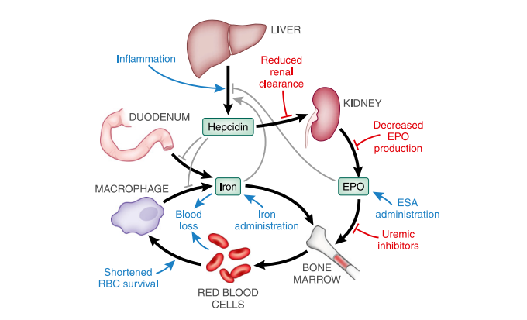

#### Current treatment options

The World Health Organization (WHO) defines anaemia in adults as haemoglobin (Hb)<12 g/dL in women and Hb<13 g/dL in men.[8] While not all patients with anaemia of CKD require a systemic therapy, they do require regular monitoring for deterioration of kidney disease and/or the anaemia. Where treatments are required, they aim to balance the potential benefits and harms from iron therapy, erythropoietin stimulating therapy, and blood transfusion and anaemia related symptoms.[9]

Iron therapy would be considered for most patients with CKD who have a transferrin saturation (TSAT) ≤20% and/or a serum ferritin concentration ≤100 ng/mL.10 The goal is to correct iron deficiency and/or increase Hb while keeping TSAT ≤30% and ferritin ≤≤500 mg/mL, thus avoiding iron overload. Intravenous iron would be considered for patients with severe iron deficiency (TSAT <12%), Hb <7 g/dL in asymptomatic patients, risk of ongoing blood loss, adverse effects with or a lack of response to oral iron.

Erythropoietin‑stimulating agents (ESA) may be considered for patients with a Hb <10 g/dL, as a way of optimising red cell mass.[10] Current agents available in Australia include epoetin alfa,[11] epoetin beta,[12] epoetin lambda,[13] and chemically modified forms such as methoxy polyethylene glycol–epoetin beta,[14] and darbepoetin alfa.[15] The Australian Product Information (PI) documents for these products do not declare a specific target Hb but do provide instruction to avoid Hb in excess of 12 g/dL.

Important safety considerations with ESAs include an increased risk of tumour progression in patients with a malignancy, hypertension, increased risk of major cardiac events in addition to the baseline risk with CKD particularly if the target of treatment is > 11 g/dL, and the small risk of pure red cell aplasia. Hyporesponsiveness or contraindication to EPOs means there is a need for other strategies to add to the current options for the anaemia of CKD.

The use of ESAs considerably reduces the need for red cell transfusion, the risks of which include iron and fluid overload, a very small risk of transfusion reaction and infection, but an increased risk of inducing antibodies to HLA tissue antigens, potentially reducing the pool of suitable donors if renal transplantation is considered. Red cell transfusion is therefore generally considered rescue therapy.

#### Rationale for targeting the Hypoxia Inducible Factor System in the Anaemia of CKD

##### Hypoxia inducible factor system

Erythropoietin (EPO) is a glycoprotein that binds to its receptor on the surface of erythroid progenitor cells mainly in the bone marrow. It serves as a stimulus for red cell survival, proliferation and differentiation.[16] It is produced by the fibroblast-like interstitial peritubular cells of the kidneys, and to a lesser extent the perisinusoidal cells in the liver, in response to changes in tissue oxygen tension.[17] The production of EPO is controlled at the level of EPO gene transcription. Hypoxia-inducible factor (HIF) is a transcription factor that regulates physiological responses to hypoxia, including EPO.[18] HIF is regulated by oxygen-dependent proteasomal degradation with a family of prolyl-hydroxylases serving as oxygen sensors; see Figure 3.[19] HIF prolyl-hydroxylase inhibitors (HIF‑PHI) inhibit prolyl-hydroxylase, leading to an increase in HIF and increased endogenous EPO.[20]

Figure 3: Central role of prolyl-hydoxylases (PHD) and the HIF transcription factor in response to hypoxia

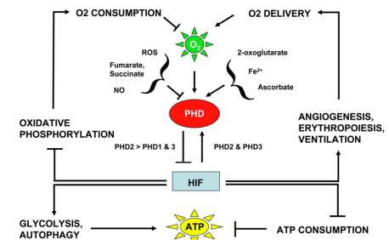

##### Vadadustat

Vadadustat is a chemically derived HIF-PHI. Its mechanism of action is depicted below.[21]

Figure 4: Mechanism of action of vadadustat

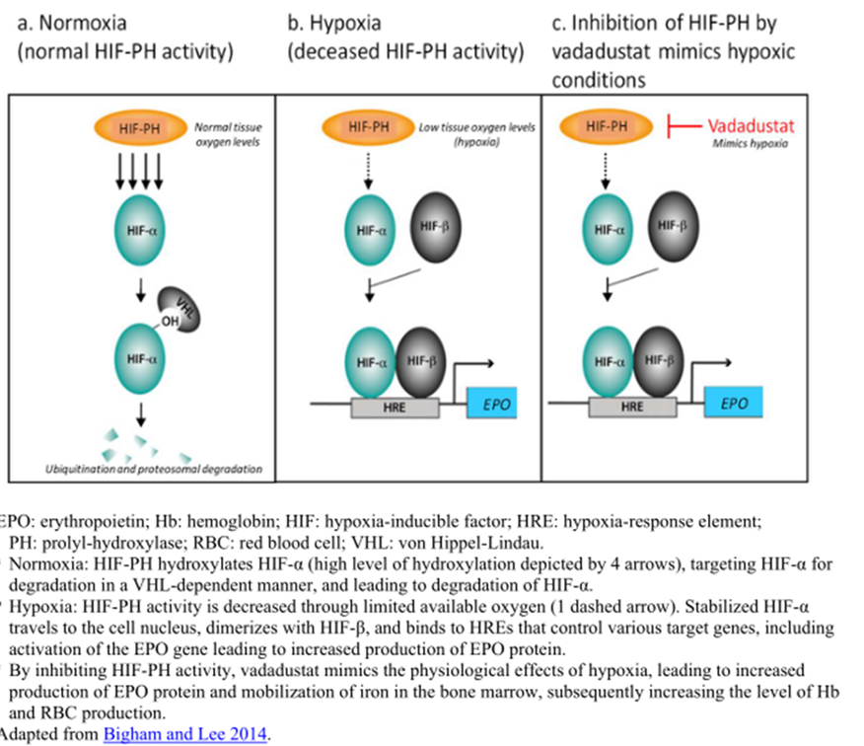

Vadadustat works by inhibiting PHD enzymes, leading to stabilisation and increased levels of HIF-α, dose-dependent increases in serum EPO, and improved production of Hb and red blood cells (RBCs). The HIF-α subunits are hydroxylated by iron-dependent PHDs and subjected to the ubiquitin-proteasome degradation pathway as a regulatory mechanism in response to oxygen. PHD enzymes require oxygen as a co-substrate and iron as a cofactor for their enzymatic activity; therefore, in hypoxic conditions, PHDs are inhibited because of low oxygen supply. Inhibition of PHDs allows HIFs to mediate transcriptional activation of genes responsible for erythropoiesis and iron mobilisation.

##### Other HIF inhibitors

Roxadustat is approved in the European Union (EU) for the indication:

*Evrenzo is indicated for treatment of adult patients with symptomatic anaemia associated with chronic kidney disease (CKD).*

Roxadustat is not approved in the United States of America (USA) or Canada.

Daprodustat is approved in the USA for the following indication:

*JESDUVROQ is a hypoxia-inducible factor prolyl hydroxylase (HIF PH) inhibitor indicated for the treatment of anemia due to chronic kidney disease in adults who have been receiving dialysis for at least four months.*

In June 2023 the European Medicines Agency's (EMA) Committee for Medicinal Products for Human Use provided a positive recommendation for daprodustat for the indication:[22]

*Jesduvroq is indicated for the treatment of symptomatic anaemia associated with chronic kidney disease (CKD) in adults on chronic maintenance dialysis.*

The relevant applicant withdrew its European application in July 2023 prior to approval due to the proposed authorisation for use only in adults on dialysis and not for patients not on dialysis.

### Regulatory status

#### Australian regulatory status

This product is considered a new chemical entity for Australian regulatory purposes.

#### Foreign regulatory status

This submission was evaluated as part of the [Australia-Canada-Singapore-Switzerland-United Kingdom (ACCESS) Consortium](https://www.tga.gov.au/australia-canada-singapore-switzerland-united-kingdom-access-consortium) with work-sharing between the TGA, Swissmedic and the United Kingdom’s Medicines and Healthcare Products Regulatory Agency. Each regulator made independent decisions regarding approval (market authorisation) of the new medicine*.*

At the time the TGA considered this submission, a similar submission had been considered by other regulatory agencies. The following table summarises these submissions and provides their status and indications, where approved.

Table 1: International regulatory status at the time of product registration.

|  |  |  |  |
| --- | --- | --- | --- |
| Region | Submission date | Status | Approved indications |
| Japan | 8 July 2019 | Approved on 29 June 2020 | *Vafseo is indicated for the treatment of renal anaemia* |
| United States of America | 29 March 2021 | Complete response letter issued 29 March 2022[23] | *N/A* |
| South Korea | 24 March 2022 | Approved 13 March 2023 | *Vafseo is indicated for the treatment of anaemia in adult patients associated with CKD undergoing hemodialysis* |
| European Union | 25 October 2021 | Approved on 24 April 2023 | *Vafseo is indicated for the treatment of symptomatic anaemia associated with chronic kidney disease (CKD) in adults on chronic maintenance dialysis* |
| United Kingdom | 24 February 2022 | Approved on 19 May 2023 | *Vafseo is indicated for the treatment of symptomatic anaemia associated with chronic kidney disease (CKD) in adults on chronic maintenance dialysis.* |
| Switzerland | 18 March 2022 | Approved on 19 June 2023 | *Vafseo is indicated for the treatment of symptomatic anaemia associated with chronic kidney disease (CKD) in adults on chronic maintenance dialysis.* |
| Taiwan | 20 January 2022 | Approved 28 September 2023 | *Vafseo is indicated for the treatment of anemia in adults with chronic kidney disease who are on chronic dialysis.* |

## Registration timeline

The following table captures the key steps and dates for this submission.

This submission was evaluated under the [standard prescription medicines registration process](https://www.tga.gov.au/how-we-regulate/supply-therapeutic-good-0/supply-prescription-medicine/application-process/prescription-medicines-registration-process).

Table 2: Timeline for Submission PM-2022-00525-1-6

|  |  |
| --- | --- |
| Description | Date |
| Submission dossier accepted and first round evaluation commenced | 19 April 2022 |
| First round evaluation completed | 12 August 2022 |
| Sponsor provides responses on questions raised in first round evaluation | 5 January 2023 |
| Second round evaluation completed | 15 March 2023 |
| Sponsor provides responses on questions raised in second round evaluation and notification to the TGA of errors/omissions in evaluation reports | 30 March 2023 |
| Delegate’s[24] Overall benefit-risk assessment and request for Advisory Committee advice | 3 July 2023 |
| Sponsor’s pre-Advisory Committee response | 18 July 2023 |
| Advisory Committee meeting | 3 and 4 August 2023 |
| Registration decision (Outcome) | 25 September 2023 |
| Administrative activities and registration in the ARTG completed | 4 October 2023 |
| Number of working days from submission dossier acceptance to registration decision* | 244 |

*Statutory timeframe for standard submissions is 255 working days

## Submission overview and risk/benefit assessment

A summary of the TGA’s assessment for this submission is provided below.

This section is a TGA summary of wording used in TGA’s evaluation report, which discussed numerous aspects of overseas evaluation reports and included some information that was commercial-in-confidence.

### Quality

Vadadustat has a molecular formula C14H11ClN2O4 and molecular mass 306.7 g/mol. Its structure is shown below.

Figure 5: Structural formula of vadadustat

*Figure 5: Chemical structure of vadadustat*

The quality evaluation notes the following about vadadustat: it displays pH dependent solubility; has a BCS Class II classification (low solubility, high permeability); is presented as an acid and not a salt and has a partition coefficient (logP) of 3.34; it is non-hygroscopic.

The tablets contain the active substance and conventional excipients for the dose form. The finished product specifications are sufficient to ensure the quality of the product at release and throughout the shelf-life. The specifications control identity, assay, and other physical, chemical, and microbiological properties relevant to the clinical use of the product. A single point dissolution limit is applied to all three strengths: ≥80% is dissolved in 30 minutes.

The commercial product formulation is the same as that used in clinical trials.

The tablets are produced from a common blend. The table shape, embossing, and colour differentiation distinguish the strengths from one another. The proposed blister and carton labelling meet TGO91 requirements.

Figure 6: Appearance of Vafseo tablets

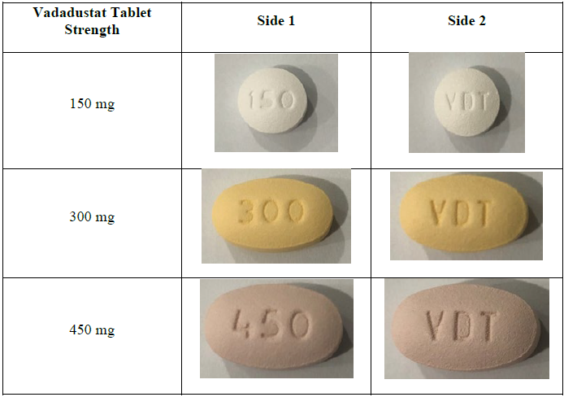

A product shelf life of 36 months, stored below 30 °C, is supported by the stability data.

Vadadustat is taken without regard to food and must be swallowed whole. Dialysis patients can take the tablets any time in relation to the dialysis.

The quality evaluator recommended approval of Vafseo from a pharmaceutical chemistry perspective.

### Nonclinical

The nonclinical evaluator had no nonclinical objections to the registration of Vafseo for the proposed indication.

The key findings from the nonclinical evaluation report were as follows.

* The pharmacology studies overall supported the utility of vadadustat and did not identify any clinically relevant hazards.
* In-vitro data suggest the potential for pharmacokinetic interactions through inhibition of CYP2C8, CYP2C9, BCRP, OAT1 and OATP1B1, downregulation of CYP3A4, and induction of CYP2B6.
* The rat and dog models used in the toxicity program were considered suitable models to assess vadadustat toxicity, based on sufficiently similar pharmacokinetic (PK) profiles and pharmacodynamic (PD) responsiveness. The repeat‑dose toxicity program found an exaggerated pharmacology of vadadustat, large increases in erythrocyte mass and resultant increased blood viscosity due to polycythaemia.
* Vadadustat was not considered to be genotoxic and was not carcinogenic in transgenic mice or in rats.
* Because of the exaggerated pharmacology of vadadustat when used in non‑anaemic animals for the reproductive and developmental toxicity studies, the relative exposure was limited. The exposures in the animal embryofetal development studies were below or only slightly higher than expected in human patients. Consequently, the evaluator was not satisfied sufficient support for the safety of the medicine was provided to warrant a Pregnancy Category B1 classification.[25] Because there is potential harm to the fetus due to the pharmacological activity of vadadustat, and because placental transfer was demonstrated in the rat, Pregnancy Category C is warranted.[26]
* Vadadustat and/or its metabolites were excreted in milk in rats at concentrations far above that in plasma. There is a risk of pharmacologically‑mediated adverse events in the breastfeeding child and vadadustat should not be used by a breastfeeding mother.

### Clinical

#### Summary of clinical studies

The clinical dossier consisted of:

* 19 Phase I studies
* 8 Phase II studies
* 10 Phase III studies

#### Pharmacology

Data from healthy subjects and from patients contributed to the understanding of the pharmacology of vadadustat.

##### Pharmacokinetics

The absolute bioavailability of vadadustat has not been established, but renal excretion data suggest bioavailability is at least 58.9%. The Tmax is 2 to 3 hours.

Vadadustat is highly protein bound (>99%) and does not distribute to red cells. Because vadadustat is an acid it is assumed the majority of plasma protein binding is to albumin.

Vadadustat and vadadustat‑O‑glucuronide are the main circulating components. Vadadustat‑O‑glucuronide is considered to be pharmacologically inactive and is the only major metabolite in humans, accounting for about 15% of systemic exposure. Vadadustat‑acyl‑glucuronide accounts for <0.1% of systemic exposure.

Vadadustat is primarily metabolised by direct glucuronidation by uridine 5’‑diphosphoglucuronosyltransferases (UGTs). The sponsor does not have specific data on the effect of UGT1A9 polymorphisms on the exposure of vadadustat. The evaluator did not agree with the sponsor that such polymorphisms could only affect exposure of the inactive metabolite but did find it is likely that patients with polymorphisms would be unlikely to have large changes in exposure.[27]

In healthy subjects there is minimal accumulation, and in CKD patients it is predicted to be around 32%. The main route of human excretion of vadadustat and its metabolites is in the urine. Compared with healthy patients, exposure was approximately 2‑fold higher in CKD patients due to reduced clearance. The proposed mechanism for reduced clearance is a down‑regulation of organic anion transporters (OAT), given vadadustat is a substrate of OAT1/3. In a study in healthy volunteers with a single dose of radiolabelled vadadustat, vadadustat had a half-life of around 6.4 hours in serum but radioactive material had a half‑life of around 15 hours.

Dose proportionality was suggested for both vadadustat and vadadustat‑O‑glucuronide over the dose range 150 mg to 600 mg in dialysis dependent CKD (DD-CKD) patients.

In study AKB-6548-CI-0009, PK measurements of Cmax, AUC and half‑life were not considered clinically significantly different if the dose was administered pre‑ or post‑dialysis, but the geometric mean AUClast and Cmax were 1.6 to 1.7‑fold higher when administered 4 hours prior to dialysis relative to 2 hours post dialysis.

Concomitant probenecid resulted in an approximately 2.2‑fold increase in vadadustat exposure (upper bound 90% CI for comparison for AUClast 2.42‑fold and for AUCinf 2.45‑fold). A cautionary statement is proposed for Section 4.5 [Interactions with Other Medicines and Other Forms of Interactions] of the Vafseo PI.

Vadadustat given with furosemide (OAT1/3 substrate) compared with furosemide given alone resulted in a 1.7‑fold increase in Cmax and approximately 2‑fold increase in AUC of furosemide. Mention of this interaction is proposed for the Vafseo PI.

BCRP‑related interactions were demonstrated with concomitant dosing of 600 mg of vadadustat with 500 mg of sulfasalazine (4.58‑fold increase in AUCinf and 2.75‑fold increase Cmax), with 40 mg of simvastatin (approximately 2‑fold increase in AUC) and rosuvastatin (2.5‑fold increase in AUC and 2.75‑fold increase Cmax). The sponsor proposes limitations to the dose of simvastatin to 20 mg daily and rosuvastatin to 10 mg daily. It also lists fluvastatin, nelfinavir, pitavastatin and topotecan as examples of BCRP substrates that may require dose adjustment.

Concomitant administration of 40 mg atorvastatin and 600 mg of vadadustat gave a 1.7‑fold increase in the atorvastatin AUC and 2.3‑fold increase of Cmax. No atorvastatin dose cap is recommended based on this interaction, however clarification will be sought from the sponsor because the maximum atorvastatin dose in Australia of 80 mg was not tested and the extent of exposure increase of atorvastatin at that dose is unknown.(Refer to Questions for the sponsor section).

As a charged particle, vadadustat is potentially susceptible to binding to co‑administered potassium and phosphate binders in the gut. The co-administration of ferrous sulfate immediate release tablet or with the co‑administration of oral iron or iron-containing phosphate binders with vadadustat reduced Cmax and AUC by approximately 50%. The co‑administration of non-iron-containing phosphate binders reduced the bioavailability of vadadustat up to 55% and 52% for AUC and Cmax respectively. The Vafseo PI recommends vadadustat is administered at least 1 hour before or 2 hours after dosing of non‑iron containing phosphate binders and at least 1 hour before oral iron supplements, products containing iron or iron‑containing phosphate binders to minimise these specific drug interactions. Vadadustat could also chelate other concomitant medications containing metal ions or potentially unbound dietary molecules with multivalent cations (for example, iron, calcium, magnesium, aluminium).

No meaningful drug‑drug interaction was demonstrated between rabeprazole and vadadustat in healthy volunteers.

The evaluator noted the characterisation of drug‑drug interactions in the submission was missing certain information. A clinical study to investigate CYP2B6 induction is a post‑marketing authorisation measure in the EU.[28] The general statement noting the absence of in vivo data for this interaction is proposed for the Vafseo PI.

No dose adjustments are proposed for patients with moderate hepatic impairment or based on age, sex, or bodyweight. There were no studies in children as the medicine is indicated for adults only.

##### Population pharmacokinetic data

A population pharmacokinetics (PopPK) model to characterise the PK of vadadustat and evaluate the impact of covariates utilised 14,021 samples from 96 healthy subjects, 2003 non-dialysis dependent CKD (NDD-CKD) patients and 2089 DD-CKD patients. The final model was a one compartment model with a sequential absorption lag time, first order oral absorption, and first order elimination. A food effect on absorption time and the absorption rate constant was estimated, and the effect of body weight was allometrically scaled for CL and V. The evaluator noted evidence of high variability in the whole data set was not fully captured by the addition of covariates (interindividual variability for clearance (47%) and absorption (88.6%)).

In study AKE-PKPD-VADADUSTAT-1954-PPK, in which the Phase III dataset was included in an updated model, for a typical DD-CKD patient, independent on eGFR (bodyweight 75 kg, bilirubin 0.3 μmol/L), clearance was 0.7222 L/hr, and volume of distribution was 11.6 L. With the addition of the Phase III data (comprising 83% of the total data set) the η-shrinkage for mean apparent clearance was 31.6%, contributing uncertainty to the interpretation of the individual exposure estimates in the exposure‑response response analyses that used the model.

Based on the final PopPK and exposure‑response models, the modelled impact of body weight, eGFR and prior ESA in the presence of a 2‑fold exposure increase due to drug-drug interactions (DDI) with simulations conducted for virtual non‑Japanese DD-CKD patients predicts:

* a more rapid increase in Hb response
* a greater risk in Hb response
* more pronounced effects in patients with lower body weight and those who had not received a prior ESA. In the DD-CKD population, ESA naive patients would require a dose reduction to 150 mg daily to maintain Hb in the defined range of 10 to 12 g/dL.
* For DD-CKD patients, eGFR did not predict vadadustat PK and no trend for Hb exposure versus eGFR was seen in this group.

Safety-exposure relationships for selected gastrointestinal disorders, hepatotoxicity and hyperkalaemia did not demonstrate clear statistically significant relationships.

##### Pharmacodynamics

Vadadustat is a potent inhibitor of the three isoforms of PHD in humans.

The Phase I and II studies showed dose dependent increases in EPO concentrations, with associated rises in reticulocyte count and total iron binding capacity and decreases in hepcidin and ferritin. The PD studies focussed on EPO levels, Hb and reticulocyte counts as PD endpoints.

A dose response relationship between dose and EPO response was demonstrated. In Japanese patients the response was estimated to be 21 to 27% higher. Haemoglobin rise is secondary to the EPO rather than primarily to the presence of vadadustat.

The secondary PD endpoints of hepcidin, ferritin and transferrin (iron‑related biomarkers) were included in studies with PD endpoints. Decreased TSAT, maintenance of serum iron, increased total iron binding capacity, decreased ferritin, and decreased mean hepcidin were all consistent with increased erythropoiesis.

The Phase I thorough QT study did not identify a significant effect of vadadustat on the QTcF interval (upper bound of 90% CI < 10 msec) in doses of up to 1200 mg.[29]

Pharmacodynamic interaction studies were not conducted, and off‑target effects were not well described in the submission. There are no studies of the concomitant use of ESAs and vadadustat included in the submission and the sponsor states it does not expect their concomitant use, although that is not explicitly stated in the draft Vafseo PI.

#### Efficacy

The requested indication includes patients on chronic maintenance dialysis. Studies CI-0016 and CI-0017 both included dialysis dependent CKD patients. As there is some overlap in the duration of dialysis required in the inclusion criteria for these studies they are both considered pivotal.

##### Pivotal studies in dialysis dependent chronic kidney disease – INNO2VATE Studies (studies CI-0016 and CI-0017)

###### Study CI-0016

Study CI-0016 was a Phase III study investigating the use of vadadustat for the correction of Hb and in conversion from a current ESA therapy. It was a Phase III, multi‑centre, randomised (1:1), open-label, active-controlled study evaluating the efficacy and safety of oral vadadustat compared with darbepoetin alfa conducted between 18 July 2016 and 31 January 2020.

The study enrolled incident dialysis patients who were to have initiated dialysis within 16 weeks prior to screening and who may or may not have received treatment with ESAs prior to study entry.

Patients randomised to vadadustat received a starting dose of 300 mg once daily with up‑and‑down titration to 150 mg, 300 mg, 450 mg or 600 mg once daily to maintain target Hb levels. For patients randomised to darbepoetin alfa, the starting dose was in accordance with the US PI for US sites or the European SmPC in the rest of the world;[30] but for patients already taking darbepoetin alfa dosing was based on their prior dosing regimen.

Of the 652 patients screened, 369 were randomised, 179 received vadadustat and 186 received darbepoetin alfa. The study completion rate was 88.4% and 87.8%, respectively, and the treatment completion rate was 66.9% and 73.9%, respectively. The main reasons for discontinuation were death (9.2%), withdrawal of consent, and lost to follow up (1.4% each). Important protocol deviations were reported for 45.9% of the vadadustat group and 20.2% of the darbepoetin group. The most common reasons for exclusion from the per protocol population (see table below) were:

* patient lacking Hb value in the primary efficacy period (vadadustat 19.9% and darbepoetin 11.2%)
* not receiving study drug in primary efficacy period (vadadustat 13.3% and darbepoetin 90%)
* did not meet ≥1 eligibility criterion (vadadustat 8.3% and darbepoetin 11.2%)
* incorrect treatment/wrong dose (vadadustat 13.8% and darbepoetin 2.1%).

The study was halted when the prespecified event rate of 631 events was reached across both the INNO2VATE CI-0016 and CI-0017 studies.

Study CI-0017

Study CI-0017 was a Phase III study investigating conversion from an ESA to vadadustat. It was a Phase III, multi-centre, randomised (1:1), open-label, active-controlled study evaluating the efficacy and safety of vadadustat for the maintenance treatment of anaemia in DD-CKD (either peritoneal dialysis or haemodialysis) after conversion from ESA therapy, conducted between 17 August 2016 and 16 January 2020.

The study enrolled patients who received chronic maintenance dialysis for at least 12 weeks prior to screening and were maintained on ESAs, with a dose received within 6 weeks prior to or during screening.

Patients randomised to vadadustat received a starting dose of 300 mg once daily with up-and-down titration to 150 mg, 300 mg, 450 mg or 600 mg once daily to maintain target Hb levels.

Patients who were randomised to darbepoetin alfa already taking darbepoetin alfa continued dosing based on their prior dosing regimen. Patients randomised to darbepoetin alfa who were switched from another ESA did so according to the US PI for US sites or the European SmPC for the rest of the world.

Of the 4,944 patients, 3,554 were randomised, and 1,768 received vadadustat and 1,769 received darbepoetin alfa. The study completion rate was 80.2% and 80.0%, respectively, and the treatment completion rate was 49.4% and 63.3%, respectively. The main reasons for discontinuation were death (15.2%), withdrawal of consent (2.8%) and lost to follow-up (1.9%). Important protocol deviations were reported for 21.2% of the vadadustat group and 8.6% of the darbepoetin group. The most common reasons for exclusion from the per protocol population (see table below) were:

* patient lacking Hb value in the primary efficacy period (vadadustat 11.5% and darbepoetin 8.7%)
* not receiving study drug in primary efficacy period (vadadustat 20.1% and darbepoetin 10.7%)
* did not meet ≥1 eligibility criterion (vadadustat 5.6% and darbepoetin 4.5%)
* incorrect treatment/wrong dose (vadadustat 12.9% and darbepoetin 2.4%).

###### Common design elements of Studies CI-0016 and CI-0017

These global Phase III studies had common elements of design. Table 1 is a summary of the study design elements that relate to studies CI-0016 and CI-0017.

Table 3: Study CI-0016 and Study CI-0017 design features

|  |  |  |
| --- | --- | --- |
| Parameter | Description | |
| **Study duration and study periods (both studies)** | * Screening period of up to 8 weeks. * Treatment periods onwards consisting of   + Initial period on study drug from Weeks 0 to 23 for conversion to study drug for maintaining Hb (CI-0016, CI-0017)   + Primary Efficacy Period (PEP) from Week 24 to 36   + Secondary Efficacy Period (SEP) from Week 40 to 52   + Long-term treatment period (Week 53 to end of treatment) where study drug was continued to assess long-term use   + Follow-up period (end of treatment + 4 weeks) for post-treatment visit for safety   + Patients who discontinued study drug were followed to the end of study to assess major adverse cardiovascular events (MACE).   Patients in the INNO2VATE studies were to receive vadadustat or darbepoetin alfa for ≥ 36 weeks and to have the option of continued long-term treatment until global study completion. Treatment duration was event driven based on achieving an adequate number of independently adjudicated MACE endpoints to allow meaningful comparison between treatment groups for the pooled MACE analyses in the INNO2VATE and PRO2TECT studies; 631 MACE were needed in each of the INNO2VATE and PRO2TECT studies. | |
| **Inclusion criteria** | **CI-0016**   * ≥18 years of age * Initiated chronic maintenance dialysis (either peritoneal or haemodialysis) for end-stage kidney disease for ≤ 16 weeks prior to Screening. * Mean screening Hb 8.0 to 11.0 g/dL (US) and between 9.0 to 12.0 g/dL (outside US) determined by the average of 2 Hb values by central laboratory * Serum ferritin ≥ 100 ng/mL and TSAT ≥20% during Screening. * Folate and vitamin B12 above lower limit of normal during Screening. | **CI-0017**   * ≥18 years of age * chronic maintenance dialysis (either peritoneal or haemodialysis) for end-stage kidney disease for ≥ 12 weeks prior to Screening. * Currently maintained on ESA therapy, with a dose received within 6 weeks prior to or during Screening. * Mean screening Hb 8.0 to 11.0 g/dL (US) and between 9.0 to 12.0 g/dL (outside US) determined by the average of 2 Hb values by central laboratory * Serum ferritin ≥100 ng/mL and TSAT ≥20% during Screening. * Folate and vitamin B12 above lower limit of normal during Screening. |
| **Exclusion criteria (both studies)** | * Anaemia due to a cause other than CKD or subjects with active bleeding or recent blood loss. * History of sickle cell disease, myelodysplastic syndromes, bone marrow fibrosis, haematologic malignancy, myeloma, haemolytic anaemia, thalassemia, or pure red cell aplasia. * RBC transfusion ≤ 8 weeks prior to randomisation. * Anticipated to recover adequate kidney function and no longer need dialysis. * AST/SGOT, ALT/SPGT or total bilirubin >2.0 × upper limit of normal during Screening (Gilbert’s syndrome not excluded). * Uncontrolled hypertension (pre-dialysis systolic blood pressure>190 mmHg or diastolic blood pressure>110 mmHg at rest) during Screening. * Severe heart failure during Screening (NYHA Class IV). * Acute coronary syndrome (hospitalisation for unstable angina or myocardial infarction), surgical or percutaneous intervention for coronary, cerebrovascular or peripheral artery disease (aortic or lower extremity), surgical or percutaneous valvular replacement or repair, sustained VT, hospitalisation for heart failure, or stroke ≤12 weeks prior to or during Screening. * History of active malignancy ≤ 2 years before or during Screening, except treated BCC of skin, curatively cSCC, or cervical CIS. * History of DVT or PE ≤ 12 weeks before randomisation. * History of haemosiderosis or haemochromatosis. * History of prior organ transplantation, or prior hematopoietic stem cell or bone marrow transplant or scheduled organ transplant (unless on kidney transplant wait-list or history of failed kidney transplant, or corneal transplants, or stem cell therapy for knee arthritis) * Hypersensitivity to vadadustat, darbepoetin alfa, or any of their excipients. * Use of an investigational medication or participation in an investigational study ≤30 days or 5 half‑lives of the investigational medication prior to Screening. * Previous participation in this study or previous participation in a study with another HIF prolyl-hydroxylase inhibitor other than vadadustat. | |
| **Stratification factors for randomisation (both studies)** | * Region of enrolment   + United States   + Europe   + Rest of World * New York Heart Association heart failure class   + 0 or I   + II or III * Central laboratory baseline Hb category   + < 9.5 g/dL   + ≥9.5 g/dL | |
| **Key protocol amendments identified by evaluator** | | |
| * Amendment 1 – June 2017   + Clarifications to study analysis populations. * Amendment 2/3 – January 2018   + Addition of several key secondary, other secondary efficacy endpoints, and safety endpoints in alignment with the statistical analysis plan.   + Increase in enrolment number from 2,200 to approximately 2,800 subjects to achieve number of required MACE (Study CI-0017)   + Lack of Efficacy added as reason for permanent discontinuation of study drug or study participation for accurate data capture.   + Dosing and Dose Adjustment Guidelines revised to rely on printed dose adjustment algorithms in lieu of Interactive Web Response System-programmed dosing recommendations.   + Changes to thresholds for rescue treatment administration.   + Sample size updated to reflect change in non-inferiority margin from −0.5 g/dL to −1.0 g/dL.   + Key subgroups prespecified for subsequent analysis. * Amendment 3/4 – September 2018   + Updated recommendations on treatment and study withdrawal.   + Sample size updated to reflect change in non-inferiority margin from −1.0 g/dL to −0.75 g/dL.   + Updated definition for the primary safety endpoint and how non-inferiority was established between treatment groups. * Primary Analysis of Primary Efficacy Endpoint updated with use of analysis of covariance with multiple imputation, stratified by randomisation strata and using Baseline Hb as the covariate. | | |
| **Study endpoints** | | |
| * *Primary:* change in average Hb between Baseline and primary efficacy period (Weeks 24 to 36) * *Key Secondary:* change in average Hb between Baseline and secondary efficacy period (Weeks 40 to 52) * Other secondary endpoints grouped into endpoints relating to Hb, endpoints relating to RBC transfusion, ESA rescue, iron-related parameters, iron supplementation, and additional analyses related to Hb, reticulocyte counts. * *Safety endpoints:* TEAEs, SAEs, Vital signs, laboratory findings. * Specific safety endpoints for MACE.   + MACE defined as: all cause mortality, non fatal MI, non fatal stroke   + MACE Plus * Thromboembolic events: arterial thrombosis, DVT, PE, vascular access thrombosis * Hospitalisation for HF * Expanded MACE (MACE and hospitalisation for HF or thromboembolic event) * Fatal/non fatal MI * Fatal/non fatal stroke * Sudden death * Cardiovascular (CV) death * Non-CV death * Hospitalisation * Hb excursions   + Hb >12.0 g/dL, >13.0 g/dL, >14.0 g/dL or < 8.0 g/dL   + Hb increase >1.0 g/dL within any 2 week interval or >2.0 g/dL in any 4 week interval. | | |
| **Statistical considerations** | | |
| **Sample size calculation**  *Study CI-0016:* for the primary efficacy analysis, the mean change from Baseline in Hb for vadadustat and darbepoetin alfa was assumed to be identical with a common standard deviation of 1.5 g/dL. Non-inferiority was established if the lower limit of the 2-sided 95% confidence interval (CI) for the difference between the mean in the vadadustat treatment group and the mean in the darbepoetin alfa treatment group is −0.75 g/dL or higher. A sample size of 200 patients per treatment groups would yield >90% power to show noninferiority. See CI-0017 for sample size calculation for the MACE endpoint.  *Study CI-0017:* for the primary efficacy analysis, the mean change from Baseline in Hb for vadadustat and darbepoetin alfa was assumed to be identical with a common SD of 1.5 g/dL. Non-inferiority was established if the lower limit of the 2-sided 95% confidence interval (CI) for the difference between the mean in the vadadustat treatment group and the mean in the darbepoetin alfa treatment group is −0.75 g/dL or higher. A sample size of 1,650 subjects per treatment group in this study would yield > 90% power to show non-inferiority.  The sample size for the MACE endpoint was based on a 2-sided 95% CI for the hazard ratio (HR) (vadadustat/darbepoetin alfa) and a prespecified non-inferiority margin of 1.25 (upper bound of the 95% CI; US FDA guidance[31]). Under the assumption that the MACE rate was the same in the 2 groups (that is, HR = 1), 631 subjects with MACEs were required in the 2 studies combined to have 80% power and to establish non-inferiority. If the HR was 0.95 favouring vadadustat, the power would be above 90%. Based on a prespecified non-inferiority margin of 1.30 (for EMA decision making), the power would be above 90% under the assumption that the HR was 1.  **Analysis populations**  Randomised population: all subjects randomised; analyses based on the randomised treatment.  Full Analysis Set population: randomised population who received ≥ 1 dose of study drug and ≥ least 1 post dose Hb. Analyses was based on randomised treatment.  PP population: all randomised patients who received study drug during the PEP (Weeks 24 to 36), had ≥ 1 Hb assessment during the PEP (Weeks 24 to 36), and had no critical or major protocol deviations affecting the primary endpoint analyses (that is, prior to Week 36). Analyses based on actual treatment received. Subjects who received both vadadustat and darbepoetin alfa (excluding rescue therapy) in error classified by the more frequently received study drug.  **Analysis of Primary Efficacy Data**  *Primary efficacy endpoint:* assess the change in average Hb between Baseline and Weeks 24 to 36 (PEP) using the randomised population and ANCOVA with multiple imputation as the primary statistical model. A mixed model for repeat measures (MMRM) on observed data was used as a supportive analysis for the primary endpoint. Missing primary endpoint data were imputed with the group to which the patient was randomised.  The primary analysis model contained treatment group, baseline Hb level, region and NYHA CHF class as predictor variables. The stratification factor of entry Hb level was not included because of the inclusion of baseline Hb. The stratification factor assignments at randomisation were respected in the analysis.  Non-inferiority of vadadustat to darbepoetin alfa was concluded if the lower bound of the 95% CI for the difference in estimated change in average Hb from Baseline in the 2 treatment groups was greater than the prespecified non-inferiority margin of −0.75 (1‑sided alpha of 0.025). If the lower limit of the 2-sided 95% CI for the difference between the mean in the vadadustat group and the mean in the darbepoetin alfa group was above zero, superiority was established.  **Sensitivity analyses:**  The primary analysis assumed missing data in both treatment arms are missing at random and would follow the trend of observed data within the same treatment arm. Tipping point analysis were used to assess the effect of potential deviations from this assumption and explore the consequences of assuming that data in the vadadustat arm are missing not at random.  The primary analysis was also repeated after setting to missing all per-visit Hb values within 4 weeks of administration rescue therapy or after end of treatment visits. Tipping point analyses were performed to assess the effect of the missing data.  MMRM fitted to the observed data only, without imputing missing values.  **Analysis of Secondary Efficacy Data**  *Key secondary efficacy endpoint*: change in average Hb value between Baseline and Weeks 40 to 52 (SEP), analysed formally if primary analysis met prespecified non-inferiority margin.  Other secondary efficacy endpoints included iron-related parameters, iron supplementation, and additional analyses related to Hb, reticulocyte counts, RBC transfusion, and ESA rescue.  **Multiplicity**  Hierarchical testing for the primary and secondary endpoint. No adjustment for multiplicity for the other efficacy endpoints. | | |
| **Permitted ESA rescue therapy** | | |
| **Criteria for Rescue therapy (common to both studies)**  ESA medication and RBC transfusion rescue therapy criteria definition:   * Narrow: Investigator-ordered for worsening anaemia; rescue therapy not starting after permanent study treatment discontinuation. * Broad-on-treatment: Any exposure to ESA medication (darbepoetin alfa not designated rescue for control arm) or RBC transfusion for any reason; not starting after permanent study treatment discontinuation. | Vadadustat arm:   * Narrow criterion, ESA rescue: for vadadustat arm decline in Hb to <9.0 g/dL, and/or associated worsening of symptoms of anaemia * Broad-on-treatment rescue: any ESA exposure, including inadvertent administration deemed ESA rescue therapy   Darbepoetin alfa arm:   * For patients in the darbepoetin alfa group with anaemia requiring rescue therapy, investigators increased the dose of darbepoetin alfa between doses beyond the 25% incremental increase recommended in the USPI and SmPC, rather than switching to another drug of the same class.   When reported, exposure to potential rescue therapy was grouped temporally into episodes (could include multiple administrations based on the gap in time between the end of one episode and the start of the next). For ESA medication, the longest gap in a single episode was 30 days. | |

Baseline demographics of the participants in Studies CI-0016 and CI-0017 are summarised below in Table 4.

Table 4: Studies CI-0016 and CI-0017 baseline demographic and disease characteristics

|  |  |  |  |  |
| --- | --- | --- | --- | --- |
|  | CI-0016 | | CI-0017 | |
|  | Vadadustat | Darbepoetin alfa | Vadadustat | Darbepoetin alfa |
| Age (year)  n  Mean (SD) | 181  56.5 (14.80) | 188  55.6 (14.60) | 1777  57.9 (13.86) | 1777  58.4 (13.84) |
| Age category, n (%)  <65 years  ≥65 years | 122 (67.4)  59 (32.6) | 137 (72.9)  51 (27.1) | 1167 (65.7)  610 (34.3) | 1161 (65.3)  616 (34.7) |
| Sex, n (%)  Male  Female | 107 (59.1)  74 (40.9) | 113 (60.1)  75 (39.9) | 990 (55.7)  787 (44.3) | 1004 (56.5)  773 (43.5) |
| Race, n (%)  Asian  Black/ African American  White | 12 (6.6)  38 (21.0)  129 (71.3) | 8 (4.3)  35 (18.6)  143 (76.1) | 76 (4.3)  432 (24.3)  1135 (63.9) | 99 (5.6)  444 (25.0)  1096 (61.7) |
| Region, n (%)  United States  Europe  Rest of World | 97 (53.6)  26 (14.4)  58 (32.0) | 102 (54.3)  16 (8.5)  70 (37.2) | 1090 (61.3)  254 (14.3)  433 (24.4) | 1086 (61.1)  281 (15.8)  410 (23.1) |
| NYHA AHF class, n (%)  Class 0 or I  Class II or III | 162 (89.5)  19 (10.5) | 162 (86.2)  26 (13.8) | 1545 (86.9)  232 (13.1) | 1547 (87.1)  230 (12.9) |
| Central lab Hb  < 9.5 g/dL (CI-0016)  < 10 g/dL (CI-0017)  ≥ 9.5 g/dL (CI-0016)  ≥10 g/dL (CI-0017) | 94 (51.9)  *  87 (48.1)  * | 99 (52.7)  *  89 (47.3)  * | *  620 (34.9)  *  1157 (65.1) | *  619 (34.8)  *  1158 (65.2) |
| Mean (SD) baseline Hb (g/dL)  Mean baseline ferritin (ng/mL)  Mean baseline TSAT (%) | 9.37 (1.07)  469.7 (316.9)  31.32 (9.45) | 9.19 (1.14)  527.8 (401.1)  34.21 (12.7) | 10.25 (0.85)  846.8 (562.7)  38.06 (13.45) | 10.23 (0.83)  840.7 (538.5)  37.63 (13.17) |
| IV iron use before first dose study drug | 119 (65.7) | 140 (74.5) | 1372 (77.3) | 1326 (74.7) |
| RBC Transfusion in 4-week screening before randomisation through first dose study drug | 6 (3.3) | 9 (4.8) | 31 (1.7) | 29 (1.6) |
| Baseline ESA use  n  Epoetin  Darbepoetin alfa  Methoxy polyethylene glycol-epoetin beta | 92  54 (58.7)  18 (19.6)  20 (21.7) | 85  44 (51.8)  21 (24.7)  20 (23.5) | 1765  970 (55.0)  484 (27.4)  311 (17.6) | 1774  967 (54.5)  521 (29.4)  286 (16.1) |
| Baseline ESA dose (adjusted for IV epoetin dose)  n  Mean (SD)  ≤90 U/kg/week  >90 U/KG/week < 300 U/kg/week  ≥ 300 U/kg/week | 90  154.7 (113.28)  36 (40.0)  45 (50.0)  9 (10.0) | 83  147.5 (115.02)  30 (36.1)  47 (56.6)  6 (7.2) | 1742  116.6 (109.37)  916 (52.6)  724 (41.6)  102 (5.9) | 1759  111.9 (109.67)  968 (55.0)  693 (39.4)  98 (5.6) |
| Diabetes mellitus | 105 (58.0) | 96 (51.1) | 971 (54.6) | 998 (56.2) |
| History of cardiovascular disease | 69 (38.1) | 73 (38.8) | 868 (48.8) | 932 (52.4) |
| On peritoneal dialysis | 22 (12.3%) | 16 (8.6%) | 137 (7.7%) | 143 (8.1%) |
| Years since dialysis initiated  n  Mean (SD) | 179  0.14 (0.0883) | 186  0.15 (0.285) | 1775  4.0 (4.02) | 1777  3.9 (4.01) |

##### Study CI-0016 Results

###### Primary endpoint

The least squares (LS) mean change in Hb from Baseline to Weeks 24 to 36:

* vadadustat 1.26 g/dL
* darbepoetin alfa 1.58 g/dL
* between group difference −0.31 g/dL (95% CI: −0.53, −0.10).

The lower bound of the 95% CI was above the prespecified non-inferiority margin of −0.75 g/dL.

##### Key secondary efficacy endpoint

The LS mean change in Hb from Baseline to Weeks 40 to 52:

* vadadustat 1.42 g/dL
* darbepoetin alfa 1.50 g/dL
* between group difference −0.07 g/dL (95% CI: −0.34, 0.19).

The lower bound of the 95% CI was above the prespecified non-inferiority margin of −0.75 g/dL.

Figure 7: Study CI-0016 mean change of baseline haemoglobin over time

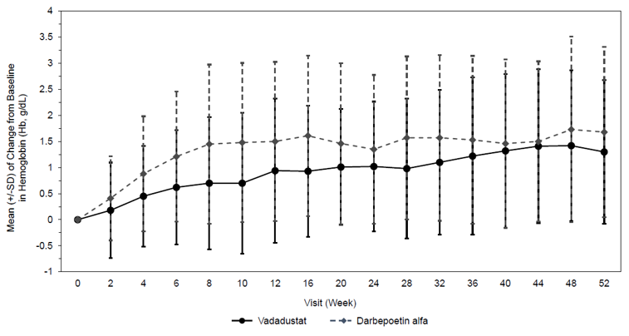

#### Study 0017 Results

##### Primary endpoint

The least squares (LS) mean change in Hb from Baseline to Weeks 24 to 36:

* vadadustat 0.19 g/dL
* darbepoetin alfa 0.36 g/dL
* between group difference −0.17 g/dL (95% CI: −0.23, −0.10).

The lower bound of the 95% CI was above the prespecified non-inferiority margin of −0.75 g/dL.

##### Key secondary efficacy endpoint

The LS mean change in Hb from Baseline to Weeks 40 to 52:

* vadadustat 0.23 g/dL
* darbepoetin alfa 0.41 g/dL
* between group difference −0.18 g/dL (95% CI: −0.25, 0.12).

The lower bound of the 95% CI was above the prespecified non-inferiority margin of −0.75 g/dL.

Figure 8: Study CI-0017 mean change of baseline haemoglobin over time

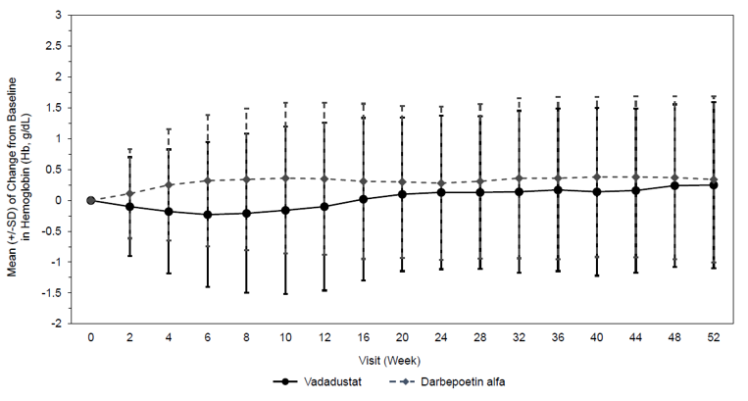

#### Other efficacy endpoints

Other efficacy endpoints including tables of comparative results for the primary and secondary analysis periods were provided. Statistical analyses are considered descriptive only for these endpoints due to the absence of adjustment for multiple comparisons.

Improvements in iron metabolism parameters (hepcidin, ferritin, serum iron, and TSAT) consistently showed a benefit in Study CI-0017. The odds of at least one administration of elemental iron was equal between vadadustat and darbepoetin alfa in Study CI-0017, whereas in Study CI-0016 this was more frequent in the vadadustat arm for each time interval of measurement. Reticulocyte count was similar between the groups in Study CI-0017 and was marginally greater at the timepoints measured in the vadadustat group in study CI-0016 with exception of the Week 52 result.

Rescue RBC transfusion was required in both studies for patients in each treatment arm. Early RBC rescue was more likely to be needed in the first 8 weeks of treatment in the vadadustat arms using the narrow criteria for assessment.

ESA rescue therapy was more frequently received in the vadadustat arms of both studies (OR for vadadustat versus darbepoetin for Weeks 2 to 8 was10.9 (95% CI: 1.39, 86.42) in study CI-0016 and 8.4 (95% CI: 5.35, 13.15) in study CI-0017). The sponsor conducted 2 post-hoc analyses of ESA rescue that redefined the narrow rescue criteria to include either ≥50% incremental increase in darbepoetin dose or ≥100% incremental increase in darbepoetin dose in the darbepoetin alfa treatment arms. In these re-analyses the difference between the vadadustat and darbepoetin arms decreased and ESA rescue was higher if the ≥50% incremental increase in darbepoetin dose was modification to the narrow rescue criteria. Using the ≥100% incremental increase in darbepoetin dose criteria modification, ESA rescue was overall similar in both arms. The evaluator sought additional analyses of the primary endpoints of the studies using different approaches for handling rescue medication and was reassured regarding the robustness of the results.

No formal quality of life assessment (QoL) was conducted in Studies CI-0016 or CI-0017. Through literature the link between Hb and QoL and results from QoL endpoints in the open-label Study CI-0025 (see below) were proposed as supportive. The open-label nature of Study CI-0025, the small sample size and short study duration of treatment are all limitations to the interpretation of the QoL data that did not demonstrate a benefit.[32]

##### Supportive studies in dialysis dependent CKD

The main supportive studies for the proposed population and dosing regimen are summarised below.

Study J03

Study J03 was a Phase III, multi-centre, randomised (1:1), double-blind, active-controlled, double-dummy, parallel group, non-inferiority study evaluating the efficacy and safety of oral vadadustat compared to darbepoetin alfa for the maintenance treatment of anaemia in 323 patients with DD-CKD conducted in Japan over 52 weeks of treatment. The study enrolled patients with anaemia secondary to DD-CKD who had received haemodialysis or hemodiafiltration for at least 12 weeks prior to screening and were maintained on ESAs, with a dose received within 8 weeks prior to screening.

The vadadustat group received a starting dose of 300 mg once daily and a placebo injection. Up-and-down titration to 150 mg, 300 mg, 450 mg or 600 mg was used to maintain target Hb levels. The darbepoetin group was dosed according to their previous dose or switched to darbepoetin from another ESA and an oral placebo. Darbepoetin dosing could be once weekly, once every 2 weeks or once every 4 weeks, and up‑and‑down titration could occur within the dosing range of 5 μg to 180 μg.

The primary efficacy endpoint was the mean Hb value at Weeks 20 and 24 in the full analysis set population. The LS mean Hb at Week 20 and 24 was 10.61 g/dL and 10.65 g/dL in the vadadustat and darbepoetin alfa treatment groups, respectively, with a between group difference of −0.05 g/dL (95% CI: −0.26, 0.17). The lower bound of the 95% CI was above the prespecified non-inferiority margin of −0.75 g/dL, demonstrating the non-inferiority of vadadustat to darbepoetin alfa.

The secondary endpoint was the mean Hb value at Week 48 and 52 in the full analysis set population. The LS mean (95% CI) Hb at Week 48 and 52 was 10.42 g/dL and 10.62 g/dL in the vadadustat and darbepoetin alfa treatment groups respectively, with a between group difference of −0.20 g/dL (95% CI: −0.40, −0.01). The lower bound of the 95% CI (−0.40) was above the prespecified non-inferiority margin of −0.75 g/dL, demonstrating the non-inferiority of vadadustat to darbepoetin alfa. The results of other efficacy endpoint analyses were also similar in both treatment groups.

Study J04

Study J04 was a Phase III, multi-centre, open-label, single arm study that evaluated the efficacy and safety of oral vadadustat in 24 adult Japanese patients with anaemia associated with DD-CKD who had received haemodialysis or haemodiafiltration 3‑times weekly prior to screening who were not treated with an ESA or had not received an ESA dose within the protocol-specified timeframe. Patients received a starting dose of vadadustat 300 mg once daily, with titration to 150 mg, 300 mg, 450 mg or 600 mg once daily to maintain target Hb levels of Hb of at least 10.0 g/dL but less than 12.0 g/dL during 24 weeks of treatment. The Baseline mean (SD) Hb across the study was 9.15 (1.00) g/dL.

The primary efficacy endpoint was the mean Hb value at Week 20 and Week 24. The LS mean (95% CI) at Week 20 and Week 24 was 10.75 g/dL (95% CI: 10.35, 11.14) and the 95% CI was within the target range. The key secondary endpoint was the change in mean Hb value over time. The mean Hb level reached the target range after 8 weeks then remained relatively stable and within the target range up to Week 24. The LS mean Hb value after 24 weeks was 10.89 g/dL (95% CI: 10.47, 11.31); 16.7% of patients at the Baseline and 73.7% of patients after 24 weeks had a Hb within the target range.

Study 0025

Study 0025 was a Phase II, multi-centre, randomised (3:3:2; 3:3:3:2; and 1:1), open-label study to evaluate vadadustat for the treatment of anaemia in subjects with DD-CKD converting from epoetin alfa therapy. The study was divided into 2 treatment groups, Main Study and ESA Hypo-responder Parallel Study to evaluate different starting doses of vadadustat based on pre-baseline ESA doses. The study enrolled 165 patients with end‑stage renal disease undergoing chronic outpatient in-centre haemodialysis three times weekly for at least 12 weeks prior to screening and had received ESA therapy (epoetin alfa) within 8 weeks of study entry. Patients in the low epoetin alfa stratum (up to and including 90 U/Kg/week) were randomised to either vadadustat commencing at 300 mg or 450 mg once daily or epoetin alfa. Patients in the high epoetin alfa stratum (more than 90 U/kg/week and less than 300 U/kg/week) were randomised either to vadadustat commencing at 300 mg, 450 mg or 600 mg once daily or continued epoetin alfa. Patients in the ESA Hypo-responder Parallel Study (epoetin alfa dose 300 U/kg/week and higher) were randomised to vadadustat commencing at 600 mg once daily or epoetin alfa.

While a ransomware attack on a central laboratory database may have impacted the results for 26 patients, the evaluator found the main issue with the interpretation of this study was the small sample sizes in the dosage groups.

Study 0022

Study 0022 was a Phase II, multi-centre, 2-part study consisting of a 6 week randomised, double-blind, placebo-controlled, dose-finding study followed by a 10 week dose adjustment and maintenance period to evaluate the efficacy, PK, PD, and safety of vadadustat for the correction and maintenance treatment of anaemia in subjects with DD-CKD. Patients randomised to the placebo group switched to vadadustat at the corresponding dose for their group at the end of the randomised period. The study randomised 60 patients who had received at least 8 weeks of chronic maintenance haemodialysis prior to screening and who had undergone a mandatory washout from injectable ESAs during the screening period. Eligible subjects were randomised in a 3:1 ratio to receive vadadustat (150 mg, 300 mg or 600 mg) or placebo once daily during the 6 week controlled period, during which no dose increases were permitted. Dose adjustments were allowed between Weeks 6 and 16. Compared with Baseline, mean Hb values increased significantly in the 600 mg, 300 mg, and 150 mg dose groups by Week 6, Week 10, and Week 12, respectively.

Study 0011

Study 0011 was Phase II open-label 16 week study designed to assess the PD response, safety, and tolerability of oral dosing of vadadustat in 94 adults with DD-CKD undergoing chronic maintenance haemodialysis, who were previously maintained on epoetin alfa therapy. Eligible subjects continued their ESA therapy during screening but were required to discontinue ESA therapy prior to their baseline visit, at which they were sequentially assigned to 1 of 3 vadadustat dose cohorts: 300 mg once daily, 450 mg once daily or 450 mg three times weekly. No increase in the vadadustat dose was permitted in the first 8 weeks of treatment, after which dose adjustments could be made. The primary efficacy endpoint was the change in Hb levels as assessed by the Week 7/8 average minus the pre-dose average, the Week 15 to 16 average minus the pre-dose average, and the Week 15/16 average minus the Week 7 to 8 average. There were no meaningful differences in mean Hb for any of the comparisons made. This study is presented in support of transitioning from stable ESA to vadadustat.

Study J02

Study J02, that ran from 03 January 2018 to 6 December 2018, was an open-label single arm study in patients undergoing peritoneal dialysis.

#### Supportive studies in NDD-CKD

Studies CI-0014 and CI-0015, the PRO2TECT Global Phase III studies, conducted in North America, Europe, and the Asia Pacific, compared vadadustat with darbepoetin alfa in NDD-CKD. In Study CI-0015 patients were on maintenance ESA treatment for anaemia in NDD-CKD and in Study CI-0014 patients had anaemia requiring treatment (Hb between 8 and 11 g/dL in the USA or between 9 and 12 g/dL outside of the USA, as determined by 2 sequential Hb values during screening) but who had not been on an ESA for at least 8 weeks. The submission also included another Phase III study conducted in Japan (Study J01) and 3 Phase II controlled studies (Studies 0021, 0005, and 0007) in NDD-CKD. After the indication was amended to include only patients with DD-CKD on chronic maintenance dialysis these studies became supportive only for efficacy, but they contribute patient data to the PK, PD, and safety analyses for vadadustat.

#### Safety

The overall safety information was assessed for the 2 pivotal studies for the DD-CKD population, comprising data from 1,947 patients who had received vadadustat and 1,955 patients who had received darbepoetin alfa. Across the development program 2,503 patients were exposed to at least one dose of vadadustat.

In the pooled safety data from both pivotal studies in DD-CKD, the median (range) duration of exposure was 55.86 weeks (range 0.1 to 163.1) in the vadadustat group and 71.71 weeks (range 0.1 to 169.1) in the darbepoetin group.

In the vadadustat group, 900 patients had up to 1 year of exposure, 772 patients had at least 52 weeks but less than 104 weeks exposure, and a further 275 patients received their study drug for at least 104 weeks.

In the darbepoetin group, 638 patients had up to 1 year of exposure, 914 patients had at least 52 weeks but less than 104 weeks exposure, and a further 403 patients received their study drug for at least 104 weeks.

##### Overall adverse events

Tabulated summaries of the treatment emergent adverse events (TEAEs) from Study CI-0016 are presented in Table 5.

Table 5: Study CI-0016 overall summary of treatment-emergent adverse events (safety population)

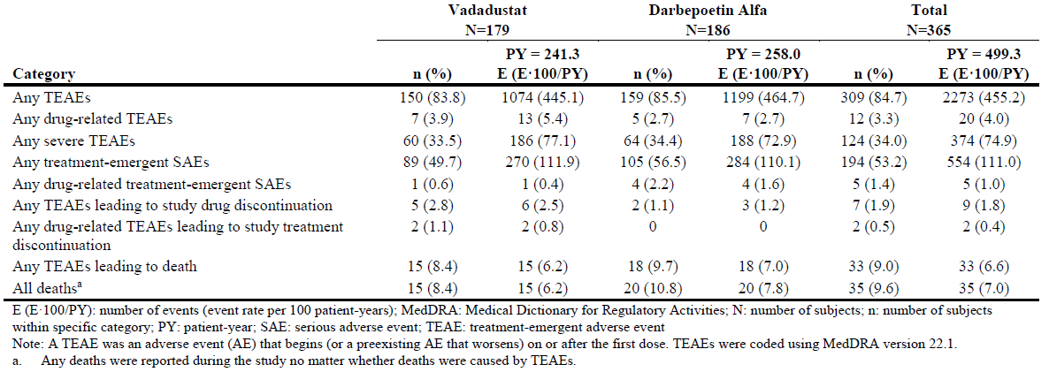

The most frequent treatment-emergent adverse events (TEAEs) by System Organ Class (SOC)[33] for the vadadustat and darbepoetin groups, respectively, were Infections and infestations (40.8% and 52.7%), Injury, poisoning, and procedural complications (34.6% and 36.0%), and Gastrointestinal disorders (34.1% and 33.9%). The most frequent TEAEs by preferred term (PT)[34] in the vadadustat group were hypertension (16.2%), diarrhoea (10.1%), nausea (7.8%), with pneumonia, vomiting, fluid overload, and dyspnoea occurring at the same incidence (all 7.3%). The most frequent TEAEs by PT in the darbepoetin alfa group were hypertension (12.9%), diarrhoea (9.7%), hypotension (8.6%), urinary tract infection (8.6%), and pneumonia (8.1%). Of the TEAEs leading to withdrawal of study drug, the only event that occurred in more than one patient was asthenia, reported for 2 patients in the vadadustat group.

Of the drug-related TEAEs, the most frequently reported in the vadadustat group was asthenia (2 [1.1%]) while fatigue, pyrexia, diarrhoea, gastroesophageal reflux disease, nausea, cataract, diabetic retinopathy, vision blurred, blood pressure increased, gamma-glutamyl transferase increased, and leucocytosis, were each reported for 1 patient (0.6%). In the darbepoetin alfa group, cerebrovascular accident, headache, lacunar infarction, seizure, arteriovenous fistula thrombosis, pruritus, and hypertension, were each reported for 1 patient (0.5%).

None of the 15 (8.4%) and 18 (9.7%) fatal TEAEs in the vadadustat and darbepoetin alfa groups, respectively were considered related to study drug.

Treatment‑emergent serious adverse events (SAEs) were reported in 49.7% and 56.5% patients in the vadadustat and darbepoetin alfa groups, respectively. By PT, the most frequently observed SAEs in the vadadustat and darbepoetin alfa groups were fluid overload (5.6% and 1.1%), pneumonia (4.5% and 3.8%), hypertensive urgency (3.9% and 1.6%), sepsis (1.7% and 3.2%), and arteriovenous thrombosis (1.7% and 3.2%).

Drug-related SAEs were observed in 0.6% and 2.2% in the vadadustat and darbepoetin alfa group, respectively. The single patient with the drug-related SAE had a diabetic retinopathy.

Tabulated summaries of the treatment TEAEs from Study CI-0017 are in Table 6.

Table 6: Study CI-0017 summary of adverse events

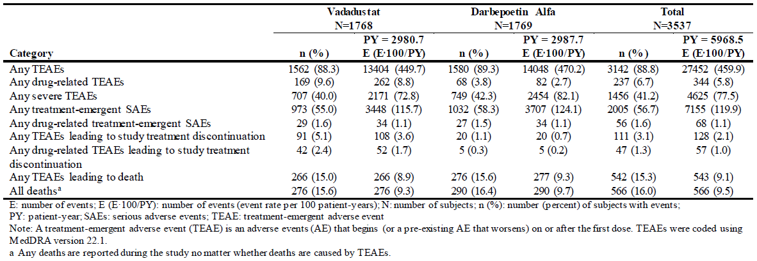

The most frequent TEAEs by SOC for the vadadustat and darbepoetin groups, respectively, were Infections and infestations (51.0% and 53.2%), Gastrointestinal disorders (41.0% and 37.4%) and Injury, poisoning, and procedural complications (40.0% and 39.9%). The most frequent TEAEs by PT in the vadadustat group were diarrhoea (13.0%), pneumonia (11.0%), hypertension (10.6%), hyperkalaemia (9.0%), and headache (9.0%). The most frequent TEAEs by PT in the darbepoetin alfa group were hypertension (13.8%), hyperkalaemia (10.8%), diarrhoea (10.1%), pneumonia (9.7%), and fall (9.0%). Of the TEAEs leading to discontinuation of study drug, no PT represented the cause in ≥1% of patients, but the most frequent reason in the vadadustat arm was diarrhoea (0.8%).

Of the drug related TEAEs, the most frequently reported in the vadadustat group by SOC were from the Gastrointestinal disorders (diarrhoea [2.2%] and nausea [1.5%]), and in the darbepoetin alfa group, were Injury, poisoning and procedural complications (0.6%), Vascular disorders (0.6%), and Investigations (0.6%).

Fatal TEAEs were reported for 266 (15.0%) and 276 (15.6%) patients in the vadadustat and darbepoetin alfa groups, respectively. The most frequent reported events were cardiac arrest (2.0% and 2.1%), septic shock (1.3% and 1.2%), and cardio-respiratory arrest (1.2% and 1.3%) for the vadadustat and darbepoetin alfa treatment groups, respectively. All Fatal TEAEs in the vadadustat group were considered unrelated, whereas one fatal acute MI in the darbepoetin alfa group was considered related.

Treatment-emergent SAEs were reported in 55.0% and 58.3% patients in the vadadustat and darbepoetin alfa groups, respectively. The most frequent treatment-emergent SAEs by SOC for vadadustat and darbepoetin alfa were Infections and infestations (27.8% and 28.2%), Cardiac disorders (16.7% and 20.0%), Injury, poisoning and procedural complications (13.1% and 13.6%), Metabolism and nutrition disorders (11.0% and 11.8%), and Gastrointestinal disorders (10.6% and 10.2%). By PT the most frequent events in vadadustat and darbepoetin groups were pneumonia (7.9% and 6.7%), sepsis (4.3% and 5.0%), fluid overload (5.5% and 5.5%), and acute myocardial infarction (4.6% and 4.4%).

Drug-related SAEs were observed in 1.6% and 1.5% of the vadadustat and darbepoetin alfa groups, respectively. The drug-related SAEs most frequently observed in at least 2 patients in the vadadustat group were arteriovenous fistula thrombosis (2 [0.1%]), duodenal ulcer (2 [0.1%]), gastritis (2 [0.1%]), and anaemia (2 [0.1%]). The drug-related SAEs most frequently observed in the darbepoetin alfa treatment group observed in at least 2 patients were arteriovenous fistula thrombosis (7 [0.4%]), acute myocardial infarction (3 [0.2%]), and DVT (2 [0.1%]). No other drug-related treatment-emergent SAE was experienced by at least 1 patient in either treatment group.

##### Major Adverse Cardiovascular Events (MACE)

MACE was a powered, pre-specified safety endpoint in the Phase III studies in DD-CKD and from the main Phase III studies in NDD-CKD. MACE events were assessed using a blinded independent Clinical Endpoints Committee to adjudicate events, using a structed process. It included data from 3,686 vadadustat patients and 3,687 darbepoetin patients.

Table 7: Global Phase III studies in Chronic kidney disease, Summary of MACE (safety population)

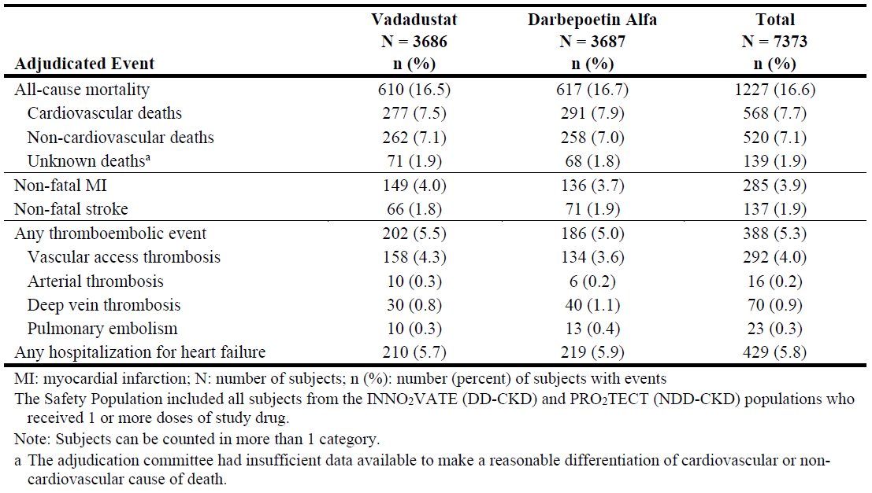

To determine whether there was a regional variation, the following analysis of MACE events was conducted.

Table 8: Global Phase III studies in Chronic kidney disease, by region, summary of MACE (safety population)

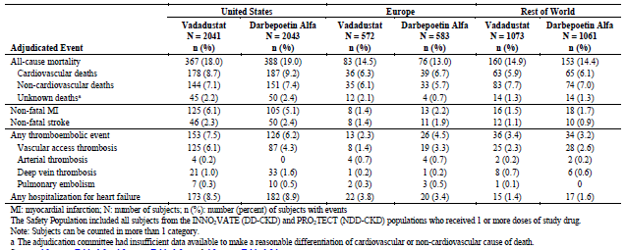

MACE events were analysed separately for DD-CKD. It was anticipated the annual MACE rate would be 12% based on a review of epidemiology and prospective clinical studies. Numerous pre-specified endpoints for MACE events were included in the analysis; as noted previously, the non-inferiority margin was based on the upper bound of the 95% CI for the HR for the comparison of vadadustat and darbepoetin alfa. For the USA this was set at 1.25 and for the EU set at 1.3.

Table 9: Study CI-0016 and Study CI-0017 summary of MACE (safety population)

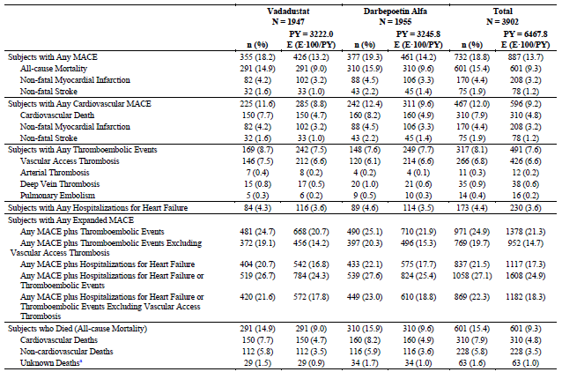

Abbreviations: MACE: major adverse cardiovascular event; N: number of subjects

The Safety Population included all subjects who received 1 or more doses of study drug.

n (%)= number (percent) of subjects with events, E (E·100/PY) = number of events (event rate per 100 patient-years). PY for each subject = (last follow-up date for events – first dose date + 1)/365.25.

a The adjudication committee had insufficient data available to make a reasonable differentiation of cardiovascular or non-cardiovascular cause of death.

The primary MACE endpoint was time to first MACE: HR 0.96 (95% CI 0.83, 1.13), meeting the pre-specified non-inferiority margins. Of the numerous other analyses, the time to first thromboembolic event (composite of vascular access thrombosis, arterial thrombosis, DVT, PE) [HR 1.20 (95% CI: 0.959, 1.493)], time to first thromboembolic event of arterial thrombosis, DVT or PE [HR 0.86 (95% CI: 0.509, 1.444)] and time to first hospitalisation for heart failure [HR 0.99 (95% CI: 0.733, 1.334) did not meet either the FDA or EMA non-inferiority margins.

Noninferiority for MACE between vadadustat and darbepoetin alfa was not demonstrated for time to first MACE event in the NDD-CKD studies [HR 1.17 (95% CI: 1.012, 1.355). This was of significant concern for the evaluation and through the evaluation process the sponsor restricted its requested indication to patients on chronic maintenance dialysis (DD-CKD).

##### Other adverse events of special interest

Worsening of hypertension, as defined by the standardised MedDRA Query, was observed in the vadadustat and darbepoetin groups in 22.9% and 19.4% in Study CI-0016 and 15.6% and 19.3% in Study CI-0017.

Hypersensitivity was an adverse event of special interest (AESI). In Study CI-0017, 0.2% of subjects were reported to have had an anaphylactic reaction and 0.1% had anaphylactic shock. No patients in Study CI-0016 had such events, and overall hypersensitivity and was reported less frequently in vadadustat compared with darbepoetin.

Hyperkalaemia, including blood potassium abnormal and blood potassium increased, was observed in 4.5% and 5.4% of the vadadustat and darbepoetin alfa groups, respectively in Study CI-0016. In Study CI-0017 these events were observed in 9.0% and 11.2% of the vadadustat and darbepoetin alfa treatment groups, respectively.

Pulmonary hypertension was reported in 0.6% and 1.1% of the vadadustat and darbepoetin alfa treatment groups, respectively in Study CI-0016 and 2.8% and 3.1% in Study CI-0017.

Cardiac valve disorders were observed in the vadadustat and darbepoetin alfa groups in 1.1% and 3.2% patients in Study CI-0016 and 2.5% and 2.9% patients in Study CI-0017.

Hepatotoxicity was given specific attention because of a potential signal arising from preclinical studies. The submission included a hepatic expert report that included results from blinded and unblinded review committee assessments. The committees used different criteria for assigning causality, limiting direct comparisons of the outcomes. The blinded committee identified 55 possibly/probably related drug induced liver injury cases in the vadadustat group and 94 cases in the darbepoetin alfa groups. There is one case of mixed hepatobiliary injury considered related to vadadustat that was assessed as probably related by both the blinded and unblinded committees. There were no cases of fulminant hepatitis with any case and no reports of death due to hepatic injury. The expert report concluded that if a hepatotoxic potential exists for vadadustat it is very low. The sponsor has included hepatotoxicity in the Risk management plan Summary of safety concerns. It proposes a targeted follow up questionnaire for potential cases.

Potential class effects of seizures and adrenal disorders were included in the events of special interest, but no signals were detected for these events. The sponsor proposes to include seizures in the Precautions section of the Vafseo PI.

#### Other clinical issues (for example, companion diagnostic considerations)

Real World Evidence includes data regarding the usage, or the potential benefits or risks, of a therapeutic good derived from sources other than traditional clinical trials. Real World Evidence/Data were not included in the submission.

Patient eligibility is not based on the use of a companion diagnostic.

### Risk management plan

The summary of safety concerns and their associated risk monitoring and mitigation strategies are presented in Table 3. The TGA may request an updated RMP at any stage of a product's life-cycle, during both the pre-approval and post-approval phases.

Table 10: Summary of safety concerns

|  |  |  |  |  |  |
| --- | --- | --- | --- | --- | --- |
| Summary of safety concerns | | Pharmacovigilance | | Risk minimisation | |
| **Routine** | **Additional** | **Routine** | **Additional** |
| **Important identified risks** | None |  |  |  |  |
| **Important potential risks** | Hepato-toxicity | ✓∗ | − | ✓ | − |
| **Missing information** | None |  |  |  |  |

* Includes Targeted follow-up questionnaire; Summary Hepatic Safety reports; Specific clinical measures in the PI.

The RMP evaluation recommended conditions of registration relating to the versions of the risk management plan, requirement for periodic safety update reports, and inclusion of the medicine in the Black Triangle Scheme.

The Delegate notes there are other significant safety concerns with this medicine that are described in the Efficacy and Safety sections above. The sponsor proposes only routine risk minimisation activities in the form of language in the Vafseo PI to mitigate the risks of MACE and vascular access occlusion. As noted by the RMP evaluator, during the course of the submission the sponsor removed myopathy and rhabdomyolysis with concomitant use of specific statins (rosuvastatin and simvastatin) and thromboembolic events (including myocardial infarction and stroke) as important identified risks, malignancies as an important potential risk, and use in patients with polycystic kidney disease and use during pregnancy and breast-feeding as important missing information from the summary of safety concerns.

Thromboembolic events (including myocardial infarction and stroke) had been proposed for a Post Authorisation Safety Study (PASS) in the EU when the proposed indication included NDD-CKD patients; however, after the indication was restricted to DD-CKD patients only, this additional pharmacovigilance activity was no longer required. The sponsor is required to monitor these events in the periodic safety update report (PSURs).

### Risk-benefit analysis

The current management strategies for the anaemia of CKD include optimising iron and Vitamin B12 levels, iron supplements, ESAs and rescue red cell transfusions. Each approach has its limitations and some significant potential safety issues. There is a need for alternative strategies. Vadadustat is proposed as an alternative strategy for managing the anaemia of CKD in a subset of CKD patients.

The proposal is supported by a clinical development plan with a broader initial scope than the currently proposed indication.

This submission was evaluated under the work-sharing and collaborative arrangements of the New Active Substance Work Sharing Initiative (NASWI) with the ACCESS partners of Swissmedic and the MHRA. The evaluators of all modules supported the registration of vadadustat for the currently proposed indication.

#### Benefits

The evidence to support use in patients with dialysis dependent CKD is supported by 2 randomised open-label, non-inferiority studies, Study CI-0016 and Study CI-0017 that compared vadadustat and darbepoetin alfa. Darbepoetin was the representative ESA. A recent Cochrane review did not find clear differences between the ESAs for efficacy and safety, although it identified limitations in the evidence that supported this conclusion.[35] While there is no specific objection to this approach, the ACM will be asked for its view on ESA use in the Australian clinical landscape.

Study CI-0016 and Study CI-0017 had similar designs allowing some pooling of the efficacy and safety information. Study CI-0016 investigated use in patients with incident dialysis and Study CI-0017 investigated use in patients on established dialysis converting from an ESA to vadadustat. This was the larger of the 2 studies and the submission relies heavily on this study for the efficacy and safety information. This study included patients on peritoneal and haemodialysis.

Both studies used a between‑treatment group comparison of the mean change from baseline Hb as the main efficacy variables, measured at 2 timepoints over the course of a year of treatment. The non-inferiority margin changed through the course of the study, but at the final analysis, and with a non-inferiority margin of −0.75 g/dL, both studies found vadadustat non-inferior to darbepoetin alfa. However, if the initial non-inferiority margin of −0.5 g/dL were applied Study CI-0016 would not have demonstrated the non-inferiority of vadadustat and darbepoetin for the primary endpoint of the change from baseline in Hb to the average over Weeks 24 to 36. Both studies met the key secondary endpoint for the change from baseline in Hb to the average over Weeks 40 to 52.

Numerous other efficacy endpoints common to each study included endpoints relating to iron homeostasis, and the need for rescue therapy including ESAs and red cell transfusion. There was no adjustment for multiple comparisons for these endpoints, no statistical inference can be drawn from these comparisons, and the findings are considered descriptive only.

Treatment was to target Hb, but the target was different between the USA and the rest of the world in both studies. This reflects the different labelled targets for ESAs. The target of 10 to 12 g/dL is consistent with the targets for ESAs available in Australia. It is possible that overshoot of target Hb within the studies is dampened as a result. The sponsor proposes to provide dosing guidelines in the PI consistent with a 12 g/dL target. While this will likely cause less confusion in a regulatory sense, there is evidence to support the lower target. The ACM is asked to comment on current Australian clinical approach to a numerical Hb target.

#### Risks

Thromboembolic disease is a known adverse effect for the class of HIF stabilisers.27 [36] A background risk of MACE exists for patients with late-stage CKD, and an increased risk is already recognised with ESAs. A major concern for this class of medicines is whether the risk of MACE is incrementally greater than for ESAs. This clinical question was given specific consideration during the clinical development program of vadadustat, and the pivotal studies were specifically powered for a comparison of vadadustat and darbepoetin alfa for MACE. Again, there was a difference between the EMA and US FDA regarding the non-inferiority margin, this time the upper bound of the 95% confidence interval for the difference between vadadustat and darbepoetin alfa. The threshold for non-inferiority was 1.25 for the US FDA and 1.3 for the EMA, and the Delegate favours the more stringent 1.25 upper bound of the 95% confidence interval to assess this endpoint. The primary MACE endpoint was time to first MACE: HR 0.96 (95% CI 0.83, 1.13), meeting the pre-specified non-inferiority margins.

Components of the MACE endpoints of the time to first thromboembolic event (composite of vascular access thrombosis, arterial thrombosis, DVT, PE) [HR 1.20 (95% CI: 0.959, 1.493)], time to first thromboembolic event of arterial thrombosis, DVT or PE [HR 0.86 (95% CI: 0.509, 1.444)] and time to first hospitalisation for heart failure [HR 0.99 (95% CI: 0.733, 1.334) did not meet either the FDA or EMA non-inferiority margins. It is recognised that the study was powered for the primary MACE endpoint, and that the subgroup analyses were not specifically powered and the estimates of risk lack some precision because of the size of the subgroups.

Non-inferiority of vadadustat and darbepoetin for MACE events was not demonstrated in the NDD-CKD Phase III studies and the Delegate considers the sponsor’s limitation of the indication to the DD-CKD population is one supported by the evidence.

Gastrointestinal adverse events may be a limitation of use for an oral medication. While gastrointestinal events were cause of discontinuation, such events occurred in less than 1% of the vadadustat DD-CKD population. Other adverse events of special interest occurred in similar proportions of patients in the vadadustat and darbepoetin alfa groups in Study CI-0017 but hypertension was numerically more frequent in the vadadustat group in Study CI-0016.

Rescue therapy with ESAs or RBCs were more frequently reported in the vadadustat arm, and particularly in the first 8 weeks of treatment, more noticeably in Study CI-0016 than Study CI‑0017. The between-treatment differences were diminished if darbepoetin rescue in the darbepoetin arm was included in the analysis.

Discontinuations were also more frequent in the vadadustat arms than the darbepoetin arms during the first treatment period (up to 24 to 36 weeks). Discontinuations due to gastrointestinal events were noted for vadadustat in Study CI-0017.

It is not intended that vadadustat and ESAs will be given concomitantly to the same patient on an ongoing basis. The safety and efficacy of combination therapy of vadadustat and ESAs as ongoing maintenance treatment for the anaemia of CKD was not described in the submission. While the risks of these 2 medicines appear similar with respect to thromboembolic and MACE events, the risks of concomitant use in recommended therapeutic doses have not been quantified and whether the risks are additive is unknown. Education for patients/carers will be important to ensure smooth transition to and from each anaemia treatment option, and especially during episodes of rescue therapy. The sponsor could highlight this uncertainty in the Vafseo PI.[37]

The primary and key secondary endpoint were change in Hb rather than relief from symptoms of anaemia, but the proposed indication limits the use to symptomatic patients. Not all international clinical guidelines require the patient to be symptomatic prior to treatment, so there is the potential for off-label use in asymptomatic patients.

##### Uncertainties

Both pivotal studies had a relatively large proportion of patients excluded from the per-protocol analysis. While sensitivity analyses were consistent with the primary analyses, there is an element of uncertainty regarding the internal validity of the studies. This is overcome to a certain extent by the numbers of patients that could be included, and the consistency of the efficacy results between the studies.

Patients on peritoneal dialysis could be included in Studies CI-0016 and CI-0017 but they represented less than 10% of the total patient population in these studies. While there is not a specific reason based on mechanism of action that vadadustat should have different efficacy or safety in this population the direct evidence is limited.

Vadadustat is highly plasma protein bound. There are limited data on the impact of relative hypoalbuminaemia in some patients with CKD. This uncertainty is overcome to a certain extent by the titration of dose to haemoglobin.

There are still some uncertainties regarding drug-drug interactions. The sponsor has a requirement in the EU to further characterise CYP2B6 induction. If approved, this information would be relevant in Australia, also.

Vadadustat treatment may continue for many years, so long-term safety is a relevant consideration. The study population included 275 patients who received vadadustat for at least 104 weeks, providing some reassurance of the tolerability of vadadustat as well as its efficacy and safety. The exposure is not sufficient to assess the incidence of uncommon and rare adverse events, and aspects of its long-term safety remain uncertain.

##### Benefit risk balance

The basis of the benefit risk considerations is weighted to prespecified, specifically powered endpoints in Studies CI-0016 and CI-0017. Non-inferiority was demonstrated for MACE events in Study CI‑0017. For this reason, the benefits are seen to balance the risks for the Study CI-0017 population. Although not the primary MACE endpoint, the imbalance in risk of thromboembolic events not in favour of vadadustat is of concern and patient selection may need to take this into account for patients with more thromboembolic risk factors than CKD alone.

Fewer patients with incident dialysis were included in the efficacy assessment giving rise to some uncertainty for this specific subset of the chronic dialysis population. This population is out of scope of the currently requested indication.

##### Requested indication and dosage regimen

The evidence in support of the indication for consideration is limited to patients with symptomatic anaemia who are on maintenance dialysis for chronic kidney disease. Symptomatic anaemia was not explicitly specified as an inclusion criterion for either of Study CI-0016 or Study CI-0017. Given the potential risk of MACE events, it would appear a reasonable limitation, but the ACM is asked to consider this specific aspect of the indication.

The indication does not specify whether the dialysis is peritoneal dialysis or haemodialysis, reflecting the entry criteria in Studies CI-0016 and CI-0017.

The sponsor proposes to limit vadadustat to adult patients, which is consistent with the main studies in the clinical study program that included only adult patients.

The proposed dosage regimen is a starting dose of 300 mg once daily orally with up-titration every 4 weeks until the target Hb is reached, and up‑and‑down titration can be used throughout therapy. The maximum daily dose is 600 mg daily.

#### Proposed action

The Delegate has not yet reached a conclusion regarding this submission. At the preliminary stage, and subject to the advice of the ACM, the Delegate is inclined to approve vadadustat for the requested indication.

If the submission is approved the Delegate proposes to impose conditions of registration relating to the Risk Management Plan and the Black Triangle Scheme.

#### Questions for the sponsor

The sponsor provided the following response to questions from the Delegate.

1. ***Is there any relationship between vadadustat-acyl-glucuronide serum concentration and MACE events?***

In the radiolabelled absorption, distribution, metabolism and excretion (ADME) Study CI-0008 in healthy male volunteers, vadadustat was extensively metabolised with 26 metabolites identified across plasma, urine and faeces. Most of these metabolites are considered minor except for vadadustat‑O‑glucuronide. Following the oral administration of [14C] vadadustat (650 mg), vadadustat, vadadustat‑O‑glucuronide, and vadadustat acyl glucuronide represent 75.0%, 14.9%, and 0.047% of the total radioactivity in plasma, respectively. Glucuronidation is the major pathway of metabolism for vadadustat with most of the radioactive dose excreted as vadadustat‑O‑glucuronide in urine. Vadadustat and vadadustat‑O‑glucuronide were the only major circulating drug-related components observed in human plasma. Comparison of PK parameters in Study CI-0008 between the metabolites of vadadustat and vadadustat indicated that the systemic exposure of the vadadustat-acyl-glucuronide is ≤0.1% relative to vadadustat. Thus, acyl-glucuronide can be considered as a negligible contributor to total radioactivity.

In study AKB-6548-CI-0020 (multiple ascending dose study in Japanese and White healthy subjects), the vadadustat-acyl-glucuronide levels were too low to allow for calculation of metabolite to parent ratios; see Table 11.

Table 11: Study CI-0020 mean pharmacokinetic parameters of vadadustat after multiple oral daily doses of 150 mg, 300 mg and 600 mg vadadustat on Day 10 in Japanese and White healthy subjects

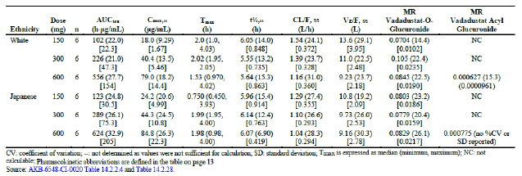

The results of MACE events from the clinical trials do not indicate a difference between vadadustat and the active comparator darbepoetin alfa. In the dialysis dependent CKD population, the primary safety endpoint, non-inferiority of time to first MACE compared to darbepoetin alfa, was met with the upper bound of the 95% CI below the pre-specified non-inferiority margin of 1.3 (HR: 0.96; CI: 0.833, 1.113), and the results were consistent between Studies CI-0016 and CI-0017.

In conclusion, Vadadustat undergoes extensive metabolism, primarily through glucuronidation, resulting in the formation of various metabolites. Vadadustat‑O‑glucuronide is the major metabolite, while vadadustat‑acyl‑glucuronide is considered negligible. The systemic exposure of vadadustat‑acyl‑glucuronide is minimal compared to vadadustat. In addition, as there is no observed difference in MACE events between vadadustat and darbepoetin alfa, it seems improbable that vadadustat‑acyl‑glucuronide would be related to MACE events.

1. ***The maximum dose of atorvastatin is 80 mg/day. Given the increase in exposure in the interaction study with atorvastatin please explain the reason there is no recommendation to lower the maximum dose for this statin in the draft Vafseo PI.***

Study CI-0030 was a 3-part, open-label study in healthy subjects to evaluate the potential for interaction of vadadustat as a perpetrator with rosuvastatin, sulfasalazine, pravastatin, atorvastatin (40 mg) and simvastatin. The PK of atorvastatin is nonlinear and thus multiple doses of atorvastatin were used in this study. This is in accordance with the draft ICH M12 guidance,[38] which states that ‘if the victim drug has dose-dependent PK, the therapeutic dose most likely to demonstrate a DDI should be used’.

The results of the study showed that when atorvastatin was administered in combination with vadadustat, total (AUC) systemic exposures to atorvastatin increased about 40%, whereas peak (Cmax) systemic exposures remained unchanged. According to the international DDI guidance,[39] this is considered a weak interaction as the atorvastatin AUC was increased by less than 2‑fold. The systemic exposures to o‑hydroxyatorvastatin were unchanged when atorvastatin was co-administered with vadadustat; whereas, the total (AUC) and peak (Cmax) exposure to p‑hydroxyatorvastatin were increased about 1.75‑fold and 2.3‑fold, respectively. Although the p‑hydroxyatorvastatin Cmax was increased by more than 2‑fold, this metabolite constitutes only a minor pathway in atorvastatin's metabolic elimination and the metabolite to parent ratio is 0.1.

Further, since both the o‑hydroxyatorvastatin and p‑hydroxyatorvastatin inhibit HMG-Co reductase similarly to parent compound,[40] this observed increase in p‑hydroxyatorvastatin would have only a minor effect on overall atorvastatin activity. Consequently, the overall pharmacologic activity of atorvastatin is not altered to a clinically meaningfully degree by coadministration with vadadustat.

The lack of clinical effect is further supported by the fact that there were no excess TEAEs observed among patients given concomitant vadadustat + statins relative to patients given darbepoetin + statins in the Phase III clinical program.

The recommended starting dose of atorvastatin is 10 mg or 20 mg, and the clinically recommended dosage range is 10 to 80 mg/day. The maintenance doses of atorvastatin should be individualised and titrated according to patient characteristics, and it is recommended to monitor the lipid levels within 2 to 4 weeks to adjust the dose accordingly. Overall, these results suggest no adjustment is needed for atorvastatin since it has a wide therapeutic window, and the clinically observed interaction was either non-existent or weak.

#### Advisory Committee considerations

The [Advisory Committee on Medicines (ACM)](https://www.tga.gov.au/committee/advisory-committee-medicines-acm), having considered the evaluations and the Delegate’s overview, as well as the sponsor’s response to these documents, advised the following.

##### Specific advice to the Delegate

1. ***The pivotal studies in dialysis dependent CKD compared vadadustat with darbepoetin alfa. Please comment on the choice of ESA comparator. Specifically:***
   1. ***Does the use of darbepoetin alfa reflect typical Australian clinical practice? If not, are there are any uncertainties with the interpretation of Studies CI-0016 and CI-0017 in the Australian context?***

The ACM advised that darbepoetin alfa is a commonly prescribed ESA for dialysis patients in Australia. Based on this, the ACM was of the view the pivotal studies are relevant to real world Australian clinical practice.

1. ***In the pivotal studies, the proposed target Hb range was 10 to 11 g/dL for the USA but 10 to 12 g/dL for the rest of the world. While 10 to 12 g/dL is the target Hb range for ESAs, should it be the target for HIF inhibitors also?***

The ACM was of the view that there is no mechanistic or clinical reason to apply a different target Hb range for HIF inhibitors. The ACM noted that global guidelines including the Caring For Australians and New Zealanders with Kidney Impairment (CARI) guidelines state that the target range is 10 to 11.5(/12) g/dL for Hb.

In providing this advice the ACM also noted that an individual’s cardiovascular risk should be evaluated when prescribing vadadustat and Hb targets considered as part of this evaluation. The ACM advised that Hb levels greater than 13 g/dL should be avoided due to unacceptable cardiovascular risks.

1. ***Please comment whether the risk of MACE events is acceptable in the context of the proposed in patients on chronic maintenance dialysis.***

The ACM agreed that the risk of MACE events is acceptable in the context of dialysis dependent chronic kidney disease.

The ACM noted that there were similar numbers of MACE events across both the vadadustat and darbepoetin alfa groups in the pivotal studies for this patient group. The ACM also considered other cohorts including data from the Dialysis Outcomes and Practice Patterns Study,[41] and was of the view that real world data aligns with the finding from the clinical studies.

The ACM also acknowledged that CKD is associated with a risk of CV events, further stating that diabetes in also a risk factor for CV events.

1. ***The sponsor proposes to restrict the indication to patients with symptomatic anaemia, but this was not a specific requirement of the main clinical studies. It is understood that this is a risk minimisation strategy to target only those patients in most clinical need, but does the ACM have any concerns with this approach?***

The ACM queried whether the application of the restriction to symptomatic anaemia would have value as a risk minimisation strategy, noting that the selection of ‘symptomatic’ patients may result in the selection of a frailer subset of dialysis patients.

The ACM noted that the symptoms of anaemia are often non-specific and overlap with many common co-morbidities and symptoms in the dialysis-dependent population. The ACM advised that anaemia is diagnosed based on Hb measurements and guidelines for the management of anaemia in dialysis dependent end stage kidney disease are based on Hb and iron measurements.

The ACM was of the view that the indication should not include ‘symptomatic’ and as such allow the treating clinician to determine the appropriateness of therapy based on laboratory results and clinical assessment.

1. ***Regarding the risk management plan:***
   1. ***Is routine risk minimisation in the form of warnings and precautions in the Vafseo Product Information sufficient to mitigate the risk of MACE events and vascular access occlusion? If not, what does the ACM suggest would be an effective risk minimisation activity?***

The ACM was of the view that routine risk minimisation in the form of warnings and precautions in the PI are sufficient and align with the current approach to MACE risk with ESA therapy. These risks are widely understood by nephrologists and are considered as part of each patient assessment.

The ACM noted that the draft PI will require review to ensure that values/numbers match the clinical study safety information for the indicated population

* 1. ***Are additional pharmacovigilance activities warranted to further characterise this risk? If so, what does the ACM suggest would be effective?***

The ACM did not identify any additional pharmacovigilance activities.

##### Conclusion

The ACM considered this product to have an overall positive benefit-risk profile for the indication:

*Vafseo is indicated for the treatment of anaemia associated with chronic kidney disease (CKD) in adults on chronic maintenance dialysis.*

## Outcome

Based on a review of quality, safety, and efficacy, the TGA decided to register Vafseo (vadadustat) as 150 mg, 300 mg and 450 mg film‑coated tablets in blister packs, indicated for:

*Vafseo is indicated for the treatment of anaemia associated with chronic kidney disease (CKD) in adults on chronic maintenance dialysis.*

### Specific conditions of registration applying to these goods

* Vafseo (vadadustat) is to be included in the Black Triangle Scheme. The PI and CMI for Vafseo must include the black triangle symbol and mandatory accompanying text for 5 years, which starts from the date that the sponsor notifies the TGA of supply of the product.
* The Vafseo EU-Risk Management Plan (RMP) (version 2.0, dated 21 February 2023, data lock point 18 August 2021), with Australian Specific Annex (version 1.3, dated September 2023), included with submission PM-2022-00525-1-6 and any subsequent revisions, as agreed with the TGA will be implemented in Australia.
* An obligatory component of risk management plans is routine pharmacovigilance. Routine pharmacovigilance includes the submission of periodic safety update reports (PSURs).
* Unless agreed separately between the supplier who is the recipient of the approval and the TGA, the first report must be submitted to TGA no later than 15 calendar months after the date of the approval letter. The subsequent reports must be submitted no less frequently than annually from the date of the first submitted report until the period covered by such reports is not less than 3 years from the date of the approval letter. The annual submission may be made up of two PSURs each covering 6 months. If the sponsor wishes, the 6-monthly reports may be submitted separately as they become available.
* If the product is approved in the EU during the 3-year period, reports can be provided in line with the published list of EU reference dates no less frequently than annually from the date of the first submitted report until the period covered by such reports is not less than 3 years from the date of the approval letter.
* The reports are to at least meet the requirements for PSURs as described in the European Medicines Agency’s Guideline on good pharmacovigilance practices (GVP) Module VII-periodic safety update report (Rev 1), Part VII.B Structures and processes. Note that submission of a PSUR does not constitute an application to vary the registration. Each report must have been prepared within 90 calendar days of the data lock point for that report.

## Attachment 1. Product Information

The [Product Information](https://www.tga.gov.au/products/australian-register-therapeutic-goods-artg/product-information-one) ([PI](https://www.tga.gov.au/products/australian-register-therapeutic-goods-artg/product-information-one)) approved with the submission for Vafseo which is described in this AusPAR can be found as Attachment 1. It may have been superseded. For the most recent PI and [Consumer Medicines Information](https://www.tga.gov.au/products/australian-register-therapeutic-goods-artg/consumer-medicines-information-cmi) (CMI), please refer to the TGA [PI/CMI search facility.](https://www.tga.gov.au/picmi-search-facility)

|  |
| --- |
| Therapeutic Goods Administration |
| PO Box 100 Woden ACT 2606 Australia  Email: [info@tga.gov.au](mailto:info@tga.gov.au) Phone: 1800 020 653 Fax: 02 6203 1605  [**https://www.tga.gov.au**](https://www.tga.gov.au) |
| D24-5220330 |

1. This is the original indication proposed by the sponsor when the TGA commenced the evaluation of this submission. It may differ to the final indication approved by the TGA and registered in the Australian Register of Therapeutic Goods.
2. UpToDate definition and staging of chronic kidney disease in adults [Definition and staging of chronic kidney disease in adults - UpToDate](https://www.uptodate.com/contents/definition-and-staging-of-chronic-kidney-disease-in-adults?search=chronic%20kidney%20disease&topicRef=102837&source=see_link), accessed 22 June 2023.
3. Levey AS, Coresh J. Chronic kidney disease*. Lancet* 2012; 379:165-180. doi: 10.1016/S0140-6736(11)60178-5.
4. AIHW: Chronic kidney disease: Australian facts [Chronic kidney disease: Australian facts, Risk factors for chronic kidney disease - Australian Institute of Health and Welfare (aihw.gov.au)](https://www.aihw.gov.au/reports/chronic-kidney-disease/chronic-kidney-disease/contents/risk-factors-for-chronic-kidney-disease) accessed 25 June 2023.
5. AIHW: Chronic kidney disease: Australian facts: Burden of Chronic kidney disease [Chronic kidney disease: Australian facts, Burden of chronic kidney disease - Australian Institute of Health and Welfare (aihw.gov.au)](https://www.aihw.gov.au/reports/chronic-kidney-disease/chronic-kidney-disease/contents/impact-of-chronic-kidney-disease/burden-of-chronic-kidney-disease) accessed 25 June 2023.
6. KDIGO guidelines in Chapter 1: Diagnosis and evaluation of anemia in CKD. *Kidney Int Suppl (2011)* 2012; 2:288-291. doi: 10.1038/kisup.2012.33.
7. Babitt JL, Lin HY. Mechanisms of anemia in CKD*. J Am Soc Nephrol* 2012; 23:1631-4. doi: 10.1681/ASN.2011111078.
8. de Benoist B, McLean E, Egli I, Cogswell M (eds). Worldwide prevalence of anaemia 1993–2005: WHO global database on anaemia. WHO; 2008.
9. KDIGO guidelines *Chapter 2: Use of iron to treat anemia in CKD.* Kidney International Supplements 2012; 2:288-291.
10. National Blood Authority. The Patient Blood Management Companion Guidelines Companions: 5. Erythropoiesis Stimulating Agents [companion-5-pbm-guidelines_0.pdf (blood.gov.au)](https://www.blood.gov.au/system/files/documents/companion-5-pbm-guidelines_0.pdf), accessed 23 June 2023.
11. Epoetin alfa (Eprex) was first registered in Australia on 17 September 1998.
12. Epoetin beta (NeoRecormon) was first registered in Australia on 9 January 2006.
13. Epoetin lambda (Novicrit) was first registered in Australia on 27 January 2010.
14. Methoxy polyethylene glycol–epoetin beta (Mircera) was first registered in Australia on 28 July 2009.
15. Darbepoetin alfa (Aranesp) was first registered in Australia on 13 July 2001.
16. Portolés J, Martín L, Broseta JJ, Cases A. Anemia in Chronic Kidney Disease: From Pathophysiology and Current Treatments, to Future Agents. *Front Med (Lausanne)*. 2021 Mar 26;8:642296. doi: 10.3389/fmed.2021.642296.
17. Pan X, Suzuki N, Hirano I, Yamazaki S, Minegishi N, Yamamoto M. Isolation and characterization of renal erythropoietin-producing cells from genetically produced anemia mice. *PLoS One*. 2011;6(10):e25839. doi: 10.1371/journal.pone.0025839.
18. Chertow GM, Pergola PE, Farag YMK, Agarwal R, Arnold S, Bako G, et al. Vadadustat in Patients with Anemia and Non-Dialysis-Dependent CKD. *N Engl J Med*. 2021;384(17):1589-1600. doi: 10.1056/NEJMoa2035938.
19. Kaelin WG, Ratcliffe PJ. Oxygen sensing by metazoans: the central role of the HIF hydroxylase pathway. *Mol Cell.* 2008; 30(4):393-402. doi: 10.1016/j.molcel.2008.04.009.
20. Bernhardt WM, Wiesener MS, Scigalla P, Chou J, Schmieder RE, Günzler V, et al. Inhibition of prolyl hydroxylases increases erythropoietin production in ESRD. *J Am Soc Nephrol*. 2010; 21(12):2151-2156. doi: 10.1681/ASN.2010010116.
21. Bigham AW, Lee FS. Human high-altitude adaptation: forward genetics meets the HIF pathway. *Genes Dev*. 2014; 28(20):2189-2204. doi: 10.1101/gad.250167.114.
22. [Jesduvroq | European Medicines Agency (europa.eu)](https://www.ema.europa.eu/en/medicines/human/EPAR/jesduvroq)
23. The US FDA sends an applicant a ‘complete response letter’ to indicate that the review cycle for an application in its current form is complete and that it is not ready for approval. See Akebia Press Release ‘Akebia Therapeutics Receives Complete Response Letter from the FDA for Vadadustat for the Treatment of Anemia due to Chronic Kidney Disease in Adult Patients’ dated 30 March 2022 <https://ir.akebia.com/news-releases/news-release-details/akebia-therapeutics-receives-complete-response-letter-fda>
24. In this report the ‘Delegate’ is the Delegate of the Secretary of the Department of Health and Aged Care who decided the submission under section 25 of the Act.
25. Pregnancy Category B1: Drugs which have been taken by only a limited number of pregnant women and women of childbearing age, without an increase in the frequency of malformation or other direct or indirect harmful effects on the human fetus having been observed. Studies in animals have not shown evidence of an increased occurrence of fetal damage.
26. Pregnancy Category C: Drugs which, owing to their pharmacological effects, have caused or may be suspected of causing, harmful effects on the human fetus or neonate without causing malformations. These effects may be reversible. Accompanying texts should be consulted for further details.
27. Sponsor response: Given that vadadustat dose will be titrated to the target Hb level, the impact of genetic polymorphisms in UGT1A1/9 is considered to be minor since previous effects have been small, and any impact on exposure could be accommodated via dose adjustment.
28. [Evrenzo | European Medicines Agency (europa.eu)](https://www.ema.europa.eu/en/medicines/human/EPAR/evrenzo)
29. The QT interval is the time from the start of the QRS wave complex to the end of the corresponding T wave. It approximates the time taken for ventricular depolarisation and repolarisation (the period of ventricular systole from ventricular isovolumetric contraction to isovolumetric relaxation). The corrected QT interval (QTc) estimates the QT interval at a standard heart rate. This allows comparison of QT values over time at different heart rates and improves detection of patients at increased risk of arrhythmias. The QTcF is the QT interval corrected for heart rate according to Fridericia’s formula.
30. The US FDA Prescribing Information (also called Label) for darbepoetin alfa is available online at [Drugs@FDA: FDA-Approved Drugs](https://www.accessdata.fda.gov/scripts/cder/daf/index.cfm?event=overview.process&ApplNo=103951); accessed 20 March 2024.

    The European Summary of Product Characteristics (SmPC; also called EPAR‑Product Information) for darbepoetin alfa is available online at [Aranesp | European Medicines Agency (europa.eu)](https://www.ema.europa.eu/en/medicines/human/EPAR/aranesp); accessed 20 March 2024.
31. Unger EF. FDA perspectives on erythropoiesis-stimulating agents (ESAs) for anemia of chronic renal failure: Hemoglobin target and dose optimization (Slide presentation from 11 September 2007 Joint Meeting of the Cardiovascular and Renal Drugs Advisory Committee and the Drug Safety and Risk Management Advisory Committee). Retrieved from <http://www.fda.gov/ohrms/dockets/ac/07/slides/2007-4315s1-10-FDA-Unger.ppt>
32. Sponsor response: A literature review has also been undertaken by the sponsor. The treatment of anaemia in CKD, including patients with DD-CKD, produces consistent improvements in QoL, particularly in the domain related to physical functioning, but also with respect to mental health and vitality, and in respiratory function. These improvements correlate with Hb level and are observed regardless of the treatment method. Therefore, despite a lack of data specific to vadadustat on QoL, it is reasonable to expect that vadadustat-induced increases in Hb will result in similar improvements in QoL as seen with other treatments of anaemia in CKD. References:

    Pergola PE, Pecoits-Filho R, Winkelmayer WC, Spinowitz B, Rochette S, Thompson-Leduc P, et al. Economic Burden and Health-Related Quality of Life Associated with Current Treatments for Anaemia in Patients with CKD not on Dialysis: A Systematic Review. *Pharmacoecon Open*. 2019 Dec;3(4):463-478. doi: 10.1007/s41669-019-0132-5.

    Spinowitz B, Pecoits-Filho R, Winkelmayer WC, Pergola PE, Rochette S, Thompson-Leduc P, et al. Economic and quality of life burden of anemia on patients with CKD on dialysis: a systematic review. *J Med Econ.* 2019 Jun;22(6):593-604. doi: 10.1080/13696998.2019.1588738.

    Johansen KL, Finkelstein FO, Revicki DA, Gitlin M, Evans C, Mayne TJ. Systematic review and meta-analysis of exercise tolerance and physical functioning in dialysis patients treated with erythropoiesis-stimulating agents. *Am J Kidney Dis*. 2010 Mar;55(3):535-48. doi: 10.1053/j.ajkd.2009.12.018.

    Gandra SR, Finkelstein FO, Bennett AV, Lewis EF, Brazg T, Martin ML. Impact of erythropoiesis-stimulating agents on energy and physical function in nondialysis CKD patients with anemia: a systematic review. *Am J Kidney Dis.* 2010 Mar;55(3):519-34. doi: 10.1053/j.ajkd.2009.09.019.
33. System Organ Class (SOC) is the highest level of the MedDRA terminology for classification of adverse events. There are 27 classes. The Medical Dictionary for Regulatory Activities (MedDRA) is an internationally used set of terms relating to medical conditions, medicines and medical devices. It was created to assist regulators with sharing information. It is also used by industry, academics, health professionals and other organisations that communicate medical information.
34. In MedDRA, preferred terms (PT) are single concepts for symptoms, signs, disease diagnosis, therapeutic indications, investigations, procedures, and characteristics. There are over 20,000 preferred terms.
35. Chung EYM, Palmer SC, Saglimebene VM, Craig JC, Tonelli M, Strippoli GFM. Erythropoiesis-stimulating agents for anaemia in adults with chronic kidney disease: a network meta-analysis. *Cochrane Database of Systematic Reviews 2023*, Issue 2 Art. No.: CD010590. DOI: 10.1002/14651858.CD010590.pub3.
36. Daprodustat US FDA Integrated Review [216951Orig1s000IntegratedR.pdf (fda.gov)](https://www.accessdata.fda.gov/drugsatfda_docs/nda/2023/216951Orig1s000IntegratedR.pdf).
37. Sponsor response: The sponsor agreed that it is not intended that vadadustat and ESAs will be given concomitantly to the same patient on an ongoing basis. The approved PI states that vadadustat should be paused for patients receiving temporary ESA rescue treatment and the ESA must be stopped before initiating Vafseo when converting to vadadustat from an ESA.
38. ICH Guideline M12 on drug interaction studies Step 2b
39. Committee for Human Medicinal Products (CHMP) Guideline on the investigation of drug interactions. CPMP/EWP/560/95/Rev. 1 Corr. 2**.
40. Product information for atorvastatin, available from the TGA website.
41. Stirnadel-Farrant HA, Karaboyas A, Cizman B, Bieber BA, Kler L, Jones D, et al. Cardiovascular Event Rates Among Hemodialysis Patients Across Geographical Regions-A Snapshot From The Dialysis Outcomes and Practice Patterns Study (DOPPS). *Kidney Int Rep*. 2019;4(6):864-872. doi: 10.1016/j.ekir.2019.03.016.