Australian Public Assessment Report for Truqap
  - Active ingredient: Capivasertib
  - Sponsor: AstraZeneca Pty Ltd
January 2025

About the Therapeutic Goods Administration (TGA)
- The Therapeutic Goods Administration (TGA) is part of the Australian Government Department of Health and Aged Care and is responsible for regulating therapeutic goods, including medicines, medical devices, and biologicals.
- The TGA administers the Therapeutic Goods Act 1989 (the Act), applying a risk management approach designed to ensure therapeutic goods supplied in Australia meet acceptable standards of quality, safety, and efficacy.
- The work of the TGA is based on applying scientific and clinical expertise to decision-making, to ensure that the benefits to the Australian public outweigh any risks associated with the use of therapeutic goods.
- The TGA relies on the public, healthcare professionals and industry to report problems with therapeutic goods. The TGA investigates reports received to determine any necessary regulatory action.
- To report a problem with a therapeutic good, please see the information on the TGA website.

About AusPARs
- An Australian Public Assessment Report (AusPAR) provides information about the evaluation of a prescription medicine and the considerations that led the TGA to approve or not approve a prescription medicine submission. Further information can be found in Australian Public Assessment Report (AusPAR) guidance.
- AusPARs are static documents that provide information that relates to a submission at a particular point in time. The publication of an AusPAR is an important part of the transparency of the TGA’s decision-making process.
- AusPARs are prepared and published by the TGA using excerpts from scientific evaluation reports and an overarching risk/benefit assessment.
- A new AusPAR may be provided to reflect changes to indications or major variations to a prescription medicine subject to evaluation by the TGA.

Copyright
© Commonwealth of Australia 2025
This work is copyright. You may reproduce the whole or part of this work in unaltered form for your own personal use or, if you are part of an organisation, for internal use within your organisation, but only if you or your organisation do not use the reproduction for any commercial purpose and retain this copyright notice and all disclaimer notices as part of that reproduction. Apart from rights to use as permitted by the Copyright Act 1968 or allowed by this copyright notice, all other rights are reserved and you are not allowed to reproduce the whole or any part of this work in any way (electronic or otherwise) without first being given specific written permission from the Commonwealth to do so. Requests and inquiries concerning reproduction and rights are to be sent to the TGA Copyright Officer, Therapeutic Goods Administration, PO Box 100, Woden ACT 2606 or emailed to <tga.copyright@tga.gov.au>.

Contents
List of abbreviations 4
Product submission 12
Submission details 12
Product background 13
Disease or condition 13
Breast cancer 13
Current treatment options 14
Clinical rationale 15
Regulatory status 15
Australian regulatory status 15
International regulatory status 15
Registration timeline 15
Submission overview and risk/benefit assessment 16
Quality evaluation summary 16
Nonclinical (toxicology) evaluation summary 17
Clinical evaluation summary 18
Summary of clinical studies 18
Pharmacology 19
Efficacy 22
Safety 36
Risk Management Plan (RMP) evaluation 41
Risk-benefit analysis 41
Delegate’s considerations 41
Independent expert advice 44
Advisory Committee on Medicines (ACM) considerations 44
Regulatory decision (outcome) 45
Specific conditions of registration applying to these goods 45
Product Information (PI) 46

List of abbreviations
Abbreviation | Meaning
ΔOFV | Change in the objective function value
χ2 | Chi-square distribution
ABC | Advanced breast cancer
ADR | Adverse drug reaction
AE | Adverse event
AESI | Adverse event(s) of special interest
AI | Aromatase inhibitor
AIC | Akaike information
AJCC | American Joint Committee on Cancer
AKT | AKT serine/threonine kinase (protein)
AKT1 | AKT serine/threonine kinase 1 (gene)
Alag | Absorption time lag
ALP | Alkaline phosphatase
ALT | Alanine aminotransferase
ANCOVA | Analysis of covariance
AST | Aspartate aminotransferase
ATC | Anatomical Therapeutic Chemical
AUC | Area under the plasma concentration-time curve
AUC0-12 | Area under the plasma concentration-time curve from zero to 12 hours
AUC0-th | Area under the plasma concentration-time curve from zero to x hours
AUC12h,ss | Area under the plasma concentration-time curve from zero to 12 hours at steady state
B- | Blood
BD | Twice daily
BIC | Bayesian information criterion
BICR | Blinded independent central review
BLQ | Below the limit of quantification
BMI | Body mass index
BoR | Best objective response
BRCA1/2 | Breast cancer gene 1/2
C | Cycle
Cxh | Plasma concentration at x hours
CBR | Clinical benefit rate
CDK4/6 | Cyclin-dependent kinase 4/6
CDK4/6i | Cyclin-dependent kinase 4/6 inhibitor
CI | Confidence interval
CL | Clearance
CL/F | Apparent clearance
Cmax | Maximum observed plasma (peak) concentration
Cmax,ss | Maximum observed plasma (peak) concentration at steady state
CMH | Cochran-Mantel Haenszel
CMV | Cytomegalovirus
COVID-19 | Coronavirus disease 2019
CR | Complete response
CRCL | Creatinine clearance
CT | Computerised tomography
CTC | Circulating tumour cell
CTCAE | Common Terminology Criteria for Adverse Event
ctDNA | Circulating tumour DNA
Ctrough | Observed capivasertib plasma concentration in samples collected pre-dose
CV | Coefficient of variation
CWRES | Conditional weighted residuals
CxWyDz | Cycle X, Week Y Day Z
CYP | Cytochrome P450
DBL | Database lock
DCO | Data cut-off
DCO1 | Data cut-off 1, 15th August 2022
DCO2 | Data cut-off 2
DCO3 | Data cut-off 3
dECG | Digital electrocardiogram
DF | Degrees of freedom
DLT | Dose limiting toxicity
DNA | Deoxyribonucleic acid
DoR | Duration of response
DRR | Durable response rate
EBE | Empirical Bayes estimate
EC | Exclusion criteria
ECG | Electrocardiogram
ECHO | Echocardiogram
ECOG | Eastern Cooperative Oncology Group
ECOG PS | Eastern Cooperative Oncology Group performance status
EBE | Empirical Bayes estimate
EORTC | European Organisation for Research and Treatment of Cancer
EORTC QLQ-BR23 | EORTC Quality of Life questionnaire breast cancer specific module
EORTC QLQ-C30 | EORTC Quality of Life questionnaire core 30 items
EQ-5D | European Quality of Life 5-Domain
EQ-5D-5L | European Quality of Life 5-Domain 5-level scale
EQ-VAS | European Quality of Life visual analogue scale
ER | Oestrogen receptor
ER+ | Oestrogen receptor-positive
ER- | Oestrogen receptor-negative
FAS | Full analysis set
FDA | Food and Drug Administration
FFPE | Formalin-fixed paraffin-embedded
FSK | Follicle stimulating hormone
GCP | Good Clinical Practice
GGT | γ glutamyl transferase
GMR | Geometric mean ratio
GOF | Goodness of fit
HbA1c | Glycosylated haemoglobin
HBV | Hepatitis B virus
HDL | High-density lipoprotein
HER2 | Human epidermal growth factor 2
HER2- | Human epidermal growth factor 2-negative
HIV | Human immunodeficiency virus
HMG-CoA | 3-hydroxy-3-methylglutaryl coenzyme A
HR | Hazard ratio
HR | Hormone receptor
HR+ | Hormone receptor-positive
HR+/HER2- | Hormone receptor-positive, human epidermal growth factor receptor 2 negative
HRQoL | Health-related quality of life
IB | Investigator’s brochure
IC | Inclusion criteria
ICH | International Council for Harmonisation
IHC | Immunohistochemistry
IIV | Inter-individual variability
IMP | Investigational medicinal product
IgG | Immunoglobulin G
IgM | Immunoglobulin M
IIR | Important identified risk
IPD | Important protocol deviation
IPR | Important potential risk
IPRED | Individual predictions
IQR | Interquartile range
ISH | In situ hybridisation
ITT | Intention to treat
IV | Intravenous
IVD | In vitro diagnostic
IVRS | Interactive voice response system
IWRS | Interactive web response system
IXRS | Interactive web/voice response system
ka | First order absorption rate constant
KM | Kaplan Meier
LDL | Low-density lipoprotein
LFT | Liver function test
LHRH | Luteinising-hormone releasing hormone
LLOQ | Lower limit of quantification
LoD | Limit of detection
LPFV | Last patient first visit
LMWH | Low molecular weight heparin
LS | Least square
LVEF | Left ventricular ejection fraction
MATE1 | Multidrug and toxin extrusion protein 1
MATE2K | Multidrug and toxin extrusion protein 2K
Max | Maximum
MedDRA | Medical Dictionary for Regulatory Activities
Min | Minimum
MMRM | Mixed model repeat measures
MRI | Magnetic resonance imaging
MS | Modelling and simulation
MTD | Maximum tolerated dose
mTOR | Mammalian target of rapamycin
MTP | Multiple testing procedure
MUGA | Multiple gated acquisition (scan)
NA | Not applicable
NC | Not calculable
NCCN | National Comprehensive Cancer Network
NE | Not evaluable
NGS | Next-generation sequencing
NTD | Non-tolerated dose
NR | Not reported
NTL | Non target lesion
NMPA | National Medical Product Administration
NONMEM | Nonlinear mixed effects modelling
NPDE | Normalised prediction distribution error
NYHA | New York Heart Association
OCT2 | Organic cation transporter 2
OFV | Objective function value
ORR | Objective response rate
OS | Overall survival
pAKT | Phosphorylated AKT
PARP | Poly (ADP-ribose) polymerase
pcVPC | Prediction corrected visual predictive check
PD | Progressive disease
PD | Pharmacodynamic
PDMP | Protocol Deviation Management Plan
PFS | Progression free survival
PFS2 | Time from randomisation to second progression or death
PGI-TT | Patient Global Impression-Treatment Tolerability
PGIC | Patient Global Impression-Change
PGIS | Patient Global Impression-Severity
PI | Principal Investigator
PI3K | Phosphatidylinositol-3-kinase
PIK3CA | Phosphatidylinositol-4.5-biphosphate 3-kinase catalytic subunit alpha (gene)
PK | Pharmacokinetic
PKB | Protein kinase B
PKPD | Pharmacokinetic-pharmacodynamic
popPK | Population pharmacokinetic
PR | Partial response
PR, PR+, PR- | Progesterone receptor, PR-positive, PR-negative
PRO | Patient-reported outcome
PRO-CTCAE | Patient-Reported Outcomes version of the Common Terminology Criteria for Adverse Events
PS | Performance status
PsN | Perl-speaks-NONMEM
PT | Preferred term
PTEN | Phosphatase and tensin homolog (protein)
PTEN | Phosphatase and tensin homolog (gene)
PS | Performance status
Q | Intercompartmental clearance
Q1 | First quartile
Q3 | Third quartile
QC | Quality control
QoL | Quality of life
QTc | Corrected QT interval
QTcF | Corrected QT interval by Fridericia’s formula
RD | Recommended dose
RECIST | Response Evaluation Criteria in Solid Tumours
RECIST v1.1 | Response Evaluation Criteria in Solid Tumours version 1.1
RNA | Ribonucleic acid
RSE | Relative standard error
RUV | Residual unexplained variability
SAE | Serious adverse event
SAEM | Stochastic approximation expectation-maximisation
SAS | Safety analysis set
SAP | Statistical Analysis Plan
SARS-CoV-2/COVID-19 | Coronavirus disease 2019
SD | Stable disease
SD | Standard deviation
SE | Standard error
SEM | Standard error of the mean
SERDs | Selective oestrogen receptor degrader
SGLT2 | Sodium-glucose cotransporter-2
SMQ | Standardised MedDRA query
SoA | Schedule of activities
SOC | System organ class
S/P- | Serum/plasma-
SUSAR | Suspected unexpected serious adverse reaction
t½ | Half-life
T4 | Thyroxine
TEAE | Treatment emergent adverse event
TFSC | Time to first subsequent chemotherapy or death
TL | Target lesion
tmax | Time to reach peak or maximum observed concentration following drug administration
TNBC | Triple-negative breast cancer
UK | United Kingdom
ULN | Upper limit of normal
US | United states
UTI | Urinary tract infection
V | Volume of distribution
VAS | Visual analogue scale
V/F | Apparent volume of distribution
VPC | Visual predictive check.
Vs | Versus
WHO | World Health Organisation

Product submission

Submission details
Type of submission: | New chemical entity
Product name(s): | Truqap
Active ingredient(s): | Capivasertib
Decision: | Approved for registration in the Australian Register of Therapeutic Goods (ARTG)
Date of decision: | 7 May 2024
Date of ARTG entry: | 9 May 2024
ARTG numbers: | 407960 and 407961
Black Triangle Scheme for this submission: | Yes
Sponsor’s name and address: | AstraZeneca Pty Ltd  PO Box 131, NORTH RYDE, NSW, 1670 Australia
Dose form: | Film-coated tablets
Strength(s): | 160mg and 200mg
Container: | Blister pack
Pack size: | 64 tablets for both strengths
Approved therapeutic use for this submission: | TRUQAP is indicated in combination with fulvestrant for the treatment of adult patients with hormone receptor (HR) positive, human epidermal growth factor receptor 2  (HER2) negative (defined as IHC 0 or 1+, or IHC 2+/ISH-) locally advanced or metastatic breast cancer following recurrence or progression on or after an endocrine-based  regimen.
For information on use, such as dosage, pregnancy category, contraindications, and precautions etc. refer to the current Product Information (PI) or Consumer Medicines Information (CMI) or contact a doctor or pharmacist.
Use the TGA PI/CMI search facility to view a PI or CMI by medicine/trade name or active ingredient.

Product background
This AusPAR provides information on the assessment of Truqap (capivasertib) 160mg tablets and 200mg tablets for the following proposed indication.
Truqap in combination with fulvestrant for the treatment of adult patients with hormone receptor (HR) positive, human epidermal growth factor receptor 2 (HER2) negative (defined as IHC 0 or 1+, or IHC 2+/ISH-) locally advanced or metastatic breast cancer following recurrence or progression on or after an endocrine based regimen.

Disease or condition

Breast cancer
Breast cancer is the second most commonly diagnosed cancer in Australia, with an age-standardised incidence rate of 78.6/100,000 population per year, and the most commonly diagnosed cancer in women with an age standardised incidence rate of 149.9/100.000 women. It is the fifth most common cause of cancer death in Australia with an age-standardised mortality rate of 12.5/100,000 population, and the second most common cause of cancer death in women with an age-standardised mortality rate of 23.1/100,000 women.
Breast cancer is classified depending on the site, the size, the stage (depending on size, invasive, lymphatic involvement and metastasis), the histology (whether the tumour is invasive, ductal or adenocarcinoma), molecular markers (hormone receptors [HR] and human epidermal growth factor receptor 2 [HER2] receptors), and cytogenetics (mutations and epigenetics). The classification is used in guiding assessments of prognosis, in determining treatment regimens and in research. The target condition of the present application is a specific subtype of breast cancer: HR positive (+), HER2 negative (-) locally advanced or metastatic breast cancer.
HR+/HER2- is the most common molecular subtype of breast cancer, accounting for approximately 70% of new presentations. It is also the molecular subtype with the best prognosis, with survival rate at 4 years of 92.5%, compared to 90.3% for HR+/HER2+, 82.7% for HR-/HER2+ and 77.0% for triple negative (negative for oestrogen receptors, progesterone receptors and HER2). However, in patients presenting with advanced HR+/HER2- breast cancer median overall survival time is 32.2 months, and in patients who also have PIK3CA mutations this is decreased to 26.9 months. This indicates a significantly poorer prognosis if the cancer presents when advanced.
In HR+/HER2- locally advanced or metastatic breast cancer the tumour has advanced beyond the breast to areas near the breast, such as the chest wall (locally advanced), or to other parts of the body, typically the bones, liver lungs and/or brain (metastatic). This often means that the tumour cells have had further mutations and changes, which may be epigenetic, and there is immune tolerance to the tumour cells. The tumour may now have multiple cell lines, with different responses to treatment. This may involve resistance or partial resistance to hormone treatment.
AKT is a component of cell signalling pathways involved in cell proliferation and survival. These involve activation through cell surface receptors such as GPCR endocrine receptors, through PI3K pathway activating AKT. The pathway is then inactivated (regulated) by PTEN. Hence, AKT inhibitors would be expected to have activity in endocrine responsive cell lines, and where there are mutations affecting the function of PI3K, AKT1 or PTEN. These mutations may prevent the inactivation of AKT1, upregulate the effects of PI3K or downregulate the effects of PTEN. The end-result being increased proliferation and survival of the neoplastic cell lines. Hence the potential role of AKT inhibitors in estrogen receptor positive breast cancers.

Current treatment options
In early breast cancer, treatment options include combinations of surgery, radiotherapy, targeted treatments (endocrine therapy or HER2 blockade) and chemotherapy based upon the classification of the tumour. ⁸ Neoadjuvant refers to chemotherapy prior to surgery, whereas adjuvant refers to chemotherapy after surgery. The aim of targeting therapy based on tumour subtype is to improve response rates and to decrease adverse effects.
The treatments for advanced breast cancer differ, in that there is less emphasis on surgery and more emphasis on targeted therapy and chemotherapy. ⁸ For HR+/HER2- locally advanced or metastatic breast cancer there may be an advantage to using fulvestrant as hormone therapy because it is less susceptible to acquired resistance. Cyclin-dependent kinase 4 and 6 inhibitors (CDK4/6i) as a group improve progression free survival (PFS) but there are differences between individual agents in overall survival (OS). There was a significant improvement in PFS but not OS with palbociclib, whereas ribociclib and abemaciclib significantly improved both PFS and OS. Palbociclib, ribociclib and abemaciclib are currently registered in Australia for the treatment of HR+/HER2- advanced or metastatic breast cancer in combination with either an aromatase inhibitor as initial endocrine-based therapy or fulvestrant.
Another treatment option is alpelisib, a PI3K inhibitor which in Australia is approved for the treatment of postmenopausal women, and men, with HR+/HER2-, advanced or metastatic breast cancer with a PIK3CA mutation. Everolimus (an inhibitor of growth factor-stimulated phosphorylation of the p70 S6 kinase) is mentioned by the Sponsor as a current treatment option, but it is not registered for the proposed indication in Australia.
Hence the proposed role of capivasertib would be as an alternative to CDK4/6i or as second-line treatment for patients who have failed CDK4/6i. However, capivasertib has a different mechanism of action than CDK4/6i and therefore may have an advantage, or disadvantage, with particular mutations, e.g. mutations affecting the function of PI3K, AKT1 or PTEN. Also, given the differences between the individual CDK4/6i, it would be important to consider OS in addition to PFS.

Clinical rationale
Advanced breast cancer remains virtually incurable. There is a need for new regimens that can extend the utility of endocrine therapy, thereby delaying the need for chemotherapy for patients with recurrence or progression after endocrine therapy with or without a CDK4/6 inhibitor, regardless of menopausal status and tumour mutational status.

Regulatory status

Australian regulatory status
This is the first application to register Capivasertib in Australia.

International regulatory status
This submission was evaluated under Project Orbis in collaboration with the US FDA and regulators in Canada, the UK, Switzerland, Israel, Singapore and Australia.
The US FDA granted approval of Capivasertib for the following restricted indication on November 16, 2023:
TRUQAP is a kinase inhibitor indicated, in combination with fulvestrant for the treatment of adult patients with hormone receptor (HR)-positive, human epidermal growth factor receptor 2 (HER2)-negative, locally advanced or metastatic breast cancer with one or more PIK3CA/AKT1/PTEN-alterations as detected by an FDA-approved test following progression on at least one endocrine-based regimen in the metastatic setting or recurrence on or within 12 months of completing adjuvant therapy.
Health Canada approved capivasertib on January 26, 2024 for the following indication:
TRUQAP (capivasertib tablets), in combination with fulvestrant, is indicated for the treatment of adult females with hormone receptor (HR) positive, human epidermal growth factor receptor 2 (HER2) negative locally advanced or metastatic breast cancer with one or more PIK3CA/AKT1/PTEN alterations following progression on at least one endocrine-based regimen in the metastatic setting or recurrence on or within 12 months of completing adjuvant therapy.
At the time of this submission, similar submissions are currently under evaluation in Singapore, Switzerland, the UK, Brazil, the EU, and Japan.

Registration timeline
This submission was assessed under the standard prescription medicines registration process.
Table 1 captures the key steps and dates of the assessment and registration process for this submission.
Table 1: Timeline for assessment and registration of Truqap
Description | Date
Submission dossier accepted and first round evaluation commenced | 31 May 2023
First round evaluation completed | 17 November 2023
Second round evaluation completed | 31 January 2024
Delegate’s Overall benefit-risk assessment and request for Advisory Committee advice | 29 February 2024
Advisory Committee meeting | April 2024
Registration decision (Outcome) | 7 May 2024
Administrative activities and registration in the ARTG completed | 9 May 2024
Number of working days from submission dossier acceptance to registration decision* | 198
*Statutory timeframe for standard submissions is 255 working days

Submission overview and risk/benefit assessment
A summary of the TGA’s assessment for this submission is provided below.

Quality evaluation summary
The composition, development, manufacture, quality control, stability and bioavailability of the product were assessed and checked for compliance with Australian legislation, standards and guidelines.
There are currently no compendial monographs on capivasertib. The quality of the drug substance is controlled in the specification to meet relevant International Conference on Harmonization (ICH) guidelines. There are appropriate tests and limits for chemical identification (by FT-IR), assay, organic impurities, chiral impurity, residual solvents, water content and particle size distribution.
The quality evaluator recommended approval for registration from a pharmaceutical chemistry perspective and with respect to:
- GMP compliance
- stability and release specifications (which dictate the medicine’s physicochemical properties, biological activity, immunochemical properties and purity)
- validation of analytical procedures
- appropriate choice of reference standards and reference materials
- consistency of medicine manufacture as demonstrated by appropriate in-process acceptance criteria and action limits
- medicine sterility
- appropriate/compatible container closure systems
- labelling that conformed to relevant Therapeutic Goods Orders.

Nonclinical (toxicology) evaluation summary
The toxicology evaluator stated that the module 4 dossier was adequate, and there are no non-clinical objections to the registration of capivasertib provided adverse effects in patients are manageable. The conclusions and recommendations from the nonclinical evaluation are reproduced below.
- The module 4 dossier was adequate with no major deficiencies.
- The in vitro and in vivo pharmacology data together provided a mechanism of action of using capivasertib in combination with fulvestrant in HR-positive, HER2 negative breast cancer, supporting the drug’s use for the proposed indication.
- In vitro studies predicted:
  - inhibitors and inducers of CYP3A4/5, UGT2B7 and P-gp may alter the systemic exposure to capivasertib
  - capivasertib is expected to alter the exposure of co-administered drugs that are CYP3A4 substrates and may increase plasma concentrations of CYP2D6 substrates
  - capivasertib is expected to increase the exposure of co-administered drugs that are substrates of OCT2 or MATE1, and the exposure of OATP1B1 substrates, which are cleared by hepatic metabolism
  - capivasertib may increase the exposure of co-administered drugs that are substrates of BCRP, OATP1B3, OAT3, and MATE2K.
- Safety pharmacology studies and toxicity studies identified effects on cardiovascular, renal and GI functions at exposures similar to the clinical exposure:
  - prolonged QTc interval, decreased heart rate and blood pressure, vasodilation, and increased cardiac contractility
  - glucosuria with concurrent diuresis and increased electrolytes excretion (and hypokalaemia)
  - decreased GI tract movement
  - decreased motor activity.
- Notable target organs/systems for toxicity are:
  - insulin signalling (hyperglycaemia and insulinemia)
  - male reproductive organs (tubular degeneration in the testis and debris and reduced spermatocytes in the epididymides)
  - haematopoietic and lymphoid systems (decreased cellularity in bone marrow, thymus and spleen)
  - hypothalamic pituitary adrenal/thyroid axis (hypertrophy of the pituitary, thyroid and adrenal glands)
  - liver (necrosis and hepatocyte vacuolation)
  - GIT (erosive enteritis).
- All the above effects may occur in patients.
- Capivasertib induced micronuclei in the bone marrow in vivo in rats via an aneugenic mode of action.
- The nonclinical studies and pharmacological activities of capivasertib predicted embryofetal toxicity if administered to pregnant patients at the proposed clinical dose. A pregnancy category D is recommended.
- There are no nonclinical objections to registration provided adverse effects in patients are manageable.
- The draft Product Information (PI) should be amended.
- Additional text is recommended for the Nonclinical Safety Specifications of the Risk Management Plan.
The potential for adverse effects, toxicities and drug interactions identified in the toxicology data is in line with the findings of the clinical studies, discussed below.

Clinical evaluation summary

Summary of clinical studies
The clinical dossier represented a full development program for a new chemical entity. The dossier contained the following studies.
Phase I
- Study D3610C00007
- Study D3614C00007
- Study D3610C00001
- Study D3610C00002
- Study D3610C00004
- Study D3610C00003
- Study D3614C00004
- Study D3614C00005
Population PK and PKPD
- PopPK analysis CAPI-MS-2022-002
- PopPK analysis CAPI-MS-2022-005
- Population C-QT/QTc relationship analysis (D3610C00001)
- Exposure response analysis CAPI-MS-2022-006
- Exposure response analysis CAPI-MS-2022-004
- PBPK modelling report
Phase II and III studies
- Jones et. al. 2020 (FAKTION)
- Study D3615C00001 (CAPItello-291)
Additional reports
- Integrated Summary of Safety
- Integrated Summary of Efficacy

Pharmacology
The pharmacology data presented in the dossier included 8 phase 1 studies, two popPK analyses, a population C-QT/QTc relationship analysis, two exposure response analyses and a PBPK modelling report.

Pharmacokinetics (PK) and Population Pharmacokinetics (PopPK)
The following extract from the proposed PI summarises the PK of Capivasertib. This version underwent some revisions, and the clinical evaluator determined that the text is an accurate reflection of the PK data in the dossier.

PK and PopPK
Capivasertib pharmacokinetics have been characterised in healthy subjects and patients with solid tumours. The systemic exposure (AUC and Cmax) increased approximately proportionally to the dose over the 80 to 800 mg dose range when given to patients. Following intermittent dosing of capivasertib 400 mg twice daily, 4 days on, 3 days off, steady-state levels are predicted to be attained on every 3rd and 4th dosing day each week, starting from week 2. During the off-dosing days, the plasma concentrations are low (approximately 0.5% to 15% of the steady state Cmax).

Absorption
Capivasertib is rapidly absorbed with peak concentration (Cmax) observed at approximately 1-2 hours in patients. The mean absolute bioavailability is 29%.

Food effect
When capivasertib was administered after a high-fat, high-calorie meal (approximately 1000 kcal), the fed to fasted ratio was 1.32 and 1.23, for AUC and Cmax, respectively, compared to when given after an overnight fast. When capivasertib was administered after a low-fat, low-calorie (approximately 400 kcal), the exposure was similar to that after fasted administration with fed to fasted ratios of 1.14 and 1.21, for AUC and Cmax, respectively. Co-administration with food did not result in clinically relevant changes to the exposure.

Distribution
The mean volume of distribution (Vss) was 205 L after intravenous administration to healthy subjects. Capivasertib is not extensively bound to plasma protein (percentage unbound 22%) and the plasma to blood ratio is 0.71.

Metabolism
Capivasertib is primarily metabolised by CYP3A4 and UGT2B7 enzymes. The major metabolite in human plasma was an ether glucuronide that accounted for 83% of total drug-related material. A minor oxidative metabolite was quantified at 2% and capivasertib accounted for 15% of total circulating drug-related material. No active metabolites have been identified.

Excretion
The effective half-life after multiple dosing in patients was 8.3 hours. The mean total plasma clearance was 38 L/h after a single intravenous administration to healthy subjects. The mean total oral plasma clearance was 60 L/h after single oral administration and decreased by 8% after repeated dosing of 400 mg twice daily.
Following single oral dose of 400 mg, the mean total recovery of radioactive dose was 45% from urine and 50% from faeces. Renal clearance was 21% of total clearance. Capivasertib is primarily eliminated by metabolism.

Special populations

Effect of race, age, gender and weight
There were no clinically significant differences in pharmacokinetics of capivasertib based on race/ethnicity (including White and Asian patients), gender or age. There was a statistically significant correlation of apparent oral clearance of capivasertib to body weight. Compared to a patient with a body weight of 66 kg, a 47 kg patient is predicted to have 12% higher AUC. There is no basis for dose modification based on body weight as the predicted effect on capivasertib exposure was small.

Renal impairment
Based on population pharmacokinetic analyses, AUC and Cmax were 1% higher in patients with mild renal impairment (creatinine clearance 60 to 89 mL/min), compared to patients with normal renal function. AUC and Cmax were 16% higher in patients with moderate renal impairment (creatinine clearance 30 to 59 mL/min), compared to patients with normal renal function.
There is no data in severe renal impairment or end-stage renal disease (creatinine clearance < 30 mL/min).

Hepatic impairment
Based on population pharmacokinetic analyses, AUC and Cmax were 5% higher in patients with mild hepatic impairment (bilirubin ≤ ULN and AST > ULN, or bilirubin > 1 ULN to ≤ 1.5 ULN), compared to patients with normal hepatic function. No dose adjustment is required for patients with mild hepatic impairment.
Based on limited data the AUC and Cmax was 17% and 13% higher respectively in patients with moderate hepatic impairment (bilirubin > 1.5 ULN to ≤ 3 ULN), compared to patients with normal hepatic function. There is limited data in patients with moderate hepatic impairment and no data in severe hepatic impairment.
To address the limited data in moderate hepatic impairment, the FDA requires the sponsor to conduct a hepatic impairment study in patients with moderate hepatic impairment.
The delegate intends to impose a condition of registration requiring the sponsor to provide this study to the TGA when available.
The proposed dose of 400mg bd for 4 days, followed by 3 days off, and the advice for oral administration with or without food is supported by the PK data.

Drug interactions

Effects of other drugs on Capivasertib
Capivasertib is extensively metabolised with 11 different metabolites identified in plasma and urine. The risk of drug interactions is an important consideration. Strong CYP3A4 inhibitors increase capivasertib concentration.
The proposed PI recommends reducing the dose of Capivasertib when administered with strong CYP3A4 inhibitors, however, the pivotal study, CAPItello-291 excluded concomitant or recent treatment with strong CYP3A4 inhibitors, and given the risk of increased toxicity, avoidance of the combination is the safest option. For moderate CYP3A4 inhibitors, the dose of capivasertib should be reduced. This is what is recommended in the US PI, and the delegate requested similar wording in the Australian PI.
The Australian PI also recommends avoidance of strong CYP3A4 inducers and caution should be used when co-administered with moderate CYP3A4 inducers, which decrease capivasertib concentration and may reduce efficacy. The delegate considered this to be appropriate.

Effects of Capivasertib on other drugs
Information about the clinical impact of co-administration of capivasertib with CYP3A substrates, hepatic transporters (OATP1B1 and OATP1B3) and renal transporters (MATE1, MATE2K and OCT2) was included in the proposed PI.
The clinical evaluator identified an important potential interaction with metformin. This is highly relevant because hyperglycaemia is one of the key adverse effects of Capivasertib, and metformin may be used to treat it. The evaluator stated:
In-vitro, capivasertib inhibited the transporter mediated PK of metformin at the expected plasma concentrations of capivasertib. Specifically, capivasertib inhibited the OCT2-mediated uptake of [14C]-metformin by 94% (100 μM) in an HEK293 cell system with a calculated IC50 value of 1.34 μM (Study KMN025).
Also clinically significant is that metformin glucose lowering effect is dependent upon OCT1 mediated uptake into hepatocytes (Shu 2007). In addition, OCT3 is involved in the absorption of metformin from the gastrointestinal tract (Shirasaka 2016). Hence, the PBPK model has not fully considered the PK and PD effects upon metformin of coadministration with capivasertib. The model did not account for any effects on OCT3 mediated absorption of metformin or the uptake of metformin into hepatocytes (mediated by OCT1). Hence, although the effects on PK of metformin are unlikely to be significant, effects on OCT1 may result in lack of efficacy for metformin.
Metformin may not be effective when administered with capivasertib. Therefore, there is uncertainty as to the optimal management of hyperglycaemia, one of the key adverse effects of capivasertib. There is a lack of clinical evidence regarding the efficacy of metformin in the treatment of capivasertib induced hyperglycaemia.
ACM advice was requested on the proposed post-market condition of registration intended to address this evidence gap. The delegate also requested changes to the PI to highlight this uncertainty.

Pharmacodynamics (PD)
Capivasertib is an oral inhibitor of all three serine/threonine-specific kinase (AKT) isoforms (AKT1/2/3), with additional activity vs p70 and protein kinase A at higher concentrations in cell lines. Capivasertib reduces cell proliferation in multiple tumour cell line panels with and without phosphatidylinositol-4,5-bisphosphate 3-kinase catalytic subunit alpha (PIK3CA), AKT1 or phosphatase and tensin homologue (PTEN) gene alterations, although activity is more marked in mutated cell lines.
Exposure-response analyses did not clearly demonstrate a dose response relationship for Capivasertib, however there was a clear increase in adverse events (diarrhoea, rash and hyperglycaemia) with increasing dose. The proposed dose regimen of 400 mg twice daily for 4 days followed by 3 days off, was in the middle range of the risk curves.
A population C-QT/QTc relationship analysis (D3610C00001) found a significant relationship between plasma concentration and ΔQTc, however the predicted mean (95% CI) ΔQTc was minor, at3.87 (2.77 to 4.97) ms, which is unlikely to be clinically significant. Notably, patients with pre-existing cardiac disease including QTcF >470ms were excluded from the study, thus, the impact of capivasertib on QTc in this patient group is unknown. The delegate requested that this information be added to the cardiac electrophysiology section of the PI.

Efficacy
Clinical efficacy evidence was provided by the pivotal study CAPItello-291, and the supportive study FAKTION.

Pivotal study: CAPItello-291 (StudyD3615C00001)

Study design
CAPItello-291 is a Phase III randomised, blinded, placebo-controlled study of capivasertib and fulvestrant compared to placebo and fulvestrant in patients with HR+/HER2- breast cancer. The study was conducted from April 2020 to August 2022 at 181 sites in 19 countries, including 12 sites in Australia. Patients assessments typically occurred every 4 weeks for the first 18 months, then 12 weekly thereafter. The study design is summarised in Table 2.
Table 2: CAPItello-291, PICO table
Population | Patients aged 18 years and older with histologically confirmed HR+/HER2- locally advanced or metastatic breast cancer, both male and female, were eligible. Patients were either post-menopausal; or pre/peri-menopausal and amenable to treatment with an LHRH agonist. Patients were required to have ECOG performance status (PS) of 0 or 1.  Recruitment of subjects with prior CDK4/6 inhibitor treatment was monitored to ensure that a minimum of 51% were recruited.  Patients with cardiac disease, significant abnormalities of glucose metabolism, or inadequate bone marrow reserve or organ function were excluded. Full inclusion and exclusion criteria are listed in the clinical evaluation report, p40- 42.  Subjects were randomised 1:1 to the Capivasertib or placebo groups.  Randomisation was stratified according to the presence or absence of liver metastases, prior CDK4/6i (yes/no) and geographic region.  AKT1/PIK3CA/PTEN alteration status was determined after randomisation using the FoundationOne CDx assay. 106 patients (15.0% of the overall population) had no result due to preanalytical failure (n=73), post analytical failure (n=19) or no FFPE tissue sample provided (n=14).
Intervention | Capivasertib 400mg twice daily on days 1-4 of each week (days 5-7 off)  + Fulvestrant 500mg administered on day 1, 15 and 29, and once monthly thereafter
Intervention | Treatment continued until disease progression or unacceptable toxicity or otherwise discontinued.
Control | Placebo (tablets identical in appearance and packaging to active treatment) 400mg twice daily on days 1-4 of each week (days 5-7 off)  + Fulvestrant 500mg administered on day 1, 15 and 29, and once monthly thereafter
Outcome | Dual primary endpoints:  - Progression free survival (PFS) by investigator assessment in the overall population (all randomised patients, ITT)  - PFS in the altered population (patients with PIK3CA/AKT1/PTEN mutations) (alpha control via an alpha-exhaustive recycling strategy outlined in the statistical analysis plan)  Secondary endpoints:  - Overall survival (OS) in the overall and altered population  - Time from randomisation to second progression/death (PFS2) in overall and altered population  - Objective response rate (ORR) in the overall and altered population  - Duration and onset of response (DoR) in overall and altered population  - Clinical benefit rate (CBR) in overall and altered population  - Time to deterioration of ECOG PS in overall and altered population.  Additional exploratory analyses were performed in the non-altered population, which was further divided into the Known non-altered population (patients in the non-altered population with a valid central test result), and the No result population (patients in the non-altered population without a valid central test result).

Participant flow and baseline characteristics
Of 901 patients enrolled, 708 were randomised (the overall population): 355 to capivasertib and 353 to placebo. All patients in the capivasertib group (100%) and all but 3 patients in the placebo group (99.1%) received study treatment. 292 (82.7%) in the capivasertib group and 307 (87.0%) in the placebo group discontinued treatment. The most common reason for discontinuation was disease progression: 209 (58.9%) in the capivasertib and 273 (77.3%) in the placebo groups.
There were 289 (40.8%) patients with altered PIK3CA/AKT1/PTEN confirmed by central testing, 155 (43.7%) in the capivasertib group and 134 (38.0%) in the placebo (altered population). Of these, 155 (100%) in the capivasertib group and 133 (99.3%) in the placebo received study treatment; and 128 (82.6%) in the capivasertib and 120 (90.2%) in the placebo discontinued treatment. The most common reason for discontinuation was disease progression: 94 (60.6%) in the capivasertib and 106 (79.1%) in the placebo groups.
Although not specified as a primary outcome, additional exploratory analyses were conducted in the 419 patients from the overall population not included in the altered population. These were classified as the Known non-altered population (those with no alteration confirmed by central testing (313 patients) and the No Result population (those without confirmation by central testing (106 patients, 15.0% of the overall population). Figure 1 shows the analysis populations relevant to the interpretation of efficacy. Analysis of the non-altered population was exploratory, and the no result population was post-hoc and exploratory:
Figure 1: CAPITello-291 Analysis populations
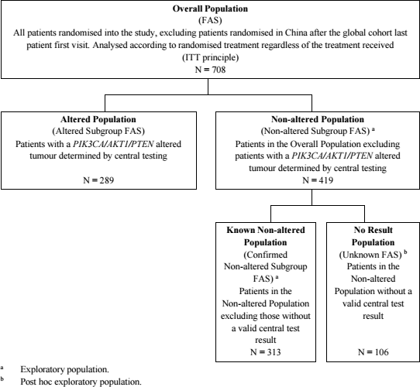
Of the 708 patients in the overall population, 701 (99.0%) were female and 7 (1.0%) were male. The age range was 26 – 90 years, 48.4% were Caucasian and 26.7% of Asian ethnicity. Other demographics were similar in both groups.
There were 287 (99.3%) females and two (0.7%) males with PIK3CA/AKT1/PTEN alterations, and these patients formed the altered population. In terms of alterations, the largest subgroup was PIK3CA alterations only: 110 (31.0%) in the capivasertib group and 92 (26.1%) in the placebo. The age range was 34-90; 52.2% of the population were Caucasian and 28.7% were Asian.
In both populations, there was a higher proportion of patients with ECOG PS 1, and with diabetes in the capivasertib group compared to the control group.
In terms of prior treatments, all patients had received hormonal therapy, 496 (70.1%) had received CDK4/6 inhibitors and 422 (59.6%) had received cytotoxic chemotherapy. Mastectomy had been performed for 25.6% patients and breast conserving surgery for 24.2%.

Results: dual primary endpoints: PFS per investigator
In the overall population, median PFS per investigator was 7.2 months (97% CI: 5.5 to 7.4) in the capivasertib group and 3.6 months (95% CI: 2.8 to 3.7) in the placebo, HR = 0.60 (95% CI: 0.51 to 0.71), p <0.001. The Kaplan-Meier curve is shown in Figure 2.
Figure 2: CAPItello-291: Kaplan-Meier curve of PFS in the overall population
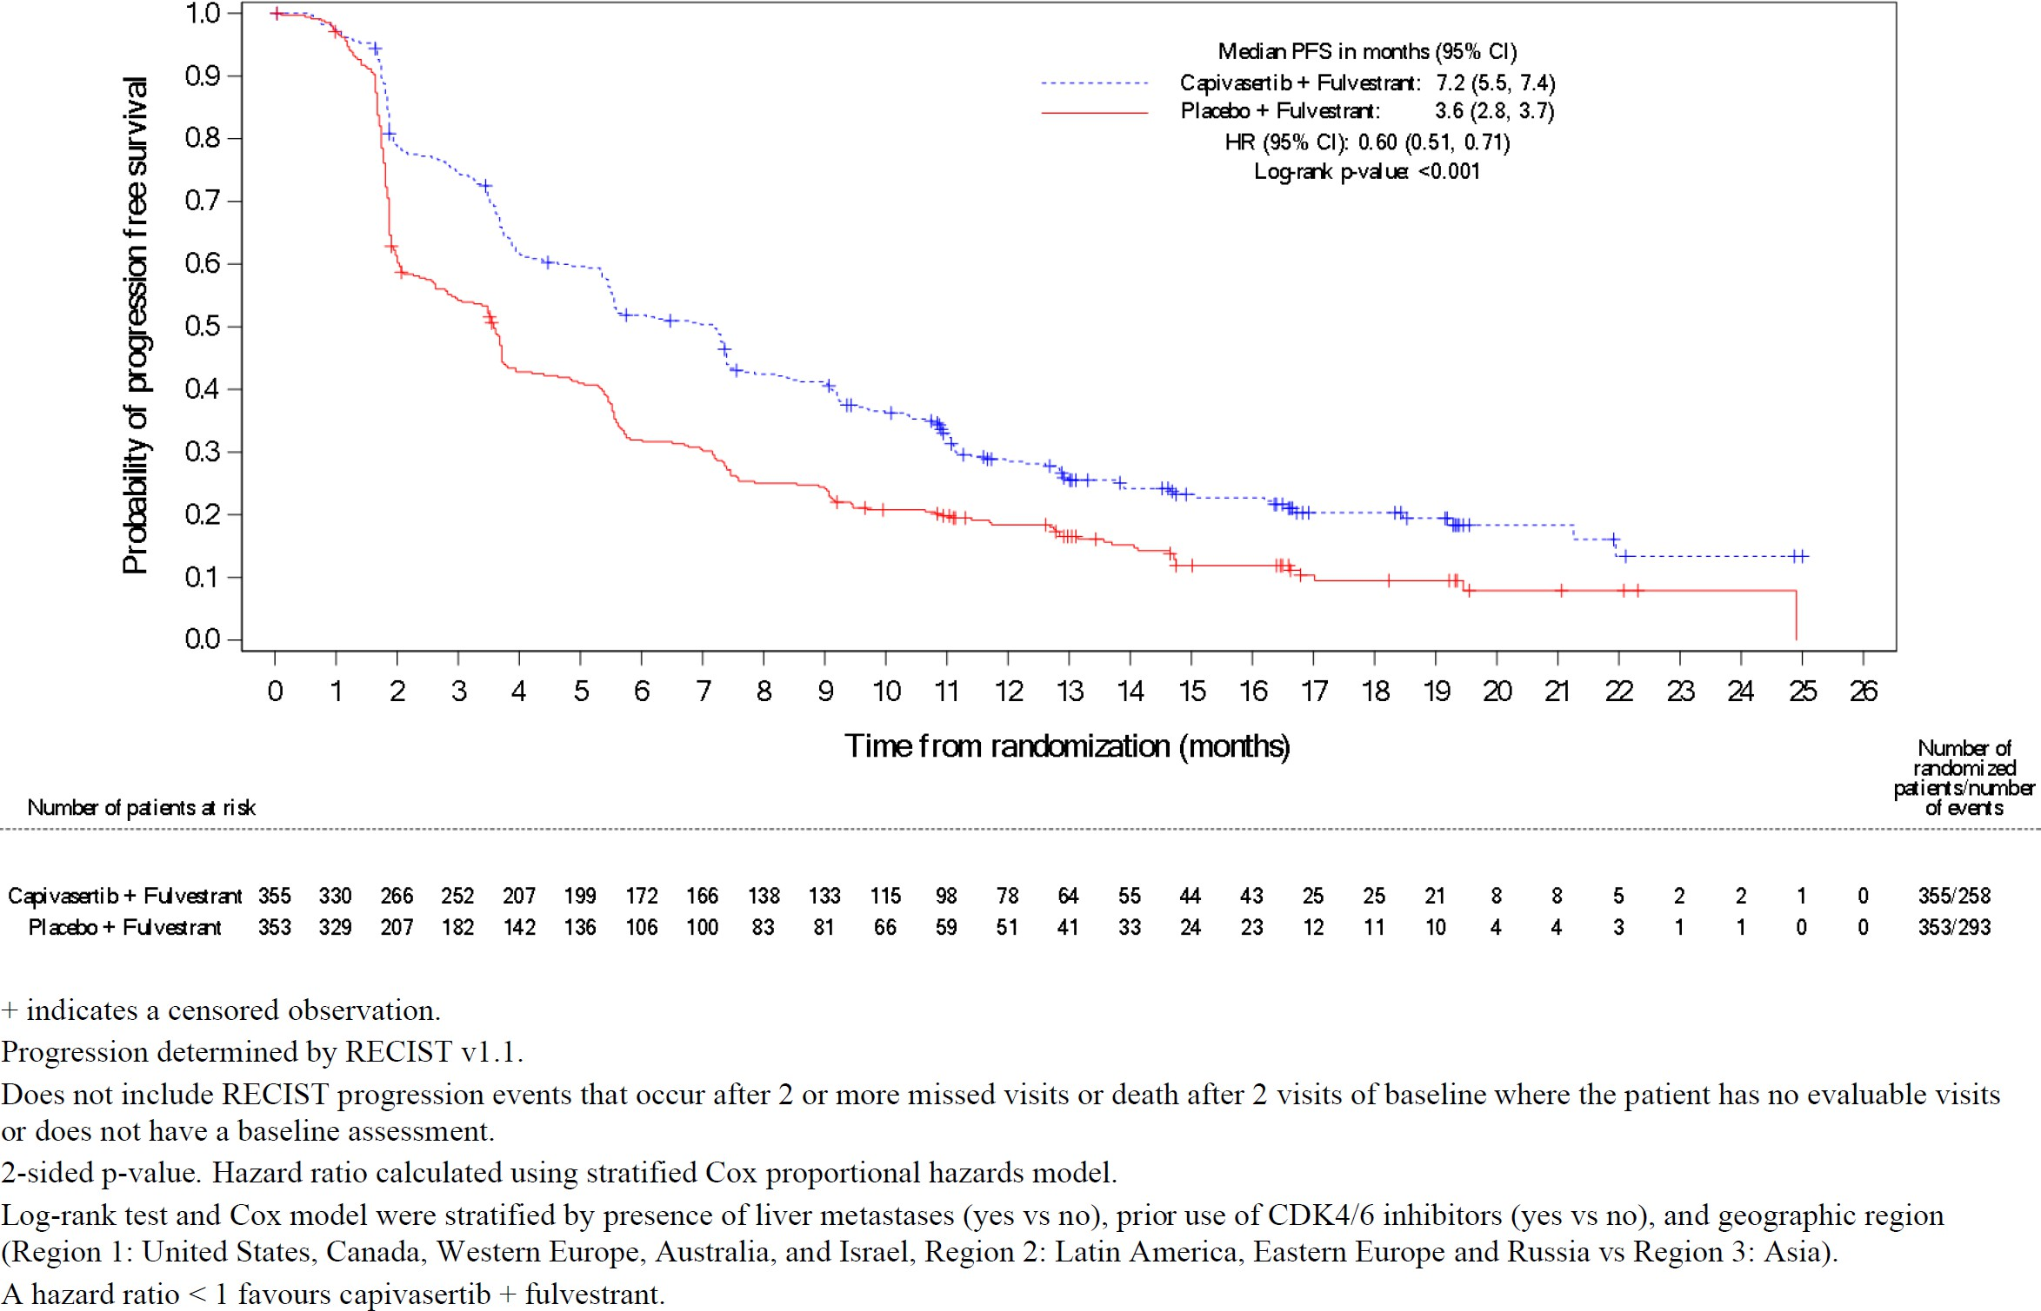
In the altered population, median PFS was 7.3 months (95% CI: 5.5 to 9.0) in the capivasertib group and 3.1 months (95% CI: 2.0 to 3.7) in the placebo, HR = 0.50 (95% CI: 0.38 to 0.65), p<0.001. The K-M curve is shown in Figure 3.
Figure 3: CAPItello-291: Kaplan-Meier curve of PFS in altered population
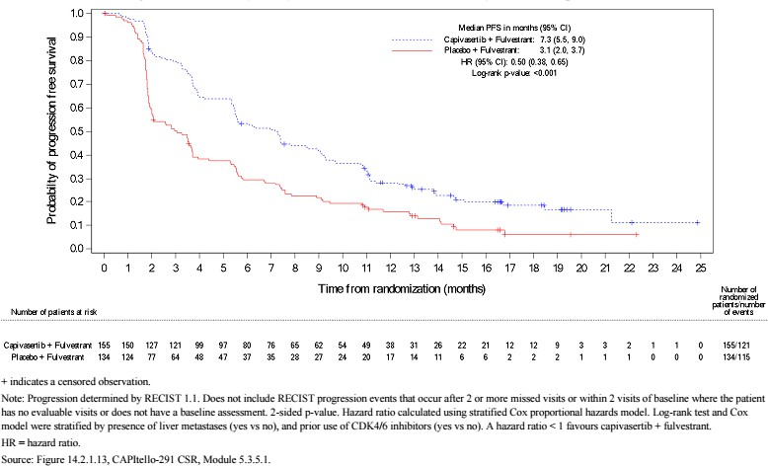

Sensitivity analyses
A sensitivity analysis of PFS per BICR showed consistent results in the overall (HR=0.61 (95% CI 0.50-0.73), p<0.001) and altered (HR=0.51 (95% CI 0.38-0.68), p<0.001) populations.
In a question to the sponsor, SwissMedic noted that “mPFS by BICR in the known non-altered population was 3.9 months in the capivasertib containing arm versus 3.7 months in the control arm, HR = 0.81 (95% CI 0.61-1.06) (according to FDA’s analyses)”. This suggests that there is no meaningful benefit for this patient group. The sponsor responded:
The Applicant considers the benefit-risk ratio to be positive irrespective of the AKT pathway alteration status.
Results suggest that sensitivity analysis of PFS by BICR is broadly consistent with the primary endpoint of PFS by investigator assessment across populations.
Hazard ratios provide a more appropriate measure of treatment effect than medians, representing data across time points rather than at a single point on the Kaplan-Meier plot. In the Known Non-altered population, the hazard ratio of BICR-assessed PFS in the capivasertib +fulvestrant arm to the placebo + fulvestrant arm was 0.85 (95% CI 0.65, 1.12) and the hazard ratio of investigator-assessed PFS was 0.79 (95% CI 0.61, 1.02).
The results, with an average treatment benefit of approximately 20% in the risk of progression, suggest efficacy of capivasertib + fulvestrant in this population.
Acknowledging that the efficacy appears stronger in the AKT pathway altered cancers, the Applicant considers that efficacy of capivasertib + fulvestrant can be expected also in the AKT pathway non-altered population.

Subgroup analyses
Analysis of PFS in the non-altered population was not included as part of the study’s primary objectives, however, the known altered population (determined by central testing) was a pre- specified subgroup. In addition, PFS was analysed post-hoc in the no result population. Results for the 2 non-altered populations combined (non-altered population) are also presented.
In the known non-altered population, the hazard ratio was 0.79 and did not reach statistical significance (95% CI: 0.61 to 1.02). The median PFS was 5.3 months in the capivasertib group compared with 3.7 months in the placebo (note that patient assessments were conducted every 8 weeks for the first 18 months). This is illustrated in the K-M curve in Figure 4.
Figure 4: CAPItello-291: Kaplan-Meier curve of PFS in the known non-altered population
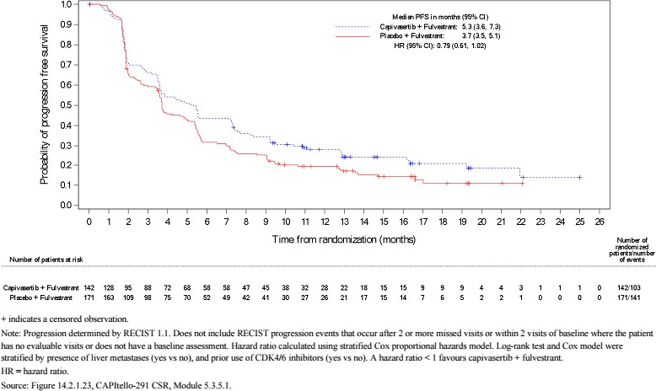
In the no result population, a 48% reduction in the risk of progression in favour of capivasertib was reported: HR = 0.52 (95% CI: 0.32 to 0.83). The median PFS was 10.0 months in the capivasertib group compared with 1.9 months in the placebo, shown in Figure 5.
Figure 5: CAPItello-291: Kaplan-Meier curve of PFS in the no result population
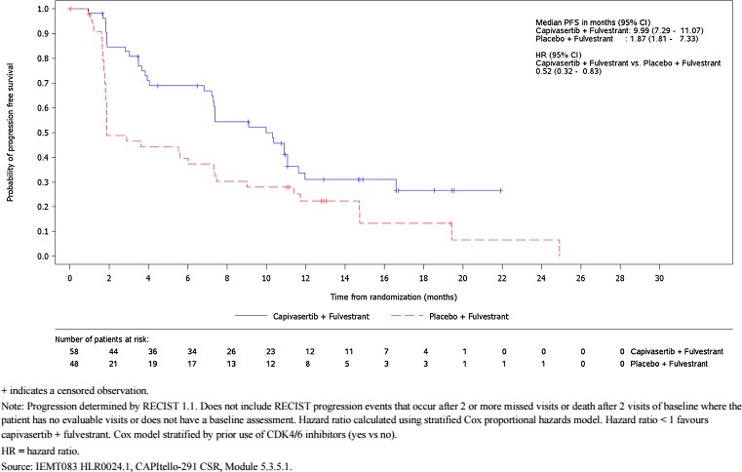
In the non-altered population (combination of the known non-altered and no result population), the HR for PFS was 0.70 (95% CI: 0.56-0.88), median PFS was 7.2 months in the capivasertib group and 3.7 months in the placebo group. The K-M curve is shown in Figure 6.
Figure 6: CAPItello-291: Kaplan-Meier curve of PFS in the combined non-altered population
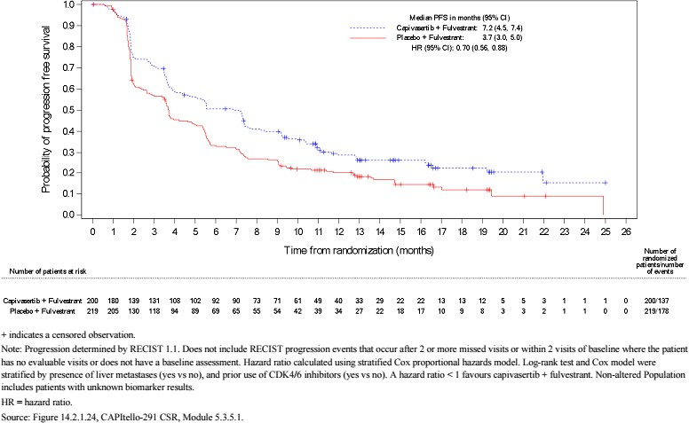
Other subgroup analyses showed a consistent effect for most subgroups and are shown in
Figure 7.
Figure 7: CAPITello-291, Forest Plot of PFS by subgroups
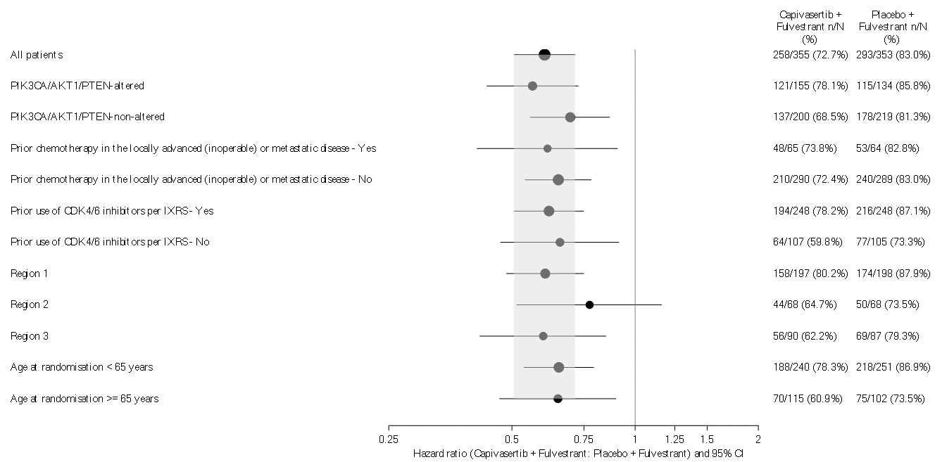
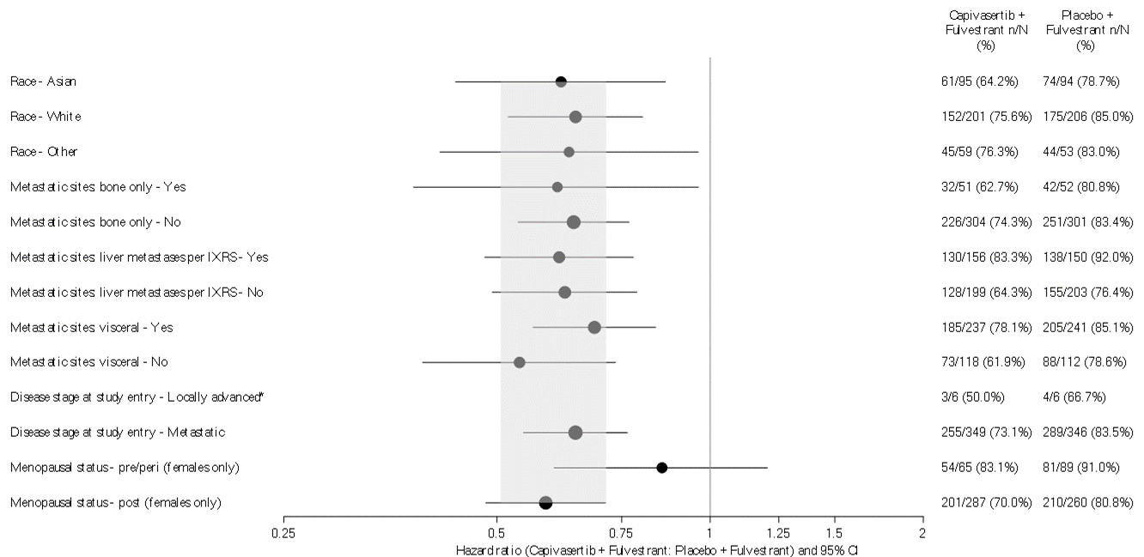
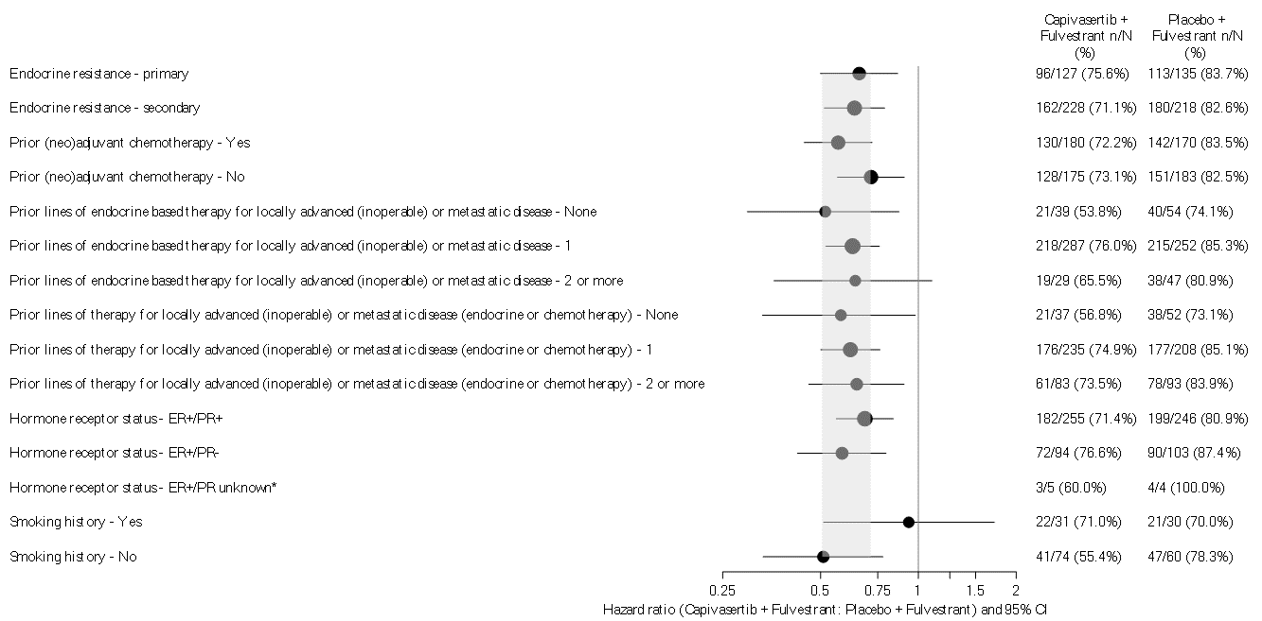
Progression determined by RECIST v1.1.
Hazard ratio < 1 implies a lower risk of progression on capivasertib + fulvestrant.
Cox proportional hazards model including treatment term only was fitted for each subgroup level as factor.
‘All patients’ analysis presents primary analysis results.
Size of circle is proportional to the number of events.
Grey band represents the 95% CI for the overall (all patients) HR.
Progression includes deaths in the absence of RECIST progression.
Does not include RECIST progression events that occur after 2 or more missed visits or death after 2 visits of baseline where the patient has no evaluable visits or does not have a baseline assessment.
The PIK3CA/AKT1/PTEN non-altered (Non-altered Population) comprises the Known Non-altered Population and No Result Population.
Race ‘Other’ includes Black or African American, Native Hawaiian or Other Pacific Islander and American Indian or Alaska Native.
Region 1: United States, Canada, Western Europe, Australia, and Israel; Region 2: Latin America, Eastern Europe, and Russia; Region 3: Asia.
* Hazard ratio and CI not calculated due to insufficient number of events.
Source: Figure 14.2.1.9.
These analyses suggested that efficacy was not affected by prior CDK4/6i use. The clinical evaluator noted that efficacy was potentially reduced in pre/peri-menopausal patients and those with a smoking history, however small patient numbers make it difficult to draw any firm conclusions. The sponsor also provided the following rationale for the findings in pre/peri- menopausal patients.
This finding may be attributed to numerical differences in baseline characteristics by menopausal status and by treatment arm, suggesting enrichment of poor prognosis characteristics (e.g., prior use of CDK4/6 inhibitors, presence of liver metastases) in the pre/peri-menopausal subgroup, with some numerical differences between arms.
Although the number of patients and the number of PFS events in pre/perimenopausal patients are too small to interpret the data clearly, the PFS results numerically favour capivasertib + fulvestrant in this subgroup of patients.

Results: Secondary endpoints

Overall survival
At the 15 August 2022 data cut off, overall survival (OS) data were 27.5% and 30.1% mature in the overall and altered populations respectively. In the overall population, median OS was not calculable. The proportion of patients surviving to 24 months was 64.3% (95% CI: 55.5 to 71.8) in the capivasertib group and 56.5% (95% CI: 48.3 to 63.9) in the placebo (HR = 0.74 (95% CI: 0.56-0.98)).
In the altered population, the proportion of patients surviving to 24 months was 63.8% (95% CI: 50.8 - 74.2) in the capivasertib group and 57.7% (95% CI: 46.1 to 67.7) in the placebo (HR =0.69 (95% CI: 0.45 to 1.05).
For the non-altered population, the HR was 0.76 (95% CI: 0.52-1.11), and for the known non- altered population, the HR was 0.92 (95% CI 0.59-1.42). In the No Result population, the HR was 0.46 (95% CI: 0.20-1.00). K-M curves for OS in the five populations are shown in Figures 8 to 12.
Figure 8: CAPITello-291, OS results, overall population
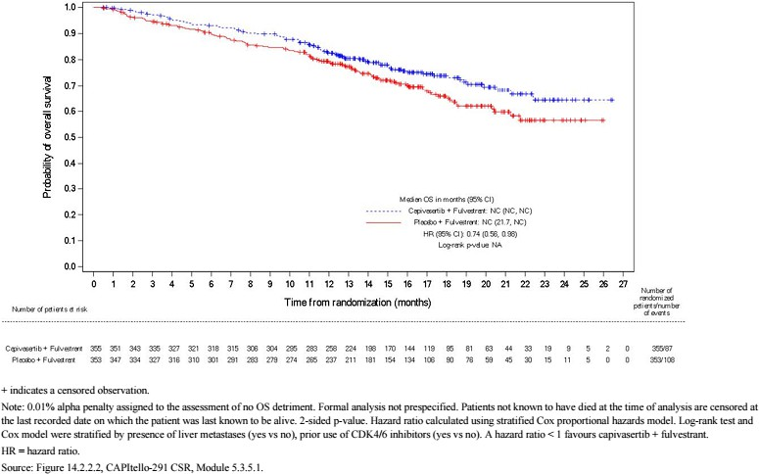
Figure 9: CAPITello-291, OS results, altered population
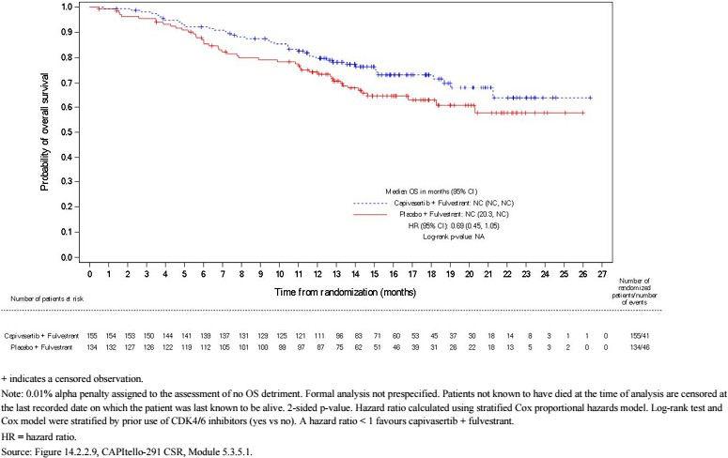
Figure 10: CAPITello-291, OS results, non-altered population
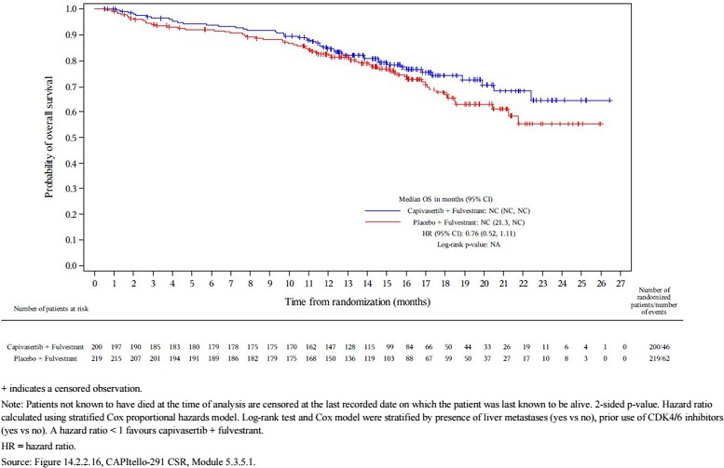
Figure 11: CAPITello-291, OS results, known non-altered population
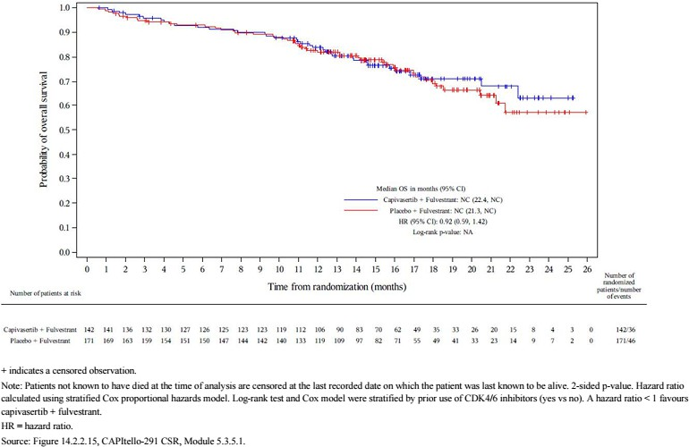
Figure 12: CAPITello-291, OS results, no result population
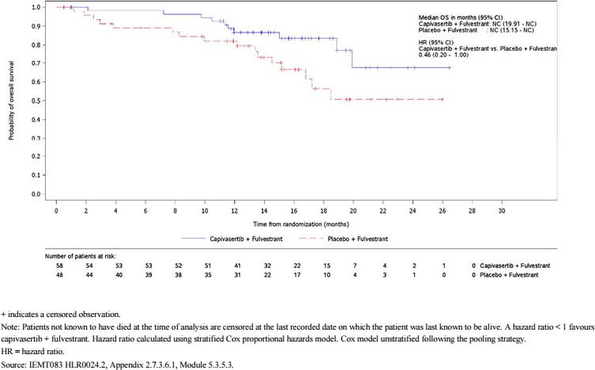

ORR and DoR
In the overall population, response was reported for 71 (22.9%) patients in the capivasertib group and 39 (12.2%) in the placebo (OR = 2.19 (95% CI: 1.42 to 3.36)).
In the altered population, response was reported for 38 (28.8%) patients in the capivasertib group and 12 (9.7%) in the placebo (OR = 3.93 (95% CI: 1.93 to 8.04)).
In the patients that responded, there was no significant difference between the treatment groups in duration of response or time to onset of response.

Supportive study: FAKTION
This was an investigator-initiated phase II randomised, blinded, placebo-controlled trial. It was conducted at 19 hospitals in the UK from 2015-2018. Evaluation of this study was based on the published article. The study design and results are summarised in Table 4.
Table 4: FAKTION Study, PICO table and results
Population | Postmenopausal women aged 18 years and over with ER+/HER2- locally advanced inoperable or metastatic breast cancer, who had relapsed or progressed on an aromatase inhibitor, were enrolled. Patients were required to have an ECOG PS of 0-2, a life expectancy of 12 weeks or more, and adequate organ function.  The study included patients who did not have measurable disease according to RECIST version 1.1.  Patients were randomised 1:1 to the capivasertib or placebo groups:  - 183 patients were screened, 140 were included:  - 69 patients were randomised to the capivasertib group and 71 to placebo  - All were female, aged between 40 and 82 years.
Intervention | Capivasertib 400 mg twice daily, 4 days on/3 days off  + Fulvestrant 500mg administered on day 1, 15 and 29, and once monthly thereafter
Control | Placebo twice daily, 4 days on/3 days off  + Fulvestrant 500mg administered on day 1, 15 and 29, and once monthly thereafter  Treatment continued until disease progression, unacceptable toxicity, loss to follow-up or withdrawal of consent.
Outcome | Primary endpoint: PFS  Results:  - Median PFS was 10.3 (95% CI: 5.0 to 13.2) months in the capivasertib group and 4.8 (95% CI: 3.1 to 7.7) months in the placebo  - unadjusted HR of 0.58 (95% CI: 0.39 to 0.84), 2-sided p = 0.0044;  - adjusted HR of 0.58 (95% CI: 0.39 to 0.85), 2-sided p = 0.0049  - There was no difference in PFS by PI3K alteration status Secondary endpoints: OS, OR and clinical benefit  OS results:  - Median OS was 26.0 (95% CI: 18.4 to 32.3) months in the capivasertib group and 20.0 (95% CI: 15.1 to 21.2) months in the placebo  - HR = 0.59 (95% CI: 0.34 to 1.05), 2-sided p = 0.071
Outcome | OR results:  - Twenty (29%) patients in the capivasertib group achieved an objective response compared with six (8%) in the placebo  - OR = 4.42 (95% CI: 1.65 to 11.84), 2-sided p = 0.0031.  Clinical benefit results:  - There were 38 (55%) patients in the capivasertib group who had clinical benefit and 29 (41%) in the placebo  - OR = 1.78 (95% CI: 0.91 to 3.47), 2-sided p= 0.093
The clinical evaluator commented:
The FAKTION study provided supportive evidence for PFS but was underpowered, or had inadequate follow-up time, to analyse OS, OR and clinical benefit. The study also included patients who did not have measurable disease according to RECIST version 1.1. Hence this study does not conform with EMA guidance. However, the study does provide supportive evidence for an improvement in PFS with capivasertib and also that PI3K alteration status does not affect efficacy. The study also provided safety data for the dosing regimen proposed by the Sponsor: 400 mg twice daily, 4 days on/3 days off, with fulvestrant 500 mg every two weeks [then monthly after the third dose].
After the round 2 evaluation, the sponsor noted that updated PFS and OS results from the FAKTION trial were published in 2022 (Howell et al.), however the 2020 paper was the focus of the evaluation. The updated hazard ratios at the DCO of 25 November 2021 were 0.56 (95% CI: 0.38-0.81, p=0.0023) for PFS and 0.66 (95% CI: 0.45-0.97, p=0.035) for OS.

Safety
Safety data comes from the pivotal CAPItello-291 study, the FAKTION study, the 8 phase I pharmacology studies, a population C-QT/QTc analysis and two exposure-response analyses. There was also an integrated summary of safety, which pooled data from CAPItello-291 and Study D3610C00001 (FTIH), giving a population of 430 patients exposed to Capivasertib and fulvestrant. This overview focuses on the safety data from the CAPItello-291 study, which provides direct comparison between the capivasertib and placebo groups. Full details of the safety evaluation can be found in the CER, Section 8.
In CAPItello-291, median total exposure was 5.3 months in the capivasertib arm and 3.5 months in the placebo arm. Treatment durations in the combined pool were similar.

Safety in CAPITello-291

Adverse events
In CAPItello-291, TEAEs were recorded for 343 (96.6%) patients in the capivasertib group and 288 (82.3%) in the placebo. The most common TEAEs in the capivasertib arm were diarrhoea (72.4% patients), nausea (34.6%), rash (22.0%) [and rash as a grouped term (38.0%)], fatigue (20.8%), vomiting (20.6%), headache (16.9%), decreased appetite (16.6%), hyperglycaemia (16.3%), maculopapular rash (16.1%), stomatitis (14.6%), asthenia (13.2%) and pruritus (12.4%).
Table 5 summarises the most common AEs in the CAPItello-291 study.
Table 5: CAPItello-291, most common AEs by PT (frequency > 5% either group)
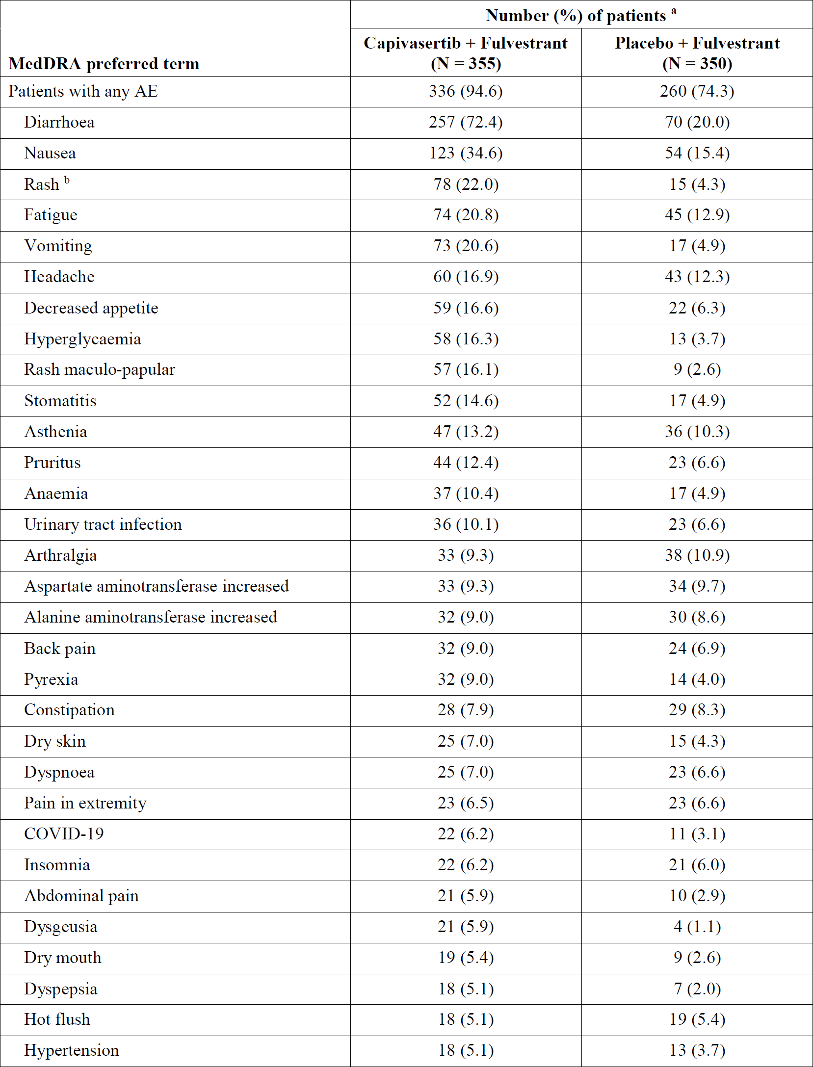
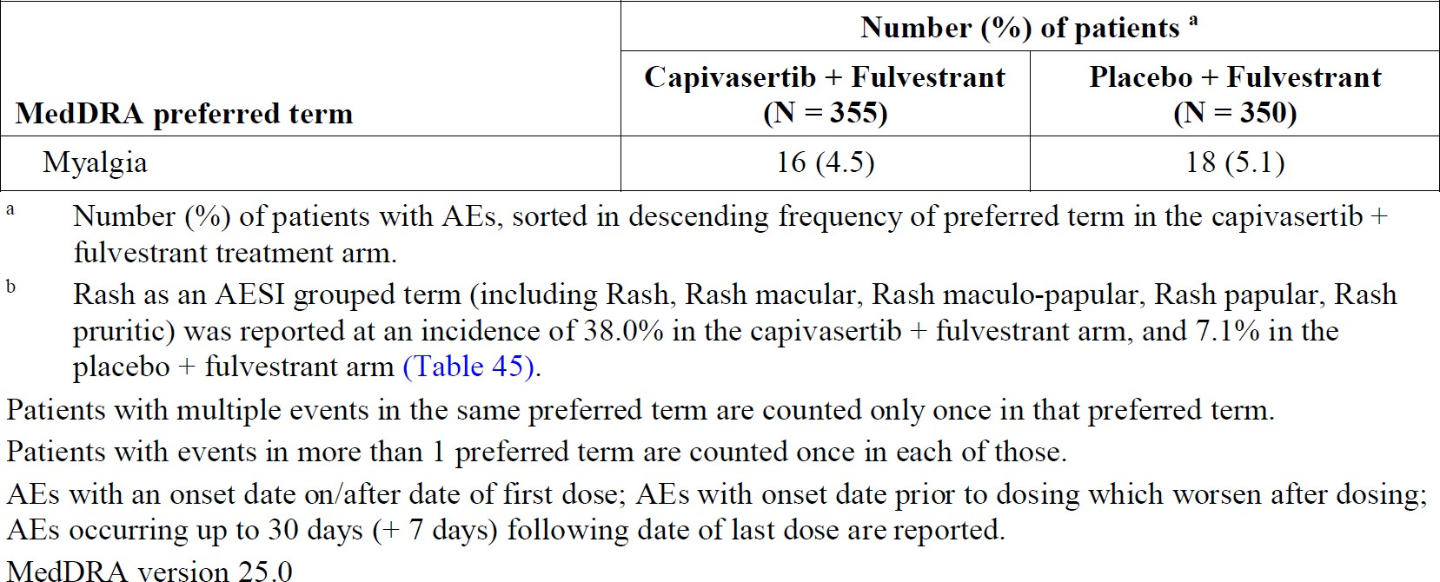

Deaths and SAEs
87 (24.5%) patients in the capivasertib group and 108 (30.6%) in the placebo group died – the majority of deaths were deemed to be related to the underlying disease. In the overall population, SAEs with outcome of death were recorded for four (1.1%) patients in the capivasertib group (acute myocardial infarction, cerebral haemorrhage, pneumonia aspiration, sepsis) and one (0.3%) in the placebo (COVID-19).
In the overall population, SAEs were recorded for 57 (16.1%) patients in the capivasertib group and 28 (8.0%) in the placebo. The most frequently reported SAEs in the capivasertib group were diarrhoea in 1.7% patients, maculopapular rash in 1.4% and vomiting in 1.1%. In the altered population, SAEs were recorded for 28 (18.1%) patients in the capivasertib group and 14 (10.5%) in the placebo. SAEs are shown in Table 6.
Table 6: CAPITello-291, SAEs by PT (frequency ≥ 2% patients in either arm)
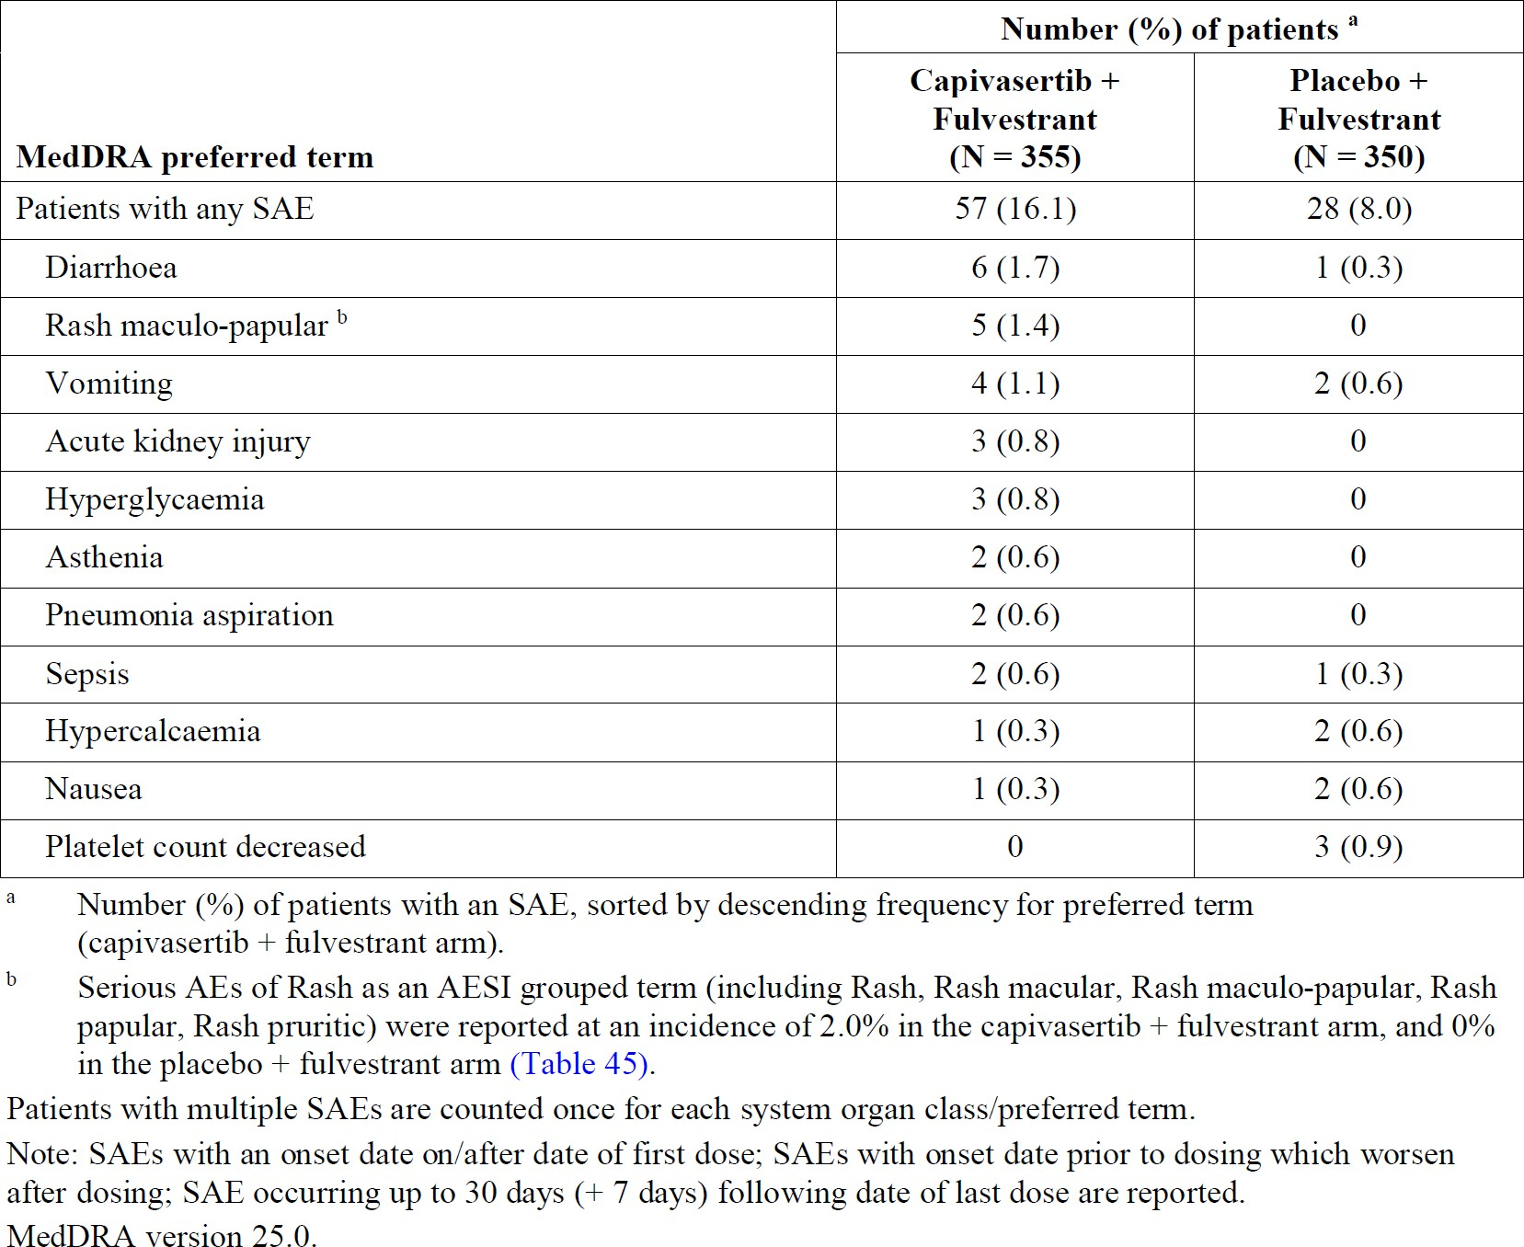

Discontinuations and dose modifications due to AEs
In CAPItello-291, in the overall population, discontinuation of capivasertib/placebo due to AE was recorded for 46 (13.0%) patients in the capivasertib group and eight (2.3%) in the placebo. The most frequently reported AEs leading to discontinuation of capivasertib alone were rash in 2.8% of patients, vomiting in 2.0%, diarrhoea in 1.4%, maculopapular rash in 1.4%, and pyrexia in 1.1%.
In the overall population, dose modification of capivasertib/placebo due to AE was recorded for 156 (43.9%) patients in the capivasertib group and 43 (12.3%) in the placebo. The most frequently reported AEs leading to dose reduction in the capivasertib group were diarrhoea in 7.9% patients, maculopapular rash in 2.5% and vomiting in 1.7%.
Dose interruption of capivasertib/placebo due to AE was recorded for 138 (38.4%) patients in the capivasertib group and 43 (12.3%) in the placebo. The most frequently reported AEs leading to dose interruption for capivasertib alone were diarrhoea in 9.0% patients, maculopapular rash in 6.2%, rash in 4.5%, vomiting in 3.1%, hyperglycaemia in 2.5% and nausea in 2.3%.

Adverse Events of Special Interest (AESIs)

Hyperglycaemia
Hyperglycaemia was a common AESI in patients treated with capivasertib. Given the potential interaction between capivasertib and metformin, it is important to determine the optimal management of hyperglycaemia. In the CAPITello-291 study, 60 patients (16.9%) in the capivasertib arm experienced hyperglycaemia compared to 14 (4.0%) in the placebo arm. In the capivasertib arm, 2 patients (0.6%) required capivasertib dose reduction, 9 (2.5) required dose interruption, and 1 (0.3%) discontinued capivasertib due to hyperglycaemia. 2 patients experienced grade 4 complications from diabetes (hyperglycaemia, DKA). 18 patients (5.1%) received insulin, 10 (2.8%) metformin and 10 (2.8%) ‘other’ antidiabetic agent. At the DCO, hyperglycaemia had not resolved in 28 (7.9%) of patients (almost half of the 60 who reported hyperglycaemia).

Diarrhoea
In CAPItello-291, diarrhoea occurred in 257 (72.4%) patients in the capivasertib arm compared to 70 (20.0%) in the placebo arm. Nausea and vomiting were also more frequent in the capivasertib arm. In the capivasertib group, 6 (1.7%) of patients experienced an SAE of diarrhoea. 5 (1.4%) patients discontinued treatment with capivasertib due to diarrhoea, while 28 (7.9%) required a dose reduction, and 32 (9.0%) required a dose interruption.
Of note, five (1.4%) patients were reported with acute kidney injury, two (0.6%) with renal failure and four (1.1%) with renal impairment. The sponsor’s response to a question from SwissMedic states that these episodes of acute kidney injury appear to have been related to dehydration from severe diarrhoea and vomiting and responded well to rehydration. The delegate noted this information should be added to the PI.

Rash
Rash as a grouped term was reported in 135 (38.0%) patients in the capivasertib arm compared to 25 (7.1%) in the placebo group. There were 5 patients (1.4%) in the capivasertib arm who experienced an SAE of rash. 10 patients (2.8%) discontinued treatment due to rash. Sixteen patients (4.5%) required a dose interruption and 8 (2.5%) a dose reduction.
Other skin related AEs reported in the capivasertib arm includes DRESS, Erythema multiforme, palmar-plantar erythrodysaesthesia and toxic skin eruption.

Updated safety data: CAPITello-291
At the request of SwissMedic, the sponsor provided updated safety data from CAPItello-291 with a DCO of 27 March 2023. In the updated safety data, in the capivasertib + fulvestrant population, there was an additional death from liver abscess and an additional SAE of acute renal injury. In total, 4 (1.1%) patients in the updated safety data had acute renal injury reported. The delegate is requesting a change to the PI to highlight the risk of renal injury associated with dehydration.
Otherwise, the pattern of AEs in the updated data was similar to the original data.

Safety in FAKTION
In the FAKTION study, grade 3–5 AEs were reported in 45 (65%) patients in the capivasertib group and 35 (50%) in the placebo. One patient in the placebo group had a grade 5 haemorrhage, attributed to disease progression. All cases of severe diarrhoea, rash, hyperglycaemia, and vomiting were grade 3, apart from one grade 4 diarrhoea in the placebo group. The most common grade 3–4 adverse events were hypertension (22 [32%] capivasertib patients and 17 [24%] placebo), diarrhoea (10 [14%] capivasertib and 3 [4%] placebo), and rash (14 [20%] capivasertib and none in the placebo).
There was one death on treatment with capivasertib (atypical pulmonary infection without disease progression) considered possibly treatment related. One death in the capivasertib treatment group had an unknown cause, and all remaining deaths in both groups (19 in the capivasertib group and 31 in the placebo) were disease related. SAEs were reported only in the capivasertib group and were acute kidney injury (2 patients), diarrhoea (3), hyperglycaemia (1), loss of consciousness (1), rash (2), sepsis (1), and vomiting (1).
In the updated 2022 publication (Howell et al.), one additional SAE of pneumonia was reported in the capivasertib group, and there was one additional death (atypical pulmonary infection) assessed as possibly related to capivasertib.

Risk Management Plan (RMP) evaluation
EU-RMP version 1 Succession 1 (date 24 March 2023; DLP 15 August 2022) and ASA version 1.0 (date 4 April 2023) were evaluated by the TGA for this submission.
The summary of safety concerns is outlined in Table 7.
Table 7: Summary of safety concerns
Summary of safety concerns | Pharmacovigilance |  | Risk minimisation
Summary of safety concerns | Routine | Additional | Routine | Additional
Important identified risks | Hyperglycaemia | ✓ | – | ✓ | –
Important potential risks | Acute Complications of Hyperglycaemia | ✓* | – | ✓ | –
Missing information | None | – | – | – | –
* Follow-up questionnaire
The evaluator concluded that the RMP, the summary of safety concerns and risk minimisation plan were acceptable.
The sponsor updated the PI according to the RMP evaluator’s recommendations.
The TGA may request an updated RMP at any stage of a product's lifecycle, during both the
pre-approval and post-approval phases. More information regarding the TGA’s risk management approach can be found in risk management plans for medicines and biologicals and the TGA's risk management approach. Information on the Australia-specific annex (ASA) can be found on the TGA website.

Risk-benefit analysis

Delegate’s considerations

Efficacy
CAPITello-291 met both dual primary endpoints and demonstrated a PFS benefit in both the overall population (HR = 0.60 (95% CI: 0.51 to 0.71)) and the altered population (HR = 0.50 (95% CI: 0.38 to 0.65)). In both populations, median survival was approximately 7 months in the capivasertib arm compared to 3-4 months in the placebo arm. This is a statistically significant and clinically meaningful benefit for patients with locally advanced and metastatic HR+/HER2-breast cancer. The lower hazard ratio in the altered population suggests that the benefit in this group is greater, which is congruent with the mechanism of action of capivasertib.
The study’s primary objectives did not include PFS in the non-altered population as an endpoint, however exploratory analyses in this population were conducted. Being exploratory (and in the no result population post-hoc), these results must be interpreted cautiously. Nevertheless, the results of the exploratory analyses seem to suggest that the PFS benefit in the overall population is driven primarily by patients with PIK3CA/AKT1/PTEN alterations. In the known non-altered population, the hazard ratio did not reach statistical significance (HR=0.79 (95% CI: 0.61 to 1.02) and the median PFS difference was less than 8 weeks (the assessment interval in the trial). A sensitivity analysis of PFS by BICR also suggested a lack of clinically meaningful benefit in the known non-altered population, with a HR of 0.81 (95% CI: 0.61-1.06) and median PFS difference of 0.2 months between arms.
In the no results population, which may have included some patients with PIK3CA/AKT1/PTEN altered tumours who were not identified due to invalid test results, a statistically significant benefit was seen (HR = 0.52 (95% CI: 0.32 to 0.83)), with median PFS of 10 months in the capivasertib group compared to 1.9 months in the placebo group. The HR in the combined non- altered population was also significant (HR = 0.70 (95% CI: 0.56-0.88)). However, this population included the 106 ‘no result’ patients. Presumably at least some of these patients would have had PIK3CA/AKT1/PTEN alterations and could potentially be driving the results.
Overall survival data is generally supportive of a benefit in both the overall and altered populations, however it is not yet mature, and therefore uncertainty remains. There is even greater uncertainty in the non-altered populations, where exploratory analyses with early OS data suggest no difference between arms, and the possibility of an OS detriment must be considered. Results in the known non-altered population are of concern: HR = 0.92 (95% CI: 0.59-1.42).
The next interim study report for CAPITello-291 is expected in Q3 2024, and the final study report is expected in Q4 2025. If approved, these will be required to be provided to the TGA as a condition of registration.

Indication
The US FDA and Health Canada have recently approved indications restricted to patients with PIK3CA/AKT1/PTEN altered tumours.
ACM advice is requested on whether to restrict the indication in Australia. While the CAPITello-291 study demonstrated a benefit in the overall population, regardless of mutation status, as well as the altered population, the fact that 106 patients had unknown mutation status has resulted in additional exploratory analysis in the known non-altered and ‘no result’ groups. These exploratory analyses suggest that the benefit seen in the overall population is driven by the altered group, and there may be no benefit, or the possibility of detriment, in the non-altered group. However, the exploratory nature of these analyses must be considered. The key question is whether these exploratory analyses are sufficient evidence to warrant restricting the indication in Australia, given a benefit has been demonstrated for both the overall and altered populations in the pivotal study.
Another consideration with the proposed indication is that is does not specify which prior therapies patients should have before receiving capivasertib. 70.1% of the overall population in the CAPItello-291 trial had received a prior CDK4/6i. The results of the trial provide evidence of an efficacy benefit for capivasertib against placebo, however, since this trial began, CDK4/6i have been approved for the same patient group. There is no data providing a direct comparison between capivasertib and any of the CDK4/6i, nor is there data for the use of capivasertib in combination with CDK4/6i. Therefore, it is not clear whether capivasertib should only be available for patients who have progressed or are unable to tolerate a CKD4/6i, and whether this should be specified in the indication.

Companion diagnostic
At the time of the FDA approval for capivasertib, the FDA also approved the FoundationOne CDx next-generation sequencing test as a companion diagnostic for capivasertib. This was the test used in the pivotal CAPItello-291 trial. At this stage, the sponsor does not plan to register a companion diagnostic in Australia. According to the sponsor, most tertiary accredited laboratories in Australia have the capability to test for AKT1/PIK3CA/PTEN alterations using Next Generation Sequencing (NGS) panels.

Safety
Capivasertib, used in combination with fulvestrant, appears to be associated with substantial toxicity compared to fulvestrant monotherapy. In the pre-clinical data for Capivasertib, the toxicology evaluation identified potential drug interactions, adverse events and toxicities, and a similar pattern is evident in the clinical data from pharmacological studies and the pivotal CAPITello-291 trial.
In general, most adverse events in CAPITello-291 seemed to be manageable with dose interruptions and reductions. However, discontinuations due to adverse events did occur in 13.0% of the capivasertib arm compared to 2.3% in the placebo. The instructions for dose interruptions and modifications to manage AEs in the PI are similar to the management strategies used in the trial. However, further changes have been requested by the delegate.
Adding capivasertib to fulvestrant is expected to increase toxicity. In the pivotal study, patients in the placebo arm also received fulvestrant, therefore it is likely that adverse events occurring disproportionately in the treatment arm can be attributed to capivasertib. Diarrhoea, rash, and hyperglycaemia occurred in high numbers of patients in the capivasertib arm of CAPItello-291 compared to placebo. Renal injury, possibly associated with dehydration from gastrointestinal side effects, also occurred. The safety profile of capivasertib appears to be similar in the overall and altered population.
An ECOG status of 0-1 was one of the inclusion criteria in CAPITello-291. It is possible that in a real-world setting, patients with higher ECOG status may be less able to tolerate the toxicities of treatment. Patients with pre-existing conditions such as diabetes may be at increased risk of hyperglycaemia related toxicities and therefore an individual risk-benefit assessment for each patient will be crucial.
The delegate has requested changes to the PI to ensure clinicians are adequately informed about the risks and requested comments from the ACM on the PI.

Management of hyperglycaemia
Hyperglycaemia is a common adverse effect of capivasertib and it is not clear what the optimal management strategy is. In the CAPItello-291 and FTIH studies, dose interruptions and reductions were used, along with metformin and insulin. However, of the 60 patients in the capivasertib arm who developed hyperglycaemia, approximately half (28) did not experience resolution of the hyperglycaemia before the DCO. The pharmacology data suggests that the hyperglycaemia may be due to insulin resistance, which means that insulin may not be an effective treatment. Furthermore, the potential interaction between capivasertib and metformin has not been characterised, therefore, metformin may not be an effective treatment either.
Without clinical evidence, it is not possible to determine the optimal management of capivasertib induced hyperglycaemia. In the CAPItello-291 trial, most patients were able to tolerate the hyperglycaemia, and given the PFS benefits of capivasertib in this patient group with advanced cancer, this issue is not a barrier to registration. However, the delegate has requested changes to the PI to inform clinicians that the optimal management of hyperglycaemia has not been established. In addition, the delegate proposes a condition of registration that requires the sponsor to conduct a clinical RCT investigating the efficacy of metformin, an SGLT2 inhibitor, and placebo in the treatment of capivasertib induced hyperglycaemia. ACM advice is requested on whether such a study is warranted, and the wording of the condition of registration.

Independent expert advice
The delegate received the following independent expert advice.

Advisory Committee on Medicines (ACM) considerations
The Advisory Committee on Medicines (ACM), having considered the evaluations and the delegate’s overview, as well as the sponsor’s response to these documents, advised the following.

Specific advice to the delegate
The ACM advised the following in response to the delegate’s specific request for advice:
- Please comment on your preferred wording for the indication. Specifically:
- Should the indication be restricted to the altered population?
The ACM was of the view that the indication should not be restricted to the altered population.
In forming this view the ACM noted that the progression free survival (PFS) benefit was demonstrated within the overall population and the altered population. While it was noted that the exploratory subgroup analysis suggested that PFS benefit is primarily driven by PIK3CA/AKT1/PTEN alteration, the ACM advised that this under powered exploratory analysis did not warrant restricting the indication, and that the indication should reflect the trial’s primary endpoint.
- Which prior treatments should be specified in the indication?
The ACM supported the inclusion of the following statement in the indication, noting that within Australia this aligns with the standard of care.
….following recurrence or progression on or after an endocrine based regimen.
- Does the ACM support a proposed condition of registration requiring the sponsor to conduct a clinical study investigating the optimal management of capivasertib induced hyperglycaemia? If so, please advise on the optimal wording of the condition of registration.
The ACM was of the view that a condition of registration is not necessary. While it is important to understand the interaction of capivasertib with metformin, the ACM acknowledged that a specific clinical study would be challenging and complex. The ACM also noted that additional information is likely to become available from ongoing clinical studies in this space.
The ACM noted that hyperglycaemia of any grade occurred in 16.3% of the patients who received capivasertib–fulvestrant and in 3.7% of those who received placebo–fulvestrant. Hyperglycaemia was treated with dose adjustments, metformin, and insulin. The pharmacology data suggests that the hyperglycaemia may be due to insulin resistance and therefore an insulin sensitising agent would seem to be a logical treatment.
The ACM also discussed challenges appropriately balancing glycaemic control, noting the dosing of Truqap is taken twice daily for 4 days followed by 3 days off treatment. The ACM additionally advised that hyperglycaemia is a common side effect of similar therapies used in the field of oncology, and that treating physicians have adequate expertise in managing this condition.
The ACM noted that the CMI could include some additional information on monitoring blood sugar. In addition, UTI is mentioned in the CMI but not the PI, and this should be corrected.
- Is the safety and efficacy information in the PI adequate to support clinicians to make risk-benefit assessments for individual patients?
Noting that Truqap would be initiated and supervised by physicians experienced in the use of anticancer medicinal products, the ACM was of the view that the safety and efficacy information in the PI is adequate to support clinicians to make risk-benefit assessments for individual patients.
The ACM noted that for each adverse event within Section 4.4. Special Warning and Precautions for Use, it would be helpful to indicate whether the patients who experienced adverse events were in the treatment or placebo arm of the CAPItello-291 study.

ACM conclusion
The ACM considered this product to have an overall positive benefit-risk profile for the indication:
TRUQAP is indicated in combination with fulvestrant for the treatment of adult patients with hormone receptor (HR) positive, human epidermal growth factor receptor 2 (HER2) negative (defined as IHC 0 or 1+, or IHC 2+/ISH−) locally advanced or metastatic breast cancer following recurrence or progression on or after an endocrine based regimen.

Regulatory decision (outcome)
Based on a review of quality, safety, and efficacy, the TGA decided to approve the registration of:
- Truqap, capivasertib 200 mg film coated tablet blister pack
- Truqap, capivasertib 160 mg film coated tablet blister pack
The approved indication for these therapeutic goods is as follows.
Truqap is indicated in combination with fulvestrant for the treatment of adult patients with hormone receptor (HR) positive, human epidermal growth factor receptor 2 (HER2) negative (defined as IHC 0 or 1+, or IHC 2+/ISH-) locally advanced or metastatic breast cancer following recurrence or progression on or after an endocrine based regimen.

Specific conditions of registration applying to these goods
Truqap (capivasertib) is to be included in the Black Triangle Scheme. The PI and CMI
for Truqap must include the black triangle symbol and mandatory accompanying text
for five years, which starts from the date of first supply of the product.
The TRUQAP EU-Risk Management Plan (RMP) (Version 1 Succession 1, date 24 March 2023; DLP 15 August 2022), with Australian Specific Annex (Version 1.0 Succession 1, dated 4 April 2023), included with submission PM-2023-01677-1-4, and any subsequent revisions, as agreed with the TGA will be implemented in Australia.
An obligatory component of risk management plans is routine pharmacovigilance. Routine pharmacovigilance includes the submission of periodic safety update reports (PSURs).
Unless agreed separately between the supplier who is the recipient of the approval and the TGA, the first report must be submitted to TGA no later than 15 calendar months after the date of this approval letter. The subsequent reports must be submitted no less frequently than annually from the date of the first submitted report until the period covered by such reports is not less than three years from the date of this approval letter. The annual submission may be made up of two PSURs each covering six months. If the sponsor wishes, the six-monthly reports may be submitted separately as they become available.
If the product is approved in the EU during the three years period, reports can be provided in line with the published list of EU reference dates no less frequently than annually from the date of the first submitted report until the period covered by such reports is not less than three years from the date of approval.
The reports are to at least meet the requirements for PSURs as described in the European Medicines Agency’s Guideline on good pharmacovigilance practices (GVP) Module VII-periodic safety update report (Rev 1), Part VII.B Structures and processes. Note that submission of a PSUR does not constitute an application to vary the registration. Each report must be submitted within ninety calendar days of the data lock point for that report.

Product Information (PI)
The Product Information (PI) approved with this submission for Truqap can be found at Attachment 1. It may have been superseded. For the current PI and Consumer Medicines Information (CMI), please refer to the TGA PI/CMI search facility.

Therapeutic Goods Administration
PO Box 100 Woden ACT 2606 Australia
Email: info@tga.gov.au Phone: 1800 020 653 Fax: 02 6203 1605
https://www.tga.gov.au
D24-3615705

This is the original indication proposed by the sponsor when the TGA commenced the evaluation of this submission. It may differ to the final indication approved by the TGA and registered in the Australian Register of Therapeutic Goods
Australian Institute of Health and Welfare (AIHW). Cancer Rankings Data Visualisation https://www.aihw.gov.au/reports/cancer/cancer-data-in-australia/contents/rankings AIHW
Harbeck N, Penault-Llorca F, Cortes J, Gnant M, Houssami N, Poortmans P, Ruddy K, Tsang J, Cardoso F. Breast Cancer. Nat. Rev. Dis. Prim. 2019; 5:66. doi: 10.1038/s41572-019-0111-2
⁴ Howlader N, Cronin KA, Kurian AW, Andridge R. Differences in Breast Cancer Survival by Molecular Subtypes in the United States. Cancer Epidemiol Biomarkers Prev. 2018 Jun;27(6):619-626. doi: 10.1158/1055-9965.EPI-17-0627. Epub 2018 Mar 28 ⁵ Fillbrunn M, Signorovitch J, André F, Wang I, Lorenzo I, Ridolfi A, Park J, Dua A, Rugo HS. PIK3CA mutation status, progression and survival in advanced HR + /HER2- breast cancer: a meta-analysis of published clinical trials. BMC Cancer. 2022 Sep 21;22(1):1002. doi: 10.1186/s12885-022-10078-5
6 Harbeck N, Penault-Llorca F, Cortes J, Gnant M, Houssami N, Poortmans P, Ruddy K, Tsang J, Cardoso F. Breast Cancer. Nature Reviews Disease Primers. 2019; 5:66. doi: 10.1038/s41572-019-0111-2 ⁷ Glaviano A, Foo ASC, Lam HY, Yap KCH, Jacot W, Jones RH, Eng H, Nair MG, Makvandi P, Geoerger B, et. al. PI3K/AKT/mTOR signaling transduction pathway and targeted therapies in cancer. Molecular Cancer (2023) 22:138 https://doi.org/10.1186/s12943-023-01827-6 ⁸ Alves C L and Ditzel H J. Drugging he PI3K/AKT/mTOR Pathway in ER+ Breast Cancer. International Journal of Molecular Science 2023 Feb 24;24(5):4522. doi: 10.3390/ijms24054522 ⁹ Jerzak KJ, Bouganim N, Brezden-Masley C, Edwards S, Gelmon K, Henning J-W, Hilton JF, Sehdev S. HR+/HER2- Advanced Breast Cancer Treatment in the First-Line Setting: Expert Review. Current Oncology 2023 Jun 2;30(6):5425-5447. doi: 0.3390/curroncol30060411.
In this report the ‘Delegate’ is the Delegate of the Secretary of the Department of Health and Aged Care who decided the submission under section 25 of the Act
Jones RH, Casbard A, Carucci M, Cox C, Butler R, Alchami F et al. Fulvestrant plus capivasertib versus placebo after relapse or progression on an aromatase inhibitor in metastatic, oestrogen receptor-positive breast cancer (FAKTION): a multicentre, randomised, controlled, phase 2 trial. The Lancet Oncology. 2020. 21(3):345-57.

