User guide for completing an application for consent to import, supply, or export a medical device that does not meet the Essential Principles
  - User guide for the consent application form on the TGA Business Services (TBS) portal
Version 3.0, March 2025

Copyright
© Commonwealth of Australia 2025
This work is copyright. You may reproduce the whole or part of this work in unaltered form for your own personal use or, if you are part of an organisation, for internal use within your organisation, but only if you or your organisation do not use the reproduction for any commercial purpose and retain this copyright notice and all disclaimer notices as part of that reproduction. Apart from rights to use as permitted by the Copyright Act 1968 or allowed by this copyright notice, all other rights are reserved and you are not allowed to reproduce the whole or any part of this work in any way (electronic or otherwise) without first being given specific written permission from the Commonwealth to do so. Requests and inquiries concerning reproduction and rights are to be sent to the TGA Copyright Officer, Therapeutic Goods Administration, PO Box 100, Woden ACT 2606 or emailed to <tga.copyright@tga.gov.au>.

Contents
Introduction 4
Existing devices in the ARTG that do not meet the Essential Principles 4
Devices under assessment for inclusion in the ARTG that do not meet the Essential Principles 4
Multiple devices included in one application 5
Application Fees 6
Fee calculation 6
How to pay 6
Accessing consent to supply application forms 8
Consent for Non-compliance Dashboard overview 9
Application Draft tab 10
Delete draft applications 10
Edit draft applications 10
Application submission tab 11
Application notification tab 11
Start a new application 12
Completing the application form 14
Application details section 15
Non-compliant Essential Principles 19
Device groups 21
Creating device groups 22
Adding devices to a device group 23
Declaration 60
Viewing status of submitted applications 62
Viewing and printing submitted applications 63
Withdrawing an application 66
Notifications related to a consent application 68
Help and Information 69
69

Introduction
This document provides guidance on how to successfully complete and submit an application for consent to import, supply, or export a medical device that does not meet the Essential Principles (EPs).
We have modernised the consent application process, moving from a paper form to an online form. The new online form, hosted in the TGA Business Services (TBS) portal now includes exempt goods such as vaping devices, devices with pre-market applications (Application for Inclusion) and devices already included in the Australian Register of Therapeutic Goods (ARTG). The new form aims to streamline the application process and allows for greater functionality, including the ability for sponsors to view the status of their current and previous applications for consent to supply.
The online application form was updated to accommodate vaping devices and accessories, which can be supplied as unapproved medical devices in Australia and must either comply with the Essential Principles (EPs) or Therapeutic Goods (Medical Device Standard - Therapeutic Vaping Devices) Order 2023 (MDSO), specifically section 7(2).
There are criminal offences under section 41MA and civil penalties under section 41MAA of the Therapeutic Goods Act 1989 (the Act), for importing, supplying, or exporting medical devices that do not meet the EPs for safety and performance, unless consent has been granted by the Secretary of the Department of Health and Aged Care.
The TGA expects compliance with the EPs, however extenuating circumstances may prevent a sponsor from meeting one or more of the EP requirements for a limited period of time.

Existing devices in the ARTG that do not meet the Essential Principles
If your device(s) is currently in the ARTG, or you have an application to vary the device(s) or manufacturer’s evidence for device(s) that do not meet the EP’s, you will also need to apply for consent to import, supply, or export the device(s).
In seeking consent an authorised representative of the sponsor needs to:
- complete and submit the application for ‘consent to import, supply, or export a medical device that does not meet the EPs’ through the TBS sponsor portal;
- upload all relevant documents as part of this application; and
- pay the applicable processing fees in full.

Devices under assessment for inclusion in the ARTG that do not meet the Essential Principles
If, during the application for inclusion process, you identify that your device(s) do not meet the EPs, you will also need to apply for consent to import, supply, or export the device(s) at the same time.
In seeking consent an authorised representative of the sponsor needs to:
- complete and submit the application for ‘consent to import, supply, or export a medical device that does not meet the EPs’ through the TBS sponsor portal;
- upload all relevant documents as part of this application; and
- pay the applicable processing fees in full.

Multiple devices included in one application
The previous version of the application form allowed sponsors to include multiple medical devices that did not meet the EPs in a single application. Additionally, it accommodated the inclusion of medical devices already listed in the ARTG and medical devices that were part of an Application for Inclusion in a single application.
The new online application will only support multiple medical devices of the same type.
Sponsors cannot submit a single application that includes medical devices already listed in the ARTG, medical devices that are part of an Application for Inclusion, and non-included medical devices (exempt goods, such as vaping devices). If consent to import, supply, or export is required for the different device types (listed in the ARTG, Application for Inclusion and non-included medical devices) sponsors will need to submit three separate applications: one for medical devices listed in the ARTG, one for medical devices part of an Application for Inclusion, and one for non-included medical devices.
Note
If you have multiple devices across the different device types (listed in the ARTG, Application for Inclusion and non-included medical devices), you will need to submit a separate application for each of the device types.


Application Fees
The application fee for consent to import, supply, or export applies to each ARTG entry/Application for Inclusion/non-included medical device included in the application. Refer to the Fees and Charges web page and Schedule 5 – Fees, Part 1 – General of the Therapeutic Goods (Medical Devices) Regulations 2002 (the Regulations).
The fee paid for the application is not refundable.
Consent for devices that do not meet EP 13 and EP 13A
On 29 September 2022, amendments to the Therapeutic Goods (Medical Device) Regulations 2002 (the Regulations) introduced fee concessions to reduce the regulatory costs for sponsors. The application fee for a consent to supply application has been reduced to a flat fee per ARTG entry/Application for Inclusion/non-included medical device when the medical device does not meet the requirements of EP 13 (information to be provided with medical devices) during the transition period from EU MDD/IVDD to EU MDR/IVDR certification, and EP 13A (patient information materials).

Fee calculation
Fees are calculated based on the total number of ARTG entries/Applications for Inclusion/non-included devices in the consent to supply application.
For example:
- If your application for consent to supply pertains to 220 ARTG entries that do not meet EPs other than, or in addition to, EP 13A, the fees are calculated as:
220 ARTG entries
1st ARTG entry | $500 | $500
219 ARTG entries | $100 x 219 | $21,900
 | TOTAL | $22,400

- If your application for consent pertains to 220 ARTG entries that do not meet the requirements solely of EP 13A, the fees are calculated as:
220 ARTG entries
220 ARTG entries | $30 x 220 | $6,600
 | TOTAL | $6,600

NOTE: The above is an example, and the dollar values used may not reflect the current fee. For up to date fees, refer to the Fees and Charges web page and Schedule 5 – Fees, Part 1 – General of the Therapeutic Goods (Medical Devices) Regulations 2002 (the Regulations).

How to pay
There are two ways to pay the processing fees for the consent to supply application.
- IMMEDIATE PAYMENT: You can pay the processing fees for your consent to supply application immediately after completing and submitting the application. To do this:
  - Calculate the total fees for your application based on the number of ARTG entries or Applications for Inclusion or non-included devices, as per the example above.
  - Go to the TGA payment page (https://www.bpoint.com.au/payments/TGA)
  - In the Biller Code field choose option 9 – “Exemption under S41MA device”
  - Enter your client ID number in the box provided.
  - Enter the consent application ID/ reference number (provided on submission) in the “ARTG No.” field to link the payment to your application.
  - Enter the total amount of fees to be paid in AUD.
  - Select the payment method.
  - Follow the instructions to complete the credit card payment.
Your application and payment will be linked during processing using the TBS Client ID number and the consent application ID provided in the payment details.
- PAYMENT AGAINST INVOICE: If you require the TGA to raise an invoice for payment, simply complete and submit your application for consent to supply, and the TGA will raise and send the submitter an invoice for the processing fees.
NOTE: Applications for consent to supply will only be processed once the application fees have been paid in full.

Accessing consent to supply application forms
- To access your consent to supply application form, log in to the TBS portal.
- In the ‘Applications’ drop-down menu, select ‘Medical Device Post Market Compliance’ under the ‘Regulatory Compliance’ heading (Figure 1).
- You will be taken to the ‘PMR Compliance Dashboard’ (Figure 2).
- Select the ‘Consent for Non-compliance Applications’ tile.
- Access the next dashboard to:
  - Start a new application
  - Edit an existing application
  - View your previous applications
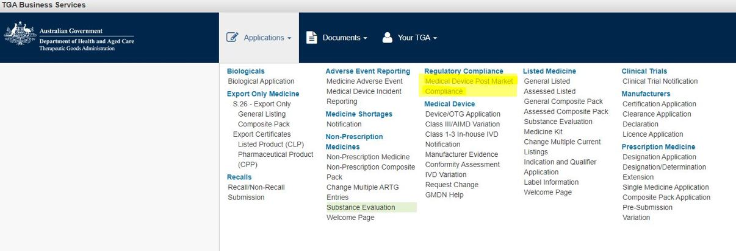 Figure 1

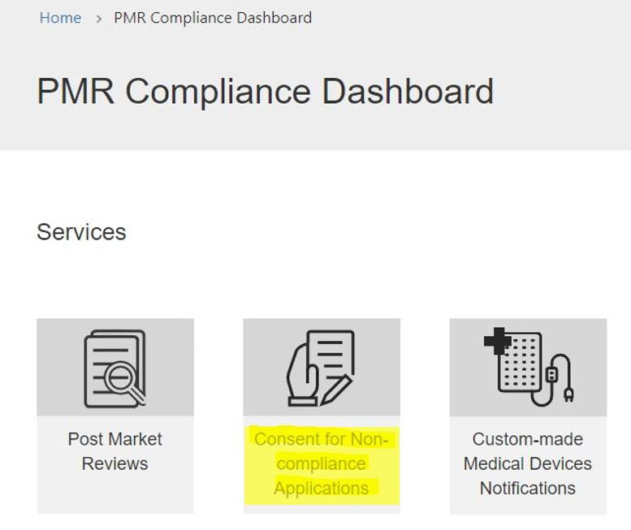
Figure 2

Consent for Non-compliance Dashboard overview
- On the ‘Consent for Non-compliance Dashboard’ (Figure 3), you will find options to:
  - View ‘Draft’ consent applications.
  - View ‘Submitted’ consent applications.
  - View ‘Notifications’ related to consent applications.
- Use the search box (magnifying glass symbol) to search for an application by:
  - Name (title) of the application.
  - Reference number.
- Perform partial text searches by typing an asterisk (*) as the wildcard character.
- Sort the table by clicking on the column heading to change the order of:
  - Reference number.
  - Title.
  - Date the application was created or modified.
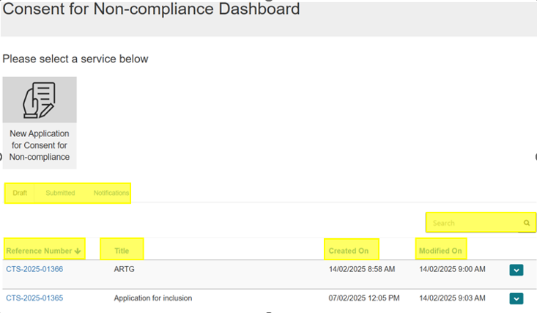
Figure 3

Application Draft tab
- The ‘Draft’ tab (Figure 4) contains all your consent applications that are in draft and not yet submitted by your organisation.
- Click on the down-arrow on the right side of the relevant application.
- Select whether you want to:
  - Edit the draft application.
  - Preview the draft application.
  - Delete the draft application.
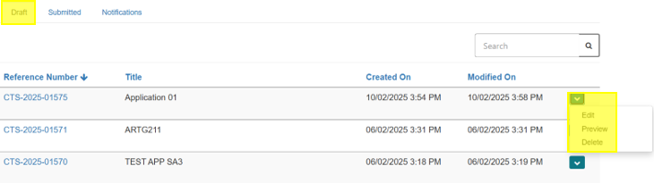
Figure 4

Delete draft applications
- Applications in the ‘Draft Consent Applications’ (Figure 5) view can be deleted permanently.
- To delete an application:
  - Click the down-arrow on the right side of the relevant application.
  - Select ‘Delete’.
  - A prompt will appear to confirm your action.
  - Select ‘Delete’ to permanently delete the application.
  - Select ‘Cancel’ if you do not wish to delete the application.
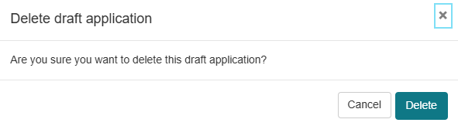
Figure 5

Edit draft applications
- To continue editing an application:
  - Click the down-arrow on the right side of the application details.
  - Select ‘Edit’.
  - You will be taken to the landing page ‘Consent for Non-compliance Application Draft’.
  - Select and complete different sections of the application form.

Application submission tab
- Choose the ‘Submitted’ tab (Figure 6) to view details of consent applications previously submitted by your organisation.
- Note that you cannot edit an application once it is submitted.
- To make amendments to a submitted application, contact the TGA via email at mdconsent@health.gov.au.
  - Requests for amendments will be considered on a case-by-case basis.
  - You may withdraw an application after it has been submitted.
  - For more information, refer to the ‘Withdrawing an application’ section of the guidance document.
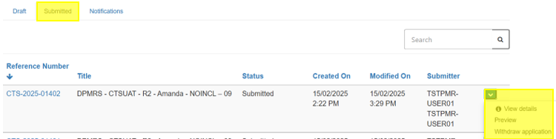
Figure 6

Application notification tab
The ‘Notifications’ tab (Figure 7) allows you to view any notifications related to devices that are part of an approved consent application.
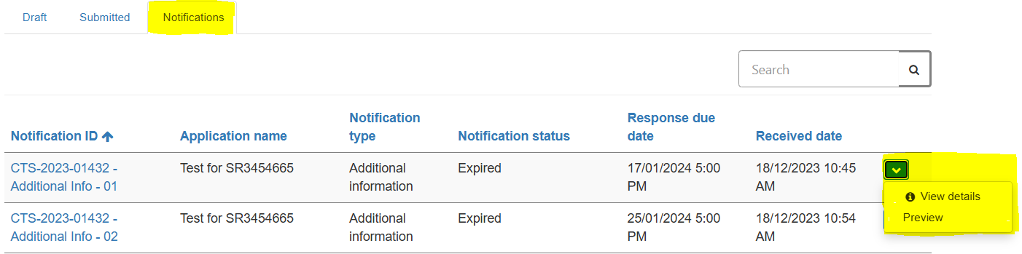
Figure 7

Start a new application
Note
Mandatory fields are indicated with a red asterisk (*) however you are encouraged to provide as much information as possible to enable us to assess your application.

On the dashboard, select the ‘New Application’ tile to start a new consent application (Figure 8).
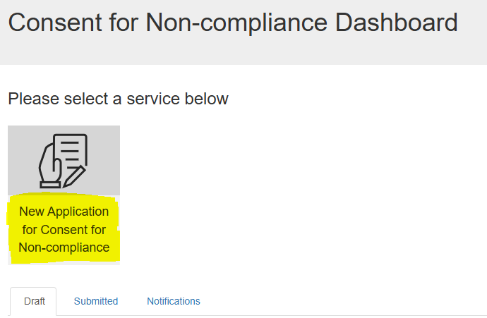
Figure 8

A window will open in the current view (Figure 9). You will be prompted to provide the following information:
- Name for the application. You can name the application anything relevant or meaningful to your organisation. Providing a relevant name will help differentiate applications over time.
- Select the type of device for which you are seeking consent for non-compliance.
NOTE: Only one type of device can be selected per application.

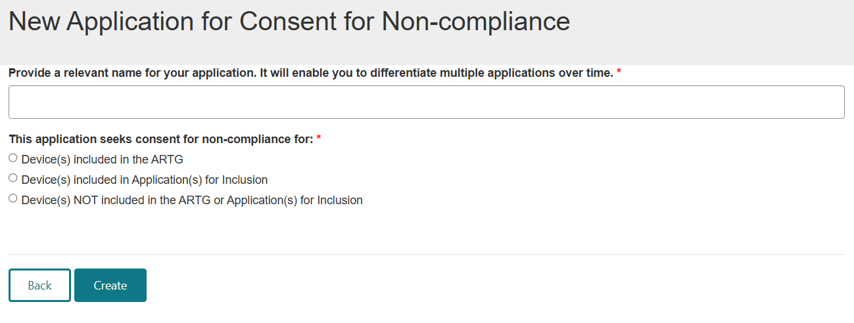
Figure 9

- Select a device category (Figure 10) from the drop-down options.
- Select the ‘Create’ button to create your new application (Figure 10).
- Your new application will be created, ready for you to complete the different sections of the application.
- The name of your application will appear at the top of the page.

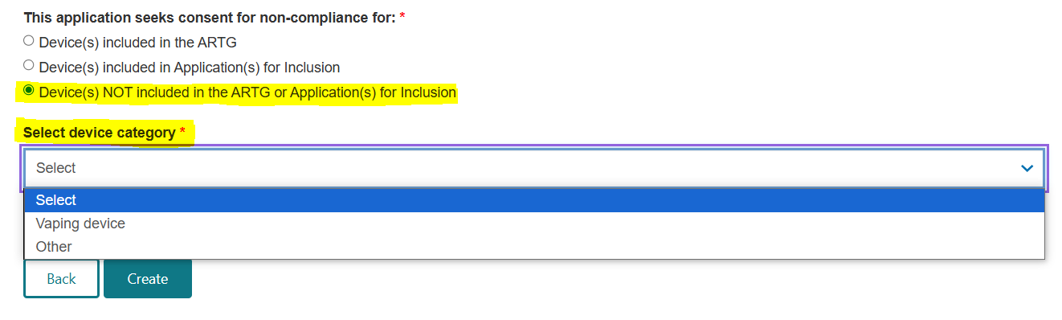
Figure 10

NOTE:
- An application reference number (consent application ID) is generated at this point (Figure 11).
  - The consent application ID can be found in the ‘Application details’ section of the form.
  - This ID is quoted in any communication with the TGA regarding this application.
  - It is also used in the payment process if the immediate payment option is chosen for the payment of application fees.
- To save the application to complete at another time:
  - Press the ‘Save’ button at the bottom of the page.
  - The newly created application will now be available to view on the ‘Draft’ tab of the dashboard (Figure 11).
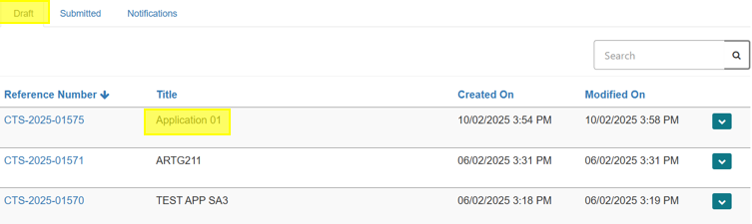
Figure 11

Completing the application form
To complete the different sections of the application:
- There is an option to ‘Expand All’ sections at once.
- Alternatively, you can expand one section at a time by clicking the ‘+’ sign on the right (Figure 12).
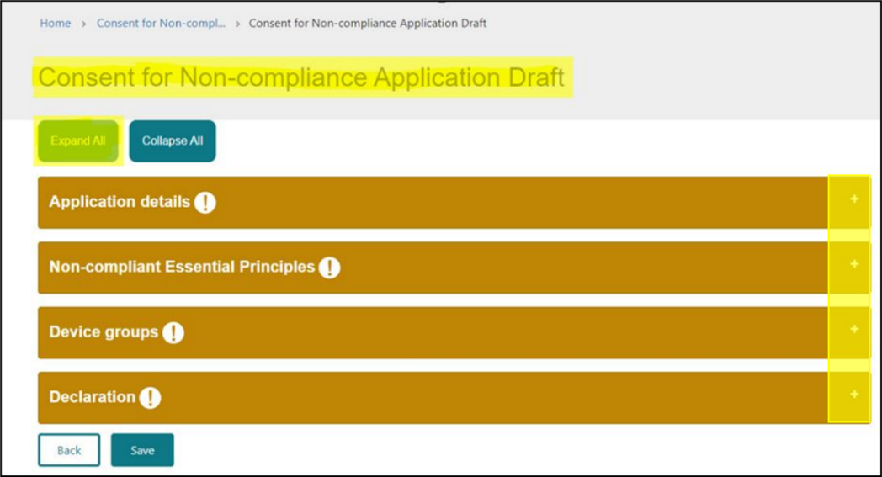
Figure 12

NOTE:
- At this stage, the sections will be amber in colour, indicating that mandatory information is required before the application can be submitted.
- When all the mandatory information in a section is completed, the section will change colour to green.

Application details section
At the top of this section (Figure 13), you will find:
- The application reference number (consent application ID), which can be quoted in communication with the TGA regarding this application.
- The field with the application name, which is auto-populated with the name you provided when you created the application.
- This is an editable field, and you can change the name of the application by typing the revised name in the field provided.
- The sponsor’s name, which will be auto-populated with your company name in TBS.
- The application category, which was selected when you created the application.
- The device category, which will ONLY be shown if your application is in relation to Device(s) NOT included in the ARTG or Application(s) for Inclusion.
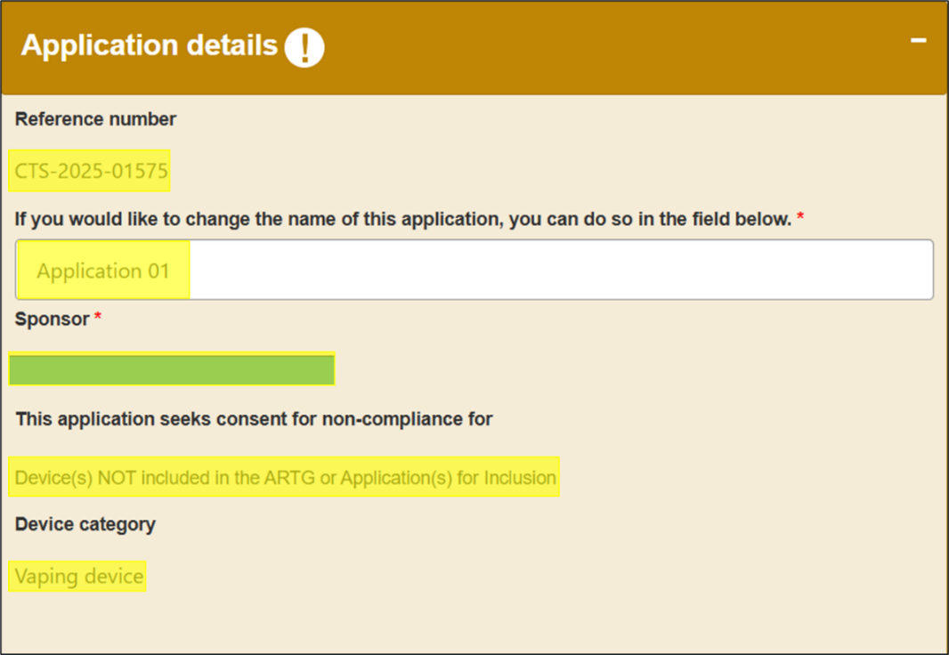
Figure 13

Select whether you are seeking consent (Figure 14) for the non-compliant device(s) to be:
- Imported
- Exported
- Supplied
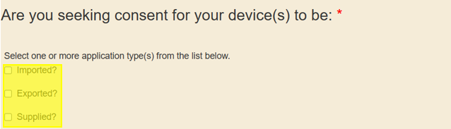
Figure 14

- Specify the reason for non-conformance to the EP(s) (Figure 15).
- Select one of the provided options in the drop-down menu.
- If a suitable option is not available, select ‘Other’.
  - A free text box will appear where you must provide an explanation for the non-conformance.
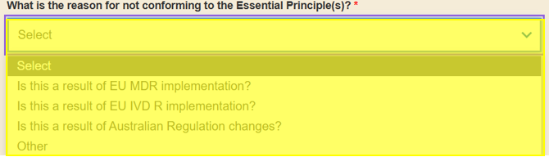
Figure 15

- Provide an explanation of the real or potential risks (Figure 16) associated with the non-conformance if the non-conforming device(s) were to be:
  - Imported
  - Exported
  - Supplied
- You may provide your response by:
  - Typing in the text box
  - Uploading document(s)
- To upload a document:
  - Click on the ‘Supporting Documents’ folder link.
  - Press the ‘Add files’ button.
  - Microsoft Word, Excel, and Adobe Acrobat documents, with a file size of up to 50MB, can be uploaded.
NOTE: As this text box is a mandatory field, if you are uploading a document, please type ‘document attached’ or a similar description in the text box provided.
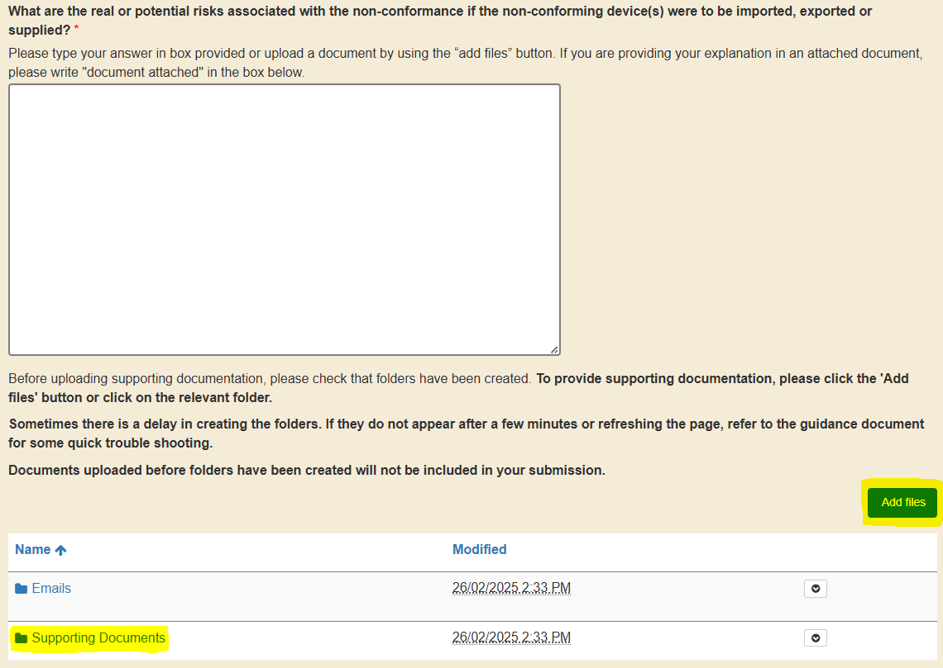Figure 16

NOTE: Sometimes there is a delay in creating folders.
- If they do not appear after a few minutes, try refreshing the page.
- Documents uploaded before folders have been created will not be included in your submission.
- Once you have completed the information in the mandatory fields for this section:
  - The section colour will change from amber to green to reflect that the section is now complete (Figure 17).
- Click the ‘Save’ button at the bottom of the page to save the information entered so far.
  - You may save the information at any time.
  - If the mandatory fields are not completed, the section will remain amber in colour.
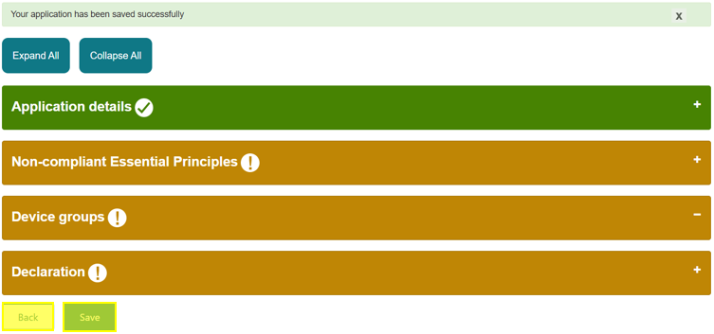
Figure 17

From here, you can:
- Click on another section to continue filling in the application.
- Select the ‘Back’ button at the bottom of the page (Figure 18).
- Click on the ‘Consent for Non-compl…’ link in the breadcrumb at the top of the page to return to the dashboard.
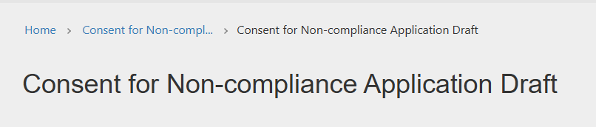
Figure 18

Non-compliant Essential Principles
- In the Non-compliant Essential Principles section:
  - Select all the EPs that the device(s) are non-compliant with.
  - Select one EP at a time and provide details as to why the device(s) is non-compliant with that EP.
- Click on the ‘Add breached Essential Principle’ button (Figure 19) to select an EP.
  - This will open a pop-out window ‘Add Non-compliant Essential Principle’.
  - Select relevant EPs and provide an explanation of how the devices are non-compliant with the EPs.
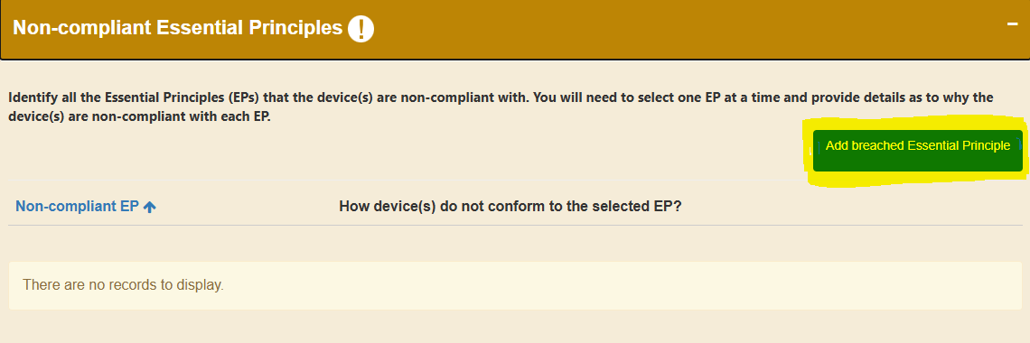Figure 19

- Click on the down-arrow on the right to select the relevant EP that the device(s) are non-compliant with (Figure 20).
- The EPs are listed in numerical order, so you may have to scroll down the list to find the relevant EP, such as EP13A.
- You can only select one EP at a time from the drop-down list.
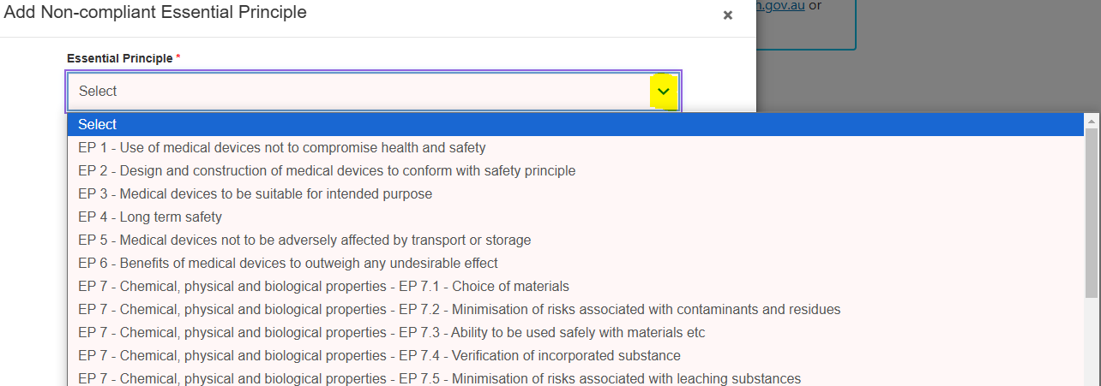Figure 20

- Provide an explanation in the free text box on how the device(s) are non-compliant with the selected EP.
- Click the ‘Save and Close’ button at the bottom of this window to save the information (Figure 21).
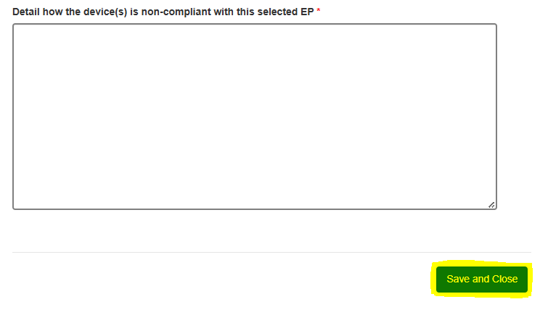Figure 21

- If multiple EPs are in breach, repeat the above steps to add additional EPs.
NOTE: The ‘Non-compliant Essential Principles’ section will turn green, indicating that the mandatory information has been provided as soon as the first EP has been selected and the reason for non-compliance has been provided.
- To edit or delete these EPs:
  - Click on the down-arrow on the right to edit or delete the EPs that you have added (Figure 22).
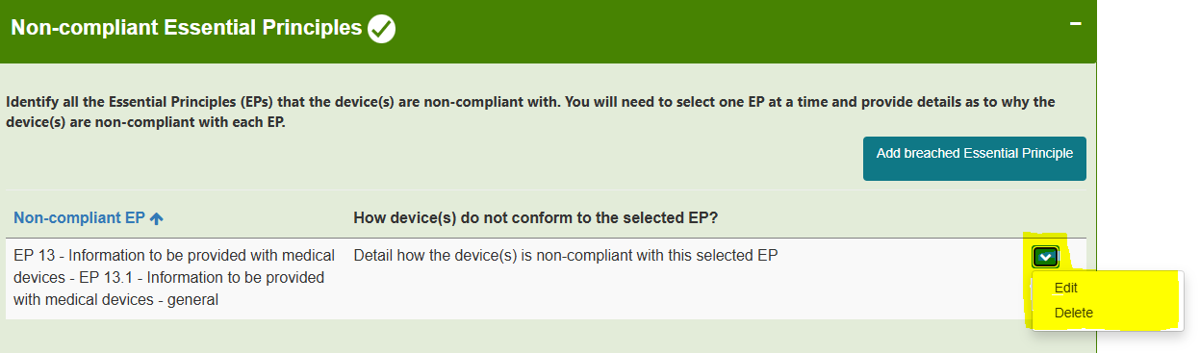
Figure 22

- Once you have selected all the relevant non-compliant EPs for this application:
  - Click the ‘Save’ button to save the information entered so far (Figure 23).
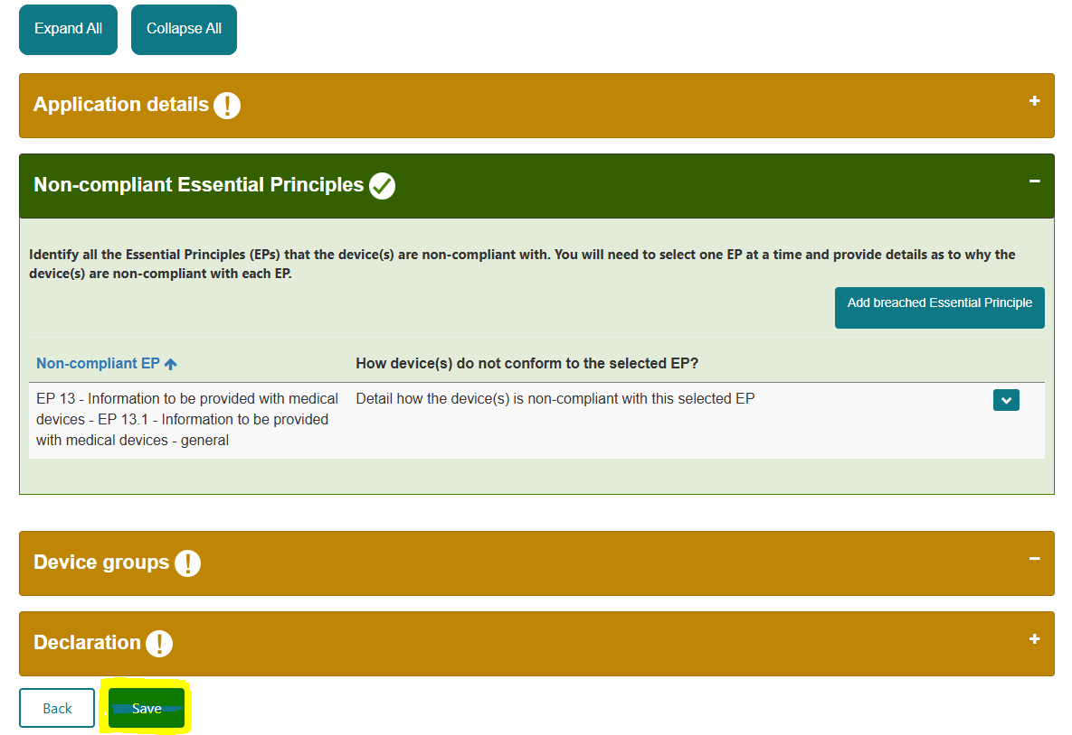Figure 23

From here, you can:
- Click on the next section to continue filling in the application.
- Select the ‘Back’ button at the bottom of the page (Figure 22).
- Click on the ‘Consent for Non-compl…’ link in the breadcrumb at the top of the page (Figure 18) to return to the dashboard.

Device groups
- In the Device groups section, provide information on the non-compliant medical device(s).
- Create a group for devices that have the same proposed start and end dates of consent, and the same Implementation Plan.
EXAMPLE:
- If you have 20 devices:
  - Five devices with the same proposed start date (e.g., 01/03/2025), end date (e.g., 01/12/2025), and Implementation Plan can be included in one group.
  - The remaining 15 devices can be grouped based on matching proposed start and end dates of consent, and Implementation Plans.
- If a singular device does not match the proposed start and end dates of consent, and Implementation Plan of other devices, create a separate group for this device.
- There is no limit on the number of device groups you can create.
  - You must create at least one group.
  - Each group must have at least one device included.
  - The same device cannot be included in multiple groups.

Creating device groups
NOTE
The screenshots shown below are what will be displayed if your application is in relation to ‘Device(s) included in the ARTG’ or ‘Device(s) included in Applications for Inclusion).’ Although the section text and table column headers maybe different for applications related to Device(s) NOT included in the ARTG or Applications for Inclusion’, the process of creating device groups is similar as outlined below.

To create a device group:
- Click on the ‘Add Device group’ button in the ‘Device groups’ section (Figure 24).
- This will open a pop-out window within the current view.
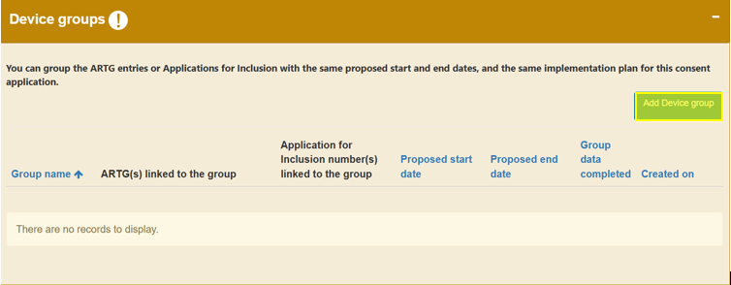Figure 24

- Provide a relevant name for the device group to identify different groups within the application.
- Click ‘Save and Close’ after entering the device group name (Figure 25).
  - The device group will be added to the ‘Device groups’ section.
- To add multiple device groups, repeat the above steps.
NOTE: If you close out of this screen by pressing the ‘x’ button before pressing ‘Save and Close’, your name for the device group will not be saved. You will be sent back to the ‘Application details’ section.

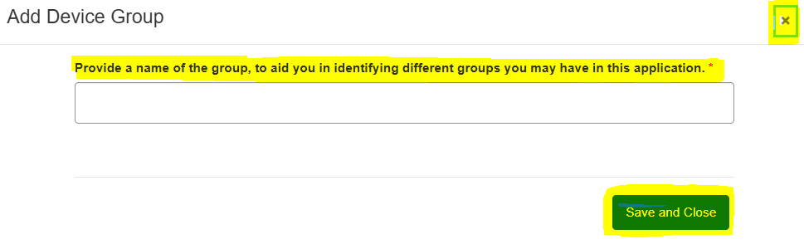Figure 25

- Click on the down-arrow on the right side of the device group.
- Select ‘Edit’ to provide details for this device group.
- Select ‘Delete’ to delete the group if it was made in error (Figure 26).
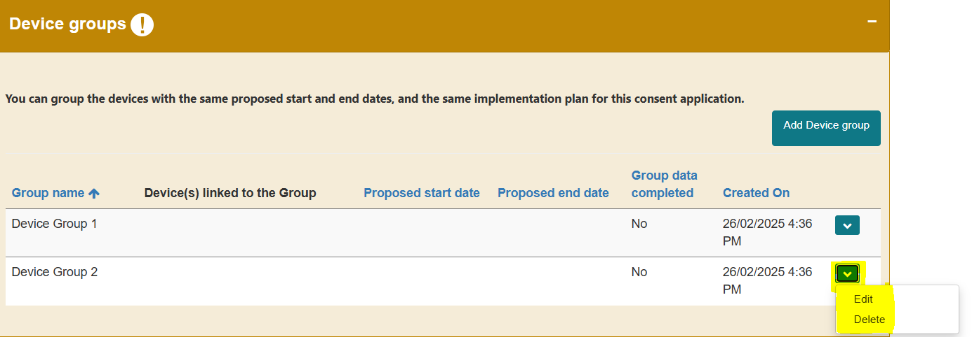Figure 26

Adding devices to a device group
- In this section, provide the details of the non-compliant devices and information on any current or future stock.
NOTE:
- Depending on the application category, the process of editing the device group is different. Below is an explanation of how to edit the device group to provide details of the non-compliance for each application category:
  - Device(s) included in the ARTG
  - Device(s) included in Application(s) for Inclusion
  - Device(s) NOT included in the ARTG or Application(s) for Inclusion

Device(s) included in the ARTG
For devices included in the ARTG:
- Click on the down-arrow on the right side of the device group (Figure 26).
- Select ‘Edit’ (Figure 26).
- A pop-out window will open within the current view (Figure 27).
- The device group name you provided is shown at the top of the window.
- This is an editable field.
- You can change the device group name if you like.
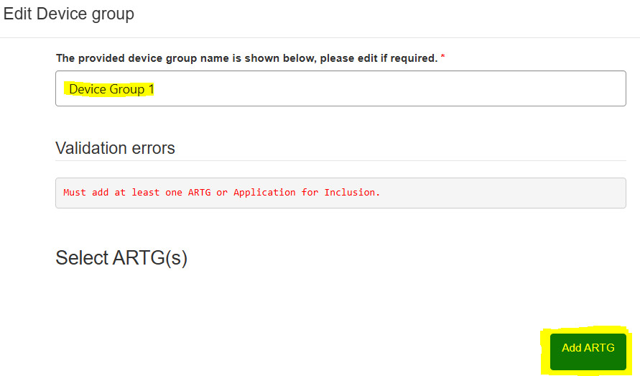
Figure 27
To add ARTG entries to this group:
- Click on the ‘Add ARTG’ button (Figure 27).
- A window will open within the current view (Figure 28).
- You will see a list of active medical device ARTG entries related to your organisation.
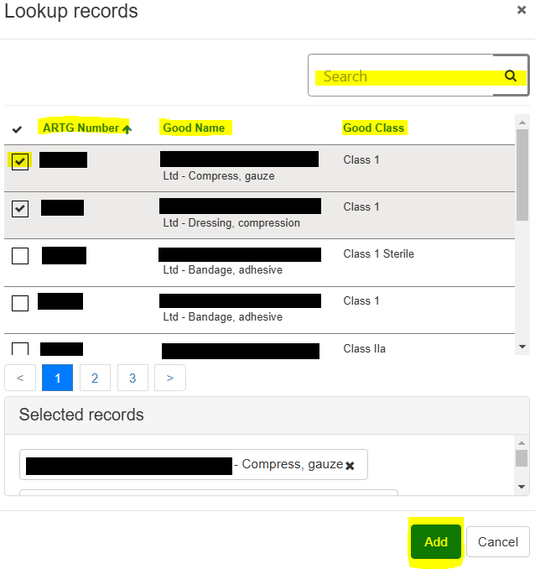
Figure 28

- Select a single or multiple devices from the list by clicking in the box on the left-hand side of the ARTG Number (Figure 28).
  - A tick in the box will indicate that the ARTG has been selected.
- Use the search box (indicated by the magnifying glass symbol) to search for devices by name or ARTG number.
  - Use partial text by typing an asterisk (*) as the wildcard character.
- Sort the table by clicking on the column heading to change the order of the ARTG entries, the name of the device, or the device class (Figure 28).
- Click on the ‘Add’ button at the bottom of this window to add all selected ARTG entries to the group.
- Repeat the above steps to add additional ARTG entries to the group.
- Click on the down arrow on the right to remove an ARTG entry if it was added in error (Figure 29).
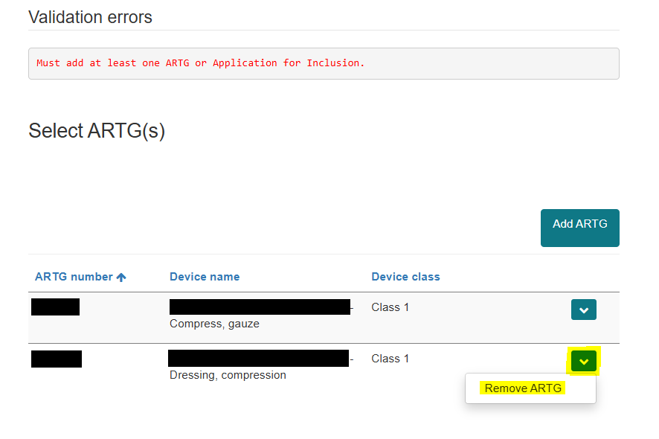
Figure 29

NOTE:
- An ARTG entry can only be included in one device group; it cannot be included in multiple device groups.
- The devices will not appear in the stock information table until the form is refreshed.
  - To refresh the form, click on the column header ‘ARTG or Application for Inclusion number’ of the ‘Provide stock level information’ table (Figure 30).
  - This will refresh the form, and the ARTGs included in the device group will appear in the stock information table.
  - You can then add stock information for the devices in this group (Figure 31).
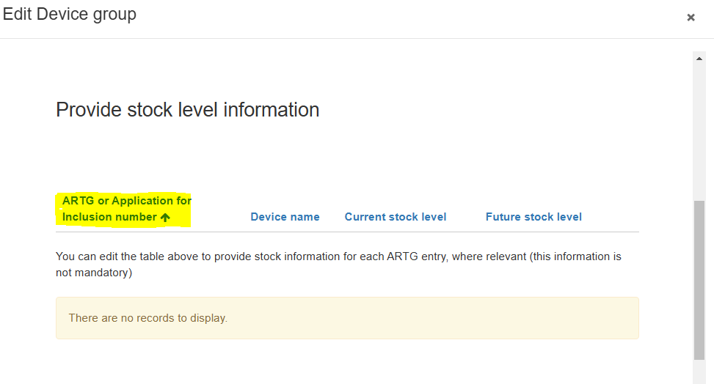Figure 30

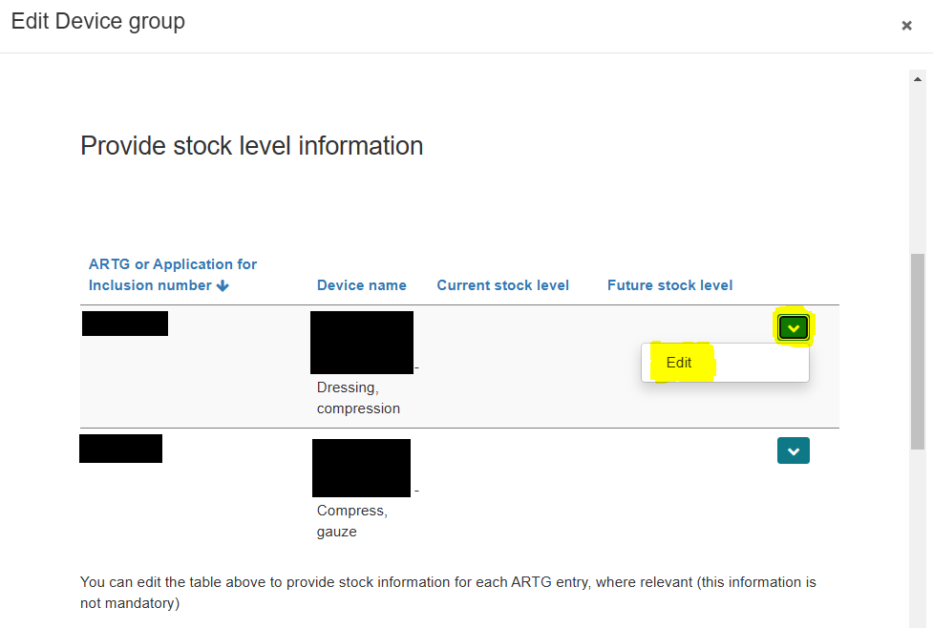
Figure 31

To provide stock information for each device:
- Click the down-arrow on the right side of the window against the device.
- Select ‘Edit’ (Figure 31).
- This will open a pop-out window (Figure 32).
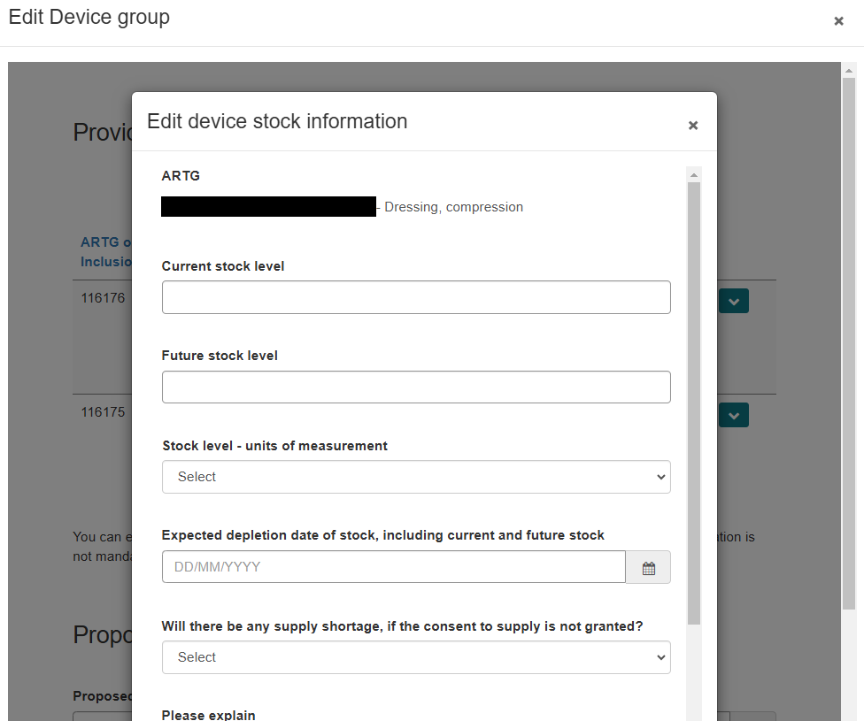
Figure 32
- Enter the current stock information for this device (Figure 32).
- Enter the expected date of stock depletion (Figure 32).
- Advise whether there will be any supply shortages or additional impact(s) to consumers if consent is not granted (Figure 32 and Figure 33).
- Click ‘Save and Close’.
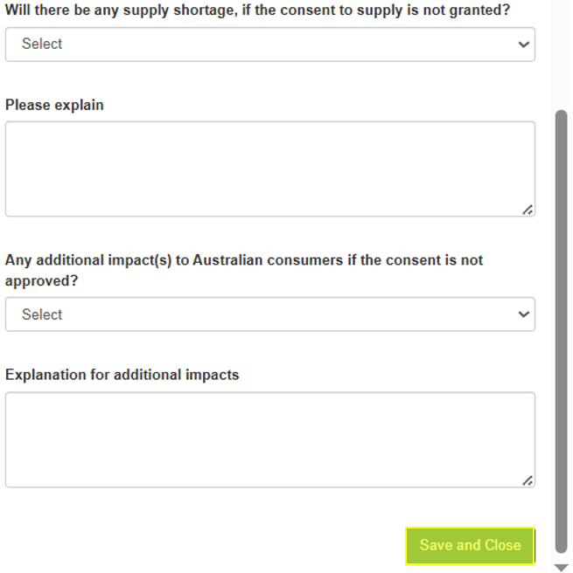
Figure 33

Any stock-related information you have provided for each device will appear in the table, in the ‘Edit Device Group’ view (Figure 34).
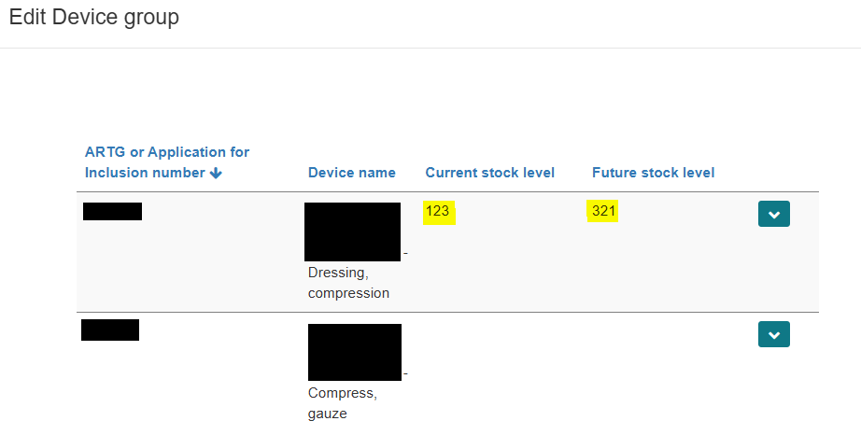 Figure 34

- Repeat the above steps to provide stock information for the other devices included in this group.
- Provide the proposed start and end date for the consent, relevant to this group of device(s).
  - The ‘Proposed end date’ must be within 3 years of the ‘Proposed start date’ of the consent (Figure 35).
  - Provide a reason for the proposed duration of consent in the text box provided (Figure 35).
- Provide details on the batches affected, if relevant (Figure 35).
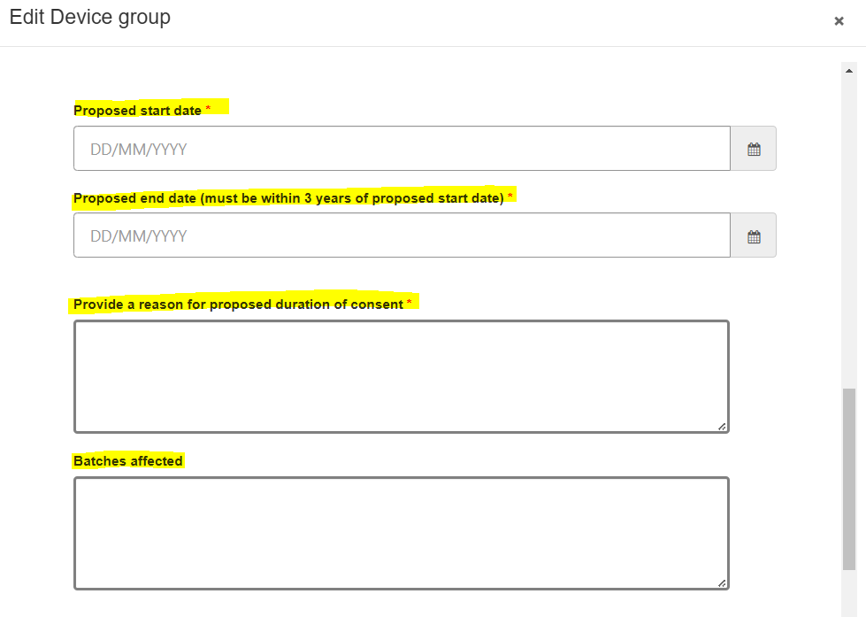Figure 35

Provide information on the strategies to be implemented to rectify the non-conformance for all the devices included in this group (Figure 36).
- Type an explanation in the free text box provided (Figure 36).
Or upload documents in the relevant folders under the ‘Documents’ section below the text box (Figure 37).
- Microsoft Word, Excel, and Adobe Acrobat documents with a file size of up to 50MB can be uploaded.
- This is a mandatory field; if you are uploading the information in a document, please type ‘document attached’ or a similar descriptor in the text box provided.

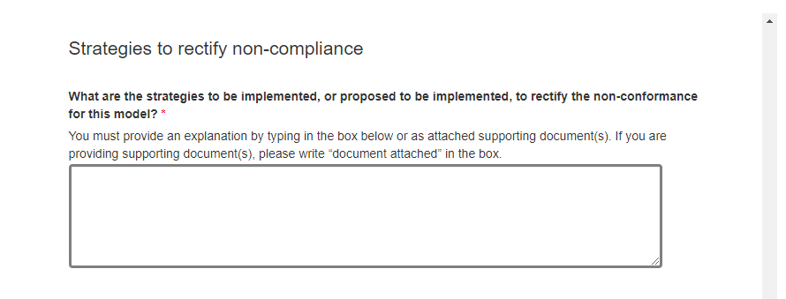
Figure 36

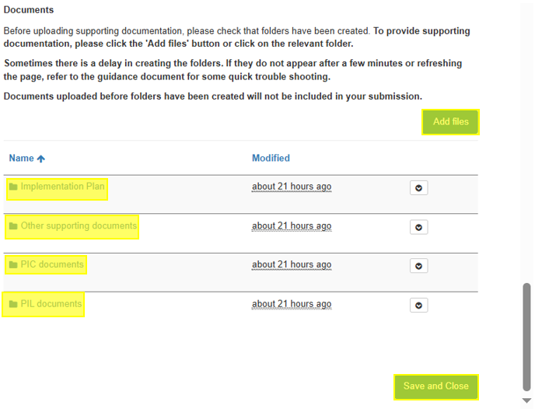 Figure 37

NOTE: If the document folders do not appear below the ‘Add files’ button, and/or you see an error message where the folders should be (Figure 38):
- There may be a delay in the SharePoint folders appearing on screen.
- To overcome this issue:
  - Select ‘Save and Close’ under the error message.
  - Reopen the ‘Device Groups’ section.
  - The folders should appear, ready for you to upload your documents.
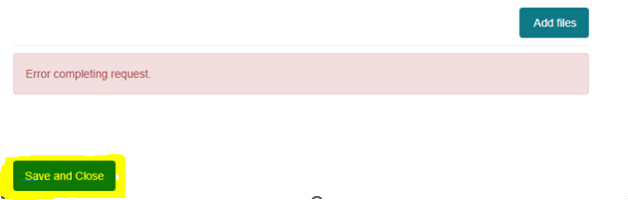 Figure 38

- To upload a document:
  - Select the relevant folder (such as ‘Implementation Plan’) by clicking on the name of the folder.
  - Click on the ‘Add files’ button (Figure 39).
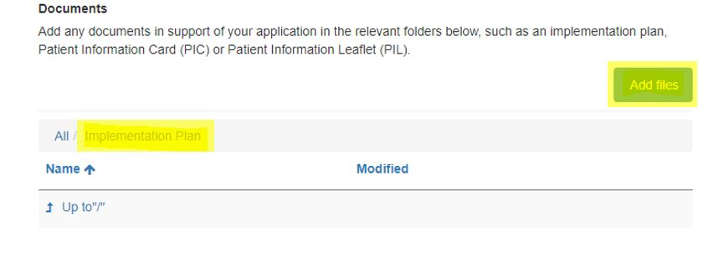 Figure 39

- Using the ‘Choose files’ option on this window:
  - Upload a document saved on your computer.
  - Select the relevant document that you wish to upload.
  - Click ‘Add files’ at the bottom of this window to add the selected file to this folder (Figure 40).
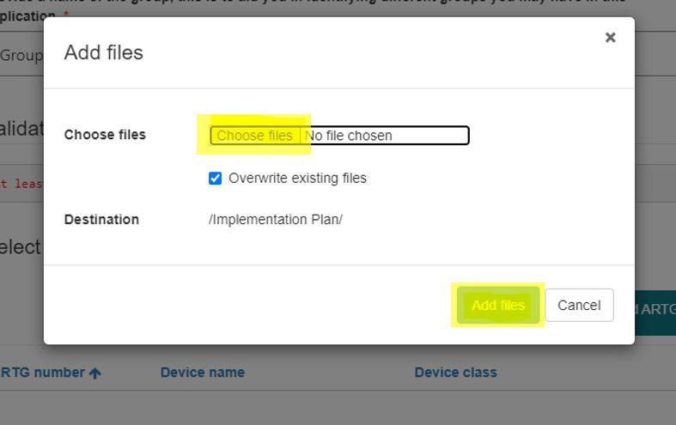
Figure 40

- You will see the name and size of the document that has been uploaded to the relevant folder.
- Click on the ‘All’ option or the ‘Up to “/”’ option to select other folders for uploading other documents if required (Figure 41).
- Click on the downward arrow on the right-hand side of the document name to delete an attached document (Figure 41).
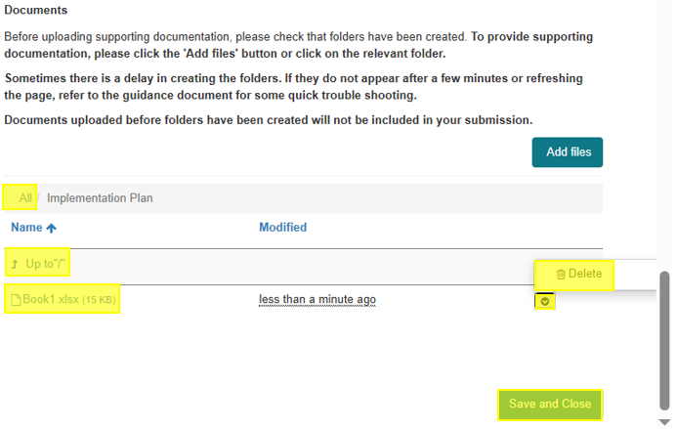 Figure 41

- Once you have completed all required information for your device group:
  - Click the ‘Save and Close’ button at the bottom of this window to save the information you have provided (Figure 41).
- Repeat the above steps to provide information for additional device groups included in the application.
- Once all the mandatory fields are completed, the ‘Device groups’ section will turn green, indicating that it is now complete (Figure 42).
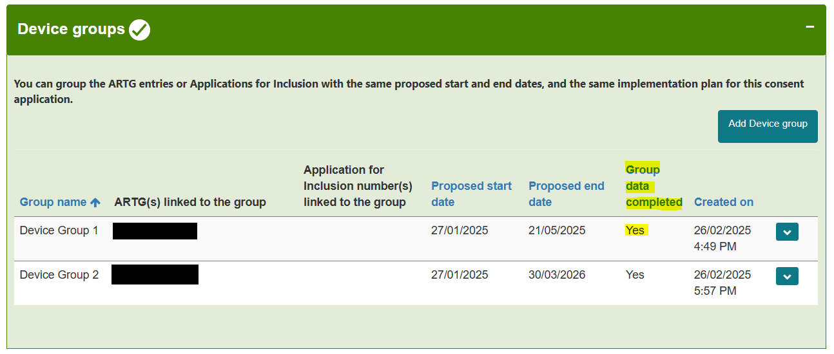 Figure 42

NOTE: If the required information related to a device group is complete:
- You will see a ‘Yes’ under the ‘Group data completed’ field (Figure 42).
- If the ‘Device groups’ section is amber in colour and the ‘Group data complete’ field displays a ‘No’:
  - This indicates that the mandatory data for this group is incomplete.
  - You will be unable to submit this application until this information is provided.

Device(s) included in Application(s) for Inclusion
For devices included in an Application for Inclusion:
- Select ‘Edit’ from the dropdown arrow of the device group you would like to add a device to.
- Ensure the device is included in Application(s) for Inclusion (Figure 43).
Figure 43

- A pop-out window will open within the current view (Figure 44).
- The device group name you provided is shown at the top of the window.
- This is an editable field, and you can change the device group name if you like.
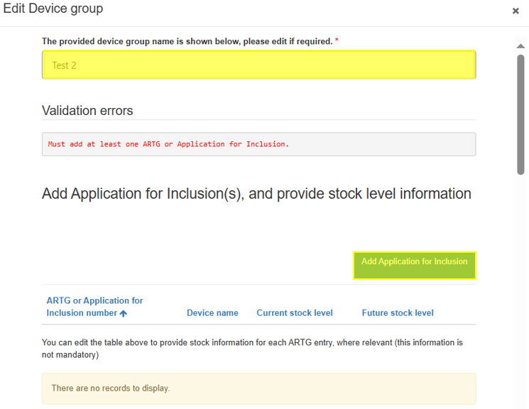
Figure 44

To add devices that are part of an Application for Inclusion:
- Click on the ‘Add Application for Inclusion’ button.
- This will open a pop-out window where you can provide the Application for Inclusion number and the device name (Figure 45).
- Once you type this information, click on the ‘Save and Close’ button to add this device to the group.
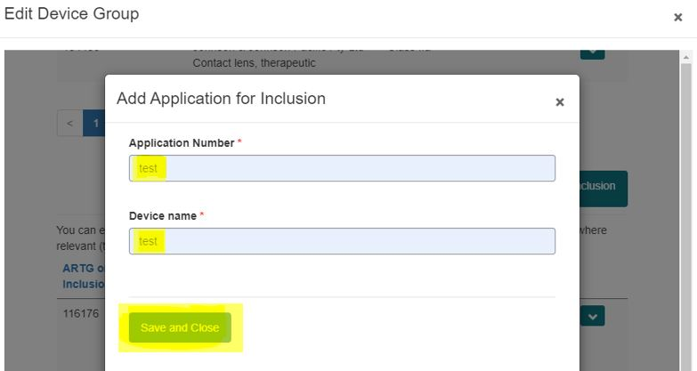 Figure 45

- Repeat the above step to add more devices that are part of an Application for Inclusion.
- The devices will be added to the group (Figure 46).
- Click on the down arrow on the right to:
  - ‘Delete’ the device if it was added in error to the group.
  - ‘Edit’ to provide stock information.
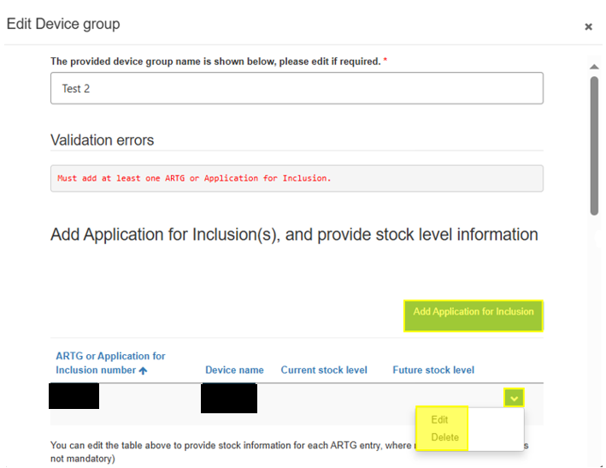
Figure 46

- To provide stock information for each device:
  - Click the down-arrow on the right side of the window against the device.
  - Select ‘Edit’ (Figure 46).
  - This will open a pop-out window (Figure 47).
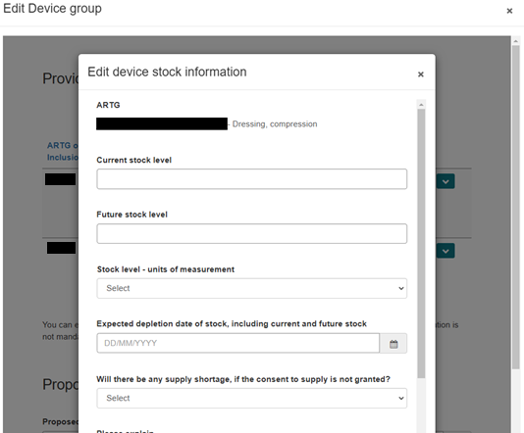 Figure 47

- Enter the current stock information for this device.
- Enter the expected date of stock depletion (Figure 47).
- Advise whether there will be any supply shortages or additional impact(s) to consumers if consent is not granted (Figure 47 and Figure 48).
- Click ‘Save and Close’ (Figure 48).
Figure 48

Any stock related information you have provided for each device will appear in the table, in ‘Edit Device Group’ view (Figure 49).
Figure 49

- Repeat the above steps to provide stock information for the other devices included in this group.
- Provide the proposed start and end date for the consent, relevant to this group of device(s).
  - The ‘Proposed end date’ must be within 3 years of the ‘Proposed start date’ of the consent (Figure 50).
  - Provide a reason for the proposed duration of consent in the text box provided (Figure 50).
- Provide details on the batches affected, if relevant (Figure 50).
Figure 50
Provide information on the strategies to be implemented to rectify the non-conformance for all the devices included in this group (Figure 51).
- Type an explanation in the free text box provided (Figure 51).
Or upload documents in the relevant folders under the ‘Documents’ section below the text box (Figure 52).
- Microsoft Word, Excel, and Adobe Acrobat documents with a file size of up to 50MB can be uploaded.
- This is a mandatory field; if you are uploading the information in a document, please type ‘document attached’ or a similar descriptor in the text box provided.
Figure 51

Figure 52

NOTE: If the document folders do not appear below the ‘Add files’ button, and/or you see an error message where the folders should be (Figure 53):
- There may be a delay in the SharePoint folders appearing on screen.
- To overcome this issue:
  - Select ‘Save and Close’ under the error message.
  - Reopen the ‘Device Groups’ section.
  - The folders should appear, ready for you to upload your documents.

Figure 53

To upload a document:
- Select the relevant folder (such as ‘Implementation Plan’) by clicking on the name of the folder.
- Click on the ‘Add files’ button (Figure 54).
Figure 54

Using the ‘Choose files’ option on this window:
- Upload a document saved on your computer.
- Select the relevant document that you wish to upload.
- Click ‘Add files’ at the bottom of this window to add the selected file to this folder (Figure 55).
Figure 55

- You will see the name and size of the document that has been uploaded to the relevant folder.
- Click on the ‘All’ option or the ‘Up to “/”’ option to select other folders for uploading other documents if required (Figure 56).
- Click on the downward arrow on the right-hand side of the document name to delete an attached document (Figure 56).
Figure 56

- Complete all required information for your device group.
- Click the ‘Save and Close’ button at the bottom of the window to save the information (Figure 57).
- Repeat the above steps for additional device groups included in the application.
- Once all mandatory fields are completed, the ‘Device groups’ section will turn green, indicating it is complete (Figure 57).
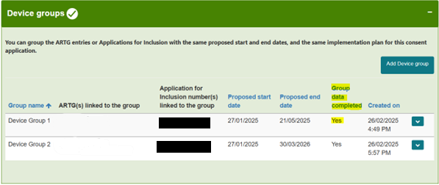 Figure 57

NOTE: If the required information for a device group is complete:
- You will see a ‘Yes’ under the ‘Group data completed’ field (Figure 57).
- If the ‘Device groups’ section is amber and the ‘Group data complete’ field displays a ‘No’:
  - This indicates that the mandatory data for this group is incomplete.
  - You will be unable to submit the application until this information is provided.

Device(s) NOT included in the ARTG or Application(s) for Inclusion
For device(s) not included in the ARTG or Application for Inclusion:
- Select ‘Edit’ from the dropdown arrow of the device group you want to add a device to.
- Ensure the device is included in the Application(s) for Inclusion (Figure 58).
Figure 58

- A pop-out window will open within the current view (Figure 59).
- The device group name you provided will be shown at the top of the window.
- This is an editable field, allowing you to change the device group name if desired.

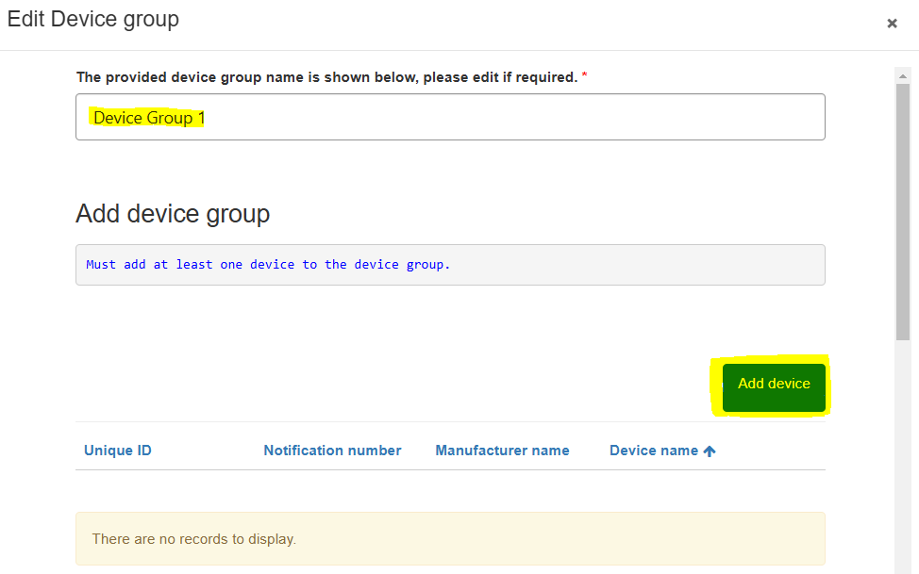
Figure 59

To add device(s) not included in the ARTG or Application for Inclusion:
- Click on the ‘Add device’ button (Figure 59) to open a window within the current view (Figure 60).
- To add devices to this group, you have two options:
  - ‘Add existing device’ if it was part of a previous consent for non-compliance application.
  - ‘Add a new device’ to the device group.

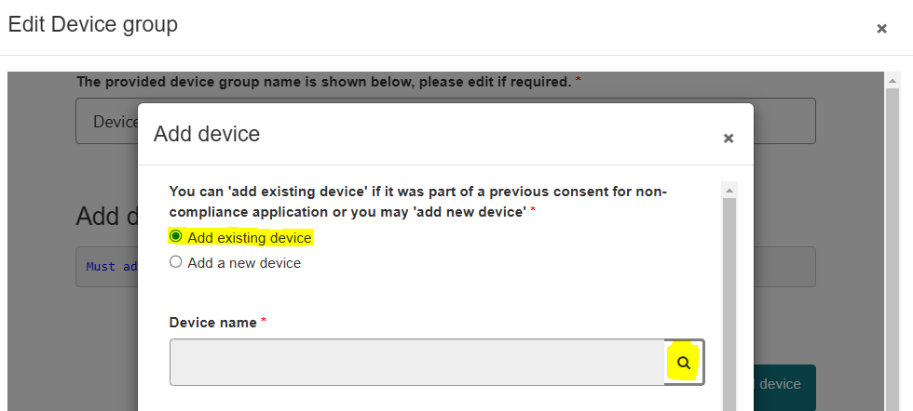 Figure 60

Add existing device
- To include a device from a previous consent for non-compliance application:
  - Select ‘Add existing device’.
  - Click on the lookup device field (indicated by the magnifying glass symbol) (Figure 61).
- A ‘Lookup records’ list will open with all devices added by the sponsor to previous applications (Figure 61).
- Use the search box (indicated by the magnifying glass symbol) to search for devices by name.
- Alternatively, select a single device from the list by clicking the checkbox.
- Click ‘Select’ (Figure 61).
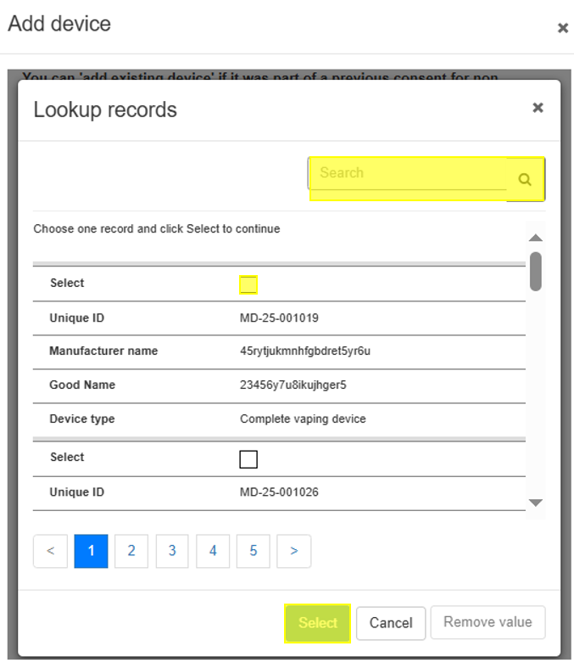
Figure 61

The selected device details will be added to the ‘Add device’ window (Figure 62).
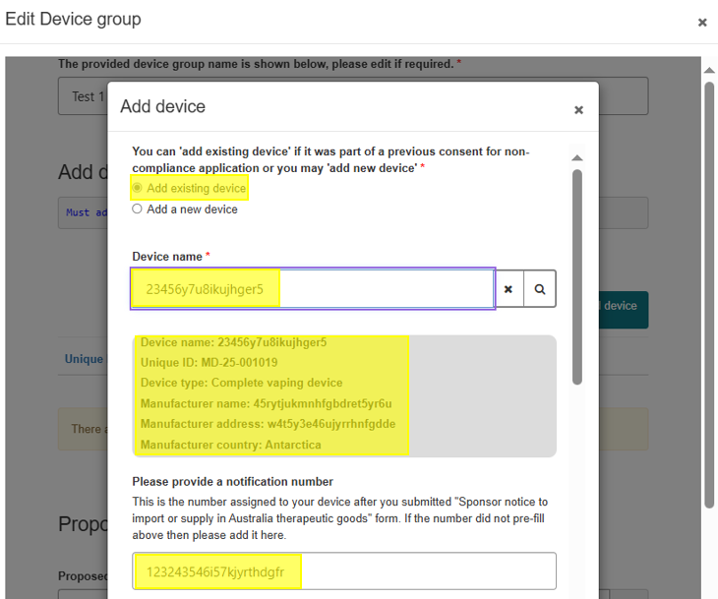
Figure 62

NOTE:
- You cannot edit device details for an existing device.
- If you provided the Notification number of your device in the previous application:
  - This number will be pre-populated.
  - If your device did not have a notification number when you submitted the previous application, you can type this number in the free text field provided.
- All devices previously included in a submitted consent for non-conformance application will be assigned a system-generated Unique ID.
  - This ID enables the TGA to differentiate different devices included in consent applications.
- Next, provide the following information for this device:
  - Current stock information.
  - Expected date of stock depletion.
  - Advice on whether there will be any supply shortages or additional impacts to consumers if consent is not granted (Figure 63).
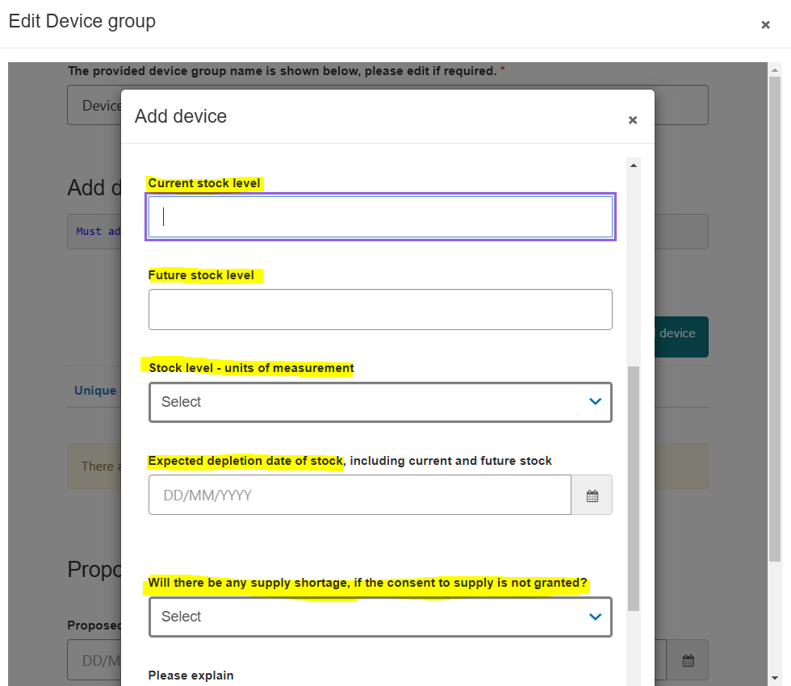
Figure 63

- Once complete, press ‘Save and Close’.
  - The device will now appear in the ‘Edit Device Group’ table (Figure 64).
- Repeat the above step to add more existing devices not included previously.
- The devices will be added to the group.
- Click on the down arrow on the right to:
  - ‘Delete’ the device if it was added in error to the group.
  - ‘Edit’ to provide stock information (Figure 64).
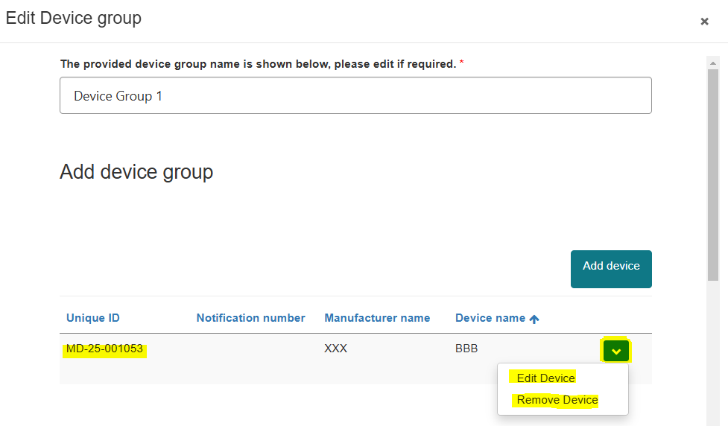
Figure 64

Add new device
- Select ‘Add a new device’.
- Type a device name.
- Select the type of device from the drop-down menu (Figure 65).
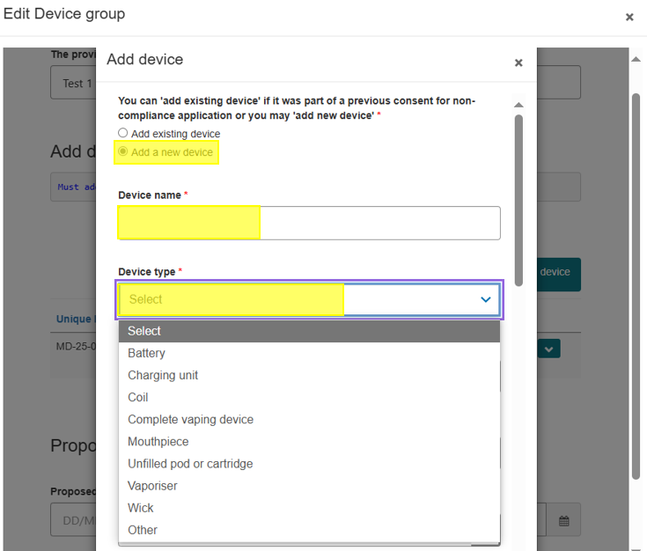
Figure 65

- Type in the device’s manufacturer name.
- Type in the device’s manufacturer address (Figure 66).
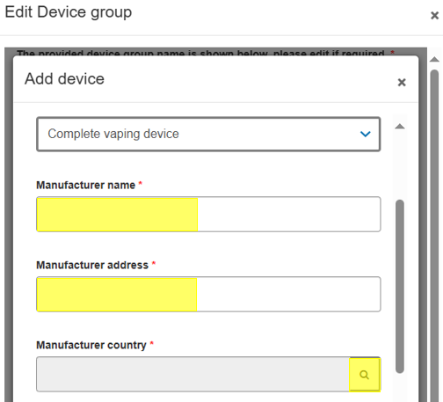
Figure 66

- Click on the lookup ‘Manufacturer country’ field (indicated by the magnifying glass symbol) to open a pop-out window.
- Use the search box to search for a country by name.
- Alternatively, select a country from the list by clicking the checkbox.
- Click ‘Select’ (Figure 67) to add the manufacturer country to the ‘Add device’ page.
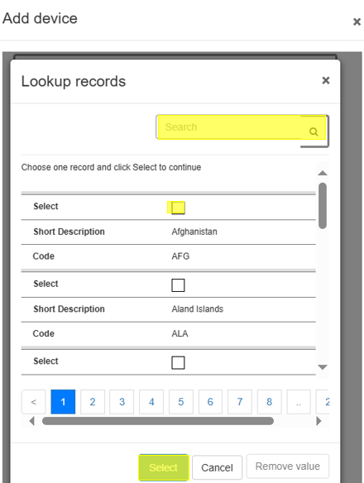
Figure 67

If your device has a notification number, type it in the text box provided (Figure 68).
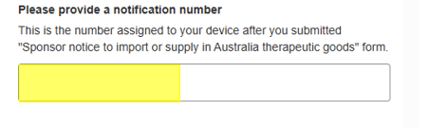
Figure 68

- Provide current stock information for this device.
- Provide the expected date of stock depletion.
- Advise whether there will be any supply shortages or additional impacts to consumers if consent is not granted (Figure 69).
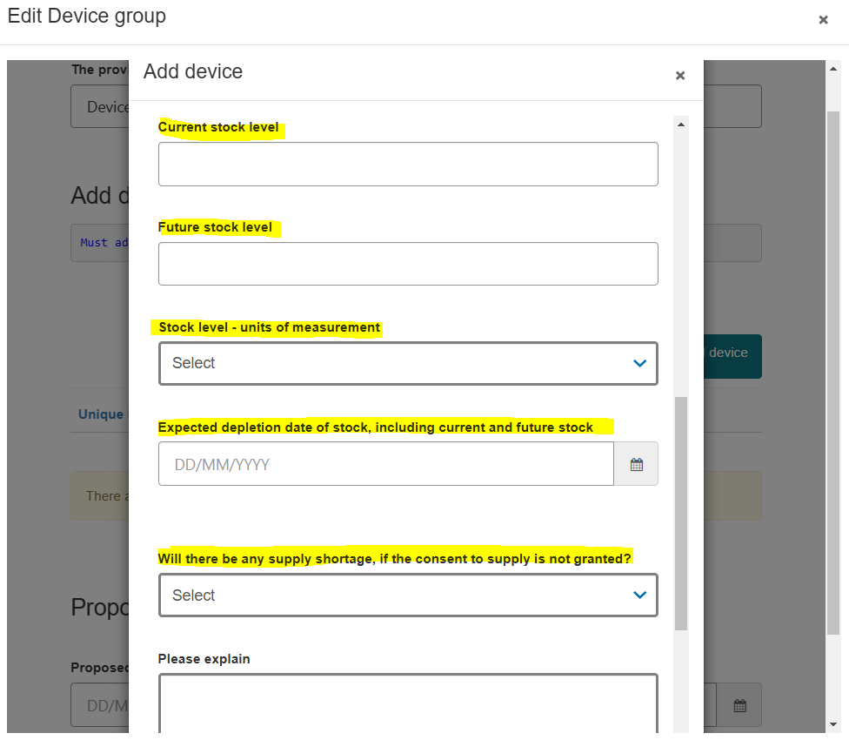
Figure 69

- Once complete, press ‘Save and Close’.
  - The device will now appear in the ‘Edit Device Group’ table (Figure 70).
- Repeat the above step to add more ‘new devices’ to the device group.
- The devices will be added to the device group.
- Click on the down arrow on the right to:
  - ‘Delete’ the device if it was added in error to the group.
  - ‘Edit’ to provide stock information (Figure 70).
Figure 70

- Provide the proposed start and end date for the consent, relevant to this group of devices.
  - The ‘Proposed end date’ must be within 3 years of the ‘Proposed start date’ of the consent.
- Provide a reason for the proposed duration of consent in the text box provided (Figure 71).
- Provide details on the batches affected, if relevant (Figure 71).
Figure 71
Provide information on the strategies to be implemented to rectify the non-conformance for all the devices included in this group (Figure 72).
- Type an explanation in the free text box provided (Figure 72).
Or upload documents in the relevant folders under the ‘Documents’ section below the text box (Figure 73).
- Microsoft Word, Excel, and Adobe Acrobat documents with a file size of up to 50MB can be uploaded.
- This is a mandatory field; if you are uploading the information in a document, please type ‘document attached’ or a similar descriptor in the text box provided.
Figure 72

Figure 73
NOTE: If the document folders do not appear below the ‘Add files’ button, and/or you see an error message where the folders should be (Figure 74):
- There may be a delay in the SharePoint folders appearing on screen.
- To overcome this issue:
  - Select ‘Save and Close’ under the error message.
  - Reopen the ‘Device Groups’ section.
  - The folders should appear, ready for you to upload your documents.
Figure 74

To upload a document:
- Select the relevant folder (such as ‘Implementation Plan’) by clicking on the name of the folder.
- Click on the ‘Add files’ button (Figure 75).
Figure 75

Using the ‘Choose files’ option on this window:
- Upload a document saved on your computer.
- Select the relevant document that you wish to upload.
- Click ‘Add files’ at the bottom of this window to add the selected file to this folder (Figure 76).
Figure 76

- You will see the name and size of the document that has been uploaded to the relevant folder.
- Click on the ‘All’ option or the ‘Up to “/”’ option to select other folders for uploading other documents if required (Figure 77).
- Click on the downward arrow on the right-hand side of the document name to delete an attached document (Figure 77).
Figure 77

- Complete all required information for your device group.
- Click the ‘Save and Close’ button at the bottom of the window to save the information (Figure 77).
- Repeat the above steps for additional device groups included in the application.
- Once all mandatory fields are completed, the ‘Device groups’ section will turn green, indicating it is complete (Figure 78).
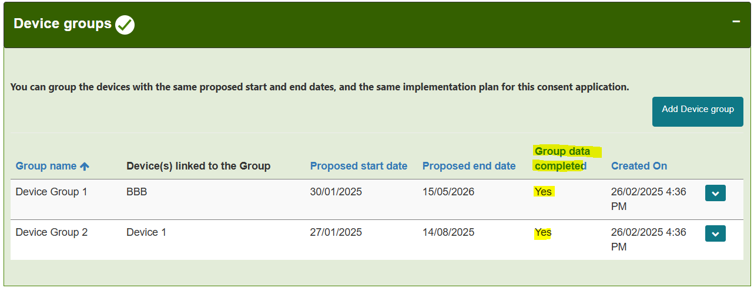 Figure 78

NOTE: If the required information for a device group is complete:
- You will see a ‘Yes’ under the ‘Group data completed’ field (Figure 78).
- If the ‘Device groups’ section is amber and the ‘Group data complete’ field displays a ‘No’:
  - This indicates that the mandatory data for this group is incomplete.
  - You will be unable to submit the application until this information is provided.

Declaration
- To submit the application, complete the ‘Declaration’ section (Figure 79).
- If any mandatory fields in other sections are not completed:
  - The ‘Declaration’ section will not display the ‘Submit’ button.
- The form can only be submitted by an authorised user with submitter access for the TBS sponsor portal.
  - Users with drafter access can only draft and save an application.
  - Users with drafter access will not see the ‘Submit’ button.
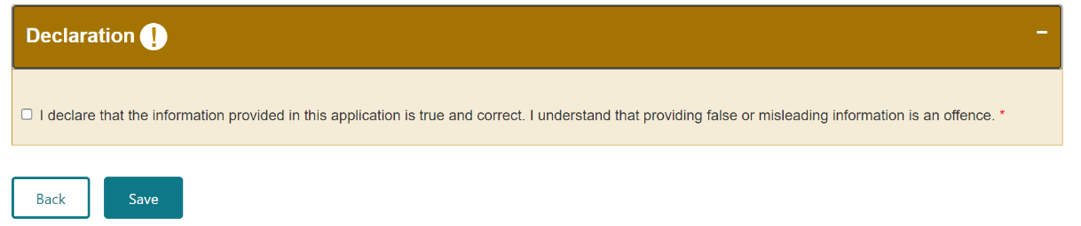 Figure 79

- Ensure all mandatory form fields in the other sections are complete.
- Read the declaration statement.
- If you agree, check the tick box under the declaration section to provide your declaration.
  - Once ticked, the colour of the ‘Declaration’ section will change to green (Figure 80).
  - This will trigger the ‘Submit’ button to appear.
NOTE: If you have completed all the mandatory fields and cannot save your response in the ‘Declarations’ section:
- Check whether you have submitter access or drafter access to the TBS sponsor portal.
- Only users with submitter access can save their response in the ‘Declaration’ section and submit the application.
- To change the type of access to the TBS sponsor portal, contact the TBS Service Desk: eBS@health.gov.au.
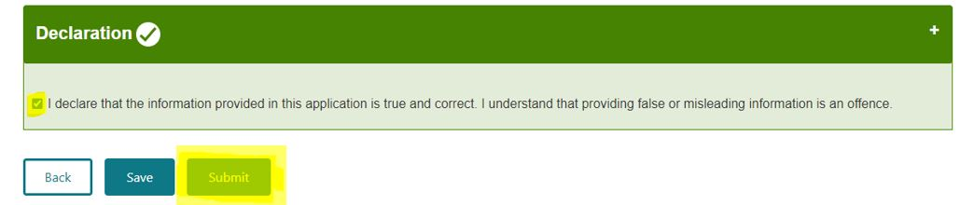
Figure 80

- From here, you can either:
  - Submit the application by clicking the ‘Submit’ button (Figure 80).
  - Click on the ‘Save’ button to keep it in draft for submission at a later time (Figure 80).
NOTE: If you have drafter access, you will only be able to save the application once you have unchecked the declarations tick box.
- Once submitted:
  - The application will move from the ‘Draft’ view to the ‘Submitted’ view (Figure 81).
  - This can be accessed through the ‘Consent for Non-compliance Application Dashboard’.

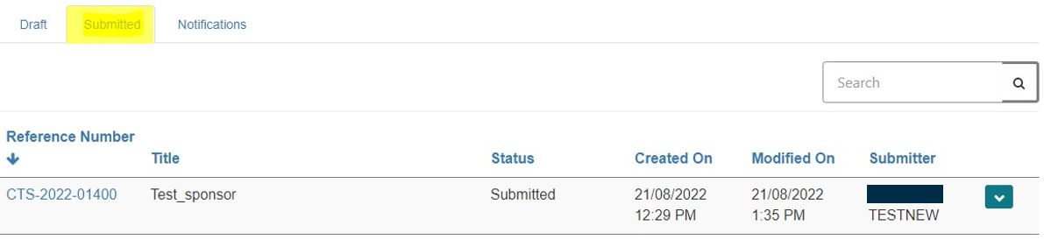
Figure 81

Viewing status of submitted applications
You can view the status of submitted applications on the ‘Submitted’ tab (Figure 82).
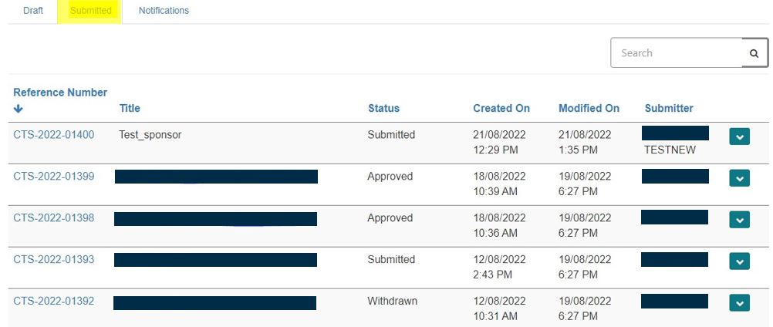
Figure 82

You will be able to see the following application statuses:
- Submitted: The application has been submitted, but not yet under review.
- Review: The application has been paid and is under review.
- Approved: The application has been approved, and consent has been granted.
- Not Approved: The application was not approved, and consent has not been granted.
- Revoked: An approved consent has been revoked.
- Expired: The consent period for this application has expired.
- Withdrawn: The application has been withdrawn by the sponsor.

Viewing and printing submitted applications
You can view and/or print a submitted application by clicking on the arrow down button along the application in ‘Submitted’ view (Figure 83).
You will see three options: ‘View details’, ‘Preview’, and ‘Withdraw application’.
- Click on ‘View details’ to view the application information provided, including any uploaded documents.
- Click on ‘Preview’ to preview and print the application form (Figure 83).
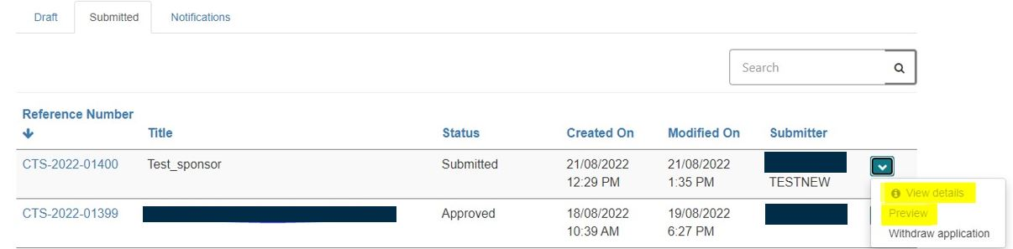
Figure 83

- On the ‘Consent for Non-compliance Application Preview’ view (Figure 84):
  - Click on the ‘Print’ button.
  - This will open a window within the current view to save or print a copy of the application (Figure 85).
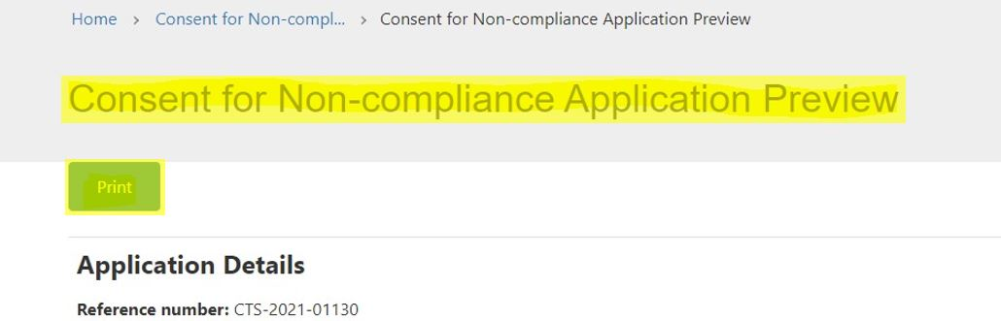
Figure 84

To save the application:
- In the ‘Destination’ section of the window, select ‘Save as PDF’ (Figure 85).
- Click ‘Save’ at the bottom of the window (Figure 85).
- This will give you the option to save the document to a desired folder on your computer.

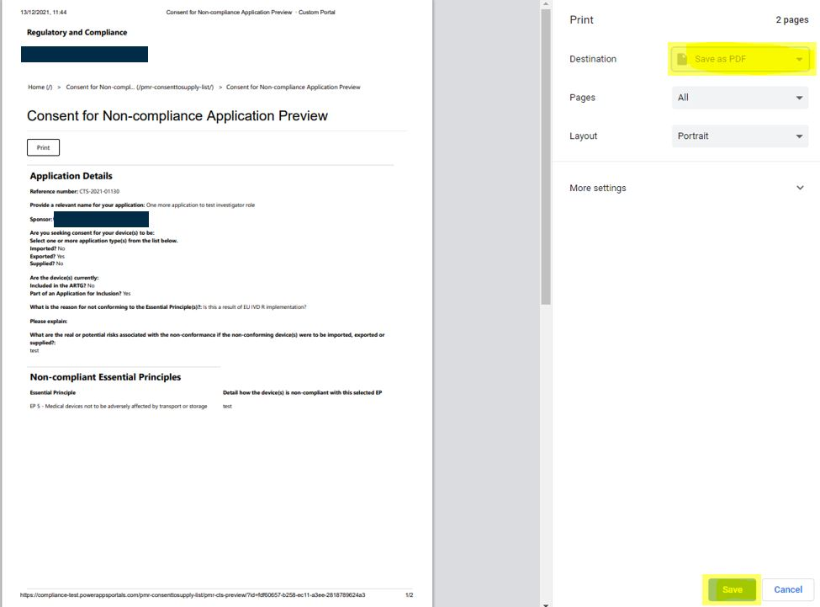
Figure 85

To print the application:
- In the ‘Destination’ section of the window, select the appropriate printer (Figure 86).
- Click the ‘Print’ button at the bottom of the window (Figure 86).

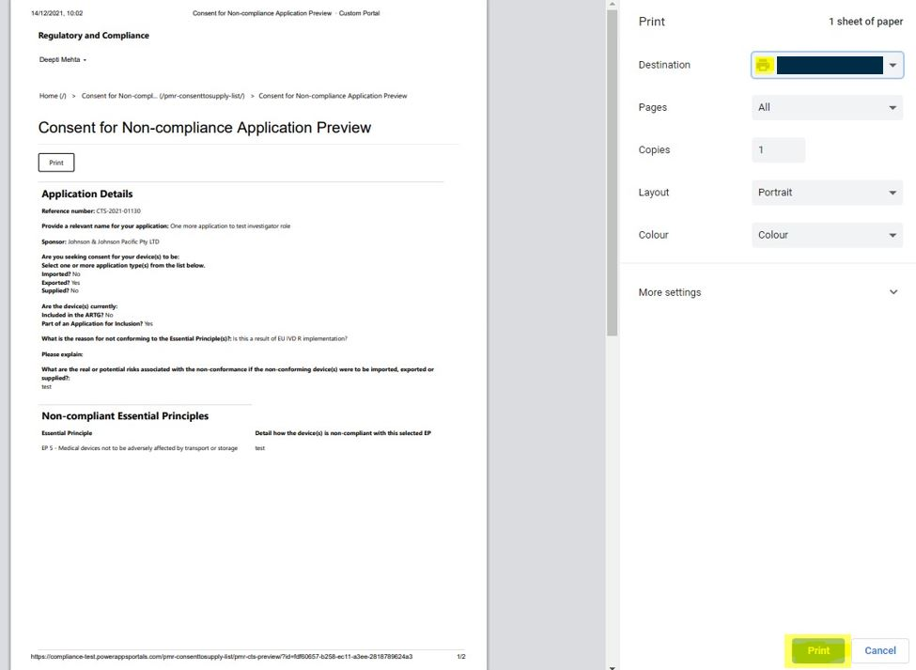
Figure 86

Withdrawing an application
- An application for consent can be withdrawn by the sponsor after it has been submitted or while it is under review by the TGA.
- Important notes:
  - Once an application is withdrawn, it cannot be reactivated.
  - Any application fees paid by the sponsor cannot be refunded.
  - If consent is required for the same devices at a later date, a new application will be required.
- To withdraw an application:
  - Go to the ‘Submitted’ tab.
  - On the application you wish to withdraw, click on the arrow down button on the right-hand side.
  - Select the ‘Withdraw application’ option (Figure 87).
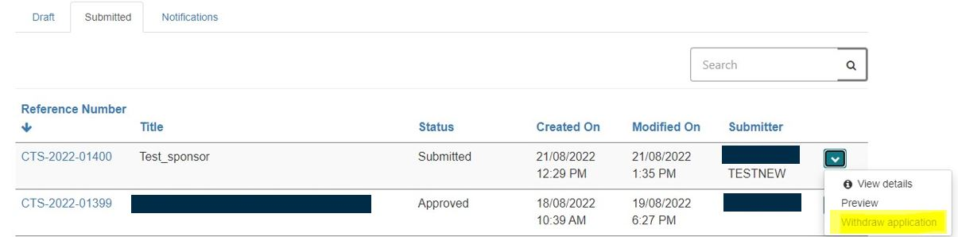
Figure 87

- A new window will open in the current view (Figure 88).
- Provide an explanation for the withdrawal of the application (mandatory field).
- Click on the ‘Withdraw’ button to withdraw the application.
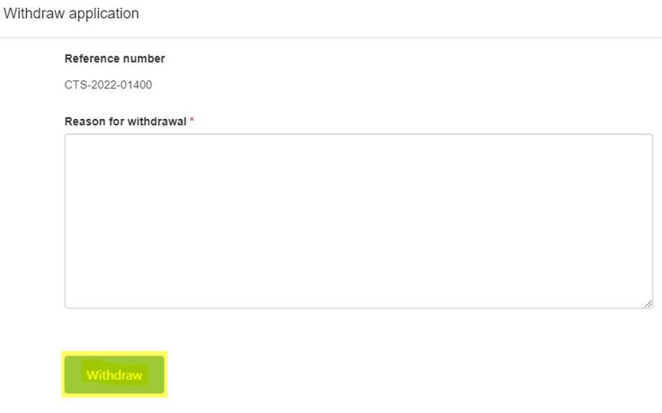
Figure 88

- A pop-up warning message will appear explaining that once an application is withdrawn, it cannot be reactivated.
- To continue with the withdrawal, press ‘OK’ to finalise.
- To cancel the withdrawal request, press ‘Cancel’.
- A withdrawal notification will be sent to you confirming the withdrawal of the application.
- This notification will be available to view from the ‘Notifications’ tab.

Notifications related to a consent application
All notifications regarding a submitted consent application can be viewed on the ‘Notifications’ tab of the dashboard (Figure 89).
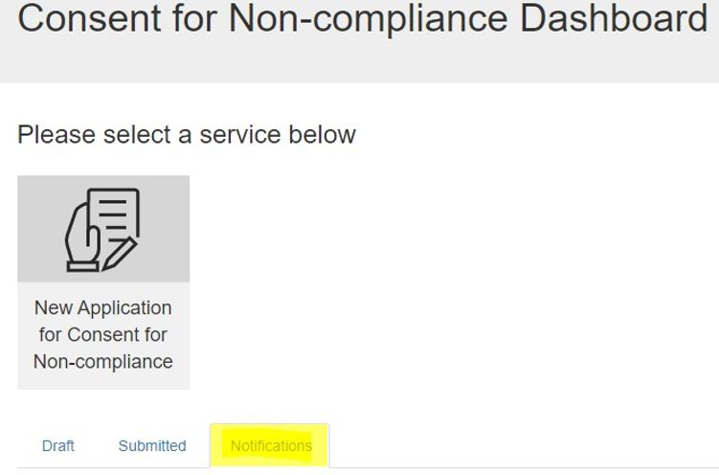
Figure 89

Notifications may include:
- Letters regarding the outcome of the application review (consent approved or not approved).
- Application withdrawal confirmation.
- Consent expiry or consent revocation notifications.
- Informal requests for more information related to a submitted application.
- Regulatory letters related to devices that are part of an approved consent application.
For guidance on how to view and respond to notifications related to a consent application, please see the guidance document on the TGA website titled “Guidance for viewing and responding to notifications on the Consent for Non-compliance Dashboard”.

Help and Information
For more information on how to submit your application, please contact mdconsent@health.gov.au or call us on 1800 141 144.

Version history
Version | Description of change | Author | Effective date
V1.0 | Original publication for new form in TBS | Medical Devices  Surveillance Branch | December 2021
V1.1 | Updated to include information on print function and status columns in submitted dashboard | Medical Devices  Surveillance Branch | December 2021
V1.2 | Updated to include information on withdrawn status | Medical Devices  Surveillance Branch | January 2022
V2.0 | Updated to reflect change in dashboard and additional features with Release 2.0 | Medical Devices  Surveillance Branch | September 2022
V2.1 | Updated to remove reference to the amount of the fee associated with the application and provide a link to the current fees web page. | Medical Devices  Surveillance Branch | July 2023
V3.0 | Updated to include changes in dashboard and additional features with Release 3.0 | Medical Devices  Authorisation Branch  Surveillance Branch | March 2025

Therapeutic Goods Administration
PO Box 100 Woden ACT 2606 Australia
Email: info@tga.gov.au Phone: 1800 020 653 Fax: 02 6203 1605
https://www.tga.gov.au
Reference/Publication #

