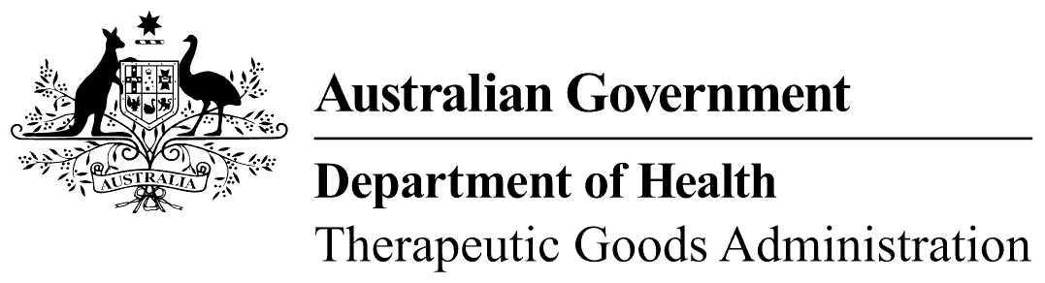
TGA use only

This form, when completed, will be classified as 'Official - sensitive'. For guidance on how your information will be treated by the TGA see: Treatment of information provided to the TGA at <https://www.tga.gov.au/treatment-information-provided-tga>.
Privacy Notice: The TGA is part of the Australian Government Department of Health and is committed to protecting your privacy and personal information. The Department of Health’s Privacy Policy contains information about how we comply with the Privacy Act 1988 and the Australian Privacy Principles.

Single-use permit application to export human substances
The TGA issues permits for the export of human substances under the Customs (Prohibited Export) Regulations 1958. For more information, see: Exporting human substances from Australia guidance.
Fill in this form to apply for single-use permit to export human substances from Australia. If you do not provide us with all of the information requested, we may be unable to process the application. Email the completed form to tga.exports@health.gov.au.
Name of applicant
Address of applicant
Phone number of applicant
ABN or CCID of applicant
Email address of applicant
Good (substance) to be exported
Volume
Brief reason for request
Destination country
Full name of patient
Flight and/or courier details
Export date (provide the month if the exact date is unknown)

Applicant’s signature and date | I declare that the information provided in this application is complete and correct to the best of my knowledge.

