First Round CER report: 22 September 2014
Second Round CER report: 20 January 2015

AusPAR Attachment 2

Extract from the Clinical Evaluation Report for Adalimumab (rch)
  - Proprietary Product Name: Humira
  - Sponsor: AbbVie Pty Ltd

About the Therapeutic Goods Administration (TGA)
- The Therapeutic Goods Administration (TGA) is part of the Australian Government Department of Health, and is responsible for regulating medicines and medical devices.
- The TGA administers the Therapeutic Goods Act 1989 (the Act), applying a risk management approach designed to ensure therapeutic goods supplied in Australia meet acceptable standards of quality, safety and efficacy (performance), when necessary.
- The work of the TGA is based on applying scientific and clinical expertise to decision-making, to ensure that the benefits to consumers outweigh any risks associated with the use of medicines and medical devices.
- The TGA relies on the public, healthcare professionals and industry to report problems with medicines or medical devices. TGA investigates reports received by it to determine any necessary regulatory action.
- To report a problem with a medicine or medical device, please see the information on the TGA website <https://www.tga.gov.au>.
About the Extract from the Clinical Evaluation Report
- This document provides a more detailed evaluation of the clinical findings, extracted from the Clinical Evaluation Report (CER) prepared by the TGA. This extract does not include sections from the CER regarding product documentation or post market activities.
- The words [Information redacted], where they appear in this document, indicate that confidential information has been deleted.
- For the most recent Product Information (PI), please refer to the TGA website <https://www.tga.gov.au/product-information-pi>.
Copyright
© Commonwealth of Australia 2015
This work is copyright. You may reproduce the whole or part of this work in unaltered form for your own personal use or, if you are part of an organisation, for internal use within your organisation, but only if you or your organisation do not use the reproduction for any commercial purpose and retain this copyright notice and all disclaimer notices as part of that reproduction. Apart from rights to use as permitted by the Copyright Act 1968 or allowed by this copyright notice, all other rights are reserved and you are not allowed to reproduce the whole or any part of this work in any way (electronic or otherwise) without first being given specific written permission from the Commonwealth to do so. Requests and inquiries concerning reproduction and rights are to be sent to the TGA Copyright Officer, Therapeutic Goods Administration, PO Box 100, Woden ACT 2606 or emailed to < tga.copyright@tga.gov.au>.

Contents
List of abbreviations 5
1. Introduction 7
1.1. Submission type 7
1.2. Drug class and therapeutic indication 8
1.3. Dosage forms and strengths 9
1.4. Dosage and administration 9
2. Clinical rationale 9
3. Contents of the clinical dossier 10
3.1. Scope of the clinical dossier 10
3.2. Paediatric data 10
3.3. Good clinical practice 10
4. Pharmacokinetics 10
4.1. Studies providing pharmacokinetic data 10
4.2. Study M10-444 - pharmacokinetic data (R&D/11/1281) 11
4.3. Results 12
4.4. Immunogenicity 13
4.5. Comparison between Studies M10-444 and DE038 14
4.6. Evaluator’s overall conclusions on pharmacokinetics 15
5. Pharmacodynamics 16
6. Dosage selection for the pivotal studies 16
7. Clinical efficacy 18
7.1. Pivotal study - M10-444 18
7.2. Evaluator's conclusions on clinical efficacy 37
8. Clinical safety 40
8.1. Study M10-444 40
8.2. Study P10-262 (Registry - interim 4-year safety data) 47
8.3. Evaluator's overall conclusions on clinical safety 60
9. First round benefit-risk assessment 62
9.1. First round assessment of benefits 62
9.2. First round assessment of risks 63
9.3. First round assessment of benefit-risk balance 64
10. First round recommendation regarding authorisation 64
11. Clinical questions 65
11.1. Efficacy 65
11.2. Safety 65
12. Second round evaluation of clinical data submitted in response to questions 66
12.1. Sponsor's proposed amendment to paediatric pJIA dosing regimen 66
12.2. Sponsor's responses to first round questions 70
13. Second round benefit-risk assessment 79
13.1. Second round assessment of benefits 79
13.2. Second round assessment of risks 79
13.3. Second round assessment of benefit-risk balance 79
14. Second round recommendation regarding authorisation 79

List of abbreviations
Abbreviation | Meaning
AAA | Anti-adalimumab antibody
ACR | American College of Rheumatology
AE | Adverse event
AESI | Adverse event(s) of special interest
AJC | Active joint count
ALT | Alanine aminotransferase
ANA | Anti-nuclear antibody
AP | Alkaline phosphatase
BCG | Bacille Calmette-Guérin
BSA | Body surface area
BUN | Blood urea nitrogen
CHQ-PF50 | Child Health Questionnaire – PF50
CHF | Congestive heart failure
CK | Creatine phosphokinase
CPK | Creatine phosphokinase
CRF | Case report form
CRO | Contract research organization
CRP | C-reactive protein
CV | Coefficient of variation
CVA | Cerebrovascular accident
DICHAQ | Disability Index of Childhood Health Assessment Questionnaire
DMARD | Disease-modifying anti-rheumatic drug
dsDNA | Double stranded DNA
EMA | European Medicines Agency
eow | Every other week
ESR | Erythrocyte sedimentation rate
EU | European Union
ET | Early termination
GCP | Good clinical practice
HCP | Health care provider
HSTCL | Hepatosplenic T-cell lymphoma
IgG1 | Human immunoglobulin
ICH | International Conference on Harmonisation
ILAR | International League of Associations for Rheumatology
ILD | Interstitial lung disease
IRB | Institutional Review Board
JADAS | Juvenile Arthritis Disease Activity Score
JIA | Juvenile idiopathic arthritis
JRA | Juvenile rheumatoid arthritis
LFT | Liver function tests
LOM | Limitation of Passive Motion Joint Count
MedDRA | Medical Dictionary for Regulatory Activities
MI | Myocardial infarction
MTX | Methotrexate
NMSC | Non-melanoma skin cancer
OL | Open-label
PedACR | Pediatric American College of Rheumatology
PGA | Physician's global assessment
PK | Pharmacokinetics
POM | Pain on Passive Motion Joint Count
PPD | Purified protein derivative
PT | Preferred Term
PYs | Patient-years
RA | Rheumatoid arthritis
RBC | Red blood cell
RF | Rheumatoid factor
SAE | Serious adverse event
SC | Subcutaneous
SD | Standard deviation
SJC | Swollen Joint Count
SOC | System Organ Class
TEAE | Treatment-emergent adverse event
TB | Tuberculosis
TI | Treatment interruption
TJC | Tender Joint Count
TNF | Tumor necrosis factor
ULN | Upper limit of normal
US | United States
VAS | Visual analog scale
WBC | White blood cell

Introduction

Submission type
This is a Category 1 submission from AbbVie P/L to extend the indications of Humira (adalimumab) for the treatment of polyarticular juvenile idiopathic arthritis (pJIA) from patients 4 years of age and older to patients 2 years of age and older.

Drug class and therapeutic indication
Humira (adalimumab) is a recombinant human immunoglobulin (IgG1) monoclonal antibody containing only human peptide sequences.
The currently approved indications are:
Rheumatoid arthritis
Humira is indicated for reducing signs and symptoms, as well as inhibiting the progression of structural damage in adult patients with moderate to severely active rheumatoid arthritis. This includes the treatment of patients with recently diagnosed moderate to severely active disease who have not received methotrexate.
Humira can be used alone or in combination with methotrexate.
Polyarticular Juvenile Idiopathic Arthritis
Humira in combination with methotrexate is indicated for reducing the signs and symptoms of moderately to severely active polyarticular juvenile idiopathic arthritis in patients aged 4 years of age and older. Humira can be given as monotherapy in case of intolerance or when continued treatment with methotrexate is inappropriate.
Psoriatic arthritis
Humira is indicated for the treatment of signs and symptoms, as well as inhibiting the progression of structural damage, of moderate to severely active psoriatic arthritis in adult patients where response to previous DMARDs has been inadequate.
Ankylosing spondylitis
Humira is indicated for reducing signs and symptoms in patients with active ankylosing spondylitis.
Crohn’s disease
Humira is indicated for the treatment of moderate to severe Crohn’s disease in adults to reduce the signs and symptoms of the disease and to induce and maintain clinical remission in patients who have had an inadequate response to conventional therapies, or who have lost response to or are intolerant of infliximab.
Ulcerative colitis
Humira is indicated for the treatment of moderate to severe ulcerative colitis in adult patients who have had an inadequate response to conventional therapy or who are intolerant to or have medical contraindications for such therapies. Patients should show a clinical response within 8 weeks of treatment to continue treatment beyond that time (see CLINICAL TRIALS).
Psoriasis
Humira is indicated for the treatment of moderate to severe chronic plaque psoriasis in adult patients who are candidates for systemic therapy or phototherapy.
Evaluator’s Comment: The proposed amendments to the currently approved indication for polyarticular juvenile idiopathic arthritis are shown below (bolded and underlined) with the deletions being identified by square brackets and strike-through:
Humira in combination with methotrexate is indicated for reducing the signs and symptoms of moderately to severely active polyarticular juvenile idiopathic arthritis in patients aged 2 [4] years of age and older. Humira can be given as monotherapy in case of intolerance to methotrexate or when continued treatment with methotrexate is inappropriate.

Dosage forms and strengths
The following dosage forms and strengths are currently registered:
Humira adalimumab (rch) 40mg vial AUST R 95779
Humira adalimumab (rch) 40mg pre-filled syringe AUST R 95780
Humira adalimumab (rch) 40mg pre-filled pen AUST R 127116
Humira adalimumab (rch) 20mg pre-filled syringe AUST R 155315
Humira adalimumab (rch) 40mg pre-filled pen AUST R 199410
Humira adalimumab (rch) 20mg pre-filled syringe AUST R 199411
Humira adalimumab (rch) 40mg pre-filled syringe AUST R 199412
Humira adalimumab (rch) 10mg pre-filled syringe AUST R 216038

Dosage and administration
The following information dosage and administration information has been taken from the proposed amendments to the approved Humira PI:
Humira is administered by subcutaneous injection. The recommended dose of Humira for patients 2 years of age and older with polyarticular juvenile idiopathic arthritis is based on weight as shown [in the table] below. Methotrexate, glucocorticoids, NSAIDs and/or analgesics may be continued during treatment with Humira.
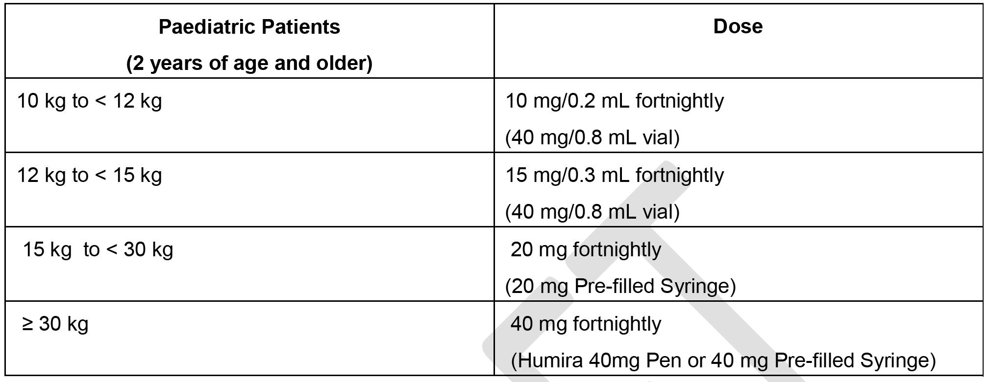
Humira has not been studied in patients with polyarticular JIA less than 2 years of age, or in patients with a weight below 10 kg.
Comment: The proposed dosage of Humira includes two new regimens: (1) 10 kg to < 12 kg; and (2) 12 kg to < 15 kg. The other two proposed regimens for patients 2 years of age and older are currently approved for patients 4 to 17 years.

Clinical rationale
The Clinical Overview stated that the pivotal study (M10-444) in paediatric patients aged 2 to < 4 years of age was undertaken by AbbVie as a commitment to the United States (US) Food and Drug Administration (FDA) and as a requirement of the European Medicines Agency (Pediatric Investigation Plan). The Clinical Overview (2.5.1) also stated that there is an ‘evident medical need for treatment of this young patient population with JIA’.
Evaluator’s Comment: The sponsor's clinical rationale is acceptable.

Contents of the clinical dossier

Scope of the clinical dossier
- Study M10-444 - uncontrolled study of compassionate use of adalimumab for the treatment of active polyarticular juvenile idiopathic arthritis (JIA) in children aged 2 to < 4 years and aged ≥ 4 years weighing < 15 kg.
- Study P10 - 262 (interim report of first 4 years registry experience) - A long-term, multi-Centre, longitudinal post-marketing, observational registry to assess long term safety and effectiveness of Humira (adalimumab) in children with moderately to severely active polyarticular or polyarticular-course juvenile idiopathic arthritis (JIA) – STRIVE.
- Bioanalysis validation report (ANA11-009) - Partial validation of the analytical method after lot change of detection Biotin-labelled antibody (analytes = anti-adalimumab antibodies; method = sandwich ELISA [double antigen technique]).
- Clinical Summary of Efficacy (CSE) Statistical Tables; Clinical Summary of Safety (CSS) Statistical Tables; tabular listing of studies; literature references.

Paediatric data
The submission provides paediatric data specifically relating to the treatment of pJIA in children aged 2 to < 4 years and aged ≥ 4 years weighing < 15 kg. The submission included a paediatric development program relating to provision of paediatric data to the EU and the USA.

Good clinical practice
The pivotal study (M10-444) complied with requirements for good clinical practice.

Pharmacokinetics

Studies providing pharmacokinetic data
Study M10-444 (the pivotal study) was a multicentre, open-label, uncontrolled study of adalimumab undertaken at 14 sites in the US (including Puerto Rico) and Europe in paediatric patients with moderately to severely active pJIA or polyarticular course JIA aged 2 to < 4 years or aged ≥ 4 years weighing < 15 kg. It was specified that the JIA diagnoses were to meet International League of Associations for Rheumatology (ILAR) criteria.
The submission included in PK report (R&D/11/1281) focusing on the pharmacokinetics (PK) and immunogenicity of adalimumab in the paediatric patients from Study M10-444 at week 24 of treatment. The PK evaluation of adalimumab was a secondary objective of Study M10-444. The PK data from Study M10-444 have been fully evaluated. There were no other studies in the submission providing PK data in the proposed patient population.

Study M10-444 - pharmacokinetic data (R&D/11/1281)

Overview
The PK report (R&D/11/1281) included Week 24 data. The recommended dose of adalimumab in the study was 24 mg/m² body surface area (BSA) up to a total dose of 20 mg administered every other week (eow) as a single dose via subcutaneous (SC) injection. At the completion of 24 weeks treatment US patients were to continue in the study until reaching the age of 4 years and ≥ 15 kg, and EU patients were to continue in the study for a maximum of 1 year. The continuation of treatment after 24 weeks was to allow time for transition to an appropriate pJIA treatment regimen.

Patient demographics
Thirty-two (32) patients were enrolled in the study and all were expected to complete a minimum of 24 weeks treatment. The majority of subjects (N = 24) were treated with SC adalimumab 0.3 mL (15 mg) eow (that is, 50 mg/mL x 0.3). Serum collection for PK analysis was optional and not required for participation in the main part of the study. Fifteen (15) patients provided serum samples for PK analysis, including pre-dose adalimumab and anti-adalimumab antibody (AAA) at Weeks 0, 12, and 24. Of the 15 patients with PK data, 11 (73.3%) were treated with adalimumab plus MTX and 4 (26.75) were treated with adalimumab without MTX. Of the 32 patients in enrolled in the study, 27 (84.4%) were treated with adalimumab plus MTX and 5 (15.5%) were treated with adalimumab without MTX. The baseline demographics of the 32 patients enrolled in the study and the subset of the 15 patients included in the PK analysis are summarised in below in Table 1. The baseline demographic characteristics of the 15 patients in the PK analysis were consistent with those of the 32 enrolled patients.

Table 1: Baseline demographic characteristics for subjects in Study M10-444.
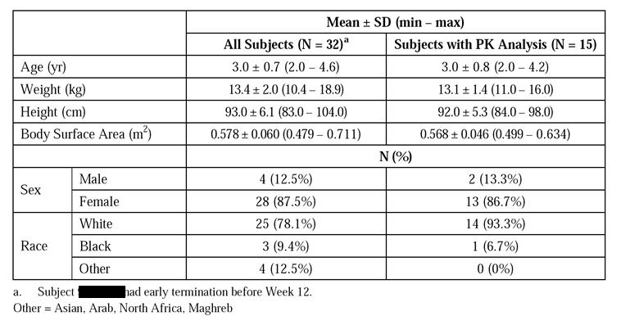

Methods

Pharmacokinetic
Serum adalimumab trough concentrations were summarised by dose at each time point using descriptive statistics including number of subjects (N), number of non-missing observations (Nnmiss), mean, median, standard deviation (SD), coefficient of variation (CV), minimum, maximum, and geometric mean. Individual subject concentration-time plots and mean concentration-time plots stratified by dose were provided. Serum adalimumab trough serum concentrations were measured at Baseline, Week 12, and Week 24.
A total of 52 serum samples were taken from 15 patients and 47 samples were analysed at Abbott Laboratories. Five (5) samples were duplicated, which appears to account for only 47 of the total number of 52 samples being analysed. Adalimumab concentrations in serum were determined using a validated enzyme-linked immunoadsorbent assay (ELISA) method. The validated analytical range for the adalimumab concentration was 3.13 to 50 ng/mL in diluted serum. Concentrations quantified above 50 ng/mL were diluted and reanalysed in a subsequent assay. Concentrations quantified below 3.13 ng/mL were reported as below the limit of quantitation (BLOQ).

Immunogenicity
Immunogenicity was assessed by serum AAA concentrations and the results were listed. The impact of AAA on serum adalimumab concentrations, efficacy and safety were analysed by carrying out subgroup analyses comparing AAA+ with AAA- subjects. Subjects were considered to be AAA+ if they had at least one AAA+ sample.
The total number of AAA samples received for the entire study was 52, and 22 were analysed for AAA at Abbott laboratories. The samples not analysed were duplicates, or showed adalimumab concentrations > 2 µg/mL, or were exhausted (1 sample). Serum samples were analysed for screening and confirmatory AAA assay using a validated double antigen immunoassay. The assay detects antibodies directed against epitopes on the entire adalimumab molecule.
The submission included a bioanalytical report for the determination of AAA in serum samples from Study M10-444. The validated assay range was from 1.031 to 25.0 ng/mL in diluted serum. Concentrations quantified above 25.0 ng/mL were diluted and reanalysed in a subsequent assay. Concentrations quantified below 1.031 ng/mL were reported as BLOQ.
Serum samples were considered to be positive for AAA if the following criteria were met: (1) the measured AAA concentration was greater than 20 ng/mL; and (2) the serum sample was collected within 30 days after an adalimumab dose.

Results

Pharmacokinetics
Serum adalimumab trough concentrations at Baseline, Week 12 and Week 24 are summarised below in Table 2 and Figure 1.

Table 2: Study M10-444 - Mean ± SD serum adalimumab trough concentrations (µg/mL) in paediatric patients (N = 15) with pJIA through to Week 24.
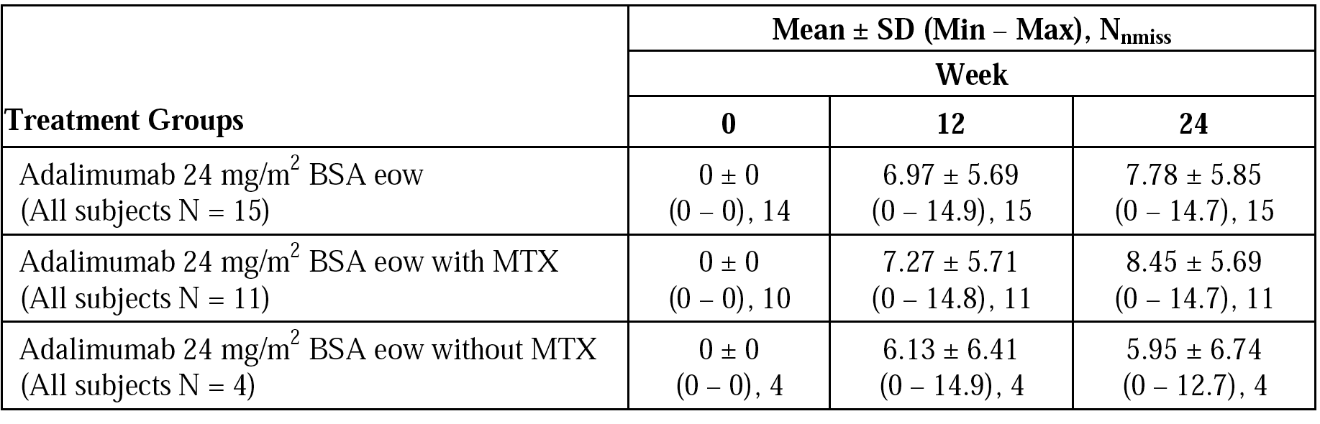
Notes: BSA = body surface area; Nnmiss = number of non-missing observations.
Figure 1: Study M10-444 - mean ± SD serum adalimumab trough concentrations versus time in paediatric patients (N = 15) with pJIA through to Week 24.
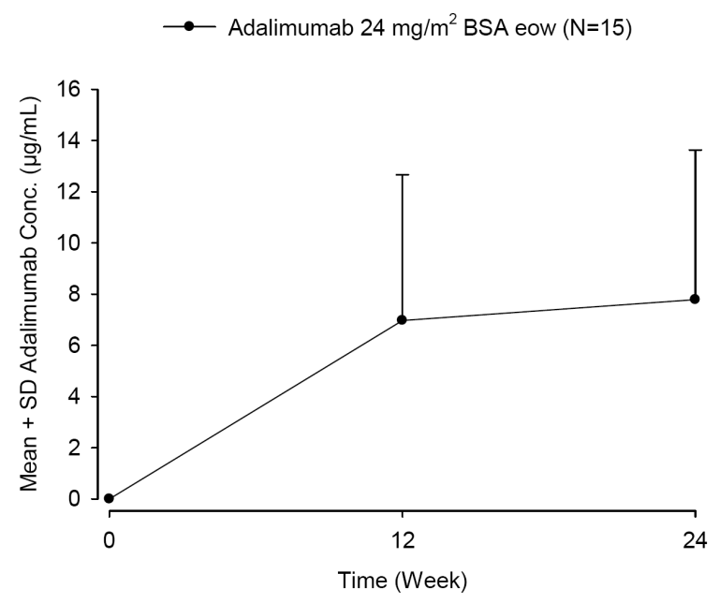
Comment: In all subjects treated with adalimumab 24 mg/m2 BSA eow (N = 15), the mean ± SD steady-state serum adalimumab trough concentrations were 6.97 ± 5.69 µg/mL and 7.78 ± 5.85 µg/mL at Week 12 and Week 24, respectively. The mean steady-state serum adalimumab trough concentrations were higher in subjects treated with adalimumab in combination with MTX compared to adalimumab without MTX at both Week 12 and Week 24. However, the inter-subject variability in serum adalimumab trough concentrations in the adalimumab without MTX group was greater than in the adalimumab with MTX at both Week 12 (CV 105% versus CV 79%, respectively) and Week 24 (CV 113% versus CV 67%, respectively). In addition, there was an imbalance in subject numbers between the adalimumab with MTX group (N = 11) and the adalimumab without MTX group (N = 4).

Immunogenicity
In the 15 subjects with samples for AAA analysis, only 1 developed antibodies during the 24 weeks of the study (that is, AAA+ rate 6.67% [1/15]). The one AAA+ subject in the study was in the adalimumab with MTX group. The adalimumab and AAA concentrations for the one AAA+ subject are summarised below in Table 3.

Table 3: Study M10-444 - Adalimumab and AAA concentrations for the one (1) AAA+ subject through to Week 24.
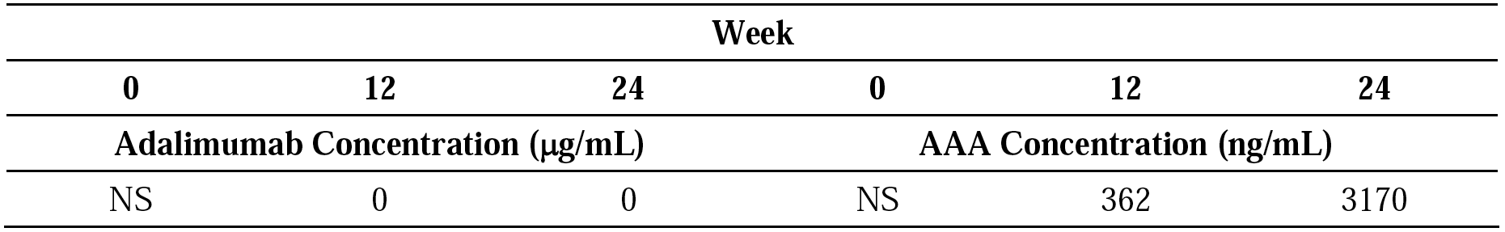
NS = no sample.
Comment: The study report included a comparison of the efficacy between AAA+ (N = 1) and AAA- (N = 14) subjects at Week 12 and Week 24 based on the PedACR30 response. The one AAA+ subject was a PedACR30 responder at both Week 12 and Week 24, while most of the AAA- subjects were responders at Week 12 (92.9% [13/14]) and at Week 24 (85.7% [12/14]). However, no clinically meaningful comparison of the PedACR30 response between AAA+ and AAA- subjects can be made, given that only 1 of the 15 subjects was AAA+. The study also included a comparison of safety between AAA+ and AAA- subjects, but once again no clinically meaningful comparison between the two groups can be made. The one AAA+ subject experienced 8 AEs categorised (preferred terms) as uveitis, gastrointestinal infection, otitis media, pseudocroup, upper respiratory infection, hepatic enzyme increased, rash and juvenile arthritis. Of the 14 AAA- subjects, 11 (78.6%) experienced at least one AE.

Comparison between Studies M10-444 and DE038

Pharmacokinetics
The submission included a comparison of the PK data from the previously evaluated Study DE038 in subjects aged 4 to 17 years with pJIA treated with adalimumab, stratified by concomitant MTX use, and the PK data from Study M10-444.
In Study DE038, treatment consisted of a 16-week, open-label, lead-in phase followed by a 32-week double-blind phase with a subsequent open-label extension phase. A total of 171 subjects were enrolled in the open-label, lead-in phase, and 133 subjects were randomised and dosed in the double-blind phase. Subjects initially received adalimumab 24 mg/m2 BSA eow SC (up to a maximum of 40 mg total body dose), and in the open-label, extension phase, fixed-doses of 20 mg or 40 mg were administered.
The mean ± SD steady-state serum adalimumab trough concentrations for the two studies are summarised below in Table 4. The data from Study DE038 are from Week 12 and Week 16 of the open-label, lead-in phase. In the open-label, lead-in phase of Study DE038 (N = 171), the mean age of the subjects was 11.3 years (range: 4, 17 years), the mean weight was 42.2 kg (range: 13, 99 kg), the mean BSA was 1.28 m2 (range: 0.57, 2.16 m2), and the majority of subjects were female (79.0%) and White (95.3%).

Table 4: Comparison of mean ± SD steady-state serum adalimumab trough concentrations in studies M10-444 and DE038.
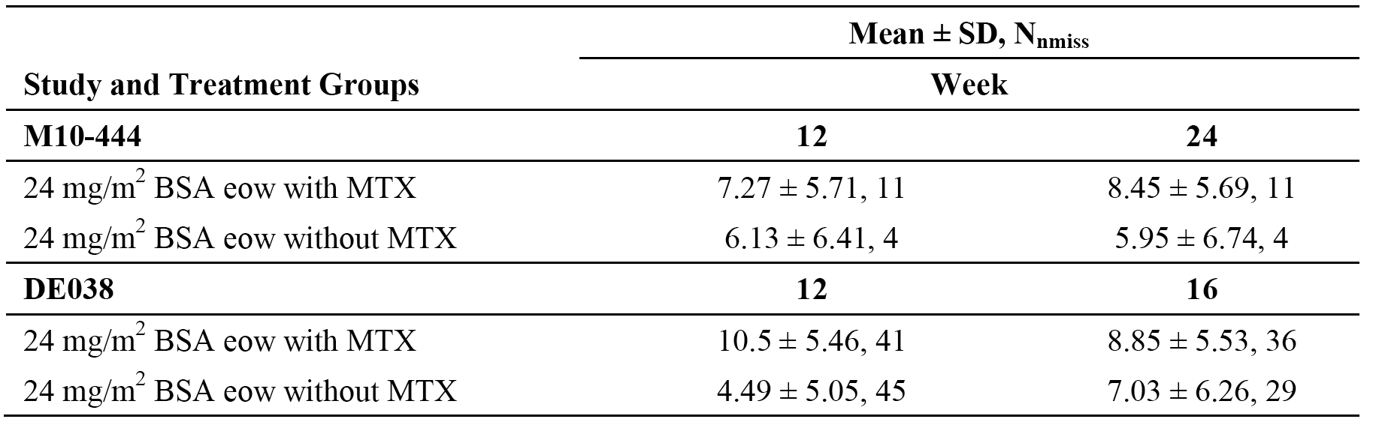
Nnmiss = number of non-missing observations.
Comment: In both studies, mean steady-state serum adalimumab trough concentrations were higher following adalimumab with MTX compared to adalimumab without MTX. In both studies, mean steady-state serum adalimumab trough concentrations following adalimumab with MTX were similar at Week 24 (Study M10-444) and Week 16 (Study DE038), while mean steady-state serum adalimumab trough concentrations following adalimumab without MTX were notably lower in Study M10-444 at Week 24 compared to Study DE038 at Week 16. However, the comparative steady-state adalimumab trough concentration data in patients treated with adalimumab without MTX should be interpreted cautiously due to the high inter-subject variability observed in both studies (CV = 113% [M10-444] versus 89% [DE038]) and the marked imbalance in subject numbers between the studies (N = 4 [M10-444] versus N = 29 [DE038]). In addition, MTX administration was controlled in Study DE038 but not in Study M10-444. Consequently, it is possible that the 4 patients from Study M10-444 on combination therapy might not have been taking a stable dose of MTX over the 24 weeks of treatment. Consequently, it is difficult to make clinically meaningful conclusions about the observed difference between the studies in adalimumab steady-state serum trough concentrations for the adalimumab without MTX treatment groups (Week 16 [DE038] versus Week 24 [M10-444]).

Immunogenicity
In Study DE038, 19 AAA+ subjects (11.1% [19/171]) were identified during the open-label. lead-in phase. Of these 19 subjects, 4 (4.7% [4/85]) had received adalimumab with MTX, and 15 (17.4% [5/86]) had received adalimumab without MTX. In Study M10-444, one subject in the adalimumab with MTX group became AAA+ by Week 24 (6.67% [1/15]). Data from Study DE038 showed no increase in AEs reported in patients who were AAA+.

Evaluator’s overall conclusions on pharmacokinetics
The pharmacokinetics of adalimumab in the proposed patient population have been adequately characterized in 15 paediatric subjects with pJIA from Study M10-444 of mean age 3.0 years (range: 2, 4.2 years) and mean weight 13.1 kg (range: 11.0, 16.0 kg). The 15 subjects with PK data were a subset of the 32 subjects enrolled in the study. Participation in the PK analysis was not a requirement for subjects enrolled into the study. The baseline demographic characteristics of the 15 subjects with PK data were consistent with those of the 32 subjects in the study.
In Study M10-444 (N = 15), following treatment with adalimumab 24 mg/m² BSA eow (with or without MTX) the steady-state mean ± SD serum adalimumab trough concentrations at Week 12 and Week 24 were 6.97 ± 5.69 µg/mL and 7.78 ± 5.85 µg/mL, respectively. The steady-state mean serum adalimumab trough concentrations at Week 12 and Week 24 were higher in subjects treated with adalimumab 24 mg/m² BSA eow with MTX (N = 11) than without MTX (N = 4). However, the difference between the two groups should be interpreted cautiously due to the imbalance in subject numbers between the two groups (N = 11 [with MTX] versus N = 4 [without MTX]), and the higher inter-subject variability in adalimumab concentration in the adalimumab without MTX group compared to the adalimumab with MTX group (CV 105% versus CV 79%, respectively).
In subjects treated with adalimumab 24 mg/m2 eow with MTX, the mean serum ± SD adalimumab steady-state trough concentration at Week 24 in the proposed paediatric group (N = 11) from Study M10-444 was similar to that at Week 16 in the approved paediatric group (N = 36) from Study DE038 (8.45 ± 5.69 versus 8.85 ± 5.53 µg/mL, respectively). However, in patients treated with adalimumab 24 mg/m2 eow without MTX, the mean ± SD serum adalimumab steady-state trough concentration at Week 24 in the proposed paediatric group (N = 4) years from Study M10-444 was lower than the corresponding concentration at Week 16 in the approved paediatric group (N = 29) from Study DE038 (5.95 ± 6.74 [CV = 113%] versus 7.03 ± 6.26 µg/mL [CV = 89%], respectively). The comparative data for steady-state adalimumab concentration in patients treated with adalimumab without MTX should be interpreted cautiously due to the high inter-subject variability in both studies and the marked imbalance in subject numbers between the two studies.
Of the 15 patients from Study M10-444 with AAA data, there was one patient who became AAA+ at Week 24 (6.7%] 1/15]). The imbalance in patient numbers between AAA+ and AAA- patients preclude clinically meaningful comparison of efficacy and safety between the two groups.

Pharmacodynamics
No new data.

Dosage selection for the pivotal studies
The sponsor stated that BSA based dosing with adalimumab in M10-444 has been used in previous clinical trials in children with JIA. However, the sponsor is proposing weight based dosing, which it states is supported by clinical and PK data. The proposed weight based dosing regimen is consistent with the approved weight base regimen for patients aged 4 to 17 years. The Clinical Overview provided a justification for the proposed weight based dosing regimen supported by clinical trial and PK data. This justification is discussed below.
In the pivotal Study M10-444, patients were administered 10, 15, or 20 mg adalimumab SC eow, based on BSA, calculated according to Table 5 below. The dose of adalimumab was determined based on height and weight at the following time points: Baseline, Week 12, Week 24, and every 12 weeks thereafter until the subjects reached the age of 4 years, and weighed 15 kg. In the event that the BSA fell between two ranges, the dose was to be rounded up to the nearest 5 kg weight and 10 cm height.

Table 5: Study M10-444 - Adalimumab total body dose in millilitres (mL) of 50 mg/mL injectable solution given every other week (eow) based on weight and height.
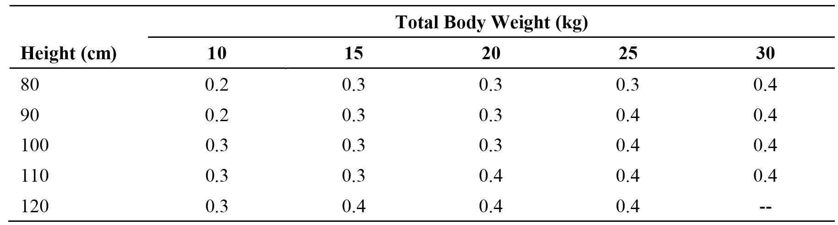
The currently approved Humira dosing schedule for patients aged 4 to 17 years is based on two body weight categories, with a cut-off of 30 kg (that is, 15 kg to < 30 kg; and ≥ 30 kg). In order to align with the approved dosage schedule the sponsor summarised the administered doses from Study M10-444 according to the subjects weight for three time points (Baseline, Week 12 and Week 24); see Table 6 below.

Table 6: Study M10-444 - Body weight and adalimumab dosing.
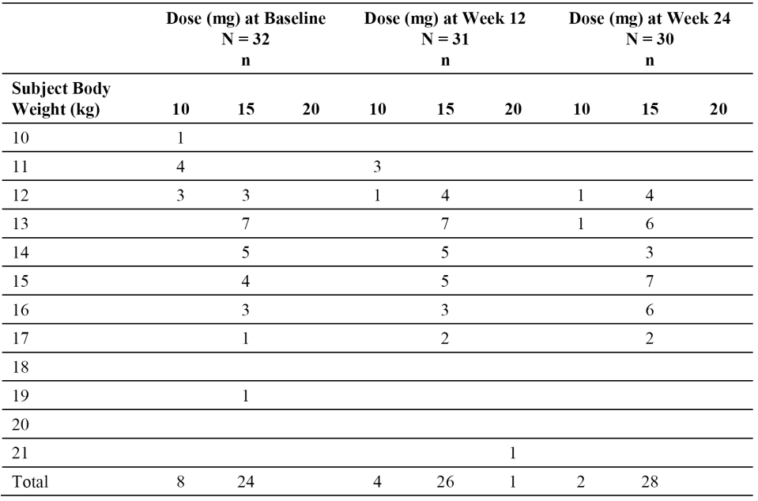
The tabulated summary of the dose distribution for patients from Study M10-444 shows that:
- the majority of patients in the study were treated with adalimumab 15 mg: 75% (24/32) at Baseline, 84% (26/31) at Week 12, and 93% (28/30) at Week 15 mg;
- all patients weighing 10 kg or 11 kg were treated with adalimumab 10 mg at Baseline and Week 12, and no patients weighed less than 12 kg at Week 24;
- the majority of patients weighing 12 kg were treated with adalimumab 15 mg: 50% (3/6) at Baseline, 80% (4/5) at Week 12, and 80% (4/5) at Week 24;
- all subjects weighing 13 kg to 20 kg (inclusive) were treated with adalimumab 15 mg at Baseline, Week 12 and Week 24; and
- one subject weighing 21 kg was treated with adalimumab 20 mg at Week 12.
Based on the dosing data from Study M10-444 the sponsor proposes the following adalimumab treatment regimens:
- 10 mg eow in patients 2 years of age and older who weigh 10 kg to < 12 kg administered via the 40 mg/0.8 mL vial;
- 15 mg eow in patients 2 years of age and older who weigh 12 kg to < 15 kg; and
- for patients 2 years of age and older who weigh > 15 kg, the currently approved dosage instructions apply (that is, 20 mg eow for patients weighing 15 kg to < 30 kg; 40 mg eow for patients weighing ≥ 30 kg).
The sponsor also compared the actual doses (n = 1145) in Study M10-444 and the proposed weight based doses (see Table 7, below). Weight at Baseline, Week 12, Week 24 and every 12 weeks thereafter was used to determine the weight based dose at those visits and visits in between these time points. The comparison used data collected up until subjects reached the age of 4 years or their weight was 15 kg. The comparative data indicates that for the majority of administered doses (63.32%) the doses were identical irrespective of the dosage method used (that is, weight based or actual dose). For most of the remaining administered doses the weight based dose was greater than the actual dose (34.67%), while the actual dose was greater than the weight based dose for only a small percentage of administered doses (2.01%).

Table 7: Study M10-444 - Comparison of 1145 adalimumab doses administered throughout the study based on BSA (actual dose) and corresponding dose based on the proposed weight categories.
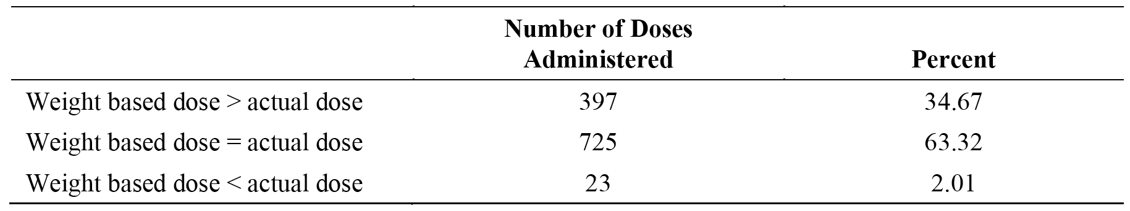
In order to further compare the weight based and BSA based dosing regimens the sponsor pooled the PK data from Study M10-444 (N = 15) with the PK data for subjects aged 4 to 6 years treated with adalimumab 10, 15, or 20 mg from Study DE038 (N = 7 for Week 12; N = 4 for Week 24). The observed concentration data were plotted in two ways: subjects in the proposed body weight based dosing ranges (10 to < 12 kg; 12 to < 15 kg; and ≥ 15 kg) and subjects who received 10, 15, or 20 mg doses. The pooled exposure data from the two studies showed that the Ctrough levels were similar for weight based and BSA based dosing (see Figure 2, below). The high variabilities observed for Ctrough levels are likely to be due to the small sample sizes.
Figure 2: Adalimumab concentrations (Ctrough) in JIA subjects aged 2 to 6 years from studies M10-444 and DE038 plotted by body weight based dosing and by BSA based dosing (Panel A = Week 12; Panel B = Week 24)
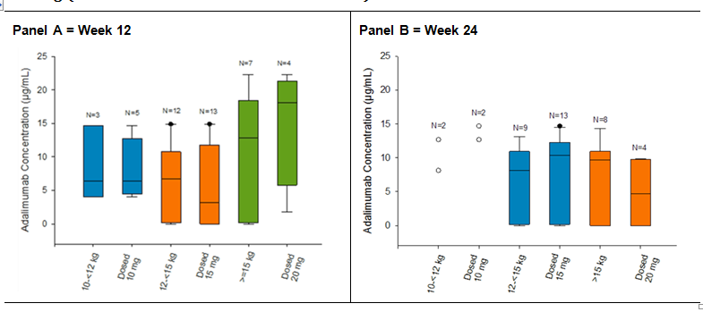
Comment: The dosing data from Study M10-444 and the pooled exposure data (Ctrough) from studies M10-444 and DE038 support the proposed weight based dosing regimens.

Clinical efficacy

Pivotal study - M10-444

Study design, objectives, locations and dates
The title of Study M10-444 was ‘Compassionate Use Study of Adalimumab in Children 2 to < 4 Years Old or Age 4 and Above Weighing Less Than 15 kg with Active Juvenile Idiopathic Arthritis (JIA)’.
It was a Phase IIIb, open-label, multicentre study for subjects 2 to < 4 years of age, and subjects ≥ 4 years of age weighing < 15 kg, diagnosed with moderately to severely active pJIA or polyarticular course JIA, per International League of Associations for Rheumatology (ILAR) criteria, treated in a clinical setting with adalimumab. The ILAR classification identifies the following 7 subcategories of JIA based on the number of joints affected and the presence or absence of serologic findings and systemic manifestations: systemic arthritis, polyarthritis (sero-positive and sero-negative), oligoarthritis (persistent and extended), enthesitis-related arthritis (ERA), psoriatic arthritis (PsA), and undifferentiated arthritis.
The primary objective of the study was to evaluate the safety of adalimumab, and the secondary objectives of the study were to collect PK data on adalimumab and to evaluate the efficacy of adalimumab.
The study was undertaken at 14 sites in the US (including Puerto Rico), France, Czech Republic and Germany. The co-ordinating investigator was located in the US (Portland, Oregon). Investigators participating in the study were representative of rheumatologists that prescribe adalimumab to subjects with JIA. The study planned to enrol approximately 30 subjects and all subjects were required to remain in the study for a minimum of 24 weeks. In the US (including Puerto Rico), at the completion of 24 weeks, subjects could continue in the study until reaching 4 years of age and ≥ 15 kg. In the EU at the completion of 24 weeks, subjects could continue for a maximum of 1 year after reaching 4 years of age and ≥ 15 kg (in order to allow transition to an appropriate treatment). All subjects had a Screening visit, Baseline visit, and visits at Weeks 2, 4, 8, 12, 16, 20, and 24. Visits beyond Week 24 occurred every 12 weeks for those subjects who continued in the study. The study design is summarised below in Figure 3.

Figure 3: Study M10-444 - Study design schemata.
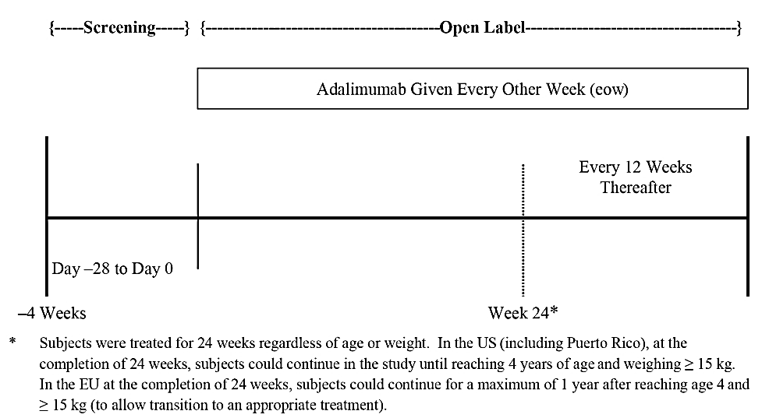
Information about the effectiveness of adalimumab therapy was provided by the subject's parents and physician. Efficacy data were collected with clinical assessments, beginning at Screening and/or Baseline and throughout the study until the final or early termination (ET) visit. Subjects were asked to provide serum samples for PK analyses (including anti-adalimumab antibody analysis).
Subjects could withdraw from the study at any time. The protocol included standard criteria triggering premature discontinuation from therapy or assessment. In addition, subjects were discontinued from the study if no dose of adalimumab had been given for a period of 60 consecutive days. However, subjects who developed an infection, which in the opinion of the investigator required temporary cessation of study medication, could remain in the study and resume study medication. If two consecutive doses or more were missed, the sponsor was to be notified. The protocol specified appropriate procedures for following up patients who discontinued prematurely.
The first subject visit was on 24 March 2009, and the last subject visit was on 21 March 2013. The clinical study report (CSR) included all data collected at the time of the database lock on 29 April 2013. An independent ethics committee (IEC)/institutional review board (IRB) reviewed the protocol and all protocol amendments. The sponsor stated that the study was conducted in accordance with the protocol, ICH guidelines, applicable regulations and guidelines governing clinical study conduct and the ethical principles that have their origin in the Declaration of Helsinki.
Comment: The study was undertaken as part of a post-approval commitment to the USA Food and Drug Administration (FDA) and a Pediatric Investigation Plan (PIP) requirement of the European Medicines Agency (EMA). It was conducted in order to collect safety, efficacy, and PK data in up to 30 subjects 2 to < 4 years of age, and subjects ≥ 4 years of age weighing < 15 kg, with moderately to severely active polyarticular or polyarticular course JIA. The study was uncontrolled and open-label in design. Consequently, the study was potentially exposed to the well-known biases associated with uncontrolled and open-label studies. Furthermore, it is noted that the primary objective of the study was safety rather than efficacy. However, the study design and the objectives are considered to be acceptable, given the very young age of the subjects and the known efficacy and safety of adalimumab for the proposed indication in children aged 4 years and above.

Inclusion and exclusion criteria
The study included subjects aged 2 to < 4 years old at Screening or aged ≥ 4 years and weighing < 15 kg with moderately to severely active pJIA or polyarticular course JIA (defined as arthritis affecting ≥ 5 joints at the time of treatment initiation). This corresponded to the ILAR categories of polyarticular RF+ disease, polyarticular RF- disease, and extended oligoarthritis disease. EU subjects must have previously failed, had an insufficient response to, or been intolerant to ≥ 1 disease-modifying anti-rheumatic drug (DMARD).
Comment: The inclusion and exclusion are considered to be satisfactory. It is noted that subjects in the EU must have previously failed, had an insufficient response to, or been intolerant to ≥ 1 DMARD. These criteria were added in order to correspond with the then approved EU indication for adalimumab for the treatment of children aged 13 to 17 with pJIA with a previously inadequate response to ≥ 1 DMARD. Previous treatment with DMARDs is not a requirement of the currently approved Australian indication for patients aged 4 to 17 years with moderately to severely active pJIA, nor is it being proposed for the amendment to the approved indication to include children aged 2 years and above.

Study treatments
Adalimumab was provided as a sterile, preservative free solution for SC injection in either:
- A 0.4-mL prefilled graduated syringe containing adalimumab 20 mg/0.4 mL for a final concentration of 50 mg/mL (US/Puerto Rico only); or
- A single-use 0.8-mL vial containing adalimumab 40 mg/0.8 mL for a final concentration of 50 mg/mL (EU only).
Adalimumab was administered by SC injection every other week (eow) on the same day of the week and at approximately the same time of day. The recommended dose of adalimumab for subjects with pJIA who were 2 to < 4 years of age or ≥ 4 years of age weighing < 15 kg, was 24 mg/m2 BSA up to a total dose of 20 mg administered eow as a single dose via SC injection. The protocol specified that injection sites were to be rotated between the thigh and abdomen. The Baseline dose was administered by site medical staff. Parents or designees were trained to administer subsequent scheduled doses, which were given at the study site or the subject's home. If a dose was missed, then administration of the missed injection was to be undertaken as soon as the missed dose was remembered up to the day of the next scheduled dose. Two doses were not to be administered on the same day. The original regular dosing schedule based on the first dosing date at Baseline was to be resumed for subjects who missed a scheduled dose. Doses not administered before the next scheduled dose was scheduled were recorded as not taken. Each subject's dosing schedule was closely monitored by site personnel during the study to ensure that all subjects maintained their appropriate dosing schedule.
Baseline measurements of height and weight were used to determine the adalimumab dose (see Table 8, below). If a dose adjustment was required, based on change in height or weight, it was done at each of the scheduled study visits at Week 12, Week 24, and every 12 weeks thereafter until the subjects reached 4 years of age and ≥ 15 kg. In the event that a subject fell between 2 ranges, the higher of the 2 dose volumes was to be utilised in order to ensure an efficacious dose. Information relating to dose was recorded in a patient diary, which was reviewed at each patient visit. Site personnel documented compliance with treatment.

Table 8: Study M10-444 - Adalimumab total dose in millilitres (mL) of 50 mg/mL injectable solution based on height and weight.
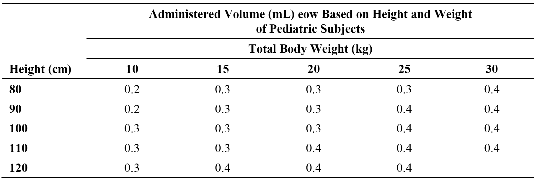
Previous DMARD treatment and other medications used to treat pJIA were captured at screening and appropriately recorded. Any medication being taken at the time of screening/enrolment or administered during the study were to be appropriately recorded. Additionally, information relating to all medications used to treat SAEs and AEs were also captured and appropriately reported.
Information relating to the use of intra-articular and/or soft-tissue corticosteroid injections was to be captured. The injected joint was considered to be non-evaluable for 3 months following the injection. Stable doses of NSAIDs, low doses of corticosteroids (≤ 0.2 mg of prednisone per kilogram per day), or both, were permitted. Live vaccines were not to be given concurrently while the subject was on adalimumab or for 70 days after the last dose of adalimumab. It was recommended that children with JIA be brought up to date with all immunizations prior to starting adalimumab. Treatment with other biologics were prohibited prior to and during the study.
Comment: Of the 32 enrolled patients, 27 (84.4%) were treated with MTX in combination with adalimumab. However, no information relating to the dose or frequency of MTX could be identified in the CSR. It appears from discussion elsewhere in the submission that MTX dose was variable rather than fixed. The sponsor will be asked to provide the relevant data relating to MTX treatment as part of its response to the first round clinical questions (see Clinical questions below).

Efficacy variables and outcomes

Overview of efficacy variables
There were no primary efficacy endpoints for this study. Efficacy endpoints measured over the course of the study were individual indicators of efficacy and the proportion of subjects with Pediatric American College (PedACR) 30/50/70/90 responses. The individual indicators of efficacy were collected with clinical assessments, beginning with the Baseline visit (physical function of the Disability Index of Childhood Health Assessment Questionnaire [DICHAQ], Parent's Global Assessment of subject's overall disease activity, Parent's Assessment of Pain, Physician's Global Assessment [PGA] of Disease Activity, joint assessments, C-reactive protein [CRP], and the Child's Health Questionnaire [CHQ-PF50]). The efficacy variables are described below:
- Joint Assessment
Starting at the Screening, an assessment of the number of active joints was recorded at all study visits. On the days that subjects were scheduled to be seen in the clinic, no analgesics were to be used within 12 hours prior to the visit.
- Disease activity was assessed using the following 2 components:
  - Number of active joints (joints with swelling not due to deformity or joints with limitation of passive motion [LOM] and with pain, tenderness, or both); and
  - Number of joints with LOM.
Tender joint count (TJC): Seventy-five joints or regions were assessed by pressure and joint manipulation on physical examination. Joint tenderness was classified as either present (‘1’), absent (‘0’) or replaced/injected (‘9’).
Swollen Joint Count (SJC): Sixty-six joints were assessed by physical examination. The joints to be examined for swelling were the same as those examined for tenderness, except that the hip, subtalar, sacroiliac, lumbar spine, thoracic spine, and cervical spine joints were excluded. Joint swelling was classified as present (‘1’), absent (‘0’) or replaced/injected (‘9’).
Pain on Passive Motion (POM) Joint Count: Seventy-five joints were assessed by physical examination. The joints to be examined for POM were the same as those examined for tenderness. POM of the joint was classified as present (‘1’), absent (‘0’), or replaced/injected (‘9’).
Limitation of Passive Motion (LOM) Joint Count: Sixty-nine joints were assessed by physical examination. The joints to be examined for LOM were the same as those examined for tenderness, except that the sacroiliac, sterno-clavicular, and acromio-clavicular joints were excluded. LOM of the joint was classified as present (‘1’), absent (‘0’), or replaced/injected (‘9’).
- Visual analogue scales (VAS)
There were three VAS assessments for each subject: physician's global assessment (PGA) of disease activity (current status); parent's global assessment of overall disease activity; and parent's assessment of pain within the previous week. The VAS assessments were undertaken at Screening (PGA), Baseline (PGA and parent) and then by both the physician and parent at Week 12, Week 24, and all study visits thereafter through to study completion or ET. Each of the VAS assessments were on a scale ranging from 0 mm (very good) to 100 mm (very bad).
- Questionnaires
The parent or guardian completed the DICHAQ and CHQ-PF50 directly on the CRFs at Baseline, Week 12 and Week 24, and at all study visits thereafter through the final or ET visit.
The DICHAQ is a self-reported subject-orientated outcome measure calculated as the mean of the following eight category scores (0 to 3): Dressing and Grooming, Arising, Eating, Walking, Hygiene, Reach, Grip, and Activities. The score of each category is calculated as the maximum of the scores for the questions within that category. If aids and devices and/or help from another person are used for a category, a lower category score will be adjusted to 2 for that category. A subject must have scores for at least six categories in order to compute the DICHAQ score. Total score is derived as average of all categories: 0 (no disability) to 3 (complete disability).
The CHQ-PF50 contains 50 questions assessing the following items: Global Health (GGH); Physical Functioning (PF); Role/Social Limitations/Emotional/Behavioural (REB); Role/Social Limitations – Physical (RP); Bodily Pain/Discomfort (BP); Behaviour (BE); Global Behaviour Item (GBE); Mental Health (MH); Self-esteem (SE); General Health Perceptions (GH); Change in Health (CH); Parental Impact – Emotional (PE); Parental Impact – Time (PT); Family Activities (FA); and Family cohesion (FC). The Statistical Analysis Plan (Final Analysis) included the scoring algorithm for the CHQ-PF50.

JIA core set of variables
The assessments outlined above contributed to the six JIA core set of variables used to calculate the PedACR responses. The six JIA core set of variables were:
- Physician's global assessment (PGA) of disease activity assessed by VAS.
- Parent's global assessment of subject's disease activity by VAS.
- Number of active joints.
- Number of joints with LOM.
- DICHAQ.
- CRP.

PedACR responses
The six JIA core set of variables were the parameters which defined the PedACR responses:
- The PedACR30 Response was defined as:
  - ≥ 30% improvement in at least three of the six JIA core set variables; and
  - ≥ 30% worsening in not more than one of the six remaining JIA core set criteria.
The percent change was calculated as: 100 x (Value -Baseline)/Baseline
- The PedACR50/70/90 Responses were defined using improvement percentages of 50%, 70% and 90%, respectively, in at least three of the six JIA core set parameters, with worsening of 30% or more in no more than one of the six remaining JIA core set criteria.

Randomisation and blinding methods
Not applicable. The study was open-label and uncontrolled. All subjects were treated with adalimumab.

Analysis populations
The safety and effectiveness variables were analysed using the intent-to-treat (ITT) population, which was defined as all subjects who were enrolled and received ≥ 1 dose of adalimumab (N=32).

Sample size
The proposed sample size for this study was approximately 30 subjects. Due to the low incidence and prevalence of JIA in subjects aged 2 to < 4 years, the size of the study was chosen based on the expected availability of eligible subjects to be enrolled in a 3-year time frame.

Statistical methods
The PedACR responses (30/50/70/90) and each of the six JIA core component scores contributing to the responses were summarised using descriptive statistics at each visit. The CHQ-PF50 and parent's global assessment of pain (100 mm VAS) were summarised at each visit. The last evaluation prior to the first dose was used for Baseline for all analyses. No statistical analyses were performed for either the efficacy or the safety results. An interim review of the data was performed for all subjects who completed 24 weeks of study treatment.
Additional efficacy analyses were presented to address missing data. Missing data were imputed for efficacy variables only up to Week 60. Missing data can occur due to a missed visit or due to dropout from the study. The efficacy data were summarised as ‘Observed’ and ‘Imputed’ up to Week 60 using Last observation Carried Forward [LOCF] and Non-Responder Imputation [NRI] approaches. The LOCF approach carried forward post-baseline values only and was used for both continuous and baseline variables. The NRI approach was used only for binary responses (for example, PedACR30). According to the NRI principle, any missing binary response at a given visit will be imputed as non-responder for that visit, which ensures the most conservative estimate for a response.

Participant flow
A total of 32 subjects were enrolled at 14 sites in the US, France, the Czech Republic, and Germany. All subjects received ≥ 1 dose of adalimumab (that is, ITT population). A total of 26 subjects (81.3%) completed the study and 6 subjects (18.8%) prematurely discontinued from the study (1 subject before Week 24 and 5 subjects after Week 24). Of the 6 (18.8%) subjects who discontinued prematurely, 3 (9.4%) withdrew consent, 2 (6.3%) discontinued the study drug because of an AE, 1 (3.1%) was lost to follow-up and 2 (6.3%) discontinued due to other reasons (that is, loss of efficacy).
The mean ± SD duration of exposure to adalimumab was 515.3 ± 245.33 days (median = 575.0). All subjects received at least 57 days of adalimumab treatment, with a maximum exposure to adalimumab of 910 days.
Comment: Subjects who discontinued the study drug were counted under each reason for discontinuation. Therefore, the sum of the counts for each reason for discontinuation was greater than the overall number of discontinuations.

Major protocol deviations
Major protocol violations, as defined by ICH guidelines, include: inclusion/exclusion criteria violations for study entry; wrong treatment or incorrect dose; the use of excluded concomitant treatment; and development of withdrawal criteria during the study, but not withdrawn.
A total of 18 subjects (56.3%) had at least 1 protocol deviation. Fourteen (14) subjects (43.8%) received at least 1 excluded concomitant medication, including Medrol, prednisone, prednisolone, ibuprofen, and naprosyn. These medications were dose-packs, single use, or intra-articular injections and not continuous treatment. It is noted that concomitant treatment with stable doses of NSAIDs, low doses of corticosteroids (≤ 0.2 mg of prednisone per kilogram per day), or both, were permitted. Three (3) subjects (9.4%) had at least 1 inclusion/exclusion criteria deviation for this study. All 3 subjects had a deviation of inclusion criteria 2 (< 5 active joints at Screening and/or Baseline) and a consequent deviation for part of inclusion criteria 3 (subjects met age and weight requirements for enrolment, but did not meet ILAR criteria due to inclusion criteria 2 deviation), and 1 subject had a deviation of exclusion criteria 3 (history of osteomyelitis). Three (3) subjects (9.4%) received the wrong treatment or incorrect dose, either a higher or lower dose of adalimumab.

Baseline data

Demographics
The majority of subjects were female (87.5%; N = 28), White (78.1%; N = 25), and < 4 years of age (87.5%; N = 28). At Baseline, mean age was 3.04 years (range: 2.0, 4.6 years) and mean weight was 13.4 kg (range: 10.4, 18.9 kg). Mean duration of JIA at the time of the first adalimumab dose was 12.3 months (range: 2.3, 40.9 months).

Disease (pJIA) activity
Baseline disease activity was consistent with moderately to severely active pJIA. The mean ± SD physician's global assessment of activity (VAS 100 mm) was 55.3 ± 19.70 mm (range: 9, 84 mm) and the mean ± SD parent's global assessment of disease activity (VAS 100 mm) was 47.6 ± 25.91 mm (range: 0, 90 mm). A total of 29 subjects (90.6%) were in the active joint count for 73 joints (AJC73) ≥ 5 category, with a mean ± SD Baseline AJC73 of 10.0 ± 7.47. Of the 32 subjects, 31 (96.9%) were RF– (that is, < 12 IU/mL) with a Baseline mean ± SD of 10.2 ± 1.24 IU/mL. The majority of subjects (61.3%; N=19) had Baseline CRP values within the normal range (that is, < 0.9 mg/dL) with a mean ± SD value of 1.6 ± 2.43 mg/dL.

Medical history
All of the subjects in the ITT population reported a medical history of JIA and the largest proportion of subjects were diagnosed with either sero-negative polyarthritis (type 2 JIA) (62.5%; N = 20) or extended oligoarthritis (type 5 JIA) (25.0%; N = 8). Other than JIA, the most frequently occurring conditions in the medical history were anaemia (31.3%; N = 10), eye disease/disorder (18.8%; N = 6), and skin disease/disorder (12.5%; N = 4). All other medical events were reported in < 10% of subjects. A total of 20 subjects (62.5%) had a pre-existing comorbidity. The most frequently reported comorbidities were anaemia (31.3%; N = 10) and uveitis (18.8%; N = 6). All other comorbidities were reported by ≤ 2 subjects.

Prior medications
Prior medications were defined as those taken before the first dose of study medicine. The majority of subjects had received prior treatment for JIA with MTX (78.1%, N = 25), systemic NSAIDs (62.5%, N = 20), or systemic corticosteroids (68.8%, N = 22). No subjects had been treated with biologics prior to the study. The majority of subjects (87.5%; N = 28) were reported to have received prior medications other than DMARDs, NSAIDs or corticosteroids. The most frequently reported (≥ 20%) prior medications (other than for JIA) were folic acid (46.0%; N = 15), live attenuated measles, mumps, rubella vaccine (40.6%; N = 13), pneumococcal vaccine (37.5%; N=12), and combination tetanus, diphtheria, and pertussis vaccine (31.3%; N = 10). All other prior medications (other than for JIA) were reported in < 20% of subjects.
Comment: One of the inclusion criteria required that subjects in the EU must have previously failed, had an insufficient response to, or been intolerant to ≥ 1 DMARD. This criterion did not apply to non-EU subjects. No information could be identified in the submission relating to the number of subjects previously failed, had an insufficient response to, or been intolerant to ≥ 1 DMARD. The sponsor will be asked to provide this information in its S31 Response following the first round clinical evaluation (see Section 12).

Concomitant medications
Concomitant medications were defined as those medications that were taken while on study drug and continued 14 days after the last dose of study drug. Medications that were being taken at the time of Screening and continued while on study drug were also included as concomitant medications. Concomitant medications for the treatment of JIA included MTX (84.4%; N = 27), systemic NSAIDs (56.3%; N = 18), and systemic corticosteroids (62.5%, N = 20). One (1) subject with JIA flare was discontinued from treatment and received etanercept within 14 days following the last dose of adalimumab. Therefore, treatment with etanercept in this subject met the definition of concomitant medication.
Nearly all subjects (96.9%; N = 31) received concomitant medications (other than for JIA). The most frequently reported (≥ 20%) concomitant medications (other than for JIA) were folic acid (56.3%; N = 18), amoxycillin (28.1%; N = 9), paracetamol (28.1%; N = 9), and Augmentin (25.0%; N = 8). All other concomitant medications (other than for JIA) were reported in < 20% of subjects.

Other baseline characteristics
The mean ± pulse rate (bpm) was 101.5 ± 21.48 bpm (range: 62, 150 bpm), and the mean ± SD body temperature was 36.44 ± 0.345 C (range: 35.9, 37.1 C). All subjects had a negative PPD skin test at screening. Consequently, no subjects were enrolled in TB prophylaxis and no subject received a CXR.

Compliance
Mean treatment compliance during the study was 97.9%: defined as the number of adalimumab injections given (mean ± SD = 35.8 ± 17.5) divided by the number of adalimumab planned (mean ± SD = 36.6 ± 17.7).

Efficacy results

Primary efficacy outcome
There were no primary efficacy outcomes defined for this study. The primary objective of this study was to evaluate the safety of adalimumab.

Secondary efficacy outcomes

PedACR response
The PedACR30/50/70/90 responses (observed data) in the ITT population through to Week 120 are summarised below in Table 9.

Table 9: Study M10-444 - PedACR response; ITT population.
Adalimumab n/N1a (%)
Visit | Analysis Method | PedACR30 | PedACR50 | PedACR70 | PedACR90
Week 12 | Observed | 29/31 (93.5) | 28/31 (90.3) | 19/31 (61.3) | 12/31 (38.7)
Week 12 | NRIb | 29/32 (90.6) | 28/32 (87.5) | 19/32 (59.4) | 12/32 (37.5)
Week 12 | LOCFc | 29/31 (93.5) | 28/31 (90.3) | 19/31 (61.3) | 12/31 (38.7)
Week 24 | Observed | 27/30 (90.0) | 25/30 (83.3) | 22/30 (73.3) | 11/30 (36.7)
Week 24 | NRIb | 27/32 (84.4) | 25/32 (78.1) | 22/32 (68.8) | 11/32 (34.4)
Week 24 | LOCFc | 28/31 (90.3) | 26/31 (83.9) | 23/31 (74.2) | 11/31 (35.5)
Week 36 | Observed | 25/27 (92.6) | 24/27 (88.9) | 18/27 (66.7) | 14/27 (51.9)
Week 36 | NRIb | 25/32 (78.1) | 24/32 (75.0) | 18/32 (56.3) | 14/32 (43.8)
Week 36 | LOCFc | 29/31 (93.5) | 28/31 (90.3) | 21/31 (67.7) | 16/31 (51.6)
Week 60 | Observed | 18/20 (90.0) | 16/20 (80.0) | 14/20 (70.0) | 10/20 (50.0)
Week 60 | NRIb | 18/32 (56.3) | 16/32 (50.0) | 14/32 (43.8) | 10/32 (31.3)
Week 60 | LOCFc | 27/31 (87.1) | 25/31 (80.6) | 22/31 (71.0) | 16/31 (51.6)
Week 72 | Observed | 17/17 (100) | 17/17 (100) | 13/17 (76.5) | 11/17 (64.7)
Week 84 | Observed | 17/17 (100) | 16/17 (94.1) | 14/17 (82.4) | 11/17 (64.7)
Week 96 | Observed | 12/13 (92.3) | 12/13 (92.3) | 10/13 (76.9) | 8/13 (61.5)
Week 108 | Observed | 8/9 (88.9) | 8/9 (88.9) | 7/9 (77.8) | 6/9 (66.7)
Week 120 | Observed | 3/3 (100) | 3/3 (100) | 3/3 (100) | 3/3 (100)
a. N1 represents the number of subjects for either observed or imputed methods.
b. NRI: Missing responses are imputed as non-response.
c. LOCF: Missing responses were imputed by last non-missing post-baseline response.
Note: Only responder percentages are displayed. Percentages were calculated using non-missing values.
Comment: The observed PedACR30 response was achieved by at least 85% of subjects from Week 12 through to Week 120. The imputed PedACR30 responses for both the LOCF and NRI methods supported the observed PedACR30 response through to Week 24, but the NRI responses were notably lower than the observed responses at Weeks 36 and 60. The observed PedACR50 response was achieved by at least 80% of subjects from Week 12 through to Week 120, while the observed PedACR70 and PedACR90 responses were achieved by at least 61% and 36% of subjects, respectively, from Week 12 through Week 120. Nearly all enrolled subjects (94%, 30/32) have completed 24 weeks of treatment, and 53% (17/32) of enrolled subjects have completed 84 weeks of treatment.

Joint assessment
The results for each of the joint assessment parameters for each visit are summarised in Table 10 (TJC75), Table 11 (SJC66), Table 12 (POM75), Table 13 (LOM69), and Table 14 (AJC73).

Table 10: Study M10-444 - Tender Joint Count for 75 joints (TJC75) by visit (observed); ITT population.
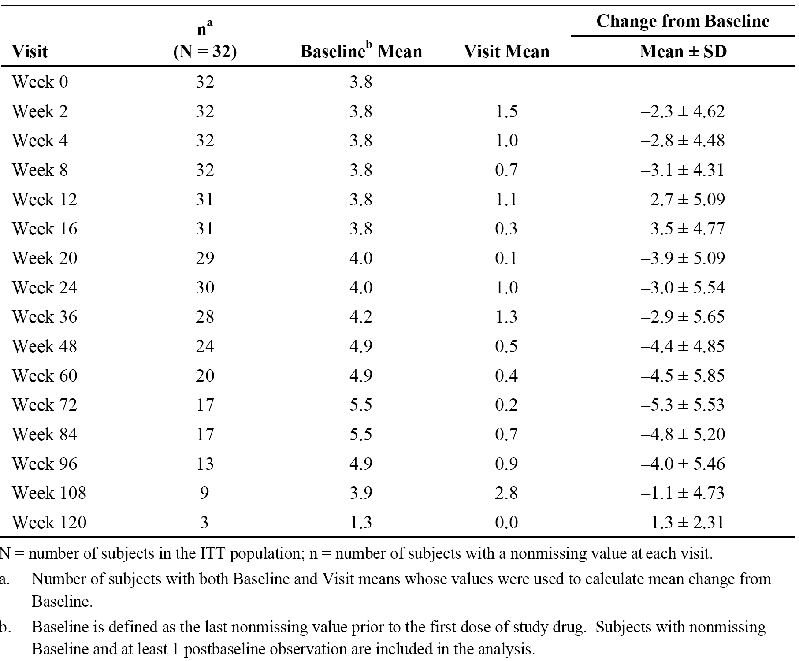

Table 11: Study M10-444 - Swollen Joint Count for 66 joints (SJC66) by visit (observed); ITT population.
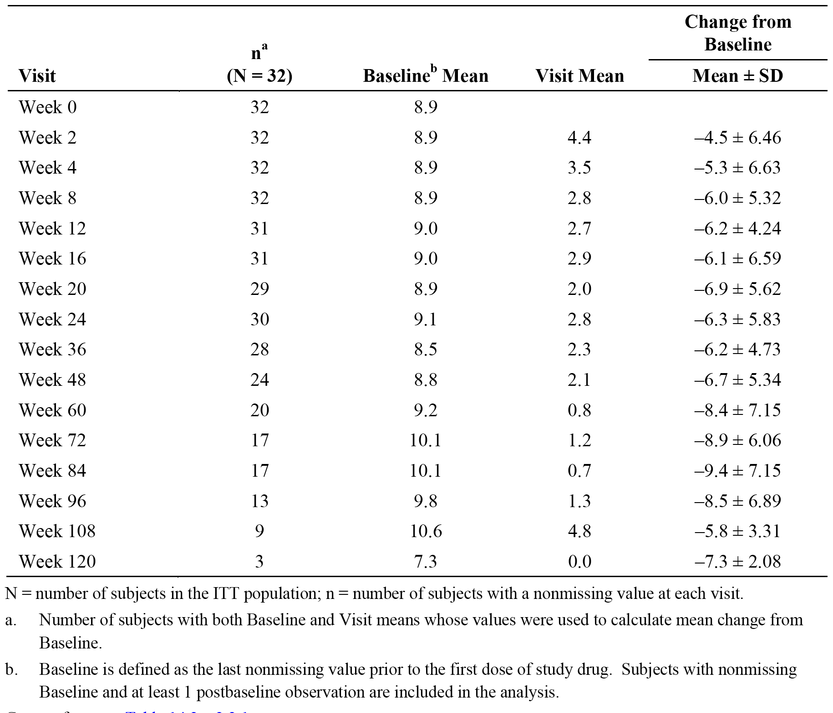

Table 12: Study M10-444 - Pain on Passive Movement for 75 joints (POM75) by visit (observed); ITT population.
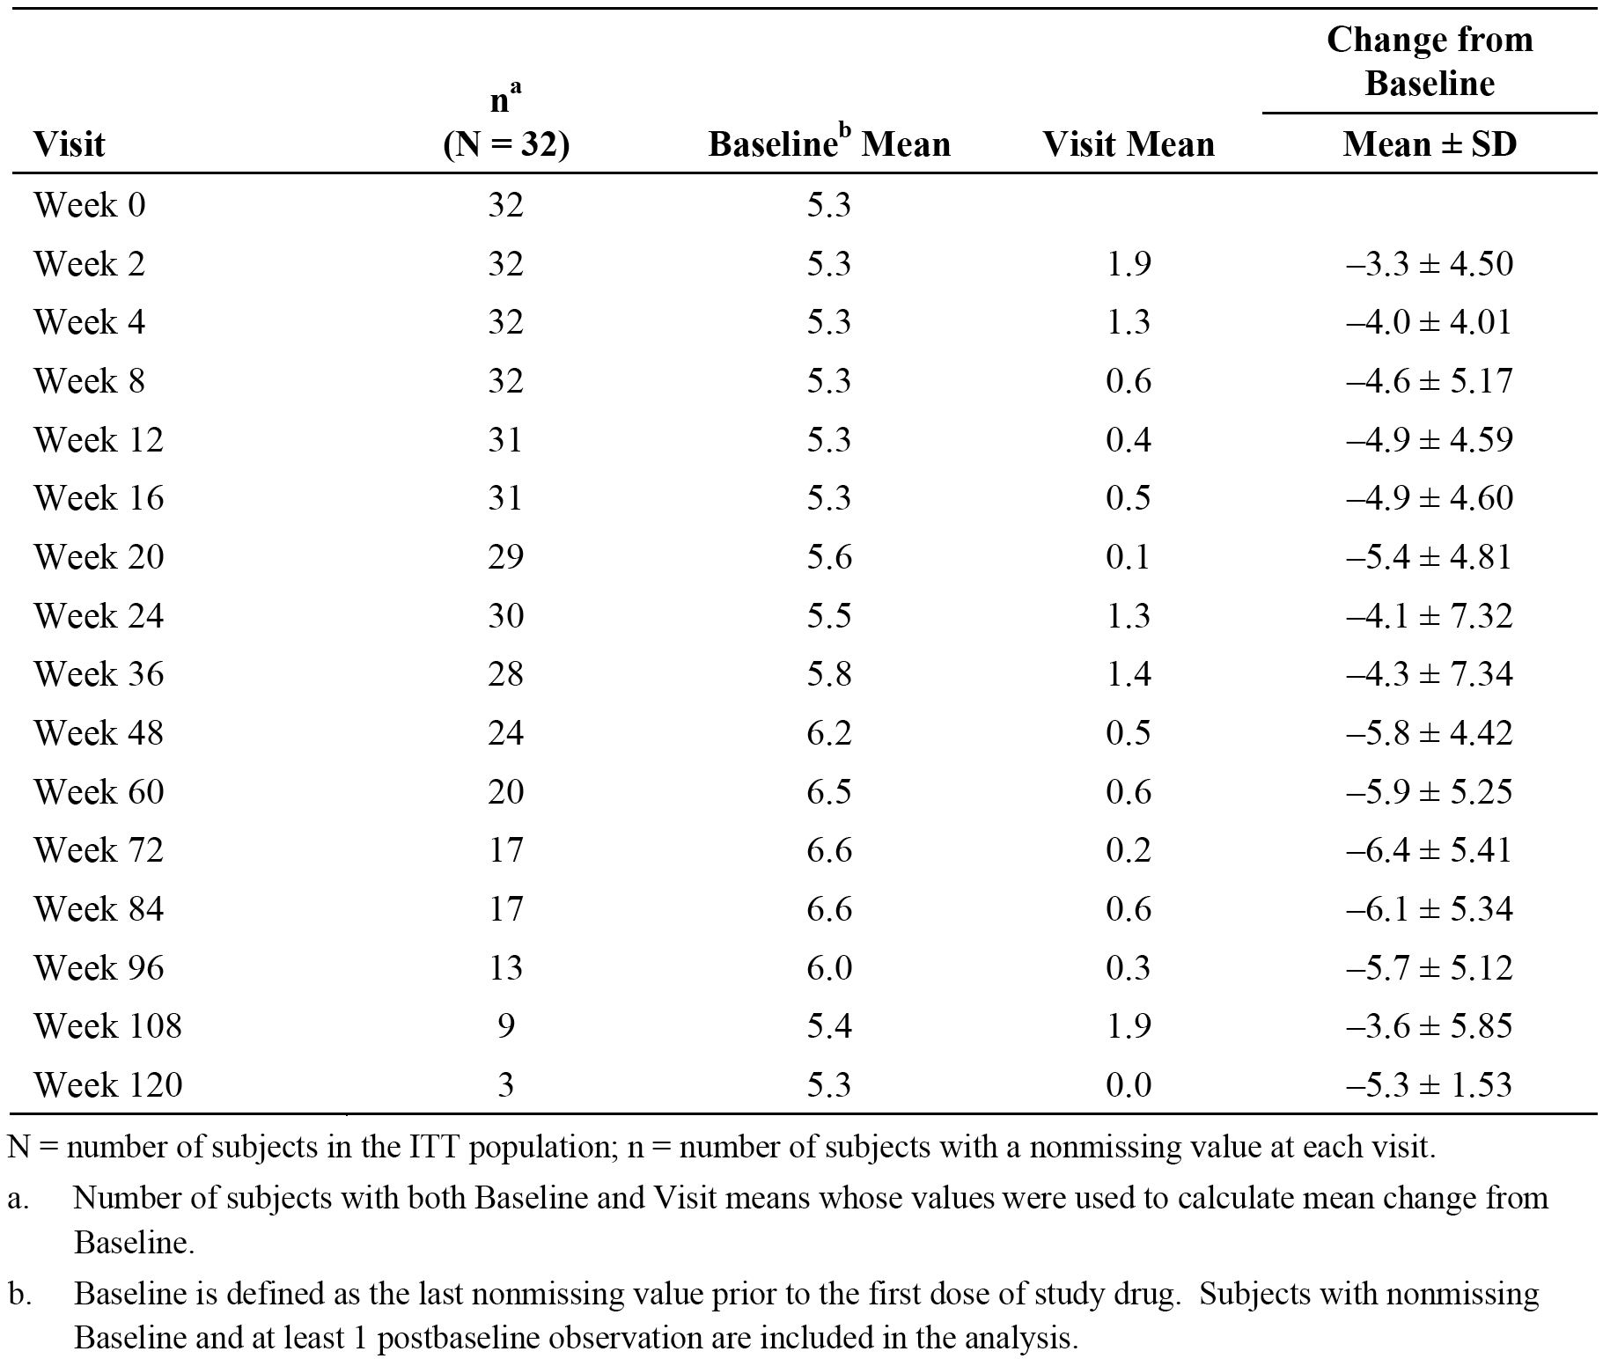

Table 13: Study M10-444 - Limitation of Movement for 69 joints (LOM69) by visit (observed); ITT population.
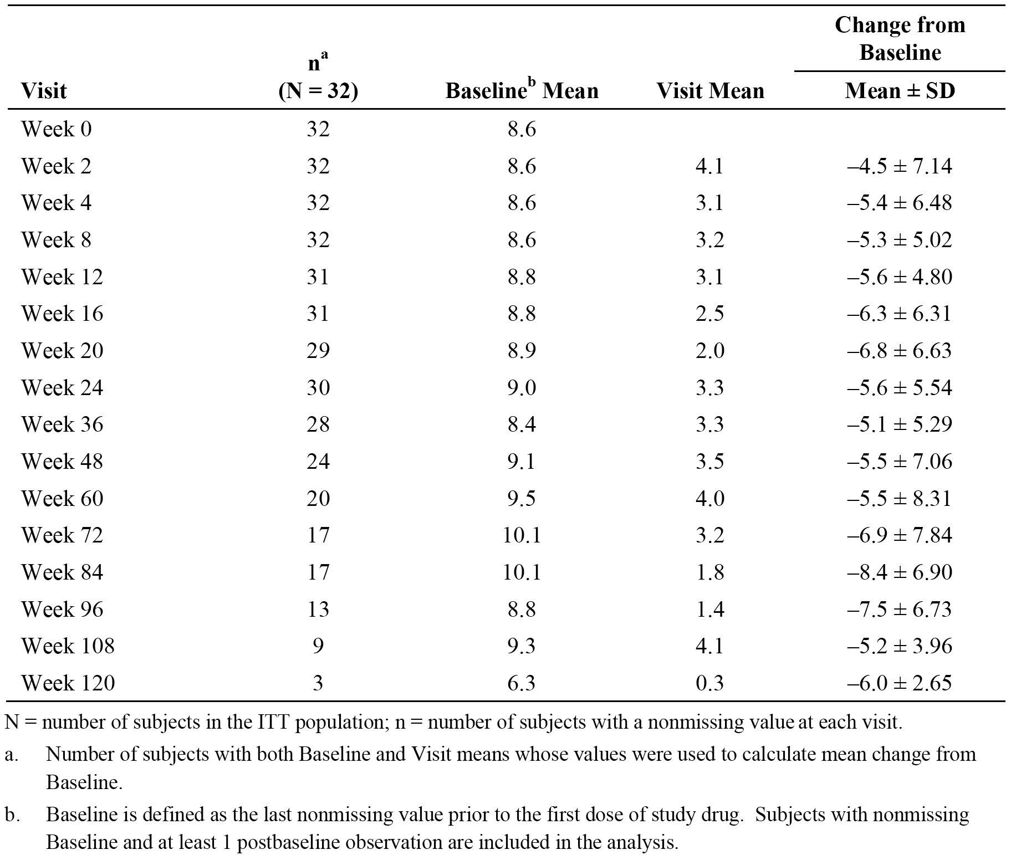

Table 14: Study M10-444 - Active Joint Count for 73 joints (AJC73) by visit (observed); ITT population.
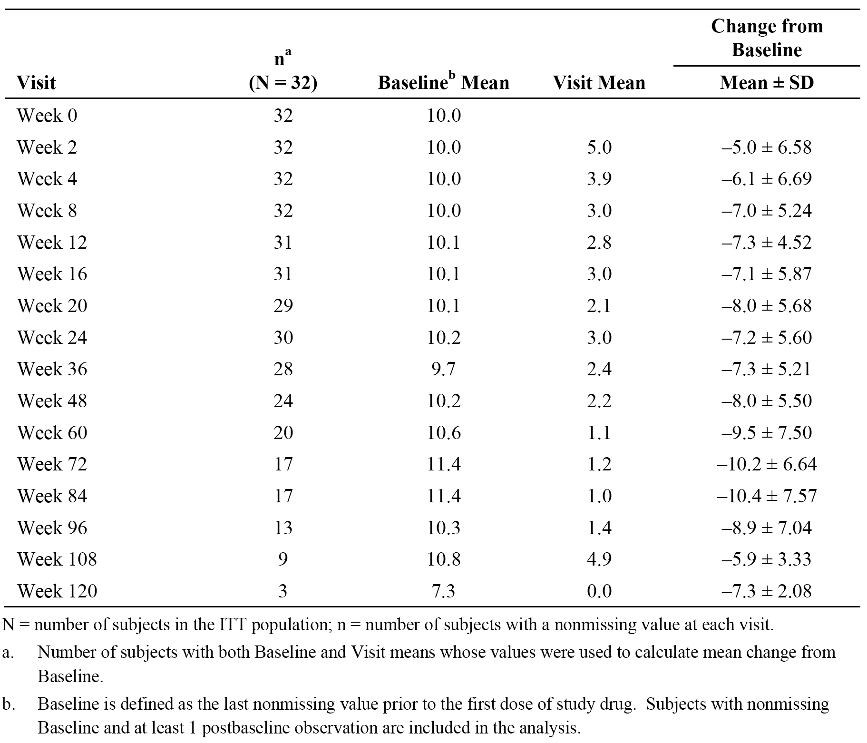
Comment: The results for the observed data set show that clinically meaningful improvement in joint swelling, pain, tenderness and movement was observed at Week 12 (first visit) and maintained through to Week 24. Thereafter, improvements in joint activity continued to be observed through to Week 120.

Visual Analog Scales (VAS)
The results for each of the three VAS parameters at each visit are summarised in Table 15 (PGA), Table 16 (parent's global assessment of disease activity), and Table 17 (parent's assessment of pain).

Table15: Study M10-444 - Physician's Global Assessment (PGA) of disease activity (VAS 0-100 mm) by visit (observed); ITT population.
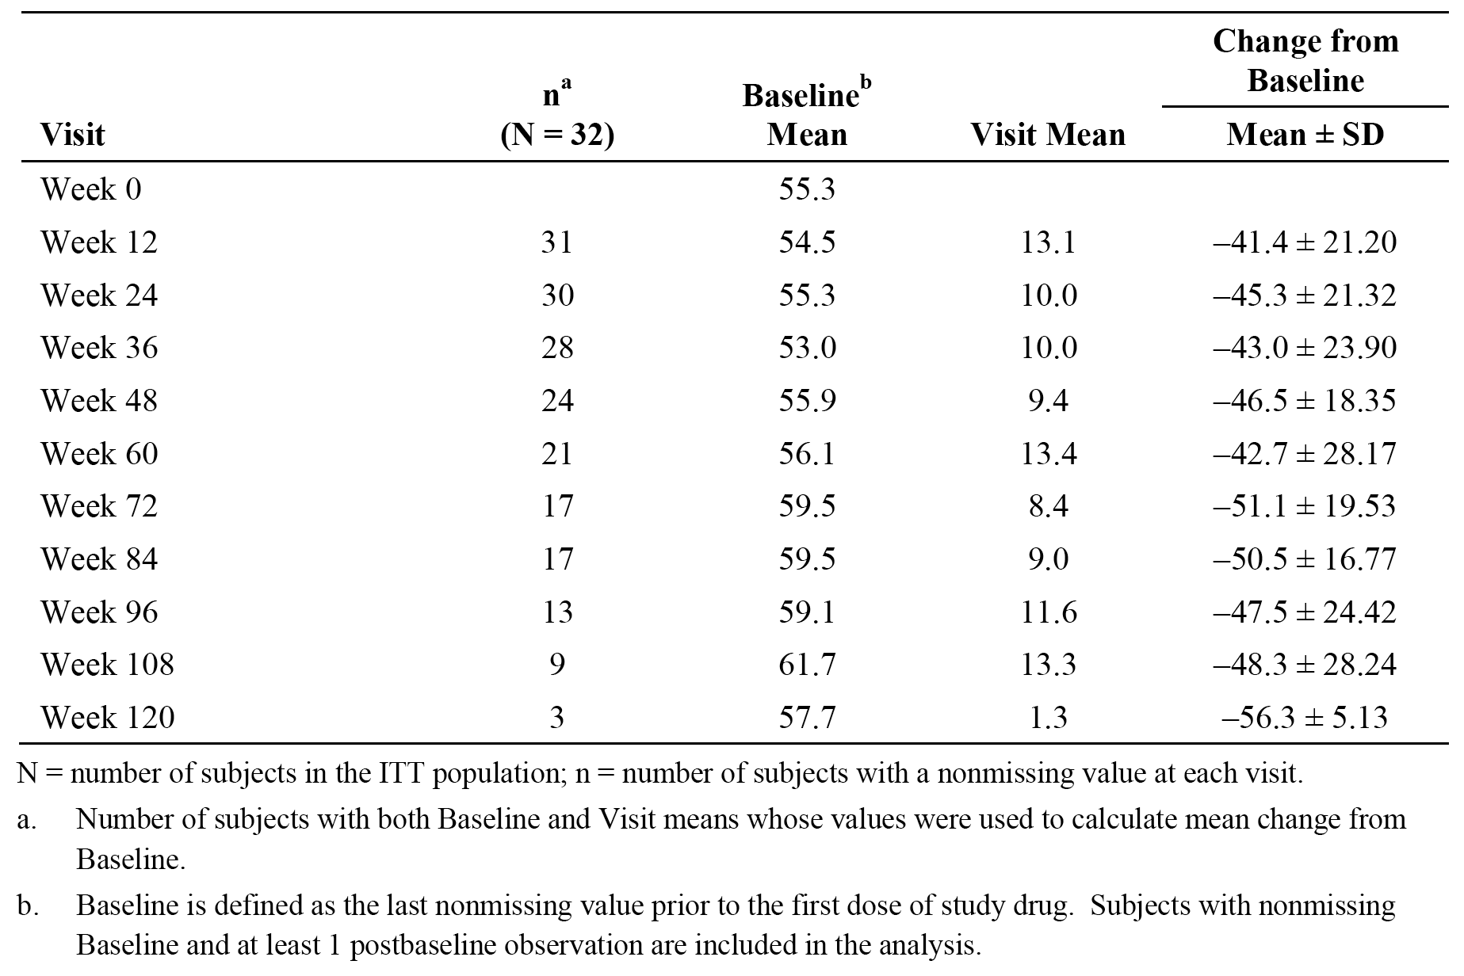

Table 16: Study M10-444 - Parent's Global Assessment of disease activity (VAS 0-100 mm) by visit (observed); ITT population.
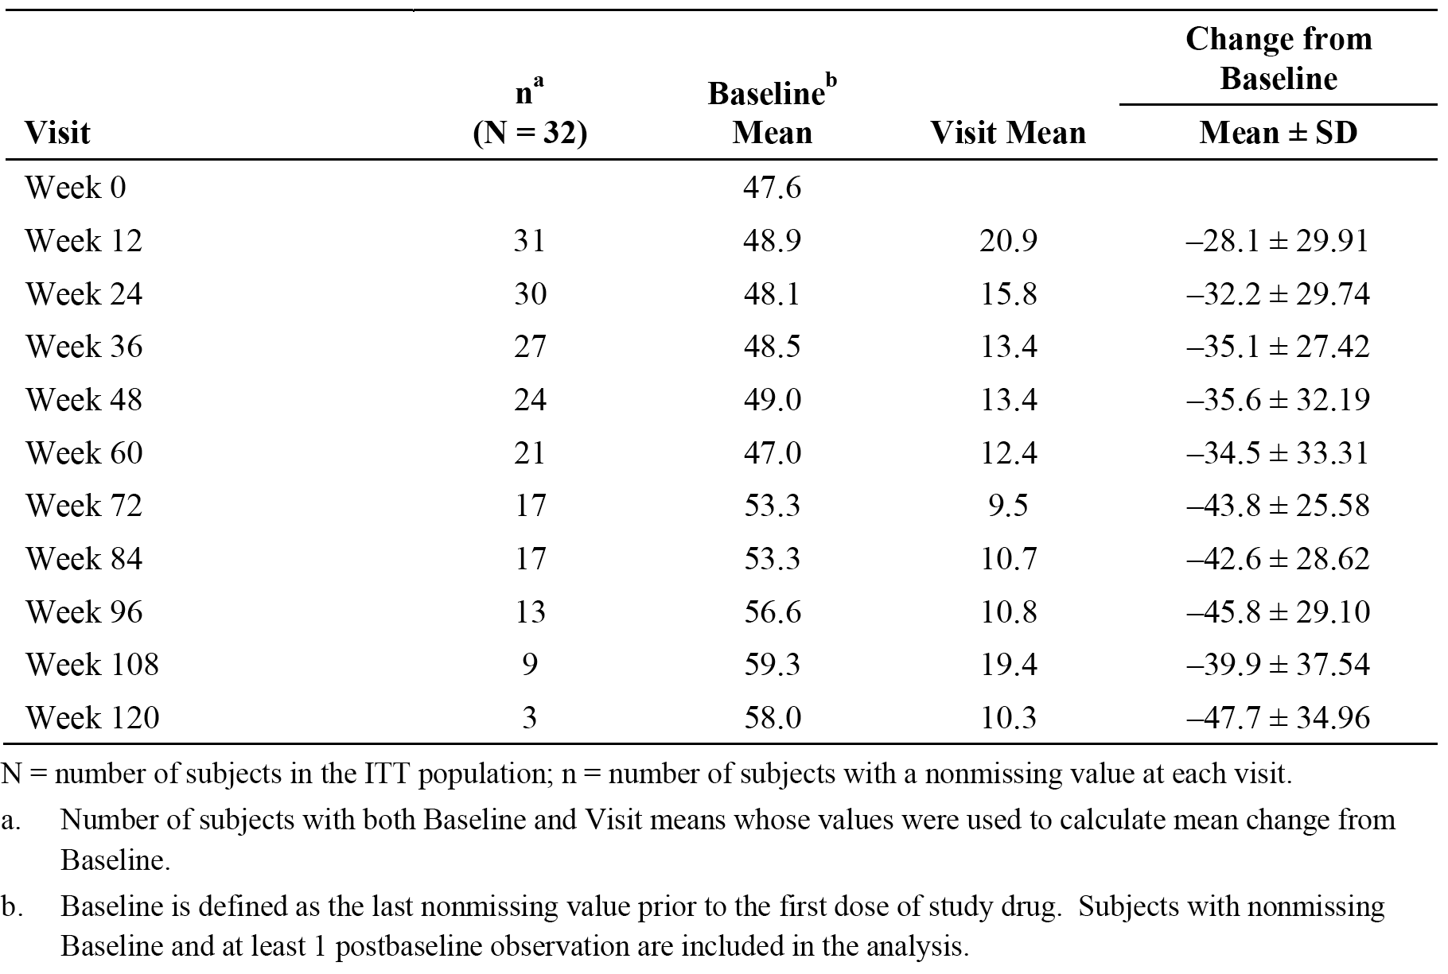

Table 17: Study M10-444 - Parent's assessment of pain (VAS 0-100 mm) by visit (observed); ITT population.
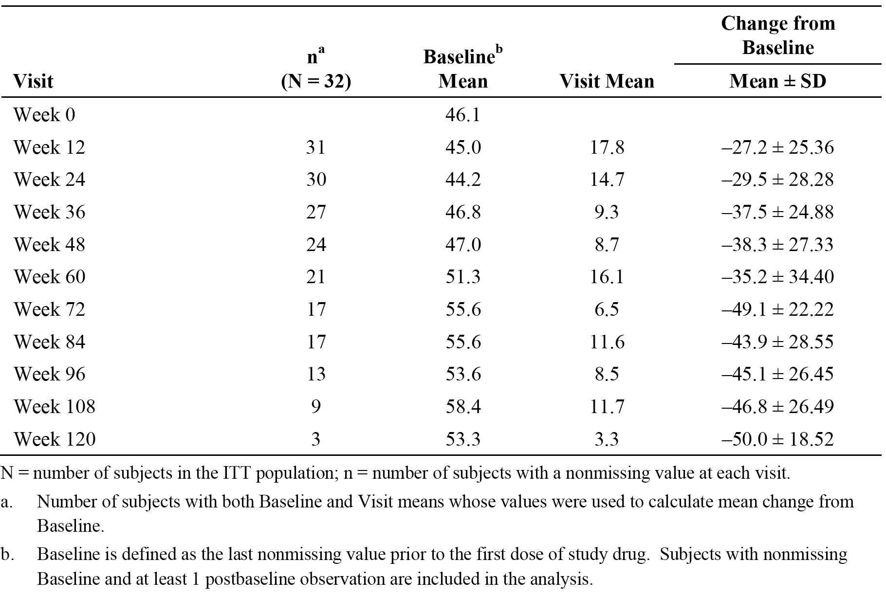
Comment: The results for each of three observed VAS assessments showed consistent clinically significant improvement from Week 12 through to Week 120.

Health and quality of life assessments
- DICHAQ
The results for the DICHAQ by visit are summarised in Table 18. The DICHAQ is a self-reported subject-orientated outcome measure calculated as the mean of eight category scores: Dressing and Grooming, Arising, Eating, Walking, Hygiene, Reach, Grip, and Activities. Each category is scored from 0 (no disability) to 3 (complete disability) and a subject must have scores for at least six categories in order to compute the DICHAQ score. The total DICHAQ score is the average of all categories, with 0 being no disability and to 3 complete disability.

Table 18: Study M10-444, Disability Index of Child Health Assessment Questionnaire (DICHAQ) by visit (observed); ITT population.
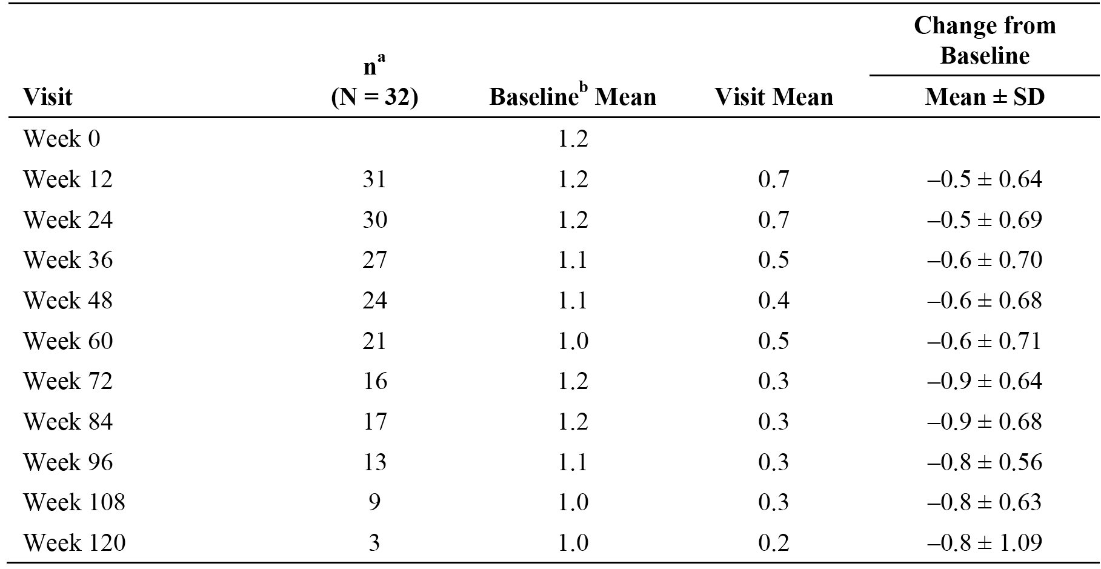
^{N} = number of subjects in the ITT population; n = number of subjects with a non-missing value at each visit.
^{a.} Number of subjects with both Baseline and Visit means whose values were used to calculate mean change from Baseline.
^{b.} Baseline is defined as the last non-missing value prior to the first dose of study drug. Subjects with non-missing Baseline and at least 1 post-baseline observation are included in the analysis.
Comment: In the observed data set, the results showed a decrease in mean change from Baseline in the DICHAQ from Week 12 through to Week 120. The results indicate a significant improvement in disability associated with the disease. The greatest reductions for Baseline were seen at Week 72 and Week 84.
- CHQ-PF50
The CHQ-PF50 is a subject-reported outcome measure that includes 50 questions related to physical and mental health, social limitations, and impact on parents and family. Scores for each category were converted to a scale from 0 (implies higher disease activity) to 100 (implies lower disease activity). The observed results for each of the 15 categories by visit are summarised in Table 19.

Table 19: Study M10-444 - Child's Health Questionnaire Parent Form (CHQ-PF50) by visit (Observed); ITT population.
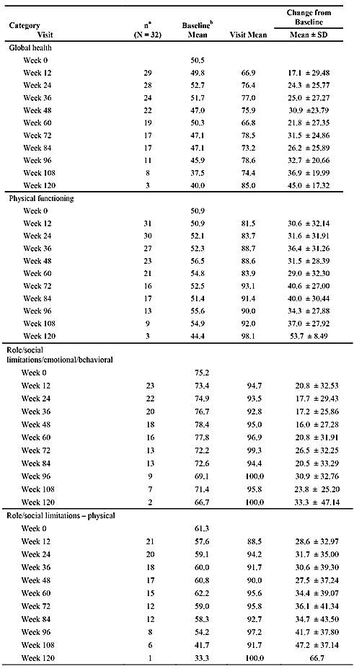

Table 19 (continued): Study M10-444 - Child's Health Questionnaire Parent Form (CHQ-PF50) by visit (Observed); ITT population.
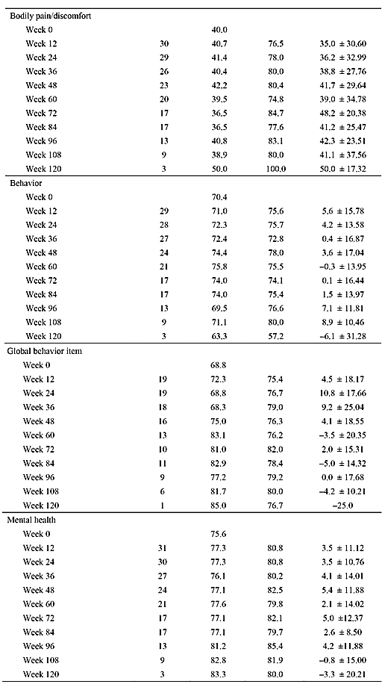

Table 19 (continued): Study M10-444 - Child's Health Questionnaire Parent Form (CHQ-PF50) by visit (Observed); ITT population.
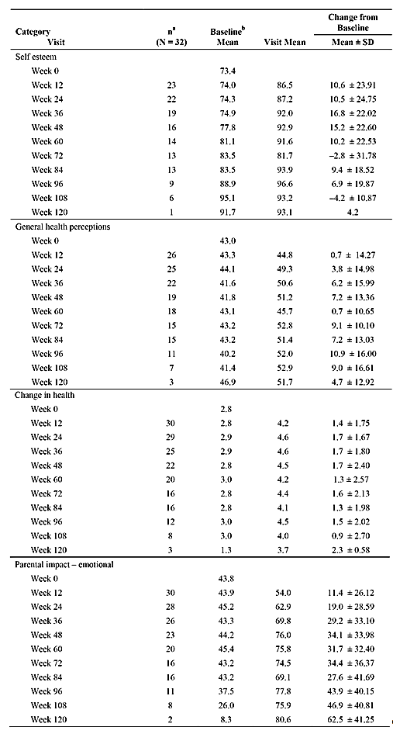

Table 19 (continued): Study M10-444 - Child's Health Questionnaire Parent Form (CHQ-PF50) by visit (Observed); ITT population.
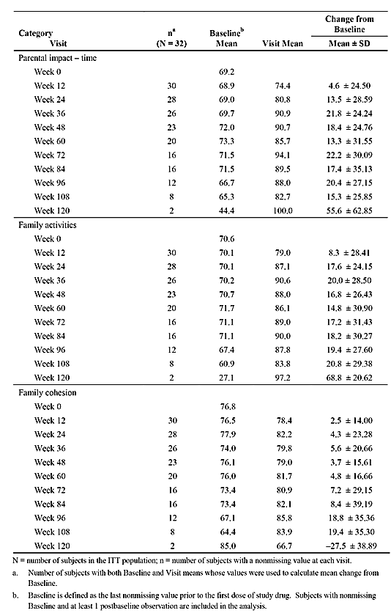
Comment: At Week 12, mean change from Baseline (observed) increased for all categories and the greatest increase was seen for the categories of physical functioning, role/social limitations/ emotional/behavioural, role/social limitations physical, and bodily pain/discomfort. Other categories showed a slow steady increase in mean from Baseline through Week 120 indicating improvement in the disease over the course of treatment with adalimumab. The categories demonstrating the greatest increase (that is, improvement) overall were global health, physical functioning, role/social limitations physical, bodily pain/discomfort, and parental impact emotional. Overall, the results suggest that the impact of disease in the subjects deceased over the course of treatment with adalimumab.

CRP
The results for the observed CRP (mg/dL) by visit are summarised in Table 20.

Table 20: Study M10-444 - CRP (mg/dL) by visit (observed); ITT population.
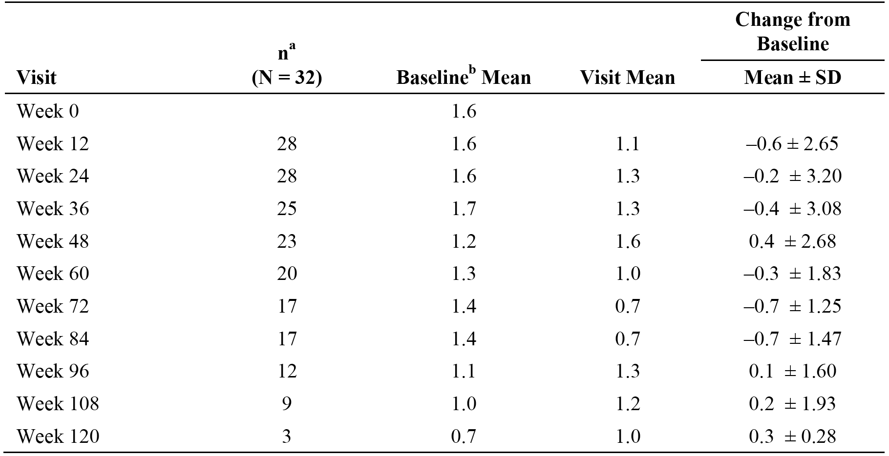
^{N} = number of subjects in the ITT population; n = number of subjects with a non-missing value at each visit.
^{a.} Number of subjects with both Baseline and Visit means whose values were used to calculate mean change from Baseline.
^{b.} Baseline is defined as the last non-missing value prior to the first dose of study drug. Subjects with non-missing Baseline and at least 1 post-baseline observation are included in the analysis.
Comment: The results showed a decrease in mean CRP for most visits through to Week 84. Normal levels were < 0.9 ng/dL, and mean values at Weeks 72 and 84 were at normal levels. Overall, the results for the CRP suggest a decrease in general inflammation associated with pJIA during the study.

Evaluator's conclusions on clinical efficacy
The assessment of the clinical efficacy of adalimumab for the treatment of moderate to severe pJIA in children aged 2 to < 4 years and children age ≥ 4 years weighing < 15 kg is based on the results of the efficacy variables from a small number of subjects (N = 32) enrolled in a multinational, multicentre, open-label, uncontrolled study (M10-444). The study aimed to treat all subjects for at least 24 weeks, and 30 of the 32 subjects (94%) achieved this objective. The majority of subjects (84.4%, N = 27) were treated with adalimumab in combination with MTX. There were no efficacy data comparing adalimumab alone to adalimumab in combination with MTX.
The most commonly reported diagnosis at Baseline in Study M10-444 was sero-negative polyarthritis (type 2 JIA) (N = 20 [62.5%]) followed by extended oligoarthritis (type 5 JIA) (N = 8 [25.0%]). All other JRA/JIA diagnoses based on ILAR criteria were reported in ≤ 2 subjects. The majority of subjects had received treatment for pJIA prior to enrollment with MTX (N = 25, 78.1%), systemic NSAIDs (N = 20, 62.5%) and/or systemic corticosteroids (N = 22, 68.8%). Prior to enrolment, no patients had been treated with biologics for treatment of their disease.
All subjects in Study M10-444 were treated with adalimumab 24 mg/m² (BSA) by SC injection eow and, as noted above, the majority of subjects also received concomitant treatment with MTX (N = 27, 84.4%). Subjects enrolled in EU countries were required to have previously failed, had an insufficient response to, or been intolerant to ≥ 1 DMARD. However, this was not a requirement for non-EU subjects.
In Study M10-444, there were no primary efficacy outcomes and all efficacy outcomes were defined as secondary outcomes. Efficacy data were available on 94% of subjects (30/32) at Week 24, 53% of subjects (17/32) at Week 84 and 9% of subjects (3/32) at Week 120. There were no statistical analyses of the efficacy outcomes and all results were presented descriptively. The main efficacy outcomes were the PedACR30/50/70/90 responses in the ITT population. The PedACR30 is a validated efficacy outcome for paediatric subjects. The PedACR50/70/90 responses do not appear to have been validated for paediatric subjects, but are commonly used clinical trial endpoints for the assessment of medications for the treatment of pJIA. The PedACR responses are considered to be acceptable efficacy endpoints for the assessment of adalimumab in the patient population studied.
The observed PedACR30 response was achieved by at least 85% of subjects from Week 12 through to Week 120. The imputed PedACR30 responses for both the LOCF and NRI methods supported the observed PedACR30 response through to Week 24, but the NRI responses were notably lower than the observed responses at Weeks 36 and 60. The observed PedACR50 response was achieved by at least 80% of subjects from Week 12 through to Week 120, while the observed PedACR70 and PedACR90 responses were achieved by at least 61% and 36% of subjects, respectively, from Week 12 through Week 120. The observed PedACR30/50/70/90 responses at Week 24 were 90.0%, 83.3%, 73.3% and 36.7% of subjects, respectively, and the responses were consistent with the results for the LOCF and NRI analyses at this time-point. Overall, the PedACR responses indicate a clear benefit for adalimumab treatment. It is considered unlikely that the magnitude of the improvements from Baseline in the observed PedACR responses are due to chance alone.
The results for the JIA core set of variables showed consistent improvement from baseline over the course of treatment for each of the parameters. The results for each of the joint assessments (TJC75, SJC66, POM75, LOM69, AJC73) showed a reduction in mean score from Baseline at all visits from Week 12 through to Week 120. In general, mean reductions from Baseline for all joint assessment scores increased from Week 12 through to Week 72 to Week 84. The number of subjects with joint assessments after the Week 84 visit was notably lower than the number prior to this visit.
The results for PGA of disease activity, parent's global assessment of disease activity and parent’s assessment of pain all showed reductions in mean VAS scores from Baseline at all visits from Week 12 through to Week 120. In general, the reductions from Baseline in mean VAS scores were higher from Week 72 through to Week 120 than from Week 12 through to Week 72. However, the number of patients assessed at Week 72 through to Week 120 (17 → 3) was notably lower than the number of patients assessed at Week 12 through to Week 72 (30 →17). Therefore, the imbalance in patient numbers between the two time periods suggests that the difference in the observed PGA VAS scores between the two time periods should be interpreted cautiously. In addition, the Week 72 through to Week 120 group can be interpreted as being a ‘survivor cohort’, while the Week 12 through to Week 72 group can be interpreted as being an ‘inception cohort’. Therefore, it is possible that the greater reductions in PGA VAS scores from Week 72 through to Week 120 compared to Week 12 through to Week 72 might represent ‘survivor-related’ bias. Consequently, in the absence of PGA VAS data on all patients in the ‘inception cohort’ from Week 72 through to Week 120 the significance of the observed difference in the PGA VAS scores between the two time periods is unclear.
The results for the DICHAQ and CHQ-PF50 assessments were consistent with improvement in the quality of life for both the subject and the parent(s) over the course of treatment with adalimumab. The results for the CRP showed a mean reduction from baseline at all visits from Week 12 through Week 84, with levels being in the normal range at Week 72 and Week 84. However, mean CRP levels were higher than Baseline at Week 96 through to Week 120, but subject numbers with CRP data at these visits were small. The majority of subjects (61.3%, N=19) had Baseline CRP values within the normal range (that is, < 0.9 mg/dL), with a mean ± SD value of 1.6 ± 2.43 mg/dL.
Overall, it is considered that the available open-label, uncontrolled data from Study M10-444 support the efficacy of adalimumab for the treatment of subjects aged 2 to < 4 years or aged ≥ 4 years weighing < 15 kg. The results for all efficacy outcomes consistently showed clinically meaningful improvements with treatment from Baseline through to Week 120.
There were no efficacy data in Study M10-444 in the proposed patient population treated with adalimumab without MTX. The sponsor is proposing that adalimumab be administered as monotherapy in cases where subjects aged 2 to < 4 years and ≥ 4 years weighing < 15 kg are intolerant to MTX or where continuous treatment with MTX is inappropriate. The proposed approach to treatment with adalimumab without MTX is identical to the approved approach for subjects aged 4 to 17 years.
There were PK data comparing serum adalimumab trough concentrations at steady-state following treatment with adalimumab 24 mg/m² eow without MTX in the proposed and approved paediatric populations. The data showed that the mean ± SD serum adalimumab steady-state trough concentration at Week 24 in the proposed paediatric population (N = 4) from Study M10-444 was lower than the corresponding adalimumab concentration at Week 16 in the approved paediatric patient population (N = 29) from Study DE038 (5.95 ± 6.74 versus 7.03 ± 6.26 µg/mL, respectively). In contrast, the mean ± SD serum adalimumab steady-state trough concentrations following treatment with adalimumab combined with MTX were similar for the proposed paediatric population (N = 11) from Study M10-444 at Week 24 and the approved paediatric population (N = 36) from Study DE038 at Week 16 (8.45 ± 5.69 versus 8.85 ± 5.53 µg/mL, respectively).
However, the comparative PK data in patients treated with adalimumab without MTX should be interpreted cautiously due to the high inter-subject variability in serum adalimumab steady-state trough concentrations observed in both studies (CV 113% [M10-444/Week 24] versus CV 89% [DE038/Week 16]) and the marked imbalance in subject numbers between the two studies (N = 4 [M10-444] versus N = 29 [DE038]). In addition, MTX administration was controlled in Study DE038 over the 16 weeks, open-label, lead-in phase, but not in Study M10-444. Consequently, it is possible that the 4 patients from Study M10-444 on combination therapy might not have been taking a stable dose of MTX over the 24 weeks of treatment.
The efficacy of adalimumab in combination with MTX in the proposed paediatric population is consistent with the efficacy of the combination in the approved paediatric population. In Study M10-444, the observed PedACR30 response at Week 24 was 90.0% (27/30) in the ITT population, while in Study DE038 the PedACR30 response at the end of the 16 weeks open-label, lead-in phase was 94% (80/85) in the adalimumab with MTX stratum and 74% (64/86) in the adalimumab without MTX stratum. Despite the uncertainties arising from the PK data it is considered that the lack of efficacy data for adalimumab without MTX in the proposed patient population should not preclude approval of the monotherapy option in cases where this might be required (that is, intolerance to MTX, continuous therapy with MTX is inappropriate).

Clinical safety

Study M10-444

Exposure
The mean ± SD duration of exposure to adalimumab was 515.3 ± 245.33 days (median = 575.0 days). All subjects received at least 57 days of adalimumab treatment, with a maximum exposure of 910 days. Thirty (30) subjects (93.8%) were exposed for ≥ 181 days, 21 subjects (65.6%) were exposed for ≥ 391 days, and 9 subjects (28.1%) were exposed for ≥ 721 days.
Adalimumab was administered at a dose of 24 mg/m² BSA, up to a total dose of 20 mg, eow by SC injection. Concomitant MTX was taken by 84.4% (N = 27) of patients, concomitant systemic NSAIDs by 62.5% (N = 20) of patients, and systemic corticosteroids by 68.8% (N = 22) of patients.

Adverse events

Overview
The primary objective of Study M10-444 was to evaluate the safety of adalimumab in subjects 2 to < 4 years of age and ≥ 4 years of age weighing < 15 kg with moderately to severely active polyarticular JIA or polyarticular course JIA. The primary study endpoint, measured over the course of the study, was the incidence of serious adverse events (SAEs) and adverse events (AEs) in the patient population. Secondary study safety endpoints included the change from Baseline in laboratory findings.
The investigator monitored each subject for clinical and laboratory evidence of adverse events (AEs) on a routine basis throughout the study. Treatment-emergent adverse events (TEAEs) were defined as AEs with an onset on or after the first dose of adalimumab and up to 70 days after the last dose of adalimumab (that is, 5 half-lives). Subjects with more than one AE reported for the same preferred term (PT) were counted only once for that term. All analyses were based on the ITT population, which included all subjects who were enrolled and received ≥ 1 dose of study drug. The TEAEs (any), TEAEs (drug related), severe TEAEs, serious TEAEs, TEAEs leading to discontinuation, and deaths reported during the study are summarised below in Table 21.

Table 21: Overview of subjects with TEAEs; ITT population.
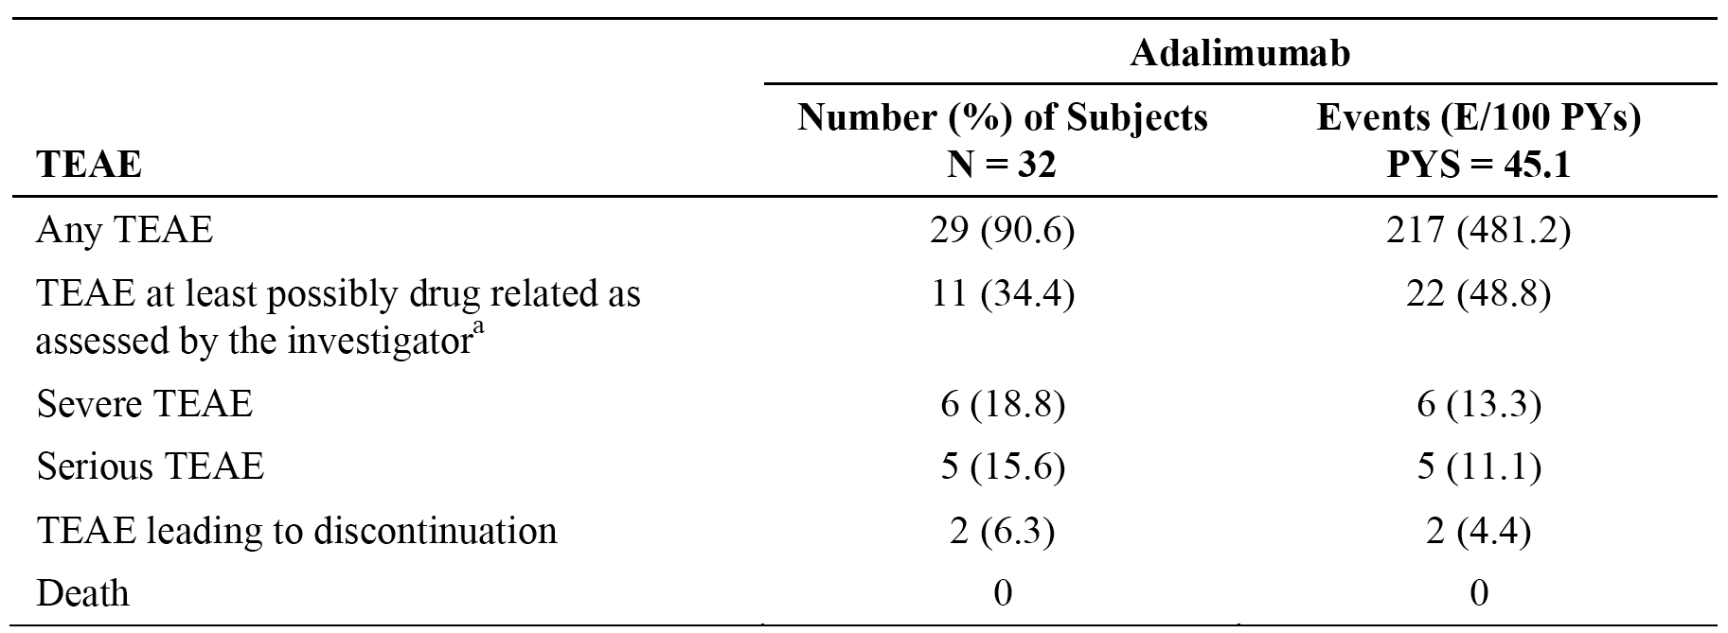
^{a.} Relationship to study drug, as assessed by investigator. Note: A TEAE is any AE with onset on or after first dose of study drug and up to 70 days after last day of study drug. An AE with unknown severity is counted as severe. An AE with unknown relationship to study drug is counted as drug-related. E/100 PYs = events per 100 patient-years.

TEAEs reported by at least 5% of subjects
A total of 29 subjects (90.6%) reported at least one TEAE (217 events, 481.2 events /100 PYs). The most frequently reported TEAEs (≥ 15% of subjects) were nasopharyngitis (25%, N = 8), pyrexia (21.9%, N = 7), bronchitis (18.8%, N = 6), cough (18.8%, N = 6), rhinorrhea (18.8%, N = 6), upper respiratory tract infection (18.8%, N = 6), juvenile arthritis (15.6%, N = 5), otitis media (15.6%, N = 5), and vomiting (15.6%, N = 5). All other TEAEs were reported by < 15% of subjects. The number of TEAEs per 100 PYs was ≤ 11 for the most frequently reported events. TEAEs reported in ≥ 5% of subjects are summarised in Table 22.

Table 22: Study M10-444 - TEAES reported by ≥ 5% of subjects by decreasing frequency and events per 100 person-years (PYs) by primary MedDRA PT; ITT population.
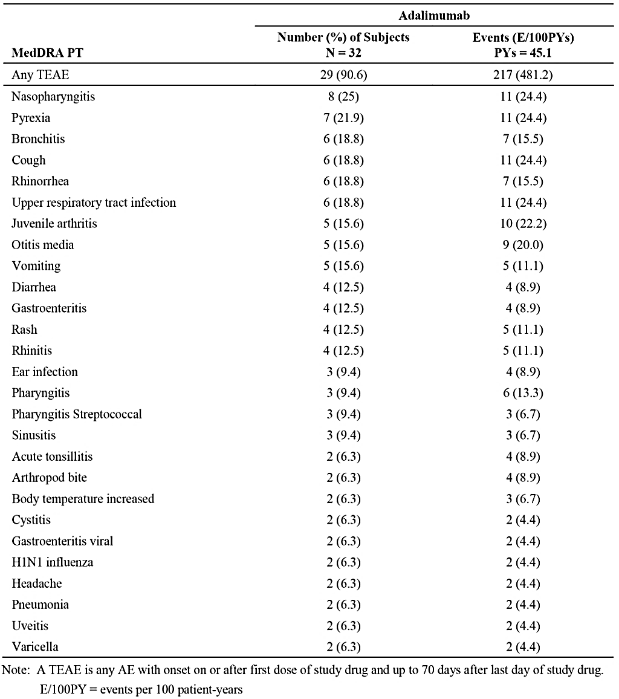
The severity of the TEAEs were rated by the investigator to be mild in 9 subjects (28.1%), moderate in 14 subjects (43.8%), and severe in 6 subjects (18.8%). There were 6 TEAEs rated as severe and each was reported once (uveitis, otitis media, platelet count decreased, type 1 diabetes mellitus, arthritis, and juvenile arthritis). Of the severe TEAEs, 1 was rated as probably related to treatment ( juvenile arthritis) and the remaining 5 were considered to be not related or probably not related to treatment.

Treatment-related TEAEs
The investigator assessed whether the TEAE was probably related, possibly related, probably not related, or not related to the use of adalimumab. TEAEs with an unknown relationship to treatment were counted as drug-related. The majority of TEAEs were considered by the investigator to be not related to treatment or possibly not related to treatment. A total of 11 subjects (34.4%) had TEAEs reported to be at least possibly related to study treatment (22 events, 48.8 events/100 PYs). The only treatment-related TEAE reported in ≥ 2 subjects was rash (N = 2, 6.3%). Five (5) subjects had 1 or more events reported to be possibly related to adalimumab (pyrexia, bronchitis, ear infection, laryngitis, otitis media, pharyngitis, pharyngitis streptococcal, pneumonia, viral pharyngitis, upper respiratory tract congestion, and rash). Six (6) subjects had events reported to be probably related to adalimumab (injection site reaction, injection site pain, injection site pruritis, injection site rash, injection site swelling, cystitis, and juvenile arthritis).

Infections
A total of 25 subjects (78.1%) reported at least one treatment-emergent infection during the study (93 events, 206.2 events/100 PYs). Infections reported in ≥ 10% of subjects were nasopharyngitis (25.0%, N = 8), bronchitis (18.8%, N = 6), upper respiratory tract infection (18.8%, N = 6), otitis media (15.6%, N = 5), gastroenteritis (12.5%, N = 4), and rhinitis (12.5%, N = 4). All other infections were reported in less than 10% of subjects. The majority of Infection AEs were considered by the investigator to be mild or moderate in severity and not related or probably not related to the study drug. Treatment emergent infections are summarised in Table 23.

Table 23: Study M10-444 - Summary of treatment-related TEAEs; ITT population.
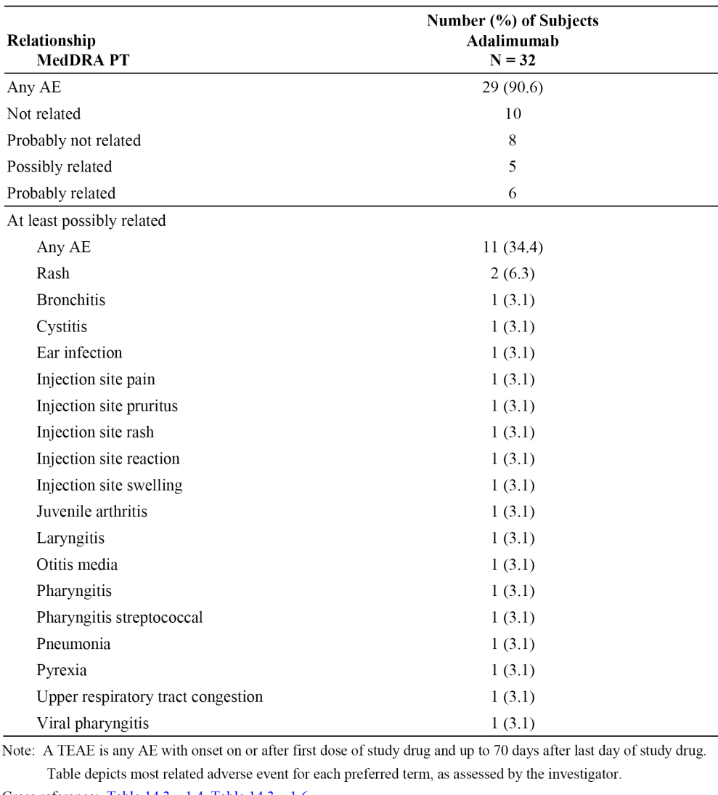
Three (3) subjects (9.3%) had serious infections considered by the investigator to be mild to moderate in severity and not related to adalimumab (1 report each of dental caries, gastroenteritis rotavirus, and varicella). No subjects prematurely discontinued the study drug as a result of an infection.

Deaths and other serious adverse events (SAEs)
No deaths were reported during the study. Five (5) subjects (15.6%) reported an SAE during the study (11.1 events/100 PYs). The 5 SAEs were dental caries, gastroenteritis rotavirus, juvenile arthritis, type 1 diabetes mellitus, and varicella. All subjects who reported SAEs were being treated with adalimumab 15 mg (0.3 mL). The listing of subjects with SAEs is provided below in Table 24.

Table24: Study M10-444 - Listing of subjects with serious TEAEs. [patient identifiers have been deleted from this table].
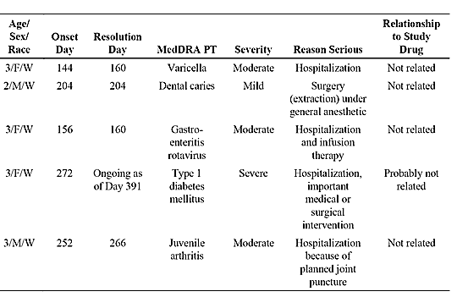

TEAEs leading to study discontinuation
Two (2) subjects (6.3%) experienced a non-serious flare of juvenile arthritis and were discontinued from the study drug due to the event. Both subjects were being treated with adalimumab 15 mg (0.3 mL) at the time of onset of the TEAE. The narratives for the two subjects are provided below:
- [information redacted] was a 2-year-old White male who experienced a flare of juvenile arthritis on Day 271 and was discontinued from adalimumab. The event was considered by the investigator to be severe and probably related to adalimumab. The event was ongoing as of Day 487.
- [information redacted] was a 2-year-old White female who experienced a flare of juvenile arthritis on post-treatment Day 554 that resolved on post-treatment Day 566. The subject was discontinued from adalimumab, received an increase in prednisone dose and was prescribed Enbrel and methotrexate. The event was considered by the investigator to be moderate in severity and not related to adalimumab.

Adverse events of special interest

Overview
TEAEs of special interest were specifically examined using standardized MedDRA queries or company MedDRA queries. Many of these TEAEs were of special interest because they were considered potential safety issues due to the immunomodulatory mechanism of action of adalimumab. Overall, 9 subjects reported 11 TEAEs of special interest (that is, oral candidiasis, allergic reaction, haematologic disorders, and injection site reaction). Of these 11 TEAEs, the most frequently reported were injection site reactions (see Table 25, below). All TEAEs of special interest were summarised.

Table 25: Study M10-444 - Overview of TEAEs of special interest.
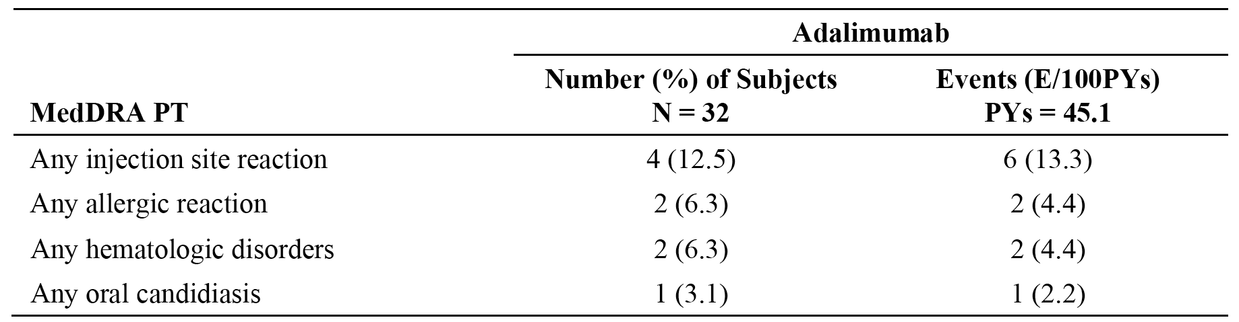
Note: A TEAE is any AE with onset on or after first dose of study drug and up to 70 days after last day of study drug. E/100 PYs = events per 100 patient-years.

Any oral candidiasis
There was 1 report of oral candidiasis in 1 subject who was receiving adalimumab 15 mg (0.3 mL) at the time of the event. The event was reported to be mild in severity and not related to adalimumab.

Any injection site related reaction
Four (4) subjects (12.5%) reported injection site reactions during the study (1 subject reported 2 events). The reactions were injection site pain, injection site pruritus, injection site rash, injection site reaction, and injection site swelling. The reactions were reported to be mild in severity and probably not related to adalimumab. The reactions resolved and the subjects continued in the study. All 4 subjects were receiving adalimumab 15 mg (0.3 mL) at the time of onset of the injection site reactions.

Any Allergic reaction including angioedema/anaphylaxis
Two (2) subjects (6.3%) reported allergic reactions during the study. Both subjects were receiving adalimumab 15 mg (0.3 mL) at the time of onset of the TEAEs. The narratives for these two subjects are provided below:
- [information redacted] was a 2-year-old female from North Africa who experienced an event of intermittent urticaria on Day 631 that lasted for 17 days. The event was considered by the investigator to be mild in severity and not related to adalimumab. The subject was treated with 2.5 mL dexchlorpheniramine twice daily.
- [information redacted] was a 3-year-old White male who experienced an event of rash on his trunk, back, abdomen, and face on Day 12 that lasted 11 days. The event was considered by the investigator to be mild in severity and possibly related to adalimumab.
There were no reports of angioedema or anaphylaxis during the study.

Any haematologic disorders including pancytopenia
Two subjects (6.3%) reported hematologic disorders during the study. Both subjects were receiving adalimumab 15 mg (0.3 mL) at the time of onset of the TEAEs. The narratives for these two subjects are provided below:
- [information redacted] was a 2-year-old White female who experienced an event of microcytic anaemia on Day 253 that was ongoing as of Day 757. The event was considered by the investigator to be mild in severity and not related to adalimumab.
- [information redacted] was a 2-year-old Asian female who experienced an event of decreased platelet count on Day 506. The event was considered by the investigator to be severe and not related to adalimumab. The reported event was considered resolved after a repeat test was performed by a local hospital laboratory and the results for platelet count were within normal range.
There were no reports of pancytopenia or leukopenia during the study.

Other TEAEs of special interest
No subjects reported the following TEAEs of special interest: malignancy; lupus-like reactions or systemic lupus erythematosus; demyelinating disorder; vasculitis; hepatitis B; diverticulitis; intestinal perforation; liver failure or other liver events; myocardial infarction; cerebrovascular accident; pulmonary embolism; worsening/new onset psoriasis; adalimumab administration-related medication error; Steven's-Johnson syndrome; erythema multiforme; congestive heart failure; interstitial lung disease; pancreatitis; sarcoidosis; progressive multifocal leukoencephalopathy or reversible posterior leukoencephalopathy syndrome; amyotrophic lateral sclerosis; tuberculosis; seizure disorder; anti-phospholipid syndrome; or severe CPK (CK) elevations.

Clinical laboratory tests

Overview
A certified central laboratory was utilised to process and provide results for the clinical laboratory tests. The clinical laboratory tests included the standard range of haematology and clinical chemistry parameters plus relevant serology parameters (that is, CRP, RF, ANA, anti-dsDNA in the case of positive ANA). All abnormal laboratory test results considered clinically significant by the investigator were followed to a satisfactory resolution. Blood specimens for RF, haematology, and clinical chemistry were obtained at Screening. Additional laboratory assessments for haematology, clinical chemistry, and CRP were taken at Baseline, Week 12, 24, and every 12 weeks thereafter, including the final study visit and, if applicable, the ET visit. The clinical laboratory tests (haematology, clinical chemistry) were summarised using mean change from baseline values and changes from baseline for individual subjects. Urinalysis was not performed.

Haematology
Haematology parameters showing shifts from low/normal to high values for individual subjects occurred notably more commonly than shifts from high/normal to low values (see Table 26, below). The majority of subjects (≥ 50%) with data had shifts from low/normal to high values for lymphocytes (81.1%) and platelet count (66.7%). All other shifts in parameters from low/normal to high values were reported in < 50% of patients with data. Only one subject (3.6%) with data had a shift from high/normal to low values (eosinophils).

Table 26: Study M10-444 - Shifts in haematology parameters for individual subjects; ITT population.
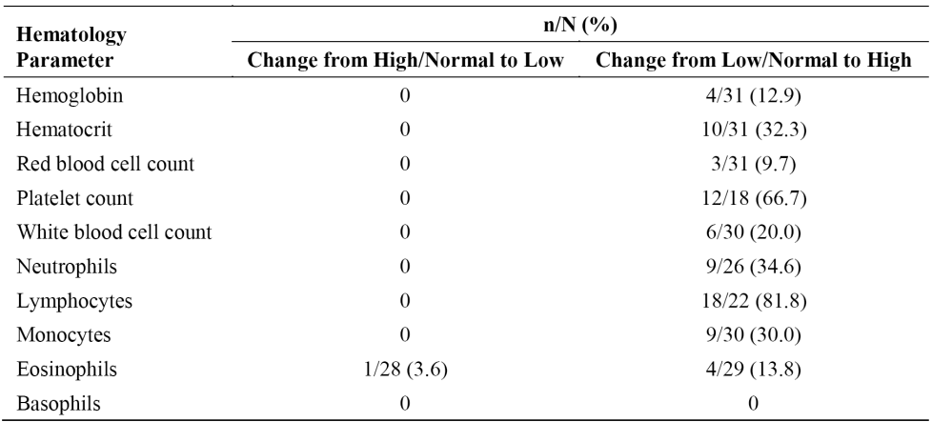
Notes: Baseline: Last observation prior to the first dose of study drug. Low: Less than lower limit of normal. Normal: Within normal range. High: Greater than the upper limit of normal. n/N = number of subjects out of total subjects.
Three (3) subjects had at least 1 clinically significant abnormality in haematology laboratory values. These subjects developed a CTC toxicity grade ≥ 3 haematology value for a single laboratory measurement during the study that resolved before the end of the study. Two (2) subjects had a decreased neutrophil count, and 1 subject with a decreased platelet count had a normal count when the test was repeated by a local hospital. None of the subjects discontinued because of abnormal haematology laboratory values.

Clinical chemistry
All shifts in clinical chemistry parameters were from low/normal to high values, with no shifts from high/normal to low values being reported (see Table 27 below). No shifts in clinical chemistry parameters from low/normal to high were report in ≥ 50% of subjects.

Table 27: Study M10-444 - Shifts in clinical chemistry parameters for individual subjects; ITT population.
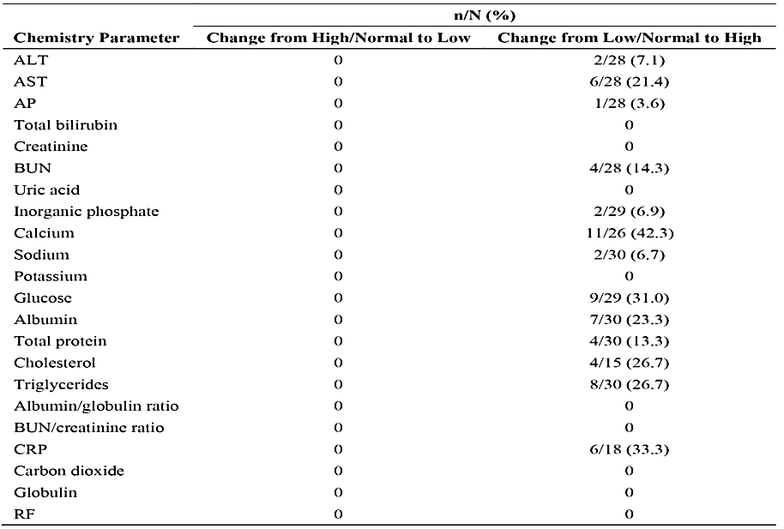
Notes: Baseline: Last observation prior to the first dose of study drug. Low: Less than lower limit of normal. Normal: Within normal range. High: Greater than the upper limit of normal. n/N = number of subjects out of total subjects.
Two (2) subjects had at least 1 clinically significant abnormality in chemistry laboratory values. These subjects developed a CTC toxicity grade ≥ 3 chemistry value for a single laboratory measurement during the treatment period that resolved before the end of the study. One (1) subject had hypernatremia and 1 subject had hyperglycaemia. Neither subject discontinued because of abnormal chemistry laboratory values.

Liver function tests:
The majority of subjects did not experience a shift in ALT or AST values. A small shift in ALT and AST values from < 1.5 × ULN to ≥ 1.5 – < 3.0 × ULN was observed for 1 subject each. Two (2) subjects had potentially clinically significant abnormalities in liver function tests. Neither subject discontinued early from the study because of the abnormal liver function test. The narratives for these two subjects are provided below:
- [information redacted] was a 3-year-old White male who had ALT and AST values above the upper limit of normal (ULN) from Day –3 through Day 85 that resolved on Day 169. This subject had received MTX 3.75 dose/units eow from Day 29 to Day 85 and increasing to 7.5 dose/units ew on Day 85 because of insufficient response.
- [information redacted] was a 3-year-old White female who had AST values above the ULN on Day 252 and which was ongoing as of Day 336 (post-treatment Day 14). This subject had been receiving MTX 7.5 dose/units of ew since Day 64.
The majority of subjects did not experience a shift in AP values. A small shift was observed in AP values from ≥ 1.5 – < 3.0 × ULN to < 1.5 × ULN for 1 subject. No shifts were observed in total bilirubin values.

Serology
No shifts were observed in final ANA or anti-dsDNA values.

Vital signs
- Pulse rate: The incidence of potentially clinically significant pulse rates of ≤ 50 bpm or decreases of ≥ 15 bpm from Baseline was 56.3% (N = 18/32). The incidence of potentially clinically significant pulse rates of ≥ 120 bpm or increases of ≥ 15 bpm from Baseline was 65.6% (N = 21/32). In most cases, the abnormal values were intermittent. At the final determination, 9 subjects had potentially clinically significant decreases in pulse rate and 8 subjects had potentially clinically significant increases in pulse rate. The mean change in pulse rate from Baseline was ± 4 bpm from Week 2 through to Week 96. The mean change in pulse rate at Week 108 and Week 120 was 14.4 bpm and 29.0 bpm, respectively, but subject numbers at both time points were relatively small (N = 9 and N = 3, respectively).
- Temperature: There was no significant change in mean temperature over the duration of the study.
- Weight: There was a gradual increase in the mean weight of the subjects throughout the course of the study. This was not unexpected as the subjects grew normally over the course of the study and the mean age increased. The mean ± SD increase in weight from Baseline to Week 120 was 5.63 ± 1.55 kg.
- Other vital signs: There were no data on blood pressure changes or ECG abnormalities.

Safety in special groups
- Intrinsic factors: Safety analyses specifically for intrinsic factors of age, weight, dose and sex were not performed.
- Extrinsic factors: Safety analyses specifically relating to extrinsic factors were not performed. Subjects with diseases other than the pJIA (such as hepatic or renal disease) were excluded from the study.
- Drug interactions: Drug interactions were not specifically evaluated.
- Overdose: No subjects overdosed during the study.
- Withdrawal and rebound: No data regarding withdrawal or rebound following cessation of adalimumab was collected.

Study P10-262 (Registry - interim 4-year safety data)

Background
The submission included interim 4-year data from a ‘Long-term, Multi-center, Longitudinal Post-marketing, Observational Registry to Assess Long Term Safety and Effectiveness of Humira (Adalimumab) in Children with Moderately to Severely Active Polyarticular or Polyarticular-course Juvenile Idiopathic Arthritis (JIA) – STRIVE’.

Objectives, setting, inclusion and exclusion criteria, and source of the patients
The interim report provided cumulative, long-term safety and effectiveness data from the first 4 years of the ongoing JIA Humira non-interventional registry through the data cut-off of 1 June 2013. The objectives of the interim report were the collection of cumulative, long-term safety data (serious adverse events [SAEs] and adverse events of special interest [AESI]) and effectiveness data from the first 4 years of ongoing JIA treatment in patients with disease affecting ≥ 5 joints at the time of diagnosis receiving commercial Humira or MTX in a routine clinical setting. Evaluation of safety is the primary objective of the Registry data, while evaluation of effectiveness is the secondary objective. Patients being prescribed and treated with MTX per the approved local product label are considered to be the reference group for Humira.
The registry includes JIA patients treated at a total of 85 actively recruiting sites in the United States, EU countries, and Australia. The inclusion and exclusion criteria are summarised in Table 29 and Table 30, respectively.

Table 29: Study P10-262 - Inclusion criteria.
The decision to prescribe either Humira or MTX must be made prior to the decision to enroll a patient in the registry. A patient is eligible for participation if he/she meets the following criteria:
- For a patient enrolling into the Humira arm; a pediatric patient diagnosed at any time with moderately to severely active polyarticular or polyarticular-course JIA (defined as arthritis affecting ≥ 5 joints at the time of diagnosis of polyarticular or polyarticular-course JIA) who has been prescribed Humira therapy according to the locally approved Humira product labeling and meets one of the following criteria:
- Newly initiated (within 24 months of registry entry) on Humira therapy and has received continuous (no more than 70 consecutive days off drug) Humira therapy, and the physician can provide available source documentation of SAEs, AEs of Special Interest, and dosing information since initiation of therapy;
- Or is entering after participation (within 24 months of registry entry or, if longer, continuously treated at the same site) in an AbbVie-sponsored study of Humira, regardless of age or the number of joints with symptoms of JIA, and has received continuous (no more than 70 consecutive days off drug) Humira therapy and the physician can provide available source documentation of SAEs, AEs of Special Interest, and dosing information since initiation of therapy.
- For a patient enrolling into the MTX arm; a pediatric patient diagnosed at any time with moderately to severely active polyarticular or polyarticular-course JIA (defined as arthritis affecting ≥ 5 joints at the time of diagnosis of polyarticular or polyarticular-course JIA) who is prescribed MTX therapy alone or in combination with other DMARDs according to the local product labeling (initiated treatment within 24 months of registry entry) and has received continuous therapy and the physician can provide available source documentation of SAEs, AEs of Special Interest, and dosing information since initiation of therapy.
- Patients who were treated in the MTX arm of this registry and prematurely discontinued from the MTX arm due to being a non-responder, or became intolerant of MTX treatment or are in need of combination treatment with Humira therapy may be eligible to enroll into the Humira treatment arm if all ongoing AEs/SAEs have been resolved, and they meet inclusion criteria and can enroll during the registry enrollment period.
- Parent or guardian has voluntarily signed and dated an informed consent/patient authorization form, approved by an IRB/Independent Ethics Committee (IEC) if applicable according to local law, after the nature of the registry has been explained and the patient's parent or legal guardian has had the opportunity to ask questions. Pediatric patients will be included in all discussions as per applicable local regulations in order to obtain verbal or written assent.

Table 30: Study P10-262 - Exclusion criteria.
- Patients should not be enrolled into the Humira or MTX arm if they cannot be prescribed and treated in accordance with the approved local Humira and/or with the local MTX product label.
- Patients should not be enrolled into the Humira or MTX arm if they require ongoing treatment with Kineret® (anakinra), Orencia® (abatacept), Rituxan® (rituximab), Enbrel® (etanercept), Remicade® (infliximab) or any other approved biologic agents or investigational agents.
- Patients should not be enrolled into the MTX arm if they have had prior treatment with any investigational agent or anti-rheumatic biologic therapy such as, but not limited to, Orencia® (abatacept), Enbrel® (etanercept), Remicade® (inflixumab), Rituxan® (rituximab), or Actemra® (tocilizumab).
The patients enrolled in the Registry are from the following sources:
- Patients prescribed Humira rolling over from Study DE038 and Study M10-444 enrolled in the Humira arm.
- New patients enrolled in either the Humira arm or MTX arm, depending on the treatment decision by the physician prior to enrolment. Patients in the Humira arm may be treated with Humira alone or in combination with MTX. Patients in the MTX arm may be treated with MTX alone or in combination with other DMARDS, but not with anti-tumour necrosis factors (anti-TNFs) or other biologic therapies.
- Patients who are non-responders, intolerant to MTX, or are in need of combination treatment with Humira who are eligible to switch to the Humira arm, up until the enrolment of the last patient in the registry.
The data collection started on 30 June 2008 (first subject enrolled in registry) and the final report is planned for August 2024. Patients who agree to participate in the Registry are to be followed for up to 10 years, and include patients who discontinue Humira (monotherapy or combination therapy with MTX) or MTX (without Humira). For patients who switch from the MTX treatment arm to the Humira treatment arm, the 10 year follow-up period starts at the time of enrolment into the Humira treatment arm. Patients who discontinue full Registry participation prior to completing the 10 years of follow-up will be offered participation in the direct to health care provider (HCP) follow-up process by their Registry physician.
Comment: In this CER, only the safety data included in Registry are reviewed. The observational effectiveness data for patients included in the Registry are considered to be not directly relevant to the submission due to the small number of patients meeting the relevant criteria (that is, children 2 to < 4 years of age and ≥ 4 years of age weighing < 15 kg). The Registry data is observational and, consequently, both the effectiveness and the safety results should be interpreted cautiously.

Variables

Effectiveness
The effectiveness variables are summarised in Table 31.

Table 31: Study P10-262 - Effectiveness variables.
- Physician’s Global Assessment of disease activity measured on a 0 – 10 cm VAS
- Parent’s Global Assessment of patient’s overall well-being measured on a 0 – 10 cm VAS
- Parent’s Global Assessment of patient’s pain measured on a 0 – 10 cm VAS
- Physical function of the Disability Index of Childhood Health Assessment Questionnaire (DICHAQ)
- Number of active joints (active joint count [AJC])
- Joint pain and swelling (tender joint count [TJC]; swollen joint count [SJC])
- Number of joints with limitation of motion (LOM)
- Number of joints with pain on passive motion (POM)
- CRP levels
- ESR levels
- American College of Rheumatology Pediatric responses
(PedACR30/50/70/90)
- Juvenile Arthritis Disease Activity Scores (JADAS)
- Child’s Health Questionnaire (CHQ-PF50) – exploratory variable
- Number of patients with inactive disease
- JIA-associated uveitis assessment

Safety
Safety variables included the following: extent of exposure to Registry drug; assessment of SAEs; assessment of AESI; laboratory values, including CRP and ESR, when collected; vital signs; growth assessments; Tanner Maturation Staging; and pregnancies.
The Physician was to monitor each patient from the time the Registry informed consent form was signed through to Registry year 5 for SAEs, AESI, and pregnancies. At the completion of Year 5 (Month 60), SAEs, CHF, malignancies and pregnancies are to be reported annually through to Year 10.
Four safety summaries are to be reported for the Registry: (a) observational SAEs and AESI including events from the first day in the Registry through the last contact, irrespective of drug treatment duration; (b) Registry treatment-emergent SAEs and AESI including all events occurring from the first dose in the Registry through to the last dose plus 70 days in the Registry, excluding AEs occurring during treatment interruption (TI) reported more than 70 days after the last dose of Registry drug prior to the TI; (c) all treatment emergent SAEs and AESI including events occurring after the first recorded dose of MTX or Humira (prior to the first registry dose if patients were already receiving treatment before the registry), up to 70 days after the last dose of registry drug (excluding SAEs and AESI occurring during TI which were more than 70 days after the last dose of registry drug prior to the TI); and (d) TI SAEs and AESI.
Comment: In this CER, the primary review of the safety data focuses on the observational adverse events as these data are considered to be more conservative than the Registry treatment-emergent adverse events. However, the adverse event profiles were generally similar for the observational adverse events and the Registry treatment-emergent adverse events.

Statistical methods
The Registry effectiveness and safety data were analysed using standard descriptive statistical methods. The data analyses are planned for two populations: (a) the all treated population, defined as patients who received at least 1 dose of MTX or Humira in the Registry; and (b) the intermittent treatment population, defined as Humira patients who had at least one TI in Humira dosing. Analyses for the TI population have not yet been conducted, as the population was too small at the time of data cut-off.

Study size
A total of 800 patients were to be enrolled into the Registry in a ratio of 5:3 in the Humira and MTX arms, respectively. The planned sample size was based on the rate of serious infection AEs in the Humira arm. Assuming a total of 500 patients with full 5 years of follow-up in the Humira arm, a maximum total exposure to Humira in the Registry would be 2500 patient years. Allowing for approximately 68% dropout, a total of approximately 1500 patient years exposure in the Humira arm will have approximately 97% power, using a two-sided test at a significance level of α = 0.05, to detect a rate of serious infection AEs of 4.8 events per 100 PYs, based on the rate of 2.8 events per 100 PYs previously seen in this population in Study DE038.
As of 1 June 2013, 778 patients have been enrolled in the Registry and 765 patients (459 in the Humira arm and 306 in the MTX arm) have been treated (5 enrolled patients were treated after the data cut-off and 8 patients were pending query resolution). Overall, 131 patients (42.8%) in the all MTX treatment group and 81 patients (17.6%) in the all Humira treatment group have discontinued the Registry drug. The CSR indicated that enrolment in the MTX arm has stopped as the enrolment goal of 300 patients was met, while enrolment in the Humira arm was to continue until the enrolment goal of 500 patients is met. The patient disposition (all treated population) as of 1 June 2013 is summarised below in Table 32.

Table 32: Study P10-262 - Study size as of 1 June 2013; all treated population.
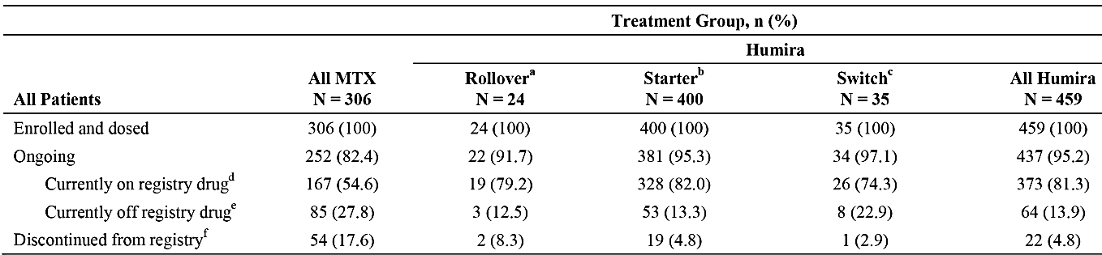
Note: Percentages are based on the number of treated patients.
Patients who rolled over from Study DE038 and Study M10-444 and are enrolled in the Humira arm. As of 1 June 2013, 12 patients rolled over from Study DE038 and 12 rolled over from Study M10-444 and received at least one dose of registry drug.
Patients who did not roll over from Study DE038 and Study M10-444 and are enrolled in the Humira arm.
Patients enrolled in the MTX arm who switched to the Humira arm as new patients.
Ongoing patients on registry drug – patients who have not discontinued registry and not permanently discontinued registry drug.
Ongoing patients off registry drug – patients who have not discontinued registry but have permanently discontinued registry drug.
Patients who have discontinued the registry were to be followed for safety if they opted-in to the HCP follow-up process. Patients were considered ‘lost to follow-up’ if no final disposition could be obtained after 1 year following their last site visit.
Comment: Of the 459 patients in the all Humira group, 12 have rolled-over from Study M10-444 and 12 from Study DE038. In Module 5.3.6 (Reports of Postmarketing Experience), the sponsor indicated that enrollment in the Registry has now been completed, and that the 5-year interim report was scheduled for submission to the FDA on 30 June 2014.

Baseline characteristics

Baseline demographic and disease characteristics
The mean ± SD age (N = 459) and weight (N = 433) of patients in the all Humira treatment group were 12.2 ± 3.94 years (range: 3, 20 years) and 47.8 ± 20.0 kg (range: 13, 118 kg), respectively. There was one patient (0.2%) aged less than 4 years, and one patient (0.2%) with a weight of less than 15 kg. The mean ± SD duration of JIA for patients in the Humira treatment group (N = 379) was 3.8 ± 3.97 years (range: 0, 16 years). The baseline demographic and disease characteristics of the all treated population as of 1 June 2013 are summarised in Table 33.

Table 33: Study P10-262 - Demographic and baseline disease characteristics as of 1 June 2013; all treated population.
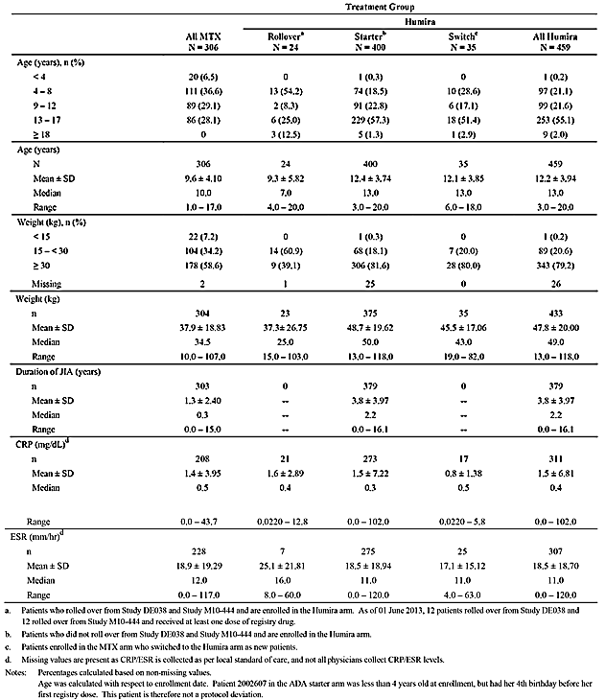
Comment: The all Humira group included only 2 patients with age and/or weight criteria directly relevant to the proposed patient population.

Prior and concomitant medications for the treatment of JIA
In the all Humira treatment group, at least one prior ‘synthetic’ DMARD had been taken by 80.2% (N = 368) of patients and at least one prior ‘biologic’ DMARD had been taken by 29.8% (N = 137) of patients. The corresponding figures for the all MTX treatment group were 13.7% (N = 42) and 0.7% (N = 2), respectively. In the all MTX treatment group, both of the patients who had been treated with prior ‘biologic’ DMARDs had received etanercept and were protocol violators.
In the all Humira treatment group, the following concomitant medications had been taken by at least one patient: ‘synthetic’ DMARDs by 66.0% (N = 303); ‘biologic’ DMARDs by 8.1% (N = 137); systemic NSAIDs by 49.9% (N = 229); and systemic corticosteroids by 24.8% (N = 114). The corresponding figures for the all MTX treatment group were 18.3% (N = 56), 24.5% (N = 75), 72.5% (N = 222), and 36.3% (N = 111).

Exposure
The observation period was defined from the Registry enrolment date up to the last date of Registry participation + 1 day (inclusive of the HCP process). The duration of Registry exposure was defined for the two treatment arms as follows: for the Humira arm, from the first Humira dose date in the Registry to the last Humira dose date in the Registry + 14 days, excluding total days of any treatment interruptions; and for the MTX arm, from the first MTX dose date in the Registry to the last MTX date in the Registry + 1 day, or the first Humira dose in the Registry + 1 day, whichever was earlier; and
As of 1 June 2013, 459 patients have received Humira, representing a cumulative exposure in the observational group of 891.3 PYs compared to 763.7 PYs in the Registry group. All patients in the Humira Registry group (N = 459) had at least 6 months of exposure, while 68% (N = 312) had at least 1 year of exposure and 36.6% (N = 168) had at least 2 years of exposure.
As of 1 June 2013, 306 patients have received MTX, representing a cumulative exposure in the observational group of 706.2 PYs compared to 503.1 PYs in the Registry group. All patients in the MTX Registry group (N = 306) had at least 6 months of exposure, while 64.1% (N = 196) of patients in this group had at least 1 year of exposure and 38.9% (N = 119) had at least 2 years of exposure.

Overview of observational adverse events
Observational AEs included events that occurred from the first day in the Registry through to the last contact in the Registry, irrespective of the duration of drug treatment. Observational AEs in the all Humira and all MTX treatment groups are summarised below in Table 34.

Table 34: Study P10-262 - Patients with observational adverse events; all treated population.
Adverse events (AEs) | All Humira (N=459)  N % |  | All MTX (N=306)  N %
Any AE | 142 | 30.9 | 125 | 40.8
Any serious AE | 30 | 6.5 | 16 | 5.2
Any AE leading to discontinuation of study drug | 25 | 5.4 | 23 | 7.5
Any severe AE | 22 | 4.8 | 12 | 3.9
Any AE at least possibly drug-related | 71 | 15.5 | 63 | 20.6
Any SAE at least possibly drug-related | 14 | 3.1 | 3 | 1.0
Any Infection | 80 | 17.4 | 64 | 20.9
Any serious infection | 12 | 2.6 | 7 | 2.3
Any opportunistic infection (excluding oral candidiasis and TB) | 0 | 0 | 0 | 0
Any TB | 0 | 0 | 0 | 0
Any lymphoma | 0 | 0 | 0 | 0
Any non-melanoma skin cancer (NMSC) | 0 | 0 | 0 | 0
Any malignancy other than lymphoma, HSTCL, leukaemia, NMSC, or melanoma | 0 | 0 | 0 | 0
Any demyelinating disorder | 0 | 0 | 0 | 0
Any AE leading to death | 0 | 0 | 0 | 0
Deaths (including non-treatment-emergent deaths) | 0 | 0 | 0 | 0

Observational adverse events
Observational AEs (all treated population) were reported in 30.9% (N = 142) of patients in the all Humira treatment group and 40.8% (N = 125) of patients in the all MTX treatment group. The observation-time adjusted observational AE rates were 38.9 events/100 PYs in the all Humira treatment group (347 events) and 44.5 events/100 PYs in the all MTX treatment group (314 events).
Preferred term observational AEs (all treated population) reported in ≥ 1% of patients in the all Humira treatment group in descending order of frequency were upper respiratory tract infection (3.1%), injection site pain (2.6%), sinusitis (2.4%), juvenile arthritis (2.0%), bronchitis (1.7%), streptococcal pharyngitis (1.7%), headache (1.7%), arthritis (1.5%), otitis media (1.3%), tonsillitis (1.3%), injection site reaction (1.1%), uveitis (1.1%), nausea (1.1%), and urinary tract infection (1.1%). Preferred term observational AEs (all treated population) reported in ≥ 1% of patients in either the all Humira treatment group (N = 459) or the all MTX treatment group (N = 306), in descending order of frequency in the all Humira treatment group were summarised.
Possibly or probably drug-related observational AEs (all treated population) were reported in 15.5% (N = 71) of patients in the all Humira treatment group and 20.6% (N = 63) of patients in the all MTX treatment group. The possibly or probably drug-related observation-time adjusted observational AE rates were 15.5 events/100 PYs in the Humira treatment group (71 events) and 20.6 events/100 PYs in the all MTX treatment group (63 events).
Preferred term possibly or probably drug-related observational TEAEs reported in ≥ 1% of patients in the all Humira treatment group were injection site pain (2.6%, N = 12), injection site reaction (1.1%, N = 5), and upper respiratory tract infection (1.1%, N = 5). Preferred term possibly or probably drug-related observational TEAEs reported in ≥ 1% of patients in the all MTX treatment group were nausea (5.2%, N = 16), vomiting (2.6%, N = 8), ALT increased (2.3%, N = 7), anxiety (1.3%, N = 4), drug intolerance (1.3%, N = 4), AST increased (1.3%, N = 4), mouth ulceration (1.0%, N = 3), pneumonia (1.0%, N = 3), and liver function test abnormal (1.0%, N = 3).

Deaths and other serious adverse events (SAEs)
No deaths occurred in the registry patients.
Observational SAEs were reported in 6.5% (N = 30) of patients in the all Humira treatment group and 5.2% (N = 16) of patients in the all MTX treatment group. The observation-time adjusted observational SAE rates were 3.4 events/100 PYs in the all MTX treatment group (24 events) and 5.4 events/100 PYs in the all Humira treatment group (48 events).
Preferred term observational SAEs reported in more than one patient in the all Humira treatment group were: juvenile arthritis (n = 4, 0.9%; 0.7 events/100 PYs); arthritis (0.7%, N = 3; 0.3 events/100 PYs); tenosynovitis (n = 2, 0.4%; 0.2 events/100 PYs); and pyelonephritis (0.4%, N = 2; 0.2 events/100 PYs). There were no preferred term observational SAEs reported in more than one patient in the all MTX treatment group.

Treatment discontinuation
A total of 131 patients (42.8%) in the all MTX treatment group and 81 patients (17.6%) in the all Humira treatment group had discontinued the registry drug as of 1 June 2013 (all treated population). Patients who discontinued the registry drug no longer took MTX and/or Humira in accordance with the protocol, but all were encouraged to remain in the registry to be followed for safety and effectiveness. The reasons for discontinuation of the registry drug are summarised below in Table 35.

Table 35: Study P10-262 - Reasons for registry drug discontinuation as of 1 June 2013; all treated population.
Final status | All MTX (n=306)  N % |  | All Humira (n=459)  N %
Discontinued registry drug | 131 | 42.8 | 81 | 71.6
AE | 20 | 6.5 | 20 | 4.4
Withdrew consent | 5 | 1.6 | 3 | 0.7
Lost to follow-up | 0 | 0 | 5 | 1.1
Intolerance | 12 | 3.9 | 6 | 1.3
Lack of efficacy | 24 | 7.8 | 43 | 9.4
Require additional therapy | 77 | 25.2 | 8 | 1.7
Patient died | 0 | 0 | 0 | 0
SAE or AESI | 0 | 0 | 4 | 0.9
Other (for example, achieved clinical remission of JIA, switched from Humira to MTX arm, needed additional treatment, registry treatment non-compliance). | 29 | 9.5 | 15 | 3.3
Observational AEs leading to treatment discontinuation were reported in 25 patients (5.4%) in the all Humira treatment group and 23 patients (7.5%) in the all MTX treatment group. The observation-time adjusted rate for observational AEs leading to registry drug discontinuation was 4.3 events/100 PYs (38 events) in the all Humira treatment group and 4.4 events/100 PYs (31 events) in the all MTX treatment group. Observational AEs leading to discontinuation of the registry drug in ≥ 2 patients in either the all Humira treatment group or the all MTX treatment group are summarised below in Table 36.

Table 36: Study P10-262 - Observational adverse events leading to discontinuation of registry drug in at least 2 patients in either the all Humira treatment group or the all MTX treatment group by decreasing order of frequency in the all Humira group as of 1 June 2013; all treated population.
 | Humira (N=459) |  |  | MTX N=306
Adverse events | N | % | Events/  100 PYs | N | % | Events/  100 PYs
ANY | 25 | 5.4 | 4.3 | 23 | 7.5 | 4.4
injection site pain | 6 | 1.3 | 0.7 | 0 | 0 | 0
Juvenile arthritis | 4 | 0.9 | 0.4 | 1 | 0.3 | 0.1
Injection site reaction | 2 | 0.4 | 0.2 | 0 | 0 | 0
Otitis media | 2 | 0.4 | 0.2 | 1 | 0.3 | 0.1
Arthritis | 2 | 0.4 | 0.2 | 0 | 0 | 0
Headache | 2 | 0.4 | 0.2 | 0 | 0 | 0
Nausea | 1 | 0.2 | 0.1 | 6 | 2.0 | 0.8
Vomiting | 1 | 0.2 | 0.1 | 3 | 1.0 | 0.4
Drug intolerance | 0 | 0 | 0 | 2 | 0.7 | 0.3
Alanine aminotransferase increased | 0 | 0 | 0 | 2 | 0.7 | 0.3
Anxiety | 0 | 0 | 0 | 2 | 0.7 | 0.3

Adverse events of special interest (AESI)
AESI reported in ≥ 1 patient in either the all MTX treatment group or the all Humira treatment group are summarised below in Table 37.

Table 37: Study P10-262 - Observational adverse events of special interest (AESI) reported in at least 1 patient in either the all MTX treatment group or the all Humira treatment group as of 1 June 2013; all treated population.
Adverse events (AEs) | All MTX n=306  N % |  | All Humira n=459  N %
 | n | % | n | %
Any parasitic infection | 0 | 0 | 2 | 0.4
Any allergic reaction including angioedema/anaphylaxis | 2 | 0.7 | 6 | 1.3
Any lupus-like reaction and systemic lupus erythematosus | 0 | 0 | 1 | 0.2
Any pancreatitis | 1 | 0.4 | 0 | 0
Any worsening/new onset of psoriasis | 2 | 0.7 | 3 | 0.7
Any haematologic disorder including pancytopenia | 3 | 1.1 | 2 | 0.4
Any injection site reaction | 3 | 1.1 | 20 | 4.4
Any seizure disorder | 0 | 0 | 1 | 0.2

Infections
A total of 80 all Humira treated patients (17.4%) and 64 all MTX treated patients (20.9%) experienced an observational infection. The observation-time adjusted rate of observational infections was 13.7 events/100 PYs in the all Humira treatment group and 16.3 events/100 PYs in the all MTX treatment group.
In the all Humira treatment group, the most frequently reported observational infectious AEs were upper respiratory tract infection (14 events in 14 patients, 1.6 events/100 PYs), sinusitis (12 events in 11 patients, 1.3 events/100 PYs), bronchitis and pharyngitis streptococcal (8 events in 8 patients each, 0.9 events/100 PYs), urinary tract infection (8 events in 5 patients, 0.9 events/100 PYs), and otitis media and tonsillitis (6 events in 6 patients each, 0.7 events/100 PYs). All remaining events were each reported in ≤ 4 all Humira treated patients.
No non-serious opportunistic infections, oral candidiasis, or TB have occurred in the registry up to the data cut-off date of 1 June 2013. Two (2) patients in the all Humira treatment group have experienced parasitic infections consisting of an arthropod infection in 1 patient considered to be unrelated to the registry drug, and giardiasis in 1 patient considered to be probably not related to the registry drug.
Observational serious infections were reported in 12 all Humira treated patients (2.6%) and 7 all MTX treated patients (2.3%). The observation-time adjusted rate of observational serious infections was 1.5 events/100 PYs in the all Humira treatment group and 1.4 events/100 PYs in the all MTX treatment group. The observational serious infections in the all Humira treatment group were pyelonephritis (1 event in each of 2 patients), tonsillitis, acute tonsillitis, viral meningitis, subcutaneous abscess, infectious mononucleosis, cellulitis, varicella, gastroenteritis, pneumonia, scarlet fever, and urinary tract infection. The observational serious infections in the all MTX treatment group were tonsillitis (3 events in 1 patient), staphylococcal infection, pyelonephritis, septic shock, urinary tract infection, viral infection, appendicitis, and respiratory tract infection. The Listing of patients with serious infections observed as of 1 June 2013 in the all treated population is summarised in Table 38.

Table 38: Study P10-262 - Listing of patients with serious infections observed as of 1 June 2013; all treated population. [Patient identifiers have been removed from this table.]
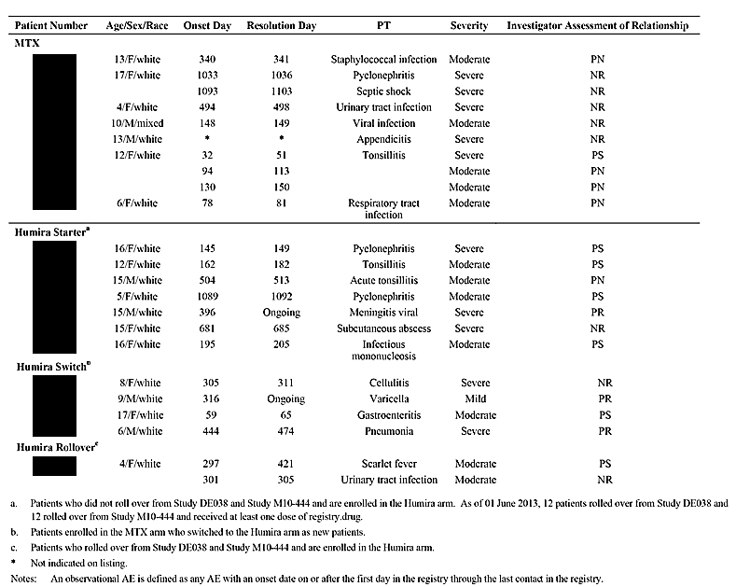

Immune reactions including lupus, lupus-like reactions, and allergic reactions (including angioedema and anaphylaxis)
In the all Humira treatment group, one 16 year old female patient experienced a treatment-emergent lupus-like reaction and was hospitalised for the condition on Day 668. The patient was subsequently discontinued from the Registry as her underlying condition was considered to be SLE rather than JIA.
Observational allergic reactions were reported in 6 patients (1.3%) in the all Humira treatment group and 2 patients (0.7%) in the all MTX treatment group. The observation-time adjusted rate of observational allergic reactions was 0.7 events/100 PYs in the all Humira treatment group and 0.3 events/100 PYs in the all MTX treatment group. The allergic reactions in the all Humira treatment group were drug hypersensitivity (2 patients), urticaria (2 patients), rash, and hypersensitivity. The allergic reactions in the all MTX treatment group were drug hypersensitivity and urticaria.

Injection site reaction related AEs
Twenty (20) all Humira treated patients (4.4%) and 3 all MTX treated patients (1.0%) experienced an observational injection site reaction. The observation-time adjusted rate for observational injection site reactions were 2.5 events/100 PYs in the all Humira treatment group and 0.4 events/100 PYs in the all MTX treatment group and The most frequently reported observational injection site reactions in patients in the all Humira treatment group were injection site pain (12 events in 12 patients, 1.3 events/100 PYs) and injection site reaction (6 events in 5 patients, 0.7 events/100 PYs). All other injection site reactions in the all Humira treatment group were reported by 1 patient each. The most frequently reported observational injection site reaction in patients in the all MTX treatment group was injection site pain (2 events in 2 patients, 0.3 events/100 PYs). Only one patient in the all MTX treatment group reported an injection site reaction.

Haematologic events
Two (2) all Humira treated patients (0.4%) and 3 all MTX treated patients (1.0%) experienced observational haematologic adverse events. The observation-time adjusted rate of these observational haematological adverse events was 0.4 events/100 PYs in both the all Humira and all MTX treatment groups. The events in the all Humira treatment group were neutropenia in 1 patient, and both thrombocytopenia and neutropenia in 1 patient. The events in the all MTX treatment group were anaemia in 2 patients and thrombocytopenia in 1 patient.

New onset or worsening psoriasis
Three (3) all Humira treated patients (0.7%) and 2 all MTX treated patients (0.7%) experienced observational new onset or worsening of psoriasis. The observation-time adjusted rate of observational new onset or worsening of psoriasis was 0.3 events/100 PYs in both the all Humira and all MTX treatment groups.

Seizure disorder
Seizure disorder was reported in 1 all Humira treated patient. At the time of enrolment, this patient had a relevant history of epilepsy requiring ongoing treatment.

Pancreatitis
Pancreatitis was reported in 1 all MTX treated patient.

Other AESI
No other AESI were reported, including events of opportunistic infections, oral candidiasis, TB, legionella infection, lymphoma, HSTCL, NMSC, leukemia, other malignancies (except lymphoma and NMSC), demyelinating disorders, vasculitis, sarcoidosis, diverticulitis, intestinal perforation, intestinal stricture, Stevens-Johnson syndrome, erythema multiforme, liver failure and other liver events, reactivation of hepatitis B, MI, CHF, CVA, pulmonary embolism, ILD, leukoencephalopathies, ALS, Humira administration-related medication error, severe CPK elevations, or antiphospholipid syndrome and associated auto-antibodies.

Post-marketing experience
The post-marketing experience for adalimumab for the treatment of pJIA is being collected in the Registry (Study P10-262). The sponsor commented that ‘following approval in the European Union to expand the indication for Humira in the treatment of pJIA to include patients 2 to < 4 years old, the protocol for the Registry was amended to allow for enrollment of patients in this age group. However, no such patients were recruited into the registry before enrollment was completed’. This statement appears to be inconsistent with the patient disposition for the interim 4-year Registry report which identified 1 patient aged < 4 years. The sponsor will be asked to clarify this matter (see Clinical Questions).
The Clinical Overview included a brief summary of post-marketing safety data collected on children aged 2 to 4 years through AbbVie's post-marketing Pharmacovigilance system conducted from the International Birthdate (IBD) of the drug through to September 2013. In this time period, there have been 49 postmarketing reports containing 131 AEs reported for JIA (JIA [5 reports], pJIA [2 reports], systemic arthritis [1 report], juvenile arthritis [4 reports], chronic juvenile arthritis [1 report], juvenile rheumatoid arthritis [15 reports], and JIA reports without subtype information [21 reports]). The most frequently reported events were stated to be injection site pain (20 reports), followed by pyrexia (8 reports), and cough (6 reports).

Evaluator's overall conclusions on clinical safety

Study M10-444
No new or unexpected safety findings emerged from the pivotal study in the proposed patient population (M10-444). In this study, the safety analyses were based on the ITT population, which included all subjects who were enrolled and received at least 1 dose of adalimumab (N = 32). The mean ± SD duration of exposure to adalimumab was 515±245 days (median 575 days) and all subjects were exposed for at least 57 days, with a maximum exposure of 910 days.
Adalimumab was administered at a dose of 24 mg/m2 BSA, up to a total dose of 20 mg, eow by SC injection. Concomitant MTX was taken by 84.4% (N = 27) of patients, concomitant systemic NSAIDs by 62.5% (N = 20) of patients, and systemic corticosteroids by 68.8% (N = 22) of patients.
Nearly all subjects (90.6%, N = 29) experienced at least 1 TEAE (217 events, 481.2 events/100 PYs). The most frequently reported TEAEs in subjects (≥ 15%) were nasopharyngitis (25%, N = 8), pyrexia (21.9%, N = 7), bronchitis (18.8%, N = 6), cough (18.8%, N = 6), rhinorrhea (18.8%, N = 6), upper respiratory tract infection (18.8%, N = 6), juvenile arthritis (15.6%, N = 5), otitis media (15.6%, N = 5), and vomiting (15.6%, N = 5). All other TEAEs were reported in < 15% of subjects.
The majority of TEAEs were considered by the investigator to be mild to moderate in severity and not related or probably not related to treatment with adalimumab. There were 18 subjects (56.3%) with TEAEs reported to be not related or probably not related to treatment with adalimumab (10 [31.3%] and 8 [25.0%], respectively). There were 11 subjects (34.4%) with events reported to be at least possibly related to treatment with adalimumab (22 events, 48.8 events/100 PYs). The only treatment-related TEAE reported in ≥ 2 subjects was rash (N = 2; 6.3%). There were 5 subjects with 1 or more events reported to be possibly related to adalimumab (pyrexia, bronchitis, ear infection, laryngitis, otitis media, pharyngitis, pharyngitis streptococcal, pneumonia, viral pharyngitis, upper respiratory tract congestion, and rash). There were 6 subjects with events reported to be probably related to adalimumab (injection site reaction, injection site pain, injection site pruritis, injection site rash, injection site swelling, cystitis, and juvenile arthritis).
No deaths were reported during the study. Five (5) subjects (15.6%) reported an SAE during the study (1 event each for dental caries, gastroenteritis rotavirus, juvenile arthritis, type 1 diabetes mellitus, and varicella). The SAE of type 1 diabetes mellitus was reported to be probably unrelated to treatment and the other 4 SAEs were reported to be unrelated to treatment. Two (2) subjects experienced a non-serious flare of juvenile arthritis during the study and were discontinued from treatment with adalimumab due to the adverse event.
A total of 25 subjects (78.1%) reported at least 1 treatment-emergent infection (93 events, 206.2/100 PYs). The most frequently occurring infections reported to be at least possibly related to study drug were nasopharyngitis, bronchitis, upper respiratory tract infection, otitis media, gastroenteritis, and rhinitis. However, without a placebo control group it is difficult to assign a causative role to adalimumab for the high infection rate observed in subjects in this study due to the high background infection rate expected in children in the age group studied.
The majority of subjects who reported an infection experienced events that were considered by the investigator to be mild or moderate in severity and not related or probably not related to study drug. Three (3) subjects had serious infections (1 report each of dental caries, gastroenteritis rotavirus, and varicella). These events were considered by the investigator to be mild to moderate in severity and not related to adalimumab. No subjects prematurely discontinued treatment with adalimumab due to an infection.
The study included an examination of TEAEs of special interest. Overall, 9 subjects reported 11 TEAEs of special interest (45.1 events/100 PYs). The adverse events of special interest were injection site reaction (4 subjects [12.5%] with 6 events for a rate of 13.3 events/100 PYs), allergic reaction (2 subjects [6.3%] with 2 events for a rate of 4.4 events/100 PYs), haematologic disorders (2 subjects with 2 events for a rate of 4.4 events/100 PYs), and oral candidiasis (1 subject [3.1%] with 1 event for a rate of 2.2 events/100 PYs).
The 5 injection site reactions were pain, pruritus, rash, reaction, and swelling. The 2 haematologic disorders were microcytic anaemia and decreased platelet count, both considered to be unrelated to treatment with adalimumab. There were no reports of leukopenia or pancytopenia. The 2 allergic reactions were skin reactions (urticaria not related to adalimumab and rash possibly related to adalimumab). There were no reports of angioedema or anaphylaxis.
There were no reports of the following listed adverse events of special interest: malignancy; lupus-like reactions or systemic lupus erythematosus; demyelinating disorder; vasculitis; hepatitis B; diverticulitis; intestinal perforation; liver failure or other liver events; myocardial infarction; cerebrovascular accident; pulmonary embolism; worsening/new onset psoriasis; adalimumab administration-related medication error; Steven's-Johnson syndrome; erythema multiforme; congestive heart failure; interstitial lung disease; pancreatitis; sarcoidosis; progressive multifocal leukoencephalopathy or reversible posterior leukoencephalopathy syndrome; amyotrophic lateral sclerosis; tuberculosis; seizure disorder; anti-phospholipid syndrome; or severe CK elevations.
The clinical laboratory tests (haematology and clinical chemistry) showed no obvious patterns in mean change from Baseline over the course of the study. Nearly all shifts in haematology and clinical chemistry parameters observed for individual subjects were from low/normal levels at Baseline to high levels with adalimumab treatment. There was no evidence of haematologic, renal or hepatic toxicity associated with adalimumab. There were no shifts from Baseline in ANA or anti-dsDNA. There were no significant changes in vital signs of pulse rate or temperature over the course of the study. The mean weight of the subjects increased over the course of the study. There were no safety data summarising changes in blood pressure over the course of the study or abnormal ECG findings. There were no data relating to the effects of age, weight, dose or sex on safety. There were no data investigating the effects of co-morbidities (for example, hepatic, renal) on safety. There were no data on the effects of withdrawal or disease symptom rebound associated with cessation of adalimumab treatment.

Study P10-262 (Registry - interim 4 year safety data)
The submission included interim 4 year safety data from a Registry for 459 enrolled patients treated with Humira and 306 enrolled patients treated with MTX. The mean ± SD duration of exposure in the observational all Humira treatment group was 891 PYs. The mean ± SD age of the 459 patients in the all Humira treatment group was 12.2 ± 3.94 years range (3, 20 years), and the mean ± SD weight was 47.8 ± 20.0 kg (range: 13, 118 kg).
The Registry included 12 patients rolled over from the pivotal study for the proposed paediatric patient population (Study M10-444) and 12 patients rolled over from the previously evaluated pivotal study (DE038) supporting the currently approved paediatric patient population. There were only two patients included in the 459 all Humira treated group who met the criteria for the proposed paediatric patient population (that is, aged > 2 years to < 4 years, or ≥ 4 years weighing < 15 kg). The interim 4 year safety data in the all Humira treatment group did not identify new or unexpected safety signals associated with Humira for the treatment of juvenile idiopathic arthritis. Overall, it is considered that all of the interim 4 year safety data from the Registry in the all Humira paediatric treatment group can be extrapolated to the proposed patient population.

First round benefit-risk assessment

First round assessment of benefits
The benefits of adalimumab for the proposed usage in the proposed patient population have been satisfactorily demonstrated in one, uncontrolled, compassionate use study (M10-444) in a small number of subjects with pJIA (N = 32). The majority of subjects in this study were treated with adalimumab in combination with MTX (84.4%, N = 27). The benefits of adalimumab for the treatment of moderately to severely active pJIA in the proposed patient population were:
- an observed PedACR30 response was achieved by at least 90% of subjects from Week 12 through to Week 120, apart from Week 108 (88.9%);
- an observed PedACR50 response was achieved by at least 80% of subjects from Week 12 through to Week 120;
- an observed PedACR70 response was achieved by at least 61% of subjects from Week 12 through to Week 120, with a greater proportion of subjects achieving a response at later compared to earlier time-points;
- an observed PedACR90 response was achieved by at least 36% of subjects from Week 12 through to Week 120, with a greater proportion of subjects generally achieving a response at later compared to earlier time-points;
- observed PedACR30/50/70/90 responses were achieved at Week 24 by 90%, 83.3%, 73.3%, and 36.7% of subjects, respectively, and 30 of the 32 patients (94%) had observed data at this time-point for each PedACR response;
- clinically meaningful improvement was observed in each of the individual JIA core set of variables contributing to the PedACR response assessments including physician's global assessment of disease activity, parent's global assessment of disease activity, number of active joints, number of joints with loss of motion, DICHAQ score, and CRP levels.
There were no efficacy data in the submission on the benefits of adalimumab alone in the proposed patient population for the proposed usage. The sponsor is proposing that adalimumab monotherapy be used in children aged 2 to < 4 years and ≥ 4 years weighing < 15 kg where patients are intolerant to MTX or continuous treatment with MTX is inappropriate. The proposed use of adalimumab monotherapy in the proposed paediatric patient population is identical to the approved use of this regimen in the approved paediatric patient population.
The efficacy of adalimumab in combination with MTX in the proposed paediatric population is consistent with the efficacy of the combination in the approved paediatric population. In Study M10-444, the observed PedACR30 response at Week 24 was 90.0% (27/30) in the ITT population, while in Study DE038 the PedACR30 response at the end of the 16 weeks open-label, lead-in phase was 94% (80/85) in the adalimumab with MTX stratum and 74% (64/86) in the adalimumab without MTX stratum.
The PK data from Study M10-444 (Week 24) in the proposed paediatric population and Study DE038 (Week 16) in the approved paediatric population showed that the mean steady-state serum adalimumab trough concentration was lower in the adalimumab without MTX group in Study M10-444 (N = 4) compared to Study DE038 (N = 29). However, it is difficult to draw clinically meaningful conclusions from the comparative PK data in subjects treated with adalimumab without MTX due to the marked inter-subject variability in steady-state serum adalimumab concentrations in the two studies (CV 113% [M10-444/Week 24] versus CV 89% [DE038/Week 16]) and the notable imbalance in subject numbers between the two studies (N = 4 [M10-444] versus N = 29 [DE038]).
On balance, it is considered that the lack of specific information on the benefits of treatment with adalimumab without MTX in the proposed patient population should not preclude approval of the monotherapy option in cases where this might be required (that is, intolerance to MTX, continuous treatment with MTX not appropriate).

First round assessment of risks
The risks of adalimumab for the proposed usage in the proposed patient population have been adequately characterised in one, open-label, uncontrolled, compassionate use study (M10-444) in a small number of subjects with pJIA (N = 32). In this study, nearly all subjects were treated with concomitant MTX (84.4%, N = 27), while the majority of subjects were also treated with concomitant systemic NSAIDs (56.3%, N = 18) and/or concomitant systemic corticosteroids (62.5%, N = 20). There are no data on the risks of adalimumab administered without MTX in the proposed patient population. However, it can be reasonably inferred that the risks of adalimumab without MTX are likely to be similar to, or less than, the risks of adalimumab with MTX.
The risks of adalimumab in combination with MTX for the treatment of moderately to severely active pJIA in the proposed paediatric patient population are considered to be comparable to the known risks of the combination for the same indication in the currently approved paediatric patient population.
The risks of adalimumab for the proposed usage in the proposed patient population based on Study M10-444 (N = 32) are summarised below:
- TEAEs reported in 90.6% of subjects (418.2 events/100 PYs); TEAEs reported by the investigator to be a least possibly related to treatment with adalimumab in 34.4% of subjects (48.8 events/100 PYs);
- serious TEAEs reported in 15.6% of subjects (11.1 events/100 PYs); TEAEs leading to discontinuation of adalimumab reported in 6.3% of subjects (4.4 events/100 PYs); no deaths reported in the study;
- TEAEs reported most frequently (≥ 15% of subjects) were nasopharyngitis (25%), pyrexia (21.9%), bronchitis (18.8%), cough (18.8%), rhinorrhea (18.8%), upper respiratory tract infection (18.8%), juvenile arthritis (15.6%), otitis media (15.6%), and vomiting (15.6%, N=5); all other TEAEs were reported by < 15% of subjects (that is, < 5 subjects);
- 5 subjects (15.3%) with 11 TEAEs reported to be possibly related to treatment (pyrexia, bronchitis, ear infection, laryngitis, otitis media, pharyngitis, pharyngitis streptococcal, pneumonia, viral pharyngitis, upper respiratory tract congestion, and rash); 6 subjects (18.8%) with 7 TEAEs reported to be probably related to treatment (injection site reaction, injection site pain, injection site pruritis, injection site rash, injection site swelling, cystitis, and juvenile arthritis);
- 5 subjects (15.6%) reported 5 SAEs (dental caries, gastroenteritis rotavirus, juvenile arthritis, type 1 diabetes mellitus, and varicella); 1 of the 5 SAEs (type 1 diabetes mellitus) was considered to be probably not related to treatment with adalimumab while the remaining 4 of the 5 SAEs were considered not related to treatment with adalimumab; 2 subjects (6.3%) experienced TEAEs (both non-serious flare of juvenile arthritis) resulting in discontinuation of adalimumab treatment;
- 25 subjects (78.1%) reported 93 TEAEs of infection (206.2 events/100 PYs); infections reported in ≥ 10% of subjects were nasopharyngitis (25.0%), bronchitis (18.8%), upper respiratory tract infection (18.8%), otitis media (15.6%), gastroenteritis (12.5%), and rhinitis (12.5%); the majority of infections were reported by the investigator to be mild or moderate in severity and not related or probably not related to treatment with adalimumab; 3 subjects (9.3%) had serious infections considered by the investigator to be mild to moderate in severity and not related to adalimumab (1 report each of dental caries, gastroenteritis rotavirus, and varicella);
- 9 subjects (28.1%) reported 11 AESI (6 injection site reactions, 2 allergic reactions, 2 haematological disorders, 1 oral candidiasis); there were no other reports of AESI including anaphylaxis/angioedema;
- no clinically meaningful changes in laboratory parameters (haematological, clinical chemistry), or vital signs (temperature, pulse rate).

First round assessment of benefit-risk balance
The benefit-risk balance of Humira (adalimumab) in the proposed patient population for the proposed usage is favourable.

First round recommendation regarding authorisation
- It is recommended that Humira (adalimumab) in combination with MTX be approved for reducing the signs and symptoms of moderately to severely active polyarticular juvenile idiopathic arthritis in patients aged 2 to 4 years, and in patients aged 4 years and older weighing < 15 kg. Consequently, as proposed by the sponsor, it is recommended that the approved indication for pJIA be amended to read:
Humira in combination with methotrexate is indicated for reducing the signs and symptoms of moderately to severely active polyarticular juvenile idiopathic arthritis in patients aged 2 years of age and older. Humira can be given as monotherapy in case of intolerance to methotrexate or when continued treatment with methotrexate is inappropriate.
- It is recommended that Humira (adalimumab) be administered subcutaneously based on weight as proposed by the sponsor.

Clinical questions

Efficacy
- Serum adalimumab steady-state trough concentrations in subjects treated with adalimumab without MTX were lower in Study M10-444 (proposed paediatric population/Week 24) compared to Study DE038 (approved paediatric population/Week 16). The PK results suggest that adalimumab administered without MTX in the proposed paediatric patient population might be less effective than in the approved paediatric patient population.
- Does the sponsor have any efficacy data from Study M10-444 comparing adalimumab without MTX to adalimumab with MTX? It is realised that such data might be limited as the majority of children in the study were administered adalimumab with MTX (84.4%, N = 27). If the sponsor has no such data from Study M10-444, does the sponsor have any other efficacy data on the use of adalimumab without MTX in the proposed patient population for the treatment of pJIA?
- In view of the PK data referred to above, if the sponsor has no efficacy data on the use of adalimumab without MTX in the proposed patient population for the proposed indication, then it should justify its proposal to use Humira monotherapy (that is, without MTX) in children aged 2 to < 4 years and ≥ 4 years weighing < 15 kg who are intolerant to MTX or when treatment with MTX is inappropriate.
- In Study M10-444, one of the inclusion criteria required that subjects in the EU must have previously failed, had an insufficient response to, or been intolerant to ≥ 1 DMARD. This criterion did not apply to non-EU subjects. How many of the enrolled patients (N = 32) had previously failed, had an insufficient response to, or been intolerant to ≥ 1 DMARD?
- In Study M10-444, 84.% (N = 27) of enrolled patients were treated with MTX plus adalimumab. What was the mean ± SD, median, and range (minimum-maximum) of the administered MTX doses? What was the mean ± SD, median, and range (minimum-maximum) of the frequency of MTX dosing? Was MTX dose fixed or flexible?
- Please provide data plots for the CRP (mg/dL) versus visit (baseline and last observation) for each individual patient in Study M10-444. In addition, please tabulate the following data for each patient (CRP mg/mL [mean, SD, minimum, Q1, median, Q3, maximum] at baseline and at time of last visit, with absolute and % change in CRP from baseline and time of last visit). The data should be tabulated using the format in Table 14.2_4.3.1 of the study report, but only baseline and last visit details are required for each individual patient.

Safety
- In Study M10-444, dosing was scheduled eow. If a scheduled dose was missed then parents or designees were instructed to administer the missed dose as soon as it was remembered up until the day of the next scheduled dose. Two doses were not to be administered on the same day. Please confirm that it was possible for dosing to occur on two consecutive days (that is, missed scheduled dose given on last day of 2 week period, followed the next day with dose given as scheduled on the first day of next 2 week period). Is the sponsor aware of any potential safety issues if two doses of adalimumab are administered in close proximity to each other?
- In Section 5.3.6 of the submission (Reports of Post-marketing Experience), the sponsor stated ‘that following approval in the European Union to expand the indication for Humira in the treatment of pJIA to include patients 2 to < 4 years old, the protocol for the Registry was amended to allow for enrolment of patients in this age group. However, no such patients were recruited into the registry before enrolment was completed’. This comment appears to be inconsistent with data provided for the 4-year interim report of the pJIA registry program (Study P10-262), which identified 1 patient aged < 4 years. Please comment on this apparent discrepancy.
- Two (2) patients were identified in the data provided for the 4-year interim report of the pJIA registry program (Study P10-262) aged < 4 years (1 patient) and < 15 kg (1 patient). Are these two patients the same patient or are they two separate patients?
- Please summarise the data presented in Tables 27, 28 and 34 of study report M10-044 by age group (that is, 2 to 4 years, ≥ 4 years). The new summary tables for the two age groups should include the same data as that provided for the total population in the identified tables.

Second round evaluation of clinical data submitted in response to questions

Sponsor's proposed amendment to paediatric pJIA dosing regimen
The Response to s31 Request (29 December 2014) includes a proposal from the sponsor to amend the Round 1 adalimumab (Humira) weight-based dosing regimen for paediatric patients (2 years of age and older) weighing 12 kg to < 15 kg (see Table 39, below). The revised dosing regimen combines patients in the two weight groups (10 kg to < 12 kg and 12 kg to < 15 kg) into one weight group (10 kg to < 15 kg), and proposes that this group be treated with adalimumab at a dose of 10 mg fortnightly using the 10 mg pre-filled syringe. The effect of the amendment is to reduce the adalimumab dose for paediatric patients (2 years of age and older) weighing 12 kg to < 15 kg from 15 mg fortnightly to 10 mg fortnightly, while maintaining the dose for patients weighing 10 kg to < 12 kg at 10 mg fortnightly. The revised regimen also proposes that the dose be provided using a 10 mg pre-filled syringe (PFS) rather than 40 mg/0.8 mL vials. Currently, a 20 mg PFS is available for patients aged 4 years of age and older weighing < 30 kg. The sponsor states that a 10 mg PFS was recently approved in Australia for the paediatric Crohn's disease application.

Table 39: Amendment to the proposed dosing regimen for pJIA paediatric patients (2 years of age and older).
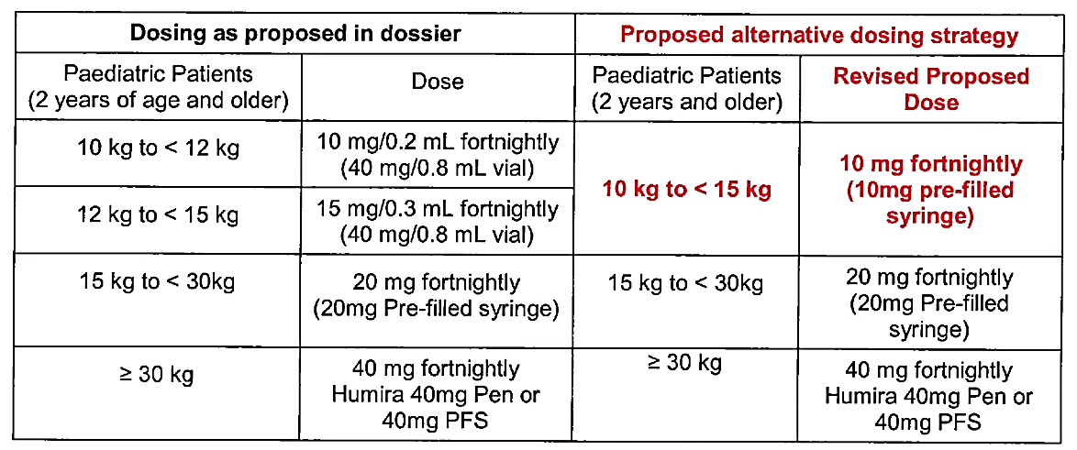
The sponsor states that the proposed amendment to the dosing regimen resulted from discussions between AbbVie and the United States FDA during evaluation of the submission by that regulatory agency. The revised dosing regimen was subsequently approved by the FDA. The sponsor states that the ‘revised dosing approved by the FDA is a much simplified patient dosing regimen which utilises the 10 mg and 20 mg pre-filled syringes for administering Humira to paediatric patients’. The sponsor has requested the TGA to considere a similar dosing strategy for the treatment of paediatric patients with pJIA. In support of the proposed revised dosing regimen the sponsor provided pharmacokinetic information, which was the justification for the amendment provided to the FDA in relation to the application in the Unites States. The data have been reviewed below.
AbbVie justification for the dose amendment
The 10 mg fortnightly dose for patients weighing 10 kg to < 15 kg is based on data collected in Study M10-444, and is further supported by PK modelling and simulation. Polyarticular JIA patients treated with adalimumab, 10 to 20 mg every other week (eow), in Study M10-444 had high PedACR30 response rates (90% at Week 24), which were similar to PedACR30 response rates observed in JIA patients ≤ 6 years in Study DE038 (89%). Patients in Study M10-444 were administered 10, 15, or 20 mg adalimumab SC eow, based on body surface area (BSA) [see Table 40, below]. In the event that the BSA fell in the middle of two ranges, the dose was to be rounded up to the nearest 5 kg weight and 10 cm height.

Table 40: M10-444 - Adalimumab total body dose in mL (50 mg/mL) injectable solution.
The majority of patients in Study M10-444 (24/32 [75%]) received 15 mg every other week (eow) starting at baseline [see Table 41 below]. Following the first 12 weeks, 16% (5/31) increased dosing from either 10 mg to 15 mg (4/5) or 15 mg to 20 mg (1/5). Based on these dose increases over 12 weeks, it is expected that patients weighing < 15 kg administered 10 mg adalimumab eow will increase in weight to ≥ 15 kg, and a subsequent dose increase to 20 mg adalimumab eow, within a relatively short period of time (< 1 year).

Table 41: Study M10-44 - Number of subjects receiving available doses of adalimumab.
In order to evaluate the comparison between doses administered following the BSA-based regimen in Study M10-444 with doses that would be administered using the weight-based regimen, population PK modelling and simulation was conducted using data from Study M10-444 (2 to < 4 years or > 4 years of age but weighing < 15 kg; N = 15 subjects provided PK samples) and Study DE038 (N = 18 subjects ≤ 6 years and administered 10, 15, 20 or 25 mg eow). A non-linear population PK model was developed which included weight as a covariate. The resulting model structure and model parameters were used to simulate adalimumab exposure under the BSA-based dosing regimen used in Study M10-444 compared to the weight-based dosing regimen. A total of 200 subjects (100 per arm) were simulated where each subject received either:
- BSA-based dosing (all BSA values in m2): 10 mg adalimumab eow for BSA < 0.5; 15 mg adalimumab eow for 0.5 ≤ BSA < 0.73; 20 mg adalimumab eow for BSA ≥ 0.73 for 24 weeks; or
- Weight-based dosing: 10 mg adalimumab eow for body weight < 15 kg; and 20 mg adalimumab eow for body weight ≥ 15 kg for 24 weeks.
The simulated adalimumab trough concentrations (μg/mL) under the weight-based dosing regimens of 10 mg eow for body weight < 10 kg or 20 mg adalimumab eow for body weight ≥ 15 kg indicated substantial overlap with concentrations following 15 mg adalimumab eow based on BSA (see Figure 4, below). For patients who would receive 10 mg eow under the proposed dosing instead of 15 mg eow, the exposure is expected to be approximately 30% lower, as opposed to approximately 20% higher for patients who would receive 20 mg adalimumab eow instead of 15 mg eow. Although there was high variability in observed and simulated trough concentrations, AbbVie considers that the predicted concentration values in Figure 4 to be within the efficacious range. All but 4 of the 33 patients in this population (2 to ≤ 6 years) among the two paediatric studies [M10-444 and DE038] achieved a response (PedACR30).

Figure 4: PK M&S - Comparison of simulated week 24 adalimumab trough concentrations (µg/mL) for pJIA patients who were dosed with either adalimumab 15 mg eow based on BSA or 10 mg or 20 mg eow based on body weight (kg).
The sponsor states that the results for Study M10-444 showed a high response rate and large range of efficacious concentrations, which overlap with simulated concentrations following 10 mg and 20 mg weight-based dosing. Therefore, the sponsor considered that a 10 mg dose is expected to provide sufficient exposure to achieve a clinical response while maintaining a positive benefit-risk profile for patients weighing 10 kg to < 15 kg. With the proposed weight-based dosing regimen, 9 of the 31 subjects in Study M10-444 who received 15 mg of adalimumab based on BSA would be dosed with 20 mg from Week 12 going forward. The sponsor stated that this is not expected to pose a higher safety risk as no relationship between adalimumab exposure and infectious adverse events has been observed based on data from both Study M10-444 and Study DE038 [see Figure 5, below].
Figure 5: Adalimumab trough concentration quartiles (Week 24) from Studies M10-444 and DE038 (< 6 years) versus infections AE%.
The sponsor concludes that the weight-based dose regimen is supported by the data from Study M10-444, as well as by simulation based on data derived from the paediatric pJIA population (2 to < 6 years) treated with adalimumab. The sponsor states that, although there was high variability in both observed and simulated trough concentrations, the expected concentration values are considered to be within the efficacious range. The three tier dosing regimen is designed to achieve a favourable benefit-risk profile in the paediatric patient population and also to provide more convenient use by the patient, physician and caregiver.
Comment: The sponsor's proposed amendment to the dosing regimen is considered to be acceptable, and is supported by the observed data from Study M10-444 and the PK M&S data in paediatric patients aged 2 to < 6 years from Studies M10-444 and DE038. The sponsor summarised the methods and results of the PopPk analysis provided in support of the proposed dosing regimen. The reporting of the PopPk analysis was consistent with the relevant TGA adopted guidelines (CHMP/EWP/185990/06). A nonlinear mixed effects modelling approach (population PK analysis) was used to examine the adalimumab concentration-time data. The NONMEM® software (Version 7.2.0) was used in the analyses (Version 7.3.0 was used for visual predictive checks and bootstrap). The PK models were fitted to the data using the first-order conditional estimation (FOCE) method with INTERACTION (FOCEI) employed within NONMEM. A one compartmental model with first-order absorption from the depot compartment and first-order elimination from the central compartment was identified as appropriate for describing the observed combined data of Studies M10-444 and DE038. The final model included weight and anti-adalimumab antibodies (AAA) as significant covariates. The adalimumab concentration (µg/mL) over time simulations were performed using BSA and weight-based adjusted dosing regimens. For the simulations, all subjects were assumed to be AAA negative and weight was considered to be equally distributed over the range 10 to 19 kg (the weight range observed in Study M10-444). Overall, the results indicate that the PK and exposure of adalimumab in paediatric subjects were similar for both dosing regimens (see Figure 6, below). The adalimumab concentrations were highly variable over the 24 week treatment period for both dosing regimens.
Figure 6: PK M&S - Median and 90% CI of adalimumab concentrations over time for both simulated trial arms (dosing by BSA eow, dosing by weight 10/20 mg eow).
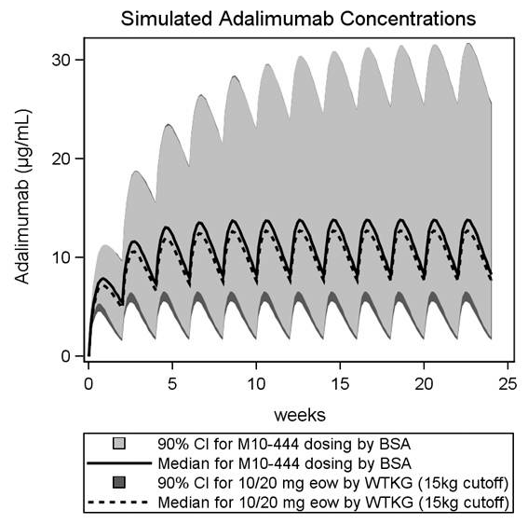

Sponsor's responses to first round questions

Efficacy

Question 1 (a) - Efficacy
Serum adalimumab steady-state trough concentrations in subjects treated with adalimumab without MTX were lower in Study M10-444 (proposed paediatric population/Week 24) compared to Study DE038 (approved paediatric population/Week 16). The PK results suggest that adalimumab administered without MTX in the proposed paediatric patient population might be less effective than in the approved paediatric patient population.
Does the sponsor have any efficacy data from Study M10-444 comparing adalimumab without MTX to adalimumab with MTX? It is realized that such data might be limited as the majority of children in the study were administered adalimumab with MTX (84.4%, N = 27). If the sponsor has no such data from Study M10-444, does the sponsor have any other efficacy data on the use of adalimumab without MTX in the proposed patient population for the treatment of pJIA?
In view of the PK data referred to above, if the sponsor has no efficacy data on the use of adalimumab without MTX in the proposed patient population for the proposed indication, then it should justify its proposal to use Humira monotherapy (that is, without MTX) in children aged 2 to < 4 years and ≥ 4 years weighing < 15 kg who are intolerant to MTX or when treatment with MTX is inappropriate.

AbbVie response:
In Study M10-444, following treatment of polyarticular JIA subjects with adalimumab, all efficacy endpoints at Week 12 through Week 120 demonstrated sustained efficacy as measured by PedACR responses and improvements in the JIA core set of variables. Observed data past Week 24 indicated continued or sustained improvements with further adalimumab treatment; however, the numbers of subjects were decreasing from Week 60 onward due to fulfilling per protocol defined completion criteria by reaching age of 4 years and weight ≥ 15 kg. Similar results were observed when data were analysed for subjects treated with adalimumab in combination with MTX (n=27) and without concomitant MTX (n=5). Please refer to Table 1 attached to this response in Attachment 2 for full details of these efficacy results [see Table 42].

Table 42: Study M10-444 - Change from baseline in efficacy endpoints in patients treated with adalimumab with or without concomitant methotrexate use.
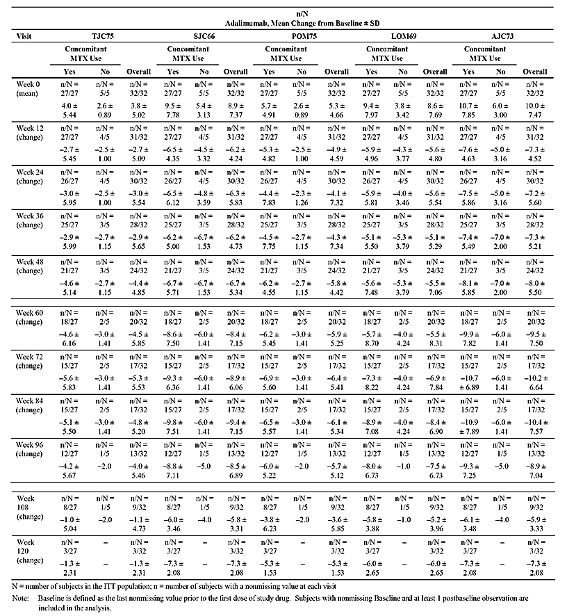
Analysis of data by MTX use showed a decrease from Baseline for all health and quality of life assessments, indicating a decrease in disease activity from Week 12 through Week 120 in subjects treated with adalimumab in combination with MTX (n=27) and without concomitant MTX (n=5). Please refer to Table 2 attached to this response in Attachment 2 for full details of these results [see Table 43]. The largest mean changes for the Parent's Global Assessment of Subject's Overall Disease Activity, the Parent's Global Assessment of Pain, and the Physician's Global Assessment of Disease Activity (range from –39.9 to –56.3 mm) occurred from Week 72 through Week 120. The largest mean change from Baseline for the DICHAQ (– 0.9) occurred at Week 72 and Week 84. However, the number of remaining enrolled subjects with these health and quality of life assessments completed during scheduled visits decreased to nearly 50% by Week 72. Results from analysis of the LOCF data were similar to the observed data. Analyses of the overall mean change from Baseline in health and quality of life assessments at Weeks 12, 24, and 60 using t-test and Wilcoxon-signed Rank test (sensitivity analysis test) for both Observed Cases and LOCF can be found in Table 2__5.2.1 and Table 2__5.2.2, respectively [not in this AusPAR].

Table 43: Study M10-444 - Change from baseline in health and quality of life assessments (observed) in patients treated with adalimumab with or without concomitant methotrexate use.
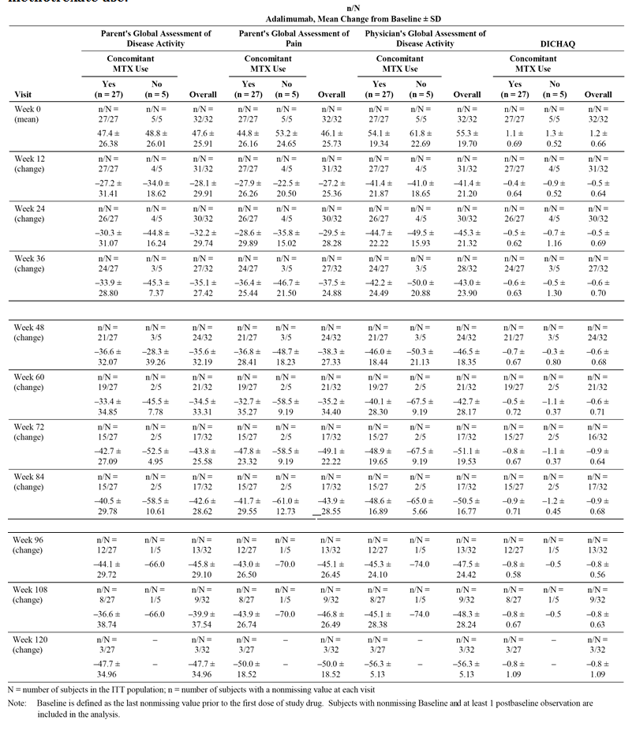
The observed increase from Baseline in the CHQ-PF50 represents efficacy of adalimumab therapy in improving the physical, mental, and emotional parameters assessed by this questionnaire. At Week 12, mean change from Baseline increased for all categories and the greatest increase was observed for physical functioning, role/social limitations/emotional/behavioral, role/social limitations – physical, and bodily pain/discomfort (Study M10-444 CSR). Other categories showed a slow steady increase in mean change from Baseline through Week 120. The categories that demonstrated the greatest increase overall were global health, physical functioning, role/social limitations – physical, bodily pain/discomfort, and parental impact – emotional. Results for the observed and LOCF data were similar. Similar results were observed when data were analysed for subjects treated with adalimumab in combination with MTX (n = 27) and without concomitant MTX (n = 5).

Clinical evaluator's comment:
The sponsor's response is satisfactory. The observed changes from baseline through to Week 108 in the efficacy endpoints of TJC75, SJC66, POM75, LOM69, and AJC73 showed consistent improvement in the small number of patients treated with adalimumab without concomitant MTX. Similarly, consistent improvements in health and quality of life assessments were seen in patients treated with adalimumab without concomitant MTX. The number of patients on adalimumab without concomitant MTX is too small to make a meaningful comparison of efficacy to patients on adalimumab with concomitant MTX. Overall, the data support the use of adalimumab without concomitant MTX in patients aged 2 to < 4 years and ≥ 4 years weighing < 15 kg who are intolerant to MTX or when treatment with MTX is inappropriate.

Question 1 (b) - Efficacy
In Study M10-444, one of the inclusion criteria required that subjects in the EU must have previously failed, had an insufficient response to, or been intolerant to ≥ 1 DMARD. This criterion did not apply to non-EU subjects. How many of the enrolled patients (N = 32) had previously failed, had an insufficient response to, or been intolerant to ≥ 1 DMARD?

AbbVie response:
As per protocol inclusion criterion #8, all subjects in the EU were required to have previously failed, have had an insufficient response, or have been intolerant to ≥ 1 DMARD. The 7 (21.9%) subjects who did not meet this criterion were subjects from the US.

Clinical evaluator's comment:
The sponsor's response is satisfactory.

Question 1 (c) - Efficacy
In Study M10-444, 84% (N=27) of enrolled patients were treated with MTX plus adalimumab. What was the mean ± SD, median, and range (minimum-maximum) of the administered MTX doses? What was the mean ± SD, median, and range (minimum- maximum) of the frequency of MTX dosing? Was MTX dose fixed or flexible?

AbbVie response:
The management of the subjects in Study M10-444 reflected the current clinical practice. The participating Investigator is asked to follow an adalimumab dosing regimen as specified in M10-444 study protocol, based on the subject's Body Surface Area (BSA) in m². Subjects could be treated with concomitant MTX according to the local label and based on the investigators’ judgment, including the selection of MTX dose that could be changed as necessary during study participation. Out of 32 enrolled subjects, 27 (84.4%) were treated with concomitant MTX throughout study participation with minimum dose of 2.5 mg and maximum dose of 17.5 mg at study Baseline as presented in Table 1_3 [not in this AusPAR] in the data included in Attachment 3 to this response (see Clinical evaluator's comment below). All subjects treated with concomitant MTX, received MTX weekly throughout their study participation except for one subject who was treated with MTX every three weeks ([information redacted]).

Clinical evaluator's comment:
The sponsor's response is satisfactory. In the 27/32 patients treated with adalimumab with concomitant MTX in the ITT population, the mean (SD) baseline MTX dose was 8.1 (3.17) mg (range: 2.5, 17.5 mg).

Question 1 (d) - Efficacy
Please provide data plots for the CRP (mg/dL) versus visit (baseline and last observation) for each individual patient in Study M10-444. In addition, please tabulate the following data for each patient (CRP mg/mL [mean, SD, minimum, Q1, median, Q3, maximum] at baseline and at time of last visit, with absolute and % change in CRP from baseline and time of last visit). The data should be tabulated using the format in Table 14.2_4.3.1 of the study report [not in this AusPAR], but only baseline and last visit details are required for each individual patient.

AbbVie response:
Most subjects (19 subjects, 61.3%) had normal (< 0.9 mg/dL) Baseline CRP while the rest of subjects (12 subjects, 38.7%) had abnormal Baseline CRP (> 0.9 mg/dL). [The mean (SD) baseline concentration for 30 patients in the ITT population with baseline and final visit data was 1.6 (2.46) mg/dL]. For 1 subject, Baseline CRP value was not available. A decrease in CRP was observed at most visits from Week 12 through Week 84 and the mean value at Week 72 and Week 84 showed CRP levels within the normal range (< 0.9 mg/dL). Results for the observed and LOCF data were similar. Similar results were observed when data were analysed for subjects treated with adalimumab in combination with MTX (n = 27). For subjects treated without concomitant MTX (n=5), 4 of these subjects had normal Baseline CRP and their mean change in CRP was 0 for most study visits. Data plots for CRP (mg/dL) for individual subjects, along with the study drug administration time points, are included in Attachment 4 to this response [not in this AusPAR]. As presented in Table 1_1 in Attachment 3 [not in this AusPAR], the mean change in CRP from Baseline [to final visit] for all subjects was -0.4, with SD=3.28 and median change of 0.0 [with range of -70.7 to 1302 mg/dL].

Clinical evaluators' comment:
The sponsor's response is satisfactory.

Question 2 (a) - Safety
In Study M10-444, dosing was scheduled eow. If a scheduled dose was missed then parents or designees were instructed to administer the missed dose as soon as it was remembered up until the day of the next scheduled dose. Two doses were not to be administered on the same day. Please confirm that it was possible for dosing to occur on two consecutive days (that is, missed scheduled dose given on last day of 2 week period, followed the next day with dose given as scheduled on the first day of next 2 week period). Is the sponsor aware of any potential safety issues if two doses of adalimumab are administered in close proximity to each other?

AbbVie response:
The study protocol required that dosing dates for study medication be calculated based on the Baseline visit date. For subjects that deviate from the protocol-specified dosing window, every effort should be made to bring the subject back to the original dosing schedule as soon as possible. The shortest time period between two injections of adalimumab during Study M10-444 was 5 days, administered between Week 20 and Week 22 for Subject [information redacted]. Following this injection, only one adverse event was reported for this subject, it was oral ulcer on the lower lip that was assessed by the investigator as probably not related to the study drug.
As summarised in the current RMP, no new safety signal or new trend was observed for the JIA 2-4 patient population during the M10-444 trial. No dose-limiting toxicity for adalimumab was observed in any of the adalimumab clinical programs. Treatment should be initiated and supervised by specialist physicians experienced in the diagnosis and treatment of RA, JIA, PsA, AS, CD, pedCD, Ps, UC, and nr-axSpA where these indications are approved. These measures minimise the potential for medication administration errors. Overdose of adalimumab has not shown any risk of harm based on safety surveillance to date.

Clinical evaluator's comment:
The sponsor's response is satisfactory.

Question 2 (b) - Safety
In Section 5.3.6 of the submission (Reports of Post-marketing Experience), the sponsor stated ‘that following approval in the European Union to expand the indication for Humira in the treatment of pJIA to include patients 2 to < 4 years old, the protocol for the Registry was amended to allow for enrollment of patients in this age group. However, no such patients were recruited into the registry before enrollment was completed’. This comment appears to be inconsistent with data provided for the 4-year interim report of the pJIA registry program (study P10-262), which identified 1 patient aged < 4 years. Please comment on this apparent discrepancy.

AbbVie response:
In the 4-Year interim report for Study P10-262 JIA Registry, one patient reported as aged < 4 years at the Baseline was enrolled in the JIA Registry as < 4 years of age, however the first dose of Humira was administered after patient’s 4th birthday, according to the current product label. Based on the recent cut-off date on 28 March 2014 and data reported in the 5-Year interim report for the JIA Registry, one patient in Czech Republic received the first dose of Humira at age of 3.5 years in Dec 2014 following the approval for treatment of pJIA patients 2 to < 4 years of age in EU.

Clinical evaluator's comment:
The sponsor's response is satisfactory.

Question 2 (c) - Safety
Two (2) patients were identified in the data provided for the 4-year interim report of the pJIA registry program (Study P10-262) aged < 4 years (1 patient) and < 15 kg (1 patient). Are these two patients the same patient or are they two separate patients?

AbbVie response:
Patient # [information redacted] 2008, was enrolled in the JIA Registry on 7 May 2012 and received the first registry dose of Humira on 14 May 2012, after her 4th birthday. Patient # [information redacted] had a weight of 13 kg at Baseline of the JIA Registry.

Clinical evaluator's comment:
The sponsor's response is satisfactory.

Question 2 (d) - Safety
Please summarize the data presented in study report M10- 044 by age group (that is, 2 to 4 years, ≥ 4 years). The new summary tables for the two age groups should include the same data as that provided for the total population in the identified tables.

AbbVie response:
The safety data from Study M10-444 on Treatment Emergent Adverse Events incl. Treatment Emergent Adverse Events of Special Interest have been presented for patients that were 2 to < 4 years of age at Baseline (n = 28) and patients ≥ 4 years of age at Baseline (n = 4) separately in Table 2_1, through 2_7, which are included in Attachment 3 to this response [not in this AusPAR]. There were no new safety signal reported in any of these two groups in Study M10-444, and the small number of subjects ≥ 4 years of age does not allow a reliable comparison between both age groups.

Clinical evaluator's comment:
The sponsor's response is satisfactory. Table 2_1 through 2_7 (Attachment 3; [not in this AusPAR]) have been examined. The overview of AEs in the two age groups is provided in Table 44 (frequencies) and Table 45 (events/100 patient-years). In patients aged 2 to < 4 years, 26/29 (92.9%) experienced at least one AE and in patients aged ≥ 4 years, 3/4 (75.0%) experienced at least one AE. The event rate (events/100 patient-years) was 516.8 (200 events/38.7 patient-years) in children aged 2 to < 4 years and 265.6 (17 events/ 6.4 patient-years).

Table44: Study M10-444 - High level overview of treatment-emergent adverse events in the two age groups; ITT population.
Note: Treatment-emergent adverse event is defined as any adverse event with an onset date on or after the first dose of adalimumab and up to 70 days after the last dose of study drug. Event with unknown severity is being counted as severe. Event with unknown relationship to study drug is being counted as drug-related. $ = as assessed by investigator.

Table 45: Study M10-444 - High level overview of treatment-emergent adverse events in the two age groups; ITT population.
Note: Treatment-emergent adverse event is defined as any adverse event with an onset date on or after the first dose of adalimumab and up to 70 days after the last dose of study drug. Event with unknown severity is being counted as severe. Event with unknown relationship to study drug is being counted as drug-related. $ = as assessed by investigator.
For those AEs experienced by patients aged 2 to < 4 years and patients ≥ 4 years the respective number of subjects experiencing each event was as follows: diarrhoea (3, 10.7% versus 1, 25.0%); vomiting (4, 14.3% versus 1, 25.0%); pyrexia (6, 21.4% versus 1, 25.0%); ear infection (2, 7.1% versus 1, 25.0%); gastroenteritis (3, 10.7% versus 1, 25.0%); nasopharyngitis (7, 25.0% versus 1, 25.0%); otitis media (4, 14.3% versus 1, 25.0%); pharyngitis (2, 7.1% versus 25.0%); rhinitis (3, 10.7% versus 1, 25.0%); and URTI (5, 17.9% versus 1, 25.0%).
The most commonly reported AEs in patients aged 2 to < 4 years (reported in ≥ 2 patients) in decreasing order of frequency were: nasopharyngitis (25.0%, n=7); bronchitis (21.4%, n=6); cough (21.4%, n=6); rhinorrhoea (21.4%, n=6); pyrexia (21.4%, n=6); URTI (17.9%, n=5); otitis media (14.3%, n=4); vomiting (14.3%, n=4); juvenile arthritis (14.3%, n=4); rash (14.3%, n=4); diarrhoea (10.7%, n=3); gastroenteritis (10.7%, n=3); pharyngitis streptococcal (10.7%, n=3); rhinitis (10.7%, n=3); sinusitis (10.7%, n=7); gastroenteritis viral (7.1%, n=2); H1N1 influenza (7.1%, n=2); uveitis (7.1%, n=2); acute tonsillitis (7.1%, n=2); cystitis (7.1%, n=2); ear infection (7.1%, n=2); pharyngitis (7.1%, n=2); pneumonia (7.1%, n=2); varicella (7.1%, n=2); arthropod bite (7.1%, n=2); body temperature increased (7.1%, n=2); and headache (7.1%, n=2).
In patients aged 2 to < 4 years, AEs reported with a rate of ≥ 5 events/100 patients-years (E/100PY) in decreasing order of frequency were: cough (28.4); pyrexia (25.8); nasopharyngitis (25.8); URTI (25.8); juvenile arthritis (23.3); otitis media (20.7); bronchitis (18.1); rhinorrhoea (18.1); rash (12.9); rash papular (12.9); vomiting (10.3); acute tonsillitis (10.3); rhinitis (10.3); arthropod bite (10.3); diarrhoea (7.8); ear infection (7.8); pharyngitis streptococcal (7.8); sinusitis (7.8); gastroenteritis (7.8); body temperature increased (7.8); uveitis (5.2); injection site reaction (5.2); cystitis (5.2); gastroenteritis viral (5.2); H1N1 influenza (5.2); pharyngitis (5.2); pneumonia (5.2); varicella (5.2); headache (5.2); upper respiratory tract congestion (5.2); and dermatitis (5.2)
In patients aged 2 to < 4 years, of the treatment-emergent events of special interest reported during administration of adalimumab, injection site reactions (any) were reported in 4 (14.3%) patients, allergic reactions (any) including angioedema/anaphylaxis and haematological disorders (including pancytopenia) were each reported in 2 (7.1%) patients, and oral candidiasis (any) was reported in 1 (3.6%) patient. No events of special interest were reported in the 4 patients aged > 4 years.

Question 3 (a) - PI and CMI
Pharmacokinetics (paediatrics): In this section it is stated that in pJIA Study II (that is, M10-444) the mean trough steady-state serum adalimumab concentration for patients receiving adalimumab subcutaneously fortnightly was 6.0 ± 6.1 µg/mL (101% CV) for adalimumab without concomitant methotrexate, and 7.9 ± 5.6 µg/mL (71.2% CV) with concomitant methotrexate. Please identify the source of these data in the submission. The steady-state data from Study M10-444 were summarised for adalimumab with and without concomitant methotrexate at Week 12 and Week 24, separately. It is recommended that Table 5 of the PK Report R&D/11/1281 be added to the PI, with the addition of CV% values for each of the parameters.

AbbVie response:
As recommended by the clinical evaluator, Table 5 of the PK Report R&D/11/1281 has been added to the revised draft PI, including the addition of the relevant CV% values for each of the parameters.

Clinical evaluator's comment:
The sponsor's response is satisfactory.

Question 3 (b) - PI and CMI
Adverse Effects (clinical trials): In the first paragraph, new patient numbers are provided while in the second paragraph new frequency values are provided for patients discontinuing due to adverse events. Which study or studies provided the data for the amendments in the first and second paragraphs, and have the safety data supporting these amendments been evaluated by the TGA?

AbbVie response:
The following studies were included in Table 3_1.1 data analysis [not in this AusPAR] for the numbers in the first and second paragraphs of the PI: DE009, DE011, DE013, DE019, DE031, DE038, M02-518, M02-570, M03-606, M03-607, M02-403, M04-691, M02-404, M05-769, M06-806, M02-528, M03-656, M04-716, M06-826, M06-827, and M10-791. Details of the data analysis are included in Attachment 6 of this response.
All other numbers in the first and second paragraphs under Adverse Effects (Clinical Trials) were updated and reviewed as part of the Humira paediatric Crohn’s Disease submission, which was still under review by the TGA at the time of submission of the pJIA application in Australia.

Clinical evaluator's comment:
The sponsor's response is satisfactory.

Question 3 (c) - PI and CMI
Adverse Effects (injection site reactions, infections, malignancies): New values are provided for a number of parameters. Please indicate how the new values have been calculated for each of the parameters. Has the TGA evaluated each of the studies contributing patients to the new values?

AbbVie response:
The following studies were included in Table 3_1.2 [not in this AusPAR] data analysis for the injection site reaction numbers in Adverse Effects section of the PI: DE009, DE011, DE013, DE019, DE031, DE038, M02-518, M02-570, M03-606, M03-607, M02-403, M04-691, M02-404, M05-769, M06-806, M02-528, M03-656, M04-716, M06-826, M06-827, and M10-791.
The following studies were included in Table 3_2 [not in this AusPAR] data analysis for the malignancies numbers in the first paragraph of the Adverse Effects section of the PI: DE009, DE011, DE013, DE019, DE031, M02-518, M02-570, M03-606, M03-607, M02-403, M04-691, M02-404, M05-769, M02-528 (excluding weekly dosing arm), M03-656, M04-716, M06-826, M06-827, and M10- 791.
The following studies were included in Table 3_3 [not in this AusPAR] data analysis for the malignancies numbers in the fourth paragraph Adverse Effects section of the PI: DE009, DE011, DE013, DE019, DE031, M02-518, M02-570, M03-606, M03-607, M02-403, M04-691, M02-404, M05-769, M02-528, M03-656, M04-716, M06-826, M06-827, and M10-791.
All other numbers under the injection site reactions, infections and malignancies headings in the Adverse Effects section of the PI were updated and reviewed as part of the Humira paediatric Crohn’s Disease submission, which was still under review by the TGA at the time of submission of the pJIA application in Australia.

Clinical evaluator's comment:
The sponsor's response is satisfactory.

Question 3 (d) - PI and CMI
Adverse Effects (Polyarticular Juvenile Idiopathic Arthritis Clinical Trials): In the first of the new paragraphs relating to pJIA Study II, please state how many patients (number and percentage) received 24 weeks and 120 weeks of treatment with Humira.

AbbVie response:
In Study M10-444, subjects were treated with adalimumab with or without concomitant MTX for minimum of 24 weeks regardless of age or weight. In the US (including Puerto Rico), at the completion of 24 weeks, subjects could continue in the study until they reach 4 years of age and a weight of ≥ 15 kg. In the EU, at the completion of 24 weeks, subjects could continue for up to one additional year after reaching age 4 and ≥ 15 kg (to allow transition to an appropriate treatment).
Out of 32 subjects enrolled in total, 31 subjects completed 24 weeks of study treatment. From those subjects that continued beyond Week 24, 3 subjects received 120 weeks of the study treatment.
The wording included in the draft PI has been amended to include the number of patients receiving the minimum 24 weeks of Humira treatment.

Clinical evaluator's comment:
The sponsor's response is satisfactory.

Second round benefit-risk assessment

Second round assessment of benefits
After consideration of the responses to clinical questions, the benefits of adalimumab in the proposed usage are unchanged from those identified in Section 9.1.

Second round assessment of risks
After consideration of the responses to clinical questions, the risks of adalimumab in the proposed usage are unchanged from those identified in Section 9.2.

Second round assessment of benefit-risk balance
The benefit-risk balance of adalimumab, given the proposed usage, is favourable. In particular, the benefit-risk balance of the amended dose regimen proposed by the sponsor in the Response to s31 Request (29 December 2014) is considered to be favourable.

Second round recommendation regarding authorisation
- It is recommended that Humira (adalimumab) in combination with MTX be approved for reducing the signs and symptoms of moderately to severely active polyarticular juvenile idiopathic arthritis in patients aged 2 to 4 years, and in patients aged 4 years and older weighing < 15 kg. Consequently, as proposed by the sponsor, it is recommended that the approved indication for pJIA be amended to read:
Humira in combination with methotrexate is indicated for reducing the signs and symptoms of moderately to severely active polyarticular juvenile idiopathic arthritis in patients aged 2 years of age and older. Humira can be given as monotherapy in case of intolerance to methotrexate or when continued treatment with methotrexate is inappropriate.
- It is recommended that Humira (adalimumab) be administered subcutaneously based on weight as proposed by the sponsor. It is recommended that the amended dose regimen proposed by the sponsor in the Response to s31 Request (29 December 2014) be approved.

Therapeutic Goods Administration
PO Box 100 Woden ACT 2606 Australia
Email: info@tga.gov.au Phone: 1800 020 653 Fax: 02 6232 8605
https://www.tga.gov.au

Clarification: ‘The EU patients could continue for up to 1 additional year after reaching age of 4 years and weight of 15 kg and above.’
Erratum: A total of 26 subjects (81.3%) completed the study and 6 subjects (18.8%) prematurely discontinued from the study. Two subjects discontinued study drug because of an AE.
Erratum: Concomitant MTX was taken by 84.4% (N=27) of patients, concomitant systemic NSAIDs by 56.3% (N=20) of patients, and systemic corticosteroids by 62.5% (N=20) of patients. Prior medications included MTX taken by 78.1% (N=25) of patients, systemic NSAIDs taken by 62.5% (N=20) of patients, and systemic corticosteroids taken by 68.8% (N=22) of patients.

