|  |
| --- |
| **March 2021** |

|  |
| --- |
| Australian Public Assessment Report for Afamelanotide |
| Proprietary Product Name: Scenesse |
| Sponsor: Clinuvel Pharmaceuticals Ltd |

About the Therapeutic Goods Administration (TGA)

* The Therapeutic Goods Administration (TGA) is part of the Australian Government Department of Health and is responsible for regulating medicines and medical devices.
* The TGA administers the *Therapeutic Goods Act 1989* (the Act), applying a risk management approach designed to ensure therapeutic goods supplied in Australia meet acceptable standards of quality, safety and efficacy (performance) when necessary.
* The work of the TGA is based on applying scientific and clinical expertise to decision-making, to ensure that the benefits to consumers outweigh any risks associated with the use of medicines and medical devices.
* The TGA relies on the public, healthcare professionals and industry to report problems with medicines or medical devices. TGA investigates reports received by it to determine any necessary regulatory action.
* To report a problem with a medicine or medical device, please see the information on the TGA website <<https://www.tga.gov.au>>.

About AusPARs

* An Australian Public Assessment Report (AusPAR) provides information about the evaluation of a prescription medicine and the considerations that led the TGA to approve or not approve a prescription medicine submission.
* AusPARs are prepared and published by the TGA.
* An AusPAR is prepared for submissions that relate to new chemical entities, generic medicines, major variations and extensions of indications.
* An AusPAR is a static document; it provides information that relates to a submission at a particular point in time.
* A new AusPAR will be developed to reflect changes to indications and/or major variations to a prescription medicine subject to evaluation by the TGA.

Copyright

© Commonwealth of Australia 2021  
This work is copyright. You may reproduce the whole or part of this work in unaltered form for your own personal use or, if you are part of an organisation, for internal use within your organisation, but only if you or your organisation do not use the reproduction for any commercial purpose and retain this copyright notice and all disclaimer notices as part of that reproduction. Apart from rights to use as permitted by the *Copyright Act 1968* or allowed by this copyright notice, all other rights are reserved and you are not allowed to reproduce the whole or any part of this work in any way (electronic or otherwise) without first being given specific written permission from the Commonwealth to do so. Requests and inquiries concerning reproduction and rights are to be sent to the TGA Copyright Officer, Therapeutic Goods Administration, PO Box 100, Woden ACT 2606 or emailed to <[tga.copyright@tga.gov.au](mailto:tga.copyright@tga.gov.au)>.

Contents

List of abbreviations 4

I. Introduction to product submission 6

Submission details 6

Product background 7

Regulatory status 8

Product Information 8

II. Registration timeline 9

III. Submission overview and risk/benefit assessment 9

Quality 9

Nonclinical 10

Clinical 12

Risk management plan 24

Risk-benefit analysis 26

Outcome 30

Attachment 1. Product Information 31

## List of abbreviations

|  |  |
| --- | --- |
| Abbreviation | Meaning |
| ACM | Advisory Committee on Medicines |
| ARTG | Australian Register of Therapeutic Goods |
| ASA | Australian-specific Annex |
| AUC | Area under the curve |
| CHMP | Committee for Medicinal Products for Human Use (European Union) |
| CNS | Central nervous system |
| CPD | Certified Product Details |
| CSR | Clinical study report |
| DLP | Data lock point |
| DLQI | Dermatology Life Quality Index |
| ECG | Echocardiogram |
| EMA | European Medicines Agency (European Union) |
| EPAR | European Public Assessment Report |
| EPP | Erythropoietic protoporphyria |
| EPP-QoL | Erythropoietic Protoporphyria Quality of Life questionnaire |
| EU | European Union |
| FDA | Food and Drug Administration (United States) |
| FECH | Ferrochelatase |
| GI | Gastrointestinal |
| GMP | Good Manufacturing Practice |
| ICH | International Conference on Harmonisation |
| LOQ | Limit of quantitation |
| MC1R | Melanocortin 1 receptor |
| MC3R | Melanocortin 3 receptor |
| MC4R | Melanocortin 4 receptor |
| MC5R | Melanocortin 5 receptor |
| MSH | Melanocyte-stimulating hormone |
| PASS | Post-authorisation safety study |
| PBRER | Periodic benefit‑risk evaluation report |
| PD | Pharmacodynamics |
| PI | Product Information |
| PK | Pharmacokinetics |
| PPIX | Protoporphyrin IX |
| PSUR | Periodic safety update report |
| QoL | Quality of Life |
| RMP | Risk management plan |
| SC | Subcutaneous |
| SUSMP | Standard for the Uniform Scheduling of Medicines and Poisons |
| Tmax | Time of maximum concentration |
| US(A) | United States of America |

## I. Introduction to product submission

### Submission details

|  |  |
| --- | --- |
| *Type of submission:* | New chemical entity |
| *Product name:* | Scenesse |
| *Active ingredient:* | Afamelanotide (as acetate) |
| *Decision*: | Approved |
| *Date of decision:* | 22 October 2020 |
| *Date of entry onto ARTG:* | 18 November 2020 |
| *ARTG number:* | 327947 |
| *Black Triangle Scheme:[1]* | Yes  This product will remain in the scheme for 5 years, starting on the date the product is first supplied in Australia. |
| *Sponsor’s name and address:* | Clinuvel Pharmaceuticals Ltd  Level 11, 535 Bourke Street,  Melbourne, VIC, 3000 |
| *Dose form:* | Controlled release implant |
| *Strength:* | 16 mg |
| *Container:* | Vial |
| *Pack size:* | Single vial pack |
| *Approved therapeutic use:* | *Scenesse is indicated for prevention of phototoxicity in adult patients with erythropoietic protoporphyria (EPP)* |
| *Route of administration:* | Subcutaneous |
| *Dosage:* | Scenesse must only be initiated by a specialist physician having expertise in the management of erythropoietic protoporphyria (EPP).  Scenesse should be administered by a healthcare professional. All healthcare professionals should be proficient in the subcutaneous implantation procedure and have completed the training program provided by Clinuvel (the sponsor) prior to administration of the Scenesse implant.  A single Scenesse 16 mg implant is inserted subcutaneously above the anterior supra-iliac crest every 2 months.  For further information, refer to the Product Information. |
| *Pregnancy category:* | B1  Drugs which have been taken by only a limited number of pregnant women and women of childbearing age, without an increase in the frequency of malformation or other direct or indirect harmful effects on the human fetus having been observed.  Studies in animals have not shown evidence of an increased occurrence of fetal damage.  The use of any medicine during pregnancy requires careful consideration of both risks and benefits by the treating health professional. This must not be used as the sole basis of decision making in the use of medicines during pregnancy. The TGA does not provide advice on the use of medicines in pregnancy for specific cases. More information is available from obstetric drug information services in your State or Territory. |

### Product background

This AusPAR describes the application by Clinuve Pharmaceuticals Ltd (the sponsor) to register Scenesse (afamelanotide) 16 mg;[2] controlled release subcutaneous implant for the following proposed indication:

*Scenesse is indicated for prevention of phototoxicity in adult patients with erythropoietic protoporphyria (EPP).*

Erythropoietic protoporphyria (EPP) is a rare condition caused by an inherited deficiency in activity of the enzyme ferrochelatase (FECH). FECH is involved in the terminal step of haem synthesis and reduced activity causes accumulation of the haem precursor, protoporphyrin IX (PPIX), in the blood and tissues of affected patients. PPIX is photoactive to blue and near ultraviolet light and causes the formation of free radicals in the skin of EPP patients when they are exposed to light.

The release of free radicals in the skin of EPP patients on exposure to light produces itching and burning pain within a short period, followed by swelling and redness which resembles a sunburn. Multiple phototoxic episodes eventually cause scarring on the areas of the body most prominently exposed to light, such as the nose and arms. In general, patients with EPP adopt restrictive behaviour to avoid strong light, such as not going into the sun. This can have a significant negative impact on the quality of life of EPP patients, restricting recreational and employment opportunities as well as causing secondary effects such as vitamin D deficiency and anxiety. As FECH deficiency is genetic, photosensitivity is lifelong for EPP patients and symptoms usually start in early childhood.

Scenesse contains a new drug substance, afamelanotide, which is a first-in-class melanocortin 1 receptor (MC1R) agonist and is a structural analogue of the endogenous compound melanocyte stimulating hormone (MSH). Afamelanotide mimics the pharmacological activity of MSH by binding to MC1R on skin melanocytes and activating the synthesis of eumelanin. Activation of this receptor leads to increased skin pigmentation, which is associated with improved light tolerance. Afamelanotide is not therapeutic against the potential systemic manifestations of EPP, such as liver disease.

Afamelanotide is the only specific medication indicated for EPP.

This application is based on a single Phase III trial, Study CUV039, which is supported by several secondary trials (Studies CUV029, CUV030, and CUV017). A post-authorisation safety study (PASS) was negotiated with the European Medicines Agency (EMA) after its approval, and data from clinical usage since that time was also available in this application as well as European periodic safety update reports (PSURs).

### Regulatory status

This product is considered a new chemical for Australian regulatory purposes.

Afamelanotide received positive designation as an Orphan drug;[3] on 25 January 2019 for the indication *‘for the treatment of erythropoietic porphyrias’*, with an extension 1 July 2019; and priority review designation;[4] on 23 October 2019 for *‘the prevention of phototoxicity in adult patients with erythropoietic protoporphyria’*.

At the time the TGA considered this application, afamelanotide had been registered for use in European Union (EU) registered by the EMA in December 2014 for the same indication as proposed with this submission:

*Scenesse is indicated for prevention of phototoxicity in adult patients with erythropoietic protoporphyria (EPP).*

Afamelanotide was registered by the United States (US) Food and Drug Administration (FDA) in October 2019, with the following indication:

*Scenesse is indicated to increase pain free light exposure in adult patients with a history of phototoxic reactions from erythropoietic protoporphyria (EPP)*

### Product Information

The Product Information (PI) approved with the submission which is described in this AusPAR can be found as Attachment 1. For the most recent PI, please refer to the TGA website at <<https://www.tga.gov.au/product-information-pi>>.

## II. Registration timeline

The following table captures the key steps and dates for this application and which are detailed and discussed in this AusPAR.

Table 1: Timeline for Submission PM-2019-05977-1-6

|  |  |
| --- | --- |
| Description | Date |
| Positive Orphan designation  Positive priority review designation | 25 January 2019, extended 1 July 2019  23 October 2019 |
| Submission dossier accepted and first round evaluation commenced | 31 January 2020 |
| Evaluation completed | 26 May 2020 |
| Delegate’s Overall benefit-risk assessment and request for Advisory Committee advice | 7 July 2020 |
| Sponsor’s pre-Advisory Committee response | 20 July 2020 |
| Advisory Committee meeting | 6/7 August 2020 |
| Registration decision (Outcome) | 26 October 2020 |
| Completion of administrative activities and registration on the ARTG | 18 November 2020 |
| Number of working days from submission dossier acceptance to registration decision* | 144 Days |

*Target timeframe for priority applications is 150 working days from acceptance for evaluation to the decision.

## III. Submission overview and risk/benefit assessment

The submission was summarised in the following Delegate’s overview and recommendations.

TGA guidance at pre-submission meetings is nonbinding and without prejudice.

### Quality

The quality evaluator has noted that:

* The proposed trade name is acceptable from a pharmaceutical chemistry perspective.
* The public access reports for the proposed products have been reviewed and require amending once evidence of Good Manufacturing Practice (GMP) clearance has been provided.[5]
* The finished product specifications for the products are acceptable.
* A shelf-life of 48 months at 2 to 8°C with the condition ‘Protect from light’ has been assigned.
* GMP clearance for the active pharmaceutical ingredient manufacturer [information redacted] expires in August 2020.
* The [information redacted] site that performs the step .does not hold GMP clearance. GMP clearance for this site is outstanding.[6]
* The finished product manufacturing site [information redacted] that performs the finished product manufacturing steps: manufacture of dosage form, packaging and labelling, testing chemical and physical, testing sterility and testing microbial, does not hold GMP clearance. GMP clearance for this site is outstanding.[7]
* The proposed PI is acceptable from a quality/pharmaceutical chemistry perspective.
* Final mock-ups labels have been provided and are acceptable from a quality/pharmaceutical chemistry perspective.
* The Certified Product Details (CPD) for the product in accordance with Guidance 7 of the *Australian Regulatory Guidelines for Prescription Medicines* should not be sought until the outstanding issues are resolved.[8]

The Delegate notes that all outstanding issues were resolved to the satisfaction of the quality/pharmaceutical chemistry evaluator.

### Nonclinical

The nonclinical evaluator has not raised any objections to the registration of afamelanotide on toxicological grounds. Summary findings include:

* The melanogenic activity of afamelanotide was demonstrated *in vitro* in human cell lines and in numerous animal species *in vivo*. Supporting utility in the proposed indication, photoprotection with afamelanotide treatment was evident in studies in pigmented hairless mice and in minipigs.
* Afamelanotide possesses secondary pharmacological activity at the melanocortin 3, 4 and 5 receptor subtypes (MC3R, MC4R and MC5R) variously expressed in the central nervous system (CNS), gastrointestinal (GI) tract, kidney, skeletal muscle, exocrine glands and elsewhere. It displays little selectivity for the MC1R over these, acting as an agonist with nanomolar potency. With limited penetration across the blood-brain barrier, and based on the findings of the toxicity program, no clinically relevant effects related to afamelanotide’s secondary pharmacological activity are predicted.
* Safety pharmacology assessment revealed effects on CNS function and respiration with afamelanotide in mice and/or rats, but only with subcutaneous (SC) injection at doses vastly higher than in patients treated with Scenesse. Cardiovascular function was unaffected in dogs. No adverse effects on CNS, cardiovascular or respiratory function are predicted in patients.
* Rapid release of afamelanotide from SC implants, along with rapid clearance, was demonstrated in laboratory animal species, as in humans.
* A study in pigmented mice revealed highest distribution of radiolabelled 125I‑afamelanotide-derived radioactivity to the Harderian gland, lacrimal gland and bladder, with brown adipose tissue, preputial gland and duodenum also showing tissue concentrations of radioactivity greater than plasma. Hydrolysis of afamelanotide to four smaller peptide fragments was observed in human plasma *in vitro*. Urinary elimination (as peptide fragments) was evident as the major route of excretion in mice and rats.
* Afamelanotide showed a low order of acute toxicity following administration by SC injection in mice and rats.
* Pivotal repeat-dose toxicity studies involved administration of SC implants at 1 or 2 month intervals in pigmented rats (6 months duration) and beagle dogs (10 months). The Harderian gland was the sole target organ for toxicity identified in the repeat-dose toxicity program, with inflammatory and degenerative changes observed in rats (but not in dogs). A relationship to high levels of distribution of afamelanotide to this tissue and expression of MC5R is seen. With the Harderian gland not present in humans, these findings are not considered relevant to patients.
* Reflecting the primary pharmacological activity of afamelanotide, treated pigmented rats and dogs in the repeat-dose toxicity studies showed increased pigmentation of skin/fur.
* SC implants were shown to be well tolerated locally in rats and dogs. Implantation site findings were mild and related to the physical presence of the polymer implant or the injection procedure rather than afamelanotide itself.
* Afamelanotide was negative in the standard battery of genotoxicity tests.
* No carcinogenicity studies have been conducted with afamelanotide. This is considered to be acceptable, in line with International Conference on Harmonisation (ICH) guidance. Proliferation of human melanoma cells expressing MC1R was shown not to be stimulated by afamelanotide *in vitro*.
* Afamelanotide did not affect male and female fertility and had no adverse effect on embryofetal development in rats. Inhibition of postnatal body weight gain was observed in the offspring of treated rats, but no other aspect of development was seen to be affected.
* The rabbit has been found to be extremely sensitive to afamelanotide (and melanocortins as a class). This precludes its use as the routine second, non-rodent species for examination of effects on embryofetal development. Findings in the rabbit were unique among tested laboratory animal species, and the species is not considered to be an appropriate one for human risk assessment for afamelanotide.
* Pregnancy Category B1, as the sponsor proposes, is considered appropriate.[9]

The Delegate notes that humans and other primates do not have Haderian glands, but this organ is known to express melanocyte-stimulating hormone (MSH) receptors and so is presumably a potential target for afamelanotide in other animals.

### Clinical

The following studies and reports were contained in the support of this submission.

Clinical pharmacology studies:

* Ten clinical pharmacology studies were submitted in support of the current application. Of these, eight contained data relevant to the pharmacokinetics (PK) of afamelanotide and seven studies contained pharmacodynamic (PD) results.
* No population PK studies were submitted for evaluation.

Efficacy and safety studies:

* Pivotal studies:
  + Study CUV039 (n = 93): A Phase III, multicentre, double-blind, randomised, placebo-controlled study to confirm the safety and efficacy of subcutaneous bioresorbable afamelanotide implants in patients with erythropoietic protoporphyria (EPP).
* Supportive studies:
  + Study CUV029 (n = 74): A Phase III, multicentre, double-blind, randomised, placebo controlled study to confirm the safety and efficacy of subcutaneous bioresorbable afamelanotide implants in patients with erythropoietic protoporphyria (EPP). This study was carried out in several European countries and is considered supportive rather than pivotal to the assessment of efficacy in this indication because of findings in a Good Clinical Practice inspection conducted by the EMA.
  + Study CUV030 (n = 77): A Phase II, multicentre, double-blind, randomised, placebo-controlled study to confirm the safety and efficacy of subcutaneous bioresorbable afamelanotide implants in patients with erythropoietic protoporphyria (EPP). This study was carried out in the USA and is considered supportive rather than pivotal to the assessment of efficacy in this indication because of findings in a Good Clinical Practice inspection conducted by the EMA.
  + Study CUV017 (n = 100):A Phase III, multicentre, randomised, placebo-controlled study to evaluate the safety and efficacy of subcutaneous bioresorbable afamelanotide implants in patients with erythropoietic protoporphyria (EPP). This study was carried out in Australia, and several European countries. Efficacy was assessed in this multiple crossover study using data on phototoxicity recorded in patient diaries.
* Other studies:
  + Study CUV010 (n = 5): A Pilot, Phase II, open study to evaluate the safety and efficacy of subcutaneous implants of afamelanotide in 5 patients with EPP.

Nine other studies were included in the submitted dossier; these studies evaluated use of afamelanotide in indications other than EPP such as polymorphous light eruption, vitiligo, and so on.

Real World Data were included from the annual report of the post-authorisation safety study (PASS) currently being undertaken in Europe and the most recent periodic benefit‑risk evaluation report (PBRER)/PSUR.

In addition, the submission included a quality summary, nonclinical overview, clinical overview, clinical summaries (of clinical pharmacology, efficacy and safety), 123 literature references, and synopses of individual studies.

#### Pharmacology

Afamelanotide is a polypeptide analogue of MSH which has two substitutions in positions 4 and 7 of the chain.

MSH is a pituitary hormone but in humans it can also be induced in the skin by exposure to ultraviolet light independent of its central secretion. Afamelanotide is more stable than naturally MSH and is able to act on melanocytes for longer.

The sponsor has conducted several studies which include developmental formulations and doses of afamelanotide as well as that proposed for marketing. The most significant of these formulations are the ‘previous process’ formulation used in the PK- and PD-based studies (Studies CUV006, CUV007 and CUV009), as well as the efficacy trials. The ‘optimised process’ is that which is proposed for marketing. Study CUV028 examined the bioequivalence between these formulations.

##### Pharmacokinetics

###### Comparison of developmental and marketing formulations

Study CUV028 included 24 healthy Caucasian subjected aged 18 to 45 years of age. Subjects received either 16 mg of the ‘previous process’ developmental formulation of afamelanotide or the ‘optimised process’ formulation intended for marketing. Blood samples were taken up to 60 days post-implantation.

Table 2: Study CUV028 Pharmacokinetic results

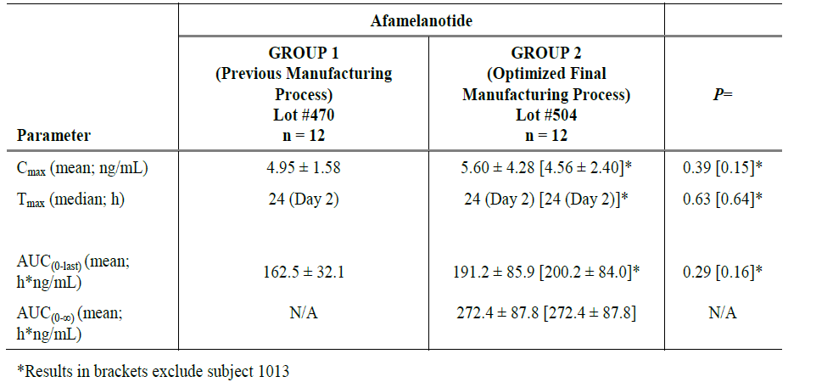

Cmax = maximum concentration; Tmax = time of maximum concentration; AUC(0-last) = area under the curve from time zero to last recording measurement; AUC(0-∞) = area under the curve from time zero extrapolated to infinity.

*Denotes results excluding one subject

Blood levels were higher in the ‘optimised process’ formulation intended for marketing than in the ‘previous process’ formulation used in trials. However, plasma levels of afamelanotide were not detectable after Day 4 in group 1 or Day 7 in group 2. The clinical evaluator has noted that the difference in the initial blood levels of afamelanotide are unlikely to be clinically significant, and the Delegate agrees with this as levels seem to equalise over the majority of the dosing period (being below the limit of quantitation (LOQ)).

###### General pharmacokinetics

Overall, the time of maximum concentration (Tmax) occurred at a median of 36 hours (24.1 to 49.6 hours) in healthy volunteers, but drug levels fell to below the LOQ within a few days. This suggests an initial rapid release of drug from the implant followed by a more sustained release over the remaining dosing period. Due of the difficulty of quantification, the terminal elimination half-life has been estimated from the initial area under the curve (AUC) as approximately 15 hours. However detailed studies of the metabolic fate of the product have not been conducted.

Dose-escalation was examined in 30 healthy subjects administered between 5 mg and 20 mg afamelanotide using non-market-formulation slow-release implants (Study EP004). The majority of blood samples did not allow quantification of PK endpoints. However, increased melanin density was observed with increasing dose.

##### Pharmacodynamics

Study CUV006 examined the melanogenic effect of non-for-market controlled release implants of 16 mg and 20 mg in 12 healthy volunteers with Fitzpatrick skin types I to III.[10]

There was a sustained increase in melanin density over time which was comparable between the 16 mg and 20 mg dose forms examined, as shown in Figure 1, below.

Figure 1: Study CUV006 Pharmacodynamic response (change in melanin density on sun exposed areas) following administration of 10 mg, 16 mg and 20 mg strengths of afamelanotide implants

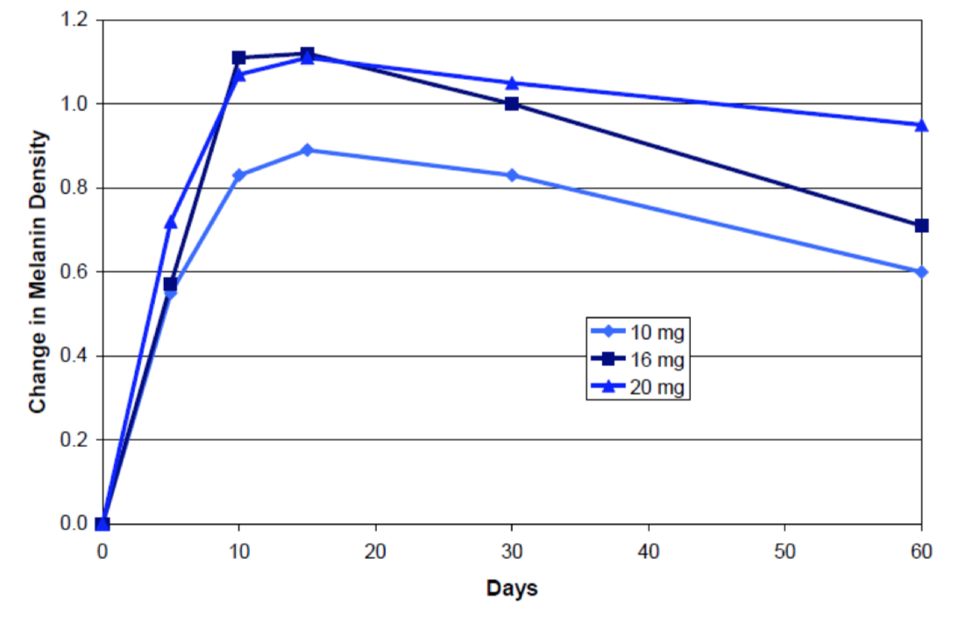

Note: A change in melanin density of 1.0 corresponds to an increase by 30%. The 10 mg dose results are from Study CUV007, not described in this document.

Figure source: Figure 2, p108 of the EPAR.[11]

#### Efficacy

##### Study CUV039

Pivotal efficacy data is provided by Study CUV039. This was a double-blinded randomised control trial that examined six months of treatment (3 x 2 monthly doses) in 93 subjects allocated 1:1 between active (n = 48) and placebo (n = 45) treatment. Patients in the active arm received afamelanotide 16 mg implants, and those in the placebo arm received dummy implants of the same size. Included patients had a confirmed diagnosis of EPP and had previously experienced phototoxic reactions. This study was conducted at 6 sites in the USA over the summer months.

Figure 2: Study CUV309 Participant flow

Study CUV309: Participant flow throughtout the pivotal study. 97 subjects were assessed for elegibility, of which 93 were randomised. 48 were allocated to scenesse, 45 to placebo.
Of 48 allocated to scenesse, 43 completed ( 3 discontinuted/incomplete intervention; 1 subject withdrew via physician decision; 2 via subject decision.
Of 45 subjects randomised to placebo, 39 completed. 3 didnt complete placebo intervention, 2 lost to follow up 1 was due to physician decision.


ITT = Intent to treat; SC = subcutaneous; QoL = quality of life; ? = unknown/unspecified

One patient was withdrawn prior to drug administration due to choroidal nevus in the left eye. The indicated clinical follow-up by an ophthalmologist was not provided for in the protocol.

+ Patient [ID redacted], Physician’s decision, clinical reasons not related to IMP, subject non‑compliant with visit schedule, site unable to contact subject.

#Two Scenesse patients in the active group did not receive complete treatment: Patient [ID redacted], withdrawal of consent, reason not given, lost to follow-up, no early termination visit; patient [ID redacted] withdrawal of consent, reason not given.

°Three placebo patients did not receive complete allocated treatment: Patient [ID redacted], lost to follow-up; no early termination visit; Patient [ID redacted], Physician‘s decision Serious adverse event, clinical reasons not related to IMP; Patient [ID redacted], Patient lost to follow-up.

Figure source: Reproduced from the EPAR for Scenesse, p54.11

The primary endpoint of Study CUV039 was the mean duration of direct sunlight exposure between 10:00 and 18:00 hours that patients did not report phototoxicity related pain (Likert score of 0). Patients reported their pain for each 15 minute block of time spent outside, specifying whether it was in ‘direct sunlight’ or ‘shade’ in a diary.

Figure 3: Study CUV039 Patient pain diary scoring between 0 and 10 and recording duration of daylight exposure

Figure 3: Study CUV039 Patient pain diary scoring between 0 and 10 and recording duration of daylight exposure.
Q1. EPP monitoring;
1.1 have you experienced any reactions to light today? Y/N
1.2 If yes, please indicate on the scale bleow how bad your pain was from this reaction (0=no pain; 10= worst imaginable)

2.TIme spent outdoors
2.1 Did you spend any times outdoors today? Y/N
2.2 If Yes, please eneter the time period you were in direct sunlight (each box represents 15 minutes). Time queried extends from 10:00 to 18:00.
2.3 If yes, please enter the time period that you were in the shade.

The mean score was determined by the total duration of pain-free exposure divided by the number of days on the study.

Secondary endpoints in the study included:

* Duration of sun exposure (hours in direct sunlight) between 10:00 and 18:00 hours on days when no pain or mild pain was experienced (pain scores of 0 to 3)
* Duration of sun exposure (hours in direct sunlight) between 10:00 and 18:00 during the study
* Quality of life assessment score according to the Dermatology Life Quality Index (DLQI);[12] and EPP-QoL (original and revised version) questionnaires.[13]
* Photoprovocation (in a subset of patients): The minimum symptom dose following photoprovocation on the lower back and dorsal surface of the hand, determined using the irradiation dose of the light source and the time to first development of symptoms at the site of photoprovocation
* Maximum and total pain severity scores (Likert scale) for phototoxic episodes.
* Number of phototoxic episodes during the study

With protocol version 4.0 (17 June 2013), an additional, eighth secondary efficacy endpoint was introduced:

* ‘Duration of direct sunlight exposure between 10:00 and 15:00 hours on days when no pain was experienced (Likert score of 0)’.

This endpoint was also used in Scenesse clinical trials Study CUV029 (as the primary efficacy endpoint in the protocol’s revised version) and in Study CUV030 (co-primary efficacy endpoint).

Of note, a subset of patients were selected to undergo a photoprovocation test in which their tolerance to metered doses of light on test areas of skin was assessed.

Table 3: Study CUV039 Results of primary endpoint

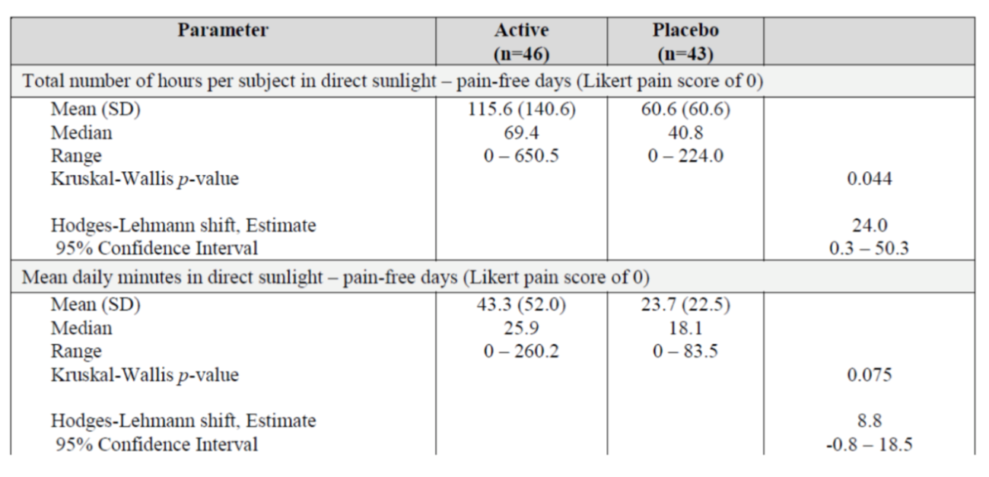

SD = standard deviation.

The difference in the median time spent pain-free in direct sunlight was 28.63 hours in favour of active treatment. This difference was statistically significant at a p = 0.05 level. However, there was no statistically significant difference between active and placebo arms in the mean amount of time spent pain-free in direct sunlight at a p = 0.05 level.

The effect observed by patients was asymmetrically distributed, with a few patients experiencing large gains in sun tolerance. There was a subset of 15 patients, 12 of whom were on active treatment, who reported more than 60 minutes in direct sunlight each day. Six of these patients, all on active treatment, reported more than 90 minutes of sun exposure each day.

Figure 4: Study CUV039 Distribution of average time in sunlight among active‑treated and placebo‑treated subjects

Figure 4: Study CUV039 Distribution of average time in sunlight among active treated and placebo treated subjects

Note: Actively-treated subjects represented by darker shaded bars, placebo treated subjects represented by lighter shaded bars. ITT = intent-to-treat.

###### Quality of Life indexes

The investigators used EPP-QoL, an EPP-specific quality of life (QoL) tool designed for this study to measure qualitative efficacy of afamelanotide. This was considered necessary because standard dermatological instruments, such as the DLQI, did not include questions about light tolerance. This questionnaire was used in two versions during Study CUV039 and these results were analysed separately. There was a statistically significant improvement in QoL scores in patients receiving active treatment compared to those on placebo.

Table 4: Study CUV039 Results of the Dermatology Life Quality Index

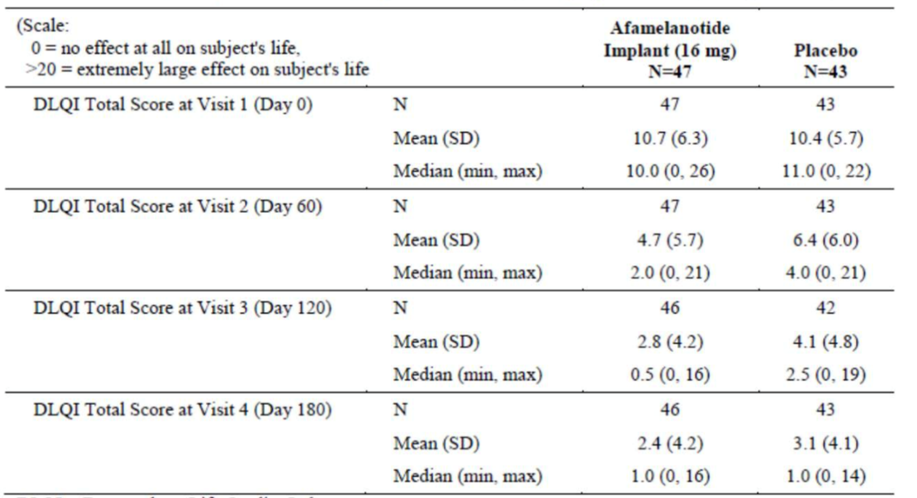

SD = Standard deviation

There was no significant difference in the DLQI results between active and placebo treated patients in Study CUV039.

###### Photoprovocation testing

Photoprovocation testing was performed in 21 patients at a single trial-site (11 active, 10 placebo) on Days 0, 30, 60 and 90. On Days 0 and 60 this was done prior to injection of the implant. Test areas on the back of the patient’s hand and lower back were exposed to light of a standardised intensity until the patient experienced symptoms.

The results generally indicated a higher light-dose tolerance in patients receiving afamelanotide than in those receiving placebo, although the statistical significance of these differences was not clear at all time-points. Patients were censored from some time-points as they reached the maximum applied irradiation dose permitted at that time point. The Delegate notes that the total number of subjects tested is small. For tests in which the maximum irradiation dose was reached but no symptoms occurred, the maximum irradiation dose was used to determine the minimum symptom dose in statistical analyses.

###### Phototoxicity

Little phototoxicity was reported during the study and there were no treatment related differences in the number of phototoxic episodes, or the severity of phototoxic episodes. A *post-hoc* assessment of the number of days on which subjects reported pain for each of the possible severity scores (using an 11-point Likert scale) showed that phototoxic pain (defined as a pain score of 4 or more on the 11-point Likert scale) was reported on 1.8% of days for subjects in the afamelanotide group, and on 3.8% of days in the placebo group. The proportion of subjects who experienced phototoxic reactions with Likert severity scores ≥ 4 was comparable between treatment groups (61% (28/46) afamelanotide group, 63% (27/43) placebo group).

Table 5: Study CUV039 Changes in minimum symptomatic dose (J/cm2) on the hand and back of patients receiving active or placebo treatment

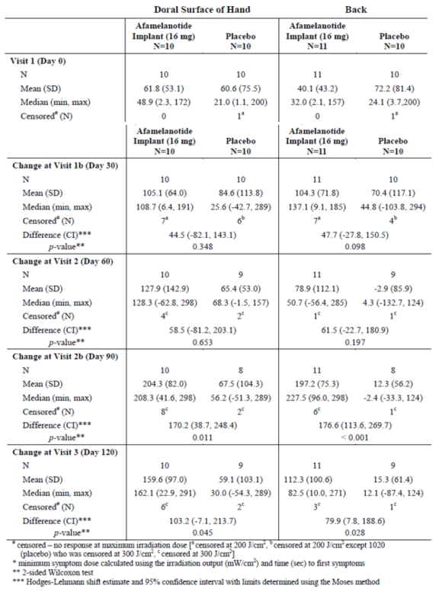

SD = standard deviation; CI = confidence interval

Table 6: Study CUV039 Distribution of maximum pain scores

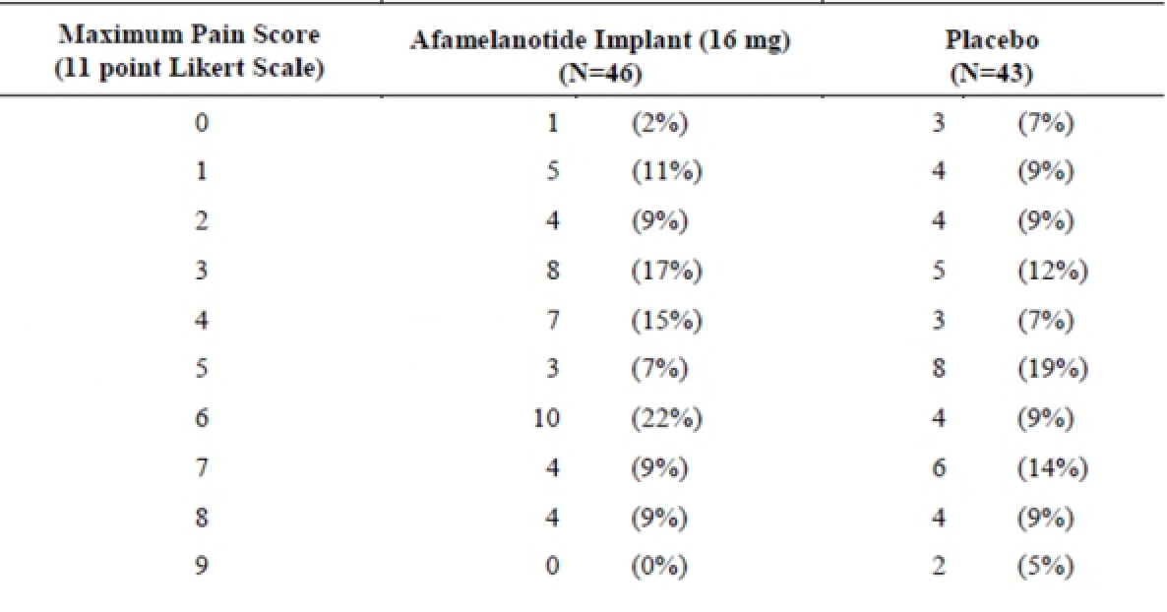

The Delegate notes that this is likely to partially reflect the high level of behavioural adaptation to photosensitivity that people with EPP have developed, which limits their tendency to expose themselves to potential phototoxicity. Hence the full potential comparative effects of afamelanotide are difficult to assess from ‘spontaneous’ exposure that is not ’dosed’ to a pre-defined limit, as was the case in the photoprovocation tests.

##### Post authorisation safety study (PASS)

The EMA authorisation for afamelanotide in 2014 required the establishment of a disease registry to gather ‘real world’ experience with the medication. CLINUVEL is required to report safety and effectiveness outcomes from the registry annually to the EMA. To date, over 94% of patients enrolled in the registry have continued on afamelanotide treatment (July 2019).

#### Safety

In the clinical trials examined, a total of 137 patients received single or multiple doses of afamelanotide in an aqueous solution presentation. The total human exposure in all trials for EPP and other indications is approximately 7140 to 10,200 days for the proposed implant, with no patients treated for more than 2 years continuously in trials. [14]

The pivotal Study CUV039 provides the largest body of controlled data in EPP patients.

Table 7: Study CUV039 Summary incidence of adverse events

Table 8: Study CUV039 Summary incidence of adverse events

TEAE = treatment emergent adverse event; SAE = serious adverse event

Table 8: Study CUV039 Specific adverse events reported by > 3 patients

Table 9: Study CUV039 Specific adverse events reported by > 3 patients

TEAE = treatment emergent adverse event

Headache was more prevalent in afamelanotide treated patients that those on placebo. Pigmentation of injection sites was common and expected on the basis of the mechanism of action of afamelanotide.

There were nine deaths in all afamelanotide studies and compassionate use programs, of which one occurred in the EPP clinical studies. These were considered not related to study treatment.

In the pivotal study there were no withdrawals from study treatment. In the supportive Study CUV017 there was one withdrawal due to thrombocytopenia, which was considered unrelated to study treatment.

No studies were performed in special populations.

Laboratory chemistry and haematology assessments were made in most studies but no clinically significant trends were reported.

The clinical evaluator has noted that echocardiogram (ECG) measurements were made in Study CUV039 but not presented in summary findings.

### Risk management plan

The sponsor has applied to register a new chemical entity, with this, the sponsor has submitted EU-risk management plant (RMP) version 8.1 (dated 1 February 2018; data lock point (DLP) 22 June 2017) and Australian-specific Annex (ASA) version 1.0 (dated December 2019) in support of this application. In response to rolling questions, the sponsor updated the ASA. The latest ASA submitted is version 1.4 (dated April 20).

The summary of safety concerns and their associated risk monitoring and mitigation strategies are summarised in Table 9, shown below.[15]

Table 9: Summary of safety concerns

|  |  |  |  |  |  |
| --- | --- | --- | --- | --- | --- |
| Summary of safety concerns | | Pharmacovigilance | | Risk Minimisation | |
| **Routine** | **Additional** | **Routine** | **Additional** |
| **Important identified risks** | Change of pigmentary lesions | ✓ | ✓*† | ✓ | ✓§ |
| Administration site reactions | ✓ | ✓*† | ✓ | ✓ǁ |
| **Important potential risks** | Allergy and hypersensitivity | ✓ | ✓*† | ✓ | ✓ |
| Off-label use in paediatric patients | ✓ | ✓*† | ✓ | ✓β |
| Off-label use in adults | ✓ | ✓*† | ✓ | ✓β |
| Use in pregnancy and lactation | ✓ | ✓*† | ✓ | ✓ |
| Administration error | ✓ | ✓*† | ✓ | ✓ǁβ |
| **Missing information** | Use in the elderly (greater than 70 years of age) | ✓ | ✓*† | ✓ | – |
| Use in patients with co-morbidities such as clinically significant renal, hepatic or cardiac impairment | ✓ | ✓*† | ✓ | – |
| Long term safety data | ✓ | ✓*† | ✓ | – |
| Pharmacokinetic data | ✓ | ✓‡ | ✓ | – |

* retrospective chart review; † disease registry; ‡ pharmacokinetic study; § educational materials for patients ; ǁ Educational materials, training and accreditation of health care professionals and treatment centres; β Controlled distribution.

#### Conditions of registration

The RMP evaluator suggested the following:

Any changes to which the sponsor has agreed should be included in a revised RMP and ASA. However, irrespective of whether or not they are included in the currently available version of the RMP document, the agreed changes become part of the risk management system.

The suggested wording is:

The Afamelanotide (Scenesse) EU-Risk Management Plan (RMP) (version 8.1, dated 1 February 2018, data lock point 22 June 2017), with Australian Specific Annex (version 1.4, dated April 2020), included with submission PM-2019-05977-1, and any subsequent revisions, as agreed with the TGA will be implemented in Australia.

The following wording is recommended for the PSUR requirement:

An obligatory component of risk management plans is routine pharmacovigilance. Routine pharmacovigilance includes the submission of periodic safety update reports (PSURs).

Reports are to be provided in line with the current published list of EU reference dates and frequency of submission of PSURs until the period covered by such reports is not less than three years from the date of this approval letter.

The reports are to at least meet the requirements for PSURs as described in the European Medicines Agency’s Guideline on good pharmacovigilance practices (GVP) Module VII-periodic safety update report (Rev 1), Part VII.B Structures and processes. Note that submission of a PSUR does not constitute an application to vary the registration.

As Scenesse is a new chemical entity it should be included in the Black Triangle Scheme as a condition of registration. The following wording is recommended for the condition of registration:

Scenesse (afamelanotide) is to be included in the Black Triangle Scheme. The PI and CMI for Scenesse must include the black triangle symbol and mandatory accompanying text for five years, which starts from the date that the sponsor notifies the TGA of supply of the product.

The Delegate commented that the RMP evaluator has not raised objections to the registration of afamelanotide. The RMP evaluator has noted that the proposed Australian product information has not specified a maximum number of implants per year, which is consistent with the FDA labelling, while the EU has recommended no more than 4 implants per year during the summer months.

### Risk-benefit analysis

#### Delegate’s considerations

Afamelanotide is an interesting product which has a clear physiological mode of action based on moderating the normal capacity for skin to increase pigment levels in response to light exposure. This is potentially useful for patients with EPP as melanin absorbs ultraviolet and visible light.

##### Efficacy

The Delegate considers the efficacy data to be problematic in that it is based on qualitative endpoints which are open to multiple interpretations. As the EMA noted with regard to the sunlight-exposure endpoint in the pivotal trial (reproduced here from the EPAR for Scenesse, p84):11

‘The Applicant argued that the definition of the primary endpoint was not fully clear, permitting different interpretations. In total, the Applicant mentioned three different possibilities of primary endpoints that could be derived from the wording.

1. Total duration of time (hours) spent in direct sunlight between 10:00 and 18:00 hours on days when no pain was experienced (Likert score of 0) (primary endpoint in original and revised CSR).

2. Mean daily duration in direct sunlight exposure between 10:00 and 18:00 hours on days when no pain was experienced was calculated for each subject by dividing the total duration of time spend in direct sunlight (for the study) by the number of days that each subject was on the study (revised CSR).

3. Mean daily duration in direct sunlight exposure calculated as time spent in direct sunlight between 10:00 and 18:00 hours on days when no pain was experienced divided by the number of pain-free days (primary endpoint according to protocol, objected to in the original CSR; no results presented).

The CHMP was of the view the primary endpoint in a confirmatory (pivotal) clinical trial should be defined unambiguously in the study protocol to avoid the post-hoc choice of the ‘most favourable’ primary endpoint. Retaining one of the possible endpoints as the only primary endpoint *post-hoc* is not considered best practice. However, if the primary endpoints interpreted in different fashions show consistent results in direction of positive efficacy, the concern over *post-hoc* selection is reduced. The assumptions made for missing values (here: diary entries) have their own effect on the primary endpoints, on all diary based endpoints, and lead themselves to an uncertainty of the effect size.

The magnitude of the effect size is considered small and is in line with the trend for positive efficacy of primary endpoint results in [Studies] CUV029 and CUV030.’

The ambiguity is inherent in the definition of the primary endpoint because mean-pain-free-exposure-time obscures the potential effect of the number of pain-free days in the denominator. The median effect of 28 hours increased pain free tolerance in 6 months of treatment is, in any case, quite modest.

The QoL index used in Study CUV039 indicates statistically significant improvements from baseline but is not validated. The DLQI did not show any significant difference between active and placebo treatment arms. While it can be argued that the DLQI does not adequately measure phototoxicity, it is notable that the average QoL impairment measured at baseline is relatively modest. The Delegate concludes that, acknowledging the rarity of EPP, these data suggest that afamelanotide may be of benefit to a sub-population of patients who have significant quality-of-life impairment without therapy rather than all EPP patients. This would support selected empirical treatment.

The Delegate is concerned that the clinical trial data may have less validity in the Australian environment due to high solar irradiance. Study CUV039 was conducted in the US Summer at seven sites located in New York, Texas, California, Alabama, North Carolina, Michigan and Utah respectively. While the Delegate is not an expert on environment science, annual solar irradiance in mainland Australian capitals is about 1800 to 2100 Kw/hr/m2.[16] While it approaches this in the south-western USA, the Delegate understands that annual solar irradiance for most of the USA is in the 1000 to 1500 Kw/hr/m2 range and Utah and Michigan certainly fall into this area. The Delegate concludes that the degree of benefit obtained by patients in Australia, particularly in summer, may be less than the trial data from the Northern Hemisphere suggests due to the higher solar intensity in Australia. The Delegate notes that a search of the SAS database;[17] indicates no previous requests to prescribe afamelanotide in Australia.

##### Maximum number of implants per year

The EU has recommended limiting the use of afamelanotide to 4 implants per year over summer, while 2 monthly dosing would suggest 6 implants per year. The Delegate feels that this may represent a realistic risk management process in Europe, but may limit the therapeutic options of patients who achieve a good therapeutic effect and wish to be outside in the Australian winter, for example, in northern Australia. The FDA has no limit and the Delegate is minded not to include this in the Australian registration. The Delegate notes, however, that patients have been treated with afamelanotide for relatively short periods of time and has concerns that maintaining a life-long regimen of two-monthly subcutaneous implants may cause scarring or injection-site-pain in the longer term.

##### Indication

The Delegate notes that the clinical evaluator has recommended approving afamelanotide with a different indication to that proposed by the sponsor, specifically:

*Scenesse is indicated to increase pain free light exposure in adult patients with a history of phototoxic reactions from erythropoietic protoporphyria (EPP).*

The Delegate agrees with the clinical evaluator that a specific effect on phototoxicity has not been clearly demonstrated and that it is the subjective endpoint of pain which has been examined. The evaluator’s recommended indication is in line with the FDA approved indication.

However, the Delegate is also aware that the effect of afamelanotide is variable with some patients achieving a good effect despite the mean population effect being marginal. This suggests that treatment is likely to be empirically directed to patients for whom avoiding the sun is itself a problem, and it will only be continued in those patients who have sufficiently good response to warrant the discomfort of therapy. In these patients, pain is likely to be the best indicator of phototoxicity, although protection from long term effects of light such as scarring and skin thickening can’t be assured.

The Delegate is minded to approve the indication as recommended by the sponsor. However, a statement will be inserted in to the *Clinical Trial* section of the PI to read:

‘There is no clinical evidence to determine whether Scenesse is protective against long term effects of phototoxicity such as scarring or skin changes resulting from exposure to light’.

##### GMP clearances

The Delegate notes that the sponsor has not obtained GMP clearance of all sites of manufacture and that the Therapeutic Goods Act does not allow a positive decision under Section 25 of the Act if the Delegate does not have adequate evidence of the quality of the goods being registered. The Delegate is unaware of any provision for making an ‘initial decision’ under this part of the Act.[18]

#### Proposed action

Pending the advice of Advisory Committee on Medicines (ACM), the Delegate currently intends to approve the registration of afamelanotide for the following indication:

*Scenesse is indicated for prevention of phototoxicity in adult patients with erythropoietic protoporphyria (EPP)*

##### Conditions

This intention [approval of the indication shown above above] being conditional on:

1. The PI as provided in response to the second round report being amended as follows:
   1. a statement inserted as the first sentence of the *Dosage* instructions to read Scenesse must only be initiated by a specialist physician having expertise in the management of erythropoietic protoporphyria (EPP).’
   2. a statement inserted into the *Clinical Trial* section of the PI to read as the last sentence, ‘There is no clinical evidence to determine whether Scenesse is protective against long term effects of phototoxicity such as scarring or skin changes resulting from exposure to light.’
2. All outstanding quality issues being resolved to the satisfaction of the Module 3 Evaluator, specifically including GMP clearance.

Additionally, the Delegate currently intends to recommend to the scheduling Delegate that afamelanotide be moved from Schedule 4 of the SUSMP to Schedule 8 of the SUSMP.[19]

##### Request for Advisory Committee advice

The committee is requested to provide advice on the following specific issues:

1. Are measures required to control the potential diversion of afamelanotide into off-label use? If so, what are ACM’s recommended actions?
2. Is the efficacy of afamelanotide sufficient to warrant inclusion of this product in the ARTG?
3. Should the number of afamelanotide implants be limited over a year?
4. The committee is (also) requested to provide advice on any other issues that it thinks may be relevant to a decision on whether or not to approve this application.

#### Advisory Committee considerations[20]

The Advisory Committee on Medicines (ACM), having considered the evaluations and the Delegate’s overview, as well as the sponsor’s response to these documents, advised the following.

##### Specific advice to the Delegate

1. ***Are measures required to control the potential diversion of afamelanotide into off-label use? If so, what are ACM’s recommended actions?***

The ACM was of the view that including afamelanotide in Schedule 8 was appropriate given the potential for diversion and misuse. As afamelanotide is intended for use in a very small patient population, the ACM advised that the potential for misuse could be minimised by restricting prescribing to registered physicians, such as dermatologists, experienced in the treatment of patients with EPP. The ACM also noted that as EPP is a life-long condition, patients should not need to provide evidence of their EPP diagnosis on an ongoing basis to access afamelanotide.

1. ***Is the efficacy of afamelanotide sufficient to warrant inclusion of this product in the ARTG?***

The ACM was of the view that the study provided was not adequately powered and special patient population groups were excluded, limiting its relevance to clinical practice. The ACM noted that it may have been difficult to adequately demonstrate the effect of the drug, as results must be interpreted considering the impact of the season and the effect of recruitment difficulties. It was likely difficult to recruit patients willing to expose themselves to sunlight as EPP is an extremely painful condition, frequently requiring the use of opiates for pain management. Despite the shortcomings of the study provided, the ACM concluded that the size of the effect was significant for the intended population due to the severity of the symptoms experienced. The ACM advised that because EPP is a rare disease with debilitating symptoms, the potential improvement to quality of life for patients justifies the listing of afamelanotide on the ARTG.

1. ***Should the number of afamelanotide implants be limited over a year?***

The ACM recommended that patients should receive a maximum of 9 implants per year, allowing for an implant every six weeks, and additional implant(s) to accommodate travel to areas of greater sun exposure if required. ACM also affirmed that treatment must be tailored to the patient, as some patients may not require treatment with afamelanotide for the entire year, depending on levels of sun exposure where they live.

1. ***The committee is (also) requested to provide advice on any other issues that it thinks may be relevant to a decision on whether or not to approve this application.***

The ACM noted that polyglactin is listed an excipient within the implant and has potential to cause a hypersensitivity reaction in susceptible patients. For this reason, the committee recommended including ‘hypersensitivity to absorbable suture containing polyglactin (for example Vicryl)’, as a contraindication within the PI.

##### Conclusion

The ACM considered this product to have an overall positive benefit-risk profile for the indication:

*Scenesse is indicated to increase pain-free light exposure in adult patients with erythropoietic protoporphyria confirmed by biochemical or genetic testing.*

### Outcome

Based on a review of quality, safety and efficacy, the TGA approved the registration of Scenesse afamelanotide (as acetate) 16 mg implant, vial, indicated for the following:

*Scenesse is indicated for prevention of phototoxicity in adult patients with erythropoietic protoporphyria (EPP)*

#### Specific conditions of registration applying to these goods

* The Product Information applying to these therapeutic goods must meet the TGA's approval at all times. Any proposed changes to the approved text of the PI, including safety related changes, must be submitted to, and be approved by, the TGA prior to distribution.

For all injectable products the Product Information must be included with the product as a package insert.

* Scenesse (afamelanotide) is to be included in the Black Triangle Scheme. The PI and CMI for Scenesse must include the black triangle symbol and mandatory accompanying text for five years, which starts from the date that the sponsor notifies the TGA of supply of the product.
* The Afamelanotide (Scenesse) EU-Risk Management Plan (RMP) (version 8.1, dated 1 February 2018, data lock point 22 June 2017), with Australian Specific Annex (version 1.4, dated April 2020), included with submission PM-2019-05977-1, and any subsequent revisions, as agreed with the TGA will be implemented in Australia.
* An obligatory component of risk management plans is routine pharmacovigilance. Routine pharmacovigilance includes the submission of periodic safety update reports (PSURs). Reports are to be provided in line with the current published list of EU reference dates and frequency of submission of PSURs until the period covered by such reports is not less than three years from the date of this approval letter.

The reports are to at least meet the requirements for PSURs as described in the European Medicines Agency’s Guideline on good pharmacovigilance practices (GVP) Module VII-periodic safety update report (Rev 1), Part VII.B Structures and processes.

Note that submission of a PSUR does not constitute an application to vary the registration.

You are reminded that sections 29A and 29AA of the Therapeutic Goods Act 1989 provide for penalties where there has been failure to inform the Secretary in writing, as soon as a person has become aware, of:

(a) information that contradicts information already given by the person under this Act;

(b) information that indicates that the use of the goods in accordance with the recommendations for their use may have an unintended harmful effect;

(c) information that indicates that the goods, when used in accordance with the recommendations for their use, may not be as effective as the application for registration or listing of the goods or information already given by the person under this Act suggests;

(d) information that indicates that the quality, safety or efficacy of the goods is unacceptable.

## Attachment 1. Product Information

The PI for Scenesse approved with the submission which is described in this AusPAR is at Attachment 1. For the most recent PI, please refer to the TGA website at <<https://www.tga.gov.au/product-information-pi>>.

|  |
| --- |
| Therapeutic Goods Administration |
| PO Box 100 Woden ACT 2606 Australia  Email: [info@tga.gov.au](mailto:info@tga.gov.au) Phone: 1800 020 653 Fax: 02 6232 8605  [**https://www.tga.gov.au**](https://www.tga.gov.au) |

1. The **Black Triangle Scheme** provides a simple means for practitioners and patients to identify certain types of new prescription medicines, including those being used in new ways and to encourage the reporting of adverse events associated with their use. The Black Triangle does not denote that there are known safety problems, just that the TGA is encouraging adverse event reporting to help us build up the full picture of a medicine's safety profile.
2. Afamelanotide (active ingredient) supplied as acetate; each implant contains 16 mg afamelanotide (18 mg as afamelanotide acetate).
3. **'Orphan drugs'** are often developed to treat small and very specific patient populations who suffer from rare diseases and conditions. In order to facilitate orphan drug access to the Australian marketplace and help offset orphan drug development costs the TGA waives application and evaluation fees for prescription medicine registration applications if a related orphan designation is in force. A medicine may be eligible for orphan drug designation if all orphan criteria set by the TGA are met. The orphan designation application precedes the registration application and the designation is specific to the sponsor, orphan indication for which designation was granted and dosage form of the medicine.
4. The TGA has implemented a priority pathway for the registration of novel prescription medicines for Australian patients. The **priority pathway** provides a formal mechanism for faster assessment of vital and life-saving prescription medicines. The target timeframe of 150 working days is up to three months shorter than the standard prescription medicines registration process.
5. **Good Manufacturing Practice** (**GMP**) is the minimum standard that a medicines manufacturer must meet in their production processes. Products must be of consistent high quality; be appropriate to their intended use; and meet the requirements of the marketing authorisation or product specification.
6. This issue was resolved prior to approval, with a GMP clearance that expires in October 2021.
7. This issue was resolved prior to approval, with a GMP clearance that expires in February 2022.
8. Guidance 7 of the Australian Regulatory Guidelines for Prescription Medicines is intended for sponsors who are submitting the Certified Product Details (CPD) for their prescription medicine to the TGA. The CPD is a summary of the formulation, quality control and shelf life for a prescription medicine.
9. **Pregnancy Category B1**: Drugs which have been taken by only a limited number of pregnant women and women of childbearing age, without an increase in the frequency of malformation or other direct or indirect harmful effects on the human fetus having been observed. Studies in animals have not shown evidence of an increased occurrence of fetal damage.
10. Fitzpatrick Classification: I) never tans, always burns; II) sometimes tans, mostly burns; III) mostly tans, sometimes burns; IV) always tans, never burns.

    The validity and practicality of sun-reactive skin types I through VI. Arch Dermatol. 124:869‑871; 1988
11. Scenesse EPAR public assessment report. Last updated June 2015; European Medicines Agency. https://www.ema.europa.eu/en/documents/assessment-report/scenesse-epar-public-assessment-report_en.pdf
12. The **Dermatology Life Quality Index** (**DLQI**) is a validated ten-question questionnaire used to measure the impact of skin disease on the quality of life of an affected person. Questions cover topics of symptoms, embarrassment, shopping and home care, clothes, social and leisure, sport, work or study, close relationships, sex, treatment. Each question refers to the impact of the skin disease on the patient’s life over the previous week. Each question is scored from 0 to 3, giving a possible score range from 0 (meaning no impact of skin disease on quality of life) to 30 (meaning maximum impact on quality of life). A series of validated ‘band descriptors’ were described in 2005 to give meaning to the scores of the DLQI. These bands are as follows: 0-1 = no effect on patient’s life, 2-5 = small effect, 6-10 = moderate effect, 11-20 = very large effect, 21-30 = extremely large effect.
13. The **Erythropoietic Protoporphyria Quality of Life questionnaire** (**EPP-QoL**) is a condition-specific instrument developed by the study investigators for measuring the impact of erythropoietic protoporphyria on the quality of life of EPP patients.
14. Long-term exposure data are available from patients on treatment in Europe.
15. *Routine risk minimisation* activities may be limited to ensuring that suitable warnings are included in the product information or by careful use of labelling and packaging.

    *Routine pharmacovigilance* practices involve the following activities:

    All suspected adverse reactions that are reported to the personnel of the company are collected and collated in an accessible manner;

    Reporting to regulatory authorities;

    Continuous monitoring of the safety profiles of approved products including signal detection and updating of labelling;

    Submission of PSURs;

    Meeting other local regulatory agency requirements.
16. YourHome: Photovoltaic systems; Commonwealth of Australia Department of Industry, Science, Energy and Resources [2020]. Your Home: Australia's guide to environmentally sustainable homes. https://www.yourhome.gov.au/energy/photovoltaic-systems
17. The **Special Access Scheme** (**SAS**) allows certain health practitioners to access therapeutic goods (such as medicines, medical devices or biologicals) that are not included in the Australian Register of Therapeutic Goods (ARTG) for a single patient. Therapeutic goods that are not included in the ARTG (and are not otherwise exempt from being in the ARTG) are described by us as 'unapproved'. The SAS database is a record of past access of therapeutic goods accessed through the SAS.
18. This issue was resolved prior to approval as GMP clearances were obtained.
19. The **Standard for the Uniform Scheduling of Medicines and Poisons** (**SUSMP**) is a record of decisions regarding the classification of medicines and chemicals into Schedules for inclusion in relevant legislation of the states and territories; includes model provisions about containers and labels, and recommendations about other controls on medicines and chemicals; and is registered on the Federal Register of Legislation as the Poisons Standard.
20. The ACM provides independent medical and scientific advice to the Minister for Health and the Therapeutic Goods Administration (TGA) on issues relating to the safety, quality and efficacy of medicines supplied in Australia including issues relating to pre-market and post-market functions for medicines.

    The Committee is established under Regulation 35 of the Therapeutic Goods Regulations 1990. Members are appointed by the Minister. The ACM was established in January 2017 replacing Advisory Committee on Prescription Medicines (ACPM) which was formed in January 2010. ACM encompass pre and post-market advice for medicines, following the consolidation of the previous functions of the Advisory Committee on Prescription Medicines (ACPM), the Advisory Committee on the Safety of Medicines (ACSOM) and the Advisory Committee on Non-Prescription Medicines (ACNM). Membership comprises of professionals with specific scientific, medical or clinical expertise, as well as appropriate consumer health issues relating to medicines.