|  |
| --- |
| **April 2014** |

|  |
| --- |
| Australian Public Assessment Report for afatinib (as dimaleate) |
| Proprietary Product Name: Giotrif |
| Sponsor: Boehringer Ingelheim Pty Ltd |

About the Therapeutic Goods Administration (TGA)

* The Therapeutic Goods Administration (TGA) is part of the Australian Government Department of Health, and is responsible for regulating medicines and medical devices.
* The TGA administers the *Therapeutic Goods Act 1989* (the Act), applying a risk management approach designed to ensure therapeutic goods supplied in Australia meet acceptable standards of quality, safety and efficacy (performance), when necessary.
* The work of the TGA is based on applying scientific and clinical expertise to decision-making, to ensure that the benefits to consumers outweigh any risks associated with the use of medicines and medical devices.
* The TGA relies on the public, healthcare professionals and industry to report problems with medicines or medical devices. TGA investigates reports received by it to determine any necessary regulatory action.
* To report a problem with a medicine or medical device, please see the information on the TGA website <<http://www.tga.gov.au>>.

About AusPARs

* An Australian Public Assessment Record (AusPAR) provides information about the evaluation of a prescription medicine and the considerations that led the TGA to approve or not approve a prescription medicine submission.
* AusPARs are prepared and published by the TGA.
* An AusPAR is prepared for submissions that relate to new chemical entities, generic medicines, major variations, and extensions of indications.
* An AusPAR is a static document, in that it will provide information that relates to a submission at a particular point in time.
* A new AusPAR will be developed to reflect changes to indications and/or major variations to a prescription medicine subject to evaluation by the TGA.

Copyright

© Commonwealth of Australia 2014  
This work is copyright. You may reproduce the whole or part of this work in unaltered form for your own personal use or, if you are part of an organisation, for internal use within your organisation, but only if you or your organisation do not use the reproduction for any commercial purpose and retain this copyright notice and all disclaimer notices as part of that reproduction. Apart from rights to use as permitted by the *Copyright Act 1968* or allowed by this copyright notice, all other rights are reserved and you are not allowed to reproduce the whole or any part of this work in any way (electronic or otherwise) without first being given specific written permission from the Commonwealth to do so. Requests and inquiries concerning reproduction and rights are to be sent to the TGA Copyright Officer, Therapeutic Goods Administration, PO Box 100, Woden ACT 2606 or emailed to <[tga.copyright@tga.gov.au](mailto:tga.copyright@tga.gov.au)>.

Contents

List of abbreviations 4

I. Introduction to product submission 7

Submission details 7

Product background 7

Regulatory status 8

Product Information 8

II. Quality findings 9

Drug substance (active ingredient) 9

Drug product 10

Biopharmaceutics 10

Advisory committee considerations 12

Quality summary and conclusions 12

III. Nonclinical findings 12

Introduction 12

Pharmacology 13

Pharmacokinetics 16

Toxicology 18

Nonclinical summary and conclusions 23

IV. Clinical findings 26

Introduction 26

Pharmacokinetics 26

Pharmacodynamics 28

Efficacy 29

Safety 32

List of questions 35

Clinical summary and conclusions 35

V. Pharmacovigilance findings 38

Risk management plan 38

VI. Overall conclusion and risk/benefit assessment 49

Quality 49

Nonclinical 50

Clinical 50

Risk management plan 59

Risk-benefit analysis 60

Outcome 71

Attachment 1. Product Information 71

Attachment 2. Extract from the Clinical Evaluation Report 71

## List of abbreviations

| **Abbreviation** | **Meaning** |
| --- | --- |
| ADME | absorption, distribution, metabolism, excretion |
| AE | adverse event |
| ALP | alkaline phosphatase |
| ALT | alanine aminotransferase |
| APTT | activated partial thromboplastin time |
| AST | aspartate aminotransferase |
| AUC | area under the plasma concentration-time curve |
| AUC0‑∞ | area under the plasma concentration-time curve from time zero to infinity |
| BCRP | breast cancer resistance protein |
| BI | Boehringer Ingelheim |
| BP | blood pressure |
| Cmax | peak plasma drug concentration |
| CL/F | apparent total clearance of the drug from plasma after oral administration |
| CNS | central nervous system |
| CPK | creatine phosphokinase |
| CrCL | creatinine clearance |
| CYP | cytochrome P450 |
| DCR | disease control rate |
| ECG | electrocardiogram |
| ECHO | echocardiography |
| ECOG | Eastern Cooperative Oncology Group |
| EGF | epidermal growth factor |
| EGFR / ErbB1 | epidermal growth factor receptor |
| ER | exposure ratio |
| GD | gestational day |
| GLP | Good Laboratory Practice |
| gMean | geometric mean |
| Hb | haemoglobin |
| HER-2 / ErbB2 | human EGF like receptor 2 |
| HR | hazard ratio |
| IC50 | half maximal inhibitory concentration |
| ILD | interstitial lung disease |
| IP | intraperitoneal |
| IV | intravenous |
| Ki | inhibitor constant |
| LDH | lactate dehydrogenase |
| LFT | liver function test |
| LOEL | Lowest Observed Effect Level |
| LVEF | left ventricular ejection fraction |
| MTD | maximum tolerated dose |
| MUGA | multiple gated acquisition |
| NOAEL | No Observed Adverse Effect Level |
| NOEL | No Observed Effect Level |
| NSCLC | non-small cell lung cancer |
| OD | once daily |
| ORR | overall response rate |
| OS | overall survival |
| P-gp | P-glycoprotein |
| PD | pharmacodynamic(s) |
| PFS | progression free survival |
| PK | pharmacokinetic(s) |
| PND | post natal day |
| PO | oral administration |
| PPE | palmar-plantar erythrodysaesthesia |
| PT | prothrombin time |
| QoL | quality of life |
| RBC | red blood cells |
| RCT | randomised controlled trial |
| RECIST | Response Evaluation Criteria In Solid Tumours |
| SAE | serious adverse event |
| SC | subcutaneous |
| Tmax | time to reach peak plasma concentration following drug administration |
| TK | tyrosine kinase |
| TKI | tyrosine kinase inhibitor |
| VD | apparent volume of distribution |

## I. Introduction to product submission

### Submission details

|  |  |
| --- | --- |
| *Type of Submission* | New Chemical Entity |
| *Decision*: | Approved |
| *Date of Decision:* | 1 November 2013 |

|  |  |
| --- | --- |
| *Active ingredient:* | Afatinib (as dimaleate) |
| *Product Names:* | Giotrif |
| *Sponsor’s Name and Address:* | Boehringer Ingelheim Pty Ltd  78 Waterloo Road  North Ryde NSW 2113 |
| *Dose form:* | Film coated tablets |
| *Strengths:* | 20 mg, 30 mg, 40 mg, 50 mg |
| *Container:* | Blister pack (in pouch) |
| *Pack sizes:* | 7, 14, 28 tablets |
| *Approved Therapeutic use:* | As monotherapy for the treatment of patients with advanced or metastatic non-squamous non-small cell carcinoma of the lung, either as first line therapy or after failure of cytotoxic chemotherapy. Tumours must have epidermal growth factor receptor (EGFR) exon 19 deletions or L858R substitution mutations. |
| *Route of administration:* | Oral |
| *Dosage:* | The recommended dose is 40 mg and the maximum dose 50 mg daily |
| *ARTG Numbers:* | 201314 (20 mg), 201318 (30 mg), 201315 (40 mg), 201320 (50 mg) |

### Product background

This AusPAR describes a submission by the sponsor, Boehringer Ingelheim Pty Ltd, to register a new chemical entity, afatinib (as dimaleate), with the trade name Giotrif. Afatinib is a tyrosine kinase inhibitor (TKI) which blocks signal transmission from the ErbB family of cell surface receptors. The ErbB family has four members:

* The epidermal growth factor receptor (EGFR or ErbB1);
* The human EGF like receptor 2 (HER-2 or ErbB2);
* ErbB3 (or HER-3);
* ErbB4 (or HER-4).

All the members apart from ErbB3 have a tyrosine kinase (TK) component.

The proposed indication is:

*For the treatment of patients with locally advanced or metastatic non‑small cell lung cancer (NSCLC) with Epidermal Growth Factor Receptor (EGFR) mutation(s).*

The indication sought in this application is based upon inhibition of the EGFR receptor. Afatinib is an irreversible inhibitor of EGFR, whereas currently registered EGFR TKIs are reversible. The drug is also being studied in other indications based on its effect on HER-2 (for example, HER-2 +ve [positive] breast cancer).

In Western populations, ~10% of NSCLCs have mutations in the EGFR that result in activation of the receptor; in Asian populations, this proportion is ~30%. The sponsor estimated the prevalence of the condition in Australia to be between 438 and 1,626 subjects. Activation of EGFR results in increased downstream signalling which supports cell survival and proliferation. EGFR mutant NSCLC cells depend upon this signalling for survival; hence, blockade of the EGFR results in cell death.

### Regulatory status

At the time of lodgement of the application with the TGA (October 2012), similar submissions had been made in a number of jurisdictions. The proposed indication was identical to that proposed for Australia. The drug has since been approved in a number of jurisdictions (Table 1). In the US, the drug is registered with the slightly different trade name of Gilotrif.

Table 1: International regulatory status for Giotrif.

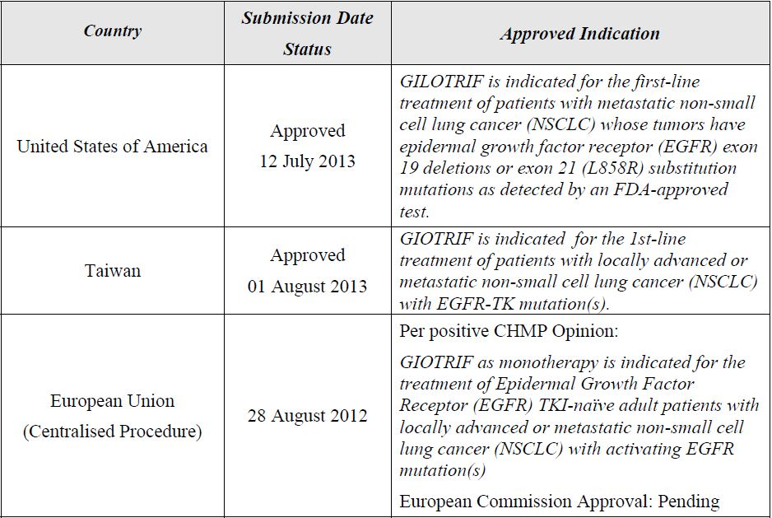

EU approval was granted on 25 September 2013.

### Product Information

The approved Product Information (PI) current at the time this AusPAR was prepared can be found as Attachment 1.

## II. Quality findings

### Drug substance (active ingredient)

Afatinib is a synthetic quinazoline derivative. The drug is synthetic. It has one chiral centre; the drug is the pure 3*S* enantiomer. The drug will not epimerise. Sidechain double bond stereochemistry (*E*) is also controlled. The drug substance is a salt formed with maleic acid. Chemically, it is related to other kinase inhibitors (Figure 1).

Figure 1. Structure of afatinib compared with other kinase inhibitors.

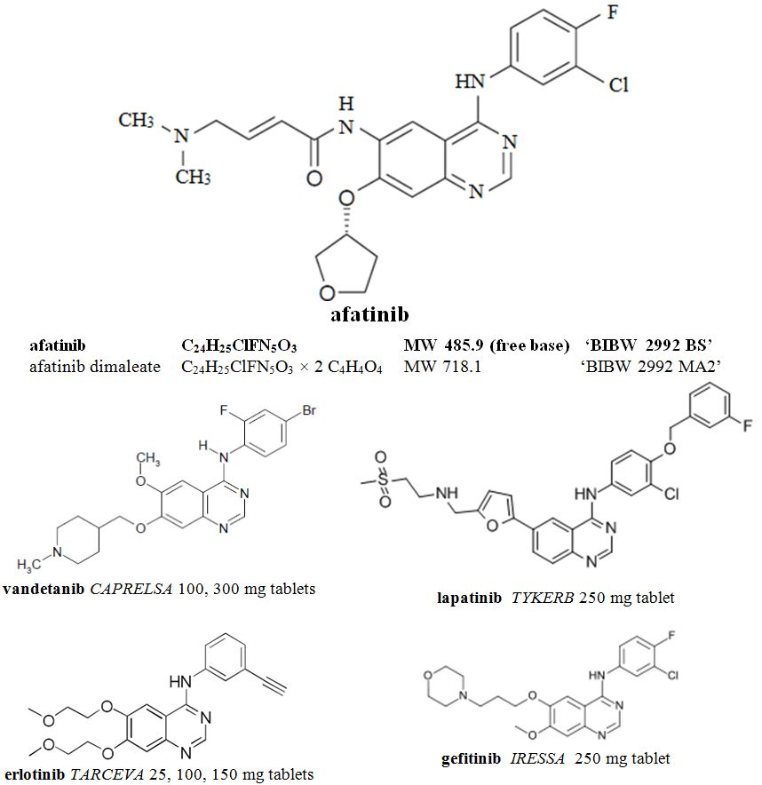

Afatinib dimaleate is crystalline. Afatinib has two basic groups, the dimethylamine (pKa 8.2) and the quinazoline (pKa 5.0). Afatinib dimaleate is very soluble in water and in aqueous buffers from pH 1 to pH 6 (> 50 mg/mL). Between pH 6 and 7 the solubility in buffers is lower, but still above 1 mg/mL (so that a dose is expected to be soluble in a small volume of fluid < 50 mL). The drug is soluble enough that the tablets can be administered as an oral solution/dispersion by stirring in 100 mL of water. Drug particle size is not controlled, which is acceptable given the solubility.

The free base is relatively lipophilic (log P = 4.7) but with a strong pH dependence.

The 4-(dimethylamino)but-2-enamide functionality (Figure 2) is unusual in drugs because it is electrophilic, reacting with nucleophiles such as thiol residues in cysteine. Afatinib is understood to thus covalently bind the epidermal growth factor receptor. The moiety does cause some moisture sensitivity for the drug and tablets, with a hydrolytic cyclisation product ‘CD 334’ the chief impurity in both the drug substance and as a degradation product in the tablet (limited to ≤1.2% in the drug and ≤3.0% in the tablet).

Figure 2. 4-(dimethylamino)but-2-enamide component.

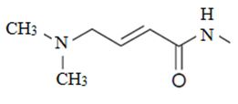

### Drug product

Four film coated, immediate release tablet strengths are proposed. The tablets are not scored. The tablets are distinguished by debossed markings and somewhat by colour and shape:

* 20 mg round; white to slightly yellowish; debossed T20 (and other side Boehringer symbol)
* 30 mg round; dark blue; debossed T30 (and other side Boehringer symbol)
* 40 mg round; light blue; debossed T40 (and other side Boehringer symbol)
* 50 mg oval; dark blue; debossed T50 (and other side Boehringer symbol)

Tablets are formulated with afatinib dimaleate but the label claims (20 to 50 mg) relate to the afatinib free base equivalent. The tablet cores for the different strengths are all compressed from the same excipient blend. Excipients are conventional.

#### Clinical trial formulations

Apart from some exploratory oral solution formulations, clinical trials have used three tablet formulations. Phase I trials used uncoated 5, 20 and 100 mg tablets (‘TF1’). The drug substance is bitter; to avoid disintegration of the tablet in the mouth and for safer handling, a film coated formulation (‘TF2’) containing microcrystalline cellulose was developed as 5, 20 and 100 mg tablets. The formulation proposed for registration (final formulation ‘FF’) uses the same set of core excipients to make smaller tablets.

The FF tablet formulation used in the pivotal clinical study (1200.32) is identical to that proposed for commercial supply, except for some film coat details and debossing, which will not affect bioavailability.

Perhaps surprisingly, the TF2 and FF formulations were not found to be bioequivalent (Study 1200.35).

### Biopharmaceutics

#### Bioavailability

Afatinib dimaleate is highly soluble, but *in vitro* permeability data were not clear cut. Boehringer Ingelheim (BI) states that passive permeability is high, but afatinib is subject to active efflux. BI debates whether the drug is either Biopharmaceutics Classification System Class 1 or 3 drug. The evaluator is of the opinion that the clear effect of food on bioavailability (below) shows that Class 3 categorisation (low permeability) is appropriate.

Absorption is relatively slow (for example, the time to reach peak plasma concentration following drug administration [Tmax] is 5 h, even with an oral solution dose). Pharmacokinetic (PK) profiles commonly show multiple peaks. Afatinib is not significantly enzymatically metabolised (although other species are significant in plasma); observed reactions involve non enzymic reaction with protein and other molecules. The apparent terminal half life is 37 h. Excretion is chiefly faecal. Adduct formation by Michael addition of biological species to afatinib is an equilibrium process, so the adducts can slowly release afatinib.

Afatinib shows non linear PK (the peak plasma drug concentration [Cmax] and area under the plasma concentration-time curve [AUC] increase slightly more than proportionally in doses from 20 to 50 mg). Afatinib is a substrate and inhibitor for the efflux pump P-glycoprotein (P-gp). The sponsor attributes non linearity to saturation of efflux transport systems in the gut lumen. There is clear accumulation after multiple doses. There are large inter subject variations in PK.

The sponsor undertook an absorption, distribution, metabolism, excretion (ADME) study (1200.25) giving 15 mg radiolabelled afatinib dimaleate oral solution doses to eight healthy volunteers. Most of the radioactivity in plasma was not attributable to afatinib (only 23%). Total urinary excretion was about 0.7% of the dose as afatinib and about 3% of the dose as radioactivity. Faecal excretion of radioactivity was chiefly between 24 and 48 h after dosing, with about 62% excreted as afatinib.

##### Absolute bioavailability

The absolute bioavailability of oral afatinib doses has not been investigated. Such a study is normally expected as part of the characterisation of the fundamental PK of a new chemical entity. It is technically feasible to prepare an intravenous (IV) solution of afatinib dimaleate.

Drug excretion is very largely faecal (only 4% in urine), so that significant absorption is not directly demonstrated by observed PK. The sponsor states that the absorption in rats was 68% (that is, including metabolites), with absolute bioavailability of afatinib itself in rats about 45%.

The sponsor notes the high solubility of afatinib dimaleate and tablets across the physiologically relevant pH range and claims that the tablets perform like an oral solution. Study 1200.35 showed the mean bioavailability of the tablets compared to an oral solution was 92% (adjusted geometric mean [gMean] ratio of the area under the plasma concentration-time curve from time zero to infinity [AUC0‑∞]).

The sponsor argues that investigation of the absolute bioavailability could be clinically difficult (ideally investigated at different doses) meaning a significant burden for the healthy volunteers. The sponsor argues that an IV formulation is not clinically needed and that an absolute bioavailability study is not warranted.

##### Bioequivalence: Study 1200.35

Study 1200.35 was a relative bioavailability comparison of single 20 mg doses of an oral solution, TF2 tablets (used in Phase II clinical trials), and the ‘FF’ tablets proposed for registration taken by 22 healthy male volunteers (open, 3 way crossover).

Surprisingly, the proposed ‘FF’ tablets gave lower Cmax and AUC *in vivo*, even though *in vitro* the TF2 tablets were slower to dissolve (TF2 92%, compared to FF 99% in 15 minutes) (Table 2).

Table 2: Comparison of PK parameters (gMean and gCV%) of afatinib after single oral administration of 20 mg afatinib as tablet (FF/TF 2) or as drinking solution (N for FF, TF 2 and drinking solution = 21/20/22).

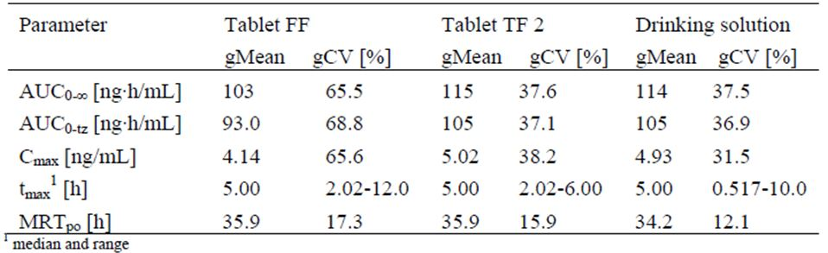

The proposed ‘FF’ tablets were not bioequivalent to either the TF2 tablets or the oral solution (90% confidence intervals [CIs] not shown here). Reasons for the lower bioavailability of the proposed tablets are not clear. The sponsor argues that the differences are not clinically relevant.

##### Food: Study 1200.3 (sub-study)

Dosing with food significantly reduces afatinib exposure. The effect of food was investigated in a sub study of trial 1200.3 (U08-1023). The sub study was a crossover comparison of fasting and fed (high fat) PK in 16 cancer patients with various advanced solid tumours. The study used 40 mg doses taken as two 20 mg TF2 tablets. A high fat high breakfast delayed absorption (3 → 7 h) and reduced afatinib Cmax by ~50% and AUC0-∞ by about 39% (geometric means).

The PI recommends administration under fasting conditions (no food for at least three hours before and at least one hour after dose). Fasting doses have been directed in all clinical trials.

### Advisory committee considerations

It is not planned to refer the submission to the Pharmaceutical Subcommittee (PSC).

### Quality summary and conclusions

Registration is recommended with respect to chemistry, quality control and bioavailability aspects.

## III. Nonclinical findings

### Introduction

The sponsor has submitted a comprehensive dossier of high quality studies. Most of the work was performed in the sponsor’s laboratories, although a selection of key studies was performed by independent laboratories. The pivotal toxicological studies were performed to Good Laboratory Practice (GLP) standard. All submitted studies were evaluated with the exception of four drug combination repeat dose toxicity studies.

### Pharmacology

#### Primary pharmacology

The four members of the ErbB family (EGFR or ErbB1, HER2 or ErbB2, ErbB3, and ErbB4) are transmembrane glycoproteins that are widely expressed on epithelial cells, including the lining epithelia of the gastrointestinal, urinary, reproductive, and respiratory tracts as well as other sites such as skin and breast.[1] Following ligand binding, ErbB proteins can form both homo- and hetero-dimers leading to autophosphorylation and activation of tyrosine kinase activity that can trigger a complex network of signal transduction pathways that regulate a variety of cell functions including proliferation, differentiation, death, motility, and adhesion.[2] ErbB3 is devoid of intrinsic kinase activity and ErbB2 appears to have no direct ligand, and so both can only support signal transduction through inclusion in heterodimers. The deregulation of ErbB signalling through gene amplification or mutation is a common event in some tumour types (Table 3). Accordingly, the inhibition of ErbB signalling using small molecule kinase inhibitors has become an active area of cancer therapy research.[3]

Table 3: ErbB gene mutations found in human cancers.[4]

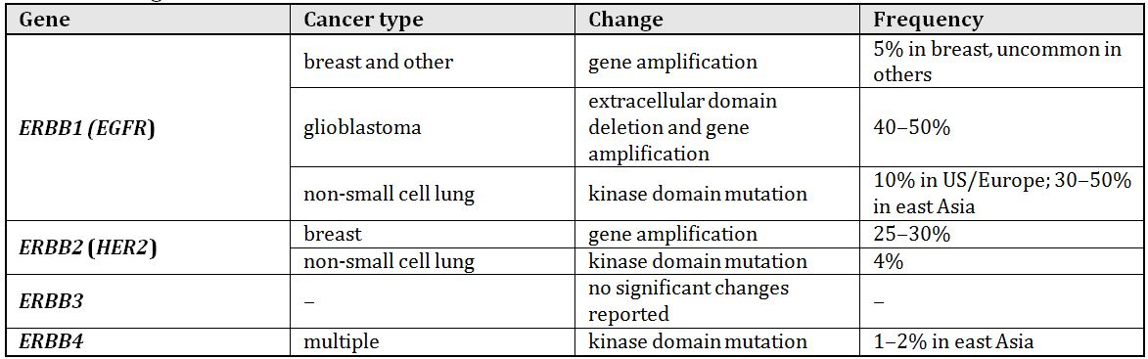

Afatinib was designed by appending an electrophile that is reactive towards cysteine residues (via Michael addition) to a 4-anilinoquinazoline scaffold that is selective for the ATP-binding site of ErbB family members. Such a drug may then be capable of covalent bonding specifically to the cysteine residue near the ATP binding site of ErbB family members, thereby blocking ATP binding and irreversibly inhibiting the kinase activity.[5]

Afatinib was shown by X-ray crystallography to bind covalently to the cysteine residue (Cys797) in the kinase domain of EGFR/ErbB1. The kinase activities of purified EGFR (both wild type and mutant), ErbB2 (HER2), and ErbB4 were all effectively inhibited by afatinib with half maximal inhibitory concentration (IC50) values of ~0.3-10 nM, ~20 nM, and ~1 nM, respectively.[6] Afatinib was also effective in inhibiting cell proliferation and autophosphorylation of EGFR in cell lines expressing wild type or mutant protein. IC50 values for inhibition of autophosphorylation of wtEGFR and mutant EGFRL858R expressed in NSCLC cells were 7 and 6 nM, respectively, and the respective IC50 values for inhibition of proliferation of these cell lines were 60 and 0.7 nM. Afatinib also showed activity towards EGFR with the T790M mutation, which often arises as a drug resistance mechanism in tumours already carrying an activating mutation of EGFR and is resistant to reversible kinase inhibitors such as gefitinib and erlotinib.[7] Afatinib IC50 values for inhibition of kinase activity, autophosphorylation, and cell proliferation associated with double mutant EGFRL858R, T790M were 10, 93, and 99 nM, respectively.

Consistent with irreversible inhibition, autophosphorylation of EGFR on cells exposed to afatinib remained blocked for up to 8 h after drug removal, with near control recovery by 48 h. In comparison, the inhibition by reversible EGFR inhibitors (for example, gefitinib) was short lived, with full recovery within 8 h.

In *in vitro* assays, afatinib showed comparable or greater inhibition than comparator drugs (both reversible and irreversible ErbB kinase inhibitors). Hence, the sponsor’s studies support the anticipated mechanism of action for afatinib.

The anti tumour activity of afatinib was tested by oral dosing of nude mice bearing subcutaneous (SC) implants of various human tumour derived cells (including breast, vulva, ovary, and stomach tumour derived cell lines) that express ErbB family members. Afatinib produced growth delay or regression of all tumour types and was generally well tolerated by mice. The maximum plasma levels of afatinib that induced regression of several of these tumour models were comparable with those found in cancer patients receiving the proposed maximum daily dose.

#### Secondary pharmacodynamics and safety pharmacology

Possible non specific inhibitory activity was tested using a panel of 32 (mainly Ser/Thr) protein kinases. Under the *in vitro* conditions employed, only three kinases showed greater than 50% inhibition at 10 µM afatinib: SAPK2a/p38α, IC50 = ~2 µM; PHK, IC50 = ~0.3-2 µM; and LCK, IC50 = ~2 µM. Non specific binding was also tested against a panel of 50 receptors using radio ligand receptor assays. Afatinib at 5 µM inhibited specific ligand binding to H2 (cimetidine) and M1 (pirenzepine) receptors by 68% and 78%, respectively. The levels of inhibition seen in both studies were considered unlikely to lead to side effects as steady state peak plasma drug concentration Cmax,ss for cancer patients receiving the proposed maximum daily dose of 50 mg of afatinib was 0.16 µM. Accordingly, both studies are consistent with the selectivity of afatinib for ErbB family members.

Safety pharmacology studies examined possible afatinib effects on the central nervous system (CNS), respiratory, cardiovascular, renal, and gastrointestinal systems. The studies of effects on the latter three systems were not GLP compliant. GLP compliant, repeat dose toxicity studies in pigs found no effect of afatinib on electrocardiogram (ECG) parameters (discussed below).

##### CNS effects

Using a modified Irwin test, mice given an oral dose of afatinib base up to 300 mg/kg and rats given afatinib dimaleate up to 18 mg/kg (base equivalent dose) showed no significant changes in behaviour or physiological state, suggesting a lack of effect on the CNS. The exposure in the rat study was approximately three times the clinical exposure based on Cmax obtained from a rat repeat dose toxicity study (~520 nM) and the clinical Cmax of 160 nM at the proposed maximum daily dose for patients.

##### Cardiovascular effects

*In vitro* studies with HEK293 cells expressing hERG showed that afatinib inhibited the hERG mediated potassium current with an IC50 of 2.4 µM. However, incubation of electrically stimulated guinea pig heart papillary muscle with up to 10 µM afatinib had no effect on various parameters related to the action potential. This suggested that afatinib has a low potential for induction of arrhythmia. Male rats given an oral dose of afatinib base at 10, 30, or 100 mg/kg showed a dose dependent increase of arterial systolic blood pressure (BP) at 30 and 100 mg/kg and transient increases in heart rate at these doses. IV dosing of anaesthetised domestic pigs with afatinib dimaleate at 0.2, 0.67, 2.0, 6.7, or 20 mg/kg (base equivalent dose) had no effect on systolic or diastolic arterial BP and heart rate and did not change cardiac electrical currents measured by ECG. The two highest afatinib doses did, however, temporarily decrease maximal left ventricular contractility (dP/dT) by ~6-10%, suggesting that afatinib has a negative inotropic effect without affecting heart rate or BP. Plasma afatinib concentrations after the two highest doses in the pig study were ~7.5- and 44 times the Cmax,ss for cancer patients. Overall, these studies indicate that cardiovascular effects of afatinib are occurring at supra clinical exposure levels. Nevertheless, a small fraction of patients treated with the reversible EGFR/ErbB1 and ErbB2 (HER2) tyrosine kinase inhibitor lapatinib showed decreases in left ventricular ejection fraction,[8] suggesting that this effect is also a risk for afatinib treatment.

##### Respiratory effects

Aside from a modest increase (~5-10%) in tidal volume, rats dosed orally at up to 100 mg/kg of afatinib base showed no respiratory effects considered biologically significant.

##### Renal/hepatic effects

Rats dosed orally with afatinib base at 30, 100, or 300 mg/kg showed increased glucose excretion at all doses and at 300 mg/kg showed increased excretion of aspartate aminotransferase (AST) and lactate dehydrogenase (LDH) and decreased excretion of Mg2+. Serum analysis after 300 mg/kg showed modest increases for glucose, AST, and alanine aminotransferase (ALT). Rat repeat dose toxicity studies did not provide evidence of hepatotoxicity (see below). Repeat dose toxicity studies showed renal toxicity (histological lesions) in rats and increased blood urea without renal structural changes in pigs (see below).

##### Gastrointestinal effects

Rats showed significant reductions in gastric emptying and secretion, and in gastrointestinal transit following oral dosing at 300 (and to a lesser extent at 100) mg/kg of afatinib base. No significant effects were observed at 30 mg/kg. There are no absorption data for the free base. Similar effects may occur in patients.

### Pharmacokinetics

The plasma kinetics of afatinib were examined after single oral and intravenous dosing of rats and pigs, and after single oral dosing of rabbits (Table 4). Plasma kinetics were also determined, in conjunction with toxicity studies, after one or more oral dosings of mice, rats, and pigs. Toxicokinetic data were also obtained for reproduction and development studies using rats and rabbits.

Table 4: Species comparison of mean plasma PK parameters after a single dose of afatinib.

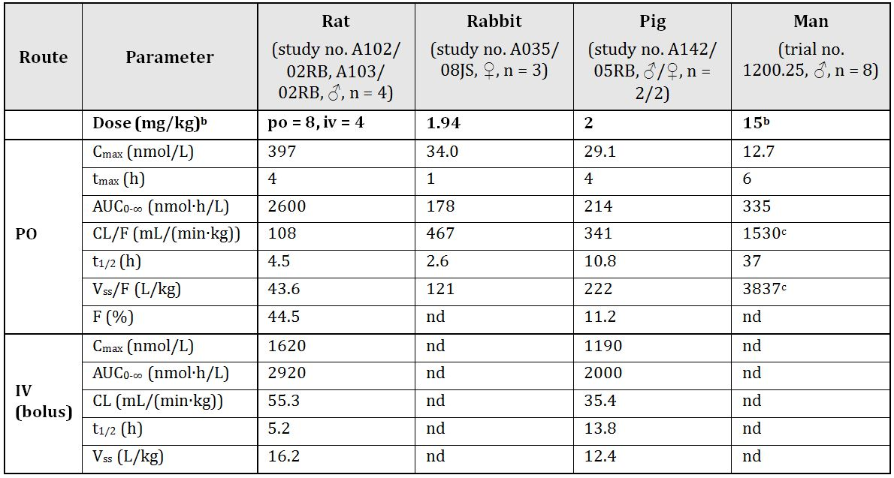

a Animal values are arithmetic means and human values are geometric means (exception is tmax values which are medians).

b Dose as free base equivalent in mg/kg for animals and in mg/subject for humans (dose conversion: 1 mg/kg = 2.06 µmoles/kg).

c Parameter not normalised to body weight.

nd = not determined.

Comparison of PK parameters after a single dose of afatinib suggested significant inter species differences in drug disposition. Bioavailability after oral dosing was 11.2% for pigs and 44.5% for rats. The volume of distribution was high (16.2 and 12.4 L/kg for rats and pigs, respectively), suggesting that there is significant drug sequestration into tissues. The apparent total clearance of the drug from plasma after oral administration (CL/F) was faster in animals than in humans (CL/F 100-500 mL/min/kg in rats, rabbits and pigs compared with 31 mL/min/kg in humans with a bodyweight of 50 kg). Following oral dosing of mice, rats, and pigs, plasma AUC and Cmax values increased more than proportionally with dose, suggesting saturation of clearance mechanisms. Human studies, over the range 20-50 mg of afatinib/subject, also indicated greater than dose proportional increases in AUC and Cmax values (clinical trial no. 1200.80). Daily repeat oral dosing of mice and pigs with afatinib for up to 3 months and one year, respectively, showed no marked increases in plasma drug levels and no effects of gender. Repeat dosing of rats, however, produced significant drug accumulation; an effect that was more pronounced in male than in female rats. There was evidence for modest drug accumulation during repeat dosing of humans.

When incubated *in vitro* with rat, pig, or human blood, afatinib showed rapid distribution predominantly into blood cells. In equilibrium dialysis studies against mouse, rat, pig, and human plasma, afatinib, at concentrations up to 0.5 µM, showed non saturable binding that ranged from ~92-95%, indicating a high level of protein binding for all species tested. Afatinib binds to human serum albumin and human alpha-1-acid-glycoprotein at protein concentrations within the physiological range.

Tissue distribution was studied in rats dosed with radiolabelled afatinib. The highest tissue concentrations of radioactivity (after both IV and oral (PO) dosing) were found in kidney, spleen, liver, pituitary, and lung, and the lowest concentration was in brain. Pigmented rats showed high concentrations of radioactivity in the retina that persisted for days after dosing. Some areas of pigmented skin also showed persistent retention of radioactivity, suggesting an affinity of afatinib and/or its metabolites for melanin. Various rat tissues showed progressive increases in radioactivity with repeated afatinib doses. This finding was thought to reflect covalent bonding of afatinib to protein, and *in vitro* studies confirmed the ability of afatinib to bond to albumin, globulins, and haemoglobin.

Metabolite profiles in plasma, bile, urine, and faeces from mice, rats, rabbits, pigs, and humans were determined. In all species examined, metabolism was relatively minor and unchanged parent compound was the major moiety in plasma and excreta. These studies identified a multitude of afatinib metabolites. A prominent theme for the generation of the metabolites identified was Michael addition reaction between afatinib (or a metabolite), which contains an acceptor α,β-unsaturated ketone group, and a nucleophilic lysine or cysteine residue (as the free amino acid, glutathione, or protein), followed by possible further modification. Cytochrome P450 (CYP) catalysed oxidative metabolic reactions play only a minor role in afatinib elimination. Similar to the animal species examined, most metabolism of afatinib in humans was via Michael addition reaction with glutathione.

Radiolabelled afatinib was predominantly (>90%) excreted via the faeces in mice, rats, and rabbits, with only minor excretion via urine. The same conclusion was reached from human studies (trial no. 1200.25). In rats, biliary excretion was relatively slow, and other processes, such as intestinal secretion, may also contribute to afatinib excretion.

The similarities in afatinib metabolism across all species examined suggest that these species are appropriate animal models for the investigation of potential human toxicity.

#### Pharmacokinetic drug interactions

Consistent with the minimal processing of afatinib by CYP enzymes, *in vitro* studies showed no significant inhibition of a panel of human CYP enzymes by afatinib, and there was no evidence for CYP enzyme induction in human hepatocytes *in vitro* or following repeat dosing of rats. IC50 values for the inhibition of 3- and 17-glucuronidation of β-estradiol (catalysed by UGT1A1 and predominantly by UGT2B7, respectively) were 24.2 and 73.7 µM afatinib, respectively, compared with the clinical Cmax of 0.16 µM and high protein binding. Hence, afatinib is unlikely to interfere with the clearance of other drugs via effects on glucuronidation or CYP metabolism.

*In vitro* studies, using polarised Caco-2 epithelial cell line monolayers, showed that afatinib is a substrate for the cellular membrane transporters P-gp and breast cancer resistance protein (BCRP) and has an efflux ratio of 4.2. These results may explain the values for bioavailability of afatinib after oral dosing, which were moderate for rat and low for pig (Table 4), and suggest that the absorption of afatinib may be affected by P-gp inhibitors or inducers. Afatinib inhibited the BCRP mediated transport of estrone 3-sulfate with an IC50 of 0.75 μM and P-gp-mediated digoxin transport with an IC50 of 1-18 μM (inhibitor constant [Ki] 3.4 µM). At the clinical dose of 50 mg, the estimated intestinal concentration is 0.2 mg/mL (50 mg/250 mL; 412 µM), which is 121 times the Ki for P-gp inhibition, suggesting afatinib may inhibit intestinal efflux of P-gp substrates and thus increase the absorption of the latter drugs. Based on 95% binding to human plasma proteins, the concentration of unbound afatinib at the patient Cmax,ss of 0.16 µM is estimated to be ~8 nM, suggesting that significant inhibitory effects on P-gp- or BCRP-mediated efflux of other pharmaceuticals in non intestinal tissues (for example, liver and kidney) expressing P-gp is unlikely.

Similar studies suggested that afatinib is not a substrate for human organic anion transporter (OAT1 or OAT3 isoforms), human organic anion transporting polypeptide (OATP2, OATP8, or OATP-B isoforms), or human organic cation transporter (OCT1, OCT2, or OCT3 isoforms). Afatinib did, however, show inhibition of the transport of other compounds by organic anion transporting polypeptide (IC50 values for OATP2, OATP8, and OATP-B were 82.8, 71.2, and 6.05 µM, respectively) and by organic cation transporter (IC50 values for OCT1 and OCT3 were 20.0 and 11.8 µM, respectively). By comparison, the concentration of unbound afatinib in plasma at the patient Cmax,ss of 0.16 µM is estimated to be ~8 nM, suggesting that these inhibitory effects are not clinically relevant. Afatinib is not an inhibitor of OAT.

### Toxicology

#### Acute toxicity

Single, GLP compliant studies, performed with mice and rats, indicated maximum non-lethal doses for orally administered afatinib dimaleate of 382 (1146 mg/m2) and 191 mg/kg (1146 mg/m2) (free base equivalent doses), respectively. This suggests that afatinib is of moderate toxicity. For both species, the gastrointestinal tract was the main target organ for toxicity.

#### Repeat dose toxicity

These studies were performed with mice, rats, and pigs given daily PO doses of afatinib for up to three months, six months, and one year, respectively. The duration of the studies, the species used (rodent and non rodent), the group sizes etc. were consistent with the relevant EMA guideline.[9] The pivotal studies for each species were performed to GLP standards.

##### Relative exposure

Exposure ratios were calculated using the mean plasma AUC0-24 h value at steady state for cancer patients dosed orally at 50 mg of afatinib per day (trial no. 1200.1-4 Meta-analysis; U10-1153-03). As shown in Table 5, relative exposure values at the No Observed Adverse Effect Level (NOAEL) for repeat dose toxicity studies were above unity for mouse studies of up to three months duration, but were significantly below unity for all pig studies of two weeks and longer and for rat studies of longer than one month. A seemingly reasonable hypothesis is that inter specific differences in sensitivity to afatinib would be related to differences in epithelial cell turnover in key target organs. The gastrointestinal tract is a key target organ for afatinib induced toxicity (see below). Epithelial cell turnover times in the colon have been estimated as one day and three to eight days in mouse and man, respectively.[10] On that basis, the following sensitivity ranking might be anticipated: mouse ≥ rat > pig ≥ man. However, the results in the table are clearly inconsistent with such a ranking, with pigs being relatively sensitive and mice being relatively insensitive to afatinib induced toxicity.

Table 5: Relative exposure in repeat-dose toxicity studies.

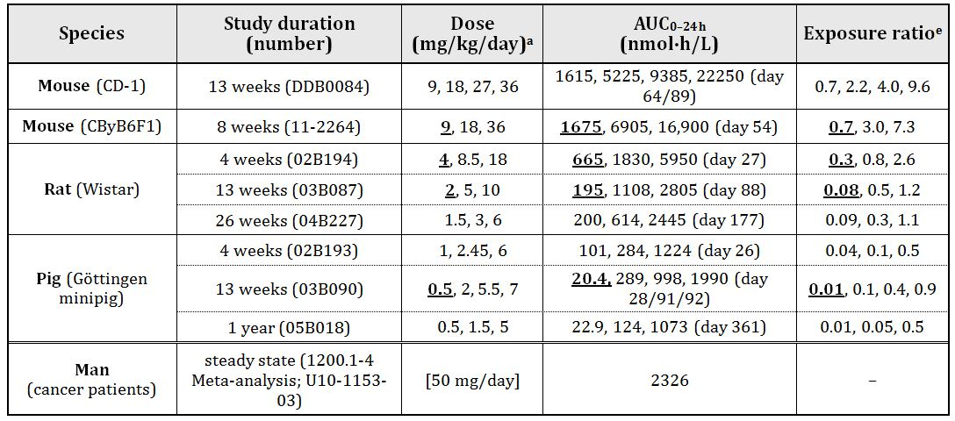

a. Dose given PO (gavage) and as dimaleate salt, but doses shown have been converted to free base equivalent.

b. NOAEL dose is bolded and underlined.

c. arithmetic mean of ♂ and ♀ values for respective dose groups.

d. day of dosing period on which plasma was sampled.

e. animal:human plasma AUC0-24 h.

##### Major toxicities

The major target organs for afatinib in the mouse were the skin and the gastrointestinal tract. The changes in skin were exhibited at the macroscopic level as swelling and reddening (cervical area and muzzle) and hair loss (torso), and at the microscopic level as dermal inflammation and epidermal hyperplasia. Other observations such as increased granulopoiesis in bone marrow, increased extramedullary haemopiesis in liver and spleen, increased circulating neutrophil counts, and changes in cell proliferative status in lymph nodes (increases in germinal centre development, granulopoiesis, and apoptosis), decreased red blood cells (RBC), increased reticulocytes and dermal inflammation. The gastrointestinal tract showed thickening of small intestine, which correlated with hypertrophy/hyperplasia of the mucosa at the microscopic level. Epithelial hyperplasia of gall bladder was seen in females at > 27 mg/kg/day (ER = 4). Drug treated mice showed other effects such as atrophy of the corneal epithelium and changes in oestrous cycle timing.

Rats showed skin changes, such as alopecia (associated with folliculitis) and inflammation (most prominent in facial area), and related secondary effects (similar to mice). Gastrointestinal effects (diffuse reddening and diarrhoea) were prominent at high doses (> 18 mg/kg/day; ER > 2) after 2-4 week dosing periods, but not in longer studies at lower doses (< 10 mg/kg/day; ER ≤ ~1). Rats given higher doses of afatinib for 3-6 month periods also showed evidence of renal papillary necrosis. The basis for the renal lesions was unclear but was thought to be related to a role for epidermal growth factor (EGF) in stimulating prostaglandin production in rat inner medulla collecting tubules. The effects of afatinib on rat skin and kidney were ameliorated but not resolved during a drug free recovery period of up to eight weeks. Rats also showed increased extramedullary haematopoesis in the spleen at > 3 mg/kg/day, although there was no evidence for decreases in RBC or haemoglobin (Hb). Other histological findings after a 4 week dosing period at 18 mg/kg/day included marked atrophy of oesophageal and gastrointestinal epithelia, erosion/ulceration of stomach (both glandular and non glandular), atrophy of epithelium of vagina and uterus, atrophy of seminal vesicles and prostate, and increased apoptosis in testes.

The main targets for afatinib toxicity in the pig were the gastrointestinal tract and cornea. After one year of daily oral dosing, the epithelium of the oesophagus and stomach showed evidence of atrophy and vacuolation. Both the corneal epithelium and the mucous glands of the larynx also showed slight-to-minimal atrophy. Atrophy of corneal epithelium was present in pigs at > 1.5 mg/kg/day (ER ≥ 0.05). Pigs dosed at 5 mg/kg/day (ER = 0.5) also showed increased circulating neutrophil counts, transient decreases in albumin/globulin ratio, and increased blood urea concentration. The latter was not associated with renal changes at the histological level. These effects were largely reversed during a 6 week, drug free recovery period. Daily, oral dosing of pigs for shorter periods (3-13 weeks), at higher doses (compared with the one year study), was associated with soft faeces/diarrhoea and with atrophy of the epithelium of the digestive tract, larynx, trachea, male accessory glands (prostate and seminal vesicle), and cornea.

Gastric ulceration was also observed in pregnant rabbits dosed at 10 or 16 mg/kg/day (ER = ≥0.6) for 13 days.

In general, the activity of afatinib towards epithelial tissues was considered consistent with its pharmacodynamic activity and with the reported effects of other EGFR inhibitors.

##### Other toxicity studies

Clinical preparations of afatinib include maleate as the counterion. Previous studies using rats and dogs have shown that maleate can induce nephrotoxicity.[11] Nephrotoxicity in dogs following a single oral dose of maleic acid at ≥ 9 mg/kg (lowest dose tested) was shown as acute tubular necrosis and elevated serum urea and creatinine levels.[12] A study by Harrison and Harrison[13] showed renal glycosuria, phosphaturia, and aminoaciduria in rats after an intraperitoneal (IP) dose of maleic acid.

Most toxicity studies with afatinib used the dimaleate salt form and showed elevated blood urea (no increases in creatinine) in rats and pigs and papillary necrosis of kidneys in rats at high doses (dose of afatinib base: > 6 mg/kg/day in rats and > 5 mg/kg/day in pigs; corresponding maleic acid dose 2.9 and 2.4 mg/kg/day, respectively). No signals of renal toxicity were detected in rats at an afatinib dose of 3 mg/kg/day (maleic acid dose 1.4 mg/kg/day) for 26 weeks and in pigs at 1.5 mg/kg/day (maleic acid dose of 0.7 mg/kg/day) for 12 months.

The toxicity of maleic acid was studied in pigs by the sponsor. Pigs were orally dosed for 32 consecutive days with maleic acid at 3 mg/kg/day (approximately equivalent to the maleic acid content of afatinib dimaleate when dosing at the afatinib free base equivalent of 6 mg/kg/day). No adverse effects were observed, suggesting the renal effects observed in rats and pigs dosed with afatinib dimaleate were probably related to afatinib rather than maleic acid.

The recommended clinical dose of afatinib base (50 mg/day or 1 mg/kg/day for a 50 kg person) delivers a maleic acid dose of ~0.5 mg/kg. The Lowest Observed Effect Level (LOEL) for maleic acid in dogs (9 mg/kg, single dose, equivalent to 180 mg/m2) is ~11 times the clinical dose (16.5 mg/m2) based on dose per body surface area (BSA). The maleic dose (3 mg/kg/day, equivalent to 60 mg/m2) in the one month pig study with no adverse effects was ~4 times the clinical dose adjusted for BSA.

Accordingly, there is a small margin (x11) between maleic acid doses capable of inducing renal effects in dogs (and an even smaller margin (x4) between the No Observed Effect Level [NOEL] in pigs) and those deriving from clinical dosing with afatinib dimaleate. Many approved medicines are prepared as maleate salts, but the amount of maleic acid taken by patients from these medicines is generally much lower than from afatinib dimaleate. There is a small probability of adverse renal effects in patients due to the dose of maleic acid.

*In vitro* experiments with the mouse 3T3 cell line examined possible synergism between afatinib and ultraviolet A irradiation. The results were inconsistent but indicated that afatinib may have phototoxicity potential.

#### Genotoxicity

Ames assay testing of afatinib gave a weakly positive result (up to 2.2 fold, reproducible increase at multiple concentrations with and without metabolic activation in the plate incorporation assay but not in the pre incubation assay) in one bacterial strain, TA98. However, *in vivo* mutagenesis testing in a lacZ mutation assay in mice dosed with up to 70 mg/kg/day (ER = 9) afatinib for four weeks gave negative results. Likewise, comet assay analysis of cells from liver, kidney, and jejunum of rats dosed twice with afatinib at up to 200 mg/kg/day, showed no evidence for induction of DNA single strand breaks. At a cytotoxic concentration (20 μg/mL) and in the absence of metabolic activation, afatinib induced chromatid breaks in an *in vitro* assay using normal human lymphocytes. However, two rat bone marrow micronucleus studies at oral doses of up to 18 mg/kg/day (ER = 3) for 4 weeks and up to 32 mg/kg/day (ER = 5) for 2 weeks gave negative results. Hence, the weight of evidence suggests that afatinib is unlikely to pose a genotoxic risk to patients.

##### Carcinogenicity

Studies assessing the carcinogenic potential of afatinib were not performed by the Sponsor. This is reasonable, given the drug’s apparent lack of genotoxicity under *in vivo* conditions and its proposed use in patients with a limited life expectancy, and is consistent with published guidelines.[14]

##### Reproductive toxicity

These studies used standard species (rat and rabbit) and appropriate group sizes and timing and duration of drug treatment. Pivotal studies were performed to GLP standards.

Results from the dosing of pregnant rats with radioactively labelled afatinib suggested that afatinib has very limited ability to cross the placenta. However, oral dosing of lactating rats demonstrated rapid excretion of high levels of afatinib and/or its metabolites into milk (milk/plasma radioactivity ratio of 137, based on AUC).

As shown in the table below, relative exposures to afatinib in all reproductive studies were near or below the clinical exposure based on AUC.

Table 6: Relative exposure in reproductive toxicity studies.

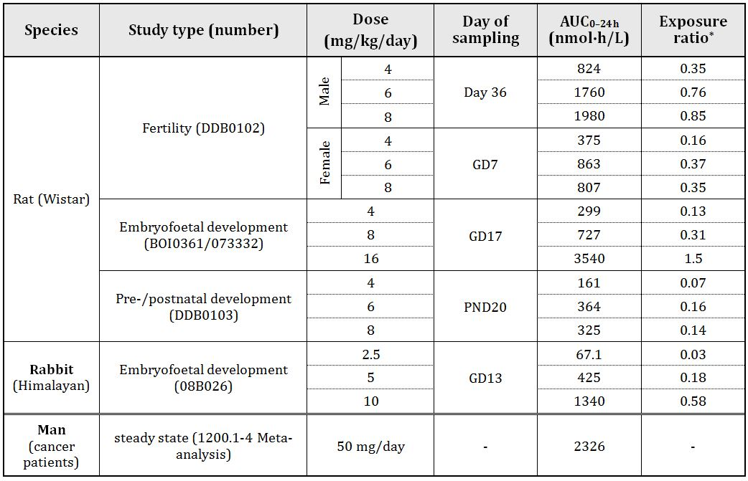

* animal:human plasma AUC0-24h ratio; GD, gestation day.

In the fertility and early embryonic development study, repeat daily dosing at up to 8 mg/kg had no significant effect on male rat mating or fertility parameters. Female rats dosed at 8 mg/kg/day showed a statistically significant decrease in numbers of live embryos per litter. This result was correlated with a decrease in corpora lutea and implantations, and associated with a decrease in weight gain.

In the embryofoetal development study, pregnant rats dosed at 16 mg/kg/day (ER = 1.5) during organogenesis showed no effect on numbers of live foetuses per litter, but showed significantly lower foetal and placental weights compared with controls, associated with decreased body weight gain of the dams. There were no foetal abnormalities. Pregnant rabbits, given oral doses of afatinib during organogenesis, showed decreased mean foetal weight and abortions at 10 mg/kg/day (ER = 0.6) and an increased resorption rate and a consequent decrease in the mean number of viable foetuses per litter at 16 mg/kg/day (ER = 1.8); the latter dose in the preliminary dose range finding study resulted in significant maternotoxicity necessitating early termination (one death on gestational day (GD) 16 and the rest sacrificed on GD 15-17). Maternal effects (decreased body weight gain and gastric ulceration) were also evident at 10 mg/kg/day. Minor skeletal and skin abnormalities of the foetuses (flexure of extremities, abnormal curvature of ribs, and less integument of forelimbs) were observed at >10 mg/kg/day. Afatinib was not teratogenic in rats or rabbits.

Embryos/foetuses might be expected to show high sensitivity to afatinib, as EGFR null mice typically have a short lifespan and can die at around mid gestation.[15] The relatively minor foetal effects in the embryofoetal developmental studies in rats and rabbits are likely explained by the finding that afatinib has a very limited ability to cross the placenta in rats.

In a pre/post natal development study in rats, no clinical signs or behavioural differences were seen in pups nursed by dams receiving oral doses of up to 8 mg/kg/day (ER = 0.14) of afatinib from GD6 to post natal day (PND) 20. Decreased pup birth weight and weight gain were observed at 6 or 8 mg/kg/day (ER = 0.16). High levels of afatinib and/or its metabolites (measured as radioactivity from radiolabelled afatinib) were detected in milk. Relatively low afatinib levels were detected in rat pup plasma (~10% of maternal plasma levels) 4 h after dosing the dams on PND 4.

###### Pregnancy classification

The sponsor has proposed Pregnancy Category C.[16] Based on the data presented, this category is considered appropriate.

##### Local tolerance

GLP compliant studies showed that afatinib (as dimaleate) had no significant irritant properties towards rabbit skin, but was an irritant when applied to the conjunctival sac of the rabbit eye. The effects on the conjunctiva were reversible. There was no skin sensitisation study on afatinib. As a film coated tablets, the risk of skin sensitisation to health professionals and patients should be low.

##### Impurities

Genotoxicity assays and a repeat dose study were performed with real or potential impurities/degradants. Four impurities required qualification. The proposed limits of the impurities/degradants in the drug substance and product are toxicologically acceptable.

Three potential impurities were mutagenic in bacterial gene mutation assays and should be controlled to as low as possible and should be no more than 30 ppm in the drug substance or finished product.

##### Paediatric use

Afatinib is not intended for use by patients under 18 years of age, hence studies using juvenile animals were not performed.

### Nonclinical summary and conclusions

#### Summary

* The sponsor, Boehringer Ingelheim Pty Ltd, has applied to register a new chemical entity, afatinib (Giotrif) for the treatment of patients with locally advanced or metastatic NSCLC with EGFR (ErbB1) mutation(s). Afatinib is proposed to exert anti tumour activity by covalently bonding to the ATP binding site of ErbB family members, thereby irreversibly inhibiting their protein tyrosine kinase activity. The proposed dosing regimen is for patients to receive up to 50 mg orally once daily. Treatment is to be continued until disease progression or until no longer tolerated by the patient.
* The nonclinical studies are comprehensive and of high quality. Most studies were performed in the sponsor’s own laboratories, although a selection of studies was performed by independent laboratories. Pivotal studies were performed to GLP standard.
* Consistent with its proposed mechanism of action, afatinib was shown by X-ray crystallography to bind covalently to the kinase domain of EGFR/ErbB1 and was shown to irreversibly inhibit the kinase activities of purified EGFR (both wild type and mutant), ErbB2 (HER2), and ErbB4 with IC50 values of ~0.3-10 nM, ~20 nM, and ~1 nM, respectively. Afatinib was also effective at inhibiting cell proliferation and autophosphorylation of EGFR in cell lines expressing wild type or mutant protein. In all these activities, afatinib showed comparable or greater inhibition than comparator drugs. Afatinib also produced growth delay or regression of various human tumour types grown as SC implants in mice at plasma drug concentrations comparable with Cmax in patients.
* In secondary pharmacodynamics studies, testing of panels of protein kinases and receptors did not identify targets that were likely to be significantly inhibited at clinical plasma levels of afatinib. Safety pharmacology studies showed no CNS or respiratory effects at supra clinical exposure levels, whilst cardiovascular, and renal effects were only seen at supra clinical exposure levels. However, rat studies suggest that afatinib may reduce gastrointestinal motility and gastric secretion in patients.
* PK studies showed inter species differences with elimination half life ranging from 2.6 h (rabbit) to 37 h (human), CL/F 30-500 mL/min/kg, and Vss/F 44-222 L/kg. Afatinib and metabolites were widely distributed in rat tissues, with the highest concentrations in kidney, spleen, liver, pituitary, and lung, and the lowest concentration in brain. Rat studies showed persistence of drug in the retina and pigmented skin, suggesting an affinity of afatinib and/or its metabolites for melanin containing tissues. Other rat tissues showed progressive accumulation of drug with repeated daily doses, which was thought to reflect covalent bonding of afatinib to protein.
* Daily repeat oral dosing of mice and pigs with afatinib for up to 3 months and one year, respectively, showed no marked increases in plasma drug levels and no effects of gender. Repeat dosing of rats, however, produced significant drug accumulation; an effect that was more pronounced in male than in female rats. There was evidence for modest drug accumulation during repeat dosing of humans.
* In all species examined, metabolism of afatinib was relatively minor and unchanged parent compound was the major moiety excreted. Similar to humans, afatinib excretion in animal models was predominantly (>90%) via the faeces, with only minor excretion via urine.
* Afatinib was shown to be a substrate for the cellular membrane transporters P-gp and BCRP. The disposition profile of afatinib may be affected by P-gp inhibitors or inducers. Afatinib is an inhibitor of P-gp and BCRP with IC50 values considerably higher than the free fraction Cmax in patients, suggesting afatinib is unlikely to alter the PK of other pharmaceuticals through P-gp or BCRP mediated efflux, although it may inhibit intestinal efflux of P-gp substrates because of the estimated high concentration in the intestine. Afatinib showed only minor metabolism by CYP enzymes, did not induce or inhibit CYP activity, and only weakly inhibited glucuronidation catalysed by UGT1A1 or by UGT2B7. These results suggest that afatinib is unlikely to interfere with the clearance of other drugs via effects on glucuronidation or CYP metabolism. *In vitro* studies also suggested low potential for interactions through organic anion transporting polypeptides (OATP2, OATP8, or OATP-B) or organic cation transporters (OCT1, OCT2, or OCT3).
* Repeat dose toxicity studies identified skin (inflammation, epidermal hyperplasia, alopecia), gastrointestinal tract (diarrhoea, mucosal hypertrophy and hyperplasia, erosion, ulceration), cornea (epithelial atrophy), and kidneys (papillary necrosis) as the major target organs. Reduced erythrocytes, extramedullary haematopoesis, and/or bone marrow granulopoiesis were also observed in some studies. The effects seen in animals were largely reversed during a drug free recovery period (skin and renal effects in rats not fully reversed).
* Afatinib showed weak mutagenic activity in one bacterial strain in the Ames assay, but lacked activity in an *in vivo* mutagenesis assay using mice. The comet assay of cells from rats dosed with afatinib failed to detect induction of DNA breakage. Afatinib was not clastogenic in rat bone marrow micronucleus studies. Hence, afatinib appears to lack both mutagenic and clastogenic activity under *in vivo* conditions and is unlikely to pose a genotoxic risk to patients. No carcinogenicity studies were presented by the sponsor. This is acceptable given afatinib’s lack of significant genotoxicity under in vivo conditions and its proposed use in patients with a limited life expectancy.
* Afatinib had no effects on fertility, although it decreased implantations. No evidence of teratogenicity was observed in rat and rabbit studies. However, afatinib showed a very limited ability to cross the placenta in rats. Whether this result holds true for other species (including humans) is unknown. It is therefore appropriate, given afatinib’s activity towards ErbB family members (key regulators of cell proliferation, differentiation, death, motility, and adhesion) and likely potential to cause foetal harm, that it be placed in Pregnancy Category C. Low birth weights and pup weight gain were detected in rats treated with afatinib during late gestation and lactation.
* Afatinib had no significant irritant properties towards rabbit skin, but was an irritant when applied to the conjunctival sac of the rabbit eye.
* An *in vitro* phototoxicity assay indicates that afatinib has low phototoxicity potential.
* Maleate (used as the counterion in afatinib dimaleate drug substance) can induce nephrotoxicity in rats and dogs. Oral dosing of pigs for 32 consecutive days at 3 mg/kg/day (approximately equivalent to the maleic acid content of afatinib dimaleate when dosing at the afatinib free base equivalent of 6 mg/kg/day) had no adverse effects. This represents a margin of ~4 fold (adjusted for BSA) between the dose given to pigs and that received from a 50 mg clinical dose of afatinib dimaleate. Hence, there is a small probability of adverse renal effects in patients due to the dose of maleate.
* The proposed limits of the impurities/degradants in the drug substance and product are toxicologically acceptable. Three potential impurities, shown to be mutagenic in bacterial assays, should be controlled to as low as possible and should be no more than 30 ppm in the drug substance or finished product.

#### Conclusions and recommendation

* The results of primary pharmacology studies support the use of afatinib for NSCLC treatment.
* The secondary pharmacodynamics and safety pharmacology studies did not identify clinically relevant hazards except for possible effects on gastrointestinal motility and gastric secretion in patients.
* The major target organs for afatinib toxicity in animal models were generally epithelial tissues, consistent with its pharmacodynamic activity and with the reported effects of other EGFR inhibitors.
* Afatinib is not considered to pose a genotoxic hazard.
* Afatinib was not teratogenic in rats and rabbits, but afatinib showed a very limited ability to cross the placenta in rats. Given afatinib’s pharmacological activity, Pregnancy Category C is appropriate.
* There are no nonclinical objections to registration.
* The draft PI should be amended as directed.

## IV. Clinical findings

A summary of the clinical findings is presented in this section. Further details of these clinical findings can be found in Attachment 2.

### Introduction

The clinical dosser documented a full clinical development program of clinical pharmacology, efficacy and safety studies. It contained the following clinical information:

* 12 clinical pharmacology studies, including 11 that mainly provided PK data and 1 that mainly provided pharmacodynamic data (on effects on the QT interval[17]);
* 4 population PK analyses;
* 1 pivotal and 1 main supportive efficacy/safety studies in NSCLC;
* 4 other efficacy/safety studies in NSCLC;
* 9 other efficacy/safety studies in other indications;
* Individual case reports (referred to as ‘augmented narratives’) of significant adverse events that had occurred in 12 other ongoing clinical trials; and
* Literature references.

### Pharmacokinetics

Table 7 shows the studies relating to each PK topic and the location of each study summary.

Table 7: Submitted PK studies.

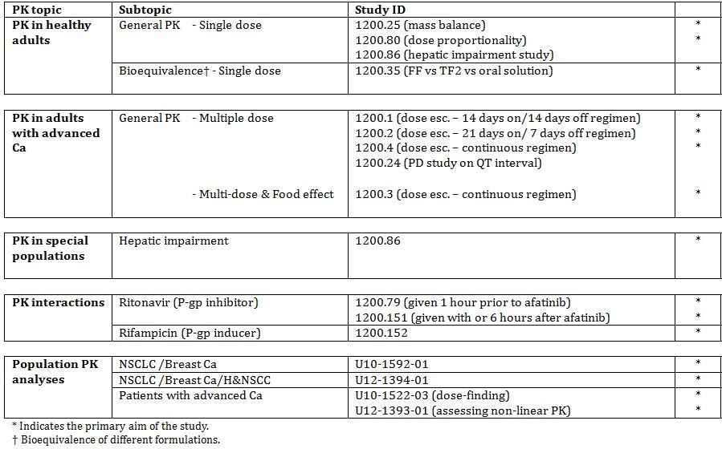

None of the pharmacokinetic studies in Table 1 had deficiencies that excluded their results from consideration.

Table 8 lists PK studies that were included in the submission but have not been reviewed in this report.

Table 8: PK studies excluded from consideration.

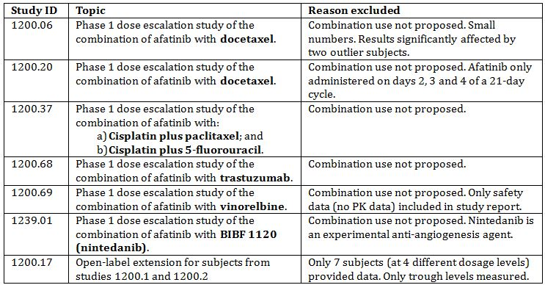

Six of the studies were phase 1 trials examining the use of afatinib in combination with other anticancer agents in patients with advanced cancer. The primary objective of these trials was to identify the maximum tolerated dose (MTD) of the combination under study and collection of PK data was a secondary objective. The conclusions of the studies were generally that afatinib did not affect the PK of the co-administered drugs. The studies were not designed to examine the effect of the other drugs on the PK of afatinib. The sponsor is only seeking approval for use of afatinib as monotherapy, and hence the data on combination use with these agents are not considered relevant to the application. Two studies examined combination with docetaxel, which is a substrate for CYP3A4, and hence may have provided some interaction data relevant to concomitant use of afatinib with other CYP3A4 substrates. However, due to design deficiencies the studies are not considered to provide firm evidence of an absence of an effect of afatinib on CYP3A4.

#### Evaluator’s overall conclusions on pharmacokinetics

The submission did not include an absolute bioavailability study. The sponsor provided a justification for not performing such a study. In brief, the justification argued the following:

* Afatinib has high passive permeability, and the effect of P-gp/BCRP on absorption is ‘mild’;
* A significant first pass effect would not be expected as afatinib is only metabolised to a minor extent;
* Bioavailability would therefore be expected to be reasonably high. This was confirmed in rats where absorption was 68% and absolute bioavailability was 45%;
* As the drug has nonlinear PK, exposure after IV administration would need to be tested at different dosage levels, and this would represent an unacceptable burden for study subjects;
* Afatinib is only intended for oral administration and safety and efficacy have been established.

The sponsor concluded that an absolute bioavailability study would provide only limited additional information and that therefore it would not be ethically justified.

*Comment: The justification is not considered acceptable. A PK study on IV administration would provide data on the fundamental parameters of clearance and volume of distribution, which remain unknown for afatinib. Determination of absolute bioavailability would allow a greater understanding of the elimination of the drug (for example, whether it is eliminated unchanged in bile or simply not absorbed), the importance of the effect of P-gp and a clearer understanding of the importance of renal clearance (given the finding that renal impairment affects afatinib PK). It is noted that the TGA’s Australian Regulatory Guidelines for Prescription Medicines (ARGPM) Appendix 15 (1) states:*

*‘...absolute bioavailability studies are normally required for all new chemical entities except those intended for intravenous administration.’*

*Given the important PK information that could be generated, it is the opinion of this evaluator that such a study would not be unethical.*

*The argument that absolute bioavailability would need to be tested at different dosage levels is not accepted. The nonlinear PK of afatinib is due to saturable absorption, which would not affect IV administration. As the relative bioavailabilities of the various proposed oral dosages are known, comparison of one oral and one IV dosage level should be feasible.*

*The sponsor has not argued that formulation issues or poor local tolerance of an IV preparation are barriers to the conduct of an absolute bioavailability study.*

The submission did not include adequate data on the effect of severe hepatic impairment or severe renal impairment. However, the draft PI excludes use of the product in these populations and this is considered acceptable.

Apart from the lack of an absolute bioavailability study, the PK data included in the submission are considered adequate.

### Pharmacodynamics

Table 9 shows the studies relating to each pharmacodynamic topic and the location of each study summary.

Table 9: Submitted pharmacodynamic studies.

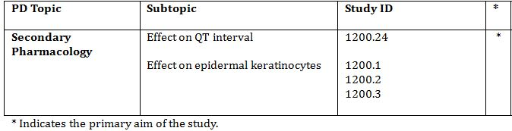

None of the pharmacodynamic studies had deficiencies that excluded their results from consideration.

#### Evaluator’s overall conclusions on pharmacodynamics

The sponsor has adequately examined the effect of afatinib on QT interval. There are no deficiencies in the submission with respect to clinical pharmacodynamic data.

### Efficacy

#### Evaluator’s conclusions on clinical efficacy for locally advanced or metastatic NSCLC with EGFR mutations

The indication for which the sponsor is seeking approval is as follows:

*‘For the treatment of patients with locally advanced or metastatic non‑small cell lung cancer (NSCLC) with Epidermal Growth Factor Receptor (EGFR) mutation(s).’*

Evidence provided in the submission has investigated the efficacy of afatinib in the following clinical situations:

* first line use in previously untreated patients;
* second line use after failure of first line chemotherapy;
* Use after failure of chemotherapy and a previous EGFR TKI.

##### First line use in previously untreated patients

Data to support use of afatinib in this group of patients come primarily from the pivotal Study 1200.32. The design and conduct of this study were consistent with the relevant EMA guidelines for anticancer agents, which have been adopted by the TGA.[18] The trial demonstrated a statistically significant benefit in terms of the primary endpoint of progression free survival (PFS). There have been several previous Phase III randomised controlled trials comparing EGFR TKIs with platinum based doublet chemotherapy in the first line treatment of EGFR mutation positive advanced NSCLC. The PFS and overall survival (OS) survival results for these and Study 1200.32 are summarised in Table 10. The hazard ratio (HR) for PFS achieved in Study 1200.32 (0.58) was somewhat higher than in these other studies. However, the prolongation of median PFS achieved in 1200.32 (4.2 months) was comparable to that achieved in the studies used for the TGA approval of gefitinib and erlotinib (IPASS and EURTAC, respectively). It is notable that none of the Phase III studies have demonstrated a survival advantage for EGFR TKIs. The pivotal study also demonstrated some benefits in the control of symptoms (cough and dyspnoea).

Table 10: Results for Phase III studies of first line use of EGFR TKIs in EGFR mutation positive NSCLC.

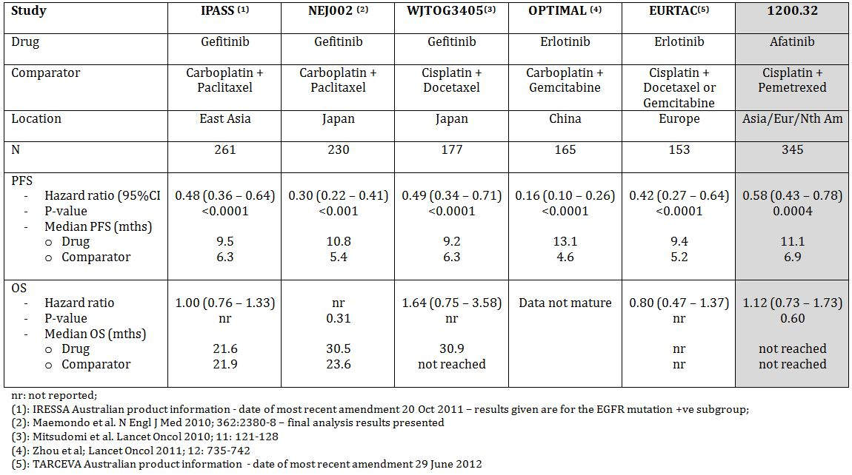

A Phase II study (Study 1200.22) in the first line setting gave results consistent with the pivotal study.

In summary, the efficacy data to support first line use are considered adequate.

##### Second line use after failure of first line chemotherapy

Current clinical guidelines recommend the use of an EGFR TKI for the first line treatment of advanced EGFR mutation positive NSCLC.[19] However, in Australia, PBS subsidy for the existing EGFR TKIs gefitinib and erlotinib is restricted to use in patients who have failed cytotoxic chemotherapy. Therefore, use of afatinib in this setting may be possible.

Evidence for efficacy of afatinib in this setting is limited to one Phase II study (1200.22). This study also enrolled patients in the first line setting. The efficacy results for subjects receiving afatinib as second line treatment after chemotherapy appeared only slightly inferior to those achieved with first line use (Tables 11 and 12). Given the clear evidence from the pivotal study for efficacy of afatinib in first line use, the submitted data, although limited, are considered adequate to support use of the drug in the second line setting following failure of chemotherapy.

Table 11: Supportive study 1200.22: Efficacy results for first line use of afatinib.

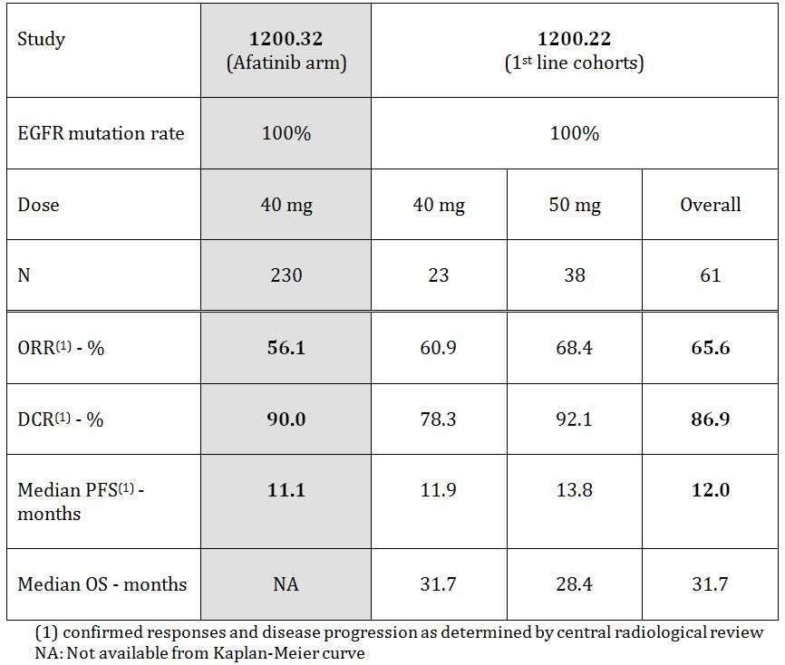

Table 12: Supportive studies: Efficacy results for second/later line use of afatinib.

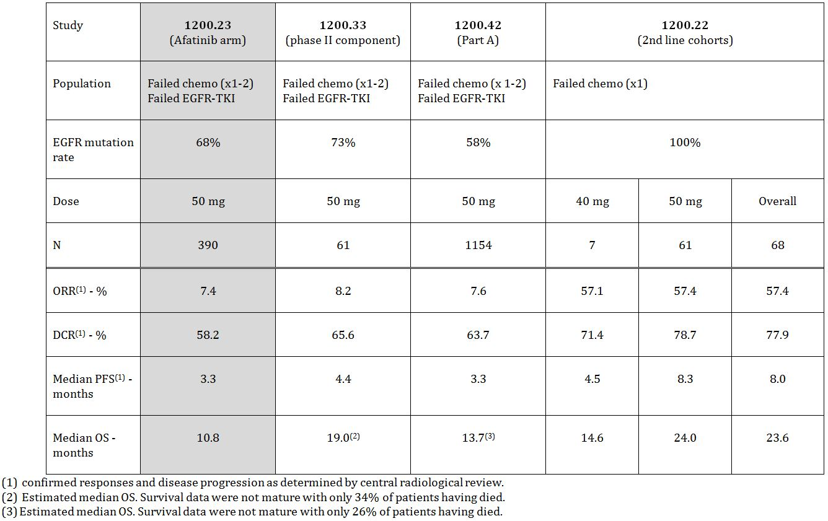

##### Use after failure of chemotherapy and a previous EGFR TKI

With the currently registered agents gefitinib and erlotinib, development of resistance generally occurs after approximately 12 months.[20] There are currently no therapies registered for this population and the availability of an effective agent in this setting would represent a significant advance.

The primary evidence to support efficacy of afatinib in this setting comes from the main supportive study (1200.23). The design and conduct of this study were consistent with the relevant EMA guidelines for anticancer agents,[21] which have been adopted by the TGA. The results indicate that efficacy of afatinib is less clear cut, compared to use as early therapy. Limitations of the efficacy data include the following:

* The study was not limited to subjects with EGFR mutation positive disease;
* The study failed to demonstrate a statistically significant effect for afatinib over placebo on the primary endpoint (OS);
* Even if the sponsor’s argument that subsequent therapies obscured a survival benefit is accepted, the size of the survival benefit appears limited (an increase in median survival of ~1.2 months);
* Efficacy assessed by PFS also appears short-lived. Although the relative risk reduction appears impressive (a HR of 0.38), the absolute risk reduction is modest, with an increase in median PFS of only 2.2 months. PFS at 6 months was increased from 6% with placebo subjects to 26% with afatinib, but 9 month PFS was only increased from 4% to 10%.
* The overall response rate (ORR) was low (7.4%).

The results of two Phase II studies in similar patient populations (Studies 1200.33 and 1200.42), gave comparable results to those obtained in 1200.23.

There have been reports of “re-responses” to EGFR TKIs occurring in patients following re-introduction of treatment after a short hiatus.[22] It is therefore not certain that the efficacy benefits demonstrated for afatinib in Study 1200.23 indicate an advantage for the drug over gefitinib or erlotinib.

Overall, it is considered that the efficacy of afatinib, in patients who have already failed treatment with an EGFR TKI and cytotoxic chemotherapy, is modest.

##### Other settings

There are no data in the submission to support use of afatinib as maintenance therapy following initial chemotherapy, an indication that is currently registered for erlotinib.

### Safety

#### Studies providing evaluable safety data

The following studies provided evaluable safety data:

##### Pivotal and main supportive efficacy studies (1200.32 and 1200.23)

These two studies are considered the most informative on the safety of afatinib for the proposed indication. Both were randomised controlled trials. Study 1200.23 was a double blind comparison with placebo and Study 1200.32 was an open label comparison with an established chemotherapy regimen (cisplatin + pemetrexed).

In these two studies, the following safety data were collected:

* General adverse events (AEs) were assessed at each study visit. Identification of AEs relied on spontaneous reporting by subjects.
* AEs of special interest were:
  + Events often seen in patients treated for oncological indications (nausea/vomiting, leukopenia, neuropathy, hepatic impairment); and
  + Events seen in association with EGFR/HER2 inhibition (diarrhoea with associated dehydration and renal impairment, rash/acne, stomatitis, ocular effects, heart failure, and Interstitial Lung Disease [ILD] like events).

These events were subjected additional analyses.

* Laboratory tests, including full blood count; biochemistry (sodium, potassium, calcium, creatinine, urea, glucose, AST, ALT, alkaline phosphatase [ALP], lactate dehydrogenase [LDH], bilirubin, uric acid and creatine phosphokinase [CPK]) and urine dipstick were performed at each study visit (every 4 weeks for Study 1200.23 and every 3 weeks for Study 1200.32). Coagulation parameters (prothrombin time [PT] and activated partial thromboplastin time [APTT]) were assessed at each study visit in Study 1200.23 but not in 1200.32.
* ECG and measurement of left ventricular ejection fraction (LVEF) (by echocardiography [ECHO] or multiple gated acquisition [MUGA] scan) were performed every 12 weeks for Study 1200.23 and every 9 weeks for Study 1200.32.
* Vital signs were assessed at each study visit.

##### Pivotal studies that assessed safety as a primary outcome

There were no studies that assessed safety as a primary outcome.

##### Dose response and non pivotal efficacy studies

The following dose response and non pivotal efficacy studies provided safety data. The safety data collected were adverse events, physical examination including vital signs, laboratory testing for haematology, biochemistry, coagulation parameters and urinalysis, ECGs and LVEF testing.

* Studies 1200.01, 1200.02, 1200.03 and 1200.04 (and the open label extension study 1200.17) were dose response studies conducted in subjects with advanced cancer. These studies also provided information on dose limiting toxicities.
* Studies 1200.42, 1200.22, 1200.33 and 1200.72 were open label, non comparative Phase II studies conducted in patients with advanced NSCLC.

##### Other studies evaluable for safety only

The submission included full study reports for a number of other studies that examined the use of afatinib in other indications. These studies were early Phase II trials exploring efficacy in a variety of malignancies. Treatment was generally continued until disease progression or unacceptable toxicity occurred. The studies collected data on AEs, laboratory testing (haematology, biochemistry and urinalysis in all studies and coagulation parameters in most studies), and physical examination including vital signs. Most of the studies also included ECGs and monitoring of LVEF.

Many of the studies were single arm, non comparative studies and/or enrolled small numbers of patients. The safety data are therefore of limited value.

##### Clinical pharmacology studies

There were 7 studies conducted in healthy volunteers (1 included patients with hepatic impairment). These were all single dose studies. These studies included monitoring of AEs, physical examination including vital signs, laboratory testing for haematology, biochemistry, coagulation parameters and urinalysis, and ECGs.

There was one pharmacodynamic study (1200.24), which investigated QT interval and other ECG effects. It also included monitoring of AEs, physical examination including vital signs, laboratory testing for haematology, biochemistry, coagulation parameters and urinalysis, and LVEF testing.

##### Other studies

As shown in Table 8, there were several studies included in the submission that examined the use of afatinib in combination with cytotoxic agents. These studies provided no evaluable data on the safety of afatinib as monotherapy. The sponsor also included some safety data (patient narratives) from various ongoing studies for which study reports are not yet available.

#### Evaluator’s overall conclusions on clinical safety

The main safety issues associated with afatinib are as follows:

* **Diarrhoea:** This is a very common toxicity occurring in up to 96% of patients. Diarrhoea of grade 3 severity is also very common, occurring in ~15% of subjects, whereas no cases grade 4 diarrhoea occurred in the 2 randomised controlled trials (RCTs). Episodes meeting the definition of a serious adverse event (SAE) occurred in ~5-7% of subjects. The consequences of diarrhoea, such as dehydration, renal impairment and electrolyte disturbances, were also more common in afatinib treated subjects. In the clinical studies, diarrhoea was actively managed with dose interruption and reduction, rehydration and loperamide. These measures appear to have been successful in managing the condition as < 5% of patients discontinued afatinib due to diarrhoea.
* **Stomatitis:** This is also a very common AE, occurring in up to 73% of subjects. Grade 3 toxicity was common (3-8%) but grade 4 toxicity was uncommon. Serious AEs of stomatitis were infrequent (~1%). In the placebo controlled study only one subject discontinued treatment due to stomatitis and none in the pivotal study.
* **Skin toxicity:** Rash or acne was very common, being seen in up to 90% of subjects. Other skin and integument effects (nail effects, pruritus, dry skin) were also very common. Grade 3 events of rash were also very common, but the other skin/integument effects were mostly of grade 1 or 2 severity. Serious skin events were uncommon and less than 2% of subjects had to discontinue treatment due to skin effects.
* **Ocular effects:** These were generally conditions such as conjunctivitis, dry eyes and blepharitis. Severity was generally mild to moderate. However, cases of keratitis were also observed. Discontinuation of afatinib due to ocular effects was uncommon (<1%).
* **Hepatic toxicity:** In both RCTs, afatinib treatment was associated with an increased incidence of LFT abnormalities. At the current time the evidence does not suggest that the drug will be associated with severe drug induced liver injury.
* **Interstitial lung disease (ILD):** ILD like AEs occurred with a higher incidence in the afatinib group of both RCTs. The overall incidence in the SAF-5 database was 0.7%. Although uncommon, such events are usually serious and often fatal.
* **Nasal effects:** The incidence of minor nasal effects such as epistaxis, rhinorrhoea and nasopharyngitis was increased in the afatinib arms of the 2 RCTs.
* **Impaired LVEF/cardiac failure:** The data suggest that afatinib treatment may possibly be associated with a slightly increased risk of these events. The trials excluded subjects with pre existing cardiac failure.
* **Pancreatitis:** The data suggest that afatinib treatment may be associated with an increased risk of acute pancreatitis.

The above safety issues have generally been observed with other EGFR or HER-2 inhibitors.

In the pivotal Study 1200.32, the incidence of AEs, grade 3 or 4 AEs, SAEs, and AEs leading to discontinuation was approximately comparable in the afatinib and chemotherapy arms. However, the pattern of AEs differed, with more haematological toxicity, nausea, vomiting and constipation in the chemotherapy arm, and more diarrhoea, stomatitis, skin and ocular toxicity in the afatinib arm.

It should be noted that use of the incidence data from the 2 RCTs might overestimate the toxicity of afatinib relative to its comparators, as the duration of treatment in the afatinib arms was longer.

### List of questions

#### Safety

In the SAF-5 dataset, there were 4 reports of drug related pancytopaenia and 3 reports of drug related bone marrow failure. Please provide any further information to address the concern that these events might represent episodes of idiosyncratic drug induced haematological toxicity.

### Clinical summary and conclusions

#### First round benefit-risk assessment

##### First round assessment of benefits

The benefits of afatinib in the proposed usage are:

In the **first line** setting (as shown in the pivotal Study 1200.32):

* A 42% reduction in the risk of PFS events (tumour progression or death), and a prolongation of median PFS of ~4.2 months (from 6.9 to 11.1), compared to cisplatin/pemetrexed chemotherapy.
* An increase in the probability of achieving an objective response (from 23% to 56%) compared to cisplatin/pemetrexed chemotherapy.
* An increase in the probability of achieving disease control (from 81% to 90%) compared to cisplatin/pemetrexed chemotherapy.
* Less cough and dyspnoea compared to cisplatin/pemetrexed chemotherapy.
* A reduction in the incidence of certain adverse effects associated with chemotherapy, including haematological toxicity, nausea and vomiting and constipation.

In the **second line** setting, after chemotherapy (as shown in Study 1200.22):

* An objective response in ~57%;
* A disease control rate of ~78%;
* A median PFS of ~8 months;
* A median OS of ~24 months.

**After failure of chemotherapy *and* a prior EGFR TKI** (as shown in Study 1200.23):

* A 62% reduction in the risk of PFS events, and a prolongation of median PFS of ~2.2 months (from 1.1 to 3.3), compared to placebo.
* An increase in the probability of achieving an objective response (from 0.5% to 7.4%) compared to placebo.
* An increase in the probability of achieving disease control (from 18.5% to 58.2%) compared to placebo.
* A delay in deterioration of cough, and an increase in the percentage of patients who had improvement in cough, dyspnoea or pain compared to placebo.

##### First round assessment of risks

The risks of afatinib in the proposed usage are:

* Gastrointestinal (especially diarrhoea and stomatitis) and dermatological adverse effects. These are very frequent and may be so severe as to warrant discontinuation of the drug in a small proportion of subjects;
* Ocular and nasal adverse effects. These are common but generally mild to moderate in severity;
* Hepatic toxicity usually manifested as abnormal liver function tests (LFTs). At this stage the available evidence does not indicate a potential for afatinib to cause severe drug induced liver impairment;
* Interstitial lung disease, which is uncommon but potentially life threatening when it occurs;
* Pancreatitis, which is also uncommon but serious;
* A possible increased risk of impaired LVEF and cardiac failure.

Overall, the incidence of adverse events etc. with afatinib appears comparable to that seen with an established NSCLC chemotherapy regimen (cisplatin/pemetrexed), although the pattern of individual adverse events differs. The pattern of AEs is similar to that seen with other EGFR TKIs such as gefitinib and erlotinib. The toxicity of the drug appears manageable (by dose reductions etc.) in that only 7-12% of patients have to discontinue treatment due to adverse events.

##### First round assessment of benefit-risk balance

###### First line use

The benefit-risk balance of afatinib, given as first line treatment, is favourable. The evidence indicates that the drug is more effective than cisplatin/pemetrexed with comparable overall toxicity. The risks associated with chemotherapy regimens such as cisplatin/pemetrexed are considered acceptable in the setting of advanced NSCLC. The other registered EGFR TKIs (gefitinib and erlotinib) are approved for use in the first line setting, and the efficacy results of the pivotal study appear comparable to those achieved with these agents in Phase III trials.

###### Second line use (after chemotherapy)

Although the evidence is limited to Phase II data, the benefit-risk balance of afatinib in this setting is considered favourable. The data on ORR and disease control rate (DCR) suggest that the drug remains highly effective even after failure of chemotherapy.

###### Use after failure of chemotherapy AND a prior EGFR TKI

The sponsor is proposing to include in the PI specific claims of efficacy in this population, as well as a specific starting dose of 50 mg per day. Use in this late line setting represents a novel use of EGFR TKIs, as neither of the other two drugs in the class has had such a claim approved. Patients with EGFR mutation positive advanced NSCLC who have already failed both chemotherapy and a prior EGFR TKI have no established therapeutic options and hence availability of a safe and effective agent would be an advance.

However, in the opinion of this evaluator, the benefit-risk balance of afatinib in this setting is considered is unfavourable. The efficacy benefits in terms of PFS, OS and response rate are modest, and are outweighed by the drug’s toxicity. Although there was some benefit associated with afatinib treatment in terms of delay in deterioration of coughing, this is likely to be outweighed by other symptoms caused by afatinib toxicity.

It is noted that, in the commentary[23] that accompanied the publication of Study 1200.23,[24] the activity of afatinib in patients progressing after erlotinib or gefitinib was describe as ‘marginal’.

If afatinib’s irreversible inhibition of EGFR gives it a true clinical advantage over the reversible inhibitors gefitinib and erlotinib, then the logical place for it would be in early therapy, not as a last resort after failure of these drugs. It is noteworthy that the sponsor has the following ongoing trials:

* A Phase IIb study comparing afatinib with gefitinib for the first line treatment EGFR mutation positive adenocarcinoma of the lung (‘LUX Lung 7’) with an estimated enrolment of 264 subjects;[25] and
* A Phase III study comparing afatinib with erlotinib for the treatment of squamous cell lung cancer after at least one prior platinum based chemotherapy regimen (‘LUX Lung 8’) with an estimated enrolment of 800 subjects.[26]

#### First round recommendation regarding authorisation

It is recommended that the application to register afatinib be approved, but with the following indication, which is more limited than that proposed by the sponsor:

***As monotherapy****, for the treatment of patients with locally advanced or metastatic non‑small cell lung cancer (NSCLC) with* ***activating*** *mutations of the Epidermal Growth Factor Receptor (EGFR):*

* + - *As first line therapy; or*
    - *After failure of cytotoxic chemotherapy.*

The indication should specify use as monotherapy because the safety and efficacy of use in combination with chemotherapy have not been established.

It is recommended that the term ‘activating mutations’ be used, as it is used in the PIs for gefitinib and erlotinib and consistency of terminology would seem desirable.

The lack of an absolute bioavailability study is a significant deficiency in the application. However, as the risks and benefits of afatinib have been adequately characterised this deficiency is not considered grounds for rejection of the application.

## V. Pharmacovigilance findings

### Risk management plan

The sponsor submitted a Risk Management Plan which was reviewed by the TGA’s Office of Product Review (OPR).

#### Safety specification

The sponsor provided a summary of ongoing safety concerns which are shown at Table 13.

Table 13: Important identified and potential risks and missing information.

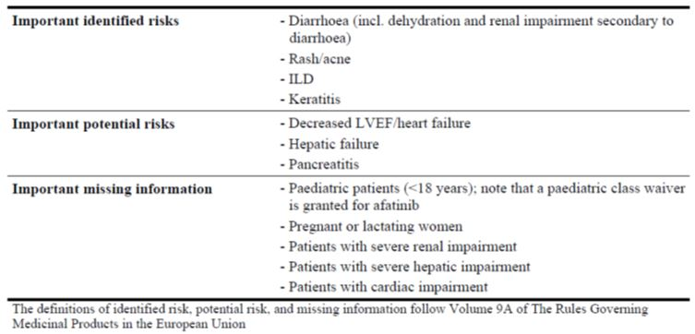

##### OPR reviewer comment

Notwithstanding the evaluation of the nonclinical and clinical aspects of the Safety Specification, some additional ongoing safety concerns should be considered.

Palmar-plantar erythrodysaesthesia (PPE) syndrome has been listed by the sponsor and in the literature[27] as a common AE, but not listed it as an ongoing safety concern. The sponsor should include this AE as an important identified risk.

The sponsor states that:

*Elderly patients were not excluded from the participation in clinical trials. However, information on elderly patients is limited due to low patient numbers: 271 patients being 75 years or older were reported in SAF-5. No clinical trials specifically in the elderly population were conducted.*

Given the limited experience with elderly patients, this population should be considered important missing information.

The sponsor states that:

*Clinically relevant drug-drug interactions of afatinib on the metabolizing enzymes UGT1A1 or UGT2B7 were considered as unlikely.*

The sponsor should provide adequate data to support this claim or otherwise add this as an ongoing safety concern.

The sponsor states that:

*No clinically relevant effect on the PK of afatinib and the respective cancer medications was observed.*

The cancer medications investigated were letrozole, docetaxel, temozolomide, paclitaxel and cisplatin, 5-fluorouracil and cisplatin, and trastuzumab. It is noted that gemcitabine is not contained in the information provided by the sponsor. The sponsor should add the combination of afatinib with gemcitabine as an ongoing safety concern (with relevant additional pharmacovigilance activities), unless evidence can be provided that gemcitabine has no clinically relevant effect on the PK of afatinib.

#### Pharmacovigilance plan

##### Proposed pharmacovigilance activities

The sponsor proposes only routine pharmacovigilance activities for important identified and potential risks and missing information (as stated above).

##### OPR reviewer’s comments in regard to the pharmacovigilance plan (PP) and the appropriateness of milestones

The sponsor only plans routine pharmacovigilance activities. This is not considered acceptable.

Patients with cardiac impairment constitute important missing information, as this patient population has been excluded from the studies presented by the sponsor. Given that population for which afatinib is indicated is likely to suffer from cardiac impairment, the sponsor should conduct relevant additional pharmacovigilance activities to investigate the effects of afatinib in cardiac impairment further.

Considering that there is only limited experience with elderly patients, this population should be investigated further with relevant additional pharmacovigilance activities.

Given the severity of hepatic failure or pancreatitis, these ongoing safety concerns should be investigated further with relevant additional pharmacovigilance activities. It is particularly important to elucidate the relationship of afatinib with pancreatitis.

Unless sufficient existing data is available, the PK relationship between afatinib and gemcitabine should be investigated further.

#### Risk minimisation activities

##### Sponsor’s conclusion in regard to the need for risk minimisation activities

The sponsor states that no additional risk minimisation activities are necessary.

##### OPR reviewer comment:

The sponsor’s conclusion is acceptable.

#### Summary of recommendations

The OPR provides these recommendations in the context that the submitted RMP (EU Risk Management Plan (EU-RMP) U12-1933-01 Version 1.0 (dated 26/07/2012, Data Lock Point [DLP] 21/03/2012) with Australian Specific Annex (ASA) Version 1.0 [dated 10/09/2012]) is supportive to the application; the implementation of a RMP satisfactory to the TGA is imposed as a condition of registration; the submitted EU-RMP is applicable without modification in Australia unless so qualified; and the draft product information and consumer medicine information documents should **not** be revised until the Delegate’s Overview has been received.

##### Further safety considerations

* Safety considerations may be raised by the nonclinical and clinical evaluators through the consolidated Section 31 request and/or the nonclinical and clinical evaluation reports respectively. It is important to ensure that the information provided in response to these includes a consideration of the relevance for the RMP, and any specific information needed to address this issue in the RMP. For any safety considerations so raised, please provide information that is relevant and necessary to address the issue in the RMP.

Unless the sponsor can provide compelling justification against any of the following recommendations, the following should be considered.

##### Recommendations in regard to ongoing safety concerns

* PPE syndrome has been listed by the sponsor and in the literature as a common adverse event, but not listed it as an ongoing safety concern. The sponsor should include this adverse event as an important identified risk.
* The sponsor states that:

*Elderly patients were not excluded from the participation in clinical trials. However, information on elderly patients is limited due to low patient numbers: 271 patients being 75 years or older were reported in SAF-5. No clinical trials specifically in the elderly population were conducted.*

Given the limited experience with elderly patients, this population should be considered important missing information.

* The sponsor states that:

*Clinically relevant drug-drug interactions of afatinib on the metabolizing enzymes UGT1A1 or UGT2B7 were considered as unlikely.*

The sponsor should provide adequate data to support this claim or otherwise add this as an ongoing safety concern.

* The sponsor states that:

*No clinically relevant effect on the PK of afatinib and the respective cancer medications was observed.*

The cancer medications investigated were letrozole, docetaxel, temozolomide, paclitaxel and cisplatin, 5-fluorouracil and cisplatin, and trastuzumab. It is noted that gemcitabine is not contained in the information provided by the sponsor. The sponsor should add the combination of afatinib with gemcitabine as an ongoing safety concern (with relevant additional pharmacovigilance activities), unless evidence can be provided that gemcitabine has no clinically relevant effect on the PK of afatinib.

##### Recommendations in regard to pharmacovigilance activities

* Patients with cardiac impairment constitute important missing information, as this patient population has been excluded from the studies presented by the sponsor. Given that population for which afatinib is indicated is likely to suffer from cardiac impairment, the sponsor should conduct relevant additional pharmacovigilance activities to investigate the effects of afatinib in cardiac impairment further.
* Considering that there is only limited experience with elderly patients, this population should be investigated further with relevant additional pharmacovigilance activities.
* Given the severity of hepatic failure or pancreatitis, these ongoing safety concerns should be investigated further with relevant additional pharmacovigilance activities. It is particularly important to elucidate the relationship of afatinib with pancreatitis.
* Unless sufficient existing data is available, the PK relationship between afatinib and gemcitabine should be investigated further.

##### Recommendations in regard to risk minimisation activities

* In regard to the proposed routine risk minimisation activities, it is recommended to the Delegate that the draft Consumer Medicine Information (CMI) document be revised as follows:
  + In the ‘Precautions’ section, the PI should include a statement that there has only been limited experience with an elderly patient population (over 75 years of age) and that his population may experience a higher rate of adverse events (or a statement to that effect).
  + In the ‘Interaction with other Medicines’ section, the PI should contain a statement that as there is a potential for afatinib to increase plasma concentrations of BCRP substrates and that caution should be exercised regarding co-administration (or a statement to that effect).
  + In the ‘Interaction with other Medicines’ section, the PI should contain a statement of potential interactions of afatinib with other common cancer drugs (or absence thereof, or missing information) (in particular in regard to gemcitabine) (or a statement to that effect).
  + In line with the clinical evaluator, in the ‘Precautions’ or ‘Adverse Events’ section, the PI should include a statement that afatinib treatment may be associated with an increased risk of developing acute pancreatitis.

#### Reconciliation of issues outlined in the RMP report

Reconciliation of issues outlined in the RMP report is as follows.

##### Recommendation in RMP evaluation report:

1. Safety considerations may be raised by the nonclinical and clinical evaluators through the consolidated section 31 request and/or the nonclinical and clinical evaluation reports, respectively. It is important to ensure that the information provided in response to these includes a consideration of the relevance for the RMP, and any specific information needed to address this issue in the RMP. For any safety considerations so raised, please provide information that is relevant and necessary to address the issue in the RMP.

##### Sponsor’s response (or summary of the response):

There were no questions from the nonclinical evaluator. The clinical evaluator requested the following information.

In the SAF-5 dataset there were 4 reports of drug-related pancytopaenia and 3 reports of drug related bone marrow failure. Please provide any further information to address the concern that these events might represent episodes of idiosyncratic drug induced haematological toxicity.

The sponsor’s response is summarised as below:

*Of the 7 cases identified one was later determined to not be pancytopaenia (Pt 162). All events occurred in patients receiving combination therapy. Six cases were non serious and all of these events recovered (1 with dose reduction and 5 without action taken). One case was considered serious but the event was associated with tumour progression. The data shows the events were consistent with one or two cell lines of marrow suppression and associated with the administration of chemotherapy. Labs tests were not available for two patients at the time of the reported event, however in these two patients follow up laboratory testing confirmed recovery. There is no indication afatinib is associated with pancytopaenia and there have been no reports of these events with afatinib monotherapy.*

The sponsor therefore considers it unnecessary to address the safety consideration raised by the clinical evaluator in the RMP.

##### OPR evaluator’s comment:

This is considered acceptable.

##### Recommendation in RMP evaluation report:

2. PPE syndrome has been listed by the sponsor and in the literature as a common adverse event, but not listed it as an ongoing safety concern. The sponsor should include this adverse event as an important identified risk.

##### Sponsor’s response (or summary of the response):

The sponsor acknowledges that PPE is an adverse reaction associated with afatinib therapy and the event is included in the current proposed labelling. The sponsor does not consider the event meets the regulatory definition of an “important” risk however. PPE is a known adverse reaction of cancer therapy, and it is easily recognisable and medical management is well understood. PPE has been adequately characterised in afatinib clinical trials.

Most events are grade 1 and 2, few events have been reported as SAEs and the event is unlikely to have serious consequences. There have been no discontinuations due to PPE in afatinib monotherapy trials. It can be concluded that there is no important impact on benefit risk, and risk minimisation with inclusion in the PI and the package leaflet is appropriate. The applicant is of the opinion that activities beyond routine PV are not required.’

##### OPR evaluator’s comment:

Given that, in the updated RMP ‘Skin reaction’ has replaced ‘Rash/acne’, it is considered that ‘PPE syndrome’ is a subset of the term, it is therefore included as an Important Identified Risk. But the sponsor should mention PPE syndrome specifically.

It is noted that for similar drug classes, the inclusion of ‘PPE syndrome’ as Important Identified Risk was required.

##### Recommendation in RMP evaluation report:

3. The sponsor states that:

*‘[e]lderly patients were not excluded from the participation in clinical trials. However, information on elderly patients is limited due to low patient numbers: 271 patients being 75 years or older were reported in SAF-5. No clinical trials specifically in the elderly population were conducted.’*

Given the limited experience with elderly patients, this population should be considered important missing information.

##### Sponsor’s response (or summary of the response):

As stated, there was no exclusion for age in clinical trials with afatinib. The safety in elderly patients using an arbitrary cut off of age >75 years was originally planned to be analysed. However, the mean age of patients participating in afatinib clinical trials was 60 years old and epidemiologic data showed the mean age of patients with advanced NSCLC is ~60-65 years old. With a mean overall survival in the EGFR TKI naive population estimated to be approximately 28 months, the number of patients >75 years old was very low and not an adequate representation of the elderly patients in the target population. Therefore to characterize the safety in the elderly population, the data was re-examined using a cut-off of age >70 years. Review of the data indicates that pooled safety data of patients in the subgroup of >70 years old was robust enough to adequately characterize the safety in elderly patients.

When pooled data from afatinib monotherapy in SAF-2 (40 mg starting dose cohort) and SAF-4 (50 mg starting dose cohort) were analysed to assess differences between ≥70 years of age compared to patients <70 years of age, adequate numbers of patients are evaluable for assessment of safety in the two cohorts. In SAF-2, there were 411 patients < 70 years of age and 340 patients ≥70 years of age.

Additionally elderly patients had a substantial duration of treatment in afatinib trials. The mean duration of treatment was higher among patients aged <70 years compared to patients aged ≥70 years in SAF-2 (10.5 months versus 8.4 months respectively) In SAF-4, the mean duration of treatment was slightly higher among patients aged ≥70 years compared to patients aged <70 years (4.4 versus 4.1, respectively) (data on file).

With an adequate number of patients >70 years old and a substantial duration of treatment exposure, there is adequate data to characterise safety in the elderly population and therefore this subpopulation is not missing information.

##### OPR evaluator’s comment:

This is considered acceptable.

##### Recommendation in RMP evaluation report:

4. The sponsor states that

*‘[c]linically relevant drug-drug interactions of afatinib on the metabolizing enzymes UGT1A1 or UGT2B7 were considered as unlikely.’*

The sponsor should provide adequate data to support this claim or otherwise add this as an ongoing safety concern.

##### Sponsor’s response (or summary of the response):

The inhibition of UDP glucuronosyltransferase (UGT) enzymes by afatinib was investigated *in vitro* using human liver microsomes.

The IC50 values for UGT1A1 were 24.2 μM and11.1 μM (two specific test reactions, using estradiol 3-glucuronidation and BIBF 1202 glucuronidation), respectively. The Ki for the latter test reaction was 10.9 μM.

An IC50 of 73.7 μM for UGT2B7 was calculated using *in vitro* estradiol 17-glucuronidation by human liver microsomes as test reaction. Unbound maximum plasma concentration of afatinib after repeated administration of 50 mg of afatinib was 0.008 μM, calculated from geometric mean total maximum plasma concentration of 0.158 μM and plasma protein binding of 95%.

*In vitro* Ki value of afatinib for UGT1A1was 1350 fold higher and IC50 value for UGT2B7 was 9200 fold higher than unbound maximum plasma concentration, and >68 fold and >460 fold higher than total plasma concentration of afatinib. Therefore, the applicant is of the opinion that the possibility of a clinical relevant DDI via inhibition of UGT1A1 and UGT2B7 by afatinib is unlikely and sufficiently supports the claim.

##### OPR evaluator’s comment:

This is considered acceptable.

##### Recommendation in RMP evaluation report:

5. The sponsor states that

*‘no clinically relevant effect on the pharmacokinetics of afatinib and the respective cancer medications was observed.’*

The cancer medications investigated were letrozole, docetaxel, temozolomide, paclitaxel and cisplatin, 5-fluorouracil and cisplatin, and trastuzumab. It is noted that gemcitabine is not contained in the information provided by the sponsor. The sponsor should add the combination of afatinib with gemcitabine as an ongoing safety concern (with relevant additional pharmacovigilance activities), unless evidence can be provided that gemcitabine has no clinically relevant effect on the pharmacokinetics of afatinib.

##### Sponsor’s response (or summary of the response):

Afatinib is indicated as monotherapy. Therefore there should be no requirement to include PK data with other anticancer medications. Data for letrozole, docetaxel, temozolomide, paclitaxel and cisplatin, 5-fluorouracil and cisplatin, and trastuzumab was only included in the dossier as background information and to support low interaction potential of afatinib.

Therefore, the sponsor is of the opinion that the combination of afatinib with gemcitabine should not be added to the RMP as an ongoing safety concern.

##### OPR evaluator’s comment:

This is considered acceptable.

##### Recommendation in RMP evaluation report:

6. Patients with cardiac impairment constitute important missing information, as this patient population has been excluded from the studies presented by the sponsor. Given that population for which afatinib is indicated is likely to suffer from cardiac impairment, the sponsor should conduct relevant additional pharmacovigilance activities to investigate the effects of afatinib in cardiac impairment further.

##### Sponsor’s response (or summary of the response):

The pharmacovigilance plan covers the actions intended to identify and characterise safety concerns.

Routine pharmacovigilance at BI is conducted according to written procedures for continuous monitoring and update of the safety profile and include the following:

* evaluation of individual case safety reports (ICSRs) from all reporting sources, with a focus on (but not limited to) serious AE reports
* review of aggregate safety data from all available sources
* qualitative and numerical signal detection (analysis of disproportionality)
* review of scientific literature with a possible implication for product safety
* safety reporting to regulatory authorities in accordance with applicable regulation/legislation

Furthermore, additional data collection via a focused questionnaire is being developed for reports of events of cardiac failure received in the post marketing setting. Information collected from the questionnaire will help to further characterise events of cardiac failure observed in patients exposed to afatinib.

##### OPR evaluator’s comment:

BI has not provided reasons why cardiac impairment should not be investigated further with additional pharmacovigilance activities, but only a description of their routine pharmacovigilance.

Describing routine pharmacovigilance activities is not a compelling justification not to conduct additional pharmacovigilance activities.

As a result, the Round 1 recommendation remains: the sponsor should conduct relevant additional pharmacovigilance activities to investigate the effects of afatinib in cardiac impairment further (or assign an existing additional activity).

##### Recommendation in RMP evaluation report:

7. Considering that there is only limited experience with elderly patients, this population should be investigated further with relevant additional pharmacovigilance activities.

##### Sponsor’s response (or summary of the response):

The pharmacovigilance plan covers the actions intended to identify and characterize safety concerns.

Routine pharmacovigilance at BI is conducted according to written procedures for continuous monitoring and update of the safety profile and include the following:

* evaluation of individual case safety reports (ICSRs) from all reporting sources, with a focus on (but not limited to) serious AE reports, review of aggregate safety data from all available sources
* qualitative and numerical signal detection (analysis of disproportionality)
* review of scientific literature with a possible implication for product safety
* safety reporting to regulatory authorities in accordance with applicable regulation/legislation

Furthermore, analysis of adverse events received in the post marketing setting will be conducted based on intrinsic factors such as age in order to further characterize safety in the elderly special population.

##### OPR evaluator’s comment:

Given the response to Question 3, elderly patients do not need to be included as Important Missing Information.

##### Recommendation in RMP evaluation report:

8. Given the severity of hepatic failure or pancreatitis, these ongoing safety concerns should be investigated further with relevant additional pharmacovigilance activities. It is particularly important to elucidate the relationship of afatinib with pancreatitis.

##### Sponsor’s response (or summary of the response):

The pharmacovigilance plan covers the actions intended to identify and characterise safety concerns.

Routine pharmacovigilance at BI is conducted according to written procedures for continuous monitoring and update of the safety profile and include the following:

* evaluation of individual case safety reports (ICSRs) from all reporting sources, with a focus on (but not limited to) serious AE reports
* review of aggregate safety data from all available sources
* qualitative and numerical signal detection (analysis of disproportionality)
* review of scientific literature with a possible implication for product safety
* safety reporting to regulatory authorities in accordance with applicable regulation/legislation

Furthermore, additional data collection via focused questionnaires is being developed for reports of events of pancreatitis and hepatic failure received in the post marketing setting. Information collected from the questionnaire will help to further characterize these events observed in patients exposed to afatinib.

##### OPR evaluator’s comment:

BI has not provided reasons why hepatic failure and pancreatitis should not be investigated further with additional pharmacovigilance activities, but only a description of their routine pharmacovigilance.

Describing routine pharmacovigilance activities is not a compelling justification not to conduct additional pharmacovigilance activities.

As a result, the Round 1 recommendation remains: the sponsor should conduct relevant additional pharmacovigilance activities to investigate the effects of afatinib with regard to hepatic failure and pancreatitis further (or assign an existing additional activity).

##### Recommendation in RMP evaluation report:

9. Unless sufficient existing data is available, the pharmacokinetic relationship between afatinib and gemcitabine should be investigated further.

##### Sponsor’s response (or summary of the response):

Afatinib film coated tablets will be used as monotherapy in the proposed indication of EGFR mutation positive NSCLC. Therefore, BI does not consider the investigation of a pharmacokinetic relationship between gemcitabine and afatinib to be warranted.

##### OPR evaluator’s comment:

This is considered acceptable, as long as afatinib is indicated as monotherapy, as stated by the sponsor.

#### Outstanding issues

##### Issues in relation to the RMP

###### Existing recommendations

* The sponsor should specifically include PPE syndrome as an Important Identified Risk.
* The sponsor should conduct relevant additional pharmacovigilance activities to investigate the effects of afatinib in cardiac impairment further (or assign an existing additional activity).
* The sponsor should conduct relevant additional pharmacovigilance activities to investigate the effects of afatinib with regard to hepatic failure and pancreatitis further (or assign an existing additional activity).
* In line with the clinical evaluator, in the ‘Precautions’ or ‘Adverse Events’ section, the PI should include a statement that afatinib treatment may be associated with an increased risk of developing acute pancreatitis.

###### New recommendations

* Based on recommendations in the nonclinical evaluation report, the sponsor should add ‘Effects on gastrointestinal motility and secretion’ as an Important Potential Risk.
* ‘Pregnant and lactating women’ should remain as Important Missing Information.
* In regard to the proposed routine risk minimisation activities, it is recommended to the Delegate that the draft product information document be revised as follows:
* In the ‘Precautions’ section, the sponsor should include a statement that it is unknown whether afatinib crosses the placenta in humans, but also that there was negligible placental transfer of afatinib in rats (or a statement to that effect).
* In the ‘Precautions’ section, the sponsor should include a statement that effects on gastrointestinal motility and gastric secretion were seen at 100 and 300 mg/kg/day in rats and that the same effects may occur in humans (or a statement to that effect).

##### Advice from the Advisory Committee on the Safety of Medicines (ACSOM)

Not applicable.

#### Comments on the safety specification of the RMP

##### Clinical evaluation report

The clinical evaluator made the following summary first round comment in regard to safety specifications in the draft RMP:

*The Safety Specification in the draft RMP is generally satisfactory. The sponsor has identified pancreatitis as an ‘important potential risk’. Other risks the sponsor places in this category are decreased LVEF/heart failure and hepatic failure. Although precautionary statements have been included in the draft PI for these latter risks, no mention of pancreatitis is included. As mentioned above, this evaluator considers there is sufficient evidence available to warrant inclusion of pancreatitis in the PI as an uncommon adverse drug reaction.*

The first round clinical evaluation report is the final report.

##### Nonclinical evaluation report

Nonclinical evaluator’s comment:

*The overview of the nonclinical program for afatinib and the conclusions drawn regarding possible clinical risks, as presented in the sponsor’s RMP (Version 1.1) provided in the Section 31 response, are comprehensive and reasonable. However, the following should be noted by the RMP evaluator:*

*SII.1.1.1: Cornea which was also identified as a target organ, is not stated in this section, although it is considered as an identified risk in the conclusion (SII.2).*

*SII.1.1.3: Decreased implantations at 8 mg/kg in the fertility and early embryonic development study is not described. While no serious adverse effects were seen in the embryofoetal development studies in rats and rabbits, there was limited placental transfer of afatinib and/or metabolites in rats. The absence of serious effects on embryofoetal development may be due to the lack of placental transfer in animal species. It is unknown whether afatinib crosses the placenta in humans. The negligible placental transfer of afatinib in rats should be stated.*

*SII.1.1.3: The animal to human exposure ratios (2.2 in rats and 0.3 in rabbits) described by the sponsor are different from the ratios calculated by the nonclinical evaluator (1.5 in rats and 0.6 in rabbits). However, these differences are not considered to have a significant impact on the assessment of potential risks in humans.*

*SII. Table 1: NOAELs indicated in the table for the following studies are inconsistent with the NOAELs determined by the nonclinical evaluator:*

*A NOAEL was not established in three repeat-dose toxicity studies (26 week study in rats, 4 and 52 week studies in minipigs), and in the 13 week carcinogenicity (dose range finding) study in mouse. The NOAEL should be 4 mg/kg/day in the rat embryofoetal and pre/post natal development studies, 8 mg/kg/day in the rabbit embryofoetal development study, and 2 mg/kg/day in the in vivo impurity qualification study in rats.*

*SII.1.2.3: Effects on gastrointestinal motility and gastric secretion were seen at 100 and 300 mg/kg/day in rats. The same effects may occur in humans, and should be stated as a potential risk.*

*SII.1.2.8: As indicated above for SII. Table 1, a NOAEL was not identified in the 52 week repeat dose study in pigs.*

#### Key changes to the updated RMP

* EU Risk Management Plan (EU-RMP) U12-1933-01 Version 1.0 (dated 26/07/2012, DLP 21/03/2012) with Australian Specific Annex (ASA) U12-1399-01 Version 1.0 (dated 10/09/2012)

has been superseded by

* EU Risk Management Plan (EU-RMP) U12-1933-02 Version 1.1 (dated 15/03/2013, DLP 21/03/2012) with Australian Specific Annex (ASA) U12-1399-02 Version 1.1 (dated 22/05/2013).

A summary of key changes between RMP versions 1.0 and 1.1 is provided in Table 14.

Table 14: Summary of key changes between RMP versions 1.0 and 1.1.

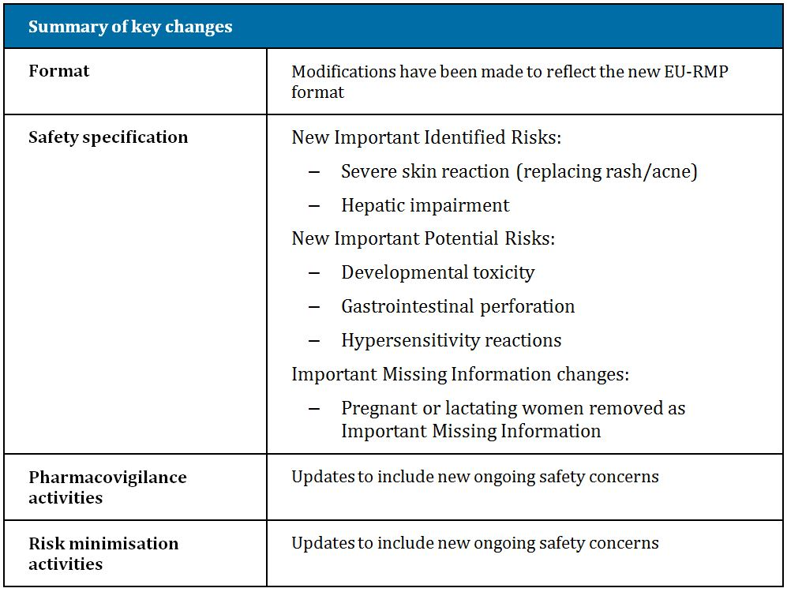

#### Suggested wording for conditions of registration

##### RMP

Implement EU Risk Management Plan (EU-RMP) U12-1933-02 Version 1.1 (dated 15/03/2013, DLP 21/03/2012) with Australian Specific Annex (ASA) U12-1399-02 Version 1.1 (dated 22/05/2013), and any future updates as a condition of registration.

##### PSUR

OMA to provide new wording when finalised.

## VI. Overall conclusion and risk/benefit assessment

The submission was summarised in the following Delegate’s overview and recommendations:

### Quality

In the Chemistry and Biopharmaceutic Summary for the Advisory Committee on Prescription Medicines (ACPM), it is noted that:

* The FF tablet formulation used in the pivotal clinical study (1200.32) is identical to that proposed for commercial supply, except for some film coat details and debossing, which will not affect bioavailability.

Registration is recommended with regard to chemistry, quality control and bioavailability aspects.

### Nonclinical

The nonclinical evaluator had no objection to registration.

### Clinical

The clinical evaluator recommends approval, with an indication modified from that originally proposed by the sponsor.

#### Overview of data

There were 12 pharmacology studies and 4 population PK analyses.

There was one **pivotal** efficacy/safety study, **Study 1200.32 (LUX Lung 3)**. This was a randomised (2:1), open label, Phase III trial of afatinib versus ‘pemetrexed + cisplatin’ as *first line* treatment of *EGFR TKI naïve* patients with NSCLC *with EGFR mutations*.

Influential supportive studies included:

* **Study 1200.22 (LUX Lung 2):** This was an open label, single arm, Phase II trial in EGFR TKI naïve patients with NSCLC with EGFR mutations receiving afatinib as first line or as second line (post chemotherapy) treatment.
* **Studies 1200.23 (LUX Lung 1):** This was a randomised study versus placebo in NSCLC patients who had failed 1-2 lines of chemotherapy and treatment with a reversible EGFR TKI, identified by the clinical evaluator as the main supportive study.
* **Study 1200.42 (LUX Lung 5) – Part A:** This large, uncontrolled study also provided support for use in patients who have progressed on treatment with other EGFR TKIs.

Two other clinical studies in NSCLC were included. Some safety data were from various non NSCLC studies. At the time of dossier submission (data cut off date 9/2/2012), 48 studies in 3868 cancer patients and 7 studies in 181 volunteers had been performed (29 of the 48 trials were ongoing).

#### Pharmacokinetics (PK)

##### ADME

Median T­max after single doses was 5-6 h, that is, absorption is relatively slow. There was no absolute bioavailability study but bioavailability of the proposed market formulation was only marginally lower than that of an oral solution. A high calorie, high fat meal reduced AUC by 39% and Cmax by 50%, and increased Tmax by >2 fold.

With single doses, PK after dosing in the 20-50 mg range was non linear, with greater than proportional increases in AUC and C­max with increasing dose (so a dose reduction from 40 mg to 30 mg, that is, by 25%, may decrease exposure by >25%), apparently due to non-linear absorption via saturation of P-gp efflux transport.

With once daily dosing, steady state Cmin was reached after 7 days; accumulation from single dose levels (as reflected by AUC and Cmax) was in the order of 2-3 fold.

Apparent volume of distribution (VD) was 2220-3150 L, suggesting extensive tissue distribution, but there were no studies of IV administration so VD was not calculable. There was binding to albumin and α-1 acid glycoprotein. There was also some degree of distribution into blood cells; *in vitro* studies suggested “rapid distribution predominantly into blood cells” (nonclinical evaluation report), and it was noted that afatinib covalently binds to haemoglobin (amongst other proteins). In rats, afatinib’s concentration was highest in kidney, spleen, liver, pituitary and lung, and lowest in brain; however PK varied across species. Also in rat studies, there was persistence of drug in the retina and pigmented skin, suggesting an affinity of afatinib and/or metabolites for melanin containing tissue (nonclinical evaluation report).

Metabolism was via ‘Michael addition’ to proteins such as albumin, globulins and Hb, an equilibrium process implying that adducts can slowly release afatinib. It seems Michael addition is not enzymatically mediated. Separately, flavin containing monooxygenase 3 may have a role in metabolism but evidence for this was from *in vitro* studies and FMO3 formed metabolites were not seen in cancer patients and were minor in healthy volunteers. CYP450 accounted for only 9% of metabolites. A large fraction of an oral dose is excreted unchanged in faeces; it is unclear if this represents unabsorbed drug or unchanged drug excreted in bile or via the intestine. In a mass balance study, 85% of an orally administered dose was excreted in the faeces and 4% in urine. Apparent renal clearance is low, suggesting non renal mechanisms are mainly responsible for clearance (but see below about effects of renal impairment on exposure).

Intra individual PK variability was moderate. Inter individual variability was moderate to high. FMO3 expression varies considerably from person to person;[28] perhaps, some alleles may produce slow or fast metaboliser phenotypes (the clinical significance of this has been validated for FMO3 substrates such as sulindac and ranitidine).

##### Special populations

In patients with mild to moderate hepatic impairment, AUC did not vary compared to patients with normal hepatic function, while Cmax rose slightly (27% with moderate impairment). FMO3 is mainly expressed in the liver. The effect of severe impairment has not been studied; the proposed PI accounts for this by recommending afatinib not be used in patients with severe hepatic impairment.

There was no direct study of the influence of renal impairment on afatinib metabolism. A population PK study found an unexpected correlation between worsening creatinine clearance and increasing AUC; this was accounted for by reduced expression of intestinal P-gp in renal impairment. The population PK analysis included very few patients with severe renal impairment; appropriately, the PI states that the drug is not recommended in this patient population.

Age, race, gender and weight were considered in population PK assessments but none of these variables had a large effect on afatinib exposure (this does not rule out significant effects on PK parameters in patients with various combinations of traits, for example, a low body weight female with diminished creatinine clearance (CrCL) could be predicted to have a significantly increased afatinib exposure, despite the absence of a ‘large’ effect of each individual trait; perhaps unsurprisingly, subjects with this combination of traits were at higher risk of grade 3+ diarrhoea and grade 3+ rash/acne from afatinib). The proposed PI notes the influence of weight, gender and CrCL (in fact a ‘Precaution’ is dedicated to this issue), so clinicians can take this into account as needed, but starting dose modifications are not proposed.

In many clinical studies, NSCLC populations were mainly from Asia (a higher proportion of NSCLC is EGFR mutant positive in Asia than in countries with mainly Caucasian populations). It is relevant that population PK studies found no influence of race on PK.

##### Drug interactions

Afatinib is a substrate and moderate inhibitor of P-glycoprotein.

An effect on afatinib’s exposure was seen with ritonavir (P-gp inhibitor) and rifampicin (P-gp inducer). The sponsor implied the effects were not clinically relevant in the context of intra subject variability of afatinib PK. Regarding P-gp inhibitors, the sponsor did note that timing of dosing may be relevant,[29] but a consideration is that chronically administered P-gp inhibitors may inhibit P-gp at concentrations lower than Cmax.

Potentially, afatinib may inhibit intestinal efflux of P-gp substrates (increasing their net absorption) because of the high concentrations of afatinib in the intestine. In terms of drug interactions resulting in altered absorption, the influence of afatinib’s toxicity (for example, in the intestine resulting in diarrhoea) might also be important.

Afatinib is considered a substrate and inhibitor of BCRP (nonclinical evaluation report). The effect of afatinib on BCRP substrates has not been studied *in vivo*. The effect of BCRP inhibition on afatinib was considered studied in the two afatinib/ritonavir studies, as ritonavir is a BCRP inhibitor *in vitro*.

#### Efficacy

##### Study 1200.32 (LUX Lung 3): pivotal study

This is an ongoing, Phase III, randomised, open label study of afatinib versus the combination of pemetrexed + cisplatin, as first line therapy in advanced or metastatic EGFR mutation positive adenocarcinoma of the lung. The data cut off was 9 February 2012.

Performance status was to be 0-1 (Eastern Cooperative Oncology Group [ECOG][30]). Prior neo adjuvant or adjuvant therapy was allowed if 12+ months had elapsed between end of chemotherapy and randomisation. Presence of active CNS metastases was an exclusion criterion.

EGFR mutation testing was done centrally using TheraScreen Mutation Kit.[31]

Randomisation was 2:1 (afatinib:comparator) as follows:

* Afatinib 40 mg once daily (OD) (increasing to 50 mg OD if patients tolerated the drug well for the first 3 weeks), continuing until disease progression or unacceptable toxicity.
* Pemetrexed (500 mg/m2) and cisplatin (75 mg/m2), both on Day 1 of a 21 Day cycle, for a maximum of 6 cycles.

Randomisation was stratified according to EGFR mutation (L858R versus Del 19 versus other) and according to race (Asian versus non Asian).

Of 1269 enrolled subjects, 924 were not randomised into the study; 817/1269 (64%) had an EGFR wild type tumour. The 36% incidence of EGFR mutant tumours is high and may reflect the large proportion of patients recruited from Asian countries.

About two thirds of 345 randomised subjects (n = 230 to the afatinib arm, n = 115 to chemotherapy) were female; mean age was 60 years (only 13 patients were 75+ yrs old); 72% were from east Asia; two thirds had never smoked. A total of 89.3% had Del19 or L858R; 10.7% had 10 different subtypes of EGFR mutation (including n = 13 with at least T790M). 10.7% had Stage IIIB at screening; 89.3% had Stage IV. Median time since diagnosis was 1-1.1 months across arms.

###### Progression free survival (PFS)

PFS was the primary endpoint; outcomes were assessed by central independent review panel, blinded to treatment. Response Evaluation Criteria In Solid Tumours (RECIST) criteria were used to determine progression and response. There were 1-5 target lesions followed for evidence of progression, every 6 weeks via CT (computed tomography) or MRI (magnetic resonance imaging) (every 12 weeks after Week 48) scan.

**Median PFS was prolonged by 4.2 months in the afatinib arm (11.1 versus 6.9 months)** (Figure 3). The HR was 0.58 (95% CI 0.43-0.78). There were conflicting findings in the subgroup with EGFR mutations other than deletion 19 or L858R (n = 37), where HR was 1.89. There was no clear cut correlation between trough afatinib levels (categorised by quartile) and PFS.

Figure 3. Kaplan-Meier estimates of PFS based on central independent review.

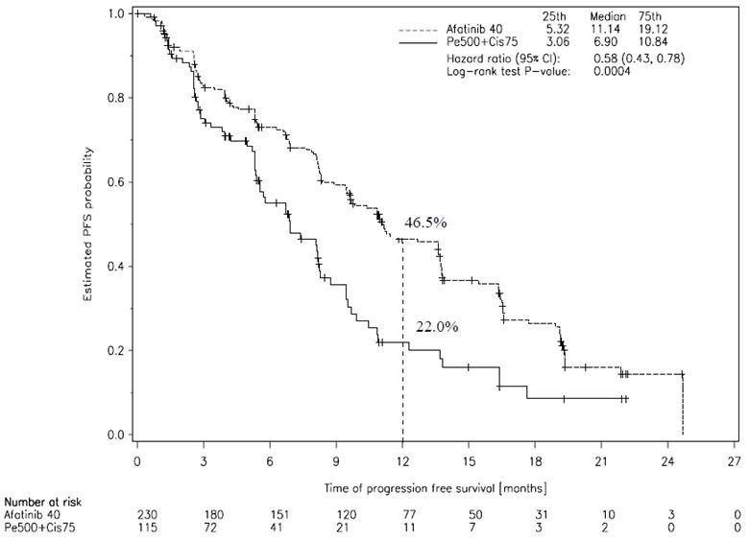

###### Overall survival (OS)

No survival difference was shown, with 29.1% of afatinib and 27% of chemotherapy patients having died by the interim cut off. The HR was 1.12 (95% CI 0.73-1.73). Table 15 shows that subsequent therapies differed across arms in patients who discontinued study treatment (afatinib patients moved to platinum based therapy; control arm patients moved to EGFR TKIs, typically erlotinib and gefitinib).

Table 15: Pivotal Study 1200.32: anticancer treatments received after discontinuation of study medication.

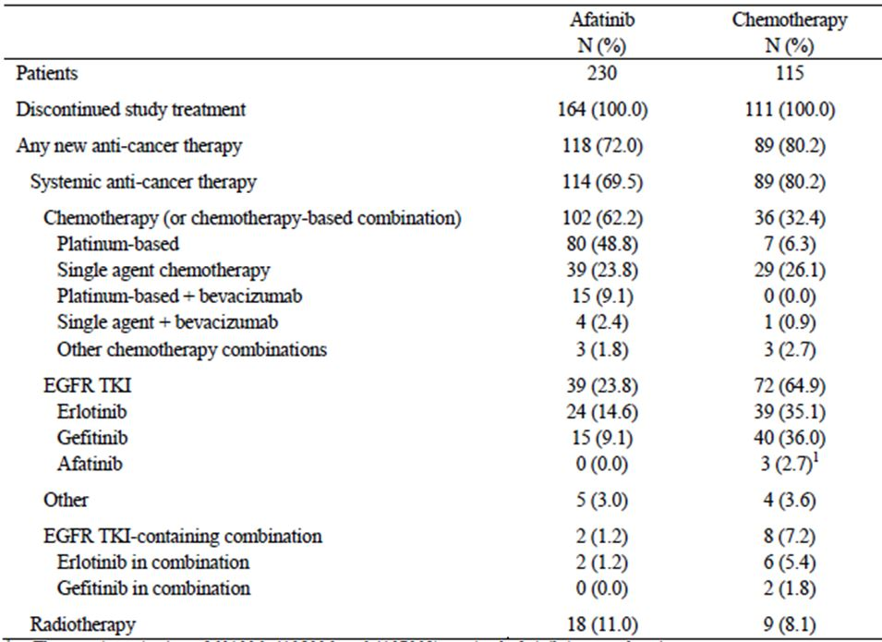

1. Three patients received afatinib in named patient use programs.

###### Overall response rate (ORR)

Afatinib produced an objective response in 56.1% versus 22.6% for chemotherapy (OR 4.7; p<0.0001); responses were twice as durable in the afatinib arm.

###### Quality of life (QoL)

Change from baseline in ECOG performance status was assessed, as was health related quality of life in three areas (cough, dyspnoea and pain). Improvement in ECOG status was seen in 11.8% of afatinib patients versus 4.5% of chemotherapy patients. 64% of afatinib patients had an improvement in dyspnoea versus 50% of chemotherapy patients; differences were lesser for cough and pain. Afatinib delayed the time to deterioration of cough and dyspnoea. Global health status improved in the afatinib arm in 50%, and worsened in 40%; for the comparator arm, results were 46% and 45% respectively; the difference largely resided in changes in physical function and symptoms (fatigue, pain, nausea and vomiting).

##### Study 1200.23 (LUX Lung 1): main supportive study

This was a randomised, double blind study, comparing afatinib versus placebo in “patients with advanced or metastatic NSCLC **who had already received treatment with 1 or 2 lines of cytotoxic chemotherapy *and* at least 12 weeks treatment with erlotinib or gefitinib (or both)”**.[32] The database cut off was 8 July 2010.

Only patients with adenocarcinoma were enrolled. Patients **need not have had** EGFR mutant positive disease. The clinical evaluator noted the trial population would be enriched for patients with EGFR mutation positive disease (EGFR TKIs confer more benefit in EGFR mutant NSCLC; those without benefit hopefully would not have been kept on treatment for 12 weeks). Indeed, actual prior therapy with gefitinib or erlotinib was for a median of 43 weeks. Mutation status was known in 141 subjects; 96 subjects had EGFR mutant positive tumours (68%). The sponsor made the following comment in the Section 31 response:

*...for 90 patients whose* ***blood serum*** *was tested for EGFR mutations at the time of screening 31 (34.4%) were tested positive for the T790M resistance mutation, which as hypothesized, suggests that a large proportion of the study population in 1200.23 had indeed this relevant EGFR mutation which confers resistance to erlotinib and gefitinib.*

Testing of “blood serum” is for circulating free DNA.[33]

Randomisation was 2:1 (afatinib versus placebo) to 50 mg afatinib once daily or placebo, and best supportive care, consistent with absence of established therapies in patients who had already received 2-3 lines of therapy for advanced disease (but see below).

A total of 697 subjects were enrolled; 585 of these were randomised (390:195). The two arms were well balanced with respect to baseline characteristics: 60% of patients were female; 58% were east Asian; mean age was 58 years; 63% had never smoked; 96.4% were Stage IV at screening; 95.7% had adenocarcinoma (plus 1.2% had the specific bronchioloalveolar subtype). In about 60%, the interval between the end of prior EGFR TKI and randomisation was <8 weeks (median duration, 5 weeks).

###### Overall survival (OS)

The primary endpoint was OS (the sponsor noted that this position was taken based on advice of the US FDA and the EU Committee for Medicinal Products for Human Use [CHMP]) on the assumption that survival time would not be long. Afatinib failed to provide an OS benefit; the HR was 1.077 (95% CI 0.86-1.35). Further therapies were given to patients with progressive disease (in 64.7% of afatinib patients versus 76.3% of placebo patients). An “inverse probability of censoring weighted” (IPCW) analysis[34] revealed a benefit for afatinib treatment; an alternative statistical approach did not. In a subgroup analysis of patients who did not receive subsequent therapy, there was a 1.2 month benefit in the afatinib group (5.8 versus 4.6 months); corresponding results for those who did receive further therapy were 12.7 versus 14.4 months (HR 1.09, p = 0.535).

There were 76.3% in the placebo arm who received systemic therapy after stopping placebo. This brings into focus the ethical basis for use of a placebo arm in this setting.

An update using a cut off of 13 February 2012 failed to find any benefit of afatinib (median OS 10.9 months in the afatinib arm, 11.7 months in the placebo arm).

###### Other efficacy outcomes

PFS was better in the afatinib arm (HR 0.38, 95% CI 0.31-0.48; median PFS 3.3 months versus 1.1 months). In the EGFR mutant positive subgroup, the HR was 0.51 (95% CI, 0.31-0.85), with median PFS rising from 1.0 months in the placebo arm to 3.3 months in the afatinib arm. In the 45 EGFR wild type patients, there was no difference across arms.

In a subset defined as EGFR TKI resistant (n = 214 in total), the HR for PFS was 0.37 (95% CI 0.26-0.52); the HR for OS was 1.09.

Afatinib was associated with a longer time to deterioration in coughing, but not pain or dyspnoea. There was some indication that a higher proportion of afatinib patients than placebo arm patients had improved cough, dyspnoea and pain symptoms. Symptoms such as diarrhoea, sore mouth and dysphagia impacted on QoL more in the afatinib arm. The global health status of patients improved in 38% for afatinib versus 29% for placebo; in the afatinib arm, there was a delay in deterioration of global health status.

##### Other supportive studies

###### Study 1200.22 (LUX-Lung 2)

This single arm study was in patients with stage IIIB or stage IV adenocarcinoma of the lung with mutant EGFR,[35] and included **previously treated** (n = 68 who had disease progression after 1 prior chemotherapy regimen) and **previously untreated** (n = 61) patients. Starting dose was 40 or 50 mg. A total of 87% of patients were from Asian countries. Results were in keeping with the results of Study 1200.32 (untreated patients) and better than results of Study 1200.23 (treated patients). The two starting doses showed similar efficacy.

This study provided the most extensive evidence of use as a second line agent, after failure of one line of chemotherapy.

###### Study 1200.33 (LUX-Lung 4)

A total of 12 patients were studied in the Phase I dose escalation component; 50 mg was chosen as the starting dose despite dose limiting toxicity occurring in 3/6 at this level. A total of 62 patients were studied in Phase II; of these, 56 were tested for EGFR status and 45/56 (73%) were positive for mutation. **Patients had received 1-2 prior chemotherapies for advanced/metastatic NSCLC, including 12+ weeks of treatment with gefitinib or erlotinib.** Efficacy results were consistent with those in Study 1200.23, though OS was longer here.

###### Study 1200.42 Part A (LUX-Lung 5)

**Patients had received 1+ prior chemotherapies for advanced or metastatic NSCLC, including 12+ weeks of treatment with gefitinib or erlotinib.**[36] In Part A, patients received 50 mg afatinib OD. Those with benefit after 12 weeks were randomised in Part B to ‘afatinib plus paclitaxel’ or to investigator’s choice of chemotherapy. A large number of patients was studied: 1154 in Part A (53% were from Europe and Australia). Few patients (84/1154) were tested for EGFR mutation; 49/84 tested positive. In Part A, efficacy results were consistent with those from the main supportive study 1200.23.

###### Study 1200.72

This was a study in patients with EGFR wild type tumours who had failed two previous lines of chemotherapy for NSCLC. The study was not reviewed in detail. There were no confirmed objective responses in 42 treated patients. This was a single arm study so it was not possible to decide if there was ‘no benefit’ or actual harm from treatment in the EGFR wild type setting.

#### Safety

##### Exposure

The afatinib safety dataset in the dossier included 3868 cancer patients, 181 volunteers, 1151 NSCLC patients treated under “named patient use” programmes and 44 patients in investigator initiated studies. Many analysis sets were defined, for example, “SAF-5” (n = 3865) included almost all patients in cancer trials exposed to afatinib.

Of 497 EGFR TKI naive NSCLC patients treated with 40 mg afatinib, n = 154 were treated for ≤6 months; n = 158 for >6-12 months; n = 130 for >12-18 months; and n = 55 for >18 months. Of 1637 EGFR TKI pre treated NSCLC patients treated with 50 mg afatinib, n = 1277 were treated for ≤6 months; n = 285 for >6-12 months, n = 54 for >12-18 months; and n = 21 for >18 months.

Mean duration of afatinib in the first line setting was 11 months, but in the second line setting after prior EGFR TKI it was 4.3 months. Another key observation was that treatment duration in the afatinib arm was longer than in the comparator arm for various studies (for example, Study 1200.32: mean 11.0 months for afatinib, 2.8 months for chemotherapy). This is relevant in interpretation of the frequency of some AEs across arms.

##### Overall view of adverse events

Data from two controlled studies allow comparison of afatinib’s safety profile versus the combination of pemetrexed and cisplatin, and also versus placebo.

In the pivotal Study 1200.32, comparison against the platinum based doublet showed a similar rate of all AEs (100% with afatinib versus 98.2% with doublet) and grades 3-4 AEs (55% versus 54%). There was a notably higher incidence in the afatinib arm of: diarrhoea and stomatitis; skin effects; epistaxis and nasopharyngitis; ocular effects; and pyrexia. There was a higher rate of ALT elevations and hypokalaemia. There was a lower rate of: haematological toxicity; nausea and vomiting; fatigue; and alopecia.

In Study 1200.23, comparison versus placebo showed a higher rate of all AEs (98.5% versus 86.7%), grade 3 AEs (41.0% versus 16.9%) and grade 4 AEs (4.9% versus 1.0%) with afatinib. Key toxicities were identified as: gastrointestinal; skin (including PPE); pyrexia; epistaxis/rhinorrhoea; and ocular.

##### Deaths and other serious AEs

In Study 1200.32, fatal AEs were seen in 5.7% (afatinib) versus 2.7% (chemotherapy). No AE was considered treatment related in the doublet arm. There were 4 fatal AEs related to afatinib: acute respiratory distress after 11 days of afatinib; chest tightness + dyspnoea leading to sudden death after 4 months; acute dyspnoea after 5 days; and sepsis (after grade 3 diarrhoea), after 2 months.

In Study 1200.23, fatal AEs were seen in 11.3% (afatinib) versus 7.7% (placebo). The study was double blind. Only 2 fatal AEs were considered drug related (both in the afatinib arm). The first was a case of acute renal + hepatic failure after 10 days of exposure; the second was a case of acute left ventricular failure after 1 month of exposure.

There were multiple other cases of fatal AEs considered related to afatinib in other studies, including cases of interstitial lung disease, left ventricular failure and hepatic failure.

In Studies 1200.32 (pivotal; platinum based doublet comparator) and 1200.23 (supportive; placebo control arm) diarrhoea was a prominent SAE for afatinib. SAEs potentially linked to diarrhoea (dehydration, hypokalaemia, acute renal failure, thromboembolism) were seen more often in the afatinib arms than the control arms.

##### Discontinuations

The clinical evaluator considered that the incidence of discontinuations for drug related AEs indicated that toxicity of afatinib can be managed in most subjects via alternative approaches (for example, dose reduction). In the pivotal Study 1200.32, discontinuations due to drug related AEs were less frequent in the afatinib arm (7.9% versus 11.7%).

##### Diarrhoea and its consequences

Diarrhoea occurred in >86% on afatinib. Grade 3 (severe) diarrhoea was also common (15%), while there were no cases of grade 4 diarrhoea in the 2 randomised, controlled studies of afatinib. In the ‘named patient’ dataset, 3 patients died from consequences of diarrhoea, though the sponsor questioned whether optimal care was given in each case.

Increasing severity of diarrhoea was associated with increasing median afatinib trough levels. Dose reduction was effective in reducing incidence and severity of diarrhoea.

The higher rate of diarrhoea in afatinib arms than control arms was despite guidance in protocols about management of this condition (proactive hydration; use of loperamide; dose reduction or interruption). More than 2/3 reporting diarrhoea did so within the first 14 days; yet 10-20% of patients in the two controlled studies had not recovered from their diarrhoea, suggesting the AE can persist. Dehydration was flagged by the evaluator as a possible consequence of diarrhoea, as were acute renal failure and hypokalaemia (for the latter, there were 5 grade 4 AEs [2.2%]).

Thromboembolic events are conceivably related via dehydration. The clinical evaluator accepted that on balance, afatinib does not induce thromboembolic events; but correcting incidence for treatment duration may be more robust for AEs where onset is equally likely at any time point on the drug. If thromboembolism were linked to dehydration, this precondition might not hold since dehydration typically occurred within the first 14 days, so correction for treatment duration might not be appropriate. On the other hand, diarrhoea was apparently persistent in a fair proportion of patients; dehydration might occur at any point during the diarrhoea AE. Dehydration is only one factor predisposing to thromboembolism in cancer patients.

##### Stomatitis

Stomatitis was very common and up to 10% of afatinib treated subjects required dose reduction because of this AE, which typically developed within 28 days of starting treatment.

##### Cardiotoxicity

Afatinib inhibits HER-2; other HER-2 inhibitors such as trastuzumab and lapatinib are linked to heart failure. There is a suggestion from supratherapeutic dosing of pigs that afatinib may be a negative inotrope. The pivotal study excluded patients with LVEF <50%. AE monitoring included ECHO/MUGA scan assessment of LVEF. There was a marginal increase in the absolute percentage of patients with clinically significant LVEF declines, in afatinib arms versus comparator arms. There were multiple deaths due to LV failure in patients on afatinib.

Study 1200.24 investigated afatinib’s effect on the QT interval, and other ECG effects. The clinical evaluator concluded from the results of this study that afatinib is not likely to cause QT prolongation.

##### Interstitial lung disease

ILD is hard to assess in a population with advanced NSCLC. Erlotinib and gefitinib have been linked to ILD. There was an increased frequency of ILD in afatinib arms relative to control arms, but incidence was low; 0.7% of patients had ILD like events considered drug related by investigators; 5 of these 28 patients died of the AE. Amongst causes of permanent discontinuation, ILD was as prominent as diarrhoea and rash/acne, at least in EGFR TKI naive subjects.

##### Liver toxicity

In both controlled studies, afatinib was linked with an increased rate of elevated LFTs. Seven patients in the clinical programme partially[37] met Hy’s Law, suggesting a potentially large hepatotoxicity liability for afatinib. This is consistent with the report of 3 cases of fatal liver failure; however the clinical evaluator noted that none of these 3 events provided convincing evidence of severe afatinib-induced liver injury.

##### Pancreatitis

There is evidence afatinib may cause asymptomatic amylase/lipase elevations through to clinical pancreatitis. The sponsor argues that all 5 AEs of pancreatitis in Studies 1200.23 and 1200.32 had a plausible other cause. The sponsor’s view is that though a causal role for afatinib cannot be ruled out, evidence does not strongly suggest causality. The sponsor does not address the occurrence of elevated amylase/lipase as noted by the evaluator. These findings were in single dose Phase I studies, but at least in Studies 1200.32 and 1200.23, routine biochemistry monitoring did not extend to amylase/lipase, so asymptomatic elevations would not necessarily be detected.

##### Pancytopaenia

There were 4 reports of drug related pancytopenia and 3 reports of drug related bone marrow failure, in the pool of 3865 patients given afatinib either as monotherapy or in combination. One of these reports was later clarified to be a case of thrombocytopenia. All cases were in patients treated in combination with chemotherapy. Six of seven AEs were non serious, transient and did not lead to discontinuation. One report in subject treated with afatinib + pemetrexed for an advanced solid tumour was a fatal event of pancytopenia (Hb 80 g/L; white cell count 0.7 x 109/L; platelets 19 x 109/L) in association with tumour progression. The events occurred one week after the last dose of study drug.

##### Skin toxicity

The report of rash or acne was very common, being seen in up to 90% of patients given afatinib. Dose interruption or reduction was required in 15-20%, but <2% discontinued because of skin toxicity. Rash often developed within the first 28 days of use. PPE was reported in 7-8% of afatinib subjects in Studies 1200.32 and 1200.23. Two patients on afatinib were diagnosed with Stevens Johnson syndrome. Increasing severity (‘grade’) of rash / acne correlated with increasing median afatinib trough levels.

##### Ocular effects

Afatinib patients experienced a higher rate of ocular effects such as conjunctivitis and dry eye than patients in the comparator arms. Cases of keratitis were also reported.

### Risk management plan

The RMP proposed by the sponsor was considered generally acceptable by the TGA’s OPR. The evaluated RMP was identified as:

EU Risk Management Plan (EU-RMP) U12-1933-02 Version 1.1 (dated 15/03/2013, DLP 21/03/2012) with Australian Specific Annex (ASA) U12-1399-02 Version 1.1 (dated 22/05/2013)

There were some outstanding issues:

* Inclusion or retention in the RMP of:
  + PPE syndrome, as an important identified risk (the RMP Evaluator notes ‘Skin reaction’ is specified as an important identified risk, but that for similar drugs PPE is specified)
  + ‘Effects on gastrointestinal motility and secretion’ as an important potential risk
  + ‘Pregnant and lactating women’ as important missing information
* Conduct of additional pharmacovigilance activities around: cardiac impairment; hepatic failure; and pancreatitis.

The Delegate supports the inclusion of PPE as a specified important identified risk in the RMP’s safety specification, since although this is a subset of ‘skin reaction’ it is quite distinct from the typical rash/acne type skin reaction associated with afatinib. The Delegate also supports retention of ‘Pregnant and lactating women’ as important missing clinical information, given what is known from pre-clinical studies.

*The sponsor should continue dialogue with the TGA’s RMP Evaluation Section to better define pharmacovigilance activities around cardiac impairment, hepatic failure and pancreatitis.* Ideally agreement should be reached prior to registration, but this is not a necessary condition of registration.

Implementation of the RMP identified above, or any updates accepted by the TGA’s RMP Evaluation section, will be a condition of registration.

### Risk-benefit analysis

#### Delegate considerations

##### Pharmacology: absence of an absolute bioavailability study

Given the weight of other evidence about afatinib’s pharmacology and efficacy/safety, the Delegate does not consider this as a deficiency that prevents registration.

##### Pharmacology: starting dose

The sponsor proposes a starting dose as follows:

*The recommended dose of Giotrif is 40 mg orally once daily for first-line treatment or for patients not previously treated with an EGFR Tyrosine Kinase Inhibitor (EGFR TKI-naïve patients).*

*For patients who received prior EGFR TKI treatment (EGFR TKI pre-treated patients) the recommended dose of Giotrif is 50 mg orally once daily.*

Starting dose in EGFR TKI pre-treated patients was partly informed by pre-clinical data:

*In pre-clinical studies, the afatinib concentration needed to yield a 50% inhibition (IC50) in a molecular kinase assay was higher in NSCLC cell lines with the T790M resistance mutation than in those with EGFR sensitising mutations (10 nM versus 0.4 nM). As about 50% of the tumours in EGFR TKI pretreated patients are expected to harbour the T790M resistance mutation, afatinib 50 mg could provide a better opportunity to overcome EGFR TKI resistance in tumours that have already progressed on EGFR TKIs. Moreover, patients who received and tolerated prolonged treatment with a reversible EGFR are more likely to tolerate the higher afatinib starting dose.*

In Studies 1200.23 and 1200.42A, starting dose was 50 mg. Dose reductions were not excessive compared to those in Study 1200.32 (which used a 40 mg starting dose). It is relevant that in 1200.32, only 7% of subjects escalated from 40 mg to 50 mg.

##### Efficacy: pivotal study – choice of comparator

In pivotal Study 1200.32, the choice of pemetrexed/cisplatin is acceptable given only patients with adenocarcinoma were studied (pemetrexed is not indicated for NSCLC of squamous histology). One caveat is that in Study 1200.32, chemotherapy arm patients had a maximum of 6 cycles (of 21 days) of treatment; 57.7% had 5-6 cycles. In EviQ, 4 cycles are suggested unless otherwise indicated.

It is stated by the sponsor that in a Phase III study (1200.34) of afatinib versus gemcitabine + cisplatin, 364 patients have been enrolled and recruitment is completed.

##### Efficacy: inclusion of quality of life data

The sponsor provided detailed information about aspects of quality of life. There was a focus on cough, dyspnoea and pain but these endpoints will not capture negative impacts on QoL of afatinib toxicity, such as diarrhoea and stomatitis. Nevertheless, in Study 1200.32 afatinib appears to improve QoL to a modest extent, relative to chemotherapy, and in Study 1200.23 the same can be said for afatinib relative to placebo.

##### Efficacy: tumour genotype

There was no evidence of efficacy in Study 1200.32 for the 37 patients with tumours of a genotype other than Del19 or L858R (there were 10 different mutation types amongst these 37 patients). The sponsor interprets this small sample size as not allowing formal declaration of negative efficacy in such patients.

A consistent outcome was noted in Study 1200.22: median PFS was longer in patients with common EGFR mutations.

A conservative approach given lack of understanding about the clinical implications of different mutation types (and unfolding experience with other targeted therapies) is to assume the negative but statistically unsubstantiated findings in Study 1200.32 reflect true worsening of outcomes in such patients given afatinib.

The evaluator noted that for individual mutations there were imbalances across arms in baseline characteristics, making it difficult to conclude that afatinib was harmful. This is true but the conservative position is still to assume a true worsening of outcomes.

The US FDA has restricted its indication for afatinib to Del 19 or L858 mutant tumours.

It is not clear whether the fraction of subjects with common mutations varies by race. It is possible that in a mainly Caucasian population, the fraction of EGFR mutant positive NSCLC tumours that are Del 19 or L858R may vary from that seen in afatinib studies; an impact on effectiveness is possible unless the indication is restricted to specific mutants.

##### Efficacy: survival advantage

In Study 1200.32, no survival difference was found; the point estimate for the OS HR favoured chemotherapy (1.12; 95% CI 0.73-1.73).

In Study 1200.23, no survival difference was found, the point estimate for the OS HR favoured placebo (1.08; 95% CI 0.86-1.35).

In these two main studies, OS outcomes were discordant with PFS and ORR outcomes. In this context, my view is that quality of life outcomes are magnified in importance.

The clinical evaluator notes that no Phase III study of an EGFR TKI has shown an OS advantage in the first line treatment of EGFR mutant advanced NSCLC; this includes Study 1200.32 (afatinib), IPASS (gefitinib) and EURTAC (erlotinib).

##### Efficacy: ‘clinical enrichment’ for patients with EGFR mutant tumours

The sponsor notes:

*Since in late-line trials retrieval of archived tumour tissue samples and sampling of new tissue are difficult, only a limited number of tumour samples were available for EGFR mutation analyses in trials 1200.23 and .42. Therefore, clinical criteria were used to enrol a patient population which was likely to have tumours with EGFR mutations.*

The strategy of ‘enriching’ patient populations for EGFR mutations by requiring patients to have derived clinical benefit from previous treatment with a reversible EGFR TKI (for example, Studies 1200.23, 1200.33, 1200.42) may exclude patients with primary resistance to reversible EGFR TKIs or early intolerance, yet these patients may have activating EGFR mutations.

Another perspective is that as well as enriching for EGFR mutant tumour genotypes, the sponsor’s approach also enriches for patients who can tolerate EGFR TKIs and who do not have primary resistance. If, for example, primary resistance was related to tumour genotype (for example, rare types of EGFR mutation), this might be of concern given that in Studies 1200.32 and 1200.22, those with ‘rare’ genotypes fared worse than those with common EGFR mutations.

The sponsor defined a ‘highly enriched’ group for EGFR mutations based on significant clinical benefit from prior therapy with EGFR TKIs (objective response or long duration of treatment): this was a post hoc definition for Study 1200.23, but was pre-defined for 1200.42 Part A. Of those with evaluable tissue in this subset, 83% were EGFR mutation positive. That high figure does not indicate the extent to which non responders to prior EGFR TKI therapy might be EGFR positive.

##### Safety

Toxicity of afatinib was well defined. One complexity of the safety assessment was that duration of exposure was imbalanced in the controlled studies.

An important toxicity is diarrhoea, which is very common, sometimes severe, possibly persistent, associated with downstream AEs such as dehydration, and detracts from patients’ quality of life, all despite protocol specified management strategies. On the up side, it does possibly respond to dose reduction. Stomatitis and skin/nail/hair effects were also prominent.

A causative role of afatinib in rarer but potentially more serious AEs was not clear in all cases, suggesting the need for enhanced pharmacovigilance in some areas.

##### Indications: adenocarcinoma versus other NSCLC

Adenocarcinoma constitutes about half of NSCLC. The sponsor notes:

*Trials 1200.22, 1200.23, and 1200.32 included patients with a tumour histology of adenocarcinoma; trial 1200.32 also included patients with mixed tumour histology where adenocarcinoma was the predominant histology. Eligibility for trial 1200.42 was independent of tumour histology... in this trial, 85.4% of patients had adenocarcinoma, 7.9% had tumours with squamous tumour histology.*

In Study 1200.32, 98% had ‘adenocarcinoma’ and 1.7% had ‘predominantly adenocarcinoma’.

The sponsor is conducting LUX Lung 8, a study of afatinib versus erlotinib for treatment of squamous cell lung cancer after 1+ platinum based chemotherapies; an estimated 800 patients will be enrolled. Until data derived from such studies are available, my strong preference is to restrict the indication to adenocarcinoma.

The influence of histology on efficacy of afatinib is not well characterised, and there is a significant risk in allowing use in an untested patient group based on the notion that mechanism of action should be ‘the same’ in non adenocarcinoma NSCLC. Variation in efficacy according to histology has been seen for some NSCLC agents, for example, pemetrexed, bevacizumab. Comparison across agents is problematic in this regard, and this extends to any comparison with other EGFR TKIs.

##### Indications: locally advanced versus metastatic disease

Patients in Studies 1200.32 and 1200.23 could be enrolled if they had metastatic disease or Stage IIIB disease with pleural/pericardial effusions. According to my interpretation of staging criteria for lung cancer, presence of a malignant pleural or pericardial effusion qualifies as distant metastases M1a, and such patients would have Stage IV disease. In Study 1200.32, there was a requirement for cytologically proven pleural or pericardial effusion. A total of 43.8% of subjects had a pleural effusion, presumably cytologically verified as tumour related. This may be one reason behind the FDA’s approval of afatinib only in metastatic disease.

##### Indications: use in patients who have failed EGFR TKIs

Study 1200.23 provides most support for afatinib after failure of chemotherapy and a prior EGFR TKI; comparison was with placebo. A 50 mg starting dose is proposed.

The evaluator notes that there are no currently registered agents for this use, but that there are limitations to the evidence for afatinib (for example, absolute PFS benefit is limited; OS benefit is at best unclear). The evaluator considers the benefit-risk balance to be unfavourable in this setting.

The evaluator proposed an indication that specified use only in the first line setting and the setting of failure of one line of chemotherapy, and stated further:

*If the TGA decides that approval is appropriate for patients in whom a prior EGFR TKI has failed, a revised indication would need to be fashioned which restricts use in this population to subjects who have received at least 12 weeks of prior therapy.*

The sponsor did not accept this position, and proposed the additional use:

*After failure of cytotoxic chemotherapy and an EGFR TKI other than afatinib.*

The sponsor’s argument in support of this position can be summarised as:

* Selection of the patients on the basis of clinical criteria rather than molecular testing in trial 1200.23.

The sponsor notes that the study was highly enriched for patients with EGFR mutations. The sponsor acknowledges that:

*...criteria applied to identify ‘highly clinically enriched’ population could have biased the selection towards a population with a better prognosis and potentially a better response to treatment in the trial than in the truly EGFR mutation positive group (which could include some patients with primary resistance to EGFR TKI).*

This is presumably why the evaluator suggests that if use after failure of EGFR TKIs is allowed, the indication should be restricted to those with some evidence of benefit of that prior therapy (that is, mirroring the clinical trial’s population).

* Clinical benefit of afatinib in Study 1200.23.

The sponsor argues that despite the failure to meet the primary endpoint of OS, the magnitude, consistency and methodological robustness of the PFS benefit show that the observed effect was not a false positive.

The sponsor contends that the PFS benefit is clinically significant ‘particularly for the subgroup of patients very likely to harbour EGFR mutation in the tumour’. This refers to the ‘highly clinically enriched subgroup’, that is, those who had achieved complete or partial response on prior EGFR TKIs or persisted on prior EGFR TKIs for 48+ weeks (and who are therefore likely to have EGFR mutant positive tumours). In this subset, 30% of afatinib subjects versus 4% of placebo subjects were progression free at 6 months.

As noted in the clinical evaluation report, this clinical enrichment for EGFR mutant positive patients excludes EGFR mutant positive patients who may be resistant to EGFR TKI therapy, for example, have primary resistance, early intolerance to treatment.

The sponsor notes data favouring afatinib in 214 patients meeting criteria for acquired resistance to erlotinib/gefitinib; but these criteria would also exclude patients with primary resistance. The clinical evaluator’s approach of restricting the indication to those with evidence of benefit of prior EGFR TKI therapy would overcome this problem.

The sponsor considers that a 3+ month gain in PFS is clinically meaningful, as “the time when tumour growth is under control is of importance to the patients”. In keeping with this, the sponsor argues that stable disease is clinically relevant in this setting. Also, the sponsor notes improvements in patient reported outcomes on afatinib.

* Discussion of the lack of OS benefit.

The sponsor argues that: in those who received no further therapy, there was a survival advantage (median OS for afatinib 5.8 months, versus 4.6 months for placebo; HR 0.66, p = 0.027); and that in those who received further therapy, detection of a survival benefit of afatinib was confounded by imbalance in use of subsequent therapies, for example, 2+ further lines were used in 44% of placebo but 28% of afatinib patients; and use of novel agents “mainly with EGFR targeting mode of action” was recorded in 24% versus 12%.

In considering the sponsor’s argument about differential use of subsequent therapies, it is worth noting that use of subsequent therapy may be tied to performance status which could be affected differentially according to treatment arm in the initial afatinib study. There was no sign that ECOG performance status declined more in the afatinib arm than the control arm.

It would be useful to see outcomes stratified according to the presence of T790M, which is a mutation associated with acquired resistance to EGFR TKIs.

The Delegate’s view is that a PFS benefit as seen in Study 1200.23, in association with improved quality of life, provides an advantage for patients. It would be necessary to restrict use to patients who had benefit after 12 weeks of prior EGFR TKI therapy, to reduce the risk that EGFR mutant positive NSCLC patients with primary resistance or early intolerance to the class (EGFR TKIs) will be treated. Such patients have not been studied in sufficient detail and there is a real possibility afatinib would not be of any benefit to those patients.

##### Overall risk-benefit

The Delegate considers afatinib has a positive benefit-risk balance for the following indication:

*Giotrif is indicated as monotherapy for treatment of patients with metastatic adenocarcinoma of the lung whose tumours have epidermal growth factor receptor (EGFR) exon 19 deletions or L858R substitution mutations. In patients previously treated with EGFR tyrosine kinase inhibitors, Giotrif should only be used if clinical benefit was sustained for 12 or more weeks on such therapy.*

The basis for this wording has been explained in earlier sections.

The ACPM’s advice is requested. Summary Information includes specific questions.

##### Advice sought

1. Does favourable benefit-risk extend to patients previously treated with an EGFR TKI?
2. (If so, is it necessary to specify within the indication ‘first line’, ‘after failure of cytotoxic chemotherapy’ and ‘after failure of cytotoxic chemotherapy and an EGFR TKI other than afatinib’?)
3. Should use be limited to lung adenocarcinoma?
4. Should use be limited to metastatic disease?
5. Should use be limited to common EGFR mutations?
6. What is the committee’s interpretation of the clinical relevance of the OS data for afatinib, in the context of accompanying PFS and quality of life data, and how does this bear on the benefit/risk assessment?

The committee is also requested to provide advice on any other issues that it thinks may be relevant to a decision on whether or not to approve this application.

#### Response from sponsor

Presented here is our pre ACPM response to the TGA Delegate’s proposed action and request for advice in relation to our application to register a new chemical entity, Giotrif afatinib 20 mg, 30 mg, 40 mg, 50 mg (as dimaleate) film coated tablets.

##### 1. Pre ACPM assessment by the Delegate

The TGA Delegate considers that afatinib has a positive benefit-risk balance for the following modified indication:

*“Giotrif is indicated as monotherapy for the treatment of patients with metastatic adenocarcinoma of the lung whose tumours have epidermal growth factor receptor (EGFR) exon 19 deletions or L858R substitution mutations. In patients previously treated with EGFR tyrosine kinase inhibitors, Giotrif should only be used if clinical benefit was sustained for 12 or more weeks on such therapy.”*

BI welcomes the Delegate’s recommendation to approve the registration of Giotrif afatinib 20 mg, 30 mg, 40 mg, 50 mg (as dimaleate) film coated tablets and accepts the Delegate’s proposed amendment to the indication.

However, considering the biological heterogeneity and the small number of patients with uncommon mutations in each subgroup, BI maintains the view that afatinib has clinical activity in all the EGFR mutations tested in the LUX-Lung 3 study.

This view is further supported by recent additional nonclinical data and clinical data from trial LUX-Lung 6 (Study 1200.34), which has a similar design and size to LUX-Lung 3 but was conducted in Asia only and used a different comparator (gemcitabine/cisplatin). These additional data broadened the data base in uncommon EGFR mutations and further corroborated activity of afatinib in uncommon EGFR mutations.

BI acknowledges that at this stage of the evaluation these data cannot be submitted for review, accepts the Delegate’s proposal to limit the indication to common mutations and will consider submission of these data after the registration of afatinib.

##### 2. Comments to issues raised by the TGA Delegate

###### 2.1 Does favourable benefit-risk extend to patients previously treated with an EGFR TKI?

There are currently no registered compounds for use in patients who have failed chemotherapy and an EGFR TKI. BI considers that the data from LUX-Lung 1 (Study 1200.23) and LUX-Lung 5 (Study 1200.42) provide sufficient evidence for the efficacy and safety of afatinib in this setting. Although the primary endpoint of OS was not met in the randomised placebo controlled trial 1200.23, the magnitude, consistency, and methodological robustness of the PFS benefit demonstrates that the observed effect of afatinib was not a false positive finding.

The demonstrated PFS benefit is consistent, robust and of a magnitude, which is considered to be clinically relevant, especially in late stage NSCLC with high proportion of patients with tumours harbouring the T790M resistance mutation.

* In patients with a high likelihood of mutations, a 3.4 months improvement in median PFS (from 1 to 4.4. months; HR = 0.28) was observed in the afatinib arm compared to placebo with a 6 month progression free rate of 30% versus 4%.
* The PFS benefit was associated with significant improvements in predefined lung cancer symptoms (cough, dyspnoea and pain). Similarly the time to deterioration of cough was significantly delayed and trends in delaying dyspnoea and pain was observed. Importantly, overall improvement was also observed for global health status in patients treated with afatinib vs. placebo.
* Hazard ratio of PFS favoured afatinib in all subgroups including a subgroup of 214 patients meeting the strict criteria for acquired resistance to erlotinib and/or gefitinib, where the median PFS by independent review was 4.5 months on afatinib versus1.0 month on placebo.

Furthermore the efficacy data observed in Study 1200.23 was replicated in the large single arm Study 1200.42 in 1154 patients, were similar median PFS, response and disease control rates were observed.

In the EGFR pre-treated setting, the adverse events of afatinib were generally predictable, related to its mode of action, and manageable by close monitoring, proactive treatment, and dose interruption and reduction according to the well defined dose reduction scheme.

In summary, based on the efficacy observed in terms of PFS and health related QoL (HRQoL) measures and a manageable safety profile, BI believes that the benefit-risk for the use of afatinib in EGFR TKI pre-treated patients is favourable.

###### 2.2 If so, is it necessary to specify within the indication ‘first line’, ‘after failure of cytotoxic chemotherapy’ and ‘after failure of cytotoxic chemotherapy and an EGFR TKI other than afatinib’?

BI agrees with the modified wording for the indication proposed by the Delegate:

*“Giotrif is indicated as monotherapy for the treatment of patients with metastatic adenocarcinoma of the lung whose tumours have epidermal growth factor receptor (EGFR) exon 19 deletions or L858R substitution mutations. In patients previously treated with EGFR tyrosine kinase inhibitors, Giotrif should only be used if clinical benefit was sustained for 12 or more weeks on such therapy.”*

###### 2.3 Should use be limited to lung adenocarcinoma?

The choice of adenocarcinoma or predominantly adenocarcinoma histology as one of the eligibility criteria in Studies 1200.32, 1200.22, 1200.23 was guided by several considerations.

First, the trials were to recruit patients with EGFR mutation positive NSCLC (1200.32 and 1200.22) or high likelihood of harbouring EGFR mutations (1200.23, where mandatory tumour testing was not required). There is an established association of EGFR mutation with adenocarcinoma histology (<10% in non East Asian, 30% East Asian population) on the background of generally low frequency of EGFR mutation in the unselected NSCLC population [R06-1262,[38] R07-1135[39]].

Indeed, multiple research groups have reported adenocarcinoma to be the predominant histological subtype of NSCLC harbouring EGFR mutations [R06-1262[40]]. The results of genetic screening in 860 consecutive surgically resected NSCLC patients in Italy demonstrated 10% (n = 39) frequency of these mutations in 375 adenocarcinomas and their absence in 454 squamous carcinomas or 31 large cell carcinomas tested [R11-4176[41]]. Significantly lower rate of EGFR mutations in non adenocarcinoma compared to adenocarcinoma tumour specimens (3% versus 42%) was subsequently reported in multiple studies [R06-1262,[42] R06-1306[43]].

Second, in pivotal Study 1200.32 the chemotherapy in the control arm include pemetrexed, which is not indicated for the treatment of patients with squamous cell lung cancer. This immediately limited their participation in the trial.

Therefore, the association between the EGFR mutation and adenocarcinoma histology as well as labelling considerations for pemetrexed in the pivotal Study1200.32 led BI to restrict the eligibility criteria to (predominantly) adenocarcinoma of the lung. This strategy also maximised the yield of mutation screening, improving feasibility of the large trials.

Study1200.42 was conducted in a similar population to 1200.23, that is, in the 3rd/4th line setting after progression on at least one chemotherapy regimen and after at least 12 weeks of EGFR TKIs, but did not limit eligibility to patients with adenocarcinoma only. The majority of the patients in this trial had NSCLC of adenocarcinoma histology (85.4%). A proportion of patients with other NSCLC histology was studied in the trial (14.6%), including 91 (7.9%) patients with squamous NSCLC.

The population studied across the four main studies is considered representative of the wider EGFR mutation positive NSCLC, owing to the fact that molecular drivers of the disease and not histology determine the success of the genotype directed therapy, such as afatinib. The current labelling of erlotinib and gefitinib is a reflection of this, as in the face of very limited data in histologies other than adenocarcinoma [R12-1015,[44] R09-4437[45]]; their recommended usage is broad to all histologies.

Although clinical development of afatinib in NSCLC was mainly focused on EGFR mutation positive disease, this agent was designed to block aberrant signalling from all homo and heterodimers formed by the ErbB family members EGFR (ErbB1), HER2 (ErbB2), ErbB3 and ErbB4, and may offer benefit to patients with other molecular drivers pertaining to different histological subtypes of NSCLC.

###### 2.4 Should use be limited to metastatic disease?

The inclusion criteria for staging in the afatinib clinical trial program were based on American Joint Committee on Cancer (AJCC) Lung cancer staging Edition 6. Patients with stage IV (metastatic disease) or stage IIIB with malignant pleural or pericardial effusion could be enrolled. According to AJCC Edition 6, presence of malignant pleural or pericardial effusion (cytologically proven) was classified as stage IIIB.

NSCLC with malignant pleural or pericardial effusion was subsequently re-classified into Stage IV, M1a, when the new edition of the AJCC Lung cancer staging (Edition 7) was released in 2010 [R12-4710[46]].

Since AJCC Edition 7.0 is in current use, BI agrees with the Delegate’s proposal to limit the indication to metastatic disease only, as it will cover the NSCLC population of patients treated in the clinical trials of afatinib.

###### 2.5 Should use be limited to common EGFR mutations?

As stated above, considering the biological heterogeneity and the small number of patients with uncommon mutations in each subgroup, BI maintains the view that afatinib has clinical activity in all the EGFR mutations tested in the LUX-Lung 3 study.

This view is further supported by recent additional non-clinical data and clinical data from trial LUX-Lung 6 (Study 1200.34), which has a similar design and size to LUX-Lung 3 but was conducted in Asia only and used a different comparator (gemcitabine/cisplatin). These additional data broadened the data base in uncommon EGFR mutations and further corroborated activity of afatinib in uncommon EGFR mutations.

BI acknowledges that at this stage of the evaluation these data cannot be submitted for review, accepts the Delegate’s proposal to limit the indication to common mutations and will consider submission of these data after the registration of afatinib.

###### 2.6 What is the committee’s interpretation of the clinical relevance of the OS data for afatinib, in the context of accompanying PFS and quality of life data, and how does this bear on the benefit/risk assessment?

The comparatively long life expectancy of patients with EGFR mutation positive NSCLC and the availability of efficacious treatments for this disease allow patients with advanced, metastatic disease to receive multiple treatment lines. Therefore, in a clinical trial, the potential effect of the investigational drug on OS is likely to be obscured by the use of anticancer therapies after disease progression and by treatment crossover in later lines. It should be noted that lack of statistical significance in the OS outcome in a trial showing clinically meaningful PFS benefit and long post progression survival (OS ≥12 months), as in the case of afatinib, does not imply lack of improvement in OS with the experimental therapy [R13-1028,[47] R13-1026[48]].

PFS is a direct and sensitive measure allowing an unbiased attribution of the effect to the investigational drug; it is not confounded by administration of anticancer therapies after progression and treatment crossover. The analysis of PFS in Studies 1200.32 and 1200.23 was based on robust predefined criteria (RECIST), and the primary assessment was based on an independent review committee which was blinded to the treatment assignments. The validity of the PFS results was ensured by implementing all practical steps presented in regulatory guidelines concerning the ascertainment of progression, the data collection process, and the associated analyses.

In a non curative setting, where disease progression indicates tumour growth, a substantial delay in disease progression represents on its own an inherent clinical benefit, particularly when associated with durable and clinically meaningful tumour response. Importantly, the improvements in PFS and tumour response were supplemented with a positive effect on patient reported outcomes (assessed comprehensively in Studies 1200.32 and 1200.23) with improvements in global health status and lung cancer related symptoms as well as delays in deterioration of such symptoms.

Therefore, considering the described inherent methodological difficulties for demonstrating an OS benefit in a setting with long post progression survival, the applicant considers the demonstrated PFS and patient reported outcomes to establish a positive benefit/risk balance for patients treated with afatinib.

##### 3. Conclusion

In conclusion, BI welcomes the Delegate’s recommendation to approve the registration of Giotrif afatinib 20 mg, 30 mg, 40 mg, 50 mg (as dimaleate) film coated tablets for the following indication:

*“Giotrif is indicated as monotherapy for the treatment of patients with metastatic adenocarcinoma of the lung whose tumours have epidermal growth factor receptor (EGFR) exon 19 deletions or L858R substitution mutations. In patients previously treated with EGFR tyrosine kinase inhibitors, Giotrif should only be used if clinical benefit was sustained for 12 or more weeks on such therapy.”*

#### Advisory Committee Considerations

The submission seeks to register a new chemical entity.

The ACPM, taking into account the submitted evidence of efficacy, safety and quality, considered Giotrif film coated tablets containing 20 mg, 30 mg, 40 mg and 50 mg of afatinib (as dimaleate) to have an overall positive benefit-risk profile for the amended indication:

*Giotrif is indicated as monotherapy for the treatment of patients with advanced or metastatic non-squamous non-small cell carcinoma of the lung, either as first line therapy or after failure of cytotoxic chemotherapy. Tumours must have epidermal growth factor receptor (EGFR) exon 19 deletions or L858R substitution mutations.*

The ACPM taking into account the submitted evidence of efficacy, safety and quality considered this product to have an overall negative benefit-risk profile for the setting where patients have failed cytotoxic chemotherapy **and** an EGFR tyrosine kinase inhibitor.

In making this latter recommendation, the ACPM:

* Advised there was a lack of support in the efficacy evidence provided in this setting, coupled with high levels of toxicity.

The committee was requested to provide advice on the following specific issues:

* Does favourable benefit-risk extend to patients previously treated with an EGFR TKI?

The evidence of benefit after previous EGFR TKI use is inadequate and the ACPM was of the view there was insufficient support to include this in the indication.

* + If so, is it necessary to specify within the indication ‘first line’, ‘after failure of cytotoxic chemotherapy’ and ‘after failure of cytotoxic chemotherapy and an EGFR TKI other than afatinib’?

Efficacy in ‘first line’ treatment is well supported.

‘Second line’ use after failure of chemotherapy is supported by sufficient evidence.

‘Second line’ use after an ‘EGFR TKI other than afatinib’ remains to be established.

* Should use be limited to lung adenocarcinoma?

The ACPM advised that NSCLC of ‘non squamous type' rather than 'adenocarcinoma' may be more suitable.

* Should use be limited to metastatic disease?

The ACPM noted the clinical trials population largely had both advanced and metastatic disease

* Should use be limited to common EGFR mutations?

The ACPM noted the clinical trials population evaluated had epidermal growth factor receptor exon 19 deletions or exon 21 (L858R) substitution mutations and other mutations were not studied to any great extent.

* What is the committee’s interpretation of the clinical relevance of the OS data for afatinib, in the context of accompanying PFS and quality of life data, and how does this bear on the benefit-risk assessment?

The ACPM advised that the evidence for PFS was adequate but noted with some concern a lack of evidence for an overall survival benefit. This could be due to a lack of follow up or differences in post trial treatments. Nonetheless, the reliance on a surrogate endpoint without demonstrating a clinical benefit is less than convincing, especially in light of the significant level of toxicity reported.

##### Proposed conditions of registration

The ACPM agreed with the delegate on the proposed conditions of registration and advised the following;

The overall survival data from Study 1200.32 (due April 2014) should be submitted as soon as possible.

##### Proposed Product Information (PI)/Consumer Medicine Information (CMI) amendments

The ACPM agreed with the delegate to the proposed amendments to the Product Information (PI) and Consumer Medicine Information (CMI) and specifically advised on the inclusion of the following:

* A suitable statement in the PI and relevant sections of the CMI alerting prescribers and users to the potential for drug interactions due to afatinib as both substrate and inhibitor of P-gp including its potential to inhibit intestinal efflux of P-gp substrates, increasing their absorption. Furthermore afatinib commonly causes diarrhoea which may affect absorption of other drugs.
* The statement in the Precautions section of the PI and relevant sections of the CMI on renal impairment is considered important and should remain.

The ACPM advised that the implementation by the sponsor of the recommendations outlined above to the satisfaction of the TGA, in addition to the evidence of efficacy and safety provided would support the safe and effective use of these products.

### Outcome

Based on a review of quality, safety and efficacy, TGA approved the registration Giotrif (afatinib as dimaleate) film coated tablet blister pack containing afatinib as dimaleate 20 mg, 30 mg, 40 mg and 50 mg, indicated for:

*As monotherapy for the treatment of patients with advanced or metastatic non-squamous non-small cell carcinoma of the lung, either as first line therapy or after failure of cytotoxic chemotherapy. Tumours must have epidermal growth factor receptor (EGFR) exon 19 deletions or L858R substitution mutations.*

#### Specific conditions of registration applying to these therapeutic goods

* The EU Risk Management Plan (EU-RMP), version 1.1, (dated 15/03/2013, DLP21/03/2012) for afatinib (as dimaleate) with Australian Specific Annex (AsA) U12-1399-02 Version 1.1 (dated 22/05/2013) and any subsequent revisions, as agreed with the TGA will be implemented in Australia.

## Attachment 1. Product Information

The Product Information approved at the time this AusPAR was published is at Attachment 1. For the most recent Product Information please refer to the TGA website at <<http://www.tga.gov.au/hp/information-medicines-pi.htm>>.

## Attachment 2. Extract from the Clinical Evaluation Report

1. Real FX, et al. (1986) Expression of epidermal growth factor receptor in human cultured cells and tissues: relationship to cell lineage and stage of differentiation. *Cancer Res.* 46: 4726-4731; Press MF, et al. (1990) Expression of the HER-2/neu proto-oncogene in normal human adult and fetal tissues. *Oncogene* 5: 953-962; Prigent SA, et al. (1992) Expression of the c-erbB-3 protein in normal human adult and fetal tissues. *Oncogene* 7: 1273-1278; Srinivasan R, et al. (1998) Expression of the c-erbB-4/HER4 protein and mRNA in normal human fetal and adult tissues and in a survey of nine solid tumour types. *J Pathol.* 185: 236-245.
2. Yarden Y, Sliwkowski MX. (2001) Untangling the erbB signalling network. *Nat Rev Mol Cell Biol.* 2: 127-137.
3. Zhang J, et al. (2009) Targeting cancer with small molecule kinase inhibitors. *Nat Rev Cancer* 9: 28-39.
4. Sergina NV, Moasser MM. (2007) The HER family and cancer: emerging molecular mechanisms and therapeutic targets. *Trends in Molecular Medicine* 13: 527-534
5. Zhang J, et al. (2009) Targeting cancer with small molecule kinase inhibitors. *Nat Rev Cancer* 9: 28-39.
6. Note that ErbB3 is devoid of intrinsic kinase activity.
7. Yun C-H, et al. (2008) The T790M mutation in EGFR kinase causes drug resistance by increasing the affinity for ATP. *Proc Natl Acad Sci USA.* 105: 2070-2075.
8. Perez EA, et al. (2008) Cardiac safety of lapatinib: pooled analysis of 3689 patients enrolled in clinical trials. *Mayo Clinic Proceedings* 83: 679-686.
9. European Medicines Agency, “Guideline on repeated dose toxicity (CPMP/SWP/1042/99 Rev 1 Corr)”, 18 March 2010.
10. Creamer B, et al. (1961) The turnover and shedding of epithelial cells. Part I The turnover in the gastrointestinal tract. *Gut* 2: 110-117; Cole JW, McKalen A. (1961) Studies on the morphogenesis of adenomatous polyps in the human colon. *Gastroenterology* 41: 122-125.
11. Cosmetic Ingredient Review Expert Panel (2007) Final Report on the Safety Assessment of Maleic Acid. *Int J Toxicol.* 26(Suppl. 2): 125-130.
12. Everett RM, et al. (1993) Nephrotoxicity of pravadoline maleate (WIN 48098-6) in dogs: evidence of maleic acid-induced acute tubular necrosis. *Fundam Appl Toxicol.* 21: 59-65.
13. Harrison HE, Harrison HC. (1954) Experimental production of renal glycosuria, phosphaturia, and aminoaciduria by injection of maleic acid. *Science* 120: 606-608.
14. European Medicines Agency, “ICH Topic S 9 Nonclinical Evaluation for Anticancer Pharmaceuticals, Step 4: Note for Guidance on Nonclinical Evaluation for Anticancer Pharmaceuticals (EMEA/CHMP/ICH/646107/2008)”, December 2008.
15. Sibilia M, Wagner EF (1995) Strain-dependent epithelial defects in mice lacking the EGF receptor. *Science* 269: 234-238.
16. Definitions of the Australian categories for prescribing medicines in pregnancy, Category C: Drugs which, owing to their pharmacological effects, have caused or may be suspected of causing, harmful effects on the human foetus or neonate without causing malformations. These effects may be reversible.
17. In cardiology, the QT interval is a measure of the time between the start of the Q wave and the end of the T wave in the heart’s electrical cycle.
18. European Medicines Agency, “Committee for Medicinal Products for Human Use (CHMP): Guideline on the evaluation of anticancer medicinal products in man (EMA/CHMP/205/95/Rev.4)”, 13 December 2012; European Medicines Agency, “Appendix 1 to the guideline on the evaluation of anticancer medicinal products in man: methodological consideration for using progression-free Survival (PFS) or disease-free survival (DFS) in confirmatory trials (EMA/CHMP/27994/2008/ Rev.1)”, 13 December 2012.
19. National Comprehensive Cancer Network (NCCN), “NCCN Clinical Practice Guidelines in Oncology – Non-Small Cell Lung Cancer”, Version 2.2013.
20. Pao W, Chmielecki J. (2010) Rational, biologically based treatment of EGFR-mutant non-small-cell lung cancer. *Nature Rev. Cancer* 10: 760-774.
21. European Medicines Agency, “Committee for Medicinal Products for Human Use (CHMP): Guideline on the evaluation of anticancer medicinal products in man (EMA/CHMP/205/95/Rev.4)”, 13 December 2012; European Medicines Agency, “Appendix 1 to the guideline on the evaluation of anticancer medicinal products in man: methodological consideration for using progression-free Survival (PFS) or disease-free survival (DFS) in confirmatory trials (EMA/CHMP/27994/2008/ Rev.1)”, 13 December 2012.
22. Pao W, Chmielecki J. (2010) Rational, biologically based treatment of EGFR-mutant non-small-cell lung cancer. *Nature Rev. Cancer* 10: 760-774.
23. Hirsch FR, Bunn PA. (2012) A new generation of EGFR tyrosine-kinase inhibitors in NSCLC. *Lancet Oncol.* 13: 442-443.
24. Miller VA, et al. (2012) Afatinib versus placebo for patients with advanced, metastatic non-small-cell lung cancer after failure of erlotinib, gefitinib, or both, and one or two lines of chemotherapy (LUX-Lung 1): a phase 2b/3 randomised trial. *Lancet Oncol.* 13: 528-538.
25. US National Institutes of Health, Clinical Trials.gov – NCT 01466660.
26. US National Institutes of Health, Clinical Trials.gov – NCT 01523587.
27. Nelson V, et al. (2013) Afatinib: emerging next-generation tyrosine kinase inhibitor for NSCLC. *OncoTargets and Therapy* 6: 135-143; Schuler M, et al. (2012) A phase II trial to assess efficacy and safety of afatinib in extensively pretreated patients with HER2-negative metastatic breast cancer. *Breast Cancer Res Treat.* 134: 1149-1159.
28. Hisamuddin IM, Yang VW. (2007) Genetic polymorphisms of human flavin-containing monooxygenase 3: implications for drug metabolism and clinical perspectives. *Pharmacogenomics* 8: 635-643.
29. Clinical Overview page 16, in discussion of Study 1200.151: “Simultaneous administration of afatinib and ritonavir was tested because it was regarded to be clinically more meaningful” and “it was concluded that afatinib can be safely combined with P-gp inhibitors such as ritonavir as long as the inhibitor is administered at the same time with or after each dose of afatinib”.
30. Oken MM, et al. (1982). Toxicity and response criteria of the Eastern Cooperative Oncology Group. *Am J Clin Oncol.* 5: 649-55.
31. TheraScreen: EGFR29 Mutation Kit, DxS Product Code EG-51; Qiagen Manchester Limited, Manchester, UK. Not on ARTG. Described as: an established and validated quantitative real-time polymerase chain reaction (PCR) protocol with fluorescence detection. The TheraScreen: EGFR29 Mutation Kit is designed to detect 29 EGFR mutations against a background of wild-type genomic DNA, i.e. 19 deletions in exon 19 (‘Del 19’), L858R, 3 insertions in exon 20, L861Q, G719S, G719A, G719C, T790M, and S768I.
32. Miller VA, et al. (2012) Afatinib versus placebo for patients with advanced, metastatic non-small-cell lung cancer after failure of erlotinib, gefitinib, or both, and one or two lines of chemotherapy (LUX-Lung 1): a phase 2b/3 randomised trial. *Lancet Oncol.* 13: 528-538.
33. O’Flaherty JD, et al. (2012) Circulating tumour cells, their role in metastasis and their clinical utility in lung cancer. *Lung Cancer* 76: 19-25.
34. Rimawi M, Hilsenbeck, SG. (2011) Making sense of clinical trial data: is inverse probability of censoring weighted analysis the answer to cross-over bias? *J Clin Oncol.* 30: 453-458; Korn EL, et al. (2011) Overall survival as the outcome for randomised clinical trials with effective subsequent therapies. *J Clin Oncol.* 29: 2439-2442.
35. A total of 82.2% of subjects had Del19 or L858R; the sponsor states that “for trial 1200.22, patients were eligible if their tumours harboured mutations in exon 18 to exon 21 of EGFR, as confirmed by direct DNA sequencing of NSCLC tumour tissue. Where tumour samples were inadequate for this, PCR methods were used.”
36. The sponsor states: “However, patients with known EGFR mutation after therapy with reversible EGFR TKIs and those with clinical benefit (disease stabilisation or tumour response) for at least 6 months with erlotinib or gefitinib were exempt from the requirement of prior chemotherapy. Following an amendment to the trial protocol, all patients were required to have disease progression following at least 1 line of chemotherapy (including platinum and where approved pemetrexed) and at least 12 weeks of treatment with erlotinib or gefitinib.”
37. There was “evidence of alternative aetiology” in all 7 cases.
38. Pao W, Miller, VA. (2005) Epidermal growth factor receptor mutations, small-molecule kinase inhibitors, and non-small-cell lung cancer: current knowledge and future directions. *J Clin Oncol.* 23: 2556-2568.
39. Sharma SV, et al. (2007) Epidermal growth factor receptor mutations in lung cancer. *Nat Rev Cancer* 7: 169-181.
40. Pao W, Miller, VA. (2005) Epidermal growth factor receptor mutations, small-molecule kinase inhibitors, and non-small-cell lung cancer: current knowledge and future directions. *J Clin Oncol.* 23: 2556-2568.
41. Marchetti A, et al. (2005) EGFR mutations in non-small-cell lung cancer: analysis of a large series of cases and development of a rapid and sensitive method for diagnostic screening with potential implications on pharmacologic treatment. *J Clin Oncol.* 23: 857-865.
42. Pao W, Miller, VA. (2005) Epidermal growth factor receptor mutations, small-molecule kinase inhibitors, and non-small-cell lung cancer: current knowledge and future directions. *J Clin Oncol.* 23: 2556-2568.
43. Janne, PA, Johnson, BE. (2006) Effect of epidermal growth factor receptor tyrosine kinase domain mutations on the outcome of patients with non-small cell lung cancer treated with epidermal growth factor receptor tyrosine kinase inhibitors. *Clin Cancer Res.* 12 (Suppl): 4416S -4420S.
44. Rosell R, et al. (2012) Erlotinib versus standard chemotherapy as first-line treatment for European patients with advanced EGFR mutation-positive non-small-cell lung cancer (EURTAC): a multicentre, open-label, randomised phase 3 trial. *Lancet Oncol.* 13: 239-246.
45. Mok TS, et al. (2009) Gefitinib orcarboplatin-paclitaxel in pulmonary adenocarcinoma. *N Engl J Med.* 361: 947-957.
46. American Joint Committee on Cancer (AJCC), “Lung cancer staging” 7th edition, Web, accessed 13 March 2014 <cancerstaging.org/references-tools/quickreferences/Documents/LungMedium.pdf>.
47. Broglio KR, Berry DA. (2009) Detecting an overall survival benefit that is derived from progression-free survival. *J Natl Cancer Inst.* 101: 1642-1649.
48. Hotta K, et al. (2011) Role of survival post progression in phase III trials of systemic chemotherapy in advanced non-small-cell lung cancer: a systematic review. *PLoS One* 6: e26646.