|  |
| --- |
| **July 2015** |

|  |
| --- |
| Australian Public Assessment Report for Aflibercept |
| Proprietary Product Name: Eylea |
| Sponsor: Bayer Australia Ltd |

About the Therapeutic Goods Administration (TGA)

* The Therapeutic Goods Administration (TGA) is part of the Australian Government Department of Health and is responsible for regulating medicines and medical devices.
* The TGA administers the *Therapeutic Goods Act 1989* (the Act), applying a risk management approach designed to ensure therapeutic goods supplied in Australia meet acceptable standards of quality, safety and efficacy (performance), when necessary.
* The work of the TGA is based on applying scientific and clinical expertise to decision-making, to ensure that the benefits to consumers outweigh any risks associated with the use of medicines and medical devices.
* The TGA relies on the public, healthcare professionals and industry to report problems with medicines or medical devices. TGA investigates reports received by it to determine any necessary regulatory action.
* To report a problem with a medicine or medical device, please see the information on the TGA website <<https://www.tga.gov.au>>.

About AusPARs

* An Australian Public Assessment Record (AusPAR) provides information about the evaluation of a prescription medicine and the considerations that led the TGA to approve or not approve a prescription medicine submission.
* AusPARs are prepared and published by the TGA.
* An AusPAR is prepared for submissions that relate to new chemical entities, generic medicines, major variations, and extensions of indications.
* An AusPAR is a static document, in that it will provide information that relates to a submission at a particular point in time.
* A new AusPAR will be developed to reflect changes to indications and/or major variations to a prescription medicine subject to evaluation by the TGA.

Copyright

© Commonwealth of Australia 2015  
This work is copyright. You may reproduce the whole or part of this work in unaltered form for your own personal use or, if you are part of an organisation, for internal use within your organisation, but only if you or your organisation do not use the reproduction for any commercial purpose and retain this copyright notice and all disclaimer notices as part of that reproduction. Apart from rights to use as permitted by the *Copyright Act 1968* or allowed by this copyright notice, all other rights are reserved and you are not allowed to reproduce the whole or any part of this work in any way (electronic or otherwise) without first being given specific written permission from the Commonwealth to do so. Requests and inquiries concerning reproduction and rights are to be sent to the TGA Copyright Officer, Therapeutic Goods Administration, PO Box 100, Woden ACT 2606 or emailed to <[tga.copyright@tga.gov.au](mailto:tga.copyright@tga.gov.au)>.

Contents

List of the most common abbreviations used in this AusPAR 4

I. Introduction to product submission 6

Submission details 6

Product background 6

Regulatory status 7

Product Information 8

II. Quality findings 8

III. Nonclinical findings 8

IV. Clinical findings 9

Introduction 9

Pharmacokinetics 10

Pharmacodynamics 11

Dosage selection for the pivotal studies 12

Efficacy 13

Safety 14

First round benefit-risk assessment 16

First round recommendation regarding authorisation 16

Clinical questions 16

Second round evaluation of clinical data submitted in response to questions 17

V. Pharmacovigilance findings 17

Risk management plan 17

VI. Overall conclusion and risk/benefit assessment 20

Quality 20

Nonclinical 20

Clinical 20

Risk management plan 24

Risk-benefit analysis 25

Outcome 31

Attachment 1. Product Information 31

Attachment 2. Extract from the Clinical Evaluation Report 31

## List of the most common abbreviations used in this AusPAR

|  |  |
| --- | --- |
| Abbreviation | Meaning |
| 2PRN | 2 mg VEGF Trap as needed |
| 2Q4 | 2 mg every 4 weeks |
| 2Q8 | 2 mg every 8 weeks |
| ADAs | anti-drug antibody |
| AE | adverse event |
| AMD | age-related macular degeneration |
| ATE | arterial thromboembolic events |
| BCVA | best corrected visual acuity |
| BP | blood pressure |
| CRT | central retinal thickness |
| CRVO | central retinal vein occlusion |
| CVA | cerebrovascular accident / stroke |
| DBP | diastolic blood pressure |
| DME | diabetic macular oedema |
| DRAE | drug-related adverse event |
| DRSS | diabetic retinopathy severity score |
| ETDRS group | Early treatment of diabetic retinopathy study group |
| EU | European Union |
| FAS | full analysis set (including all randomized subjects who received any study drug, had baseline assessments and at least one post-baseline assessment) |
| FA | fluorescein angiography |
| FP | fundus photography |
| GCP | good clinical practice |
| IgG1 Fc | constant region of Immunoglobulin G type 1 |
| IOP | intra-ocular pressure |
| IVT | intra-vitreal therapy |
| LLOQ | lower limit of quantification |
| LOCF | last observation carried forward |
| LPC | laser photocoagulation |
| MI | myocardial infarction |
| NEI VFQ-25 | National Eye Institute Visual Functioning Questionnaire-25 |
| OCT | optical coherence tomography |
| PI | product information |
| PK | pharmacokinetic |
| SBP | systolic blood pressure |
| TEAEs | treatment-emergent adverse effects |
| VA | visual acuity |
| VEGF | vascular endothelial growth factor |
| VEGF-R1 | VEGF receptor type 1 |
| VEGF-R2 | VEGF receptor type 2 |
| VEGF Trap | aflibercept (VEGF Trap-Eye is the intravitreal formulation) |
| VTE | aflibercept (VEGF Trap-Eye) |
| Wet AMD | neovascular (wet) age-related macular degeneration |

## I. Introduction to product submission

### Submission details

|  |  |
| --- | --- |
| Type of submission: | Extension of indications |
| Decision: | Approved |
| Date of decision: | 2 February 2015 |
| Active ingredient: | Aflibercept |
| Product names: | Eylea (also known as VEGF Trap-Eye) |
| Sponsor’s name and address: | Bayer Australia Ltd PO Box 903 Pymble NSW 2073 |
| Dose form: | Solution for intravitreal injection |
| Strength: | 40 mg/mL |
| Containers: | Vial with needle and Prefilled syringe |
| Pack size: | 1’s |
| Approved therapeutic use: | *Eylea (aflibercept) is indicated in adults for the treatment of diabetic macular oedema (DME).* |
| Routes of administration: | Intravitreal injection |
| Dosage: | Eylea treatment is initiated with one injection per month for five consecutive months, followed by one injection every two months. After the first 12 months, the treatment interval may be extended based on visual and anatomic outcomes. |
| ARTG numbers: | 180859 and 180860 |

### Product background

This AusPAR describes the application by the sponsor, Bayer Australia Ltd, to extend the indications for Eylea (aflibercept) in preparations suitable for intravitreal injection to include diabetic macular oedema (DME).

Aflibercept is an inhibitor of Vascular Endothelial Growth Factor (VEGF).

The currently approved indications are as follows:

*Eylea (aflibercept) is indicated in adults for the treatment of:*

* + - *neovascular (wet) age-related macular degeneration (wet AMD)*
    - *visual impairment due to macular oedema secondary to central retinal vein occlusion (CRVO)*

No new dosage forms or strengths are proposed. The following dosage forms and strengths are currently registered:

* AUST R 180860 Eylea aflibercept (rch) 40 mg/ml solution for intravitreal injection pre-filled syringe containing a single dose of 50 uL solution containing 2 mg aflibercept
* AUST R 180859 Eylea aflibercept (rch) 40 mg/ml solution for intravitreal injection vial with needle containing a single dose of 50 uL solution containing 2 mg aflibercept

The proposed route of administration is the same as for the current indications (by intravitreal injection). The proposed dose is 2 mg aflibercept per month for 5 consecutive months, followed by 2 mg every two months.

The extension of indication to diabetic macular oedema is consistent with the other anti-VEGF agent registered for intravitreal injection in Australia, ranibizumab (Lucentis).

### Regulatory status

Eylea was approved in Australia for the indication of neovascular (wet) age-related macular degeneration in March 2012.

At the time the TGA considered this application, a similar application had been approved in the European Union and the USA and was under consideration in Canada, Switzerland, Singapore and New Zealand (see Table 1 for approved indications in the EU and the USA).

Table 1: International regulatory status

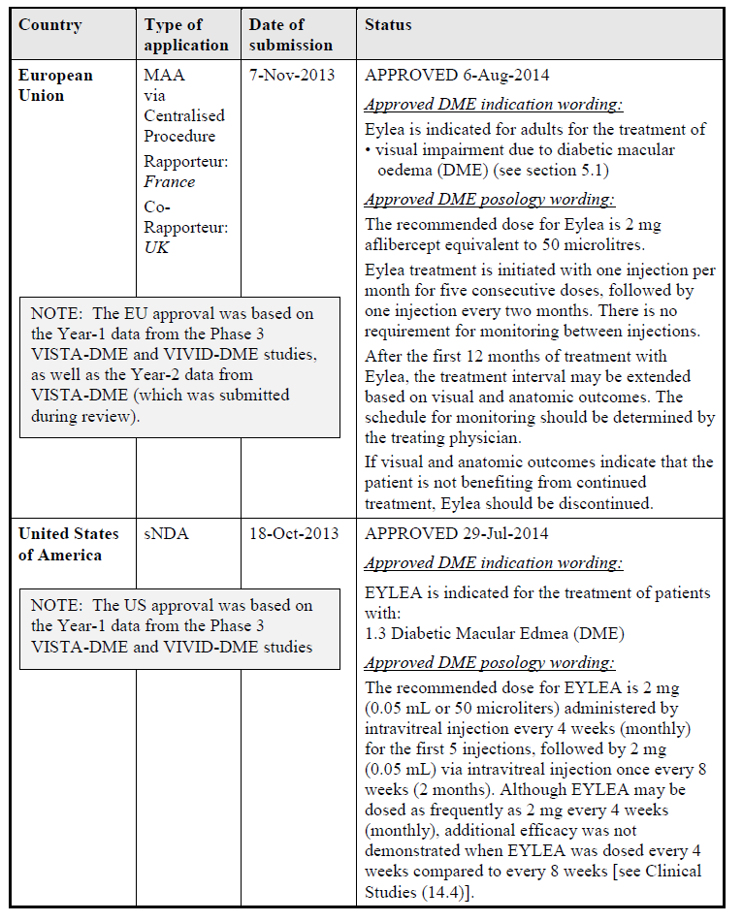

### Product Information

The approved Product Information (PI) current at the time this AusPAR was prepared can be found as Attachment 1. For the most recent Product Information please refer to the TGA website at <<https://www.tga.gov.au/product-information-pi>>.

## II. Quality findings

There was no requirement for a quality evaluation in a submission of this type (an extension of indications).

## III. Nonclinical findings

There was no requirement for a nonclinical evaluation in a submission of this type.

## IV. Clinical findings

A summary of the clinical findings is presented in this section. Further details of these clinical findings can be found in Attachment 2.

### Introduction

#### Clinical rationale

The clinical rationale for the use of aflibercept (also referred to in the application as ‘VEGF Trap’ and ‘VEGF Trap-Eye) in DME is related to its action in binding to and therefore inactivating VEGF within the eye. The pathogenesis of DME involves overexpression of VEGF and consequent vascular leakage into and under the retina as well as development of new vessels (neovascularisation). Vascular leakage in the region of the macula (the part of the retina capable of clear vision required for reading and other focus-requiring activities) leads to oedema, with consequent blurring and distortion of vision, and loss of visual acuity.

Aflibercept is a recombinant protein, expressed in Chinese Hamster Ovary (CHO) cells, consisting of specific domains of the human VEGF receptors, VEGF-R1 and VEGF-R2, fused to an immunoglobulin (IgG1 Fc). Aflibercept binds to VEGF with a higher affinity than its natural receptors and the stability of the aflibercept-VEGF complex then does not allow VEGF to bind to sites of action within the retina. The mechanism of action is identical to that involved in the other approved indications. All of these conditions are associated with overexpression of VEGF. Another product that is currently licensed for use in DME (ranibizumab) is also an inhibitor of VEGF. The clinical rationale is therefore appropriate.

#### Contents of the clinical dossier

##### Scope of the clinical dossier

The submission contained the following clinical information related to the application for extension of indications to include diabetic macular oedema:

* One clinical pharmacology study in subjects with DME that provided pharmacokinetic data
* One study that provided pharmacodynamic data, including safety and initial bioeffect
* Two pivotal efficacy/safety studies.

#### Paediatric data

The submission did not include paediatric data. This is appropriate given that the proposed indication is a condition of middle-aged and elderly people and is very rare in the paediatric population.

#### Good clinical practice

Evidence is provided in the study reports that the studies were audited for compliance with Good Clinical Practice (GCP) according to the current GCP guideline.

### Pharmacokinetics

#### Studies providing pharmacokinetic data

The pharmacokinetics of intravitreal aflibercept have been considered previously in both healthy subjects and target populations in relation to the indications that are already approved. The two studies evaluated in this report in relation to subjects with DME are:

* Study 13336 (Pharmacokinetic analysis of VEGF Trap following IVT administration of VEGF Trap-Eye in Subjects with DME; original protocol number VGFT-OD-0706.PK, a sub-study to VGFT-OD-0706 [DA VINCI]).
* Study VGFT-OD-0307 (An exploratory study of the safety, tolerability and biological activity of intravenously administered VEGF Trap in patients with diabetic macular edema).

The latter study is of limited relevance in terms of pharmacokinetics for this indication, given that subjects with DME received aflibercept as an intravenous infusion rather than an intravitreal injection. Aflibercept is formulated to be delivered directly to the eye, thereby maximising local ocular effects (reduction in macular oedema) while minimising the potential for systemic adverse effects (particularly a dose-dependent rise in blood pressure). In subjects with wet age related macular degeneration (wetAMD) or central retinal vein occlusion (CRVO), aflibercept was slowly absorbed into the systemic circulation after intravitreal injection, reaching peak concentrations well below those associated with systemic effects. Both free and bound aflibercept is expected to be cleared by proteolytic catabolism, as is the case for other large proteins.

Table 2 shows the studies relating to each pharmacokinetic topic. In addition, pharmacokinetic data were derived from a substudy of the Phase II clinical study (DA VINCI), which had primary objectives related to tolerability and biological effect.

Table 2:. Submitted pharmacokinetic studies.

|  |  |  |  |
| --- | --- | --- | --- |
| PK topic | Subtopic | Study ID | * |
| PK in special populations | Target population § - Single dose | Study VGFT-OD-0512 (CLEAR-IT) | * |
|  | - Multi-dose | Study VGFT-OD-0307 (IV infusions x 4)  Study 13336 (Protocol VGFT-OD-0706.PK; sub-study of DA VINCI) |  |

* Indicates the primary aim of the study. § Subjects who would be eligible to receive the drug if approved for the proposed indication.

Table 3 lists pharmacokinetic results that were excluded from consideration due to study deficiencies.

Table 3: Pharmacokinetic results excluded from consideration.

|  |  |  |
| --- | --- | --- |
| Study ID | Subtopic(s) | PK results excluded |
| VGFT-OD-0307 | PK after intravenous infusion | All (because no information provided concerning assay method) |
| VGFT-OD-0512 (CLEAR-IT) | PK after IVT administration | All (because no information provided concerning assay method) |

#### Evaluator’s conclusions on pharmacokinetics

The data provided support the sponsor’s contention that systemic exposure to both free and bound aflibercept is very low following intravitreal injection. Other aspects of systemic pharmacokinetics have limited relevance to the application for intravitreal administration for local activity within the eye.

### Pharmacodynamics

#### Studies providing pharmacodynamic data

The primary pharmacological basis for the mechanism of action of aflibercept in DME is the same as in wetAMD and oedema following CRVO: binding and inactivation of VEGF, thus preventing the action of VEGF on increasing leakage of fluid from capillaries leading to formation of oedema. The primary pharmacodynamic endpoint in the clinical studies is the central retinal thickness (CRT) measured via optical coherence tomography (OCT). This provides a direct objective measure of retinal thickness, which is directly related to the amount of oedema within the retina. Measurements of CRT are available from the Phase II trial (DA VINCI) and the two pivotal Phase III studies (VISTA DME and VIVID DME). Clinical outcomes from these trials (particularly visual outcomes) are considered in the section on efficacy.

Table 4 shows the studies relating to each pharmacodynamic topic.

Table 4: Submitted pharmacodynamic studies.

|  |  |  |  |
| --- | --- | --- | --- |
| PD Topic | Subtopic | Study ID | * |
| Secondary Pharmacology | Effect on central retinal thickness (indicator of oedema) in target population§ | VGFT-OD-0706 (DA VINCI) | * |
| 91745 (VIVID DME) |  |
| VGFT-OD-1009 (VISTA DME) |  |

* Indicates the primary aim of the study. § Subjects who would be eligible to receive the drug if approved for the proposed indication.

None of the pharmacodynamic studies had deficiencies that excluded their results from consideration.

#### Evaluator’s conclusions on pharmacodynamics

The evidence provided from three large, well designed clinical studies indicates that aflibercept causes a rapid and large reduction in central retinal thickness, which is a direct measure of reduced macular oedema. The reduction in CRT is much greater in all dosing regimens of aflibercept studied than that observed in the active control groups, treated with laser photocoagulation. The ‘saw-tooth’ pattern observed in CRT measurements in all of the 2 mg every 8 weeks (2Q8) groups, who received active injections at every second visit after the first five doses, is a strong indicator that the reduction in CRT is directly due to the effect of aflibercept and is partially lost when there is an eight week gap between doses. However, the loss of effect is very small and the overall effect on CRT over 52 weeks is similar in the 2 mg every 4 weeks (2Q4) and 2Q8 groups.

### Dosage selection for the pivotal studies

The lower dosage group in the DA VINCI study (0.5 mg Q4 weekly (0.5Q4)) had a significantly better reduction in CRT than the laser photocoagulation subjects and the effect was only marginally smaller than that observed in the higher dose (2 mg) groups at various dosing frequencies. In addition, the change in best corrected visual acuity (BCVA) was similar in the 0.5Q4 group compared with the other groups receiving 2 mg. In summary, at Week 52, the mean improvement in BCVA (expressed as number of letters gained) was -1.3 for the laser photocoagulation (LPC) group, 11.0 for the 0.5Q4 group, 13.1 for the 2Q4 group, 9.7 for the 2Q8 group and 12.0 for the 2 mg VEGF Trap as needed (2PRN) group. It is not clear to this evaluator that the choice of the 2Q8 weekly dosing regimen is well justified by these data, particularly taking into account the mean total amount of aflibercept ( mg) administered to the four aflibercept groups (5.9, 21.6, 14.4 and 14.8 respectively). It could be argued on the basis of these results that a very similar effect could be achieved using 0.5Q4 weekly, with much lower exposure to aflibercept.

Similarly, in DA VINCI the effectiveness of the 2 mg PRN dosing regimen was also comparable to the other groups in relation to its impact on CRT (see Figure 1 below).

Figure 1. Effect of aflibercept vs laser photocoagulation on central retinal thickness in DA VINCI study. Change from baseline in central retinal thickness (µm) by Visit to Week 52. LOCF (FAS).

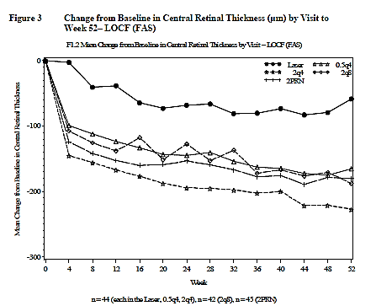

The primary visual acuity endpoint of the study (change from baseline to Week 24) was significantly better in terms of gains in ETDRS letter score in the 2PRN group compared with the LPC group. The statistical comparison is not provided for 2PRN versus 2Q8 but there was a numerical advantage for 2PRN in terms of mean letters gained (10.3, SD 7.5 for 2PRN versus 8.5, SD 7.5 for 2Q8) and in the proportion of patients who gained ≥ 15 letters (42.2% versus 23.8%). The total exposure of patients to aflibercept was similar in the two groups (mean 8.71 mg versus 7.67 mg). Safety results did not appear to differ among the various dosing groups, with the exception of an apparently lower rate of non-ocular severe treatment-emergent adverse events (TEAEs) in the 2PRN group compared with the other three (LPC 11.4%, 0.5Q4 20.5%, 2Q4 18.2%, 2Q8 21.4%, 2PRN 11.1%).

The submission argues that there were more subjects in the 0.5Q4 group compared with the 2Q8 group who had a reduction in BCVA (≥10 lost letters) at Week 24 (6.8% versus 0%) and at Week 52 (also 6.8% versus 0%) and this has been the major consideration in determining that the dose of 2 mg Q8 weekly would be tested in the pivotal clinical studies. Although this was not a predetermined primary or secondary endpoint in the DA VINCI study, it is probably a reasonable argument although it would have been interesting to see the results of a larger group receiving 0.5 mg Q4 weekly. It should also be noted that no subject in the 2PRN group lost ≥ 10 letters over 24 weeks, although 2 subjects did so over 52 weeks. A second argument is that there is evidence in the literature that intraocular VEGF levels may be higher in DME patients compared to those in AMD patients and that a similar dose to the one shown to be effective in AMD would be likely to be required. This is reasonable but could have been tested more rigorously.

In summary, the choice of dose for the Phase III studies based on the key Phase II study could have been any of the three dosing regimens tested. The arguments against the 0.5Q4 dose are reasonable but the data would not support superiority of any one of the 2 mg regimens over the others. In particular, few arguments can be sustained to support the 2Q8 regimen compared with the 2PRN regimen, which may be more practicable but was not tested in the Phase III trials. Logistical considerations may be important in determining which dosing regimen is preferred.

### Efficacy

#### Studies providing efficacy data

The submission contains two pivotal clinical efficacy studies, known as VIVID DME and VISTA DME, both of which were carried out in subjects with clinically significant macular oedema with central involvement. The sponsor’s clinical overview in the submission presents a summary of the two trials combined because their methods and measurements were very similar. In this report, each trial will be summarised separately but there were some common features that for efficiency will be described only once. All information is drawn directly from the full study reports.

The definition of ‘clinically significant macular oedema’ requires that it meets at least one of the following three criteria (developed by the ETDRS Group in 1985)

* retinal thickening at or within 500 μm from the centre of the macular
* hard exudates at or within 500 μm from the centre of the macular associated with thickening of the adjacent retina
* an area or areas of retinal thickening at least one disk area in size, at least part of which is within one disk diameter of the centre of the macula.

Retinal thickness is measured using optical coherence tomography (OCT), a well‑established non-invasive technique for imaging cross-sections of the retina with a high degree of accuracy.

The active control used in both studies is LPC, which has been widely used since the 1980s for the treatment of diabetic retinopathy. Its role is primarily to prevent further visual loss and it is recognised that it has limited capacity to restore lost vision or resolve macular oedema.[1] Nevertheless, given its position as the treatment of choice prior to the development of anti-VEGF treatments, laser photocoagulation is a reasonable control.

Both studies used identical dosing regimens: 2Q4 for one group and 2Q4 for 5 doses followed by 2Q8 for a second group. The active control was LPC. The studies were well designed in terms of maintaining masking, with all groups receiving both intravitreal injections (sham in the case of the control group) and LPC (sham in the case of the aflibercept groups). Masked observers assessed endpoints. The primary endpoint for the VIVID study was change from baseline in BCVA in ETDRS letter score at Week 52.

The Phase II study (DA VINCI) also provided some efficacy data in terms of changes in visual acuity and these generally support the results of the two pivotal studies.

#### Evaluator’s conclusions on efficacy for diabetic macular oedema

The three clinical studies investigating clinical efficacy (one small Phase II study, DA VINCI, and two large Phase III studies, VIVID and VISTA) have provided evidence for clinical efficacy of aflibercept administered IVT in diabetic macular oedema. Questions remain about the translation of the dosage schedule used in the Phase III trials, to clinical practice in Australia.

### Safety

#### Studies providing safety data

The following studies provided evaluable safety data:

* VGFT-OD-0706 (DA VINCI) (n=219; 175 treated with aflibercept and 44 with LPC for 52 weeks; dose-response and non-pivotal efficacy study)
* 91745 (VIVID DME) (n=404; 271 treated with aflibercept and 133 with LPC for 52 weeks at time of reporting; study on-going)
* VGFT-OD-1009 (VISTA DME) (n=461; 307 treated with aflibercept and 154 with LPC for 52 weeks).

The latter two studies are regarded as pivotal efficacy studies. However, neither of these studies assessed safety as a primary outcome. In both studies, safety was a secondary outcome.

The following studies provided in the dossier are less relevant to the current application and will not be considered further:

* VGFT-OD-0307 (n=6 subjects with DME exposed to aflibercept administered intravenously); no detailed safety results provided in targeted pharmacokinetic report
* VGFT-OD-0512 (n=5 subjects with DME exposed to aflibercept given IVT but at double the currently proposed dose); a brief summary of AEs is included in the sponsor’s Summary of Clinical Safety. States that four subjects had ocular AE (most commonly conjunctival haemorrhage), all of which were mild, and that four subjects had a total of 11 systemic AEs, no single one of which occurred in more than one subject, and none of which were considered related to study drug. Two subjects had serious AEs (coronary artery disease in one and serious infectious conditions with systemic complications in the other; neither were likely to have been related to treatment). No increase in systemic blood pressure occurred (increased blood pressure (BP) is a marker of systemic effect of aflibercept).

These two studies were not fully reported in the submission and insufficient detail was provided regarding adverse effects. The dose and route of administration was also different from the proposed dosing regimen. For these reasons and due to the small number of subjects involved, they will not be considered further.

The relevant studies therefore provide evaluable safety data on 753 subjects treated with aflibercept and 331 controls treated with LPC. The dose regimens studied include the proposed dosing for DME (2Q8 weekly following 5 initial monthly doses).

#### Patient exposure

In the three submitted studies which had adequate details provided, the control group was treated with LPC. A total of 753 patients were exposed to aflibercept in these three studies and 11 further subjects being exposed in the early phase studies. Given the absence of detail regarding safety outcomes in these latter studies, these 11 are not considered further in this report.

Table 5: Exposure to aflibercept and comparator (laser photocoagulation) in clinical studies.

|  |  |  |  |  |  |
| --- | --- | --- | --- | --- | --- |
| Study type/Indication | Controlled studies | | Uncontrolled studies | Total Aflibercept | Notes |
| Aflibercept | LPC | Aflibercept |  | |
| Clinical pharmacology | | | | | |
|  |  | | 6 |  | IV dose 0.3 mg/kg; No details provided |
| 5 | IVT at 4 mg; few details provided |
| Diabetic macular oedema | | | | | |
| Pivotal | 578 | 287 |  | 578 |  |
| Other | 175 | 44 |  | 175 |
| TOTAL | 753 | 331 | 11 | 753 |

The exposure of patients to aflibercept in the three relevant clinical studies (DA VINCI, VIVID and VISTA) included the proposed dosing regimen to be used in DME (2Q8 weekly after 5 initial monthly doses) as well as lower and higher doses. All treatments were given over at least a 12 month period and the pivotal clinical studies are on-going and planned to continue for three years. Data from the 52 week time-point is provided for all three studies in this submission.

#### Postmarketing data

Aflibercept has been available in the USA since November 2011 and in the EU and other countries including Australia, since 2012. In Australia, aflibercept was marketed for use in wetAMD initially and eedema due to CRVO was approved at the end of 2013. The sponsor has received AE reports in relation to patients with both of these indications. A total of 1761 reports have been made over a period during which about 996,000 vials of aflibercept have been sold. Of these reports, 1444 were made by health care providers and of these, 866 were serious. The most common category of AE was ocular (59%), followed by infections (10%). There are no issues of particular concern in these data.

#### Evaluator’s conclusions on safety

No issues are raised in the submission that suggest any alteration in the assessment of clinical safety of aflibercept as previously evaluated for its approved indications of wetAMD and macular oedema secondary to CRVO. Aflibercept is generally well tolerated when administered via the intravitreal route in patients with DME and the most common adverse effects are related primarily to the process of injection. There is little evidence for significant systemic adverse effects and this is consistent with the pharmacokinetic evidence for very low systemic absorption from the site of administration within the eye.

### First round benefit-risk assessment

#### First round assessment of benefits

The benefits of aflibercept in the proposed usage (diabetic macular oedema) are:

* Significant reduction in central retinal thickness measured by OCT, indicating reduced macular oedema, commencing within 4 weeks of the first treatment and maintained to 52 weeks with maintenance injections either at 4 weekly or 8 weekly intervals
* Significant improvement in best corrected visual acuity as measured by ETDRS letters.

#### First round assessment of risks

The risks of aflibercept in the proposed usage (diabetic macular oedema) are:

* Moderate to high risk (about 50%) of intra-vitreal injection-related adverse effects (not directly related to the drug itself), particularly conjunctival haemorrhage and eye pain
* Low risk (≤ 5%) of minor ocular reactions (conjunctival haemorrhage and eye pain)
* Very low risk (≤ 1%) of severe ocular reactions
* Very low risk (≤ 1%) of treatment-related severe systemic reactions.

#### First round assessment of benefit-risk balance

The evaluator was unable to comment until the Dosage & Administration section of the PI is clarified.

### First round recommendation regarding authorisation

The evaluator was unable to comment until the Dosage & Administration section of the PI is clarified.

### Clinical questions

Please comment on the translation of the dosage regimen used the Phase III trials to clinical practice in Australia.

### Second round evaluation of clinical data submitted in response to questions

No second round evaluation was conducted. The sponsor's response to the clinical question on dosing was noted by the Delegate but the issue was not resolved. Dosing is discussed in the Delegate's overview (below *Overall conclusion and risk benefit assessment*) and will be discussed at the Advisory Committee on Prescription Medicines meeting (ACPM).

## V. Pharmacovigilance findings

### Risk management plan

The sponsor submitted an EU Risk Management Plan (EU-RMP) version 13.0, dated 25 October 2013, data lock point 31 July 2013 and Australian specific annex (ASA), version 2.0, dated December 2013 as well as EU-RMP, version 16.1, dated 3 July 2014, data lock point 31 July 2013 and ASA version 2.1, dated July 2014 which were reviewed by the TGA’s Post-Market Surveillance Branch (PMSB).

#### Safety specification

The sponsor provided a summary of ongoing safety concerns which are shown at Table 6.

Table 6: Ongoing safety concerns

Table 6: Ongoing safety concerns

#### Pharmacovigilance plan

The sponsor proposes routine as well as additional pharmacovigilance activities. Routine pharmacovigilance activities also include follow up questionnaires for events relating to the identified risk of Endophthalmitis, Hypertension and Arterial Thromboembolic Events.

Additional pharmacovigilance activities include a Post Authorisation Safety Study (PASS) and three long-term safety studies.

#### Risk minimisation activities

The sponsor proposes only routine risk minimisation activities for the Australian market. In contrast additional risk minimisation activities are conducted in Europe, including educational materials for patients and physicians.

#### Reconciliation of issues outlined in the RMP report

Table 7 summarises the PMSB’s first round evaluation of the RMP, the sponsor’s responses to issues raised by the PMSB and the PMSB’s evaluation of the sponsor’s responses.

Table 7: Reconciliation of issues outlined in the RMP report

|  |  |  |  |
| --- | --- | --- | --- |
| Recommendation in RMP evaluation report | Sponsor’s response | | PMSB evaluator comment |
| Safety considerations may be raised by the nonclinical and clinical evaluators through the consolidated request for further information and/or the Nonclinical and Clinical Evaluation Reports respectively. It is important to ensure that the information provided in response to these include a consideration of the relevance for the Risk Management Plan, and any specific information needed to address this issue in the RMP. For any safety considerations so raised, the sponsor should provide information that is relevant and necessary to address the issue in the RMP. | There was no nonclinical evaluation relevant for this application.  In the first round Clinical Evaluation Report issued 1 May 2014, there are no new safety considerations raised by the clinical evaluator that would require further consideration in the Risk Management Plan. | The response has been noted. | |
| It is recommended that the table in the EU-RMP providing details and milestones regarding the ongoing/planned studies be updated. Furthermore, the sponsor should submit the final PASS protocol, and the final outcome of the outcome Study BAY 86-5321/16598 for review. | Revision has been made to the ASA to the EU-RMP to provide an update of the milestones of the ongoing/planned studies.  A commitment is provided that the final PASS protocol, and the final outcome of the outcome Study BAY 86-5321/16598 will be submitted to the TGA for review when they become available. | This is considered acceptable. | |
| It is recommended that the sponsor implements educational materials for patients to accurately inform patients about the frequency of side effects associated with the use of Eylea. | The sponsor has considered the issues raised in the RMP evaluation report and hereby accepts the RMP recommendation to implement patient educational materials as an additional risk minimisation activity to inform patients about the frequency of side effects associated with the use of Eylea. The ASA has been updated accordingly and a draft content of the patient educational material for implementation in Australia is provided in the Appendix of the updated ASA. | This is considered acceptable. However, it is recommended that the final version of the educational materials be submitted to the TGA for review. | |
| It is recommended that the sponsor undertakes further risk minimisation activities to prevent medication errors, including the addition of the following statement in the Australian PI in section ‘Dosage & Administration’: The prefilled syringe and the glass vial contain more than the recommended dose of 2 mg. The extractable volume of the syringe (90 microlitres) and the total volume of the glass vial (100 microlitres) is not to be used in total. The excess volume should be expelled before injecting. Injecting the entire volume of the glass vial or the prefilled syringe could result in overdose. | The sponsor has considered the issues raised in the RMP evaluation report and hereby agrees to include the following additional statements into the Australian PI as further risk minimisation activities to prevent medication errors:  ‘*The prefilled syringe and the glass vial contain more than the recommended dose of 2 mg. The excess volume should be expelled before injecting. Injecting the entire volume of the glass vial or the prefilled syringe could result in overdose*.’  The sponsor is of the opinion that the actual extractable volume of the syringe (90 microlitres) and the vial (100 microlitres) is immaterial to the prescriber and could potential leads to confusion. As such, the sponsor considers that the advice to be included in the PI should focus on highlighting the important messages only, that is, the fact that the syringe and the vial contain more than the recommended dose and that the excess volume should be expelled before injecting in order to avoid the potential consequence of overdose.  The ASA has been updated accordingly and the amended Australian PI is provided in clean and annotated copies. | Pending the Delegate’s approval this is considered acceptable. | |

#### Summary of recommendations

It is considered that the sponsor’s response to the TGA has not adequately addressed all of the issues identified in the RMP evaluation report.

##### Outstanding issues

###### Issues in relation to the RMP

It is recommended that the final version of the patient educational materials be submitted to the TGA for review.

###### Advice from the Advisory Committee on the Safety of Medicines (ACSOM)

ACSOM advice was not sought for this submission.

##### Suggested wording for conditions of registration

###### RMP

Implement EU-RMP, version 16.1, dated 3 July 2014, data lock point 31 July 2013 and Australian specific annex, version 2.1, dated July 2014, and any future updates, as agreed with the TGA as a condition of registration.

## VI. Overall conclusion and risk/benefit assessment

The submission was summarised in the following Delegate’s overview and recommendations:

### Quality

There was no requirement for a quality evaluation in a submission of this type (an extension of indications).

### Nonclinical

There was no requirement for a nonclinical evaluation in a submission of this type (an extension of indications).

### Clinical

The main clinical studies relevant to this application for extension of indications were:

* DA VINCI, Phase II, dose ranging
* VISTA, Phase III, efficacy/safety
* VIVID, Phase III, efficacy/safety.

#### Pharmacokinetic and pharmacodynamic studies

The PK/PD profile and immunogenicity of aflibercept in patients with diabetic macular oedema is similar to that observed in AMD and CVRO patients. Systemic exposure to both free and bound aflibercept is low following intravitreal injection.

#### Phase II dose ranging study

##### DA VINCI

The study was conducted at 39 sites in 3 countries: United States, Canada and Austria.

The total sample size was 219; 42 to 45 patients in each of the 5 treatment groups.

**Primary objective**: investigate the effect of four different doses/dose-intervals (and laser) on BCVA in patients with diabetic macular oedema.

The following tables describe the study design as well as the results obtained.

Table 8: Study design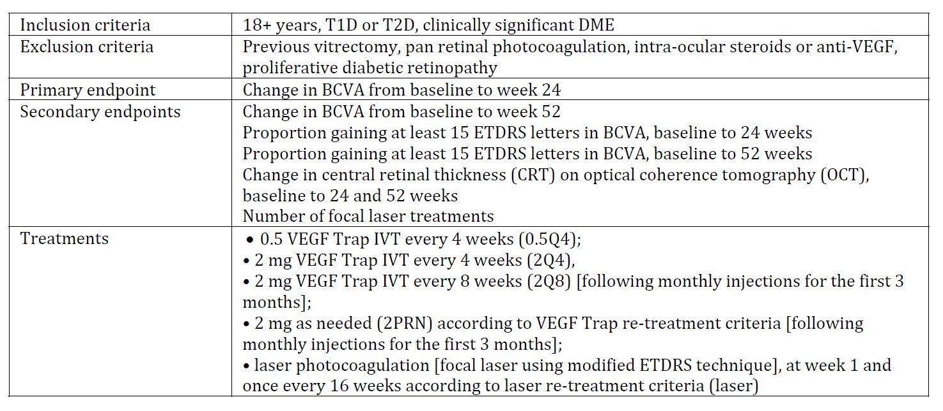

Table 9: Change in BCVA from baseline to 24 weeks (primary endpoint), LOCF

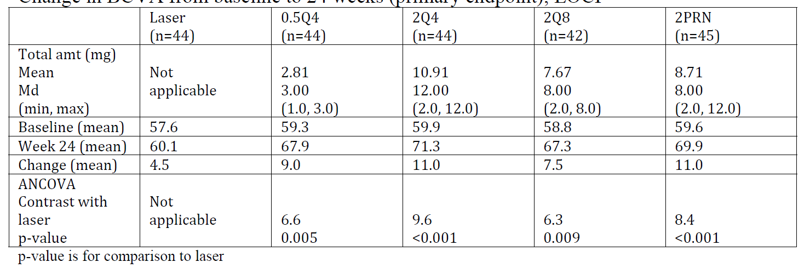

Table 10: Percentage of patients with gain in ETDRS letter score of 15+ letters, 24/52 weeks (secondary endpoints), LOCF

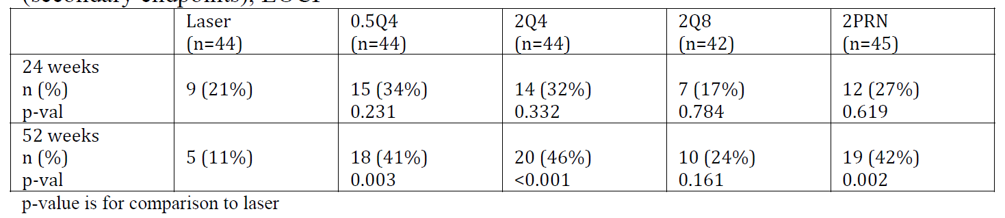

Table 11: Loss of 10+ ETDRS letters from baseline to 24/52 weeks, LOCF

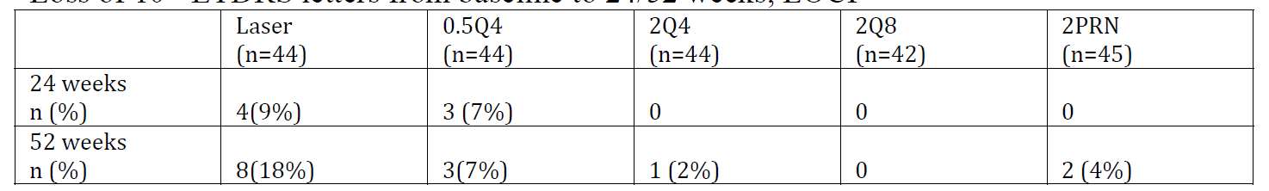

As with most other Phase II dose-ranging studies, DA VINCI was not designed or powered to detect clinically meaningful differences between different doses of aflibercept.

The sponsor states (in the dossier and in response to a request for further information) that the 0.5Q4 dose was not tested in the two Phase III studies because:

* More patients in the 0.5Q4 group lost 10+ or 15+ letters at 24 weeks and 52 weeks compared to patients who received 2 mg doses. (As the clinical evaluator points out, this was only a trend; the sample size was not sufficient to show that the greater loss of 10+ or 15+ letters with the 0.5 mg dose compared to the 2 mg dose was statistically significant.)
* Some experts have hypothesised that intraocular VEGF levels might be higher in DME patients than AMD patients and, consequently, a dose at least as high as that for AMD would be required for DME. (The dosing for AMD is 2 mg per month for 3 consecutive months, followed by 2 mg every 2 months.)

Based on this reasoning, the sponsor tested the 2Q4 and 2Q8 dosing regimens in the two Phase III trials (VISTA and VIVID, see below). The sponsor stated that the 2Q4 regimen was intended as ‘further benchmarking the efficacy of the 2Q8 arm as well as delivering additional safety information at a higher exposure level.’ That is, the focus of the Phase III trials was on the 2Q8 dosing regimen.

The reasons given by the sponsor for not testing the 2PRN regimen were that:

*‘[It] … requires an intense monthly monitoring scheme compared to the 2Q8 group (monitoring was done for masking purposes only in this treatment group, but no treatment decisions were made at these visits). Since both groups ended up with similar efficacy and similar number of injections, the results indicate that intensive monitoring in the PRN group does not translate into a patient relevant benefit. To the contrary, rigid monthly monitoring comes with additional burden to the patients due to more office visits and additional examination procedures. In addition, a fixed 2Q8 dosing has an advantage over variable PRN dosing regimens in that treatment is delivered on a proactive basis and not in response to recurrence of disease.*’

The European Medicines Agency’s (EMA’s) Committee for Medicinal Products for Human Use (CHMP) considered the decision not to investigate the PRN regimen in Phase III as contentious. The following is an excerpt from EMA, Variation Assessment Report, EMA/430291/2014:

*It was agreed that a similar number of injections was administered to the 2Q8 and 2PRN groups, that the visual acuity and anatomic outcomes were similar between the two groups, and that it might generally be preferable to treat a disease proactively than prevent its worsening. However, the treatment period was relatively short, and DME is a chronic condition, with a waxing and waning course. It would therefore have been valuable to investigate a PRN dosing regime in phase 3 to gain information about the possible effects of a reduced injection frequency later on in the treatment course.’*

*‘Furthermore, in order to take into account the fluctuations in CRT observed in the 2Q8 group upon start of the bi-monthly treatment schedule, the applicant changed the phase 3 VISTA and VIVID protocols to try to improve efficacy in the 2Q8 group. The original protocol stated that the subjects in the 2Q8 group were to receive monthly 3 doses at the first 3 visits (baseline, week 4, and week 8) before starting the 2Q8 schedule. This was revised by the addition of another dose at week 12 and hence changing the number of initial monthly doses for subjects in the 2Q8 group to a total of 5 injections. This change was considered acceptable by the CHMP, albeit more or less arbitrary.*

#### Phase III studies (efficacy)

VISTA was conducted 54 centres in the USA whereas VIVID was conducted at 73 centres in Japan, Europe and Australia.

The following tables describe the study design as well as the results obtained in VISTA.

Table 12: Study design

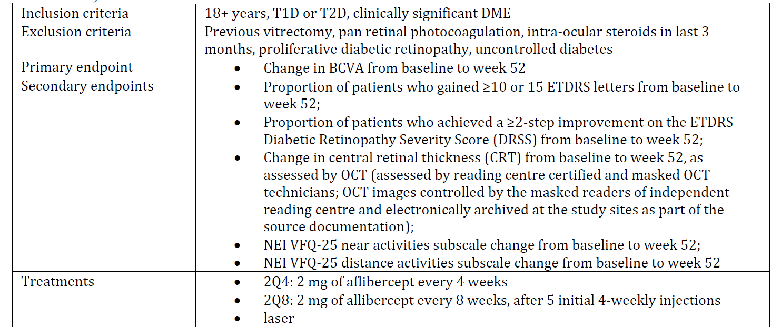

Table 13: Selected baseline characteristics, VISTA, VIVID

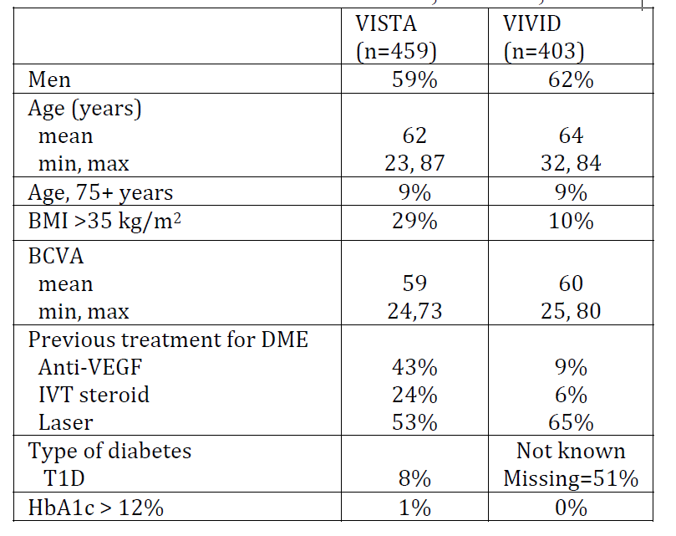

Table 14: Results for primary endpoint, change in BCVA, baseline to 52 weeks, LOCF. Full-analysis set

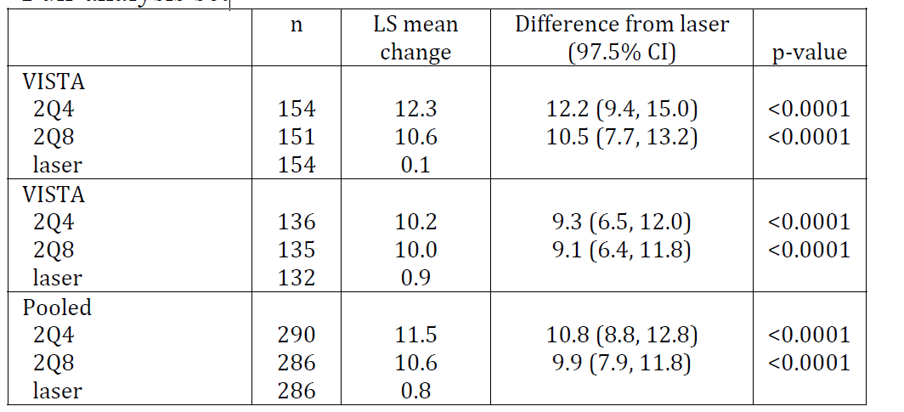

The full-analysis set (essentially the Intent-to-Treat (ITT) population) and per-protocol analyses produced similar results. Analysis of secondary endpoints and other endpoints as well as the subgroup analyses were supportive.

The EMA received 2 year efficacy data for VISTA from the sponsor which showed maintenance of efficacy.[2]

#### Safety

The main safety data were the 12 months follow-up from VISTA and VIVID.

The available data suggested that adverse events for DME are similar to those for AMD and CRVO. They are mainly related to the process of injection.

The pharmacokinetic evidence suggests low systemic absorption from the site of administration within the eye. The available data did not clarify whether arterial thromboembolic events are more common in patients with DME.

The available data did not clarify the safety of bilateral use and whether systemic adverse effects, including arterial thromboembolic events are more frequent with the increased overall exposure associated with bilateral use.

#### Clinical evaluator’s recommendation

The evaluator was unable to comment until the Dosage & Administration section of the PI is clarified.

### Risk management plan

Table 6 (above) shows a summary of the ongoing safety concerns.

Besides routine pharmacovigilance, four safety studies are proposed (not specific for the indication of diabetic macular oedema). None of these studies will be conducted in Australia.

* A PASS to evaluate physician and patient knowledge of safety and safe use information in Europe. First patient expected first quarter of 2015 and study report available first quarter of 2016 (estimated)
* Study 15971 in EU (LIBRA). Long term investigation and risk-benefit analysis of real life utilisation of aflibercept in macular disease. Adverse drug reactions (ADRs) (including ATEs), concomitant use of anti-VEGF agents for wet AMD and CRVO, long-term safety beyond 2 years. First patient enrolled second quarter of 2014 with interim study reports every 12 months. Final study report available third quarter 2020 (estimated)
* Study VEGF-OD-0910, US, open-label, long-term safety and tolerability extension study of intravitreal aflibercept in neovascular AMD (extension of VIEW-1). Study report available in 2014
* Review of safety outcomes of Study BAY 86-5321/16598, planned pending EMA feedback and approval. This study will investigate posology for neovascular AMD, extending treatment beyond 2Q8 without affecting efficacy. Final study report available 2017 (estimated).

### Risk-benefit analysis

#### Delegate’s considerations

The main weaknesses/ambiguities/uncertainties in the currently-available evidence for the extension-of-indication to diabetic macular oedema are:

* Limited information on the optimal dosing schedule, especially for long-term use, including the place of PRN or extend-and-treat dosing
* Whether bilateral use carries an increased risk of systemic adverse drug reactions, including arterial thromboembolic events
* Whether arterial thromboembolic events are a greater risk in patients with diabetes
* Use in patients with T1D
* Use in patients with HbA1c>12%
* When to stop, if there has been no improvement.

If these weaknesses/ambiguities/uncertainties can be addressed in the PI, then the Delegate has no reason to say, at this time, that the extension-of-indication to include diabetic macular oedema for Eylea should not be approved for registration.

##### Dosing

The problem of translating the dosing schedule used in the Phase III trials to the real world of everyday clinical practice, applies to this indication for diabetic macular oedema, as for the other indications.

The EMA Variation Assessment Report [EMA/430291/2014] noted that, in the Phase II DAVINCI trial, BCVA was relatively well-maintained during the 6 month off-drug follow-up period. Patients were allowed to receive other DME treatments during this time, however less than a fifth of the subjects for whom data were available at Week 76 received additional treatments (mainly anti-VEGF agents and laser). The treatments were distributed evenly across the groups. Therefore, patients were able to maintain improvements in vision following one year of treatment with aflibercept despite the limited use of further treatment in this period. This has a bearing on the issue of possible cessation of treatment.

EMA/430291/2014 also stated that the DA VINCI results suggested that improvements in vision achieved in the first year of treatment may persist after treatment has ceased, as reflected in a relatively well-maintained BCVA gain during the 6 month off-drug follow-up period of the study and despite only limited use of further treatment in this period. This would support an extended treatment interval.

Therefore, the EMA considered that it was reasonable to allow a gradually extending interval between treatments after the initial year of therapy, as approved for the AMD indication. However, the benefits of an extended treatment interval versus a fixed dosing regimen in the long-term treatment of DME remain unproven as this was not investigated in the pivotal Phase III trials. Therefore, the EMA requested that the posology for long-term treatment should be further investigated in a postmarketing study with a view to comparing different treatment regimens (2Q8, PRN, and treat-and-extend) after the first year of treatment, thereby exploring different common practices in the management of DME as well as criteria for possibly ceasing treatment if no longer required.

#### Summary of issues

The two Phase III trials show efficacy for the pre‐specified primary endpoint of best corrected visual acuity. The available data did not raise any new safety concerns.

#### Proposed action

The Delegate had no reason to say, at this time, that the extension‐of‐indication to include diabetic macular oedema for Eylea should not be approved for registration.

#### Conditions of registration

* Implement the latest EU-RMP with the latest ASA
* Submit to the TGA any studies relevant to the efficacy and safety (and the dosing) of aflibercept as soon as the results become available.

#### Request for Advisory Committee on Prescription Medicines (ACPM) advice

1. Instructions to prescribers in the Dosing & Administration section of the PI.

#### Response from sponsor

The sponsor welcomes the opportunity to respond to the Delegate’s Request for ACPM’s Advice (dated 22 October 2014) concerning our Category 1 application to vary the conditions of registration for Eylea (AUST R 180859, 180860) to extend the indications to include the addition of:

*Diabetic macular oedema (DME)*

The sponsor concurs with the Delegate’s pre-ACPM preliminary assessment that there is no reason to say, at this time, that the extension-of-indication to include diabetic macular oedema for Eylea should not be approved for registration*.*

##### Dosage and administration section of the PI

The sponsor acknowledges that the Delegate is seeking the ACPM’s advice on the instructions to prescribers in the Dosage & Administration section of the Eylea PI and the sponsor welcomes the Delegate’s comment on the Dosage & Administration section. Based on the clarification sought from the Delegate, the sponsor understands that the intent of the Delegate’s proposal is ‘*to include information common to the three indications ‘up-front’ and only include any differences under the specific indications*’. The sponsor has taken the Delegate’s proposal into consideration and would like to hereby accept the Delegate’s proposal to harmonise the Dosage & Administration section of the Eylea PI to include the common information ‘up-front’. However, the sponsor would like to modify the Delegate’s wording slightly. The changes proposed by the sponsor are considered editorial in nature in order to improve readability and to remove undue repetition.

##### Eylea for the treatment of diabetic macular oedema

Diabetic macular oedema (DME) is a manifestation of diabetic retinopathy and is the most frequent cause of blindness in young and middle aged adults. The clinical efficacy and safety of Eylea in the treatment of DME is supported by the two pivotal Phase III studies, VIVID-DME and VISTA-DME. These studies were planned for a maximum treatment duration of three years. Two Eylea dosing regimens were studied in these trials (that is, Eylea 2Q4 and 2Q8 after initial 5 monthly doses) against LPC.

The one year data of both VIVID-DME and VISTA-DME provided in the submitted dossier demonstrated robust and consistent benefits of Eylea in all efficacy measures. In both studies, Eylea was superior to laser treatment in the improvement of BCVA assessed by the ETDRS chart in subjects at Week 52 compared to baseline (adjusted difference to laser in the integrated analysis: +9.9 letters [2Q8] and +10.8 letters [2Q4] , both p < 0.0001). The superiority of Eylea treatment was further supported by the visual and anatomic secondary outcomes. Significantly greater percentage of Eylea treated patients gained ≥ 15 ETDRS letters and ≥ 10 ETDRS letters at Week 52 compared to those treated by laser across both studies. Significant improvements in mean CRT was also shown compared to laser. Both Eylea groups were well tolerated, without notable differences between the two dosing regimen compared with laser in the incidence of ocular or non-ocular TEAEs.

Since both the 2Q4 and 2Q8 Eylea groups showed very similar levels of efficacy (both of which are superior to laser treatment), the 2Q8 dosing regimen is considered the preferred dosing regimen as it achieved very similar improvements as the 2Q4 group but with fewer median injections. In addition, although subjects in the 2Q8 group were seen monthly, no treatment decisions were made at non-injection visits. This indicates that there is no requirement for monitoring between injections. Therefore, the 2Q8 dosing regimen (that is, 2 mg every 8 weeks after initial 5 monthly doses) is considered a more practical dosing regimen for translation into real-world clinical practice as it requires fewer injections and clinic visits. Thus, the findings from the first year data of both VIVID-DME and VISTA-DME studies supports the sponsor’s proposal that for the treatment of DME:

*Eylea treatment is initiated with one injection per month for five consecutive months, followed by one injection every two months****.***

##### Information on long-term use

The Delegate has identified ‘*the optimal dosing schedule, especially for long-term use including the place of PRN or extend-and-treat dosing*’ as one of the main weakness in the submitted evidence. In response to this, the sponsor would like to highlight the availability of the second year data of both VIVID-DME and VISTA-DME (included with this reposnse). A summary of the key efficacy and safety results for both VIVID-DME and VISTA-DME at Week 100 (Year 2), relevant to supporting the proposed dosing for long-term use are presented herewith.

For the 2Q8 treatment arm in both VIVID-DME and VISTA-DME, the treatment was initiated with one injection per month for five consecutive months, after which the treatment interval was extended in all patients to one injection every 2 months through the observation period to Week 100. All efficacy endpoint assessments at Week 100 are considered exploratory analyses only. The Year 2 results of both VIVID-DME and VISTA-DME demonstrated superior efficacy for Eylea (both dosage regimens) over laser treatment through to Week 100. Results of the key primary and secondary endpoints show that the 2Q8 dosing regimen achieved similar efficacy to the 2Q4 dosing regimen throughout the observation period up to Week 100 in both studies. Both Eylea groups demonstrated significant improvements over laser treatment in the mean change in BCVA at Week 100. The statistically significant differences to laser at Week 52 were maintained through Week 100. The mean differences in EDTRS letters gained at Week 100 remained clinically meaningful in both studies. For all three functional parameters (Gain of 10/15 letters and ≥ 2-step improvement in ETDRS DRSS), the favourable differences over laser at Week 100 remained nominally statistically significant for both Eylea groups and consistent across both studies. The results of the changes in CRT show a stable course during the second year of treatment for all treatment arms. A significant improvement in mean CRT as compared to laser was seen through to Week 100. Consistent with the findings from the 1 Year results, Eylea was generally well tolerated over 100 weeks treatment in both studies, with no notable differences compared to laser treatment in the incidence of ocular or non-ocular TEAEs. The following tables summarise the Year 2 results.

Table 15: Overview of the VIVID-DME Year 2 efficacy results at Week 100 (exploratory analysis only).

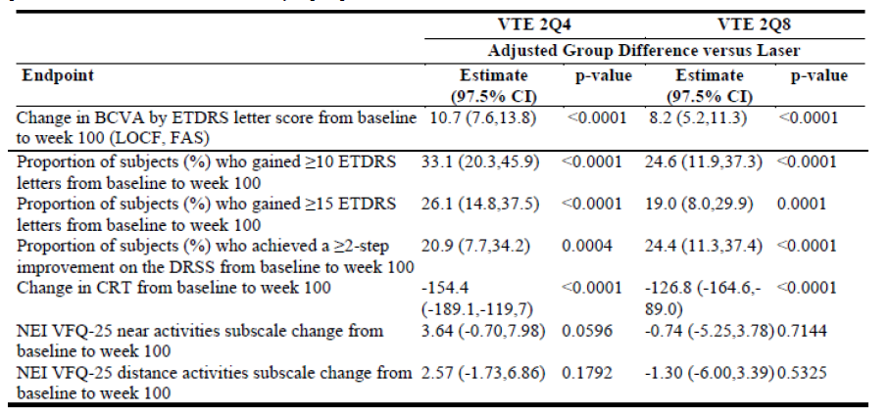

Table 16: Overview of the VISTA-DME Year 2 efficacy results at Week 100 (exploratory analysis only)

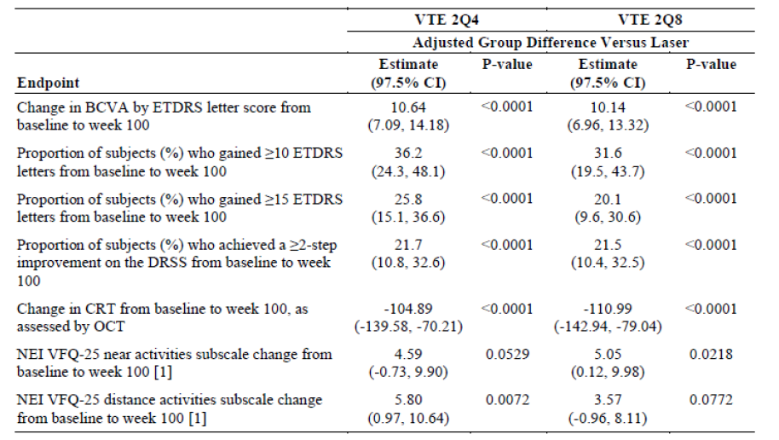

##### Translation of the available evidence on optimal dosing into real-world clinical practice

The Year 2 results from VIVID-DME and VISTA-DME demonstrates that the 2Q8 dosing regimen is effective in maintaining the visual gains for the long-term treatment of DME. Since the mean change in BCVA showed a tendency to increase over almost the entire first year of Eylea treatment (see Figures 2 and 3 below), the sponsor sees no data-driven rationale for a label that recommends a deviation from the studied posology in the first year of treatment. This is supported by the analysis of the time until the first gain of 15 letters compared to baseline.

Figure 2: VIVID-DME: Mean Change in BCVA (±SE) from Baseline to Week 100 (LOCF) (FAS)

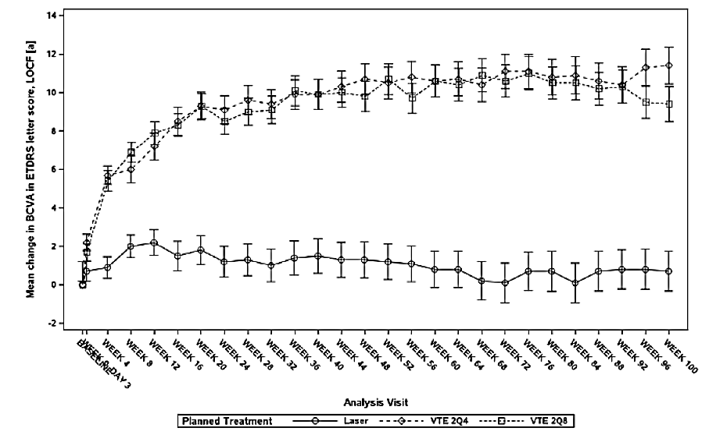

Figure 3: VISTA-DME: Mean Change in BCVA (±SE) from Baseline to Week 100 (LOCF) (FAS)

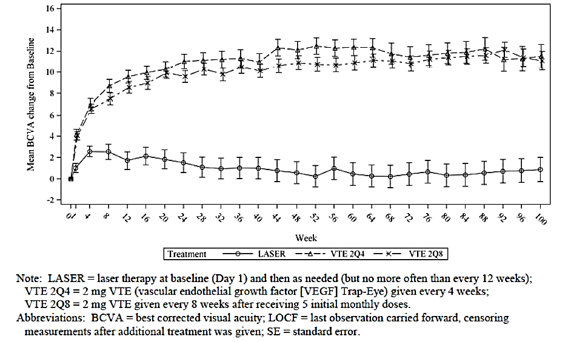

The figures above from the Year 2 data of VIVID-DME and VISTA-DME show that after one year of Eylea treatment visual acuity stabilises on a level that is significantly and approximately 2 lines better than laser, while no further gains are observed during the second year. Thus, at the transition from the first year of treatment into the second year, a plateau seems to be reached where patients have achieved the maximum effect. Consequently, this seems to be a logical time point at which an extension of the treatment interval may be considered. The sponsors therefore agrees with the Delegate’s proposal to include the following in the Dosage & Administration section of the Eylea PI to enable physicians to have some flexibility during ongoing treatment of DME, such that:

*After the first 12 months, the treatment interval may be extended based on visual and anatomic outcomes.*

The sponsor intends to conduct a Post authorisation efficacy study (PAES) in EU to gather additional information on long-term dosing, specifically to study a treat-and-extend regimen in direct comparison with continued 2Q8 dosing and PRN dosing. Pending such data being available, the sponsor accepts the Delegate’s proposal to acknowledge the limitation on long-term treatment in the Eylea PI and proposes to include the following under the Dosage & Administration section:

*There is limited information on the optimal dosing interval and monitoring interval for long-term (e.g., > 12 months) treatment. Consequently, the monitoring intervals should be determined by the treating ophthalmologist based on the individual patient’s response.*

The sponsor also hereby acknowledges the Delegate’s general concern to avoid unnecessary treatment in patients who have shown no improvement and agrees to accept the following statement under the Dosage & Administration section in the Eylea PI:

*If visual and anatomic outcomes indicate that the patient is not benefiting from continued treatment, Eylea should be discontinued.*

##### Other main weakness/ambiguities/uncertainties identified by the delegate

For the other weaknesses identified by the Delegate (that is, bilateral use, risk of arterial thromboembolic events, use in patients with type 1 diabetes, use in patients with HbA1c > 12%), the sponsor provided comments on PI and revised proposed Eylea PI (annotated and non-annotated versions). The details of these are beyond the scope of this AusPAR.

##### Conclusion

Eylea represents a clinically meaningful treatment option which provides sustained treatment efficacy in improving visual outcomes in patients with DME. The compelling results of both VIVID-DME and VISTA-DME demonstrate strong superiority of Eylea over laser, with improvement in vision and anatomical outcome measures that were both statistically significant and clinically relevant. The safety profile of Eylea in DME was generally consistent with the known profile in the already approved indications wet AMD and CRVO. The results of the Year 2 data support the durability of the effects seen in the first year of the study. In view of the burden of untreated DME and taking into consideration the applicability of the dosing schedule used in the Phase III trials into the real world of clinical practice, the sponsor agrees with the Delegate to apply a flexible approach for the long-term use of Eylea in the requested DME indication.

#### Advisory Committee Considerations

The Advisory Committee on Prescription Medicines (ACPM), having considered the evaluations and the Delegate’s overview, as well as the sponsor’s response to these documents, advised the following:

The ACPM, taking into account the submitted evidence of efficacy, safety and quality, agreed with the delegate and considered Eylea solution for injection containing 40 mg/mL of afliberceptto have an overall positive benefit–risk profile for the additional indication**:**

*Eylea (aflibercept) is indicated in adults for the treatment of:*

*diabetic macular oedema (DME)*

In making this recommendation the ACPM acknowledged the minor uncertainties in dosing schedule and surveillance intervals which the committee considered will be resolved in clinical practice. However, the further guidance to be derived from the investigations prompted by the EMA should be useful.

##### Proposed conditions of registration

* Subject to satisfactory implementation of the Risk Management Plan most recently negotiated by the TGA
* Negotiation of Product Information and Consumer Medicines Information to the satisfaction of the TGA
* Submit to the TGA any studies relevant to the efficacy and safety (and the dosing) of aflibercept as soon as the results become available.

##### Proposed Product Information (PI)/Consumer Medicine Information (CMI) amendments

The ACPM agreed with the Delegate on the proposed amendments to the PI and CMI.

### Outcome

Based on a review of quality, safety and efficacy, TGA approved the registration of Eylea aflibercept (rch) 40 mg/mL solution for intravitreal injection vial with needle and Eylea aflibercept (rch) 40 mg/mL solution for intravitreal injection pre-filled syringe for intravitreal injection, indicated for:

*Eylea (aflibercept) is indicated in adults for the treatment of diabetic macular oedema (DME).*

#### Specific conditions of registration applying to these goods

1. The Eylea [aflibercept (rch)] EU Risk Management Plan (RMP), version 16.1, dated 3 July 2014 (data lock point [DLP] 31 July 2013) and Australian specific annex, version 2.1, dated July 2014, and any subsequent revisions, as agreed with the TGA will be implemented in Australia.
2. Submit to the TGA any studies relevant to the efficacy and safety (and the dosing) of aflibercept as soon as the results become available.

## Attachment 1. Product Information

The Product Information approved for Eylea at the time this AusPAR was published is at Attachment 1. For the most recent Product Information please refer to the TGA website at <<https://www.tga.gov.au/product-information-pi>>.

## Attachment 2. Extract from the Clinical Evaluation Report

|  |
| --- |
| Therapeutic Goods Administration |
| PO Box 100 Woden ACT 2606 Australia  Email: [info@tga.gov.au](mailto:info@tga.gov.au) Phone: 1800 020 653 Fax: 02 6232 8605  [**https://www.tga.gov.au**](https://www.tga.gov.au) |

1. Virgili G, Parravano M, Menchini F, Brunetti M. Antiangiogenic therapy with anti-vascular endothelial growth factor modalities for diabetic macular oedema. Cochrane Database of Systematic Reviews 2012, Issue 12. Art. No.: CD007419. DOI: 10.1002/14651858.CD007419.pub3. (accessed 16 April 2014)
2. EMA, Variation Assessment Report, EMA/430291/2014